B2 - CERBERUS QUIVER
Modular Semantic Interface Representation Architecture
D/E/F/G Semantic Coverage • Panel Construction • Spatial Validation • DARTBOARD Manifestation
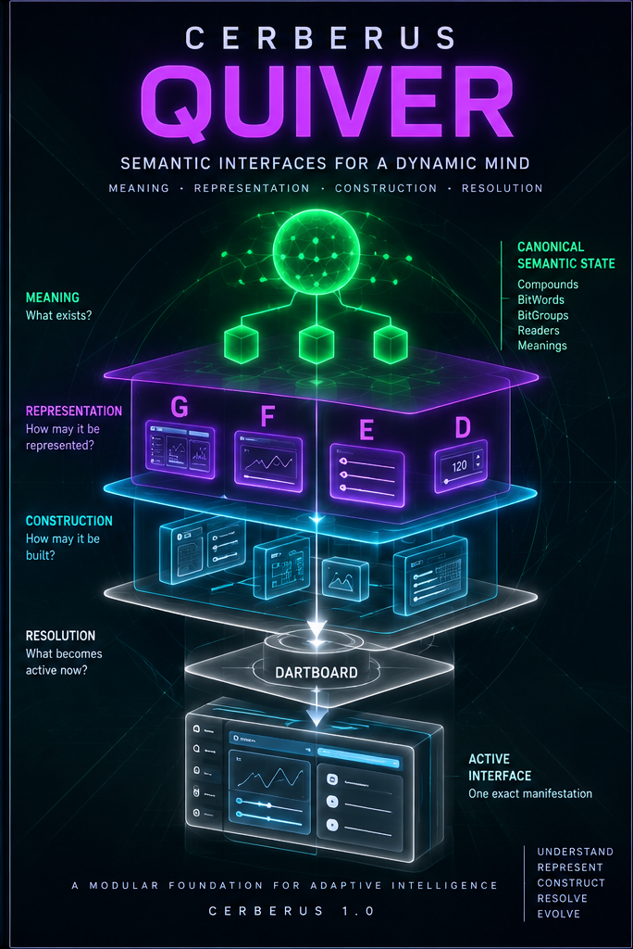
Version 1.0 | PASS 8 VERIFIED RELEASE
Registered semantic representation capability over canonical state - rebuildable, composable, and governed.

Executive Orientation
QUIVER is the governed semantic-interface representation layer of CERBERUS. It sits between semantic machinery that owns meaning and canonical state, reusable construction machinery that gives representations spatial bodies, and DARTBOARD, which resolves one exact task-bounded manifestation for the current context. QUIVER does not store the truth of the thing being represented. It stores governed interface possibility over that truth.
The architecture is designed so that interface capability can accumulate around stable semantic meaning. A semantic value can acquire several D representations. A BitWord can acquire several complete F views. A Compound can acquire several G views. The same representation can use several registered constructions, and the same construction can be reused across unrelated semantic domains. The result is a system that can become increasingly adaptive without turning interface implementation into another source of semantic authority.
Panels provide structure. QUIVER provides semantic instrumentation. DARTBOARD provides active manifestation.

The architecture includes a formal Panel Construction grammar, normalized display geometry, explicit spatial validation, Shell landing, and a sharper Three-Graph separation between meaning, representation, and construction. It also preserves the Same-Record Law: D, E, F, and G are alternate governed lenses over canonical state rather than copies that synchronize upward and downward.

Definitive reconstruction sentence
QUIVER is CERBERUS's governed semantic-interface representation layer: it registers how canonical Reader-resolved structures may be represented through D/E/F/G contracts, binds those representations to reusable construction capability, and supplies valid possibilities for DARTBOARD to resolve into exact task-bounded manifestations without transferring semantic authority away from canonical state.

Document map
# | Section | Purpose
1 | System Ownership and Instrumentation Boundary | What QUIVER owns, what it consumes, and where DARTBOARD begins.
2 | Semantic Coverage: D / E / F / G | Coverage classes, exact active coverage, defaults, overrides, and Word/Compound boundaries.
3 | Panel Construction Grammar | Display, Panel, Placement, Panel Group, Array, Interface Element, and recursive composition.
4 | Semantic Instrumentation and the Three-Graph Model | How Reader-resolved semantics bind to reusable construction without category collapse.
5 | Normalized Geometry and Spatial Validation | Parent-local 0-100 geometry, occupancy, void, overlap, fit, and bounded spatial policies.
6 | Resolution, DARTBOARD, and Shell Landing | How registered possibilities become one exact authorized active interface.
7 | Reversible Semantic Zoom and Panel Recomposition | Scope changes over one canonical lineage; Zoom is not Branch.
8 | Native Reconstruction Architecture | What the Personal Core must reconstruct independent of Airtable or renderer technology.
9 | Capability Gaps and Development Boundaries | How QUIVER interacts with SPD, PORT, BUILD, PATCH, and the future DataSpec direction.
10 | Ownership Matrix | Definitive responsibility and non-responsibility boundaries.
11 | Formal Invariant Registry | Compact laws that must survive reconstruction.
12 | Native Verification Checklist | Practical tests for semantic parity, construction parity, DARTBOARD, and Semantic Zoom.
13 | Closing Orientation | The final compressed architecture and reconstruction test.

1. System Ownership and Instrumentation Boundary
QUIVER exists because semantic meaning and interface representation are different kinds of structure. A Semantic Kernel, Reader Binding, BitWord, or canonical record must remain meaningful even when no interface is visible. Conversely, a visual control or task surface can change radically without redefining the underlying semantic object. QUIVER therefore preserves representation intent rather than frozen screens.
The durable object is not a screenshot. It is a governed relationship among semantic scope, representation intent, contextual eligibility, and construction capability. Rendered surfaces remain derivative. They may be discarded and regenerated from the same canonical source.

1.1 The instrumentation model
OWNERSHIP MAP
CANONICAL SEMANTIC MACHINERY
Bits / BitGroups / Placements / BitWords / Compounds
Readers / Reader Bindings / Canonical State
-> representation binding
QUIVER
D / E / F / G | Variants | Eligibility | Construction Bindings
<->
PANEL CONSTRUCTION
Display / Panel / Panel Group / Placement / Array / Interface Element
-> active resolution
DARTBOARD
->
CERBERUS SHELL

This map is a composition and handoff map, not a destructive conversion pipeline. Canonical state remains persistent throughout. QUIVER registers possible representations of that state. Panel Construction supplies reusable spatial structure. DARTBOARD resolves the exact active composition for the current task. The Shell supplies stable application territory.

1.2 What QUIVER owns
- Registered D/E/F/G representation capability over governed semantic targets.
- Declared semantic membership for coordinated E representations.
- Representation variants, defaults, placement-specific overrides, lifecycle, version, and eligibility.
- Explicit bindings from representation capability to reusable construction capability.
- The possibility graph from which DARTBOARD resolves the active interface.

1.3 What QUIVER does not own
- Canonical semantic state or the meaning of Bits, BitGroups, BitWords, Compounds, or Reader Bindings.
- VISOR structural geography and routing across the Base.
- Reusable Panel geometry as an implementation-independent construction definition.
- The exact active task-bounded interface graph; that belongs to DARTBOARD.
- Mutation authority. A visible control never grants permission by virtue of being visible.
REGISTERED POSSIBILITY != ACTIVE RESOLUTION | RENDERED INTERFACE != CANONICAL STATE

1.4 VISOR, QUIVER, Panel Construction, and DARTBOARD
VISOR supplies structural terrain: containment, relationships, valid routes, dependencies, and orientation within the wider CERBERUS Base. QUIVER supplies governed representation capability over semantic structures located in that terrain. Panel Construction supplies reusable spatial bodies. DARTBOARD resolves which valid semantic and spatial possibilities become active now. These systems cooperate through explicit relationships while preserving ownership boundaries.
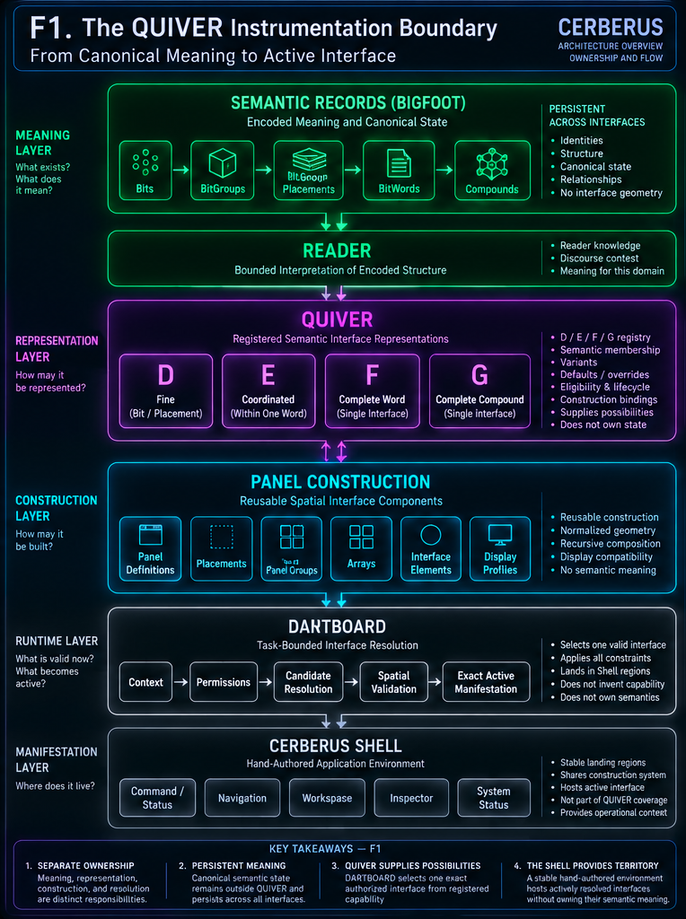
Figure 1. The QUIVER instrumentation boundary. Canonical semantic machinery remains authoritative; QUIVER registers representation capability, Panel Construction supplies reusable spatial bodies, DARTBOARD resolves the active manifestation, and the CERBERUS Shell supplies stable territory.

2. Semantic Coverage: D / E / F / G
D, E, F, and G are semantic-coverage classes. They answer how much governed semantic structure one representation contract covers. They do not rank interface quality, visual size, maturity, user skill, modality, or runtime order. A physically large control can still be D. A compact control can be F or G if it truly represents the complete governed object at that scope.
Class | Semantic coverage | Boundary
D | One independently viable Bit or one Reader-bound BitGroup placement. | Fine scope; may be implemented by one or several UI elements.
E | Two or more Reader-bound BitGroup placements coordinated inside one BitWord. | May not cross the BitWord boundary; composition does not merge identity.
F | One complete BitWord. | Complete Word representation; distinct from a complete internal D/E partition.
G | One complete Compound BitWord. | Complete Compound representation; constituent BitWord boundaries remain intact.

2.1 D - fine semantic representation
D is the smallest independently viable QUIVER representation scope. In the modern Reader architecture, the preferred semantic address is not a context-free reusable BitGroup definition alone. A normalized BitGroup Placement identifies an occurrence inside a BitWord, and a Reader Binding assigns the bounded semantic role of that occurrence. D then registers a valid representation over that resolved target.
BitGroup Definition
-> BitGroup Placement
-> Reader Binding
-> bounded semantic role
-> QUIVER D

Mathematical compatibility constrains which representations are possible, but it does not select one. A SCALAR may be representable through a slider, dial, numeric input, hardware knob, voice interaction, haptic magnitude, or structured AI operation. None of those follows automatically from the mathematics or from a semantic label such as Tempo or Intensity. QUIVER must register the relationship explicitly.

2.2 Defaults and Reader-bound overrides
Reusable semantic machinery can carry useful general representation defaults, while a particular Reader-bound occurrence can override that default. This preserves reuse without blindly forcing every instance of the same mathematical structure into the same interface geometry. The override does not redefine the BitGroup or erase the default; it states that this semantic occurrence requires another registered representation.

2.3 E - coordinated representation inside one BitWord
E exists when several Reader-bound placements inside one BitWord benefit from coordinated representation. E declares semantic membership explicitly. It does not create a new BitGroup, infer membership from Panel proximity, or merge the identities of its members. Its boundary is the BitWord: an E may coordinate any valid subset of placements within one Word, but it may not cross into another Word.
E COMPOSITION != SEMANTIC MERGER | E MAY NOT CROSS A BITWORD BOUNDARY

Several registered E alternatives may legitimately overlap in possibility space. For example, one E may contain BG:1 + BG:2 and another BG:2 + BG:3. That overlap is acceptable while they are alternatives. Once the active interface is resolved, however, exposed semantic ownership must be exact: required state is covered completely and no semantic placement is accidentally owned twice in the same active partition.

2.4 F - one complete BitWord
F is a first-class complete-Word representation. A BitWord may have several F variants: compact, engineering, learning, accessibility, AI-native, hardware, or others. Every valid F still covers the complete Word. A complete D/E partition over the same Word can be state-equivalent to F, but it is a different representation path; completeness alone does not transform an internal D/E composition into an F contract.

2.5 G - one complete Compound BitWord
G applies the same complete-object principle at Compound scale. A holistic G may present the Compound as one unified tool, or the user may resolve the Compound through its constituent BitWords. If one Word opens internally into D/E while neighboring Words remain at F, the semantic hierarchy still preserves the Compound and each Word boundary. Visual flattening never authorizes semantic flattening.

2.6 Scope, variant, and authority are independent
- Scope answers how much semantic structure is represented.
- Variant answers how that scope is represented.
- Construction answers how the chosen representation occupies spatial territory.
- Authority answers what actions are actually permitted.
- None of these axes silently determines another.
SEMANTIC COVERAGE != VISUAL SIZE != MODALITY != RUNTIME ORDER

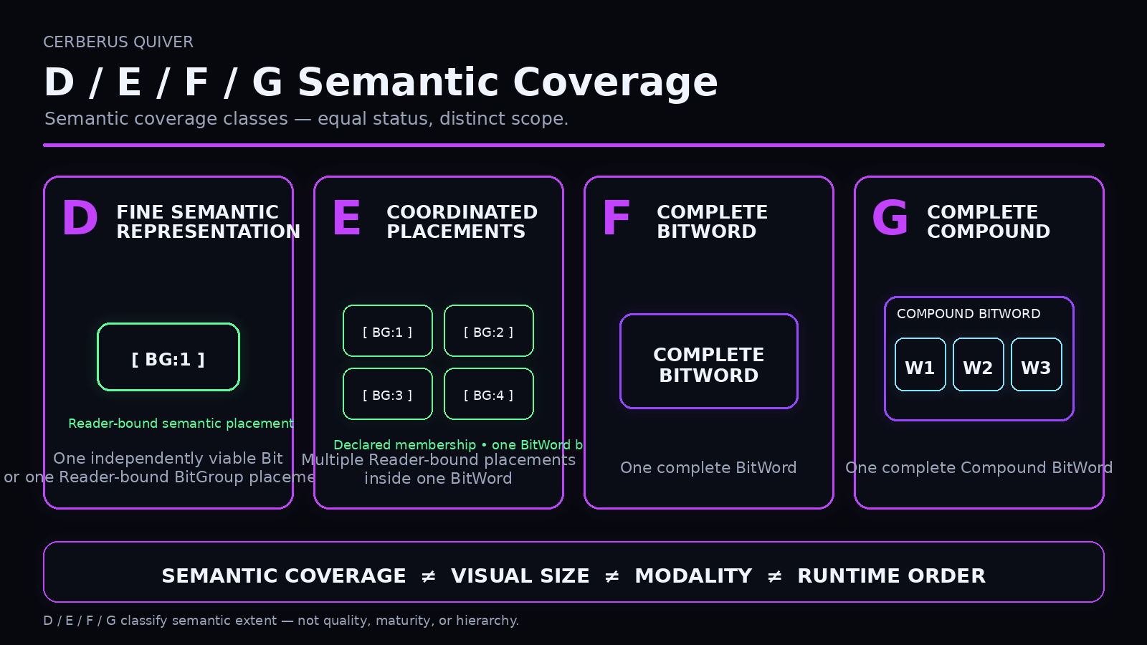
Figure 2. D/E/F/G are semantic coverage classes, not a hierarchy. D exposes fine semantic scope, E coordinates Reader-bound placements within one BitWord, F covers one complete BitWord, and G covers one complete Compound BitWord.

3. Panel Construction Grammar
D/E/F/G describe semantic extent; they do not specify how an interface occupies space. Panel Construction provides the reusable spatial grammar that QUIVER can instrument. Its strength comes from being deliberately semantically ignorant: the rectangle machine should be excellent at containment, placement, size, repetition, nesting, and validation without needing to understand TIME, MUSIC, BODY, FITNESS, or any other semantic domain.

3.1 Core construction objects
Object | Role | Does not establish
Display | Bounded destination or construction root. | Semantic content or coverage class.
Panel | Reusable bounded spatial container. | Semantic identity by itself.
Placement | One occurrence of a reusable child inside a parent. | A new reusable definition.
Panel Group | Reusable composite of multiple Panels. | E/F/G semantic membership.
Array | Rule-derived repeated placement. | Semantic grouping.
Interface Element | Manifestable presentation or interaction mechanism. | Reader meaning or mutation authority.

3.2 Definition versus occurrence
A Panel Definition is reusable identity. A Placement is one local occurrence. The same Panel can appear in a desktop Workspace, a tablet Inspector, and a compact task surface without being copied into three independent definitions. The Placement carries local parent, position, size, Z, display order, and overrides while the reusable definition remains stable.
PANEL DEFINITION != PANEL PLACEMENT | REUSABLE STRUCTURE != LOCAL OCCURRENCE

PANEL DEFINITION A
Default W = 40
Default H = 50
-> Placement Desktop
-> Placement Tablet
-> Placement Compact

3.3 Recursive composition
Panels may contain child Panels, Panel Groups, Interface Elements, or other valid construction objects. This recursion allows complex interfaces to emerge from a small grammar instead of from an ever-growing inventory of one-off screen types. A nested container can own a local 0-100 coordinate system, so a reusable internal construction can be scaled and placed in many parents without rewriting all child geometry.
DISPLAY
└─ WORKSPACE PANEL
├─ TOOLBAR PANEL
├─ CONTENT PANEL
│ └─ PANEL GROUP
│ ├─ PANEL 1
│ ├─ PANEL 2
│ └─ PANEL 3
│ └─ PANEL GROUP
│ ├─ PANEL 3A
│ └─ PANEL 3B
└─ STATUS PANEL

3.4 Panel Group and Array are construction concepts
A Panel Group means that spatial structures are composed together. An E contract means that semantic placements are coordinated together inside one BitWord. Those are different statements. Likewise, an Array derives repeated geometry; it does not define semantic membership. The construction graph can look similar to the semantic graph without becoming the semantic graph.
PANEL GROUP != E / F / G | ARRAY != SEMANTIC MEMBERSHIP

3.5 Renderer code remains downstream
Panel Construction should describe reusable interface structure without freezing one frontend technology. HTML/CSS, native desktop widgets, mobile frameworks, embedded hardware, or future renderers may materialize the same construction semantics differently. The construction contract is portable; renderer code is implementation material.
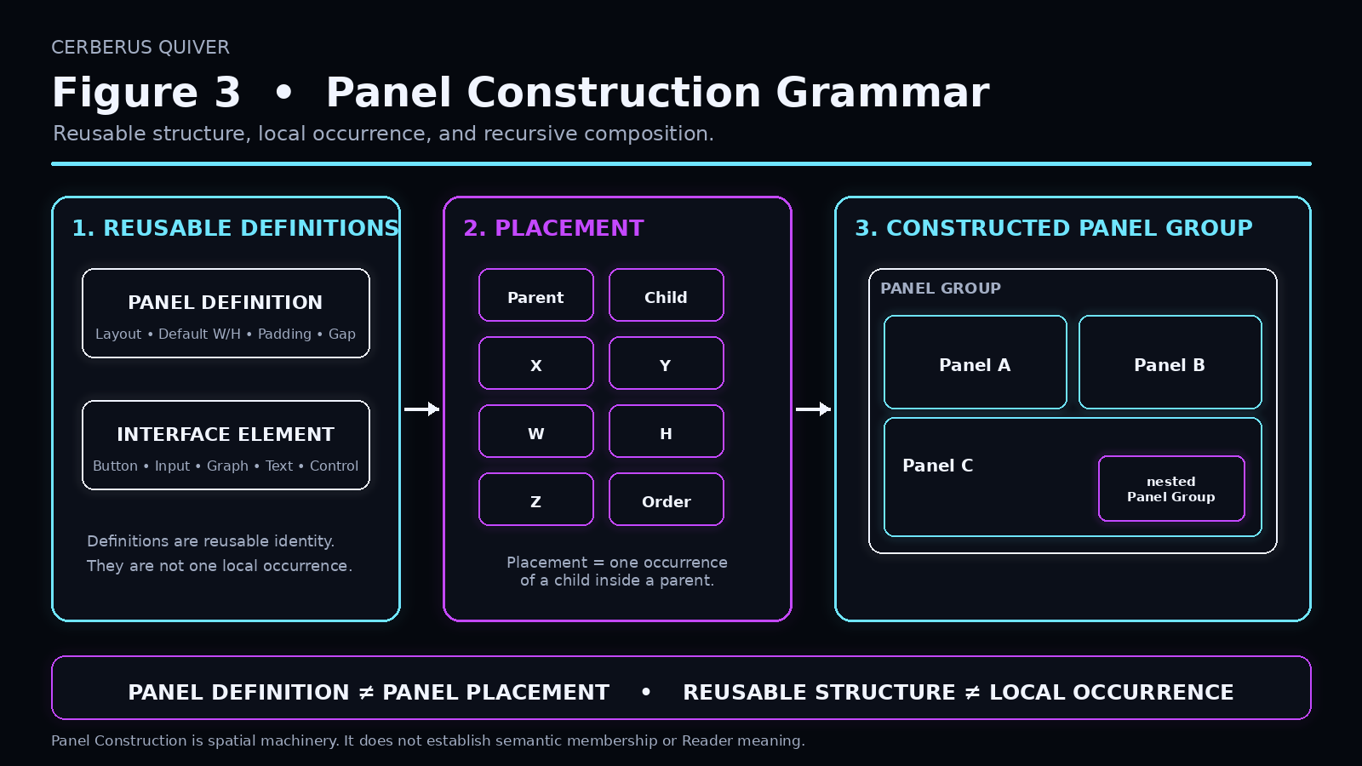
Figure 3. Panel Construction Grammar. Reusable Panel definitions, Interface Elements, Placements, and Panel Groups compose recursively while preserving the distinction between reusable structure and local occurrence.

4. Semantic Instrumentation and the Three-Graph Model
The semantic layer and the construction layer can now be joined without category collapse. QUIVER performs the joining through explicit construction bindings between governed representation contracts and reusable construction roots. The Panel does not become the semantic object; it becomes a valid body through which that semantic object can be represented.
QUIVER INSTRUMENTS PANELS; PANELS DO NOT CREATE SEMANTIC MEANING

4.1 One visible control can have several identities
MATHEMATICAL STRUCTURE
SCALAR BitGroup
->
SEMANTIC OCCURRENCE
Reader Binding: Tempo
->
REPRESENTATION
QUIVER D: Slider Variant
->
CONSTRUCTION
Slider Element placed inside Panel

A visible slider may look simple, but its mathematical type, semantic role, representation contract, and construction occurrence are independent identities. Keeping them separate makes reuse possible in both directions: one semantic target can have many representations, and one construction or Interface Element can serve many unrelated semantic targets.

4.2 Same semantics, different construction
An E containing BG:1, BG:2, BG:3, and BG:4 can be represented as a 2x2 grid, a vertical stack, a staggered layout, or another registered structure. The E membership does not change. Conversely, the same 2x2 Panel Group can be reused by different E contracts in different domains. Construction reuse never implies semantic equivalence.
SAME SEMANTIC MEMBERSHIP CAN USE DIFFERENT GEOMETRY; SAME GEOMETRY CAN SERVE DIFFERENT SEMANTICS

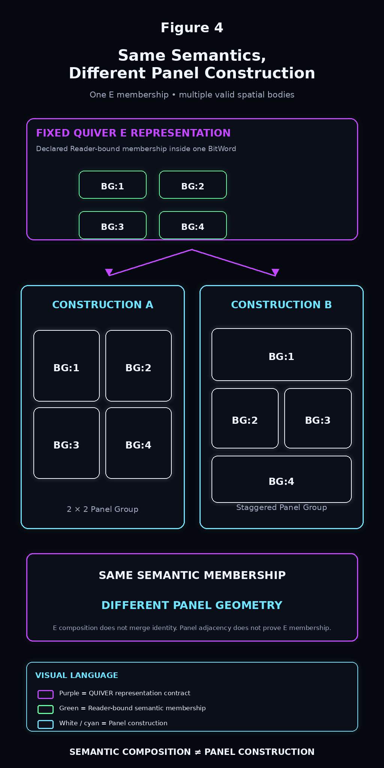
Figure 4. Same semantics, different Panel construction. A governed semantic representation can be realized through multiple valid spatial topologies without redefining the underlying meaning.

4.3 The Three-Graph architecture
QUIVER becomes much easier to reconstruct when three graphs are carried simultaneously. The Semantic Graph answers what exists and what it means. The Representation Graph answers how that meaning may be represented. The Construction Graph answers how a selected representation may be spatially built. DARTBOARD sits downstream and composes the resolved result. No one graph should be used as a substitute for the others.
Graph | Primary question | Typical contents
Semantic Graph | What exists and what does it mean? | Compound, BitWord, BitGroup Placement, Reader Binding, canonical semantic value.
Representation Graph | How may it be represented? | D/E/F/G contracts, membership, variants, defaults, overrides, construction bindings.
Construction Graph | How may it be built spatially? | Display, Panel Group, Panel, Placement, Array, Interface Element, geometry.
Active DARTBOARD Graph | What exact composition is active now? | Selected semantic targets, active placements, current context, permissions, spatial state.

4.4 Why one universal interface graph is dangerous
A universal graph that mixes Word membership, E membership, Panel containment, coordinates, permissions, and runtime activation may appear convenient, but it destroys provenance. A later AI cannot tell whether an edge means semantic containment, representation coordination, spatial placement, or runtime selection. The Three-Graph split localizes errors and change propagation. Wrong meaning points to the Semantic Graph; wrong control choice points to QUIVER; wrong placement points to Panel Construction; wrong active selection points to DARTBOARD.
MEANING != REPRESENTATION != CONSTRUCTION

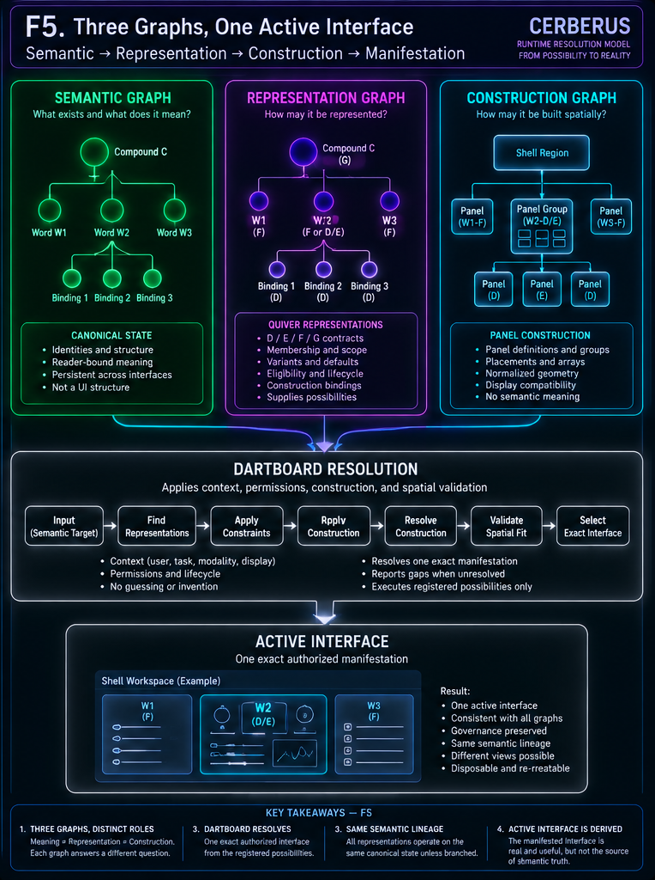
Figure 5. Three graphs, one active interface. Semantic meaning, QUIVER representation possibility, and spatial construction remain distinct until DARTBOARD resolves one exact authorized manifestation.

5. Normalized Geometry and Spatial Validation
Once a representation is semantically valid and a construction is registered, a separate mechanical question remains: can that construction exist inside the available Display? Spatial validity is its own gate. A semantically correct E may have a construction that does not fit the current landing region. A beautiful layout may be semantically illegal. Neither form of validity repairs the other.

5.1 Display Profile and normalized space
A Display Profile describes the material destination: orientation, aspect ratio, physical or logical dimensions, and other manifestation characteristics required by the implementation. Panel Construction uses a normalized parent-local coordinate language, normally X=0-100 and Y=0-100, so construction definitions can survive changes in material resolution.
Display space: D = [0,100] x [0,100]
Panel bounds: P = [x0,x1] x [y0,y1]
0 <= x0 < x1 <= 100
0 <= y0 < y1 <= 100

NORMALIZED GEOMETRY != MATERIAL RESOLUTION | NORMALIZED 10 x 10 != PHYSICAL SQUARE

5.2 Parent-local geometry
Every valid container may own its own local normalized space. A child Panel therefore needs to know only its coordinates inside its parent, not global screen pixels. Global bounds can be derived through the parent transform when needed for collision analysis or rendering. This preserves reusable internal topology while allowing the same Panel Group to occupy different parent sizes and aspect ratios.
x_global = parent_x0 + (x_local / 100) * parent_width
y_global = parent_y0 + (y_local / 100) * parent_height

5.3 Occupancy and voidspace are derived
Once active Panel bounds are known, occupied territory is the union of active regions. Voidspace is the parent Display minus that occupied territory. Neither needs to be authored as independent semantic truth. They are derived spatial observations. This makes voidspace operationally useful: DARTBOARD can ask whether any available region satisfies a candidate construction's minimum geometry instead of visually guessing where something might fit.
Occupied O = union(P1, P2, ... Pn)
Void V = Display - O

OCCUPANCY != SEMANTIC COVERAGE | AVAILABLE VOID != PERMISSION TO INVENT CONTENT

5.4 Overlap and spatial policies
Two Panels spatially overlap when their interior areas intersect. Edge contact alone is not area overlap. Overlap detection is not the same as overlap permission: some interfaces legitimately layer modals, floating inspectors, overlays, or transient controls. The initial construction grammar therefore supports a small set of explicit policies.
Policy | Meaning | Typical response
EXCLUSIVE | Participating Panels may not occupy the same active territory. | Overlap produces spatial failure and must be resolved or stopped.
LAYERED | Overlap is intentional and rendering precedence matters. | Validate that layering is permitted, then use Z-order.
SWAP | A preferred placement failed but registered alternatives exist. | Test alternate placement or landing candidates deterministically.

Z-ORDER != OVERLAP PERMISSION | SEMANTIC OVERLAP != SPATIAL OVERLAP

5.5 Fit is a bounded test
A construction fits when it remains within its parent, meets minimum geometry, satisfies overlap policy, and all required nested children also validate. Fit does not mean design perfection; accessibility, readability, and preference may impose additional constraints. The spatial engine should remain bounded enough to be objectively testable.
SpatialValid(C) =
Contained(C)
AND MinimumGeometry(C)
AND ChildrenValid(C)
AND OverlapPolicySatisfied(C)

5.6 Explainable spatial evidence
Spatial validation should produce inspectable evidence rather than a generic Layout Error. A failed candidate can report that containment passed, width passed, height passed, overlap failed, the collision is with Panel C, and policy is EXCLUSIVE. These results are useful to DARTBOARD, PATCH, BUILD, and future diagnostics because the ownership of failure remains visible.

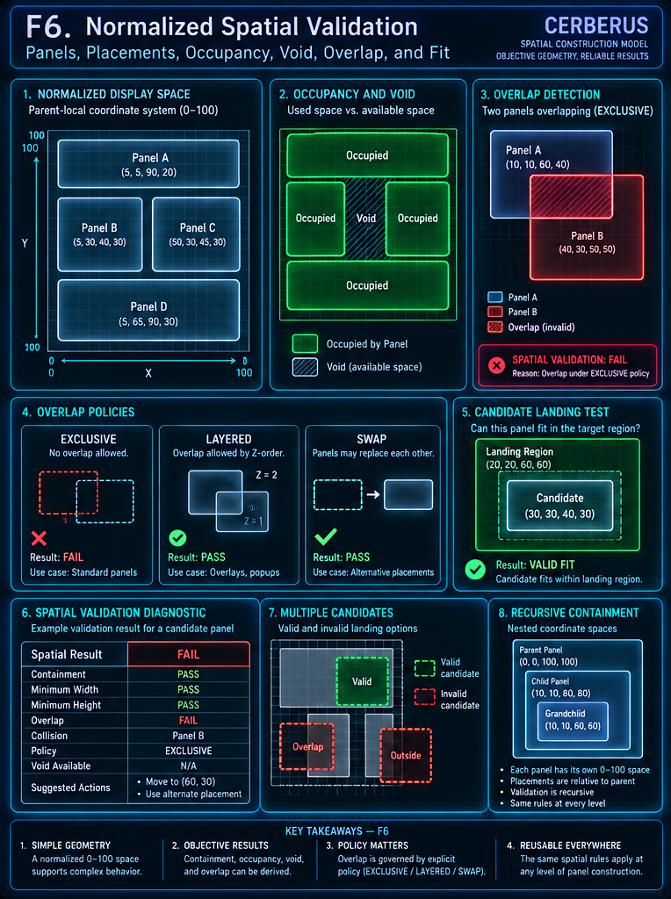
Figure 6. Normalized spatial validation. Parent-local geometry makes containment, occupancy, voidspace, overlap, fit, and alternate landing decisions machine-checkable rather than visually guessed.

6. Resolution, DARTBOARD, and Shell Landing
QUIVER and Panel Construction can both contain many valid alternatives. Runtime still needs one exact active composition. DARTBOARD performs this task-bounded narrowing after semantic validity, contextual eligibility, permissions, lifecycle, representation selection, construction compatibility, spatial fit, and landing availability have been evaluated.
QUIVER POSSIBILITY != DARTBOARD ACTUALITY | REGISTERED != ELIGIBLE != SELECTED != ACTIVE

6.1 Resolution funnel
CANONICAL SEMANTIC TARGET
-> QUIVER REPRESENTATION CANDIDATES
-> SEMANTIC COVERAGE VALIDATION
-> VIEWER / TASK / MODALITY CONTEXT
-> PERMISSION PRUNING
-> LIFECYCLE / VERSION ELIGIBILITY
-> DEFAULT / OVERRIDE / VARIANT RESOLUTION
-> CONSTRUCTION BINDINGS
-> DISPLAY COMPATIBILITY
-> SPATIAL FIT
-> LANDING CANDIDATES
-> DARTBOARD
-> EXACT ACTIVE INTERFACE GRAPH

This funnel is conceptual. A native runtime may optimize the implementation, but it must preserve the distinctions so that the final manifestation remains explainable and missing governance never becomes silent guesswork.

6.2 Permission pruning before manifestation
Unauthorized representation paths should be pruned before the active interface is assembled. Hiding a forbidden control after construction can still leak labels, counts, breadcrumbs, empty placeholders, Panel occupancy, or relationship hints. The authorized possibility graph must therefore be established before DARTBOARD creates the visible interface.
VISIBLE != WRITABLE | INTERFACE CONTROL != MUTATION AUTHORITY

6.3 Defaults, overrides, variants, and construction candidates
Defaults provide a governed starting choice when several valid representations remain. Overrides replace a general default at a specific Reader-bound semantic occurrence. Representation variants remain independent from construction variants: an accessibility F may have both wide and tall constructions, while the semantic interaction strategy remains the same. Display compatibility and spatial fit narrow construction candidates downstream of the representation decision.

6.4 Landing Regions
A Landing Region is bounded runtime territory into which a resolved construction may be instantiated. The hand-authored CERBERUS Shell can expose regions such as Workspace, Inspector, Overlay, or Utility areas. A reusable construction does not permanently belong to a landing region; landing is a runtime relationship. The same E or F construction may appear in different authorized regions for different tasks.
CONSTRUCTION != LANDING | NO VALID LANDING != PERMISSION TO SQUEEZE

6.5 The hand-authored Shell
The first Native Personal Core should use a deliberately hand-authored Shell. Stable navigation, command/status, Workspace, Inspector, and system-status territory provides a reliable development floor while QUIVER becomes progressively more adaptive. The Shell can use the same normalized Panel grammar and spatial validator without becoming part of the D/E/F/G semantic hierarchy.
CERBERUS SHELL
├─ Command / Status
├─ Navigation
├─ Workspace <- primary QUIVER landing territory
├─ Inspector
└─ System Status

SHELL REGION != QUIVER COVERAGE CLASS | SAME SPATIAL GRAMMAR, DIFFERENT ARCHITECTURAL PURPOSE

6.6 No valid candidate
If no valid semantic-representation-construction-landing combination survives, the runtime must report the gap. It must not generate a plausible control from field names, squeeze a large construction into invalid geometry, or silently degrade required semantic scope. A genuine unresolved state is useful information: it identifies whether capability is missing in semantics, QUIVER, construction, spatial territory, permissions, lifecycle, Shell, or the resolution policy itself.
NO VALID CANDIDATE != PERMISSION TO INVENT ONE

6.7 Action return path
When an active Interface Element invokes an authorized action, the operation returns through the governing action contract, permissions, Operators, and Rules to canonical state. QUIVER does not become a temporary state store. Once canonical state changes, active representations re-resolve from the updated source.
Active Interface Element
-> Action Contract
-> Permission / Rule / Operator Validation
-> Canonical Semantic State
-> Reader resolves updated meaning
-> QUIVER / DARTBOARD refresh manifestation

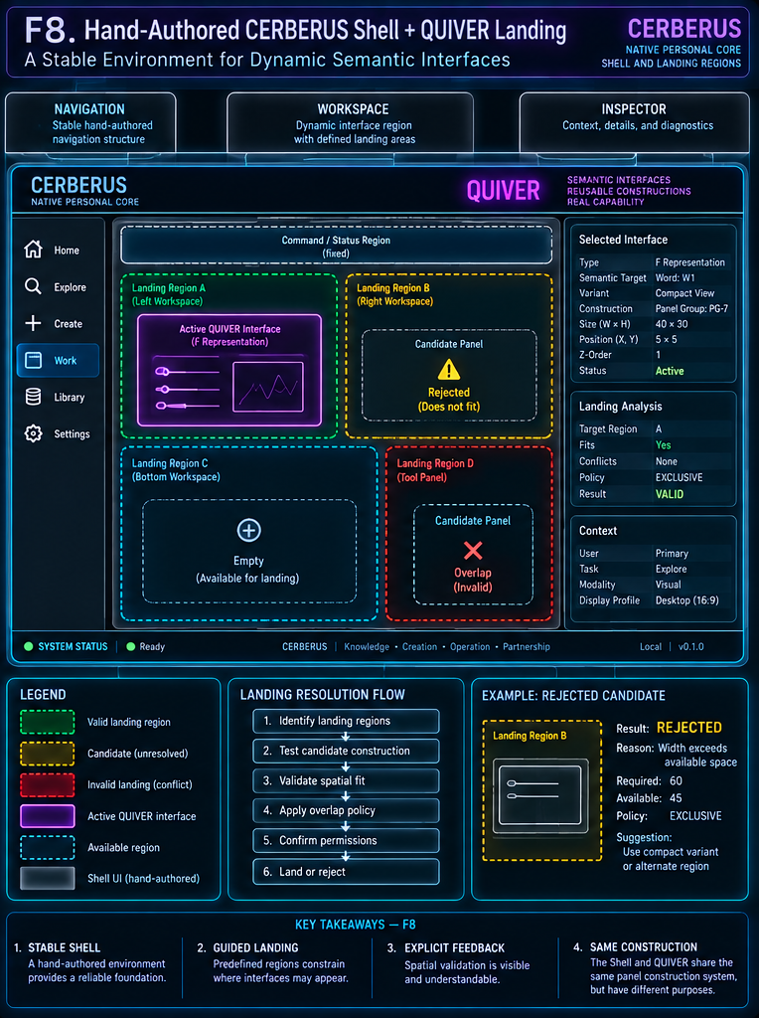
Figure 8. Hand-authored CERBERUS Shell and QUIVER landing. The Shell supplies stable application territory while DARTBOARD places one valid resolved construction into an authorized landing region and rejects incompatible candidates explicitly.

7. Reversible Semantic Zoom and Panel Recomposition
The Same-Record Law is the central consequence of keeping interface representation separate from semantic state. D, E, F, and G do not contain synchronized copies of the object. They are alternate governed lenses over one canonical semantic lineage. A user can move from Compound scope to Word scope, open a Word into D/E internals, edit a fine semantic target, and return to a complete view without an apply-upward synchronization step.
REVERSIBLE SEMANTIC ZOOM = CHANGE OF REPRESENTED SCOPE OVER ONE CANONICAL LINEAGE

7.1 Zoom is not a D -> E -> F -> G pipeline
Semantic Zoom follows valid registered scope relationships, not a mandatory ladder. A Compound may open directly into constituent Words. A Word may resolve directly into an E + D + D partition. A task may address one D directly without visiting G or F. D/E/F/G remain coverage classes rather than execution stages.

7.2 Same-Record Law
If F displays Tempo=120 and a D exposes that same canonical Tempo through a slider, they do not hold two values. D acts through governed mutation on canonical state. F, E, and G resolve the updated value from the same source. There is no child state to merge upward and no parent state to overwrite.
D interaction
-> governed mutation
-> CANONICAL STATE
-> all active or future representations re-resolve

NO APPLY-UPWARD OPERATION IS REQUIRED BECAUSE THERE IS NO SEMANTIC COPY HIERARCHY

7.3 Panel Recomposition
Semantic Zoom may require a different spatial body. A holistic F Panel can be replaced locally by a D/E Panel Group. A G region can expose constituent Word Panels. If the finer construction does not fit locally, DARTBOARD may choose another registered construction, another landing region, or an authorized recomposition of surrounding territory. Panel Recomposition is spatial; it does not create semantic state.
SEMANTIC ZOOM != PANEL RECOMPOSITION | REPRESENTATION REPLACEMENT != STATE REPLACEMENT

7.4 Zoom versus Branch
Zoom preserves one lineage. Branch creates another governed semantic lineage that can later diverge independently. Opening another window, displaying the same object on hardware and desktop, or opening a fine D view does not create a branch. Branch requires an explicit semantic/state operation and its own governing authority.
ZOOM != BRANCH | MULTIPLE MANIFESTATIONS != MULTIPLE SEMANTIC OBJECTS

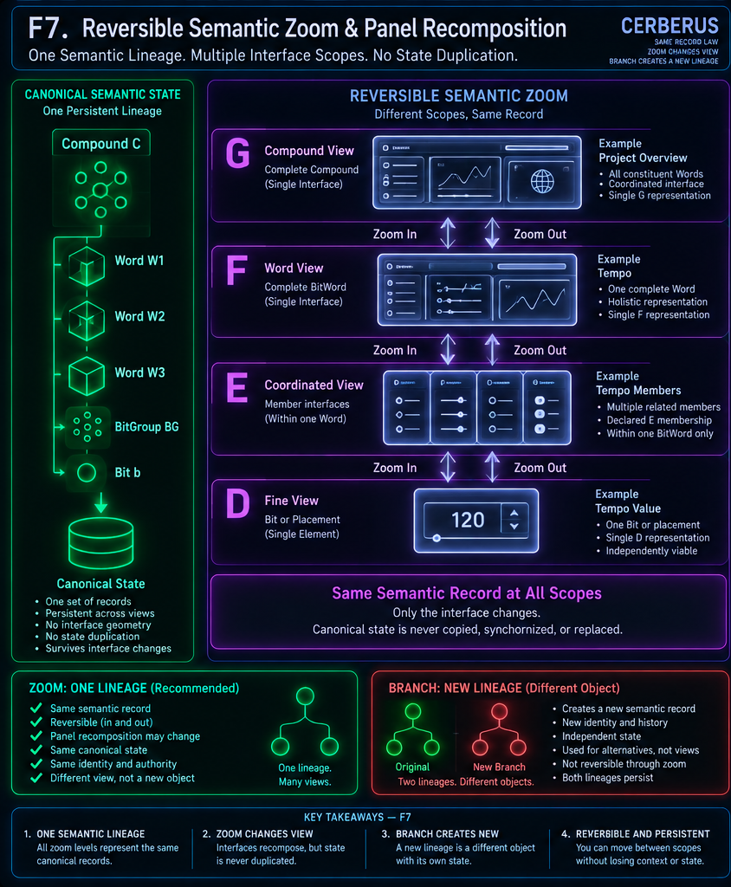
Figure 7. Reversible Semantic Zoom and Panel Recomposition. G, F, E, and D can expose different scopes of one persistent canonical lineage. Panel topology may change, but Zoom does not branch semantic identity; Branch explicitly creates a new lineage.

7.5 Permissions and lifecycle still apply at finer scope
A user allowed to see a G summary is not automatically allowed to discover every F, E, or D descendant. Zoom requests must be re-evaluated against permissions, lifecycle, representation availability, and current spatial constraints. A semantic object can be addressable while a finer representation is currently unavailable. That condition should remain explicit rather than triggering runtime invention.

7.6 Interface history is not semantic history
A traversal such as G -> F -> D/E -> D -> F -> G is interface history. If no semantic mutation occurred, canonical semantic state may be unchanged throughout. If a value changed while D was active, the zoom event and the semantic event remain independently identifiable. Semantic Zoom is not time travel and does not automatically select historical state.

8. Native Reconstruction Architecture
The Native Personal Core must reconstruct QUIVER as architecture, not as an Airtable-shaped copy. The durable target is operational-semantic behavior and governed relationships. A SQL table that looks like an Airtable table is not architectural parity if the migration loses Reader-bound addressing, Word boundaries, scope/variant separation, construction bindings, exact active coverage, or the distinction between registered possibility and DARTBOARD actuality.
SCHEMA PARITY != ARCHITECTURAL PARITY

8.1 Minimum reconstructable responsibilities
Layer | Native responsibilities
Semantic | Bit/BitGroup/BitWord/Compound identity; normalized placements; Readers; Reader Bindings; canonical semantic state.
QUIVER | D/E/F/G registries; membership; variants; defaults/overrides; eligibility; lifecycle/version; construction bindings.
Construction | Display Profiles; Panel Definitions; Placements; Panel Groups; Arrays; Interface Elements; normalized geometry; variants.
Spatial | Containment, occupancy, void, overlap, fit, landing-candidate validation, recursive spatial diagnostics.
Runtime | Viewer/task/modality context; permission result; active landing; DARTBOARD candidate resolution; active graph; action route.

8.2 Native D/E/F/G
D must identify the exact fine semantic target, preferably a Reader-bound placement rather than a naked reusable BitGroup definition. E must preserve explicit membership and one-BitWord scope. F must remain one complete BitWord and stay distinct from a complete internal D/E partition. G must remain one complete Compound while preserving constituent Word identity through recursive resolution.

8.3 Native construction
Panel Definitions remain independent of occurrences. Placements remain first-class. Panel Groups remain recursively reusable. Interface Elements remain component identity rather than semantic identity. Construction bindings remain explicit so DARTBOARD never has to infer which Panel topology belongs to which QUIVER representation.

8.4 Native spatial validator
The initial geometry engine should stay intentionally small and testable: parent-local normalized coordinates, deterministic bounds, recursive containment, minimum geometry, overlap detection, explicit overlap policy, occupancy, void, and candidate landing tests. If future real use proves that this grammar is insufficient, it can expand later without changing the underlying distinction between semantic meaning and construction.

8.5 Native DARTBOARD contract
DARTBOARD should receive structured candidates rather than raw data plus an instruction to design something useful. At minimum, it must know the semantic target, required coverage, eligible QUIVER contracts, context, permissions, lifecycle, selected or candidate variants, construction candidates, Display Profile, landing candidates, and spatial-validation results. Its output is one active manifestation or an explicit unresolved state.

8.6 The Shell as a stable floor
The first Native Personal Core should keep the Shell deliberately hand-authored. Stable navigation and debugging territory localize failures while QUIVER, Panel Construction, and DARTBOARD are being proven. Later systems may generalize more of the Shell declaratively, but the first generation benefits from a predictable operating frame.

8.7 Technology is material, not canon
The architecture should not define React, Electron, Qt, HTML/CSS, SQLite, PostgreSQL, or any other implementation technology as canonical QUIVER meaning. SQLite may be the first persistence material, but PORT must be able to translate the same operational relationships into another material later. The system remains QUIVER if the contracts and invariants survive.
NATIVE MATERIAL != CANONICAL ARCHITECTURAL MEANING

8.8 Native QUIVER build order
Within the larger Native Personal Core migration, QUIVER-specific construction should follow dependency order. This is not a demand for separate development phases; it is a reconstruction dependency map that keeps semantic identity, construction, and runtime resolution independently testable.
Semantic registries / Readers
-> QUIVER D/E/F/G definitions
-> Panel definitions
-> Placements / Panel Groups / Elements
-> Construction bindings
-> Normalized geometry
-> Spatial validator
-> Shell Landing Regions
-> DARTBOARD resolution
-> Reversible Semantic Zoom

8.9 Verification before authority
A newly reconstructed native QUIVER should not become authoritative merely because it runs. It should first be observed, compared against the governed source architecture, refined where necessary, and explicitly promoted only after verification.
CONSTRUCT -> OBSERVE -> COMPARE -> PATCH -> VERIFY -> PROMOTE

9. Capability Gaps and Development Boundaries
A governed runtime becomes much easier to improve when it can identify where a request stopped resolving. QUIVER should therefore distinguish missing meaning from missing representation, missing construction, missing spatial territory, missing permission, and missing resolution policy. Failure is evidence; it should not be hidden behind a plausible but unregistered interface.

9.1 Capability-gap taxonomy
Gap | Meaning
Semantic Gap | Required semantic identity, placement, Reader, or bounded meaning is missing or unresolved.
QUIVER Gap | Semantic target exists, but the required D/E/F/G representation does not.
Construction Gap | Representation exists, but no valid registered construction realizes it.
Spatial Gap | Construction exists, but the current Display or landing region cannot fit it.
Permission Gap | Capability exists but is not authorized for the current viewer/context.
Lifecycle Gap | Capability exists but is not currently eligible for manifestation.
Shell Gap | No suitable authorized manifestation region exists.
Resolution Gap | Multiple valid candidates remain with no governed tie-breaker.
Action Gap | Representation exists, but requested mutation lacks governed authority.

9.2 SPD
SPD should preserve the operational meaning of the implementation structures that realize QUIVER and Panel Construction: what each registry or field means, what relationships and cardinalities are required, what is derived, and which system owns authority. The QUIVER paper defines what architecture must exist. SPD describes what the current implementation structure means operationally.

9.3 PORT
PORT translates preserved operational meaning into target material. An Airtable linked record and a SQLite foreign-key/junction structure may implement the same relationship differently. PORT owns that material translation; QUIVER and Panel Construction own the source architectural meaning being translated.

9.4 BUILD
BUILD becomes appropriate when required structure does not yet exist. If an F representation exists but no compact construction is registered, runtime should expose the construction gap. BUILD can later use bounded SPD Bundles and constructive lenses to propose new candidate structure. Runtime failure does not become runtime invention.

9.5 PATCH
PATCH becomes appropriate when existing structure is broken, ambiguous, redundant, or invalid: an E crosses a Word boundary, an EXCLUSIVE construction overlaps, a construction binding points to deprecated structure, or active semantic coverage duplicates one placement. QUIVER should expose enough evidence for PATCH to refine the problem without becoming PATCH itself.

9.6 DataSpec boundary
The current QUIVER + Panel Construction system is a deployed proving ground for the much broader future DataSpec research. CERBERUS 1.0 should first prove the lowest sufficient construction grammar - Panel, Placement, Group, Array, Element, normalized geometry, spatial validation, and DARTBOARD landing - before back-porting speculative generality from a future declarative language.
CURRENT CONSTRUCTION IS A PROVING GROUND, NOT A FAILURE TO ALREADY BE DATASPEC

9.7 Gap provenance
Every unresolved interface request should identify the stage where resolution stopped. The point is not only to report failure, but to preserve enough evidence that the correct owner can act on it later.
Semantic Target PASS
Reader Resolution PASS
QUIVER F PASS
Permission PASS
Construction PASS
Spatial Fit FAIL
Reason Minimum width exceeds available landing region
Result UNRESOLVED

9.8 Failure is development evidence
An explicit UNRESOLVED result is often more valuable than a convincing but ungoverned interface. A QUIVER gap teaches representation needs. A construction gap teaches spatial-body needs. A Shell or spatial gap teaches manifestation-environment needs. CERBERUS 1.0 should allow these failures to inform BUILD and PATCH rather than hiding them through runtime improvisation.

10. Ownership Matrix
The table below is the definitive responsibility boundary for the architecture in this specification. Reconstruction should preserve both the positive ownership and the explicit non-ownership of each system.
Architecture | Owns | Does not own
Semantic Records / BIGFOOT | Encoded semantic structure, identities, canonical state. | Interface geometry or active runtime manifestation.
Reader | Bounded interpretation of encoded placements. | UI construction or representation selection.
VISOR | Structural orientation, containment, governed routes and relationships. | Active interface manifestation.
QUIVER | Registered D/E/F/G representation capability, membership, variants, eligibility, construction bindings. | Canonical semantic state.
Panel Construction | Reusable spatial definitions, occurrences, groups, arrays, elements, geometry. | Semantic meaning or coverage legality.
Spatial Validator | Derived containment, occupancy, void, overlap, fit, landing viability. | Semantic legality or representation ownership.
DARTBOARD | Exact active task-bounded interface composition. | Source semantic or reusable-definition ownership.
CERBERUS Shell | Stable hand-authored application territory. | D/E/F/G semantic coverage.
Action / Authority | Permission to perform governed mutations. | Representation meaning.
SPD | Operational-semantic description of implementation structure. | Runtime representation selection.
PORT | Material translation between implementations. | Source architectural meaning.
BUILD | Proposed construction from bounded SPD precedent. | Runtime authority.
PATCH | Problem-resolution and refinement. | Interface manifestation itself.

11. Formal Invariant Registry
These laws are intended to survive renderer changes, database migration, interface redesign, and future extension. They are reconstruction tests: when an implementation contradicts one of them, it has crossed an ownership boundary or changed the architecture.

11.1 Semantic ownership
SEMANTIC MEANING != INTERFACE GEOMETRY

BITGROUP != READER-BOUND PLACEMENT

READER MEANING != QUIVER REPRESENTATION

RENDERED INTERFACE != CANONICAL STATE

INTERFACE VISIBILITY != MUTATION AUTHORITY

11.2 QUIVER coverage
D / E / F / G = SEMANTIC COVERAGE CLASSES

SCOPE != VARIANT

MATHEMATICAL COMPATIBILITY != INTERFACE SELECTION

E COMPOSITION != SEMANTIC MERGER

E MAY NOT CROSS A BITWORD BOUNDARY

F = ONE COMPLETE BITWORD

G = ONE COMPLETE COMPOUND BITWORD

COMPOUND RESOLUTION PRESERVES BITWORD BOUNDARIES

11.3 Construction
PANEL != SEMANTIC REPRESENTATION

PANEL DEFINITION != PANEL PLACEMENT

PANEL GROUP != E / F / G

ARRAY != SEMANTIC MEMBERSHIP

PANEL SIZE != SEMANTIC SCOPE

PANEL BOUNDARY != SEMANTIC BOUNDARY

CONSTRUCTION REUSE != SEMANTIC IDENTITY

11.4 Three graphs
SEMANTIC GRAPH != REPRESENTATION GRAPH

REPRESENTATION GRAPH != CONSTRUCTION GRAPH

MEANING != REPRESENTATION != CONSTRUCTION

VISUAL FLATTENING != SEMANTIC FLATTENING

11.5 Spatial
NORMALIZED GEOMETRY != MATERIAL RESOLUTION

OCCUPANCY != SEMANTIC COVERAGE

VOID / OVERLAP = DERIVED SPATIAL STATE

VOID EXISTS != CONSTRUCTION FITS

SEMANTIC OVERLAP != SPATIAL OVERLAP

Z-ORDER != OVERLAP PERMISSION

FIT != DESIGN PERFECTION

SPATIAL VALIDITY != SEMANTIC VALIDITY

11.6 Runtime
REGISTERED POSSIBILITY != ACTIVE RESOLUTION

QUIVER != DARTBOARD

REGISTERED != ELIGIBLE != SELECTED != ACTIVE

VISIBLE != WRITABLE

CONSTRUCTION != LANDING

NO VALID CANDIDATE != PERMISSION TO INVENT

ACTIVE GRAPH != QUIVER REGISTRY

INTERFACE TRANSITION != SEMANTIC MUTATION

11.7 Semantic Zoom
ZOOM != BRANCH

ZOOM != SEMANTIC DECOMPOSITION

SEMANTIC ZOOM != PANEL RECOMPOSITION

REPRESENTATION REPLACEMENT != STATE REPLACEMENT

MULTIPLE MANIFESTATIONS != MULTIPLE SEMANTIC OBJECTS

ZOOM HISTORY != SEMANTIC HISTORY

FINER SCOPE != GREATER AUTHORITY

12. Native Verification Checklist
A native implementation earns authority after independent observation and verification. Running code is not enough. The implementation must demonstrate semantic parity, construction parity, spatial determinism, bounded DARTBOARD behavior, and Same-Record Semantic Zoom.

12.1 Representation verification
- The semantic target still resolves through the correct Reader-bound path.
- D/E/F/G coverage class is unchanged by migration.
- E memberships are explicit and remain inside one BitWord.
- F and G completeness rules are preserved.
- Compound constituent Word boundaries survive active resolution.
- Scope, variant, lifecycle, version, default, and override remain distinct.
- Construction bindings remain explicit and traceable.

12.2 Construction verification
- Panel Definition remains distinct from Placement.
- Parent/child construction relationships survive migration.
- Local overrides remain local and do not mutate reusable definitions.
- Panel Groups recurse correctly.
- Arrays derive the expected placements.
- Construction reuse does not duplicate definitions or semantic identity.

12.3 Spatial verification
- Known containment fixtures PASS and known violations FAIL.
- Edge contact is not misclassified as area overlap.
- EXCLUSIVE overlap fails.
- LAYERED overlap requires explicit permission and then respects Z-order.
- SWAP tests only registered alternatives.
- Voidspace derives correctly from active occupancy.
- Nested geometry validates recursively.

12.4 DARTBOARD verification
Candidate state | Expected behavior
One valid candidate | Resolve it exactly.
Three candidates; two pruned by permission | Resolve the remaining authorized candidate.
Two valid candidates; explicit priority exists | Follow the governed priority.
Two valid candidates; no tie-breaker | Expose a resolution gap.
Zero valid candidates | Return UNRESOLVED; do not invent capability.

12.5 Same-Record Semantic Zoom test
1. Open one BitWord through an F representation.
2. Record the current canonical value.
3. Open one internal D representation through a valid zoom path.
4. Perform an authorized semantic mutation.
5. Confirm canonical state changed.
6. Return to F.
7. Confirm F resolves the changed value directly from canonical state.
8. Confirm no child-to-parent synchronization record was required.
IF D CHANGES MUST BE "APPLIED BACK" TO F, THE IMPLEMENTATION HAS DRIFTED FROM THE SAME-RECORD LAW

12.6 Compound boundary test
1. Open one Compound through G.
2. Resolve constituent Words.
3. Open one Word into D/E internals.
4. Verify the D/E members retain that Word's semantic ownership.
5. Verify neighboring Words remain distinct.
6. Verify the visual construction may place several scopes together without flattening semantic lineage.

12.7 Permission-safe Zoom test
1. Grant access to a G summary.
2. Restrict one internal Word or Reader Binding.
3. Request finer Semantic Zoom.
4. Confirm the unauthorized descendant representation is pruned before manifestation.
5. Confirm forbidden labels, placeholders, counts, breadcrumbs, or structural hints do not leak through Panel construction.

12.8 Reconstruction questions
1. What does QUIVER own, and why is it not DARTBOARD?
2. What exactly does each of D, E, F, and G cover?
3. Why must E remain inside one BitWord?
4. Why is a Panel Group not an E/F/G semantic object?
5. Why are Panel Definition and Placement separate?
6. What are the Semantic, Representation, and Construction Graphs?
7. How are occupancy, voidspace, overlap, and fit derived?
8. Why does permission pruning occur before manifestation?
9. What happens when no registered candidate fits?
10. Why does Semantic Zoom require no state synchronization?
11. How is Zoom different from Branch?
12. What survives when the rendered interface is destroyed?
13. What should SPD describe, what should PORT translate, and when should BUILD or PATCH be invoked?

13. Closing Orientation
A CERBERUS interface is not the thing it represents. The underlying semantic structure exists independently. Reader-bound interpretation resolves what that structure means. QUIVER registers the governed ways that meaning may be exposed. Panel Construction gives those representations reusable spatial bodies. Spatial validation determines whether those bodies fit the current territory. DARTBOARD selects one exact authorized manifestation. The Shell gives that manifestation somewhere stable to live. Actions return through governing authority to the same canonical state.
Because those responsibilities remain separate, the interface can change radically without semantic ownership changing. A Compound can become a set of Word views. One Word can open into coordinated fine controls. Panels can rearrange. The Display can change. The modality can change. The renderer can eventually change. The active surface can disappear entirely and be rebuilt later. The ownership chain remains recoverable.
NOT TO FREEZE THE INTERFACE, BUT TO MAKE INTERFACE POSSIBILITY ITSELF GOVERNED, REUSABLE, COMPOSABLE, RESOLVABLE, AND RECONSTRUCTABLE.

13.1 The compressed architecture
SEMANTIC GRAPH
What exists and what does it mean?
+
QUIVER REPRESENTATION GRAPH
How may it be represented?
+
PANEL CONSTRUCTION GRAPH
How may that representation be built?
+
RUNTIME CONTEXT
What is valid now?
-> DARTBOARD
-> ONE ACTIVE MANIFESTATION
-> CERBERUS SHELL
-> governed action returns to CANONICAL STATE

13.2 Reconstruction success test
A fresh human or AI has the core architecture when it can explain that canonical semantic state and Reader-bound meaning remain authoritative outside QUIVER; QUIVER registers valid D/E/F/G representations; Panel Construction supplies reusable spatial bodies independently of semantic meaning; explicit construction bindings join the two capability spaces; spatial validation determines what fits the current Display and landing context; DARTBOARD resolves one exact authorized task-bounded manifestation; and Reversible Semantic Zoom changes represented scope while preserving one semantic lineage.
End of PASS 8 Verified Release.

