CERBERUS MATRYOSHKA / CYBERNETIC DEVELOPMENT THEORY

CYBERNETIC
EVOLUTION THEORY
  - Construction, Refinement, Operational Compression,
and Inheritance in Evolving Intelligence Architectures
FORMAL ARCHITECTURE PAPER
Version 0.1 | Verified Release

GOVERNING QUESTION
How can a cybernetic architecture evolve through rapid construction and correction while preserving human authority, historical lineage, and reusable capability?

Cybernetic evolution converts resolved complexity into operational inheritance.
Independent research and architecture by Shane Conrad
CERBERUS worked architecture • BUILD ↔ PATCH development cycle • human-gated canonical change

EXECUTIVE ORIENTATION

A theory of progress through constructed evidence
Cybernetic Evolution Theory describes how a deliberately constructed intelligence architecture can advance without requiring its final form to be known in advance. The theory begins from a practical observation: complex systems are often understood most accurately after some portion of them exists. Construction exposes relationships, constraints, duplicated responsibilities, missing boundaries, and unexpectedly powerful abstractions that are difficult to discover from speculation alone. A mature development process therefore does not treat uncertainty as a reason to wait for total understanding. It builds what is sufficiently tractable, studies the resulting evidence, and converts what is learned into a more coherent next state.
The central mechanism is directed iteration. BUILD turns available structured intelligence into material architecture. Use produces evidence. Friction exposes mismatches between the current structure and the mechanism the system is trying to express. PATCH converts that evidence into bounded candidate correction. Repeated BUILD ↔ PATCH reverberation can then refine, merge, split, supersede, or prune structures until a mechanism becomes stable enough to normalize and reuse.
The payoff is not merely a cleaner design. Once a mechanism is stabilized and normalized, later work no longer needs to reconstruct the full reasoning that produced it. The system can address the result through registered identities, relationships, Readers, Semantic Kernels, interfaces, and runtime contracts. Large conceptual domains can therefore become compact operational objects at another resolution. Their complexity has not vanished; it has been compiled behind governed structure.
THEORY STATUS  An architectural theory derived from repeated CERBERUS development patterns. It formalizes a directed, evidence-responsive, human-gated design process. | NOT A BIOLOGICAL CLAIM  The language of evolution is structural and cybernetic. This paper does not claim Darwinian reproduction, autonomous self-modification, or removal of human authority.

CORE THESIS
Existing capability enables a conceptual unlock. Construction creates material evidence. Friction guides correction. Stabilized mechanisms normalize into reusable infrastructure. Reuse lowers reconstruction cost and expands the frontier of what can be built next.

READER MAP

Contents and argument path
§ | Section | Function
1 | Architecture That Learns How to Be Built | Problem and thesis
2 | From Hypothesis to Mechanism | How knowledge matures through implementation
3 | The Unlocking Frontier | Why stable capability changes what can be built next
4–7 | BUILD, Friction, PATCH, and Reverberation | The evolutionary engine
8 | Structural Selection and Transformation | How architectures add, merge, split, refine, supersede, or prune
9–11 | Stabilization, Normalization, and Compression | How resolved complexity becomes reusable
12 | Inheritance | Operational and contextual reuse
13 | Papers, Archives, and Published Generations | Current authority and preserved lineage
14 | Worked Evolutionary Cases | TIME-128, development workflow, and RESIDUAL
15 | Cybernetic Evolution Laws | Compact formal propositions and selection
16 | The Self-Referential Threshold | When the architecture contains machinery for its own development
17 | Boundaries and Failure Modes | What the theory does not authorize
18 | Conclusion | Resolved complexity becomes inheritance
The figure plates are intentionally interleaved with the argument. They are not decorative inserts; each plate carries a bounded explanatory obligation approved before composition.

CYBERNETIC EVOLUTION THEORY

1. Architecture That Learns How to Be Built
A mature cybernetic architecture is not only a structure. It is also a process for turning incomplete understanding into increasingly reusable capability.
Traditional architecture is often described as if the important reasoning occurs before implementation: define the requirements, design the system, then build the design. That sequence remains valuable where the mechanism is already understood. It becomes less reliable when the work itself is exploratory, when the system spans multiple domains, or when the implementation environment reveals constraints that cannot be known from prose alone.
Cybernetic Evolution Theory addresses that condition. It assumes that the architecture begins from an incomplete but useful state. Some structures are already dependable. Other ideas are hypotheses. Some problems are tractable now; others remain beyond the current dependency frontier. Development advances by selecting the next sufficiently supported problem, materializing a bounded solution, operating it, and allowing the resulting evidence to change what the system believes about itself.
This makes implementation part of reasoning. A Table that is awkward to route, a Field that requires constant exceptions, two subsystems that repeatedly reproduce the same behavior, or a workflow that collapses from dozens of steps into one stable address are not merely coding details. They are observations about the architecture. The system becomes better when those observations can be captured without granting every observation immediate authority to rewrite the system.
FIRST PRINCIPLE
A cybernetic architecture evolves not by perfect foresight, but by turning implementation evidence into governed structure.

The process is cumulative. Each resolved mechanism becomes part of the substrate from which later mechanisms can be reasoned about. The architecture therefore changes not only in size, but in what it makes possible to understand. This compounding effect is the basis of conceptual unlocking and the reason the development frontier can move outward over time.

FIGURE 01 / WAVE B
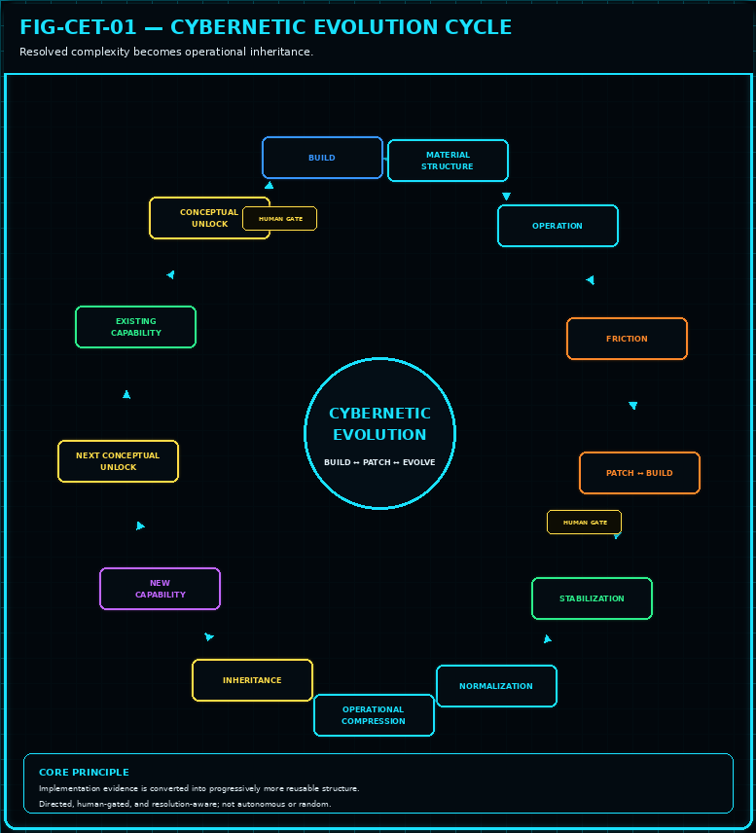
Figure 1. The Cybernetic Evolution Cycle. The full theory moves from existing capability through conceptual unlock, construction, operation, friction, correction, stabilization, normalization, compression, inheritance, and renewed capability. Human gates remain part of canonical structural change.

CYBERNETIC EVOLUTION THEORY

2. From Hypothesis to Mechanism
Cybernetic knowledge matures when plausible structure is forced to meet material behavior.

2.1 Hypothesized Structure
A hypothesis is a portable best-current explanation. It may be expressed in conversation, notation, a diagram, or a formal paper. Its value is not that it is guaranteed to be correct; its value is that it makes an idea explicit enough to inspect, communicate, and eventually test. Early CERBERUS work relied heavily on this mode because there was not yet enough built infrastructure to test every architectural claim directly.

2.2 Discovered Mechanism
Construction changes the epistemic status of the idea. Once a structure exists, the system can observe what actually governs its behavior. Sometimes the implementation confirms the hypothesis. Sometimes the mechanism is simpler than expected. Two apparently different concepts may collapse into one deeper operation. One broad concept may split into two owners with different responsibilities. A proposed universal rule may reveal a conditional boundary. The implementation does not make the system infallible, but it increases the quality of evidence available to architectural judgment.

2.3 Operationalized Structure
A discovered mechanism becomes operationalized when it is sufficiently stable to support downstream dependency. At that point it can be normalized, addressed, reused, and inherited. The structure can still change later; stabilization is not permanence. It is a declaration that the mechanism is coherent enough for other parts of the system to rely upon it without reconstructing its entire design history.
MECHANICS SUPERSEDE GUESSWORK
When implementation reveals a stronger governing mechanism, the mechanism should take current architectural precedence. Earlier hypotheses retain historical value, but they no longer outrank the structure that actually works.

FIGURE 02 / WAVE C
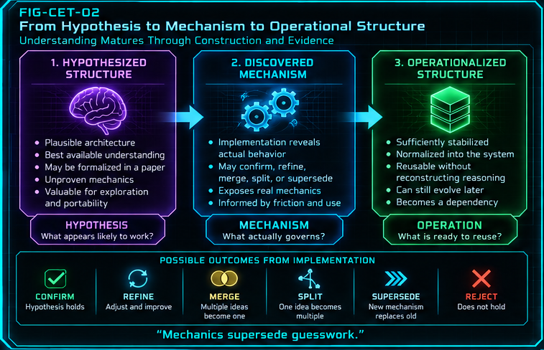
Figure 2. From Hypothesis to Mechanism to Operational Structure. A plausible model becomes materially testable, implementation reveals the governing mechanism, and a sufficiently stable mechanism becomes reusable structure. Confirmation, refinement, merge, split, supersession, or rejection are all possible outcomes.

CYBERNETIC EVOLUTION THEORY

3. The Unlocking Frontier
Development proceeds through the next tractable concept, not through a requirement to solve the entire future architecture at once.
Complex architectures contain dependency structure. Some questions can be answered immediately because the supporting concepts are already stable. Others remain too speculative because too many of their premises are unresolved. Cybernetic Evolution Theory calls the boundary between those conditions the unlocking frontier.
A conceptual unlock occurs when newly stabilized capability reduces the dependency burden of another problem enough that productive construction becomes possible. This is not a claim that the newly tractable concept is the most important concept, or that concepts unlock in a universal order. It means only that the existing architecture now supplies enough stable ground for the problem to be approached with less guesswork.
The frontier moves because architecture compounds. A normalized Reader, a stable identity model, a reusable semantic kernel, or a reliable development tool can eliminate entire classes of uncertainty from later work. That change may make a previously vague concept suddenly concrete. The designer can now ask different questions because the system can already answer the foundational ones.
UNLOCKING LAW
Capability changes the reachable problem space. A stabilized mechanism can therefore create value beyond its immediate function by making later reasoning tractable.

The practical consequence is important: do not force the architecture to solve everything at once. Build the concept for which the current system provides sufficient support, stabilize it, attach it to the architecture, and then re-evaluate the frontier. The next useful problem may become obvious only after the current one has been normalized.

FIGURE 03 / WAVE B
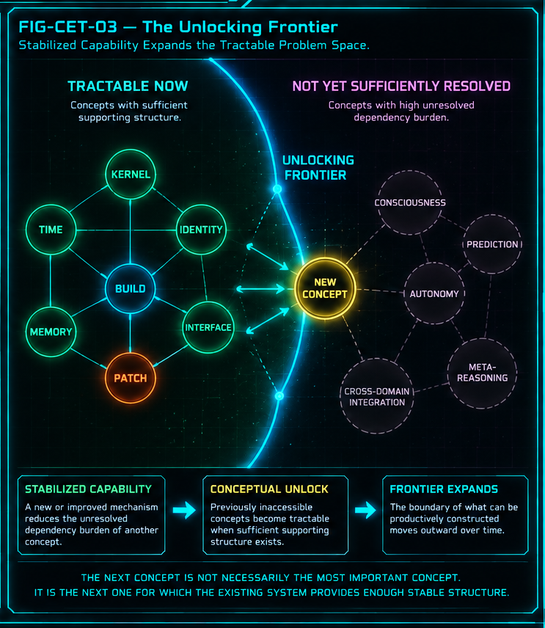
Figure 3. The Unlocking Frontier. Stabilized capability reduces unresolved dependencies and moves the boundary of tractable construction. Concepts beyond the frontier are not impossible; they simply require additional underpinning structure.

CYBERNETIC EVOLUTION THEORY

4. BUILD — Constructive Evolution
BUILD turns the system’s current intelligence into something material enough to test.
BUILD — Bundled Unfolding Intelligence Lenses for Development — is the constructive side of cybernetic evolution. It receives structured intelligence about what exists, what the target environment can do, and what the proposed mechanism requires. In CERBERUS, SPD Bundles provide a particularly important substrate because they expose the shape, order, fields, relations, and implementation context needed for a new structure to be constructed coherently.
Within Cybernetic Evolution Theory, BUILD is not equivalent to free-form generation. Its role is bounded: use what is presently known to materialize a candidate structure that can be inspected and operated. This distinction matters because evolutionary progress depends on evidence. An idea that remains only conversational can be debated indefinitely. A material candidate can reveal whether ownership is coherent, whether the route is addressable, whether a relation duplicates another mechanism, and whether the proposed schema creates or reduces friction.
BUILD therefore produces directed variation. The system may construct a new Table, extend an existing registry, compose a relationship, or propose another bounded structure. The objective is not novelty for its own sake. The objective is to turn present understanding into an inspectable state whose behavior can teach the architecture something it did not know before construction.
BUILD QUESTION
Given what is currently known, what structure should now exist?

CYBERNETIC EVOLUTION THEORY

5. Friction — Implementation as Evidence
Friction is the signal that a material structure and its intended mechanism are not yet perfectly aligned.
Implementation friction includes repeated difficulty, redundancy, exception handling, ambiguous ownership, unstable routing, awkward addressability, or any other pattern that consistently appears when the structure is used. The key theoretical move is to treat such friction as evidence rather than as mere inconvenience.
Repeated duplication may indicate that ownership has been split incorrectly. Constant exceptions may reveal that a supposedly universal rule is conditional. Shared machinery across two systems may suggest convergence. A component with conflicting responsibilities may need differentiation. A route that cannot be addressed cleanly may indicate incomplete normalization. A workflow that becomes dramatically simpler after another mechanism exists may reveal a new abstraction worth promoting.
Friction does not contain its own solution. A difficult interface may be poorly designed, or the difficulty may simply be inherent in the task. The system should therefore interpret friction as a reason to investigate, not as permission to rewrite. This keeps the architecture from oscillating every time an implementation detail becomes inconvenient.
FRICTION RULE
Friction → evidence → investigation. Not friction → automatic rewrite.

The distinction also protects conceptual work. Implementation is an important source of evidence, but it is not the only source of truth. Semantic intent, domain constraints, safety requirements, and human priorities remain part of selection. Friction matters because it increases the information available to that judgment.

CYBERNETIC EVOLUTION THEORY

6. PATCH — Corrective Evolution
PATCH makes correction explicit without letting the correction mechanism become the owner of truth.
PATCH is the corrective counterpart to BUILD. Where BUILD asks what structure should be constructed from current intelligence, PATCH asks what bounded change should be considered in response to evidence from the structure that already exists. The distinction is subtle but essential: PATCH expresses proposed correction; it does not automatically own or commit the canonical result.
A PATCH can identify the affected location, explain the observed problem, propose bounded operations, compare alternatives, preserve a before/after difference, and carry the evidence that motivated the change. That makes correction inspectable. It also preserves authority: the existence of a good proposal is not identical to authorization to change the system.
This separation is especially important in human-AI development. AI systems can be effective at detecting patterns, generating alternatives, and evaluating local consistency. They should not silently convert those capabilities into final authority over system structure. PATCH provides a place for machine-assisted correction to become legible before a human-approved owner commits the canonical change.
PATCH QUESTION
Given what now exists and what implementation has revealed, what bounded change should be considered?

CYBERNETIC EVOLUTION THEORY

7. BUILD ↔ PATCH Reverberation
Constructive and corrective reasoning become an evolutionary engine when they repeatedly inform one another.
BUILD and PATCH are most powerful as a coupled process. BUILD materializes current understanding. Operation exposes friction. PATCH converts the observed mismatch into a bounded correction proposal. Approved corrections feed revised intelligence back into BUILD, which materializes a better structure. The cycle repeats until the mechanism is stable enough for its role.
The term reverberation emphasizes that this is not a one-way pipeline. Each side changes the conditions under which the other operates. A PATCH may reveal that the original BUILD assumptions were incomplete. A revised BUILD may eliminate the friction entirely, reveal a deeper issue, or show that the proposed PATCH was unnecessary. The process advances by allowing construction and correction to interrogate one another through material evidence.
Neither mechanism is sufficient alone. BUILD without PATCH can confidently harden bad assumptions into infrastructure. PATCH without BUILD can become endless critique because alternatives are never forced through real construction. Their coupling turns design discussion into a bounded experimental loop.
REVERBERATION
BUILD creates something reality can answer. PATCH turns the answer into structured correction. BUILD makes the correction real enough to test again.

FIGURE 04 / WAVE C
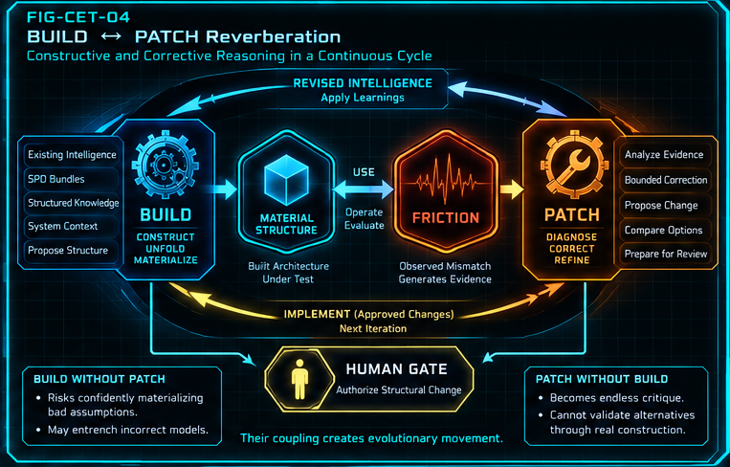
Figure 4. BUILD ↔ PATCH Reverberation. Existing intelligence becomes material structure through BUILD. Use exposes friction. PATCH diagnoses and proposes bounded correction. Human authorization gates canonical structural change before revised intelligence returns to construction.

FIGURE 05 / WAVE C
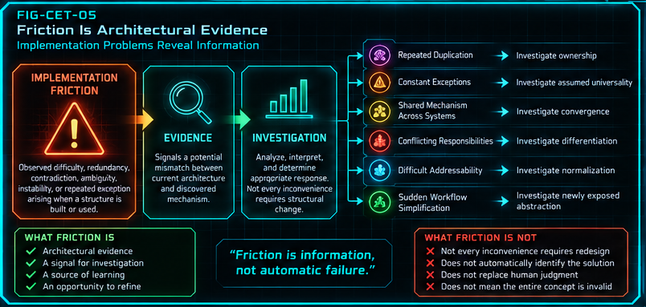
Figure 5. Friction Is Architectural Evidence. Implementation friction is routed into investigation rather than automatic rewrite. Different friction patterns can suggest ownership, universality, convergence, differentiation, normalization, or abstraction questions.

CYBERNETIC EVOLUTION THEORY

8. Structural Selection and Transformation
Evolution changes architecture through more than addition. It also merges, separates, refines, replaces, and removes.
A system that only accumulates components becomes larger without necessarily becoming better. Cybernetic evolution therefore needs a grammar of structural transformation. Accretion adds a genuinely new mechanism. Convergence recognizes that two separately named concepts are manifestations of one deeper operation. Differentiation separates one overloaded abstraction into independently governed mechanisms. Refinement preserves the same core mechanism while improving its boundaries, relations, or implementation. Supersession replaces current authority with a better mechanism while preserving the former state as lineage. Pruning removes structure that no longer provides a justified independent role.
These transformations explain an important feature of exploratory architecture: names and boundaries are provisional until the mechanism is understood. Two papers may initially appear to describe different systems because they were discovered from different directions. Material use can later reveal that they should converge. The reverse can also happen when one early concept carries several responsibilities that need different owners.
Selection is therefore not simply “keep what works.” The system must decide what kind of transformation the evidence justifies. That decision depends on coherence, bounded ownership, interoperability, addressability, recoverability, usefulness, implementation evidence, and human priorities. Formal selection is developed in Section 15.
LINEAGE RULE
Supersession changes current authority. It does not require historical erasure.

FIGURE 06 / WAVE C
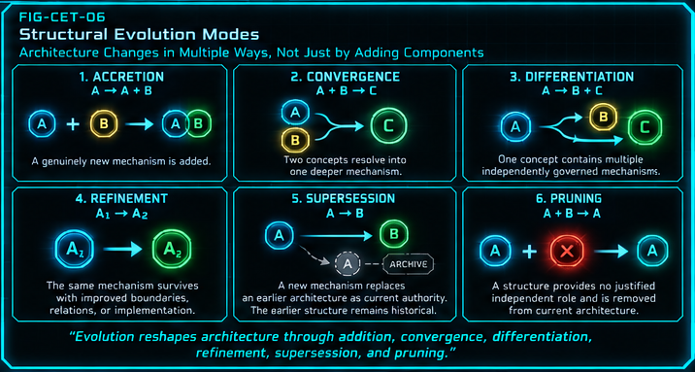
Figure 6. Structural Evolution Modes. Six transformation modes provide a compact grammar for architectural change: accretion, convergence, differentiation, refinement, supersession, and pruning.

CYBERNETIC EVOLUTION THEORY

9. Stabilization and Normalization
A local solution becomes system capability only when the wider architecture can address and depend on it.
A mechanism can work in isolation and still be expensive to reuse. It may depend on conversational memory, implicit naming, local scripts, or undocumented assumptions. Stabilization is the point at which the mechanism becomes coherent enough for dependency: its identity, ownership, relationships, behavior, and operational boundary are sufficiently resolved that another component can rely on it.
Normalization performs the next transition. The stabilized mechanism is attached to governed system infrastructure — identities, classifications, Tables, Fields, relationships, Semantic Kernels, Readers, routes, interfaces, or other registered machinery. The exact structures vary by domain, but the principle is constant: the system should know where the mechanism lives and how to resolve it without reconstructing the entire history that produced it.
This separation between stabilization and normalization is useful. A mechanism can be conceptually stable before it has been integrated everywhere. Conversely, a structure can be heavily registered while still embodying a weak mechanism. Cybernetic evolution seeks both: a mechanism dependable enough to reuse and a normalized route that makes reuse deterministic.
NORMALIZATION PRINCIPLE
Knowledge becomes more powerful when the system knows where it lives.

FIGURE 07 / WAVE D
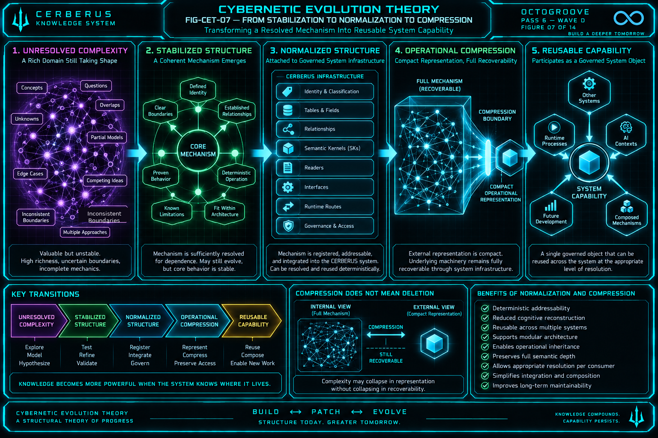
Figure 7. From Stabilization to Normalization to Compression. A rich unresolved domain becomes a stable mechanism, attaches to governed CERBERUS infrastructure, and can then expose a compact representation without deleting the machinery that gives the representation meaning.

CYBERNETIC EVOLUTION THEORY

10. Operational Compression
Resolved complexity can become small in representation without becoming small in meaning.
Operational compression is one of the central consequences of cybernetic evolution. Once a mechanism has been stabilized and normalized, another system no longer needs the entire internal graph expanded locally. It can interact through a compact governed representation whose deeper semantics remain recoverable through the registered machinery behind it.
This differs from ordinary data compression. The objective is not merely to encode the same bytes more efficiently. Operational compression changes the architectural interface. A large domain becomes addressable through a small object because the system has already paid the cost of organizing the semantics, rules, relationships, and interpretation machinery elsewhere.
The distinction prevents a common misunderstanding: a compact node does not necessarily contain all of the knowledge it can access. It can instead function as a governed point from which that knowledge is resolvable. This allows later systems to operate at the appropriate resolution rather than importing every internal detail of every dependency.
COMPRESSION LAW
Complexity may collapse in representation without collapsing in recoverability.

Operational compression is therefore a form of architectural compilation. The expensive work of understanding, testing, normalizing, and binding a concept is performed once. Subsequent contexts can inherit the result at much lower cognitive and computational cost.

FIGURE 08 / WAVE E
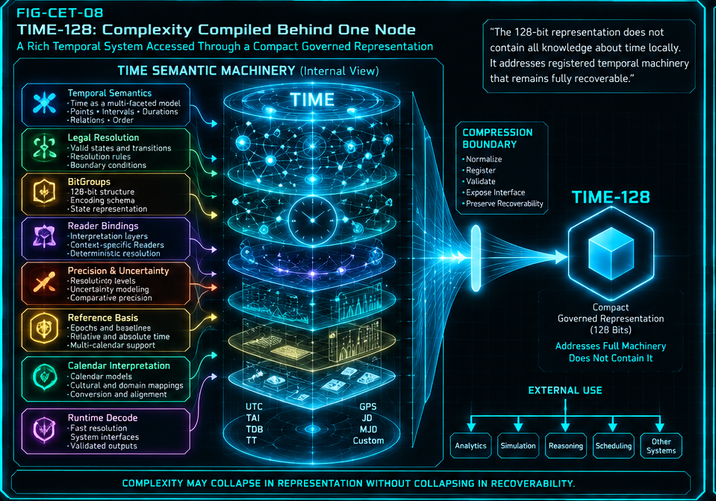
Figure 8. TIME-128: Complexity Compiled Behind One Node. TIME-128 illustrates operational compression: temporal semantics, legal resolutions, Reader behavior, precision, reference bases, calendar interpretation, and runtime decoding remain behind a compact governed representation.

CYBERNETIC EVOLUTION THEORY

11. Resolution-Relative Complexity
The same subsystem can be a graph internally and a node externally without contradiction.
Cybernetic systems are nested. A component that appears atomic from one perspective may contain a large relational structure when inspected internally. Resolution-relative complexity formalizes that fact. The correct representation depends on the question being asked and the contract required by the consumer.
At the internal resolution, TIME can be a graph of semantics, Readers, resolutions, reference frames, calendars, validation rules, and runtime interfaces. At the external resolution, a consumer may require only a bounded TIME-128 state and a known Reader contract. Both views are valid because they address the same subsystem at different resolutions.
This principle supports modular architecture. Consumers do not need to absorb every dependency’s internal graph, and subsystem designers do not need to erase internal richness to make integration manageable. The system instead exposes the minimum sufficient governed contract at each boundary while preserving the deeper owner behind it.
RESOLUTION PRINCIPLE
A whole graph at one resolution may legitimately function as one node at another.

FIGURE 09 / WAVE E
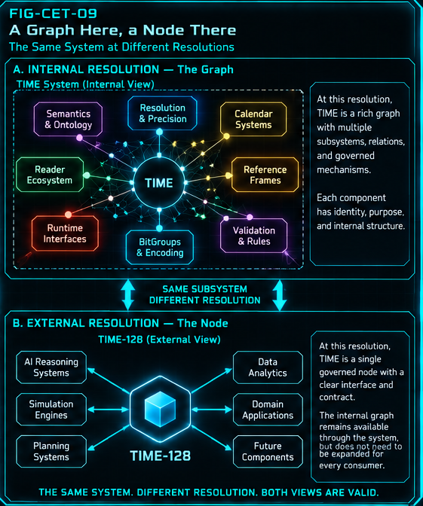
Figure 9. A Graph Here, a Node There. The same TIME subsystem is shown at two resolutions: internally as a rich graph and externally as one governed TIME-128 node connected to consumers. The node does not replace the graph; it is the interface appropriate to the higher-level view.

CYBERNETIC EVOLUTION THEORY

12. Inheritance
The system advances fastest when later work can inherit resolved capability instead of reconstructing it.

12.1 Operational Inheritance
Operational inheritance occurs when a normalized mechanism becomes directly reusable by another runtime, model, tool, or subsystem. The consumer receives a stable interface and the benefits of prior refinement without reimplementing the mechanism. Improvements made behind that contract can propagate forward as long as compatibility is preserved.

12.2 Contextual Inheritance
Contextual inheritance addresses a different problem: future cognitive instances do not share an uninterrupted mind. A new AI conversation can easily lose the design history, terminology, boundaries, and rationale that made the current system coherent. Formal papers and BOOTSTRAP Threads provide a bounded way to transfer that understanding into a new context.
The two inheritance channels are complementary. Operational inheritance lets systems reuse machinery. Contextual inheritance lets future collaborators reuse understanding. Both reduce reconstruction burden. Both allow new work to begin from a higher capability floor than the work that came before it.
INHERITANCE PRINCIPLE
Solved complexity becomes inherited capability.

FIGURE 10 / WAVE F
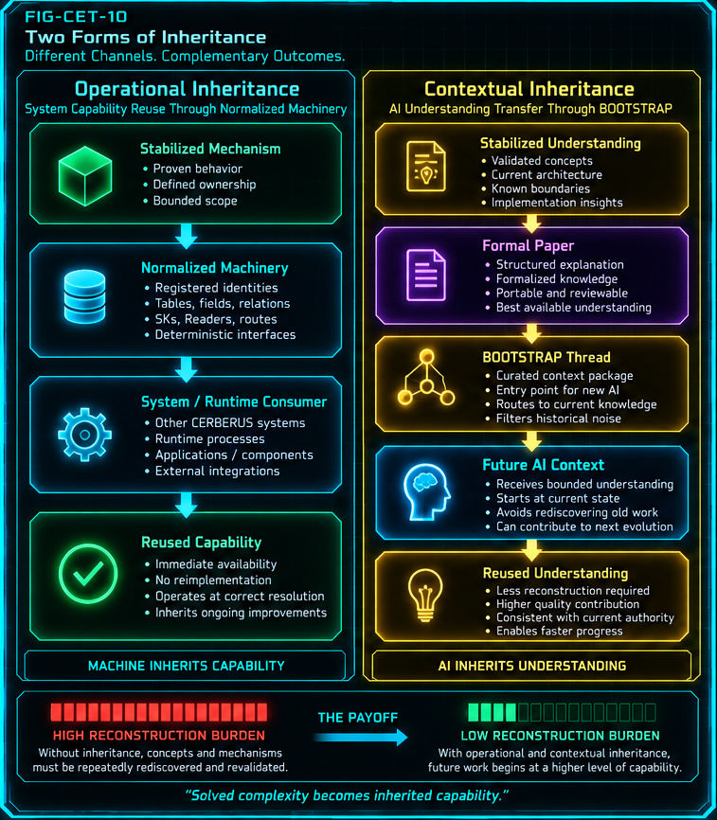
Figure 10. Two Forms of Inheritance. Operational inheritance transfers reusable machinery; contextual inheritance transfers bounded understanding through formal papers and BOOTSTRAP. Both reduce the amount of prior work that must be reconstructed.

CYBERNETIC EVOLUTION THEORY

13. Papers, Archives, and Published Generations
Documentation becomes part of the evolutionary system when it distinguishes current authority from preserved lineage.
CERBERUS papers began primarily as a way to preserve an idea long enough to return to it later. When the implementation base was immature, a paper often had to precede construction because the paper was the best available portable representation of the concept. As the architecture matured, structured notation, BUILD, PATCH, registries, and live schemas made it increasingly practical to construct first and formalize afterward.
That change does not make papers less important. It changes their role. An exploratory paper records a strong hypothesis. A transitional paper records an architecture that is still moving substantially. An operational paper explains machinery that has already been stabilized enough to inspect. The paper is therefore a formal state capture: a bounded representation of what the system currently understands, at the maturity level that actually exists.
Publication closes the loop. A stabilized build is written into a formal paper. The relevant BOOTSTRAP Thread is updated so future AI contexts route toward the new understanding. The public site advances to the new current state. The superseded paper moves into the archive, where it remains readable as design lineage without competing for current authority.
ARCHIVE PRINCIPLE
Superseded knowledge should lose authority without losing history.

FIGURE 11 / WAVE F
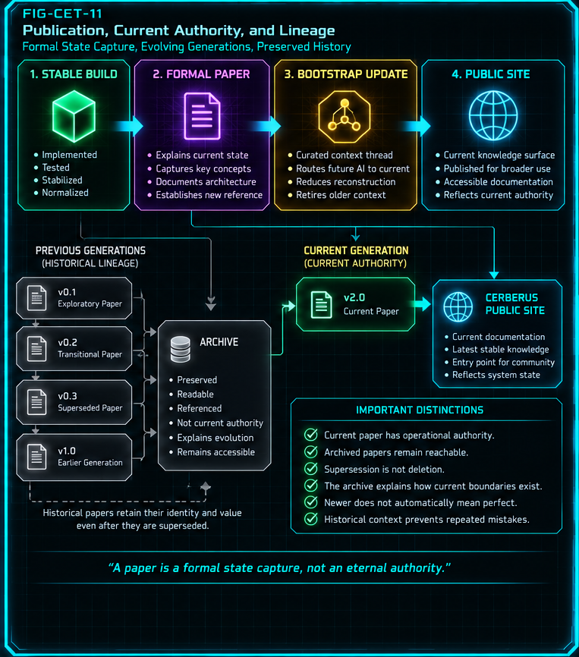
Figure 11. Publication, Current Authority, and Lineage. Stable builds become formal papers, BOOTSTRAP updates, and public current-state documentation. Prior generations remain archived and reachable, but current authority follows the active published state.

CYBERNETIC EVOLUTION THEORY

14. Worked Evolutionary Cases
The theory is easiest to evaluate by following mechanisms that have already moved through several stages of the cycle.

14.1 TIME-128 — compiled temporal capability
TIME-128 demonstrates the compression side of the theory. Temporal representation required substantial conceptual work: state encoding, legal resolution, Reader behavior, calendar interpretation, precision, reference basis, and runtime relationships. Once those mechanics became normalized, other systems could treat TIME-128 as one governed object at their resolution. The work did not disappear. It became infrastructure.

14.2 Development workflow — from paper-first to build-first
The CERBERUS development workflow itself evolved. Earlier work often followed idea → brainstorm → paper → build attempt → discovery. That process was necessary because the system lacked many of the structures now available for direct material reasoning. The modern path increasingly follows idea → structured notation → BUILD → use → PATCH ↔ BUILD → stable schema → paper → BOOTSTRAP/publication. The older method created the foundations that made the newer method possible.

14.3 RESIDUAL — a live build-first case
RESIDUAL provides a current example of the transition. An earlier architecture paper captured a plausible theory of quantitative evidence before the present implementation machinery existed. A live Airtable build can now be inspected directly. The correct next paper should therefore be written against the mechanics that survive construction and refinement, while the older paper remains valuable as the hypothesis lineage that explains how the current structure was reached.
WORKED-CASE LESSON
The paper does not have to be right forever to be useful. Its job is to preserve a bounded state of understanding until stronger mechanics can supersede it.

FIGURE 12 / WAVE G
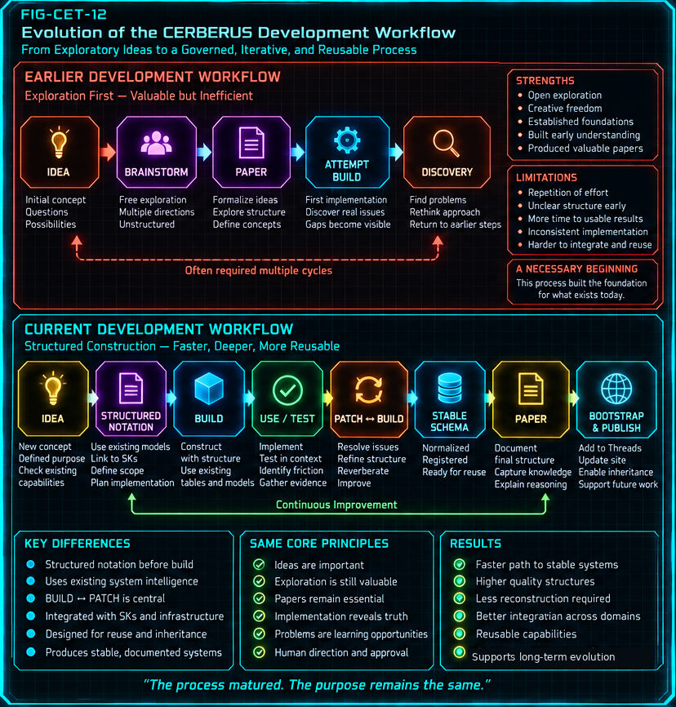
Figure 12. Evolution of the CERBERUS Development Workflow. The development process matures from exploratory paper-first work toward structured notation, direct construction, use, PATCH ↔ BUILD refinement, stable schema, publication, and inherited context.

CYBERNETIC EVOLUTION THEORY

15. Cybernetic Evolution Laws
The theory can be compacted into a set of operational propositions that constrain how evolutionary language is used.
The following laws are not claims of natural science. They are formal architectural propositions derived from the development process defined in this paper. Together they describe what may be inferred from capability, construction, friction, correction, stabilization, compression, inheritance, and governance.
Law | Operational statement
CET-01 — Unlocking | Stabilized capability can reduce unresolved dependency burden and make previously inaccessible construction tractable.
CET-02 — Construction | Available structured intelligence can be unfolded into material structure through BUILD.
CET-03 — Friction | Repeated implementation friction constitutes evidence about mismatch between current architecture and discovered mechanism.
CET-04 — Refinement | PATCH can express bounded correction without becoming canonical authority.
CET-05 — Reverberation | Repeated BUILD ↔ PATCH cycles can progressively align material structure with discovered mechanics.
CET-06 — Mechanics Supersede Guesswork | When implementation reveals a stronger governing mechanism, the mechanism takes current architectural precedence over earlier hypotheses.
CET-07 — Structural Transformation | Evolution may proceed through accretion, convergence, differentiation, refinement, supersession, or pruning.

CYBERNETIC EVOLUTION LAWS / CONTINUED
Law | Operational statement
CET-08 — Lineage Preservation | Superseded structures may lose current authority while remaining recoverable as historical lineage.
CET-09 — Normalization | Stable mechanisms become broadly reusable when attached to governed identities and relationships.
CET-10 — Operational Compression | Resolved conceptual complexity may be represented compactly while deeper semantics remain recoverable.
CET-11 — Resolution Relativity | A structure may legitimately function as a graph at one resolution and a node at another.
CET-12 — Inheritance | Normalized machinery and bounded BOOTSTRAP context allow later processes to inherit prior work rather than reconstruct it.
CET-13 — Human-Gated Selection | Structural change becomes canonical through governed selection and authorization rather than mere generation or mutation.
CET-14 — Recursive Evolution | A sufficiently mature cybernetic architecture may operationalize portions of the evolutionary process through which it was itself developed.

15.1 Cybernetic selection
Selection determines which candidate structural outcome becomes current. It is directed rather than Darwinian. The system can generate alternatives and evaluate them against criteria such as coherence, bounded ownership, interoperability, addressability, recoverability, robustness, compressibility, usefulness, and implementation evidence. Those criteria inform judgment; they do not replace it.
A selected structure may be retained, refined, merged, split, superseded, or pruned. Human authorization remains the canonical gate because selection can involve values, priorities, risk tolerance, and domain judgments that exceed local structural optimization. The point of the machinery is to make the decision better informed and more inspectable, not to dissolve responsibility.

FIGURE 13 / WAVE G
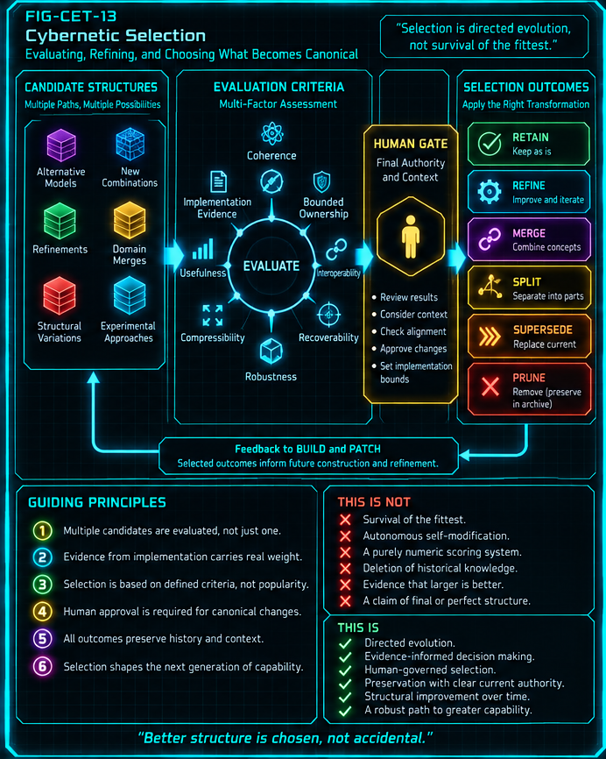
Figure 13. Cybernetic Selection. Candidate structures are evaluated against explicit architectural criteria and implementation evidence. Human authority gates the outcome before retain, refine, merge, split, supersede, or prune becomes canonical.

CYBERNETIC EVOLUTION THEORY

16. The Self-Referential Threshold
A major maturity transition occurs when the architecture begins to contain explicit machinery for managing the same evolutionary process that created it.
Early in a project, evolution lives mostly in the creator’s habits: brainstorm, build, notice problems, revise, remember what changed, and explain the result to the next collaborator. As the architecture matures, portions of that process can become explicit system components. SPD records structure. BUILD materializes candidate construction. PATCH expresses bounded correction. Archives preserve lineage. Normalization registers stable mechanisms. Papers and publication capture state. BOOTSTRAP transfers bounded understanding into future contexts.
At this threshold the system does not become autonomous. It becomes more inspectable. Development actions that once depended on memory or improvisation acquire addresses, contracts, and routes. The architecture can use its own structured knowledge to help construct itself, evaluate its own friction, preserve its own history, and publish improved state — while canonical change remains governed by external human authority.
This creates a recursive advantage. Better development machinery improves the quality and speed of later development. Those later improvements can in turn strengthen the development machinery. The feedback loop is potentially powerful because the object being improved includes the tools used to perform improvement.
SELF-REFERENTIAL THRESHOLD
The architecture increasingly contains machinery for managing the process through which it evolves, without becoming the final authority over that evolution.

FIGURE 14 / WAVE H
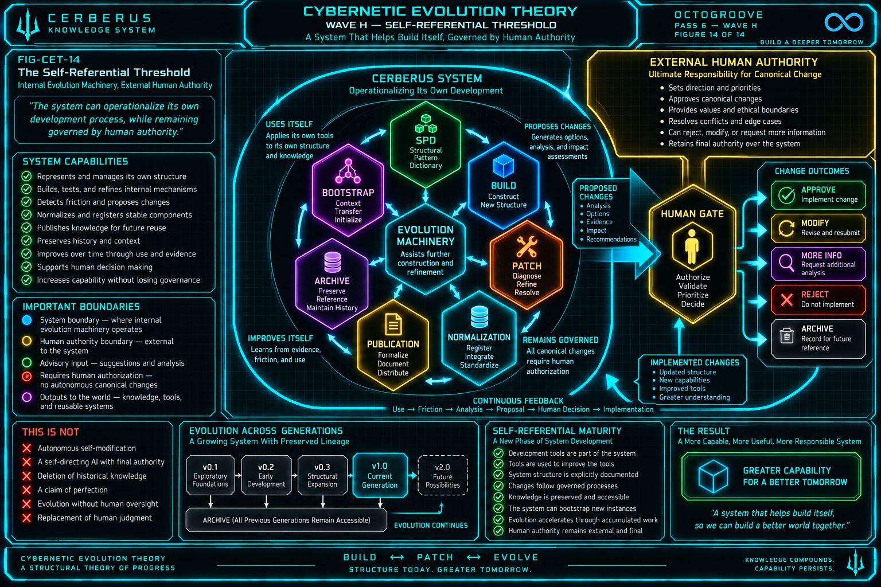
Figure 14. The Self-Referential Threshold. SPD, BUILD, PATCH, normalization, publication, archive, and BOOTSTRAP become an internal development machinery. Proposed changes still cross an explicit external human authority boundary before canonical commitment.

CYBERNETIC EVOLUTION THEORY

17. Boundaries and Failure Modes
Cybernetic evolution is useful only if the evolutionary metaphor remains bounded by architectural discipline.

17.1 Evolution is directed, not autonomous
The theory does not authorize unrestricted self-modification. BUILD can construct. PATCH can propose. Selection can compare. None of those operations is equivalent to final authority. Human governance remains part of the system boundary for canonical change.

17.2 Friction is evidence, not a command
A difficult implementation does not automatically prove that the architecture is wrong. The system must distinguish structural mismatch from inherent task difficulty, tooling limitations, temporary implementation defects, and local inconvenience. Premature reaction can create more instability than the friction it attempts to solve.

17.3 Stabilization is not ossification
A stabilized component is dependable enough to support downstream work, not immune to future evidence. Treating every stable structure as permanent would stop evolution; treating no structure as dependable would prevent inheritance. The system needs both commitment and the possibility of governed revision.

17.4 Compression must preserve recoverability
A compact representation is valid only if the semantics required by its contract remain resolvable. If compression hides ambiguity, destroys provenance, or makes the governing mechanism inaccessible, it has reduced legibility rather than created operational inheritance.

17.5 Archive and current authority must remain distinct
Historical documents are valuable precisely because they preserve earlier states. They become dangerous when availability is mistaken for authority. BOOTSTRAP and publication should route new contexts toward current state while keeping older generations reachable as lineage.
BOUNDARY PRINCIPLE
The theory increases the system’s ability to evolve; it does not remove the need to know who is allowed to decide what the system becomes.

CYBERNETIC EVOLUTION THEORY

18. Conclusion — Resolved Complexity Becomes Inheritance
The long-term advantage of cybernetic evolution is not endless iteration. It is the conversion of expensive understanding into reusable capability.
Cybernetic Evolution Theory begins with incomplete knowledge and does not apologize for it. A sufficiently tractable concept can be constructed before the entire architecture is known. That construction creates evidence. Friction turns hidden assumptions into visible questions. PATCH makes correction explicit. BUILD makes the corrected idea material again. Repeated reverberation allows the architecture to converge toward mechanisms that are better grounded in use.
The important transition occurs when a mechanism stops being a local achievement and becomes system infrastructure. Stabilization makes it dependable. Normalization makes it addressable. Operational compression lets other systems consume it at the appropriate resolution. Inheritance lets later runtime and cognitive work begin from the result instead of paying the original reasoning cost again.
That is why the development frontier can expand. Every successful cycle changes the substrate on which the next problem is solved. The architecture accumulates more than components; it accumulates solved dependencies, clearer boundaries, reusable Readers, governed addresses, development tools, and formalized knowledge. New work begins from a higher floor.
At sufficient maturity, the process becomes partially self-referential. The system contains explicit structures for representing its own architecture, building new structures, expressing corrections, preserving lineage, normalizing results, publishing current state, and transferring context forward. Human authority remains outside the canonical commit boundary, but the quality of information available to that authority improves.
CLOSING PRINCIPLE
Complexity has not vanished. It has been compiled. What was once expensive reasoning becomes governed structure; what becomes governed structure can become inherited capability; inherited capability unlocks the next frontier.

COMPACT GLOSSARY

Stable terms used by this theory
Term | Definition
Cybernetic Evolution | Directed evolution of a constructed cybernetic architecture through evidence-responsive iteration.
Conceptual Unlock | A transition in which stabilized capability reduces unresolved dependencies enough for productive construction to begin.
Unlocking Frontier | The boundary between concepts presently tractable and those still requiring additional underpinning structure.
BUILD | Constructive unfolding of existing structured intelligence into material or proposed architecture.
Implementation Friction | Evidence-generating mismatch exposed through construction or use.
PATCH | A bounded corrective proposal mechanism that does not itself become canonical authority.
Reverberation | Repeated BUILD ↔ PATCH iteration through which construction and correction inform one another.
Cybernetic Selection | Human-gated retention, modification, convergence, differentiation, supersession, or rejection of candidate structure.
Convergence | Multiple concepts resolving into one deeper mechanism.

COMPACT GLOSSARY / CONTINUED
Term | Definition
Differentiation | One concept resolving into multiple mechanisms with distinct responsibilities.
Supersession | A newer mechanism replacing earlier current authority while lineage remains recoverable.
Stabilization | The point at which a mechanism is dependable enough to support downstream dependency.
Normalization | Attachment of a stable mechanism to governed identities and relationships for deterministic reuse.
Operational Compression | A compact governed representation whose deeper semantics remain recoverable through registered machinery.
Operational Inheritance | Reuse of normalized machinery by downstream systems without reconstruction.
Contextual Inheritance | Transfer of bounded understanding to future cognitive contexts through papers and BOOTSTRAP.
Resolution-Relative Complexity | The principle that the same subsystem may be a graph internally and a node externally.
Lineage | Preserved historical states that explain how current architecture emerged without competing for current authority.
CYBERNETIC EVOLUTION THEORY / v0.1 / VERIFIED RELEASE

