CERBERUS
PHYSICS
Multi-Resolution Physical Semantics Through Graph-Native Bit Representation
Registry-Driven Physical Identity, Independent Resolution Strata, Mirror Graph Integration, and Deliberate Scientific Domain Handoffs
v0.1 · Pass 8 Verified Release
Represent what must remain distinct. Derive what can be recovered.
Reference what is too rich to repeat. Route what belongs elsewhere.
Resolve only as deeply as the current question requires.

Document Status
Field | Value
Document class | Formal architecture / semantic-kernel specification
Version | v0.1 · Pass 8 Verified Release
Scope | Common physical semantic joiner and routing architecture
Scientific posture | Representation of established physical distinctions; not a claim of new physical theory
Figure system | 36 actual rendered figures built in Pass 6
Bit architecture | Reference candidate; widths and ownership remain falsifiable
Release status | VERIFIED RELEASE — Pass 8 complete

Abstract
CERBERUS PHYSICS defines a compact graph-native semantic joiner for physical objects, relationships, and state. The architecture begins from stable registry identity, adds only state distinctions that must vary independently, and uses explicit references and domain handoffs rather than attempting to compress all scientific knowledge into one monolithic BitWord.
The system is organized into six published semantic strata spanning common physical relations, atomic state, electronic state, nuclear/nucleon state, fundamental-particle state, and quantum/field routing. These strata follow prefix invariance for portable publication while physical resolution itself remains branching and object-dependent.
The paper integrates the working CERBERUS SK Reader and experimental Mirror Graph grammar. The SK Reader decodes semantic payload; the Mirror places that payload on Point and Relationship records in versionable graph state; specialist domains extend the same common identities without replacing them. Thirty-six figures and full BitGroup specification cards make the candidate architecture explicit enough to implement, challenge, and falsify.
CENTRAL THESIS: Complexity does not have to be embedded where it is used; it only has to remain precisely reachable.

Document Spine
Part I — Purpose & Representation Law Sections 1–6
Part II — Compression Grammar Sections 7–13
Part III — Registry Semantics Sections 14–19
Part IV — Six-Stratum Architecture Sections 20–25
Part V — PHYSICS¹ — Common Physical Semantics Sections 26–34
Part VI — PHYSICS² — Atomic Identity & State Sections 35–41
Part VII — PHYSICS³ — Electronic / Atomic-Internal State Sections 42–50
Part VIII — PHYSICS⁴ — Nuclear / Nucleon State Sections 51–56
Part IX — PHYSICS⁵ — Fundamental Particle Identity & State Sections 57–65
Part X — PHYSICS⁶ — Quantum / Field Routing Sections 66–75
Part XI — Mirror Graph Reference Sections 76–80
Part XII — Recursive Resolution Sections 81–84
Part XIII — Domain Handoffs Sections 85–89
Part XIV — Worked Examples & Boundary Tests Sections 90–95
Part XV — Non-Collapse Law Sections 96–97
Part XVI — Provisional Bit Family Section 98
Part XVII — Implementation & Falsification Section 99
Part XVIII — Conclusion Section 100

Part I — Purpose & Representation Law
PART THESIS: Define the common physical semantic responsibility before allocating Bits.

1. Problem Statement
Physical knowledge becomes difficult to reuse when identity, state, representation, graph structure, and domain interpretation are stored as if they were one thing. CERBERUS PHYSICS provides a small common semantic joiner that keeps those responsibilities separate while remaining precise enough to route into richer scientific models.
This specification is intentionally architectural. It does not propose new laws of nature. It proposes how established physical distinctions can be represented, addressed, expanded, and tested inside a graph-native semantic system.

2. Scope of the Common Layer
The common layer owns stable physical identity, minimum common state, bounded relationship semantics, and explicit routes to registries and specialist domains. It does not attempt to contain organic chemistry, crystallography, nuclear structure, quantum field theory, or numerical simulation in one universal word.
A successful common layer therefore has a negative definition as well as a positive one: it is defined partly by what it refuses to own.

3. The Joiner Thesis
PHYSICS acts as a common physical ABI: several specialist domains can meet on the same registered object and relationship identities before diverging into their own explanatory grammars. Shared identity is the bridge; domain expertise remains distributed.

Figure 1. PHYSICS Is the Joiner
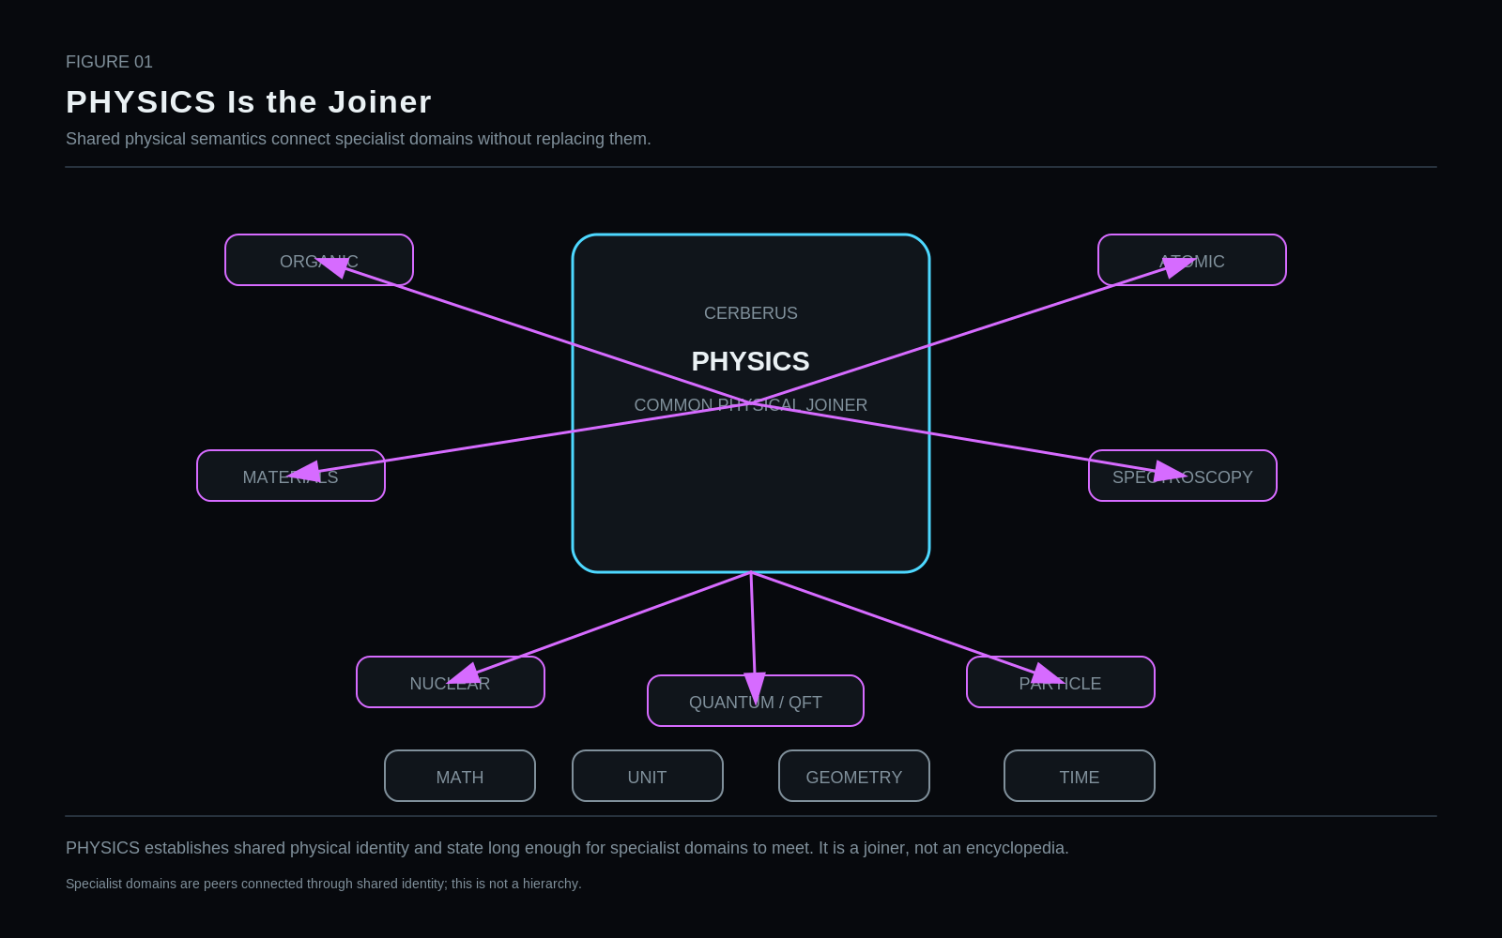
PHYSICS establishes shared physical identity and state long enough for specialist domains to meet. It is a joiner, not an encyclopedia.
Restraint: Specialist domains are peers connected through shared identity; this is not a hierarchy.

4. Representation Is Not Discovery
A semantic representation can be novel while the science it represents remains established. Every field, visual, and routing mechanism in this paper must preserve that boundary. Architectural confidence and scientific-content confidence are tracked separately.

Figure 2. Representation Is Not Discovery
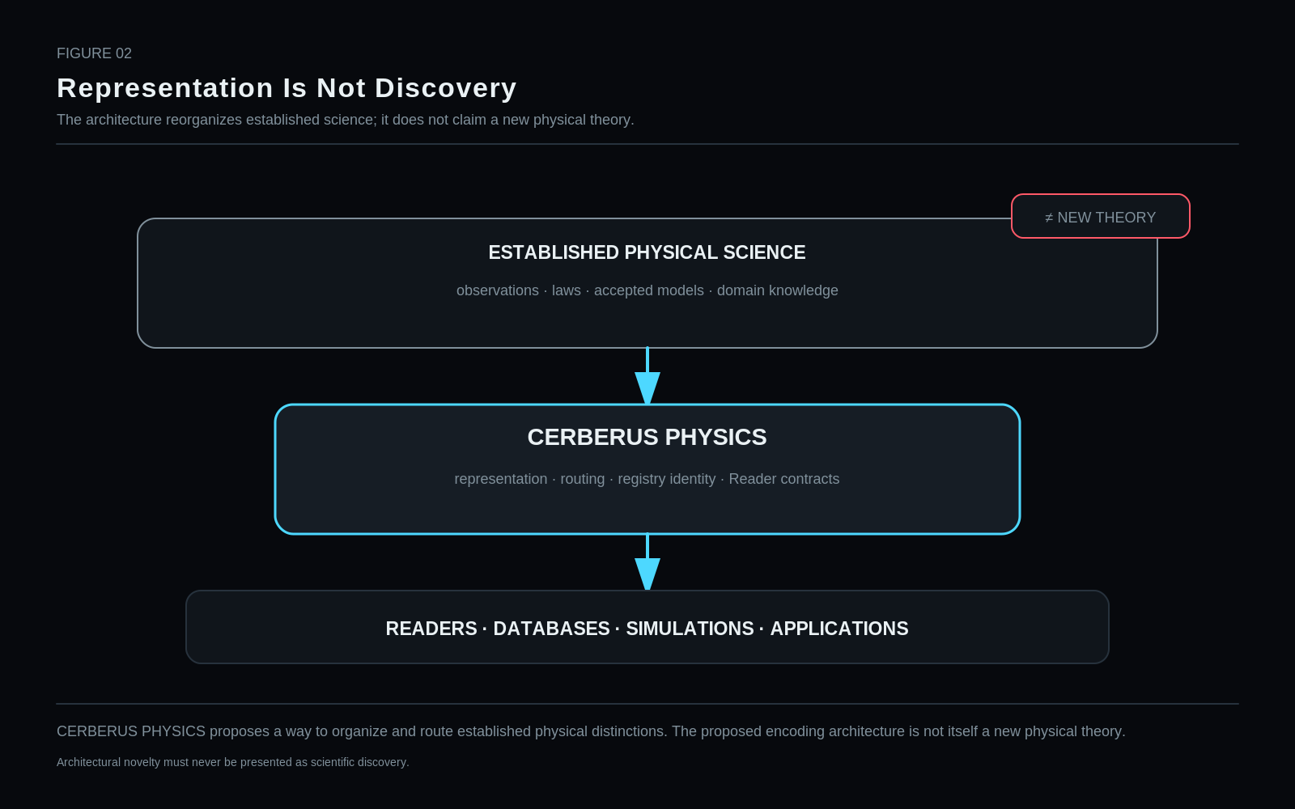
CERBERUS PHYSICS proposes a way to organize and route established physical distinctions. The proposed encoding architecture is not itself a new physical theory.
Restraint: Architectural novelty must never be presented as scientific discovery.

5. Minimum Sufficient Resolution
Larger BitWords are not inherently better. The preferred representation resolves only the distinctions required by the current question, preserves routes to deeper state, and avoids copying information that can be deterministically recovered.
The governing objective is minimum faithful resolution, not maximum encoded detail.

6. Core Representation Laws
The architecture obeys recurring laws: Identity ≠ Address ≠ State; Point ≠ Relationship; Reference ≠ Referenced Contents; Graph Topology ≠ Physical Semantics; Reader Projection ≠ Physical State; Prefix Order ≠ Mandatory Physical Traversal.
Core non-collapse grammar
Code / value | Address | Semantic assignment
Identity | ≠ | Address
Address | ≠ | State
Point | ≠ | Relationship
Reference | ≠ | Contents
Graph topology | ≠ | Physical semantics
Reader projection | ≠ | Physical state
Prefix order | ≠ | Physical traversal

Part II — Compression Grammar
PART THESIS: Choose encoding primitive by semantic question, not convenience.

7. Which One? — SCALAR Selectors
A one-of-N identity question is encoded as a scalar selector into a canonical registry. The BitGroup carries the address; the registry carries reusable identity and stable scientific facts.

8. Which Set? — MASK Semantics
A mask is appropriate only when several named memberships can be simultaneously true. Reusing a MASK for one-of-N identity wastes width and invites illegal combinations.

9. Magnitude, Reference, Graph, and Handoff
Magnitude routes to typed quantitative systems. Large reusable state routes through references. Connectivity belongs to Mirror relationships. Display location belongs to Mirror coordinates. Specialist interpretation belongs to a domain handoff.

Figure 3. Compression Decision Grammar
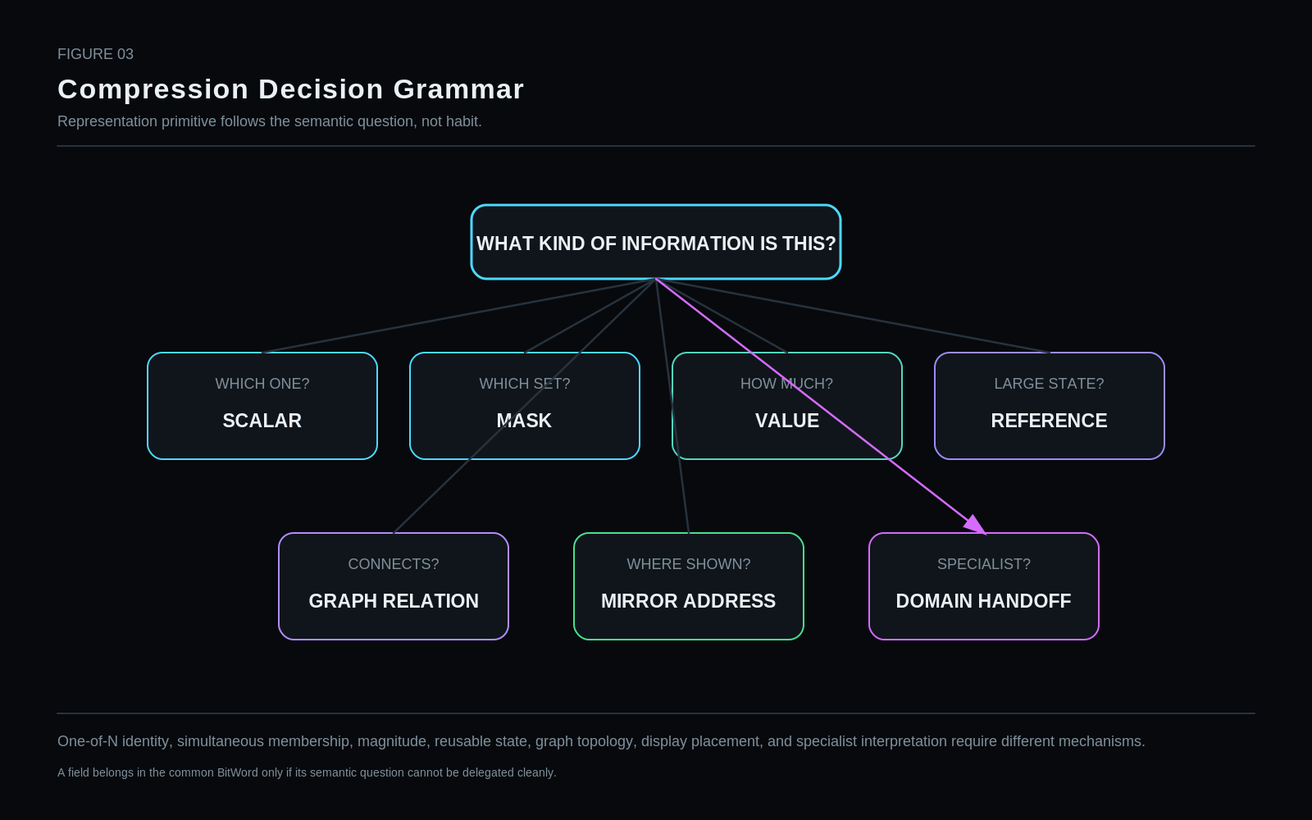
One-of-N identity, simultaneous membership, magnitude, reusable state, graph topology, display placement, and specialist interpretation require different mechanisms.
Restraint: A field belongs in the common BitWord only if its semantic question cannot be delegated cleanly.

10. Zero, Null, Reserved, and Not Applicable
Zero can be a valid physical value. Null means no assertion. Reserved means an address exists but is not assigned. Not Applicable means the semantic dimension does not belong to the selected identity. These states cannot be merged safely.

Figure 10. Zero Is Not Unspecified
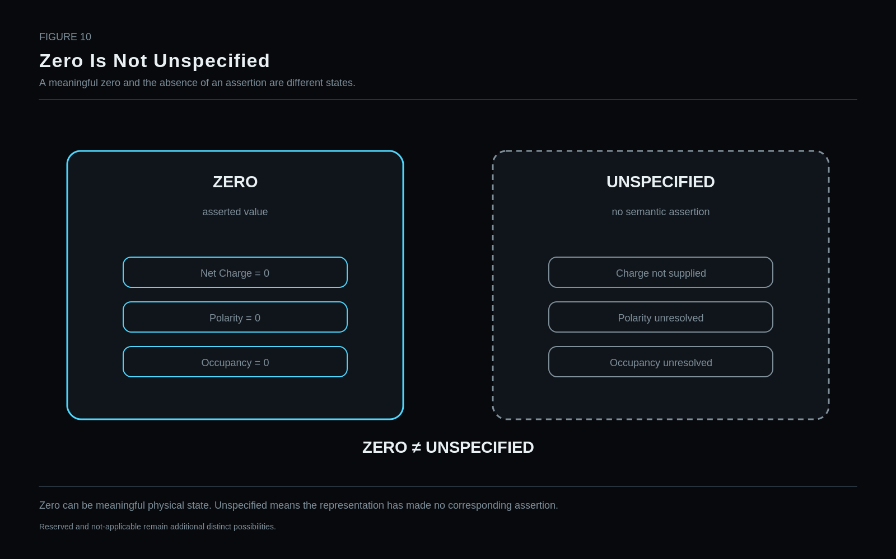
Zero can be meaningful physical state. Unspecified means the representation has made no corresponding assertion.
Restraint: Reserved and not-applicable remain additional distinct possibilities.

11. One-of-N Compression
The element selector demonstrates the rule: one 7-bit selector is preferable to more than one hundred independent element flags because exactly one element identity is chosen.

Figure 4. One-of-N Beats N Flags
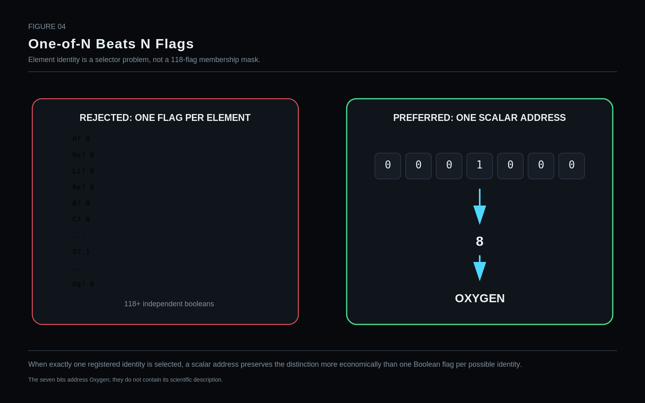
When exactly one registered identity is selected, a scalar address preserves the distinction more economically than one Boolean flag per possible identity.
Restraint: The seven bits address Oxygen; they do not contain its scientific description.

12. Compression by Reachability
Semantic compression is not achieved by discarding complexity. It is achieved by keeping a compact exact address to complexity that lives elsewhere. A tiny payload can participate in a large scientific graph without reproducing the graph inside itself.

Figure 5. Small Spine, Huge Reach
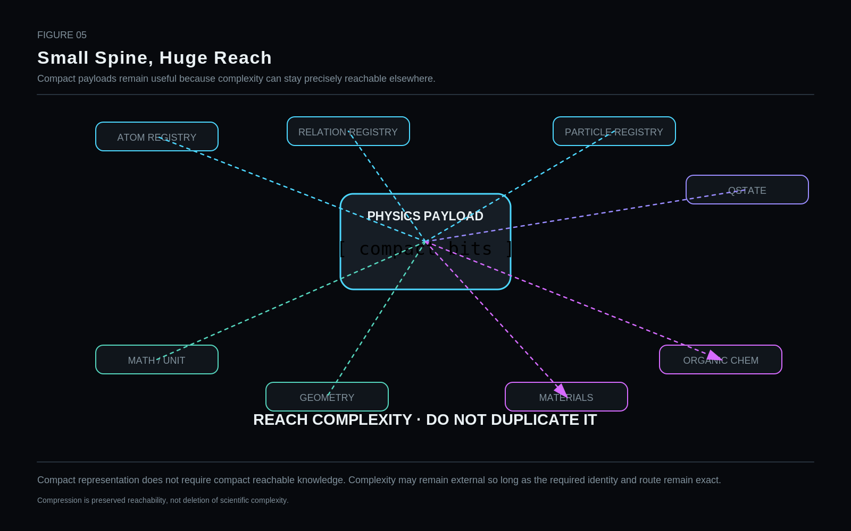
Compact representation does not require compact reachable knowledge. Complexity may remain external so long as the required identity and route remain exact.
Restraint: Compression is preserved reachability, not deletion of scientific complexity.

13. Encoding Contract Before Bit Pattern
Raw binary does not carry universal meaning. The same pattern may be SCALAR, MASK, signed quantity, registry reference, or another governed encoding. The semantic address includes the BitGroup contract.

Figure 6. Selector vs Mask
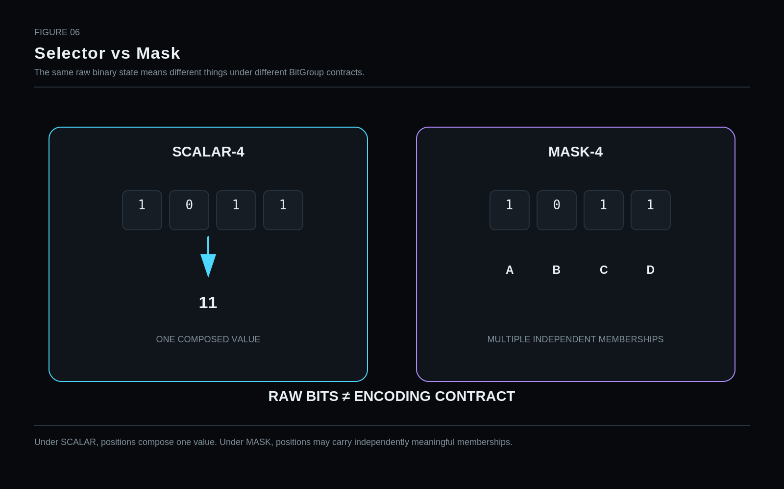
Under SCALAR, positions compose one value. Under MASK, positions may carry independently meaningful memberships.

Part III — Registry Semantics
PART THESIS: Keep stable reusable identity in registries and mutable condition in instances.

14. Canonical Registry Ownership
Registries own stable reusable identities. Atomic identity, particle identity, relation identity, basis identity, operator identity, and similar stable semantic objects are registered once and referenced many times.

15. Instance State Ownership
Instance records own state that can vary between two instances of the same registered identity. Neutron count, net charge, occupancy, selected projection, and current referenced state therefore belong to instances rather than the identity registry.

16. Derivation Economy
If a property is deterministically recoverable from authoritative fields, it should generally remain derived. Proton count, mass number, and ordinary atomic electron count provide straightforward examples.

17. Exact-Key Resolution
The preferred Reader path is deterministic: scoped binary key → scalar/reference address → canonical record → requested projection. Fuzzy semantic search is unnecessary for decoding a correctly addressed BitGroup.

Figure 7. Binary → Registry → Meaning
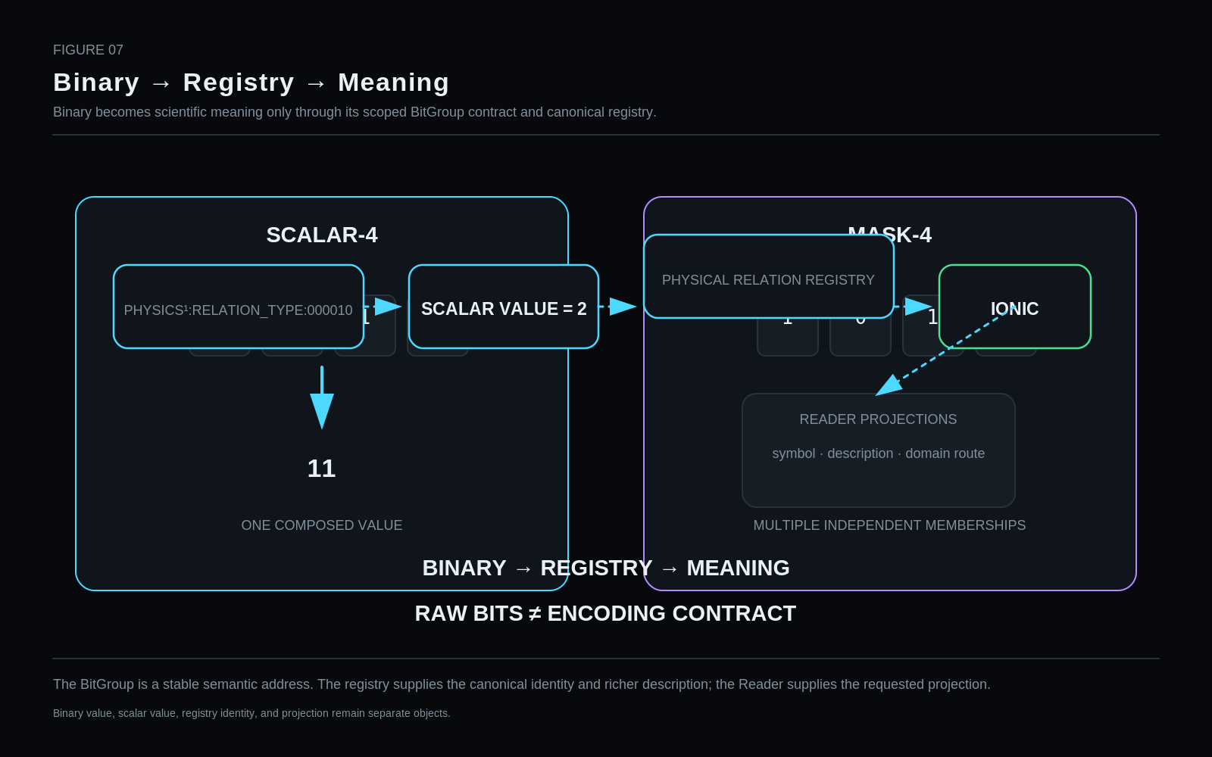
The BitGroup is a stable semantic address. The registry supplies the canonical identity and richer description; the Reader supplies the requested projection.
Restraint: Binary value, scalar value, registry identity, and projection remain separate objects.

18. Reader Projection
One canonical identity may produce several projections: structural symbol, human-readable name, binary code, debug identifier, domain-specific label, or visual asset. Projection changes do not create new physical identity.

Figure 8. Identity Facts vs Instance State
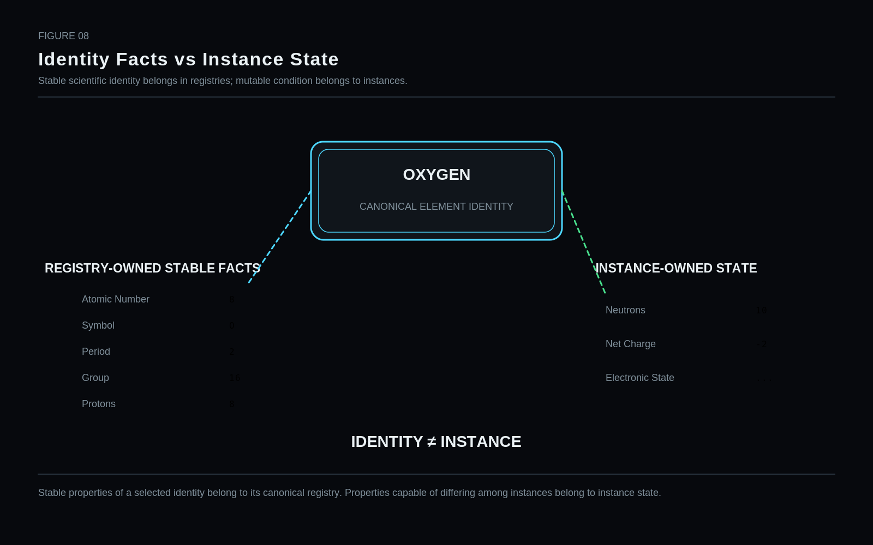
Stable properties of a selected identity belong to its canonical registry. Properties capable of differing among instances belong to instance state.

19. Scientific Provenance Boundary
Semantic key stability does not create scientific authority. Registry records should be capable of linking to sources or authorities that justify their scientific content, while the semantic address remains stable across provenance updates.

Figure 9. Derivation Economy
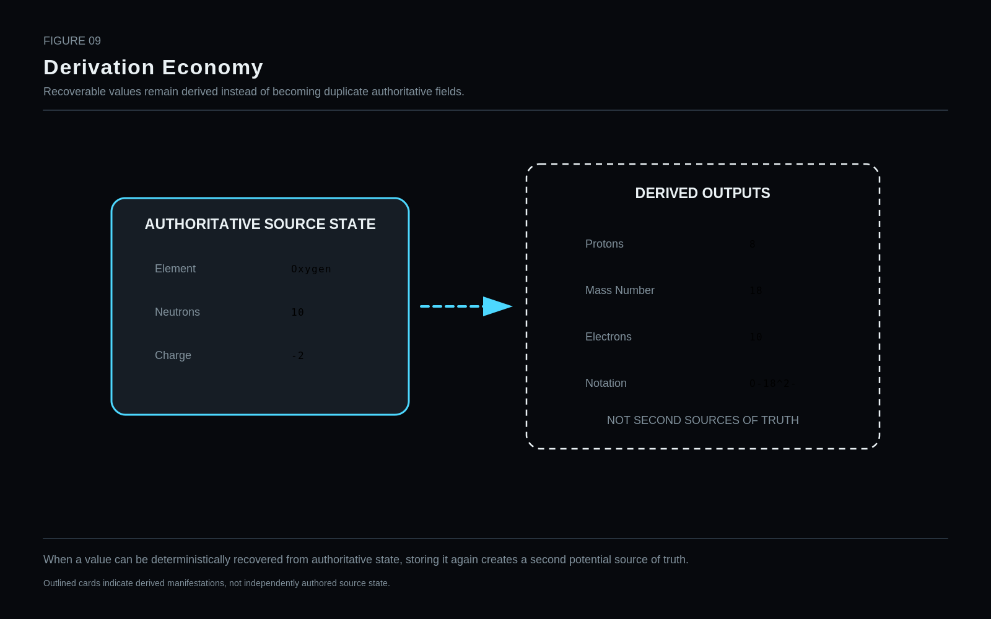
When a value can be deterministically recovered from authoritative state, storing it again creates a second potential source of truth.
Restraint: Outlined cards indicate derived manifestations, not independently authored source state.

Part IV — Six-Stratum Architecture
PART THESIS: Publish cumulative semantic strata without pretending reality follows one linear ladder.

20. Six Published Strata
The reference architecture publishes six ordered strata: PHYSICS¹ common physical semantics, PHYSICS² atomic state, PHYSICS³ electronic state, PHYSICS⁴ nuclear/nucleon state, PHYSICS⁵ fundamental-particle state, and PHYSICS⁶ quantum/field routing.
Field | Value
PHYSICS¹ | Common physical semantics / relationships
PHYSICS² | Atomic identity and state
PHYSICS³ | Electronic / atomic-internal state
PHYSICS⁴ | Nuclear / nucleon state
PHYSICS⁵ | Fundamental particle identity/state
PHYSICS⁶ | Quantum / field routing

21. Prefix Invariance
A published higher-resolution word extends lower-resolution semantics without moving or redefining the published prefix. Once a stable address is released, later growth occurs by extension and routing rather than reinterpretation.

22. Prefix Order Is Not Ontology
The cumulative publication order is a portability grammar. It is not a claim that every physical object literally contains or traverses every preceding stratum. Electrons, photons, atoms, and nuclei have different legitimate resolution paths.

Figure 11. Six-Stratum Resolution Architecture
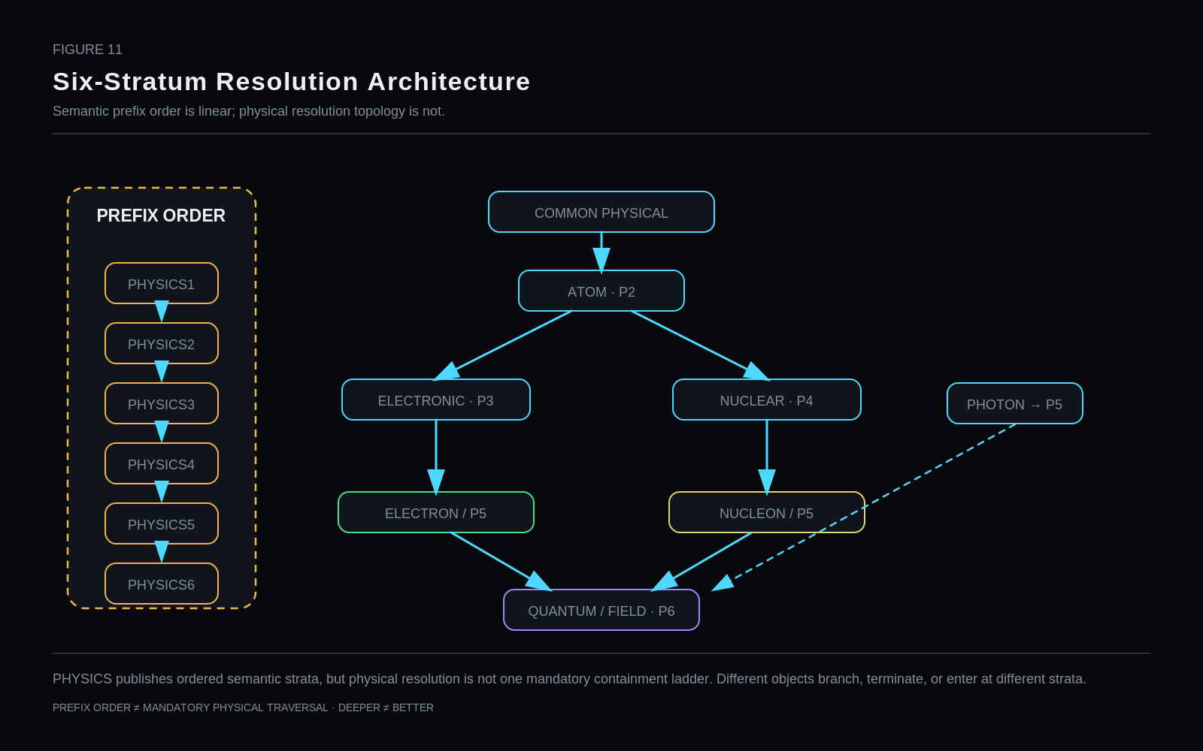
PHYSICS publishes ordered semantic strata, but physical resolution is not one mandatory containment ladder. Different objects branch, terminate, or enter at different strata.
Restraint: PREFIX ORDER ≠ MANDATORY PHYSICAL TRAVERSAL · DEEPER ≠ BETTER

23. Independent Stratum Decoding
Each stratum must be independently decodable when its surrounding graph context is explicit. This lets Mirror records carry the locally relevant state slice instead of repeating the full portable prefix at every child node.

Figure 12. Independent Strata
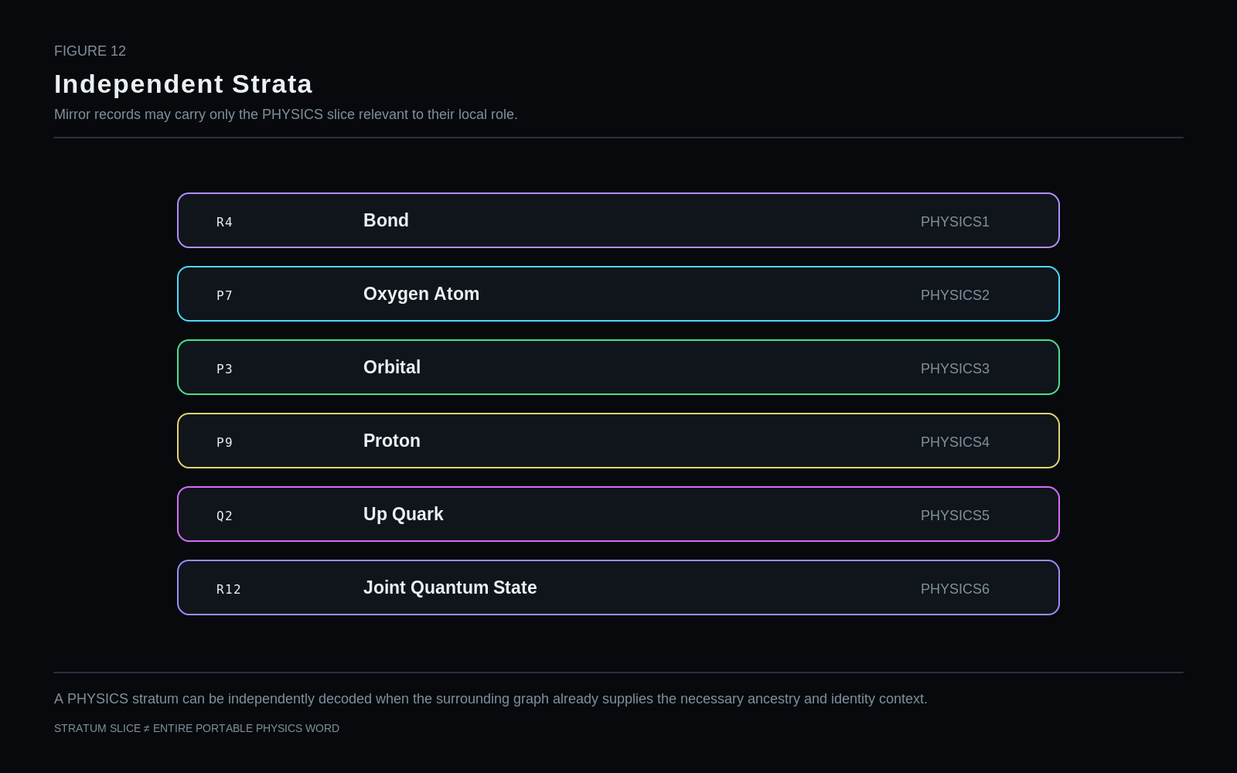
A PHYSICS stratum can be independently decoded when the surrounding graph already supplies the necessary ancestry and identity context.
Restraint: STRATUM SLICE ≠ ENTIRE PORTABLE PHYSICS WORD

24. Portable Word vs Contextual Slice
Portable exchange favors self-contained cumulative words. Graph-local storage can be more economical because ancestry already supplies identity and scope. Context compression is valid only when that ancestry is explicit and stable.

Figure 13. Portable Word vs Contextual Slice
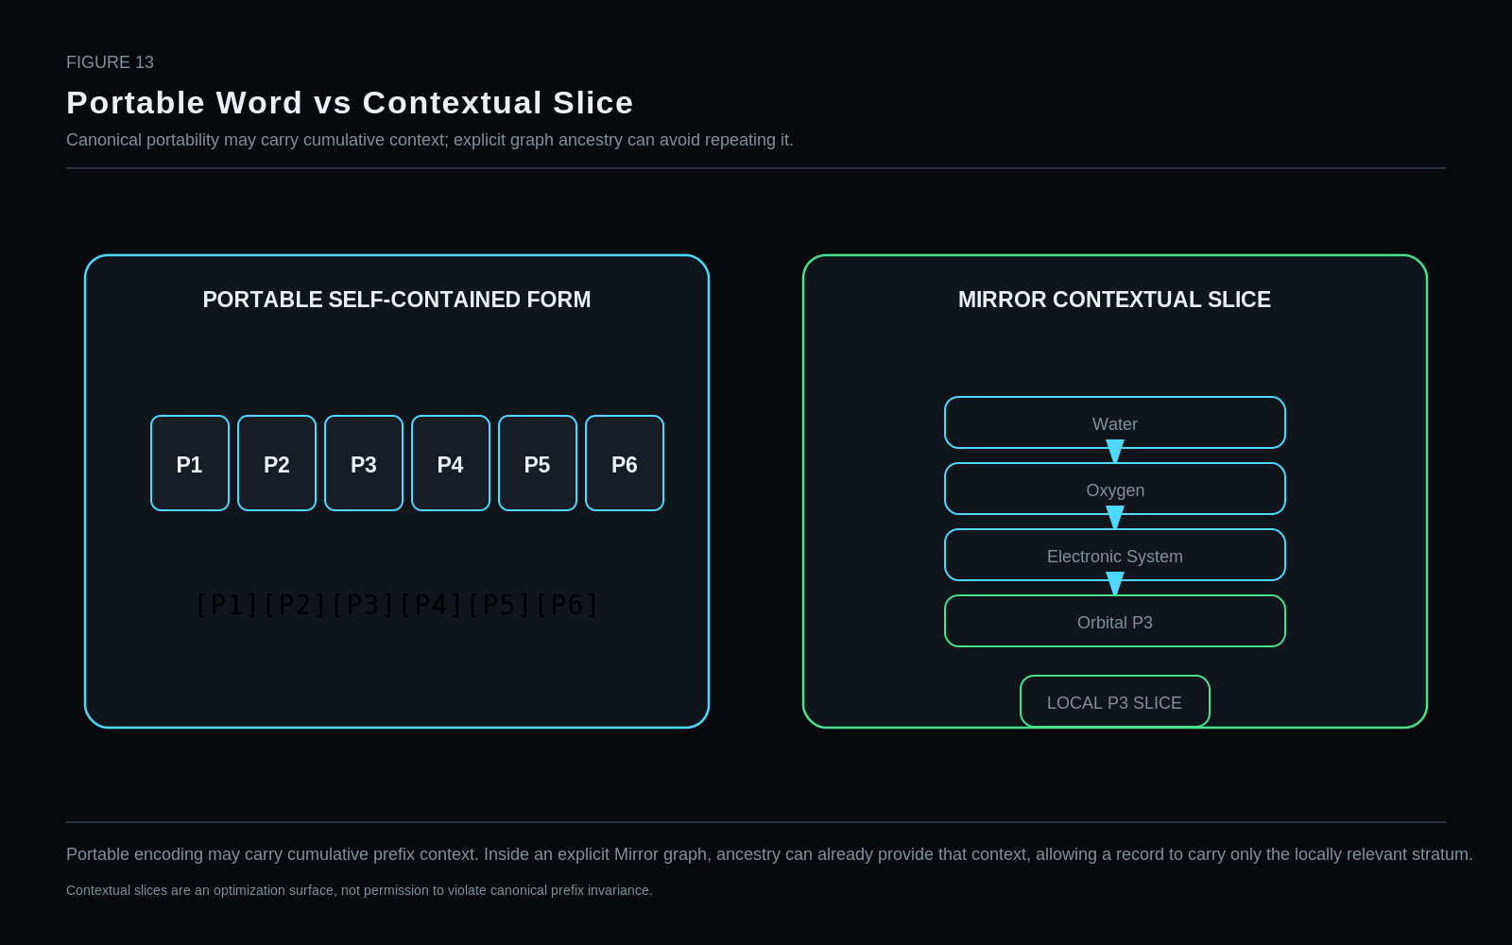
Portable encoding may carry cumulative prefix context. Inside an explicit Mirror graph, ancestry can already provide that context, allowing a record to carry only the locally relevant stratum.
Restraint: Contextual slices are an optimization surface, not permission to violate canonical prefix invariance.

25. Resolution Is a Question-Driven Operation
Resolution is chosen by the task. Walking through a scene may require geometry and coarse object identity; a nanoscopic operation may require atomic or electronic resolution. Deeper state is neither automatically truer nor automatically more relevant.

Part V — PHYSICS¹ — Common Physical Semantics
PART THESIS: Build the common relation surface while aggressively attacking fields that belong elsewhere.

26. PHYSICS¹ Reference Candidate Ledger
PHYSICS¹ is the least-settled stratum because it tries to capture common physical relationship semantics across several scientific families. The current ~26-bit label is a reference-candidate target region, not a reconciled final sum of every surfaced candidate field.
The sections that follow therefore distinguish core candidate groups from fields under explicit elimination or relocation pressure.
Field | Value
Current label | PHYSICS¹ ≈26 bits — historical/reference candidate
Core candidate groups | Relation Type; Order; State; Endpoint Polarity A; Endpoint Polarity B
Under attack | Process Class; Phase/Regime
Likely metadata | Physical Entity Class; Relation Family
Arithmetic status | Not reconciled; the label is not a canonical inventory sum

Figure 14. PHYSICS¹ Candidate Surface
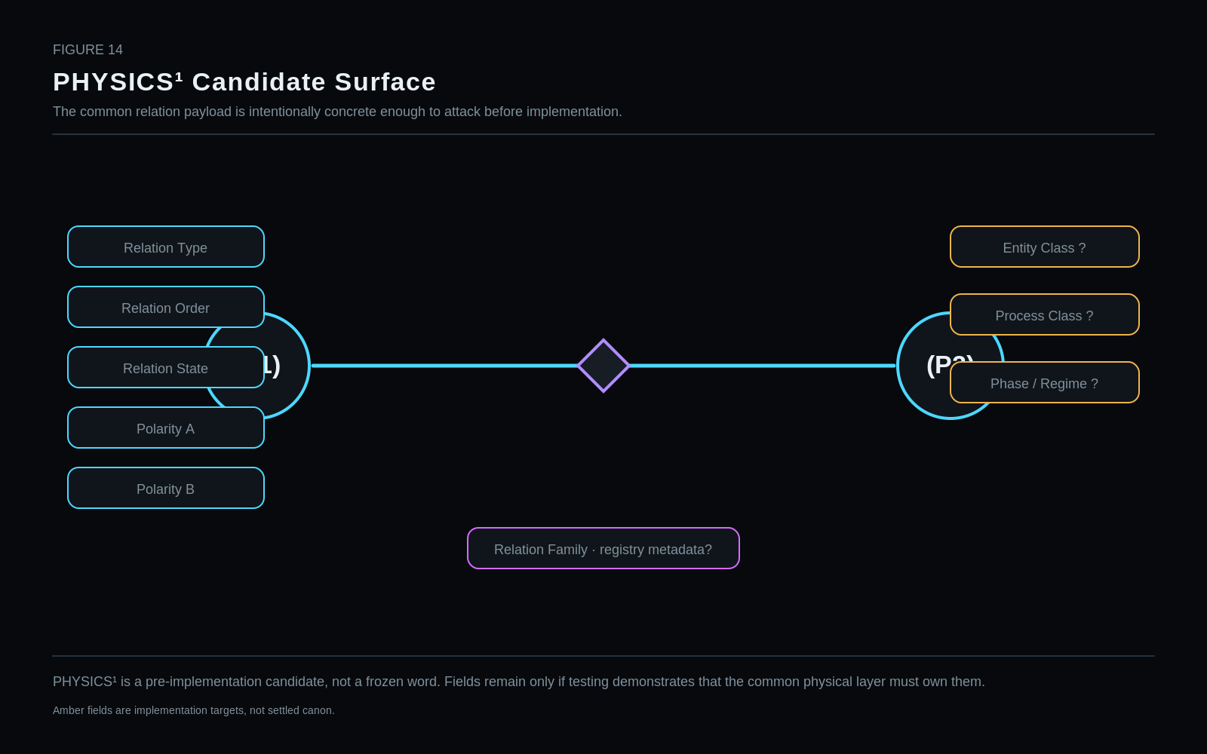
PHYSICS¹ is a pre-implementation candidate, not a frozen word. Fields remain only if testing demonstrates that the common physical layer must own them.
Restraint: Amber fields are implementation targets, not settled canon.

27. Relationship Type
Relationship Type is the primary one-of-N selector for the common relation surface. Its scientific safety depends on registry family metadata so chemical, force/field, contact, and transfer relations are not flattened into one explanatory taxonomy.
1. Canonical BitGroup name | Relationship Type
2. Semantic question answered | Which registered common physical relationship identity is being asserted?
3. Owning stratum | PHYSICS¹ — Common Physical Semantics
4. Point / Relationship applicability | Relationship records
5. Encoding primitive | SCALAR selector
6. Provisional width | 6 bits — reference candidate
7. Binary / value range | 64 addresses (0–63)
8. Null / unspecified behavior | Address 0 is the current null/unspecified candidate. A relationship record may also be absent entirely when no relation is asserted.
9. Reserved values | Addresses 9–63 are currently unassigned and remain registry capacity.
10. Registry / calculation route | Exact binary key or decoded scalar value → Physical Relation Registry → stable relation identity + family metadata + Reader projections.
11. Stable identity vs variable state | Stable relation identity selector; not relation strength, process, or event state.
12. Derived properties | Relation Family and structural symbol can be registry-derived. Domain-specific parameters are not duplicated here.
13. Reader interpretation | Decode one relation identity, then project a structural symbol or domain route appropriate to the selected Reader.
14. Visual projection | Relationship carrier with relation-family texture or symbol; family metadata prevents a false single scientific taxonomy.
15. Valid domain handoffs | Chemistry, mechanics, electromagnetism, thermodynamics, materials, specialist interaction models.
16. Worked example | 000010 → scalar 2 → Ionic.
17. Non-collapse distinctions | Relation Type ≠ Relation Order ≠ Relation Strength ≠ Relation State ≠ Process ≠ Event.
18. Known limitations | The current candidate list spans explanatory levels. Relation Family metadata is therefore required, and the registry will need expert review.
19. Implementation test | Attempt to encode covalent, ionic, gravitational, electrical, magnetic, contact, and thermal examples without type confusion; verify exact Reader lookup.
20. Revision status | REFERENCE CANDIDATE — DOMAIN REVIEW REQUIRED

Published value mapping
Code / value | Address | Semantic assignment
000000 | 0 | Unspecified / null candidate
000001 | 1 | Covalent / molecular bonding
000010 | 2 | Ionic
000011 | 3 | Metallic
000100 | 4 | Gravitational
000101 | 5 | Electrical
000110 | 6 | Magnetic
000111 | 7 | Mechanical contact / constraint
001000 | 8 | Thermal coupling
001001–111111 | 9–63 | Reserved for registered relation identities
STATUS: REFERENCE CANDIDATE — DOMAIN REVIEW REQUIRED

28. Relationship Order / Multiplicity
Order is a separate attribute from identity and is only meaningful where the selected relation type defines such a dimension. Applicability is part of the contract, not an afterthought.
1. Canonical BitGroup name | Relationship Order / Multiplicity
2. Semantic question answered | What multiplicity or order does this relationship carry where that dimension is scientifically meaningful?
3. Owning stratum | PHYSICS¹
4. Point / Relationship applicability | Relationship records whose selected Relation Type defines an order/multiplicity dimension
5. Encoding primitive | SCALAR selector
6. Provisional width | 3 bits — reference candidate
7. Binary / value range | 8 addresses (0–7)
8. Null / unspecified behavior | 000 = no order asserted / not supplied. Applicability must be checked separately.
9. Reserved values | 111 reserved.
10. Registry / calculation route | Decode locally; Relation Type Registry determines whether the dimension is applicable and how to interpret the value.
11. Stable identity vs variable state | Variable relation attribute; not identity.
12. Derived properties | Reader may derive line multiplicity for structural views.
13. Reader interpretation | Render single/double/triple or distributed relation only for applicable relation types.
14. Visual projection | Line multiplicity or distributed-band projection.
15. Valid domain handoffs | Chemistry and any specialist relation model that defines a meaningful multiplicity dimension.
16. Worked example | Covalent + order 2 → double-bond structural projection.
17. Non-collapse distinctions | Relation Type ≠ Relation Order; order for a covalent bond does not imply that gravitational relations have “double” or “triple” forms.
18. Known limitations | The candidate vocabulary is intentionally broad. Some values may migrate to specialist registries after implementation tests.
19. Implementation test | Run applicability tests across chemical and non-chemical relation types; any nonsensical universal interpretation is a failure.
20. Revision status | REFERENCE CANDIDATE — APPLICABILITY-GOVERNED

Published value mapping
Code / value | Address | Semantic assignment
000 | 0 | Unspecified / not asserted
001 | 1 | Single
010 | 2 | Double
011 | 3 | Triple
100 | 4 | Quadruple
101 | 5 | Multiple / composite
110 | 6 | Continuous / distributed
111 | 7 | Reserved
STATUS: REFERENCE CANDIDATE — APPLICABILITY-GOVERNED

Figure 15. Relation Type ≠ Relation Order
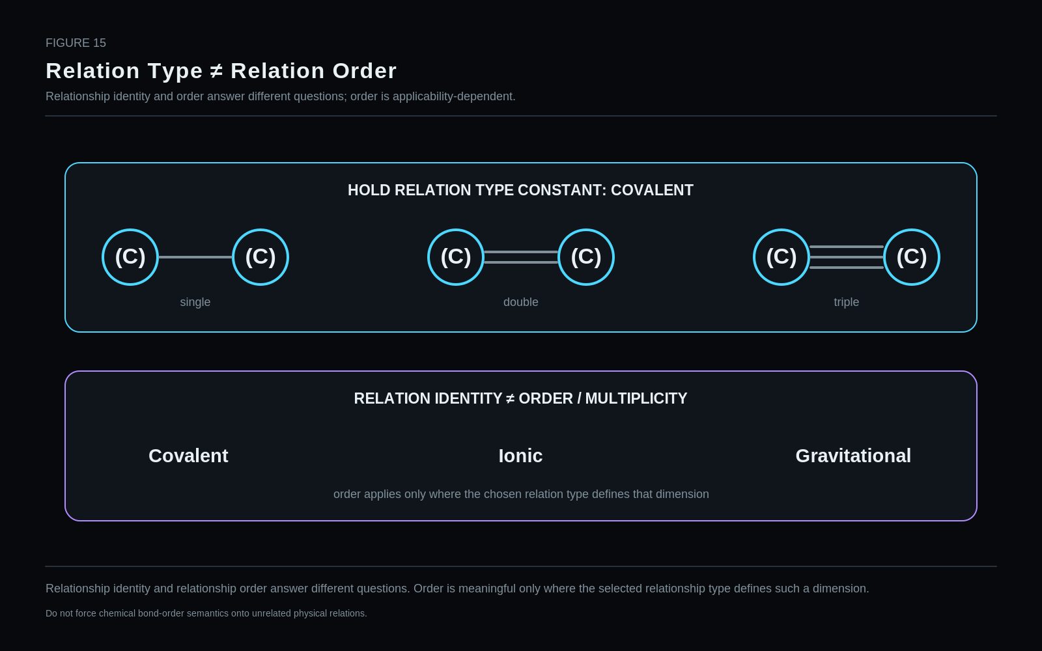
Relationship identity and relationship order answer different questions. Order is meaningful only where the selected relationship type defines such a dimension.
Restraint: Do not force chemical bond-order semantics onto unrelated physical relations.

29. Relationship State
Relationship State is retained as a falsifiable candidate for persistent relation condition. The field must be deleted or narrowed if forming, breaking, transient, or similar values prove to belong primarily to Process or Event ownership.
1. Canonical BitGroup name | Relationship State
2. Semantic question answered | What persistent state does the selected relationship currently occupy?
3. Owning stratum | PHYSICS¹
4. Point / Relationship applicability | Relationship records when a persistent state distinction is required
5. Encoding primitive | SCALAR selector
6. Provisional width | 3 bits — reference candidate
7. Binary / value range | 8 addresses (0–7)
8. Null / unspecified behavior | 000 = unspecified.
9. Reserved values | No permanently reserved code in the current sketch; 111 remains the most likely revision point.
10. Registry / calculation route | Decode locally; Relation Type and domain metadata constrain legal meanings.
11. Stable identity vs variable state | Variable relation state.
12. Derived properties | Event history may be derived from separate Event records; it must not be inferred solely from relation state.
13. Reader interpretation | Project stable/forming/breaking/etc. only when the relation model supports the distinction.
14. Visual projection | Stable solid line, forming dashed line, breaking strike, oscillating wave; projection only.
15. Valid domain handoffs | Operators, Processes, Events, chemistry, materials, dynamics.
16. Worked example | A covalent relationship can be structurally present while its state is marked forming during a modeled process.
17. Non-collapse distinctions | Relation State ≠ Process ≠ Event. “Breaking” as a state label cannot replace the event that produced the change.
18. Known limitations | Several values risk collapsing process semantics. This group is retained only as a falsifiable common-core candidate.
19. Implementation test | Attempt to move forming/breaking/transient semantics into Process/Event ownership; remove the BitGroup if no common persistent state remains.
20. Revision status | REFERENCE CANDIDATE — ELIMINATION PRESSURE

Published value mapping
Code / value | Address | Semantic assignment
000 | 0 | Unspecified
001 | 1 | Stable
010 | 2 | Forming
011 | 3 | Breaking
100 | 4 | Oscillating
101 | 5 | Transient
110 | 6 | Intermittent
111 | 7 | Constrained / unresolved candidate
STATUS: REFERENCE CANDIDATE — ELIMINATION PRESSURE

30. Endpoint Polarity A
Endpoint A Polarity is a qualitative projection semantic. It offers rapid visual interpretation while preserving exact charge and field quantities elsewhere.
1. Canonical BitGroup name | Endpoint Polarity A
2. Semantic question answered | What qualitative signed polarity class is projected at endpoint A?
3. Owning stratum | PHYSICS¹
4. Point / Relationship applicability | Relationship endpoint projection where a bounded qualitative polarity class is useful
5. Encoding primitive | SCALAR selector
6. Provisional width | 3 bits
7. Binary / value range | Seven signed classes plus unspecified
8. Null / unspecified behavior | 111 = unspecified/reserved. 000 is meaningful neutral/zero, not null.
9. Reserved values | 111 currently serves as unspecified/reserved.
10. Registry / calculation route | Decode directly; exact electric charge and field quantities route to typed quantitative systems.
11. Stable identity vs variable state | Variable endpoint projection; not stable particle charge identity.
12. Derived properties | Color/shape Reader projection is derived from signed class.
13. Reader interpretation | Render +3 red, +2 orange, +1 yellow, 0 white, -1 purple, -2 blue, -3 green, always with a numeric label.
14. Visual projection | Signed label + semantic color; gradients indicate static bias, arrows indicate actual process.
15. Valid domain handoffs | Electromagnetism, chemistry, electrostatics, materials, quantity systems.
16. Worked example | Endpoint A = +1 can be paired with the complementary endpoint = -1 while exact charge remains elsewhere.
17. Non-collapse distinctions | Polarity Class ≠ Exact Electric Charge ≠ Oxidation State ≠ QCD Color Charge.
18. Known limitations | A seven-class scale is qualitative. It must never substitute for a continuous field or exact charge quantity.
19. Implementation test | Compare projection against exact charge/field values and verify that zero and unspecified remain distinguishable.
20. Revision status | REFERENCE CANDIDATE — PROJECTION SEMANTIC

Published value mapping
Code / value | Address | Semantic assignment
000 | 0 | Neutral / zero
001 | +1 | Positive class +1
010 | +2 | Positive class +2
011 | +3 | Positive class +3
100 | -1 | Negative class -1
101 | -2 | Negative class -2
110 | -3 | Negative class -3
111 | — | Unspecified / reserved
STATUS: REFERENCE CANDIDATE — PROJECTION SEMANTIC

31. Endpoint Polarity B
Endpoint B Polarity mirrors the Endpoint A grammar so asymmetric relation bias can be shown without turning the visual palette into an exact physical quantity.
1. Canonical BitGroup name | Endpoint Polarity B
2. Semantic question answered | What qualitative signed polarity class is projected at endpoint B?
3. Owning stratum | PHYSICS¹
4. Point / Relationship applicability | Relationship endpoint projection where a bounded qualitative polarity class is useful
5. Encoding primitive | SCALAR selector
6. Provisional width | 3 bits
7. Binary / value range | Seven signed classes plus unspecified
8. Null / unspecified behavior | 111 = unspecified/reserved. 000 is meaningful neutral/zero, not null.
9. Reserved values | 111 currently serves as unspecified/reserved.
10. Registry / calculation route | Decode directly; exact electric charge and field quantities route to typed quantitative systems.
11. Stable identity vs variable state | Variable endpoint projection; not stable particle charge identity.
12. Derived properties | Color/shape Reader projection is derived from signed class.
13. Reader interpretation | Render +3 red, +2 orange, +1 yellow, 0 white, -1 purple, -2 blue, -3 green, always with a numeric label.
14. Visual projection | Signed label + semantic color; gradients indicate static bias, arrows indicate actual process.
15. Valid domain handoffs | Electromagnetism, chemistry, electrostatics, materials, quantity systems.
16. Worked example | Endpoint B = +1 can be paired with the complementary endpoint = -1 while exact charge remains elsewhere.
17. Non-collapse distinctions | Polarity Class ≠ Exact Electric Charge ≠ Oxidation State ≠ QCD Color Charge.
18. Known limitations | A seven-class scale is qualitative. It must never substitute for a continuous field or exact charge quantity.
19. Implementation test | Compare projection against exact charge/field values and verify that zero and unspecified remain distinguishable.
20. Revision status | REFERENCE CANDIDATE — PROJECTION SEMANTIC

Published value mapping
Code / value | Address | Semantic assignment
000 | 0 | Neutral / zero
001 | +1 | Positive class +1
010 | +2 | Positive class +2
011 | +3 | Positive class +3
100 | -1 | Negative class -1
101 | -2 | Negative class -2
110 | -3 | Negative class -3
111 | — | Unspecified / reserved
STATUS: REFERENCE CANDIDATE — PROJECTION SEMANTIC

Figure 16. Polarity Spectrum
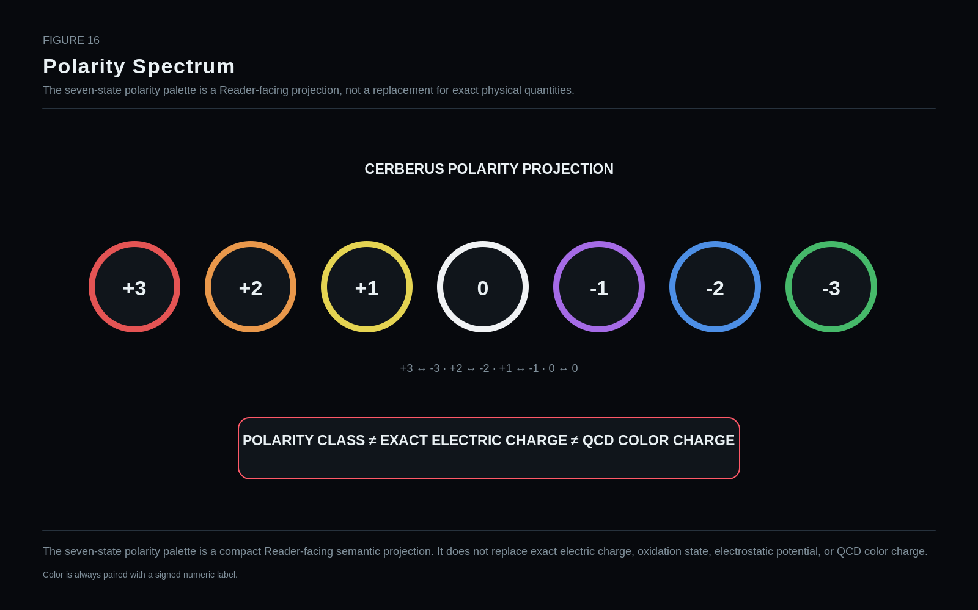
The seven-state polarity palette is a compact Reader-facing semantic projection. It does not replace exact electric charge, oxidation state, electrostatic potential, or QCD color charge.
Restraint: Color is always paired with a signed numeric label.

32. Process Class — Candidate Under Attack
A universal Process Class inside PHYSICS¹ currently fails the ownership test. The preferred architecture represents persistent relation state, reusable process/operator identity, and specific event occurrence as separate objects.
1. Canonical BitGroup name | Process Class
2. Semantic question answered | Should the common relation payload encode what transformation/process is occurring?
3. Owning stratum | PHYSICS¹ — candidate under attack
4. Point / Relationship applicability | Originally imagined for relationships; ownership is disputed
5. Encoding primitive | Historical SCALAR candidate
6. Provisional width | 4 bits — historical sketch only
7. Binary / value range | 16 addresses were proposed; no values are published
8. Null / unspecified behavior | No null policy is locked because the group itself is not accepted.
9. Reserved values | All addresses effectively uncommitted.
10. Registry / calculation route | Preferred route is Relation State → Operator/Process object → Event occurrence, not a universal in-band process selector.
11. Stable identity vs variable state | Would be dynamic/process semantics, which argues against common relation ownership.
12. Derived properties | None should be derived from this field while the group is under attack.
13. Reader interpretation | No canonical Reader projection.
14. Visual projection | Amber candidate / attack card only.
15. Valid domain handoffs | Operator, Process, Event, chemistry, dynamics.
16. Worked example | Heat-transfer process should not be collapsed into the existence of a thermal coupling relationship.
17. Non-collapse distinctions | Relation ≠ Process ≠ Event.
18. Known limitations | Strong ownership conflict and high risk of semantic collapse.
19. Implementation test | Try to model all candidate examples using Relation State + Operator/Process + Event. If successful, delete this group.
20. Revision status | ELIMINATION TARGET — NOT ADMITTED TO v0.1 COMMON CORE
STATUS: ELIMINATION TARGET — NOT ADMITTED TO v0.1 COMMON CORE

33. Physical Phase / Regime — Candidate Under Attack
Solid, liquid, gas, plasma, and similar labels may be scientifically useful, but usefulness alone does not prove common-core ownership. Materials and thermodynamic systems are the likely owners unless implementation repeatedly demonstrates a domain-independent need.
1. Canonical BitGroup name | Physical Phase / Regime
2. Semantic question answered | Should the common PHYSICS relation/object payload own solid/liquid/gas/plasma or similar regime classification?
3. Owning stratum | PHYSICS¹ — candidate under attack
4. Point / Relationship applicability | Object/material state only if a genuine universal common need is demonstrated
5. Encoding primitive | Historical SCALAR candidate
6. Provisional width | 4 bits — historical sketch only
7. Binary / value range | 16 addresses were discussed; no canonical mapping is published
8. Null / unspecified behavior | Not locked.
9. Reserved values | Not locked.
10. Registry / calculation route | Likely route to Materials, Thermodynamics, or a derived specialist state.
11. Stable identity vs variable state | Variable material/thermodynamic state.
12. Derived properties | May be derived from specialist state under specified conditions.
13. Reader interpretation | No canonical common Reader projection beyond an amber candidate badge.
14. Visual projection | Candidate phase badges.
15. Valid domain handoffs | Materials science, thermodynamics, plasma physics, fluid systems.
16. Worked example | Water may be liquid, but “liquid” is not necessarily a universal PHYSICS primitive needed by every physical object.
17. Non-collapse distinctions | Physical identity ≠ material phase; phase ≠ complete thermodynamic state.
18. Known limitations | Likely domain leakage if kept universally.
19. Implementation test | Attempt to satisfy all common examples through domain handoff; keep only if repeated cross-domain need cannot be represented cleanly elsewhere.
20. Revision status | ELIMINATION / RELOCATION TARGET
STATUS: ELIMINATION / RELOCATION TARGET

34. Physical Entity Class — Likely Metadata
Entity family classification is probably derivable from the selected registry identity. Adding a universal BitGroup for atom/molecule/particle/body/etc. risks duplicating metadata already known by the registry.
1. Canonical BitGroup name | Physical Entity Class
2. Semantic question answered | Does a common object require an in-band class such as atom, molecule, particle, body, field, or relation?
3. Owning stratum | PHYSICS¹ — candidate metadata
4. Point / Relationship applicability | Point records if a common entity-class discriminator proves necessary
5. Encoding primitive | Not locked; likely registry metadata rather than BitGroup
6. Provisional width | Not locked
7. Binary / value range | Not locked
8. Null / unspecified behavior | Not locked.
9. Reserved values | Not locked.
10. Registry / calculation route | Preferred route is registry identity → entity-family metadata.
11. Stable identity vs variable state | Stable classification metadata, not variable physical state.
12. Derived properties | Likely derivable from the selected registry identity.
13. Reader interpretation | Could label object families for navigation without adding payload bits.
14. Visual projection | Family badge only.
15. Valid domain handoffs | All specialist domains.
16. Worked example | Element selector already implies an atomic identity; an additional “atom” Bit may be redundant.
17. Non-collapse distinctions | Entity Class ≠ Exact Identity; classification ≠ object.
18. Known limitations | High redundancy risk.
19. Implementation test | Remove the field and test whether registry metadata is sufficient for all Readers and routing decisions.
20. Revision status | CANDIDATE — LIKELY REGISTRY METADATA
STATUS: CANDIDATE — LIKELY REGISTRY METADATA

Part VI — PHYSICS² — Atomic Identity & State
PART THESIS: Represent atomic identity, isotope distinction, and ion state with minimum independent fields.

35. PHYSICS² Atomic Contract
PHYSICS² answers the minimum common questions needed to distinguish an atomic instance from its stable element identity: which element, how many neutrons, and what net integral electric charge.
Field | Value
Element Selector | 7 bits
Neutron Count | 8 bits
Net Electric Charge | 8 bits
Increment | +23 bits
Cumulative reference label | PHYSICS² ≈49

Figure 17. PHYSICS² Atomic Payload
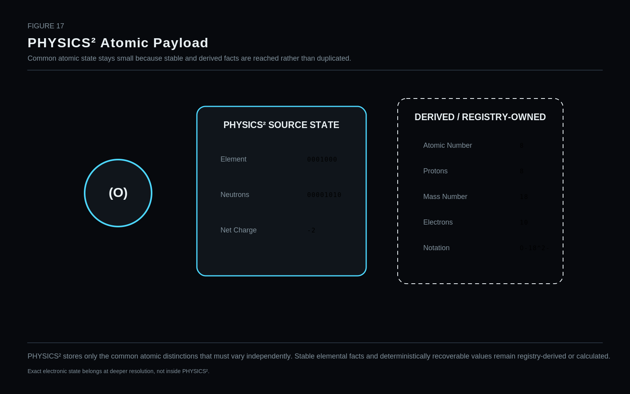
PHYSICS² stores only the common atomic distinctions that must vary independently. Stable elemental facts and deterministically recoverable values remain registry-derived or calculated.
Restraint: Exact electronic state belongs at deeper resolution, not inside PHYSICS².

36. Element Selector
The Element selector is the strongest early compression result in the paper: seven bits address all currently recognized elements while leaving stable elemental facts in a canonical registry.
1. Canonical BitGroup name | Element Selector
2. Semantic question answered | Which chemical element identity does this atomic Point instantiate?
3. Owning stratum | PHYSICS² — Atomic Identity & State
4. Point / Relationship applicability | Atomic Point / atom instance
5. Encoding primitive | SCALAR selector into Atom / Element Registry
6. Provisional width | 7 bits
7. Binary / value range | 128 addresses; direct values 1–118 currently assigned to recognized elements
8. Null / unspecified behavior | 0000000 is the provisional null/unspecified address. This policy remains implementation-governed.
9. Reserved values | 119–127 are unassigned address capacity, not asserted future elements.
10. Registry / calculation route | Exact key → Element Registry → stable facts such as name, symbol, atomic number, period, group.
11. Stable identity vs variable state | Stable identity selector.
12. Derived properties | Proton count = atomic number; element name/symbol and stable facts are registry-derived.
13. Reader interpretation | Project symbol, name, structural token, binary key, or debug ID without changing identity.
14. Visual projection | Bounded atom ring with element symbol; ring is an object enclosure, not an electron orbit.
15. Valid domain handoffs | Chemistry, materials, spectroscopy, biology, nuclear/atomic domains.
16. Worked example | 0001000 → 8 → Oxygen.
17. Non-collapse distinctions | Element ≠ Atom Instance ≠ Isotope ≠ Ion ≠ Electronic State.
18. Known limitations | The selector is adequate for present element registry size but does not encode isotope, charge, or electron state.
19. Implementation test | Round-trip all assigned values 1–118 and confirm exact lookup; verify 119–127 do not resolve to invented element identities.
20. Revision status | REFERENCE CANDIDATE — STRONG

Published value mapping
Code / value | Address | Semantic assignment
0000000 | 0 | Provisional null / unspecified address
0000001–1110110 | 1–118 | Direct registry address: H through Og
1110111–1111111 | 119–127 | Unassigned address capacity
STATUS: REFERENCE CANDIDATE — STRONG

Figure 18. Seven Bits Address the Element Registry
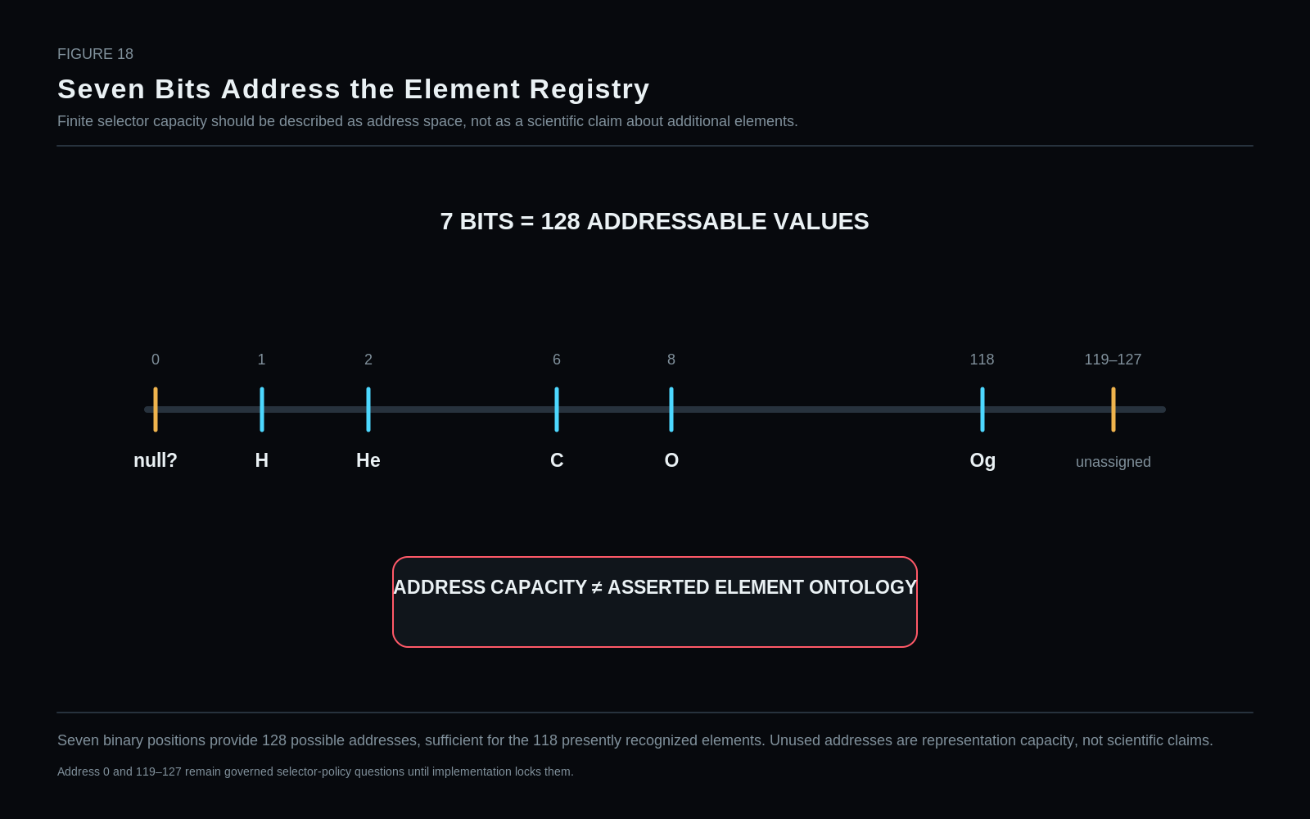
Seven binary positions provide 128 possible addresses, sufficient for the 118 presently recognized elements. Unused addresses are representation capacity, not scientific claims.
Restraint: Address 0 and 119–127 remain governed selector-policy questions until implementation locks them.

37. Neutron Count
Neutron count creates isotope distinction without inventing a separate isotope identity registry for every atomic instance. Zero neutrons remains a legitimate value and therefore cannot serve as null.
1. Canonical BitGroup name | Neutron Count
2. Semantic question answered | How many neutrons does this atomic instance contain?
3. Owning stratum | PHYSICS²
4. Point / Relationship applicability | Atomic instance / nucleus parent state
5. Encoding primitive | Unsigned SCALAR
6. Provisional width | 8 bits
7. Binary / value range | 0–255 neutrons
8. Null / unspecified behavior | No in-band null: zero is physically meaningful. Unspecified must be represented by absent/unresolved state outside this numeric value.
9. Reserved values | None in the direct 0–255 range.
10. Registry / calculation route | Decode directly; isotope notation and mass number are derived with Element/atomic number.
11. Stable identity vs variable state | Variable atomic state.
12. Derived properties | Mass number A = Z + N; isotope label derives from Element + N.
13. Reader interpretation | Return integer neutron count and derived isotope notation when requested.
14. Visual projection | Numeric state card; not one visible neutron icon per count unless nucleus is explicitly hydrated.
15. Valid domain handoffs | Nuclear physics, isotope chemistry, mass/quantity systems.
16. Worked example | Oxygen with N=10 → Oxygen-18.
17. Non-collapse distinctions | Neutron Count ≠ Mass Number ≠ Atomic Number.
18. Known limitations | 255 is a representation bound, not a physical law. Objects outside the common envelope force width revision or specialist routing.
19. Implementation test | Verify N=0 remains representable and never collapses into unspecified; stress values near 255.
20. Revision status | REFERENCE CANDIDATE — STRONG
STATUS: REFERENCE CANDIDATE — STRONG

38. Net Electric Charge
Net electric charge differentiates neutral atoms and ions while remaining independent from isotope. A signed numeric encoding is preferable to a qualitative polarity palette at this layer.
1. Canonical BitGroup name | Net Electric Charge
2. Semantic question answered | What is the atom instance’s net integral electric charge in elementary-charge units?
3. Owning stratum | PHYSICS²
4. Point / Relationship applicability | Atomic instance
5. Encoding primitive | Signed SCALAR
6. Provisional width | 8 bits — reference candidate
7. Binary / value range | Candidate two’s-complement range -128…+127 e
8. Null / unspecified behavior | No in-band null: 0 is meaningful neutral charge. Unspecified state must remain external to the numeric value.
9. Reserved values | None if standard signed-integer mapping is used.
10. Registry / calculation route | Decode directly; electron count derives as Z - Q when Q is expressed in units of +e.
11. Stable identity vs variable state | Variable atomic state.
12. Derived properties | Electron count from atomic number and net charge for ordinary atomic ions.
13. Reader interpretation | Return signed integer charge and formatted ionic notation.
14. Visual projection | Exact signed quantity card; qualitative polarity is a separate projection.
15. Valid domain handoffs | Electromagnetism, chemistry, spectroscopy, quantitative unit systems.
16. Worked example | Oxygen Z=8 with Q=-2 → 10 electrons and O-18^2- when N=10.
17. Non-collapse distinctions | Net Electric Charge ≠ Polarity Class ≠ Oxidation State.
18. Known limitations | The bounded common field targets integral atomic ion charge. Fractional effective charges or larger ranges route elsewhere.
19. Implementation test | Round-trip negative, zero, and positive values; verify neutrality is not treated as unspecified.
20. Revision status | REFERENCE CANDIDATE — IMPLEMENTATION MAPPING TO LOCK
STATUS: REFERENCE CANDIDATE — IMPLEMENTATION MAPPING TO LOCK

39. Element, Isotope, Ion, and State
Element identity, neutron count, net charge, and electronic condition are orthogonal enough to require independent representation. The same Oxygen identity can therefore appear as multiple isotopes, ions, and electronic states.

Figure 19. Element ≠ Isotope ≠ Ion ≠ Atomic State
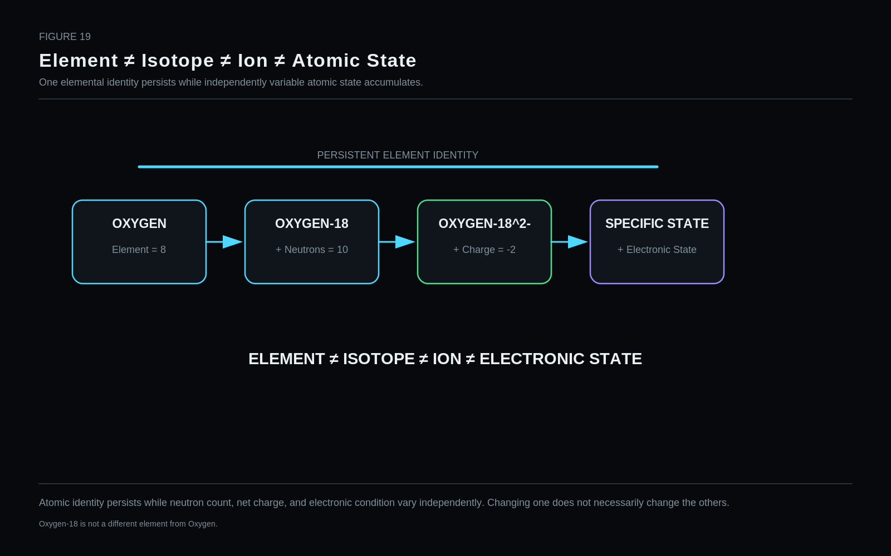
Atomic identity persists while neutron count, net charge, and electronic condition vary independently. Changing one does not necessarily change the others.
Restraint: Oxygen-18 is not a different element from Oxygen.

40. Derived Atomic Facts
Atomic number and proton count come from the Element registry. Mass number derives from Z + N. Ordinary atomic electron count derives from Z - Q under the signed charge convention. These remain Reader results rather than second sources of truth.

41. Atomic Resolution Boundary
PHYSICS² deliberately stops before exact electronic configuration. It preserves the ability to descend into PHYSICS³ or into a specialist atomic model when the current task requires that detail.

Part VII — PHYSICS³ — Electronic / Atomic-Internal State
PART THESIS: Resolve electronic detail selectively and validate physical legality separately from bit decodability.

42. PHYSICS³ Electronic Contract
PHYSICS³ introduces a compact electronic system: a reusable configuration reference and bounded orbital-state descriptors sufficient for common atomic-internal resolution. The layer is intentionally not a substitute for a complete many-electron wavefunction.
Field | Value
Electron Configuration Ref | 12 bits
n | 4 bits
l | 3 bits
m | 4 bits
Occupancy | 2 bits
Electron Spin Projection | 2 bits
Increment | +27 bits
Cumulative reference label | PHYSICS³ ≈76

Figure 20. Selective Electronic Hydration
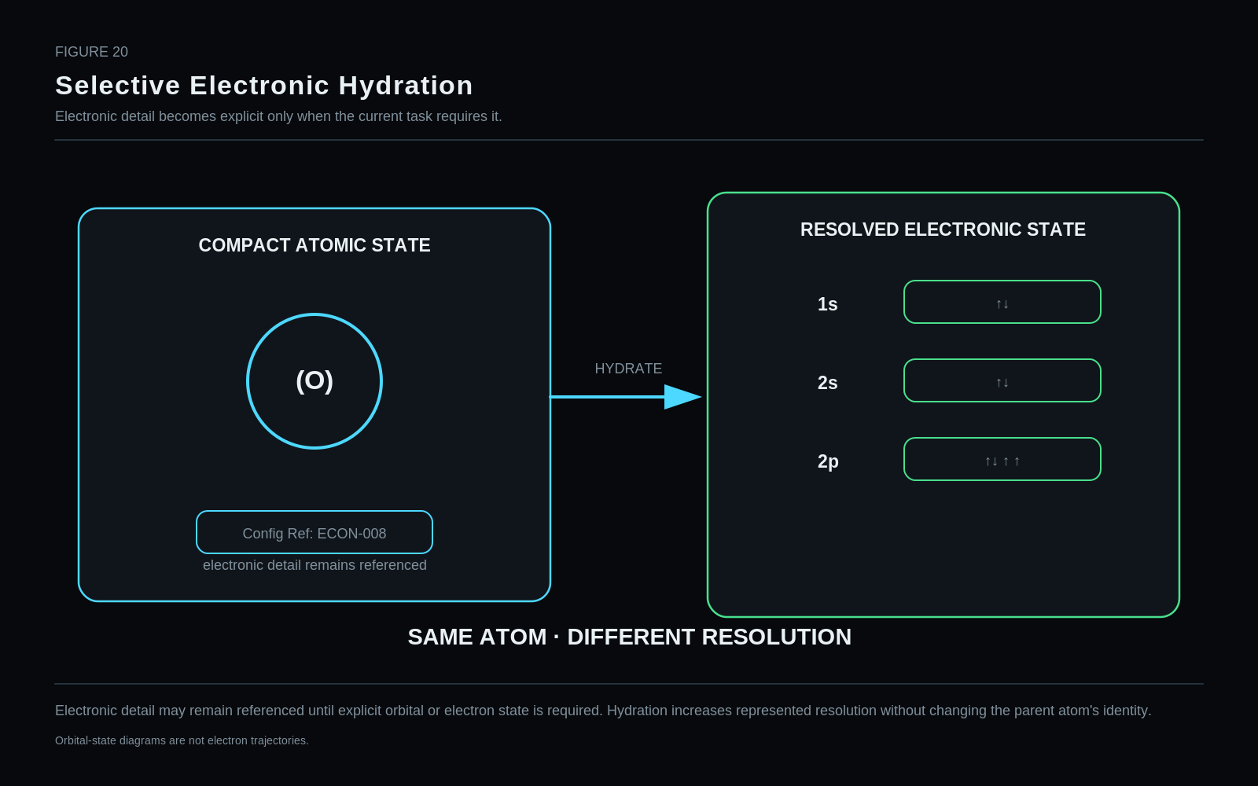
Electronic detail may remain referenced until explicit orbital or electron state is required. Hydration increases represented resolution without changing the parent atom's identity.
Restraint: Orbital-state diagrams are not electron trajectories.

43. Electron Configuration Reference
Configuration references support cheap default state and selective hydration. A common atom can remain compact until a Reader needs to expose explicit orbital records.
1. Canonical BitGroup name | Electron Configuration Reference
2. Semantic question answered | Which reusable electron-configuration state should this atomic electronic system use as its compact starting representation?
3. Owning stratum | PHYSICS³ — Electronic / Atomic-Internal State
4. Point / Relationship applicability | Electronic-system Point or atomic child context
5. Encoding primitive | Registry reference
6. Provisional width | 12 bits
7. Binary / value range | 4096 addresses
8. Null / unspecified behavior | 0 = no configuration reference asserted.
9. Reserved values | Registry governs unassigned addresses; 1–4095 available for records.
10. Registry / calculation route | Reference → Electron Configuration Registry / state object.
11. Stable identity vs variable state | Variable state reference; may point to ground, excited, ion-specific, or domain-defined configuration records.
12. Derived properties | Reader may derive occupancy summaries from the referenced configuration.
13. Reader interpretation | Return configuration notation or expand into explicit orbital records when hydrated.
14. Visual projection | Compact ECON-### token or orbital occupancy display.
15. Valid domain handoffs | Atomic physics, spectroscopy, quantum chemistry, QSTATE.
16. Worked example | ECON-008 may project 1s² 2s² 2p⁴ for neutral oxygen ground configuration.
17. Non-collapse distinctions | Configuration Reference ≠ Complete Wavefunction ≠ Orbital Geometry.
18. Known limitations | Reference capacity is an architectural choice; complex correlated state may need deeper QSTATE routing.
19. Implementation test | Resolve known configuration records exactly, hydrate selected orbitals, and verify no duplicate source truth.
20. Revision status | REFERENCE CANDIDATE — STRONG
STATUS: REFERENCE CANDIDATE — STRONG

44. Principal Quantum Number n
The current candidate intentionally bounds the common envelope to n=1…8. Higher-n states are not impossible; they are explicit tests of whether the common width should expand or route to a richer specialist state.
1. Canonical BitGroup name | Principal Quantum Number n
2. Semantic question answered | What principal quantum number is assigned to the selected orbital state?
3. Owning stratum | PHYSICS³
4. Point / Relationship applicability | Orbital-state record
5. Encoding primitive | Bounded SCALAR
6. Provisional width | 4 bits
7. Binary / value range | Candidate common envelope n = 1…8; additional codes reserved
8. Null / unspecified behavior | 0000 = unspecified / no orbital state asserted.
9. Reserved values | 1001–1111 reserved. They are not values n=9…15 in this v0.1 candidate.
10. Registry / calculation route | Decode locally; values outside the common envelope route to specialist state or force width revision.
11. Stable identity vs variable state | Variable orbital-state descriptor.
12. Derived properties | Constrains legal l values.
13. Reader interpretation | Display n as an integer state descriptor.
14. Visual projection | Orbital state card, not a spatial shell radius.
15. Valid domain handoffs | Atomic physics, spectroscopy, quantum chemistry, QSTATE.
16. Worked example | n=2 permits l=0 or 1.
17. Non-collapse distinctions | n ≠ orbital geometry ≠ energy by itself.
18. Known limitations | Principal quantum number is physically unbounded in principle; n≤8 is a deliberate common-layer envelope, not a scientific maximum.
19. Implementation test | Stress Rydberg/high-n examples; if common use requires n>8, widen or route.
20. Revision status | REFERENCE CANDIDATE — BOUNDED COMMON ENVELOPE

Published value mapping
Code / value | Address | Semantic assignment
0000 | — | Unspecified / no orbital state asserted
0001–1000 | 1–8 | Principal quantum number n = 1…8
1001–1111 | 9–15 | Reserved; route deeper or revise width if needed
STATUS: REFERENCE CANDIDATE — BOUNDED COMMON ENVELOPE

45. Orbital Angular Momentum Quantum Number l
The 3-bit l field is coherent with the n≤8 common envelope because the legal maximum l is seven. Validity remains conditional on l<n.
1. Canonical BitGroup name | Orbital Angular Momentum Quantum Number l
2. Semantic question answered | What orbital-angular-momentum quantum number is assigned to the selected orbital state?
3. Owning stratum | PHYSICS³
4. Point / Relationship applicability | Orbital-state record after n is known
5. Encoding primitive | Unsigned SCALAR
6. Provisional width | 3 bits
7. Binary / value range | 0–7
8. Null / unspecified behavior | No in-band null because l=0 is valid. Applicability and unresolved state are controlled by the parent orbital record.
9. Reserved values | None in-band.
10. Registry / calculation route | Decode directly; legality requires 0 ≤ l < n.
11. Stable identity vs variable state | Variable orbital-state descriptor.
12. Derived properties | Constrains legal m range.
13. Reader interpretation | Display integer l and optional domain label (s,p,d,f,...) as a Reader projection.
14. Visual projection | State card; not a literal orbital shape.
15. Valid domain handoffs | Atomic physics, spectroscopy, quantum chemistry.
16. Worked example | n=2, l=1 identifies a p-type orbital class.
17. Non-collapse distinctions | l ≠ orbital geometry; the familiar letter label is a projection of l.
18. Known limitations | Width is coherent only while the common n envelope is limited to n≤8.
19. Implementation test | Validate every l against n and reject mechanically representable but illegal combinations.
20. Revision status | REFERENCE CANDIDATE — LEGALITY-GOVERNED

Published value mapping
Code / value | Address | Semantic assignment
000–111 | 0–7 | Orbital angular momentum l = 0…7; validity requires l < n
STATUS: REFERENCE CANDIDATE — LEGALITY-GOVERNED

46. Magnetic Quantum Number m
The 4-bit signed candidate covers -7…+7 and reserves one address. The scientific legality condition -l≤m≤+l remains stronger than mechanical decodability.
1. Canonical BitGroup name | Magnetic Quantum Number m
2. Semantic question answered | What magnetic quantum number is assigned to the selected orbital state?
3. Owning stratum | PHYSICS³
4. Point / Relationship applicability | Orbital-state record after l is known
5. Encoding primitive | Signed bounded SCALAR
6. Provisional width | 4 bits
7. Binary / value range | Candidate -7…+7 plus one reserved code
8. Null / unspecified behavior | 1111 reserved / unspecified.
9. Reserved values | 1111.
10. Registry / calculation route | Offset decode maps 0000…1110 to -7…+7; legality requires -l ≤ m ≤ +l.
11. Stable identity vs variable state | Variable orbital-state descriptor.
12. Derived properties | No independent geometric orientation should be derived without a chosen representation/basis.
13. Reader interpretation | Display signed integer m.
14. Visual projection | State card only.
15. Valid domain handoffs | Atomic physics, spectroscopy, quantum chemistry.
16. Worked example | l=1 permits m=-1,0,+1.
17. Non-collapse distinctions | m ≠ physical trajectory or literal orientation glyph.
18. Known limitations | The mapping is tied to the l≤7 common envelope.
19. Implementation test | Reject m values outside ±l even when the bit pattern is mechanically decodable.
20. Revision status | REFERENCE CANDIDATE — LEGALITY-GOVERNED

Published value mapping
Code / value | Address | Semantic assignment
0000–1110 | -7…+7 | Offset mapping, one code per magnetic quantum number
1111 | — | Reserved / unspecified
STATUS: REFERENCE CANDIDATE — LEGALITY-GOVERNED

47. Orbital Occupancy
Two bits are sufficient for empty, singly occupied, doubly occupied, and unresolved/reserved. Occupancy remains different from the identity of any explicitly hydrated electron Point.
1. Canonical BitGroup name | Orbital Occupancy
2. Semantic question answered | How many electrons occupy the selected orbital state?
3. Owning stratum | PHYSICS³
4. Point / Relationship applicability | Orbital-state record
5. Encoding primitive | SCALAR selector
6. Provisional width | 2 bits
7. Binary / value range | 0,1,2 plus unspecified
8. Null / unspecified behavior | 11 = unspecified/reserved.
9. Reserved values | 11 currently serves as unresolved/reserved.
10. Registry / calculation route | Decode directly; electron Points may be separately instantiated only when needed.
11. Stable identity vs variable state | Variable orbital state.
12. Derived properties | Total electron count may be derived by summing resolved occupancies when the configuration is fully explicit.
13. Reader interpretation | Render empty, single, or double occupancy.
14. Visual projection | —, ↑, or ↑↓ in an orbital-state diagram.
15. Valid domain handoffs | Atomic physics, spectroscopy, quantum chemistry.
16. Worked example | 2p occupancy records can reconstruct the familiar oxygen ground-state occupancy projection.
17. Non-collapse distinctions | Occupancy ≠ Individual Electron Identity.
18. Known limitations | Correlated many-electron state can exceed the explanatory adequacy of a simple occupancy field.
19. Implementation test | Verify 0 remains distinct from unspecified and compare expanded occupancy against referenced configuration.
20. Revision status | REFERENCE CANDIDATE — STRONG

Published value mapping
Code / value | Address | Semantic assignment
00 | 0 | Empty orbital
01 | 1 | Single occupancy
10 | 2 | Double occupancy
11 | — | Unspecified / reserved
STATUS: REFERENCE CANDIDATE — STRONG

48. Electron Spin Projection
A small local spin-projection field is useful only with declared basis/context. The familiar up/down arrow is a state glyph and must not be read as physical motion.
1. Canonical BitGroup name | Electron Spin Projection
2. Semantic question answered | What spin projection is asserted for the selected electron state on the chosen axis/basis?
3. Owning stratum | PHYSICS³
4. Point / Relationship applicability | Resolved electron Point or orbital occupancy detail
5. Encoding primitive | SCALAR selector
6. Provisional width | 2 bits
7. Binary / value range | ±1/2 plus unspecified/reserved
8. Null / unspecified behavior | 00 = unspecified.
9. Reserved values | 11 reserved.
10. Registry / calculation route | Decode locally with basis/context supplied by the owning quantum state.
11. Stable identity vs variable state | Variable quantum-state descriptor.
12. Derived properties | Arrow glyph is a Reader projection only.
13. Reader interpretation | Project ↑ or ↓ as a state label.
14. Visual projection | Arrow glyph paired with text; arrow does not mean motion.
15. Valid domain handoffs | Atomic physics, spectroscopy, QSTATE.
16. Worked example | Electron E1 may have projection +1/2 on the selected axis.
17. Non-collapse distinctions | Intrinsic Spin ≠ Spin Projection ≠ Helicity.
18. Known limitations | Axis/basis context is required; a local 2-bit projection does not represent the full spin state.
19. Implementation test | Round-trip both projections and verify basis context is not silently assumed.
20. Revision status | REFERENCE CANDIDATE — CONTEXT-DEPENDENT

Published value mapping
Code / value | Address | Semantic assignment
00 | — | Unspecified
01 | -1/2 | Negative projection on selected axis
10 | +1/2 | Positive projection on selected axis
11 | — | Reserved
STATUS: REFERENCE CANDIDATE — CONTEXT-DEPENDENT

49. Electronic Legality Envelope
A Bit pattern may be syntactically valid and scientifically illegal. PHYSICS³ therefore requires domain validation of n, l, m, occupancy, and any basis-dependent state constraints before a Reader may treat the decoded combination as a physical state.

Figure 21. Quantum Numbers as Bounded State
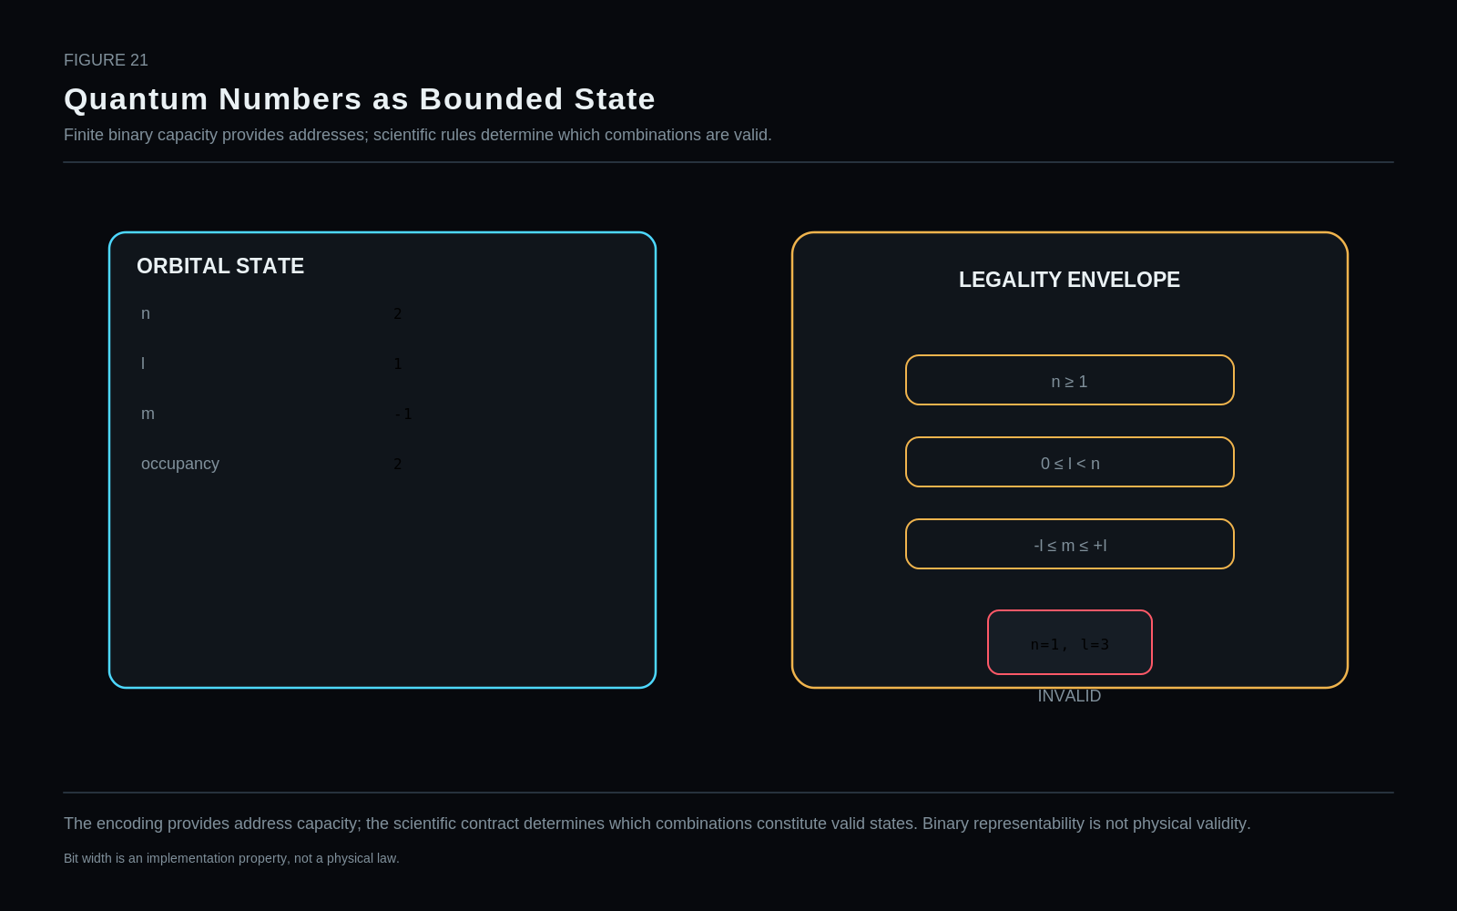
The encoding provides address capacity; the scientific contract determines which combinations constitute valid states. Binary representability is not physical validity.
Restraint: Bit width is an implementation property, not a physical law.

50. Electronic Hydration
The same atom can exist at coarse electronic resolution, configuration-reference resolution, orbital resolution, or explicit electron-Point resolution. Hydration changes represented detail, not the atom’s identity.

Part VIII — PHYSICS⁴ — Nuclear / Nucleon State
PART THESIS: Open nuclear detail without repeating the atom or confusing state with decay events.

51. PHYSICS⁴ Nuclear Contract
PHYSICS⁴ adds an address to reusable nuclear state plus optional addressable nucleon instances. Composition remains inherited from PHYSICS² so the child graph does not repeat parent totals.
Field | Value
Nuclear State Ref | 12 bits
Nucleon Type | 2 bits
Nucleon Spin Projection | 2 bits
Increment | +16 bits
Cumulative reference label | PHYSICS⁴ ≈92

Figure 22. Nuclear Resolution Without Repeating the Atom
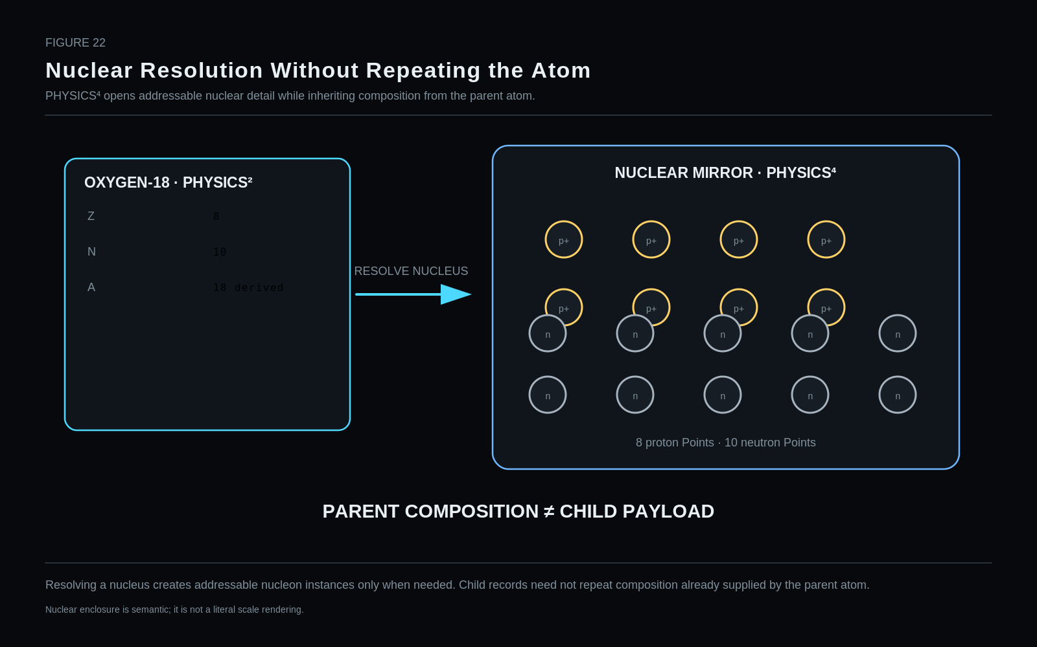
Resolving a nucleus creates addressable nucleon instances only when needed. Child records need not repeat composition already supplied by the parent atom.
Restraint: Nuclear enclosure is semantic; it is not a literal scale rendering.

52. Nuclear State Reference
Nuclear State Reference is the main escape hatch into specialist nuclear models. A compact reference can route to energy, angular momentum, parity, decay pathways, and richer domain state without embedding those structures in the common word.
1. Canonical BitGroup name | Nuclear State Reference
2. Semantic question answered | Which reusable nuclear-state object describes the resolved nucleus?
3. Owning stratum | PHYSICS⁴ — Nuclear / Nucleon State
4. Point / Relationship applicability | Nucleus child context
5. Encoding primitive | Registry reference
6. Provisional width | 12 bits
7. Binary / value range | 4096 addresses
8. Null / unspecified behavior | 0 = no nuclear-state reference asserted.
9. Reserved values | Registry-governed.
10. Registry / calculation route | Reference → NSTATE Registry / specialist nuclear-state object.
11. Stable identity vs variable state | Variable nuclear state reference.
12. Derived properties | Parent atomic Z and N supply composition; nuclear state need not repeat totals.
13. Reader interpretation | Return nuclear-state label or route to detailed energy/J/parity/decay model.
14. Visual projection | NSTATE-### card.
15. Valid domain handoffs | Nuclear physics, nuclear engineering, decay/event systems.
16. Worked example | O-18 nucleus may reference NSTATE-042.
17. Non-collapse distinctions | Nuclear State ≠ Nuclear Composition ≠ Decay Event.
18. Known limitations | The reference does not encode the mathematical nuclear model itself.
19. Implementation test | Resolve state references while removing duplicate parent composition from child nucleon records.
20. Revision status | REFERENCE CANDIDATE — STRONG
STATUS: REFERENCE CANDIDATE — STRONG

53. Nucleon Type
A two-bit selector distinguishes proton and neutron within an explicitly resolved nucleus. The graph Point ID still owns the individual nucleon identity.
1. Canonical BitGroup name | Nucleon Type
2. Semantic question answered | Is the selected nucleon instance a proton or neutron?
3. Owning stratum | PHYSICS⁴
4. Point / Relationship applicability | Resolved nucleon Point
5. Encoding primitive | SCALAR selector
6. Provisional width | 2 bits
7. Binary / value range | Proton, neutron, unspecified, reserved
8. Null / unspecified behavior | 00 = unspecified / null candidate.
9. Reserved values | 11 reserved.
10. Registry / calculation route | Decode to Particle/Nucleon Registry identity; graph Point ID provides instance identity.
11. Stable identity vs variable state | Stable identity selector for the local nucleon instance.
12. Derived properties | Stable proton/neutron physical facts are registry-owned.
13. Reader interpretation | Project p+ or n.
14. Visual projection | Gold proton Point or steel neutron Point.
15. Valid domain handoffs | Particle physics, nuclear physics, QCD specialist route.
16. Worked example | 01 → proton; 10 → neutron.
17. Non-collapse distinctions | Nucleon Type ≠ Nucleon Instance ID.
18. Known limitations | Other baryons are not represented by this narrow nucleon-type group; they belong to broader particle identity.
19. Implementation test | Instantiate multiple proton/neutron Points and verify type does not replace Point identity.
20. Revision status | REFERENCE CANDIDATE — STRONG

Published value mapping
Code / value | Address | Semantic assignment
00 | — | Unspecified / null candidate
01 | p | Proton
10 | n | Neutron
11 | — | Reserved
STATUS: REFERENCE CANDIDATE — STRONG

54. Nucleon Spin Projection
Nucleon spin projection can be selectively exposed while the many-body nuclear state remains authoritative in an NSTATE object. The local projection is therefore subordinate context, not a replacement model.
1. Canonical BitGroup name | Nucleon Spin Projection
2. Semantic question answered | What spin projection is asserted for the selected nucleon on the chosen axis/basis?
3. Owning stratum | PHYSICS⁴
4. Point / Relationship applicability | Resolved proton/neutron Point when local spin projection is needed
5. Encoding primitive | SCALAR selector
6. Provisional width | 2 bits
7. Binary / value range | ±1/2 plus unspecified/reserved
8. Null / unspecified behavior | 00 = unspecified.
9. Reserved values | 11 reserved.
10. Registry / calculation route | Decode locally; axis/basis supplied by nuclear/quantum context.
11. Stable identity vs variable state | Variable quantum-state descriptor.
12. Derived properties | Projection glyph only.
13. Reader interpretation | Project ↑ or ↓.
14. Visual projection | State arrow next to nucleon Point.
15. Valid domain handoffs | Nuclear physics, QSTATE, particle physics.
16. Worked example | P1 may carry +1/2 projection while N1 carries -1/2 in a selected state view.
17. Non-collapse distinctions | Intrinsic Spin ≠ Spin Projection.
18. Known limitations | Local projection is not the complete many-body nuclear spin state.
19. Implementation test | Verify parent NSTATE can remain authoritative while local projection is selectively resolved.
20. Revision status | REFERENCE CANDIDATE — CONTEXT-DEPENDENT

Published value mapping
Code / value | Address | Semantic assignment
00 | — | Unspecified
01 | -1/2 | Negative projection on selected axis
10 | +1/2 | Positive projection on selected axis
11 | — | Reserved
STATUS: REFERENCE CANDIDATE — CONTEXT-DEPENDENT

55. Parent Composition vs Child Instances
PHYSICS² already knows Z and N. Hydrating the nucleus creates P1…Pn and N1…Nm Points, but each child does not need to repeat the total number of protons and neutrons.

56. Nuclear State vs Decay Event
A nuclear state can persist, transition, or decay. The state, transition operator/process, event occurrence, any daughter state, and emitted objects are different semantic owners.

Part IX — PHYSICS⁵ — Fundamental Particle Identity & State
PART THESIS: Let particle identity govern applicable state instead of forcing one universal particle payload.

57. PHYSICS⁵ Particle Contract
PHYSICS⁵ is where the original fixed-width intuition begins to break down most strongly. Stable particle identity is common, but applicable state dimensions differ substantially among electrons, quarks, photons, and other particles.
ARCHITECTURE REPAIR: The original PHYSICS⁵ fixed payload is not treated as settled. Particle Type + registry-governed applicability + rich Particle State Reference is the preferred direction.

Figure 23. Fundamental Particle Resolution
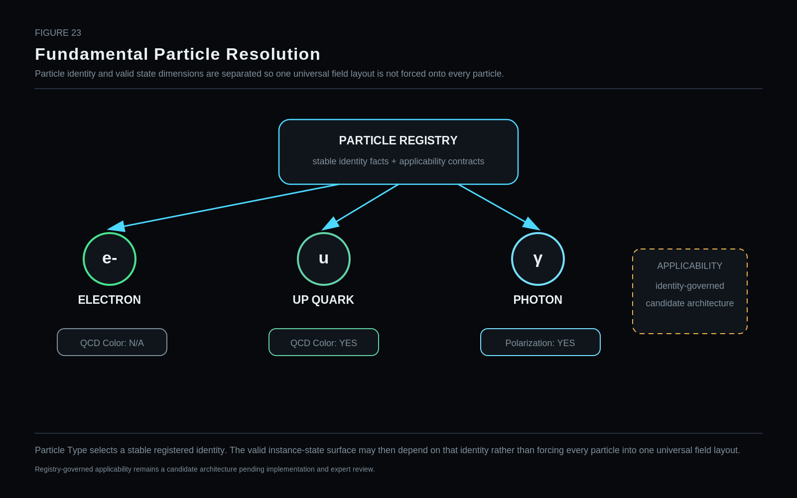
Particle Type selects a stable registered identity. The valid instance-state surface may then depend on that identity rather than forcing every particle into one universal field layout.
Restraint: Registry-governed applicability remains a candidate architecture pending implementation and expert review.

58. Particle Type
A small scalar selector into a Particle Registry remains a strong common primitive. The registry can own family, stable charge, intrinsic spin class, interactions, and the applicability contract for additional state dimensions.
1. Canonical BitGroup name | Particle Type
2. Semantic question answered | Which registered fundamental-particle identity does this Point instantiate?
3. Owning stratum | PHYSICS⁵ — Fundamental Particle Identity / State
4. Point / Relationship applicability | Fundamental-particle Point
5. Encoding primitive | SCALAR selector into Particle Registry
6. Provisional width | 6 bits — reference candidate
7. Binary / value range | 64 addresses
8. Null / unspecified behavior | 0 = unspecified / no particle identity asserted.
9. Reserved values | 1–63 are registry capacity; exact v0.1 assignments are intentionally not frozen in this paper.
10. Registry / calculation route | Exact key → Particle Registry → family, symbol, stable facts, interaction metadata, applicable state grammar.
11. Stable identity vs variable state | Stable identity selector.
12. Derived properties | Family/generation/stable charge/spin class are registry-derived.
13. Reader interpretation | Project electron, photon, quark, etc. using registry symbols and domain routes.
14. Visual projection | Bounded particle Point with identity label.
15. Valid domain handoffs | Particle physics, QCD, quantum mechanics, QFT.
16. Worked example | Electron and photon can enter PHYSICS⁵ without fake atomic/nuclear traversal.
17. Non-collapse distinctions | Particle Identity ≠ Particle Instance ≠ Particle State.
18. Known limitations | Registry assignments need expert review before publication.
19. Implementation test | Round-trip a representative particle set and verify registry-governed applicability.
20. Revision status | REFERENCE CANDIDATE — REGISTRY ASSIGNMENTS NOT YET FROZEN
STATUS: REFERENCE CANDIDATE — REGISTRY ASSIGNMENTS NOT YET FROZEN

59. QCD Color State
A three-bit quark/antiquark color-state projection is useful only under strict applicability rules. QCD color is not visible color, not electrical polarity, and not a universal field for every particle.
1. Canonical BitGroup name | QCD Color State
2. Semantic question answered | What quark/antiquark color-charge class is asserted when that state dimension applies?
3. Owning stratum | PHYSICS⁵
4. Point / Relationship applicability | Quark and antiquark contexts; not universal to all particles
5. Encoding primitive | SCALAR selector
6. Provisional width | 3 bits
7. Binary / value range | unspecified, R, G, B, anti-R, anti-G, anti-B, reserved
8. Null / unspecified behavior | 000 = unspecified within an applicable quark/antiquark state. Non-applicable identities do not instantiate this field.
9. Reserved values | 111 reserved; gluon color structure routes to specialist QCD state.
10. Registry / calculation route | Decode local class for applicable identities; richer QCD state → specialist QCD object / QSTATE.
11. Stable identity vs variable state | Variable gauge-state descriptor in bounded contexts.
12. Derived properties | Pattern+label Reader projection derives from code.
13. Reader interpretation | Use distinct pattern grammar, never the electrical polarity palette.
14. Visual projection | Slash/backslash/dot patterns plus labels.
15. Valid domain handoffs | QCD, hadron models, specialist particle state.
16. Worked example | Up quark Q1 may project RED; electron receives N/A.
17. Non-collapse distinctions | QCD Color Charge ≠ Visible Color ≠ Electrical Polarity.
18. Known limitations | A gluon is not faithfully represented by one simple quark-color label; this field is not universal.
19. Implementation test | Apply to quark, electron, photon, gluon examples and require applicability routing instead of fake values.
20. Revision status | REFERENCE CANDIDATE — IDENTITY-GOVERNED APPLICABILITY

Published value mapping
Code / value | Address | Semantic assignment
000 | unspecified | Unspecified within an applicable quark/antiquark state
001 | R | Red quark color
010 | G | Green quark color
011 | B | Blue quark color
100 | anti-R | Anti-red antiquark color
101 | anti-G | Anti-green antiquark color
110 | anti-B | Anti-blue antiquark color
111 | — | Reserved; gluon color structure routes to specialist QCD state
STATUS: REFERENCE CANDIDATE — IDENTITY-GOVERNED APPLICABILITY

Figure 24. Polarity Color ≠ QCD Color
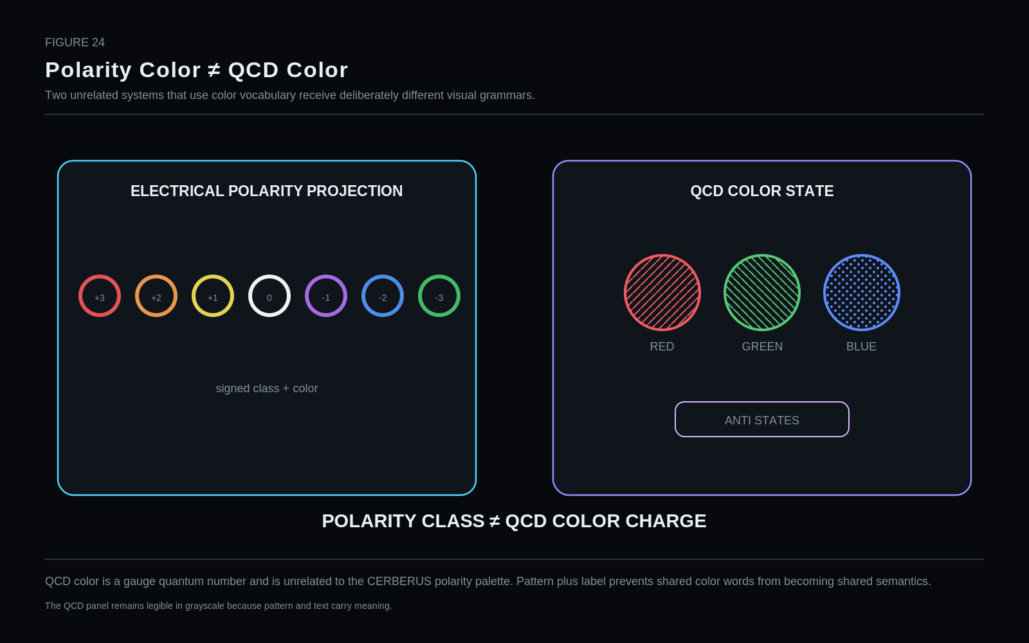
QCD color is a gauge quantum number and is unrelated to the CERBERUS polarity palette. Pattern plus label prevents shared color words from becoming shared semantics.
Restraint: The QCD panel remains legible in grayscale because pattern and text carry meaning.

60. Combined Spin/Helicity — Rejected
The earlier combined Spin/Helicity group is explicitly rejected. Spin projection and helicity answer different questions and require different context.
1. Canonical BitGroup name | Combined Spin / Helicity (historical candidate)
2. Semantic question answered | Can one universal 3-bit field represent both spin projection and helicity?
3. Owning stratum | PHYSICS⁵ — historical candidate
4. Point / Relationship applicability | Originally universal particle state; now rejected
5. Encoding primitive | Historical SCALAR candidate
6. Provisional width | 3 bits — rejected combined field
7. Binary / value range | No value mapping is published because the semantic object is invalid as a universal field.
8. Null / unspecified behavior | Not applicable.
9. Reserved values | All codes uncommitted.
10. Registry / calculation route | Replace with identity-governed state contract and separate Spin Projection / Helicity routes where applicable.
11. Stable identity vs variable state | Would mix different state semantics.
12. Derived properties | None.
13. Reader interpretation | No canonical Reader.
14. Visual projection | Red non-collapse card.
15. Valid domain handoffs | Particle physics, QSTATE.
16. Worked example | Helicity depends on momentum direction; spin projection depends on a selected axis. They cannot be silently treated as one variable.
17. Non-collapse distinctions | Spin Projection ≠ Helicity.
18. Known limitations | Semantic collapse.
19. Implementation test | Any implementation retaining one shared field must prove lossless interpretation across massive, massless, spin-0, spin-1/2, and spin-1 examples.
20. Revision status | REJECTED FOR v0.1 COMMON CORE
STATUS: REJECTED FOR v0.1 COMMON CORE

61. Particle Spin Projection — Replacement Candidate
A replacement spin-projection route should be identity-governed rather than universally fixed. Different intrinsic spin classes imply different legal projection sets.
1. Canonical BitGroup name | Particle Spin Projection (replacement candidate)
2. Semantic question answered | When applicable, what spin projection is asserted on a declared axis/basis?
3. Owning stratum | PHYSICS⁵ — registry-governed extension candidate
4. Point / Relationship applicability | Only particle identities/state contracts that define the selected projection
5. Encoding primitive | Width not yet locked; likely small selector or state reference
6. Provisional width | Not locked after Wave E/F repair
7. Binary / value range | Identity-dependent
8. Null / unspecified behavior | Applicability-controlled; no universal in-band null is assumed.
9. Reserved values | Not locked.
10. Registry / calculation route | Particle Registry applicability contract → local extension or Particle State Ref / QSTATE.
11. Stable identity vs variable state | Variable state descriptor.
12. Derived properties | Reader glyph only.
13. Reader interpretation | Project signed spin result in declared basis.
14. Visual projection | Axis/state label, not motion arrow.
15. Valid domain handoffs | Particle physics, quantum mechanics, QSTATE.
16. Worked example | Electron spin projection can reuse a ±1/2 local grammar when the basis is explicit.
17. Non-collapse distinctions | Intrinsic Spin ≠ Spin Projection ≠ Helicity.
18. Known limitations | Different spin classes require different value sets.
19. Implementation test | Build identity-specific contracts for electron, photon, scalar particle, and spin-1 massive particle; reject universal mapping if ambiguity remains.
20. Revision status | REPLACEMENT CANDIDATE — WIDTH NOT LOCKED
STATUS: REPLACEMENT CANDIDATE — WIDTH NOT LOCKED

62. Helicity — Replacement Candidate
Helicity requires momentum context and is therefore its own state question. It may be a local projection or a derived Reader result from a richer particle state.
1. Canonical BitGroup name | Helicity (replacement candidate)
2. Semantic question answered | When applicable, what is the projection of spin along the particle momentum direction?
3. Owning stratum | PHYSICS⁵ — registry-governed extension candidate
4. Point / Relationship applicability | Identity/state contexts where helicity is a meaningful requested projection
5. Encoding primitive | Width not locked
6. Provisional width | Not locked
7. Binary / value range | Identity-dependent; typically sign/orientation semantics in the applicable model
8. Null / unspecified behavior | Applicability-controlled.
9. Reserved values | Not locked.
10. Registry / calculation route | Particle Registry → state contract → Particle State Ref / QSTATE as required.
11. Stable identity vs variable state | Variable state descriptor tied to momentum context.
12. Derived properties | Can be derived from a full state only when the required momentum/spin information is available.
13. Reader interpretation | Render same/opposite spin-momentum orientation using explicit labels.
14. Visual projection | Separate momentum and spin arrows.
15. Valid domain handoffs | Particle physics, QFT, QSTATE.
16. Worked example | A photon Reader may expose helicity under a declared state model.
17. Non-collapse distinctions | Helicity ≠ Spin Projection on arbitrary axis.
18. Known limitations | Not universally applicable; frame/model considerations matter for massive particles.
19. Implementation test | Require explicit momentum context and compare against full particle state.
20. Revision status | REPLACEMENT CANDIDATE — APPLICABILITY REVIEW
STATUS: REPLACEMENT CANDIDATE — APPLICABILITY REVIEW

63. Polarization — Applicability Challenge
Polarization is scientifically important but not universally applicable and may be richer than a small fixed palette. The preferred design routes through identity-specific state contracts and richer state references.
1. Canonical BitGroup name | Polarization (universal-field challenge)
2. Semantic question answered | Should a compact common particle field encode polarization class?
3. Owning stratum | PHYSICS⁵ — candidate under attack
4. Point / Relationship applicability | Photon and other contexts where polarization is meaningful; not universal
5. Encoding primitive | Historical 3-bit candidate
6. Provisional width | 3 bits — historical candidate; not accepted as universal
7. Binary / value range | No canonical universal mapping published.
8. Null / unspecified behavior | Applicability-controlled.
9. Reserved values | All values remain uncommitted in the common core.
10. Registry / calculation route | Preferred route: identity-specific state contract → Particle State Ref / QSTATE / specialist polarization object.
11. Stable identity vs variable state | Variable state descriptor.
12. Derived properties | Reader-specific simple class may be derived from richer state.
13. Reader interpretation | May render a bounded polarization projection only when a domain Reader explicitly defines it.
14. Visual projection | Orientation/ellipse projection only as a Reader view.
15. Valid domain handoffs | Optics, electromagnetism, quantum mechanics, QSTATE.
16. Worked example | Photon polarization may be exposed; electron must not receive a fake polarization value merely because the field exists.
17. Non-collapse distinctions | Polarization ≠ Particle Identity ≠ Helicity.
18. Known limitations | Polarization state can be richer than a small fixed class and is not universal.
19. Implementation test | Apply the field to electron, quark, photon, vector boson, and composite examples; remove fixed universal field if N/A dominates.
20. Revision status | UNIVERSAL-FIELD ELIMINATION TARGET
STATUS: UNIVERSAL-FIELD ELIMINATION TARGET

64. Particle State Reference
Particle State Reference provides the common escape hatch when local fields become awkward. It lets the common layer remain small while specialist models preserve exact applicable state.
1. Canonical BitGroup name | Particle State Reference
2. Semantic question answered | Which reusable complex particle-state object should this instance use?
3. Owning stratum | PHYSICS⁵
4. Point / Relationship applicability | Fundamental-particle Point when local common fields are insufficient
5. Encoding primitive | Registry reference
6. Provisional width | 12 bits — reference candidate
7. Binary / value range | 4096 addresses
8. Null / unspecified behavior | 0 = no particle-state reference.
9. Reserved values | Registry-governed.
10. Registry / calculation route | Reference → PSTATE object → identity-specific extensions / QSTATE / specialist domain.
11. Stable identity vs variable state | Variable state reference.
12. Derived properties | Applicable simple projections may derive from the referenced state.
13. Reader interpretation | Resolve PSTATE-### and project only requested attributes.
14. Visual projection | Compact reference card.
15. Valid domain handoffs | Particle physics, QCD, quantum mechanics, QFT.
16. Worked example | Photon γ1 may route to a particle-state object containing polarization/helicity context.
17. Non-collapse distinctions | Reference ≠ Referenced Contents.
18. Known limitations | 4096-address capacity is architectural, not scientific.
19. Implementation test | Use the state reference as an escape hatch for cases that do not fit the compact common grammar.
20. Revision status | REFERENCE CANDIDATE — STRONG ESCAPE HATCH
STATUS: REFERENCE CANDIDATE — STRONG ESCAPE HATCH

65. Particle Applicability Architecture
The preferred repair architecture is a small common particle core plus Particle Registry plus registry-governed applicable extensions. This is more faithful than a universal payload filled with N/A values and collapsed meanings.

Part X — PHYSICS⁶ — Quantum / Field Routing
PART THESIS: Route into rich quantum and field state instead of imitating it inside the common word.

66. PHYSICS⁶ Routing Contract
As state becomes mathematically richer, the common layer should increasingly route rather than imitate. PHYSICS⁶ therefore addresses representation, QSTATE, basis, operator, observable, and field identity.
Field | Value
Representation Class | 4 bits
QSTATE Ref | 16 bits
Basis Ref | 12 bits
Operator Ref | 12 bits
Observable Ref | 10 bits
Field Type | 6 bits
Measurement Status | 3 bits historical candidate — rejected as universal owner
Historical increment | +63 bits
Cumulative reference label | PHYSICS⁶ ≈182

Figure 25. PHYSICS⁶ Is a Router, Not a Wavefunction
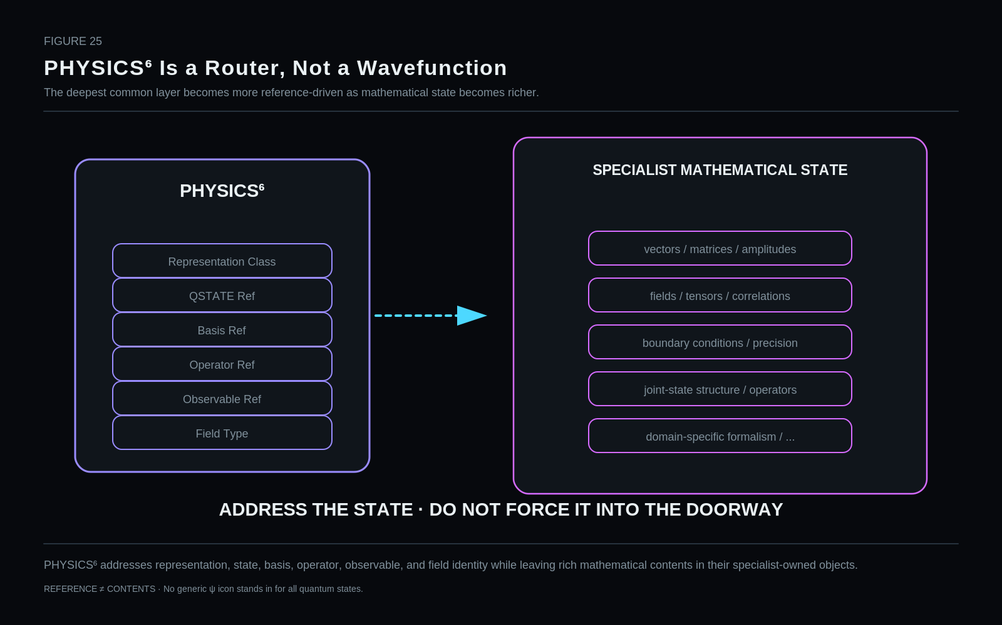
PHYSICS⁶ addresses representation, state, basis, operator, observable, and field identity while leaving rich mathematical contents in their specialist-owned objects.
Restraint: REFERENCE ≠ CONTENTS · No generic ψ icon stands in for all quantum states.

67. Quantum Representation Class
Representation Class tells a Reader how the referenced state is expressed. It does not tell the Reader what physical state it is.
1. Canonical BitGroup name | Quantum Representation Class
2. Semantic question answered | Which registered representation family is being used to express the referenced quantum/field state?
3. Owning stratum | PHYSICS⁶ — Quantum / Field Routing
4. Point / Relationship applicability | QSTATE / field-state route
5. Encoding primitive | SCALAR selector
6. Provisional width | 4 bits
7. Binary / value range | 16 representation-class addresses
8. Null / unspecified behavior | 0000 = unspecified.
9. Reserved values | 0110–1111 reserved in the current candidate.
10. Registry / calculation route | Decode class → representation registry / Reader → referenced mathematical state object.
11. Stable identity vs variable state | Representation metadata, not physical state.
12. Derived properties | Reader can choose a compatible display or parser.
13. Reader interpretation | Select state-vector, density-operator, joint-state, field-state, or Fock-space handling.
14. Visual projection | Representation badge; no generic wavefunction icon.
15. Valid domain handoffs | Quantum mechanics, quantum information, QFT, specialist math runtime.
16. Worked example | QSTATE may use density-operator representation while preserving the same physical state identity.
17. Non-collapse distinctions | Representation Class ≠ Quantum State.
18. Known limitations | The list is not exhaustive; future classes require registry review.
19. Implementation test | Represent the same state in multiple bases/representations and confirm identity persists.
20. Revision status | REFERENCE CANDIDATE — ROUTING METADATA

Published value mapping
Code / value | Address | Semantic assignment
0000 | 0 | Unspecified / null
0001 | 1 | State-vector representation
0010 | 2 | Density-operator representation
0011 | 3 | Joint-state representation
0100 | 4 | Field-state representation
0101 | 5 | Fock-space / occupation representation
0110–1111 | 6–15 | Reserved for registered representation classes
STATUS: REFERENCE CANDIDATE — ROUTING METADATA

68. QSTATE Reference
QSTATE is the primary doorway to rich quantum state. It can also be a joint state shared by several graph members, which makes relational quantum state explicit.
1. Canonical BitGroup name | QSTATE Reference
2. Semantic question answered | Which reusable quantum-state object is being addressed?
3. Owning stratum | PHYSICS⁶
4. Point / Relationship applicability | Any object/relation requiring rich quantum state
5. Encoding primitive | Registry reference
6. Provisional width | 16 bits
7. Binary / value range | 65,536 addresses
8. Null / unspecified behavior | 0 = no QSTATE reference.
9. Reserved values | Registry-governed.
10. Registry / calculation route | Reference → QSTATE Registry/Object → mathematical data, joint members, precision, specialist model.
11. Stable identity vs variable state | Variable state reference.
12. Derived properties | Reader projections derive from QSTATE only when valid.
13. Reader interpretation | Resolve state object without copying mathematical contents into the common BitWord.
14. Visual projection | QSTATE-### doorway.
15. Valid domain handoffs | Quantum mechanics, quantum information, QFT.
16. Worked example | Entangled photons A and B both route to one shared QSTATE-184.
17. Non-collapse distinctions | QSTATE Reference ≠ Quantum State Contents ≠ Measurement Result.
18. Known limitations | Address capacity is finite implementation infrastructure, not a theoretical state-space bound.
19. Implementation test | Round-trip joint and single-object states and verify exact membership and state identity.
20. Revision status | REFERENCE CANDIDATE — STRONG
STATUS: REFERENCE CANDIDATE — STRONG

69. Basis Reference
Basis identity is separate from state identity. The same state may have different coordinates in different bases without becoming a different physical state.
1. Canonical BitGroup name | Basis Reference
2. Semantic question answered | Which registered basis / coordinate representation is used to express the current quantum-state coordinates?
3. Owning stratum | PHYSICS⁶
4. Point / Relationship applicability | QSTATE representation context
5. Encoding primitive | Registry reference
6. Provisional width | 12 bits
7. Binary / value range | 4096 addresses
8. Null / unspecified behavior | 0 = no basis reference asserted.
9. Reserved values | Registry-governed.
10. Registry / calculation route | Reference → Basis Registry.
11. Stable identity vs variable state | Representation metadata.
12. Derived properties | Coordinates of the same state may be transformed between registered bases by specialist math.
13. Reader interpretation | Label the active basis and route to compatible coordinates.
14. Visual projection | BASIS-### token.
15. Valid domain handoffs | Quantum mechanics, math runtime, spectroscopy.
16. Worked example | The same QSTATE Q1 may be represented in Basis A or Basis B.
17. Non-collapse distinctions | Basis ≠ Quantum State.
18. Known limitations | Basis may be composite/contextual; a short ref only addresses it.
19. Implementation test | Transform one state between two bases and verify the state identity does not change.
20. Revision status | REFERENCE CANDIDATE — STRONG
STATUS: REFERENCE CANDIDATE — STRONG

70. Operator Reference
Operator identity is separately registered so transformations, evolution rules, or analysis operations can be addressed without copying formal mathematical objects into the common word.
1. Canonical BitGroup name | Operator Reference
2. Semantic question answered | Which registered operator identity is relevant to the current state/action/analysis?
3. Owning stratum | PHYSICS⁶
4. Point / Relationship applicability | Quantum/field analysis or governed state transformation context
5. Encoding primitive | Registry reference
6. Provisional width | 12 bits
7. Binary / value range | 4096 addresses
8. Null / unspecified behavior | 0 = no operator reference.
9. Reserved values | Registry-governed.
10. Registry / calculation route | Reference → Operator Registry → formal operator object / runtime.
11. Stable identity vs variable state | Operational/analytical reference, not physical state.
12. Derived properties | None assumed in common core.
13. Reader interpretation | Resolve operator identity and domain contract.
14. Visual projection | OP-### route.
15. Valid domain handoffs | Quantum mechanics, QFT, math runtime.
16. Worked example | A measurement or evolution workflow may reference a specific registered operator.
17. Non-collapse distinctions | Operator ≠ Observable ≠ Result.
18. Known limitations | The common ref does not encode the operator matrix/function.
19. Implementation test | Resolve operators with different bases/representations and verify domain validation catches incompatibility.
20. Revision status | REFERENCE CANDIDATE — STRONG
STATUS: REFERENCE CANDIDATE — STRONG

71. Observable Reference
Observable identity answers what is being observed or evaluated. The observed result belongs to a measurement event/result record, not to the observable identity itself.
1. Canonical BitGroup name | Observable Reference
2. Semantic question answered | Which registered observable identity is being requested or evaluated?
3. Owning stratum | PHYSICS⁶
4. Point / Relationship applicability | Measurement/analysis context
5. Encoding primitive | Registry reference
6. Provisional width | 10 bits
7. Binary / value range | 1024 addresses
8. Null / unspecified behavior | 0 = no observable reference.
9. Reserved values | Registry-governed.
10. Registry / calculation route | Reference → Observable Registry → measurement/analysis contract.
11. Stable identity vs variable state | Analytical target metadata.
12. Derived properties | A measurement result is produced by an event/process, not stored in this identity.
13. Reader interpretation | Resolve what is being observed without conflating it with the observed value.
14. Visual projection | OBS-### route.
15. Valid domain handoffs | Quantum mechanics, experimental physics, measurement systems.
16. Worked example | Spin-z observable may be requested while the resulting value is recorded elsewhere.
17. Non-collapse distinctions | Observable ≠ Measurement Result.
18. Known limitations | 1024 addresses may prove too small or poorly partitioned; implementation will test.
19. Implementation test | Record multiple results for the same observable and confirm identity remains stable.
20. Revision status | REFERENCE CANDIDATE — IMPLEMENTATION CAPACITY TO TEST
STATUS: REFERENCE CANDIDATE — IMPLEMENTATION CAPACITY TO TEST

72. Field Type
Field Type is a small registry selector for common field-family identity. A field configuration can be enormous and must therefore remain a referenced specialist state rather than six bits pretending to be the field.
1. Canonical BitGroup name | Field Type
2. Semantic question answered | Which registered field identity/family is in scope?
3. Owning stratum | PHYSICS⁶
4. Point / Relationship applicability | Field relationship/state context
5. Encoding primitive | SCALAR selector into Field Registry
6. Provisional width | 6 bits
7. Binary / value range | 64 addresses
8. Null / unspecified behavior | 0 = unspecified / no field type asserted.
9. Reserved values | 1–63 registry-defined; this paper intentionally does not freeze a complete cross-domain field taxonomy.
10. Registry / calculation route | Selector → Field Registry → field-family identity + specialist state/configuration route.
11. Stable identity vs variable state | Stable field identity/family selector.
12. Derived properties | Field configuration is separate and may be referenced/derived in specialist systems.
13. Reader interpretation | Project field family label and available domain routes.
14. Visual projection | FIELD-### / field-family badge.
15. Valid domain handoffs | Electromagnetism, gravitation, QFT, materials/effective-field models.
16. Worked example | A record may identify an electromagnetic field while its spatiotemporal configuration lives in a specialist object.
17. Non-collapse distinctions | Field Type ≠ Field Configuration ≠ Force.
18. Known limitations | A single cross-domain field taxonomy may prove scientifically awkward; registry family metadata is required.
19. Implementation test | Stress EM, gravitational, QCD, weak, and effective/material field examples for taxonomy leakage.
20. Revision status | REFERENCE CANDIDATE — REGISTRY TAXONOMY REVIEW
STATUS: REFERENCE CANDIDATE — REGISTRY TAXONOMY REVIEW

73. Measurement Status — Rejected Universal Field
The former Measurement Status candidate is rejected because it can silently merge preparation, physical state, measurement setup, event history, result, and observer knowledge.
1. Canonical BitGroup name | Measurement Status (historical candidate)
2. Semantic question answered | Can one 3-bit common field summarize whether a quantum state is prepared, measured, resolved, or known?
3. Owning stratum | PHYSICS⁶ — historical candidate under attack
4. Point / Relationship applicability | Originally imagined as universal quantum-state metadata; now rejected as a single semantic owner
5. Encoding primitive | Historical SCALAR candidate
6. Provisional width | 3 bits — rejected universal group
7. Binary / value range | No value mapping published.
8. Null / unspecified behavior | Not applicable.
9. Reserved values | All codes uncommitted.
10. Registry / calculation route | Replace with explicit graph: Preparation/Setup → Physical State → Observable/Operator → Measurement Event → Result → Observer Knowledge.
11. Stable identity vs variable state | Would collapse state, event history, result, and epistemic knowledge.
12. Derived properties | No common result should derive from this field.
13. Reader interpretation | No canonical Reader.
14. Visual projection | Amber/red decomposition card.
15. Valid domain handoffs | Measurement/event systems, perspective/knowledge, quantum runtime.
16. Worked example | “Measured” could mean an event occurred, a result exists, or an observer knows the result; those are not the same fact.
17. Non-collapse distinctions | Quantum State ≠ Measurement Event ≠ Measurement Result ≠ Observer Knowledge.
18. Known limitations | Severe semantic collapse.
19. Implementation test | Model measurement workflows without the field. If explicit graph succeeds, permanently remove it.
20. Revision status | REJECTED FOR v0.1 COMMON CORE
STATUS: REJECTED FOR v0.1 COMMON CORE

74. Measurement as an Explicit Graph
The preferred architecture decomposes measurement into preparation/setup, physical state, observable/operator, measurement interaction or event, result, and observer knowledge. This graph makes epistemic and physical boundaries explicit.

Figure 26. Entanglement Is a Joint State
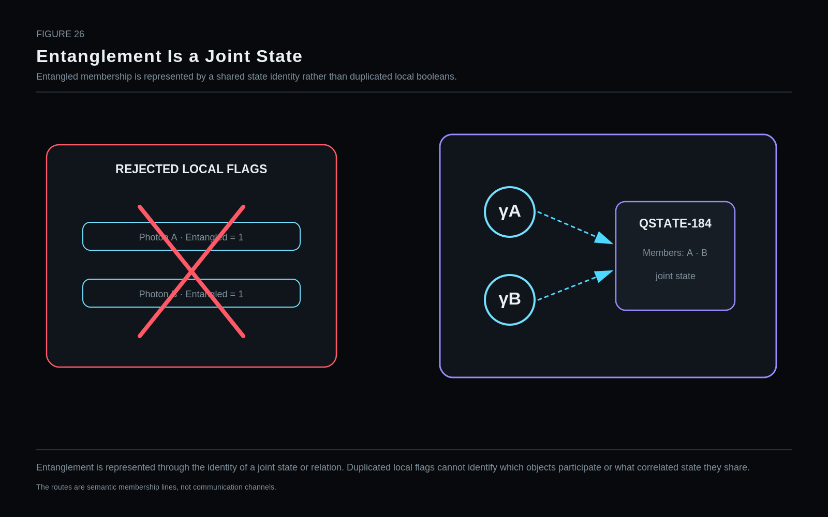
Entanglement is represented through the identity of a joint state or relation. Duplicated local flags cannot identify which objects participate or what correlated state they share.
Restraint: The routes are semantic membership lines, not communication channels.

75. Route Rather Than Imitate
PHYSICS⁶ is successful when a short common address can reliably reach the required mathematical object, not when the common word reproduces that object. This is the deepest expression of the small-spine/huge-reach rule.

Part XI — Mirror Graph Reference
PART THESIS: Use Mirror Graph to place already-decoded semantics without creating a second semantic engine.

76. Mirror Graph Responsibility
The Mirror owns which semantic payload belongs to which Point or Relationship in which Mirror State at which Mirror address. It does not reinterpret the PHYSICS payload.

Figure 27. PHYSICS Inside an Experimental Mirror
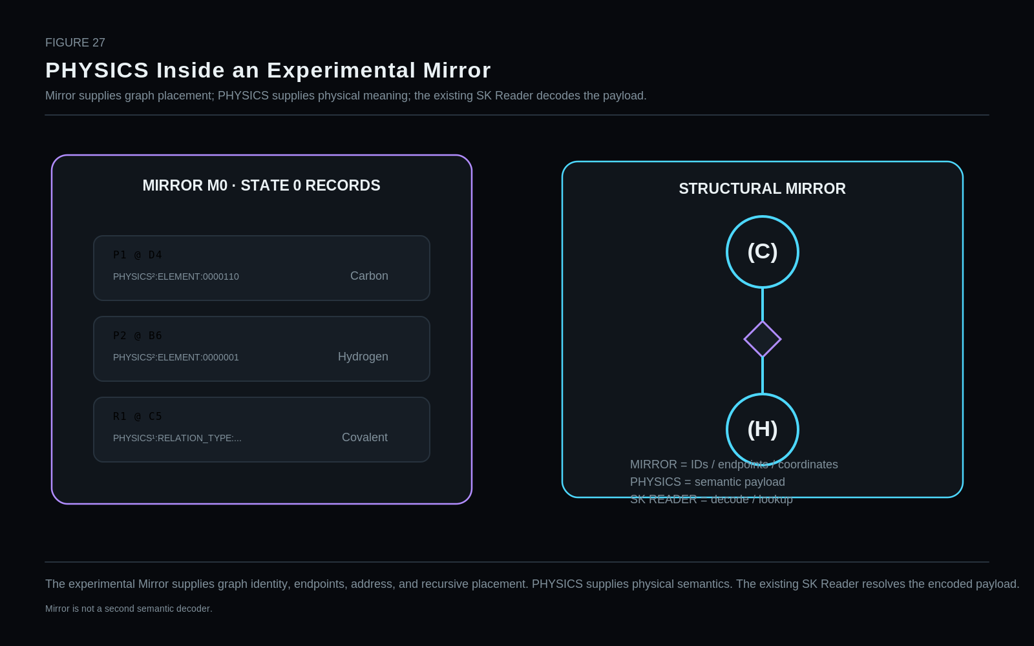
The experimental Mirror supplies graph identity, endpoints, address, and recursive placement. PHYSICS supplies physical semantics. The existing SK Reader resolves the encoded payload.
Restraint: Mirror is not a second semantic decoder.

77. State 0 as Records
Mirror State 0 is a set of actual records: Point records, Relationship records, coordinates, endpoints, and payload links. The graph therefore exists before any grid image is rendered.

78. SK Reader Responsibility
The existing SK Reader answers what the encoded payload means. Mirror mechanics answer where that payload belongs. This separation prevents the Mirror from becoming a second semantic decoder.

79. Structural Mirror Image
A Mirror Image can use table geometry as a semantic grid: fields define one axis, records define the other, and a lookup supplies the selected symbol at the intersection. Blank display cells are rendering behavior, not missing canonical graph records.

Figure 28. State Records → Structural Mirror Image
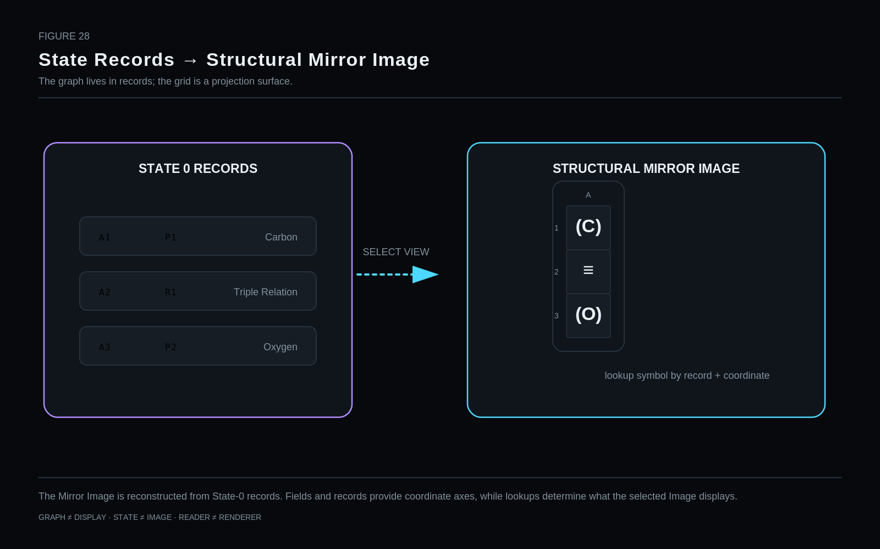
The Mirror Image is reconstructed from State-0 records. Fields and records provide coordinate axes, while lookups determine what the selected Image displays.
Restraint: GRAPH ≠ DISPLAY · STATE ≠ IMAGE · READER ≠ RENDERER

80. Graph ≠ Display
Renderer failure, missing symbols, or a broken formula need not imply graph failure. Graph state, Reader decode, image/view choice, and physical display are separate layers and therefore separately diagnosable.

Part XII — Recursive Resolution
PART THESIS: Allow both objects and relationships to resolve recursively and at mixed depth.

81. Object Descent
Any bounded physical object may expose a child Mirror when deeper resolution is needed. Parent context remains available while the child graph adds internal structure.

Figure 29. Object Resolution Descent
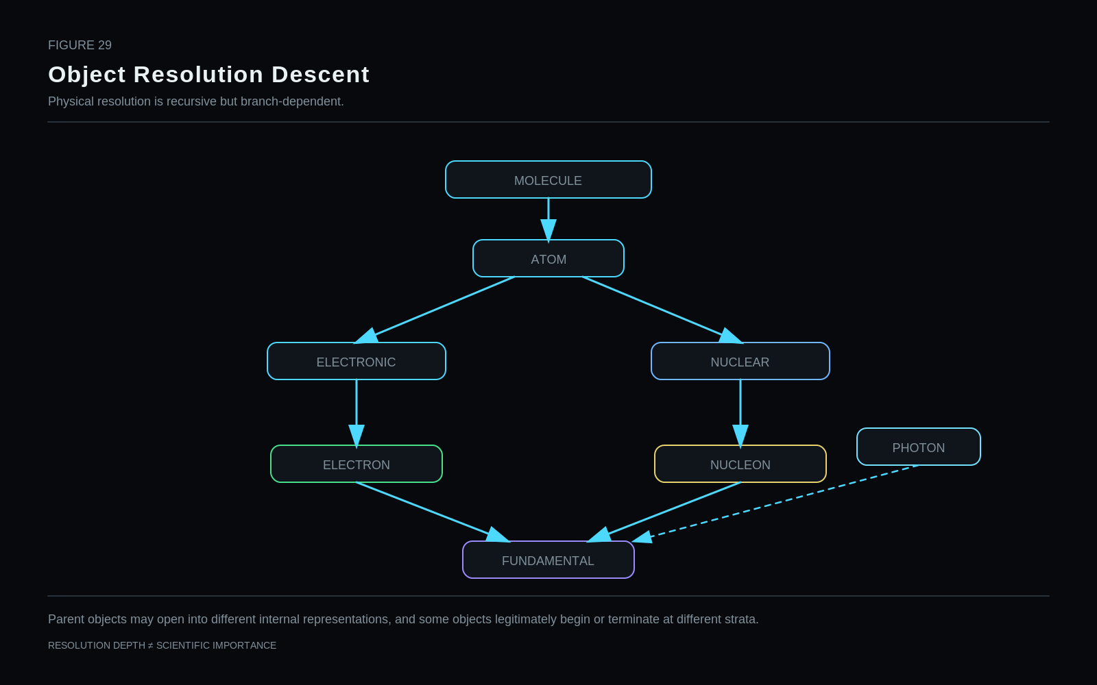
Parent objects may open into different internal representations, and some objects legitimately begin or terminate at different strata.
Restraint: RESOLUTION DEPTH ≠ SCIENTIFIC IMPORTANCE

82. Relationship Descent
Relationships can also be recursively resolved. A covalent relation may remain valid at a structural layer while an electronic or quantum Reader exposes deeper explanatory structure.

Figure 30. Relationship Resolution Descent
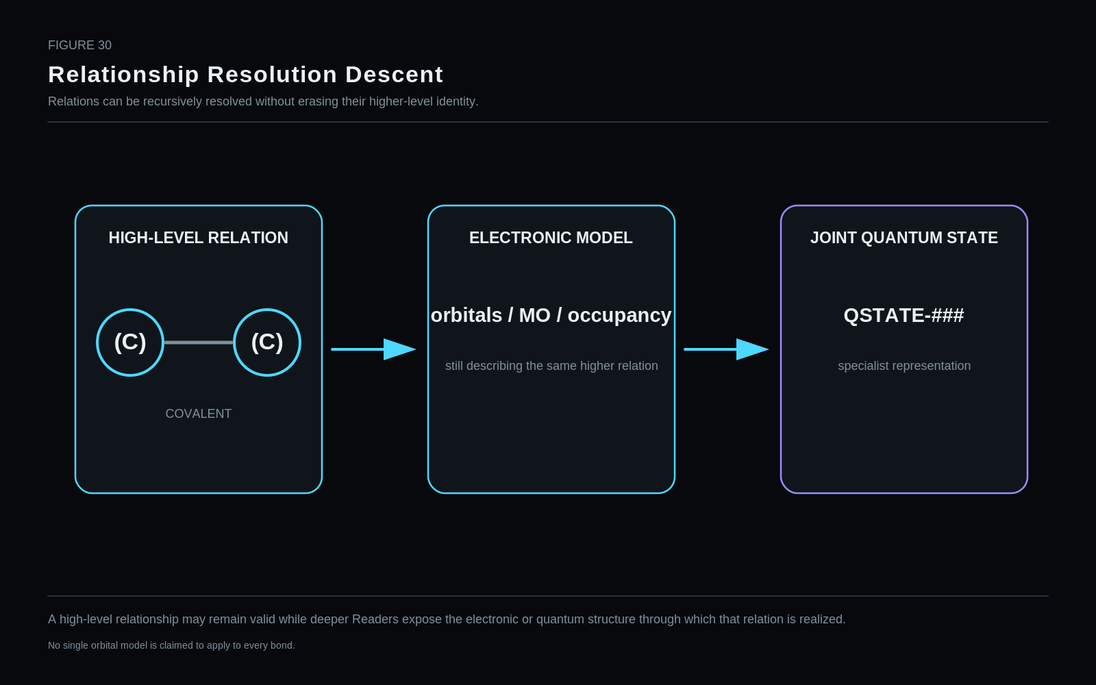
A high-level relationship may remain valid while deeper Readers expose the electronic or quantum structure through which that relation is realized.
Restraint: No single orbital model is claimed to apply to every bond.

83. Mixed Resolution
One graph can legitimately contain coarse and deeply resolved branches at the same time. Resolution follows the causal or analytical corridor, not a requirement for uniform depth.

84. Resolution Termination
A branch terminates when additional detail is unnecessary for the current task or when the next meaningful representation belongs to a specialist model. Stopping is therefore a correctness decision, not a deficiency.

Part XIII — Domain Handoffs
PART THESIS: Treat specialist handoff as a deliberate boundary, not a failure of the common layer.

85. Domain Handoff Contract
A handoff preserves the common physical identity while opening a specialist interpretation. The specialist domain extends the object; it does not replace the common identity with a competing translation.

Figure 31. Domain Handoff Fan-Out
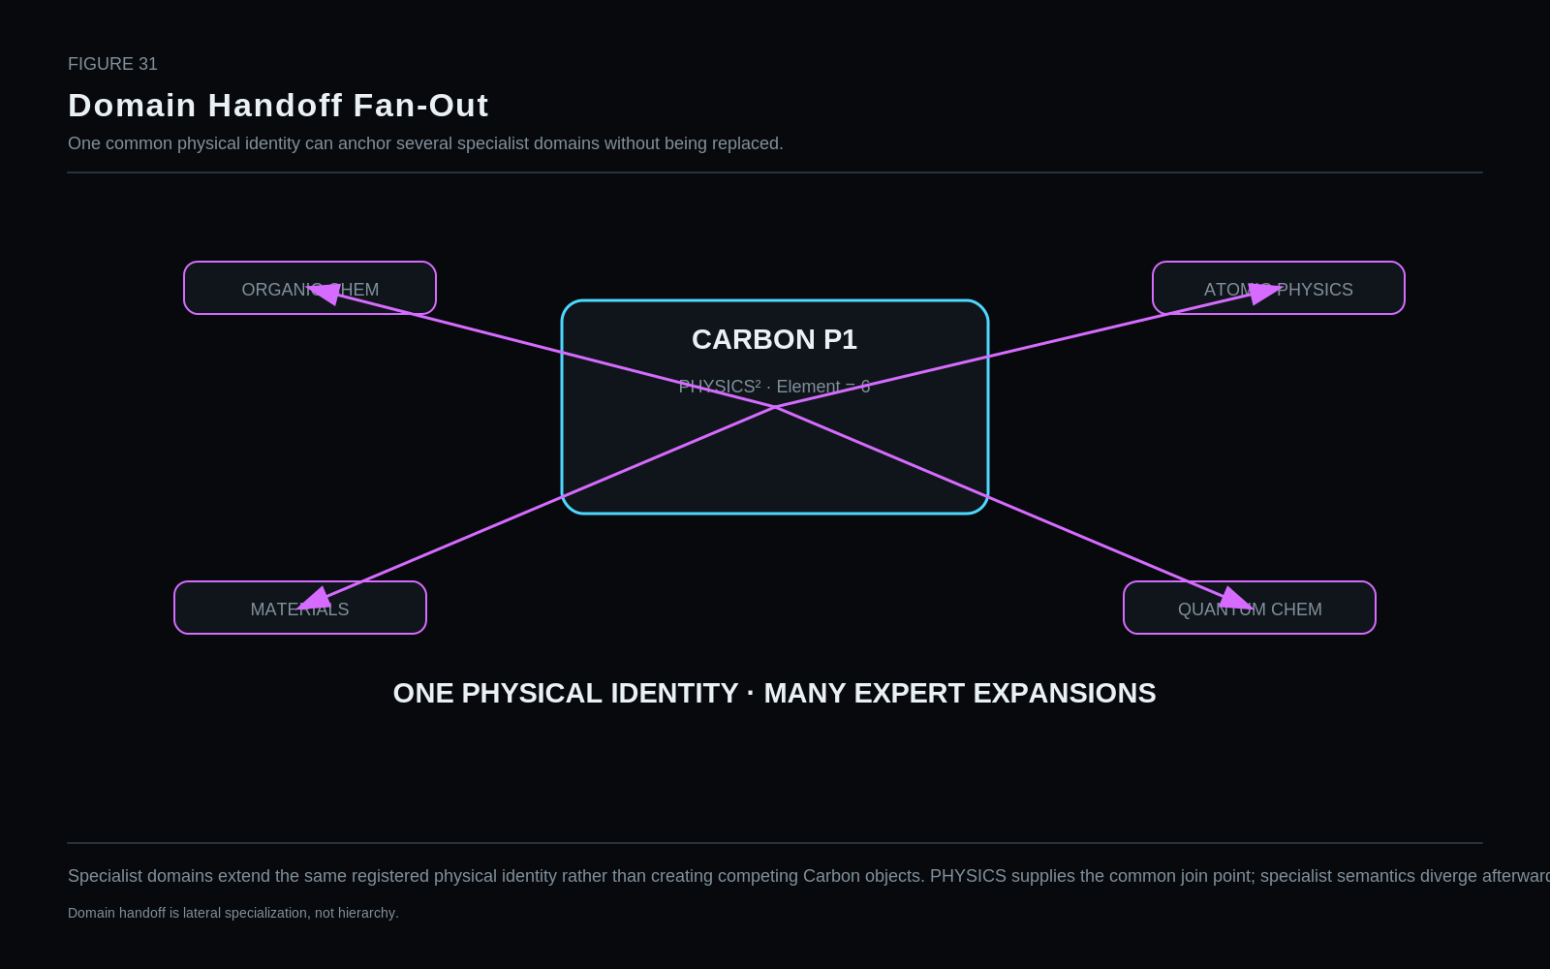
Specialist domains extend the same registered physical identity rather than creating competing Carbon objects. PHYSICS supplies the common join point; specialist semantics diverge afterward.
Restraint: Domain handoff is lateral specialization, not hierarchy.

86. Chemistry Handoffs
Benzene illustrates the boundary: PHYSICS can provide carbon/hydrogen identities and structural relationships, while organic chemistry owns aromaticity, resonance, reaction semantics, and richer bonding interpretation.

87. Materials and Crystallography Handoffs
NaCl illustrates a different boundary. PHYSICS can expose sodium/chlorine identities and ionic relation semantics, while crystallography and materials science own lattice, unit-cell, defect, phase, and bulk-property structures.

88. Mechanics and Quantity Handoffs
A falling-body example demonstrates that a physical relationship is not a numerical solution. Mass, distance, velocity, acceleration, geometry, units, and dynamics route to typed quantitative and mechanics systems.

89. Quantum and QCD Handoffs
Proton valence uud is a bounded educational/structural projection, not the complete proton QCD state. Entangled photons similarly route to a shared QSTATE rather than local flags. In both cases the common layer stops deliberately.

Figure 32. Shared Identity, Divergent Expertise
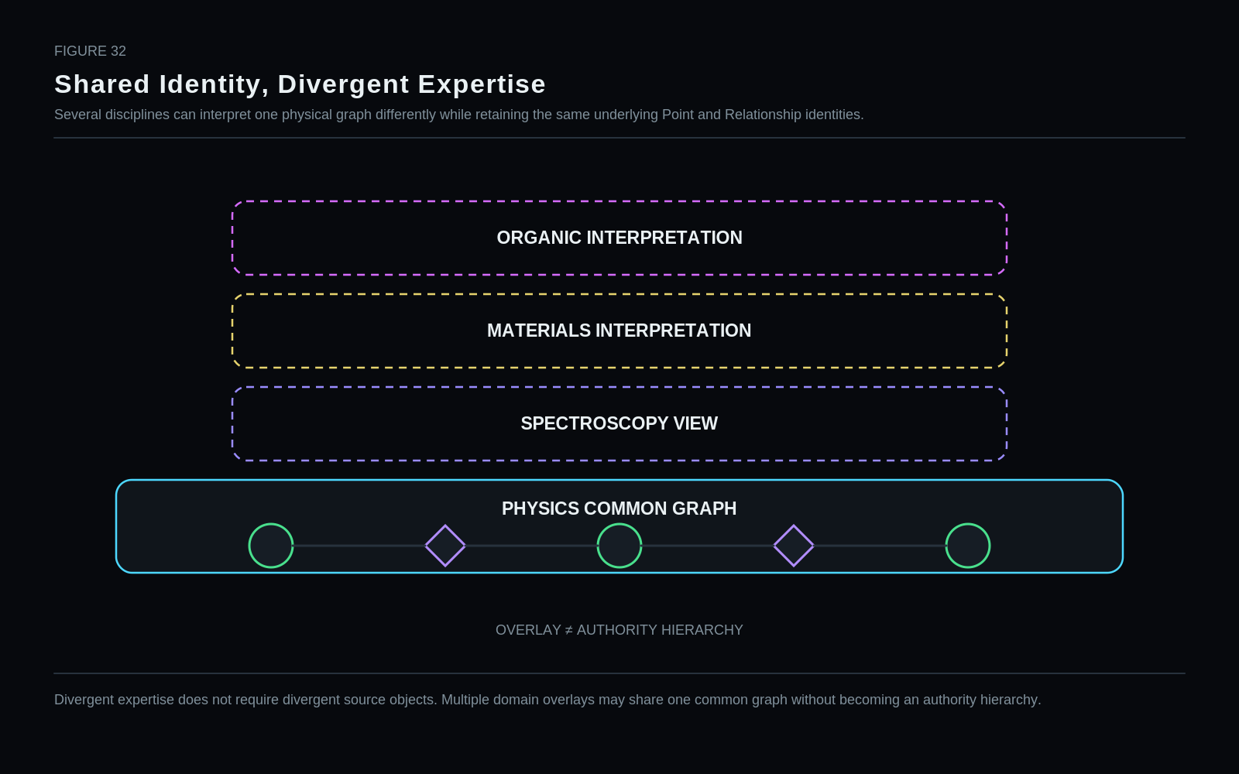
Divergent expertise does not require divergent source objects. Multiple domain overlays may share one common graph without becoming an authority hierarchy.

Part XIV — Worked Examples & Boundary Tests
PART THESIS: Stress the common joiner against examples from chemistry, mechanics, atomic, nuclear, particle, and quantum state.

90. Worked Example — Oxygen-18 2-
Oxygen-18²⁻ demonstrates atomic compositional economy. Element=8, Neutrons=10, and Net Charge=-2 are sufficient to derive proton count 8, mass number 18, electron count 10, and formatted isotope/ion notation.

91. Worked Example — Water
Water demonstrates mixed-resolution graph use. The molecule may remain structural while only the Oxygen branch is hydrated into electronic or nuclear state. Hydrogen Points can remain coarse when they are not part of the current question.

Figure 33. Water Across Resolution
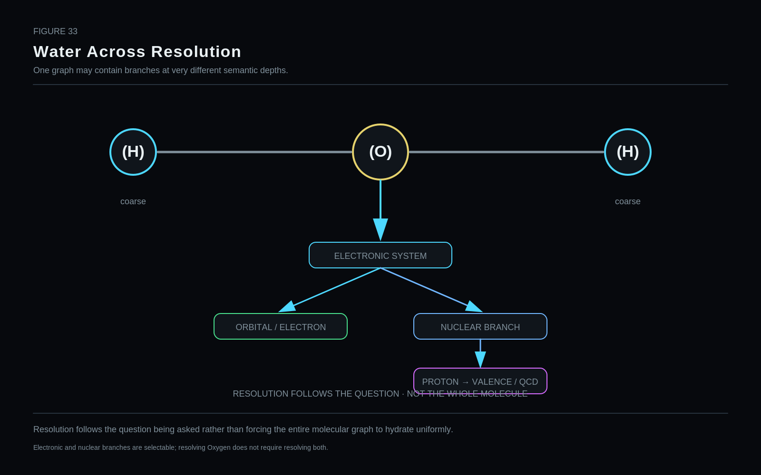
Resolution follows the question being asked rather than forcing the entire molecular graph to hydrate uniformly.
Restraint: Electronic and nuclear branches are selectable; resolving Oxygen does not require resolving both.

92. Worked Example — Carbon Dioxide
CO₂ demonstrates repeated registry identity and relation-order projection. Two Oxygen Points may share one canonical element identity while remaining distinct instances connected to the Carbon Point by separate relationship records.

93. Worked Example — Sodium Chloride
NaCl demonstrates the common-to-specialist boundary. Ionic identity and atomic endpoints can be common; crystal lattice, space group, and material behavior are specialist-owned.

94. Worked Example — Falling Body
A gravitational relationship can be represented without copying the entire mechanics calculation into the relation record. Typed quantity routes supply the numeric state needed by a mechanics runtime.

95. Worked Example — Entangled Photons
Two photon Points may route to one joint QSTATE. The shared state identity preserves membership and correlation structure that two local Entangled=true flags cannot express.

Figure 34. Three Boundary Tests
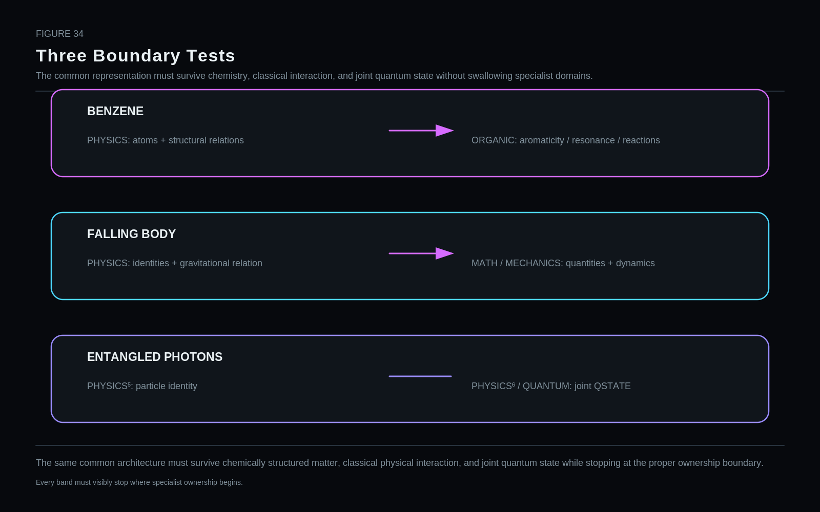
The same common architecture must survive chemically structured matter, classical physical interaction, and joint quantum state while stopping at the proper ownership boundary.
Restraint: Every band must visibly stop where specialist ownership begins.

Part XV — Non-Collapse Law
PART THESIS: Make semantic non-collapse a formal correctness requirement.

96. Non-Collapse Law Register
The architecture is protected by explicit non-collapse laws. Important examples include: Physical Identity ≠ Physical State; Point ≠ Relationship; Relation Type ≠ Relation Order; Element ≠ Isotope ≠ Ion; Ground State ≠ Unspecified; Position ≠ Velocity ≠ Momentum; Force ≠ Energy; Particle Identity ≠ Particle State; Spin Projection ≠ Helicity; Basis ≠ Quantum State; Observable ≠ Result; Graph Topology ≠ Physical Semantics; Mirror Coordinate ≠ Physical Position; Reference ≠ Contents.
Selected non-collapse law register
Code / value | Address | Semantic assignment
Physical Identity | ≠ | Physical State
Element | ≠ | Isotope / Ion / Electronic State
Relation | ≠ | Process / Event
Spin Projection | ≠ | Helicity
Quantum State | ≠ | Measurement Result
Basis | ≠ | Quantum State
Observable | ≠ | Result
Entanglement | ≠ | Two local flags
Mirror Coordinate | ≠ | Physical coordinate
Image | ≠ | Semantic state

97. Epistemic and Display Boundaries
Scientific truth, a CERBERUS representation, a Reader projection, a rendered image, a measurement result, and an observer’s knowledge are different semantic objects. Keeping them distinct makes later correction possible.

Part XVI — Provisional Bit Family
PART THESIS: Publish candidate widths as hypotheses, not commitments.

98. Provisional Bit Family — PHYSICS-26-49-76-92-119-182
The current cumulative labels remain reference candidates rather than canonical widths. They record the hypothesis entering implementation. Wave D–F review has already exposed fields likely to move, split, disappear, or expand.
Bit count is an output of semantic design. A smaller number is accepted only if required distinctions remain intact; a larger number is accepted when extra width prevents semantic collapse.

Figure 35. Provisional PHYSICS Bit Ladder
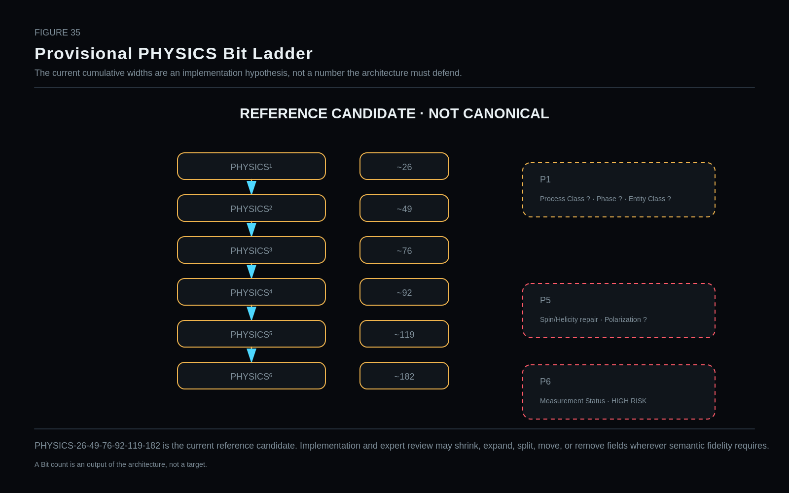
PHYSICS-26-49-76-92-119-182 is the current reference candidate. Implementation and expert review may shrink, expand, split, move, or remove fields wherever semantic fidelity requires.
Restraint: A Bit count is an output of the architecture, not a target.

Part XVII — Implementation & Falsification
PART THESIS: Let implementation expose false assumptions, then repair the earliest responsible owner.

99. Implementation, Validation, and Falsification
Paper-first implementation freezes a hypothesis before Airtable, SK Reader, Mirror Graph, and domain stress tests begin. Failures are classified by lowest responsible layer: domain science, PHYSICS semantics, SK encoding, registry design, Reader, Mirror, Airtable schema, or display.
The repair rule is earliest-owner repair. A broken symbol lookup is not evidence that particle semantics are wrong; a collapsed particle field is not fixed by changing a grid formula. Every correction is followed by retest.
Field | Value
Failure class | Example
DOMAIN SCIENCE | Scientific content or applicability is wrong
SEMANTIC COLLAPSE | One field merges distinctions that must remain separate
MISSING COMMON STATE | A cross-domain distinction actually required is absent
REDUNDANT BITGROUP | The value is derivable or registry-owned
DOMAIN LEAKAGE | A specialist concept is forced into common PHYSICS
READER / MIRROR / AIRTABLE / DISPLAY FRICTION | Infrastructure failure; not automatically evidence against the semantic abstraction

Figure 36. Hammer the Nonsense Out
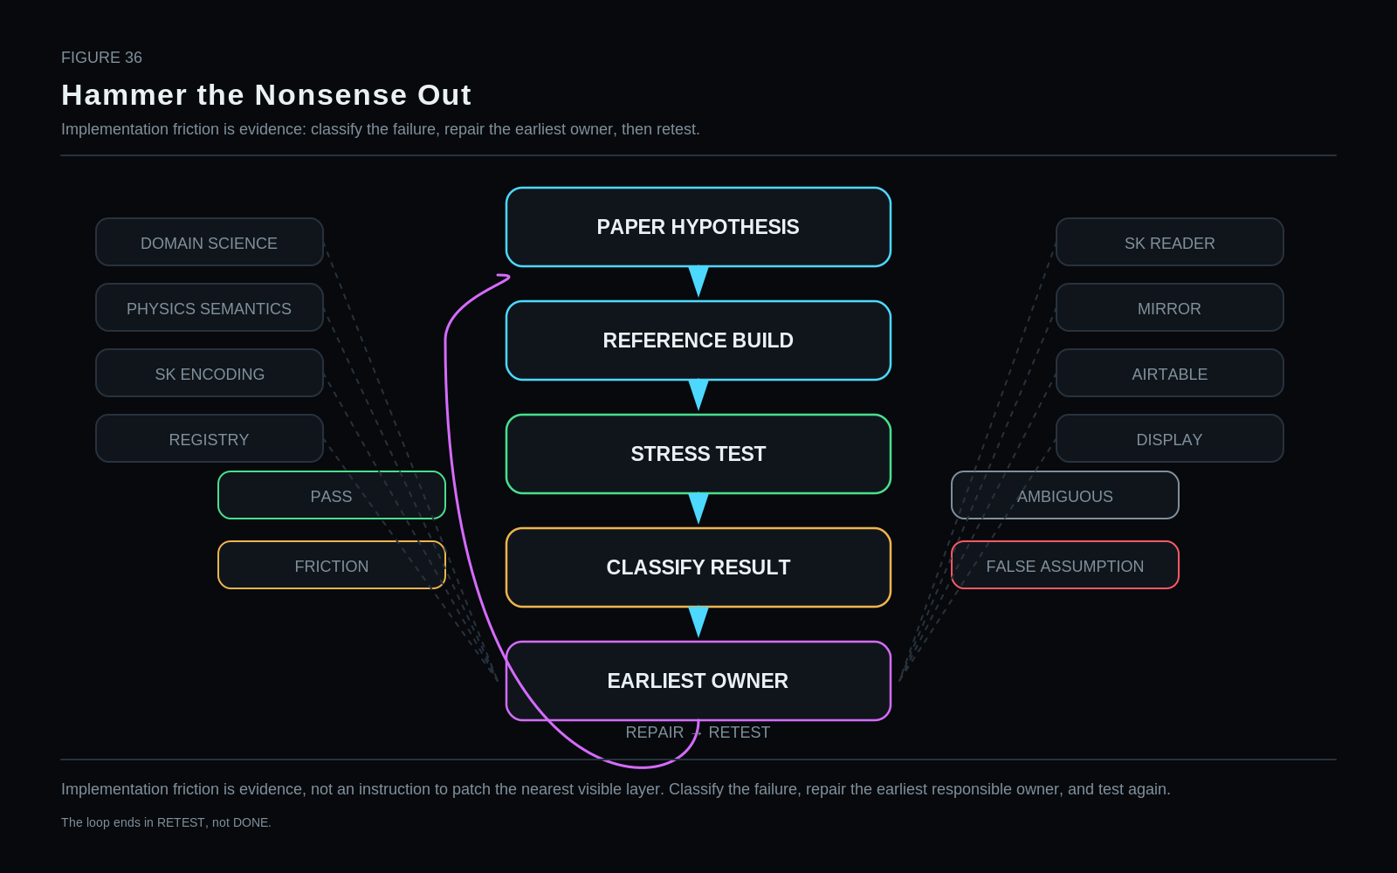
Implementation friction is evidence, not an instruction to patch the nearest visible layer. Classify the failure, repair the earliest responsible owner, and test again.
Restraint: The loop ends in RETEST, not DONE.

Part XVIII — Conclusion
PART THESIS: Conclude with the representation law that survives across all six strata.

100. Conclusion
CERBERUS PHYSICS is a proposal for shared physical semantic infrastructure: identify what must remain common, keep reusable identity in registries, keep mutable state with instances, derive recoverable facts, reference state too rich to repeat, route specialist interpretation outward, and resolve only as deeply as the current question requires.
The strongest result is not a particular bit count. It is a disciplined place to stand between established science and executable semantic systems without confusing the representation with the reality it describes.

