CERBERUS

Generate Spec Architecture
Registry-Driven Semantic Kernel Compilation, D/E/F/G Figure Construction, and Professional Publication Workflow
BOOTSTRAP ARCHITECTURE | v0.1 | AUGUST 2026
Core publication law
A Semantic Kernel Specification is a published projection of governed registry state, not an independent source of semantic truth.

Operational law
Corrections flow upstream. Publications flow downstream.

Purpose
This paper defines the intended architecture for a future Generate Spec command. It is designed to function first as a build blueprint, later as a verified operational paper regenerated from the implemented system, and finally as the source for a compact command README.

Executive Summary
Generate Spec converts governed CERBERUS registry state into reproducible professional Semantic Kernel specifications. The workflow moves semantic authority upstream into Airtable, BOSS, BIGFOOT, Community and World registries, SK Memory, Reader contracts, and D/E/F/G semantic manifestations. The generated Word document becomes a versioned downstream view of a frozen registry snapshot rather than a competing truth store.
The target command accepts a semantic publication target such as a Community or BitWord, resolves exact stable identities, freezes a publication snapshot, validates required data, traverses the registered vocabulary, compiles a format-independent SpecPack, resolves authorized D/E/F/G figure manifests, assembles a publication profile, renders the requested artifact, performs visual quality assurance, and publishes the result with a generation manifest.
The bootstrap version of this paper intentionally describes target behavior rather than claiming that every table, field, validation routine, and runtime step is already implemented. Once the system is built and edited, the same paper structure should be regenerated from the implemented records. That regenerated paper becomes operational documentation and can then be distilled into the README for the Generate Spec command.
Bootstrap status
Table names, field bindings, validation routines, renderer behavior, and command details in this document are design requirements until implemented and verified. The operational edition must be regenerated from actual implemented state.

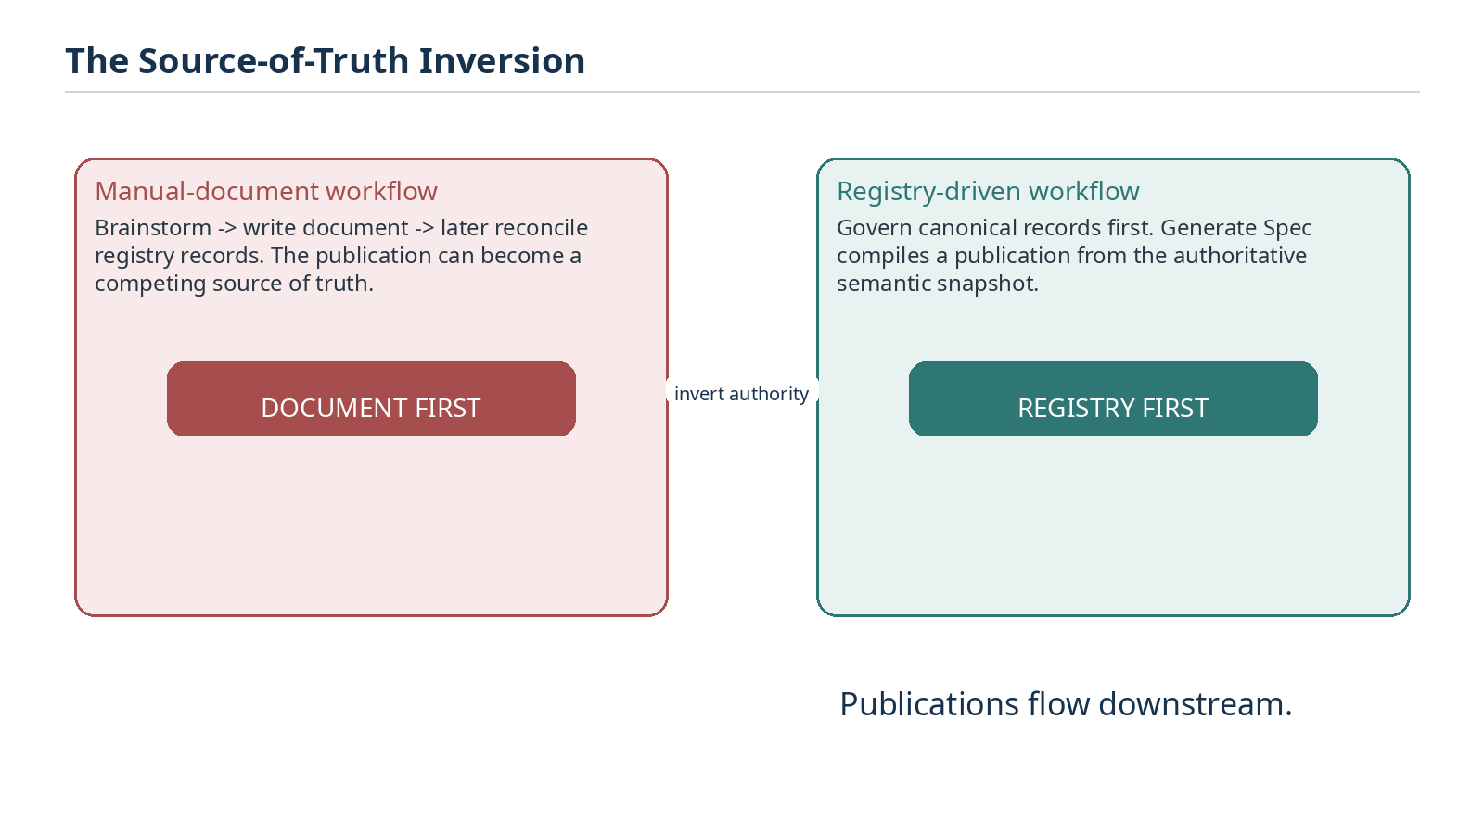
Figure 1. The authority inversion moves semantic truth from documents into governed registries.
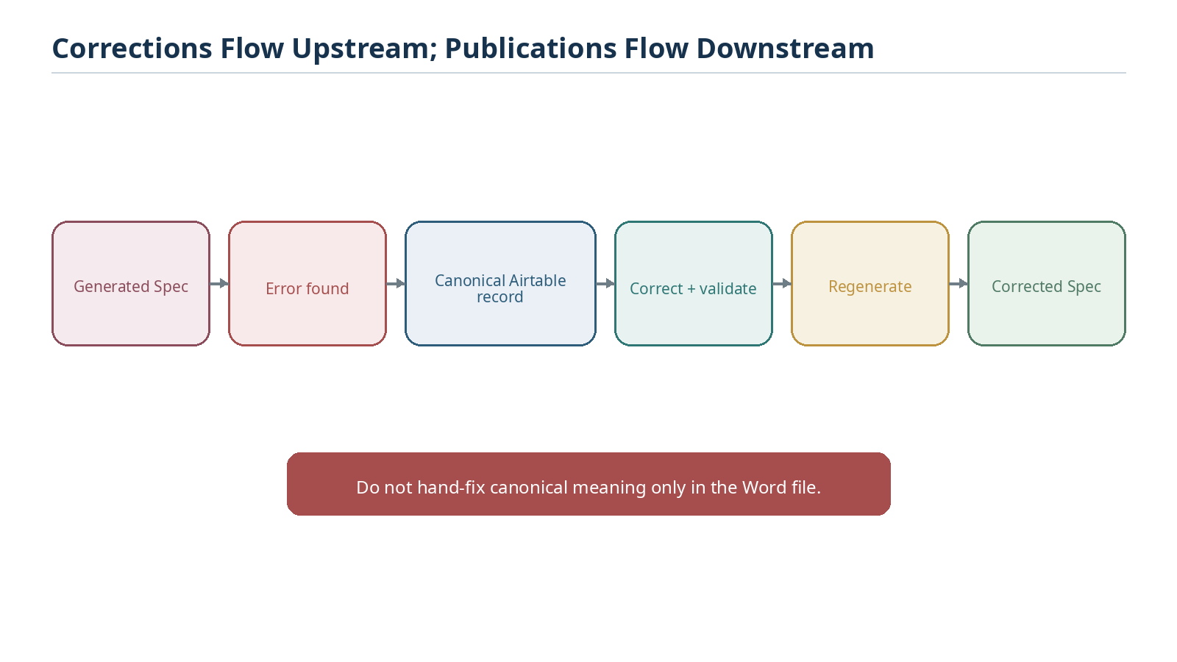
Figure 2. Corrections repair canonical records first; generated publications are regenerated downstream.

Contents
1. Purpose, Scope, and Design Laws
2. Source-of-Truth Architecture
3. Publication Targets and Semantic Resolution
4. The Generate Spec Compiler Pipeline
5. The SpecPack Intermediate Representation
6. Publication Profiles and Narrative Authority
7. D/E/F/G Figure Construction
8. Airtable-Assisted Authoring Workflow
9. Validation, Failure, and Change Management
10. Rendering, Visual QA, and Publication
11. Versioning and Reproducibility
12. Bootstrap-to-Operational Lifecycle
Appendix A. Target Implementation Tables and Fields
Appendix B. Future Generate Spec Command Contract
Appendix C. Build Checklist

1. Purpose, Scope, and Design Laws
The purpose of Generate Spec is to make professional specification publishing a governed compilation operation. Semantic work is performed and approved in the registries. The command reads that state, proves that the required publication inputs exist, and creates a professional artifact whose semantic content can be traced back to stable source records.

1.1 Intended lifecycle
This architecture is intentionally recursive. The present paper is the bootstrap specification for the workflow. It should be used while building the Airtable tables, bindings, validation logic, figure manifests, and renderer. When those systems become authoritative, this same paper should be regenerated from them and converted from target architecture into operational documentation.
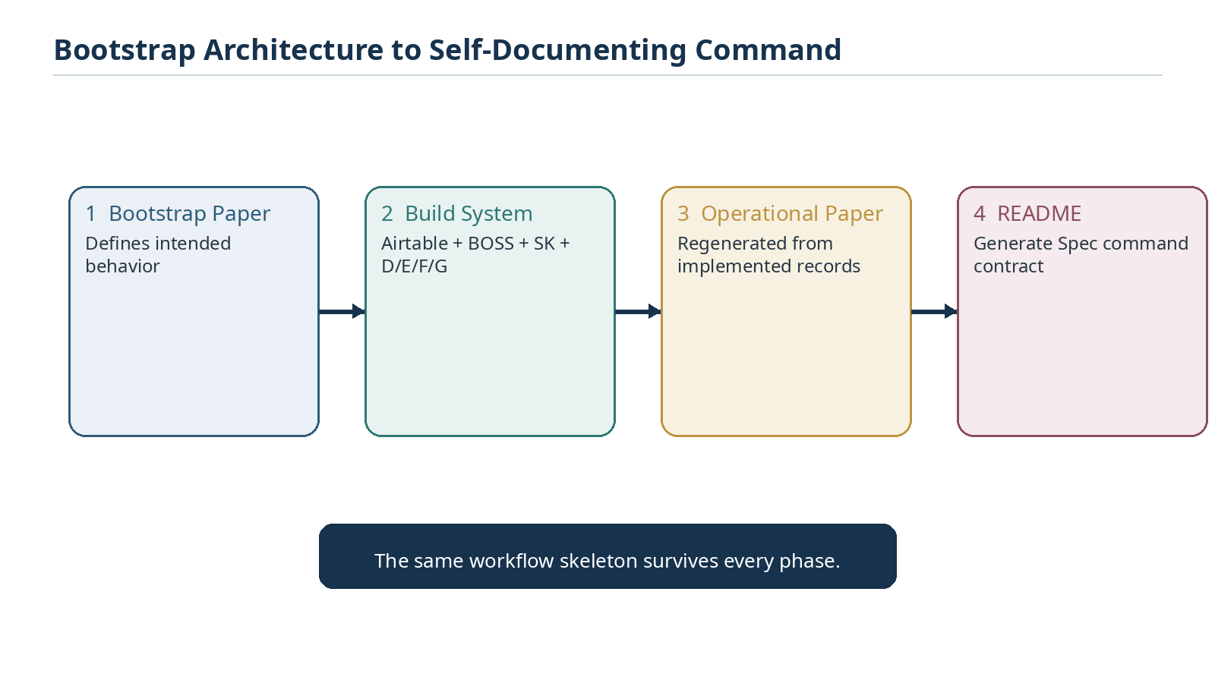
Figure 3. The paper itself progresses from bootstrap design to build guide, operational paper, and command README.

1.2 Core design laws
Law | Requirement
Registry Authority | Canonical semantic facts live in governed registries, not only in generated documents.
Upstream Correction | A semantic error discovered in an artifact is corrected at its authoritative source and then regenerated.
Frozen Publication | Each generation run uses an internally stable snapshot of target identities, versions, ordering, memory, and figure bindings.
Validation Before Prose | Missing canonical data is surfaced before editorial generation; the publication engine does not silently fabricate semantic truth.
Figure Semantics First | D/E/F/G records define semantic composition. Rendered images are manifestations, not truth stores.
Profile Separation | The same compiled semantic payload may render through different authorized publication profiles.
Reproducibility | A generation manifest identifies the source snapshot and enough configuration to reproduce the semantic publication.
Historical Integrity | Older records resolve through the historical SK and World snapshots that governed them.

Architecture equation
Generate Spec = Resolve + Frozen Registry State + Validation + SpecPack + D/E/F/G Figure Program + Publication Profile + Render/QA.

2. Source-of-Truth Architecture
Generate Spec depends on CERBERUS becoming sufficiently self-describing that the publication engine can discover all required content from a target coordinate. Airtable provides the canonical operational records; BOSS provides symbolic context and form bindings; BIGFOOT provides stable semantic identities and relations; Community and World structures provide bounded language context; SK records provide exact Bit/BitGroup/BitWord semantics; SK Memory provides teaching fields; SOLAR provides aliases and linguistic routing; D/E/F/G provide authorized semantic figure compositions.

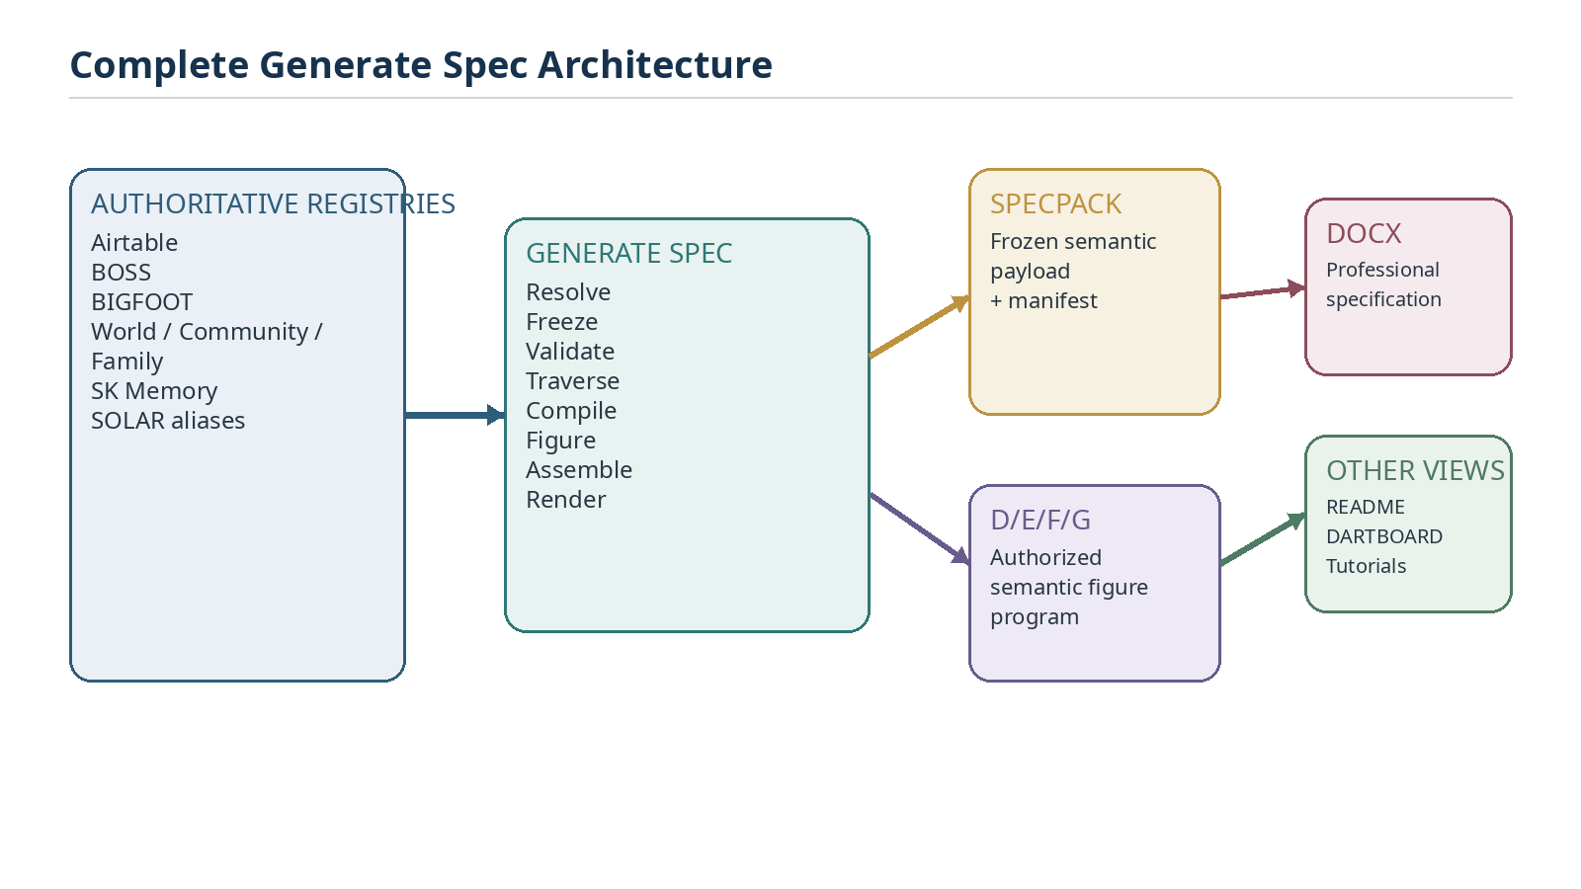
Figure 4. The complete architecture separates authoritative registries, compilation, semantic figure programs, and publication outputs.

2.1 Authority classes in the document
Generated specifications contain three different classes of content. Keeping these classes explicit prevents polished prose from becoming an accidental source of semantic authority.
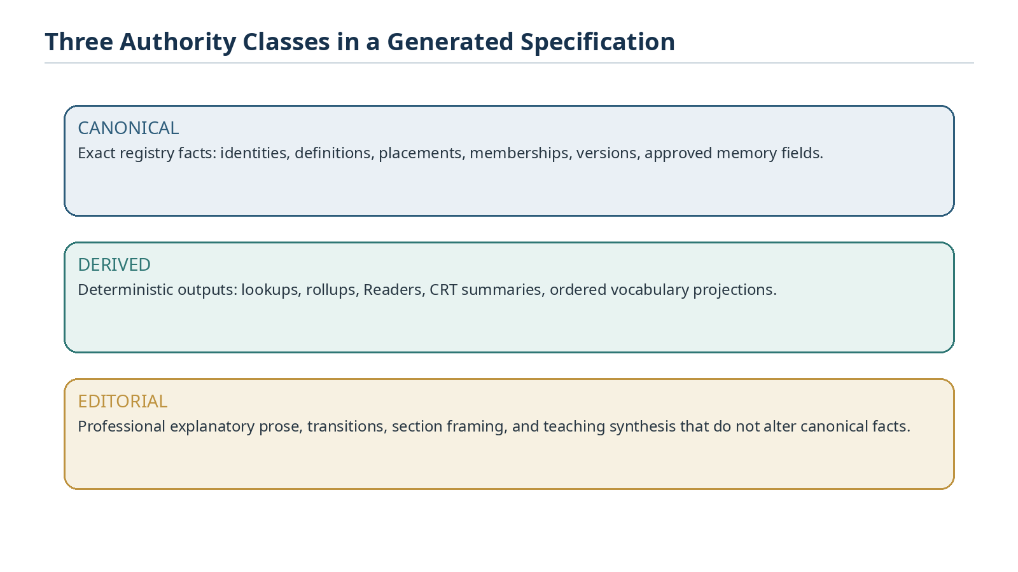
Figure 12. Canonical, derived, and editorial content have different authority boundaries.
Class | Examples | May generator alter semantic content?
Canonical | Stable IDs, definitions, placements, Family/Community/World membership, approved examples, versions | No
Derived | Lookups, rollups, CRT summaries, Readers, ordered vocabulary projections | Only through deterministic source logic
Editorial | Introductions, connective explanation, synthesis, teaching transitions, captions | Yes, if consistent with canonical and derived inputs

3. Publication Targets and Semantic Resolution
The future command should begin from a semantic target rather than from a manually supplied bundle of fields. For a Descriptive Semantic Kernel, the preferred entry point is the Community or its authoritative BitWord. The target is then used to recover the complete publication context through explicit links.

3.1 Community entry point
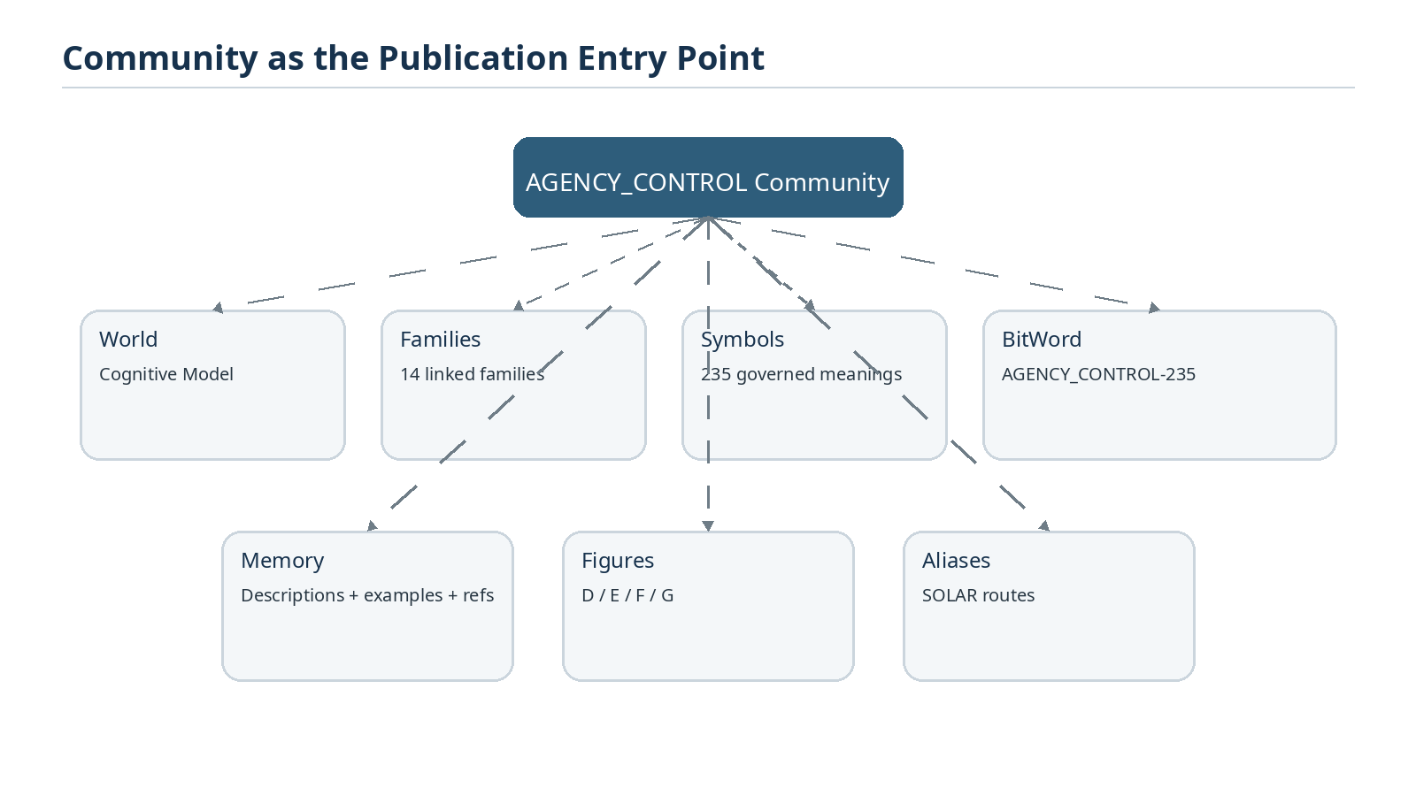
Figure 5. A Community target exposes the World, Families, Symbols, BitWord, memory, aliases, and figure program required for publication.
A Community is particularly suitable for Descriptive SK generation because it corresponds to one bounded symbolic language. Once linked correctly, the Community becomes the query root for vocabulary compilation and the publication engine does not need the user to re-enter the width, Family inventory, symbol inventory, examples, or World context.

3.2 BitWord entry point
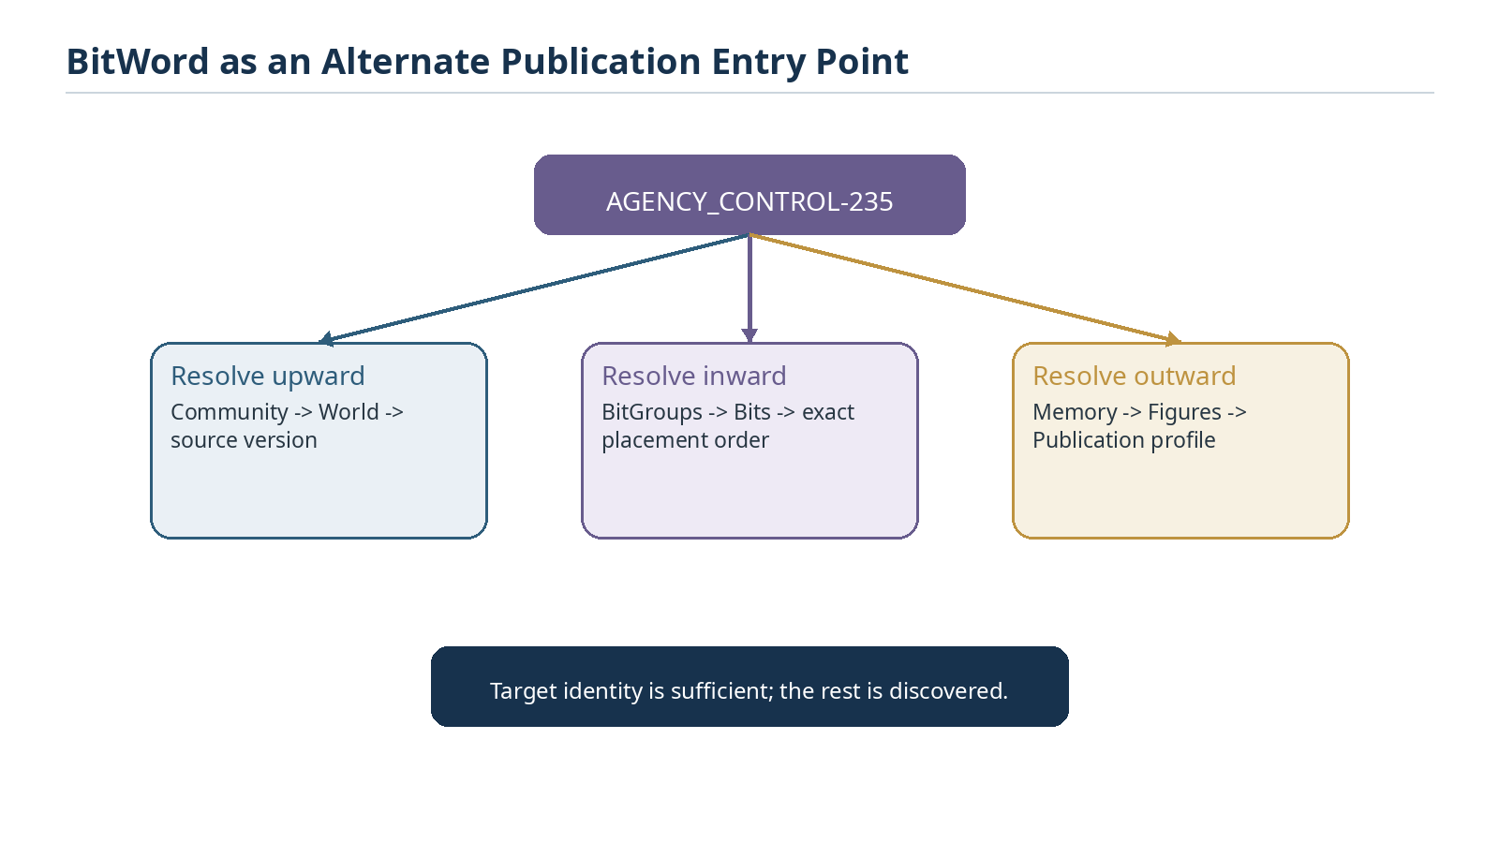
Figure 6. A BitWord can resolve upward to contextual ownership, inward to exact placements, and outward to publication memory and figures.

3.3 Human labels resolve to stable targets
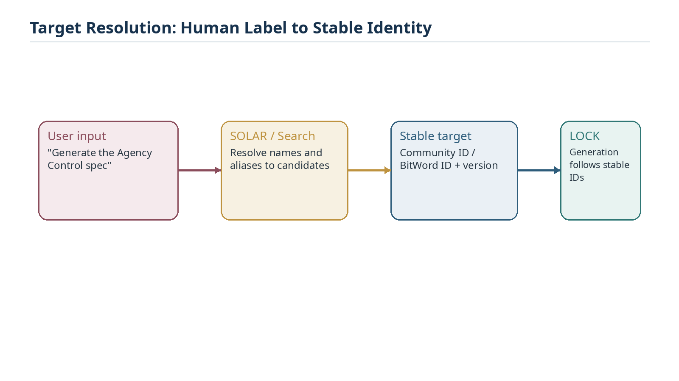
Figure 7. Natural names and aliases may help locate the target, but generation locks onto stable semantic identities and versions.
SOLAR and search surfaces can assist discovery, but alias text is not itself the authority for generation. Once the intended Community or BitWord is resolved, the run should use stable IDs and explicit version bindings. Ambiguity must remain explicit rather than being silently converted into a publication target.

4. The Generate Spec Compiler Pipeline
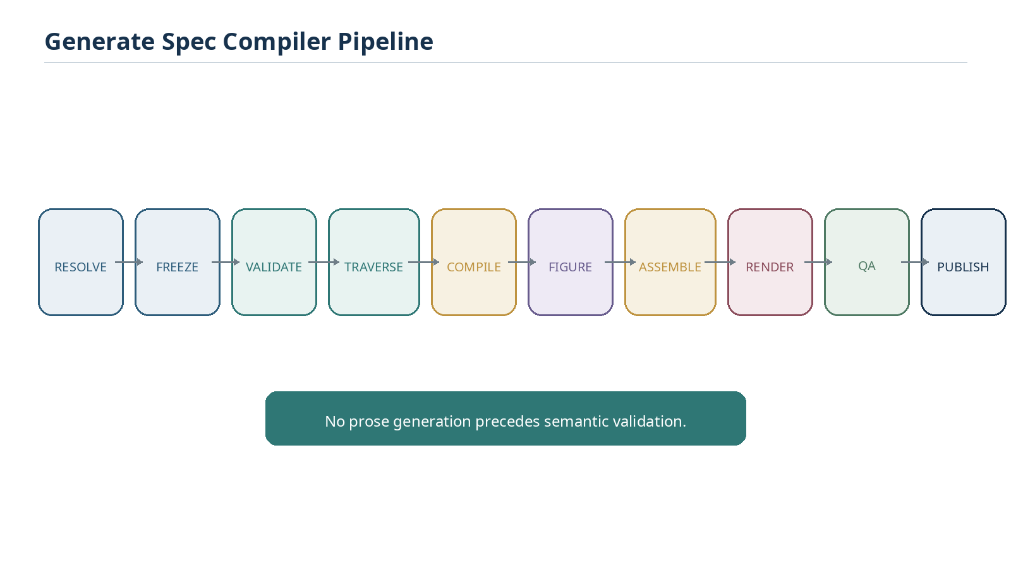
Figure 8. The canonical compiler sequence is Resolve, Freeze, Validate, Traverse, Compile, Figure, Assemble, Render, QA, and Publish.

4.1 Resolve
Resolve identifies the exact target record and all required ownership relationships. For a Community target this includes its World, source specification/version, linked Families, Semantic Symbols, authoritative BitWord, BitGroups, Bits, Reader contracts, SK Memory, and eligible figure bindings. Exact IDs take precedence over names or aliases when available.

4.2 Freeze
Freeze establishes the semantic snapshot for the publication run. Without a freeze boundary, concurrent registry edits could cause the opening pages of a document to reflect one state while later pages reflect another. The freeze need not duplicate the entire database; it needs to preserve the exact resolved record identities, versions, values, order, and binding state required to reproduce the run.
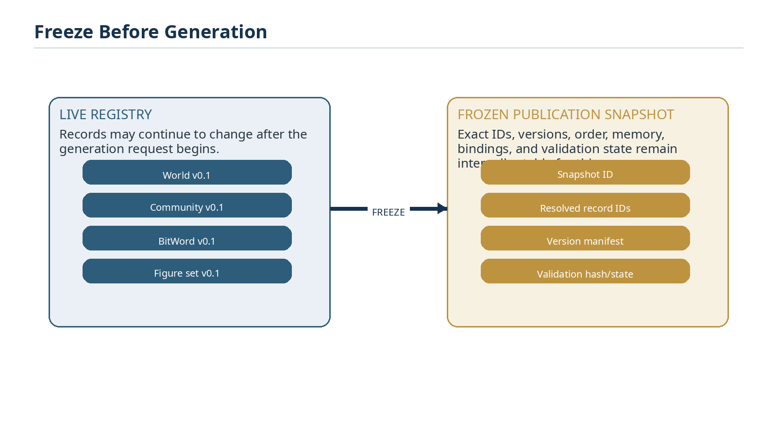
Figure 9. The live registry may continue changing while the frozen publication snapshot remains internally stable.

4.3 Validate
Validation establishes that the source graph is publishable under the selected profile. Required checks should be explicit and profile-dependent. A Descriptive SK profile may require World resolution, Community identity, Family paths, Semantic Symbol bindings, exact Bit placement order, required teaching-memory fields, source version, and a valid publication target. References may be permitted to remain blank where the authoring standard allows them.
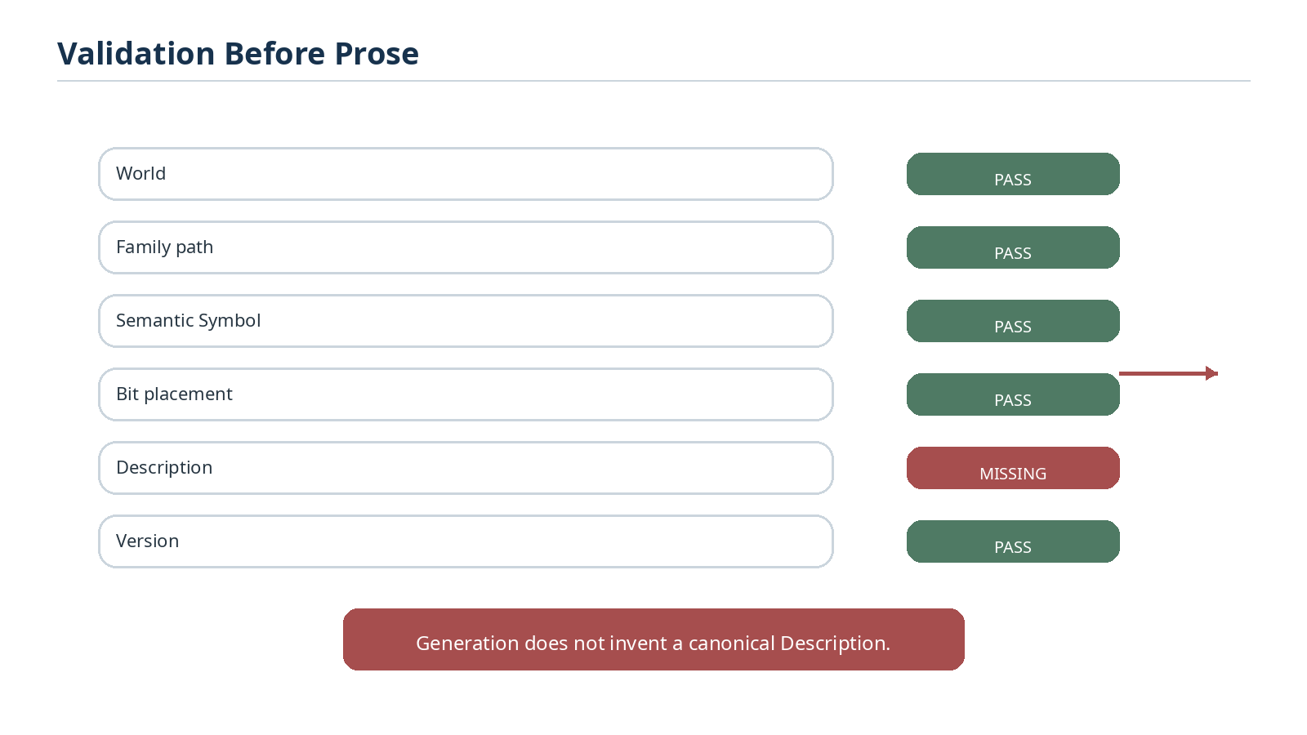
Figure 10. A missing canonical field is a validation condition, not a prompt for silent prose invention.
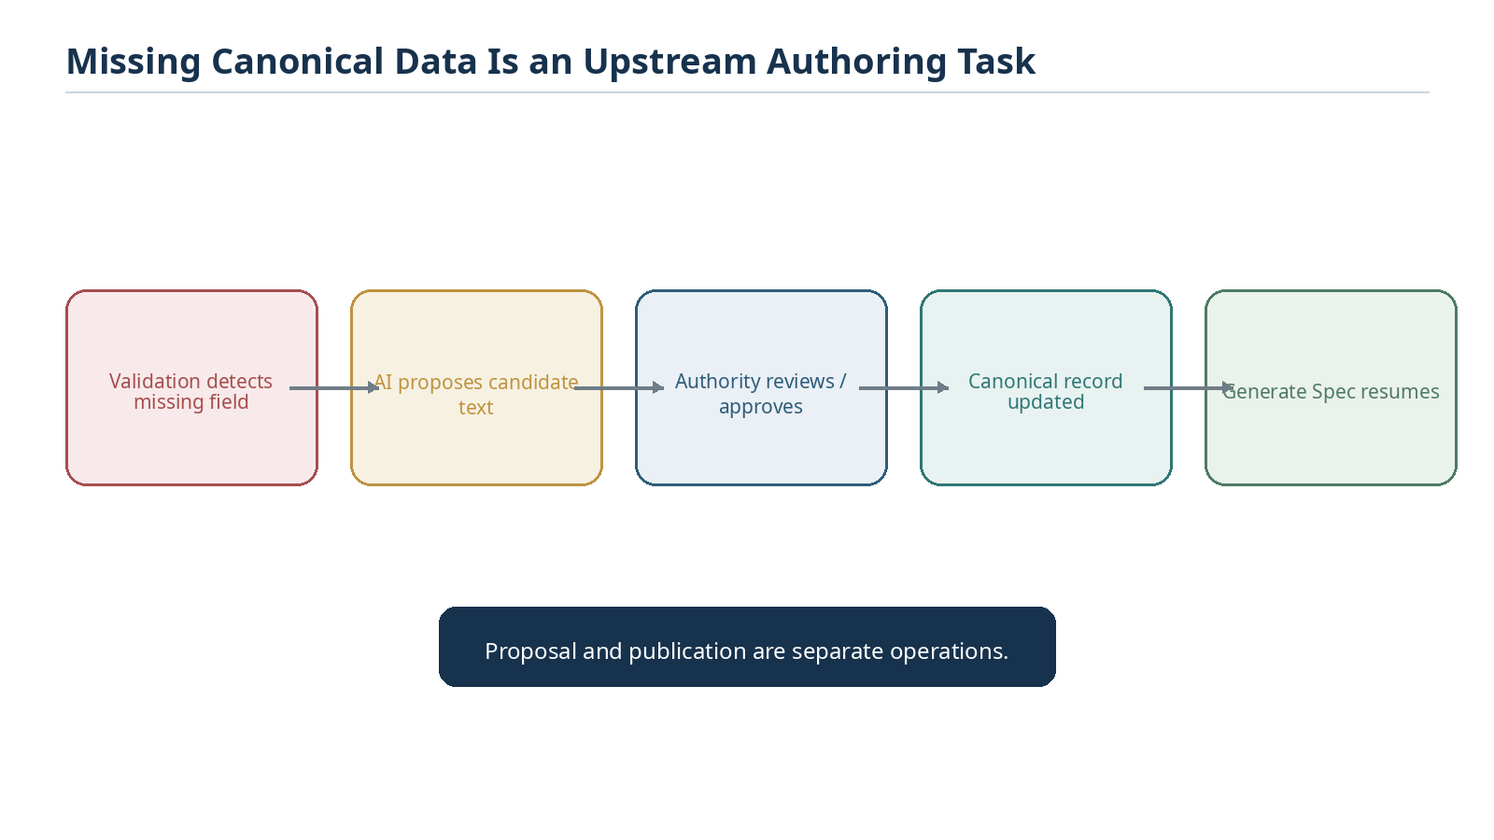
Figure 11. When canonical data is missing, AI may propose an upstream edit for approval before publication resumes.

4.4 Traverse and compile
Traversal walks the registered semantic graph rather than parsing a prior Word document. The exact traversal depends on the target, but a Community publication typically moves through World, Community, Family, Semantic Symbol, BitGroup, and Bit structures while collecting associated memory, Reader, relation, and publication records.
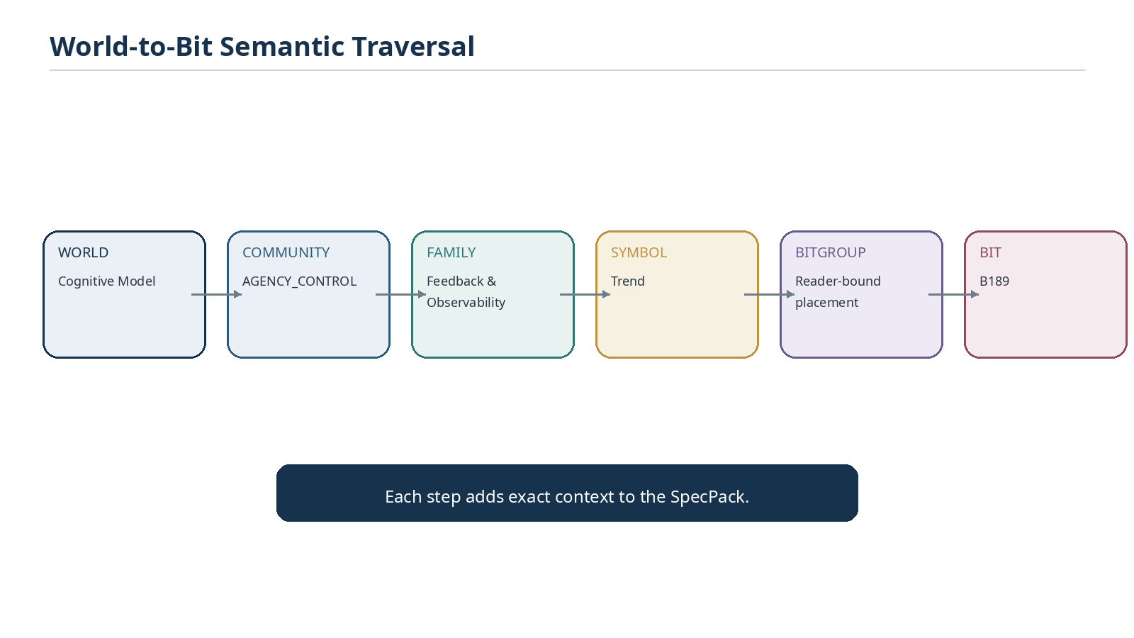
Figure 13. World-to-Bit traversal progressively adds exact context to the compiled publication payload.
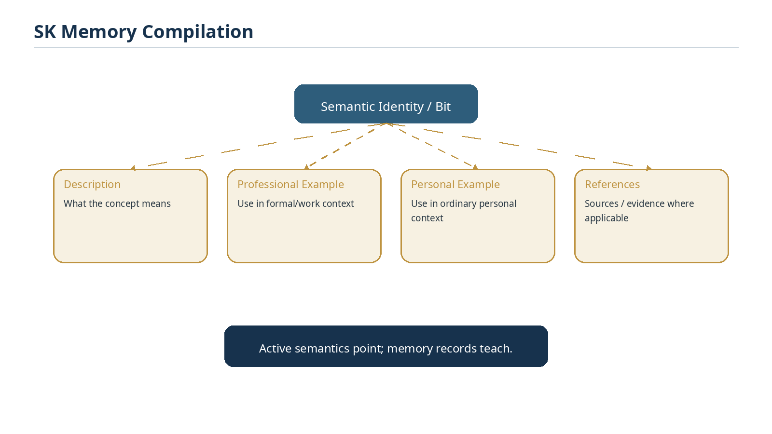
Figure 14. SK Memory supplies the teaching fields associated with active semantic identities.

4.5 Figure, assemble, render, QA, publish
After semantic validation and compilation, Generate Spec resolves the authorized D/E/F/G Figure Program, assembles the selected publication profile, renders the artifact, visually verifies it, and publishes it with a manifest. These downstream steps may improve presentation but must not silently mutate the frozen semantic snapshot.

5. The SpecPack Intermediate Representation
The compiler should not couple canonical registry traversal directly to a Word document. A format-independent intermediate representation, referred to here as the SpecPack, gives the system a stable publication payload that can support multiple renderers and makes validation, testing, and reproducibility easier.

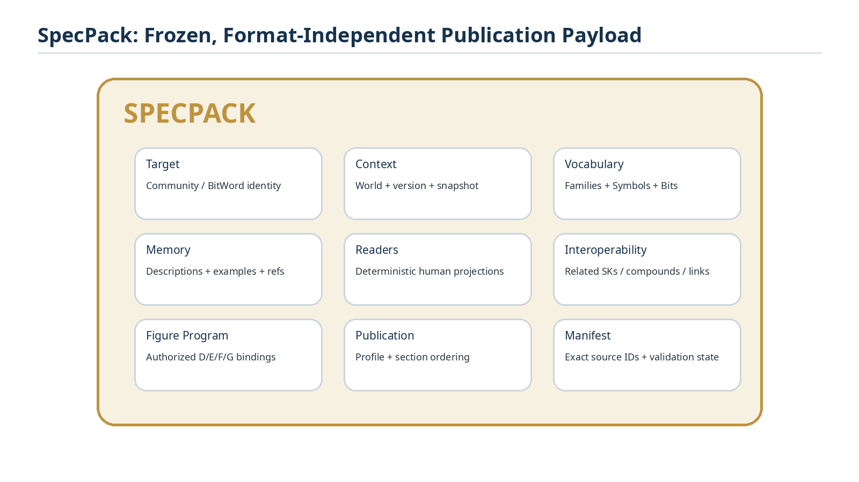
Figure 15. The SpecPack contains the frozen semantic payload, teaching memory, figure program, publication metadata, and provenance required for one generation run.
SpecPack section | Contents
Target | Stable target identity, target type, selected version
Context | World, Community, source snapshot, source specification
Vocabulary | Families, Semantic Symbols, BitGroups, Bits, exact canonical order
Memory | Descriptions, professional examples, personal examples, references
Readers | Canonical human-readable projections and output contracts
Interoperability | Declared related SKs, compounds, Bitlinks, World relationships
Figure Program | Authorized D/E/F/G manifests and publication bindings
Publication | Selected profile, section order, captions, optional inclusions
Manifest | Source record IDs, versions, validation state, generator metadata

5.1 One semantic payload, multiple manifestations
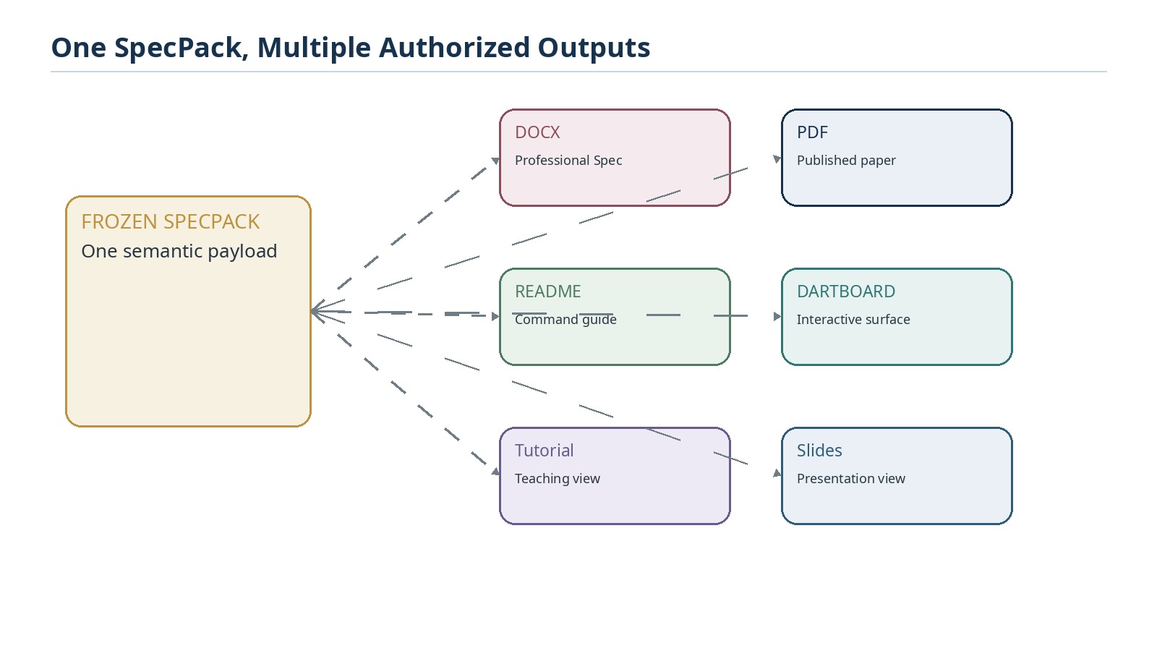
Figure 16. A SpecPack can support several authorized output formats without recompiling semantic meaning.
The Word specification is therefore a manifestation of the SpecPack, not the SpecPack itself. This allows a future PDF, README, DARTBOARD interface, tutorial, or slide deck to use the same validated semantic snapshot while applying a different renderer or publication profile.

6. Publication Profiles and Narrative Authority
Canonical data does not by itself determine the optimal order, typography, figure placement, or explanatory pacing of a professional paper. Publication Profiles specify the authorized document structure while keeping semantic truth separate from presentation.
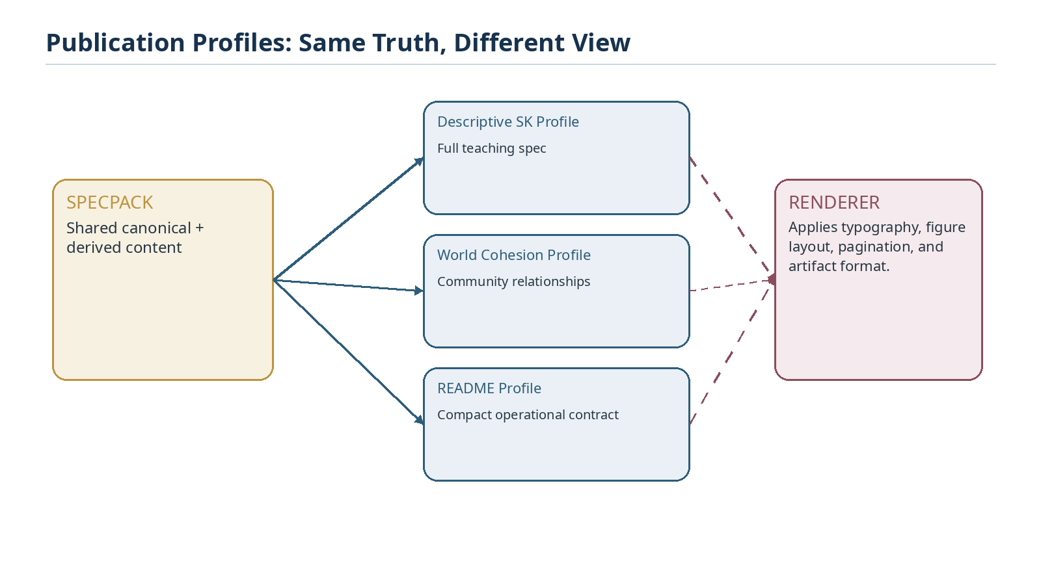
Figure 17. Publication Profiles convert one SpecPack into different authorized document types.

6.1 Professional Descriptive SK Profile
A candidate Professional Descriptive SK Profile should contain the following sections where relevant: title and generation manifest; executive summary; bounded question; owns/does-not-own boundaries; World and Community context; Family architecture; complete vocabulary tables; Reader and explanation behavior; professional and personal examples; D/E/F/G figures; interoperability; versioning and migration; implementation notes; validation and conformance; references.

6.2 Narrative assembly
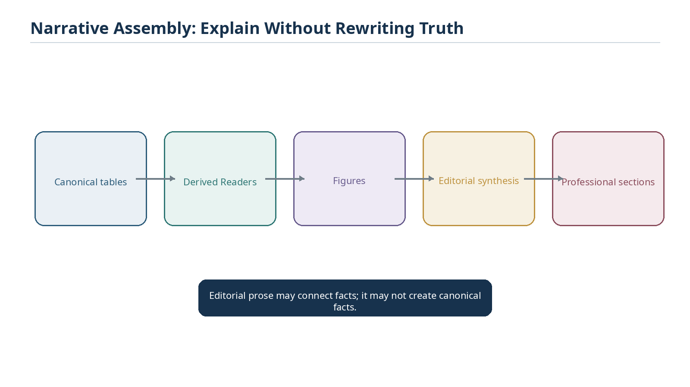
Figure 26. Narrative assembly combines canonical tables, derived Readers, authorized figures, and editorial synthesis without rewriting source truth.
Editorial AI remains valuable. It can compose transitions, emphasize distinctions, explain figures, organize sections, and improve readability. It cannot silently create new semantic identities, change a Bit placement, assign a Family, alter a World, invent a missing canonical definition, or assert an undeclared equivalence. When a required canonical fact is absent, the correct path is upstream authoring and approval.

7. D/E/F/G Figure Construction
D/E/F/G already describes semantic coverage within DARTBOARD. Generate Spec should reuse that existing grammar rather than introduce a competing illustration hierarchy. For publication purposes, the semantic manifestation identifies what is composed; a thin publication binding identifies how and where that composition is presented in a particular paper.

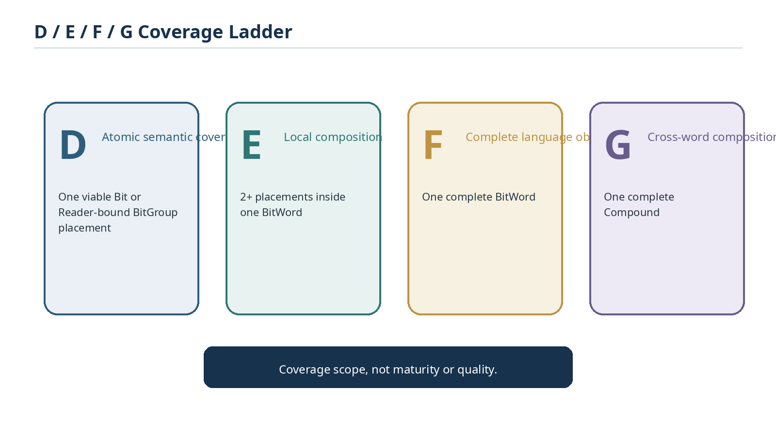
Figure 18. D/E/F/G defines semantic coverage from one placement through a complete Compound; the letters do not represent maturity.

7.1 D - atomic explanatory coverage
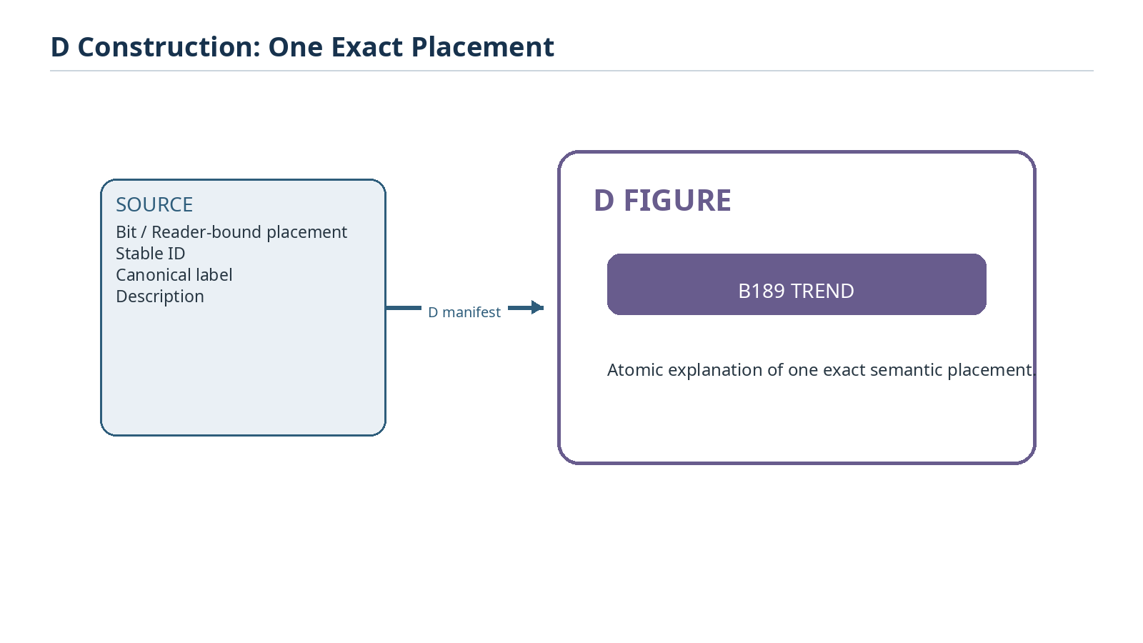
Figure 19. A D figure manifests one exact Bit or Reader-bound BitGroup placement.
D figures are appropriate for an exact semantic primitive or one Reader-bound placement that deserves isolated explanation. All labels should resolve from canonical records so that a figure cannot drift from the underlying semantic identity.

7.2 E - local composition
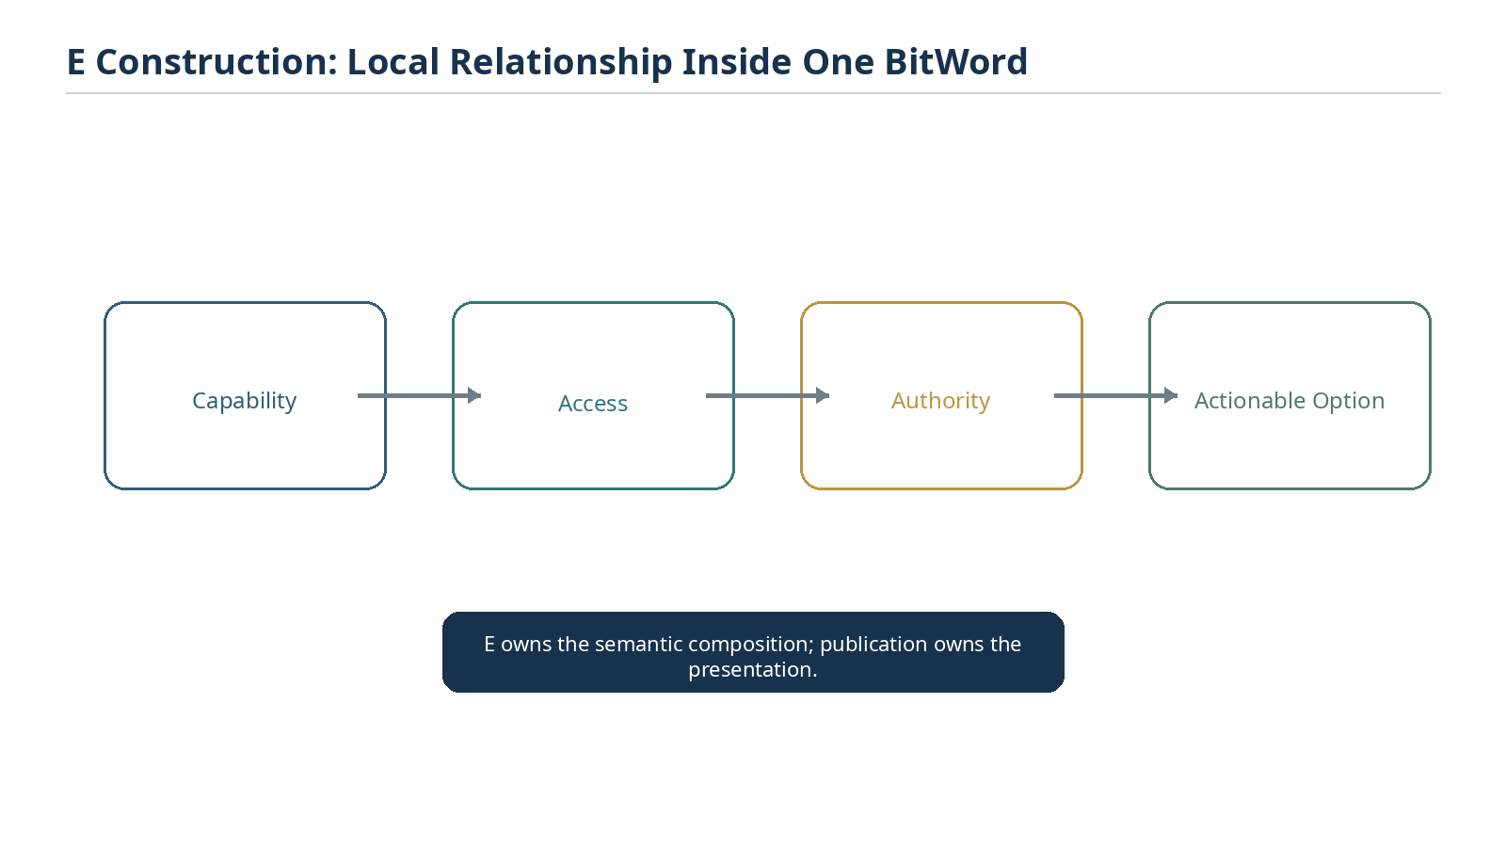
Figure 20. An E figure composes two or more placements inside one BitWord, such as a sequential actionability gate.

7.3 F - complete BitWord
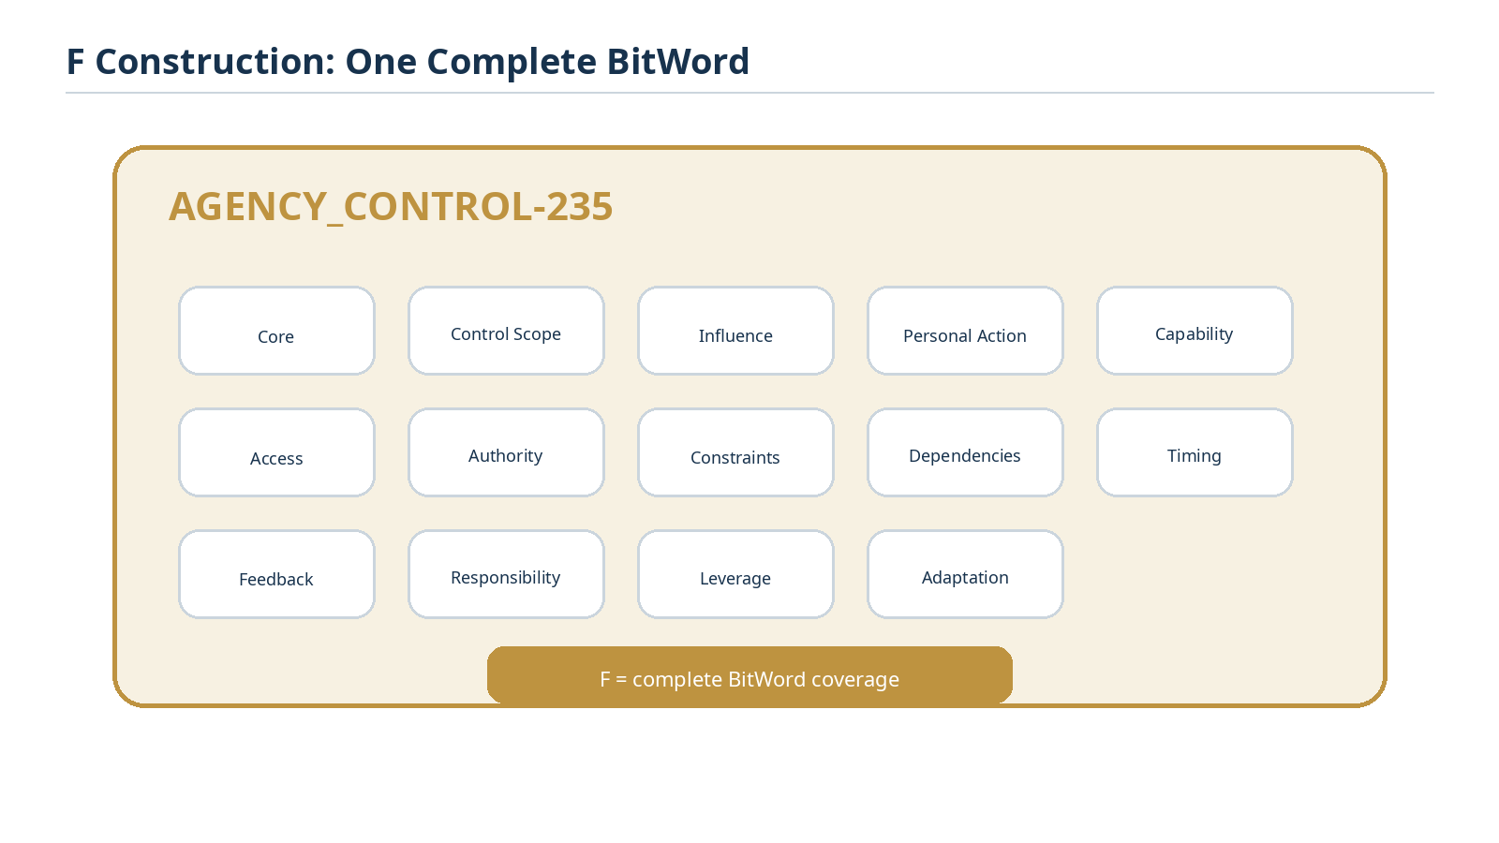
Figure 21. An F figure represents one complete BitWord and can provide a full Community-scale architecture view.

7.4 G - complete Compound
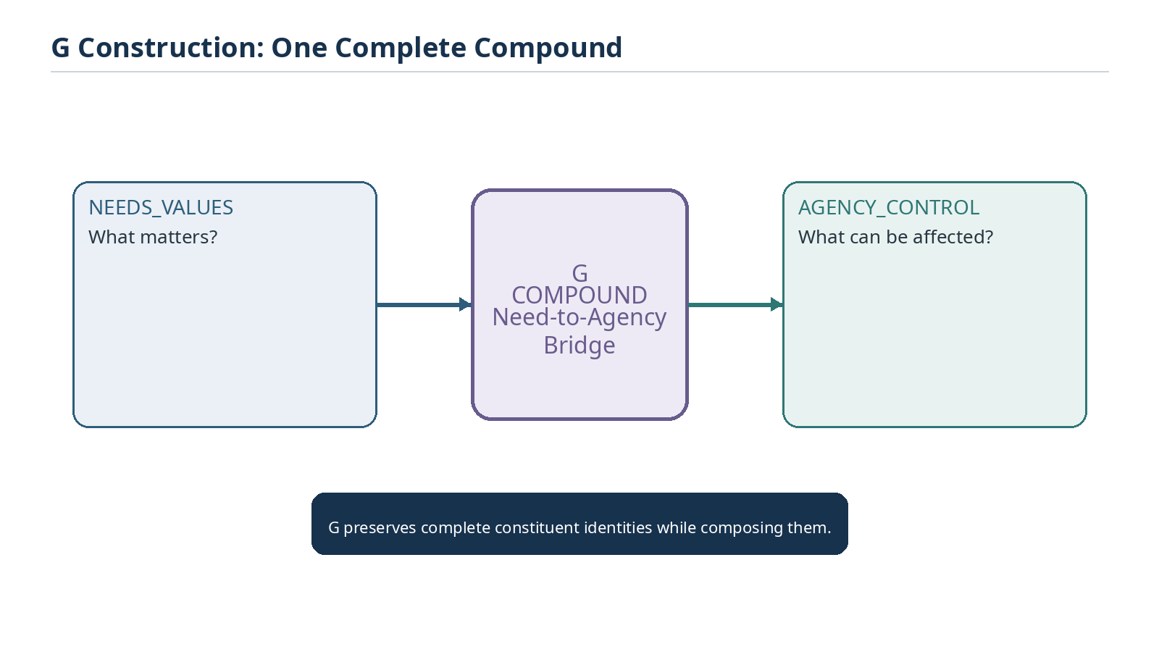
Figure 22. A G figure composes complete constituent semantic structures while preserving their independent identities.

7.5 Semantic manifest versus rendered image
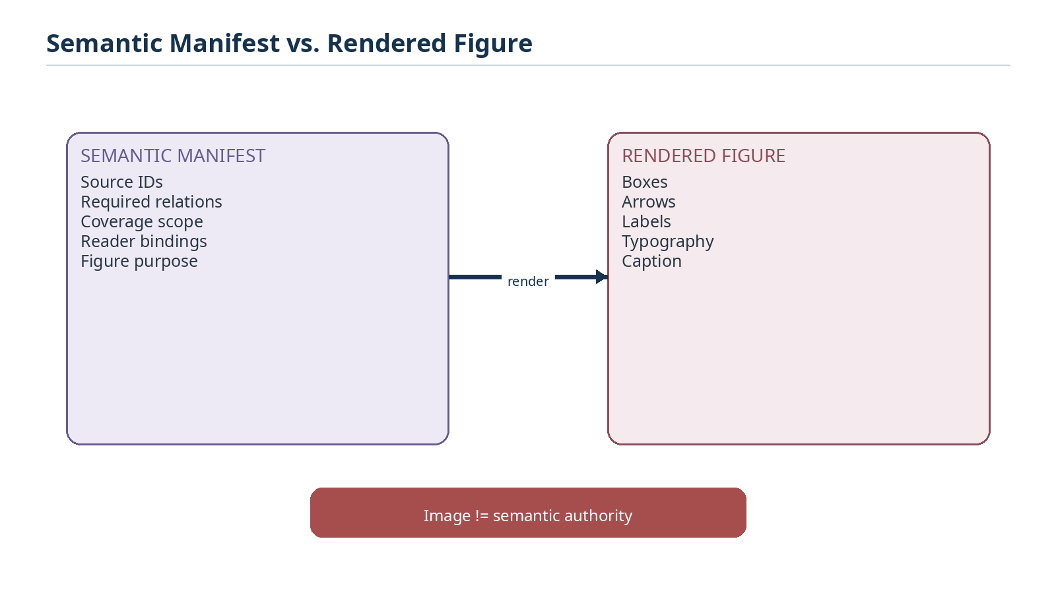
Figure 23. The D/E/F/G semantic manifest is authoritative for the figure composition; the image is a rendered manifestation.
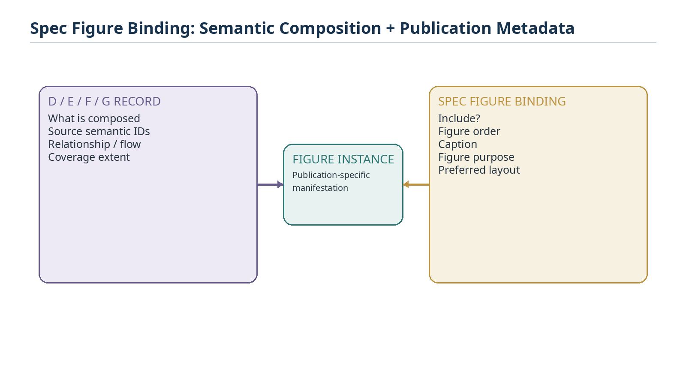
Figure 24. A thin Spec Figure Binding can add publication-specific order, caption, purpose, and layout without contaminating semantic composition.
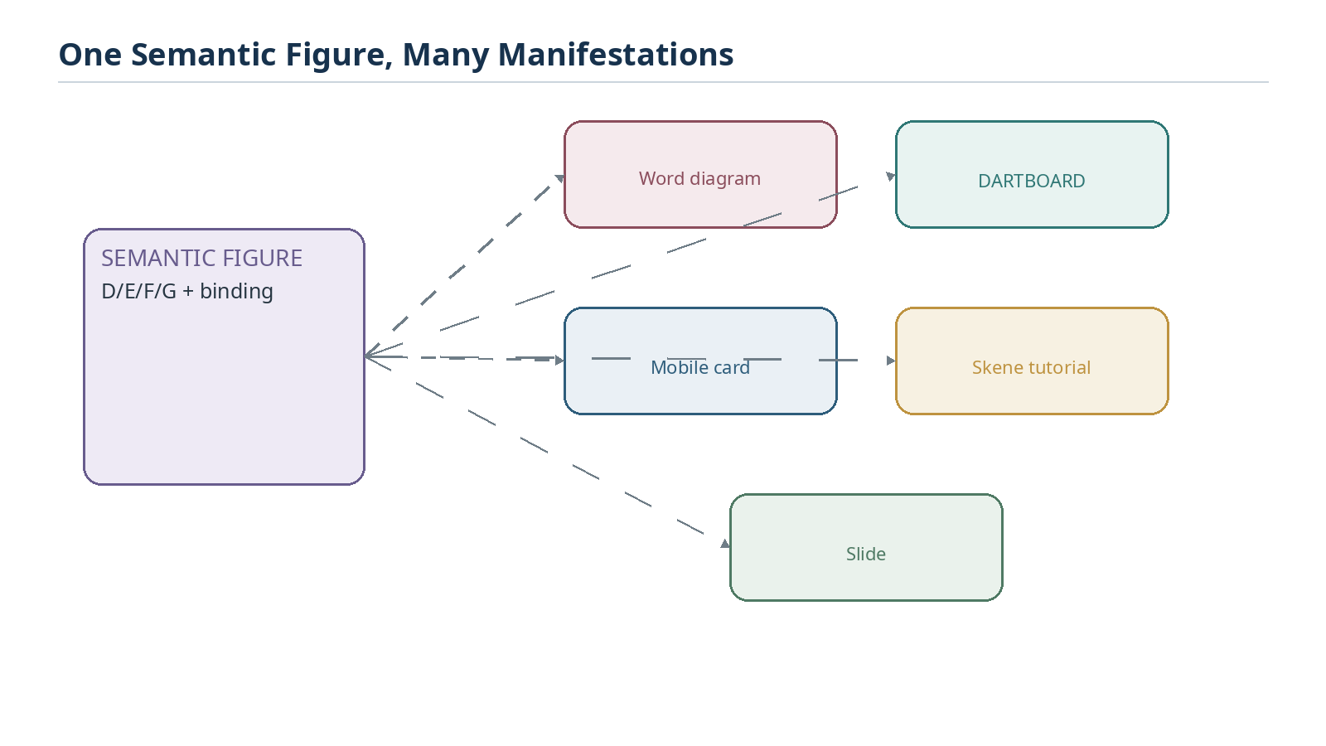
Figure 25. The same semantic figure can later render into Word, DARTBOARD, mobile, Skene, or slide manifestations.

8. Airtable-Assisted Authoring Workflow
Once the relevant Airtable tables are implemented and linked, the collaborative workflow changes substantially. Semantic design decisions are no longer allowed to exist only in chat or prose documents. Approved decisions are written into the canonical records. Later publication work reads the implemented records back out and compiles the specification from them.

8.1 Target authoring loop
- Design or revise the bounded semantic language in conversation or an editing surface.
- Resolve the appropriate World, Community, Family, Semantic Symbol, Bit/BitGroup/BitWord, Memory, alias, and figure records.
- Write approved canonical changes directly into Airtable through authorized connected tools.
- Run validation against the target Community or BitWord.
- Inspect the compiled vocabulary and Figure Program from the registry state.
- Invoke Generate Spec only after the source state is publishable.
- If the generated document reveals a semantic error, repair the source record and regenerate.
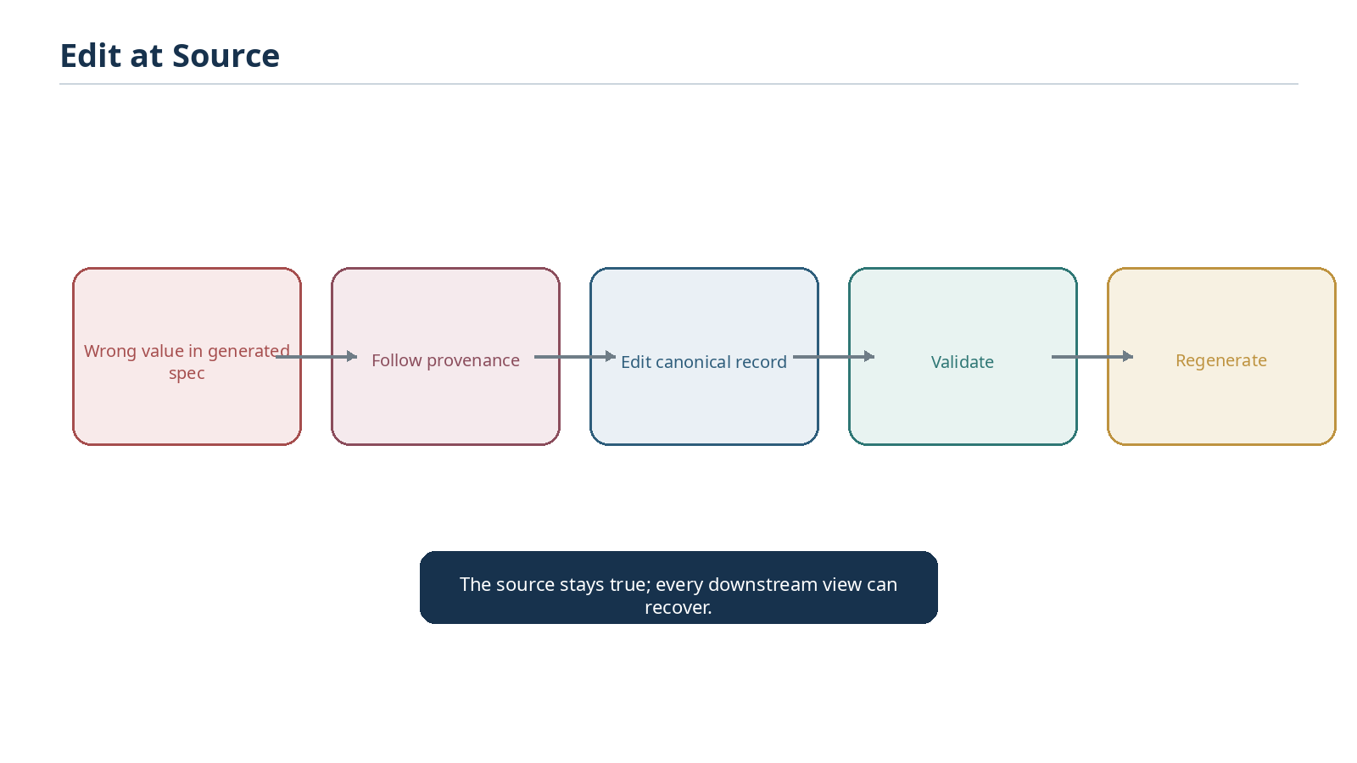
Figure 29. Generated artifacts act as inspection surfaces; semantic corrections are made at the source.

8.2 Adding vocabulary becomes a propagation event
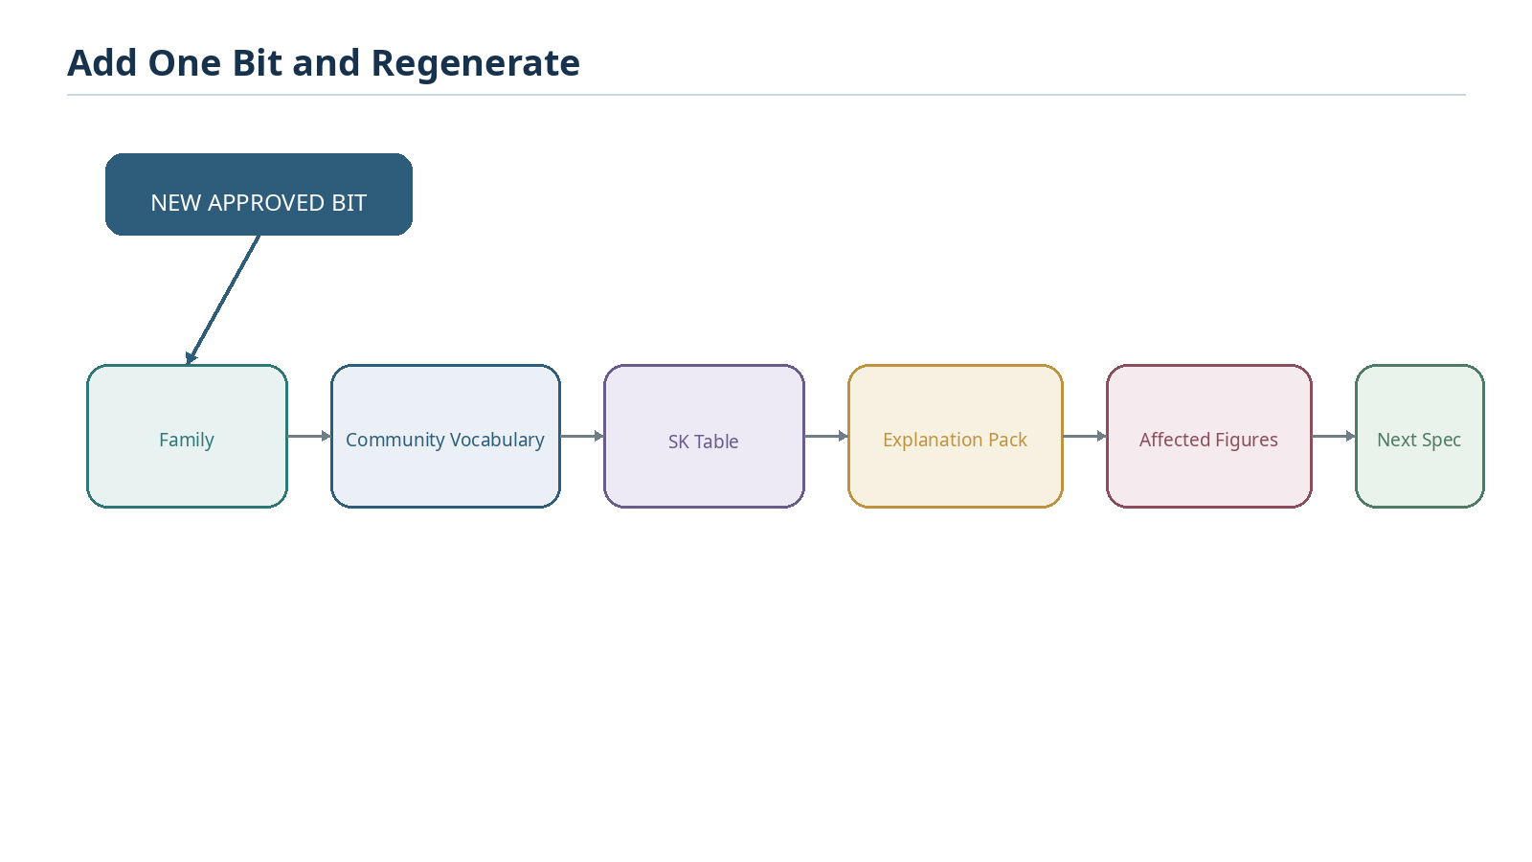
Figure 30. An approved new Bit can automatically propagate through its Family, Community vocabulary, teaching memory, affected figures, and the next generated specification.
This propagation is one of the major benefits of registry-driven publication. The author does not hunt through a large Word document to update every representation of the concept. The semantic record is corrected once, and all properly linked views can be regenerated.

9. Validation, Failure, and Change Management
Generate Spec must fail safely. A polished document is not a valid substitute for unresolved source state. Validation should distinguish blocking errors, permitted incompleteness, warnings, and publication-only presentation issues.
Class | Examples | Expected behavior
Blocking semantic error | Missing target identity, invalid Bit placement, unresolved required World, contradictory version binding | Stop generation and report exact records
Required memory missing | Description or example required by profile is blank | Stop or mark unresolved according to profile; do not invent canonical content
Permitted blank | References allowed to be empty in current authoring phase | Publish blank field without inference
Warning | Unused alias, optional figure unavailable, noncritical relation not installed | Publish with manifest warning if profile allows
Presentation defect | Clipped table, broken glyph, bad page break | Fix renderer/layout and re-render without changing semantic snapshot

9.1 Presentation change versus semantic change
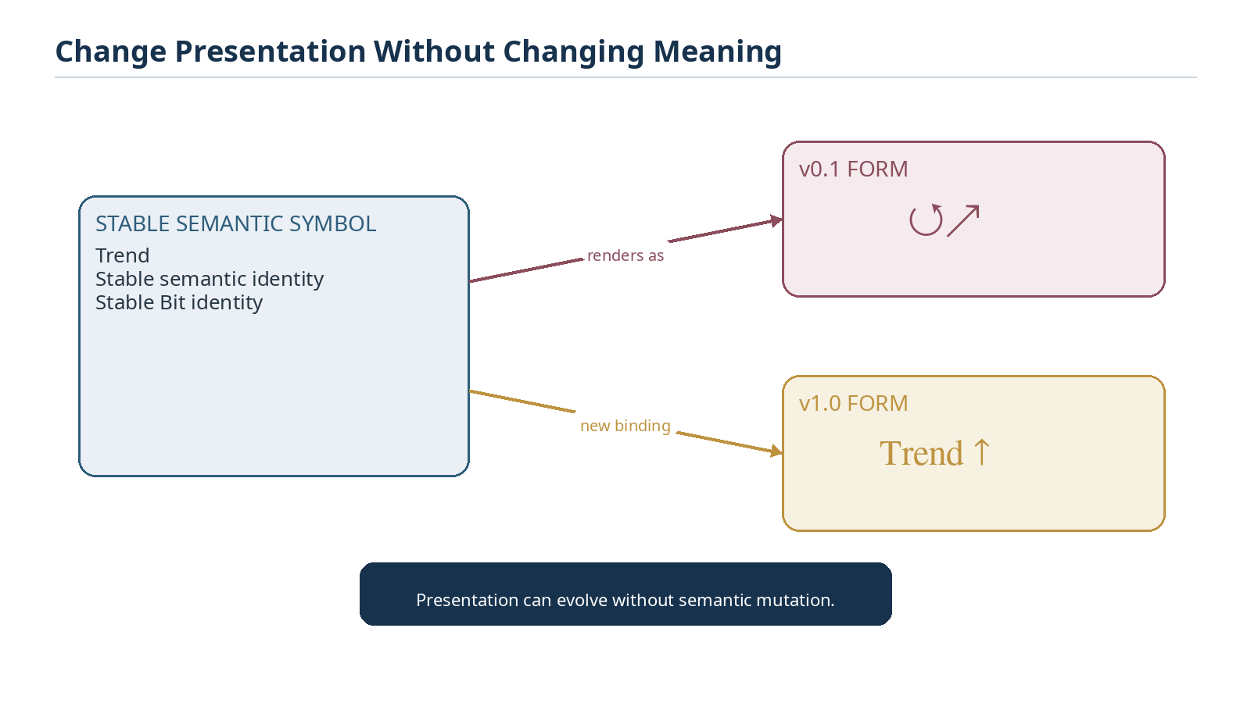
Figure 31. A symbol form can change while the stable Semantic Symbol and Bit identity remain unchanged.
Presentation bindings are versionable. A current BOSS form change should not rewrite an older specification that used a different form. The generation target and snapshot determine which binding belongs in the published artifact.

9.2 Placement migration
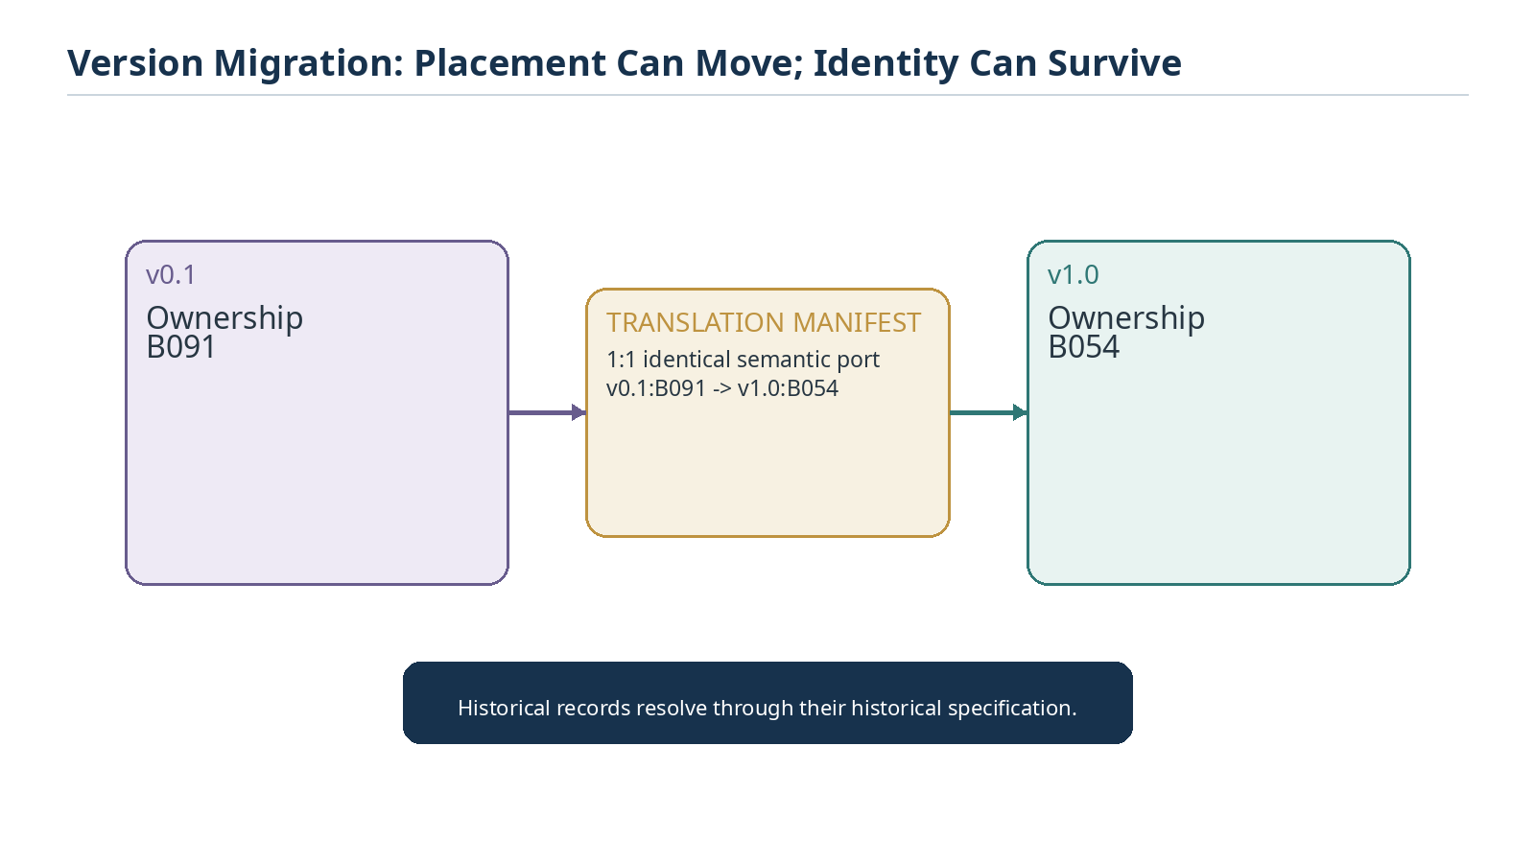
Figure 32. A 1:1 semantic port can move an identical concept from one physical Bit position to another while preserving historical interpretation.
More complex migrations may involve refinement, consolidation, deprecation, or unresolved translation. The generator must follow the declared translation manifest rather than infer equivalence from labels or glyphs.

10. Rendering, Visual QA, and Publication
Professional publication requires a second class of validation: artifact quality. Semantic validity can coexist with a visually broken Word file. The renderer therefore converts the structured paper model into DOCX, and the QA stage renders the DOCX to page images so layout defects can be inspected before publication.
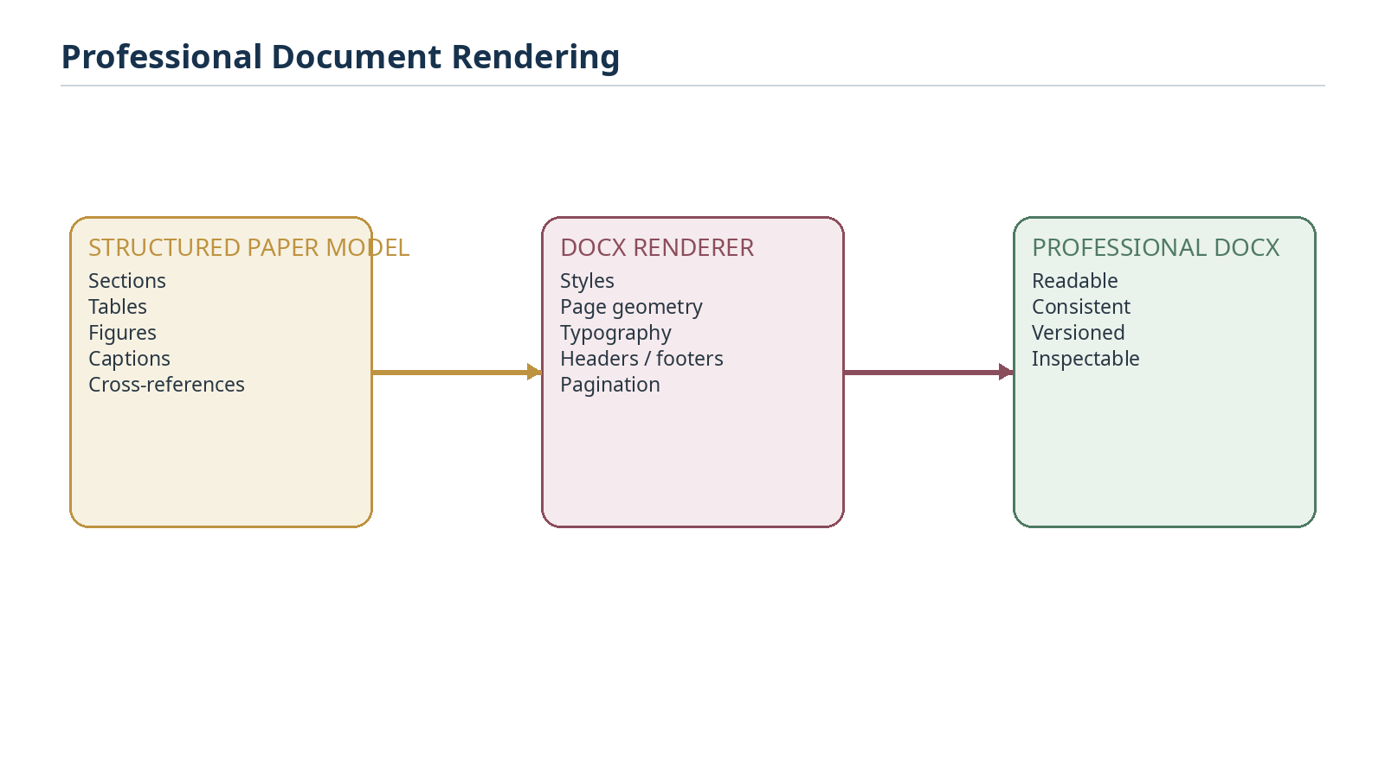
Figure 27. The renderer turns the structured paper model into a professional DOCX without changing semantic content.

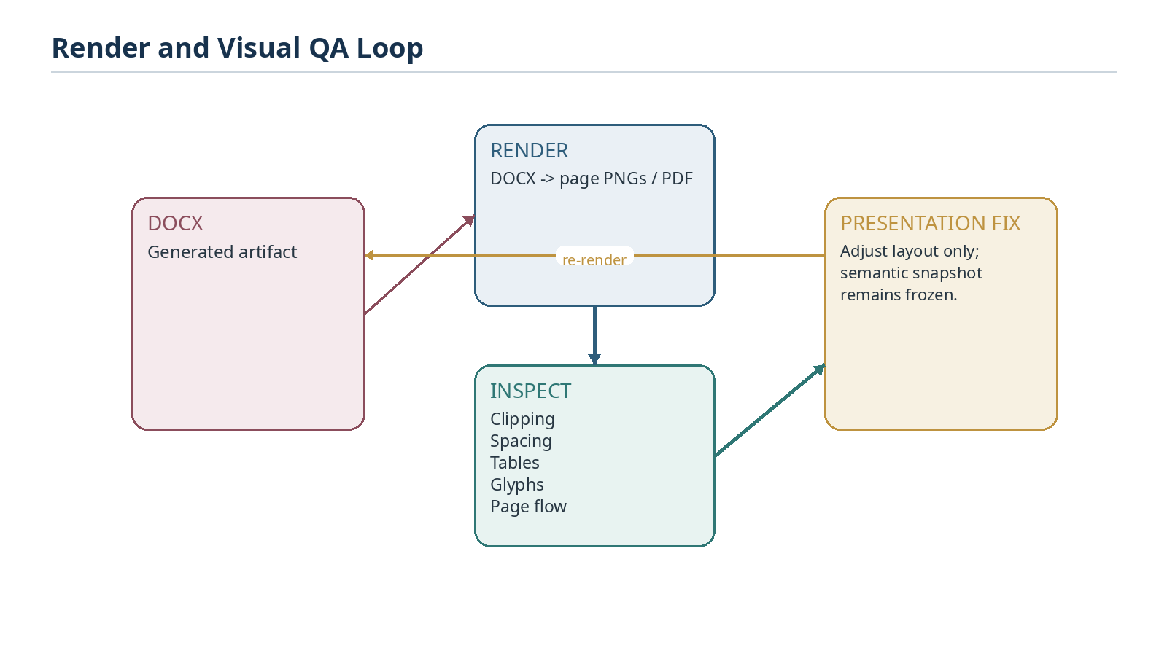
Figure 28. Visual QA iterates on presentation while the semantic snapshot remains frozen.

10.1 Visual QA checklist
- Every expected page renders successfully.
- No clipped or overlapping text appears in figures, tables, captions, headers, or footers.
- Glyphs render consistently and do not silently fall back to missing-character boxes.
- Tables wrap naturally and preserve readable padding and hierarchy.
- Figure captions remain paired with their figures where practical.
- Page breaks avoid orphaned headings, isolated captions, and avoidable blank regions.
- Any layout correction is presentation-only unless a separate semantic edit is explicitly approved.

10.2 Publish with provenance
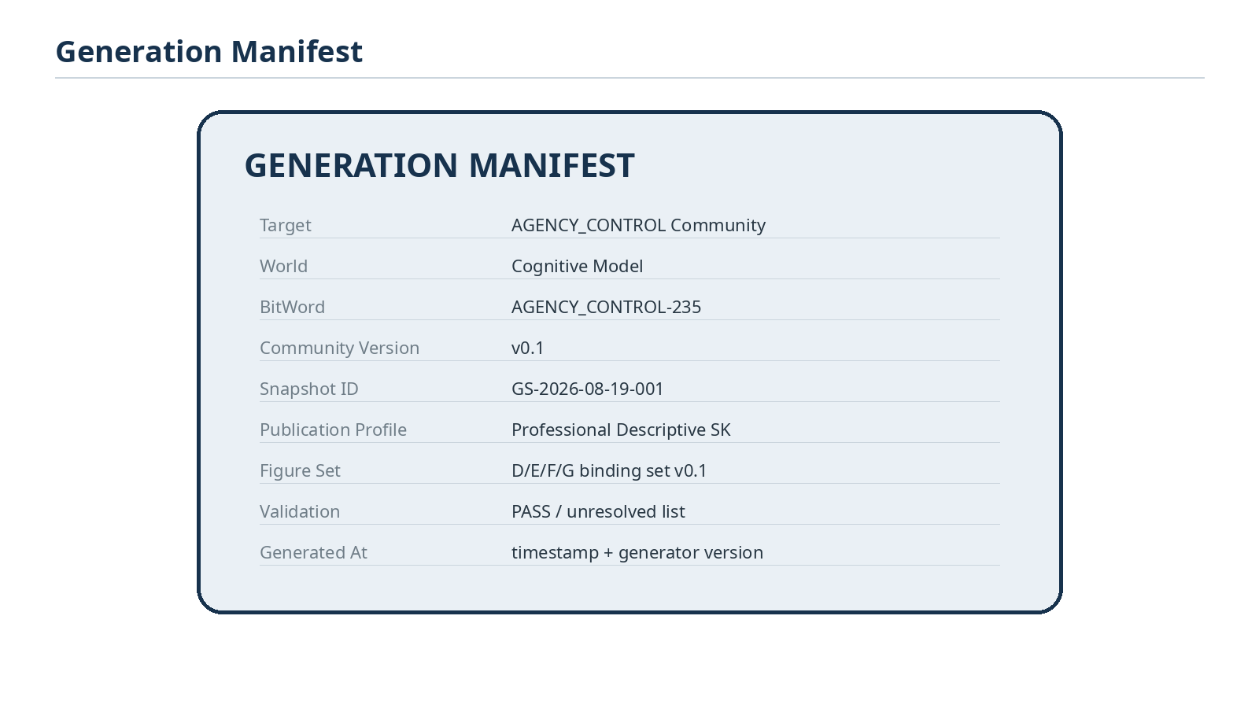
Figure 33. The Generation Manifest records the exact target, source versions, snapshot, profile, figure set, validation result, and generator metadata.
The manifest makes the document inspectable and reproducible. It should be stored with or embedded in the publication metadata and should identify enough source state that another generation run can determine whether it is reproducing the same semantic snapshot or a newer one.

11. Versioning and Reproducibility
The semantic publication should be reproducible even when rendering implementations evolve. Two runs against the same frozen snapshot and publication profile may have small nonsemantic pagination differences, but they should resolve the same target, vocabulary, definitions, Reader outputs, and semantic figure manifests.
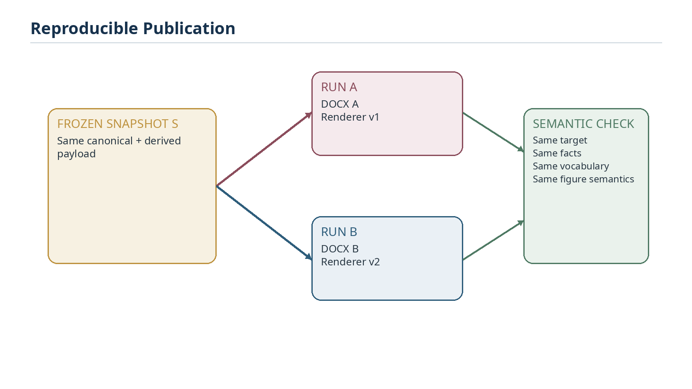
Figure 34. Reproducibility is defined primarily at the semantic publication level; renderer evolution must not alter source meaning.

11.1 Snapshot identity
A snapshot identifier may be implemented as a stored publication snapshot, a manifest of exact record IDs and versioned values, or another deterministic mechanism. The implementation can evolve, but the operational requirement remains: the source state used for a publication must be recoverable enough to explain exactly what the document represents.

12. Bootstrap-to-Operational Lifecycle
This paper is intentionally designed to be superseded by its own implementation. During the build phase it acts as a checklist of required capabilities. Once the system is complete, the authoritative tables and actual runtime behavior replace provisional assumptions. The paper should then be regenerated using the same section skeleton, with implemented table names, actual field bindings, real validation behavior, real failure modes, and real command syntax.

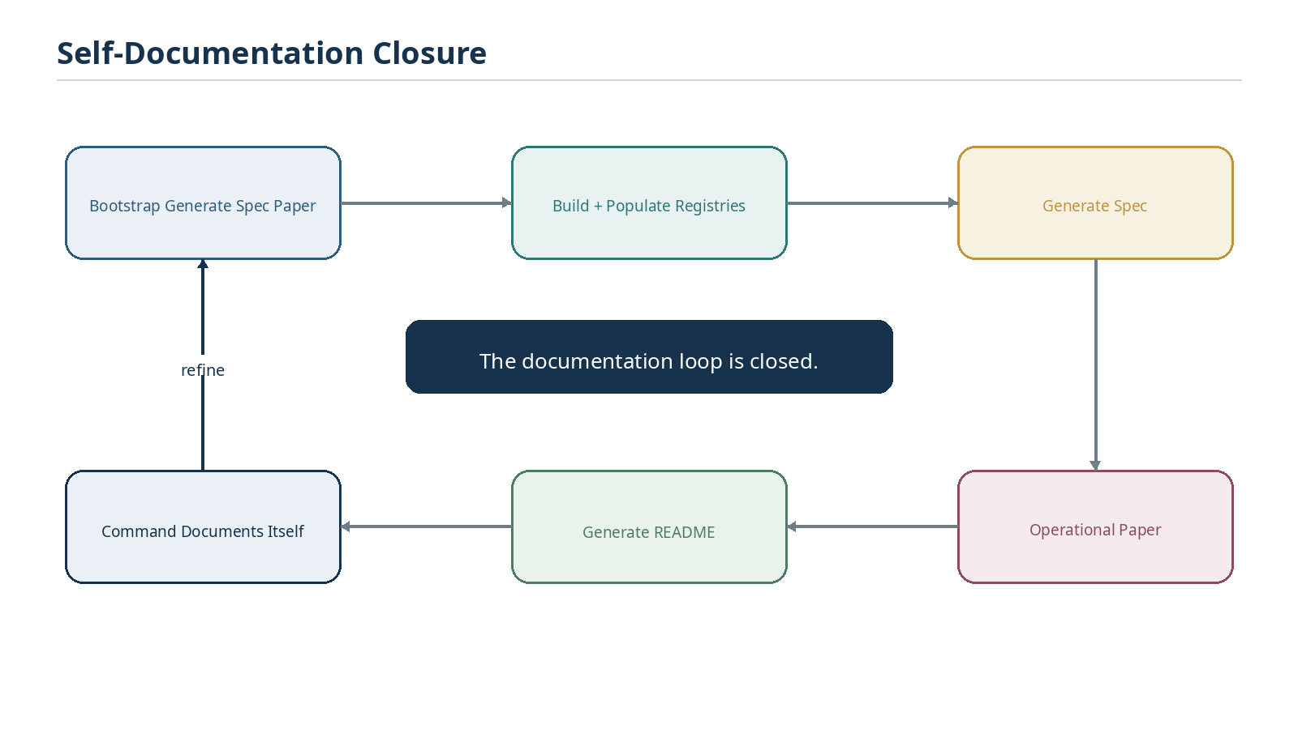
Figure 35. The completed system can use Generate Spec to regenerate the operational paper that defines Generate Spec, then distill it into the command README.
Closure test
A strong first end-to-end validation of the finished command is to regenerate this architecture paper from the newly authoritative system. If the regenerated operational edition can be traced entirely to implemented records and verified runtime behavior, the documentation loop has closed.

12.1 Final operational principle
The mature workflow is simple from the user perspective: build and govern the data once, maintain semantic truth at the source, compose explanatory structures through D/E/F/G, and publish specifications as reproducible views. The complexity belongs in the linked registries and compiler, not in repeated manual document reconstruction.
Cover-line summary
Build the data once. Govern it at the source. Compose its figures through D/E/F/G. Publish its specifications as reproducible views.

Appendix A. Target Implementation Tables and Fields
The following structures are implementation targets for the bootstrap phase. The operational edition of this paper should replace these candidate names with the exact deployed tables and fields.
Registry / table | Candidate required links or fields | Role in Generate Spec
World | World ID, name, Communities, version/status | Top-level domain context and World snapshot membership
Community | Community ID, World, Families, source SK/BitWord, version/status | Preferred Descriptive SK publication root
Family | Family ID, Community links, order, Semantic Symbols | Ordered local vocabulary composition
Semantic Symbol | Stable symbol ID, Family links, form binding, description/memory links | Governed symbolic meaning and context
Unique Symbol Form | Exact visual form, rendering notes, Semantic Symbol backlinks | Presentation identity only
BitWord | Stable identity, version, ordered BitGroups/Bits, Community binding | Exact machine-readable language object
BitGroup / Bit | Stable identity, placement, Reader binding, Semantic Symbol | Exact semantic address and local composition
SK Memory | Description, professional example, personal example, references | Teaching and explanation records
SOLAR Alias | Alias text, target type, target stable ID, scope/version | Natural-language routing to registered targets
D/E/F/G | Coverage class, source semantic IDs, composition/flow, Reader context | Authoritative semantic figure manifest
Spec Figure Binding | Figure target, D/E/F/G record, include/order/caption/layout | Publication-specific figure manifestation
Publication Profile | Profile ID, required fields, section order, policies | Controls document structure and validation requirements
Generation Manifest | Target, versions, snapshot, profile, figure set, validation, generator metadata | Reproducibility and provenance

Appendix B. Future Generate Spec Command Contract
The final README should be shorter than this architecture paper because the system itself will already contain the linked semantics. The following is the intended command contract to validate during implementation.
Command
Generate Spec

Element | Target contract
Purpose | Compile a professional semantic specification from authoritative CERBERUS registry state.
Required input | Community or BitWord target; optional publication profile and output format.
Resolution | Resolve stable target ID and exact version. Aliases may assist discovery but do not govern generation.
Pipeline | Resolve -> Freeze -> Validate -> Traverse -> Compile -> Figure -> Assemble -> Render -> QA -> Publish.
Authority | Canonical registry state is authoritative. Generated prose cannot alter canonical semantics.
Failure | Do not infer missing required canonical data. Return the exact unresolved records/fields.
Primary output | Professional specification artifact plus Generation Manifest and validation result.
Correction | Repair the authoritative source record and regenerate.

Appendix C. Bootstrap Build Checklist
# | Capability | Completion criterion | Done
1 | World / Community / Family graph | Every governed Semantic Symbol resolves through explicit context to a World. | [ ]
2 | BOSS forms | Semantic Symbols are separated from Unique Symbol Forms. | [ ]
3 | SK bindings | Communities/BitWords resolve exact ordered Bits and BitGroups. | [ ]
4 | SK Memory | Required teaching fields exist and can be traversed deterministically. | [ ]
5 | SOLAR aliases | Aliases can resolve targets at World, Community, Family, Symbol, and other registered levels. | [ ]
6 | D/E/F/G manifests | Figure semantics are stored independently from rendered images. | [ ]
7 | Figure bindings | Publication-specific caption/order/layout can be attached without mutating semantic manifests. | [ ]
8 | Publication profiles | Professional Descriptive SK requirements are encoded and validateable. | [ ]
9 | Freeze mechanism | Generation can establish an internally stable semantic snapshot. | [ ]
10 | Validation engine | Required missing data is detected before narrative generation. | [ ]
11 | SpecPack compiler | Validated source state compiles into a format-independent publication payload. | [ ]
12 | DOCX renderer | The paper model renders with professional styling and stable figures/tables. | [ ]
13 | Visual QA | Rendered pages can be inspected and presentation defects repaired without semantic drift. | [ ]
14 | Generation manifest | Published artifacts record enough source/version/provenance data for inspection. | [ ]
15 | Source-edit loop | A semantic correction can be made in Airtable and propagated by regeneration. | [ ]
16 | Self-documentation test | Generate Spec can regenerate the operational edition of this paper from implemented state. | [ ]

Conclusion
Generate Spec is the publication layer that turns CERBERUS from a system described by documents into a system capable of describing itself. The command does not replace semantic authoring; it makes semantic authoring persistent, governed, inspectable, and reusable. Once canonical data, teaching memory, symbolic context, and D/E/F/G figure manifests are stored at the source, specification writing becomes a reproducible compilation and publishing operation.
The bootstrap paper should now be used as an implementation map. Each completed subsystem reduces the amount of bespoke document reconstruction required. When the full workflow is operational, the system should regenerate this same paper from its own records and produce the final Generate Spec README from verified implemented behavior.
Final principle
The goal is not to automate writing around uncertain data. The goal is to make the data authoritative enough that writing can become a reliable view of the system.

