CERBERUS
BRAIN ROOT STACK 11
MIRROR
Mapped Imaginal Relational Reasoning Over Routes
Bounded Possibility-Space, Relational Resolution, and Governed State Transition
CORE PROPOSITION
MIRROR gives possibility a formal place to exist before consequence receives authority.


FORMAL ARCHITECTURE / RUNTIME METHOD SPECIFICATION
PASS 8 | VERIFIED RELEASE | v0.1 CYAN

SECTION 00
Abstract
CERBERUS MIRROR - Mapped Imaginal Relational Reasoning Over Routes - provides a bounded non-authoritative relational reasoning architecture for representing what may happen before any possible consequence is allowed to become authoritative. A MIRROR begins from explicitly mapped state, instantiates only the Points, Relationships, semantic payloads, addresses, and contextual structures required by the bounded problem, and exposes those structures inside an Imaginal field in which system-permitted configurations and Routes may be explored.
Imaginal is used here as a formal CERBERUS term: the imaginary liminal possibility-space existing inside the bounds of a mapped domain and the valid possibility states available within that field-space. MIRROR therefore does not grant unrestricted invention. Its possibilities remain constrained by the identities, relationships, Rules, Models, Operators, resolution contracts, and source state actually mapped into the episode.
The World or other source remains authoritative while MIRROR reasons over a distinct representation. Points and Relationships are first-class semantic objects; Mirror-local address is kept separate from object identity; semantic state is interpreted through registered contracts rather than inferred from display; and candidate Routes may be traversed or transformed without directly mutating the source. Later runtime stages can validate a resolved candidate and permit only approved consequences to cross the authority boundary.
CORE PROPOSITION
MIRROR maps bounded state into an Imaginal relational field where valid possibilities can be reasoned over through explicit Routes before any resulting consequence receives authority or persistence.

SECTION 00
Paper Map
Eight parts move from the Cyan Mirror itself through bounded possibility, relational state, route reasoning, field-space, Fluid resolution, causal closure, and reconstruction. The first two Parts establish the visual and semantic grammar used by every later Part.
Table 00-A. Paper architecture
Part | Sections | Theme | Purpose
PART I | 01-04 | The Cyan Mirror | Define MIRROR, its responsibility, primitive ontology, and State 0.
PART II | 05-08 | The Imaginal Field | Define bounded system-valid possibility and its epistemic limits.
PART III | 09-13 | Relational State | Define Points, Relationships, configuration, payloads, Views, and display.
PART IV | 14-18 | Reasoning Over Routes | Formalize Routes, behavior, reasoning operations, and state transformation.
PART V | 19-23 | Field-Space and Resolution | Define topology, scale, recursive refinement, and Interaction Fields.
PART VI | 24-28 | Fluid Resolution | Hydrate, resolve, validate, detect staleness, and govern commitment.
PART VII | 29-31 | Causal Closure and Persistence | Preserve required residue, burn scaffolding, serialize, and reload.
PART VIII | 32-34 | The Complete Mirror | Stress-test the grammar and integrate the complete Cyan Mirror Chronicle.

SECTION 00
Visual Language
MIRROR is officially identified by Cyan. The paper uses a technical-fantasy visual language built from luminous panes, rune-grids, spectral filaments, bounded chambers, and recursive panes. These motifs are semantic reconstruction surfaces: they teach the same distinctions that the text formalizes.
Table 00-B. MIRROR visual grammar
Visual | Meaning
Cyan | MIRROR boundary, Point/Relationship manifestation, field-space, candidate Routes, nested Mirrors
Gold | Selected or validated Route
Green | Approved authoritative commitment
Amber | Resolution Tie or surviving causal residue
Red | Invalid, blocked, contradictory, or stale Route/state
Grey / ash | Transient MIRROR structure safely burned after closure
Dark exterior | Outside the declared mapped field; not necessarily empty reality

VISUAL LAW
The fantasy surface should reveal the architecture rather than decorate it. A reader should eventually understand the Cyan boundary, gold Route, green commit, amber Tie, and grey ash without requiring a separate explanation.

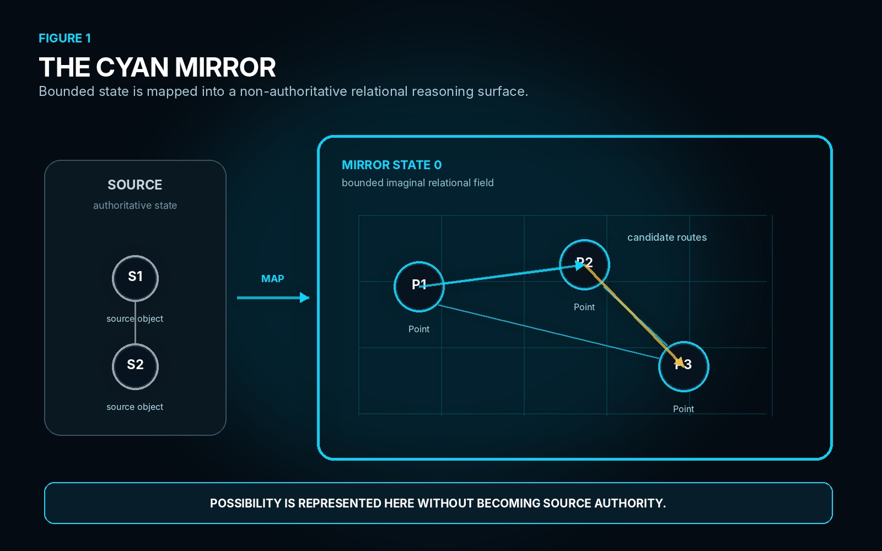
Figure 1. The Cyan Mirror. Authoritative source state is mapped into a bounded non-authoritative relational field where Points, Relationships, and candidate Routes can exist without becoming source authority.

PART I
THE CYAN MIRROR
MIRROR is defined before possibility, runtime mutation, or domain-specific reasoning is introduced. The first four sections establish the bounded reasoning surface, its primitive vocabulary, and its episode-relative baseline state.

SECTION 01
MIRROR
MIRROR stands for Mapped Imaginal Relational Reasoning Over Routes. It is a bounded reasoning architecture in which selected state from an authoritative or otherwise governed source is represented as a distinct relational configuration. That representation can be explored, recomposed, traversed, compared, and transformed without granting those candidate operations authority over the source.
Mapped means that the episode declares the state and contracts it actually contains. Imaginal names the bounded possibility-space available inside that map. Relational means that the configuration of Points and Relationships matters in addition to the objects themselves. Reasoning describes the registered operations that may inspect or transform the representation. Over preserves the boundary between reasoning and source mutation. Routes are the traversable paths through relational, semantic, spatial, temporal, procedural, or transformational structure.
MIRROR is therefore more than a visual graph. A rendered network may be one View of Mirror State, but the architecture resides in the identities, addresses, relationships, semantic payloads, source routes, and reasoning contracts that make the graph reconstructable and executable.
DEFINITION
MIRROR is a bounded reasoning architecture in which mapped semantic state is instantiated as Points and Relationships inside a non-authoritative Imaginal field so that possible Routes, transformations, configurations, and consequences can be reasoned over before governed commitment.

T1. MIRROR acronym and responsibility
Letter | Term | Responsibility
M | Mapped | Declare the bounded state, source basis, relationships, contracts, and resolution surface available to this episode.
I | Imaginal | Expose the valid possibility-space available within the mapped domain without asserting that those possibilities are authoritative.
R | Relational | Represent configuration through independently identified Points and Relationships.
R | Reasoning | Read, decode, compare, traverse, calculate, test, transform, validate, and resolve over the mapped configuration.
O | Over | Reason over represented state without collapsing that reasoning into source mutation.
R | Routes | Traverse relational, spatial, semantic, procedural, temporal, causal, or transformational paths.

SECTION 02
The Resolution Surface
A source state may be authoritative while still being unsuitable as a scratchpad for every hypothesis, attempted action, speculative branch, or unresolved interaction. MIRROR inserts a bounded reasoning surface between known state and possible consequence. The source can remain stable while candidate configurations change rapidly inside the Mirror.
This separation allows an intelligence to test a state transition, move a Point, alter a Relationship, compare competing Routes, or discover that a proposed interaction cannot resolve without directly changing the underlying source. MIRROR can therefore contain states that are internally meaningful but never become consequential outside the bounded episode.
The authority boundary is crossed only by a later governed commitment. A Mirror may successfully generate a candidate result and still fail authorization, source-basis validation, or some later Rule. The existence of a coherent candidate therefore proves only that the candidate was representable and resolvable under the Mirror configuration that produced it.
NON-COLLAPSE
SOURCE ≠ MIRROR ≠ CANDIDATE ≠ COMMITTED SOURCE

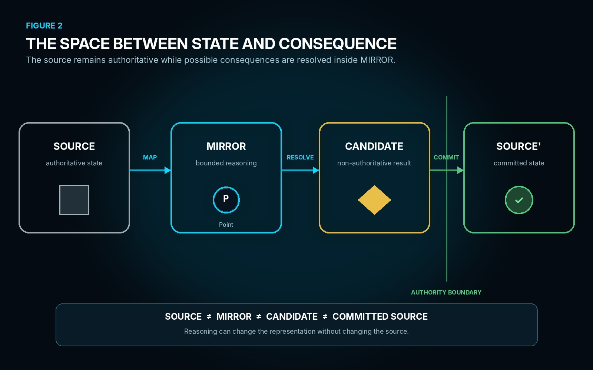
Figure 2. The Space Between State and Consequence. Mapping, resolution, and commitment are distinct stages; only the final governed boundary permits consequence to return to authoritative state.
SECTION 03
Minimum MIRROR Ontology
MIRROR deliberately begins with a small primitive ontology. The architecture should prefer recursive composition over inventing a new object class for every domain. A meal, molecule, combat interaction, document build, or other specialized system may require rich semantics, but those semantics should attach to a stable set of general Mirror objects wherever possible.
The seven primitive concepts are MIRROR, Mirror State, Point, Relationship, Route, View, and Tie. MIRROR is the bounded reasoning environment. State is one explicit configuration. A Point is an instantiated semantic object. A Relationship is an independently identified semantic relation. A Route is a traversal. A View is a projection. A Tie records a future dependency that requires some result of resolution to remain available.
This does not mean every implementation must expose all seven objects as separate database tables. It means the distinctions must remain representable. Collapsing them for storage convenience must not silently erase their independent semantics.
T2. Minimum MIRROR ontology
Primitive | Owns
MIRROR | Bounded non-authoritative reasoning environment.
Mirror State | One explicit configuration of Points, Relationships, addresses, payloads, and context.
Point | One independently identified instantiated semantic object.
Relationship | One independently identified semantic relation with declared endpoints.
Route | One ordered traversable path through relational and/or transformational structure.
View | One derived projection of Mirror State for interpretation, analysis, diagnosis, or presentation.
Tie | One surviving dependency requiring sufficient information from resolution to persist.

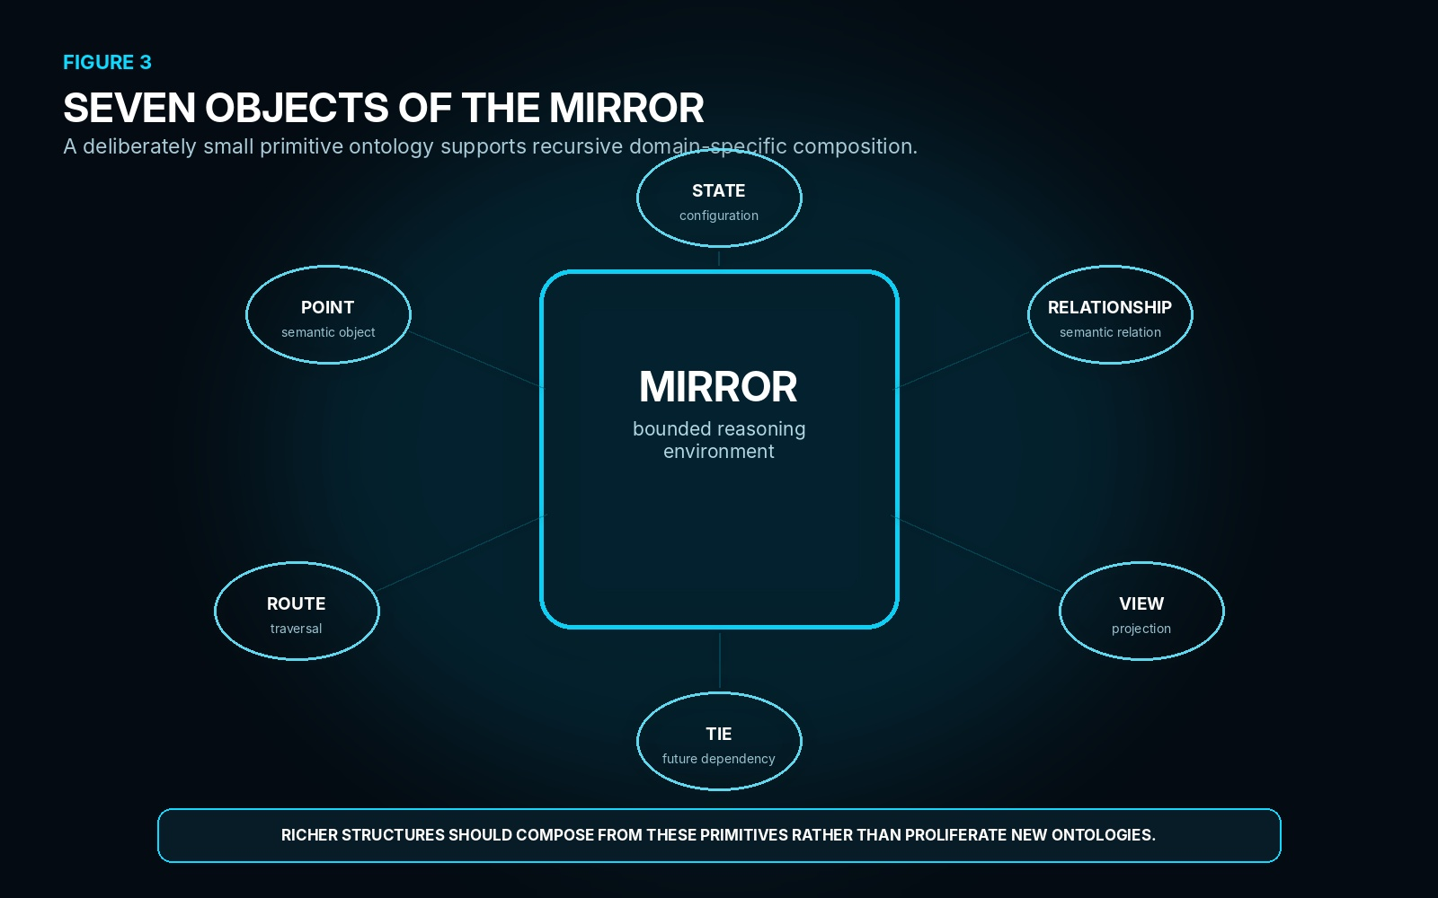
Figure 3. Seven Objects of the Mirror. MIRROR, State, Point, Relationship, Route, View, and Tie form the minimal recursive vocabulary from which richer domain structures can be composed.
SECTION 04
Mirror State 0
Mirror State 0 is the explicit baseline configuration from which one bounded reasoning episode begins. It is episode-relative. State 0 does not imply the first historical state of an object, the first state of a World, or an ontological origin. It simply marks the configuration against which this Mirror begins its reasoning.
State 0 may contain a source basis, Point instances, Relationship instances, Mirror-local addresses, semantic contracts, encoded state, applicable contextual references, and a resolution contract. The exact payload depends on the bounded problem. A combat Mirror may map actors and local geometry. A molecular Mirror may map physical constituents and relations. A document Mirror may map construction records and dependencies.
The baseline is also the reference against which candidate state is later compared. An operator can change semantic state while Point identity remains stable; a spatial transformation can change Mirror Address without changing semantic identity; a relationship can be added or removed without replacing its endpoint Points. Those distinctions become meaningful only because State 0 gives the episode a precise starting configuration.
STATE 0 LAW
STATE 0 = the baseline of this reasoning episode, not the beginning of historical time.

State 0. Minimum baseline responsibilities
State 0 component | Purpose
Mirror ID | Which bounded reasoning environment this State belongs to.
State ID | Which explicit configuration is being referenced.
Source Basis | The source identity, revision, or bounded dependency set from which State 0 was mapped.
Points | Instantiated semantic objects participating in the episode.
Relationships | Independently identified relations connecting declared endpoints.
Addresses | Mirror-local positions defined by the active Address-Space Contract.
Semantic Payloads | Registered contracts and encoded state carried by Points and Relationships.
Resolution Contract | The bounded detail and contextual structures required by the current problem.

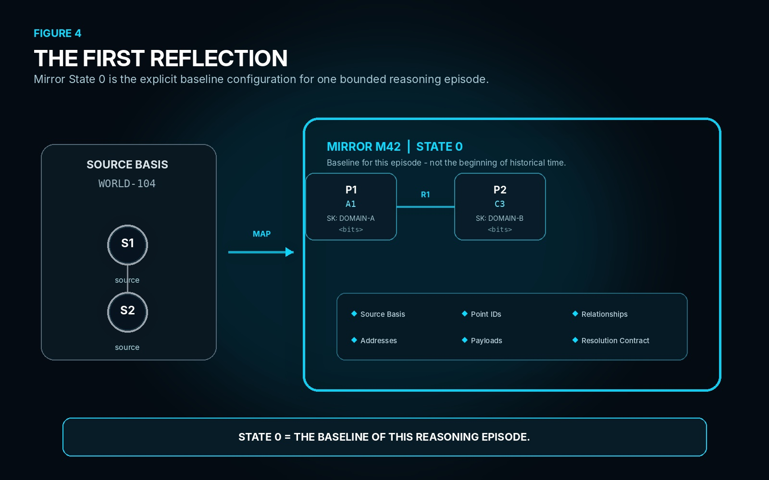
Figure 4. The First Reflection. Mirror State 0 captures the bounded baseline required by the current episode while preserving explicit reference to the source basis from which it was mapped.

PART II
THE IMAGINAL FIELD
MIRROR does not merely hold alternate states. It exposes a bounded possibility-space whose contents remain constrained by the mapped domain, its registered semantics, and the contracts available to the current episode.

SECTION 05
Imaginal
Imaginal is a formal CERBERUS term for the imaginary liminal space that exists inside the bounds of a mapped domain and the valid possibility states available within that field-space. In practical terms, Imaginal is imagination that can be used within the defined system. A MIRROR may therefore represent what is not currently authoritative without granting itself permission to invent state that the mapped domain cannot support.
The distinction matters because non-authoritative reasoning is useful only when the possibility-space retains a contract with the system being reasoned about. In a game, the contract may include registered characters, legal positions, equipment, abilities, damage Models, Rules, and Operators. In another domain, the available identities and transformations may be entirely different. MIRROR does not force those domains into one ontology; it requires only that the bounded field declare the structures on which its possibilities depend.
An Imaginal state may represent a candidate configuration, plan, prediction, counterfactual, alternative arrangement, unresolved interaction, or proposed transformation. None of those labels makes the state real. The state remains a possibility inside the bounded field until later stages determine whether it is context-valid, selected for resolution, successfully resolved, and permitted to cross an authority boundary.
IMAGINAL DEFINITION
IMAGINAL = the imaginary liminal possibility-space inside a mapped domain and the valid possibility states available within that field-space.

NON-COLLAPSE
Imaginal ≠ arbitrary imaginary. Non-authoritative reasoning remains bounded by the system it claims to represent.

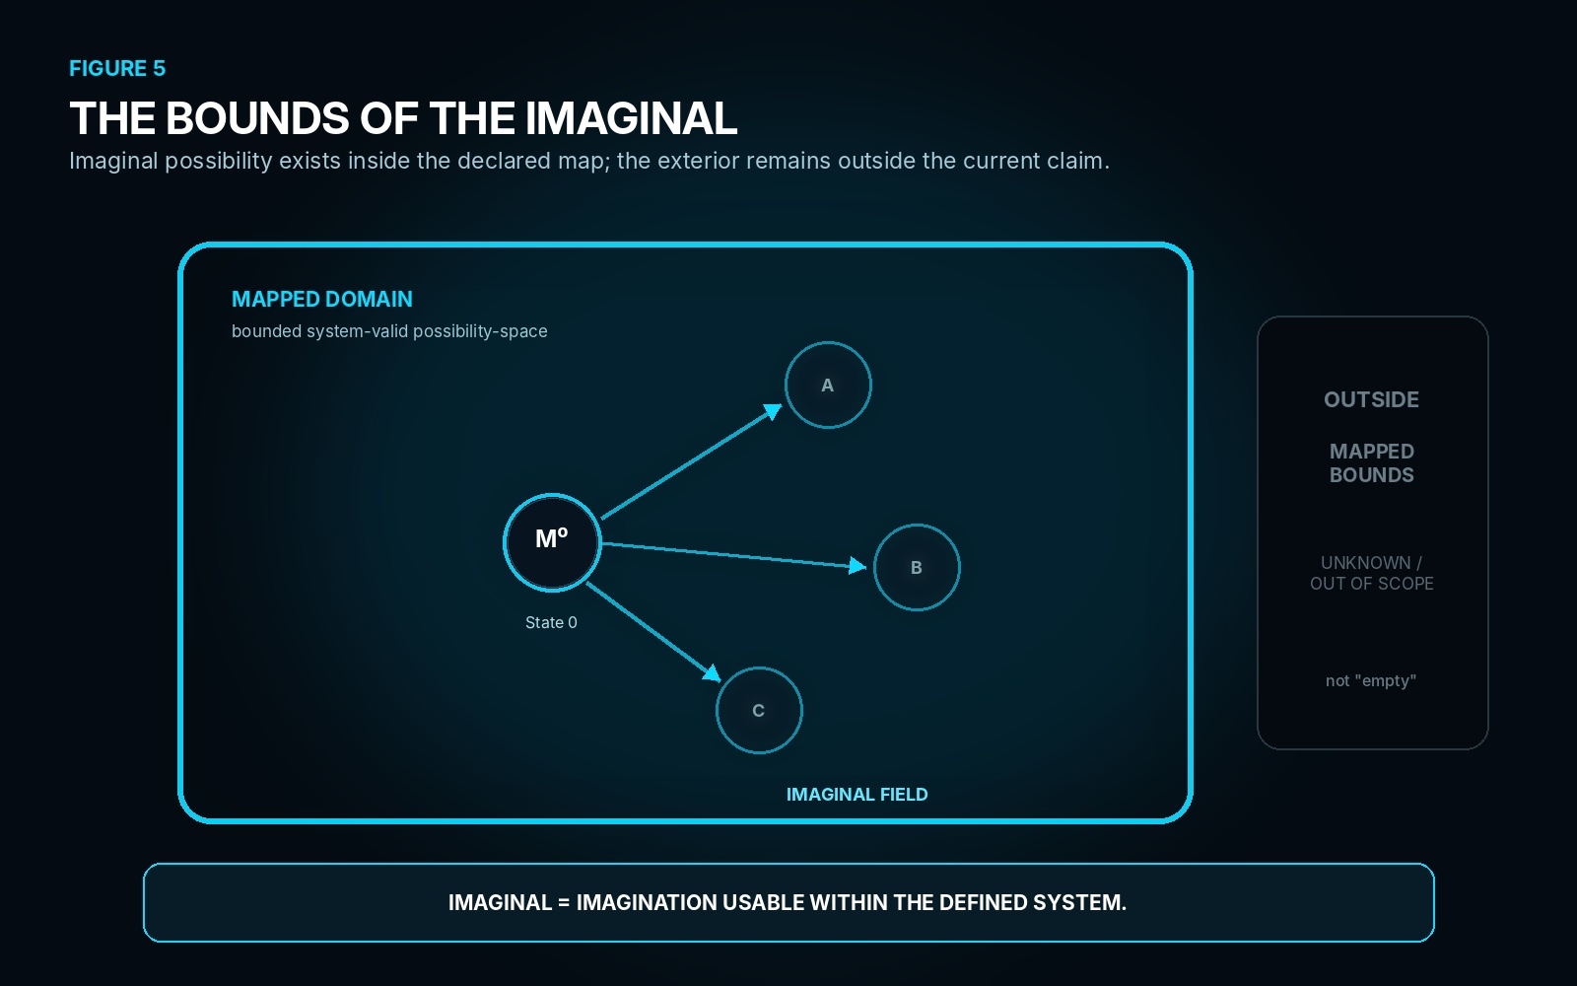
Figure 5. The Bounds of the Imaginal. System-permitted possibilities exist inside the declared Cyan boundary; the exterior remains outside the current map rather than being treated as empty or known.
SECTION 06
Possibility Under Contract
An Imaginal Field is generated from a mapped contract rather than from unrestricted combinatorics. The contract may expose identities, current state, Relationships, Rules, Models, Operators, constraints, available resolution, source dependencies, and other bounded structures required by the problem. Together they determine what the Mirror is presently capable of representing and reasoning over.
This does not require MIRROR to enumerate every theoretically reachable configuration. Possibility may be generated lazily. A local interaction can expose only the branches relevant to the active query, and additional branches can appear when a Rule becomes applicable, a deeper Relationship is opened, or Hydration later reveals more state. The Imaginal Field is therefore a bounded possibility surface, not necessarily a precomputed list of all future worlds.
The mapped contract also creates useful failure boundaries. A proposed Route may be rejected immediately because the required Point does not exist, an Operator is not registered, a Relationship is incompatible, or the represented domain does not permit the requested configuration. Other Routes may remain representable but require later context-specific validation. MIRROR should preserve that difference rather than treating every rejected branch as the same kind of failure.
BOUNDED IMAGINALITY
Mapped identities + state + relations + Rules + Models + Operators + constraints + resolution → bounded Imaginal possibility.

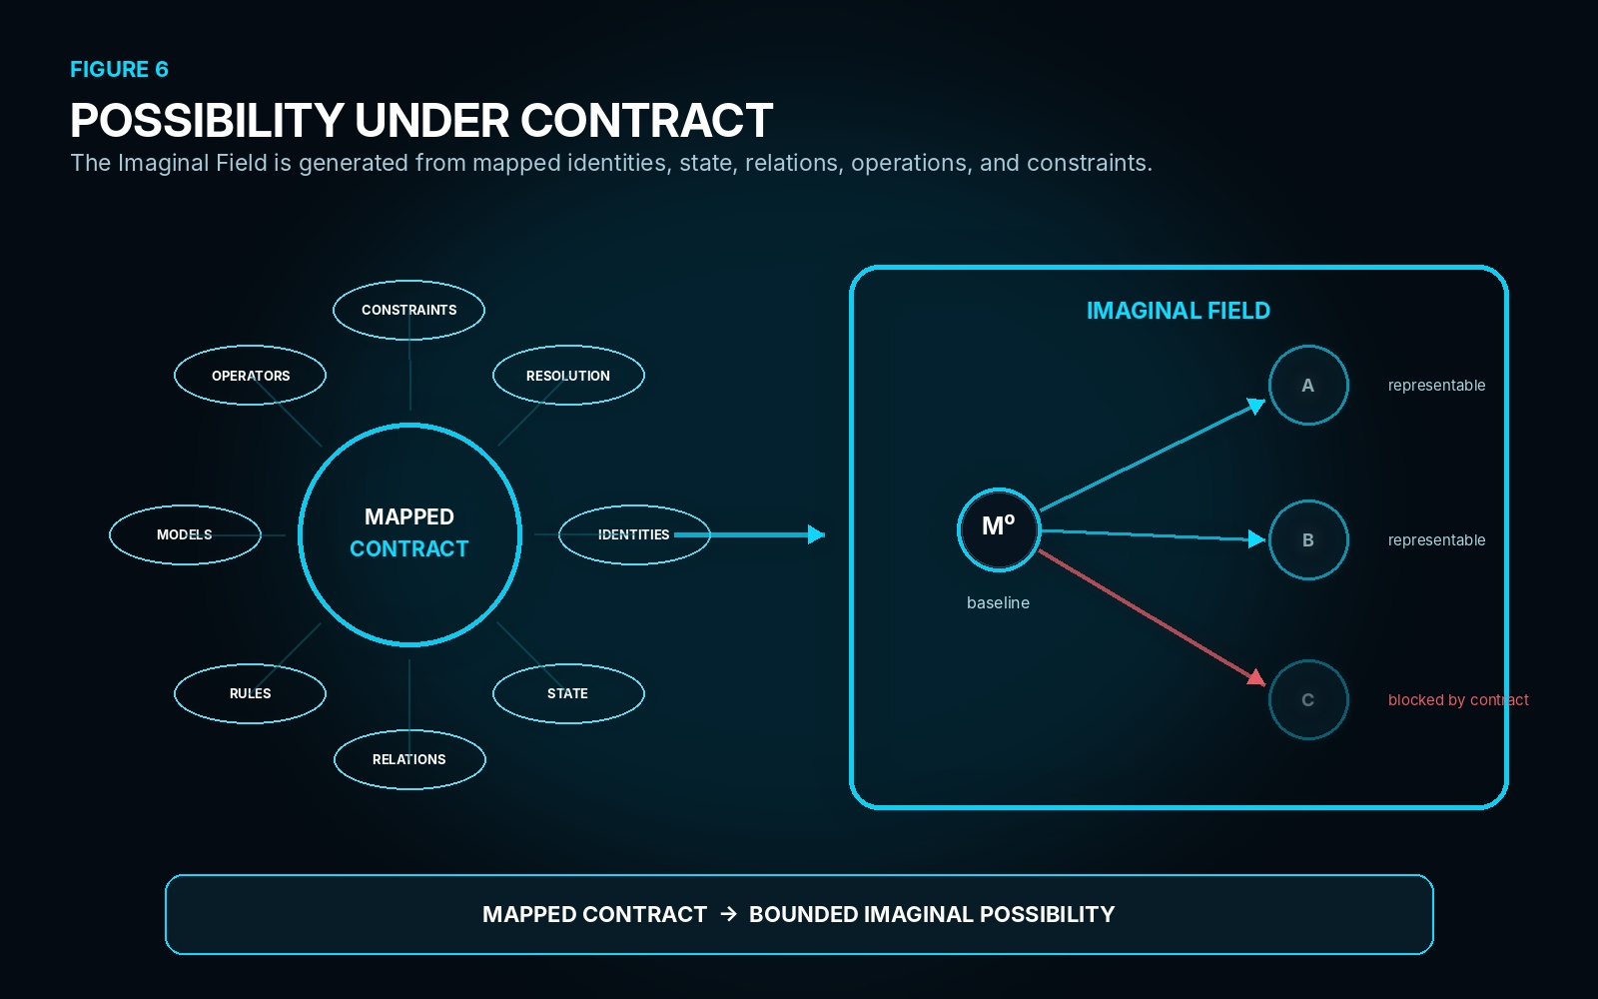
Figure 6. Possibility Under Contract. The mapped contract supplies the identities, state, relations, operations, constraints, and resolution surfaces from which the bounded Imaginal Field can be generated.
SECTION 07
Five States of Possibility
MIRROR separates five stages that are easy to collapse in ordinary simulation language. A Route can be Possible because the mapped system can represent it, Valid because the current constraints permit it, Selected because some agent or procedure chooses to attempt it, Resolved because its outcome has been determined, and Committed because the consequence has been granted authority outside the candidate Mirror state.
The ladder is intentionally non-linear in implementation even though it is shown sequentially for explanation. Many possible Routes may be discarded before full validation. Several valid Routes may coexist. A selected Route can still fail during resolution because deeper state changes the result. A resolved candidate can become stale before commitment. The stages are semantic states of the Route, not a requirement that every implementation materialize five separate tables or objects.
This separation is especially important for intelligent agents. A planner may maintain several valid candidate Routes without executing any of them. A player may select a Route that later resolves differently than expected. A deterministic interaction may resolve successfully but still lack permission to commit. MIRROR keeps each of those situations legible because representability, validity, selection, resolution, and authority remain distinct.
T3. Five states of possibility
Stage | Meaning | Boundary
Possible | Representable under the mapped domain and current MIRROR contracts. | May never be context-valid or selected.
Valid | Satisfies the currently applicable constraints known to the Mirror. | May coexist with other valid Routes.
Selected | Chosen for attempted evaluation or execution inside MIRROR. | Selection does not guarantee success.
Resolved | The bounded outcome of the selected Route has been determined. | Result is still non-authoritative.
Committed | The approved consequence has crossed the authority boundary. | Becomes consequential to the governed source.

POSSIBILITY LADDER
POSSIBLE ≠ VALID ≠ SELECTED ≠ RESOLVED ≠ COMMITTED

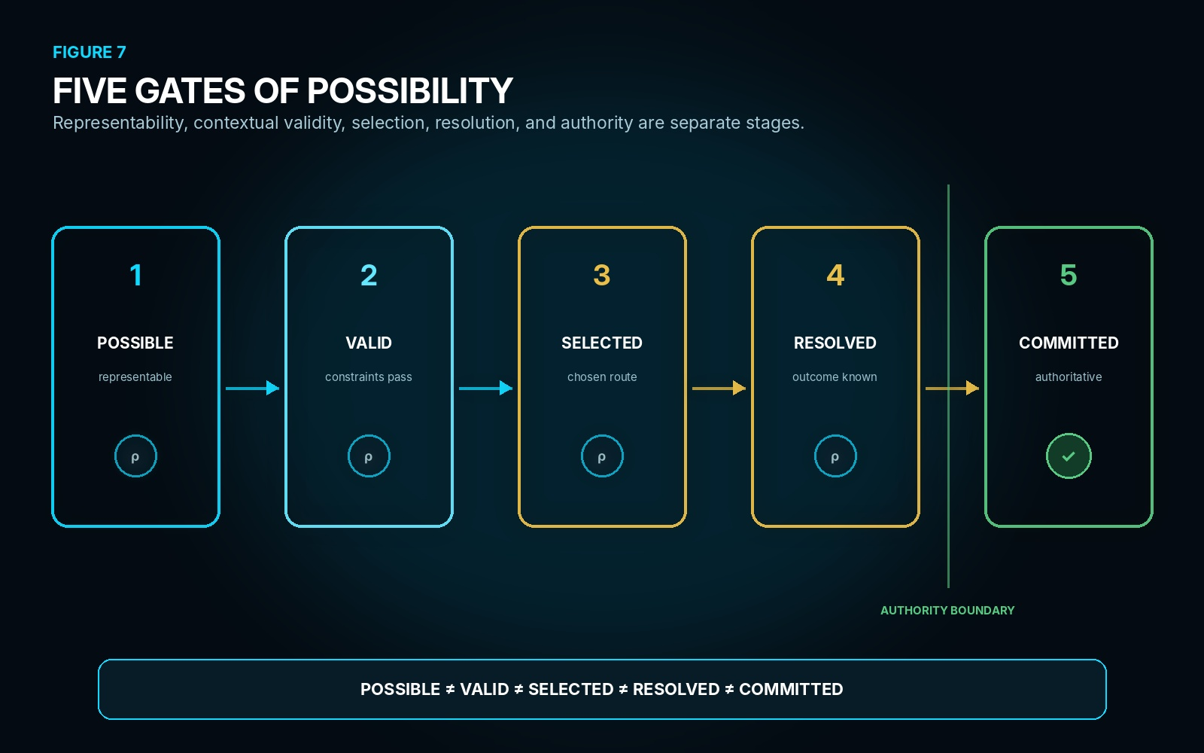
Figure 7. Five Gates of Possibility. Each gate changes the semantic status of a Route; only the final gate crosses the authority boundary into committed consequence.
SECTION 08
Bounded Knowledge
The strength of an Imaginal claim depends on the completeness and reliability of the mapped domain. A formally bounded game can define its legal objects, states, Rules, Models, actions, Operators, spatial contracts, and outcome procedures with unusual precision. Within that declared system, MIRROR can often make strong statements about which configurations are representable and which Routes are valid.
Open real-world reasoning is different. The Mirror may contain incomplete observations, uncertain state, approximate Models, missing actors, hidden constraints, or causal mechanisms that have not been mapped. MIRROR can still be useful, but the result must be interpreted as a possibility permitted by the current model and evidence rather than a complete statement about reality. More detailed reasoning does not remove that epistemic boundary.
The boundary should therefore be visible and inspectable. A Mirror may explicitly mark unresolved state, declare assumptions, identify out-of-scope dependencies, or request deeper observation before a candidate becomes trustworthy enough for its intended use. The correct response to missing knowledge is not to silently fill the exterior of the map. It is to preserve the distinction between mapped, unresolved, and unmapped state.
EPISTEMIC LAW
MODEL-PERMITTED ≠ GUARANTEED REALITY

SCOPE LAW
Outside the declared Mirror boundary means out of scope for this episode, not nonexistent.

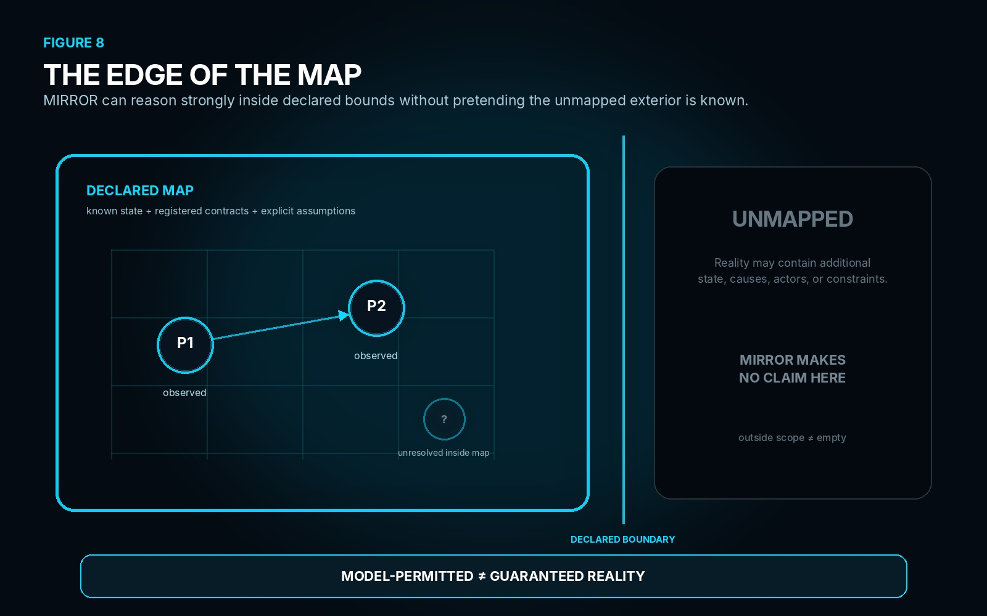
Figure 8. The Edge of the Map. MIRROR reasons over the declared map and its assumptions while preserving the unmapped exterior as outside the current claim rather than converting absence of representation into absence of reality.

PART III
RELATIONAL STATE
MIRROR becomes useful when its contents remain precisely distinguishable: instance identity, local address, semantic state, relationship identity, configuration, and visual projection must never silently collapse into one another.

SECTION 09
Points
A Point is an independently identified instantiated semantic object participating in a Mirror State. Point identity answers which exact Mirror instance is being referenced. Mirror address answers where that instance is located inside the local Address-Space Contract. Semantic contract identifies which registered system can interpret its payload, while semantic state records the currently encoded condition available to the Mirror.
These properties must remain separable because different operations change different things. A character can move from A1 to B4 without becoming another character. A material Point can change temperature or charge state without moving. Two Points can carry equivalent semantic payloads while remaining separate instances. MIRROR therefore treats the Point identifier as the stable local handle through which address and state can change without identity collapse.
A Point may also retain a route back to the source state from which it was mapped and, where deeper structure exists, an exact route into a child Mirror. Neither route changes what the Point is. They preserve provenance and recursive reachability so that the current Mirror can stay compact while deeper complexity remains available when required.
T4. Point structure
Property | Meaning | Boundary
Point ID | Exact Point instance inside this MIRROR episode. | Stable across local movement or state change.
Mirror Address | Local position defined by the Mirror Address-Space Contract. | May change without changing Point identity.
Semantic Contract | Registered SK / Reader contract used to interpret payload. | Meaning does not come from address.
Semantic State | Current encoded state carried by the Point. | May change while identity remains stable.
Source Route | Route back to mapped authoritative source, where applicable. | Supports traceability and source-basis checks.
Child Route | Optional route to deeper child MIRROR. | Supports recursive resolution without embedding all detail.

POINT LAW
POINT IDENTITY ≠ MIRROR ADDRESS ≠ SEMANTIC IDENTITY ≠ SEMANTIC STATE

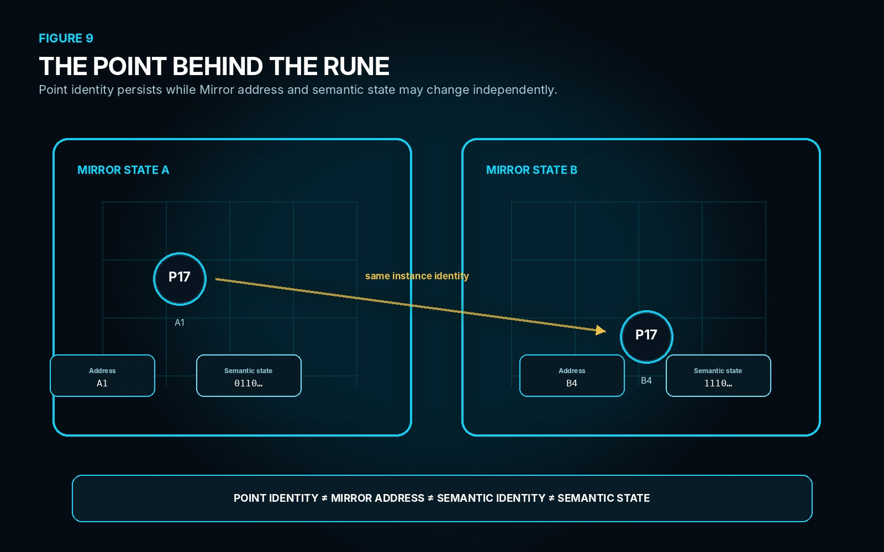
Figure 9. The Point Behind the Rune. P17 remains the same Point instance while its Mirror address and semantic state change independently between two Mirror States.
SECTION 10
Relationships
A Relationship is an independently identified semantic relation connecting declared endpoints within a Mirror State. It is not merely a line drawn between two Points. The Relationship can carry its own identity, direction, semantic contract, encoded state, provenance, and optional route to deeper relational structure.
This independence matters whenever two Points participate in several simultaneous relations. The same pair of objects can be structurally connected, constrained, referenced, aligned, exchanging something, or participating in another registered relation at the same time. If MIRROR reduced every Relationship to an endpoint pair, those distinct semantics would collide.
The Relationship identifier therefore provides the stable handle through which endpoints, state, direction, or other governed properties can be reasoned over without losing relation identity. A later transformation may create, remove, replace, or change a Relationship, but those are changes to relational state rather than proof that the relation was never independently represented.
T5. Relationship structure
Property | Meaning | Boundary
Relationship ID | Exact relation instance in this MIRROR. | Distinct even when endpoints are shared.
Endpoint A | First bound endpoint. | Endpoint identity does not define relation identity.
Endpoint B | Second bound endpoint. | Multiple Relationships may bind the same pair.
Direction | Optional ordered orientation of the relation. | Direction is relation state, not Point identity.
Semantic Contract | Registered contract used to interpret the relation payload. | Relation meaning is explicit and decodable.
Semantic State | Current encoded relation condition. | May change independently of endpoint identity.

RELATIONSHIP LAW
RELATIONSHIP IDENTITY ≠ ENDPOINT PAIR

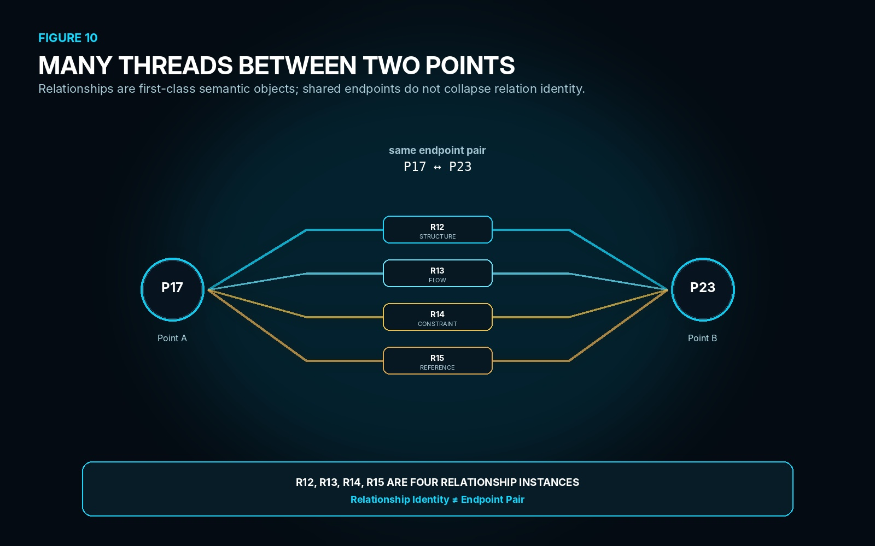
Figure 10. Many Threads Between Two Points. P17 and P23 participate in several independently identified Relationships; the endpoint pair alone cannot stand in for relational identity.
SECTION 11
Configuration
A Mirror configuration is the exact arrangement of instantiated Points, Relationships, addresses, and semantic states present in one Mirror State. The Point inventory is therefore necessary but not sufficient. Two Mirrors can contain the same kinds of constituent objects while exposing different relational organizations, different constraints, different available Routes, and different consequences under the same incoming interaction.
A complex molecule is a useful structural example. Its constituents matter, but so does the exact way those constituents are related in the represented configuration. MIRROR is interested in that relational structure because behavior and transformation depend on the configuration that actually exists, not merely on a list of components that could have been connected in some other way.
This principle generalizes beyond physical structures. Ingredients, characters, tasks, document artifacts, machines, or abstract semantic objects can all occupy the same primitive graph grammar. The domain defines what each Point and Relationship means. MIRROR preserves which exact semantic objects are present and how they are configured for the reasoning episode.
CONFIGURATION LAW
SAME POINT INVENTORY + DIFFERENT RELATIONSHIPS = DIFFERENT CONFIGURATION

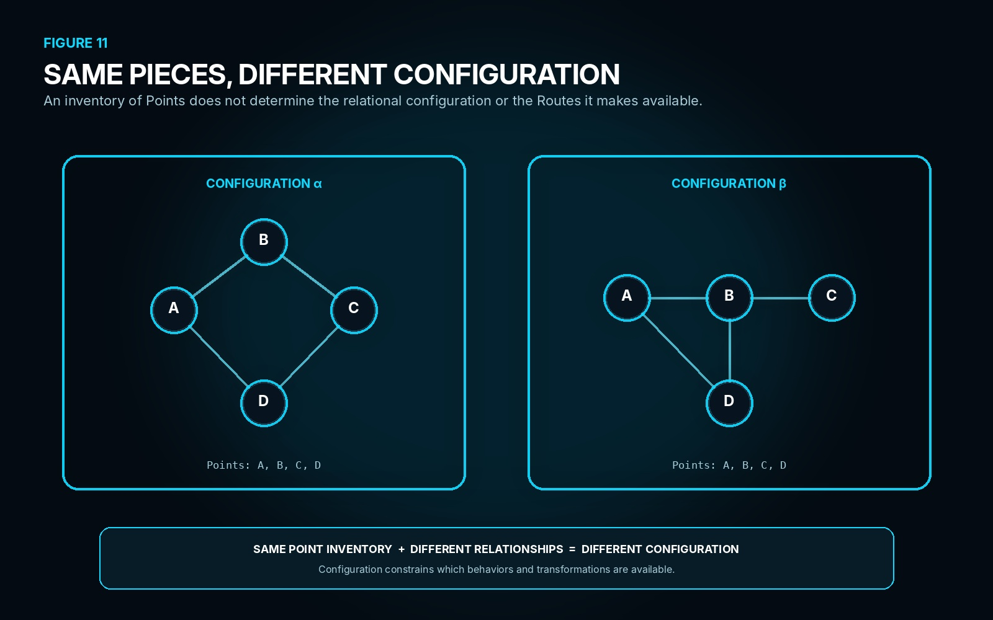
Figure 11. Same Pieces, Different Configuration. Two Mirrors contain the same Point inventory A-D while their independently represented Relationships produce different configurations and therefore different available Routes.
SECTION 12
Semantic Payload
MIRROR does not need to redefine the semantics of every domain it represents. Instead, a Point or Relationship can carry a compact semantic payload together with the registered contract required to interpret it. The Mirror owns the assignment: which payload belongs to which exact instance in which Mirror State. The Semantic Kernel owns the bounded semantic contract, and the Reader resolves the encoded payload into registered meaning.
That separation allows the same graph machinery to host radically different domains without turning MIRROR into a universal dictionary. A Point carrying PHYSICS semantics and a Point carrying FOOD semantics can participate in Mirrors built from the same Point and Relationship primitives while remaining interpretable only through the appropriate registered contract. The relational container stays generic; meaning remains domain-owned.
Relationships can be decoded by the same principle. A relation is not forced to inherit meaning from its endpoints or from the line used to display it. When a Relationship carries its own semantic payload, the Reader can resolve the registered relation and its state independently of the connected Points.
OWNERSHIP BOUNDARY
MIRROR owns assignment. SK owns semantic contract. Reader owns deterministic decoding.

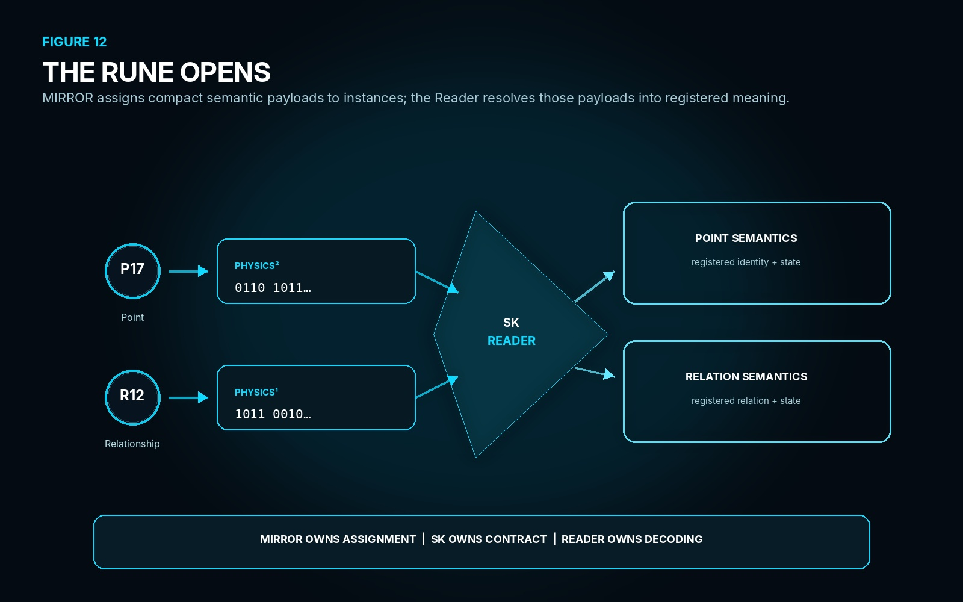
Figure 12. The Rune Opens. Point and Relationship payloads remain compact inside MIRROR and are resolved through their declared SK Reader contracts into registered semantic meaning.
SECTION 13
State, View, and Display
Mirror State is the stored relational configuration being reasoned over. A View is a derived projection that selects or emphasizes particular aspects of that same State. A Display is the rendered manifestation through which a View becomes visible or interactive. Keeping these surfaces separate prevents presentation choices from silently creating new truth.
One molecular Mirror State could support a Structure View, an Identity View, a Binary View, a charge-oriented View, or a diagnostic View without duplicating the underlying configuration. Likewise, a combat Mirror could expose tactical, semantic, debug, or presentation Views over the same resolved Point and Relationship state. The View changes what is projected; it does not automatically change what exists inside the Mirror.
The same separation applies to interpretation and rendering. The Reader determines semantic meaning from the encoded contract. The renderer decides how a selected View is shown. A richer image, icon, animation, or graph layout can therefore change while the underlying semantic state remains identical.

PROJECTION LAW
MIRROR STATE ≠ VIEW ≠ DISPLAY | READER ≠ RENDERER

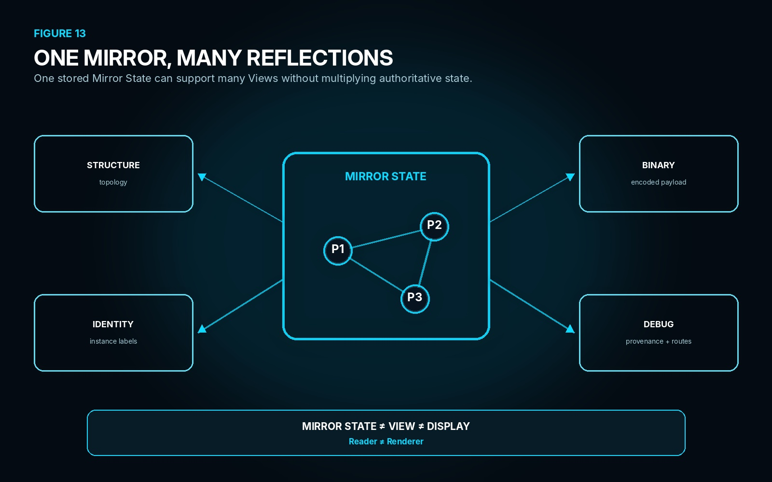
Figure 13. One Mirror, Many Reflections. A single stored Mirror State feeds several independently derived Views; none of those projections becomes a separate authoritative state merely by being rendered differently.

PART IV
REASONING OVER ROUTES
MIRROR becomes operational when configured state exposes traversable Routes. This Part distinguishes route structure from relationships and transformations, shows behavior as realized traversal, and connects MIRROR to Readers, Rules, Models, and Operators without transferring ownership of those mechanisms into the Mirror itself.

SECTION 14
Routes
A Route is an ordered traversable path through relational, spatial, semantic, procedural, temporal, or transformational structure inside a MIRROR. Routes can be stored, generated, discovered, proposed by an agent, or exposed only after some local condition becomes visible. Their common property is ordered traversability through the current bounded configuration.
A Route is not synonymous with a Relationship. A Relationship describes some part of the current configuration; a Route may traverse one or many Relationships, cross addresses, invoke registered transformations, or pass through several Mirror States. Likewise, a Route is not itself an Operator. The Route provides the path through which operations and relational state become behaviorally relevant.
The Imaginal Field can therefore expose many candidate Routes without forcing the source to change. Cyan traces communicate possibilities; gold identifies the currently selected or validated traversal; red marks a branch that has been blocked or invalidated. Those colors express Route status rather than changing the underlying semantic identities of the Points and Relationships involved.
ROUTE DEFINITION
A Route is an ordered traversable path through relational, spatial, semantic, procedural, temporal, or transformational structure within a MIRROR.

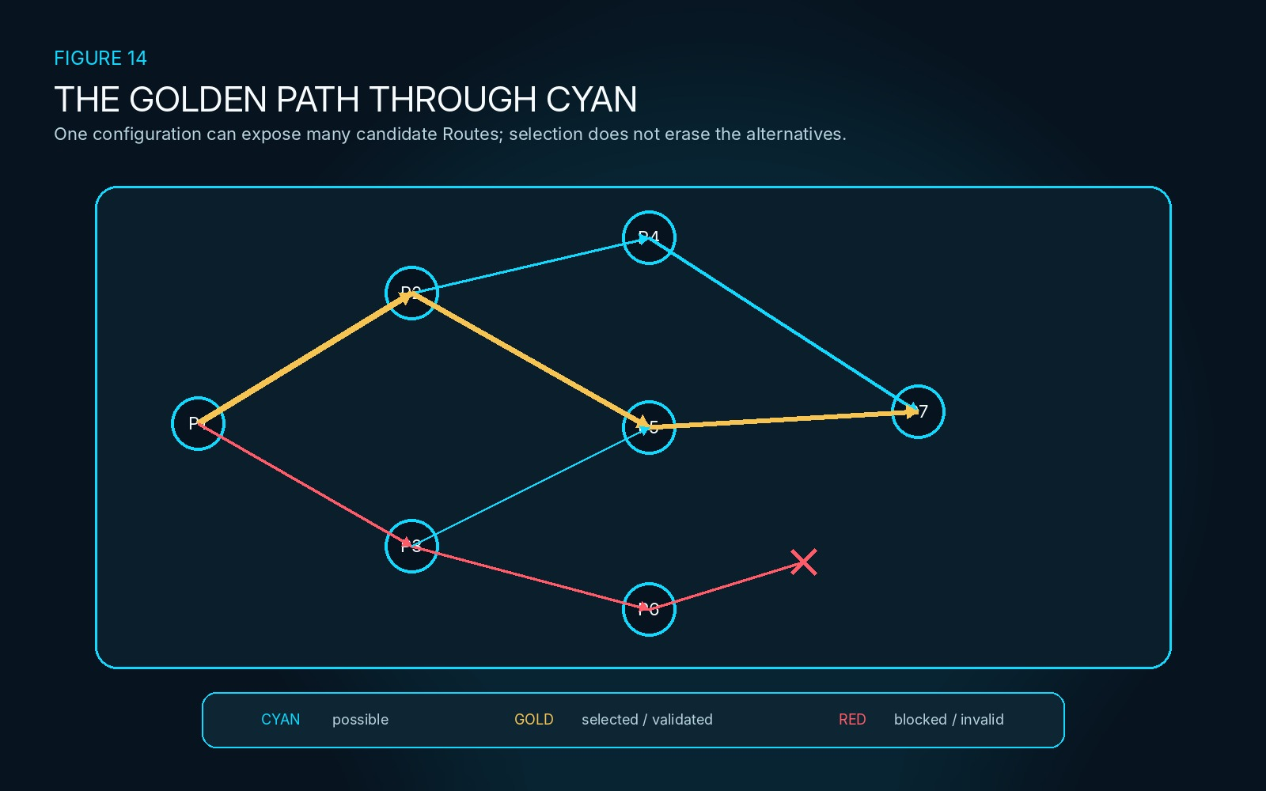
Figure 14. The Golden Path Through Cyan. One configuration can expose many candidate Routes; selection highlights a traversal without erasing the alternatives or granting the selected Route source authority.
SECTION 15
Behavior as Route
Behavior does not require MIRROR to introduce a second primitive substance called behavior. When an input, request, or active process actually realizes a Route through configured state, the resulting traversal is behavior. The configuration defines what is available; the realized Route records what happened through that configuration.
This principle applies across domains. A molecular configuration can expose a transformation path, a character configuration can expose an action path, and a meal configuration can expose a preparation path. The domain semantics differ, but the MIRROR grammar remains stable: instantiated Points and Relationships define the current configuration, while a realized Route carries the episode from one meaningful configuration toward another.
Behavior therefore depends on more than a Point inventory. Different Relationships, constraints, addresses, or available transformations can expose different Routes even when the same kinds of objects remain present.
BEHAVIOR LAW
BEHAVIOR = a realized Route through configured relational state.

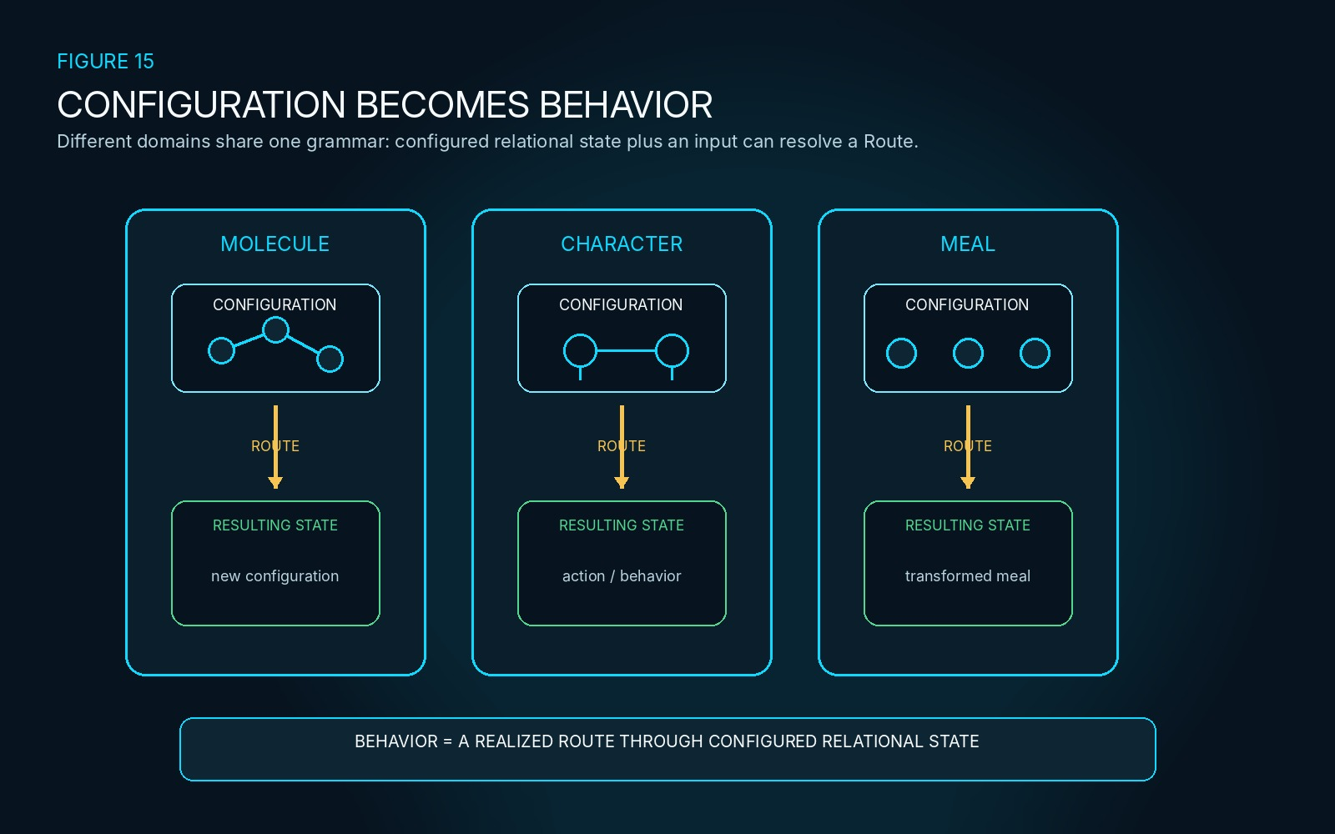
Figure 15. Configuration Becomes Behavior. Molecular, character, and meal configurations use the same MIRROR principle: behavior appears when one available Route is actually realized through configured state.
SECTION 16
Reasoning Over Relations
Reasoning in MIRROR means operating over the bounded representation rather than mutating the authoritative source directly. Existing CERBERUS machinery can be brought to the same relational surface so that semantic state can be decoded, candidate Routes compared, applicable relations matched, calculations performed, proposed transformations tested, and results validated before any later commitment.
MIRROR does not take ownership of the Reader, Rule, Model, or Operator. The Reader resolves registered semantic meaning. Rules constrain or validate applicability. Models calculate, interpret, derive, or predict. Operators propose bounded state transformation. MIRROR owns the configured workspace that assigns those mechanisms to exact Points, Relationships, candidate Routes, addresses, and episode state.
This distinction is important for inspectability. A failed candidate can be examined to determine whether the problem came from missing semantic resolution, a Rule, a Model, an Operator, a Relationship, or the configuration itself rather than collapsing every failure into one generic planning error.
T6. MIRROR reasoning operations
Operation | MIRROR use
Read | Retrieve mapped state
Decode | Resolve semantic payload
Compare | Inspect state differences
Match | Find applicable relations
Filter | Narrow candidate set
Traverse | Follow Route
Calculate | Apply Model/formula
Test | Evaluate candidate
Transform | Apply Operator
Validate | Check Rules/basis
Resolve | Determine result

OWNERSHIP BOUNDARY
MIRROR supplies the common relational surface. Reader, Rules, Models, and Operators retain their own semantic and operational authority.

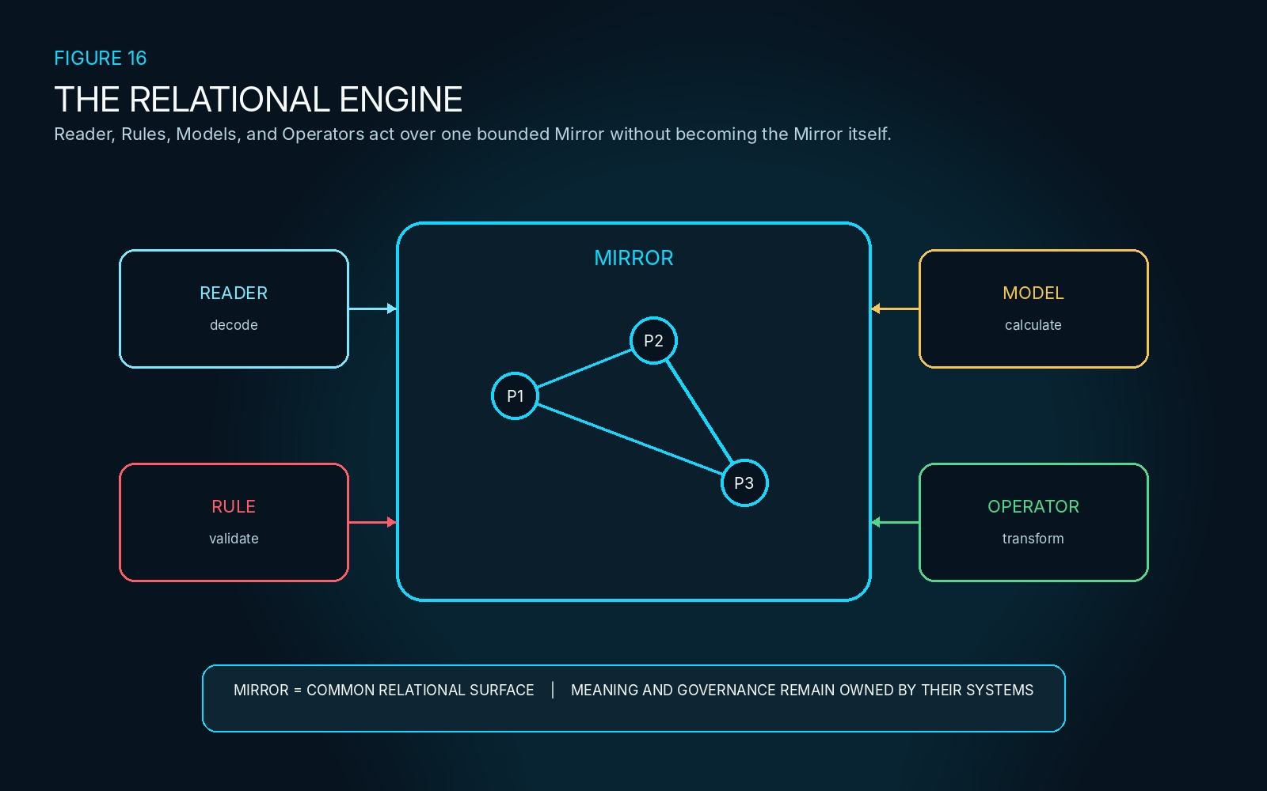
Figure 16. The Relational Engine. Reader, Rule, Model, and Operator mechanisms converge on one bounded MIRROR configuration without becoming MIRROR-owned semantics.
SECTION 17
Relationships and Transformations
A Relationship describes how declared semantic objects are configured. A transformation changes some part of that configuration or state. MIRROR must preserve the difference because the same Relationship can persist across several transformations, and a transformation can occur without becoming a persistent Relationship.
A Route may use both. It can traverse a stable Relationship, invoke a transformation, continue through the resulting Mirror State, and then follow another Relationship. Treating all three as equivalent would erase whether the system is describing configuration, changing configuration, or traversing through a sequence that may contain both.
NON-COLLAPSE
RELATIONSHIP ≠ TRANSFORMATION | ROUTE ≠ RELATIONSHIP

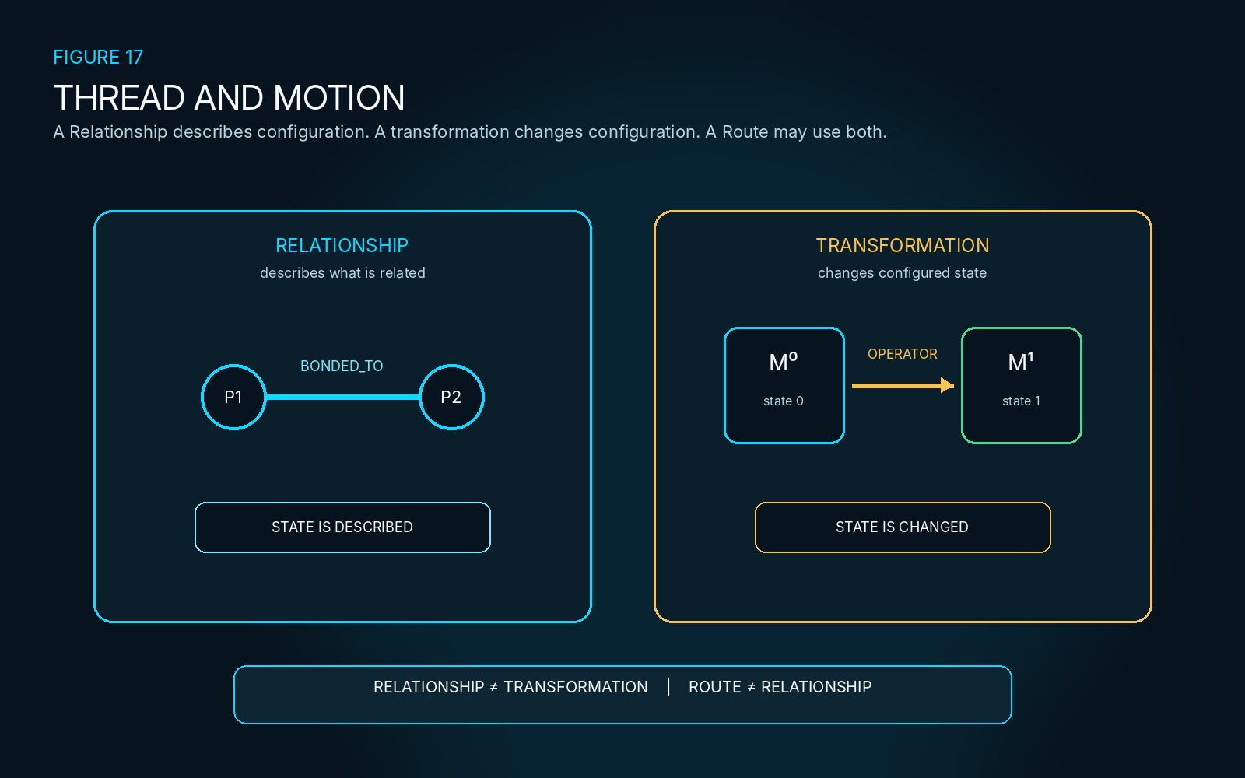
Figure 17. Thread and Motion. A persistent Relationship describes configured state while a transformation changes state; a Route may traverse one and invoke the other without collapsing their identities.
SECTION 18
Bit Operator Routes
Bit Operator Language gives MIRROR an exact way to express candidate semantic state change without embedding domain meaning into the graph machinery. The Mirror identifies the exact Point and reasoning context; the registered semantic contract determines what the indexed state means; the Operator specifies the bounded change.
The cooking example remains deliberately small. COOKING-128 registers sequential semantic positions for steak doneness. A candidate cooking Route can apply PUSH 71 → 75 to the steak Point. The Point remains the same instantiated object while its registered semantic state changes from RAW to MEDIUM inside the candidate Mirror State.
EXACT SEMANTIC TRANSFORMATION
POINT P17 / COOKING-128
STATE 71 RAW
OPERATOR PUSH 71 → 75
CANDIDATE STATE 75 MEDIUM

This does not make MIRROR the Bit Operator specification and does not grant the candidate mutation authority. It demonstrates how a relational Route can call an exact registered transformation while preserving Point identity and source separation.
OPERATOR LAW
POINT IDENTITY MAY PERSIST WHILE SEMANTIC STATE CHANGES. The candidate transformation remains non-authoritative until later validation and commitment.

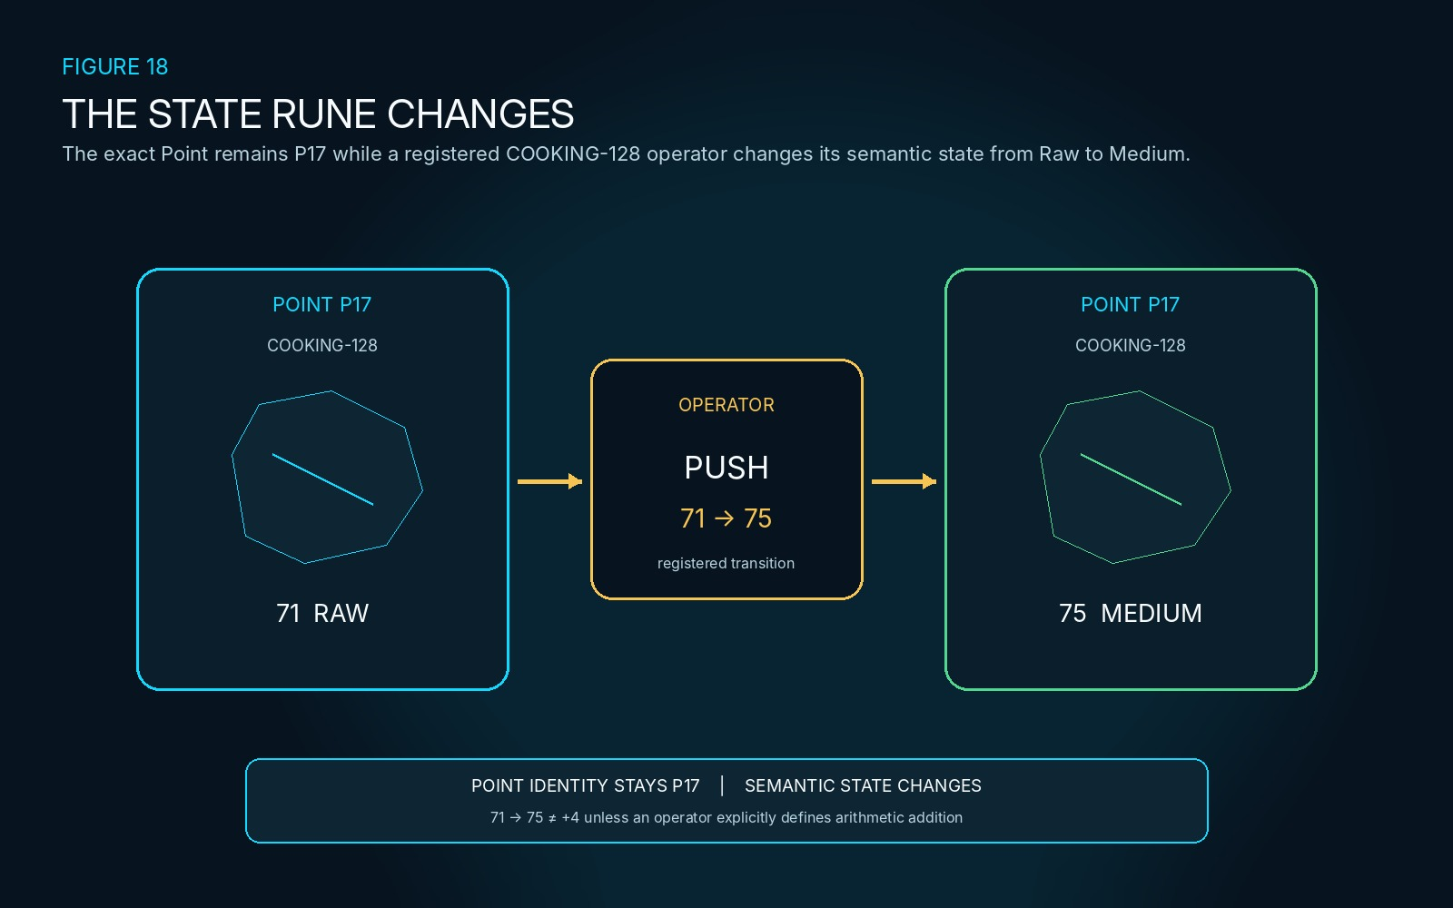
Figure 18. The State Rune Changes. P17 remains the same Point while the registered COOKING-128 state changes from 71 RAW to 75 MEDIUM inside the candidate transformation.

PART V
FIELD-SPACE AND RESOLUTION
MIRROR can now declare where represented state exists locally and how much distinction the current problem requires. This Part formalizes Address-Space Contracts, explicit scale, recursive refinement, independent resolution axes, and generative Interaction Fields without equating Mirror coordinates or detail with source reality or authority.

SECTION 19
Mirror Address Space
A MIRROR may declare its own Address-Space Contract. The local space can be a square grid, hex grid, graph, tree, timeline, table, nested-cell hierarchy, or abstract semantic field. What matters is that the topology and mapping are explicit enough for Points, Relationships, and Routes to be addressed deterministically inside the current reasoning episode.
A spatial Address-Space Contract can declare topology, scale, bounds, origin, orientation, and the projection rule by which source state enters the Mirror. A one-meter hex Mirror and a thirty-meter hex Mirror can both represent the same region for different questions. Likewise, a graph-native Mirror may have no meaningful physical distance at all.
Mirror coordinates therefore do not acquire physical meaning merely because they look spatial. Correspondence exists only where the mapping contract defines it. This separation lets MIRROR use convenient local spaces for reasoning without overwriting the coordinate, geometry, or topology owned by the source.
T7. Address-Space Contract example
Property | Example
Topology | Hex
Scale | 1 m
Bounds | 12 × 12
Origin | World XYZ
Orientation | declared
Projection | World → Mirror

ADDRESS-SPACE LAW
MIRROR SPACE ≠ SOURCE SPACE | MIRROR COORDINATE ≠ PHYSICAL POSITION unless the declared mapping explicitly establishes that correspondence.

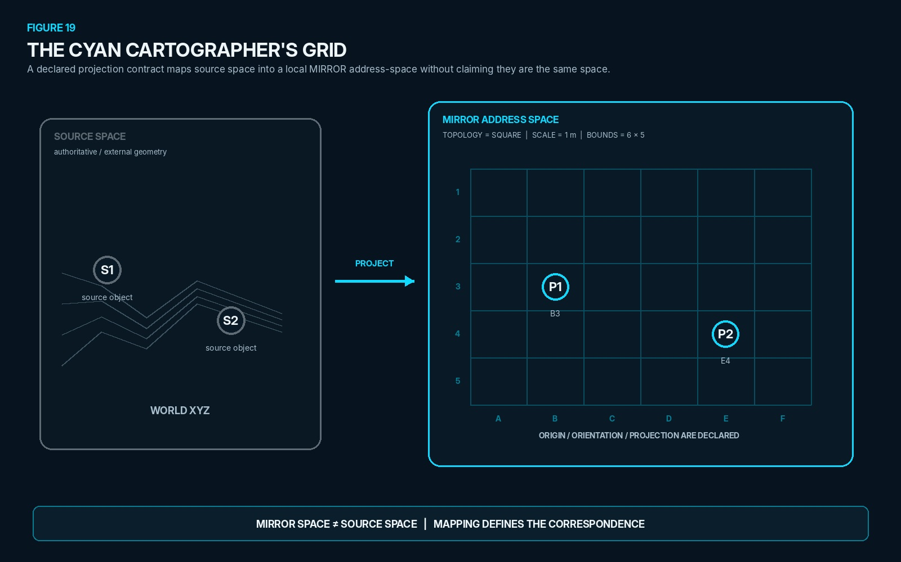
Figure 19. The Cyan Cartographer's Grid. Source geometry is projected into a declared local address-space; the mapping establishes correspondence without making Mirror space identical to source space.
SECTION 20
Scale
Scale is an explicit property of the active Address-Space Contract rather than an assumed property of MIRROR. The same bounded region may be represented with thirty-meter cells for regional routing, one-meter cells for local interaction, or quarter-meter cells where the current causal question requires finer positional distinction.
No scale is inherently more correct simply because it is finer. A finer field costs more representation and may expose distinctions irrelevant to the current problem. A coarser field is sufficient whenever all distinctions that could change the bounded result remain preserved.
Scale therefore follows the same economy used elsewhere in CERBERUS: resolve only what the consequence requires. If a coarse representation can determine the valid result, MIRROR does not need to refine the entire field merely because a higher-resolution representation is possible.
SCALE LAW
The required interaction determines sufficient scale. Greater spatial detail does not create greater authority.

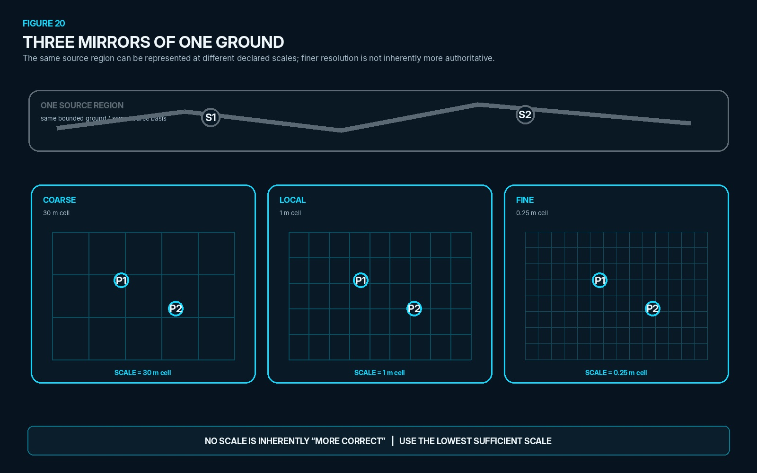
Figure 20. Three Mirrors of One Ground. One source region is represented at three declared scales; the field becomes more discriminating without becoming more authoritative.
SECTION 21
Recursive Refinement
MIRROR can refine only the local region whose current reasoning problem requires greater distinction. A coarse cell such as D5 can open into child addresses D5:A1 through D5:A4, and one of those cells can refine again into addresses such as D5:A2:B7. The address itself preserves the ancestry of the refinement.
This allows a large field to remain compact while a small causal frontier becomes precise. A projectile interaction, molecular relation, hand position, or local collision can receive deeper resolution without forcing every neighboring cell or branch to expand to the same detail.
The interpretation of coarse occupancy must remain disciplined. Two Points mapped to the same coarse cell are not thereby proven to share the same exact position. Likewise, an empty Mirror cell does not assert that source reality is empty; it means only that no relevant Point has been projected there at the current bounded resolution.
REFINEMENT LAW
SAME COARSE CELL ≠ SAME EXACT POSITION | EMPTY MIRROR CELL ≠ EMPTY SOURCE SPACE

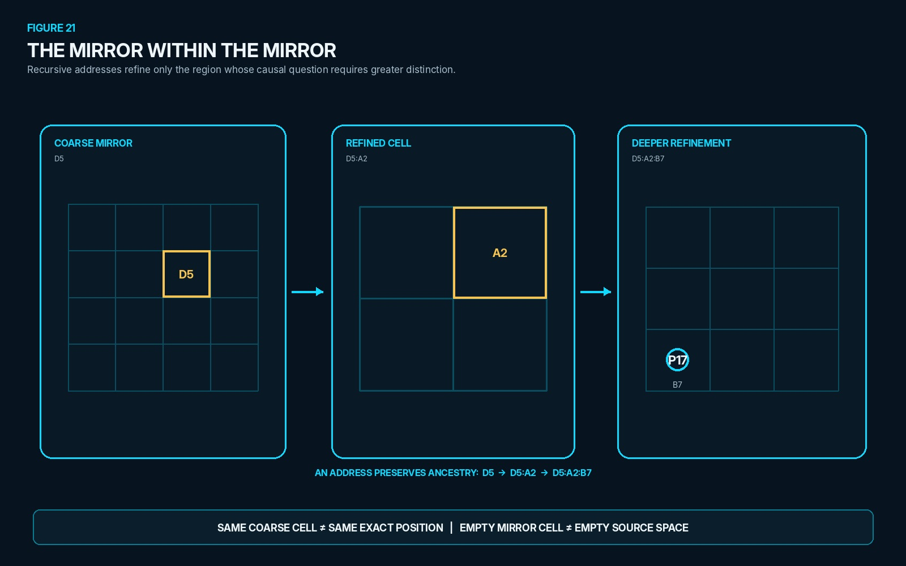
Figure 21. The Mirror Within the Mirror. Recursive addresses refine only the region that needs more distinction while preserving the exact ancestry of the coarse address.
SECTION 22
Independent Resolution Axes
MIRROR does not have one universal detail slider. Semantic, spatial, temporal, and graph resolution answer different questions and can change independently. A deeply resolved physical object can remain spatially coarse; a projectile can require precise position while retaining shallow semantic state; a graph branch can be opened deeply without increasing temporal sampling.
This independence prevents resolution from becoming an uncontrolled synonym for fidelity. The current causal question determines which axis needs additional distinction. Increasing one axis should not force unrelated representational costs on the others.
T8. Independent resolution axes
Resolution axis | Question
Semantic | What meaning depth is needed?
Spatial | How precisely must location be distinguished?
Temporal | At what time granularity must change resolve?
Graph | How deeply must composition be opened?

RESOLUTION LAW
SEMANTIC RESOLUTION ≠ SPATIAL RESOLUTION ≠ TEMPORAL RESOLUTION ≠ GRAPH RESOLUTION | GREATER RESOLUTION ≠ GREATER AUTHORITY

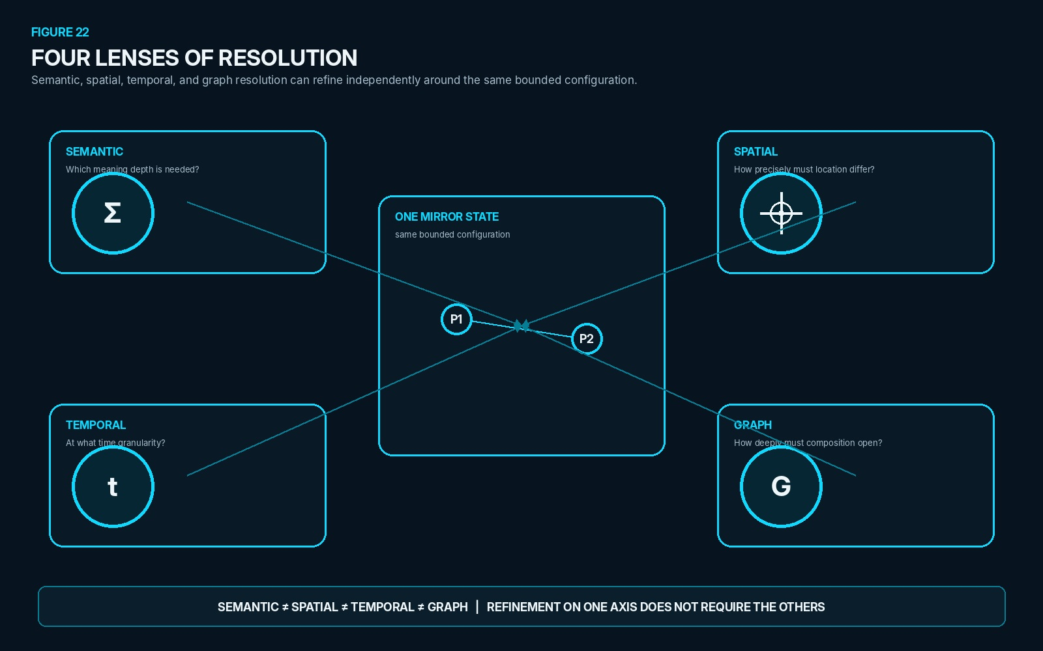
Figure 22. Four Lenses of Resolution. Four independent resolution axes focus on different aspects of one bounded Mirror State; refinement on one axis does not require refinement on the others.
SECTION 23
Interaction Fields
MIRROR can represent bounded mathematical Interaction Fields without creating a permanent record for every empty location in the field. A field can be declared generatively by type, center, scale, and pattern; relevant Points are then tested against the field only where the current reasoning problem requires an interaction result.
GENERATIVE FIELD EXAMPLE
FIELD
Type = FIRE_AOE
Center = C4
Scale = 1 m
Pattern = AOE-03

P1 @ B4 → 0.80
P2 @ C5 → 0.55
P3 @ F8 → 0.00

The field output is not yet a final consequence. A target-specific result can still require semantic state, resistance, applicable Models, Rules, and other resolution inputs. The Interaction Field owns the generative spatial influence surface; downstream reasoning determines what that influence means for each intersecting Point.
This approach keeps large spaces economical. Empty cells can remain implicit, while the field generates only the local values required to resolve relevant intersections. The same principle can support area attacks, zones of influence, sensor regions, environmental gradients, and other bounded fields without turning MIRROR into a dense raster database.
FIELD LAW
FIELD GEOMETRY MAY BE GENERATIVE. Only relevant intersections need to become explicit resolution paths.

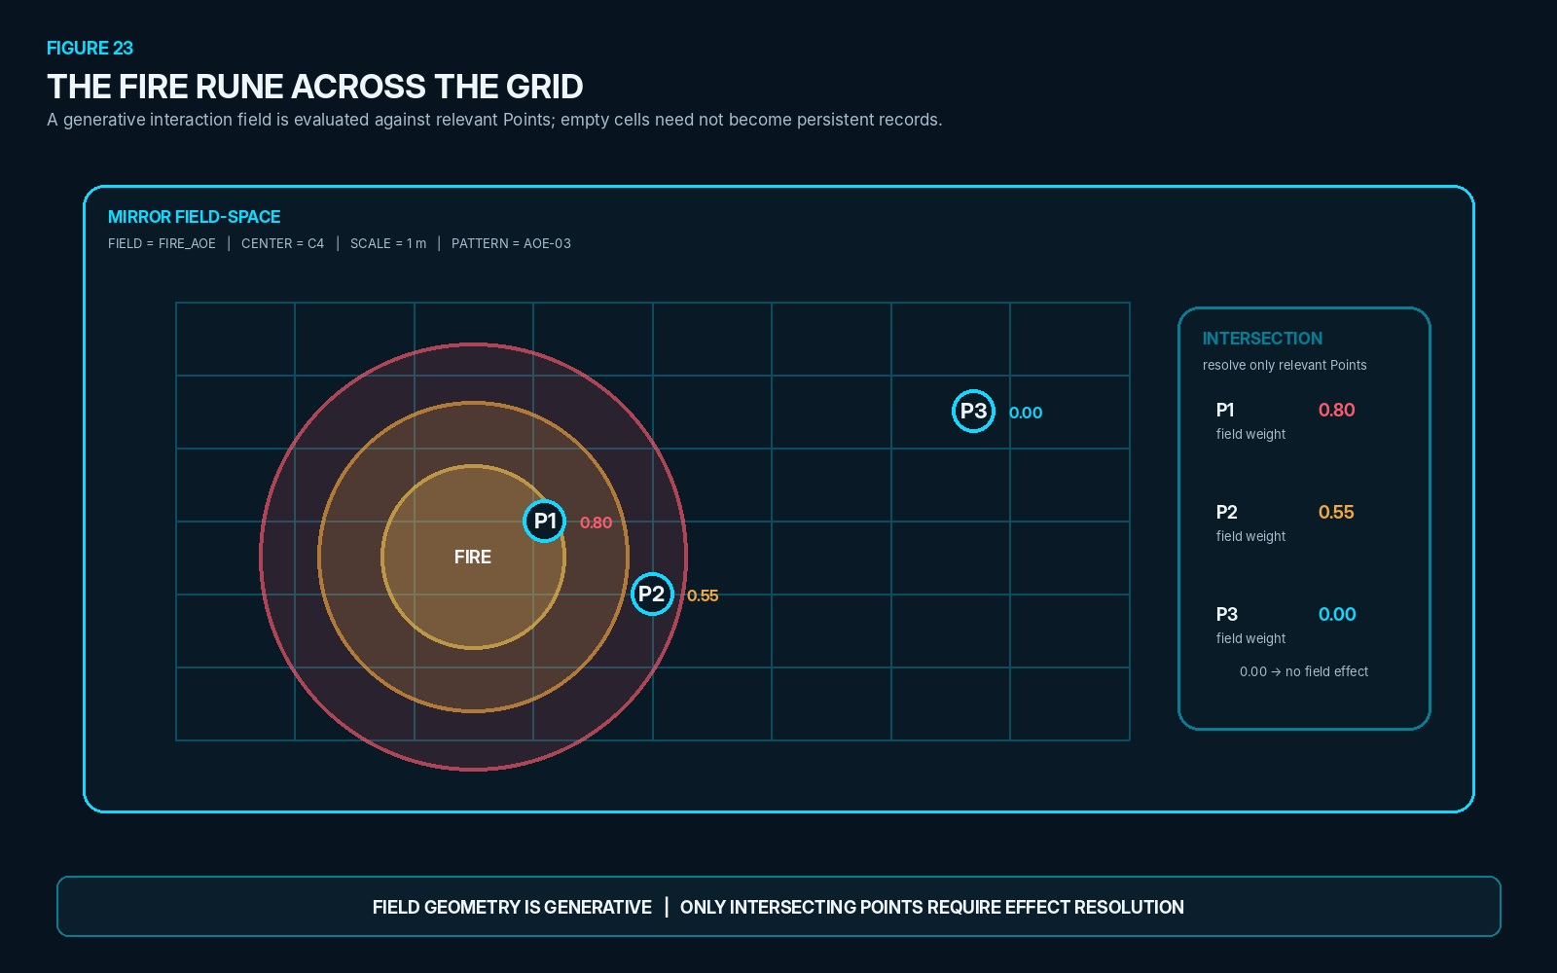
Figure 23. The Fire Rune Across the Grid. A generative FIRE_AOE field is evaluated against mapped Points; only intersecting Points require effect-resolution paths while empty field-space remains implicit.

PART VI
FLUID RESOLUTION
MIRROR now connects bounded possibility to governed change. Hydration determines which source distinctions must become explicit; Fluid marks an authoritative transition that is not yet settled; MIRROR resolves candidate consequences behind the authority boundary; source-basis validation prevents stale writes; and governed commitment permits only exact approved deltas to cross back into source state.

SECTION 24
Hydrating the Mirror
Hydration determines how much source state must become explicit for the current causal question. MIRROR does not replace the Hydration Policy; it consumes the bounded state that Hydration makes available. The runtime begins from authoritative source state, identifies the causal frontier that could change the answer, hydrates the minimum sufficient semantic, spatial, temporal, and graph detail, and instantiates that material as Mirror State 0.
If the active Mirror cannot resolve the interaction because a consequential distinction is still missing, it can request deeper Hydration only where the ambiguity survives. The additional detail may refine a local address, open deeper semantic structure, increase temporal sampling, or expose more graph composition without forcing unrelated regions to expand.
Hydration changes what the Mirror can currently resolve; it does not itself alter authoritative state. Provenance and source identity therefore remain intact while the candidate reasoning surface becomes more detailed. This supports iterative deepening rather than exhaustive World loading.
HYDRATION SEQUENCE
AUTHORITATIVE SOURCE
↓
IDENTIFY BOUNDED CAUSAL FRONTIER
↓
HYDRATE MINIMUM SUFFICIENT STATE
↓
MIRROR STATE 0
↓ if insufficient
REQUEST DEEPER RESOLUTION
HYDRATION LAW
HYDRATION CHANGES AVAILABLE RESOLUTION. HYDRATION ≠ MUTATION.
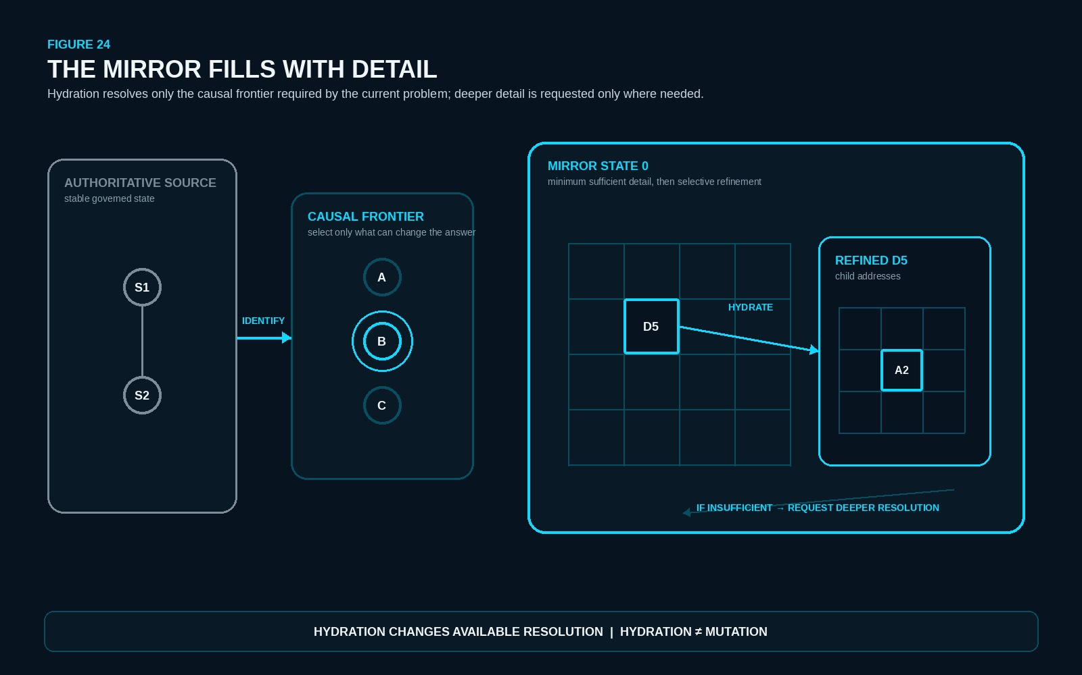
Figure 24. The Mirror Fills With Detail. Hydration resolves only the causal frontier required by the current problem and can deepen selected regions without mutating authoritative source state.
SECTION 25
Fluid State
Fluid describes the settlement condition of an authoritative transition. A stable source can receive a proposed change and become Fluid because the consequence has not yet been resolved, accepted, or rejected. Fluid is therefore not a location, graph, or candidate state; it answers whether the authoritative transition is settled.
MIRROR answers a different question: where is the proposed change being represented and reasoned over? A Fluid episode can open one or more bounded Mirrors while the authoritative source itself remains unchanged. The Mirror may branch through candidate Routes, refine relevant state, and determine a result without becoming the authority that ultimately owns the change.
Once the episode resolves and the result is either committed or rejected, the authoritative transition can return to Stable. If consequential information is still missing, the episode may remain Fluid while additional state is hydrated and the bounded resolution continues.
SETTLEMENT SEQUENCE
STABLE
↓ proposed change
FLUID
↓ MIRROR resolution
COMMIT / REJECT
↓
STABLE
FLUID LAW
FLUID = UNSETTLED AUTHORITATIVE TRANSITION. MIRROR = RESOLUTION SURFACE. FLUID ≠ MIRROR.
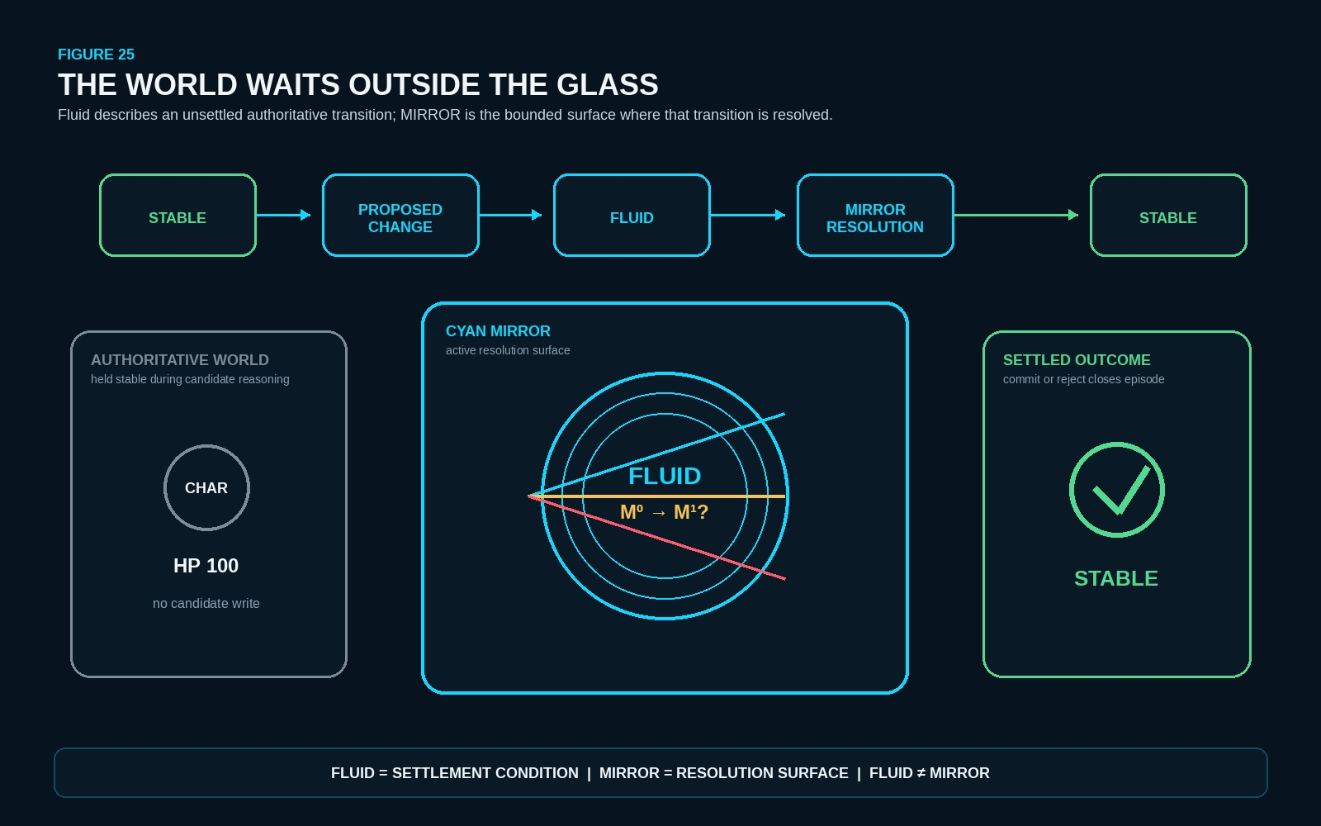
Figure 25. The World Waits Outside the Glass. Authoritative state remains stable outside the Cyan boundary while a Fluid transition is reasoned over inside MIRROR and later closes through commitment or rejection.
SECTION 26
Transactional Resolution
A governed mutation is treated as a bounded transaction rather than as permission to use authoritative state as a scratchpad. The request first creates or selects Mirror State 0, then generates or selects a candidate Route. Applicable Rules constrain what may proceed, Models calculate or interpret the interaction, Operators propose exact state transformations, and the resulting candidate state is validated before any source write is considered.
This makes failure inspectable. Missing state can trigger deeper Hydration; an invalid Relationship can block a Route; a Rule can reject an action; a Model contradiction can prevent a result; an Operator can be unavailable; a target can remain ambiguous; or stochastic input can remain unresolved. None of those failures require partially mutating the source and then trying to undo the damage.
The runtime proposition is deliberately strict: if the required interaction cannot be coherently represented and resolved inside its bounded MIRROR, it is not ready to become authoritative state. Successful candidate computation remains distinct from later authorization and commitment.
TRANSACTIONAL RESOLUTION
REQUEST
↓
MIRROR STATE 0
↓
SELECT / GENERATE ROUTE
↓
RULES → MODELS → OPERATORS
↓
CANDIDATE STATE
↓
VALIDATION
TRANSACTIONAL LAW
IF THE REQUIRED INTERACTION CANNOT BE COHERENTLY RESOLVED IN ITS BOUNDED MIRROR, IT SHOULD NOT BE COMMITTED AS AUTHORITATIVE STATE.
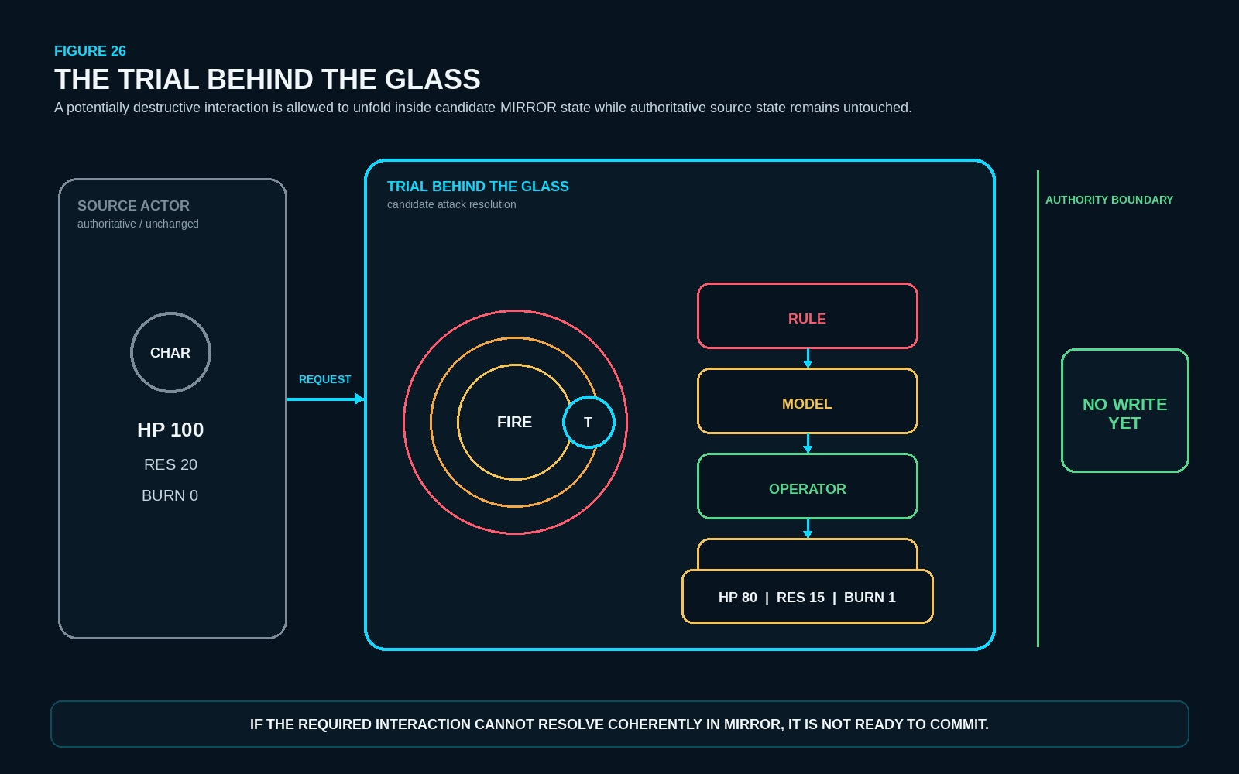
Figure 26. The Trial Behind the Glass. A potentially destructive interaction resolves entirely in candidate MIRROR state; the authoritative source actor remains unchanged until a later governed commit.
SECTION 27
Source Basis and Staleness
Every mutation MIRROR preserves the source basis from which its candidate state was constructed. The basis may be a revision identifier, state fingerprint, or bounded dependency set rather than a lock on the entire World. Its purpose is to let the system ask, immediately before commitment, whether the source assumptions that produced the resolution are still valid.
Consider a candidate created from World Revision 104 in which CHAR-4 has HP = 80. While the candidate is resolving, another authorized process changes the relevant source state so that CHAR-4 now has HP = 60. The old candidate may still be internally coherent relative to Revision 104, but it is now stale as a commit proposal because the source basis on which it depended no longer matches.
Staleness should trigger bounded rehydration and re-resolution rather than blind commitment. MIRROR does not require whole-World locking: only changes to dependencies whose values can alter the bounded result need to invalidate the commit attempt. This keeps concurrency possible while preserving causal correctness.
SOURCE-BASIS LAW
A RESULT VALID AGAINST ONE SOURCE BASIS IS NOT AUTOMATICALLY A VALID COMMIT AGAINST A CHANGED SOURCE BASIS. VALID CANDIDATE ≠ STILL-VALID COMMIT.
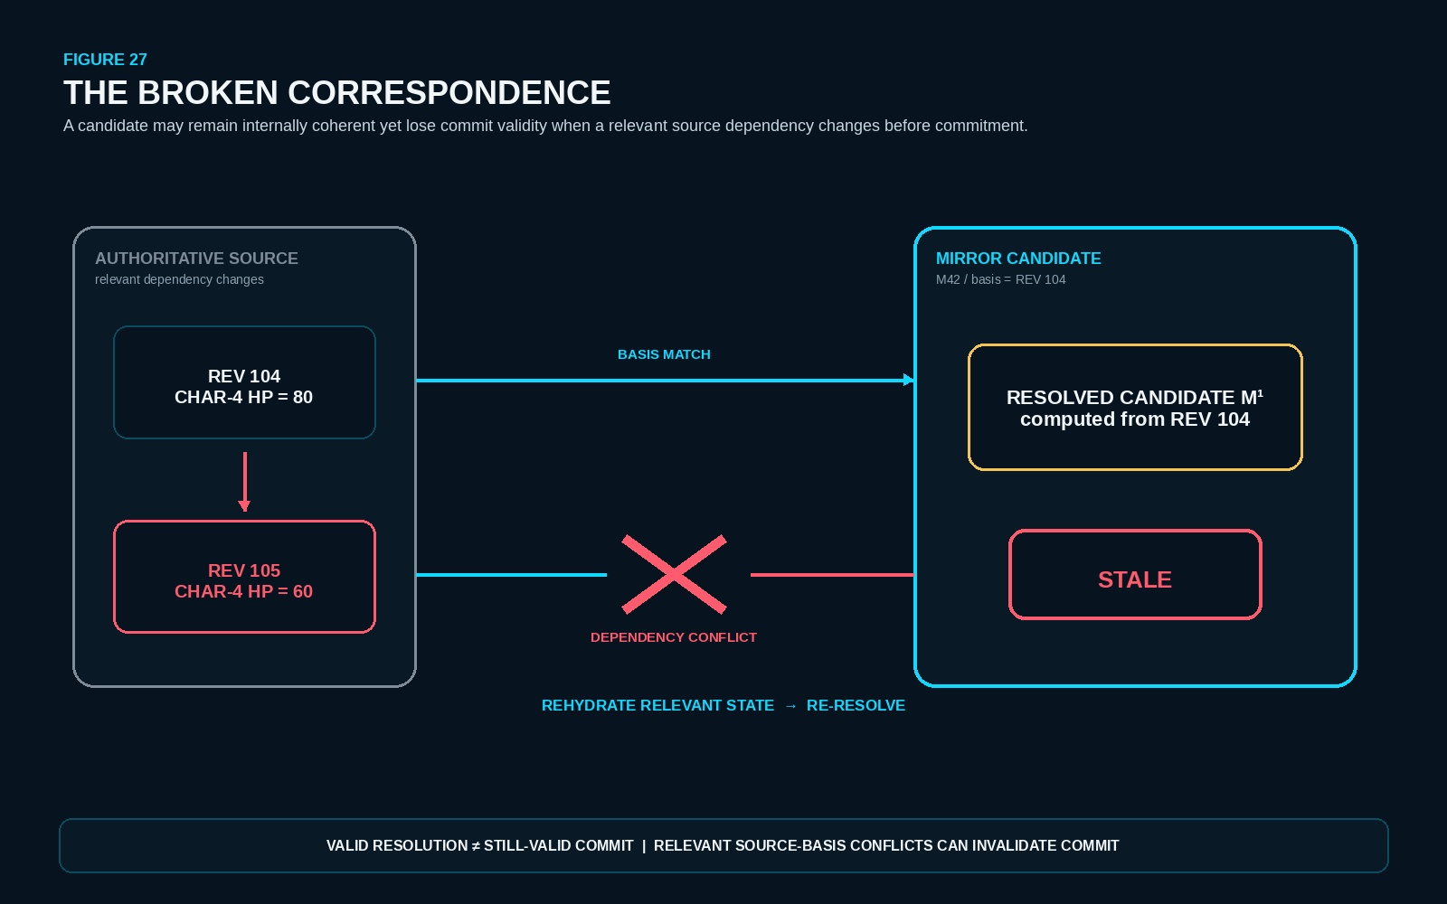
Figure 27. The Broken Correspondence. A candidate resolved against World Revision 104 becomes stale when a relevant source dependency changes before commitment, requiring bounded rehydration and re-resolution.
SECTION 28
Governed Commitment
Resolution determines a candidate consequence; commitment grants authority to an exact change. MIRROR therefore does not write its complete resolved graph back into the source. Only the approved consequential delta needs to cross the boundary, together with enough provenance and source-basis information to make the write inspectable.
The conceptual commit packet is deliberately small. It identifies the exact Target, the Prior State against which the candidate was resolved, the Approved New State or Delta, the Operator provenance that produced the transformation, Rule or Model provenance where those mechanisms materially support the result, and the Source Basis that must still be current at commitment time.
T9. Candidate Commit Packet
Commit packet field | Purpose
Target | Exact authoritative object, record, field, or state target receiving the approved consequence.
Prior State | The relevant source state against which the candidate consequence was resolved.
Approved New State / Delta | The exact consequential change authorized to cross the boundary.
Operator Provenance | The registered Operator or transformation route that produced the candidate change.
Rule / Model Provenance | Applicable Rule and Model references where they materially support validation or calculation.
Source Basis | The source revision, fingerprint, or bounded dependency set that must remain valid for commit.

For the running combat example, a rich candidate Mirror may have required geometry, interaction fields, resistance logic, Rules, Models, and many intermediate records, yet the authoritative consequence can still be only three exact deltas: HP 100 → 80, Fire Resistance 20 → 15, and Burn 0 → 1. The rest remains computation unless later causal-persistence rules require some residue to survive.
COMMIT LAW
COMPUTATION ≠ WRITE ≠ EVENT ≠ MEMORY. ONLY THE APPROVED CONSEQUENTIAL DELTA CROSSES THE AUTHORITY BOUNDARY.
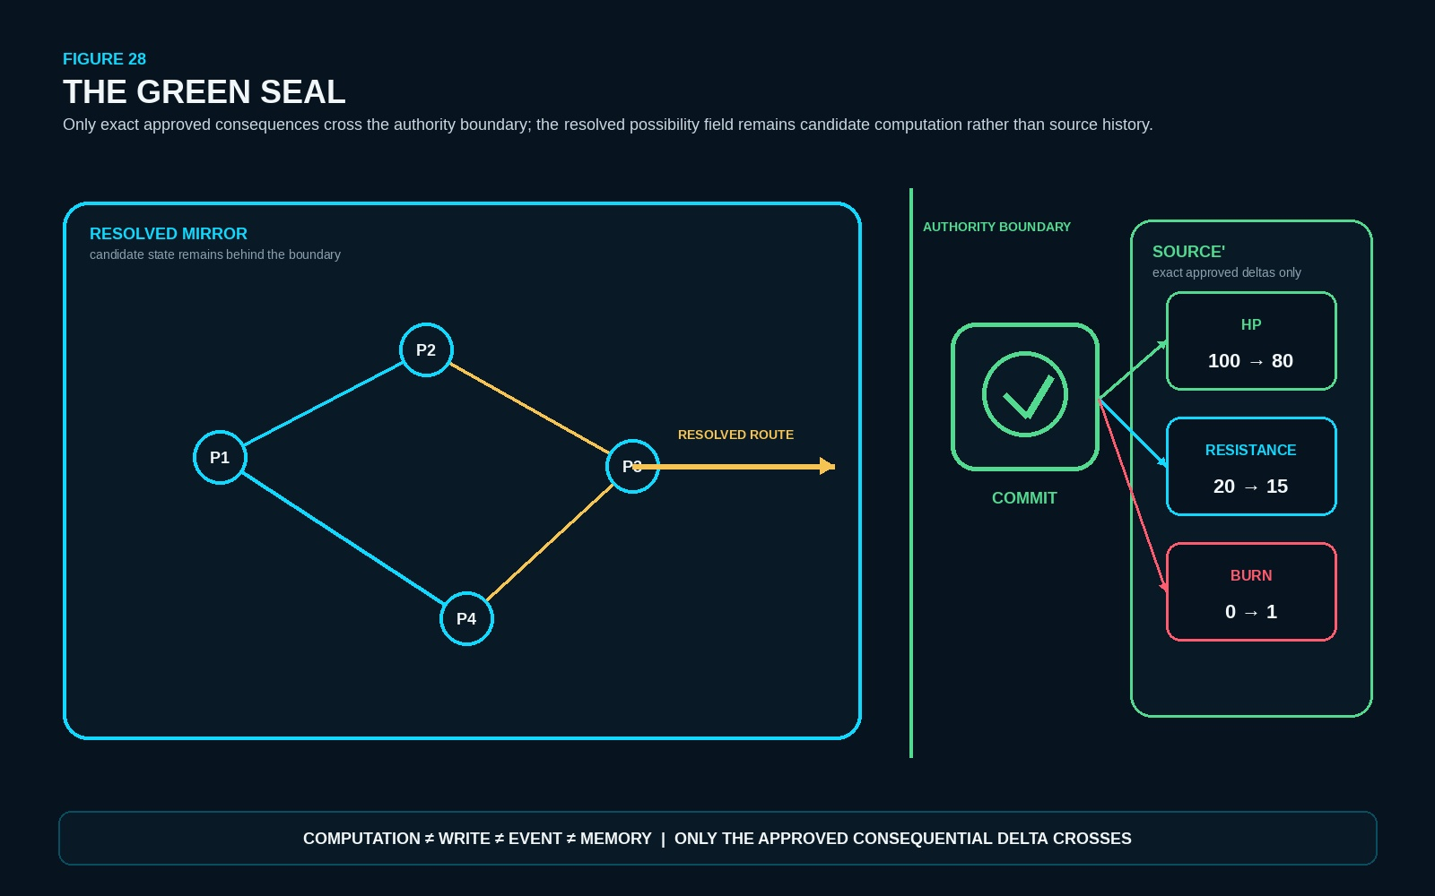
Figure 28. The Green Seal. The resolved gold Route reaches the green commitment boundary, and only the exact approved HP, Resistance, and Burn deltas cross while the larger Cyan possibility field remains behind.

PART VII
CAUSAL CLOSURE AND PERSISTENCE
MIRROR now determines what must survive after a bounded reasoning episode has resolved. Consequential residue may leave the Cyan field through explicit Resolution Ties; untied resolution scaffolding may be burned; and sufficiently complete graph state can be serialized, reconstructed, and reloaded without preserving the original display or conversational context.

SECTION 29
Resolution Ties
A successful MIRROR episode can produce far more information than the future actually needs. Geometry, candidate branches, intermediate calculations, temporary Relationships, evaluation state, and debugging structure may all have been necessary to determine the result. After resolution, MIRROR therefore asks a narrower persistence question: what information produced here still has an unresolved future dependency?
A continuing dependency becomes a Resolution Tie. The Tie belongs to the future causal requirement rather than automatically to the temporary Mirror record that first carried it. Sufficient residue may be externalized as authoritative State, an unresolved Contract, a persistent Event, autobiographical Memory, or a Procedure that remains relevant to later reconstruction. These destinations are deliberately distinct because each preserves a different kind of future consequence.
A compact Resolution Receipt may also be retained by implementation policy to make closure inspectable, but the receipt is not a sixth causal-residue class. It records that resolution occurred and what was preserved; it does not by itself establish a new causal dependency. The governing economy is therefore selective: preserve enough to satisfy every live Tie, not enough to preserve the whole Mirror simply because the Mirror once existed.
RESOLUTION TIE LAW
A RESOLUTION TIE PRESERVES SUFFICIENT FUTURE-REQUIRED RESIDUE, NOT THE WHOLE MIRROR THAT PRODUCED IT.

T10. Resolution Tie Destinations
Destination | What survives | Boundary
STATE | A consequential condition that is now true in authoritative state. | State residue does not require preservation of the full resolving episode.
CONTRACT | An owed or unresolved consequence that must still be satisfied. | Earned obligation ≠ already received state.
EVENT | The occurrence itself remains causally useful as history. | Event identity persists only when the occurrence still explains future state.
MEMORY | An autobiographically addressable relation to the occurrence. | World Event ≠ actor Memory.
PROCEDURE | A historically valid mechanism remains useful for later reconstruction. | Reconstructable route ≠ proof that the historical case followed it.
RECEIPT | Compact implementation record of resolution, commitment, Ties, and closure. | Optional record; not a sixth causal-residue class.

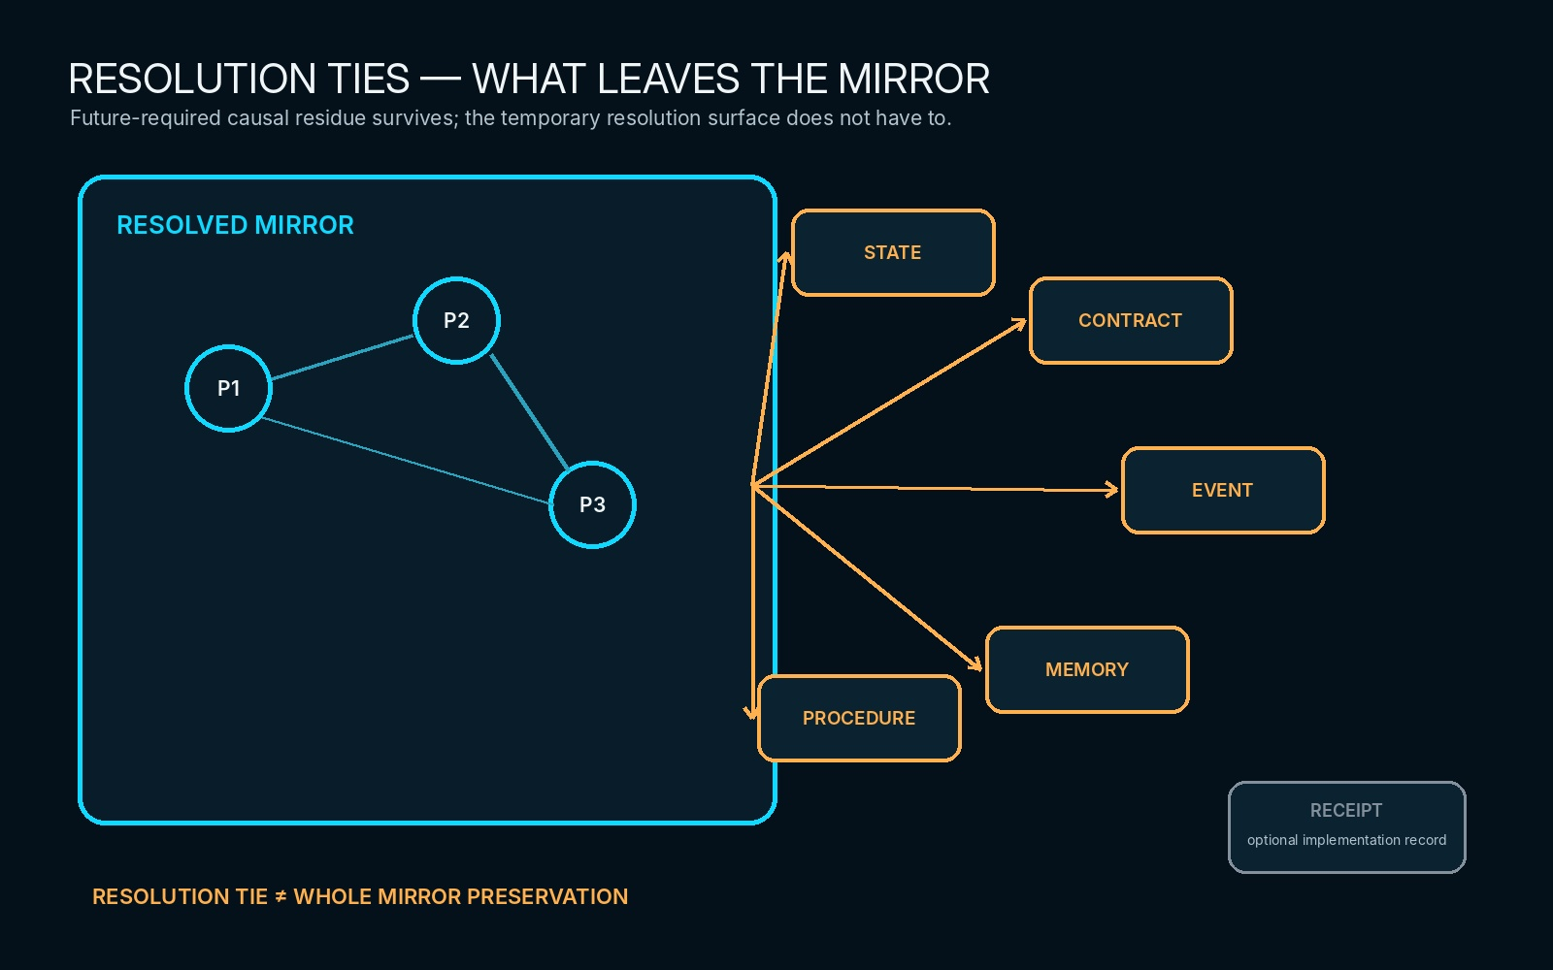
Supporting visual — Resolution Ties. Amber dependencies carry only the future-required residue out of the resolved Cyan field; the larger Mirror remains disposable.
SECTION 30
Burning the Mirror
Once the approved consequence has crossed the authority boundary and every continuing dependency has been externalized, the remaining candidate structure is resolution scaffolding. The term is intentional: these records were computationally useful because they helped determine the result, not because their temporary existence automatically deserves permanent historical status.
Closure therefore follows an explicit order. MIRROR resolves the selected Route, commits only approved consequences, identifies future dependencies, externalizes sufficient residue, verifies that every Resolution Tie can still be satisfied, and only then burns untied transient state. Burning is not deletion of required truth. It is the safe removal of representation whose causal responsibility has already ended.
All four binary closures remain meaningful. A 0→0 interaction may represent a real attempted action that was successfully defended; 1→1 may represent a tested state that remained active; 0→1 and 1→0 record visible change. The absence of a final delta therefore does not prove that no resolution occurred. Persistence and historical importance are evaluated separately from whether the final bit happened to change.
CANONICAL CLOSURE ALGORITHM
RESOLVE
→ COMMIT APPROVED CONSEQUENCES
→ IDENTIFY FUTURE DEPENDENCIES
→ EXTERNALIZE SUFFICIENT RESIDUE
→ VERIFY RESOLUTION TIES
→ BURN UNTIED TRANSIENT STATE
→ CLOSE FLUID EPISODE

CLOSURE LAW
RESOLUTION SCAFFOLDING IS NOT AUTOMATICALLY WORLD HISTORY. MIRROR RECORDS PERSIST BY CAUSAL NECESSITY, NOT MERELY BECAUSE THEY EXISTED DURING COMPUTATION.

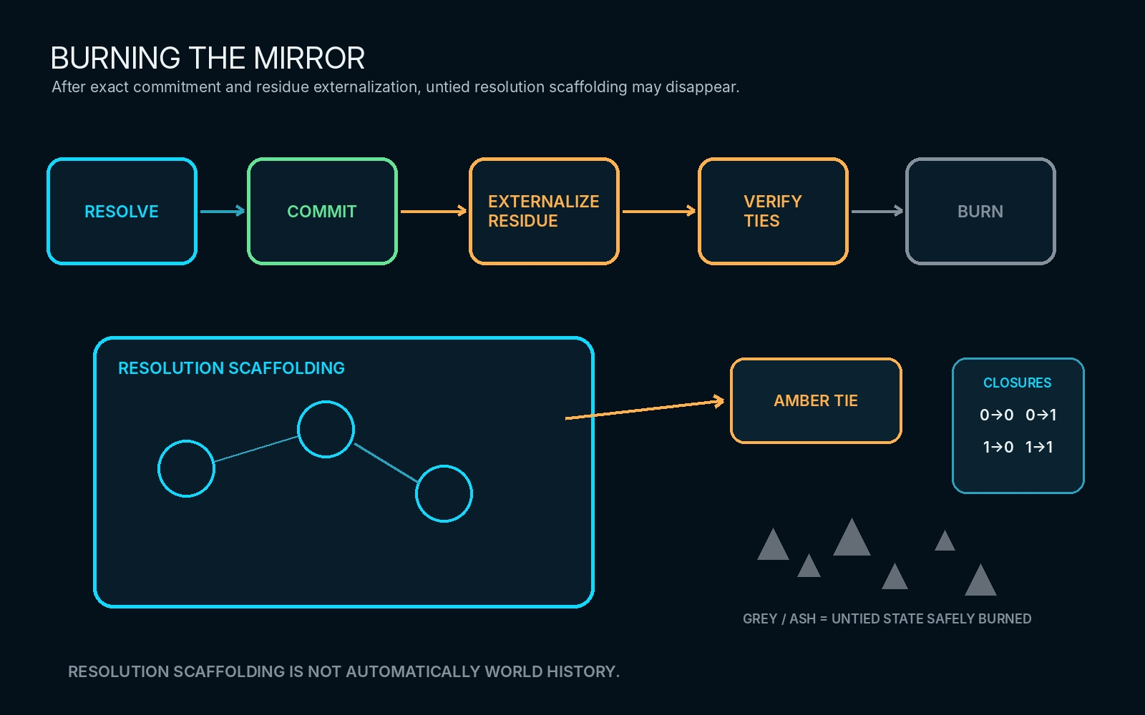
Supporting visual — Burning the Mirror. Exact consequences and Amber Ties survive; untied Cyan scaffolding dissolves safely to grey ash after closure.
SECTION 31
Serialization and Reload
MIRROR is a data-and-contract architecture rather than a particular rendered graph. A bounded Mirror can therefore be serialized as a compact packet containing stable Mirror and State identity, Point and Relationship identities, Mirror-local addresses, endpoints, semantic contracts, encoded payloads, and the interpretation versions required to reconstruct the same relational state.
CONCEPTUAL MIRROR PACKET
M|MIR-042|STATE-0|FORMAT-1
P|P1|A1|PHYSICS²@0.1|<bits>
P|P2|A3|PHYSICS²@0.1|<bits>
R|R1|P1>P2|PHYSICS¹@0.1|<bits>

The packet does not need to embed every item of knowledge reachable through those semantic addresses. Instead, an Interpretation Manifest declares the external semantic contracts and versions required for deterministic reconstruction. If the original display can be destroyed and the same Mirror graph reconstructed from the packet plus its declared dependencies, then State, View, and Display have remained correctly separated.
T11. Interpretation Manifest
Dependency | Version | Reconstruction responsibility
MIRROR FORMAT | v1 | Defines packet grammar, graph identity, Point/Relationship structure, and addressing expectations.
PHYSICS¹ | v0.1 | Resolves shared physical semantics used by mapped relationships or common physical state.
PHYSICS² | v0.1 | Resolves the deeper physical semantics carried by selected Point payloads.
BIT OPERATOR | v2 | Resolves registered semantic transformation operations referenced by Routes.
READER CONTRACT | v1 | Deterministically decodes the declared SK payloads into registered meaning.

A Mirror Data Signature can further declare which local Fields participate in the active projection—for example {C,D,E,G,I,K}—without claiming that the Signature is the data itself, a display order, a read permission, or write authority. The signature makes the local reconstruction surface explicit while preserving those independent responsibilities.
Once topology, semantic slots, expected Readers, allowed Routes, validation behavior, and Views become reusable, the bounded structure can function as a Reloadable Intelligence Matrix. The Matrix preserves a reasoning structure that can be reconstructed and instantiated with new state. Matrix ≠ loaded context, Template ≠ instance, and available structure ≠ active reasoning episode.
RECONSTRUCTION LAW
MIRROR PACKET ≠ RENDERED GRAPH. SUFFICIENT IDENTITIES + TOPOLOGY + SEMANTIC CONTRACTS + STATE + ADDRESSES + DECLARED DEPENDENCIES CAN RECONSTRUCT THE MIRROR WITHOUT PRESERVING ITS ORIGINAL DISPLAY.

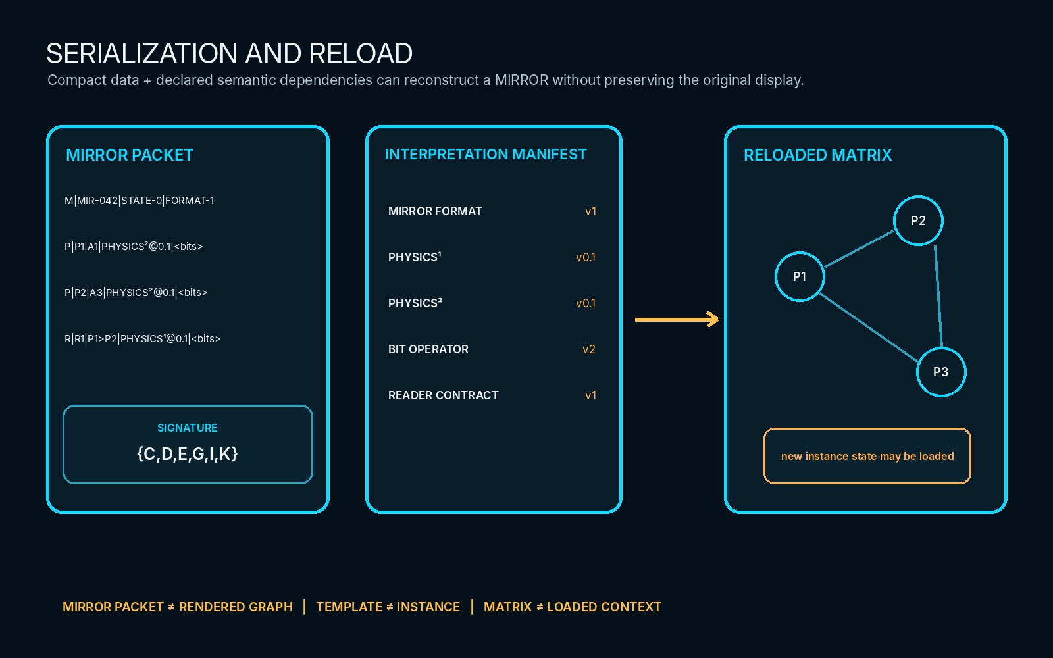
Supporting visual — Serialization and Reload. A compact Mirror packet plus its Interpretation Manifest reconstructs a reloadable graph while preserving the separation between data, dependency, topology, and display.

PART VIII
THE COMPLETE MIRROR
The final Part stress-tests MIRROR across unrelated domains, converts its non-collapse boundaries into a normative regression surface, and closes the architecture with one complete Cyan Mirror Chronicle. No new primitive is introduced here; the purpose is to prove that the existing grammar survives composition.

SECTION 32
Cross-Domain Demonstrations
MIRROR is intended to remain domain-independent. That claim is meaningful only if the same primitive grammar can survive radically different configuration problems without changing what MIRROR itself owns. The final stress test therefore places PHYSICS, a meal, a workout, and combat side by side. Each domain supplies its own semantics, Models, Rules, Operators, temporal assumptions, and state contracts; MIRROR continues to supply bounded State, Points, Relationships, Routes, Views, and Ties.
The examples are deliberately compact. They are not miniature specifications for the four domains. Their purpose is to ask whether the same MIRROR distinctions remain legible when the represented thing changes from molecular configuration, to semantic transformation, to temporally organized training, to spatial interaction and authoritative state change.
T12. Cross-Domain Stress Tests
Domain | Bounded configuration | MIRROR stress test | Boundary preserved
PHYSICS | Complex molecule | Point identity; first-class Relationships; semantic payload; nested resolution; configuration-driven possibility. | Physical semantics remain owned by PHYSICS / registered Readers; MIRROR owns assignment and relational configuration.
Meal | Ingredient / steak transformation | Composition; quantities; Bit Operator transformation; recursive outputs; candidate state. | COOKING semantics and Operators remain domain-owned; Relationship ≠ transformation.
Workout | Exercise / set / load / rest over TIME | Temporal organization; repetition; progression; planned vs resolved state; timeline addressing. | The workout domain owns training meaning; MIRROR represents the bounded configuration and Routes without inventing progression semantics.
Combat | Actors + spatial field + state deltas | Spatial projection; scale; Interaction Field; Fluid resolution; exact deltas; Resolution Ties; burn. | World authority remains outside MIRROR; a resolved candidate still requires fresh basis and governed commitment.

DOMAIN-INDEPENDENCE LAW
A DOMAIN SUPPLIES MEANING. MIRROR SUPPLIES RELATIONAL POSSIBILITY AND RESOLUTION. THE PRIMITIVE GRAMMAR MUST NOT CHANGE MERELY BECAUSE THE DOMAIN CHANGES.

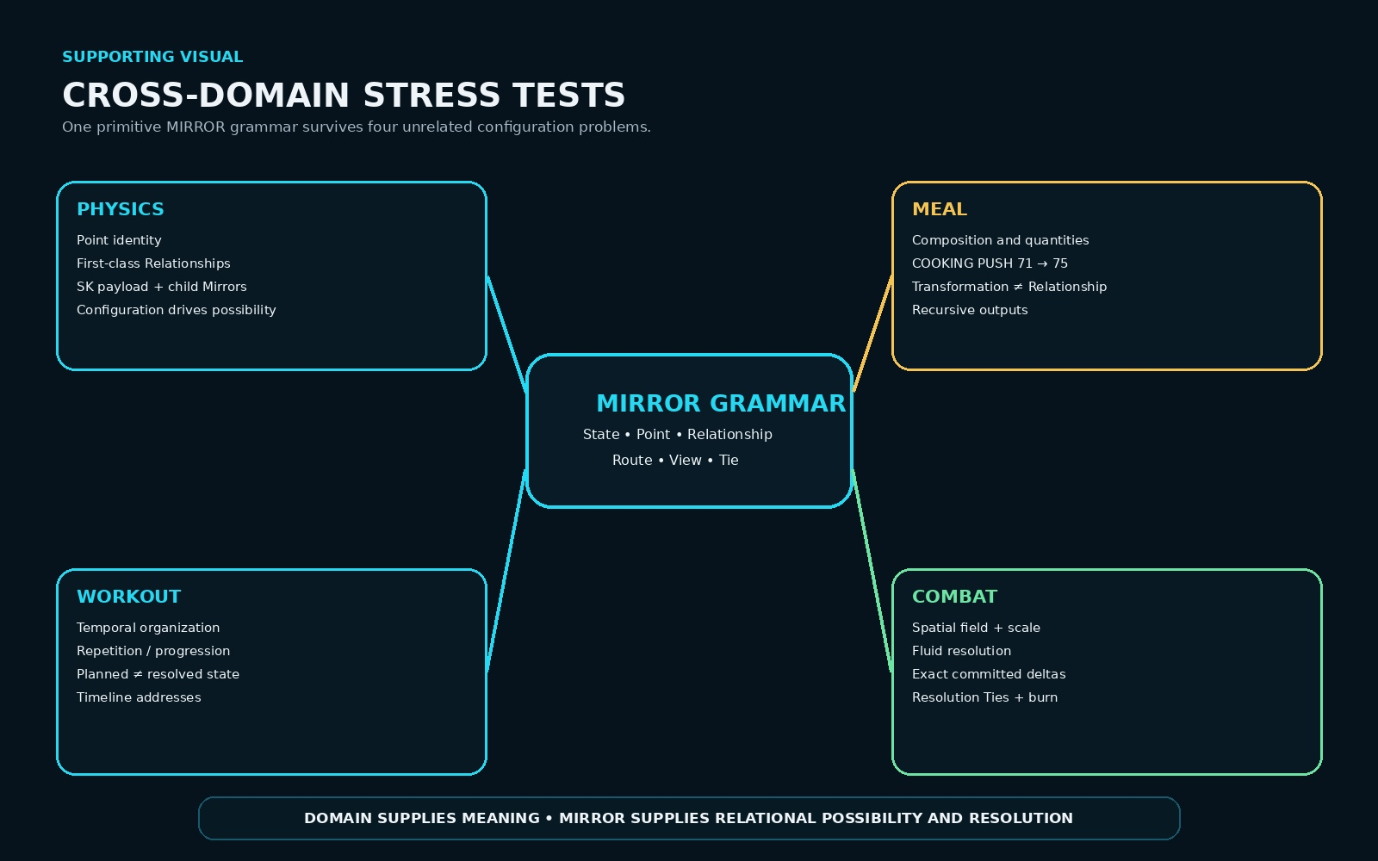
Supporting visual — Cross-Domain Stress Tests. PHYSICS, meal, workout, and combat retain different domain semantics while reusing the same MIRROR primitives and responsibility boundaries.
Workout reconstruction surface
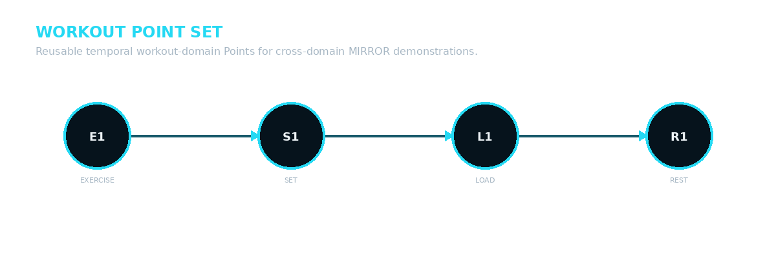
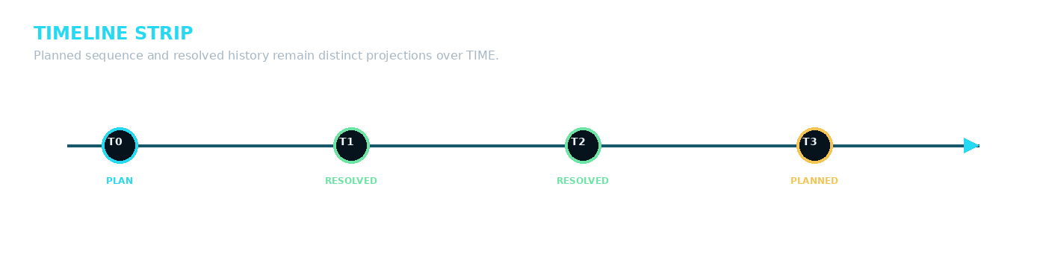
MIR-A52 + MIR-A53. A workout can be expressed as a bounded Point configuration organized through TIME while planned and resolved states remain distinguishable.

SECTION 33
Formal Non-Collapse Laws
The architecture has accumulated many distinctions that are easy to blur in an implementation even when the prose remains correct. In the completed MIRROR specification these are not stylistic cautions. They are normative regression requirements. A schema, runtime, renderer, serialization format, or future optimization that makes one side of a locked distinction silently stand in for the other has changed the architecture.
The table below consolidates the formal law surface established throughout this specification and exercised through the cross-domain demonstrations. Some rows are phrased as paired boundaries and others as direct propositions; all serve the same purpose: preserve semantic ownership while permitting implementation freedom underneath that ownership.
T13. Formal Non-Collapse Laws
Family | Locked law | Regression requirement
Authority | Mirror ≠ Source | A representation inside MIRROR does not inherit source authority.
Authority | Mirror State ≠ Authoritative State | Candidate relational state remains non-authoritative until governed commitment.
Authority | Resolved ≠ Committed | Knowing the outcome is not the same as granting it authority.
Authority | Successful Resolution ≠ Authorization | A coherent result can still lack permission to commit.
Authority | Authorization ≠ Mutation | Permission to write and the actual completed write remain separate events.
Imaginal | Imaginal ≠ Arbitrary Imaginary | Possibility remains bounded by the mapped system.
Imaginal | Imaginal Possibility ≠ Current State | Representability does not assert that the candidate is presently true.
Imaginal | Imaginal Possibility ≠ Guaranteed Future State | A possible branch need never occur.
Imaginal | Possible ≠ Valid | Representability does not prove contextual validity.
Imaginal | Valid ≠ Selected | Several valid Routes may coexist without being chosen.
Imaginal | Selected ≠ Resolved | An attempted Route can still fail or change under deeper resolution.
Imaginal | Model-Permitted ≠ Guaranteed Reality | Real-world claims remain bounded by model and evidence.
Identity | Point ≠ Relationship | Instantiated objects and semantic relations remain first-class and independent.
Identity | Point Identity ≠ Mirror Address | Movement does not create a new Point.
Identity | Mirror Address ≠ Semantic Identity | Location does not define what an object means.
Identity | Semantic Identity ≠ Semantic State | What something is differs from its current encoded condition.
Identity | Relationship Identity ≠ Endpoint Pair | Several distinct relations may share the same endpoints.
Routing | Relationship ≠ Transformation | Configuration and change remain different semantic objects.
Routing | Route ≠ Relationship | Traversal through structure is not identical to an edge in that structure.
Routing | Behavior ≠ MIRROR | Behavior is a result of realized traversal, not the reasoning environment itself.
Routing | Behavior = realized traversal through configured relational state | Behavior remains derivable from Route realization without becoming a new primitive.
Space | Mirror Space ≠ Source Space | A local projection need not reproduce source geometry.
Space | Mirror Coordinate ≠ Physical Position | Physical correspondence exists only when declared by the mapping contract.
Space | Same Coarse Cell ≠ Same Exact Position | Insufficient resolution is not proof of exact co-location.
Space | Empty Mirror Cell ≠ Empty Source Space | Absence from the projection is not absence from reality.
Resolution | Spatial Resolution ≠ Semantic Resolution | Location precision and meaning depth may change independently.
Resolution | Temporal Resolution ≠ Spatial Resolution | Sampling through TIME does not imply spatial refinement.
Resolution | Greater Resolution ≠ Greater Authority | More detail does not confer stronger truth or permission.
Representation | Mirror State ≠ View | A projection over state does not become another state.
Representation | View ≠ Display | A selected projection and its rendered manifestation remain separate.
Representation | Reader ≠ Renderer | Semantic decoding and presentation have different owners.
Runtime | Hydration ≠ Mutation | Resolving more explicit state does not change the source.
Runtime | Fluid ≠ MIRROR | Settlement condition differs from the workspace used to resolve it.
Runtime | Candidate Delta ≠ Committed Delta | A proposed consequence differs from an authoritative write.
Runtime | Valid Candidate ≠ Still-valid Commit | A source-basis change can stale an otherwise coherent result.
Runtime | Computation ≠ Write | Calculation alone is not mutation.
Persistence | Write ≠ Event | Not every authoritative change requires Event persistence.
Persistence | Event ≠ Memory | What happened differs from what an actor remembers.
Persistence | Resolution Tie ≠ Preserve Whole Mirror | A future dependency requires sufficient residue, not permanent scaffolding.
Persistence | Burned Mirror ≠ Lost Required Residue | Safe burning occurs only after every Tie is externally satisfiable.
Reload | Template ≠ Instance | Reusable structure and one loaded execution remain distinct.
Reload | Matrix ≠ Loaded Context | Persistent reasoning structure differs from current hydrated state.
Reload | Available Knowledge ≠ Active Knowledge | Reachable semantic infrastructure need not be loaded into the active episode.
Signature | Signature ≠ Data | The selected field set is not the values contained by those fields.
Signature | Signature ≠ Field Meaning | Projection membership does not define a field’s semantics.
Signature | Signature ≠ Display Order | Membership in the active surface does not prescribe presentation order.
Signature | Signature ≠ Read Permission | Inclusion in a projection does not automatically grant access.
Signature | Signature ≠ Write Authority | Projection membership never grants mutation authority by itself.

REGRESSION LAW
IMPLEMENTATION MAY COMPRESS STORAGE, REARRANGE DISPLAY, OR OPTIMIZE EXECUTION; IT MAY NOT SILENTLY COLLAPSE A LOCKED MIRROR DISTINCTION.

SECTION 34
The Cyan Mirror Chronicle
The final Chronicle recombines the paper’s established visual and semantic grammar rather than introducing a second system at the end. An authoritative state is selectively mapped into Mirror State 0. The mapped configuration opens a bounded Imaginal Field. Points and Relationships expose possible Routes. Resolution deepens only where the causal question requires additional semantic, spatial, temporal, or graph distinction.
Rules, Models, Readers, and Operators act through their existing responsibilities while MIRROR provides the common relational surface. Candidate Routes remain Cyan until one is selected or validated, at which point the chosen traversal becomes Gold. The selected Route resolves a candidate consequence, but the source still waits outside the glass. Immediately before commitment, the Source Basis is checked again. A stale basis returns the episode to bounded Hydration and re-resolution; a fresh basis permits the approved exact delta to cross through the Green commitment boundary.
After commitment, the Mirror is still not automatically history. Amber Resolution Ties identify only the information whose causal responsibility continues into the future. Sufficient residue is externalized to the appropriate State, Contract, Event, Memory, or Procedure surface. Once those dependencies are satisfied, the remaining Cyan scaffolding has completed its work and can dissolve safely to ash. The new authoritative World state then becomes available as the source basis of later episodes.
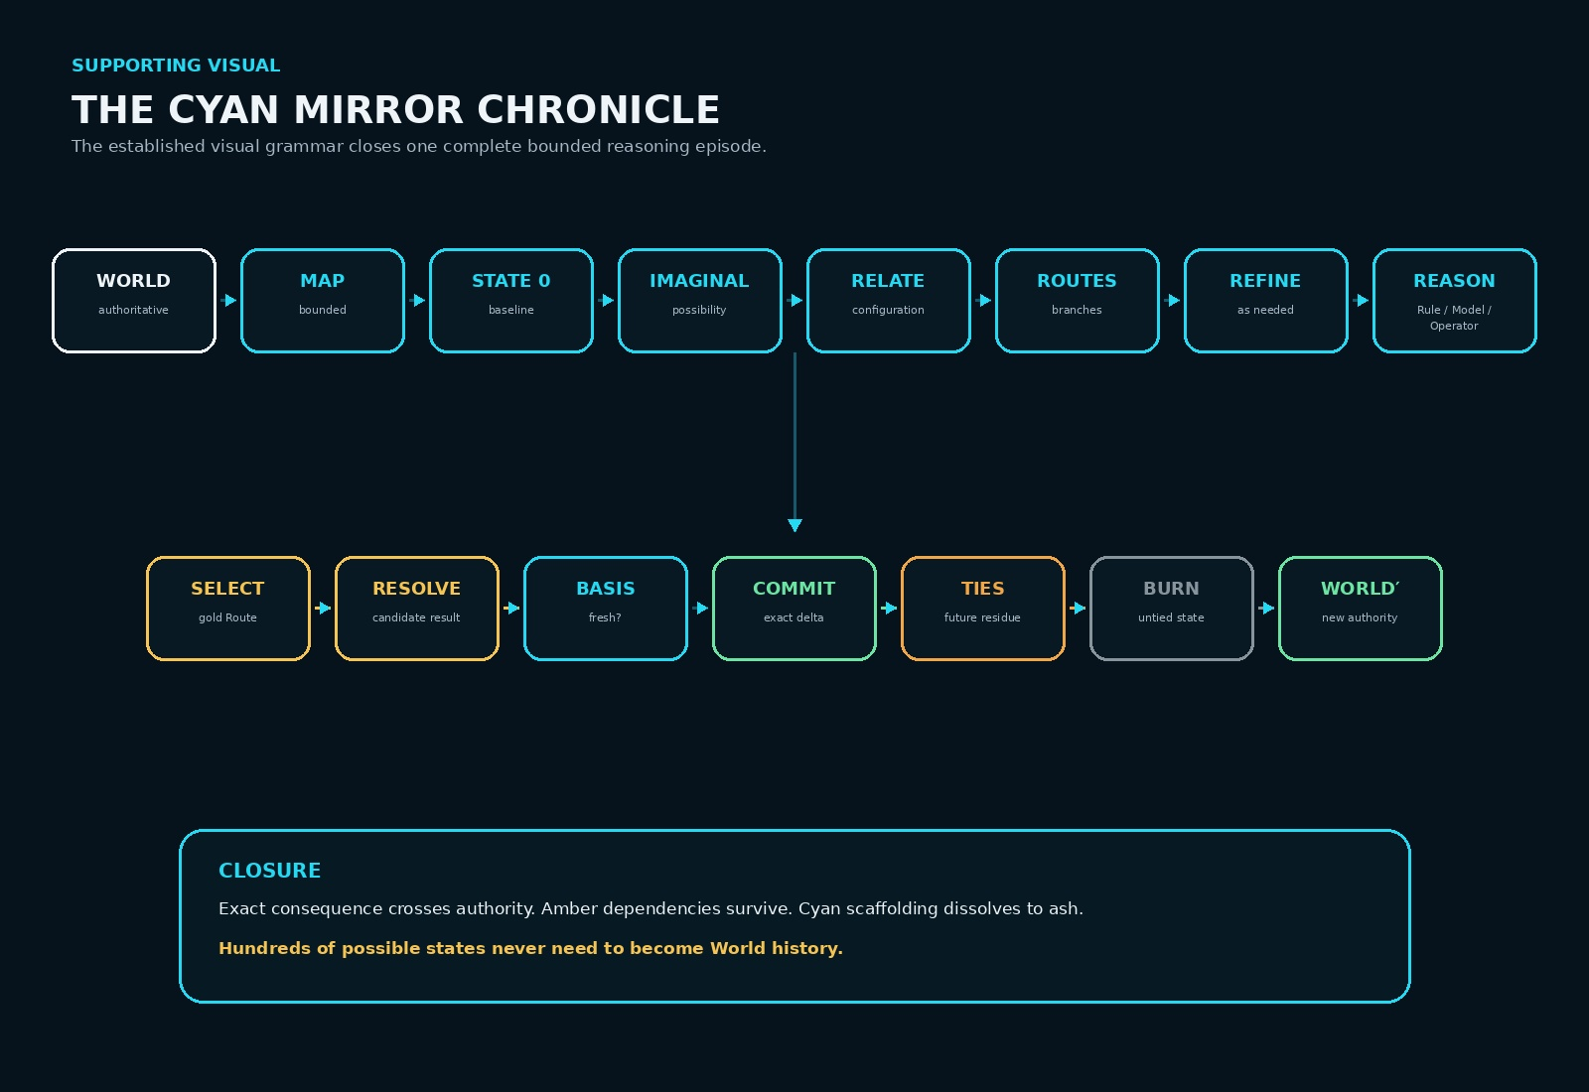
Supporting visual — The Cyan Mirror Chronicle. The complete lifecycle recombines established Cyan, Gold, Green, Amber, Red/validation, and ash grammar without adding new MIRROR primitives.
CLOSING PROPOSITION
MIRROR GIVES POSSIBILITY SOMEWHERE TO EXIST BEFORE REALITY MUST CHOOSE.

FORMAL CLOSING LAW
MAP WHAT MATTERS. OPEN ONLY THE POSSIBILITIES PERMITTED BY THE MAPPED FIELD. REASON OVER THE RELATIONSHIPS. RESOLVE THE ROUTES. COMMIT THE CONSEQUENCE. PRESERVE THE RESIDUE. BURN THE REST.

The hundreds of represented possibilities, rejected branches, temporary calculations, and intermediate configurations inside a rich Mirror never needed to become World history. MIRROR is complete when the consequential result is authoritative, every continuing dependency remains reachable, and the disposable reasoning surface can disappear without losing anything the future still needs.
PASS 8 VERIFIED RELEASE
Verified through Pass 8.

