CERBERUS

FORMAL_LOGIC-45
Descriptive Semantic Kernel Specification v0.1
Logical Objects, Connectives, Quantification, Consequence, Inference, Validity, Modal Language, and SK Memory
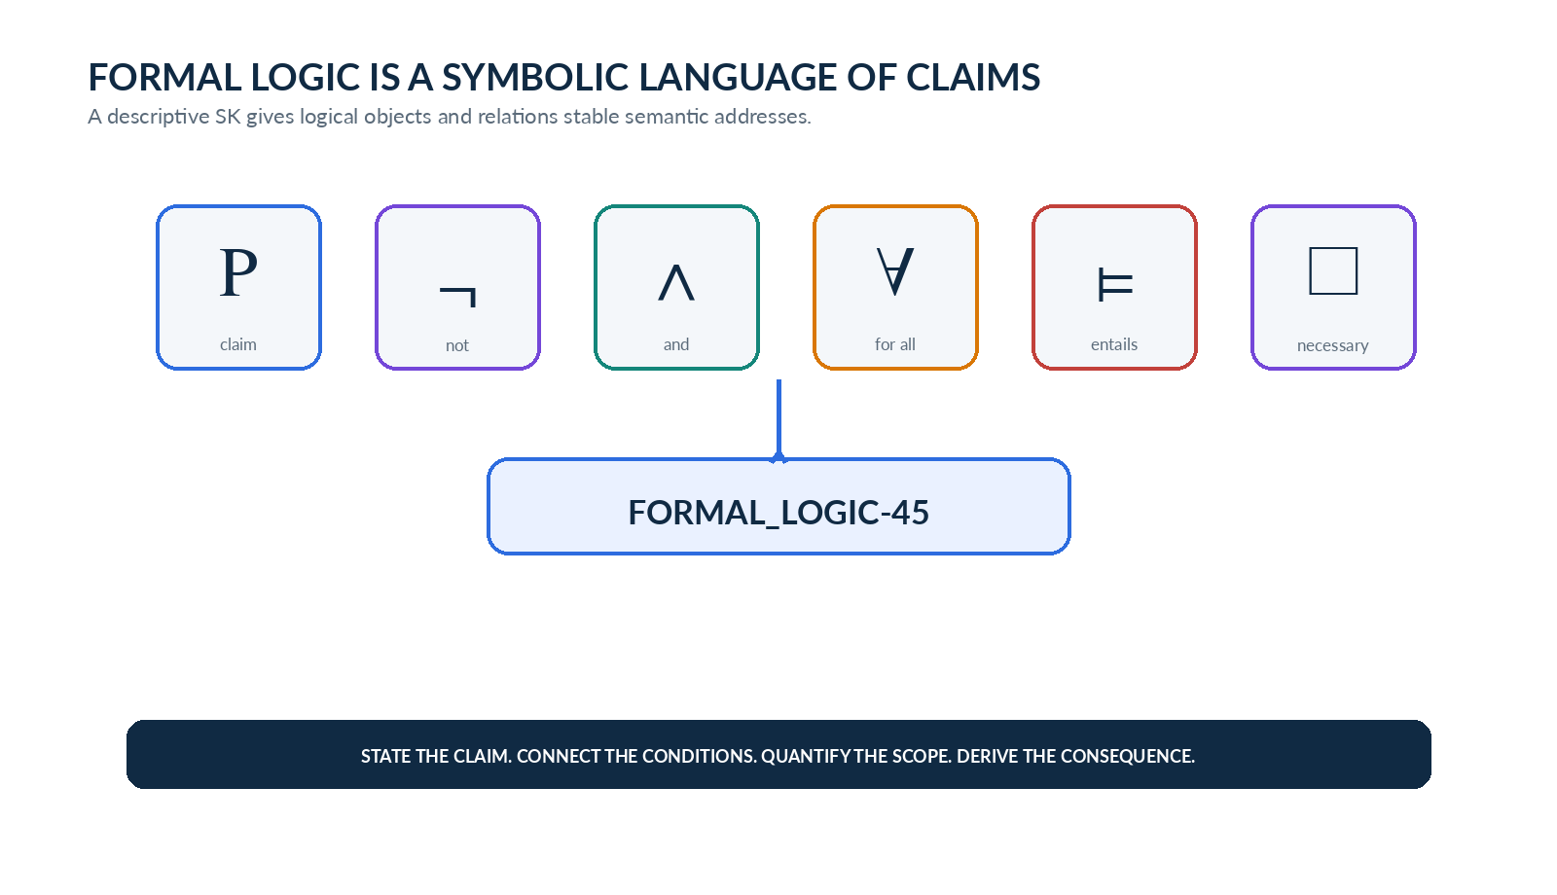
Figure 1. Formal logic compresses claims, conditions, scope, consequence, and modal relationships into a bounded symbolic vocabulary.
CORE PRINCIPLE | State the proposition. Connect the conditions. Quantify the claim. Derive the consequence. FORMAL_LOGIC-45 is descriptive: it teaches a bounded logic vocabulary but does not execute proofs or decide truth.

Candidate Descriptive Semantic Kernel Specification
18 August 2026

Document Control
Specification | CERBERUS FORMAL_LOGIC-45
Class | Descriptive Semantic Kernel
Status | Candidate Specification
Version | v0.1
Word width | 45 Bits
Reader topology | A1-G1 across seven DESCRIPTION-n BitGroups
Memory layers | Symbol; Description; Professional Use; Personal Use; References
References | Reserved and intentionally blank in v0.1
Execution boundary | Descriptive only; selecting a Bit does not execute inference, proof search, model checking, or theorem proving.
Build sequence | MATHEMATICAL_OPERATORS-77 → FORMAL_LOGIC-45 → GRAPH_NETWORK-n → STATE_MACHINE-n → CONTROL_SYSTEMS-n

Abstract
FORMAL_LOGIC-45 is a 45-Bit descriptive vocabulary kernel for foundational formal-logic concepts. It gives stable semantic addresses to logical objects and truth markers, truth-functional connectives, quantifiers and binding operations, semantic and syntactic consequence relations, classical inference patterns, validity and model properties, and a minimal bridge into modal logic. Each active Bit resolves deterministically through SK Memory to a symbol or schema, a concise Description, a Professional Use, a Personal Use grounded in CERBERUS architecture, and a References layer reserved but intentionally left blank in v0.1.
The kernel is deliberately non-executable. Selecting → does not test implication; selecting modus ponens does not infer a conclusion; selecting ⊨ does not evaluate a model. The purpose of the SK is to build a shared symbolic metalanguage that can later be reused by functional Rule, proof, graph, state-machine, and control-system architectures without forcing this descriptive Word to become those systems.
NOTATION BOUNDARY | FORMAL_LOGIC-45 uses → for material implication. CERBERUS already reserves ⇒ for semantic structure manifesting through an interface contract, so this SK does not repurpose ⇒ as its primary implication glyph.

Reading Map
Part | Purpose
Part 1 | Semantic boundary, SK Memory, 45-Bit anatomy, Reader topology, binary selection
Part 2 | A1 — Logical Objects & Truth
Part 3 | B1 — Logical Connectives
Part 4 | C1 — Quantification & Binding
Part 5 | D1 — Semantic & Syntactic Relations
Part 6 | E1 — Inference Patterns
Part 7 | F1 — Validity & Model Properties
Part 8 | G1 — Modal Logic
Part 9 | Interface variants, study sets, contextual symbol use
Part 10 | Future reuse, formal laws, consolidated registry, glossary

Part 1 | Semantic Boundary and 45-Bit Architecture

1. Purpose and Bounded Question
FORMAL_LOGIC-45 answers one bounded question: which formal-logic concepts are selected in the current descriptive vocabulary, and what registered memory should a human or AI retrieve for each selected concept? The Word stores participation through Bits; semantic labels and SK Memory provide the meaning. It is not a truth engine, proof engine, theorem prover, or model checker.
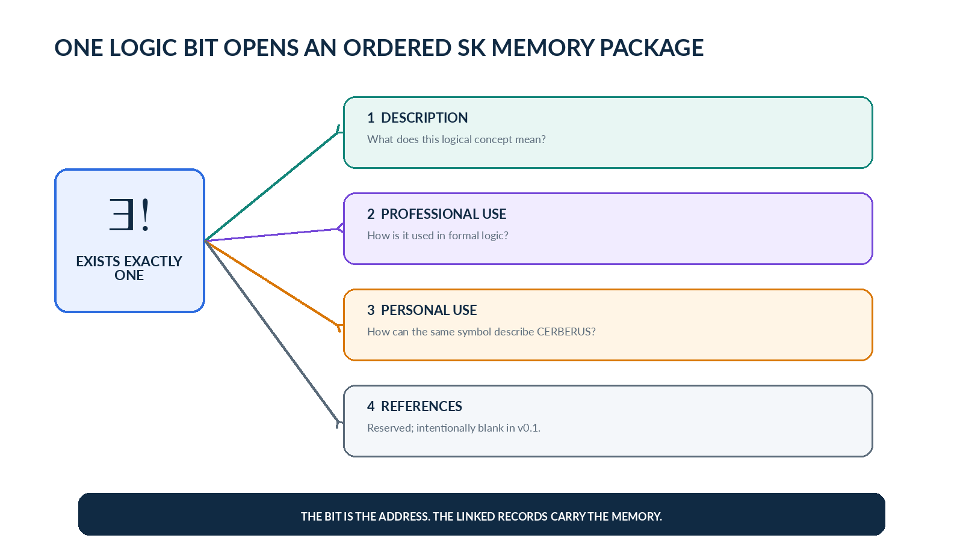
Figure 2. One active logic Bit is a deterministic address into four ordered SK Memory layers.
The requested v0.1 memory package contains Symbol, Description, Professional Use, and Personal Use. References remain structurally available but blank. Personal Use intentionally reuses the formal symbol itself where helpful, because the goal is not to invent a CERBERUS-specific pseudo-notation but to learn where established logical notation already describes the architecture precisely.

1.1 Word Anatomy
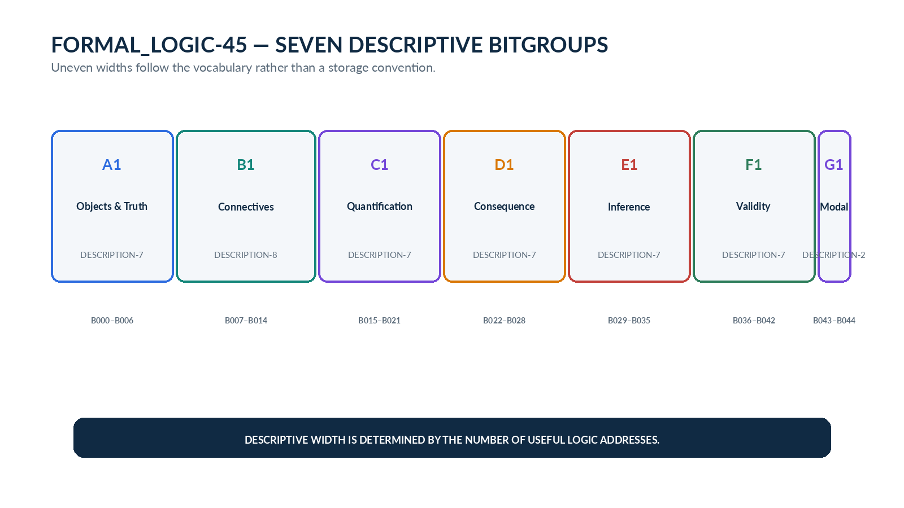
Figure 3. Seven uneven DESCRIPTION-n BitGroups form FORMAL_LOGIC-45 without padding to a conventional binary width.
The seven BitGroups are independently useful descriptive categories. Their widths are the count of current semantic addresses in each category. A future revision may add or split concepts if additional resolution earns its existence; v0.1 does not reserve fake concepts merely to reach a round width.
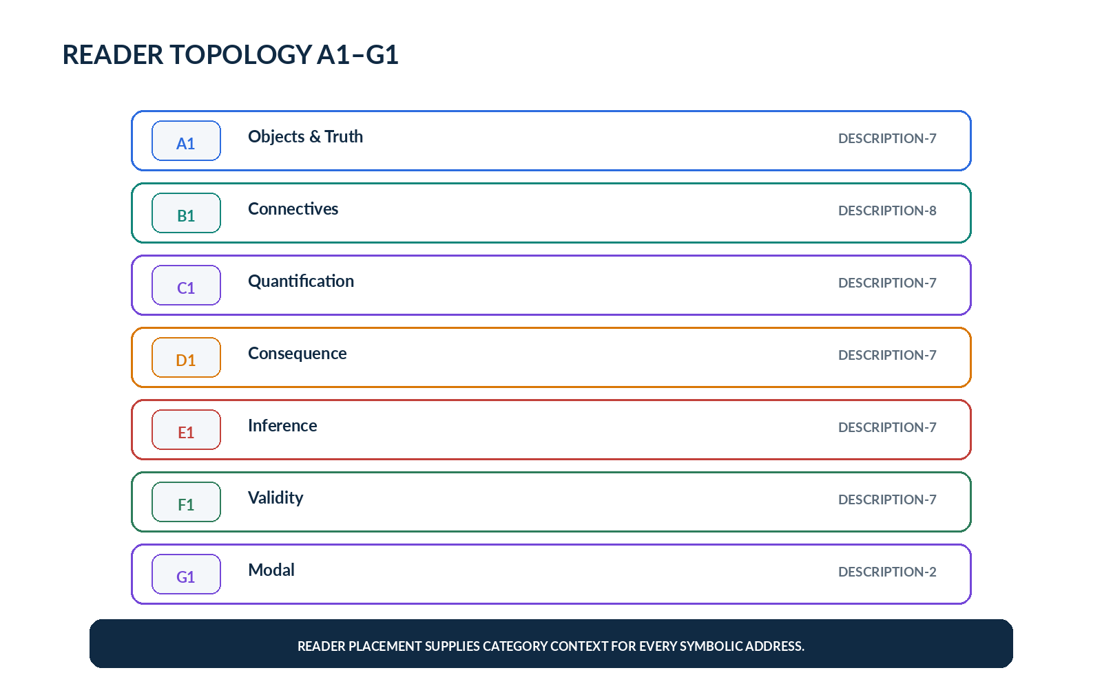
Figure 4. Reader topology A1-G1 supplies stable category context for every descriptive address.

1.2 Binary Selection Semantics
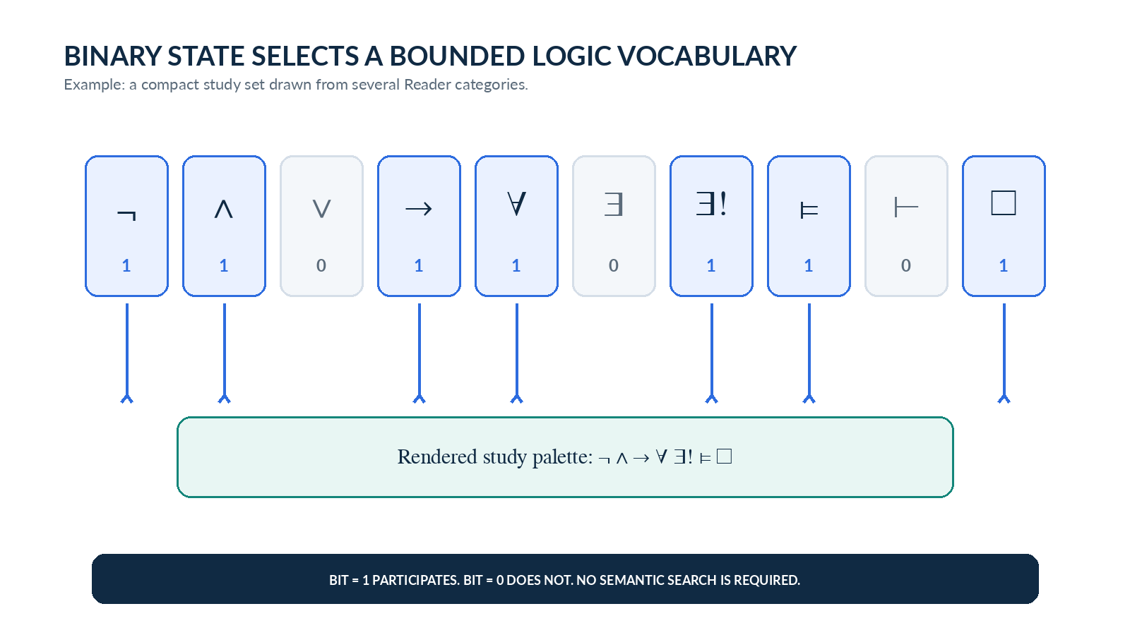
Figure 5. Binary state selects a bounded study vocabulary from the registered 45 concepts.
A Bit value of 1 means the corresponding logical concept participates in the current descriptive projection. A Bit value of 0 means the concept is omitted from that projection. This selection state is useful for full atlases, category study sets, “symbols I keep confusing” collections, and context-specific learning views. The binary state does not assert that the represented proposition is logically true; it selects the concept record.
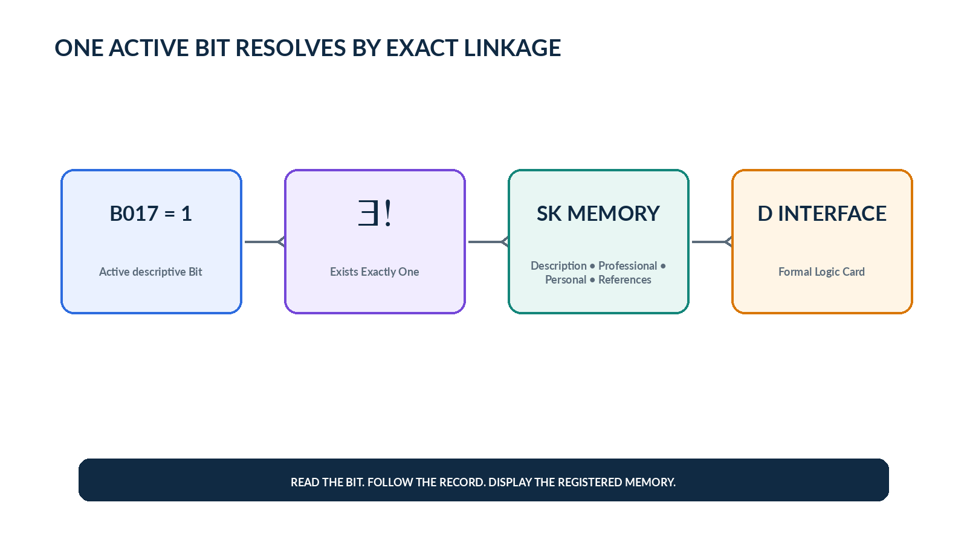
Figure 6. Active-Bit retrieval is exact linkage rather than similarity search or runtime semantic inference.

1.3 SK Memory Resolution
Each Bit can link to four ordered memory sources: Description, Professional Use, Personal Use, and References. The Bit address selects the logic concept; the interface decides how much memory resolution to expose. Operational or compact views may show only the symbol and name. Study views may reveal all populated layers. References are intentionally blank in v0.1 so later resources can be added without pretending a bibliography has already been curated.
ARCHITECTURAL SEPARATION | Bits select concepts. Reader placement supplies category meaning. SK Memory preserves explanation and examples. D/F interfaces choose how much of that memory to reveal. None of these layers executes the logical operator.

Part 2 | Logical Objects and Truth

2. A1 — Logical Objects & Truth
A1 provides the basic objects that later logical structures operate on: truth and contradiction markers, propositions, predicates, formulas, premise contexts, and models or interpretations. These concepts answer “what kind of logical thing is this?” before the language begins connecting or quantifying claims.
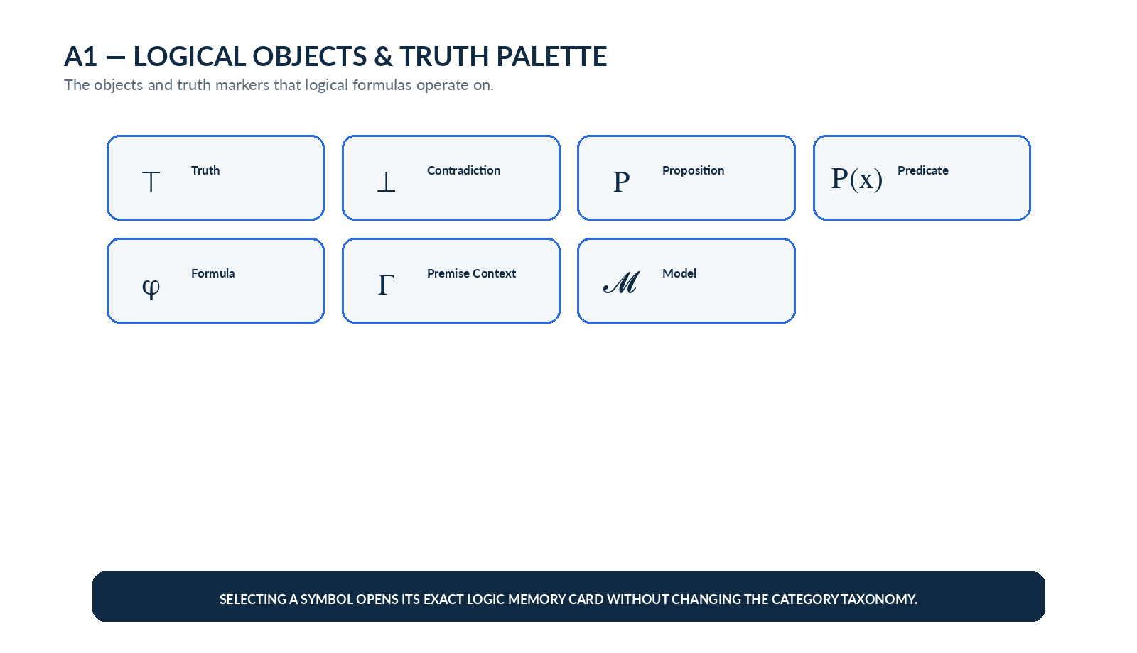
Figure 7. A1 exposes seven foundational logical objects and truth markers.
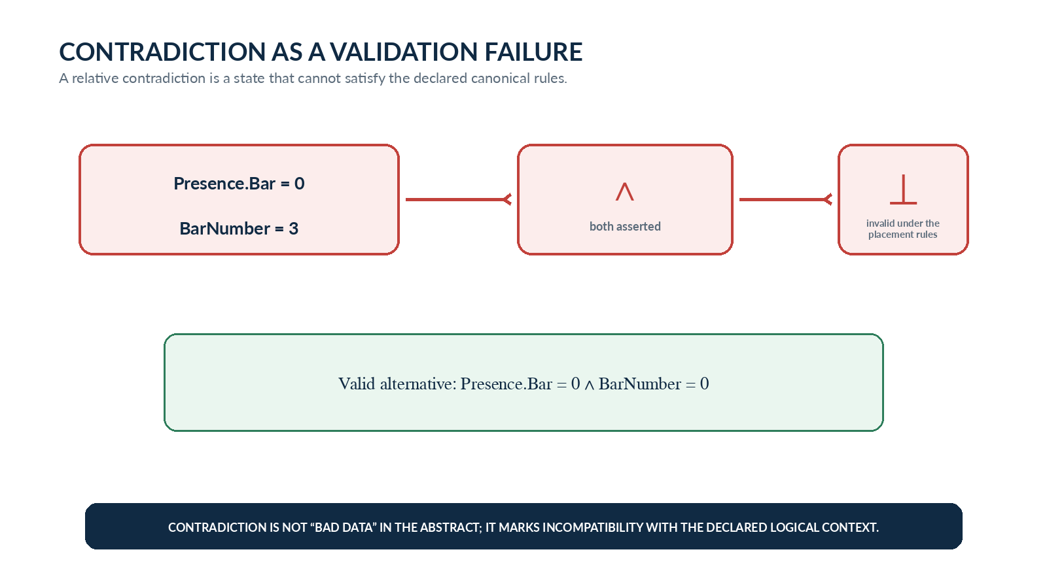
Figure 8. Contradiction can be taught through a CERBERUS state that cannot satisfy the declared placement rules.

2.1 A1 Record Registry
Bit | Symbol / Schema | Concept | Description | Professional Use | Personal Use | References
B000 | ⊤ | Truth | A distinguished truth value or formula that is true under the relevant logical interpretation. | In classical propositional logic, P ∨ ¬P is logically valid. | ValidPlacement(p) = ⊤ when every declared MUSICAL_PLACEMENT validation rule for p passes. | —
B001 | ⊥ | Falsehood / Contradiction | A distinguished falsehood value or an impossible state relative to the declared logical context. | P ∧ ¬P is contradictory in classical logic. | Presence.Bar = 0 ∧ BarNumber = 3 can be treated as ⊥ relative to the canonical presence-gating rules. | —
B002 | P | Proposition | A declarative statement that can be evaluated as true or false. | P may stand for the proposition “7 is prime.” | P := “Every exposed Reader placement has an active interface path.” | —
B003 | P(x) | Predicate | A proposition-valued expression whose truth depends on one or more supplied objects or values. | Prime(x) is true for some values of x and false for others. | ValidInterface(x) can evaluate whether interface record x satisfies its declared contract. | —
B004 | φ | Formula | A well-formed logical expression assembled from propositions, predicates, connectives, and quantifiers. | φ = (P ∧ Q) → R. | φ = (Presence.Bar = 1) → (BarNumber > 0). | —
B005 | Γ | Premise / Assumption Context | A set or ordered context of formulas treated as premises or assumptions for a logical task. | Γ = {P, P → Q}. | Γ can hold the currently asserted placement conditions, such as Type.Note = 1, Presence.Bar = 1, and BarNumber = 3. | —
B006 | 𝓜 | Model / Interpretation | A structure or interpretation under which logical symbols and formulas receive meaning and truth values. | A first-order structure interprets predicates, functions, and objects before formulas are evaluated. | 𝓜 can represent the currently resolved CERBERUS record state against which a Rule or validation formula is evaluated. | —

Part 3 | Logical Connectives

3. B1 — Logical Connectives
B1 describes truth-functional ways of joining propositions. The category deliberately uses → for material implication so the logical language remains visually distinct from the locked CERBERUS interface-manifestation symbol ⇒. Connective cards teach both the formal relation and a CERBERUS-grounded use of the same notation.
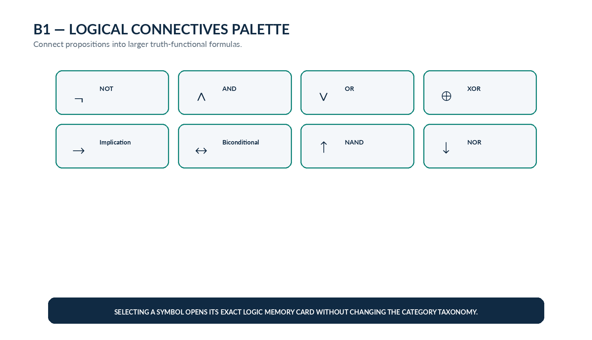
Figure 9. B1 connective palette.
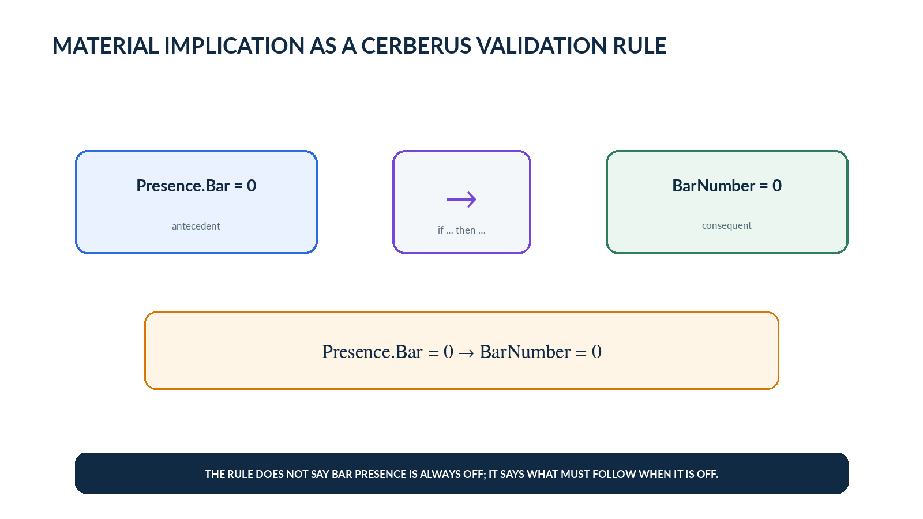
Figure 10. Material implication formalizes the canonical rule that an inactive Bar address requires Bar Number = 0.

3.1 B1 Record Registry
Bit | Symbol / Schema | Concept | Description | Professional Use | Personal Use | References
B007 | ¬ | Negation / NOT | Reverses the truth value of a proposition. | If P is true, ¬P is false; if P is false, ¬P is true. | ¬Active(Branch) states that the Branch condition is not active. | —
B008 | ∧ | Conjunction / AND | True only when every participating conjunct is true. | P ∧ Q is true exactly when both P and Q are true. | Presence.Bar = 1 ∧ BarNumber > 0 describes a canonically active Bar address. | —
B009 | ∨ | Disjunction / OR | Inclusive OR: true when at least one participating proposition is true. | P ∨ Q is false only when both P and Q are false. | HasF(W) ∨ HasCompletePartition(W) can express that at least one complete BitWord representation is available. | —
B010 | ⊕ | Exclusive OR / XOR | True when exactly one of two participating propositions is true. | P ⊕ Q excludes the case in which P and Q are simultaneously true. | ModeA ⊕ ModeB can require exactly one of two mutually exclusive interface modes to be active. | —
B011 | → | Material Implication | States that whenever the antecedent is true, the consequent must be true. | P → Q is false only when P is true and Q is false. | Presence.Bar = 0 → BarNumber = 0 formalizes the canonical inactive-quantity rule. | —
B012 | ↔ | Biconditional | States that two propositions have the same truth value; each implies the other. | P ↔ Q abbreviates (P → Q) ∧ (Q → P). | ActiveAddressDimension(x) ↔ PresenceBit(x) = 1 can define address participation exactly through the Presence Bit. | —
B013 | ↑ | NAND | Negation of conjunction: false only when both operands are true. | P ↑ Q ≡ ¬(P ∧ Q). | EditableMode ↑ ReadOnlyLock can model a constraint in which the interface must not simultaneously be editable and locked read-only. | —
B014 | ↓ | NOR | Negation of disjunction: true only when both operands are false. | P ↓ Q ≡ ¬(P ∨ Q). | CandidateA ↓ CandidateB can state that neither candidate condition is currently active. | —

Part 4 | Quantification and Binding

4. C1 — Quantification & Binding
C1 turns local propositions into scoped claims. Universal and existential quantifiers say how many objects satisfy a predicate; free and bound variable concepts make scope explicit; substitution shows how a symbolic formula becomes a concrete instance. This category is especially useful for CERBERUS laws that quantify over every placement, every Bit, or exactly one active interface path.
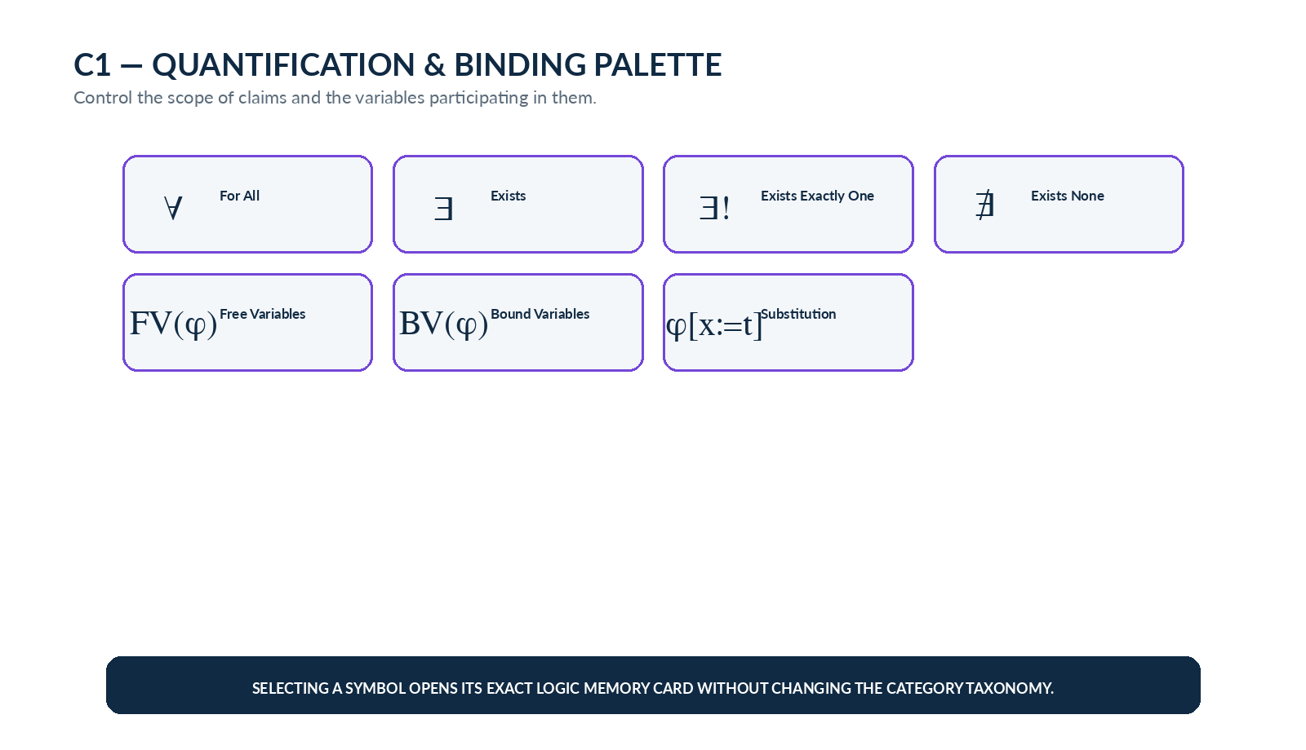
Figure 11. C1 quantification and binding palette.
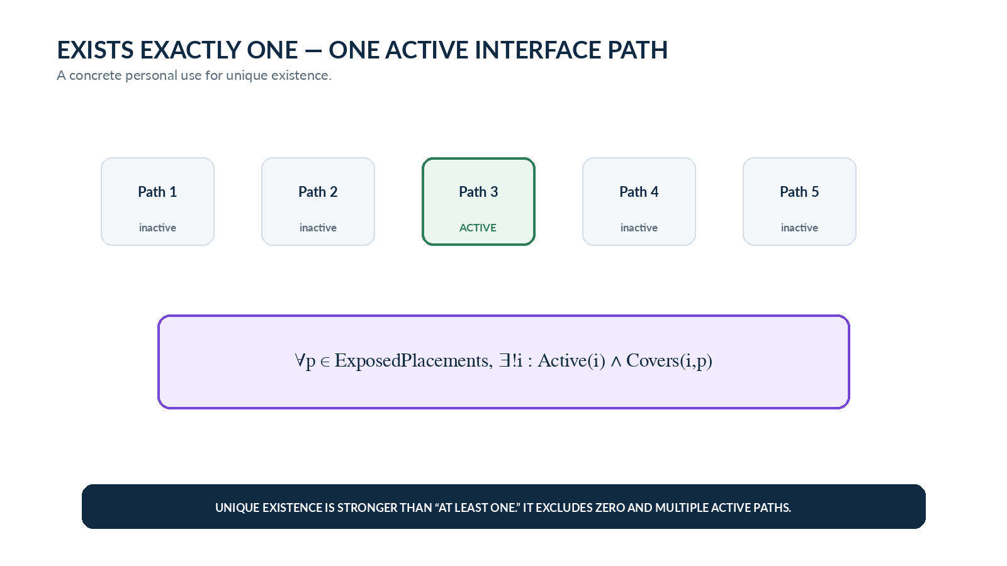
Figure 12. Unique existence provides a concise symbolic form for Exact Interface Coverage.

4.1 C1 Record Registry
Bit | Symbol / Schema | Concept | Description | Professional Use | Personal Use | References
B015 | ∀ | Universal Quantifier / For All | Requires the enclosed proposition to hold for every object in the declared domain. | ∀x ∈ S, P(x). | ∀p ∈ ExposedPlacements, HasInterface(p). | —
B016 | ∃ | Existential Quantifier / Exists | States that at least one object in the declared domain satisfies the predicate. | ∃x ∈ S : P(x). | ∃Fᵥ(W) can state that at least one complete F Variant exists for BitWord W. | —
B017 | ∃! | Unique Existential / Exists Exactly One | States that exactly one object in the declared domain satisfies the predicate. | ∃!x ∈ S : P(x). | ∀p, ∃!i : Active(i) ∧ Covers(i,p) expresses Exact Interface Coverage. | —
B018 | ∄ | There Exists No | States that no object in the declared domain satisfies the predicate. | ∄x ∈ S : P(x). | ∄r ∈ ReservedBits : r = 1 expresses the requirement that all Reserved Bits remain zero. | —
B019 | FV(φ) | Free Variables | The variables occurring in φ that are not bound by a quantifier within the formula. | If φ = P(x) ∧ ∀y Q(y), then FV(φ) = {x}. | In ValidPlacement(p) → Resolvable(p,c), p and c remain free until the current placement and context are supplied. | —
B020 | BV(φ) | Bound Variables | Variables whose occurrences are governed by quantifiers inside the formula. | In ∀x P(x), the variable x is bound. | In ∀p ∈ Placements, Valid(p), the quantifier binds p throughout the rule body. | —
B021 | φ[x:=t] | Substitution | Replaces free occurrences of variable x in formula φ with term t, subject to the rules of the formal system. | P(x)[x:=3] yields P(3). | TrackNumber = x with x := 14 yields the exact conditional constraint TrackNumber = 14. | —

Part 5 | Semantic and Syntactic Relations

5. D1 — Semantic & Syntactic Relations
D1 separates two questions that are often blurred in ordinary language: what follows because every admissible interpretation makes it true, and what follows because a declared proof calculus can derive it. Satisfaction and semantic entailment concern models and truth; derivability concerns proof rules. Logical equivalence and interderivability are related but also belong to different layers.
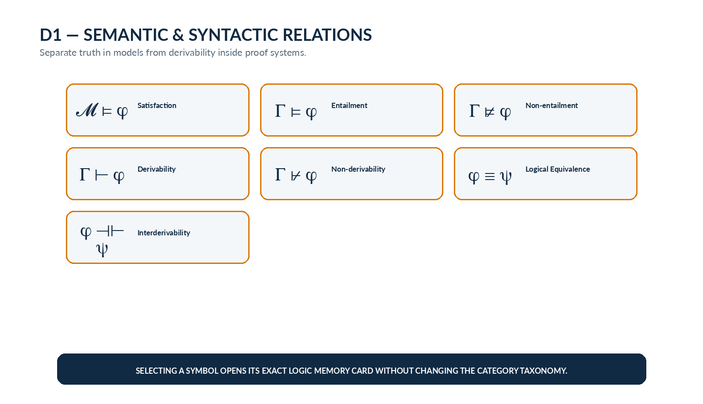
Figure 13. D1 consequence and derivation palette.
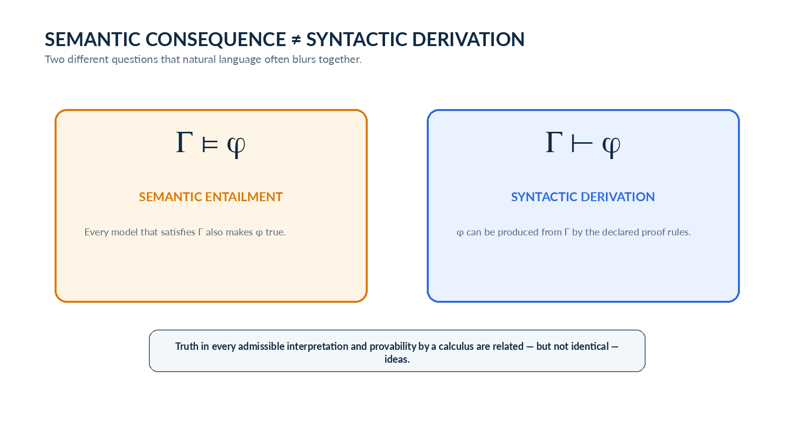
Figure 14. Semantic entailment and syntactic derivation are related but distinct relations.
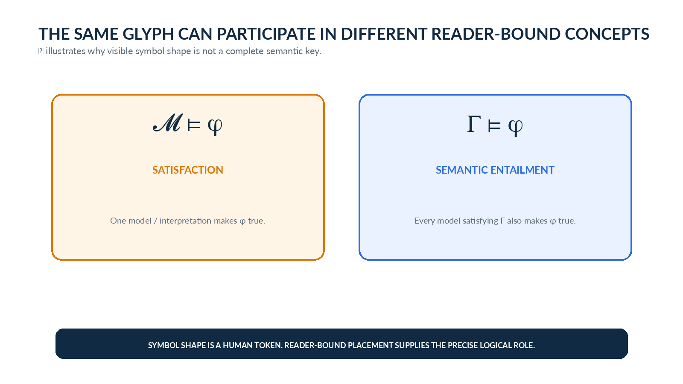
Figure 15. The visible glyph ⊨ participates in different Reader-bound concepts depending on the surrounding logical structure.

5.1 D1 Record Registry
Bit | Symbol / Schema | Concept | Description | Professional Use | Personal Use | References
B022 | 𝓜 ⊨ φ | Satisfaction | Formula φ is true under the model or interpretation 𝓜. | 𝓜 ⊨ P(a) states that P(a) is true in model 𝓜. | CERBERUSState ⊨ ValidPlacement(p) when the current records satisfy the placement-validity formula. | —
B023 | Γ ⊨ φ | Semantic Entailment | Every admissible model that satisfies all premises in Γ also satisfies φ. | {P, P → Q} ⊨ Q. | {Presence.Bar = 1, CanonicalPlacement} ⊨ BarNumber > 0. | —
B024 | Γ ⊭ φ | Semantic Non-entailment | The premises Γ do not guarantee φ; at least one model satisfies Γ while φ is false. | Γ ⊭ φ demonstrates failure of semantic consequence. | {SCALAR-8} ⊭ SliderInterface: scalar mathematics alone does not entail a slider manifestation. | —
B025 | Γ ⊢ φ | Syntactic Derivability | Formula φ can be derived from Γ by the declared formal inference rules. | P, P → Q ⊢ Q by modus ponens. | A future CERBERUS Rule engine could derive a validation conclusion from explicit registered premises and inference rules. | —
B026 | Γ ⊬ φ | Syntactic Non-derivability | No derivation of φ is available from Γ under the currently declared proof system. | Γ ⊬ φ may hold even when the relation is not yet known to be semantically invalid. | A bounded CERBERUS rule language may fail to derive a consequence that is not represented by its available inference machinery. | —
B027 | φ ≡ ψ | Logical Equivalence | φ and ψ have the same truth value under every relevant interpretation. | P → Q ≡ ¬P ∨ Q in classical propositional logic. | This card helps distinguish logical equivalence from the broader CERBERUS use of ≡ in statements such as Fᵥ(W) ≡ P_DE(W). | —
B028 | φ ⊣⊢ ψ | Interderivability | Each formula is derivable from the other under the chosen formal proof system. | φ ⊣⊢ ψ means φ ⊢ ψ and ψ ⊢ φ in the relevant calculus. | A future bounded Rule calculus could use interderivability to show two rule forms can mechanically reproduce one another. | —

Part 6 | Inference Patterns

6. E1 — Inference Patterns
E1 treats an inference schema itself as the displayed symbolic object. This is intentionally broader than a single Unicode glyph: the “symbol” may be a complete premise/conclusion pattern such as modus ponens. The SK describes these patterns but does not execute them.
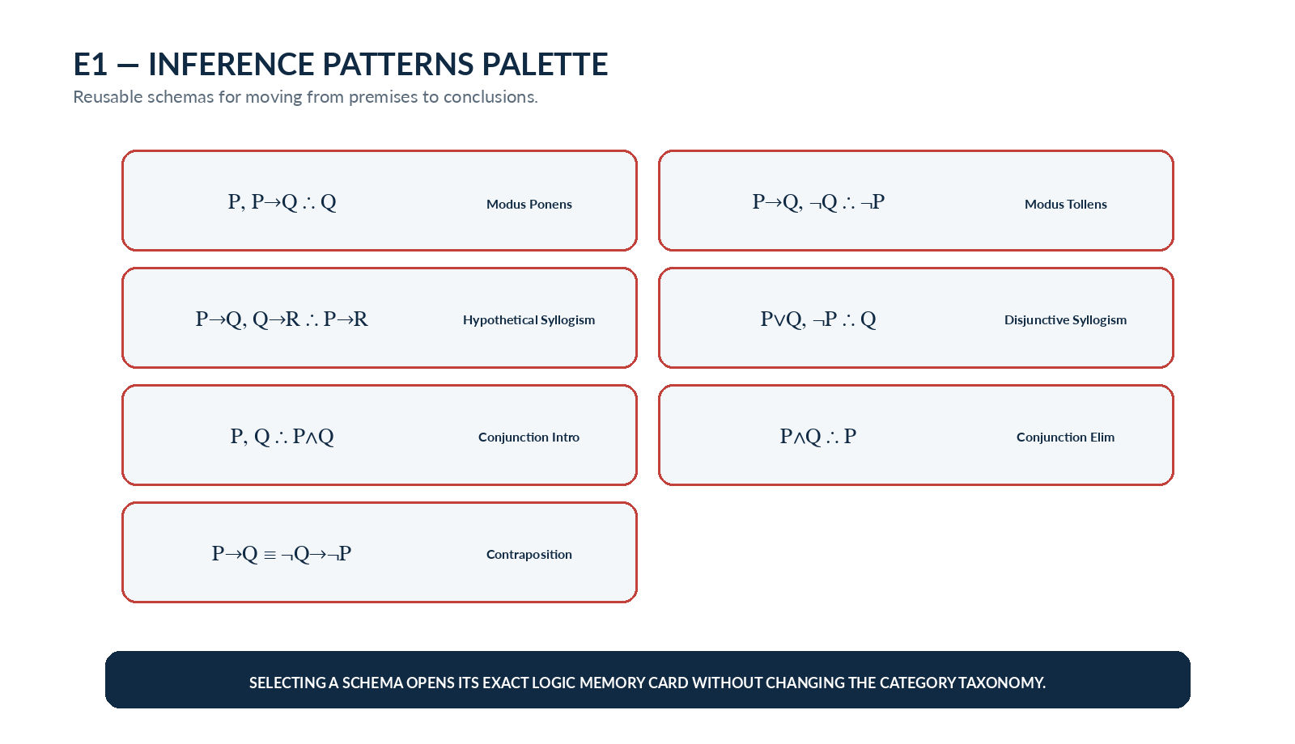
Figure 16. E1 inference-pattern palette. Each tile is a reusable symbolic schema rather than necessarily a single glyph.
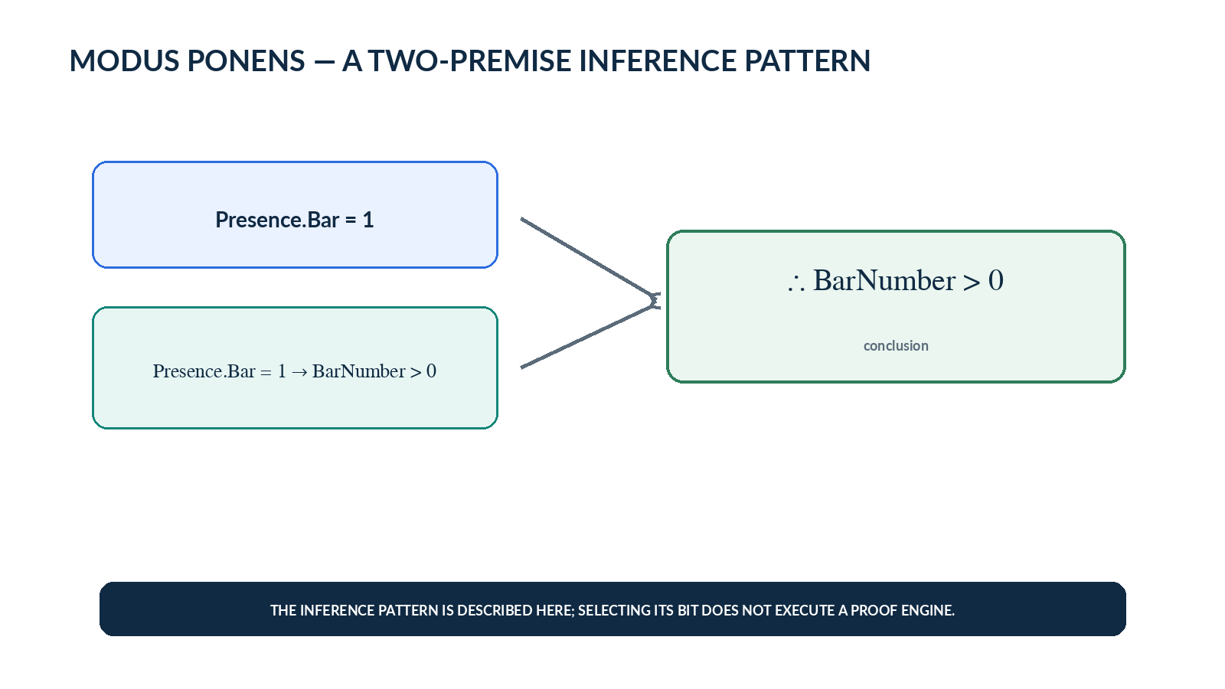
Figure 17. Modus ponens connects two explicit premises to a conclusion in a form that maps cleanly onto validation reasoning.

6.1 E1 Record Registry
Bit | Symbol / Schema | Concept | Description | Professional Use | Personal Use | References
B029 | P, P→Q ∴ Q | Modus Ponens | From P and P → Q, infer Q. | P; P → Q; therefore Q. | Presence.Bar = 1; Presence.Bar = 1 → BarNumber > 0; therefore BarNumber > 0. | —
B030 | P→Q, ¬Q ∴ ¬P | Modus Tollens | From P → Q and ¬Q, infer ¬P. | P → Q; ¬Q; therefore ¬P. | ValidActiveBar → BarNumber > 0; ¬(BarNumber > 0); therefore ¬ValidActiveBar. | —
B031 | P→Q, Q→R ∴ P→R | Hypothetical Syllogism | Chains two implications into a new implication. | P → Q; Q → R; therefore P → R. | Bit active → Descriptive record resolves; record resolves → memory can display; therefore Bit active → memory can display. | —
B032 | P∨Q, ¬P ∴ Q | Disjunctive Syllogism | From a disjunction and the negation of one alternative, infer the other. | P ∨ Q; ¬P; therefore Q. | If the selected complete BitWord view is F ∨ P_DE and no valid F is selected, the complete partition supplies the active representation. | —
B033 | P, Q ∴ P∧Q | Conjunction Introduction | Combines two established propositions into a conjunction. | P; Q; therefore P ∧ Q. | Presence.Bar = 1 and BarNumber = 3 can be combined into Presence.Bar = 1 ∧ BarNumber = 3. | —
B034 | P∧Q ∴ P | Conjunction Elimination | Extracts an individual conjunct from an established conjunction. | P ∧ Q; therefore P (and analogously Q). | From a validated state Presence.Bar = 1 ∧ BarNumber = 3, the system may use the established fact Presence.Bar = 1. | —
B035 | P→Q ≡ ¬Q→¬P | Contraposition | Transforms an implication into the logically equivalent implication from negated consequent to negated antecedent. | P → Q is logically equivalent to ¬Q → ¬P in classical logic. | ValidActiveAddress → Quantity > 0 supports the contrapositive Quantity ≤ 0 → ¬ValidActiveAddress. | —

Part 7 | Validity and Model Properties

7. F1 — Validity & Model Properties
F1 describes properties of entire formulas, premise sets, or proof systems rather than local connectives. Satisfiable and unsatisfiable ask whether any model can realize the constraints. Consistent and inconsistent are framed proof-theoretically here through derivability of contradiction. Soundness and completeness then compare proof machinery with semantic consequence.
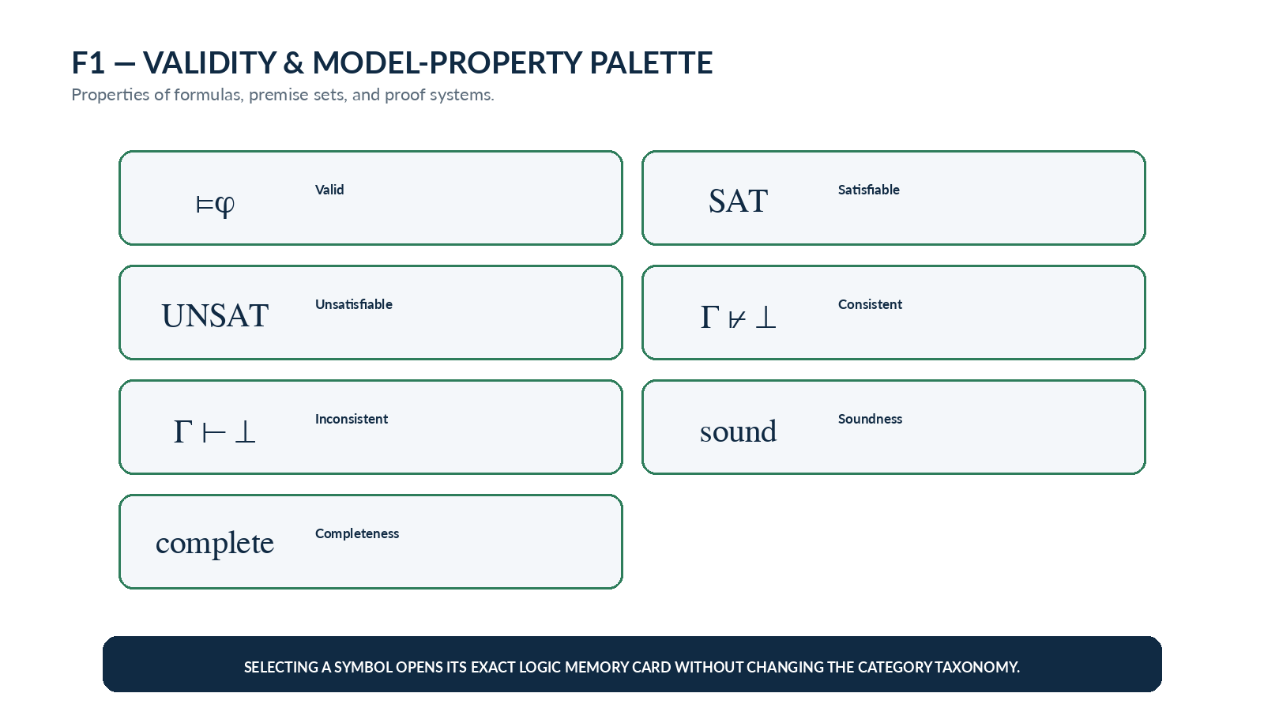
Figure 18. F1 validity and model-property palette.
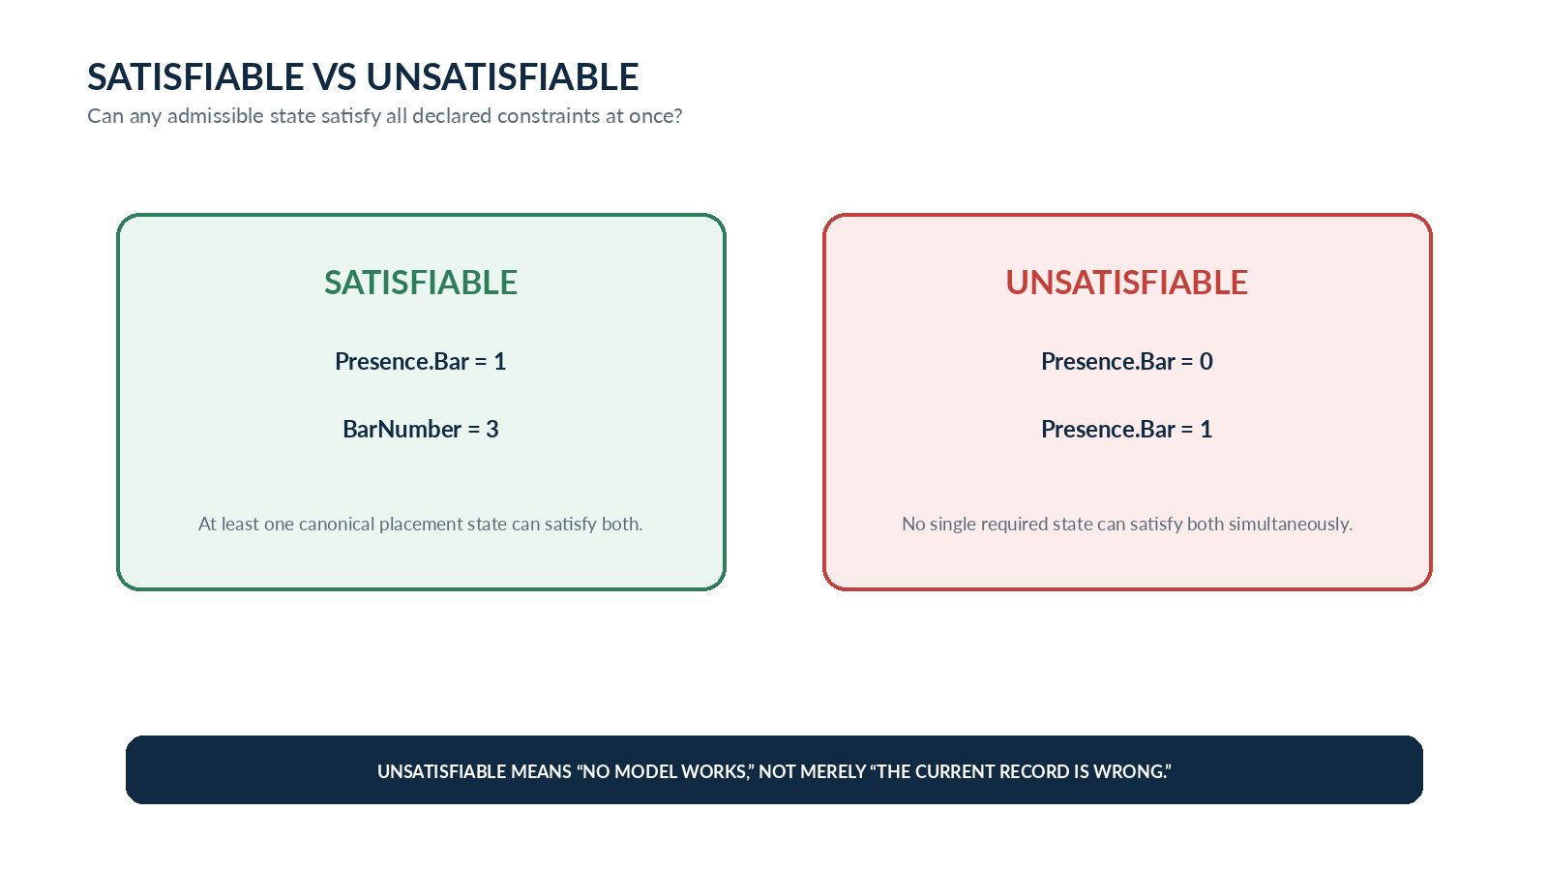
Figure 19. Satisfiability asks whether at least one admissible state can satisfy all required constraints.
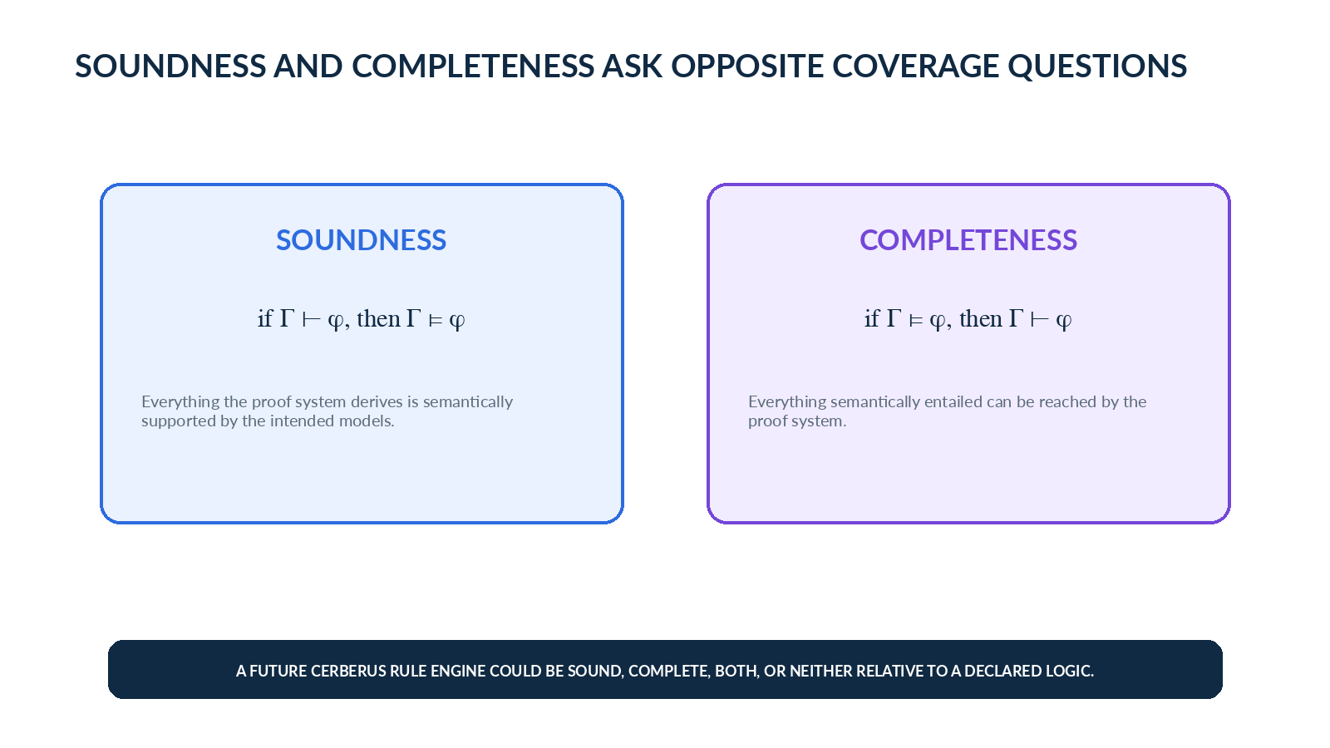
Figure 20. Soundness and completeness compare derivability with semantic entailment in opposite directions.

7.1 F1 Record Registry
Bit | Symbol / Schema | Concept | Description | Professional Use | Personal Use | References
B036 | ⊨ φ | Logical Validity | φ is true under every admissible interpretation in the selected logical semantics. | ⊨ P ∨ ¬P in classical propositional logic. | A CERBERUS validation law intended to hold across every conforming state can be discussed as a candidate validity claim once its semantics are formally defined. | —
B037 | ∃𝓜(𝓜⊨φ) | Satisfiable | At least one admissible model makes φ true. | A formula is satisfiable when there exists some model 𝓜 with 𝓜 ⊨ φ. | A proposed interface Ruleset is satisfiable if at least one record configuration can satisfy all required constraints simultaneously. | —
B038 | ¬∃𝓜(𝓜⊨φ) | Unsatisfiable | No admissible model makes φ true. | P ∧ ¬P is unsatisfiable in classical logic. | Requiring Presence.Bar = 0 and Presence.Bar = 1 in the same mandatory state makes that conjunction unsatisfiable. | —
B039 | Γ ⊬ ⊥ | Consistency | The premise set Γ does not derive contradiction under the selected proof system. | A theory is syntactically consistent when Γ ⊬ ⊥. | A CERBERUS Ruleset is consistent when its declared rules do not mechanically force mutually contradictory required states. | —
B040 | Γ ⊢ ⊥ | Inconsistency | The premise set Γ derives contradiction under the selected proof system. | Γ is inconsistent when Γ ⊢ ⊥. | If a future Rule calculus derives both an active and prohibited state from one required context, Γ ⊢ ⊥ would diagnose the inconsistency. | —
B041 | sound | Soundness | A proof system is sound when every formally derivable consequence is semantically entailed by the premises. | If Γ ⊢ φ, then soundness requires Γ ⊨ φ. | If a future CERBERUS Rule engine derives “valid,” soundness requires that derived result to correspond to an actually valid state under the intended semantics. | —
B042 | complete | Completeness | A proof system is complete when every semantically entailed consequence expressible in its language is formally derivable. | If Γ ⊨ φ, completeness requires Γ ⊢ φ. | For a bounded CERBERUS rule language, completeness asks whether every consequence represented by its semantics can also be reached by its declared inference machinery. | —

Part 8 | Modal Logic

8. G1 — Modal Logic
G1 is intentionally small in v0.1. Necessity and possibility create a bridge toward later State Machine and temporal-logic work without prematurely turning this kernel into a complete modal-logic course. The Personal Uses are illustrative learning applications; FORMAL_LOGIC-45 does not yet define a CERBERUS accessibility relation or modal semantics.
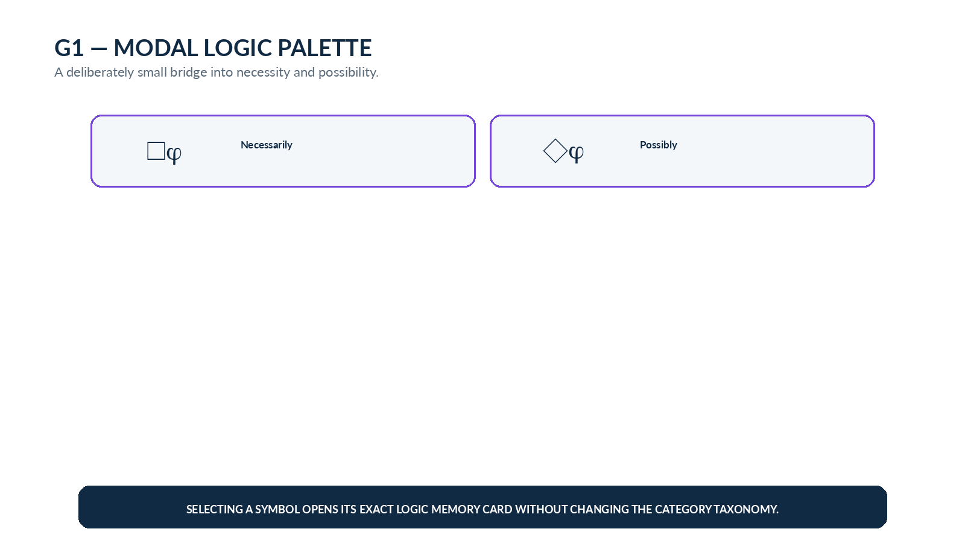
Figure 21. G1 modal palette.
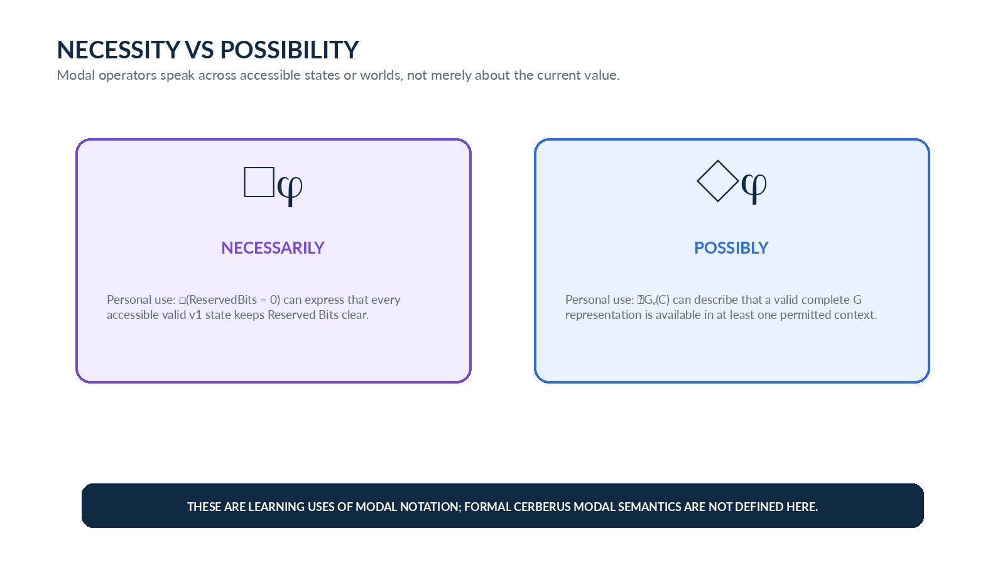
Figure 22. Necessity and possibility speak across accessible states rather than only about the current record value.

8.1 G1 Record Registry
Bit | Symbol / Schema | Concept | Description | Professional Use | Personal Use | References
B043 | □φ | Necessity | φ holds in every accessible relevant state or world under the chosen modal interpretation. | □P is read “necessarily P.” | □(ReservedBits = 0) can express the learning idea that every accessible valid v1 state keeps Reserved Bits clear. | —
B044 | ◇φ | Possibility | φ holds in at least one accessible relevant state or world under the chosen modal interpretation. | ◇P is read “possibly P.” | ◇Gᵥ(C) can express the learning idea that a valid complete G representation exists in at least one permitted context for Compound C. | —

Part 9 | Interface Architecture and Study Use

9. Bit-Level D — Formal Logic Card
The canonical Bit-level D is a memory card rather than an execution control. The symbol or schema dominates visually, followed by Description, Professional Use, Personal Use, and References. References remain visible as a registered layer even when empty so later curation can extend the memory package without changing the Descriptive Bit address.
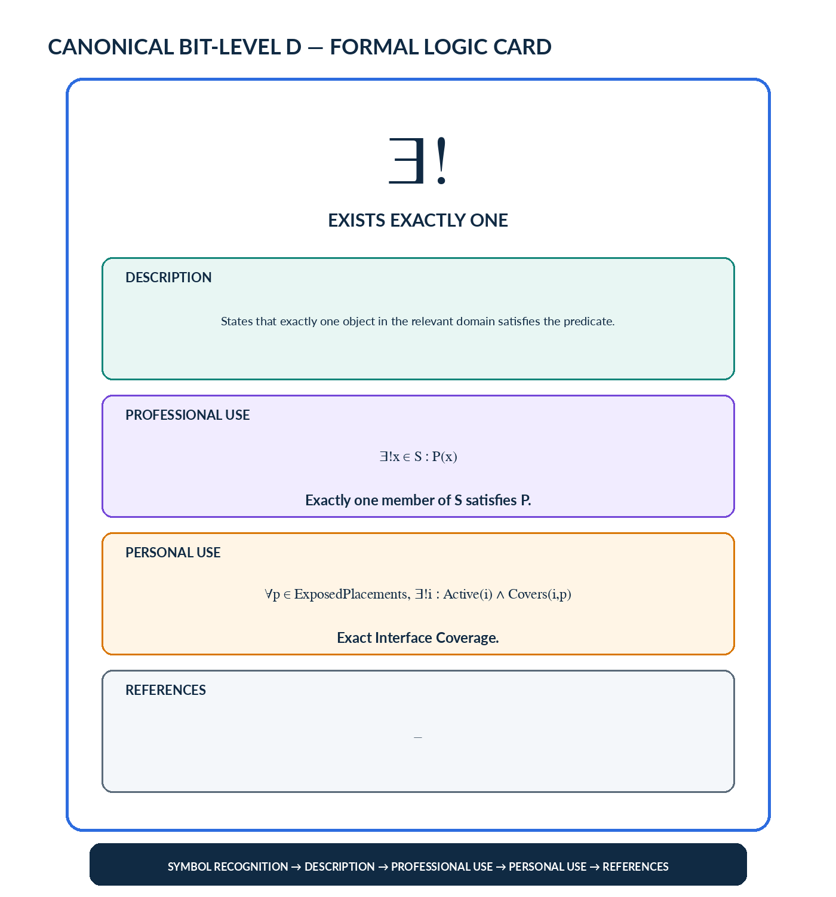
Figure 23. Canonical Formal Logic Card: symbol recognition, description, professional use, personal use, and blank References.

9.1 BitGroup Palettes
Each DESCRIPTION-n BitGroup may render as a compact symbol palette. Selecting one active Bit opens its exact Formal Logic Card. The palette is a descriptive D for that BitGroup; it does not combine categories merely for visual symmetry. An E interface should be added only if a coordinated multi-BitGroup interaction later earns its existence.

9.2 Complete-Word F Variants
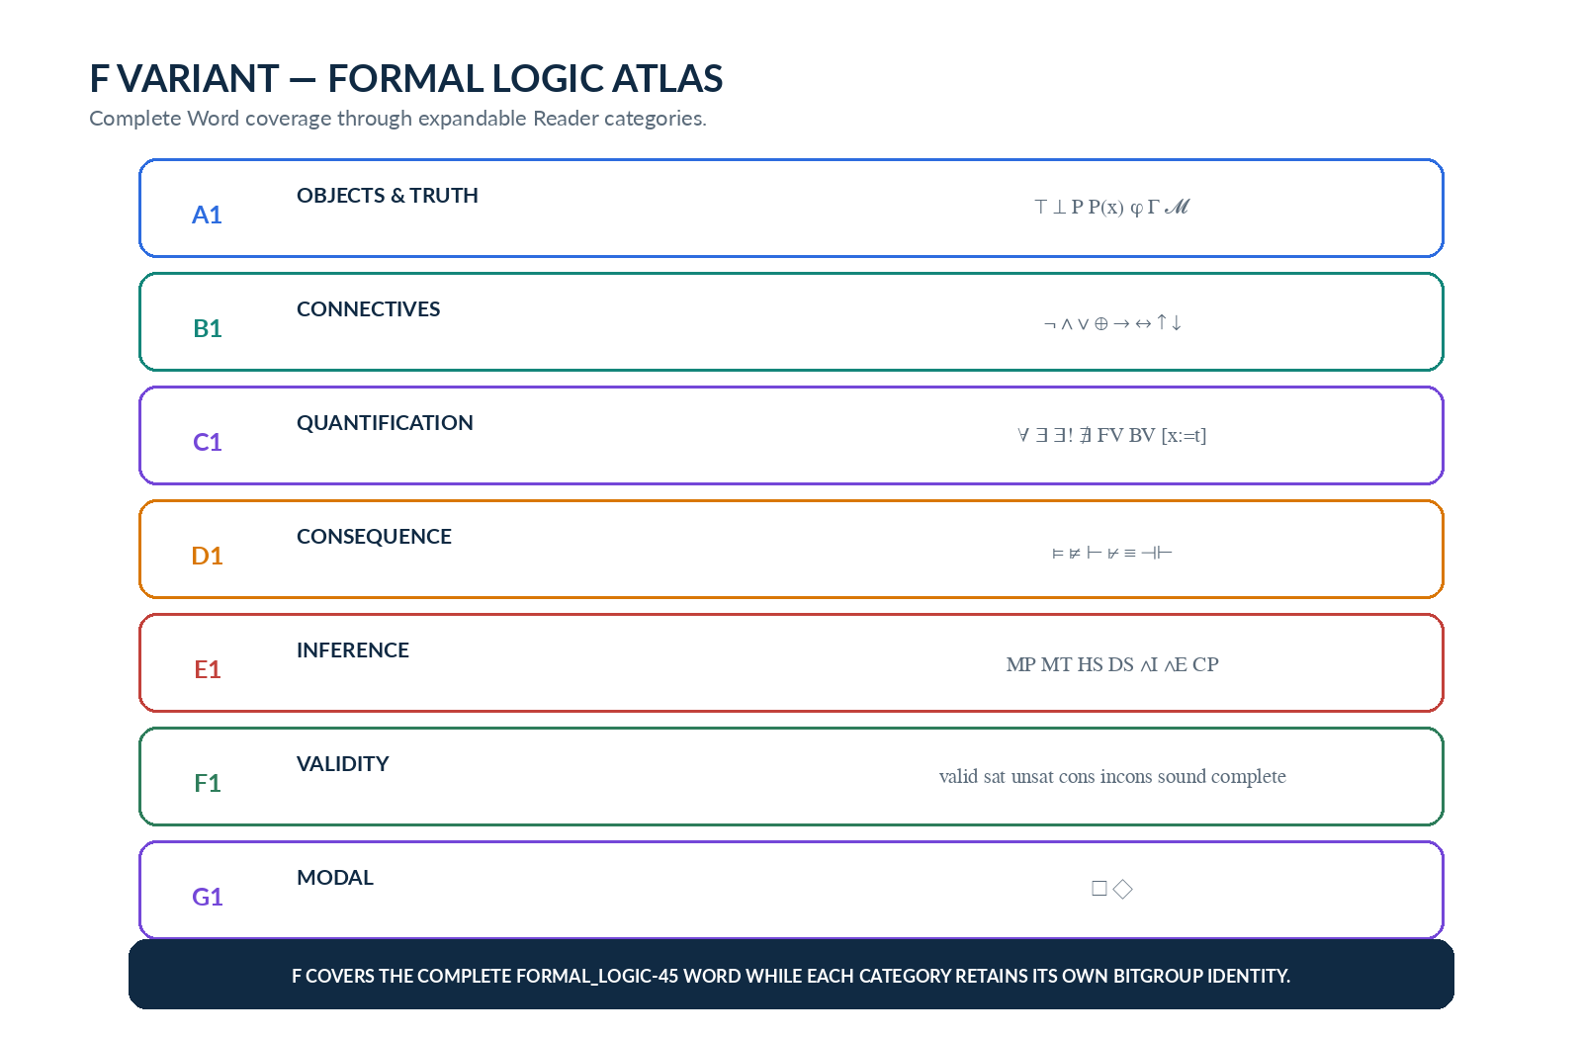
Figure 24. F Variant — Logic Atlas. All seven Reader categories remain visible inside one complete-Word interface.
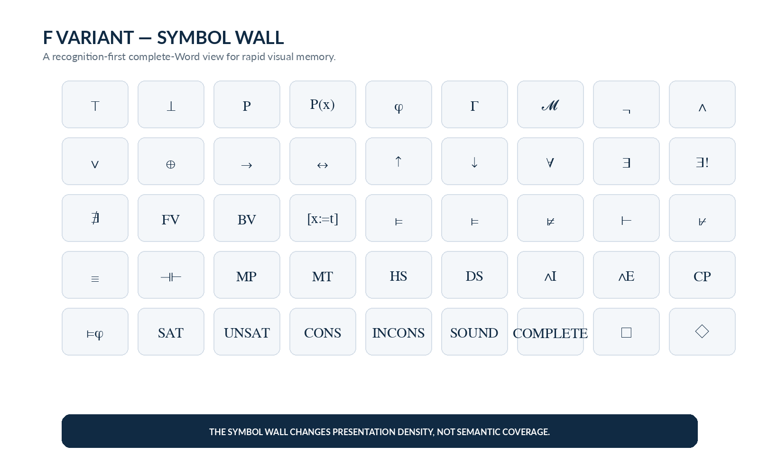
Figure 25. F Variant — Symbol Wall. Recognition density changes while semantic coverage remains complete.
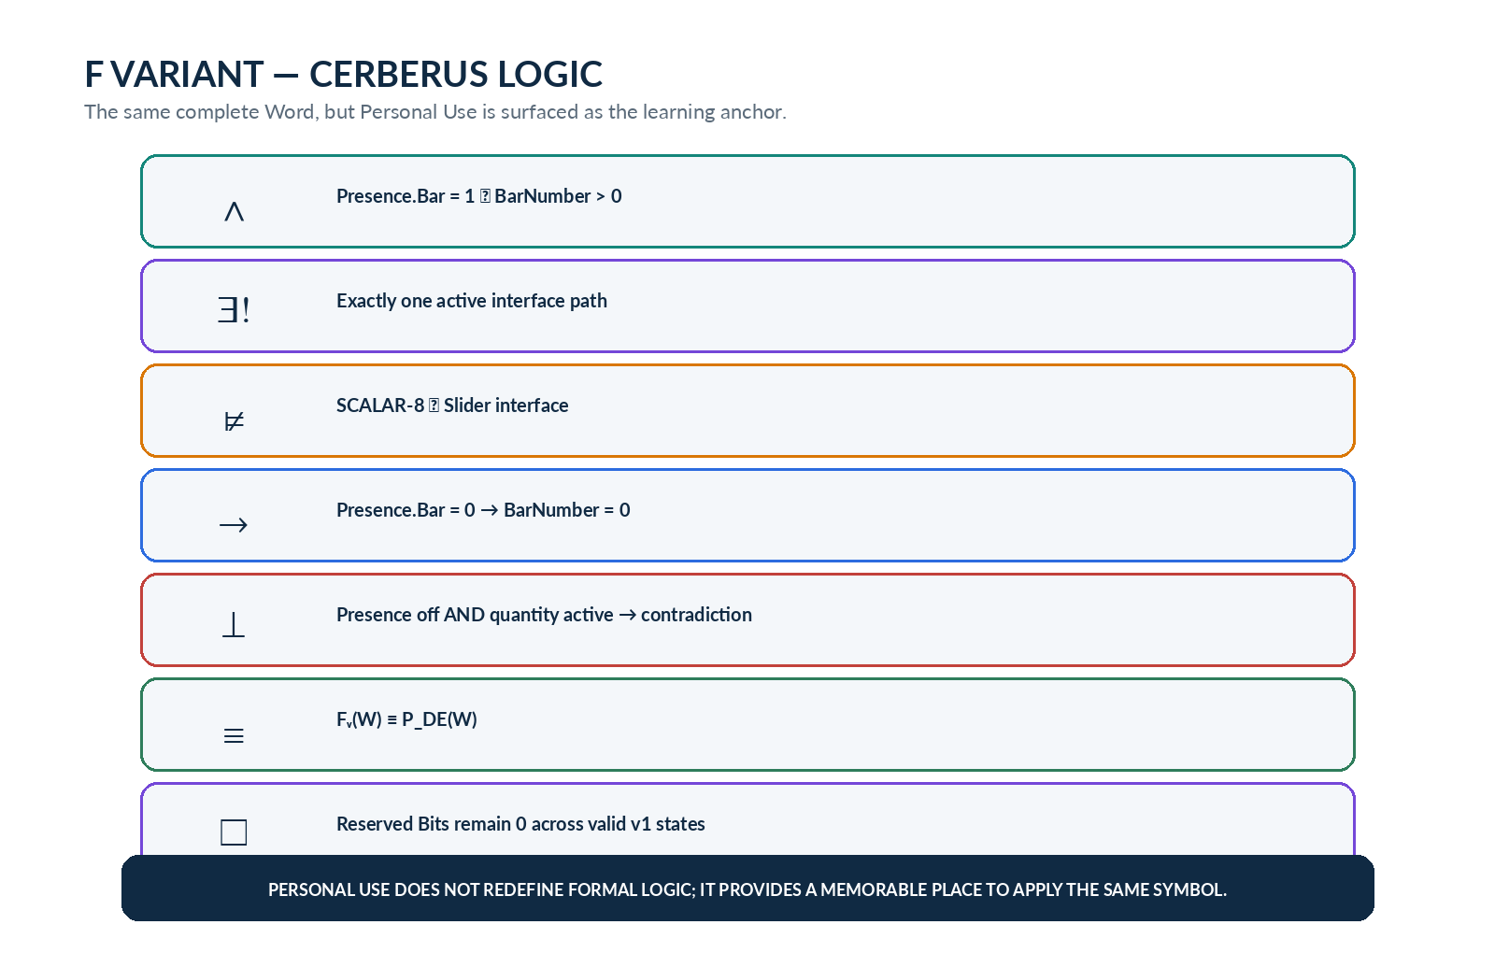
Figure 26. F Variant — CERBERUS Logic. Personal Use becomes the primary learning anchor without redefining formal logic.

9.3 Example Study Sets
FOUNDATIONAL SET
¬ ∧ ∨ → ∀ ∃ ∃! ⊨ ⊢
CONSEQUENCE SYMBOLS I KEEP CONFUSING
⊨ ⊭ ⊢ ⊬ ≡ ⊣⊢
STATE-MACHINE PREPARATION
¬ ∧ → ∀ ∃ □ ◇

These study sets are ordinary Bit selections. They do not create new logic concepts or mutate the SK taxonomy. A user can maintain many such selections as different descriptive projections over the same 45 semantic addresses.

Part 10 | Reuse, Formal Laws, and Reference Registry

10. Relationship to Future Symbolic SKs
FORMAL_LOGIC-45 is designed to become a shared language for later descriptive kernels rather than an isolated reference. GRAPH_NETWORK can reuse quantifiers and consequence when describing reachability or unique roots. STATE_MACHINE can treat transition guards as predicates and implications over graph edges. CONTROL_SYSTEMS can reuse logical conditions around modes, safety constraints, controller states, and feedback decisions.
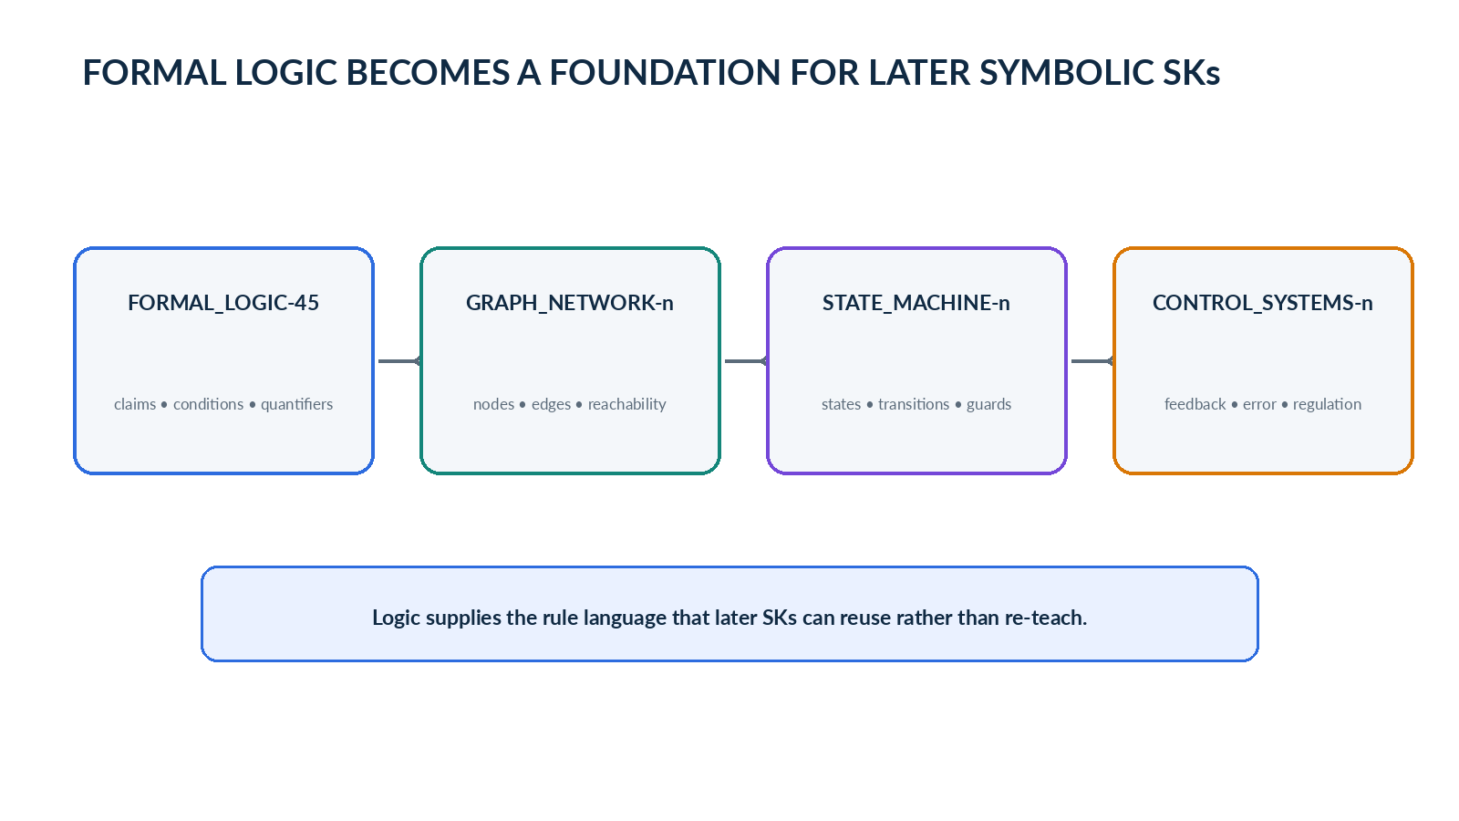
Figure 27. Formal logic supplies a rule language that later Graph, State Machine, and Control Systems SKs can reuse.

10.1 Descriptive Vocabulary vs Functional Logic
This specification intentionally stops at descriptive identity and memory. A future functional logic system may add arity, operand domains, binding rules, parser grammar, precedence, proof rules, semantics, model structures, evaluation functions, and validation. Those functional records may link to the same semantic addresses defined here. The descriptive SK should not be retroactively treated as executable merely because later systems reuse its vocabulary.
VALIDITY VS UTILITY | A BitWord can be grammatically valid, descriptive, artistic, experimental, functional, or operationally useless. FORMAL_LOGIC-45 chooses a practical descriptive construction, but CERBERUS does not prohibit alternate or experimental BitWord tactics.

10.2 Candidate Formal Laws
Law | Requirement
Law 1 — Descriptive Boundary | FORMAL_LOGIC-45 SHALL describe logic concepts but SHALL NOT claim that selecting a Bit executes the represented operation, inference, or proof.
Law 2 — Exact Addressing | Each concept SHALL have one stable Reader-bound descriptive address in this specification version.
Law 3 — Binary Participation | Bit = 1 selects the concept for the current descriptive projection; Bit = 0 omits it. Bit value SHALL NOT be interpreted as the truth value of the represented proposition.
Law 4 — Memory Separation | Description, Professional Use, Personal Use, and References SHALL remain distinct memory layers.
Law 5 — Blank References | References MAY remain empty. Missing references SHALL NOT be filled by runtime guesswork.
Law 6 — Symbol Context | Visible symbol shape SHALL NOT be treated as sufficient semantic identity when multiple Reader-bound concepts can use the same glyph.
Law 7 — Implication Notation | This SK uses → for material implication and SHALL NOT repurpose the locked CERBERUS ⇒ interface-manifestation symbol.
Law 8 — Personal Use Integrity | Personal Use MAY apply the formal symbol to CERBERUS architecture but SHALL NOT silently redefine the professional logical meaning.
Law 9 — Category Independence | A1-G1 remain independent descriptive BitGroups. Cross-category E interfaces SHOULD exist only when coordinated interaction earns their existence.
Law 10 — Future Functional Reuse | Functional logic systems MAY link to these semantic addresses without making FORMAL_LOGIC-45 itself executable.
Law 11 — Modal Restraint | □ and ◇ are descriptive learning concepts in v0.1; this SK SHALL NOT imply a complete CERBERUS modal semantics.
Law 12 — No Silent Inference | When required context or memory is absent, the descriptive system SHALL preserve absence rather than invent a logical interpretation or reference.

10.3 Consolidated Bit Registry
Bit | Reader | Symbol / Schema | Concept | Category
B000 | A1 | ⊤ | Truth | Logical Objects & Truth
B001 | A1 | ⊥ | Falsehood / Contradiction | Logical Objects & Truth
B002 | A1 | P | Proposition | Logical Objects & Truth
B003 | A1 | P(x) | Predicate | Logical Objects & Truth
B004 | A1 | φ | Formula | Logical Objects & Truth
B005 | A1 | Γ | Premise / Assumption Context | Logical Objects & Truth
B006 | A1 | 𝓜 | Model / Interpretation | Logical Objects & Truth
B007 | B1 | ¬ | Negation / NOT | Logical Connectives
B008 | B1 | ∧ | Conjunction / AND | Logical Connectives
B009 | B1 | ∨ | Disjunction / OR | Logical Connectives
B010 | B1 | ⊕ | Exclusive OR / XOR | Logical Connectives
B011 | B1 | → | Material Implication | Logical Connectives
B012 | B1 | ↔ | Biconditional | Logical Connectives
B013 | B1 | ↑ | NAND | Logical Connectives
B014 | B1 | ↓ | NOR | Logical Connectives
B015 | C1 | ∀ | Universal Quantifier / For All | Quantification & Binding
B016 | C1 | ∃ | Existential Quantifier / Exists | Quantification & Binding
B017 | C1 | ∃! | Unique Existential / Exists Exactly One | Quantification & Binding
B018 | C1 | ∄ | There Exists No | Quantification & Binding
B019 | C1 | FV(φ) | Free Variables | Quantification & Binding
B020 | C1 | BV(φ) | Bound Variables | Quantification & Binding
B021 | C1 | φ[x:=t] | Substitution | Quantification & Binding
B022 | D1 | 𝓜 ⊨ φ | Satisfaction | Semantic & Syntactic Relations
B023 | D1 | Γ ⊨ φ | Semantic Entailment | Semantic & Syntactic Relations
B024 | D1 | Γ ⊭ φ | Semantic Non-entailment | Semantic & Syntactic Relations
B025 | D1 | Γ ⊢ φ | Syntactic Derivability | Semantic & Syntactic Relations
B026 | D1 | Γ ⊬ φ | Syntactic Non-derivability | Semantic & Syntactic Relations
B027 | D1 | φ ≡ ψ | Logical Equivalence | Semantic & Syntactic Relations
B028 | D1 | φ ⊣⊢ ψ | Interderivability | Semantic & Syntactic Relations
B029 | E1 | P, P→Q ∴ Q | Modus Ponens | Inference Patterns
B030 | E1 | P→Q, ¬Q ∴ ¬P | Modus Tollens | Inference Patterns
B031 | E1 | P→Q, Q→R ∴ P→R | Hypothetical Syllogism | Inference Patterns
B032 | E1 | P∨Q, ¬P ∴ Q | Disjunctive Syllogism | Inference Patterns
B033 | E1 | P, Q ∴ P∧Q | Conjunction Introduction | Inference Patterns
B034 | E1 | P∧Q ∴ P | Conjunction Elimination | Inference Patterns
B035 | E1 | P→Q ≡ ¬Q→¬P | Contraposition | Inference Patterns
B036 | F1 | ⊨ φ | Logical Validity | Validity & Model Properties
B037 | F1 | ∃𝓜(𝓜⊨φ) | Satisfiable | Validity & Model Properties
B038 | F1 | ¬∃𝓜(𝓜⊨φ) | Unsatisfiable | Validity & Model Properties
B039 | F1 | Γ ⊬ ⊥ | Consistency | Validity & Model Properties
B040 | F1 | Γ ⊢ ⊥ | Inconsistency | Validity & Model Properties
B041 | F1 | sound | Soundness | Validity & Model Properties
B042 | F1 | complete | Completeness | Validity & Model Properties
B043 | G1 | □φ | Necessity | Modal Logic
B044 | G1 | ◇φ | Possibility | Modal Logic

10.4 Glossary
Term | Definition
Descriptive Bit | A Bit whose active state selects a bounded semantic memory address rather than directly executing the described concept.
Formula (φ) | A well-formed logical expression.
Premise Context (Γ) | A collection of assumptions or premises for consequence or derivation.
Model / Interpretation (𝓜) | A structure under which formulas receive meaning and truth values.
Semantic Entailment (⊨) | Truth-preserving consequence across every admissible model satisfying the premises.
Syntactic Derivability (⊢) | Provability from premises by the declared formal inference rules.
Satisfiable | Having at least one admissible model.
Consistent | Not deriving contradiction under the selected proof system.
Soundness | Derivability implies semantic entailment.
Completeness | Semantic entailment implies derivability for the language and proof system in question.
Modal Necessity (□) | Truth in every accessible relevant state or world under a modal interpretation.
Modal Possibility (◇) | Truth in at least one accessible relevant state or world under a modal interpretation.

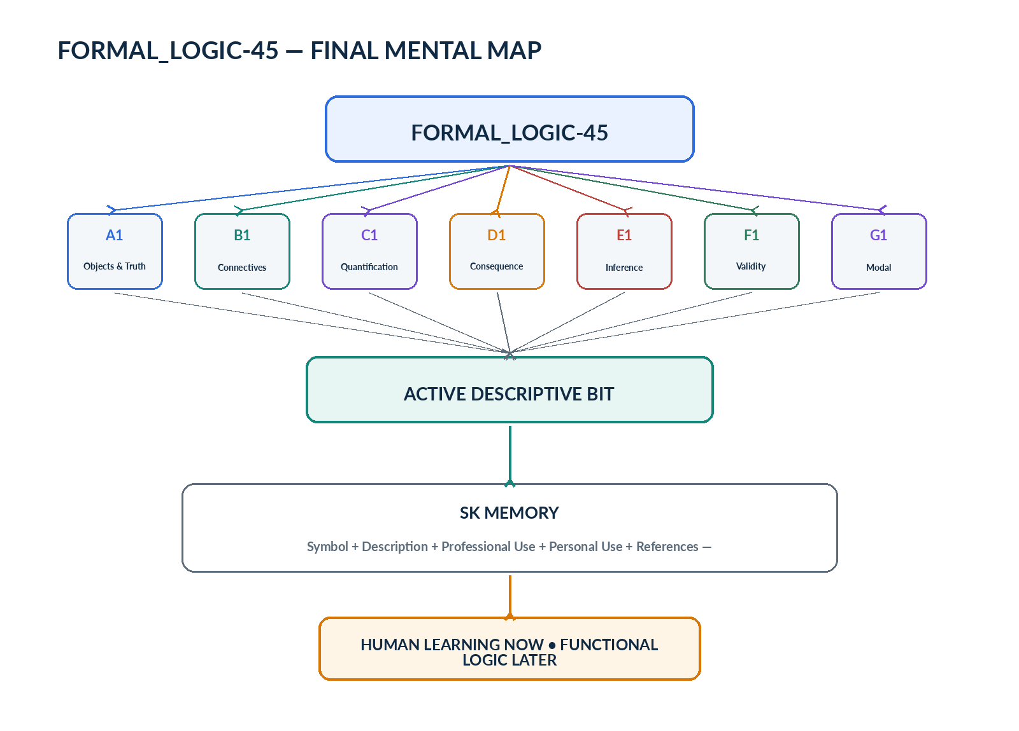
Figure 28. FORMAL_LOGIC-45 final mental map: Bits select logical concepts, SK Memory explains them, interfaces teach them, and future functional systems may reuse the same vocabulary.
END-STATE | Symbols provide the compression. Bits provide the addresses. SK Memory provides the meaning. Professional Use preserves formal context. Personal Use anchors the same symbols inside CERBERUS. Future systems can reuse the vocabulary without changing what this descriptive SK is.

