CERBERUS EFFECTS 64
  - Candidate Semantic Kernel Specification
Typed procedural effect root and family routing
Candidate v0.1 • Reviewed edition • Shane Conrad

Abstract
EFFECTS-64 defines the common declaration through which a procedural Effect becomes typed, inspectable and routable. Fourteen Reader placements describe the specialist route, input and output Value Classes, Domain, value basis, polarity, gain, bias, bounds, missing-input policy, composition role, determinism, evaluation mode and interpretation version. Twelve four-bit placements and two eight-bit placements occupy exactly sixty-four bits.
The root connects a bounded semantic declaration to specialist interpretation. Compound records identify assembly members, an Effect Graph connects Signals, Formula Profiles specify computation, and Application Bindings connect results to authorized targets. This separation lets the same source support visual, audio, movement and haptic applications without surrendering source identity or confusing a projection with canonical truth.
This edition integrates eight explanatory figures and three explicit numerical or stateful examples. Candidate state vocabularies remain visible alongside their unresolved registration and interpretation boundaries. Examples demonstrate their declared contracts; they do not establish complete native runtime conformance.

Reading order
The paper moves from ownership and physical allocation to Reader semantics, the placement catalogue, family routing, worked evaluation contracts, integration rules and implementation handoff. The placement catalogue retains candidate D Requirement keys for later interface binding.

1 The common root contract
An Effect root answers a common question: what kind of typed procedural relationship is being declared, and which specialist owns its interpretation? It supplies a shared envelope while allowing FIELD, LIGHT, AUDIO and the other specialist territories to remain independently bounded. [1, 2]
In specialist mode A1 selects one semantic continuation through <R>. In assembly mode A1 declares ROOT; exact members remain in Compound and runtime edges remain in the Effect Graph. A family selector is therefore not a family membership mask.
Owner | Responsibility
<R> | Semantic continuation. Root to registered specialist interpretation; not membership or runtime wiring.
Compound | Constituent membership. Identifies assembly constituents; does not prescribe runtime edges.
Effect Graph | Runtime signal flow. Owns wiring, branching and explicit transforms; typed edges require validation.
Formula Profile | Formula details. Owns declared formula and parameter semantics.
Application Binding | Target application. Owns target identity, destination parameter, mapping, baseline, application mode, mask/scope, context, permissions and provenance trace.
Renderer | Realization. Realizes renderer-neutral requests.
TIME / TIMING_RIG | Global scheduling. Owns global timing; M1 specifies local evaluation posture.
An Application Binding may supply destination parameter, baseline, mapping, application mode, scope, permissions and provenance. A Renderer realizes that request. Neither the root nor a rendered preview establishes world, gameplay, memory or historical authority.

The bounded effect envelope
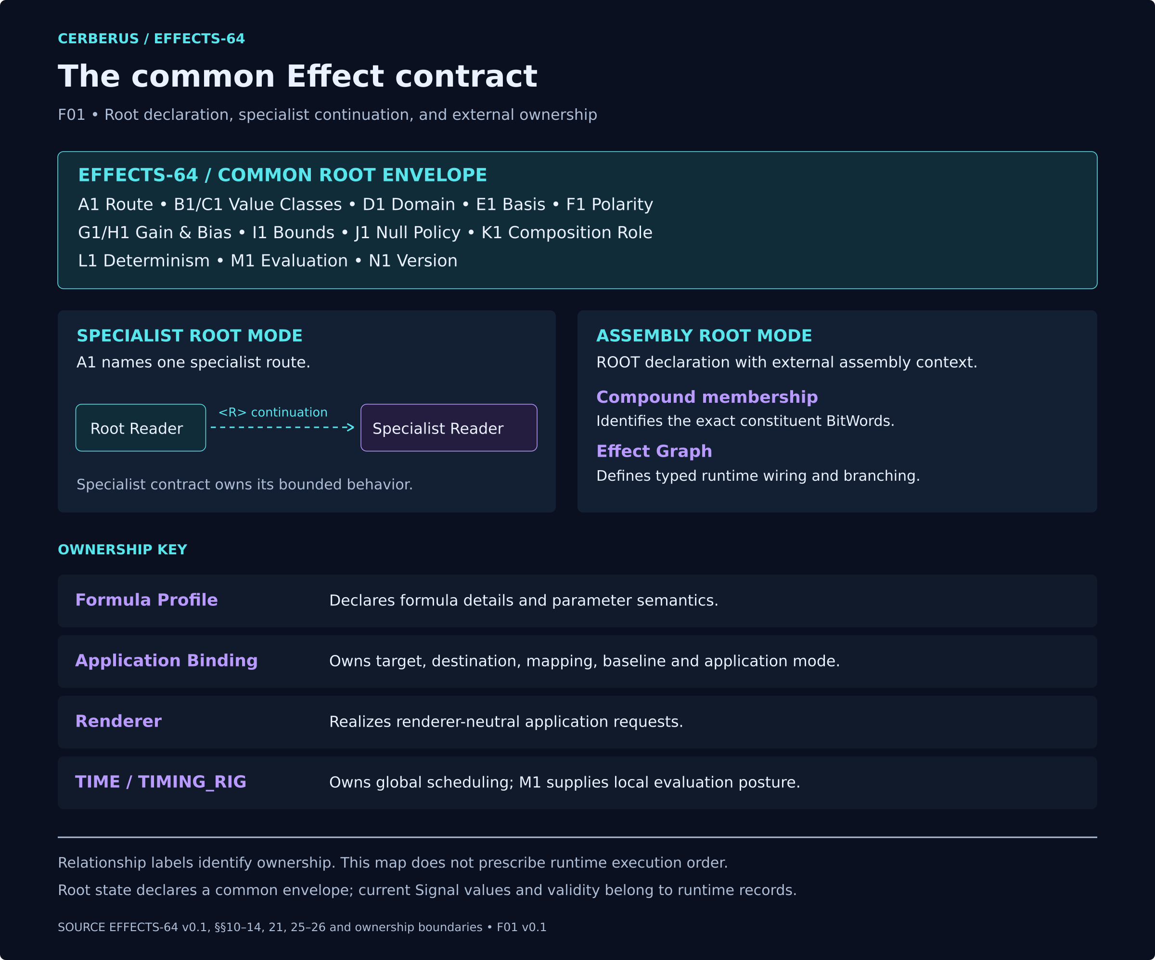
F01. EFFECTS-64 declares the common root envelope. Specialist mode uses <R> semantic continuation. Assembly membership, graph wiring, formula details, target application, realization and global scheduling retain their named owners.
The ownership boundaries apply to both authoring and evaluation. Opening a specialist editor follows the selected contract; it does not add specialist payload to the root.

2 Physical allocation and mathematical carriers
SCALAR-4 and SCALAR-8 provide positional mathematics. EFFECTS Reader placements provide semantic interpretation. Similar mathematics in a specialist does not establish shared registered BitGroup identity; identity reuse is an implementation decision. [1, 3]
Reader | Bit range | Carrier | Meaning
A1 | B000–B003 | SCALAR-4 | Effect Class / Specialist Route
B1 | B004–B007 | SCALAR-4 | Input Value Class
C1 | B008–B011 | SCALAR-4 | Output Value Class
D1 | B012–B015 | SCALAR-4 | Effect Domain Class
E1 | B016–B019 | SCALAR-4 | Value Basis
F1 | B020–B023 | SCALAR-4 | Polarity / Orientation
G1 | B024–B031 | SCALAR-8 | Gain / Intensity
H1 | B032–B039 | SCALAR-8 | Bias / Offset
I1 | B040–B043 | SCALAR-4 | Bounds Policy
J1 | B044–B047 | SCALAR-4 | Null / Missing Behavior
K1 | B048–B051 | SCALAR-4 | Composition Role
L1 | B052–B055 | SCALAR-4 | Determinism Posture
M1 | B056–B059 | SCALAR-4 | Evaluation Mode
N1 | B060–B063 | SCALAR-4 | Version / Reserved
The twelve four-bit placements contribute 48 bits; G1 and H1 contribute 16. There are no gaps or overlaps. Allocation specifies address territory, not a serialization convention for assigning numerical weights to physical addresses.
Additional width requires a new root responsibility. Compound membership, graph edges, target identity, Formula details and specialist semantics already have owners and do not justify widening EFFECTS.

The complete 64 bit allocation
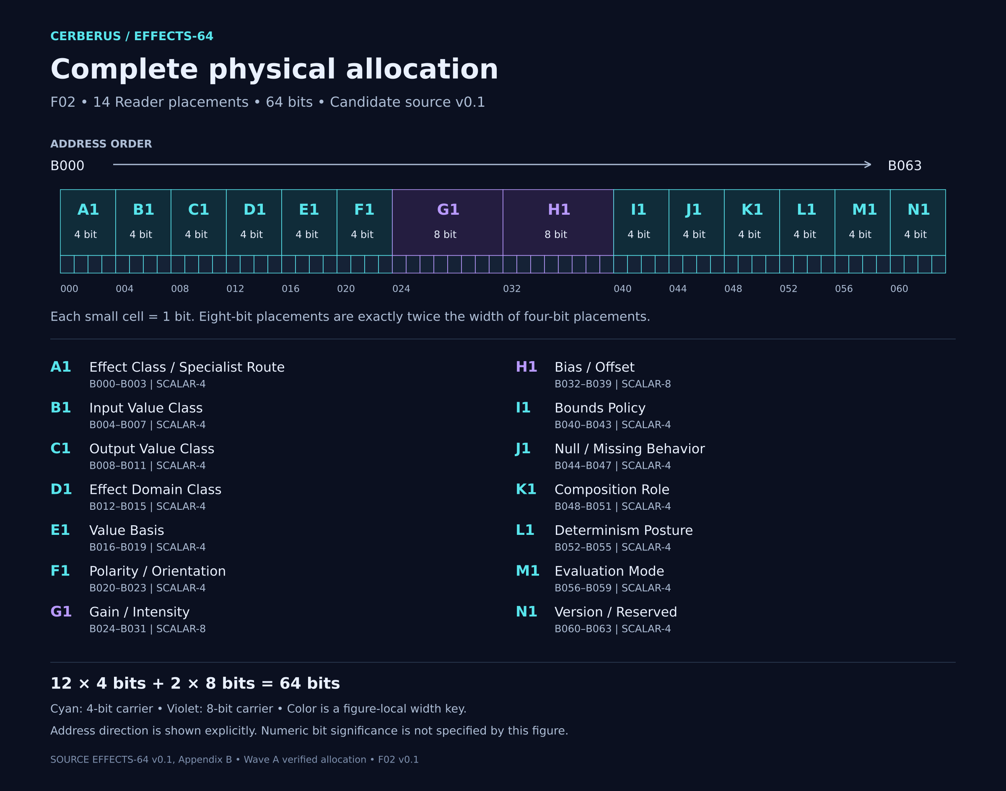
F02. EFFECTS-64 allocates B000–B063 across fourteen Reader placements. G1 and H1 occupy eight bits each; the other twelve occupy four bits each. Equal-width bit cells preserve physical proportions. The figure describes allocation, not a particular state or numeric bit-significance convention.
Each cell represents one bit. The wider Gain and Bias placements are therefore shown at twice the width of each categorical placement.

3 Typed Signals and Domain
Value Class identifies what a value means at a typed boundary. Domain identifies where that relationship is meaningful. A Scalar can be evaluated over a Field, a Vector over a Volume, and a Mask over a Surface. Numeric storage alone cannot establish compatibility. [1, 3]
A direct connection requires compatible producer and consumer contracts, including the applicable basis, component interpretation and Domain requirements. A declared transform must supply any conversion; the graph must not introduce a hidden coercion. An absent required binding prevents resolution. A known violated constraint is reported as a violation under the governing Reader contract.
Domain adapters expose only the fields required by a Formula or specialist: element identity, coordinates, normals or tangents, path position, normalized index, anchor distances, membership, state and an external Frame where required. Selecting D1 does not guarantee that those fields exist.
The static root declaration and the current Signal are separate. Current values, sample identity, runtime availability and provenance travel with evaluation context. They are not additional bits silently appended to EFFECTS-64.
One source may feed several specialist applications. A shared cause can appear as movement, color, light, audio or haptics while each branch retains the source provenance and its own declared transformation.

Value Class and Domain remain separate
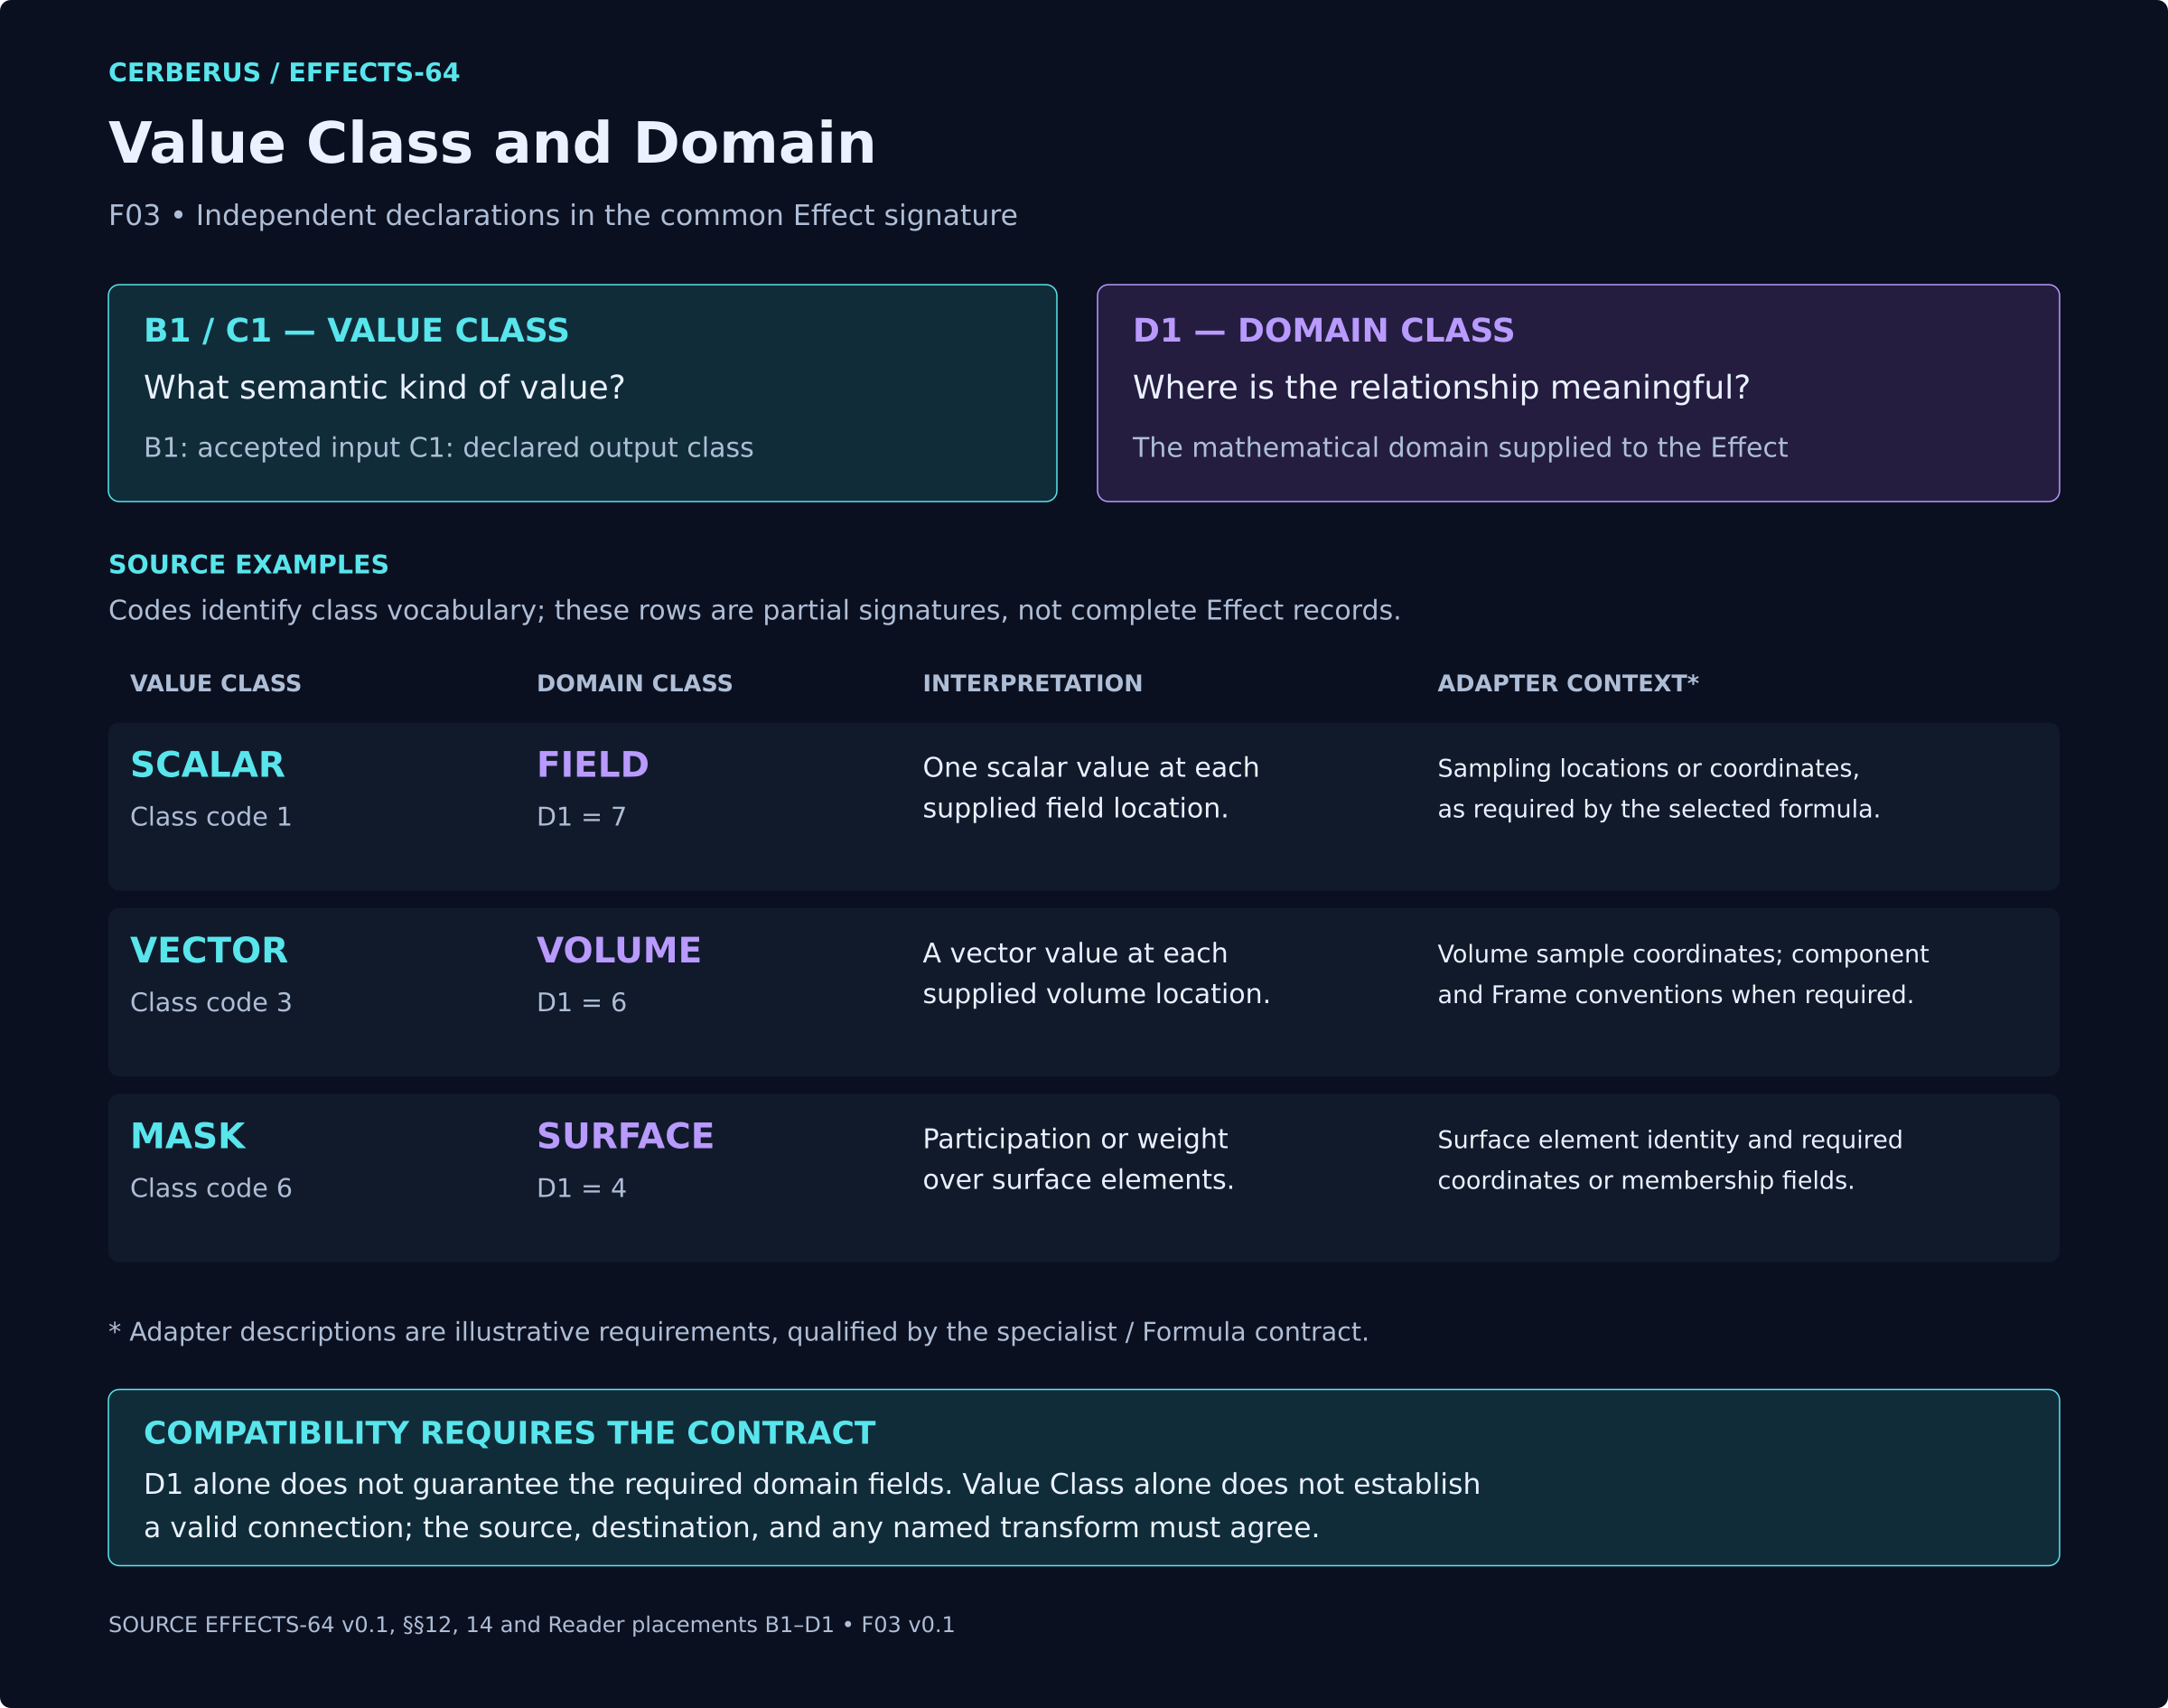
F03. Value Class describes the semantic kind of a value; Domain describes where the relationship is meaningful. Scalar over Field, Vector over Volume and Mask over Surface illustrate independent declarations. Adapter requirements remain governed by the selected contract.
The illustrated adapter fields are conditional requirements of the selected contract. They are not a universal adapter schema.

4 Reader resolution and evaluation
The Reader resolves a stored declaration against versioned semantics. The evaluator computes with the resolved declaration and runtime inputs. Reading must preserve source state; an interpretation result is not an implicit write or migration. [3]
Resolve the governing interpretation version and registered dependencies before applying dependent meanings. Resolve A1 and its K1 role agreement, the typed boundary, Domain and basis, then the applicable policies and specialist continuation. Where specialist information is required to complete a declaration, retain that dependency explicitly rather than treating a procedural reading order as proof of availability.
Dimension | Meaning
SemanticValidation | VALID: known required checks pass. INVALID: a known rule is violated. UNRESOLVED: required governed information is missing.
Applicability | ACTIVE, INACTIVE or CONDITIONAL under the governing dependency. Inactive stored state is preserved.
Trust | STABLE, VARIABLE, WARNING, CONDITIONAL or EXPERIMENTAL remains distinct from semantic validation.
Evaluation result | Carries the current output, availability or failure, and provenance. A fallback does not erase current failure.
For generic gain and bias, a known unsupported non-neutral operation is INVALID. Missing information needed to decide support is UNRESOLVED. Neutral settings count as a no-op only where the governing contract permits that behavior. This deliberately reconciles the older blanket UNRESOLVED illustration with the Reader validation distinction.
This paper does not prescribe a universal execution order between specialist computation, polarity and shaping. Each Formula Profile must identify the stage at which its inputs and transformations apply.

Reading and computing have distinct outputs
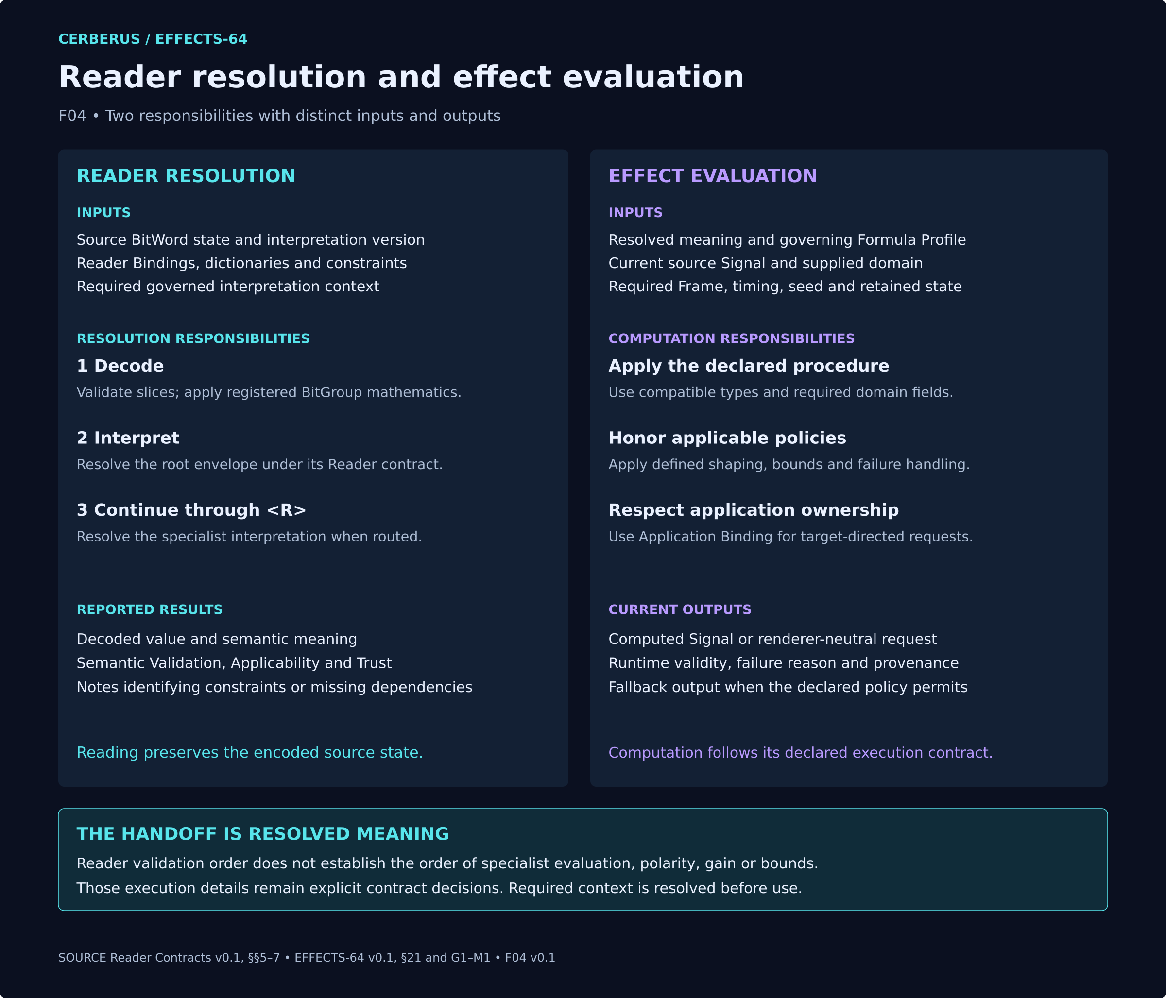
F04. Reader resolution preserves source state while reporting meaning and validation. Effect evaluation uses that meaning under a declared procedure and runtime context. The two responsibilities have distinct outputs.
A resolved semantic contract can coexist with a missing current runtime source. Keep both facts visible.

5 Reader placement catalogue
The following catalogue preserves the v0.1 written declarations and candidate DREQ keys. These keys specify interface requirements; they are not asserted live D#.# identities. State numbers are categorical raw values except for G1 and H1. [1]
B1 and C1 carry an unresolved source conflict: old figures use EXTENSION 13, whereas the written vocabulary uses 15. The catalogue retains written 15 as the proposed correction; it does not silently validate either disputed encoding. Values 13–14 remain unspecified pending an explicit decision.
E1 ABSOLUTE is retained as a basis label whose exact meaning remains to be clarified. It must not automatically apply an absolute-value operation. F1 separately contains that polarity operation. Specialist-derived C1 has no newly invented sentinel code.

Reader placements A1 and B1

A1 Effect Class / Specialist Route
Routes the root into one registered specialist Effect class or declares ROOT mode.
Representative states: 0 ROOT / NO ROUTE; 1 FIELD; 2 MASK; 3 MODULATION; 4 BLEND; 5 GATE; 6 MOVEMENT; 7 PARTICLE; 8 COLOR; 9 LIGHT; 10 GEOMETRY; 11 MATERIAL; 12 AUDIO; 13 HAPTIC; 14 CAMERA; 15 REGISTERED EXTENSION.
Reader formula / mathematics: SCALAR-4 categorical route selection.
Validation / boundary: A1 must agree with K1 Composition Role unless an extension contract explicitly permits another pairing.
Does not own: specialist behavior, Compound membership, graph topology
Semantic Route • DREQ-ROUTE.EFFECT_CLASS

B1 Input Value Class
Declares the semantic class accepted at the root ingress.
Representative states: 0 NONE; 1 SCALAR; 2 SIGNED_SCALAR; 3 VECTOR; 4 ANGULAR / ORIENTATION; 5 PROBABILITY; 6 MASK; 7 EVENT; 8 BOOLEAN; 9 PULSE; 10 LIFECYCLE; 11 PATH / TRAJECTORY; 12 CATEGORICAL / INDEX; 15 EXTENSION.
Reader formula / mathematics: SCALAR-4 semantic type selection.
Validation / boundary: Connections that do not match B1 require an explicit named transform or resolve UNRESOLVED.
Does not own: actual source identity, runtime source value
Type Selection • DREQ-TYPE.EFFECT_INPUT

Reader placements C1 and D1

C1 Output Value Class
Declares or constrains the semantic Value Class emitted by the resolved Effect contract.
Representative states: Same common type vocabulary as B1; output may be specialist-derived when the exact class is resolved by the specialist Reader.
Reader formula / mathematics: SCALAR-4 semantic type selection.
Validation / boundary: Output class must agree with the routed specialist / Formula result.
Does not own: renderer implementation, downstream target identity
Type Selection • DREQ-TYPE.EFFECT_OUTPUT

D1 Effect Domain Class
Declares the mathematical domain over which the Effect relationship is meaningful.
Representative states: 0 NONE; 1 POINT; 2 AXIS; 3 PATH; 4 SURFACE; 5 REGION; 6 VOLUME; 7 FIELD; 8 ORDERED_SET; 9 SEMANTIC_SET; 10 MULTI_DOMAIN; 11 EXTERNAL_ADAPTER; 15 EXTENSION.
Reader formula / mathematics: SCALAR-4 domain class selection.
Validation / boundary: Required domain fields are validated by the specialist / Formula contract; D1 alone does not guarantee them.
Does not own: canonical world geometry, target identity, Frame ownership
Domain Selection • DREQ-DOMAIN.EFFECT

Reader placements E1 and F1

E1 Value Basis
Declares the value basis / range convention used by the root contract.
Representative states: 0 SOURCE_DECLARED / PASS_THROUGH; 1 NORMALIZED_0_1; 2 SIGNED_-1_1; 3 ABSOLUTE; 4 CATEGORICAL; 5 INDEXED; 6 BINARY; 7 DOMAIN_NORMALIZED; 8 EXTERNAL_PROFILE; 9–15 reserved.
Reader formula / mathematics: SCALAR-4 basis selection.
Validation / boundary: Basis must be semantically compatible with the declared Value Class.
Does not own: actual endpoint unit conversion unless explicitly bound
Basis Selection • DREQ-BASIS.EFFECT_VALUE

F1 Polarity / Orientation
Declares whether sign / orientation is preserved, inverted, rectified, or delegated.
Representative states: 0 PRESERVE; 1 INVERT / NEGATE; 2 ABSOLUTE; 3 RECTIFY_POSITIVE; 4 RECTIFY_NEGATIVE; 5 REVERSE_ORIENTATION; 6 EXTERNAL; 7 PROFILE; 8–15 reserved.
Reader formula / mathematics: SCALAR-4 polarity / orientation selection.
Validation / boundary: Operations that do not make sense for the declared Value Class are UNRESOLVED rather than silently coerced.
Does not own: source identity, specialist-specific orientation models
Polarity Selection • DREQ-POLARITY.EFFECT
The inherited UNRESOLVED wording remains candidate language here; a general polarity validation revision requires its own explicit decision.

Reader placements G1 and H1

G1 Gain / Intensity
Applies a generic root-level multiplicative strength to compatible values.
Representative states: Raw 0..255 maps by candidate g = G1 / 128. Raw 128 = neutral 1.0×.
Reader formula / mathematics: g = G1 / 128.
Validation / boundary: Gain is illegal for Value Classes that do not admit generic scaling unless an explicit profile/transform makes the operation meaningful.
Does not own: cross-Effect parameter relationships; those belong to MODULATION_EFFECT
Scalar • DREQ-SCALAR.EFFECT_GAIN

H1 Bias / Offset
Applies a generic root-level centered offset to compatible values.
Representative states: Raw 0..255 maps by candidate b = (H1 - 128) / 128. Raw 128 = neutral 0.
Reader formula / mathematics: b = (H1 - 128) / 128; compatible affine root shaping may use y = g·x + b before bounds.
Validation / boundary: Bias is illegal for categorical, Event, Boolean, Pulse, Lifecycle, Path, and other incompatible classes unless an explicit transform/profile applies.
Does not own: second Signal inputs or multi-Signal algebra; those belong to BLEND_EFFECT
Signed Scalar • DREQ-SCALAR.EFFECT_BIAS

Reader placements I1 and J1

I1 Bounds Policy
Declares root out-of-range behavior after compatible generic shaping.
Representative states: 0 PRESERVE / UNBOUNDED; 1 CLAMP; 2 WRAP; 3 MIRROR / PING_PONG; 4 REJECT; 5 EXTERNAL_CONSTRAINT; 6 PROFILE; 7–15 reserved.
Reader formula / mathematics: SCALAR-4 policy selection.
Validation / boundary: Bounds behavior cannot fabricate semantic compatibility or override specialist safety / capability rules.
Does not own: target-specific constraint system unless explicitly routed
Policy Selection • DREQ-POLICY.BOUNDS

J1 Null / Missing Behavior
Declares how the root behaves when required input / context is missing or invalid.
Representative states: 0 UNRESOLVED; 1 ZERO; 2 HOLD_LAST_VALID; 3 BYPASS / PRESERVE_SOURCE; 4 SUPPRESS; 5 ERROR; 6 EXTERNAL_POLICY; 7–15 reserved.
Reader formula / mathematics: SCALAR-4 failure-policy selection.
Validation / boundary: Fallback values preserve runtime validity metadata. Missing does not become valid merely because a fallback is available.
Does not own: actual runtime validity state, source recovery
Failure Policy • DREQ-POLICY.NULL

Reader placements K1 and L1

K1 Composition Role
Declares how the rooted Effect participates in the shared procedural grammar.
Representative states: 0 ROOT / ASSEMBLY; 1 GENERATOR; 2 SELECTOR; 3 ELIGIBILITY / EVENT TRANSFORM; 4 PARAMETER TRANSFORMER; 5 SIGNAL COMBINER; 6 APPLICATION; 7 EMITTER / POPULATION LIFECYCLE; 8 AUXILIARY; 9–15 reserved.
Reader formula / mathematics: SCALAR-4 role selection.
Validation / boundary: K1 should match the expected role for A1 specialist route or an explicitly registered extension.
Does not own: specialist internal algorithm
Role Selection • DREQ-ROLE.EFFECT

L1 Determinism Posture
Declares or delegates the root determinism posture for replay and debugging.
Representative states: 0 DERIVE / INHERIT; 1 DETERMINISTIC; 2 SEEDED_DETERMINISTIC; 3 RUNTIME_STOCHASTIC; 4 EXTERNALLY_DRIVEN; 5 MIXED / ASSEMBLY_DERIVED; 6–15 reserved.
Reader formula / mathematics: SCALAR-4 determinism posture.
Validation / boundary: Declared posture must agree with source, Formula, seed, specialist, and context dependencies.
Does not own: actual random generator implementation, external source behavior
Determinism State • DREQ-DETERMINISM.EFFECT

Reader placements M1 and N1

M1 Evaluation Mode
Declares when the root Effect envelope is recomputed.
Representative states: 0 LIVE; 1 SNAPSHOT; 2 SAMPLE_AND_HOLD; 3 EVENT_DRIVEN; 4 SPECIALIST / EXTERNAL; 5–15 reserved.
Reader formula / mathematics: SCALAR-4 evaluation mode.
Validation / boundary: M1 does not own global start, duration, repetition, synchronization, or specialist-local time parameters.
Does not own: TIME / TIMING_RIG global scheduling
Evaluation State • DREQ-EVAL.MODE

N1 Version / Reserved
Pins the interpretation version of EFFECTS-64¹.
Representative states: 0 baseline Candidate interpretation; 1–14 future registered interpretations; 15 reserved.
Reader formula / mathematics: SCALAR-4 version identifier.
Validation / boundary: Historical records remain readable through their declared Reader/version. Migration is separate and optional.
Does not own: specialist version identity, migration execution
Metadata Inspection • DREQ-META.VERSION_INSPECT

6 Family routes and composition roles
A1 selects a route and K1 declares procedural role. They must agree unless an explicit registered extension permits another pairing. COLOR routes to COLOR_EFFECT; it does not route to the distinct COLOR vocabulary. MASK is a supported selector association, while its exact series alias remains an implementation registration check.
A1 | Route | Candidate target | K1
0 | ROOT / NO SPECIALIST | EFFECTS-64¹ | 0
1 | FIELD | FIELD_EFFECT-64¹ | 1
2 | MASK | MASK_EFFECT-32-64 | 2
3 | MODULATION | MODULATION_EFFECT-64¹ | 4
4 | BLEND | BLEND_EFFECT-32-64 | 5
5 | GATE | GATE_EFFECT-32-64 | 3
6 | MOVEMENT | MOVEMENT_EFFECT-64¹ | 6
7 | PARTICLE | PARTICLE_EFFECT-64-128 | 7
8 | COLOR | COLOR_EFFECT-64¹ | 6
9 | LIGHT | LIGHT_EFFECT-64¹ | 6
10 | GEOMETRY | GEOMETRY_EFFECT-64¹ | 6
11 | MATERIAL | MATERIAL_EFFECT-64¹ | 6
12 | AUDIO | AUDIO_EFFECT-64¹ | 6
13 | HAPTIC | HAPTIC_EFFECT-64¹ | 6
14 | CAMERA | CAMERA_EFFECT-64¹ | 6
15 | REGISTERED EXTENSION | external registered specialist | By contract
The table states candidate targets, not evidence of live registration. K1 role meanings are listed in the placement catalogue. ROOT owns no specialist operation; an extension must declare its target and allowed role.

A partial LIGHT declaration
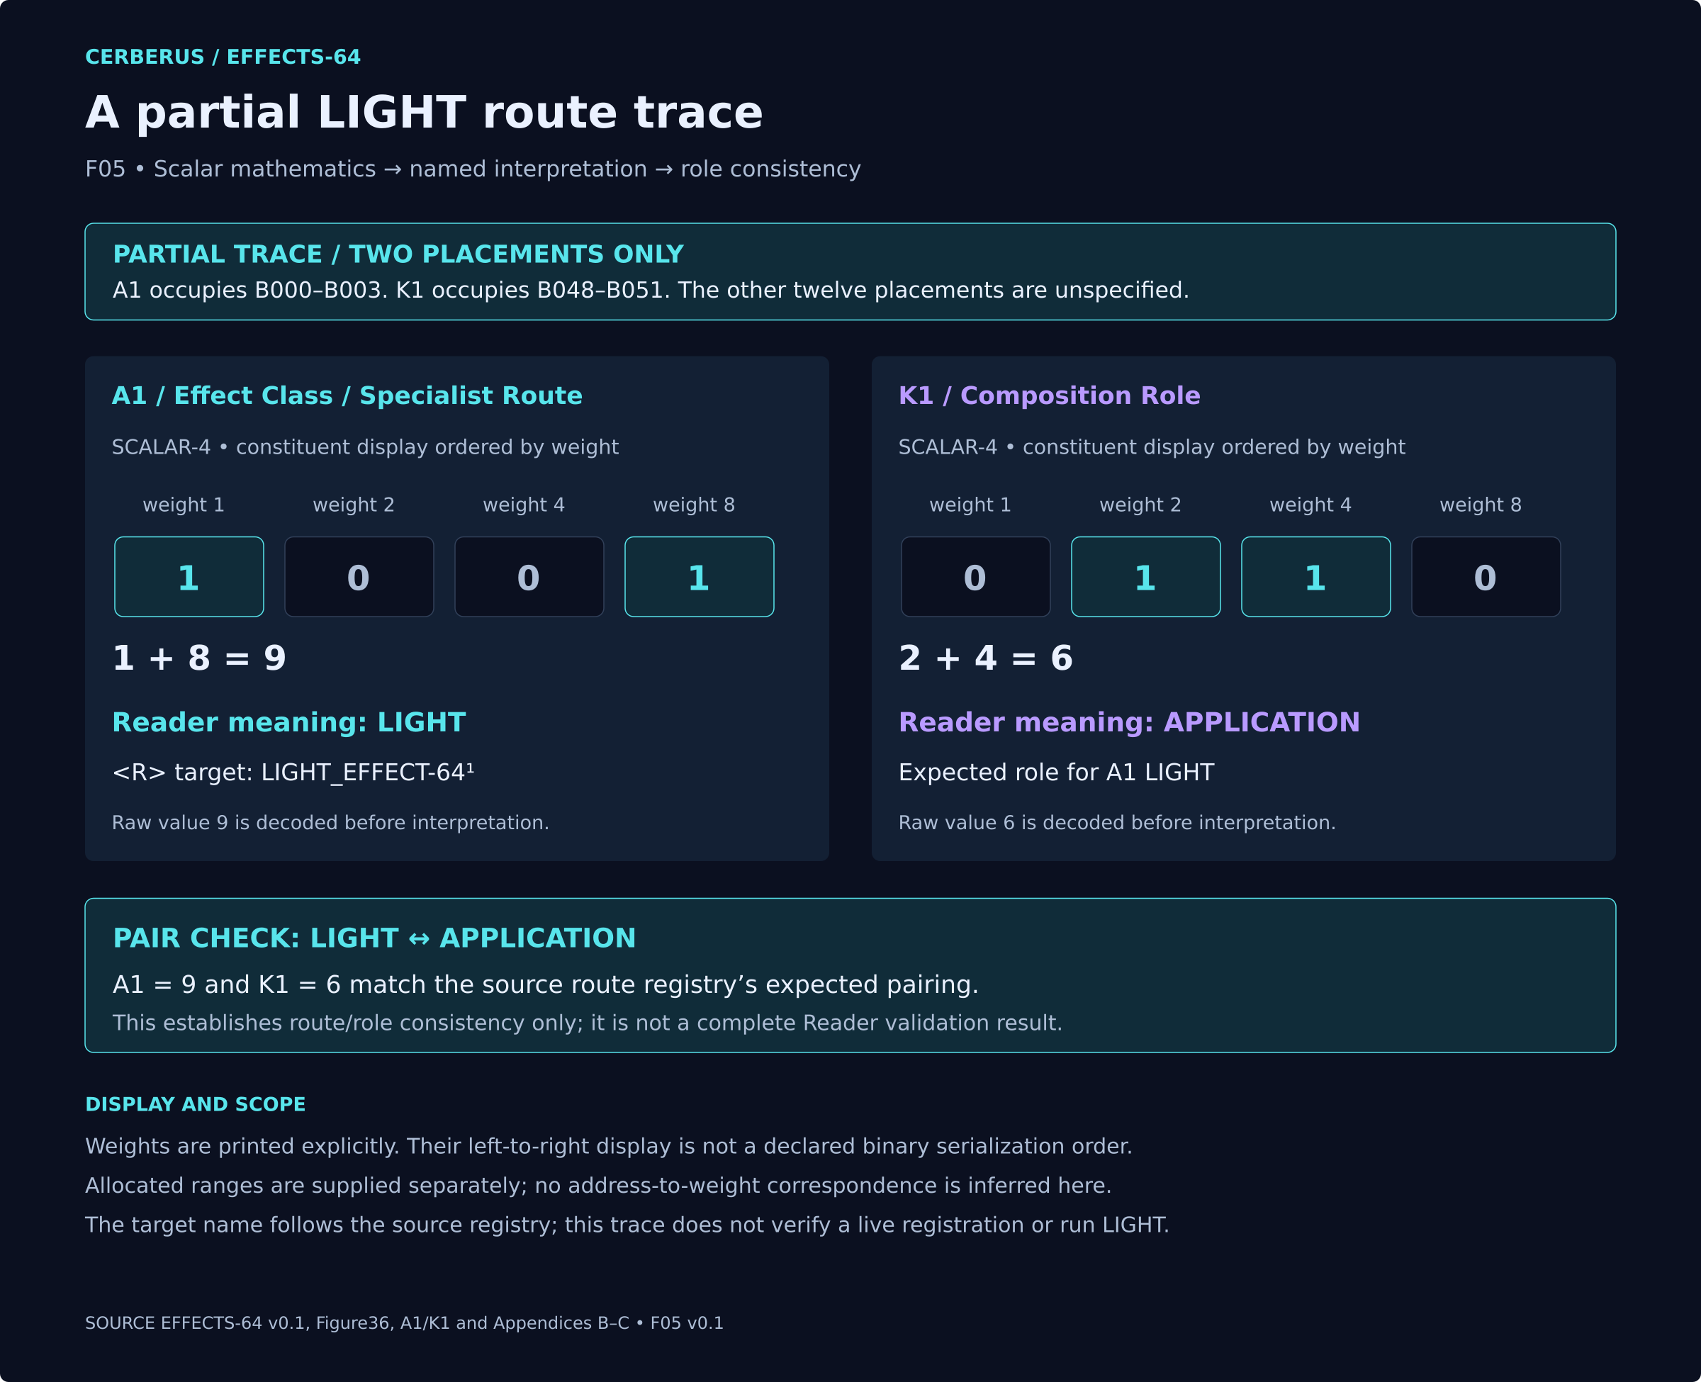
F05. Two SCALAR-4 values demonstrate the partial LIGHT route and APPLICATION role. Explicit weighted sums establish raw 9 and raw 6; source dictionaries supply their meanings. Full record validity requires the remaining declarations and context.
A1 raw 9 selects LIGHT and K1 raw 6 selects APPLICATION. The displayed weighted sums demonstrate only this pair. The other twelve placements, registration and context are required before full record validity can be assessed.

7 Generic gain bias and bounds
G1 decodes gain by dividing its raw value by 128. H1 decodes bias by subtracting 128 from its raw value and dividing by 128. With raw values from 0 through 255, gain ranges from 0 to 1.9921875 and bias from −1 to 0.9921875. Raw 128 is neutral for both placements. [1]
The approved example accepts a valid unitless Scalar at the shaping stage over one Point element. It uses normalized basis, PRESERVE polarity and CLAMP to the closed interval [0,1]. The procedure preserves polarity, applies gain then bias, and clamps the result. This order belongs to the example contract.
Input | Neutral output | Shaped output | Clamped output
0 | 0 | 0.25 | 0.25
0.25 | 0.25 | 0.625 | 0.625
0.5 | 0.5 | 1 | 1
0.75 | 0.75 | 1.375 | 1
1 | 1 | 1.75 | 1
The non-neutral settings are G1 raw 192 and H1 raw 160, producing gain 1.5 and bias 0.25. The output reaches the upper bound at input 0.5. The neutral comparison uses raw 128 for both. [4]
Generic shaping does not address another Effect parameter and does not combine a second Signal. Those operations belong to MODULATION_EFFECT and BLEND_EFFECT respectively. WRAP, MIRROR, degenerate intervals and general constraint ownership require their own complete contracts.

The approved scalar shaping example
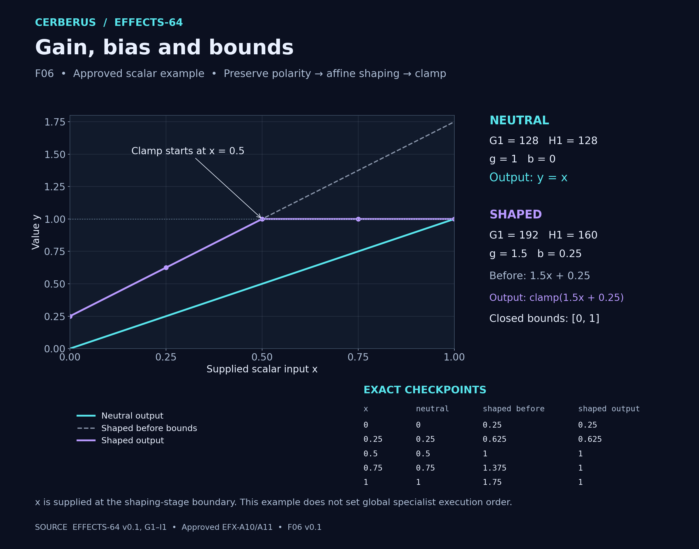
F06. The approved scalar example compares neutral shaping with gain 1.5 and bias 0.25, followed by clamping to the closed interval [0,1]. The shaped output reaches 1 at x=0.5. This is an explicit shaping-stage contract, not a global specialist execution order.
The five checkpoints distinguish the unbounded affine result from the bounded output. Saturation does not alter the declared gain or bias.

8 Compound membership and graph computation
Compound answers which words participate. The Effect Graph answers which ports connect, in which direction, with which transforms and result port. The same membership can therefore support different computations. [1, 4]
The approved example contains ROOT, ADD and MULTIPLY. Both arithmetic nodes use BLEND_EFFECT-32¹: A1 is 1 for ADD and 2 for MULTIPLY; B1 and C1 are stored 0 and inactive; D1 is 0 OPERATOR_DEFAULT; E1 is 0 NONE; F1 is 0 PRESERVE; G1 is 0 UNRESOLVED. ROOT is only partially declared with A1=0 and K1=0.
Three external Signals provide X=0.25, SCALE=1.5 and OFFSET=0.25. All ports use unitless, non-normalized Scalar values under SOURCE_DECLARED basis, with one component, a shared Point element and an aligned evaluation instant. Inputs are valid. No hidden normalization or clamp is introduced.
Graph | Wiring and result
A | X and SCALE enter MULTIPLY. Its 0.375 output and OFFSET enter ADD. Result port ADD returns 0.625.
B | X and OFFSET enter ADD. Its 0.5 output and SCALE enter MULTIPLY. Result port MULTIPLY returns 0.75.
Only wiring and the result port change. Membership and node settings remain fixed. These calculations establish the illustrated graph distinction; they do not assert a fully serialized root word or native assembly conformance.

Identical members different graph results
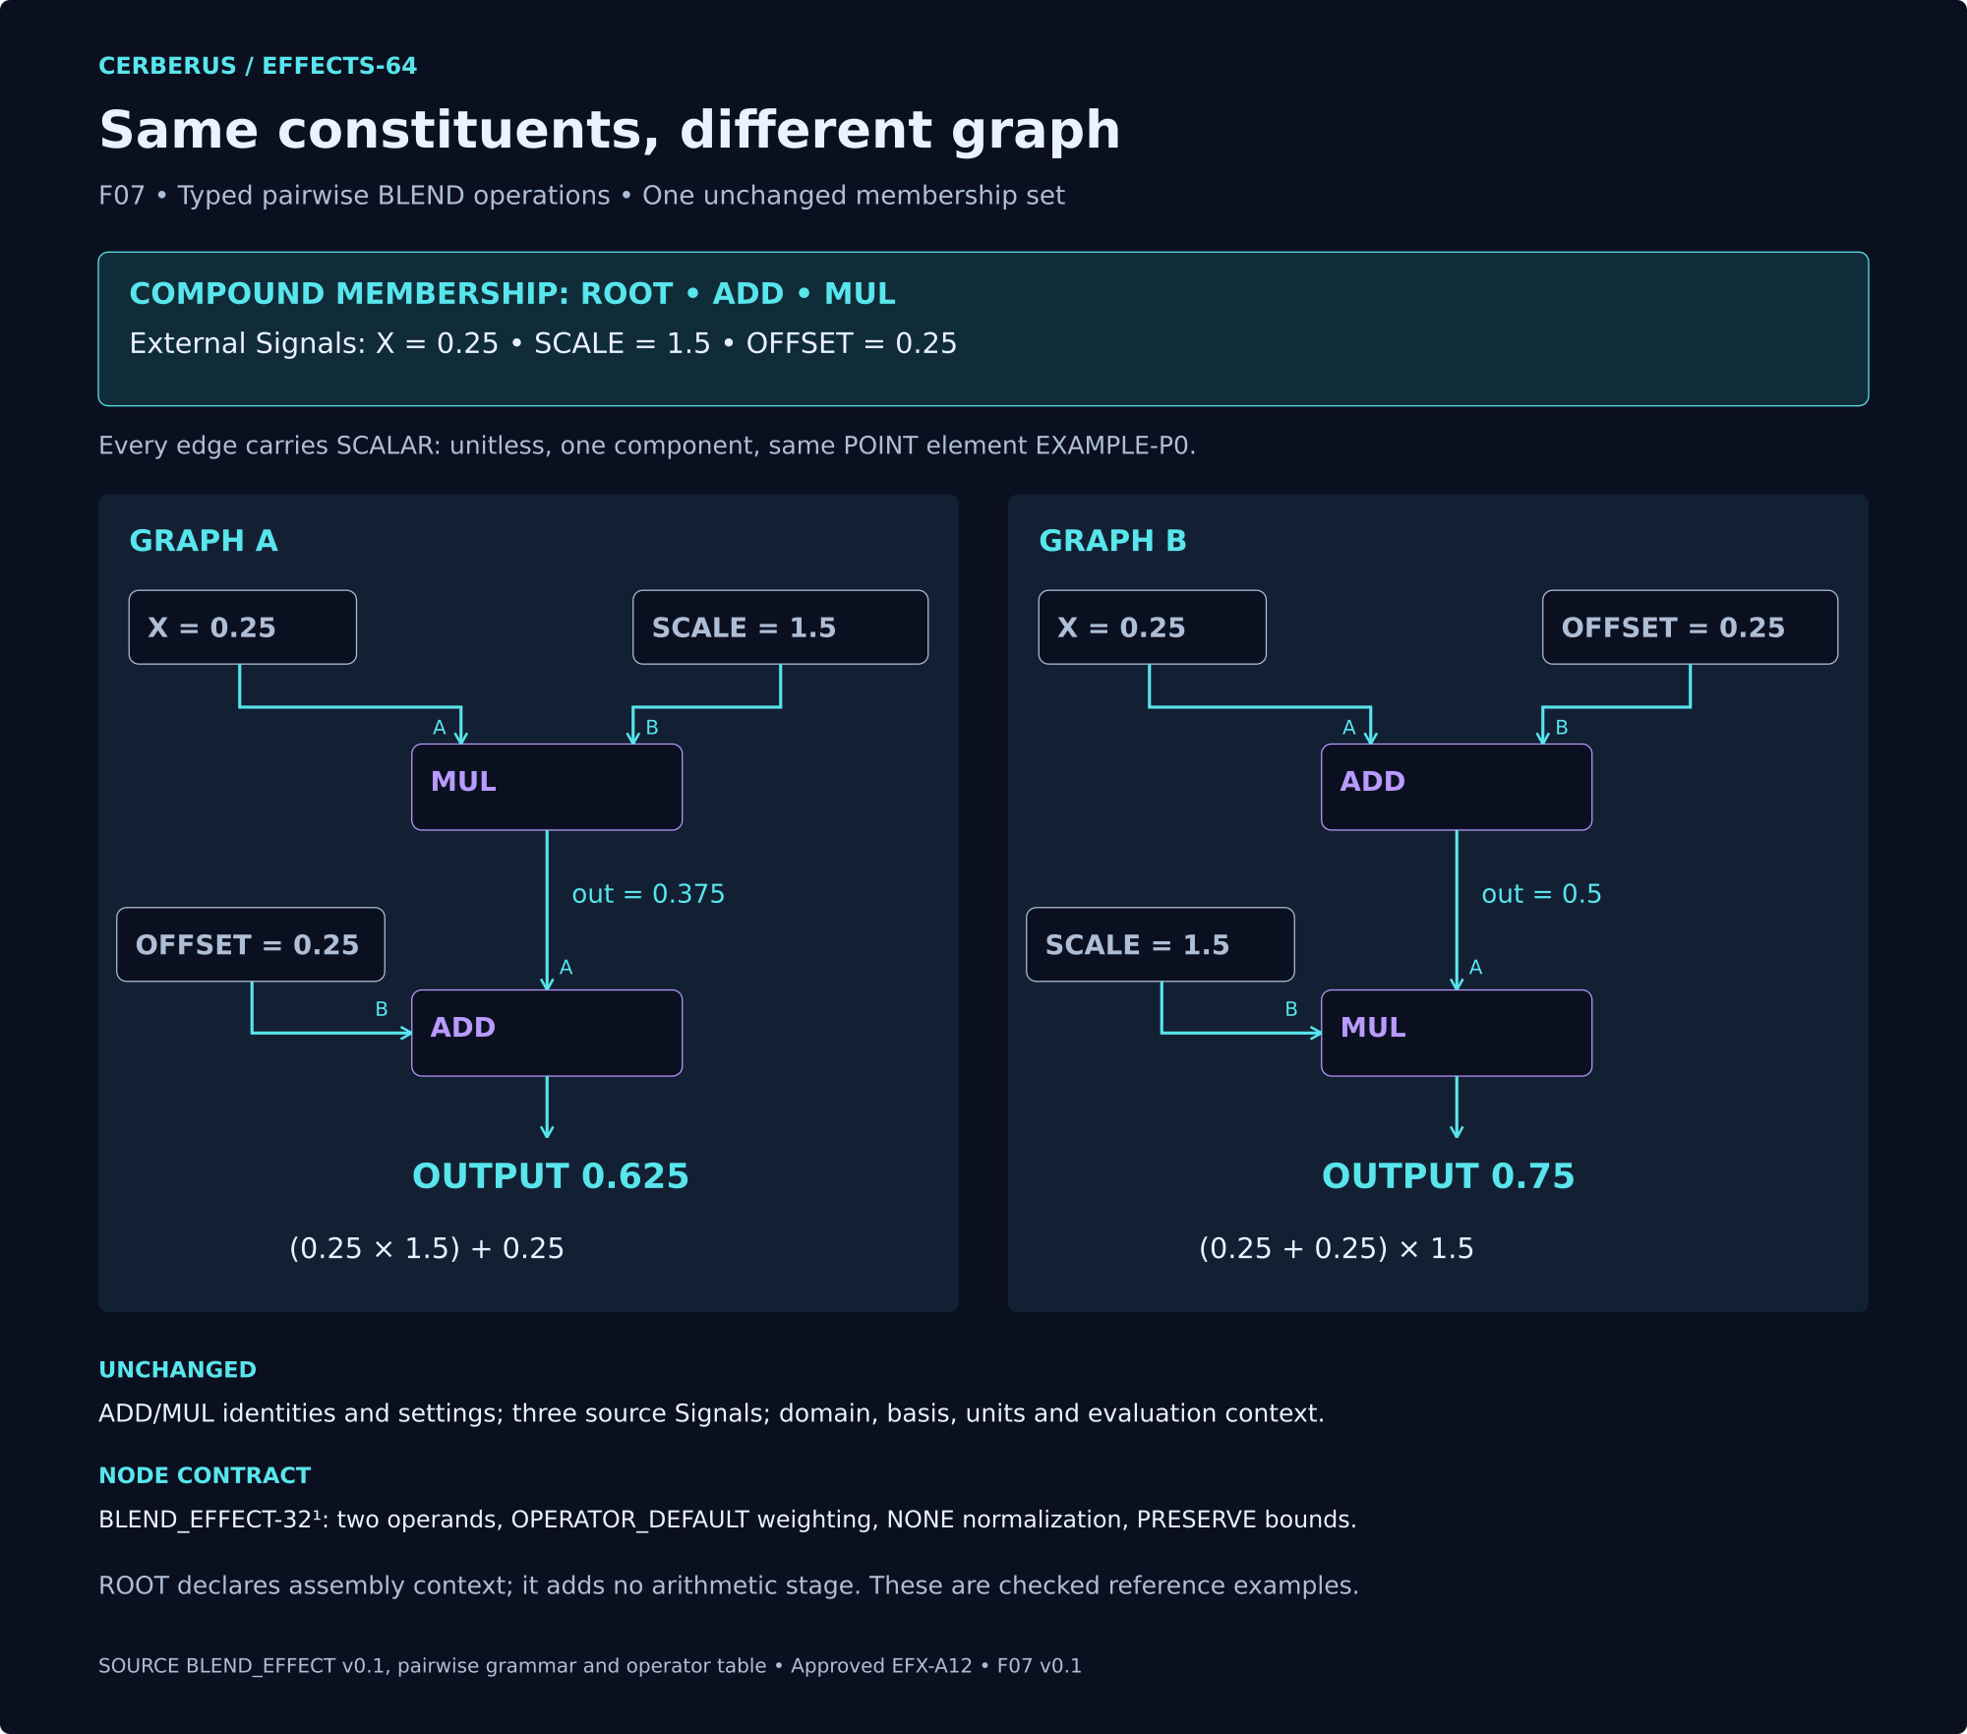
F07. The same ADD and MULTIPLY BLEND words receive the same three scalar Signals under a shared domain and value contract. Changing wiring and the result port gives 0.625 in Graph A and 0.75 in Graph B. Compound membership and node settings remain unchanged.
Port direction and result selection carry computational meaning beyond the Compound inventory.

9 Missing input and retained output
J1 selects a missing-input policy; it does not report the current validity state. The approved HOLD_LAST_VALID example uses J1=2 and retains the last successful final output for an exact context key. [4]
The key includes Effect instance, Reader and specification version, Formula Profile version, Signal Class and basis, Domain element and context generation. A held result keeps its original sample provenance. It is not a new successful evaluation and must not refresh history or receive the shaping operation again.
Step | Current event | Returned output
0 | C0 missing; history empty | None
1 | C0 valid final output 0.625 | 0.625 current; retain step 1
2 | C0 missing | 0.625 held from step 1
3 | C0 valid final output 0 | 0 current; retain step 3
4 | C0 missing | 0 held from step 3
5 | C1 context reset; missing | None; previous history ineligible
Valid zero is a real output, not an empty-history marker. A missing current source remains visible even when eligible history provides a number. SemanticValidation can remain VALID for the declared policy while current runtime resolution is UNRESOLVED.
C0 and C1 are context-generation labels, not Reader placement names. The finite example has supplied steps and no expiry within its scope. Production retention lifetime and SAMPLE_AND_HOLD triggers require separate profile and scheduling contracts.

Hold last valid with visible failure
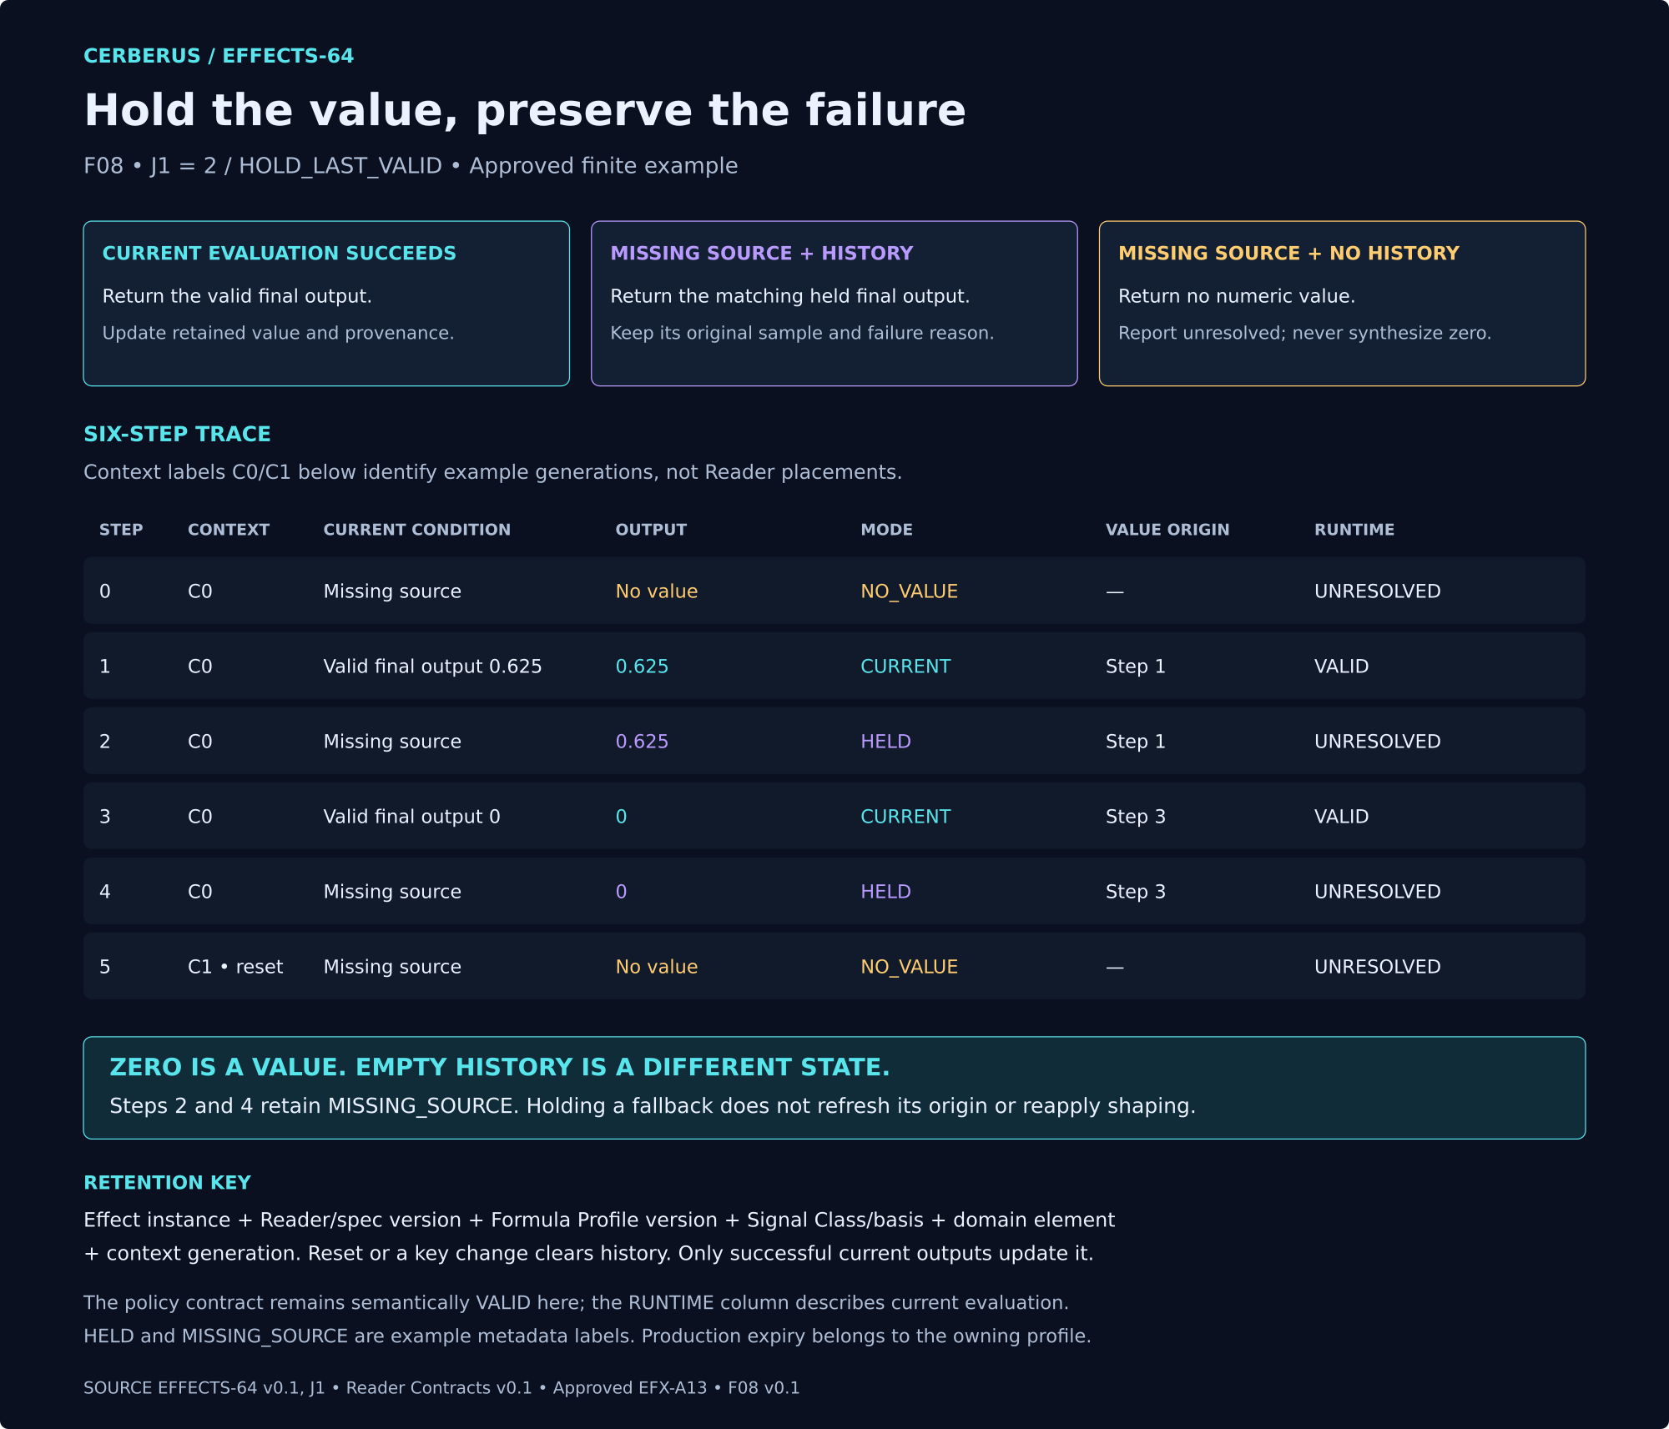
F08. HOLD_LAST_VALID returns a previously successful final output only when eligible history exists for the exact retention key. Missing-source failures remain visible. Valid zero can be retained; a context reset clears history and produces no numeric fallback until a new successful evaluation.
Resetting context invalidates history eligibility. No numeric fallback is fabricated when the eligible history is empty.

10 Interfaces applications and replay
A mathematical BitGroup does not dictate control geometry. Interface-0 combines the decoded state with a semantic D contract. A1 can therefore become a grouped family selector while the same SCALAR-4 mathematics serves a different control elsewhere. The placement catalogue supplies the candidate D Class and DREQ for every Reader. [1]
The specialist DARTBOARD exposes the root envelope and its specialist continuation. An assembly family map is an inspection projection from Compound and Graph context. It is not stored as an additional root mask. Exact BOSS, BIGFOOT, COLOR and D identities must be resolved during implementation.
Application Binding supplies target identity, destination parameter, mapping, baseline, application mode, optional mask or scope, required Frame and timing context, permissions and provenance. Renderer replacement is possible only when the replacement satisfies the same declared endpoint contract.
Preview remains derived until explicitly saved, registered or promoted. A branch edit must preserve parent and sibling state. Historical configurations remain interpretable through their declared Reader and Formula versions; migration is a separate governed operation.
L1 determinism must be supported by the source, Formula Profile, seed policy, specialist and context. Labeling a root deterministic cannot make an externally driven or stochastic dependency deterministic. M1 supplies local evaluation posture, while TIME and TIMING_RIG retain global scheduling.

Creative assemblies
Dragon Scale Shimmer uses an adapter for an ordered or spatial scale domain, a FIELD pattern, MASK participation and shared Movement, Color and Light branches. A GATE peak event can feed PARTICLE, with a separate modulation source controlling a declared FIELD parameter. Every connection still requires specialist type and Domain preflight.
Historical Echo Trail projects retained Path, age, confidence or class without rewriting the history. Resonance Cloud distributes a shared source across several specialist applications while preserving one provenance anchor. These are architectural scenarios, not complete executable datasets. [1, 2]

11 Root laws

EFFECTS-R01 Bounded Root
EFFECTS SHALL define the common Effect envelope and routing contract and SHALL NOT absorb specialist semantics.

EFFECTS-R02 Specialist Ownership
Each non-root Effect Class SHALL resolve through <R> to the registered specialist contract owning that bounded question.

EFFECTS-R03 Typed Boundary
Input and Output Value Classes SHALL be explicit and SHALL NOT be inferred solely from numeric representation.

EFFECTS-R04 Domain Separation
Value Class and Effect Domain SHALL remain separately inspectable.

EFFECTS-R05 No Silent Coercion
Incompatible Value Classes SHALL require an explicit transform before connection.

EFFECTS-R06 Generic Shaping Only
Gain and Bias MAY perform only the declared generic root transformation on semantically compatible values.

EFFECTS-R07 Modulation Separation
Root Gain/Bias SHALL NOT substitute for MODULATION_EFFECT parameter relationships.

EFFECTS-R08 Blend Separation
Root Gain/Bias SHALL NOT substitute for BLEND_EFFECT multi-Signal combination.

Root laws continued

EFFECTS-R09 Bounds Visibility
Root out-of-range behavior SHALL remain explicit.

EFFECTS-R10 Failure Visibility
Fallback behavior SHALL NOT erase runtime validity state.

EFFECTS-R11 Role Validation
Composition Role SHALL be compatible with the routed specialist class or an explicitly registered extension.

EFFECTS-R12 Determinism Integrity
Root determinism SHALL be derived or validated against the actual source / specialist / Formula dependency chain.

EFFECTS-R13 Evaluation Locality
Root evaluation posture SHALL NOT take ownership of global scheduling or specialist-local temporal semantics.

EFFECTS-R14 Routing Separation
<R> SHALL mean semantic continuation only.

EFFECTS-R15 Compound Separation
Compound membership SHALL remain external to A1 Effect Class routing.

EFFECTS-R16 Graph Separation
Runtime Effect Graph topology SHALL NOT be inferred from Compound membership or root state.

Root laws continued

EFFECTS-R17 Source Preservation
Root shaping and routing SHALL NOT silently rewrite canonical upstream source identity.

EFFECTS-R18 World Non-Authority
No Effect projection SHALL establish canonical world, gameplay, historical, or memory truth.

EFFECTS-R19 Renderer Separation
The Family SHALL emit semantic or renderer-neutral requests while endpoint implementation remains external.

EFFECTS-R20 Shared Cause
One typed Signal MAY drive multiple specialist applications while retaining shared provenance.

EFFECTS-R21 Preview Separation
Preview SHALL remain derived until explicitly saved, registered, or promoted.

EFFECTS-R22 Branch Isolation
Assembly branches SHALL preserve parent and sibling state.

EFFECTS-R23 Historical Interpretability
Superseded root and specialist versions SHALL remain interpretable by their declared Readers.

EFFECTS-R24 Minimum Resolution
Additional EFFECTS width SHALL require genuinely new root-level semantic responsibilities, not space for specialist semantics.

12 Integration conformance scenarios
These are required scenarios and expected outcomes inherited from the candidate specification. They are not reported test executions. Compare workbook and native behavior against identical registered structures, versions, inputs and context. [1, 3]

EFX-I01 Scalar compatibility
Scenario: FIELD emits Scalar; LIGHT accepts Scalar.
Expected: Direct connection resolves without hidden coercion.

EFX-I02 Signed movement
Scenario: Signed Scalar feeds MOVEMENT rotation.
Expected: Sign / polarity remains explicit.

EFX-I03 Incompatible type
Scenario: Vector feeds scalar-only consumer without transform.
Expected: Connection rejected / unresolved.

EFX-I04 Mask preservation
Scenario: Mask weight becomes zero.
Expected: Application suppressed while upstream source remains unchanged.

EFX-I05 Gate preservation
Scenario: Gate inactive below threshold.
Expected: Upstream source remains available and only gate output changes.

Conformance scenarios continued

EFX-I06 Modulation
Scenario: Wave controls SHIMMER amplitude.
Expected: Target parameter semantically addressed; source identities unchanged.

EFX-I07 Blend
Scenario: Two Scalar Fields enter MULTIPLY.
Expected: Declared output remains typed Scalar Field.

EFX-I08 Seed replay
Scenario: Particle system uses stable seed.
Expected: Same semantic inputs + seed reproduce the same renderer-neutral population parameters.

EFX-I09 Compound vs graph
Scenario: Same Compound, different edge topology.
Expected: Constituent identity unchanged while runtime output changes by graph wiring.

EFX-I10 Renderer replacement
Scenario: Swap compatible renderer.
Expected: SK configuration and renderer-neutral requests remain valid.

Conformance scenarios continued

EFX-I11 Shared cause
Scenario: One Signal feeds Movement + Light + Haptic.
Expected: All outputs retain one provenance chain.

EFX-I12 Branch isolation
Scenario: Edit Branch B.
Expected: Parent and sibling remain unchanged.

EFX-I13 Formula version
Scenario: Replay older Formula after new version exists.
Expected: Historical configuration resolves under declared version.

EFX-I14 Null behavior
Scenario: Required source missing.
Expected: Declared missing/null behavior occurs; no fabricated value.

EFX-I15 External timing
Scenario: Move whole performance to a new shared anchor.
Expected: Local Effect semantics remain unchanged.

13 Candidate decisions and implementation handoff
Issue | Boundary carried forward
Value Class extension | Written 15 is the proposed correction to old illustrated 13. A final code decision is still required; unspecified codes are not silently reserved.
MASK identity | Selector role is supported; exact registered series or alias requires verification.
ABSOLUTE basis | Clarify E1 independently of F1 absolute-value polarity.
Specialist derived output | No sentinel code is assigned to specialist-derived C1.
General evaluation | F06 order and bounds are example-specific. General specialist order and non-clamp bounds remain contract-owned.
Retention and timing | F08 fixes its finite retention behavior. Production expiry and general evaluation triggers remain external contracts.
Implementation must resolve SCALAR identities, establish the exact A1–N1 allocation, register routes and role pairs, bind Reader fields and DREQs, and supply complete Formula and adapter contracts. Registration must preserve historical interpretation and distinguish missing information from known incompatibility.
The SK Builder workbook should exercise these registered structures and test states before native implementation is treated as conformant. Port the behavior and compare identical inputs; spreadsheet layout is not the native interface contract. No live Base registration or runtime test completion is implied by this paper.

References and edition notes
[1] CERBERUS EFFECTS-64 Candidate Semantic Kernel Specification v0.1. Source declaration, placements, laws and integration scenarios.
[2] CERBERUS EFFECTS Studio Architecture v0.1 Verified Release. Family architecture and creative context.
[3] CERBERUS EFFECTS Reader Contracts v0.1. Reader binding, validation, applicability, Trust and evaluation boundaries.
[4] EFFECTS-64 approved worked datasets and figure contracts, Pass 6 Waves E–H, v0.1. Scalar shaping, BLEND graph comparison and retained-output example.
[5] CERBERUS Semantic Kernel Bitlinking Formal Specification v1.0; Self Contained Bitstate Parameterization v1.0; Semantic Bitword Notation and Extension Grammar v2.0. Underlying semantic and structural machinery.

Edition scope
This composition retains the candidate v0.1 semantic status. Eight figures replace the older fragmented visual sequence. The written Reader catalogue, physical allocation, candidate route map, twenty-four root laws and fifteen integration scenarios are retained. Generic gain and bias validation follows the approved known-violation versus missing-information distinction. Broader changes remain explicit candidate decisions.
Numerical examples are deliberately bounded. F05 is a partial route trace; F06 specifies one shaping stage; F07 uses complete decoded BLEND node placements and a partial ROOT; F08 specifies a finite retained-output contract. None is a substitute for complete registered record validation.

