CERBERUS BOSS 0
Symbolic Language Architecture
Semantic Symbols, Unique Forms, Families, Communities, Worlds, and Governed Symbolic Resolution
FORM | reusable symbolic appearance
SYMBOL | registered symbolic use
FAMILY | local symbolic neighborhood
COMMUNITY | bounded symbolic language
WORLD | broad symbolic environment
BRAIN Root Stack B5 • BOOTSTRAP Compression Library • Reconstruction Artifact
Version 0.1 • Current canonical reconstruction with historical source preservation

Document Purpose and Authority
This BOOTSTRAP 0 artifact reconstructs the mature BOSS architecture as the Base's governed symbolic-language layer. It is designed to orient a fresh AI or human reader quickly while preserving routes into deeper source papers, implementation records, and later operational extensions.
Core thesis
BOSS gives meaning a governed symbolic language.

Bounded Question
BOSS asks
How can a Base register reusable symbolic forms and contextual meanings so humans can learn them and machines can route them without confusing appearance, symbolic use, contextual membership, or exact semantic identity?

Corpus Authority and Audit
Audit class | Treatment in this artifact
Current canonical | Five-table BOSS registry; Semantic Symbol as the junction; explicit Family → Community → World context; Unique Form separated from meaning; live lookup inheritance and Symbol Viewer behavior.
Supporting current | World resolution, reversible semantic zoom, vocabulary projections, collision handling, versioned recovery, human/machine use of the same registered Symbol records.
Historical / refined | The earlier BaseCode paper establishes symbolic sovereignty, learning, grammar, media, and execution ambitions. Its Community-as-top-level model and separate BaseCode code-space are not required to reconstruct the current five-table core.
Outward extension | Embedded Semantic Communication is a proposed protocol extension for carrying reconstructable semantic structure across Bases while preserving local representation.
Cross-system dependencies | Semantic Kernels and BIGFOOT for exact semantic identity, SOLAR for linguistic ingress, VISOR for structural location, QUIVER for interface representation, and CERBERUS runtime owners for state and mutation.

Contents
Part | Title | Purpose
Part 1 | What BOSS Is | governed symbolic language, non-collapse, reconstruction spine
Part 2 | Appearance and Meaning | polysemy, form reuse, Semantic Symbol junction
Part 3 | The Five Registry Tables | Unique Form, Symbol, Family, Community, World, live route
Part 4 | Contextual Language Graph | installation, projections, reversible zoom, reclassification
Part 5 | Resolution and Learning | Symbol Viewer, machine routing, ambiguity, change classes
Part 6 | Authority and Boundaries | semantic truth, BIGFOOT, SOLAR, VISOR, QUIVER
Part 7 | Operational and Communication Extensions | grammar/runtime extensions and cross-Base semantic communication
Part 8 | Reconstruction and Scaling | build procedure, laws, test cases, source map

Reading Contract
Read the artifact in order for first reconstruction. Later use may enter at any figure or section, but current authority should be taken from the mature registry model before consulting historical or proposed extension material.
Primary reconstruction spine
Exact semantic identity ↔ Semantic Symbol ↔ Unique Form, with Symbol → Family → Community → World providing progressive symbolic context.

PART 1
What BOSS Is
Governed symbolic language, contextual navigation, and identity separation

BOSS is the Base's symbolic registry and language layer. It does not make a glyph true, invent the semantic object behind a symbol, or own runtime state. It gives registered meaning a stable symbolic use, a reusable appearance, and an explicit contextual route through local vocabulary, bounded language, and broad symbolic environment.
Reconstruction sentence
BOSS makes symbolic language both human-readable and machine-routable from the same registered source.

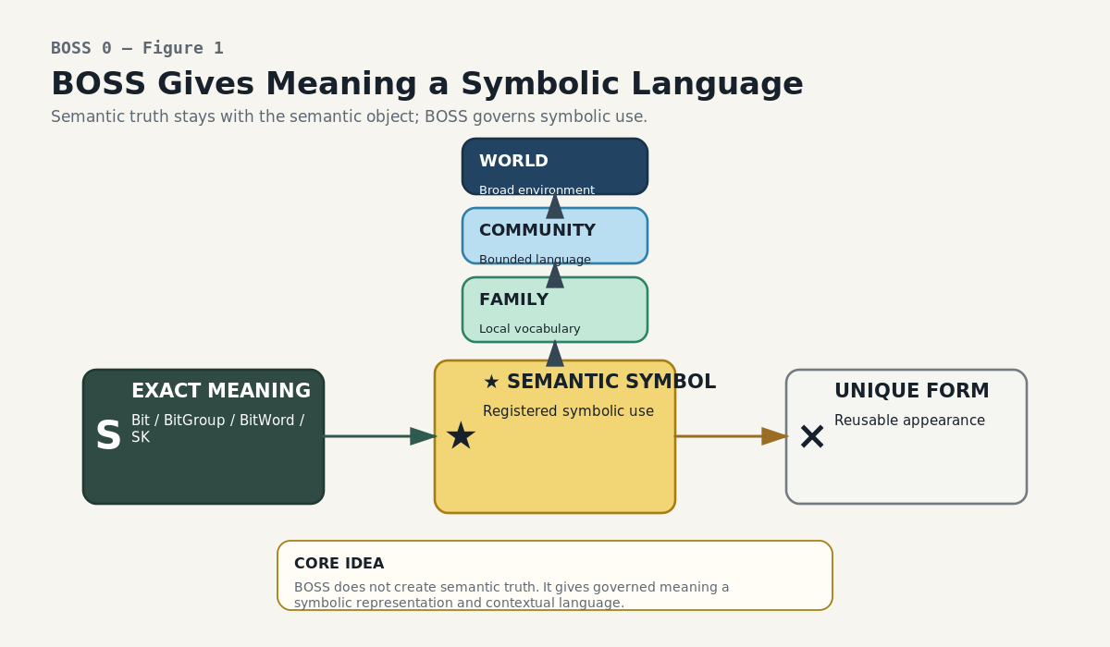
Figure 1. BOSS Gives Meaning a Symbolic Language. BOSS organizes symbolic representation and context around exact semantic objects without taking semantic authority away from them.
The Five Questions
Layer | Question
Form | What does it look like?
Semantic Symbol | What registered symbolic meaning is being used here?
Family | What local symbolic neighborhood does that meaning participate in?
Community | What bounded symbolic language is being spoken?
World | What broad symbolic environment contains that language?

The Non-Collapse Rule
The architecture works because the visible form, the governed symbolic use, the contextual containers, and the exact semantic object are not treated as one identity. They can change, repeat, or be traversed independently while explicit links preserve the intended relationship.
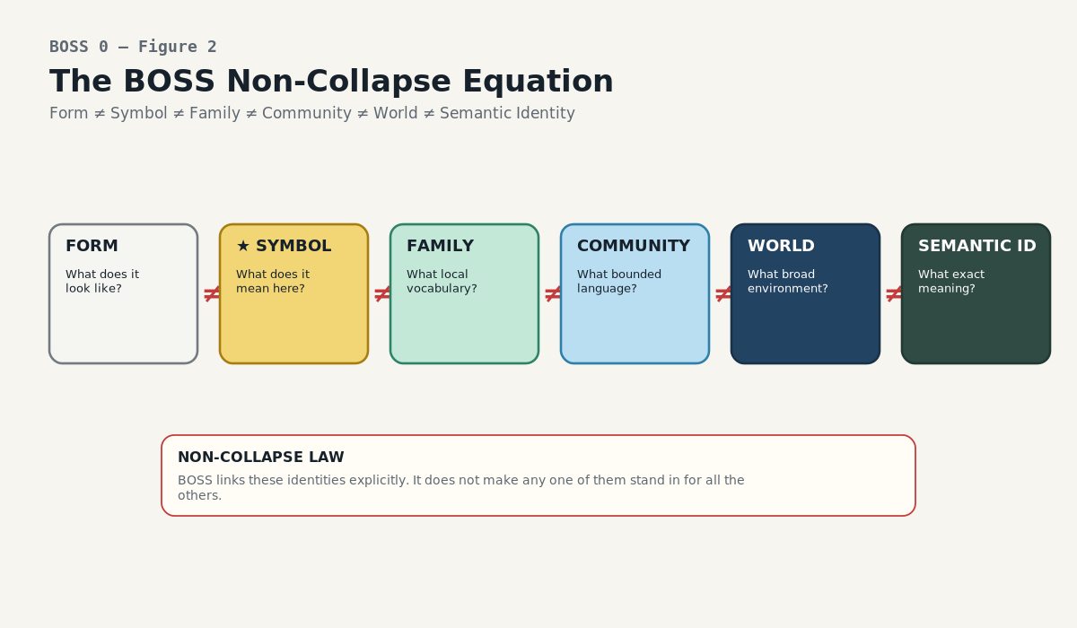
Figure 2. The BOSS Non-Collapse Equation. Form, Semantic Symbol, Family, Community, World, and exact semantic identity remain separate identities joined by explicit relations.
Central equation
Form ≠ Semantic Symbol ≠ Family ≠ Community ≠ World ≠ exact semantic identity.

This equation is not merely database normalization. It is the safety condition that lets BOSS reuse familiar marks aggressively without converting visual coincidence into false semantic equivalence.

PART 2
Appearance and Meaning
Collision-safe form reuse and the Semantic Symbol junction

Symbolic systems naturally reuse marks. Arrows, boxes, equality signs, multiplication marks, colors, and custom forms may participate in many languages. BOSS treats reuse as normal and inspectable rather than as an error to be eliminated.
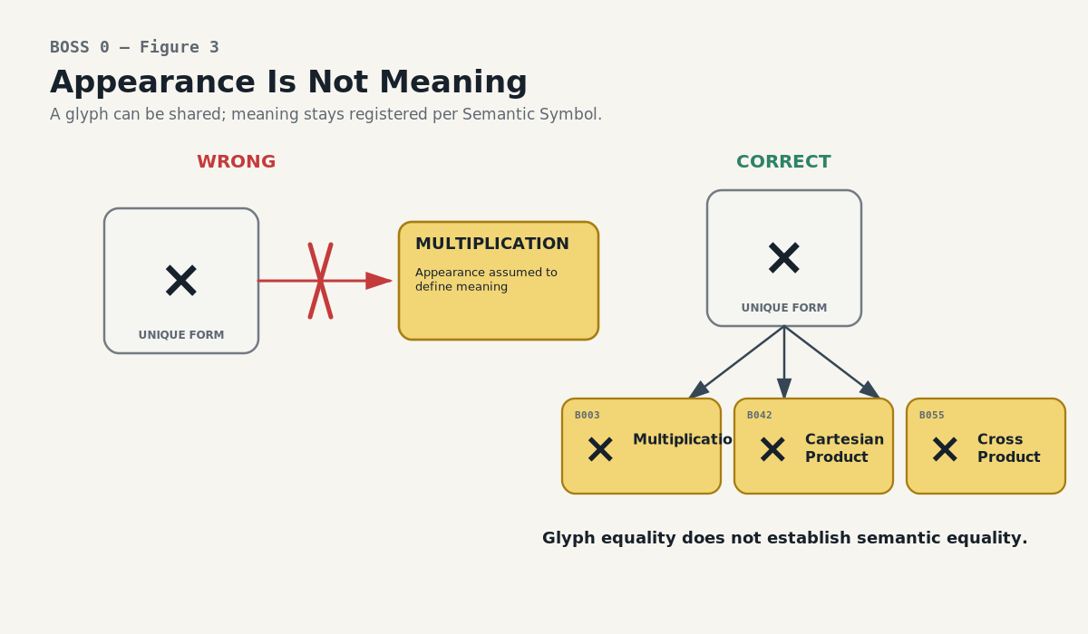
Figure 3. Appearance Is Not Meaning. Visual equality is not semantic equality. A familiar glyph can still be ambiguous until the registered symbolic use is resolved.
Form Equality and Semantic Equality Are Independent Tests
• If the exact visual form already exists, reuse the Unique Form record.
• If the intended meaning is exactly an existing Semantic Symbol, reuse that Symbol and add legitimate contextual membership.
• If the form is shared but the meaning differs, create a separate Semantic Symbol linked to the same Form.

Real Collision Example: ×
The Mathematical Operators language makes the rule concrete. The same visible × is legitimately used for three different registered operations. The appearance is shared; the meanings are not.
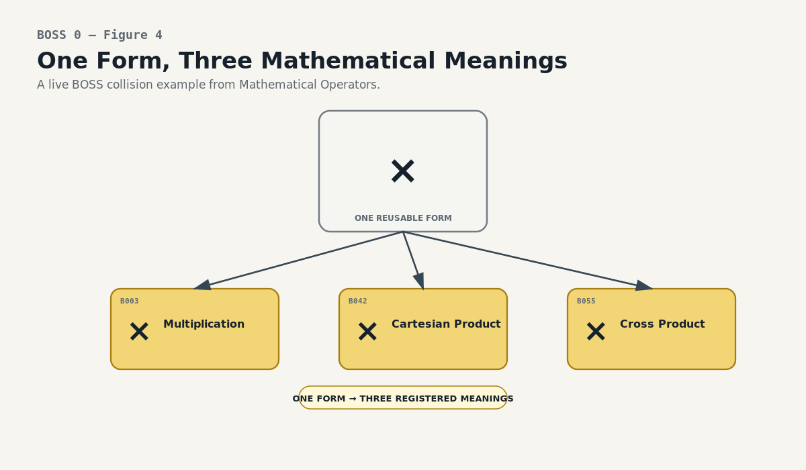
Figure 4. One Form, Three Mathematical Meanings. The same × appearance is reused by B003 Multiplication, B042 Cartesian Product, and B055 Cross Product without collapsing the three meanings.
Key | Registered meaning | Collision treatment
B003 | Multiplication | Separate Semantic Symbol; shared × form
B042 | Cartesian Product | Separate Semantic Symbol; shared × form
B055 | Cross Product | Separate Semantic Symbol; shared × form

The Inverse Case: Genuine Semantic Reuse
The opposite case is equally important. One governed symbolic meaning may intentionally participate in more than one Family. When the meaning is genuinely identical, BOSS should not duplicate the Semantic Symbol merely to satisfy a tree-shaped interface. Family membership is an explicit relation and may be multi-linked where true reuse requires it.
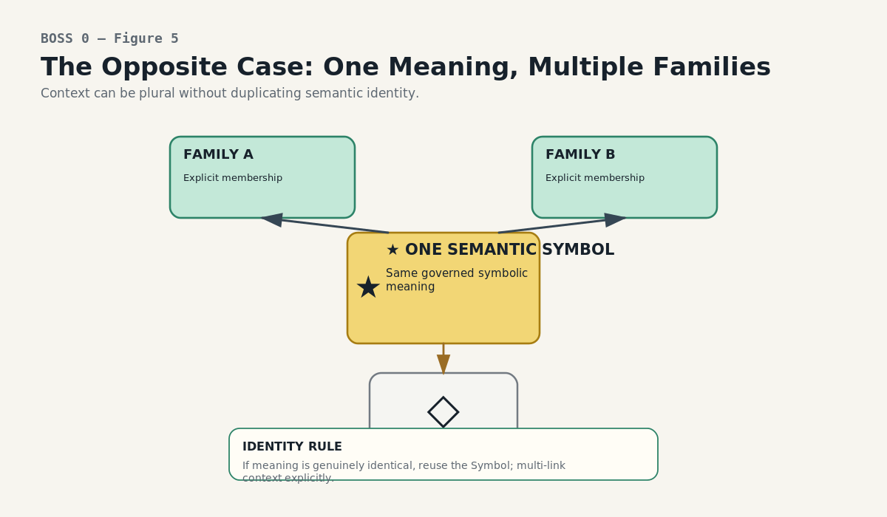
Figure 5. One Meaning, Multiple Families. When one registered symbolic meaning genuinely belongs in more than one Family, reuse the Semantic Symbol and link the memberships explicitly.
Reuse law
Same form can mean different things. One meaning can participate in multiple contexts. Only explicit identity and relationship tests decide which case applies.

The Semantic Symbol Is the Junction
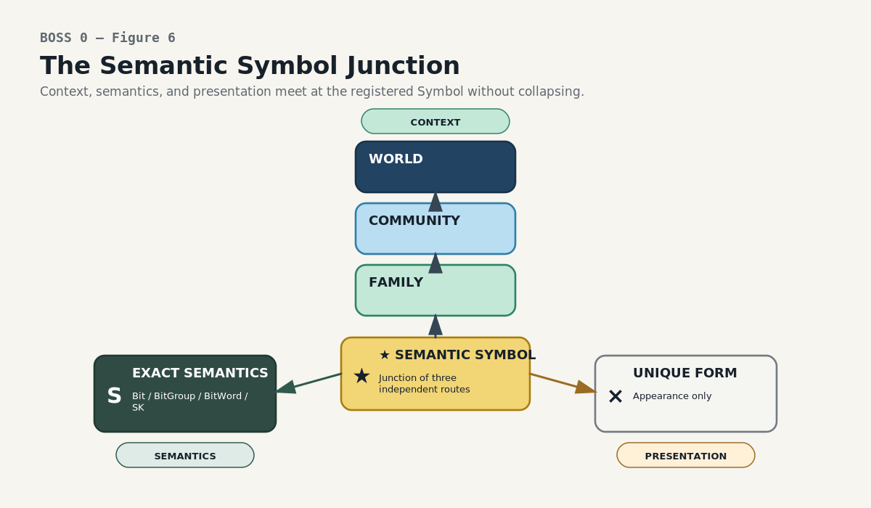
Figure 6. The Semantic Symbol Junction. The Semantic Symbol is the junction between contextual ancestry, exact semantic binding, and visual presentation.
The Semantic Symbol is the one BOSS record that joins all three directions without collapsing them. Upward, it resolves contextual ancestry. Sideways, it binds to a reusable visual Form. Inward, it binds to exact Semantic Kernel objects or stable semantic identities.
Path | Purpose | Authority
Context path | Symbol → Family → Community → World | Adds symbolic orientation; does not rewrite meaning.
Presentation path | Symbol → Unique Form | Determines current symbolic appearance; does not own definition.
Semantic path | Symbol → Bit / BitGroup / BitWord / SK identity | Connects symbolic use to exact semantic authority.

PART 3
The Five Registry Tables
A small normalized core that can expose a very large symbolic language

The mature BOSS implementation is deliberately compact. Five core registries separate appearance, symbolic use, local vocabulary, bounded language, and broad symbolic environment. Linked records and lookups provide traversal without copying the same semantic definitions between levels.
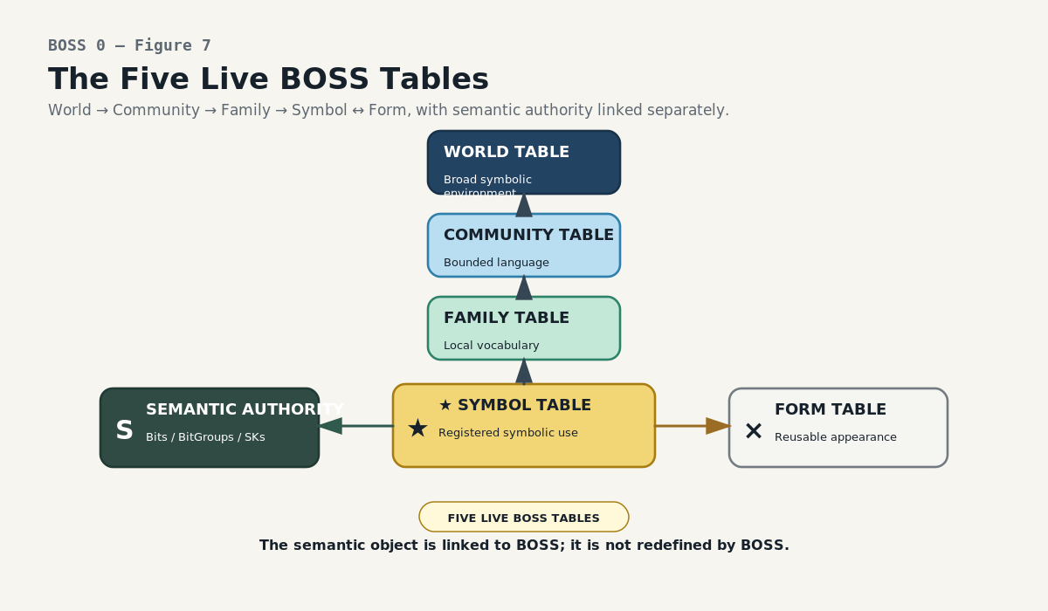
Figure 7. The Five Live BOSS Tables. The mature registry separates Unique Form, Semantic Symbol, Family, Community, and World while linking exact semantic objects through the Semantic Symbol.
Registry | Owns | Does not own
Unique Form | exact reusable appearance | semantic definition
Semantic Symbol | one governed symbolic use | underlying SK truth
Family | local symbolic neighborhood | member identity
Community | bounded symbolic language | one giant merged Symbol record
World | broad symbolic environment | universal ontology

Anatomy of a Semantic Symbol Record
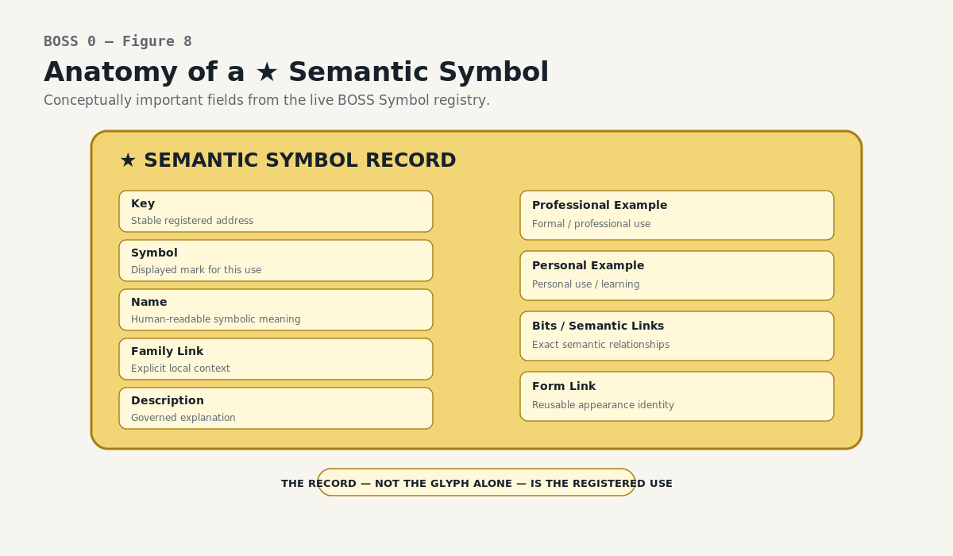
Figure 8. Anatomy of a Semantic Symbol. A governed symbolic use is a record with stable identity, teaching memory, context, and semantic relationships—not merely a visible glyph.
The live Symbol registry makes the distinction operational. A Symbol record can carry a stable Key, visible Symbol, Name, Description, Professional Example, Personal Example, Family relation, and semantic bindings. The visible mark is therefore only one attribute of a richer governed use.
Human / machine contract
Humans may browse the Symbol, description, examples, and Family. Software may route by stable Key and explicit links. Both consume the same registered record.

Unique Form: Appearance Without Semantic Authority
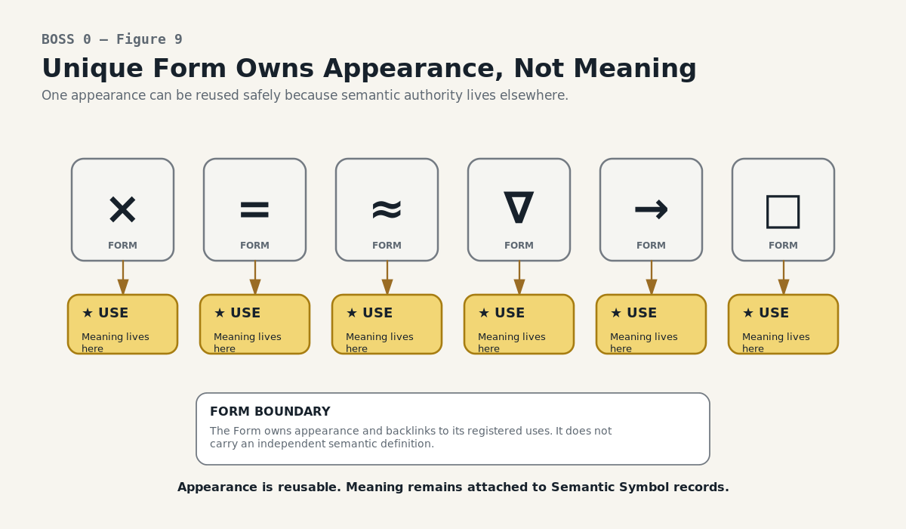
Figure 9. Unique Form Owns Appearance, Not Meaning. The Unique Form registry deduplicates rendering while semantic definitions remain on linked Semantic Symbol records.
The Unique Form registry is a visual concordance. It stores the exact reusable token and exposes backlinks to every Semantic Symbol that uses it. This makes collisions visible and searchable while keeping definitions where they belong.
• Changing a Form does not silently change the Semantic Symbol meaning.
• A Bit or BitGroup should not use the raw Form as its semantic authority.
• If a Form resolves to several Symbols and no sufficient context is available, the correct output is a collision set—not a guess.

Family: Local Symbolic Neighborhood
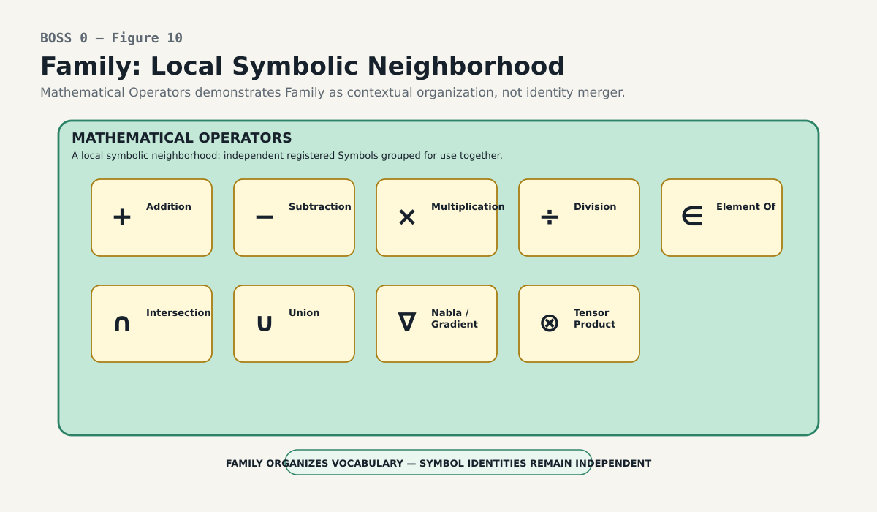
Figure 10. Family — Local Symbolic Neighborhood. A Family organizes a local vocabulary and contrast set while preserving each member as its own registered Symbol.
A Family places neighboring meanings where they can be learned, compared, and navigated together. It can expose local morphology or a shared stem, but Family identity is not the visual stem itself and member Symbols do not lose their individual identities inside the grouping.
Family role
Family is the explicit contextual anchor on the Symbol. Broader Community and World ancestry can then be derived through registered parent relationships.

Community: Bounded Symbolic Language
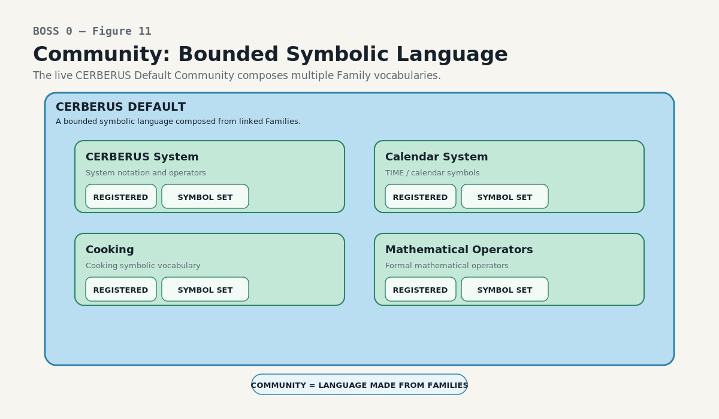
Figure 11. Community — Bounded Symbolic Language. A Community composes Families into one coherent symbolic language without flattening their member Symbols into a single undifferentiated list.
A Community composes Families into one coherent language. The current CERBERUS Default Community demonstrates the role by linking multiple Families—such as CERBERUS System, Calendar System, Cooking, and Mathematical Operators—without copying every Symbol into a new authority table.
Community is a language context, not a mega-kernel. Its installed Families may evolve independently, and exact semantic authority remains with the Symbols and the Semantic Kernel objects to which they bind.

World: Broad Symbolic Environment
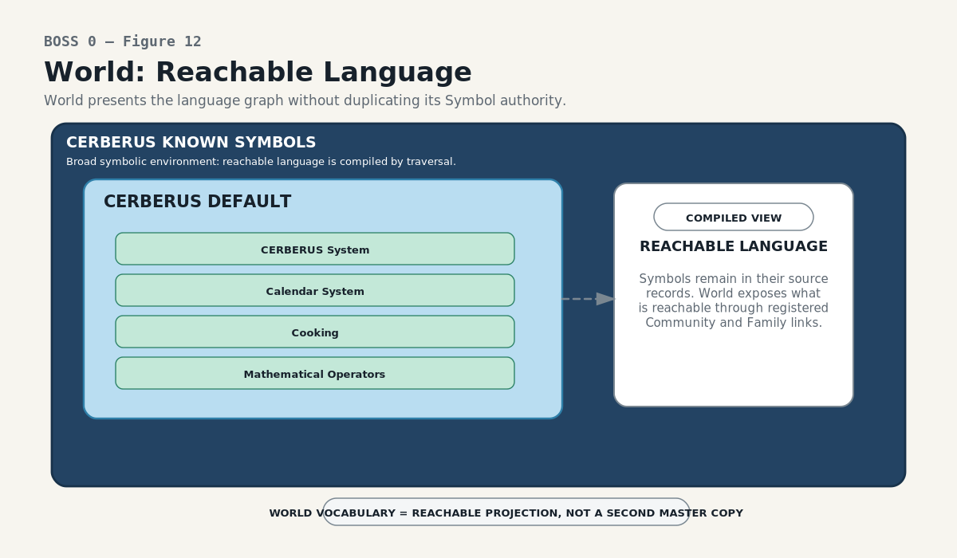
Figure 12. World — Reachable Language. A World provides broad symbolic environment and can expose the recursively reachable language beneath it as a compiled projection.
A World provides the broadest BOSS context. Its reachable Symbol inventory can be displayed as a whole-language surface, but that surface is a recursively compiled view over Communities, Families, and Symbols rather than a second master copy of the language.
World resolution law
A governed Symbol should have an explicit route to at least one registered World. When a final contextual home is not known, provisional placement should remain explicit rather than becoming an unmarked null or an inferred guess.

The Current Language Route
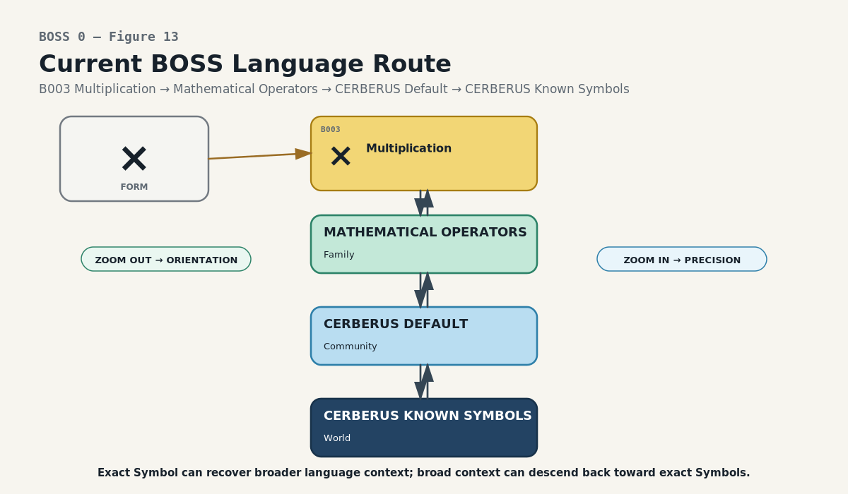
Figure 13. Current BOSS Language Route. A registered Symbol can resolve outward through Mathematical Operators → CERBERUS Default → CERBERUS Known Symbols and back toward the exact Symbol.
The live Mathematical Operators Family demonstrates the routing model. One Symbol such as B003 Multiplication belongs to Mathematical Operators; the Family links to CERBERUS Default; the Community links to CERBERUS Known Symbols. The route can be followed upward for broader orientation or downward for exact inspection.
Lookup Inheritance
BOSS should store the narrowest authoritative relationship once. A Symbol links to Family. Family links to Community. Community links to World. Lookups can then expose Community and World on lower-level records or interfaces without manually re-entering the same context at every level.
Implementation rule
Link once. Derive broader context through traversal.

PART 4
Contextual Language Graph
Installation, vocabulary projection, semantic zoom, and reclassification

Once the five registries are linked, BOSS scales by installation rather than redesign. New symbolic languages become reachable because new registered paths exist; higher-level vocabulary surfaces update by traversal rather than by copying their source records.
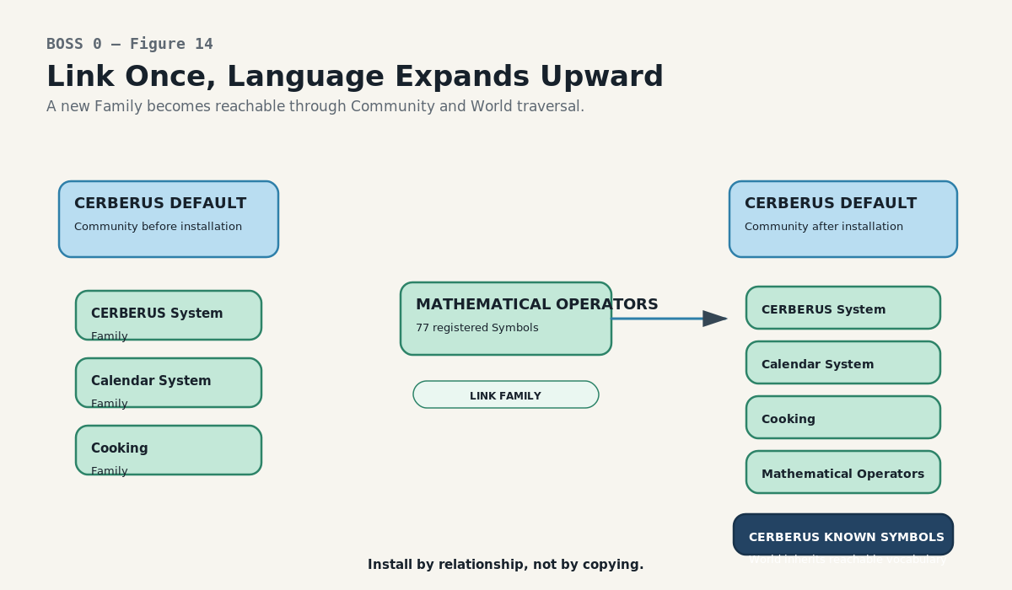
Figure 14. Link Once, Language Expands Upward. Installing a Family into a Community expands reachable vocabulary through relationship and lookup rather than copying every Symbol upward.
Language Installation
A new Family can be populated independently, reviewed, and then linked into the appropriate Community. That one relationship makes its Symbols reachable from the Community and, through the Community-to-World link, from the World. The installation event changes reachability—not Symbol identity.

Compiled Vocabulary Is a Projection
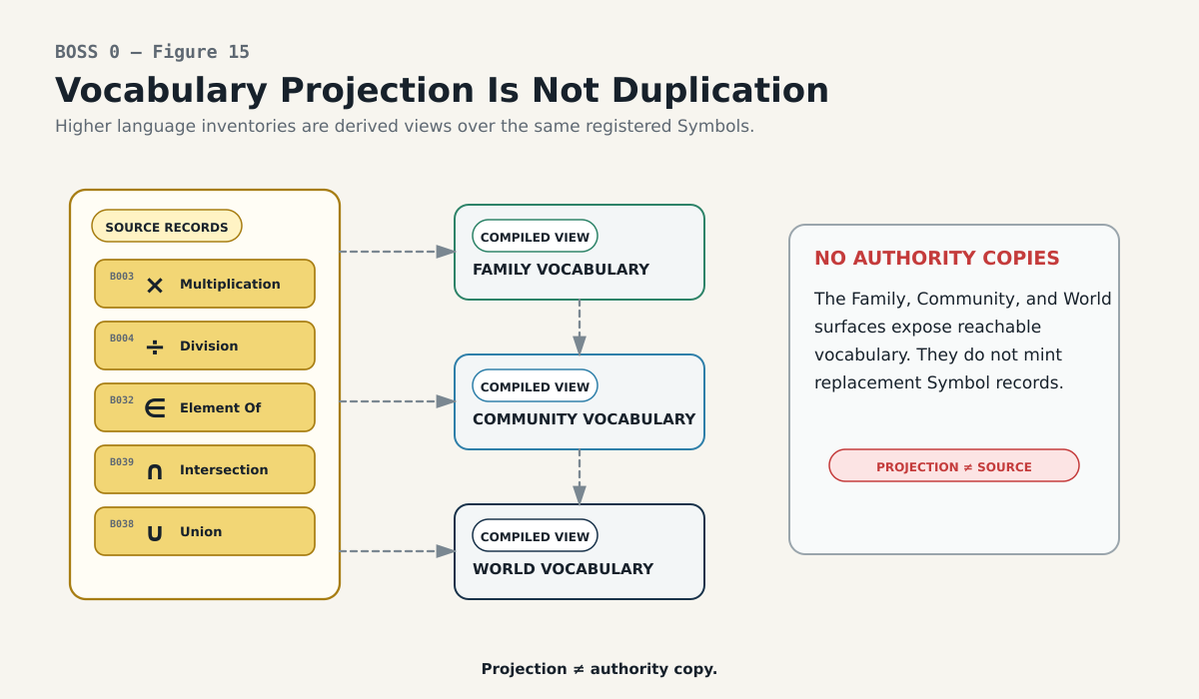
Figure 15. Vocabulary Projection Is Not Duplication. Family, Community, and World vocabularies are derived surfaces over registered source records, not competing truth stores.
Family, Community, and World vocabulary lists are derived navigation surfaces. They may project Symbol, Name, Description, examples, source version, Reader output, and exact semantic bindings, but they must remain traceable to the registered source records that own those values.
Projection law
Vocabulary projection ≠ semantic duplication ≠ new authority.

This makes large languages inexpensive to reorganize. Move or install a Family, and the projected vocabulary changes because the graph changed. The source Symbols do not need to be re-authored.

Reversible Semantic Zoom
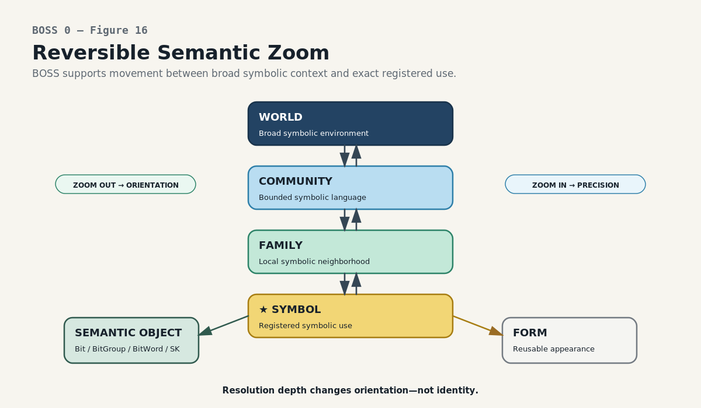
Figure 16. Reversible Semantic Zoom. BOSS supports movement from broad context toward exact Symbol and semantic binding, and from exact identity back toward broader explanation.
BOSS can be entered at broad context or exact identity. A World can be opened and traversed down through Community, Family, and Symbol. An exact Symbol or semantic object can travel the same graph in reverse to recover the language and environment in which it is being used.
Direction | What changes | What does not change
Zoom outward | amount of contextual orientation | registered Symbol identity
Zoom inward | precision of the selected symbolic/semantic target | historical provenance of the route

Context Is Additive
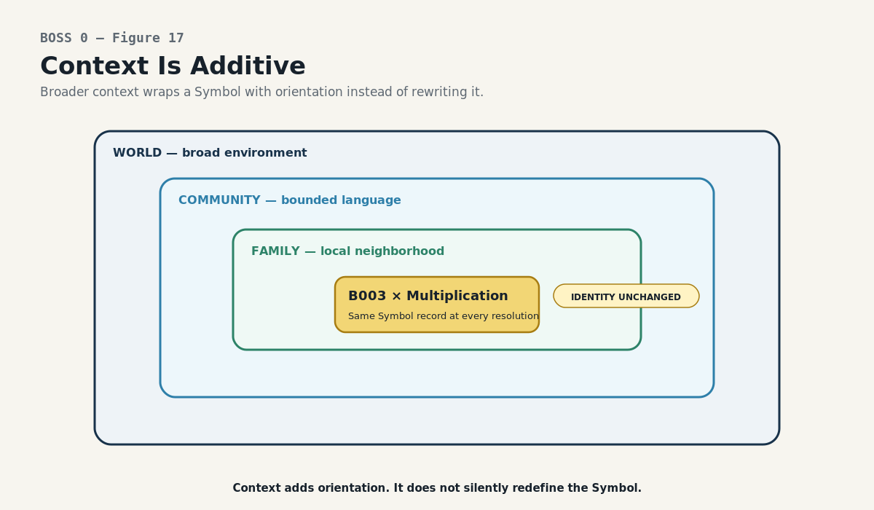
Figure 17. Context Is Additive. Family, Community, and World add orientation around a Symbol without silently rewriting the Symbol’s registered meaning.
World, Community, Family, and Symbol are not four competing definitions. Each answers a different question. Adding a broader level provides orientation around the same registered Symbol; it does not silently overwrite the Symbol description or the exact semantic object behind it.
Additive context
Context adds orientation. It does not silently rewrite identity.

Reclassification Without Identity Loss
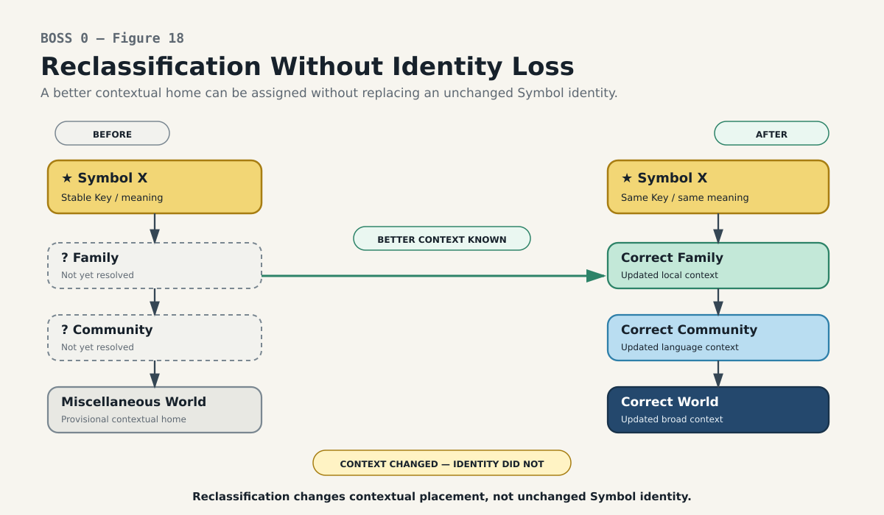
Figure 18. Reclassification Without Identity Loss. A better contextual route can replace a provisional placement while the same Semantic Symbol identity remains stable.
Context can improve. A Symbol may begin in a provisional location and later acquire a more appropriate Family, Community, or World route. When the meaning itself is unchanged, reclassification changes the contextual path rather than replacing the Semantic Symbol.
This distinction is essential for an evolving knowledge system: correction of organization must not be mistaken for correction of meaning, and a better label must not retroactively alter the identity of records that used the earlier context.

PART 5
Resolution and Learning
One registry serving human exploration, machine routing, ambiguity, and historical change

The mature BOSS registry is not only a backend taxonomy. The same records can drive a human Symbol Viewer and deterministic machine routing. That shared source is one of the strongest architectural advantages of the design.
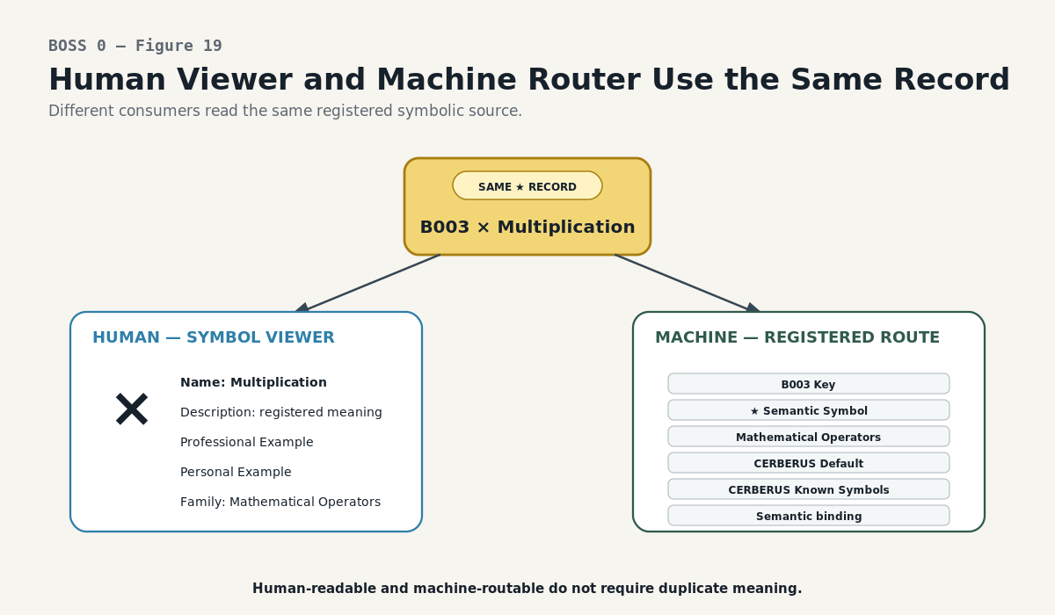
Figure 19. Human Viewer and Machine Router Use the Same Record. The Symbol Viewer and machine routing both consume the same governed registry record instead of maintaining separate learning and operational definitions.
The Symbol Viewer as a Human-Facing BOSS Reader
A human can click through registered Symbols and see the Name, Description, Professional Example, Personal Example, and contextual links. A machine can resolve the Key and traverse the same Family, Community, World, Form, and semantic relationships. Learning and operation do not need separate meaning stores.

Four First-Class Entry Modes
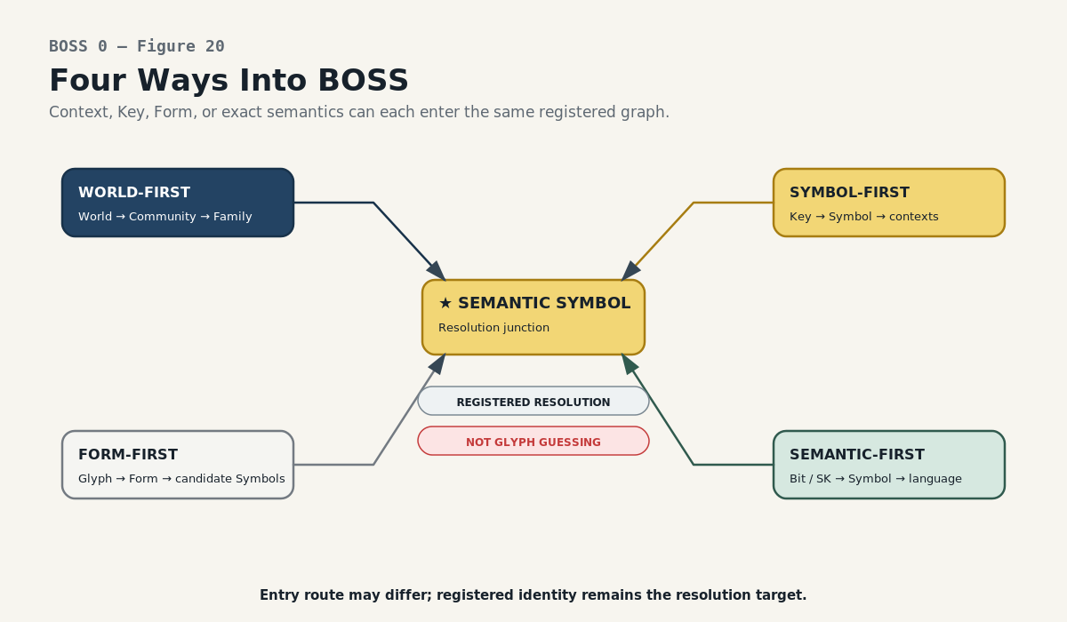
Figure 20. Four Ways Into BOSS. World-first, Symbol-first, Form-first, and semantic-first entry all resolve through the same registered graph.
Entry | Resolution behavior
World-first | browse broad environment → language → neighborhood → exact Symbol
Symbol-first | load stable Symbol identity → context, Form, and semantic bindings
Form-first | load exact Form → enumerate candidate Semantic Symbols → narrow only with explicit context
Semantic-first | load exact Bit / BitGroup / BitWord / SK identity → recover linked symbolic use and explanation

These paths make BOSS a resolution network rather than a one-way classification tree.

Unknown Context Stays Unknown
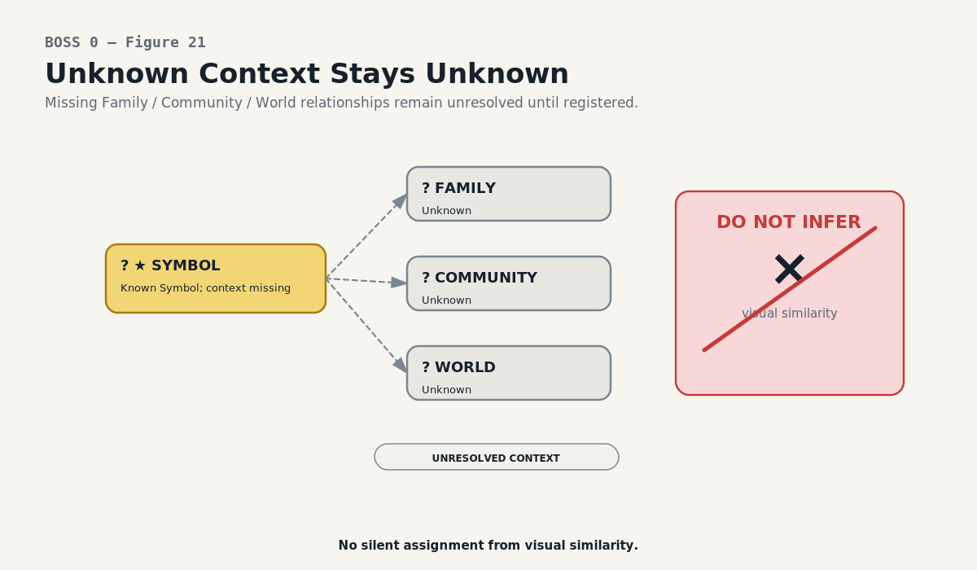
Figure 21. Unknown Context Stays Unknown. Missing context remains explicit. BOSS does not infer Family, Community, World, or meaning merely from visual similarity.
BOSS is explicitly anti-guessing when a registered path is incomplete. A common-looking mark must not be assigned a Family, Community, World, or meaning merely because the shape resembles something familiar. Missing ancestry is data and should remain inspectable.
Resolution rule
If multiple registered meanings remain valid, return the collision set or request more context. Do not choose one from the glyph alone.

Four Independent Change Classes
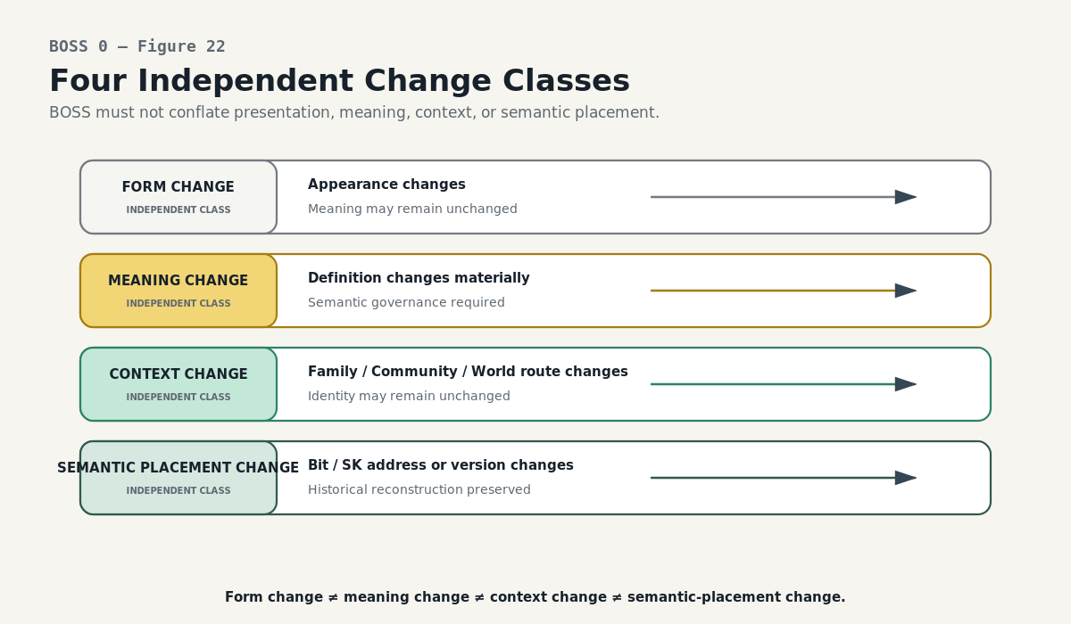
Figure 22. Four Independent Change Classes. Form change, meaning change, context change, and semantic-placement change are distinct governance events.
A symbolic system evolves along several dimensions. BOSS must record which dimension actually changed because each has different migration and historical consequences.
Change class | Example | Identity consequence
Form change | new glyph or rendering | meaning may remain the same
Meaning change | definition or semantic contract changes | requires semantic governance; may create new identity/version
Context change | Family / Community / World route changes | Symbol may remain the same
Semantic placement change | same meaning moves to a new SK address/version | stable meaning may be translated while historical address remains recoverable

PART 6
Authority and Boundaries
Symbolic language is powerful because it does not silently absorb neighboring authorities

BOSS coordinates with exact semantics, lexical routing, structural location, interface representation, and runtime state. Its reliability depends on remaining clear about which of those responsibilities it actually owns.
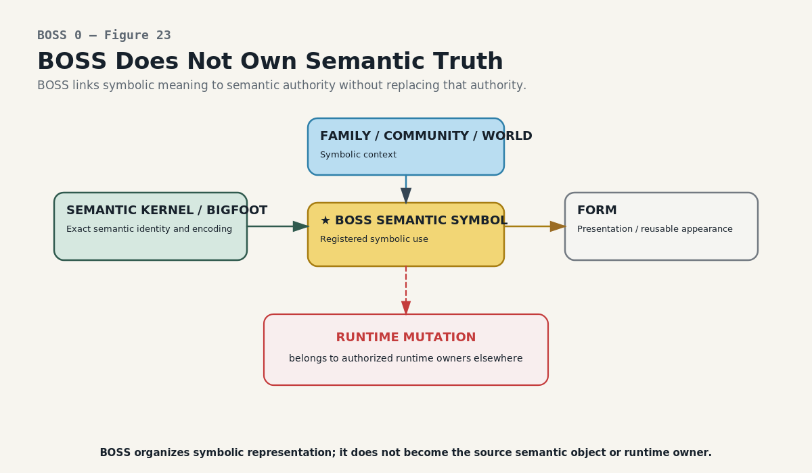
Figure 23. BOSS Does Not Own Semantic Truth. BOSS governs symbolic representation and context; exact semantic identity, runtime state, and mutation authority remain with their proper owners.
BOSS Does Not Own Semantic Truth
Semantic Kernels and BIGFOOT provide exact semantic identity and versioned semantic structure. BOSS supplies the governed symbolic use, appearance relation, and symbolic contextual organization around those objects. A BOSS projection can explain or navigate an exact meaning; it cannot rewrite that meaning merely for convenience.
Authority boundary
BOSS representation ≠ semantic truth ≠ runtime state ≠ mutation authority.

Neighboring Root-Stack Questions
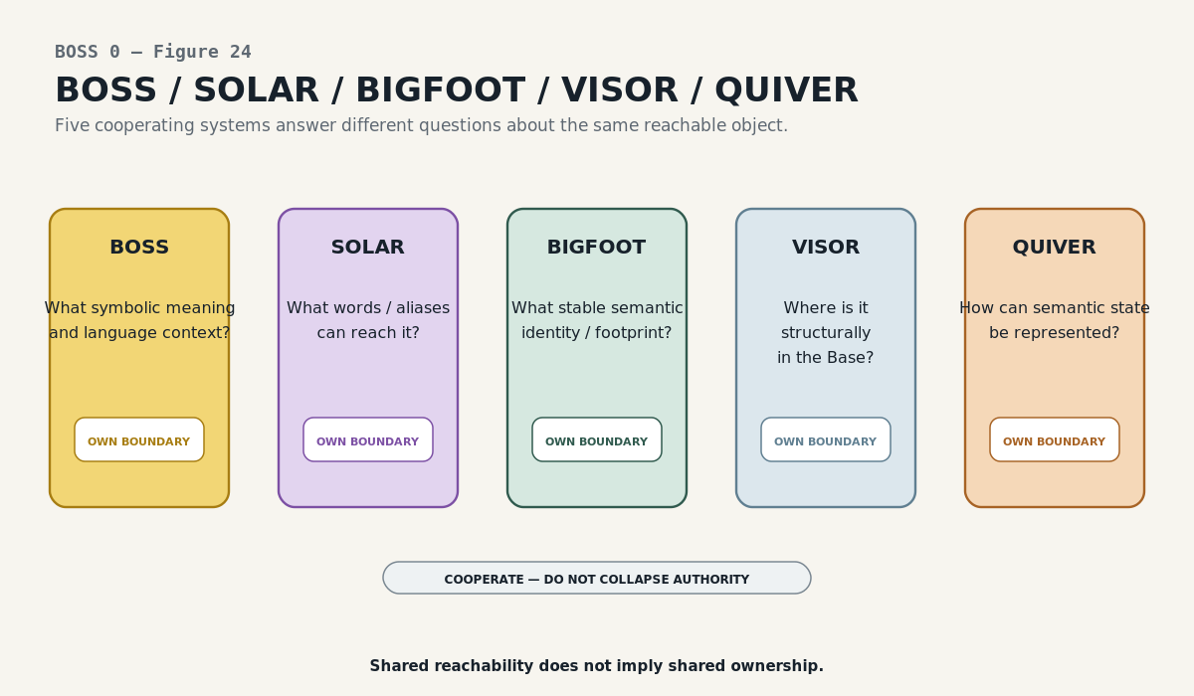
Figure 24. BOSS / SOLAR / BIGFOOT / VISOR / QUIVER. Neighboring Root Stack responsibilities cooperate through explicit contracts without collapsing their questions or authorities.
System | Primary question
BOSS | What symbolic meaning is being represented, and in what symbolic language context?
SOLAR | What words or aliases can reach the registered target?
BIGFOOT | What exact semantic identity exists, and what is its semantic footprint?
VISOR | Where is the structure located in the Base, and how is that structural terrain routed?
QUIVER | How can semantic state be represented or interacted with through registered interface forms?

These systems can point to one another without becoming one another. A BOSS Form is symbolic appearance; a QUIVER representation is an interface capability. A SOLAR alias is an address to a target; it is not the target. A VISOR location identifies structural terrain; it does not define symbolic meaning.

PART 7
Operational and Communication Extensions
What becomes possible after the registered symbolic core exists

The earlier BOSS design correctly anticipated a much larger operational language environment: grammar, parser, resolver, validator, compiler, media bindings, Action Contracts, AI Skills, symbolic keyboards, and multimodal renderers. Those are legitimate extensions, but the current five-table registry is already a complete symbolic-language core without them.
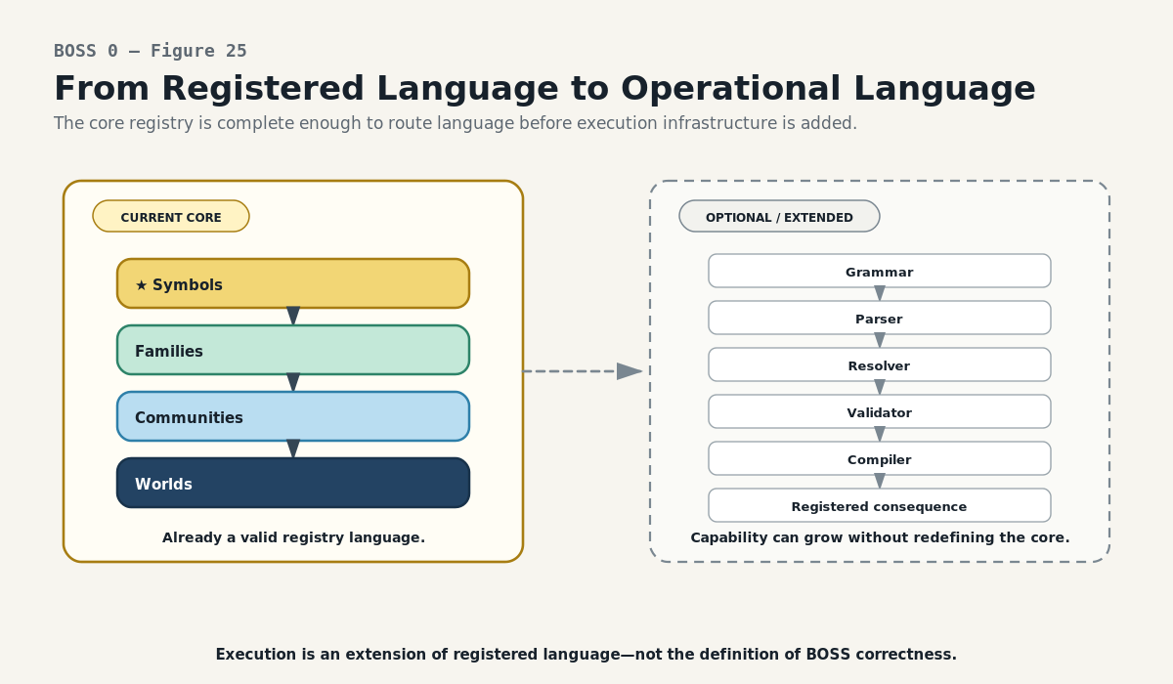
Figure 25. From Registered Language to Operational Language. Grammar, parsing, validation, compilation, and execution are legitimate extensions over the registered language, not prerequisites for the five-table core.
Registered Core vs Operational Runtime
A registered language becomes operational when its Symbols acquire valid composition rules and registered consequences. A parser may recognize tokens; a resolver identifies the governed Symbol; validation checks typed composition; a compiler or binding may then produce an output. None of those later stages may infer semantic identity from appearance when an explicit Symbol path exists.
Extension rule
Execution can extend BOSS. It does not redefine what a registered Symbol means.

BOSS Beyond One Base
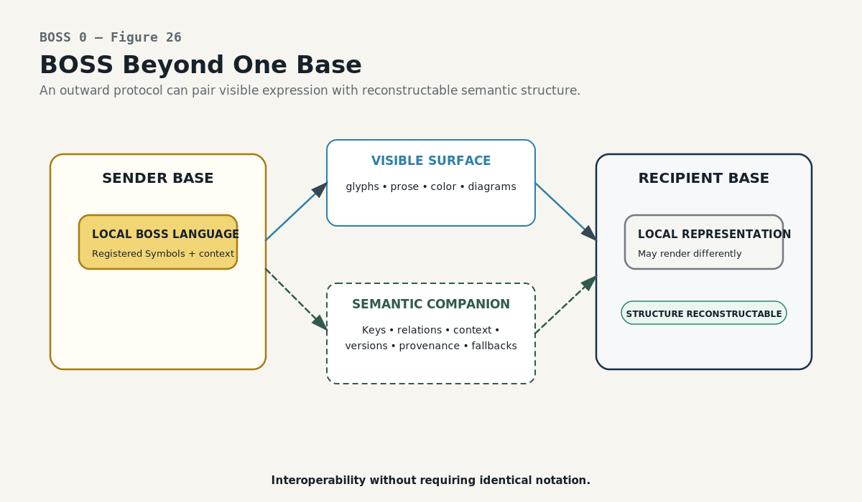
Figure 26. BOSS Beyond One Base. A visible surface can travel with a semantic companion so another Base can reconstruct intended logic without adopting identical notation.
Embedded Semantic Communication is an outward protocol concept built on the same separation of surface and meaning. A visible message can remain concise, cultural, personal, artistic, or multimodal while a machine-readable semantic companion carries the Symbol identities, typed relations, context, provenance, versions, fallbacks, and policy required for reconstruction.
The recipient does not need to adopt the sender’s glyphs. It can render a validated local equivalent, text fallback, accessibility label, sound, or interface representation while retaining the source relation graph and provenance. The goal is interoperability without semantic flattening.
Protocol status
This is an outward BOSS extension and protocol architecture, not a requirement for current BOSS registry correctness or a claim of universal deployment.

PART 8
Reconstruction and Scaling
How to rebuild, extend, test, and audit BOSS without collapsing its identities

Reconstruction Procedure
Step | Action | Invariant
1 | Identify or create the exact Unique Form for each reusable appearance. | Form owns appearance only.
2 | Create one Semantic Symbol per governed symbolic meaning; assign a stable Key and teaching memory. | Same form may fan out to several Symbols.
3 | Link each Symbol to its legitimate Family membership(s). | Context is explicit, not guessed.
4 | Link Family → Community and Community → World. | Broader context derives by traversal.
5 | Expose Community and World lookups or equivalent derived routes. | Do not duplicate ancestry manually.
6 | Bind Symbols to exact semantic objects where the semantic architecture exists. | BOSS does not replace SK/BIGFOOT authority.
7 | Build human and machine readers over the same records. | Learning and operation share registered meaning.
8 | Test collisions, unresolved context, projections, reclassification, and historical recovery. | Failure must remain inspectable.

Installing a New Language
A new symbolic language does not require a new BOSS architecture. Populate its Symbols and Forms, organize them into one or more Families, link those Families into an appropriate Community, and link the Community into a World. The reachable language expands because the graph gained registered paths.
Scaling principle
Grow by installation, not by redesign.

BOSS Laws and Reconstruction Test
Twelve Reconstruction Laws
• Form equality is not semantic equality.
• The Semantic Symbol is the registered symbolic use; the glyph alone is not.
• Same Form + different meaning produces separate Semantic Symbols.
• Same meaning + legitimate multiple contexts may reuse one Semantic Symbol with explicit multi-membership.
• Family, Community, and World context is linked, not inferred from appearance.
• Family is the narrow explicit anchor; broader ancestry should be derived through registered relations.
• World resolution provides contextual completeness without claiming a universal ontology.
• Compiled vocabularies are projections over source records, not new truth stores.
• Exact semantic objects bind through governed Symbols rather than treating raw visual Forms as semantic authority.
• Unknown or ambiguous context remains unresolved until evidence supports selection.
• Form change, meaning change, context change, and semantic-placement change are distinct governance events.
• Operational and cross-Base extensions may consume BOSS meaning but may not silently acquire authority over it.
Generalization Test
Give a fresh AI a new formal symbolic-language paper and ask it to install the language into BOSS. A successful reconstruction should create or reuse Forms, register distinct Symbol meanings, organize them into Families, attach those Families to a Community and World route, bind exact semantics where available, and make the language reachable without copying every Symbol upward.
Failure indicators
• Merging all visually identical glyphs into one meaning.
• Putting semantic definitions on Unique Form and then bypassing the Semantic Symbol.
• Copying the same Symbols into Family, Community, and World as separate authorities.
• Guessing Family or World from a glyph when the explicit context is missing.
• Treating a vocabulary projection or interface display as canonical semantic truth.

Source Map and Historical Preservation
BOSS evolved from a broad symbolic-language concept into a small normalized registry with clear authority boundaries. The compression artifact preserves that lineage without making a fresh reader reconstruct the architecture chronologically.
Source | Role | Preserved contribution
BOSS — BaseCode Operational Symbolic System | Historical / proposed foundation | Establishes symbolic sovereignty, local languages, learning, grammar, operational bindings, media, accessibility, and federation ambitions. Earlier Community-as-top-level and separate BaseCode code-space are not required for the mature five-table core.
CERBERUS BOSS — Symbol Registry Architecture | Primary current structural authority | Defines Unique Form vs Semantic Symbol, Family / Community / World organization, collisions, lookup inheritance, versioning, and deterministic resolution.
CERBERUS Semantic World — Semantic World Resolution Architecture | Current contextual and resolution authority | Adds World resolution, additive context, reversible semantic zoom, recursive vocabulary compilation, SOLAR ingress, and versioned World/Community snapshots.
BOSS — Embedded Semantic Communication | Proposed outward extension | Defines dual-channel cross-Base semantic reconstruction, semantic packets, crosswalks, receipts, disclosure, and recipient-native rendering.
Live BOSS implementation | Mature implementation evidence | Confirms the Symbol → Family → Community → World wiring, whole-language lookups, Symbol Viewer behavior, and practical language installation using Mathematical Operators.

Final Reconstruction
BOSS in one paragraph
BOSS is a governed symbolic-language graph centered on the Semantic Symbol. Unique Forms own reusable appearance. Semantic Symbols own registered symbolic use. Families organize local vocabularies. Communities organize bounded languages. Worlds organize broader symbolic environments. Exact semantic objects retain their own authority. Explicit links make the whole language traversable, learnable, collision-safe, versionable, and extensible.

The architecture is intentionally small at its center. Its power comes from separation and traversal: link identities rather than collapsing them, derive broader language surfaces rather than copying them, and allow operational or communication systems to consume registered meaning without silently becoming the source of that meaning.

