CERBERUS
MATERIAL_EFFECT-64
Candidate Semantic Kernel Specification
Renderer-Neutral Procedural Surface / Material Application

CORE SPECIFICATION STATEMENT
MATERIAL_EFFECT-64 defines a bounded Spatial / Visual Application Semantic Kernel that maps an accepted typed Effect Signal into a renderer-neutral material-parameter request. The Kernel declares the addressed material-parameter family, application operation, input and output bases, material slot and channel selection, pattern-mix behavior, bounds handling, COLOR and LIGHT continuation, baseline semantics, failure behavior, local evaluation posture, Formula Profile, and interpretation version.

CANDIDATE • HUMAN-FACING COMPRESSION ARTIFACT • NOT RUNTIME TRUTH

Document Status and Reading Contract
AUTHORING POSTURE
The records are the machine. This Specification is the human compression artifact: a static teaching, planning, inspection, and reconstruction manual for the bounded MATERIAL_EFFECT-64 semantic contract. Runtime implementations should consume canonical records and registered Reader definitions directly rather than depend on this document.

Status
Candidate. D interface identities remain DREQ-* requirements until implementation assigns exact D#.# records. No BIGFOOT, BOSS, COLOR, or Registry identities are invented merely to make the document appear complete.

Primary bounded question
How does a procedural Signal control surface/material presentation?

Core ownership law
MATERIAL_EFFECT describes how a procedural Signal becomes a surface/material-parameter request. It does not own the material asset, surface geometry, color identity, illumination behavior, renderer implementation, or canonical world truth.

Resolution posture
MATERIAL_EFFECT-64¹ is the minimum complete Candidate member. A 32-bit member is not proposed because it would force essential application semantics into opaque profiles or renderer defaults.

Source evolution
The older Effects Studio reference used historical COLOR_EFFECT / COLOR-128 wording. Current specialist routing explicitly uses COLOR_EFFECT-64¹ and COLOR-32-64 while preserving the older source as architecture history rather than silently rewriting it.

Contents and Reading Map
FIGURE-FIRST READING
Reader pages pair a dedicated semantic figure with the declaration strip and Property / Contract block. Use the figures to recover the mental model quickly; use the contract blocks and appendices for exact Candidate states and implementation planning.

Document contents
• Part 1 — Purpose, Surface Ownership, and Normative Laws
• Part 2 — Resolution, Mathematical Inventory, and Reader Topology
• Part 3 — MATERIAL_EFFECT-64¹ Reader-Role Interface Specifications
• Part 4 — Interface-0, D Requirements, and Complete DARTBOARD
• Part 5 — Reader Algorithm, Typed Output, and Specialist Routing
• Part 6 — Worked Examples, Invalid States, and Conformance
• Part 7 — Planning Handoff and Promotion Gate
• Appendices A–G — Reader states, bit map, applicability, compatibility, DREQs, routing, build checklist

Part 1 — Purpose, Surface Ownership, and Normative Laws
1. Kernel Card
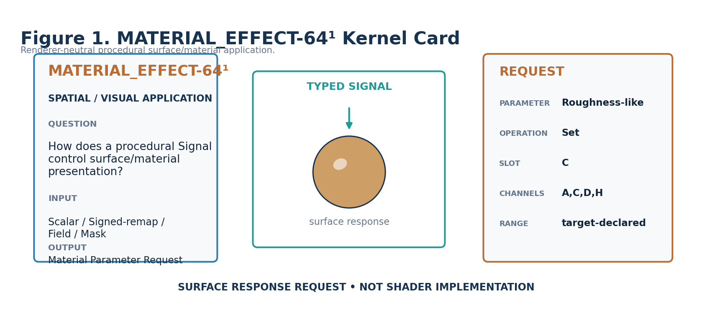
Figure 1. MATERIAL_EFFECT-64¹ bounded application contract.
MATERIAL_EFFECT-64¹ is a Spatial / Visual Application Semantic Kernel. Its sole bounded job is to convert an accepted typed procedural Signal into a renderer-neutral request against a surface/material parameter. The word does not describe the material asset itself; it describes the requested behavior applied to a bound material target.
The Candidate accepts Scalar directly, explicitly remapped Signed Scalar, Field under a declared domain-aware Formula Profile, and Mask under an explicit participation/material Formula. Other Signal Classes require declared transformation rather than silent numeric coercion.

2. Source Preservation
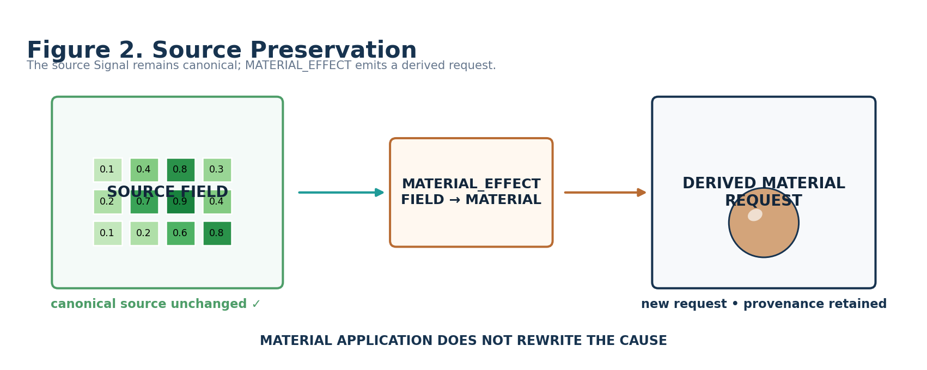
Figure 2. The source Signal remains canonical while MATERIAL_EFFECT emits a derived request.
MATERIAL_EFFECT is an application layer, not a source mutation layer. Upstream Signals remain intact and reusable by other Effects. A Shimmer Field can therefore drive Movement, Color, Light, and Material branches without any branch rewriting the shared cause.

3. Specialist Ownership Boundary
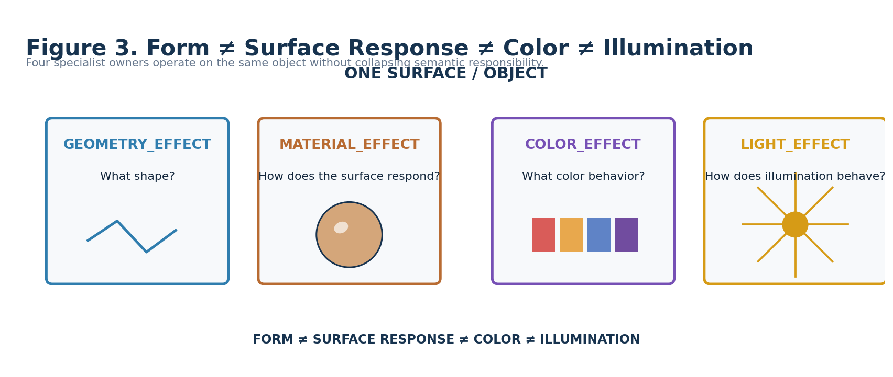
Figure 3. Form, material response, color behavior, and illumination remain separate semantic owners.
The same visible object may participate in multiple specialist Effects, but those Effects answer different bounded questions. GEOMETRY_EFFECT owns geometric-form change. MATERIAL_EFFECT owns surface/material response. COLOR_EFFECT owns behavior across registered colors. COLOR owns registered color identity. LIGHT_EFFECT owns illumination behavior.
This separation is not cosmetic. It prevents a normal-strength request from becoming geometry mutation, an emissive material from automatically becoming a light source, or a material color route from duplicating COLOR channel state.

4. Material Asset Identity vs Effect
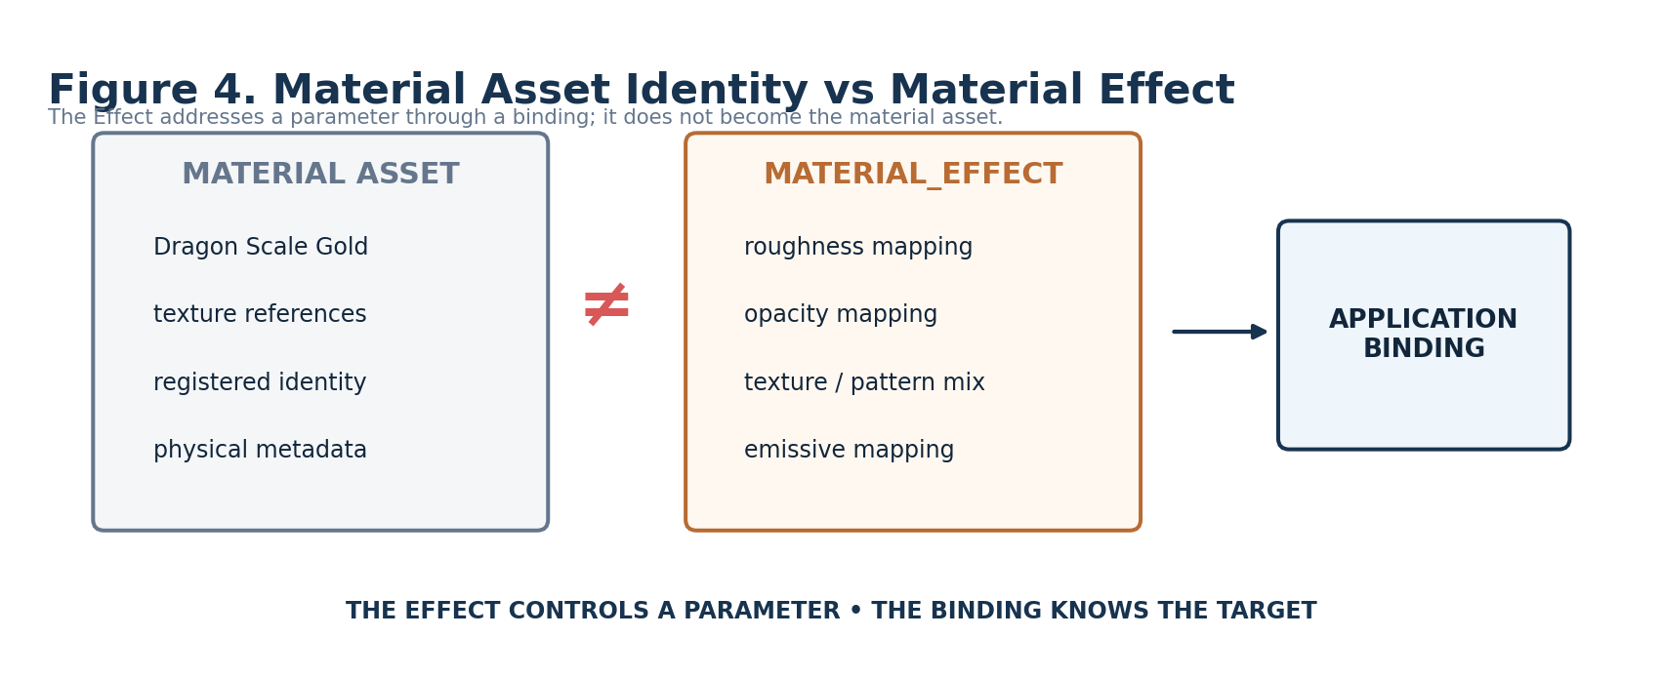
Figure 4. Material identity is external to the procedural request.
A material asset may contain texture references, shader graphs, fabrication metadata, physical descriptors, provenance, and implementation-specific resources. MATERIAL_EFFECT does not absorb those identities. E1 addresses a material slot through an external Material/Application Binding; the Binding knows which actual asset and layer the slot resolves to.

5. Emissive Material vs Illumination
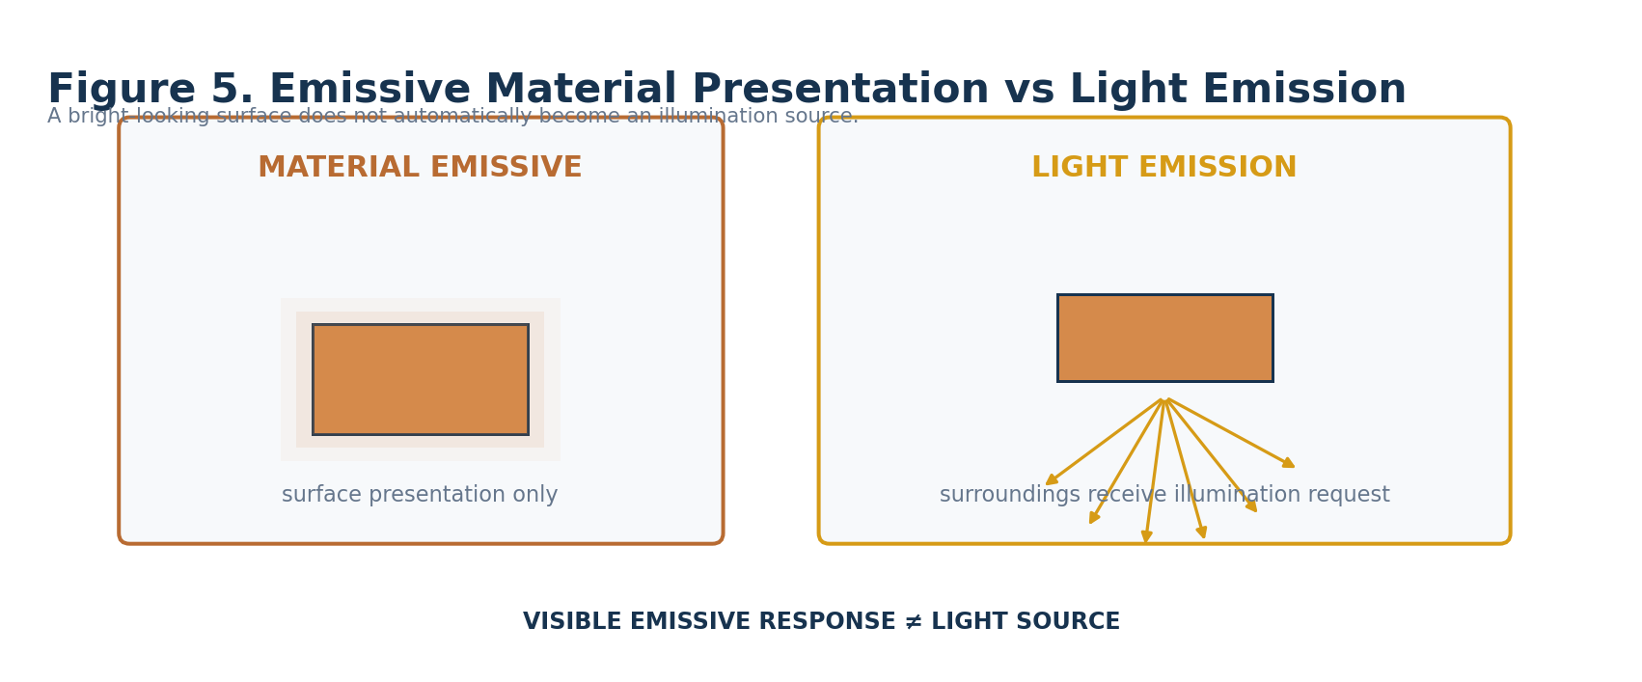
Figure 5. Bright-looking material presentation and actual illumination are independent contracts.
MATERIAL emissive response is a surface-presentation request. When that surface must also illuminate its surroundings, J1 routes to LIGHT_EFFECT. A renderer may choose to visually bloom an emissive-looking surface, but that visual implementation does not grant MATERIAL_EFFECT ownership of illumination semantics.

6. Geometry vs Normal Strength
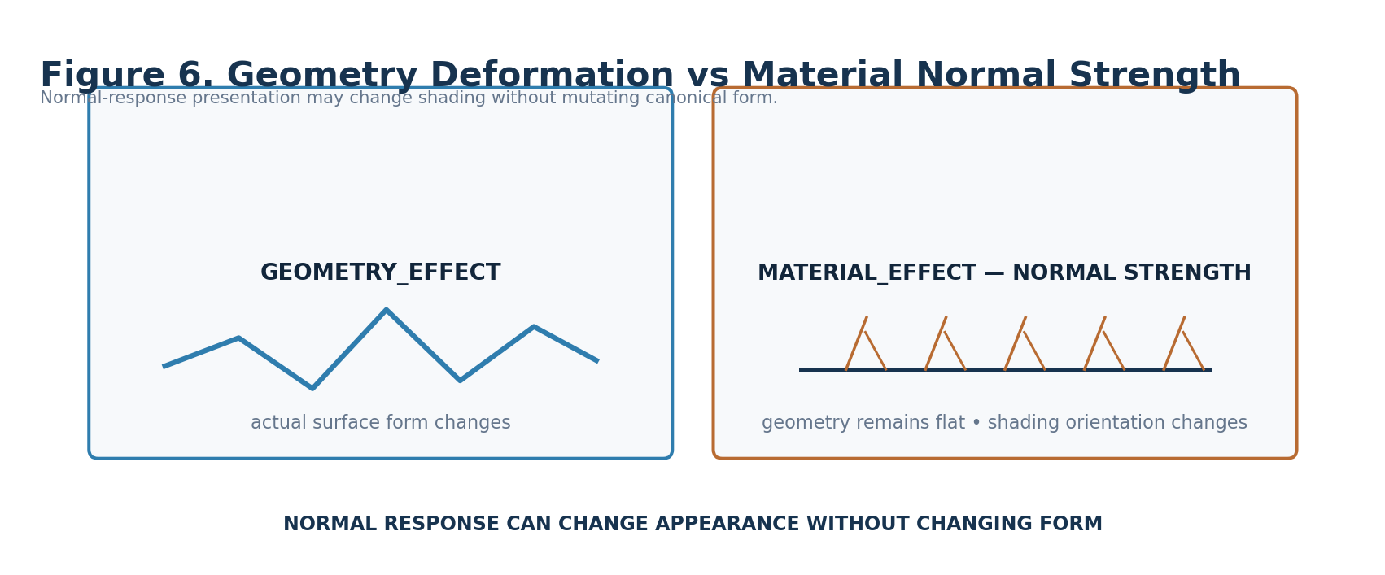
Figure 6. Normal-response presentation can alter shading without mutating canonical form.
Normal-strength control is intentionally material presentation. It may change how local shading normals are interpreted while the canonical mesh or geometry remains unchanged. If actual form displacement, topology change, or vertex movement is required, GEOMETRY_EFFECT owns that request.

Normative Candidate Laws
Law | Name | Candidate normative statement
MAT-R01 | Bounded Application | MATERIAL_EFFECT SHALL describe surface/material parameter behavior only.
MAT-R02 | Safe Zero | A1=0 SHALL emit no Material Request regardless of stored downstream role state.
MAT-R03 | Source Preservation | MATERIAL_EFFECT SHALL NOT rewrite the upstream Effect Signal.
MAT-R04 | Math / Meaning Separation | Generic BitGroups SHALL remain mathematical; material meaning belongs to Reader placements.
MAT-R05 | Parameter Explicitness | A1 SHALL identify the surface/material parameter class being controlled.
MAT-R06 | Operation Explicitness | B1 SHALL declare how the mapped value applies to the target parameter.
MAT-R07 | Range Separation | Input and Output range semantics SHALL remain independently inspectable.
MAT-R08 | Material Non-Ownership | E1 SHALL address a material slot without owning material asset identity.
MAT-R09 | Channel Non-Ownership | F1 SHALL select bound channel positions without embedding renderer channel identities.
MAT-R10 | Pattern Separation | Texture/pattern mixing SHALL NOT be substituted for BLEND_EFFECT Signal combination.
MAT-R11 | Geometry Separation | Material normal/distortion presentation SHALL NOT silently mutate canonical geometry.
MAT-R12 | Color Separation | Actual color identity/behavior SHALL route through COLOR / COLOR_EFFECT when required.
MAT-R13 | Light Separation | Emissive surface presentation SHALL NOT imply illumination semantics.
MAT-R14 | Baseline Explicitness | Relative/additive/multiplicative operations SHALL resolve against an explicit baseline contract.
MAT-R15 | Null Visibility | Missing target, slot, channel, source, COLOR, LIGHT, or required domain state SHALL remain inspectable.
MAT-R16 | Evaluation Locality | Local evaluation posture SHALL NOT claim global timing ownership.
MAT-R17 | Formula Visibility | Mapping equations SHALL remain versioned and inspectable through Formula Profiles.
MAT-R18 | Renderer Separation | Renderer implementation and endpoint capability SHALL remain external.
MAT-R19 | Projection Separation | Previewed material appearance SHALL remain derived presentation rather than canonical state.
MAT-R20 | Minimum Resolution | Additional width SHALL require genuinely new atomic material capability.

Part 2 — Resolution, Mathematical Inventory, and Reader Topology
7. Minimum Sufficient Member
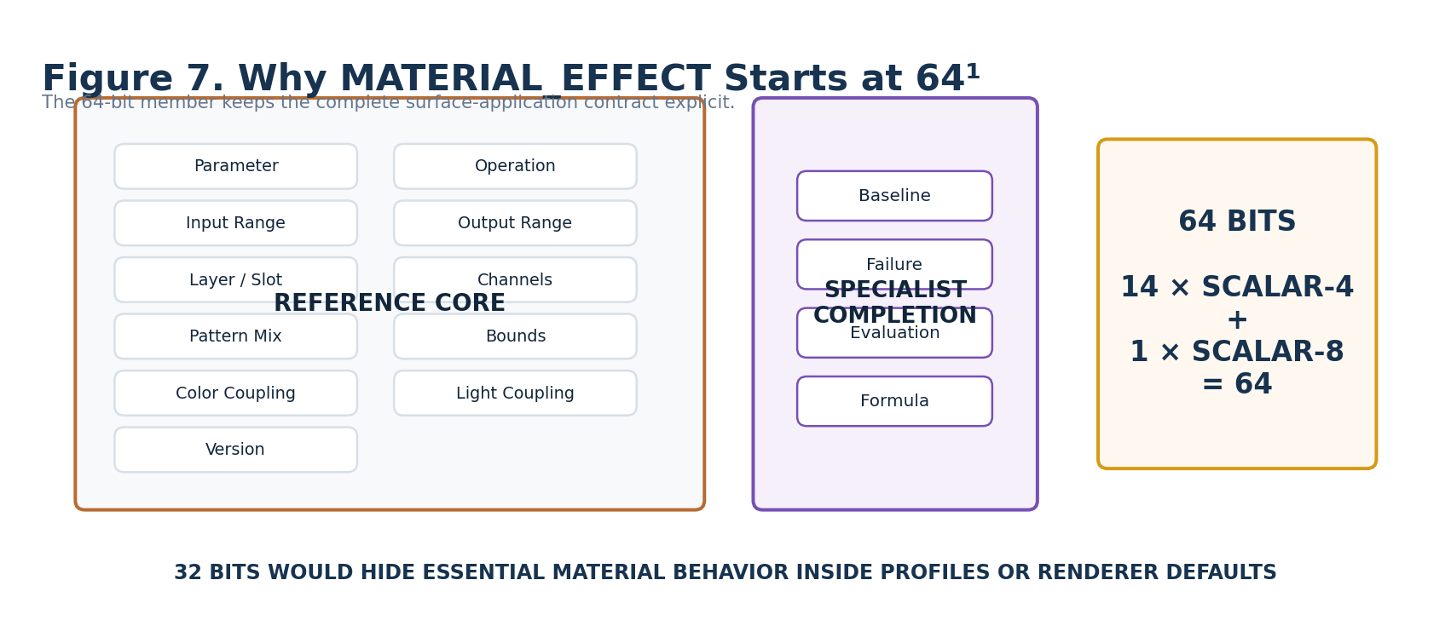
Figure 7. The 64-bit member keeps the complete material-application contract explicit.
The specialist architecture adds Baseline, Null/Failure, Evaluation, and Formula Profile to the Reference core because those states materially affect whether the request is deterministic, reversible, inspectable, and valid. This completion yields an exact 64-bit allocation without padding.

Exact Candidate Allocation
Reader |  |  | Bits | Carrier | Meaning
A1 |  |  | B000:B003 | SCALAR-4 | Material Parameter Class
B1 |  |  | B004:B007 | SCALAR-4 | Operation Mode
C1 |  |  | B008:B011 | SCALAR-4 | Input Range
D1 |  |  | B012:B015 | SCALAR-4 | Output Range
E1 |  |  | B016:B019 | SCALAR-4 | Material Layer / Slot
F1 |  |  | B020:B027 | SCALAR-8 | Material Channel Mask
G1 |  |  | B028:B031 | SCALAR-4 | Texture / Pattern Mix Mode
H1 |  |  | B032:B035 | SCALAR-4 | Bounds Policy
I1 |  |  | B036:B039 | SCALAR-4 | Color Coupling Mode
J1 |  |  | B040:B043 | SCALAR-4 | Emissive / Light Coupling
K1 |  |  | B044:B047 | SCALAR-4 | Baseline Mode
L1 |  |  | B048:B051 | SCALAR-4 | Null / Failure Behavior
M1 |  |  | B052:B055 | SCALAR-4 | Evaluation Mode
N1 |  |  | B056:B059 | SCALAR-4 | Formula Profile
O1 |  |  | B060:B063 | SCALAR-4 | Version / Reserved
EXACT WIDTH
14 × SCALAR-4 = 56 Bits; 1 × SCALAR-8 = 8 Bits; total = 64 Bits. F1 earns the eight-bit width because each constituent Bit functions as one inspectable channel-slot selector.

8. Reusable Mathematical Inventory
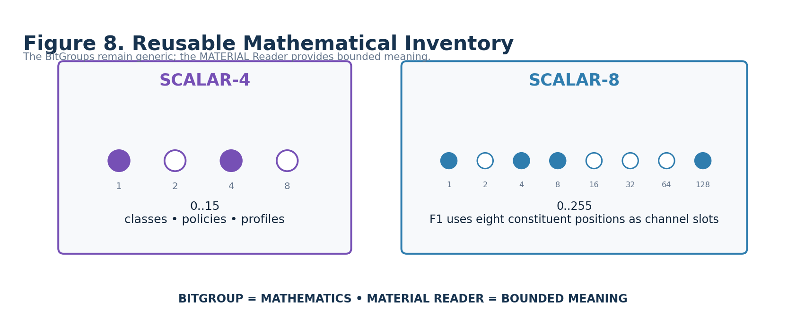
Figure 8. Only generic SCALAR-4 and SCALAR-8 mathematics are required.
SCALAR-4 contributes the generic 0..15 selection space used by fourteen categorical, policy, profile, address, and metadata Readers. SCALAR-8 contributes the eight atomic member positions used by F1 as a channel mask. Neither BitGroup knows anything about materials.

9. Physical Bit Map
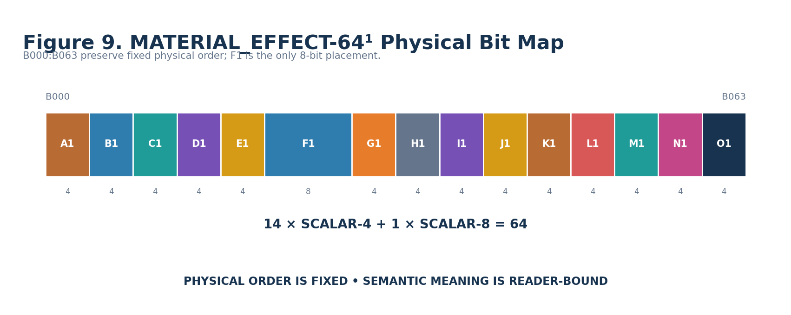
Figure 9. MATERIAL_EFFECT-64¹ occupies B000:B063 with one 8-bit channel-mask placement.
Physical order is canonical. Reader topology may group placements conceptually for human teaching, but conceptual grouping does not reorder Bits or create new mathematical structures.

10. Reader Topology
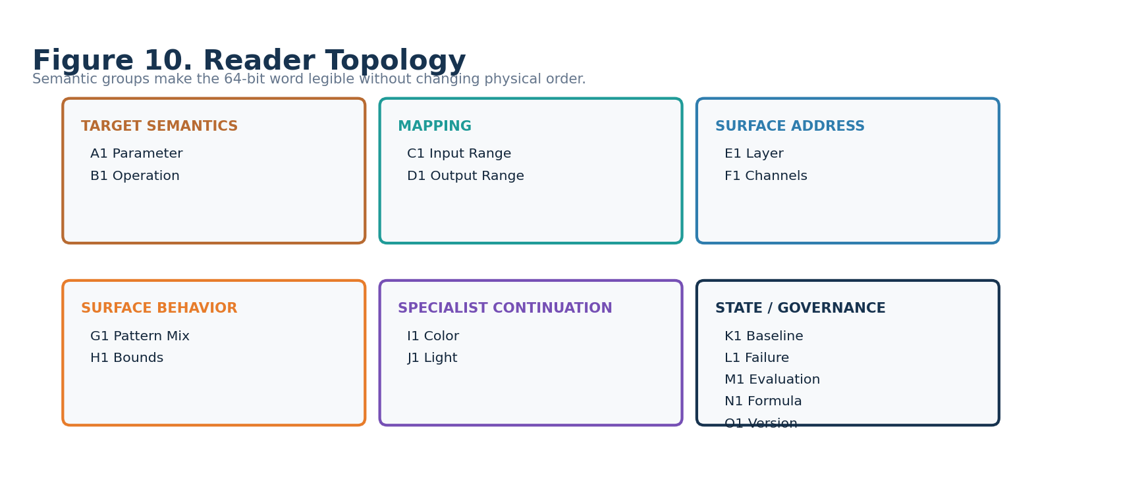
Figure 10. The Reader groups the word into target, mapping, address, behavior, continuation, and governance roles.

26. Input Range vs Output Range
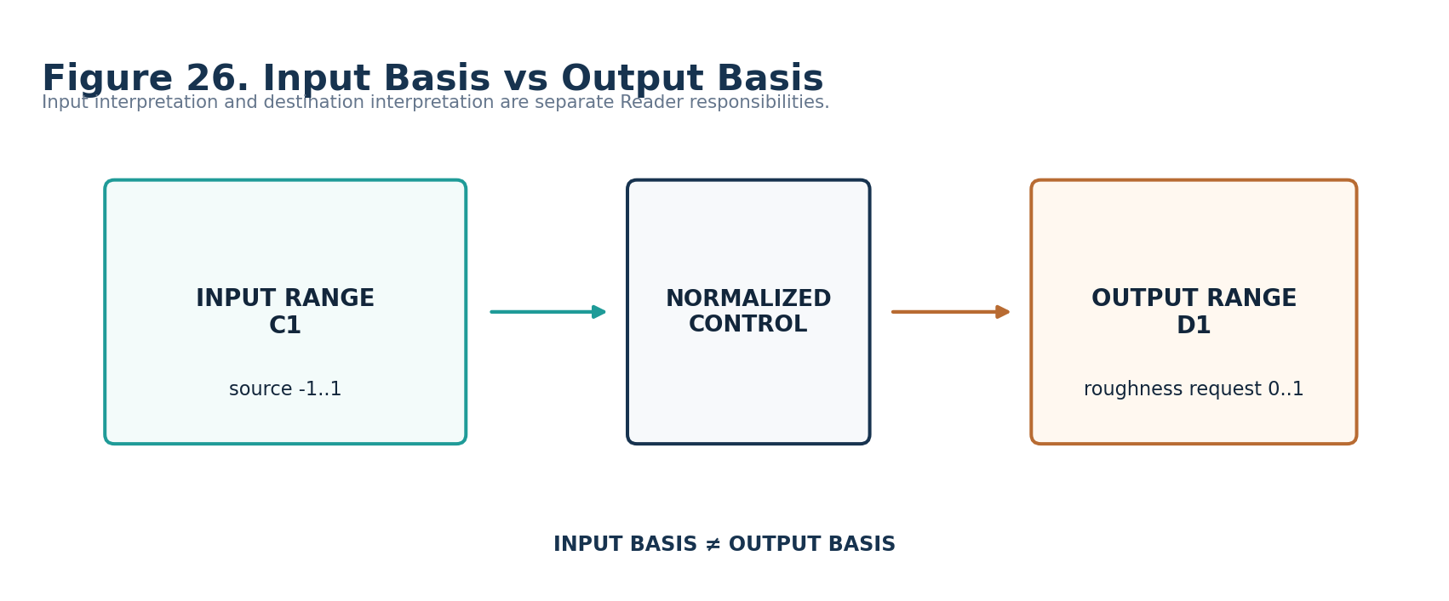
Figure 26. Source interpretation and destination interpretation remain independent.
C1 answers how the source interval is interpreted. D1 answers what basis the destination request uses. This prevents an upstream Signed Scalar from being confused with the destination material range and keeps actual renderer/unit calibration external.

27. Layer vs Channel
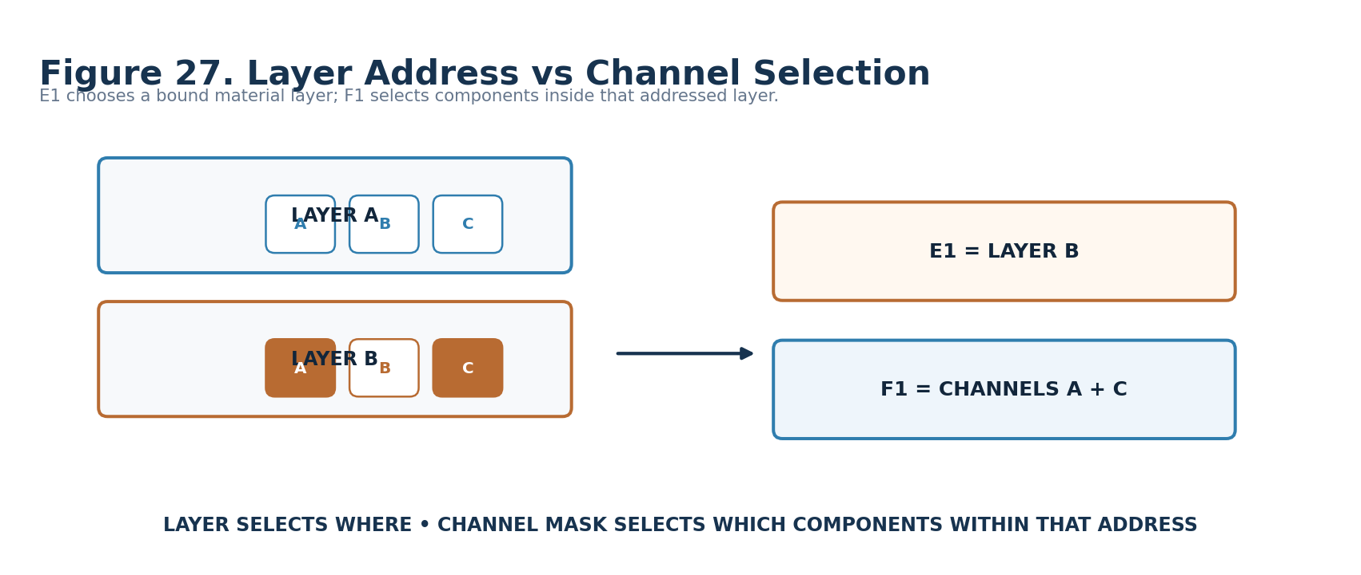
Figure 27. E1 addresses the material layer; F1 selects components inside that address.
A material can expose several bound layers, each with its own channel map. E1 and F1 therefore answer different questions and must remain separate. The Binding resolves both semantic addresses into actual implementation resources.

Part 3 — MATERIAL_EFFECT-64¹ Reader-Role Interface Specifications
11. Material Parameter Class — A1
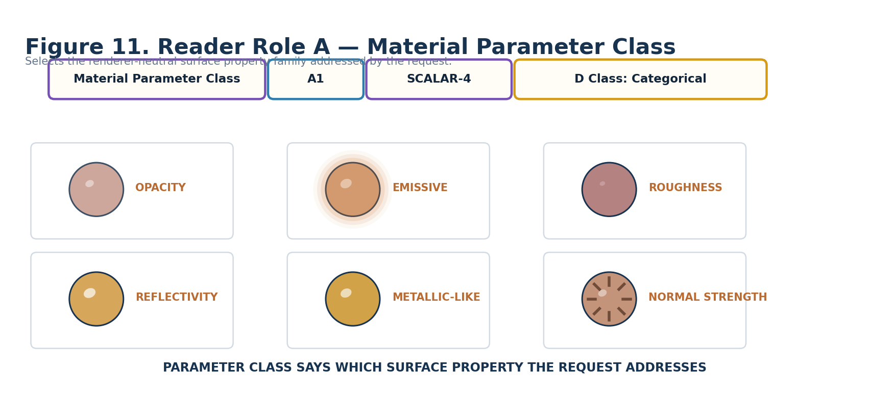
Figure 11. Material Parameter Class.
DECLARATION
Material Parameter Class | A1 | SCALAR-4 | DREQ-CAT.MATERIAL_PARAMETER

Property | Contract
D Class | Cat
D Requirement Key | DREQ-CAT.MATERIAL_PARAMETER
Purpose | Selects the renderer-neutral surface/material parameter family addressed by the request.
Representative states | 0 OFF; 1 OPACITY; 2 EMISSIVE; 3 ROUGHNESS-LIKE; 4 REFLECTIVITY; 5 METALLIC-LIKE; 6 REFRACTION; 7 TEXTURE/PATTERN MIX; 8 NORMAL STRENGTH; 9 SURFACE RESPONSE PROFILE; 10–15 reserved.
Validation / boundary | A1=0 is safe zero/no request. Parameter applicability may constrain later roles.
Reader formula / mathematics | SCALAR-4 raw value 0..15 resolves through the A1 categorical vocabulary.
Does not own | Material asset identity, renderer shader model, geometry, color identity, light implementation.

12. Operation Mode — B1
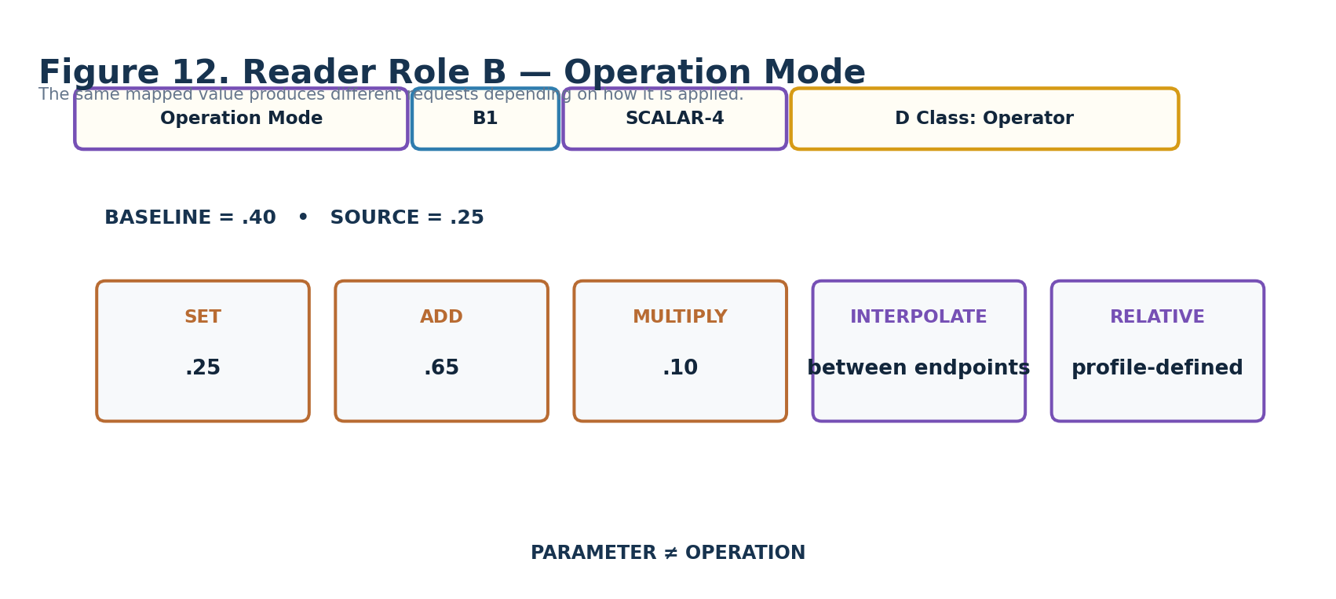
Figure 12. Operation Mode.
DECLARATION
Operation Mode | B1 | SCALAR-4 | DREQ-OP.MATERIAL_APPLICATION

Property | Contract
D Class | Op
D Requirement Key | DREQ-OP.MATERIAL_APPLICATION
Purpose | Declares how the mapped value applies to the addressed material parameter.
Representative states | 0 SET; 1 ADD; 2 MULTIPLY; 3 INTERPOLATE; 4 RELATIVE; 5 PROFILE; 6 EXTERNAL; 7–15 reserved.
Validation / boundary | ADD/MULTIPLY/RELATIVE require a resolvable K1 baseline or an exact profile-defined equivalent.
Reader formula / mathematics | SCALAR-4 categorical operator selection. Exact equations belong to the selected Formula Profile.
Does not own | Parameter identity, baseline source, destination units.

13. Input Range — C1
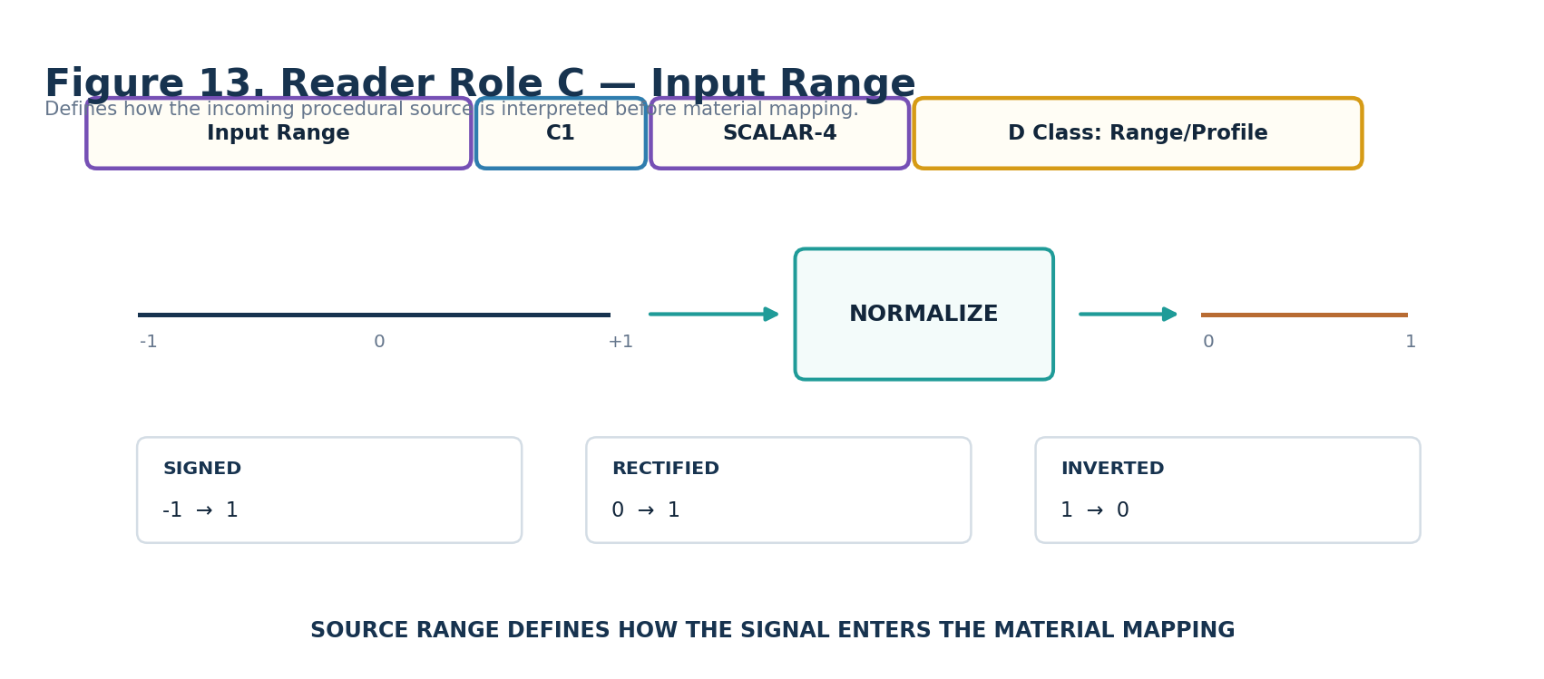
Figure 13. Input Range.
DECLARATION
Input Range | C1 | SCALAR-4 | DREQ-RANGE.MATERIAL_INPUT

Property | Contract
D Class | Range
D Requirement Key | DREQ-RANGE.MATERIAL_INPUT
Purpose | Declares how the incoming procedural Signal range is interpreted before mapping.
Representative states | 0 SOURCE_DECLARED; 1 NORMALIZED_0_1; 2 SIGNED_-1_1; 3 RECTIFIED; 4 ABSOLUTE; 5 INVERTED_0_1; 6 PROFILE; 7 EXTERNAL_RANGE; 8–15 reserved.
Validation / boundary | Signed or other source classes remain semantically typed; range selection alone is not silent coercion.
Reader formula / mathematics | SCALAR-4 selects a registered input-basis interpretation.
Does not own | Upstream Signal identity, source generation, destination material range.

14. Output Range — D1
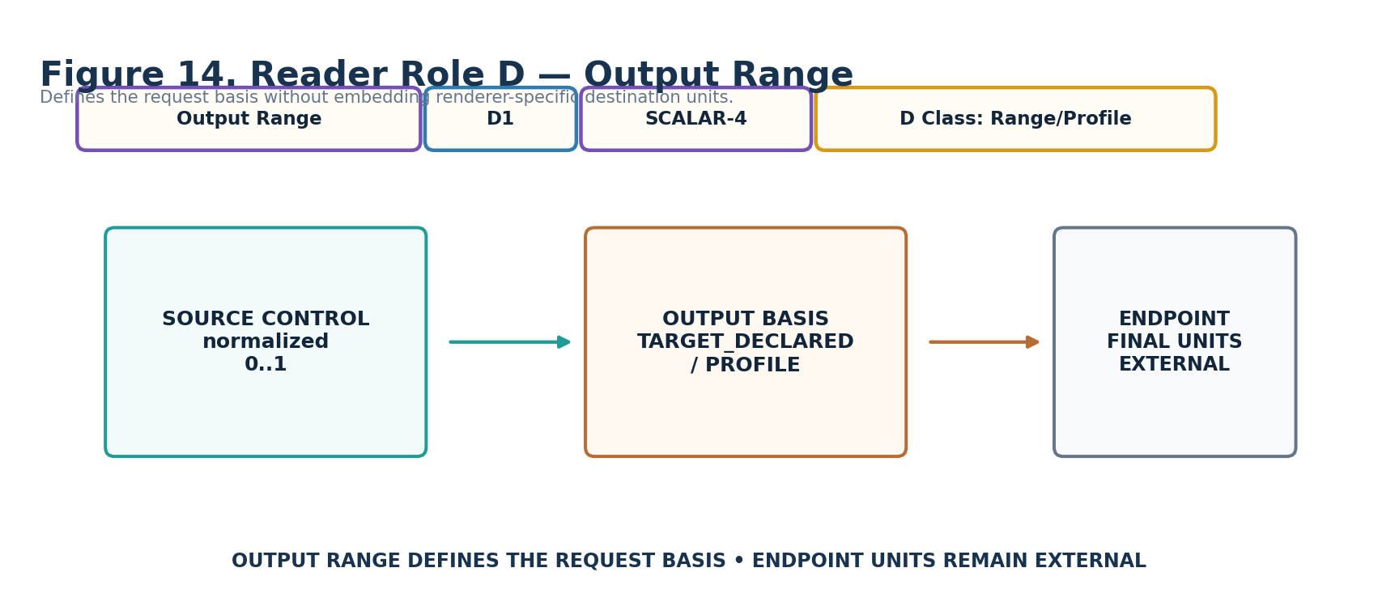
Figure 14. Output Range.
DECLARATION
Output Range | D1 | SCALAR-4 | DREQ-RANGE.MATERIAL_OUTPUT

Property | Contract
D Class | Range
D Requirement Key | DREQ-RANGE.MATERIAL_OUTPUT
Purpose | Declares the destination request basis for the addressed material parameter.
Representative states | 0 TARGET_DECLARED; 1 NORMALIZED_0_1; 2 SIGNED_-1_1; 3 POSITIVE_NORMALIZED; 4 PARAMETER_PROFILE; 5 BINDING_RANGE; 6 EXTERNAL_RANGE; 7–15 reserved.
Validation / boundary | Actual renderer or physical units are resolved by the Formula Profile / Application Binding / endpoint.
Reader formula / mathematics | SCALAR-4 selects the output-basis contract.
Does not own | Renderer units, material asset storage format, source range.

15. Material Layer / Slot — E1
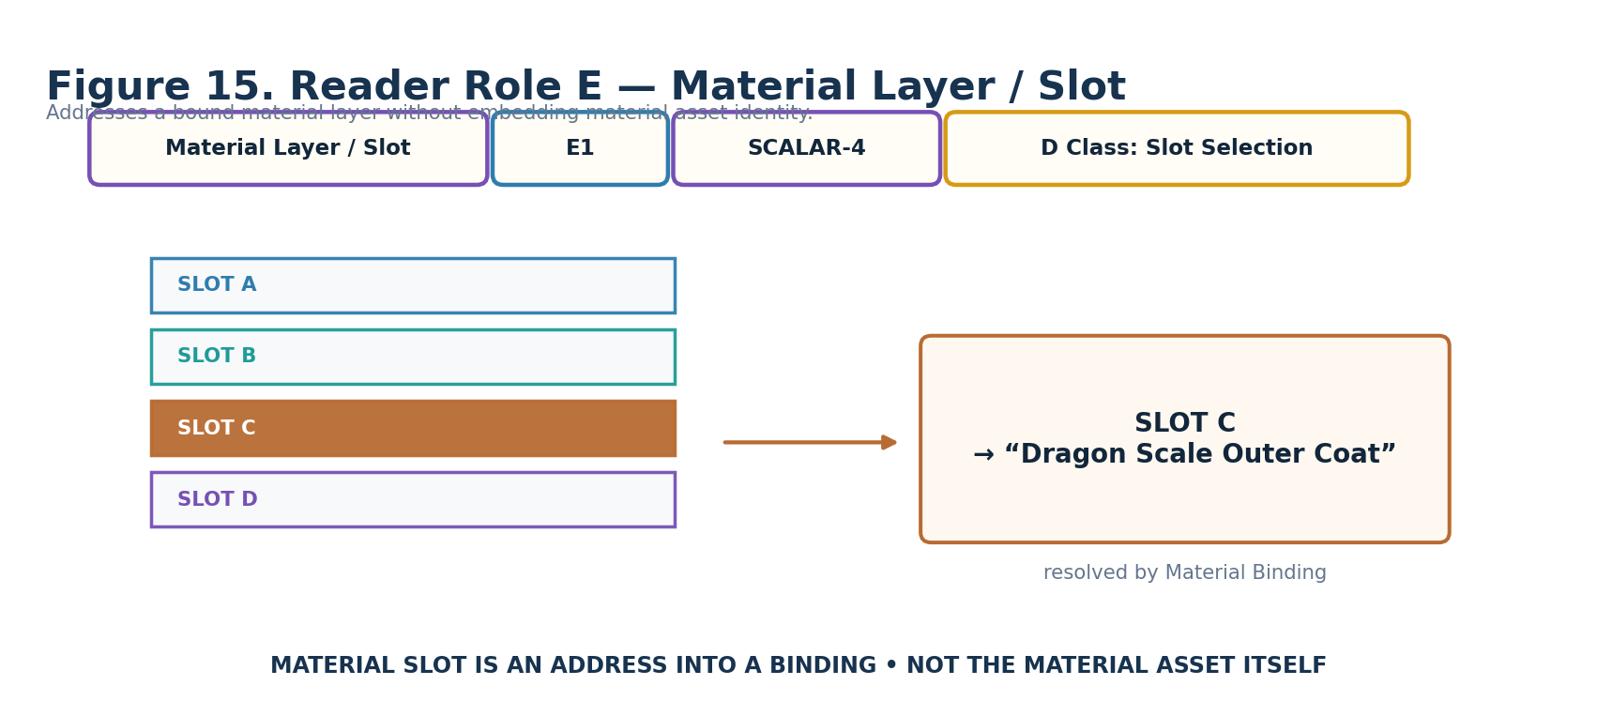
Figure 15. Material Layer / Slot.
DECLARATION
Material Layer / Slot | E1 | SCALAR-4 | DREQ-SLOT.MATERIAL_LAYER

Property | Contract
D Class | Slot
D Requirement Key | DREQ-SLOT.MATERIAL_LAYER
Purpose | Selects a material layer/slot address that the external Material Binding resolves.
Representative states | 0 DEFAULT/PRIMARY; 1 SLOT A; 2 SLOT B; 3 SLOT C; 4 SLOT D; 5 SLOT E; 6 SLOT F; 7 SLOT G; 8 SLOT H; 9 SLOT I; 10 SLOT J; 11 SLOT K; 12 SLOT L; 13 SLOT M; 14 EXTERNAL SLOT; 15 reserved.
Validation / boundary | If a selected slot is unavailable, L1 governs failure. No slot identity is fabricated.
Reader formula / mathematics | SCALAR-4 slot selection.
Does not own | Material asset identity, layer implementation, target object.

16. Material Channel Mask — F1
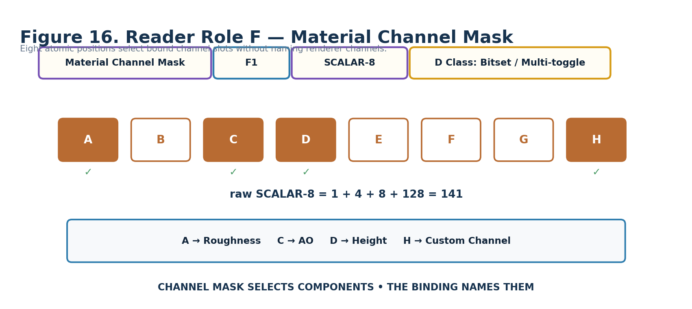
Figure 16. Material Channel Mask.
DECLARATION
Material Channel Mask | F1 | SCALAR-8 | DREQ-BITSET.MATERIAL_CHANNELS

Property | Contract
D Class | Bitset
D Requirement Key | DREQ-BITSET.MATERIAL_CHANNELS
Purpose | Selects zero to eight bound material channel slots using the constituent Bits of SCALAR-8.
Representative states | Each constituent Bit selects slot A–H. Example 141 = A+C+D+H. F1=0 means binding default/whole parameter unless the exact profile requires explicit channels.
Validation / boundary | Every active slot must resolve unless the Formula/Binding explicitly allows partial resolution.
Reader formula / mathematics | Bitset: weights 1,2,4,8,16,32,64,128 map to channel slots A–H.
Does not own | Actual channel names, renderer channel packing, texture asset identity.

17. Texture / Pattern Mix Mode — G1
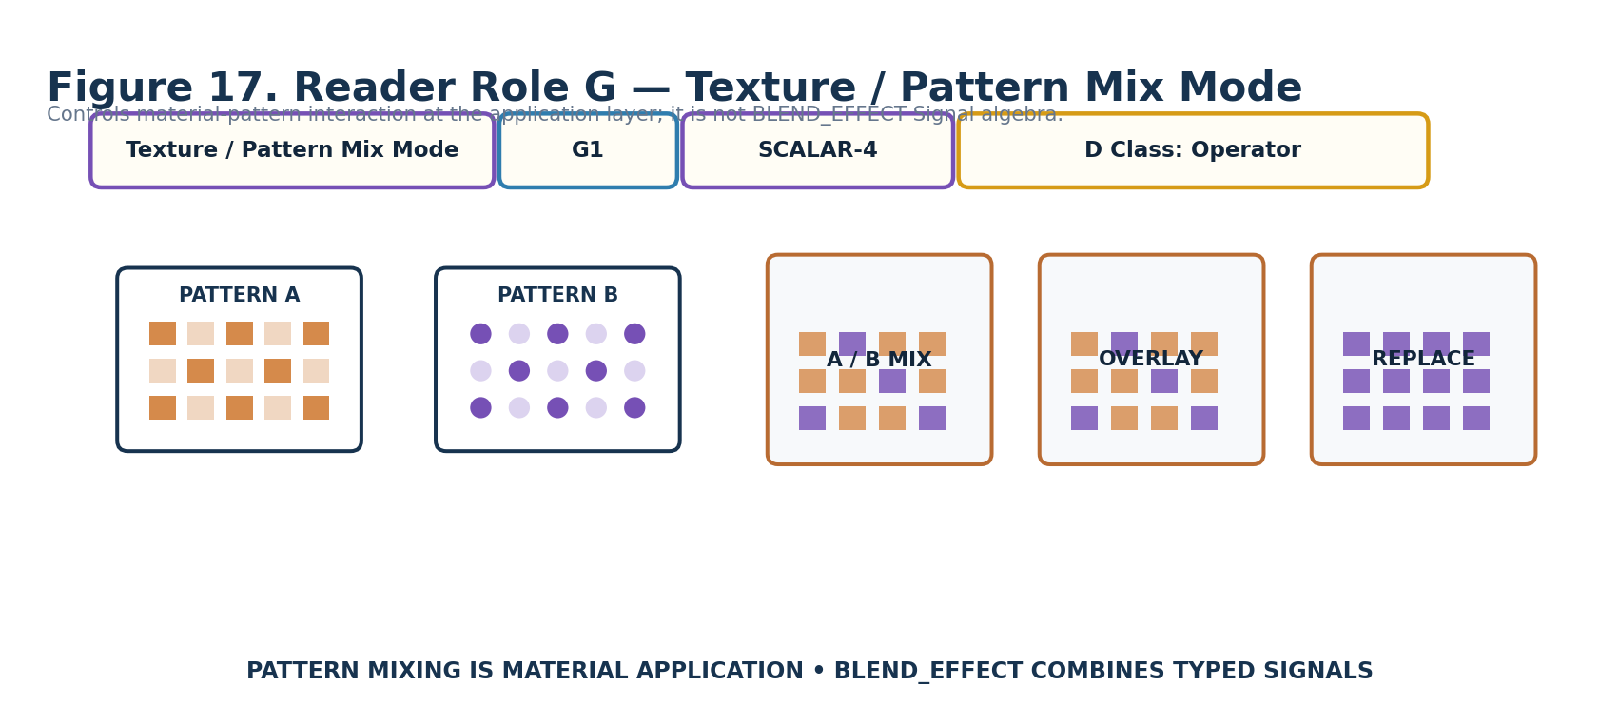
Figure 17. Texture / Pattern Mix Mode.
DECLARATION
Texture / Pattern Mix Mode | G1 | SCALAR-4 | DREQ-OP.MATERIAL_PATTERN_MIX

Property | Contract
D Class | Op
D Requirement Key | DREQ-OP.MATERIAL_PATTERN_MIX
Purpose | Declares how material textures/pattern inputs interact at the material-application layer.
Representative states | 0 NONE/NA; 1 A/B MIX; 2 OVERLAY; 3 REPLACE; 4 EXTERNAL; 5 PROFILE; 6–15 reserved.
Validation / boundary | Pattern inputs must resolve under the active Material Binding / Formula Profile.
Reader formula / mathematics | SCALAR-4 operator/profile selection.
Does not own | BLEND_EFFECT typed Signal algebra, texture asset identity.

18. Bounds Policy — H1
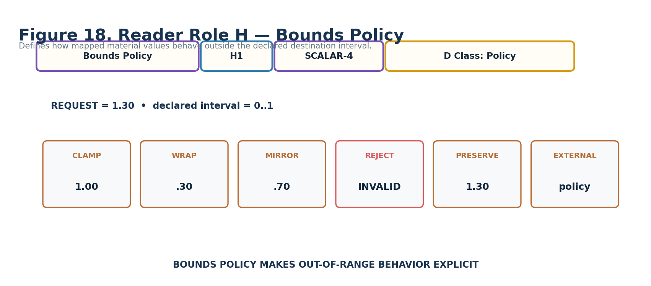
Figure 18. Bounds Policy.
DECLARATION
Bounds Policy | H1 | SCALAR-4 | DREQ-POLICY.BOUNDS

Property | Contract
D Class | Policy
D Requirement Key | DREQ-POLICY.BOUNDS
Purpose | Declares behavior when mapped material values exceed the declared destination bounds.
Representative states | 0 CLAMP; 1 WRAP; 2 MIRROR/PING_PONG; 3 REJECT; 4 PRESERVE_OVERFLOW; 5 EXTERNAL_CONSTRAINT; 6 PROFILE; 7–15 reserved.
Validation / boundary | REJECT produces invalid/unresolved request state rather than silently clamping.
Reader formula / mathematics | SCALAR-4 policy selection.
Does not own | Destination units, endpoint capability.

19. Color Coupling Mode — I1
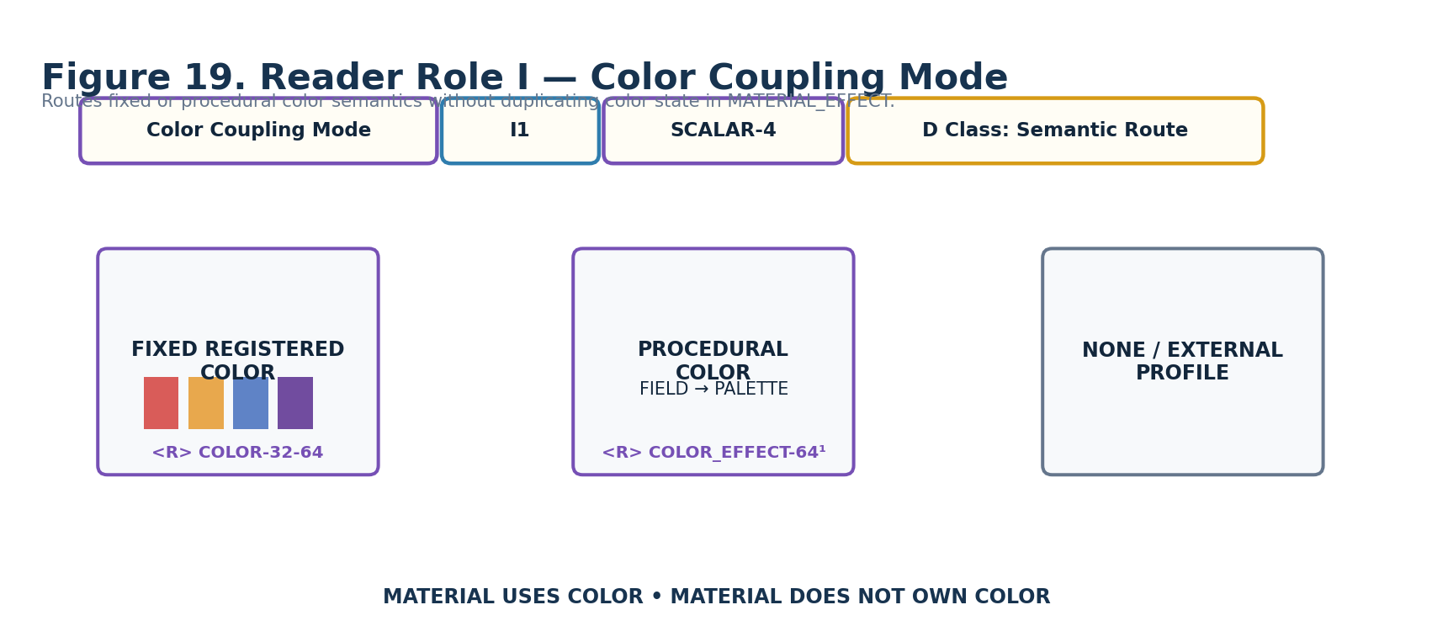
Figure 19. Color Coupling Mode.
DECLARATION
Color Coupling Mode | I1 | SCALAR-4 | DREQ-ROUTE.MATERIAL_COLOR

Property | Contract
D Class | Route
D Requirement Key | DREQ-ROUTE.MATERIAL_COLOR
Purpose | Routes color semantics required by the material request without storing color channel state.
Representative states | 0 NONE; 1 FIXED REGISTERED COLOR; 2 EXTERNAL COLOR_EFFECT; 3 PALETTE/COLOR BEHAVIOR ROUTE; 4 EXTERNAL COLOR PROFILE; 5–15 reserved.
Validation / boundary | Required color routes must resolve or L1 governs failure.
Reader formula / mathematics | SCALAR-4 semantic-route selection.
Does not own | COLOR identity, RGBA channel values, palette state.

20. Emissive / Light Coupling — J1
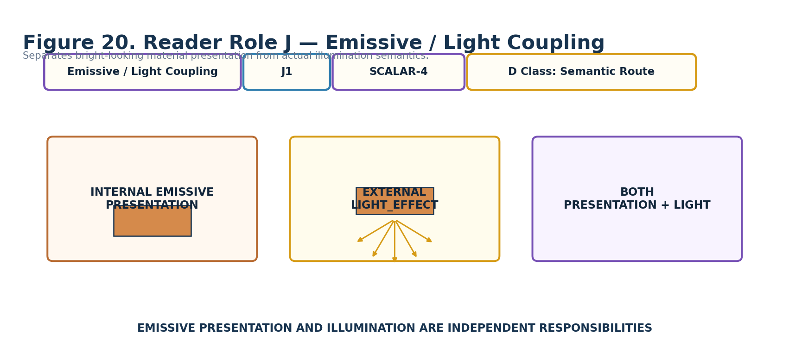
Figure 20. Emissive / Light Coupling.
DECLARATION
Emissive / Light Coupling | J1 | SCALAR-4 | DREQ-ROUTE.MATERIAL_LIGHT

Property | Contract
D Class | Route
D Requirement Key | DREQ-ROUTE.MATERIAL_LIGHT
Purpose | Declares whether emissive surface presentation remains local or continues into LIGHT semantics.
Representative states | 0 NONE; 1 INTERNAL EMISSIVE PRESENTATION; 2 EXTERNAL LIGHT_EFFECT; 3 EMISSIVE + EXTERNAL LIGHT; 4 PROFILE; 5 EXTERNAL POLICY; 6–15 reserved.
Validation / boundary | A MATERIAL emissive request does not itself create an illumination request.
Reader formula / mathematics | SCALAR-4 route/coupling selection.
Does not own | Light source identity, light transport, renderer illumination implementation.

21. Baseline Mode — K1
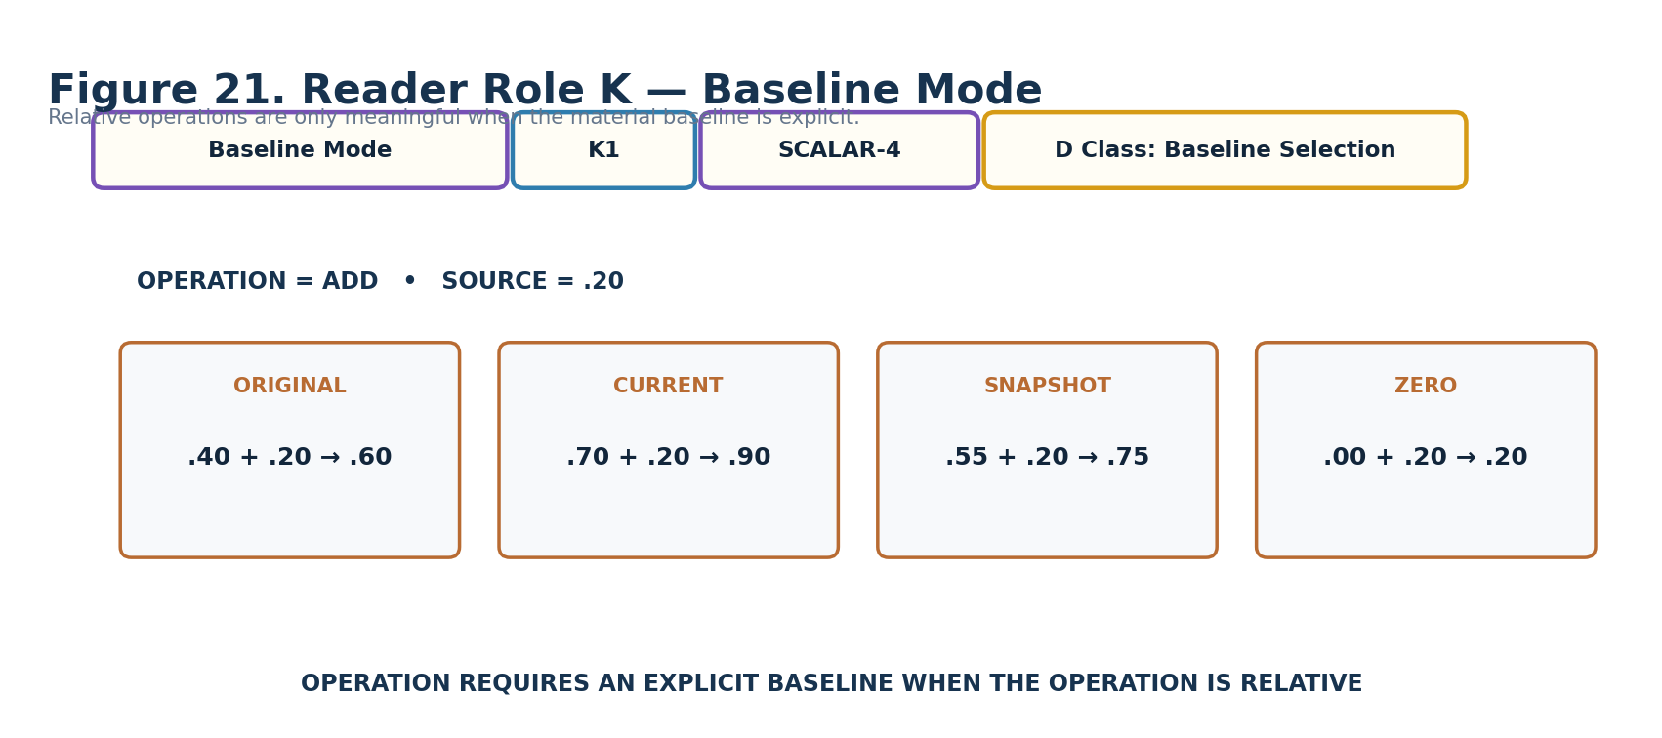
Figure 21. Baseline Mode.
DECLARATION
Baseline Mode | K1 | SCALAR-4 | DREQ-BASELINE.MATERIAL

Property | Contract
D Class | Baseline
D Requirement Key | DREQ-BASELINE.MATERIAL
Purpose | Declares the reference baseline used by relative material operations.
Representative states | 0 REGISTERED/ORIGINAL MATERIAL; 1 CURRENT MATERIAL STATE; 2 CAPTURED SNAPSHOT; 3 ZERO/NEUTRAL; 4 EXTERNAL BASELINE; 5 PROFILE; 6–15 reserved.
Validation / boundary | Relative/additive/multiplicative operations require a valid baseline contract.
Reader formula / mathematics | SCALAR-4 baseline selection; exact sampling/capture rules belong to the Binding/Profile.
Does not own | Material history, target identity, operation mathematics.

22. Null / Failure Behavior — L1
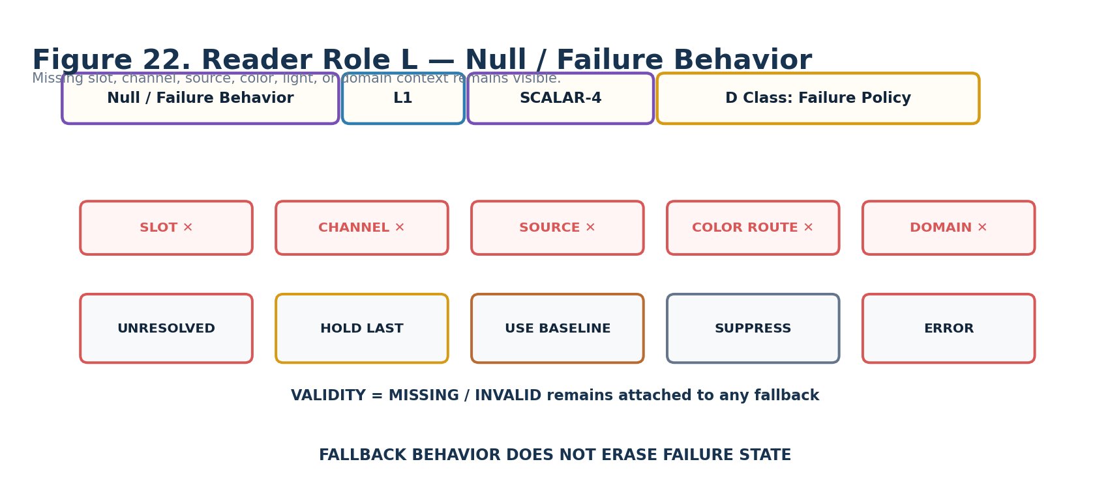
Figure 22. Null / Failure Behavior.
DECLARATION
Null / Failure Behavior | L1 | SCALAR-4 | DREQ-POLICY.FAILURE

Property | Contract
D Class | Policy
D Requirement Key | DREQ-POLICY.FAILURE
Purpose | Declares failure behavior when required source, slot, channel, route, domain, or endpoint context is missing/invalid.
Representative states | 0 UNRESOLVED/NO REQUEST; 1 HOLD LAST VALID; 2 USE BASELINE; 3 SUPPRESS MATERIAL APPLICATION; 4 ERROR; 5 EXTERNAL POLICY; 6–15 reserved.
Validation / boundary | Fallback values retain explicit invalid/missing validity; fallback does not convert missing data into valid data.
Reader formula / mathematics | SCALAR-4 failure-policy selection.
Does not own | Root cause of failure, external recovery workflow.

23. Evaluation Mode — M1
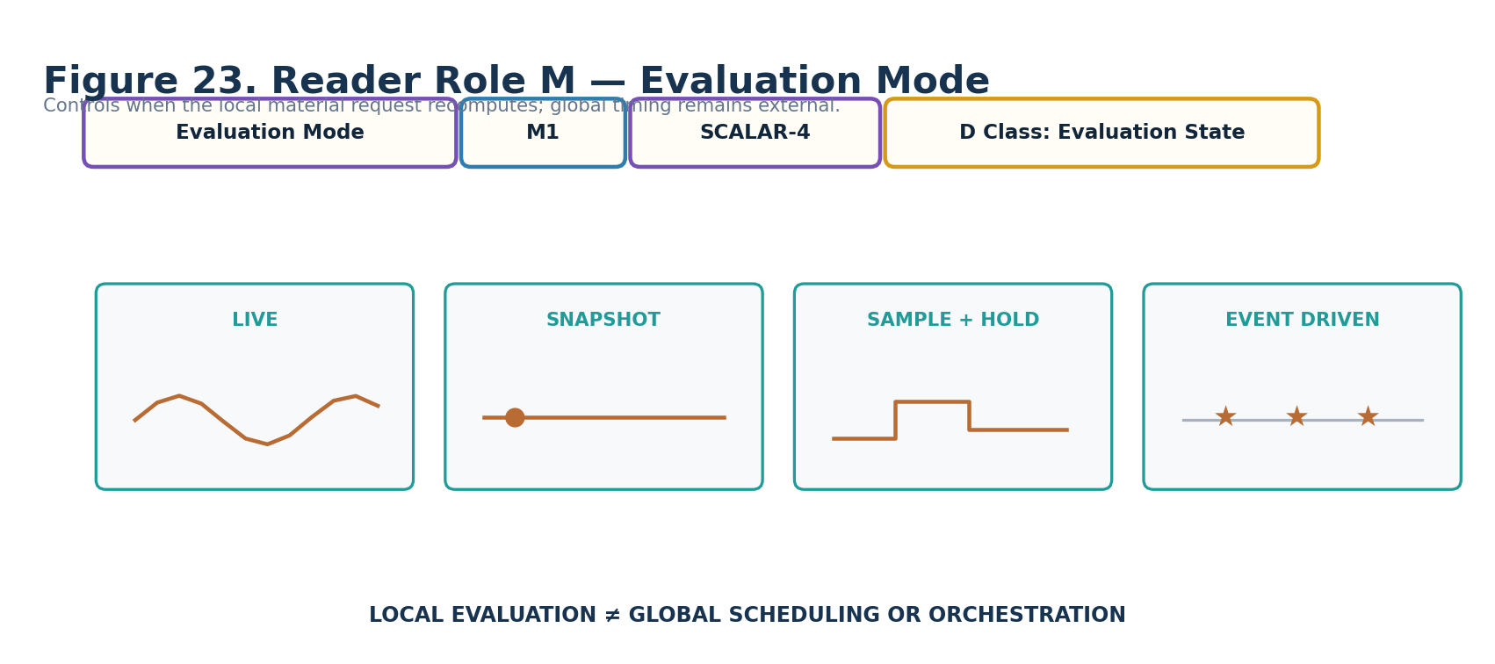
Figure 23. Evaluation Mode.
DECLARATION
Evaluation Mode | M1 | SCALAR-4 | DREQ-EVAL.MODE

Property | Contract
D Class | Eval
D Requirement Key | DREQ-EVAL.MODE
Purpose | Controls when the local material request recomputes.
Representative states | 0 LIVE; 1 SNAPSHOT; 2 SAMPLE_AND_HOLD; 3 EVENT_DRIVEN; 4–15 reserved.
Validation / boundary | Global scheduling, start/duration/repetition, and orchestration remain external.
Reader formula / mathematics | SCALAR-4 evaluation-state selection.
Does not own | Global TIME semantics and orchestration.

24. Formula Profile — N1
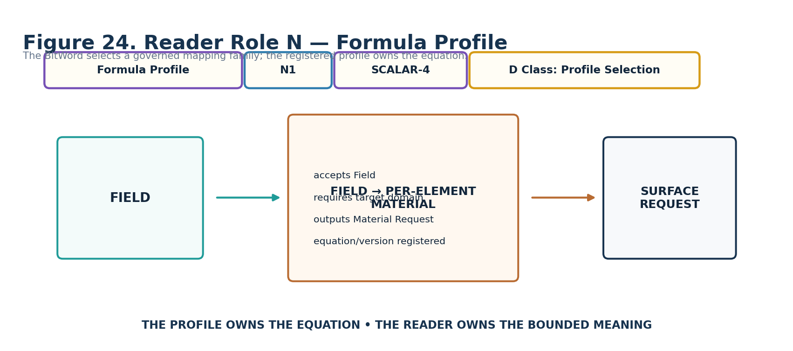
Figure 24. Formula Profile.
DECLARATION
Formula Profile | N1 | SCALAR-4 | DREQ-PROFILE.MATERIAL_FORMULA

Property | Contract
D Class | Profile
D Requirement Key | DREQ-PROFILE.MATERIAL_FORMULA
Purpose | Selects the registered Formula Profile that performs the material mapping.
Representative states | 0 DIRECT/BINDING DEFAULT; 1 SCALAR→MATERIAL PARAMETER; 2 SIGNED→MATERIAL REMAP; 3 FIELD→PER-ELEMENT MATERIAL; 4 MASK→MATERIAL PARTICIPATION; 5 FIELD→TEXTURE MIX; 6 FIELD→NORMAL STRENGTH; 7 SCALAR→OPACITY; 8 SCALAR→EMISSIVE; 9 EXTERNAL MATERIAL FORMULA; 10–15 reserved.
Validation / boundary | Profile must declare accepted input classes, required domain fields, parameter semantics, output basis, undefined conditions, determinism posture, version, and human explanation.
Reader formula / mathematics | SCALAR-4 profile identity; equation lives in the registered Formula Profile.
Does not own | The formula itself, upstream Signal generation, endpoint implementation.

25. Version / Reserved — O1
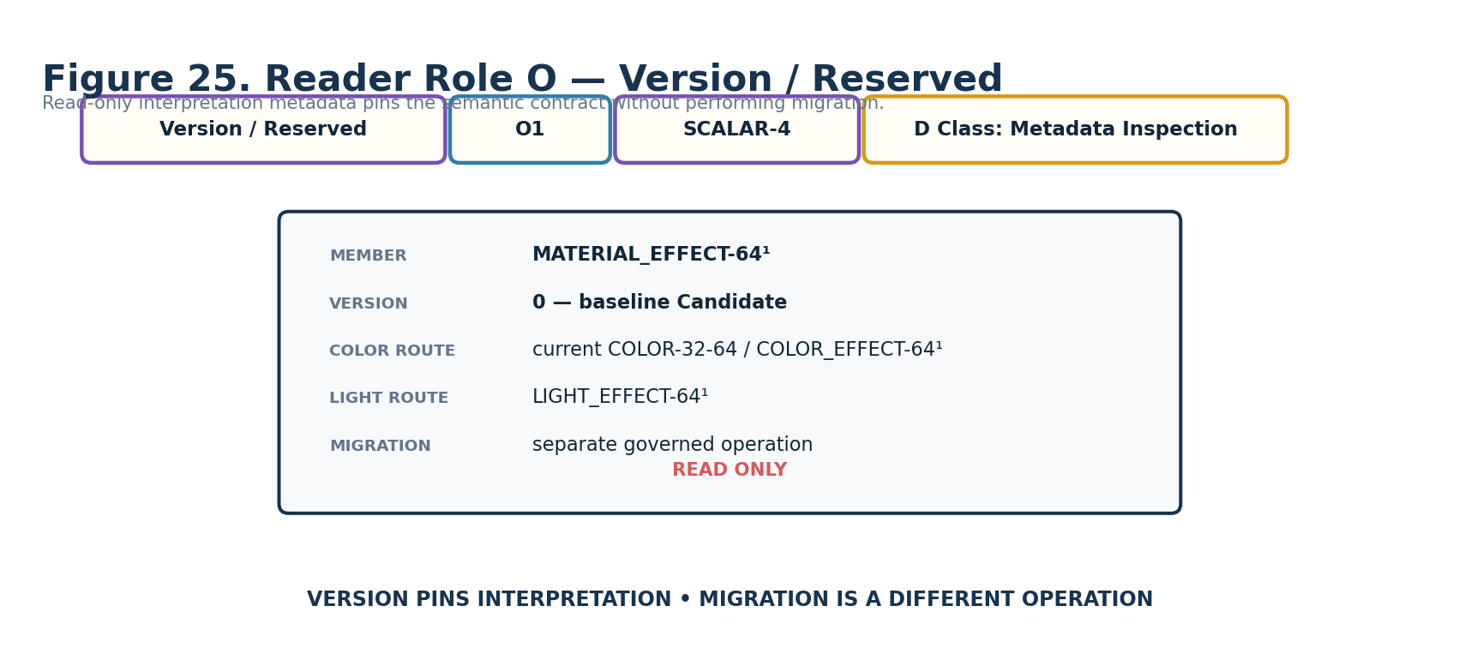
Figure 25. Version / Reserved.
DECLARATION
Version / Reserved | O1 | SCALAR-4 | DREQ-META.VERSION_INSPECT

Property | Contract
D Class | Meta
D Requirement Key | DREQ-META.VERSION_INSPECT
Purpose | Pins the interpretation version of the Candidate Reader contract.
Representative states | 0 baseline Candidate interpretation; 1–14 future registered interpretations; 15 reserved.
Validation / boundary | Migration is a separate governed operation; version inspection does not mutate stored records.
Reader formula / mathematics | SCALAR-4 interpretation-version identity.
Does not own | Migration workflow, upgrade authority, current network availability.

Part 4 — Interface-0, D Requirements, and Complete DARTBOARD
28. Interface-0 Assembly
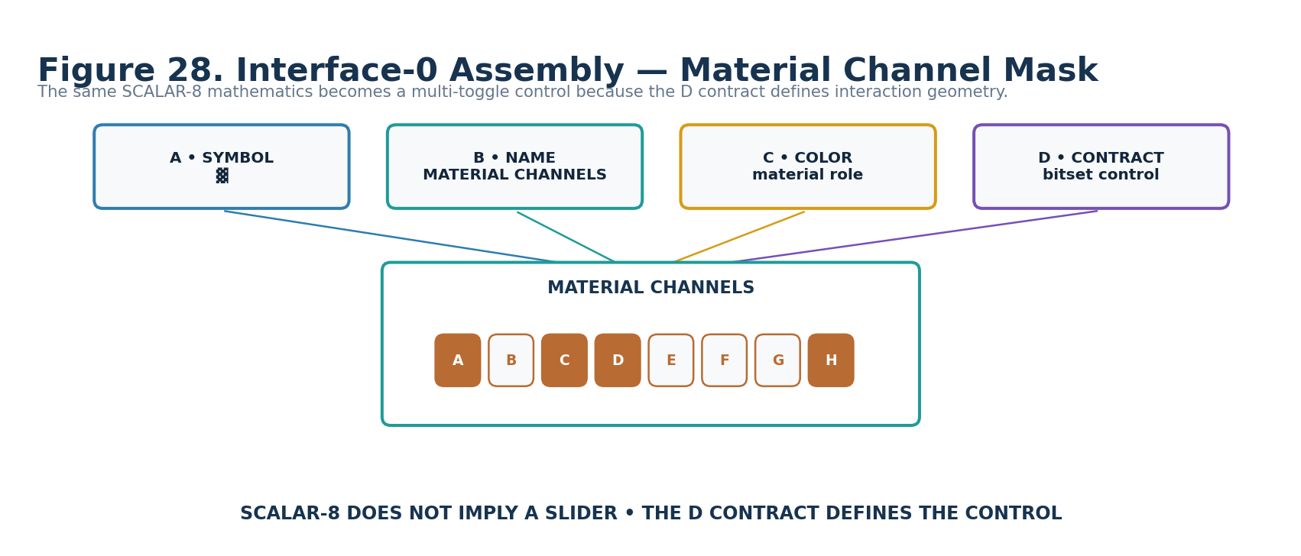
Figure 28. F1 demonstrates why D interface geometry cannot be inferred from BitGroup mathematics.
F1 and a conventional scalar slider can both be mathematically SCALAR-8. Their interface forms are nevertheless different because the D contract describes the interaction geometry appropriate to the bounded Reader meaning. The Material Channel Mask therefore presents eight atomic toggles rather than a continuous slider.

29. Complete Generated MATERIAL DARTBOARD
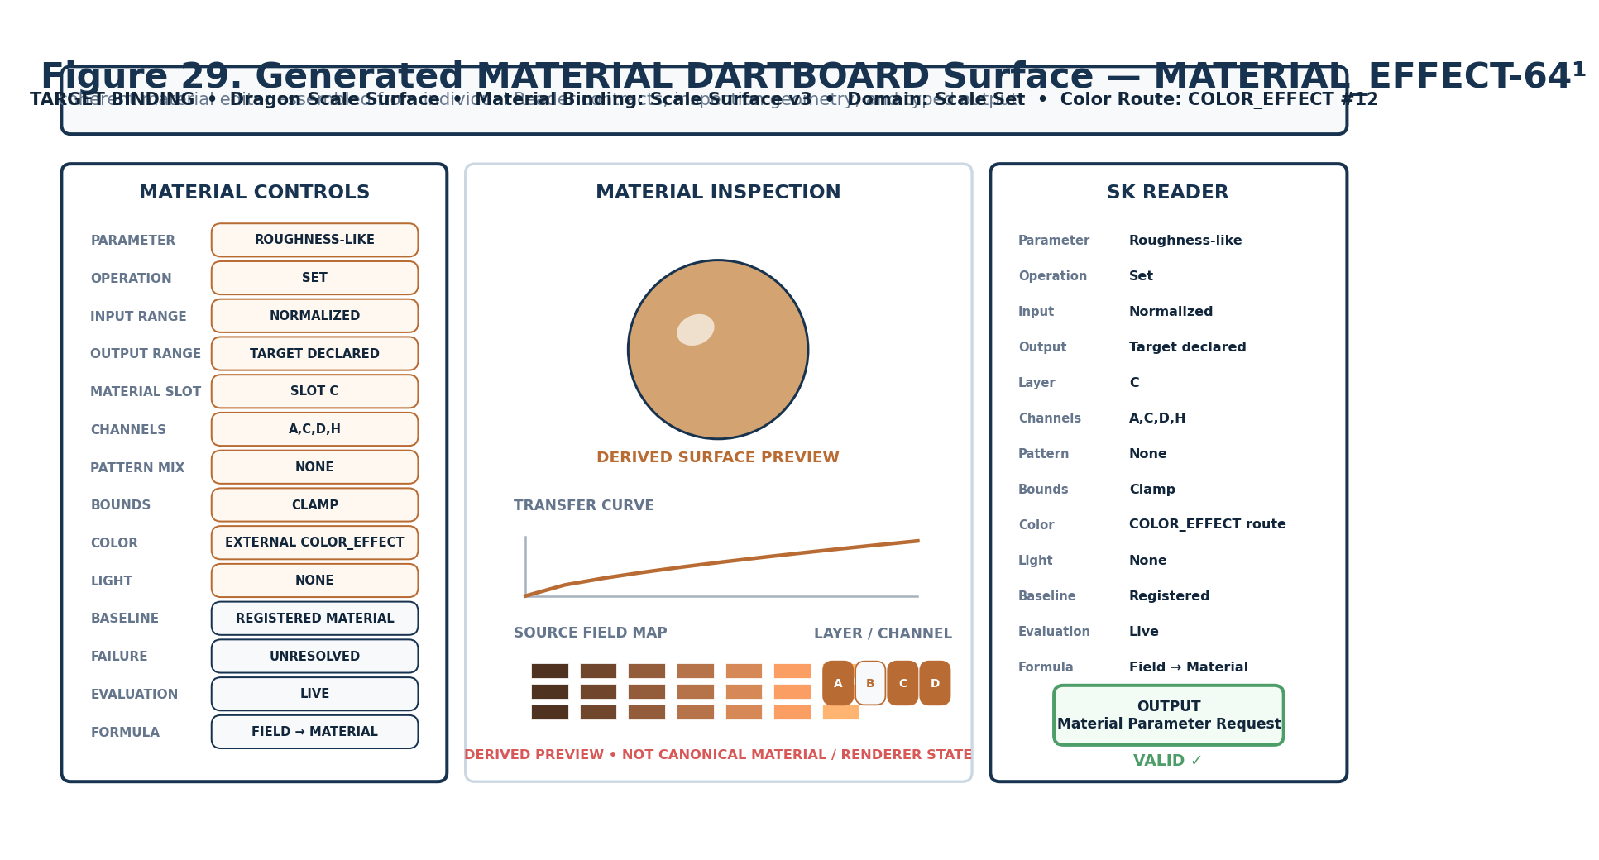
Figure 29. MATERIAL_EFFECT-64¹ material-authoring surface.
The top binding strip is runtime context rather than another BitWord placement. The left column exposes Reader controls, the center provides derived inspection surfaces, and the right column shows the deterministic Reader resolution and typed output. The viewport is explanatory projection only; it does not become canonical material state.

30. One Control to Exact Bits
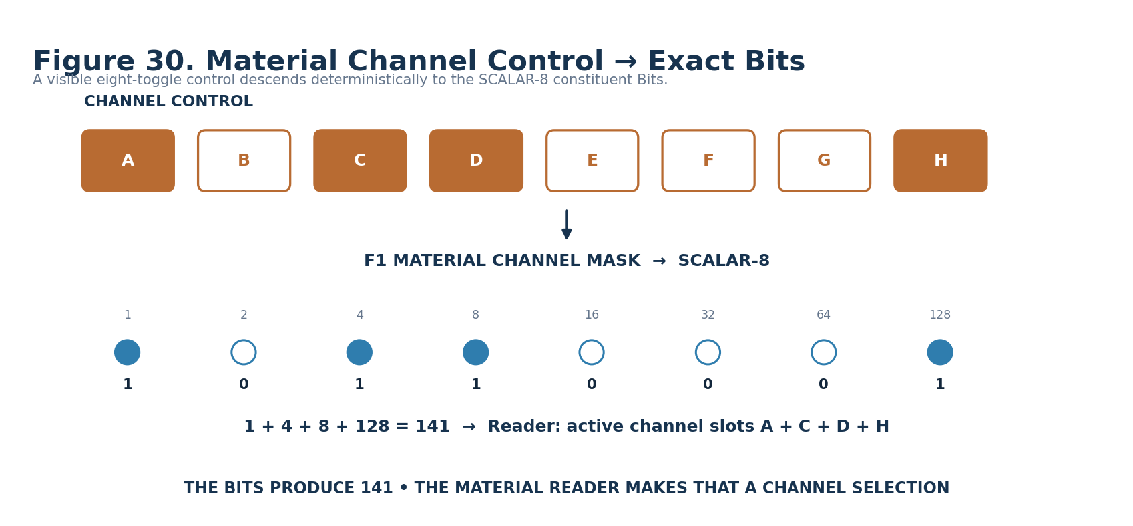
Figure 30. F1=141 resolves from channel toggles A+C+D+H.
This is the same atomicity visible in BIGFOOT: the eight constituent Bits retain their generic binary weights, while the MATERIAL Reader interprets which bound channel positions are active. A human can decode the state manually from the printed weights if necessary.

Candidate D Requirement Map
CANDIDATE BOUNDARY
These are requirement keys, not exact D#.# identities. Exact D records, BOSS symbols, interface assets, and Registry links are implementation work and must not be fabricated inside this Candidate paper.

Reader | Semantic role | Candidate D requirement
A1 | Material Parameter Class | DREQ-CAT.MATERIAL_PARAMETER
B1 | Operation Mode | DREQ-OP.MATERIAL_APPLICATION
C1 | Input Range | DREQ-RANGE.MATERIAL_INPUT
D1 | Output Range | DREQ-RANGE.MATERIAL_OUTPUT
E1 | Material Layer / Slot | DREQ-SLOT.MATERIAL_LAYER
F1 | Material Channel Mask | DREQ-BITSET.MATERIAL_CHANNELS
G1 | Texture / Pattern Mix Mode | DREQ-OP.MATERIAL_PATTERN_MIX
H1 | Bounds Policy | DREQ-POLICY.BOUNDS
I1 | Color Coupling Mode | DREQ-ROUTE.MATERIAL_COLOR
J1 | Emissive / Light Coupling | DREQ-ROUTE.MATERIAL_LIGHT
K1 | Baseline Mode | DREQ-BASELINE.MATERIAL
L1 | Null / Failure Behavior | DREQ-POLICY.FAILURE
M1 | Evaluation Mode | DREQ-EVAL.MODE
N1 | Formula Profile | DREQ-PROFILE.MATERIAL_FORMULA
O1 | Version / Reserved | DREQ-META.VERSION_INSPECT
Part 5 — Reader Algorithm, Typed Output, and Specialist Routing
31. Reader Pipeline
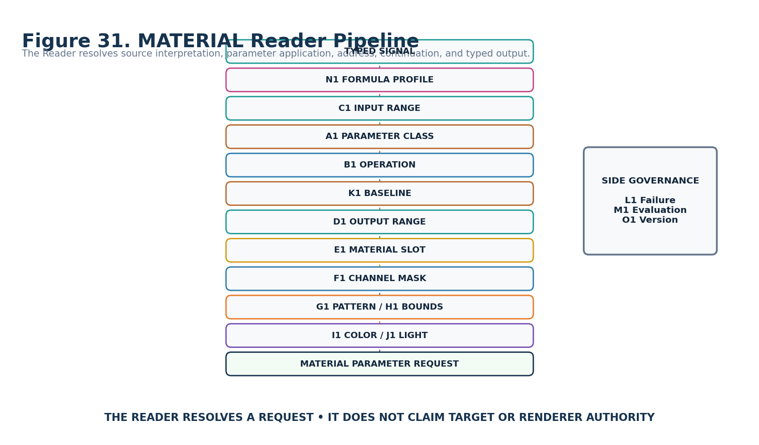
Figure 31. Deterministic semantic resolution from typed source to material request.
The conceptual algorithm starts from a typed source and exact Formula Profile, interprets the source basis, selects the material parameter and operation, resolves any baseline, maps into the output basis, addresses the bound layer/channels, applies pattern/bounds semantics, resolves specialist COLOR/LIGHT continuations, and finally emits a renderer-neutral Material Parameter Request. L1, M1, and O1 govern failure, local evaluation, and interpretation version respectively.

32. Typed Output Structure
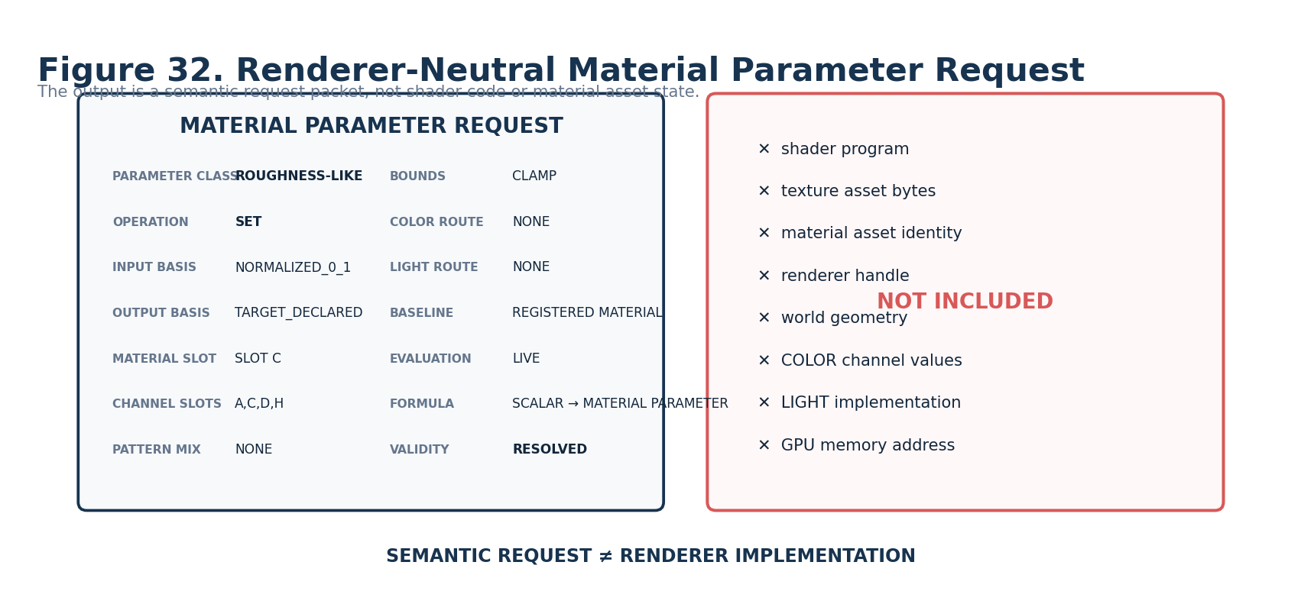
Figure 32. Renderer-neutral Material Parameter Request.
The request intentionally excludes shader code, texture bytes, GPU handles, renderer-specific channel packing, target geometry ownership, actual color channel state, and illumination implementation. Those responsibilities remain with their declared owners.

33. Material Application Binding
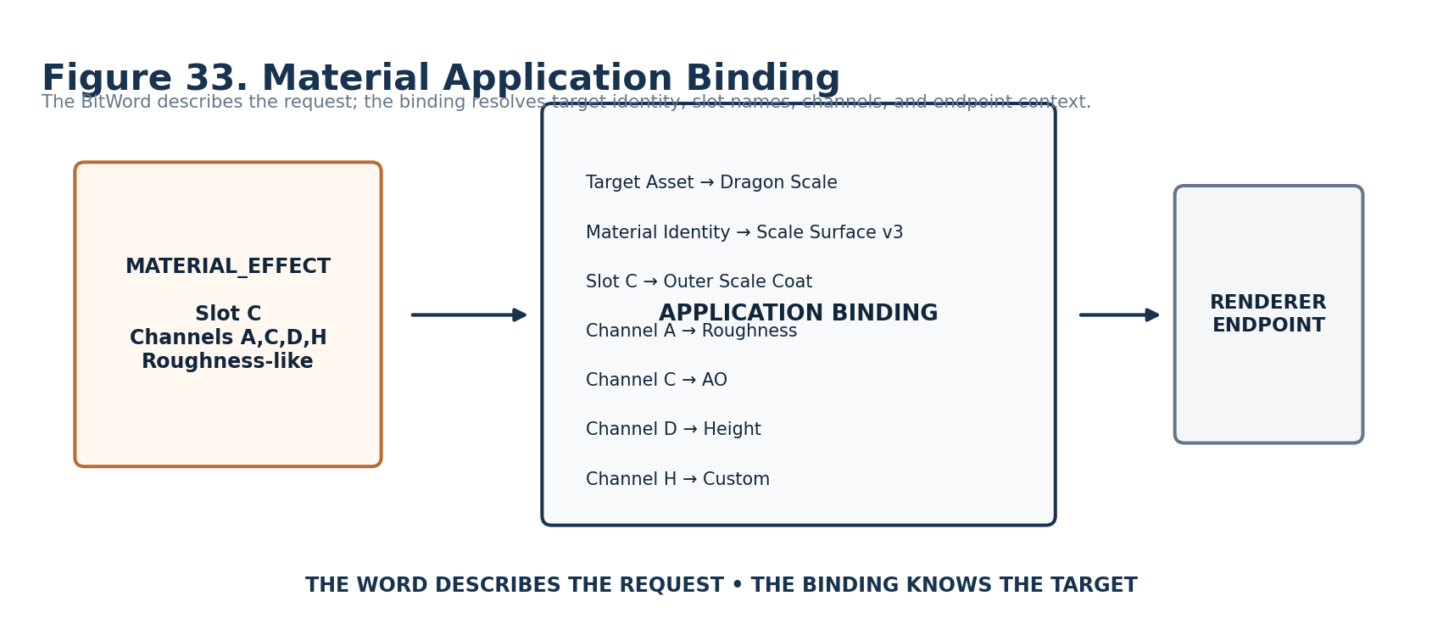
Figure 33. The Binding resolves target/material/channel identities outside the BitWord.

34. COLOR Continuation
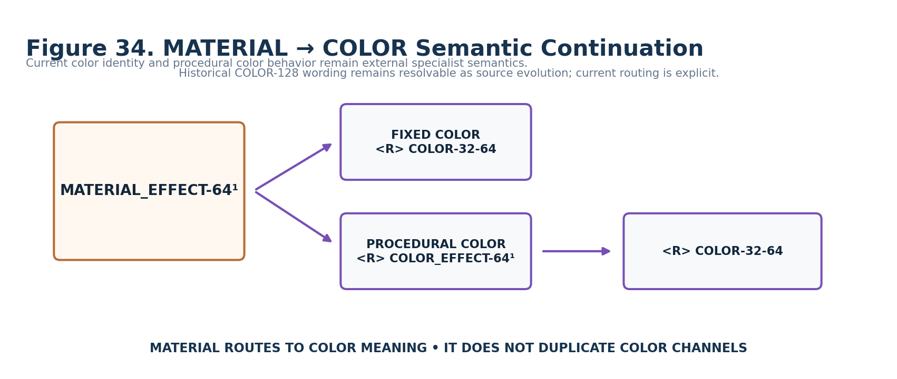
Figure 34. MATERIAL routes to fixed or procedural color semantics without embedding color state.
For a fixed registered color, MATERIAL_EFFECT may continue to COLOR-32-64. For procedural color behavior it continues to COLOR_EFFECT-64¹, which in turn uses registered colors. Historical COLOR-128 wording is preserved as architecture history but not silently treated as the current specialist identity.

35. LIGHT Continuation
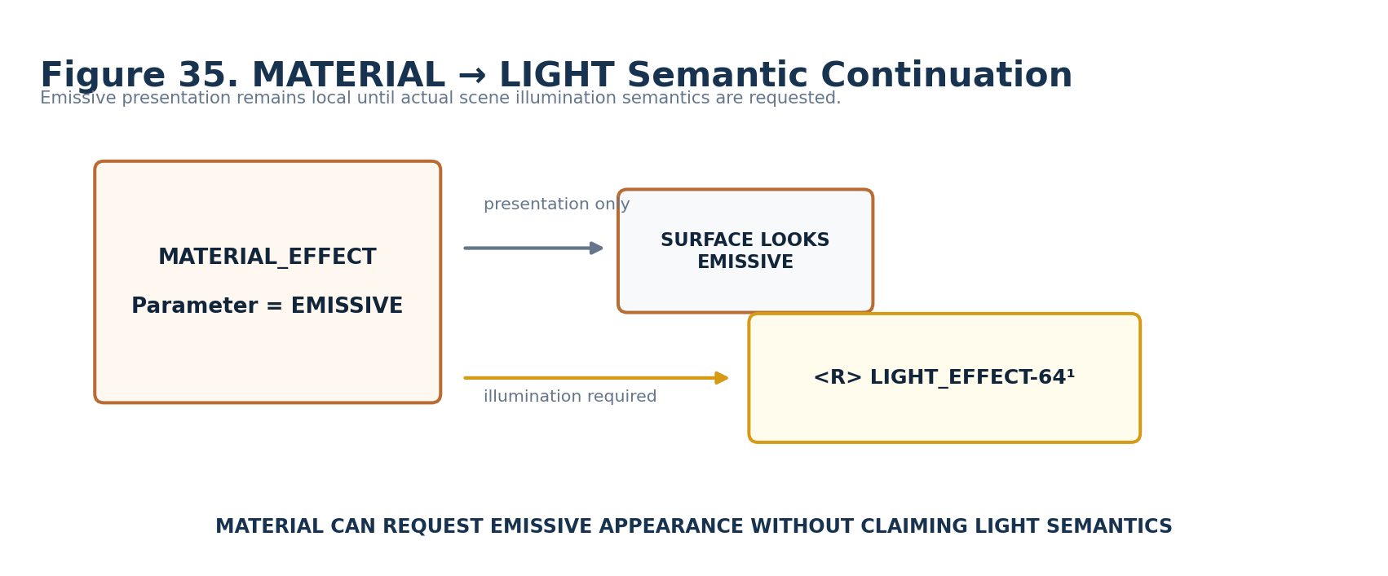
Figure 35. Actual illumination requires explicit LIGHT_EFFECT continuation.

36. Relationship Grammars
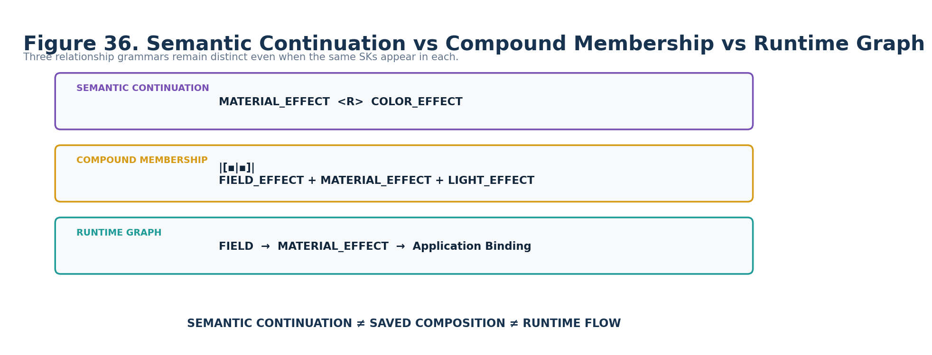
Figure 36. Semantic continuation, Compound membership, and runtime graph topology remain distinct.

37. Input Compatibility and Explicit Transforms
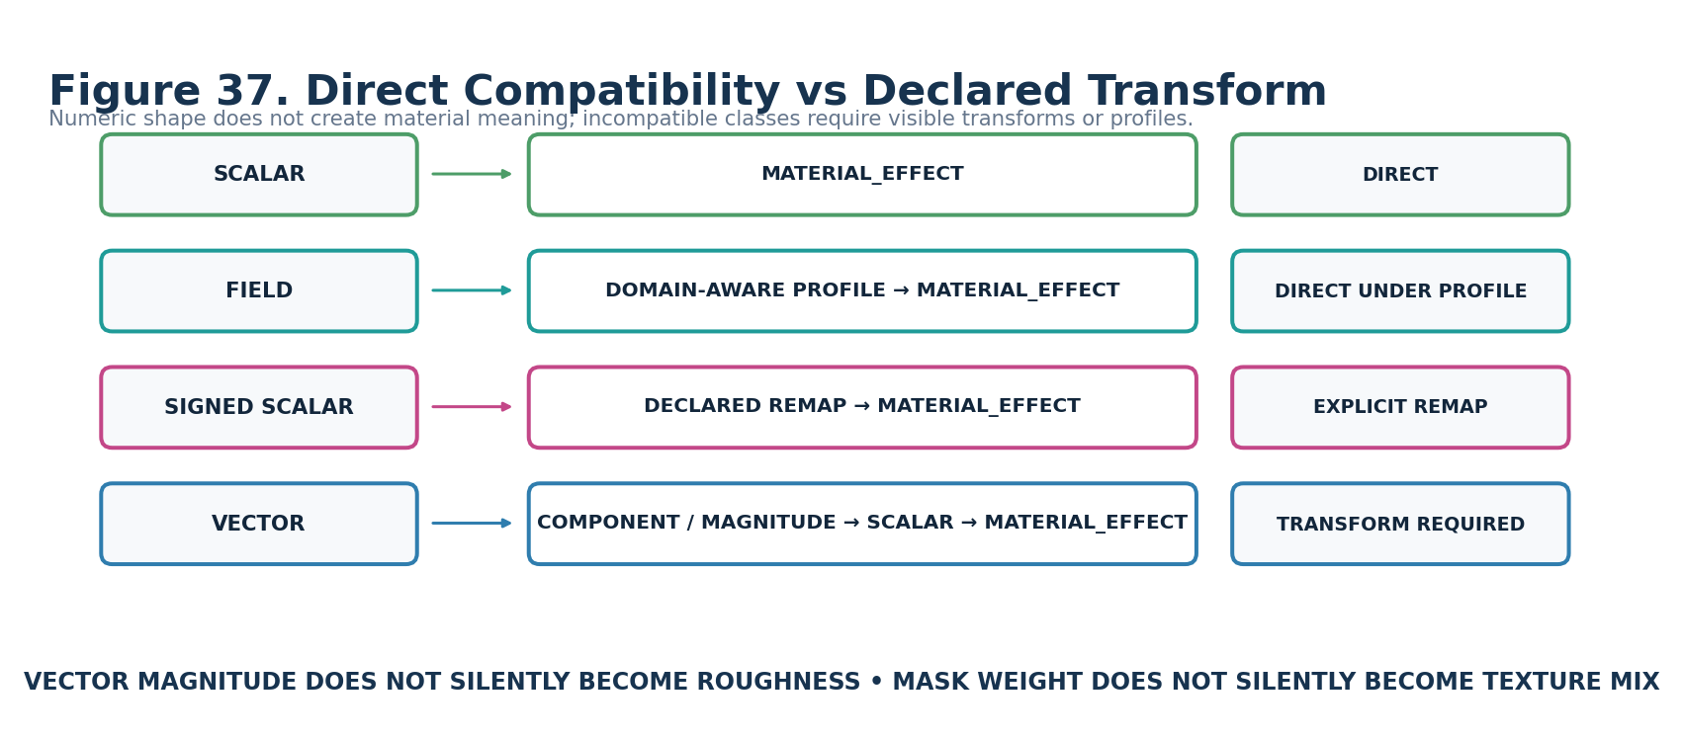
Figure 37. Direct compatibility is semantic, not merely numeric.
Scalar can feed a compatible MATERIAL Formula directly. Field can feed domain-aware formulas directly when the required domain is supplied. Signed Scalar requires an explicit signed-compatible profile or remap. Vector requires an explicit component, magnitude, or other declared transform before a material Scalar-style mapping can occur.

38. Interoperability Card
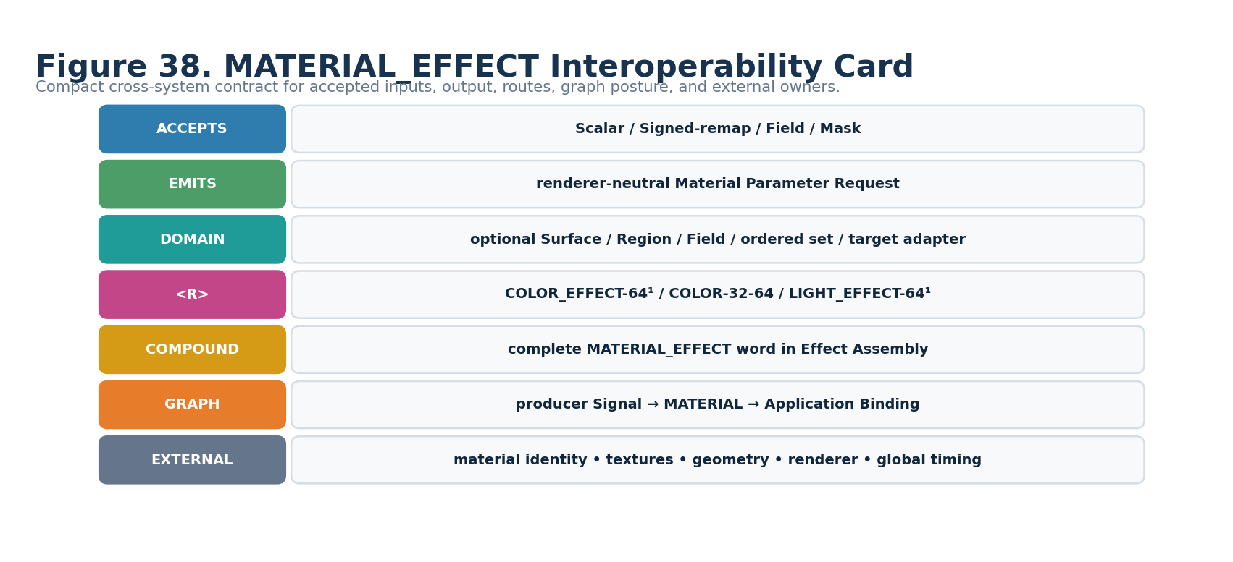
Figure 38. Compact Effects Studio interoperability contract.

Determinism Posture
MATERIAL_EFFECT-64¹ does not dedicate a placement to determinism because the word introduces no intrinsic randomness. Determinism is derived from the upstream Signal, registered Formula Profile, baseline source, material/application binding, and evaluation context. A stored determinism flag could contradict that dependency chain and is therefore intentionally omitted from this Candidate member.
DERIVED DETERMINISM
deterministic source + deterministic Formula Profile + deterministic baseline/binding + deterministic evaluation context → deterministic Material Parameter Request. Stochastic upstream state remains stochastic downstream through provenance.

Part 6 — Worked Examples, Invalid States, and Conformance
39. Worked Example — Wet Stone
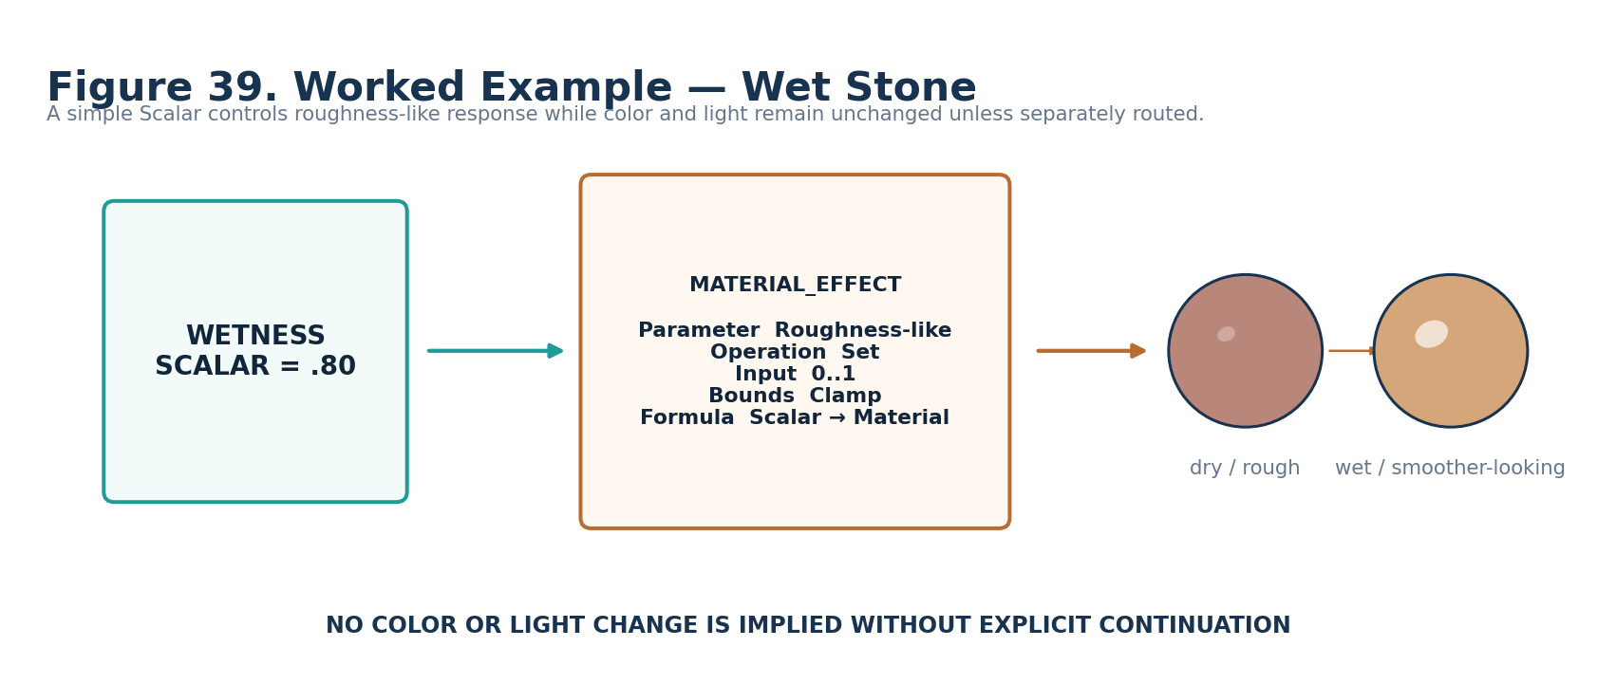
Figure 39. Scalar wetness maps to roughness-like surface response.
This minimal example demonstrates that a material request can be useful without changing color or illumination. A wetness Scalar of 0.80 is mapped through a Scalar→Material Formula into a roughness-like request for the bound stone material. COLOR and LIGHT remain unchanged because no continuation is declared.

40. Worked Example — Dragon Scale Shimmer
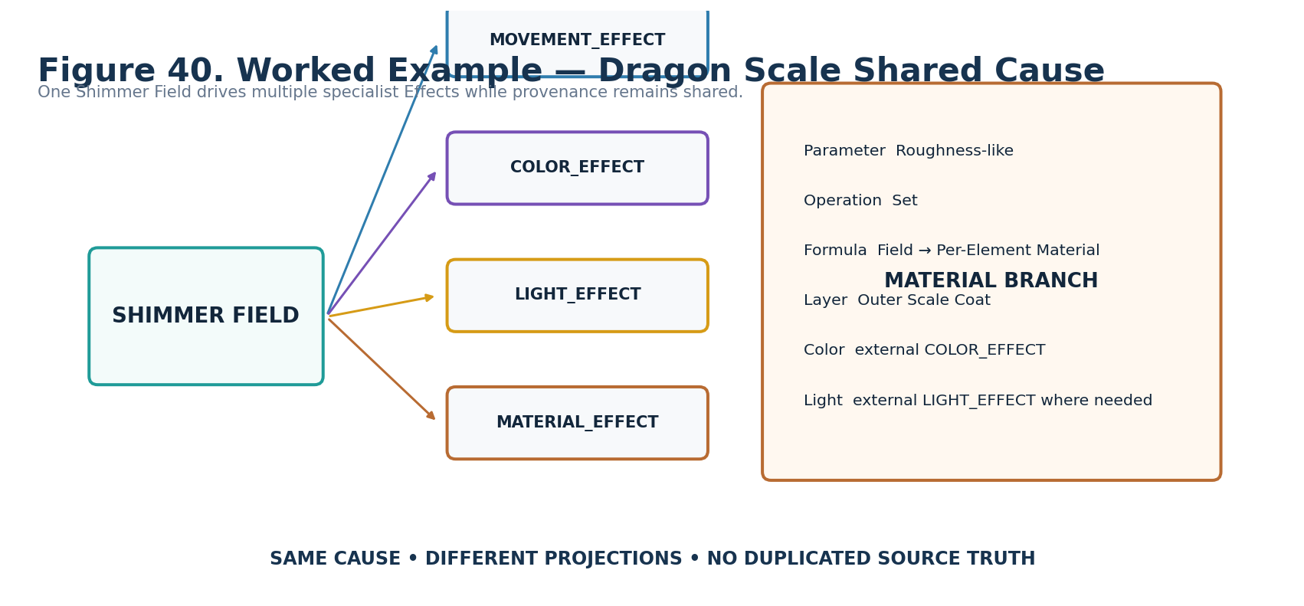
Figure 40. One Field drives multiple specialist projections including MATERIAL_EFFECT.
The Shimmer Field remains one shared cause. MATERIAL_EFFECT maps the Field into per-element roughness-like response on the Outer Scale Coat while COLOR_EFFECT, LIGHT_EFFECT, and MOVEMENT_EFFECT resolve their own bounded projections. This is a conformance test for source preservation and provenance.

41. Worked Example — Texture Reveal Through Mask
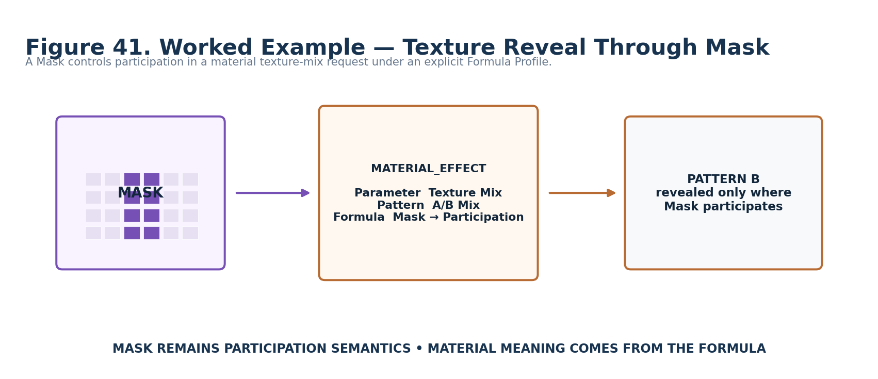
Figure 41. Mask participation gates a material pattern mix under an explicit profile.
The Mask stays a participation Signal. It does not become material amount merely because both can be represented numerically. The selected Formula Profile explicitly interprets Mask participation into texture/pattern application.

42. Invalid State — Missing Material Slot
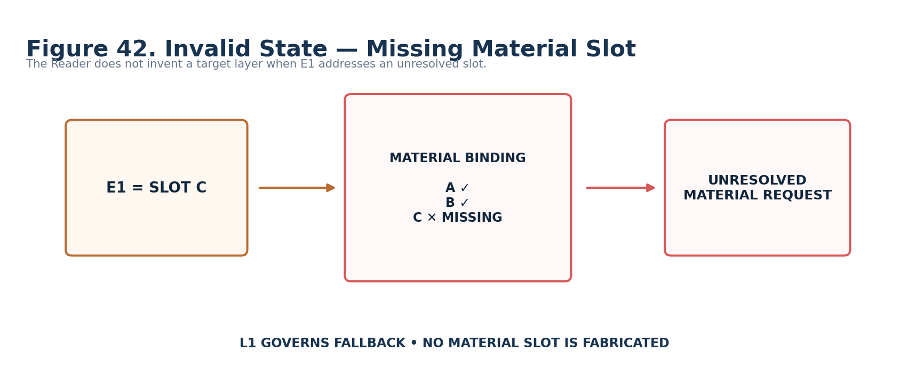
Figure 42. E1 slot address does not resolve in the active Material Binding.
L1 governs whether the request becomes unresolved, holds last valid, uses baseline, suppresses application, errors, or defers to an external policy. No replacement slot is invented.

43. Invalid State — Missing Channel Binding
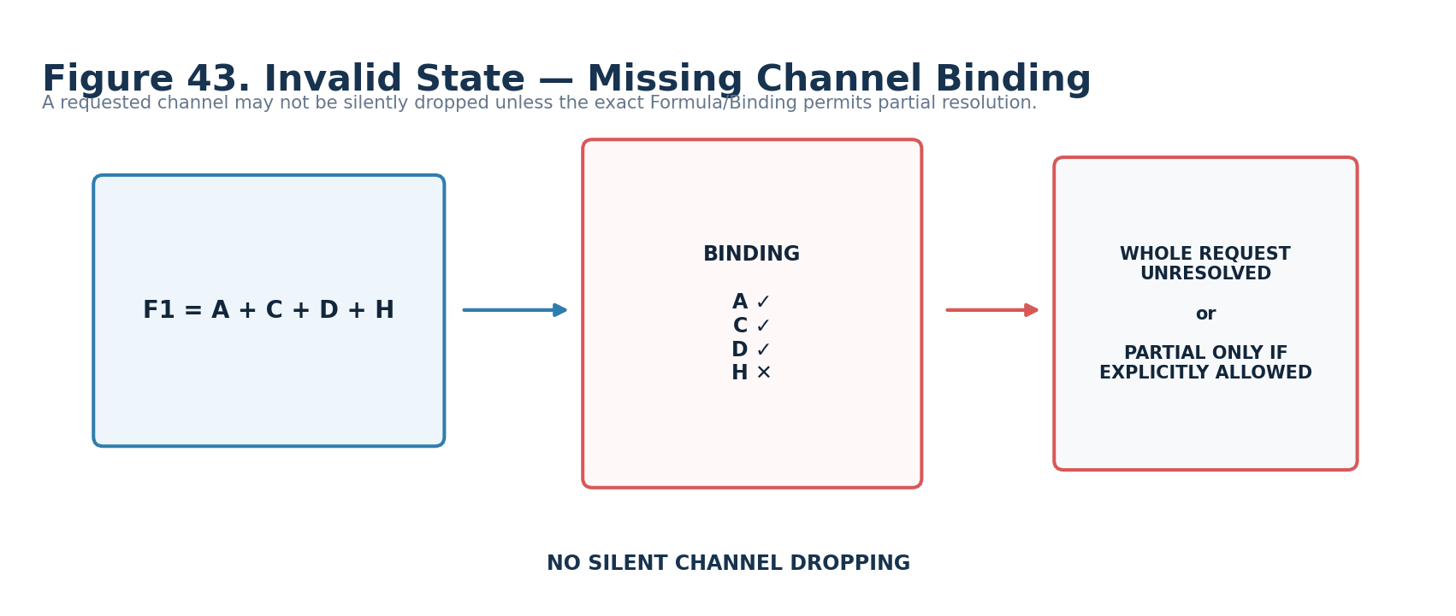
Figure 43. One requested F1 channel is unavailable.
By default the request cannot silently drop H and proceed as though the requested state were A+C+D. Partial resolution is permitted only when the exact Formula Profile or Material Binding explicitly declares that behavior.

44. Invalid State — Missing COLOR Route
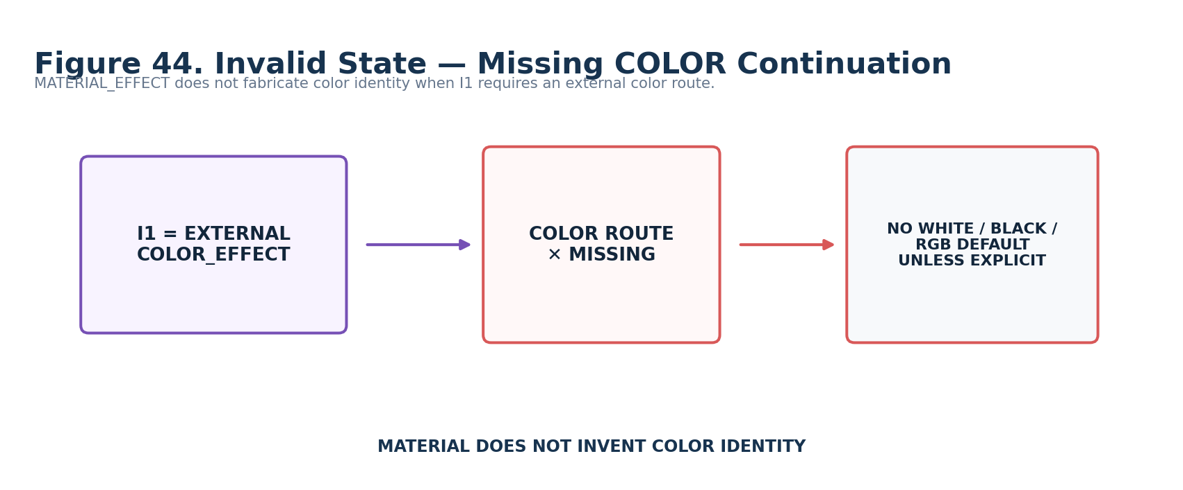
Figure 44. I1 requires an external color route that is absent.
MATERIAL_EFFECT does not fabricate white, black, RGB(1,1,1), or any other color identity. L1 governs the visible fallback/invalid state.

45. Endpoint Capability Mismatch
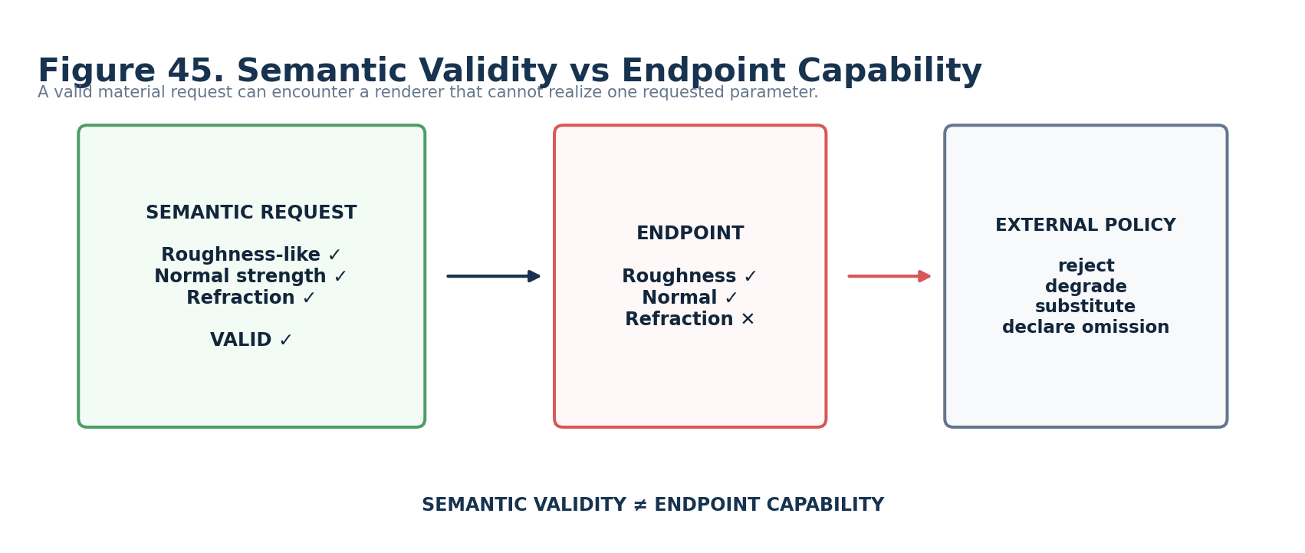
Figure 45. A valid semantic request encounters a renderer without one requested capability.
Semantic validity and endpoint capability are different layers. The renderer or Application Binding can reject, degrade, substitute, or explicitly omit unsupported realization, but the upstream MATERIAL_EFFECT request does not become semantically different merely because one endpoint cannot realize it.

46. Minimum Sufficient Resolution Gate
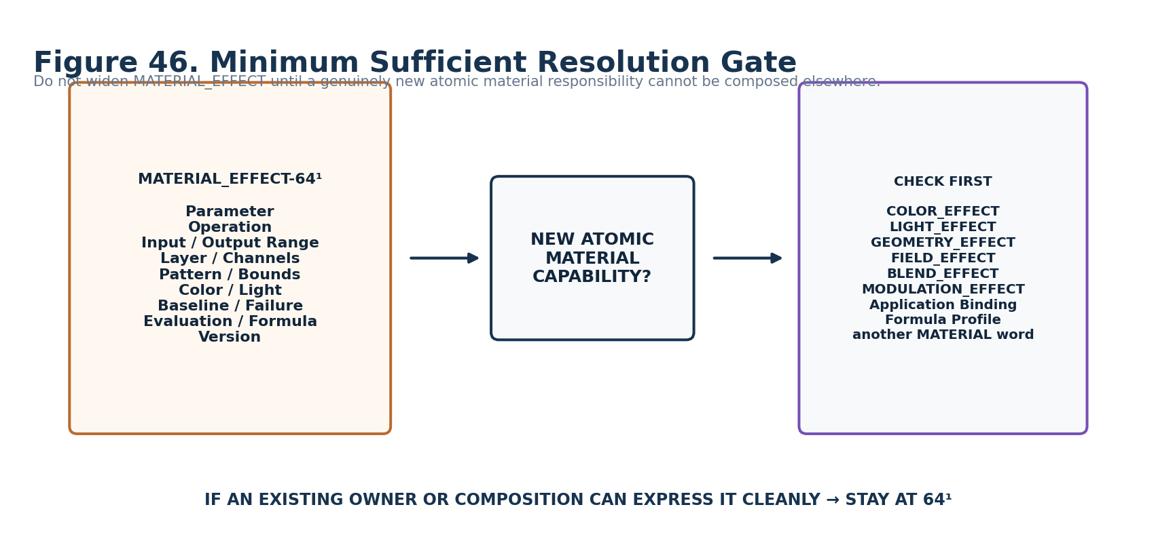
Figure 46. MATERIAL_EFFECT stays at 64¹ until a genuinely new atomic responsibility earns width.
Before proposing MATERIAL_EFFECT-128², first ask whether the capability belongs in COLOR_EFFECT, LIGHT_EFFECT, GEOMETRY_EFFECT, FIELD_EFFECT, BLEND_EFFECT, MODULATION_EFFECT, an Application Binding, a Formula Profile, another MATERIAL_EFFECT word, or the renderer. Structural richness is not itself a reason to widen the word.

Conformance Scenarios
ID | Scenario | Expected result
C-01 | Safe zero | A1=0 emits no Material Request regardless of other stored role values.
C-02 | Scalar direct | Normalized Scalar maps through a declared Scalar→Material profile.
C-03 | Signed remap | Signed Scalar is rejected unless an explicit signed-compatible profile/remap is selected.
C-04 | Vector transform | Vector is rejected for scalar material control unless a visible component/magnitude transform exists.
C-05 | Field domain | Field→per-element material requires the declared target domain.
C-06 | Mask participation | Mask remains participation semantics under the selected material Formula.
C-07 | Missing slot | Unresolved E1 slot produces visible failure under L1.
C-08 | Missing channel | Requested F1 channel cannot be silently dropped.
C-09 | Missing color | Required I1 COLOR route remains unresolved unless explicit fallback exists.
C-10 | Emissive separation | J1 internal emissive does not create LIGHT semantics.
C-11 | Endpoint mismatch | Valid request can remain valid even when an endpoint cannot realize one parameter.
C-12 | Renderer replacement | Equivalent renderer-neutral request survives renderer replacement; realization may differ.
C-13 | Source preservation | Material branch does not mutate a shared Field used by other Effects.
C-14 | Version inspection | O1 reads interpretation version without mutating/migrating the record.

Part 7 — Planning Handoff and Promotion Gate
47. Deterministic Planning Manifest
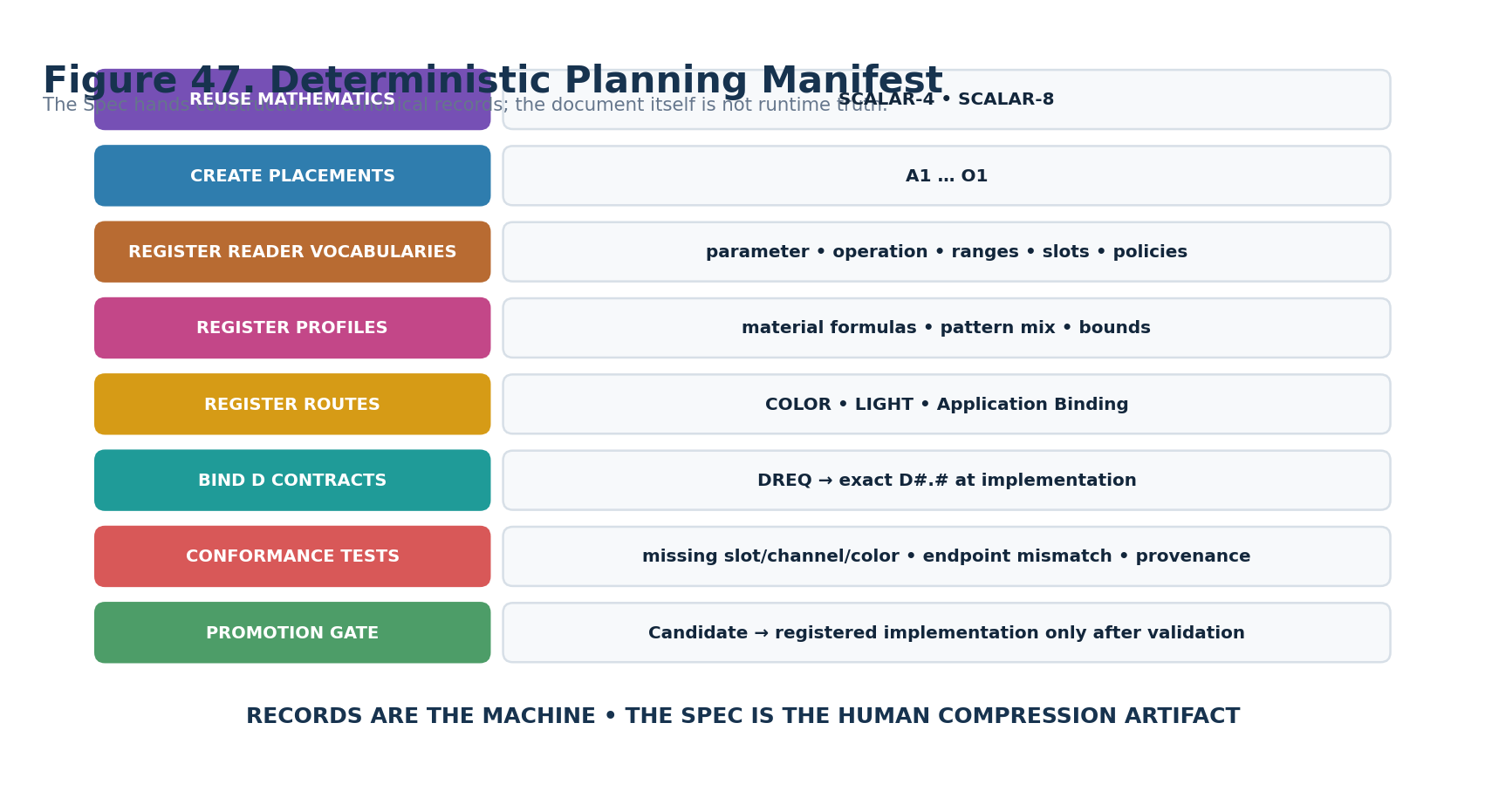
Figure 47. Record construction plan for promotion from Candidate paper to canonical implementation.
The implementation task is to create or resolve canonical records that realize this Candidate architecture. The document is not an executable dependency. Once the Reader records and their required semantic assets exist, implementations consume those records directly.

Construction Checklist
□ Resolve/reuse canonical SCALAR-4 and SCALAR-8 BitGroups.
□ Create A1:O1 MATERIAL_EFFECT-64¹ placements at the exact B000:B063 addresses.
□ Register the Material Parameter, Operation, Input Range, Output Range, Layer/Slot, Pattern Mix, Bounds, Color Coupling, Light Coupling, Baseline, Failure, Evaluation, Formula Profile, and Version vocabularies.
□ Bind F1 constituent Bits to channel-slot positions A–H while preserving generic SCALAR-8 mathematics.
□ Register Material Formula Profiles with accepted input classes, domain requirements, mapping equations, undefined conditions, determinism posture, and human-readable explanations.
□ Register current COLOR routes to COLOR_EFFECT-64¹ and COLOR-32-64; preserve historical COLOR-128 references as source evolution metadata.
□ Register LIGHT continuation through LIGHT_EFFECT-64¹ where actual illumination semantics are required.
□ Define Material/Application Binding requirements for target identity, material identity, slot map, channel map, output range/unit mapping, baseline context, and endpoint capability policy.
□ Resolve exact D#.# interface contracts from the DREQ-* map and bind interface metadata/BOSS assets without changing Reader semantics.
□ Test Safe Zero, direct Scalar, explicit Signed remap, Vector rejection/transform, Field domain, Mask participation, missing slot/channel/color, emissive separation, endpoint mismatch, source preservation, renderer replacement, and version inspection.
□ Promote only after the Reader, bindings, profiles, conformance suite, and version interpretation are deterministic and inspectable.

Promotion Gate
CANDIDATE → REGISTERED
Promotion requires canonical Bit/BitGroup reuse, exact placement registration, Reader vocabularies, Formula Profiles, D contracts, Material Binding semantics, COLOR/LIGHT continuation routes, version interpretation, and conformance results. The Candidate paper shall not be treated as sufficient implementation evidence by itself.

Appendix A — Complete Candidate Reader State Enumerations

A1 Material Parameter Class
Value | Candidate meaning
0 | OFF / NO REQUEST
1 | OPACITY
2 | EMISSIVE
3 | ROUGHNESS-LIKE
4 | REFLECTIVITY
5 | METALLIC-LIKE
6 | REFRACTION
7 | TEXTURE / PATTERN MIX
8 | NORMAL STRENGTH
9 | SURFACE RESPONSE PROFILE
10–15 | RESERVED / EXTENSION

B1 Operation Mode
Value | Candidate meaning
0 | SET
1 | ADD
2 | MULTIPLY
3 | INTERPOLATE
4 | RELATIVE
5 | PROFILE
6 | EXTERNAL
7–15 | RESERVED

C1 Input Range
Value | Candidate meaning
0 | SOURCE_DECLARED
1 | NORMALIZED_0_1
2 | SIGNED_-1_1
3 | RECTIFIED
4 | ABSOLUTE
5 | INVERTED_0_1
6 | PROFILE
7 | EXTERNAL_RANGE
8–15 | RESERVED

D1 Output Range
Value | Candidate meaning
0 | TARGET_DECLARED
1 | NORMALIZED_0_1
2 | SIGNED_-1_1
3 | POSITIVE_NORMALIZED
4 | PARAMETER_PROFILE
5 | BINDING_RANGE
6 | EXTERNAL_RANGE
7–15 | RESERVED

E1 Material Layer / Slot
Value | Candidate meaning
0 | DEFAULT / PRIMARY
1 | SLOT A
2 | SLOT B
3 | SLOT C
4 | SLOT D
5 | SLOT E
6 | SLOT F
7 | SLOT G
8 | SLOT H
9 | SLOT I
10 | SLOT J
11 | SLOT K
12 | SLOT L
13 | SLOT M
14 | EXTERNAL SLOT
15 | RESERVED

G1 Texture / Pattern Mix
Value | Candidate meaning
0 | NONE / NOT APPLICABLE
1 | A/B MIX
2 | OVERLAY
3 | REPLACE
4 | EXTERNAL
5 | PROFILE
6–15 | RESERVED

H1 Bounds Policy
Value | Candidate meaning
0 | CLAMP
1 | WRAP
2 | MIRROR / PING_PONG
3 | REJECT
4 | PRESERVE_OVERFLOW
5 | EXTERNAL_CONSTRAINT
6 | PROFILE
7–15 | RESERVED

I1 Color Coupling
Value | Candidate meaning
0 | NONE
1 | FIXED REGISTERED COLOR
2 | EXTERNAL COLOR_EFFECT
3 | PALETTE / COLOR BEHAVIOR ROUTE
4 | EXTERNAL COLOR PROFILE
5–15 | RESERVED

J1 Emissive / Light Coupling
Value | Candidate meaning
0 | NONE
1 | INTERNAL EMISSIVE PRESENTATION
2 | EXTERNAL LIGHT_EFFECT
3 | EMISSIVE + EXTERNAL LIGHT
4 | PROFILE
5 | EXTERNAL POLICY
6–15 | RESERVED

K1 Baseline Mode
Value | Candidate meaning
0 | REGISTERED / ORIGINAL MATERIAL
1 | CURRENT MATERIAL STATE
2 | CAPTURED SNAPSHOT
3 | ZERO / NEUTRAL
4 | EXTERNAL BASELINE
5 | PROFILE
6–15 | RESERVED

L1 Null / Failure
Value | Candidate meaning
0 | UNRESOLVED / NO REQUEST
1 | HOLD LAST VALID
2 | USE BASELINE
3 | SUPPRESS MATERIAL APPLICATION
4 | ERROR
5 | EXTERNAL POLICY
6–15 | RESERVED

M1 Evaluation Mode
Value | Candidate meaning
0 | LIVE
1 | SNAPSHOT
2 | SAMPLE_AND_HOLD
3 | EVENT_DRIVEN
4–15 | RESERVED

N1 Formula Profile
Value | Candidate meaning
0 | DIRECT / BINDING DEFAULT
1 | SCALAR → MATERIAL PARAMETER
2 | SIGNED → MATERIAL REMAP
3 | FIELD → PER-ELEMENT MATERIAL
4 | MASK → MATERIAL PARTICIPATION
5 | FIELD → TEXTURE MIX
6 | FIELD → NORMAL STRENGTH
7 | SCALAR → OPACITY
8 | SCALAR → EMISSIVE
9 | EXTERNAL MATERIAL FORMULA
10–15 | RESERVED

O1 Version
Value | Candidate meaning
0 | baseline Candidate interpretation
1–14 | future registered interpretations
15 | RESERVED

F1 Material Channel Mask — SCALAR-8 Atomic Slot Map
Mathematical state | Material Reader meaning
Bit weight 1 | Slot A
2 | Slot B
4 | Slot C
8 | Slot D
16 | Slot E
32 | Slot F
64 | Slot G
128 | Slot H
0 | Binding default / whole parameter unless exact profile requires explicit channels

Appendix B — Complete B000:B063 Physical Map
Reader | Physical Bits | BitGroup | Reader meaning
A1 | B000:B003 | SCALAR-4 | Material Parameter Class
B1 | B004:B007 | SCALAR-4 | Operation Mode
C1 | B008:B011 | SCALAR-4 | Input Range
D1 | B012:B015 | SCALAR-4 | Output Range
E1 | B016:B019 | SCALAR-4 | Material Layer / Slot
F1 | B020:B027 | SCALAR-8 | Material Channel Mask
G1 | B028:B031 | SCALAR-4 | Texture / Pattern Mix Mode
H1 | B032:B035 | SCALAR-4 | Bounds Policy
I1 | B036:B039 | SCALAR-4 | Color Coupling Mode
J1 | B040:B043 | SCALAR-4 | Emissive / Light Coupling
K1 | B044:B047 | SCALAR-4 | Baseline Mode
L1 | B048:B051 | SCALAR-4 | Null / Failure Behavior
M1 | B052:B055 | SCALAR-4 | Evaluation Mode
N1 | B056:B059 | SCALAR-4 | Formula Profile
O1 | B060:B063 | SCALAR-4 | Version / Reserved
Figure 9. Physical BitWord map repeated for Appendix B.

Appendix C — Parameter-Class Applicability Matrix
Parameter |  |  | Slot | Channels | Pattern Mix | Color Route | Light Route | Baseline
Opacity |  |  | ✓ | optional | — | — | — | required for relative ops
Emissive |  |  | ✓ | optional | — | optional | ✓ | required for relative ops
Roughness-like |  |  | ✓ | optional | — | — | — | required for relative ops
Reflectivity |  |  | ✓ | optional | — | — | — | required for relative ops
Metallic-like |  |  | ✓ | optional | — | — | — | required for relative ops
Refraction |  |  | ✓ | optional | — | — | — | required for relative ops
Texture/Pattern Mix |  |  | ✓ | ✓ | ✓ | optional | — | required for relative ops
Normal Strength |  |  | ✓ | ✓ | — | — | — | required for relative ops
MATRIX INTERPRETATION
This matrix is Candidate applicability guidance, not a universal renderer ontology. Exact Formula Profiles may narrow or extend required roles while preserving MATERIAL_EFFECT ownership boundaries.

Appendix D — Input Compatibility and Transform Matrix
Signal Class | Posture | Rule
Scalar | DIRECT | Compatible Formula Profile still required.
Signed Scalar | EXPLICIT REMAP / SIGNED PROFILE | No silent rectification.
Field | DIRECT UNDER DOMAIN-AWARE PROFILE | Required domain/context must resolve.
Mask | DIRECT UNDER PARTICIPATION PROFILE | Mask stays participation semantics.
Vector | TRANSFORM REQUIRED | Component/magnitude/etc. must be declared.
Angular / Orientation | PROFILE / TRANSFORM REQUIRED | No default material interpretation.
Probability | PROFILE / TRANSFORM REQUIRED | Probability does not silently become opacity.
Event | PROFILE REQUIRED | Only when event-driven material behavior is explicitly modeled.
Path / Trajectory | DOMAIN TRANSFORM / PROFILE REQUIRED | No direct material meaning by numeric resemblance.

Appendix E — Candidate D Requirement Index
Reader | Role | BitGroup | DREQ
A1 | Material Parameter Class | SCALAR-4 | DREQ-CAT.MATERIAL_PARAMETER
B1 | Operation Mode | SCALAR-4 | DREQ-OP.MATERIAL_APPLICATION
C1 | Input Range | SCALAR-4 | DREQ-RANGE.MATERIAL_INPUT
D1 | Output Range | SCALAR-4 | DREQ-RANGE.MATERIAL_OUTPUT
E1 | Material Layer / Slot | SCALAR-4 | DREQ-SLOT.MATERIAL_LAYER
F1 | Material Channel Mask | SCALAR-8 | DREQ-BITSET.MATERIAL_CHANNELS
G1 | Texture / Pattern Mix Mode | SCALAR-4 | DREQ-OP.MATERIAL_PATTERN_MIX
H1 | Bounds Policy | SCALAR-4 | DREQ-POLICY.BOUNDS
I1 | Color Coupling Mode | SCALAR-4 | DREQ-ROUTE.MATERIAL_COLOR
J1 | Emissive / Light Coupling | SCALAR-4 | DREQ-ROUTE.MATERIAL_LIGHT
K1 | Baseline Mode | SCALAR-4 | DREQ-BASELINE.MATERIAL
L1 | Null / Failure Behavior | SCALAR-4 | DREQ-POLICY.FAILURE
M1 | Evaluation Mode | SCALAR-4 | DREQ-EVAL.MODE
N1 | Formula Profile | SCALAR-4 | DREQ-PROFILE.MATERIAL_FORMULA
O1 | Version / Reserved | SCALAR-4 | DREQ-META.VERSION_INSPECT

Appendix F — COLOR / LIGHT / GEOMETRY Routing Contract
Relationship |  |  | When used | Protected ownership
MATERIAL_EFFECT → COLOR-32-64 |  |  | Fixed registered color identity required. | COLOR owns channel state.
MATERIAL_EFFECT → COLOR_EFFECT-64¹ |  |  | Procedural color behavior required. | COLOR_EFFECT owns palette/traversal/mapping behavior.
MATERIAL_EFFECT → LIGHT_EFFECT-64¹ |  |  | Actual illumination behavior required. | LIGHT_EFFECT owns illumination request semantics.
MATERIAL_EFFECT vs GEOMETRY_EFFECT |  |  | Normal/shading presentation stays material; actual form mutation routes to Geometry. | GEOMETRY_EFFECT owns form/topology change.
MATERIAL_EFFECT vs BLEND_EFFECT |  |  | Pattern mixing is local material application; typed Signal combination routes to BLEND_EFFECT. | BLEND_EFFECT owns Signal combination algebra.
EVOLUTION NOTE
Historical source documents may mention COLOR-128. The current Candidate architecture explicitly uses COLOR-32-64 and COLOR_EFFECT-64¹. This note records architectural evolution rather than silently overwriting the source lineage.

Appendix G — Build / Conformance Checklist
□ Resolve/reuse canonical SCALAR-4 and SCALAR-8 BitGroups.
□ Create A1:O1 MATERIAL_EFFECT-64¹ placements at the exact B000:B063 addresses.
□ Register the Material Parameter, Operation, Input Range, Output Range, Layer/Slot, Pattern Mix, Bounds, Color Coupling, Light Coupling, Baseline, Failure, Evaluation, Formula Profile, and Version vocabularies.
□ Bind F1 constituent Bits to channel-slot positions A–H while preserving generic SCALAR-8 mathematics.
□ Register Material Formula Profiles with accepted input classes, domain requirements, mapping equations, undefined conditions, determinism posture, and human-readable explanations.
□ Register current COLOR routes to COLOR_EFFECT-64¹ and COLOR-32-64; preserve historical COLOR-128 references as source evolution metadata.
□ Register LIGHT continuation through LIGHT_EFFECT-64¹ where actual illumination semantics are required.
□ Define Material/Application Binding requirements for target identity, material identity, slot map, channel map, output range/unit mapping, baseline context, and endpoint capability policy.
□ Resolve exact D#.# interface contracts from the DREQ-* map and bind interface metadata/BOSS assets without changing Reader semantics.
□ Test Safe Zero, direct Scalar, explicit Signed remap, Vector rejection/transform, Field domain, Mask participation, missing slot/channel/color, emissive separation, endpoint mismatch, source preservation, renderer replacement, and version inspection.
□ Promote only after the Reader, bindings, profiles, conformance suite, and version interpretation are deterministic and inspectable.

Final Human-Learning Test
COMPLETION CRITERION
A knowledgeable human should be able to skim the figures months later and recover the bounded question, physical allocation, Reader meanings, ownership boundaries, interface geometry, specialist continuations, failure posture, and construction plan without traversing the live Registry. If the figures do not accomplish that, the Specification is not finished.

Reference Basis
• CERBERUS SK Specification Authoring Standard v1.0 — governing document-production and human-learning conventions.
• CERBERUS Effects Studio SK Interoperability Reference v0.1 — Effects Family interoperability, typed Signal, ownership, Formula Profile, and Application Binding context.
• CERBERUS COLOR_EFFECT-64 Candidate Semantic Kernel Specification v0.1 — current procedural color routing precedent.
• CERBERUS COLOR-32-64 Candidate Semantic Kernel Specification v0.1 — current registered color identity precedent.
• CERBERUS LIGHT_EFFECT-64 Candidate Semantic Kernel Specification v0.1 — illumination ownership and emissive-continuation precedent.
• CERBERUS GEOMETRY_EFFECT-64 Candidate Semantic Kernel Specification v0.1 — form-deformation ownership boundary.
• Current MATERIAL_EFFECT-64 brainstorm approved in the working conversation — Candidate allocation, Reader vocabularies, DREQ plan, figure plan, and specialist refinements.

