SOMATIC_STATE-124
Semantic Kernel Specification
Descriptive State Language for Body-Addressed Sensation, Physiology, and Motor Response

STATUS  Candidate Specification | VERSION  v0.1 | DATE  19 August 2026
KERNEL TYPE  Descriptive State Language SK | LOGICAL WIDTH  124 bits | CONSTRUCTION  9 DESCRIPTION-n families

BODY ADDRESS • STATE QUALITY • ORDINAL LEVEL • TEMPORAL TRACE • PERSONAL GRAPH ROUTING

1. Executive Summary
SOMATIC_STATE-124 is a self-contained descriptive Language Semantic Kernel for mutable bodily sensation, physiological state, motor response, and recovery state. It is designed to compile ordinary human descriptions into compact, exact semantic handles that can be attached to BODY-128 anatomical addresses and routed through a person’s experience graph.
The Kernel is intentionally companion-oriented rather than anatomical. BODY-128 identifies where; SOMATIC_STATE-124 identifies what bodily state is asserted there. An optional ordinal Level records how strongly the state was declared. TIME and STATE_MACHINE can then preserve how a multi-location body-state configuration changes across an Episode.
CORE PRINCIPLE
Locate through BODY. Describe through SOMATIC_STATE. Grade through Level. Observe change through TIME and STATE_MACHINE. Interpret only through an explicit Model.

2. Kernel Card
Specification | SOMATIC_STATE-124 Descriptive Semantic Kernel Specification
Bounded question | What mutable bodily sensation, physiological state, motor response, or experienced somatic condition is being asserted about this body or BODY-addressed region?
Canonical semantic output | One or more addressed Somatic Assertions plus an optional derived 124-bit routing mask.
Atomic state vocabulary | 124 registered state Bits, B000-B123.
Reader topology | Nine DESCRIPTION-n families, A1-I1.
Body address authority | BODY-128 or a declared compatible descendant/relationship.
State-change authority | TIME + STATE_MACHINE or another explicitly declared temporal/state model.
Symbol authority | BOSS projection. Glyphs are replaceable presentation handles; Bit identity remains stable.

3. Ownership Firewall
SOMATIC_STATE-124 owns | State identity: tightness, tingling, restlessness, shallow breathing, tremor, nausea, sweating, dizziness, sleep-recovery state, and related registered somatic vocabulary.
BODY-128 owns | Canonical anatomical identity, macroscopic location, system/structure/orientation masks, and hierarchical anatomical path.
EMOTION-64 owns | Core affect presence and declared affect intensity; emotion does not silently define the body state.
TIME / STATE_MACHINE own | Temporal anchoring, runs, traces, transitions, configuration change, and related state-machine semantics.
Surrounding record owns | Experiencer, observer, source, context, cause claims, evidence, confidence, consent, notes, attachments, and provenance.
Interpretive Models / Rules own | Diagnosis, cause, danger assessment, recommendations, thresholds, measurement interpretation, causal inference, and cross-person comparison.
BOUNDARY LAW
Anatomical identity ≠ Somatic state ≠ Emotion ≠ Interpretation. These layers may be connected in one Episode without becoming equivalent.

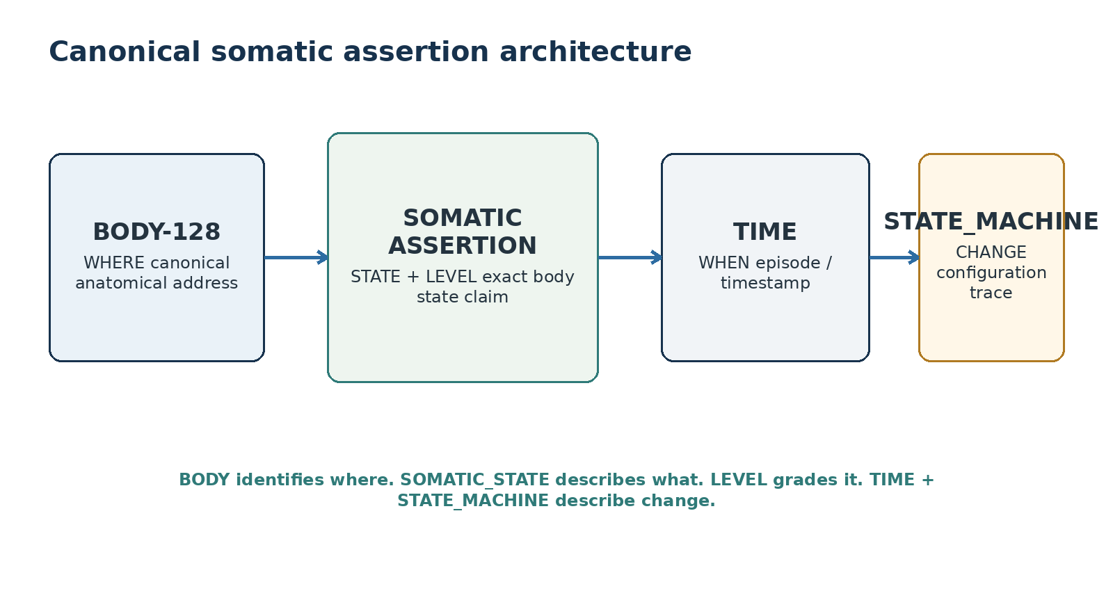
Figure 1. Canonical somatic assertion architecture.
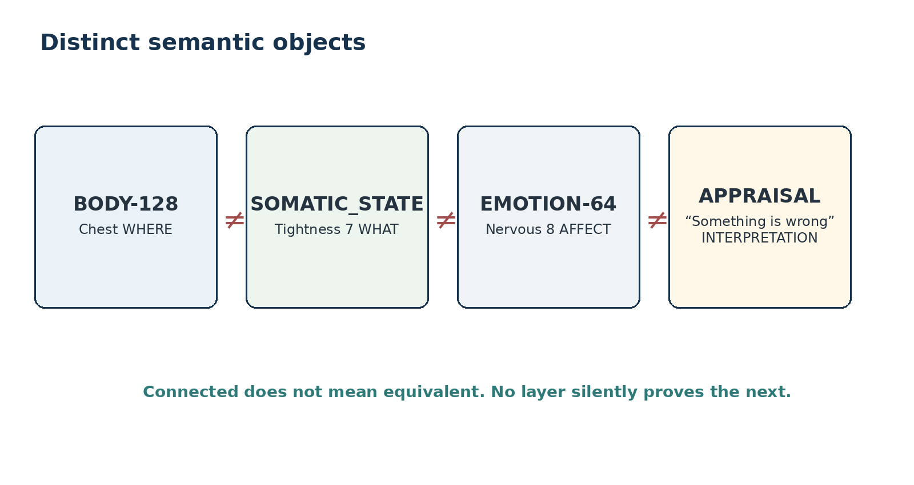
Figure 2. BODY, somatic state, affect, and appraisal remain distinct semantic objects.

4. Canonical Somatic Assertion
The fundamental compilation unit is a Somatic Assertion. The assertion binds one registered SOMATIC_STATE Bit to one BODY address and may carry an ordinal Level and surrounding provenance. The state Bit is the exact semantic handle; the BODY word identifies the anatomical referent; the Level is a declared scalar attached to the assertion rather than a reinterpretation of either Kernel.
CANONICAL FORM
Somatic Assertion = BODY Address + SOMATIC_STATE Bit + optional Level + surrounding Episode/provenance.

4.1 Atomic assertion versus aggregate routing mask
A single Somatic Assertion SHOULD normally select one exact state Bit. Multiple simultaneous body states SHOULD be represented as linked assertions so each state preserves its own BODY location and Level. A derived 124-bit multi-hot routing mask MAY summarize which SOMATIC_STATE concepts are active anywhere in the bounded Episode. The mask is a routing projection; it is not authoritative for location or intensity.

4.2 Level semantics
The recommended v0.1 Level convention mirrors the ordinal discipline used by EMOTION-64: 0 means present but unrated; 1-10 are declared ordinal strengths. No assertion means no positive assertion of presence. The scale is not a probability, medical measurement, or guaranteed interval-scale quantity. Cross-person normalization requires an explicitly named Model.

4.3 Self-felt, observed, and measured perspectives
Source perspective belongs to the surrounding record. “My heart feels fast,” “their hands are visibly shaking,” and “heart rate = 128 bpm” are different kinds of evidence. A system may link them, but SOMATIC_STATE-124 MUST NOT silently convert a subjective sensation into an instrument measurement or an interpretation.
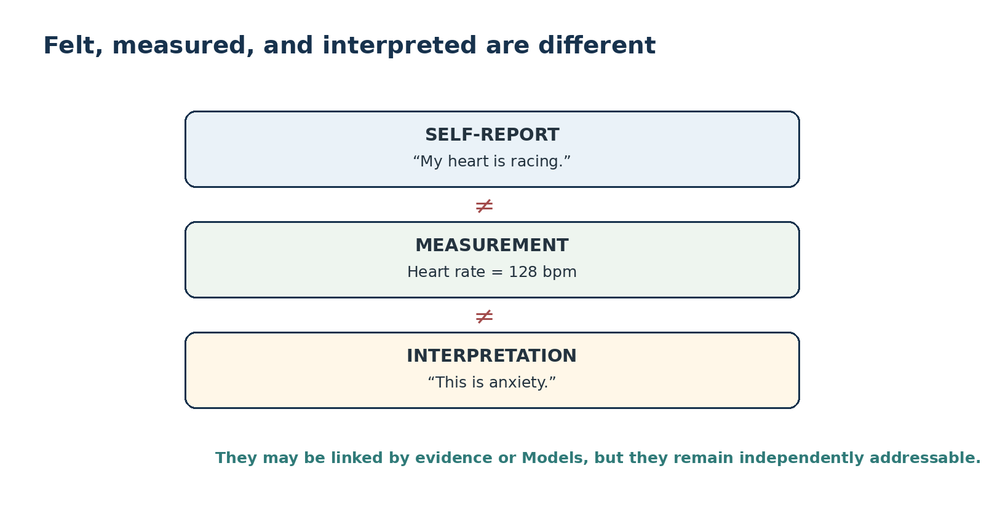
Figure 3. Felt state, measured value, and interpretation remain separate.

5. BODY-128 Companion Contract
BODY-128 is the preferred anatomical semantic bus. It already owns system masks, structure masks, orientation/topology flags, and hierarchical Region/Component/Terminal paths. SOMATIC_STATE-124 therefore spends no Bits on anatomy. “Jaw Tightness,” “Stomach Fluttering,” and “Hands Shaking” are compositions of a BODY address and one SOMATIC_STATE concept.
MINIMUM SUFFICIENT BODY RESOLUTION
The compiler MUST resolve no deeper anatomical specificity than the source statement supports. “My hand is tingling” does not authorize invention of a specific finger or nerve.

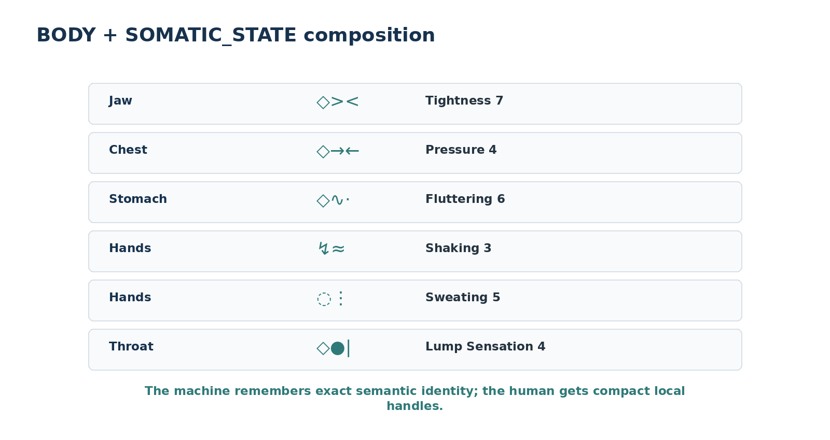
Figure 4. BODY + SOMATIC_STATE creates compact local handles without duplicating anatomy.

6. Natural-Language Compilation Contract
SOMATIC_STATE-124 is designed so a person can speak normally and let the system compile their description. The compiler resolves recognized body phrases through BODY, recognized state phrases through the SOMATIC_STATE memory layer, and preserves every unresolved or ambiguous phrase rather than inventing semantics.
Rule | Requirement
Exact phrase preservation | The original human statement remains available. Structured compilation is a projection, not a replacement.
Minimum sufficient BODY resolution | Resolve only the anatomical specificity actually expressed or explicitly supplied by context.
No cause injection | A statement such as “my stomach is tight because I am anxious” may record a reported causal claim, but the co-occurrence itself does not make the cause canonical.
No diagnosis injection | “Chest pressure” compiles as a somatic assertion. It does not become a diagnostic category.
No hidden intensity mapping | Words such as “very” remain qualitative unless a declared language-to-scale Model maps them to a number.
Split compound statements | One sentence may compile into several independently addressable assertions.
Preserve ambiguity | When a phrase is not safely resolvable, retain the source phrase or route to clarification instead of silently selecting a Bit.
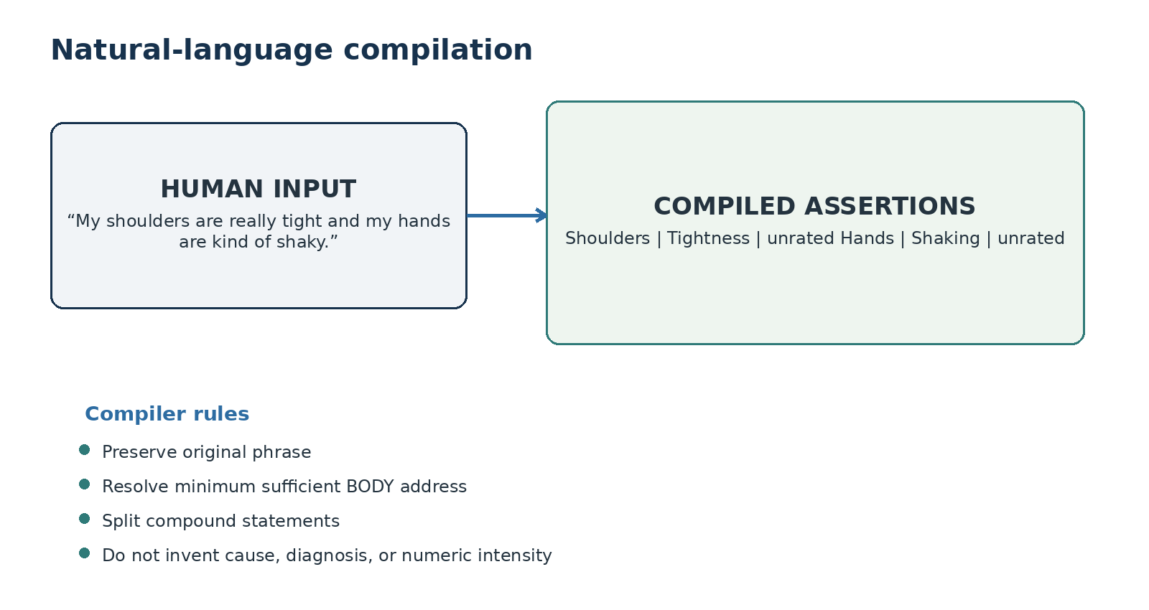
Figure 5. Ordinary human language compiles into bounded Somatic Assertions.

7. State-Machine and Temporal Integration
SOMATIC_STATE-124 describes the state vocabulary; it does not encode change as additional state Bits. At one time t, a Somatic Configuration Cₜ is the set of active addressed assertions. STATE_MACHINE can then describe C₀ → C₁ → C₂ as a run or trace, while TIME supplies temporal anchors. Rising, falling, oscillating, or persistent patterns are derived from repeated states rather than silently stored inside the state identity.
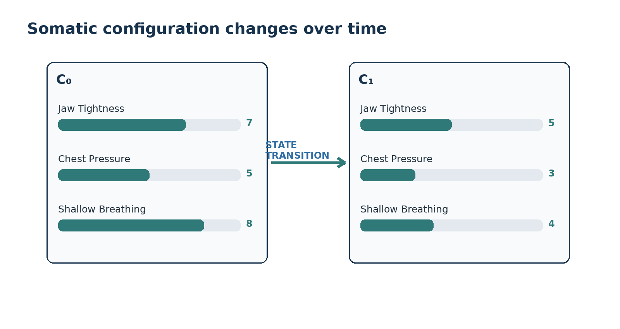
Figure 6. The same semantic states can carry different ordinal Levels across configurations.
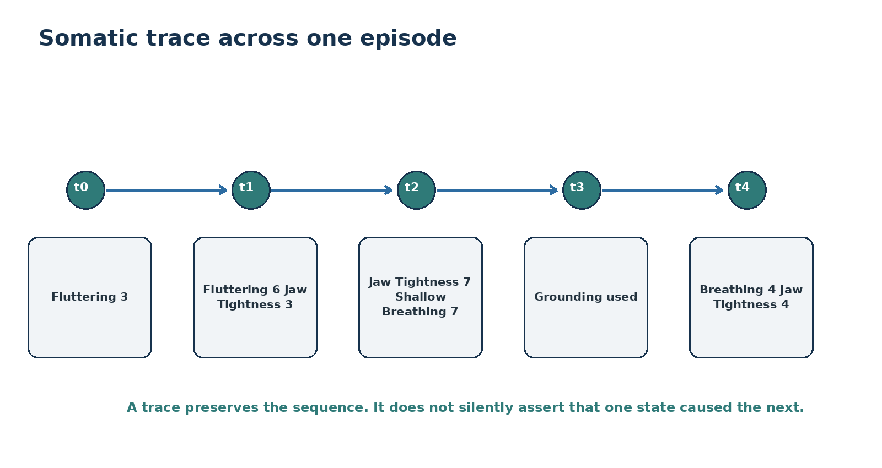
Figure 7. A temporal trace preserves sequence without inventing causation.

8. BOSS Symbol Projection
The symbol set in this specification is a candidate BOSS presentation pack, not the semantic identity itself. Each Bit remains authoritative by registered identity and Reader placement. BOSS may change one symbol, a family, or the entire presentation pack without changing SOMATIC_STATE Bit meaning or historical records. The symbols are mnemonic handles intended to improve local recognition, not definitions that a runtime may infer from by shape alone.
The candidate morphology uses one family stem plus simple modifiers. Reuse is deliberate: ↑ suggests increase/high, ↓ suggests decrease/low, >< suggests constriction, ↔ suggests extension, ∿ suggests rhythmicity, ≈ suggests oscillation, ∅ suggests absence/depletion, and || suggests holding or rigidity. These cues are pedagogical only; BOSS identity remains exact.
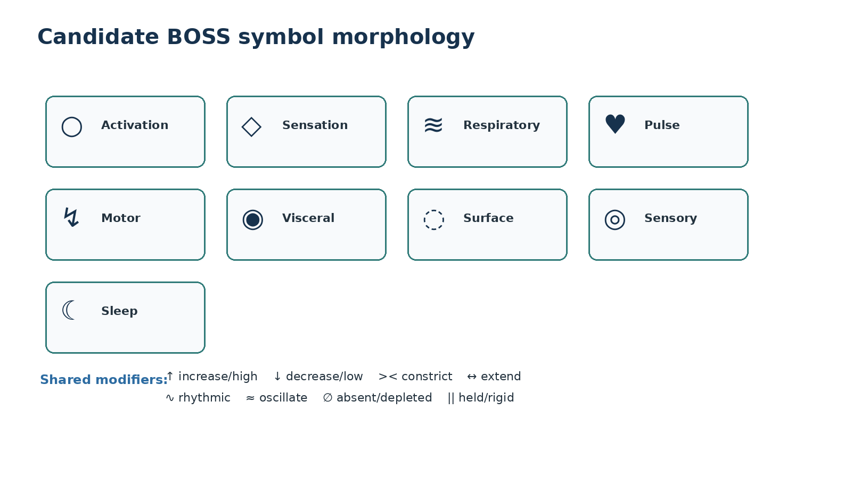
Figure 8. Candidate BOSS family stems and reusable visual modifiers.

9. Reader Topology and Bit Allocation
Reader | Bit Range | Width | Language Territory
A1 | B000-B009 | 10 | Whole-body activation, settling, energy, fatigue, and sleepiness.
B1 | B010-B051 | 42 | Combinable felt qualities such as pain, pressure, tightness, tingling, warmth, heaviness, and stiffness.
C1 | B052-B063 | 12 | Breathing speed, depth, regularity, effort, and air-related sensations.
D1 | B064-B070 | 7 | Subjective heartbeat and pulse experiences.
E1 | B071-B085 | 15 | Muscular contraction, tremor, movement, freezing, startle, and motor tempo.
F1 | B086-B096 | 11 | Digestive, appetite, visceral, urgency, and swallowing states.
G1 | B097-B105 | 9 | Sweating, flushing, chills, goosebumps, salivation, and tear-related surface responses.
H1 | B106-B115 | 10 | Lightheadedness, dizziness, balance, visual, auditory, and sensory sensitivity states.
I1 | B116-B123 | 8 | Pre-sleep settling, sleep continuity, recovery quality, and waking state.
NO PADDING RULE
The width is 124 because 124 state concepts survived the current semantic inventory. No Bits were added merely to reach 128.

10. Descriptive Memory Contract
Every registered Bit resolves to a complete teaching package. At minimum, the package contains Candidate Symbol Set, Name, Description, Professional Example, Personal Example, Common Expressions/Aliases, and References. References are intentionally blank in v0.1 pending a later sourcing pass. Common expressions live in SK Memory and may route to the same state identity without creating additional Bits.

11. Full Bit Registry
The registry below is complete for this candidate version. Activating a Bit selects the descriptive state concept; it does not establish that the state is objectively true, medically significant, emotionally caused, or appropriate for any downstream action. Candidate symbols are BOSS projections and may be changed without changing Bit identity.

A1 — Global Activation & Energy
Whole-body or broad activation/energy states. These terms are intentionally separable: settled is not fatigue, energized is not wired, and immobility is not implied.
Bit | Candidate Symbol Set | Name | Description | Professional Example | Personal Example
B000 | ○↑  ○+↑ · ○⚡ | General Activation | Broad bodily activation or physiological “up” state without specifying emotional meaning. | A human-factors study could record Whole Body + General Activation during a demanding task. | I could log Whole Body + General Activation when my body feels switched on even before I know why.
B001 | ○=  ○· · ○— | Settled / Bodily Calm | Broad bodily settledness with relatively low internal agitation; it does not imply positive mood. | A recovery log could record Whole Body + Settled after a rest interval. | I could log Settled after sitting quietly, even if I am still sad.
B002 | ○↝  ○↔ · ○…↝ | Restlessness | Difficulty remaining physically settled, often experienced as an urge to move or reposition. | An ergonomics observation could record Restlessness during prolonged seated work. | I could log Restlessness when I keep shifting in my chair and cannot get comfortable.
B003 | ○↯  ○⚡ · ○!! | Agitation | Heightened bodily activation accompanied by disturbed or unsettled motor tone. | A behavioral observation could record Whole Body + Agitation during a stressful procedure. | I could log Agitation when my body feels intensely wound up and movement feels hard to settle.
B004 | ○↓  ○↓~ · ○≪ | Sluggishness | Bodily activation or movement feels unusually slow, effortful, or reduced. | A fatigue-monitoring workflow could record Sluggishness after an extended shift. | I could log Sluggishness when ordinary movement feels slow and heavy.
B005 | ○−  ○↓− | Fatigue | Reduced physical energy or capacity relative to the current context. | A training diary could record Fatigue after repeated exertion without claiming a medical cause. | I could log Fatigue after a long day when I have less physical energy than usual.
B006 | ○∅  ○−− · ○↓↓ | Exhaustion | Pronounced bodily depletion in which available physical energy feels very low. | An occupational recovery record could distinguish Exhaustion from ordinary Fatigue. | I could log Exhaustion when I feel physically spent and need substantial recovery.
B007 | ○☾  ○↓☾ | Sleepiness | Bodily tendency toward sleep or reduced wakefulness. | A sleep study diary could record Sleepiness separately from Fatigue. | I could log Sleepiness when my eyes and body want to fall asleep even if I am not physically sore.
B008 | ○+  ○↑+ | Energized | Increased available physical energy without implying distress or overactivation. | A wellness record could note Energized after restorative sleep. | I could log Energized when I feel ready to move and do things.
B009 | ○↑↯  ○⚡↑ · ○++! | Wired / Overactivated | High bodily activation that feels difficult to settle or transition into rest. | A sleep diary could record Wired / Overactivated before bedtime while leaving cause unresolved. | I could log Wired when I am tired but my body still feels intensely switched on.

B1 — Sensation & Mechanical Quality
Highly compositional felt qualities designed to attach to exact BODY addresses. BODY supplies location; these Bits supply the state quality.
Bit | Candidate Symbol Set | Name | Description | Professional Example | Personal Example
B010 | ◇!  ◇!! | Pain | General painful sensation when a more specific quality is not being asserted. | An incident record could attach Pain to the relevant BODY address and keep mechanism separate. | I could log Knee + Pain 5 after noticing a painful sensation.
B011 | ◇~  ◇~~ | Ache | Dull, persistent, or diffuse aching quality. | A workstation study could record Neck + Ache after sustained posture. | I could log Lower Back + Ache when it feels dull rather than sharp.
B012 | ◇≈  ◇~+ | Soreness | Sore or tender-feeling discomfort often described as diffuse rather than sharply localized. | A training log could record Quadriceps + Soreness following exercise. | I could log Shoulders + Soreness the day after lifting.
B013 | ◇·!  ◇•! | Tenderness | Increased discomfort or sensitivity associated with contact, pressure, or palpation. | A physical assessment record could note a BODY region as Tender without inferring cause. | I could log Forearm + Tenderness when pressing the area feels unusually sensitive.
B014 | ◇⋯  ◇~? | Discomfort | Unpleasant bodily sensation that is present but not further specified. | A usability trial could record Hand + Discomfort during prolonged device use. | I could log Chest + Discomfort when something feels unpleasant but I cannot describe it more precisely.
B015 | ◇→←  ◇><· | Pressure | Sensation of pressing force, load, or inward force at a BODY-addressed region. | A participant report could record Head + Pressure during a task. | I could log Chest + Pressure when it feels as if something is pressing inward.
B016 | ◇><  ◇>|< | Tightness | Sensation of constriction, restricted ease, or increased local tension. | An ergonomics record could encode Shoulders + Tightness without labeling the cause. | I could log Jaw + Tightness 7 when my jaw feels constricted.
B017 | ◇>|<  ◇→●← | Compression / Squeezing | Sensation of stronger circumferential or inward squeezing/compression. | A symptom observation could distinguish Chest + Compression from generic Pressure. | I could log Upper Arm + Compression when it feels tightly squeezed.
B018 | ◇▲  ◇^ | Sharpness | Sharply defined painful or uncomfortable quality with clear sensory edges. | A movement trial could record Knee + Sharpness during one motion. | I could log Ankle + Sharpness when the sensation feels sudden and pointed.
B019 | ◇↓|  ◇!| | Stabbing | Punctate or stabbing painful quality. | An incident record could describe Side + Stabbing while leaving diagnosis to a separate model. | I could log Abdomen + Stabbing if the sensation feels like brief pointed jabs.
B020 | ◇∿!  ◇∿∿ | Throbbing | Rhythmic swelling, aching, or beating-like sensation. | A report could record Temple + Throbbing and separately store any measured pulse. | I could log Head + Throbbing when the discomfort comes in rhythmic waves.
B021 | ◇∿  ◇•∿ | Pulsing | Rhythmically pulsing sensation without requiring pain. | A device-comfort study could record Finger + Pulsing after repeated pressure. | I could log Hand + Pulsing when I can feel a repeated pulse-like sensation.
B022 | ◇♨  ◇☼! | Burning | Burning or hot-pain sensory quality. | A research observation could record Skin Region + Burning while keeping etiology unresolved. | I could log Throat + Burning when it feels hot and irritating.
B023 | ◇✦  ◇*! | Stinging | Sharply irritating or stinging sensory quality. | A surface-contact study could record Skin + Stinging after exposure. | I could log Finger + Stinging when the sensation feels like many tiny sharp points.
B024 | ◇)(  ◇><≈ | Cramping | Contracting, gripping, or cramp-like sensation. | A sports log could record Calf + Cramping during exertion. | I could log Abdomen + Cramping when it repeatedly grips and releases.
B025 | ◇>·<  ◇>•< | Pinching | Localized sensation of being pinched or compressed at a point. | A fit assessment could record Shoulder + Pinching under a strap. | I could log Hip + Pinching when one movement creates a small compressed feeling.
B026 | ◇←→  ◇↔→ | Pulling | Traction-like sensation as if tissue or a region is being pulled. | A mobility assessment could record Hamstring + Pulling during range testing. | I could log Calf + Pulling when stretching produces a traction-like feeling.
B027 | ◇↔  ◇<—> | Stretching | Sensation of extension or tissue being lengthened. | A flexibility record could describe Posterior Thigh + Stretching during a controlled movement. | I could log Side + Stretching during a deep reach.
B028 | ◇⇢  ◇→! | Shooting | Rapidly traveling sharp or intense sensation along a path. | An observation could record a Shooting sensation across BODY-linked regions without asserting nerve involvement. | I could log Leg + Shooting when the sensation seems to travel quickly downward.
B029 | ◇↗↘  ◇↝↝ | Radiating | Sensation experienced as spreading outward from an apparent starting area. | A report could link Chest + Radiating with additional BODY targets while keeping the relation explicit. | I could log Shoulder + Radiating when discomfort seems to spread into my upper arm.
B030 | ◇⚡  ◇↯ | Electric / Shock-like | Electrical, shock-like, or sudden current-like sensation. | A sensory log could record Hand + Electric / Shock-like after a particular movement. | I could log Finger + Electric when the sensation feels like a quick tiny shock.
B031 | ◇···  ◇∴ | Tingling | Fine tingling sensation with many small distributed sensory points. | A human-subject record could encode Left Hand + Tingling as a self-report. | I could log Fingers + Tingling when they feel lightly tingly.
B032 | ◇⋮⋮  ◇⁝⁝ | Pins and Needles | Prickling paresthesia-like experience commonly described as pins and needles. | A recovery log could distinguish Foot + Pins and Needles from Numbness. | I could log Foot + Pins and Needles after sitting in one position too long.
B033 | ◇∅  ◇○× | Numbness | Reduced or absent felt sensation at a BODY-addressed region. | A safety report could record Hand + Numbness and route separately for evaluation. | I could log Fingertips + Numbness when sensation feels reduced.
B034 | ◇⁝  ◇•••! | Prickling | Fine-point prickling sensation without necessarily using the idiom pins and needles. | A skin-sensation study could record Forearm + Prickling. | I could log Skin + Prickling when it feels like tiny points touching me.
B035 | ◇≈≈  ◇~~~ | Buzzing / Vibration | Perceived buzzing, humming, or vibrating sensation. | A tool-use study could record Hand + Buzzing / Vibration after equipment exposure. | I could log Foot + Buzzing when it feels as if it is faintly vibrating.
B036 | ◇∿→  ◇~↝ | Crawling Sensation | Sensation resembling movement across or beneath a body surface. | A sensory observation could record Skin Region + Crawling Sensation without inferring a cause. | I could log Arm + Crawling Sensation when it feels like something is moving across the skin.
B037 | ◇✳  ◇*~ | Itching | Itchy sensory state commonly associated with an urge to scratch. | A skin observation could record Forearm + Itching and preserve its time course. | I could log Ankle + Itching when I keep wanting to scratch it.
B038 | ◇☼  ◇↑° | Warmth | Felt warmth at a BODY-addressed region. | A thermal-comfort study could record Face + Warmth as a subjective state. | I could log Face + Warmth when it feels noticeably warmer than the rest of me.
B039 | ◇❄  ◇↓° | Coldness | Felt cold at a BODY-addressed region. | An environmental study could record Hands + Coldness during exposure to a cool room. | I could log Feet + Coldness when they feel unusually cold.
B040 | ◇▼  ◇↓● | Heaviness | Sensation of increased weight, load, or bodily heaviness. | A fatigue assessment could record Legs + Heaviness after prolonged activity. | I could log Legs + Heaviness when they feel difficult to lift.
B041 | ◇⇧  ◇△ | Lightness | Sensation of reduced weight or unusual bodily lightness. | A movement study could record Whole Body + Lightness after a recovery interval. | I could log Arms + Lightness when they feel unusually easy to move.
B042 | ◇●  ◇⊕ | Fullness | Sensation of internal filling, pressure, or fullness. | A dietary observation could record Stomach + Fullness after a meal. | I could log Abdomen + Fullness when I feel physically full.
B043 | ◇○  ◇∅○ | Hollow / Empty Sensation | Felt internal hollowness or emptiness at a BODY-addressed region. | A subjective-state record could encode Stomach + Hollow / Empty without assigning emotional meaning. | I could log Stomach + Hollow when it feels empty in a very noticeable way.
B044 | ◇⊕  ◇↔+ | Swelling / Puffiness | Experienced or observed sense of enlargement, puffiness, or expansion. | A post-activity record could note Ankle + Swelling / Puffiness as an observation. | I could log Fingers + Puffiness when rings feel tighter and the fingers look fuller.
B045 | ◇●|  ◇•│ | Lump Sensation | Localized sensation of a lump, blockage, or contained mass-like feeling. | A participant report could encode Throat + Lump Sensation without asserting obstruction. | I could log Throat + Lump Sensation when swallowing feels as though something is sitting there.
B046 | ◇↓  ◇⇣ | Sinking Sensation | Felt downward-dropping or sinking quality. | An experience record could encode Stomach + Sinking Sensation during an event. | I could log Stomach + Sinking when I get a sudden dropping feeling.
B047 | ◇∿·  ◇~~· | Fluttering | Light, rapid, fluctuating internal sensation. | A self-report study could record Stomach + Fluttering and keep emotion separate. | I could log Stomach + Fluttering for what I would casually call butterflies.
B048 | ◇∅·  ◇−≈ | Dryness | Unusually dry bodily sensation at the addressed region. | A workplace comfort record could encode Mouth + Dryness during prolonged speaking. | I could log Mouth + Dryness when it feels noticeably dry.
B049 | ◇<>  ◇← → | Relaxed / Loose | Reduced local tension or a loosened bodily tone. | A mobility session could record Shoulders + Relaxed / Loose after a recovery technique. | I could log Jaw + Relaxed when it no longer feels clenched or tight.
B050 | ◇−  ◇↓− | Weakness | Experienced reduction in local or generalized physical strength. | A task record could capture Hand + Weakness during repeated gripping. | I could log Legs + Weakness when standing feels harder than usual.
B051 | ◇||  ◇== | Stiffness | Reduced ease, flexibility, or smoothness of movement at the addressed region. | A mobility assessment could record Neck + Stiffness before movement testing. | I could log Neck + Stiffness when turning my head feels restricted.

C1 — Respiratory State
Respiratory states distinguish rate, depth, regularity, effort, and subjective air-related experience without converting sensation into instrument measurement.
Bit | Candidate Symbol Set | Name | Description | Professional Example | Personal Example
B052 | ≋≫  ≋↑↑ | Rapid Breathing | Breathing perceived or observed as unusually rapid relative to the current context. | A workload study could record Respiratory BODY + Rapid Breathing during a demanding interval. | I could log Rapid Breathing when my breathing suddenly speeds up.
B053 | ≋≪  ≋↓↓ | Slow Breathing | Breathing perceived or observed as unusually slow relative to the current context. | A relaxation protocol could record Slow Breathing as an observed respiratory state. | I could log Slow Breathing when my breaths become noticeably slower.
B054 | ≋ˉ  ≋− | Shallow Breathing | Breathing with reduced perceived or observed depth. | A posture study could record Shallow Breathing during constrained seated work. | I could log Shallow Breathing when I notice I am taking small breaths.
B055 | ≋↓  ≋⇵ | Deep Breathing | Breathing with increased perceived or observed depth. | A recovery record could note Deep Breathing during a paced-breathing interval. | I could log Deep Breathing when each breath feels full and deep.
B056 | ≋||  ≋— | Breath Holding | Voluntary or involuntary pause in breathing. | A movement analysis could record Breath Holding during a high-effort lift. | I could log Breath Holding when I catch myself pausing my breath.
B057 | ≋⌁  ≋~!~ | Irregular Breathing | Breathing rhythm is inconsistent or uneven. | A physiological observation could record Irregular Breathing while leaving mechanism unresolved. | I could log Irregular Breathing when my breaths keep changing pace and depth.
B058 | ≋!  ≋!! | Labored Breathing | Breathing experienced or observed as requiring increased effort. | A field observation could record Labored Breathing after exertion and keep interpretation separate. | I could log Labored Breathing when each breath feels like work.
B059 | ≋∅  ≋× | Breathlessness | Subjective sensation of being short of breath. | A self-report instrument could record Breathlessness independently from measured oxygen values. | I could log Breathlessness when I feel short of breath even before any measurement exists.
B060 | ≋↑  ≋+? | Air Hunger | Felt need for more air or a sense that current breathing is insufficient. | A respiratory symptom log could distinguish Air Hunger from generic Breathlessness. | I could log Air Hunger when I keep feeling that I need a bigger breath.
B061 | ≋↓…  ≋↘ | Sighing | Repeated or notable sighing pattern. | A behavioral observation could record Sighing frequency during a task. | I could log Sighing when I keep taking long sighs without planning to.
B062 | ≋○  ≋☾○ | Yawning | Repeated or notable yawning pattern. | A sleepiness study could record Yawning separately from self-reported Sleepiness. | I could log Yawning when I keep yawning even if I have not rated myself sleepy yet.
B063 | ≋!↑  ≋↑! | Gasping | Abrupt inhalation or gasping respiratory pattern. | A startle experiment could record Gasping as an observable respiratory response. | I could log Gasping when I suddenly take a sharp breath in.

D1 — Cardiovascular & Pulse Experience
Subjective pulse/heartbeat experience. Measurement values and rhythm interpretation remain separate.
Bit | Candidate Symbol Set | Name | Description | Professional Example | Personal Example
B064 | ♥·  ♥! | Heartbeat Awareness | Unusually salient awareness of one’s heartbeat without specifying rate or rhythm. | A self-report study could record Heart + Heartbeat Awareness while a sensor stores measurements separately. | I could log Heartbeat Awareness when I can strongly feel each beat.
B065 | ♥≫  ♥↑↑ | Rapid Heartbeat Sensation | Heartbeat feels unusually fast to the experiencer; this is not a measured heart-rate value. | A participant could report Rapid Heartbeat Sensation while a wearable independently records bpm. | I could log Rapid Heartbeat Sensation when my heart feels like it is racing.
B066 | ♥≪  ♥↓↓ | Slow Heartbeat Sensation | Heartbeat feels unusually slow to the experiencer; measurement remains separate. | A recovery study could record Slow Heartbeat Sensation as subjective data. | I could log Slow Heartbeat Sensation when the beats feel far apart.
B067 | ♥!!  ♥● | Pounding Heartbeat | Heartbeat feels unusually forceful or pounding. | A workload record could capture Pounding Heartbeat as a self-report. | I could log Pounding Heartbeat when I can feel strong beats in my chest.
B068 | ♥∿  ♥~~ | Fluttering Heartbeat | Flutter-like or rapidly fluctuating heartbeat sensation. | A symptom observation could record Fluttering Heartbeat and route measurements separately. | I could log Fluttering Heartbeat when my heart feels briefly fluttery.
B069 | ♥…  ♥∿∅ | Skipped-Beat Sensation | Sensation that a heartbeat was missed, paused, or interrupted. | A self-report record could capture Skipped-Beat Sensation without treating it as a rhythm diagnosis. | I could log Skipped-Beat Sensation when it feels like one beat did not arrive normally.
B070 | ♥⌁  ♥~!~ | Irregular-Heartbeat Sensation | Heartbeat rhythm feels irregular to the experiencer. | A monitoring workflow could keep Irregular-Heartbeat Sensation separate from ECG interpretation. | I could log Irregular-Heartbeat Sensation when the rhythm feels uneven.

E1 — Muscular & Motor Response
Muscular and motor response vocabulary. Voluntary versus involuntary status may require context; the state label itself does not diagnose mechanism.
Bit | Candidate Symbol Set | Name | Description | Professional Example | Personal Example
B071 | ↯><  ↯>|< | Clenching | Sustained contraction used to tightly close, grip, or hold a body part. | A motor observation could record Jaw + Clenching during a task. | I could log Hands + Clenching when I notice I am gripping tightly.
B072 | ↯||  ↯[] | Bracing | Body or region becomes rigidly prepared against anticipated force, effort, or discomfort. | A lifting analysis could record Trunk + Bracing before load transfer. | I could log Shoulders + Bracing when I notice them rigidly preparing for something.
B073 | ↯∿  ↯~~~ | Tremor | Relatively rhythmic involuntary oscillatory movement. | A motor assessment could record Hand + Tremor as an observed state. | I could log Hand + Tremor when it rhythmically shakes on its own.
B074 | ↯≈  ↯≈≈ | Shaking | Broader visible or felt shaking that need not be rhythmically regular. | A field record could capture Whole Body + Shaking following an event. | I could log Hands + Shaking when they visibly shake.
B075 | ↯≈·  ↯∿· | Quivering | Fine, rapid trembling or quivering movement. | A facial-motor observation could record Lip + Quivering. | I could log Lip + Quivering when it trembles very finely.
B076 | ↯!·  ↯·! | Twitching | Brief localized involuntary contraction or movement. | A motor log could record Eyelid + Twitching over time. | I could log Eyelid + Twitching when it gives short little movements.
B077 | ↯!!  ↯⚡! | Spasm | Sudden involuntary muscular contraction or burst of contraction. | A movement observation could record Calf + Spasm while keeping cause external. | I could log Calf + Spasm when it suddenly contracts hard on its own.
B078 | ↯↔  ↯↝ | Fidgeting | Repeated small restless movements. | A classroom observation could record Fidgeting without assigning a psychological cause. | I could log Fidgeting when my hands or feet keep making small movements.
B079 | ↯⇆  ↯↔↔ | Pacing | Repeated walking or back-and-forth locomotion. | A behavioral observation could record Pacing as a motor pattern. | I could log Pacing when I repeatedly walk back and forth through the room.
B080 | ↯↻  ↯⟳ | Repetitive Movement | Repeated motor action not otherwise specified. | A task study could record Repetitive Movement and link the exact BODY parts involved. | I could log Repetitive Movement when I keep repeating the same motion.
B081 | ↯■  ↯||× | Freeze / Immobility | Markedly reduced or absent voluntary movement in a wakeful context; it is not synonymous with calm. | A behavioral observation could record Freeze / Immobility after an unexpected event. | I could log Freeze when I am awake but my body suddenly does not move.
B082 | ↯!↑  ↯⚡↑ | Startle Response | Abrupt bodily reaction to a sudden or unexpected stimulus. | A stimulus-response study could record Startle Response and its BODY components. | I could log Startle Response when a loud sound makes my body jump.
B083 | ↯⚡  ↯↑↯ | Motor Agitation | Increased purposeless, disturbed, or unsettled bodily movement. | A behavioral record could distinguish Motor Agitation from ordinary intentional activity. | I could log Motor Agitation when my body keeps moving in an unsettled way.
B084 | ↯↓  ↯≪ | Motor Slowing | Noticeably reduced movement speed relative to the person’s current context. | A task-performance record could capture Motor Slowing during fatigue. | I could log Motor Slowing when reaching and walking feel noticeably slower.
B085 | ↯❄≈  ↯❄∿ | Shivering | Repeated small muscular contractions commonly experienced as cold-associated shaking. | An environmental study could record Whole Body + Shivering during cold exposure. | I could log Shivering when my body rapidly shakes while I feel cold.

F1 — Digestive & Visceral State
Digestive and visceral vocabulary, including appetite and urgency. Colloquial expressions should compile to these primitives when safe.
Bit | Candidate Symbol Set | Name | Description | Professional Example | Personal Example
B086 | ◉~!  ◉≈! | Nausea | Sensation associated with feeling that one may vomit. | A travel study could record Stomach + Nausea as a self-report. | I could log Nausea when my stomach feels like I might be sick.
B087 | ◉~  ◉≈ | Queasiness | Milder or less specifically defined stomach unease. | A motion-comfort study could distinguish Queasiness from stronger Nausea. | I could log Queasiness when my stomach feels unsettled but not strongly nauseated.
B088 | ◉○  ◉∅ | Hunger | Bodily hunger state. | A nutrition diary could record Hunger before a meal. | I could log Hunger when my body clearly wants food.
B089 | ◉↑  ◉+ | Increased Appetite | Appetite experienced as higher than the relevant personal or contextual baseline. | A longitudinal diary could record Increased Appetite as a change from baseline. | I could log Increased Appetite when I want substantially more food than usual.
B090 | ◉↓  ◉− | Reduced Appetite | Appetite experienced as lower than the relevant personal or contextual baseline. | A recovery record could note Reduced Appetite while leaving cause unresolved. | I could log Reduced Appetite when I have little interest in eating despite mealtime.
B091 | ◉⊕  ◉↔ | Bloating | Sensation of abdominal expansion, fullness, or distension. | A dietary observation could record Abdomen + Bloating after a meal. | I could log Bloating when my abdomen feels expanded and full.
B092 | ◉↻  ◉⟳ | Churning | Rolling, shifting, or churning visceral sensation. | A self-report study could record Stomach + Churning during an event. | I could log Churning when my stomach feels as if it is rolling around.
B093 | ◉↑♨  ◉↑! | Reflux / Heartburn Sensation | Reported upward-burning or reflux-like sensation; the label does not establish cause. | A symptom diary could record Upper Digestive BODY + Reflux / Heartburn Sensation. | I could log Reflux / Heartburn Sensation when I feel burning rising upward after eating.
B094 | ◉!↓  ◉▼! | Bowel Urgency | Strong immediate bodily urge to defecate. | A gastrointestinal diary could record Bowel Urgency with time and context. | I could log Bowel Urgency when I suddenly feel I need a bathroom immediately.
B095 | ◉!≈  ◉!· | Urinary Urgency | Strong immediate bodily urge to urinate. | A bladder diary could record Urinary Urgency separately from measured volume. | I could log Urinary Urgency when I suddenly feel a very strong need to urinate.
B096 | ◉×↑  ◉|× | Difficulty Swallowing | Swallowing feels difficult, impaired, or obstructed to the experiencer. | A self-report record could encode Throat + Difficulty Swallowing and route for separate evaluation. | I could log Difficulty Swallowing when a normal swallow feels hard to complete.

G1 — Autonomic & Surface Response
Surface/autonomic responses observable or felt at the skin, eyes, or mouth. Emotion is not implied by the response.
Bit | Candidate Symbol Set | Name | Description | Professional Example | Personal Example
B097 | ◌⋮  ◌··↓ | Sweating | Increased perspiration at a BODY-addressed region or generally. | A thermal-comfort study could record Hands + Sweating while storing ambient temperature separately. | I could log Hands + Sweating when my palms become noticeably sweaty.
B098 | ◌≈❄  ◌··❄ | Clamminess | Cool, damp, or clammy skin sensation or observation. | A field observation could record Skin + Clamminess as a surface state. | I could log Hands + Clamminess when they feel both damp and cool.
B099 | ◌☼↑  ◌↑° | Flushing | Increased visible redness/warmth or felt flushing at a surface region. | A social-stress experiment could record Face + Flushing as an observed or reported state. | I could log Face + Flushing when my face suddenly feels and looks warmer.
B100 | ◌○  ◌−☼ | Pallor | Unusual paleness as an observed surface state. | An observer record could note Face + Pallor while keeping interpretation external. | I could record Pallor if someone notices my face looks unusually pale.
B101 | ◌❄  ◌↓↓° | Chills | Felt waves or episodes of cold/chill. | An environmental record could capture Whole Body + Chills during temperature change. | I could log Chills when cold waves repeatedly run through my body.
B102 | ◌•••  ◌⁝⁝ | Goosebumps | Raised skin follicles or gooseflesh as a surface response. | A stimulus study could record Skin + Goosebumps following a stimulus. | I could log Goosebumps when the skin on my arms visibly raises.
B103 | ◌≈+  ◌··+ | Excess Salivation | Increased salivary production relative to the current context. | A taste-response study could record Mouth + Excess Salivation. | I could log Excess Salivation when my mouth suddenly produces much more saliva.
B104 | ◌··↓  ◌·↓ | Tearfulness | Increased tendency toward tear formation, with or without crying. | An observer or self-report record could capture Eyes + Tearfulness while emotion remains separate. | I could log Tearfulness when my eyes keep filling with tears even before I describe the emotion.
B105 | ◌◎≈  ◎·· | Watery Eyes | Increased tearing or watery-eye state. | An environmental exposure study could record Eyes + Watery Eyes. | I could log Watery Eyes when my eyes keep watering.

H1 — Vestibular & Sensory State
Vestibular and sensory experiences. Objective sensory testing remains separate from subjective state.
Bit | Candidate Symbol Set | Name | Description | Professional Example | Personal Example
B106 | ◎↑~  ◎~↑ | Lightheadedness | Faint, floating, or near-faint head sensation distinct from specific spinning. | A standing-task study could record Head + Lightheadedness as a subjective state. | I could log Lightheadedness when my head feels floaty and faint.
B107 | ◎↺  ◎~↺ | Dizziness | Nonspecific dizzy sensation without requiring a spinning interpretation. | A balance assessment could record Dizziness and separately record objective sway. | I could log Dizziness when I feel dizzy but cannot describe it more specifically.
B108 | ◎⟳  ◎↻ | Spinning Sensation | Experience that self or environment is rotating or spinning. | A vestibular study could record Spinning Sensation while objective measurements remain separate. | I could log Spinning Sensation when the room seems to rotate.
B109 | ◎≈  ◎↔~ | Unsteadiness | Reduced subjective sense of stable balance. | A gait assessment could record Unsteadiness while separately measuring gait parameters. | I could log Unsteadiness when standing feels less stable than usual.
B110 | ◎~~  ◎≈≈ | Blurred Vision | Visual detail appears blurred or insufficiently sharp. | A visual-task record could capture Eyes + Blurred Vision during prolonged focus. | I could log Blurred Vision when text suddenly looks less sharp.
B111 | ◎><  ◎>|< | Tunnel Vision | Perceived narrowing of the visual field. | A self-report record could encode Tunnel Vision during an event without inferring cause. | I could log Tunnel Vision when my visible field feels narrowed toward the center.
B112 | ◎☼!  ◎✦! | Light Sensitivity | Increased discomfort or sensitivity to light. | A sensory profile could record Eyes + Light Sensitivity under a specific lighting condition. | I could log Light Sensitivity when normal room light feels unusually harsh.
B113 | ◎)))!  ◎≋! | Sound Sensitivity | Increased discomfort or sensitivity to sound. | A sensory study could record Ears + Sound Sensitivity under controlled audio exposure. | I could log Sound Sensitivity when ordinary sounds suddenly feel too intense.
B114 | ◎)))  ◎∿) | Ringing in Ears | Perceived ringing, tone, or buzzing auditory sensation. | A self-report record could capture Ears + Ringing in Ears independently from measured sound. | I could log Ringing in Ears when I hear a tone that is not coming from the room.
B115 | ◎··✦  ◎✦✦ | Visual Spots / Flickering | Perceived spots, flashes, flickering, or small transient visual artifacts. | A visual-symptom diary could record Visual Spots / Flickering and its time course. | I could log Visual Spots / Flickering when I see brief spots or flashes.

I1 — Sleep & Recovery State
Sleep and recovery descriptions focused on settling, continuity, restorative quality, and waking state.
Bit | Candidate Symbol Set | Name | Description | Professional Example | Personal Example
B116 | ☾↯  ☾↝ | Difficulty Settling for Sleep | Body has difficulty transitioning into a physically settled pre-sleep state. | A sleep diary could distinguish Difficulty Settling for Sleep from delayed sleep onset itself. | I could log Difficulty Settling when I am in bed but my body will not physically calm down.
B117 | ☾×  ☾…× | Difficulty Falling Asleep | Sleep onset is experienced as difficult or delayed. | A sleep diary could record Difficulty Falling Asleep with bedtime and estimated onset. | I could log Difficulty Falling Asleep when I stay awake much longer than I intended.
B118 | ☾↻↑  ☾↑↻ | Repeated Waking | Recurrent waking during one sleep period. | A sleep record could count Repeated Waking events across the night. | I could log Repeated Waking when I wake up several times overnight.
B119 | ☾↑!  ☾⇡ | Early Waking | Waking earlier than intended with difficulty remaining asleep or returning to sleep. | A sleep diary could record Early Waking separately from total sleep duration. | I could log Early Waking when I wake hours before I planned to get up.
B120 | ☾−  ☾∅+ | Unrefreshing Sleep | Sleep occurred but did not feel physically restorative. | A recovery study could record Unrefreshing Sleep despite an adequate recorded duration. | I could log Unrefreshing Sleep when I slept but wake feeling physically unrecovered.
B121 | ☾=  ☾+ | Restful Sleep | Sleep experienced as physically restorative and settled. | A wellness log could record Restful Sleep as a subjective recovery state. | I could log Restful Sleep when I wake feeling physically restored.
B122 | ☾→↑  ☾↑+ | Waking Alert | Waking with relatively immediate bodily alertness and readiness. | A shift-work study could record Waking Alert after a sleep interval. | I could log Waking Alert when I wake and quickly feel physically awake.
B123 | ☾→~  ☾↓~ | Waking Groggy | Waking with lingering heaviness, slowing, or reduced alertness. | A sleep diary could record Waking Groggy as distinct from total sleep time. | I could log Waking Groggy when I wake but my body and head still feel slow.

12. Natural-Language Alias Layer
Common human phrases SHOULD route through SK Memory to existing state Bits rather than create redundant Bits. Aliases are descriptive compiler aids; they do not redefine the canonical state.
Common Expression | Candidate Compilation
“butterflies in my stomach” | BODY: Stomach + Fluttering
“my stomach dropped” | BODY: Stomach + Sinking Sensation
“my heart is racing” | Heart + Rapid Heartbeat Sensation
“my heart is pounding” | Heart + Pounding Heartbeat
“pins and needles” | Relevant BODY address + Pins and Needles
“my palms are sweaty” | Hands + Sweating
“lump in my throat” | Throat + Lump Sensation
“my jaw is clenched” | Jaw + Clenching
“my shoulders are tight” | Shoulders + Tightness
“I’m wired” | Whole-body BODY referent + Wired / Overactivated

13. Somatic Configurations and Personal Analog Modeling
A bounded Episode may contain many Somatic Assertions at once. The set Cₜ of addressed assertions at time t forms a Somatic Configuration. Over repeated times, the person’s body state becomes a graded semantic trajectory: the state identities remain discrete and inspectable, while their declared Levels can rise, fall, persist, or oscillate. This is the basis for a personal “analog-like” body signal surface without sacrificing exact semantic addressing.
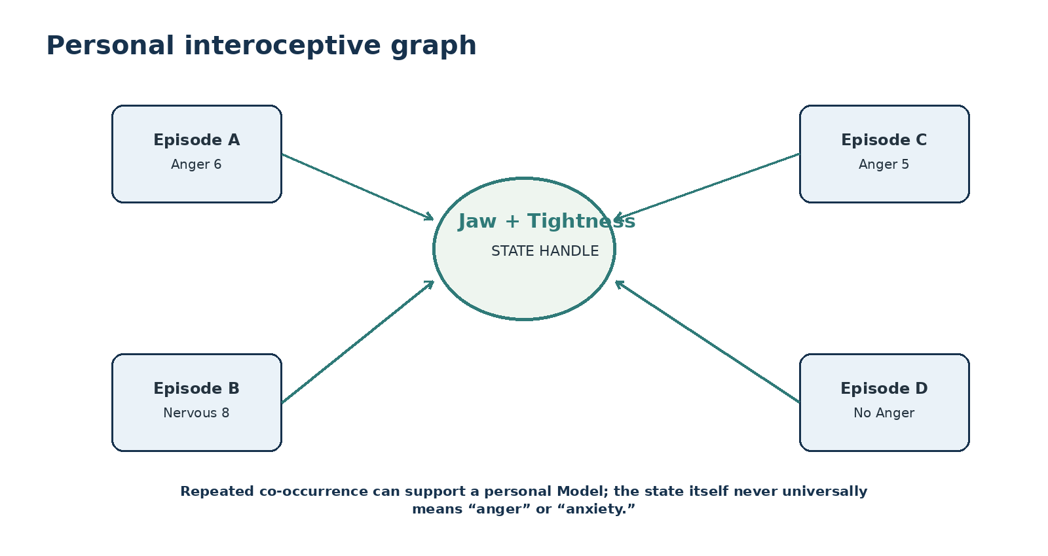
Figure 9. Repeated co-occurrence can build a personal interoceptive graph without universalizing the association.

14. Bit-Smart Routing
The 124 state Bits form a large attractor basin for ordinary bodily experience. A current Episode can compile a cheap semantic routing signature from active SOMATIC_STATE Bits, BODY masks/paths, EMOTION-64 state, Cognitive Model Bundle concepts, and other authorized context. The Router can first filter by Bits and graph topology, then open richer Experience or Reflection content only for the surviving neighborhood.
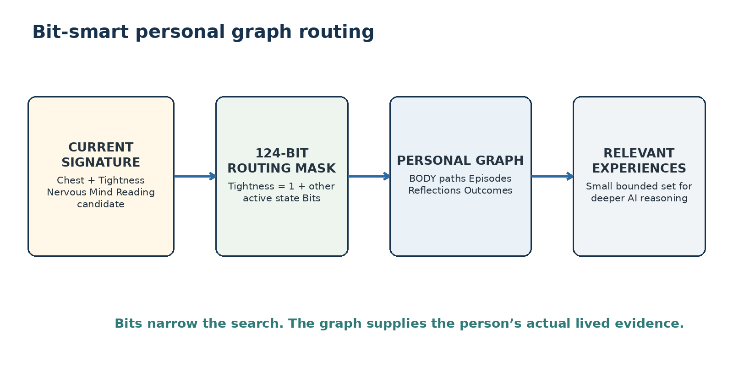
Figure 10. Bits provide the cheap first pass; personal graph records provide the lived evidence.

15. Personal Interoceptive Learning
Repeated SOMATIC_STATE observations can support person-specific Models such as “Jaw Tightness has often co-occurred with Anger in this graph” or “Grounding was followed by lower Restlessness in several similar Episodes.” Such relationships MUST remain explicitly scoped to their evidence, person, time window, and Model. The Kernel itself never defines Tightness as Anger, Nervousness, danger, or disease.
PERSONAL MODEL LAW
Observed association in a person’s graph ≠ universal somatic meaning. Personal evidence may guide routing while the shared state vocabulary remains model-neutral.

16. Regulation and Control-System Handoff
SOMATIC_STATE-124 describes current and historical body states; REGULATION-n and future CONTROL_SYSTEMS work can operate over those states without changing their identity. A regulation attempt is an Operator or action in the Episode. The resulting Somatic Delta is observed by comparing configurations before and after the action. “Breathing exercise reduced Tightness” is therefore an evidence-bearing episode relation, not a universal property embedded in the Tightness Bit.

17. Interpretive and Safety Boundaries
Placement inside a Cognitive Model Bundle does not make a somatic state psychological. Bodily experiences may have many possible contexts, mechanisms, or causes. A valid SOMATIC_STATE assertion proves only that a conforming source recorded a particular state claim at a particular BODY address under the supplied provenance. Stronger medical, causal, safety, or psychological interpretation requires the appropriate explicit evidence, Model, Rule, or professional workflow.
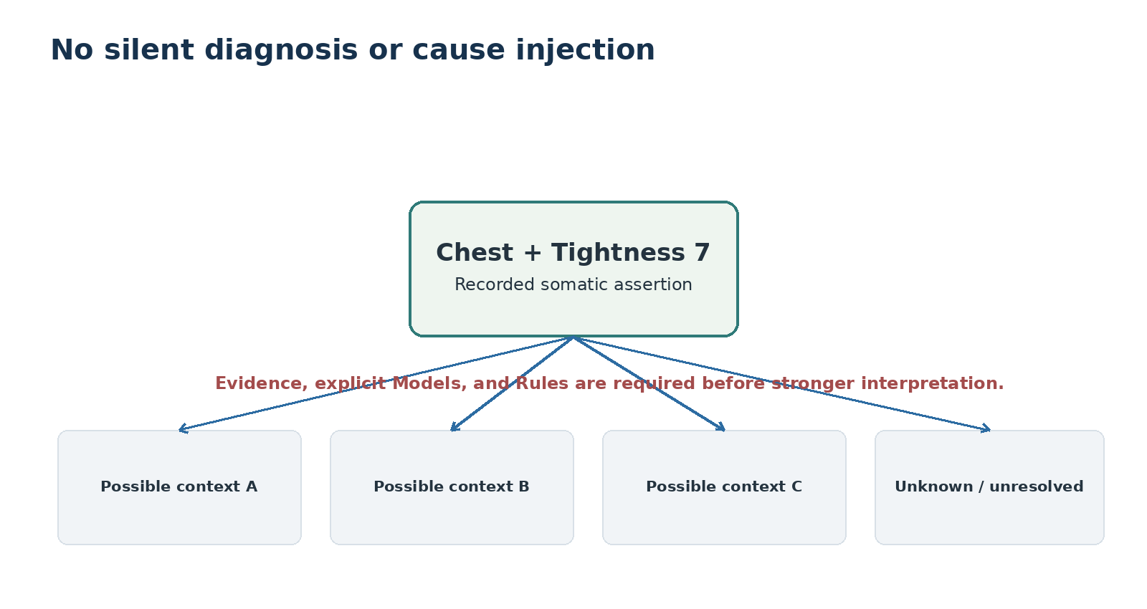
Figure 11. One state assertion may remain compatible with multiple contexts until evidence resolves more.

18. Cognitive Model Bundle Interoperability
Inside the Cognitive Model Bundle, SOMATIC_STATE-124 is one descriptive layer among several. EMOTION-64 supplies affective state; APPRAISAL_EVIDENCE describes observation and inference; COGNITIVE_PATTERNS may identify candidate appraisal structures; NEEDS_VALUES and AGENCY_CONTROL preserve meaning and agency; COPING_PATTERN records current responses; REGULATION supplies candidate strategies; and the Cognitive Episode Model composes these without collapsing their authority boundaries.
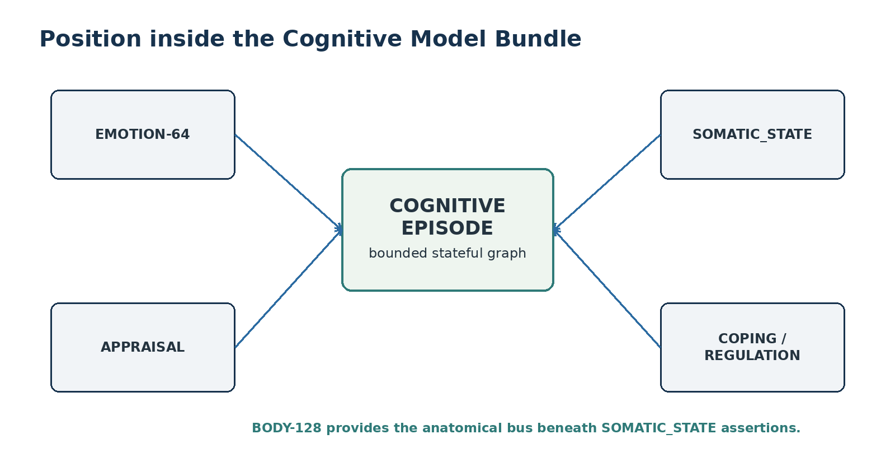
Figure 12. SOMATIC_STATE contributes body-state semantics to the larger Cognitive Episode graph.

19. DARTBOARD Interface Requirements
Requirement | Interface Contract
DREQ-SOM-01 | Select exact SOMATIC_STATE Bit from the registered Reader family.
DREQ-SOM-02 | Resolve or request the minimum sufficient BODY address; never fabricate anatomy.
DREQ-SOM-03 | Support present/unrated and ordinal Level 1-10 without treating the Level as a measurement.
DREQ-SOM-04 | Allow multiple linked assertions in one Episode and show the derived multi-hot routing mask separately.
DREQ-SOM-05 | Expose BOSS symbols as replaceable projections; exact Bit identity remains inspectable.
DREQ-SOM-06 | Preserve the original human phrase and source perspective.
DREQ-SOM-07 | Display validation warnings for ambiguous compilation, missing BODY address, or unsupported state labels.
DREQ-SOM-08 | Permit reversible zoom from Episode configuration → state family → exact state Bit → SK Memory.
DREQ-SOM-09 | Do not infer diagnosis, cause, emotion, or recommended action from the state Bit alone.

20. Conformance Rules
Class | Conformance Requirement
Bit identity | B000-B123 retain the same registered state meanings within this candidate version.
Atomic assertion | A canonical atomic Somatic Assertion resolves one exact state Bit and one BODY address or explicitly records missing/unresolved location.
Aggregate mask | A multi-hot 124-bit mask is derived from linked assertions and MUST NOT replace location- or Level-bearing records.
BOSS projection | Changing glyphs MUST NOT change Bit identity, Reader address, historical records, or compiled semantic meaning.
BODY separation | SOMATIC_STATE MUST NOT redefine anatomical identity or silently infer a more specific BODY location.
Measurement separation | Subjective state and instrument measurements remain separately typed.
Interpretation separation | Emotion, diagnosis, cause, danger, and recommendation require explicit external semantics.
Temporal integrity | State change is derived from ordered configurations; later interpretation does not rewrite earlier recorded assertions.
Unknown input | Unrecognized or ambiguous phrases are preserved or routed for clarification rather than guessed.
References | Per-Bit References Memory exists but is intentionally blank in v0.1 pending formal sourcing.

21. Required Test Classes
Test Class | Expected Behavior
Round-trip Bit | Bit → Reader memory → same Bit identity.
Body compilation | Natural-language body phrase resolves only to supported BODY depth.
Compound sentence | One sentence with several body states compiles to several linked assertions.
No hidden intensity | Qualitative intensifier remains qualitative unless a declared Model translates it.
Mask derivation | Linked assertions deterministically produce the expected multi-hot 124-bit routing mask.
Symbol replacement | Changing BOSS symbol projections leaves Bit identity and compiled records unchanged.
Perspective separation | Self-report, observation, and measurement remain independently typed.
No silent diagnosis | State inputs do not trigger diagnostic or causal outputs without an explicit Model/Rule.
Temporal trace | Ordered configurations reproduce the same state-machine trace after round trip.
Unknown phrase | Unrecognized language remains preserved and unresolved rather than silently mapped.

22. Implementation Handoff
Component | Minimum Contract
SOMATIC State Registry | Bit ID, Reader family, canonical name, BOSS Key, description, examples, aliases, references, status, version.
Somatic Assertion record | Subject/Episode, BODY reference, SOMATIC_STATE Bit, Level, source perspective, confidence, evidence, time, provenance.
Compiler alias table | Natural-language phrases, language/locale, target Bit, confidence/authority, disambiguation notes.
BOSS symbol table | Stable BOSS Key → candidate primary symbol → alternate symbols → pack/version.
Configuration resolver | Collect bounded Episode assertions and derive 124-bit multi-hot routing mask.
Temporal resolver | Order configurations and expose state-machine runs/traces without mutating source assertions.
Graph router | Intersect state Bits with BODY addresses and authorized Cognitive Model Bundle features to retrieve bounded personal evidence.
Reader | Deterministically project Reader family, symbol, description, examples, aliases, Level semantics, and validation state.

23. Related CERBERUS Specifications
Specification | Relationship
BODY-128 Formal System Specification v1.0 | Provides canonical macroscopic anatomical identity, hierarchical BODY addressing, semantic bus behavior, and the explicit rule that mutable symptom/state lives outside BODY identity.
EMOTION-64 Formal Specification v0.1 | Provides the parallel affect-state precedent for presence, ordinal intensity discipline, extension sovereignty, provenance, and no-silent-theory boundaries.
STATE_MACHINE-101 Semantic Kernel Specification v0.1 | Provides the descriptive language for states, configurations, transitions, runs, traces, reachability, and temporal behavior.
CERBERUS Cognitive Model Bundle Cohesion Architecture v0.1 | Places SOMATIC_STATE inside the broader personal cognitive graph alongside appraisal, affect, needs, agency, coping, counter-lenses, regulation, and routing.

24. Formal Summary
FORMAL SUMMARY
SOMATIC_STATE-124 = 124 stable somatic-state identities + BODY-addressed composition + optional ordinal Level + BOSS-replaceable symbols + derived multi-hot routing mask + state-machine-compatible configuration traces + personal graph routing surface.

The architecture is intentionally easy to speak into and easy to inspect afterward. A person can say “my jaw is tight and my hands are shaky,” while the runtime compiles exact body-addressed state handles. Over time, those handles become reusable coordinates into the person’s own Experiences, Reflections, regulation attempts, and outcomes. The machine carries exact recall; the human receives stable local language for noticing and reasoning through bodily experience.

Glossary
Term | Definition
Aggregate Routing Mask | Derived multi-hot 124-bit word indicating which SOMATIC_STATE concepts are active anywhere in the bounded assertion set.
Atomic Somatic Assertion | One exact SOMATIC_STATE Bit bound to one BODY address with optional Level and surrounding provenance.
BOSS Projection | Replaceable human-facing symbol/glyph assigned to a stable semantic identity.
BODY Address | Canonical anatomical referent resolved through BODY-128 or a declared compatible descendant.
Level | Optional ordinal declaration: 0 present/unrated, 1-10 declared strength.
Personal Interoceptive Graph | Person-scoped graph of body states, Episodes, emotions, actions, outcomes, and reflections accumulated over time.
Somatic Configuration | Set of active addressed Somatic Assertions at a bounded time or Episode state.
Somatic Trace | Ordered sequence of Somatic Configurations over time.
State Bit | One B000-B123 semantic identity in the SOMATIC_STATE-124 vocabulary.

