CERBERUS
STORYBOARD CONTINUITY ENGINE
A World That Exists Between Frames
Semantic World State, Recursive Cybernetic Resolution, and Selective Simulation
0  NODEKEY | 1  PROCESS | 2  ROUTING | 3  PROTOCOL | 4  THEORY | 5  RULE | 6  TARGET | 7  BEHAVIOR | 8  SIM | 9  WORLD
Illustrative Architecture Paper
Version 0.2 | August 2026
The world persists because every consequential state can become the valid starting state of what happens next.

Different Assets • Different Semantics • Different Scales • Same Computational Process

EXECUTIVE SUMMARY

Abstract
The Storyboard Continuity Engine (SCE) is the CERBERUS runtime continuity architecture for advancing a persistent semantic world from one addressable state to the next. Its central claim is that simulation does not require a separate computational universe. Once an Asset is represented through canonical Bits, BitGroups, BitWords, Readers, NodeKeys, Models, Rules, Operators, and routes, the same underlying computational grammar can resolve bounded operations, behavioral consequences, local simulation, and persistent world-state change.
SCE therefore separates world existence from continuous rendering. A world can remain semantically present while much of it is not instantiated, animated, or numerically resolved at high fidelity. When an interaction becomes consequential, Reconstruction raises the necessary representation to sufficient fidelity, Simulation resolves the relevant interaction, and only consequential change is committed back into World State. The new state is again semantically addressable, closing the runtime cycle.
The Atlas Infinite Ring expresses this closure as 0 → 1 → 2 → 3 → 4 → 5 → 6 → 7 → 8 → 9 → 0: NodeKey Update, Process, Routing, Protocol, Theory, Rule Application, Target Affected, Behavior, Simulation, World State, and back to NodeKey Update. DRAGON ARMORY and SCE are consequently not treated as unrelated engines. They operate the same cybernetic process at different causal scales: bounded transformation is extended outward until consequence becomes persistent world reality.
Core proposition
SCE keeps a simulated world coherent by preserving addressable semantic state, resolving only the bounded computation required by current consequence, and returning committed results to addressable world state.

What this paper formalizes
- The distinction among existence, instantiation, simulation, animation, and rendering.
- The Bit-defined and route-defined substrate that makes Assets computationally interoperable without forcing them to share semantics.
- The Atlas Infinite Ring and NodeKey Closure as the complete runtime cycle.
- The relationship between DRAGON ARMORY bounded operations and SCE world continuity.
- World State as a composable graph of spatial, ecological, social, temporal, and historical structures.
- Goal and Target persistence, interrupts, ranked fallback, multiple runtime rhythms, and bounded perception.
- Reconstruction, Hot/Warm/Cold attention, Simulation Bubbles, and Lowest Sufficient Resolution.
- The authority boundary between derived state, proposals, Committed Deltas, and persistent world truth.
- Recursive group behavior, embedded need loops, bounded knowledge, memory, generational continuity, environmental reclamation, and projection independence.

Scope
This is an illustrative architecture paper. It defines the continuity problem and the computational relationships that allow a semantic world to persist and change. Detailed BIGFOOT tables, individual BitWord specifications, complete DARTBOARD and DRAGON ARMORY specifications, Effects mathematics, Skene implementation, rendering code, PULSE, EDIFICE federation, and engine-specific source code remain neighboring systems or downstream implementation concerns unless needed here to define an interface.

NAVIGATION

Paper Map
Part | Theme | Purpose
1 | Persistent Semantic Reality | Why a world can exist without continuous rendering.
2 | One Computational Grammar | Bits, routing, the Atlas Infinite Ring, and NodeKey Closure.
3 | World State as Model Fabric | Tile, Zone, Region, Habitat, Society, Infrastructure, and Map.
4 | Behavioral Continuity | Goals, Targets, interrupts, fallback, rhythms, and perception.
5 | Selective Simulation | Reconstruction, fidelity, bounded attention, authority, and orchestration.
6 | Recursive World Continuity | Herds, BID, knowledge, memory, generations, ecology, and projections.
7 | Integrated Runtime Trace | Crystal Bat → Forest Elk through the complete cycle.
8 | Principles and Boundaries | Formal laws, implementation boundaries, and the Infinite World Loop.

Reading strategy
The figures form a parallel visual argument. The early figures establish the computational machine; the middle figures show how it selectively operates; the later figures demonstrate that behavior, history, ecology, and presentation remain consequences of the same underlying runtime grammar.

PART 1
Persistent Semantic Reality
A world is continuous because its state remains addressable, not because every part of it is constantly rendered.

1. A World That Exists Between Frames
The intuitive model of a simulated world is often visual: if the camera can see it, the engine updates it; if the camera leaves, the thing is either frozen or continues through a hidden numerical approximation. SCE begins from a different premise. The authoritative world is semantic state. Rendering is one possible projection of that state, not the condition under which the world exists.
This allows a deer, forest, village, river, Tribe, building, or weather system to remain part of the world while no high-resolution representation is active. Their identities, current conditions, relationships, and histories can persist compactly. When something becomes operationally relevant, the system resolves only the representation required to determine what happens next.
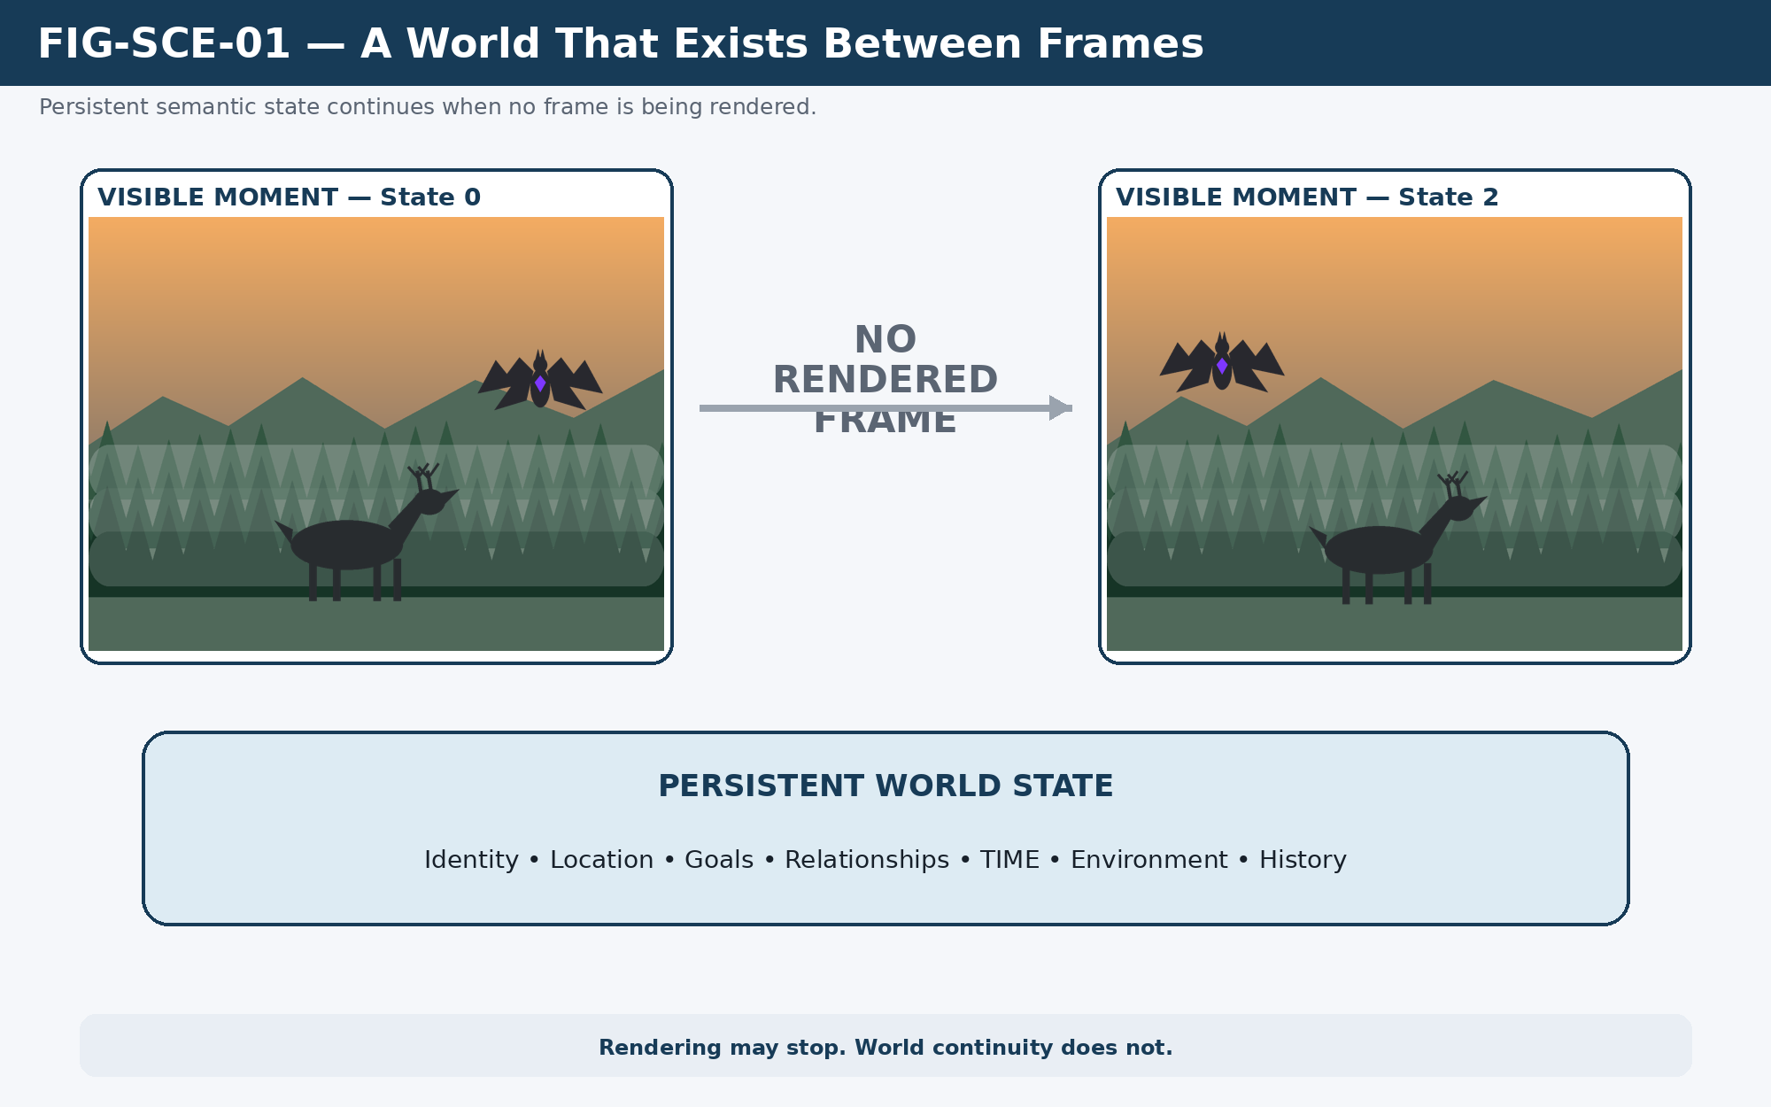
Figure 1. A World That Exists Between Frames: projection may disappear while persistent semantic state continues.
Rendering may stop. World continuity does not.

2. Existence, Instantiation, Simulation, Animation, and Rendering
SCE depends on a strict separation among five concepts that conventional real-time systems often blur. Existence means that an addressable semantic state persists. Instantiation means that an active representation has been materialized. Simulation means that interaction is currently being resolved. Animation means that motion or performance is being expressed. Rendering means that perceptible output is being produced.
An Asset may stop at any of these boundaries. A cold Region may exist without active geometry. An instantiated character may be available for interaction without currently being simulated. A simulated event may resolve without animation because nobody observes it. An animation may exist as an internal performance without being rendered to a viewer. Separating these states makes selective computation possible without treating unrendered reality as nonexistent.
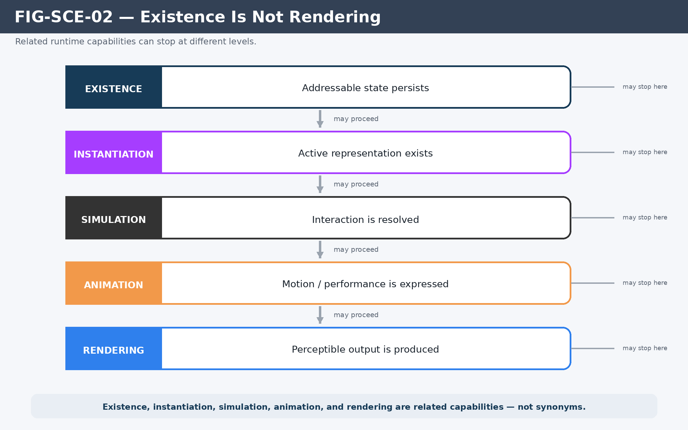
Figure 2. Existence is not rendering: related capabilities can stop at different runtime boundaries.

3. The Storyboard Is State Continuity
The word “Storyboard” names the ordered continuity of meaningful states, not a requirement for visual frames. A canonical sequence can be expressed as State₀ → Event → State₁ → Event → State₂. The world remains causally continuous if each state is a valid consequence of the previous state and can serve as the authoritative starting point for the next operation.
A Crystal Bat may emit a Screech while a Forest Elk is grazing at dusk in light rain. The event changes what the Elk perceives, which may change its Goal, which may cause movement, which may alter herd configuration and local position. None of those transitions requires a rendered frame to be canonical. Frames, prose, audio, debug panels, or educational views can be generated later from the same resolved states.
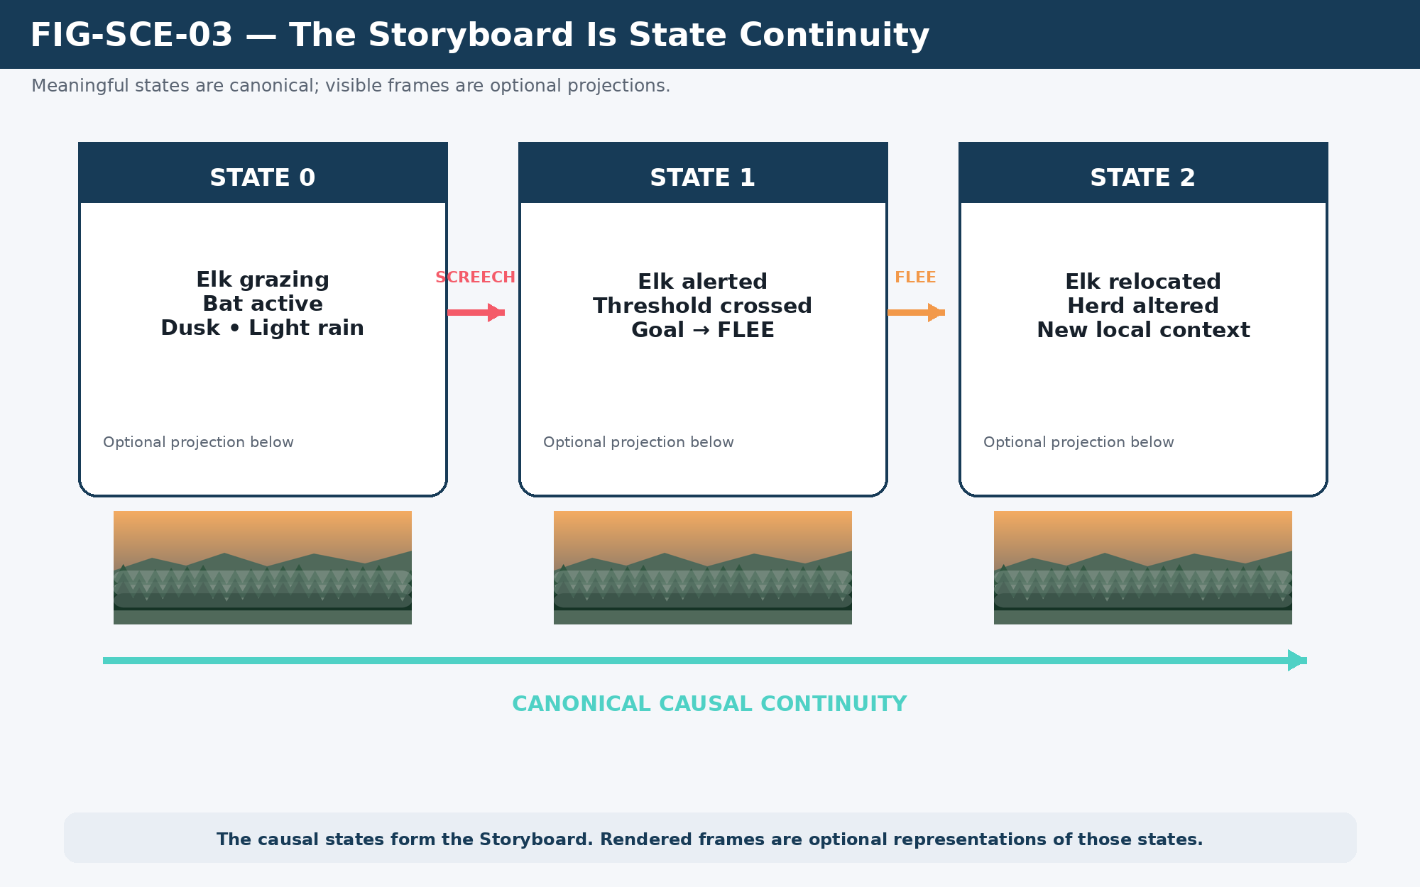
Figure 3. The Storyboard is the sequence of causal states; rendered frames are optional projections of those states.
Continuity criterion
A world-state transition is valid when the resulting state is an authorized consequence of the preceding addressable state and applicable runtime contracts.

PART 2
One Computational Grammar
Different semantic systems can participate in the same runtime process once their Bits, Readers, Models, Rules, Operators, and routes are defined.

4. From Bits to a Simulatable Asset
Simulation begins below the level of “character AI” or “world logic.” CERBERUS first gives state stable computational meaning. Bits encode primitive state. BitGroups provide reusable mathematical structures. BitWords bind those structures into bounded semantic contracts. Readers deterministically interpret them. NodeKeys identify exact addressable referents. Taxonomies, Model Keys, Models, Rules, Operators, and routes determine which structures participate in a given operation.
A simulation-ready Asset is therefore not a special species of object. It is a registered thing whose relevant state, interpretation, and transformation contracts are sufficiently defined for the current operation. A human, deer, robot, river, forest, vehicle, or Region can differ radically in meaning while still being resolved through the same computational grammar.
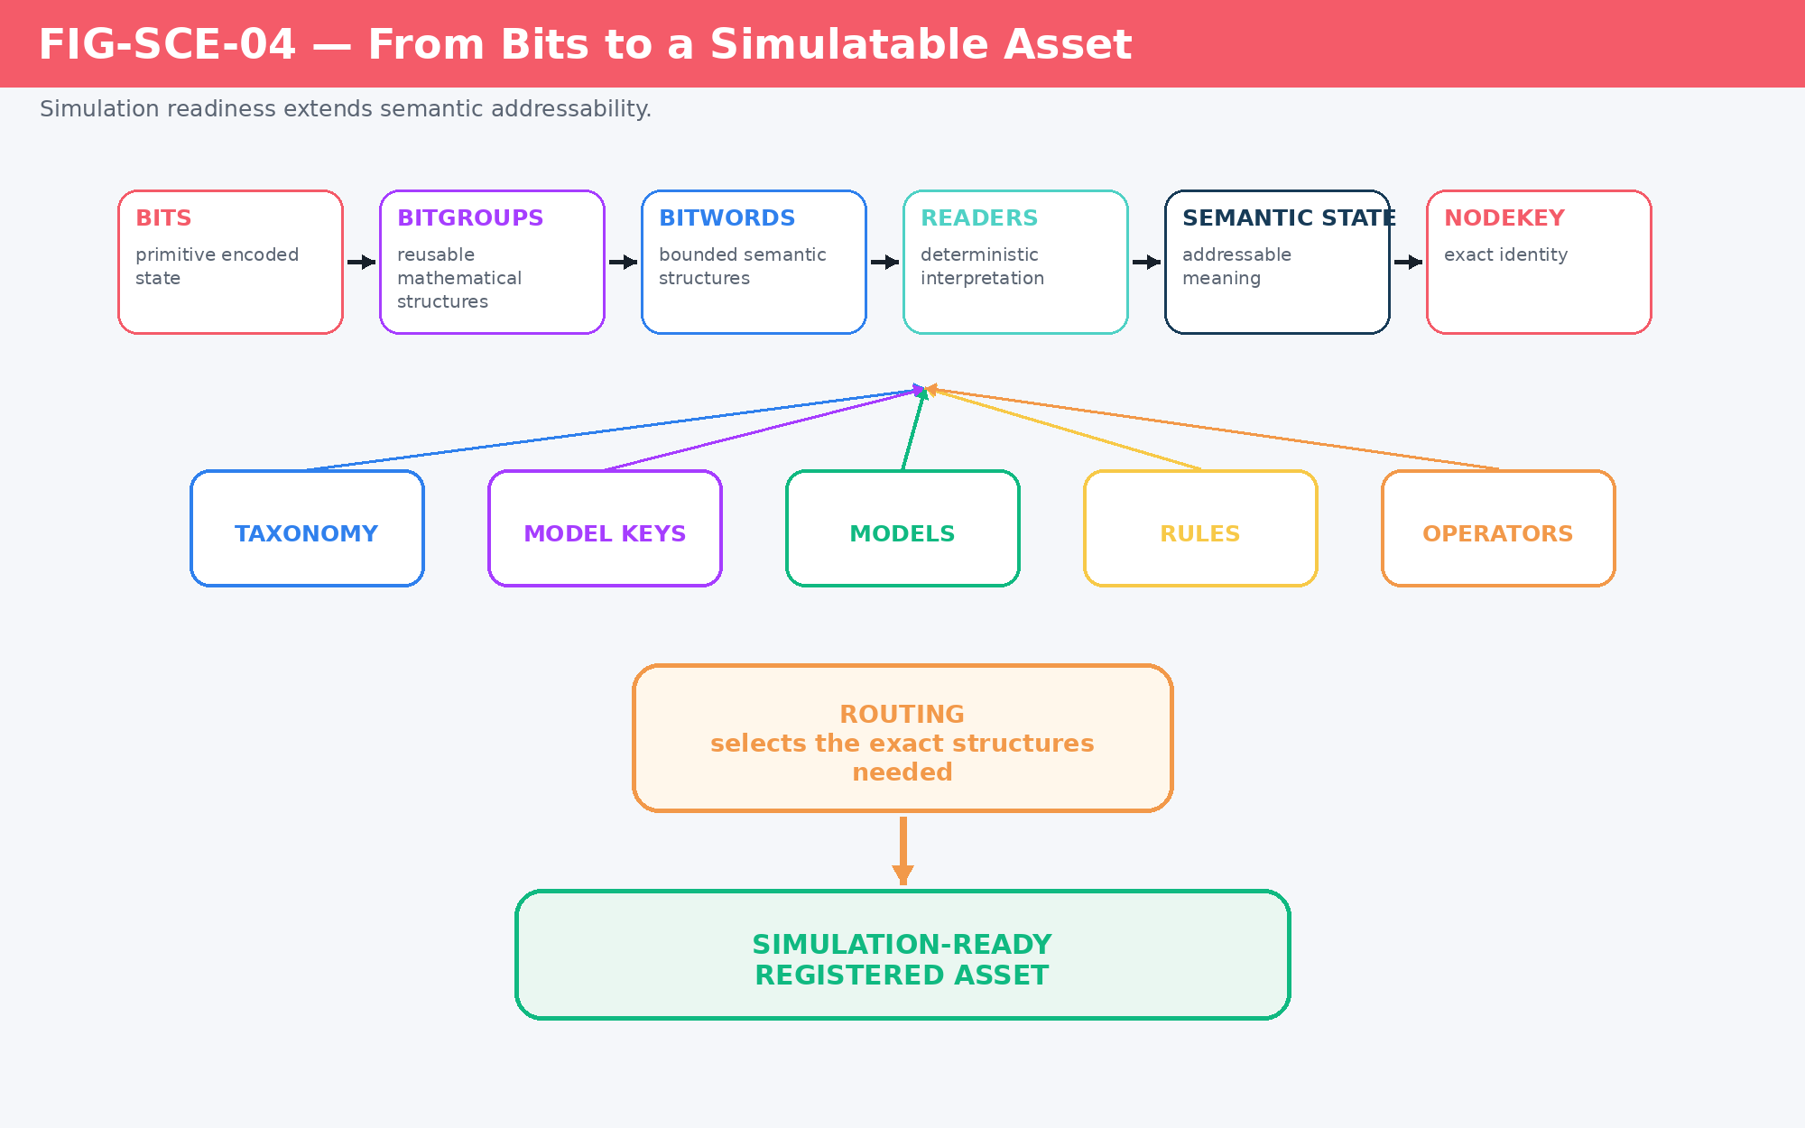
Figure 4. From Bits to a simulatable Asset: simulation readiness extends semantic addressability.

5. Same Computational Process, Different Assets
Shared runtime machinery does not require shared semantics. The deer need not use the same Models as the river; the robot need not use the same behavior contracts as the farmer; the Region need not expose the same state as the vehicle. What they share is the process by which exact state is addressed, interpreted, routed, transformed, written, and made addressable again.
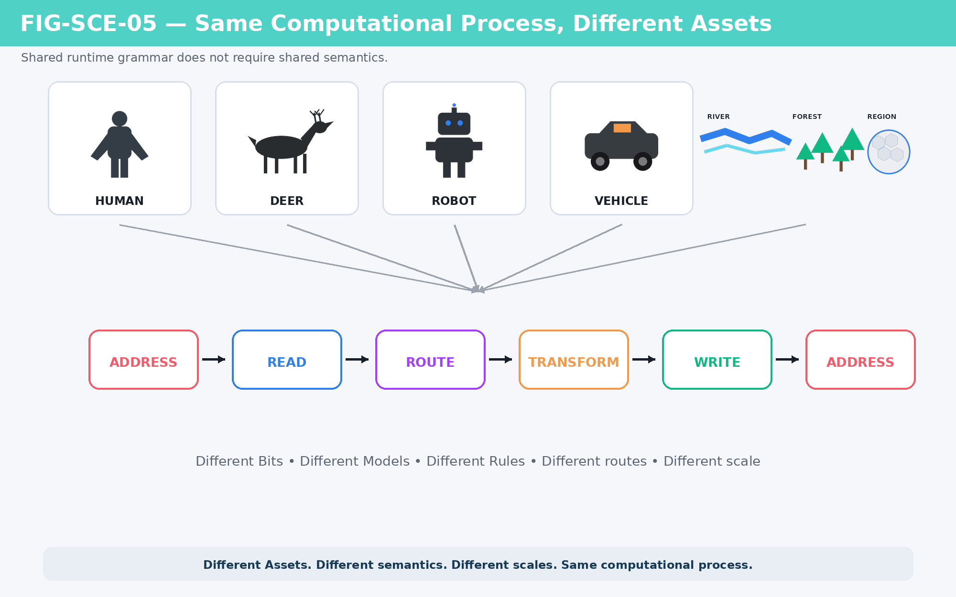
Figure 5. Different Assets can preserve distinct semantic contracts while using the same address-read-route-transform-write-address process.
Shared computation does not require shared semantics.

6. The Atlas Infinite Ring
The Atlas Infinite Ring expresses the complete causal cycle. The runtime begins from NodeKey-addressable state, determines the bounded Process, resolves Routing, applies the relevant Protocol, selects or evaluates the applicable Theory, applies Rules, determines how the Target is affected, propagates that effect into Behavior, resolves Behavior through Simulation, commits consequential World State, and returns the result to NodeKey-addressable state.
The Ring is not simply a list of software modules. It is a semantic decomposition of a complete cybernetic transformation. Individual operations may require only a bounded subset of the available families, but a consequence that changes the persistent world is not complete until the new state can again be addressed by the system.
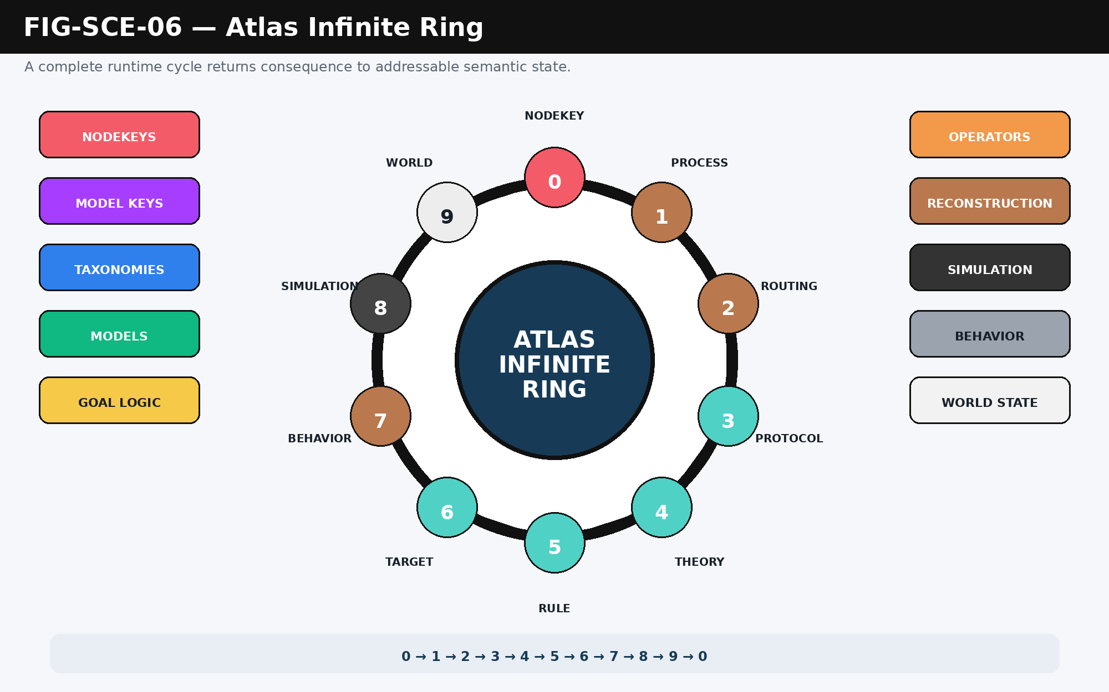
Figure 6. The Atlas Infinite Ring: 0 → 1 → 2 → 3 → 4 → 5 → 6 → 7 → 8 → 9 → 0.

7. NodeKey Closure
The return to 0 is therefore not merely a numbering convenience. It marks closure. A runtime cycle begins with semantic identity and ends by returning consequence to semantic identity. Once the updated world has been re-registered as exact state, it can become the input to the next cybernetic cycle without reconstructing meaning from a transient output packet.
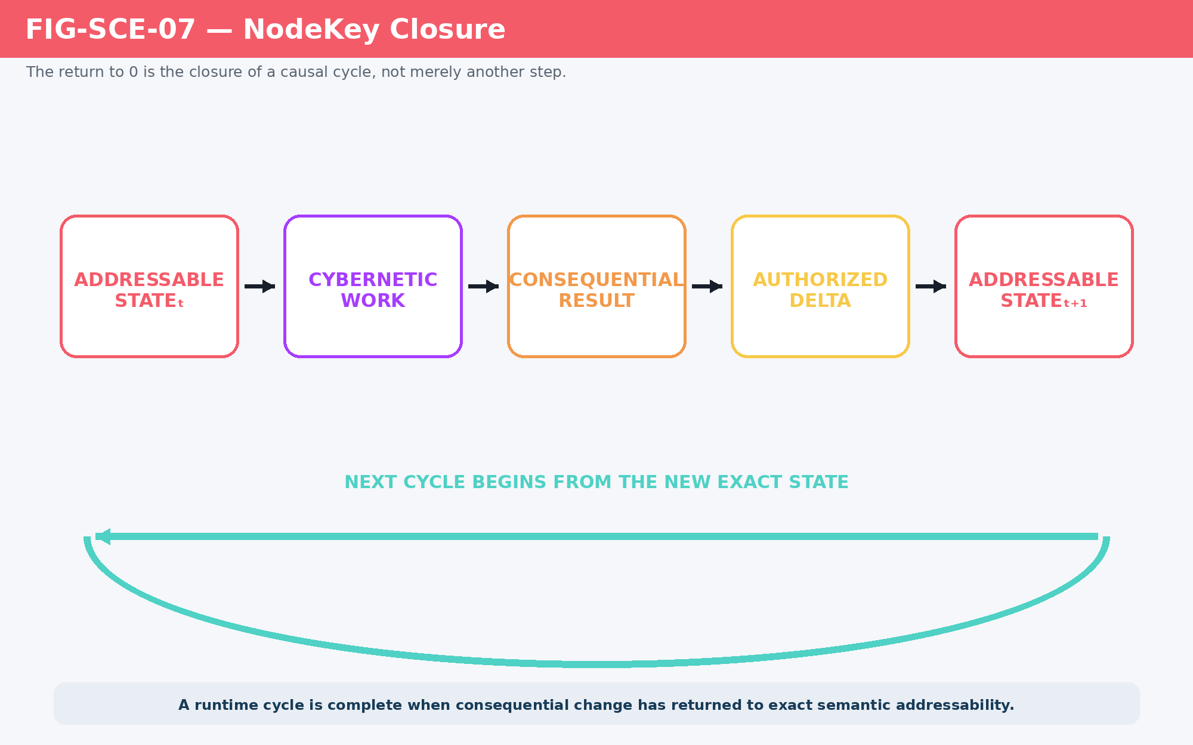
Figure 7. NodeKey Closure: consequential change becomes complete runtime state when it returns to exact addressability.
NodeKey Closure
A runtime cycle is complete when its consequential result has returned to exact semantic addressability from which subsequent computation can proceed.

8. DRAGON ARMORY and SCE: Same Loop, Different Scale
DRAGON ARMORY and SCE should not be conceptualized as unrelated engines. DRAGON ARMORY primarily resolves bounded transformation: Process → Routing → Protocol → Theory → Rule Application → Target Affected. SCE continues from the affected target through Behavior → Simulation → World State → NodeKey Update. The substrate and computational grammar remain the same; the causal boundary becomes larger.
This distinction clarifies why the architecture scales. A local Operator can alter one target. That change can alter behavior. Behavior can affect nearby Assets and environmental state. The resulting world change can alter future Goals, routes, and Models. SCE is the continuation of bounded cybernetic resolution until the consequence becomes persistent world context.
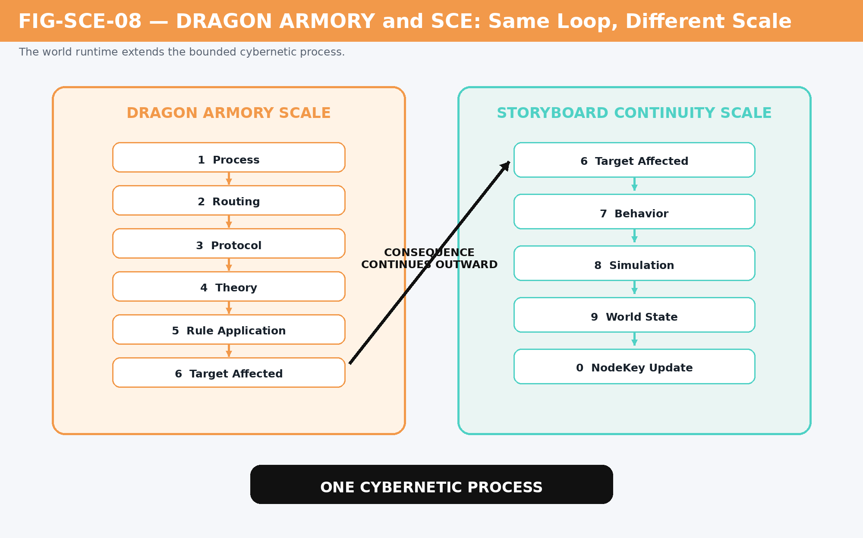
Figure 8. DRAGON ARMORY and SCE operate the same cybernetic process across different causal scales.

9. Semantic Families Feed the Ring Selectively
The semantic families surrounding the Ring are available runtime resources, not mandatory subsystems that must all execute on every tick. A Screech event may require Actor and Target NodeKeys, an Action or Operator, auditory Models, environmental attenuation, response Rules, Goal logic, and only enough local simulation to determine the consequence. A simple table lookup may require far less. A major physical interaction may require more.
This is a central source of computational economy. The runtime routes to what is required by the current semantic problem rather than continually reevaluating the entire world through every available family.
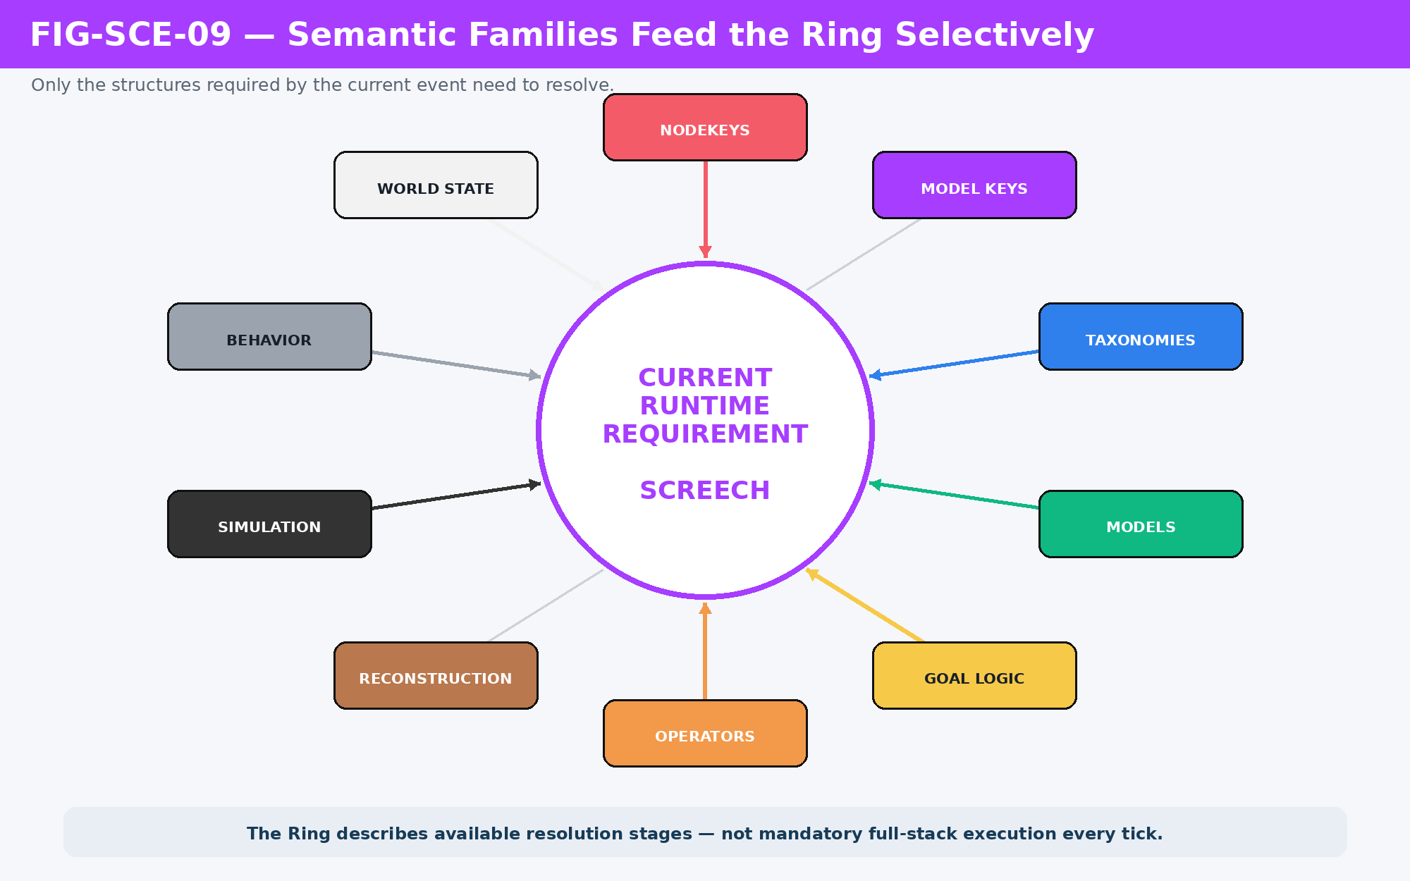
Figure 9. Semantic families feed the Ring selectively according to the current runtime requirement.

PART 3
World State as Model Fabric
The simulated world is a composable graph of spatial, ecological, social, temporal, and historical structures.

10. World State Is a Graph, Not a Frame
World State is not a giant rendered snapshot. It is a graph of addressable relationships and bounded state. Spatial organization may include World, Region, Zone, and Tile. Assets occupy, traverse, modify, or observe those structures. Other Models cut across them: Habitat, Society, Infrastructure, TIME, history, and individual state can intersect the same spatial referents without becoming children of a single rigid hierarchy.
This matters because different questions traverse different structures. A movement query may care about Tiles and Zone adjacency. A breeding query may care about Habitat, season, and carrying capacity. A social development query may care about Region, Society, Infrastructure, and Life Trajectory. A map query may expose selected portions of these structures without owning them.
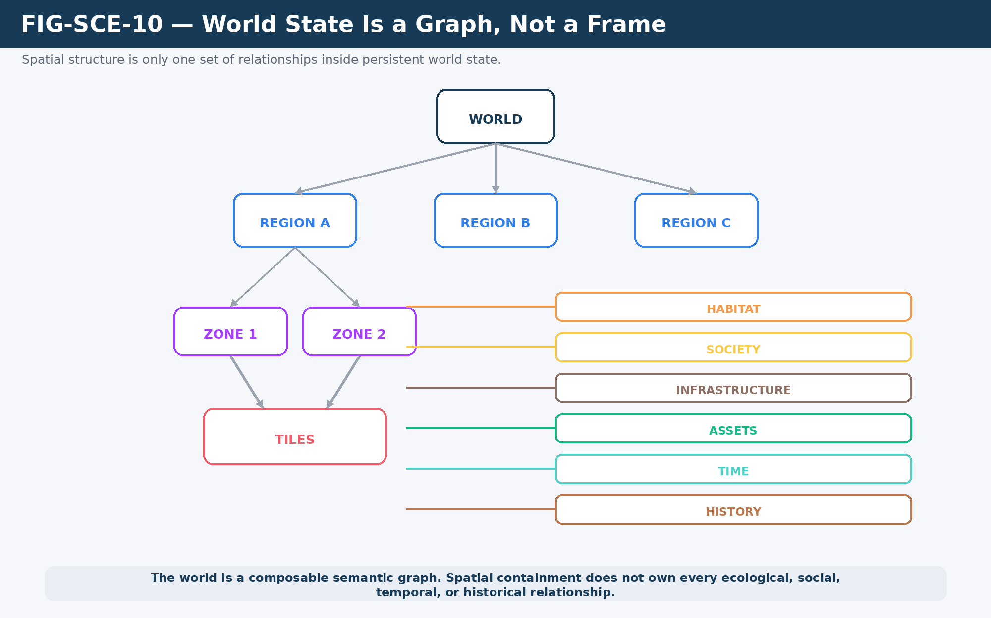
Figure 10. World State is a graph of spatial and cross-cutting semantic structures, not a rendered frame.

11. Tile, Zone, Region, and Map
Tiles provide local spatial substrate. Zones group contiguous Tiles according to declared combinations or conditions. Regions aggregate Zones into larger spatial, geological, or organizational structures. Map is deliberately different: it is a projection Model that determines what portions of these structures are exposed and how they are represented.
This separation avoids a common modeling error in which the visual map becomes the world database. A Region may change while its Map representation remains stable; a Map may highlight only certain fields; multiple maps may expose the same underlying Region differently. Canonical state belongs to the world structures, not to the visualization.
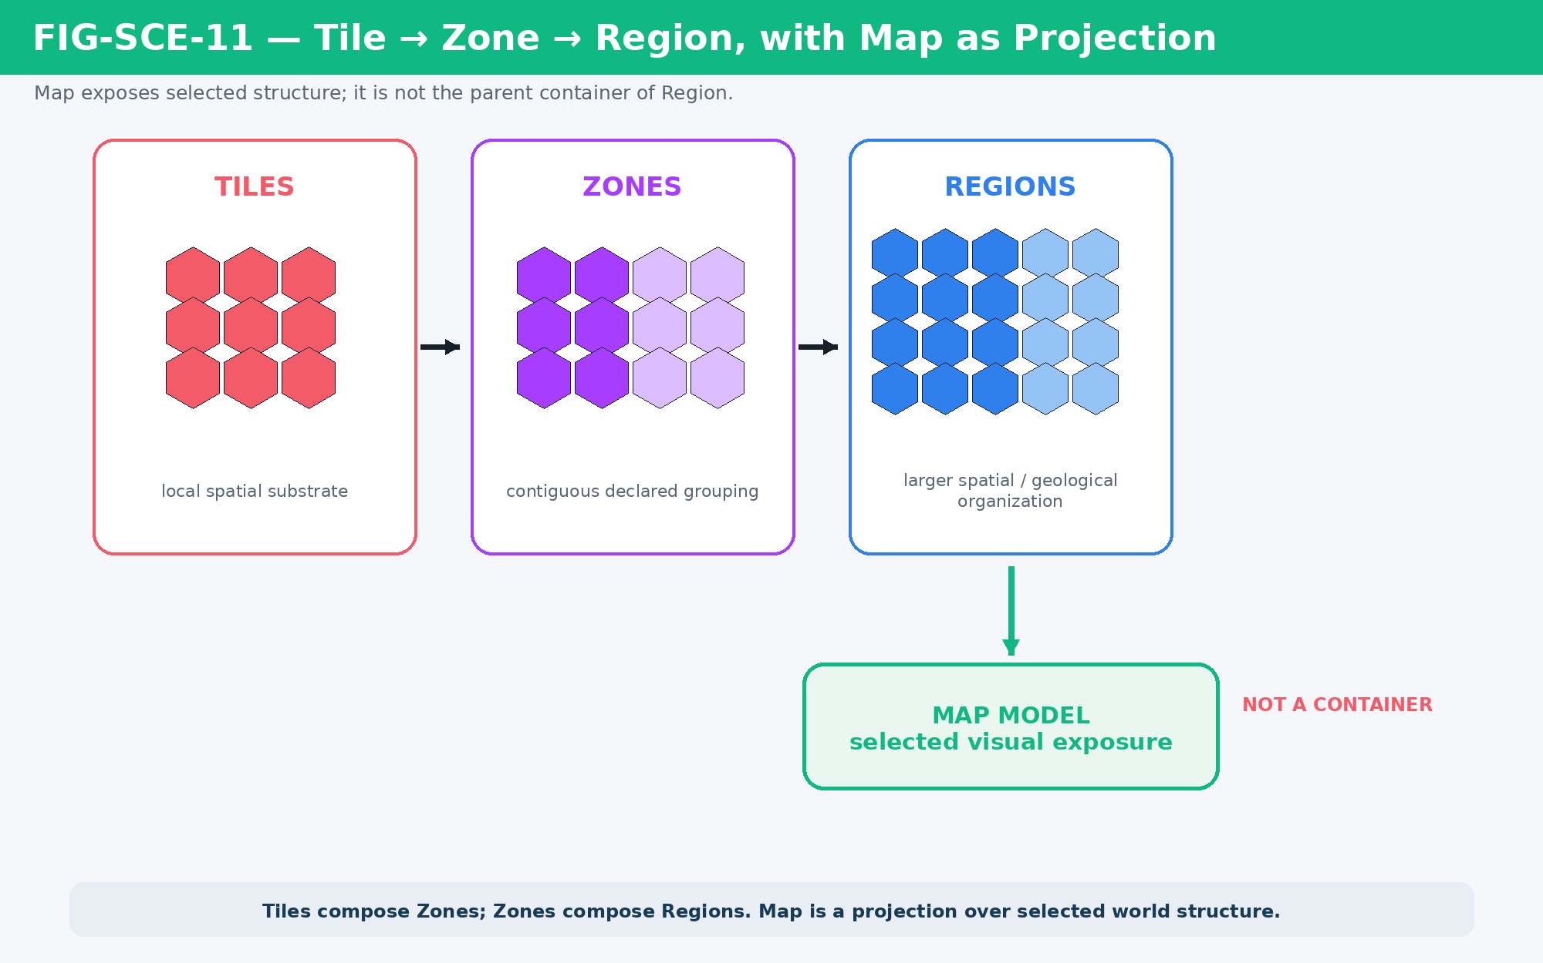
Figure 11. Tile → Zone → Region forms spatial structure; Map is a selected projection of that structure.

12. World Models Form a Fabric
The Figma architecture already demonstrates that world modeling is not reducible to one hierarchy. Habitat can read temperature, food sources, migration conditions, carrying capacity, and breeding constraints. Society can organize customs, roles, and collective behavior. Infrastructure can change how people interact with structural capacity. Life Trajectory can connect social and environmental conditions to individual development. These Models intersect through explicit junctions while preserving their own semantic ownership.
SCE consumes this fabric rather than replacing it. Runtime routing selects the relevant Models for the current event. World continuity therefore emerges from interoperable contracts rather than from a monolithic “world engine.”
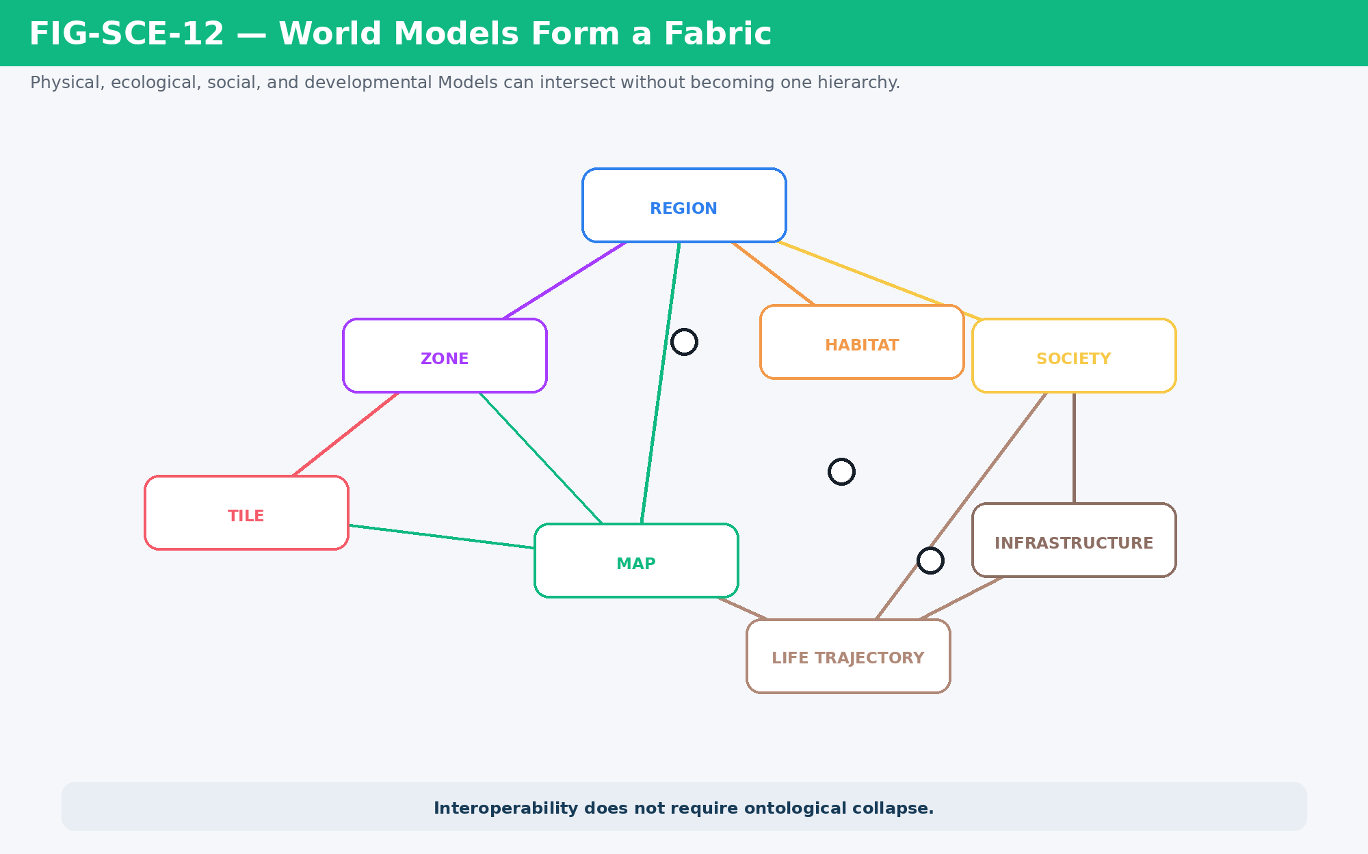
Figure 12. World Models form an interoperable fabric without collapsing physical, ecological, social, and developmental structures into one hierarchy.

13. Map Is Projection, Not World Truth
The Map Model is a useful local example of a broader architectural principle. Canonical world truth may include Tiles, Zones, Regions, Habitats, Societies, Infrastructure, Assets, history, and TIME. The Map Model selects and transforms some of that state for a particular viewing purpose. A Game Map, Strategic Map, Debug Map, Educational Map, and Cinematic Layout can all be valid projections of the same underlying world.
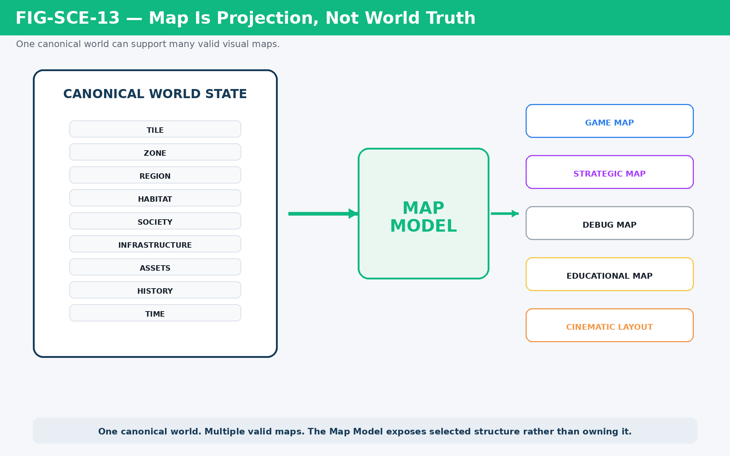
Figure 13. Map is projection, not world truth: one world can support multiple valid map views.
One world. Multiple valid maps.

PART 4
Behavioral Continuity
Stable Goals and Targets persist until completion, invalidation, interruption, or a higher-priority change requires reconsideration.

14. Goal + Target = Behavioral Continuity
Anything intentionally moving through the world can be modeled around a simple persistent pair: Current Goal and Target. A deer may GRAZE toward a shrub. A wolf may HUNT a deer. A farmer may WORK a field. A robot may INSPECT a weld joint. The semantic details differ, but the continuity grammar is shared: maintain the Goal and Target while the action remains valid.
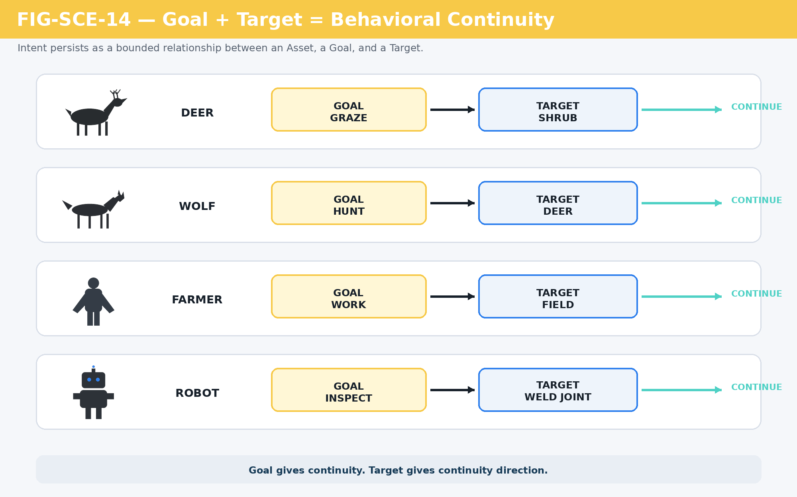
Figure 14. Goal gives behavior continuity; Target gives that continuity direction.

15. Continuity Before Reconsideration
SCE does not require an actor to rebuild its decision state every frame. Stable behavior can continue until a meaningful event changes the conditions under which the current Goal was selected. Relevant causes include Goal completion, Target invalidation, TIME thresholds, perceived threats, new opportunities, status changes, world events, or a higher-authority directive.
This pattern is both computationally efficient and behaviorally plausible: choose → continue → continue → event → reconsider. A grazing elk does not need to recalculate its entire identity merely because one more frame has passed.
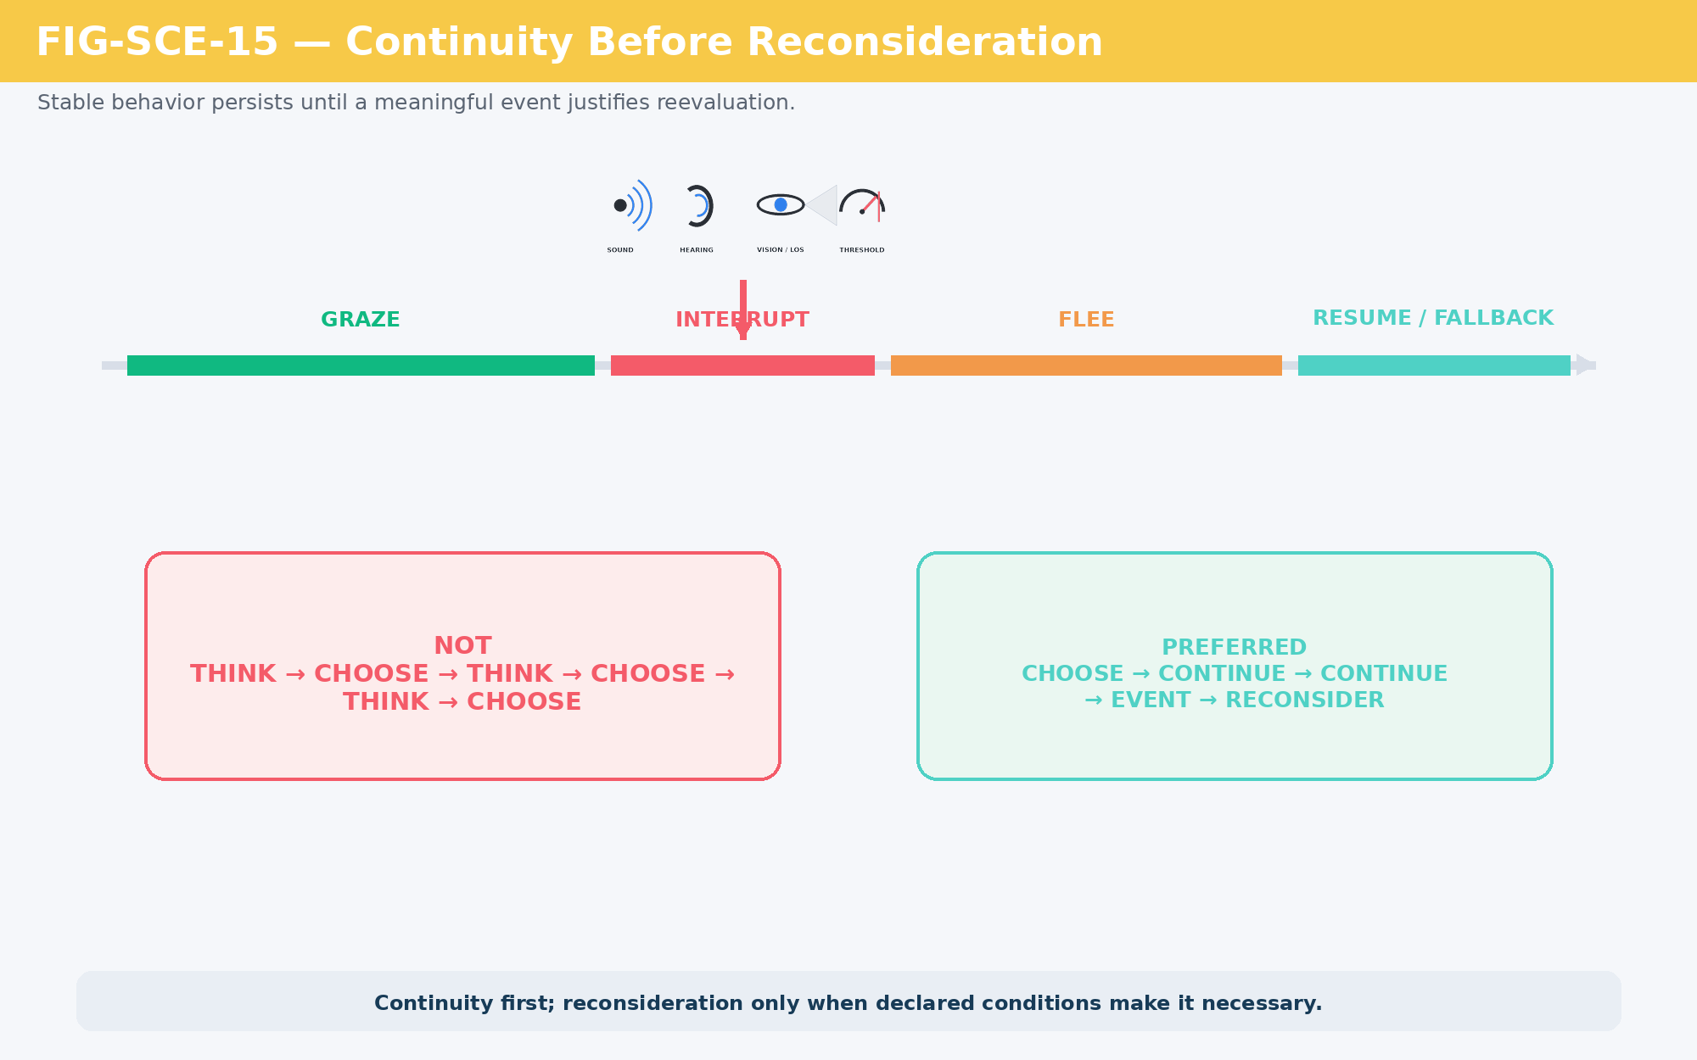
Figure 15. Continuity before reconsideration: stable behavior persists until an explicit cause justifies reevaluation.

16. Ranked Goal Fallback
Continuity also benefits from maintaining more than one viable candidate. A ranked Goal set can identify a Primary Goal and a Secondary continuity fallback without reducing the actor to only two possible behaviors. If the Primary Goal becomes temporarily impossible, the system can promote the next eligible candidate rather than discard the entire actor state and reroll from nothing.
This preserves stability while still allowing context to matter. Goal weights can change with TIME, weather, Zone, loaded Assets, BID-like needs, season, knowledge, and perceived events. Randomness may introduce bounded variation, but it need not replace the deterministic structure that makes the decision understandable.
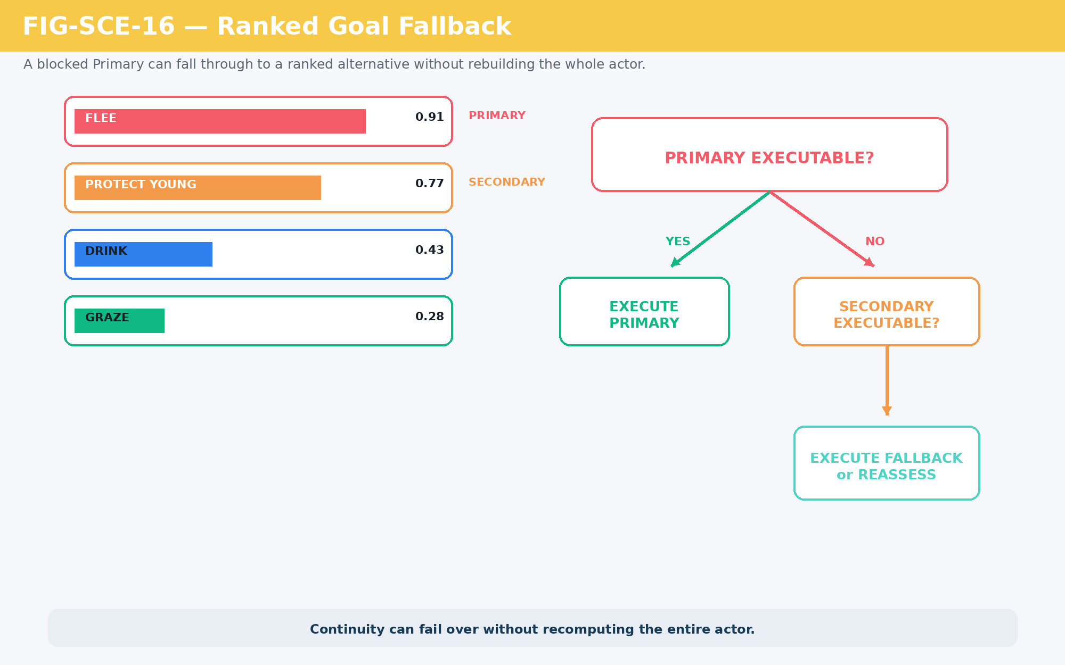
Figure 16. Ranked Goal fallback maintains continuity without rebuilding the complete decision state.

17. One World, Many Runtime Rhythms
The world does not have one meaningful update frequency. Immediate collision may require frame-scale resolution. Sound and damage can be event-driven. Need decay may update on intervals. Work routines may change hourly. Ecological processes may update daily or seasonally. Infrastructure, population, and cultural change may operate on much longer rhythms.
SCE therefore treats TIME as a routing context rather than forcing every process into a universal tick. A process is evaluated at the frequency required by its causal role. This avoids wasting computation on stable relationships while preserving enough temporal resolution for consequential interaction.
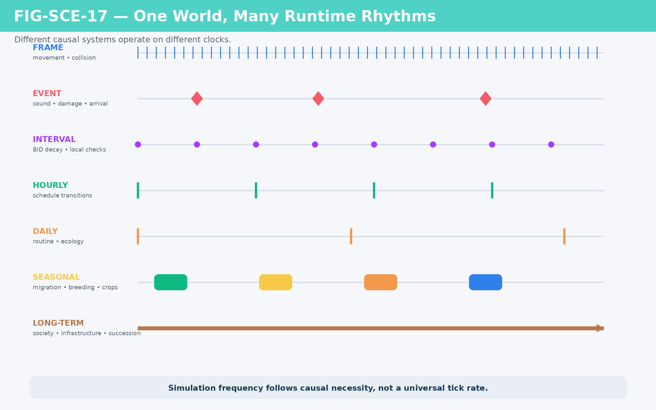
Figure 17. One world, many runtime rhythms: update frequency follows causal necessity.

18. A World Event Is Not Automatically Perceived
Canonical world truth and actor awareness are distinct. An event can occur without every nearby Asset knowing that it occurred. Perception therefore uses routing and filtering. A broad phase identifies plausible receivers by location, distance, eligibility, or other inexpensive tests. A narrow phase applies orientation, line of sight, attenuation, thresholds, or more expensive checks only when necessary.
For hearing, an Action can emit a sound event. Nearby candidates then evaluate attenuation and response thresholds. For vision, proximity and facing can be tested before expensive line-of-sight checks. Only successful perception becomes part of the actor’s state and can influence subsequent Goal selection or memory.
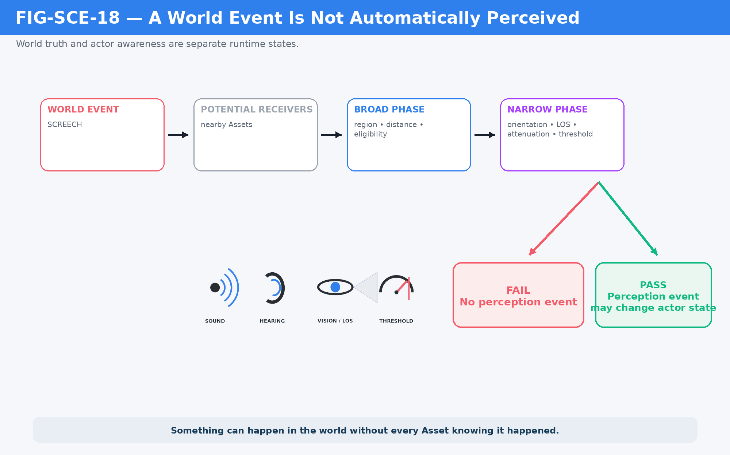
Figure 18. A world event becomes a perception event only after the applicable broad- and narrow-phase conditions succeed.

PART 5
Selective Simulation
Reconstruct only what is needed, resolve only the necessary fidelity, and persist only consequential change.

19. Reconstruction Raises Fidelity When Needed
Persistent semantic state does not require all Assets to remain fully instantiated. Reconstruction is the operation that raises a bounded Asset or context to the representation required for execution. It can combine canonical identity, current state, relevant reference Models, local geometry, environmental context, and a requested fidelity level to produce an active representation.
After simulation, the system does not need to preserve every temporary detail. It can compress the consequential result back into persistent state. This produces a useful three-stage relationship: Reconstruction raises executable fidelity; Simulation resolves interaction; World State preserves consequential result.
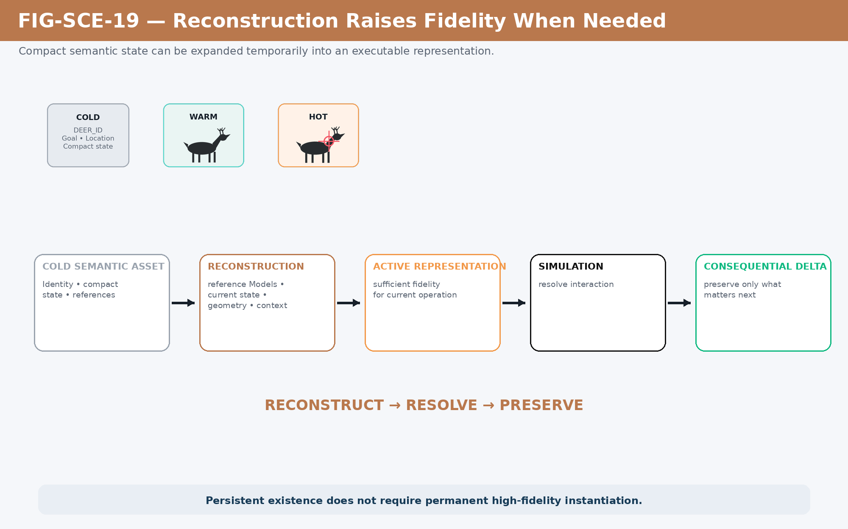
Figure 19. Reconstruction raises fidelity when operational relevance demands it, then consequential state is preserved compactly.
Reconstruct → Resolve → Preserve.

20. Hot, Warm, Cold, and the Simulation Bubble
Computational attention can be spatially and semantically bounded. Hot state receives the highest active fidelity because immediate interaction depends on it. Warm state remains available at lower resolution because it is nearby, likely to matter, or useful for prediction. Cold state persists semantically without expensive active instantiation.
A Simulation Bubble temporarily creates a high-fidelity context around an interaction that requires more resolution than its surroundings. This makes very large persistent worlds tractable: the world can remain semantically complete while only small regions are computationally expensive at any moment.
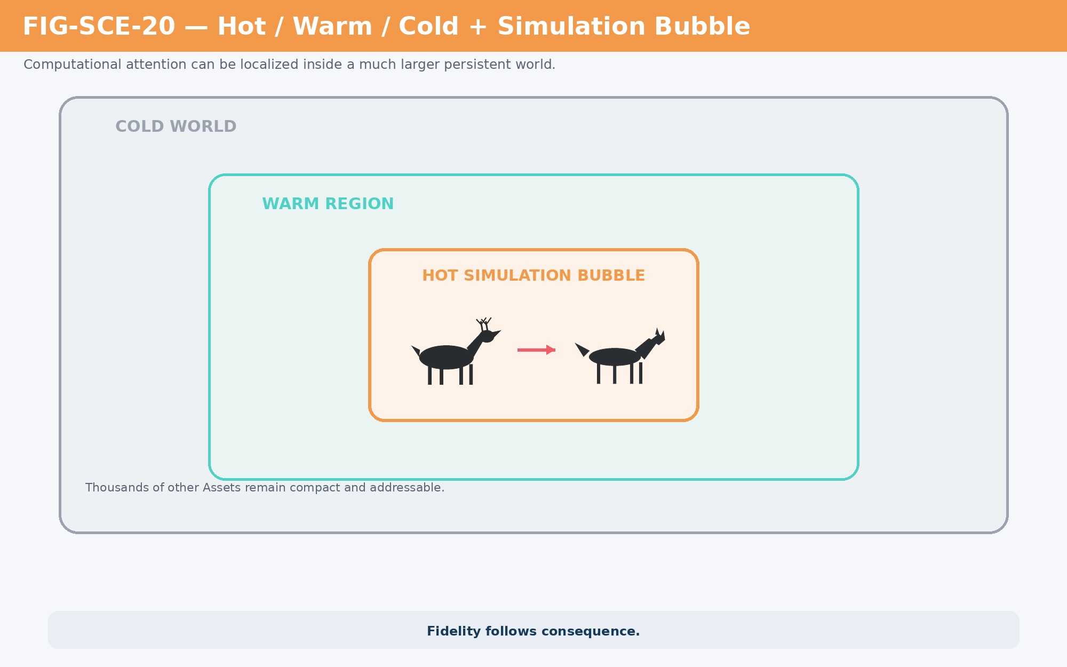
Figure 20. Hot/Warm/Cold attention localizes expensive computation inside a persistent world.

21. Lowest Sufficient Resolution
The governing question is not “How much detail can the engine calculate?” but “What is the lowest resolution sufficient to determine the consequential result?” Operational consequence, observer proximity, uncertainty, interaction complexity, evidence requirements, dependency reach, presentation need, and compute budget can all influence that decision.
Some events are resolved symbolically. Others need statistical, structural, geometric, or high-fidelity physical treatment. Selecting the highest available resolution by default wastes computation and can create false precision. SCE instead makes fidelity an explicit runtime decision.
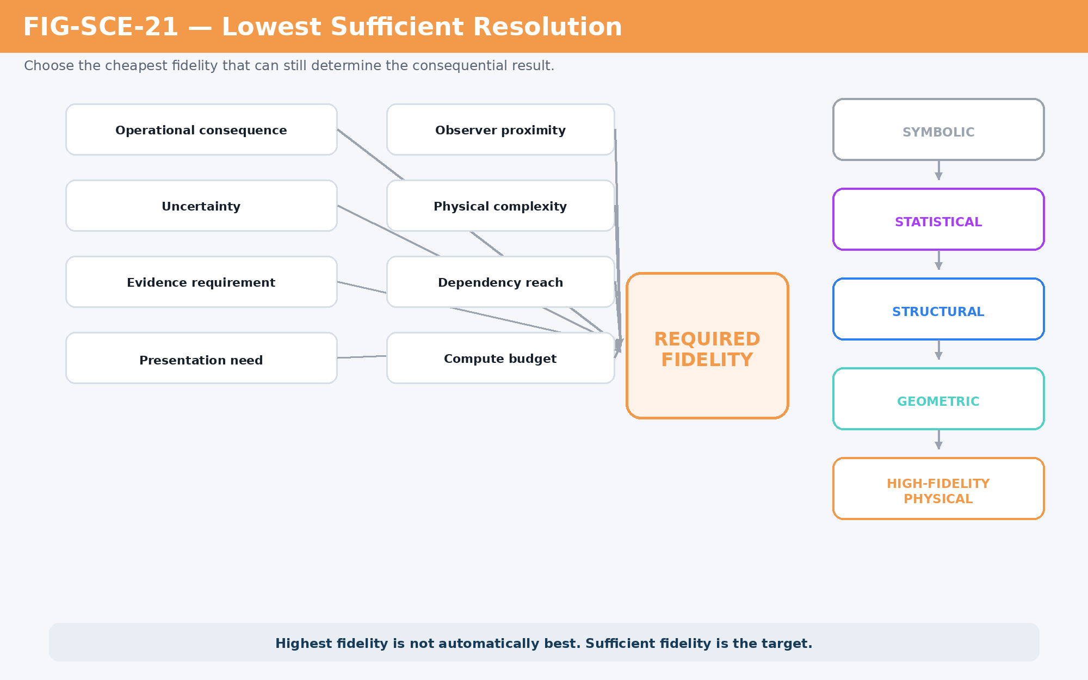
Figure 21. Lowest Sufficient Resolution chooses the minimum fidelity capable of resolving the consequential outcome.

22. Behavior Is Not Simulation
Behavior and Simulation occupy adjacent Ring positions because they answer different questions. Behavior describes what an Asset now attempts because of its state, Goal, and Target. Simulation determines what actually happens when that attempt encounters terrain, other Assets, movement limits, TIME, physical constraints, and other applicable world structures.
An elk can attempt to FLEE toward a safe Region. The final trajectory may be altered by obstacles, herd cohesion, injury, predator location, or environmental conditions. Intent therefore does not dictate outcome. Simulation mediates the attempt through the world.
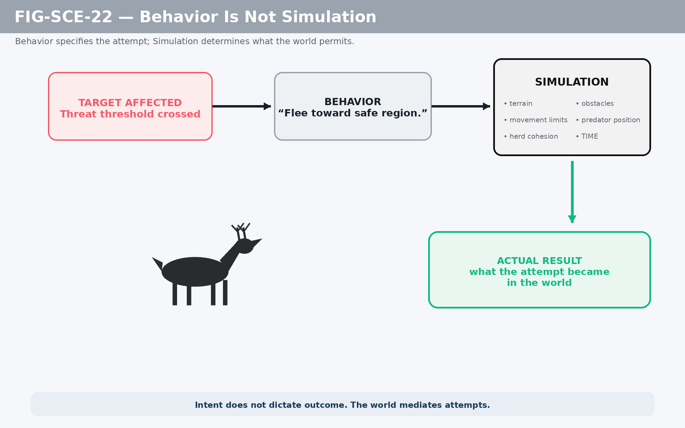
Figure 22. Behavior defines the attempt; Simulation mediates that attempt through the active world.

23. From Proposal to Canonical World Change
SCE must also distinguish computation from authority. A runtime can calculate derived values, assemble transient Runtime Packets, and generate proposals without mutating canonical state. The useful state classes are Definition, Live State, Derived State, Proposal, Committed Delta, and Projection. Only an authorized consequential mutation becomes a Committed Delta and updates Live State.
This prevents transient inference from quietly becoming history. A failed candidate Goal, intermediate force value, diagnostic threshold, or projection choice does not automatically become world truth. Canonical state changes only through the appropriate mutation authority.
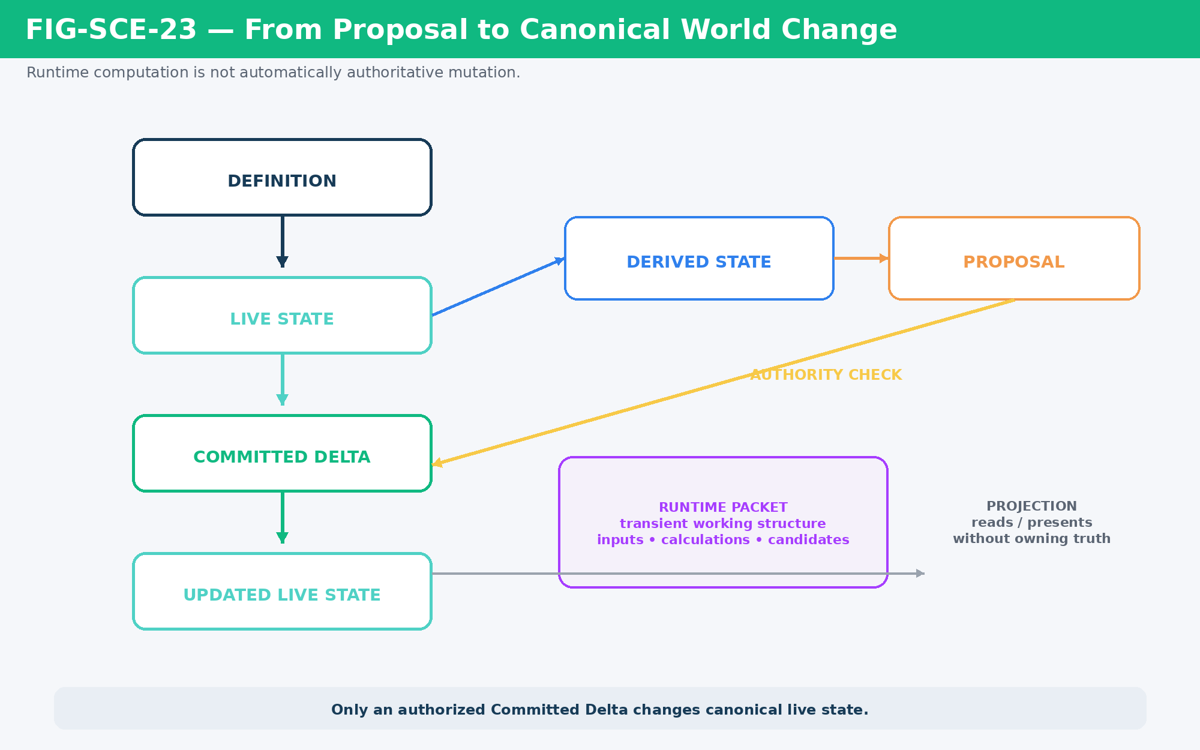
Figure 23. Derived state and proposals remain outside canonical truth until authorized as a Committed Delta.
State class | Meaning | Authority
Definition | Declares what can exist and the contracts that apply. | Canonical definition
Live State | Current authoritative runtime state. | Canonical state
Derived State | Calculated from authoritative state for current use. | Transient unless written
Proposal | Candidate action or state change. | Not canonical
Committed Delta | Authorized consequential mutation. | Canonical mutation
Projection | Human/media-facing representation. | Consumes state; does not own it

24. SCE, DARTBOARD, Praxis, Effects, and Projection
SCE describes the continuity problem: how registered world state becomes the next causally valid world state. DARTBOARD is the operational control and orchestration surface that coordinates Goals, directives, Actors, performance, Strategems, Rules, Effects, and other registered systems. Praxis determines actual interaction. Effects determine consequential interpretation. Skene and other projection systems determine how resolved state becomes perceptible.
These are responsibility boundaries, not a claim that every event must execute through one rigid synchronous software call stack. DARTBOARD does not become the owner of every system it coordinates, and SCE does not replace the canonical structures whose results it carries forward.
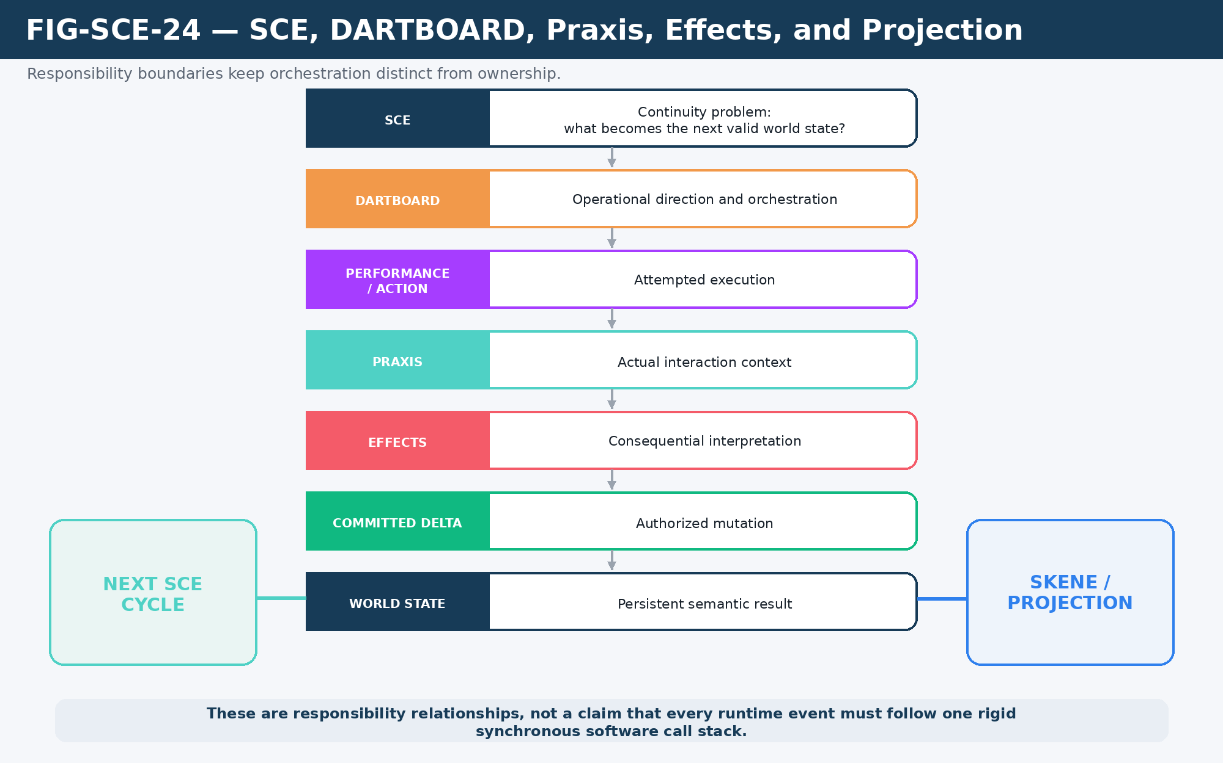
Figure 24. Responsibility boundaries among SCE continuity, DARTBOARD orchestration, Praxis interaction, Effects consequence, and downstream projection.

PART 6
Recursive World Continuity
The same cybernetic grammar scales from individual needs to herds, knowledge, memory, generations, ecosystems, and media projections.

25. Herd as One, Members as Many
Group behavior demonstrates recursive decomposition. A herd can temporarily resolve a macro Goal such as FLEE toward a Safe Region once at the group level. That shared trajectory can then decompose into local member execution only where individual variation matters: small heading offsets, fawn proximity, injury constraints, obstacle avoidance, leader/follower behavior, or stochastic variation.
The same principle generalizes beyond animals. Crowds, military units, robot swarms, convoys, production cells, or other coordinated groups can resolve collective intent at the highest useful level and recursively expose lower-level detail only when consequence requires it.
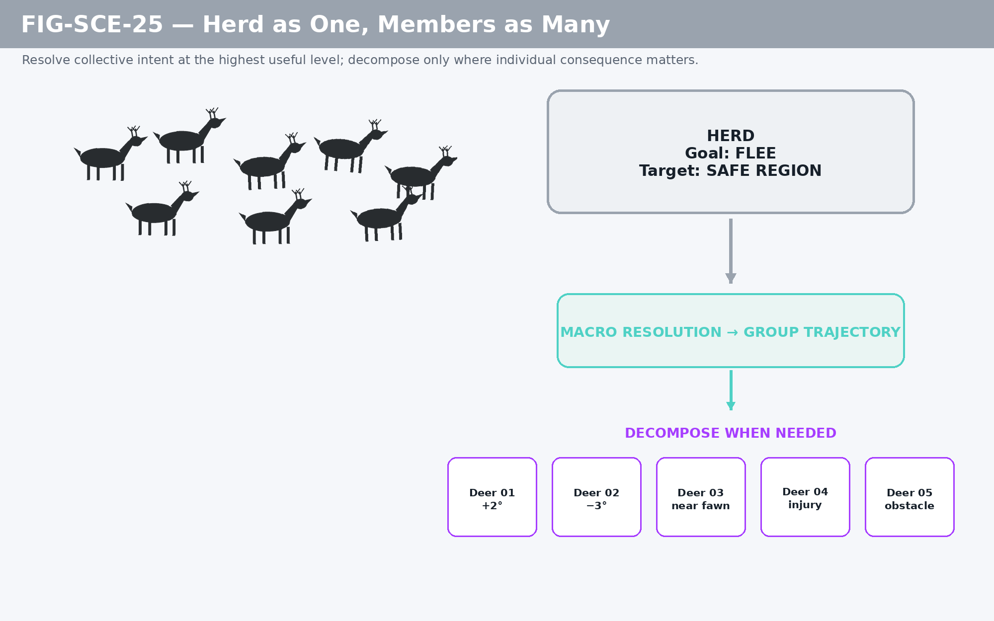
Figure 25. Herd as one, members as many: resolve collective intent once and decompose only where local consequence matters.

26. BID as an Embedded Cybernetic Loop
Need systems such as hunger and water are not isolated numeric meters. They are small feedback loops embedded within the larger actor runtime. TIME changes the need value; the need changes Goal weighting; the Goal resolves a Target; an Action changes the world or actor; the resulting state restores or further alters the need; ordinary Goal competition then resumes.
This illustrates the recursive character of the architecture. The same feedback logic can exist inside an actor, across a herd, within an economy, or across a world-scale process without requiring a different fundamental machine at each scale.
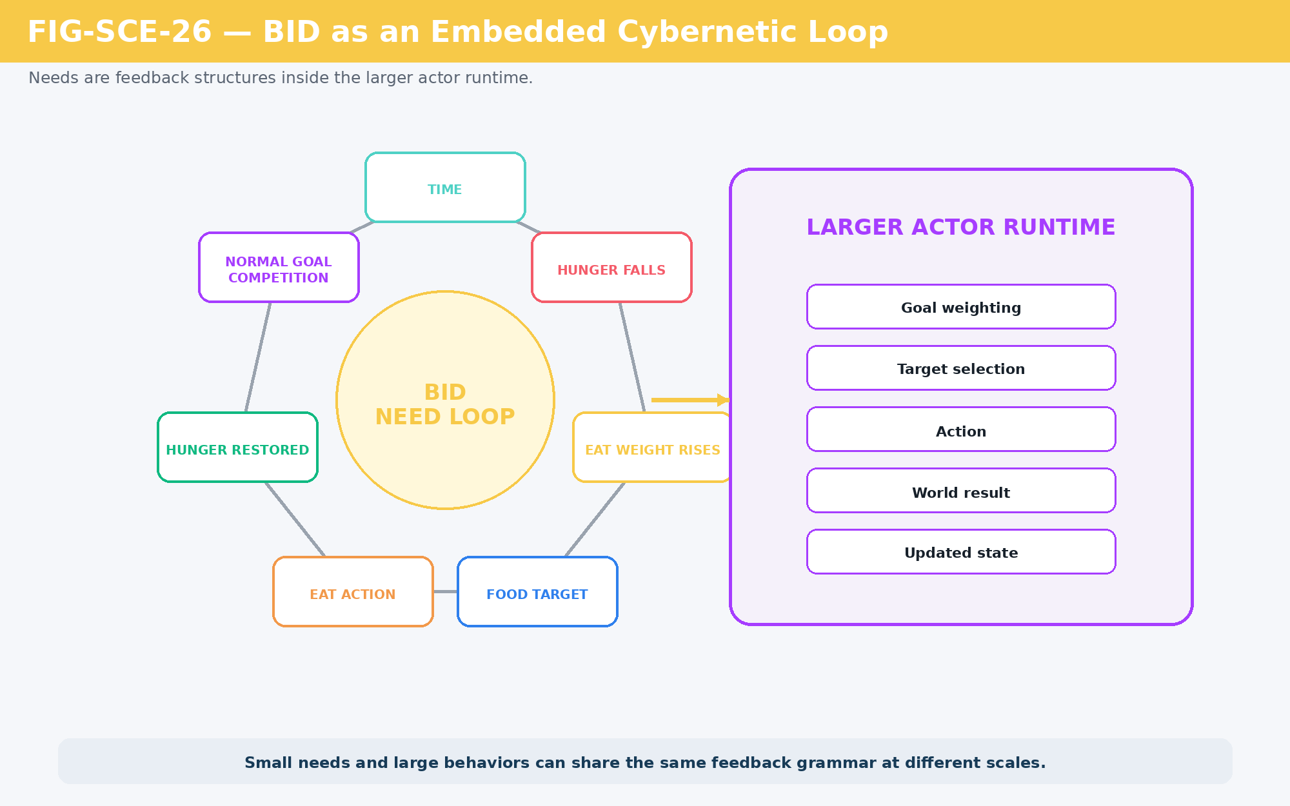
Figure 26. BID as an embedded cybernetic loop: needs alter behavior and are themselves changed by behavioral consequence.

27. World Truth, Character Knowledge, and Memory
The world can know more than a character. Canonical World State may contain exact registered facts, while a character has bounded access determined by knowledge level, experience, role, or other permissions. A useful ladder can move from no access, to Alias/Folk knowledge, Taxonomy, Registry Facts, and Behavioral Mechanics. The character’s answer is generated from the accessible layer rather than by copying the entire world database into the character.
Uncertainty can be added without corrupting truth. A character may provide a guaranteed answer from the highest achieved level and optionally extend with an “Also, I think…” branch that reaches toward a deeper layer and may be imperfect. That speculative extension does not automatically become canonical evidence. Memory is likewise governed writeback: an experience may create individual memory, relationship change, Tribe memory, affinity, historical record, or no persistent write depending on the applicable contract.
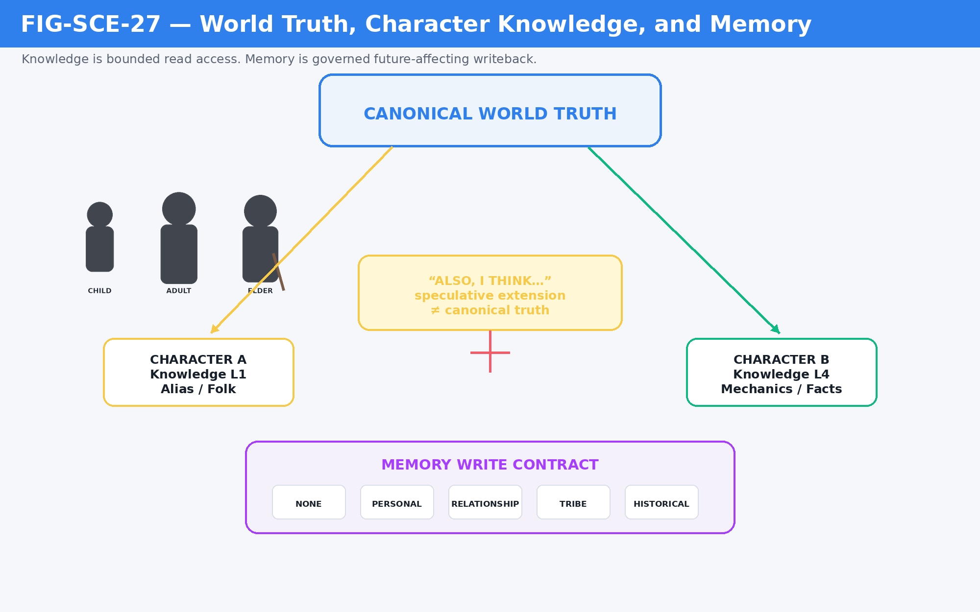
Figure 27. Knowledge is bounded read access to world truth; memory is governed future-affecting writeback.

28. Seasonal and Generational Memory Spine
Long-duration social continuity does not require exhaustive autobiographical simulation. Compact historical records such as Tribe_ID + World_ID + Season + Value can preserve patterns across years. Current conversations, plans, affinities, and warnings can query recent history, the same season in prior years, or deeper historical layers.
Generations can occupy different historical windows. A child may know only a short period directly. An adult may remember a broader span. An elder may have lived through events that younger members only know by inherited narrative. This creates durable cultural variation from small, semantically meaningful state rather than enormous undifferentiated memory logs.
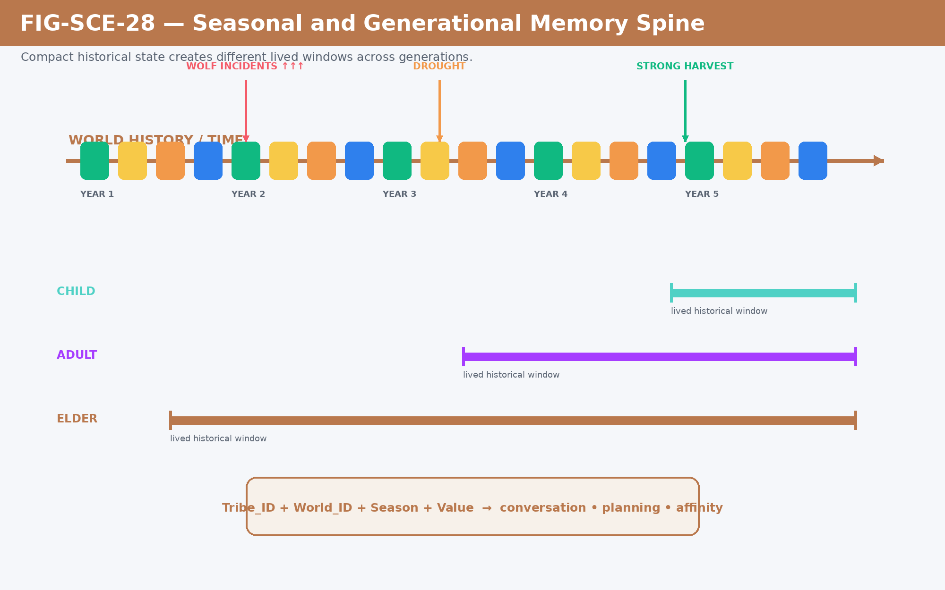
Figure 28. Seasonal and generational memory: compact historical state supports different temporal access windows and future behavior.

29. Natural Baseline, Civilization Overlay, and Reclamation
World continuity applies to environments as well as characters. A natural substrate can remain semantically present while a civilization overlays roads, buildings, fields, and other infrastructure. The overlay changes World State without necessarily erasing the underlying ecological identity. If maintenance stops, TIME and ecological processes can drive decay, vegetation return, and succession toward the underlying baseline.
This is more powerful than replacing a “forest object” with a “village object” and later replacing it again. The layered model preserves causal history, permits coexistence between natural and built state, and allows reclamation to emerge from interactions among Society, Infrastructure, Habitat, TIME, and ecology.
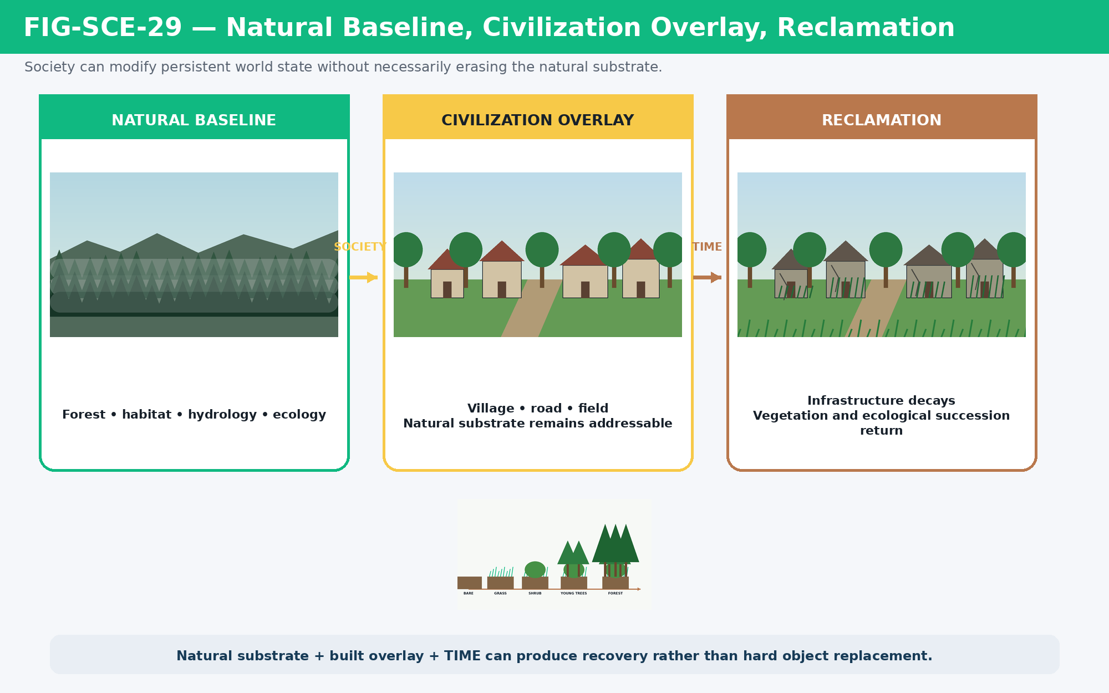
Figure 29. Natural baseline, civilization overlay, and reclamation: built state can modify a persistent substrate without erasing it.

30. One Event, Many Projections
Projection independence generalizes the Map distinction to every presentation medium. A canonical runtime event—such as a Crystal Bat Screech affecting a Forest Elk—can be consumed by a game, film, prose system, debug interface, educational explanation, or map. Each projection selects different information, timing, staging, and sensory expression while remaining downstream of the same resolved event and Committed Delta.
This allows the world to support many interfaces without duplicating truth. Projection may interpret, stage, and communicate. It does not independently define the event that occurred.
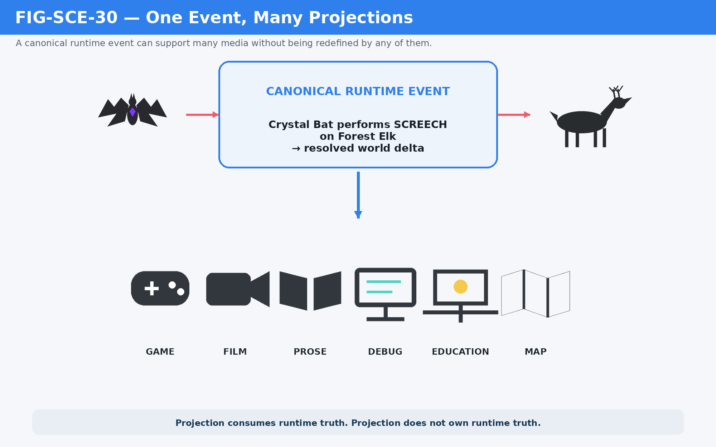
Figure 30. One event, many projections: multiple media consume the same canonical runtime truth without owning it.
Projection consumes runtime truth. Projection does not own runtime truth.

PART 7
Integrated Runtime Trace
The Crystal Bat → Forest Elk example demonstrates how the same architecture connects semantic identity, perception, Goal continuity, selective simulation, and persistent world change.

31. Crystal Bat → Forest Elk: One Complete Runtime Cycle
A worked trace makes the architecture concrete. Consider dusk in a forest under light rain. A Crystal Bat is active with a HUNT Goal. A Forest Elk is grazing. The Bat performs SCREECH. The event is routed through the exact Actor, Action, Target, environmental context, applicable Models, response Rules, and perception conditions required by the case.

Initial addressable state
- Crystal Bat NodeKey resolves the active actor and its current Goal, state, and available Action.
- Forest Elk NodeKey resolves the target, current GRAZE Goal, position, relevant perception state, and herd context.
- TIME resolves dusk. World context resolves forest and light rain. Only the contracts required by the event are activated.

Cybernetic resolution
Process identifies the attempted Screech interaction. Routing determines the registered semantic paths required by the Actor, Action, Target, and local context. Protocol determines the applicable execution contract. Theory resolves the formal Model needed for the interaction. Rule Application evaluates attenuation, thresholds, or other constraints. Target Affected records the bounded consequence on the Elk.

Behavioral consequence
If the perception and response conditions cross the applicable threat threshold, the Elk’s decision state changes. FLEE becomes the active Goal or highest eligible candidate. This is not yet the final physical outcome. Behavior describes the attempt: move toward a safer Target or Region.

Selective reconstruction and simulation
If the Elk and herd were represented only at lower fidelity, Reconstruction raises the local movement, terrain, herd, and obstacle state to the lowest level sufficient to resolve the escape. The Simulation Bubble does not need to include unrelated Regions or systems. Simulation then mediates the FLEE behavior through active terrain, movement constraints, herd cohesion, predator position, and applicable TIME-dependent state.

Committed world consequence
The result may change location, herd configuration, active Goal, perception state, and eligible memory. Derived values and rejected proposals remain transient. Authorized consequential changes become Committed Deltas. World State is updated, and the affected NodeKeys now resolve against the new canonical state. The runtime cycle has closed and the new world is ready to become the starting point of what happens next.
Worked-trace summary
NodeKey State → Process → Routing → Protocol → Theory → Rule Application → Target Affected → Behavior → Reconstruction / Simulation → Committed Delta → World State → NodeKey State.

PART 8
Principles and Boundaries
The architecture can be summarized as a small set of laws that preserve causal continuity while keeping implementation modular.

32. The Infinite World Loop
The full architecture can now be read as nested rings around one causal spine. Bits, BitGroups, BitWords, Readers, Models, Rules, and Operators provide the computational substrate. Goals, Targets, perception, Reconstruction, Effects, and runtime context provide active resolution. Tiles, Zones, Regions, Habitats, Societies, Infrastructure, and Assets provide the world fabric. TIME, knowledge, memory, history, and World State provide continuity. Maps, Skene, games, films, books, educational systems, and debug views provide projection.
The inner machinery can change state at the scale of a single target. The outer structures can preserve that consequence across a world and through generations. The architecture does not require the world to be calculated continuously at maximum fidelity. It requires every consequential change to be resolvable, authoritative, and capable of becoming the next addressable state.
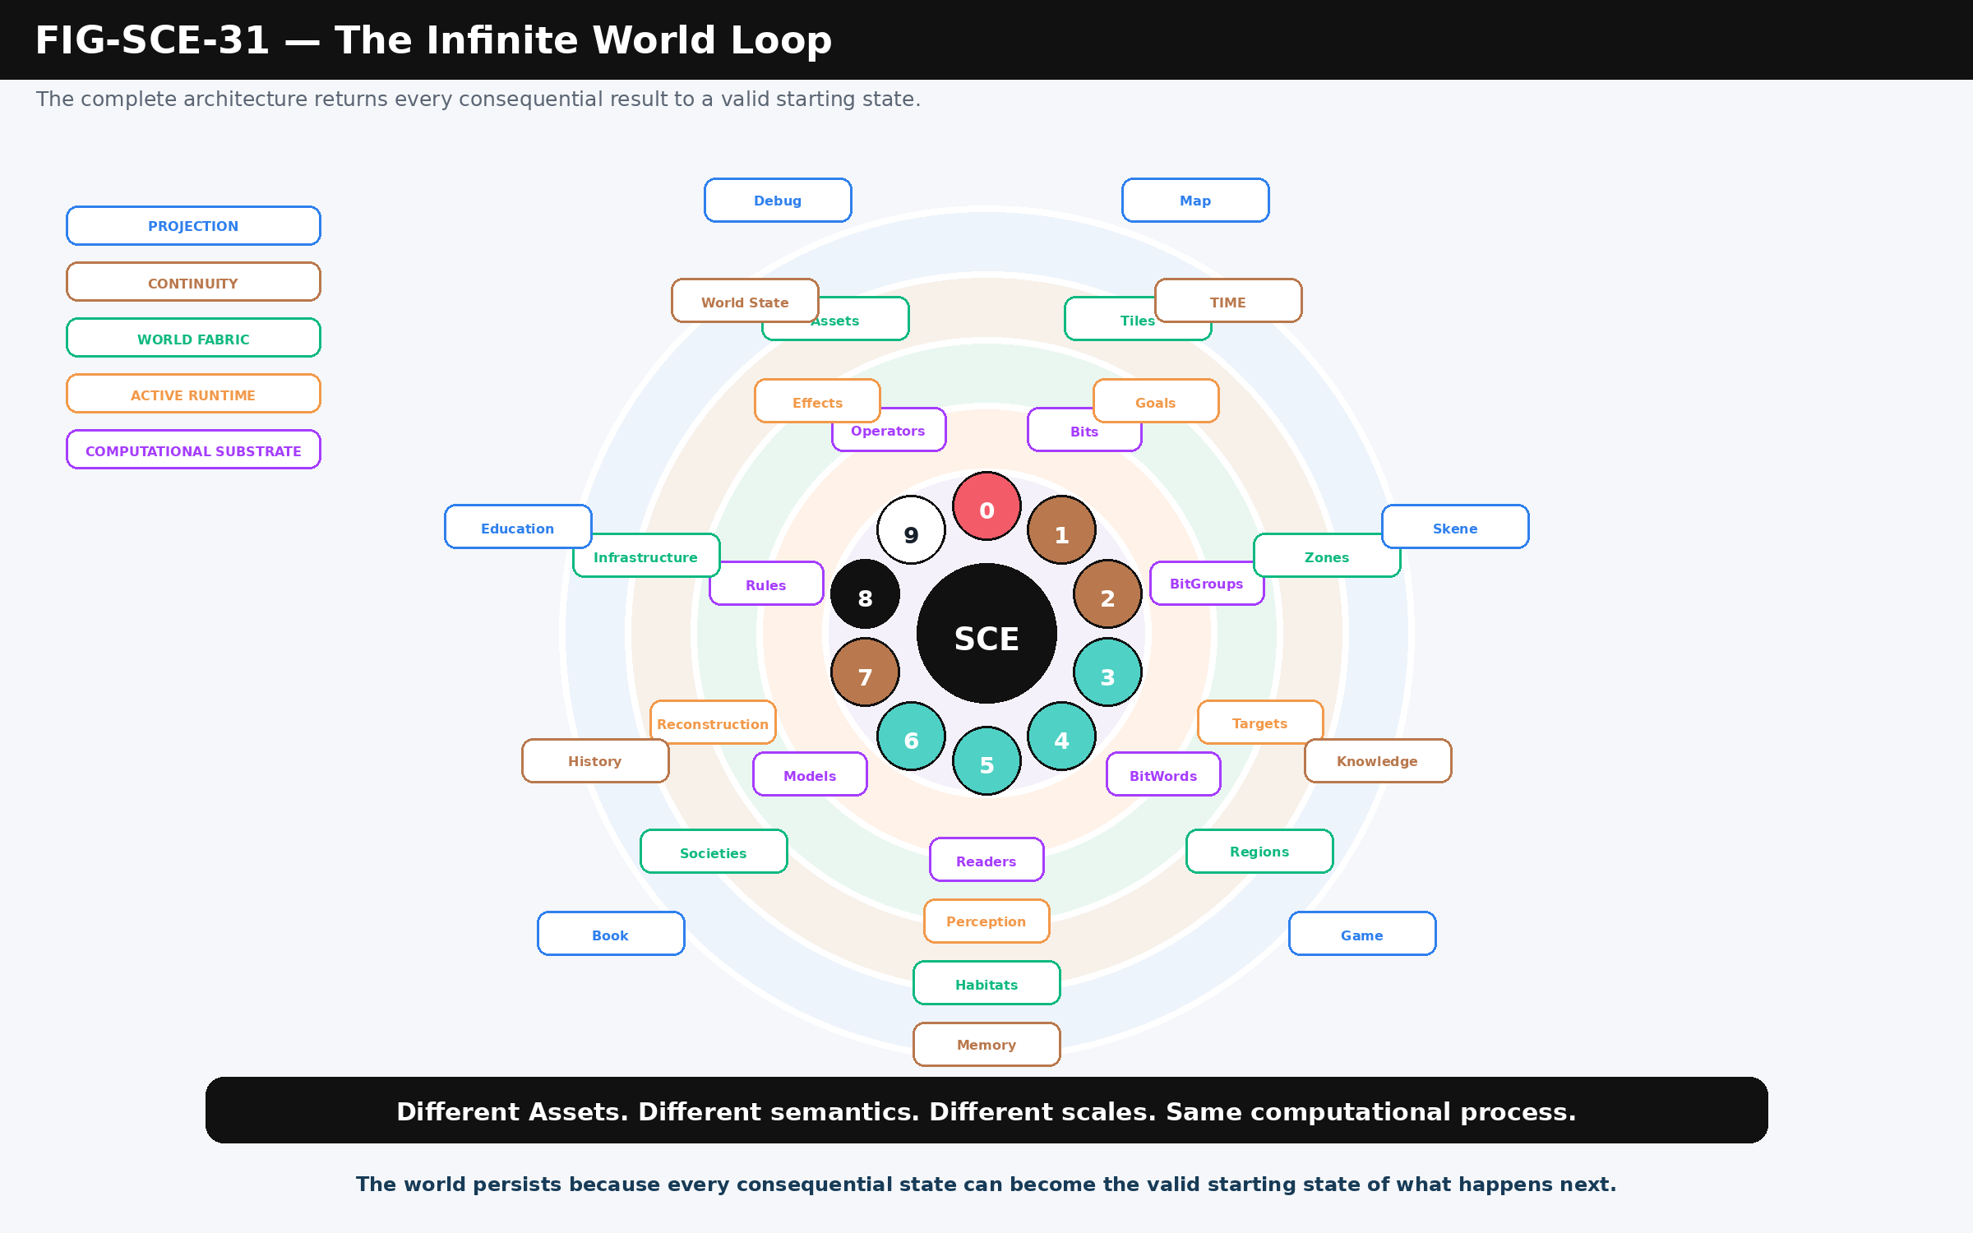
Figure 31. The Infinite World Loop: computational substrate, active runtime, world fabric, continuity, and projection surround the same 0 → 9 → 0 causal cycle.

33. Formal Principles of the Storyboard Continuity Engine
Principle | Meaning
Persistent Semantic Reality | World existence is maintained through authoritative semantic state rather than continuous rendering.
Same Computational Grammar | Different Assets and scales may preserve different semantic contracts while using the same runtime process.
NodeKey Closure | A consequential cycle closes when its result returns to exact addressable semantic state.
Continuity Before Reconsideration | Stable Goals and behaviors persist until declared conditions justify reevaluation.
Lowest Sufficient Resolution | Resolve only the fidelity necessary to determine the consequential outcome.
Localized Resolution | Expensive simulation is bounded to the Assets, relationships, and spatial context that actually matter.
Consequential Delta | Persist what changes future runtime; transient computation need not become canonical state.
Projection Independence | Presentation consumes runtime truth but does not define or own it.
Knowledge Separation | Character knowledge is bounded access to world truth rather than omniscient duplication.
Recursive Decomposition | Group or macro-level intent can decompose into local execution only where individual variation matters.
Natural Continuity | Built overlays may modify a natural substrate without necessarily erasing its underlying state.
Authority Before Mutation | Derived values and proposals become world truth only through authorized Committed Deltas.

34. Implementation Boundaries
SCE is deliberately not the owner of every system it coordinates or depends on. BIGFOOT retains the operational semantic primitives. BitWord Readers retain deterministic interpretation. DARTBOARD retains operational orchestration. Praxis retains interaction context. Effects retain consequence modeling. Skene and other projection systems retain presentation responsibilities. Detailed spatial, ecological, social, bodily, temporal, and behavioral Models remain independently authorable structures that SCE can route into when needed.
This modularity is what permits the architecture to scale. A new species, robot, vehicle, weather system, or social structure does not require rewriting the entire simulation engine. It requires sufficiently defined semantic state, computational contracts, and routes. Once those exist, the Asset can enter the same runtime fabric while preserving its own native meaning.

Explicit non-scope
- This paper does not define every Bit or BitWord used by every simulated Asset.
- It does not replace the detailed specifications for DARTBOARD, DRAGON ARMORY, Effects, Skene, PULSE, EDIFICE, or other CERBERUS systems.
- It does not prescribe one rendering engine, game engine, database, or programming language.
- It does not require maximum fidelity or continuous simulation for semantic existence.
- It does not allow generated projection, derived state, or unsupported character belief to silently become canonical evidence.

35. Conclusion — A World Ready for What Happens Next
The Storyboard Continuity Engine reframes simulation as continuity over addressable semantic state. A world need not remain continuously rendered, fully instantiated, or numerically resolved at maximum fidelity in order to exist. It needs stable identity, interpretable state, bounded computational contracts, governed mutation, and enough Reconstruction to resolve consequence when consequence matters.
That structure allows the same cybernetic grammar to operate at radically different scales. A Bit changes. A target changes. An actor changes behavior. A herd changes direction. A Society changes a landscape. A Region changes over seasons. A memory changes future dialogue. A projection changes how a resolved event is perceived. The semantic contracts differ; the runtime principle does not.
The Storyboard Continuity Engine does not keep a world alive by continuously calculating everything in it. It keeps the world alive by ensuring that every consequential state can become the valid starting state of what happens next.

The complete cycle can therefore be read in one line: NodeKey State → Process → Routing → Protocol → Theory → Rule Application → Target Affected → Behavior → Simulation → World State → NodeKey State. Different Assets. Different semantics. Different scales. Same computational process.

APPENDIX A

Atlas Infinite Ring Reference
Position | Name | Operational meaning
0 | NodeKey Update | Exact semantic state is available as the starting or closing condition of the cycle.
1 | Process | The bounded operation currently being resolved is established.
2 | Routing | The relevant semantic addresses, relationships, and computational paths are selected.
3 | Protocol | The applicable execution contract is resolved.
4 | Theory | The formal Model or mathematical interpretation required by the operation is selected.
5 | Rule Application | Applicable constraints, thresholds, and Rules are evaluated.
6 | Target Affected | The bounded consequence on the target is determined.
7 | Behavior | The affected state changes what an Asset now attempts or continues doing.
8 | Simulation | Behavior is resolved against the active world and applicable constraints.
9 | World State | Consequential results become persistent authoritative world state and close back to 0.

Reading the Ring
The positions describe a complete causal grammar. A particular event may route through only the semantic families required by that event; the Ring should not be interpreted as a demand to execute all families or all expensive simulation stages continuously.

APPENDIX B

Runtime State Classes
State class | Operational boundary
Definition | Canonical declaration of what can exist, how it is structured, and which contracts apply.
Live State | Authoritative current state read by runtime systems.
Derived State | A value computed from Live State for current reasoning or execution.
Proposal | A candidate Goal, Action, change, route, or other unresolved possibility.
Committed Delta | An authorized mutation that changes canonical state.
Projection | A presentation of canonical or resolved state for a viewer, medium, interface, or diagnostic purpose.
Runtime Packet | A transient working structure used to carry resolved inputs, calculations, thresholds, and outputs through an operation.

APPENDIX C

Visual Architecture Provenance
The 31 figures in this paper were designed before composition as a controlled OctoGroove visual set. The Atlas Infinite Ring and Figma World/Map model diagrams supplied by the system author were treated as canonical visual references for ordering, family identities, spatial relationships, and routing grammar. The paper figures were then redrawn or composed for document scale rather than treated as screenshots of the production workspace.
Recurring illustrative assets such as the Crystal Bat, Forest Elk, herd, age family, projection symbols, perception symbols, runtime-rhythm symbols, fidelity states, seasonal panels, and environmental continuity panels were produced as reusable paper assets. External environmental references were used only as visual grounding during asset production; the final figure set uses controlled local implementations so figure numbering and semantic contracts remain stable independent of source-image replacement.
Visual rule
Canonical architecture governs the figure. Source imagery supports the figure. Neither stock imagery nor presentation convenience is allowed to silently redefine the architecture.

