CERBERUS SPD

Semantic Provenance Derivation Architecture
  - Portable Operational Semantics | Structural Derivation | Deterministic Serialization | Reconstruction | Constructive Precedent
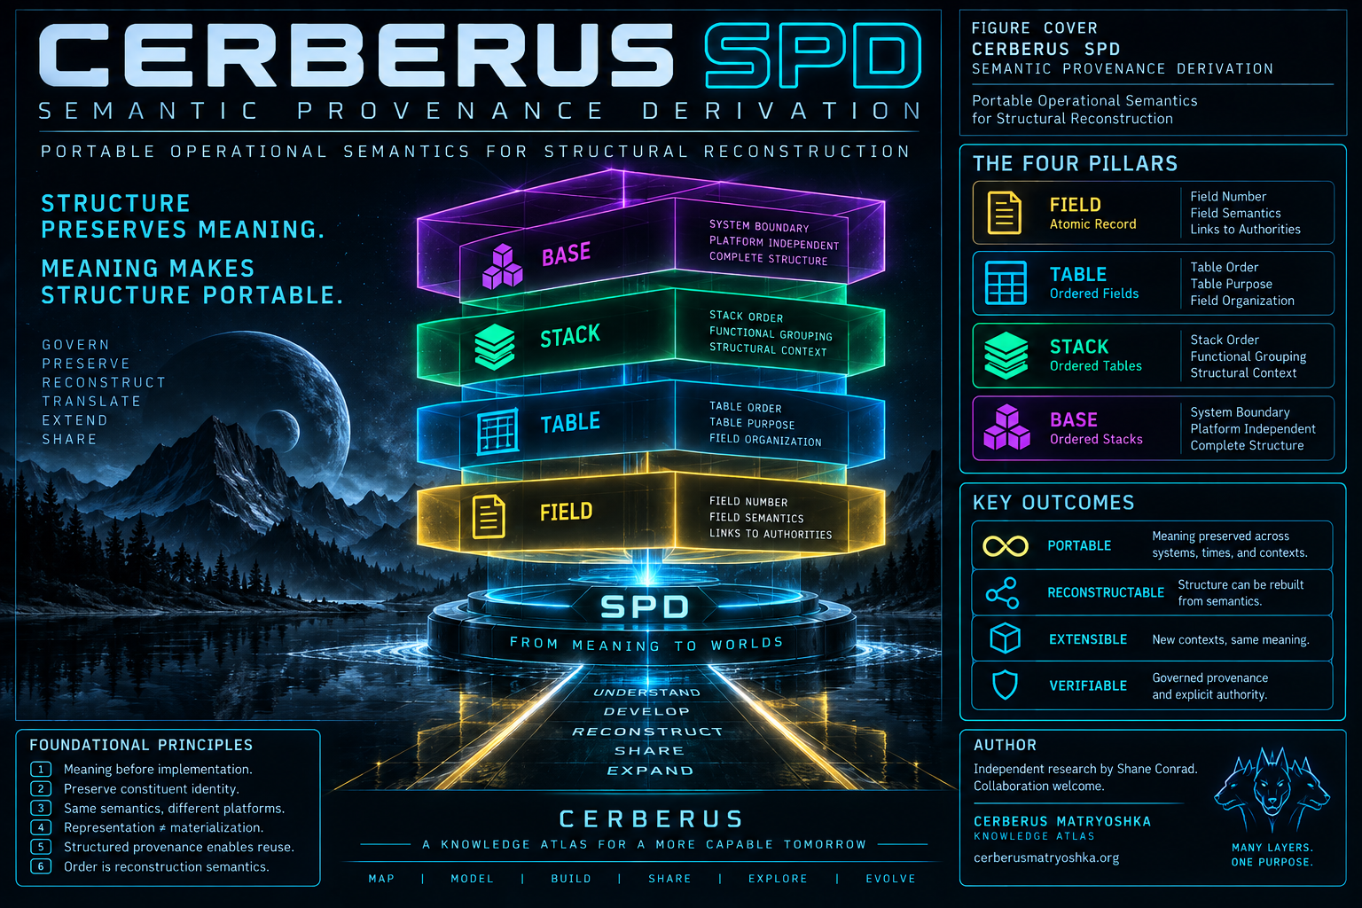
Version 1.0 | PASS 8 VERIFIED RELEASE
SPD describes structure well enough to rebuild it - and well enough for CERBERUS to learn from it.
Independent research by Shane Conrad | Collaboration welcome.

Executive Orientation
Semantic Provenance Derivation (SPD) is CERBERUS's portable operational-semantic representation of implementation structure. It exists because a working platform can show what a schema currently looks like without necessarily preserving why the structure exists, which governed systems give its fields meaning, which relationships must survive reconstruction, or which details are essential rather than incidental to the source platform.
SPD addresses that gap by representing one Field at a time in governed structural context. A Field remains linked to its Table and enclosing Stack, references BOSS Field Type vocabulary, preserves explicit relationship and DRAGON classification provenance when applicable, carries bounded lists, code, description, and lifecycle where required, and derives readable structural projections from those governed sources rather than copying their authority into a second competing schema.
The result is a reconstruction-grade structural language. Ordered Fields compose into Tables, ordered Tables into Stacks, and ordered Stacks into a Base representation. The same language can describe existing or proposed structure, allowing PORT to translate the operational contract into another material system and allowing BUILD to reason constructively over bounded SPD precedent without permitting representation itself to cross the material-authority boundary.
ORIENTATION LAW
SCHEMA APPEARANCE != OPERATIONAL SEMANTICS | SPD REPRESENTATION != LIVE IMPLEMENTATION

Definitive reconstruction sentence
Semantic Provenance Derivation is CERBERUS's portable operational-semantic representation of implementation structure. Each SPD Field record represents one Field in governed structural context, preserving or deriving the identity, position, enclosing Table and Stack, Field Type, relationship targets, Classification, bounded values, executable behavior, purpose, provenance, and lifecycle required to interpret that Field operationally. Ordered Fields deterministically compose into Tables, ordered Tables into Stacks, and ordered Stacks into a reconstructable Base representation. Derived projections remain subordinate to the governed semantic sources from which they are obtained, allowing the representation to remain human-readable and machine-resolvable without copying authority into SPD itself. Because SPD preserves the operational contract rather than only the material schema of a particular platform, it can describe both existing and proposed structures, support semantically lossless translation through PORT, and provide bounded structural precedent through SPD Bundles for BUILD while remaining distinct from construction, refinement, translation, and mutation authority.

Document map
# | Section | Purpose
1 | Orientation and Architectural Ownership | Why SPD exists, what it owns, and the boundaries that keep representation separate from semantic owners and material implementation.
2 | The Atomic SPD Field | One record equals one Field; atomic identity, local data, governed references, derived context, and optional semantics.
3 | Structural Context and Field Semantics | Table and Stack ancestry, BOSS Field Type, explicit relationship targets, classification, lists, code, description, and lifecycle.
4 | Semantic Provenance and Source Authority | How VISOR, BOSS, DRAGON, registered Tables, and Field-local semantics supply governed meaning.
5 | Derived Projection and Verification | Source authority versus readable projection, reproducible derivation, provenance classes, and checkable consistency.
6 | Field SPD Serialization Grammar | Current Field Writer syntax, conditional clauses, deterministic order, and the distinction between semantic contract and textual convention.
7 | Deterministic Composition I - Field to Table | Field ordering, Table boundaries, membership, and reconstruction conflicts.
8 | Deterministic Composition II - Stack to Base | Stack boundaries, Base traversal, resolution-bound completeness, and platform-independent ordering.
9 | Live Proof - Registry Index | The current ten-record live proof slice and the mechanisms it demonstrates.
10 | Lifecycle and Non-Destructive Structural Simulation | Planned, Drafted, Functional, Deprecated; proposed structure without automatic materialization.
11 | Semantic Portability and Losslessness | What must survive platform change and what source-material conveniences may legitimately disappear.
12 | PORT and Target-Material Translation | One-to-one, one-to-many, many-to-one, unresolved, and non-equivalent material mappings.
13 | Reconstruction and Verification | Construction authority, observation, semantic comparison, failure classes, and the Native CERBERUS implication.
14 | SPD Bundles and BUILD | Bounded structural precedent, BUILD lenses, and Proposed SPD as the preferred constructive output.
15 | BUILD <-> PATCH Reverberation | Constructive divergence, corrective convergence, PORT, authority, and cumulative structural learning.
16 | Invariant Registry and Closing Architecture | Formal laws, failure tests, responsibility registry, mature definitions, and closing thesis.

1. Orientation and Architectural Ownership
SPD exists to make implementation structure operationally legible outside the material platform that currently expresses it.

1.1 The problem of platform-bound structure
CERBERUS depends on implementation structure: Tables exist for specific purposes, Fields carry types and relationships, classifications constrain identity, lists bound legal values, code determines behavior, and structural order supports deterministic reconstruction. A platform such as Airtable can materially express those facts, but a platform export is not automatically a complete statement of the system's operational meaning.
A Linked Record demonstrates the problem clearly. Airtable can show that a Field links to another Table, but reconstruction needs to know which relationship is semantically required and what must survive if the target runtime uses a foreign key, junction table, object reference, or another material primitive. Copying the source mechanism too literally creates platform lock-in; ignoring it entirely risks semantic loss.
FOUNDATIONAL DISTINCTION
MATERIAL STRUCTURE != PORTABLE STRUCTURAL MEANING

1.2 From schema description to operational-semantic representation
SPD is not a prettier schema report. It is a governed representation of implementation structure that preserves enough operational meaning for another human, assistant, runtime, or reconstruction process to understand what the represented structure is supposed to do. Operational-semantic meaning includes location, order, structural type, relationship destination, classification, bounded values, executable logic, purpose, lifecycle, and the provenance of those meanings.
This is why the word semantic is intentionally narrow in SPD. It does not claim ownership over all conceptual meaning in CERBERUS. It captures the meaning required to understand and reconstruct implementation structure faithfully.

1.3 Semantic, Provenance, Derivation
The name is literal architecture. Semantic identifies the operational meaning that must survive. Provenance identifies the governed source of that meaning. Derivation identifies how SPD obtains readable structural context from those sources rather than requiring humans to re-author every shared fact on every Field record.
SEMANTIC = operational meaning required for faithful structure
PROVENANCE = path back to the governed source of that meaning
DERIVATION = deterministic resolution of readable structural context

1.4 What SPD owns
SPD owns the portable operational-semantic representation of implementation structure. At the atomic level, that representation is one Field record. At larger resolutions, those Fields deterministically compose into Tables, Stacks, and eventually a Base representation. SPD is powerful because it preserves the relationship between structure and the systems that give that structure meaning, not because it absorbs those systems.

1.5 Architectural boundaries
• VISOR owns structural geography. SPD derives reconstruction context from that geography. VISOR locates; SPD describes.
• BOSS owns governed structural/type vocabulary. SPD references BOSS Field Types and projects readable names and symbols.
• DRAGON owns registered identity and classification semantics. SPD preserves the Field relationship to those classifications.
• PORT translates operational meaning into target material. SPD says what must survive; PORT determines how it survives.
• PATCH represents bounded approaches to resolving structural problems. SPD represents the structure being inspected or refined.
• BUILD constructively reasons over bounded SPD precedent. BUILD consumes SPD; it is not part of SPD derivation itself.
• The live Base is material implementation. SPD may describe it, compare against it, or propose changes without becoming it.
BOUNDARY LAW
CAPABILITY THAT CONSUMES SPD != RESPONSIBILITY OWNED BY SPD

Figure 1 - Semantic Provenance Derivation
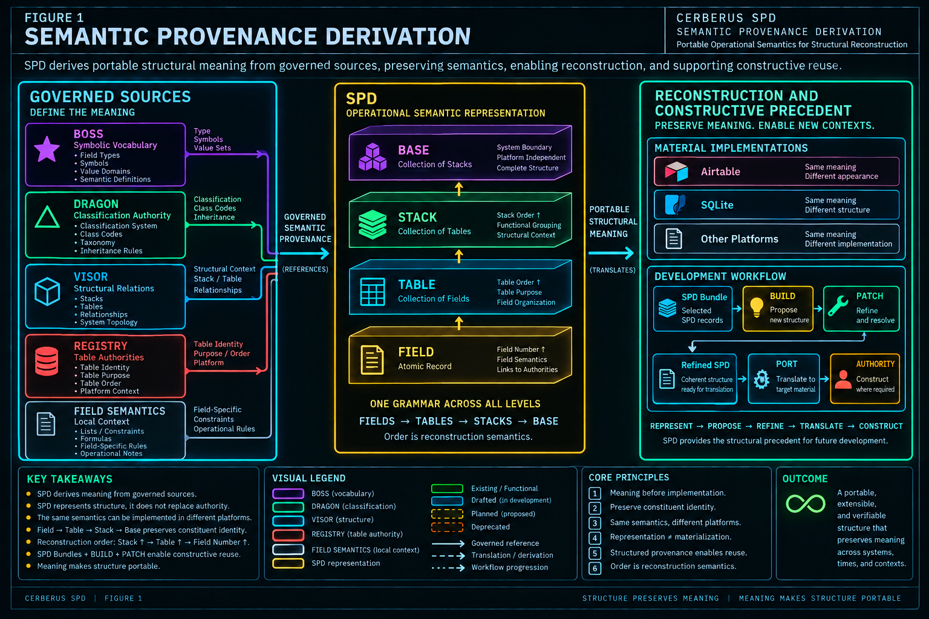
Figure 1. SPD derives portable structural meaning from governed sources, preserves constituent identity and ordering, and supports reconstruction and constructive reuse without collapsing semantic ownership or material authority.

2. The Atomic SPD Field
The entire architecture begins from one stable grain: one SPD record represents one implementation Field.

2.1 One SPD record equals one Field
The Field is the smallest reconstruction-grade structural unit. If SPD began at the Table or Stack level, it would still need subordinate languages for the Fields contained within those structures. That would create overlapping descriptions that could drift independently. The mature design avoids that problem by making the Field atomic and deriving larger resolutions through governed ancestry and deterministic composition.
ATOMICITY LAW
ONE SPD RECORD = ONE FIELD

2.2 Field identity exists in context
A Field Name is necessary but not sufficient. The same label can occur in multiple Tables, a superficially similar label can serve different purposes, and a Field may be renamed without changing the broader role it occupies. SPD therefore interprets Field identity through the combination of Field Name, Field Number, Table relationship, enclosing Stack, governed Type, and applicable local semantics.
Field Number is structural order within the parent Table, not decorative display metadata. It allows a reconstruction system to recover the intended Field sequence even if a database query returns records in arbitrary order.

2.3 Three information classes inside one record
The live SPD Field becomes easiest to reason about when its contents are separated into three conceptual classes. These classes describe the semantic role of the information; they do not require three separate storage mechanisms.
Class | Examples | Role
Direct Field Representation | Field Name, Field Number, List, Code, Description, Status | Field-local structural assertions carried by this SPD record.
Linked Governed Authority | Table, Field Type, Table Link, Classification Used | Identity-bearing references to registered semantic owners.
Derived Context / Projection | Table Purpose, Stack, Stack Purpose, Stack Order, Table Order, Field Type Name, Symbol, Registry Table ID, helpers | Readable, sortable, and serializable values resolved from governed sources.

2.4 Optional semantics remain optional
Not every Field has a relationship target, classification, bounded List, Code payload, or extended Description. SPD should not fabricate empty semantic machinery merely to make every record visually symmetrical. The representation expands to the semantics of the Field rather than forcing every Field through unused clauses.

2.5 Implementation scaffolding is not automatically canonical SPD
The current Airtable Writer also contains helper and development scaffolding such as Code-presence formulas and temporary issue or purge fields. Those objects may be useful while building the Writer, but a Field present in the implementation is not automatically part of the enduring SPD semantic contract. Portable architecture must distinguish the system being represented from the temporary material used to develop it.

Figure 2 - One SPD Record = One Field
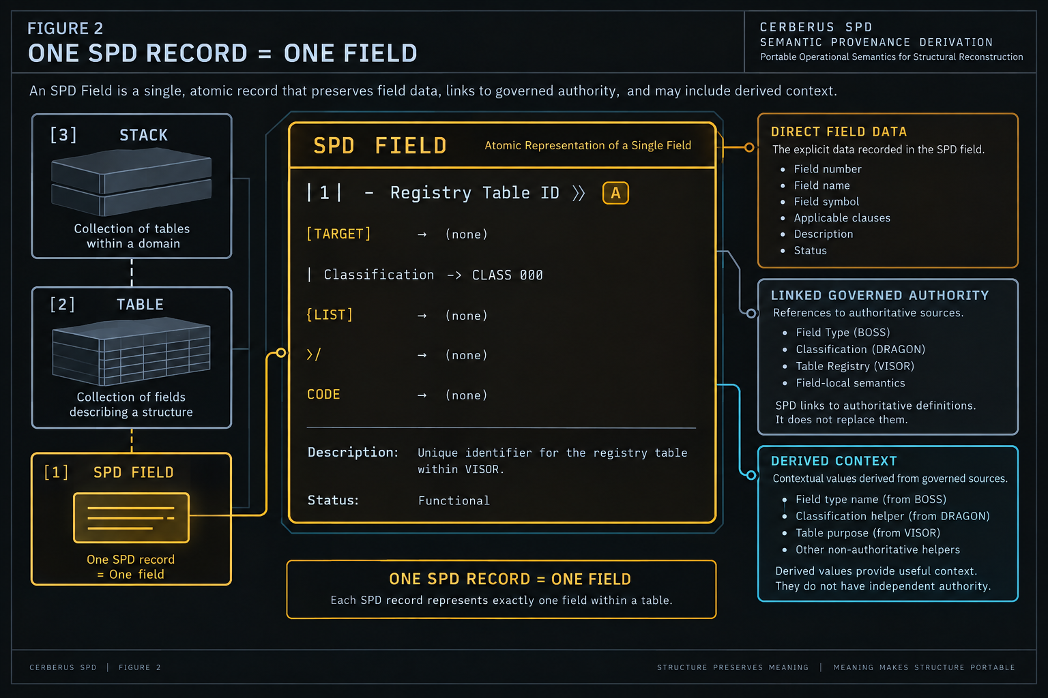
Figure 2. One SPD Field is the atomic representation. Direct Field data, linked governed authority, and derived context remain distinguishable while Stack and Table ancestry situate the Field inside larger structure.

3. Structural Context and Field Semantics
An SPD Field becomes reconstruction-grade by combining local structure with governed Table, Stack, Type, relationship, classification, value, and behavior semantics.

3.1 Table relationship and Stack ancestry
Each ordinary SPD Field links to its registered Table. That Table is the gateway through which Table Purpose, Table Order, Stack identity, Stack Purpose, and Stack Order become derivable. Shared context therefore remains singular at its governed source rather than being manually duplicated across every Field.
STACK
-> TABLE
-> SPD FIELD

The Field can participate in larger reconstruction without becoming the owner of the Table or Stack context it uses. This is an early example of the distinction between representation and authority.

3.2 BOSS Field Type, readable name, and symbol
The live SPD uses a linked BOSS Field Type rather than an isolated duplicate Type ontology. Human-readable Field Type Name and compact Symbol can then be projected from that governed reference. The projection improves readability, but the linked BOSS identity remains the provenance anchor.
TYPE LAW
FIELD TYPE NAME != FIELD TYPE AUTHORITY | SYMBOL != COMPLETE FIELD SEMANTICS

3.3 Relationship form and relationship destination
A relationship-capable Type does not determine its destination. A Linked Record can point to many different Tables, so SPD represents the target independently through Table Link and derives a registered target identity for serialization. Reconstructing the broad Type while losing the target creates an incomplete structural contract.
RELATIONSHIP LAW
FIELD TYPE != RELATIONSHIP TARGET

3.4 DRAGON classification
Some Fields carry registered DRAGON Classification or Determination semantics. SPD preserves the relationship to that governed source through Classification Used. A helper that merely reports whether classification is present may support Writer logic, but presence does not replace identity.

3.5 Bounded Lists
A Field Type can define the broad value form while the individual Field supplies the actual bounded vocabulary. The current Color Field is Single Select, but its twelve allowed colors are local Field semantics. Platform migration that preserves the Type while discarding the list loses part of the Field contract.

3.6 Code, Description, and lifecycle
Code is represented explicitly when executable behavior is part of the Field contract. Code presence must not be inferred solely from Type. Description supplements formal structure with operational explanation, but should not replace relationships or classifications that can be represented directly. Status records SPD lifecycle using the exact values Planned, Drafted, Functional, and Deprecated; it describes structural state and does not grant mutation authority.

4. Semantic Provenance and Source Authority
SPD is trustworthy because represented meaning remains traceable to the governed systems and local assertions that supply it.

4.1 Provenance is operational
In SPD, provenance is not limited to authorship history or timestamps. It asks which governed structure supplies a semantic fact. If SPD says a Field is inside VISOR, that statement has structural provenance. If it says the Field uses Short Text, that Type has BOSS provenance. If it says the Field carries CLASS 000, that relationship has DRAGON provenance. Provenance preserves the path from representation back to governed meaning.

4.2 Source authority is identity-bearing
A source authority is the governed object or relationship from which SPD obtains a semantic fact. The linked Table, BOSS Field Type, Table Link target, and Classification Used relationship are examples. Readable labels and symbols may change or be reformatted, but the identity-bearing source remains the anchor that prevents a display value from becoming an accidental substitute for the semantic object it describes.

4.3 VISOR provenance
VISOR supplies structural geography. The Field points to a Table; the Table belongs to a Stack; the Table and Stack carry their own purposes and ordering. SPD derives that context through the structural path rather than independently asserting a second geography. The current Registry Index proof resolves Table Order 2 inside VISOR Stack Order 3 through exactly this chain.

4.4 BOSS provenance
BOSS supplies governed structural vocabulary. SPD applies a BOSS Type to a particular Field and can derive a readable Type Name and Symbol for serialization. Those projections make the Writer compact, but they do not create a second SPD-owned Type system.

4.5 DRAGON provenance
DRAGON supplies registered classification semantics. SPD can show that a Field uses a particular Classification without becoming the owner of that Classification. A numeric or boolean helper that says a classification exists is useful for conditional output, but it does not preserve which governed classification the Field uses.

4.6 Relationship and Field-local provenance
Relationship target provenance comes from the linked registered Table. Field-local semantics such as Field Number, bounded List, Code, Description, and SPD lifecycle may be asserted directly in the SPD record. Not every semantic fact must be externalized into another registry; the requirement is that SPD remains clear about which meaning is referenced, which is asserted locally, and which is derived.
PROVENANCE LAW
CONVERGENCE OF MEANING != CONSOLIDATION OF AUTHORITY

Figure 3 - The Semantic Provenance Graph
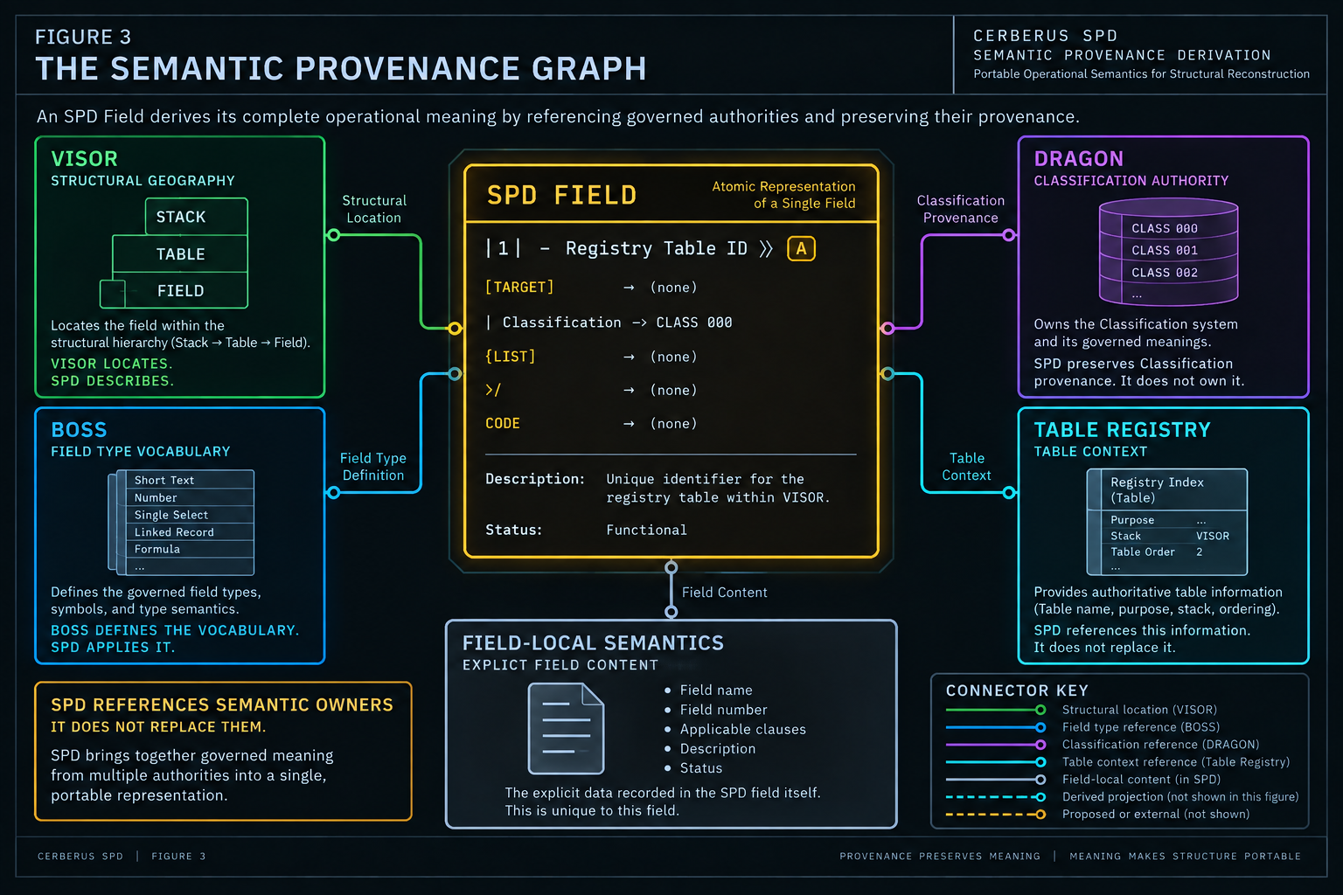
Figure 3. An SPD Field is the convergence point for governed structural context, BOSS Type semantics, DRAGON Classification, registered relationship targets, and Field-local semantics. SPD references those owners; it does not replace them.

5. Derived Projection and Verification
Derived values make SPD readable and serializable, but they remain subordinate to the governed sources from which they are resolved.

5.1 Derived projection
A derived projection is information calculated, looked up, or resolved from a governed reference or local assertion for readability, ordering, serialization, inspection, or routing. Table Purpose, Stack Order, Field Type Name, Symbol, Registry Table ID, Code presence, and Classification presence are examples in the current Writer.

5.2 Source authority versus projection
Projection and source can carry the same meaning at different roles. A Table Purpose lookup can be fully accurate while still not being the Table. A Symbol can correctly represent a BOSS Type while still not carrying the Type's identity. Repeated projections across many SPD records do not create duplicated authority when all remain derived from the same governed source.
KEY LAW
DERIVED VALUE != SOURCE AUTHORITY

5.3 Reference, assertion, projection
The three provenance classes introduced earlier also provide a useful verification model: references anchor governed identity, assertions record Field-local semantics, and projections expose deterministic views. A value with no explainable source or local assertion is weaker reconstruction evidence because its provenance is unclear.

5.4 Reproducible derivation
A healthy projection should be reproducible. Field Type Name should remain derivable from Field Type. Table Order should remain derivable from the registered Table. Stack Order should remain derivable through Table-to-Stack ancestry. Registry Table ID should remain derivable from the explicit target relationship. If deleting a supposed helper destroys the only surviving semantic fact, the helper was not merely a projection.

5.5 Derivation creates checkable relationships
Because projection and source are separate, verification can compare them. Does Symbol agree with the linked BOSS Type? Does Table Order agree with the Table Registry? Does Stack agree with the Table's VISOR membership? Does Classification presence agree with Classification Used? Does Code presence agree with actual Code? Derivation therefore turns SPD from a set of claims into a structure containing evidence for why those claims should be true.

5.6 Portable identity
Airtable record IDs are material implementation identifiers. They can assist migration, but they should not become the only portable semantic identity. SPD preserves registered CERBERUS relationships and identities so a target runtime may assign its own internal persistence keys while still reconstructing the same operational structure.

Figure 4 - Source Authority != Derived Projection
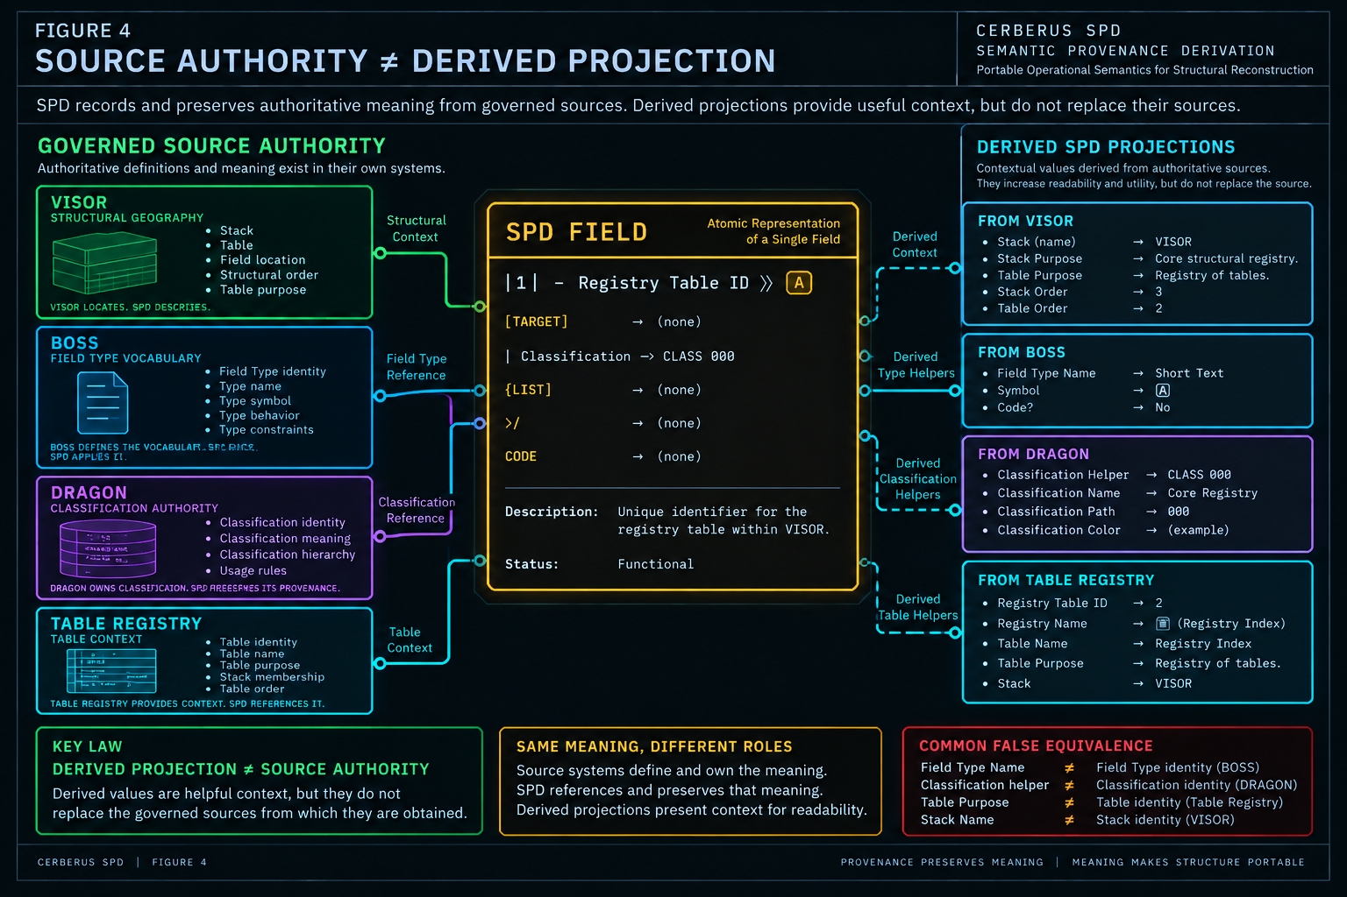
Figure 4. Governed sources retain semantic authority while SPD exposes readable derived projections. Projection improves readability and utility; provenance prevents the projection from silently replacing its source.

6. Field SPD Serialization Grammar
The current Writer compresses a relationally distributed SPD Field into a deterministic, human-readable reconstruction surface.

6.1 Serialization is a projection of SPD
The SPD Field record and the Field SPD string are not the same object. The record carries governed links and local assertions; the Writer serializes those semantics into a compact text representation that can be inspected, copied into documentation, parsed, compared, or assembled into larger structural outputs.

6.2 Required core
The current Field Writer begins from a required core containing Field Number, Field Name, and the BOSS-derived Type Symbol. In abstract form:
|N| - FIELD NAME >> SYMBOL

The exact delimiter is a current serialization convention. The enduring requirement is that Field order, identity, and governed Type semantics remain recoverable.

6.3 Conditional clauses
The Writer expands only when the represented semantics require it. An explicit relationship target is emitted when Table Link is active; Classification is emitted when a governed Classification Used relationship exists; a bounded List is emitted for value sets; Code is introduced only when Code exists; Description appears when provided; Status records lifecycle.
|N| - FIELD NAME >> SYMBOL
[TARGET]
| Classification -> CLASS
{LIST}
>/
CODE
Description: ...
Status: Planned | Drafted | Functional | Deprecated

6.4 Clause order is deterministic
The current clause order is Core -> Relationship -> Classification -> List -> Code -> Description -> Status. That order is a Writer grammar, not a hierarchy of semantic authority. Given the same SPD Field state and the same Writer version, serialization should be reproducible.

6.5 Omission is not permission to guess
If a Classification clause is absent, a reader must not invent a default Classification. If a List is absent, it must not infer an empty legal set. If Code is absent, it must not create formula behavior. If a target is absent, it must not guess a destination from the Field Name. Conditional omission is part of the grammar, not a license for silent completion.

6.6 Current text convention versus enduring semantic contract
Markers such as brackets, braces, the classification arrow, and the Code prefix belong to the current SPD Writer convention. Future serializers may express equivalent meaning differently. The semantic contract is normative; the exact textual delimiters are implementation conventions that should evolve only through a governed change so old and new outputs are not silently confused. Functional and Planned Fields still use the same operational-semantic grammar; lifecycle distinguishes their state without requiring a second speculative schema language.

Figure 5 - The SPD Field Grammar
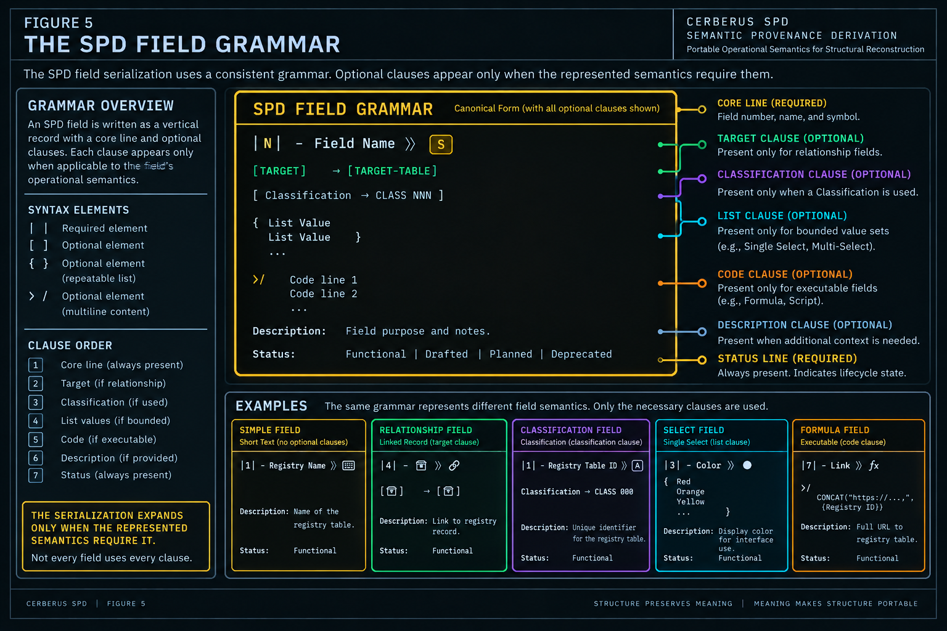
Figure 5. Field SPD serialization uses a required core and conditional clauses for target, classification, bounded list, code, description, and lifecycle. The serialization expands only when the represented semantics require it.

7. Deterministic Composition I - Field to Table
Larger SPD structures are compositions of atomic Fields, not separately maintained competing schemas.

7.1 Three nested order coordinates
Every represented Field participates in three nested order coordinates: Stack Order, Table Order, and Field Number. Field Number is interpreted within Table context; Table Order is interpreted within Stack context; Stack Order is interpreted within the larger Base traversal. The global structural sort key is therefore the ordered tuple (Stack Order, Table Order, Field Number).
RECONSTRUCTION ORDER
STACK ORDER ↑ -> TABLE ORDER ↑ -> FIELD NUMBER ↑

7.2 Field to Table
The live Table SPD Writer emits a Table header when Field Number equals 1, then emits the Field SPD. Subsequent Fields in the same Table emit only their Field content. The first Field is still a Field; it merely serves as the deterministic serialization boundary for its parent Table.

7.3 Table identity survives composition
Composition does not flatten Fields into an anonymous stream. The Table header retains Table Order, Table identity, and Table Purpose. Fields remain Fields within that bounded container. This lets a linear serialized artifact remain semantically hierarchical.

7.4 Membership and order are separate facts
A Field can belong to the correct Table and still carry the wrong Field Number. Correct membership with incorrect order is not full SPD equivalence. Similarly, retrieval order is not structural order; a platform query may return records arbitrarily unless the Writer explicitly sorts by the governed coordinates.

7.5 Order conflicts
Duplicate Field Numbers within one Table create a reconstruction conflict unless a governed tie-break rule exists. Sparse numbering can remain sortable but may indicate intentional reservation, removal, incomplete coverage, or an inconsistency. The Writer should expose those conditions rather than silently use incidental platform order as a semantic tie-breaker.

8. Deterministic Composition II - Stack to Base
Table boundaries compose into Stack boundaries, and ordered Stacks can conceptually compose into a Base representation without flattening constituent identity.

8.1 Stack resolution
The current Stack SPD Writer emits a Stack header when the current row is the first Field of Table Order 1. It then emits the Table header where Field Number equals 1 and finally emits the Field SPD. A single atomic Field record can therefore carry additional serialization responsibility without changing its structural identity.

8.2 Current header assumption
The live Writer currently assumes the first serializable Table has Table Order 1 and the first Field has Field Number 1. That is a real implementation condition and should remain explicit. A future serializer may generalize boundary detection, but the current paper does not pretend that arbitrary sparse starting indexes are already handled.

8.3 Base resolution
The live Airtable proof contains Field SPD, Table SPD, and Stack SPD formula outputs. A dedicated Base SPD formula does not yet exist. Base resolution is therefore the conceptual ordered composition of Stack representations under Stack Order. The architecture is established even though corpus coverage and a final Base-level Writer remain incomplete.

8.4 Linear serialization is not a flat model
A portable SPD artifact may be read top-to-bottom while preserving Stack boundaries, Table boundaries, Field order, membership, purpose, Types, and relationships. Linear traversal is a deterministic representation of nested structure, not a claim that the semantic model is one flat Table.

8.5 Completeness is resolution-bound
A complete Field does not imply a complete Table. A complete Table does not imply a complete Stack. A complete Stack does not imply a complete Base. Mechanism completeness and corpus coverage are different dimensions, and SPD should state which resolution has actually been completed.

8.6 Target storage order may differ
A target runtime such as SQLite may not physically store columns in SPD Field Number order or may not model Tables and Stacks as literal nested objects. That can still be semantically faithful if membership, governed order, purpose, and Field contracts remain explicitly recoverable. Structural nesting in SPD is not a requirement for identical physical nesting in target storage.

8.7 Composition conflict classes
Conflict | Meaning
Missing | A required member is absent at the resolution being reconstructed.
Duplicate | Two members claim the same order coordinate within one parent.
Orphaned | A Field cannot resolve its Table or a Table cannot resolve its Stack.
Misordered | Membership is correct but the governed position is wrong.
Misassigned | A member points to the wrong parent structure.
Drifted | A derived projection disagrees with its governed source.
Lifecycle mismatch | The represented state is inconsistent with the reconstruction claim.

Figure 6 - Deterministic Structural Composition
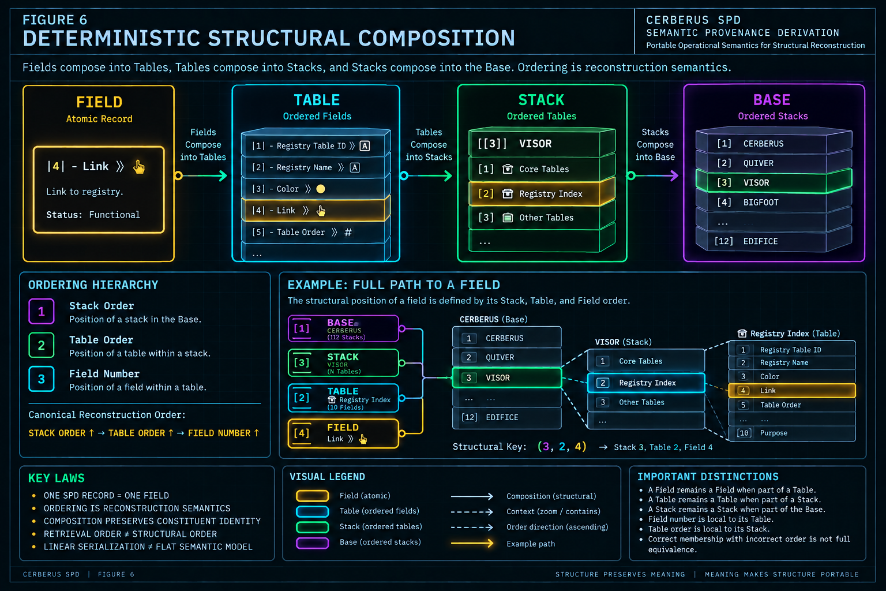
Figure 6. Atomic Fields compose into ordered Tables, ordered Tables into Stacks, and ordered Stacks into the Base. Composition preserves constituent identity and uses Stack Order, Table Order, and Field Number as reconstruction semantics.

9. Live Proof - Registry Index
The current live Writer contains a bounded, real proof of the SPD mechanism: ten Functional Field records for the Registry Index table inside VISOR.

9.1 Proof boundary
The live SPD table currently contains exactly ten records, all representing Fields of the Registry Index. The Table is Table Order 2 inside VISOR Stack Order 3. Its registered Table Purpose is 'Gives Orientation to all the Registries used in the System,' and the enclosing VISOR Stack Purpose is 'Shows Relational Structure of the base.' All ten current SPD records have lifecycle Functional.

9.2 The ten Fields
# | Field | BOSS Type | Additional semantics
1 | Registry Table ID | Short Text | CLASS 000; Description
2 | Registry Name | Short Text | -
3 | Color | Single Select | 12-value bounded List
4 | 🗃 | Linked Record | Explicit target: 🗃
5 | Table Order | Number | -
6 | Platform | Single Select | Prime, Atlas, Athena, Agora, Global Prime
7 | Status | Single Select | Planned, Draft, Functional, Partner-Ready, Public-Ready
8 | Link URL | URL | -
9 | Link | Click | -
10 | Purpose | Long Text | -

9.3 Field 1 - Classification plus Type
Registry Table ID demonstrates multiple semantic sources converging on one Field. Its Type is Short Text through BOSS; its compact Symbol is derived from that Type; it carries the governed Classification CLASS 000; and it currently has the placeholder Description 'Words and stuff.' The placeholder prose is not promoted into a polished definition merely because it exists in the live proof. The mechanism being demonstrated is that Description is conditionally serialized when present.

9.4 Field 3 - Bounded List
Color demonstrates Type plus Field-local value semantics. Single Select defines the broad value form; the explicit twelve-color list defines the legal vocabulary for this Field. Reconstructing only Single Select would preserve the Type while losing the Field contract.

9.5 Field 4 - Explicit relationship target
The 🗃 Field demonstrates relationship form and destination as separate semantics. Linked Record describes the relationship form; the registered target identifies where the relation points. A generic link with no destination is not equivalent.

9.6 Field 7 - Two different Status systems
The represented Registry Index contains a Field named Status whose legal values include Planned, Draft, Functional, Partner-Ready, and Public-Ready. Separately, the SPD record describing that Field has its own lifecycle Status: Functional, drawn from the SPD vocabulary Planned, Drafted, Functional, Deprecated. Draft and Drafted must not be normalized into one another without an explicit mapping because they belong to different objects and different vocabularies.

9.7 Table and Stack serialization behavior
Because Registry Index is Table Order 2, Field 1 correctly emits the Table header but does not emit the VISOR Stack header under the current Stack Writer rule. The Stack header belongs at Table Order 1, Field Number 1. The absence of a Stack header in this slice is therefore evidence that the Writer respects structural boundaries rather than printing parent context indiscriminately.

9.8 What the proof demonstrates - and what it does not
The proof materially demonstrates atomic Fields, ordering, Table/Stack derivation, BOSS Type linkage, Classification, bounded Lists, explicit targets, Description, lifecycle, Field serialization, Table boundary emission, and conditional Stack logic. It does not yet demonstrate full VISOR coverage, complete Base SPD, a dedicated Base Writer, full Native reconstruction, or every possible Type and Code case. A working proof of mechanism is not the same as a completed corpus.

9.9 Live proof invariants
Invariant | Current proof value
SPD record count | 10
Represented Table | Registry Index
Table Order | 2
Enclosing Stack | VISOR
Stack Order | 3
Field Number range | 1 through 10
SPD lifecycle | All 10 records Functional

PROOF BOUNDARY
MECHANISM COMPLETENESS != CORPUS COMPLETENESS

Figure 7 - Live Example - The Registry Index
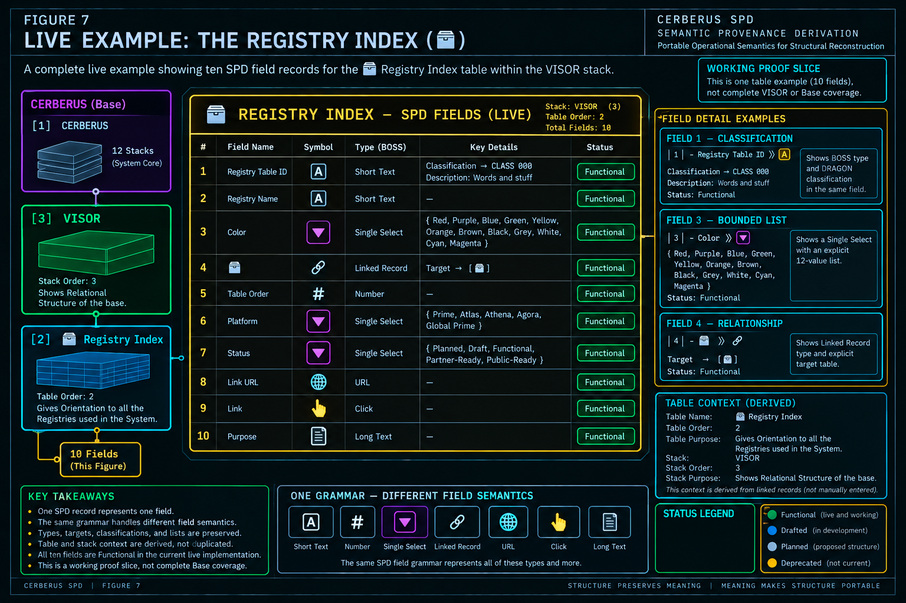
Figure 7. The ten-record Registry Index is the current working proof slice. It demonstrates one grammar across different Field semantics while explicitly remaining one Table example rather than complete VISOR or Base coverage.

10. Lifecycle and Non-Destructive Structural Simulation
SPD can represent existing, developing, proposed, and deprecated structure without treating representation as material existence or permission to modify the Base.

10.1 Exact lifecycle vocabulary
State | Meaning | What it does not mean
Planned | Intended structure can be represented before materialization. | The Field or Table already exists.
Drafted | The SPD definition is developing and not yet treated as Functional. | The structure is complete or approved for arbitrary mutation.
Functional | The represented structure is functioning as intended at its current scope. | The entire SPD corpus is complete or immutable.
Deprecated | The structure is no longer preferred but remains legible for history, migration, and context. | The representation should be erased automatically.

LIFECYCLE LAW
PLANNED != MATERIALIZED | DRAFTED != FUNCTIONAL | DEPRECATED != ERASED

10.2 Same grammar, different lifecycle state
Existing and proposed structures use the same operational-semantic language. A Planned Field can already specify its Name, order, Table, Type, target, classification, list, code requirements, Description, and other semantics while still not existing materially. This is a major simplification: CERBERUS does not need one schema language for reality and another for proposals.

10.3 Non-destructive structural simulation
Because proposed structure can be represented before construction, SPD becomes a bounded non-destructive structural simulation surface. It can answer what Fields would exist, where they would belong, what they would link to, and which semantics would apply while leaving the current material Base unchanged. The Base no longer needs to be the sketchpad for every idea.

10.4 SPD structural simulation is not MIRROR
CERBERUS already has MIRROR for broader non-destructive relational reasoning. SPD may represent unrealized implementation structure without becoming MIRROR. The overlap is a capability - representation without materialization - while ownership remains domain-specific.

10.5 Mixed lifecycle composition
A larger Table or Stack representation can contain Functional, Drafted, and Planned Fields simultaneously. Composition preserves those distinctions rather than inferring one parent state from the children or vice versa. Parent lifecycle and child lifecycle remain object-bound unless an explicit rule says otherwise.

10.6 Construction boundary
A complete Planned SPD can be inspected, compared, PATCHed, and PORTed without being constructed. Lifecycle is a property of the representation, not a mutation command. The transition from representation to material change remains authority-bound.

Figure 8 - Represented Structure != Material Structure
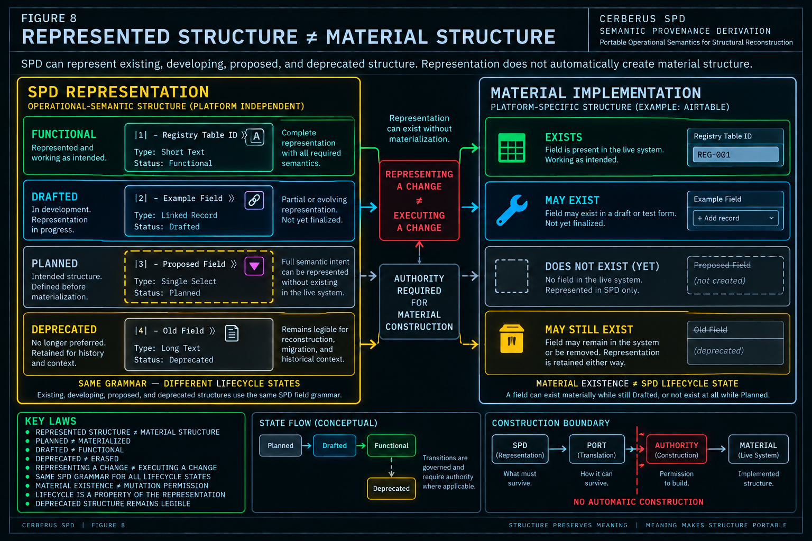
Figure 8. SPD lifecycle can describe Functional, Drafted, Planned, and Deprecated structure independently of material existence. Representing or refining a structural change does not execute that change; authority remains required for material construction.

11. Semantic Portability and Losslessness
SPD separates the operational contract from the material platform so structure can survive migration without requiring literal platform replication.

11.1 Airtable is current material, not permanent ontology
The live Writer currently exists in Airtable, making Airtable a productive proof environment, schema laboratory, and sandbox. But Airtable Field Types, record IDs, helper formulas, lookup projections, and interface conveniences should not silently become permanent CERBERUS ontology. SPD exists precisely so the operational meaning can survive when those material mechanisms change.

11.2 What must survive
A semantically faithful migration may need to preserve Field identity, structural location, Field Number, Table Order, Stack Order, governed Field Type semantics, relationship targets, Classification provenance, bounded Lists, Code behavior, purpose, lifecycle, and the derivation paths required to recover readable context. The target may realize those requirements with a different number and arrangement of physical objects.

11.3 Semantic losslessness
Semantic losslessness means the required operational meaning remains expressible and recoverable in the target. It does not require byte identity, platform ID identity, UI identity, or literal formula identity. The essential comparison is between operational contracts, not source and target appearances.
PORTABILITY LAW
SEMANTIC EQUIVALENCE != PLATFORM IDENTITY

11.4 Linked Record example
An Airtable Linked Record may become a SQLite foreign key or, when cardinality requires it, a junction table. One source Field can therefore map to multiple target structures. The migration remains faithful if the governed source-to-target relationship survives and remains reconstructable.

11.5 Single Select example
A bounded Single Select may become a governed lookup table, a value plus CHECK constraint, or another constrained representation. Converting it to unconstrained free text while discarding the legal List would preserve storage capacity while losing the Field semantics.

11.6 Executable behavior
Code-bearing Fields require behavioral translation rather than syntax copying. A formula copied as text into another environment is not equivalent merely because the characters survived. PORT and verification must determine whether the target expression or application logic preserves the source behavior.

11.7 Derived helpers need not remain stored
A native runtime may derive Table Purpose, Stack Order, Field Type Name, Symbol, or other projections dynamically instead of storing them as Airtable-style lookup Fields. Semantic fidelity requires that the values remain reproducible from the governed relationships, not that every source-platform helper be physically cloned.

12. PORT and Target-Material Translation
PORT is the translation layer between an SPD operational contract and the material structures available in a destination runtime.

12.1 The PORT boundary
SPD answers what the structure means. PORT answers how that meaning can be expressed in the target material. Keeping these responsibilities separate prevents the portable representation from becoming a giant database-specific translation matrix and prevents the target platform from quietly redefining the source semantics for convenience.
PORT BOUNDARY
SPD SAYS WHAT MUST SURVIVE. PORT DETERMINES HOW IT SURVIVES.

12.2 One-to-one, one-to-many, and many-to-one
Some translations are approximately one-to-one, such as a simple text or number Field. Others are one-to-many, such as a relationship that requires a junction structure and constraints. The reverse is also possible: several Airtable helper Fields may collapse into one native governed relationship from which the same projections are calculated. Material Field count is therefore not a portable invariant.

12.3 Non-equivalence must remain visible
A target may lack an exact analogue for a source capability. PORT must be able to expose partial, non-equivalent, or unresolved translation rather than silently approximate the source and claim success. The exact status vocabulary for PORT can evolve, but the architectural requirement is stable: semantic loss and non-equivalence must not be concealed.

12.4 Unresolved is not permission to invent
When a target mapping cannot yet be established, the safe state is unresolved. Choosing the closest-looking target Type without a governed basis creates hidden semantic drift. The absence of a direct material feature may require compensating application logic, a different normalized structure, PATCH, BUILD, or a human decision.

12.5 One SPD contract, multiple materializations
The same SPD contract can support Airtable, SQLite, Native CERBERUS, and future platforms whose storage models differ substantially. The material implementations need not resemble one another so long as the governed structural meaning and provenance remain recoverable.

13. Reconstruction and Verification
A translated plan becomes material only through authority, and a successful write is not equivalent to proof that the intended semantics survived.

13.1 Reconstruction specification versus construction authority
A complete SPD can specify a target structure in detail; PORT can translate it into a target-material plan. Neither fact grants permission to mutate the live system. Material construction remains a separate authorized action. This keeps representation, translation, and execution distinct even when all three are technically possible in the same software environment.

13.2 Execution success is not semantic success
A database API can report that every requested object was created. That proves execution, not equivalence. A target can contain the right number of Fields and still have the wrong relationship destination, lose a List, misplace order, flatten purpose, or drop classification provenance. Verification must compare the observed target against the SPD contract.

13.3 Re-deriving an SPD view
A strong verification pattern is to observe the target and derive an equivalent SPD view from it, then compare that view with the source contract. The serialized text does not need to be character-for-character identical; the operational meaning must be equivalent. Conversely, matching documentation text does not prove the underlying target relationships or behaviors actually exist.

13.4 Reconstruction failure classes
Failure | Meaning
LOST | A source semantic requirement disappears in the target.
MISTRANSLATED | A source concept is mapped to the wrong target behavior.
UNRESOLVED | No governed target mapping has yet been established.
MISBOUND | The broad Type survives but points to the wrong target.
DECONTEXTUALIZED | Information survives but loses its Field/Table/Stack attachment.
UNPROVENANCED | A readable value survives while the governed source relation is lost.
MISORDERED | Membership survives but governed structural order does not.

13.5 Native CERBERUS implication
Native CERBERUS should not be built by literally cloning Airtable. The preferred path is to read governed SPD semantics, translate them through PORT, construct the native material equivalent, observe the result, and verify it. Airtable scaffolding can be left behind where the native environment can derive the same meaning more cleanly. Portable semantics survive; sandbox scaffolding need not.
Once SPD coverage is complete enough, migration stops being platform archaeology. Instead of asking what an Airtable Field probably meant, Native reconstruction can ask what operational-semantic contract the registered SPD explicitly declares.

14. SPD Bundles and BUILD
Once a structural corpus is represented in SPD, existing implementation knowledge can become bounded constructive precedent rather than passive documentation.

14.1 SPD Bundle
An SPD Bundle is a bounded collection of SPD structural representations selected as relevant precedent for a constructive or analytical task. A Bundle may contain individual Fields, a complete Table, multiple related Tables, a subset of a Stack, a complete Stack, or a cross-structural collection when the task genuinely requires it.
BUNDLE LAW
BUNDLING PRESERVES MEMBER IDENTITY

Bundle membership does not flatten the selected structures or transfer their authority. A VISOR Field remains a VISOR-located Field; a BOSS Type remains BOSS-owned; a DRAGON Classification remains DRAGON-owned. The Bundle is a selection boundary, not a semantic merger.

14.2 Context makes precedent intelligent
BUILD requires more than a bag of Field names or Types. A relationship Field is meaningful because of the Table it belongs to, the target it points to, the purpose of the structure, its ordering, classification, and surrounding patterns. Flattening those dimensions destroys the reason the precedent is useful.

14.3 BUILD - Bundled Unfolding Intelligence Lenses for Development
BUILD uses SPD Bundles as its unfolding intelligence. Existing structural precedent is selected, examined through bounded lenses, and unfolded into candidate new structure. This is not an empty-prompt schema generator and it is not a clone command. Precedent constrains and informs construction without becoming a universal template obligation.

14.4 BUILD lenses
Lens | Question it brings into focus
Identity | Stable identity needs, existing identity patterns, and duplication risks.
Field | Field combinations, order, Types, Lists, Code, and optionality.
Relationship | Source/target structure, hierarchy, ownership, dependency, and cardinality implications.
State | Lifecycle, stored versus derived state, and valid structural distinctions.
Reader | Reader references, bindings, resolved values, and SK-related structure.
Classification | Where DRAGON determination is required and which provenance must be preserved.
Runtime | Persistent structure versus task-bounded or derived runtime manifestation.
PORT | Material implications and target-environment constraints without redefining semantics.
Interface | QUIVER-facing implications without turning display convenience into persistence by default.
Authority | Semantic owners, approval boundaries, and mutations that require explicit authorization.

14.5 Lenses do not become owners
A BUILD Relationship Lens does not become VISOR. A Field Lens does not become BOSS. A Classification Lens does not become DRAGON. An Interface Lens does not become QUIVER. A PORT Lens does not become PORT. A Lens is a bounded way of examining precedent; it does not absorb the subsystem being examined.

14.6 Preferred output: Proposed SPD
BUILD should generally propose SPD before proposing physical implementation. Proposed SPD keeps candidate structure portable, inspectable, PATCHable, and available for PORT before any material write occurs. Directly emitting Airtable Fields or SQL DDL would entangle constructive reasoning with one target platform too early.
CONSTRUCTIVE BOUNDARY
BUILD PROPOSAL != MATERIALIZED STRUCTURE

15. BUILD <-> PATCH Reverberation
BUILD expands relevant precedent into candidate structure; PATCH prunes and refines that candidate toward a cleaner resolution.

15.1 Constructive divergence and corrective convergence
BUILD performs bounded constructive divergence: it asks what useful new structure can unfold from relevant precedent. PATCH performs bounded corrective convergence: it asks what is redundant, incomplete, misbound, wrongly persisted, unclear, or unnecessarily complex in the candidate. Their value comes from remaining distinct.
REVERBERATION LAW
BUILD = BOUNDED CONSTRUCTIVE DIVERGENCE | PATCH = BOUNDED CORRECTIVE CONVERGENCE

15.2 The developmental cycle
EXISTING VERIFIED STRUCTURE
-> SPD
-> RELEVANT SPD BUNDLE
-> BUILD
-> PROPOSED SPD
-> PATCH
-> REFINED SPD
-> PORT
-> AUTHORITY
-> CONSTRUCTION
-> OBSERVATION / VERIFICATION
-> FUNCTIONAL STRUCTURE
-> SPD
-> FUTURE PRECEDENT

15.3 Reverberation rather than one-way pipeline
PATCH may discover that the chosen Bundle was incomplete, a source structure is itself broken, a relationship is contradictory, or a material assumption has leaked into the proposal. In that case the process can return to BUILD with refined precedent. PORT may also expose a non-equivalence that requires PATCH or BUILD before translation can continue. The system can reverberate until the proposal is coherent enough for authority and construction.

15.4 A bounded constructive example
Imagine a new runtime relationship Table. A Bundle might include Registry precedent, Reader-related Tables, runtime relations, and existing validation patterns. BUILD could propose Runtime ID, source record, placement record, Reader Binding, Resolved Value, Validation, and Status. PATCH might then determine that Resolved Value should be derived rather than stored, that Validation duplicates a Rule mechanism, or that Runtime ID should reuse an existing identity pattern. The refined SPD is stronger because constructive expansion and corrective refinement contributed different forms of reasoning.

15.5 New structure becomes new precedent
Once refined SPD is PORTed, authorized, constructed, independently verified, and represented as Functional, it joins the structural corpus. Future BUILD tasks can select it into later Bundles. SPD therefore acts as explicit structural memory: CERBERUS can preserve how successful implementation structure was built and reuse that precedent without relying on opaque statistical imitation.

15.6 The complete signature law
SYSTEM SIGNATURE
SPD REPRESENTS. BUILD PROPOSES. PATCH REFINES. PORT TRANSLATES. AUTHORITY CONSTRUCTS. VERIFICATION PROVES.

Figure 9 - Portability and Constructive Reuse
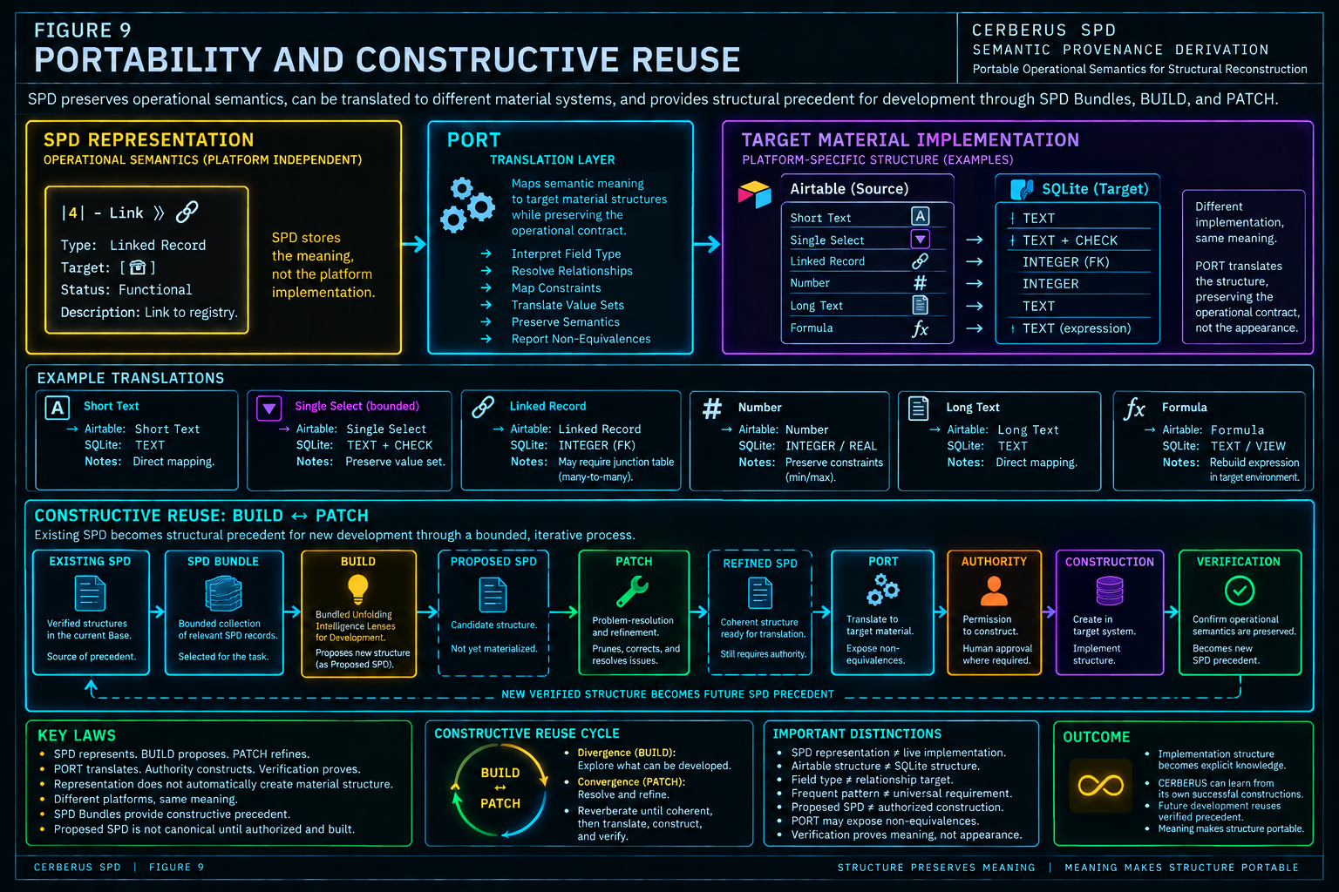
Figure 9. SPD preserves operational meaning across material implementations and supplies bounded precedent for BUILD. BUILD proposes, PATCH refines, PORT translates, authority constructs, verification proves, and verified structure becomes future SPD precedent.

16. Invariant Registry and Closing Architecture
The mature system can now be protected by a compact registry of distinctions that future implementations, papers, assistants, and migrations must preserve.

16.1 Invariant registry
Domain | Invariant
Atomicity | ONE SPD RECORD = ONE FIELD
Composition | FIELD -> TABLE -> STACK -> BASE
Ordering | STACK ORDER -> TABLE ORDER -> FIELD NUMBER
Context | FIELD NAME ALONE != FIELD IDENTITY IN CONTEXT
Provenance | DERIVED PROJECTION != SOURCE AUTHORITY
VISOR boundary | VISOR LOCATES. SPD DESCRIBES.
BOSS boundary | SPD USES BOSS FIELD TYPES; SPD DOES NOT OWN A PARALLEL TYPE ONTOLOGY.
DRAGON boundary | SPD REPRESENTS DRAGON CLASSIFICATION; SPD DOES NOT OWN IT.
Relationship | FIELD TYPE != RELATIONSHIP TARGET
Executable behavior | FIELD TYPE != CODE PRESENCE
Lifecycle | PLANNED != MATERIALIZED; DRAFTED != FUNCTIONAL; DEPRECATED != ERASED
Representation | SPD REPRESENTATION != LIVE IMPLEMENTATION
Execution | REPRESENTING A CHANGE != EXECUTING A CHANGE
Portability | SEMANTIC EQUIVALENCE != PLATFORM IDENTITY
PORT | SPD SAYS WHAT MUST SURVIVE; PORT DETERMINES HOW IT SURVIVES.
Bundle | SPD BUNDLE != NEW STRUCTURE; BUNDLING PRESERVES MEMBER IDENTITY.
BUILD | BUILD PROPOSAL != MATERIALIZED STRUCTURE
PATCH | PATCH REFINEMENT != CANONICAL MUTATION
Authority | SEMANTIC VALIDITY != MUTATION AUTHORITY

16.2 Reconstruction failure tests
Claim | Result
Field Name is enough to reconstruct a Field. | FAIL - structural context and operational semantics may also be required.
Field Type Name is more authoritative than the linked BOSS Type. | FAIL - the readable name is a projection.
A link symbol identifies the target Table. | FAIL - relationship form and destination are separate.
Classification presence fully preserves Classification. | FAIL - presence is not governed identity.
Code can be inferred from Type. | FAIL - executable behavior must be represented explicitly when present.
Table Purpose should be manually rewritten into every Field. | FAIL - shared context should derive from the governed Table.
Table SPD is a separately maintained schema. | FAIL - it is composed from atomic Fields.
Output order is cosmetic. | FAIL - ordering is reconstruction semantics.
Planned SPD means the Field exists. | FAIL - Planned is a representational lifecycle state.
Deprecated means erase the structure. | FAIL - Deprecated remains legible.
Native CERBERUS must recreate every Airtable helper Field. | FAIL - projections may be re-derived differently.
SQLite is correct only if it literally resembles Airtable. | FAIL - semantic equivalence does not require platform identity.
BUILD may directly construct the patterns it infers. | FAIL - the preferred output is Proposed SPD.
A frequent pattern is automatically a universal rule. | FAIL - precedent is evidence, not authority.
An SPD Bundle may flatten member context without loss. | FAIL - Table, Stack, order, target, and provenance are part of the precedent.
PATCH may directly mutate the Base because it found the right answer. | FAIL - problem resolution is not mutation authority.
PORT may silently approximate a non-equivalent target. | FAIL - semantic loss must be exposed.
Successful construction proves semantic equivalence. | FAIL - execution success requires independent verification.
Matching SPD text proves the target implementation is equivalent. | FAIL - documentation can match while material behavior is wrong.
SPD owns neighboring systems because they interact with it. | FAIL - interoperation does not collapse ownership.

16.3 Responsibility registry
System | Responsibility
VISOR | Structural geography and location.
BOSS | Governed structural/type vocabulary.
DRAGON | Registered identity and Classification semantics.
SPD | Portable operational-semantic representation of implementation structure.
BUILD | Constructive reasoning over bounded SPD precedent.
PATCH | Bounded problem-resolution and refinement.
PORT | Target-material semantic translation.
AUTHORITY | Permission for material construction.
VERIFICATION | Evidence that constructed material preserves the intended contract.

16.4 Mature SPD definition
Semantic Provenance Derivation is CERBERUS's portable operational-semantic representation of implementation structure. Each SPD Field record represents one Field in governed structural context, preserving or deriving the identity, position, enclosing Table and Stack, Field Type, relationship targets, Classification, bounded values, executable behavior, purpose, provenance, and lifecycle required to interpret that Field operationally. Ordered Fields deterministically compose into Tables, ordered Tables into Stacks, and ordered Stacks into a reconstructable Base representation. Derived projections remain subordinate to the governed semantic sources from which they are obtained, allowing the representation to remain human-readable and machine-resolvable without copying authority into SPD itself. Because SPD preserves the operational contract rather than only the material schema of a particular platform, it can describe both existing and proposed structures, support semantically lossless translation through PORT, and provide bounded structural precedent through SPD Bundles for BUILD while remaining distinct from construction, refinement, translation, and mutation authority.

16.5 Mature BUILD relationship
BUILD - Bundled Unfolding Intelligence Lenses for Development - uses bounded SPD Bundles as its unfolding intelligence. It examines existing operational-semantic structural precedent through explicit development lenses, unfolds relevant patterns and differences into candidate structure, and preferably expresses that candidate first as Proposed SPD. BUILD therefore extends SPD from reconstruction intelligence into construction intelligence without changing SPD's role as representation.

16.6 Mature BUILD <-> PATCH relationship
BUILD and PATCH form a bounded developmental Reverberation. BUILD performs constructive divergence by unfolding relevant SPD precedent into candidate structure. PATCH performs corrective convergence by locating and resolving redundancy, conflict, misbinding, missing semantics, unnecessary materialization, and other structural defects. Either mechanism can return unresolved problems to the other until a coherent SPD proposal is ready for PORT, authority, construction, and verification.

16.7 Closing architecture
SPD began from a narrow requirement: describe implementation structure well enough that it can survive outside the platform in which it was first built. That requirement produced a disciplined architecture. One record represents one Field. The Field remains situated in its Table and Stack. Its Type remains traceable to BOSS, its Classification to DRAGON, its structural geography through VISOR, and its targets through explicit registered relationships. Lists, Code, purpose, order, and lifecycle remain available without turning readable projections into new authorities.
The same grammar can describe existing and proposed structure. PORT can translate that operational contract into a different material environment. Verification can test whether the translation preserved meaning. And once a corpus of successful structure has been represented in SPD, bounded Bundles can become explicit construction precedent for BUILD. PATCH can refine the resulting candidate, authority can permit materialization, and verified structure can return to SPD as new precedent.
CERBERUS therefore does not need to forget how it built itself each time it grows. Its implementation structure becomes legible enough to preserve, rebuild, inspect, compare, translate, and reuse.
CLOSING THESIS
SPD DESCRIBES STRUCTURE WELL ENOUGH TO REBUILD IT - AND WELL ENOUGH FOR CERBERUS TO LEARN FROM IT.

