CERBERUS TRANSFORM MATRIX
Architecture
A Governed Framework for Cross-Domain Value Mapping,
Modality Translation, and Operational Parameter Resolution
▪︎-> x▪︎x
CORE THESIS
The Transform Matrix is a governed registry of explicit mappings between typed value spaces. A Packet (▪︎->) carries selected semantic state toward a Transform (x▪︎x). The Transform computes correspondence under a declared contract. It does not independently infer meaning, override Rules, or possess authority to act.

Architecture Paper · Version 0.1 · August 2026

Abstract
The CERBERUS Transform Matrix formalizes a compact but general computational mechanism: a governed source value is sent as a Packet, resolved through an explicit Transform contract, and returned as a typed target value. The same primitive can support representation conversion, semantic remapping, perceptual projection, and operational parameter resolution. What began as a useful mechanism for expressive interfaces therefore generalizes into cross-domain infrastructure that can sit between measurements, Semantic Kernels, Models, perceptual systems, movement systems, guidance systems, and governed Operators.
The architecture separates mapping from agency. A Transform may calculate a fan speed, permitted velocity, stride length, color value, or semantic band, but it does not itself perform the action or claim that source and target meanings are equivalent. Semantic identity, value type, unit, domain, context, version, and governance remain explicit. This makes mappings inspectable, reusable, composable where authorized, and safer to operate across systems with very different semantic and physical consequences.
The Matrix is best understood as a view over a Transform Registry rather than a single monolithic spreadsheet. Each populated source-target cell indicates one or more registered Transform contracts. Underneath that view, the same records form a Transform Graph whose paths can support direct or chained resolution. Path existence alone is insufficient: chain composition must be contract-compatible, context-valid, and explicitly permitted.
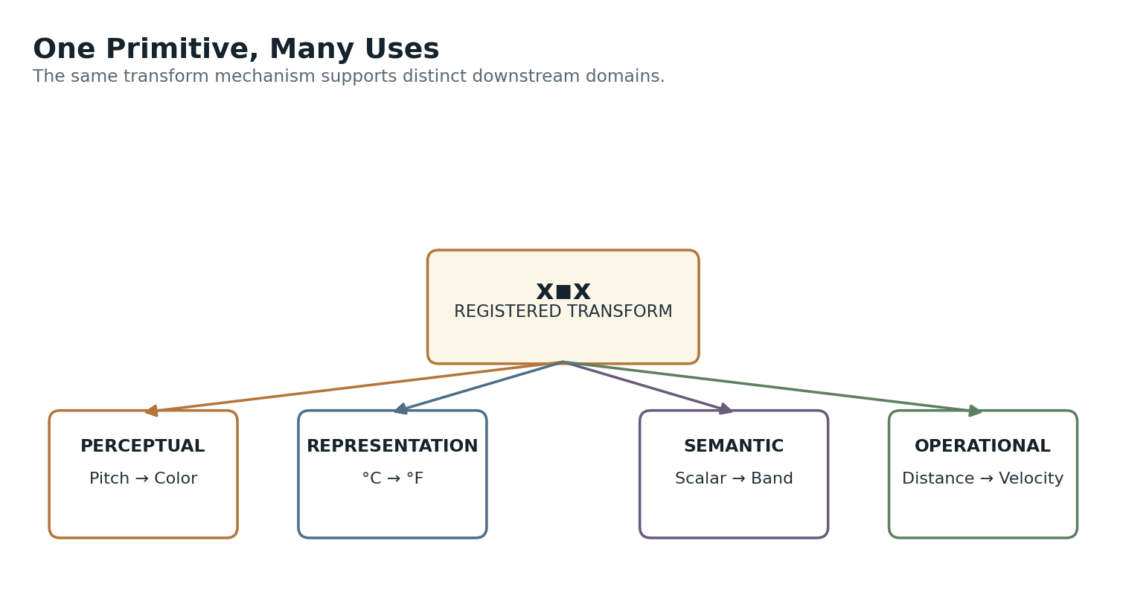
Figure 1. One primitive, many uses: the same mapping mechanism can serve perceptual, representation, semantic, and operational consumers.

Paper Map
Part | Focus
I | Purpose and architectural boundary
II | Packet and Transform grammar
III | Registry, Matrix, and contextual resolution
IV | Four Transform categories
V | Source and target contracts
VI | Transform mechanics and mapping methods
VII | Arity, fan-out, fan-in, and multivariate mappings
VIII | Transform chains and graph composition
IX | Context, personalization, and resolver behavior
X | Safety, loss, versioning, and provenance
XI | Boundaries with Models, Rules, and Operators
XII | Cross-system applications
XIII | Transform Registry architecture
XIV | Core laws
XV | Complete architecture

I. Purpose and Architectural Boundary
The Transform Matrix is a deterministic mapping layer, not another intelligence or authority layer.
The central problem is simple: CERBERUS frequently needs a value expressed in one governed space to become usable in another. A sensor voltage may need calibration into temperature. A temperature may need normalization. A normalized control value may need conversion into revolutions per minute. A pitch value may need translation into color or particle speed. A walking-speed scalar may need to parameterize stride length and cadence. These are structurally similar operations even though their downstream meanings differ greatly.
The Transform Matrix gives those correspondences a common architecture without collapsing their semantics. It does not assert that Pitch is Color, that Distance is Velocity, or that a normalized scalar is interchangeable with any other normalized scalar. It says only that a declared, versioned mapping exists from one typed source contract to one typed target contract under specified conditions.
FOUNDATIONAL BOUNDARY
A Transform computes correspondence. The downstream system decides whether and how that result may be used.

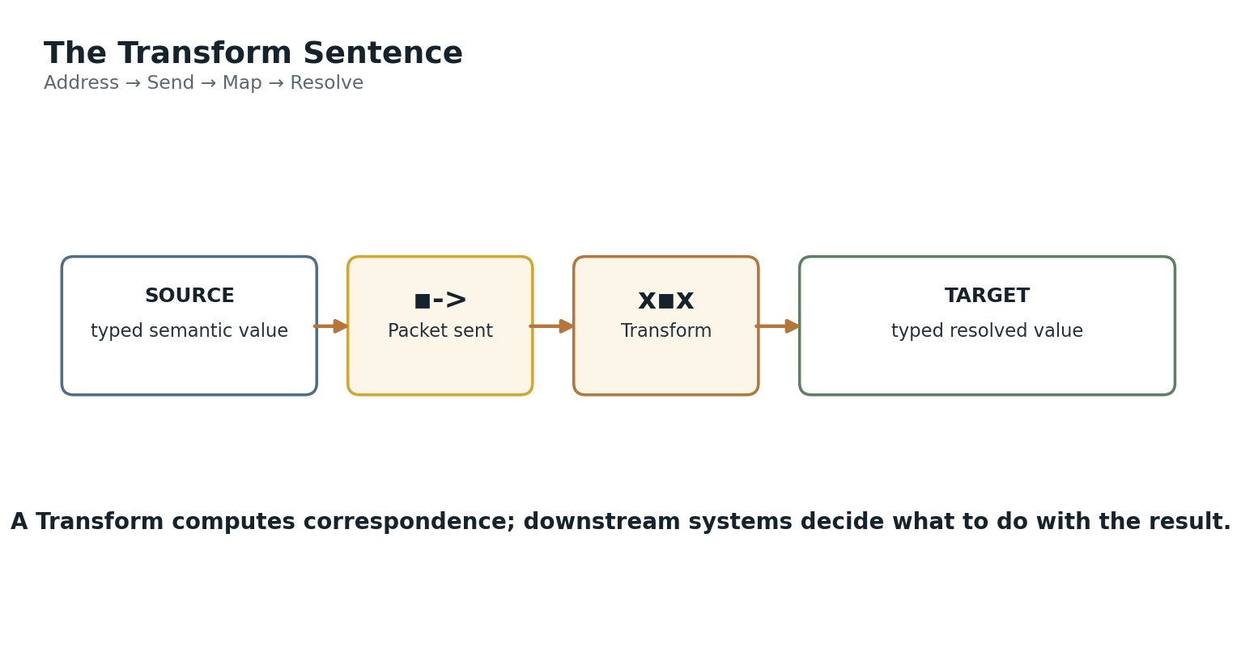
Figure 4. The Transform sentence: typed source value → Packet → Transform → typed target value.
This separation is particularly important for operational use. A Transform may calculate that a motor target should be 0.64 or that the permitted velocity is 0.42 m/s. An Operator, constrained by Rules and permissions, is still required to mutate actual state. The Transform can therefore be reusable infrastructure without inheriting agency simply because one consumer happens to be a machine-control system.
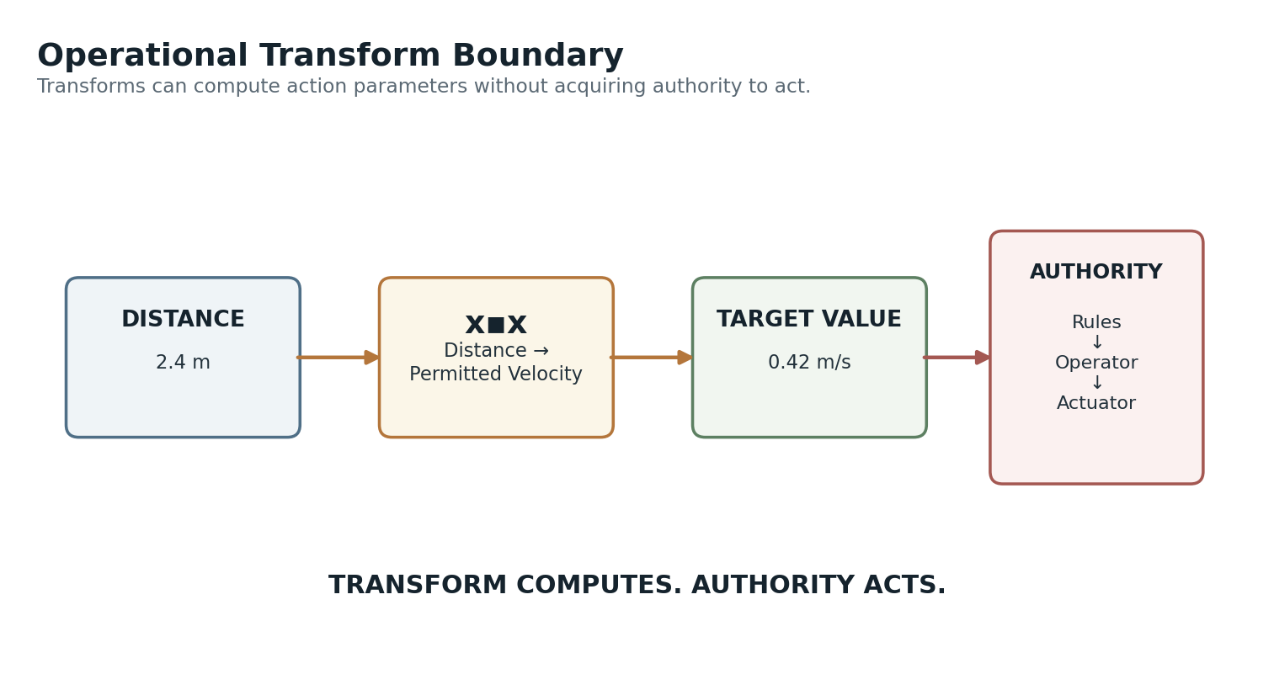
Figure 10. Operational boundary: a Transform can compute a permitted velocity without authorizing the actuator to use it.

II. Core Transform Grammar
Two small notation primitives separate transfer from conversion.
Packet notation is ▪︎->. It means that selected semantic state is being sent onward for transformation. The Packet is not the source object itself, and it is not the Transform. It is the runtime transfer of the required value state into the mapping mechanism.
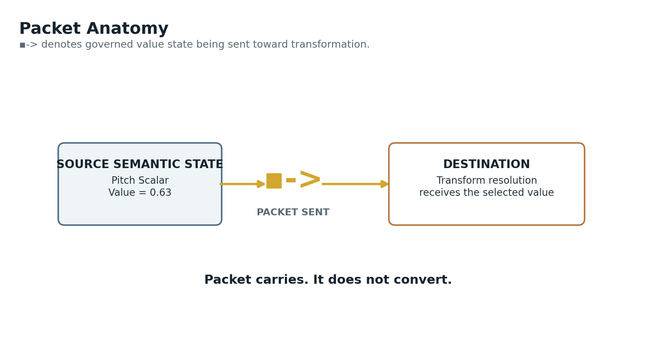
Figure 2. Packet anatomy: ▪︎-> carries selected semantic state toward a Transform.
Transform notation is x▪︎x. A Transform is the declared conversion contract applied to the Packet. The Transform binds a source contract, mapping method, target contract, and governance metadata. The output is a new typed value in the target space.
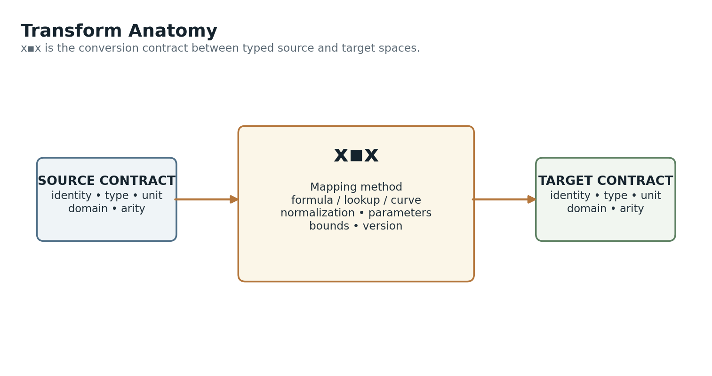
Figure 3. Transform anatomy: source contract, mapping logic, and target contract remain explicit.
Notation | Role | Not
▪︎-> | Packet being sent | Not a Transform; not the output
x▪︎x | Declared Transform | Not a Model; not an Operator
Source value | Governed input state | Not an anonymous number
Target value | Resolved mapped output | Not automatic authority to act

III. Registry, Matrix, and Contextual Resolution
The Matrix is a discoverable projection over durable Transform records.
The Transform Matrix should not be treated as one enormous physical spreadsheet whose axes must contain every possible semantic value. The durable source of truth is the Transform Registry. Each Transform record declares one mapping contract. A Matrix view can then project those records into source-target coordinates for discovery, comparison, debugging, and coverage analysis.
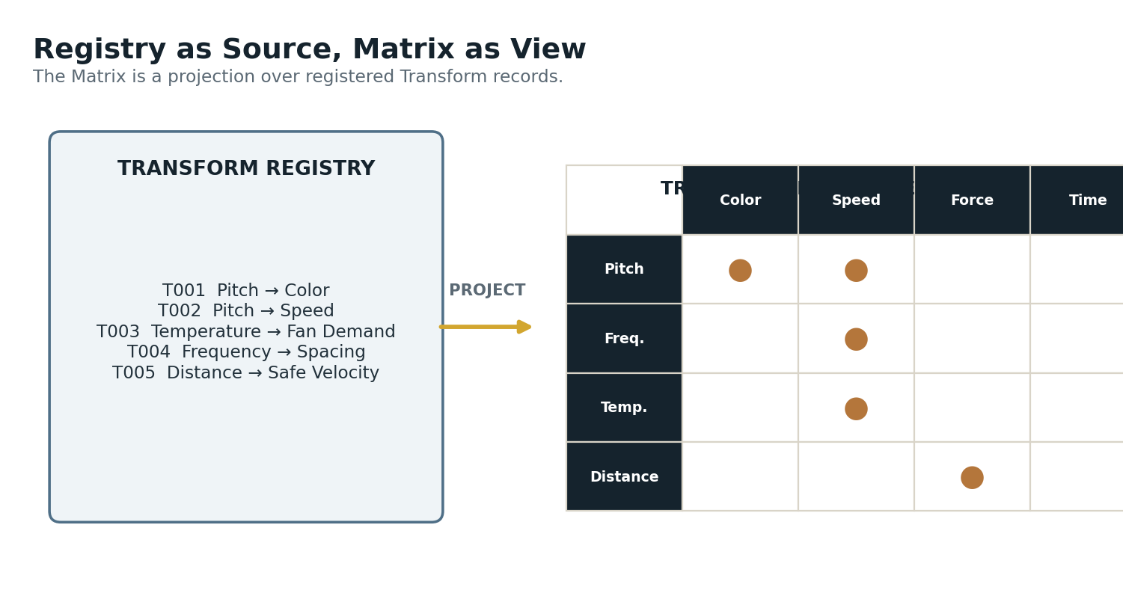
Figure 5. Registry to Matrix: each populated cell represents at least one registered Transform contract.
An empty Matrix cell means no governed correspondence is registered for that source-target pair in the current scope. A populated cell does not necessarily contain exactly one Transform. Contextual mappings can coexist: Pitch → Color may have one transform for music visualization, another for an accessibility profile, another for a personal perceptual language, and another for scientific display.
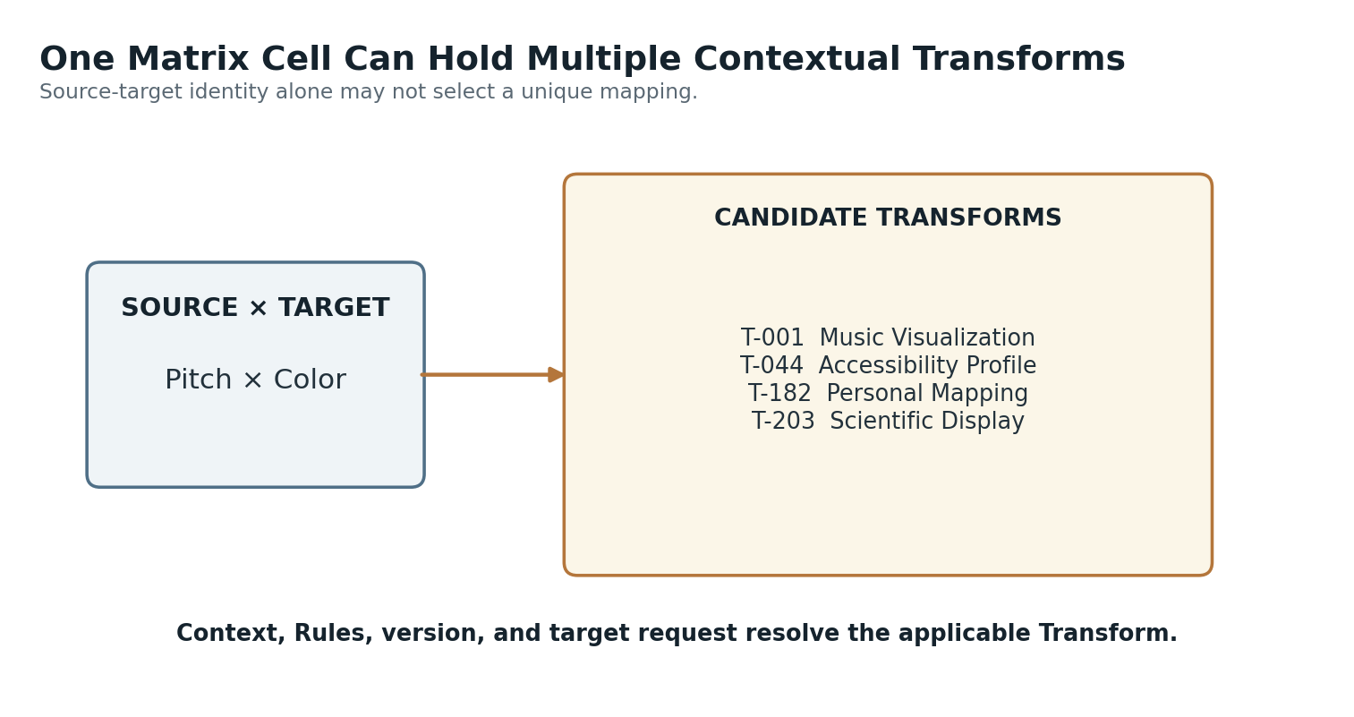
Figure 6. One source-target cell can contain multiple contextual Transform contracts.
Resolution therefore occurs before execution. The resolver considers source identity, requested target, current context, version scope, user or application profile, applicable Rules, and contract compatibility. Only after selection does x▪︎x execute.
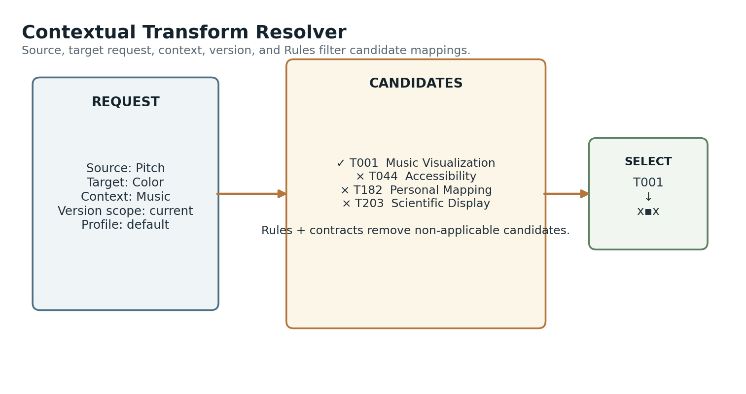
Figure 24. Contextual resolver filtering several Pitch → Color candidates to one applicable Transform.

IV. Four Transform Categories
A practical taxonomy for organizing mappings by role.
The following four categories are useful architectural groupings. They need not become permanent ontology classes unless later implementation proves that distinction useful. Their purpose is to make different risk and interpretation profiles visible.
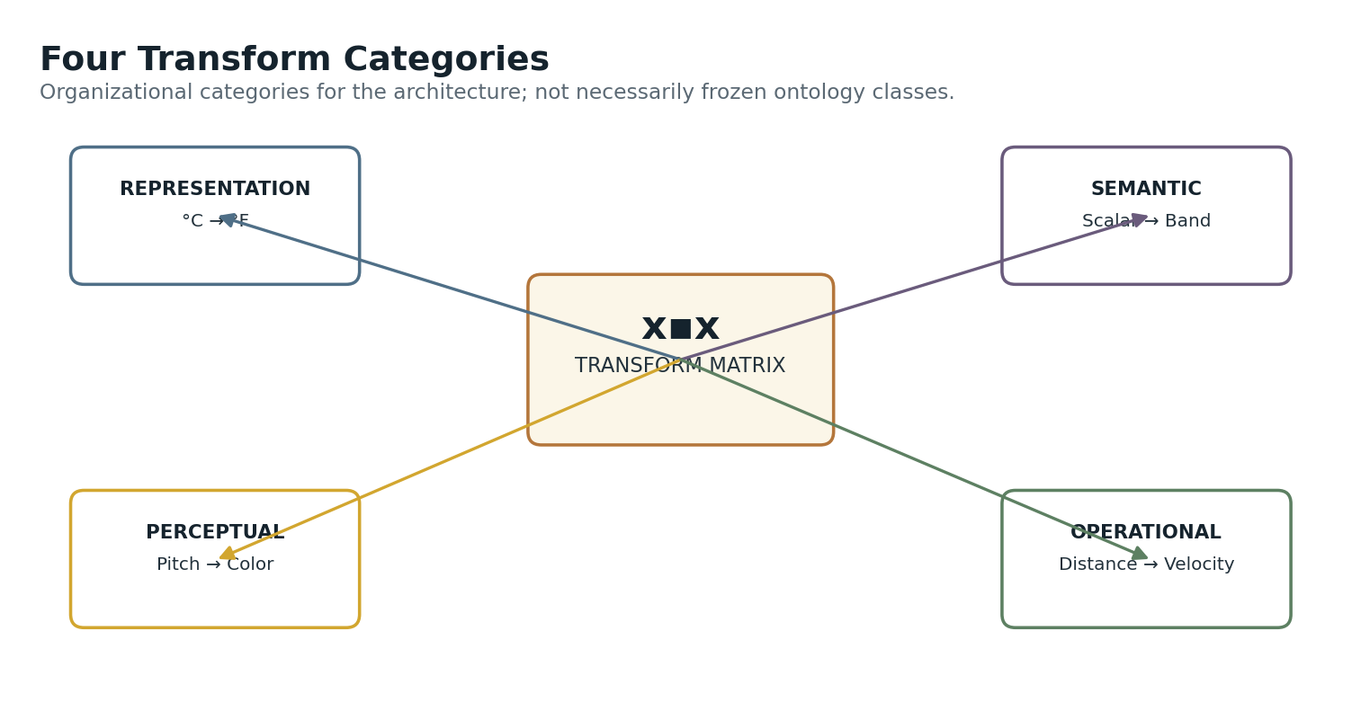
Figure 42. Four transform categories arranged around the common x▪︎x primitive.

Representation Transforms
Representation Transforms preserve the general underlying property while changing its representational coordinate system. Unit conversion, percentage conversion, scale conversion, and comparable encoding changes fit naturally here. They often have strong invertibility and relatively low semantic ambiguity, although source and target contracts still remain explicit.
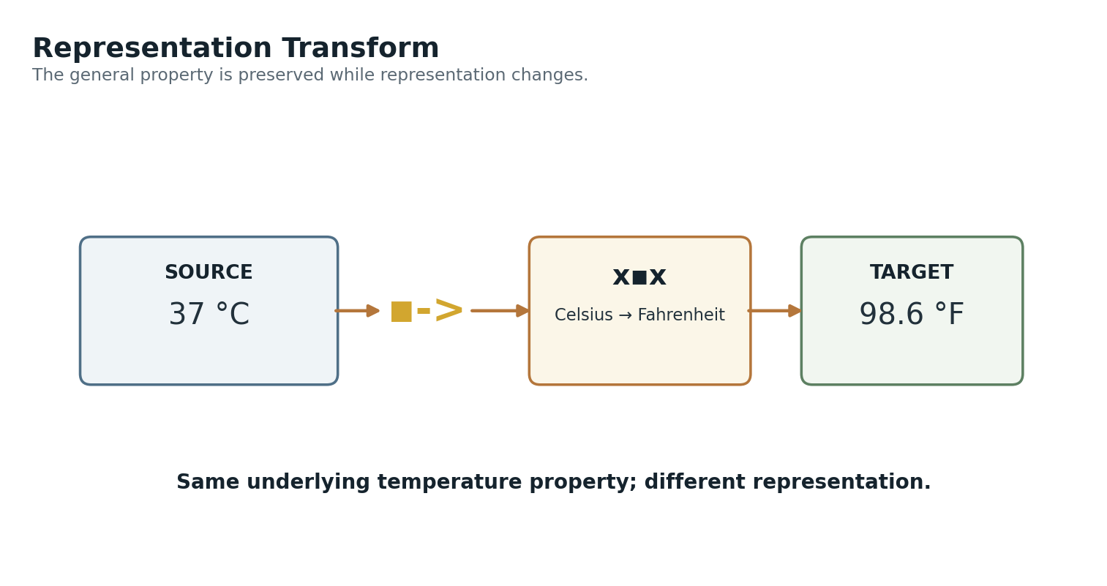
Figure 7. Representation transform example: 37 °C becomes 98.6 °F while remaining temperature.

Semantic Transforms
Semantic Transforms map one governed semantic representation into another. A continuous severity scalar can become a Low/Medium/High severity band, or a detailed state can be projected into a coarser category. The Transform should remain a declared mapping. If the target requires prediction, uncertain inference, or explanatory interpretation, that work belongs to a Model upstream rather than being hidden inside a supposedly simple Transform.
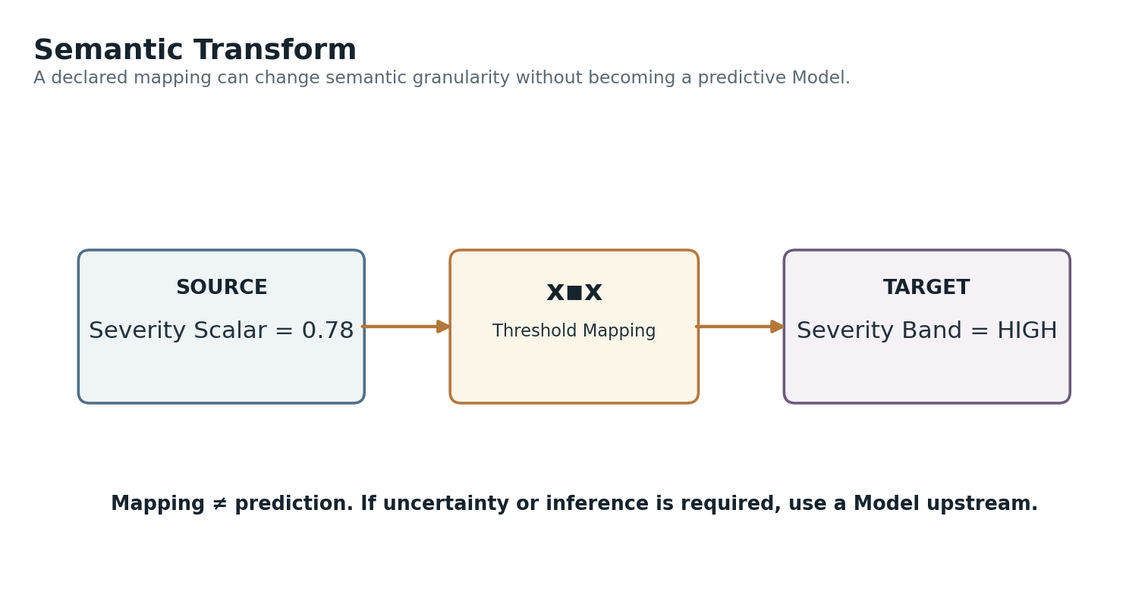
Figure 8. Semantic transform example: a continuous severity scalar mapped into a discrete semantic band.

Perceptual Transforms
Perceptual Transforms map semantic values into human-perceptible modalities such as color, opacity, size, sound, particle density, motion rate, shape deformation, or haptic intensity. AAA is one important consumer, but perceptual mapping is not owned by AAA. The Transform Matrix can support any surface that needs a declared relationship between semantic state and perceptual rendering.
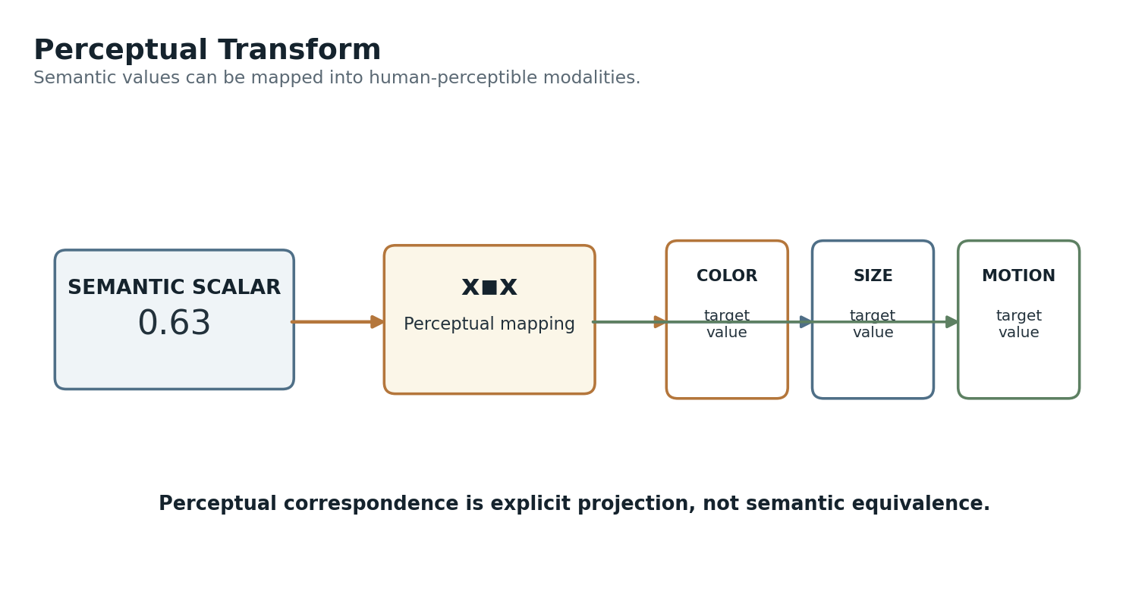
Figure 9. Perceptual transforms map a governed scalar into one or more perceptual channels.

Operational Transforms
Operational Transforms resolve values intended for governed action systems: distance to permitted velocity, normalized cooling demand to target RPM, walking speed to stride period, or sensor confidence to guidance weight. Operational use has the strongest need for explicit units, bounds, failure policies, versioning, and authority separation.
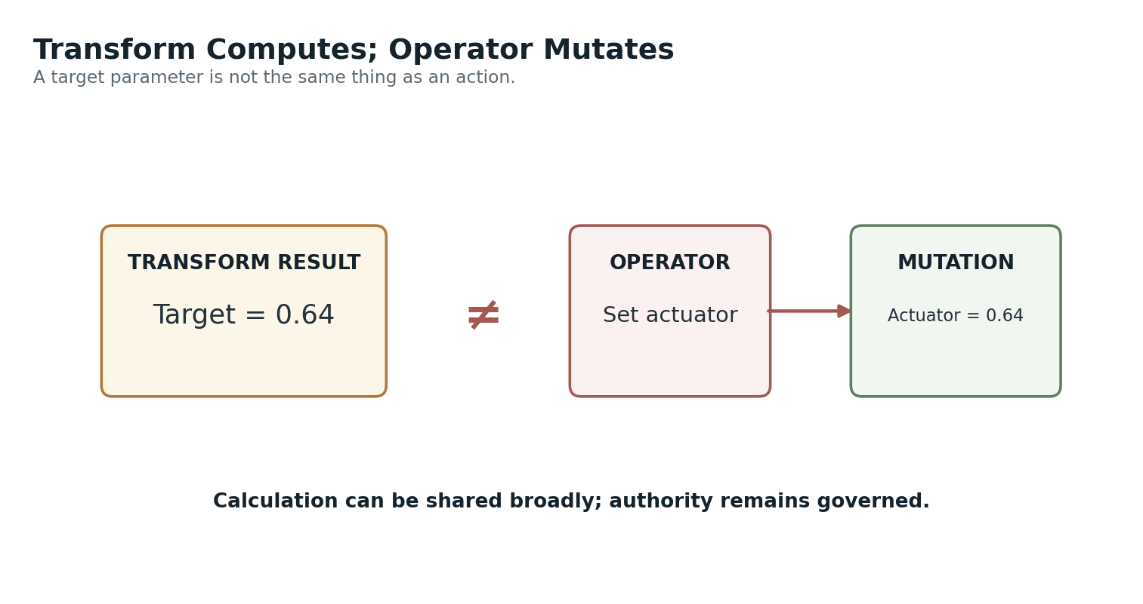
Figure 35. Transform computes; Operator mutates. Calculation and agency remain distinct.

V. Source and Target Contracts
Meaning travels with the endpoint contract, not with the number alone.
A Transform input is not simply “0.72.” At minimum, the runtime must know what the value represents and whether the selected Transform accepts that semantic identity, value type, unit, domain, and context. The same is true of the output. This protects the Matrix from becoming a loose numerical conversion utility detached from the system’s semantic structure.
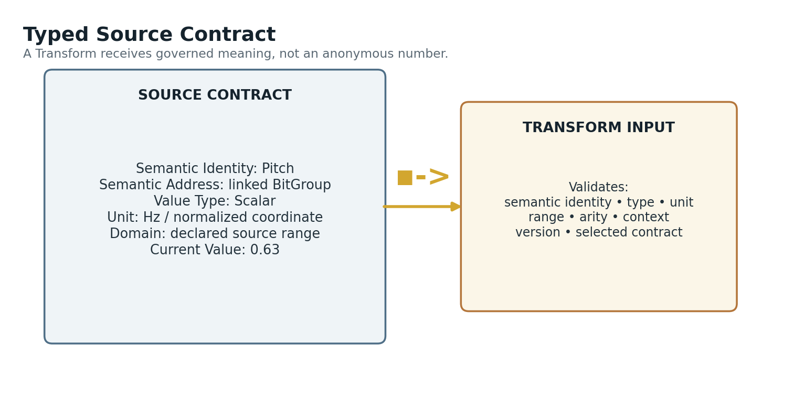
Figure 11. Typed source contract: identity, address, value type, unit, domain, and current value remain attached to the source.
Unit compatibility is useful but insufficient. Body Height = 180 cm and Distance to Wall = 180 cm share both number and unit yet describe different semantic properties. A Transform registered for one should not automatically accept the other.
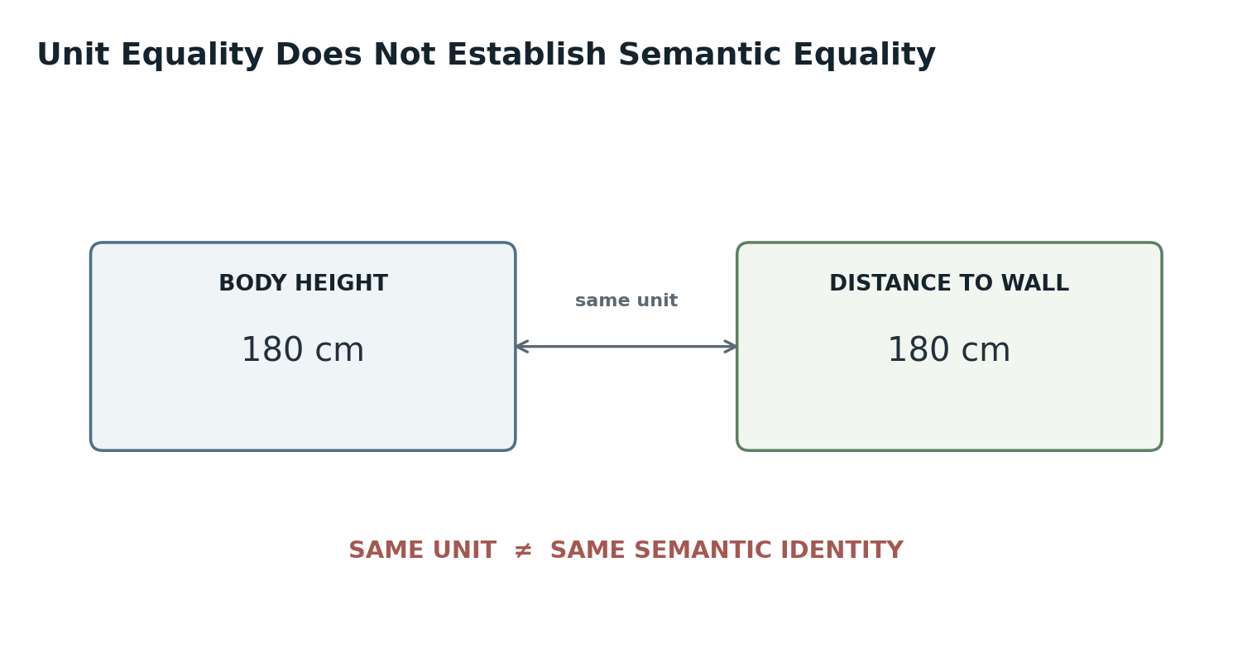
Figure 12. Same units do not imply interchangeable semantics.
Normalization creates a shared computational coordinate but likewise does not create semantic equivalence. Pitch = 0.63 normalized and Temperature = 0.63 normalized occupy the same numerical position in different governed spaces.
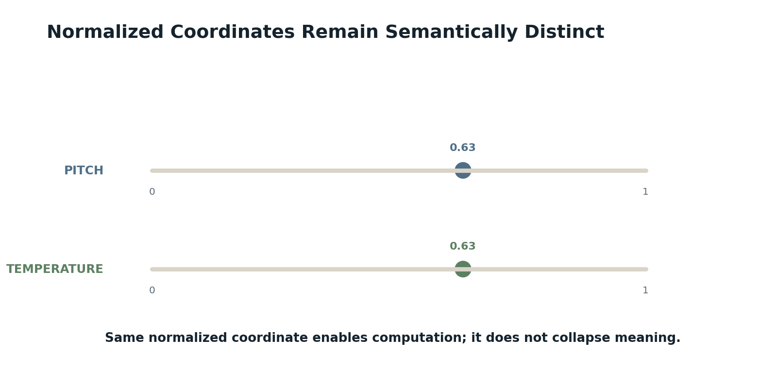
Figure 13. Normalized but distinct: numerical comparability does not collapse semantic identity.
CONTRACT RESOLUTION RULE
Transform compatibility resolves from semantic identity + value type + unit + domain + arity + context, not from numerical similarity alone.

VI. Transform Mechanics and Mapping Methods
Normalization, formulas, lookups, and policies make the mapping explicit.
A common transform pattern normalizes the source domain, applies a mapping function, then resolves the result into the target domain. This is useful when source and target ranges differ radically, but it is only one mechanism. Direct affine conversion, nonlinear curves, piecewise functions, thresholds, crosswalk tables, and enumerated lookups are all legitimate Transform methods when their contracts are explicit.
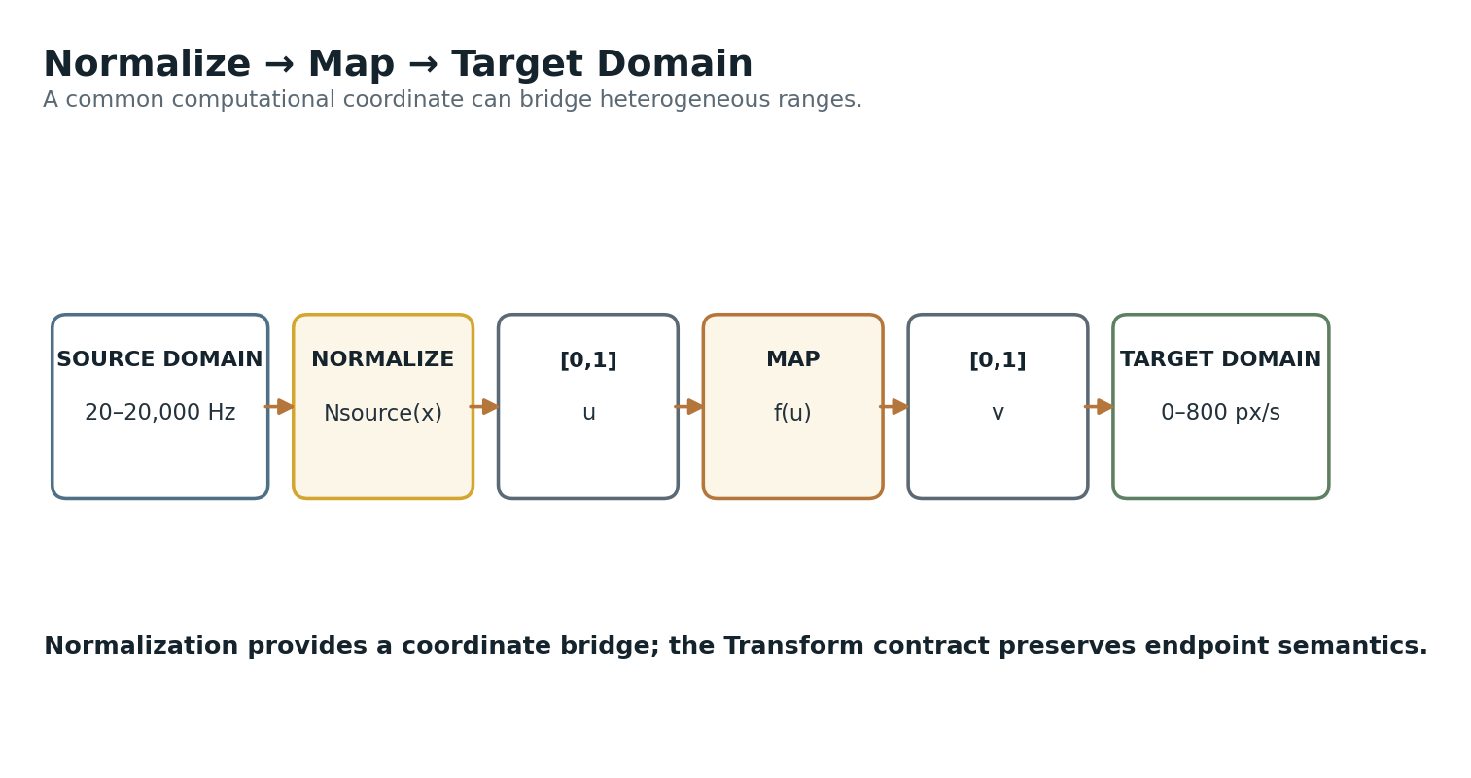
Figure 14. Normalize → map → target domain: a common bridge between heterogeneous value ranges.
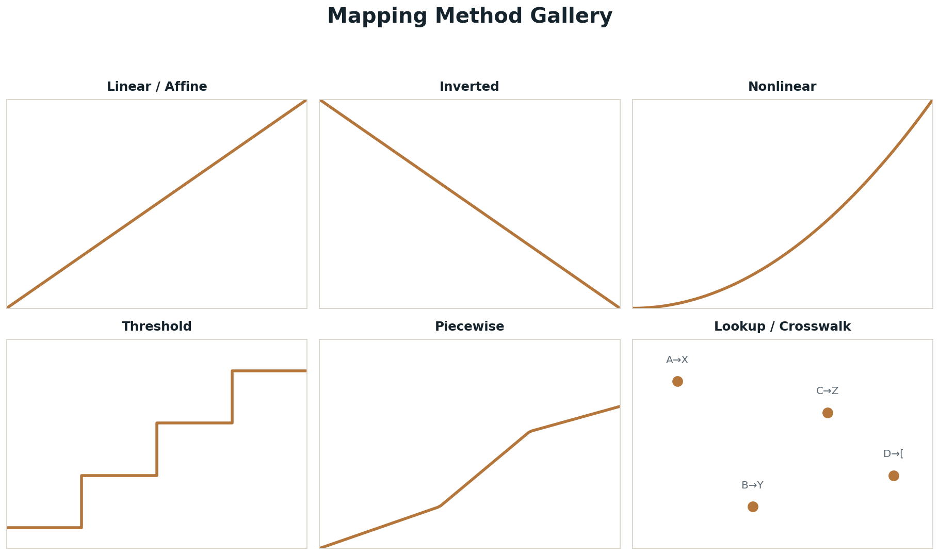
Figure 15. Mapping method gallery: linear, inverted, nonlinear, threshold, piecewise, and lookup/crosswalk mappings.
Method | Typical Form | Useful For
Linear / affine | y = ax + b | Direct proportional or offset conversion
Inverted | y = 1 - x or equivalent | Opposing direction mappings
Nonlinear | y = f(x) | Perception, physics, or response curves
Threshold / quantized | Ranges → discrete outputs | Bands, levels, step controls
Piecewise | Different f(x) by region | Systems with regime changes
Lookup / crosswalk | Explicit input → output table | Categorical or irregular mappings

The implementation should expose the method rather than burying it in opaque code. A reader should be able to determine whether a Transform is linear, thresholded, lookup-based, or composed, and should be able to inspect its source and target ranges, normalization, bounds, and parameters.

VII. Arity, Fan-Out, Fan-In, and Multivariate Mapping
Transforms can operate across 1:1, 1:N, N:1, and N:M contracts.
Arity is part of the Transform contract. A one-to-one Transform maps one input to one output. A one-to-many Transform can fan one source into several target values. Many-to-one and many-to-many Transforms accept typed tuples and produce coordinated results. Explicit arity makes the runtime contract legible and prevents accidental use of an output that was derived from a different input structure.
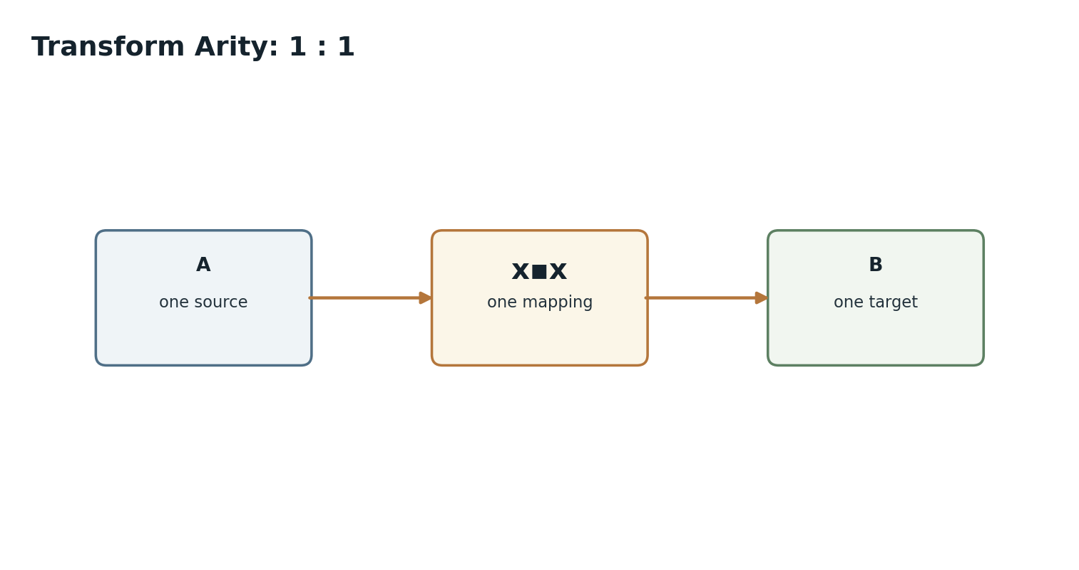
Figure 16. Transform arity 1:1.
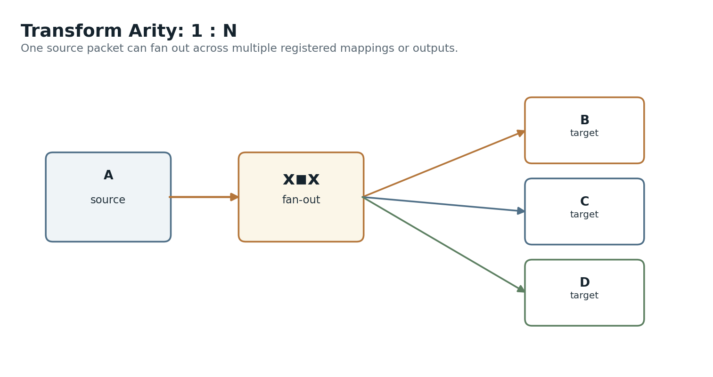
Figure 17. Transform arity 1:N fan-out.
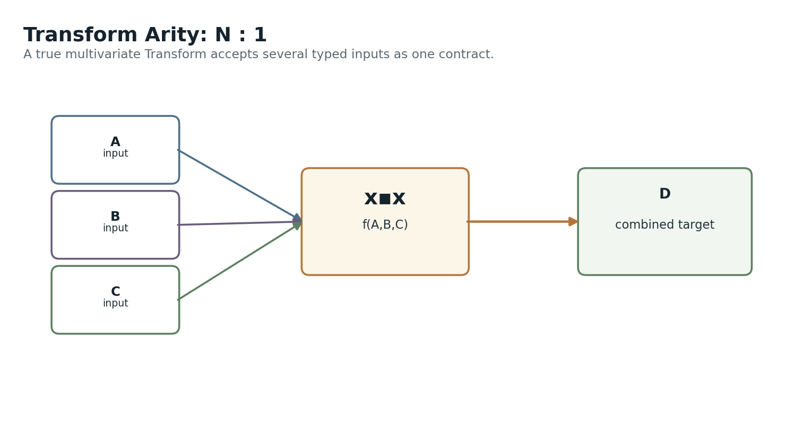
Figure 18. Transform arity N:1 multivariate input.
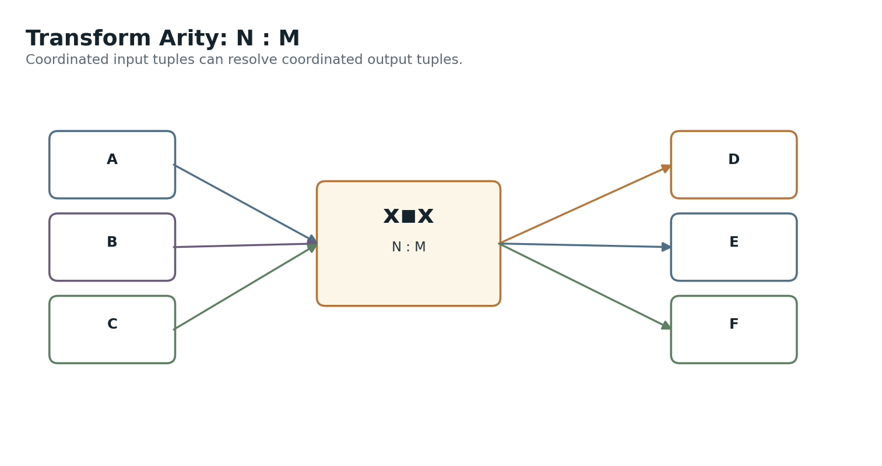
Figure 20. Transform arity N:M coordinated mapping.
Fan-in requires an additional distinction. Several independent transforms followed by aggregation are not the same thing as one multivariate transform f(A,B,C). The former computes separate contributions and combines them later; the latter defines one mapping over the joint input tuple. The Registry should declare which mechanism is intended.
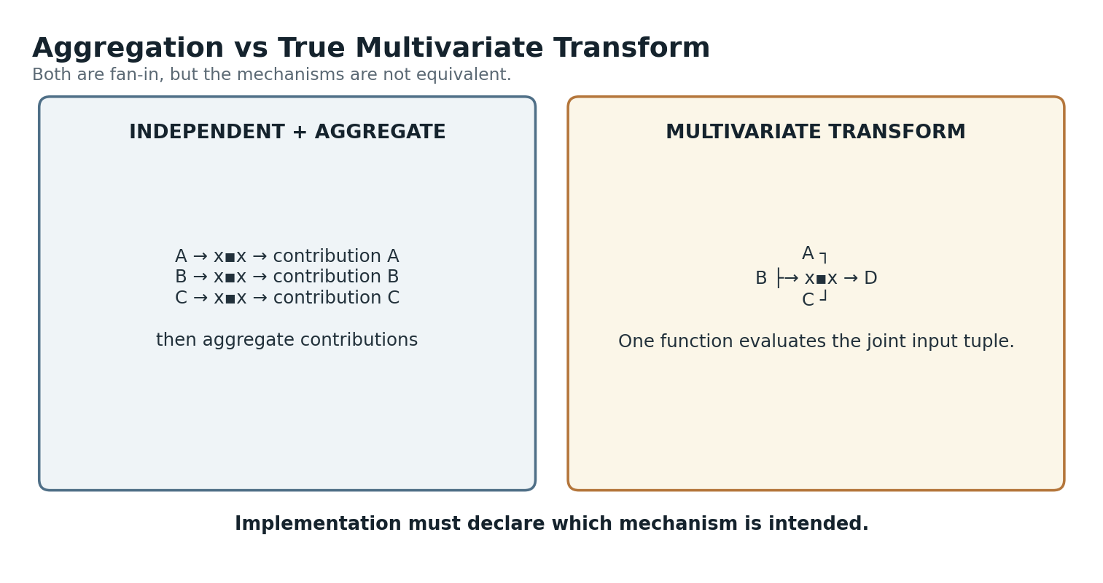
Figure 19. Aggregation versus a true multivariate Transform.
AAA first exposed the value of fan-out: one pitch Packet might produce color, spacing, and size outputs that AAA groups into an Expression Bundle. The Transform Matrix generalizes the same structure beyond expression. A movement system may fan walking speed into stride length, cadence, arm swing, and torso rotation; each output remains a typed target parameter rather than an “expression.”

VIII. Transform Chains and Graph Composition
The Matrix exposes cells; the Transform Graph exposes paths.
Transforms can compose when contracts permit. A raw sensor voltage can be calibrated into a physical measurement, normalized into a scalar, and then mapped into a control parameter. Keeping these stages separate makes each contract inspectable and replaceable instead of hiding the entire path inside one large formula.
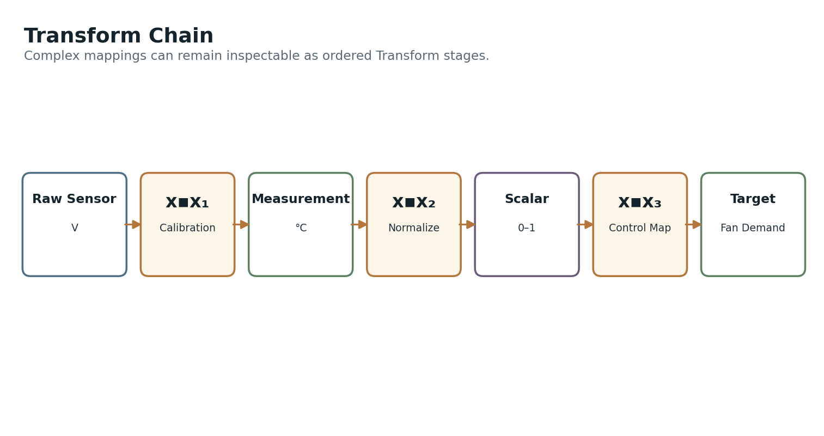
Figure 21. Transform chain: raw sensor → calibration → normalized scalar → control target.
The same Registry can therefore support two complementary views. The Matrix answers “what direct correspondences are registered?” The Transform Graph answers “what potential mapping paths connect these spaces?”
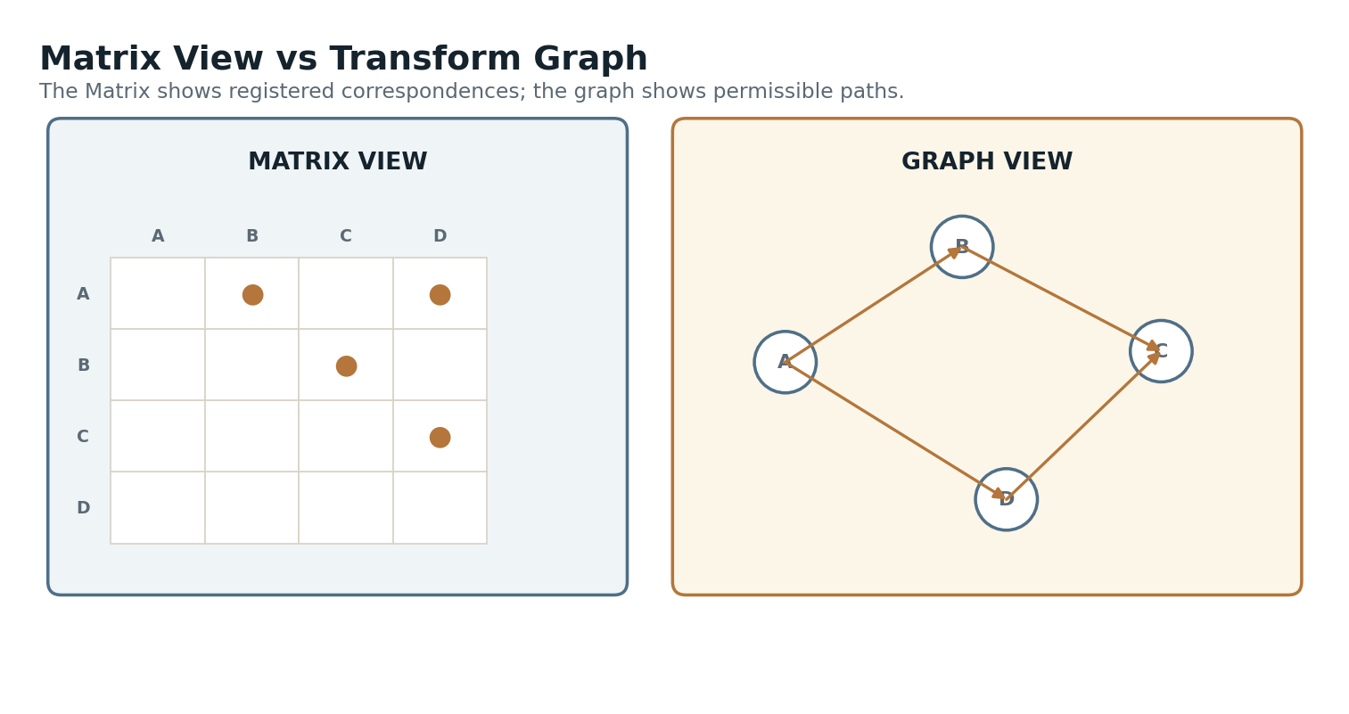
Figure 22. Matrix view versus Transform Graph view.
Graph reachability must never be treated as semantic permission. A path A → B → C → D may exist while composition is still invalid because units, contexts, version constraints, loss characteristics, or declared composition policies are incompatible. Chain validity must therefore be resolved, not assumed.
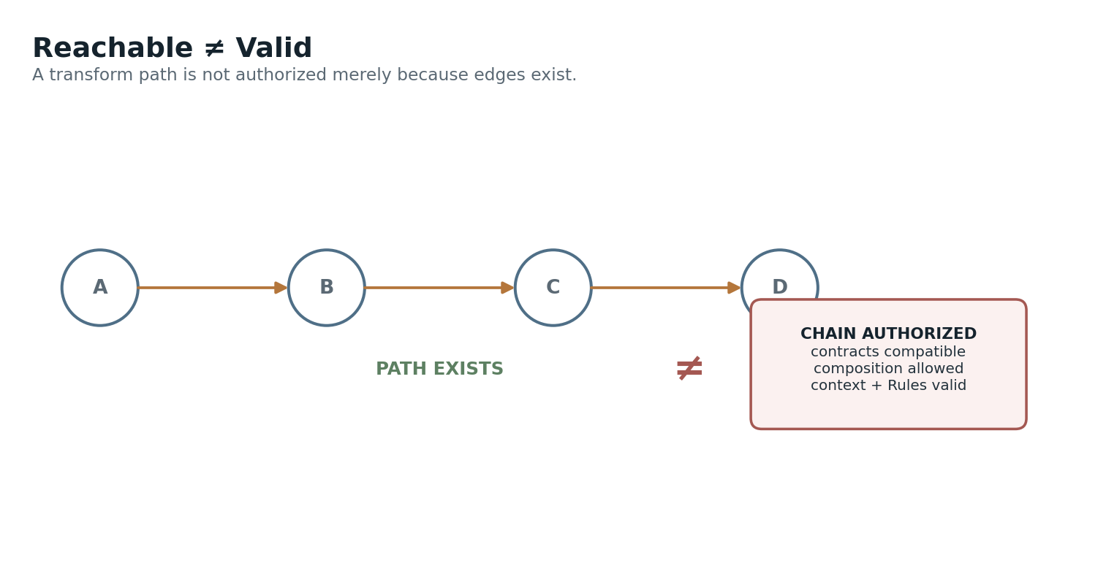
Figure 23. Reachable does not mean valid: composition requires compatible contracts and explicit permission.
COMPOSITION LAW
A Transform graph is a map of possible correspondence paths. It is not a license to compose every reachable path.

IX. Context, Personalization, and Resolver Behavior
The same semantic endpoints may support several legitimate mappings.
Context is not an afterthought. A transform record may be global, application-specific, profile-specific, accessibility-specific, experimental, or personal. The resolver needs enough context to choose among multiple valid mappings without rewriting the source semantic state.
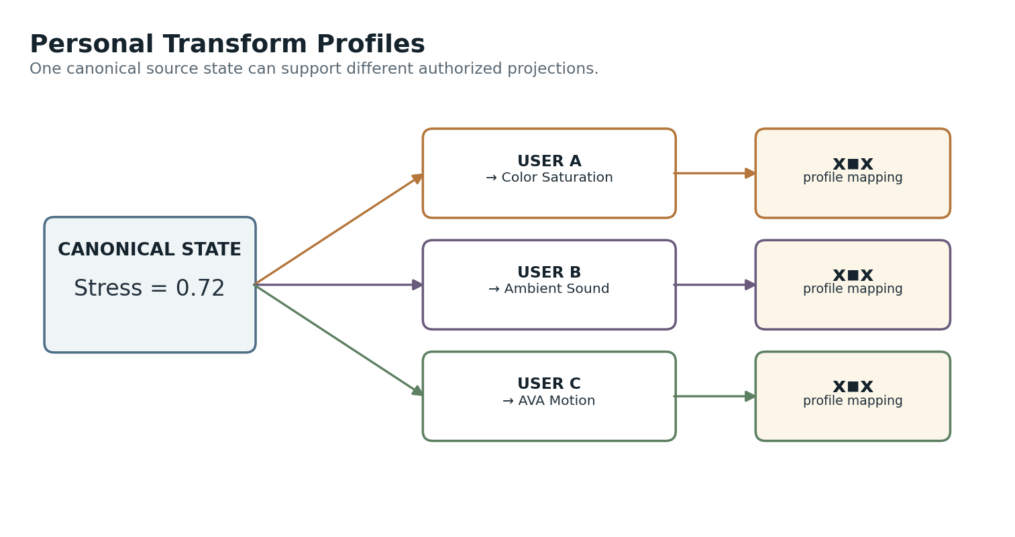
Figure 25. Personal mapping profiles: the same canonical stress scalar can project differently for different users.
This aligns naturally with runtime pluralism. A shared canonical state can support multiple representational or perceptual pathways while preserving the underlying source. The personal mapping is a projection choice, not a mutation of the source ontology.
Resolver inputs can include source semantic address, requested target semantic address, current application, user profile, platform capabilities, active Rules, permitted transform versions, and performance or precision requirements. The resolver should return a specific Transform identity and version before execution.

X. Safety, Loss, Versioning, and Provenance
Operational reliability depends on declared behavior at the edges.
Transforms need explicit behavior when inputs are out of range. Clamp, reject, extrapolate, flag, or use a fallback Transform are all possible policies, but the runtime should not silently choose among them.
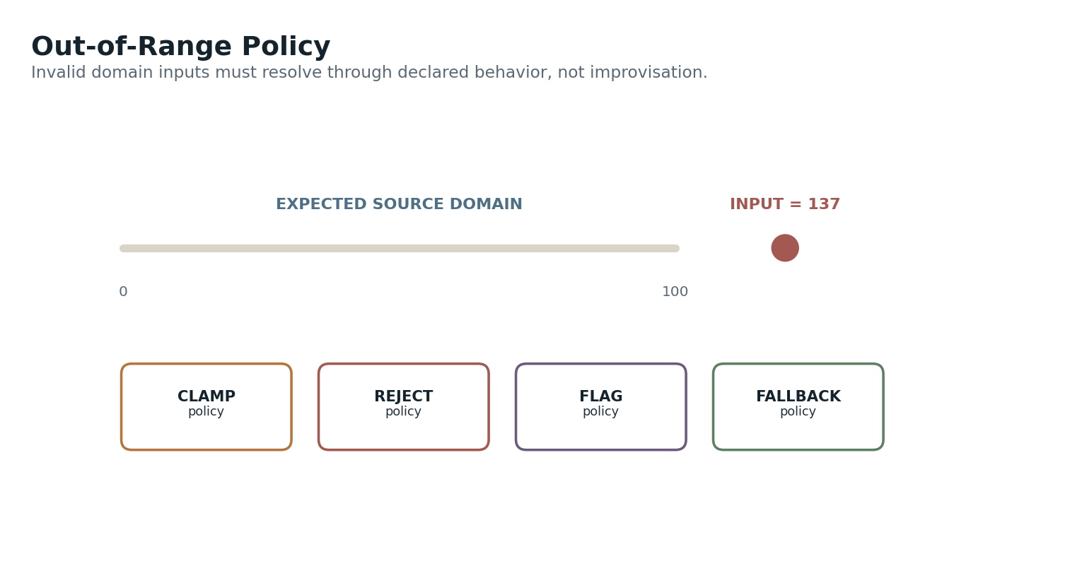
Figure 26. Out-of-range handling through declared policy.
Missing data requires the same discipline. No output, default value, last-known value, fallback transform, Model-estimated value, or error state may all be appropriate in different systems. The policy should be part of the contract or governed by explicit Rules.
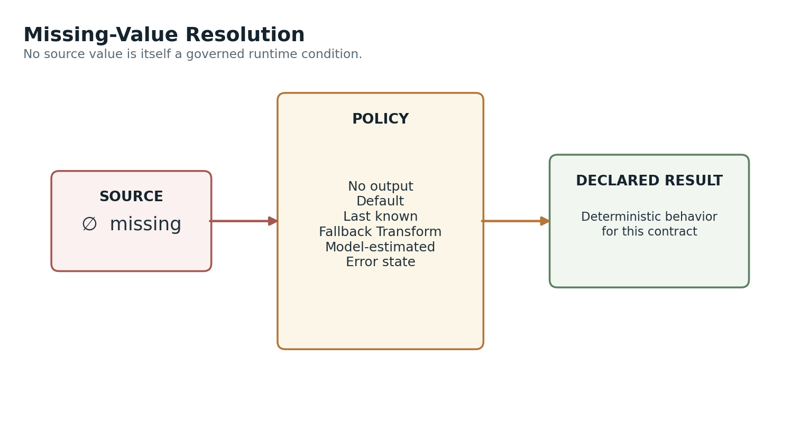
Figure 27. Missing-value resolution policies.
Precision and quantization should also be visible. Mapping 0.736284 into Level 4 intentionally discards information. That loss may be desirable, but it must not be mistaken for a reversible replacement of the original scalar.
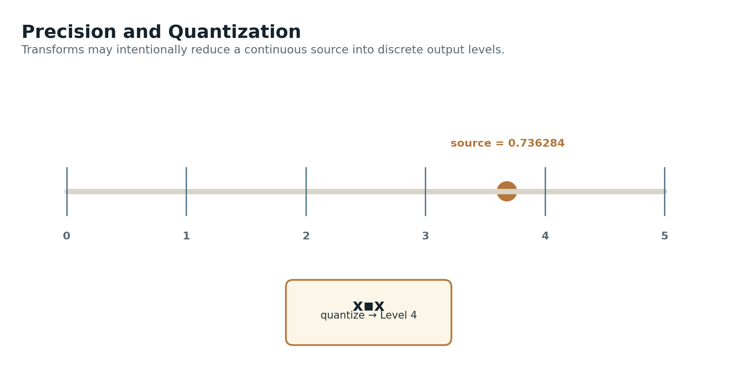
Figure 28. Continuous source mapped into discrete target levels.
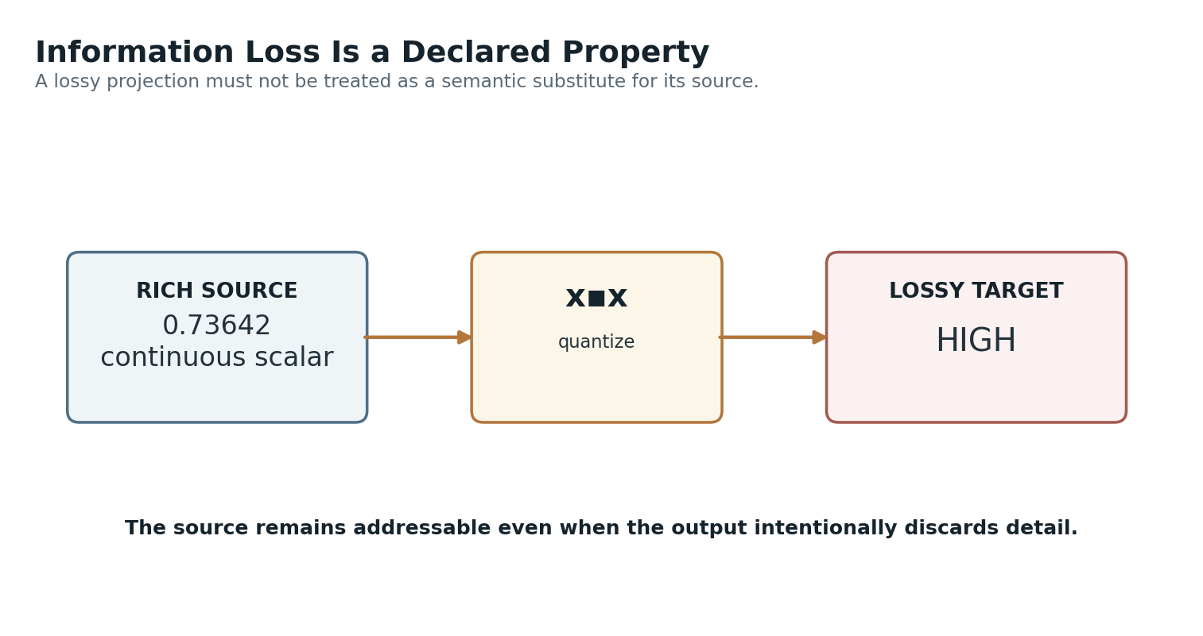
Figure 30. Information loss: a coarse output does not replace the richer source.
Invertibility is therefore a useful Transform property. Some mappings are fully invertible, some return only a possible source range, and some are non-invertible. Chain construction and provenance should be able to inspect that property.
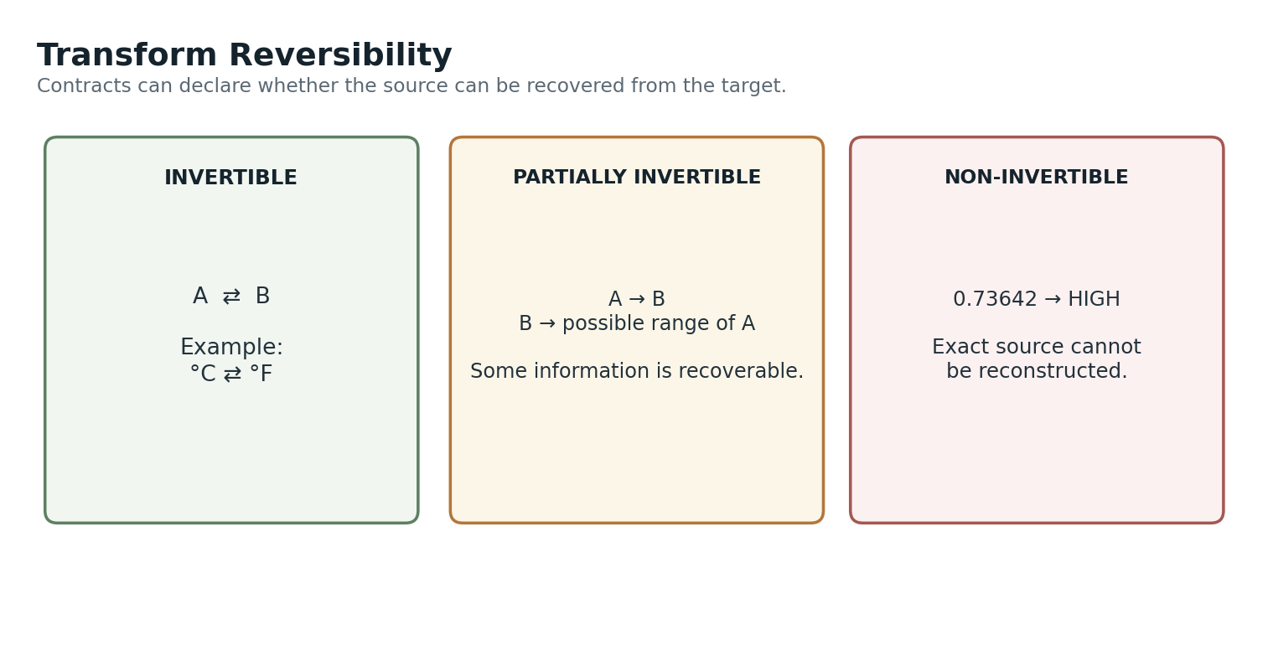
Figure 29. Transform reversibility: invertible, partially invertible, and non-invertible cases.
Material Transform changes need versioning. A revised Pitch → Color formula may only affect presentation, while a revised Voltage → Torque mapping can materially change physical behavior. In either case, versioned contracts keep historical outcomes interpretable and make upgrades deliberate rather than silent.
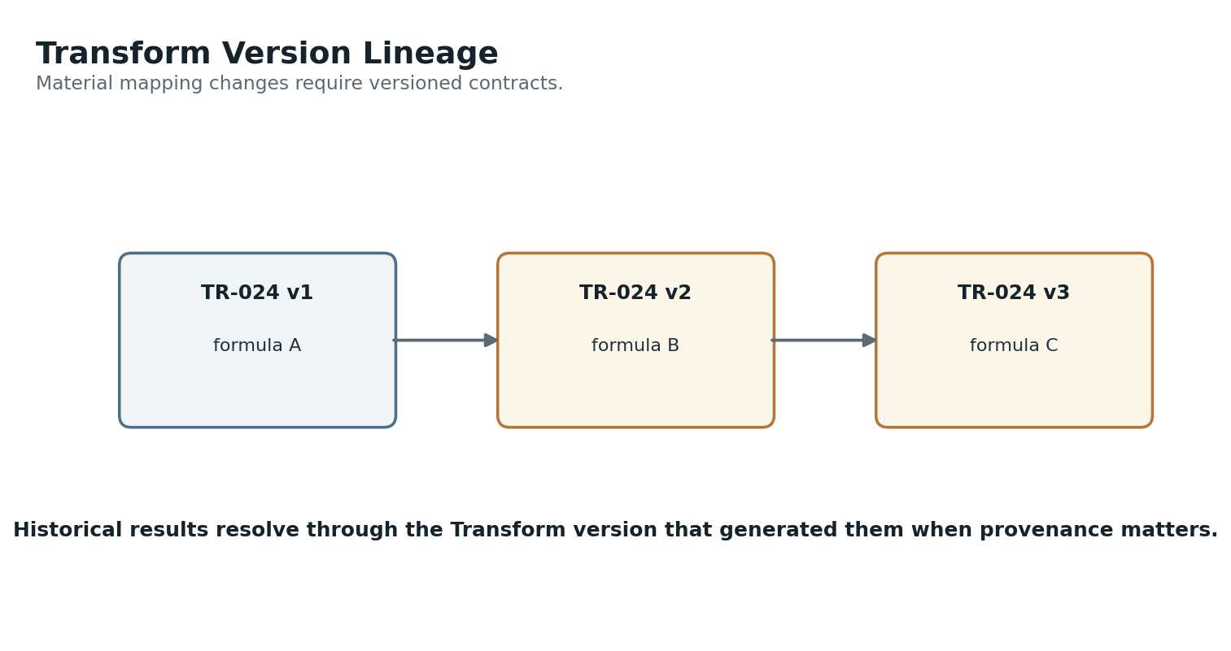
Figure 31. Transform version lineage.
Where transformed values materially affect persisted or operational outcomes, the system should be able to reconstruct the source identity, source value, Transform identity and version, context, relevant parameters, and resulting target value. Not every transient result needs permanent logging, but provenance should be available where consequence justifies it.
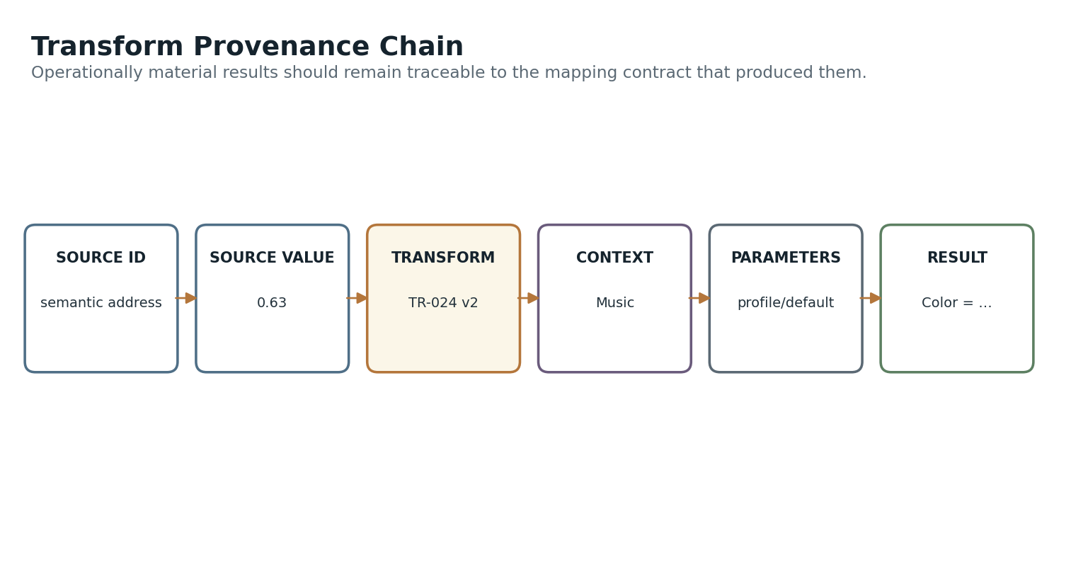
Figure 32. Transform provenance chain.

XI. Boundaries with Models, Rules, and Operators
The Transform Matrix remains powerful by staying narrow.

Transform vs Model
A Model interprets, predicts, estimates, or explains. A Transform applies a declared mapping. For example, temperature, humidity, and system load might feed a Model that estimates cooling demand. That derived scalar can then feed a Transform that deterministically maps demand into target RPM.
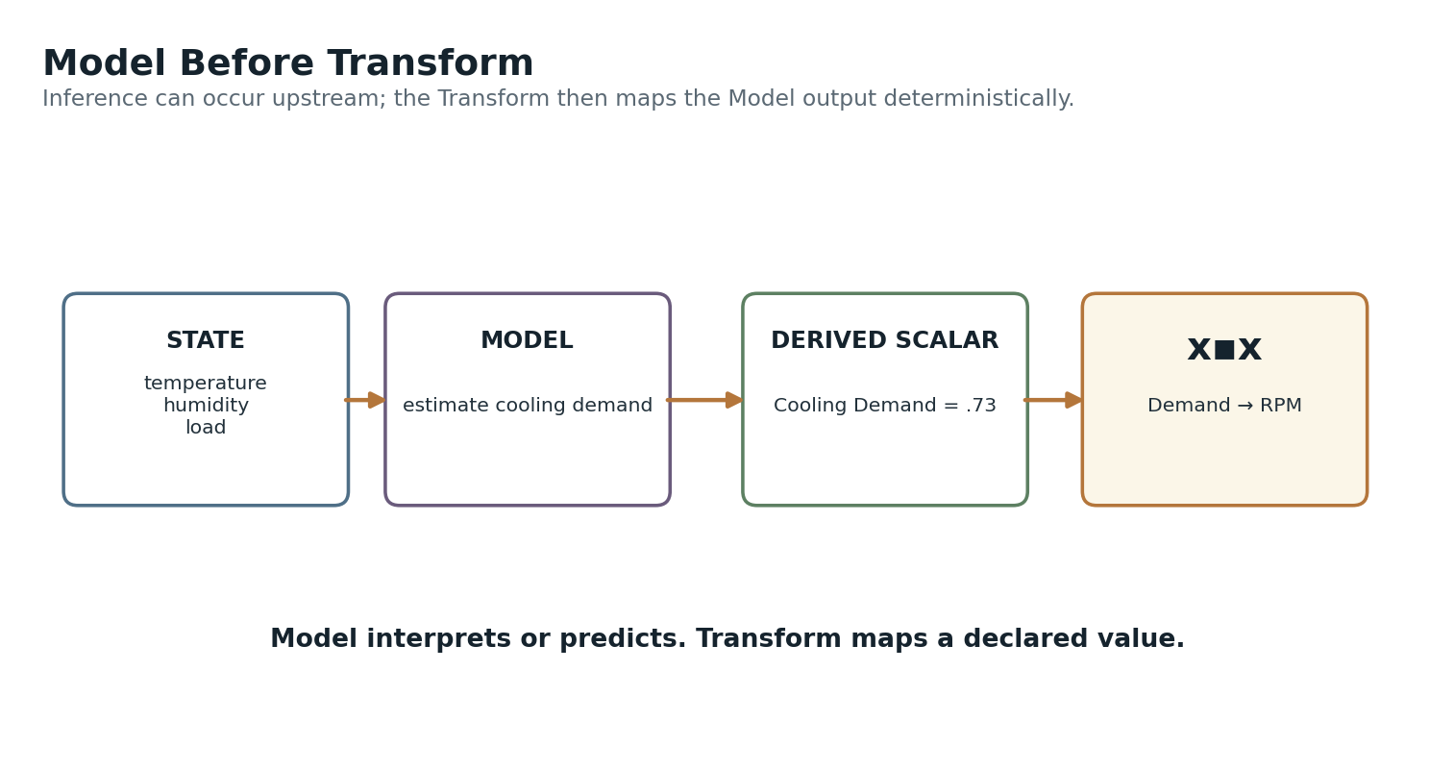
Figure 33. Model before Transform: uncertain interpretation upstream, deterministic mapping downstream.

Transform vs Rule
A Transform maps. A Rule constrains validity, permission, or state transition. If a transform returns 1820 RPM but maintenance mode limits the system to 1600 RPM, the Rule constrains the permissible target. The Transform does not override the Rule simply because its formula produced a number.
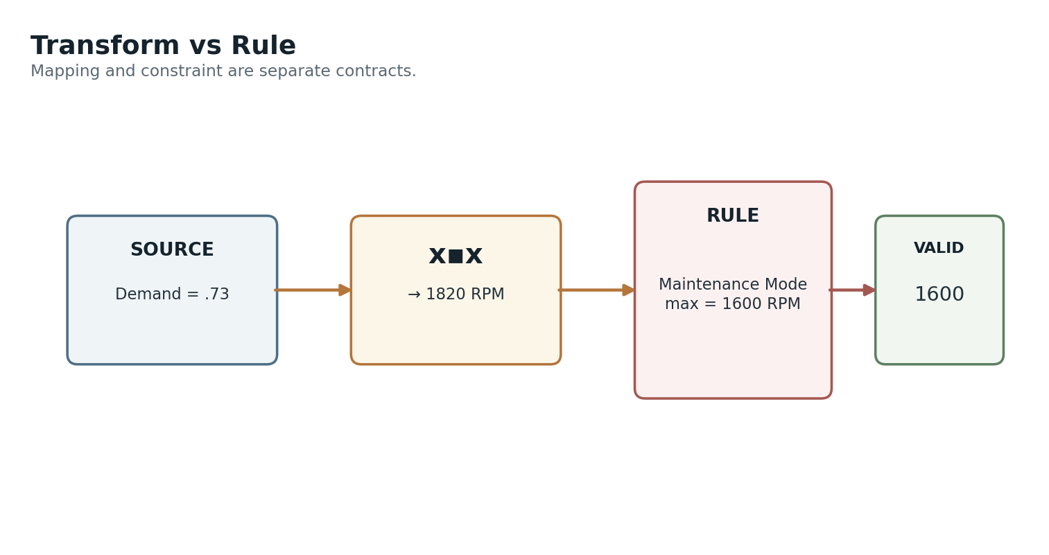
Figure 34. Mapping versus constraint: Rule evaluation remains downstream or contract-bound.

Transform vs Operator
An Operator performs mutation. A Transform can calculate the parameter the Operator may use, but the Operator remains the agentive boundary. This means the same Transform infrastructure can be reused by visual interfaces and robots without collapsing “compute a value” into “perform an action.”
ARCHITECTURAL APHORISM
TRANSFORM COMPUTES. AUTHORITY ACTS.

XII. Cross-System Applications
The same infrastructure can sit at very different points in the CERBERUS ecosystem.

Calibration and Measurement
Calibration demonstrates that transforms can operate into semantic state, not only outward from it. A raw sensor voltage can be mapped through a calibration curve into a typed physical measurement. The calibrated output then becomes ordinary governed semantic state available to Models, Rules, displays, and Operators.
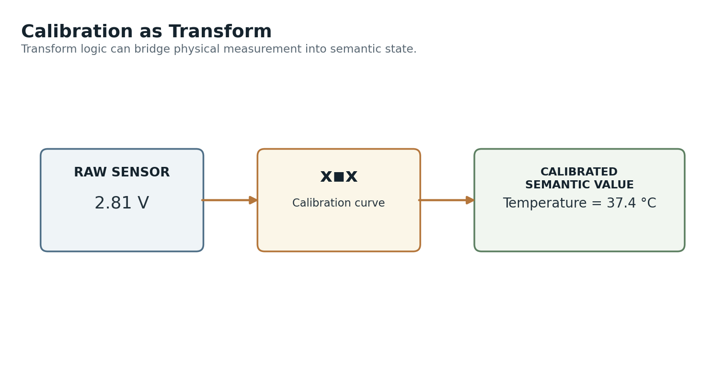
Figure 36. Calibration transform: physical sensor value → calibrated semantic measurement.

AAA and Perceptual Projection
AAA is a downstream consumer of perceptual transform outputs. Pitch can become a color value, frequency can become particle spacing, and a nutrition scalar can become particle density. Only after x▪︎x resolves the target modality value does AAA package that result as an Expression or Expression Bundle. The Transform Matrix therefore remains reusable outside AAA.
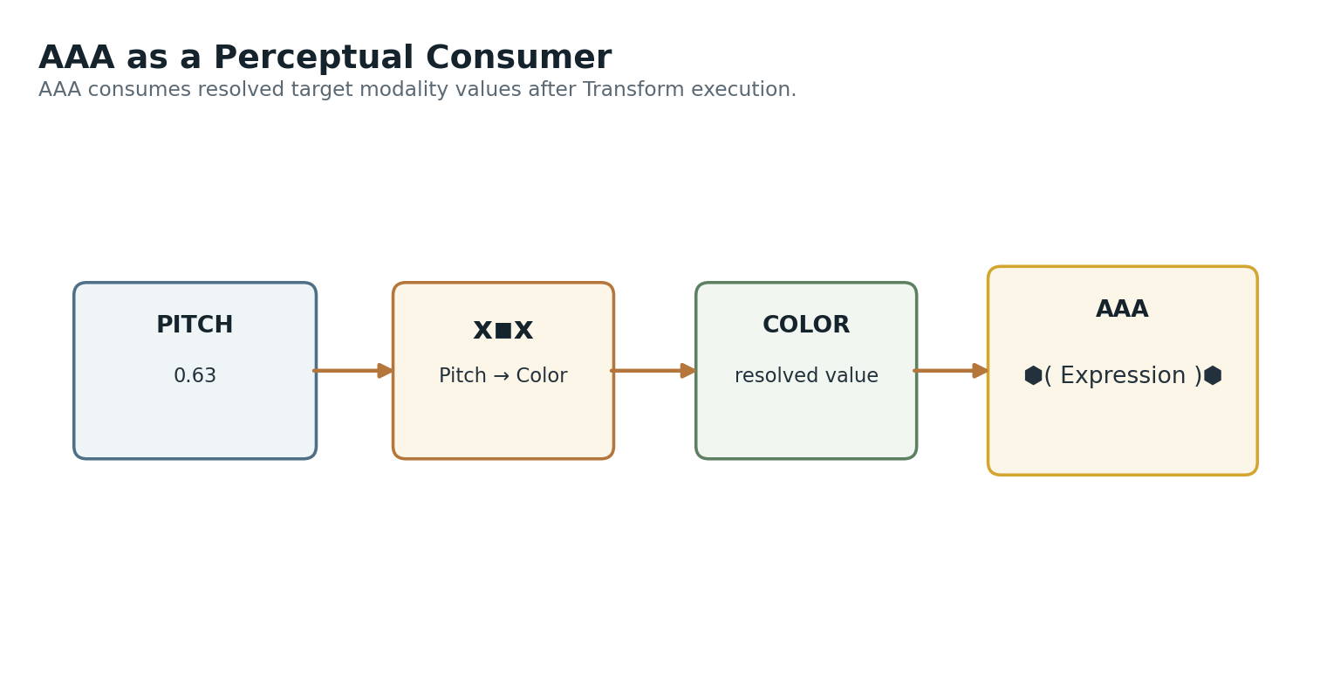
Figure 37. AAA as one perceptual consumer of a resolved Transform output.

Movement Parameterization
Movement systems provide a strong operational example. Walking Speed can fan out through registered transforms into stride length, stride period, arm swing amplitude, torso rotation, and breathing rate. Movement Operators then use the resolved parameters to execute or render motion. The transform system coordinates numbers; it does not own the movement itself.
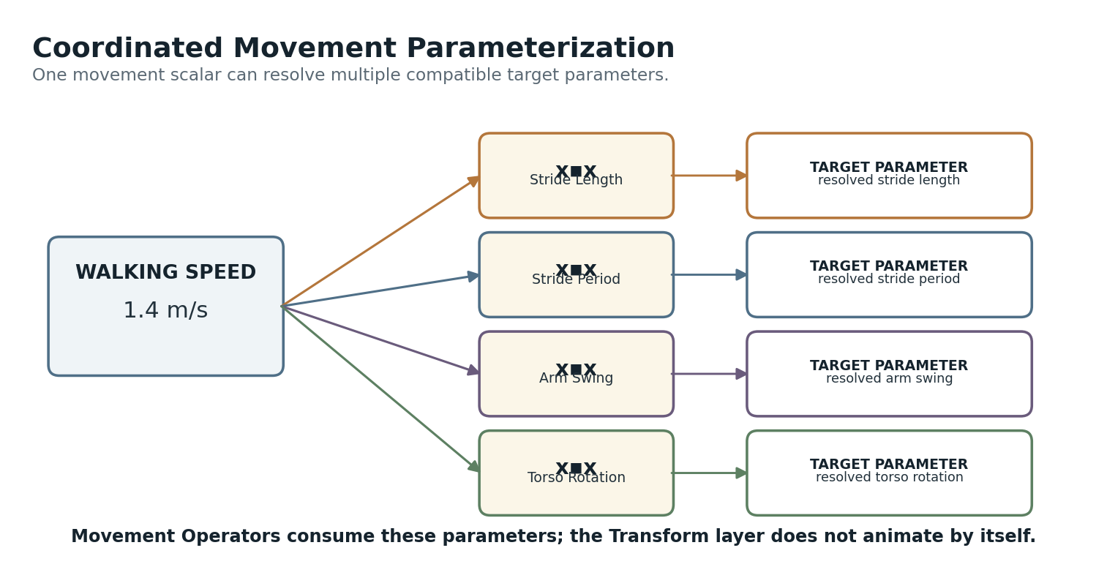
Figure 38. Coordinated movement parameterization from one source scalar.

PULSE and Guidance
PULSE channels can likewise map sensed spectral or landmark values into guidance weights, confidence values, or other operational parameters. Navigation Rules and planners retain authority over actual movement. This makes the Transform Matrix useful between sensing and decision-making without turning it into a navigation system.
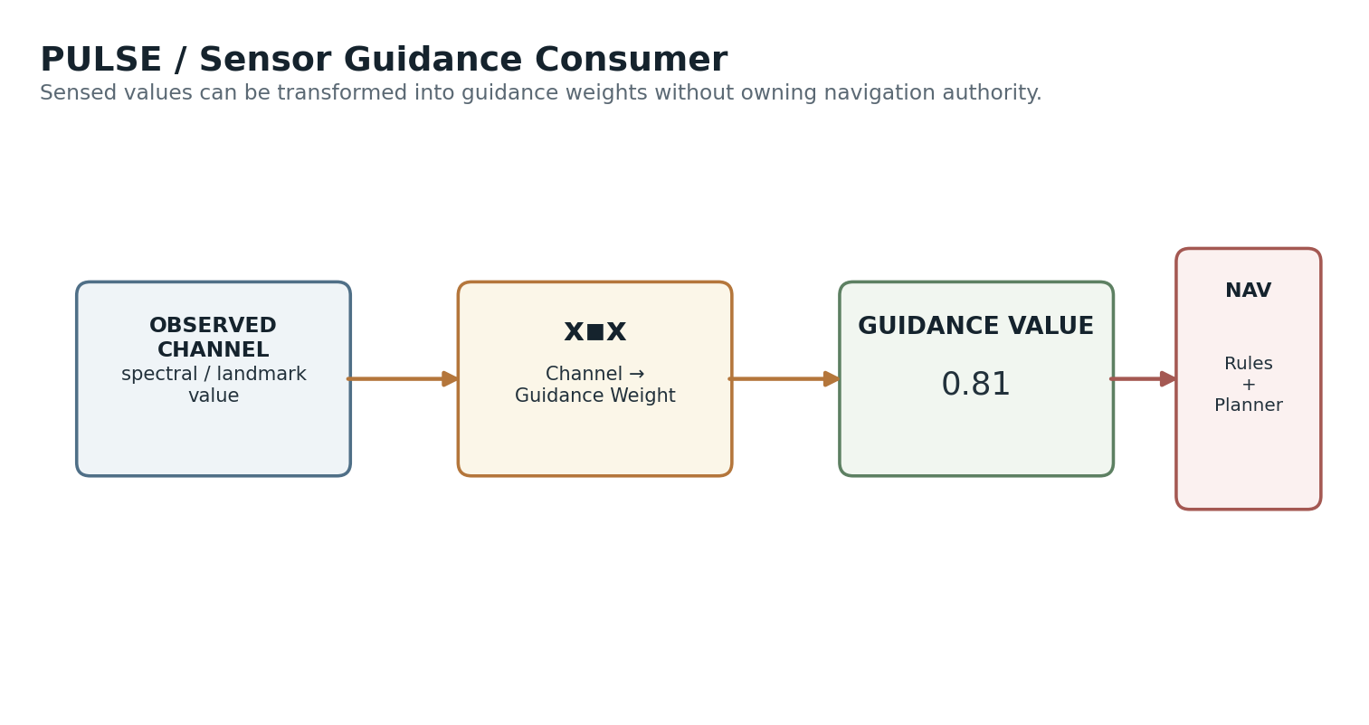
Figure 39. PULSE / sensor guidance: observation → Transform → guidance parameter → governed navigation.

XIII. Transform Registry Architecture
A minimal durable record should make both endpoints and the mapping contract inspectable.
The implementation should begin with the smallest record structure that answers the necessary questions. The following groups describe the information the mechanism requires; they do not imply that every item must become a separate Airtable field immediately.
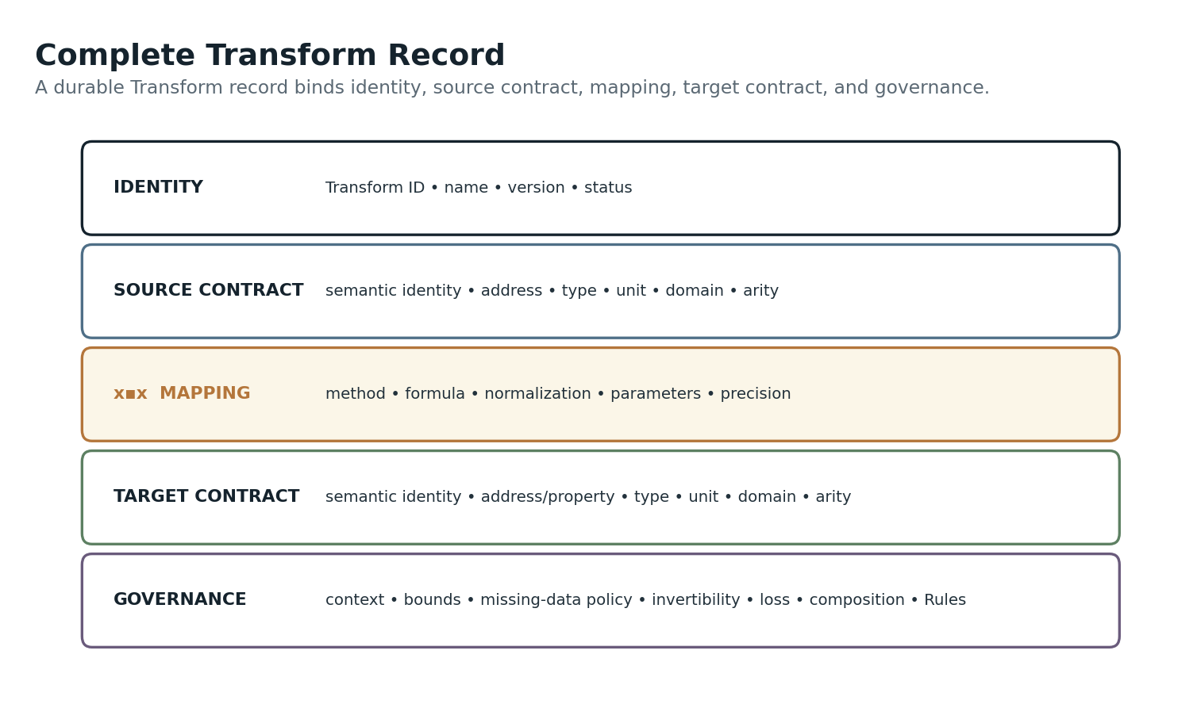
Figure 40. Complete Transform record: identity, source contract, mapping, target contract, and governance.
Group | Candidate Fields
Identity | Transform ID; name; description; version; status
Source Contract | Source semantic identity; SK/BitGroup or property; value type; unit; domain; arity
Mapping | Method; formula; normalization; parameters; lookup values; precision
Target Contract | Target semantic identity/property; value type; unit; domain; arity
Governance | Context; bounds policy; missing-data policy; invertibility; loss; composition permission; applicable Rules
Relations | Applications; Models; Operators; EFFECTS; movement systems; PULSE; other consumers

The Matrix itself can remain a generated view. A compact first implementation might use a Transform Registry, a Transform Value / Lookup table only where irregular mappings require enumerated records, and a Transform Chain / Set table for ordered compositions. This avoids prematurely multiplying tables while preserving a path to richer composition.
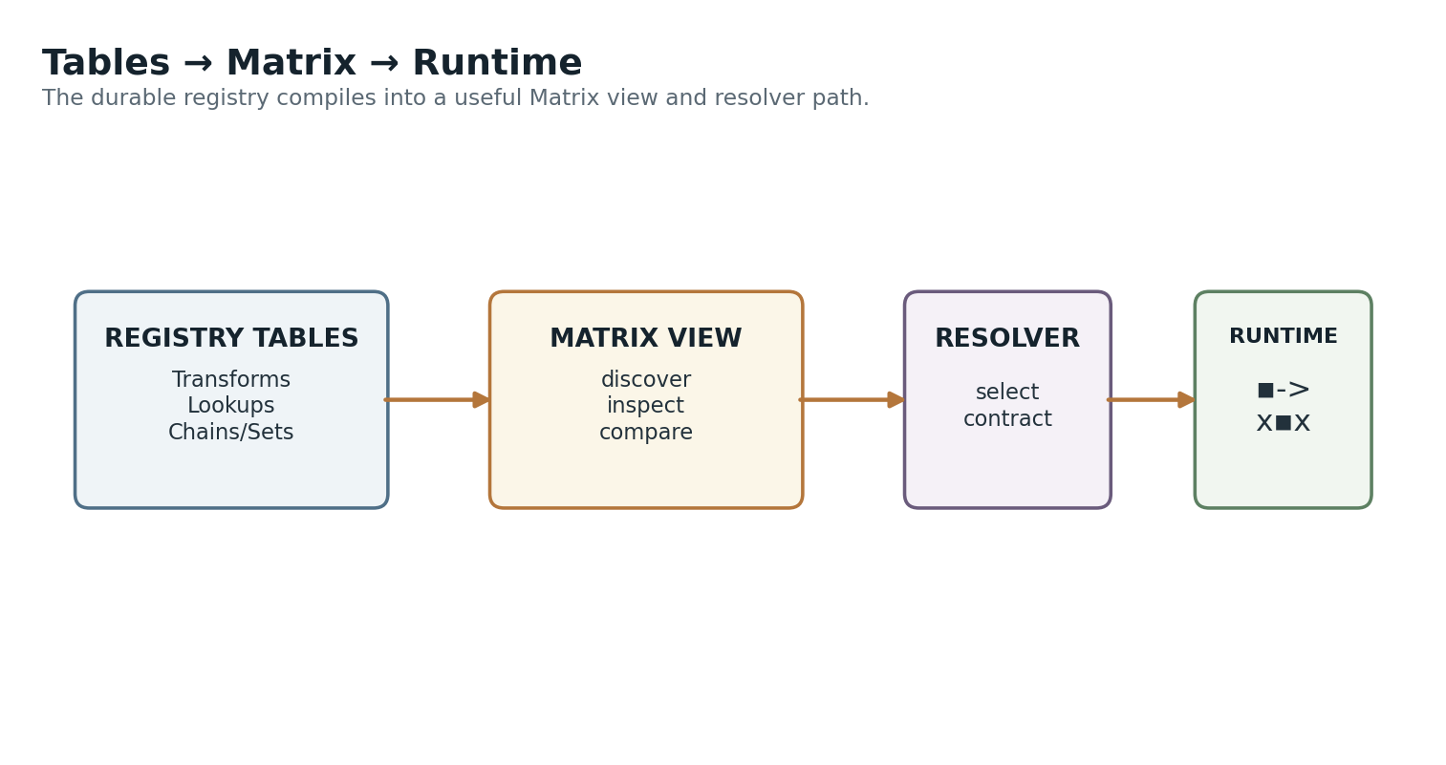
Figure 41. Durable tables feed the Matrix view, resolver, and runtime ▪︎-> → x▪︎x path.

XIV. Core Laws
A compact contract for keeping the Transform Matrix narrow, safe, and composable.
TM-L01 — MAPPING SEPARATION
A Transform maps values; it does not independently establish the semantic identity of its source.

TM-L02 — PACKET SEPARATION
▪︎-> denotes governed value state being sent into transformation. The Packet is neither the Transform nor its output.

TM-L03 — TRANSFORM SEPARATION
x▪︎x performs the declared mapping between typed source and target contracts.

TM-L04 — SEMANTIC IDENTITY PRESERVATION
Shared numbers, units, ranges, or normalized coordinates do not imply semantic equality.

TM-L05 — EXPLICIT CORRESPONDENCE
A source-target mapping is registered rather than inferred from numerical compatibility alone.

TM-L06 — MODEL BOUNDARY
Prediction, uncertainty, and explanatory inference belong to Models rather than being silently embedded into a simple Transform.

TM-L07 — RULE BOUNDARY
Transform output does not override normative constraints.

TM-L08 — OPERATOR BOUNDARY
An operational Transform may calculate an action parameter without acquiring authority to perform the action.

TM-L09 — CONTEXTUAL RESOLUTION
Multiple transforms may connect the same source and target; context resolves the applicable contract.

TM-L10 — COMPOSITION SAFETY
Reachability through a Transform Graph does not by itself authorize composition.

TM-L11 — LOSS DISCLOSURE
Lossy, quantized, or non-invertible outputs are projections and must not be treated as semantic substitutes for richer sources.

TM-L12 — VERSION RESOLUTION
Material mapping changes require versioned Transform contracts.

TM-L13 — EXPLICIT FAILURE BEHAVIOR
Bounds, missing inputs, unsupported types, and invalid contexts resolve through declared policy rather than runtime improvisation.

TM-L14 — PROVENANCE AVAILABILITY
Where transformed values materially influence persisted or operational outcomes, the generating source and Transform contract should remain resolvable.

XV. Complete Architecture
The Transform Matrix becomes a general cross-domain mapping fabric while preserving the authority and semantic boundaries around it.
The Transform Matrix can sit between physical observation and semantic measurement, between semantic representations, between semantic state and human perception, or between semantic state and operational parameterization. That breadth comes from the narrowness of x▪︎x itself: it does not need to know how AAA renders an Expression, how a movement system animates a body, how PULSE plans navigation, or how an Operator mutates a registry. It only needs to resolve a declared mapping between typed spaces.
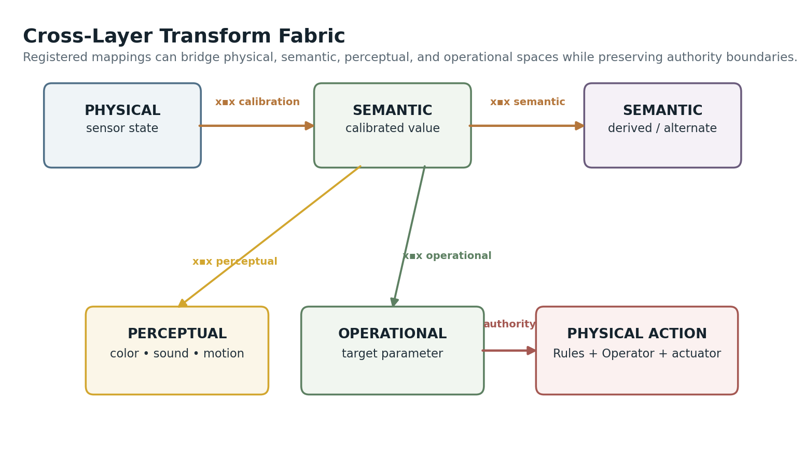
Figure 43. Cross-layer transform fabric: physical, semantic, perceptual, and operational spaces connected by explicit mappings.
Viewed at system scale, the Transform Matrix is both a Registry and a routing surface. The Registry preserves the exact contract. The Matrix exposes direct coverage. The Transform Graph exposes possible paths. The resolver chooses an applicable Transform or valid chain. The runtime carries a Packet and executes x▪︎x. The downstream consumer then interprets or acts on the target value according to its own authority.
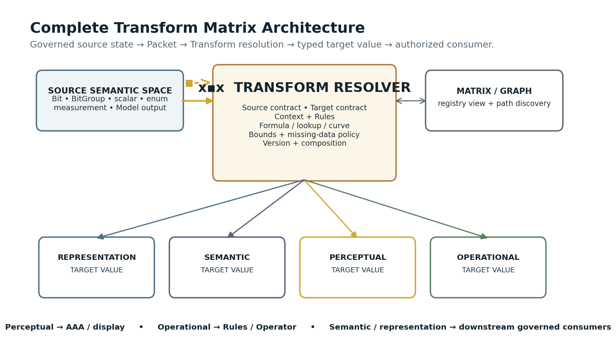
Figure 44. Complete Transform Matrix architecture.
CLOSING PRINCIPLE
A library of explicit correspondences between governed value spaces can be shared across perception, representation, semantics, simulation, movement, sensing, and control—without turning correspondence itself into intelligence or agency.

Figure Index
Figure | Title
1 | One primitive, many uses
2 | Packet anatomy
3 | Transform anatomy
4 | The Transform sentence
5 | Registry to Matrix
6 | One cell, multiple contexts
7 | Representation Transform
8 | Semantic Transform
9 | Perceptual Transform
10 | Operational Transform boundary
11 | Typed source contract
12 | Unit equality ≠ semantic equality
13 | Normalized but distinct
14 | Normalize → map → target domain
15 | Mapping method gallery
16 | Arity 1:1
17 | Arity 1:N
18 | Arity N:1
19 | Aggregation vs multivariate
20 | Arity N:M
21 | Transform chain
22 | Matrix vs graph
23 | Reachable ≠ valid
24 | Contextual resolver
25 | Personal transform profiles
26 | Out-of-range policy
27 | Missing-value resolution
28 | Precision and quantization
29 | Transform reversibility
30 | Information loss
31 | Transform version lineage
32 | Transform provenance chain
33 | Model before Transform
34 | Transform vs Rule
35 | Transform vs Operator
36 | Calibration as Transform
37 | AAA as perceptual consumer
38 | Movement parameterization
39 | PULSE / guidance consumer
40 | Complete Transform record
41 | Tables → Matrix → runtime
42 | Four Transform categories
43 | Cross-layer transform fabric
44 | Complete Transform Matrix architecture

