GROOVED PASS
Build the Document Before You Write It
A Human-Gated Method for Semantic, Visual, and Artifact-Aware Document Creation
1  TYPE | 2  GOVERN | 3  CONTENT | 4  FIGURES | 5  ASSETS | 6  BUILD | 7  COMPOSE | 8  VERIFY
Illustrative Methodology Paper
Version 0.1 | August 2026
The Word document is not where document creation begins. It is where the approved architecture of the document is compiled into a human-readable artifact.

Decide → Govern → Design → Visualize → Source → Build → Compose → Verify

EXECUTIVE SUMMARY

Abstract
Generative AI can draft competent prose faster than most document workflows can plan it. That speed creates a recurring failure mode: composition begins before the document type, governing specification, content architecture, visual explanation, source assets, and quality criteria have been resolved. The result may be fluent, attractive, and still structurally expensive to revise.
GROOVED PASS is a staged human-AI method that moves those decisions upstream. A document is progressively compiled through eight explicit passes: Document Type, Template and Writing Specification, Content Architecture, Figure Architecture, Asset Architecture, Asset and Figure Production, Document Composition, and Conformance and Visual QA. Each pass produces a bounded artifact for the next pass, ends with an AI self-check, and requires an explicit human gate before its decisions become authoritative.
The method is designed to reduce semantic drift, late-stage rework, decorative rather than explanatory figures, uncontrolled asset sourcing, and silent AI interpretation. It also provides a controlled way to reopen earlier decisions: upstream revisions can mark downstream artifacts stale, and errors are corrected in the earliest pass that owns the faulty decision rather than patched at the end.
Core proposition
Professional AI-assisted document generation should be treated as a staged semantic and visual compilation process, not as a single act of prose generation.

What the method produces
- A declared document type and governing document contract.
- An approved Content Map before long-form composition begins.
- A Figure Manifest in which every figure has an explanatory obligation.
- An Asset Manifest with stable numbered identities assigned before sourcing.
- A completed figure set before the final document is composed.
- A human-gated revision trail with explicit approval, revision, rollback, and stale states.
- A final document that has been checked both semantically and visually against its upstream design.

Scope
This paper defines the document-creation method itself. It is intentionally independent of any particular subject domain, software platform, or downstream architecture. The method can be applied to illustrated technical papers, specifications, manuals, guides, research summaries, proposals, educational documents, and other artifacts where semantic correctness and visual construction benefit from staged review.

NAVIGATION

Paper Map
1 | The Write-First Problem
2 | The Central Inversion
3 | The Document as a Compiled Artifact
4 | The Eight-Pass Method
5 | Pass 1 — Document Type
6 | Pass 2 — Template and Writing Specification
7 | Pass 3 — Content Architecture
8 | Pass 4 — Figure Architecture
9 | Pass 5 — Asset Architecture
10 | Pass 6 — Asset and Figure Production
11 | Pass 7 — Document Composition
12 | Pass 8 — Conformance and Visual QA
13 | Human Gates and Completion Reports
14 | Pass State, Locking, and Dependency
15 | Rollback and Error Ownership
16 | Why GROOVED PASS Reduces Rework
17 | Scaling and Reusable Profiles
18 | Self-Application, Boundaries, and Principles
19 | Conclusion
Reading strategy
Figures carry a parallel explanatory argument. A reader can follow the paper linearly, or use the figures as a compact visual summary of the method and return to the prose for operational detail.

PART I — WHY THE WORKFLOW MUST CHANGE

1. The Write-First Problem
AI document generation is often treated as a direct transformation from prompt to prose. The user asks for a paper; the model immediately starts writing; structure, figures, sources, and layout are discovered while the artifact is already being assembled. This feels efficient because the first pages appear quickly. In complex documents, however, the early speed can hide expensive downstream uncertainty.
The core failure is premature composition. Several distinct design questions are collapsed into one generation event: What kind of document is this? What rules govern it? What is the argument? What needs visual explanation? Which source assets are required? Which visual claims are safe to make? What counts as finished? When those questions are answered only after prose exists, every new answer can invalidate work already performed.
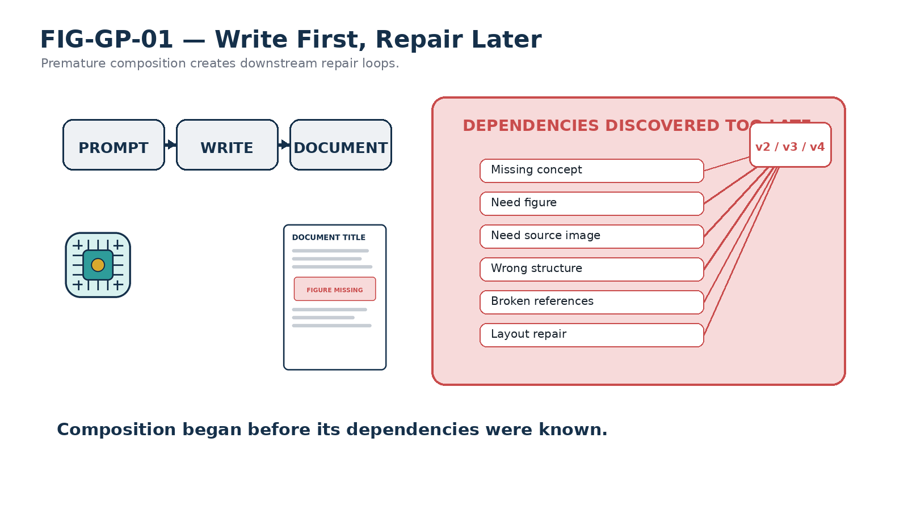
Figure 1. Write first, repair later: unresolved dependencies create repeated downstream rework.

Fluency is not construction
A fluent document can still be the wrong artifact. It can have the wrong scope, omit a required concept, introduce figures too late, use images decoratively, or present a polished layout that does not conform to the user’s intended structure. GROOVED PASS therefore separates generation quality from construction quality. The goal is not merely to produce good sentences; it is to make the document’s decisions visible before they harden into expensive dependencies.
Upstream verification
A thesis changed during brainstorming is cheap. The same thesis changed after twenty figures and thirty pages may require rebuilding most of the document.

2. The Central Inversion
GROOVED PASS changes the order of operations. Instead of writing first and repairing later, it treats composition as a late-stage activity that consumes already-approved semantic and visual architecture. The document is designed before it is phrased at length.
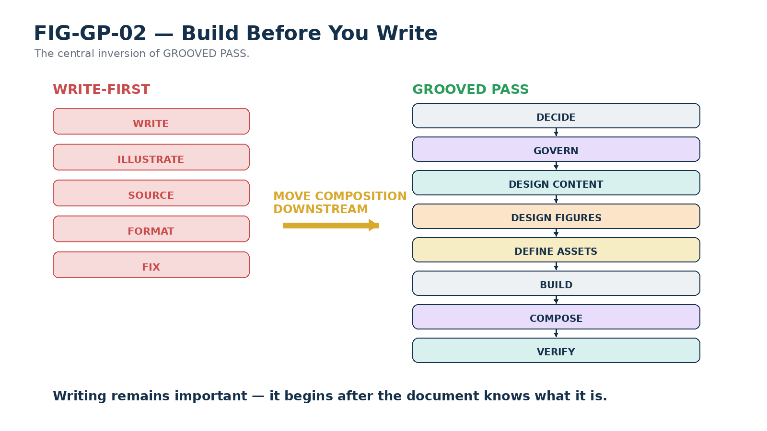
Figure 2. Build before you write: composition moves from the beginning of the workflow to near the end.
This inversion does not reduce writing to mechanical assembly. It creates a stable environment in which writing can be more coherent. By Pass 7, the writer knows the artifact type, its governing contract, the approved content sequence, the figures that must be taught through, and the assets those figures depend on. Creativity remains available, but it operates inside a deliberate architecture rather than discovering that architecture accidentally.
Content is architected before it is phrased. Figures are architected before they are drawn. Assets are identified before they are sourced. The document is verified against those decisions after it is composed.

3. The Document as a Compiled Artifact
The method is best understood as a compilation pipeline. Each pass resolves a different class of uncertainty and exports a bounded artifact to the next pass. The final Word document is therefore not the sole record of the work. It is the compiled release produced from a chain of prior decisions.
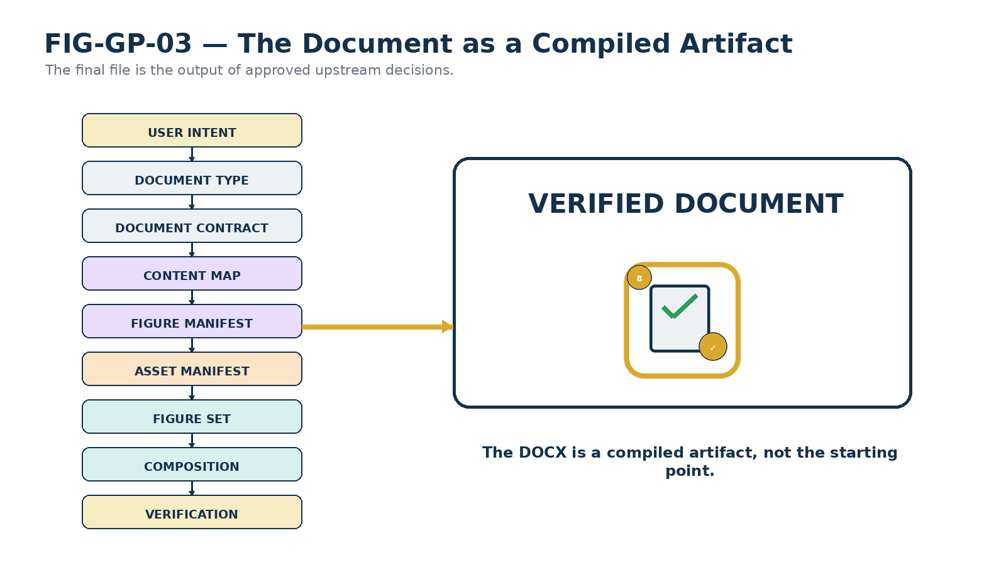
Figure 3. The document as compiled artifact: intent is progressively transformed into a verified release.
This distinction makes revision more tractable. If the Content Map changes, the system can inspect the Figure Manifest rather than reverse-engineering the final DOCX to determine what may be affected. If a source image is replaced, the Asset Manifest can preserve the stable requirement while the figure remains conceptually unchanged. The intermediate artifacts turn document creation into a process that can be inspected, resumed, and rebuilt.
PART II — THE GROOVED PASS METHOD

4. The Eight-Pass Method
GROOVED PASS is organized as eight passes. The first six establish the artifact’s identity, governance, content, visual logic, and source material. Pass 7 composes the document. Pass 8 closes the method by checking whether the composed artifact actually conforms to what was approved upstream.
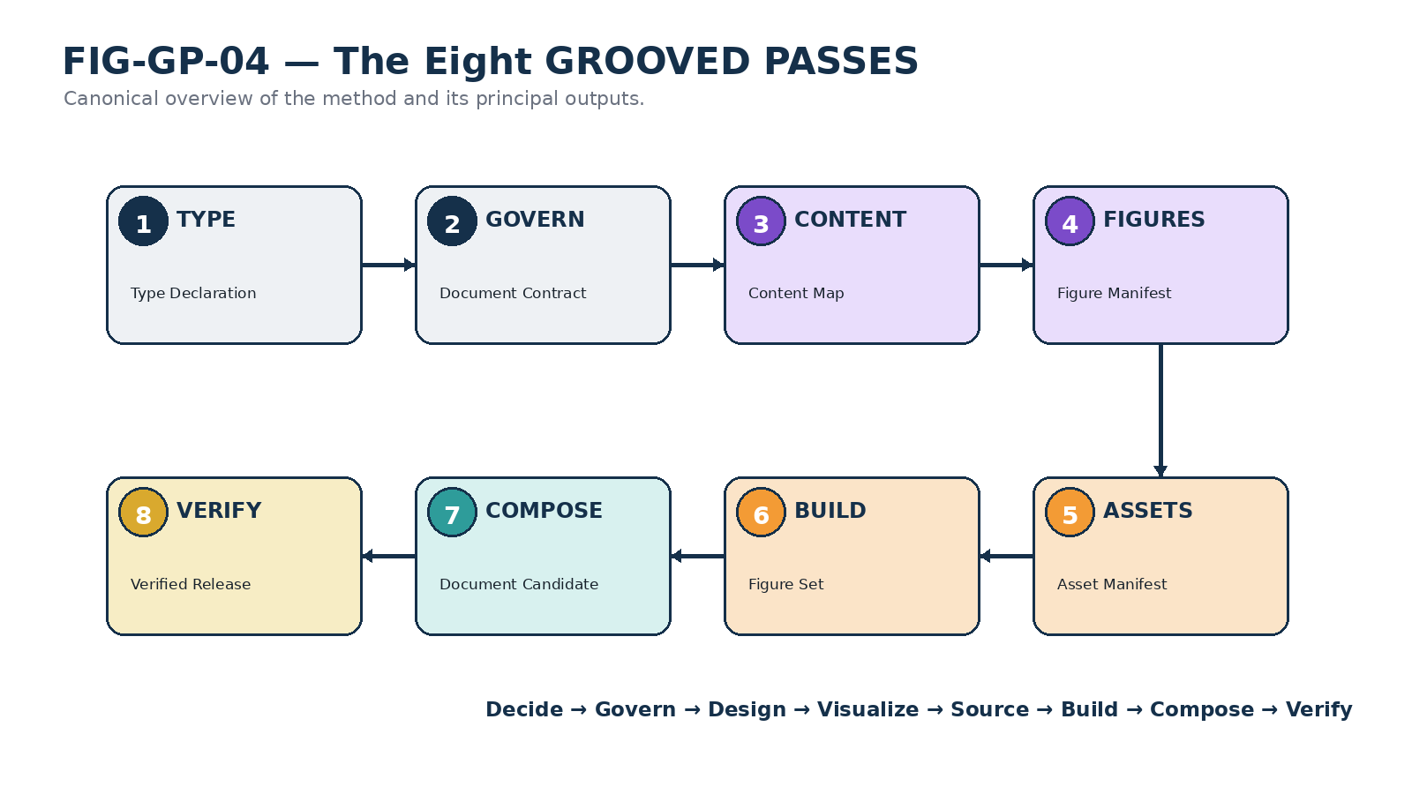
Figure 4. Canonical overview of the eight GROOVED PASSES and their principal outputs.

Why eight passes
The eight-pass sequence separates decisions that fail differently. Document type and governance establish the artifact contract; content and figure architecture establish meaning; asset and production passes establish visual feasibility; composition integrates the approved channels; verification tests the release against the architecture that produced it.
The boundaries are intentionally explicit so that a failure can be routed back to the pass that owns it. The method is sequential for authority, but iterative for correction.
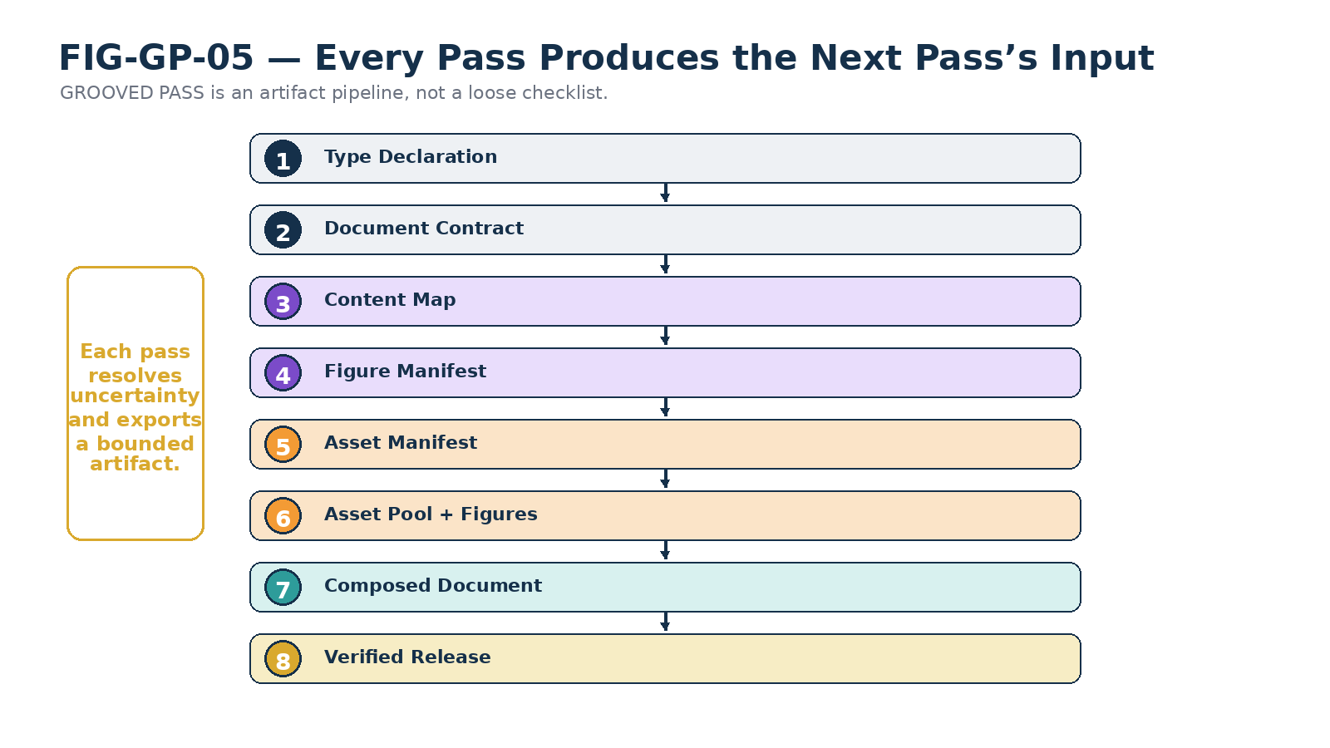
Figure 5. Each pass produces an artifact consumed by the next pass.
A pass is not merely a conversational stage. It has an owner, a completion condition, an output, and a user gate. The method becomes reliable because the next pass does not silently inherit unresolved assumptions from the previous one.
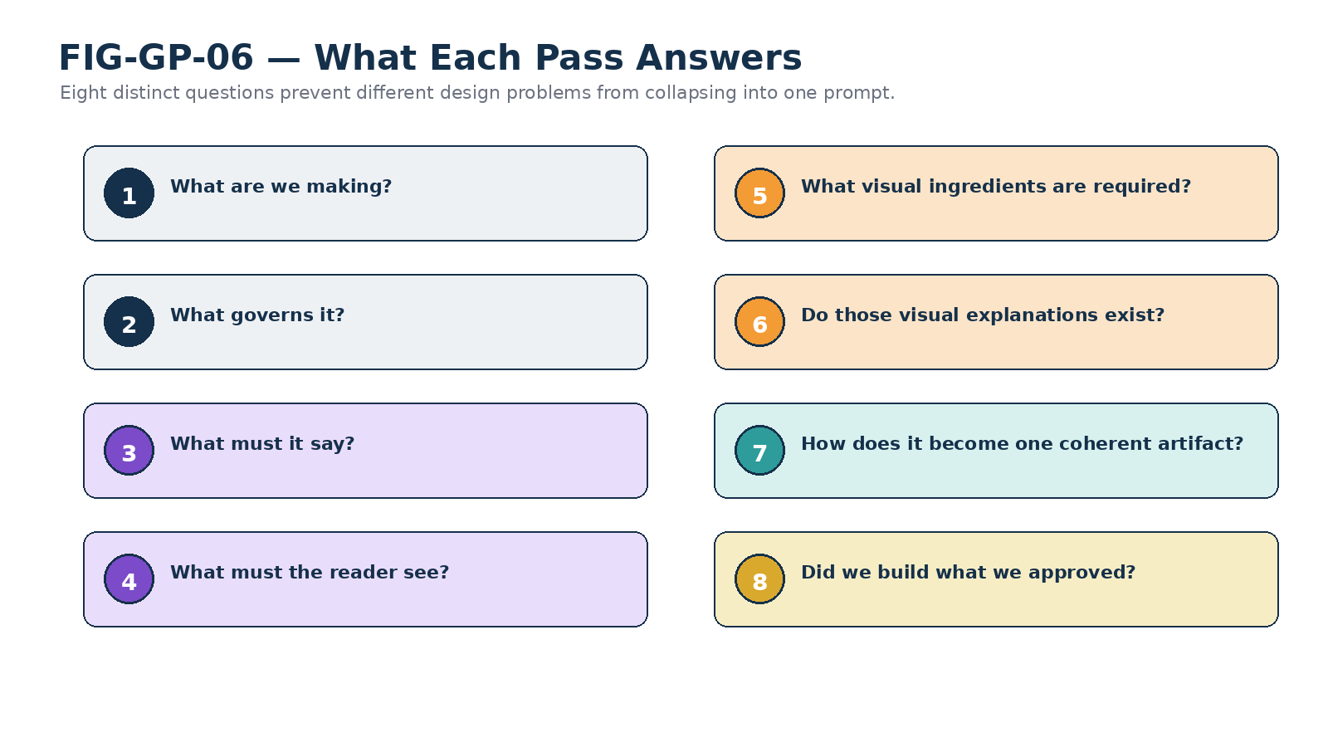
Figure 6. Each pass answers a different governing question.
Canonical sequence
Decide → Govern → Design → Visualize → Source → Build → Compose → Verify.

5. Pass 1 — Document Type
Pass 1 answers the most basic question: What are we making? A professional paper, formal specification, reference guide, instruction manual, proposal, white paper, research summary, SOP, and SK specification may discuss the same subject while demanding very different reader expectations, structures, evidence, visual density, and tone.
The purpose of the pass is not to force every document into a rigid taxonomy. It is to prevent the system from behaving as though “a document” were a single undifferentiated artifact. If two plausible document types would materially change the outcome, the distinction must be surfaced before composition begins.
PASS 1 — DOCUMENT TYPE
What are we making?
Output: Document Type Declaration
AI completion checklist
- Purpose and intended audience are sufficiently clear.
- The proposed artifact type matches the requested use.
- The expected level of technicality and formality is understood.
- Competing artifact types that would materially change the result have been surfaced.
- Any known delivery format requirement is recorded.
Gate: “I recommend this document type and these implications. Approve, revise, or choose another type?”

6. Pass 2 — Template and Writing Specification
Pass 2 establishes governance. GROOVED PASS distinguishes the Writing Specification from the Template because they solve different problems. A Writing Specification controls what the artifact must contain or obey. A Template controls how the artifact is presented.
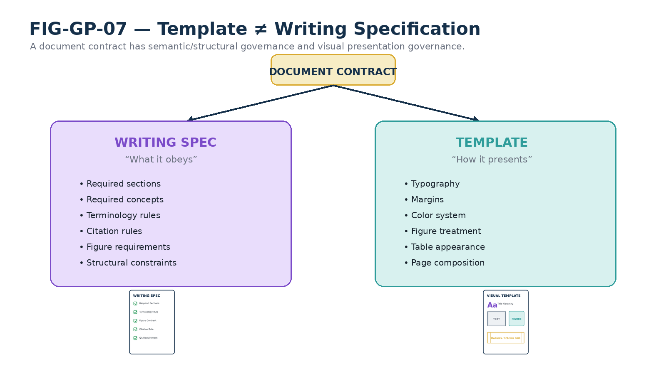
Figure 7. Template and Writing Specification cooperate, but they are different forms of governance.
A Writing Specification may require sections, terminology, examples, citation behavior, figure conventions, or structural rules. A Template may determine typography, spacing, page composition, color, table appearance, and recurring visual treatments. When no mature specification exists, the pass may create a provisional contract rather than silently inventing standards downstream.
PASS 2 — TEMPLATE / WRITING SPECIFICATION
What governs this kind of artifact?
Output: Document Contract
AI completion checklist
- The governing Writing Specification has been selected or explicitly marked provisional.
- The presentation template or style system has been selected separately.
- Mandatory structural, citation, terminology, and figure rules are identified.
- Conflicts between governing sources are surfaced.
- No material formatting decision is being mistaken for a semantic requirement.
Gate: “These are the governing specifications and template rules. Approve this document contract?”

7. Pass 3 — Content Architecture
Pass 3 determines what the particular document will say. The goal is not to draft polished paragraphs. It is to produce an approved semantic map: the core proposition, reader destination, scope, non-scope, concept sequence, major sections, examples, terminology, dependencies, open questions, and conclusion.
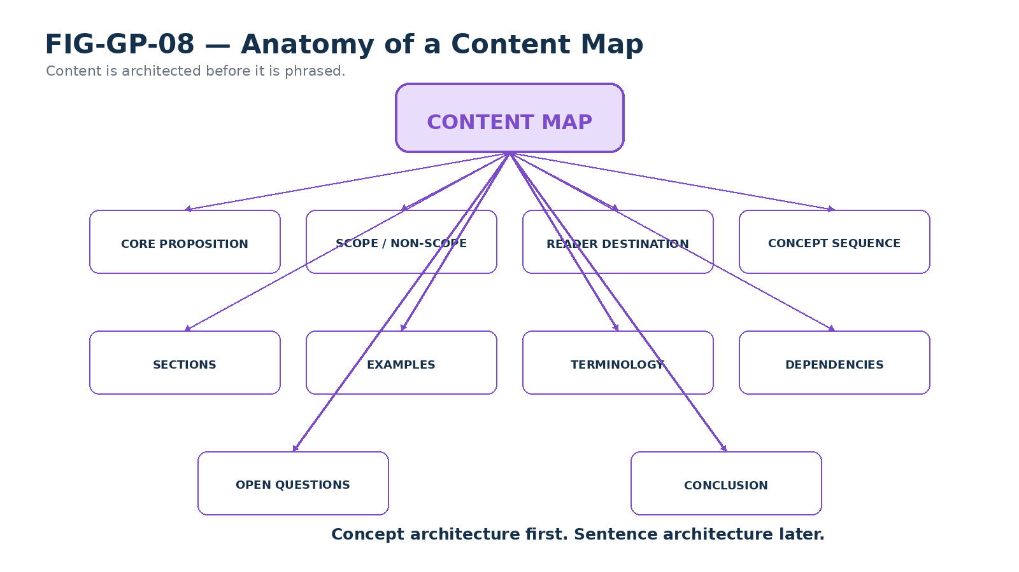
Figure 8. A Content Map is more than an outline: it captures the document’s semantic architecture before sentence-level composition.
The Content Map should be detailed enough that figure design can begin without guessing what the paper means. This is also the correct stage to expose unresolved architectural or terminological questions. If an ambiguity would materially affect the next pass, GROOVED PASS requires it to be raised now rather than hidden inside an illustration or prose choice.
PASS 3 — CONTENT ARCHITECTURE
What must this particular document say?
Output: Approved Content Map
AI completion checklist
- A clear core proposition or teaching objective is stated.
- Scope and non-scope are explicit enough to prevent drift.
- The concept sequence is coherent and dependencies are respected.
- Key examples and terminology are identified.
- Open questions that materially affect figures or later composition are surfaced.
- The intended conclusion follows from the planned content.
Gate: “This is the proposed content architecture. What should be added, removed, corrected, or reordered before it is locked?”

8. Pass 4 — Figure Architecture
Pass 4 asks what the reader must be shown. Figures are treated as a parallel explanatory channel rather than decoration attached after the prose is complete. Every planned figure receives a Figure Contract that defines its purpose and required relationships before drawing begins.
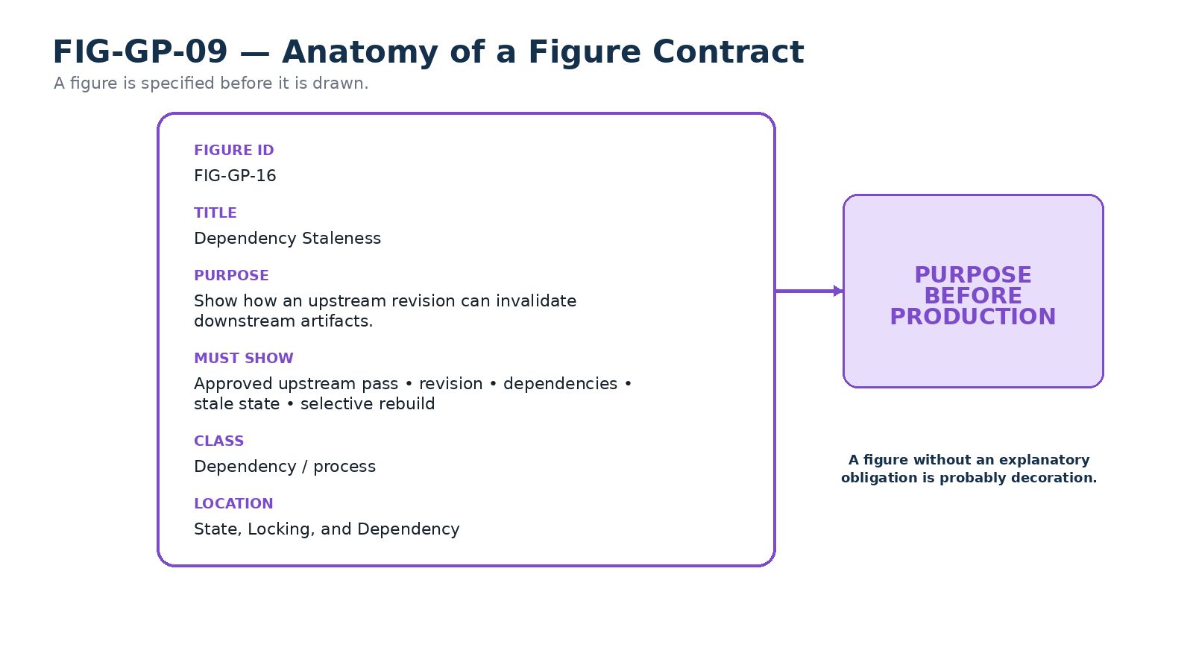
Figure 9. A Figure Contract specifies the explanatory obligation of a figure before production.
A useful figure contract records a stable Figure ID, working title, purpose, required elements, figure class, intended location, asset dependencies, and the misunderstanding it is meant to prevent. If visual design exposes a conceptual gap, the correct response is to reopen Pass 3 rather than force an unclear idea into a diagram.
PASS 4 — FIGURE ARCHITECTURE
What must the reader see?
Output: Figure Manifest + Figure Contracts
AI completion checklist
- Every proposed figure has a defined teaching purpose.
- The figure sequence follows the approved content sequence.
- Redundant or purely decorative figures have been removed.
- Every figure identifies the relationships or elements it must show.
- Asset dependencies can be identified without yet sourcing the assets.
- Figure design has not silently changed the approved content.
Gate: “These are the figures and what each one must prove. Approve the figure architecture?”

9. Pass 5 — Asset Architecture
Pass 5 determines which source images, screenshots, silhouettes, icons, maps, references, or generated visuals are required to build the approved figures. Crucially, those requirements receive stable numbered identities before acquisition begins.
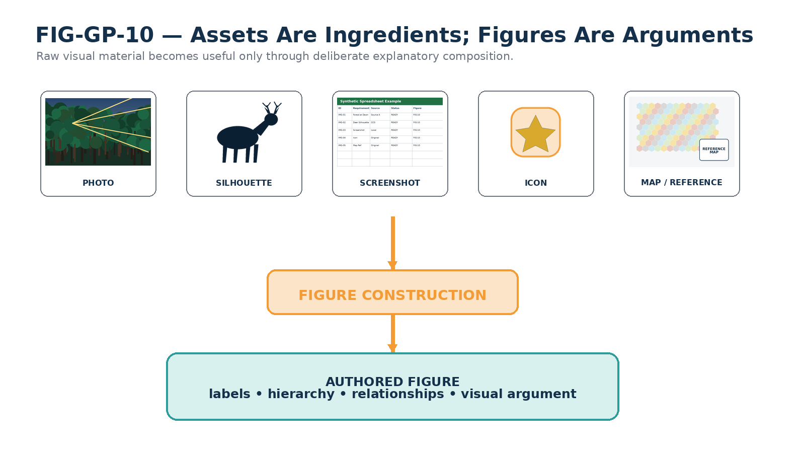
Figure 10. Assets are ingredients; figures are arguments. Source material becomes explanatory only through authored visual composition.
A photograph, screenshot, or downloaded icon is not automatically a figure. It may be an ingredient used to build one. GROOVED PASS therefore separates Asset IDs from Figure IDs. The Figure Contract depends on the semantic requirement represented by an Asset ID, not on a transient filename or URL.

Requirement first, implementation second
The Asset Manifest defines what the figure needs before the workflow commits to where that need will be satisfied. A required forest image, diagram source, screenshot, or silhouette can therefore be searched, generated, replaced, or upgraded without changing the conceptual contract that requested it.
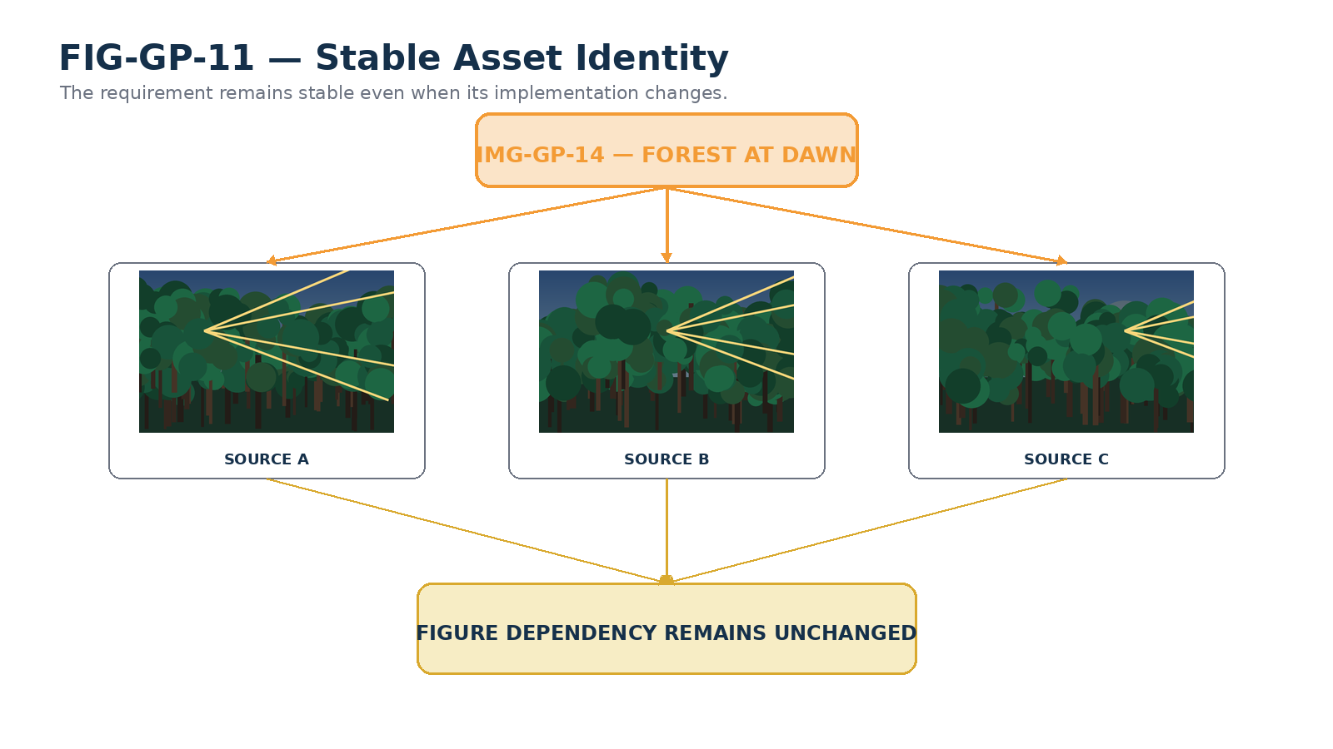
Figure 11. Stable asset identity allows a source implementation to be replaced without changing the figure’s conceptual dependency.
PASS 5 — ASSET ARCHITECTURE
What visual ingredients are required?
Output: Approved Asset Manifest
AI completion checklist
- Every externally required visual asset has a stable numbered placeholder.
- Each asset is mapped to the figure or figures that require it.
- Search, generation, local screenshots, trace/redraw, crop, and reference uses are distinguished.
- Licensing or provenance requirements are known where applicable.
- Unnecessary stock imagery has been excluded.
- The asset requirement is defined independently of any particular source file.
Gate: “This is the numbered asset manifest. Approve it before assets are acquired or generated?”

10. Pass 6 — Asset and Figure Production
Pass 6 produces the visual material that Passes 4 and 5 designed. Assets are searched, generated, captured, cropped, redrawn, normalized, and attributed as required. The figures are then constructed and checked against their Figure Contracts.
The important sequencing rule is that the figure set should ideally exist before long-form composition. This prevents the writer from discovering during page layout that a central visual explanation is impossible, illegible, unsupported, or conceptually different from what the paper claims.
PASS 6 — ASSET & FIGURE PRODUCTION
Do the planned visual explanations now actually exist?
Output: Completed Asset Pool + Completed Figure Set
AI completion checklist
- All required assets have been acquired, generated, or explicitly resolved.
- Source and license notes are recorded where applicable.
- Every approved Figure Contract has a produced figure candidate.
- Figures are readable at intended document size.
- The visual language is coherent across the set.
- Each figure has been checked for accidental semantic implications or departures from the approved content.
Gate: “The asset pool and figure set are complete. Revise any visual now, or approve production before composition?”

11. Pass 7 — Document Composition
Pass 7 is where long-form writing and page assembly finally occur. The writer now consumes an approved Document Contract, Content Map, Figure Manifest, Asset Manifest, and completed Figure Set. Composition is therefore late, but it is not secondary: it is the stage where the already-designed semantic and visual channels are integrated into one coherent artifact.
Prose should prepare the reader for a figure, explain the relationships that matter, and avoid redundantly narrating every visual element. Figures should appear where they advance understanding, not where layout happens to leave space. Terminology and examples should remain consistent with the approved Content Map.
PASS 7 — DOCUMENT COMPOSITION
How do the approved components become one coherent artifact?
Output: Composed Document Candidate
AI completion checklist
- The approved Content Map governs the section sequence.
- All approved figures appear in their intended conceptual locations.
- Terminology and examples remain consistent with upstream decisions.
- Text and figures complement rather than duplicate one another.
- No material new assumption has been introduced silently during writing.
- Captions, cross-references, and document structure are internally coherent.
Gate: “The document is composed. Approve the content candidate for final conformance and visual QA?”

12. Pass 8 — Conformance and Visual QA
Pass 8 closes the Groove. A composed document is not assumed correct merely because the file was created successfully. GROOVED PASS checks both semantic conformance and artifact conformance.

Semantic conformance
- The thesis and reader destination still match the approved Content Map.
- Required sections, examples, terminology, and figures are present.
- Scope has not drifted and unsupported assumptions have not been introduced.
- Figure meanings still match their contracts and the prose that references them.
- The conclusion follows from the document that was actually produced.

Artifact conformance
- Render the document page by page.
- Inspect text clipping, overlap, broken tables, image readability, captions, whitespace, and page breaks.
- Verify numbering, references, headers, footers, and the absence of unresolved placeholders.
- Repair defects, render again, and repeat until the artifact is clean.
PASS 8 — CONFORMANCE & VISUAL QA
Did we actually build what we approved?
Output: Verified Release Artifact + Conformance Report
AI completion checklist
- The final artifact has been checked against every material upstream decision.
- Every page has been rendered and visually inspected.
- All figures remain readable at normal viewing size.
- No unresolved placeholder, broken reference, or layout defect remains.
- Any required revision has been made in the pass that owns the problem, then revalidated downstream.
Gate: “Final QA is complete. Approve the verified artifact for release?”

PART III — HUMAN AUTHORITY AND CONTROLLED PROGRESSION

13. Human Gates and Completion Reports
GROOVED PASS is not autonomous document generation. It is staged human-AI co-authorship. The AI performs each pass, audits its own work, and presents the result. The user decides whether the pass becomes authoritative.
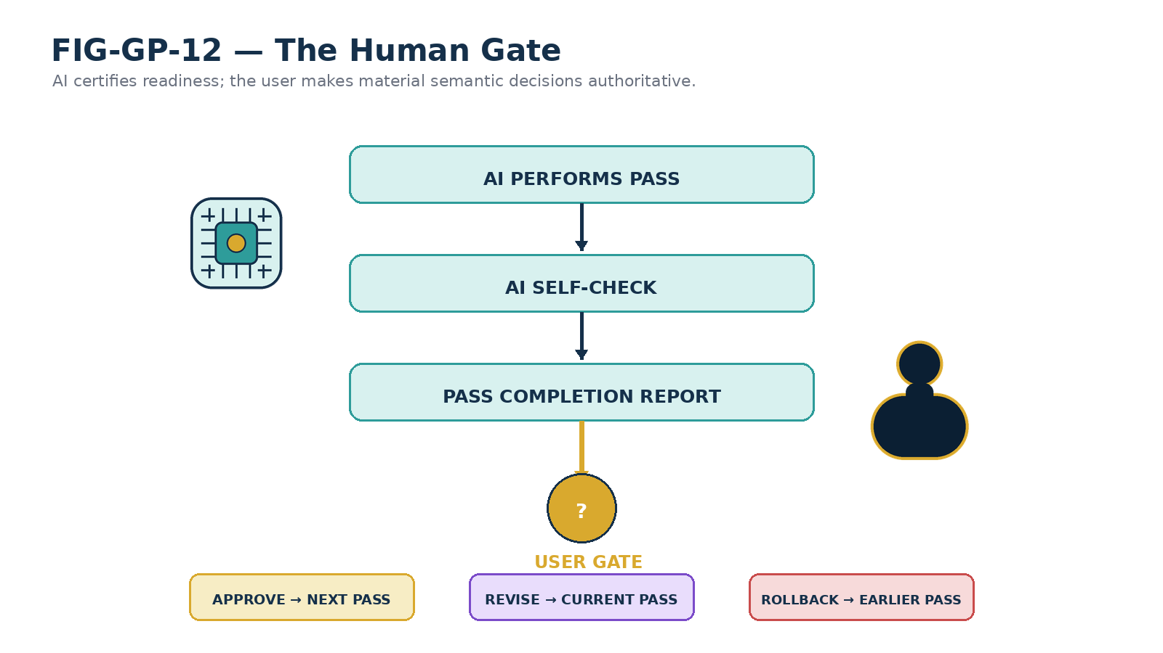
Figure 12. The Human Gate: AI work is followed by self-check, completion report, and explicit user authority.

The Human Authority Principle
Material semantic decisions become authoritative only through explicit human approval.

The AI may conclude that a pass is ready for review. It cannot convert its own interpretation into user-approved meaning. This is especially important for architecture, terminology, scope, and any decision that would propagate into later figures or prose.

Meaningful gates, not procedural noise
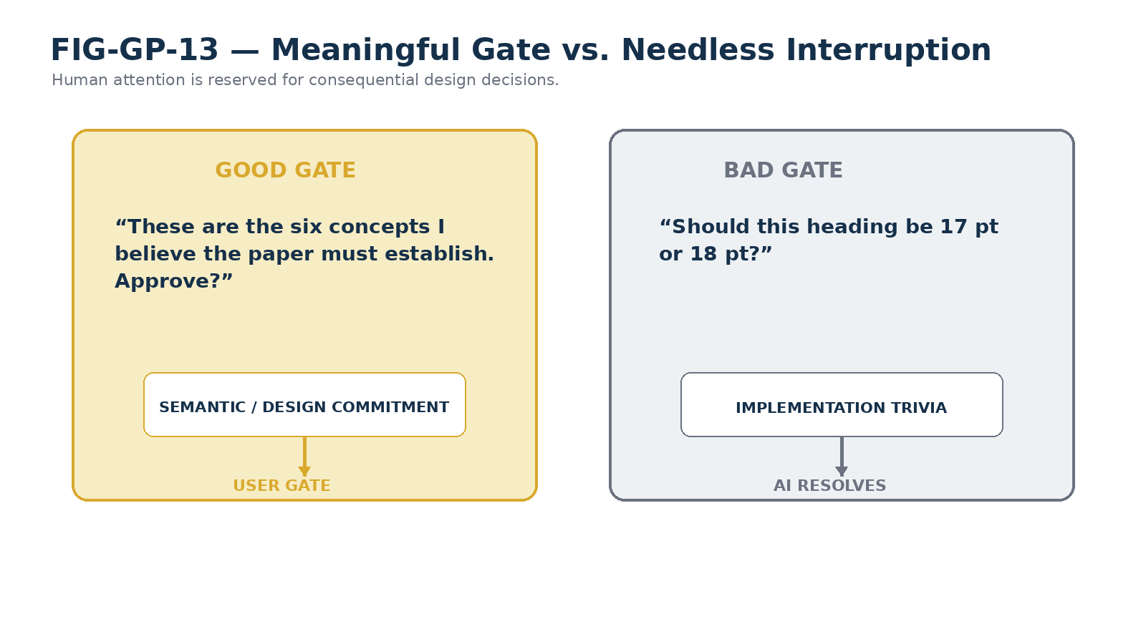
Figure 13. Human review should govern consequential semantic and design commitments, not routine implementation trivia.
The method should not interrupt the user for choices that the governing template or professional judgment can safely resolve. A good gate asks the user to approve the content architecture, figure meaning, or another downstream commitment. A poor gate spends human attention on routine typographic trivia that does not affect meaning.

The Pass Completion Report
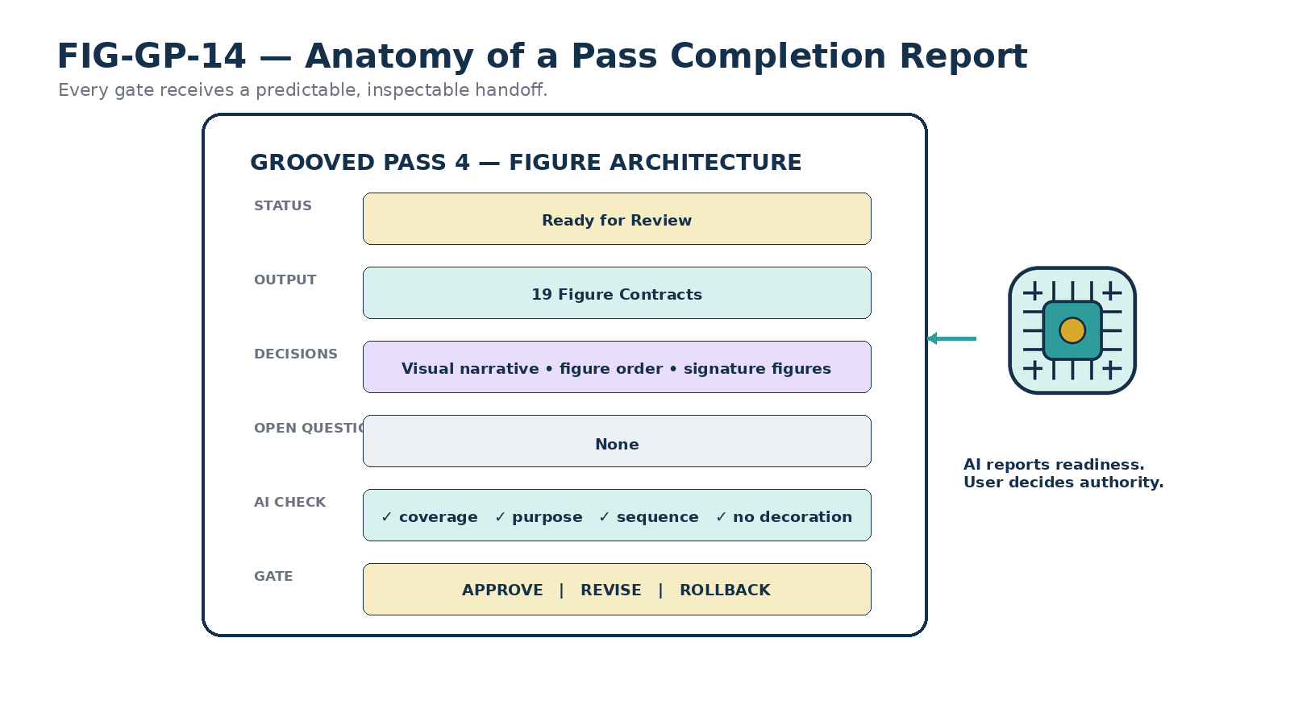
Figure 14. Standard anatomy of a Pass Completion Report.
The completion report creates a predictable handshake between passes. It identifies the pass status, what was decided, what artifact was produced, open questions, AI checklist results, affected dependencies, and the available gate actions. The standard gate vocabulary is deliberately small: APPROVE, REVISE, or ROLL BACK.
Approval is a lock, not immutability
An approved pass becomes the current authoritative version. The user can reopen it later; reopening simply triggers dependency review rather than erasing the ability to change.

14. Pass State, Locking, and Dependency
A pass moves through explicit states so that the workflow does not confuse “discussed,” “ready,” and “approved.” The minimal state vocabulary is ACTIVE, READY FOR REVIEW, APPROVED, REVISE, REOPENED, and STALE.
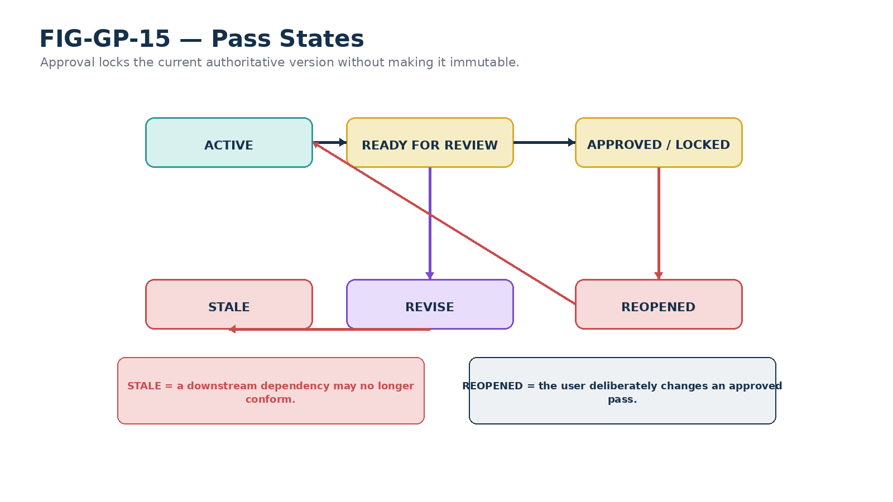
Figure 15. Pass lifecycle: approval creates an authoritative lock while preserving the ability to reopen and revise.
STALE is a downstream condition, not a moral judgment about quality. It means that an upstream dependency has materially changed and the downstream artifact can no longer be assumed current. A stale figure may still be valid; it simply requires an impact check.
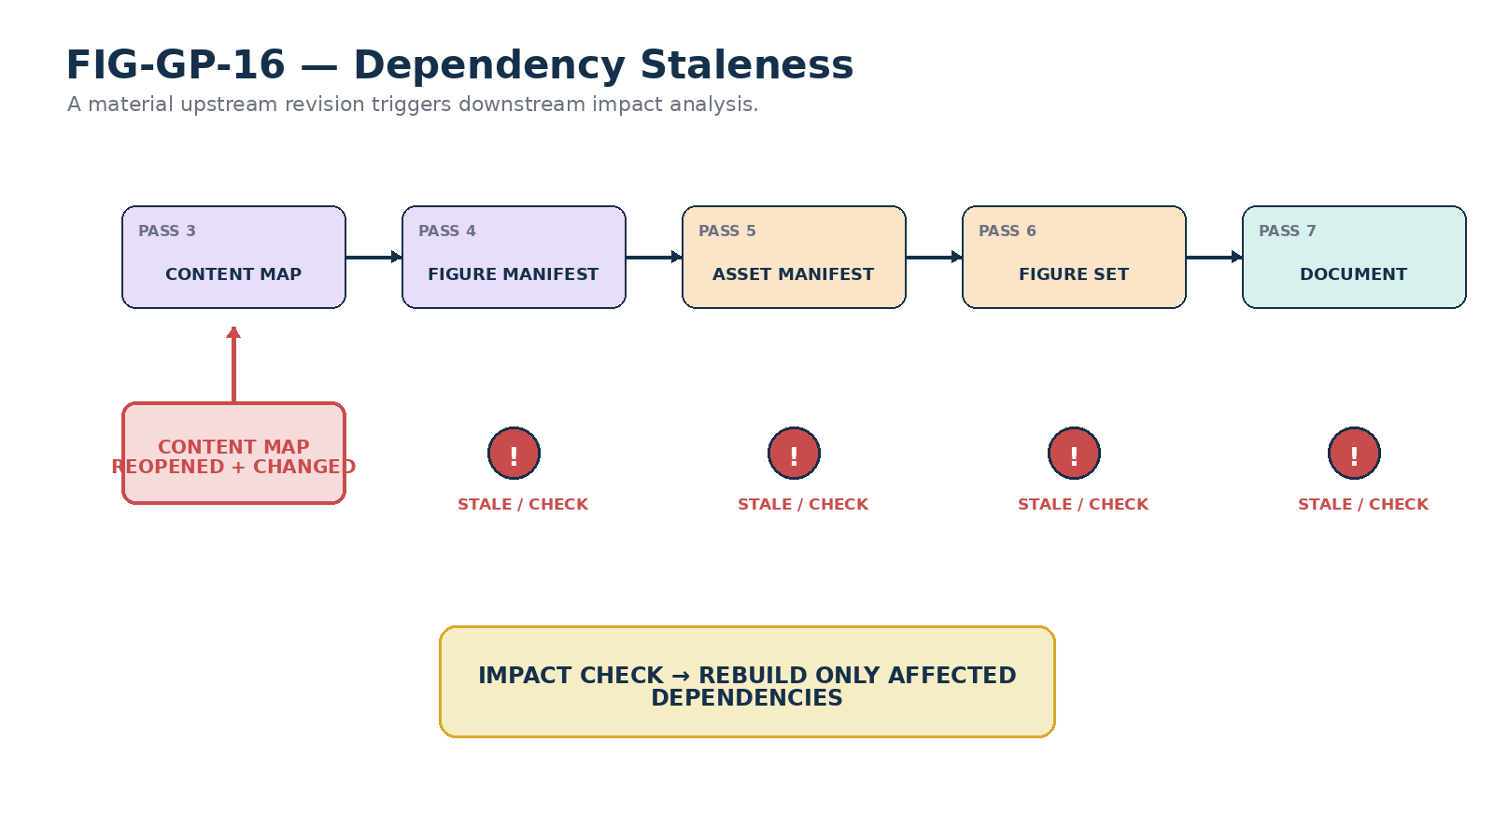
Figure 16. Upstream changes can mark dependent artifacts stale; the system then rebuilds only what is actually affected.

Selective rebuild
Dependency awareness prevents two opposite mistakes. The first is silent drift: an upstream change occurs and later artifacts are treated as though nothing changed. The second is wasteful full rebuild: every downstream artifact is discarded even when only one figure was affected. GROOVED PASS instead checks the actual dependency surface and rebuilds selectively.

15. Rollback and Error Ownership
When a problem is found late, the instinct is often to patch the final document. GROOVED PASS asks a different question: Which pass owns the faulty decision? The correction should happen there, then propagate forward through the affected dependencies.
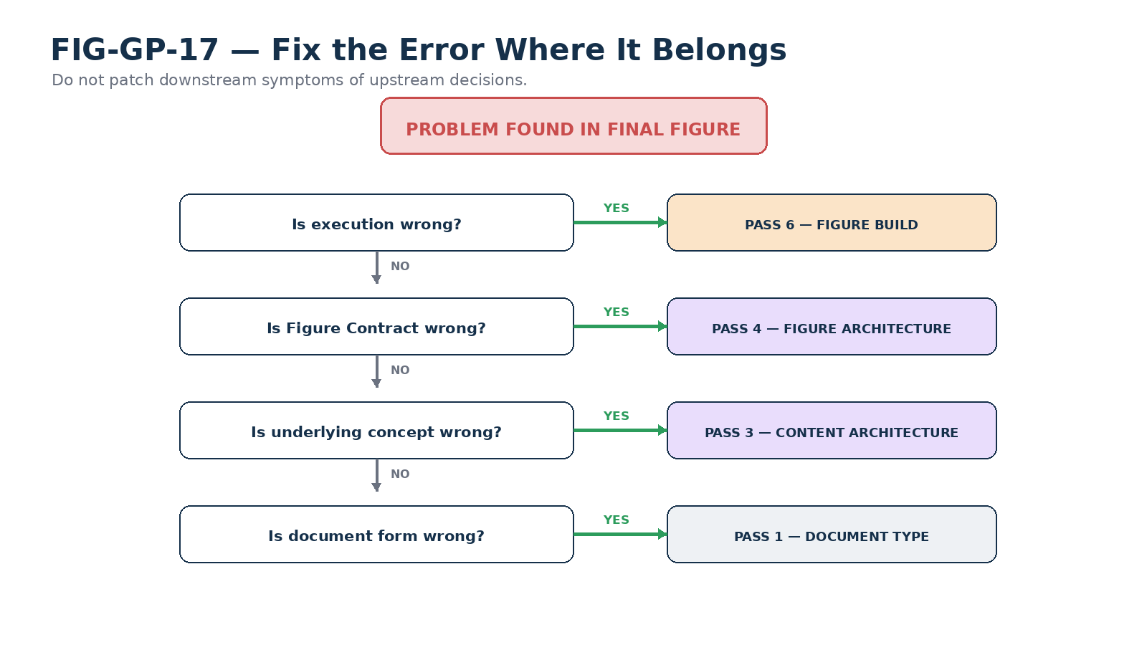
Figure 17. Fix the error where it belongs: downstream symptoms should not conceal upstream decisions.
If the visual execution is poor but the Figure Contract is correct, repair Pass 6. If the figure’s intended meaning is wrong, return to Pass 4. If the figure is wrong because the underlying concept was misunderstood, reopen Pass 3. If the entire artifact should have been a specification rather than an illustrative paper, return to Pass 1.
Pass Ownership Principle
Correct an error in the earliest pass that owns the incorrect decision.

PART IV — WHY THE METHOD REDUCES REWORK

16. Why GROOVED PASS Reduces Rework
The gates are not intended as bureaucracy. They are a cost-control mechanism for semantic error. Every unresolved decision accumulates dependent work as it travels downstream. The more that depends on a decision, the more expensive that decision becomes to change.
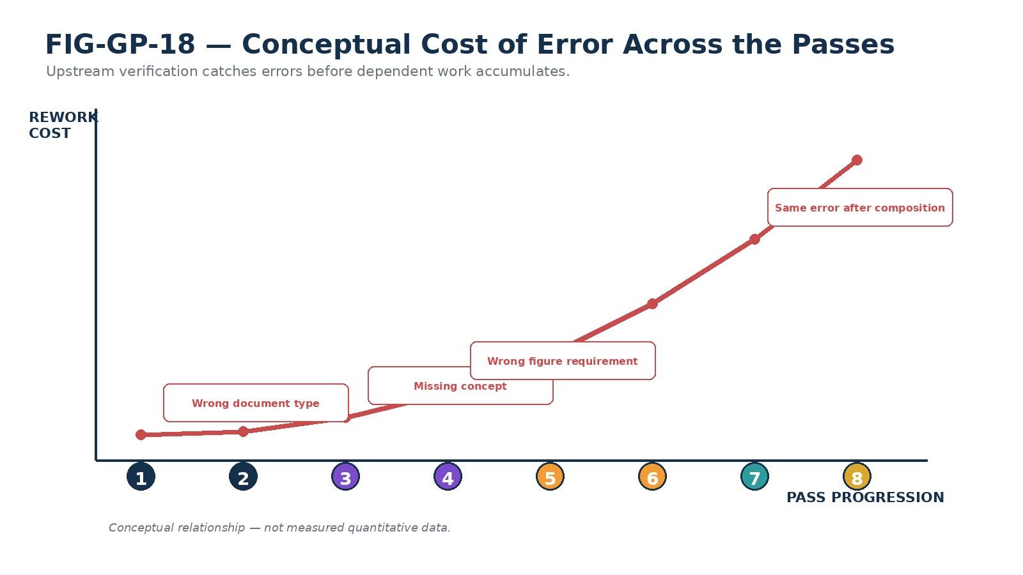
Figure 18. Conceptual rework cost rises as upstream errors propagate into more dependent artifacts; the curve is illustrative, not measured data.

Semantic error containment
GROOVED PASS attempts to contain an error before it becomes an ecosystem of secondary work. A missing concept should be discovered while reviewing the Content Map, not after the final layout. A figure problem should be discovered during Figure Architecture or production, not after it has been referenced by multiple sections. A licensing problem should be exposed in the Asset Pass, not at release.

Upstream verification
The method therefore treats early review as leverage. The user is asked to make the highest-value decisions when they are cheapest to change. Later passes become progressively more deterministic because fewer unresolved assumptions survive into them.

17. Scaling and Reusable Profiles
Not every document deserves an eight-stage ceremony of equal intensity. A one-page memo and a forty-page illustrated architecture paper have different coordination costs. GROOVED PASS therefore allows a pass to be pre-satisfied when an approved contract already resolves its decisions.
For example, an established SK specification may already have a known document type, Writing Specification, visual template, citation behavior, and figure grammar. Passes 1 and 2 can then be confirmed quickly rather than reinvented. The rule is not that every pass must consume the same amount of conversation; the rule is that material unresolved decisions must not be silently skipped.
Pass compression
A pass may be pre-satisfied by an existing approved contract. It should not be silently omitted when a material unresolved decision remains.

Document profiles
Repeated document families can eventually be represented as reusable profiles containing the document type, Writing Specification, template, figure grammar, citation conventions, and QA rules. Such profiles make early passes nearly instantaneous while preserving the gate model. The method naturally extends toward a document build system in which Content Maps, Figure Manifests, Asset Manifests, figure directories, and QA reports are retained as structured project artifacts.
PART V — METHOD INTEGRITY

18. Self-Application, Boundaries, and Principles

The first GROOVED PASS paper is itself GROOVED
This paper was developed using the method it describes. Its document type was selected first; its governing style remained provisional while the process itself was still being designed; the content was brainstormed and approved before figure design; the figure set was planned before asset requirements; assets and figures were produced before the final Word document; and the completed artifact entered a dedicated QA pass after composition.
The recursive use is useful because it exposes practical friction. If the method cannot efficiently build the paper that defines it, the method needs revision. Self-application therefore functions as an early operational test rather than as proof of universal validity.

What GROOVED PASS does not guarantee
- It does not guarantee that the underlying claims are true.
- It does not replace domain expertise, research quality, or source verification.
- Human approval does not automatically make an interpretation correct.
- A completed checklist cannot rescue a weak thesis or inadequate evidence.
- The method has overhead and should be scaled to the complexity and consequences of the artifact.
- Exploratory drafting remains useful; it simply should not silently become the authoritative release without passing through appropriate review.

Formal principles
Principle | Meaning
Late Composition | Final prose composition follows semantic and visual architecture.
Human Authority | Material semantic decisions require explicit human approval before becoming authoritative.
Meaningful Gate | Human attention is requested for consequential decisions rather than routine implementation trivia.
Pass Ownership | Errors are corrected in the earliest pass that owns the faulty decision.
Dependency Staleness | A material upstream revision may invalidate dependent downstream artifacts.
Upstream Verification | Decisions should be verified at the cheapest meaningful stage.
Figure Purpose | Every figure has an explicit explanatory obligation.
Asset Identity | Required assets receive stable identities before acquisition.
Asset–Figure Separation | Assets are source material; figures are authored explanatory objects.
Dual-Channel Design | Prose and figures are designed as complementary explanatory channels.
Conformance Closure | The final artifact is not complete until checked against approved upstream architecture.

19. Conclusion — The Document as a Verified Compilation
GROOVED PASS changes where document creation begins. The process does not begin when the first paragraph is written. It begins when the intended artifact is classified, governed, architected, visualized, and supplied with the assets required to explain itself.
By the time composition begins, the document already knows what it is, what it must say, what it must show, what source material it requires, and which decisions have been approved by the user. By the time it is released, the artifact has been checked against those decisions rather than judged only by whether it looks finished.
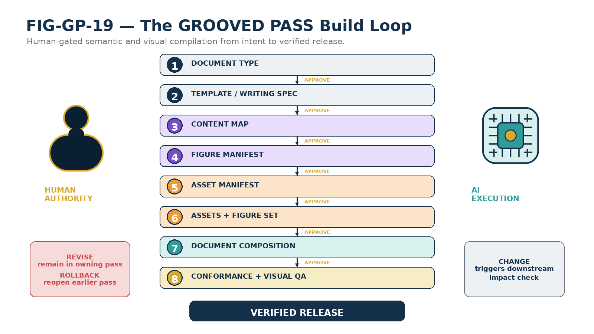
Figure 19. The complete GROOVED PASS build loop: each pass is human-gated, revisable, dependency-aware, and closed by verification.
The Word document is not where document creation begins. It is where the approved architecture of the document is compiled into a human-readable artifact.

The method can be summarized in eight verbs: Decide. Govern. Design. Visualize. Source. Build. Compose. Verify. Its deeper purpose is equally compact: make meaning explicit before it becomes expensive.

APPENDIX A

Operational Gate Checklists
The following compact checklist is intended for repeated use by an AI collaborator before requesting user approval. These checks are not substitutes for the detailed pass contracts above; they are the minimum completion questions that prevent silent advancement.
Pass | AI must confirm | User gate
1 — Type | Purpose, audience, artifact class, technicality, competing types, delivery format. | Approve recommended document type.
2 — Govern | Writing Spec, template, mandatory rules, conflicts, provisional decisions. | Approve document contract.
3 — Content | Thesis, scope, non-scope, sequence, examples, terms, open questions, conclusion. | Approve Content Map.
4 — Figures | Purpose per figure, sequence, required relationships, no decoration, asset dependencies. | Approve Figure Manifest and contracts.
5 — Assets | Stable IDs, figure mapping, acquisition mode, provenance needs, treatment, no unnecessary stock. | Approve Asset Manifest.
6 — Build | Assets resolved, sources recorded, figures built, contract match, readability, visual coherence. | Approve visual production set.
7 — Compose | Content Map followed, figures placed intentionally, terms stable, no silent assumptions, references coherent. | Approve document candidate for QA.
8 — Verify | Semantic conformance, rendered-page inspection, references, readability, no placeholders or layout defects. | Approve verified release.

Universal pre-gate questions
- Is anything unresolved that materially affects the next pass?
- Did the AI silently infer anything the user should explicitly approve?
- Does this pass still conform to all approved upstream passes?
- Is the produced artifact complete enough for the next pass to consume without guessing?
- If a problem was discovered, is the current pass actually the owner of that problem?
APPENDIX B

Standard Pass Completion Report Template
PASS [N] — [NAME]
Status: READY FOR REVIEW
Output produced: [artifact]
Decisions locked as candidates: [summary]
Open questions: [none or list]
AI check: [pass/fail per completion criterion]
Dependencies affected: [list]
Gate: APPROVE | REVISE | ROLL BACK

The completion report should be concise enough to review quickly but specific enough that the user knows exactly what would become authoritative on approval. It should never conceal an unresolved material question behind a generic “looks good” request.
Release note
This v0.1 paper treats the GROOVED PASS method as an illustrative operational methodology. Later versions may formalize document profiles, machine-readable pass artifacts, dependency tracking, and reusable writing specifications without changing the central human-gated progression.

