CERBERUS BRAID
Bounded Recursive Alphanumeric Interleaved Datafields
A Graph Fabric Method for Deterministic, Traceable, Completion-Gated Assembly
|[ A ]| → [ 2 ] → | C | → ( 7 )
MEANING LOCATION MEANING LOCATION

Architecture and Formal Method Specification
CERBERUS Graph Fabric
Version 0.1 | August 2026 | Pass 8 Verified Release

Document Control and Scope
This specification formalizes BRAID as a bounded recursive construction method that operates over the native CERBERUS Stack-Table-Field-Record grammar. BRAID does not replace CERBERUS structure, SPINE output contracts, or the Graph Fabric itself. It defines how intelligence can move through bounded graph locations, read only the semantic context required for the current responsibility, persist useful resolution, gate advancement on completion, and retain a traversable construction trail.
Control | Value
Document class | Architecture and formal method specification
Method | BRAID - Bounded Recursive Alphanumeric Interleaved Datafields
Architectural context | CERBERUS Graph Fabric
Structural substrate | |[Stack]| [Table] |Field| (Record)
Primary execution unit | Bounded Table responsibility
Primary memory model | Persistent graph state with selective retrieval
Boundary integration | SPINE Output Contracts and Classes
Validation model | Domain implementation, friction classification, revision, and retest
Prototype platforms | Airtable, Excel, graph/relational systems; future CERBERUS-native runtime
Status | Pass 8 verified release

Boundary of this specification
BRAID v0.1 specifies the general construction method. It does not define universal Workout, Meal, or Garden schemas; mandatory Field-letter assignments; a universal completion-state vocabulary; a required storage platform; or a universal graph traversal algorithm. Those details belong to implementations or later specifications. The three domain Builders are deliberately reserved as experimental tests of the abstraction rather than evidence assumed in advance.

Source dependencies
Source | Role in BRAID
CERBERUS SPINE - Stacked Planning Intelligence Network Explorer v1.0 (August 2026) | Establishes SPINE Class 1 Field, Class 2 Table, and Class 3 Stack output boundary behavior; BRAID preserves those Classes unchanged.
CERBERUS TIME-32-64-96-128 Formal Semantic Kernel Specification v0.1 (August 2026) | Provides the worked derivation-economy example in which ordinary recurrence is represented by Month x Week x Phase selection rather than duplicated event rows.
CERBERUS native structural grammar | Provides the Stack, Table, Field, and Record notation that BRAID interprets as a recursive construction address.

Contents
Section | Topic
Executive Summary | Core proposition and architectural placement
1 | Formal Definition and Purpose
2 | Native Structural Grammar
3 | The Semantic-Locational Braid
4 | The Bounded Table Execution Contract
5 | Completion-Gated Routing
6 | Passes as Bounded Execution Cycles
7 | Selective Semantic Retrieval and Context Economy
8 | Persistent Resolution and Externalized Build Memory
9 | Sequential Execution Over Graph Data
10 | Recursive Reachability and Linked Datafields
11 | Derived State and Derivation Economy
12 | BRAID and SPINE Output Scope
13 | BRAID Within the CERBERUS Graph Fabric
14 | Construction Trails and Provenance
15 | Earliest-Owner Repair and Selective Staleness
16 | Platform Independence
17 | Three-Domain Experimental Program
18 | Falsification and Revision
19 | Future Data-Defined Builders
20 | Formal Principles and Non-Collapse Laws
21 | Minimum Implementation Contract
22 | Strategic Implications
Appendix A | Primitive Grammar and Notation
Appendix B | BRAID Principle Registry
Appendix C | Non-Collapse Law Registry
Appendix D | Experimental Evaluation Checklist
Glossary | Defined terms

Executive Summary
BRAID - Bounded Recursive Alphanumeric Interleaved Datafields - is a Graph Fabric method for turning the native CERBERUS structural grammar into an inspectable construction process. Its central observation is that the canonical notation alternates semantic and locational roles: a Stack establishes broad semantic scope, a Table identifies a bounded routed location, a Field establishes local meaning, and a Record specifies an instance at that location. BRAID uses that alternation to control how reasoning enters a graph, narrows context, resolves a finite responsibility, persists its result, validates completion, and routes onward.
The method is intentionally smaller than a workflow engine and broader than a document builder. A BRAID run does not require all project state to remain in immediate model context. Instead, the Graph Fabric preserves resolved state and relations. Each bounded operation retrieves only the Fields and Records needed for the current Table responsibility. Useful reasoning is written back into persistent graph state before working context is released. The next operation begins from that persisted state rather than from an ever-growing transcript.
BRAID also separates construction from publication scope. SPINE already defines whether a Stack publishes a Field, a governed Table projection, or one or more complete Stacks. BRAID does not change those Classes. It governs how a result can be built internally; SPINE governs what structural scope crosses the Stack boundary. A complex BRAID process can therefore yield a compact Class 1 output, while a comparatively simple construction may expose a Class 3 Stack.
The method treats provenance as an operational object. A completed result should remain traversable backward through the Tables, selected Fields, resolved Records, completion decisions, and prior state that produced it. When a downstream result is wrong, correction should occur at the earliest responsible source state. Only dependent descendants become stale and require rebuilding; unaffected branches remain valid. This turns construction history into repair infrastructure rather than passive logging.
BRAID v0.1 is explicitly falsifiable. Three independent domains - Workout, Meal, and Garden planning - are proposed as practical stress tests because they emphasize different relationships: temporal and physiological progression; nutritional and resource composition; and spatial-temporal biological growth. Friction must be classified before it is repaired. A domain-specific requirement belongs to the domain, a tool limitation belongs to the implementation, and only a failure of the general method justifies revising BRAID itself. When BRAID is revised, all three domains are retested.
CENTRAL PROPOSITION Complex outputs can be assembled through a sequence of bounded graph locations by alternating semantic interpretation with routed specification, preserving each completed resolution as linked graph state.

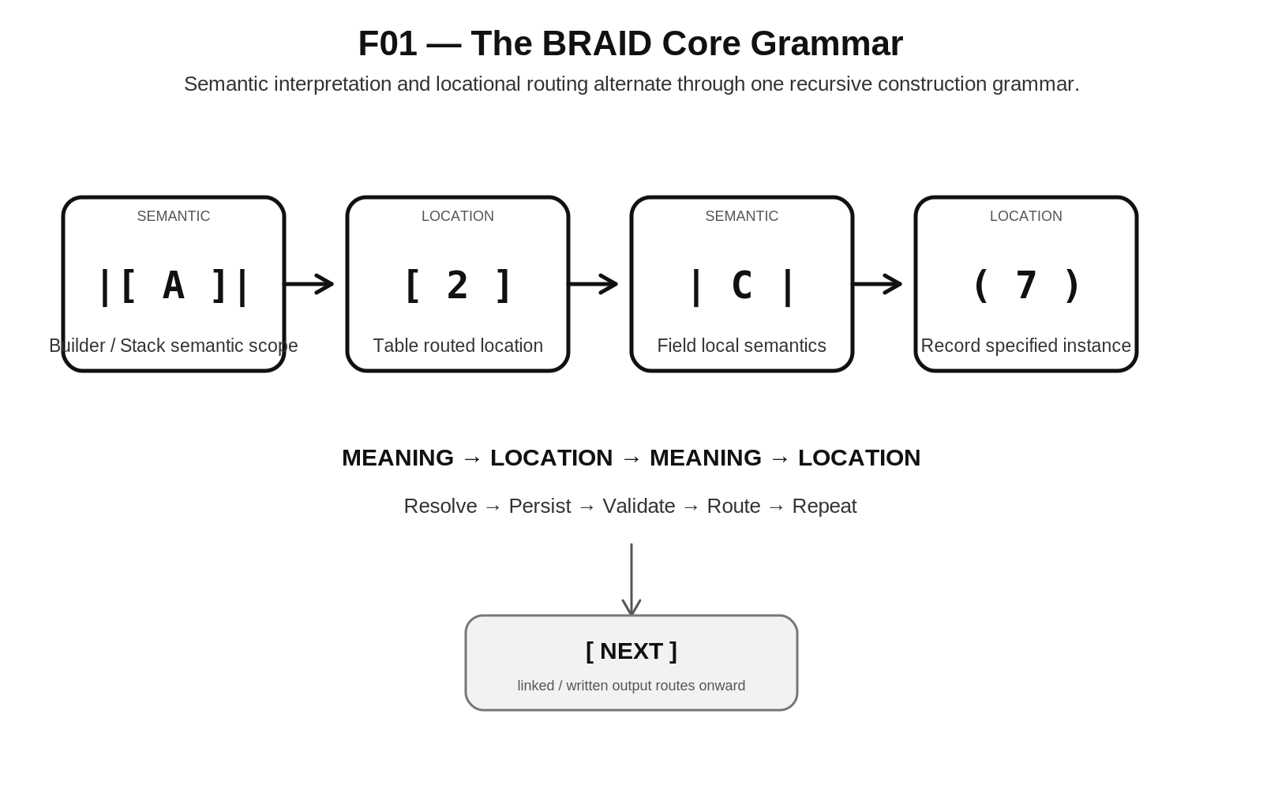
Figure 1. The BRAID Core Grammar
PART I - FOUNDATION

1. Formal Definition and Purpose
BRAID is a bounded recursive assembly method for graph-backed work. It operates over a persistent relational substrate and gives intelligence a disciplined way to enter, resolve, and leave bounded locations without confusing structural address with semantic meaning. The method is especially useful when an output is too complex to construct reliably in one transient reasoning context but can be decomposed into finite responsibilities whose results remain useful to later work.
FORMAL DEFINITION BRAID is a graph-fabric construction method in which bounded Table responsibilities retrieve selected semantic Fields and Records, perform a finite resolution, write persistent graph state, evaluate an explicit completion condition, and route to the next permitted location while retaining construction provenance.

BRAID is not another CERBERUS Root Stack. It is a method that may be used within Stacks and across project-local build graphs. SPINE can discover and plan through the outputs of Stacks that use BRAID, but SPINE is not the construction method itself. Likewise, Excel or Airtable may prototype BRAID, but neither platform defines the method.
The purpose is not to force every domain into the same schema. The purpose is to preserve a small set of construction laws while allowing domain Tables and Fields to remain appropriately different. BRAID therefore focuses on bounded responsibility, selective retrieval, explicit completion, persistent resolution, recursive reachability, traceable derivation, and source-level repair.

2. Native Structural Grammar
BRAID begins with the native CERBERUS structural notation. Four forms remain distinct: Stack, Table, Field, and Record. They are not equivalent identity levels and they must not collapse into one generic node type merely because they can all be represented in a graph.
|[ Stack ]|
[ Table ]
| Field |
( Record )

Form | BRAID role | Primary question
|[ Stack ]| | Broad semantic scope | What semantic construction am I inside?
[ Table ] | Bounded routed location | Where in the construction am I operating?
| Field | | Local semantic meaning | What does this information mean here?
( Record ) | Specified instance location | Which instance is being resolved or referenced?

The alphanumeric presentation adds an execution-readable projection to these roles. Letters represent semantic interpretation in the canonical BRAID address; numerals represent routing or instance specification. The address does not replace canonical registry identity. It is a bounded routing notation that lets a human or machine read the role of each position immediately.
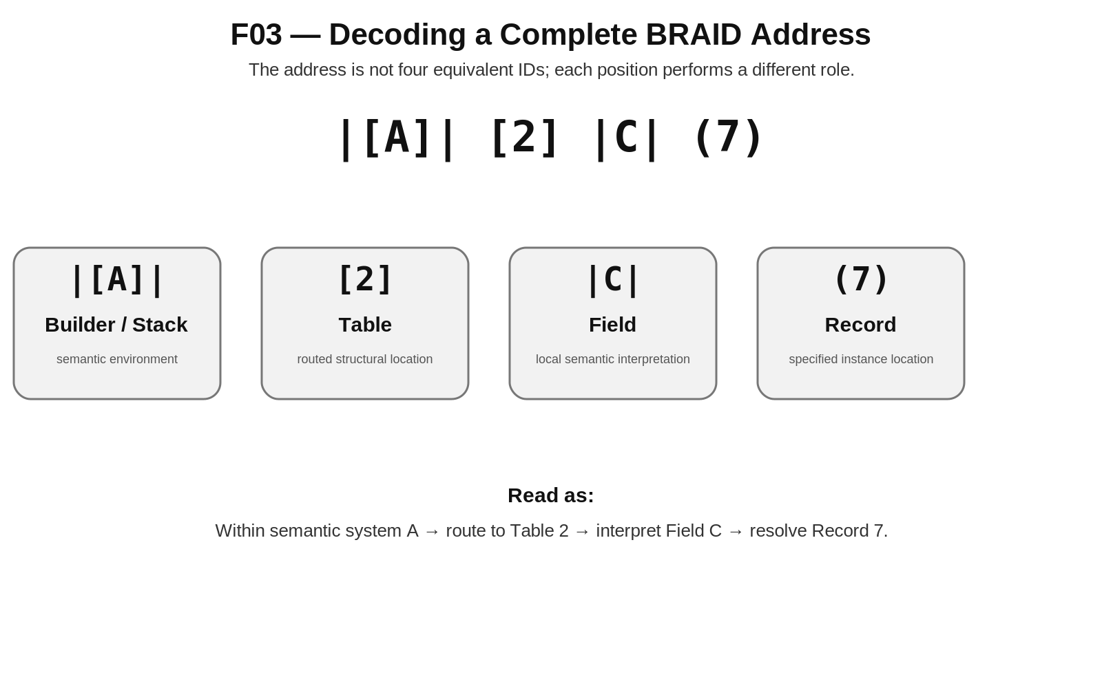
Figure 3. Decoding a Complete BRAID Address

3. The Semantic-Locational Braid
The name BRAID describes the interleaving of two role types. The semantic strand carries the meaning of the construction: the Stack establishes broad context and the Field establishes local meaning. The locational strand carries where work is occurring: the Table routes to a bounded location and the Record specifies an instance. The two strands are not separate stores. They are two interpretive roles woven through one graph grammar.
SEMANTIC STRAND: |[ Stack ]| ───────── | Field |
LOCATIONAL STRAND: [ Table ] ───────── ( Record )

This yields the core reading rule: letters interpret; numerals locate. A complete address such as |[A]| [2] |C| (7) can therefore be read as: within semantic scope A, route to Table 2, interpret Field C, and resolve Record 7. BRAID uses this distinction repeatedly so that what something means is never silently equated with where it happens to live.
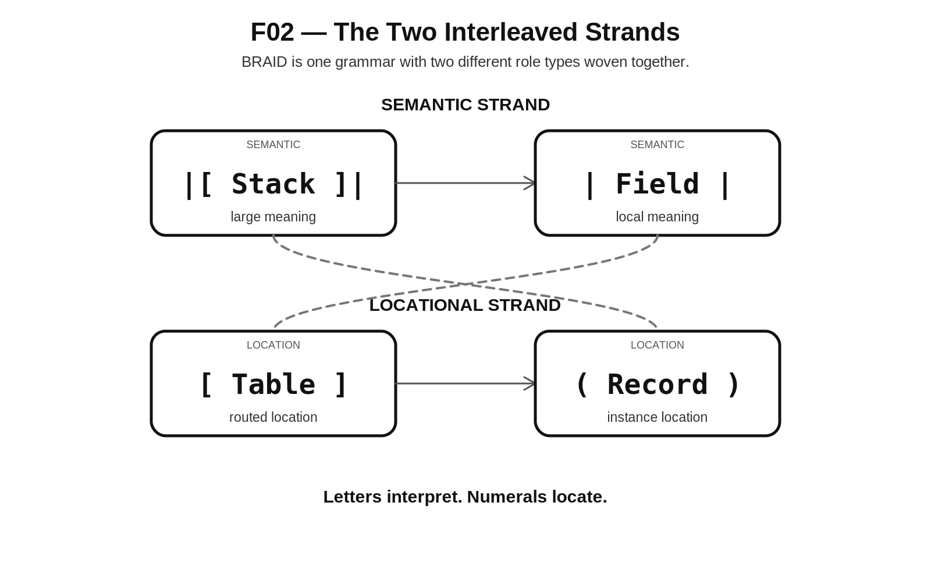
Figure 2. The Two Interleaved Strands
INVARIANT Meaning and location remain orthogonal. Structural address may tell BRAID where to read or write, but semantic interpretation determines what that state means.

PART II - BOUNDED ASSEMBLY

4. The Bounded Table Execution Contract
The Table is BRAID's minimum bounded execution surface. A Table may contain many domain Fields and Records, but its construction responsibility must remain finite enough that completion can be evaluated. This does not require every Table to be small. It requires the Table to have a bounded purpose and an explicit way to determine whether that purpose has been satisfied.
A generic BRAID Table needs enough orchestration information to answer five questions: what am I responsible for resolving; what approved state may I read; what am I allowed to write; what constitutes completion; and where does a completed result route next. These responsibilities can be represented as dedicated control Fields, linked contracts, Stack metadata, or another governed mechanism. BRAID v0.1 does not mandate one universal field layout.
Contract dimension | Requirement
Bounded responsibility | The finite construction problem owned by the current Table.
Allowed inputs | The upstream graph state, Fields, and Records the Table may read.
Write authority | The state the operation is permitted to create or mutate.
Completion condition | The test that determines whether advancement is allowed.
Next route | The permitted downstream location or terminal output reached after completion.

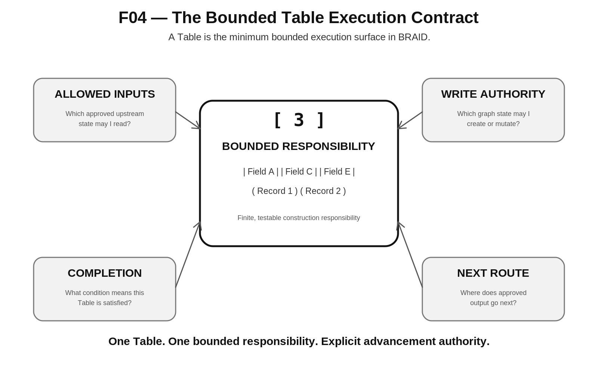
Figure 4. The Bounded Table Execution Contract
BOUNDED TABLE PRINCIPLE One Table owns one finite, testable construction responsibility. Domain complexity may be deep, but the current execution boundary must remain inspectable.

5. Completion-Gated Routing
BRAID separates route order from advancement authority. Numbering can identify the intended order in which Tables become eligible, but a Table does not advance merely because a next number exists. The current responsibility must satisfy its completion contract. This prevents a partially resolved or invalid state from silently becoming the input to later work.
[2] → completion check
FAIL → remain in [2], resolve or repair
PASS → route to [3]

The exact completion-state vocabulary may vary by Builder. A review-heavy publication process may use READY FOR REVIEW and APPROVED; a deterministic calculation may simply distinguish ACTIVE, COMPLETE, and BLOCKED. BRAID requires explicit advancement permission, not one universal state machine.
Candidate state | Typical interpretation
NOT STARTED | The bounded responsibility has not been entered.
ACTIVE | Work is currently being resolved.
READY FOR REVIEW | Required work exists but human or governed review remains.
APPROVED / COMPLETE | The Table has permission to advance.
BLOCKED | A missing input, permission, or dependency prevents completion.
STALE | Previously valid state has been invalidated by an upstream change.
REOPENED | A completed responsibility has been intentionally returned to active work.

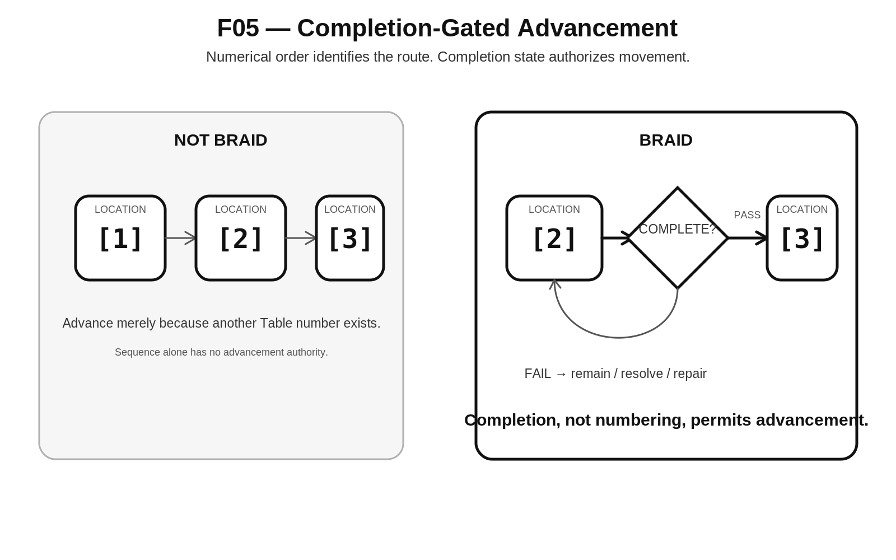
Figure 5. Completion-Gated Advancement

6. Passes as Bounded Execution Cycles
BRAID generalizes the idea of a Pass. A Pass is not intrinsically a content stage, a figure stage, or any other domain-specific label. It is one bounded attempt to satisfy the completion contract of a target Table. OctoGroove can therefore be understood as one configured BRAID implementation whose Tables happen to correspond to document-production responsibilities.
A Pass begins by resolving the target Table, reading only the approved upstream state required for that responsibility, performing the bounded reasoning or deterministic operation, writing the result into the graph, and evaluating completion. If the completion condition passes, the route advances. If it fails, the current responsibility remains active or enters repair.
PASS TARGET: [4]
READ: [1 | B,D] [2 | A,C,E] [3 | F]
RESOLVE: bounded responsibility of [4]
WRITE: [4](...)
VALIDATE: completion contract
ROUTE: [5]

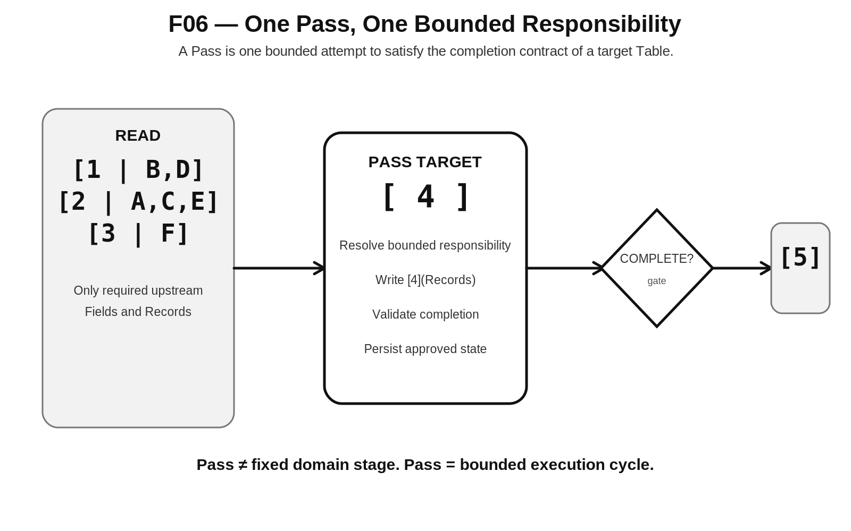
Figure 6. One Pass, One Bounded Responsibility

7. Selective Semantic Retrieval and Context Economy
Selective Field reading is one of BRAID's most important controls for AI-assisted construction. The Graph Fabric may hold far more state than the current operation needs. BRAID therefore treats available context and required context as different objects. A route such as [2 | A,C,E] means: enter Table 2, but expose only Fields A, C, and E to the bounded operation.
This narrows reasoning without destroying reachability. Fields B, D, F, and G still exist in the Table and remain available to other responsibilities. They are simply omitted from the current read. The result is a form of explicit context budgeting: the graph carries the larger project, while each operation works from the smallest governed semantic slice sufficient to solve its task.
[2 | A,C,E]
Route to Table 2.
Read only semantic Fields A, C, and E.
Leave B, D, F, and G available but outside the current reasoning context.

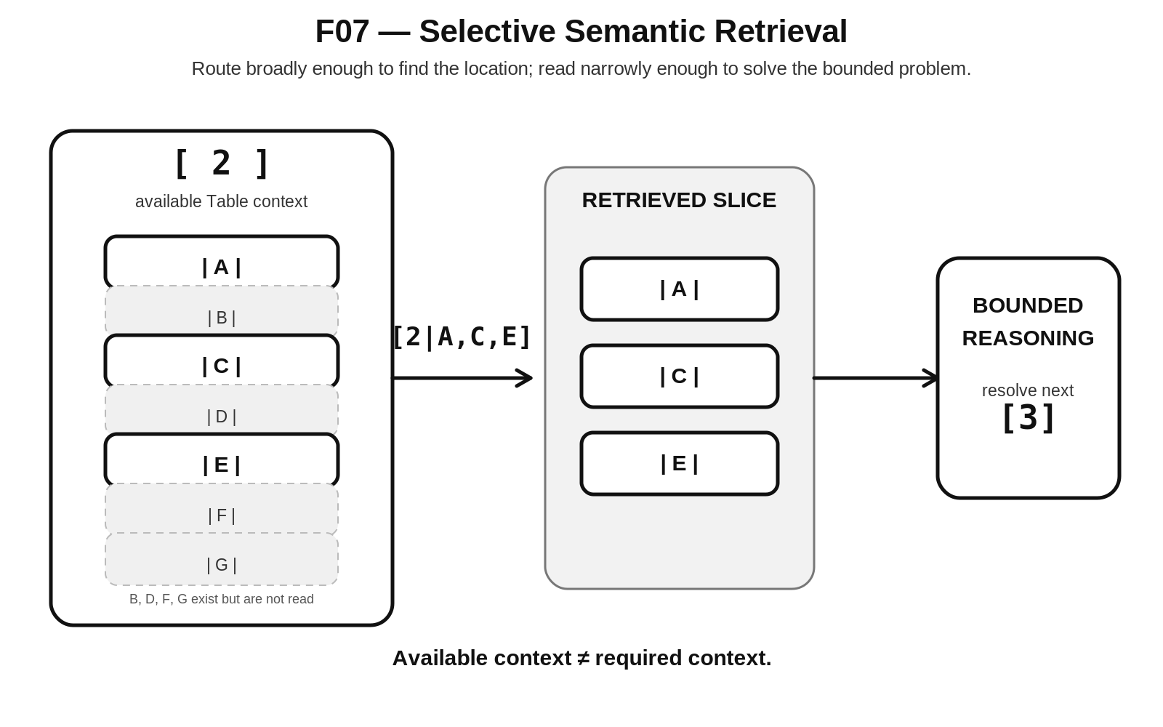
Figure 7. Selective Semantic Retrieval
CONTEXT ECONOMY Route broadly enough to find the correct location; read narrowly enough to solve the bounded problem.

8. Persistent Resolution and Externalized Build Memory
BRAID assumes that useful resolution should become persistent graph state rather than remaining only in transient model context. The execution rhythm is therefore resolve, write, persist, and release. Later operations retrieve the prior resolution from the graph instead of relying on a model to reconstruct every earlier decision from conversation history.
This changes the role of the language model or other intelligence. Working context becomes a temporary reasoning surface rather than the authoritative long-term memory of the build. The Graph Fabric becomes the durable state of the construction. Human corrections, approved outputs, linked dependencies, and completion results can therefore survive across sessions, models, and implementations.
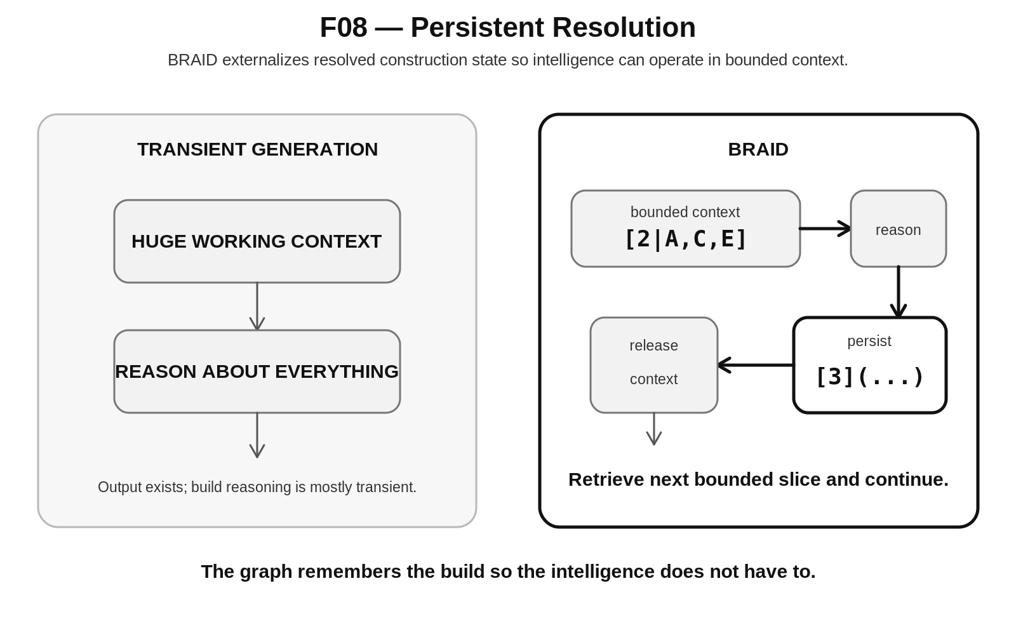
Figure 8. Persistent Resolution
PERSISTENCE PRINCIPLE The graph remembers the build so the intelligence does not have to.

PART III - RECURSIVE GRAPH CONSTRUCTION

9. Sequential Execution Over Graph Data
BRAID can keep the reasoning frontier simple without forcing the information structure itself to become linear. Tables may execute in a governed sequence while their Records branch, converge, cross-link, and serve multiple downstream consumers. This distinction is critical: sequential execution is a control property; graph shape is a data property.
A Builder can therefore say that Table 3 may not execute until Table 2 is complete while still allowing multiple Table 2 Records to feed several Table 3 and Table 4 Records. Approved feedback relations may also exist when a domain requires iterative refinement. The method only requires that the control semantics remain explicit enough that a loop cannot be mistaken for accidental circular dependency.
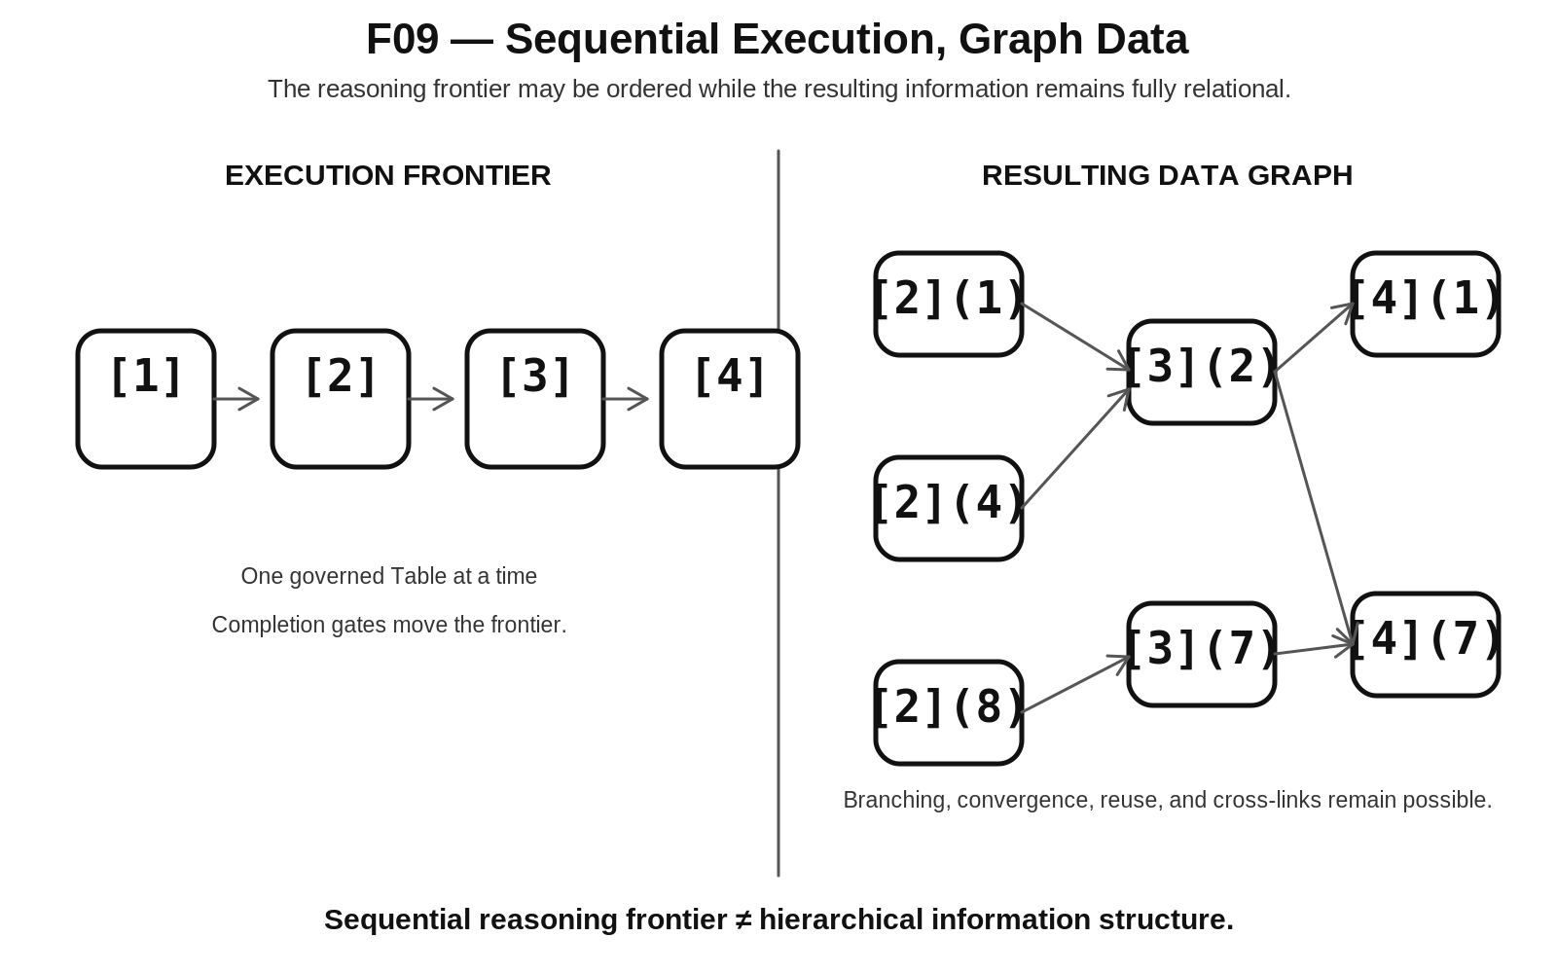
Figure 9. Sequential Execution, Graph Data
NON-COLLAPSE Sequential reasoning frontier does not equal hierarchical information structure.

10. Recursive Reachability and Linked Datafields
BRAID favors reachability over repeated embedding. A high-level Record should not copy every lower-level fact that might eventually be needed. Instead, it should link to the bounded child Records or knowledge objects that own that complexity. The parent remains compact while deeper semantics remain traversable.
This matters for reuse. A single low-level object can serve many higher-level parents without duplicating its identity or semantics. In a future training Builder, an annual program might link to workout slots, which link to workouts, which link to prescriptions, which link to canonical exercise knowledge. The annual schedule does not need to embed anatomy, equipment, technique, and variation data merely because those facts remain reachable.
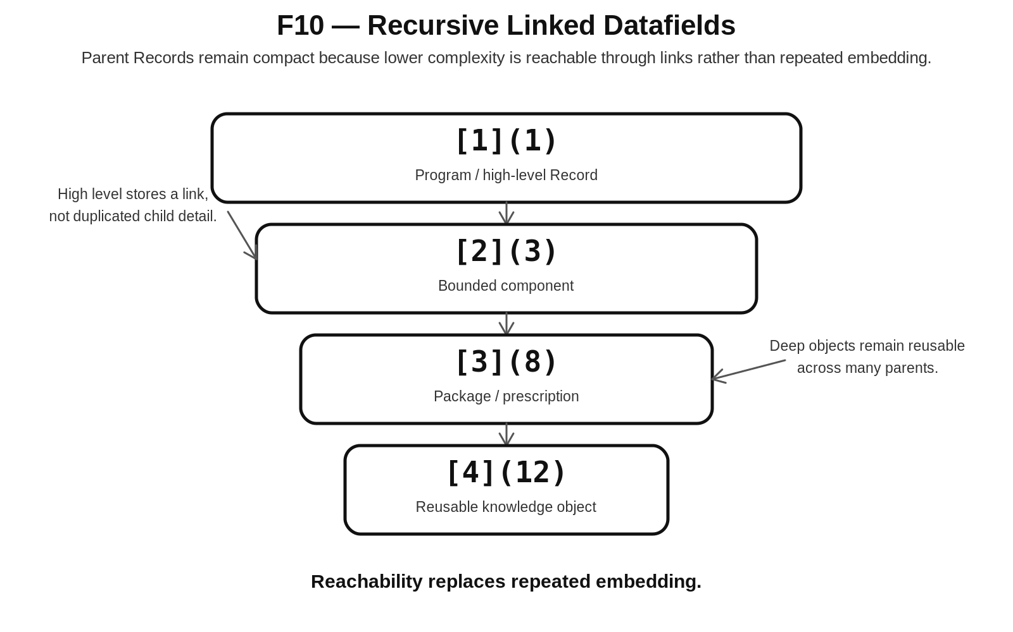
Figure 10. Recursive Linked Datafields
RECURSIVE REACHABILITY Complexity should be reachable through governed relations rather than repeatedly embedded into parent Records.

11. Derived State and Derivation Economy
BRAID distinguishes authored source state from deterministically recoverable manifestations. Where a rule, mask, or structured value can reliably generate many instances, storing every manifestation as separately authored truth can create unnecessary duplication and synchronization risk. The preferred pattern is to store the generative structure and derive manifestations when needed.
TIME-32 provides a concrete CERBERUS-native example. Ordinary recurrence is factored through Month Set, Week Set, and Phase Set. Selecting Months 0 and 1, all three Weeks, and the two mirrored Phases ○ and □ yields 2 x 3 x 2 = 12 ordinary positions. Those twelve positions do not need twelve independent authored event rows merely to preserve the recurrence. The intercalary branch remains separate.
Month Set {0,1}
× Week Set {−, =, ≡}
× Phase Set {○, □}
= 12 ordinary positions
Grouped TIME-32 payload:
1100000000 | 111 | 100000100000 | 000000 | 1

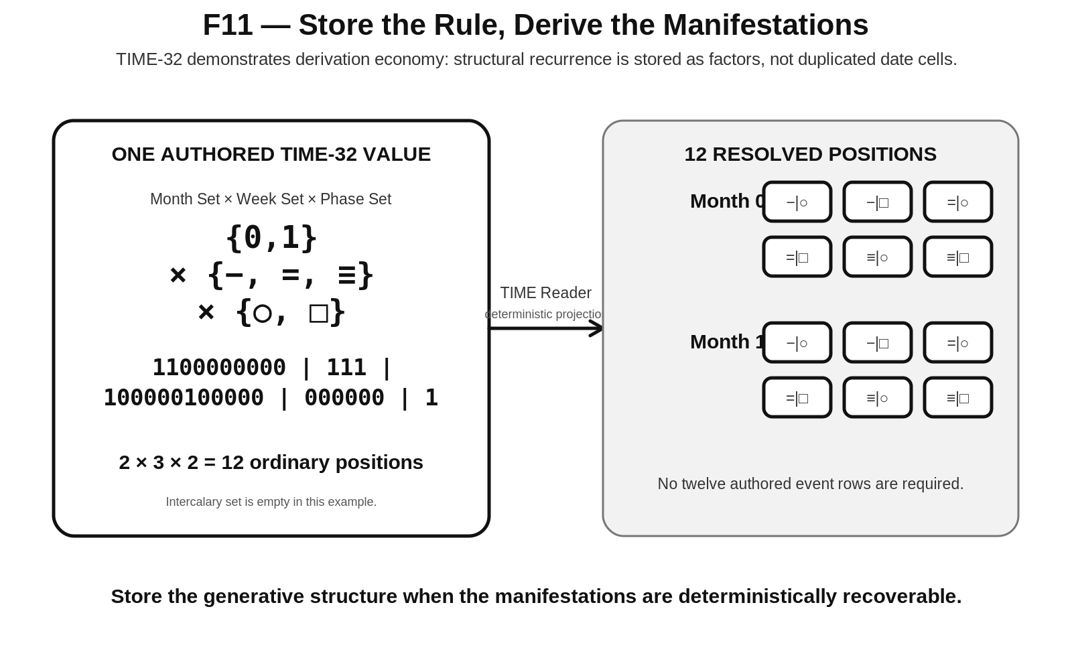
Figure 11. Store the Rule, Derive the Manifestations
DERIVATION ECONOMY Store the generative structure when the manifestations are deterministically recoverable.

PART IV - CERBERUS INTEGRATION

12. BRAID and SPINE Output Scope
BRAID and SPINE solve adjacent but different problems. BRAID governs how a result is recursively constructed. SPINE governs what structural scope a Stack publishes across its boundary and how that output can participate in Base-level planning. The distinction must remain explicit because internal construction complexity does not determine the type of output that a consumer sees.
The current SPINE specification defines three output Classes. Class 1 publishes a canonical typed field-level result. Class 2 publishes a governed Table projection identified through selected Fields. Class 3 publishes one or more complete operational Stacks. BRAID does not introduce a fourth Class and does not reinterpret Record as an output Class. Record remains the specified instance within the structural grammar.

SPINE Class | Published scope | BRAID implication
Class 1 | | Field | | A complex BRAID can resolve to one compact typed value.
Class 2 | [ Table ] + governed Fields | BRAID may construct a structured table projection for downstream use.
Class 3 | |[ Stack ]| | BRAID may yield a complete recursive Stack environment.

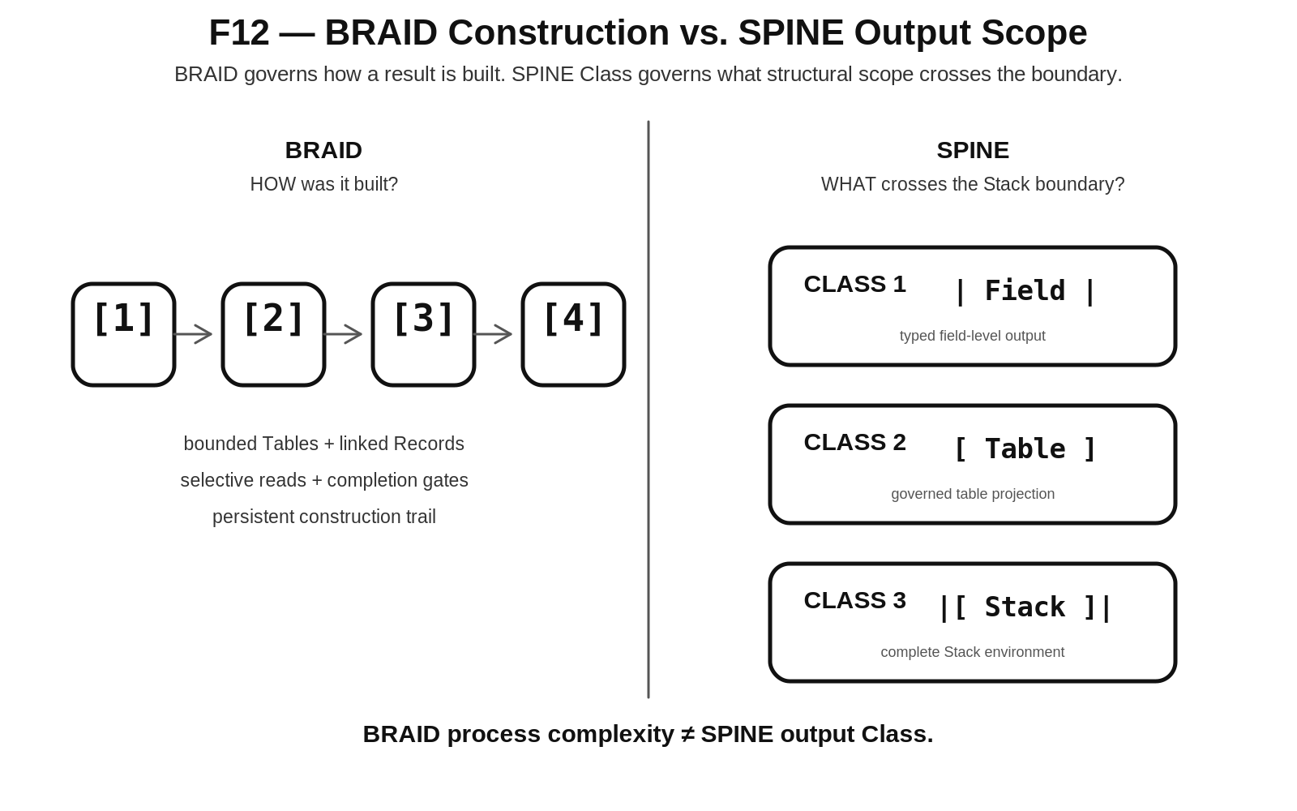
Figure 12. BRAID Construction vs. SPINE Output Scope
OUTPUT-SCOPE SEPARATION BRAID construction complexity does not determine SPINE output Class.

13. BRAID Within the CERBERUS Graph Fabric
BRAID operates within a larger architecture of distinct responsibility owners. CERBERUS governs registry truth, permissions, identity, and execution authority. BIGFOOT supplies semantic identities and operational terminology. BOSS supplies symbolic and operational semantic representation. VISOR owns structural topology and orientation. SPINE exposes Stack output contracts and Base-level planning. DARTBOARD resolves runtime manifestation. BRAID supplies the bounded recursive construction method that can operate through this governed fabric.
This is a responsibility map, not a claim that every operation travels through these systems in one fixed linear order. Different tasks may consult different owners at different times. The important constraint is that BRAID must not silently absorb responsibilities already owned elsewhere. It can read, route, and write through governed relations while leaving source authority intact.
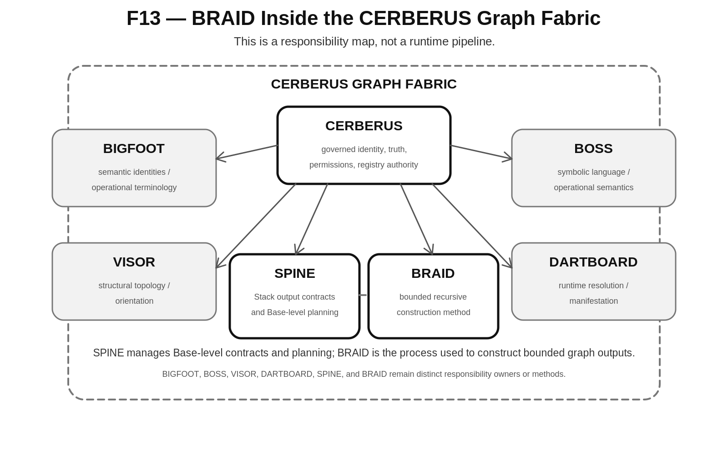
Figure 13. BRAID Inside the CERBERUS Graph Fabric

14. Construction Trails and Provenance
A BRAID result should be able to explain how it came to exist. The construction trail is the traversable relation set connecting the final result to the Tables, selected Fields, resolved Records, prior state, completion decisions, and approvals that contributed to it. This is stronger than a chronological log because the trail follows actual dependency and derivation structure.
A construction trail supports questions that ordinary output files cannot reliably answer: why was this element included; which upstream Field was read; which Record supplied this value; which earlier state was responsible; and where should a correction begin. Because the trail is part of the graph, it can be traversed selectively rather than reconstructed by model memory.
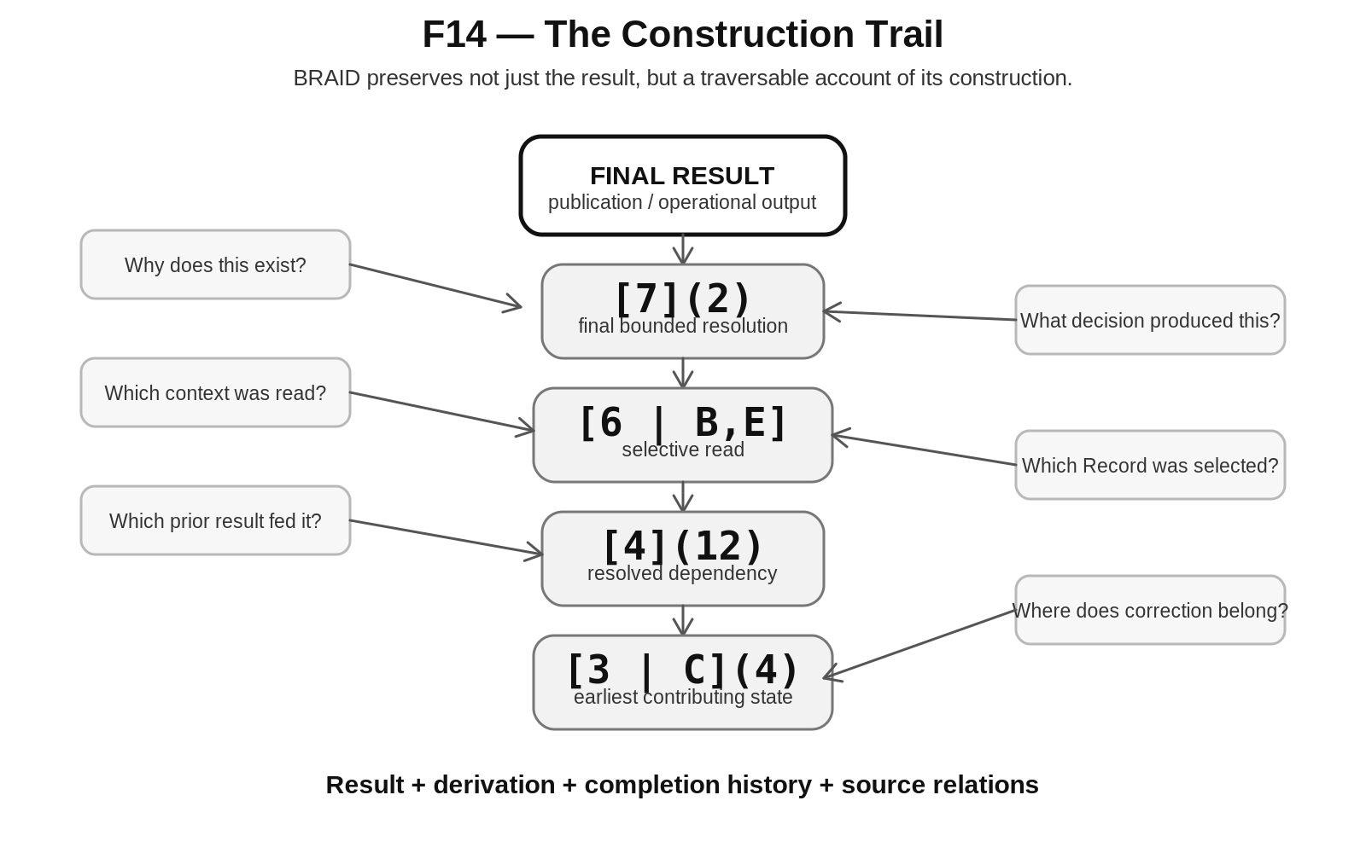
Figure 14. The Construction Trail
TRACEABLE CONSTRUCTION BRAID preserves not just the result, but a traversable account of its construction.

15. Earliest-Owner Repair and Selective Staleness
When a downstream manifestation is wrong, BRAID directs repair toward the earliest graph state that actually owns the error. Patching only the final output may hide the symptom while leaving every dependent branch incorrect. Source-level correction lets the dependency graph determine what must be rebuilt.
After the source is corrected, descendants that depend upon the changed state become stale. Unaffected branches remain valid. This creates a selective rebuild frontier rather than requiring whole-project regeneration. The same provenance that answers why a result exists therefore also answers which results are no longer trustworthy after a correction.
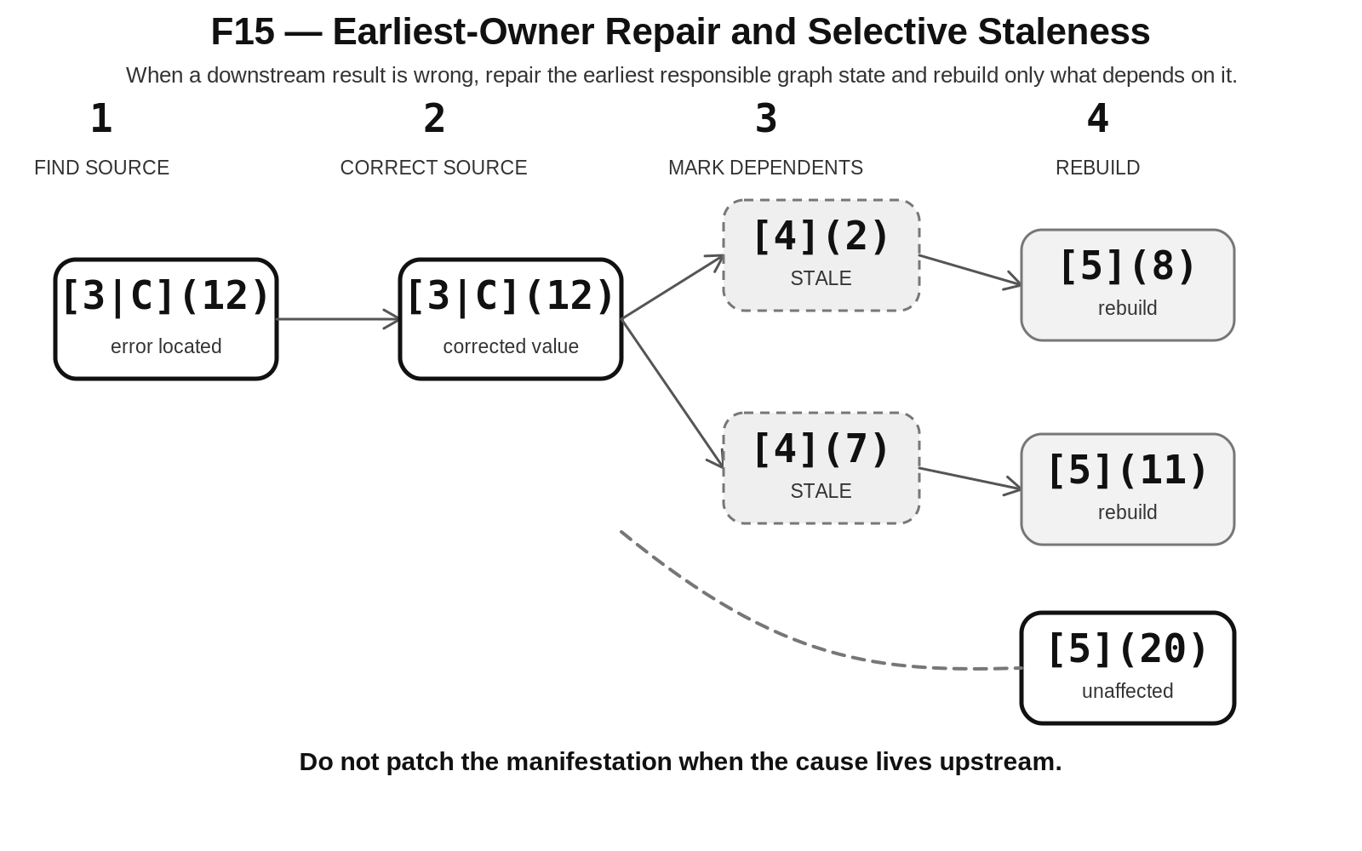
Figure 15. Earliest-Owner Repair and Selective Staleness
REPAIR RULE Do not patch the manifestation when the cause lives upstream.

16. Platform Independence
BRAID is defined by its semantic roles and execution laws, not by an application. Airtable can express linked records, formulas, contracts, and review interfaces. Excel can express a portable local Builder with tables, formulas, and explicit routing. Graph or relational databases can provide persistent structured runtimes. A future CERBERUS-native platform can implement the same contracts directly.
Platform-specific limitations must therefore be classified as implementation friction rather than silently rewritten into BRAID principles. If one prototype requires a helper Table because of an Airtable formula limit, that workaround belongs to the implementation unless the same need appears across independent platforms and domains.
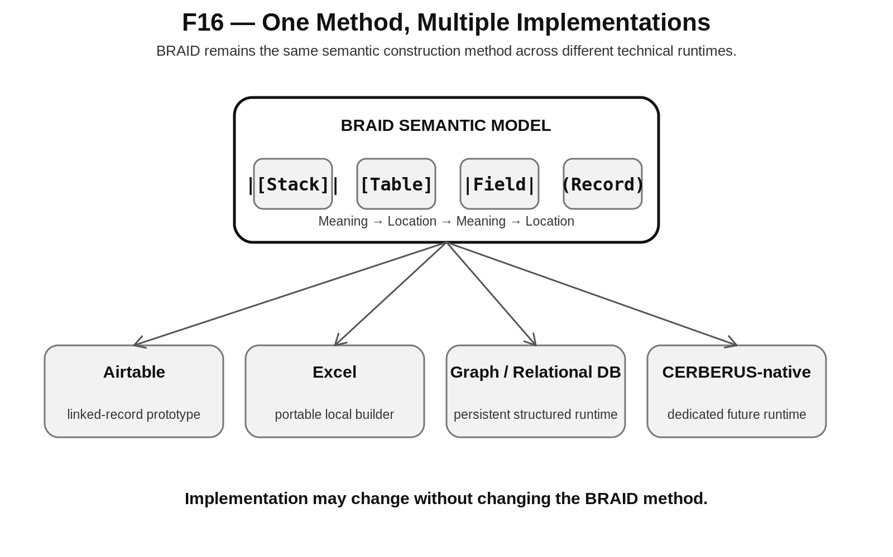
Figure 16. One Method, Multiple Implementations
PORTABILITY The platform manifests BRAID; the platform does not define BRAID.

PART V - EXPERIMENTAL VALIDATION

17. Three-Domain Experimental Program
BRAID v0.1 is a hypothesis to be tested through independently useful domain implementations. The first three tests are deliberately different: physical training, meal planning, and gardening. A method that only fits document assembly may simply be a document workflow in disguise. A method that survives temporal, physiological, nutritional, resource, spatial, and biological relations earns stronger evidence that its abstraction is genuinely broader.
Domain | Primary stresses | What success should look like
Workout | Temporal recurrence; physiological relations; performance prescription; progression; planned vs observed state | Program logic remains compact while workouts, prescriptions, observations, and progression remain deeply linked and temporally addressable.
Meal | Temporal placement; nutrition; recipe composition; inventory; resource and substitution logic | Meals can be assembled from linked ingredients and recipes while preserving nutrition, inventory, cost/resource, and demand relations without duplicating truth.
Garden | Spatial addressing; temporal growth; biological relations; soil/water/resources; harvest and yield | Planting instances remain spatially and temporally addressable while biological and resource relations remain reachable through the graph.

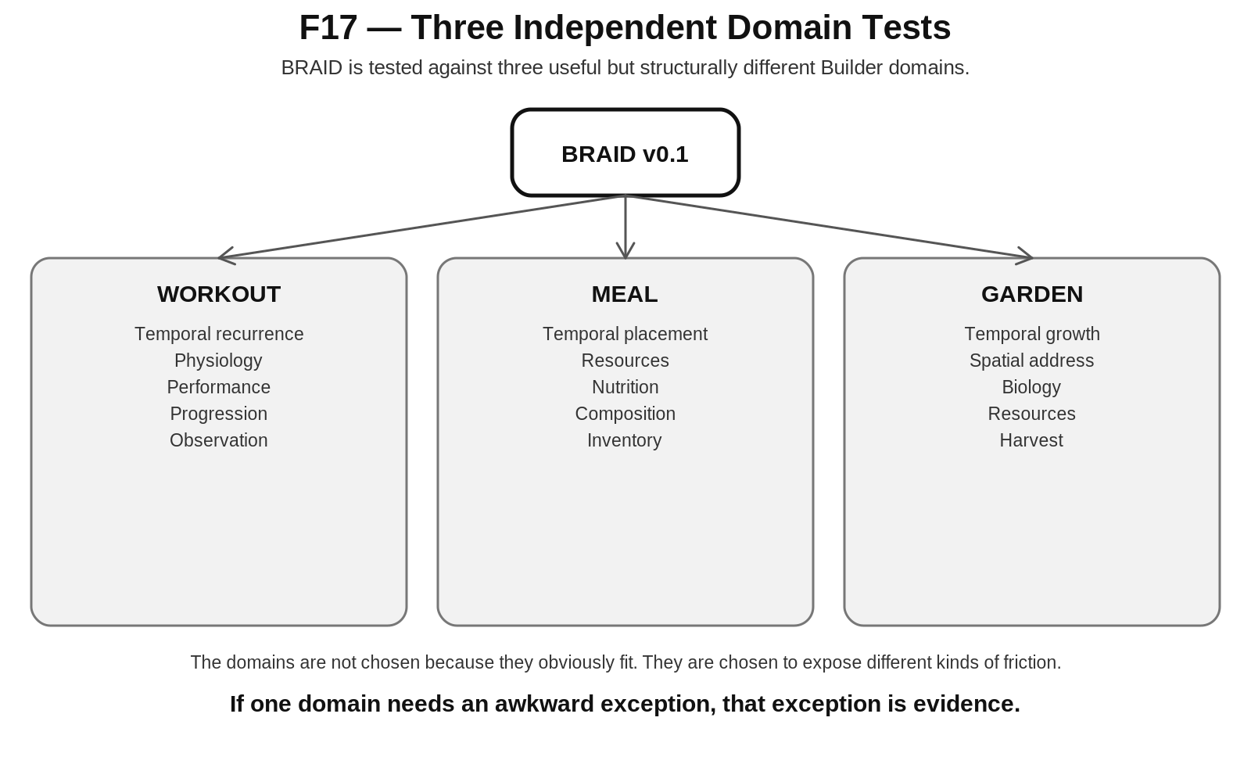
Figure 17. Three Independent Domain Tests
The domain papers should therefore be treated as experiments against BRAID, not as demonstrations guaranteed to succeed. If Garden naturally demands multiple simultaneous routes, or Meal completion lives at a different scope than expected, or Workout progression requires a feedback form not captured by the current method, that friction becomes evidence to classify and investigate.

18. Falsification and Revision
BRAID development must distinguish three kinds of friction before changing the method. Domain detail is a legitimate requirement unique to the problem area. Implementation friction is caused by the prototype technology or deployment environment. BRAID principle failure occurs only when the general method itself cannot express or govern the required construction without an awkward exception.
This classification prevents the abstraction from becoming a dumping ground for every local difficulty. If a principle fails, the exact principle should be revised and the change should be explicit. The new BRAID version must then be retested across all prior domain experiments. A fix that helps one domain but breaks another is not a general repair.
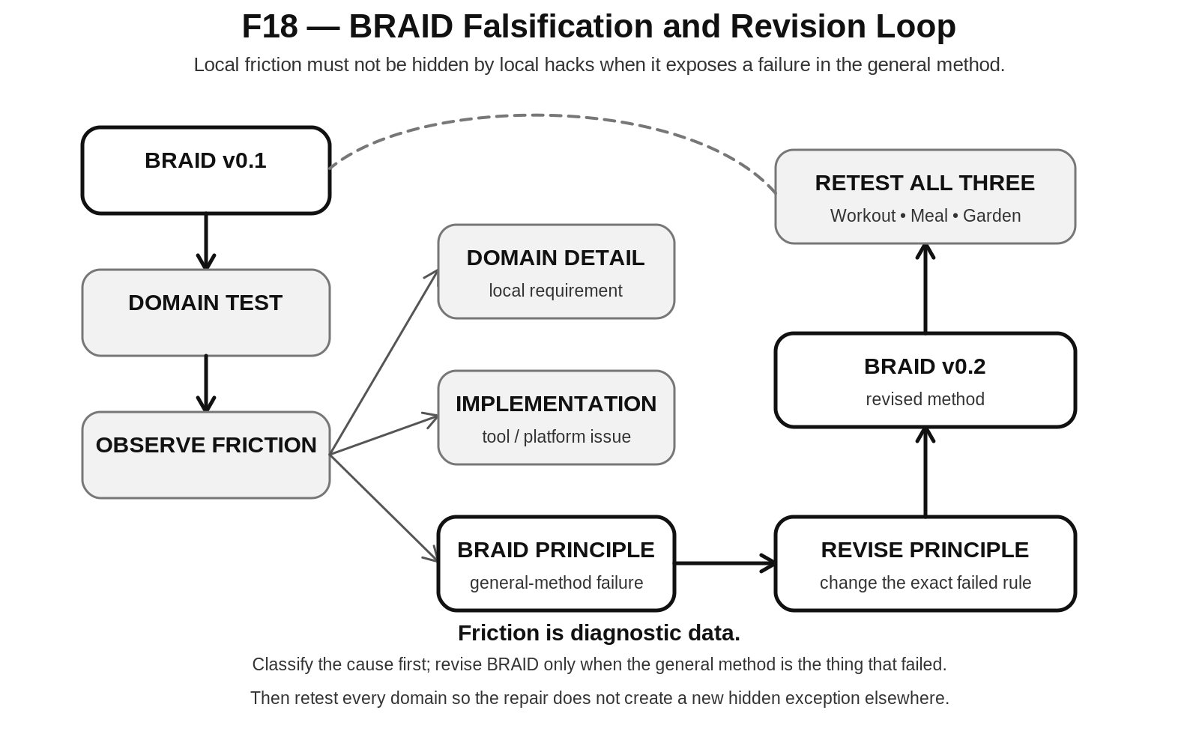
Figure 18. BRAID Falsification and Revision Loop
SCIENTIFIC DISCIPLINE Local friction must not be hidden by local hacks when it exposes a failure in the general method.

19. Future Data-Defined Builders
If the core BRAID principles survive independent domain tests, a future implementation may be able to define Builders as data. A Builder definition could identify its entry Table, available Tables, required reads, completion contracts, routes, and output contract. A generic runtime could then interpret that definition and execute the same bounded construction semantics across many domains.
This is a future implication rather than a v0.1 requirement. BRAID should first prove that its bounded responsibilities, selective reads, completion gates, persistence model, and provenance rules remain stable across domain implementations. Only then is it useful to ask whether Builder definitions can become portable executable contracts.
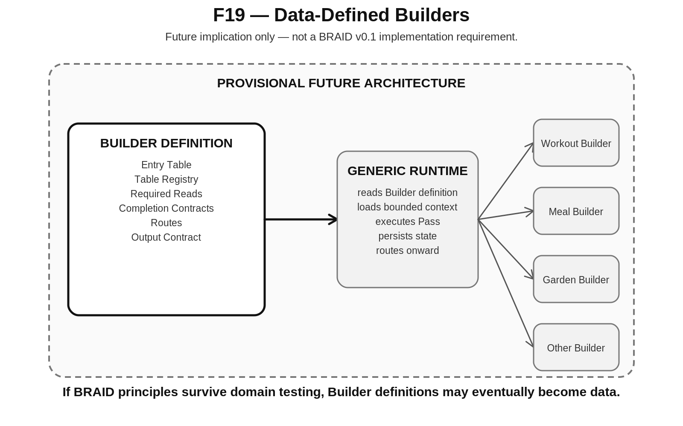
Figure 19. Data-Defined Builders
STATUS Data-defined Builders are a future hypothesis. They are not required for BRAID v0.1 compliance.

PART VI - FORMAL METHOD

20. Formal Principles and Non-Collapse Laws
BRAID is intentionally governed by a small set of principles rather than one mandatory implementation schema. The principles define what must remain true even as domain Fields, state vocabularies, review models, and platforms diverge.
ID | Principle | Normative statement
BRAID-P01 | Semantic-Locational Alternation | Letters express semantic interpretation; numerals express routing or instance specification.
BRAID-P02 | Structural Non-Collapse | Stack, Table, Field, and Record remain distinct structural roles.
BRAID-P03 | Bounded Table Responsibility | Every executing Table owns a finite and testable construction responsibility.
BRAID-P04 | Completion-Gated Advancement | Execution may route onward only after the current Table reaches an allowed completion state.
BRAID-P05 | Explicit Routing | The graph, not transient model memory, determines where execution proceeds.
BRAID-P06 | Selective Semantic Retrieval | An operation should retrieve only the Fields and Records required for its bounded responsibility.
BRAID-P07 | Persistent Resolution | Useful completed reasoning is written into persistent graph state.
BRAID-P08 | Sequential Execution / Graph Independence | Ordered execution does not imply hierarchical or linear data structure.
BRAID-P09 | Recursive Reachability | Higher-level Records should reach deeper complexity through governed relations rather than unnecessary duplication.
BRAID-P10 | Derivation Economy | Deterministically derivable manifestations should not automatically become separately authored truth.
BRAID-P11 | Traceable Construction | Outputs should retain traversable relations to the state and operations that produced them.
BRAID-P12 | Source-Level Repair | Corrections should occur at the earliest responsible graph state, with affected descendants rebuilt as necessary.
BRAID-P13 | Output-Scope Separation | BRAID construction complexity does not determine SPINE output Class.
BRAID-P14 | Empirical Revision | Domain implementations test BRAID principles; friction must be attributed and used to revise the method rather than hidden through local exceptions.

Non-collapse laws
Category | Non-collapse laws
Semantic and structural | Meaning != location; Stack != Table; Table != Field; Field != Record; Record identity != Record meaning.
Execution and data | Table order != semantic hierarchy; sequential execution != linear data; completion != mere output existence; route != semantic relationship.
Authority and state | Read permission != write authority; derived manifestation != authored source; construction trail != final artifact.
Integration | BRAID process != SPINE Class; internal complexity != output scope; Graph Fabric != BRAID execution; BRAID != storage platform.
Repair and learning | Correction != final-output patch; successful output != understood success.

INTERPRETIVE RULE Whenever two concepts can vary independently, BRAID must not encode them as if they were the same thing merely for implementation convenience.

21. Minimum Implementation Contract
A minimal BRAID implementation does not require a sophisticated runtime. It requires enough explicit state that a bounded operation can be reconstructed and audited. The following contract is sufficient for a first implementation test.
Minimum element | Purpose
Builder / Stack scope | The semantic environment that owns the construction.
Table identity and order | A stable routed location and its eligibility relation to other Tables.
Field definitions | The local semantics available at the Table.
Record identities | The specific instances created, read, or linked.
Allowed read set | The selected upstream state the current responsibility may retrieve.
Write target / authority | The state the current responsibility may create or mutate.
Completion contract | The condition that authorizes advancement.
Next route or terminal output | The next Table or final output reached on completion.
Dependency relations | Enough provenance to identify downstream staleness when an upstream source changes.
Execution receipt | A record of completion, approval, or failure sufficient to reconstruct the construction trail.

The implementation may add richer permissions, versioning, human review, confidence, transformation contracts, or domain-specific state. Those additions should extend the method without altering the core distinction between semantic meaning, routed location, persistent graph state, completion authority, and output scope.

22. Strategic Implications
BRAID changes the unit of AI-assisted construction from the monolithic prompt to the bounded graph responsibility. Instead of asking one model invocation to understand the whole project, remember every previous decision, infer the next step, and produce a finished artifact, BRAID externalizes the durable state and makes the current responsibility explicit. Intelligence becomes a resolver operating over governed graph state rather than the sole container of project memory.
This has implications beyond document production. A successful domain Builder can preserve the structure of why it worked: which inputs were read, which relations were followed, which Records were selected, which completion conditions passed, and which corrections occurred. Repeatedly successful trails may later become evidence for improving routing, templates, defaults, or domain guidance while remaining inspectable.
The method also creates a clean handoff between construction and publication. BRAID can build a result recursively; SPINE can expose that result as a typed Stack boundary; QUIVER and VISOR can present approved relations; DARTBOARD can resolve runtime manifestation; and CERBERUS can preserve governance and truth underneath. The method therefore fits into the wider architecture without requiring any neighboring system to surrender its responsibility.
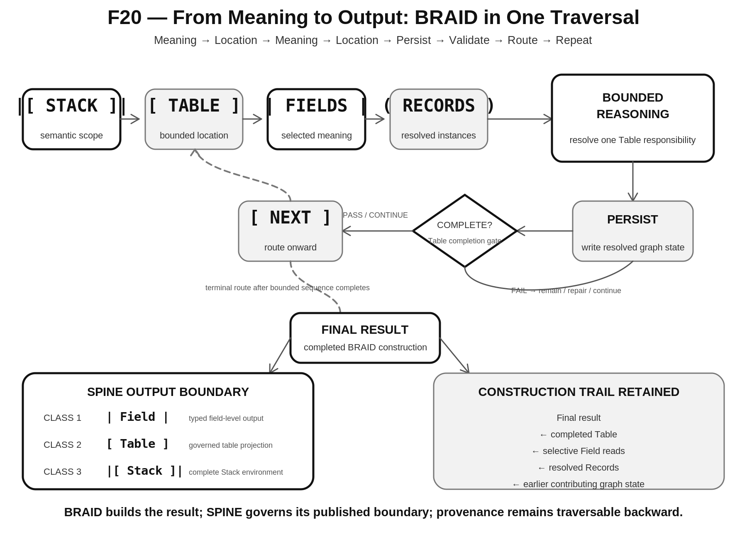
Figure 20. From Meaning to Output: BRAID in One Traversal
STRATEGIC SUMMARY BRAID builds the result. SPINE governs the published boundary. The Graph Fabric preserves the construction. Provenance makes the result explainable and repairable.

APPENDICES

Appendix A. Primitive Grammar and Notation
Notation | Name | BRAID interpretation | Example question
|[ A ]| | Stack / Builder scope | Large semantic environment | What construction am I inside?
[ 2 ] | Table | Bounded routed location | Where am I working?
| C | | Field | Local semantic meaning | What does this value mean here?
( 7 ) | Record | Specified instance | Which instance am I reading or writing?
[2 | A,C,E] | Selective Table read | Projection of selected Fields from one Table | Which semantic slice is required for this operation?

Canonical BRAID address:
|[A]| [2] |C| (7)
Reading:
Within semantic scope A → route to Table 2 → interpret Field C → resolve Record 7.

Appendix B. BRAID Principle Registry
ID | Name | Short test
BRAID-P01 | Semantic-Locational Alternation | Can meaning and location be read as distinct roles?
BRAID-P02 | Structural Non-Collapse | Are Stack, Table, Field, and Record still distinguishable?
BRAID-P03 | Bounded Table Responsibility | Can the current Table responsibility be stated and tested?
BRAID-P04 | Completion-Gated Advancement | Can advancement be denied when completion fails?
BRAID-P05 | Explicit Routing | Is the next route explicit in persistent state?
BRAID-P06 | Selective Semantic Retrieval | Can the operation retrieve only its required semantic slice?
BRAID-P07 | Persistent Resolution | Does useful resolution survive release of model context?
BRAID-P08 | Sequential Execution / Graph Independence | Can graph data branch while execution remains governed?
BRAID-P09 | Recursive Reachability | Can deeper complexity be reached without parent duplication?
BRAID-P10 | Derivation Economy | Are derived manifestations distinguishable from authored truth?
BRAID-P11 | Traceable Construction | Can the output be traversed back to its contributing state?
BRAID-P12 | Source-Level Repair | Can a correction invalidate only dependent descendants?
BRAID-P13 | Output-Scope Separation | Can the same internal method publish different SPINE output scopes?
BRAID-P14 | Empirical Revision | Can domain friction revise the method through explicit evidence?

Appendix C. Non-Collapse Law Registry
- Meaning != location.
- Stack != Table.
- Table != Field.
- Field != Record.
- Record identity != Record meaning.
- Table order != semantic hierarchy.
- Sequential execution != linear data.
- Completion != mere output existence.
- Route != semantic relationship.
- Read permission != write authority.
- Derived manifestation != authored source.
- Construction trail != final artifact.
- BRAID process != SPINE Class.
- Internal complexity != output scope.
- Graph Fabric != BRAID execution.
- BRAID != storage platform.
- Correction != final-output patch.
- Successful output != understood success.

Appendix D. Experimental Evaluation Checklist
Evaluation dimension | Question
Boundedness | Can every execution step be assigned a finite responsibility without hiding essential work outside the graph?
Context control | Can each step state exactly which upstream Fields and Records it needs?
Completion | Can the system tell when a Table is complete, blocked, stale, or requires review?
Routing | Can forward movement and branches be represented explicitly without relying on model memory?
Persistence | Does useful resolution survive between sessions and model invocations?
Graph fit | Can domain relationships branch, converge, and recurse without forcing a tree or flat table?
Derivation | Can deterministic manifestations remain derived rather than duplicated as authored truth?
Provenance | Can a final result be traversed backward to its contributing state and decisions?
Repair | Can an upstream correction mark only dependent descendants stale?
Output boundary | Can the completed result publish through the correct SPINE Class without changing BRAID semantics?
Platform independence | Can the method be implemented on another platform without redefining the principles?
Friction classification | Can observed problems be separated into domain detail, implementation issue, or BRAID principle failure?
Retest discipline | After a principle revision, can all prior domains be rerun against the new version?

Glossary
Term | Definition
BRAID | Bounded Recursive Alphanumeric Interleaved Datafields; the Graph Fabric method defined by this specification.
Bounded responsibility | A finite construction problem owned by one executing Table.
Completion contract | The explicit condition that authorizes advancement from a bounded responsibility.
Construction trail | The traversable relation set connecting a result to the Tables, Fields, Records, state, and decisions that produced it.
Derivation economy | The principle of storing recoverable generative structure instead of duplicating every deterministic manifestation as authored truth.
Graph Fabric | The broader persistent relational substrate on which BRAID reads, writes, links, and preserves construction state.
Pass | One bounded attempt to satisfy the completion contract of a target Table.
Persistent resolution | Useful reasoning or deterministic output written into graph state so later operations need not reconstruct it from transient context.
Selective semantic retrieval | Retrieval of only the Fields and Records needed for the current bounded responsibility.
Source-level repair | Correction of the earliest graph state that owns an error, followed by selective downstream staleness and rebuild.
SPINE Class | The structural scope of a Stack output: Class 1 Field, Class 2 Table projection, or Class 3 complete Stack.
Stale | A previously valid state that can no longer be trusted because an upstream dependency changed.

References
1. CERBERUS SPINE - Stacked Planning Intelligence Network Explorer: Typed Output Contracts, Recursive Stack Composition, and Operational Planning Across CERBERUS. Version 1.0. August 2026.
2. CERBERUS TIME-32-64-96-128 Formal Semantic Kernel Specification. Version 0.1. August 2026.

