CERBERUS
HYDRATION POLICY
Adaptive Resolution, Fluid State, and Causal Closure
FORMAL MECHANISM SPECIFICATION | v0.1 | VERIFIED RELEASE
Hydrate what must be known.
Resolve what is changing.
Remember what remains consequential.
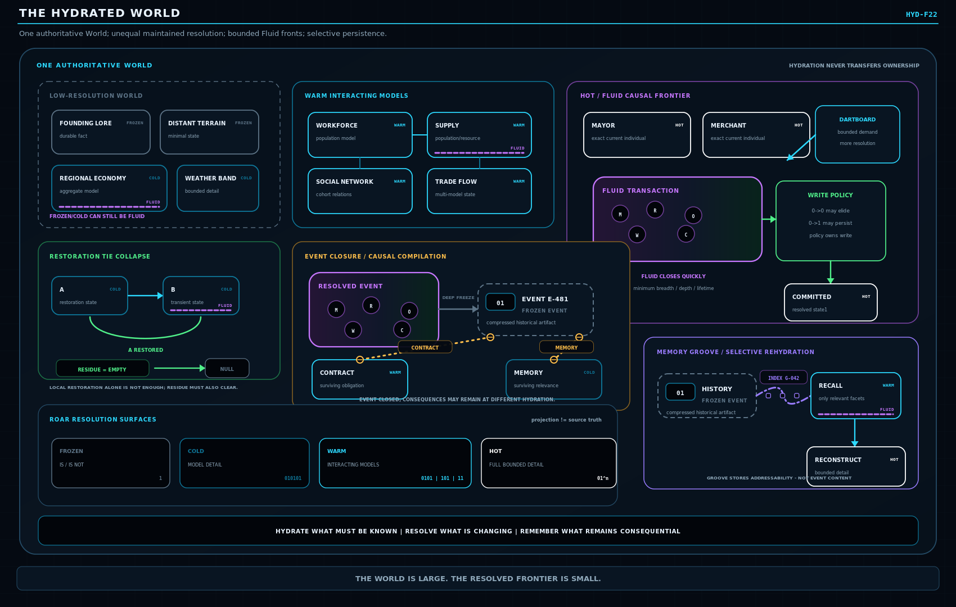
GENERAL MECHANISM SCOPE
This paper defines the general resolution, transition, persistence, and closure mechanism. Specialized character trauma, fear, phobia, and psychological tolerance mechanics are intentionally reserved for a companion application paper.

ABSTRACT
Persistent simulation does not require persistent maximum resolution.
CERBERUS Hydration Policy defines how a persistent semantic World may keep different regions at different levels of explicit resolution while preserving the information required for valid future behavior. Hydration answers how much state must currently be resolved. Fluidity answers whether the represented state is settled or still undergoing bounded causal resolution. These dimensions are orthogonal: Frozen, Cold, Warm, and Hot regions may each be Stable or Fluid.
The architecture treats Fluid State as temporary causal workspace rather than a place where the World permanently lives. Fluid episodes should resolve the smallest sufficient causal frontier, at the lowest sufficient semantic depth, for the shortest sufficient time. After resolution, Write Policy determines whether the result is persisted; Residual Ties determine which consequences remain relevant; Restoration Tie Collapse permits transient history to disappear when the affected causal scope has genuinely restored and no residue survives.
Hydration does not replace SCE World state, Rules, Operators, GROOVE, ROAR, DARTBOARD, Memory, or Causal Residue. It coordinates resolution demand across them while preserving source ownership and historical integrity.
GOVERNING THESIS
Persistent Worlds can remain mostly compressed, temporarily hydrate only the causal regions that require explicit resolution, and retain only those consequences that continue to matter.

Two-axis model
Dimension | Question | States
Hydration | How much semantic state must be explicitly resolved now? | Frozen / Cold / Warm / Hot
Transition | Is the currently represented state settled? | Stable / Fluid

Primary non-collapse boundary
HYDRATION != STATE VALUE | FLUID != BIT FLIP | COMPUTE != WRITE != EVENT != MEMORY
SECTION 01
The Hydration Problem
One authoritative World, unequal maintained resolution
A persistent World can be semantically large even when only a small portion of it must be explicitly resolved at any given moment. Treating every region as permanently maximally detailed wastes compute, storage, and causal attention. Treating compressed regions as absent, however, destroys continuity. Hydration Policy occupies the middle ground: the World remains authoritative while different semantic regions retain only the resolution required for valid current and future behavior.
Hydration is therefore not a second World graph. The active graph is simply the currently hydrated contour of the same World. A town may preserve most lore in Frozen form, maintain its economy as Cold statistical state, resolve population dynamics as Warm interacting models, and represent a particular mayor as Hot because an exact conversation or decision currently depends on that individual.
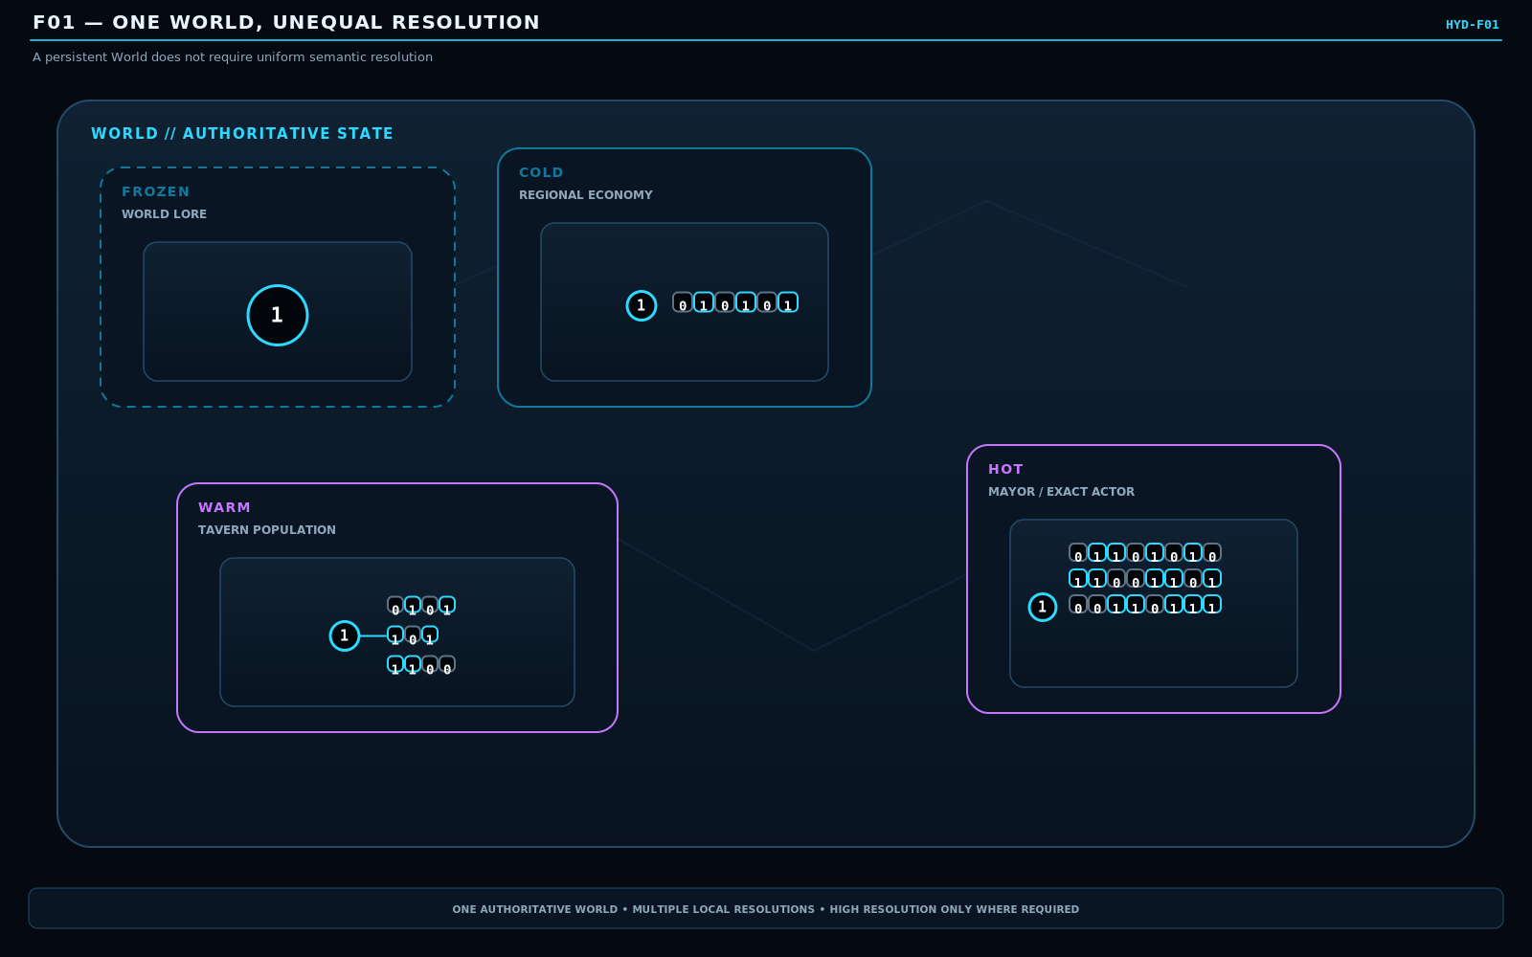
Figure 1. One World, Unequal Resolution. One authoritative World carries several maintained resolutions at once. High resolution is sparse and local to current causal demand.
SECTION 02
Hydration Is Resolution, Not State
The same semantic identity can be represented at different explicit depths
Promotion from Frozen toward Hot does not create a new object and does not, by itself, mutate World truth. It expands how much of an already-authoritative semantic region is explicitly represented. Demotion does the inverse: it retains less explicit detail while preserving enough information, constraints, or reconstruction support for future behavior.
This distinction is essential. A Frozen fact is not less true than a Hot fact, and a Hot object is not inherently more important. Hydration is a runtime resolution policy. Authority continues to belong to the underlying World or owning subsystem.
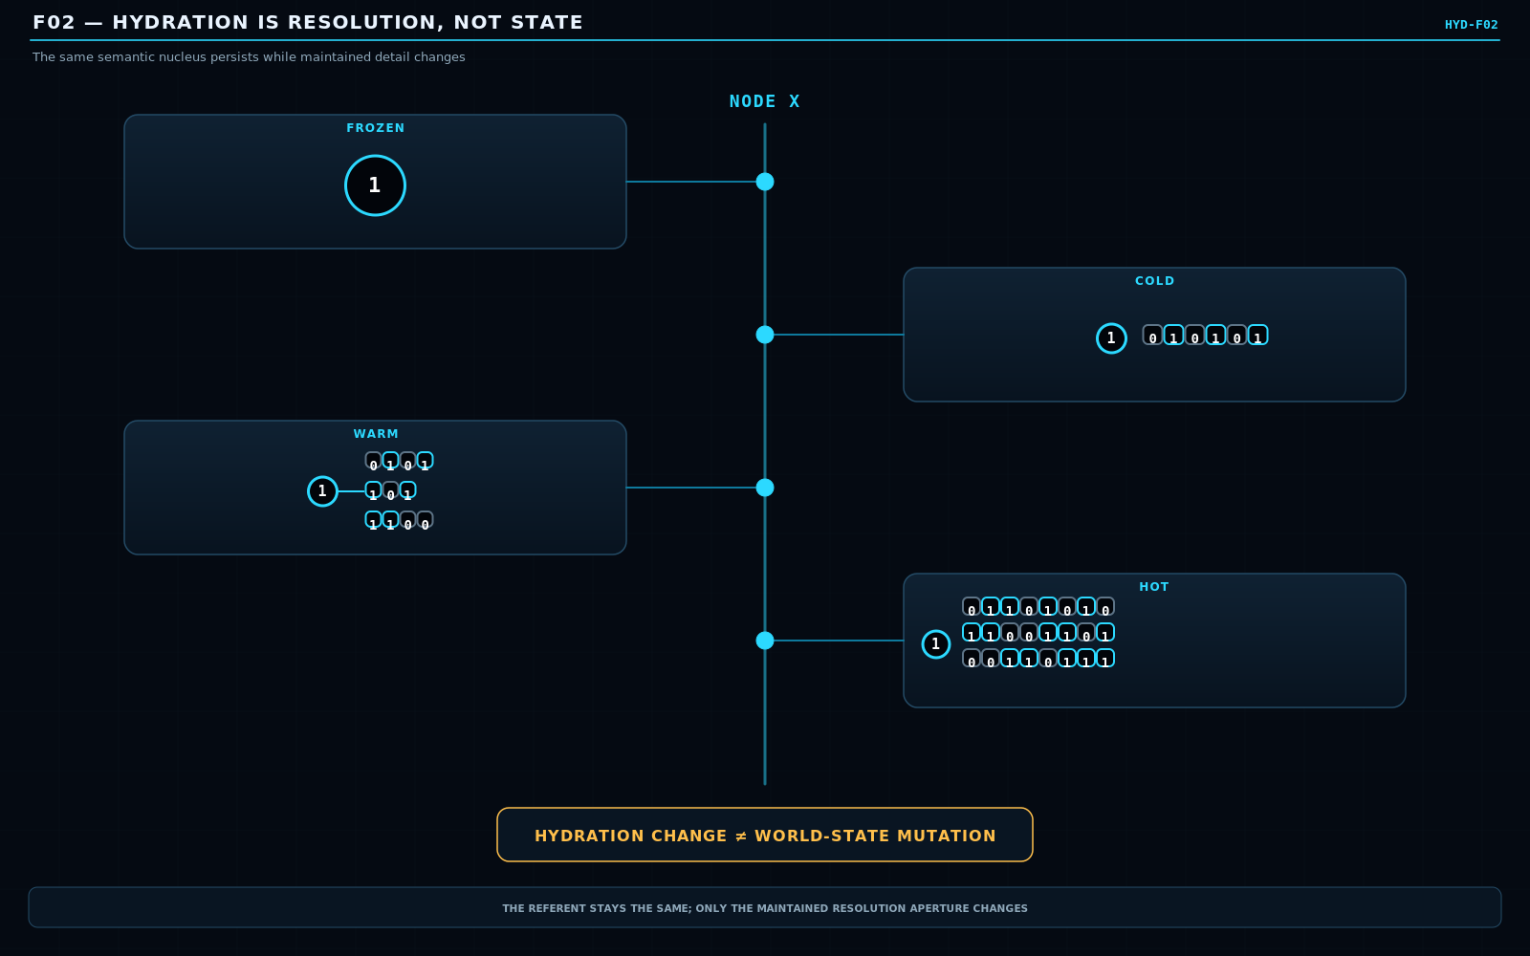
Figure 2. Hydration Is Resolution, Not State. A stable semantic nucleus persists while the amount of explicitly maintained detail changes around it.
SECTION 03
Frozen, Cold, Warm, Hot
A four-level resolution vocabulary
Level | Compact notation | Interpretation
Frozen | 0/1 | Minimal authoritative state sufficient to preserve the bounded fact or commitment.
Cold | 010101 | Important bounded details retained for background evolution or later reconstruction.
Warm | 010101 10101 1100 | Multiple relevant models or semantic regions are simultaneously resolved.
Hot | 01^n | Full bounded detail currently required to resolve the active question or interaction.

The notation is explanatory rather than a claim that every domain must literally store these exact strings. Its purpose is to make resolution visible: Frozen preserves the smallest sufficient state; Cold retains bounded detail; Warm resolves several interacting structures; Hot resolves the complete bounded detail required by the present causal problem.
Hot must never be interpreted as infinite detail. It is only the full detail required inside the current bounded scope. If a different question appears, a different region may hydrate and the former Hot region may cool.
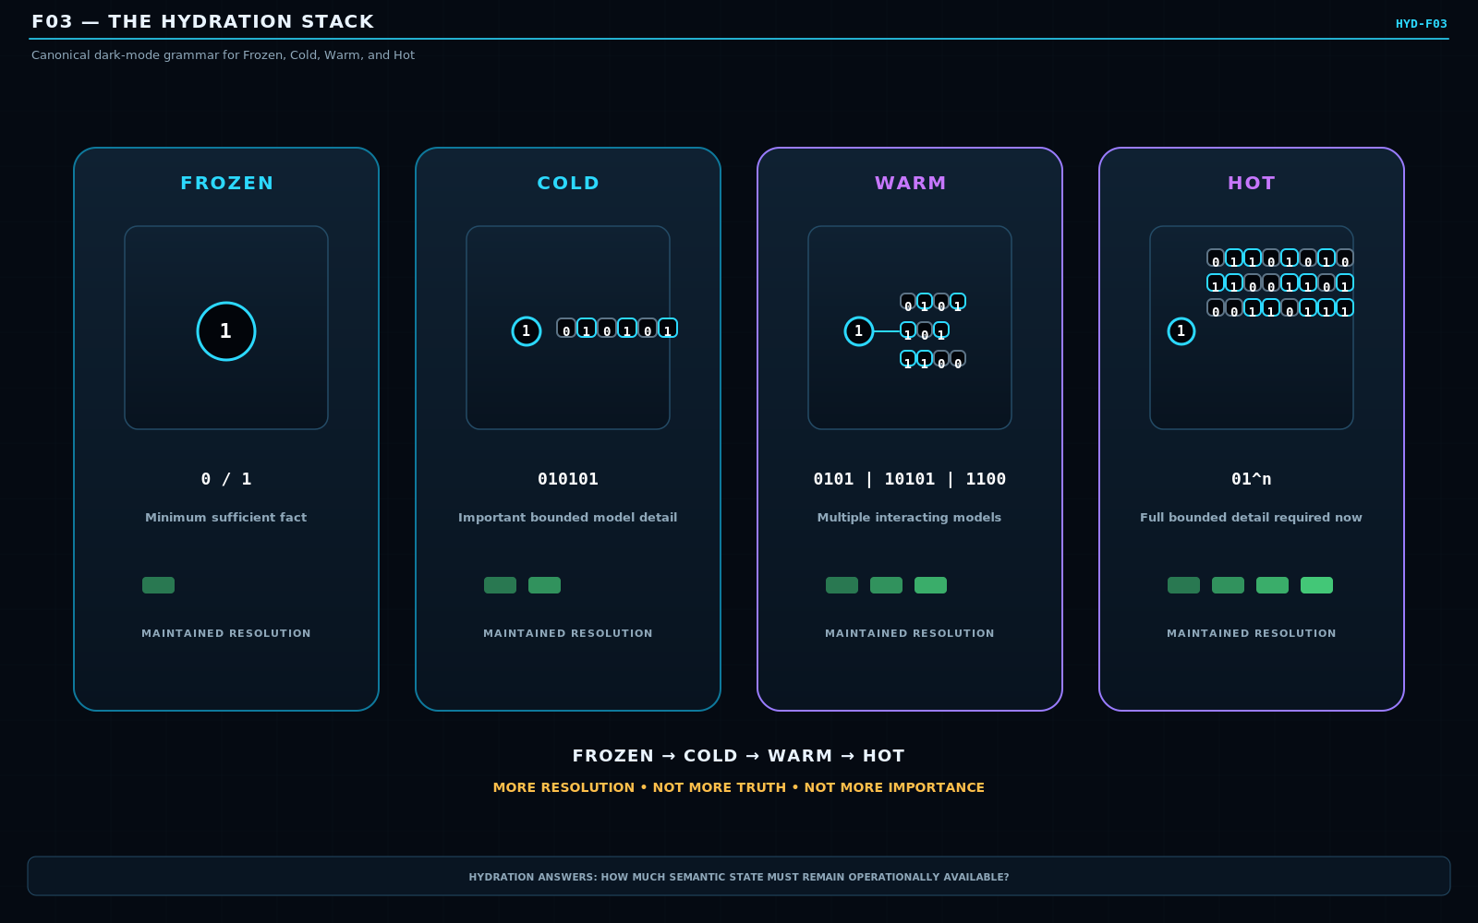
Figure 3. The Hydration Stack. Hydration increases structural resolution, not authority, truth, or intrinsic importance.
SECTION 04
Stable and Fluid
Resolution depth and transition condition are independent
Fluid is not a fifth hydration level. It is an orthogonal transition condition indicating that the currently represented state has not yet reached a committed causal resolution. A Frozen lore record can become Fluid while being edited. A Cold economy can remain Cold while one statistical update is unresolved. A Warm population model may be Fluid while interacting groups settle. A Hot individual interaction may be Fluid while exact choices and consequences resolve.
The architecture therefore has eight basic combinations: four hydration levels crossed with two transition conditions. The distinction prevents an easy but damaging collapse in which "more active" is treated as "more resolved" or every transition is forced into Hot representation.
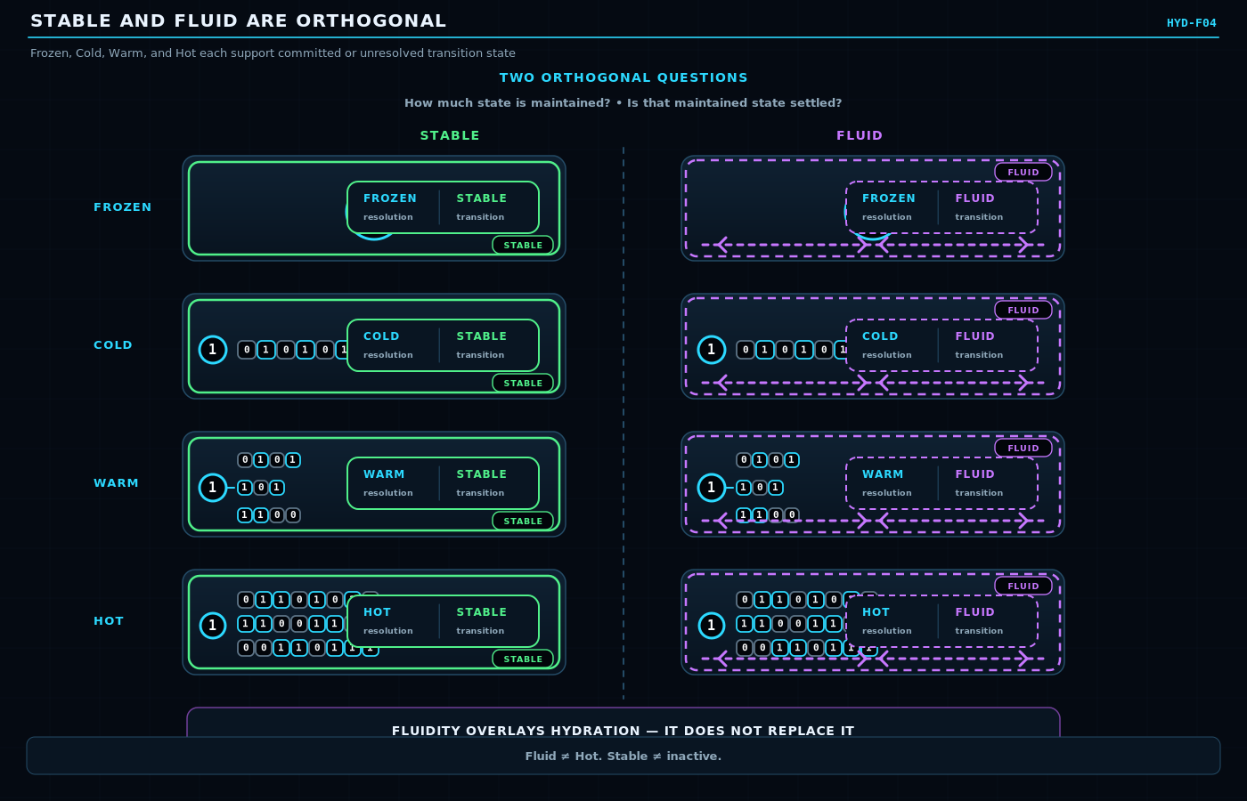
Figure 4. Stable and Fluid Are Orthogonal. Each hydration level may be Stable or Fluid. Fluidity overlays resolution rather than replacing it.
SECTION 05
The Four Informative Closures
A resolved transition can preserve or change the bit value
Fluid does not mean that a bit must flip. A Model can run, Rules can be evaluated, Operators can execute, and the bounded episode can resolve back to the same represented value. That closure is still information because the system learned that the tested causal process preserved the state under the conditions that actually obtained.
0 -> 0 0 -> 1 1 -> 0 1 -> 1
All four closures are therefore valid. The architecture must not equate state delta with event existence, write necessity, causal significance, or learning value. Whether a resolved closure becomes persistent history is a later Write Policy decision.
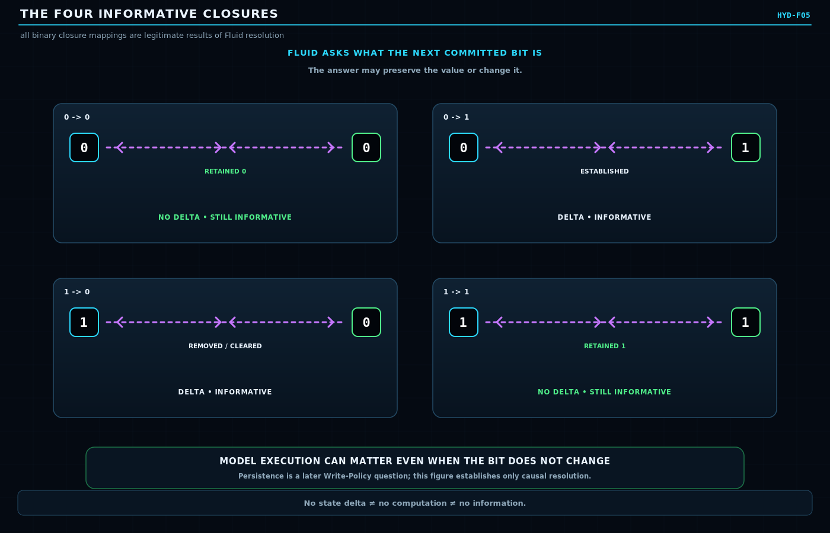
Figure 5. The Four Informative Closures. Identity-preserving and state-changing outcomes are equally legitimate results of Fluid resolution.
SECTION 06
Fluid Without More Resolution
Transition can remain bounded at the existing hydration level
A transition only needs the semantic depth required to resolve its bounded question. Editing a Frozen lore fact does not automatically justify hydrating the entire historical region. Updating a Cold statistical economy does not require exact individual simulation. The system should resist promoting state merely because activity exists.
OPERATIONAL LAW
Resolve the smallest sufficient causal frontier, at the lowest sufficient semantic depth, for the shortest sufficient time.

This law turns hydration into a resource discipline. Breadth, depth, and lifetime are separate costs. A narrow Hot interaction may be cheaper and safer than a broad Warm population event; a long-lived Frozen edit can still be problematic if its responsibility never closes.
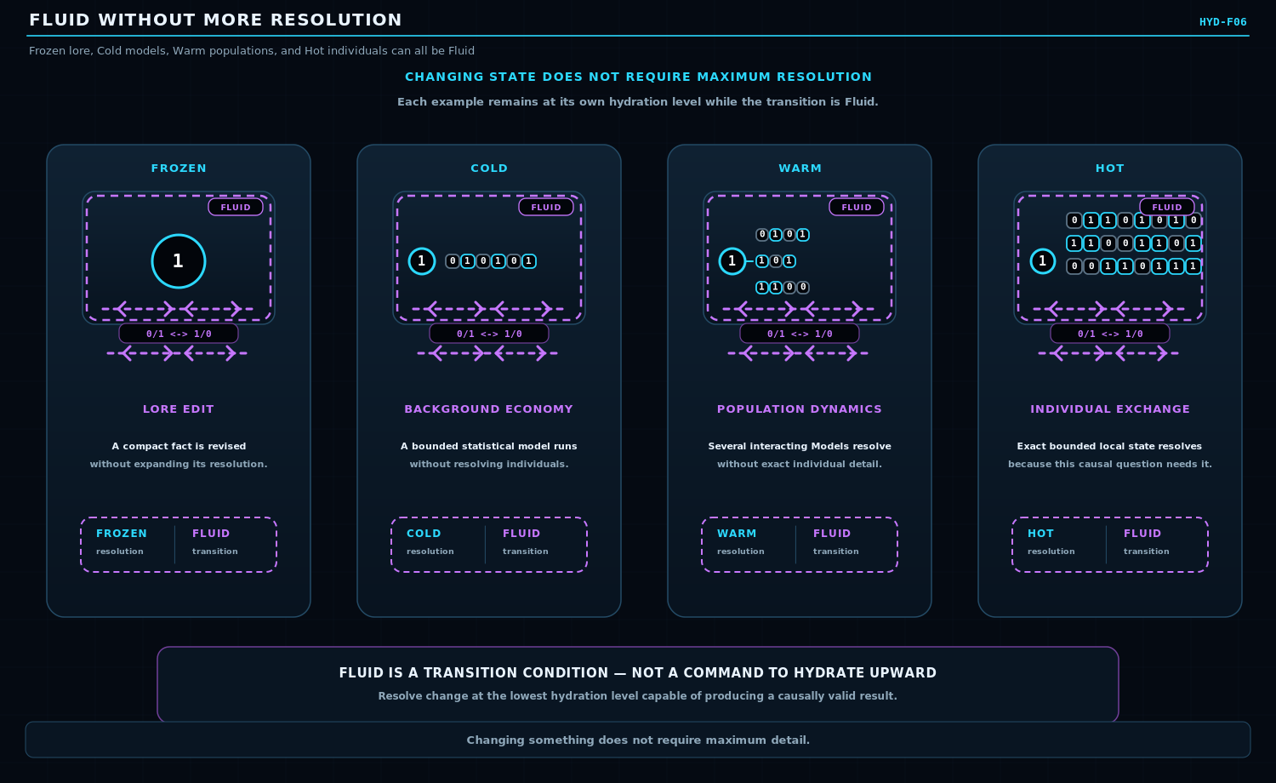
Figure 6. Fluid Without More Resolution. Fluid processes can occur at Frozen, Cold, Warm, or Hot resolution without forcing promotion.
SECTION 07
Causal Hydration Topology
Hydrate along causal relevance, not merely physical distance
Hydration demand should follow the causal corridor of the active problem. A remote actuator may need Hot resolution because the current task depends on its exact state, while several nearby objects can remain Frozen or Cold because they are causally irrelevant to the bounded event. Spatial proximity can matter to domain Models, but it is not the governing hydration rule.
This makes the hydrated contour a semantic topology. Routes, dependencies, contracts, observations, memory accesses, and operator requirements can pull distant regions into higher resolution. The policy remains demand-driven: the owning systems state what they need; Hydration coordinates how much resolution is maintained.
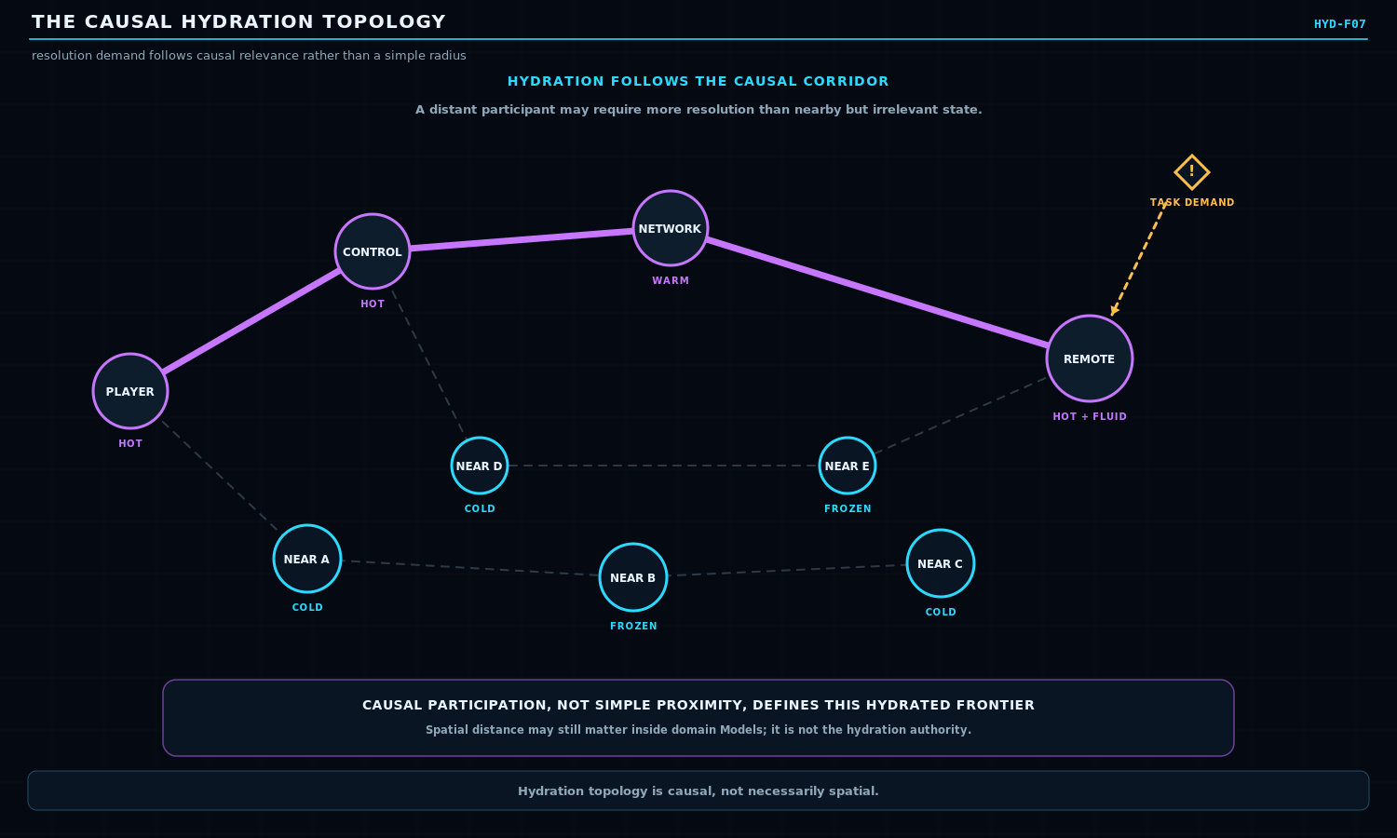
Figure 7. The Causal Hydration Topology. A distant but causally involved node can hydrate more deeply than unrelated nearby context.
SECTION 08
Promotion and Demotion
Resolution changes must not masquerade as World-state mutation
Promotion resolves more existing state. Demotion retains less explicit state. Neither operation, by itself, changes the World value being represented. A separate Fluid transition is required when the World itself is changing.
This separation also clarifies cooling. When a Hot interaction finishes, the system may demote the affected region to Warm, Cold, or Frozen according to future need. Cooling is not deletion; it is a reduction in maintained explicit resolution. The authoritative consequences must first be externalized into whatever State, Contract, Event, Memory, Procedure, or other residue continues to matter.
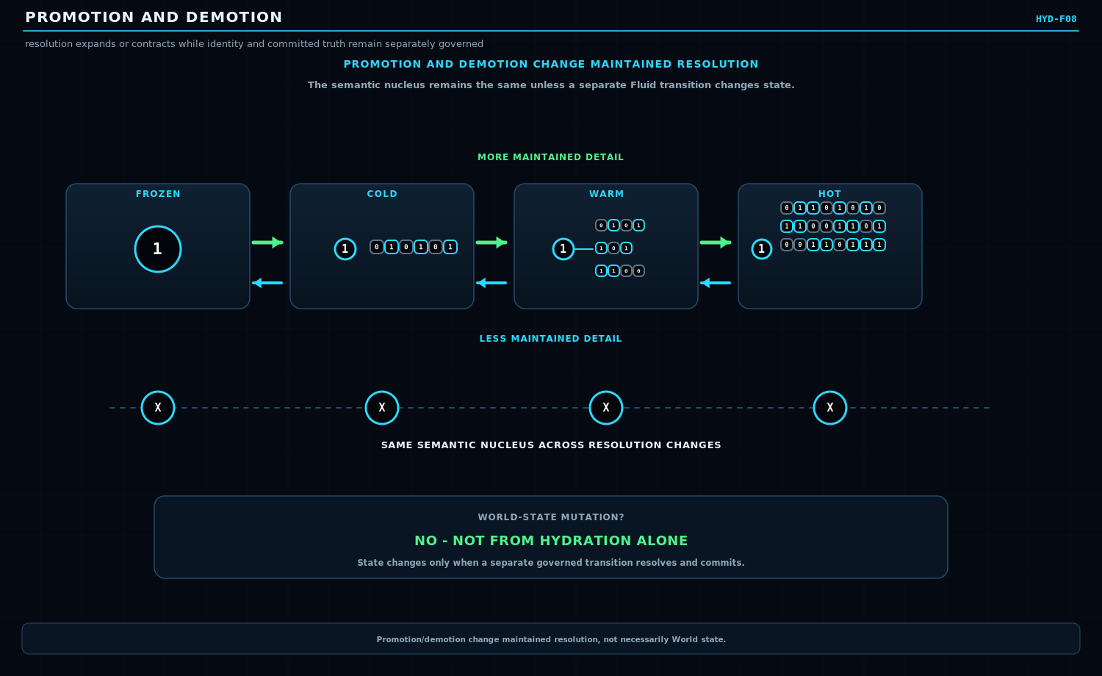
Figure 8. Promotion and Demotion. Hydration moves up and down the resolution stack while World state may remain unchanged.
SECTION 09
Selective Rehydration and Reconstruction
Recover only the detail required by the next valid behavior
When future behavior requires detail that is no longer explicitly maintained, the system can rehydrate the relevant branches. Reconstruction must remain provenance-aware. Some details may be directly Known; others can be Constrained by surviving state; some may be Likely under a Model; some remain Unknown.
The central safety rule is that likelihood must never silently become historical fact. CERBERUS already distinguishes World truth from reconstructed history and recollection. Hydration must preserve that distinction when it expands a compressed region.
DEHYDRATION SAFETY
Dehydrate only what can later be recovered or safely reconstructed at the level future behavior requires.

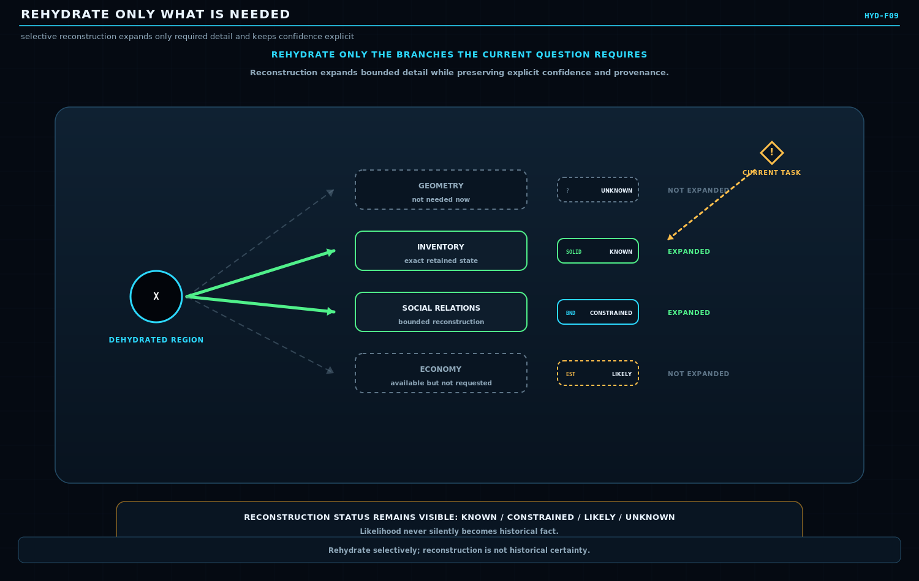
Figure 9. Rehydrate Only What Is Needed. Selective reconstruction expands requested branches while preserving Known, Constrained, Likely, and Unknown provenance.
SECTION 10
The Fluid Causal Frontier
Temporary high-resolution workspace for unresolved responsibility
A Fluid Event is a bounded transition condition in which currently represented semantic state has not yet reached committed causal resolution. Inside that boundary, Models may evaluate alternatives, Rules may gate legality, Operators may transform state, dependencies may wait, writes may remain pending, and new consequences may be spawned.
The figure is deliberately not a universal pipeline. Different events can contain parallel models, several Rules, multiple Operators, synchronization points, or branches that close at different times. The important boundary is responsibility: which unresolved causal obligations still belong to the current Event?
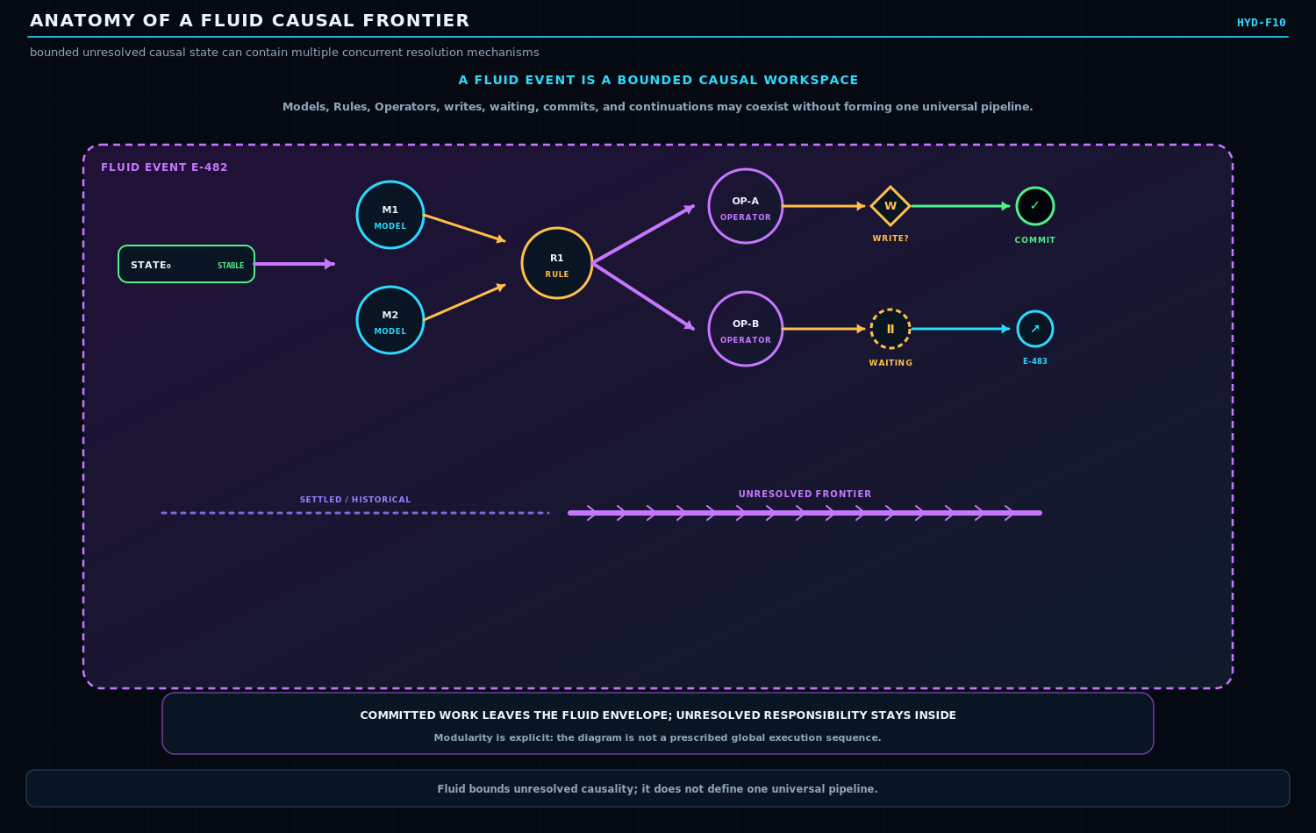
Figure 10. Anatomy of a Fluid Causal Frontier. A bounded Event envelope contains unresolved causal work while committed branches leave the frontier.
SECTION 11
Fluid Cost: Breadth, Depth, Lifetime
Keep unresolved causality narrow, shallow enough, and short-lived
Fluid cost is not one variable. Breadth measures how much semantic territory is simultaneously drawn into the unresolved frontier. Depth measures the resolution required inside that territory. Lifetime measures how long the responsibility remains open. A system can be expensive or fragile along any one of these axes even when the other two remain modest.
The optimization law is intentionally qualitative rather than a universal numeric formula. Domains may price these axes differently. The general policy is simply to avoid unnecessary expansion: resolve the smallest sufficient causal frontier at the lowest sufficient depth for the shortest sufficient time.
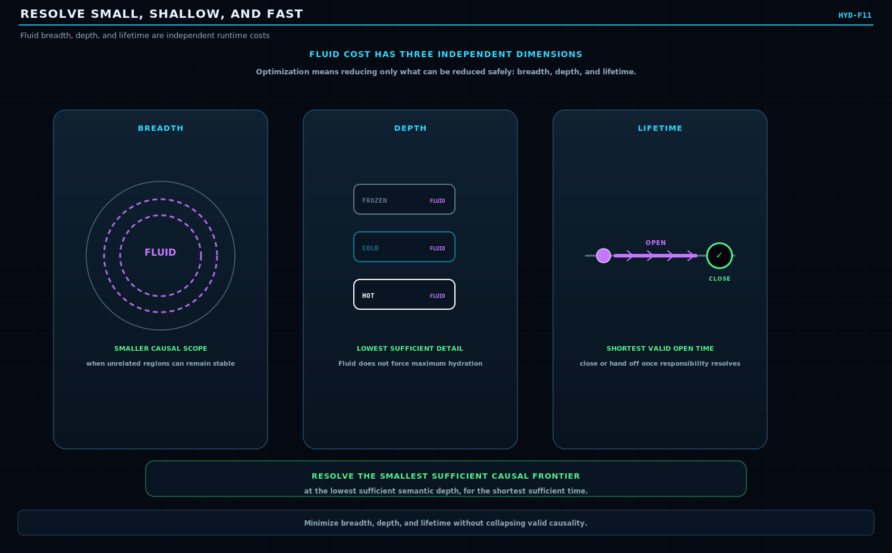
Figure 11. Resolve Small, Shallow, and Fast. Breadth, semantic depth, and unresolved lifetime are independent dimensions of Fluid cost.
SECTION 12
Fluid Closure by Responsibility
A parent Event can close while causal continuation survives elsewhere
Fluid episodes should close as soon as their bounded obligations are resolved, transferred, or safely discarded under the governing Ruleset. They do not need to remain open merely because some downstream consequence continues to exist.
A projectile strike can resolve trajectory, collision, and immediate injury while a spawned fire becomes a new Event. The parent Event closes once its own responsibility is settled, but provenance links the child Event back to its cause. This prevents one initiating action from becoming a giant permanent transaction that owns every consequence forever.
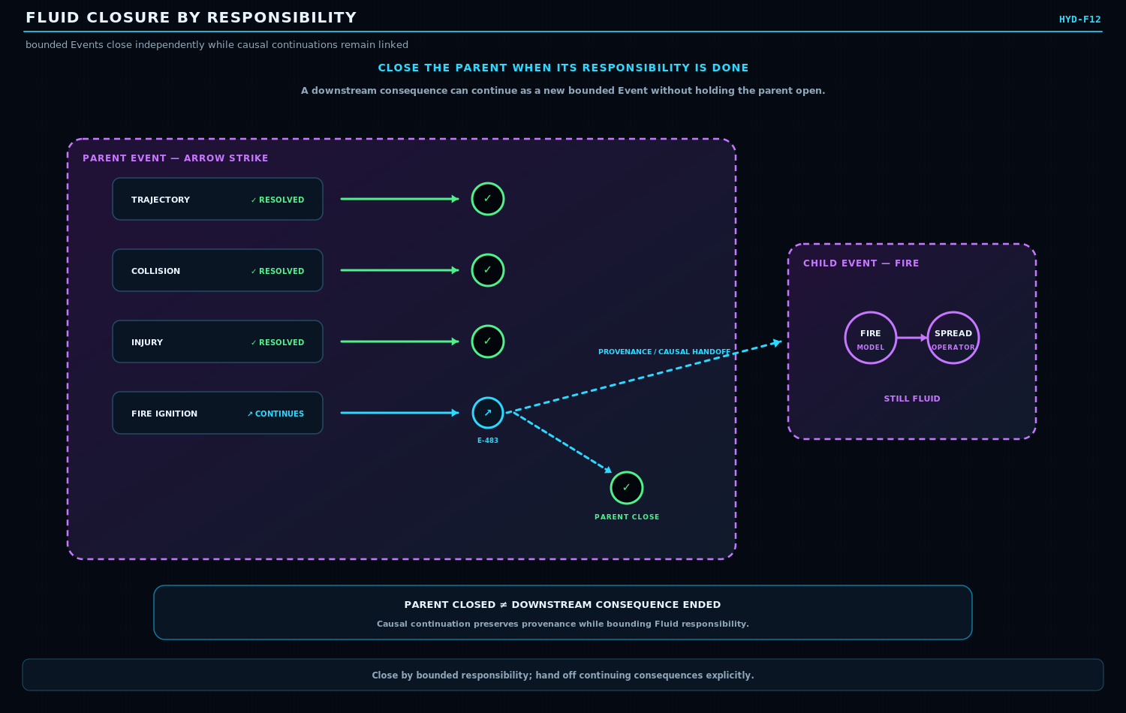
Figure 12. Fluid Closure by Responsibility. Continuing consequences can be externalized into new bounded Events or Contracts while the initiating Event closes.
SECTION 13
Write Policy
Computation and persistence are separate decisions
A resolved computation does not automatically require a persistent write. Conversely, an identity-preserving result may still deserve persistence when the attempt, test, audit, or governed proof is itself important. Write Policy therefore sits downstream of resolution rather than being inferred from the existence of a state delta.
Candidate policy names such as WRITE_ON_DELTA, WRITE_ON_RESIDUE, WRITE_ON_ATTEMPT, WRITE_ALWAYS, and WRITE_NEVER are useful illustrations, not canonical vocabulary in this paper. The architecture only requires that persistence decisions be explicit enough to distinguish computation from durable recording.
NON-COLLAPSE LAW
Compute != Write != Event != Memory. A 0 -> 0 result can be informative without forcing a durable record.

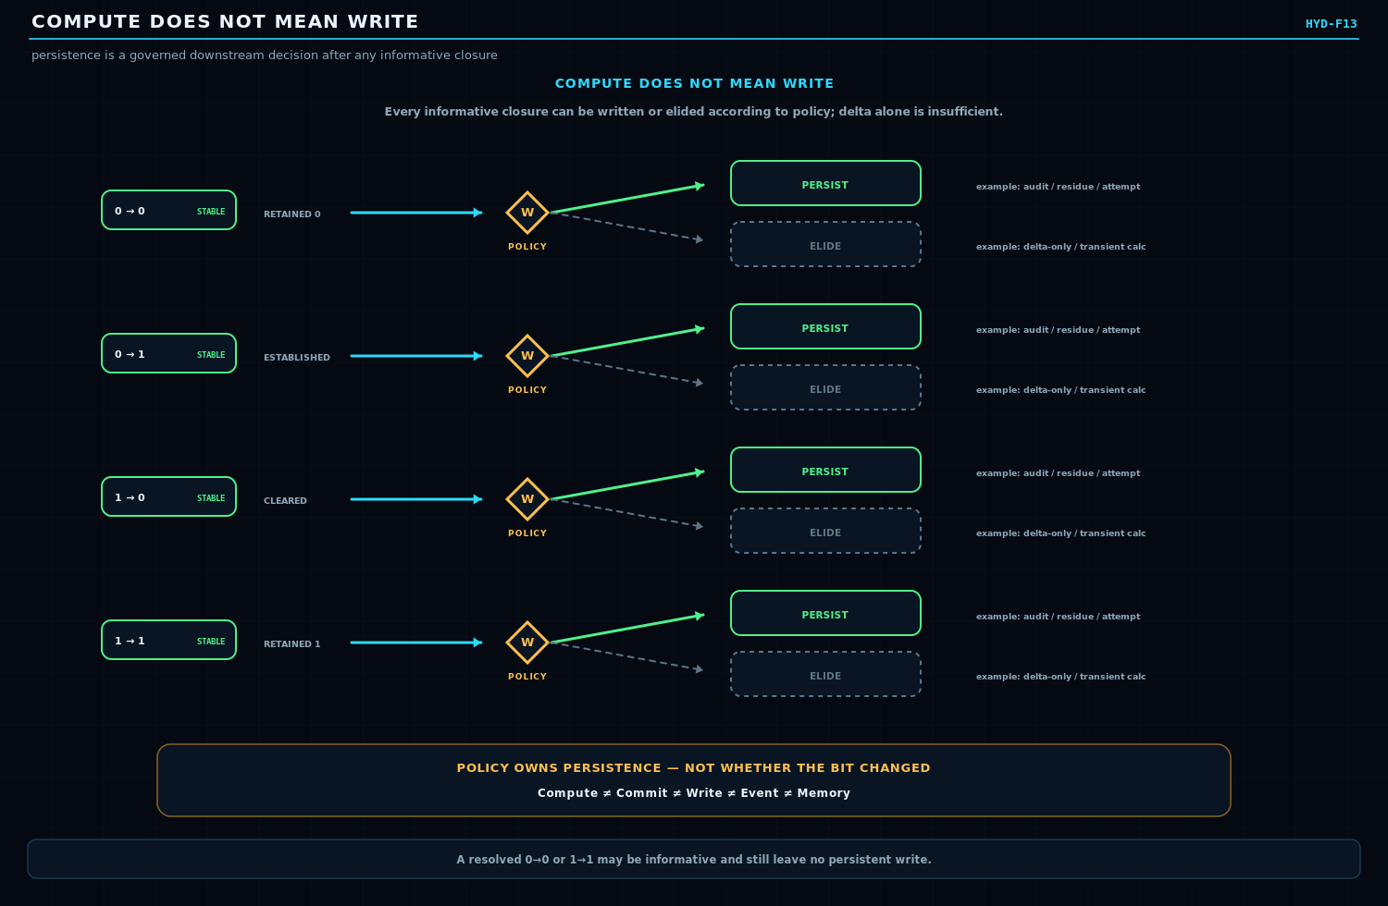
Figure 13. Compute Does Not Mean Write. Any closure can be persisted or elided according to governing Write Policy; state delta alone does not own persistence.
SECTION 14
Memory Pools
One Event can write bounded products into several specialized stores
Different persistence surfaces may care about different products of the same Event. A World History pool may require provenance and causal outcome. An autobiographical pool may require the actor-specific experience. A Skill pool may retain a learned relation. A machine Fault pool may preserve failure evidence. Specialized pools can therefore define their own write conditions, retention rules, hydration, and reconstruction behavior.
The key architectural rule is selective routing rather than indiscriminate duplication. The original Event need not be copied whole into every pool. Each approved write can produce the smallest bounded artifact that preserves the memory function of that pool.
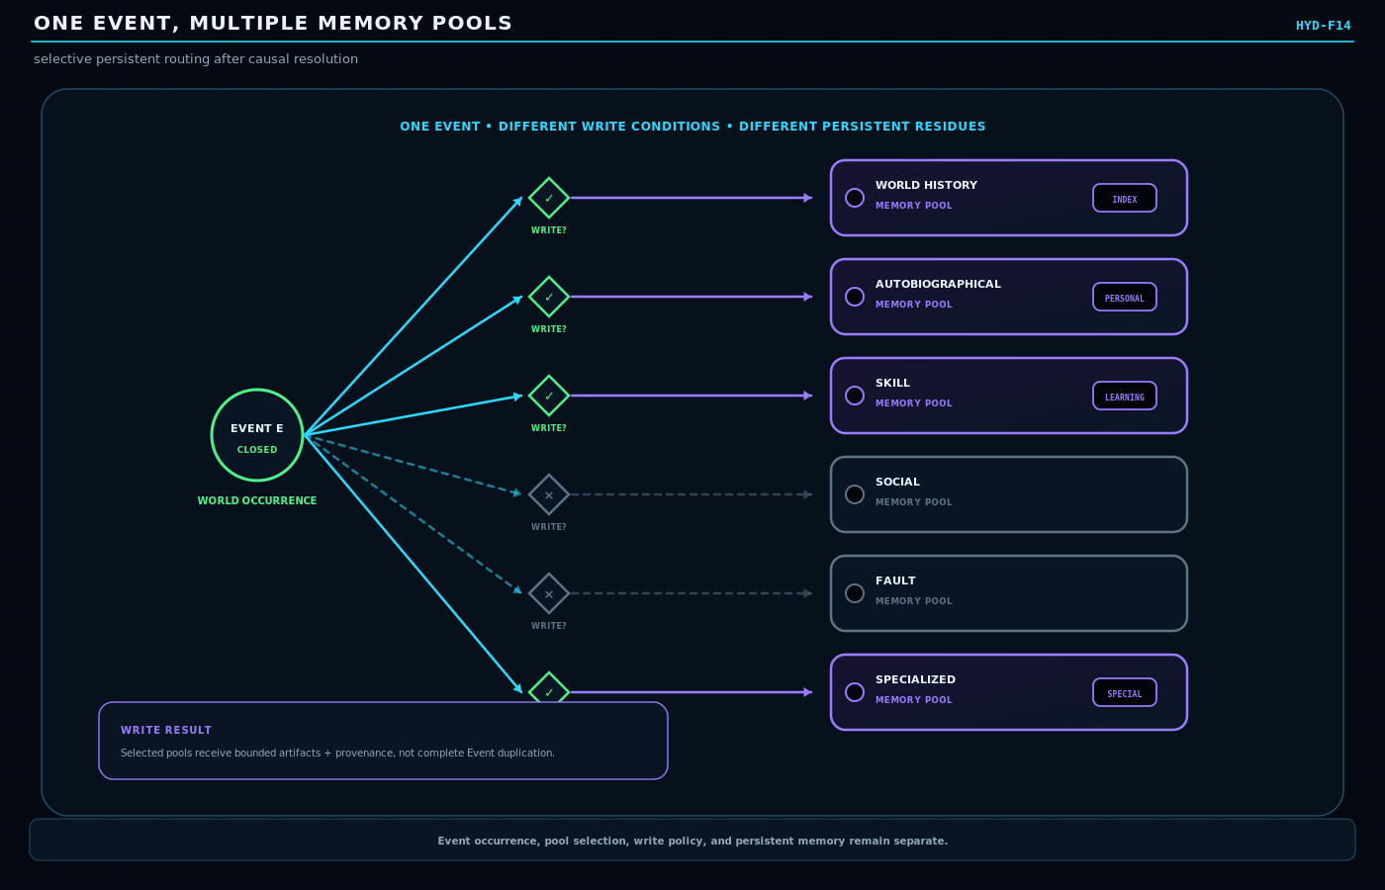
Figure 14. One Event, Multiple Memory Pools. Independent Write Policies decide which memory pools receive bounded Event-derived artifacts and provenance.
SECTION 15
Residual Ties
Why something continues to matter after the originating Event closes
A Residual Tie is a persistent reason Event-derived information continues to matter after the original Fluid Event has closed. The tie can connect the historical Event to surviving State, Contract, Event, Memory, Procedure, responsibility, or another causal consequence. The surviving targets may each hydrate independently of the original Event.
Residual Tie is not an active route and is not the original Event. It is a durable causal relation that explains why some consequence remains operationally relevant. Event closure therefore does not imply consequence closure, and historical compression does not require severing the reason a consequence exists.
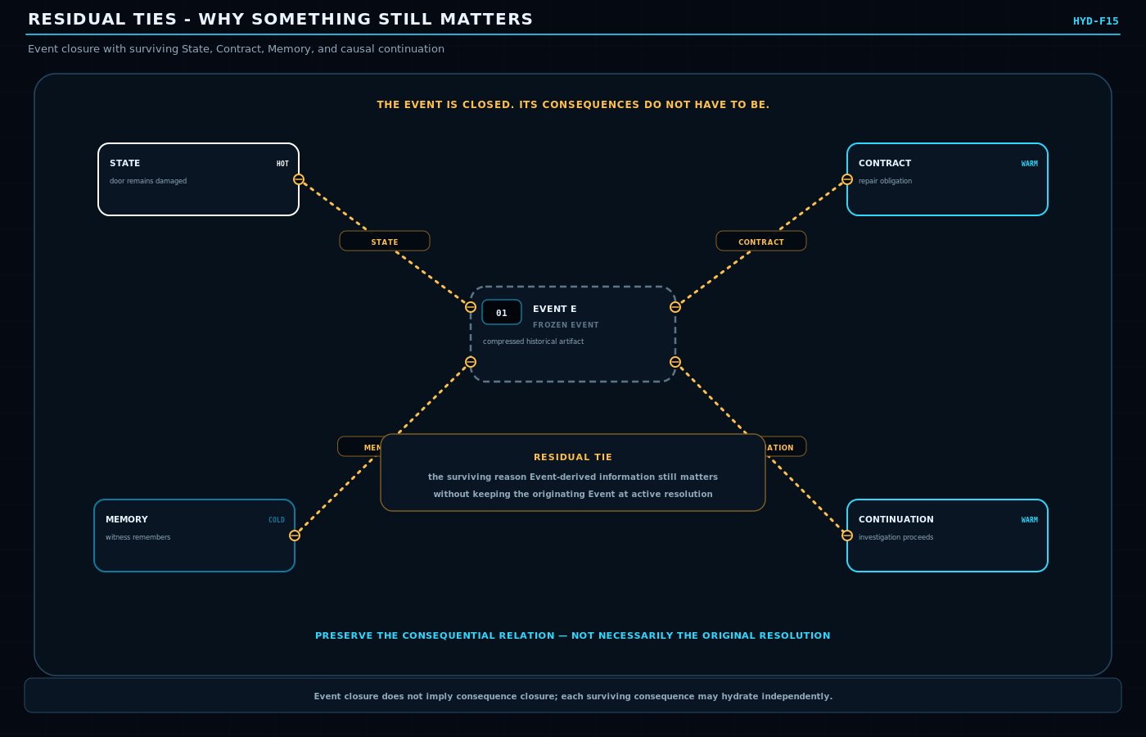
Figure 15. Residual Ties: Why Something Still Matters. A Frozen Event can retain only the causal relations that still matter while surviving consequences hydrate independently.
SECTION 16
Restoration Tie Collapse
Transient causal history may disappear when restoration is complete and residue is empty
Restoration Tie Collapse is a candidate causal cleanup mechanism. A Restoration Tie exists when the affected bounded causal scope returns to the relevant restoration state from which the episode began. Restoration alone is insufficient. The system must also confirm that no consequential residue survives.
RESTORED CAUSAL SCOPE + RESIDUE = EMPTY -> EVENT MEMORY MAY COLLAPSE
The test is therefore causal rather than cosmetic. It is not enough to compare one final Field with its starting value. Direct writes, spawned Operators, Contracts, observers, dependent Events, memories, and external effects may all preserve consequential differences even when a local object appears restored.
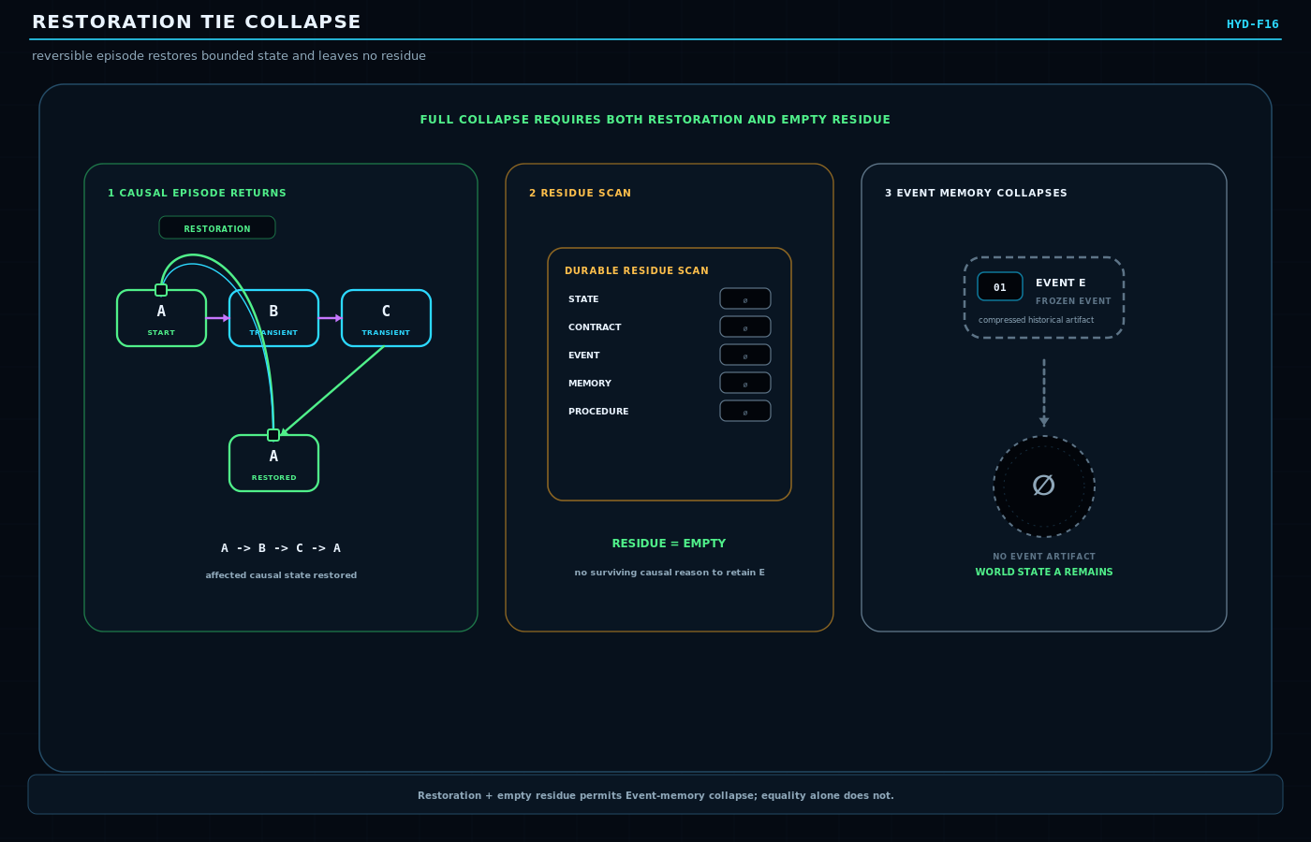
Figure 16. Restoration Tie Collapse. A bounded episode returns to its restoration state, the residue scan is empty, and the transient Event memory can collapse.
SECTION 17
Local Restoration Is Not World Restoration
A restored object can still leave consequential World residue
Suppose a door begins closed, opens, a guard observes an intruder, and the door closes again. The door state has locally tied back to its starting condition. The World has not. The guard now possesses information that can alter future behavior, and that Memory residue preserves the causal significance of the episode.
This counterexample prevents Restoration Tie Collapse from degenerating into value matching. Restoration must be evaluated across the bounded causal responsibility of the Event, not merely the most visible object that changed.
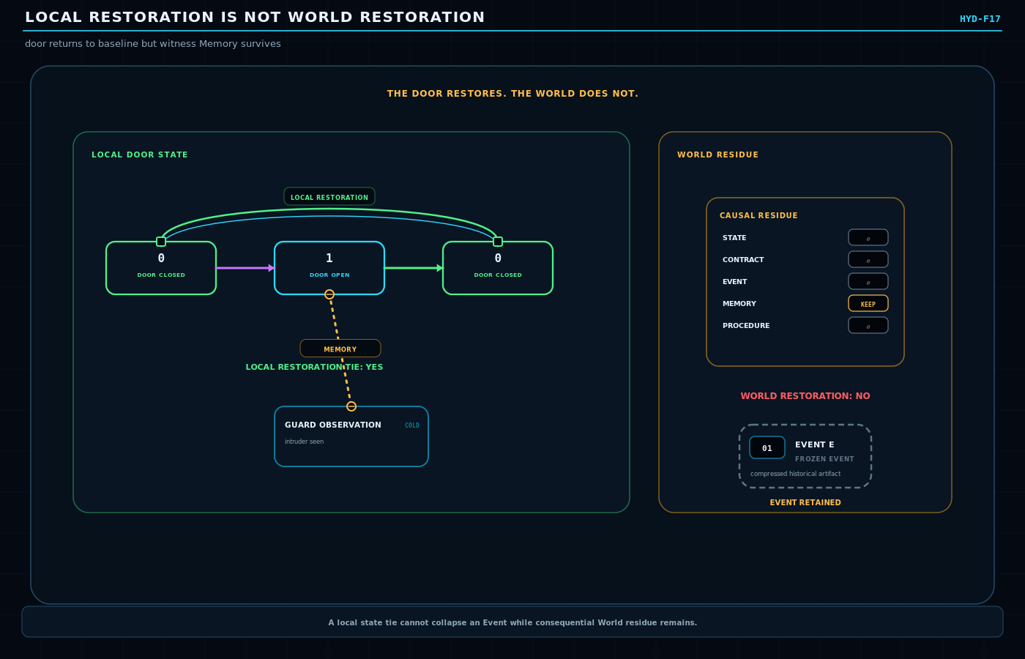
Figure 17. Local Restoration Is Not World Restoration. The door restores, but a surviving observer memory prevents complete World restoration and therefore prevents full Event collapse.
SECTION 18
Partial Restoration Tie Collapse
Restored branches may disappear while consequential branches survive
Causal cleanup need not be all-or-nothing. A complex Event may contain several branches that return cleanly to their restoration states and a small number that leave durable residue. The restored branches can collapse while surviving State, Contract, Memory, or continuing Event branches retain provenance.
This produces an important compression effect: a large, richly resolved Fluid Event can close into a tiny historical structure without losing the reasons that future behavior still depends upon it. Historical representation becomes proportional to surviving causal significance rather than peak runtime complexity.
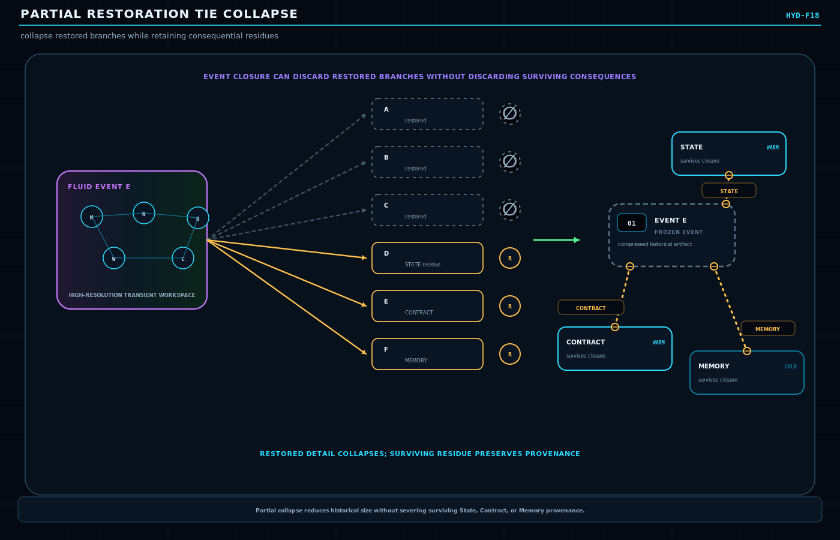
Figure 18. Partial Restoration Tie Collapse. Restored branches are pruned while the few surviving causal residues remain connected to their provenance.
SECTION 19
Deep Freeze
Compile the resolved Event into minimal consequential history
Deep Freeze is a lifecycle operation, not a fifth hydration level. It occurs after the Event has resolved and the system has determined what, if anything, must survive. Rich transient process state can then be discarded while the Event is represented by a small Frozen historical packet plus explicit surviving ties.
The operation resembles causal compilation rather than simple shrinking. The high-resolution process is no longer maintained; what remains is the minimum historical structure needed to preserve State, Contract, Event, Memory, Procedure, provenance, or other consequences that future behavior requires.
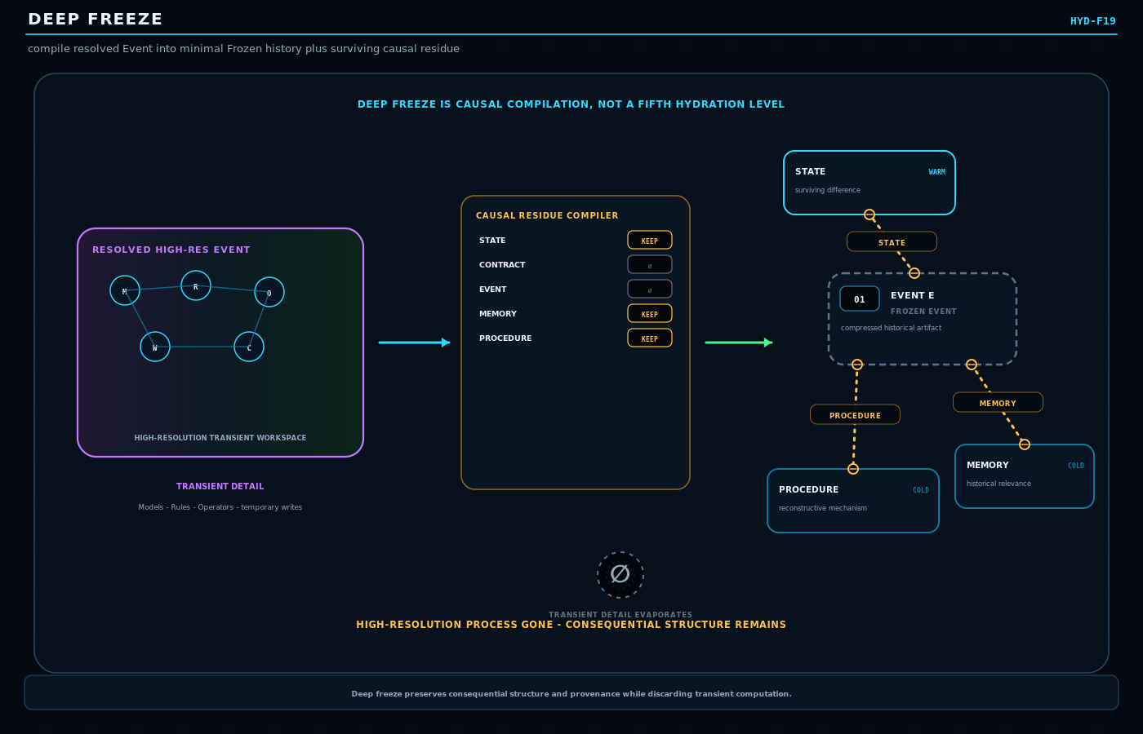
Figure 19. Deep Freeze. A large active Event resolves, causal residue is extracted, and the remaining history compiles into a compact Frozen packet with explicit surviving ties.
SECTION 20
Memory Groove and Selective Rehydration
History can remain large while the actor carries only a compact route
CERBERUS Memory Mechanics separates World history from the compact identity and routing structure carried by a person. A Memory Groove is an addressability mechanism, not a copy of the World Event. It allows relevant historical material to be located and rehydrated when recollection or current reasoning requires it.
A Frozen World Event can therefore remain stored once while an actor holds a small indexed route. Recollection may rehydrate only the relevant projection into Warm or Hot state. If the current interpretation itself is being revised, that present reasoning can become Fluid without rewriting the historical Event.
MEMORY PRINCIPLE
History large. Identity small. Memory indexed.

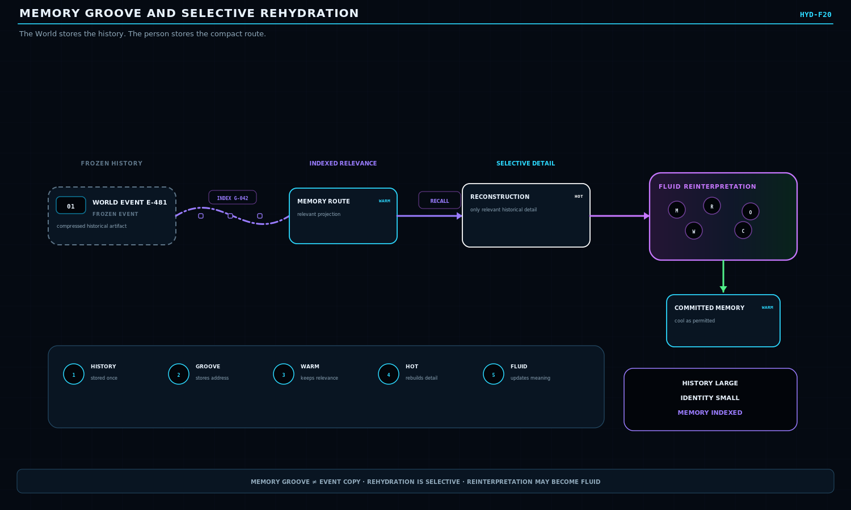
Figure 20. Memory Groove and Selective Rehydration. A compact Groove addresses Frozen history; current recollection selectively rehydrates only the material required now.
SECTION 21
Frozen at Time: World, Memory, Perspective
Historical truth, experience, and belief require independent timelines
A persistent World may freeze several epistemically distinct products at the same historical moment. World History records what actually happened or what the authoritative World supports. Memory History records what the character experienced or retained. Perspective History records what the character believed, knew, was taught, inferred, or heard at that time.
Later truth must not rewrite earlier perspective. If a character believed at t1 that rebels destroyed a bridge and learns at t2 that lightning was responsible, the t1 perspective remains historically correct as a record of belief even though it was factually wrong about the World. This makes later decisions reconstructable from the information actually available to the character at the time.
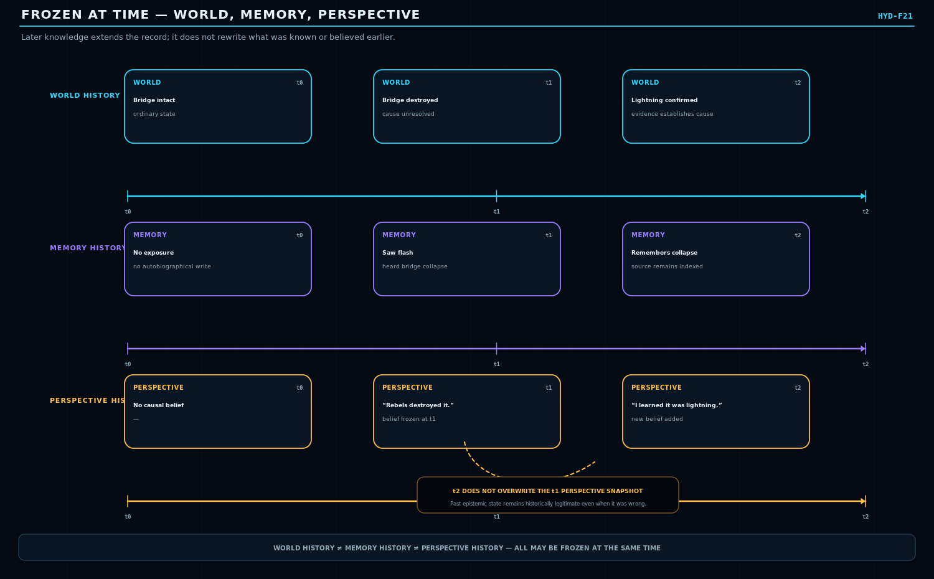
Figure 21. Frozen at Time: World, Memory, Perspective. World History, Memory History, and Perspective History remain separate timestamped surfaces; later knowledge extends rather than overwrites the earlier epistemic state.
SECTION 22
ROAR and Resolution Surfaces
Projection may expose different detail without becoming the source of truth
ROAR can project the same stable underlying Report or World structure at different explanatory resolutions. Hydration and ROAR therefore interact naturally, but their responsibilities must remain distinct. ROAR determines how an existing source is reported or projected. Hydration determines how much state is currently maintained or reconstructed to support valid behavior.
A high-detail ROAR surface does not automatically authorize a Hot World representation, and a low-detail ROAR view does not dehydrate the source. Projection is explanatory; hydration is a resolution policy. The source remains owned by the subsystem that governs its truth.
BOUNDARY
ROAR projection != Hydration authority != source ownership.

Layer | Governing question | What changes
Source / owner | What is authoritative? | The governed semantic state itself.
Hydration | How much of that state must be explicitly maintained now? | Resolution depth and reconstruction demand.
ROAR | How should the available state be explained or projected? | Presentation / explanatory surface.

SECTION 23
Hydration Demand Across CERBERUS
Many systems may request resolution; none surrender ownership to Hydration
System | Example hydration demand | Ownership remains with
DARTBOARD | A runtime Target requires exact bounded state for resolution. | Target/domain owner
SCE | The next valid World requires additional causal state. | World / SCE
GROOVE | A projection needs source detail to preserve grounded interpretation. | Source records
Memory | A recollection route needs historical detail. | World history / memory structures
BODY | A local physical interaction requires finer anatomical state. | BODY domain
SPINE / BRAID | A task or build dependency requires a more explicit capability/state contract. | Owning Stack / graph
Bits Before Tokens | A semantic search requires a finer bounded representation. | Semantic owners / registries

Competing demands should resolve to the highest sufficient resolution actually required by the active bounded responsibilities, not to an unbounded maximum. Exact arbitration, permissions, and cross-system priority remain open implementation questions rather than rules invented by this paper.
SECTION 24
Reconstruction and Historical Integrity
Compression is safe only when future behavior can recover what it truly needs
Dehydration is valid only when the system preserves enough information to support the next valid World. That may mean exact state, constraints, a reconstruction procedure, a Model version, provenance, or an explicit Unknown. The architecture must never fill a gap with an unmarked inference simply because a more detailed representation is requested later.
Historical Model Version Integrity is particularly important. If a reconstruction depends on a Model, the system must know which historical version is authorized for that reconstruction. Re-running a newer Model against old compressed state may create a plausible present-day interpretation without recreating what the old World actually contained.
Reconstruction status | Meaning | Historical handling
Known | Directly preserved or authoritatively recoverable. | May be restored as fact within the bounded scope.
Constrained | Not stored exactly, but surviving state limits the valid possibilities. | Restore the constraint; do not invent the missing exact value.
Likely | A Model supports a plausible reconstruction. | Mark as inference with Model/version provenance.
Unknown | The surviving record cannot safely determine the detail. | Preserve uncertainty rather than fabricate continuity.

HISTORICAL INTEGRITY
A newer Model may generate a useful present interpretation without recreating the exact historical state. Version and provenance remain part of the reconstruction contract.

SECTION 25
Operational Diagnostics
Long-lived Fluid state is a signal to inspect responsibility
Fluid is intended to be temporary. A long-lived Fluid object or Event is not automatically an error - some processes are genuinely ongoing - but it is a diagnostic prompt. The system should be able to distinguish legitimate continuity from unresolved responsibility that has become stuck or orphaned.
Condition | Interpretation | Expected response
Genuinely ongoing | The causal process is still validly in progress. | Remain Fluid within bounded responsibility.
Waiting | Resolution depends on an external condition or dependency. | Preserve explicit wait reason / timeout policy.
Barrier | Multiple branches must reach a synchronization condition. | Retain bounded unresolved branches.
Deadlock | Responsibilities mutually prevent closure. | Raise diagnostic / recovery path.
Orphaned Event | No owner can validly complete or close the Event. | Repair ownership or governed cancellation.
Failed Operator | A required transformation could not complete. | Record failure residue as policy requires.
Dangling Contract | A continuing obligation remains unowned or unresolved. | Transfer or explicitly retain responsibility.
Runaway propagation | Causal frontier is expanding without sufficient bound. | Apply Ruleset limits / isolate propagation.

SECTION 26
Non-Collapse Laws
The distinctions that keep Hydration semantically safe
Law A | Law B
Hydration != state value. | Resolution change != World-state mutation.
Fluid != bit flip. | Fluid != Hot.
Activity != Hydration. | Importance != Hydration.
0 -> 0 != no information; 1 -> 1 != no information. | Computation != Write; Write != Event; Event != Memory.
Event closure != consequence closure. | Local restoration != World restoration.
Restoration != deletion. | Frozen != forgotten.
Deep Freeze != hydration level. | Memory Groove != copied World history.
Reconstruction != historical fact. | ROAR projection != source truth.
Hydration demand != ownership. | Perspective History != World History.
Stable != inactive. | Fluid != necessarily changing value.
Residual Tie != original Event. | Low resolution != low importance.

These are architecture-preserving boundaries rather than claims that every domain must use identical storage structures or thresholds. Their purpose is to prevent Hydration from silently taking ownership of semantics already governed elsewhere in CERBERUS.
SECTION 27
The Hydrated World
Integrated runtime view and remaining research questions
The complete architecture is intentionally asymmetric: most of the World can remain Frozen or Cold, a smaller set of interacting regions become Warm, and only the exact bounded causal frontier that currently demands it becomes Hot. Fluidity appears only where state is unresolved, and it disappears when responsibility closes. Writes, residues, restoration, deep freeze, memory routing, and reconstruction operate as separate governed mechanisms rather than one undifferentiated persistence system.
Figure 22. The Hydrated World. Integrated view of unequal resolution, bounded Fluid fronts, write decisions, residual causality, lawful collapse, memory routing, selective rehydration, and external resolution demand.
COMPRESSED LAW
Hydrate what must be known. Resolve what is changing. Remember what remains consequential.

Open research questions
- What is the canonical attachment scope of Hydration Policy: Record, Field, relation, semantic region, runtime projection, or a governed combination?
- Must every domain implement all four hydration levels, or may domains expose only meaningful subsets?
- Should Write Policies be a canonical enumerated vocabulary, Model-defined contracts, or both?
- What promotion thresholds and evidence contracts determine when a region must hydrate?
- What demotion audit proves that later reconstruction remains safe?
- How should nested Fluid sub-events inherit and discharge responsibility?
- How aggressively may partial Restoration Tie Collapse prune provenance while preserving auditability?
- Which subsystem canonically owns Residual Tie lifecycles?
- How should competing hydration demands be arbitrated when several systems request different depths?
- Can one source simultaneously support projections at different hydration levels without duplication?
- When should a continuous process remain one Fluid Event versus periodic committed Events?
- How are permissions and SCREEN constraints applied to promotion, reconstruction, and memory rehydration?
- What audit record, if any, should survive after lawful Event collapse?
Explicit exclusions
- No automatic adaptive-zero or self-rewriting baseline architecture is specified here.
- No clinical trauma, fear, phobia, dissociation, or psychological tolerance model is defined in this mechanism paper.
- No universal numeric hydration formula or fixed threshold is imposed across domains.
- No requirement is made that Hydration metadata live in the same Record as the semantic state it governs.
- Hydration does not replace SCE, GROOVE, ROAR, Memory, Rules, Operators, DARTBOARD, or Causal Residue.
Conclusion
Persistent simulation does not require persistent maximum resolution. CERBERUS can retain each semantic region at the lowest resolution sufficient to preserve valid future behavior, temporarily enter Fluid State when represented information requires causal resolution, and collapse transient computation after externalizing only the State, Contract, Event, Memory, Procedure, or other residue that still matters.
The result is a World that is semantically persistent without being computationally uniform. Resolution follows causal need. Transition remains explicitly bounded. History survives in proportion to consequence. Reconstruction stays provenance-aware. The architecture therefore preserves continuity while allowing most of the World to remain cool, compact, and recoverable until exact detail is genuinely required.
ARCHITECTURAL BOUNDARY SUMMARY
What Hydration owns - and what it does not
Hydration coordinates | Hydration does not own
Maintained resolution depth | World truth or domain identity
Stable vs Fluid transition condition | Operator semantics or Rule legality
Promotion / demotion requests | DARTBOARD Target identity
Bounded Fluid frontier lifetime | ROAR source truth
Write-policy handoff points | Memory content semantics
Residual / restoration closure coordination | Causal Residue categories themselves
Selective reconstruction demand | Historical fact when evidence is absent

FINAL RECONSTRUCTION TEST
One World. Unequal resolution. Orthogonal Fluidity. Bounded causal fronts. Explicit writes. Persistent residues. Lawful collapse. Indexed memory. Provenance-aware reconstruction. Ownership preserved.

Minimal operational cycle
DEMAND -> HYDRATE -> RESOLVE -> EXTERNALIZE CONSEQUENCE -> COOL / COLLAPSE
The cycle is not a universal execution pipeline. It is the minimum conceptual sequence needed to reconstruct Hydration Policy: a bounded responsibility creates resolution demand; the required semantic region hydrates; Fluid work resolves; surviving consequences are written or tied explicitly; and transient resolution is demoted or collapsed when its obligations end.

