CERBERUS

BOOTSTRAP
  - Governed Knowledge-Acquisition Fabric
Steps, Threads, Cords, Sheets, Folds, Core Sufficiency, and Thread Archives
CORE ARCHITECTURE STATEMENT
BOOTSTRAP is the governed knowledge-acquisition fabric of a Base. Steps compose into Threads; Threads compose into Cords; Cords compose into Sheets; Folds curate bounded knowledge loadouts across the Fabric. Core is a sufficiency role rather than a composition depth, and Thread Archives are a separate lifecycle structure rather than another Fabric level.

Version 0.2 • August 2026 • BOOTSTRAP Reconstruction Architecture
B7 — BOOTSTRAP
Primary question: How is the required knowledge assembled and acquired?

Executive Summary
BOOTSTRAP turns governed source material into an authored acquisition path that can be inspected, reused, and composed. Its smallest current semantic unit is the Step: one required acquisition act inside a larger path. Steps form Threads. Threads form Cords. Cords form Sheets. Folds select the combination of Fabric structures required for a declared purpose. The composition is semantic rather than quantitative: moving upward in the Fabric means the composition contract has changed, not merely that more files have been added.
The current architecture deliberately separates three questions that older prototypes visually blended together. Fabric depth answers how knowledge is composed. Core answers which Fabric structure is the lowest one sufficient to understand how a selected system works. Lifecycle answers whether an active Thread remains in the active Fabric or has moved into the separate Thread Archives table. Core is therefore not another rung after Fold, and Archive is not another rung after Fold.
BOOTSTRAP also preserves ownership boundaries. It may direct a learner to a Registry, Stack, Semantic Kernel, BIGFOOT identity, BOSS symbol, SOLAR entry, or another governed resource, but the referenced system remains authoritative for the meaning and operation of that object. BOOTSTRAP owns the acquisition route and the declared learning contract, not every semantic object encountered along the route.
The same governed acquisition substrate can support more than one consumer. Human documentation, human curriculum, and AI familiarization may present information differently while resolving from the same authored order, definitions, figures, and semantic references. This does not make human and machine interpretation identical; it makes their coordinates more mutually resolvable and makes divergence easier to locate.
CURRENT ARCHITECTURE UPDATE
This revision teaches the live architecture directly: one Thread is one record in the shared Thread Table; Bundle is no longer a formal Fabric layer; Core is a sufficiency role; and archived Threads live in the dedicated Thread Archives Table rather than behind an Archive Status toggle.

Section Index
Part | Focus
0 | Reconstruction Orientation
1 | Why BOOTSTRAP Exists
2 | Ownership and Semantic Boundary
3 | The BOOTSTRAP Fabric
4 | Core as Sufficiency
5 | Current BOOTSTRAP Implementation
6 | Thread Archives and Lifecycle
7 | Traversal and Acquisition Rules
8 | Shared Human + AI Acquisition
9 | Boot Loadouts and Reuse
10 | Evolution, Reproducibility, and Historical Knowledge
11 | Wider CERBERUS Relationships
12 | Representative Applications
13 | BOOTSTRAP Laws
14 | Common Misunderstandings and Anti-Patterns
15 | Reconstruction Test
A | Source and Correction Map
B | Unresolved Register

Part 0 - Reconstruction Orientation

0.1 Identity and Primary Question
BOOTSTRAP is the B7 Root Stack capability concerned with governed knowledge acquisition. In the CERBERUS notation architecture, F-language asks a distinct question from semantic construction, registry location, or interface manifestation: how is the knowledge required for a task or system assembled and acquired? BOOTSTRAP answers that question with a Fabric of reusable acquisition structures.
STEP -> THREAD -> CORD -> SHEET -> FOLD
This sequence is the canonical Fabric composition ladder. Core and Archive are intentionally absent from it because they answer different questions. Core marks sufficiency. Archive marks lifecycle placement.

0.2 Reconstruction Decoder
Concept | Current meaning
Step | Smallest ordered acquisition act inside a governed learning path.
Thread | One bounded authored acquisition path.
Cord | A purposeful composition of Threads that should be acquired together.
Sheet | A coherent knowledge ecosystem composed primarily from related Cords.
Fold | A purpose-specific acquisition loadout that may select across Fabric resolutions.
Core | The lowest-level Fabric structure sufficient to understand how the selected system works.
Thread Archives | A separate lifecycle table for archived Threads; not a Fabric level.

0.3 Scope of This Artifact
This document is a reconstruction interface for BOOTSTRAP itself. It teaches the current semantic model, the current live implementation pattern, the traversal laws that govern acquisition, the relationship to human and AI learning, and the boundary between implemented behavior and designed future capability. Historical prototypes remain visible through the source map, but the main body follows the shortest route to current understanding.

Part 1 - Why BOOTSTRAP Exists

1.1 Information Storage Is Not Knowledge Acquisition
A repository can contain every relevant document and still be a poor reconstruction interface. Definitions may arrive after applications. Deprecated material may sit beside current material without a visible distinction. A learner may follow an interesting link and never return to the governing sequence. Required prerequisites may be implicit, and the learner may have no reliable way to know when the selected subject has been acquired sufficiently.
Figure 1 separates those two conditions. On the left, the corpus contains documents, tables, specifications, diagrams, and references. In the center, BOOTSTRAP adds authored order, Read Instructions, required-material selection, bounded references, Fabric composition, and sufficiency. On the right, the result is not a new semantic source; it is a reconstructable model produced from governed acquisition of the existing sources.
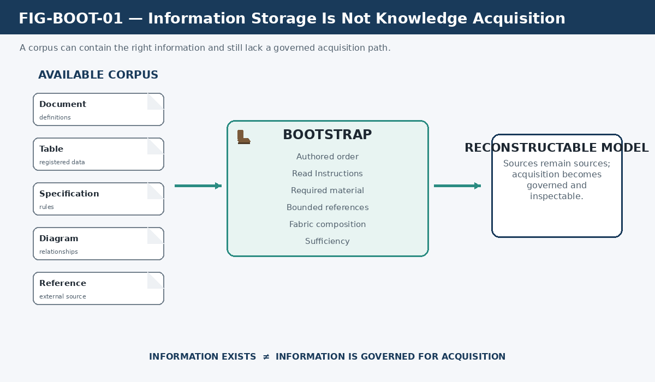
Figure 1. Information Storage Is Not Knowledge Acquisition. BOOTSTRAP adds a governed acquisition layer over available source material without claiming ownership of the source semantics.
ACQUISITION PRINCIPLE
A corpus answers what information exists. BOOTSTRAP answers what must be acquired, in what authored order, under what instructions, and to what declared sufficiency.

1.2 Visible Acquisition Instead of Hidden Orchestration
BOOTSTRAP moves the learning plan out of hidden model behavior and into governed structure. The learner may still reason about what it reads, but it does not silently invent the route by which required material becomes active context. This makes acquisition inspectable: when a misunderstanding appears, the system can ask whether the problem belongs to the source, the authored order, the instruction, a missing dependency, or the learner rather than treating the entire process as opaque model behavior.
Figure 3 contrasts an improvised path with a governed path. The hidden route lets the consumer decide what seems useful and in what order; the visible route preserves the authored acquisition structure as an inspectable object. The purpose is not to eliminate judgment. It is to stop the acquisition contract from disappearing inside judgment.
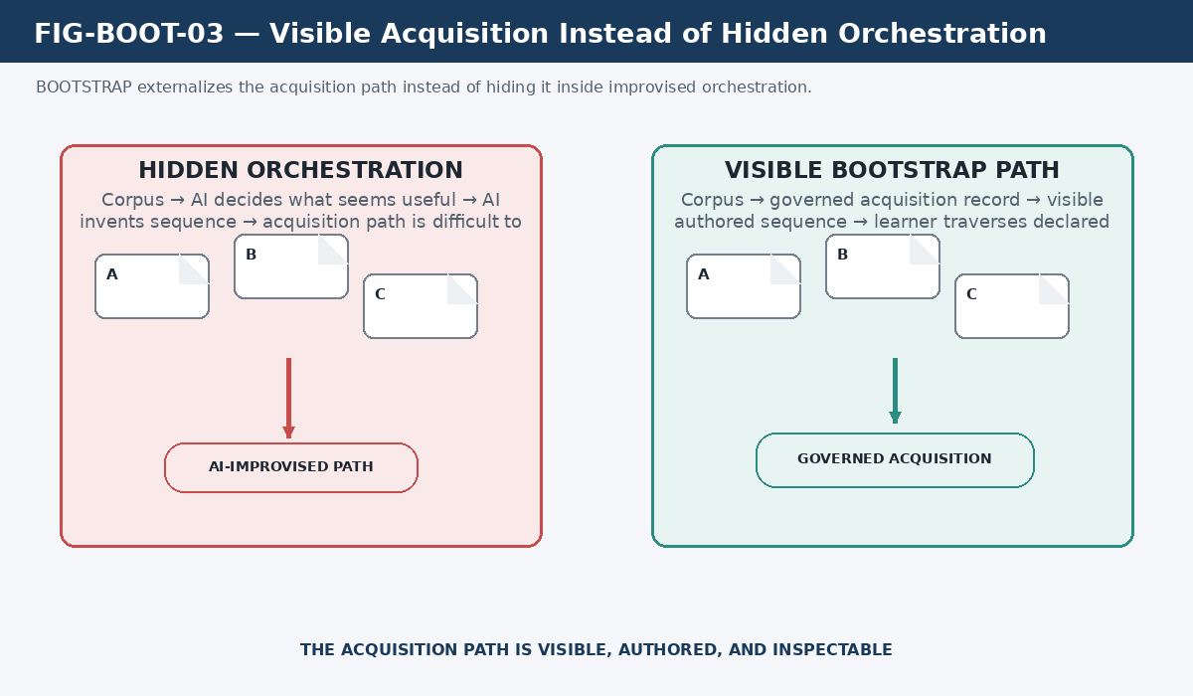
Figure 3. Visible Acquisition Instead of Hidden Orchestration. BOOTSTRAP externalizes the acquisition path so it can be authored, inspected, corrected, and reused.

1.3 Order Is Knowledge
Document equality does not imply instructional equality. Two learners can receive the same sources and form materially different models if they encounter assumptions, definitions, examples, and implementation details in different dependency orders. BOOTSTRAP therefore treats authored sequence as part of the knowledge design rather than as incidental presentation.
Figure 2 holds the source set constant while changing the path. One route acquires A, then B, then C, then D, then E. Another route encounters the same symbols in a different order. The figure does not claim that only one path can ever be valid; it shows that path is a governed variable with semantic consequences.
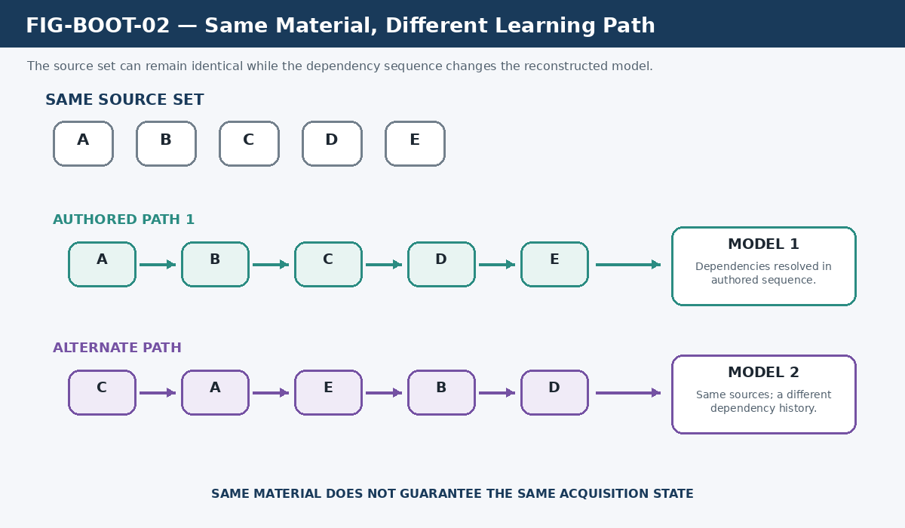
Figure 2. Same Material, Different Learning Path. Identical source sets can support different acquisition histories when dependency order changes.
AUTHORED ORDER RULE
A learner may report a suspected ordering defect. It may not silently replace the declared acquisition sequence with a preferred one.

Part 2 - Ownership and Semantic Boundary

2.1 What BOOTSTRAP Owns
BOOTSTRAP owns the knowledge-acquisition contract. That contract includes the authored order of acquisition, Read Instructions, composition of smaller acquisition structures into larger ones, selection of required material, bounded routing into referenced systems, designation of the Core needed for a selected system, placement of archived Threads into the Thread Archives lifecycle structure, and the conditions under which a declared Boot is sufficiently reconstructed.
- Authored acquisition order and local Read Instructions.
- Fabric composition across Steps, Threads, Cords, Sheets, and Folds.
- Selection of required versus optional acquisition material for a declared loadout.
- Bounded excursions into other governed structures and the obligation to return.
- Core designation as the minimum sufficient learning structure for a selected system.
- Thread lifecycle placement between the active Thread Table and Thread Archives.
- Reconstruction sufficiency criteria for the selected Boot contract.

2.2 What BOOTSTRAP Does Not Own
A BOOTSTRAP link does not transfer semantic ownership. A Thread may instruct the learner to inspect a Registry, a Stack, a Semantic Kernel, a BIGFOOT BitWord identity, a BOSS symbolic record, a SOLAR lexical structure, or a DARTBOARD presentation artifact. Those systems remain authoritative for their own internal objects. BOOTSTRAP determines when and why the learner must visit them.
Figure 4 places BOOTSTRAP at the center of the acquisition route while keeping Registry/Stack, BIGFOOT, BOSS, Semantic Kernels, SOLAR, and DARTBOARD outside its ownership boundary. The dashed routes express acquisition access, not containment.
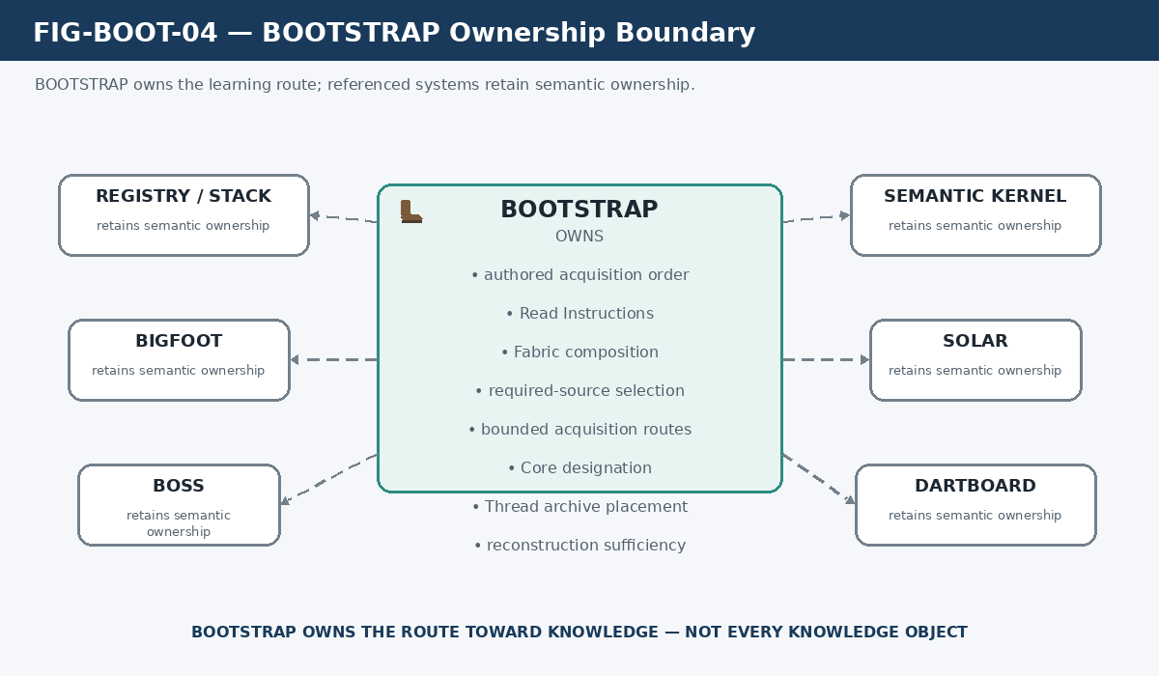
Figure 4. BOOTSTRAP Ownership Boundary. BOOTSTRAP governs the path toward knowledge while referenced systems retain semantic ownership of their own structures.
OWNERSHIP PRESERVATION LAW
BOOTSTRAP governs acquisition of knowledge; it does not absorb ownership of the knowledge being acquired.

2.3 Source Authority
The acquisition system must preserve source authority rather than flattening every input into an undifferentiated summary. Explicit later corrections may supersede earlier teachings. Live implementation may provide evidence about current structure. Historical materials remain valuable for provenance and architectural intent. When the evidence does not justify a canonical resolution, the correct state is unresolved rather than guessed.

Part 3 - The BOOTSTRAP Fabric

3.1 Canonical Fabric Grammar
The current Fabric grammar is deliberately small. A Step is an acquisition unit. A Thread gives those Steps a bounded authored sequence. A Cord groups Threads that should be learned together. A Sheet organizes Cords into a coherent knowledge ecosystem. A Fold assembles the purpose-specific loadout required for a declared mode, task, learner, or operating condition.
Figure 5 is the primary Fabric reconstruction figure. It shows Step -> Thread -> Cord -> Sheet -> Fold and explicitly rejects Bundle, Archive, and Core as extra rungs. Bundle is historical terminology, Archive belongs to lifecycle, and Core belongs to sufficiency.
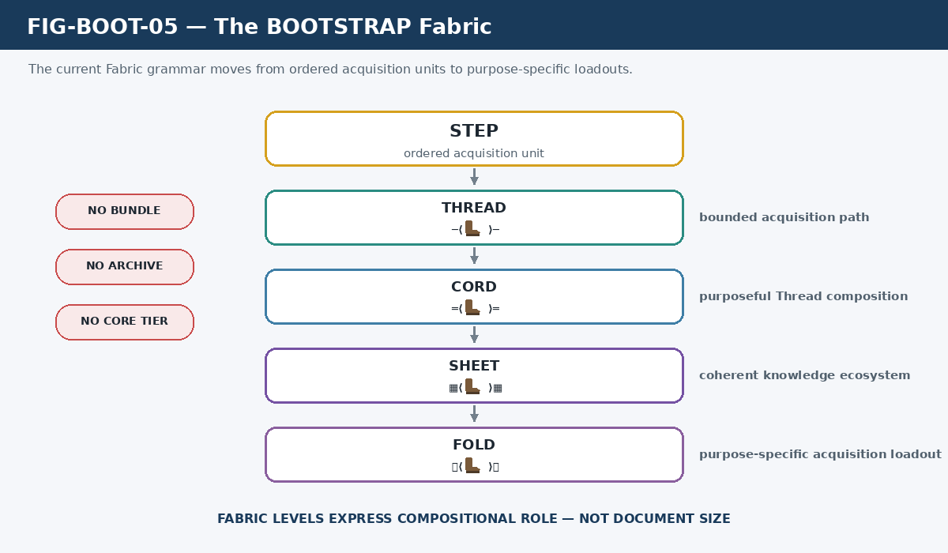
Figure 5. The BOOTSTRAP Fabric. Current composition proceeds from Step to Thread to Cord to Sheet to Fold; Core and Archive remain orthogonal concerns.

3.2 Step - Smallest Acquisition Unit
A Step is the smallest ordered acquisition act inside a governed path. A Step may require reading a source, following an instruction, inspecting a governed object, traversing a bounded external reference, or performing another declared act needed by the Thread. The conceptual Step is intentionally broader than the implementation detail that historically equated a Step with one Airtable field.
Current Thread records expose numbered attachment positions, Read Instructions, and governed links. Those mechanisms can realize Steps, but the semantic contract should survive even if the storage interface changes. Step is therefore defined by its role in acquisition rather than by one physical field type.

3.3 Thread - One Bounded Authored Acquisition Path
A Thread is the first named Fabric object in which sequential acquisition is directly traversed. It provides a bounded purpose, Read Instructions, an authored sequence of required material, and any explicit excursions needed to resolve governed external objects. A Thread can be short or extensive without changing its semantic type.
Figure 6 expands one Thread. It begins with Read Instructions, moves through ordered Steps, allows a governed external-object excursion, returns to the Thread, and then continues. The figure deliberately avoids binding Step to a specific Airtable field, because the acquisition contract is more stable than the current field layout.
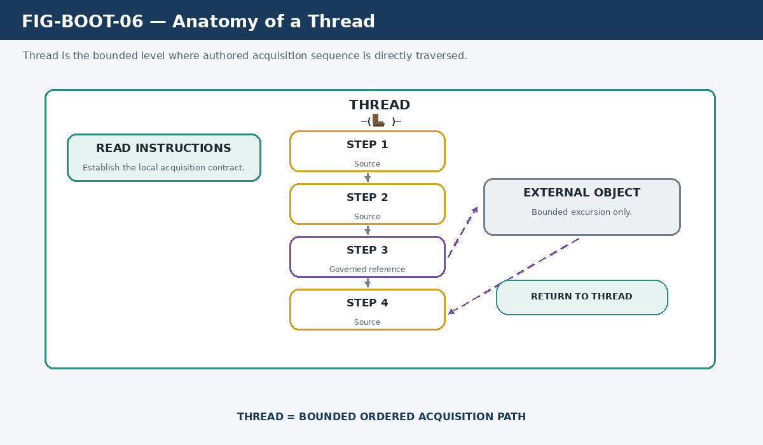
Figure 6. Anatomy of a Thread. A Thread carries a bounded authored acquisition sequence and may include explicit bounded excursions before returning to the governing path.

3.4 Cord - Purposeful Thread Composition
A Cord composes Threads that should be acquired together as one useful learning structure. The reason for a Cord is semantic coherence: its constituent Threads jointly teach something that is more useful as a coordinated structure than as isolated paths. The current System Core is implemented at this Fabric resolution.

3.5 Sheet - Coherent Knowledge Ecosystem
A Sheet composes related Cords into a larger coherent ecosystem. A Sheet is not defined by a file count, record count, or context-window threshold. It is justified when several Cords form a meaningful subject surface that can be selected, taught, or reused as one ecosystem.

3.6 Fold - Purpose-Specific Acquisition Loadout
A Fold is a curated acquisition loadout assembled for a declared purpose. It may select complete Sheets, direct Cords, direct Threads, another Fold, and the Core required for the selected mode. This makes Fold more than the mandatory parent of Sheet: it is the selection surface that declares what this particular Boot needs.
Figure 7 compares Cord, Sheet, and Fold side by side. Cord is shown as a Thread composition, Sheet as a Cord ecosystem, and Fold as a purpose-driven selection. Figure 9 then makes the non-tree behavior explicit by showing one Fold selecting structures at several Fabric resolutions without changing their identities.
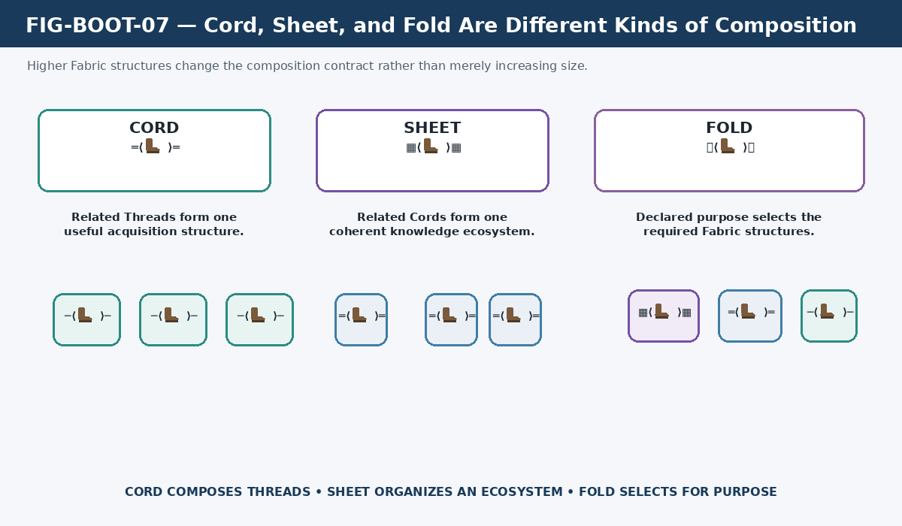
Figure 7. Cord, Sheet, and Fold Are Different Kinds of Composition. The structures differ by semantic role rather than merely by increasing scale.
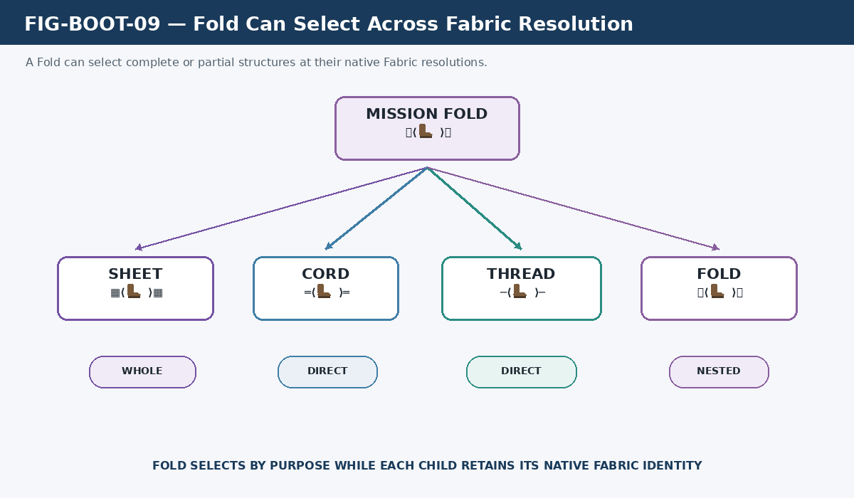
Figure 9. Fold Can Select Across Fabric Resolution. A Fold may select complete or direct structures at their native Fabric levels when the declared purpose requires them.

3.7 Composition Is Semantic, Not Quantitative
The common shortcut Thread = small, Cord = medium, Sheet = large, Fold = largest is useful only as a vague intuition and is unsafe as a definition. A Thread can contain extensive material. A Cord can be small if only a few bounded paths must be learned together. A Sheet exists because of ecosystem coherence. A Fold exists because a declared operating purpose requires a particular selection.
Figure 8 makes this correction visually explicit. The left side crosses out the size ladder; the right side replaces it with semantic roles. The practical consequence is that a designer should not create a higher Fabric level merely because a document-count threshold was crossed.
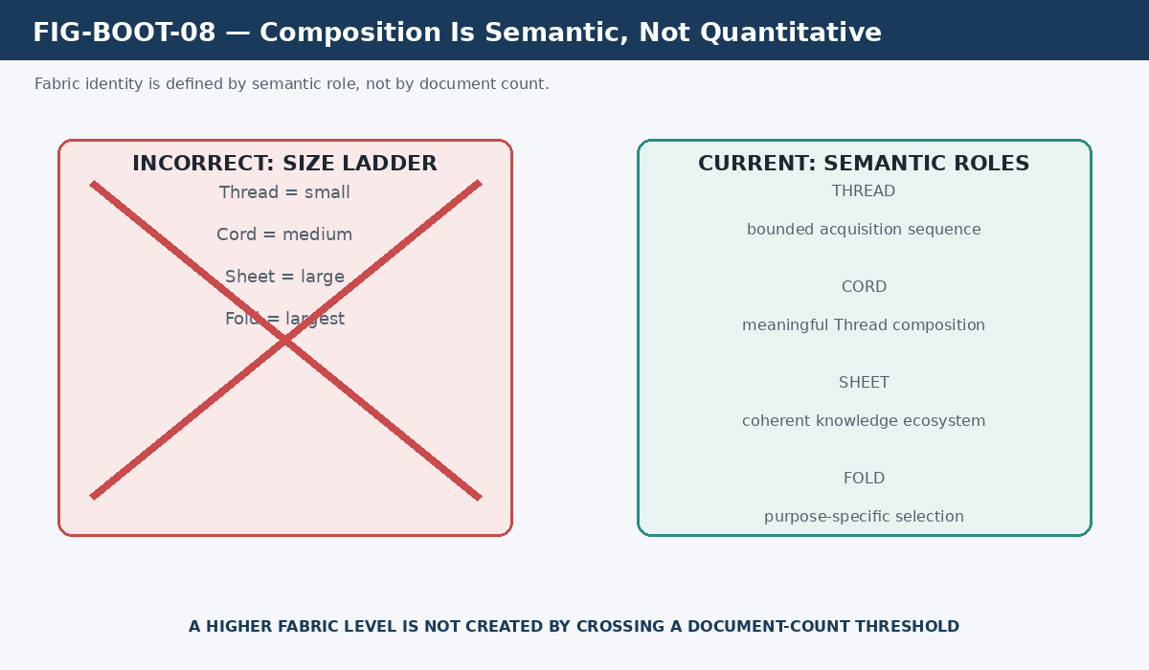
Figure 8. Composition Is Semantic, Not Quantitative. Fabric levels are defined by the role of the composition rather than by size alone.

Part 4 - Core as Sufficiency

4.1 Core Is a Role
Core answers a different question from Fabric depth: what is the lowest-level acquisition structure sufficient to understand how this system works? Because that answer depends on the complexity of the selected system, Core can resolve physically as a Thread, Cord, Sheet, or Fold. A simple subsystem may boot from one Thread. A broader system may require several Threads bound as a Cord. Systems with wider procedural or safety requirements may require a Sheet or Fold before the learner has the minimum sufficient operating model.
Figure 10 places the Fabric ladder on one axis and Core sufficiency on another. The figure shows four possible resolutions: Core -> Thread, Core -> Cord, Core -> Sheet, and Core -> Fold. The important relationship is not upward progression; it is minimum sufficient reconstruction.
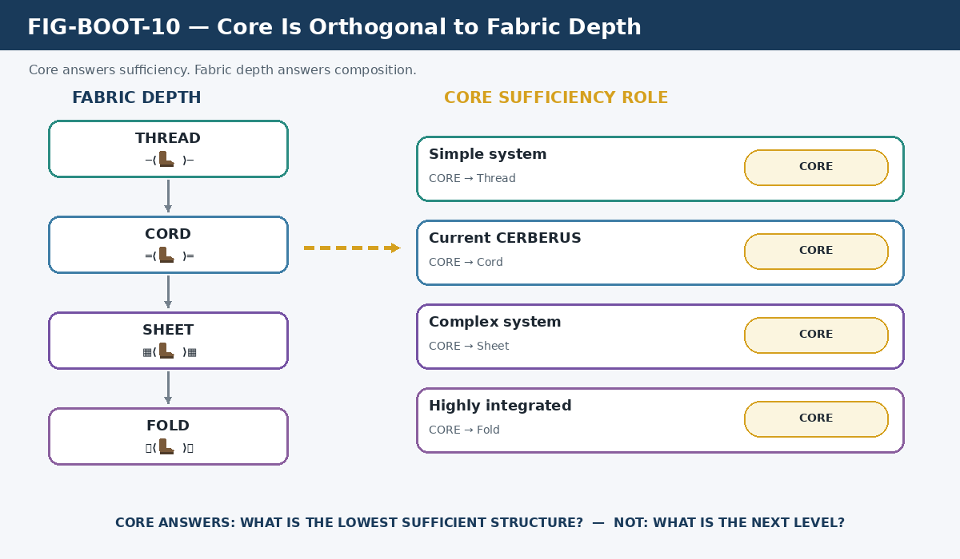
Figure 10. Core Is Orthogonal to Fabric Depth. Core identifies the lowest sufficient Fabric structure rather than introducing another composition level.
CORE SUFFICIENCY LAW
Core is the lowest-level Fabric structure sufficient to boot the learner into understanding how the selected system works.

4.2 Current CERBERUS System Core
In the current CERBERUS Base, System Core is implemented as a Cord. That Cord links foundational Threads including System Architecture; B1 CERBERUS through B10 SOLAR; GROOVE; DRAGON Learning; Features; Preserving Human Experience; Principles; Semantic Kernel Details; and Transform Mechanics. The membership is an implementation fact that can evolve as the Base evolves.
Figure 11 shows that current Cord and its foundational Thread membership. The figure intentionally labels Core as a role above the Cord rather than renaming Cord as Core. A fresh learner should leave this section able to say both statements correctly: the current System Core is a Cord, and Core does not mean Cord.
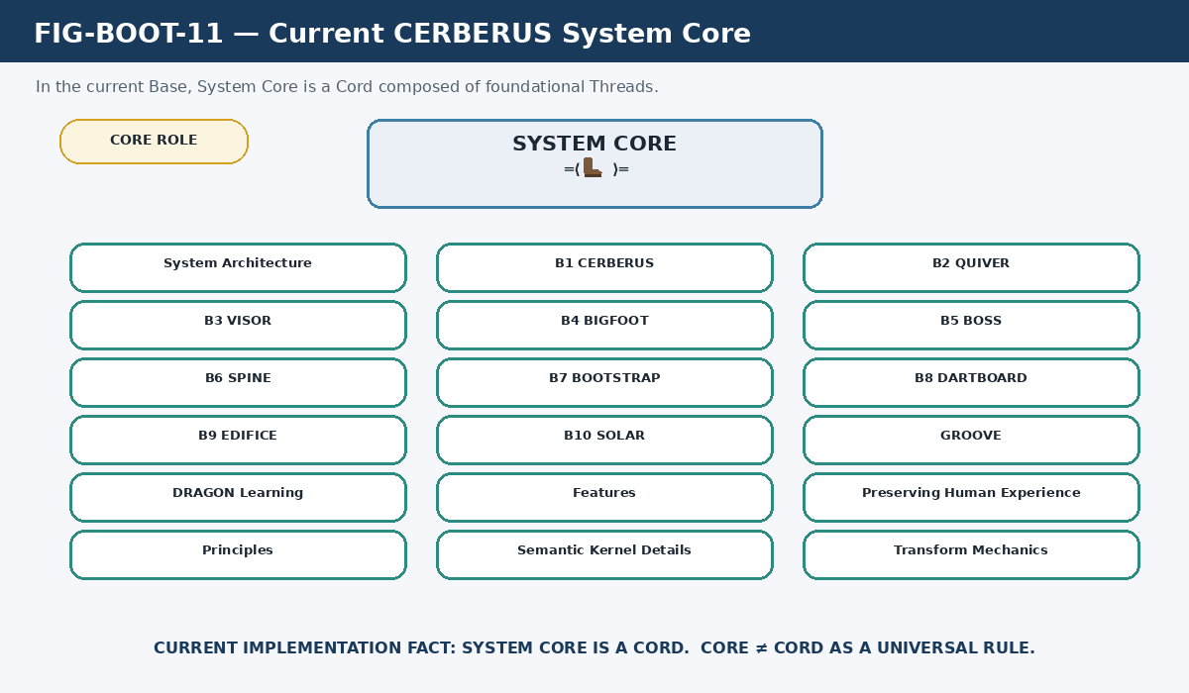
Figure 11. Current CERBERUS System Core. System Core is currently realized as a Cord composed of foundational Threads; that implementation does not redefine the Core concept.

4.3 Core Does Not Mean Exhaustive Knowledge
Sufficient reconstruction is not exhaustive ingestion. The purpose of Core is to establish the minimum common operating ground needed to interpret the selected system correctly. Specialist knowledge can then be layered only when the task requires it. This enables progressive disclosure for cognition: shared language and foundation first, task-relevant competence next, deep evidence only when necessary.

Part 5 - Current BOOTSTRAP Implementation

5.1 Current Five-Table Architecture
The current live implementation uses four active Fabric tables plus one separate lifecycle table: Thread, Cord, Sheet, Fold, and Thread Archives. This is a substantial correction to the earliest prototype, which treated each Thread as its own Airtable table and proposed separate Core-registry mechanics. The current design centralizes each Fabric class into a shared registry.
Figure 12 maps the five tables. The active composition lane contains Thread, Cord, Sheet, and Fold. Thread Archives is placed laterally, not underneath Fold, because it represents lifecycle placement rather than a higher compositional depth.
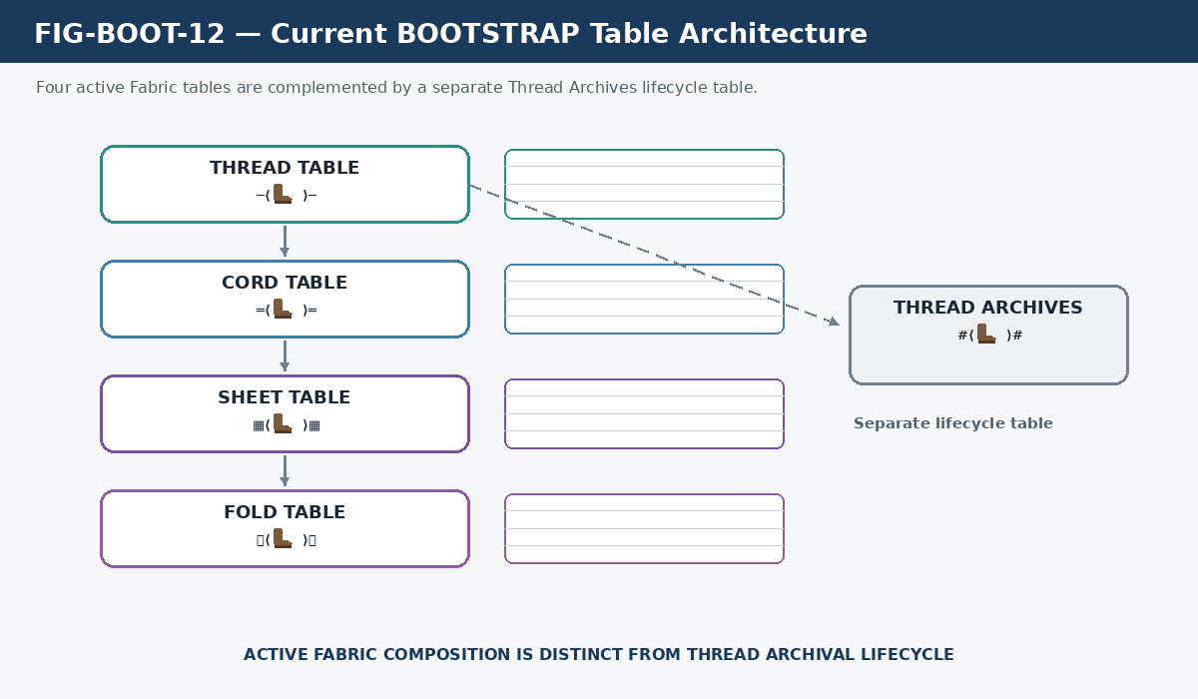
Figure 12. Current BOOTSTRAP Table Architecture. Four shared registries implement active Fabric composition while Thread Archives remains a separate lifecycle table.
Structure | Current role | Primary relation
Thread | Registry of bounded acquisition paths | Steps, source positions, governed references, Cord/Fold relations
Cord | Registry of purposeful Thread compositions | Threads; optional Sheet/Fold membership
Sheet | Registry of coherent knowledge ecosystems | Cords; visibility into constituent Threads; Fold membership
Fold | Registry of purpose-specific acquisition loadouts | Folds, Sheets, Cords, Threads, and declared Core use
Thread Archives | Lifecycle registry for archived Threads | Archived Thread-shaped records; restore semantics not yet formalized

5.2 One Record = One Thread
The shared Thread Table contains many Thread records. Each record is one bounded acquisition object. A current Thread record can include its identity, a selection/classification field, Read Instructions, links to governed Registry/Stack/SK structures, numbered source positions, higher Fabric relations, and a SOLAR relation. The exact field inventory is an implementation surface; the semantic Thread contract is the durable concept.
Figure 13 shows a shared Thread registry on the left and expands one selected record on the right. This explicitly replaces the obsolete equation one Thread = one Airtable table. It also prevents the current numbered attachment slots from being mistaken for a permanent conceptual limit on the number of Steps a Thread may contain.
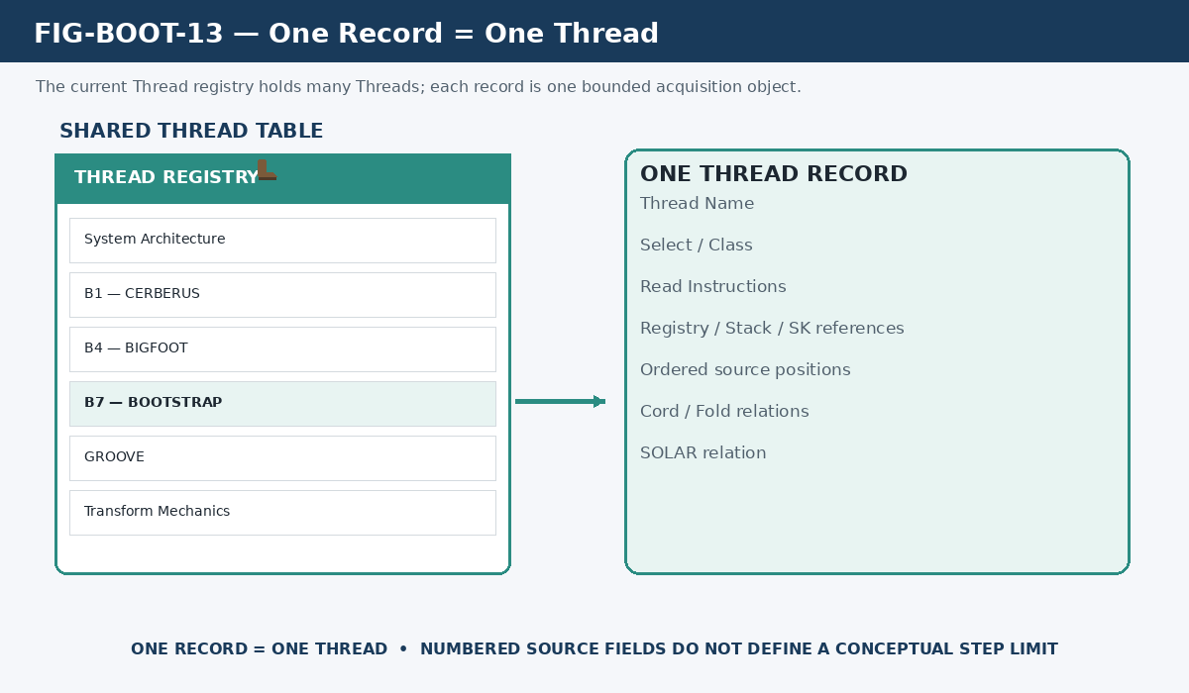
Figure 13. One Record = One Thread. The current Thread Table is a shared registry in which each record is one bounded acquisition path.

5.3 Cord Record Contract
A Cord record identifies one purposeful Thread composition. Its current implementation can link constituent Threads and expose relationships upward into Sheet or Fold structures. A Cord may also have its own document or explanation surface, but its defining semantic act is composition of related Threads.

5.4 Sheet Record Contract
A Sheet record identifies one coherent knowledge ecosystem. Its current implementation links Cords and can expose the Threads contained through those Cords. The semantic contract should not be weakened merely because the current live Sheet registry is still comparatively sparse.

5.5 Fold Record Contract
A Fold record represents a declared-purpose loadout and can select across Fabric resolutions. The current live Fold table exposes relationships to Folds, Sheets, Cords, and Threads. This implementation directly supports the semantic definition established in Part 3: Fold is a curated selection surface rather than simply the final nested container in a strict tree.

5.6 Airtable Is an Implementation Surface
Airtable currently hosts BOOTSTRAP, but BOOTSTRAP is not conceptually identical to Airtable. The architecture should survive migration to a custom runtime, another database, a local graph store, or a future CERBERUS interface. Table names, record fields, and current link mechanics are implementation evidence; the Fabric contracts and acquisition laws are the ontology that implementation must preserve.

Part 6 - Thread Archives and Lifecycle

6.1 Thread Archives Is a Separate Table
The current architecture places archived Threads in the dedicated Thread Archives Table. This supersedes the earlier Features-paper model in which archival state was primarily represented by a Status value and filtered views over the same active records. The new separation gives archival lifecycle its own explicit structural surface.

6.2 Composition and Lifecycle Are Independent Axes
Figure 14 separates the two axes. The composition axis runs Thread -> Cord -> Sheet -> Fold. The lifecycle axis runs Active Thread -> Thread Archives. Archive does not mean a structure is larger, more composed, or semantically above Fold. It means the Thread has entered a different lifecycle placement.
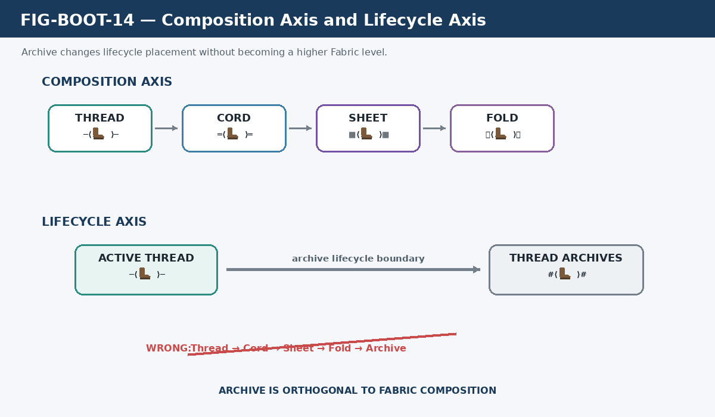
Figure 14. Composition Axis and Lifecycle Axis. Thread Archives is orthogonal to Fabric depth and therefore does not follow Fold in the composition ladder.
ARCHIVE ORTHOGONALITY LAW
Thread Archives are lifecycle infrastructure. They are not another Fabric composition level.

6.3 Archive Mechanics Not Yet Formalized
The current evidence establishes where archived Threads live but does not yet establish every lifecycle operation. The canonical move-versus-copy rule, restore/reactivation procedure, legality of active higher structures directly referencing archived Threads, broader Archive scope, and exact relationship to future version lineage remain unresolved. BOOTSTRAP should preserve those gaps explicitly rather than inventing mechanics to make the model look complete.

Part 7 - Traversal and Acquisition Rules

7.1 Read Instructions First
A selected Thread begins by establishing its local acquisition contract. Read Instructions tell the learner how the Thread should be traversed, which material is required, how linked resources should be handled, and what local constraints apply. The learner should not infer a substitute contract from file names or surrounding context when explicit instructions exist.

7.2 Authored Order Is Semantic
The declared order of required Steps is part of the knowledge design. The learner can flag a dependency problem, missing prerequisite, or suspected error, but the proper response is to surface that issue rather than quietly rewrite the Thread. This rule keeps human authorship inspectable and makes later correction possible.

7.3 Governed Thread Traversal
Figure 15 expresses the operational loop without reviving obsolete Bundle mechanics. The learner resolves the Thread, reads its instructions, resolves the required order, acquires the current Step, advances position, and tests whether the Thread contract is satisfied. If not, acquisition continues. If yes, the Thread is complete for the declared contract.
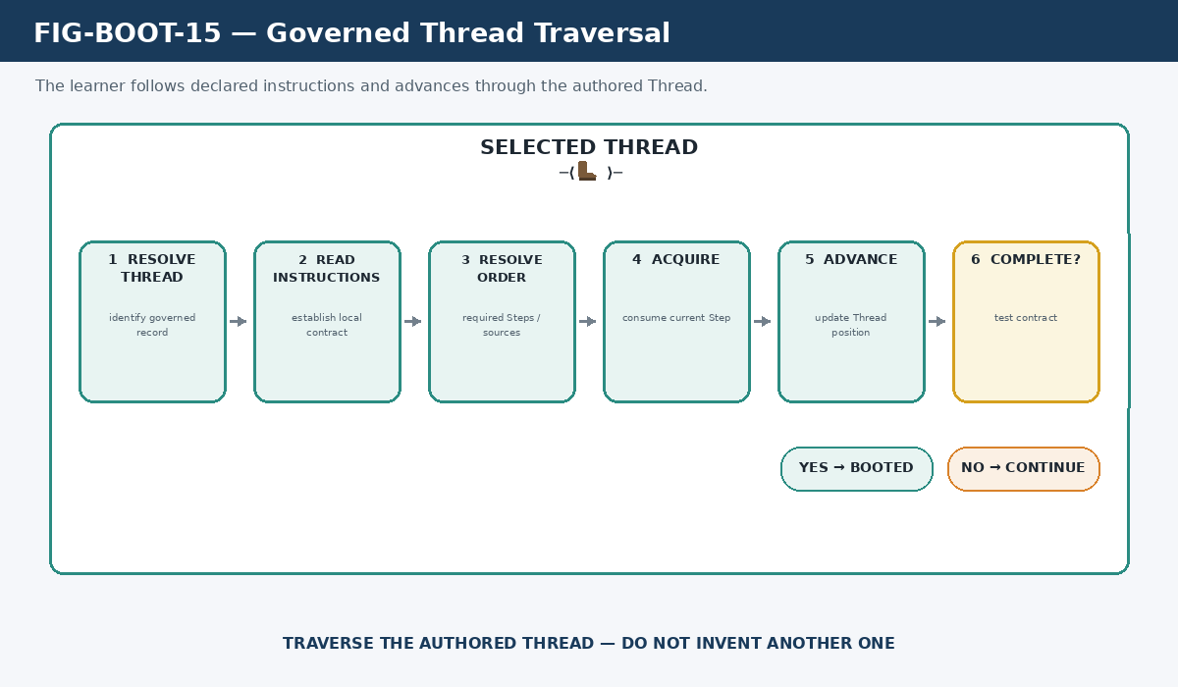
Figure 15. Governed Thread Traversal. The learner resolves the Thread, follows its declared acquisition order, and completes only when the local contract is satisfied.

7.4 Bounded Excursion and Return
A linked resource is an excursion from the governing Thread, not an invitation to abandon the Thread and consume everything adjacent to the referenced object. The Thread establishes the scope of the excursion: what object must be inspected, why it matters, and when control returns.
Figure 16 makes that boundary visible. Step 3 opens an explicit reference into an external system. The required object is acquired while unrelated content remains outside the active route. The learner then returns to Step 4 of the governing Thread.
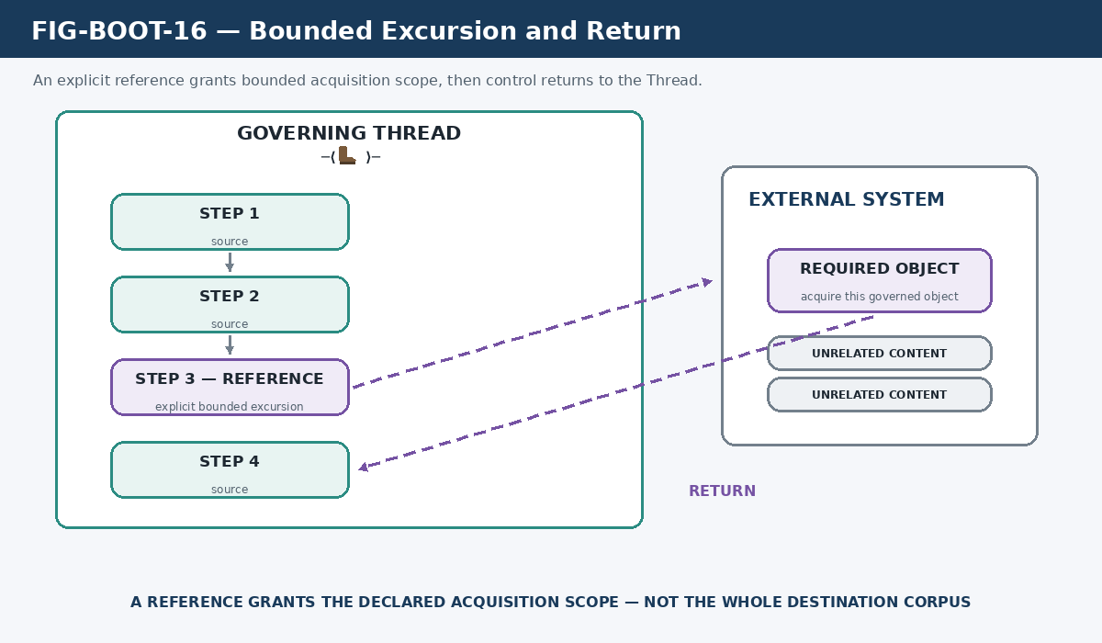
Figure 16. Bounded Excursion and Return. An explicit reference grants the declared acquisition scope and then returns control to the governing Thread.

7.5 Higher Fabric Structures Can Remain Declarative
The procedural walking intelligence belongs primarily at Thread resolution. Cord, Sheet, and Fold can remain declarative compositions that resolve which Threads or other Fabric structures must be acquired. This keeps the runtime small while allowing the content architecture to become rich: the walker knows how to walk, and the Fabric records know what should be walked for a declared purpose.

7.6 Missing Evidence Remains Unresolved
A missing required source is not permission to fabricate an equivalent explanation from model intuition. Likewise, a later correction can supersede an earlier source without destroying the earlier source as provenance. BOOTSTRAP needs enough evidence discipline to represent canonical, corrected, historical, and unresolved states rather than collapsing them into one summary.
Figure 17 shows three outcomes. Authoritative evidence is followed. A later correction teaches the current canonical state while preserving the older source as history. Missing or conflicting evidence ends in an unresolved state rather than an invented replacement.
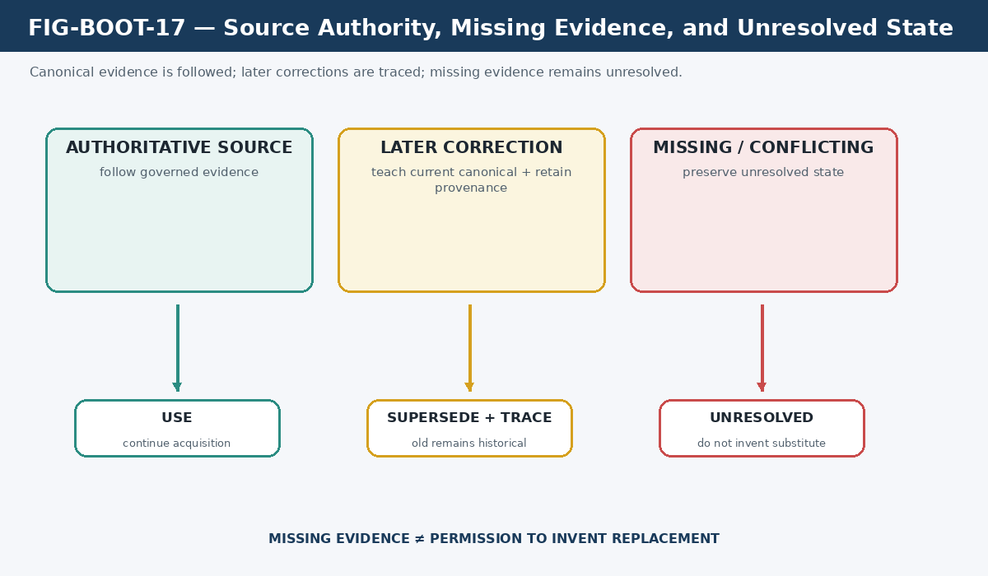
Figure 17. Source Authority, Missing Evidence, and Unresolved State. BOOTSTRAP follows governed evidence, traces corrections, and preserves unresolved gaps instead of silently patching them.

7.7 Completion Means Contract Satisfaction
Completion is relative to the selected acquisition contract. Required Steps and required bounded references must be completed. Optional structures may remain unloaded if the selected Thread or Fold does not require them. Completion does not mean the learner has mastered all possible knowledge in the domain; it means the declared Boot contract has been satisfied sufficiently for its purpose.

Part 8 - Shared Human + AI Acquisition

8.1 One Governed Source, Multiple Consumers
BOOTSTRAP is not intrinsically an AI-only mechanism. The consumer can be an AI, a human reader, a student, a future maintainer, or another authorized participant. Presentation can differ by consumer while the governed source, dependency order, reference structure, and semantic coordinates remain shared.
Figure 18 places one governed BOOTSTRAP source above three downstream surfaces: human documentation, curriculum/training, and AI familiarization. The figure is deliberately asymmetric about presentation but symmetric about source governance. The same acquisition substrate can serve different interaction modes without maintaining three competing knowledge systems.
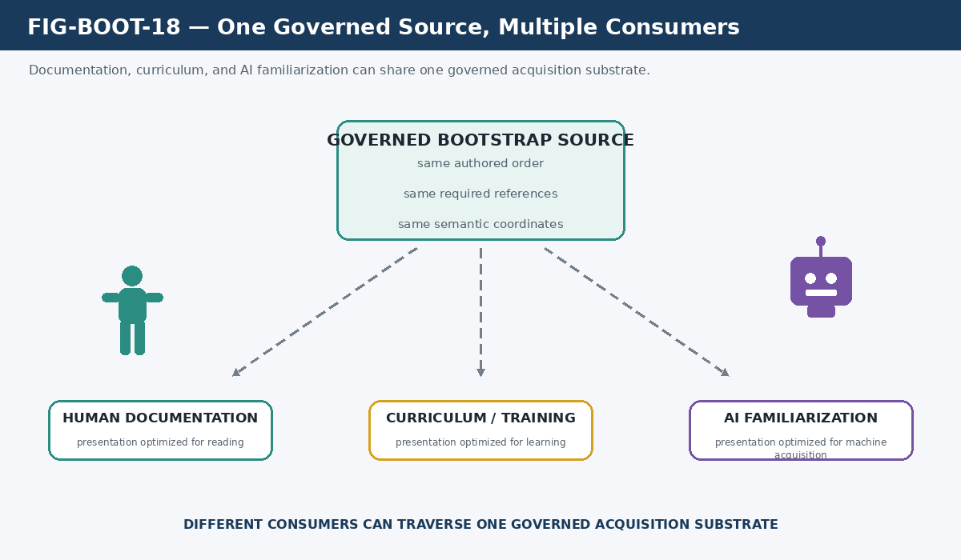
Figure 18. One Governed Source, Multiple Consumers. Documentation, curriculum, and AI familiarization can resolve from the same governed acquisition substrate while using different presentation surfaces.

8.2 Same Material Is Not the Same Learning Path
The principle from Figure 2 becomes especially important when humans and AI share a curriculum. If both consumers merely receive the same files but choose independent orders, the resulting models can diverge unnecessarily. BOOTSTRAP reduces that avoidable divergence by governing the sequence itself, not merely distributing the source set.

8.3 Semantic Alignment Without Identity
Shared acquisition can become more precise when the material resolves into CERBERUS semantic coordinates such as World, Community, Family, Symbol, Semantic Kernel, Reader, BitGroup, and Bit. These coordinates do not make internal cognition identical. They give both consumers stable locations from which agreement, difference, or uncertainty can be discussed.
Figure 19 shows a human map and an AI map on opposite sides of shared coordinates. Source sequence, terminology, examples, figures, and semantic addresses move the two consumers toward more mutually resolvable models while preserving distinct interpretations at the edges.
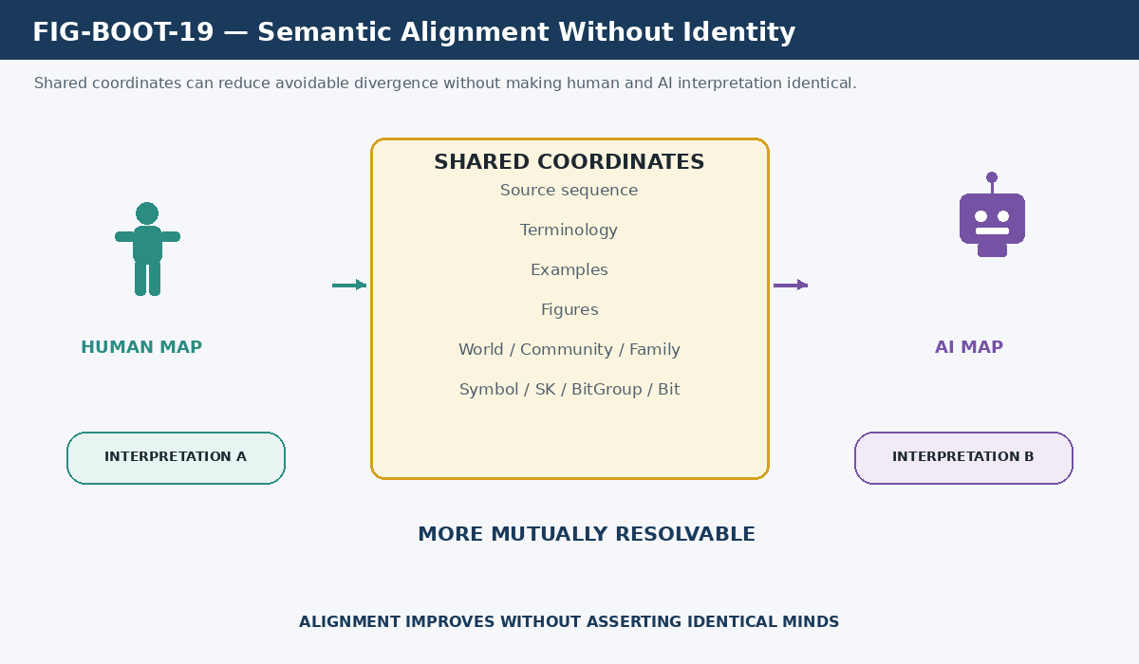
Figure 19. Semantic Alignment Without Identity. Shared semantic coordinates reduce avoidable divergence while preserving the boundary between different interpreters.
ALIGNMENT PRINCIPLE
BOOTSTRAP does not make minds identical. It makes their semantic coordinate systems more congruent by controlling the material, order, definitions, figures, and reference structure they share.

8.4 Resolution Into CERBERUS Semantic Coordinates
BOOTSTRAP may route the learner from broad subject context toward increasingly precise semantic locations. A document can name a Community, a Family, a symbol, an SK, a BitGroup, or an exact Bit. The acquisition path therefore becomes compatible with machine-addressable meaning without turning BOOTSTRAP into the owner of those meanings.

8.5 Documentation as Acquisition Infrastructure
A well-authored BOOTSTRAP source can serve as both human-facing documentation and machine familiarization infrastructure. The advantage is maintenance integrity: when the underlying knowledge structure changes, the governed documentation surface and the AI acquisition route can re-resolve from the same corrected source rather than drifting as separately maintained systems.

Part 9 - Boot Loadouts and Reuse

9.1 Reuse Without Duplication
A canonical Thread can participate in more than one Cord, Sheet, or Fold without copying its source knowledge. Higher Fabric structures reference the governed acquisition object. This makes a change to the underlying Thread traceable and allows future version controls to distinguish a deliberate pin from accidental duplication.
Figure 20 shows one canonical Thread branching into two Cords, a Sheet, and a Fold. The branches represent composition references, not cloned source content. The Thread retains one governed identity even when its usefulness spans several higher structures.
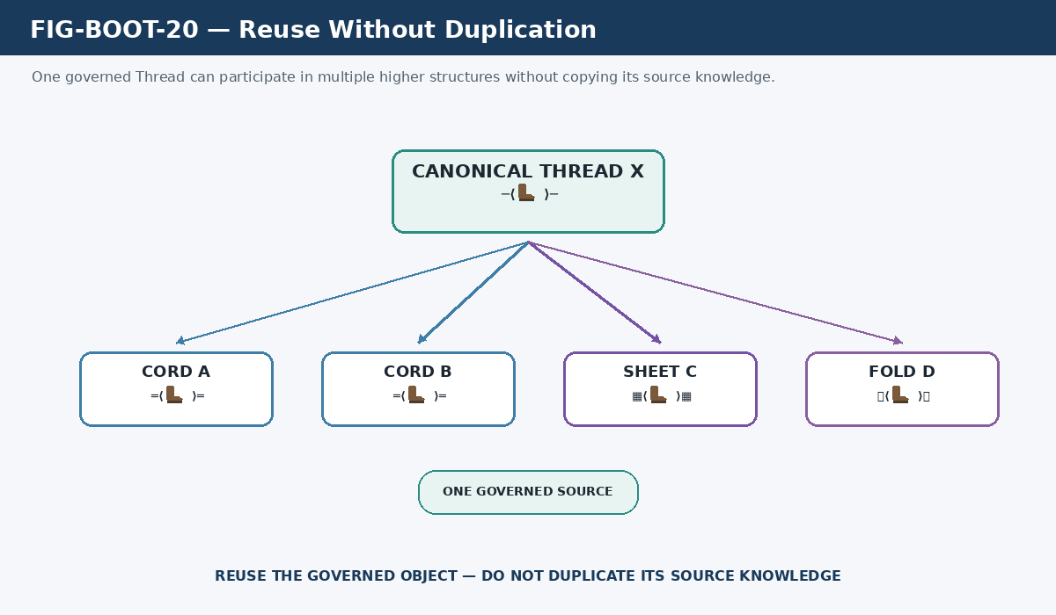
Figure 20. Reuse Without Duplication. One governed Thread identity can participate in multiple higher Fabric compositions without copying its source knowledge.

9.2 Selective Loading and Fold Sufficiency
A Fold is complete relative to its declared purpose. It does not imply that every available Thread, Cord, Sheet, or specialist body of knowledge must be loaded. The architecture can therefore pay context cost in proportion to semantic need: foundation first, specialist competence only when relevant, and deep source descent only when evidence or additional depth is required.
Figure 21 shows a broad available library on the left and a specialist Fold on the right. The Fold selects required Core, one Sheet, one Cord, and one direct Thread while everything else remains available but unloaded. This is the practical meaning of Fold sufficiency.
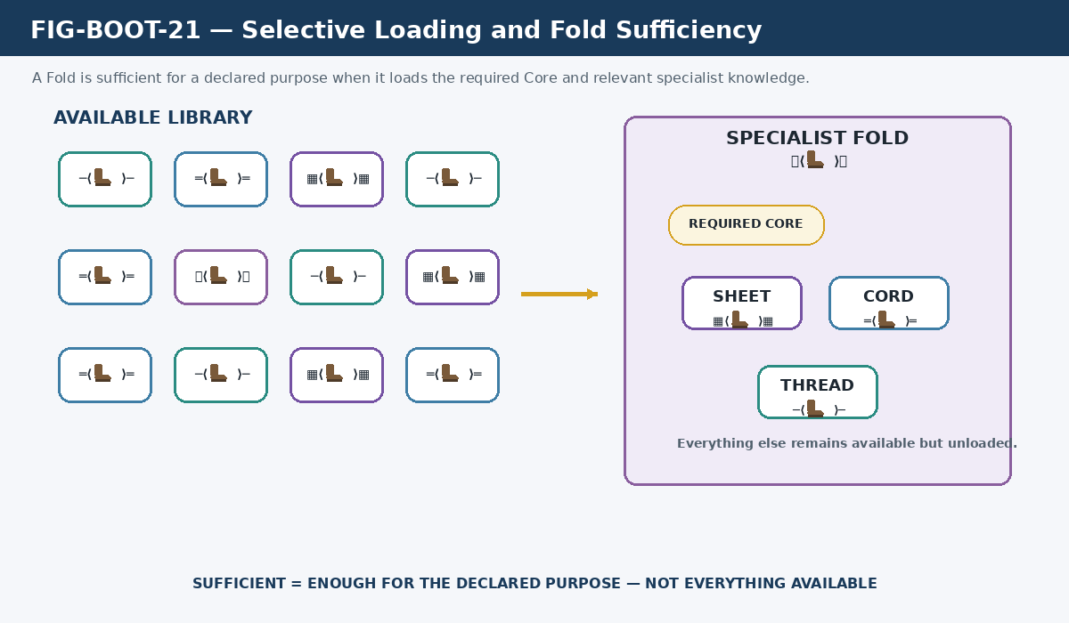
Figure 21. Selective Loading and Fold Sufficiency. A Fold loads enough governed knowledge for the declared purpose without requiring exhaustive ingestion of the available library.

9.3 Current CERBERUS General Assistant Bootup
The current General Assistant Bootup provides a live integration example. The Fold named CERBERUS General Assistant Bootup links the System Core Cord. System Core then resolves its foundational Threads, each of which carries its own acquisition material, instructions, and governed references. The Boot therefore demonstrates several BOOTSTRAP dimensions simultaneously: Fold selection, Core sufficiency, Cord composition, Thread traversal, and bounded reference resolution.
Figure 22 presents that route from top to bottom. It begins with the General Assistant Bootup Fold, passes through the Core role to the System Core Cord, expands into representative foundational Threads, and ends at Steps, sources, bounded references, and the reconstructed CERBERUS operating model.
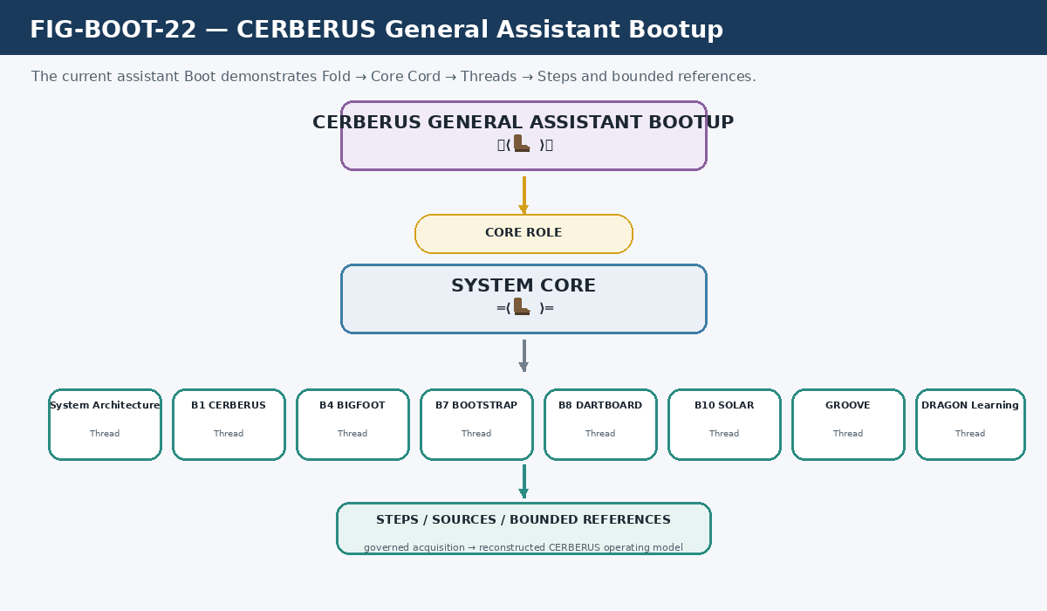
Figure 22. CERBERUS General Assistant Bootup. The current assistant Boot is a Fold whose foundational Core resolves as a Cord of governed Threads.

9.4 Specialist Acquisition
A specialist loadout can reuse the same foundation while adding task-relevant Threads, Cords, Sheets, or AI Skills. A simulation task can add simulation competence. A document-production task can add OctoGroove. A combined task can load both. This modularity is a direct consequence of separating common Core, domain knowledge, and procedural skill rather than stuffing all possible competence into one permanently maximal context window.

Part 10 - Evolution, Reproducibility, and Historical Knowledge

10.1 Preserve the Current / Future Boundary
BOOTSTRAP has always been designed with reproducibility and evolution in mind, but the reconstruction artifact must distinguish what is live from what is architectural possibility. The current implementation already supports shared Fabric registries, one Thread per record, Read Instructions, ordered sources, registered references, separate Thread Archives, System Core, and selective Fold composition. Other capabilities remain designed or partially formalized.
Figure 23 puts those states side by side. The left region contains current canonical implementation. The right region preserves intended growth such as universal version pinning, richer clone/fork/merge workflows, archive restoration semantics, access gating, and broader lifecycle controls. Keeping both visible prevents the system from forgetting its design trajectory without pretending the future is already implemented.
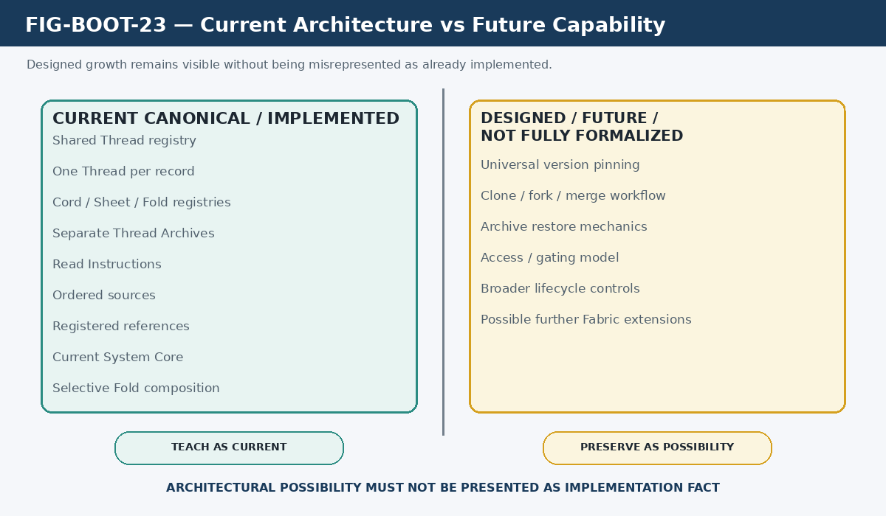
Figure 23. Current Architecture vs Future Capability. Implemented structure is taught as current while designed growth remains visible as possibility rather than fact.

10.2 Version Pinning
The earlier Fabric architecture proposed explicit version identities, manifest pinning, and reproducible loadouts. Those ideas remain compatible with the current architecture, but they are not yet universal fields or enforced contracts across every live BOOTSTRAP table. The singular reconstruction paper therefore preserves version pinning as designed capability rather than silently teaching the old prototype schema as current.

10.3 Clone, Fork, Compare, Merge, and Publish
Likewise, clone/fork lineage, structural comparison, selective merge, and publication are powerful higher-order capabilities that can build on stable Fabric identities. They belong to BOOTSTRAP evolution because a governed loadout should eventually be reproducible, comparable, and traceable. Their exact current implementation remains future-facing and should be formalized only when the Base defines the necessary identity and lineage contracts.

10.4 Historical Boots and Knowledge Horizons
BOOTSTRAP can support historical or role-bounded knowledge states by selecting only the material a consumer is supposed to know at a given point. This is useful for training, historical simulation, narrative intelligence, spoiler-safe assistants, or branch-specific world models. The architectural principle is selective governed acquisition; the narrative or temporal system remains responsible for defining the actual historical state.

Part 11 - Wider CERBERUS Relationships
BOOTSTRAP becomes more useful because it can route into other CERBERUS systems without collapsing their responsibilities. Figure 4 established the ownership boundary; this section names the principal companions a fresh assistant should recognize.
Companion | BOOTSTRAP relationship | Boundary
VISOR / Registry / Stack routing | May be referenced to locate governed structural material. | VISOR and the referenced Registry/Stack own their own structure and routes.
BIGFOOT | May be referenced when acquisition requires canonical Bits, BitGroups, BitWords, or SK-bound identities. | BIGFOOT owns operational semantic identities.
BOSS | May be referenced for symbolic/semantic registry meanings and Family/Community/World placement. | BOSS owns symbolic and semantic registration.
SOLAR | Current Fabric tables expose SOLAR relations and future Boots can use lexical/personalized resolution. | SOLAR owns lexical/personalized interpretation.
DARTBOARD | Can present BOOTSTRAP material through usable interface surfaces. | DARTBOARD owns interface manifestation, not acquisition order.
DRAGON | Can track learner exposure, mastery, curriculum progression, or training state. | DRAGON owns learning-state mechanics rather than BOOTSTRAP Fabric composition.
GROOVE | Can preserve relationships, provenance, and grounded development context around BOOTSTRAP artifacts. | GROOVE does not replace the BOOTSTRAP acquisition contract.

CROSS-SYSTEM PRINCIPLE
BOOTSTRAP knows what must be acquired and where to acquire it. The destination system remains responsible for what that thing means and how it operates.

Part 12 - Representative Applications

12.1 Human Onboarding and Curriculum
A human learner can traverse the same governed source order used to familiarize an AI, while receiving a presentation optimized for reading, exercises, discussion, or DARTBOARD interaction. The advantage is a shared semantic substrate: curriculum and system documentation need not drift into separate interpretations of the same architecture.

12.2 AI Familiarization
A fresh AI can use BOOTSTRAP to reconstruct a bounded system without replaying the full developmental history of that system. Core provides the minimum operating model; task-relevant Threads and AI Skills add specialist competence; deeper historical sources remain available when evidence or provenance is required.

12.3 Specialist Assistants
A specialist assistant can be produced by composing the general foundation with a declared specialist Fold or task-relevant Fabric additions. The assistant can therefore be specialized through structured content rather than through one opaque prompt whose assumptions are difficult to inspect or reproduce.

12.4 Historical, Narrative, and Role-Bounded Knowledge
The same selective loading model can constrain knowledge by role, point of view, or historical position. BOOTSTRAP supplies the acquisition mechanism; TIME, scene history, permissions, world state, or other companion systems define which knowledge belongs in the selected horizon.

Part 13 - BOOTSTRAP Laws
Law | Rule
1. Authored Order Law | Acquisition sequence is governed knowledge and must not be silently reordered.
2. Fabric Composition Law | Steps compose Threads; Threads compose Cords; Cords compose Sheets; Folds curate bounded selections across the Fabric.
3. Core Sufficiency Law | Core is a role of minimum sufficient understanding, not a composition depth.
4. Thread Determinism Law | A selected Thread follows its declared instructions and ordered required acquisition material.
5. Excursion Return Law | A bounded linked-resource excursion returns to the governing Thread unless explicitly redirected.
6. Composable Knowledge Law | Reusable Fabric structures may participate in multiple higher compositions without duplicating their source knowledge.
7. Sheet Coherence Law | A Sheet exists because its constituent knowledge forms a coherent ecosystem.
8. Fold Sufficiency Law | A Fold is complete for its declared purpose, not exhaustive of all available knowledge.
9. Selective Loading Law | Only material required by the selected Boot contract needs to be loaded.
10. Ownership Preservation Law | A BOOTSTRAP reference does not transfer semantic ownership from the referenced system.
11. Source Authority Law | Explicit authoritative source instructions remain visible and bounded.
12. Missing Source Law | Missing required evidence remains unresolved rather than being replaced by invention.
13. Archive Orthogonality Law | Thread Archives are lifecycle infrastructure, not another Fabric composition level.
14. Shared Source Law | Different consumers may use different presentations while resolving from the same governed acquisition source.
15. Interpretation Boundary Law | Shared BOOTSTRAP does not guarantee identical human interpretation or identical model behavior.

Part 14 - Common Misunderstandings and Anti-Patterns
Incorrect interpretation | Current model
One Thread is one Airtable Table. | One Thread is currently one record in the common Thread Table.
Bundle is a formal BOOTSTRAP level. | The formal Fabric grammar is Step -> Thread -> Cord -> Sheet -> Fold. Bundle is historical terminology.
One Airtable field universally equals one Step. | Step is the acquisition unit; current fields and links are implementation mechanisms that can express Steps.
Core is another level after Cord or above Fold. | Core is orthogonal and marks the lowest sufficient Fabric structure.
Archive is a Status toggle over active Threads. | Archived Threads currently live in the dedicated Thread Archives Table.
Archive is above Fold. | Archive is lifecycle placement, not Fabric composition.
Fold simply means largest container. | Fold is a declared-purpose loadout and may select across Fabric resolutions.
A BOOTSTRAP link makes the destination part of BOOTSTRAP. | BOOTSTRAP governs the acquisition route; semantic ownership remains with the destination system.
The learner should optimize the reading order silently. | The learner may report a suspected defect but must preserve authored order until it is explicitly changed.
A missing source can be reconstructed from intuition. | Missing required evidence remains unresolved unless a governed substitute is explicitly authorized.
A valid Boot must load the entire Base. | Core and Fold sufficiency permit selective loading appropriate to the declared purpose.

Part 15 - Reconstruction Test

15.1 Integrated BOOTSTRAP Mental Model
The final reconstruction must preserve several dimensions at once without collapsing them into one hierarchy. Fabric describes composition. Core describes sufficiency. Lifecycle describes active versus archived Thread placement. Traversal describes how a selected Thread is walked. Ownership describes the boundary between acquisition and semantic authority. Consumers describe who can traverse the source. Evidence handling describes how canonical, corrected, historical, and unresolved states remain distinguishable.
Figure 24 brings those dimensions together around BOOTSTRAP. A correct reading does not turn the surrounding cards into additional Fabric levels. They are coordinated axes that all contribute to governed knowledge acquisition.
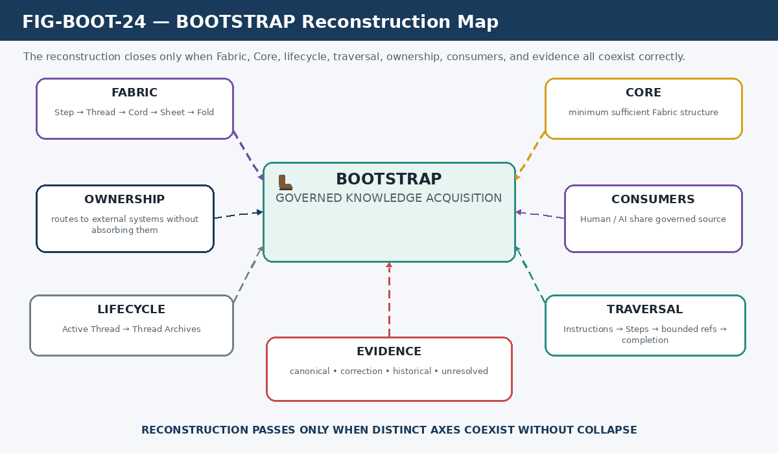
Figure 24. BOOTSTRAP Reconstruction Map. The full mental model coordinates Fabric, Core, lifecycle, traversal, ownership, consumers, and evidence without collapsing them into a single hierarchy.

15.2 Competency Questions
Question | Pass condition
What problem does BOOTSTRAP solve? | The learner distinguishes governed acquisition from mere storage.
What is the Fabric grammar? | Step -> Thread -> Cord -> Sheet -> Fold.
Why is Thread different from Cord? | Thread is a bounded authored acquisition path; Cord composes related Threads.
Why is Sheet different from Cord? | Sheet organizes a coherent knowledge ecosystem rather than simply more Threads.
Why is Fold not just the largest container? | Fold is a purpose-specific loadout that can select across Fabric resolutions.
What does Core mean? | The lowest sufficient Fabric structure needed to understand how the selected system works.
Can Core be a Thread? | Yes, if one Thread is sufficient for the selected system.
What is the current CERBERUS System Core? | A Cord containing the current foundational Threads.
Where do archived Threads go? | The separate Thread Archives Table.
Is Archive a Fabric level? | No. Archive belongs to lifecycle.
Can an AI silently reorder a Thread? | No. It may report a problem but must preserve authored order until changed.
What is a bounded reference? | An explicit acquisition excursion into a governed external object followed by return to the Thread.
Does BOOTSTRAP own BIGFOOT or BOSS because it links to them? | No. It owns the route; those systems retain semantic ownership.
What happens when required evidence is missing? | The state remains unresolved rather than being filled by invention.
Can humans and AI use the same BOOTSTRAP? | Yes. Presentation can differ while the governed source and acquisition structure remain shared.

RECONSTRUCTION GATE
If a learner cannot distinguish Core from Fabric depth or Archive from Fabric composition, BOOTSTRAP has not been reconstructed correctly.

Appendix A - Source and Correction Map
The singular BOOTSTRAP artifact is a current reconstruction, not a deletion of earlier development. The following map preserves the principal source contributions and identifies where later architecture supersedes prototype implementation details.
Source | Contribution | Current treatment
CERBERUS_Bootstrap_Fabric_Architecture_v0.1 | Mechanical spine: visible acquisition, deterministic Thread traversal, bounded excursions, reusable Cords/Sheets/Folds, selective loading, source laws, reproducibility ideas. | Retained conceptually; prototype Bundle, one-Table-per-Thread, dedicated Core-registry, and universal version-field assumptions are historical.
CERBERUS_BOOTSTRAP_Features_Human_AI_Learning_and_Evolving_Knowledge_Architecture_v0.1 | Human + AI shared acquisition, order-as-knowledge, semantic alignment, documentation/curriculum surfaces, knowledge horizons. | Retained conceptually; Archive-as-Status/filter model is superseded.
CERBERUS_System_Notation_Architecture_v0.2 | F-language formalizes Thread, Cord, Sheet, Fold and states that Core is orthogonal to the composition ladder. | Current formal grammar source.
Current live BOOTSTRAP tables | Shared Thread/Cord/Sheet/Fold registries, Thread Archives, System Core Cord, General Assistant Bootup Fold. | Current implementation evidence.
Later BOOTSTRAP corrections | Bundle deprecated; one Thread per shared-table record; Core is minimum sufficient structure; Archives separated into their own Table. | Current canonical corrections applied throughout this artifact.

A.1 Live BOOTSTRAP Table References
Thread Table: https://airtable.com/appiH1vP0JiSQ287Y/tblA59Q1wmSsZOkHL/viwzZSozRCKkilvYS?blocks=hide
Cord Table: https://airtable.com/appiH1vP0JiSQ287Y/tblQEyHqd54umyz1C/viwC7gq7Srg4uGfNH?blocks=hide
Sheet Table: https://airtable.com/appiH1vP0JiSQ287Y/tblm2nlarJf3o19UY/viw8v54R65rDw9PG3?blocks=hide
Fold Table: https://airtable.com/appiH1vP0JiSQ287Y/tbl3LAmI6VyFqjDqk/viw8V5wQmLW8XnNFC?blocks=hide
Thread Archives: https://airtable.com/appiH1vP0JiSQ287Y/tblCqXwdEmAoBVvFx/viwBkG4LZCsgUsGWE?blocks=hide

Appendix B - Unresolved Register
The following items are intentionally left unresolved because current documentation and live implementation do not yet establish a canonical answer. The unresolved register is part of the reconstruction contract: absence of evidence is represented rather than repaired by assumption.
Unresolved item | Known boundary
Archive transfer semantics | Whether archival operation is canonically move, copy, snapshot, or another lifecycle transformation.
Archive restoration | How a Thread is restored/reactivated and whether identity/version rules change during restoration.
Archived-Thread reuse | Whether active Cords, Sheets, or Folds may legally maintain direct references to archived Threads.
Archive scope | Whether future lifecycle registries will also exist for Cords, Sheets, Folds, or other BOOTSTRAP objects.
Version pinning contract | Exact current fields, identity rules, and enforcement mechanism for reproducible pinned loadouts.
Clone/fork/merge implementation | Exact lineage, comparison, merge, and publish workflow for evolving BOOTSTRAP structures.
Access and gating | Formal permission, emergency-procedure, restricted-knowledge, and role-gating mechanics.
Future Fabric extension | Whether any additional Fabric level will ever be needed beyond Fold; none is currently canonical.

CLOSING PRINCIPLE
The corpus can remain deep, historical, and evolving. BOOTSTRAP should make the reconstruction interface bounded, authored, inspectable, and sufficient.

CERBERUS BOOTSTRAP • Governed Knowledge-Acquisition Fabric • Version 0.2

