CERBERUS
SK MEMORY SYSTEM
Descriptive Bits, Ordered Knowledge Layers, Recursive References, and Deterministic Semantic Documentation
CORE SYSTEM STATEMENT
An SK does not need to contain its documentation directly. Descriptive Bits provide bounded semantic memory addresses. Active Bits deterministically route to linked Description, Professional Example, Personal Example, and References records. Interfaces decide how much of that attached memory to expose.

SHORT FORM
Read the Bits. Follow the records. Display the active memory.
Reference Architecture v0.1
18 August 2026
Prototype implementation and review

Document Control
Field / Law | Reference statement
Document title | CERBERUS SK Memory System - Descriptive Bits, Ordered Knowledge Layers, Recursive References, and Deterministic Semantic Documentation
Version | 0.1
Date | 18 August 2026
Status | Reference architecture draft for prototype implementation and review
Primary subject | Descriptive Bits, deterministic binary activation, linked memory records, ordered References records, operational/educational projections, recursive semantic references, CRT gathering, and scoped AI context.
Primary boundary | SK Memory attaches recoverable explanatory and referential memory to Semantic Kernel addresses. It does not replace functional semantic state, DARTBOARD, autobiographical Memory registries, or the runtime implementation of referenced target types.
Companion architecture | CERBERUS DARTBOARD - Record-Driven Semantic Interface Resolution & Construction Architecture v0.2

Abstract
This paper defines the CERBERUS SK Memory System: a deterministic documentation and reference architecture built from Descriptive Bits. A DESCRIPTION-n BitGroup supplies bounded memory addresses at any semantically justified width. At runtime, binary state is read in Bit order. Inactive Bits are ignored. Each active Bit resolves an exact Descriptive Bit record, which links outward to four ordered memory layers: Description, Professional Example, Personal Example, and References.
The References layer is intentionally broader than a bibliography. A References Link resolves one References record whose paired fields - Reference Description 1 with Link 1, Reference Description 2 with Link 2, and so forth - preserve explicit order. Each Link may route to any supported addressable object: another SK, a figure, a drawing, an audio clip, a document, a personal Memory, an attachment, an Instance, or an external resource. Reference Description explains why the target matters; the Link resolves the target itself.
The architecture therefore separates functional semantics from human memory while letting one semantic object serve operational and educational use. D/E/F/G interfaces may expose no SK Memory, a concise Description, deeper examples, or ordered References without duplicating or rewriting the functional record. CERBERUS Rollup Traversal can gather only active memory records into bounded context for DARTBOARD, AI, or other renderers. Bits carry activation. Records carry memory. Interfaces carry presentation.

Reading Map
Field / Law | Reference statement
Part 1 | Purpose and separation | Figures 1-2
Part 2 | Descriptive Bits and deterministic activation | Figures 3-6
Part 3 | The four ordered memory layers | Figures 7-10
Part 4 | References and recursive routing | Figures 11-17
Part 5 | Boundedness, ownership, and operational/educational reuse | Figures 18-25
Part 6 | Pure descriptive kernels and width-independent retrieval | Figures 26-27
Part 7 | CRT, AI context, validation, and rebuildability | Figures 28-31
Part 8 | Complete architecture, contracts, laws, and prototype sequence | Figure 32

BOUNDARY
SK Memory is not a second semantic truth layer. It is a deterministic memory layer attached to semantic addresses for explanation, learning, examples, provenance, and reference routing.

Part 1 | Purpose and Separation
A functional Semantic Kernel can be completely valid as a machine while still being difficult for a human to relearn. Definitions may live in a specification, examples in a training guide, personal insight in notes, and useful references in unrelated files. SK Memory attaches that human context to exact semantic addresses without forcing the functional SK to absorb the documentation payload.
The architecture begins with a strict separation. Functional semantics own the values and rules that make the SK operational. SK Memory owns recoverable explanation, examples, personal associations, and routes to relevant objects. An interface may display both together, but displaying them together does not collapse their ownership.
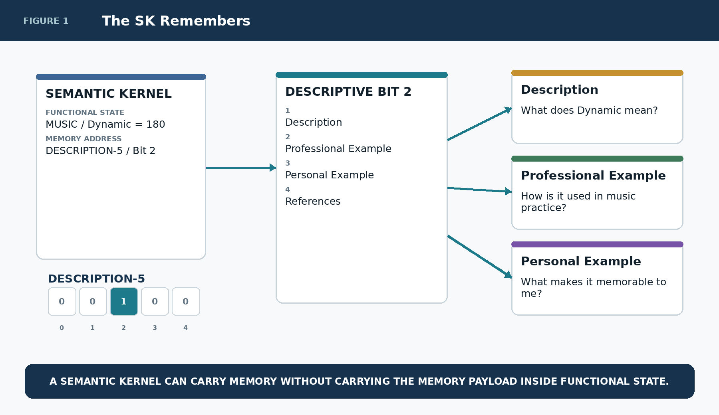
Figure 1. The SK Remembers

Functional State and Memory Remain Distinct
This separation is what allows one BitGroup to be used both operationally and educationally. The functional value can remain stable while a learning interface asks for additional memory resolution. Conversely, a work interface can suppress most memory and expose only the operational control.
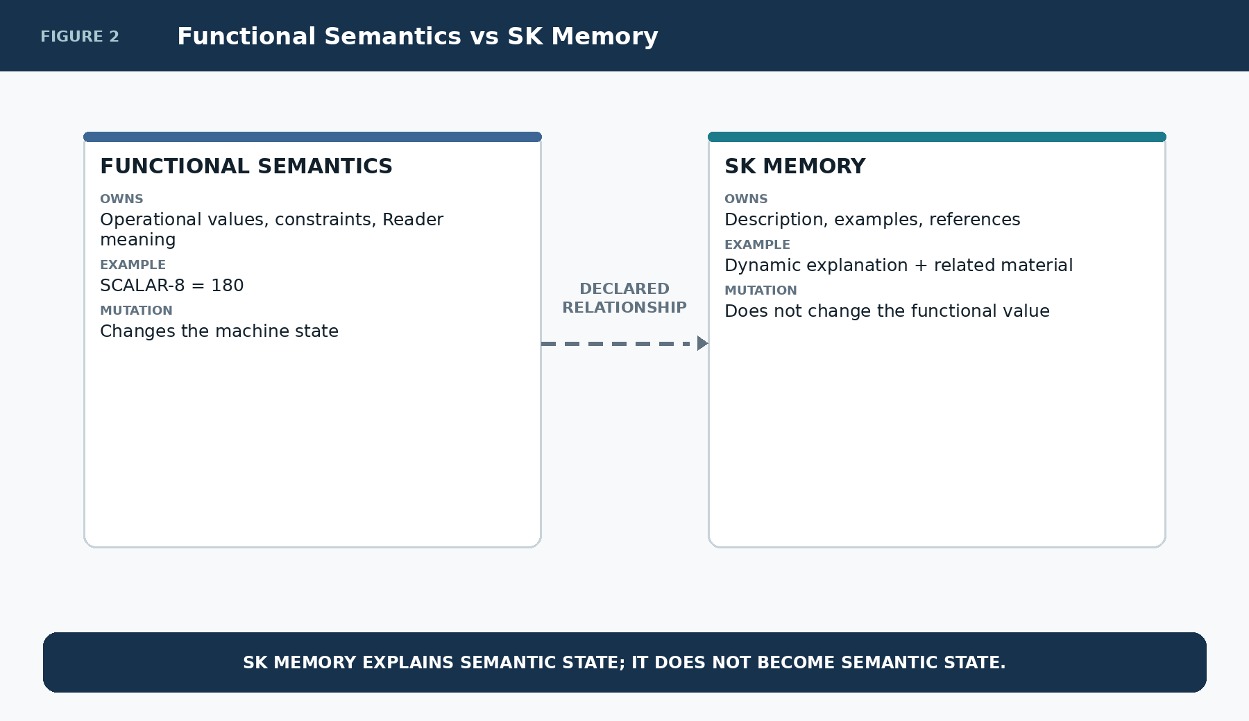
Figure 2. Functional semantics and SK Memory are linked but independently owned.

Part 2 | Descriptive Bits and Deterministic Activation
DESCRIPTION-n is the canonical descriptive BitGroup family. Its width is not constrained to powers of two. n is simply the number of independently addressable descriptive memory positions required by the semantic design. A five-address instructional layer should be DESCRIPTION-5; a forty-nine-address knowledge kernel may be DESCRIPTION-49. Padding has no semantic value.
The binary pattern is an activation mask. The system reads the Bits in order. A zero produces no normal retrieval. A one causes the runtime to follow the exact registered memory route for that Bit. The algorithm does not search prose or infer relevance from similarity.
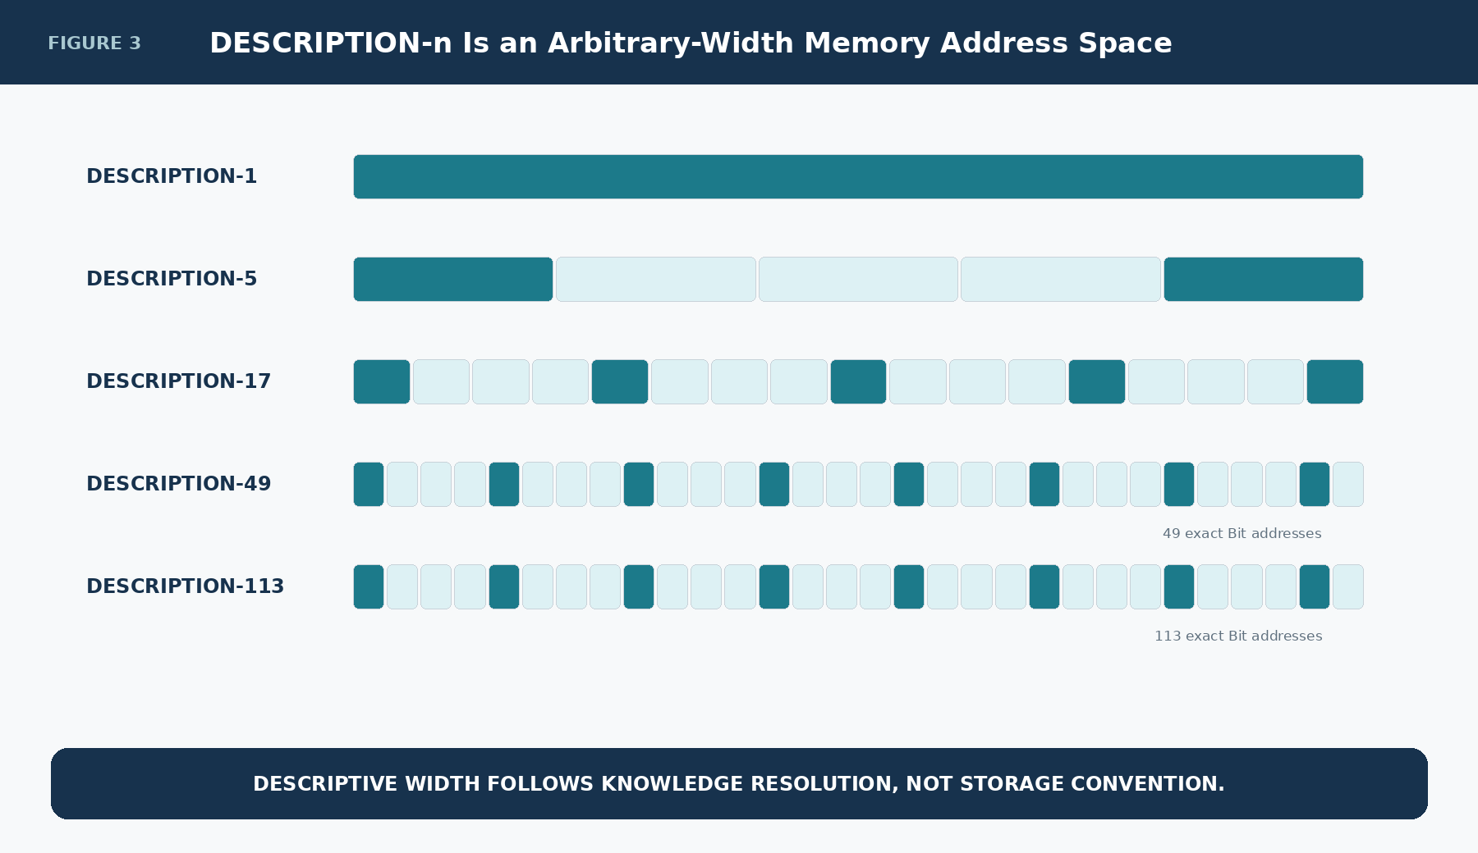
Figure 3. Arbitrary-width DESCRIPTION-n BitGroups

Binary Activation Is the Retrieval Gate
A binary word such as 10110010 is enough to decide which memory addresses participate. The human-readable material remains outside the binary representation, preserving compactness and deterministic decoding.
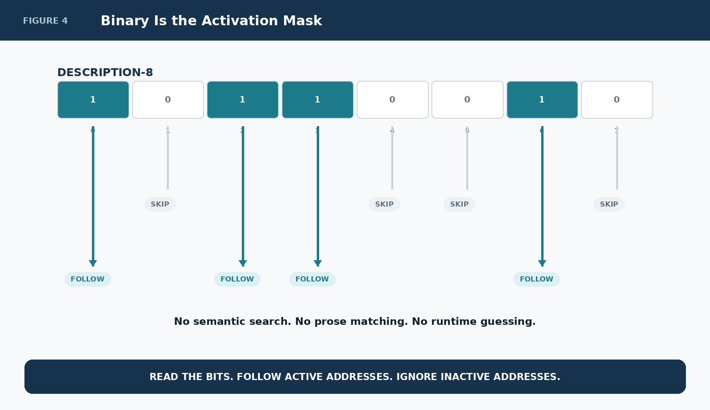
Figure 4. Binary values gate memory retrieval

One Bit Resolves One Registered Memory Address
An active Bit does not contain the explanation itself. It resolves the corresponding Descriptive Bit record. That record is the stable semantic memory address and carries links to the ordered memory layers.
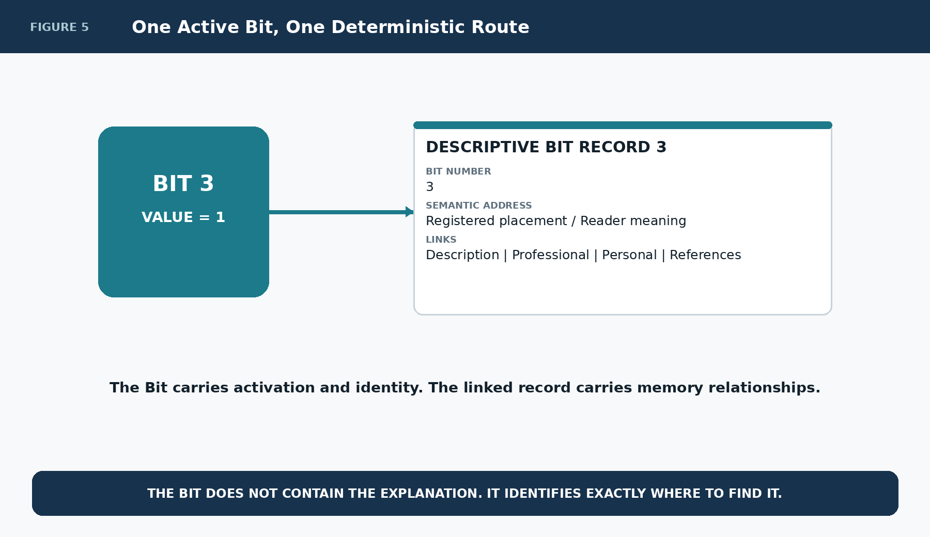
Figure 5. One active Bit follows one exact route

The Descriptive Bit Record
The Descriptive Bit record remains deliberately compact. At minimum it identifies the Bit and provides links to Description, Professional Example, Personal Example, and References records. Physical field names may evolve during implementation, but the separation of these four relationships is architectural.
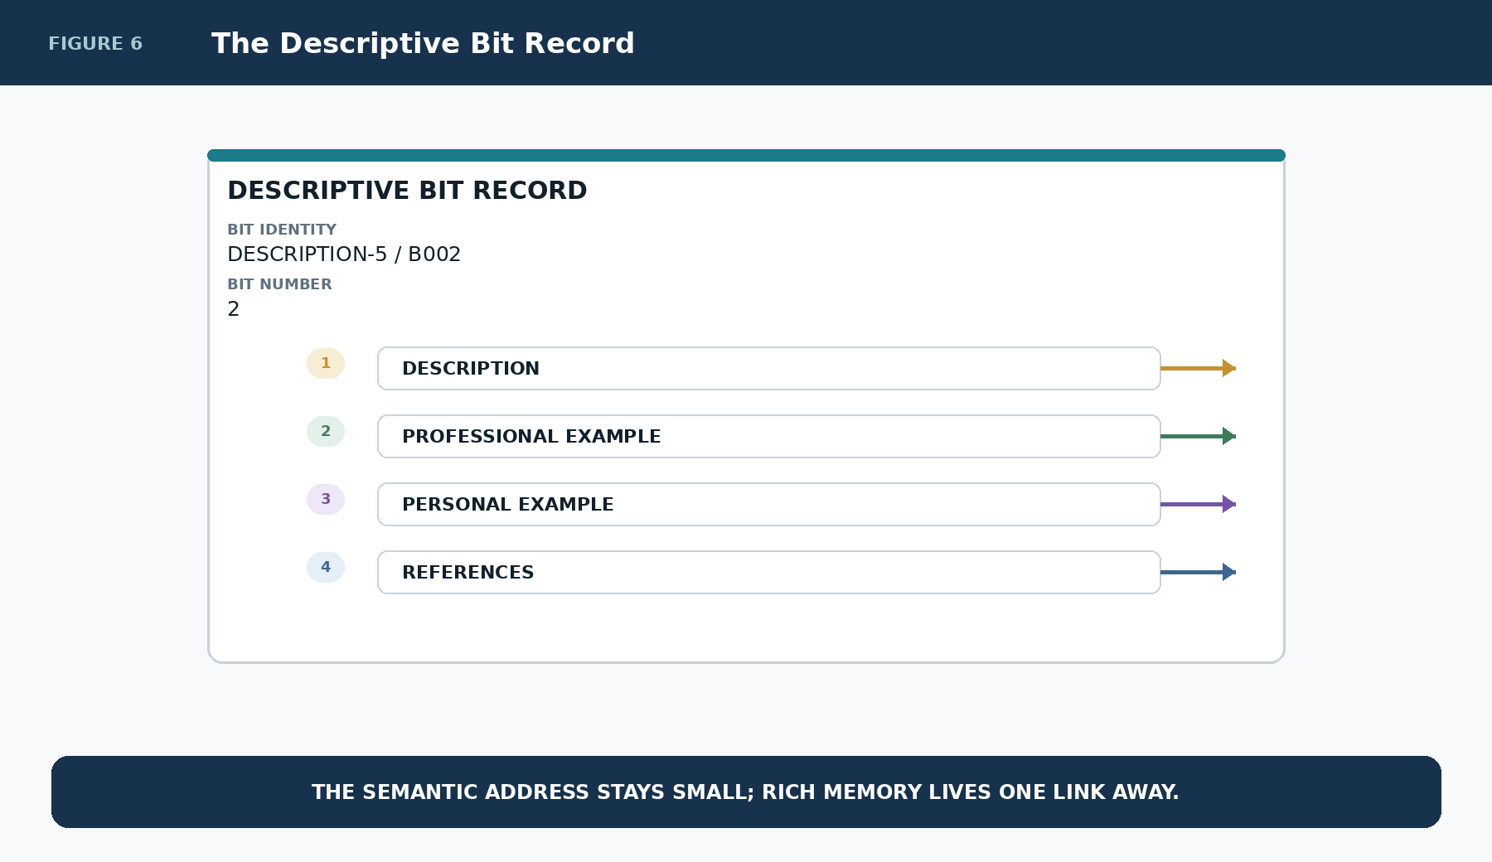
Figure 6. The compact Descriptive Bit record

Part 3 | The Four Ordered Memory Layers
Each Descriptive Bit can resolve four distinct memory layers. Their order is meaningful because each answers a different human question. Description explains what the semantic object is. Professional Example shows domain-valid use. Personal Example records a user-specific experiential bridge. References route outward to relevant objects and deeper knowledge.
Keeping these layers separate prevents a personal association from silently becoming a canonical definition and prevents an inspirational reference from being mistaken for authoritative semantic truth.
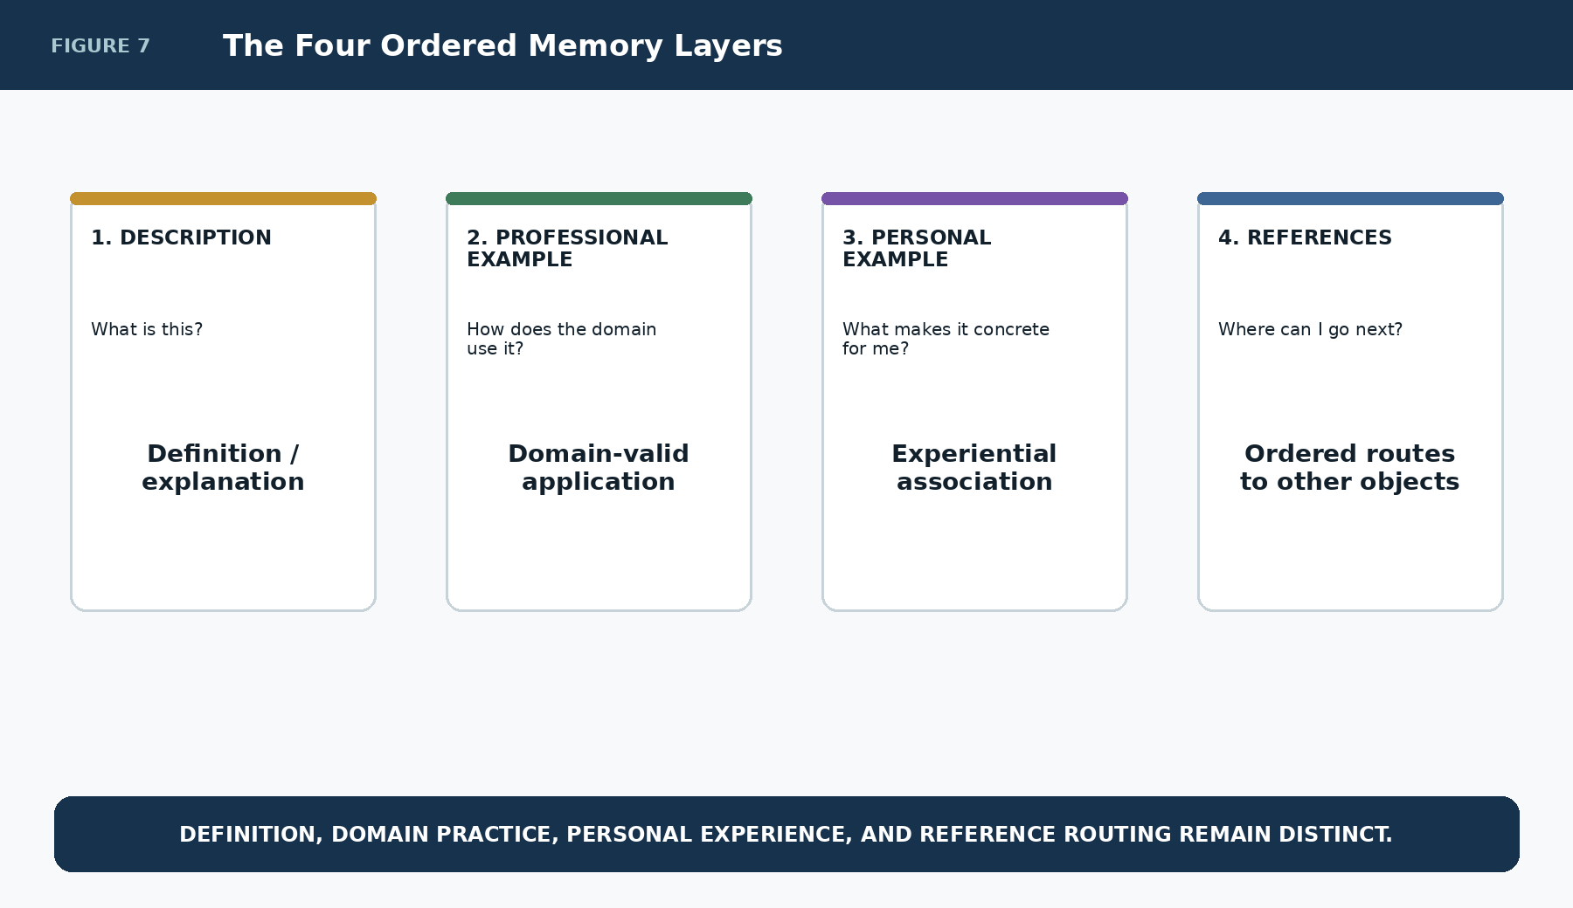
Figure 7. The four ordered memory layers

Description
The Description layer is the concise explanatory layer. It should make the semantic address understandable without duplicating the full functional specification. It may be shared, publisher-owned, or locally curated depending on the SK.
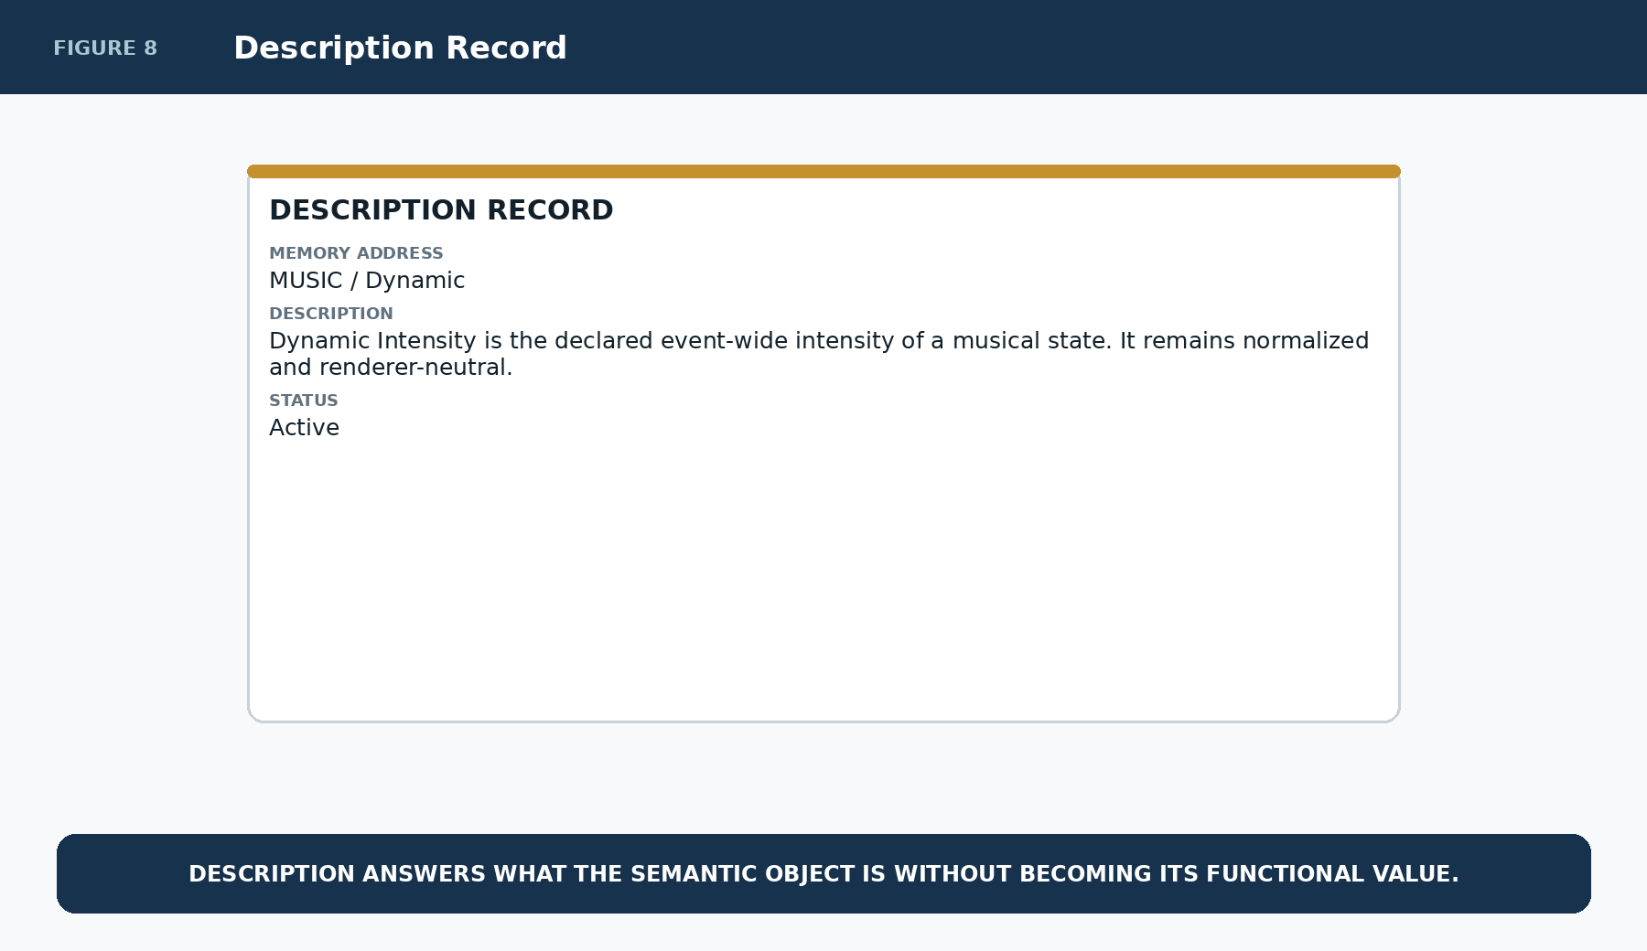
Figure 8. A Description record

Professional Example
The Professional Example layer demonstrates how the semantic object is applied in a credible domain context. It can be maintained by the SK author, an organization, an expert community, or another trusted source while remaining distinct from the canonical definition.
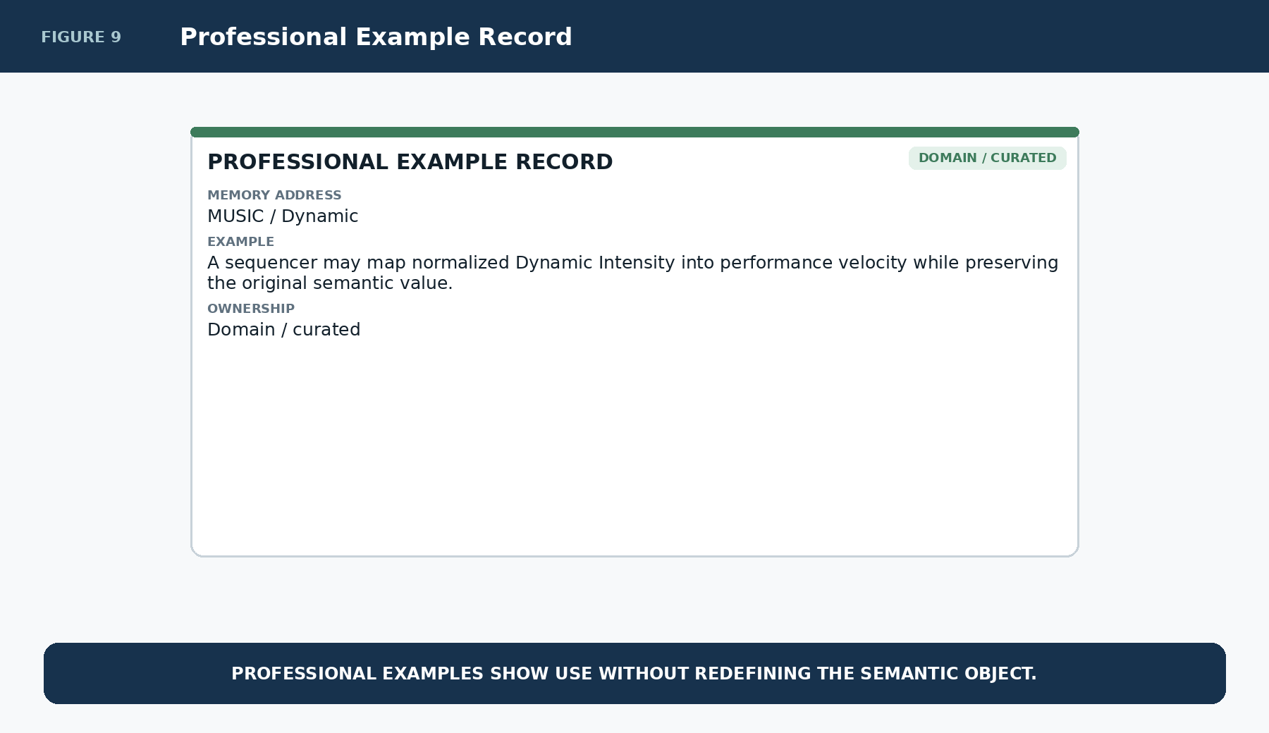
Figure 9. A Professional Example record

Personal Example
The Personal Example layer records what makes the semantic address concrete for a particular person. Two people can use the same SK and the same shared Description while maintaining completely different experiential associations.
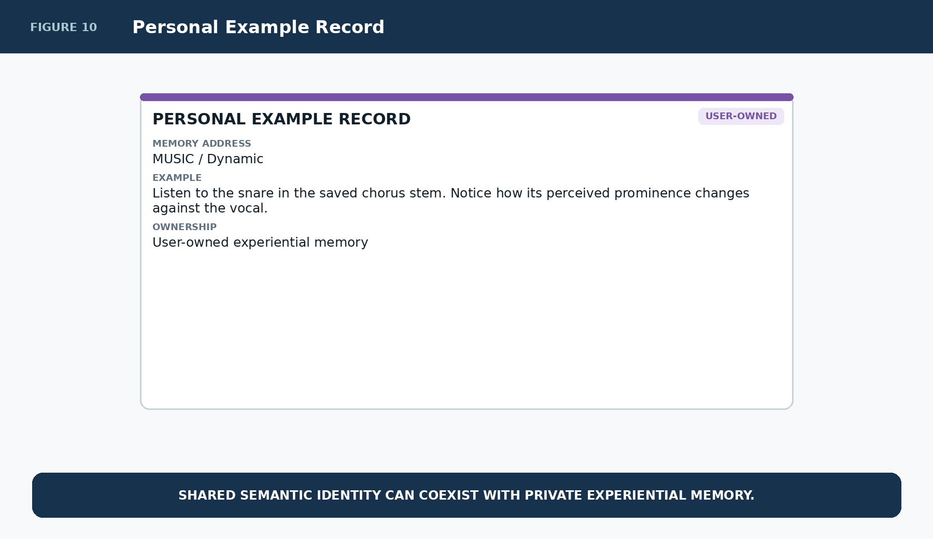
Figure 10. A Personal Example record

Part 4 | References and Recursive Routing
The References layer links to one record in the References Table. That record contains ordered field pairs: Reference Description 1 with Link 1, Reference Description 2 with Link 2, and so forth. Ordering is therefore structural and deterministic. The interface can walk the populated pairs in field order without a separate sort merely to recover the canonical sequence.
A Reference is not limited to a URL. The References record owns an ordered route bundle. Each target may be any supported addressable object.
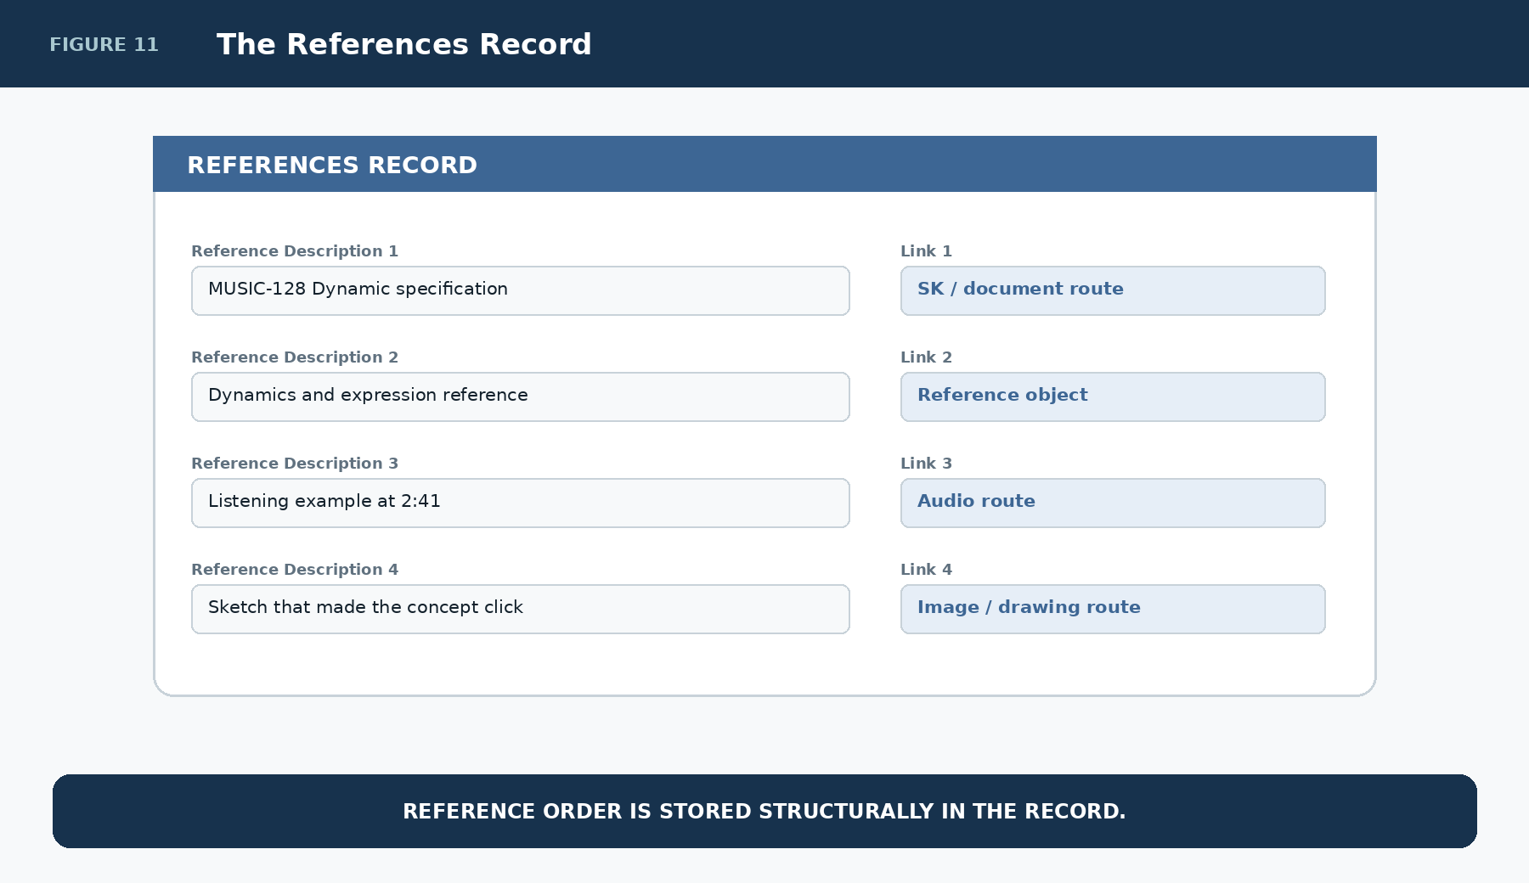
Figure 11. An ordered References record

One References Link, Many Ordered Targets
The Descriptive Bit does not need to hold many individual target links. Its References Link resolves the single References record. The ordered Description/Link pairs inside that record then route to the individual targets.
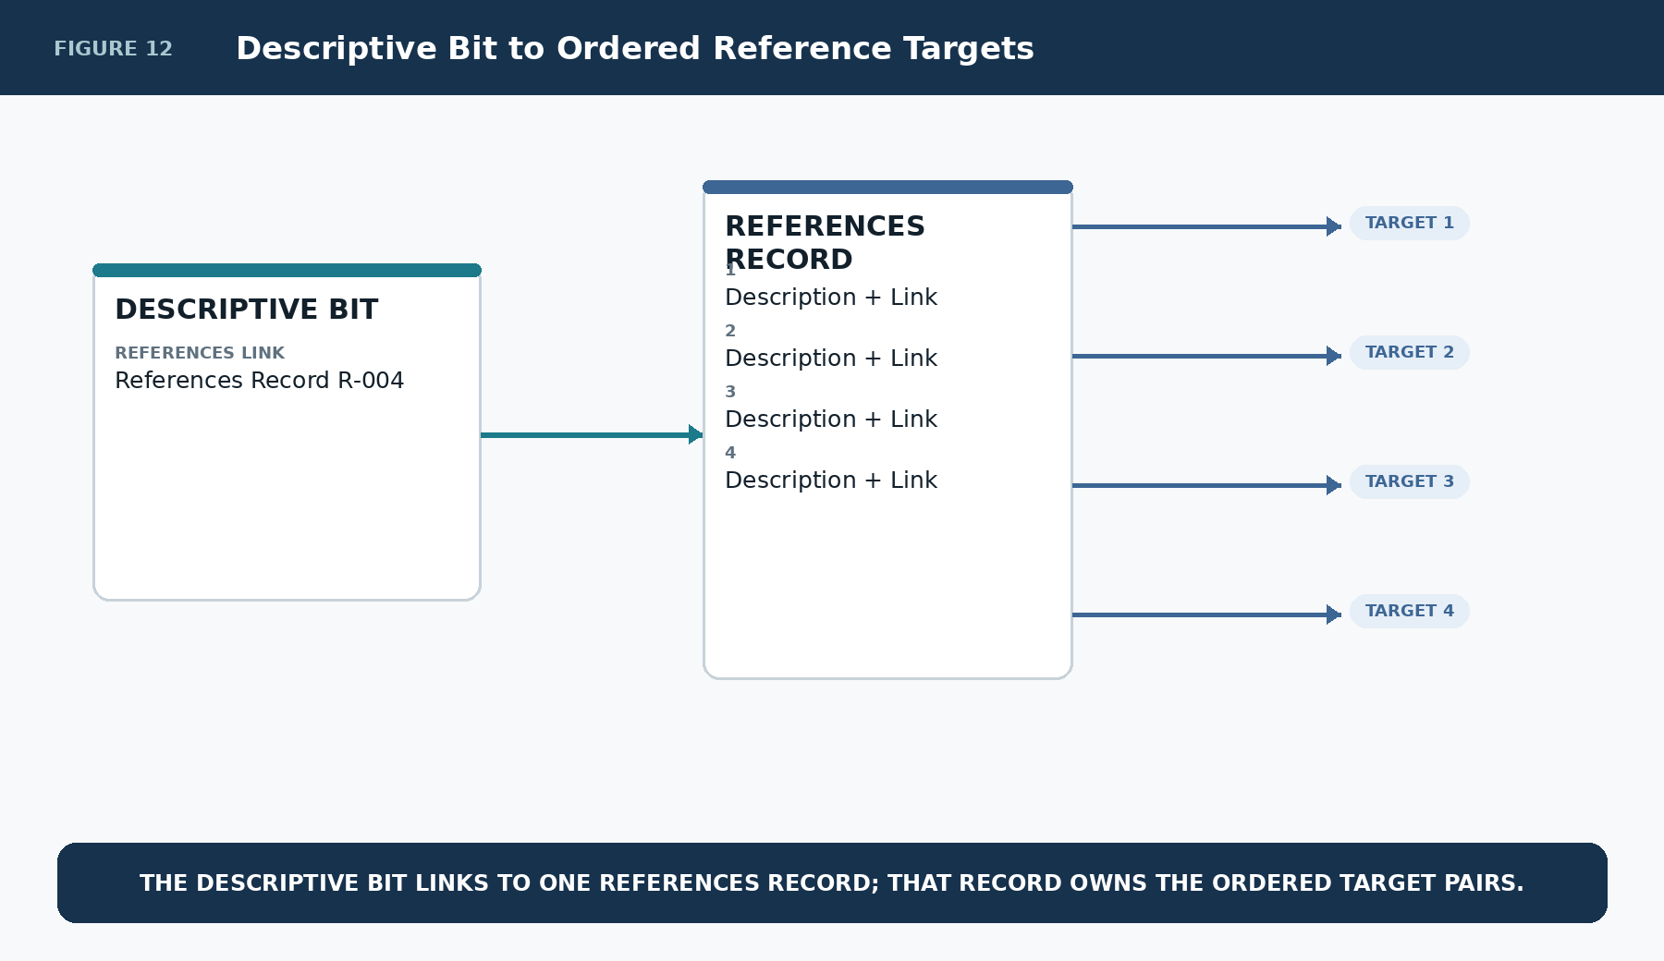
Figure 12. A Descriptive Bit resolves one ordered References record

A Reference Can Be Anything Addressable
A Reference may target another SK, an image, a drawing, an audio excerpt, a Memory, a document, an attachment, an Instance, a dataset, a local file, or an external resource. SK Memory owns the relevance relationship and its human explanation; the referenced target type owns how it opens or executes.
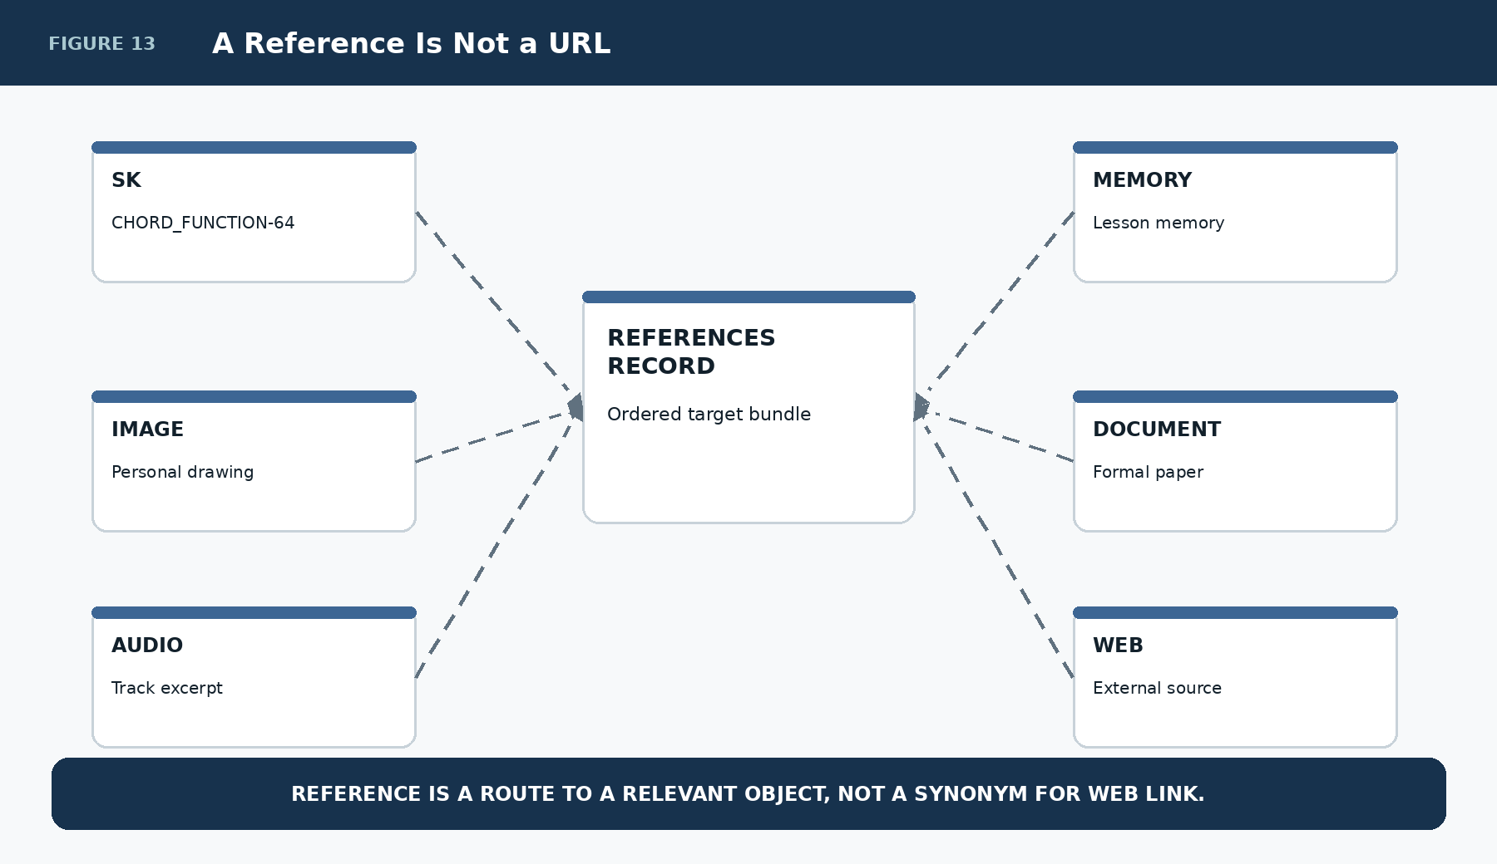
Figure 13. Reference targets are not restricted to web links

Reference Description Is Part of the Memory
Every route is more useful when the human can see why it matters. Reference Description should therefore name or explain the relevance of the target rather than presenting an opaque address. The description is the explanatory cue; the Link is the machine-resolvable route.
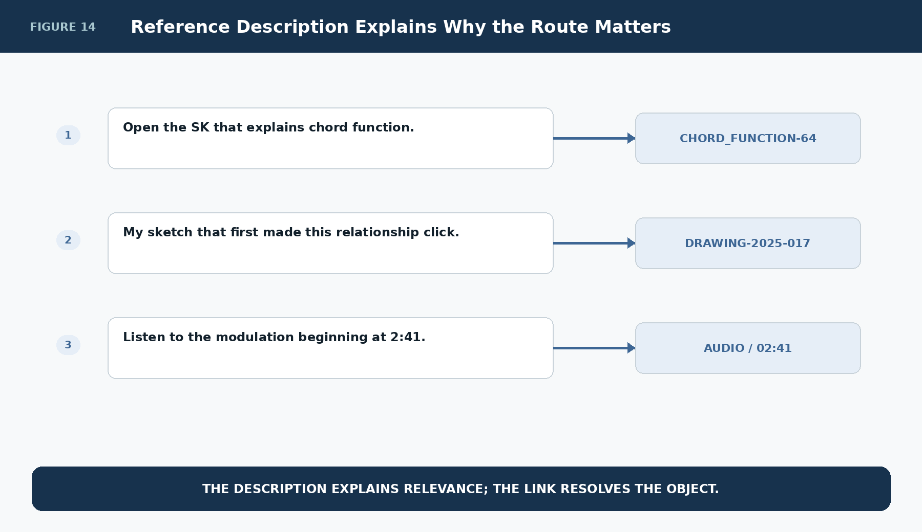
Figure 14. Reference Description explains why each target matters

Creative Artifacts Can Preserve Cognitive Provenance
A picture, sketch, scene, or sound may be valuable because it is the artifact that caused an abstraction to become understandable. Referencing that object preserves cognitive provenance: not merely what the concept means, but how the person actually came to understand it.
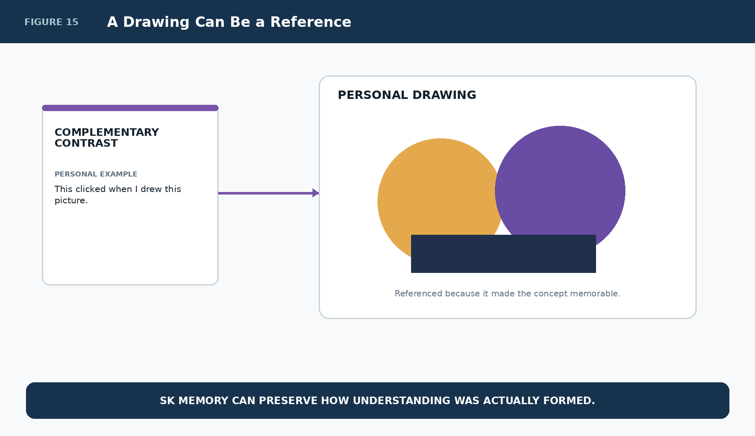
Figure 15. A personal drawing can be a first-class Reference

Another SK Can Be a Reference
When a semantic point requires deeper explanation than the current kernel should contain, the References record can route to another bounded SK. The source kernel remains small; the referenced SK preserves its own identity, Reader structure, Bits, interfaces, and memory.
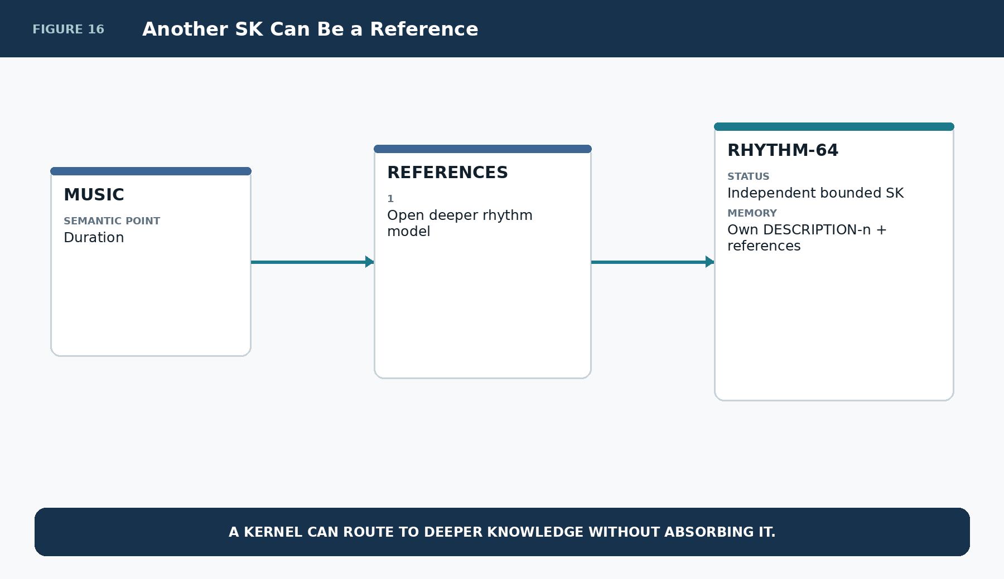
Figure 16. A bounded SK routes to another bounded SK

Recursive SK Memory
A referenced SK may expose its own SK Memory and its own References. This creates a graph of bounded knowledge machines rather than one monolithic document. The recursion is explicit because each transition is a registered Reference route.
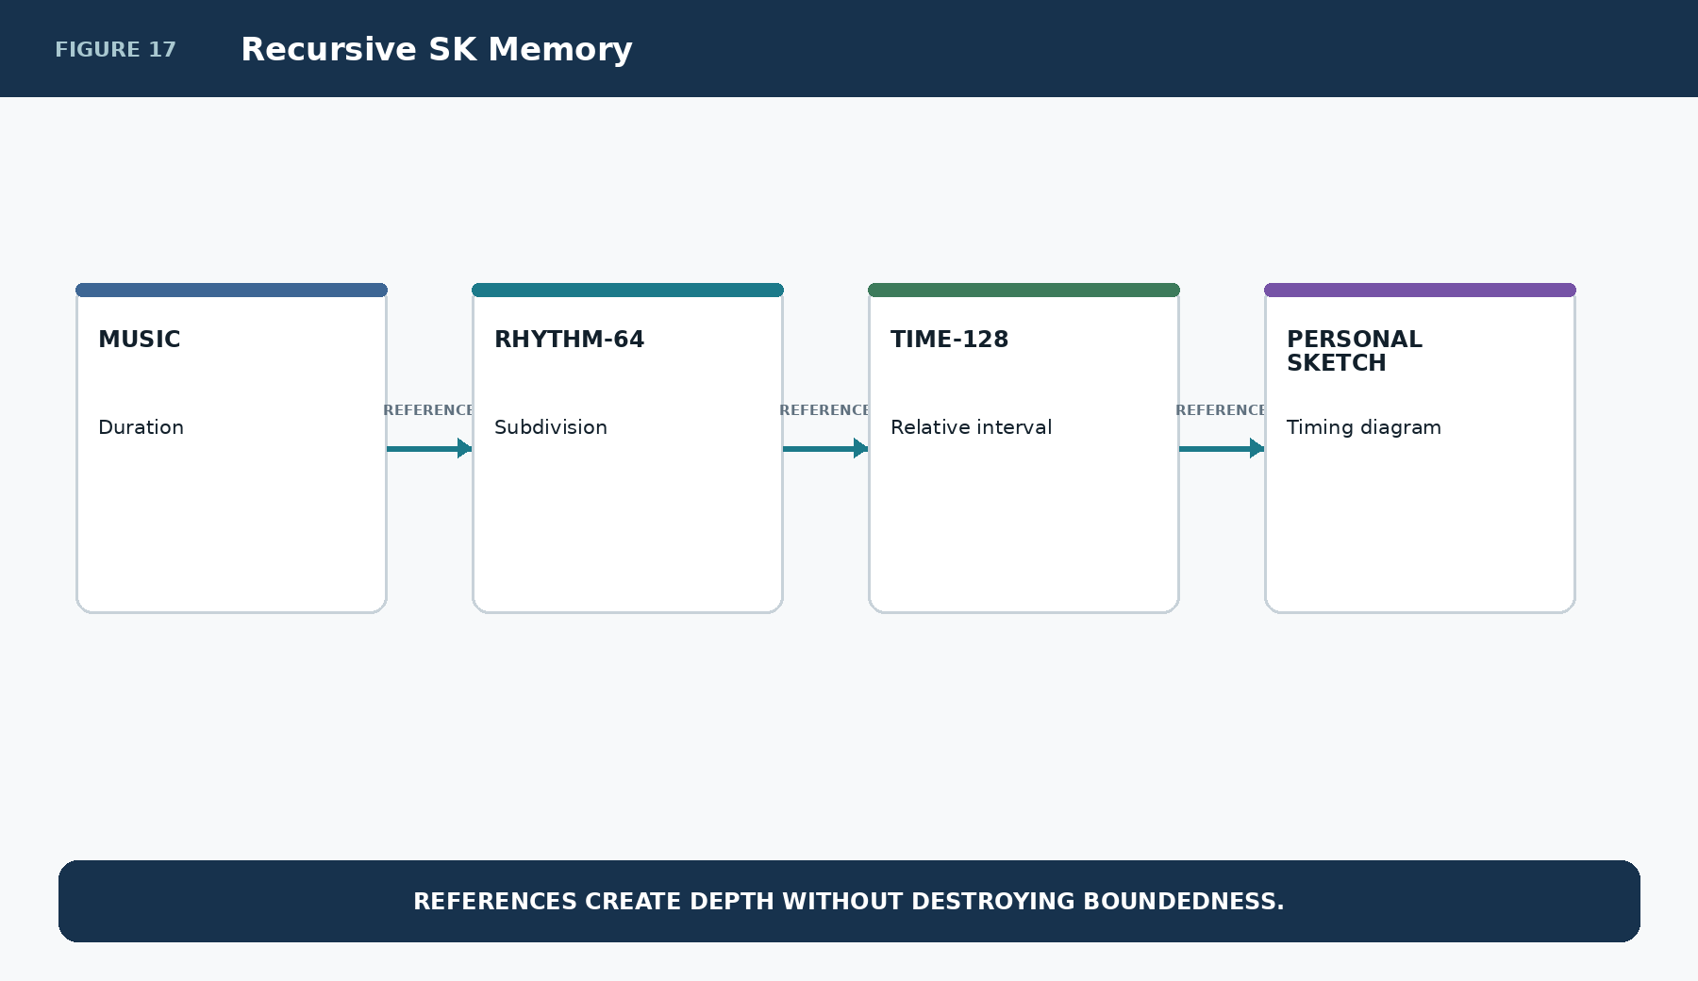
Figure 17. Reference traversal can continue recursively

Part 5 | Boundedness, Ownership, and Operational/Educational Reuse
SK Memory is intentionally link-rich and payload-light. The BitGroup carries selection; linked records carry memory. Rich documentation therefore does not require the functional BitWord to become a large prose container.
Ownership can also remain layered. Description may be shared, Professional Example may be domain-curated, Personal Example may be private, and References may point to both shared and personal objects.
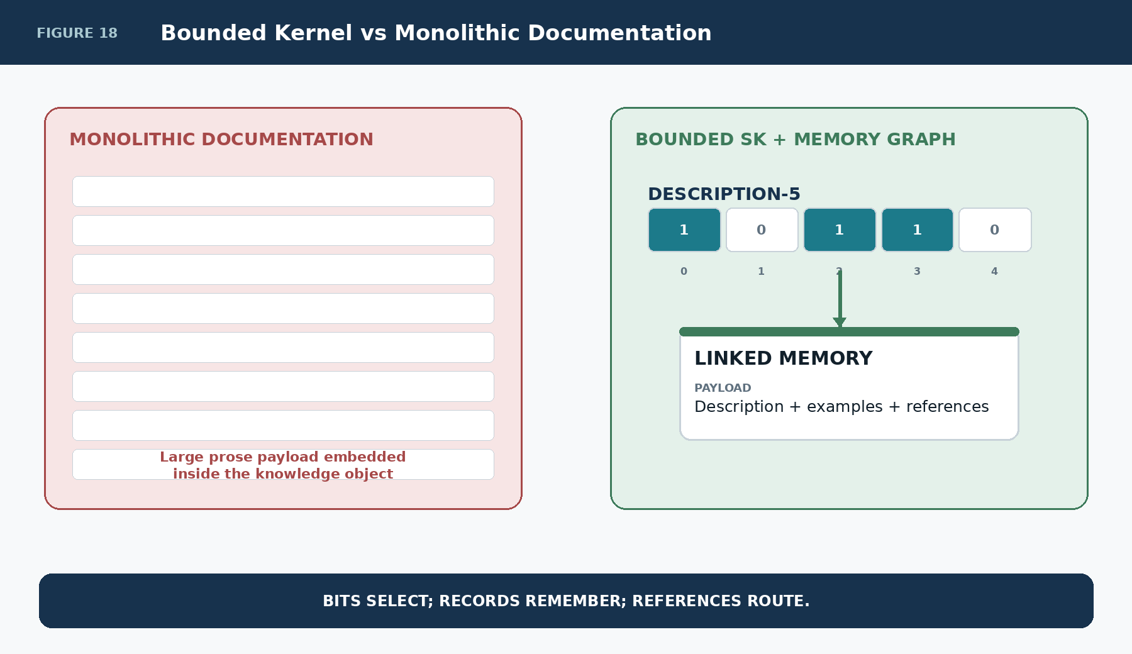
Figure 18. Bounded SKs remain compact because memory is linked

Shared Semantic Identity, Different Memory Ownership
The memory layers do not require a single ownership policy. Shared semantics can coexist with organization-specific professional examples, user-owned personal examples, and mixed References. This is especially important when public Semantic Kernels are reused inside private personal systems.
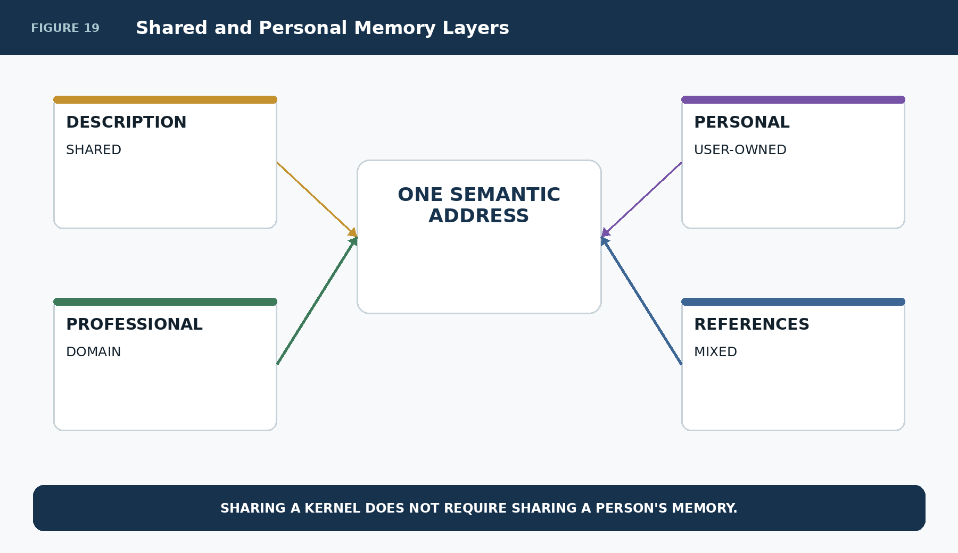
Figure 19. Shared and user-owned memory can coexist around one semantic address

The Same BitGroup Can Be Operational and Educational
The same functional source can drive a minimal operational interface and a richer educational interface. Both manipulate the same canonical semantic state. The difference is the amount of SK Memory the selected interface chooses to expose.
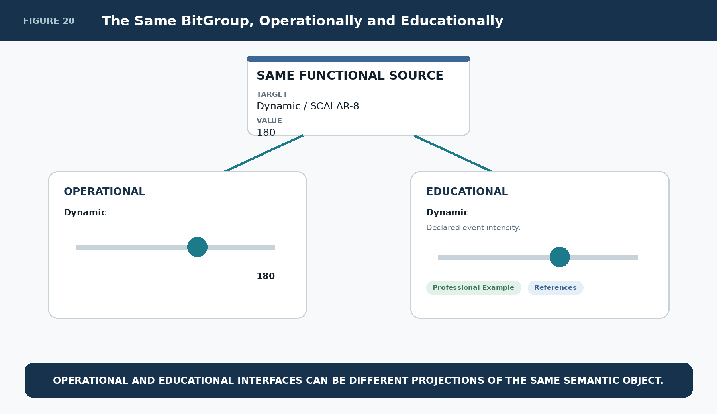
Figure 20. One functional source supports operational and educational projections

Memory Resolution
A useful interface pattern is cumulative memory resolution. Resolution 0 may expose only operation. Resolution 1 adds Description. Resolution 2 adds Professional Example. Resolution 3 adds Personal Example. Resolution 4 adds References. The exact visual treatment is not mandated by SK Memory; what matters is that memory exposure can vary without rewriting source state.
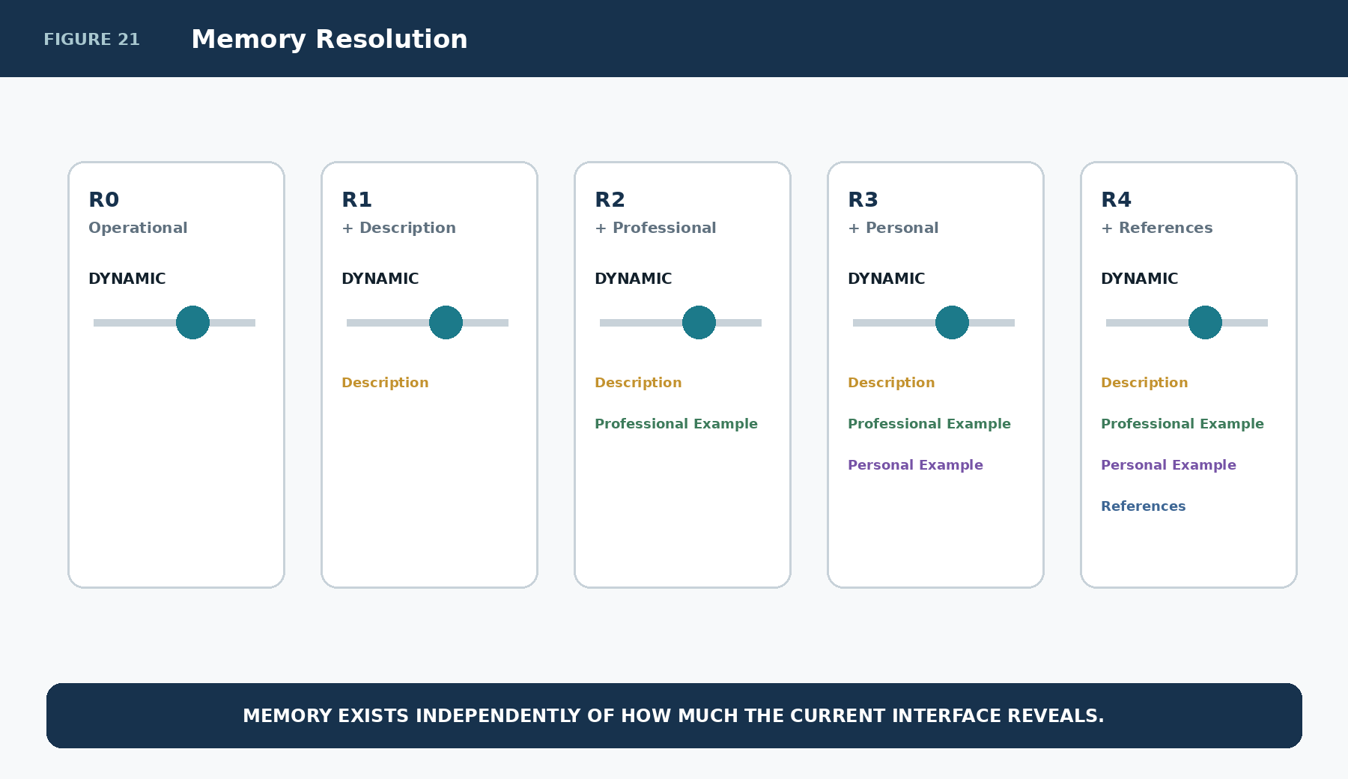
Figure 21. Increasing memory resolution over the same functional state

The Interface Requests Memory Resolution
DARTBOARD or another renderer may choose a compact work view, a learning view, or a deep-study view. These are presentation choices over registered memory. The SK Memory System supplies addressable content; the interface contract determines how much to display and how it is arranged.
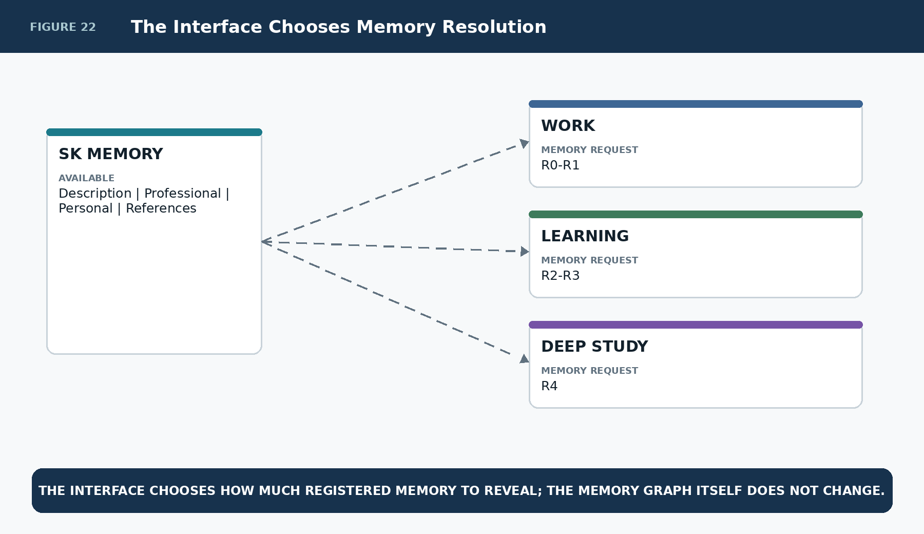
Figure 22. Different interface variants request different memory depths

Small DESCRIPTION Groups as Interface Memory
A complicated functional BitWord may need only a small descriptive BitGroup to make its principal interfaces self-explaining. MUSIC, for example, could associate five descriptive addresses with Pitch/Register, Duration, Dynamic, Articulation, and Microtone while leaving all functional state in the functional BitGroups.
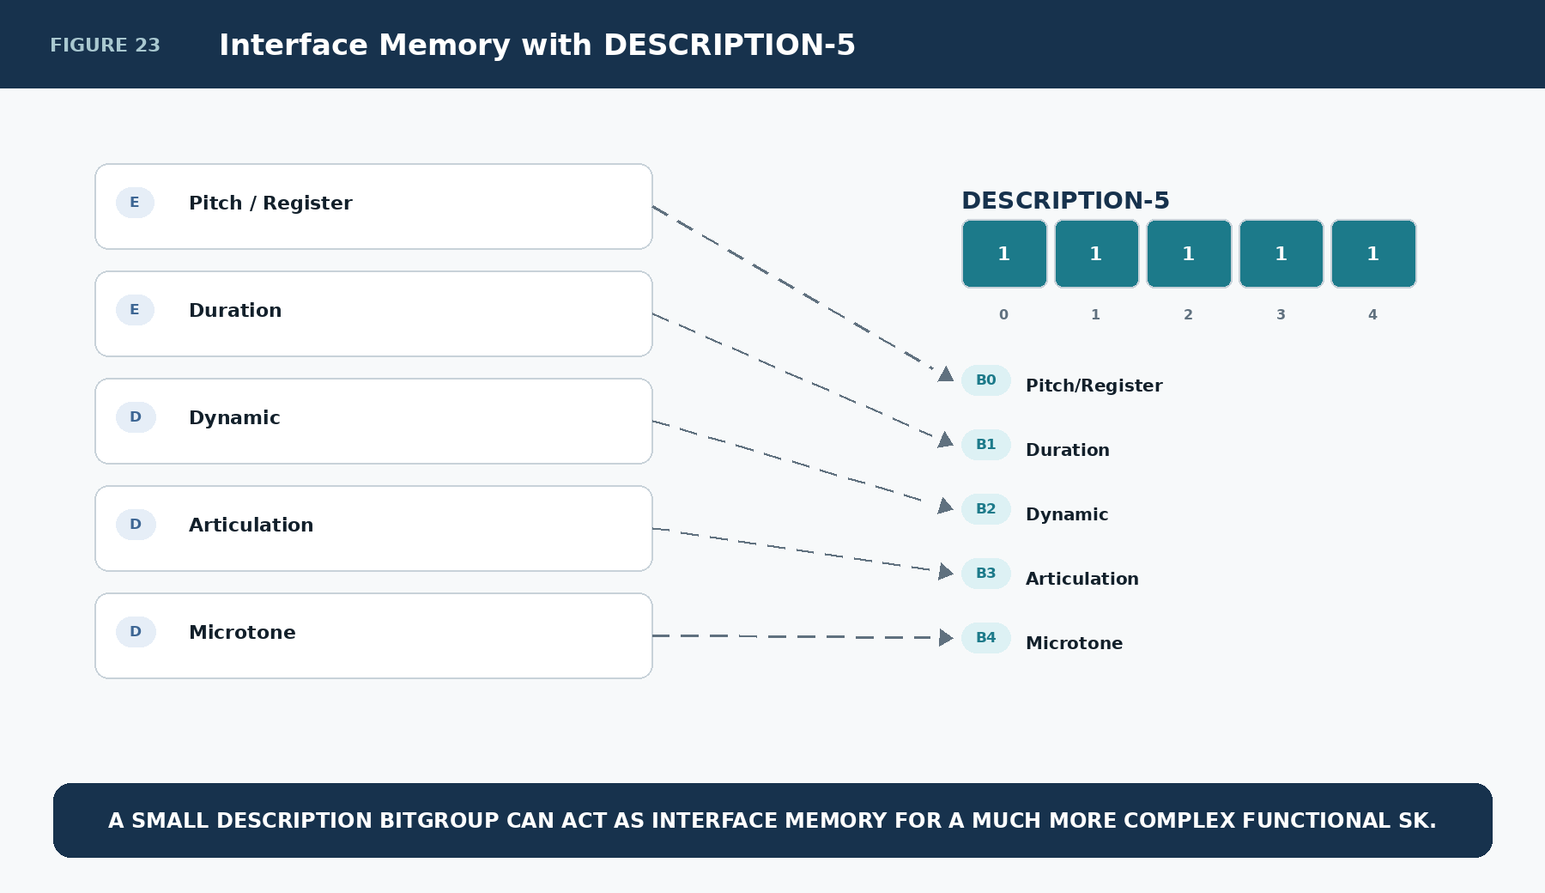
Figure 23. DESCRIPTION-5 supplies memory addresses for five major MUSIC interfaces

One Functional Interface Opens Its Attached Memory
The explanation shown above an E interface, the examples shown below it, and the References buttons all come from linked SK Memory records. The functional E continues to own only its Reader-bound manipulation coverage. Memory can therefore be expanded or collapsed independently.
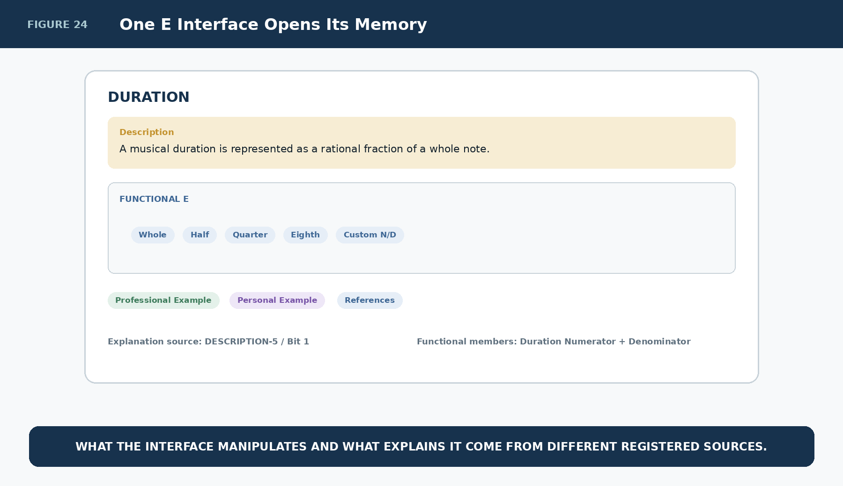
Figure 24. An E interface displays functional state and attached memory together

Explanatory Semantic Zoom
When an interface descends from a whole BitWord into a subsystem and then into one parameter, the selected memory address can descend with it. Whole-tool memory explains the overall machine; E-level memory explains a coordinated subsystem; D-level memory explains the exact semantic parameter.
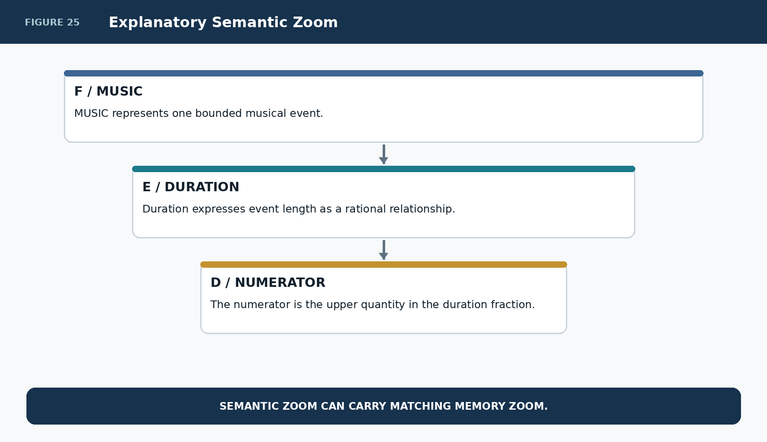
Figure 25. Memory can become more specific as semantic scope narrows

Part 6 | Pure Descriptive Kernels and Width-Independent Retrieval
The same mechanism scales beyond interface documentation. A knowledge-oriented SK may be almost entirely descriptive. TENNIS-49, for example, can use DESCRIPTION-49 as a bounded address space for forty-nine learning concepts. Reader semantics name the addresses; linked memory records explain them; D/E/F interfaces decide how the knowledge is presented.
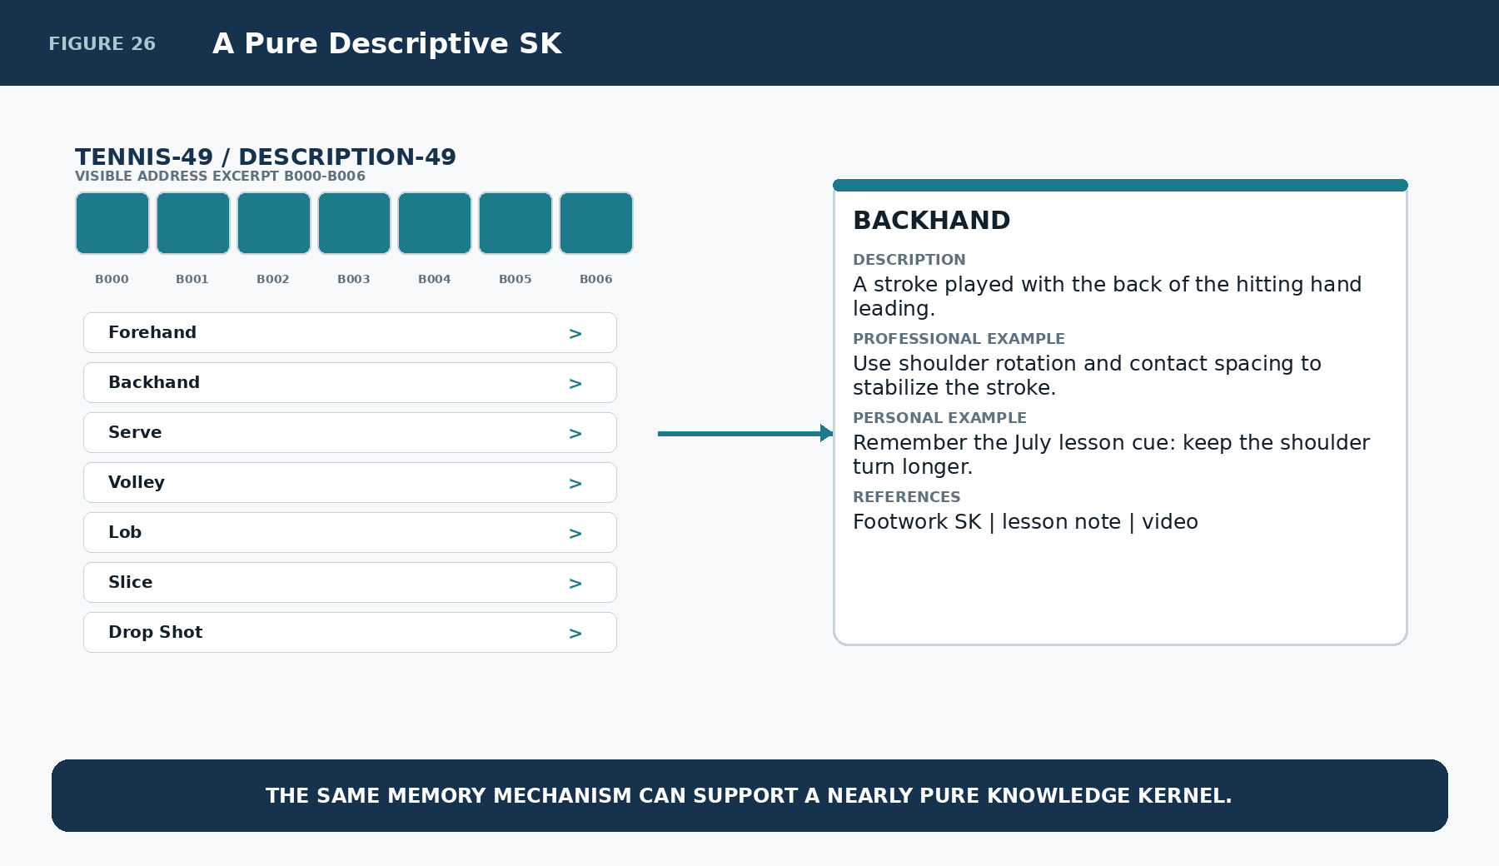
Figure 26. A nearly pure descriptive TENNIS kernel

The Retrieval Algorithm Does Not Change with Width
DESCRIPTION-5, DESCRIPTION-49, and DESCRIPTION-317 all use the same logic: read Bit, test activation, follow exact link, retrieve registered memory, render the requested memory resolution. Width changes the number of available addresses, not the algorithm.
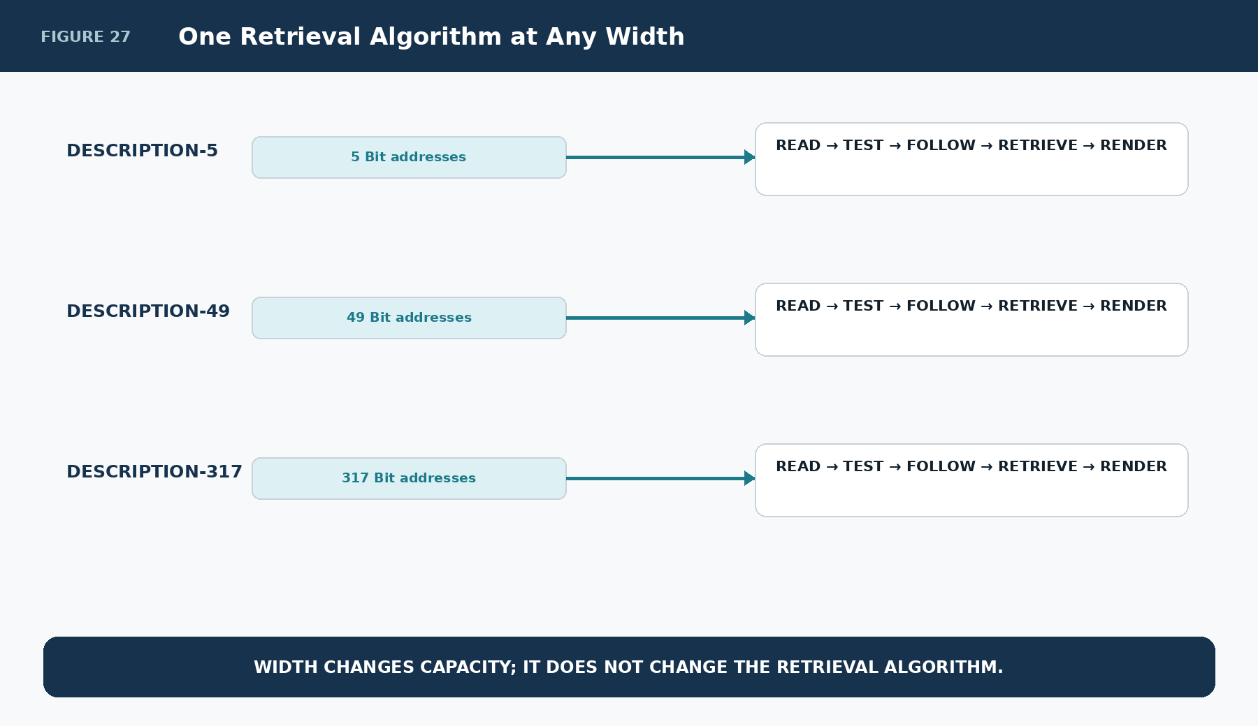
Figure 27. The same retrieval algorithm applies at every DESCRIPTION-n width

Part 7 | CRT, AI Context, Validation, and Rebuildability
CERBERUS Rollup Traversal can gather active SK Memory in exactly the same deterministic spirit as other linked record traversal. The binary activation mask determines which Descriptive Bit records are active. CRT gathers the registered memory linked to those records. It does not run a semantic search over every note in the system.
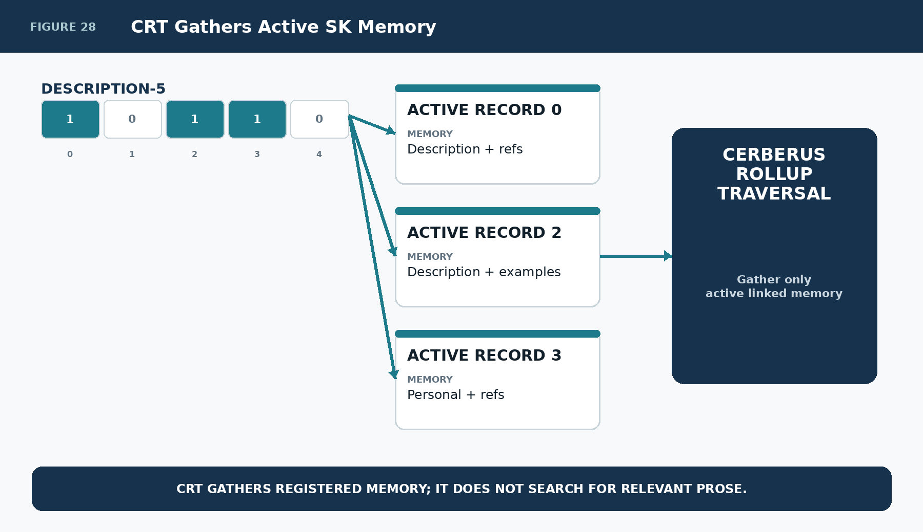
Figure 28. CRT gathers only the memory linked to active descriptive addresses

Semantically Scoped AI Context
An AI request such as “Explain Dynamic” can be resolved through the exact semantic route MUSIC → Dynamic → DESCRIPTION-5 / Bit 2. The resulting context package can include the exact Description, Professional Example, Personal Example, and ordered References associated with that address. This lets AI assistance consume bounded registered context rather than requiring broad corpus retrieval for every explanation.
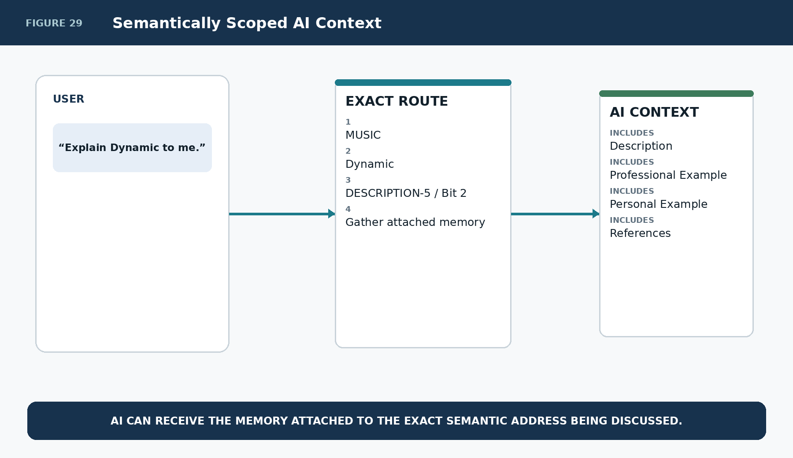
Figure 29. AI context can be assembled from an exact semantic memory address

Validation and Missing Memory
SK Memory should fail visibly on broken required relationships and preserve absence where optional memory does not exist. An active Bit with no Descriptive Bit record is invalid. A References Link to a missing References record is invalid. A populated Reference Description without a target Link is incomplete. By contrast, a semantic address may legitimately have a Description but no Personal Example.
The system must not silently invent content merely because an optional memory layer is empty.
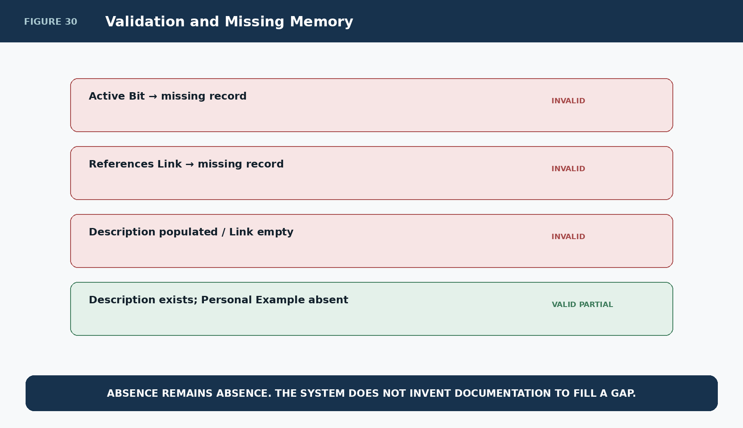
Figure 30. Missing or malformed memory remains explicit

Rebuildability
The rendered learning surface is disposable. If the binary state, Descriptive Bit records, linked memory records, ordered References record, interface contracts, and source values remain, the explanatory interface can be reconstructed. This keeps human-facing memory presentation downstream of the authoritative graph.
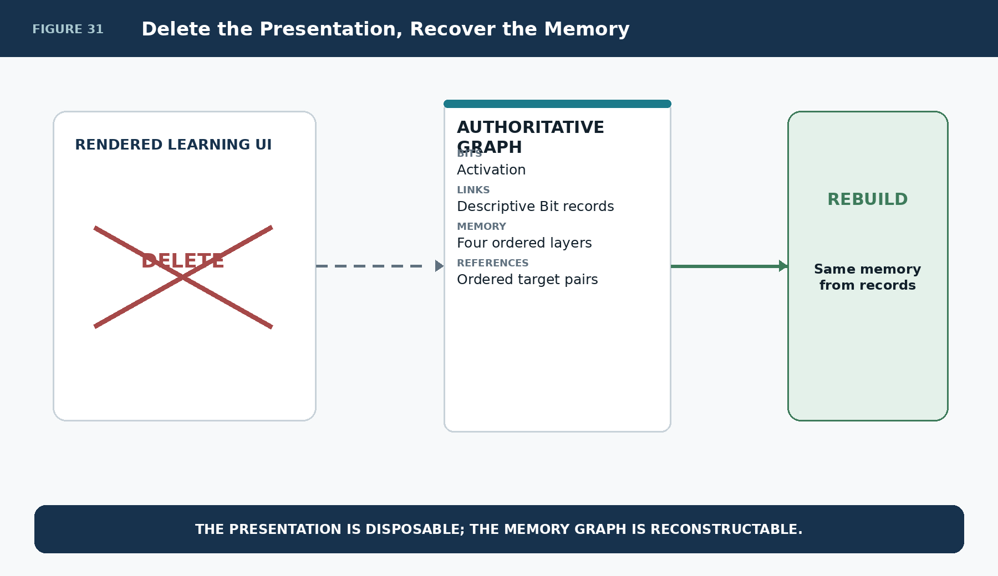
Figure 31. Deleting presentation does not delete SK Memory

Part 8 | Complete Architecture
The complete system is deliberately simple at runtime. A Semantic Kernel contains functional semantics and, where needed, DESCRIPTION-n. Binary state selects the active descriptive addresses. Each active address resolves one Descriptive Bit record. That record links to Description, Professional Example, Personal Example, and one References record. The References record owns ordered Reference Description / Link pairs and may route to any supported object, including another SK with its own SK Memory. CRT and the interface system then expose only the memory required by the current context while preserving the same underlying semantic state.
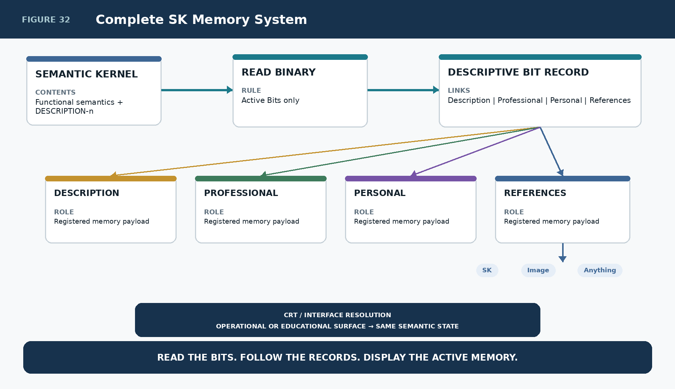
Figure 32. Complete SK Memory System

Reference Record Contracts
Field / Law | Reference statement
DESCRIPTION-n | Arbitrary-width Descriptive BitGroup. Width n equals the number of independently addressable descriptive semantic positions required by the design.
Descriptive Bit Record | Stable memory address for one descriptive Bit. Links to Description, Professional Example, Personal Example, and References records.
Description Record | Human-readable explanation of the semantic address. Remains separate from functional state.
Professional Example Record | Domain-valid application or example associated with the semantic address.
Personal Example Record | User-owned or user-specific experiential example associated with the semantic address.
References Record | Ordered paired fields: Reference Description 1 + Link 1, Reference Description 2 + Link 2, and so forth.
Reference Link | Route to any supported addressable target. The target type owns its own opening, rendering, or execution behavior.

Reference Laws
Field / Law | Reference statement
Descriptive Activation Law | Only active Descriptive Bits participate in normal SK Memory retrieval.
Address Determinism Law | Descriptive memory SHALL resolve through explicit Bit identity and registered links rather than semantic text inference.
Arbitrary Width Law | DESCRIPTION-n MAY use any positive width justified by the required descriptive resolution.
Memory Separation Law | Description, Professional Example, Personal Example, and References remain distinct memory layers.
Functional Separation Law | Displaying SK Memory beside a functional interface does not make the memory payload part of the functional semantic state.
Operational/Educational Projection Law | Operational and educational interfaces MAY expose different SK Memory resolutions while manipulating the same functional semantic records.
Reference Record Law | A Descriptive Bit References Link resolves one ordered References record.
Reference Pair Law | Each populated Reference target SHOULD have a corresponding human-readable Reference Description explaining why the route matters.
Reference Order Law | Reference Description n / Link n field position defines deterministic reference order.
Reference Routing Law | A Reference may target any supported routable object type, including another SK, image, drawing, audio, Memory, document, attachment, Instance, local resource, or external resource.
Recursive Reference Law | A referenced SK MAY expose its own SK Memory without requiring the source kernel to absorb the referenced SK semantics.
Bounded Kernel Law | External memory depth SHOULD be expressed through explicit references rather than unbounded enlargement of the source kernel.
Personal Memory Separation Law | Personal Examples remain distinct from shared or canonical descriptive claims.
Presentation Resolution Law | Interfaces determine how much registered SK Memory is currently exposed.
Provenance Law | References may preserve evidentiary, educational, historical, or inspirational relationships without implying identical authority.
CRT Gathering Law | CRT gathers registered memory linked to active semantic addresses; it does not infer relevance from unrelated prose.
Scoped AI Context Law | AI context MAY be assembled from exact semantic memory addresses and their linked records.
No Silent Inference Law | Missing optional memory remains absent; broken required relationships remain explicit rather than being silently replaced with guessed content.
Rebuildability Law | SK Memory presentation can be reconstructed from binary activation, registered links, memory records, interface contracts, and referenced source state.

Prototype Implementation Sequence
- Register DESCRIPTION-n as an arbitrary-width Descriptive BitGroup family.
- Create Descriptive Bit records with stable Bit identity and links to the four memory layers.
- Create the Description, Professional Example, Personal Example, and References tables.
- Implement the References record pattern with ordered Reference Description n / Link n field pairs.
- Prove the binary retrieval path: read Bit → if 1, resolve Descriptive Bit record → follow linked memory.
- Implement at least two D variants over the same functional BitGroup: operational and educational.
- Add memory-resolution selection so interfaces can expose Description only, deeper examples, or References without changing functional state.
- Prove a small interface-memory example such as DESCRIPTION-5 attached to five major MUSIC interfaces.
- Prove a mostly descriptive kernel such as TENNIS-49 using the same retrieval algorithm.
- Add one Reference target that is another SK and prove recursive traversal.
- Add one personal artifact Reference such as an image or drawing and preserve its relevance description.
- Integrate CRT so only active Descriptive Bit records are gathered into the current build/context manifest.
- Use the same bounded memory package as scoped AI context for an exact semantic address.
- Validate broken links and partial optional memory without silent substitution.
- Delete the rendered learning interface and rebuild it from registered state to prove reconstructability.
CLOSING SYSTEM STATEMENT
BITS SELECT WHAT TO REMEMBER. RECORDS PRESERVE WHAT IS REMEMBERED. REFERENCES CONNECT MEMORY TO THE WIDER GRAPH. INTERFACES DECIDE HOW MUCH TO REVEAL.

Conclusion
The SK Memory System gives Semantic Kernels a compact, deterministic way to carry documentation, learning context, personal association, and reference routes without polluting functional semantic state. A DESCRIPTION-n BitGroup supplies bounded addresses. Binary activation decides which addresses matter now. Each active address resolves one compact Descriptive Bit record and, through it, the ordered memory layers needed for the current context.
The result is intentionally simple: read the Bits, follow the registered links, retrieve the active memory, and let the interface decide how much to reveal. The same functional BitGroup can therefore serve a terse operational surface, a guided educational surface, a personal learning environment, or an AI context package without changing the canonical semantic value. Another SK can be a Reference. A drawing can be a Reference. A memory can be a Reference. The kernel remains bounded because deeper knowledge is reached through explicit routes rather than absorbed into one monolithic payload.
In this architecture, the smallest descriptive Bit can become the doorway to an arbitrarily rich but still inspectable memory graph.

