CERBERUS
Sensory Detection,
Normalization & Perception
Bitmapping Guide
Normalization Tables, Normalized Perception States, Transform Matrix Routing, and Human Semantic Variability
CORE SYSTEM STATEMENT
Any mathematically measurable state may expose a registered Normalization Contract that converts its native quantitative domain into the 0-100 coordinate of a specific Normalized Perception Record. Once normalized, the state can participate in the Transform Matrix and route through registered mathematical relationships into other detectable or expressible perceptions.

FORMAL ARCHITECTURE GUIDE
Version v0.1 | 23 August 2026
Short form: Measure locally. Normalize explicitly. Transform commonly. Mask variability.

Document Control
Control | Specification
Specification | CERBERUS Sensory Detection, Normalization & Perception Bitmapping Guide
Version | v0.1
Status | Formal architecture guide for implementation and review
System role | Standardized measurable-state ingress into Normalized Perception Records and Transform Matrix correspondence.
Primary unit | One measurable state resolved through one registered Normalization Scale to one Normalized Perception value.
Core output | Traceable normalized state, Scale/Step state, validity and provenance sufficient for Transform Matrix routing.
Primary design boundary | Normalization Table owns raw-to-normalized ingress. Transform Matrix owns declared normalized correspondence.
Companion architecture | Personal Perceptual Languages / MRMM v1.0; CERBERUS Multimodal Expressive Environments v0.1.

Source Basis and Companion Architecture
This guide extends two existing CERBERUS architectures without replacing them. Personal Perceptual Languages / Mathematical Relationship Modality Modeling (PPL/MRMM) defines explicit, inspectable mappings from canonical data and mathematical relationships into sensory and symbolic modalities. Multimodal Expressive Environments (MEE) defines the governed downstream path from source state and Expression Events through MRMM Projection Contracts into renderers and perceptual scenes.
Reference | Role in this guide
[1] Personal Perceptual Languages: Mathematical Relationship Modality Modeling, v1.0 | Supplies the explicit normalization, transform, projection, personalization, accessibility, reversibility, and source-traceability principles that this guide formalizes into a reusable registered 0-100 ingress layer.
[2] CERBERUS Multimodal Expressive Environments, Formal Specification v0.1, 15 August 2026 | Supplies the source/projection ownership boundary, MRMM Projection Contract role, renderer separation, provenance discipline, hysteresis precedent, failure visibility, accessibility, and actuation boundary.

FOUNDATIONAL RELATION
Measured state owns what was measured. A Normalization Scale owns how that state enters a bounded 0-100 coordinate. A Normalized Perception Record owns the stable perception identity. The Transform Matrix owns declared correspondence among normalized perceptions. Models and Masks own scoped interpretation. MRMM and MEE own downstream projection and expression.

Contents
- Part I - Foundation and Architecture
- Part II - Measurable State and Detection
- Part III - The Normalization Table
- Part IV - Normalized Perceptions and the Transform Matrix
- Part V - Bitmapping and Human Variability
- Part VI - Multimodal Projection and Worked Examples
- Part VII - Runtime, Conformance, and Extension
- Appendix A - Governing Laws
- Appendix B - Reference Data Contracts
- Appendix C - Conformance Test Matrix
- Appendix D - References and Glossary

Executive Summary
CERBERUS needs a common mathematical ingress for values that originate in very different domains. Temperature, pressure, light, acceleration, vibration, odor concentration, humidity, and other measurable quantities use different units, scales, instruments, and formulas. The Normalization Table resolves that heterogeneity before the state enters the Transform Matrix.
A measurable item exposes a NormalizationContractRef. That exact reference selects a registered Normalization Scale. The Scale declares the input Quantity and raw unit, raw minimum and maximum, formula or FormulaRef, resolution mode, up to ten ordered Steps, optional Step colors or a default color treatment, gates or hysteresis when required, failure behavior, provenance, and the exact NormalizedPerceptionRef it targets. The Scale then resolves the raw state into a 0-100 coordinate while retaining sufficient metadata to reconstruct how the result was produced.
The Transform Matrix operates on Normalized Perception Records rather than arbitrary raw units. TEMPERATURE, BRIGHTNESS, PRESSURE, VIBRATION, ROUGHNESS, AIRFLOW, SCENT INTENSITY, LOUDNESS, and future perception dimensions can therefore share a stable 0-100 interface without being treated as semantically identical. A registered Transform determines correspondence. Numeric similarity alone never does.
When a human semantic distinction cannot yet be defended as a quantitative Model, the architecture uses a scoped Mask rather than manufactured precision. This preserves the distinction between measurable state, normalized state, modeled perceptual response, personal or cultural interpretation, and perceptual projection. The result is a reusable foundation for sensory SKs, Personal Perceptual Languages, accessibility substitutions, multimodal analytical interfaces, simulation, robotics, and expressive environments.
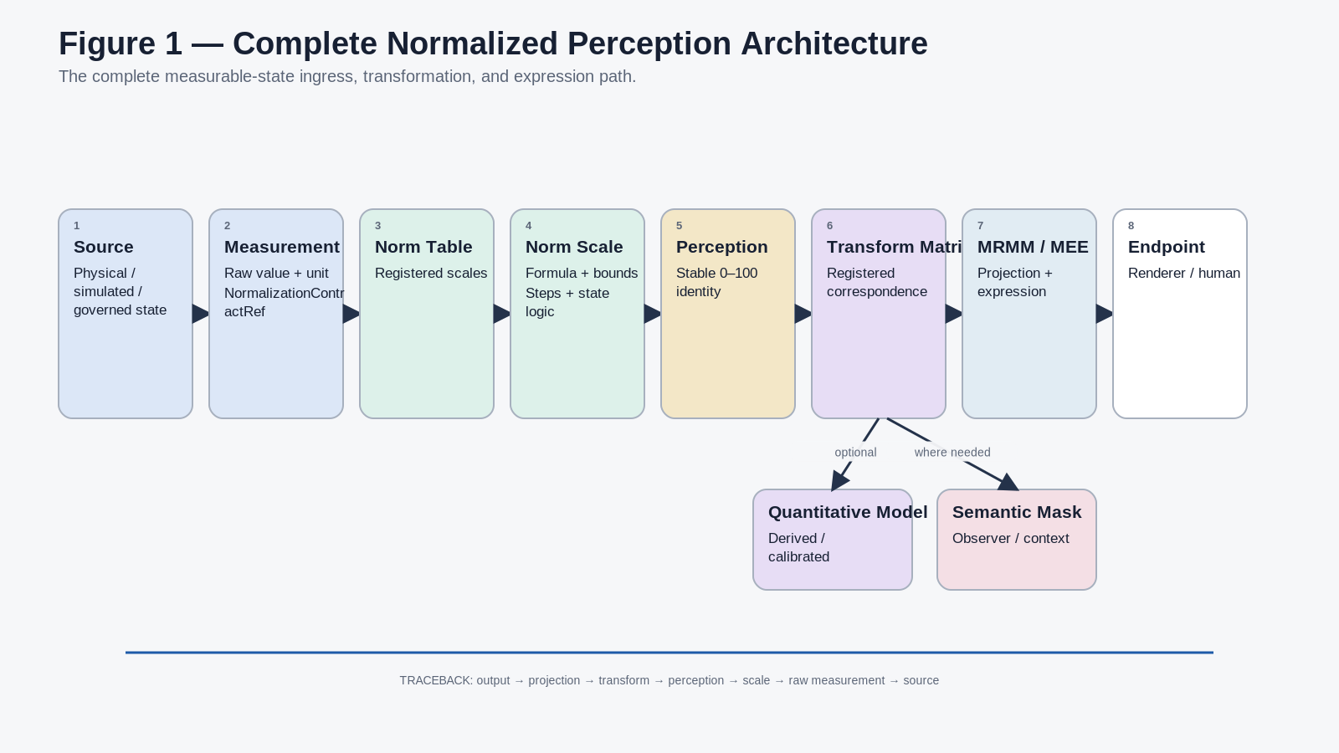
Figure 1. Complete normalized perception architecture from source state through normalization, Transform Matrix correspondence, and downstream expression.

PART I
Foundation and Architecture
Defines the bounded question, architectural position, ownership model, quantifiability boundary, and laws that govern the entire system.

1. Purpose and Scope
The purpose of this guide is to define how CERBERUS converts heterogeneous measurable states into standardized 0-100 Normalized Perception states that can participate in a shared Transform Matrix. The architecture is intentionally strict at semantic boundaries and permissive at composition boundaries: measured quantities keep their native meaning and provenance, while registered normalization and Transform contracts make those quantities mathematically interoperable.

1.1 Bounded Question
BOUNDED QUESTION
How does CERBERUS convert heterogeneous measurable states into standardized 0-100 Normalized Perception states so they can participate in a shared Transform Matrix while preserving raw measurements, formulas, domain-specific ranges, GRADED/GRADIENT behavior, hysteresis, provenance, and human semantic variability?

1.2 In Scope
- Measurable-state ingress and exact Normalization Contract linking.
- Normalization Table responsibilities and Normalization Scale semantics.
- Formula transparency, raw bounds, common 0-100 output, and reversibility declarations.
- GRADED and GRADIENT Step resolution, with one to ten Steps per Scale.
- Custom per-Step colors or a registered default color treatment.
- Gating, hysteresis, null, overflow, saturation, precision, and provenance behavior.
- Normalized Perception Records and normalized Transform Matrix interoperability.
- Quantitative Models, Semantic Masks, and the boundary between them.
- Sensory Bitmapping and downstream MRMM / MEE integration.

1.3 Explicit Non-Goals
- This guide does not define universal physics, sensor hardware, or domain-specific scientific thresholds.
- It does not define final physical Airtable schemas for the Normalization Table or Transform Matrix.
- It does not define every future Normalized Perception identity or every sensory SK.
- It does not define renderer technology, device actuation authority, or universal human interpretation.
- It does not treat a convenient 0-100 coordinate as proof that two perceptions are semantically equivalent.

2. Core Proposition and Primary Invariant
CORE PROPOSITION
Measure locally. Normalize explicitly. Transform commonly. Mask variability.

A measurable item owns the native value and unit. A Normalization Scale owns the bounded mathematical question used to translate that value into a 0-100 coordinate. A Normalized Perception Record owns the stable semantic dimension that participates in the Transform Matrix. A Transform owns one declared correspondence between source and target perceptions. A Mask owns observer- or context-scoped semantic interpretation where quantitative evidence is insufficient.
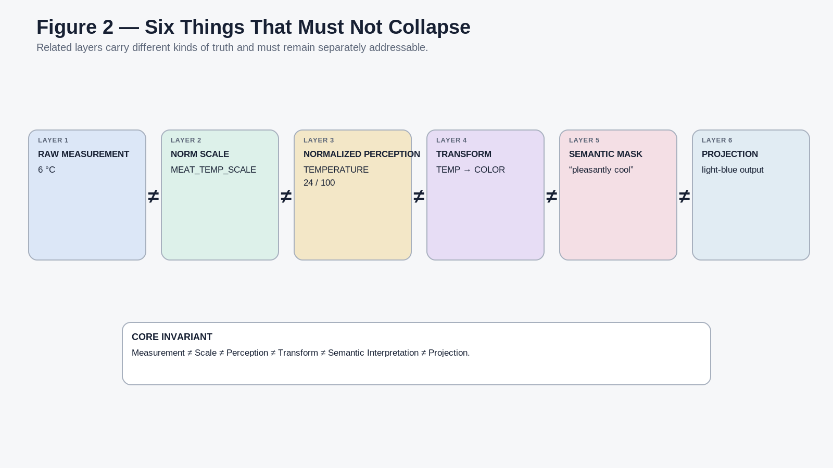
Figure 2. Measurement, Normalization Scale, Normalized Perception, Transform, semantic interpretation, and perceptual projection remain distinct.

3. Architectural Position
PPL/MRMM already defines a source -> normalization -> operator chain -> projection model -> renderer architecture and requires projection contracts to declare inputs, transforms, output parameters, scale, bounds, null behavior, version, and explanation [1]. MEE extends that discipline into a governed expressive pipeline in which source state remains authoritative, MRMM defines mapping, and renderers determine local presentation [2].
This guide formalizes the raw-to-normalized portion as a shared registered layer. It places the Normalization Table between measurable state and the Transform Matrix, then hands normalized state forward to MRMM and MEE rather than creating a competing projection system.
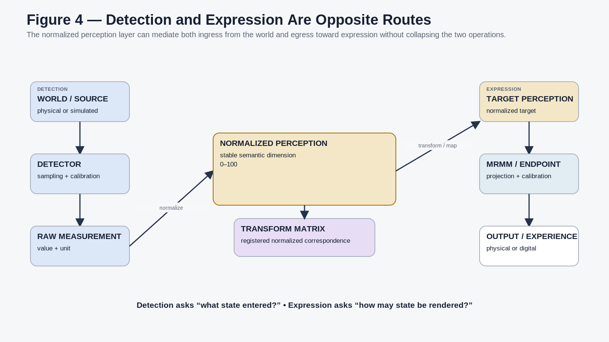
Figure 4. Detection and expression are opposite directional routes around the common Normalized Perception layer.

4. Ownership Across the Chain
Every stage may consume the output of the previous stage without inheriting its authority. Normalization is allowed to interpret a raw value inside a declared Scale, but it does not redefine the underlying physical Quantity. The Transform Matrix may compute a target perception, but it does not authorize actuation. A renderer may emit sound, light, motion, or force as presentation, but it does not become a shortcut into canonical world-state mutation.
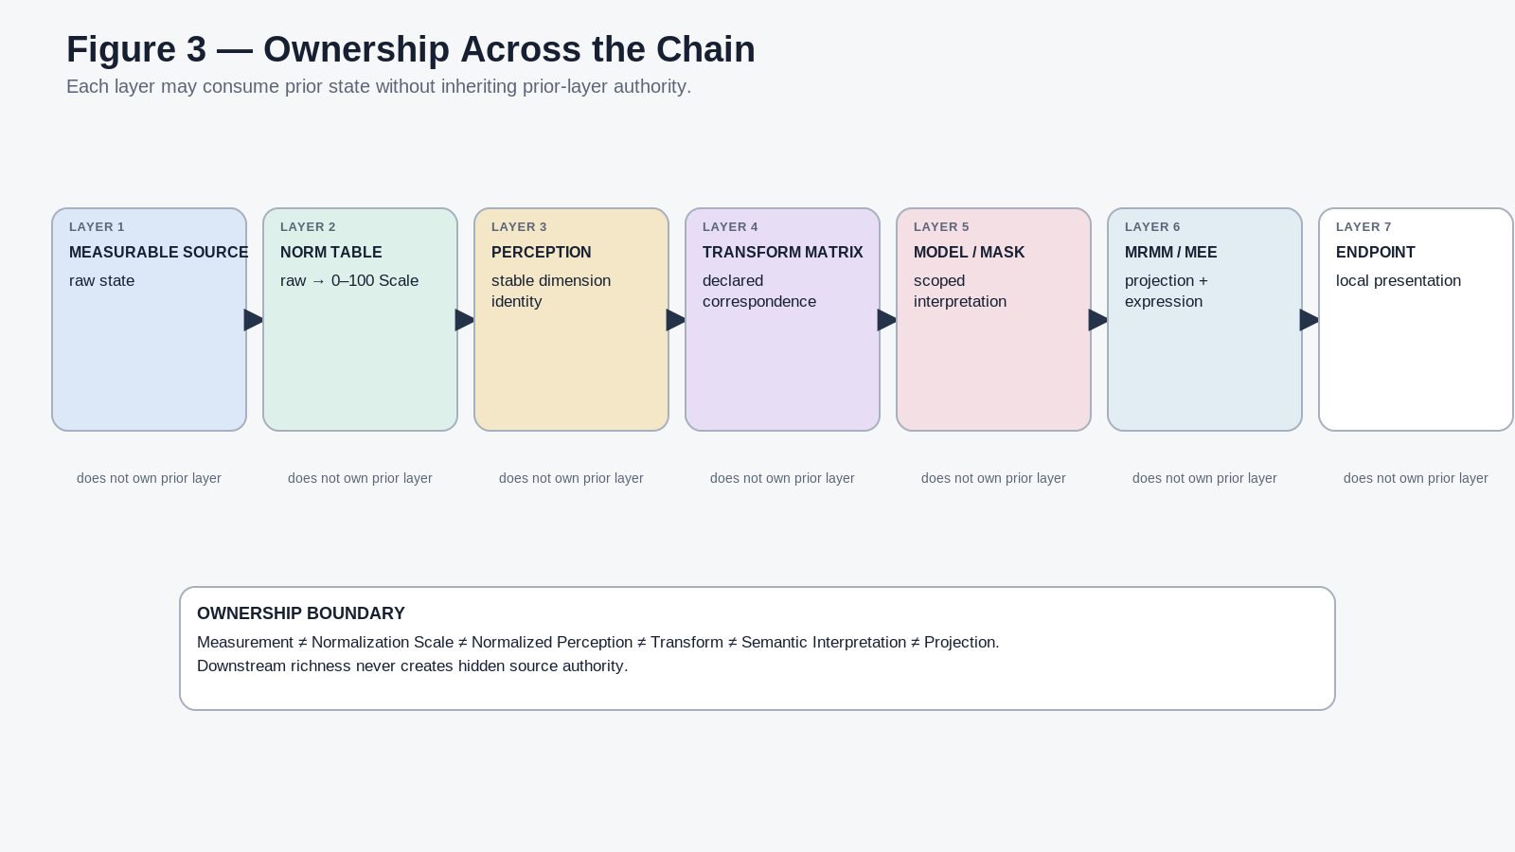
Figure 3. Ownership across measurable source, Normalization Table, Normalized Perception, Transform Matrix, Model or Mask, MRMM/MEE, and endpoint.

5. Quantifiability Gate
Before a candidate perceptual dimension becomes a normalized Transform Matrix dimension, the architecture classifies what kind of claim is being made. The objective is not to force every human experience into mathematics. It is to quantify what can be defended, retain explicit Models where calibrated relationships exist, and leave semantic variability masked or unresolved when evidence does not justify a numeric claim.
Class | Meaning | Default treatment
Q0 | Directly measurable quantitative state | Normalize directly through a registered Scale.
Q1 | Deterministically derived quantitative state | Compute the declared formula, then normalize.
Q2 | Quantitatively modeled or calibrated perceptual state | Apply the declared Model and calibration, then normalize.
S | Semantic variable whose meaning depends on observer or context | Represent with a scoped Mask.
U | Unresolved relationship with insufficient evidence | Preserve as unresolved; do not manufacture precision.

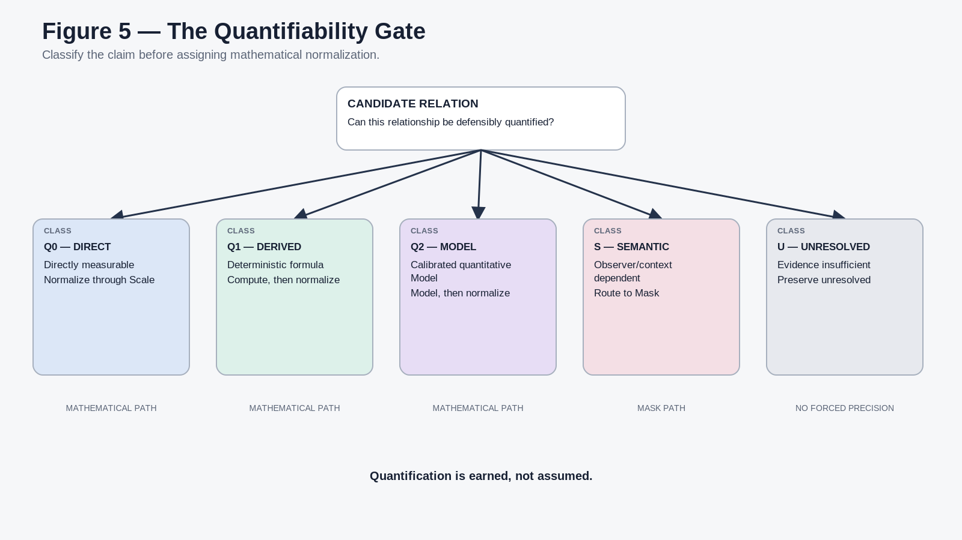
Figure 5. Quantifiability Gate separating direct, derived, modeled, semantic, and unresolved relationships.

6. Governing Laws
The governing laws are intentionally restrictive at ownership boundaries and permissive at composition boundaries. They preserve raw state, make every quantitative ingress explainable, and prevent normalized compatibility from being mistaken for semantic identity.
Law family | IDs | Governing effect
Source and ingress | NPG-L01–L07 | Preserve raw state, require explicit Scale ingress, keep Quantity and Scale ownership separate, stabilize perception identity, and expose formula/bounds/version.
Range and state logic | NPG-L08–L14 | Declare GRADED/GRADIENT behavior, bounded Steps, color-as-projection, stateful logic, null integrity, overflow visibility, and precision limits.
Transform boundary | NPG-L15–L17 | Separate raw-to-normalized ingress from normalized correspondence; common 0-100 compatibility never authorizes undeclared equivalence.
Human interpretation | NPG-L18–L21 | Masks remain non-authoritative and observer-scoped; quantification is earned and promotion to a Model requires evidence and versioning.
Detection and expression | NPG-L22–L23 | Computable output does not establish detection, physical realization, actuation authority, or source truth.
Provenance continuity | NPG-L24 | Keep the semantic route traceable from perceptual output back through Transform, Scale, raw measurement, and source.

The complete normative law set is reproduced in Appendix A for implementation and conformance reference.
PART II
Measurable State and Detection
Defines the information that must exist before normalization and preserves the boundary between physical state, detected state, and quantitative evidence.

7. Measurable Item Contract
A Normalization Scale cannot safely operate on a floating number. The measurable item must preserve enough context to identify what was measured, in which unit, with what precision and validity, at what time, and through which normalization route. The semantic contract may be implemented as a record, runtime packet, Model result, sensor event, simulation value, or other governed structure.
Field family | Required semantic content
Identity | Item or state identity; Quantity identity.
Measurement | Raw Value; Raw Unit; optional Reference Frame where relevant.
Sampling | Timestamp; sample window, rate, or duration where relevant.
Quality | Declared Precision; Error or Uncertainty; Validity state.
Routing | NormalizationContractRef selecting the exact registered Scale.
Provenance | Source, actor or process, calibration identity where applicable, and version.

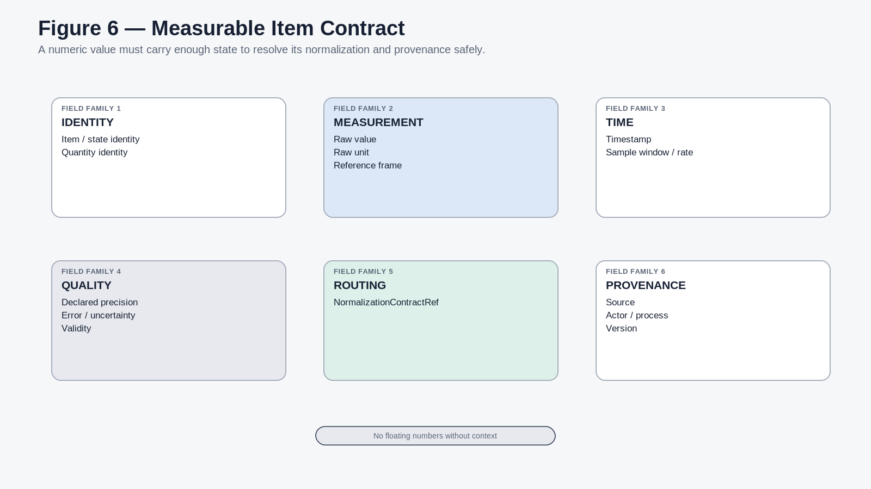
Figure 6. Minimum semantic field families carried by a measurable item before normalization.

8. Physical State Is Not Detected State
A physical or simulated state exists independently of the detector that observes it. Detector range, sensitivity, sampling, noise, resolution, calibration, and environmental conditions mediate the measured value. The measured state may be highly reliable without being identical to the underlying physical reality. This distinction allows CERBERUS to preserve sensor limitations as inspectable metadata instead of smuggling them into the meaning of the Quantity.
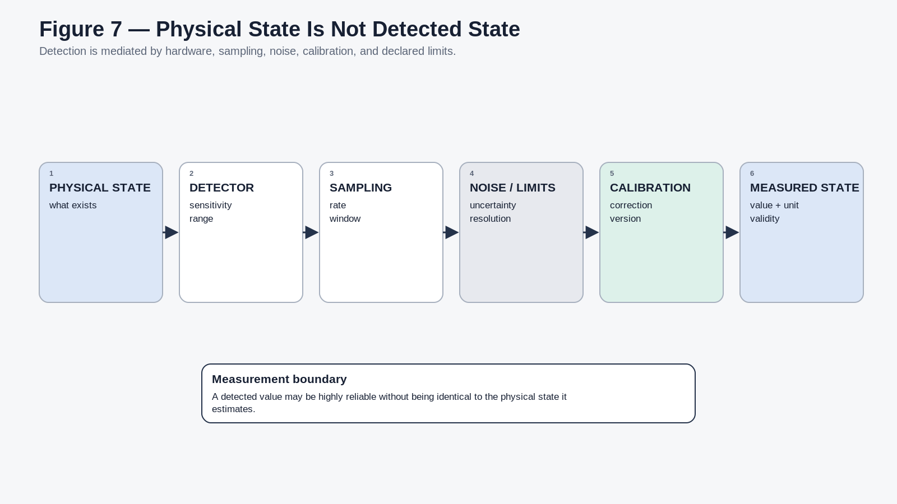
Figure 7. Detection is mediated by detector characteristics, sampling, limits, and calibration.

9. Value, Validity, Precision, and Uncertainty
The numeric value is only one field in the measurement packet. VALID, MISSING, UNKNOWN, BELOW DETECTION, OUT OF RANGE, SATURATED LOW, SATURATED HIGH, SENSOR ERROR, NOT APPLICABLE, and UNRESOLVED are different states. Numeric zero remains a valid number and SHALL NOT double as a universal null marker.
Normalization also cannot manufacture precision. A source that reliably distinguishes only a small number of states may be encoded in a fine numeric datatype for convenience, but the declared precision and uncertainty must continue to describe the actual information content.
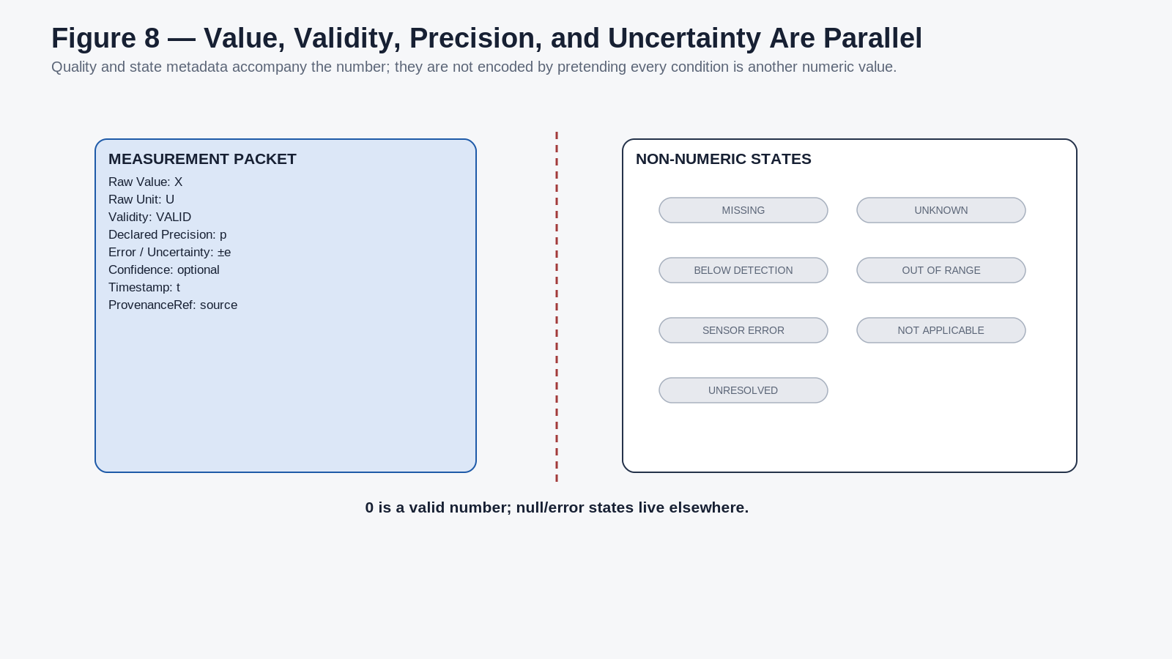
Figure 8. Numeric value, validity, precision, uncertainty, and null-like states remain parallel rather than collapsed.

10. The Normalization Contract Link
NormalizationContractRef is the exact semantic route from the measurable item into the Normalization Table. The reference may be authored directly on the measurable state, supplied by a Model, or resolved through an explicit contextual selector. What matters is that the applied Scale is inspectable. The Transform Matrix does not receive a raw value and guess which Scale was intended.
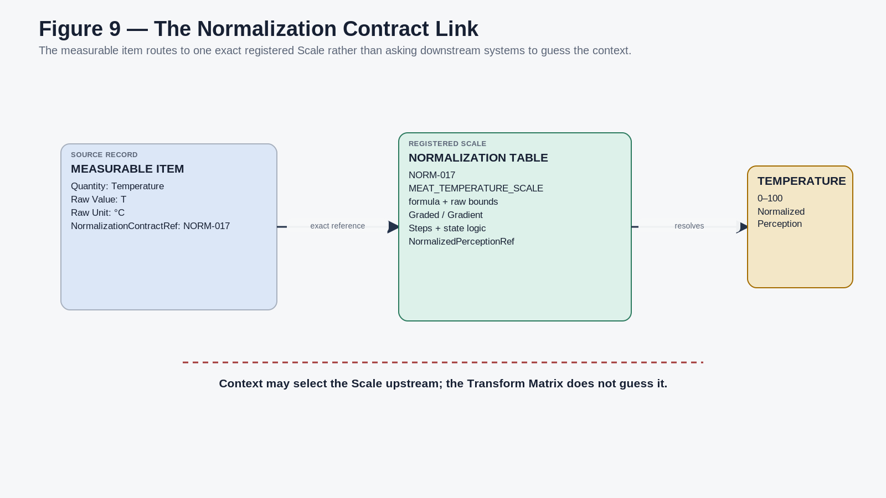
Figure 9. Exact NormalizationContractRef from a measurable item to its registered Scale and target Normalized Perception.

DETECTION TAKEAWAY
Normalization begins only after identity, Quantity, raw unit, validity, precision, provenance, and the exact Scale route are known. Detection supplies evidence; normalization interprets that evidence inside a declared contract.

PART III
The Normalization Table
Defines the shared registry of raw-to-normalized ingress contracts: formulas, bounds, Step architecture, colors, gates, hysteresis, and failure behavior.

11. Normalization Table as the Ingress Registry
The Normalization Table is the shared conversion dictionary for measurable domains. Its records absorb raw-unit heterogeneity before state enters the Transform Matrix. A pressure sensor, temperature probe, light meter, simulation field, laboratory measurement, robot, weather station, or human-entered measurement can all use the same architectural route if they expose a valid Normalization Contract link.
SYSTEM ROLE
Normalization Table owns ingress. Transform Matrix owns correspondence.

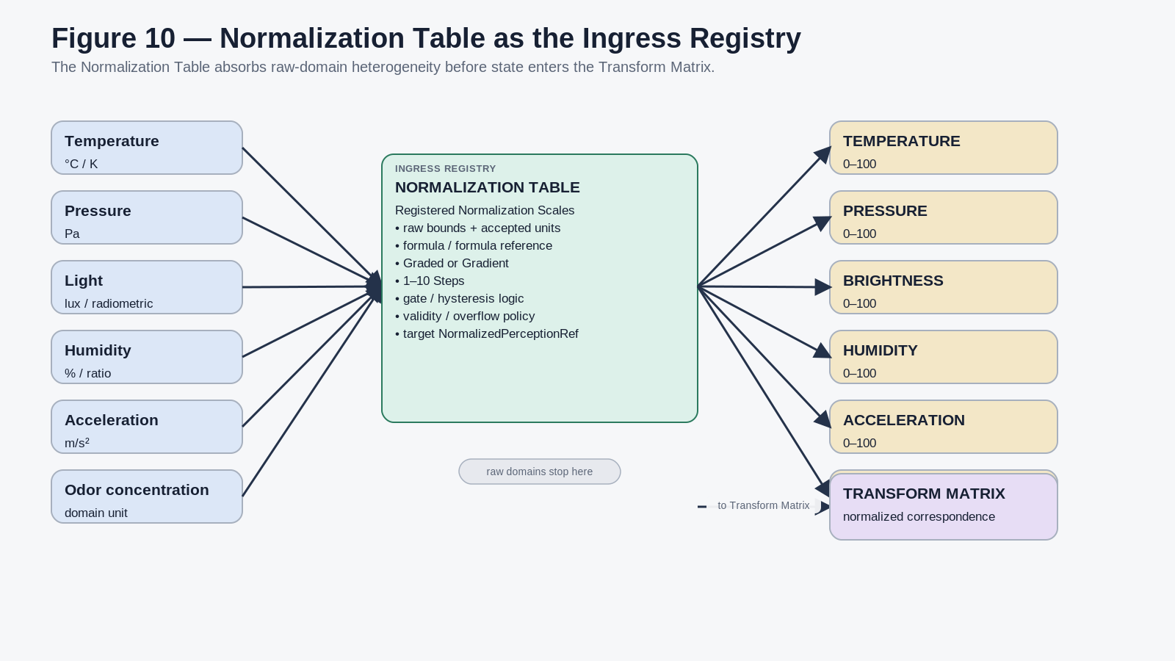
Figure 10. The Normalization Table absorbs heterogeneous raw domains and resolves them into specific 0-100 Normalized Perception Records.

12. Normalization Scale Record
A Normalization Scale is one registered answer to one bounded quantitative question. It may be simple and linear or complex and stateful. The exact physical table schema may evolve, but the semantic field families must remain reconstructable.
Field family | Required semantic content
Identity | NormalizationScaleID, ScaleName, Version, Status.
Target | NormalizedPerceptionRef identifying the exact Transform Matrix perception record.
Input | QuantityRef, AcceptedRawUnit, RawMin, RawMax.
Mathematics | Formula or FormulaRef, FormulaType, forward normalization, optional inverse normalization.
Resolution mode | GRADED or GRADIENT.
Step architecture | StepCount from 1 to 10; ordered Step definitions.
Color behavior | DEFAULT or CUSTOM; custom Step colors up to StepCount.
State logic | Optional gate Rules, enter/exit thresholds, hysteresis, minimum duration, previous-state requirements.
Bounds and failure | BelowRangePolicy, AboveRangePolicy, ClampPolicy, SaturationPolicy, NullPolicy.
Governance | Source, formula version, provenance, validation status.

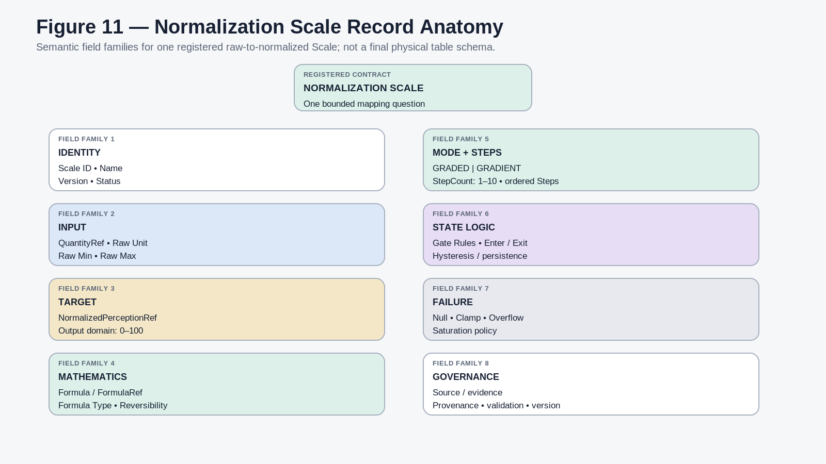
Figure 11. Semantic anatomy of a Normalization Scale record.

13. One Quantity, Many Bounded Questions
The measured Quantity owns what was measured. The Normalization Scale owns the bounded question being asked of that Quantity. TEMPERATURE therefore does not need one universal CERBERUS raw scale. Meat cooking, human contact, room environment, industrial furnace, cryogenic, and stellar contexts can each define separate Normalization Scales while pointing to the same stable TEMPERATURE Normalized Perception identity.
This architecture preserves two facts simultaneously: the perception dimension can remain stable across contexts, while the ScaleRef retains the exact raw-domain meaning of each normalized value. A normalized value is never sufficient evidence for raw-domain comparison unless the relevant Scale relationship is also known.
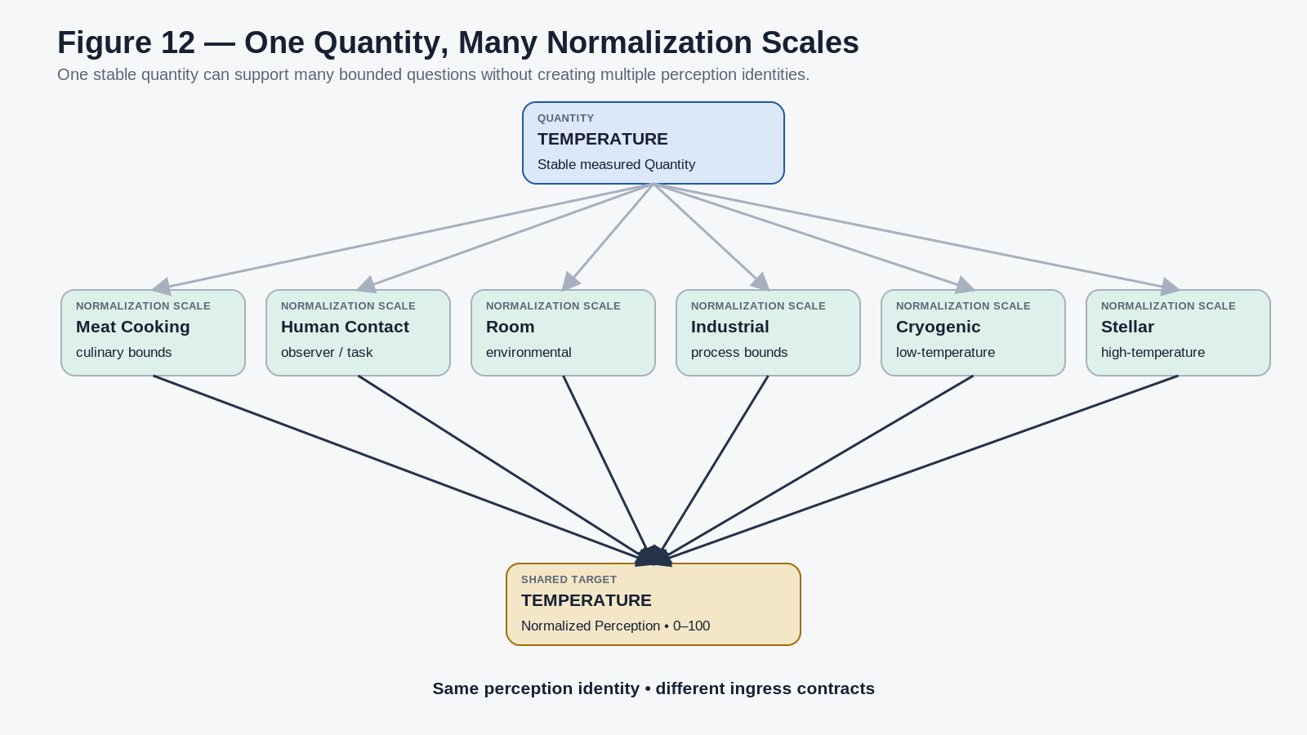
Figure 12. One measured Quantity can support many bounded Normalization Scales that resolve into one stable Normalized Perception identity.

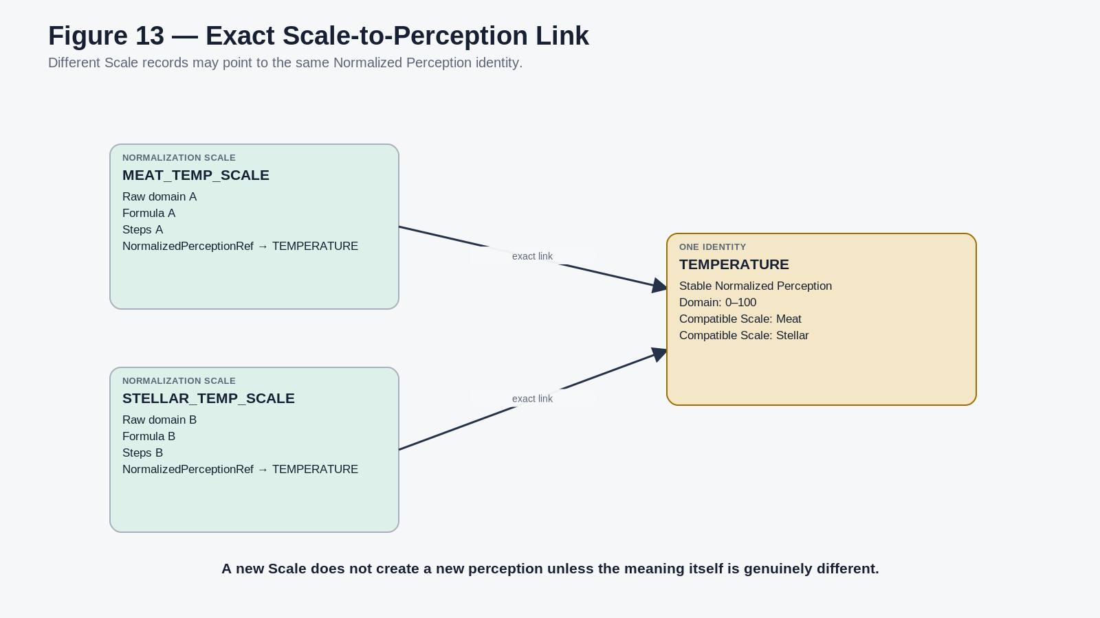
Figure 13. Different Scale records can point to the same Normalized Perception Record through exact NormalizedPerceptionRef links.

14. Common 0-100 Coordinate
Where suitable, every Normalized Perception Record uses the common 0-100 coordinate. The purpose is not to express a universal percentage of reality. It is to publish a stable, bounded interface that Transform records can consume. The active Scale defines what 0, 100, and every intermediate position mean for that bounded question.
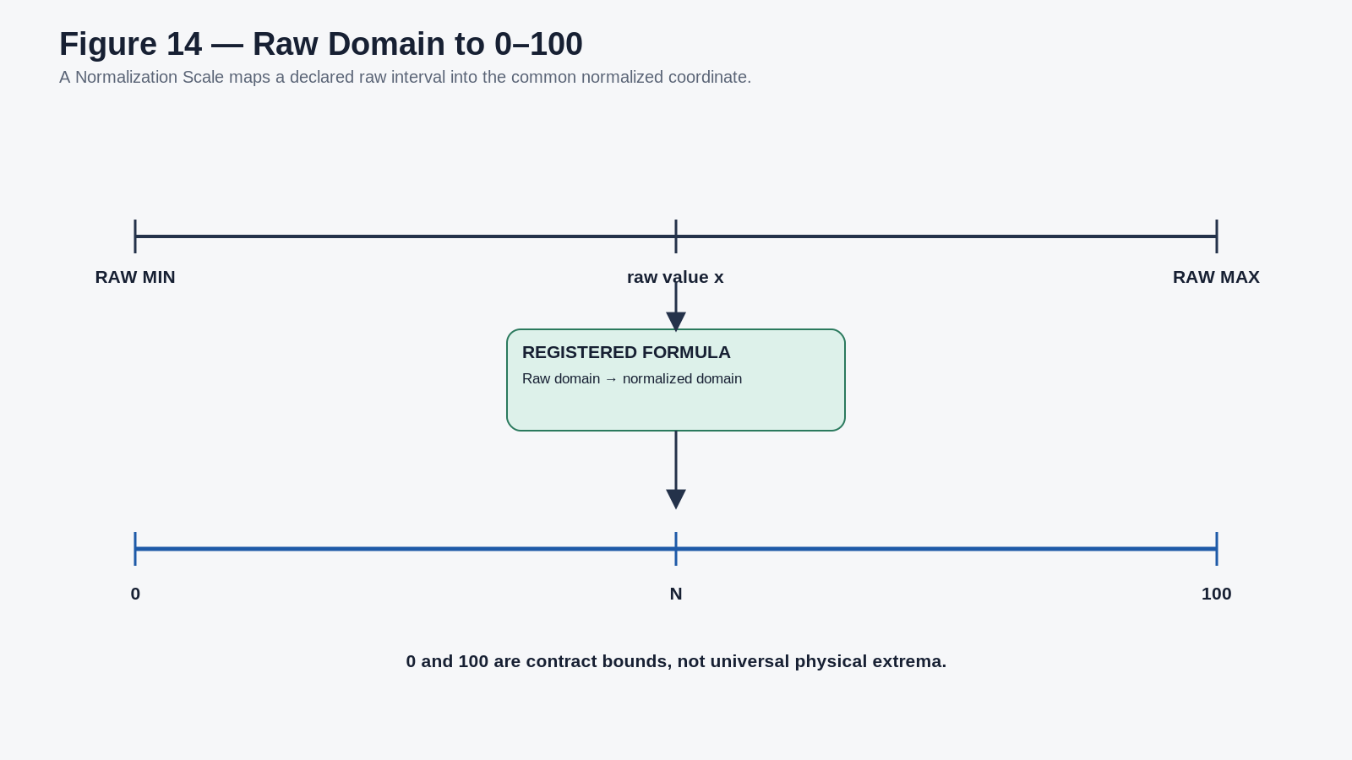
Figure 14. A declared raw interval is mapped through a registered formula into the common 0-100 normalized coordinate.

15. Formula Transparency and Reversibility
A semantic normalized value must remain explainable. The system should be able to resolve the raw value, raw unit, Scale ID, raw bounds, Formula or FormulaRef, Formula version, and resulting Normalized Perception value. PPL/MRMM already requires projection mappings to expose source, transform, scale, bounds, null behavior, and version [1]; the Normalization Table makes that discipline reusable before Transform Matrix routing.
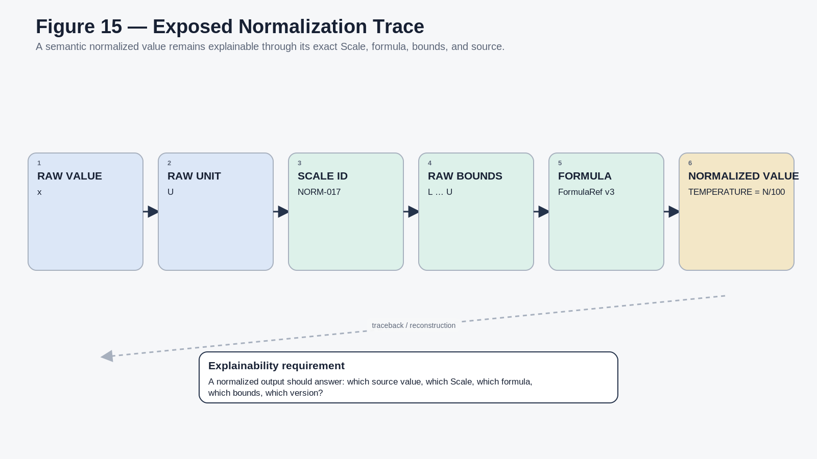
Figure 15. Normalization trace showing the information required to reproduce and explain a normalized value.

15.1 Formula Families
Supported formula families may include LINEAR, LOGARITHMIC, CENTERED, SIGNED, PIECEWISE, GATED, DOMAIN MODEL, CUSTOM, and IDENTITY. The family label is descriptive; the exact registered Formula or FormulaRef remains authoritative.
Family | Representative form / use
LINEAR | N = 100 * clamp((x - xmin) / (xmax - xmin), 0, 1).
LOGARITHMIC | For positive domains spanning orders of magnitude: N = 100 * (ln(x) - ln(xmin)) / (ln(xmax) - ln(xmin)).
CENTERED / SIGNED | Maps a declared center to the middle of the normalized domain; one form is N = 50 + 50 * clamp((x - center) / radius, -1, 1).
PIECEWISE | Different explicit equations apply to different raw subdomains.
GATED | A Gate resolver selects the active formula regime before publishing 0-100.
DOMAIN MODEL | A validated domain-specific Model produces the bounded coordinate.
CUSTOM | Registered formula with declared input, output, bounds, and provenance.
IDENTITY | Already normalized compatible input passes through without semantic redefinition.

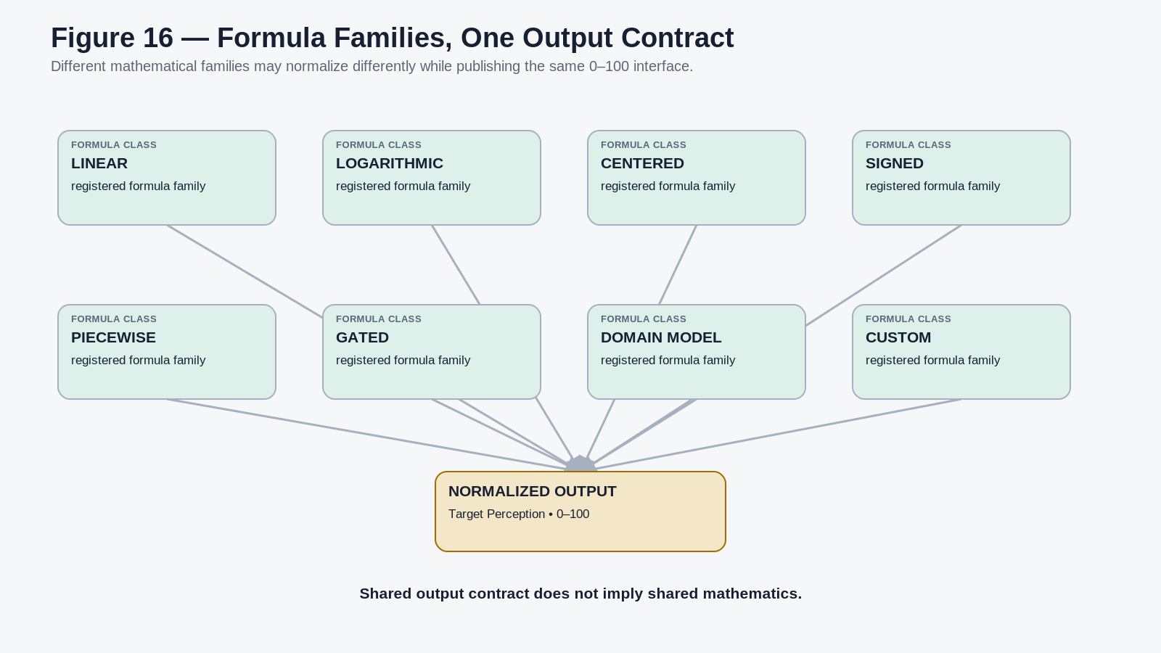
Figure 16. Different formula families can publish one common normalized output contract without sharing the same mathematics.

Where reverse conversion is meaningful, the Scale should declare reversibility as EXACT, APPROXIMATE, RANGE-ONLY, or UNSUPPORTED. The raw measurement remains authoritative even when a normalized state can be inversely mapped.

16. Step Architecture
A Normalization Scale may define from one to ten ordered Steps. The number of Steps belongs to the Scale, not to the Normalized Perception itself. Each used Step can expose a name, raw minimum and maximum, normalized minimum and maximum, optional color, entry and exit conditions, and provenance.
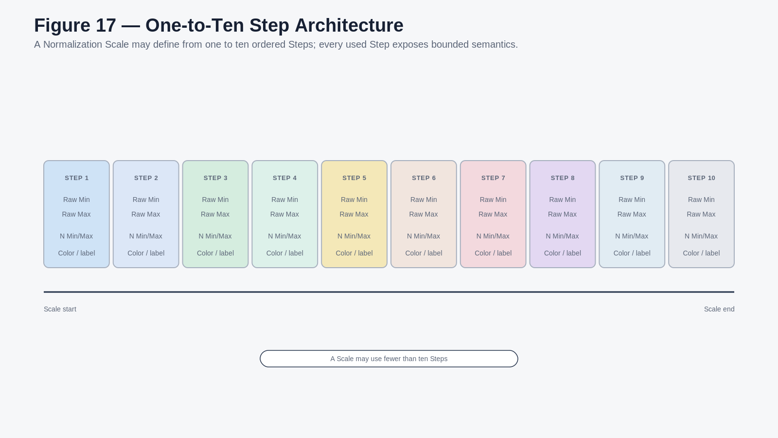
Figure 17. One-to-ten ordered Step architecture for a registered Normalization Scale.

17. GRADED Mode
GRADED mode resolves the current value into a discrete registered Step. The raw measurement and normalized coordinate may remain available, but the operational answer is the Step identity. This mode is appropriate when stable categories or operational bands are more useful than tiny continuous changes.
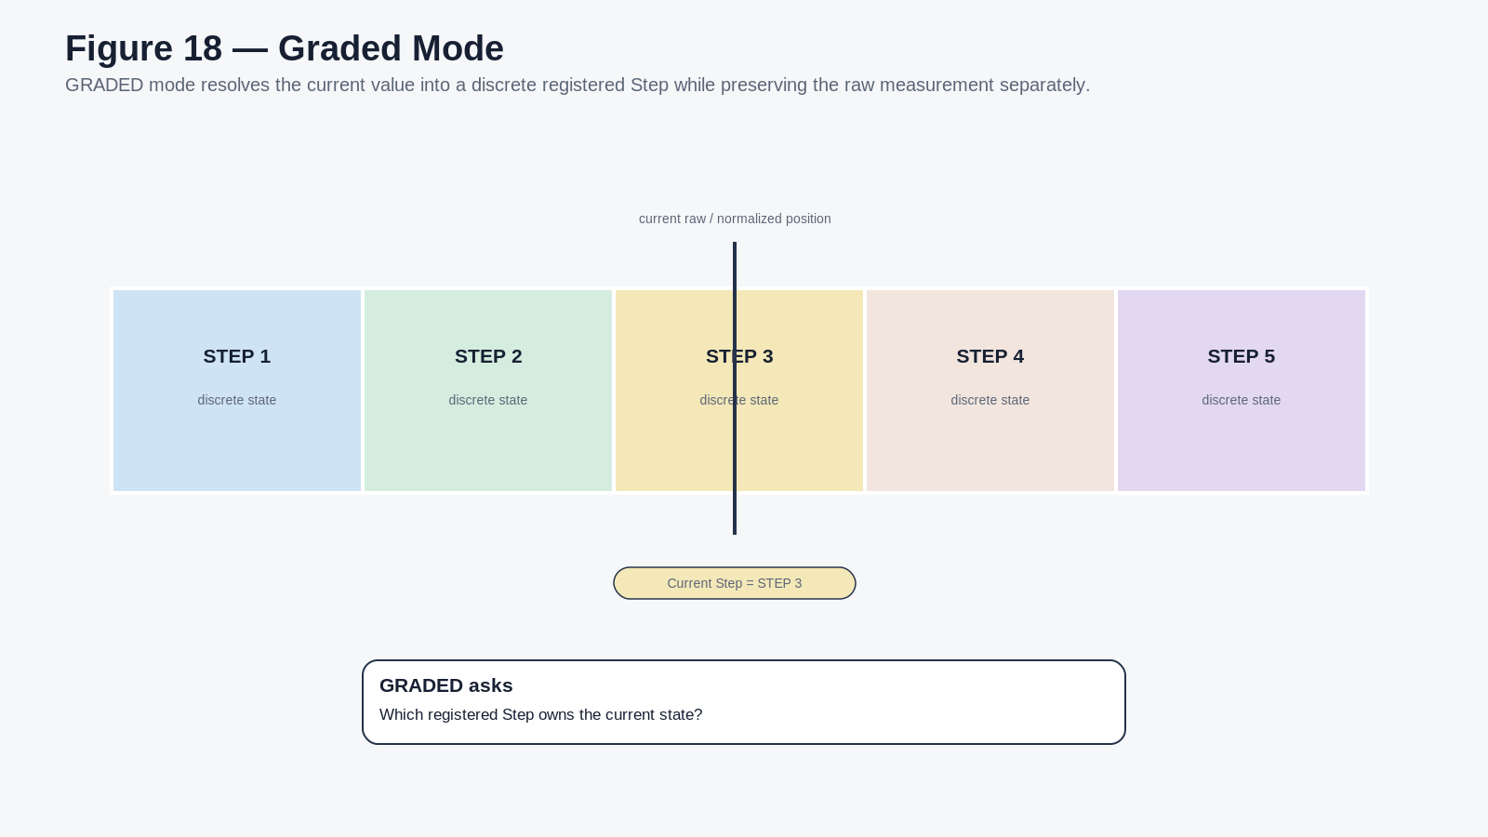
Figure 18. GRADED mode resolves a continuous position into a discrete registered Step state.

18. GRADIENT Mode
GRADIENT mode preserves continuous position across the Scale. Ordered Step definitions can act as anchor points, allowing interpolation of mapped presentation values between anchors. GRADED and GRADIENT therefore do not require two unrelated schemas: they can read the same ordered Step architecture differently.
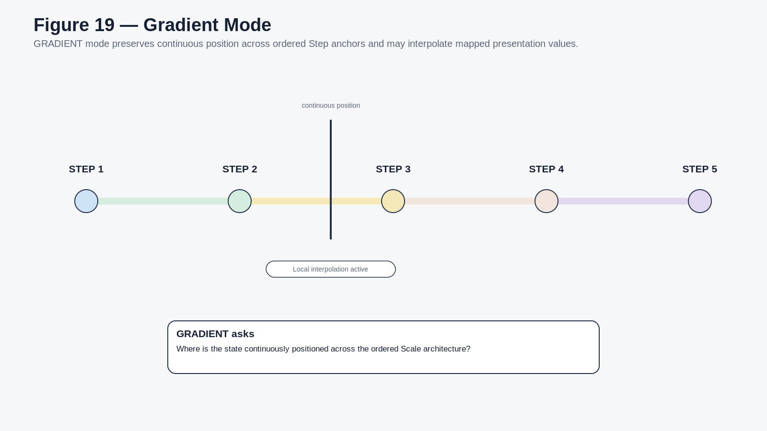
Figure 19. GRADIENT mode preserves continuous position across ordered Step anchors.

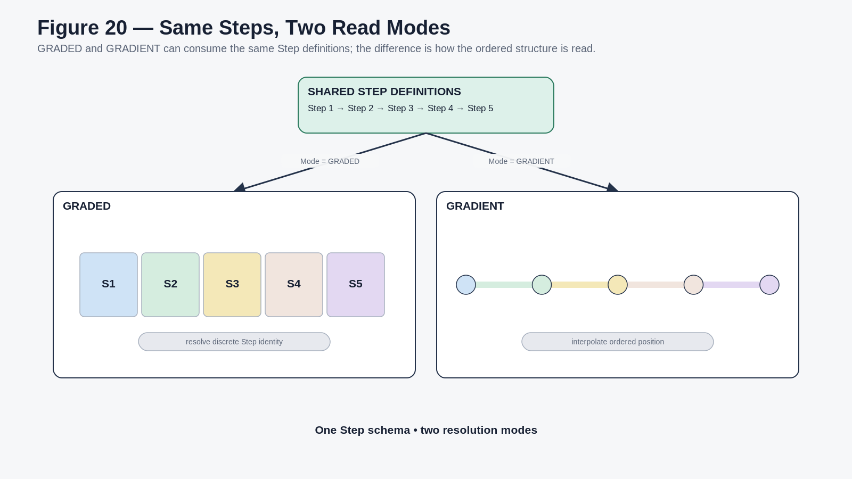
Figure 20. The same Step definitions can be resolved as discrete GRADED states or continuous GRADIENT interpolation.

19. Step Colors and Default Visual Mapping
A Scale can attach a custom color to each registered Step, up to its StepCount, or specify ColorMode = DEFAULT to invoke a registered default visual treatment. The default palette is an implementation asset rather than a semantic law of this guide.
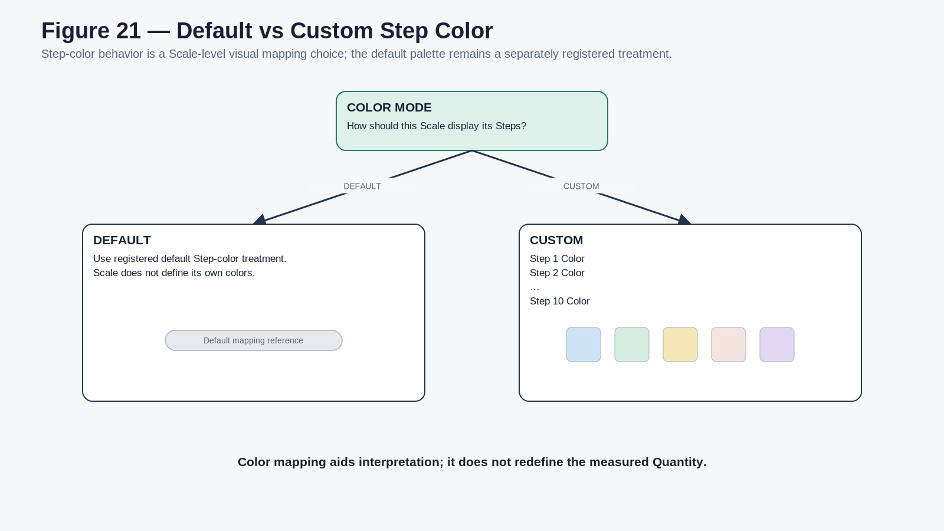
Figure 21. A Normalization Scale can use a registered default Step-color treatment or explicit custom colors.

19.1 Scale Color Is Not a COLOR Transform
Step color answers: how should this Scale itself be visually represented? A Transform Matrix relationship to COLOR answers: how does this normalized perception mathematically correspond to the normalized COLOR perception? These are separate operations even when they happen to produce similar hues.
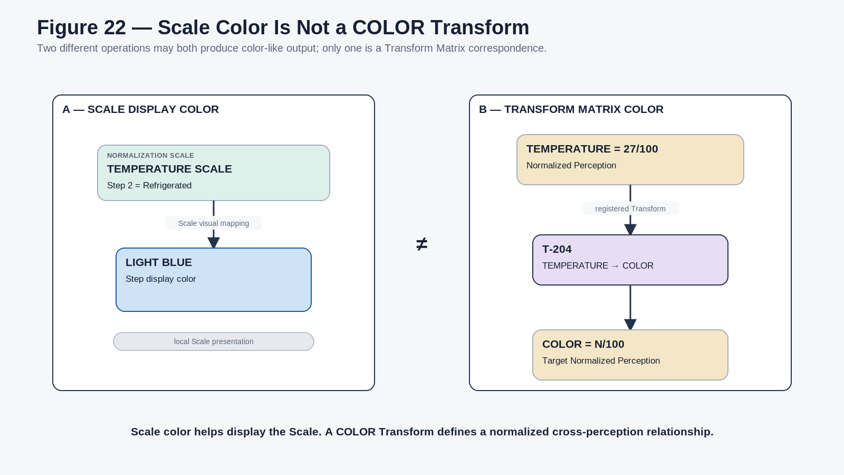
Figure 22. Scale display color remains distinct from a registered Transform Matrix relationship to COLOR.

20. Hysteresis
Some Scale boundaries need state memory. Instead of using one threshold in both directions, a Scale may define separate enter and return conditions. The current raw value, previous resolved Step, and transition contract then jointly determine the current Step. This prevents small fluctuations from causing rapid Step chatter. MEE already uses the same architectural principle for coherence persistence and requires hysteresis or smoothing to remain declared rather than hidden in rendering behavior [2].
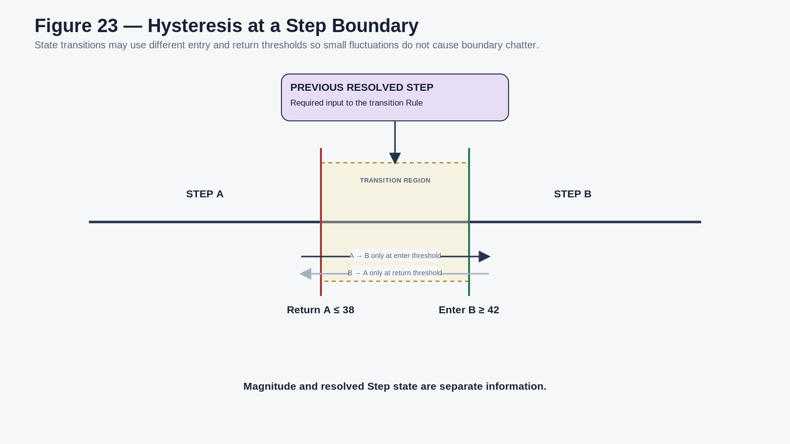
Figure 23. Hysteresis uses separate enter and return thresholds plus previous resolved state.

21. Gated Normalization
A Gate determines which mathematical regime applies. Different raw regions may use different formulas while still publishing one normalized 0-100 result. Gate identity and FormulaRef remain inspectable so downstream systems can explain how the value was produced. Gating and hysteresis are orthogonal: a Scale may use neither, one, or both.
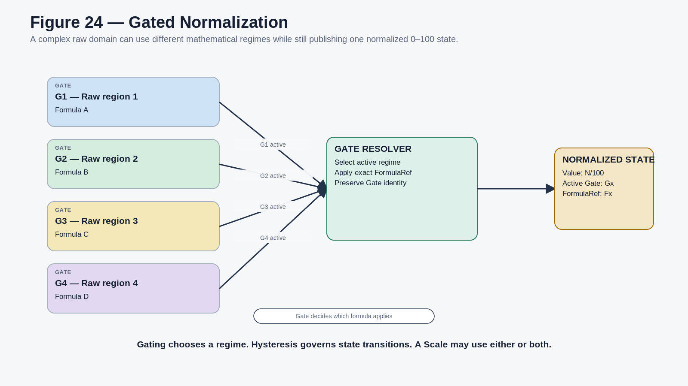
Figure 24. Gated normalization selects among declared formula regimes before publishing one normalized state.

22. Null, Saturation, Overflow, and Precision
Out-of-range behavior is a contract decision. Possible policies include CLAMP, SATURATE, OVERFLOW, REJECT, ROUTE TO EXTENSION, or another declared domain-specific rule. If a raw value exceeds RawMax and the Scale publishes 100 through clamping, the runtime must still preserve the fact that the source exceeded the Scale domain. MEE applies the same principle downstream: out-of-range values are clamped only when the applicable contract permits it; otherwise overflow remains inspectable [2].
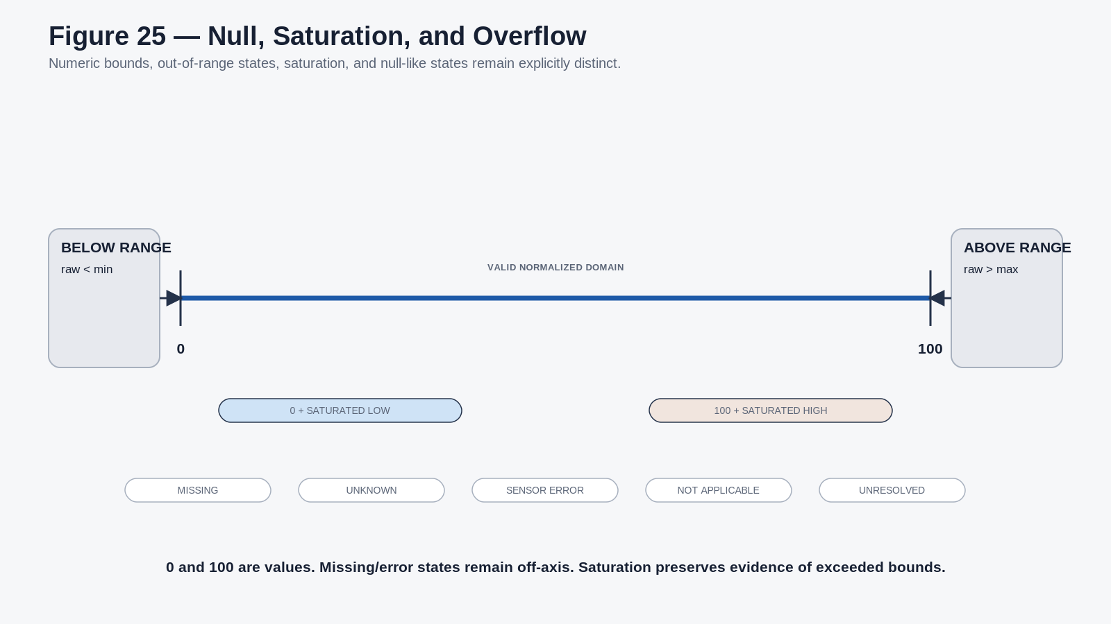
Figure 25. Numeric bounds, saturation, overflow, and null-like states remain explicitly distinct.

23. Versioning and Contextual Scale Selection
Normalization Scales are versioned independently of raw measurements, Normalized Perception identity, Transform Matrix relationships, Masks, and renderers. A revised MEAT_TEMP_SCALE v2 can therefore coexist with historical values generated under v1 without redefining TEMPERATURE itself.
Scale selection may be explicit on the measurable item or supplied by an inspectable contextual Model. The same raw state may legitimately feed several Normalization Scales at once - for example process temperature, safety temperature, and a human thermal-response Model - provided each normalized result retains its ScaleRef and provenance.
PART IV
Normalized Perceptions and the Transform Matrix
Defines the stable 0-100 perception vocabulary and the registered mathematical relationships that connect normalized perceptions.

24. Normalized Perception Records
A Normalized Perception Record defines the stable semantic dimension that receives normalized values and participates in the Transform Matrix. It is distinct from a runtime value. TEMPERATURE is the definition; TEMPERATURE = 63/100 under a specific Scale at a specific time is an instance of state against that definition.
Field family | Semantic content
Identity | PerceptionKey, Name, Perception Family or Type.
Domain | Normalized Domain: 0-100.
Capabilities | Detectable, Expressible, or conditional capability states.
Relations | Inbound Transform Relations; Outbound Transform Relations.
Ingress | Compatible Normalization Scales.
Interpretation | Model and Mask relations where applicable.
Governance | Version and provenance.

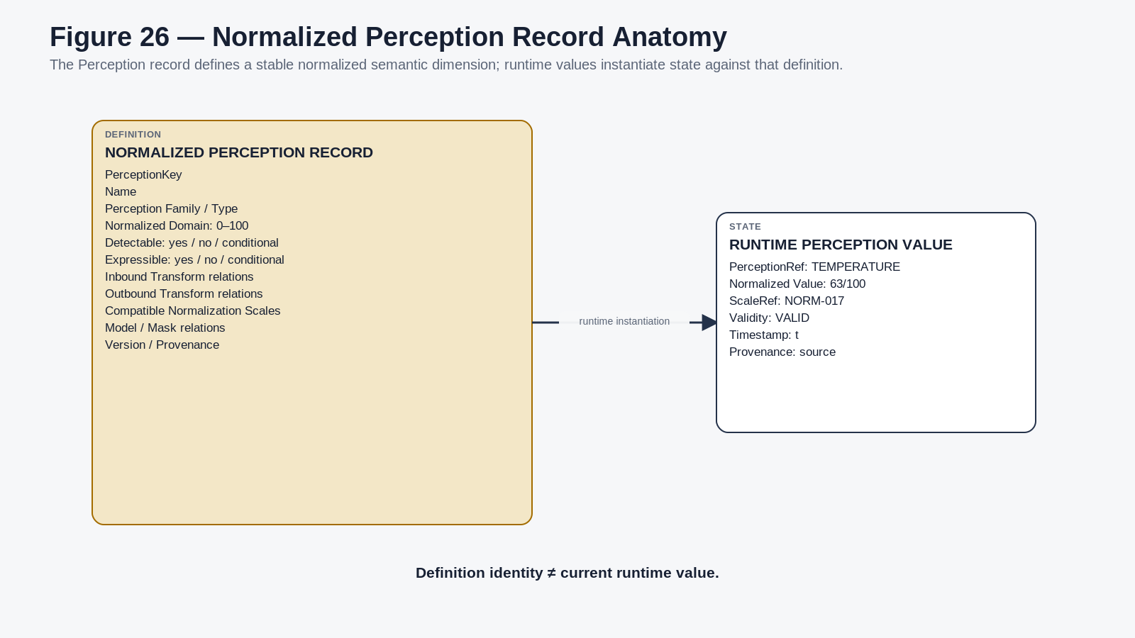
Figure 26. Stable Normalized Perception definition versus a runtime perception value.

25. Common Normalized Perception Language
The Transform Matrix can maintain a large vocabulary of normalized perceptions such as TEMPERATURE, BRIGHTNESS, PRESSURE, VIBRATION, ROUGHNESS, AIRFLOW, SCENT INTENSITY, LOUDNESS, and later taste, tactile, vestibular, visual, auditory, or machine-oriented dimensions. They share a numeric coordinate but retain separate identity and semantics.
CRITICAL LAW
Common coordinate. Different meanings. A registered Transform is required for correspondence.

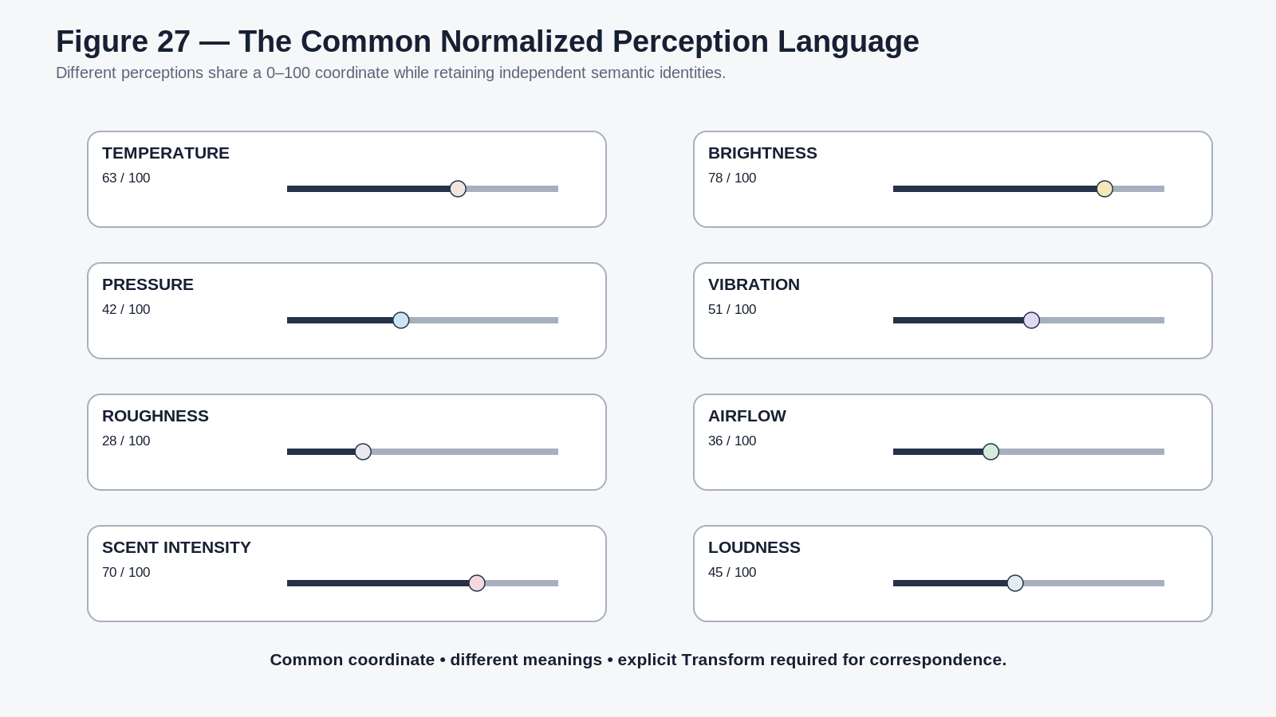
Figure 27. Different Normalized Perception identities share 0-100 while remaining semantically independent.

26. Transform Matrix
The Transform Matrix is the common relational environment for Normalized Perception Records. It answers a different question from the Normalization Table: given a source perception in a normalized state, what declared mathematical correspondence exists to another normalized perception? Every edge is a registered Transform with its own identity, formula or Model, direction, classification, version, and provenance.
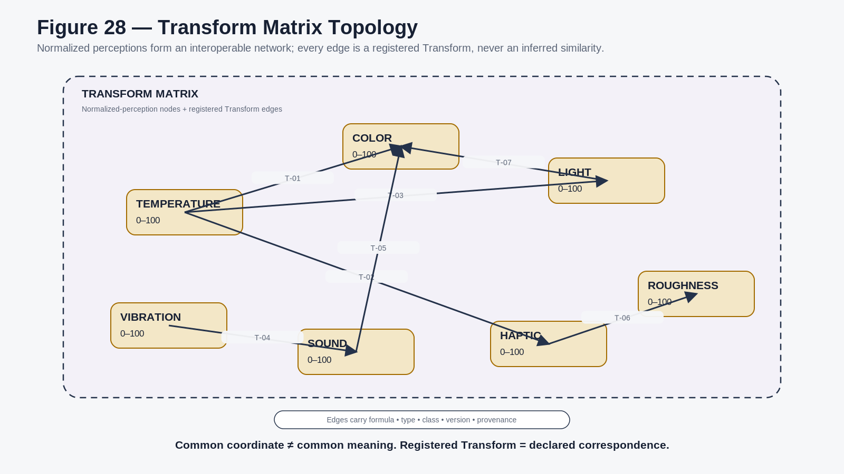
Figure 28. Normalized Perception nodes connected by registered Transform Matrix relationships.

27. Transform Relationship Types
A Transform may preserve the source value directly or compute a different target. Useful relationship types include IDENTITY, INVERT, CURVE, SCALE, WINDOW, THRESHOLD, QUANTIZE, PIECEWISE, GATE, MULTI-INPUT, and CUSTOM FORMULA. Shared 0-100 normalization removes much raw-unit conversion from the edge logic, but it does not eliminate the need for explicit semantics.
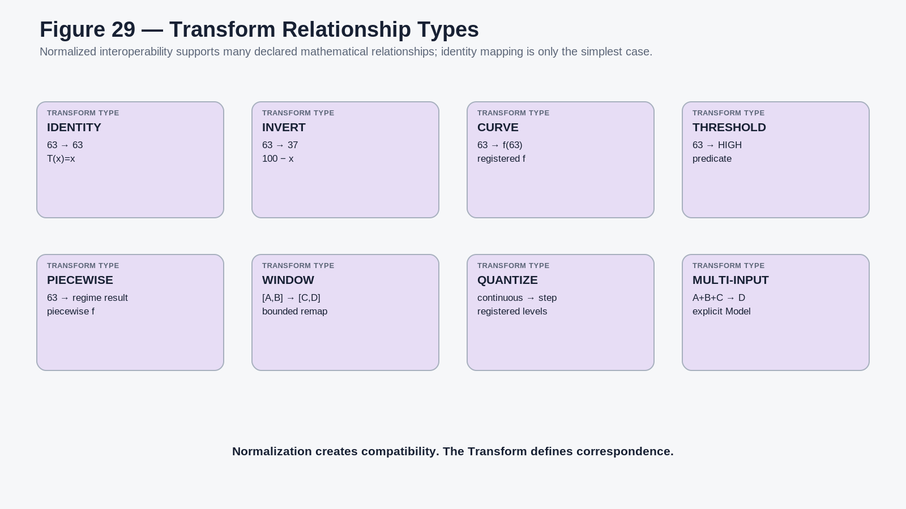
Figure 29. Representative Transform relationship types over normalized source and target perceptions.

28. One-to-Many and Many-to-One Composition
One normalized perception may drive several target perceptions through independent registered Transform edges. TEMPERATURE may influence COLOR, HAPTIC, LIGHT, and SOUND in one expressive profile. Conversely, several normalized perceptions may feed an explicit derived Model. TEMPERATURE, HUMIDITY, and AIRFLOW can contribute to a modeled THERMAL COMFORT perception if the Model is defensible. Fan-in never means silent averaging merely because all inputs happen to use 0-100.
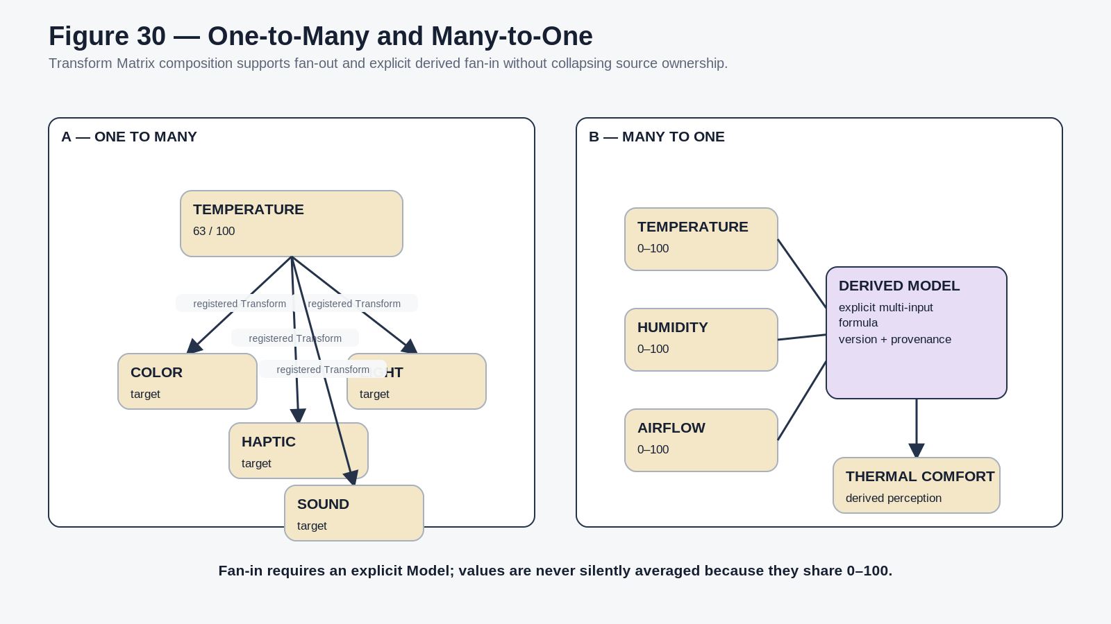
Figure 30. Explicit one-to-many Transform fan-out and many-to-one Model composition.

29. Detectable, Expressible, and Modeled Dimensions
A Normalized Perception Record may be DETECTABLE ONLY, EXPRESSIBLE ONLY, BOTH, or MODELLED / SYNTHETIC depending on system capabilities. A chemical concentration may be detected directly while no device can express that exact modality. The Transform Matrix can still route the normalized state into color, sound, haptics, text, or another available channel.

30. Reverse Normalization and Actuation Boundary
Where a Scale is reversible, a normalized target may be converted into a candidate physical target value. That computation is not actuation authority. MEE explicitly separates projection from operational state change: if an endpoint is intended to change canonical or physical state, the operation must pass through the appropriate Rules, permissions, and state-transition pathway [2].
ACTUATION BOUNDARY
Inverse normalization computes a candidate physical value. It does not authorize execution.

PART V
Bitmapping and Human Variability
Defines how normalized semantic state is encoded and where mathematical modeling yields to observer-scoped interpretation.

31. Normalized Perception to Sensory Bitmap
The common 0-100 semantic domain is not itself a BitWord layout. A future sensory SK may encode a Normalized Perception with whatever bit capacity is sufficient for its justified precision, validity state, Step or Gate identity, and routing requirements. Encoding resolution follows the semantic contract; it does not create additional information.
A runtime sensory packet should remain resolvable to the Normalized Perception identity, normalized value, applied Scale, validity, precision, provenance, and any active Step or Gate state. The Reader can then decode the BitWord without treating the binary representation as the source of meaning.

32. Mathematics Ends; Masks Begin
Some human experiences are partially measurable and partially observer-dependent. A physical temperature can be measured. A calibrated thermal-response Model may be developed for a person or population. The semantic judgment pleasantly warm or too hot may still depend on observer, context, acclimation, body location, expectation, culture, or current activity. The architecture preserves those layers instead of forcing them into one falsely objective number.
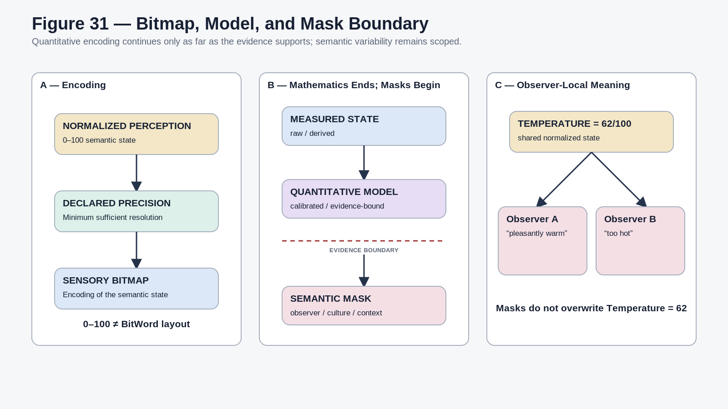
Figure 31. Normalized semantic encoding, quantitative Model boundary, and observer-local Mask interpretation.

33. Mask Scope
Mask scope | Meaning
INDIVIDUAL | Interpretation, association, preference, or sensitivity scoped to one person.
GROUP | Shared semantic mapping for a team or defined group.
CULTURAL | Contextual mapping associated with a declared cultural framework.
TASK | Interpretation optimized for one operational or analytical task.
CONTEXT | Temporary or situational interpretation.
POPULATION MODEL | Modeled group behavior that is not asserted as universal human truth.
ARTISTIC | Deliberate expressive interpretation.
EXPERIMENTAL | Provisional mapping under evaluation.

A Mask can consume a Normalized Perception state or Model result, but it cannot silently rewrite the raw measurement, the Scale mathematics, or the normalized state. Observer-local truth remains local.

34. Mask-to-Model Evolution
A Mask does not mean a concept is inherently beyond mathematics. It means the current system does not yet justify promoting that interpretation into a canonical quantitative Model. Research, calibration, improved sensors, or validated psychophysical relationships may later support an explicit Model and Normalization Scale. That promotion must be versioned, evidence-backed, and inspectable; historical Mask evidence remains provenance rather than disappearing.
PART VI
Multimodal Projection and Worked Examples
Shows how normalized state feeds PPL/MRMM and MEE, then applies the architecture to temperature, tactile, scent, flavor, and accessibility.

35. Integration with PPL / MRMM
PPL/MRMM treats normalization, scaling, mathematical relationships, and projection models as explicit components of a perceptual language [1]. Its reference normalized scalar is a convenient bridge between arbitrary domain values and renderer parameters, and it requires missing, uncertain, and reversible states to be declared rather than hidden. This guide turns that normalization step into a reusable registered Normalization Table and standardizes the Transform Matrix perception coordinate as 0-100.
The resulting handoff is: Canonical or Measured Quantity -> Normalization Scale -> Normalized Perception -> Transform Matrix -> MRMM Projection Contract -> Renderer-Neutral Parameter. MRMM therefore consumes stable normalized source dimensions instead of repeatedly reinterpreting raw physical units.

36. Integration with Multimodal Expressive Environments
MEE remains the downstream expressive architecture. It preserves source ownership, Expression Event eligibility, MRMM Projection Contracts, endpoint capability, local calibration, provenance, accessibility, and renderer independence [2]. The Normalization Table and Transform Matrix strengthen the quantitative input side of that system; they do not replace its expressive lifecycle.
DOWNSTREAM BOUNDARY
Resolve measured state through the Normalization Table. Compute perception correspondence in the Transform Matrix. Let MRMM map the resulting state into modality parameters. Let MEE govern expression and renderer context. Projection remains projection.

37. Temperature Reference Example
Temperature is the primary worked example because one physical Quantity can appear in radically different bounded questions. A meat-cooking Scale may use culinary raw bounds, a chosen formula, ordered Steps, and instructional colors. A stellar Scale may use a vastly different raw domain, formula, Steps, and color treatment. Both can target the same TEMPERATURE Normalized Perception Record while preserving their Scale identity.
The conceptual labels Frozen, Refrigerated, and Thawed and their example colors are instructional Scale content, not authoritative food-safety thresholds in this guide. Likewise, the stellar branch demonstrates architectural scale independence without asserting astrophysical thresholds not supplied by an authoritative source.
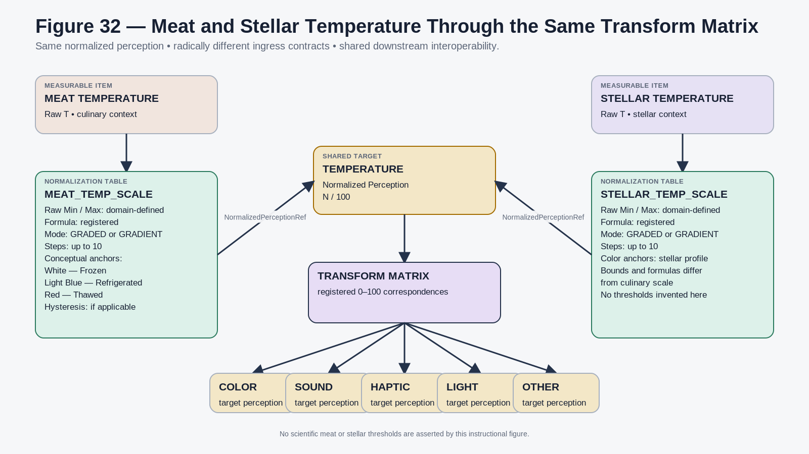
Figure 32. Meat and stellar temperature use different Normalization Scales but enter the same TEMPERATURE Normalized Perception and shared Transform Matrix.
Instructional architecture only: exact scientific thresholds and formulas remain domain-owned.

38. Tactile State as a Compound Example
A tactile system illustrates why the Transform Matrix should contain multiple normalized perception dimensions rather than one vague touch intensity. Candidate quantitative dimensions can include PRESSURE, SHEAR, FRICTION, VIBRATION FREQUENCY, VIBRATION AMPLITUDE, ROUGHNESS, COMPLIANCE, MOISTURE, TEMPERATURE, CONTACT AREA, DURATION, and VELOCITY. Each dimension may have its own Normalization Scale and Transform routes. Higher semantic descriptions such as silky, sticky, scratchy, comfortable, or gross remain Masks unless a defensible Model exists.

39. Scent and Flavor
Scent is a useful boundary case because measurable chemistry and personal semantic association can diverge sharply. Compound identity, concentration, volatility, diffusion, temperature, humidity, exposure time, decay, and validated receptor-response Models may all be quantitative. Descriptors such as woody, fresh, smoky, clean, medical, or a personal memory association remain semantic interpretation unless they have separately validated quantitative Models.
Flavor further demonstrates compound experience. Taste, retronasal scent, thermal state, tactile texture, trigeminal response, sound, and TIME may each contribute independently. A higher Model can compose those states while preserving the source identity of each component. The compound does not erase its inputs.

40. Accessibility and Personal Perceptual Languages
The Transform Matrix is particularly useful for sensory substitution. If a perception is detectable but unavailable or overloaded for a user, an explicit Transform may route it into another channel - for example SOUND -> HAPTIC or COLOR -> TEXT / SYMBOL. PPL/MRMM already treats accessibility, personalization, learnability, and calibration as first-class design concerns [1], while MEE allows alternate modality mappings that preserve relevant semantics without changing the source state [2].
PART VII
Runtime, Conformance, and Extension
Defines the runtime packet, forward and reverse traceability, failure behavior, conformance tests, implementation sequence, and future extension boundary.

41. Common Runtime Packet
A normalized measurement moving into the Transform Matrix should remain reconstructable from a compact runtime packet. Storage technology may vary, but the semantic content should be sufficient for routing, explanation, replay, and error handling.
Field | Purpose
SourceIdentity | Exact source state, record, event, or Model output.
RawValue / RawUnit | Native measurement and unit.
NormalizationScaleRef | Exact Normalization Table record applied.
NormalizationScaleVersion | Version used to produce the normalized result.
NormalizedPerceptionRef | Exact target perception identity.
NormalizedValue | 0-100 state.
ResolvedStep | Optional GRADED Step identity.
GateState | Optional active Gate identity.
Validity | VALID, MISSING, UNKNOWN, etc.
Saturation / Overflow | Explicit boundary state where relevant.
DeclaredPrecision | Effective precision of the normalized result.
Error / Confidence | Measurement or Model uncertainty where available.
Timestamp | Time associated with the state.
Provenance | Source, Scale, Formula, calibration, and relevant versions.

42. Canonical Runtime Route
FORWARD ROUTE
Physical / simulated / measured state -> detector -> raw measurement -> NormalizationContractRef -> Normalization Table -> registered Scale -> formula + bounds + Step/state logic -> 0-100 -> Normalized Perception Record -> Transform Matrix -> target perception(s) -> Model and/or Mask -> MRMM -> expression endpoint -> perceptual experience.

The architectural value of this route is that each stage can evolve independently. Sensor technology can change without rewriting Transform edges. Normalization Scales can be versioned without redefining the Perception identity. New perceptual renderers can be added without changing the raw source. This mirrors MEE runtime pluralism and PPL renderer independence [1][2].

43. Source Traceback
REVERSE EXPLANATION ROUTE
Perceptual output -> Projection Contract -> target Normalized Perception -> Transform -> source Normalized Perception -> Normalization Scale -> Formula + bounds -> raw measurement -> detector / source.

A user or AI should be able to ask why a color, tone, haptic pattern, or other perceptual output appeared and recover the full semantic path. PPL/MRMM treats this explainability as a central requirement, and MEE preserves provenance through source, phenomenon, Expression Event, Projection Contract, renderer, and captured artifact [1][2].

44. Conformance Test Architecture
Test family | Coverage | Conformance objective
Traceability and reconstruction | NPG-C01–C03, C19 | Recover source value/unit, exact Scale/version, Formula lineage, and full output-to-source explanation path.
Scale semantics | NPG-C04–C13 | Verify multi-Scale Quantity use, shared Perception identity, GRADED/GRADIENT behavior, color mode, hysteresis, gates, null separation, overflow, and precision.
Transform semantics | NPG-C14–C15 | Resolve only declared Transform edges and reject correspondence inferred from numeric similarity alone.
Human variability | NPG-C16–C17 | Allow observer-local Masks while preserving the same underlying quantitative state.
Projection portability | NPG-C18 | Change renderer or endpoint without rewriting the semantic Transform chain.
Actuation boundary | NPG-C20 | Require a governed operational path before a computed target can mutate or actuate physical/canonical state.

Appendix C contains the complete twenty-test reference matrix with questions and PASS conditions.

45. Implementation Roadmap
- Create the initial Normalized Perception Records that will participate in the Transform Matrix.
- Create the Normalization Table as the registered ingress library.
- Implement simple LINEAR Normalization Scales first.
- Add the shared one-to-ten Step architecture.
- Implement GRADED and GRADIENT resolution over the same ordered Step definitions.
- Add DEFAULT and CUSTOM Step-color behavior without conflating it with COLOR Transform relationships.
- Add gated and hysteretic Scale logic where a domain requires it.
- Connect measurable records through exact NormalizationContractRef links.
- Route normalized runtime state into the Transform Matrix.
- Implement basic registered cross-perception Transforms and conformance tests.
- Add quantitative Models and scoped Masks for human semantic variability.
- Connect MRMM, Personal Perceptual Languages, MEE, and endpoint capability contracts; verify full provenance and reconstruction.

46. Extension Boundary
Although this guide is sensory-focused, the Normalization Table is structurally reusable for any measurable state that needs to enter the Transform Matrix: battery state, machine load, pressure, damage, risk, weather severity, manufacturing tolerances, resource levels, population density, latency, queue depth, or future domains. The extension law remains the same: preserve the native source, declare the bounded Scale, publish an explicit normalized perception, and register any cross-domain correspondence rather than inferring it.
CLOSING PROPOSITION
The Normalization Table absorbs domain heterogeneity. The Transform Matrix provides normalized perceptual interoperability. Masks preserve human semantic variability. MRMM and MEE turn governed state into rich experience without allowing presentation to become source truth.

PART A
Governing Laws
Compact reference for the normative rules that constrain normalization, transformation, masking, and projection.

ID | Law | Normative requirement
NPG-L01 | Raw State Preservation | Normalization SHALL NOT silently replace or erase the raw measurement, unit, or source provenance.
NPG-L02 | Explicit Ingress | A measurable state entering a Normalized Perception SHALL resolve through an identifiable Normalization Scale.
NPG-L03 | Scale Ownership | The Normalization Scale owns the bounded mapping question; it does not redefine the underlying physical Quantity.
NPG-L04 | Perception Stability | Different Normalization Scales MAY resolve into the same stable Normalized Perception Record.
NPG-L05 | Common Coordinate | Where suitable, Normalized Perception state SHALL use the shared 0-100 coordinate.
NPG-L06 | Local Meaning | A normalized value has meaning only with respect to its Normalized Perception and relevant Normalization Scale.
NPG-L07 | Formula Transparency | A semantic Normalization Scale SHALL expose its formula or exact Formula reference, raw bounds, and version.
NPG-L08 | Graded/Gradient Declaration | Every Scale using Step structure SHALL declare whether it resolves as GRADED or GRADIENT.
NPG-L09 | Step Boundedness | Scale Steps SHALL expose their quantitative boundaries sufficiently to reproduce their resolution.
NPG-L10 | Color Is Projection | Step color SHALL NOT be treated as intrinsic physical meaning of the normalized Quantity.
NPG-L11 | Stateful Logic Declaration | Gates, hysteresis, persistence, smoothing, and transition logic SHALL remain explicit.
NPG-L12 | Null Integrity | Numeric zero SHALL NOT silently represent missing, unknown, invalid, undetected, or inapplicable state.
NPG-L13 | Overflow Visibility | Clamping or saturation SHALL NOT silently erase evidence that the raw state exceeded the declared domain.
NPG-L14 | Precision Integrity | Normalization SHALL NOT claim greater semantic precision than its source and Model justify.
NPG-L15 | Transform Separation | The Normalization Table owns raw-to-normalized ingress. The Transform Matrix owns declared normalized correspondence.
NPG-L16 | Compatibility Is Not Equivalence | A shared 0-100 coordinate permits mathematical interoperability; it does not establish semantic equivalence.
NPG-L17 | Registered Transformation | Cross-perception mapping SHALL require a declared Transform rather than inferred correspondence from numeric similarity.
NPG-L18 | Mask Non-Override | Semantic or observer Masks SHALL NOT rewrite raw state, Normalization Scale mathematics, or normalized canonical state.
NPG-L19 | Observer Scope | Human semantic interpretation SHALL remain scoped to the applicable observer, group, culture, task, or context.
NPG-L20 | Quantification Is Earned | A semantic distinction SHALL remain Masked or unresolved when no defensible quantitative Model exists.
NPG-L21 | Evidence-Based Promotion | A Mask MAY become a mathematical Model only through explicit evidence, governance, and versioning.
NPG-L22 | Detection/Expression Separation | A value that can be mathematically transformed into an output does not thereby establish detection, physical realization, or authorized actuation.
NPG-L23 | Projection Non-Override | Perceptual output SHALL remain distinguishable from the governed state and Transform chain that produced it.
NPG-L24 | Provenance Continuity | Semantic mappings SHOULD remain traceable from output through Transform, Normalization Scale, raw measurement, and source.

PART B
Reference Data Contracts
Implementation-neutral semantic contracts for the Normalization Scale and normalized runtime packet.

B.1 Reference Normalization Scale Contract
Field family | Reference content
Identity | NormalizationScaleID, ScaleName, Version, Status.
Target | NormalizedPerceptionRef identifying the exact Transform Matrix perception record.
Input | QuantityRef, AcceptedRawUnit, RawMin, RawMax.
Mathematics | Formula or FormulaRef, FormulaType, forward normalization, optional inverse normalization.
Resolution mode | GRADED or GRADIENT.
Step architecture | StepCount from 1 to 10; ordered Step definitions.
Color behavior | DEFAULT or CUSTOM; custom Step colors up to StepCount.
State logic | Optional gate Rules, enter/exit thresholds, hysteresis, minimum duration, previous-state requirements.
Bounds and failure | BelowRangePolicy, AboveRangePolicy, ClampPolicy, SaturationPolicy, NullPolicy.
Governance | Source, formula version, provenance, validation status.

B.2 Reference Normalized Runtime Packet
Field | Reference content
SourceIdentity | Exact source state, record, event, or Model output.
RawValue / RawUnit | Native measurement and unit.
NormalizationScaleRef | Exact Normalization Table record applied.
NormalizationScaleVersion | Version used to produce the normalized result.
NormalizedPerceptionRef | Exact target perception identity.
NormalizedValue | 0-100 state.
ResolvedStep | Optional GRADED Step identity.
GateState | Optional active Gate identity.
Validity | VALID, MISSING, UNKNOWN, etc.
Saturation / Overflow | Explicit boundary state where relevant.
DeclaredPrecision | Effective precision of the normalized result.
Error / Confidence | Measurement or Model uncertainty where available.
Timestamp | Time associated with the state.
Provenance | Source, Scale, Formula, calibration, and relevant versions.

B.3 Reversibility States
State | Meaning
EXACT | The raw value can be recovered uniquely within declared precision and bounds.
APPROXIMATE | An inverse estimate is available but information has been lost or rounded.
RANGE-ONLY | The inverse identifies a bounded range or Step rather than a unique raw value.
UNSUPPORTED | The mapping is intentionally non-invertible or no validated inverse exists.

PART C
Conformance Test Matrix
Reference test set for validating semantic correctness, traceability, and boundary preservation.

ID / Test | Question | Conformance condition
NPG-C01 Raw Traceability | Can the normalized value be traced to its original measurement and unit? | PASS if source value, unit, Scale, and Formula lineage are recoverable.
NPG-C02 Scale Resolution | Can the exact Normalization Scale be identified? | PASS if the runtime resolves an exact Scale ID and version.
NPG-C03 Formula Reproduction | Can the normalized result be regenerated? | PASS if the declared Formula and bounds reproduce the result within declared precision.
NPG-C04 Multi-Scale Quantity | Can one Quantity use several Scales without identity collision? | PASS if each normalized result retains its distinct ScaleRef.
NPG-C05 Shared Perception | Can different Scales resolve to the same Perception identity? | PASS if they share NormalizedPerceptionRef without erasing Scale provenance.
NPG-C06 GRADED Resolution | Does the Scale resolve the correct discrete Step? | PASS if raw/normalized position and transition Rules select the expected Step.
NPG-C07 GRADIENT Resolution | Does interpolation behave as declared? | PASS if the continuous position follows the ordered anchors and Scale formula.
NPG-C08 Color Behavior | Does DEFAULT/CUSTOM color resolve correctly? | PASS if Scale display color follows its declared mode without becoming a COLOR Transform.
NPG-C09 Hysteresis | Do transitions resist chatter? | PASS if enter/return conditions and prior state are honored.
NPG-C10 Gate Selection | Does the correct formula regime apply? | PASS if active Gate and FormulaRef match the raw region and Rules.
NPG-C11 Null Separation | Is missing distinct from numeric zero? | PASS if null-like states remain nonnumeric state metadata.
NPG-C12 Overflow Visibility | Is saturation or out-of-range state inspectable? | PASS if clamping never erases evidence of exceeded bounds.
NPG-C13 Precision Integrity | Does normalization avoid fake precision? | PASS if declared precision is no greater than source/Model support.
NPG-C14 Transform Routing | Can normalized state route through the declared edge? | PASS if the exact Transform is resolved and produces the expected target state.
NPG-C15 No Implicit Correspondence | Are undeclared cross-perception mappings rejected? | PASS if numeric similarity alone does not authorize a Transform.
NPG-C16 Mask Non-Override | Does semantic interpretation leave quantitative state unchanged? | PASS if Masks remain scoped derived interpretation.
NPG-C17 Observer Variation | Can two Masks yield different local descriptions? | PASS if both preserve the same underlying normalized state.
NPG-C18 Renderer Independence | Can presentation change without rewriting source? | PASS if alternate endpoints preserve the semantic Transform chain.
NPG-C19 Traceback | Can output be traced to Transform, Perception, Scale, and raw source? | PASS if the full explanation route is recoverable.
NPG-C20 Actuation Boundary | Does computable reverse mapping remain separate from execution authority? | PASS if candidate target values require a governed operational path before mutation or actuation.

PART D
References and Glossary
Source basis and compact terminology for implementation, review, and future extension.

References
[1] CERBERUS. Personal Perceptual Languages: Mathematical Relationship Modality Modeling - Constructed Synesthetic Simulations for Analytical, Professional, and Creative Data Experience. Version 1.0.
[2] CERBERUS. Multimodal Expressive Environments: Canonical State, Coherent Expression, and Cross-Modal Projection. Formal Specification v0.1. 15 August 2026.

Glossary
Term | Definition
Measurable Item | A governed state carrying a quantitative value, unit, validity, precision, provenance, and normalization route.
NormalizationContractRef | Exact reference from a measurable state to the Normalization Scale that resolves it.
Normalization Table | Shared registry of raw-to-normalized Scale contracts.
Normalization Scale | One registered bounded mapping from a raw Quantity domain into a specific 0-100 Normalized Perception.
Normalized Perception Record | Stable semantic perception identity participating in the Transform Matrix.
Normalized Value | The 0-100 state produced under one declared Scale for one Normalized Perception.
Transform Matrix | Registered relational environment connecting Normalized Perception Records through explicit transforms.
Transform | One declared mathematical correspondence from source perception state to target perception state.
GRADED | Resolution mode that returns a discrete registered Step state.
GRADIENT | Resolution mode that preserves continuous position across ordered Step anchors.
Gate | Rule selecting which mathematical regime or formula applies.
Hysteresis | Stateful transition logic using different entry and return conditions, often with prior-state memory.
Mask | Observer-, group-, culture-, task-, or context-scoped semantic interpretation that does not rewrite quantitative state.
MRMM Projection Contract | Declared mapping from source semantics or relationships into perceptual modality parameters.
Renderer | Software or device that realizes renderer-neutral projection parameters as actual perceptual output.
Sensory Bitmap | Bit-encoded representation of normalized semantic state at a justified resolution.

END OF GUIDE
CERBERUS Sensory Detection, Normalization & Perception Bitmapping Guide | v0.1

