CERBERUS
Language SKs for Simulation
Addressable Language, Bounded Vocabulary, Translation, and Linguistic Possibility States
FORMAL SYSTEM ARCHITECTURE SPECIFICATION
Version 0.1
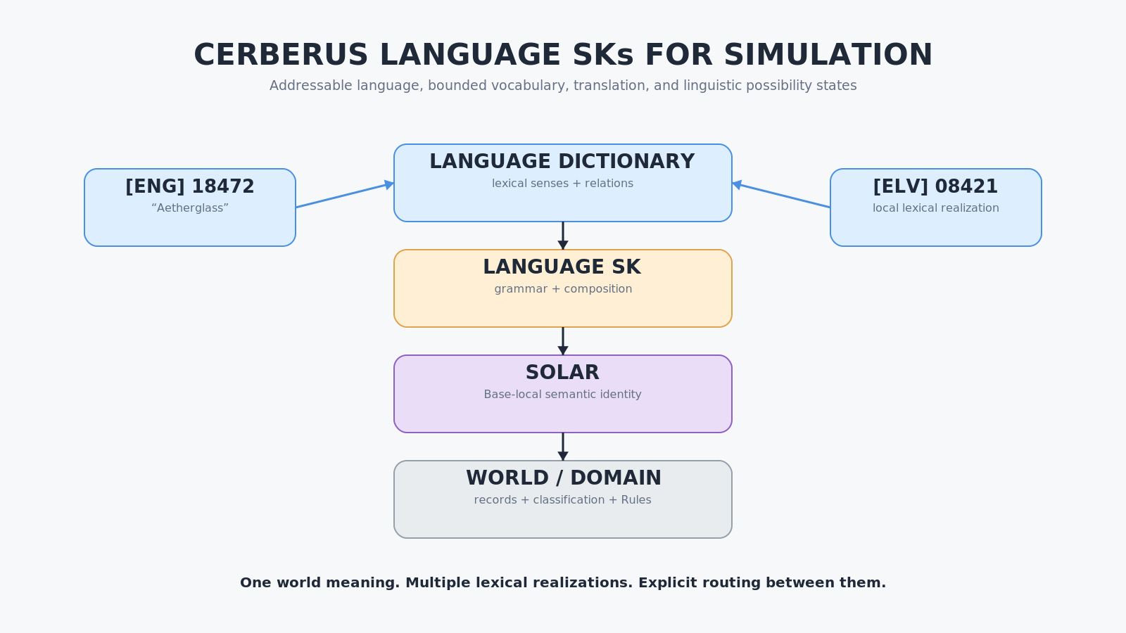
CORE PROPOSITION
Language is an addressable relational system. Shared dictionaries define lexical possibility; Language SKs govern linguistic composition; character Skill and MASK state determine which routes a simulated mind can presently reach.

Document Control
Field | Specification
Document | CERBERUS Language SKs for Simulation
Subtitle | Addressable Language, Bounded Vocabulary, Translation, and Linguistic Possibility States
Version | 0.1
Status | Formal system architecture specification
Primary scope | Lexical-sense addressing; Language Dictionary / Language SK separation; SOLAR binding; bounded vocabulary; Linguistic Possibility States; translation; multilingual character competence; simulation consequences.
Semantic dependencies | CERBERUS; BIGFOOT; SCALAR-N; SOLAR; Domain SKs; Skill SKs; MASKs; Operators; PULSE.
Companion progression architecture | CERBERUS Playable Semantic Skills - Formal Specification v0.1
Companion perception architecture | CERBERUS PULSE for Fantasy and Simulation - Formal System Specification v1.0
Explicit boundary | Does not define universal grammar, final dictionary schema, final packet format, phonetics, speech synthesis, universal semantic-distance equations, or an LLM training method.

Abstract
CERBERUS Language SKs model language as an addressable relational system rather than as a collection of rendered text strings. A Language Dictionary provides stable lexical-sense records and lexical relations. A Language SK governs how those lexical objects may be parsed, composed, inflected, ordered, and rendered within a particular language. SOLAR remains a separate Base-local semantic resolver that connects a resolved lexical sense to the identity, records, classifications, Semantic Kernels, Rules, Operators, and other structures that give the referenced thing operational meaning inside a Base.
This separation allows both natural and invented languages to become machine-addressable without requiring linguistic records to own world truth. A lexical sense may be represented compactly by a numeric address, resolved into deeper linguistic context only when needed, and then handed onward through SOLAR when the communication process requires Base-local meaning. The same architecture allows fictional terminology to be added as first-class vocabulary rather than as exceptional flavor text.
Together, these layers provide the foundation for bounded vocabulary, linguistic possibility states, translation competence, and emergent linguistic simulation.
CORE OWNERSHIP LAW
Language resolves linguistic identity. SOLAR resolves Base identity. Domain systems resolve operational meaning.

Contents
PART I LANGUAGE FOUNDATIONS
1. Purpose and Scope
2. Language Is Not Merely Rendered Text
3. Fundamental System Separation
4. Lexical Senses as Addressable Records
5. Numeric Lexical Addressing
6. Language Dictionary and Language SK Are Separate Systems
7. Symbols and Learned Relations
8. SOLAR Binding: From Lexical Meaning Into the Base
9. World-Specific Lore Vocabulary
PART II BOUNDED MINDS
10. Character Language Skill and Vocabulary MASK
11. Vocabulary Loadouts
12. Linguistic Possibility States
13. Relational Fallback
14. Precision Degradation and Human-Like Error
15. Word Knowledge, Conceptual Knowledge, Operator Capability, and Experience
PART III TRANSLATION AND MULTILINGUAL COMPETENCE
16. Translation as Lexical-Sense Routing
17. Target-Language Reconstruction
18. Translator Competence as an Intersection of Reachable Language State
19. Invented-Language Fluency
PART IV LEARNING, COMMUNICATION, AND SIMULATION
20. Language Learning Expands Linguistic Possibility
21. PULSE, Knowledge, and Language
22. Binary Language Routing Between Systems
23. Multiple NPC Linguistic Realities
24. Emergent Simulation Properties
25. Communication and Relational Compatibility
26. Conclusion - Bounded Minds Inside Shared Language

List of Figures
Figure 1. Language Architecture Separation
Figure 2. Anatomy of a Lexical Sense Record
Figure 3. Numeric Lexical Addressing
Figure 4. Dictionary vs. Language SK
Figure 5. Symbols and Learned Relations
Figure 6. Language -> SOLAR -> World
Figure 7. World-Specific Lore Vocabulary
Figure 8. Character Vocabulary MASK
Figure 9. Vocabulary Loadout Composition
Figure 10. Linguistic Possibility State
Figure 11. Relational Fallback
Figure 12. Precision Degradation
Figure 13. Word vs. Concept vs. Operator vs. Experience
Figure 14. Translation Relation Types
Figure 15. Target-Language Reconstruction
Figure 16. Translator Competence Intersection
Figure 17. Invented-Language Translation
Figure 18. Language Learning Expands Possibility
Figure 19. PULSE -> Knowledge -> Language
Figure 20. Binary Language Routing
Figure 21. Multiple NPC Linguistic Realities
Figure 22. Whole-System Language Simulation
PART I LANGUAGE FOUNDATIONS

1. Purpose and Scope
The purpose of this specification is to define an architectural starting point for the Language branch of CERBERUS. It does not attempt to solve linguistics, define a universal grammar, establish a complete dictionary schema, or prescribe a final binary packet format. Instead, it establishes the minimum ownership boundaries and routing relationships required for language to become a reusable semantic simulation substrate.
The foundational route is:
surface expression → lexical sense → Language Dictionary → Language SK → SOLAR → world/domain meaning
The route may be traversed in different directions depending on whether the system is parsing, rendering, translating, learning, or resolving a linguistic expression into operational Base meaning. The important architectural requirement is that the participating systems remain distinct authorities.

Foundational Boundary
Language Dictionary owns lexical identity and lexical relationships.
Language SK owns the rules by which linguistic objects are composed and realized.
SOLAR owns Base-local semantic identity and routing.
World and Domain systems own the actual things, facts, classifications, Rules, Operators, and other operational structures being referenced.
No one layer is required to duplicate the internal truth of another.

Reference Terms
Term | Meaning
Language Dictionary | Canonical language-local store of addressable lexical senses and lexical relationships.
Lexical sense | A resolved linguistic meaning associated with a stable dictionary address; distinct from the visible spelling alone.
Language SK | Semantic Kernel governing the legal grammatical composition, parsing, morphology, ordering, and realization of lexical objects for a declared language.
SOLAR binding | The handoff from a resolved lexical sense to the Base-local semantic identity used to route deeper into CERBERUS.
Language Skill state | Character-relative progression and accessibility associated with a represented language.
Vocabulary MASK | A bounded acquisition surface indicating which declared lexical positions are currently reachable by a character.
Linguistic Possibility State | The set of linguistic realizations currently reachable from a semantic intent under an entity's language, lexical access, grammar, contextual knowledge, and relational state.
Translation relation | A declared relation between resolved lexical senses or lexical bundles in different languages; may be 1<->1, 1<->N, N<->1, or N<->N.
Reachable state | The portion of shared linguistic and semantic structure that a particular entity can currently traverse.

2. Language Is Not Merely Rendered Text
A conventional simulation may represent language as a set of dialogue strings, localized string replacements, or Boolean flags such as SPEAKS_LANGUAGE = TRUE. Those representations may be sufficient for fixed dialogue, but they collapse several independent questions into one surface artifact.
A rendered sentence does not by itself distinguish:
- which lexical sense was intended;
- which grammatical relations were used;
- which world identity the expression refers to;
- whether the speaker knows the relevant concept;
- whether a synonym or approximation was selected;
- whether another language lexicalizes the same meaning with one token or several;
- whether the same spelling has multiple senses;
- whether the expression belongs to ordinary language, specialist terminology, or fictional lore.
CERBERUS therefore treats rendered language as one possible projection of deeper addressable structures.

Language Architecture Principle
Language is modeled as an addressable relational system rather than merely rendered text.

This does not make surface language unimportant. Human communication still occurs through speech, writing, signs, symbols, and other rendered forms. The architectural change is that those forms are no longer required to be the sole source of semantic identity inside the system.

3. Fundamental System Separation
Figure 1 establishes four separate authorities.

3.1 Language Dictionary
The Language Dictionary answers:
What lexical sense is this?

Its responsibilities may include lexical senses, definitions, parts of speech or other language-local type declarations, synonyms, antonyms, broader and narrower lexical relations, morphology, inflectional forms, register, dialect, usage, translation relations, and a binding onward to SOLAR.
These are linguistic properties of the lexical object. They do not establish where the referenced thing lives in the Base or what operational Rules govern it.

3.2 Language SK
The Language SK answers:
How does this language work?

It governs the legal interaction and realization of lexical objects. Depending on the language, this can include syntax, ordering, agreement, morphology, inflection, conjugation, phrase composition, sentence composition, parsing, or other language-specific structures.
The Language SK should not be assumed to use the same grammar taxonomy as every other language. The architecture requires a declared language contract, not a claim that all languages are internally identical.

3.3 SOLAR
SOLAR answers:
What Base-local semantic identity does this resolved sense refer to?

A Language Dictionary may know that Aetherglass is a noun with a particular lexical definition. SOLAR knows that the resolved lexical sense binds to the Base identity AETHERGLASS, from which the system may route to the actual classification, records, Semantic Kernels, world history, crafting systems, or other structures that own the thing itself.

3.4 World and Domain Systems
World and Domain systems answer:
What is this thing, and what does it actually do?

They own the underlying operational truth: a material's properties, an artifact's history, a person's records, a cooking Operator, a magical Rule, a classification, a location, or any other domain structure.

Core Ownership Law
Language resolves linguistic identity. SOLAR resolves Base identity. Domain systems resolve operational meaning.

This law is the primary architectural protection against turning either the Language Dictionary or SOLAR into an uncontrolled monolithic knowledge store.
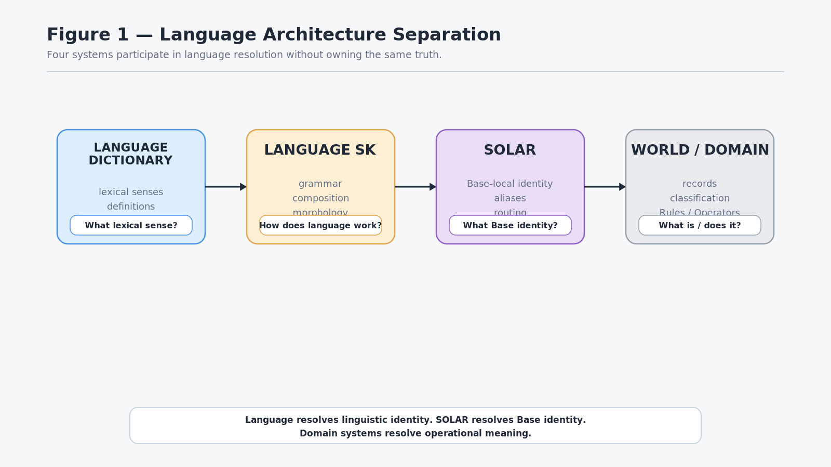
Figure 1. Language Architecture Separation

4. Lexical Senses as Addressable Records
A Language Dictionary should address lexical senses, not merely spellings.
The English surface form bank demonstrates the distinction. A financial institution and the edge of a river may share the same spelling and pronunciation while referring to different lexical senses. If a numeric dictionary address pointed only to the surface string bank, the system would still need to disambiguate after dereferencing the address.
Instead, the records may be conceptually separated:
- [ENG] 17024 → bank, noun, financial-institution sense
- [ENG] 17025 → bank, noun, river-edge sense
The numbers are illustrative. The architectural point is that the lexical identities are distinct even when the rendered word is identical.

Conceptual Lexical Record
A lexical record may carry information such as:
- dictionary address;
- language identity;
- lemma or surface form;
- lexical sense;
- lexical type;
- definition;
- synonym and related-word links;
- morphology and inflectional information;
- register or dialect metadata;
- translation relationships;
- SOLAR binding.
This list describes responsibility, not a final Airtable schema.

Lexical-Sense Law
A stable dictionary address identifies a lexical sense, not merely a character string.

This allows ambiguity to be resolved at the language layer before the lexical identity is used for compact communication or deeper semantic routing.
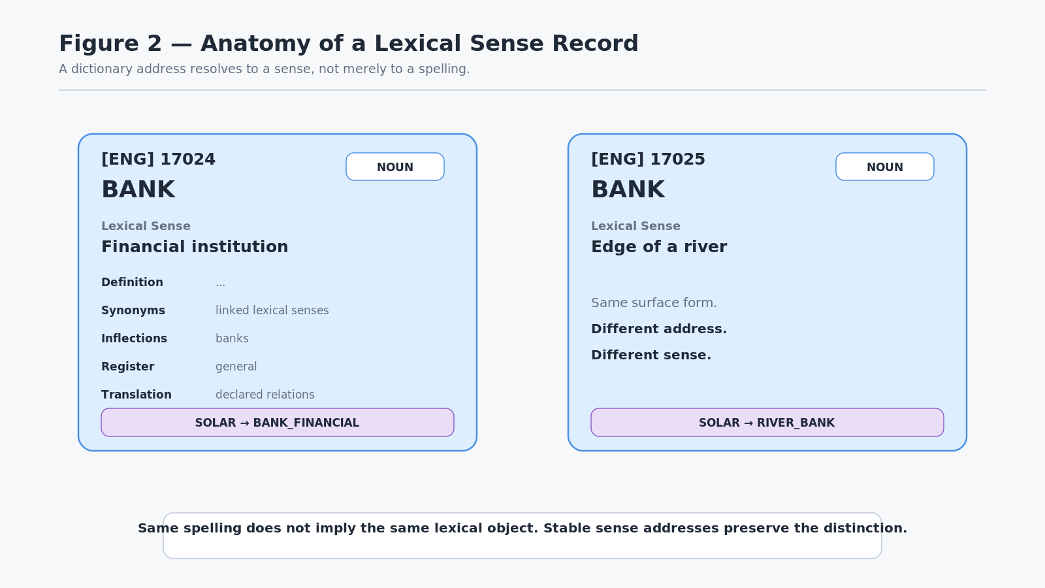
Figure 2. Anatomy of a Lexical Sense Record

5. Numeric Lexical Addressing
The Language Dictionary can be addressed through reusable BIGFOOT mathematics without assigning lexical semantics to the BitGroup itself.
For example:
binary state → SCALAR-N → 17024 → Language Dictionary record 17024
SCALAR-N remains a generic mathematical BitGroup. It knows how to interpret the binary state as a bounded unsigned scalar. It does not know that 17024 refers to bank, Aetherglass, or any other lexical object.
The Language Dictionary owns that association.

Address Ownership Law
The BitGroup determines the address. The Language Dictionary determines what the address means.

This preserves the existing BIGFOOT boundary that Bits and BitGroups remain pure mathematics and logic rather than domain semantics.

Progressive Resolution
Once the language contract and dictionary version are known, a system may communicate a compact lexical identity such as:
[ENG:v4] 17024

If the contract is already established by the active session or route, the exchange may require only the address itself.
The recipient can then expand as deeply as required:
address → lexical sense → lexical relations → SOLAR identity → world/domain structures
If only lexical identity is required, the route can stop early.

Compression Principle
Transmit lexical identity first; expand linguistic context only when required.

This makes language resolution compatible with compact machine exchange while retaining the ability to reconstruct richer human-facing meaning when necessary.
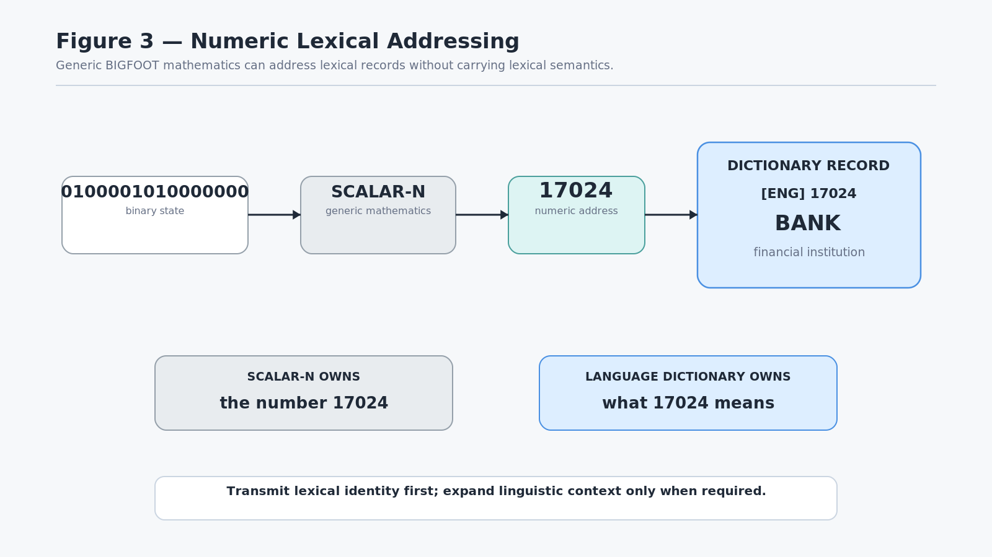
Figure 3. Numeric Lexical Addressing

6. Language Dictionary and Language SK Are Separate Systems
A Dictionary can identify lexical objects and declare relationships among them without owning the grammar that determines how those objects become a valid utterance.
Consider two lexical records:
- HOUSE — noun
- RED — adjective, modifying HOUSE
Those records describe lexical identity and a relationship. The target Language SK determines how the relationship should be rendered in that language.
A particular Language SK may apply ordering, agreement, morphology, phrase-construction rules, or other language-specific requirements before producing a surface expression such as:
“The red house.”

Another Language SK may realize the same broad semantic relationship using a different order, different morphology, or a different number of surface tokens.

Language Composition Law
A Dictionary defines the lexical possibilities of a language. A Language SK defines how those possibilities may legally combine.

This separation is essential for simulation because it allows an invented language to possess genuine machine-readable grammatical behavior rather than functioning as a substitution cipher over English strings.
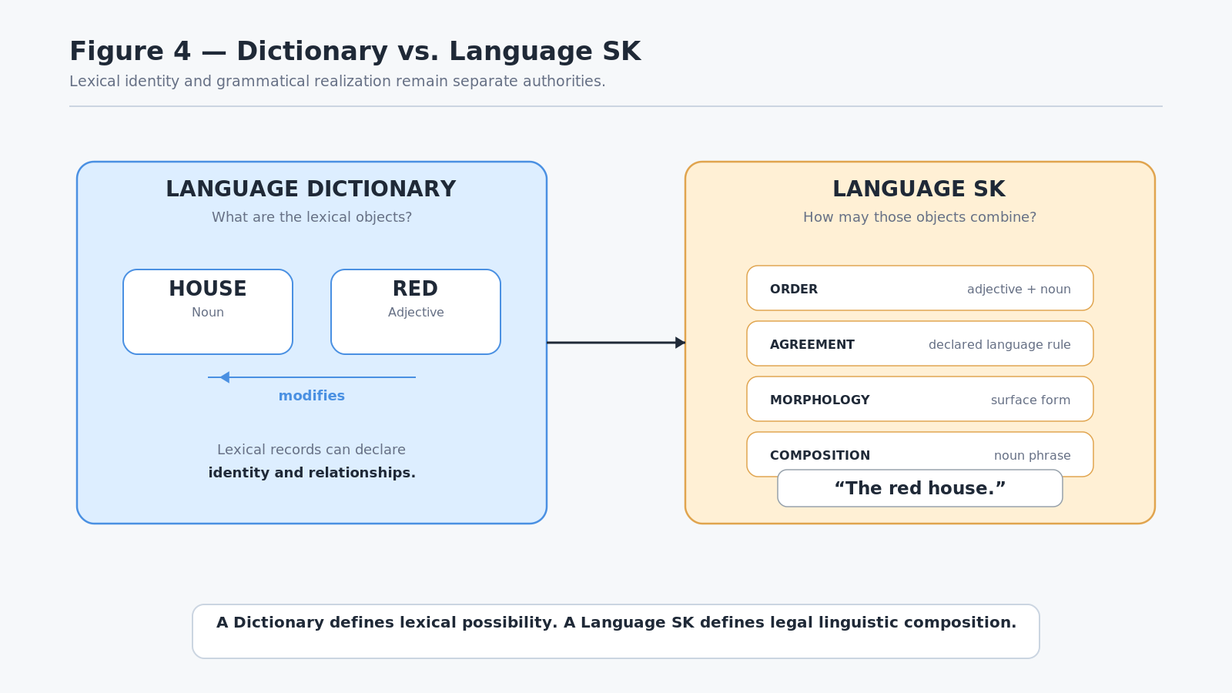
Figure 4. Dictionary vs. Language SK

7. Symbols and Learned Relations
A symbolic pattern does not require an intrinsic resemblance to its meaning.
The expression:
Ghaspolto mangreve fuplup.

may initially be meaningless to a reader. The same sequence can become communicatively meaningful if a linguistic community establishes stable mappings and relations for its components.
For example, an invented language might declare Ghaspolto as a lexical sense connected to slicing, cutting, blades, and division. The visible symbol has not changed. What has changed is the learned relational structure that can be reached through it.
This paper does not claim that a dictionary graph reproduces the full internal representation of a human brain. The narrower architectural point is that communication depends on sufficiently compatible symbolic and relational conventions between communicating systems.

Symbolic Relation Principle
Symbols become communicatively meaningful through learned relational conventions.

Relational Compatibility Principle
Communication requires sufficient relational compatibility between systems, not identical internal representation.

A human, an LLM, a deterministic parser, and another machine may represent the referenced concept internally in different ways while still communicating successfully if they can resolve the symbolic pattern into sufficiently compatible relational territory.
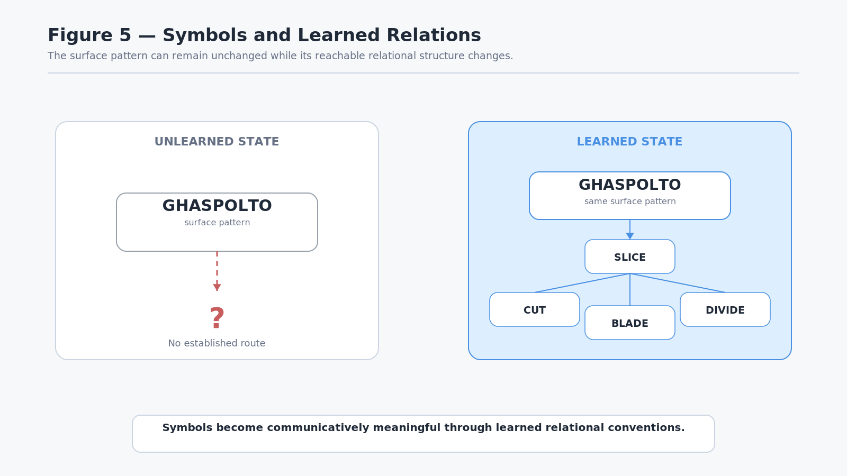
Figure 5. Symbols and Learned Relations

8. SOLAR Binding: From Lexical Meaning Into the Base
A Language Dictionary and SOLAR may both participate in natural-language resolution, but they do not perform the same task.
Consider the fictional lexical record:
[ENG] 18472 → Aetherglass

The Language Dictionary may own:
- the surface form Aetherglass;
- its lexical sense;
- its type as a noun;
- a linguistic definition;
- synonyms or related terms;
- morphology;
- translation relationships.
The record may then bind to:
SOLAR → AETHERGLASS

SOLAR resolves the lexical sense into the Base-local semantic identity. From there the system can reach the actual world structures that own the thing:
- classification as a magical material;
- material properties;
- known deposits or locations;
- historical records;
- crafting uses;
- Rules;
- Operators;
- relevant Semantic Kernels;
- documents or other references.

Synonym and Alias Boundary
This separation also protects a useful distinction.
A synonym is a lexical relationship between language objects.
An alias in SOLAR is a Base-resolution expression that may route to a semantic identity.
They can occasionally overlap in surface form, but they are not the same authority and should not be merged simply because both assist natural-language resolution.

Handoff Law
Language owns the lexical sign. SOLAR owns Base routing. World and Domain systems own the referenced thing itself.

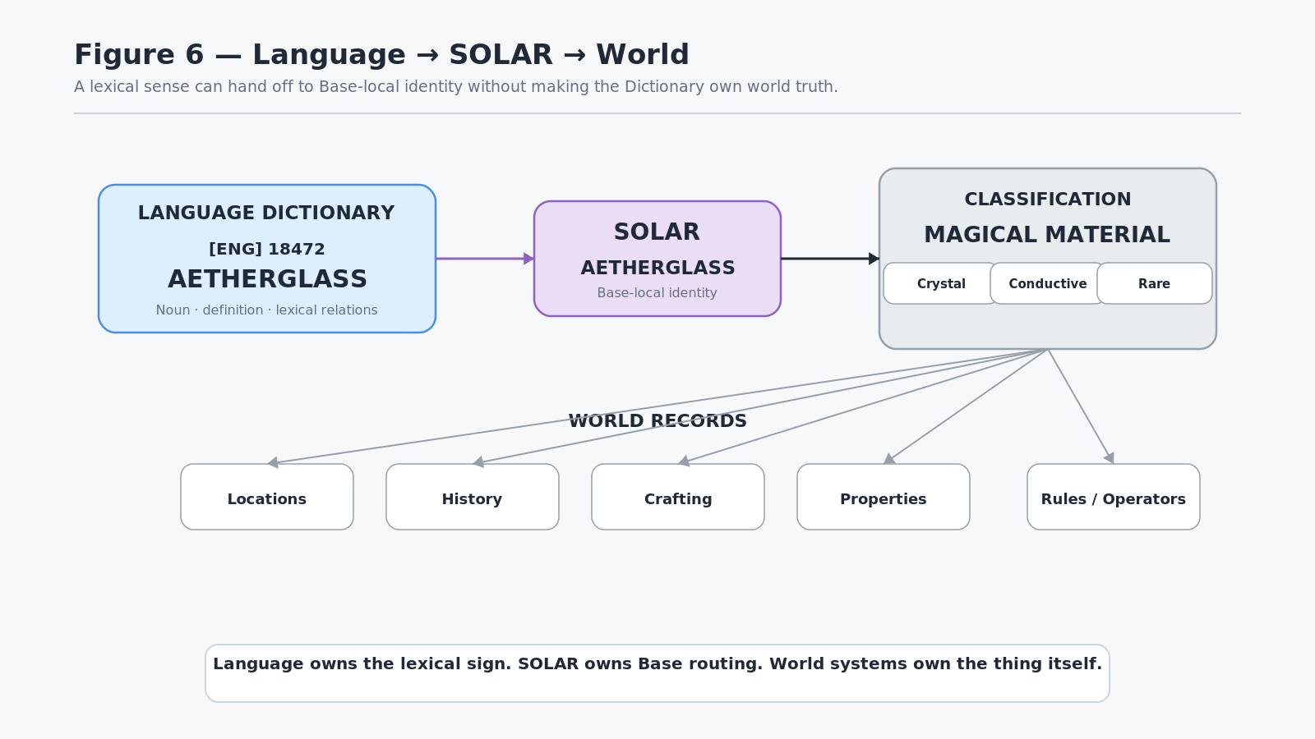
Figure 6. Language -> SOLAR -> World

9. World-Specific Lore Vocabulary
A simulation world can extend a language with invented terminology without modifying the underlying language engine.
A world Dictionary may contain ordinary lexical entries and world-specific entries in the same addressable space:
- 00001 → house
- 00002 → road
- 00003 → king
- 18471 → crystal
- 18472 → Aetherglass
- 18473 → Thornwake
- 18474 → Veyrbound
- 18475 → Veilwalking
The invented words are not treated as exceptional dialogue strings. They are ordinary lexical records within that world's declared language contract.
That means they can be:
- defined;
- typed;
- grammatically composed;
- linked to synonyms or related vocabulary;
- translated;
- numerically addressed;
- bound through SOLAR;
- linked to classification and world records;
- acquired or excluded by character language state in later layers of the architecture.

Lore Vocabulary Principle
A fictional term becomes part of a language when the world gives it stable lexical and relational identity.

Extensibility Principle
Adding a new lore word extends the world's linguistic possibility space without requiring the Language SK to be redesigned.

The Language SK continues to govern how lexical objects of the declared types interact. The Dictionary simply gains another addressable lexical object and its relationships.
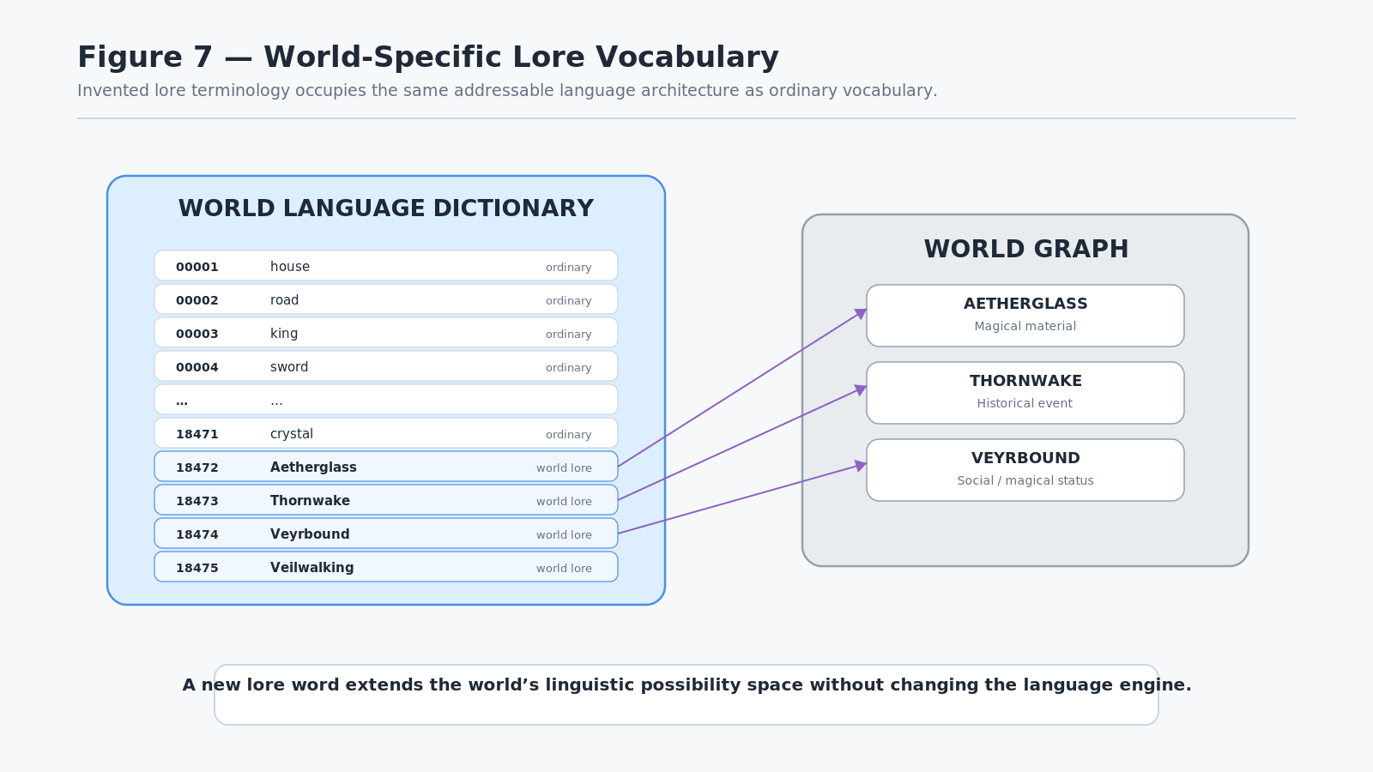
Figure 7. World-Specific Lore Vocabulary
PART II BOUNDED MINDS

10. Character Language Skill and Vocabulary MASK
A Language Dictionary describes what lexical senses exist within a declared language contract. That canonical Dictionary should not be rewritten whenever a character learns or forgets a word. Instead, character-relative linguistic knowledge is represented separately.
A character may carry a vocabulary MASK over the relevant Dictionary positions. If a Dictionary position is reachable, the character can use that lexical route subject to the rest of the language and semantic state. If a position is not acquired, the lexical entry still exists in the language, but it is not directly available to that character.
For example, the world language may contain the following lexical senses:
- cut
- slice
- chop
- sever
- julienne
- brunoise
- carve
- dice
A particular character may currently have acquired only:
- cut
- chop
- carve
- dice
The missing words have not been removed from the language. They are simply outside that character's current lexical access.

Character Vocabulary Law
The Dictionary defines possible language. Character Skill and MASK state define acquired language.

This preserves the same architectural pattern used elsewhere in CERBERUS: the shared semantic structure defines the possibility space, while compact character-relative state determines what an individual can presently use.
The MASK is not intended to claim that all human vocabulary can be reduced to a single universal binary model. It is a deterministic representation of declared accessibility inside the simulation architecture. Different Language SKs may structure lexical acquisition differently, but the ownership boundary remains the same: the canonical language is not rewritten to express individual ignorance.

Bounded Access Rather Than Artificial Simplicity
This distinction matters because the system does not need to instruct an LLM to "sound less intelligent" or to randomly avoid advanced words. The character's available linguistic routes already impose a bound.
If slice is outside the character's current vocabulary, that route is unavailable regardless of whether the underlying machine could otherwise generate the word. The simulation therefore constrains the rendered linguistic possibility by character state rather than by a vague stylistic prompt.
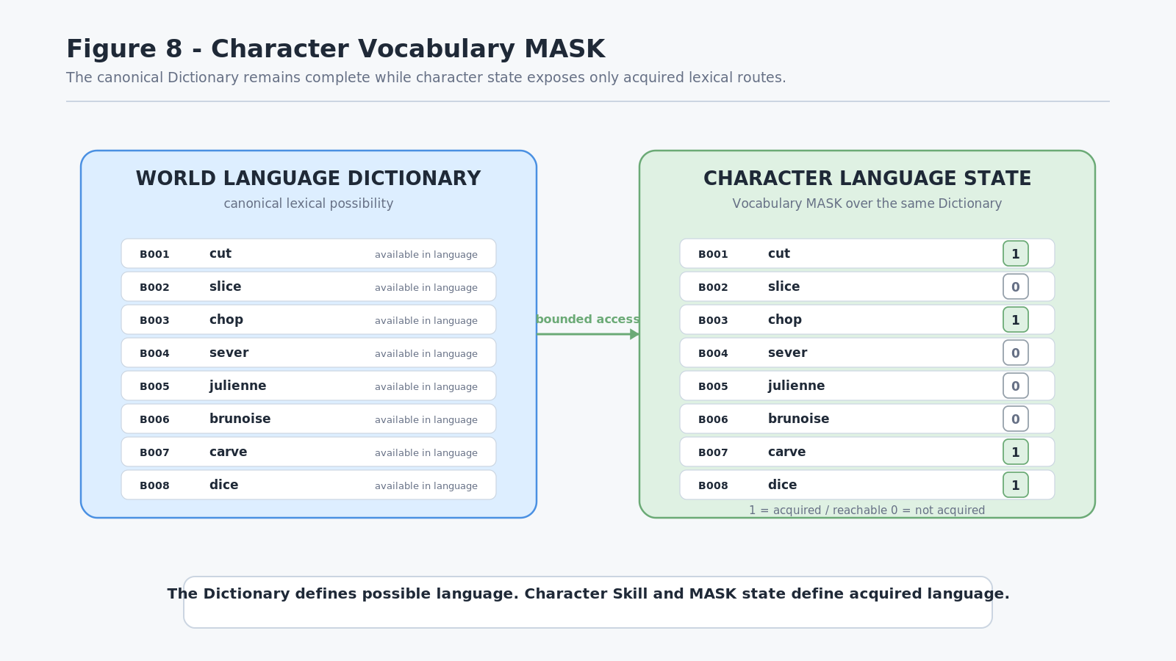
Figure 8. Character Vocabulary MASK

11. Vocabulary Loadouts
Characters do not need to acquire every vocabulary position one record at a time during initialization. Reusable loadouts can provide bounded starting states associated with upbringing, occupation, education, culture, environment, or other simulation context.
Illustrative loadouts might include:
- general adult vocabulary;
- local dialect;
- blacksmith terminology;
- military basics;
- court terminology;
- arcane scholarship;
- cooking terminology;
- personal learning accumulated through prior simulation history.
These loadouts are compositional sources of access. They are not permanent character classes.
A blacksmith character might begin with a broad everyday language loadout plus local dialect and forge terminology. Another character may share the same general vocabulary but have court, diplomatic, and historical terms instead. Personal learning can then add or remove specific positions over time according to the relevant simulation rules.

Loadout Composition Principle
Vocabulary loadouts compose a starting linguistic state; they do not define a permanent identity or class.

This distinction allows two characters with similar backgrounds to diverge naturally after different experiences.
A loadout may also overlap with another loadout. The same lexical sense does not need to be duplicated simply because it appears in several contexts. Multiple loadouts may expose the same Dictionary position, while the character ultimately maintains one bounded state over the shared language.
This also allows culture and profession to affect language without forcing every difference into a persona prompt. A character may speak differently because different words, registers, and relations are actually reachable.
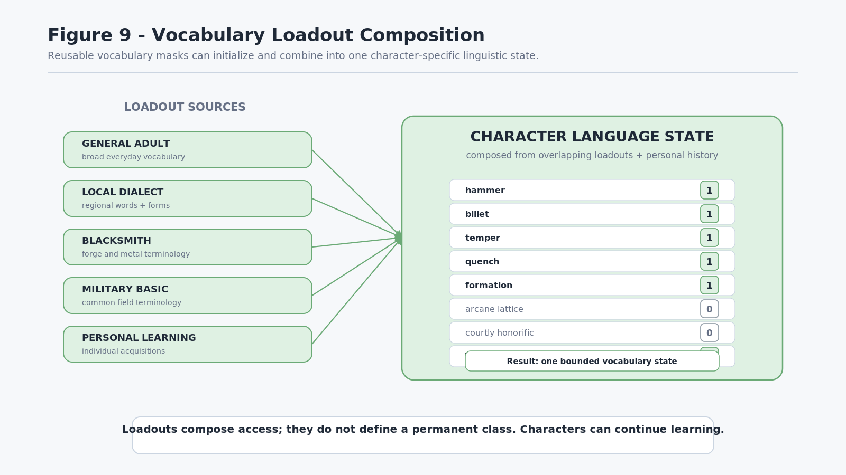
Figure 9. Vocabulary Loadout Composition

12. Linguistic Possibility States
The central concept introduced by this paper is the Linguistic Possibility State.
A working definition is:
A Linguistic Possibility State is the set of linguistic realizations reachable by an entity from a semantic intent under its current language, lexical access, grammar, contextual knowledge, and relational state.

The state is character-relative. It is derived from the intersection of a semantic target with the structures that the character can currently traverse.
Consider the semantic intent JULIENNE.
The complete language graph may contain several possible ways to express that meaning:
- julienne;
- cut into thin strips;
- slice into matchsticks;
- make thin strips;
- slice;
- cut.
An expert cook may be able to reach several of these realizations. A novice may lack the specialist lexical term but still possess a compositional paraphrase. A child may only reach the broad word cut.
The intended semantic target can remain stable while the available expression set changes.

Linguistic Possibility Law
The Language Graph defines what can be linguistically expressed; bounded entity state determines what can presently be reached.

This law is important because it places individuality in the reachable graph rather than in an independently authored dialogue tree.

Possibility Is Not the Same as Output
The Linguistic Possibility State is not necessarily one final sentence. It is the current set of valid or reachable linguistic routes from which a later resolution process may select an expression appropriate to context, grammar, register, communication goal, and other declared constraints.
A character may therefore possess several ways to express the same broad meaning. Different outputs can be generated without changing the underlying semantic intent or the character's competence state.
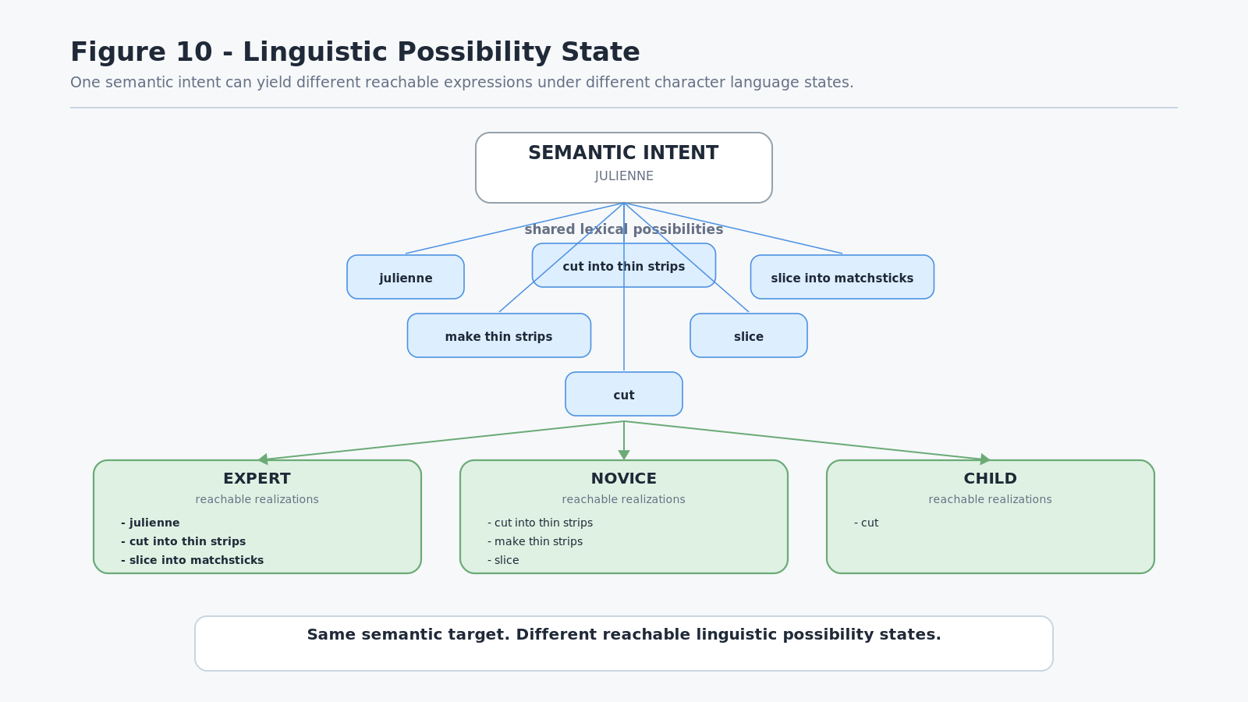
Figure 10. Linguistic Possibility State

13. Relational Fallback
If a preferred lexical entry is unavailable, the Language Dictionary's relational graph can provide alternative routes.
Suppose the semantic target is SLICE, and the preferred lexical realization is the word slice. The character's MASK indicates that this exact lexical entry is not acquired.
The Language system can inspect declared lexical relations such as:
- strong synonym -> cut;
- contextual alternative -> carve;
- broader term -> divide;
- partial or differently implied relation -> sever.
The character's MASK then filters those candidates. If cut and divide are reachable while carve and sever are not, the system may select cut as the best valid realization because it is both reachable and more closely compatible with the intended lexical sense.
The important point is that the synonym or relation graph remains linguistically authoritative. The character MASK does not invent replacement words. It only determines which registered alternatives are currently traversable.

Fallback Principle
Semantic intent may remain stable while lexical realization falls back through the best reachable registered relation.

This behavior creates lexical resilience. A character does not become unable to communicate merely because the preferred term is unknown.

Synonym Does Not Mean Universal Equivalence
This specification does not imply that every declared synonym is interchangeable in every sentence or context. Lexical relations can differ in strength, register, grammatical behavior, domain, implication, or cultural use. A Language SK and the lexical relation metadata can therefore constrain which alternatives are appropriate for the current expression.
The key architecture is not "unknown word equals any synonym." It is:
semantic target -> preferred lexical route -> accessibility check -> registered lexical neighborhood -> compatible reachable alternative -> grammatical realization
This is sufficient to create natural paraphrase and vocabulary substitution without hard-coded dialogue branches.
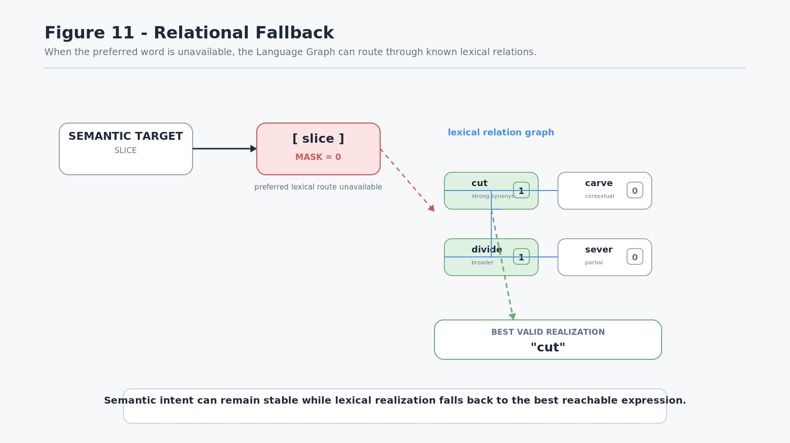
Figure 11. Relational Fallback

14. Precision Degradation and Human-Like Error
Relational fallback does not always preserve exact meaning.
If the exact lexical sense and strong equivalents are unavailable, the character may only be able to reach a broader or related concept. At that point the system can produce an approximation rather than an exact paraphrase.
For example, consider the semantic target BRUNOISE.
A character may lack:
- the exact term brunoise;
- the more precise expression fine dice;
while still knowing the broader concept dice.
The character can therefore resolve the instruction toward DICE even though that is not the globally precise interpretation.
This is not random failure. It is a rational selection inside a bounded semantic and linguistic state.

Bounded Interpretation Law
A bounded agent may select the closest reachable interpretation rather than the globally correct interpretation.

This is one of the most important simulation consequences of the architecture.
A conventional game may simulate misunderstanding through a fixed probability such as NPC_ERROR_RATE = 12%. CERBERUS can instead allow mistakes to emerge from the actual structure of what the character knows and how those known concepts relate to the intended target.
The result is a graded family of possible outcomes:
- exact lexical sense -> precise interpretation;
- strong synonym -> near-equivalent interpretation;
- paraphrase -> preserved meaning through multiple known words;
- broader concept -> reduced precision;
- related concept -> plausible approximation;
- distant relation -> likely misunderstanding;
- no useful route -> unknown or request for clarification.
This ladder is qualitative in the present paper. No universal numeric semantic-distance equation is established here.

Human-Like Error Without Simulating Humanity
The machine remains a machine. The human-like quality arises because the available linguistic distinctions and relations are built from linguistic structures that human communities use to communicate.
A character who cannot reach brunoise but can reach dice may make the same kind of category-level approximation a human novice might make. The architecture does not need to tell the model to "make a realistic mistake." The constraint itself creates a realistic possibility of error.
The same principle generalizes beyond cooking.
A character who does not know torsional deformation may describe a beam as "twisting." A tracker who lacks a bear-track concept may identify a print only as "large animal tracks" or misclassify it using the closest known pattern. A fantasy villager may call Aetherglass a "shiny crystal" because the precise lore term is outside their lexical state.
The error is informative because it reveals the structure of the character's reachable knowledge.
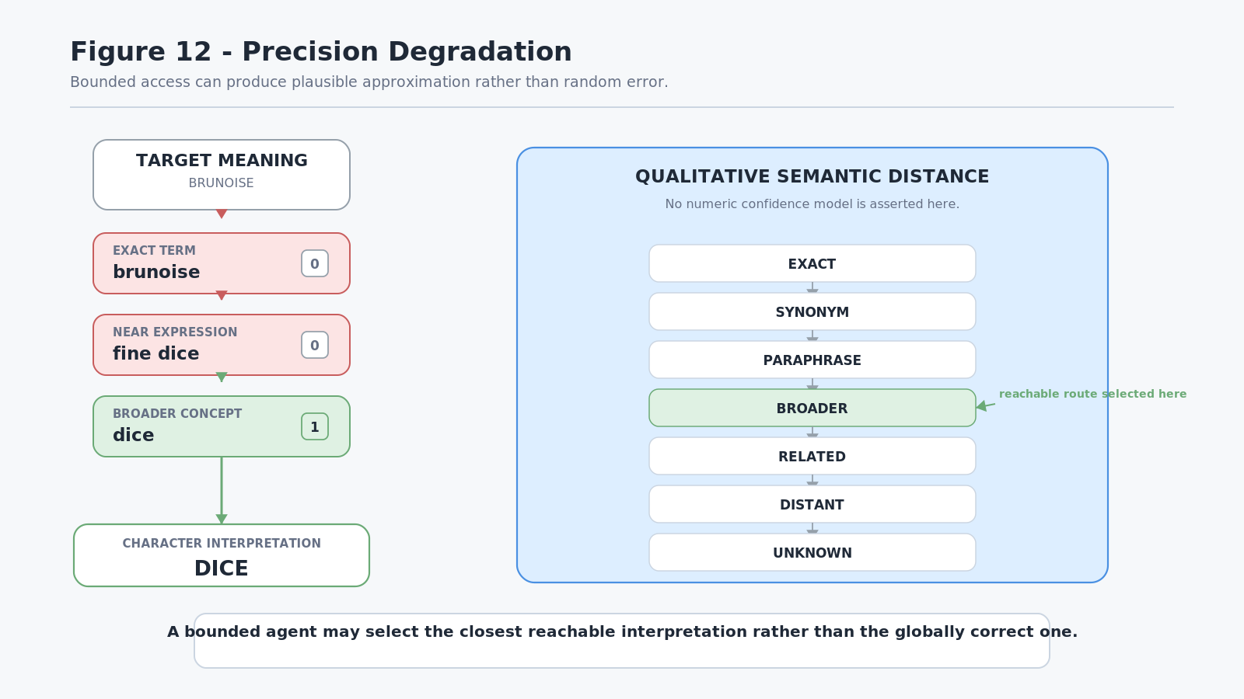
Figure 12. Precision Degradation

15. Word Knowledge, Conceptual Knowledge, Operator Capability, and Experience
Language state must remain separate from conceptual and operational competence.
The following states are not equivalent:
KNOWS WORD != UNDERSTANDS CONCEPT != CAN PERFORM OPERATOR != HAS EXPERIENCED COMPETENCE
A simulation that collapses these states would lose many of the most useful behaviors produced by the architecture.

15.1 Word Without Operational Competence
A character may know the lexical entry brunoise, understand the definition, and still be unable to perform the knife technique.
The character can truthfully say:
"I know what brunoise means, but I cannot do it."

The Language Dictionary and Language Skill support the word. The relevant Domain Skill does not yet support the Operator at the required competence.

15.2 Concept and Operator Without the Formal Word
Another character may have learned the physical technique through demonstration or repeated practice without acquiring the formal lexical term.
That character may truthfully say:
"I know how to do that, but I do not know what it is called."

The operational capability exists. The lexical route does not.

15.3 Word Without Correct Conceptual Understanding
A character may recognize the word Aetherglass while holding an incomplete or incorrect model of what Aetherglass actually is. Lexical familiarity alone does not grant the SOLAR-linked world knowledge associated with the term.
This distinction is especially valuable in lore-heavy simulations. Characters can repeat names, rumors, religious terms, historical titles, or technical vocabulary without possessing authoritative understanding.

15.4 Concept Without Local Lexical Realization
A multilingual or foreign character may understand the underlying world object perfectly while lacking the local word for it. The semantic route exists, but the target Language Dictionary position is outside the character's current MASK.
This can produce statements such as:
"I know the object, but I do not know what you call it here."

Competence Separation Law
Lexical familiarity, conceptual understanding, operational capability, and practiced experience are independently representable states.

This protects the ownership boundaries established by the broader CERBERUS architecture:
- Language Dictionary and Language Skill own linguistic structure;
- SOLAR and world/domain systems own semantic and operational identity;
- Skill SKs own progression and competence;
- character MASKs own bounded acquisition state.
No one system needs to impersonate all the others.
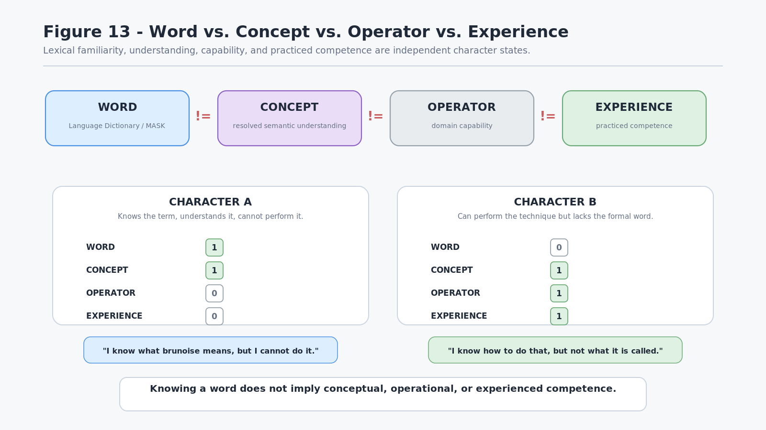
Figure 13. Word vs. Concept vs. Operator vs. Experience
PART III TRANSLATION AND MULTILINGUAL COMPETENCE

16. Translation as Lexical-Sense Routing
A translation relationship joins addressable lexical senses across two language systems. Because a lexical address identifies a resolved sense rather than only a spelling, translation can bind the intended linguistic object without forcing every use of the same surface word through one route.
A minimal declared relation may be written conceptually as:
[ENG] 17024 <-> [SPA] 16716

The relation is not required to be one-to-one. A linguistic distinction lexicalized as one address in one language may require several lexical objects in another, and multiple source objects may correspond to one target realization. Accordingly, the routing layer may admit:
- one-to-one (1 <-> 1),
- one-to-many (1 <-> N),
- many-to-one (N <-> 1), and
- many-to-many (N <-> N) relations.
These cardinalities describe declared cross-language relations. They do not assert that the related expressions are universally interchangeable in every context.
TRANSLATION RELATION LAW
Translation binds resolved lexical senses and linguistic structures, not merely surface strings.

Figure 14 establishes the four basic cardinality patterns while keeping the language identity explicit at every address.
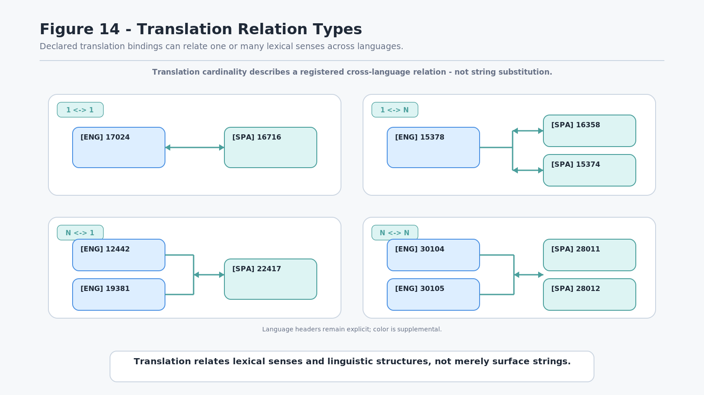
Figure 14. Translation Relation Types

17. Target-Language Reconstruction
Translation does not require the target language to inherit source-language word order, inflection, agreement, or other surface grammar. The source Language SK first resolves the source expression into lexical objects and relevant grammatical relationships. Translation bindings map the lexical material into target-language lexical objects. The target Language SK then composes those objects according to its own grammar.
The conceptual route is:
Source expression -> source lexical senses + relations -> translation bindings -> target lexical senses -> target Language SK -> target surface expression

For example, an English noun and adjective may preserve the semantic relation that the adjective modifies the noun. A Spanish Language SK can then determine target ordering, agreement, and morphology independently of the English surface order.
This avoids making every language pair responsible for reproducing the other language's grammar. The source language primarily needs to understand how to resolve itself; the target language primarily needs to understand how to render itself.
TARGET RECONSTRUCTION LAW
Translation preserves the relevant meaning and relationships; the target Language SK determines target surface realization.

GRAMMAR OWNERSHIP LAW
Source grammar does not own target grammar.

Figure 15 visualizes the handoff from source resolution through translation bindings into target-language reconstruction.
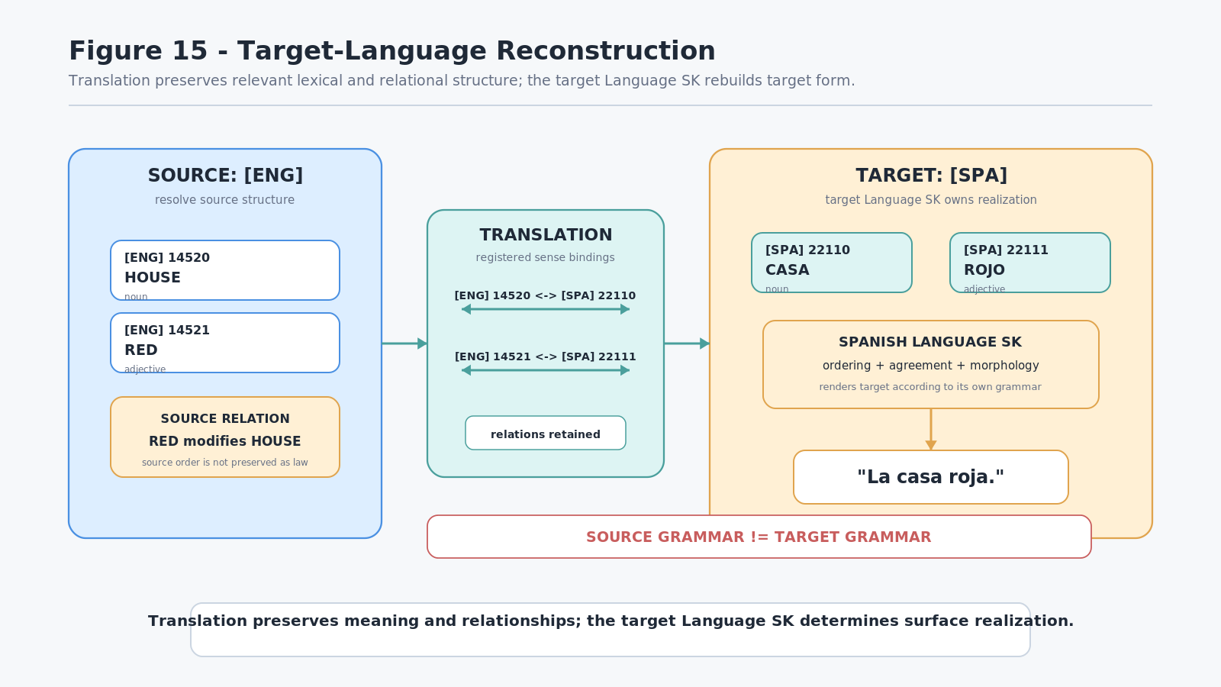
Figure 15. Target-Language Reconstruction

18. Translator Competence as an Intersection of Reachable Language State
The existence of a complete translation graph does not grant a character complete translation ability. Canonical routing and character capability remain separate.
A character translator must possess enough reachable state in the source language to interpret the source expression and enough reachable state in the target language to produce an adequate realization. This can include vocabulary, grammar, idiomatic knowledge, specialist terminology, or other Language Skill capabilities declared by the relevant language systems.
If an ideal target expression requires a lexical entry that the character has not acquired, the canonical translation relation remains valid while that particular character cannot traverse it directly. The character may then use an accessible synonym, paraphrase, broader term, or other permitted fallback route.
This creates translation quality from actual bounded linguistic state instead of a generic boolean such as TRANSLATOR = TRUE or a random translation-success percentage.
A character may therefore be:
- broadly fluent but weak in technical vocabulary,
- highly capable in specialist terminology but awkward in ordinary conversation,
- strong in source comprehension but weak in target production,
- familiar with an archaic language but unable to render modern slang, or
- capable of accurate conceptual interpretation while lacking the preferred target word.
TRANSLATOR COMPETENCE LAW
Character translation capability is constrained by the intersection of reachable linguistic state in the participating languages.

CANONICAL-KNOWLEDGE BOUNDARY
The system may contain a valid translation that a bounded character cannot personally produce.

Figure 16 demonstrates this distinction by keeping the translation route intact while one target token remains outside the character's acquired target-language state.
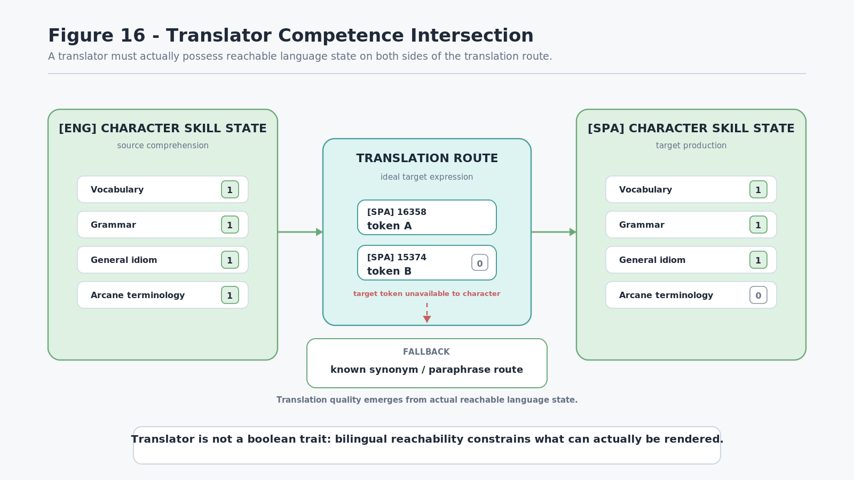
Figure 16. Translator Competence Intersection

19. Invented-Language Fluency
The architecture does not require a language to have evolved historically on Earth. A fictional language can use the same fundamental components as any natural language represented by the system:
Language Dictionary + Language SK + translation relations + character-bounded access

A fantasy world may therefore contain Common, Old Elvish, High Draconic, ritual languages, professional notations, or other authored linguistic systems without treating them as text-substitution exceptions.
Once their lexical senses, grammatical rules, and translation relationships are represented, they become traversable linguistic systems. Different characters can have different vocabulary and grammar masks over each one. A court interpreter may be nearly unrestricted in Common, strong in Old Elvish, and weak in High Draconic, while a Draconic scholar has the opposite distribution.
No global "speaks language" flag is required to explain these differences. The same bounded-access architecture used for ordinary vocabulary produces partial fluency, specialized fluency, archaic expertise, translation gaps, and misunderstandings.
INVENTED-LANGUAGE PARITY LAW
If the required lexical and grammatical relations exist, an invented language can participate in the same routing and simulation architecture as any other represented language.

BOUNDED FLUENCY PRINCIPLE
A language may be complete at the world level while every individual character possesses only a partial reachable state over it.

Figure 17 uses abstract reachability masks rather than a universal numerical fluency score. The purpose is to show different linguistic access profiles, not to canonize one measure of fluency.
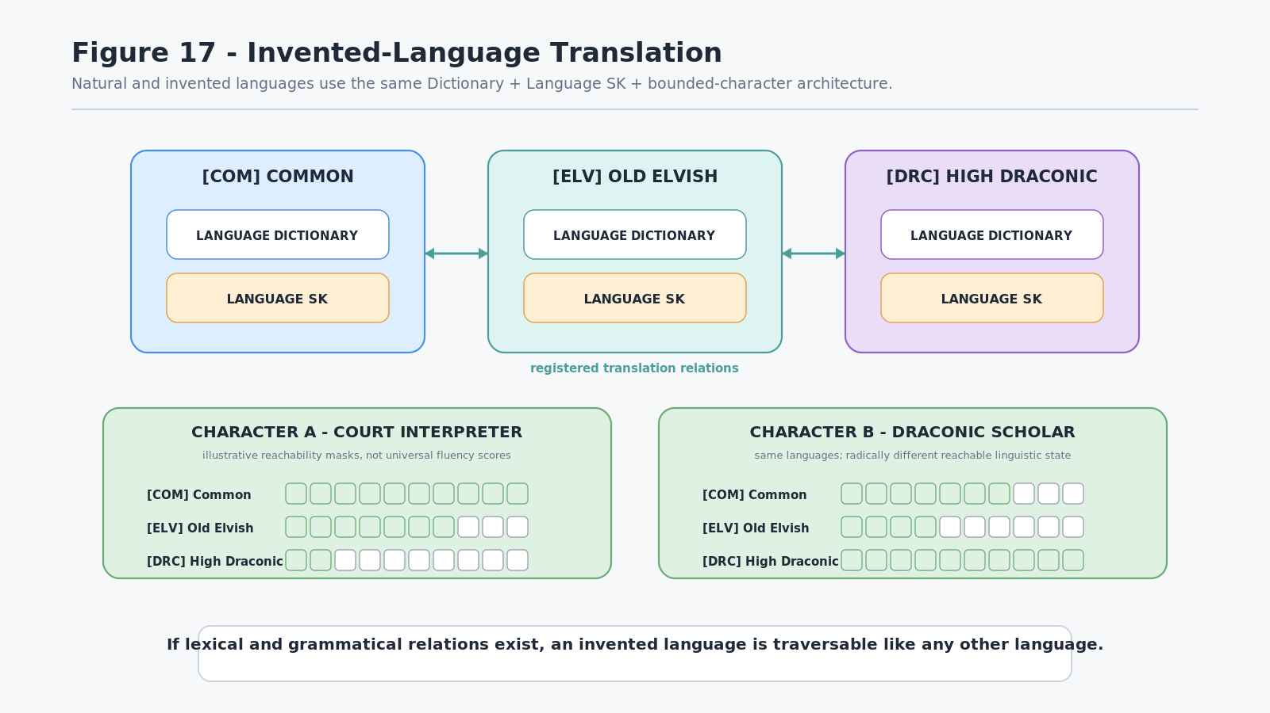
Figure 17. Invented-Language Translation
PART IV LEARNING, COMMUNICATION, AND SIMULATION

20. Language Learning Expands Linguistic Possibility
The canonical Language Dictionary describes the language available to the world or linguistic community. A character's current Language Skill and vocabulary MASK describe only the portion of that language the character has acquired. Learning therefore changes the character rather than rewriting the language.
A simplified acquisition event may be represented as:
Dictionary entry exists -> character encounters / studies / practices it -> acquisition requirement is satisfied -> character MASK position changes 0 -> 1

Once a lexical route becomes reachable, it can participate in future comprehension, expression, paraphrase, translation, and other Language SK operations. The newly acquired word may also expose registered relations to synonyms, broader terms, narrower terms, or Base-linked semantic identities that were previously unreachable to that character.
This creates a direct expansion of the character's Linguistic Possibility State. Before learning a specialized word such as julienne, a character may only be able to express the concept compositionally as "cut it into thin strips." After acquisition, the shorter specialist lexical route becomes available without removing the older paraphrase.
LANGUAGE LEARNING LAW
Learning expands an entity's reachable linguistic possibility space without modifying the canonical language.

CANONICAL LANGUAGE BOUNDARY
The Dictionary can be complete while every character remains only partially fluent in it.

Figure 18 holds the Dictionary constant while one character MASK position changes from unavailable to reachable.
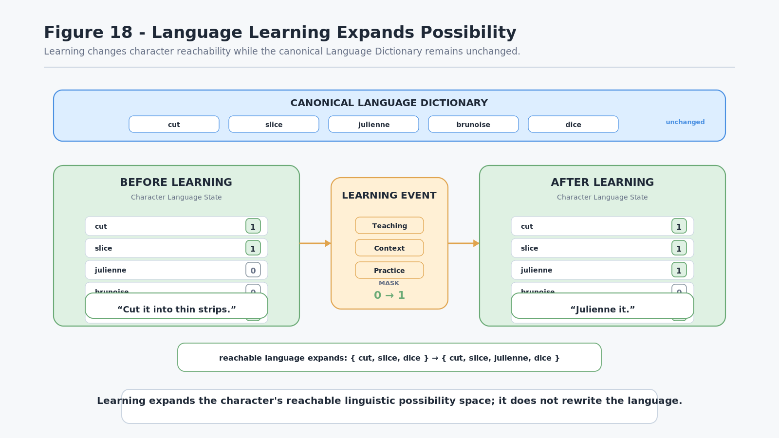
Figure 18. Language Learning Expands Possibility

21. PULSE, Knowledge, and Language
Language does not own perception and does not replace domain understanding. A character may receive semantic information from the world through PULSE or another authorized perception system, attempt to resolve that information through available domain knowledge, and only then express the result through reachable language.
The conceptual route is:
World State -> PULSE Reader -> perceived semantics -> domain knowledge -> Language state -> expression

Because these stages remain separate, several states are possible:
- a character perceives an object but cannot identify it;
- a character understands the concept but does not know the local word for it;
- a character recognizes a word but lacks the domain knowledge necessary to understand the thing accurately; or
- a character understands the concept and source-language word but cannot produce a valid translation in another language.
These are not contradictory states. They are consequences of independently bounded perception, conceptual knowledge, and linguistic reachability.
PERCEPTION-LANGUAGE SEPARATION LAW
What an entity can perceive, understand, name, and translate are independently governable states.

PROJECTION BOUNDARY
PULSE exposes readable world information; Language systems determine how a character can linguistically resolve and express that information.

Figure 19 visualizes the pipeline and four representative combinations of successful and failed resolution.
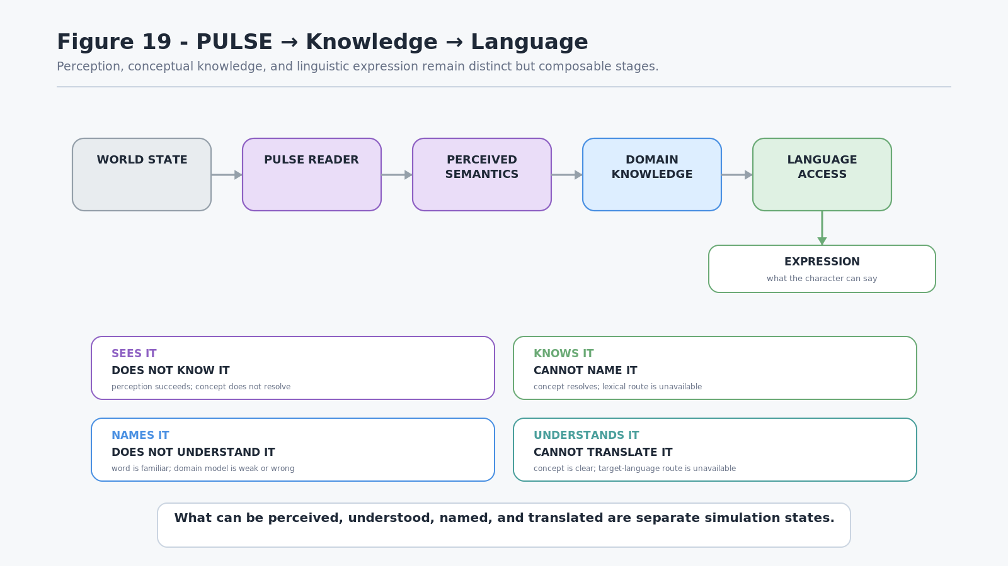
Figure 19. PULSE -> Knowledge -> Language

22. Binary Language Routing Between Systems
Once a Language Dictionary assigns stable numeric addresses to lexical senses, systems do not always need to exchange rendered natural-language strings. Where the participating systems share the relevant language contract, they may exchange compact lexical identities and the relational or grammatical metadata required for the task.
A conceptual exchange may resemble:
[ENG:v4] 18472 24110

A receiving system can then choose its own depth of resolution. It may follow the lexical identities through SOLAR and act directly on the resolved Base meaning, or it may map them into a target language and ask the target Language SK to render a human-facing sentence.
This creates a useful separation between communication identity and presentation:
addressable lexical structure -> local semantic resolution -> optional natural-language rendering

Natural language remains essential wherever humans or simulated linguistic agents need language, but it no longer has to be the mandatory machine-to-machine transport surface.
COMPACT LINGUISTIC EXCHANGE PRINCIPLE
Systems may exchange lexical identity first and expand linguistic context only when required.

RENDERING OPTIONALITY PRINCIPLE
Natural-language rendering is optional when a receiving system can directly resolve the shared lexical identities into usable semantic state.

Figure 20 demonstrates one source system resolving English-facing text into lexical addresses and one receiving system either using the meaning directly or rendering it through a Spanish Language SK.
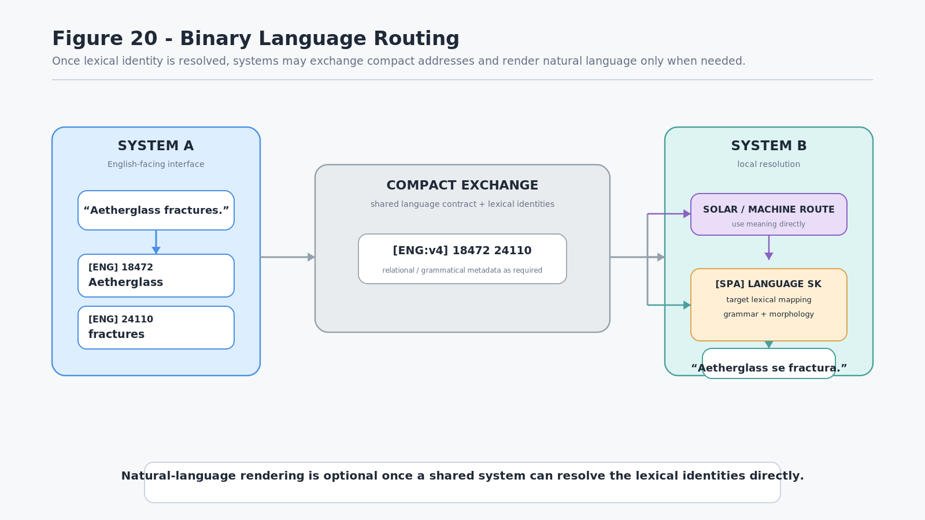
Figure 20. Binary Language Routing

23. Multiple NPC Linguistic Realities
A single canonical world fact can produce different expressions when it is routed through different characters. The world does not need to contain separate versions of the object, and the dialogue system does not need to author a unique response tree for every NPC.
Consider one canonical world object: an Aetherglass shard. Different characters may route the same object through different combinations of domain knowledge, Language Skill, vocabulary MASKs, cultural loadouts, and translation access.
A blacksmith with strong material knowledge but weak arcane vocabulary might say, "Some kind of crystal." An arcane scholar may identify it directly as "Aetherglass." A child with limited lore vocabulary may call it a "shiny rock." A foreign translator may know exactly what the object is while lacking the local Common-language word.
All four outputs can be internally coherent relative to the speaker's bounded state.
The resulting differences do not require the system to make the NPCs randomly wrong or artificially simplify their reasoning. The characters simply traverse different reachable portions of the shared semantic and linguistic graph.
BOUNDED LINGUISTIC REALITY PRINCIPLE
Different entities may produce different linguistic interpretations of one canonical world state because each entity traverses a different reachable graph.

DIALOGUE EMERGENCE PRINCIPLE
Distinct NPC language can emerge from shared linguistic structure plus bounded character state rather than individually scripted dialogue inventories.

Figure 21 places four characters around one canonical object to show the divergence of expression without divergence of world truth.
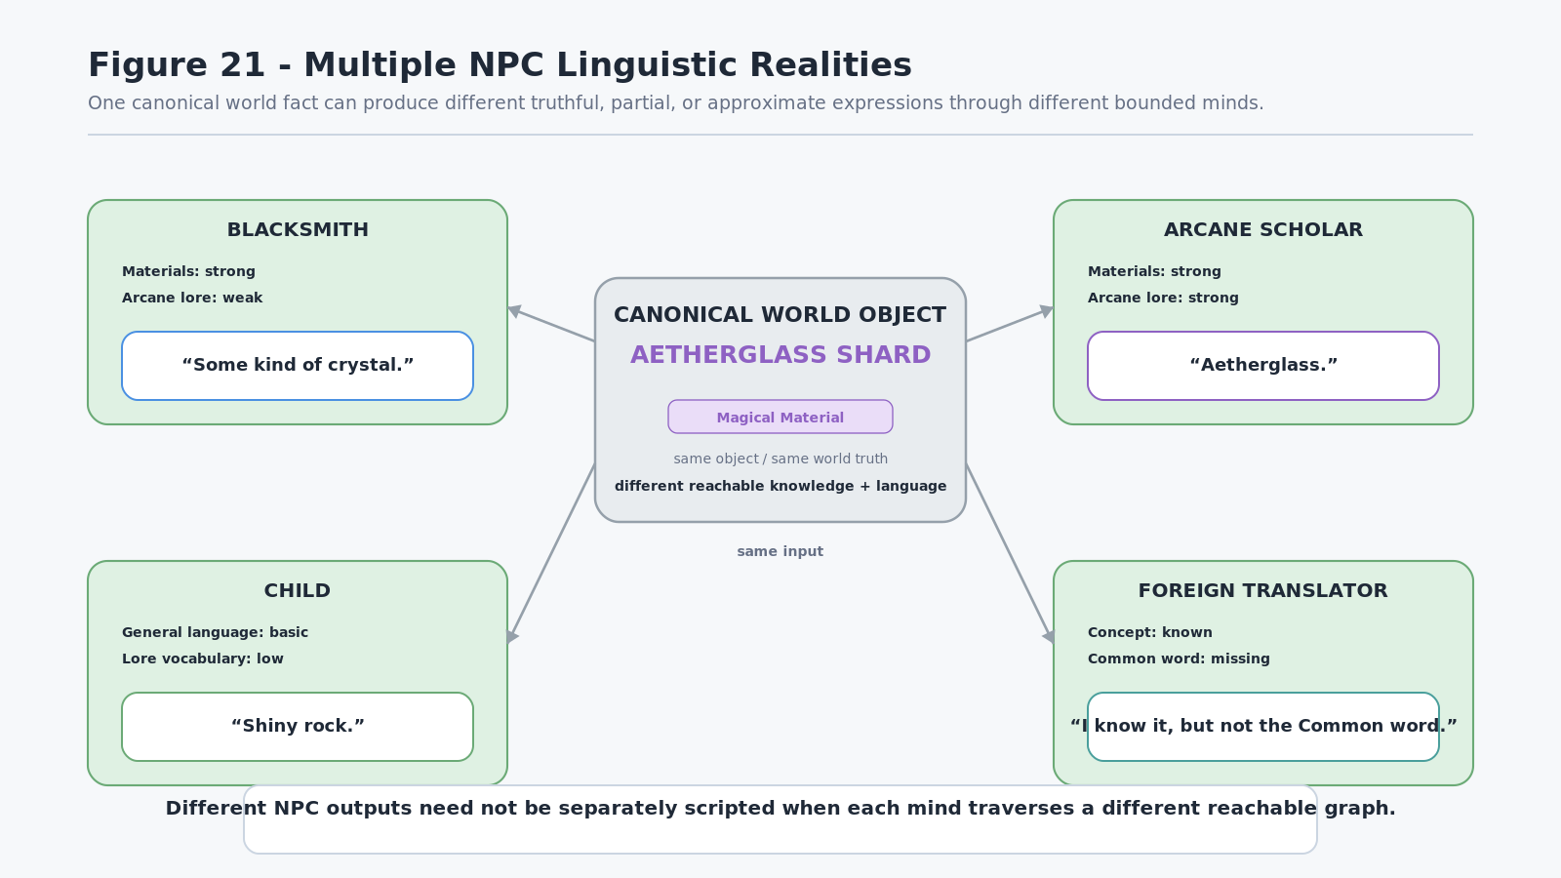
Figure 21. Multiple NPC Linguistic Realities

24. Emergent Simulation Properties
The combined architecture produces a large set of simulation behaviors from a comparatively small number of primitives:
Language Dictionary + Language SK + SOLAR bindings + character Skill/MASK state + domain knowledge + translation relations

From those structures, a simulation can obtain individual vocabulary, partial fluency, occupational jargon, dialectal vocabulary, technical terminology, paraphrase, synonym fallback, unknown words, reduced precision, plausible misunderstanding, invented-language fluency, specialist translation, archaic language competence, cultural vocabulary, and ongoing learning.
These properties are not necessarily separate runtime modules. Many are different visible consequences of one deeper constraint: the entity can only traverse linguistic and semantic routes currently available to it.
That constraint also explains why mistakes can appear human-like without claiming the machine itself is human. If the globally preferred concept or word is unreachable, a bounded character can select a broader or related reachable state, ask for clarification, paraphrase, or fail to resolve the expression entirely.
EMERGENT LINGUISTIC INDIVIDUALITY LAW
Complex linguistic individuality can emerge from bounded access to shared linguistic structures rather than individually authored dialogue systems.

REACHABILITY PRINCIPLE
Linguistic behavior is constrained by the meanings, lexical relations, grammatical structures, and knowledge routes the entity can actually reach.

25. Communication and Relational Compatibility
Language operates as a communication interface because symbolic patterns are associated with sufficiently compatible relational structures across members of a linguistic community. The symbol itself does not need to contain the full meaning it evokes. Instead, the symbol provides a compact conventional route into a larger learned relational neighborhood.
Different participants do not need identical internal representations. Human beings routinely communicate despite different memories, experiences, expertise, and conceptual detail. What communication requires is sufficient compatibility for the transmitted symbol or expression to place the participants in overlapping semantic territory.
The same principle can apply between simulated agents or between machines and humans. A machine can remain computationally non-human while operating through linguistic structures whose words, grammar, distinctions, and relations were formed through human communication and culture.
RELATIONAL COMPATIBILITY PRINCIPLE
Communication requires sufficiently compatible mappings between symbolic patterns and relational meaning, not identical internal representations.

SYMBOLIC RELATION PRINCIPLE
Symbols become communicatively meaningful through learned relational conventions rather than through their surface shape alone.

This paper treats the Language Graph as a machine-addressable representation of some of those conventions. It does not claim to model the total cognitive structure of human language or thought.

26. Conclusion - Bounded Minds Inside Shared Language
CERBERUS Language SKs model language as an addressable relational system rather than only a set of text strings. The Language Dictionary supplies stable lexical senses and lexical relations. The Language SK governs legal grammatical composition and realization. SOLAR connects resolved lexical senses to Base-local semantic identities. Domain and world systems own the actual entities, concepts, Rules, and Operators those identities refer to.
Character Skill and MASK state then provide bounded access over the shared linguistic structure. That bounded state determines which lexical routes a character can presently understand, express, translate, approximate, or misinterpret. The same complete language can therefore support a child, scholar, translator, blacksmith, foreign visitor, ancient archivist, or invented-language specialist without requiring a separate language model for each role.
The complete architecture can be summarized as:
World / Domain Graph -> SOLAR <-> Language Dictionary -> Language SK + Translation Routing -> Character Skill / MASK State -> Linguistic Possibility State -> Understanding / Expression -> Communication

Learning and teaching feed back into character state, expanding future reachability while preserving the canonical language.
The central thesis of the paper is therefore:
CERBERUS Language SKs model language as an addressable relational system. Language Dictionaries define lexical possibility, Language SKs govern linguistic composition, SOLAR connects lexical senses to Base-local meaning, and bounded Skill and MASK states determine which linguistic possibilities an entity can presently understand, express, translate, approximate, or misinterpret.

A simulated mind does not require a separately authored dialogue model of its personality when meaningful individuality can instead emerge from the linguistic relations, semantic structures, and knowledge routes that mind is actually able to reach.
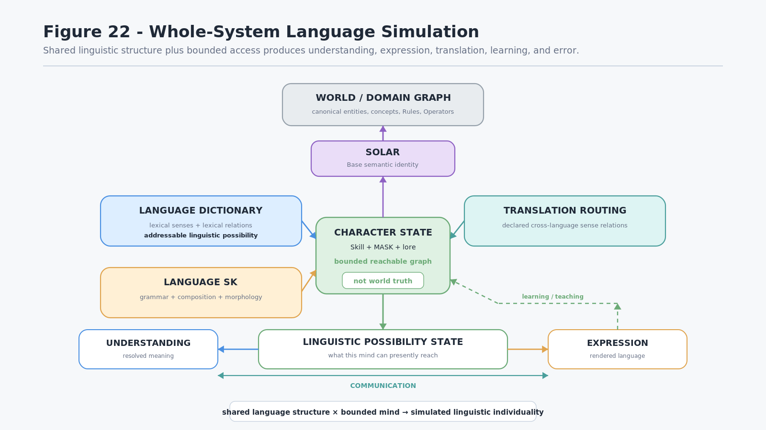
Figure 22. Whole-System Language Simulation
CLOSING PRINCIPLE
A simulated mind does not require a separately authored dialogue model of its personality when meaningful individuality can instead emerge from the linguistic relations, semantic structures, and knowledge routes that mind is actually able to reach.

Companion Architecture References
Architecture | Relationship to this specification
CERBERUS Playable Semantic Skills - Formal Specification v0.1 | Defines Domain SK / Skill SK separation, experience, Level, MASK acquisition, and portable character competence used by Language Skill state.
CERBERUS PULSE for Fantasy and Simulation - Formal System Specification v1.0 | Defines selective semantic perception and Reader-bounded world visibility referenced by the perception-language boundary.
CERBERUS BIGFOOT | Provides reusable semantic-free Bit and BitGroup mathematics, including SCALAR-N addressing principles.
CERBERUS SOLAR | Provides Base-local lexical/semantic identity resolution and routing beyond the Language Dictionary.

