CERBERUS
EXECUTABLE
PROFESSIONAL WORLDS
Compiling Professional Knowledge into Semantic Simulation,
Real-World Routing, Fantasy Projection, and Skill Development
━━━━━━━━━━━━━━━━━━━━━━━━━━━━━━━━━━━━━━━━━━━━━━━━━━━━
CORE THESIS | Build the profession once. Teach it through worlds. Route it into reality. Reskin the worlds without corrupting the professional substrate.

DOCUMENT CLASS: Formal Architecture Specification
VERSION: v0.1
RELEASE: Pass 7 Composition + Pass 8 Verified QA
DATE: 26 August 2026
FIGURE SET: EPW-01 through EPW-32

Abstract
This paper defines a CERBERUS architecture for turning a governed professional corpus into an executable semantic world. The central mechanism is Semantic Affordance Routing: a task expresses the transformation it needs, a target contributes relevant semantic properties, Semantic Kernels resolve those requirements to stable professional identities, and real or simulated objects expose capability profiles against the same coordinates. Hard Rules and gates determine eligibility; local workflow policies narrow or bias use without rewriting professional truth; live instance state describes what a particular object can do now; actor skill and goal may further contextualize the choice; and an explicit scoring Model ranks the remaining candidates. The resulting Contextual Affordance is therefore derived, inspectable, and temporary rather than an intrinsic property of the object.
The architecture deliberately joins three domains that are usually separated: professional knowledge representation, world simulation, and real-world assistance. The same semantic contract can support a simulated tool, a bound physical tool, an AI or NPC acting in a professional world, and a fantasy projection that preserves selected professional reasoning while adding explicit fictional mechanics. Task performance can then generate competency evidence, allowing knowledge and skill development to arise from successful participation in the world instead of from detached testing alone.
FOUNDATIONAL INVARIANT | Canonical capability, local workflow, live instance state, actor capability, task requirement, and routing result are separate semantic owners. They meet during routing; they do not overwrite one another.

Scope and Non-Scope
The specification defines the semantic architecture, routing stages, separation laws, illustrative scoring mathematics, physical-object binding contract, simulation/fantasy relationship, and competency-evidence loop. It does not define a universal tool-rating authority, a universal scoring formula, a final hardware binding stack, a final Airtable schema, or a claim that simulation performance is equivalent to professional certification or physical execution.

Companion Architecture
Companion | Responsibility in this architecture
Semantic Knowledge Packing | Controls progressive exposure to semantic routes, bundles, learning stages, and Life Chunks without simplifying World Truth.
World-Driven Agency | Keeps actors comparatively thin by placing domain semantics, requirements, operations, and shared task state into the World.
Storyboard Continuity Engine | Preserves persistent causal World State, event consequence, bounded perception, and continuity across time.
FASK / Statebound Entanglement | Adds explicit fantasy overlays, alternate Rules, translations, and fictional relations without redefining canonical professional semantics.

Contents
Section | Title
1 | Purpose and Design Position
2 | Compiling Professional Knowledge into World Structure
3 | Capability-First Task and Target Routing
4 | Suitability Models, Gates, and Extensible Semantics
5 | Local Workflow and Scoped Operational Use
6 | Live Instance State, Actor Context, and Contextual Affordance
7 | The Semantic Affordance Router and Explainability
8 | Physical Objects, Simulation, and Cross-Professional Reuse
9 | FASK Projection and Transferable Reasoning
10 | Competency Evidence and Skill Projection
11 | The Executable Professional World Cycle
12 | Formal Model
13 | Governance, Provenance, and Versioning
14 | Implementation Guidance
15 | Formal Design Laws
16 | Conclusion
Appendix A | Glossary
Appendix B | Minimal Routing Trace Contract
Appendix C | Non-Scope and Safety Boundary

1. Purpose and Design Position
Professional knowledge is normally stored as documents, standards, procedures, equipment manuals, competency frameworks, case studies, and the experience of practitioners. These sources are valuable, but they are usually passive: a retrieval system can quote them, yet the surrounding world does not necessarily become capable of enforcing their prerequisites, representing their objects, exposing their tools, or producing the consequences described by the corpus.
Executable Professional Worlds treats the corpus as an upstream source from which governed semantic structures can be compiled. A concept becomes addressable. An object receives a persistent identity and state model. A procedure becomes an Operator and Task structure. A prerequisite becomes a Requirement. A standard becomes a Rule. Equipment descriptions become capability profiles. Failure modes become recognizable state patterns with consequences. Competencies become Skill identities and evidence contracts. The objective is not to replace professional authority with software; it is to give validated professional knowledge a computational form capable of participating in a World.
DESIGN POSITION | A profession can be represented as an executable semantic world when its concepts, objects, states, relations, procedures, Rules, requirements, resources, Tasks, and competencies are given explicit computational ownership.

The flagship mechanism is Semantic Affordance Routing. Instead of asking a recipe or Task to hard-code one exact implementation, the Task declares what it needs. The target contributes relevant properties. The environment identifies available candidates. Professional capability, hard Rules, local workflow, live object state, actor context, and a registered scoring Model then determine what should be recommended here and now.

2. Compiling Professional Knowledge into World Structure
The first architectural problem is not routing. It is compilation. A professional corpus contains heterogeneous claims with different operational meanings, so it must not be flattened into one generic “knowledge” layer. Terminology, measurements, procedures, standards, equipment descriptions, prerequisites, failure modes, and competencies each require different executable structures.
COMPILATION LAW | Corpus ingestion is not automatic truth conversion. Professional interpretation, validation, versioning, and authority remain upstream of executable semantics.

EPW-01 — From Professional Corpus to Executable World
The professional corpus is the source material, not the runtime itself.
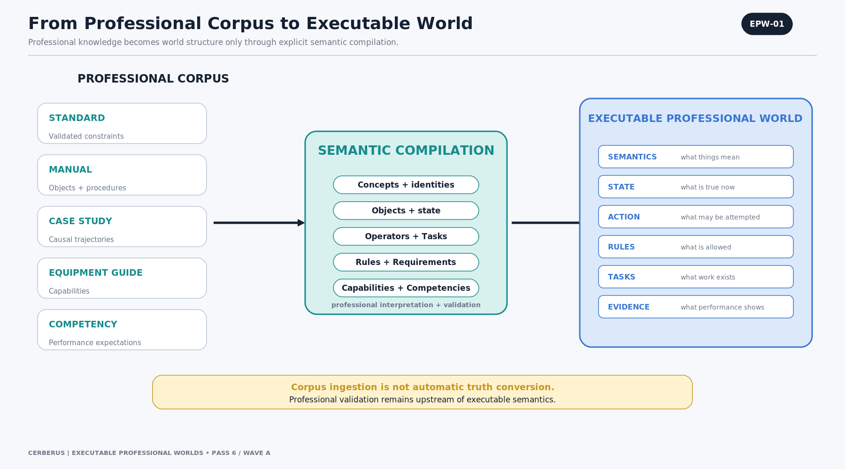
Figure EPW-01. From Professional Corpus to Executable World
The compilation layer extracts and registers concepts, objects, state, operations, Rules, requirements, capabilities, competencies, Tasks, and evidence structures. The output is an executable professional world in which the source material can become observable, actionable, testable, or consequential.
The validation note at the bottom of the figure is essential: a compiler can transform a validated claim into executable form, but compilation does not establish that the claim is professionally correct.
ARCHITECTURE LAW | Professional validation remains authoritative upstream of semantic compilation.

EPW-02 — Different Knowledge Compiles into Different Structures
Different source claims own different runtime structures.
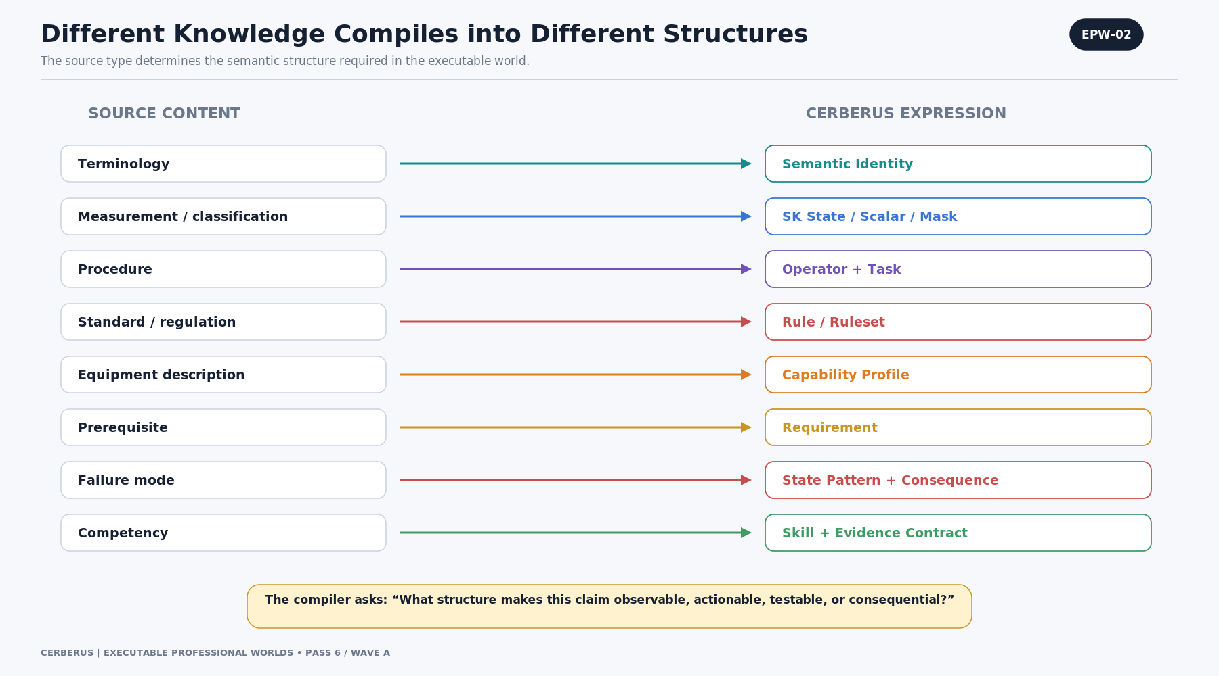
Figure EPW-02. Different Knowledge Compiles into Different Structures
Terminology resolves to semantic identity; measurable or classified state resolves to typed SK state; procedures resolve to Operators and Tasks; standards resolve to Rules or Rulesets; equipment descriptions resolve to Capability Profiles; prerequisites resolve to Requirements; failure modes resolve to state patterns and consequences; competencies resolve to Skill identities and evidence contracts.
This separation prevents a common failure mode in knowledge systems: treating every sentence as interchangeable descriptive text even when one sentence defines a meaning, another authorizes an action, and a third establishes a requirement.
ARCHITECTURE LAW | The compiler asks what structure makes a professional claim observable, actionable, testable, or consequential.

EPW-03 — Professional Semantic Identity Is the Shared Coordinate
The stable professional coordinate is the resolved semantic identity, not the raw physical bit address.
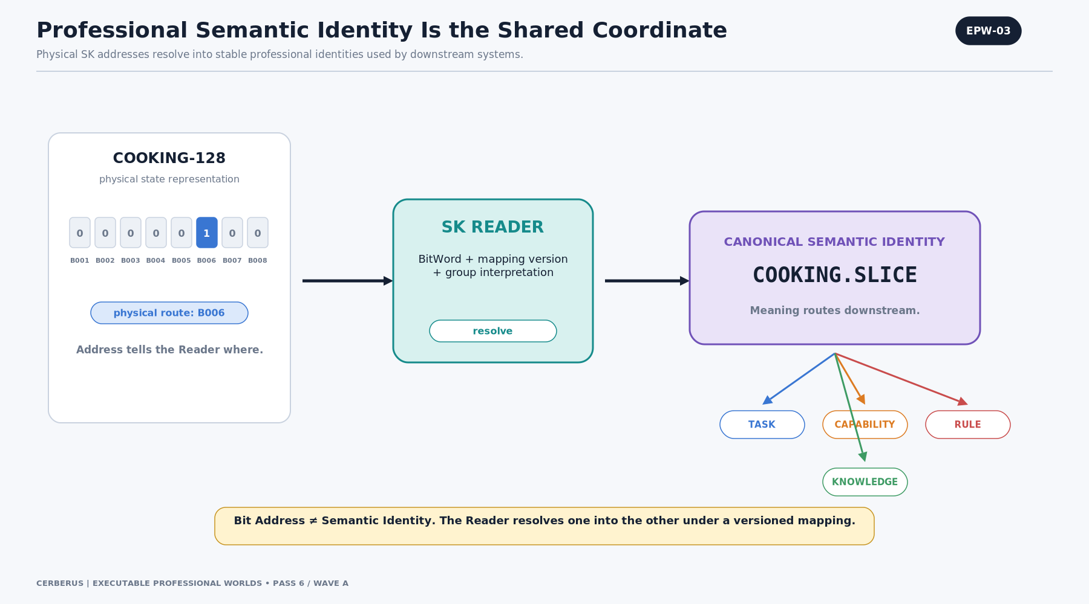
Figure EPW-03. Professional Semantic Identity Is the Shared Coordinate
A BitWord and mapping version provide a bounded physical representation. The SK Reader resolves that representation into a canonical semantic identity such as COOKING.SLICE. Tasks, capabilities, Rules, and knowledge then route from that identity.
This allows a mapping version to move a meaning to a different physical address without forcing every downstream record to be rewritten, provided the versioned Reader still resolves to the same semantic identity.
ARCHITECTURE LAW | Bit Address ≠ Semantic Identity. The Reader resolves one into the other under a declared mapping version.

EPW-04 — One Professional World, Different Learning Depth
The World can remain professionally rich while different learners resolve different semantic depth.
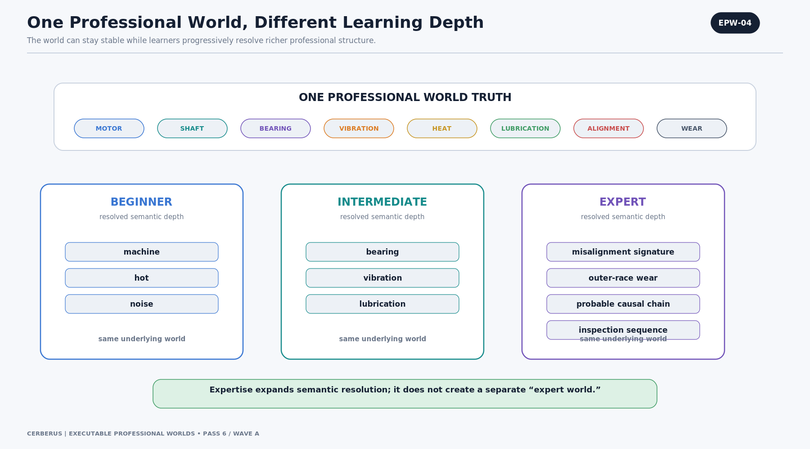
Figure EPW-04. One Professional World, Different Learning Depth
A beginner may recognize only machine, heat, and noise. An intermediate learner may resolve bearing, vibration, and lubrication. An expert may resolve an outer-race wear signature, probable causal chain, and inspection sequence. These are different comprehension states over the same underlying professional World Truth.
This model allows one environment to support developmental progression without constructing separate “toy worlds” whose rules stop matching the advanced environment.
ARCHITECTURE LAW | World Truth ≠ Semantic Comprehension ≠ Character Knowledge.

EPW-05 — Knowledge Structure and World Structure Meet
Professional learning and professional world mechanics meet at the Task.
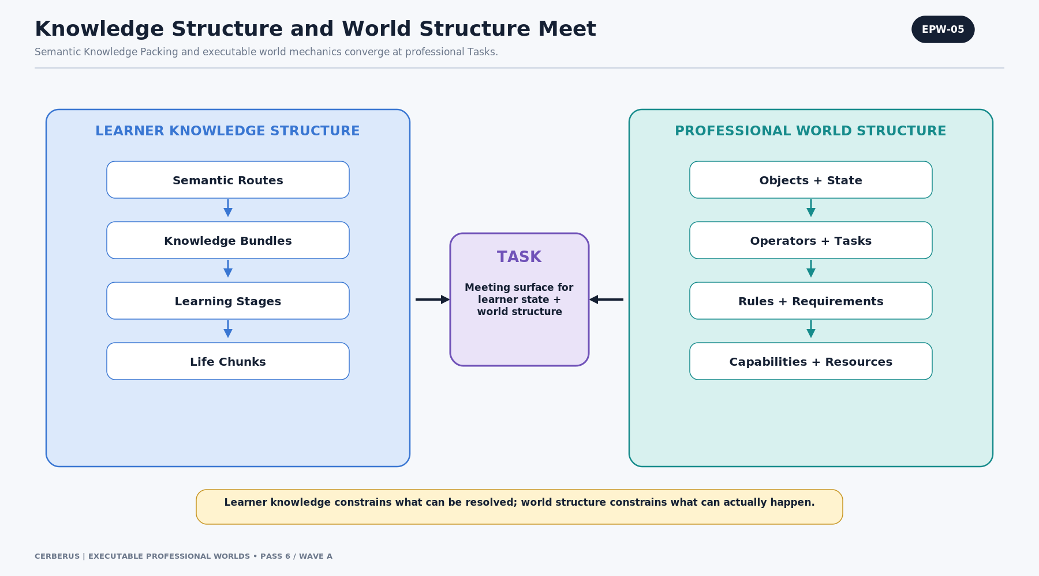
Figure EPW-05. Knowledge Structure and World Structure Meet
Semantic Routes, Knowledge Bundles, Learning Stages, and Life Chunks describe what the learner can meaningfully resolve. Objects, state, Operators, Rules, requirements, capabilities, and resources describe what the World can actually make available or consequential.
The Task is the meeting surface: the learner confronts an executable problem whose solution requires both world structure and bounded comprehension. The learner does not gain knowledge merely because the World contains it.
ARCHITECTURE LAW | Learner knowledge constrains what can be resolved; world structure constrains what can actually happen.

3. Capability-First Task and Target Routing
Once professional meaning is addressable, Tasks need a portable way to request implementation. The default pattern is capability-first: specify the intended transformation, identify the target, declare the required object class, and allow the environment to resolve the best eligible implementation. Exact object binding remains available when a professional procedure truly mandates one.
ROUTING LAW | Tasks ask for capabilities when implementation choice is genuinely open. Professional Rules may still require an explicit object, model, device, or procedure.

EPW-06 — Tasks Ask for Capabilities, Not Object IDs
Capability-first routing removes unnecessary coupling between a procedure and one local inventory item.
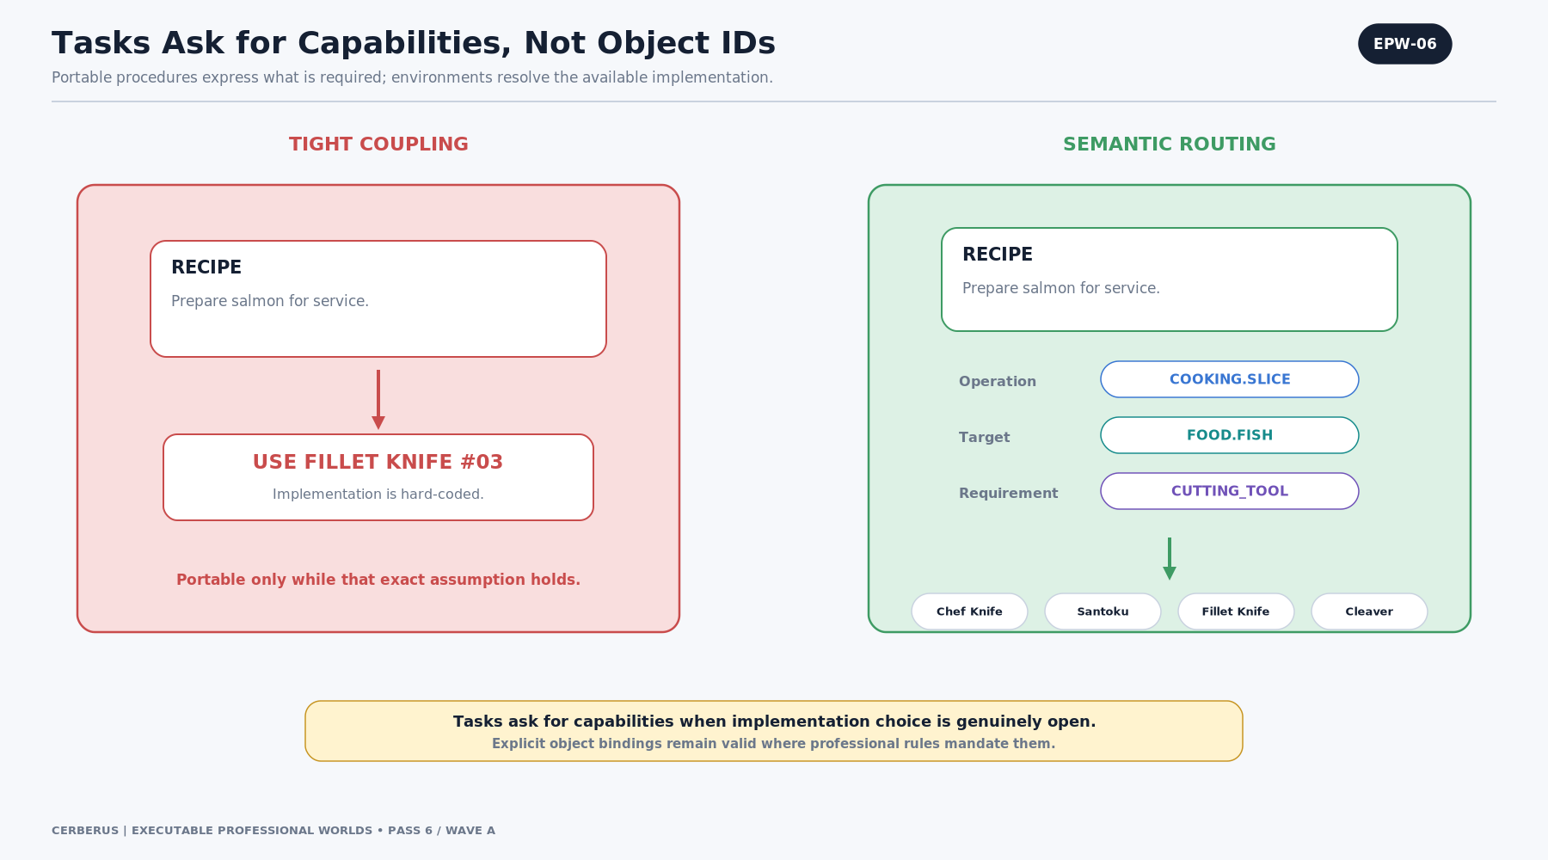
Figure EPW-06. Tasks Ask for Capabilities, Not Object IDs
A recipe that says “use Fillet Knife #03” works only while that exact assumption holds. A semantic recipe that says COOKING.SLICE + FOOD.FISH + CUTTING_TOOL can travel between kitchens and simulations because the environment resolves whichever valid implementations are actually available.
The architecture does not forbid explicit binding. It distinguishes portable requirement logic from cases in which a standard, calibration, safety rule, or validated procedure requires a specific implementation.
ARCHITECTURE LAW | Task intent should be portable; implementation should be resolved from the current environment unless explicitly fixed by professional authority.

EPW-07 — Task + Target Produce the Requirement Query
The Task does not own every capability dimension by itself. The target contributes relevant semantic properties.
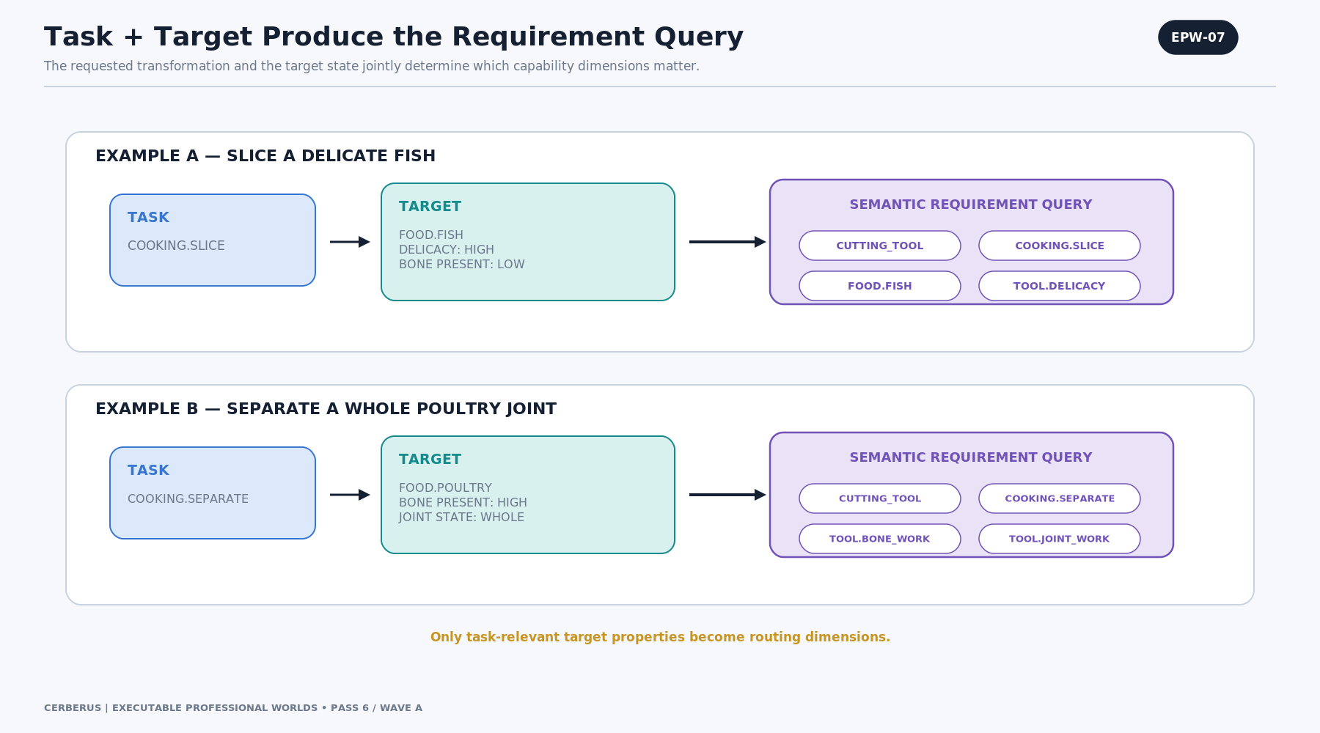
Figure EPW-07. Task + Target Produce the Requirement Query
Slicing a delicate fish can generate a query containing CUTTING_TOOL, COOKING.SLICE, FOOD.FISH, and TOOL.DELICACY. Separating a whole poultry joint can instead activate COOKING.SEPARATE, FOOD.POULTRY, TOOL.BONE_WORK, and TOOL.JOINT_WORK.
Only task-relevant target properties should enter the query. A target may expose many semantic facts that do not matter for the current transformation, and indiscriminately multiplying them into the score would create meaningless penalties.
ARCHITECTURE LAW | Operation semantics + relevant target semantics + applicable Rules/context = current capability query.

EPW-08 — Objects Expose Multidimensional Capability Profiles
Real or simulated objects answer the semantic query by exposing multidimensional capability profiles.
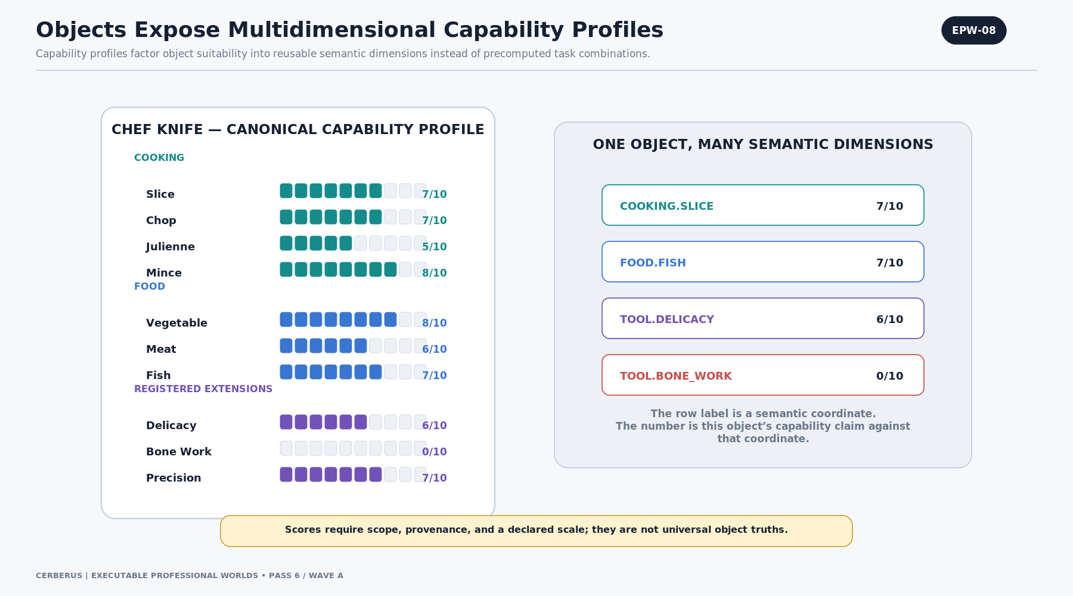
Figure EPW-08. Objects Expose Multidimensional Capability Profiles
The chef knife does not store a separate “fish slicing score,” “vegetable chopping score,” and “meat mincing score” for every possible combination. Instead it declares independent capability claims such as COOKING.SLICE = 7/10, FOOD.FISH = 7/10, TOOL.DELICACY = 6/10, and TOOL.BONE_WORK = 0/10.
Each score therefore needs scope and provenance. It is a claim about this object or object type against one semantic coordinate under a declared scale, source, version, and condition—not a universal number that floats free of context.
ARCHITECTURE LAW | The semantic identity is the coordinate; the number is the object’s bounded capability claim against that coordinate.

EPW-09 — Composition Avoids the Combination Explosion
Factorized capability dimensions prevent a combinatorial schema explosion.
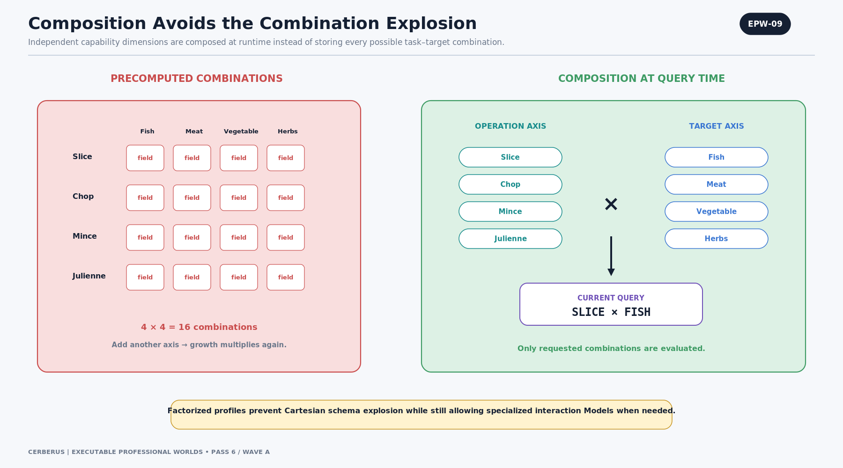
Figure EPW-09. Composition Avoids the Combination Explosion
If every operation-target pair were stored as its own field, adding one operation or target class would multiply schema size. Composition instead stores reusable operation and target dimensions and constructs the requested pair at runtime.
Factorization does not imply that all real-world dimensions are statistically or causally independent. Where interaction effects matter, a registered specialized Model can own those effects without forcing the entire schema to precompute every combination.
ARCHITECTURE LAW | Compose ordinary combinations at query time; register specialized interaction Models only where the profession actually requires them.

4. Suitability Models, Gates, and Extensible Semantics
Capability matching needs explicit mathematics, but mathematical elegance must not erase professional constraints. This architecture therefore distinguishes eligibility from preference. Mandatory Rules and hard gates are evaluated first. Only surviving candidates are scored and ranked by a declared Model.

EPW-10 — Slice × Fish = 49/100
A simple strict-conjunction Model can combine two independent 0–10 capability dimensions.
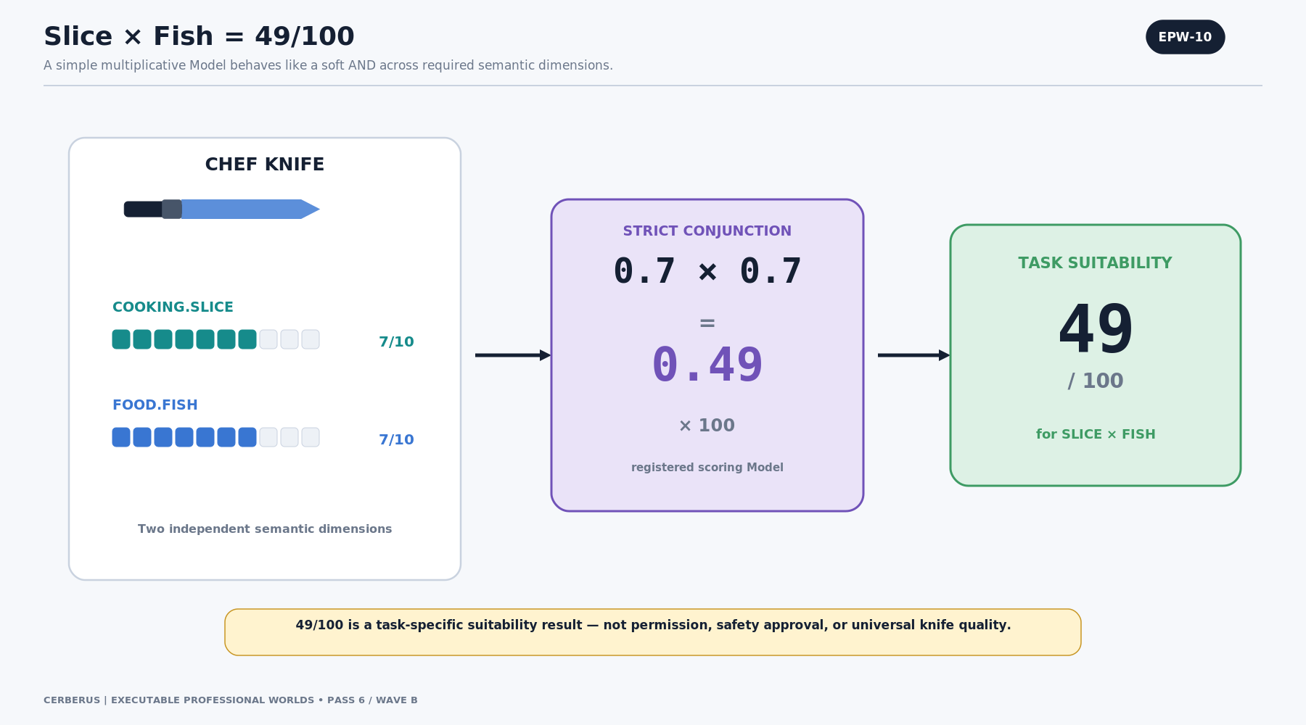
Figure EPW-10. Slice × Fish = 49/100
For the chef knife, COOKING.SLICE = 7/10 and FOOD.FISH = 7/10. Normalizing each to 0–1 and multiplying gives 0.49, expressed as 49/100 for the current SLICE × FISH query.
Multiplication behaves like a soft AND: high performance on one dimension cannot completely compensate for weakness on another. The result is still only a task-specific suitability score; it is not permission, safety approval, or universal knife quality.
S = 100 × (7/10) × (7/10) = 49
Illustrative registered Model: STRICT_CONJUNCTION

EPW-11 — More Dimensions Create a Stricter Match
Adding another relevant dimension makes the strict-conjunction result more demanding.
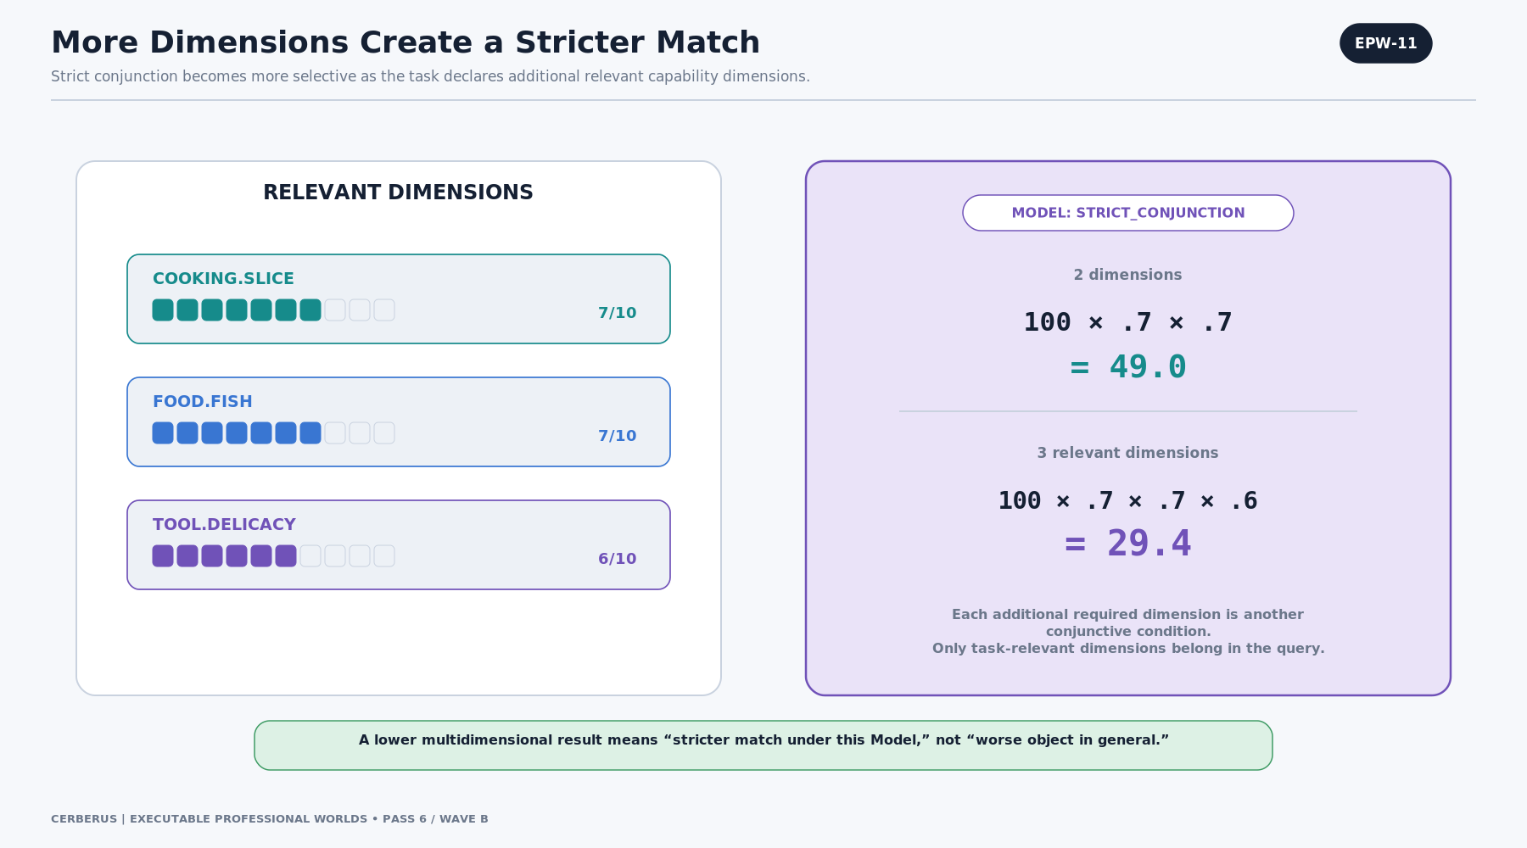
Figure EPW-11. More Dimensions Create a Stricter Match
If TOOL.DELICACY = 6/10 is genuinely relevant, the same Model yields 29.4. The lower number does not mean the knife is “worse” in general. It means the candidate is a stricter match against a more specific multidimensional query under this scoring Model.
CERBERUS should permit alternate registered Models: weighted preference, bottleneck/minimum, threshold, lexicographic priority, or a hybrid model that uses hard gates followed by soft ranking.
S = 100 × 0.7 × 0.7 × 0.6 = 29.4
Only task-relevant dimensions belong in the query.

EPW-12 — Hard Gates Before Soft Ranking
Mandatory constraints are resolved before preference.
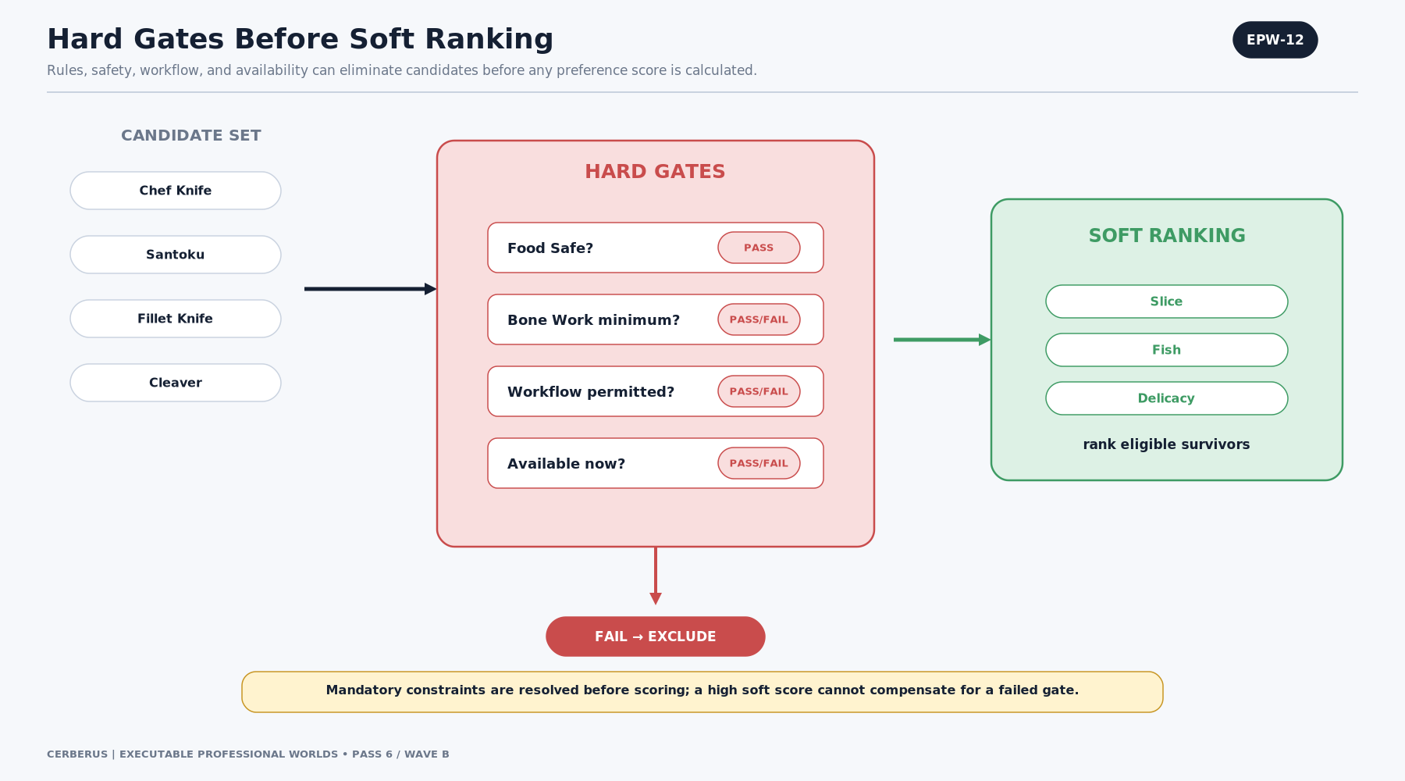
Figure EPW-12. Hard Gates Before Soft Ranking
Food safety, required minimum capability, local prohibitions, availability, actor permission, or other hard conditions can disqualify a candidate before any soft ranking occurs. This prevents a high score in desirable dimensions from compensating for a failed safety or policy gate.
A scoring Model therefore operates over an eligible candidate set, not over every object that loosely resembles the requested class.
ARCHITECTURE LAW | Hard gates precede soft ranking. A failed mandatory constraint cannot be averaged away.

EPW-13 — Zero, N/A, and Missing Are Different
Capability data needs three different non-positive states.
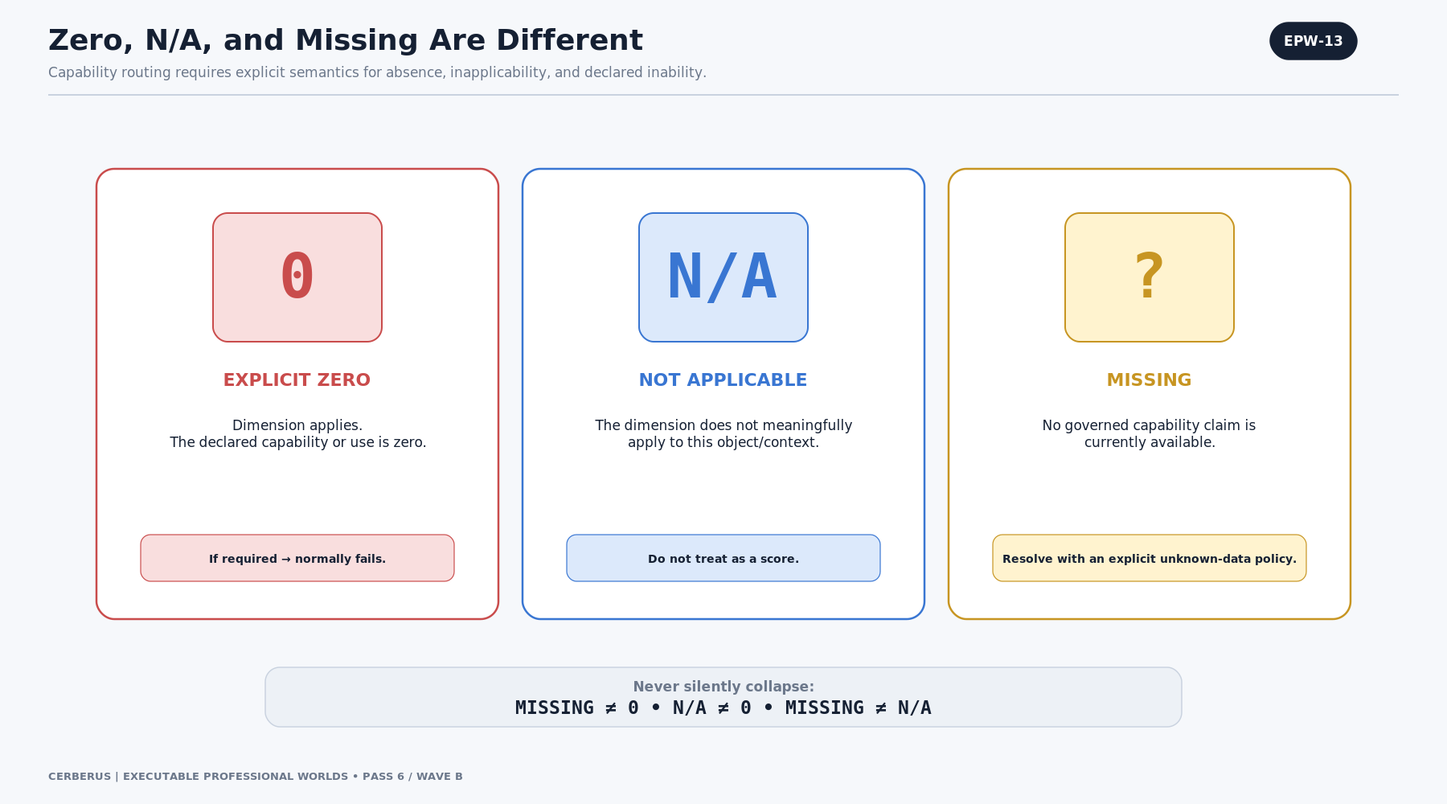
Figure EPW-13. Zero, N/A, and Missing Are Different
Zero means the dimension applies and the declared capability is explicitly zero. N/A means the dimension does not meaningfully apply. Missing means no governed capability claim is currently available.
These states require different routing policy. A required zero normally fails; N/A may be legitimate because the query was inappropriate for the object; Missing should invoke an explicit unknown-data policy rather than silently passing or failing as if the answer were known.
ARCHITECTURE LAW | Never silently collapse Missing → 0, N/A → 0, Missing → N/A, or any reverse substitution.

EPW-14 — Capability Semantics Can Extend Without Rebuilding the Core
The capability surface can grow without rebuilding the canonical core.
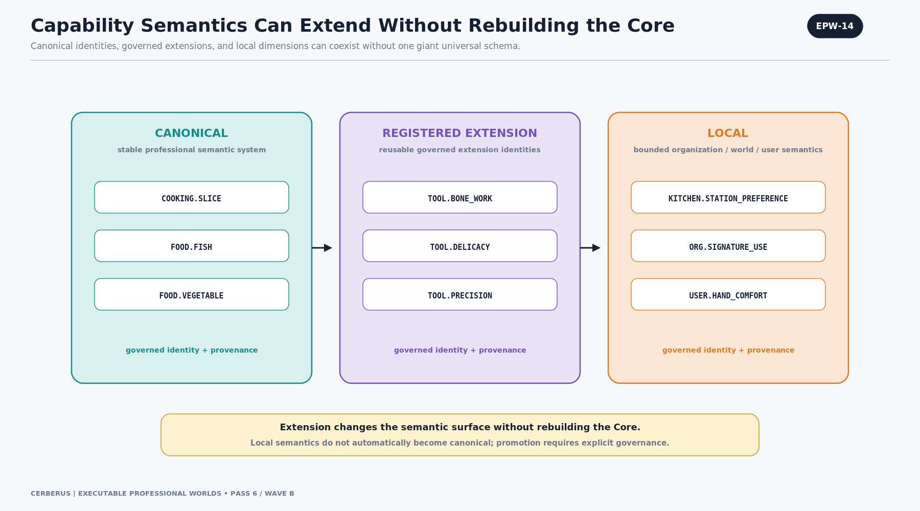
Figure EPW-14. Capability Semantics Can Extend Without Rebuilding the Core
Canonical identities such as COOKING.SLICE and FOOD.FISH belong to stable professional semantic systems. Registered extensions such as TOOL.BONE_WORK, TOOL.DELICACY, and TOOL.PRECISION can be reusable across multiple systems. Local identities can represent bounded organization, world, manufacturer, or user-specific semantics.
A local tag can later be promoted through governance if repeated use demonstrates that it deserves a reusable registered identity. Until then, local semantics should remain scoped rather than silently entering the universal professional ontology.
ARCHITECTURE LAW | Extensibility is allowed; ownership and scope must remain explicit.

5. Local Workflow and Scoped Operational Use
Real professional environments routinely narrow the use of otherwise capable equipment. A kitchen may reserve one knife for allergen-controlled prep, a machine shop may dedicate a tool to aluminum, or a lab may restrict a gripper to sterile handling. These decisions are operational policy, not changes to the physical object’s canonical capability.
LOCAL WORKFLOW LAW | Canonical capability describes what an object is professionally suited to do. Local Workflow describes what this environment permits, prefers, reserves, discourages, or forbids.

EPW-15 — Canonical Capability Is Not Local Workflow
Canonical capability and Local Workflow are two different semantic owners attached to the same object.
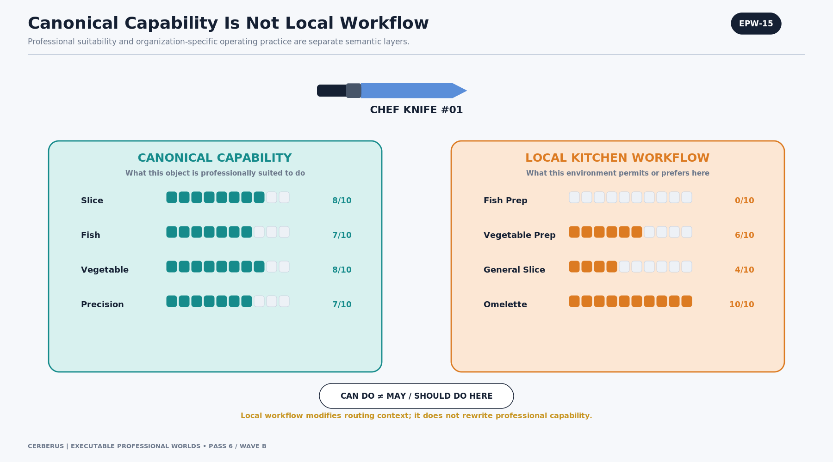
Figure EPW-15. Canonical Capability Is Not Local Workflow
A chef knife may be professionally suited to slice fish and vegetables while a particular kitchen gives it low or zero routing preference for those uses and a high preference for omelette work. Both statements can be true at once.
The Workflow layer should reference the same semantic coordinates when possible, because the environment is modifying use of a professional capability rather than inventing a new physical property.
ARCHITECTURE LAW | Can do ≠ may do here ≠ should do here.

EPW-16 — Two Kinds of Zero
A numeric zero has different meaning depending on which layer owns it.
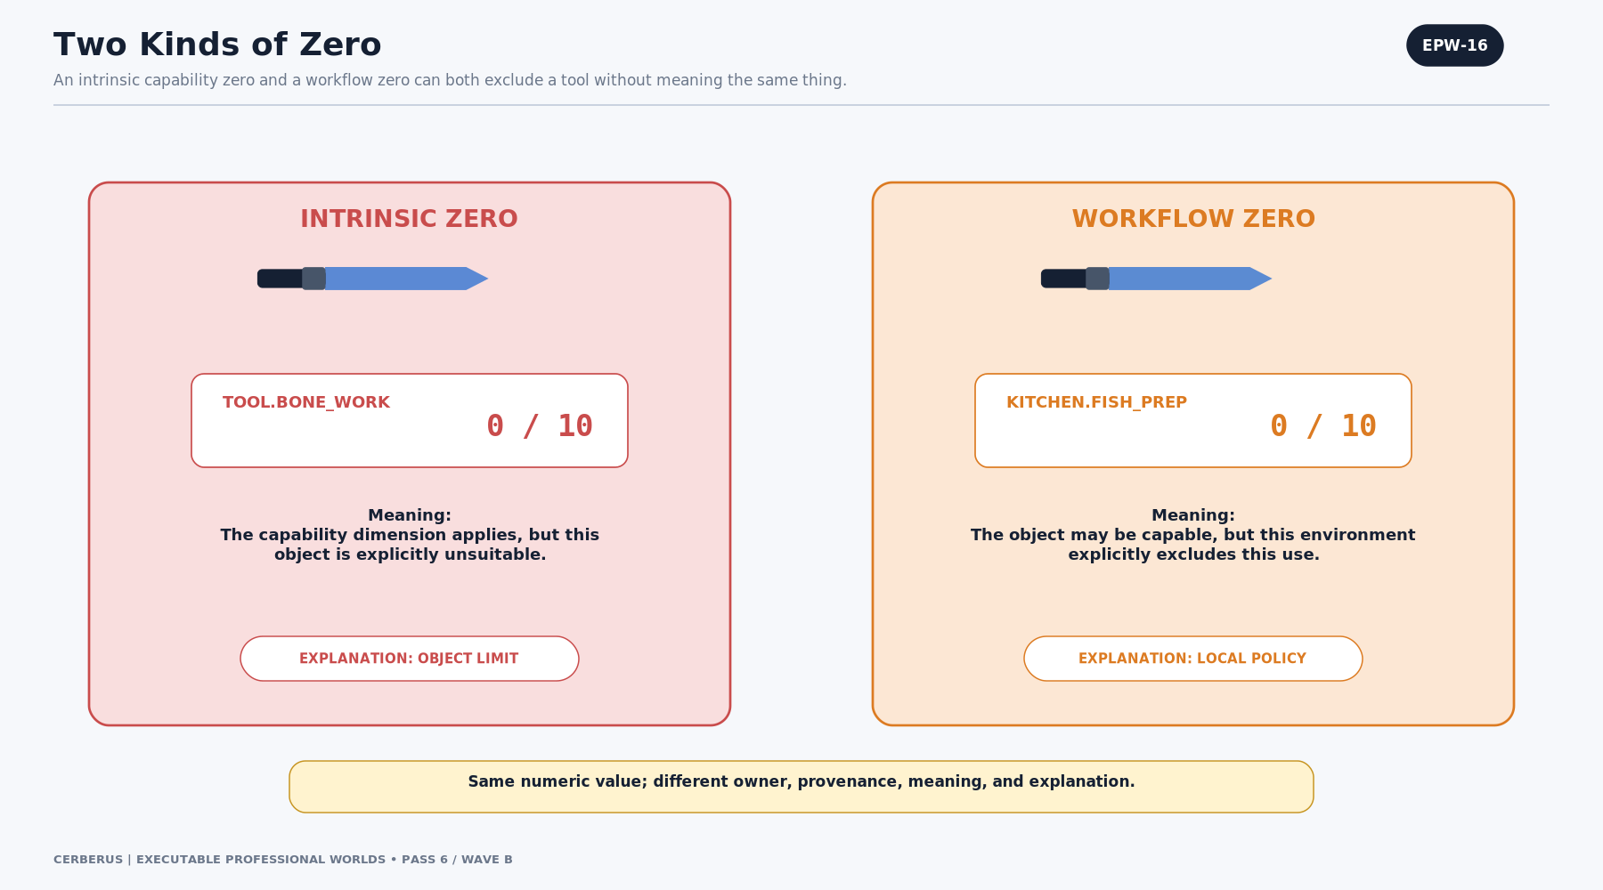
Figure EPW-16. Two Kinds of Zero
An intrinsic TOOL.BONE_WORK = 0 says the object is unsuitable for bone work. A KITCHEN.FISH_PREP workflow zero says the object may physically be capable but this environment excludes that use.
The explanation engine must preserve that provenance. “Object limitation” and “local policy” are not interchangeable reasons, even when both remove the candidate from a routing result.
ARCHITECTURE LAW | Same numeric value; different owner, provenance, meaning, and explanation.

EPW-17 — Local Workflow Can Prohibit or Prefer
Local Workflow can express both hard exclusion and soft preference.
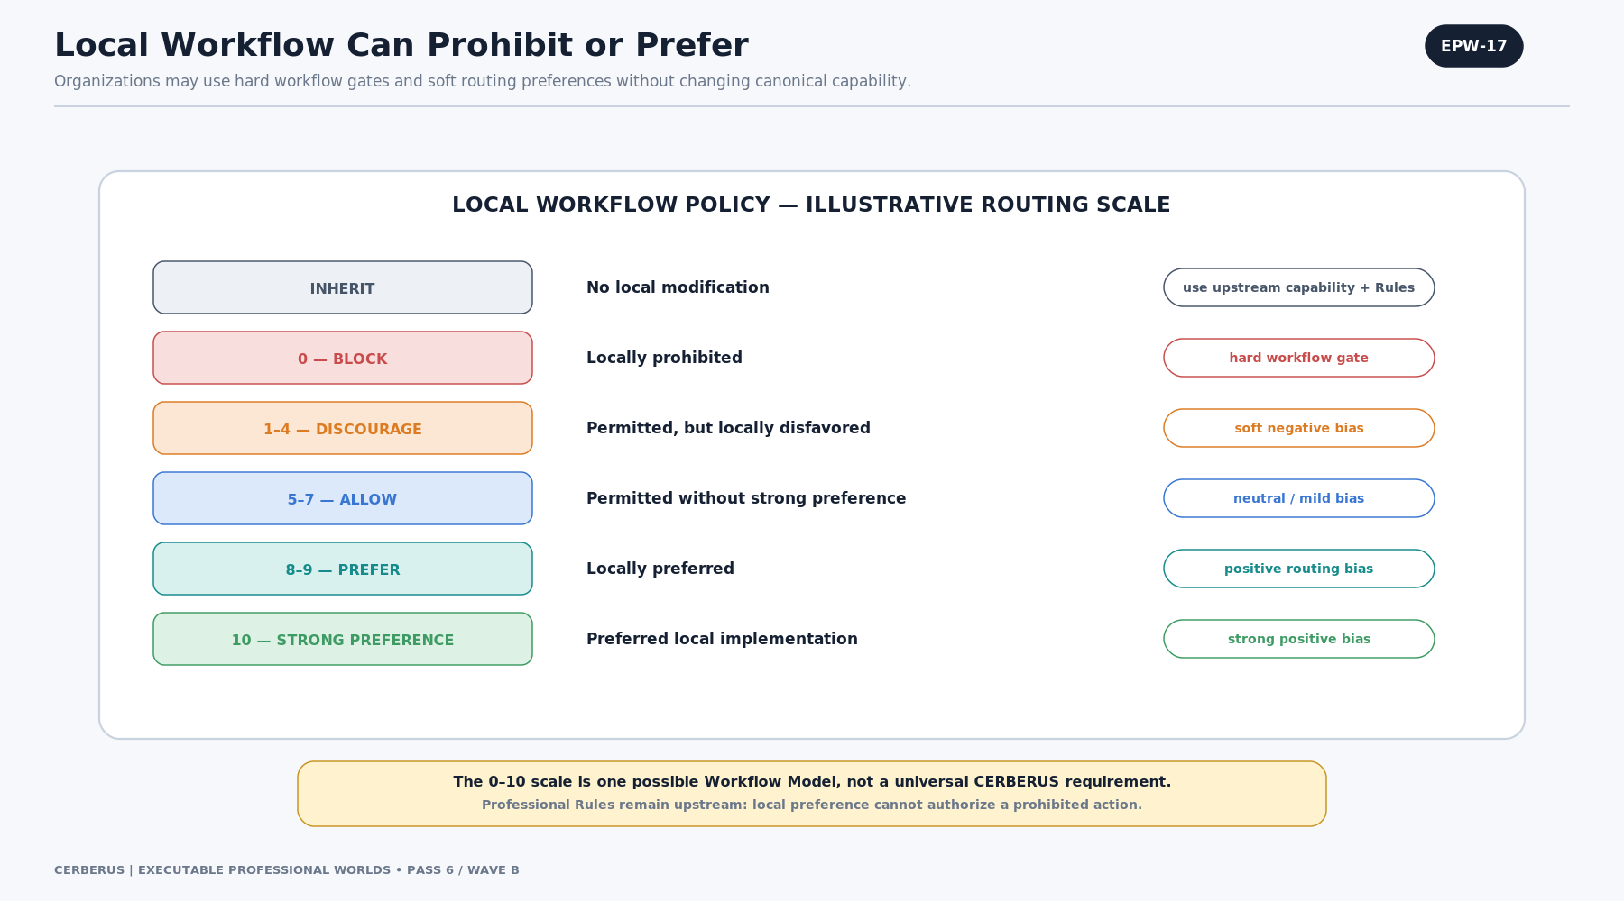
Figure EPW-17. Local Workflow Can Prohibit or Prefer
The figure shows an illustrative 0–10 routing scale: inherit, block, discourage, allow, prefer, and strong preference. This is one possible Workflow Model, not a CERBERUS-wide requirement. Categorical policies can implement the same responsibilities.
Professional Rules remain upstream. A local preference can choose among valid implementations, but it cannot lawfully transform a professionally prohibited action into an allowed one.
ARCHITECTURE LAW | Workflow narrows or biases routing context; it does not overwrite upstream professional Rules.

EPW-18 — The Omelette-Only Knife
The omelette-only knife is a compact stress test for layer separation.
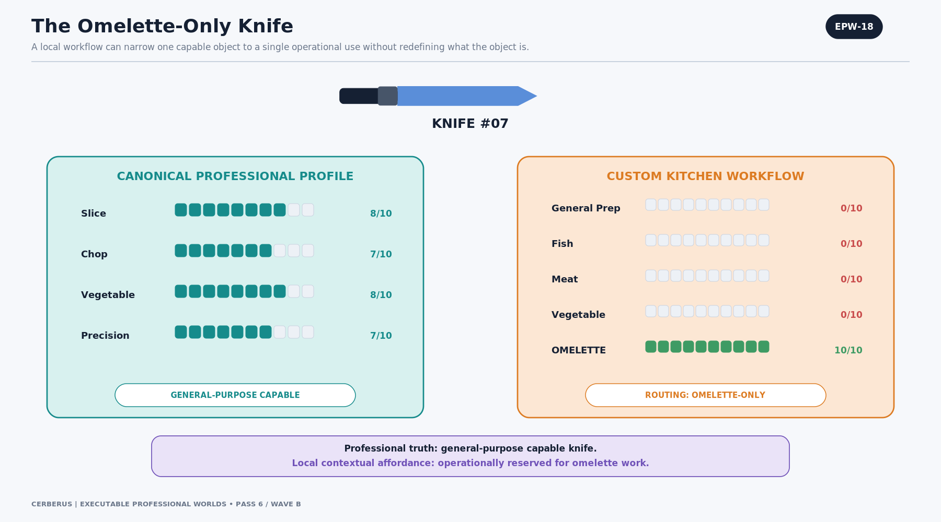
Figure EPW-18. The Omelette-Only Knife
Knife #07 remains canonically general-purpose capable: it can slice, chop, handle vegetables, and perform precision work. A custom kitchen workflow then sets its general-prep routes to zero and gives OMELETTE a maximum local preference.
The resulting contextual affordance is “omelette-only in this kitchen,” not “physically incapable of everything except omelettes.” This example demonstrates why local operational specialization must not be written back into canonical professional truth.
ARCHITECTURE LAW | The object remains what it is; the environment changes how the object participates here.

6. Live Instance State, Actor Context, and Contextual Affordance
Professional suitability and local policy still do not answer the whole routing question. The system must also know the state of the exact object now and, where relevant, the capability or permission of the actor who will use it. These inputs converge only at runtime into Contextual Affordance.

EPW-19 — Tool Design Is Not This Tool Right Now
The canonical design profile is not the state of a particular physical instance.
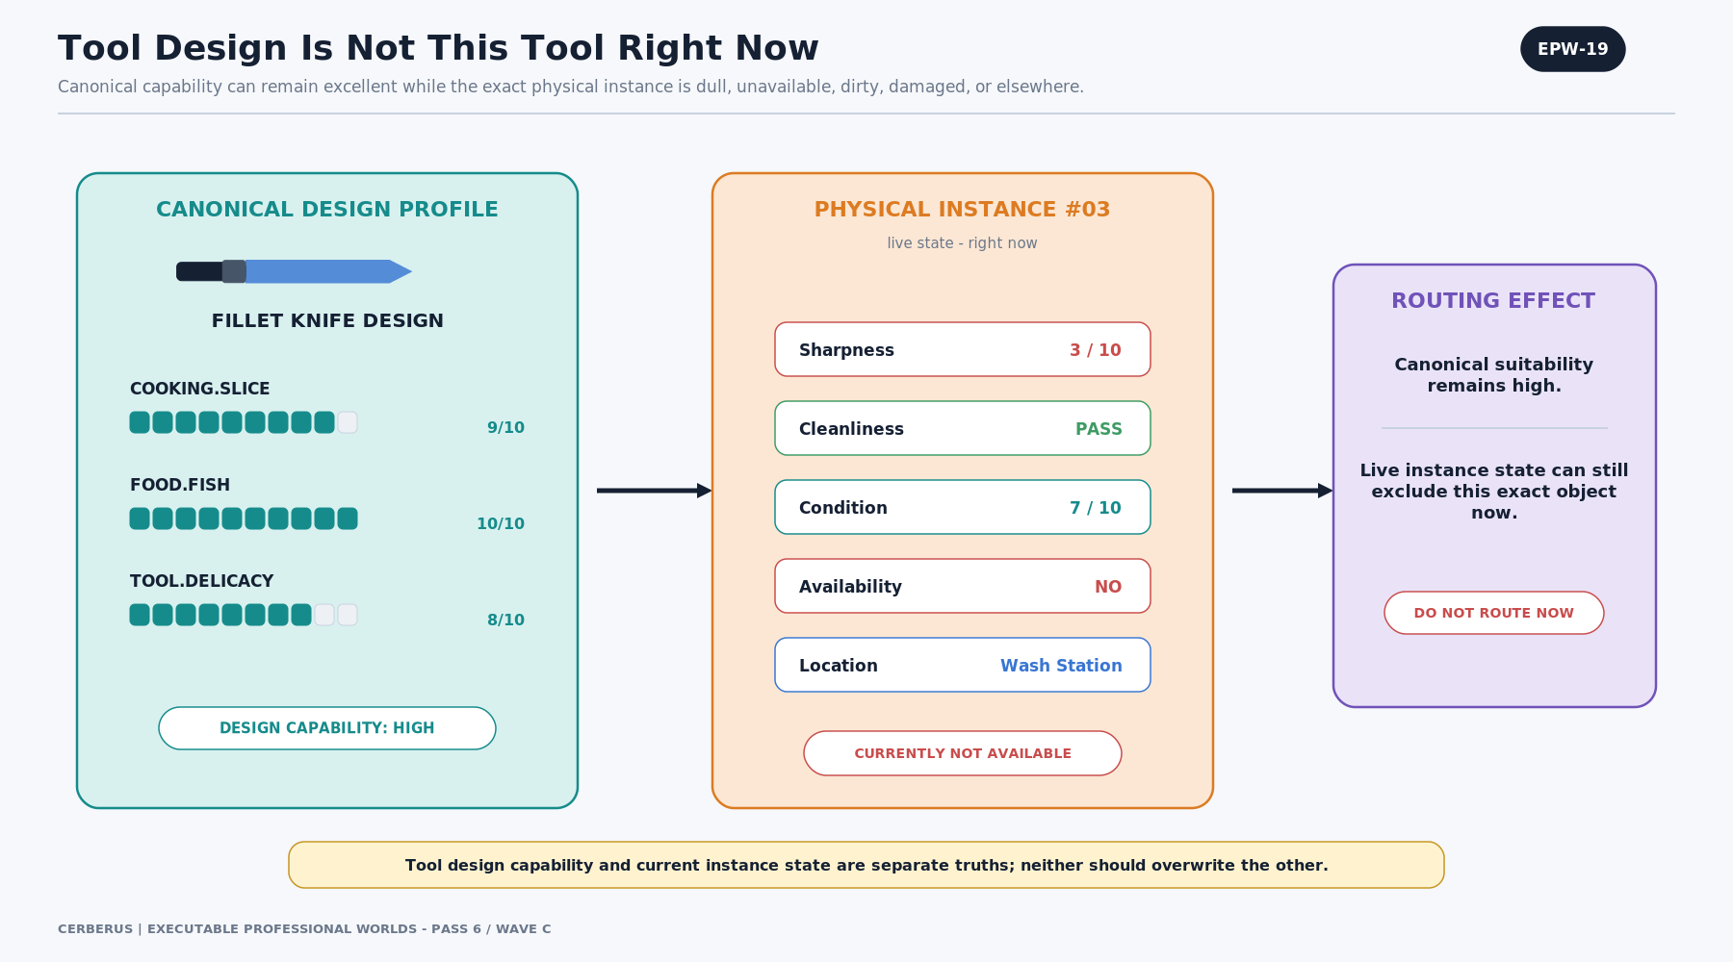
Figure EPW-19. Tool Design Is Not This Tool Right Now
A fillet-knife design can remain highly suitable for slicing fish and delicate handling even while Fillet Knife #03 is dull, unavailable, dirty, damaged, or at the wash station. Live state can exclude an otherwise ideal tool without changing the design profile.
This allows maintenance, logistics, cleanliness, condition, and location to affect routing while preserving stable professional semantics for the tool type.
ARCHITECTURE LAW | Tool design capability and current instance state are separate truths; neither should overwrite the other.

EPW-20 — Contextual Affordance Is Derived
Contextual Affordance is the derived answer to a bounded routing question.
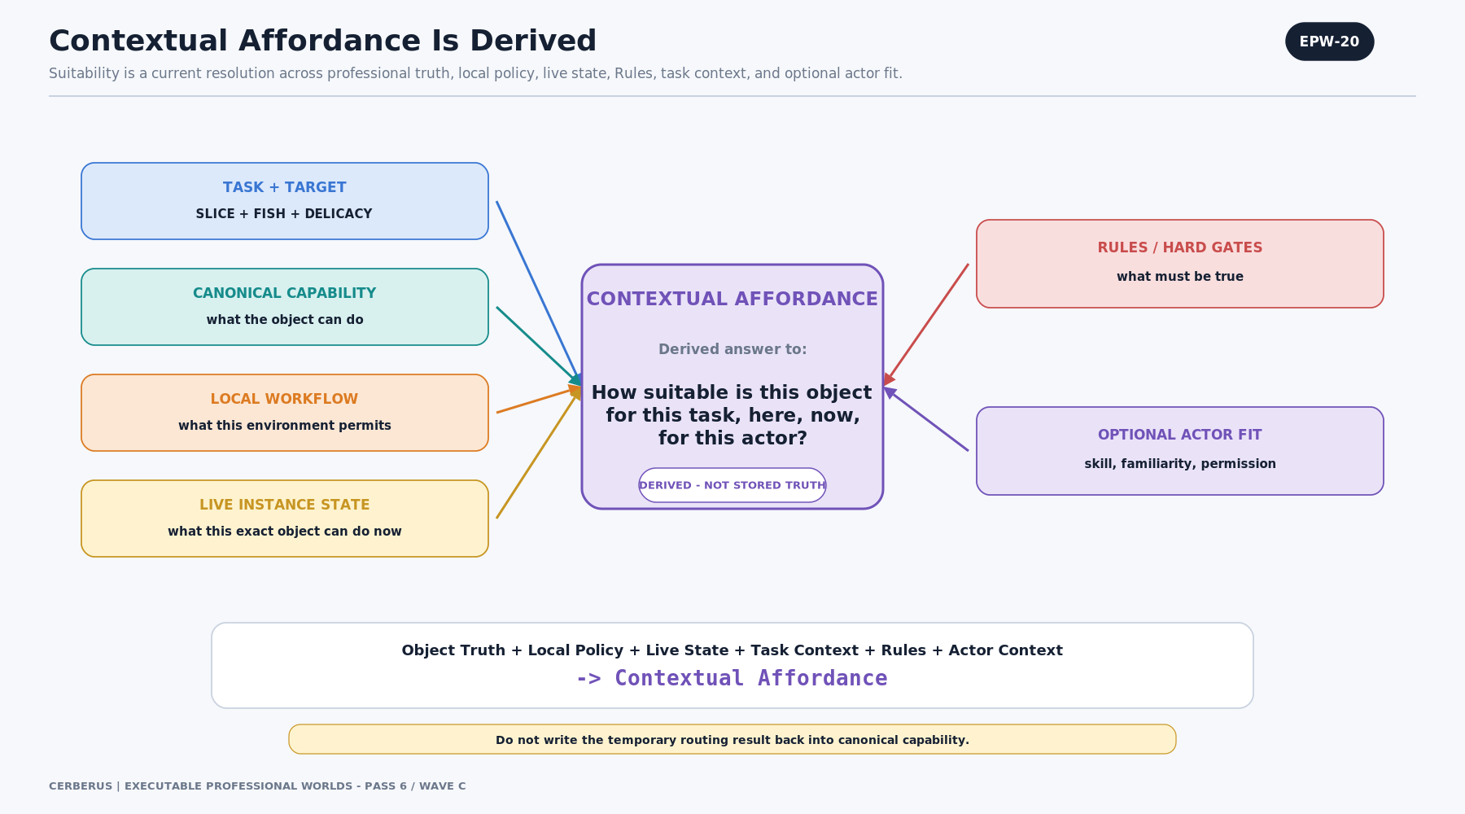
Figure EPW-20. Contextual Affordance Is Derived
The current Task and Target establish semantic demand. Canonical capability describes professional suitability. Local Workflow contributes environmental policy. Live Instance State contributes current availability and condition. Rules establish hard constraints. Optional Actor Fit contributes skill, familiarity, or permission.
The output answers: how suitable is this object for this task, here, now, for this actor? Because the answer depends on transient context, it should not be stored back into the canonical capability profile.
ARCHITECTURE LAW | Contextual Affordance is derived, not stored truth.

EPW-21 — Best Tool Does Not Always Mean Best Tool for This Actor
The intrinsically best tool may not be the best tool for the current actor and goal.
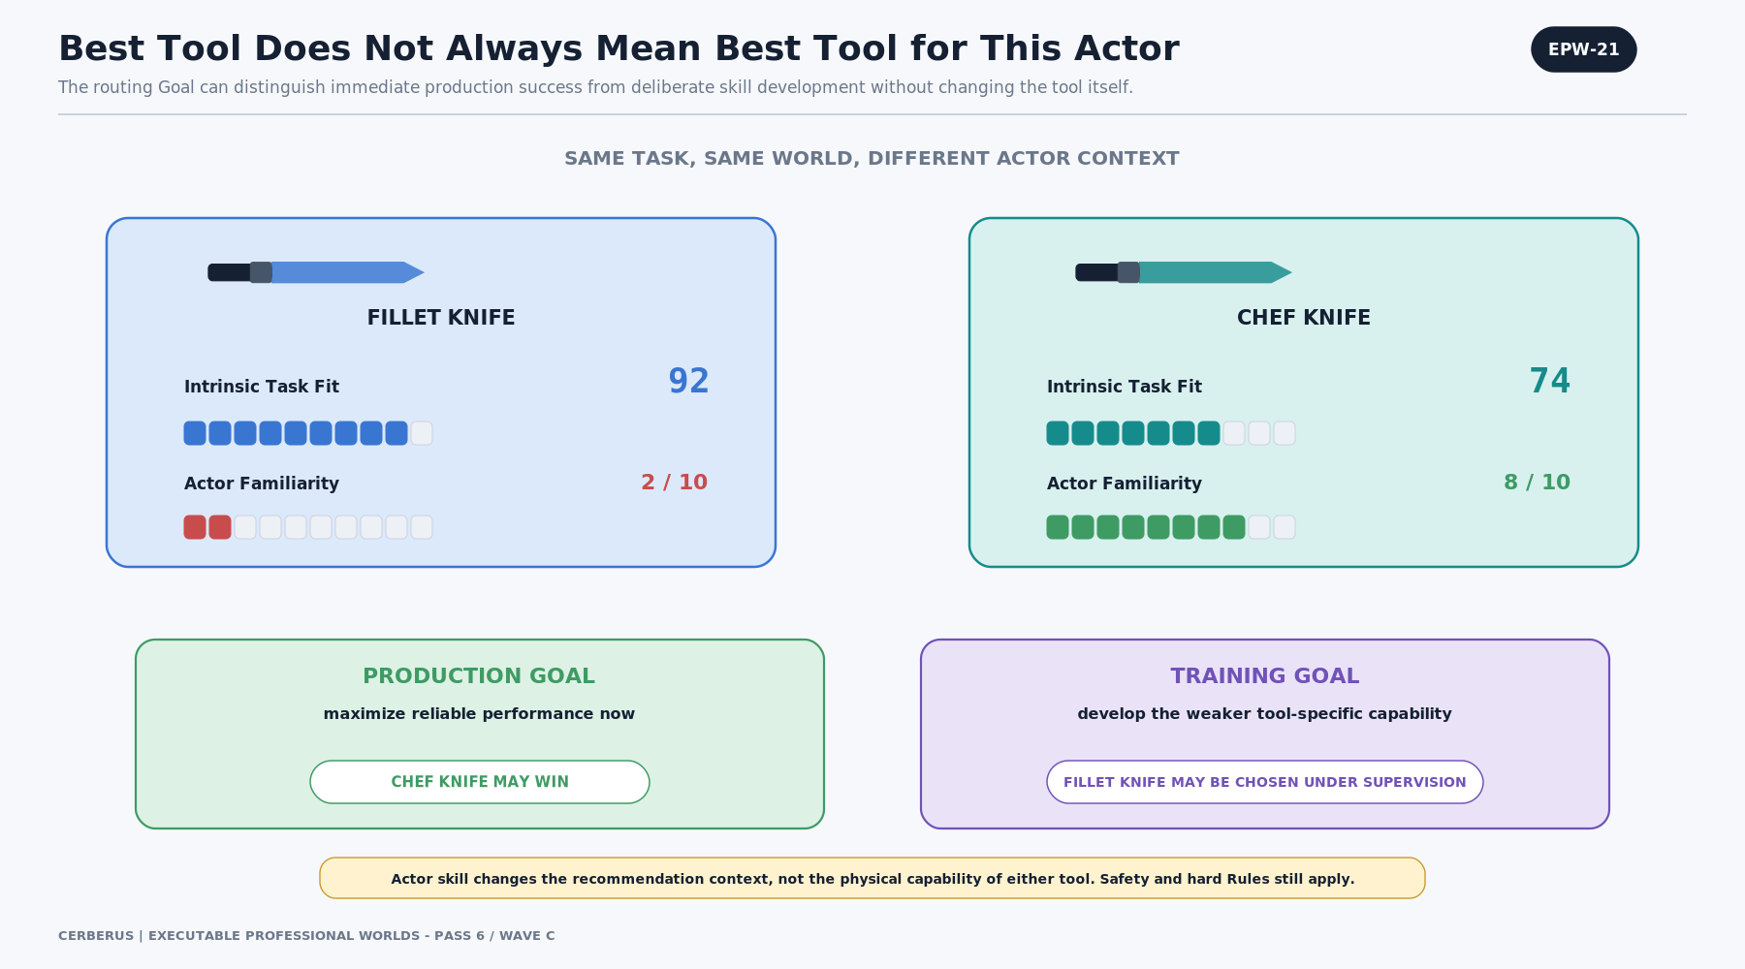
Figure EPW-21. Best Tool Does Not Always Mean Best Tool for This Actor
A fillet knife can have an intrinsic task fit of 92 while the actor has little familiarity with it; a chef knife can have a lower intrinsic fit but much greater actor familiarity. A production Goal may favor reliable immediate success, while a training Goal may deliberately select the weaker capability under supervision.
Actor Skill changes recommendation context, not the physical tool. Safety, permission, and hard professional Rules continue to constrain both production and training modes.
ARCHITECTURE LAW | Object capability ≠ actor capability. Goal logic may choose differently without mutating either.

7. The Semantic Affordance Router and Explainability
The routing engine is deliberately a transparent sequence of semantic stages rather than one opaque recommendation call. Each stage has a distinct owner and can be inspected, tested, replaced, or explained.
ROUTER SPINE | Semantic Demand → Requirement Query → Environment Search → Candidate Set → Canonical Capability → Hard Gates → Local Workflow → Instance State → Actor Context → Scoring Model → Contextual Affordance → Ranking → Explanation → Select / Hand Off

EPW-22 — The Semantic Affordance Router
The complete router keeps all major inputs on a stable vertical spine.
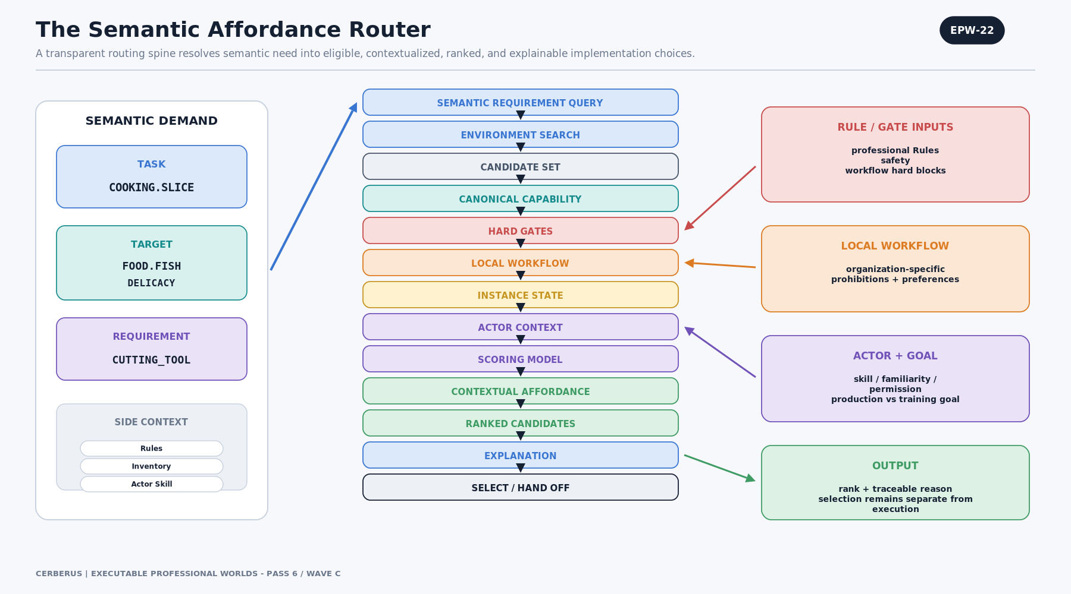
Figure EPW-22. The Semantic Affordance Router
Task, Target, and required object class produce the semantic requirement query. The environment search finds accessible candidate classes and instances. Capability records answer the demanded semantic dimensions. Rules and hard gates eliminate invalid candidates. Local Workflow, instance state, actor context, and the scoring Model contextualize the survivors.
The router ends in ranking, explanation, and selection or handoff. Selection is not automatic execution; an Operator or downstream action system still owns mutation of World State.
ARCHITECTURE LAW | Routing decides what should be selected; action authority decides what may actually be executed.

EPW-23 — Slice Fish: Rank the Available Kitchen
The slice-fish example demonstrates why canonical ranking and current recommendation must remain distinct.
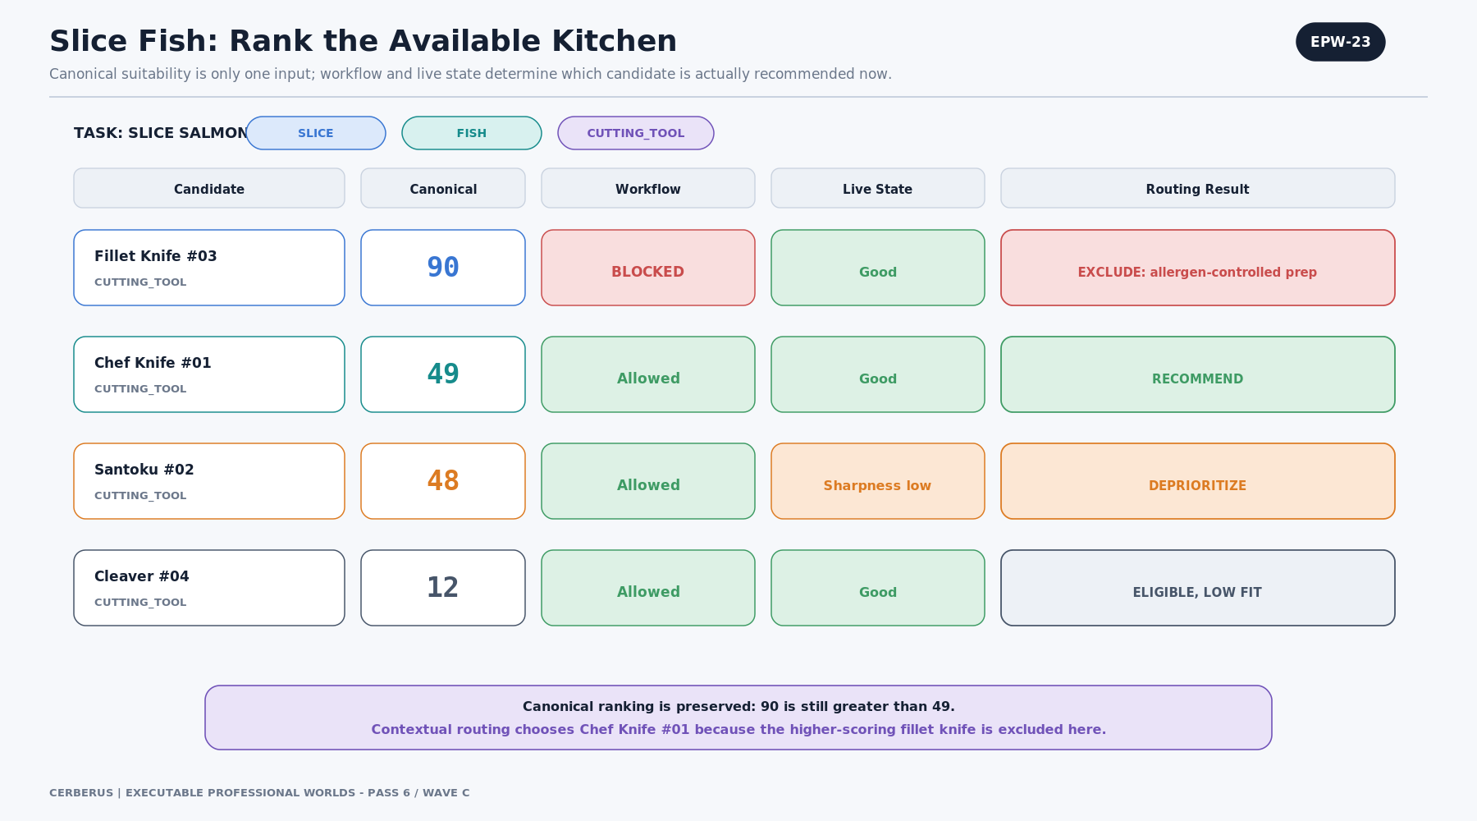
Figure EPW-23. Slice Fish: Rank the Available Kitchen
The fillet knife remains canonically strongest at 90. The chef knife scores 49, the santoku 48, and the cleaver 12. The local kitchen workflow excludes the fillet knife because it is reserved for allergen-controlled prep; the santoku is deprioritized because sharpness is low.
Chef Knife #01 becomes the highest remaining eligible candidate. Nothing about the current recommendation rewrites the canonical score of the fillet knife.
Candidate | Canonical | Workflow | Live State | Routing Result
Fillet Knife #03 | 90 | Blocked | Good | Exclude: allergen-controlled prep
Chef Knife #01 | 49 | Allowed | Good | Recommend
Santoku #02 | 48 | Allowed | Sharpness low | Deprioritize
Cleaver #04 | 12 | Allowed | Good | Eligible, low fit

EPW-24 — Why Was This Knife Recommended?
A recommendation should expose the trace that produced it.
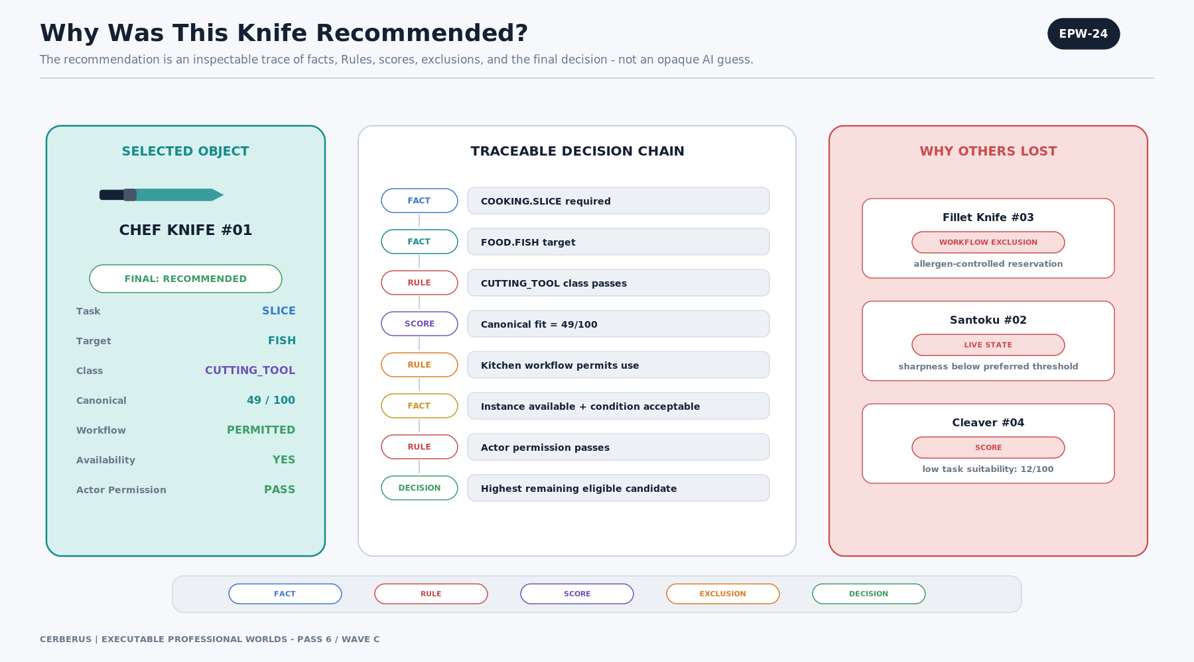
Figure EPW-24. Why Was This Knife Recommended?
The trace distinguishes facts such as COOKING.SLICE and FOOD.FISH, Rules such as CUTTING_TOOL class or local workflow permission, the canonical task score, explicit exclusions, and the final decision. This lets an operator, learner, auditor, or AI inspect which factor actually controlled the result.
Natural-language explanation can summarize this trace, but the trace itself should remain data-shaped and reproducible rather than being reconstructed after the fact from an opaque model output.
ARCHITECTURE LAW | Explainability is provenance of decision, not merely persuasive prose.

8. Physical Objects, Simulation, and Cross-Professional Reuse
Because the router is semantic rather than tied to one user interface, the same contract can resolve simulated objects or bound physical objects. The binding mechanism only needs to establish object identity and provide the governed profiles required by the router.

EPW-25 — The Same Router Can Bind to Physical Objects
A physical inventory can expose real object instances to the same semantic router.
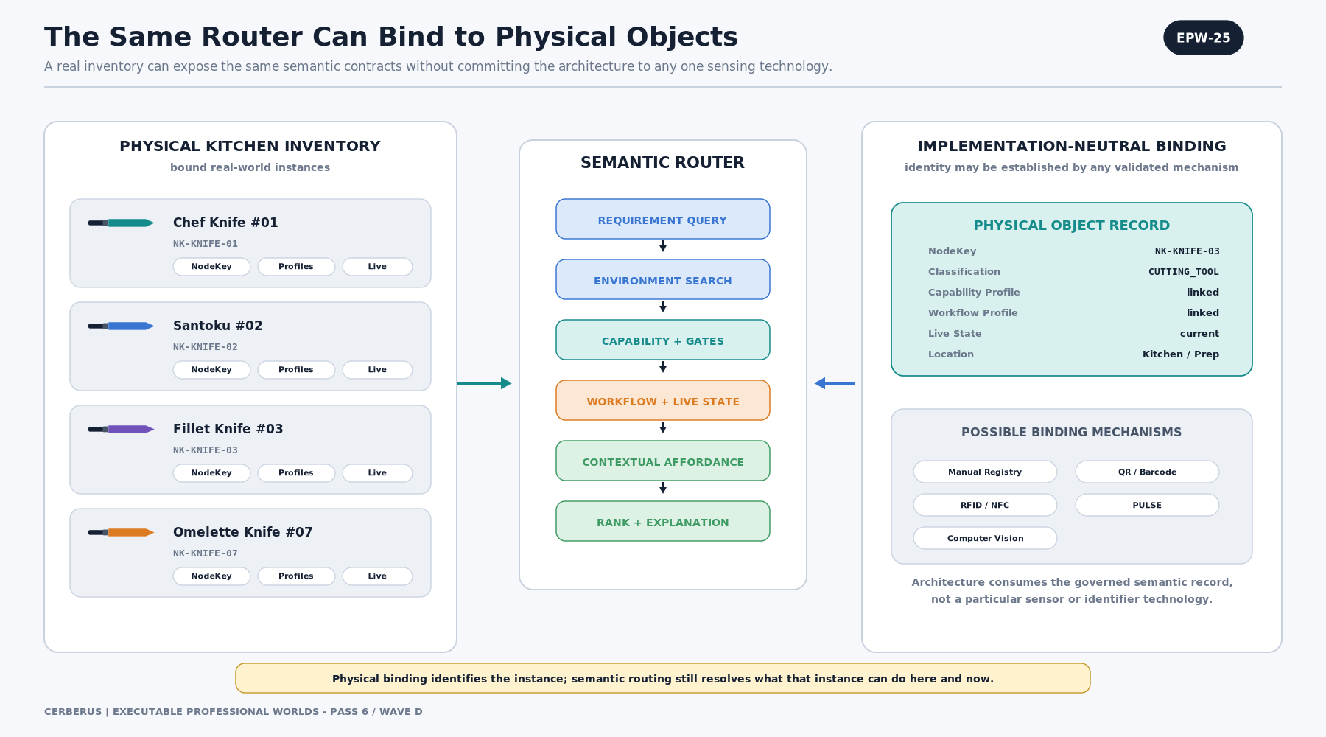
Figure EPW-25. The Same Router Can Bind to Physical Objects
Each object can carry a NodeKey or equivalent stable identity, classification, canonical capability profile, Local Workflow profile, current live state, and location. The router queries those records rather than relying on the display name of the tool.
Binding technology remains implementation-neutral. Manual registry, QR or barcode, RFID/NFC, computer vision, PULSE, or another validated mechanism can establish identity without changing the routing contract.
ARCHITECTURE LAW | Physical binding identifies the instance; semantic routing still decides what that instance can be used for here and now.

EPW-26 — One Routing Grammar Across Professions
The routing grammar is domain-general even though professional semantics remain domain-specific.
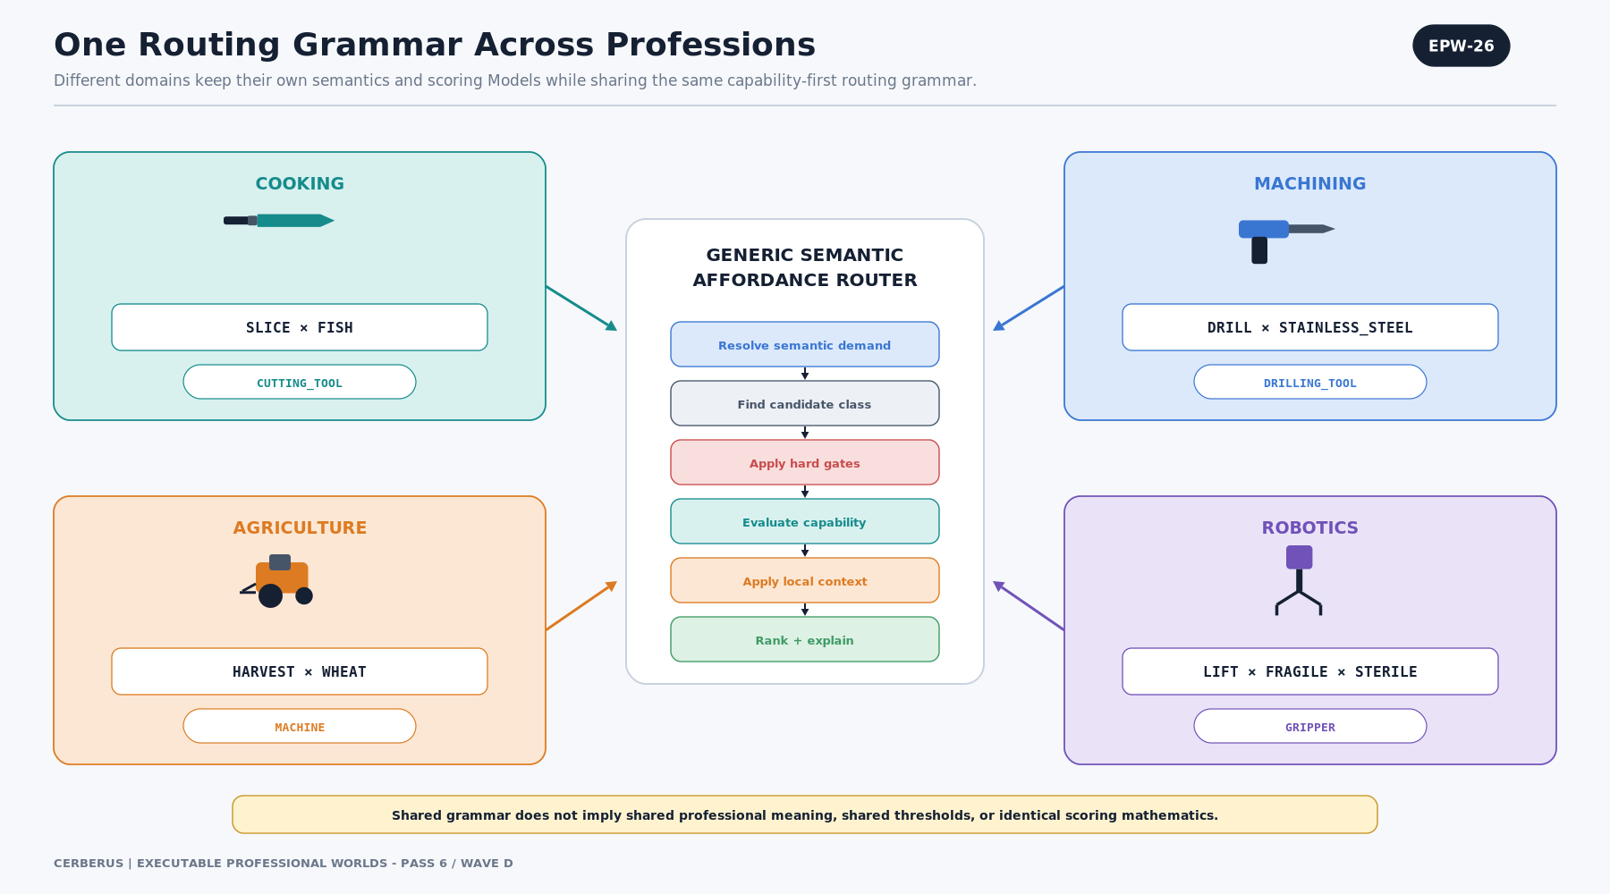
Figure EPW-26. One Routing Grammar Across Professions
Cooking can request SLICE × FISH → CUTTING_TOOL. Machining can request DRILL × STAINLESS_STEEL → DRILLING_TOOL. Agriculture can request HARVEST × WHEAT → MACHINE. Robotics can request LIFT × FRAGILE × STERILE → GRIPPER.
The shared grammar is: resolve demand, find candidates, apply hard gates, evaluate capability, apply local context, rank, and explain. The professions do not have to share semantic meanings, thresholds, safety Rules, or scoring mathematics.
ARCHITECTURE LAW | Shared routing grammar does not imply shared professional meaning.

EPW-27 — Simulation and Reality Share Professional Semantics
Simulation and reality can share professional semantic identities without claiming identical fidelity.
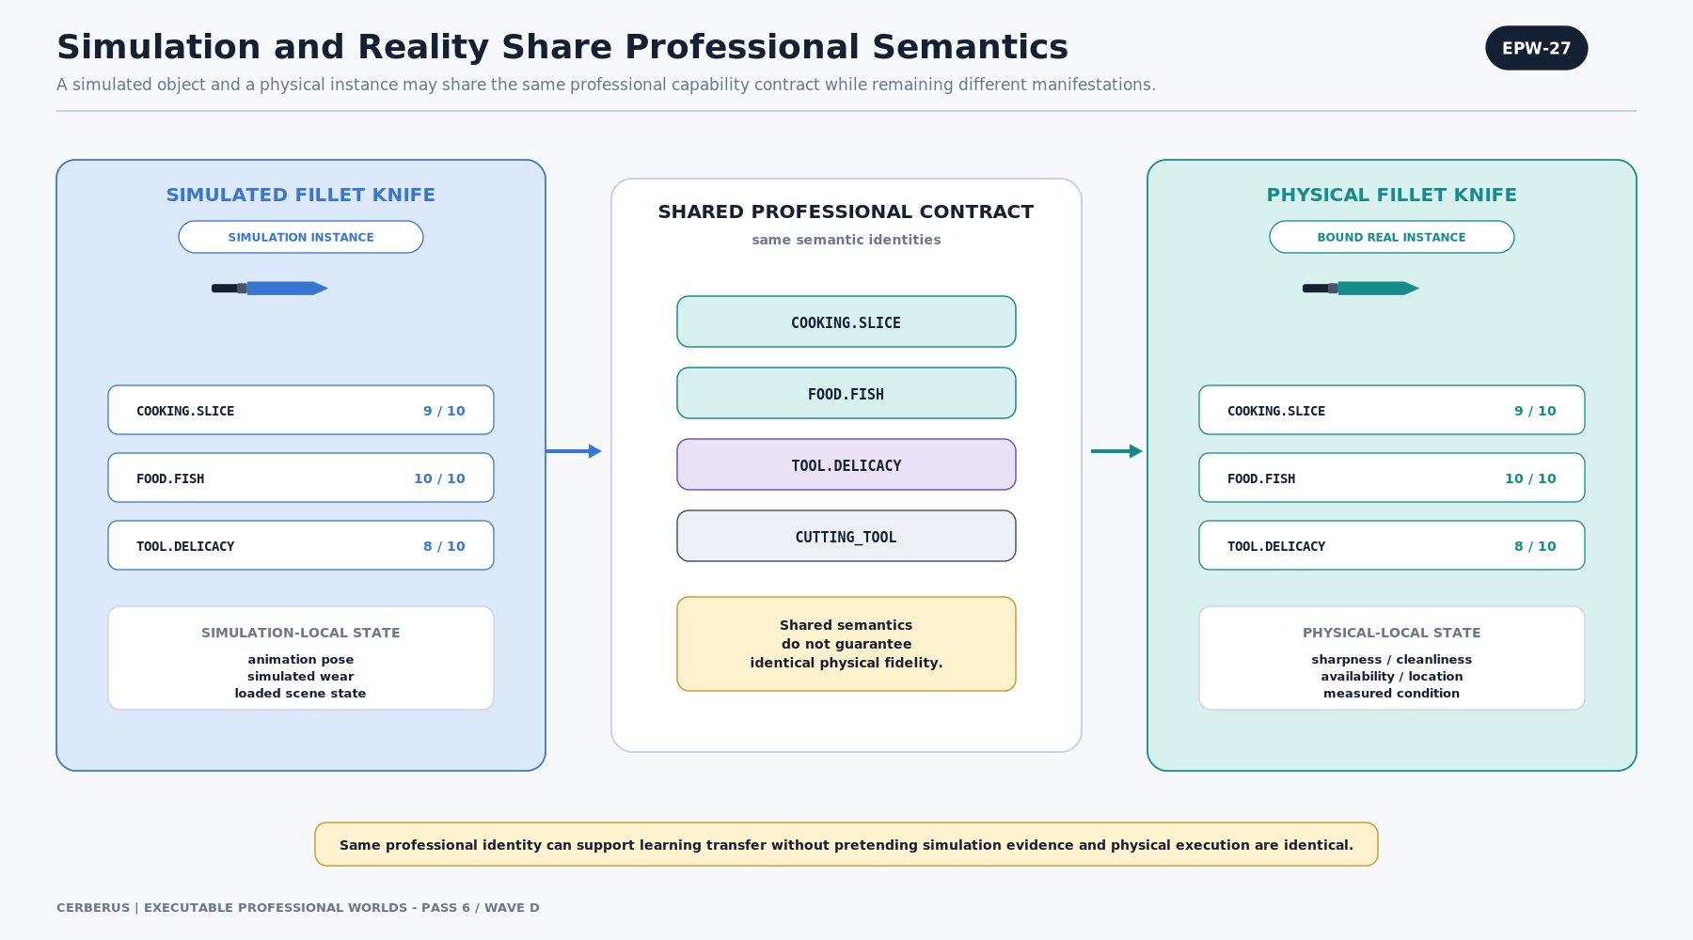
Figure EPW-27. Simulation and Reality Share Professional Semantics
A simulated fillet knife and a bound physical fillet knife can both declare COOKING.SLICE, FOOD.FISH, TOOL.DELICACY, and CUTTING_TOOL. The simulated instance may have animation-local state; the physical instance may have sharpness, cleanliness, wear, location, or maintenance state.
This is the critical bridge for training transfer: the learner can rehearse the same professional reasoning structure in simulation, while the system still records that physical execution and simulation evidence have different fidelity.
ARCHITECTURE LAW | Shared semantic contract ≠ identical physical fidelity.

9. FASK Projection and Transferable Reasoning
Fantastically Altered Semantic Kernels (FASK) allow the same professional substrate to support fictional worlds without silently changing what the professional semantics mean. Fantasy state, alternate Rules, translations, and fictional relationships are explicit overlays or branches. The professional substrate remains inspectable beneath them.

EPW-28 — FASK Extends the Professional Substrate
FASK attaches fictional mechanics above the canonical professional substrate.
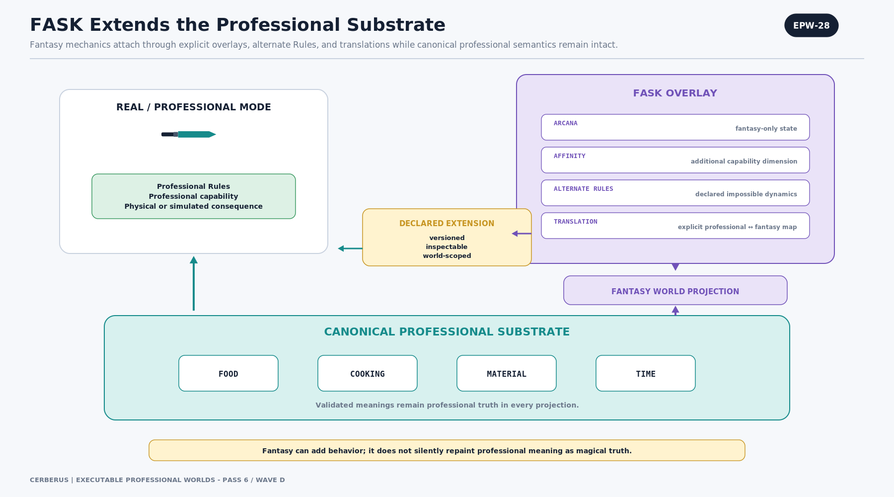
Figure EPW-28. FASK Extends the Professional Substrate
FOOD, COOKING, MATERIAL, TIME, and other professional Kernels retain their validated meanings. The FASK overlay can add ARCANA, AFFINITY, declared impossible dynamics, or explicit professional-to-fantasy translations and then project a fantasy World.
This means a professional update can improve the shared substrate without requiring fantasy authors to reinvent basic food, materials, time, logistics, or tool semantics. Fictional mechanics remain versioned extensions rather than hidden corruption of canonical truth.
ARCHITECTURE LAW | Fantasy can add behavior; it does not silently repaint professional meaning as magical truth.

EPW-29 — Fantasy Can Preserve Transferable Reasoning
A fantasy reskin can preserve professional reasoning even when it introduces fictional dimensions.
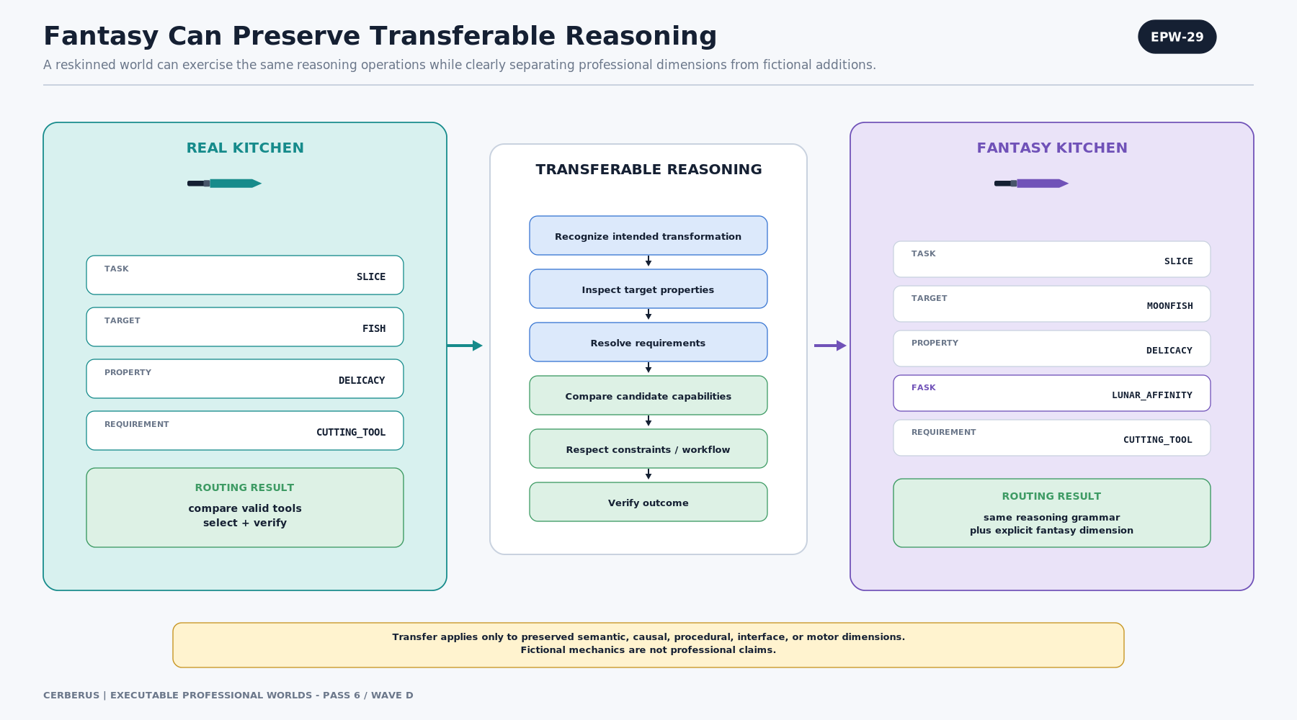
Figure EPW-29. Fantasy Can Preserve Transferable Reasoning
A real kitchen task may route SLICE × FISH × DELICACY. A fantasy kitchen may route SLICE × MOONFISH × DELICACY × LUNAR_AFFINITY. The professional reasoning operations can still be shared: identify the transformation, inspect target properties, resolve requirements, compare capabilities, respect constraints, and verify the outcome.
Transfer claims must remain dimension-bounded. A fantasy projection may preserve semantic, causal, or procedural reasoning while failing to preserve physical interface, motor execution, stress, or real-equipment fidelity.
ARCHITECTURE LAW | Fantasy transfer is claimed only along the professional dimensions the projection actually preserves.

10. Competency Evidence and Skill Projection
When Tasks are executable and outcomes are observable, work itself can become a source of competency evidence. The architecture can record not just whether a learner selected the right answer, but which semantic requirements they recognized, which invalid candidates they rejected, whether they respected workflow and Rules, and whether they verified the resulting state.

EPW-30 — Work Produces Competency Evidence
A professional Task can produce typed evidence as part of normal participation.
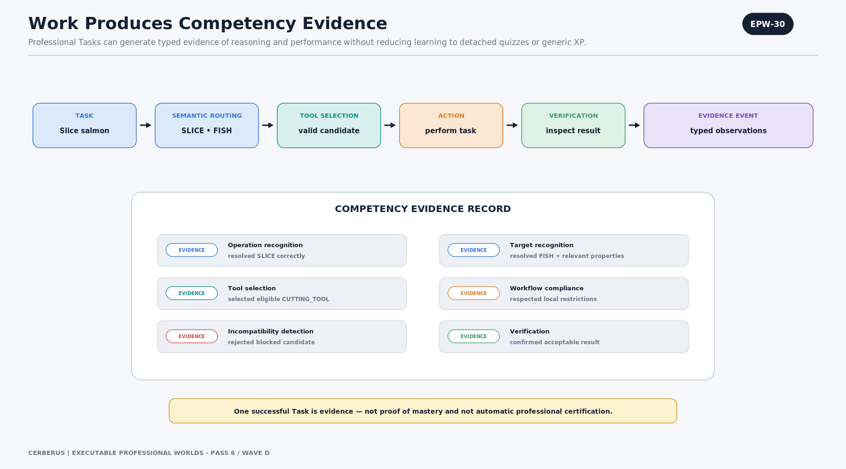
Figure EPW-30. Work Produces Competency Evidence
The learner receives a task, resolves the semantic demand, selects a valid tool, performs or proposes the action, and verifies the result. Evidence can then be attached to operation recognition, target recognition, tool selection, workflow compliance, incompatibility detection, and verification.
One successful task is evidence, not mastery. The architecture supports accumulation across repeated tasks, target classes, tool classes, contexts, error detection, correction, and verification.
ARCHITECTURE LAW | Doing the work can be the assessment instrument, but one successful performance is not automatically a competency claim.

EPW-31 — Skill Level Is a Projection of Evidence
A compact Skill level can be retained for fast runtime eligibility while evidence remains the provenance behind it.
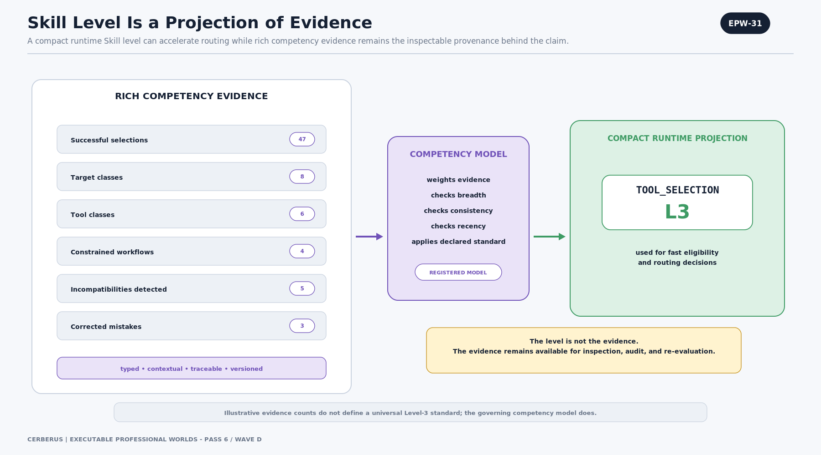
Figure EPW-31. Skill Level Is a Projection of Evidence
A registered Competency Model evaluates rich evidence and can project a compact state such as TOOL_SELECTION L3. The Model can require breadth, consistency, recency, context diversity, error correction, or other profession-specific criteria.
The level is useful for routing and access decisions, but it should not replace the evidence graph or imply a universal standard unless the governing competency authority explicitly defines one.
ARCHITECTURE LAW | Skill Level is the compact operational projection. Competency Evidence is the provenance behind the claim.

11. The Executable Professional World Cycle
The complete architecture is a compounding loop. Professional knowledge becomes structured semantics; structured semantics become an executable World; the World supports simulation, real-world binding, and explicit fantasy projections; Tasks generate routing decisions and actions; consequences generate competency evidence; evidence changes learner knowledge, Skill, and accessible affordances; and repeated difficulties can expose corpus, Model, interface, simulation, or sequencing problems for human review.

EPW-32 — Executable Professional World Cycle
The closing architecture shows how the pieces become one professional-development system.
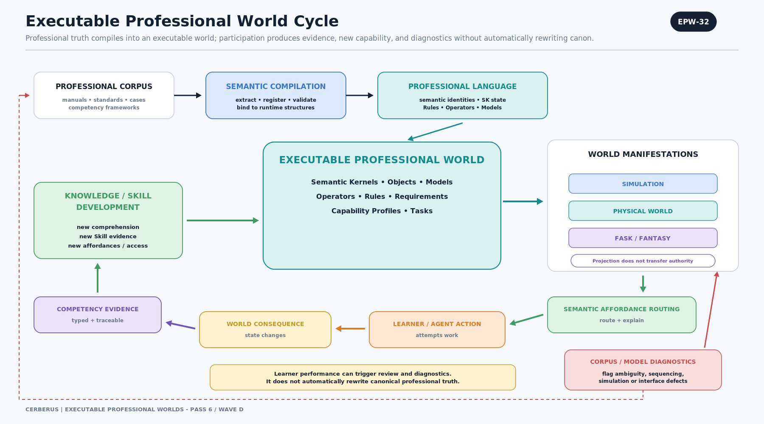
Figure EPW-32. Executable Professional World Cycle
Professional corpus and semantic compilation produce the language and executable professional world. That world can manifest as simulation, physical-world binding, or FASK/fantasy projection. Semantic Affordance Routing connects learner or agent intent to eligible implementations; actions change World State; verified consequences produce competency evidence; evidence informs knowledge and Skill development; and new capability opens new Tasks.
Diagnostic feedback is intentionally review-oriented. Repeated learner or system difficulty may flag a bad semantic definition, missing prerequisite, unrealistic Model, poor interface, or genuinely difficult competency, but those observations do not automatically mutate canonical professional truth.
ARCHITECTURE LAW | Professional development produces reusable truth. Simulation, routing, assistance, learning, and fantasy are consumers of that governed substrate.

12. Formal Model

12.1 Professional Semantic World
A compact representation of an executable Professional Semantic World can be written as:
P = (Σ, N, K, O, R, M, Q, C)

Symbol | Meaning
Σ | Professional semantic language and identity space
N | Entities / NodeKeys and addressable world objects
K | Semantic Kernels and typed state spaces
O | Operators / attempted professional transformations
R | Rules and Rulesets constraining allowable dynamics
M | Models used for interpretation, derivation, simulation, and scoring
Q | Tasks and task/dependency structures
C | Competency contracts and evidence models

12.2 Learner State
Lₜ = (Cₜ, Kₜ, Sₜ, Eₜ, Aₜ)

Component | Meaning
Cₜ — Comprehension | Semantic routes and distinctions the learner can meaningfully resolve.
Kₜ — Knowledge | Facts, procedures, relationships, and known resources.
Sₜ — Skill | Capabilities the learner can reliably execute under the declared evidence Model.
Eₜ — Evidence | Observed performance history supporting current competency claims.
Aₜ — Access | Tools, environments, Tasks, mentors, permissions, and projection layers currently available.

The separation prevents “understands the word,” “knows a relevant procedure,” “can execute it reliably,” and “has demonstrated it across varied contexts” from collapsing into one generic knowledge flag.

12.3 Fantasy Projection
F = P ⊕ (FASK, R_f, T, Π)

The operator ⊕ means declared extension rather than semantic replacement. FASK contributes fantasy overlays; R_f contributes alternate World Rules; T contributes explicit translation manifests; Π contributes perceptual and narrative projection. The professional substrate P remains separately inspectable.

12.4 Routing Demand and Candidate Set
Let T be the Task and X its target. The current demanded capability dimensions are D(T,X). Let R be the required object class and O_R the accessible objects satisfying that class. Hard gates G determine the eligible subset:
O* = { o ∈ O_R | G(o, T, X, e, t, a) = 1 }

Here e represents the environment, t the current time/state context, and a the actor when actor-specific gating is relevant.

12.5 Canonical Capability Score
For a declared strict-conjunction Model over 0–10 capability dimensions, canonical task-specific suitability can be represented as:
S_C(o) = 100 × ∏[d ∈ D] ( C(o,d) / 10 )

C(o,d) is the canonical capability claim of object o against semantic dimension d. This equation is illustrative and applies only when the registered Model declares multiplication appropriate.

12.6 Contextual Routing Score
S_R(o) = f( S_C(o), W(e,o,D), I(o,t), A(a,o), R )

W is Local Workflow, I is live instance state, A is optional actor compatibility, and R represents applicable Rules. The function f is explicitly registered and versioned. Local Workflow modifies routing, not canonical capability.

12.7 Learning Event
(Lₜ, Wₜ, Q) → Action → ΔW → Outcome → Evidence → Lₜ₊₁

A learner encounters Task Q in World Wₜ, acts, produces a World delta and outcome, generates typed evidence, and may thereby change the learner state. This loop supports both realistic and declared fantasy projections as long as evidence claims remain bounded by the fidelity of the environment.

13. Governance, Provenance, and Versioning
A routing engine becomes dangerous or misleading when a score, identity, or policy loses its owner. Every professional claim therefore needs explicit provenance and scope. The architecture should preserve the source authority behind capabilities, the mapping version behind semantic resolution, and the local authority behind Workflow overrides.
Data Element | Minimum Governance Context
Semantic Identity | Stable identity, Kernel/namespace, mapping version, definition authority
Capability Score | Object/object type, semantic dimension, score, scale, profile class, source, version, conditions
Hard Gate | Rule owner, condition, scope, version, failure consequence
Local Workflow | Environment/organization owner, targeted semantic identity, policy type, value, reason, effective period
Instance State | Object instance identity, measurement/source, timestamp, validity/quality
Actor Fit | Actor or role, Skill/familiarity/permission source, scope, recency
Routing Result | Task, target, candidate set, model version, gates, exclusions, ranking, explanation trace, timestamp
Competency Evidence | Task context, outcome, verification method, environment fidelity, evidence type, provenance, date

13.1 Mapping Stability
Bit addresses can change between mapping versions while semantic identities remain stable. A stored state therefore needs the BitWord/Language Pack identity and mapping version required to reconstruct the intended semantics. Downstream capability or workflow records should route by stable semantic identity rather than fragile display text or raw address alone.

13.2 Capability Authority
A manufacturer score, laboratory measurement, professional-standard rating, local expert assessment, and user preference are not automatically equivalent. Capability Profiles should allow multiple scoped claims and a resolution policy that declares which authority is valid for the current Task and World.

13.3 Local Workflow Authority
Local Workflow is intentionally allowed to narrow professional use, but its authority is bounded to its environment or organization. A kitchen may reserve a knife for omelette work; that does not become a universal fact about the knife. Workflow records should therefore carry environment ownership, reason, effective period, and whether the rule is a hard block or soft preference.

13.4 Diagnostics Without Canon Mutation
Repeated learner failures, odd recommendations, or simulation inconsistencies can generate diagnostic events. These events may identify a missing prerequisite, poor semantic definition, unrealistic Model, incorrect score, interface defect, or genuine competency difficulty. Diagnostics should trigger review and evidence gathering, not automatic changes to canonical professional truth.

14. Implementation Guidance

14.1 Minimal Routing Data Contract
Layer | Example Fields
Task | Task ID, Operation semantic identity, Target ID, Goal, required object class
Target | Target semantic identities, live properties, relevant state, condition
Object | NodeKey, classification, canonical capability profile
Workflow | Environment ID, semantic identity, policy type, modifier/gate, reason
Instance | Condition, availability, cleanliness, sharpness, location, timestamp
Actor | Role, permissions, Skills, familiarity, training/production Goal
Rules | Mandatory gates, thresholds, prohibitions, safety constraints
Model | Scoring Model ID/version, required dimensions, normalization, tie-break policy
Trace | Candidate set, exclusions, scores, final rank, explanation factors, selected object

14.2 Candidate Lifecycle
A candidate should move through explicit states rather than appearing directly in a ranked list: discovered → class-matched → gate-evaluated → eligible → scored → contextualized → ranked → selected/handed off. Alternate exits should preserve the reason for exclusion: canonical incompatibility, professional Rule, Local Workflow, live state, actor permission/Skill, or missing data policy.

14.3 Binding Real Objects
The router should consume a governed semantic object record, not a sensing technology. The object may be identified manually, through QR/barcode, RFID/NFC, computer vision, PULSE, or another validated mechanism. This keeps the professional routing model stable even as binding technologies change.

14.4 Scoring Model Registry
Model Class | Use
Strict conjunction | All scored dimensions jointly matter; multiplicative example used in this paper.
Weighted preference | Some dimensions matter more than others after gates pass.
Bottleneck / minimum | The weakest required dimension dominates suitability.
Threshold | Candidate passes only if each declared dimension exceeds its threshold.
Lexicographic | Primary criteria dominate; secondary criteria break ties.
Hybrid | Hard gates first, then one or more ranking Models.

The scoring Model must be registered, inspectable, and versioned. A ranking value without its Model and input dimensions is not a meaningful professional claim.

14.5 Custom Semantic Tags
Custom tags are intentionally open-ended. Delicacy, Bone Work, Precision, Wet Grip, Frozen Material, Fibrous Material, Small-Hand Control, Sterile Handling, or any other useful dimension can be added as long as ownership and scope are explicit. Stable professional concepts should remain canonical; broadly reusable additions should become registered extensions; organization- or user-specific distinctions should remain local.

14.6 Performance and Caching
A practical implementation can pre-index object classes, cache semantic identity resolution, and precompute frequently used canonical capability components while still keeping the final Contextual Affordance derived from current Workflow, instance state, Rules, actor context, and Task. Caching may accelerate evaluation; it must not erase the separation between stable and live state.

15. Formal Design Laws
Law | Definition
Professional Truth Before Routing | Canonical professional meaning and capability originate in governed sources; routing consumes those claims rather than manufacturing them.
Tasks Request Capabilities, Not Implementations | When professional choice is open, Tasks specify what is needed; environments resolve available implementations.
Explicit Binding Exception | If a standard or validated procedure mandates a specific object or device, explicit binding is permitted and must remain visible.
Targets Contribute Requirements | Relevant target state can activate capability dimensions needed by the current transformation.
Semantic Identity Routes the System | Versioned SK state resolves to stable semantic identity before downstream capability, Rule, Task, and knowledge routing.
Capability Is Multidimensional | Objects expose independent capability claims against reusable semantic dimensions.
Composition Beats Combination Tables | Ordinary task-target combinations are composed at runtime; specialized interaction Models are registered only where needed.
Hard Gates Precede Soft Ranking | Mandatory safety, Rule, permission, workflow, availability, and threshold failures cannot be averaged away.
Zero, N/A, and Missing Are Distinct | Explicit inability, inapplicability, and unknown data are different states with different routing policy.
Extensible Semantics Are Governed | Canonical, registered-extension, and local semantic identities may coexist without silently changing ownership.
Canonical Capability ≠ Local Workflow | What an object can do is separate from what an environment permits, prefers, reserves, or forbids.
Intrinsic Zero ≠ Workflow Zero | The same numeric zero can represent object limitation or local exclusion; provenance must remain visible.
Instance State ≠ Design Capability | Live condition, location, availability, cleanliness, or wear do not rewrite canonical design capability.
Actor Capability ≠ Object Capability | Skill, familiarity, permission, or training Goal change recommendation context, not the object’s physical truth.
Contextual Affordance Is Derived | Suitability here and now is computed from current Task, Target, Rules, Workflow, state, and actor context; it is not universal object truth.
Scoring Models Are Explicit | A score is meaningful only with its declared Model, dimensions, scale, and version.
Recommendations Are Explainable | Final selection should be reconstructable from facts, Rules, scores, exclusions, and decision policy.
Simulation and Reality May Share Contracts | Common professional semantics can support both simulated and physical objects without implying identical physical fidelity.
FASK Extends, It Does Not Rewrite | Fantasy overlays, alternate Rules, and translations remain explicit extensions of canonical professional semantics.
Performance Produces Evidence, Not Automatic Mastery | Task outcomes can support competency claims, but one result does not automatically establish mastery or certification.
Skill Level Is a Projection of Evidence | Compact runtime Skill states remain traceable to richer performance evidence and the competency Model that produced them.
Diagnostics Trigger Review, Not Canon Mutation | Observed failures can flag issues for professional review but do not silently rewrite authoritative knowledge.

16. Conclusion
Executable Professional Worlds turns professional knowledge from passive reference into governed World structure. Semantic Kernels provide stable coordinates; Tasks and Targets express what is needed; objects expose capability against those coordinates; hard Rules and gates establish eligibility; Local Workflow narrows use without rewriting truth; live Instance State says what the exact object can do now; actor context and Goal refine the choice; explicit Models calculate task-specific suitability; and Contextual Affordance provides a derived, explainable answer to what should be used here and now.
The same mechanism can route a recipe to a real knife, a simulated mechanic to a tool, a robot to a gripper, a learner to a professionally valid action, or a fantasy character to an explicitly altered implementation while preserving the professional substrate underneath. That convergence is the strategic advantage: improvements to the professional semantic world compound across simulation, assistance, training, AI agency, robotics, and fantasy rather than fragmenting into unrelated systems.
CLOSING PRINCIPLE | Build the profession once. Teach it through worlds. Route it into reality. Reskin the worlds endlessly—without losing the professional truth underneath.

Appendix A — Glossary
Term | Definition
Canonical Capability | Governed professional claim about what an object or object type is suited to do against a semantic dimension.
Capability Dimension | Semantic coordinate against which an object exposes a bounded capability claim.
Contextual Affordance | Derived answer to how suitable a specific object is for a specific Task, target, environment, time, and optionally actor.
Explicit Object Binding | A Task or procedure that requires a specific implementation rather than an open capability search.
Hard Gate | Mandatory eligibility condition that is resolved before ranking.
Local Workflow | Environment- or organization-owned policy describing permitted, prohibited, discouraged, preferred, or reserved uses.
Semantic Affordance Routing | Pipeline that resolves semantic demand into eligible, contextualized, ranked, and explainable implementations.
Semantic Identity | Stable professional meaning resolved from a versioned physical SK representation.
Semantic Requirement Query | Current set of semantic capabilities demanded by the Task, target, and applicable context.
Live Instance State | Current state of the exact object instance: condition, cleanliness, sharpness, availability, location, wear, and related live properties.
Registered Extension | Reusable governed semantic identity that extends the stable professional surface without being part of the original canonical Kernel.
Local Semantic | Bounded organization-, world-, manufacturer-, or user-specific semantic identity.
Competency Evidence | Typed, provenance-bearing observation of performance that may support a Skill or competency claim.
Skill Level | Compact operational projection derived from evidence by a registered competency Model.
FASK | Fantastically Altered Semantic Kernel; explicit fantasy extension or overlay that preserves separation from canonical professional semantics.

Appendix B — Minimal Routing Trace Contract
A minimal trace should be sufficient to reconstruct why a recommendation occurred without relying on hidden prose or model intuition.
Trace Element | Required Content
Task | Task ID; Goal; requested operation
Target | Target ID; semantic target class; relevant live properties
Requirement Query | Required object class; requested semantic dimensions
Candidate Discovery | Environment/Inventory ID; candidate object IDs
Canonical Capability | Capability claims used for each candidate; source/version
Hard Gates | Gate ID; pass/fail; reason; authority
Local Workflow | Policy ID; block/bias/preference; reason; environment owner
Instance State | State values; timestamp; validity/quality
Actor Context | Skill/familiarity/permission if used; Goal mode
Scoring Model | Model ID/version; dimensions; normalized inputs; result
Ranking | Ordered eligible candidates; tie-break policy
Exclusions | Candidate; exclusion layer; reason
Decision | Selected object or no valid candidate; handoff destination
Explanation | Data-shaped trace plus optional natural-language summary

Example: Slice Fish
Task asks for COOKING.SLICE on FOOD.FISH using a CUTTING_TOOL. Canonical capability ranks Fillet Knife #03 at 90, Chef Knife #01 at 49, Santoku #02 at 48, and Cleaver #04 at 12. Local Workflow excludes Fillet Knife #03 because it is reserved for allergen-controlled prep. Live state deprioritizes Santoku #02 because sharpness is below the preferred threshold. Chef Knife #01 becomes the highest remaining eligible candidate. The trace must preserve all of those facts simultaneously.

Appendix C — Non-Scope and Safety Boundary
The architecture is designed to make professional reasoning explicit, but it does not itself establish professional authority or physical competence. Implementations should preserve the following boundaries:
- No universal capability score is assumed. Scores require domain authority, source, conditions, scale, and version.
- No universal scoring formula is assumed. The multiplicative model in this paper is illustrative and registered, not mandatory.
- No physical sensing or binding mechanism is mandated. Identity may be established by multiple validated technologies.
- No simulation result automatically proves physical motor skill, equipment handling, stress performance, or safe real-world execution.
- No competency evidence automatically equals professional certification unless a recognized authority explicitly defines that equivalence.
- No Local Workflow policy may silently rewrite canonical professional capability or upstream professional Rules.
- No fantasy extension may be presented as a professional or physical claim merely because it shares the same substrate.
- No diagnostic signal from a game, learner, AI agent, or simulation should automatically mutate authoritative professional knowledge.
CERTIFICATION BOUNDARY | Simulation performance is evidence about performance under the declared simulation fidelity. It is not automatically equivalent to professional certification or verified physical execution.

CERBERUS | EXECUTABLE PROFESSIONAL WORLDS
Formal Architecture Specification v0.1
PASS 7 COMPOSITION • PASS 8 VERIFIED QA

