B4 - CERBERUS BIGFOOT

Semantic Codec and Footprint Architecture
  - Binary Semantic Construction | Fixed-Width Storage | Deterministic Code/Decode | Reader Resolution | Contextual Footprints
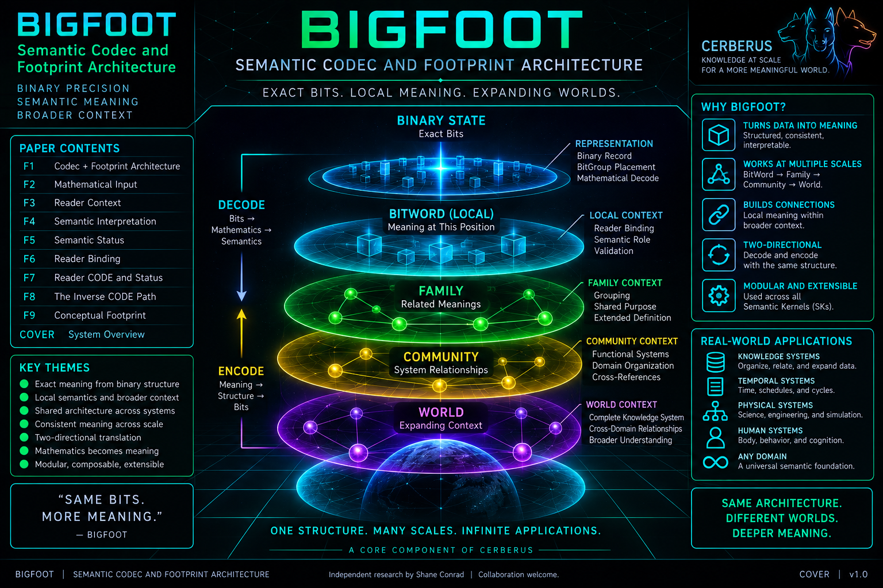
Version 1.0 | PASS 8 VERIFIED RELEASE
BIGFOOT preserves meaning across representation and across scale.

Executive Orientation
BIGFOOT is CERBERUS's governed semantic codec and semantic footprint architecture. It preserves exact semantic meaning across two different forms of expansion: representation and context. Across representation, it binds governed semantic constructions to compact binary state and deterministically recovers meaning through normalized placement, mathematical decoding, Reader interpretation, and semantic status. Across context, it preserves exact BitWord identity as that structure participates in Family, Community, and World membership.
The mature architecture joins the original BIGFOOT semantic geography to the newer executable machinery beneath it. The footprint model remains intact: Bits form BitGroups, BitGroups participate in BitWords, and BitWords belong within progressively broader semantic contexts. The newer machinery explains exactly where each reusable BitGroup occurs, how BitWord instances are stored, how binary slices are mathematically decoded, how Reader-local meanings are registered, and how valid, inactive, invalid, and unresolved states remain distinct.
SEMANTIC DEFINITION != BINARY INSTANCE != MATHEMATICAL VALUE != READER INTERPRETATION != EFFECTIVE ASSERTION != CONTEXTUAL MEMBERSHIP

The BitWord is the central junction. On one side it is a complete governed fixed-width semantic construction capable of producing and receiving binary instances. On the other it is a stable semantic identity that can participate in contextual Families, Communities, and Worlds. Structural composition through Compound BitWords is separate again: composition builds larger bounded semantic objects, while contextual membership locates objects within a broader semantic geography.

Definitive reconstruction sentence
BIGFOOT is CERBERUS's governed semantic codec and semantic footprint architecture: it defines atomic semantic identities, composes them into reusable BitGroups and exact fixed-width BitWords, registers legal semantic resolutions, stores bounded binary instances, deterministically decomposes and mathematically decodes those instances, resolves BitWord-local meaning through versioned Readers and Reader CODE, preserves the distinction between stored, registered, valid, active, inactive, invalid, and unresolved state, supports a governed inverse encoding architecture over the same semantic structure, composes complete BitWords without flattening their identity, and locates exact semantic constructions within broader Family, Community, and World context without allowing representation or context to silently rewrite local meaning.

Document map
# | Section | Purpose
1 | Orientation and Architectural Ownership | Codec + footprint thesis, identity preservation, and ownership boundaries.
2 | BIT - Atomic Semantic Identity | Stable primitive identity versus current encoded state.
3 | BITGROUP - Reusable Mathematical Structure | Width, encoding type, Decode Rule, Decoder Key, and algorithm reuse.
4 | BitGroup Placement - Exact Occurrence Geometry | Normalized ordered occurrence inside one BitWord.
5 | BITWORD - Complete Governed Construction | Fixed width, ordered placements, prefix, and definition/instance separation.
6 | Legal Resolution and Prefix Invariance | Registered readable widths and preservation of earlier semantics.
7 | Binary Records and Storage | Fixed-width encoded instances and compact persistent payloads.
8 | BitGroup Instances and Mathematical Decode | Deterministic slicing plus SCALAR / MASK / TWOS decode.
9 | Reader Architecture | Reader registry, Reader Binding, local semantic roles, and constraints.
10 | Reader CODE | Registered local code dictionaries and non-invention discipline.
11 | Semantic Projection and Status | VALID, INACTIVE, INVALID, UNRESOLVED, and effective assertion.
12 | Inverse CODE Path | Governed semantic intent back to candidate binary state.
13 | Compound BitWords | Structural composition without Word-boundary collapse.
14 | Family, Community, and World | Contextual footprint without semantic rewrite.
15 | Native Reconstruction and System Boundaries | Portable responsibilities, current materialization, and neighboring owners.
16 | Invariant Registry and Verification | Reconstruction laws, failure tests, and calibration requirements.

Figure 1 - BIGFOOT: Codec + Footprint Architecture
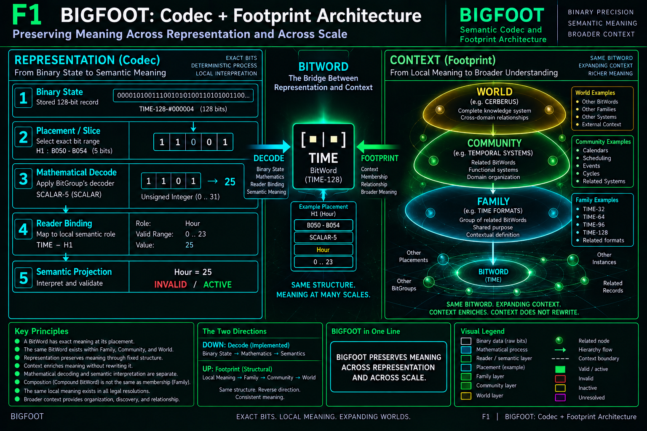
Figure 1. BIGFOOT preserves meaning across representation and across scale. The exact BitWord is the bridge between binary codec machinery and broader contextual footprint.

1. BIGFOOT Orientation and Architectural Ownership

1.1 Two complementary preservation problems
BIGFOOT exists because semantic identity is vulnerable in two directions. Representation can collapse meaning into anonymous bytes, while broad context can collapse exact local identity into vague categorization. BIGFOOT prevents both losses. The codec preserves the relationship between governed semantics and binary state; the footprint preserves the relationship between exact semantic identity and broader conceptual location.
Three relationships around one stable BitWord
SEMANTIC CONSTRUCTION -> BITWORD -> BINARY INSTANCE
|
+-> FAMILY -> COMMUNITY -> WORLD
|
+-> COMPOUND BITWORD [structural composition]

1.2 Identity-first architecture
BIGFOOT does not infer semantic identity from binary similarity, observed width, field names, or user-interface labels. An anonymous binary string does not explain itself. A governed semantic record requires the binary payload to remain linked to an exact BitWord and legal resolution, from which placement geometry, mathematical decoding, and Reader interpretation can be resolved.
• Binary similarity does not establish semantic identity.
• Observed string length does not establish BitWord identity.
• A display label does not become a machine-level semantic address.
• A derived projection does not become canonical merely because it is easier to read.

1.3 BIGFOOT ownership
BIGFOOT owns the stable semantic codec and footprint responsibilities needed to preserve semantic identity through encoding, decoding, interpretation, composition, and contextual membership. It does not become universal semantic authority simply because it operates on meaning-bearing structures.
BIGFOOT owns | BIGFOOT does not thereby own
Bits, BitGroups, BitWords, normalized placements | BOSS symbolic language or Symbol Appearance
Legal BitWord resolutions and fixed-width encoded instances | VISOR-wide structural geography
Mathematical code/decode contracts and decoder dispatch | QUIVER interface geometry or representation possibility
Reader registry, Reader Bindings, Reader CODE, semantic projection | DARTBOARD task-bounded active manifestation
Compound BitWord composition | MIRROR possible relational reasoning
Family / Community / World contextual footprint | SOLAR lexical routing or destination naming
Semantic interpretation of stored state | Universal mutation authority

Interpretation authority is not mutation authority.

2. BIT - Atomic Governed Semantic Identity

2.1 The primitive is the identity, not the current value
The `▪︎` Bit is BIGFOOT's smallest registered semantic primitive. The Bit is not merely the observed value 0 or 1; those are possible encoded states. Stable Bit identity survives state change. A Bit may therefore carry a governed definition, class, value type, allowed state or encoding, version, lifecycle status, epistemic scope, provenance, documentation, and relationships without reducing its identity to a current Boolean value.
Bit identity laws
BIT IDENTITY != BIT STATE
BIT IDENTITY != BIT POSITION
BIT IDENTITY != SYMBOL APPEARANCE

2.2 Position belongs to a larger construction
A Bit is not semantically defined by an absolute position inside one particular BitWord. Position becomes meaningful through BitGroup and Placement structure. This allows the same primitive or reusable pattern to participate in larger governed constructions without turning every occurrence into a new atomic identity.

3. BITGROUP - Reusable Bounded Mathematical Structure

3.1 Reusable binary semantic machinery
A `|▪︎▪︎|` BitGroup composes Bits into a reusable bounded binary structure. Its contract includes a governed width, encoding type, member structure, human-readable Decode Rule, and machine-facing Decoder Key. The BitGroup supplies reusable mathematical behavior without assigning the BitWord-local semantic role of every future occurrence.

3.2 Width is part of the contract
Width determines the number of local encoded positions, the legal slice length, the mathematical range, and the amount of BitWord territory an occurrence consumes. Examples include SCALAR-5, MASK-10, TWOS-11, and TWOS-17. A five-bit unsigned scalar can mathematically represent 0 through 31; whether a local Reader later constrains that value to a smaller semantic range is a separate question.

3.3 Decode Rule versus Decoder Key
The Decode Rule is the human-readable mathematical contract. The Decoder Key is the executable dispatch identity used by generic runtime machinery. They are related but not synonymous. The current architecture demonstrates a small reusable mathematical vocabulary - SCALAR, MASK, and TWOS - serving many differently sized BitGroups.
DECODE RULE != DECODER KEY | BITGROUP MATHEMATICS != BITWORD-LOCAL SEMANTIC ROLE

Figure 3 - Decoder Reuse
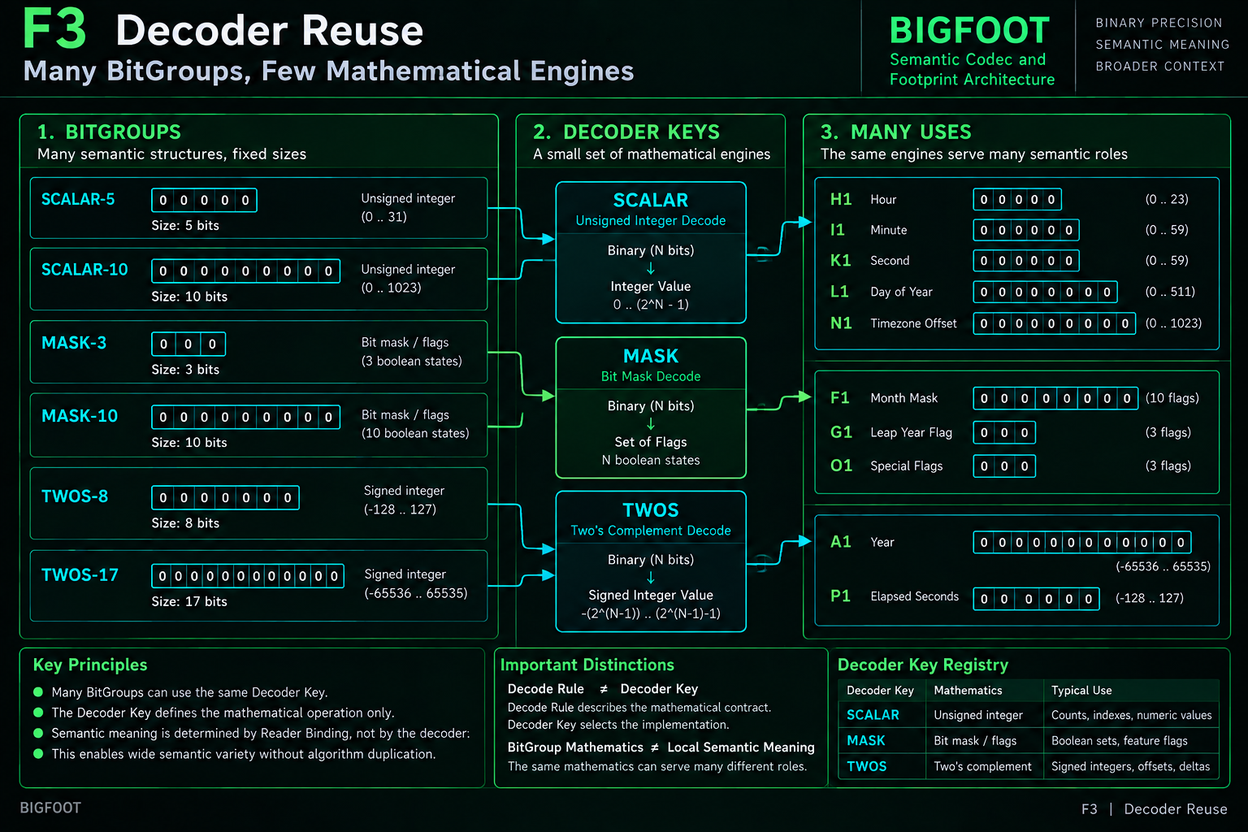
Figure 3. Many BitGroups reuse a small set of mathematical engines. Decoder Keys select mathematics; Readers supply local semantic meaning.

4. BitGroup Placement - Exact Occurrence Geometry

4.1 BitGroup versus BitGroup Placement
The normalized `|▪︎▪︎| #` Placement represents one exact ordered occurrence of one BitGroup inside one BitWord. The BitGroup owns reusable structure. The Placement owns occurrence geometry: BitWord identity, Group Index, linked BitGroup, zero-based Start Bit, governed Width, End Exclusive, readable Bit Range, and derived Decoder Key.

4.2 One-based order, zero-based geometry
Group Index is one-based ordinal order within the BitWord, while Start Bit is a zero-based binary address. These coordinates answer different questions and must not be conflated. A placement can be the eighth BitGroup occurrence while beginning at bit position 50.

4.3 TIME H1 example
Exact occurrence geometry
TIME-32-64-96-128#08
BitGroup = SCALAR-5
Group Index = 8
Start Bit = 50
Width = 5
End Exclusive = 55
Bit Range = B050-B054

At this layer the occurrence is not yet semantically `Hour`. The placement tells BIGFOOT where SCALAR-5 occurs. The Reader Binding later tells BIGFOOT what that occurrence means within TIME.
BITGROUP != BITGROUP PLACEMENT != READER BINDING

Figure 2 - Semantic Construction
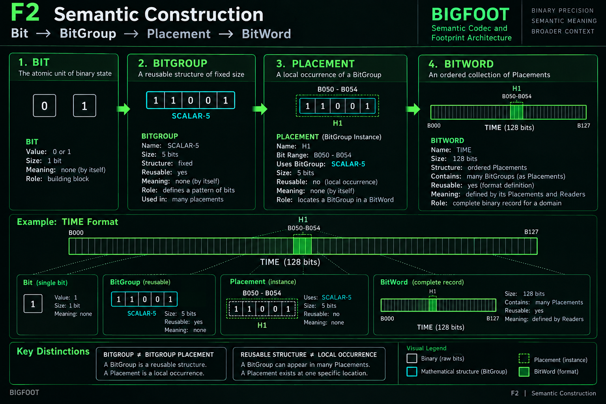
Figure 2. Reusable semantic structure is separated from local occurrence. A BitGroup can appear in many placements; a placement exists at one exact BitWord location.

5. BITWORD - Complete Governed Fixed-Width Construction

5.1 Ordered construction, not an unordered bag
The `[▪︎|▪︎]` BitWord is a complete governed semantic encoding structure. It has a stable identity, prefix, maximum width, ordered placements, version, type, specification, and relationships to legal resolutions, Readers, encoded records, Compound BitWords, and contextual containers. Membership alone is insufficient: placement order, position, and width are part of the construction.

5.2 Definition versus instance
A BitWord defines what may be encoded. It is not itself one encoded state. TIME-32-64-96-128 defines the governed TIME structure; TIME-128-#000004 is one particular encoded instance. This separation allows one definition to support many instances without duplicating the semantic grammar for each record.

5.3 Normalized placement replaces wide positional dependence
Earlier Airtable development exposed BG 1 through BG 20 and related offsets directly on the BitWord row. Those fields were valuable construction scaffolds. The normalized placement table makes occurrence geometry explicit as records, removing the architectural dependency on a fixed number of physical `BG n` columns. The semantics have not changed; the representation has become more portable.

6. Legal Resolution and Semantic Prefix Invariance

6.1 One BitWord, several governed readable extents
The `∈ [▪︎|▪︎]` profile registers legal widths through which one BitWord lineage may be instantiated. TIME uses the same 128-bit BitWord definition with legal profiles TIME-32, TIME-64, TIME-96, and TIME-128. A legal profile is more than a string length: it is a governed semantic boundary.
Resolution | Width | Last Bit | Fully contained placements
TIME-32 | 32 | B031 | A1-E1
TIME-64 | 64 | B063 | A1-J1
TIME-96 | 96 | B095 | A1-O1
TIME-128 | 128 | B127 | A1-P1

6.2 Prefix invariance
Extending a legal resolution must preserve the semantics of all earlier positions. TIME-64 extends TIME-32; it does not reinterpret B000-B031. TIME-96 and TIME-128 continue the same lineage. The preservation rule applies to complete placement identity and local semantic meaning, not merely to character-for-character binary prefix appearance.

6.3 Fully contained placement rule
A placement is readable at legal width W only when its End Exclusive is less than or equal to W. Partial semantic fields are not valid. TIME-32 therefore contains A1 through E1 and contains no partial F1. The absence of F1 at TIME-32 does not mean Year is zero; there are simply no Year bits in that record resolution.
ABSENT BY RESOLUTION != STORED ZERO != INACTIVE

6.4 TIME-128 exact normalized placement map
ID | BitGroup | Start | End Excl. | Bit Range
A1 | MASK-10 | 0 | 10 | B000-B009
B1 | MASK-3 | 10 | 13 | B010-B012
C1 | MASK-12 | 13 | 25 | B013-B024
D1 | MASK-6 | 25 | 31 | B025-B030
E1 | SCALAR-1 | 31 | 32 | B031
F1 | TWOS-17 | 32 | 49 | B032-B048
G1 | SCALAR-1 | 49 | 50 | B049
H1 | SCALAR-5 | 50 | 55 | B050-B054
I1 | SCALAR-6 | 55 | 61 | B055-B060
J1 | SCALAR-3 | 61 | 64 | B061-B063
K1 | SCALAR-6 | 64 | 70 | B064-B069
L1 | SCALAR-10 | 70 | 80 | B070-B079
M1 | SCALAR-4 | 80 | 84 | B080-B083
N1 | TWOS-11 | 84 | 95 | B084-B094
O1 | SCALAR-1 | 95 | 96 | B095
P1 | SCALAR-32 | 96 | 128 | B096-B127

Figure 4 - BitWord Layout and Legal Prefix Resolution
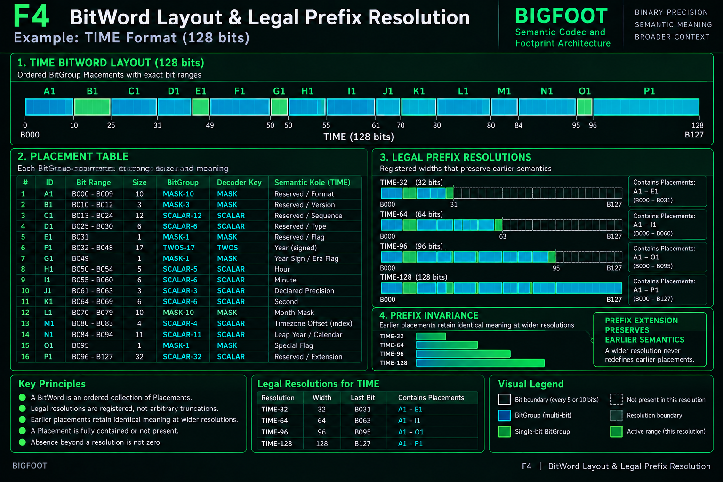
Figure 4. TIME uses one stable placement map with four registered legal widths. Wider legal resolutions preserve the meaning of every earlier fully contained placement.

7. Binary Records and Compact Storage

7.1 `0 ▪︎ 1` - the actual encoded BitWord instance
Once a legal resolution is selected, BIGFOOT can persist one actual encoded instance. The current `0 ▪︎ 1` concept binds a record identity to one exact BitWord, one exact legal profile, and one binary payload. Example record names include TIME-32-#000001, TIME-64-#000002, TIME-96-#000003, and TIME-128-#000004.

7.2 Structural binary validation
A record is structurally valid when its selected legal profile exists, the payload width exactly matches the governed width, and every stored character belongs to the binary alphabet {0,1}. Structural validity does not prove semantic validity. A perfectly formed 128-bit TIME record may still encode an Hour value that violates the Reader contract.

7.3 Binary state alone is not a governed record
Identity-first storage
GOVERNED SEMANTIC RECORD = BITWORD IDENTITY + LEGAL RESOLUTION + BINARY STATE

Observed length is a validation fact after identity is known; it is not the identity itself. Sixty-four binary characters do not automatically mean TIME-64. Another BitWord may also have a legal width of 64.

7.4 Wide per-bit tables are development scaffolding
The `▪︎|▪︎|▪︎|▪︎` table exposes Bit0 through Bit127 as separate fields and remains useful for human inspection, formula development, and diagnostic views. It should not be mistaken for the portable persistence ontology. A native runtime can store one fixed-width binary payload and derive local bit or placement views on demand.
128-BIT SEMANTICS != 128 REQUIRED DATABASE COLUMNS

8. BitGroup Instances and Mathematical Decode

8.1 `0 |▪︎▪︎| 1` - Record × Placement
A runtime BitGroup instance is the local realization of one normalized placement inside one actual encoded record. It is derived from Record × Placement and remains traceable to both. The placement supplies geometry; the record supplies bits; the BitGroup supplies the mathematical encoding contract.

8.2 Deterministic slice extraction
For a placement with Start Bit s and End Exclusive e, the local slice is BinaryState[s:e]. H1 begins at 50 and ends before 55, so the current TIME test record exposes the five-bit slice `11001`. The slice length must match both Placement Width and governed BitGroup Width.

8.3 Generic decoder dispatch
The Decoder Key selects a reusable mathematical engine. SCALAR returns an unsigned numeric state, MASK returns the set of active local positions, and TWOS returns a signed two's-complement value. The decoder must remain domain-agnostic: it recovers mathematics, not Reader-local semantic labels.
Decoder Key | Input interpretation | Output type | Example
SCALAR | Unsigned fixed-width binary | Unsigned integer | 11001 -> 25
MASK | Independent local Boolean positions | Set of active local positions | 110 -> {0,1}
TWOS | Fixed-width two's complement | Signed integer | 10110010101100101 -> -39579

8.4 Mathematical range versus semantic constraint
SCALAR-5 legitimately represents 0 through 31. That does not imply every semantic role using SCALAR-5 accepts the entire range. The TIME H1 Reader later constrains Hour to 0 through 23. This is how `25` can be mathematically valid while `Hour = 25` is semantically invalid.
BINARY SLICE != MATHEMATICAL VALUE != SEMANTIC MEANING

8.5 Determinism and independent verification
Given the same governed slice, BitGroup, Decoder Key, and decoder version, the mathematical result must be reproducible. BIGFOOT can therefore verify geometry, slice width, decoder dispatch, and mathematical result before any Reader semantics are considered. A Reader failure must never be used to retroactively declare correct binary mathematics invalid.

8.6 Native mathematical executor boundary
A generic native decoder should resolve record identity, legal resolution, fully contained placements, exact slices, Decoder Keys, and typed mathematical results without knowing domain labels such as Hour, Year, Pitch, or Hazard. Unknown Decoder Keys must remain explicitly unsupported rather than falling back to a guessed algorithm, and raw mathematical results should remain traceable to their source slices for audit and reconstruction.

8.7 Selected TIME mathematical calibration checkpoints
The current TIME-128 test record exercises each generic decoder family before Reader meaning is applied. These checkpoints are mathematical calibration targets only; the semantic role and semantic status belong to later Reader stages.
ID | Binary slice | Decoder | Mathematical result
A1 | 1011001010 | MASK | {0,2,3,6,8}
F1 | 10110010101100101 | TWOS | -39579
H1 | 11001 | SCALAR | 25
J1 | 010 | SCALAR | 2
M1 | 1011 | SCALAR | 11
P1 | 10110010101100101011001010110010 | SCALAR | 2998055602

Figure 5 - Binary Record to Mathematical Decode
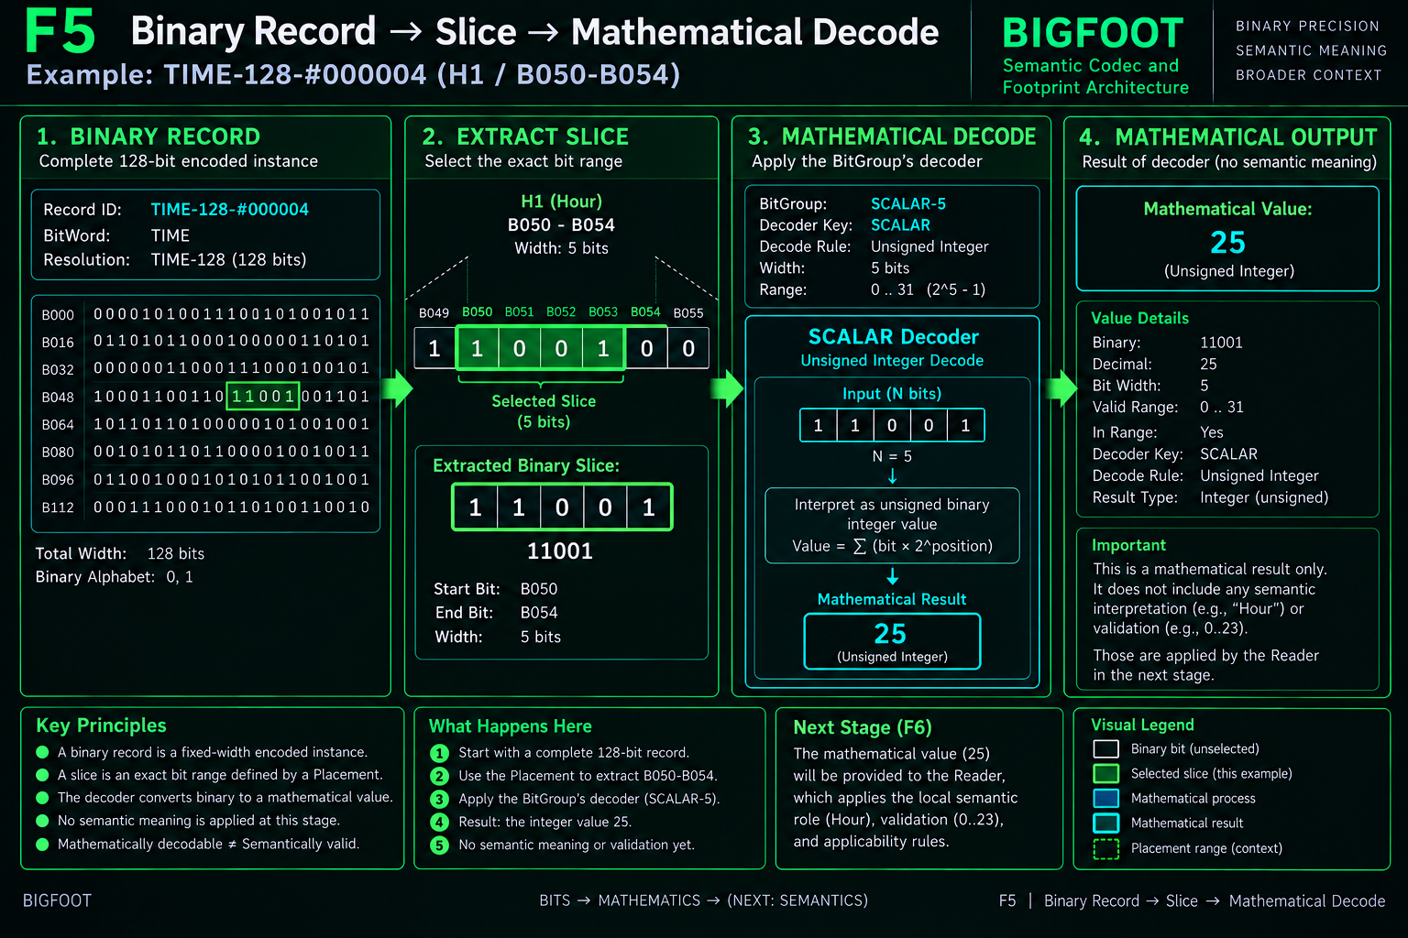
Figure 5. The decoder recovers mathematical state only. TIME H1 resolves from B050-B054 = 11001 to SCALAR = 25; the semantic role `Hour` belongs to the Reader stage.

9. Reader Architecture - BitWord-Local Meaning

9.1 `[▪︎|▪︎] 📖` - versioned interpretation contract
A Reader is a governed interpretation contract bound to one exact BitWord. The TIME Reader, TIME-READER-v1, interprets only placements fully contained in the selected legal TIME resolution, preserves prefix semantics, does not redefine BitGroup mathematics, does not invent missing meanings, and does not authorize mutation.

9.2 `[▪︎|▪︎] 📖 #` - Reader Binding
A Reader Binding links one exact Reader to one exact normalized placement and declares a Semantic Key, Semantic Role, and Interpretation or Constraint. Placement answers where the bits are; the decoder answers what mathematical state they encode; Reader Binding answers what that state means here.
WHERE? PLACEMENT | WHAT MATHEMATICALLY? DECODER | WHAT DOES IT MEAN HERE? READER

9.3 TIME Reader Binding registry
Key | Semantic Role | Key | Semantic Role
A1 | Month Set | I1 | Minute
B1 | Week Set | J1 | Declared Precision
C1 | Phase Set | K1 | Second
D1 | Intercalary Set | L1 | Millisecond
E1 | Calendar Specified | M1 | Temporal Reference Basis
F1 | Year | N1 | UTC / Civil Offset
G1 | Year Specified | O1 | Offset Specified
H1 | Hour | P1 | Fine Tick Count

9.4 Reader-local semantic constraints
Reader constraints can be narrower than BitGroup mathematical ranges. H1 Hour accepts 0-23 despite SCALAR-5 supporting 0-31; I1 Minute and K1 Second accept 0-59 despite SCALAR-6 supporting 0-63; L1 Millisecond accepts 0-999 despite SCALAR-10 supporting 0-1023. These constraints belong to the semantic role, not the generic decoder.

9.5 H1 worked interpretation
Same bits, more meaning
Binary slice 11001
Mathematical SCALAR = 25
Reader Binding TIME-H1
Semantic Role Hour
Constraint 0..23
Projection Hour = 25
Validation INVALID
Applicability ACTIVE

9.6 Reader determinism and versioned reprojection
Given the same source record, mathematical decode, Reader version, Reader Binding, Reader CODE registry, and declared relationships, the semantic projection must be reproducible. If a Reader contract changes, a newer Reader may explicitly reproject the same source binary state; it must not silently pretend the earlier projection came from the newer interpretation contract.

9.7 Reader output remains a derived semantic lens
Reader interpretation may convert numeric state into Boolean, enumerated, symbolic, set-valued, or constrained semantic values while preserving provenance to the underlying mathematics. That projection is useful for downstream systems, but it does not replace the source binary record, determine interface geometry, select runtime manifestation, or gain mutation authority.
READER INTERPRETS; READER DOES NOT REDEFINE BITGROUP MATH OR AUTHORIZE MUTATION

Figure 6 - Reader Binding
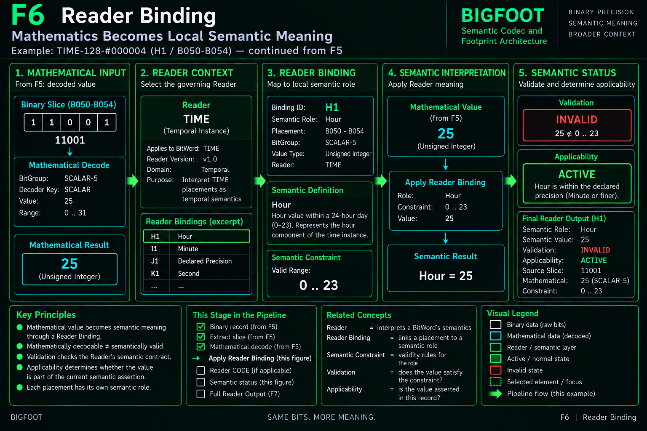
Figure 6. The Reader converts a mathematical state into BitWord-local semantic meaning. The H1 value 25 is mathematically decoded correctly but violates the TIME Hour constraint 0-23.

10. Reader CODE - Registered Local Enumerations

10.1 Binary code, mathematical value, semantic meaning
Some Reader Bindings interpret a mathematical value directly; others use a governed Reader CODE dictionary. Reader CODE assigns exact numeric and binary codes to meanings local to one Reader Binding. The same binary pattern can mean something different elsewhere because code meaning is scoped by its binding context.
BINARY CODE != MATHEMATICAL VALUE != SEMANTIC MEANING

10.2 J1 Declared Precision
Binary | Value | Registered meaning
000 | 0 | No Time
001 | 1 | Hour
010 | 2 | Minute
011 | 3 | Second
100 | 4 | Millisecond
101 | 5 | Fine Tick
110 | 6 | Time Present / Source Precision Unknown
111 | 7 | Reserved

The current test record contains J1 = `010`. SCALAR-3 decodes that slice to the mathematical value 2. The J1 Reader CODE then resolves 2 to `Minute`. The binary code, numeric value, and semantic meaning remain separate objects linked by registration.

10.3 M1 Temporal Reference Basis
Binary | Value | Registered meaning
0000 | 0 | Base / Floating
0001 | 1 | UTC
0010 | 2 | Fixed Offset
0011 | 3 | Named Civil
0100 | 4 | Continuous / Atomic
0101 | 5 | Simulation / Model
0110 | 6 | External Authority

The test record contains M1 = `1011`, which mathematically decodes to 11. No current M1 Reader CODE maps 11 to a semantic meaning. The correct result is therefore UNRESOLVED, not an invented interpretation and not a claim that the binary or mathematical state is invalid.

10.4 Reserved versus unregistered
A reserved code is explicitly recognized by the Reader contract. An unregistered code has no registered semantic resolution. These states are not equivalent. Registration discipline is a central defense against semantic hallucination inside the codec.

11. Semantic Projection, Validation, and Applicability

11.1 `0 [▪︎|▪︎] 📖 1` - derived Reader Output
Reader Output is the derived semantic projection of one decoded placement under one Reader Binding. It may preserve the source record, mathematical state, semantic key and role, interpreted value, validation, applicability, notes, and code-resolution provenance. The output is reconstructable and does not replace the canonical binary source record.

11.2 Independent status dimensions
BIGFOOT separates physical presence, mathematical decodability, semantic registration, semantic validation, and applicability. A value may be present and decoded while inactive; decoded while unresolved; registered while invalid; or valid while not asserted. This multidimensional status model is required to preserve information instead of collapsing distinct conditions into a generic error or null state.
Binding | Decoded / Semantic | Validation | Applicability | Reason
A1 Month Set | MASK={0,2,3,6,8} | VALID | INACTIVE | E1 Calendar Specified = FALSE
F1 Year | -39579 | VALID | INACTIVE | G1 Year Specified = FALSE
H1 Hour | 25 | INVALID | ACTIVE | 25 violates semantic range 0..23
I1 Minute | 22 | VALID | ACTIVE | Within declared Minute precision
J1 Declared Precision | Minute | VALID | ACTIVE | Registered J1 code 010
K1 Second | 44 | VALID | INACTIVE | J1 precision stops at Minute
M1 Reference Basis | 11 | UNRESOLVED | ACTIVE | No registered M1 code for 1011
N1 Offset | 345 | VALID | INACTIVE | O1 Offset Specified = FALSE

11.3 Gates are semantic, not destructive
E1, G1, and O1 are presence gates. J1 governs declared clock precision. These relationships change effective semantic assertion without deleting the gated binary state. Year may remain stored while Year Specified is false; Offset may remain stored while Offset Specified is false; Second and Millisecond may remain stored while declared precision is Minute.

11.4 Core status law
STORED != DECODED != REGISTERED != VALID != ASSERTED

• INACTIVE is not ABSENT, ZERO, or INVALID.
• UNRESOLVED is not INVALID; it is a bounded lack of registered semantic meaning.
• RESERVED is not UNREGISTERED; it is explicitly governed code space.
• UNSPECIFIED is not WILDCARD.
• Reader validation observes semantic conformity; it does not silently coerce the source state.

11.5 Effective projection is not a complete record image
A simplified semantic view may expose only currently asserted values, but the underlying record can still preserve inactive, reserved, invalid, or unresolved state. If those raw states are discarded, exact binary reconstruction may become impossible even when the visible semantic projection remains useful. Semantic round-trip preservation and bit-for-bit identity are therefore different guarantees.

11.6 Status is observation, not action authority
INVALID does not imply DELETE, INACTIVE does not imply ZERO, UNRESOLVED does not imply GUESS, and RESERVED does not imply REASSIGN. Reader status reports what is stored and what the current contract can legitimately assert. Any correction, normalization, or mutation remains a separately governed action.

11.7 Raw provenance preserves inactive, invalid, and unresolved state
A semantic projection may legitimately omit currently inactive values for presentation, but reconstruction-grade BIGFOOT retains the source slice and mathematical result. This is essential for inactive values such as K1 Second = 44, invalid active values such as H1 Hour = 25, and unresolved states such as M1 code 1011. Without the raw provenance, a simplified projection cannot guarantee exact binary reconstruction.

Figure 7 - Reader CODE and Semantic Status
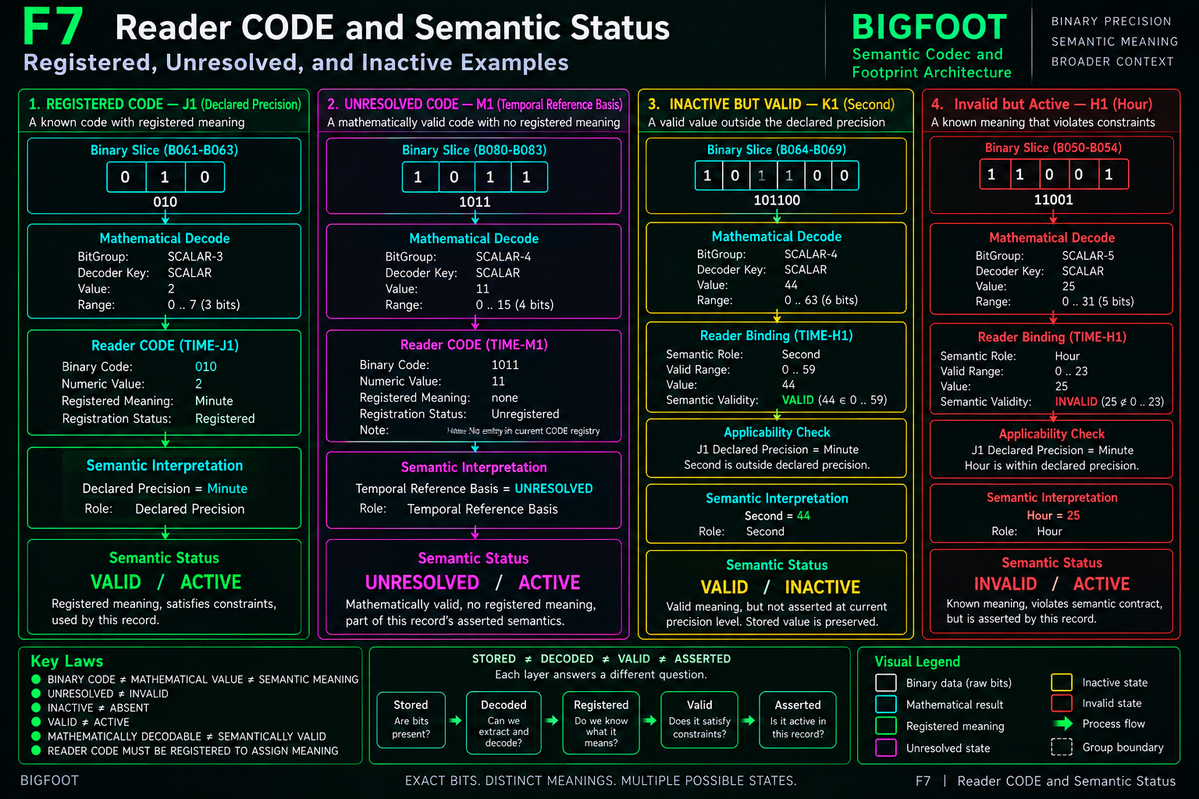
Figure 7. Registered, unresolved, inactive, and invalid states are independent semantic conditions. BIGFOOT preserves raw state and provenance instead of collapsing them into a single validity flag.

12. The Inverse CODE Path

12.1 Conceptual symmetry, unequal implementation maturity
The current Base materially demonstrates a generic Decode architecture. The same governed definitions also determine an inverse Code path, but an equivalent generalized Writer / Encoder executor is not yet represented as completed machinery. Native reconstruction must make the inverse path explicit rather than pretending a generic Writer already exists.
GENERIC DECODE: MATERIALLY IMPLEMENTED | GENERIC ENCODE: STRUCTURALLY SPECIFIED, BUILD REQUIRED

12.2 Governed inverse route
Inverse CODE path
SEMANTIC INTENT
-> exact Reader Binding
-> semantic validation
-> Reader CODE or direct value
-> mathematical encode
-> fixed-width binary slice
-> governed placement packing
-> candidate BitWord record
-> decode / compare / verify
-> separate commit authority

12.3 Direct numeric, MASK, and Reader CODE examples
Hour = 17 resolves through H1, validates against 0-23, and encodes through SCALAR-5 as `10001`. A Month Set resolves semantic members back to local MASK positions and then to a fixed-width mask slice. Declared Precision = Minute resolves through the J1 Reader CODE and produces `010`. In each case the Reader supplies local semantic meaning while the BitGroup supplies binary mathematics.

12.4 Local update versus full construction
A local update starts from an existing binary record and replaces only a declared write set, preserving all untargeted bits - including inactive, reserved, or unresolved state. Full construction starts without a source record and therefore requires an explicit initialization contract for every required placement. Binary zero cannot be assumed to be a universal null because zero has field-specific semantics.

12.5 Candidate before commit
Encoding should construct a candidate state, decode the candidate through the ordinary Reader path, compare the resulting semantics against the intended write, and only then hand the candidate to the system that owns mutation authority. Successful encoding proves representational correctness; it does not authorize persistence.
CODE AND DECODE SHARE ONE GOVERNED STRUCTURE. ENCODE SUCCESS != MUTATION AUTHORITY.

Figure 8 - The Inverse CODE Path
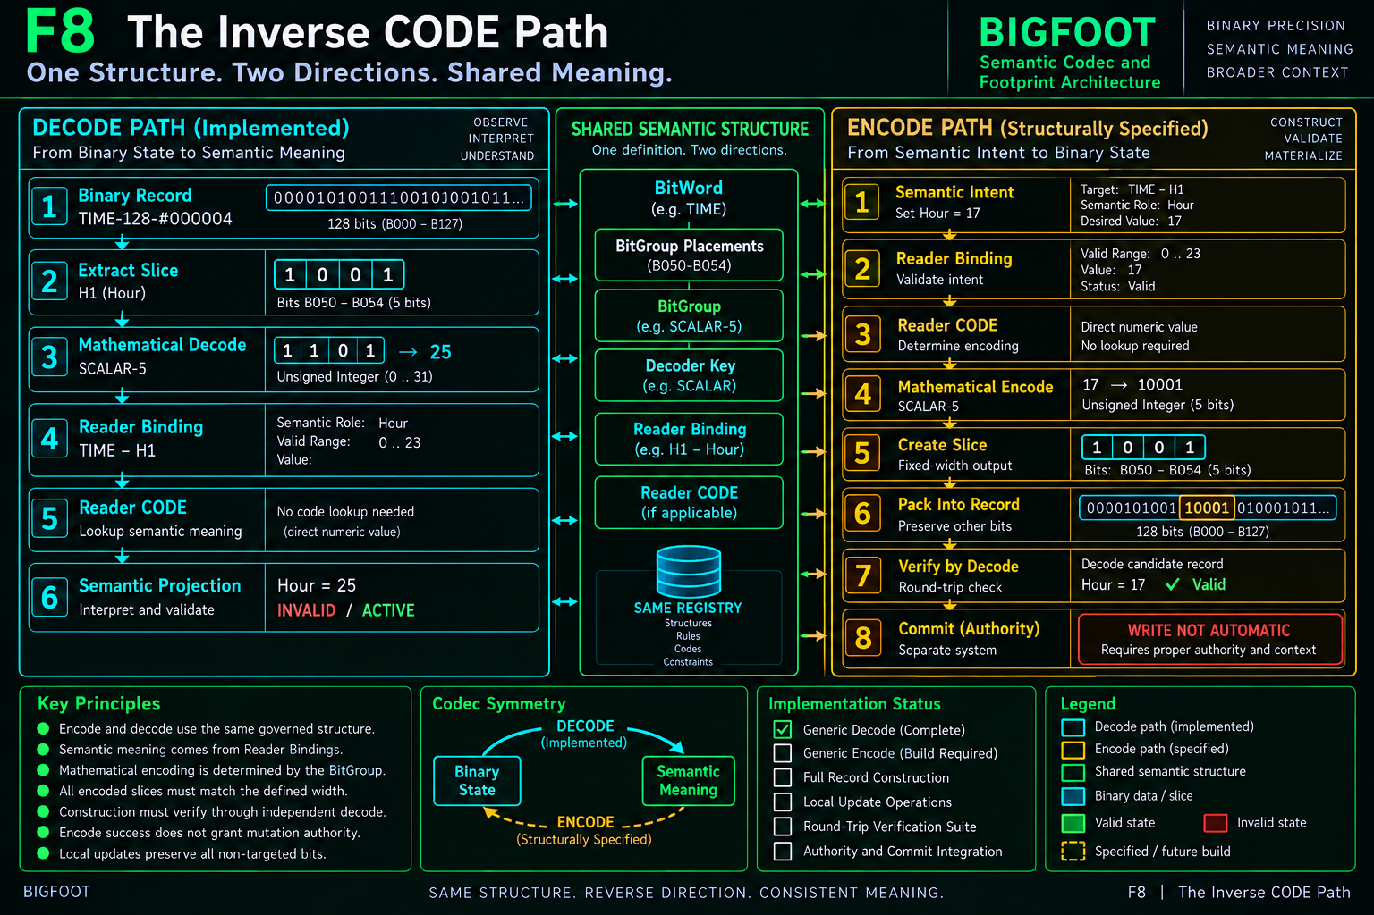
Figure 8. Decode is currently implemented generically; Encode is structurally specified over the same BitWord, Placement, BitGroup, Reader Binding, and Reader CODE definitions and remains a native build requirement.

13. Compound BitWords - Structural Composition

13.1 Complete Words compose without flattening
The `|[▪︎|▪︎]|` Compound BitWord represents a bounded composition of complete BitWords. Constituent Word identities and Reader boundaries survive composition. Compound is therefore not the next contextual level above BitWord; it is a separate structural relationship that creates a larger bounded semantic object from complete constituent Words.
COMPOUND BITWORD != FAMILY

13.2 Structural composition versus internal BitGroup composition
BitGroups compose the internal structure of one BitWord. Compound membership composes complete BitWords. These are different scales of construction. Similar database link shapes must not be mistaken for equivalent semantic relationships.

13.3 Constituent identity is mandatory
• Compound membership must be registered rather than inferred from co-occurrence.
• Constituent BitWord boundaries remain recoverable.
• Constituent Reader contracts do not disappear merely because the Words participate in one Compound.
• Changing Compound composition is a structural semantic change, not merely a contextual recategorization.

14. Family, Community, and World - Contextual Footprint

14.1 Family - local semantic neighborhood
`[▪︎|▪︎] 📁` Family places BitWords in a bounded local semantic neighborhood. Family membership adds contextual location without changing BitWord width, placements, Reader semantics, or encoded instances. Family is not a super-BitWord and its breadth is not the sum of member bit widths.

14.2 Community - bounded conceptual language
`[▪︎|▪︎] 🗃` Community groups Families into a broader bounded conceptual language. The intermediate Family layer remains meaningful and must not be flattened into one anonymous list of BitWords.

14.3 World - broad semantic domain
`[▪︎|▪︎] 🗄️` World is BIGFOOT's broadest established contextual scale. A World is a registered semantic domain, not a claim to contain all possible semantics. Contextual membership is relational semantic geography rather than encoded instance state.

14.4 Context without collapse
Semantic footprint
BITWORD -> FAMILY -> COMMUNITY -> WORLD
Context enriches meaning.
Context does not silently rewrite local meaning.

Broader context may support discovery, orientation, and relational understanding, but it does not repair an invalid Reader value, resolve an unregistered local code, establish runtime activation, imply causality, or grant mutation authority. Those relationships belong to their own governing systems.

14.5 Two provenance traces
Instance trace | Definition / footprint trace
Binary Record | Bit
Binary Slice / BitGroup Instance | BitGroup
Mathematical Decode | Placement
Reader Binding | BitWord
Semantic Projection | Family
 | Community
 | World

The traces meet through stable BitWord and Placement identity. A single decoded semantic value can therefore remain connected both to its exact source bits and to the broader semantic footprint of its governing BitWord.

14.6 Footprint as a typed semantic graph
The folder-like Family, Community, and World notation is a human-facing scale metaphor, not a required storage material. Native BIGFOOT may use normalized membership relations, but the relation type must survive: BitWord-to-Family contextual membership is not the same relationship as BitWord-to-Compound structural composition. Similar database shapes do not establish equivalent meaning.

14.7 Contextual membership does not smuggle hidden logic
Membership does not by itself establish causality, execution order, dependency, runtime selection, write permission, or Reader override. Those relationships require their own governed structures. Likewise, semantic similarity does not establish membership, and membership should not be treated as exclusive unless the governing context explicitly says so.

14.8 Footprint is part of reconstruction
A migration that preserves the codec but discards Family, Community, and World loses half of mature BIGFOOT. Conversely, preserving the old contextual hierarchy while losing placement geometry, binary records, decoders, and Readers preserves only the earlier shell. Complete reconstruction requires both codec and footprint, while allowing contextual reorganization to remain distinct from binary kernel versioning.

Figure 9 - From Exact Meaning to Conceptual Footprint
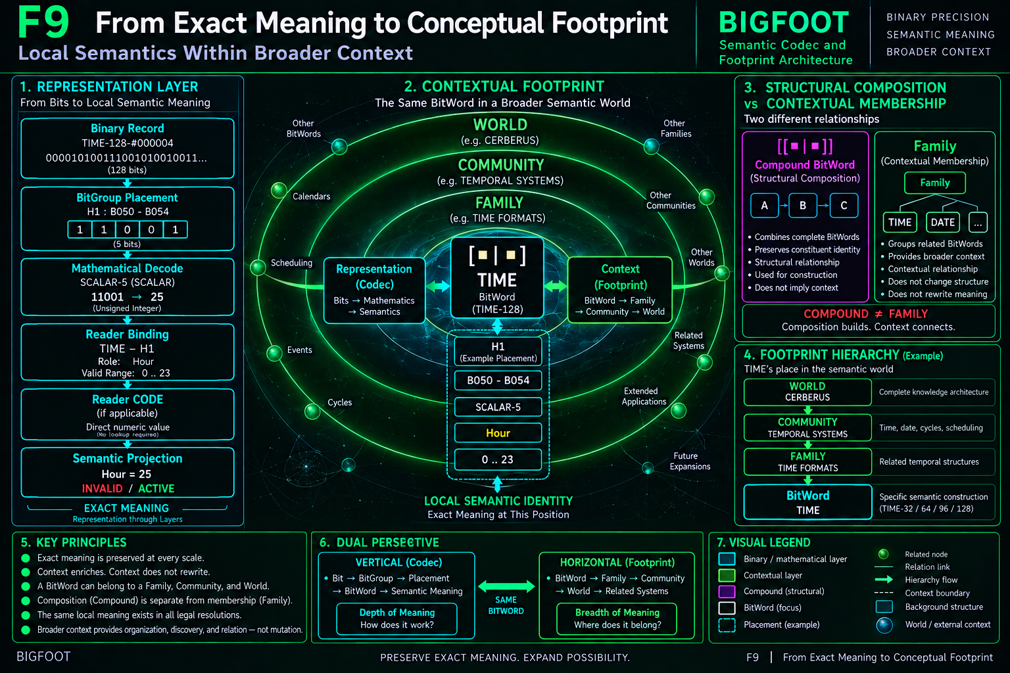
Figure 9. Structural composition and contextual membership are separate. Exact local semantic identity remains recoverable as context broadens from BitWord to Family, Community, and World.

15. Native Reconstruction and System Boundaries

15.1 Reconstruction preserves operational meaning, not Airtable appearance
If Airtable disappeared, BIGFOOT would still be reconstructable only if a future implementation preserved the semantic responsibilities and relationships described in this paper. Matching table names is insufficient. The native runtime must preserve stable identity, ordered occurrence geometry, legal resolutions, binary payloads, mathematical codec dispatch, Reader interpretation, status distinctions, Compound composition, and contextual membership.

15.2 Definition-side native responsibilities
Registry | Minimum responsibility
BIT | Stable primitive identity, definition, allowed state/encoding, provenance.
BITGROUP | Width, encoding type, members, Decode Rule, Decoder Key.
BITWORD | Stable identity, prefix, complete width, ordered semantic construction.
PLACEMENT | BitWord, Group Index, BitGroup, Start Bit, Width, End Exclusive, range.
LEGAL RESOLUTION | BitWord-local registered readable width.
READER | Versioned interpretation contract for one exact BitWord.
READER BINDING | Reader × Placement semantic key, role, constraints, relationships.
READER CODE | Registered local binary/numeric code to semantic meaning mappings.
COMPOUND | Typed structural composition of complete BitWords.
FAMILY / COMMUNITY / WORLD | Typed contextual semantic membership.

15.3 Runtime native route
JOIN-driven native Decode
BINARY RECORD
-> LEGAL RESOLUTION
-> eligible normalized PLACEMENTS
-> binary slices
-> Decoder Key dispatch
-> typed mathematical states
-> Reader Bindings / Reader CODE / constraints
-> semantic projection + validation + applicability

A native runtime should prefer joins and governed registries over duplicated helper fields. Airtable lookups and formula mirrors are useful development materializations, but derived information should remain derived wherever a stable source relation already exists. SQLite is an initial persistence material, not the ontology.

15.4 Current Airtable materialization
Surface | Role | Architectural responsibility
▪︎ | BIT | Stable semantic primitive registry.
|▪︎▪︎| | BITGROUP | Reusable bounded mathematical semantic structures.
|▪︎▪︎| # | BitGroup Placement | Normalized ordered occurrence geometry.
[▪︎|▪︎] | BITWORD | Complete governed Semantic Kernel construction.
|[▪︎|▪︎]| | Compound BitWord | Structural composition of complete BitWords.
▪︎|▪︎|▪︎|▪︎ | Wide Bit View | Development / inspection scaffold exposing Bit0-Bit127.
[▪︎|▪︎] 📁 | Family | Local contextual semantic neighborhood.
[▪︎|▪︎] 🗃 | Community | Bounded conceptual language / community.
[▪︎|▪︎] 🗄️ | World | Broad semantic domain.
|▪︎▪︎| 🧮 | Generic Decoder | SCALAR / MASK / TWOS mathematical decode surface.
[▪︎|▪︎] 📖 | Reader Registry | Exact BitWord Reader contracts.
0 ▪︎ 1 | Binary Record | Encoded BitWord instances with exact binary state.
0 |▪︎▪︎| 1 | BitGroup Instance | Record × Placement slice and mathematical result.
∈ [▪︎|▪︎] | Legal Resolution | Governed BitWord-readable prefix profiles.
[▪︎|▪︎] 📖 # | Reader Binding | Reader × Placement semantic role and constraints.
0 [▪︎|▪︎] 📖 1 | Reader Output | Derived semantic projection, validation, applicability.
[▪︎|▪︎] 📖 CODE | Reader CODE | Registered Reader-local code dictionaries.
[▪︎|▪︎] 🖥️ | Reader Console | Airtable test harness / convenience surface, not authority.

15.5 System boundary matrix
Neighbor | BIGFOOT handoff / boundary
BOSS | BIGFOOT resolves semantic identity; BOSS governs symbolic language and appearance.
VISOR | VISOR exposes structural geography; structural visibility does not transfer BIGFOOT semantic ownership.
QUIVER | QUIVER represents Reader-resolved semantics; interface geometry does not redefine Reader meaning.
DARTBOARD | DARTBOARD selects one task-bounded manifestation; semantically available does not mean runtime selected.
MIRROR | MIRROR reasons over possible relations; reasoned possibility does not mutate BIGFOOT state.
SOLAR | SOLAR provides lexical routing; lexical address is not destination meaning.
GROOVE | GROOVE preserves versioned interpretive routes; the Entry does not become the BIGFOOT semantic source.
PORT / SPD | SPD preserves operational meaning; PORT translates that meaning into target material without silent redesign.
BUILD / PATCH | BUILD proposes missing structure from precedent; PATCH refines divergence. BIGFOOT does not absorb those development roles.

15.6 Native construction order
• BIT registry
• BITGROUP registry
• decoder dispatch
• BITWORD registry
• normalized placements
• legal resolutions
• Reader registry
• Reader Bindings
• Reader CODE
• binary record persistence
• slice extraction
• mathematical decoder executor
• Reader resolution executor
• semantic projection and status
• Compound composition
• Family / Community / World membership
• generic Writer / Encoder
• round-trip verification
CONSTRUCT -> OBSERVE -> COMPARE -> PATCH -> VERIFY -> PROMOTE

16. Formal Invariant Registry and Verification

16.1 Identity invariants
• BIT IDENTITY != BIT STATE
• BITGROUP != BITGROUP PLACEMENT
• PLACEMENT != READER BINDING
• BITWORD DEFINITION != BINARY INSTANCE
• REPEATED BITGROUP USE != SHARED INSTANCE STATE
• READER != BITWORD

16.2 Binary and resolution invariants
• LEGAL RESOLUTION != ARBITRARY TRUNCATION
• LEGAL WIDTH MUST BE REGISTERED
• PLACEMENT MUST BE FULLY CONTAINED
• ABSENT BY RESOLUTION != ZERO
• PREFIX EXTENSION MUST PRESERVE EARLIER SEMANTICS
• BINARY RECORD WIDTH MUST MATCH GOVERNED RESOLUTION
• BINARY PAYLOAD ALONE != GOVERNED SEMANTIC RECORD

16.3 Mathematical and Reader invariants
• DECODE RULE != DECODER KEY
• DECODER KEY SELECTS MATHEMATICS ONLY
• UNKNOWN DECODER KEY MUST NOT BE GUESSED
• MATHEMATICAL RANGE != SEMANTIC CONSTRAINT
• BINARY CODE != MATHEMATICAL VALUE != SEMANTIC MEANING
• UNREGISTERED CODE MUST NOT BE GUESSED
• READER OUTPUT != SOURCE BINARY RECORD

16.4 Semantic status invariants
• STORED != DECODED != REGISTERED != VALID != ASSERTED
• INACTIVE != ABSENT
• INACTIVE != INVALID
• UNRESOLVED != INVALID
• RESERVED != UNRESOLVED
• UNSPECIFIED != WILDCARD
• NONZERO != ASSERTED

16.5 CODE invariants
• SEMANTICALLY WRITABLE != MERELY MATHEMATICALLY ENCODABLE
• UNREGISTERED MEANING MUST NOT RECEIVE A GUESSED CODE
• ENCODED SLICE WIDTH MUST MATCH BITGROUP WIDTH
• LOCAL WRITE PRESERVES UNDECLARED STATE
• WRITE NEEDS MORE WIDTH != AUTOMATIC RESOLUTION EXPANSION
• ENCODE SHOULD BE VERIFIABLE THROUGH DECODE
• ENCODE SUCCESS != COMMIT AUTHORITY

16.6 Compound and footprint invariants
• COMPOUND BITWORD != FAMILY
• COMPOUND MUST PRESERVE CONSTITUENT WORD IDENTITY
• FAMILY MEMBERSHIP != BITWORD RECOMPILATION
• COMMUNITY MEMBERSHIP != FAMILY ERASURE
• WORLD MEMBERSHIP != INSTANCE STATE
• CONTEXT ENRICHES; CONTEXT DOES NOT SILENTLY REWRITE
• CONTEXTUAL MEMBERSHIP != OPERATIONAL DEPENDENCY

16.7 TIME-128 calibration vector
ID | Slice | Mathematical decode | Reader interpretation | Status
A1 | 1011001010 | MASK={0,2,3,6,8} | Month Set | VALID / INACTIVE
B1 | 110 | MASK={0,1} | Week Set | VALID / INACTIVE
C1 | 010101100101 | MASK={1,3,5,6,9,11} | Phase Set | VALID / INACTIVE
D1 | 011001 | MASK={1,2,5} | Intercalary Set | VALID / INACTIVE
E1 | 0 | SCALAR=0 | Calendar Specified = FALSE | VALID / ACTIVE
F1 | 10110010101100101 | TWOS=-39579 | Year = -39579 | VALID / INACTIVE
G1 | 0 | SCALAR=0 | Year Specified = FALSE | VALID / ACTIVE
H1 | 11001 | SCALAR=25 | Hour = 25 | INVALID / ACTIVE
I1 | 010110 | SCALAR=22 | Minute = 22 | VALID / ACTIVE
J1 | 010 | SCALAR=2 | Declared Precision = Minute | VALID / ACTIVE
K1 | 101100 | SCALAR=44 | Second = 44 | VALID / INACTIVE
L1 | 1010110010 | SCALAR=690 | Millisecond = 690 | VALID / INACTIVE
M1 | 1011 | SCALAR=11 | Temporal Reference Basis | UNRESOLVED / ACTIVE
N1 | 00101011001 | TWOS=345 | UTC / Civil Offset = 345 | VALID / INACTIVE
O1 | 0 | SCALAR=0 | Offset Specified = FALSE | VALID / ACTIVE
P1 | 10110010101100101011001010110010 | SCALAR=2998055602 | Fine Tick Count | VALID / INACTIVE

A native implementation should reproduce these results through the registered structure rather than by hard-coding expected semantic outputs. Calibration should compare record width, placement geometry, slice extraction, mathematical decode, Reader role, Reader CODE resolution, validation, and applicability layer by layer.

16.8 Reconstruction failure tests
• `SCALAR-5 means Hour` - wrong: SCALAR-5 is reusable mathematics; H1 supplies the local Hour role.
• `25 is invalid binary` - wrong: 11001 is valid SCALAR-5 state; Hour = 25 is the semantic violation.
• `INACTIVE means zero or absent` - wrong: inactive stored state remains recoverable.
• `UNRESOLVED means invalid` - wrong: mathematical decode succeeded but no registered semantic meaning exists.
• `TIME-32 is arbitrary truncation` - wrong: it is a registered legal semantic resolution.
• `Reader Output is canonical source` - wrong: it is a derived projection.
• `Family is a larger BitWord` - wrong: Family is contextual membership.
• `Compound BitWord is the next footprint level` - wrong: Compound is structural composition.
• `Native BIGFOOT needs 128 database columns` - wrong: compact storage plus explicit placement geometry is sufficient.
• `Specified inverse CODE means generic Writer exists` - wrong: generalized execution remains a native build requirement.
• `Encoding valid candidate bits authorizes persistence` - wrong: commit authority is separate.

16.9 Closing compression
Complete BIGFOOT reconstruction map
SEMANTIC DEFINITION CHAIN
BIT -> BITGROUP -> PLACEMENT -> BITWORD -> LEGAL RESOLUTION
-> BINARY RECORD -> BITGROUP INSTANCE -> MATHEMATICAL DECODER
-> READER BINDING -> READER CODE / CONSTRAINT -> SEMANTIC PROJECTION
REVERSE CODE CHAIN
SEMANTIC INTENT -> READER MEANING -> REGISTERED CODE / VALUE
-> MATHEMATICAL ENCODE -> FIXED-WIDTH SLICE -> PLACEMENT PACKING
-> CANDIDATE BINARY RECORD -> DECODE / VERIFY -> AUTHORITY
CONTEXT CHAIN
BITWORD -> FAMILY -> COMMUNITY -> WORLD
SEPARATE STRUCTURAL COMPOSITION
BITWORD -> COMPOUND BITWORD

BIGFOOT PRESERVES EXACT MEANING FROM BINARY STORAGE TO SEMANTIC INTERPRETATION AND FROM LOCAL SEMANTIC IDENTITY TO BROAD CONCEPTUAL CONTEXT.

The architecture does not depend on a specific database surface. It depends on disciplined distinctions: reusable structure versus occurrence, definition versus instance, mathematics versus semantic meaning, stored state versus effective assertion, structural composition versus contextual membership, interpretation versus mutation authority. Preserve those boundaries and BIGFOOT can migrate. Collapse them and a superficially similar implementation ceases to be semantically equivalent.

BIGFOOT
Semantic Codec and Footprint Architecture
Preserve identity. Preserve provenance. Preserve boundaries.
Never infer more meaning than the governed structure actually provides.
Version 1.0 | PASS 8 VERIFIED RELEASE
Independent research by Shane Conrad | CERBERUS

