CERBERUS
LIGHT_EFFECT-64
Candidate Semantic Kernel Specification
Renderer-Neutral Procedural Illumination Application

CORE SPECIFICATION STATEMENT
LIGHT_EFFECT-64 defines a bounded Spatial / Visual Application Semantic Kernel that maps an accepted typed Effect Signal into a renderer-neutral illumination request. The Kernel declares the light behavior family, destination light parameter, normalized requested intensity envelope, normalized spatial extent, direction/cone interpretation, attenuation/falloff behavior, volumetric participation, shadow participation, color-binding semantics, accumulation/mixing behavior, null/failure handling, local evaluation posture, Formula Profile, and interpretation version.

Field Specification
Field | Specification
Document | CERBERUS LIGHT_EFFECT-64 Candidate Semantic Kernel Specification
Version | 0.1
Date | August 2026
Series | LIGHT_EFFECT-64
Member | LIGHT_EFFECT-64¹
Effects Studio Role | Spatial / Visual Application
Bounded Question | How does a procedural Signal control renderer-neutral illumination behavior?
Output | Renderer-neutral Illumination Request
Authoring Basis | CERBERUS SK Specification Authoring Standard v1.0; Effects Studio SK Interoperability Reference v0.1; current conversation architecture
Spec Class | Candidate Spec: semantic contract, Reader topology, Bit allocation, D Classes, DREQs, visual manual, and planning handoff fixed; exact registered D#.# / BOSS / interface records remain implementation promotion gates.

INTERPRETATION RULE
LIGHT_EFFECT-64 is the Series identity in this document. The mathematical BitGroups are generic SCALAR structures. Light-specific meaning belongs to Reader placements. The Spec is a human-facing compression artifact; once implemented, runtime uses live CERBERUS records directly.

Section Index
Ref. | Section
Part 1 | Purpose, scope, illumination ownership, interoperability, and normative laws
Part 2 | Member architecture, mathematical inventory, Reader topology, and color continuation
Part 3 | LIGHT_EFFECT-64¹ Reader-role interface specifications
Part 4 | Interface-0, D requirements, and complete DARTBOARD
Part 5 | Reader algorithm, typed output, color routing, and interoperability
Part 6 | Worked examples, invalid states, and conformance
Part 7 | Planning handoff and promotion gate
Appendix A | Complete Reader state enumerations
Appendix B | Complete B000:B063 physical Bit map
Appendix C | Light Class / Reader applicability guidance
Appendix D | Input compatibility and transform matrix
Appendix E | Candidate D requirement index
Appendix F | Color / Material / Light routing contract
Appendix G | Conformance / build checklist

Part 1 — Purpose, Scope, Ownership, Interoperability, and Normative Laws

1. Purpose and Bounded Question
LIGHT_EFFECT-64 is the renderer-neutral illumination application language for the Effects Studio. It answers one bounded question: how does a procedural Signal control illumination behavior? The word is deliberately independent of renderer implementation, world-space light object identity, material surface response, and actual color channel identity.
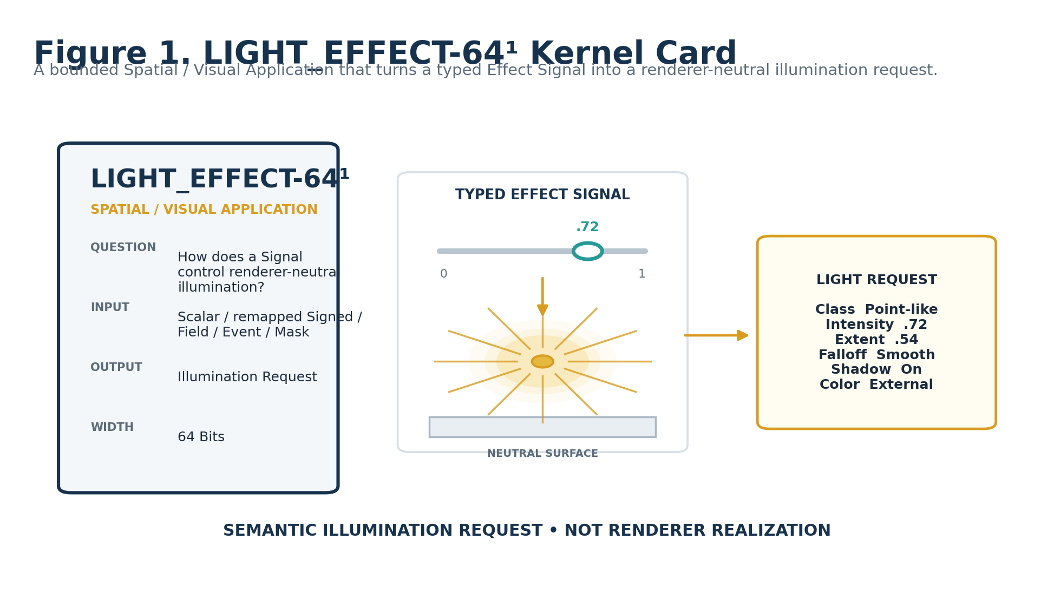
Figure 1. LIGHT_EFFECT-64¹ Kernel Card.

2. Renderer Separation
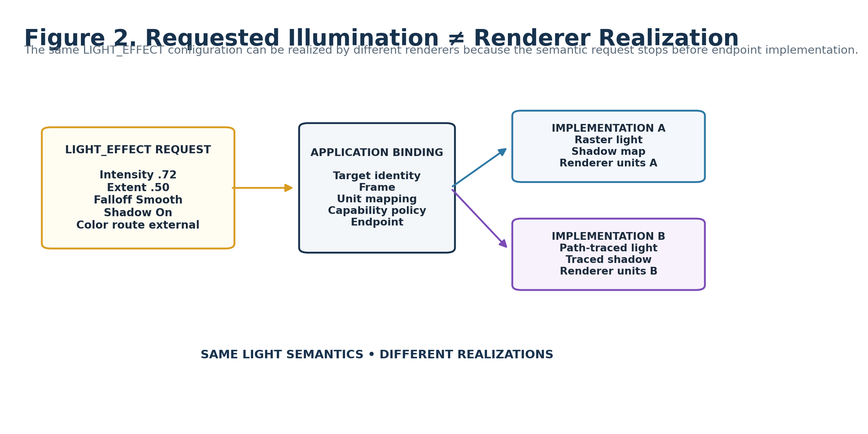
Figure 2. Requested illumination versus renderer realization.
A valid LIGHT_EFFECT state is a semantic request. Application Binding resolves target identity, Frame, physical/unit mapping, endpoint capabilities, and renderer connection. This separation allows renderer replacement without rewriting the stored Light semantics.

3. LIGHT / COLOR / MATERIAL Ownership
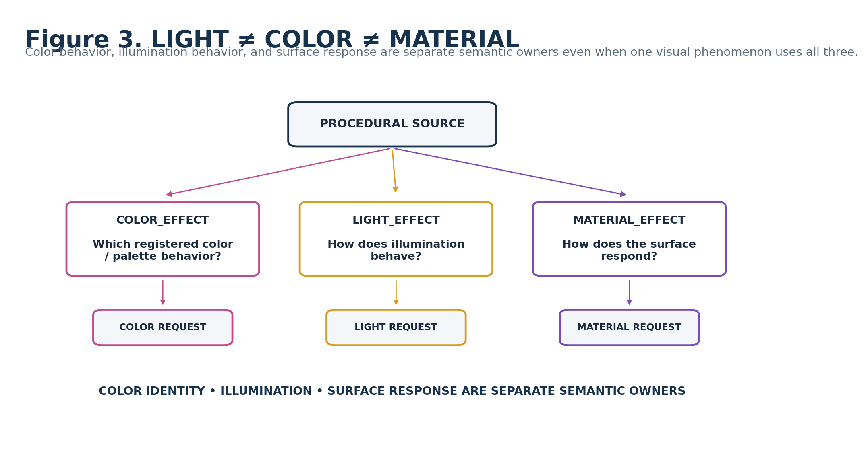
Figure 3. LIGHT, COLOR, and MATERIAL remain separate semantic owners.
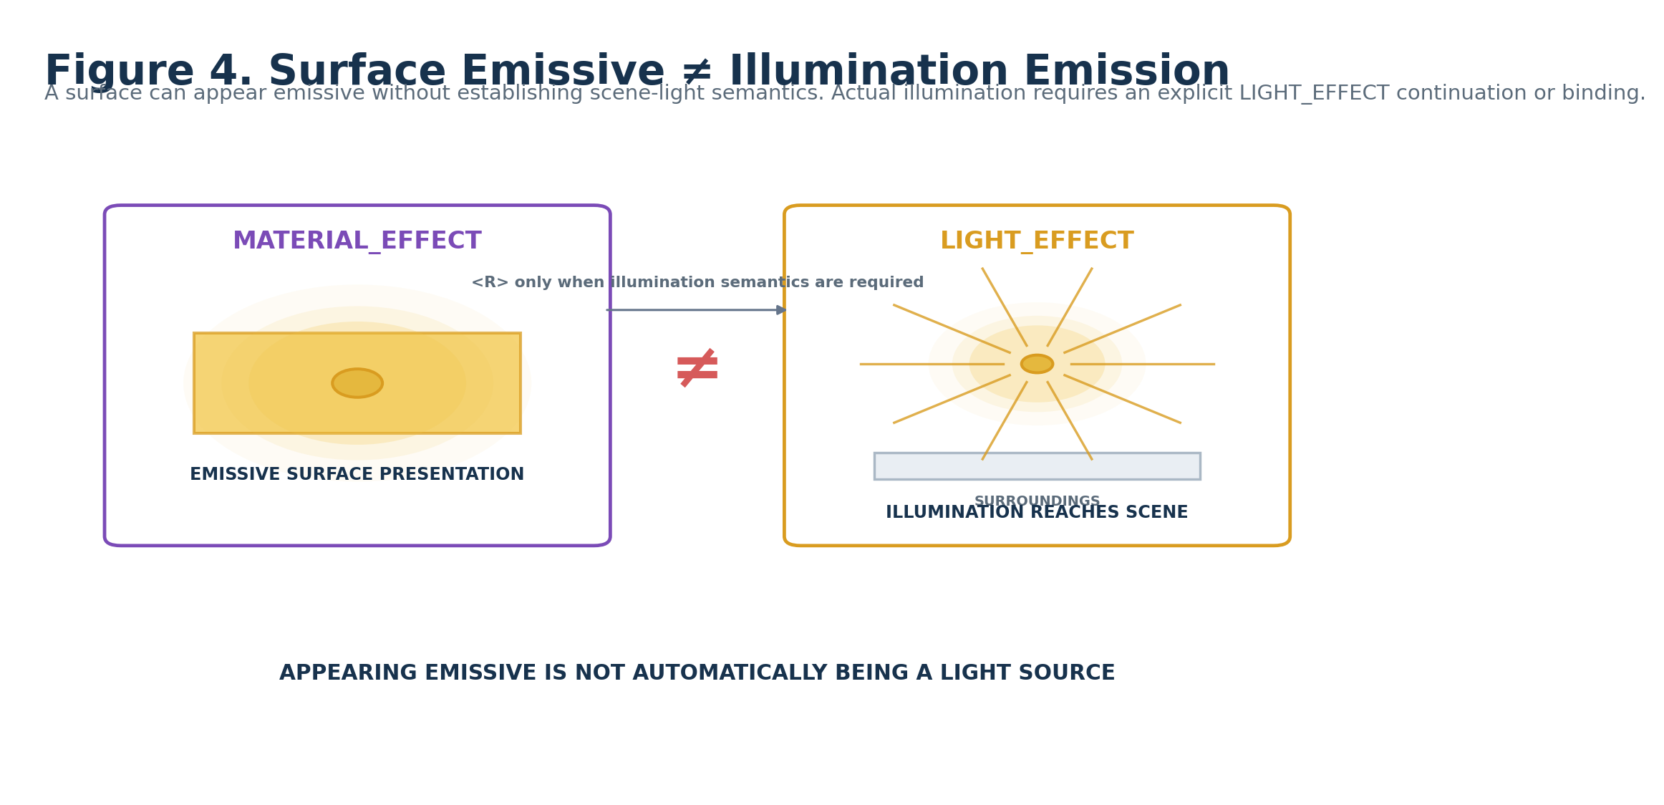
Figure 4. Surface emissive presentation is not automatically illumination emission.

4. Shared-Cause Multimodality
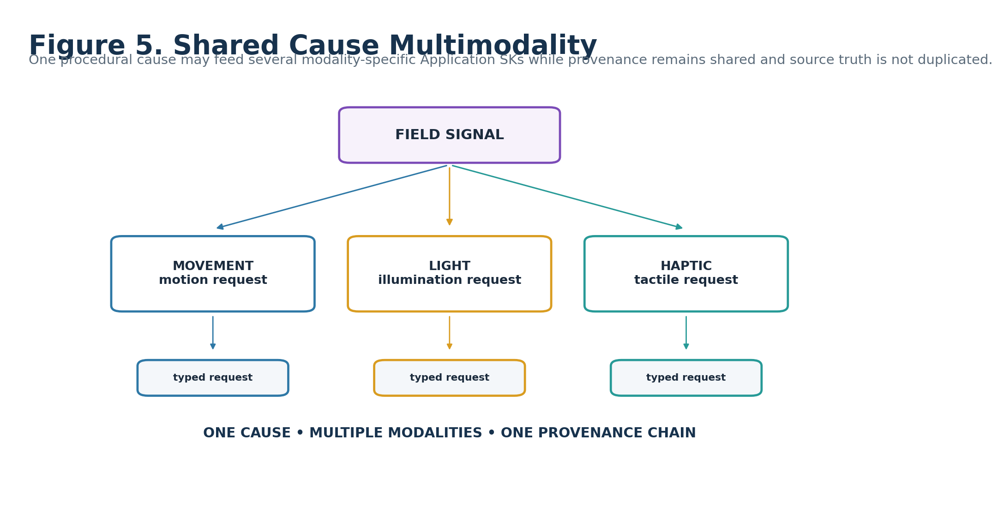
Figure 5. One procedural cause may feed Movement, Light, and Haptic applications while preserving one provenance chain.

5. Spatial Ownership Firewall
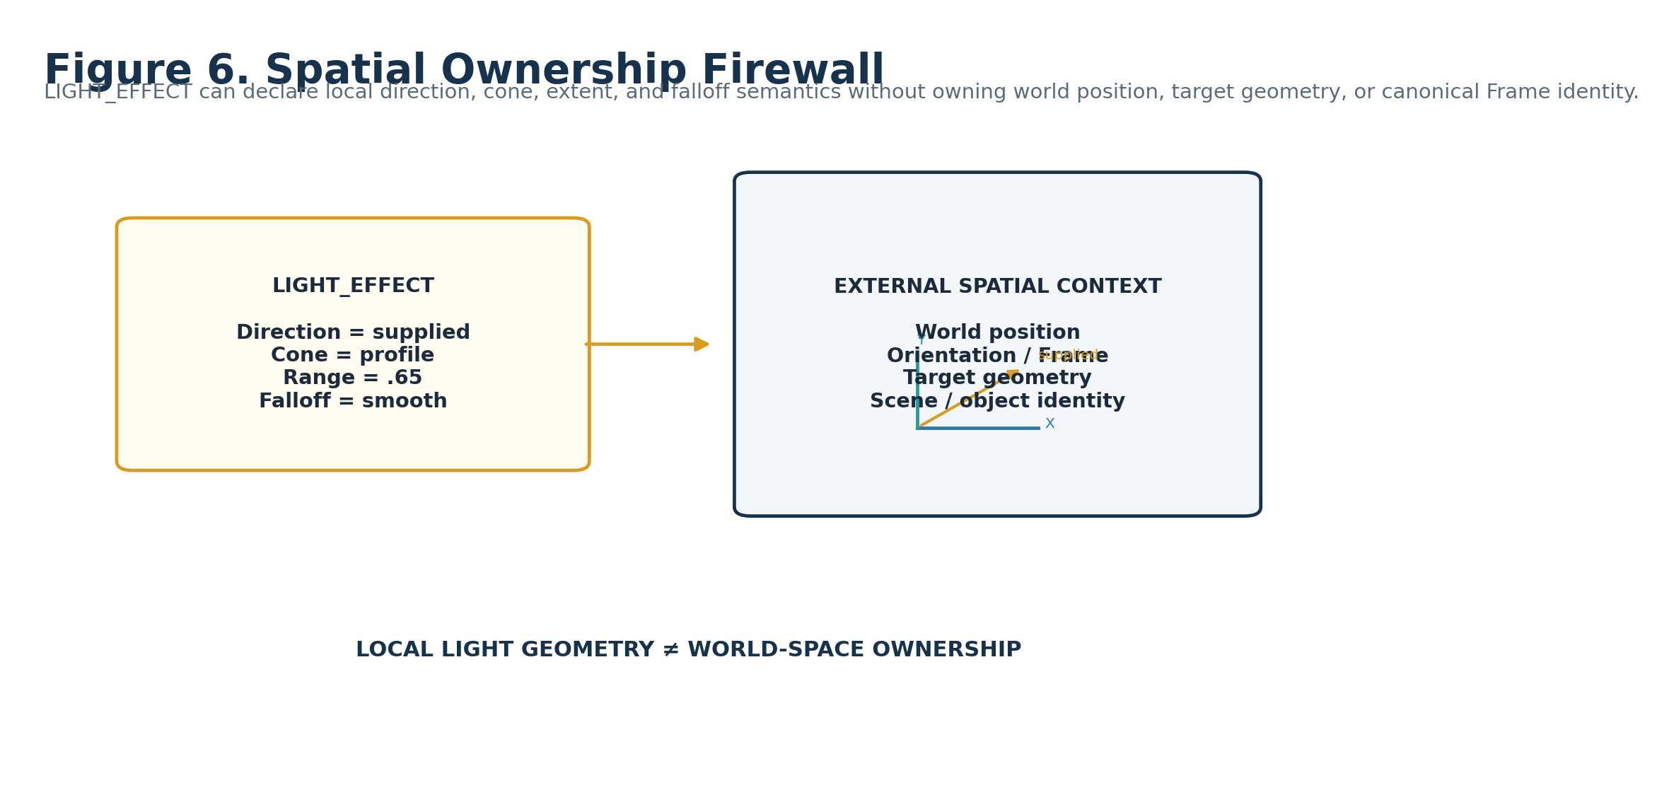
Figure 6. Local light geometry does not own world-space placement or target geometry.

6. Ownership and Non-Ownership
LIGHT_EFFECT owns | LIGHT_EFFECT does not own
Renderer-neutral illumination family and requested parameter control | World-space light identity, world position, or canonical Frame identity
Normalized requested illumination magnitude | Universal photometric units or endpoint calibration
Normalized spatial extent / radius | Target-specific world-unit scale
Direction/cone interpretation and falloff profile | Target geometry or renderer-specific light implementation
Volumetric and shadow participation semantics | Volume/medium identity, shadow map/ray-tracing implementation, receiver geometry
Color binding / continuation posture | Actual RGBA channel identity
Local light-request accumulation/mixing | General complete-Signal BLEND_EFFECT algebra
Null/failure and local evaluation posture | Global start/duration/repeat/synchronization

7. Normative LIGHT Laws
Law | Normative statement
LIGHT-R01 Bounded Illumination | LIGHT_EFFECT SHALL describe renderer-neutral illumination behavior only.
LIGHT-R02 Safe Zero | A1=0 SHALL resolve to OFF / NO LIGHT REQUEST regardless of other stored roles.
LIGHT-R03 Source Preservation | LIGHT_EFFECT SHALL NOT rewrite the upstream Effect Signal.
LIGHT-R04 Renderer Separation | Endpoint calibration and renderer implementation SHALL remain external.
LIGHT-R05 Magnitude Non-Authority | C1 SHALL express normalized requested illumination magnitude, not universal physical output units.
LIGHT-R06 Spatial Non-Ownership | Range, direction, cone, and falloff semantics SHALL NOT imply ownership of world position, geometry, or Frame identity.
LIGHT-R07 Parameter Explicitness | B1 SHALL identify which light parameter the incoming Signal primarily controls.
LIGHT-R08 No Silent Coercion | Signed or Vector inputs SHALL NOT become Scalar light control without an explicit transform/remap.
LIGHT-R09 Falloff Explicitness | Spatial attenuation behavior SHALL remain inspectable through F1 or its registered profile.
LIGHT-R10 Volumetric Separation | G1 SHALL declare volumetric participation without owning the volume, medium, or volumetric renderer.
LIGHT-R11 Shadow Separation | H1 SHALL declare shadow participation without owning target geometry or renderer shadow implementation.
LIGHT-R12 Color Routing | Actual color identity SHALL remain external; I1 SHALL route or bind to registered color semantics.
LIGHT-R13 Mixing Explicitness | Interaction with other illumination requests SHALL follow J1 rather than renderer-default assumptions.
LIGHT-R14 Null Visibility | Missing required source/domain/color/Frame state SHALL remain inspectable.
LIGHT-R15 Evaluation Locality | L1 controls local recomputation posture; global performance timing remains external.
LIGHT-R16 Formula Visibility | Formula identity/version SHALL remain inspectable wherever mapping behavior changes semantic output.
LIGHT-R17 Projection Separation | Preview illumination SHALL remain derived presentation rather than canonical source/world truth.
LIGHT-R18 Minimum Resolution | 64¹ SHALL remain the minimum complete LIGHT member until genuinely new atomic illumination semantics justify another level.

Part 2 — Member Architecture, Mathematical Inventory, and Reader Topology

8. Minimum Sufficient Resolution
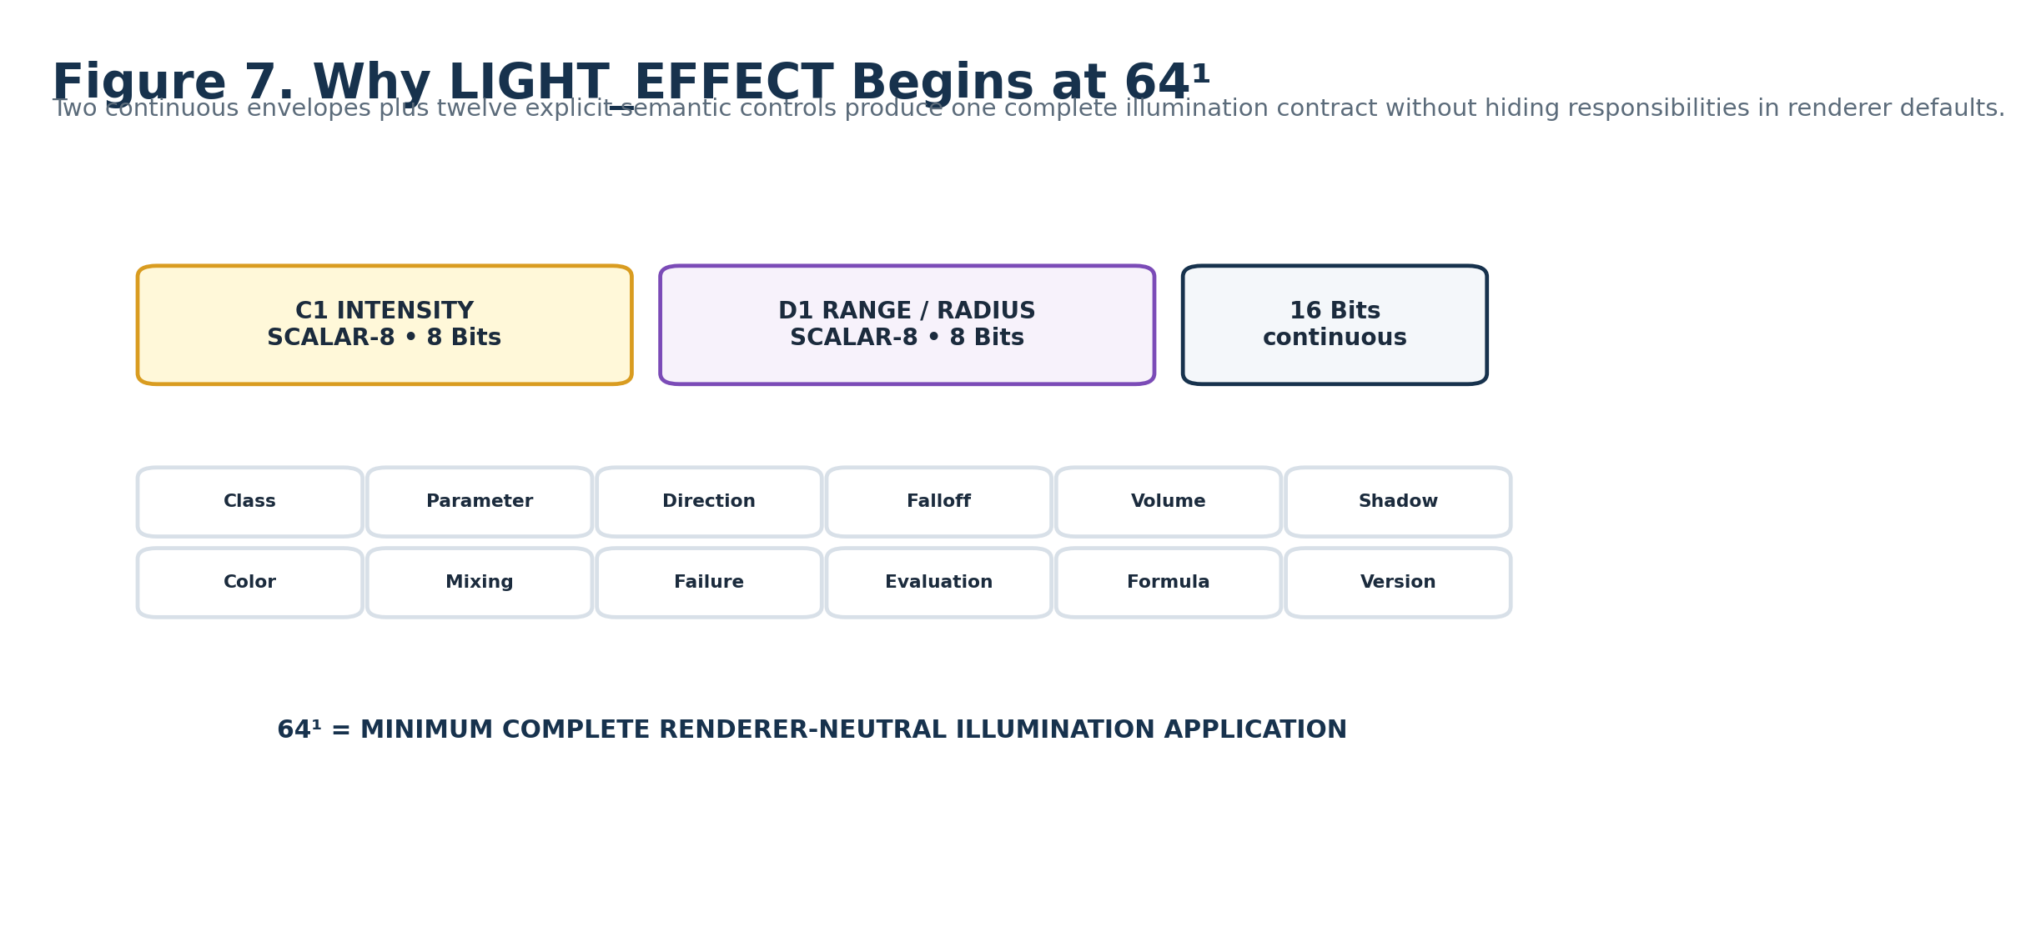
Figure 7. Why LIGHT_EFFECT begins at 64¹.
RESOLUTION PRINCIPLE
There is no LIGHT_EFFECT-32¹ in this Candidate architecture. A lower member would need to hide or remove parts of the same bounded illumination question. LIGHT_EFFECT-64¹ is therefore the minimum complete member, not an “advanced” version of an implicit 32-bit base.

9. Mathematical BitGroup Inventory
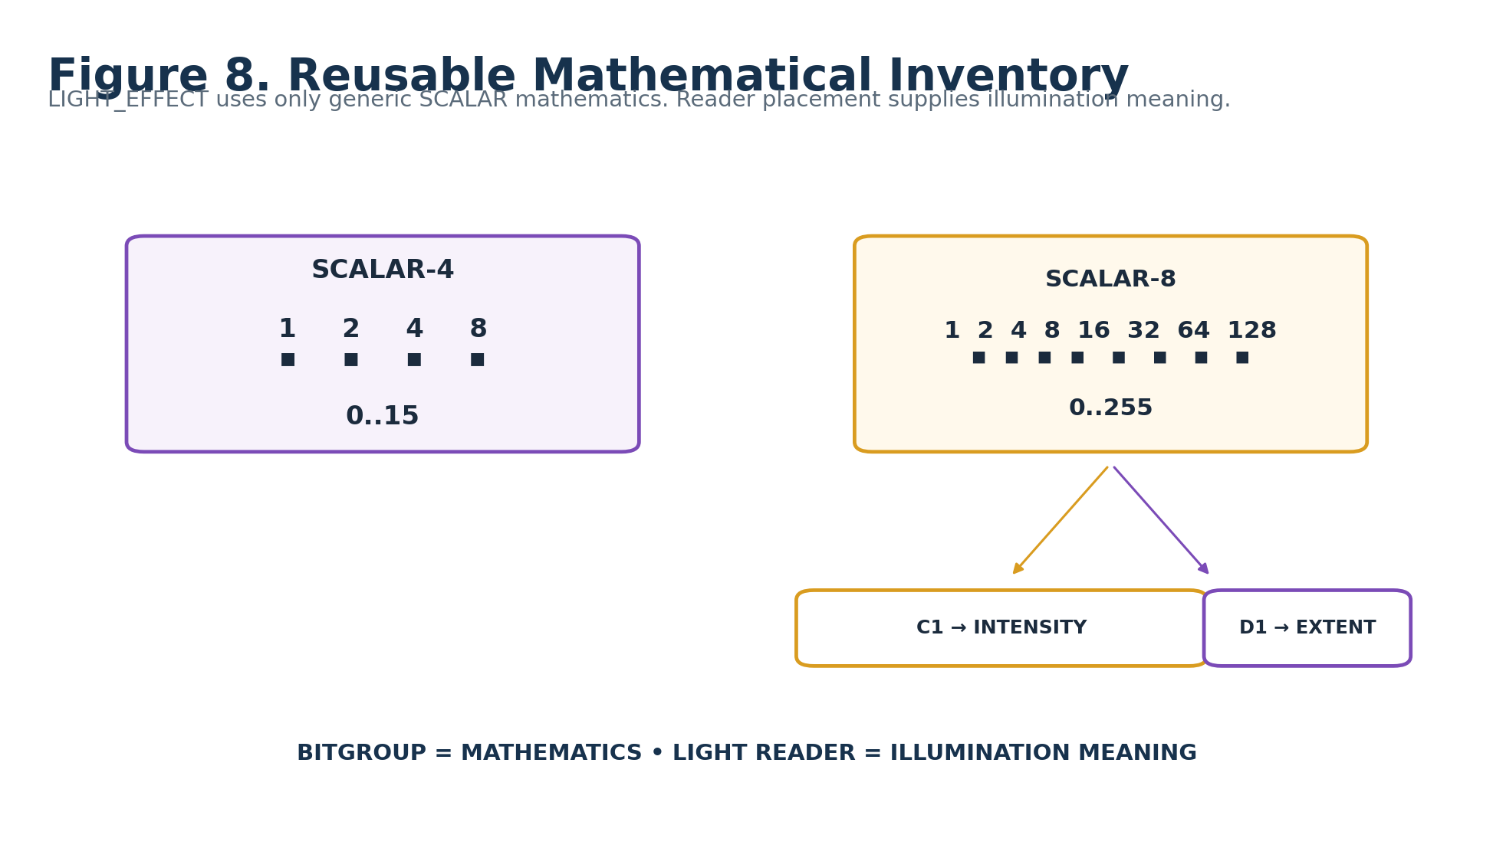
Figure 8. Reusable mathematical inventory used by LIGHT_EFFECT-64¹.
BitGroup | Width | Formula / Range | LIGHT uses
SCALAR-4 | 4 | Σ bᵢ·2ⁱ → 0..15 | Light Class, Parameter, Direction/Cone, Falloff, Volumetric, Shadow, Color, Mixing, Failure, Evaluation, Formula, Version
SCALAR-8 | 8 | Σ bᵢ·2ⁱ → 0..255 | Requested Intensity and Range / Radius

10. Exact Physical Placement Map
Reader | Physical Bits | BitGroup | Semantic role
A1 | B000:B003 | SCALAR-4 | Light Role / Class
B1 | B004:B007 | SCALAR-4 | Light Parameter Target
C1 | B008:B015 | SCALAR-8 | Intensity Range / Requested Magnitude
D1 | B016:B023 | SCALAR-8 | Range / Radius
E1 | B024:B027 | SCALAR-4 | Direction / Cone
F1 | B028:B031 | SCALAR-4 | Attenuation / Falloff
G1 | B032:B035 | SCALAR-4 | Volumetric Participation
H1 | B036:B039 | SCALAR-4 | Shadow Participation
I1 | B040:B043 | SCALAR-4 | Color Binding Mode
J1 | B044:B047 | SCALAR-4 | Accumulation / Mixing
K1 | B048:B051 | SCALAR-4 | Null / Failure Behavior
L1 | B052:B055 | SCALAR-4 | Evaluation Mode
M1 | B056:B059 | SCALAR-4 | Formula Profile
N1 | B060:B063 | SCALAR-4 | Version / Reserved

11. Reader Address Topology
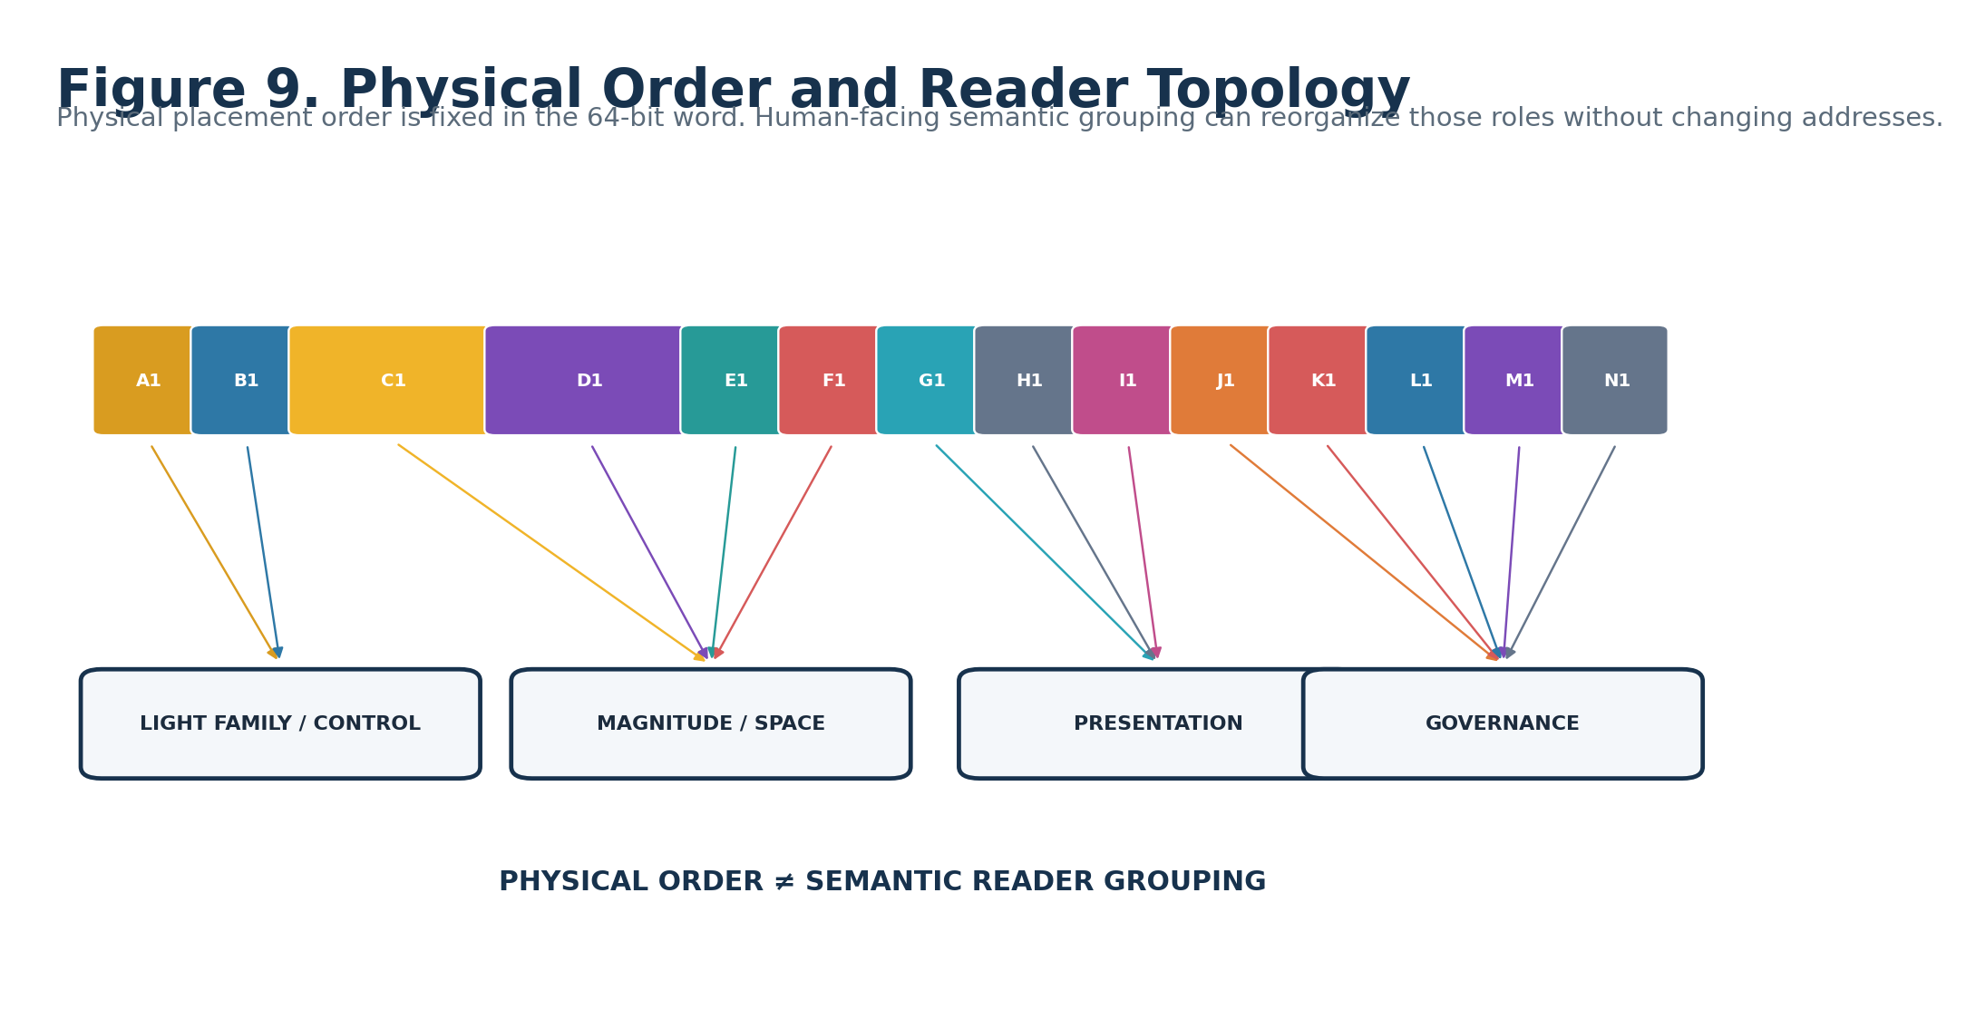
Figure 9. Physical order and semantic Reader topology.

12. Parameter Target vs Illumination Envelopes
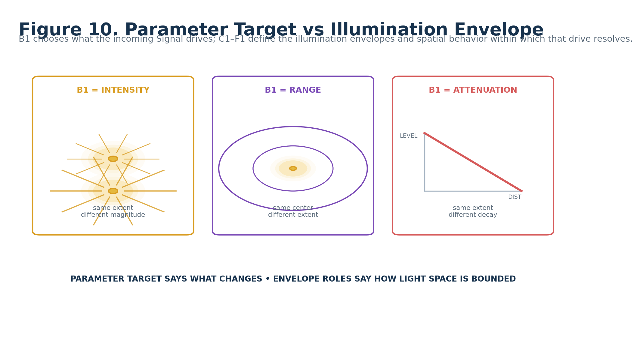
Figure 10. B1 selects the parameter family while C1–F1 define the illumination envelope and local spatial behavior.
The apparent overlap between Light Parameter Target and dedicated magnitude/space roles is deliberate. B1 identifies which light quantity the incoming procedural Signal primarily controls. C1–F1 provide the bounded semantic envelope and local interpretation used by the selected mapping. This keeps dynamic source routing explicit while preserving stable light-state semantics.

13. Intensity vs Range vs Falloff
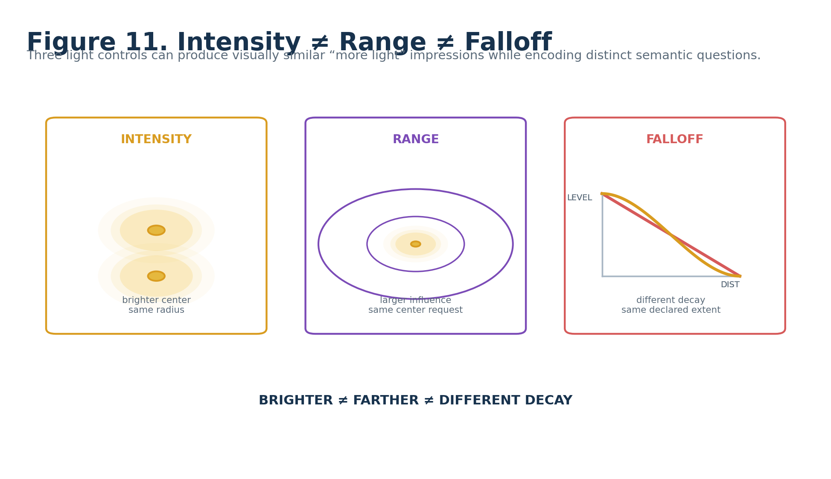
Figure 11. Brighter, farther, and different decay are distinct semantic controls.

14. Current Color Continuation
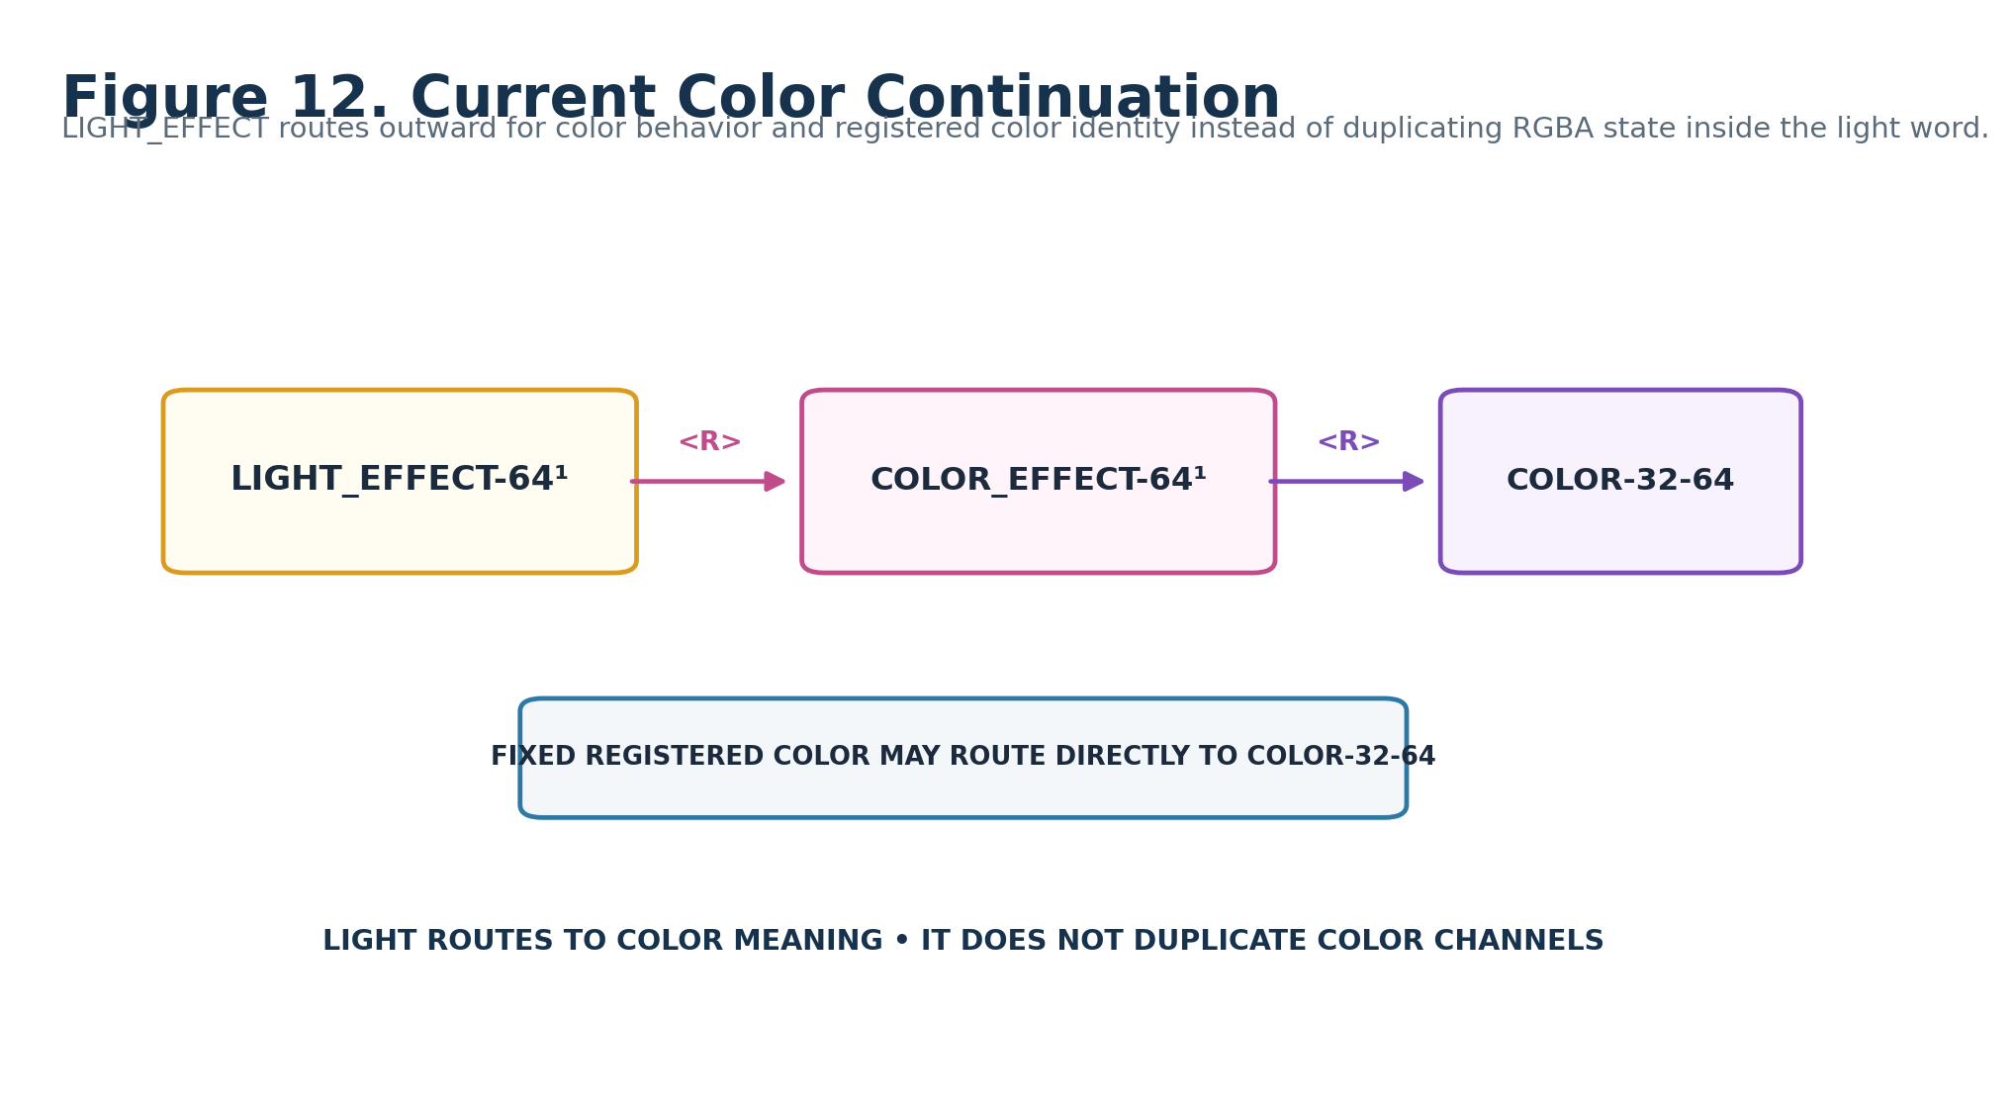
Figure 12. LIGHT routes to current COLOR_EFFECT / COLOR semantics instead of duplicating color identity.

ARCHITECTURE EVOLUTION
Effects Studio Reference v0.1 predates the current COLOR architecture and names older COLOR targets. This Candidate specialist Spec records the current continuation posture explicitly: LIGHT_EFFECT may route through COLOR_EFFECT-64¹ for procedural color behavior and to COLOR-32-64 for actual registered color state. The historical reference is not silently rewritten.

Part 3 — LIGHT_EFFECT-64¹ Reader-Role Interface Specifications
FIGURE CONTRACT
Each Reader role is taught through an actual interface control and a semantic consequence viewport before its formal contract table. The document grammar repeats; the semantic visualization changes with the role.

The gallery is intentionally visual-first. The declaration strip identifies the semantic role, Reader address, reusable mathematical carrier, and Candidate D class. The control then demonstrates the intended interaction geometry, while the consequence viewport keeps the underlying scene constant and changes only the Reader variable being taught.
These figures are human-facing compression artifacts of the record architecture. They do not replace the live Reader, D, Formula, BOSS, COLOR, or Application Binding records that will become canonical after implementation.

15. Light Role / Class — A1
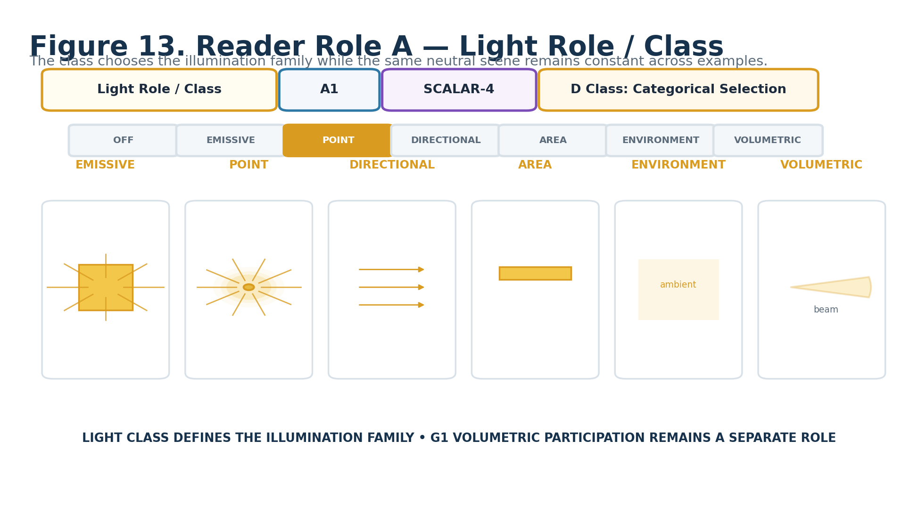
Figure 13. Light Role / Class — A1.
DECLARATION
Light Role / Class | A1 | SCALAR-4 | DREQ-CAT.LIGHT_CLASS
Property | Contract
D Class | Categorical Selection
D Requirement Key | DREQ-CAT.LIGHT_CLASS
Purpose | Defines the illumination family under which subsequent roles are interpreted.
Representative states | 0 OFF / NO REQUEST; 1 EMISSIVE; 2 POINT-LIKE; 3 DIRECTIONAL; 4 AREA / REGION; 5 ENVIRONMENTAL; 6 VOLUMETRIC; 7–15 RESERVED / extension.
Validation / boundary | A1=0 is the safe no-op. Class-specific non-applicable controls may be disabled by exact interface rules without mutating stored values.
Reader formula / mathematics | SCALAR-4 raw 0..15.
Does not own | Target identity, world position, color identity, renderer implementation.

16. Light Parameter Target — B1
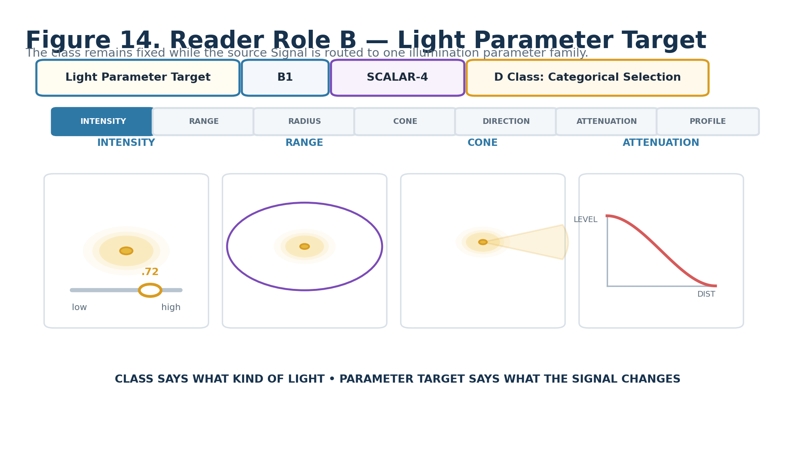
Figure 14. Light Parameter Target — B1.
DECLARATION
Light Parameter Target | B1 | SCALAR-4 | DREQ-CAT.LIGHT_PARAMETER
Property | Contract
D Class | Categorical Selection
D Requirement Key | DREQ-CAT.LIGHT_PARAMETER
Purpose | Declares which illumination parameter the accepted Signal primarily drives.
Representative states | 0 INTENSITY; 1 RANGE; 2 RADIUS; 3 CONE; 4 DIRECTION; 5 ATTENUATION; 6 PROFILE / EXTERNAL; 7–15 RESERVED.
Validation / boundary | The selected Formula Profile must support the chosen parameter family. B1 does not replace the dedicated C1–F1 envelope/spatial roles.
Reader formula / mathematics | SCALAR-4 raw 0..15.
Does not own | Exact target light identity or renderer parameter handle.

17. Intensity Range / Requested Magnitude — C1
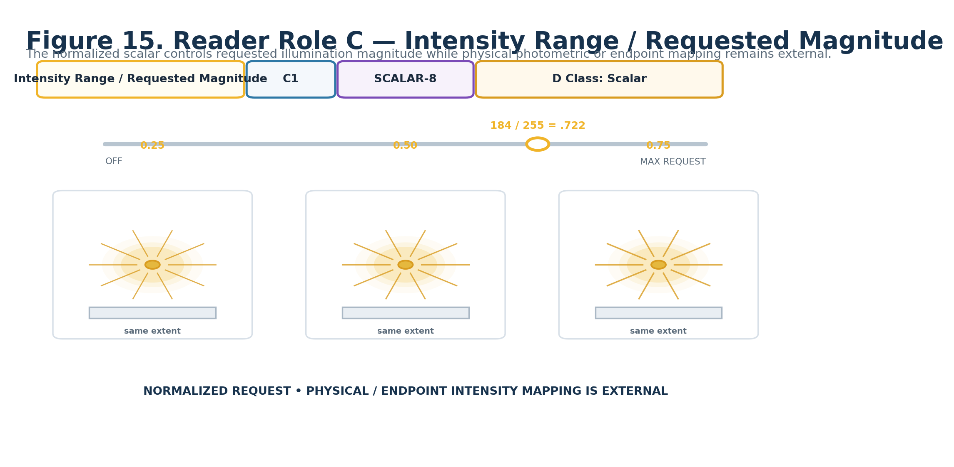
Figure 15. Intensity Range / Requested Magnitude — C1.
DECLARATION
Intensity Range / Requested Magnitude | C1 | SCALAR-8 | DREQ-SCALAR.LIGHT_INTENSITY
Property | Contract
D Class | Scalar
D Requirement Key | DREQ-SCALAR.LIGHT_INTENSITY
Purpose | Carries normalized requested illumination magnitude.
Representative states | 0 → 0.000; 64 → 0.251; 128 → 0.502; 192 → 0.753; 255 → 1.000.
Validation / boundary | Physical photometric or endpoint-specific intensity ranges MUST be provided by Formula/Application Binding/endpoint contracts rather than silently encoded here.
Reader formula / mathematics | i = C1 / 255.
Does not own | Photometric units, endpoint calibration, color, or spatial extent.

18. Range / Radius — D1
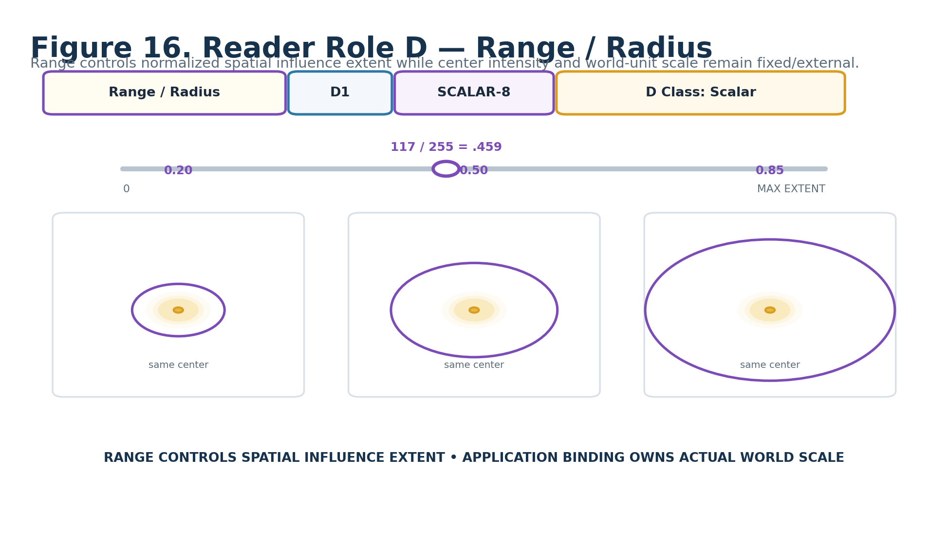
Figure 16. Range / Radius — D1.
DECLARATION
Range / Radius | D1 | SCALAR-8 | DREQ-SCALAR.LIGHT_EXTENT
Property | Contract
D Class | Scalar
D Requirement Key | DREQ-SCALAR.LIGHT_EXTENT
Purpose | Carries normalized requested spatial influence extent / radius.
Representative states | 0 → 0.000; 64 → 0.251; 128 → 0.502; 192 → 0.753; 255 → 1.000.
Validation / boundary | The normalized coordinate is Reader semantics. Target-specific world-unit scale remains external.
Reader formula / mathematics | r = D1 / 255.
Does not own | World-space scale, target geometry, or falloff shape.

19. Direction / Cone — E1
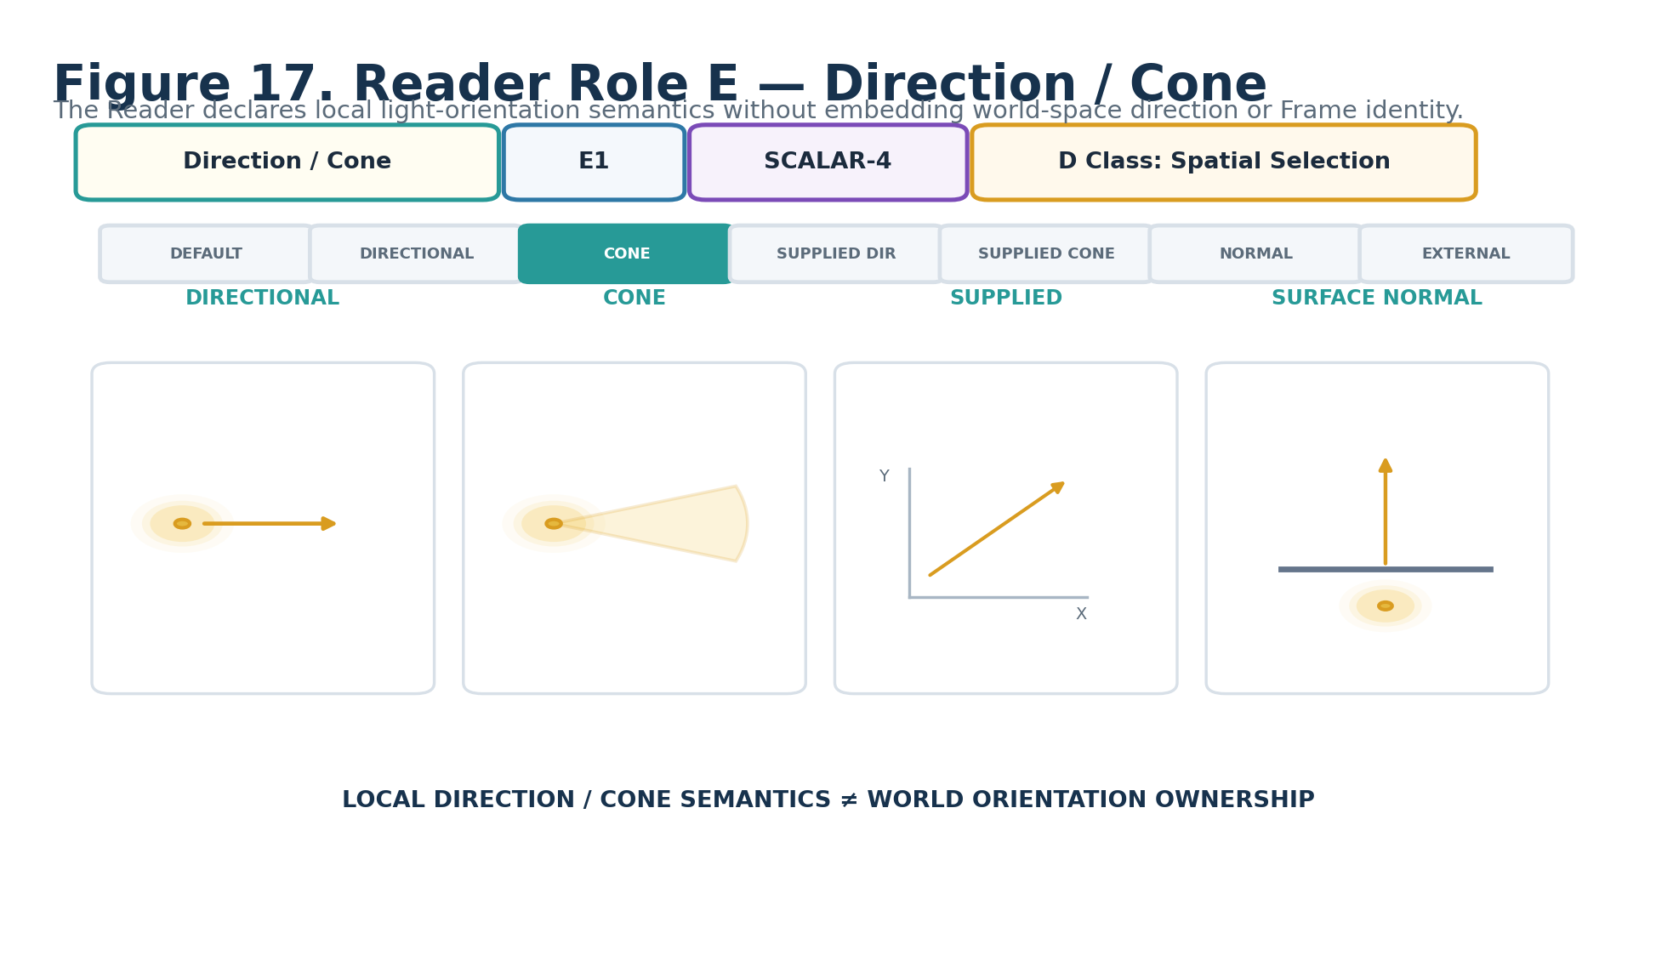
Figure 17. Direction / Cone — E1.
DECLARATION
Direction / Cone | E1 | SCALAR-4 | DREQ-SPATIAL.LIGHT_DIRECTION_CONE
Property | Contract
D Class | Spatial Selection
D Requirement Key | DREQ-SPATIAL.LIGHT_DIRECTION_CONE
Purpose | Declares how directional or conical illumination is oriented in local/supplied spatial context.
Representative states | 0 BINDING / PROFILE DEFAULT; 1 DIRECTIONAL ORIENTATION; 2 CONE; 3 SUPPLIED DIRECTION; 4 SUPPLIED CONE; 5 SURFACE / NORMAL-ORIENTED; 6 EXTERNAL PROFILE; 7–15 RESERVED.
Validation / boundary | Supplied/normal-oriented modes require the referenced Frame, direction, normal, or domain context. Missing required context follows K1.
Reader formula / mathematics | SCALAR-4 raw 0..15; exact vectors/cone values remain in supplied context/profile.
Does not own | World-space position, canonical Frame identity, or target geometry.

20. Attenuation / Falloff — F1
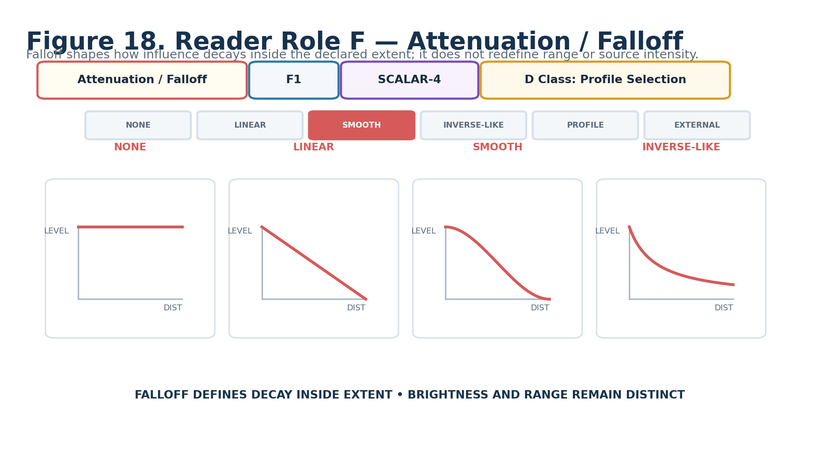
Figure 18. Attenuation / Falloff — F1.
DECLARATION
Attenuation / Falloff | F1 | SCALAR-4 | DREQ-PROFILE.LIGHT_FALLOFF
Property | Contract
D Class | Profile Selection
D Requirement Key | DREQ-PROFILE.LIGHT_FALLOFF
Purpose | Selects how illumination influence decays within the declared extent.
Representative states | 0 NONE / UNIFORM; 1 LINEAR; 2 SMOOTH; 3 INVERSE-LIKE; 4 PROFILE / MODEL; 5 EXTERNAL; 6–15 RESERVED.
Validation / boundary | Profile/External states require explicit registered profile identity. Falloff does not silently change D1 extent or C1 magnitude.
Reader formula / mathematics | SCALAR-4 selects falloff semantics; exact curve mathematics live in the registered profile where required.
Does not own | Range, center intensity, or renderer-specific attenuation implementation.

21. Volumetric Participation — G1
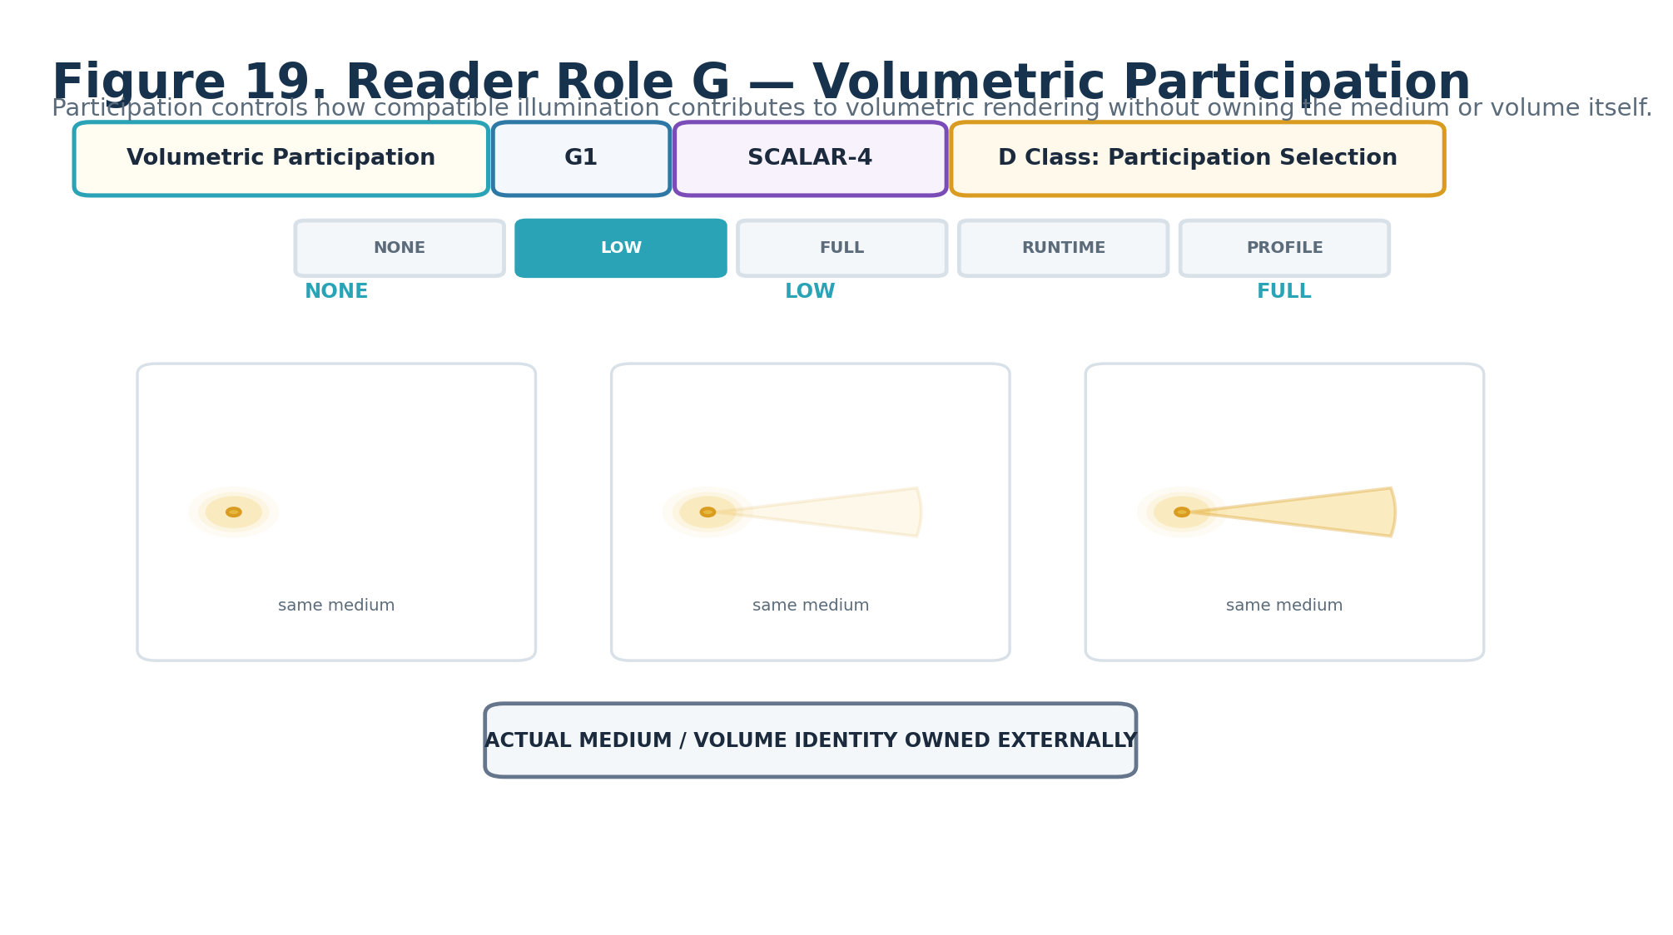
Figure 19. Volumetric Participation — G1.
DECLARATION
Volumetric Participation | G1 | SCALAR-4 | DREQ-CAT.VOLUMETRIC_PARTICIPATION
Property | Contract
D Class | Participation Selection
D Requirement Key | DREQ-CAT.VOLUMETRIC_PARTICIPATION
Purpose | Declares how compatible illumination participates in volumetric rendering.
Representative states | 0 NONE; 1 LOW; 2 FULL; 3 EXTERNALLY DETERMINED; 4 PROFILE / MODEL; 5–15 RESERVED.
Validation / boundary | A valid volumetric request does not imply endpoint support. Actual medium/volume identity and renderer capability remain external.
Reader formula / mathematics | SCALAR-4 raw 0..15.
Does not own | Medium identity, density field, volume geometry, or volumetric renderer implementation.

22. Shadow Participation — H1
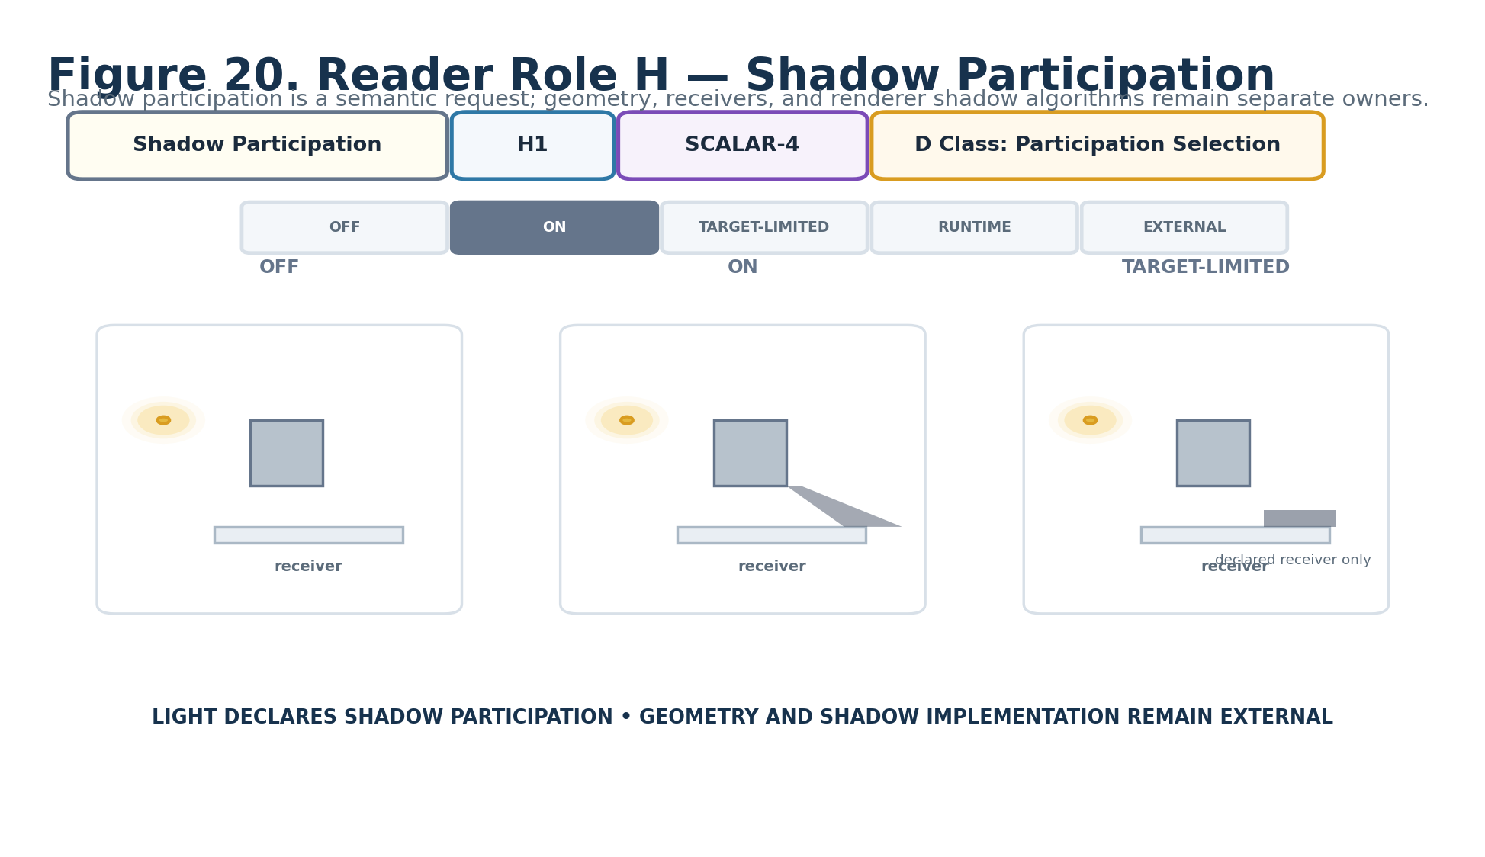
Figure 20. Shadow Participation — H1.
DECLARATION
Shadow Participation | H1 | SCALAR-4 | DREQ-CAT.SHADOW_PARTICIPATION
Property | Contract
D Class | Participation Selection
D Requirement Key | DREQ-CAT.SHADOW_PARTICIPATION
Purpose | Declares whether and how shadow semantics participate in the light request.
Representative states | 0 OFF; 1 ON; 2 TARGET-LIMITED; 3 RUNTIME / PROFILE; 4 EXTERNAL; 5–15 RESERVED.
Validation / boundary | TARGET-LIMITED requires explicit target/receiver context. Missing target does not authorize guessing receiver geometry.
Reader formula / mathematics | SCALAR-4 raw 0..15.
Does not own | Occluder/receiver geometry, shadow-map resolution, ray-tracing implementation.

23. Color Binding Mode — I1
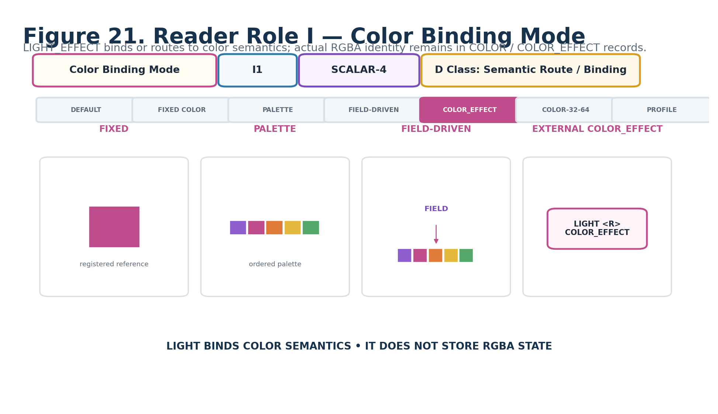
Figure 21. Color Binding Mode — I1.
DECLARATION
Color Binding Mode | I1 | SCALAR-4 | DREQ-ROUTE.LIGHT_COLOR
Property | Contract
D Class | Semantic Route / Binding
D Requirement Key | DREQ-ROUTE.LIGHT_COLOR
Purpose | Declares how the illumination request obtains color behavior or registered color identity.
Representative states | 0 NONE / ENDPOINT DEFAULT; 1 FIXED REGISTERED COLOR; 2 PALETTE; 3 FIELD-DRIVEN; 4 EXTERNAL COLOR_EFFECT; 5 DIRECT COLOR-32-64; 6 PROFILE / EXTERNAL; 7–15 RESERVED.
Validation / boundary | Modes requiring color references or COLOR_EFFECT routes must resolve them explicitly. Missing required color context follows K1.
Reader formula / mathematics | SCALAR-4 selects routing/binding semantics.
Does not own | RGBA channel identity; that remains in COLOR-32-64 or other registered color records.

24. Accumulation / Mixing — J1
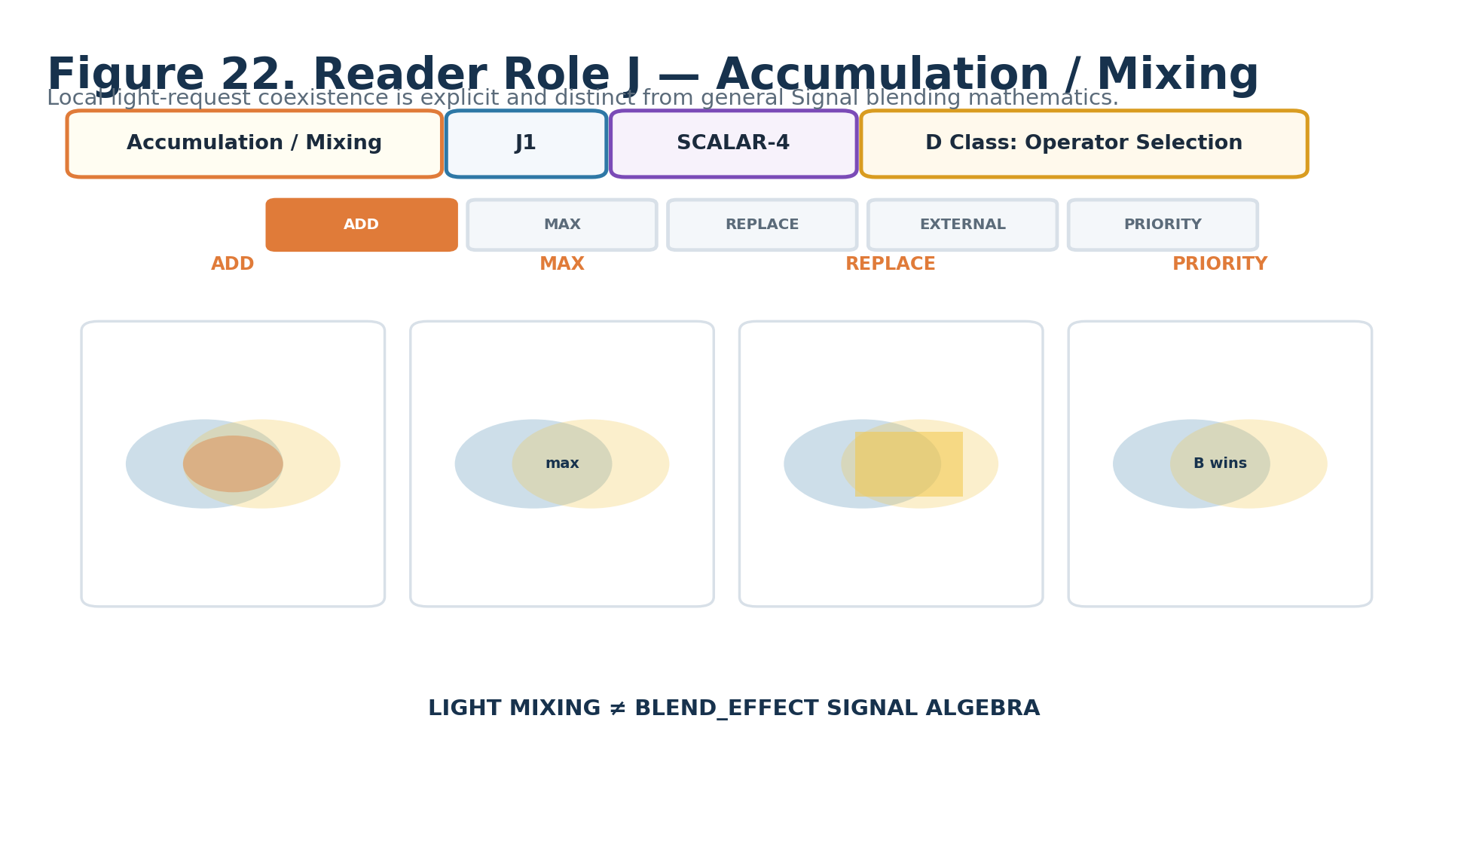
Figure 22. Accumulation / Mixing — J1.
DECLARATION
Accumulation / Mixing | J1 | SCALAR-4 | DREQ-OP.LIGHT_MIX
Property | Contract
D Class | Operator Selection
D Requirement Key | DREQ-OP.LIGHT_MIX
Purpose | Declares how this illumination request coexists with other compatible light requests in the same application scope.
Representative states | 0 ADD; 1 MAX; 2 REPLACE; 3 EXTERNALLY MIXED; 4 PRIORITY; 5–15 RESERVED.
Validation / boundary | This is light-request coexistence, not general complete-Signal BLEND_EFFECT algebra. External mixing requires an explicit mixer/binding contract.
Reader formula / mathematics | SCALAR-4 raw 0..15.
Does not own | General Signal blend mathematics or renderer-default light accumulation.

25. Null / Failure Behavior — K1
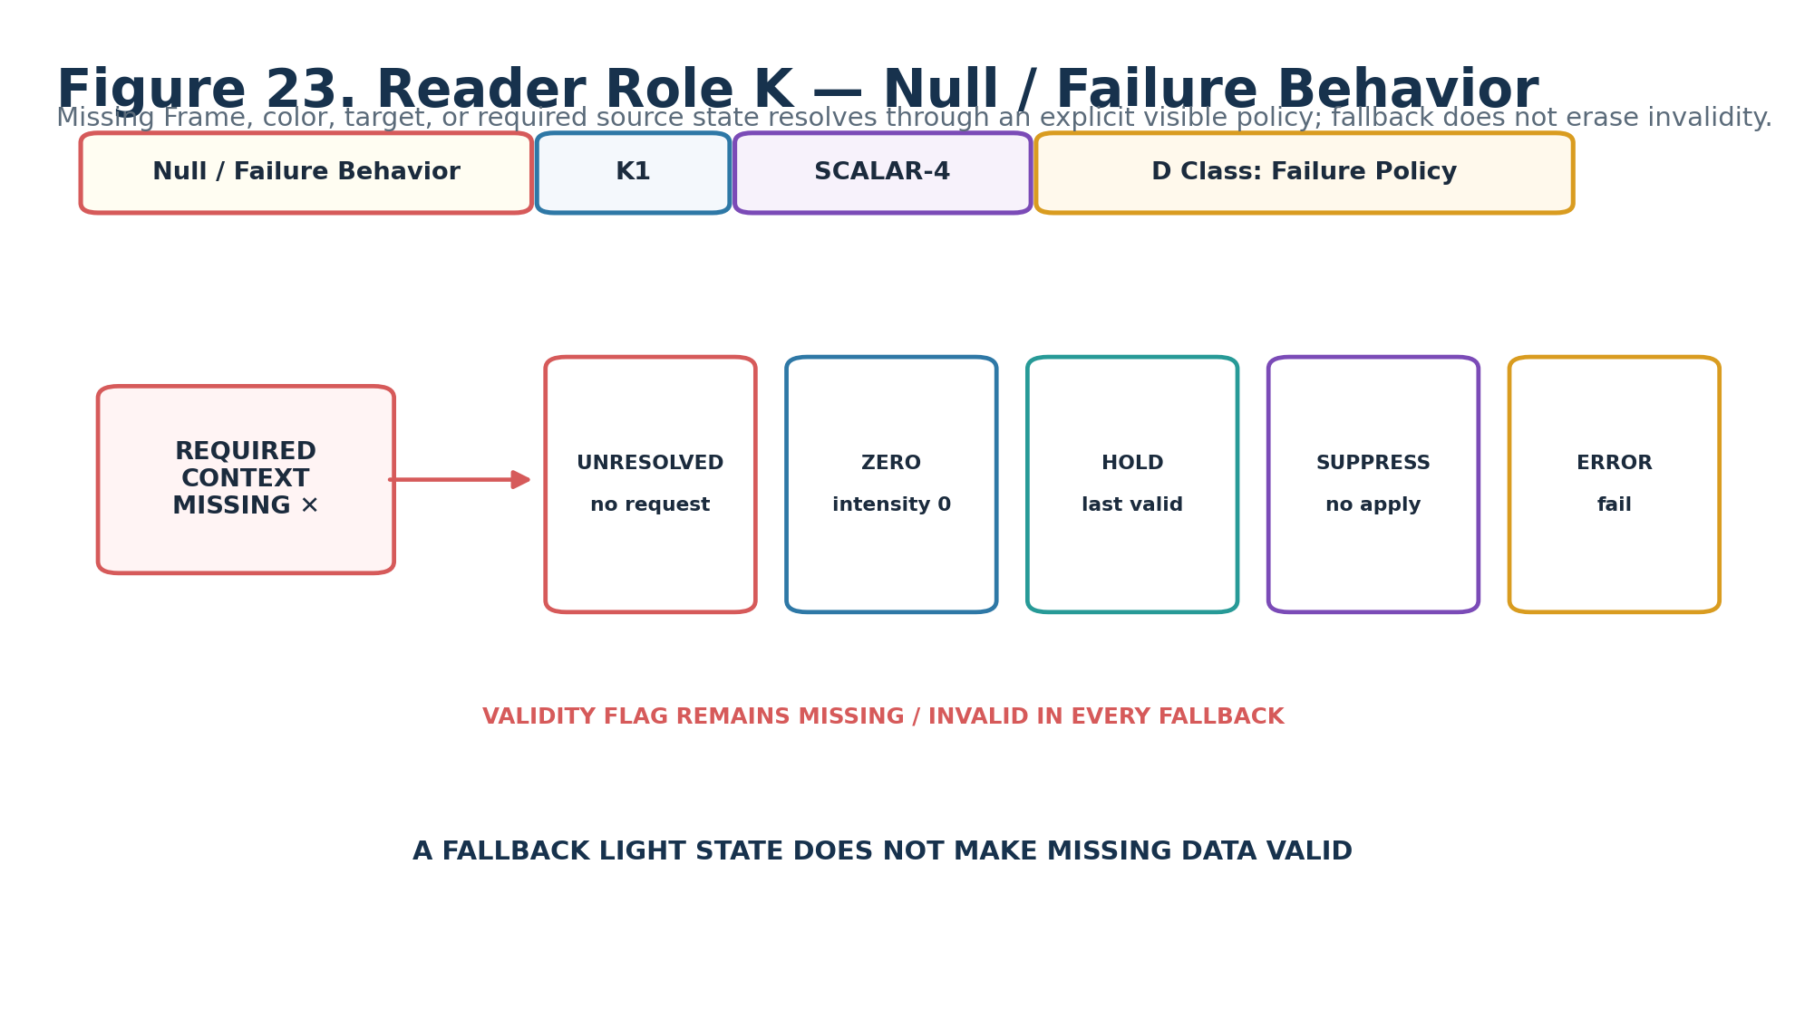
Figure 23. Null / Failure Behavior — K1.
DECLARATION
Null / Failure Behavior | K1 | SCALAR-4 | DREQ-POLICY.FAILURE
Property | Contract
D Class | Failure Policy
D Requirement Key | DREQ-POLICY.FAILURE
Purpose | Defines visible behavior when required source, Frame, target, color route, profile, or other context is missing/invalid.
Representative states | 0 UNRESOLVED / NO LIGHT REQUEST; 1 ZERO INTENSITY; 2 HOLD LAST VALID; 3 SUPPRESS APPLICATION; 4 ERROR; 5 EXTERNAL POLICY; 6–15 RESERVED.
Validation / boundary | Fallback outputs SHALL preserve validity/provenance. A numeric fallback never makes missing context valid.
Reader formula / mathematics | SCALAR-4 raw 0..15.
Does not own | Fabricated Frame, color, target, or source values.

26. Evaluation Mode — L1
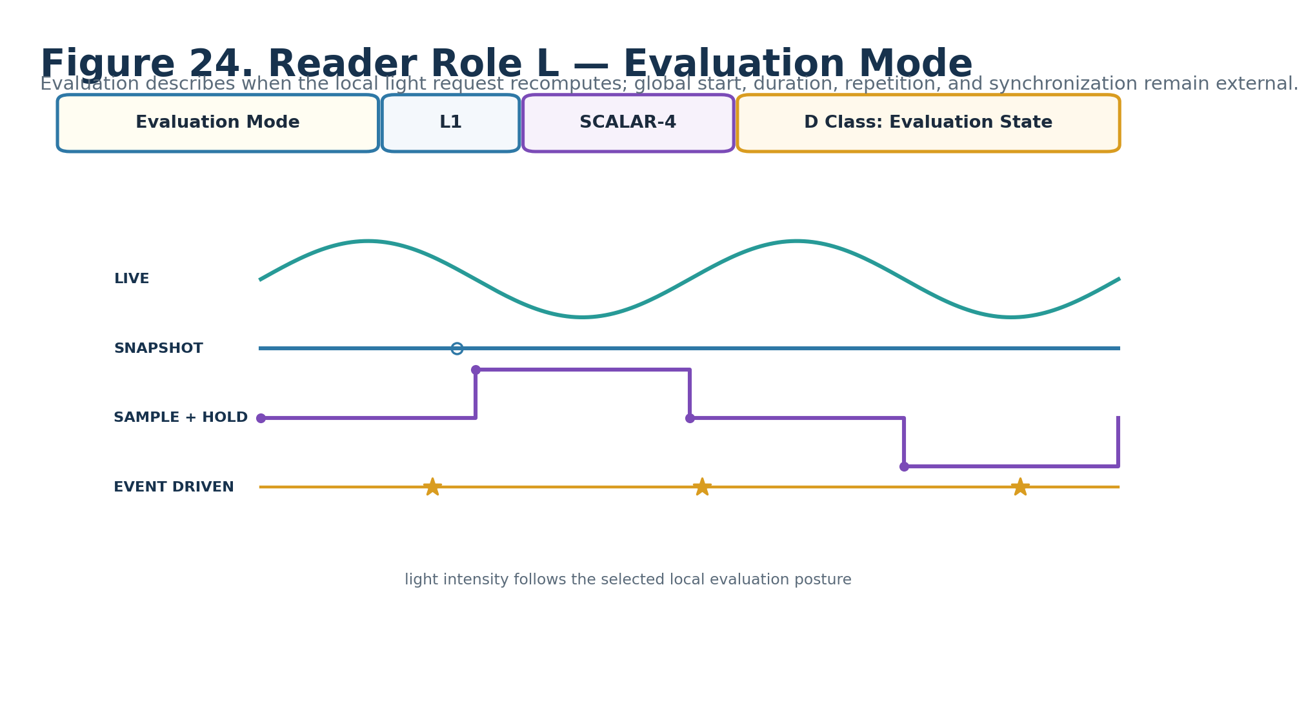
Figure 24. Evaluation Mode — L1.
DECLARATION
Evaluation Mode | L1 | SCALAR-4 | DREQ-EVAL.MODE
Property | Contract
D Class | Evaluation State
D Requirement Key | DREQ-EVAL.MODE
Purpose | Declares when the local light request recomputes against supplied source/domain context.
Representative states | 0 LIVE; 1 SNAPSHOT; 2 SAMPLE_AND_HOLD; 3 EVENT_DRIVEN; 4–15 RESERVED.
Validation / boundary | SAMPLE_AND_HOLD and EVENT_DRIVEN require explicit sample/event trigger context. Global start/duration/repetition remain external.
Reader formula / mathematics | SCALAR-4 raw 0..15.
Does not own | Global timing, synchronization, or source Signal lifecycle.

27. Formula Profile — M1
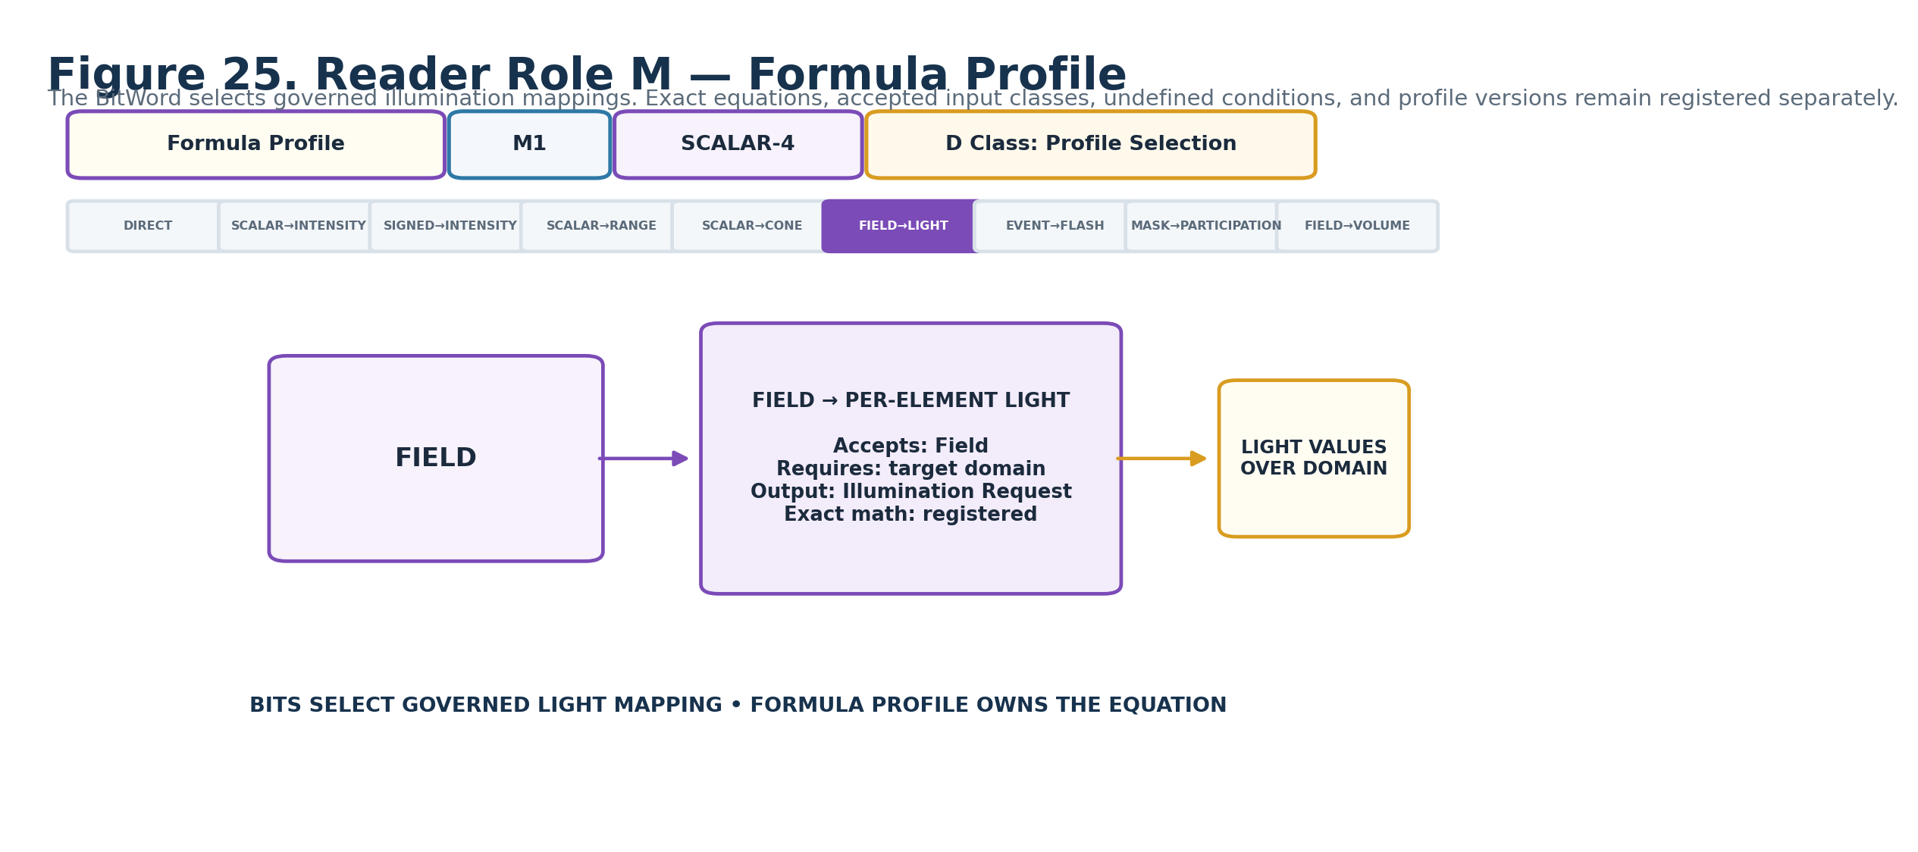
Figure 25. Formula Profile — M1.
DECLARATION
Formula Profile | M1 | SCALAR-4 | DREQ-PROFILE.LIGHT_FORMULA
Property | Contract
D Class | Profile Selection
D Requirement Key | DREQ-PROFILE.LIGHT_FORMULA
Purpose | Selects the registered mapping that turns the accepted typed Signal into the selected light parameter semantics.
Representative states | 0 DIRECT / BINDING DEFAULT; 1 SCALAR→INTENSITY; 2 SIGNED SCALAR→INTENSITY REMAP; 3 SCALAR→RANGE/RADIUS; 4 SCALAR→CONE PARAMETER; 5 FIELD→PER-ELEMENT LIGHT; 6 EVENT→FLASH REQUEST; 7 MASK→PARTICIPATION/INTENSITY; 8 FIELD→VOLUMETRIC CONTROL; 9 EXTERNAL LIGHT FORMULA; 10–15 RESERVED.
Validation / boundary | Each profile must register accepted input class, required context, exact equation/version, undefined conditions, output semantics, and deterministic posture.
Reader formula / mathematics | SCALAR-4 selects Formula Profile identity/class; exact equation lives in the profile record.
Does not own | Renderer implementation or hidden unit conversion.

28. Interpretation Version — N1
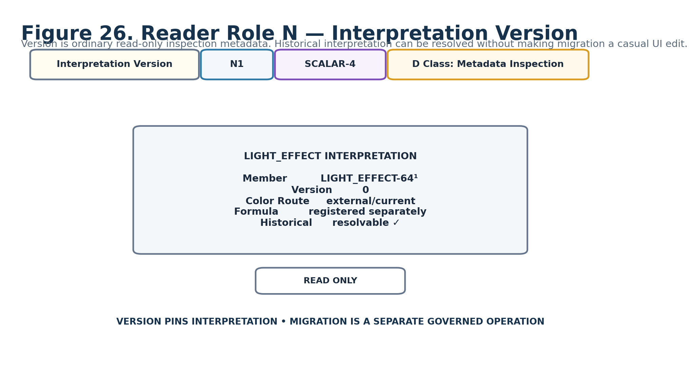
Figure 26. Interpretation Version — N1.
DECLARATION
Interpretation Version | N1 | SCALAR-4 | DREQ-META.VERSION_INSPECT
Property | Contract
D Class | Metadata Inspection
D Requirement Key | DREQ-META.VERSION_INSPECT
Purpose | Pins the Reader interpretation required to resolve historical stored Bits and routing/profile relationships.
Representative states | 0 baseline Candidate interpretation; 1–14 registered future interpretations; 15 RESERVED.
Validation / boundary | Ordinary DARTBOARD presentation is read-only. Migration/version conversion is a separate governed operation.
Reader formula / mathematics | SCALAR-4 raw 0..15.
Does not own | Spec document version, Formula Profile version, target asset version, or renderer version.

Part 4 — Interface-0, D Requirements, and Complete DARTBOARD

29. Interface-0 Assembly
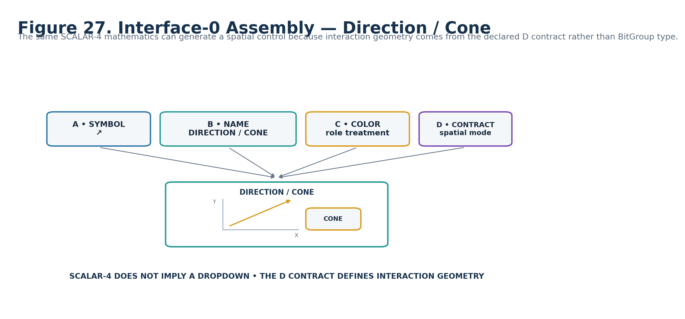
Figure 27. Interface-0 assembly for Direction / Cone.

30. Complete Generated LIGHT DARTBOARD
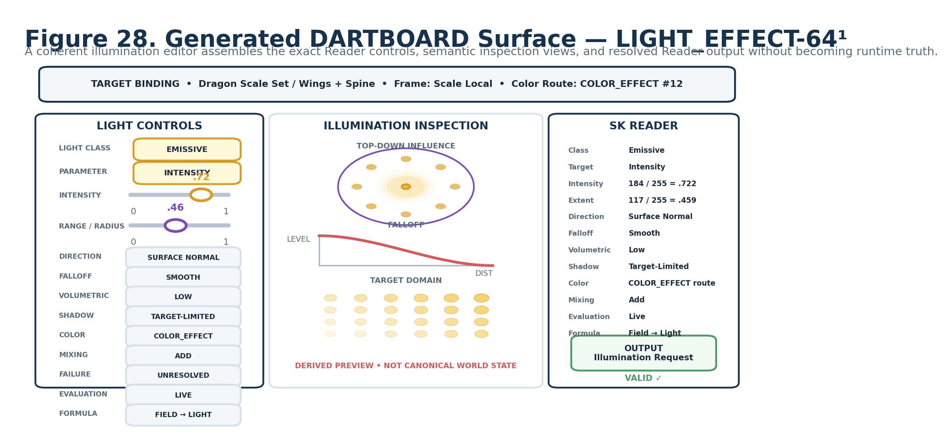
Figure 28. Complete LIGHT_EFFECT-64¹ illumination authoring surface.
The top binding strip is runtime context rather than another BitWord placement. The left column exposes the Reader roles using the interface forms established in the role gallery, the center provides derived illumination inspection, and the right column shows deterministic Reader resolution and typed output.

31. One Control Descends to Exact Bits
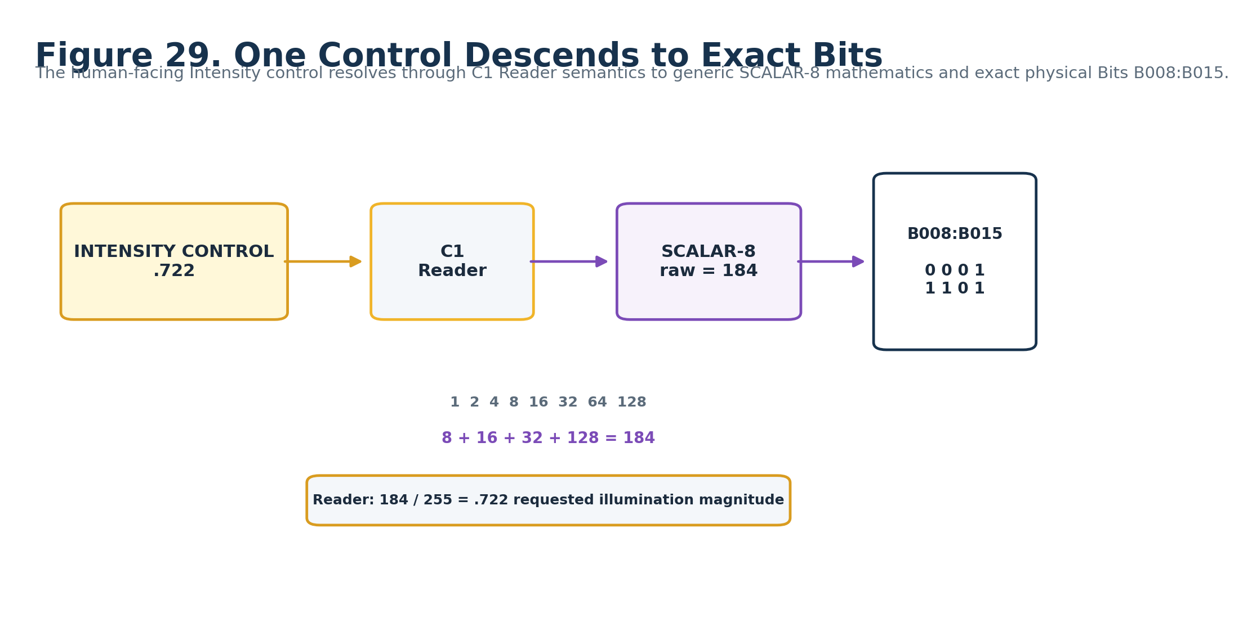
Figure 29. C1 Intensity descends from interface control to Reader semantics, SCALAR-8 mathematics, and exact B008:B015 Bits.

32. Complete Physical BitWord Map
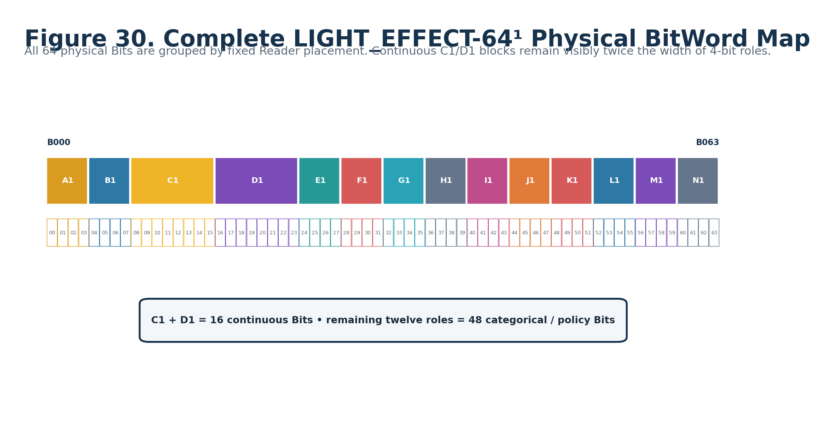
Figure 30. Complete LIGHT_EFFECT-64¹ B000:B063 map.

33. Candidate D Requirement Plan
Reader | D Class | Candidate requirement
A1 | Categorical Selection | DREQ-CAT.LIGHT_CLASS
B1 | Categorical Selection | DREQ-CAT.LIGHT_PARAMETER
C1 | Scalar | DREQ-SCALAR.LIGHT_INTENSITY
D1 | Scalar | DREQ-SCALAR.LIGHT_EXTENT
E1 | Spatial Selection | DREQ-SPATIAL.LIGHT_DIRECTION_CONE
F1 | Profile Selection | DREQ-PROFILE.LIGHT_FALLOFF
G1 | Participation Selection | DREQ-CAT.VOLUMETRIC_PARTICIPATION
H1 | Participation Selection | DREQ-CAT.SHADOW_PARTICIPATION
I1 | Semantic Route / Binding | DREQ-ROUTE.LIGHT_COLOR
J1 | Operator Selection | DREQ-OP.LIGHT_MIX
K1 | Failure Policy | DREQ-POLICY.FAILURE
L1 | Evaluation State | DREQ-EVAL.MODE
M1 | Profile Selection | DREQ-PROFILE.LIGHT_FORMULA
N1 | Metadata Inspection | DREQ-META.VERSION_INSPECT

Part 5 — Reader Algorithm, Typed Output, Color Routing, and Interoperability

34. Reader Evaluation Pipeline
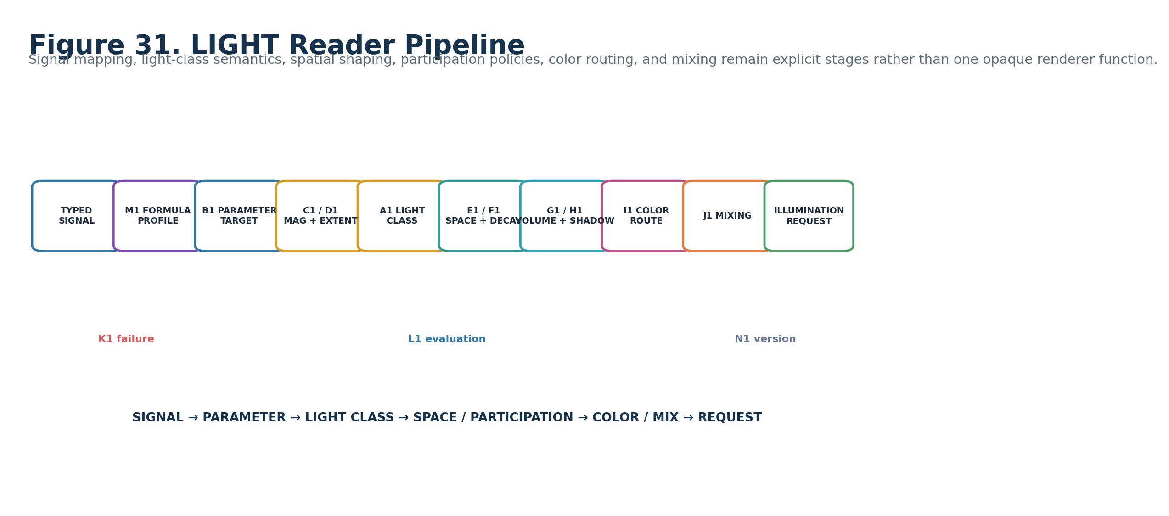
Figure 31. LIGHT Reader pipeline.

35. Renderer-Neutral Illumination Request
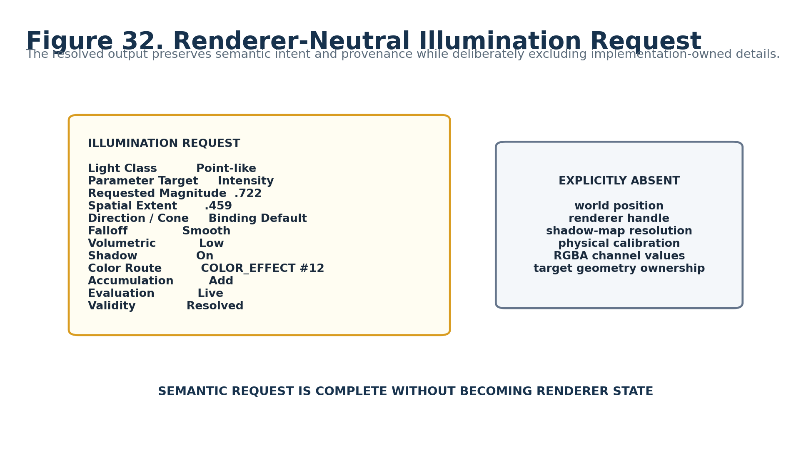
Figure 32. Example typed Illumination Request and deliberately absent implementation-owned fields.

36. Direct Compatibility and Explicit Transforms
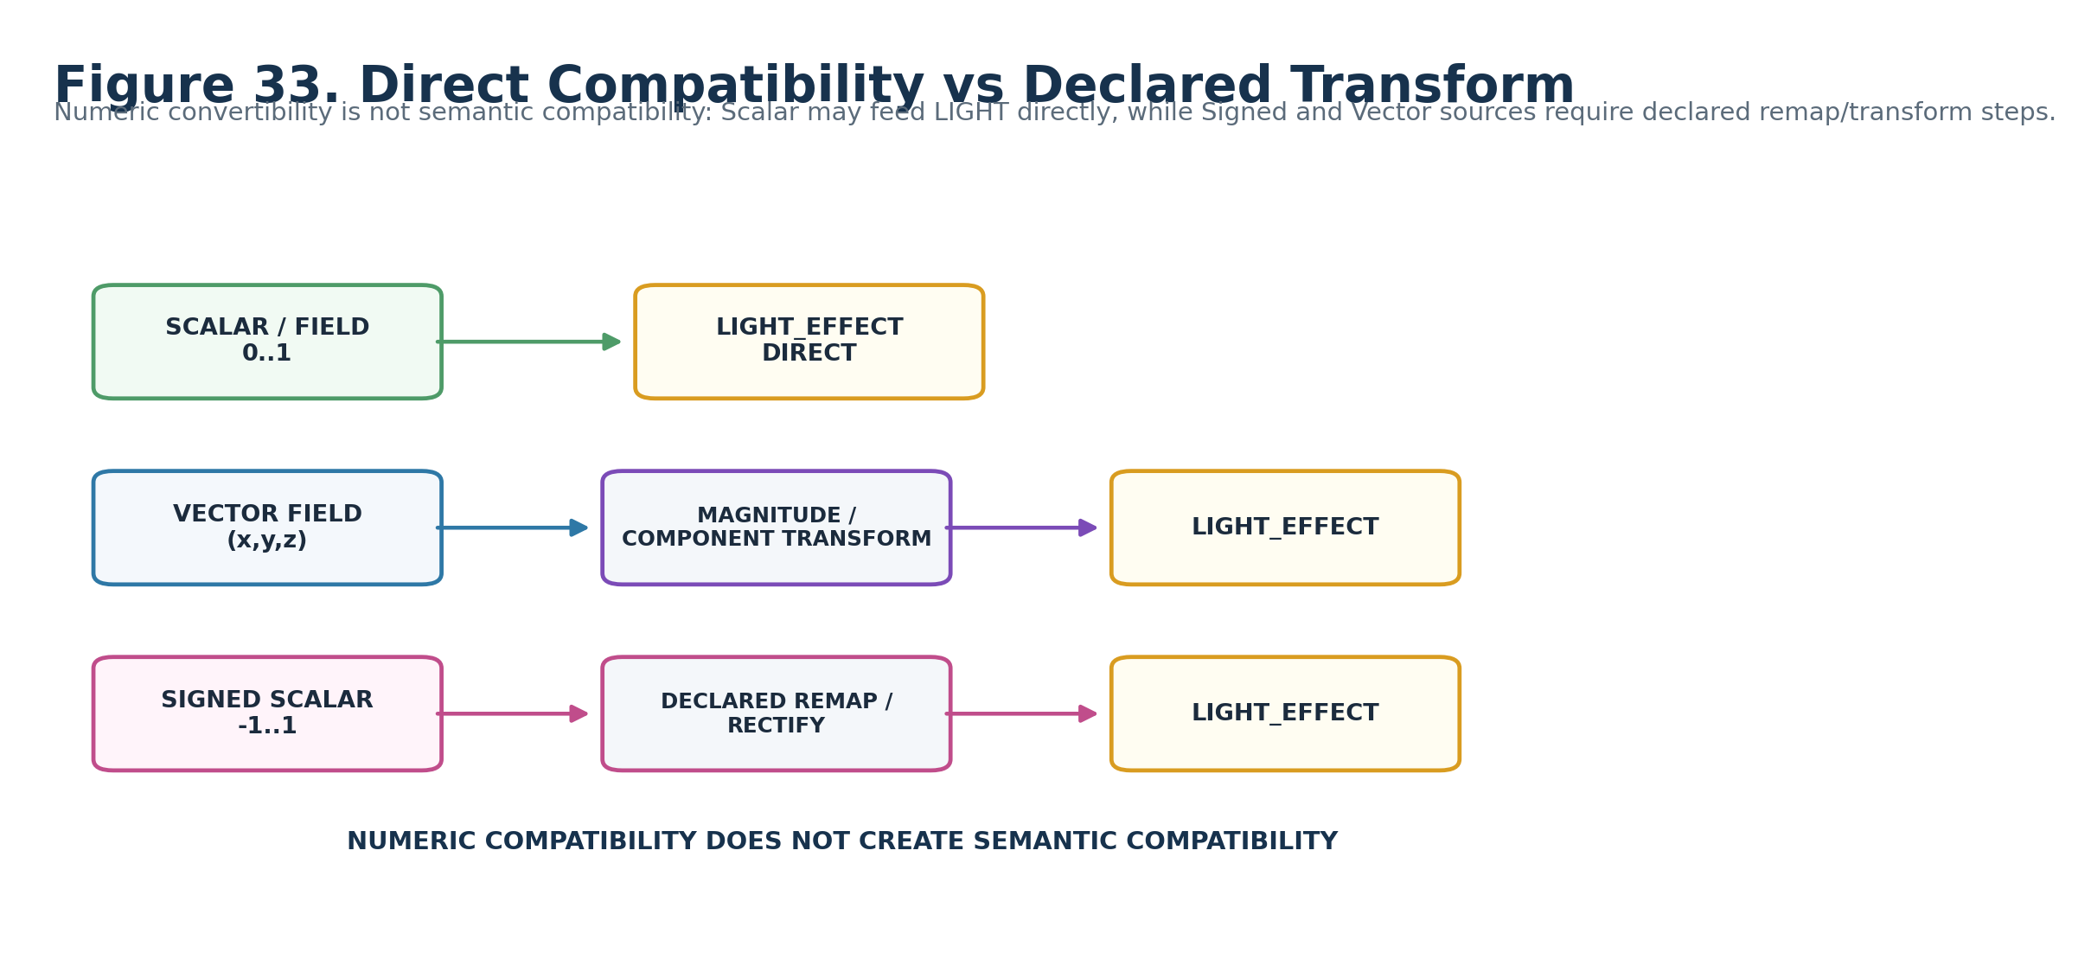
Figure 33. Scalar direct compatibility versus declared Signed/Vector transforms.
NO SILENT COERCION
A Vector does not become light intensity merely because magnitude is calculable. Signed Scalar does not become positive intensity merely because rectification is available. The transform/remap is itself semantic structure and must remain visible.

37. Interoperability Card
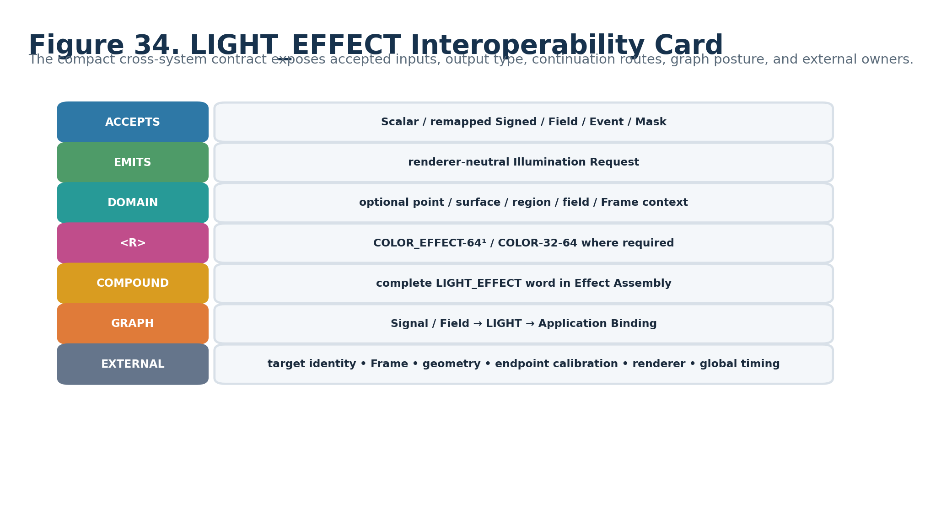
Figure 34. LIGHT_EFFECT interoperability card.

38. Continuation, Compound, and Runtime Graph
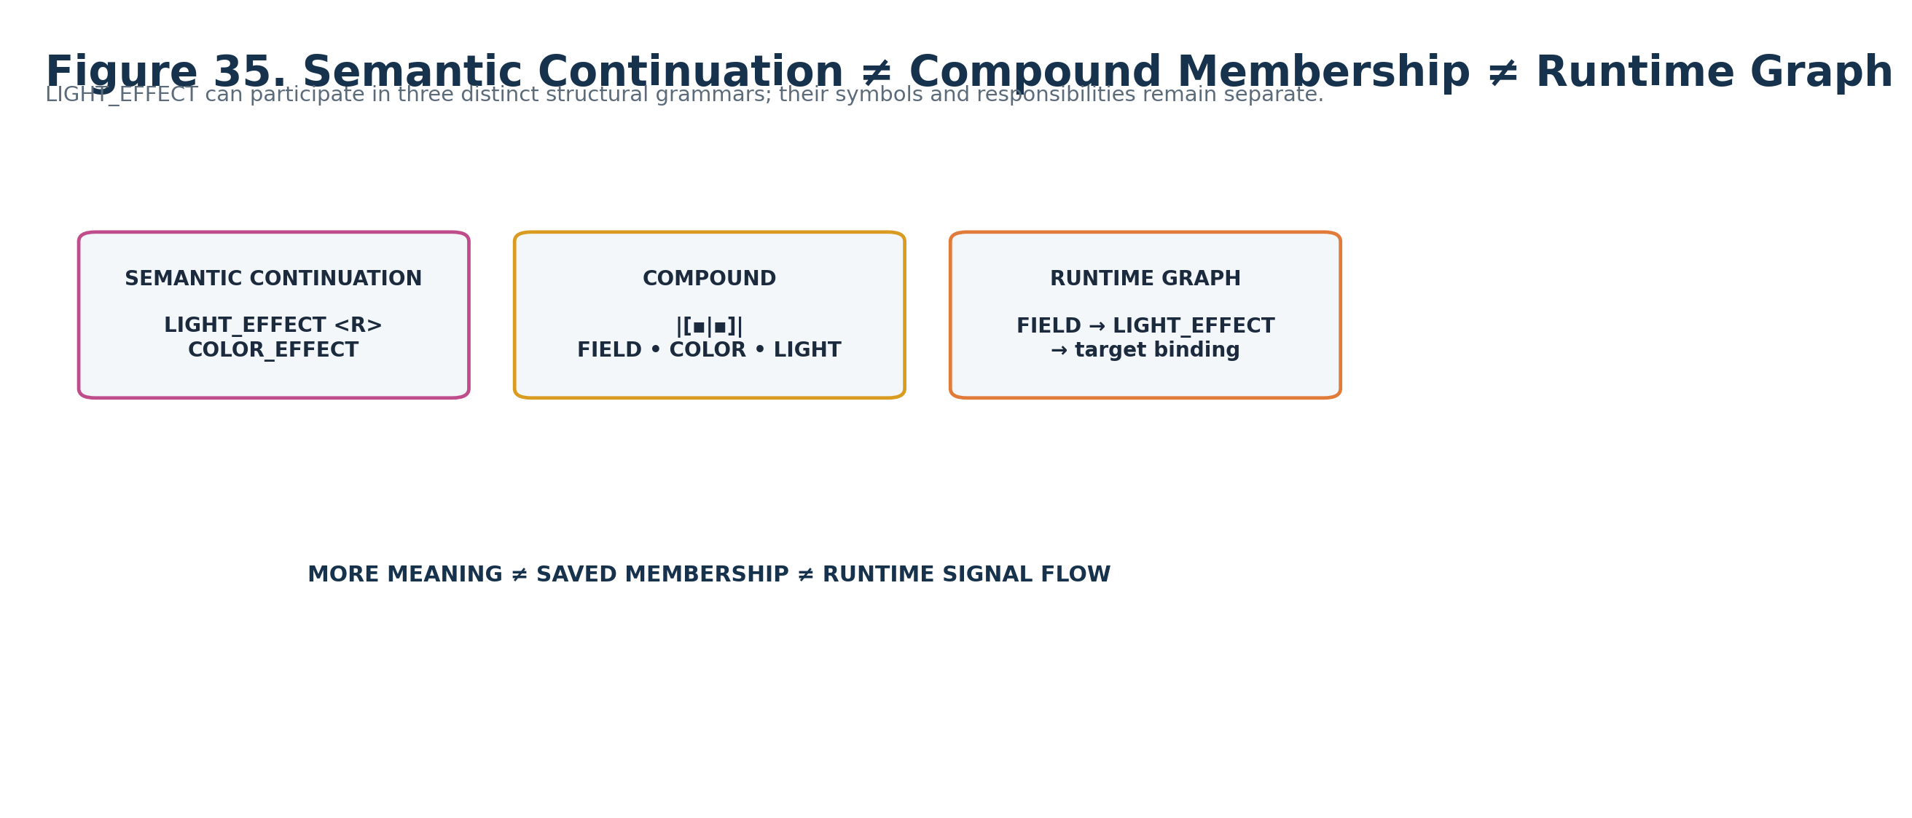
Figure 35. Semantic continuation, Compound membership, and runtime signal flow are distinct grammars.

39. Endpoint Capability Boundary
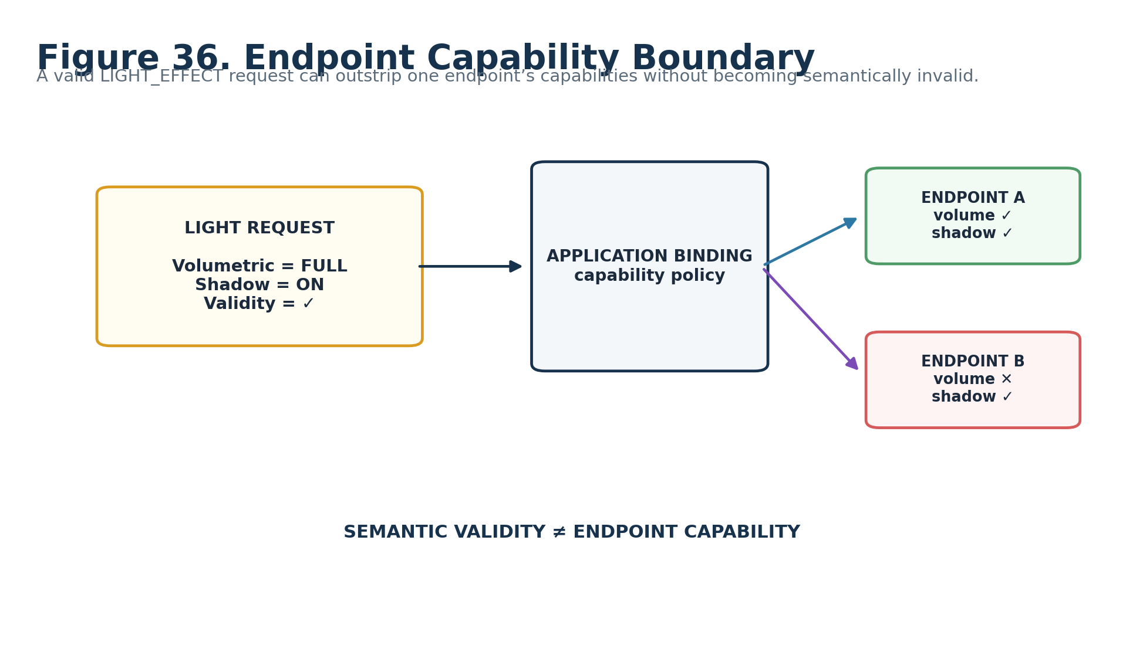
Figure 36. Semantic validity remains distinct from renderer/endpoint capability.

40. Determinism Posture
LIGHT_EFFECT adds no intrinsic stochastic behavior, so this Candidate architecture stores no separate Determinism Reader. Determinism derives from upstream Signal state, the selected Formula Profile, local Evaluation Mode, supplied context, and Application Binding. A deterministic source with deterministic Formula/context yields a deterministic Light Request; stochastic source state remains stochastic downstream. This avoids a redundant stored claim that could contradict provenance.

Part 6 — Worked Examples, Invalid States, and Conformance

41. Worked Example Triptych
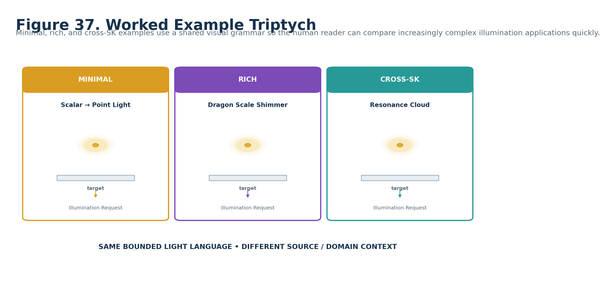
Figure 37. Minimal, rich, and cross-SK LIGHT examples.

42. Minimal Example — Scalar Point Light
Reader | Resolved state
A1 | POINT-LIKE
B1 | INTENSITY
C1 | .65 requested magnitude
D1 | .40 normalized extent
E1 | Binding default
F1 | SMOOTH
G1 | NONE
H1 | OFF
I1 | ENDPOINT DEFAULT
J1 | ADD
K1 | UNRESOLVED / NO REQUEST on failure
L1 | LIVE
M1 | SCALAR→INTENSITY
N1 | baseline

43. Rich Example — Dragon Scale Shimmer
FIELD_EFFECT evaluates the Dragon Scale domain into a shared Shimmer Field consumed by Movement, Color, and LIGHT. A representative Light branch uses EMISSIVE, INTENSITY, FIELD→PER-ELEMENT LIGHT, SURFACE NORMAL, SMOOTH falloff, external COLOR_EFFECT, and ADD mixing. The Light request is one projection; the Shimmer Field remains available and unchanged.

44. Cross-SK Example — Resonance Cloud
A Resonance Event can feed Light intensity/coherence while the same provenance drives Geometry, Haptic, Audio, and Color branches. The point is not that LIGHT knows resonance semantics; rather, the accepted typed source and Formula Profile map declared resonance values into light-request semantics. This preserves shared cause without duplicating source truth.

45. MATERIAL Emissive Continuation
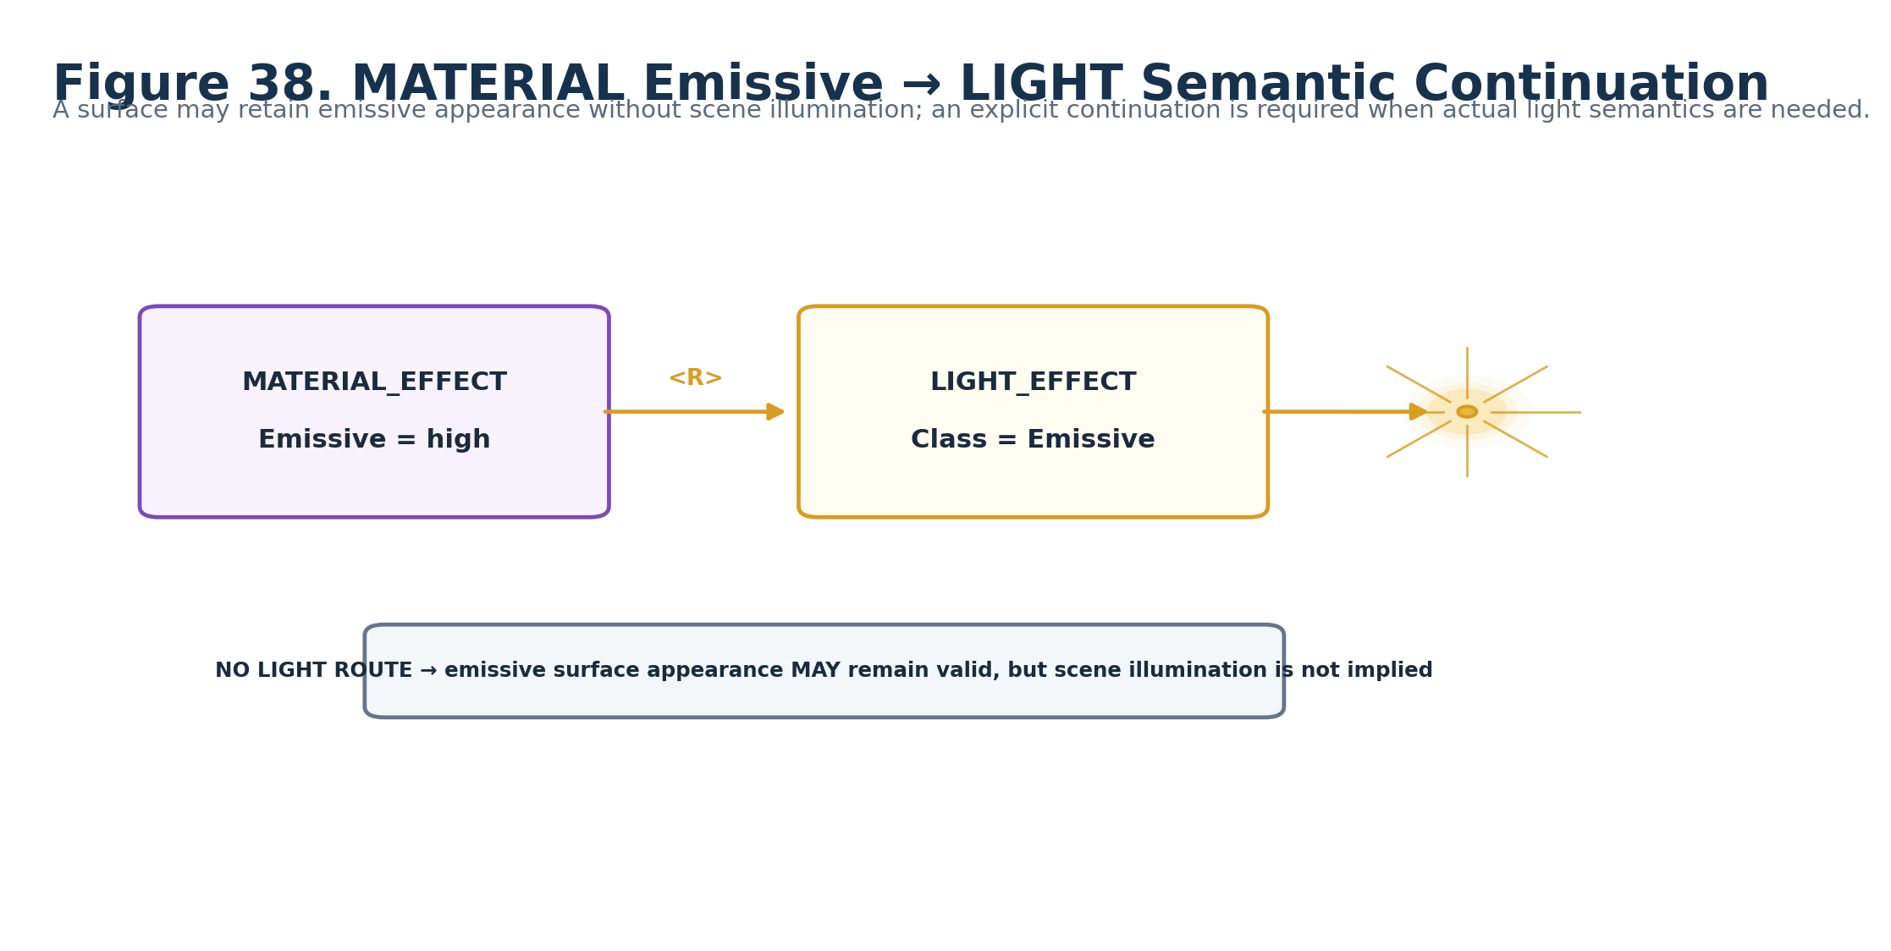
Figure 38. MATERIAL emissive presentation routes to LIGHT only when actual illumination semantics are required.

46. Invalid Directional Context
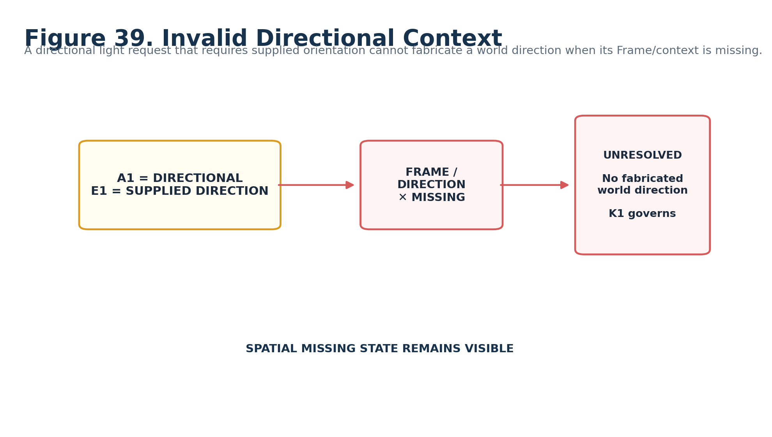
Figure 39. Missing supplied Direction / Frame leaves directional semantics unresolved.

47. Missing Color Route
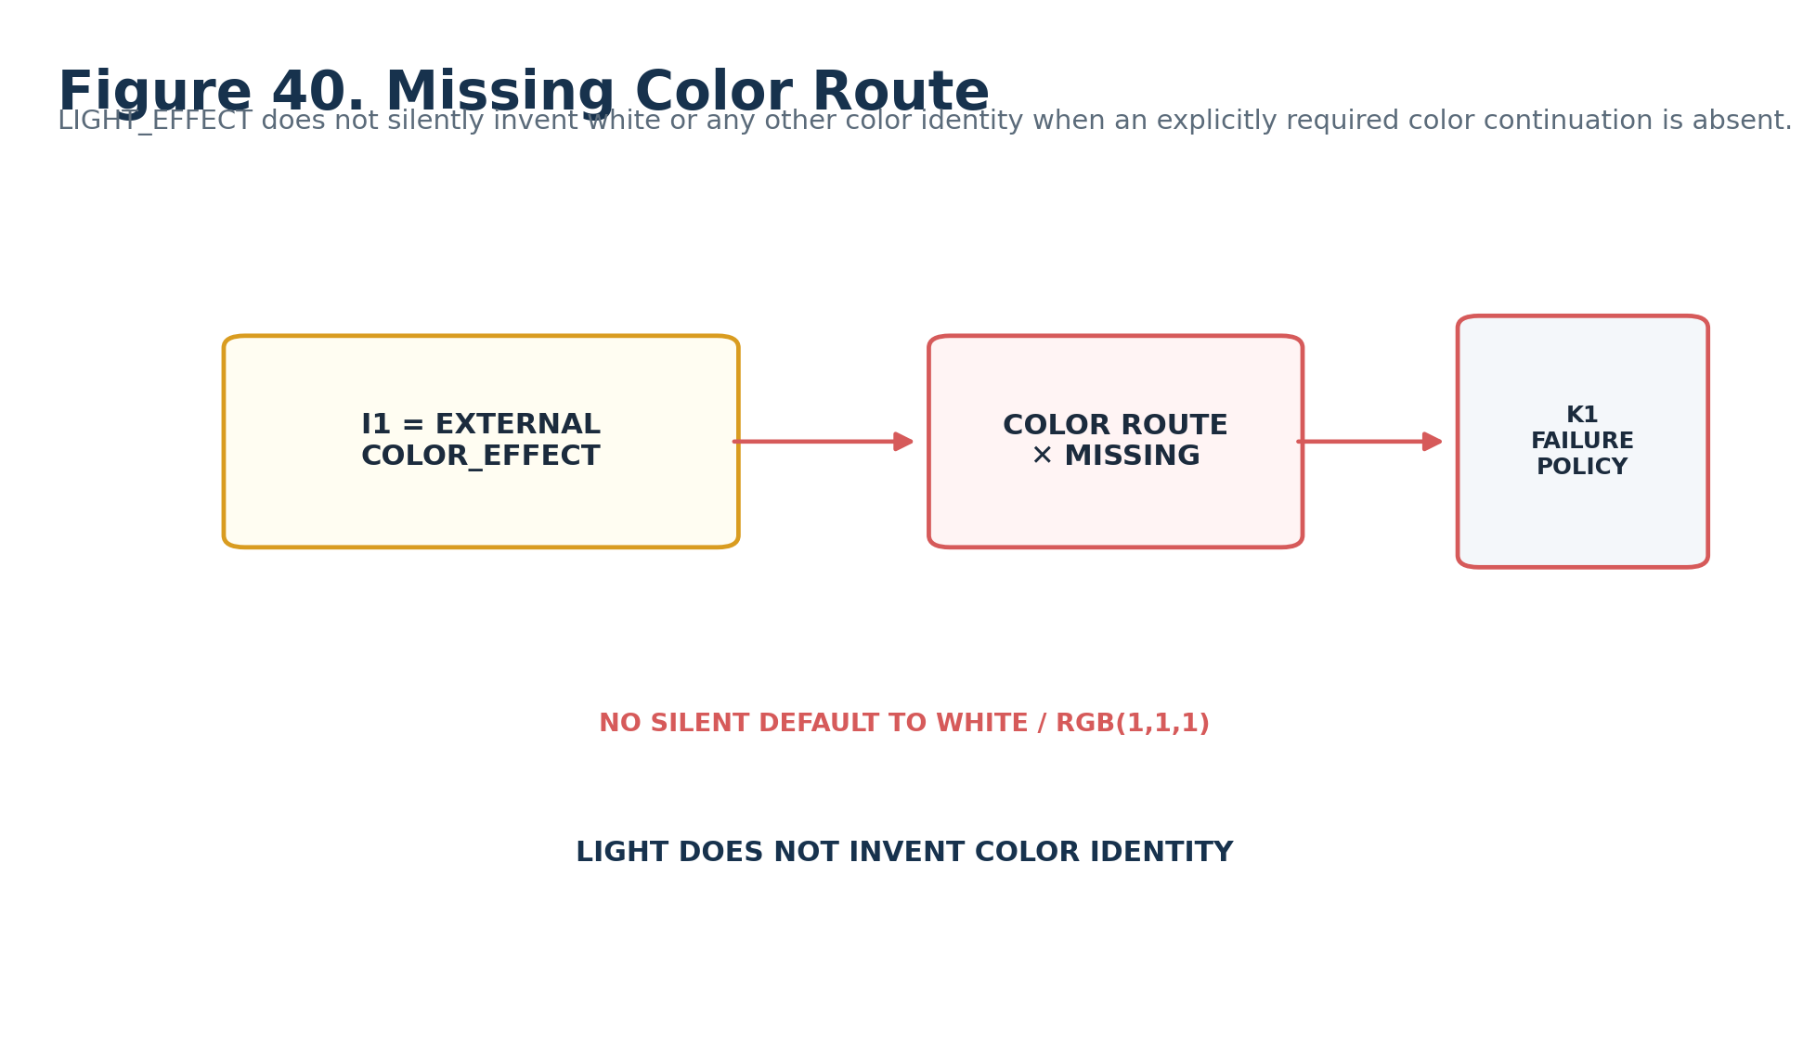
Figure 40. Explicit color route missing: LIGHT does not invent color identity.

48. Target-Limited Shadow Without Target
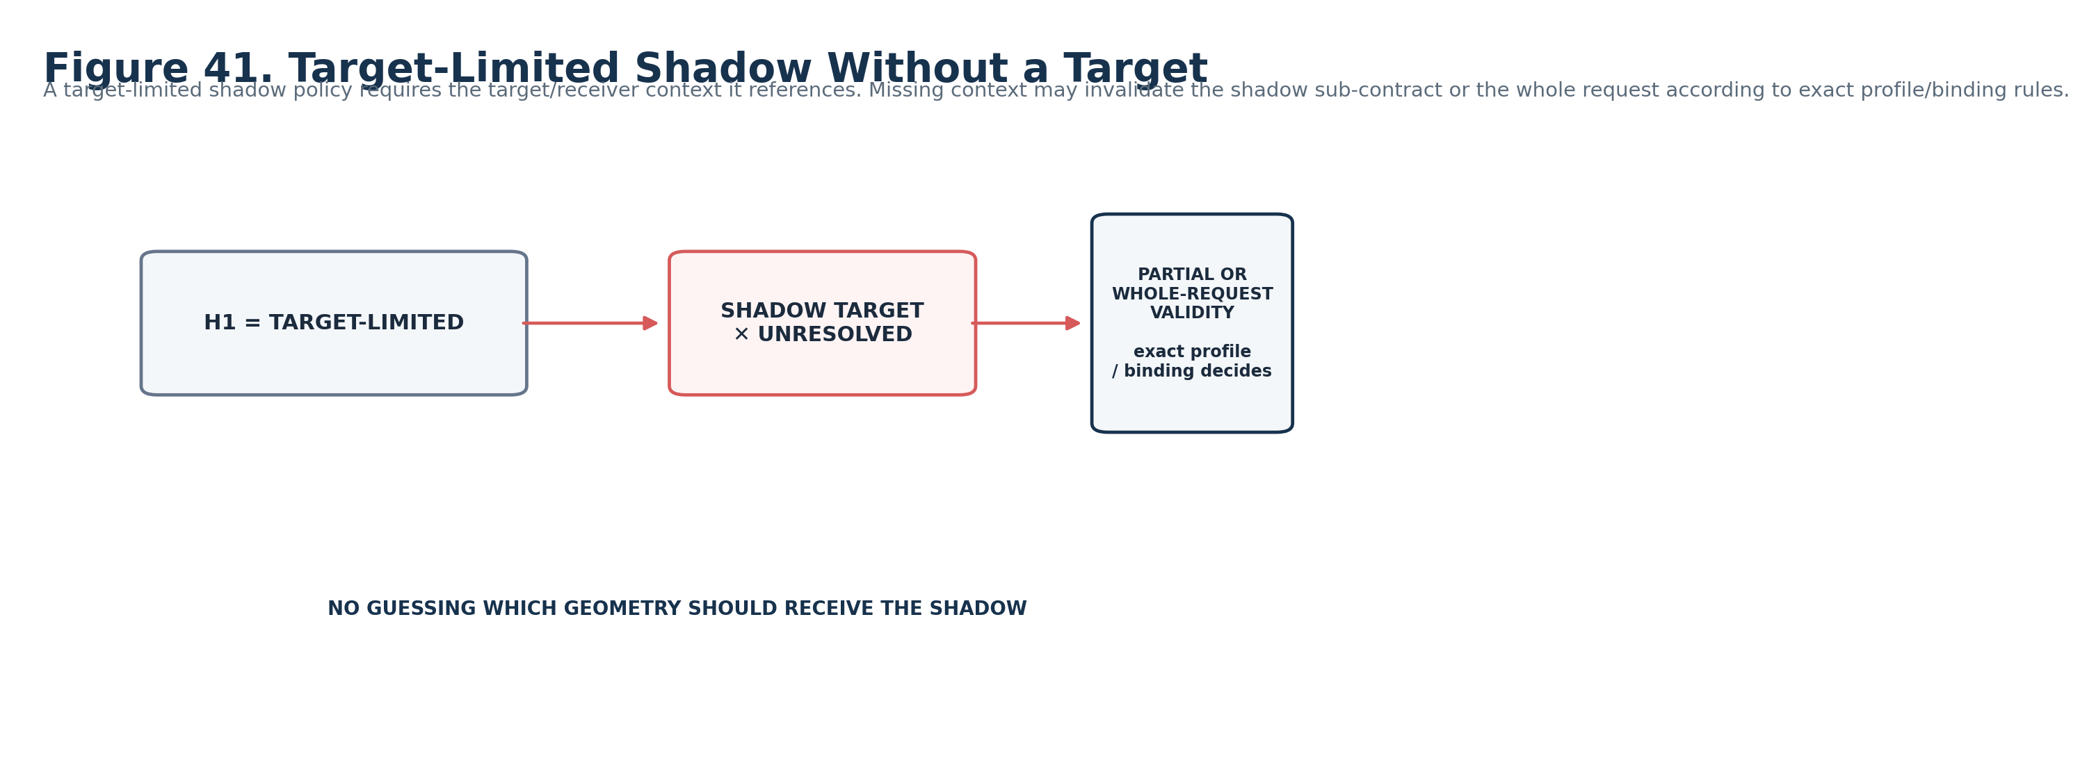
Figure 41. TARGET-LIMITED shadow semantics require an explicit receiver context.

49. Valid Semantics, Unsupported Endpoint
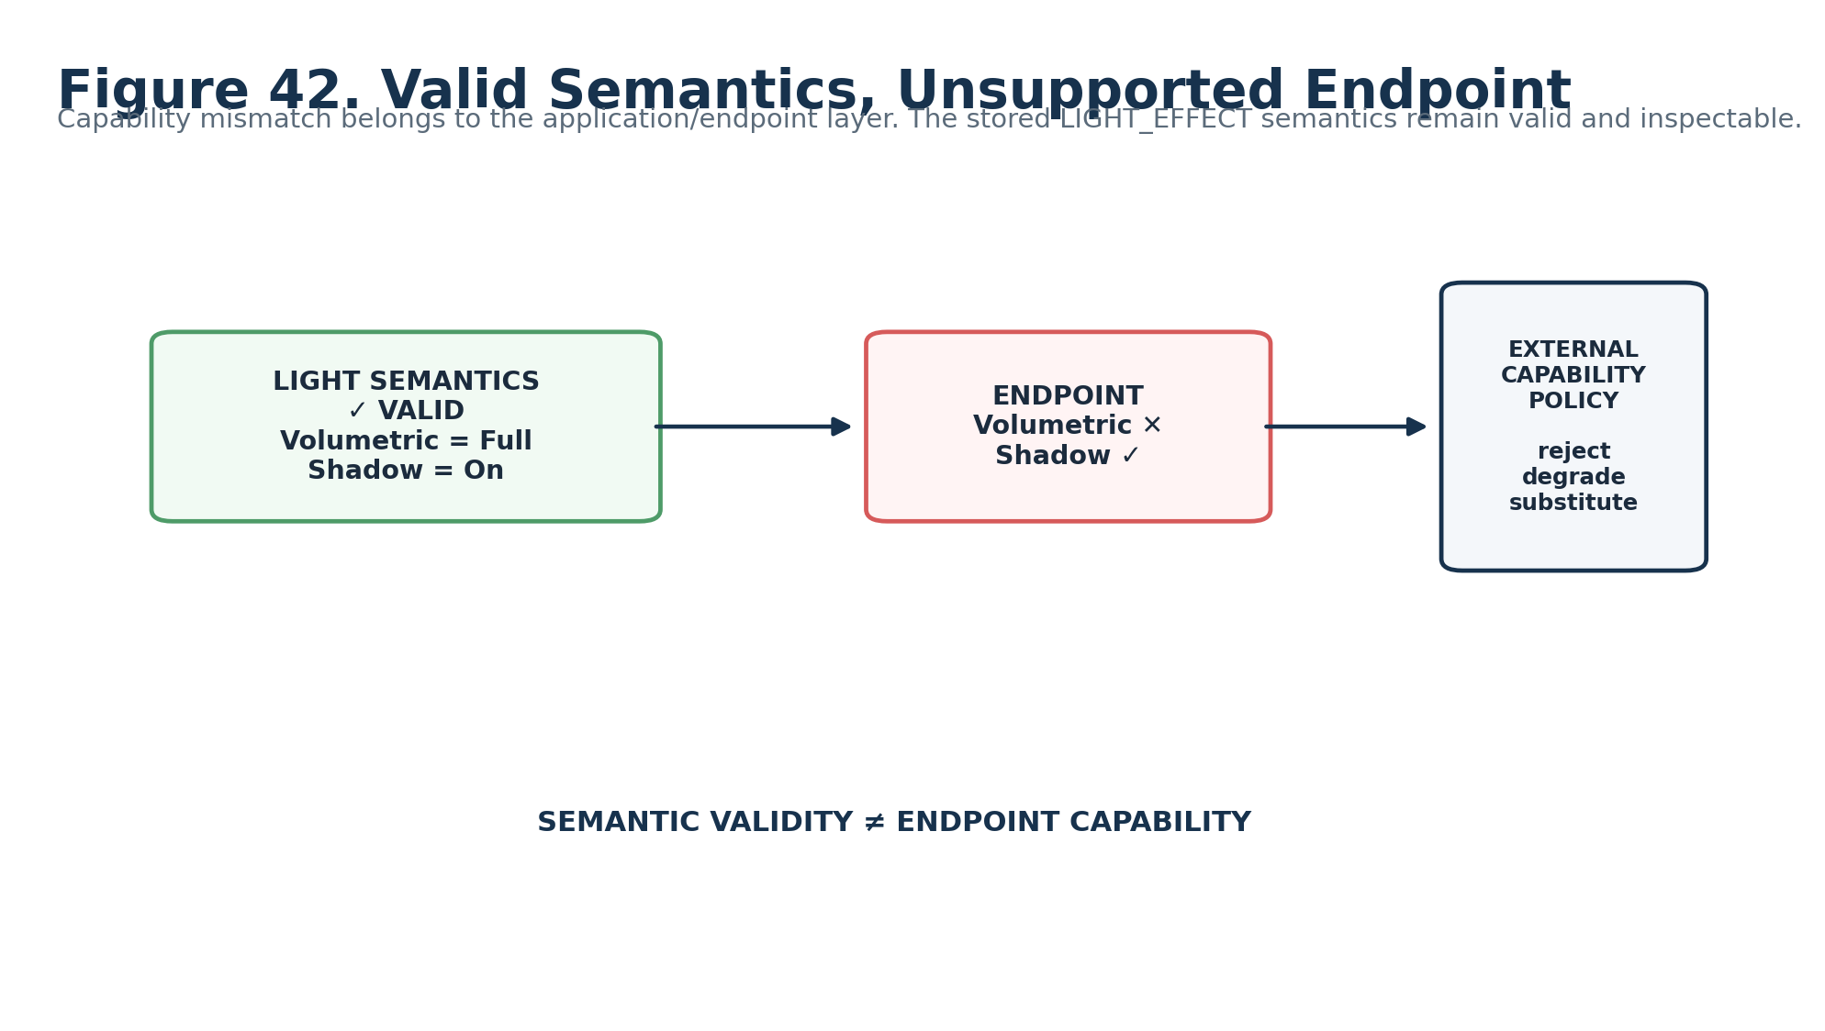
Figure 42. A renderer capability mismatch does not retroactively invalidate the LIGHT semantic request.

50. Minimum Sufficient Resolution Gate
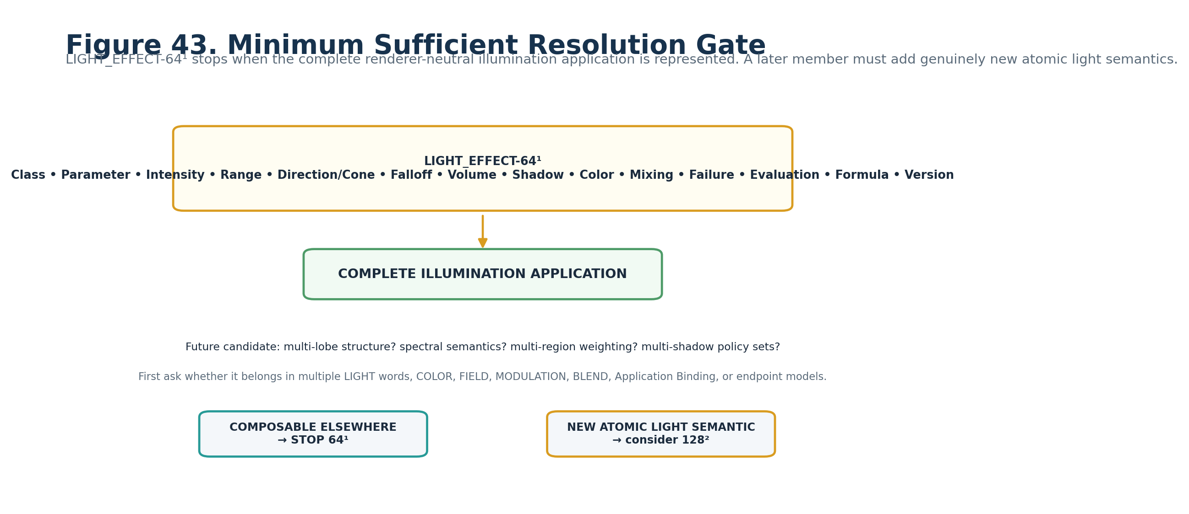
Figure 43. A future level must earn existence through genuinely new atomic LIGHT capability.

Part 7 — Planning Handoff and Promotion Gate

51. Deterministic Planning Manifest
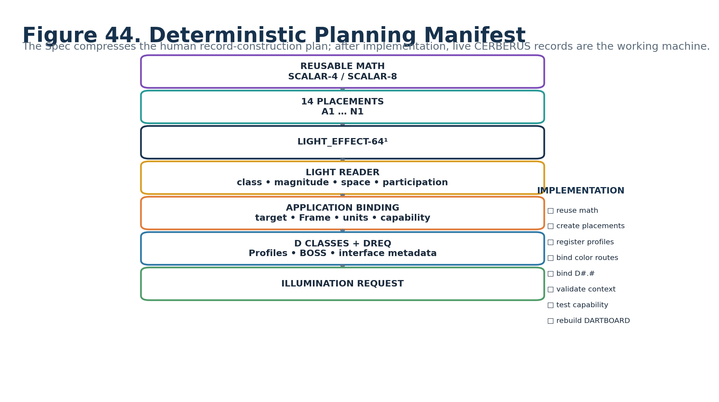
Figure 44. Human-facing record-construction manifest.

52. Records Required for Implementation
Record group | Planning requirement
Mathematical BitGroups | Reuse existing SCALAR-4 and SCALAR-8 mathematics; do not create light-specific duplicates.
LIGHT_EFFECT-64¹ BitWord | Create the exact B000:B063 placements A1:N1 defined here.
Reader Enumerations | Register class, parameter, spatial, falloff, participation, color-route, mixing, failure, evaluation, formula, and version vocabularies.
Formula Profiles | Register exact equation identity/version, accepted typed inputs, required domain/Frame state, output semantics, undefined conditions, and deterministic posture.
Application Binding | Resolve exact target light/application identity, Frame, physical/unit mapping, color references, capability policy, endpoint, and provenance.
Color Continuation | Bind current COLOR_EFFECT-64¹ / COLOR-32-64 semantic routes where required; preserve historical architecture evolution notes.
D Contracts | Resolve Candidate DREQs to exact registered D#.# contracts.
BOSS / Interface Metadata | Bind symbols, labels, role colors, and generated interface treatment without making them semantic identity.
Validation | Implement input compatibility, missing context, color-route, shadow-target, extent/falloff, and endpoint-capability separation checks.
Tests | Run conformance matrix, renderer replacement, shared provenance, invalid context, endpoint capability, and DARTBOARD reconstruction tests.

53. Candidate → Formal Promotion Gate
PROMOTION GATE
Formal promotion requires exact registered D#.# bindings; finalized Reader enumeration records; approved Formula Profile identities/versions; current COLOR continuation routes; BOSS/interface records; Application Binding contracts; input transform validation; missing-context behavior; endpoint-capability policy; conformance tests; and verification that the DARTBOARD can be regenerated from live records.

54. Human-Learning Completion Test
A knowledgeable human should be able to return to this manual months later, skim the figures, and recover the correct mental model: LIGHT_EFFECT turns a typed procedural cause into a renderer-neutral illumination request; it separates intensity, extent, direction, falloff, volumetric participation, shadows, color routing, and mixing; it does not become COLOR, MATERIAL, geometry, world placement, renderer implementation, or endpoint calibration.
If the BitWord has not yet been built, this Spec provides a planning map for the records and validations that must exist. Once built, the live CERBERUS records are the machine; this document remains the compressed human instruction manual.

Appendix A — Complete Reader State Enumerations
Reader role | Enumeration / formula
A1 Light Class | 0 OFF/NO_REQUEST; 1 EMISSIVE; 2 POINT_LIKE; 3 DIRECTIONAL; 4 AREA/REGION; 5 ENVIRONMENTAL; 6 VOLUMETRIC; 7–15 RESERVED/extension
B1 Parameter Target | 0 INTENSITY; 1 RANGE; 2 RADIUS; 3 CONE; 4 DIRECTION; 5 ATTENUATION; 6 PROFILE/EXTERNAL; 7–15 RESERVED
C1 Intensity | 0–255; i=C1/255
D1 Range/Radius | 0–255; r=D1/255
E1 Direction/Cone | 0 BINDING/PROFILE_DEFAULT; 1 DIRECTIONAL_ORIENTATION; 2 CONE; 3 SUPPLIED_DIRECTION; 4 SUPPLIED_CONE; 5 SURFACE/NORMAL_ORIENTED; 6 EXTERNAL_PROFILE; 7–15 RESERVED
F1 Falloff | 0 NONE/UNIFORM; 1 LINEAR; 2 SMOOTH; 3 INVERSE_LIKE; 4 PROFILE/MODEL; 5 EXTERNAL; 6–15 RESERVED
G1 Volumetric | 0 NONE; 1 LOW; 2 FULL; 3 EXTERNALLY_DETERMINED; 4 PROFILE/MODEL; 5–15 RESERVED
H1 Shadow | 0 OFF; 1 ON; 2 TARGET_LIMITED; 3 RUNTIME/PROFILE; 4 EXTERNAL; 5–15 RESERVED
I1 Color Binding | 0 NONE/ENDPOINT_DEFAULT; 1 FIXED_REGISTERED_COLOR; 2 PALETTE; 3 FIELD_DRIVEN; 4 EXTERNAL_COLOR_EFFECT; 5 DIRECT_COLOR_32_64; 6 PROFILE/EXTERNAL; 7–15 RESERVED
J1 Mixing | 0 ADD; 1 MAX; 2 REPLACE; 3 EXTERNALLY_MIXED; 4 PRIORITY; 5–15 RESERVED
K1 Failure | 0 UNRESOLVED/NO_LIGHT_REQUEST; 1 ZERO_INTENSITY; 2 HOLD_LAST_VALID; 3 SUPPRESS_APPLICATION; 4 ERROR; 5 EXTERNAL_POLICY; 6–15 RESERVED
L1 Evaluation | 0 LIVE; 1 SNAPSHOT; 2 SAMPLE_AND_HOLD; 3 EVENT_DRIVEN; 4–15 RESERVED
M1 Formula | 0 DIRECT/BINDING_DEFAULT; 1 SCALAR→INTENSITY; 2 SIGNED_SCALAR→INTENSITY_REMAP; 3 SCALAR→RANGE/RADIUS; 4 SCALAR→CONE_PARAMETER; 5 FIELD→PER_ELEMENT_LIGHT; 6 EVENT→FLASH_REQUEST; 7 MASK→PARTICIPATION/INTENSITY; 8 FIELD→VOLUMETRIC_CONTROL; 9 EXTERNAL_LIGHT_FORMULA; 10–15 RESERVED
N1 Version | 0 baseline Candidate interpretation; 1–14 registered future interpretations; 15 RESERVED

Appendix B — Complete B000:B063 Physical Bit Map
Global Bit | Reader | BitGroup | Local Bit | Contribution | Reader interpretation
B000 | A1 | SCALAR-4 | 0 | 1 | Light Role / Class
B001 | A1 | SCALAR-4 | 1 | 2 | Light Role / Class
B002 | A1 | SCALAR-4 | 2 | 4 | Light Role / Class
B003 | A1 | SCALAR-4 | 3 | 8 | Light Role / Class
B004 | B1 | SCALAR-4 | 0 | 1 | Light Parameter Target
B005 | B1 | SCALAR-4 | 1 | 2 | Light Parameter Target
B006 | B1 | SCALAR-4 | 2 | 4 | Light Parameter Target
B007 | B1 | SCALAR-4 | 3 | 8 | Light Parameter Target
B008 | C1 | SCALAR-8 | 0 | 1 | Intensity Range / Requested Magnitude
B009 | C1 | SCALAR-8 | 1 | 2 | Intensity Range / Requested Magnitude
B010 | C1 | SCALAR-8 | 2 | 4 | Intensity Range / Requested Magnitude
B011 | C1 | SCALAR-8 | 3 | 8 | Intensity Range / Requested Magnitude
B012 | C1 | SCALAR-8 | 4 | 16 | Intensity Range / Requested Magnitude
B013 | C1 | SCALAR-8 | 5 | 32 | Intensity Range / Requested Magnitude
B014 | C1 | SCALAR-8 | 6 | 64 | Intensity Range / Requested Magnitude
B015 | C1 | SCALAR-8 | 7 | 128 | Intensity Range / Requested Magnitude
B016 | D1 | SCALAR-8 | 0 | 1 | Range / Radius
B017 | D1 | SCALAR-8 | 1 | 2 | Range / Radius
B018 | D1 | SCALAR-8 | 2 | 4 | Range / Radius
B019 | D1 | SCALAR-8 | 3 | 8 | Range / Radius
B020 | D1 | SCALAR-8 | 4 | 16 | Range / Radius
B021 | D1 | SCALAR-8 | 5 | 32 | Range / Radius

Appendix B — Complete B000:B063 Physical Bit Map (continued)
Global Bit | Reader | BitGroup | Local Bit | Contribution | Reader interpretation
B022 | D1 | SCALAR-8 | 6 | 64 | Range / Radius
B023 | D1 | SCALAR-8 | 7 | 128 | Range / Radius
B024 | E1 | SCALAR-4 | 0 | 1 | Direction / Cone
B025 | E1 | SCALAR-4 | 1 | 2 | Direction / Cone
B026 | E1 | SCALAR-4 | 2 | 4 | Direction / Cone
B027 | E1 | SCALAR-4 | 3 | 8 | Direction / Cone
B028 | F1 | SCALAR-4 | 0 | 1 | Attenuation / Falloff
B029 | F1 | SCALAR-4 | 1 | 2 | Attenuation / Falloff
B030 | F1 | SCALAR-4 | 2 | 4 | Attenuation / Falloff
B031 | F1 | SCALAR-4 | 3 | 8 | Attenuation / Falloff
B032 | G1 | SCALAR-4 | 0 | 1 | Volumetric Participation
B033 | G1 | SCALAR-4 | 1 | 2 | Volumetric Participation
B034 | G1 | SCALAR-4 | 2 | 4 | Volumetric Participation
B035 | G1 | SCALAR-4 | 3 | 8 | Volumetric Participation
B036 | H1 | SCALAR-4 | 0 | 1 | Shadow Participation
B037 | H1 | SCALAR-4 | 1 | 2 | Shadow Participation
B038 | H1 | SCALAR-4 | 2 | 4 | Shadow Participation
B039 | H1 | SCALAR-4 | 3 | 8 | Shadow Participation
B040 | I1 | SCALAR-4 | 0 | 1 | Color Binding Mode
B041 | I1 | SCALAR-4 | 1 | 2 | Color Binding Mode
B042 | I1 | SCALAR-4 | 2 | 4 | Color Binding Mode
B043 | I1 | SCALAR-4 | 3 | 8 | Color Binding Mode

Appendix B — Complete B000:B063 Physical Bit Map (continued)
Global Bit | Reader | BitGroup | Local Bit | Contribution | Reader interpretation
B044 | J1 | SCALAR-4 | 0 | 1 | Accumulation / Mixing
B045 | J1 | SCALAR-4 | 1 | 2 | Accumulation / Mixing
B046 | J1 | SCALAR-4 | 2 | 4 | Accumulation / Mixing
B047 | J1 | SCALAR-4 | 3 | 8 | Accumulation / Mixing
B048 | K1 | SCALAR-4 | 0 | 1 | Null / Failure
B049 | K1 | SCALAR-4 | 1 | 2 | Null / Failure
B050 | K1 | SCALAR-4 | 2 | 4 | Null / Failure
B051 | K1 | SCALAR-4 | 3 | 8 | Null / Failure
B052 | L1 | SCALAR-4 | 0 | 1 | Evaluation Mode
B053 | L1 | SCALAR-4 | 1 | 2 | Evaluation Mode
B054 | L1 | SCALAR-4 | 2 | 4 | Evaluation Mode
B055 | L1 | SCALAR-4 | 3 | 8 | Evaluation Mode
B056 | M1 | SCALAR-4 | 0 | 1 | Formula Profile
B057 | M1 | SCALAR-4 | 1 | 2 | Formula Profile
B058 | M1 | SCALAR-4 | 2 | 4 | Formula Profile
B059 | M1 | SCALAR-4 | 3 | 8 | Formula Profile
B060 | N1 | SCALAR-4 | 0 | 1 | Version
B061 | N1 | SCALAR-4 | 1 | 2 | Version
B062 | N1 | SCALAR-4 | 2 | 4 | Version
B063 | N1 | SCALAR-4 | 3 | 8 | Version

Appendix C — Light Class / Reader Applicability Guidance
Light Class | Commonly applicable Reader semantics | Boundary note
OFF | All roles stored but output forced to no request. | A1=0 short-circuits output.
EMISSIVE | Intensity, extent, surface/normal orientation, color, mixing. | Actual surface geometry and material emissive state remain external.
POINT-LIKE | Intensity, range/radius, falloff, volume, shadow, color, mixing. | Exact point position from binding.
DIRECTIONAL | Intensity, supplied direction/Frame, shadow, color, mixing. | Range may be non-applicable or profile-specific.
AREA / REGION | Intensity, region extent, orientation, falloff/profile, shadow, color. | Actual region/geometry external.
ENVIRONMENTAL | Intensity, color, mixing, optional profile/volume. | No implicit world probe/environment identity.
VOLUMETRIC | Intensity, extent, direction/cone, falloff, color, volume participation. | Actual volume/medium and renderer external.

GUIDANCE ONLY
This table is a human-facing applicability guide. Exact Formula Profile and D-contract rules are authoritative once registered. Non-applicable controls may be disabled/collapsed without mutating their stored Bits.

Appendix D — Input Compatibility and Transform Matrix
Input Signal Class | Posture | Requirement
Scalar | DIRECT | Direct Scalar light Formula/Profile may consume it.
Field | DIRECT under declared profile | Per-element / domain-aware light profiles may consume the Field directly.
Event | DIRECT under event profile | Event→Flash or event-triggered light profile.
Mask | DIRECT under declared profile | Participation/intensity mapping when profile expects Mask semantics.
Signed Scalar | REMAP REQUIRED | Explicit rectify/remap/signed-compatible Light Formula; no silent positive-intensity coercion.
Vector | TRANSFORM REQUIRED | Magnitude or component transform first; resulting Scalar/Signed Scalar then follows compatible path.
Probability | PROFILE / TRANSFORM REQUIRED | Only when an exact Light Formula declares probability interpretation.
Angular / Orientation | CONTEXT / PROFILE REQUIRED | May supply direction/orientation semantics but must not silently become intensity.

Appendix E — Candidate D Requirement Index
Reader | Semantic role | D Class | Candidate requirement
A1 | Light Role / Class | Categorical Selection | DREQ-CAT.LIGHT_CLASS
B1 | Light Parameter Target | Categorical Selection | DREQ-CAT.LIGHT_PARAMETER
C1 | Intensity Range / Requested Magnitude | Scalar | DREQ-SCALAR.LIGHT_INTENSITY
D1 | Range / Radius | Scalar | DREQ-SCALAR.LIGHT_EXTENT
E1 | Direction / Cone | Spatial Selection | DREQ-SPATIAL.LIGHT_DIRECTION_CONE
F1 | Attenuation / Falloff | Profile Selection | DREQ-PROFILE.LIGHT_FALLOFF
G1 | Volumetric Participation | Participation Selection | DREQ-CAT.VOLUMETRIC_PARTICIPATION
H1 | Shadow Participation | Participation Selection | DREQ-CAT.SHADOW_PARTICIPATION
I1 | Color Binding Mode | Semantic Route / Binding | DREQ-ROUTE.LIGHT_COLOR
J1 | Accumulation / Mixing | Operator Selection | DREQ-OP.LIGHT_MIX
K1 | Null / Failure Behavior | Failure Policy | DREQ-POLICY.FAILURE
L1 | Evaluation Mode | Evaluation State | DREQ-EVAL.MODE
M1 | Formula Profile | Profile Selection | DREQ-PROFILE.LIGHT_FORMULA
N1 | Version / Reserved | Metadata Inspection | DREQ-META.VERSION_INSPECT

Appendix F — Color / Material / Light Routing Contract
Relationship | Meaning | Not implied
LIGHT_EFFECT <R> COLOR_EFFECT-64¹ | Light requires procedural color behavior such as palette mapping or field-driven color. | COLOR_EFFECT membership inside LIGHT or duplicated palette state.
LIGHT_EFFECT <R> COLOR-32-64 | Light requires a fixed registered color identity/state. | RGBA Bits copied into LIGHT_EFFECT.
MATERIAL_EFFECT <R> LIGHT_EFFECT | Surface emissive or material behavior requires actual illumination semantics. | Every emissive-looking material automatically emits scene light.
MATERIAL_EFFECT <R> COLOR_EFFECT / COLOR | Material needs color behavior or registered color state. | Material becomes the owner of COLOR identity.
Runtime Graph: FIELD → LIGHT | A producer Signal controls Light through a graph edge. | Semantic continuation or Compound membership.
Compound |[▪︎|▪︎]| | Complete LIGHT word is a constituent of a saved Effect Assembly. | Runtime execution order or continuation meaning.

Appendix G — Conformance / Build Checklist
□ B000:B063 allocation matches the approved LIGHT_EFFECT-64¹ map.
□ SCALAR-4 and SCALAR-8 are reused as generic mathematics rather than light-specific duplicate BitGroups.
□ A1=0 yields safe OFF / no Illumination Request.
□ Every Reader role has a registered definition, enumeration or Reader formula, validation rule, and non-ownership boundary.
□ C1 and D1 are normalized Reader semantics, not universal physical-unit claims.
□ B1 parameter target is compatible with the selected Formula Profile and required context.
□ Signed Scalar input never silently becomes positive intensity; declared remap/rectification is explicit.
□ Vector input never silently becomes Scalar; magnitude/component transform is explicit.
□ Supplied Direction/Cone modes validate Frame/orientation context and never fabricate world-space values.
□ Falloff profile identity/version is inspectable where required.
□ Volumetric participation remains separate from medium identity and endpoint capability.
□ Shadow participation remains separate from occluder/receiver geometry and renderer shadow implementation.
□ Color binding routes to current COLOR_EFFECT-64¹ / COLOR-32-64 records and does not duplicate RGBA state.
□ J1 light-request mixing is not substituted for BLEND_EFFECT Signal algebra.
□ K1 fallbacks preserve invalid/missing status and provenance.
□ L1 evaluation does not claim global timing ownership.
□ Formula Profiles declare accepted inputs, exact equations, required domain state, undefined conditions, output semantics, and determinism.
□ Endpoint capability mismatch is handled externally and does not silently mutate LIGHT semantic state.
□ Candidate DREQs are resolved to exact D#.# before Formal promotion.
□ BOSS symbols and interface profiles are bound without becoming semantic identity.
□ DARTBOARD can be regenerated from live records and is treated as a disposable human-facing projection.
□ Rendered instruction manual has been visually inspected for figure legibility, clipping, and semantic clarity.
PRODUCTION PRINCIPLE
The records are the machine. The Spec is the human compression artifact. LIGHT_EFFECT stays compact because illumination semantics live in the 64-bit word while exact target identity, Frame, units, color records, capability policy, and renderer realization remain explicit in their proper owners.

