CERBERUS

RESIDUAL Architecture
Recorded Experimental Statistics Informing Dynamic Utilization Across Lenses
Governed Quantitative Evidence, Scientific Provenance, and Reality-Anchored Value Resolution
CORE SPECIFICATION STATEMENT
RESIDUAL records humanity’s measured, observed, calculated, defined, or statistically characterized access to quantitative reality. The property exists independently of the record. RESIDUAL preserves the quantitative claim, its unit, context, provenance, and status so Models and Lenses can reuse evidence without confusing the measurement with the thing measured.

Field | Specification
Document | CERBERUS RESIDUAL Architecture
Expansion | Recorded Experimental Statistics Informing Dynamic Utilization Across Lenses
Version | v0.1
Date | August 2026
Primary hierarchy | Constant → Family → Community → World
Primary World example | Science
Flagship Community | Material Science
Status | Foundational architecture / implementation blueprint

“RESIDUAL does not tell reality what its values are. It preserves what people discovered when they went looking.”

Executive Summary
RESIDUAL is CERBERUS’s quantitative evidence architecture. It gives the system a governed place for singular numerical values while preserving a hard boundary between external reality, human observation, the recorded result, and the later Models or Lenses that interpret that result. A girder has whatever physical strength it has whether anyone measures it, names the property, publishes a textbook, or records a value in Airtable. RESIDUAL therefore treats the database as a record of quantitative access to reality, not as the creator of reality.
The system mirrors the zoom grammar already used by CERBERUS Semiotics. One Constant is a singular addressable value. Constants are grouped into Families; Families resolve into Communities; Communities resolve into Worlds. A Science World may contain Material Science, Cybernetics, Chemistry, Physics, Biology, and other quantitative Communities. Material Science may use property-centered Families such as Tensile Strength, Compression Strength, and Shear Strength, while Chemistry may organize Families around coherent quantitative subdomains such as Organic Chemistry or Biochemistry. The hierarchy is governed but extensible rather than pretending to be a final ontology of nature.
Families are designed to become dense Airtable quantitative surfaces. When quantities use different units, value and unit fields can operate in pairs. A 500-field table can therefore hold 250 value/unit pairs per record. When an entire Family shares a unit contract, such as a Tensile Strength table governed in MPa, every value field can carry quantitative data without repeating the unit. Five hundred value fields across one hundred records can expose fifty thousand addressable quantitative cells. The unit contract remains explicit even when it is not redundantly repeated in every cell.
RESIDUAL is deliberately parallel to, but separate from, Semiotics. Semiotics answers what a concept means and where it belongs conceptually. RESIDUAL answers what quantitative values have been recorded, under what conditions, by what source or method, and with what status. Explicit links connect the two. Models and Lenses then dynamically utilize those values for aerospace design, simulation, medical applications, manufacturing, comparison, prediction, or other purposes without silently rewriting the source evidence.
FOUNDATIONAL PRINCIPLE
Reality is ontically prior to the RESIDUAL record. A RESIDUAL value is authoritative about what CERBERUS currently records from a declared source and context; it is not identical to the underlying property itself.

Law | Normative intent
R01 — Reality Independence | External reality does not depend on CERBERUS records.
R02 — Observation Separation | A measured or derived value shall not be treated as identical to the underlying property.
R03 — Recorded Authority | RESIDUAL is authoritative about the quantitative claims currently registered in RESIDUAL, subject to source, context, status, and version.
R04 — Provenance Preservation | Quantitative records should retain sufficient provenance to understand how and where the value applies.
R05 — Context Applicability | A value shall not silently generalize beyond its declared conditions.
R06 — Evidence Multiplicity | Multiple valid or conflicting observations of one property may coexist.
R07 — Lens Separation | Lenses may interpret and transform RESIDUAL evidence but do not silently rewrite the source record.
R08 — Semiotic Separation | Meaning and quantitative evidence remain separately governed and explicitly linked.
R09 — Correction Direction | Better evidence updates or supersedes the record; it does not imply that reality changed.
R10 — Historical Integrity | Previously used quantitative records remain historically resolvable under their original provenance and version.

Contents
Part | Scope
Part I | Reality, Observation, and Recorded Quantitative Evidence
Part II | RESIDUAL Identity and Resolution Hierarchy
Part III | Semiotic Meaning and Quantitative Evidence
Part IV | Evidence Multiplicity, Conditions, and Provenance
Part V | Dense Family Tables and Constant Addressing
Part VI | Dynamic Utilization Across Lenses
Part VII | Scientific Correction, Versioning, and System Interoperability
Part VIII | Airtable Implementation Blueprint and Conformance

READING NOTE
This paper defines the global RESIDUAL architecture. It intentionally does not freeze a complete scientific ontology or a universal set of Constant Families. Worlds, Communities, Families, conditions, and evidence records can expand as the system gains governed quantitative sources.

Part I — Reality, Observation, and Recorded Quantitative Evidence

1. Reality Is Prior to the Record
RESIDUAL begins from a deliberately simple claim: properties and events in the external world do not wait for CERBERUS to name or measure them. A material object has physical structure and behavior before a scientist tests it. A molecule behaves before a database assigns it a row. A system can therefore be wrong about reality, incomplete about reality, or later improve its representation of reality without changing reality itself.
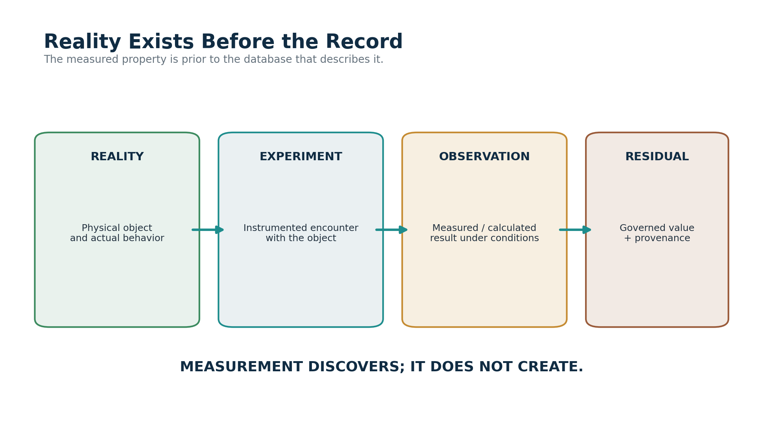
Figure 1. Reality exists before the record.
The architecture moves from reality through measurement into a governed record. The causal direction is not reversed.
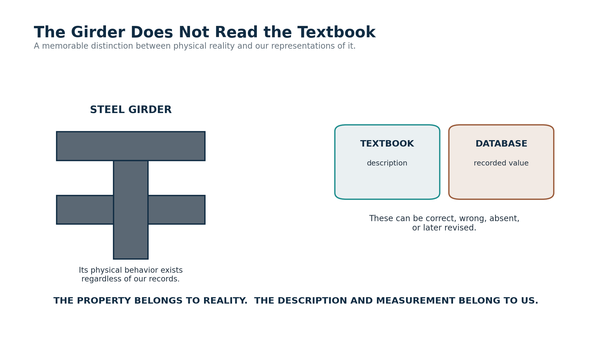
Figure 2. The girder does not read the textbook.
The physical property is not created by the human description, textbook, database, or interface.

2. Property, Observation, and Record
A robust quantitative architecture separates the property being studied from the observation generated by an encounter with that property and from the record that later preserves the observation. These distinctions are especially important when measurements vary, methods improve, or values depend on conditions. RESIDUAL stores the record; it does not claim direct possession of the property itself.
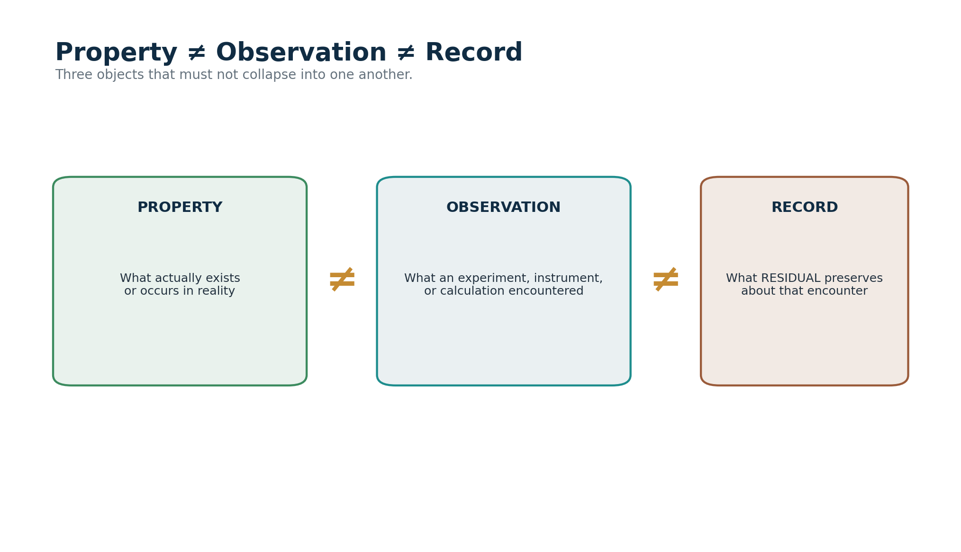
Figure 3. Property, observation, and record are distinct epistemic objects.
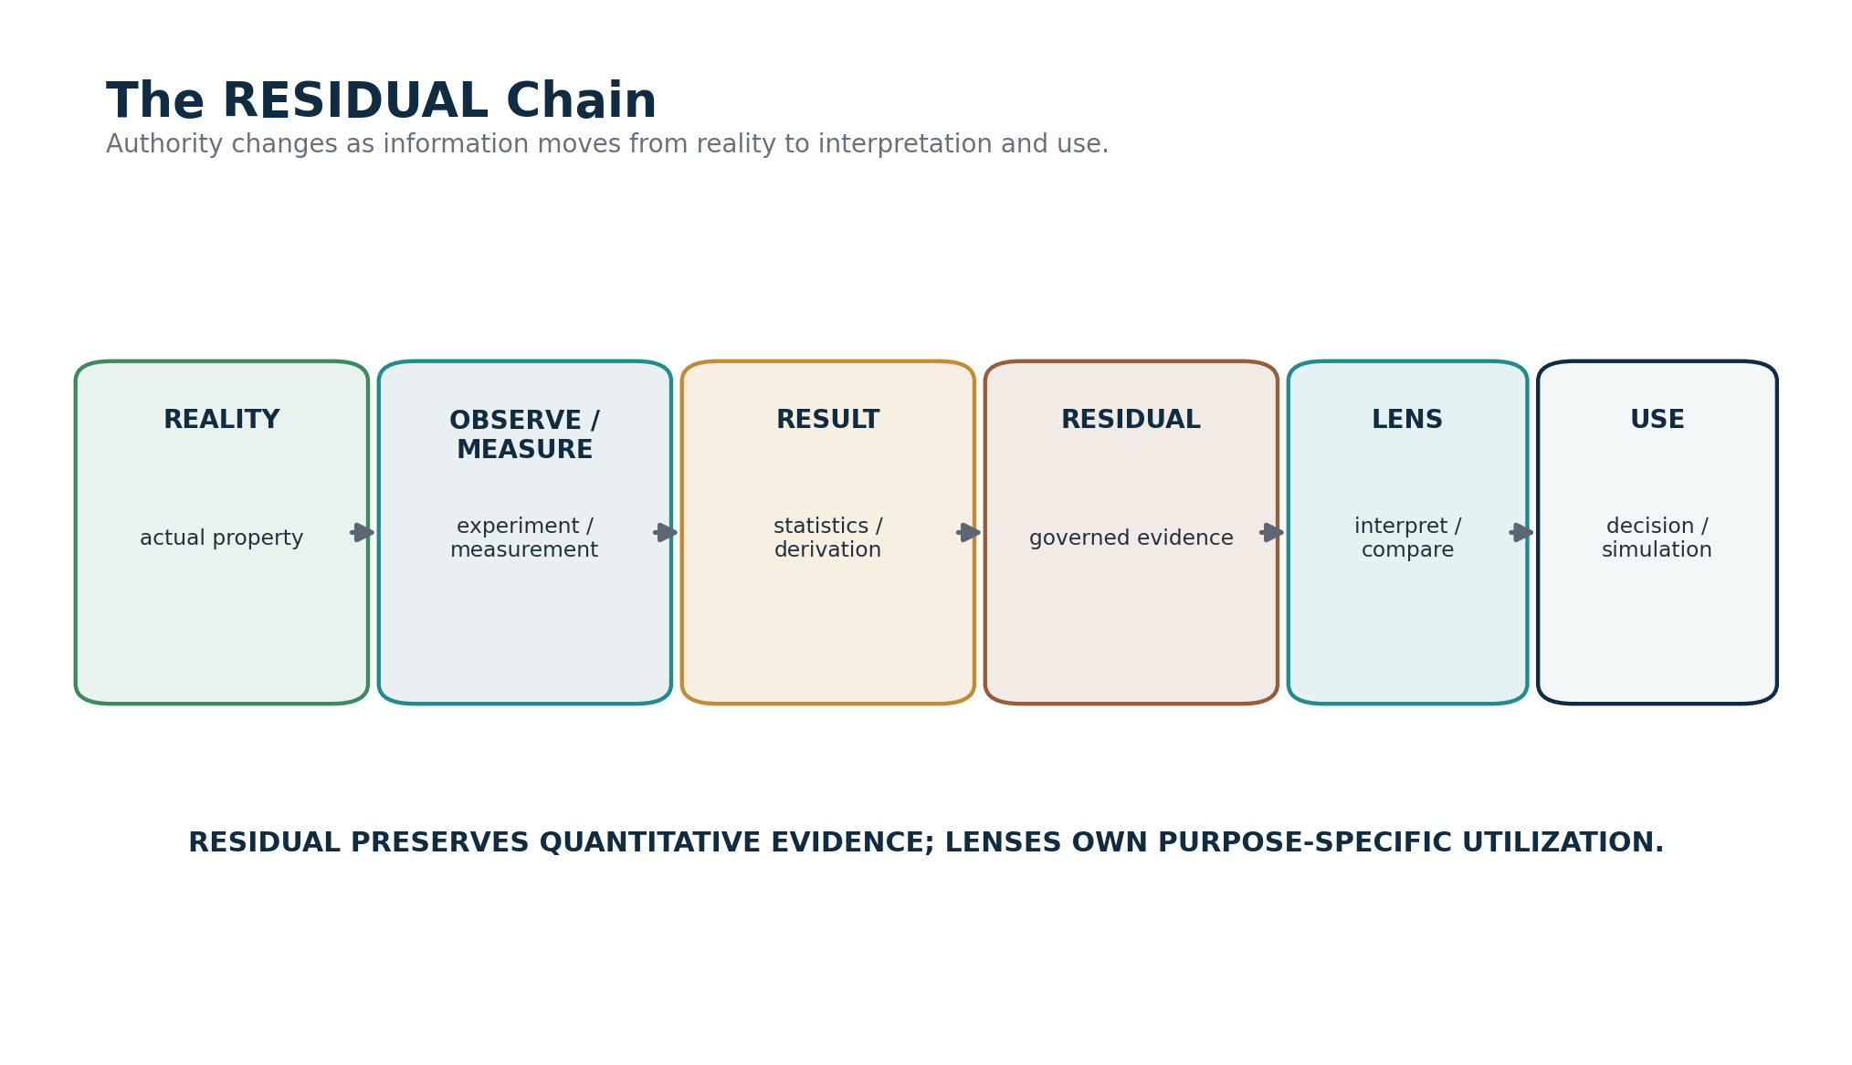
Figure 4. The RESIDUAL chain from reality to use.
A Lens can use a record without becoming the owner of the evidence that produced it.

3. Why the Name RESIDUAL Matters
A compact value often represents the residue of a much larger scientific effort. Sample preparation, calibration, experimental design, measurement, replication, statistical treatment, standards, publication, and criticism can collapse into a number small enough to occupy one cell. RESIDUAL preserves that reusable quantitative inheritance while retaining routes back to the work that produced it.
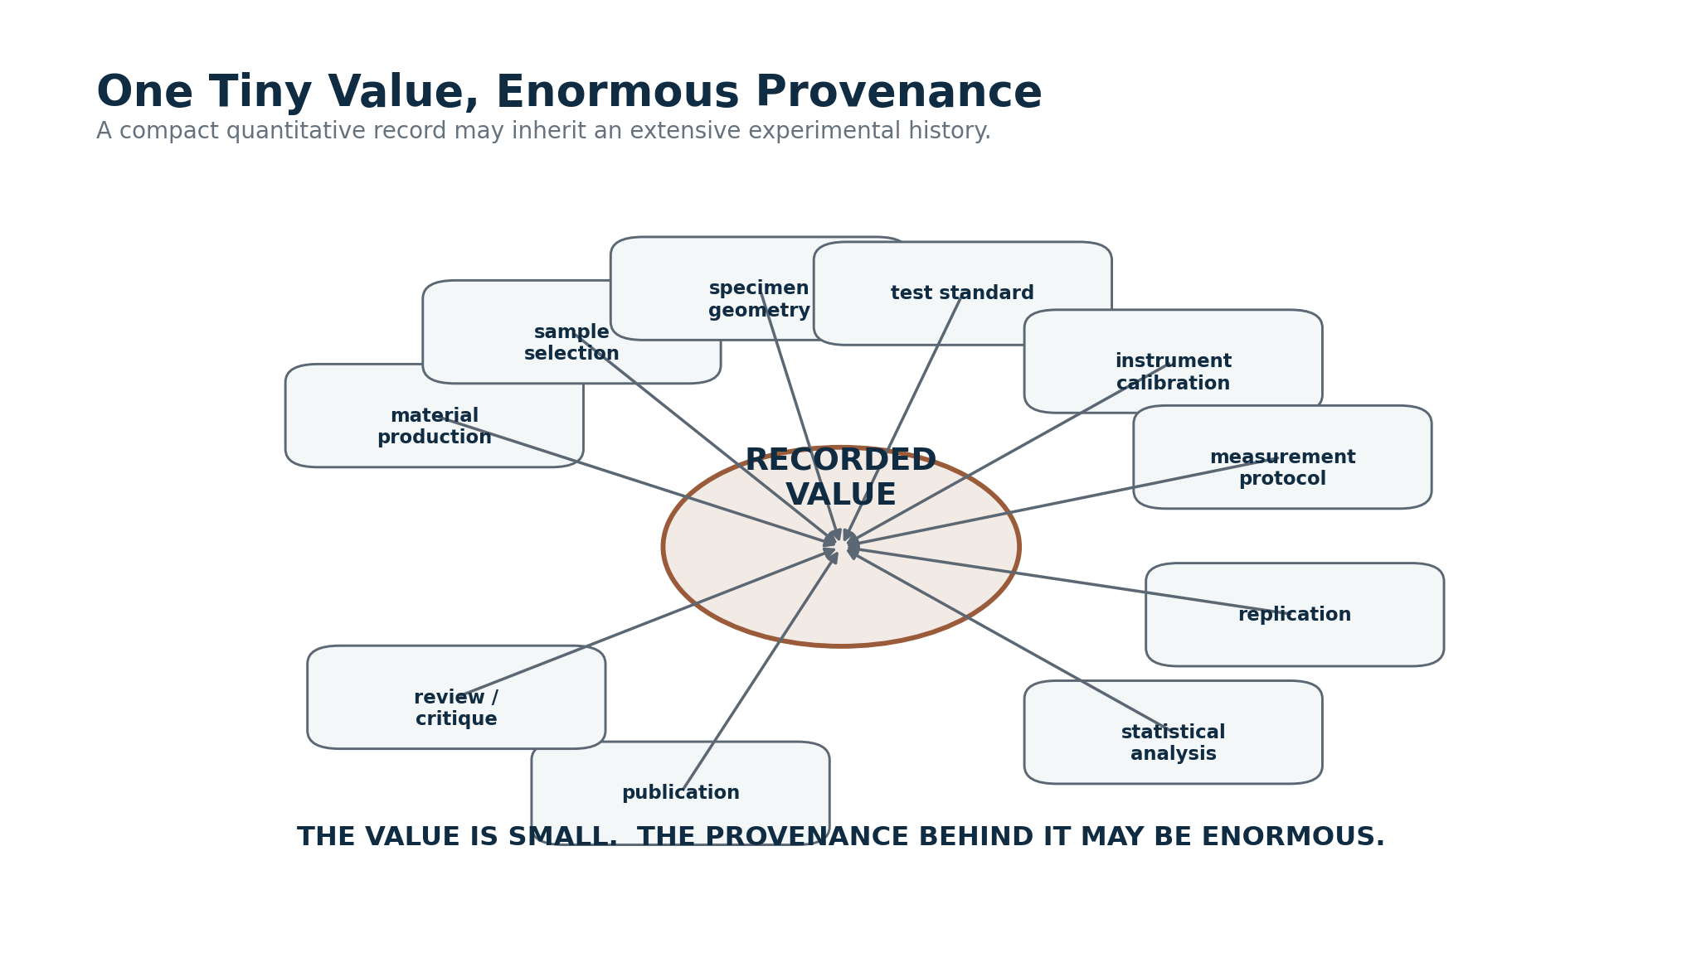
Figure 5. One tiny value can inherit an enormous provenance history.
RESIDUAL INTELLIGENCE
The property existed before the research. What remains after the research is a reusable quantitative record of humanity’s encounter with that property.

Part II — RESIDUAL Identity and Resolution Hierarchy

4. The Constant as the Quantitative Primitive
A Constant is the smallest singular quantitative value RESIDUAL intends to route and reuse. In a dense Family Table, a Constant may be represented by one exact record-by-field intersection rather than by a dedicated row in a separate “constants” table. Its semantic address derives from the Family, subject or record identity, field identity, unit contract, context, and provenance that make the cell interpretable.
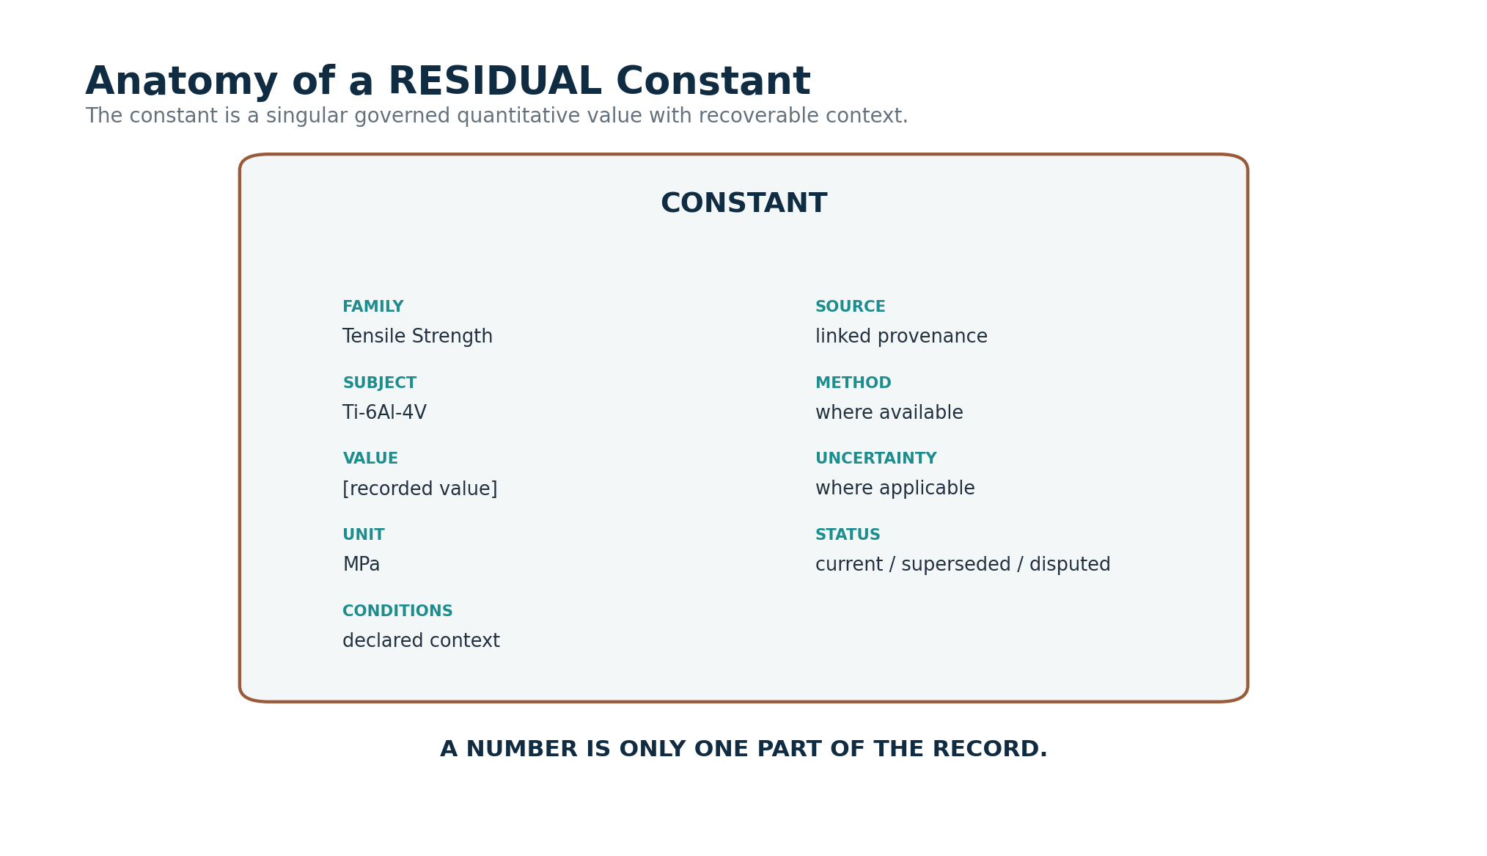
Figure 6. Anatomy of a governed RESIDUAL Constant.
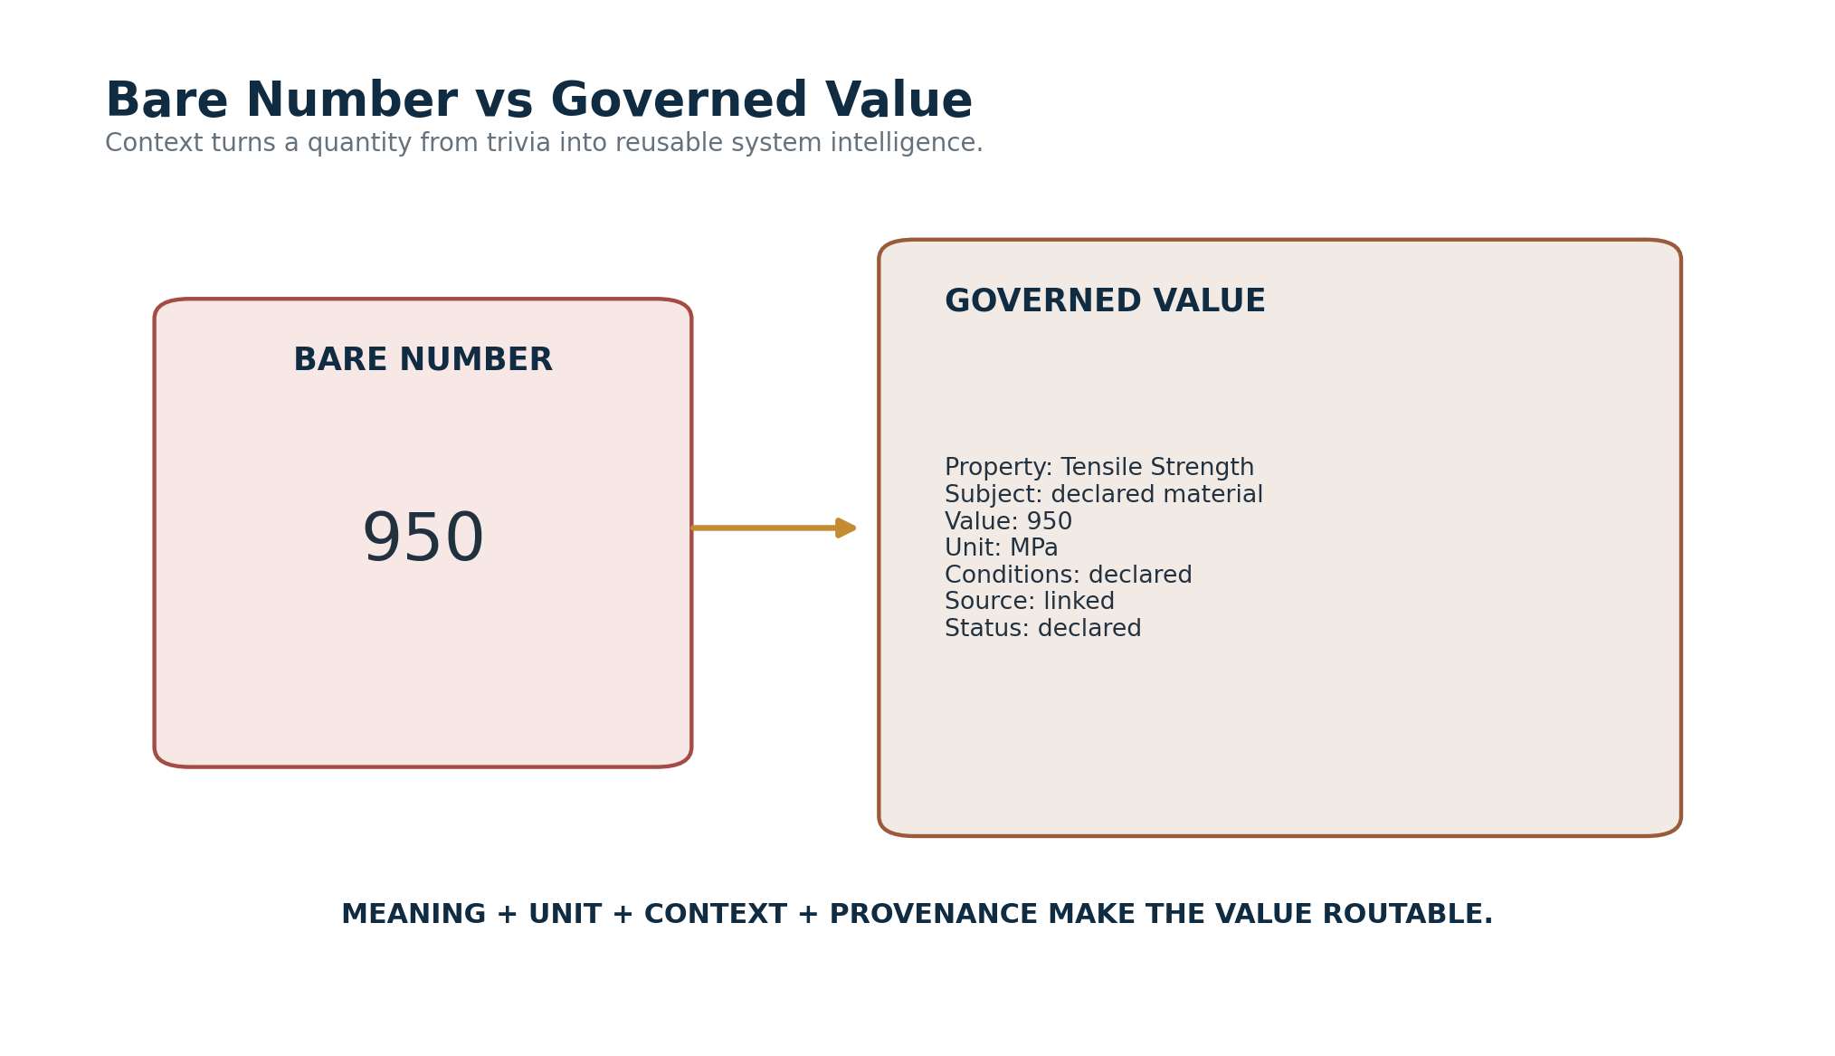
Figure 7. A bare number compared with a governed quantitative value.

5. Quantitative Classes
RESIDUAL can contain mathematical constants, defined reference quantities, measured values, experimental observations, statistical estimates, derived values, reference values, and context-dependent properties. These share a quantitative routing architecture but should retain different epistemic classes. A mathematical constant is not treated as though it were a laboratory estimate, and an experimentally measured material property is not presented as metaphysically invariant merely because RESIDUAL calls the individual value a Constant.
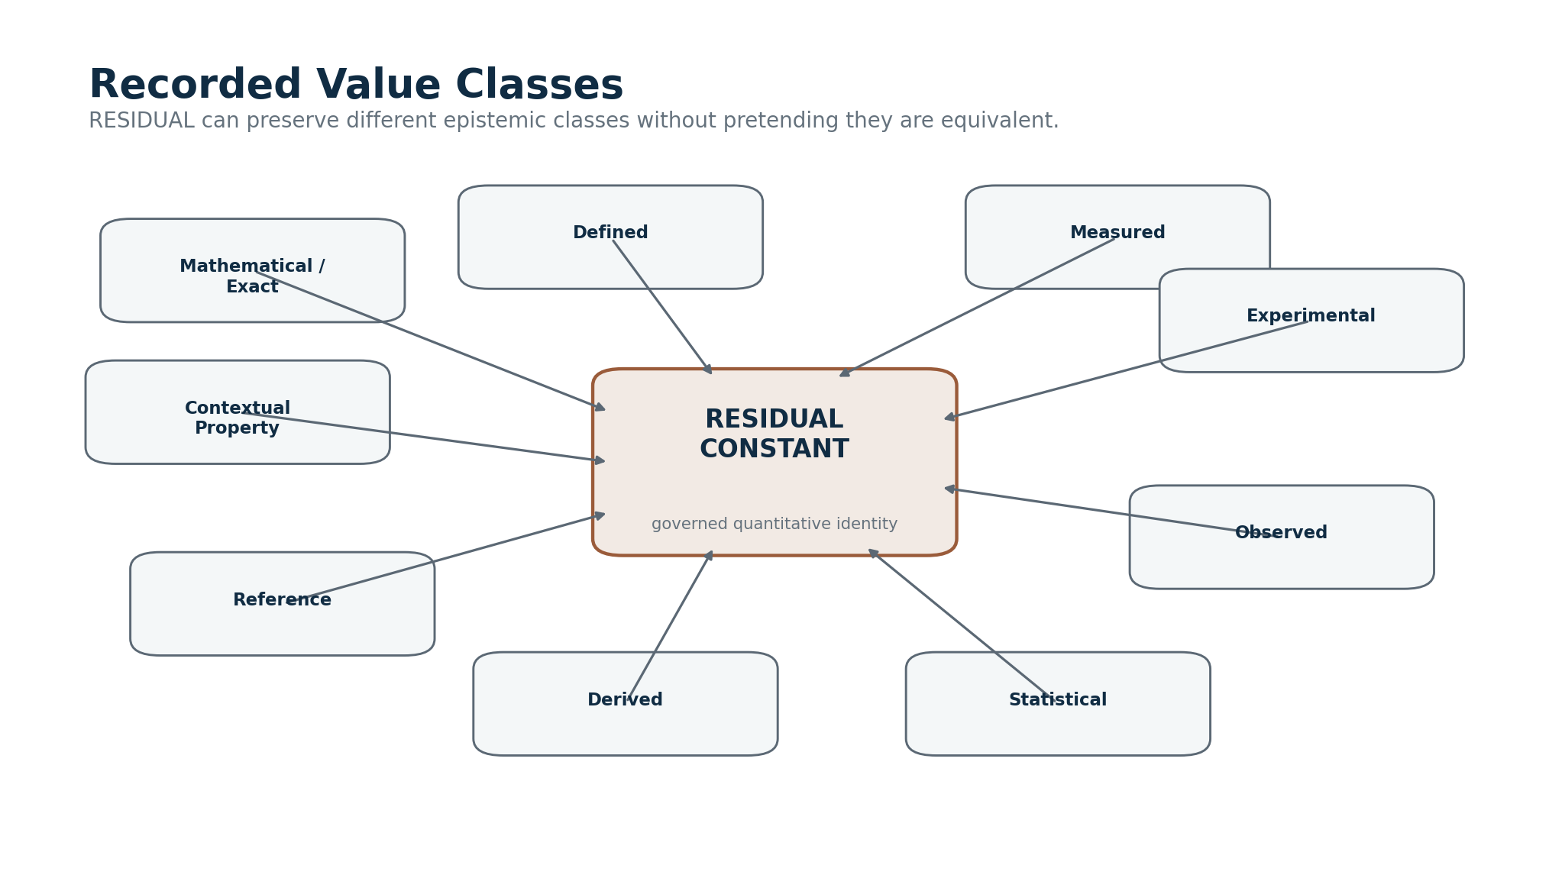
Figure 8. Recorded value classes within the RESIDUAL architecture.

6. Constant → Family → Community → World
The global resolution grammar mirrors the zoom structure already used elsewhere in CERBERUS. Constants group into Families. Families belong to Communities. Communities resolve into Worlds. The same pattern allows a user, model, or routing system to move from one recorded value upward into domain context or downward from a broad scientific domain into a precise quantitative address.
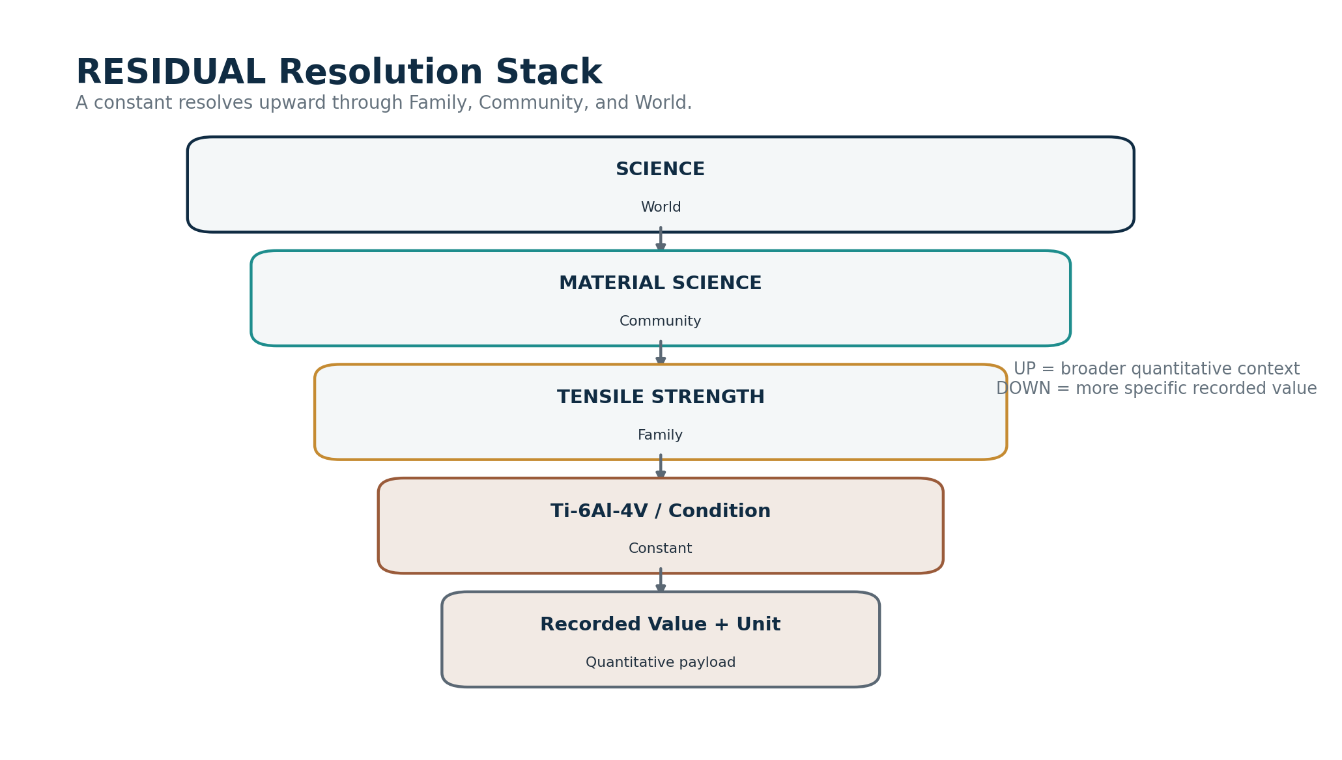
Figure 9. The RESIDUAL resolution stack from Science World to one quantitative value.
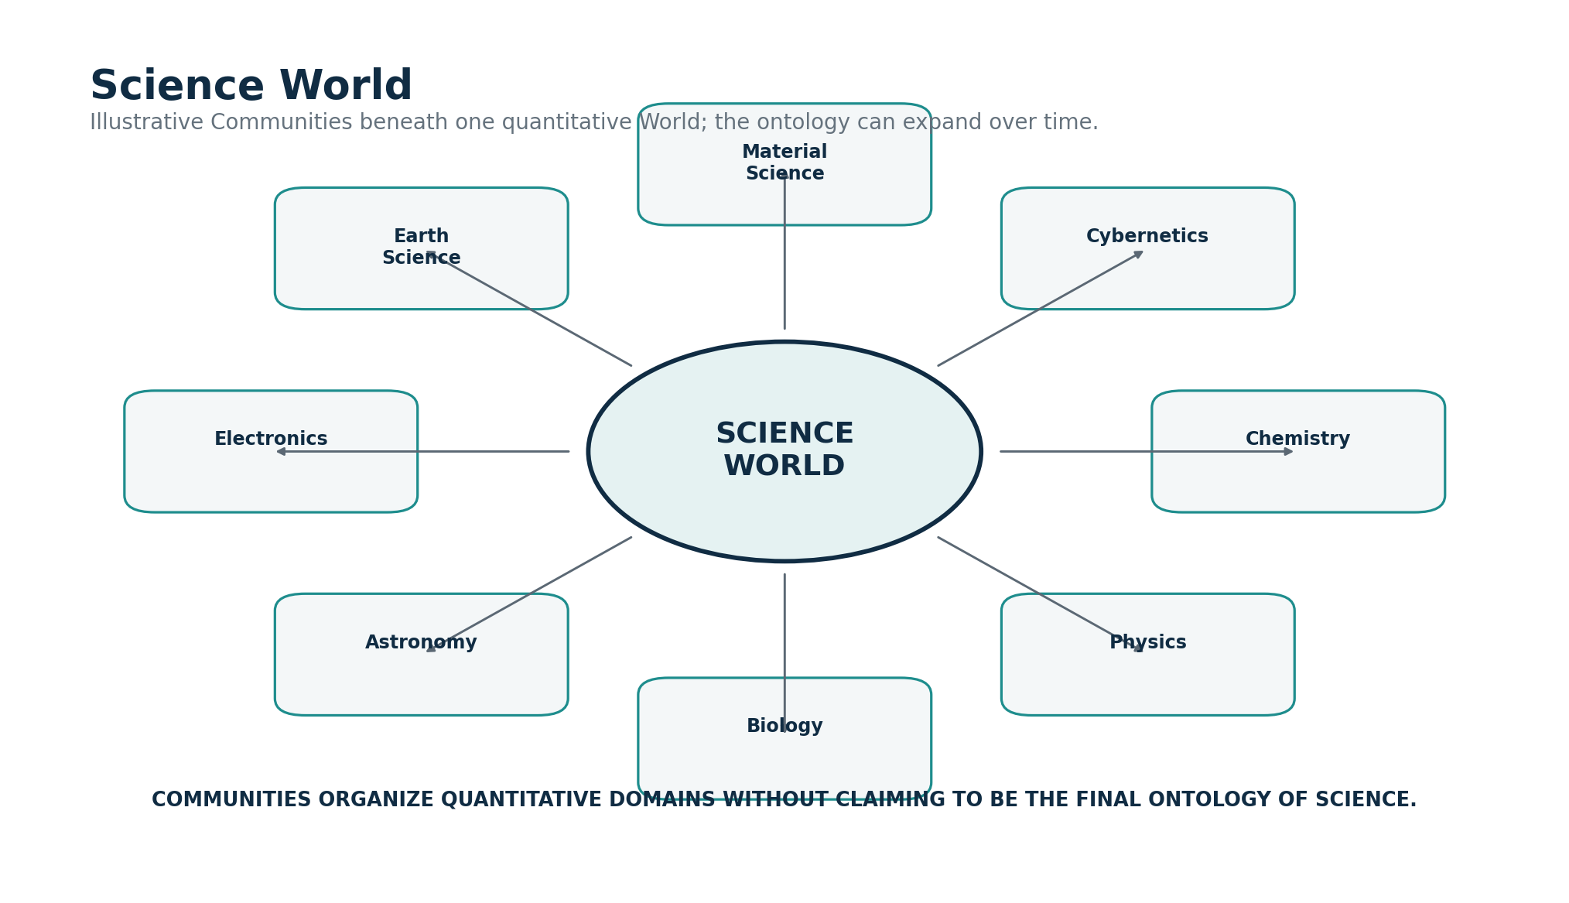
Figure 10. Illustrative Communities inside a Science World.

7. Community and Family Organization
The hierarchy is intentionally extensible. Material Science can use property-centered Families such as Tensile Strength, Compression Strength, Shear Strength, Elastic Modulus, or Thermal Conductivity. Chemistry can organize Families around coherent quantitative domains such as Organic Chemistry, Biochemistry, Physical Chemistry, or other structures that best support the values being recorded. RESIDUAL requires governed placement, not one universal philosophy of scientific taxonomy.
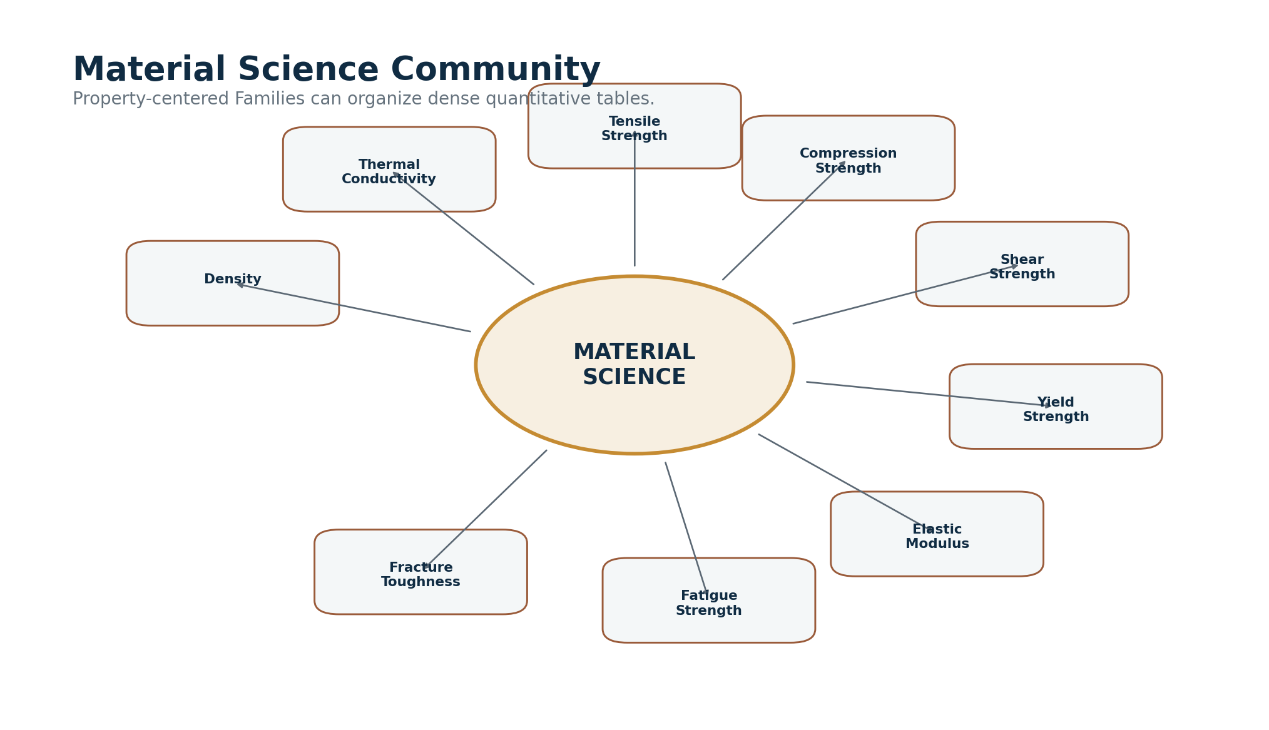
Figure 11. Material Science Community with property-centered Families.
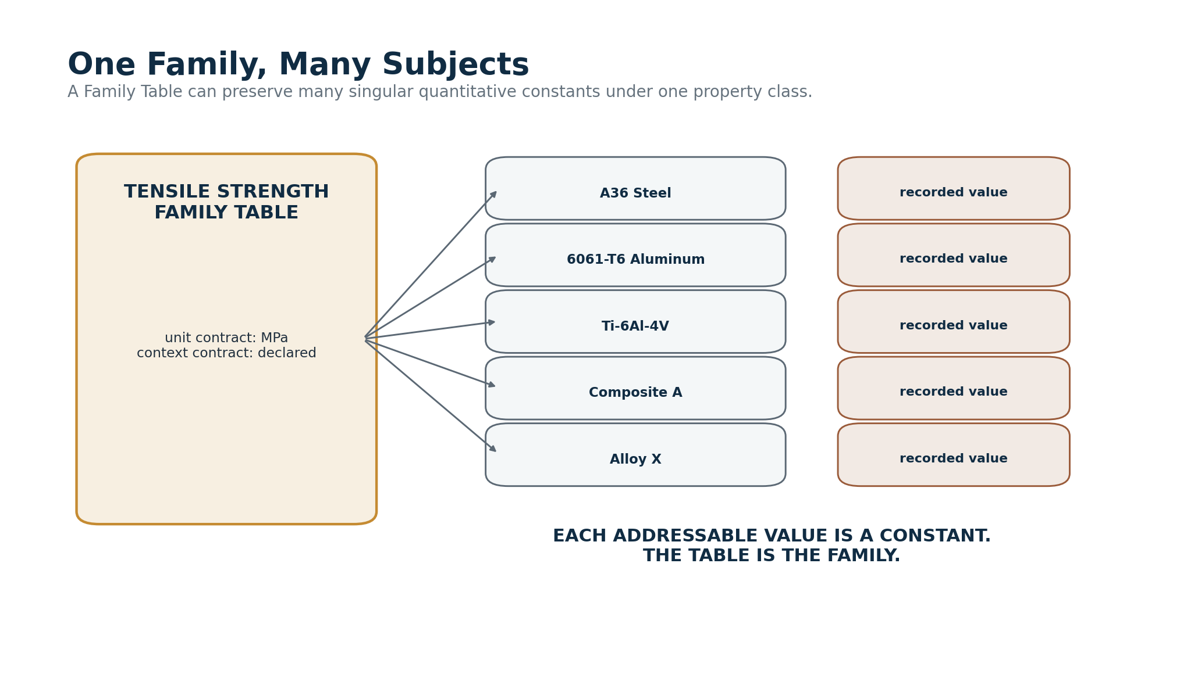
Figure 12. One Family Table can contain many subject-specific Constants.

Part III — Semiotic Meaning and Quantitative Evidence

8. Parallel Resolution Systems
Semiotics and RESIDUAL solve different problems. Semiotics organizes conceptual meaning through World, Community, Family, and Semantic Symbol. RESIDUAL organizes quantitative evidence through World, Community, Family, and Constant. The two systems can deliberately mirror one another without becoming the same registry. Meaning can remain stable while values change; values can remain stable while symbols or labels change.
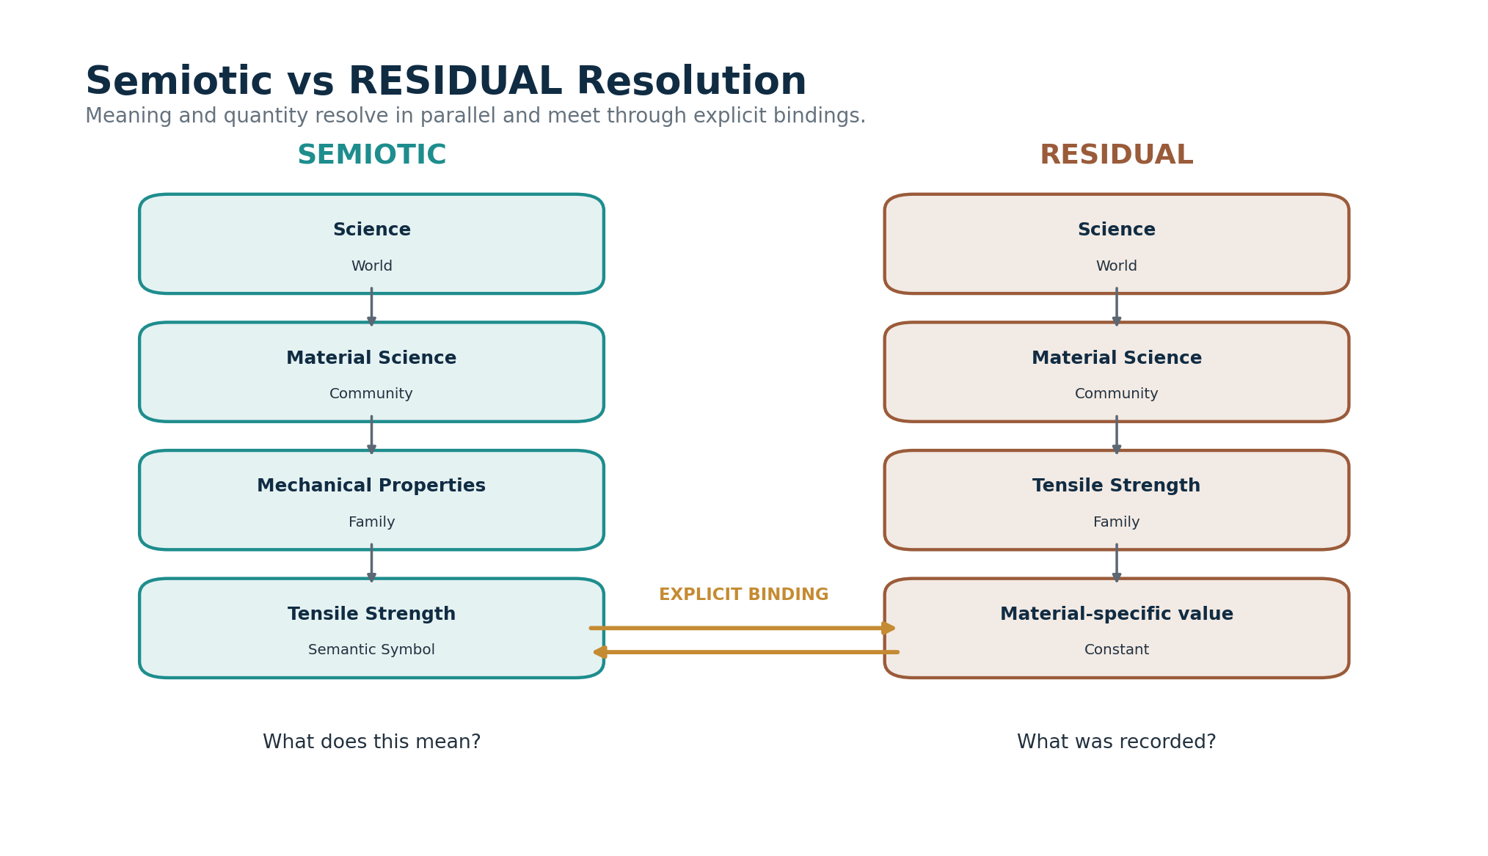
Figure 13. Semiotic and RESIDUAL resolution operate in parallel.
The left side answers what a concept means. The right side answers what quantitative evidence has been recorded.
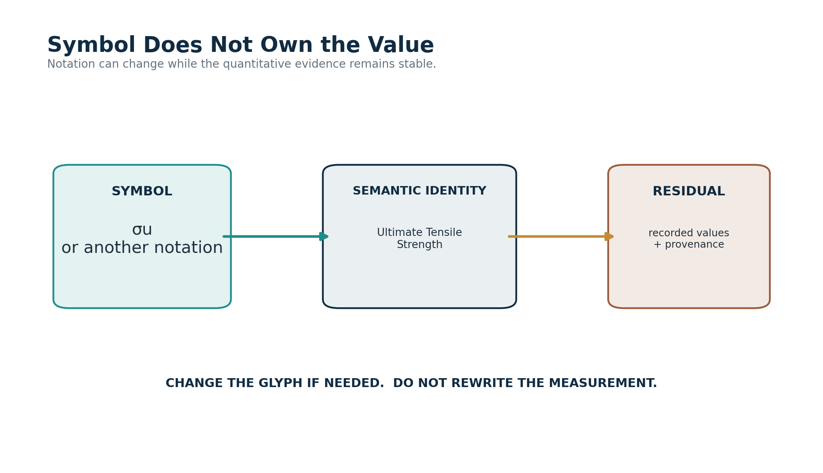
Figure 14. Symbol form does not own the quantitative value.

9. Stable Meaning, Evolving Evidence
The semantic identity “Tensile Strength” can remain stable while new experiments, standards, or reference sets update the available evidence. Conversely, the symbol used to render that concept may change without modifying the measurements. This separation lets CERBERUS improve notation and quantitative knowledge independently while preserving explicit bindings between them.
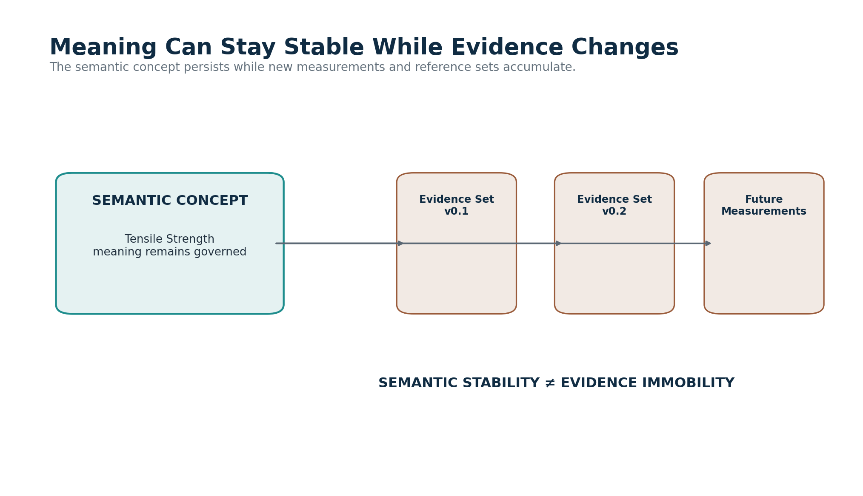
Figure 15. Semantic meaning can remain stable while evidence evolves.
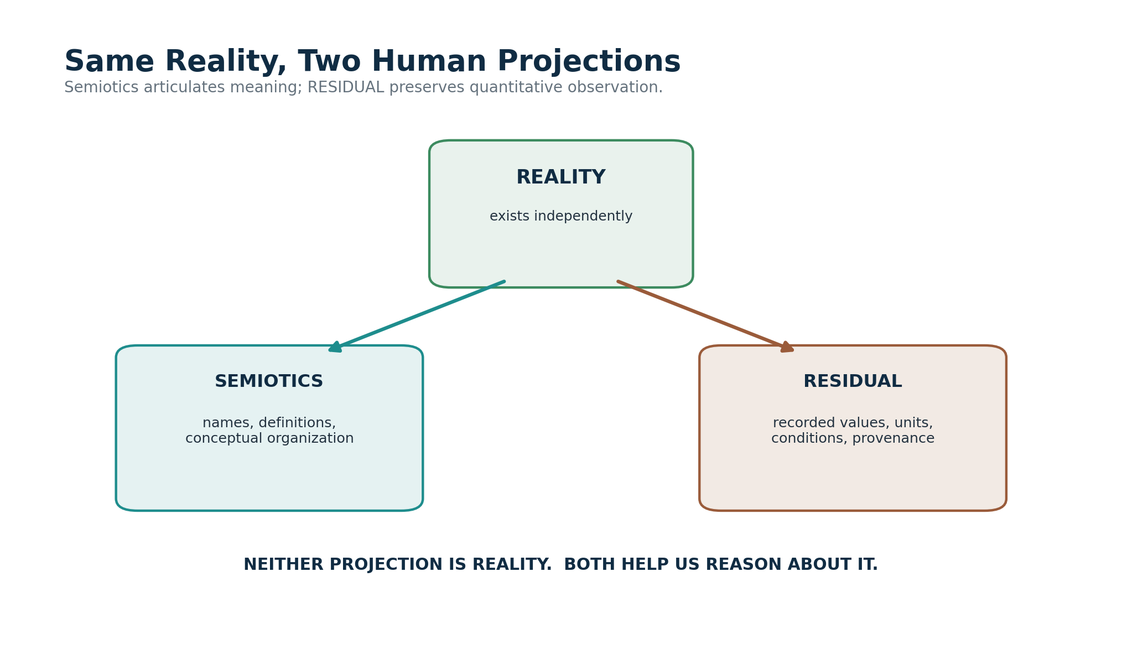
Figure 16. Reality supports both semiotic and quantitative human projections.
AUTHORITY BOUNDARY
Semiotics owns governed meaning and symbolic organization. RESIDUAL owns governed quantitative records and their provenance. Neither system is the external reality to which both ultimately refer.

Part IV — Evidence Multiplicity, Conditions, and Provenance

10. Multiple Measurements Are Expected
Scientific evidence is often plural. Different samples, instruments, conditions, methods, or statistical treatments can produce different quantitative results for what appears to be the same property. RESIDUAL should preserve those records rather than collapsing them into one unexplained number. A preferred reference can exist without deleting the evidence that led elsewhere.
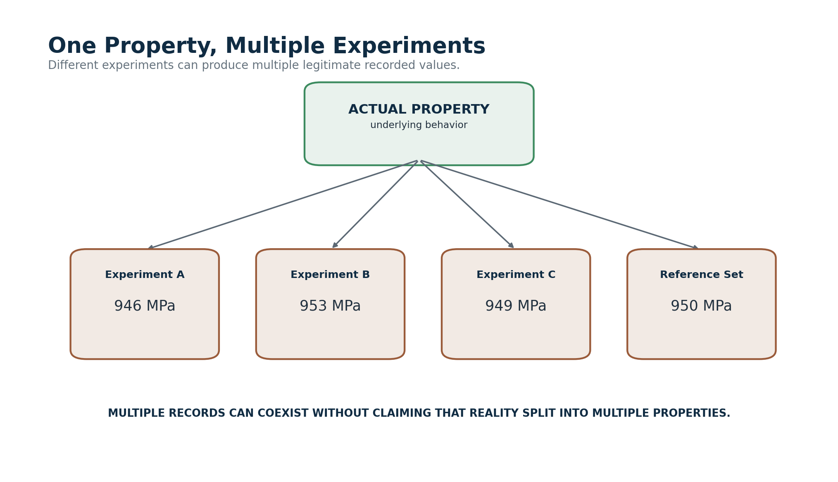
Figure 17. One property can generate multiple experimental records.
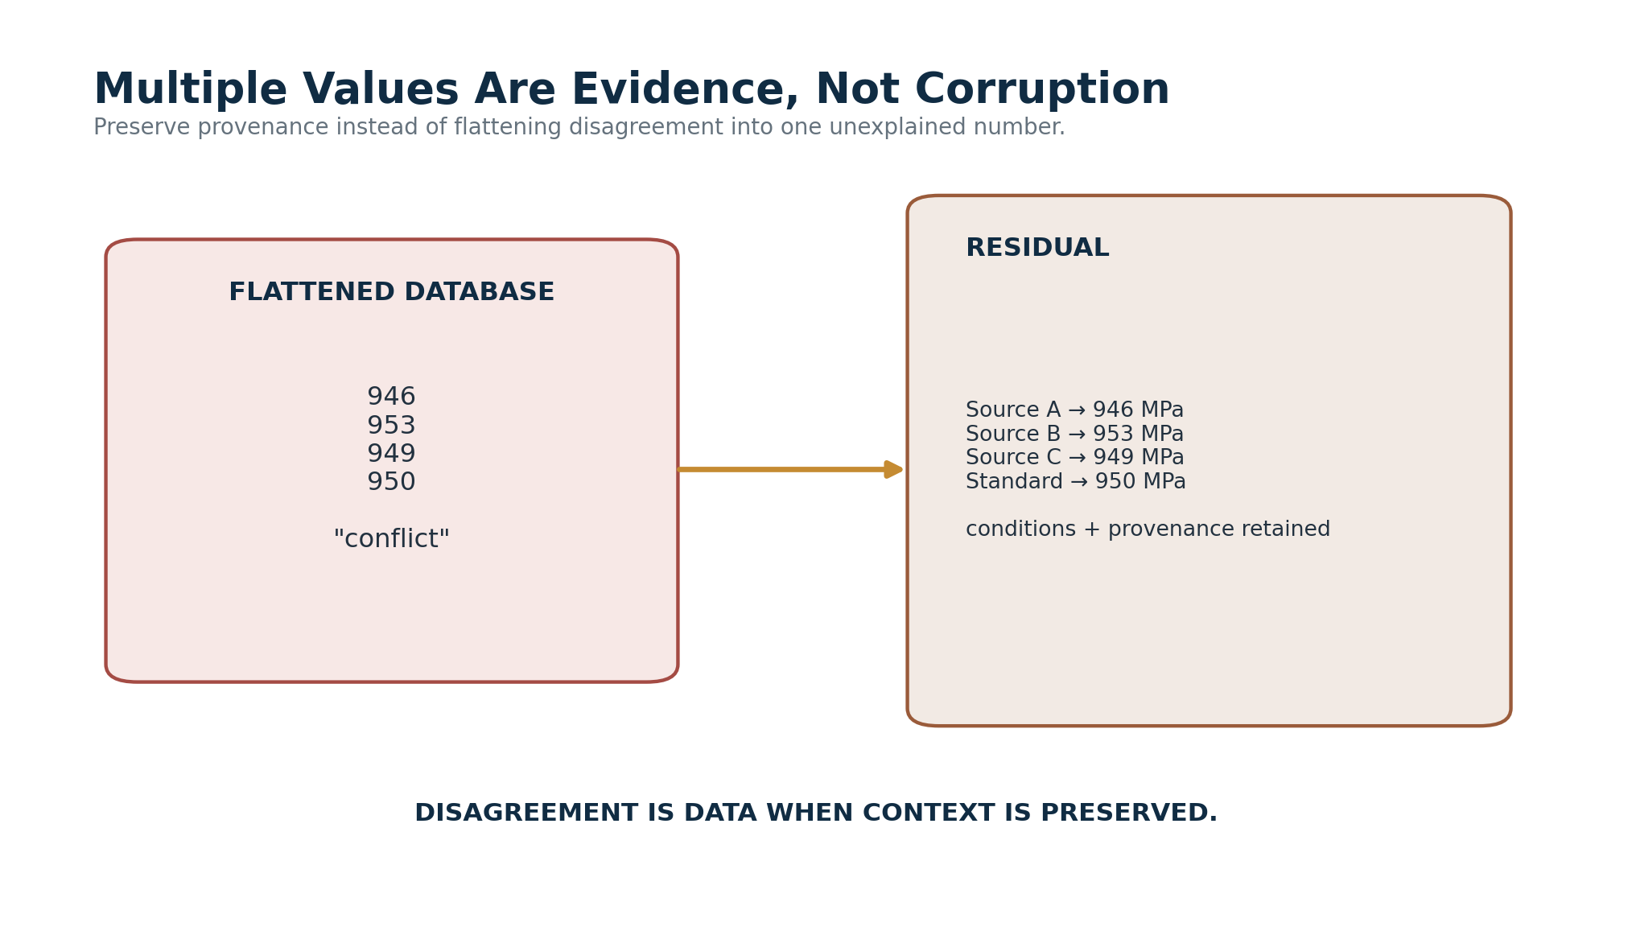
Figure 18. Multiple values are evidence, not corruption.

11. Conditions Determine Applicability
Context-sensitive properties require explicit applicability. Temperature, pressure, material grade, heat treatment, orientation, strain rate, manufacturing state, sample geometry, measurement method, or test standard can determine whether a recorded value is appropriate for a task. RESIDUAL should make contextual specificity cheap enough that users do not need to pretend a convenient reference value is universal.
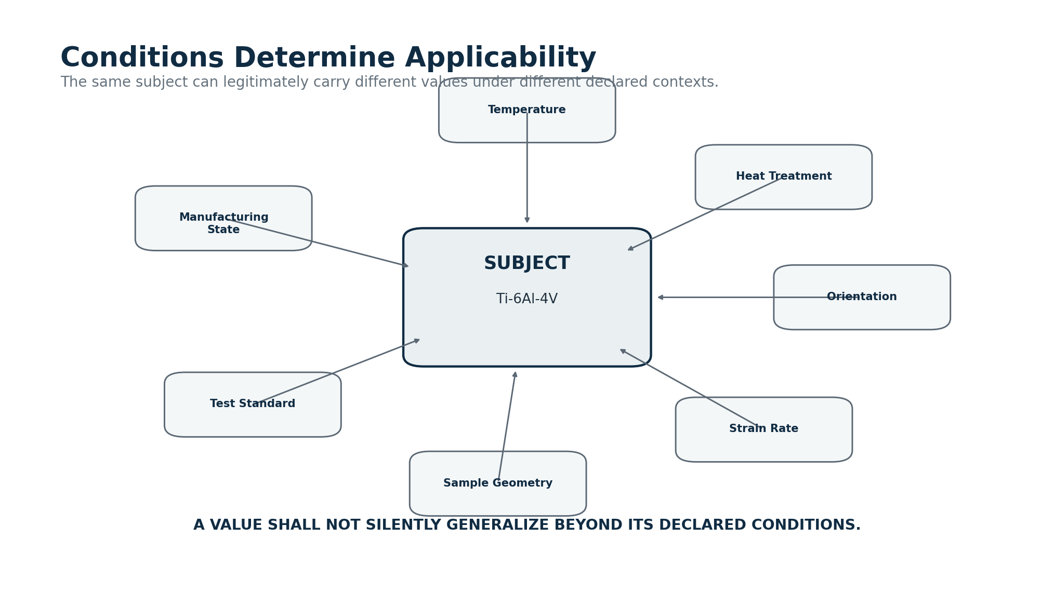
Figure 19. Conditions determine whether a recorded value applies.

12. Uncertainty and Provenance
Uncertainty belongs to the measurement or estimate, not to the ontological existence of the property. Where a source reports uncertainty, confidence information, distributional statistics, or method-specific limits, RESIDUAL should preserve them. Provenance should remain traversable from the stored value to the source, experiment, method, instrument, sample, and conditions when such detail is available and useful.
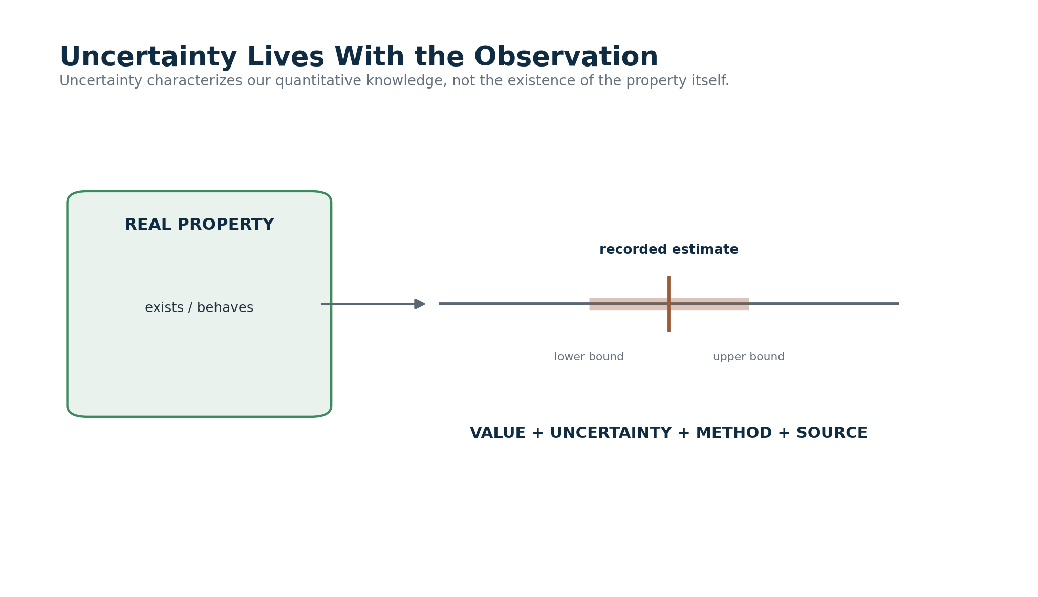
Figure 20. Uncertainty lives with the observation.
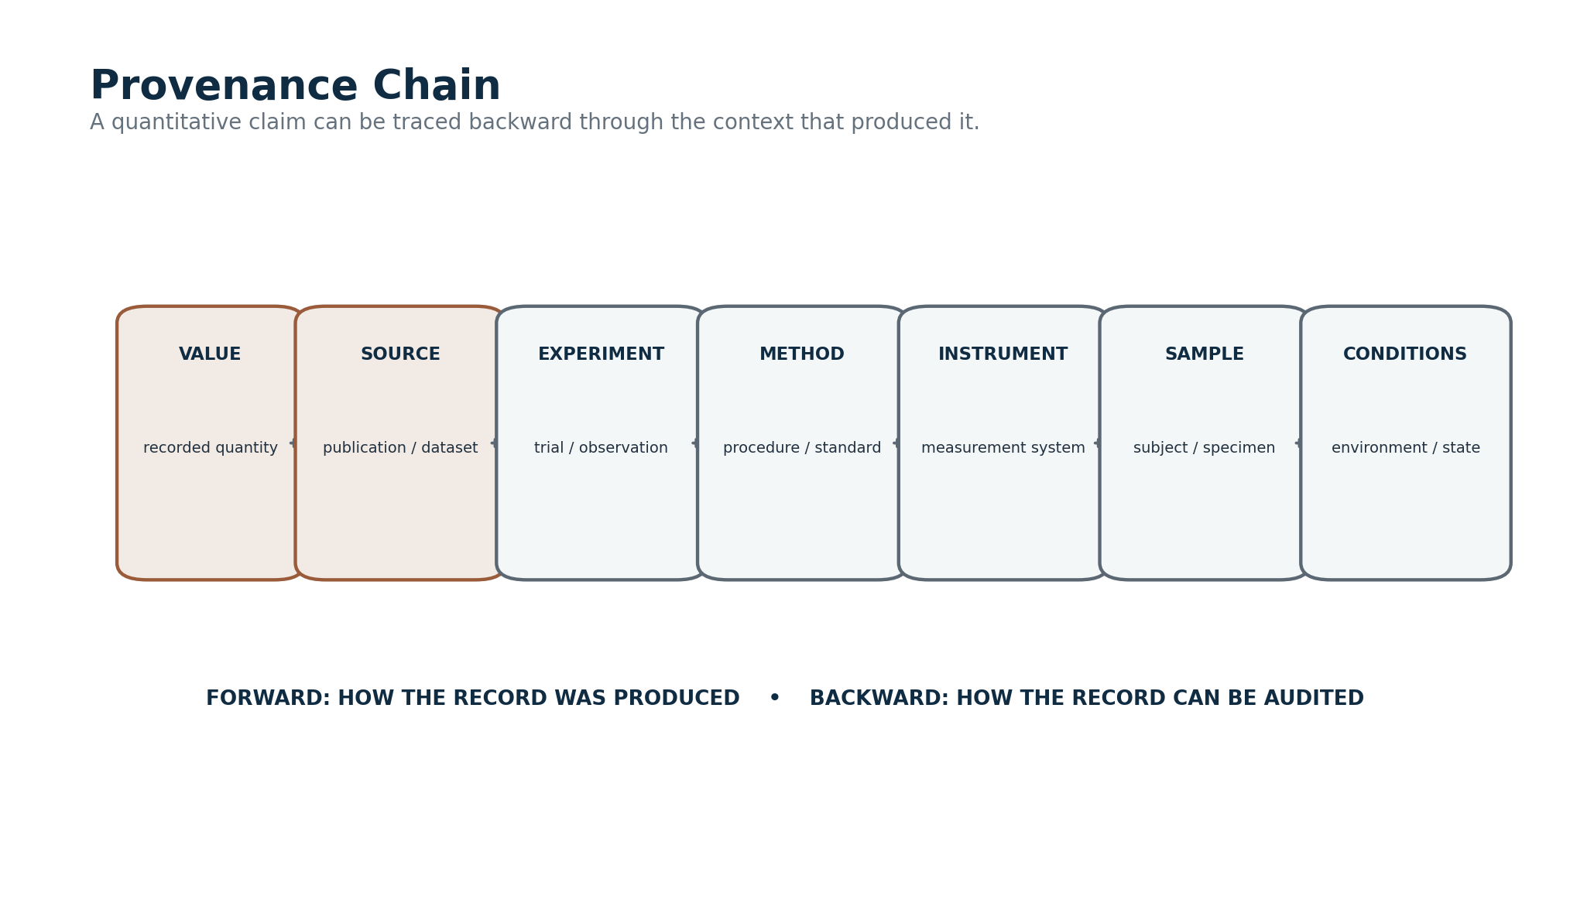
Figure 21. A provenance chain makes quantitative evidence auditable.

13. Evidence Status and Historical Integrity
A current preferred value, a superseded historical record, and a disputed value can coexist. Status affects default routing and display, not whether the historical evidence still exists. This allows past simulations, decisions, publications, or assistant loadouts to remain reproducible using the quantitative records that were actually available at the time.
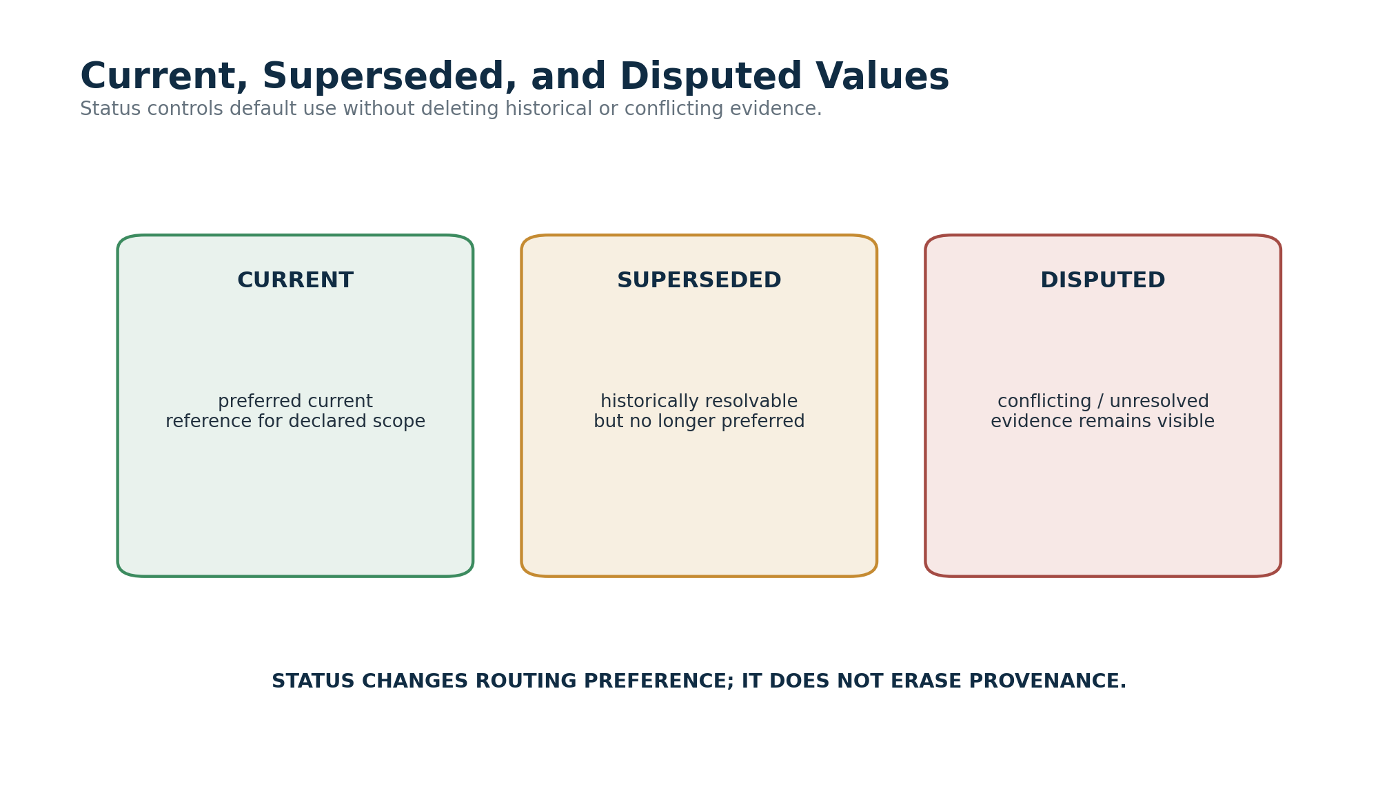
Figure 22. Current, superseded, and disputed quantitative records.

Part V — Dense Family Tables and Constant Addressing

14. Families as Quantitative Tables
The physical Airtable implementation can take advantage of wide tables. A Family is not merely a label around constants; it can be the actual quantitative table in which those values live. The logical Constant is then a specific quantitative cell resolved through the Family, the record key, the field key, and the Family’s unit/context contract. This preserves very high density while retaining deterministic addresses.
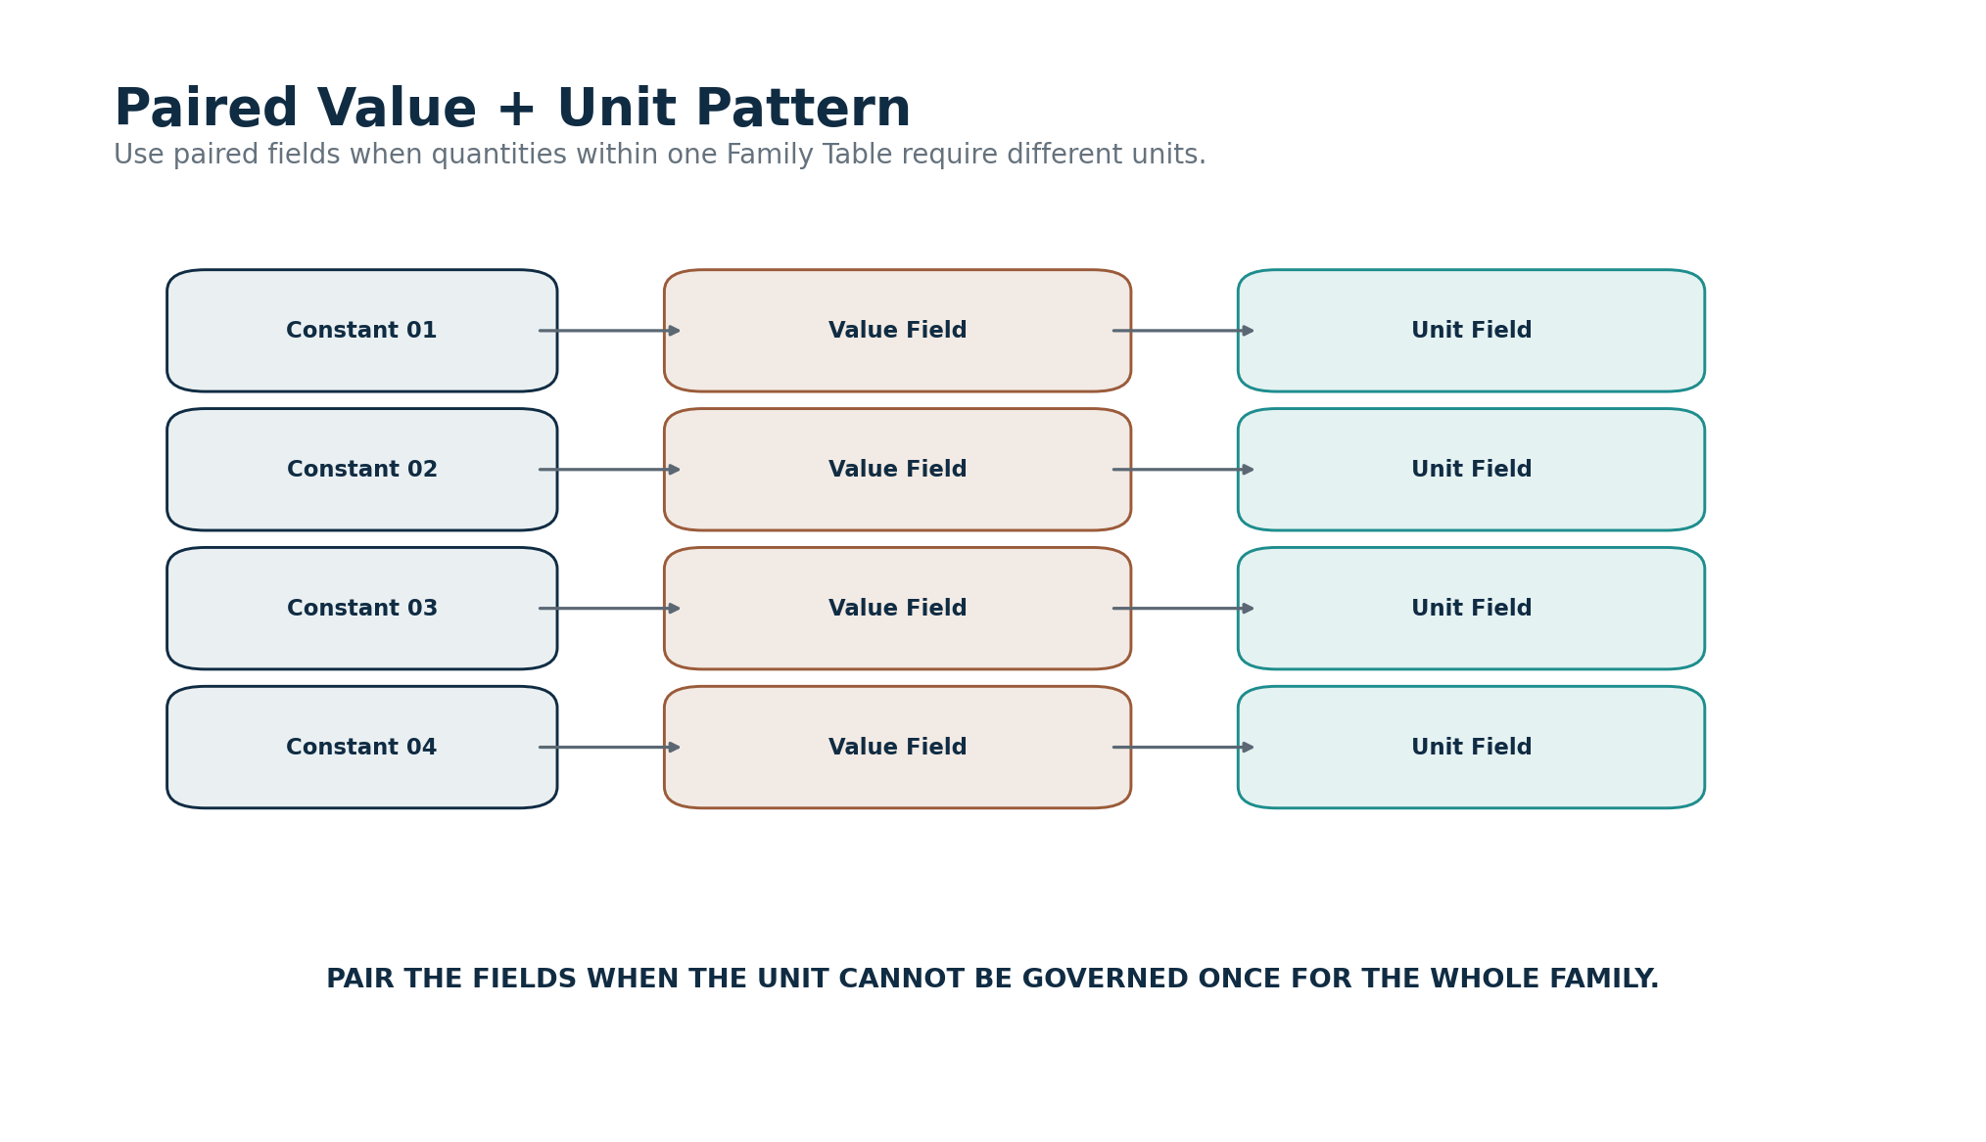
Figure 23. Paired Value + Unit fields for heterogeneous quantitative Families.
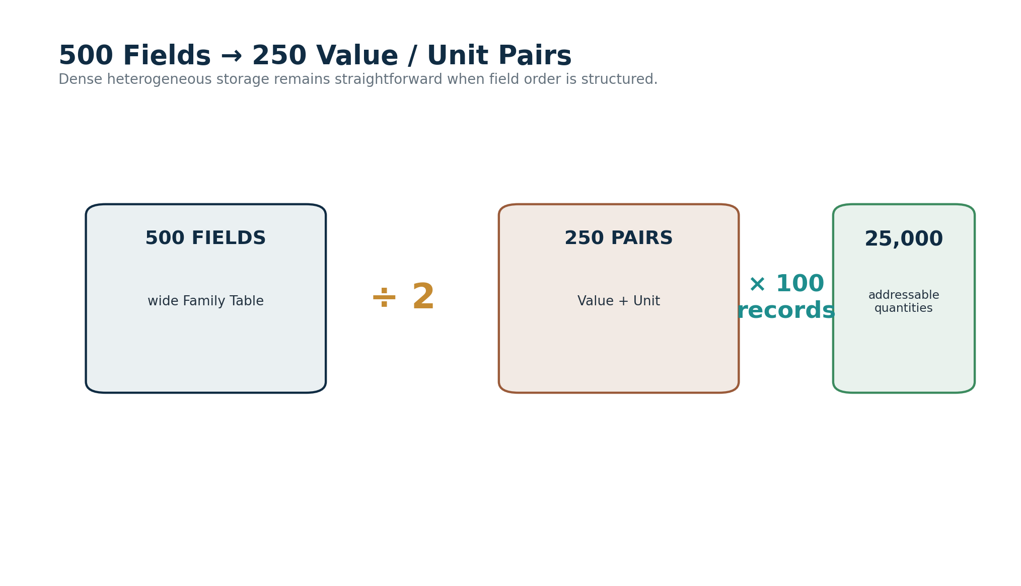
Figure 24. Five hundred fields can encode 250 Value/Unit pairs per record.

15. Homogeneous Unit Families
A property-specific Family such as Tensile Strength can often declare one unit contract for the whole table. In that case, the unit need not be repeated in every value field. Each record-by-field intersection is still one addressable Constant, but all values inherit the Family’s governed unit unless an explicit exception or alternate-unit contract is declared.
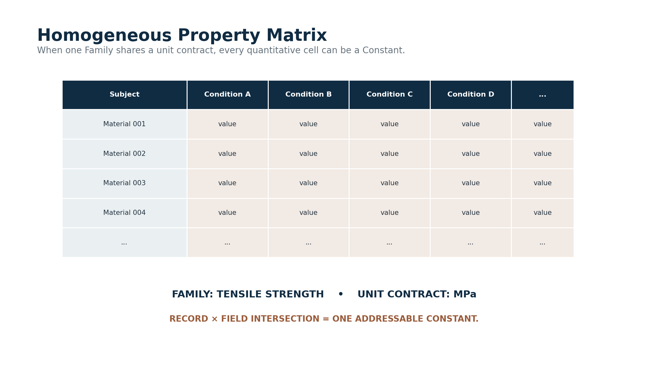
Figure 25. A homogeneous Family matrix where each quantitative cell is a Constant.
The exact record and field together identify the singular value; the Family supplies the property semantics and unit contract.
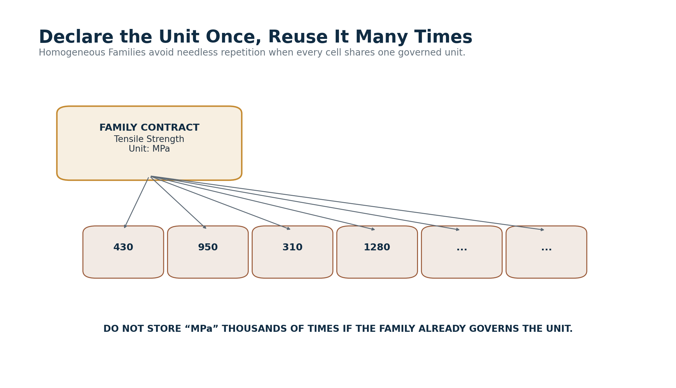
Figure 26. Declare a common unit once and reuse it across the Family.
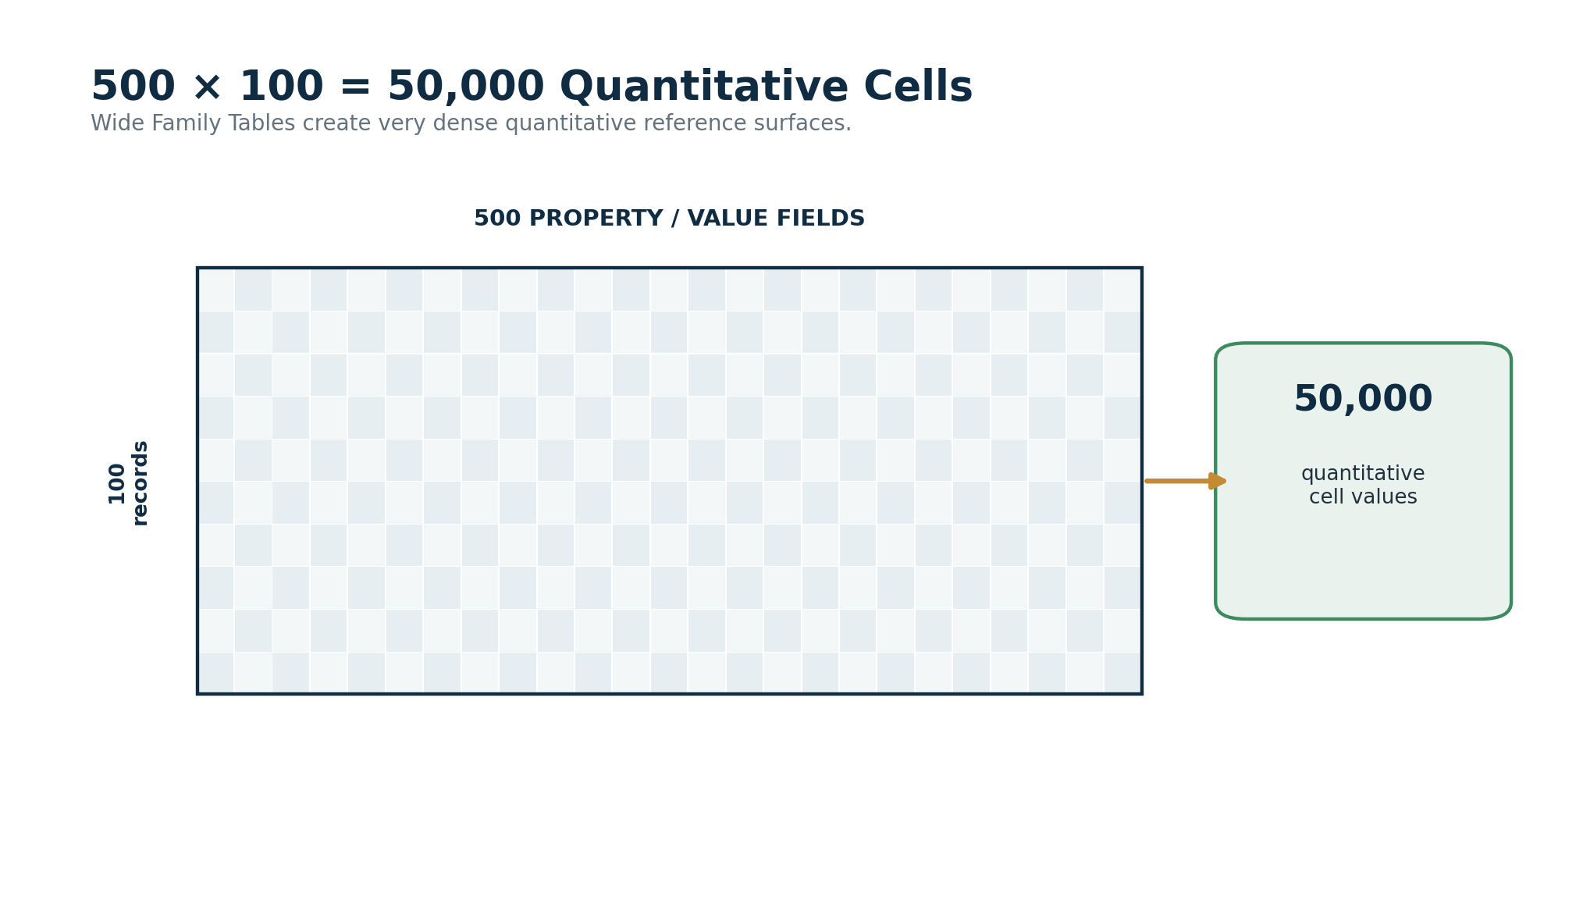
Figure 27. A 500-field by 100-record matrix exposes 50,000 quantitative cells.
DENSITY PRINCIPLE
If units vary by constant, pair Value + Unit. If the unit is invariant across a Family or property field, govern it once and spend the remaining fields on quantitative values.

Part VI — Dynamic Utilization Across Lenses

16. RESIDUAL Feeds Lenses
The final four words of the acronym are operational: Dynamic Utilization Across Lenses. RESIDUAL values are not intended to remain passive reference trivia. Models and Lenses can select, compare, normalize, aggregate, filter, calculate, rank, or simulate with them while preserving which source records informed the result.
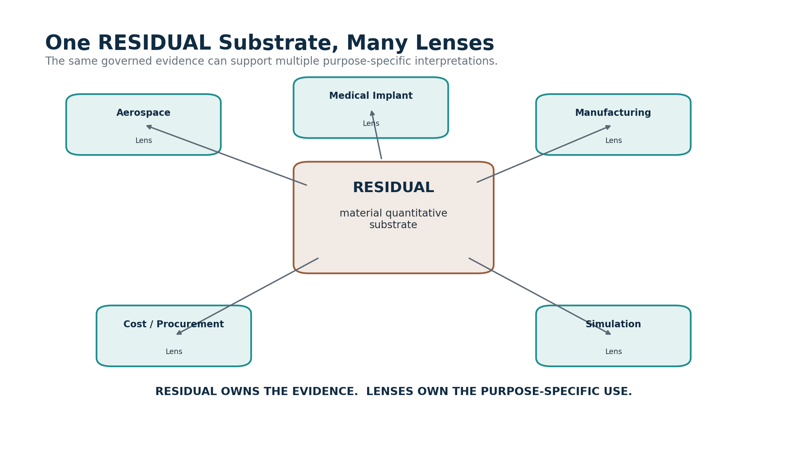
Figure 28. One RESIDUAL quantitative substrate can feed many Lenses.
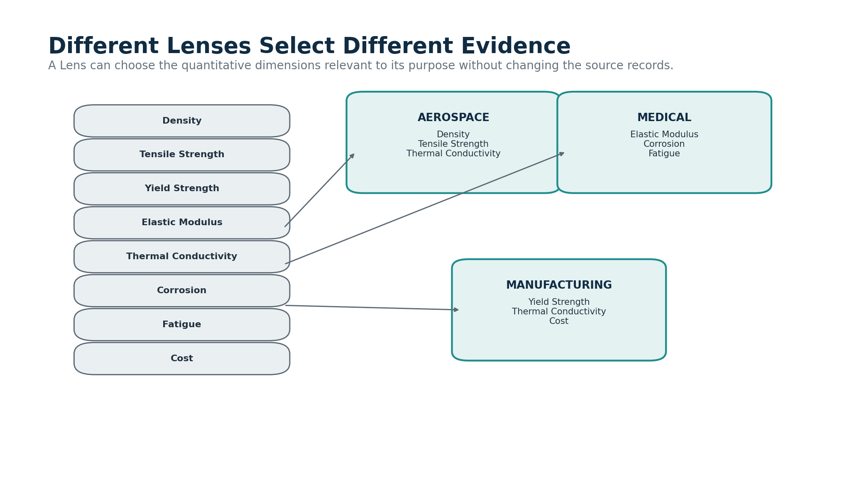
Figure 29. Different Lenses select different evidence from the same substrate.

17. Evidence Is Not the Implication
A Lens may legitimately derive different conclusions from the same evidence because its purpose is different. Aerospace design may emphasize density and thermal performance; a medical implant Lens may emphasize elasticity, fatigue, and corrosion; manufacturing may prioritize machinability, thermal behavior, or cost. Those interpretations belong to the Lens. The recorded measurement remains a RESIDUAL object.
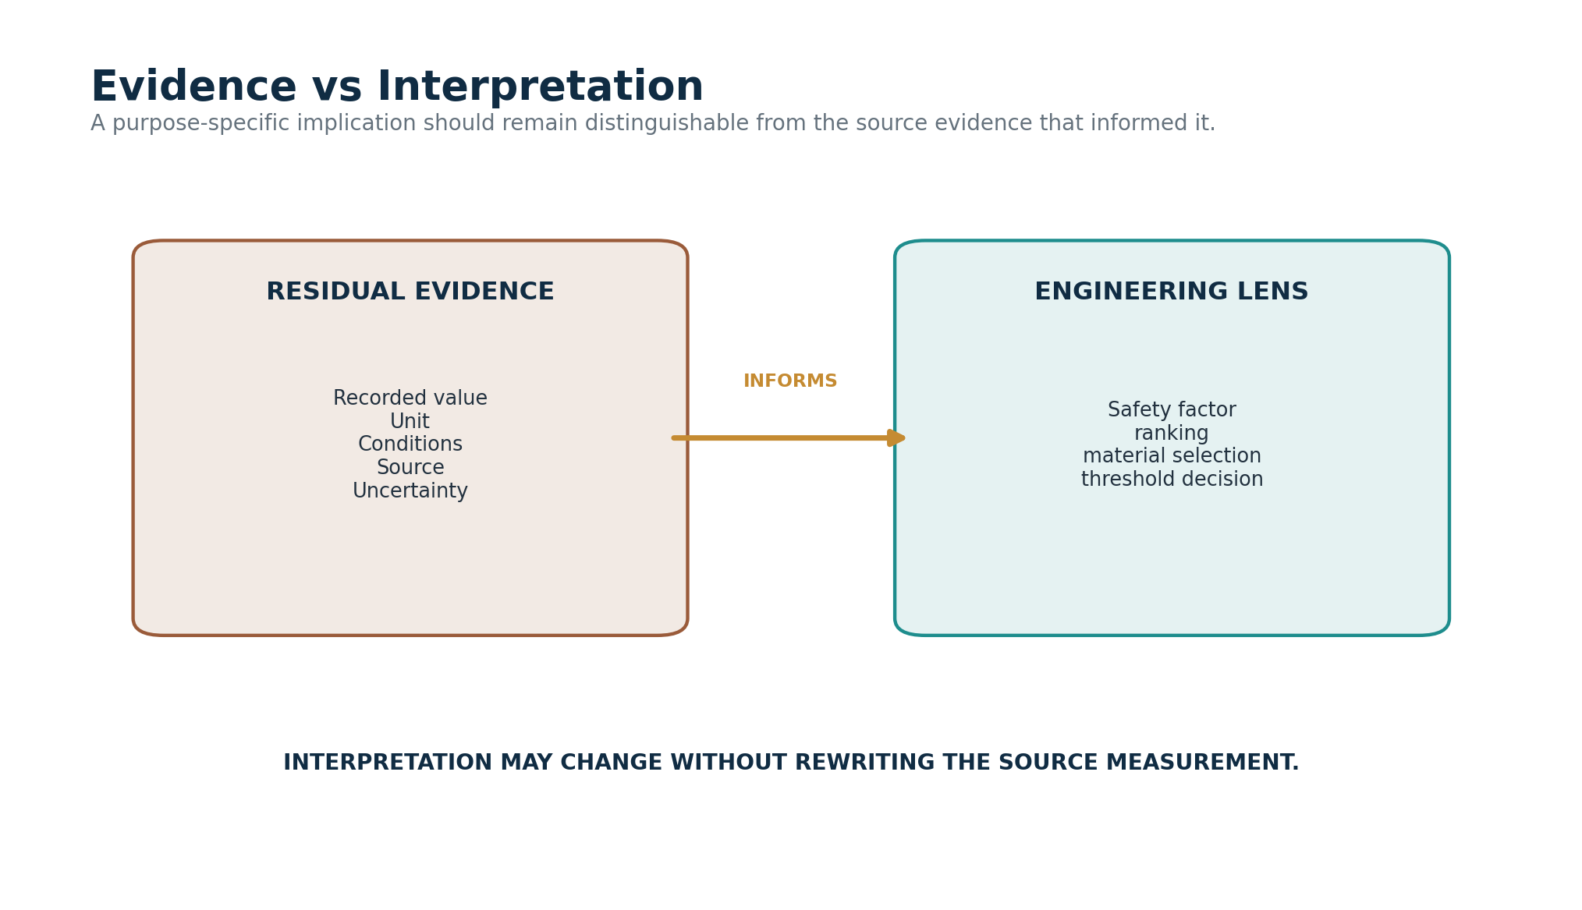
Figure 30. RESIDUAL evidence and Lens interpretation remain separate.

Part VII — Scientific Correction, Versioning, and System Interoperability

18. Better Evidence and Scientific Correction
When a better experiment, improved calibration, new standard, more applicable sample, or stronger dataset changes what CERBERUS should rely on, the correction happens in the recorded evidence. The former value can be superseded rather than erased. Lenses then re-resolve against the new preferred evidence. The database has changed because human knowledge changed; the change does not imply that the external property was rewritten by the database update.
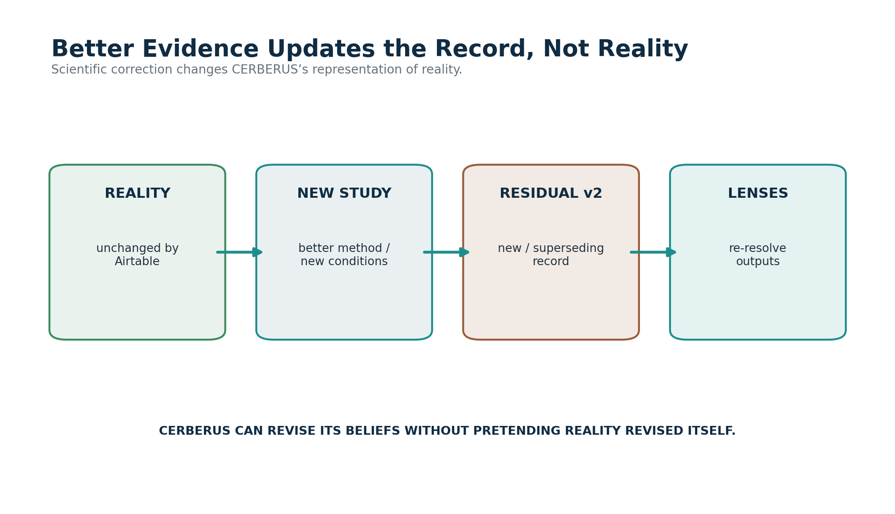
Figure 31. Better evidence updates the RESIDUAL record, not external reality.

19. DARTS and DARTBOARD
RESIDUAL becomes useful through the larger CERBERUS architecture. Semiotic resolution can identify what a quantitative property means. Routing can locate the correct Family table, record, and field. Temporal structures can distinguish historical measurements, effective dates, or time-dependent applicability. ARMORY can relate quantitative knowledge to a person’s own work and experience. Display and DARTBOARD can then render the relevant comparison, inspector, simulation input, or learning surface. No projection needs to absorb the authority of the others.

20. BOOTSTRAP and Quantitative Learning
BOOTSTRAP can teach both the meaning of a property and the evidence recorded about it. A Material Science learning package can introduce Tensile Strength through Semiotics, explain how the property is measured, then route the learner and its companion AI into the exact RESIDUAL Family tables and provenance records. This gives the assistant access to the same governed quantitative substrate being taught to the human rather than forcing either consumer to rely on detached prose alone.
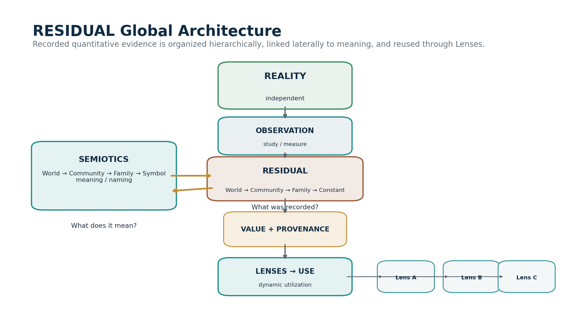
Figure 32. The global RESIDUAL architecture.
Reality remains external; Semiotics runs laterally as the meaning system; RESIDUAL preserves quantitative evidence; Lenses and DARTBOARD turn that evidence into task-specific use.

Part VIII — Airtable Implementation Blueprint and Conformance

21. Minimum Registry Structure
The first implementation can remain intentionally small. The central requirement is not a giant scientific ontology; it is a stable path from World to Community to Family table and then to addressable quantitative cells. Existing CERBERUS registries can provide stable identities, descriptions, table links, semantic bindings, provenance links, and status. The dense Family tables carry the numerical payload.
Structure | Purpose
RESIDUAL Worlds | Stable quantitative World identity, description, Communities, status, version.
RESIDUAL Communities | Community identity, World membership, Families, semantic links, documentation.
RESIDUAL Families | Family identity, Community, Airtable table link, unit mode, unit contract, field/record interpretation, status.
Family Data Tables | The dense quantitative matrices. A Family is physically realized as its governed table.
Source / Provenance records | Publications, datasets, standards, experiments, methods, organizations, dates, and other evidence context.
Lens Bindings | Explicit relationships identifying which RESIDUAL Families or Constants a Model/Lens consumes.
Version / Status metadata | Current, superseded, disputed, archived, source version, and historical resolution information.

22. Family Table Contract
Contract element | Implementation meaning
Family Identity | Stable ID and human name for the quantitative Family.
Community / World | Upward resolution path.
Table Link | Exact Airtable table containing the quantitative matrix.
Unit Mode | Paired Value+Unit, homogeneous Family unit, field-specific unit contract, or declared hybrid.
Canonical Unit / Unit Contract | Unit inherited by cells when the Family is homogeneous.
Record Axis | What one record represents: subject, material, source set, condition set, experiment, or other governed entity.
Field Axis | What one value field represents: condition, subject, constant slot, source slot, or other governed dimension.
Semantic Binding | Link from quantitative Family or field meaning into the Semiotic system.
Provenance Binding | How source, method, uncertainty, condition, or version context is resolved.
Status / Version | Current interpretation and historical reproducibility.

23. Constant Addressing
The implementation should treat one quantitative cell as the singular Constant whenever the Family table is a matrix. The address is therefore not “the number 950”; it is the governed intersection of Family identity, record identity, value-field identity, and the applicable unit/context/provenance contract. This gives the system a precise quantitative coordinate without requiring tens of thousands of extra Constant records merely to duplicate cell identity.
CONCEPTUAL CONSTANT ADDRESS
Family → Record → Field → Value, with inherited or paired Unit plus Context and Provenance. Exact physical field IDs and routing keys should be taken from the implemented Airtable registries rather than invented in prose.

24. Example Initial Science World
World | Community | Illustrative Families
Science | Material Science | Tensile Strength; Compression Strength; Shear Strength; Yield Strength; Elastic Modulus; Fatigue Strength; Fracture Toughness; Density; Thermal Conductivity
Science | Cybernetics | Gain; Damping; Response Time; Feedback Delay; Stability Margin; Noise; Thresholds; other measured or reference control quantities
Science | Chemistry | Organic Chemistry; Biochemistry; Physical Chemistry; Analytical Chemistry; other governed quantitative domain Families

These are starting examples, not claims that every scientific quantity must be organized under these exact Families. The RESIDUAL hierarchy is deliberately versioned and extensible so the system can adopt better organization as actual datasets and research communities are incorporated.

25. Conformance Checklist
ID | Check
C01 | Every governed Constant resolves through one Family, Community, and World path.
C02 | Every Family resolves to an exact quantitative table or declared data surface.
C03 | Every quantitative cell has an interpretable unit through a paired field or governed unit contract.
C04 | Context-sensitive values do not silently generalize beyond declared applicability.
C05 | Multiple evidence records may coexist without forced flattening.
C06 | Current/superseded/disputed status affects routing but preserves history.
C07 | Semiotic meaning and RESIDUAL quantity remain separately governed and explicitly linked.
C08 | Lens calculations retain routes back to the RESIDUAL evidence they consumed.
C09 | Source correction changes the recorded representation, not the ontological status of external reality.
C10 | Historical uses can resolve the RESIDUAL version and provenance originally available to them.

26. Closing Architecture Statement
RESIDUAL gives CERBERUS a quantitative memory of humanity’s encounters with reality. It does not reduce reality to the values we happen to have recorded, and it does not force one interpretation to own the evidence. A Constant can remain singular and precise; Families can become enormous dense tables; Communities and Worlds can provide domain-scale organization; Semiotics can explain what the values mean; Lenses can reuse them dynamically; and provenance can preserve the intellectual and experimental work that made the values available in the first place.
CLOSING PRINCIPLE
Reality exists. People study it. RESIDUAL records what they found. Lenses decide what to do with it.

CERBERUS RESIDUAL Architecture • v0.1

