CERBERUS MIRROR
Recursive Semantic Graph Composition
Domain Mirrors, PIECE Intelligence, the EDIFICE, and Stable Graph Archives
BRAIN Root Stack B11 | Official System Color: Cyan
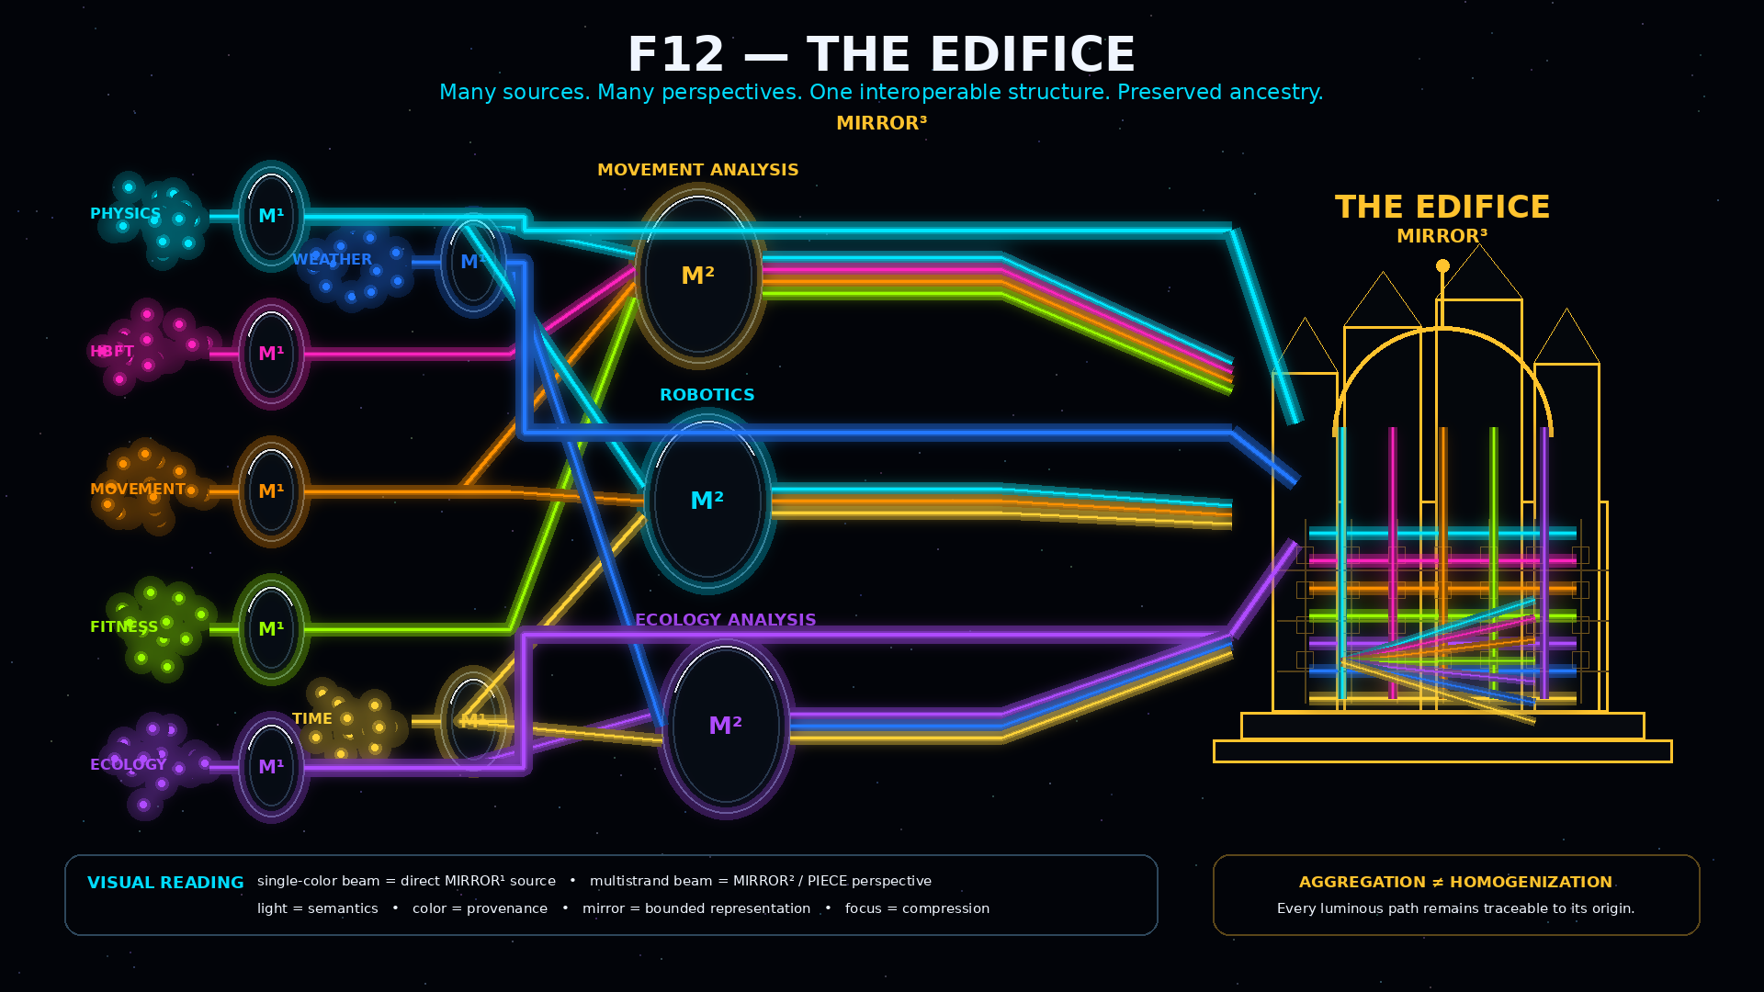
Formal Architecture Companion Paper | Version 0.1 | Pass 8 Verified Release | September 2026
Core thesis: A Graph may be a Point without ceasing to be a Graph.

Document Status
This paper is a companion extension to the established CERBERUS MIRROR architecture rather than a replacement for the MIRROR core specification. It formalizes the recursive consequence discovered through implementation work: complete bounded Mirror Graphs can themselves become semantically addressable Points inside higher-order Mirrors, and particular recursive configurations can be preserved separately as Stable Graphs.
The existing MIRROR specification defines a bounded, non-authoritative relational reasoning architecture in which mapped Points, Relationships, semantic payloads, Routes, and candidate states can be explored without becoming source authority [1]. The EDIFICE defines PIECE as a bounded cognitive lens and preserves divergent intelligence without requiring a universal ontology [2]. CERBERUS PHYSICS demonstrates compact exact references, graph-native identity, mixed resolution, and selective semantic hydration [3]. This paper composes those foundations into a recursive graph architecture.
A Graph may be a Point without ceasing to be a Graph.

Abstract
Large semantic systems create a recurring architectural problem: the internal structure required to represent a domain can become enormous while higher-order systems that use that domain often need only a bounded reference to it. Flattening every domain into one universal graph duplicates intelligence, weakens boundaries, and makes provenance difficult to preserve. Reducing a domain to an opaque label has the opposite failure: the higher-order system can name the domain but cannot recover the structure beneath it when deeper reasoning becomes necessary.
Recursive MIRROR resolves this tension through semantic graph-to-Point representation. A MIRROR¹ expresses a bounded domain as an explicit graph of semantically resolvable Points and declared Relationships. The complete graph may receive stable Mirror Identity and participate at a higher semantic composition level as one Point while preserving exact reachability into its internal graph. Multiple MIRROR¹ domains may participate in MIRROR² compositions representing bounded PIECE perspectives, and one MIRROR¹ may participate in any number of such PIECEs without semantic duplication. MIRROR¹ domains may also remain directly available to MIRROR³ as source intelligence outside any one PIECE perspective. Within this paper, MIRROR³ is the graph-native relational representation of THE EDIFICE.
The same architecture supports persistence. A particular recursive network can be preserved as a Stable Graph containing the identities, versions, topology, Semantic Joints, unique instantiated state, causal residue, dependencies, and provenance required for reconstruction while reusable source intelligence remains independently stored. The result is a layered many-to-many intelligence architecture in which source possibility, bounded perspective, instantiated state, and archival configuration remain distinct but exactly traceable.

Scope and Nonclaims
This paper formalizes recursive representation of complete graphs as higher-order semantic Points. It covers MIRROR¹ domain graphs, Mirror Identity, graph-to-Point semantic compression, many-to-many source reuse, MIRROR² PIECE representation, Semantic Joints, selective hydration, direct MIRROR¹-to-MIRROR³ source routes, MIRROR³ as EDIFICE relational representation, Stable Graph persistence, Stable World Graphs, archive closure, and selective reconstruction.
It does not define a universal relationship vocabulary, fixed MIRROR SK bit width, remote synchronization protocol, distributed consistency model, Stable Graph binary serialization, archival cryptography, cache policy, conflict-resolution runtime, or a final MIRROR-native execution engine. It also does not claim that semantic compression produces a universal storage ratio. Its claim is structural: reusable intelligence can remain independently addressable while the configuration that uses it is stored separately.

Recursive Terminology Note
Superscripts denote recursive composition order, not authority, database nesting, or hydration depth. MIRROR¹ is a bounded domain Mirror Graph. MIRROR² is a Mirror Graph whose Points may include whole MIRROR¹ identities and can provide a graph-native representation for a PIECE. MIRROR³ is a Mirror Graph whose Points may include MIRROR²/PIECE identities and direct MIRROR¹ source identities; within this paper it represents the EDIFICE relational ecology. Stable Graph is not MIRROR⁴. It is a persistence artifact that records a particular configuration across the recursive system.
Recursive scale describes how a graph participates as a Point. Hydration describes how deeply an active branch is opened. Authority remains governed separately.

Contents
PART I — From Network to Mirror
1. The Structure Between the Nodes; 2. MIRROR¹; 3. Representation Without Authority; 4. Mirror Identity; 5. Semantic Resolution Surfaces; 6. Graph-to-Point Compression
PART II — Mirrors Become Cognition
7. Reusable Domain Mirrors; 8. Many-to-Many Reflection; 9. MIRROR²; 10. PIECE Representation; 11. Same Mirrors, Different PIECEs; 12. Semantic Joints; 13. Cross-Mirror Traversal; 14. Selective Hydration; 15. Mixed Resolution
PART III — From PIECE to EDIFICE
16. Direct Source Intelligence; 17. Unbounded Source Intelligence; 18. Perspective Intelligence; 19. Compressed Possibility Kernels; 20. MIRROR³; 21. THE EDIFICE; 22. Layered Many-to-Many Intelligence; 23. Exact Provenance
PART IV — Stable Graphs
24. Stable Graph; 25. Persistence Without Duplication; 26. Archive Closure; 27. Stable Graph Modes; 28. Stable World Graphs; 29. Historical Stable Graphs; 30. Selective Reconstruction
PART V — Formal System
31. Formal Model; 32. Positive Laws; 33. Non-Collapse Registry; 34. Authority, Failure, and Scope; 35. Worked Recursive Synthesis and Conclusion

PART I
From Network to Mirror
How a bounded domain graph becomes a reusable semantic Point without losing its internal structure.

1. The Structure Between the Nodes
A semantic system is not defined only by the identities it contains. Two systems may contain exactly the same objects while representing radically different worlds because the Relationships between those objects differ. The sequence A→B→C→D is not equivalent to A→C, A→D, and B→D even though the same four semantic identities are present. The graph therefore carries information that cannot be recovered from the inventory of nodes alone.
CERBERUS already provides mechanisms for semantic identity, registered meaning, Rules, Models, and bounded transformations. MIRROR gives the relational configuration itself a first-class representation. It exposes which objects participate in a domain, which Relationships are explicitly valid, which routes can be traversed, where greater resolution exists, and which expected links are absent because they are unsupported or nonsensical.
MIRROR exposes the structure between semantically resolved Points.

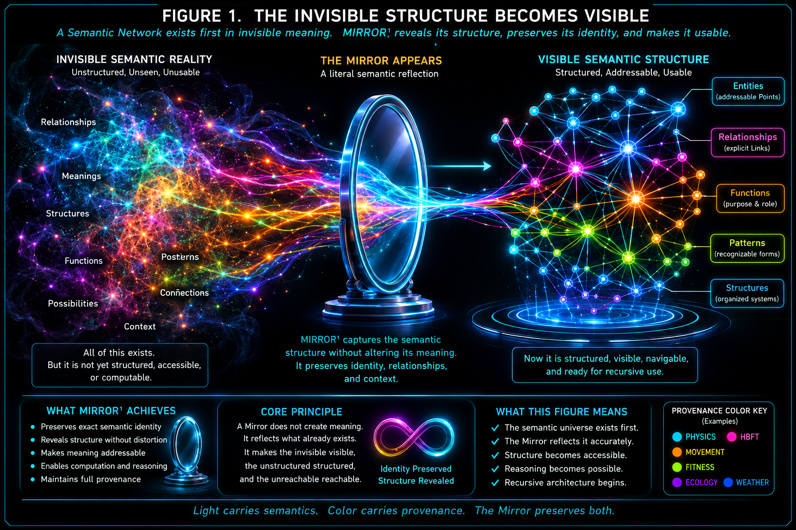
Figure 1. The relational structure becomes explicit. Semantic identities do not by themselves describe the topology of a domain; MIRROR makes declared structure visible, addressable, and traversable without redefining the identities themselves.

2. MIRROR¹ — The Bounded Domain Graph
A MIRROR¹ is the first recursive unit considered in this paper. It represents one bounded semantic domain. Examples include PHYSICS, HUMAN_BODY_FORCE_TRANSMISSION (HBFT), COOKING, FITNESS, WEATHER, ECOLOGY, or any other domain whose records and Relationships can be made explicitly traversable. The domains do not need to share one internal topology. PHYSICS may contain a broad representational possibility space; HBFT may use a sparse explicit anatomy graph; COOKING may emphasize ingredients, tools, transformations, recipes, and process state.
The shared architectural property is simple: each domain is bounded, semantically resolvable, and explicitly traversable. In the current Airtable-oriented implementation model, ordered Tables provide orientation, linked Records provide graph topology, and lookups project selected fields across those record edges. Binary semantic bindings provide meaning through registered Readers. The implementation therefore uses record-to-record topology and field projection rather than literal field-to-field edges.

Three responsibilities
- Table order provides orientation: where an unfamiliar intelligence should generally begin and what broad surfaces follow.
- Explicit links provide topology: which Records are actually connected in this Mirror.
- Semantic binary bindings provide meaning: what a Point or local mapping resolves to through its registered semantic contract.
Table 1. Core Recursive Vocabulary
Term | Formal role | Key distinction
Point | Semantically addressable object participating in a Mirror Graph | Point size does not determine internal complexity.
Relationship | Explicit graph connection between Points | Relationship does not imply ownership, equivalence, or authority.
MIRROR¹ | Bounded domain Mirror Graph | Represents a domain; does not become source authority.
Mirror Identity | Stable semantic identity for an entire Mirror | Identity does not contain the graph.
Mirror Point | Higher-order Point representing a complete lower-order Mirror | Point is not the hydrated graph.
Semantic Joint | Exact local intersection of independently encoded Mirrors | One joint proves only its declared intersection.
Hydration | Increase in active internal graph resolution | Hydration does not grant authority.
Stable Graph | Persistence artifact for one recursive configuration | Stable Graph is not MIRROR⁴.

3. Representation Without Authority
The word Mirror describes more than appearance. A physical mirror can provide a faithful representation of an object without becoming the object itself. The same discipline governs CERBERUS MIRROR. A Mirror can represent current state, derived state, possible state, alternate resolution, candidate state, graph topology, or projected consequences without gaining automatic authority to mutate the source from which the representation was mapped [1].
This boundary is critical because recursive MIRROR increases representational reach. A higher-order Mirror can inspect a complete domain Point or PIECE Point, hydrate internal structure, and reason over candidate routes while source authority remains elsewhere. Greater visibility, greater resolution, or larger scope does not itself create jurisdiction.
AUTHORITATIVE SOURCE -> bounded mapping -> MIRROR REPRESENTATION -> governed validation -> optional commit
Representational fidelity does not imply mutation authority.

4. Mirror Identity
Once a domain Mirror becomes a reusable semantic object, the complete Mirror can receive stable identity. A future MIRROR Semantic Kernel may resolve compact binary/SCALAR addresses to Mirror identities such as PHYSICS, HBFT, COOKING, or FITNESS. The exact bit width is deliberately outside this paper. Governance, stable identity, versioning, provenance, Reader resolution, compatibility, and lifecycle matter more than choosing a bit count prematurely.
The compact identity does not contain the full graph. It tells the system which registered Mirror to resolve. A million-record domain can therefore appear externally as one semantic Point while its internal topology remains independently addressable.
Table 2. Recursive MIRROR Levels
Level | Primary role | Typical Points | What remains beneath the Point
MIRROR¹ | Domain representation | Domain records / semantic objects | Local semantic topology
MIRROR² | Higher-order composition / PIECE representation | Complete MIRROR¹ identities | Independently resolvable domain Mirrors
MIRROR³ | EDIFICE relational representation | PIECE identities and direct MIRROR¹ source identities | PIECE structures and source-domain Mirrors
Stable Graph | Persistence artifact, not a fourth Mirror level | Saved identities, topology, state references | Reconstructable recursive configuration
Superscripts indicate recursive composition order. They do not establish authority hierarchy.

5. Semantic Resolution Surfaces
Mirror Identity answers which Mirror is being addressed. It does not, by itself, resolve every local record inside that Mirror. Recursive MIRROR therefore separates semantic resolution into complementary surfaces rather than forcing one universal representation.
Table 3. Semantic Resolution Surfaces
Surface | Question answered | Example
SK Reader | What does this binary semantic contract mean? | 01010110 -> LEFT FEMUR
MIRROR Binary Translation | What registered semantic binding does this local Mirror mapping resolve to? | HBFT / Bone / Mapping 54 -> HBFT-BONE binding
Mirror Graph | How are these resolved objects related in this representation? | LEFT FEMUR -> participates in -> LEFT HIP JOINT

The proposed MIRROR Binary Translation surface is intentionally local: Mirror + Table + mapping position resolves to a registered semantic binding. It does not translate the entire graph into one universal schema. Encoding, meaning, and topology remain separate. This separation is what later allows semantic joints to connect independently encoded Mirrors without refactoring either one.

6. Graph-to-Point Semantic Compression
The central recursive operation begins when an entire Mirror receives a higher-order semantic representation. Let M_i be a bounded Mirror Graph. Define a conceptual graph-to-Point operator rho such that rho(M_i)=p_i, where p_i is the higher-order Point representing M_i. The Point is not the graph, but it preserves an exact route back into the graph while the declared contract remains valid.
rho(M_i) = p_i p_i != M_i Resolve(p_i) -> M_i
This is semantic compression in the architectural sense: large structure can occupy one position at a higher composition level because the lower-order information does not need to be duplicated at that level. The information is not magically stored inside a few bits. The compact Point preserves exact reachability to the structure that already stores it.
Non-destructive semantic compression depends on exact reachability.

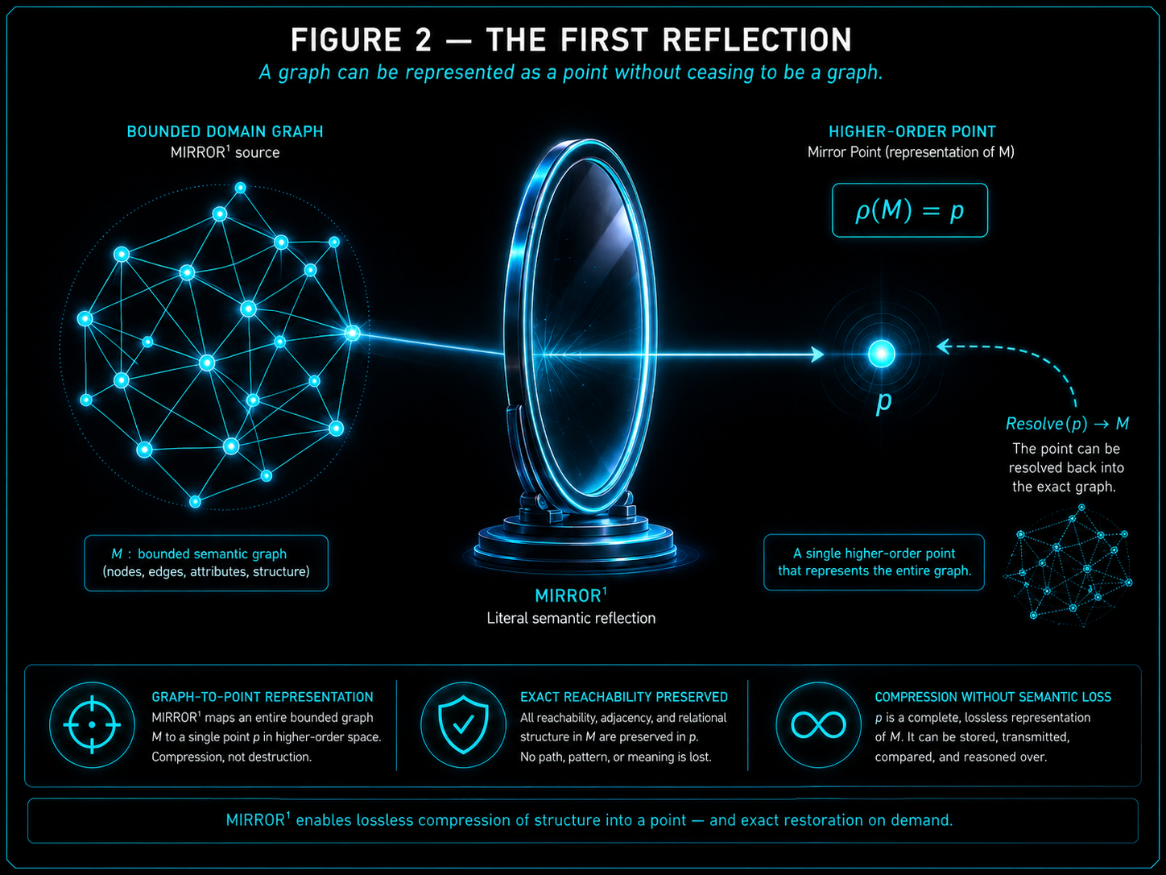
Figure 2. The first reflection. A complete MIRROR¹ may participate externally as one higher-order semantic Point while preserving exact reachability into the graph beneath it; the source graph is not destroyed by the compression.

Initial formal laws
- RCG-L01 — Graph-to-Point Law: any bounded Mirror Graph with stable semantic identity and resolvable contents may participate as a Point at a higher semantic composition level.
- RCG-L02 — Exact Reachability Law: semantic compression remains non-destructive only while the represented lower-order structure remains exactly resolvable within the claimed scope.

PART II
Mirrors Become Cognition
Reusable domain Mirrors compose into higher-order graph structures without surrendering their native identity.

7. Reusable Domain Mirrors
Once a MIRROR¹ possesses stable identity, it should not need to be rebuilt for every system that uses it. PHYSICS may support movement analysis, robotics, materials engineering, simulation, chemistry, or biology. Recursive MIRROR treats the source domain as one reusable semantic object. Each consumer establishes its own relationship to that exact source rather than maintaining a subtly divergent local copy.
Reuse does not imply shared runtime state. Several PIECEs may reference the same PHYSICS Mirror while maintaining different active questions, hydrated branches, evidence, assumptions, candidate states, Models, permissions, and local memory. What is shared is the source identity and its resolvable structure.
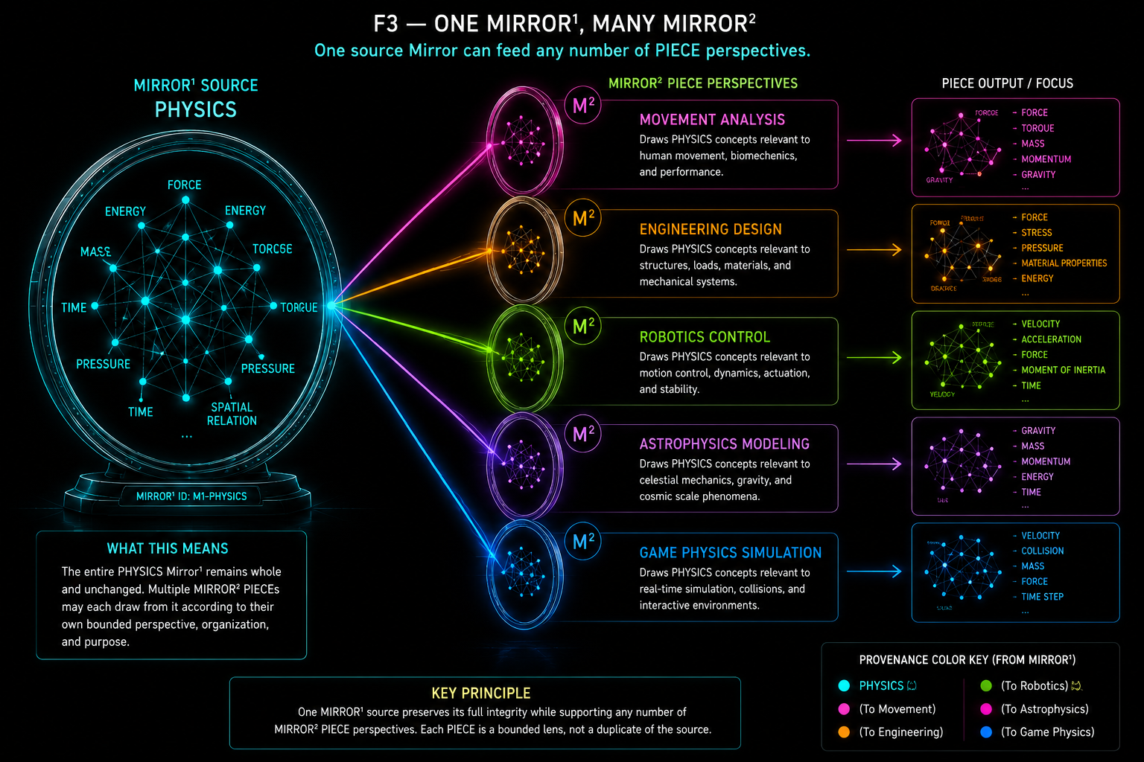
Figure 3. One source Mirror may participate in many higher-order Mirrors without semantic duplication. The source remains independently addressable while its intelligence is reused through distinct PIECE routes.
Nodes are reusable. Paths are specific.

8. Many-to-Many Reflection
The architecture is not a tree in which every MIRROR¹ has exactly one MIRROR² parent. One source may participate in many PIECEs, and one PIECE may compose many source Mirrors. These two directions occur simultaneously, producing a layered many-to-many graph of graphs.
Cardinality follows semantic need rather than symmetry. PHYSICS might participate in Movement, Robotics, and Materials PIECEs. HBFT might participate in Movement, Clinical, and Fitness PIECEs. FITNESS might participate in only one of those. No architectural rule forces every Mirror to have the same number or kind of connections.
Table 4. Many-to-Many Mirror Participation
Pattern | Valid? | Meaning
One MIRROR¹ -> one MIRROR² | Yes | One source domain participates in one bounded PIECE.
One MIRROR¹ -> many MIRROR² | Yes | One reusable source participates in several divergent PIECEs.
Many MIRROR¹ -> one MIRROR² | Yes | A PIECE composes several source domains.
Many MIRROR¹ -> many MIRROR² | Yes | General recursive network case.
Copy MIRROR¹ once per MIRROR² | Not required | Higher-order Relationships may reference one canonical Mirror identity.
MIRROR² automatically owns MIRROR¹ | No | Participation does not transfer domain ownership.
Co-membership implies all cross-links | No | Higher-order Relationships remain explicit.

9. MIRROR² — The MirrorMirror Graph
A MIRROR² is a Mirror Graph whose Points may themselves resolve to complete MIRROR¹ graphs. At MIRROR¹ resolution, PHYSICS can contain particles, fields, quantities, state, materials, and physical Relationships; HBFT can contain bones, landmarks, joints, muscles, attachments, hubs, and routes. At MIRROR² resolution those enormous structures may appear simply as PHYSICS and HBFT Points while MIRROR² adds its own Relationships between them.
Those higher-order Relationships are not inherited automatically. The fact that PHYSICS, HBFT, and FITNESS are all available does not establish PHYSICS→HBFT→FITNESS until the higher-order graph declares that topology. Semantic identity remains separate from relational organization at every recursive level.
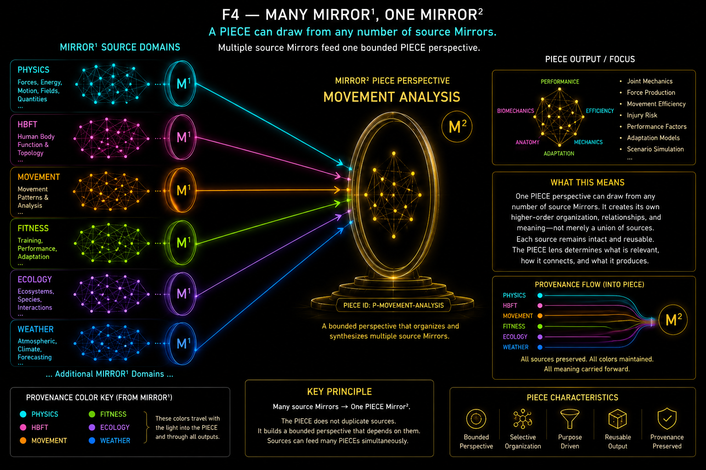
Figure 4. Many MIRROR¹ domains may converge into one MIRROR² / PIECE composition. Source distinctions remain independently visible while a higher-order graph organizes their bounded use.

10. PIECE Representation
THE EDIFICE defines PIECE as a Perspective-Indexed Experimental Cognitive Engine: a bounded cognitive lens with declared perspective, scope, evidence access, assumptions, operators, outputs, and version [2]. PIECE is not a deployment size. A PIECE may be a model, agent, Stack-scale compound lens, or Base-scale habitat. Recursive MIRROR does not redefine that architecture; it supplies a graph-native relational representation for it.
P_j = (D_j, R_j, M_j, O_j, E_j, Q_j)
Here D_j denotes participating domain Mirrors, R_j higher-order Relationships, M_j Models, O_j Operators, E_j Evidence surfaces, and Q_j the bounded query/output/perspective contract. The notation is explanatory rather than a final physical schema. Its purpose is to establish P_j != D_j: a PIECE is not merely a bag of Mirrors.
Table 5. PIECE Composition Dimensions
Dimension | Question
Domain Mirrors | Which bounded semantic worlds does this PIECE use?
Higher-Order Relationships | How does the PIECE relate those domains?
Models | Which predictive, interpretive, or derivational structures operate across them?
Operators | Which registered transformations or actions are available?
Evidence | What information may enter this perspective?
Resolution Policy | Which domains or branches are opened when needed?
Scope / Exclusions | Which questions belong inside or outside the lens?
Outputs | What bounded results may the PIECE emit?
Provenance | Which source Mirrors and traversal paths produced the result?

11. Same Mirrors, Different PIECEs
Two PIECEs can have identical source-domain sets and still be different cognitive structures. A mechanics-first PIECE may traverse PHYSICS→HBFT→FITNESS. A goal-first PIECE may begin from FITNESS, resolve required anatomy through HBFT, and then seek physical constraints in PHYSICS. The same sources support different directions of inquiry, Models, evidence priorities, hydration patterns, and outputs.
This is a concrete graph representation of divergent cognition. Shared knowledge does not require shared cognition. The EDIFICE can preserve multiple bounded lenses over the same source intelligence without demanding that one perspective become the canonical replacement for the source or for the other PIECEs [2].
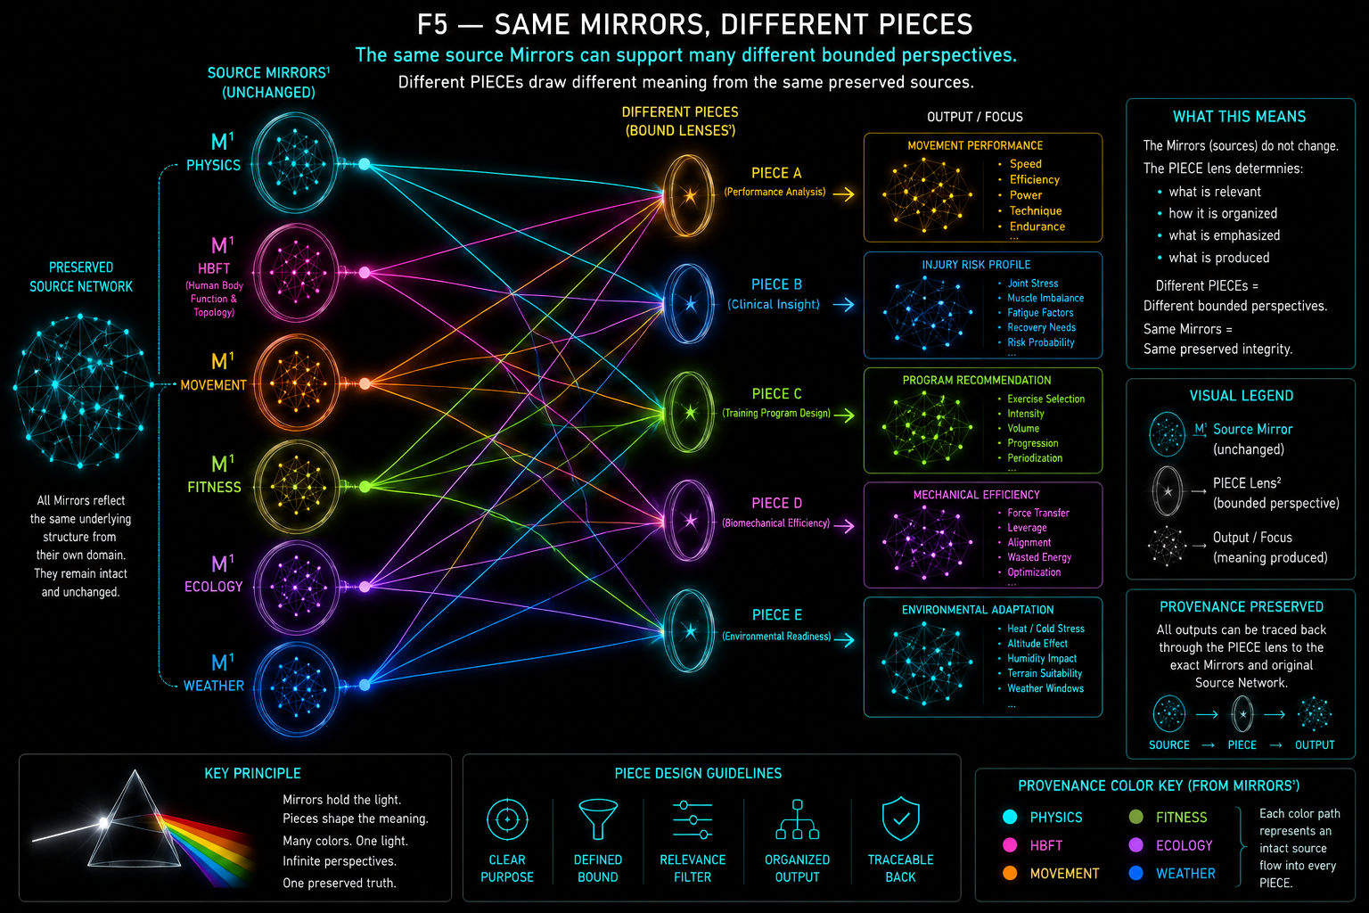
Figure 5. Identical source Mirrors can support divergent PIECEs because higher-order topology, perspective, and active routes remain independently specified. Shared source membership does not imply shared cognition.

12. Semantic Joints
Two independently constructed Mirrors may represent the same semantic object while encoding it differently. HBFT may resolve a local code such as 0101 to LEFT FEMUR while FITNESS resolves 01110 to the same registered semantic identity. The local binaries, Tables, Readers, graph structures, and purposes can remain different. Their shared resolved identity becomes a Semantic Joint.
Resolve_A(a) = S and Resolve_B(b) = S => J(a,b;S) may be declared within scope
The joint says exactly one thing: these local graph objects resolve to the same semantic identity within the declared scope. It does not prove shared encoding, shared Reader, shared schema, shared topology, shared state, shared governance, or broad domain equivalence. Compatibility can therefore grow one proven semantic joint at a time.
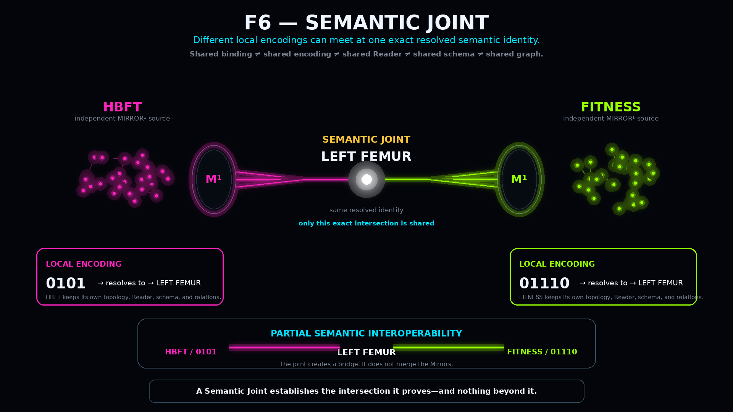
Figure 6. HBFT and FITNESS use different local encodings but meet exactly at the resolved semantic identity LEFT FEMUR. The joint provides a bridge without merging the two Mirrors.
Table 6. Semantic Joint Compatibility Limits
Condition | Established by shared identity? | Explanation
Same resolved referent | Yes | This is the basis of the joint.
Same local binary | No | Local encodings may differ.
Same Reader | No | Different Readers may resolve the same object.
Same Table schema | No | Structural organization may differ.
Same graph topology | No | Mirrors may use the identity in different relational contexts.
Same source authority | No | A shared referent does not merge governance.
Broader domain equivalence | No | One joint proves only the bounded intersection.
Valid traversal at the joint | Potentially | Requires declared traversal scope.

13. Cross-Mirror Traversal
A Semantic Joint becomes operationally valuable when a PIECE follows a route through it. A movement-analysis question may begin in FITNESS at Squat, resolve the relevant Hip Joint, cross into HBFT at a shared identity, hydrate the local anatomical structure, then reach Torque and cross another Semantic Joint into PHYSICS. No ontology merger is required. Each domain contributes what it natively knows.
FITNESS / Squat -> Hip Joint -> J_Hip -> HBFT / Hip Joint -> Torque -> J_Torque -> PHYSICS / Torque
Route direction matters. FITNESS→HBFT→PHYSICS and PHYSICS→HBFT→FITNESS may traverse the same source Mirrors while asking different questions. Cross-Mirror reasoning is therefore path-sensitive, and provenance must retain the route actually realized. Co-membership in one PIECE never licenses arbitrary traversal; domain boundaries may be crossed only through declared semantic connectivity.

14. Selective Hydration
Once a higher-order Point is known, the system must decide how much of the structure beneath it should become active. Recursive MIRROR does not require all-or-nothing expansion. If a query concerns the greater trochanter, HBFT can hydrate only the route required to reach Lower Limb→Left Femur→Greater Trochanter while unrelated bones, muscles, ligaments, joints, cavities, and routes remain compressed.
H(p, r) -> G_r where commonly G_r is a proper subset of M
Hydration is an increase in active semantic resolution, not ontological creation. If a requested relationship is not present in the registered source graph, deeper resolution must not silently invent it. Decodable is not the same as mapped, and representable is not the same as valid.
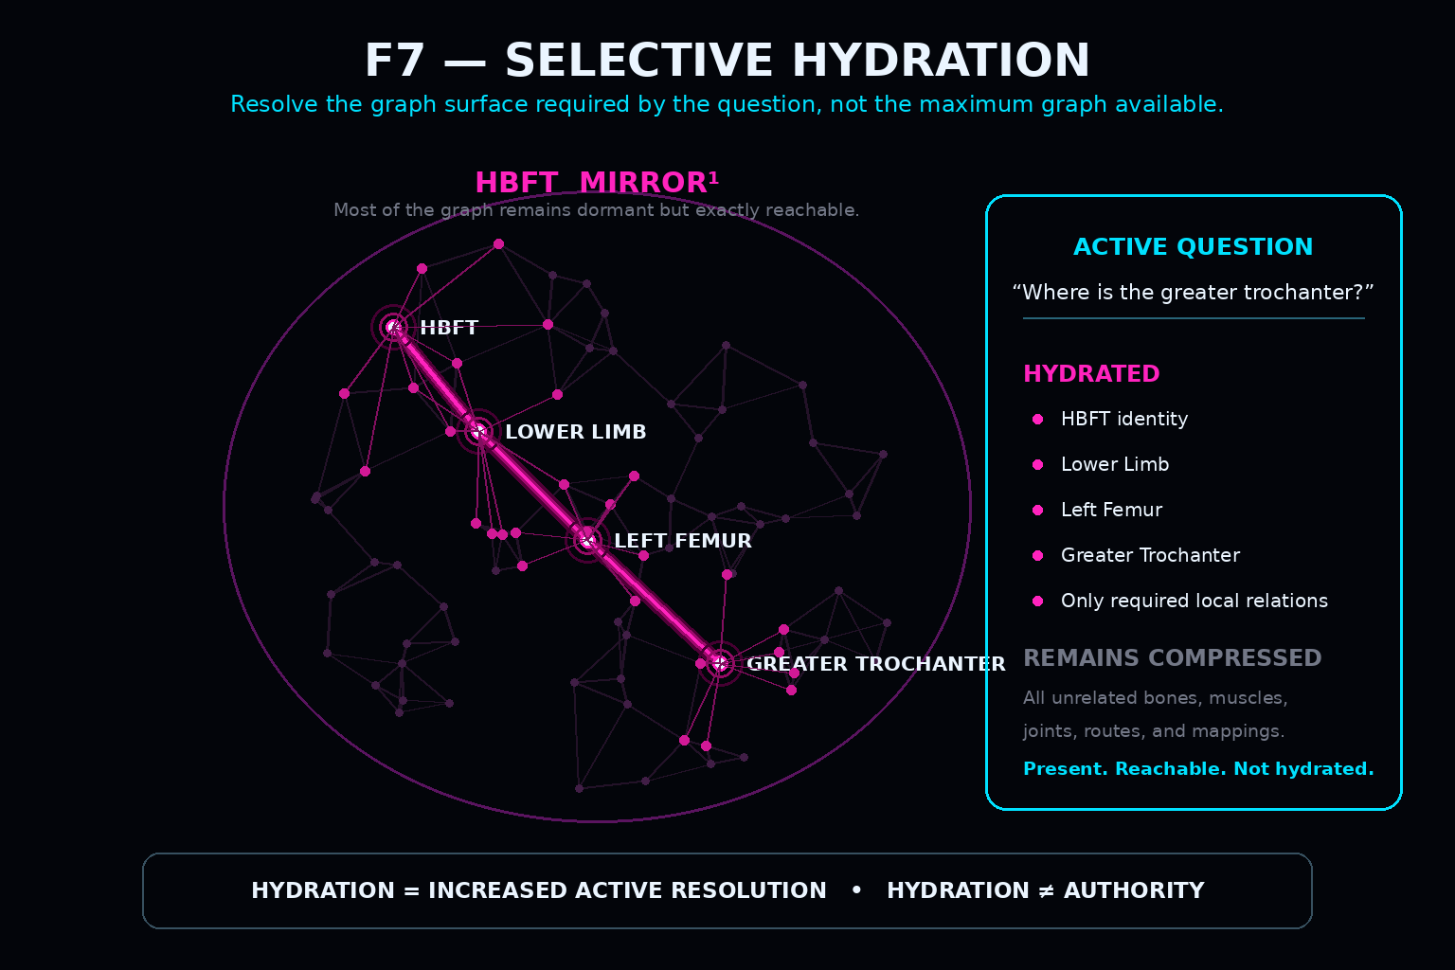
Figure 7. Selective hydration resolves only the HBFT branch required by the active question. The remaining anatomy stays present and exactly reachable but is not actively opened.
Table 7. Hydration States
State | Representation | Typical use
Compressed | Whole Mirror appears as one Point | Domain availability and higher-order routing
Shallow | Mirror plus major Table/region surfaces | Orientation
Selective | Only query-relevant branch expanded | Normal reasoning
Deep | Detailed local Records and Relationships resolved | Precise analysis
Cross-Mirror | Hydrated branch crosses a Semantic Joint | Multi-domain reasoning
Mixed | Different Mirrors/branches exist at different depths | Efficient PIECE operation
Dormant but available | Mirror is addressable but not currently hydrated | Source intelligence for later use

15. Mixed Resolution
Selective hydration naturally produces graph states in which different branches operate at different semantic depths. PHYSICS may remain a single whole-domain Point while FITNESS resolves only Squat, MOVEMENT resolves an intermediate movement pattern, and HBFT hydrates deeply to Left Hip→Left Femur→Greater Trochanter. This is not an incomplete state. It is the intended consequence of question-driven resolution.
Resolution depth does not equal importance, certainty, or authority. A compressed PHYSICS Point may still provide the most fundamental constraint in the active problem, while HBFT is opened deeply only because the question demands anatomical specificity. Deeper is not automatically better [3].
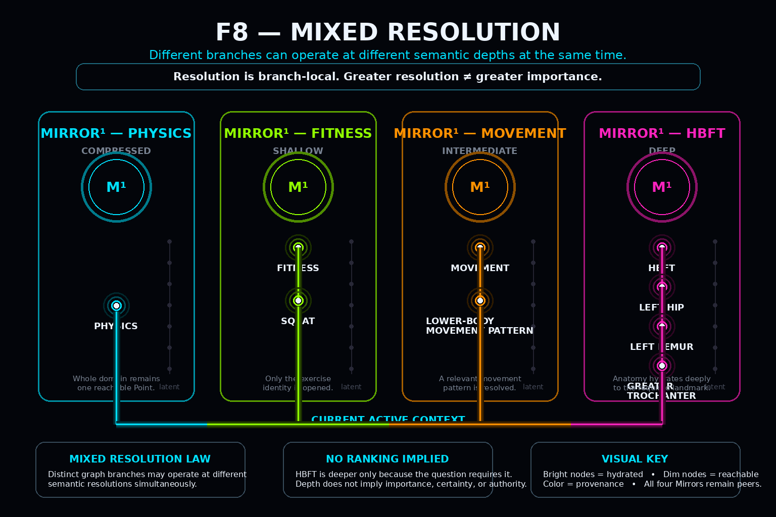
Figure 8. A PIECE can operate across several Mirrors at different semantic depths simultaneously. Mixed resolution is branch-local and does not create a ranking of truth, importance, or authority.

PART III
From PIECE to EDIFICE
Source intelligence and bounded perspective intelligence remain jointly addressable in a recursive many-to-many ecology.

16. Direct Source Intelligence
MIRROR² is not a mandatory gateway between a domain and the EDIFICE. A MIRROR¹ may feed one MIRROR², many MIRROR² structures, MIRROR³ directly, or all of those routes at the same time. This preserves the source domain as a first-class intelligence surface instead of hiding it behind the perspectives that happen to use it.
If several PIECEs use PHYSICS, Movement Analysis may emphasize human force transmission and torque, Robotics may emphasize actuators and collision, and Materials may emphasize stress and material response. None of those bounded uses is equivalent to PHYSICS itself. The direct source route keeps the full registered domain independently available.
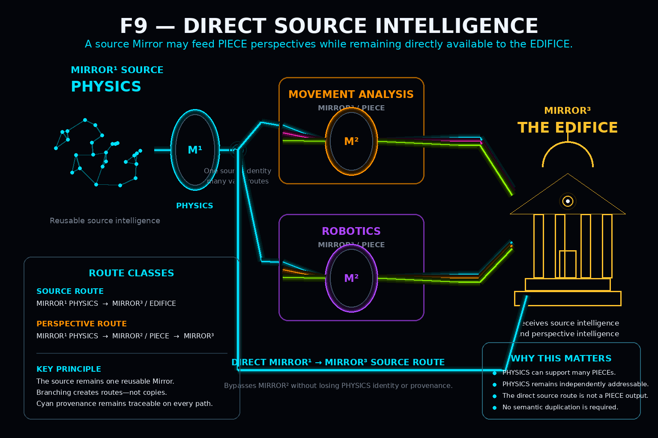
Figure 9. PHYSICS may feed several MIRROR² / PIECE perspectives while remaining directly available to MIRROR³ as source intelligence. Branching creates routes, not semantic copies.

17. Unbounded Source Intelligence
For this paper, Unbounded Source Intelligence has a narrow technical meaning: a MIRROR¹ made available to MIRROR³ without first being bounded through one specific PIECE perspective. The source Mirror is still bounded by its own semantic scope, version, provenance, permissions, topology, and authority rules. Unbounded means PIECE-unbounded, not semantically or operationally unbounded.
Unbounded Source Intelligence = unbounded by one PIECE perspective, not unbounded by semantic governance.

This distinction matters because possibility is usually larger than any one perspective. A movement PIECE may use only a narrow portion of PHYSICS. A materials PIECE may open an entirely different branch. The EDIFICE can preserve the source possibility space alongside the perspectives constructed from it.

18. Perspective Intelligence
Perspective Intelligence answers a different question from source intelligence. Source intelligence asks what bounded semantic possibility is available. Perspective intelligence asks how one PIECE organizes and uses selected portions of that possibility. A PIECE may select domains, establish higher-order Relationships, privilege routes, activate Models and Operators, admit particular Evidence, and hydrate only the graph surfaces relevant to its query.
The source preserves possibility. The PIECE preserves a particular use of possibility. The distinction prevents a bounded cognitive lens from silently becoming the definition of the domain it uses.
Table 8. Source Intelligence vs Perspective Intelligence
Property | Source Intelligence | Perspective Intelligence
Primary representation | MIRROR¹ | MIRROR² / PIECE
Route to MIRROR³ | Direct | PIECE-mediated
Bounded by one PIECE perspective | No | Yes
Domain scope still bounded | Yes | Yes
Higher-order organization | Domain-local | PIECE-specific
Source duplication required | No | No
May combine several domains | Not by definition | Yes
Provenance | Mirror identity + source route | Mirror identity + PIECE path
Primary question | What semantic possibility is available? | How does this lens organize and use that possibility?

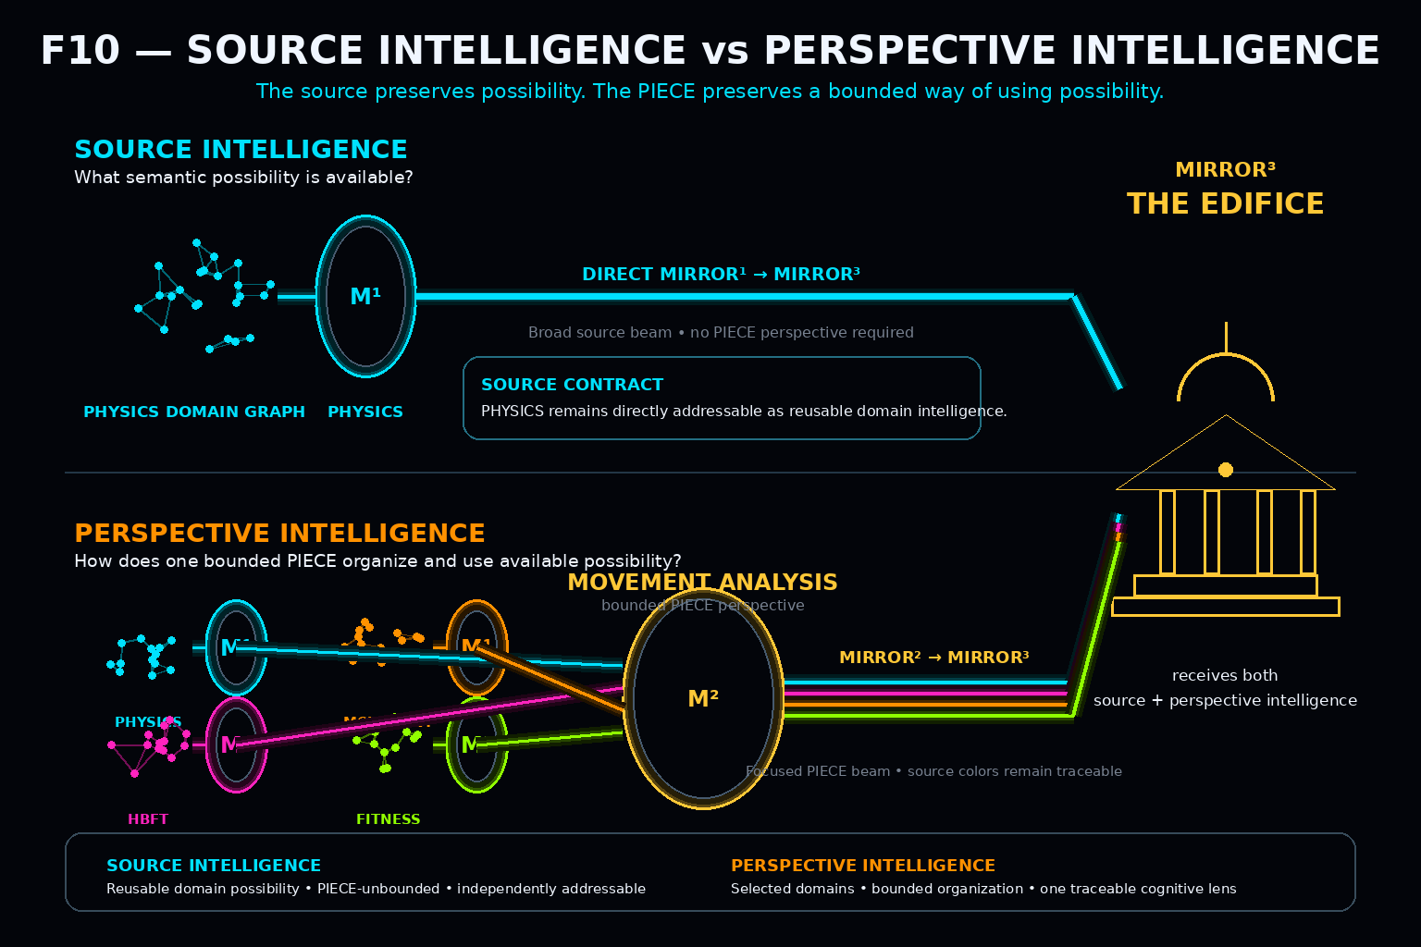
Figure 10. Direct source intelligence preserves available domain possibility, while a MIRROR² / PIECE combines several sources into a bounded perspective beam. Both enter MIRROR³ without replacing one another.

19. Compressed Possibility Kernels
At EDIFICE scale, an intelligence environment may have access to PHYSICS, CHEMISTRY, WEATHER, ECOLOGY, GEOGRAPHY, FOOD, MOVEMENT, ECONOMICS, MUSIC, TIME, and many other domains. Each may contain a substantial internal graph. The EDIFICE does not need to keep every domain fully hydrated to retain access to that intelligence. It can retain each as a compact higher-order identity while preserving exact reachability beneath it.
The phrase compressed kernel of possibilities therefore means a compact semantic handle to a much larger registered possibility structure. It does not mean that a tiny code physically contains the domain. Reuse canonical intelligence; duplicate only what genuinely differs.

20. MIRROR³ — The MirrorMirrorMirror Graph
The next recursive step occurs when complete MIRROR² / PIECE structures themselves become addressable Points. Movement Analysis, Robotics Engineering, Ecological Analysis, Weather Analysis, and other PIECEs can each contain large internal MIRROR² structures while appearing as single Points at the MIRROR³ level.
V^3 includes {rho(P_1), ..., rho(P_n)} union {rho(M_1^1), ..., rho(M_m^1)}
Because MIRROR¹ sources can bypass MIRROR², MIRROR³ contains more than PIECE Points. It can include direct source Mirrors and other legitimate EDIFICE-level Points required by the declared graph. MIRROR³ therefore preserves both bounded cognition and source intelligence.

21. THE EDIFICE
Within the scope of this paper, MIRROR³ is the graph-native relational representation of THE EDIFICE. The EDIFICE itself remains the broader executable federation defined in its source architecture [2]; MIRROR³ does not claim to contain every scheduler, transport, storage layer, permission mechanism, observer, or runtime process. It represents the relationships through which source domains, PIECEs, evidence surfaces, observations, dependencies, outputs, and provenance become jointly addressable.
The EDIFICE is therefore an ecology rather than a universal mind. Its coherence comes from governed interoperability, not forced semantic sameness. Different PIECEs may preserve disagreement, different evidence standards, different internal representations, and different operating assumptions while still participating in a larger graph.
Figure 12. THE EDIFICE as a recursive ecology of source intelligence and bounded perspective. Provenance-colored MIRROR¹ light may branch through MIRROR² / PIECE surfaces or reach MIRROR³ directly; distinct origins remain visible rather than collapsing into anonymous white light.

22. Layered Many-to-Many Intelligence
The complete architecture is layered but not hierarchically owned. MIRROR² is “above” MIRROR¹ only in the sense that it can treat a whole MIRROR¹ as one Point. MIRROR³ is “above” MIRROR² only in the same representational sense. Higher recursive composition does not create lower-level jurisdiction or semantic possession.
One source Mirror may occur in many PIECEs and directly in THE EDIFICE at the same time. One PIECE may compose many source Mirrors. The network scales through reuse and explicit Relationships rather than forcing every object into one parent-child tree.
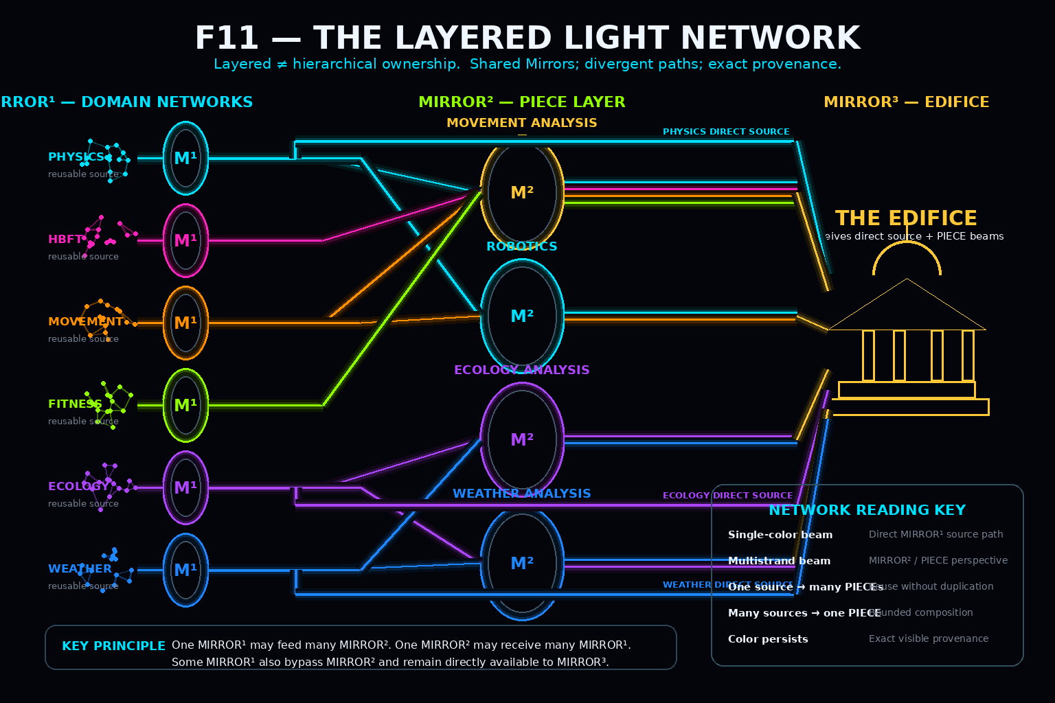
Figure 11. Recursive MIRROR forms a layered many-to-many intelligence network rather than a parent-child tree. Domain Mirrors can feed several PIECEs, PIECEs can combine several domains, and direct source routes can bypass the PIECE layer while preserving color-coded provenance.

23. Exact Provenance
Many-to-many reuse makes provenance more important, not less. PHYSICS→EDIFICE, PHYSICS→Movement PIECE→EDIFICE, and PHYSICS→Robotics PIECE→EDIFICE are distinct realized paths even when they share the same source Mirror. A higher-order result should therefore retain enough provenance to identify which source, PIECE, Semantic Joints, and lower-order graph route produced the contribution.
Exact provenance allows the EDIFICE to trace a result backward through PIECE, Mirror, Table, Record, and semantic Point. Higher-order aggregation need not destroy ancestry. The visual language used throughout this paper expresses that law directly: light carries semantics; color carries provenance.
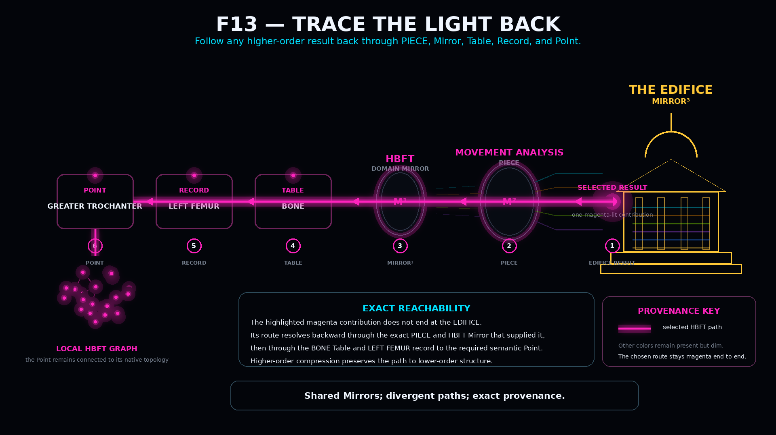
Figure 13. A selected higher-order contribution can be traced backward through MIRROR³, the specific MIRROR² / PIECE, MIRROR¹, Table, Record, and local semantic Point. Compression preserves the path to lower-order structure.
Branch freely; preserve the realized route exactly.

PART IV
Stable Graphs
How a particular recursive configuration can persist without duplicating the reusable intelligence that makes it possible.

24. Stable Graph
A mature EDIFICE may have access to enormous source Mirrors and many PIECEs while a particular active world or intelligence state uses only a bounded configuration of them. The naive archival strategy is to copy everything. Recursive MIRROR instead separates reusable semantic intelligence from the topology and state unique to the configuration being preserved.
S_t = (I_t, nu_t, T_t, J_t, X_t, Pi_t)
I_t contains referenced identities; nu_t contains exact versions; T_t contains reconstructive topology; J_t contains required Semantic Joints; X_t contains unique instantiated state and future-relevant residue; Pi_t contains provenance and dependency information. This notation defines responsibilities, not a final file format.
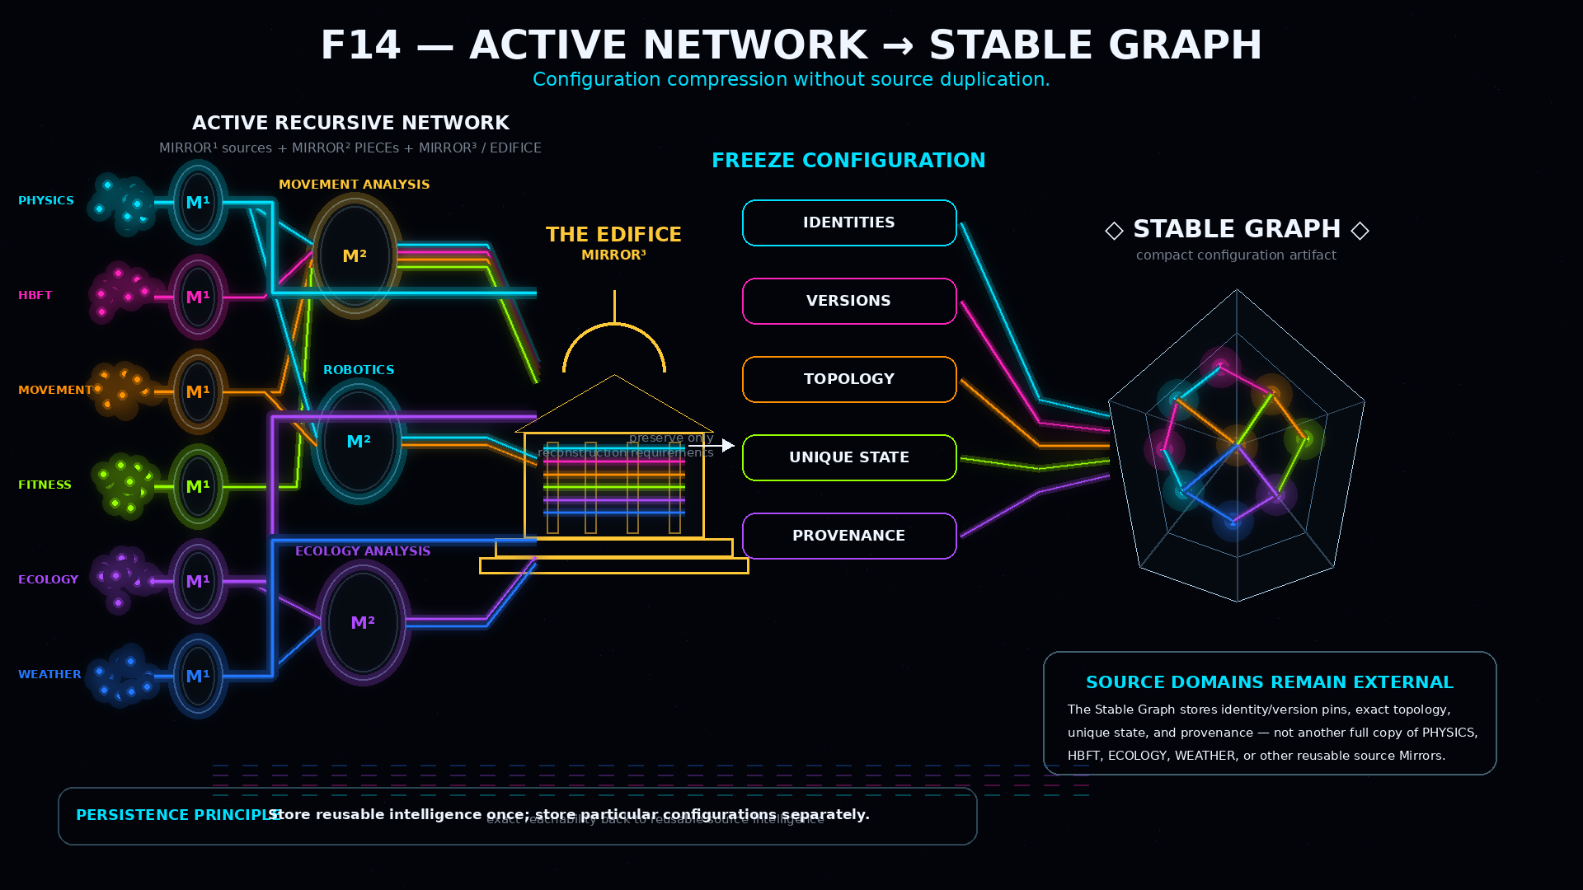
Figure 14. A massive active recursive configuration condenses into a compact Stable Graph while reusable source Mirrors remain externally visible and intact. The archive stores the configuration required for reconstruction, not duplicate copies of every source domain.
Table 9. Stable Graph Conceptual Contents
Content class | Purpose | Embedded?
Mirror Identity | Identify required source domain | Reference or bundle
Mirror Version | Ensure correct semantic reconstruction | Must be preserved or exactly resolvable
PIECE Identity / Version | Reconstruct the exact bounded lens | Reference or bundle
Graph Topology | Preserve configuration-specific Relationships | Persist where not derivable
Semantic Joints | Preserve required cross-Mirror intersections | Persist where reconstruction depends on them
Unique Instantiated State | Preserve what distinguishes this configuration | Persist
Causal Residue | Preserve unresolved consequences relevant to future state | Persist while causally relevant
Provenance | Preserve source/path ancestry | Persist within declared scope
Dependency Manifest | Identify everything required for closure | Persist

25. Persistence Without Duplication
The fundamental persistence split is reusable structure versus unique difference. Canonical PHYSICS may tell a world what physical semantics are available. The world-specific state tells us that this bridge exists here, this storm is located here, this population has this size, this character remembers this event, or this contract remains unresolved. Those are particular state, not reusable possibility.
Where a property can be deterministically reconstructed from stable source semantics, stored state, and a registered Model, the architecture does not inherently require the archive to duplicate it. Runtime systems may still cache derived values for performance. Persistence law remains distinct from cache policy: persist irreducible difference; derive what remains safely recoverable.
Store reusable intelligence once; store particular configurations separately.

26. Archive Closure
A reference-based archive is useful only if its dependencies can actually be recovered. If a Stable Graph references PHYSICS v12 but that exact version disappears and only PHYSICS v13 remains, the surviving archive may still be historically informative, but it can no longer claim exact reconstruction of the original semantic environment.
For every required dependency d: Resolvable(d, exact_version) OR Preserved(d, S_t)
Archive closure is therefore a declared reconstructability condition. Exact restoration fails when a required dependency is neither exactly reachable nor preserved inside the archive. The failure should be explicit rather than silently substituting a later or merely similar dependency.
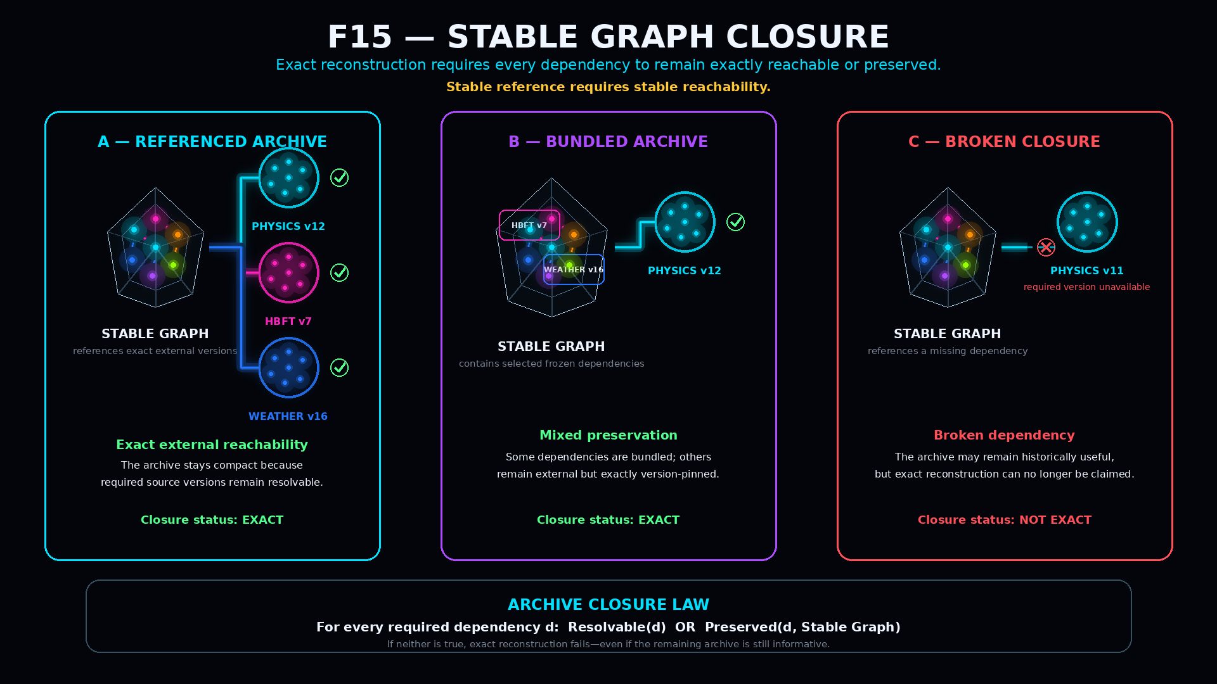
Figure 15. Stable Graph closure. Referenced archives remain exact when pinned dependencies are still reachable; bundled archives preserve selected dependencies internally; broken closure occurs when a required dependency is neither available nor preserved.

27. Stable Graph Modes
Recursive MIRROR supports several persistence strategies without treating one as universally correct. A Referenced Stable Graph is compact and depends on exact external source preservation. A Bundled Stable Graph embeds selected dependencies while referencing others. A Self-Contained Stable Graph Archive preserves every dependency required for exact reconstruction inside the package. The semantic identity of a dependency does not change merely because one archive references it and another bundles it.
Table 10. Stable Graph Modes
Mode | Source dependencies | Archive size tendency | Primary advantage
Referenced | Version-pinned externally | Smallest | Maximum semantic reuse
Bundled | Selected dependencies embedded | Medium | Balanced resilience and reuse
Self-Contained | All required dependencies embedded | Largest | Maximum archival independence

28. Stable World Graphs
A Stable World Graph applies Stable Graph persistence to one bounded simulated or modeled world state. The world may have access to enormous reusable semantic possibility through PHYSICS, WEATHER, ECOLOGY, GEOGRAPHY, HBFT, FOOD, TIME, and other Mirrors, but the actual world is only one configuration inside those possibility spaces.
The archive therefore records which source Mirrors and exact versions define the world, which PIECEs exist, how sources and PIECEs are related, which entities are instantiated, what mutable values distinguish them, what topology is unique, and what historical residue remains causally active. Availability in a source Mirror never implies instantiation in the world.
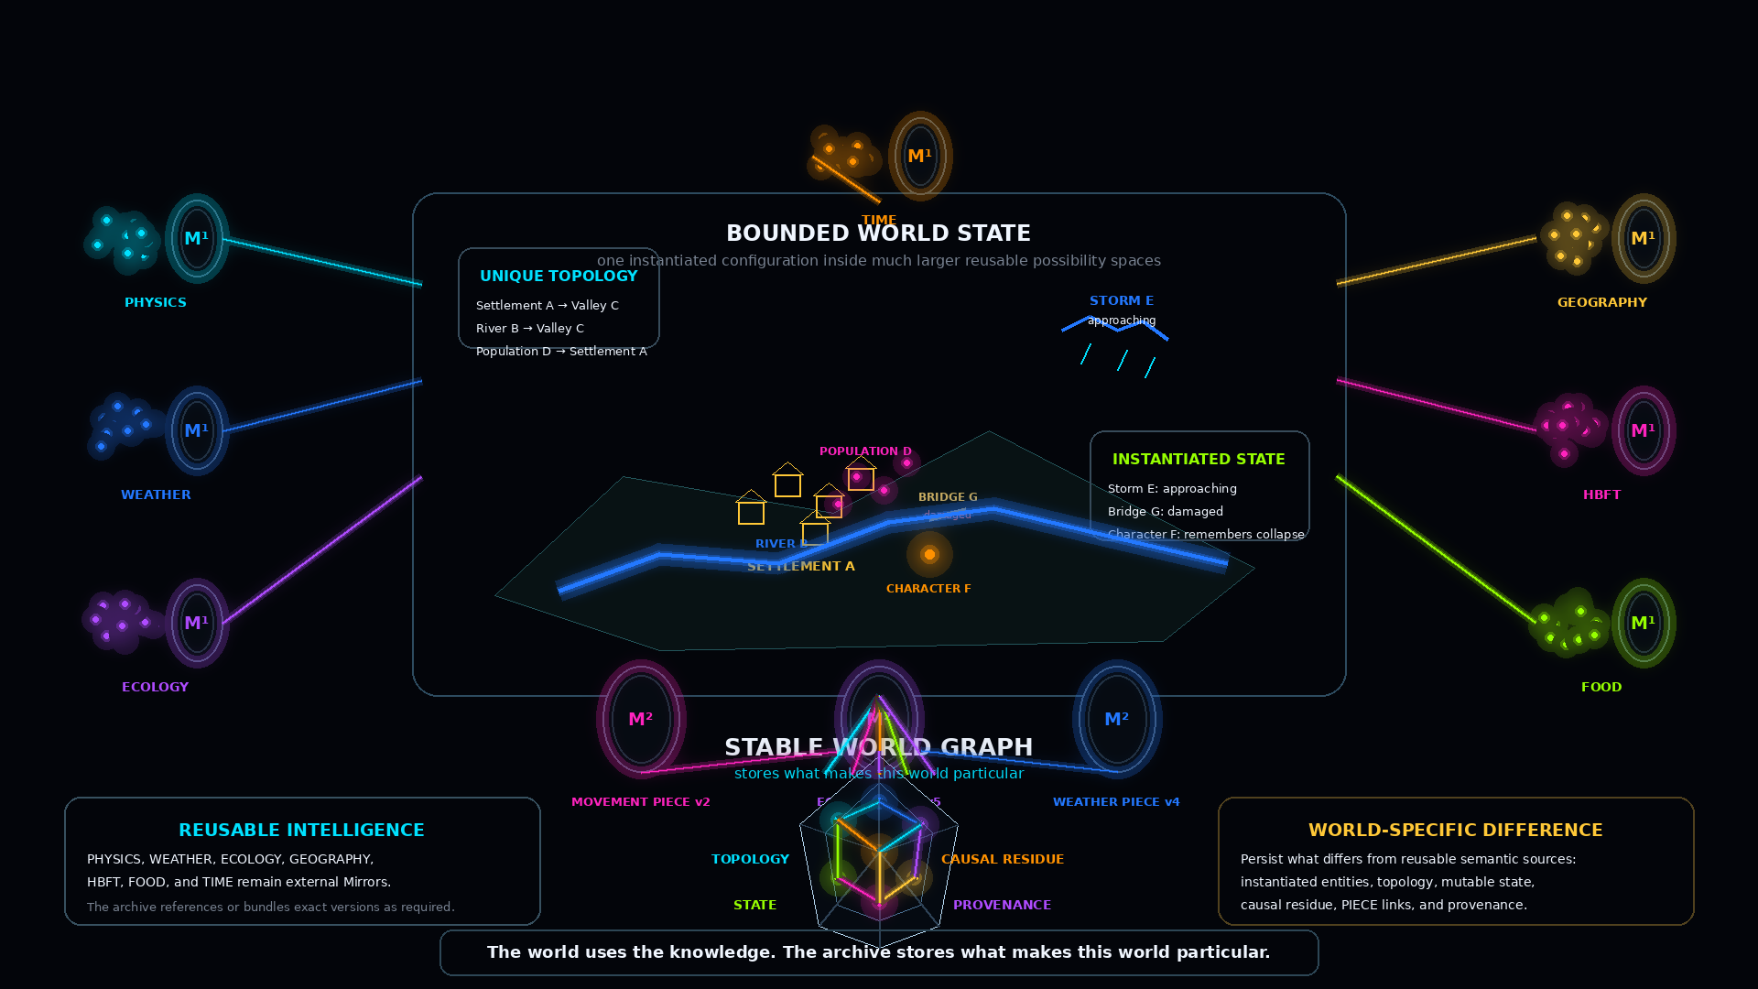
Figure 16. A Stable World Graph separates large reusable source intelligence from the topology, instantiated state, PIECE relationships, causal residue, dependency pins, and provenance that make one world particular.
Table 11. World Archive Separation
Layer | What it represents | Archive treatment
Source Possibility | What a reusable domain permits or knows | Reference or bundle stable Mirror
Perspective Intelligence | How a PIECE organizes source domains | Preserve PIECE identity/version/topology
World Topology | Particular Relationships defining this world | Persist if unique
Instantiated State | What is currently or historically true | Persist
Causal Residue | Past difference still affecting future | Persist while causally relevant
Derived State | Deterministically recoverable values | May be derived rather than duplicated
Archive Metadata | Provenance/version/dependency closure | Persist
Dormant Possibility | Available but currently unused intelligence | Do not confuse with instantiated state

Archive the world that happened, not every possibility available to the world.

29. Historical Stable Graphs
A world can preserve a sequence of Stable Graphs S0, S1, S2, and so forth, each corresponding to a bounded historical configuration. One may represent the world before a volcanic eruption, another immediately afterward, and another after migration and reconstruction. The earlier graph remains a valid archive even though live reality later changes.
Historical validity is distinct from runtime authority. A Stable Graph can be loaded, compared, reconstructed, or studied without automatically becoming the active authoritative world. Restoration requires an explicit governed transition from archive representation to live state. Stable Graph is therefore not frozen reality, and archive is not live state.

30. Selective Reconstruction
Restoring a Stable Graph does not require immediate full hydration of every dependency. A large world can first reconstruct source identities, exact versions, PIECE identities, and major topology and become available at coarse resolution. Only an active query needs to open the relevant branches more deeply.
A query about Character F may follow WORLD→Settlement A→Character F→HBFT→Left Femur→Greater Trochanter while PHYSICS, WEATHER, ECOLOGY, FOOD, and unrelated anatomy remain compressed. Reconstructability is therefore not the same as continuous instantiation. The world can become operational before every reachable structure has been expanded.
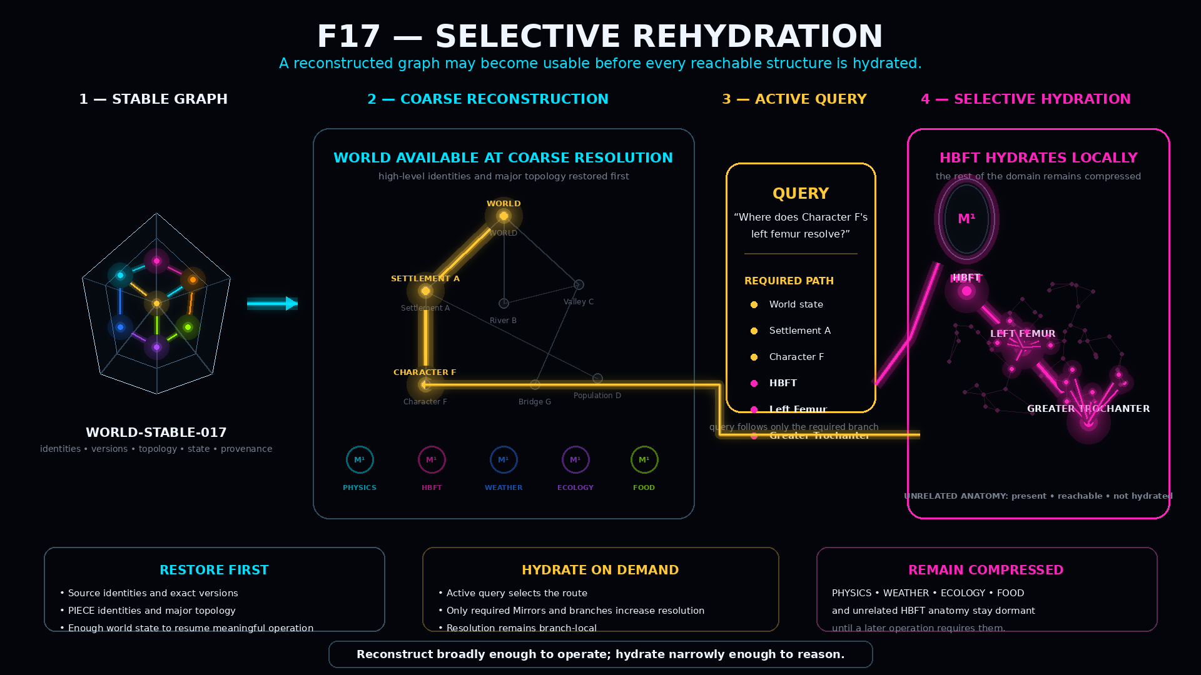
Figure 17. Selective rehydration. A Stable World Graph first restores coarse operational structure, then a query hydrates only the exact HBFT branch required to reach LEFT FEMUR and GREATER TROCHANTER while unrelated domains remain dormant but reachable.

PART V
Formal System
Positive laws, non-collapse boundaries, authority constraints, failure modes, and one complete recursive synthesis.

31. Formal Model
Recursive MIRROR requires a deliberately small formal object set. Let v denote a semantically addressable Point. A Point may represent LEFT FEMUR, TORQUE, SQUAT, PHYSICS, or an entire Movement Analysis PIECE. Internal complexity does not determine whether the object can participate as one Point at the current semantic composition level.
Relationship: e = (v_a, r, v_b)
A Relationship establishes only its declared semantics. It does not automatically imply equivalence, ownership, containment, authority, symmetry, or inheritance. A bounded domain Mirror is represented conceptually as M_i^1=(V_i,E_i,Sigma_i,Gamma_i), where V_i is the set of local Points, E_i explicit Relationships, Sigma_i semantic bindings, and Gamma_i the metadata required for bounded interpretation such as scope, Table organization, version, provenance, and translation contracts.
Graph-to-Point: rho(M_i) = p_i and Resolve(p_i) -> M_i
Semantic Joint: Resolve_A(a)=S and Resolve_B(b)=S => J(a,b;S) within declared scope
Hydration: H(p,r) -> G_r where G_r may be only the required subgraph of M
Stable Graph: S_t=(I_t,nu_t,T_t,J_t,X_t,Pi_t)
These formulas are interface-level formalizations. They state what responsibilities must remain distinct; they do not require every future implementation to serialize literal objects with these exact symbols.

32. Positive Law Registry
Table 12. Positive Formal Laws
ID | Law | Architectural meaning
RCG-L01 | Graph-to-Point | A bounded Mirror with stable identity may participate as a Point at higher composition.
RCG-L02 | Exact Reachability | Non-destructive compression requires continued exact resolution to the represented lower graph.
RCG-L03 | Reuse | One Mirror identity may participate in any number of higher-order graphs without duplicate identity.
RCG-L04 | Explicit Path | Shared source identity does not infer higher-order topology; Relationships remain explicit.
RCG-L05 | Provenance | A result remains attributable to the specific source and traversal path that produced it.
RCG-L06 | Semantic Joint | Independent Mirrors may interoperate where local bindings resolve to the same identity within scope.
RCG-L07 | Hydration | Resolution may increase only along graph surfaces required by the active operation.
RCG-L08 | Mixed Resolution | Different branches may operate at different semantic depths simultaneously.
RCG-L09 | Direct Source | A MIRROR¹ may participate directly in MIRROR³ without mandatory MIRROR² mediation.
RCG-L10 | Perspective | A PIECE may organize source Mirrors without owning, replacing, or duplicating them.
RCG-L11 | Stable Configuration | A recursive configuration may persist separately from reusable source domains.
RCG-L12 | Archive Closure | Exact restoration requires every necessary dependency to remain exactly resolvable or preserved.

33. Non-Collapse Registry
The positive laws describe what Recursive MIRROR permits. The non-collapse registry describes distinctions that must remain true even when the system becomes highly connected. These boundaries prevent semantic reuse from silently turning into ontology merger, authority escalation, or archival overclaim.
Table 13. Non-Collapse Registry
ID | Boundary
RCG-NC-01 | Mirror Identity != Mirror Contents
RCG-NC-02 | Mirror Point != Hydrated Mirror Graph
RCG-NC-03 | Graph Complexity != External Resolution
RCG-NC-04 | Shared Mirror != Shared PIECE
RCG-NC-05 | Shared Binding != Shared Encoding
RCG-NC-06 | Shared Binding != Shared Reader
RCG-NC-07 | Shared Binding != Shared Schema
RCG-NC-08 | Shared Binding != Shared Graph
RCG-NC-09 | One Semantic Joint != General Compatibility
RCG-NC-10 | Mirror Relationship != Mirror Integration
RCG-NC-11 | Layered Relationship != Hierarchical Ownership
RCG-NC-12 | Source Intelligence != Perspective Intelligence
RCG-NC-13 | Source Possibility != Instantiated State
RCG-NC-14 | Available Mirror != Active PIECE
RCG-NC-15 | PIECE Point != Hydrated PIECE
RCG-NC-16 | Multi-PIECE Synthesis != Cognitive Merger
RCG-NC-17 | Stable Graph != Duplicated Source Corpus
RCG-NC-18 | Archived Topology != Fully Hydrated Runtime
RCG-NC-19 | Reconstructability != Continuous Instantiation
RCG-NC-20 | Stable Graph != Frozen Reality
RCG-NC-21 | Archive != Live State
RCG-NC-22 | Hydration != Authority
RCG-NC-23 | Projection != Commit
RCG-NC-24 | Representation of THE EDIFICE != Total Implementation of THE EDIFICE
Stable Graph is also explicitly not MIRROR⁴; this remains an architectural boundary rather than an additional numbered law.

34. Authority, Failure, and Scope
Recursive scale increases representational reach, not automatic authority. MIRROR¹, MIRROR², MIRROR³, and Stable Graph may represent semantic state, hydrate lower structure, and participate in reasoning, but none becomes source-authoritative merely through representation. Any commit remains subject to the authority model of the governed source [1].
Table 14. Recursive Authority Matrix
Structure | Represent? | Hydrate? | Reason? | Aggregate? | Automatically authoritative? | Automatically commit?
MIRROR¹ | Yes | Yes | Yes | Domain-local | No | No
MIRROR² / PIECE | Yes | Yes | Yes | Yes | No | No
MIRROR³ / EDIFICE | Yes | Yes | Yes | Yes | No | No
Stable Graph | Preserves representation | During reconstruction | Not inherently | Preserves configuration | No | No
Authoritative Source | Owns declared truth | Depends | Depends | Depends | Yes, within scope | Governed

Explicit failure conditions
- Broken Mirror Resolution: a higher-order Point no longer resolves to the Mirror it claims to represent.
- Unsupported Semantic Joint: two objects appear similar but do not resolve to the same registered semantic identity.
- Undeclared Cross-Mirror Route: Mirrors coexist in a PIECE but no valid Relationship or Joint authorizes the requested traversal.
- Stale Archive Dependency: a Stable Graph references an exact version that is no longer available and was not preserved.
- Projection Treated as Commit: a represented candidate is mistaken for authoritative source state.
- PIECE Treated as Source: a bounded use of a domain is mistaken for the source domain itself.
- Missing Provenance: an EDIFICE result cannot identify the source/PIECE path that produced it.

Scope closure
This paper intentionally stops before distributed synchronization, cache policy, cryptographic archive validation, serialization format, autonomous PIECE evolution, autonomous EDIFICE reconfiguration, and deeper named recursive orders. Those may become later papers once implementation evidence justifies them. The contribution here is the bounded formal architecture required to reason about graph-of-graphs composition and persistence without flattening semantic worlds.

35. Worked Recursive Synthesis and Conclusion
Consider a Movement Analysis PIECE using four reusable MIRROR¹ domains: PHYSICS, HBFT, MOVEMENT, and FITNESS. At MIRROR² resolution the PIECE may organize those source Points into a mechanics-oriented relational lens while the source Mirrors remain independently addressable. PHYSICS simultaneously participates in Movement Analysis, Robotics, and a direct MIRROR¹→MIRROR³ route.
A query asks: analyze a squat at the left hip. FITNESS hydrates to Squat and resolves the relevant Hip Joint. A Semantic Joint crosses into HBFT, which hydrates only the required local anatomy: Left Hip, Left Femur, relevant landmarks, and force-transmission structure. The active route reaches Torque, which provides another Semantic Joint into PHYSICS. PHYSICS hydrates only Torque, Force, Moment Arm, Axis, and the physical Relationships required by the question. The active PIECE therefore contains several Mirrors at different depths while all lower source identities remain intact.
The Movement Analysis PIECE emits a bounded perspective contribution to MIRROR³. The EDIFICE receives that multistrand PIECE result while direct PHYSICS source intelligence remains independently available. If the world state must persist, a Stable Graph records the exact source/PIECE versions, world topology, Semantic Joints, unique state, causal residue, dependencies, and provenance required for reconstruction. Later restoration first reestablishes coarse structure and then rehydrates only the branch needed by the next query.
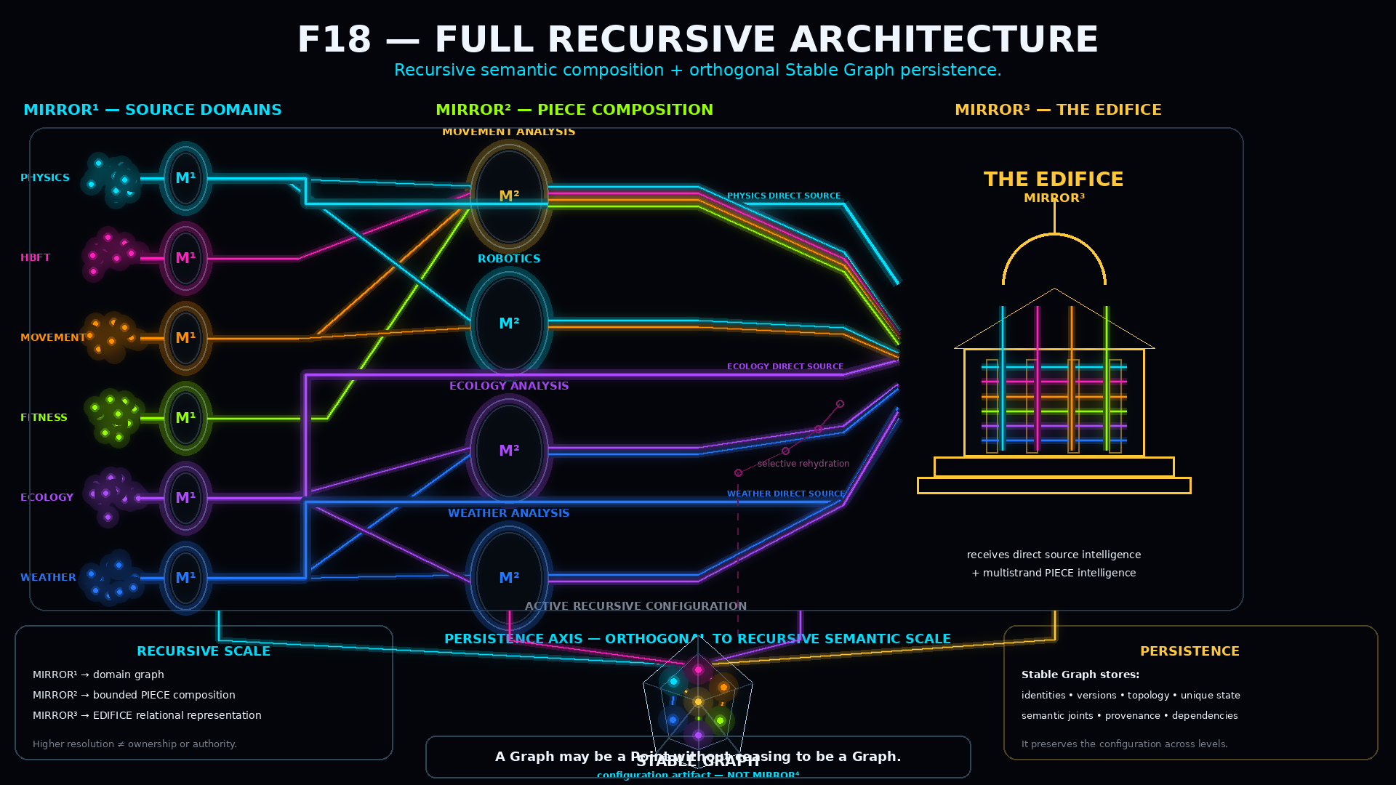
Figure 18. Full Recursive MIRROR architecture. MIRROR¹ source domains become reusable Points, participate many-to-many in MIRROR² / PIECE compositions, and may also reach MIRROR³ directly. THE EDIFICE receives both source and perspective intelligence, while Stable Graph persistence remains orthogonal to recursive semantic order rather than becoming MIRROR⁴.
A Graph may be a Point without ceasing to be a Graph.

Shared Mirrors; divergent paths; exact provenance.

Store reusable intelligence once; store particular configurations separately.

Recursive MIRROR turns semantic scale into a controllable architectural property. A domain can remain rich internally while appearing compact externally. Multiple cognitive lenses can share source intelligence without becoming the same cognition. Semantic Joints can provide exact partial interoperability without universal schema agreement. Hydration can follow the active question rather than forcing global expansion. The EDIFICE can retain source possibility alongside bounded perspective. Stable Graphs can preserve particular worlds without requiring indiscriminate duplication of every reusable domain.
The deeper principle is not compression for its own sake. It is preserved reachability. Intelligence remains useful across scale when every higher-order abstraction can still identify what it represents, where that structure lives, which path was actually used, and which authority remains responsible for consequence. Recursive MIRROR therefore provides a disciplined way for graph-native semantic systems to become larger without becoming flatter.

Source Architecture and References
[1] CERBERUS MIRROR — Mapped Imaginal Relational Reasoning Over Routes, v0.1, Pass 8 Verified Release. Establishes bounded non-authoritative Mirror State, Points, Relationships, Routes, source authority separation, semantic payload contracts, hydration, and governed commit.
[2] THE EDIFICE — Executable Federated Divergent Intelligence Architecture, v2.0, August 2026. Establishes PIECE as a bounded cognitive lens, divergent semantic habitats, canonical reconstruction, bounded interoperability, federation, and non-homogenization.
[3] CERBERUS PHYSICS — Multi-Resolution Physical Semantics Through Graph-Native Bit Representation, v0.1, Pass 8 Verified Release. Establishes registry-driven identity, compact exact references, graph-native semantics, question-driven resolution, selective hydration, mixed resolution, and explicit separation of identity, address, state, graph topology, and specialist interpretation.
[4] THE EDIFICE — Many Forms, One Architecture, v1.0, August 2026. Companion architecture demonstrating reuse of shared cybernetic infrastructure while native semantic habitats remain domain-specific, and reference corpora remain separate from individual bounded state.

Figure Index
Figure 1. The Invisible Structure Becomes Visible
Figure 2. The First Reflection
Figure 3. One MIRROR¹, Many MIRROR²
Figure 4. Many MIRROR¹, One MIRROR²
Figure 5. Same Mirrors, Different PIECEs
Figure 6. Semantic Joint
Figure 7. Selective Hydration
Figure 8. Mixed Resolution
Figure 9. Direct Source Intelligence
Figure 10. Source Intelligence vs Perspective Intelligence
Figure 11. The Layered Light Network
Figure 12. THE EDIFICE
Figure 13. Trace the Light Back
Figure 14. Active Network -> Stable Graph
Figure 15. Stable Graph Closure
Figure 16. Stable World Archive
Figure 17. Selective Rehydration
Figure 18. Full Recursive Architecture

