CERBERUS
BITS BEFORE TOKENS
Semantic Searching through Hierarchical Bitcode Routing,
Relevance Fade, and Accreted GROOVE Networks
CORE SYSTEM STATEMENT
Use small, bounded semantic measurements to decide where expensive language-model attention is worth spending. Route broadly with tiny words. Let irrelevant meaning fade. Spend tokens only where semantics survive.

Formal Specification v0.1
15 August 2026 | CERBERUS / SOLAR / BIGFOOT / Routing SK / GROOVE
Status: Draft reference architecture for prototype routing, retrieval, interface design, semantic budget testing, and formal revision.

Document Control
Field | Value
Document | CERBERUS Bits Before Tokens - Semantic Searching
Version | 0.1
Date | 15 August 2026
System | CERBERUS / SOLAR / BIGFOOT / Routing Semantic Kernels / GROOVE
Specification role | Defines a hierarchical semantic retrieval architecture that routes queries through bounded BitWords and GROOVE networks before loading high-volume source tokens.
Primary design boundary | Routing metadata guides attention; source material remains the ground for consequential factual claims.
Normative vocabulary | MUST, MUST NOT, SHALL, SHALL NOT, SHOULD, SHOULD NOT, MAY
Implementation status | Draft for prototype evaluation and comparative retrieval testing.

Abstract
Bits Before Tokens specifies a semantic search architecture in which large language models use bounded Routing Semantic Kernels, the GROOVE 000/00 network, and persistent semantic projections to narrow the knowledge space before reading substantial source text. A request is measured against small Routing SK vocabularies, preserved as a multifactor query state, factorized into independently traversable branches, and recursively resolved through increasingly precise semantic regions. Branch relevance is re-evaluated at every depth. Low-value paths undergo Semantic Fade and stop consuming computation. Surviving branches route into 000 domain maps, 00 knowledge bundles, registered Models, Operators, Rules, FASKs, and GROOVEd literature. Only after this semantic narrowing does the system spend large token budgets on source language.
The architecture separates semantic relevance, source authority, and contextual applicability. A company standard may be authoritative inside one organization; a game law may be fully authoritative inside a fictional world yet have zero applicability to a real-world question. This separation permits established, experimental, speculative, personal, company, historical, and fictional knowledge to coexist without collapsing their epistemic or contextual boundaries.
The specification does not prohibit embeddings, keyword search, full-text retrieval, or ordinary LLM reasoning. It repositions them. Textual and vector methods become lower-level candidate-generation and source-inspection tools inside a prior semantic routing plan. The resulting system aims to externalize semantic work that would otherwise be repeatedly reconstructed from prose, creating a search substrate that becomes more efficient as GROOVE projections, query traces, and routing structures accrete over time.
THESIS
The system does not ask language to rediscover a semantic world that has already been mapped. It uses mapped semantic structure to decide where language-model attention should go.

Companion Architecture Basis
Companion artifact | Role in this specification
CERBERUS SOLAR - System Operational Lexical Alias Registry v0.1 | Provides exact lexical-to-typed-target resolution, ambiguity preservation, phrase parsing, and the rule that probabilistic similarity does not itself establish canonical correspondence.
BIGFOOT 4 Tables Details | Provides stable Bit, BitGroup, BitWord, and Compound BitWord identity and explicit composition/reuse relationships.
CERBERUS Routing Semantic Kernels v0.1 | Provides bounded semantic routing contracts, multifactor route masks, nested routing, and reusable route structure.
GROOVE v1.0 / Semantic Grooving v1.0 | Provides persistent source-grounded semantic projections, 000/00 routing manifests, semantic accretion, and reusable corpus descriptions.
SOLAR-GROOVE Semantic Recovery v0.1 | Provides the fallback path from unresolved lexical material through GROOVEd corpus evidence to candidate BIGFOOT operands.

Contents
Section | Title
0 | Executive Summary
1 | Purpose and Scope
2 | Architectural Position
3 | Core Thesis: Bits Before Tokens
4 | Why Tokens Should Not Be the First Retrieval Primitive
Part I | Hierarchical Semantic Routing
5 | Global 000 and Domain 000
6 | Bounded Semantic Reach
7 | Multifactor Query States
8 | Semantic Query Factorization
9 | Parallel Subject, Intent, Context, and Epistemic Routing
10 | Active Semantic Frontier
11 | Recursive Resolution and Cross-Branch Intersections
Part II | Semantic Fade
12 | Relevance Signals
13 | Contextual Relevance Re-Evaluation
14 | Semantic Fade and Continuation Thresholds
15 | Semantic Beam Width and Routing Budgets
16 | Stopping Conditions
Part III | Authority, Applicability, and Epistemic Context
17 | Relevance vs Authority vs Applicability
18 | Context-Bounded Authority
19 | Company Standards
20 | Game Law and World-Bounded Truth
21 | CIRCLE / FRINGE / FASK
22 | Permission-Bounded Retrieval
Part IV | GROOVE Retrieval and Progressive Attention
23 | 00 Knowledge Bundles
24 | Saved GROOVE Coordinates
25 | Document-Level Semantic Matching
26 | Branch-Conditioned Descriptions
27 | Retrieval Funnel
28 | Selective Source Reopening
29 | Token Attention
Part V | Semantic Search Execution
30 | Semantic Search Plan
31 | Models, Operators, Rules, and Literature
32 | Source Selection and Grounding
33 | Search Trace and Explainability
34 | Semantic Budgeting
Part VI | Accretive Search
35 | Saved Query Routes
36 | Reusable Query Families
37 | Routing and Intersection Improvement Candidates
38 | Semantic Work Persistence
Part VII | Formal Objects and Scoring
39 | RouteState
40 | Semantic Search Plan Object
41 | Illustrative Scoring
42 | No Magic Score
Part VIII | Worked Examples
43 | Potato Cooking
44 | Bio-Materials Research
45 | Company Policy
46 | Game Law
47 | Cross-Domain Historical Research
Part IX | Formal Principles, Failure Modes, and Conformance
48 | Normative Principles
49 | Failure Modes
50 | Conformance Requirements
51 | Implementation Roadmap and Open Questions
Glossary | Reference Terms

List of Figures
Fig. | Interface / diagram
1 | Bits Before Tokens attention funnel
2 | Global 000 Knowledge Router
3 | Query Factorization Console
4 | Active Semantic Frontier
5 | Semantic Fade Explorer
6 | Authority and Applicability Inspector
7 | Semantic Search Plan Builder
8 | GROOVE Retrieval Funnel
9 | Why This Source Was Read
10 | Semantic Budget Monitor
11 | Same Domain, Different Intent
12 | Context-Bounded Authority: Game Law
13 | Cross-Domain Semantic Search DAG
14 | Direct SOLAR vs Semantic Search
15 | Bits Before Tokens Search Lifecycle

0. Executive Summary
Bits Before Tokens proposes that semantic routing should normally precede high-volume text retrieval when a governed semantic architecture already exists. Instead of treating every query as an invitation to search the entire document universe, the system first asks a small sequence of bounded questions: Which broad domains are active? What is the user trying to do? Which context or world applies? Which epistemic layers are allowed? Which finer semantic branches remain relevant after each pass?
Each routing pass operates over a compact, inspectable vocabulary. A Routing SK may expose sixteen, thirty-two, sixty-four, or another bounded number of semantic factors. The request can activate several factors simultaneously. Those factors become independent branches, not competing labels. Each branch may then be routed through a finer semantic surface. The resulting query topology is therefore a dynamic directed acyclic graph rather than a one-best-classification tree.
The system uses Semantic Fade to stop expanding branches that no longer justify further attention. Fade is not a blind depth penalty. Relevance is re-evaluated at every resolution level against the original request plus inherited parent context. A branch may strengthen as the vocabulary becomes more precise. A broad Materials route may be only moderately relevant while a deeper Self-Healing Materials route becomes highly relevant. Conversely, a superficially related branch may fall below the continuation threshold and disappear before any large documents are opened.
The surviving semantic frontier routes into the GROOVE network. Global and domain 000 surfaces identify semantic neighborhoods; 00 manifests expose bounded document bundles, Masters, Models, Operators, Rules, FASKs, and saved GROOVE projections. Query routes can be intersected with saved source coordinates and branch-conditioned descriptions. This produces a much smaller candidate set. Only then does the system reopen original files and spend substantial language-model tokens.
The architecture also separates three dimensions that ordinary retrieval systems often collapse: semantic relevance, authority or trust, and contextual applicability. A source can be strongly relevant yet low-authority. A source can be fully authoritative yet inapplicable to the current world or organization. These distinctions are preserved in the search plan and search trace rather than hidden inside one opaque relevance number.
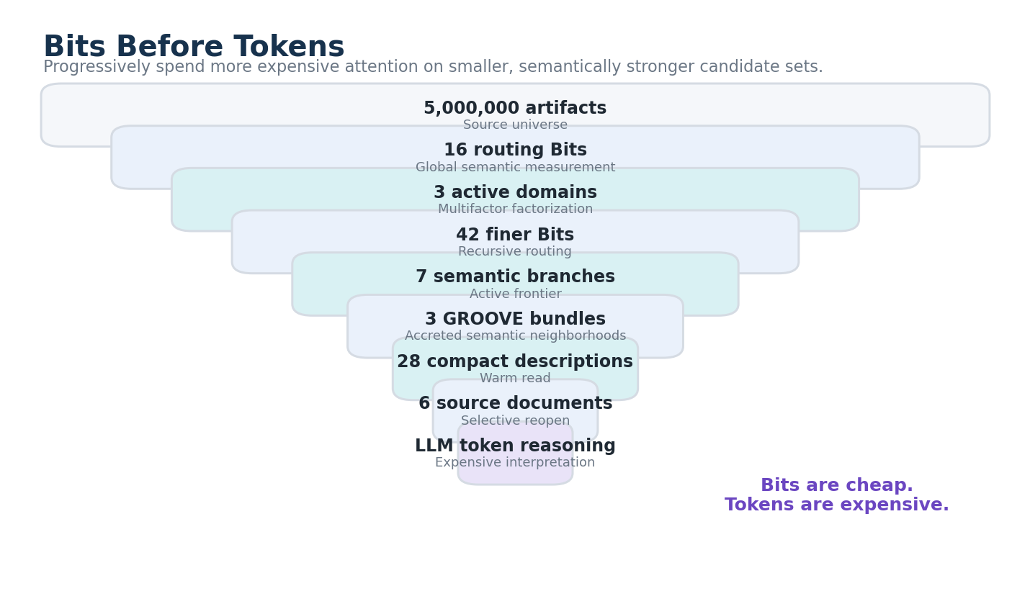
Figure 1. Bits Before Tokens attention funnel. The figure shows a funnel from millions of source artifacts through tiny Routing SK decisions, active domains, finer semantic branches, GROOVE bundles, compact descriptions, and finally a handful of original source documents before LLM token reasoning begins.
ENGINEERING SUMMARY
Route broadly with tiny words. Let irrelevant meaning fade. Spend tokens only where semantics survive.

1. Purpose and Scope
This specification defines a reference architecture for semantic search over CERBERUS knowledge environments. It focuses on query routing, retrieval planning, relevance pruning, authority and applicability handling, GROOVE-assisted source selection, token budgeting, and explainable search traces. It is intended to guide prototype Interfaces, data schemas, Routing SK design, LLM orchestration, search experiments, and later formal implementation.

1.1 Goals
- Use bounded semantic structures to reduce retrieval scope before reading large quantities of source language.
- Preserve multifactor query meaning so a request may travel through several domains at once.
- Make relevance pruning explicit through Semantic Fade rather than silently dropping candidates inside opaque model state.
- Keep relevance, authority, applicability, permissions, and epistemic status inspectably separate.
- Reuse existing 000/00 GROOVE structure and saved semantic projections rather than reconstructing domain organization per query.
- Permit exact SOLAR resolution to short-circuit broader semantic search when a registered lexical address already exists.
- Provide a route trace that explains why a domain, bundle, Model, Operator, Rule, FASK, or source document was opened.

1.2 Non-goals
- The architecture does not claim that Routing SKs replace full-text search, embeddings, databases, or LLM reasoning.
- It does not claim that a high relevance score is equivalent to factual truth.
- It does not require one universal routing hierarchy or one fixed BitWord width for all human knowledge.
- It does not require one global numeric trust score to represent every epistemic relationship.
- It does not make GROOVE metadata authoritative evidence for a factual claim when the underlying source should be inspected.

2. Architectural Position
Bits Before Tokens sits across several existing CERBERUS layers rather than replacing any of them. SOLAR handles exact lexical addressing. BIGFOOT provides stable semantic identity and factorization. Routing SKs provide bounded, reusable semantic measurement surfaces. GROOVE provides persistent corpus structure and document-level semantic coordinates. Models, Operators, Rules, CIRCLE, FRINGE, and FASK provide formal and epistemic structures inside the semantic territory reached by routing.
USER LANGUAGE
-> SOLAR exact routes where available
-> Routing SK query factorization
-> 000 / 00 semantic navigation
-> GROOVE projection matching
-> selective source reopening
-> Models / Operators / Rules / literature
-> LLM reasoning, construction, or answer

BOUNDARY
Routing guides attention. It does not become the source of truth. GROOVE descriptions orient. Observable sources remain available for grounding. Models and Rules retain their own authority.

3. Core Thesis: Bits Before Tokens
The architecture treats high-volume language as an expensive late-stage representation. Early search should preferentially use stable identities, bounded BitWords, route masks, small scores, and compact GROOVE projections. The objective is not token avoidance for its own sake. The objective is to avoid repeatedly spending language-model attention on semantic territory that a governed external architecture has already made legible.
A useful implementation can therefore be extensive up front while remaining data-efficient at run time. It may contain many small Routing SKs, many 000 semantic maps, many 00 bundles, and many saved GROOVE projections. The per-query cost remains bounded by the active frontier: only the semantic branches that survive relevance, applicability, permission, and search-budget criteria continue to expand.
BITS BEFORE TOKENS PRINCIPLE
A system SHOULD use available bounded semantic structure to reduce the retrieval space before consuming large quantities of source-language tokens.

4. Why Tokens Should Not Be the First Retrieval Primitive
Token-first retrieval forces an LLM or retrieval model to rediscover domain boundaries indirectly through text similarity, chunk selection, or latent geometry. That remains useful when no explicit semantic structure exists. Once semantic structure has been externalized, however, repeated reconstruction becomes unnecessary work. A query asking about marine structural repair should not need to read music, tax, fantasy, culinary, or unrelated engineering documents merely because their prose happens to share general words such as repair, structure, system, or model.
Bits Before Tokens therefore treats text retrieval as a downstream operation. A Routing SK first answers bounded semantic questions. GROOVE then answers where the corresponding knowledge has already accumulated. Only the final candidate set is opened in full. This creates two efficiencies: context efficiency, because irrelevant tokens are excluded; and semantic efficiency, because the system reuses domain structure instead of asking the model to infer that structure repeatedly.

Part I - Hierarchical Semantic Routing

5. Global 000 and Domain 000
The 000 network is the semantic switchyard. A global 000 exposes broad knowledge territories. Each active territory can open a domain 000 that exposes finer routing surfaces, subdomains, 00 bundles, cross-domain bridges, and registered semantic components. The visible Interface may use human-readable labels, but the operational layer can remain tiny: an ordered Routing SK BitWord and the associated route definitions.
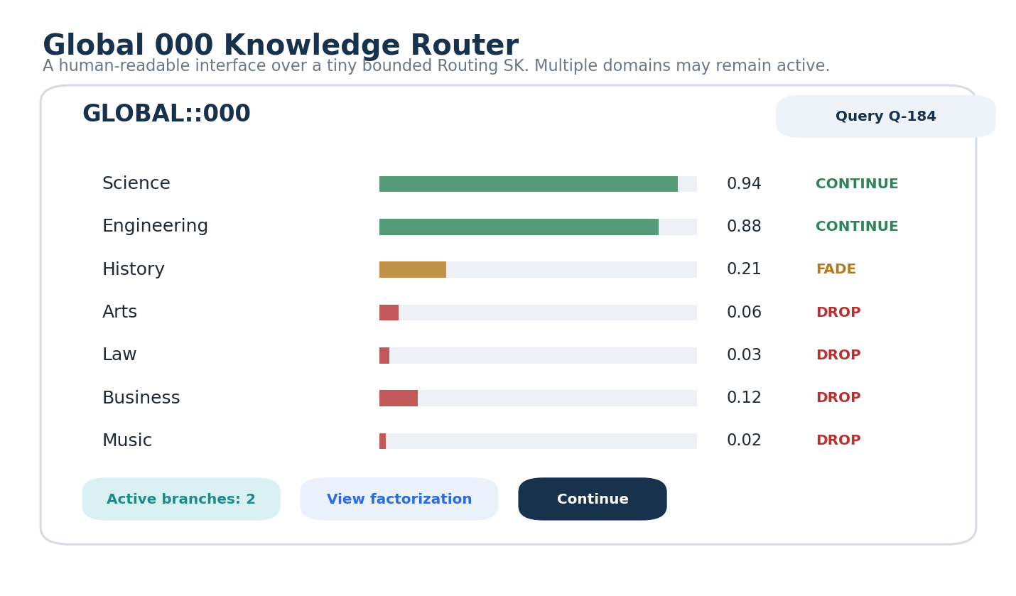
Figure 2. Global 000 Knowledge Router. The interface presents a Global 000 with relevance scores for broad domains. Science and Engineering remain active while low-relevance domains fade or drop. The visible labels are a human projection over a bounded routing surface.
The global router does not need to encode every leaf of human knowledge. It only needs enough distinctions to direct a request into a smaller semantic neighborhood. A branch may then load the next relevant Routing SK. Coverage grows through depth and composition rather than through one gigantic word.

6. Bounded Semantic Reach
Bounded Semantic Reach is the ability to expose very large semantic territory through recursively composed local routing vocabularies. A top-level word may distinguish Science, Engineering, History, Law, Arts, and other broad domains. The Science route may expose a second bounded word. Materials may expose a third. Self-Healing Materials may expose a fourth. Each local state remains small and auditable even when the reachable graph is enormous.
KNOWLEDGE-16
-> SCIENCE-16
-> MATERIALS-32
-> RESPONSIVE_MATERIALS-64
-> 00 bundles / Models / literature

This architecture avoids the assumption that full semantic coverage requires a single flat ontology. The routing network may be polyhierarchical, versioned, domain-specific, and selectively available. Different organizations or applications may publish different Routing SK families while sharing stable BIGFOOT identities where exact semantic identity exists.

7. Multifactor Query States
A query is not forced into one category. Routing SKs may permit multiple active routes. If a request concerns biological repair mechanisms, structural materials, and marine infrastructure, all three semantic factors may survive the same pass or emerge through parallel passes. The combined state is preserved before branch factorization so co-occurrence is not lost.
QUERY ROUTING STATE
Science = 1
Engineering = 1
History = 0
...
SCIENCE BRANCH
Biology = 1
Materials = 1
Physics = 1

MULTIFACTOR QUERY PRINCIPLE
A query MAY simultaneously activate multiple compatible semantic routes. One-best-domain classification SHOULD NOT be imposed when several factors materially contribute to the request.

8. Semantic Query Factorization
Semantic Query Factorization is the progressive decomposition of a request into independently traversable semantic branches. Each branch inherits the originating request and the context of its parent route. This permits a deeper pass to ask a more precise question than the global pass without pretending the branch is a separate user request.
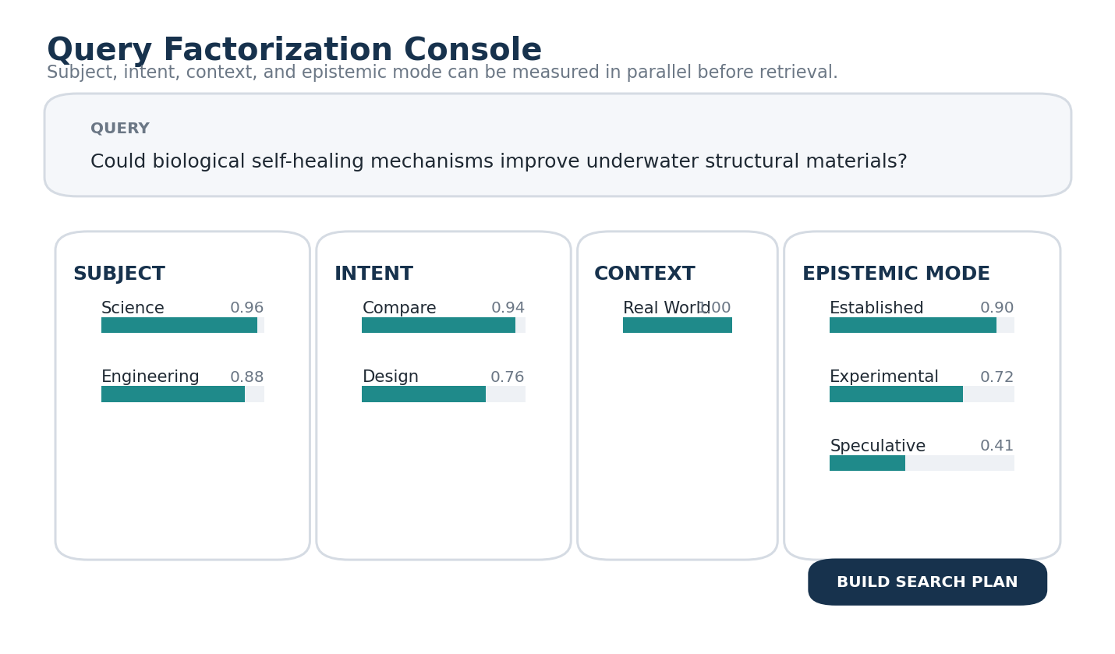
Figure 3. Query Factorization Console. The console shows parallel Routing SK measurements for subject, intent, context, and epistemic mode. The query activates Science and Engineering, Compare and Design, Real World context, and both established and experimental knowledge layers.
The factorization process may be implemented by an LLM, deterministic classifier, hybrid model, or specialist router. What matters for conformance is that the resulting semantic coordinates, route versions, and branch provenance remain inspectable and that uncertain or unsupported interpretations are not silently promoted to canonical identity.

9. Parallel Subject, Intent, Context, and Epistemic Routing
Topic routing alone is insufficient. The same subject should produce different search plans when the user asks to explain, compare, design, simulate, verify, speculate, or find official policy. Bits Before Tokens therefore permits several tiny Routing SKs to measure orthogonal dimensions in parallel. A SUBJECT router identifies semantic territory. An INTENT router identifies the requested operation. A CONTEXT router establishes the world, organization, project, or environment. An EPISTEMIC router identifies whether established, experimental, speculative, historical, fictional, or personal material should remain eligible.
Routing dimension | Example active factors | Search consequence
Subject | Science + Engineering | Open scientific and engineering 000 surfaces.
Intent | Compare + Design | Retain comparative literature and applicable Models/Operators.
Context | Real World | Suppress world-specific fictional rules unless explicitly requested.
Epistemic mode | Established + Experimental | Prioritize CIRCLE; permit FRINGE; keep FASK only where requested or strongly relevant.

10. Active Semantic Frontier
At any moment, the query maintains a bounded set of branches eligible for further expansion. This is the Active Semantic Frontier. Branches behind the frontier have already been expanded, resolved, merged into an intersection, or dropped. The router only spends another pass on the frontier, keeping the query cost proportional to relevant semantic territory rather than the size of the full knowledge graph.
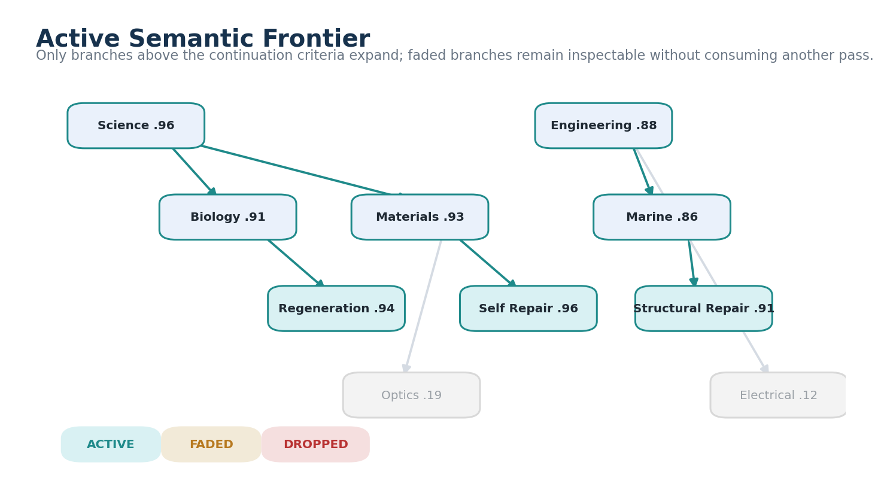
Figure 4. Active Semantic Frontier. The graph shows active branches such as Biology to Regeneration, Materials to Self Repair, and Marine to Structural Repair. Low-relevance Optics and Electrical branches are faded instead of expanded.

11. Recursive Resolution and Cross-Branch Intersections
Recursive routing increases semantic precision. A branch such as Materials may load a Materials Routing SK; Self Repair may load another. Parallel branches may also intersect. Biology to Regeneration and Materials to Self Repair can form a Cross-GROOVE semantic surface without either branch losing its identity. Marine to Structural Repair may then intersect with the resulting surface to produce a highly specific candidate region for underwater self-repair research.
This means the active topology is a directed acyclic graph, not a mandatory tree. Branches can split, intersect, and rejoin. The 000/00 architecture should therefore expose explicit bridge and intersection objects rather than relying on folder nesting alone.
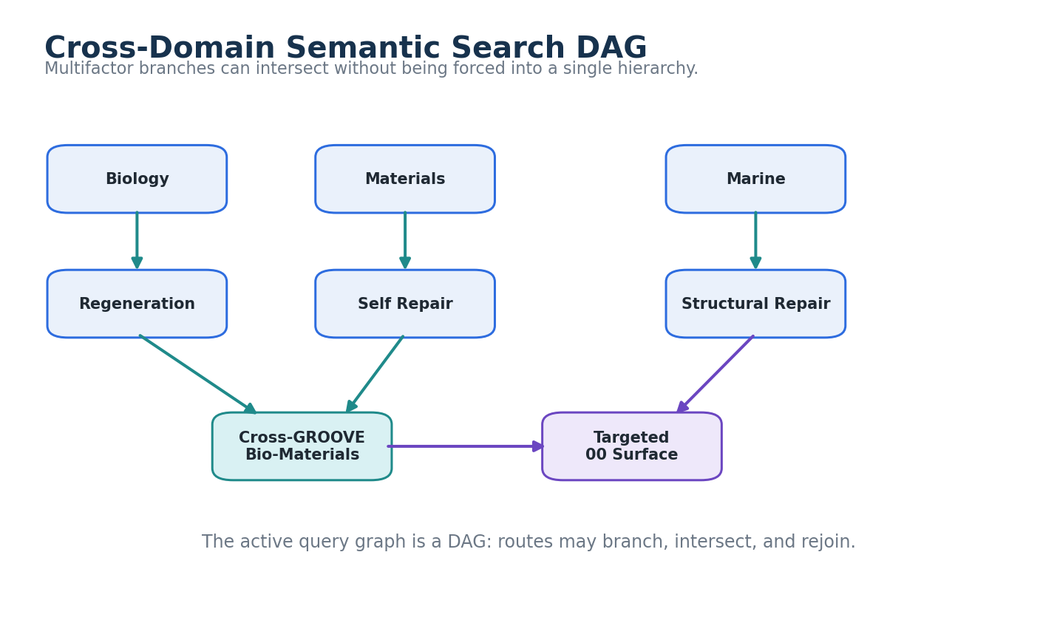
Figure 13. Cross-Domain Semantic Search DAG. The diagram shows Biology and Materials routes forming a Cross-GROOVE Bio-Materials surface, while Marine to Structural Repair joins later to produce a targeted 00 surface. The query topology is a DAG rather than a single hierarchy.

Part II - Semantic Fade

12. Relevance Signals
Every active branch may carry a contextual relevance signal R in the interval [0,1] or an equivalent bounded representation. The score indicates how strongly that branch appears to contribute to the originating request under the current routing vocabulary. It is a runtime search property, not a canonical property of the semantic object itself.
Relevance may be estimated by an LLM, classifier, rule set, registered relationship strength, GROOVE overlap, or a hybrid method. The architecture does not prescribe one universal estimator. It does prescribe inspectability: the system should be able to show which branch was scored, under which router and version, and why it was continued or dropped.

13. Contextual Relevance Re-Evaluation
Relevance is re-evaluated at every depth. The deeper pass receives the original request plus the semantic context inherited from its parent branch. This is intentionally different from a mechanical decay function. A broad route can become more relevant as ambiguity is removed. Materials may begin at 0.61, Responsive Materials may rise to 0.82, and Self Repair may rise to 0.96.
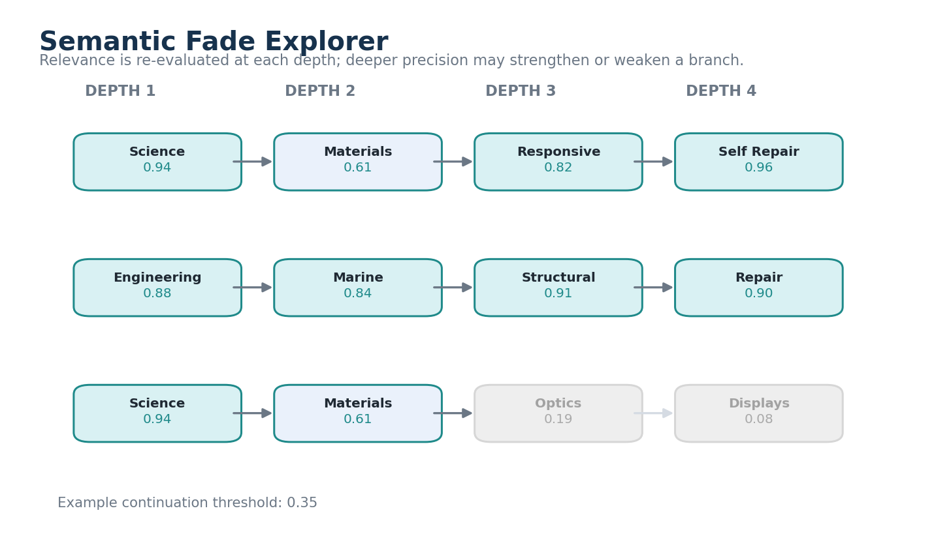
Figure 5. Semantic Fade Explorer. The interface shows relevance across routing depth. One branch strengthens from Materials to Responsive to Self Repair, while an Optics branch falls below the continuation threshold and stops expanding.
RELEVANCE RE-EVALUATION PRINCIPLE
Semantic relevance MAY increase or decrease at deeper routing levels and SHOULD be re-evaluated against the originating request rather than mechanically decayed by depth.

14. Semantic Fade and Continuation Thresholds
Semantic Fade is the progressive attenuation and pruning of branches that no longer justify further semantic work. A branch below the continuation criterion remains available for trace inspection but does not consume another Routing SK pass. Implementations may use one threshold, several bands such as strong/continue/borderline/drop, or adaptive thresholds based on query complexity.
Band | Illustrative R | Default behavior
Strong | >= 0.75 | Continue and consider early bundle lookup.
Continue | 0.40-0.74 | Expand if search budget permits.
Borderline | 0.25-0.39 | Retain for trace or second-pass rescue; do not expand by default.
Drop | < 0.25 | Stop semantic expansion unless explicitly reopened.

Thresholds are configuration, not universal truth. Research exploration may keep broad branches alive. A fast operational query may prune aggressively. A user may also explicitly pin a branch so it remains active despite a low automatic relevance estimate.

15. Semantic Beam Width and Routing Budgets
Semantic Fade naturally creates a beam-like search over an authored semantic graph. The beam width should be configurable. A runtime may continue every branch above a threshold, preserve the top N branches, or use a hybrid policy. It may also cap maximum semantic depth, total Routing SK evaluations, number of 00 bundles opened, number of GROOVE descriptions read, and token budget for source reopening.
Budget parameter | Illustrative value | Purpose
Maximum active branches | 12 | Prevents a broad multifactor query from exploding.
Minimum continuation relevance | 0.35 | Prunes low-value routes.
Maximum semantic depth | 7 | Prevents pathological routing loops or over-resolution.
Maximum Routing SK evaluations | 120 | Bounds semantic compute.
Source reopen limit | 20 | Bounds expensive full-fidelity source reads.
Token budget | 40,000 | Bounds LLM context consumption.

16. Stopping Conditions
Routing should stop when further semantic resolution no longer improves the task. Typical stopping conditions include reaching a sufficiently precise 00 neighborhood, exhausting relevant child routers, dropping below relevance or applicability thresholds, hitting a budget, encountering unresolved ambiguity that requires user input, or reaching a registered Model/Operator/Rule that directly satisfies the intent. Exact SOLAR resolution can also short-circuit broad search entirely.

Part III - Authority, Applicability, and Epistemic Context

17. Relevance vs Authority vs Applicability
A single relevance score cannot safely carry every search decision. Bits Before Tokens separates semantic relevance R, source authority or trust T, and contextual applicability A. Relevance asks whether the source or branch is about the current request. Authority asks how strongly the source may establish the kind of claim being made. Applicability asks whether the source governs or pertains to the current context.
Route / Source State
R = Semantic Relevance
T = Authority / Trust
A = Context Applicability
R, T, and A remain separately inspectable.

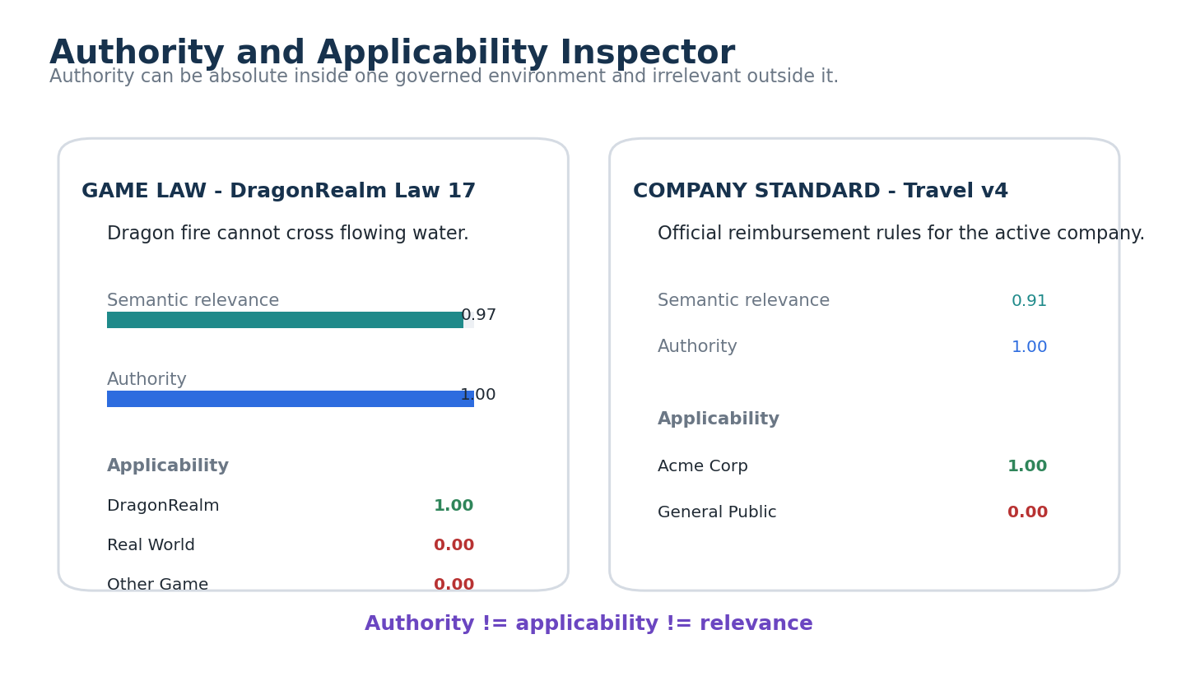
Figure 6. Authority and Applicability Inspector. The interface compares a DragonRealm game law and a company travel standard. Both can have authority 1.00 in their own environment while applicability becomes zero outside that environment.

18. Context-Bounded Authority
Authority is contextual. A company standard may be authoritative for official company procedure. A game law may be authoritative for simulation behavior. A legal text may be authoritative only in its jurisdiction and time range. A scientific source may be high-quality evidence without being a governing rule. The search runtime should therefore apply authority within a declared claim and context rather than treating one trust number as universal truth.
CONTEXT-BOUNDED AUTHORITY PRINCIPLE
A source MAY be fully authoritative within one governed environment and completely inapplicable elsewhere.

19. Company Standards
Company standards demonstrate why authority must remain distinct from semantic relevance. For an official-policy query, an active company standard may be required to satisfy a high authority floor while drafts, notes, and forum discussion are suppressed. For a question about employee confusion, those same low-authority sources may become highly relevant evidence about perceptions while remaining non-authoritative about the policy itself.
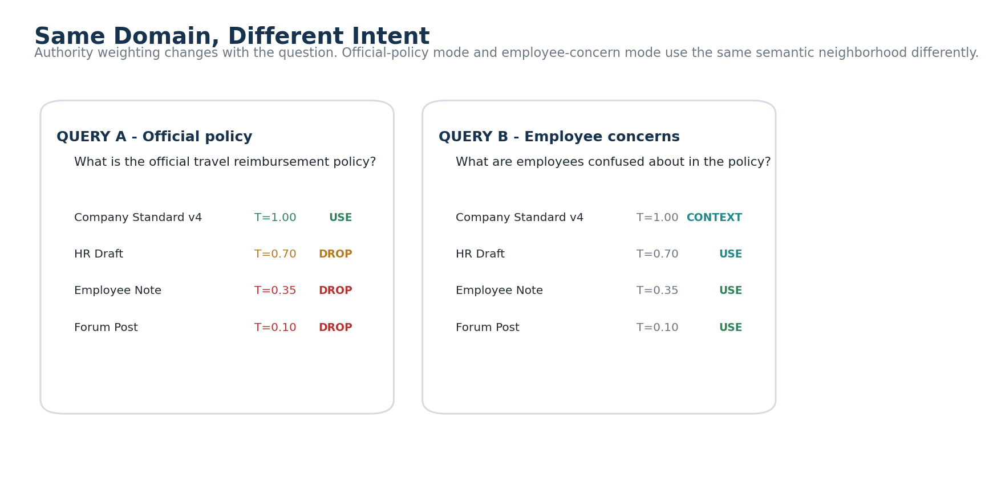
Figure 11. Same Domain, Different Intent. Two queries use the same policy neighborhood differently. Official-policy mode uses the company standard and drops commentary; employee-concern mode uses commentary as evidence of confusion while keeping the official policy as context.

20. Game Law and World-Bounded Truth
Game law provides a deliberately obvious boundary case. A rule such as Dragon fire cannot cross flowing water may have authority 1.00 inside DragonRealm. The same rule should have applicability 0.00 in a real-world combustion query. It is not untrustworthy outside the game; it is simply outside its governing scope. Treating this as applicability avoids corrupting the meaning of authority.
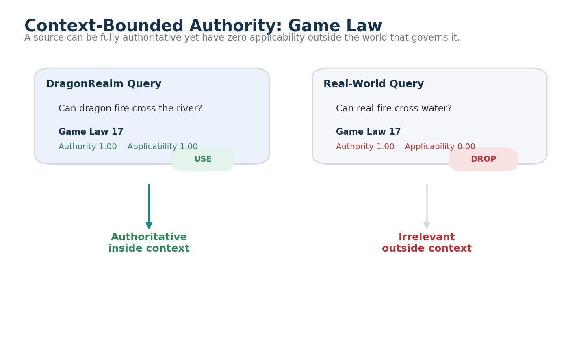
Figure 12. Context-Bounded Authority: Game Law. The DragonRealm query uses Game Law 17 because both authority and applicability are 1.00. A real-world query drops the same law before retrieval because applicability is 0.00 even though authority within DragonRealm remains 1.00.

21. CIRCLE / FRINGE / FASK
The same separation supports epistemic routing. CIRCLE can represent established common knowledge, FRINGE developing or experimental structures, and FASK explicitly speculative or fantasy structures. A factual query may prioritize CIRCLE and require stronger evidence. A design or speculative query may intentionally keep FRINGE and FASK active. The epistemic status should influence the search plan without implying that speculative material is low-quality within its intended role.
Layer | Typical use in search | Boundary
CIRCLE | Established explanation, standard reference, verified reusable knowledge | Does not imply universal authority outside its declared domain.
FRINGE | Experimental, developing, unresolved, field-testing material | Should remain distinguishable from established acceptance.
FASK | Speculative, fantasy, counterfactual, alternative-system exploration | May be highly useful for ideation while remaining noncanonical for factual claims.

22. Permission-Bounded Retrieval
Permissions constrain routing before disclosure. Unauthorized branches, bundle names, source counts, or hidden semantic targets must not leak through relevance scoring or autocomplete. A semantic search plan should be computed over the knowledge graph visible to the active user or agent. When a hidden candidate would otherwise change the ambiguity state, the user-facing result should reveal only the accessible resolution state.

Part IV - GROOVE Retrieval and Progressive Attention

23. 00 Knowledge Bundles
The 00 layer is where routing turns into bounded knowledge retrieval. A domain 000 may expose several local 00 manifests. Each 00 can contain a GROOVE map of source Entries, relation types, canonical ownership notes, branch-conditioned descriptions, Master artifacts, Models, Operators, Rules, FASKs, and external bridges. The search runtime should stop expanding semantic categories when the 00 neighborhood is already precise enough to answer the question.
Because documents can participate in multiple GROOVE bundles, 00 membership is a semantic projection rather than physical file ownership. A single source can appear in Biology, Materials, and Food Science neighborhoods through different branch-conditioned descriptions while preserving one stable source identity.

24. Saved GROOVE Coordinates
Saved GROOVE projections let the search runtime compare a query path against semantic work performed earlier. Instead of visually or textually parsing every source during every query, the runtime can first inspect each Entry identity, Routing SK coordinates, branch descriptions, relations, source locator, version, and review status. This is the practical expression of Semantic Work Persistence: expensive interpretation can become reusable search infrastructure.

25. Document-Level Semantic Matching
After routing reaches a relevant 00 neighborhood, the query route can be compared with document-level GROOVE coordinates. Documents whose semantic branches strongly overlap the active query path receive higher relevance. Documents with no relevant route intersection can fall out before source text is read. The comparison may include exact route identity, ancestor/descendant relationships, cross-GROOVE intersections, semantic enrichment, and branch-conditioned relevance.

26. Branch-Conditioned Descriptions
A branch-conditioned description explains why one source belongs in one semantic bundle. It is deliberately smaller than the source and more specific than a generic summary. The same document can therefore have separate descriptions for Materials, Biology, or History without duplicating the source itself. During retrieval, these compact descriptions provide a warm read: the LLM can decide which sources deserve a cold full-fidelity reopen.

27. Retrieval Funnel
The retrieval funnel progressively increases processing cost while reducing candidate count. Routing SK evaluation is cheapest and broadest. GROOVE coordinate matching is slightly richer. Branch-conditioned descriptions add prose. Selective source reopening loads original documents, images, or other artifacts. Full LLM reasoning occurs last. The architecture intentionally spends the most expensive computation on the smallest candidate set.
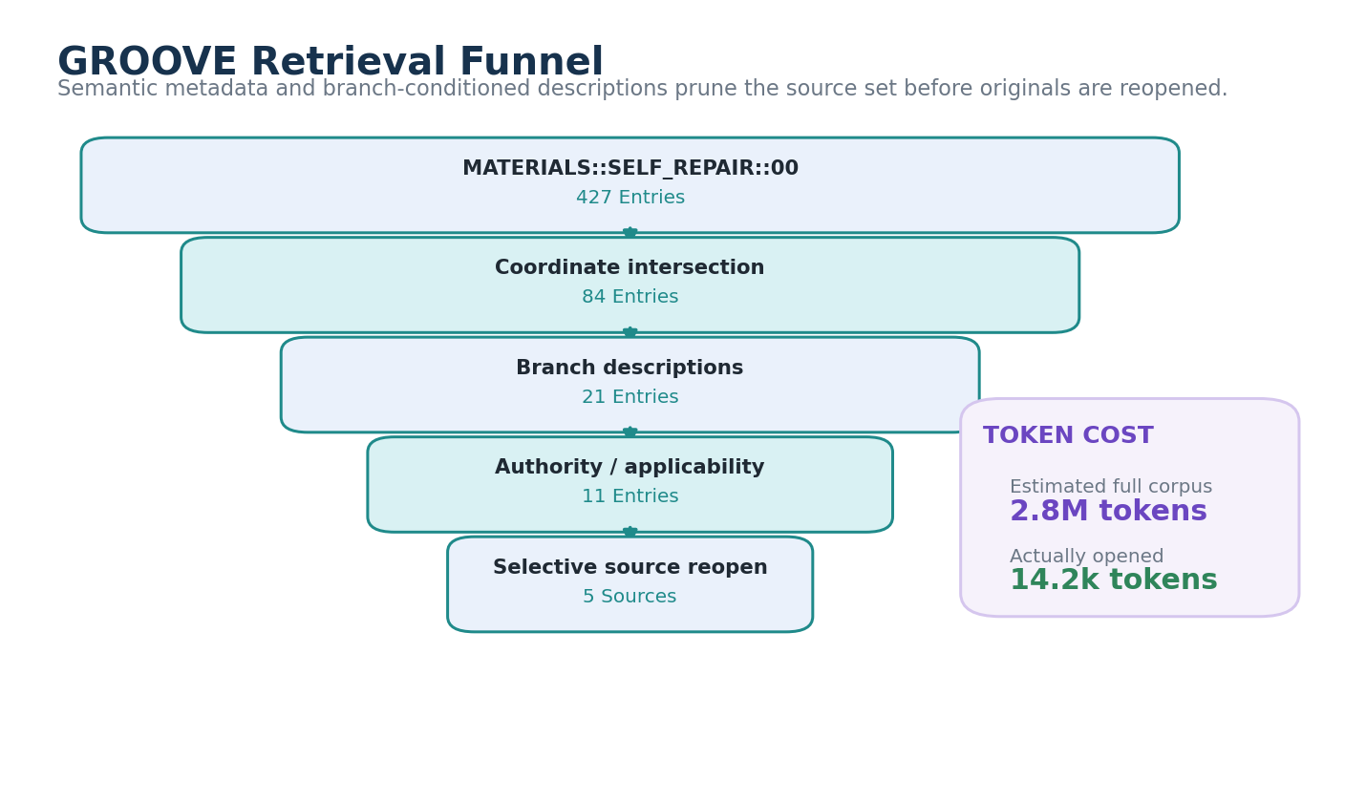
Figure 8. GROOVE Retrieval Funnel. The interface narrows 427 Entries to 84 by semantic coordinates, to 21 by branch descriptions, to 11 by authority and applicability, and finally to five reopened sources. An illustrative token-cost panel contrasts the full corpus with the text actually opened.
PROGRESSIVE ATTENTION PRINCIPLE
Increasingly expensive processing SHOULD be reserved for increasingly smaller, more relevant candidate sets.

28. Selective Source Reopening
GROOVE metadata is not the final factual authority. When the answer depends on specific evidence, the runtime should reopen the selected original Entries. A document link focuses the actual file; a GROOVE location description provides a semantic landing zone; the LLM reads the local source context. This preserves the principle that GROOVE points while the artifact grounds.

29. Token Attention
Token attention begins only after semantic routing has made the candidate space small enough to justify high-fidelity reading. The final LLM context may include the original request, semantic search plan, active route trace, selected GROOVE descriptions, source excerpts, applicable Models or Rules, and unresolved alternatives. The token budget can therefore be allocated to reasoning rather than to rediscovering the corpus map.

Part V - Semantic Search Execution

30. Semantic Search Plan
A Semantic Search Plan is the compact execution graph produced before source retrieval. It declares active semantic routes, intent, context, epistemic layers, relevance thresholds, authority constraints, applicable GROOVE stores, maximum frontier size, source-reopen policy, and token budget. It is not necessarily persisted forever, but it should be inspectable during execution and may be saved when useful for repeatable query families.
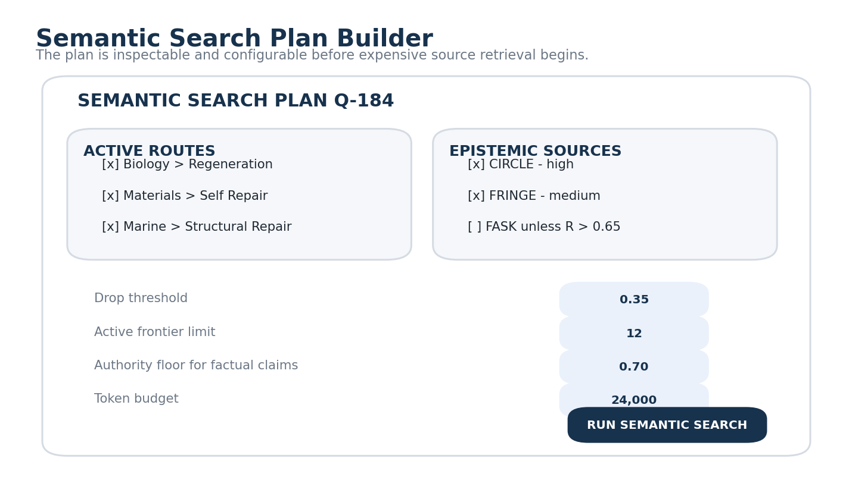
Figure 7. Semantic Search Plan Builder. The builder shows active routes, allowed epistemic layers, a drop threshold, frontier limit, authority floor, and token budget before the search runs. The plan exposes configuration rather than hiding the retrieval strategy in model state.
Search Plan field | Meaning
Query ID | Stable operational identity for trace and comparison.
Originating request | The exact user expression or structured request.
Active route graph | Current subject/domain branches and intersections.
Intent state | Explain, compare, design, verify, simulate, etc.
Context / world | Organization, jurisdiction, game, project, location, or other applicability frame.
Epistemic policy | Which CIRCLE, FRINGE, FASK, historical, personal, or external layers are eligible.
Continuation policy | Relevance thresholds, branch limits, depth, and budget.
Source policy | Authority floors, source-type constraints, permission rules, reopen limit.
Token budget | Maximum source-language context allocated to downstream reasoning.

31. Models, Operators, Rules, and Literature
Reaching a semantic coordinate should not only return documents. The same route may expose registered Models, Operators, Rules, Readers, CIRCLE knowledge, FRINGE structures, FASKs, and simulations. Query intent determines which of these are useful. An explanatory query may prioritize Models and literature. A build query may prioritize Models, Operators, Rules, and example Instances. A verification query may prioritize canonical sources, Rules, and evidence-bearing documents.

32. Source Selection and Grounding
Source selection combines semantic fit with authority, applicability, permissions, diversity, version state, and the claim type being constructed. A high-authority source should not automatically dominate an unrelated query; a highly relevant low-authority source should not be allowed to establish official policy. The runtime can therefore preserve several separately visible metrics rather than one hidden score.
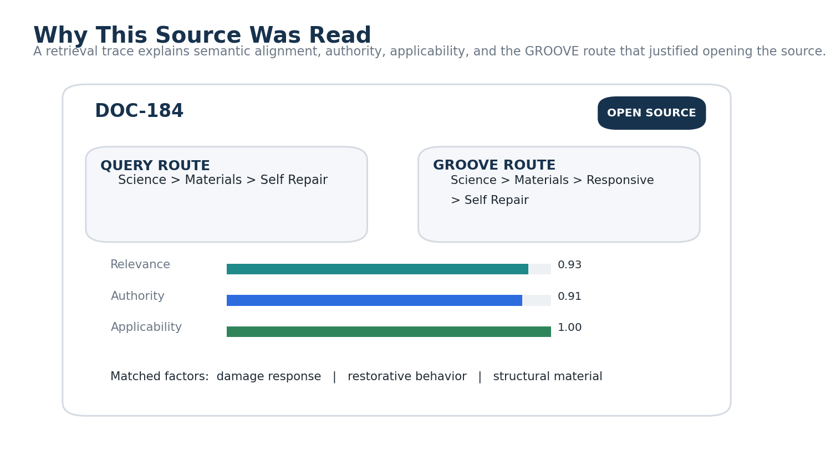
Figure 9. Why This Source Was Read. The source-inspector interface explains why DOC-184 was opened: the query route and GROOVE route overlap, relevance and authority are high, applicability is 1.00, and specific semantic factors matched.

33. Search Trace and Explainability
A semantic search trace should preserve enough operational provenance to answer: Which SOLAR spans resolved exactly? Which Routing SK versions were used? Which Bits activated? Which branches were factored? Which branches faded and why? Which 000 and 00 surfaces were opened? Which GROOVE projections were matched? Which sources were reopened? Which authority and applicability constraints affected selection?
This trace turns retrieval from an opaque hidden operation into an inspectable semantic argument. It can also support debugging and later architecture improvement without making every runtime score canonical knowledge.

34. Semantic Budgeting
Semantic budgeting makes the efficiency claim measurable. A runtime can expose how many Routing SK evaluations were performed, how many branches expanded or dropped, how many 00 bundles opened, how many GROOVE descriptions were read, how many original sources were reopened, and how many tokens were consumed. These metrics permit direct comparison with token-first retrieval baselines.
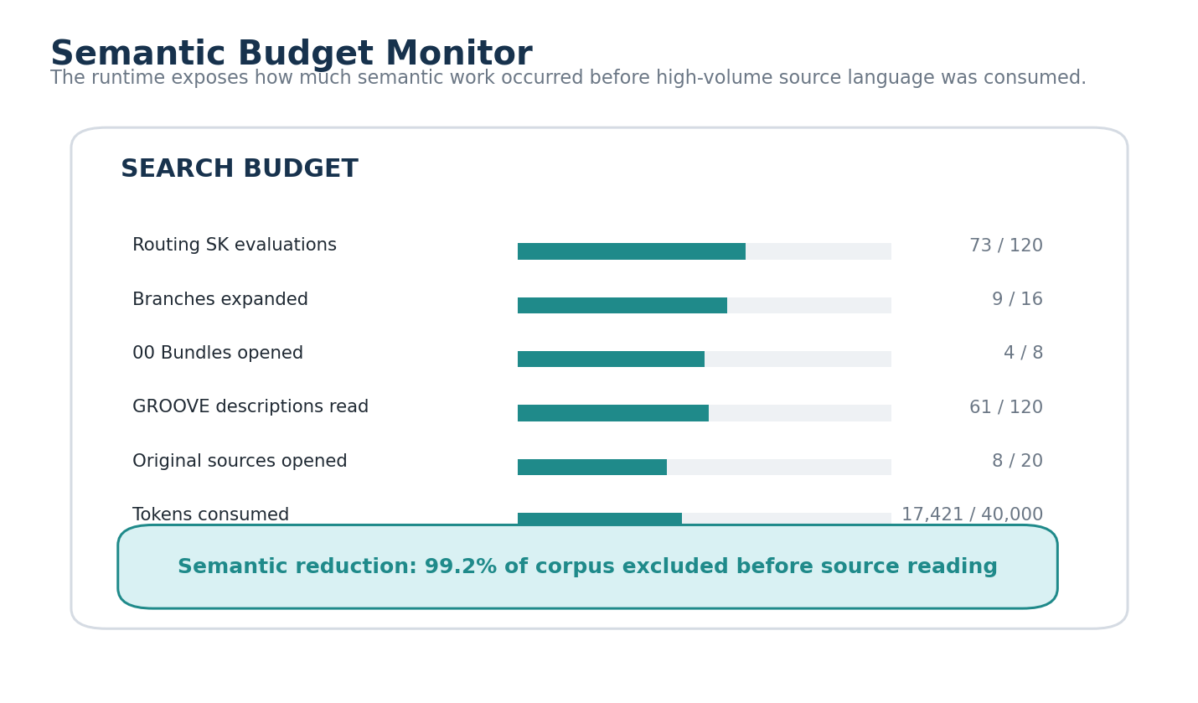
Figure 10. Semantic Budget Monitor. The budget monitor shows routing evaluations, branch expansions, bundle opens, description reads, source opens, and tokens consumed. The bottom banner reports the fraction of the corpus excluded before source reading.

Part VI - Accretive Search

35. Saved Query Routes
A successful search may leave behind a compact route trace containing the originating intent, semantic path, intersections, faded branches, selected 00 bundles, source set, and final semantic construction. Saving every query is unnecessary, but repeated or high-value routes can become reusable search profiles. This is another form of Semantic Accretion: search itself creates inspectable infrastructure for future search.

36. Reusable Query Families
When many requests repeatedly traverse the same combination of branches, the pattern can be packaged as an Intersection Profile or a specialized Routing SK candidate. For example, repeated queries combining Biology to Regeneration with Materials to Structural Repair may justify a reusable Bio-Adaptive Materials semantic instrument. The new instrument should be explicitly reviewed rather than automatically rewriting the existing Routing SKs.

37. Routing and Intersection Improvement Candidates
Search traces can reveal where the architecture is thin. If a large fraction of queries repeatedly require the same expensive cross-branch intersection, a new 000 bridge, 00 bundle, GROOVE projection, Routing SK, or SOLAR Alias may reduce future cost. The system can surface these as improvement candidates while preserving governance boundaries: runtime popularity does not automatically create canonical structure.

38. Semantic Work Persistence
Semantic Work Persistence is the principle that sufficiently grounded semantic work should be reusable rather than recomputed from source material for every subsequent query. GROOVE classifications, branch descriptions, relation maps, canonical ownership notes, route traces, and published Sweep Profiles are all ways of externalizing prior interpretation. Bits Before Tokens uses these structures as search infrastructure.
SEMANTIC WORK PERSISTENCE
Do not repeatedly spend inference on semantic work that has already been performed, preserved, and made inspectable.

Part VII - Formal Objects and Scoring

39. RouteState
RouteState is an operational object representing one active semantic branch for one query. It is not the canonical state of the Routing SK. A minimal RouteState can contain the current coordinate, parent route, router version, relevance, authority policy, applicability, depth, permission state, and provenance for the scoring decision.
RouteState {
QueryID
RouterID + Version
Coordinate / Active Bit
ParentRoute
Relevance R
AuthorityPolicy / SourceFloor
Applicability A
Depth
Status = Active | Faded | Dropped | Resolved
Provenance
}

40. Semantic Search Plan Object
The Search Plan aggregates RouteStates and execution policy. It can be constructed by an LLM from the request, by deterministic rules, or by a hybrid planner. Conformance depends on behavior rather than platform. The plan must preserve route identity and configuration sufficiently for the user or debugger to understand what semantic regions were searched and why.

41. Illustrative Scoring
This specification intentionally does not mandate one mathematical score. An implementation may use a continuation function over relevance, applicability, parent context, query intent, and budget. A simple implementation might require applicability above a threshold before continuation and then rank active branches by relevance. Evidence weighting at the source layer may combine relevance, applicability, and authority. These are implementation examples, not normative formulas.
ContinuationScore(branch) = f(R, A, ParentContext, QueryIntent, Budget)
Illustrative only:
Continue when A > 0 and R >= threshold
EvidenceWeight = g(R, A, T)
The factors remain separately inspectable.

42. No Magic Score
The architecture should resist collapsing every decision into one opaque scalar. A displayed score of 0.84 cannot explain whether a branch was topical, authoritative, applicable, permitted, or merely similar. Interfaces should therefore expose the major dimensions separately even when an implementation uses a composite score internally for ranking or scheduling.
Dimension | Question answered | Example
Relevance R | Is this semantic branch or source about the request? | Self-Healing Materials = 0.96
Authority T | How strongly may this source establish this kind of claim? | Company Standard = 1.00 for official policy
Applicability A | Does this information govern or pertain to the current context? | DragonRealm law = 0.00 in real-world query
Permission | May this user/agent know or use this route/source? | Authorized / hidden
Epistemic status | What kind of knowledge is this? | CIRCLE / FRINGE / FASK

Part VIII - Worked Examples

43. Worked Example A - Potato Cooking Query
Request: What temperature should I bake potatoes? This query demonstrates aggressive collapse. SOLAR may resolve bake and potato directly to registered semantic targets. The Subject router activates Food and Cooking; unrelated domains fade immediately. A Food 000 route opens a potato/cooking 00 bundle. GROOVE identifies a small set of cooking-time and thermal-processing sources or a registered Cooking Times Model. The runtime can therefore reach the relevant Model or source material after only a few semantic passes.
SUBJECT: Food + Cooking
INTENT: Explain / Lookup
CONTEXT: Real World
ROUTE: FOOD::000 -> Potato -> Baking / Thermal Processing
00: Potato Cooking Bundle
TOKEN STAGE: selected Model + small source set

44. Worked Example B - Bio-Materials Research Query
Request: Could biological self-healing mechanisms improve underwater structural materials? This query remains multifactor. Science activates Biology, Materials, and Physics; Engineering activates Marine and Structural. Biology to Regeneration intersects Materials to Self Repair. Marine to Structural Repair joins the downstream semantic surface. Established sources receive priority for descriptive claims while experimental and FASK layers may remain available for design ideation.
The key property is that the system can keep several branches active long enough to discover the intersection while allowing unrelated branches to fade. The search therefore spends tokens on biologically inspired material repair, submerged structural constraints, and relevant Models instead of on the full Science and Engineering corpus.

45. Worked Example C - Company Policy
Request A: What is our official travel reimbursement policy? Context resolves to the company environment. Intent is official lookup. The authority floor is high. The current company standard remains active while drafts, notes, and forum posts fall out for purposes of establishing policy. Request B: What are employees confused about in the travel reimbursement policy? The semantic route is almost identical, but the intent changes. Employee notes and discussion now become relevant evidence about confusion while remaining non-authoritative about the official rule.

46. Worked Example D - Game Law
Request A: Can dragon fire cross the river? Context is DragonRealm. The Game Law route has authority 1.00 and applicability 1.00, so it survives and directly answers the query. Request B: Can real fire cross water? Context is Real World. The same game law retains authority inside DragonRealm but has applicability 0.00 and is dropped before source retrieval. The example demonstrates why scope should not be represented as a reduction in trust.

47. Worked Example E - Cross-Domain Historical Research
Request: How did music recording technology affect political movements in a specified historical period? Subject routing activates Music, Technology, History, Politics, and Culture. Intent activates Explain and Compare. Historical context constrains the time period. The active frontier can remain broad for several passes because the value lies in cross-domain relations. GROOVE projections over historical documents, recordings, biographies, and technology histories can intersect through stable Entry identities. Only the sources surviving both semantic and temporal constraints are reopened.
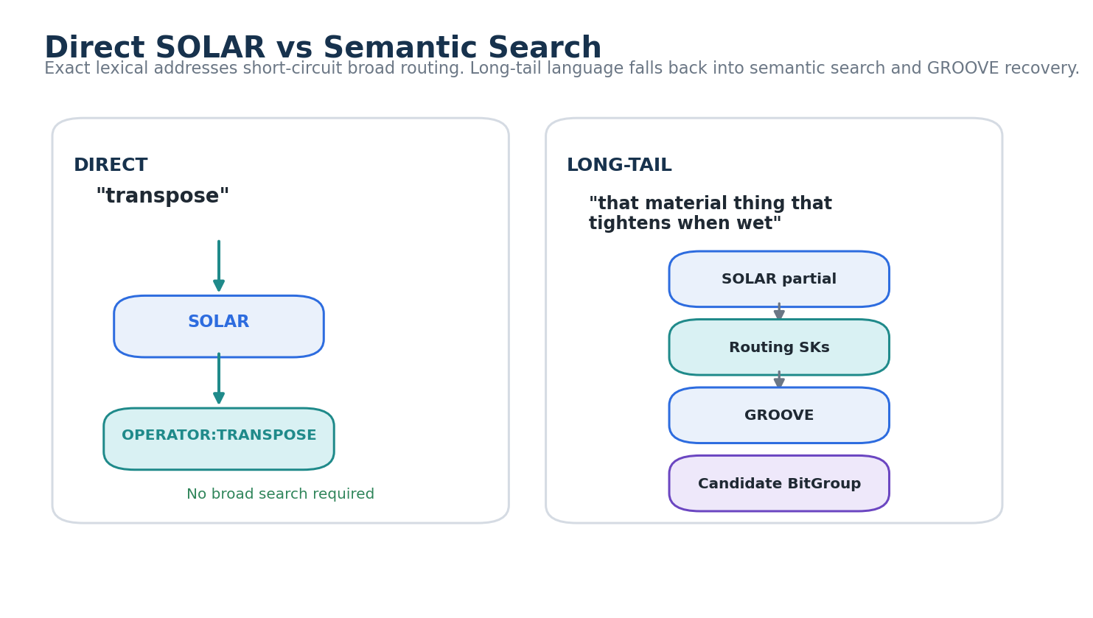
Figure 14. Direct SOLAR vs Semantic Search. The left path shows an exact SOLAR Alias for transpose resolving directly to an Operator. The right path shows long-tail language using partial SOLAR resolution, Routing SKs, GROOVE, and a candidate BitGroup before the system commits to a semantic operand.

Part IX - Formal Principles, Failure Modes, and Conformance

48. Normative Principles
ID | Principle | Requirement
BBT-L01 | Bits Before Tokens | Use available bounded semantic structure to reduce retrieval scope before consuming large source-language contexts.
BBT-L02 | Multifactor Query | Preserve multiple compatible active routes when they materially contribute to the request.
BBT-L03 | Recursive Resolution | Active branches may use finer Routing SKs until a stopping condition or sufficient semantic precision is reached.
BBT-L04 | Semantic Fade | Branches should stop expanding when contextual relevance falls below the configured continuation criterion.
BBT-L05 | Relevance Re-Evaluation | Deeper branches may become more or less relevant and should be re-evaluated against the originating request.
BBT-L06 | Authority Separation | Semantic relevance, source authority, and contextual applicability remain distinguishable.
BBT-L07 | Context-Bounded Authority | A source may be authoritative in one environment and inapplicable elsewhere.
BBT-L08 | Progressive Attention | More expensive processing is reserved for smaller, more relevant candidate sets.
BBT-L09 | Semantic Work Persistence | Existing GROOVE classifications and routing structures are reused rather than reconstructed when appropriate.
BBT-L10 | Source Grounding | Routing and GROOVE metadata guide retrieval; consequential factual claims remain groundable in underlying sources.
BBT-L11 | Permission First | Unauthorized semantic routes or source existence must not leak through routing, counts, or explanations.
BBT-L12 | No Magic Score | Implementations should preserve inspectable dimensions even when composite ranking is used internally.
BBT-L13 | Exact Address Precedence | Exact SOLAR or canonical semantic addressing outranks probabilistic broad routing for the same lexical operand.
BBT-L14 | Traceability | Search execution should preserve enough route and source provenance to explain why a source was read.

49. Failure Modes
Failure | Why it fails | Correction
One-best-domain classification | Destroys multifactor queries and hides cross-domain intersections. | Preserve compatible active routes and factor branches.
Mechanical relevance decay | Drops deep branches that become more relevant with precision. | Re-evaluate against request + parent context.
Trust used as scope | Makes a valid game/company rule appear untrustworthy outside its domain. | Separate authority from applicability.
GROOVE description treated as evidence | Allows compact metadata to silently replace the source. | Reopen original Entries for consequential claims.
Unbounded branch explosion | Turns semantic routing into an expensive graph walk. | Use thresholds, frontier limits, depth, and budgets.
One opaque score | Prevents users from knowing whether relevance, authority, or context caused a decision. | Expose major dimensions separately.
Permission leakage | Hidden routes appear in candidate counts or autocomplete. | Apply permissions before disclosure.
Routing treated as truth | A query classification is mistaken for canonical semantic identity. | Keep runtime RouteState separate from canonical Routing SK meaning.
Token-first fallback everywhere | Ignores existing semantic structure and repeats domain reconstruction. | Use direct SOLAR / routing / GROOVE before broad source reading where available.
Overpruning exploratory queries | Aggressive thresholds erase useful cross-domain possibilities. | Use intent-sensitive search budgets and allow user-pinned branches.

50. Conformance Requirements
ID | Requirement
BBT-C01 | A conforming implementation SHALL preserve the identity and version of each Routing SK used during semantic search.
BBT-C02 | A query MAY activate multiple compatible routes; conformance SHALL NOT require single-label classification.
BBT-C03 | Runtime query RouteState SHALL remain distinct from canonical Routing SK state and identity.
BBT-C04 | Semantic Fade SHALL be an explicit continuation decision or equivalent inspectable state, not only an invisible hidden-model effect.
BBT-C05 | Relevance SHOULD be re-evaluated at deeper routing levels rather than forced to monotonically decay with depth.
BBT-C06 | Authority and contextual applicability SHALL remain distinguishable in the data model or equivalent behavior.
BBT-C07 | Information with zero applicability to the active context SHALL NOT influence an answer merely because it is authoritative elsewhere.
BBT-C08 | Permission filtering SHALL occur before hidden routes, counts, source names, or ambiguity information are disclosed.
BBT-C09 | Exact authorized SOLAR resolution SHALL outrank lower-authority similarity or broad semantic routing for the same lexical span.
BBT-C10 | 00 and GROOVE metadata MAY guide retrieval but SHALL NOT silently replace required source inspection for consequential factual claims.
BBT-C11 | The search runtime SHOULD expose or retain the active semantic frontier and branch status.
BBT-C12 | Search budgets SHOULD be configurable by task or profile.
BBT-C13 | The runtime SHOULD preserve a route trace sufficient to identify active branches, dropped branches, selected 00 bundles, and reopened sources.
BBT-C14 | Cross-domain intersections SHALL preserve the identities of their parent branches rather than flattening them into an unexplained merged label.
BBT-C15 | Composite internal ranking MAY be used, but major decision dimensions SHOULD remain inspectable.
BBT-C16 | Saved query traces or improvement candidates SHALL NOT automatically mutate canonical Routing SKs, SOLAR, BIGFOOT, Models, or Rules.
BBT-C17 | Branch-conditioned GROOVE descriptions SHOULD identify their source Entry and semantic branch.
BBT-C18 | The implementation SHALL provide a path from selected GROOVE metadata back to the original Observable Entry where access permits.
BBT-C19 | Search execution SHOULD permit direct semantic-target retrieval without opening literature when a Model, Operator, Rule, or exact target already satisfies the intent.
BBT-C20 | The architecture SHALL permit unresolved or ambiguous outcomes when semantic support is insufficient.

51. Implementation Roadmap and Open Questions
Phase | Build focus | Exit criterion
1 - Global routing | Prototype SUBJECT / INTENT / CONTEXT Routing SKs and Global 000. | Queries produce inspectable multifactor route states.
2 - Fade | Add relevance re-evaluation, thresholds, active frontier, and budgets. | Low-value branches stop expanding without losing traceability.
3 - 00 integration | Connect domain 000 routes to local GROOVE manifests and saved projections. | Queries reach bounded source neighborhoods before text retrieval.
4 - Authority | Add authority, applicability, epistemic status, and permission behavior. | Company/game/CIRCLE/FASK boundary fixtures pass.
5 - Token funnel | Add branch descriptions, source ranking, selective reopen, and token budget monitoring. | Search can demonstrate measurable semantic reduction before source reading.
6 - Accretion | Save high-value route traces and candidate intersection profiles. | Repeated query families reuse prior semantic work without mutating canon.
7 - Comparative testing | Compare against token-first and ordinary hybrid retrieval baselines. | Quality, cost, latency, recall, and explainability can be evaluated empirically.

Open design questions include how many top-level Routing SKs should operate in parallel, when to prefer a 16-bit versus 64-bit routing surface, how to calibrate relevance across different router families, how to set authority defaults without implying universal truth, how to represent jurisdiction and time-bound applicability, how much route-trace data should persist, and which search patterns genuinely earn new intersection profiles or specialized Routing SKs.
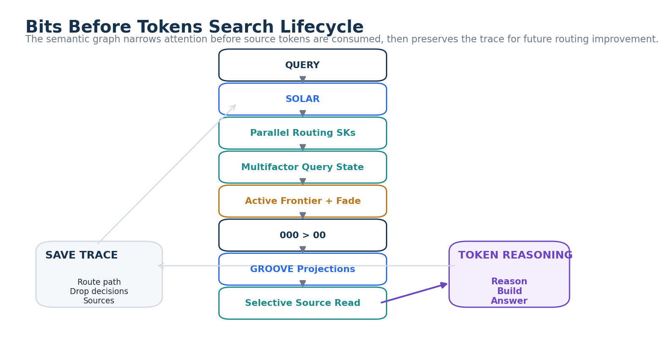
Figure 15. Bits Before Tokens Search Lifecycle. The lifecycle routes a query through SOLAR, parallel semantic measurements, multifactor factorization, active-frontier pruning, 000 and 00 navigation, GROOVE projections, selective source reading, and final token reasoning. A saved trace can feed future routing improvement without mutating canonical structures automatically.

Conclusion
Bits Before Tokens treats semantic structure as an attention-allocation system. The architecture assumes that a mature knowledge environment should not repeatedly ask an LLM to rediscover its own domain boundaries from prose. Small Routing SKs can cover large semantic territory through recursive composition. GROOVE can preserve document-level semantic work. 000 and 00 can make the corpus navigable. Semantic Fade can remove irrelevant branches early. Authority and applicability can keep company standards, game laws, scientific literature, experimental structures, and speculative FASKs in their proper contexts.
The resulting search process remains language-friendly at entry and source-grounded at the end, but much of the middle is handled by compact semantic state. This does not eliminate tokens. It allocates them. It does not replace reasoning. It decides where reasoning is worth spending. The practical design principle is therefore simple: spend Bits before tokens.

Glossary
Term | Definition
000 | A corpus- or domain-level semantic navigation surface that routes users or AI systems toward bounded knowledge neighborhoods.
00 | A local GROOVE manifest or knowledge-bundle map exposing documents, relations, Masters, components, and source locators.
Active Semantic Frontier | The bounded set of query branches currently eligible for further semantic expansion.
Applicability (A) | A contextual measure of whether a source, rule, or semantic structure pertains to the active world, organization, jurisdiction, project, or other scope.
Authority / Trust (T) | A contextual measure of how strongly a source may establish a specified kind of claim. It is not the same as topical relevance or applicability.
BIGFOOT | The CERBERUS semantic identity spine for stable Bits, BitGroups, BitWords, and Compound BitWords and their explicit composition.
Bits Before Tokens | The principle that bounded semantic structure should reduce search scope before large quantities of source-language tokens are consumed.
Bounded Semantic Reach | Large reachable semantic territory obtained through recursively composed small routing vocabularies.
Branch-Conditioned Description | A compact GROOVE description explaining why one source is relevant inside one specific semantic branch.
CIRCLE | Established common knowledge layer in the DRAGON/GROOVE ecosystem.
Cross-GROOVE Intersection | A semantic surface produced by intersecting compatible saved GROOVE projections or active semantic branches.
FASK | An explicitly speculative, fantasy, or alternative semantic structure that remains distinct from established canonical knowledge.
FRINGE | Developing, experimental, or unresolved knowledge space kept distinct from established CIRCLE knowledge.
GROOVE | Grounded Relations Over Observable Versioned Entries; a method for persisting source-grounded semantic relations, routing handles, descriptions, and traversal structure.
Multifactor Query State | A query routing result in which several compatible semantic factors are active simultaneously.
Relevance (R) | A runtime measure of how strongly a route or source contributes to the current request under the active semantic context.
RouteState | Operational state for one query branch, including route identity, relevance, applicability, depth, status, and provenance.
Routing Semantic Kernel | A bounded semantic structure used to classify, organize, or route toward registered semantic destinations.
Semantic Fade | The explicit pruning of branches that no longer justify further semantic expansion.
Semantic Query Factorization | Progressive decomposition of one request into multiple independently traversable semantic branches.
Semantic Search Plan | An inspectable execution graph defining active routes, intent, context, epistemic policy, continuation thresholds, authority rules, source policy, and budgets.
Semantic Work Persistence | The reuse of prior grounded semantic interpretation instead of recomputing it from source language for every query.
SOLAR | System Operational Lexical Alias Registry; the lexical address layer mapping registered expressions to exact typed semantic targets.
Token Attention | The high-cost source-language reading and reasoning stage intentionally delayed until semantic routing has narrowed the candidate set.

