CYBERNETIC MECHANICS
III
EVALUATION & REASONING
Visual Anatomy of Determination, Permission, and Logical Consequence
Paper III of III | Cybernetic Mechanics Series | Version 0.1 | Verified Release | September 2026
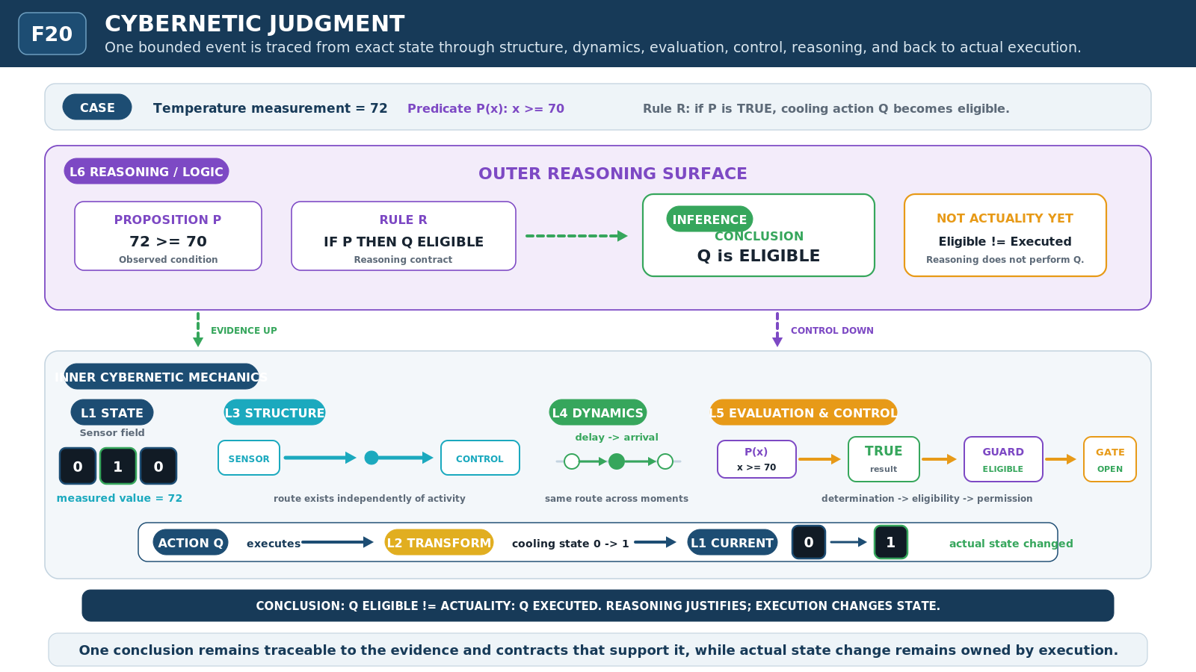
Figure F20 - Cybernetic Judgment. One bounded episode is traced from state through behavior, evaluation, control, and reasoning while preserving the final distinction: Q ELIGIBLE is not Q EXECUTED.
RESEARCH POSTURE
Experimental, non-canonical visual mechanics paper. The paper pressure-tests working Evaluation, Control, and Reasoning vocabulary; it does not promote Trial terms, glyphs, or classifications into CERBERUS canon.

0. Abstract and Reading Contract
Cybernetic Mechanics III examines the outer operational dyad of the Cybernetic Language Trial: Evaluation & Control and Reasoning / Logic. Papers I and II established bounded state, direct transformation, structural organization, routing, persistence, and concurrent activity. This paper begins when an intelligence observes those mechanics, makes explicit determinations about them, uses resolved conditions to govern what may proceed, and reasons over propositions, Models, constraints, alternatives, and consequences.
The visual program preserves the series discipline that closely related events must remain separable when their contracts differ. Observation is not evaluation. A truth-valued result is not generic activation. Eligibility is not execution. A proposition is not a state transition. Entailment, derivability, and inference are different relations. The purpose is not to replace logic notation or programming semantics, but to expose enough cybernetic anatomy that the reader can see what was observed, what was determined, what was permitted, and what actually occurred.
READING LAW
Paper III treats Evaluation and Reasoning as experimentally useful semantic layers. Repeated use of a term or visual form is evidence that the distinction is useful, not proof that the term is primitive, canonical, or permanently named.
BOUNDED QUESTION
How can a cybernetic system observe and evaluate information, resolve explicit results, govern what may proceed, and reason over complete structures without collapsing observation, evaluation, control, logical consequence, and execution into one operation?
SERIES COMPRESSION
BE -> CHANGE -> ORGANIZE -> BEHAVE -> EVALUATE -> REASON. Paper III owns EVALUATE -> REASON: Evaluation & Control plus Reasoning / Logic.
VISUAL LAW
Show the observation. Show the determination. Show the permission. Show the actuality. Never confuse a conclusion with an execution.

Contents
1. The Evaluation-Reasoning Dyad
2. Observation Is Not Evaluation
3. Observe, Detect, and Measure
4. Compare, Match, Test, Threshold, and Predicate
5. Boolean Result as a Distinct State
6. Boolean Evaluation Composition
7. Guard and Eligibility
8. Gate, Enable, Disable, and Suppress
9. Choose: Resolving Among Alternatives
10. From Evaluation to Control
11. When Results Become Reasoning Objects
12. Proposition, Formula, Assumption Context, and Model
13. Quantification, Existence, and Unique Existence
14. Satisfaction and Satisfiability
15. Entailment, Derivability, and Inference
16. Equivalence Without Identity
17. Truth, Validity, Consistency, and Satisfiability
18. Necessity, Possibility, and Reachability
19. Semantic Resolution and the Outer / Inner Contract
20. Cybernetic Judgment - Full-Series Synthesis
21. Open Questions and Non-Collapse Laws
22. Conclusion
Appendix A. Working Vocabulary
SERIES BOUNDARY
Domain systems still own what their states, observations, propositions, and outcomes mean. Paper III owns the cybernetic distinctions by which information is inspected, evaluated, controlled, and reasoned over at bounded semantic surfaces.

SERIES POSITION

1. The Evaluation-Reasoning Dyad
The Cybernetic Mechanics series is organized as three complementary dyads. Paper I owns State and Transformation: what information is and what directly changes. Paper II owns Structure and Dynamics: how information is organized and how that organization behaves through time. Paper III owns Evaluation and Reasoning: what can be determined about those mechanics, what may proceed because of a resolved condition, and what follows when determinations participate in larger semantic structures.

Core thesis
Evaluation converts bounded observations into explicit determinations. Control consumes determinations to govern eligibility, permission, suppression, and selection among alternatives. Reasoning operates over propositions, formulas, assumption contexts, Models, and relations among them to determine consequence, consistency, satisfiability, modality, and related properties. None of these acts is identical to executing the mechanism being described.

Primary visual proposition
A reader should be able to trace a judgment in both directions. Outward, low-level mechanics can be compressed into observations, results, propositions, and conclusions. Inward, a high-level claim can be resolved toward the observations, controls, behaviors, structures, transformations, and exact states that support or implement it. The layers remain connected without becoming interchangeable.
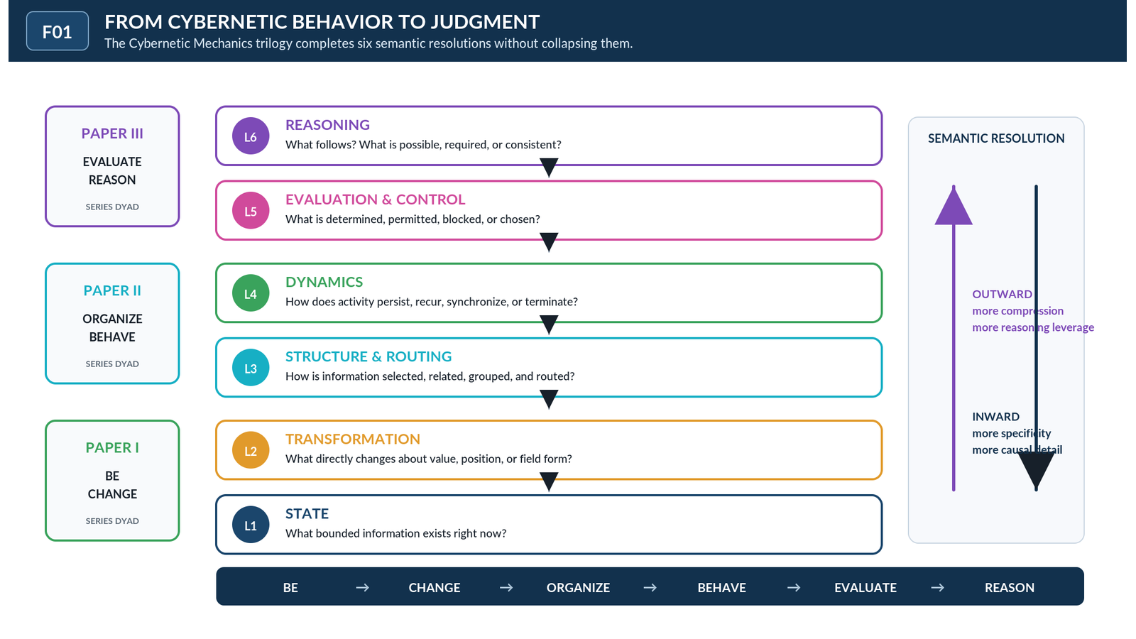
Figure F01 - From Cybernetic Behavior to Judgment. The six-layer language is grouped into three complementary dyads. Paper III owns Evaluation & Control plus Reasoning / Logic without replacing the mechanics beneath it.
SERIES THESIS
BE, CHANGE, ORGANIZE, BEHAVE, EVALUATE, and REASON are six different questions about one cybernetic system. The series is successful only if the same event remains traceable across all six without semantic collapse.

L5 - EVALUATION & CONTROL

2. Observation Is Not Evaluation
Observation acquires or exposes information from a bounded source. It may reveal a stored value, occupancy pattern, route state, timing fact, or another declared property, but acquisition alone does not judge what that information means relative to a criterion. The source can remain unchanged while a new observational result becomes available elsewhere.
Evaluation begins when observed information is placed under a declared condition. A value of 72 can be observed without being safe, unsafe, high, low, valid, or invalid. Those determinations arise only when a threshold, predicate, comparison, or other evaluative contract is applied. Keeping the stages separate makes provenance visible: an intelligence can ask both what was read and how the conclusion was obtained.
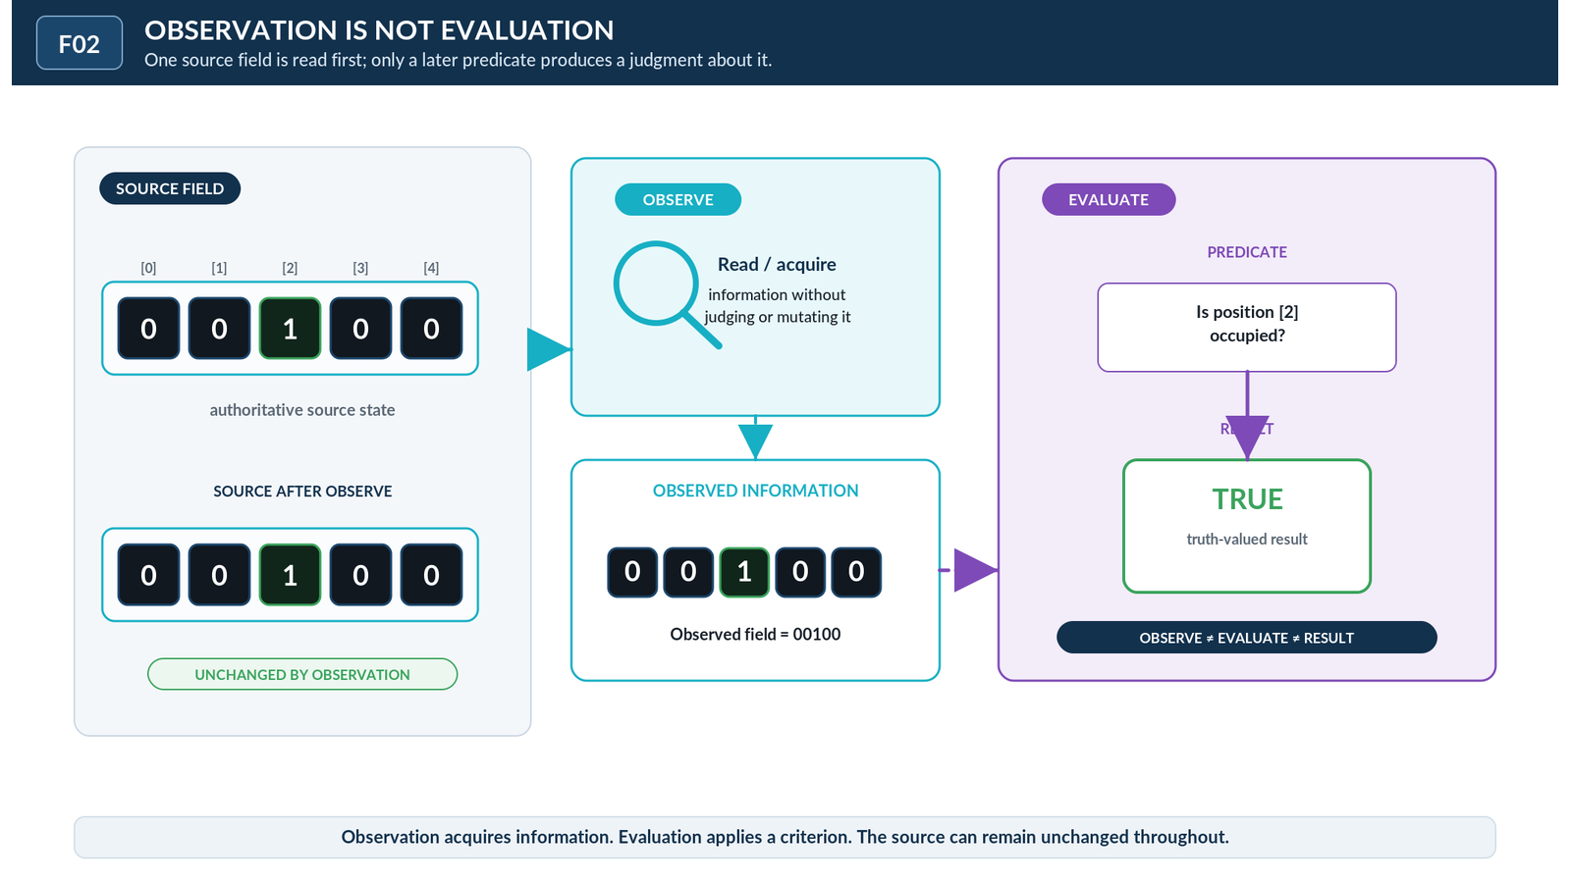
Figure F02 - Observation Is Not Evaluation. One bounded state can be observed without mutation and then evaluated under a separate condition. Acquisition and judgment remain distinct operations.
OBSERVATION LAW
Observe != evaluate. Reading a state can expose evidence without producing a judgment, and neither operation implies mutation of the observed source.

INFORMATION ACQUISITION

3. Observe, Detect, and Measure
OBSERVE is the broadest working mechanic in this family: obtain or expose relevant information under a declared access contract. DETECT narrows that role by asking whether a defined phenomenon, feature, or condition is present. MEASURE resolves a quantity, magnitude, count, coordinate, duration, or other metric according to a measurement contract. The three may share sensors or Readers while producing different kinds of outputs.
The distinction matters because a detection result is commonly Boolean while a measurement result need not be. A detector may resolve PRESENT or ABSENT; a measurement may resolve 72, 4.3 seconds, position 6, or another quantitative value. Observation can support either without committing to a particular output type. The language therefore keeps acquisition, condition recognition, and quantitative resolution separate.
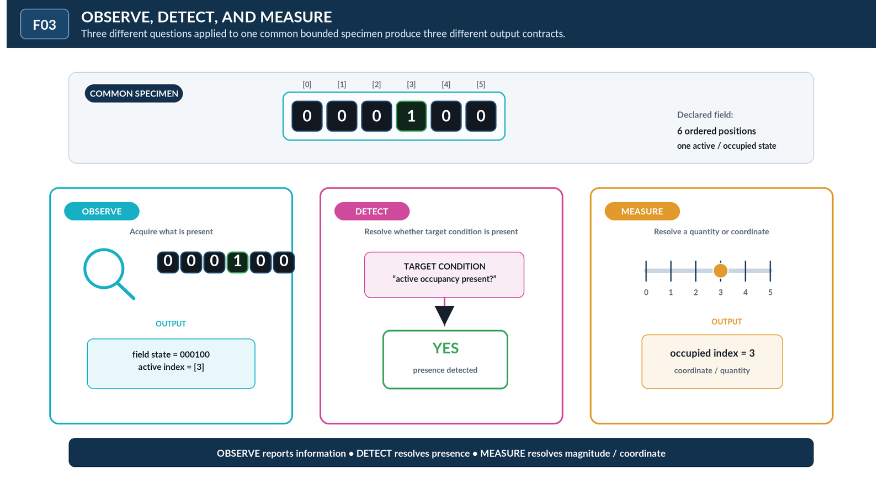
Figure F03 - Observe, Detect, and Measure. The same source supports three distinct information-facing mechanics: general observation, condition detection, and quantitative measurement.
ACQUISITION DISTINCTION
OBSERVE asks what information is available. DETECT asks whether a declared thing is present. MEASURE asks how much, how many, where, or to what degree under a metric contract.

EVALUATION ANATOMY

4. Compare, Match, Test, Threshold, and Predicate
Evaluation contains several related mechanics that should not collapse merely because they often end in a truth-valued result. COMPARE establishes a relation between supplied values or states. MATCH asks whether an input corresponds to a declared target or pattern. THRESHOLD partitions an ordered domain relative to a boundary. PREDICATE names the condition or truth-valued function to be applied. TEST is the bounded act of applying a condition to supplied information.
These distinctions preserve reusable structure. A predicate can exist before any object is tested. A threshold can be one ingredient inside a predicate without becoming every kind of comparison. A match can compare a complex pattern rather than a scalar magnitude. The resulting Boolean state belongs downstream of the evaluative contract rather than being hidden inside the name of the operation.
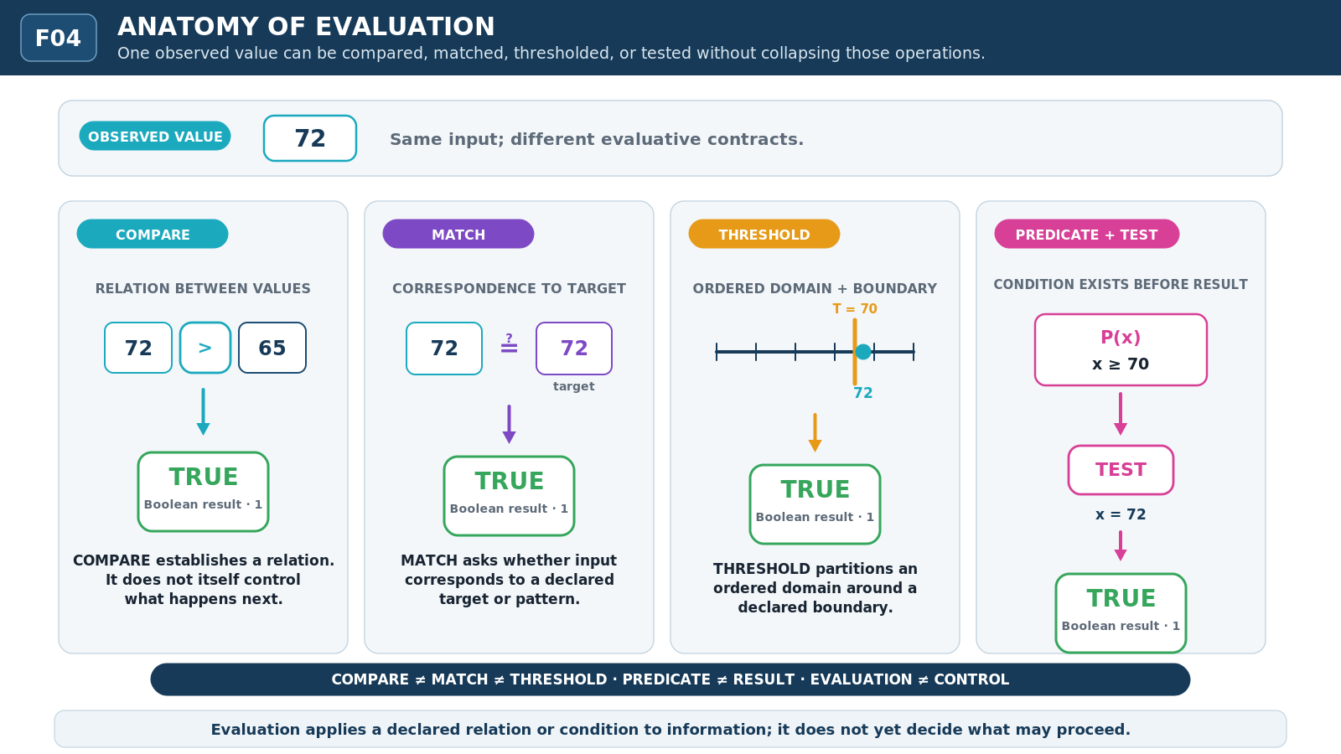
Figure F04 - Anatomy of Evaluation. COMPARE, MATCH, THRESHOLD, TEST, and PREDICATE expose related but non-identical ways of forming a bounded determination.
PREDICATE LAW
Predicate != result. The condition may exist before evaluation; the result exists only after the declared condition has been applied to relevant input.

RESULT STATE

5. Boolean Result as a Distinct State
A Boolean result is a truth-valued determination produced under an evaluative or logical contract. Its implementation may use the same physical binary substrate as many other cybernetic states, but that shared encoding does not erase semantic role. A visible 1 can encode active state, occupancy, trigger, gate-open status, selected membership, or TRUE depending on the contract that owns it.
Paper III therefore treats the Boolean result as an explicit semantic object. TRUE and FALSE identify the outcome of a truth-valued evaluation; they do not by themselves pulse a trigger, open a gate, mutate a state, or assert that every represented proposition in the surrounding system is true. Later control mechanics may consume the result, but consumption is another operation.
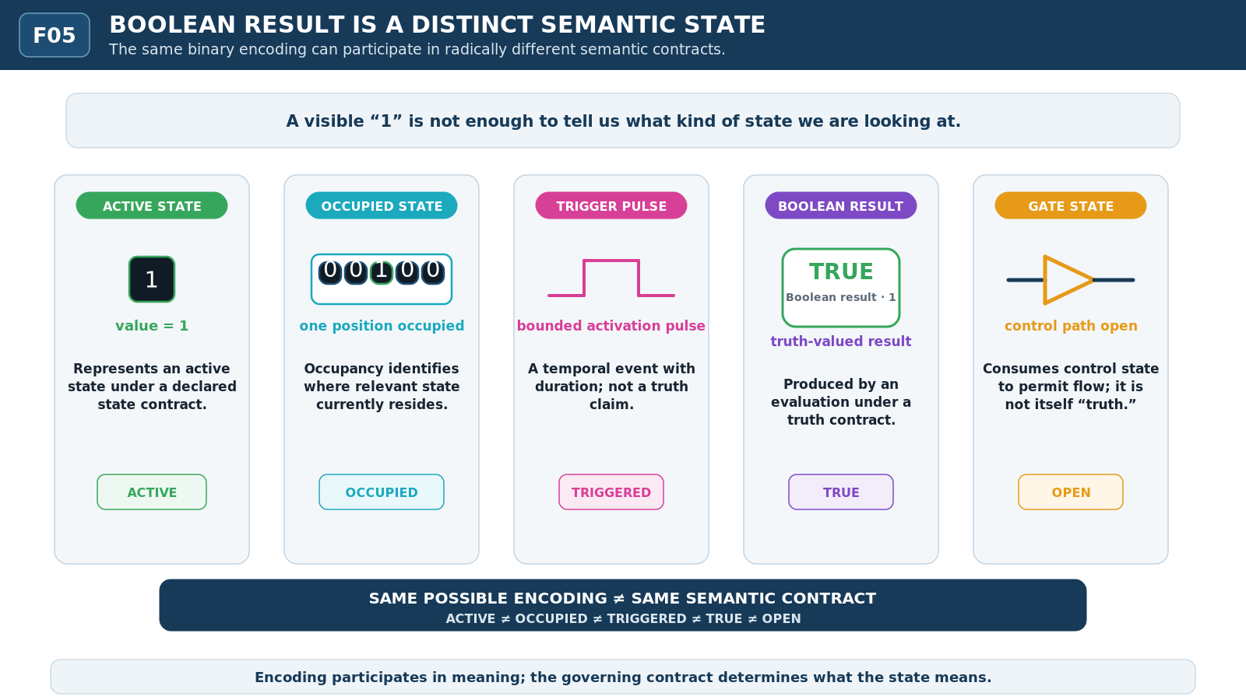
Figure F05 - Boolean Result Is a Distinct Semantic State. Binary encodings can participate in active state, occupancy, trigger, gate, or truth-result contracts without those semantics collapsing into one another.
FOUNDATIONAL LAW
Bit state != truth value. Boolean result != trigger. Encoding participates in meaning; it does not determine semantic interpretation alone.

BOOLEAN COMPOSITION

6. Boolean Evaluation Composition
Once truth-valued results exist, they can be composed. NOT reverses one Boolean condition. AND requires participating conditions together. OR is satisfied when at least one participating condition is satisfied under its contract. XOR distinguishes exclusive truth among its operands. The familiar operations are retained here because they provide a compact compositional surface over resolved evaluations.
The important boundary is semantic rather than mathematical. AND does not mean JOIN, OR does not mean FAN-OUT, and XOR does not mean physical exclusive occupancy. The same symbols may be implemented over bits, but Paper III uses them specifically as operations over truth-valued conditions. Structural convergence, routing plurality, and occupancy belong to different layers and retain their own contracts.
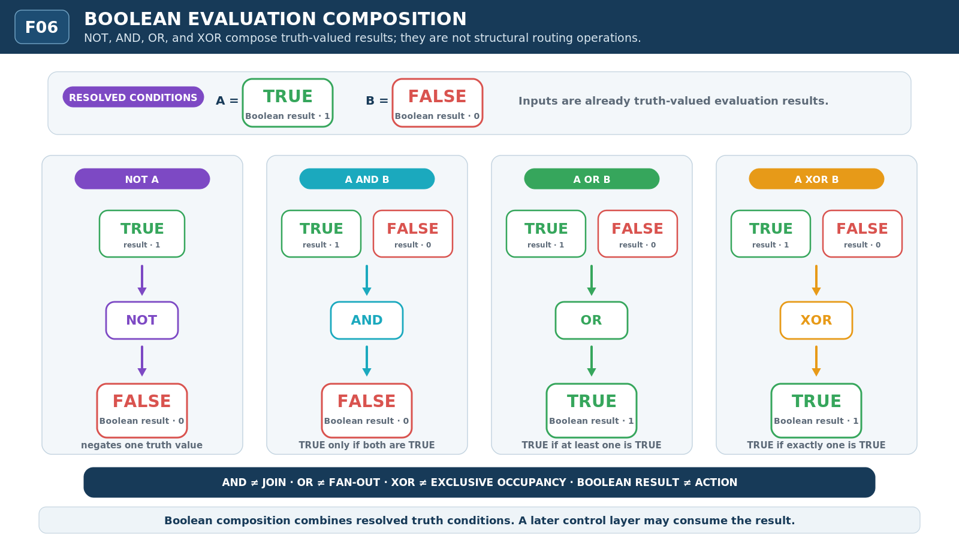
Figure F06 - Boolean Evaluation Composition. NOT, AND, OR, and XOR compose already resolved truth-valued conditions. Boolean composition is not structural joining, routing, or execution.
BOOLEAN COMPOSITION LAW
Boolean composition combines truth-valued conditions. It does not, by itself, join structures, route information, perform actions, or mutate the evaluated sources.

ELIGIBILITY

7. Guard and Eligibility
A GUARD states the condition under which an operation, transition, route, or other candidate behavior is eligible. The guard can be evaluated to TRUE or FALSE, but eligibility remains distinct from execution. A satisfied guard means the declared eligibility condition holds; it does not prove that resources are available, that another controller has granted permission, or that the operation actually occurred.
This distinction gives systems a place to represent unrealized opportunity. An operation may be eligible yet waiting behind a barrier, disabled by policy, suppressed by another control, or simply not selected. Conversely, an ineligible operation can remain perfectly intact as an object or capability. The guard describes a conditional relation, not an event that automatically fires.
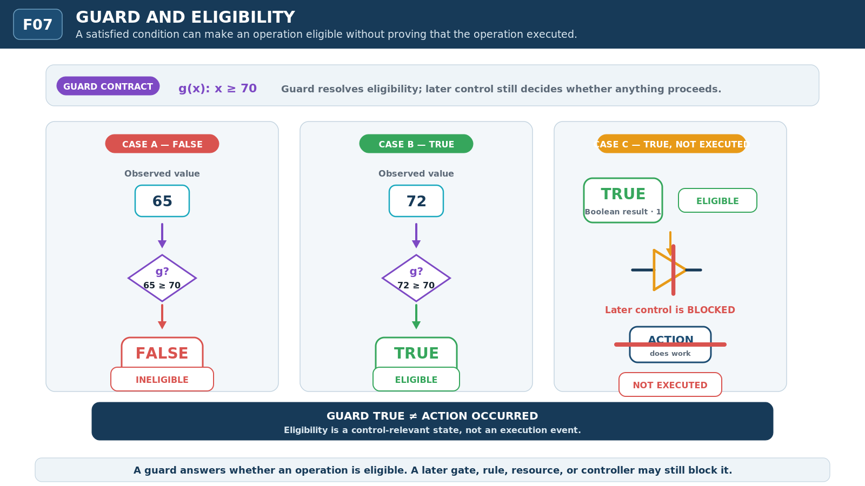
Figure F07 - Guard and Eligibility. A GUARD evaluates whether an operation is eligible. A satisfied guard can leave an operation eligible without implying that the operation actually executed.
ELIGIBILITY LAW
Guard TRUE != action occurred. Eligibility is a resolved control-relevant condition, not evidence that the guarded operation executed.

CONTROL RELATIONS

8. Gate, Enable, Disable, and Suppress
Control begins when resolved conditions govern what is available or permitted to proceed. ENABLE makes an operation, route, capability, or other target available under the active control contract. DISABLE removes that availability while preserving the target itself. GATE conditionally permits or blocks passage according to a supplied control state. SUPPRESS inhibits expression or propagation of something that may otherwise remain present or available.
The vocabulary separates several forms of non-execution that are often drawn identically. A disabled operation has not been deleted. A suppressed result has not necessarily been made false. A closed gate need not destroy the path behind it. These distinctions preserve what still exists when a system chooses not to express, expose, or execute it.
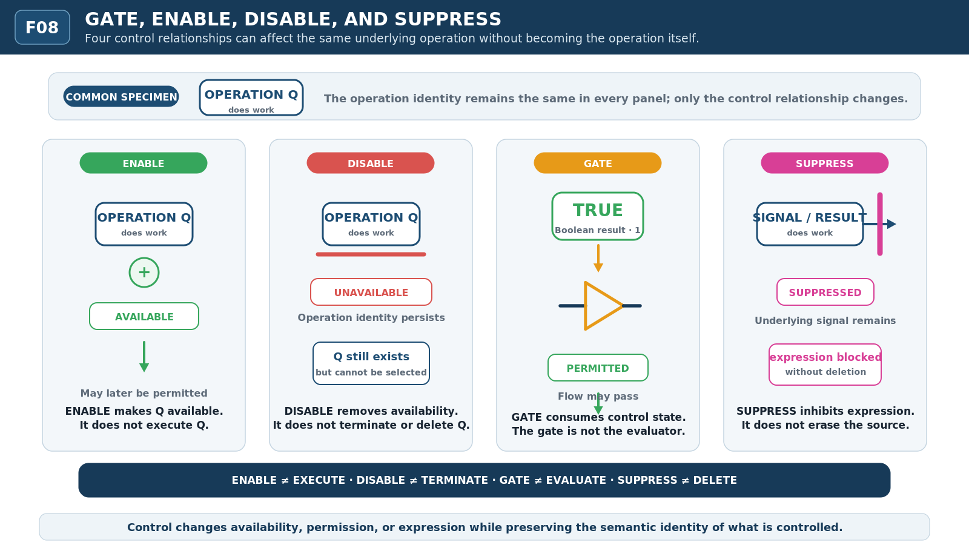
Figure F08 - Gate, Enable, Disable, and Suppress. Four control relations are compared over a common operation so availability, conditional permission, and inhibited expression remain separate.
CONTROL LAW
Unavailable != absent. Blocked != deleted. Suppressed != false. Control governs expression and permission without silently rewriting object identity.

RESOLUTION AMONG ALTERNATIVES

9. Choose: Resolving Among Alternatives
Paper II used SELECT as a structural participation relation: selected members are in scope for an operation or context without becoming active or winning a competition. CHOOSE belongs outward in control because it resolves among candidate alternatives. The candidates may already be selected, eligible, ranked, or otherwise available; CHOOSE identifies which alternative is resolved to proceed under the active decision contract.
This also preserves the handoff from dynamics. A RACE can produce the temporal fact that A arrived before B. That fact may become evidence for a later CHOOSE operation, but RACE does not contain the policy that says the fastest result should win. Temporal competition and evaluative selection remain separate, allowing another rule to ignore the race, choose the slower result, or abstain entirely.
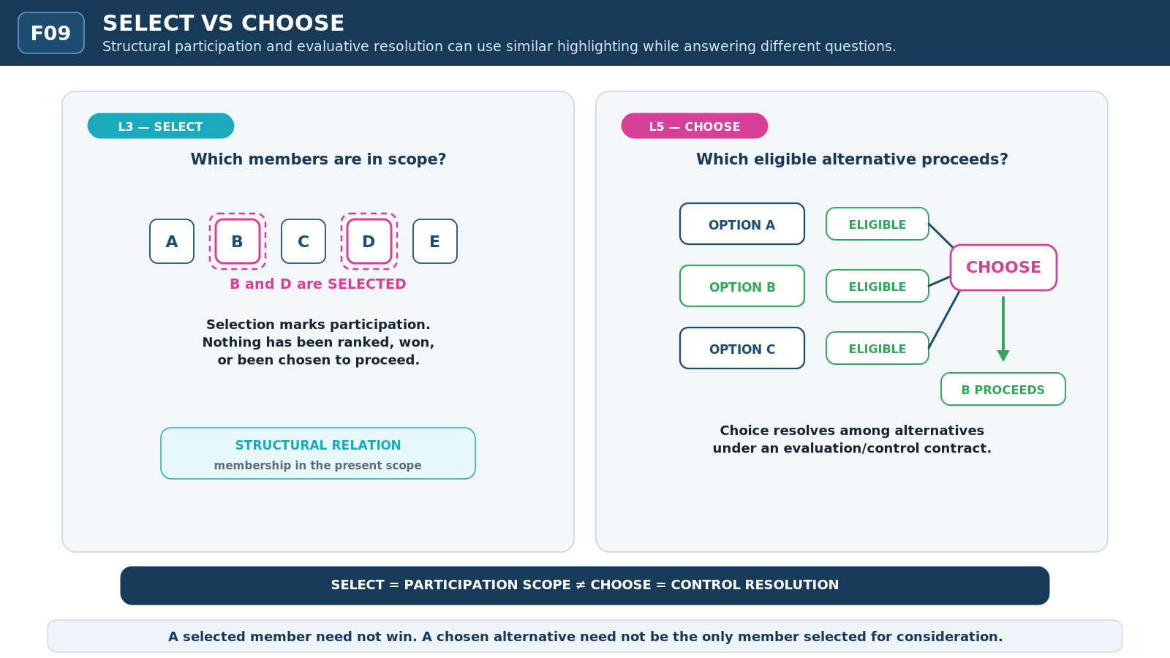
Figure F09 - SELECT vs CHOOSE. SELECT establishes participation in a structural scope; CHOOSE resolves among alternatives. Structural inclusion does not identify the selected outcome.
CHOICE LAW
SELECT defines participation. RACE produces a timing fact. CHOOSE resolves among alternatives. Similar diagrams do not make these mechanics equivalent.

L5 SYNTHESIS

10. From Evaluation to Control
The complete L5 surface can now be read as a staged relationship rather than one opaque decision box. A source is OBSERVED. Relevant information is EVALUATED under an explicit condition. The evaluation produces a RESULT. A GUARD or other controller interprets that result in relation to eligibility. A GATE or control state permits or suppresses a candidate ACTION. Only when the action actually executes do lower layers perform the corresponding routing, dynamics, transformation, or state change.
This sequence is explanatory anatomy, not a mandatory universal pipeline. Some systems may combine or omit stages when a simpler contract is sufficient. The language nevertheless keeps the distinctions available so that a debugger, human reviewer, or reasoning system can descend when causality matters. High-level control can remain compact without making its internal provenance irrecoverable.
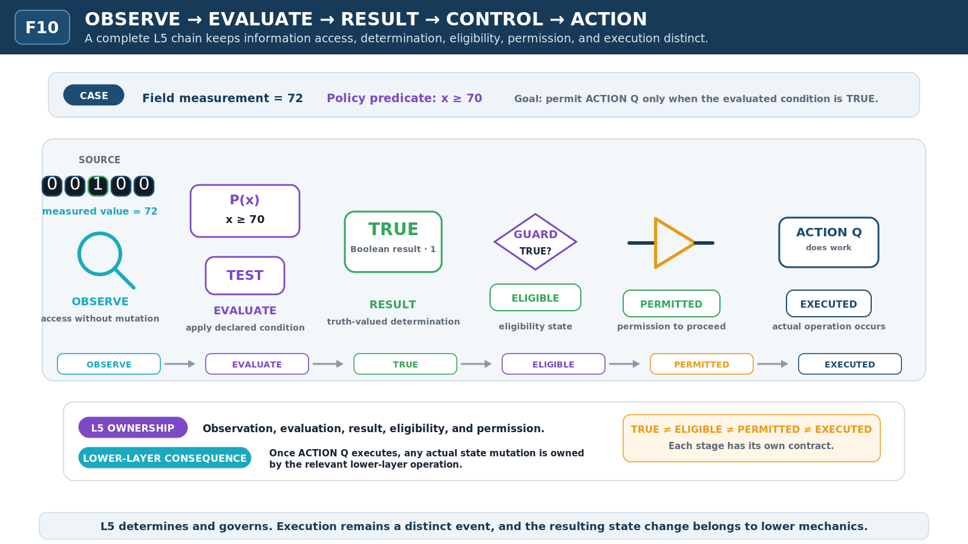
Figure F10 - Observe -> Evaluate -> Result -> Control -> Action. The complete L5 pipeline preserves observation, evaluation, resolved result, control, action, and lower-layer transformation as separate stages.
L5 NON-COLLAPSE
Observed != determined != eligible != permitted != executed. These states can coincide in a simple system, but coincidence does not erase their different cybernetic roles.

L6 - REASONING / LOGIC

11. When Results Become Reasoning Objects
Evaluation answers a bounded question about supplied information. Reasoning begins when resolved claims participate in a larger semantic structure. A Boolean result may become evidence for a proposition, a premise in an argument, a constraint inside an assumption context, or one observation among several Models. The result remains traceable to its evaluation while gaining a new role in a reasoning surface.
The transition is therefore not a change from bits into magic. It is a change in semantic relation. L5 can establish that a condition is true under a bounded test. L6 can then ask what follows if that condition and other propositions are jointly admitted. The same truth value can be present at both layers while the owned question changes from determination to consequence.
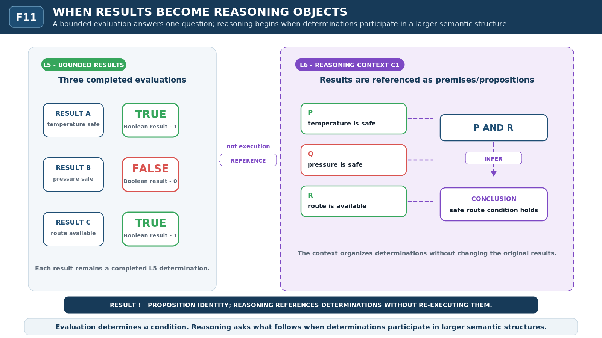
Figure F11 - When Results Become Reasoning Objects. Resolved evaluations become premises or propositions only when placed into a larger reasoning context. A result can be referenced without being rewritten.
MIDPOINT TRANSITION
Evaluation determines a condition. Reasoning determines what follows when conditions, propositions, assumptions, and Models participate in a larger semantic structure.

REASONING OBJECTS

12. Proposition, Formula, Assumption Context, and Model
A PROPOSITION is a truth-evaluable claim under a declared interpretation. A FORMULA gives explicit logical structure to propositions, predicates, connectives, quantifiers, or related reasoning objects. An ASSUMPTION CONTEXT bounds which premises, definitions, constraints, or provisional commitments are active for a reasoning task. A MODEL supplies an admissible interpretation under which formulas can be evaluated.
These objects provide accessibility without taking ownership of the mechanism being described. A Model of a routed system is not the route itself. An assumption that a sensor is calibrated does not make the physical sensor calibrated. A formula that constrains a transition does not perform the transition. Reasoning structures can describe, predict, compare, or constrain lower mechanics while remaining distinct semantic objects.
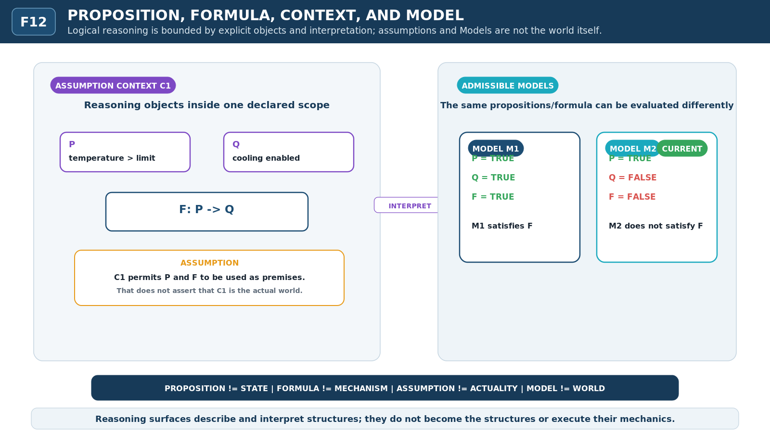
Figure F12 - Proposition, Formula, Context, and Model. Reasoning occurs inside declared semantic contexts. Propositions and formulas are evaluated under assumptions and Models without becoming the mechanisms they describe.
MODEL BOUNDARY
Assumption != actuality. Model != world. Formula != mechanism. The reasoning surface can describe a system without becoming the authority for the system it describes.

LOGICAL SCOPE

13. Quantification, Existence, and Unique Existence
Quantification changes the scope of a claim rather than the physical arrangement of the objects being discussed. Universal quantification asks whether a condition holds for every member in a declared domain. Existence asks whether at least one member satisfies the condition. Unique existence adds the requirement that exactly one member satisfies it. These claims may be evaluated over cells, objects, routes, Models, or any other bounded domain with an appropriate predicate.
The visual similarity to lower mechanics can be misleading. Unique existence is not exclusive occupancy: one is a logical claim about how many members satisfy a condition, while the other is a state contract governing where occupancy may reside. Existence is not activation, and quantification is not aggregation. The reasoning layer ranges over objects without silently changing them.
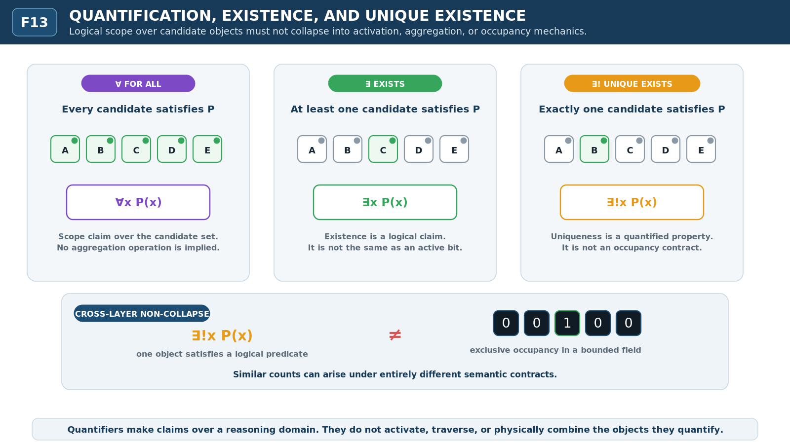
Figure F13 - Quantification, Existence, and Unique Existence. Universal, existential, and unique-existential scope range over candidate objects without collapsing into activation, occupancy, or aggregation.
QUANTIFICATION LAW
Existence != presence state. Unique existence != exclusive occupancy. Quantification ranges over a semantic domain; it does not itself activate, aggregate, or traverse its members.

MODELS & FORMULAS

14. Satisfaction and Satisfiability
SATISFACTION is a relation between a particular Model or interpretation and a formula: under that Model, the formula holds. SATISFIABILITY is a property of a formula or set of formulas: at least one admissible Model exists in which the relevant requirements can be satisfied. The distinction becomes visible only when multiple candidate Models are kept separate.
A formula can therefore be satisfiable even when it is false in the Model representing the current system state. Likewise, one Model failing to satisfy a formula does not establish unsatisfiability if another admissible Model satisfies it. This separation gives reasoning systems a clean way to distinguish what is true here from what is realizable somewhere within the declared semantic space.
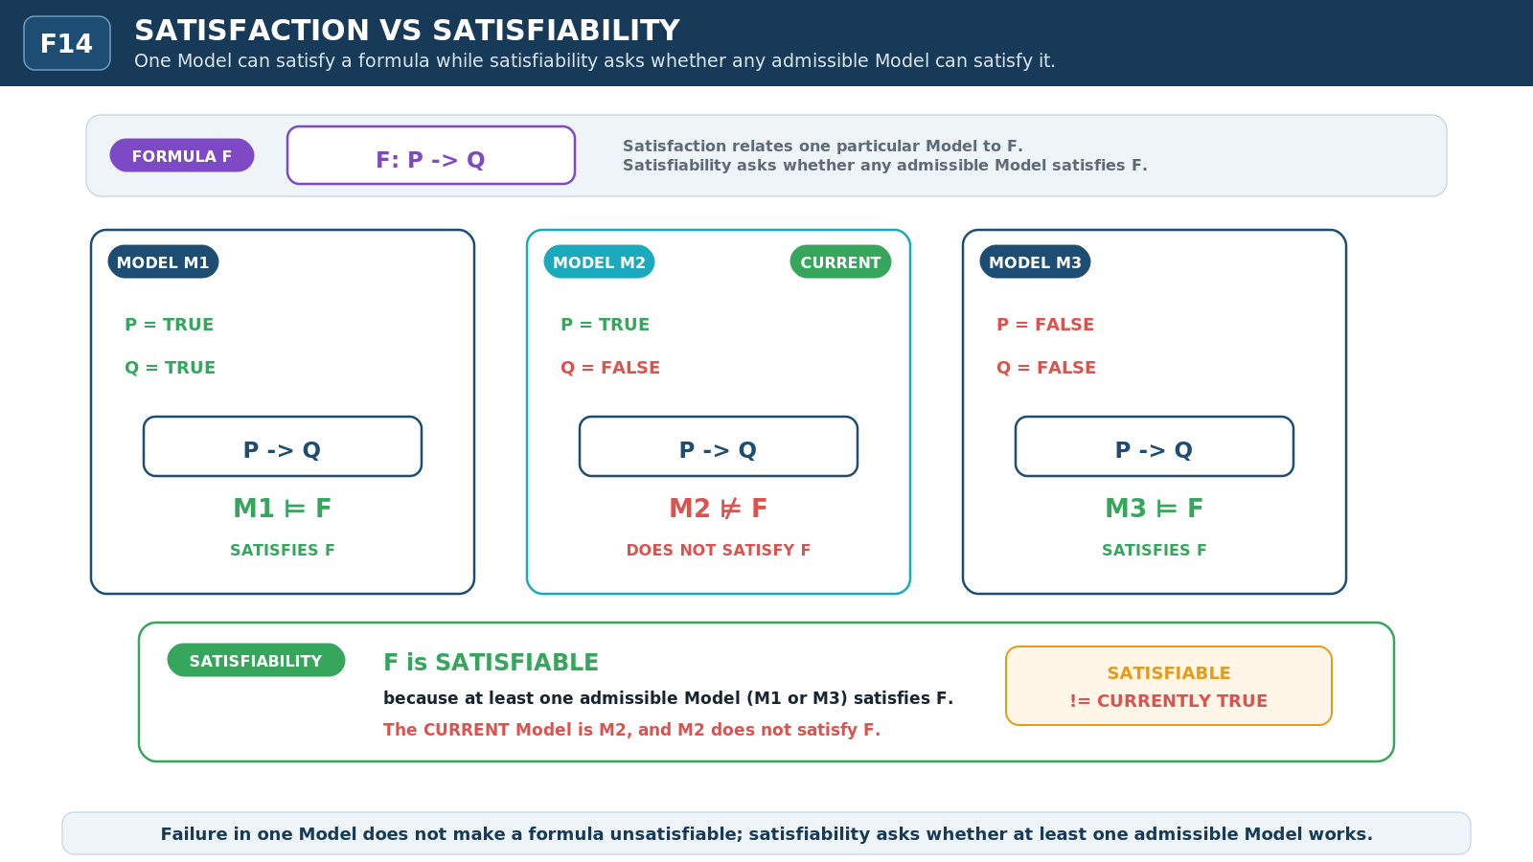
Figure F14 - Satisfaction vs Satisfiability. A particular Model can satisfy a formula, while satisfiability asks whether at least one admissible Model can satisfy it. Current truth is a separate question.
SATISFIABILITY LAW
Satisfied here != satisfiable somewhere. Satisfiable != currently true. Failure in one Model != unsatisfiable across all admissible Models.

CONSEQUENCE

15. Entailment, Derivability, and Inference
ENTAILMENT is a semantic consequence relation: in every admissible Model in which the premises hold, the conclusion also holds. DERIVABILITY is a formal relation: a conclusion can be obtained from premises using the rules of a declared proof or inference system. INFERENCE is the bounded reasoning occurrence in which premises, evidence, or intermediate claims are processed to produce a conclusion. These concepts can align in a well-designed formal system without becoming the same relation.
The distinction is especially important visually because arrows are easily overloaded. A causal arrow says that one event or operation leads to another in the represented mechanism. A derivation trace records formal rule application. An entailment connector expresses semantic consequence across Models. An inference path records a reasoning process. Paper III gives each relation a distinct visual channel so logical consequence never masquerades as physical motion.
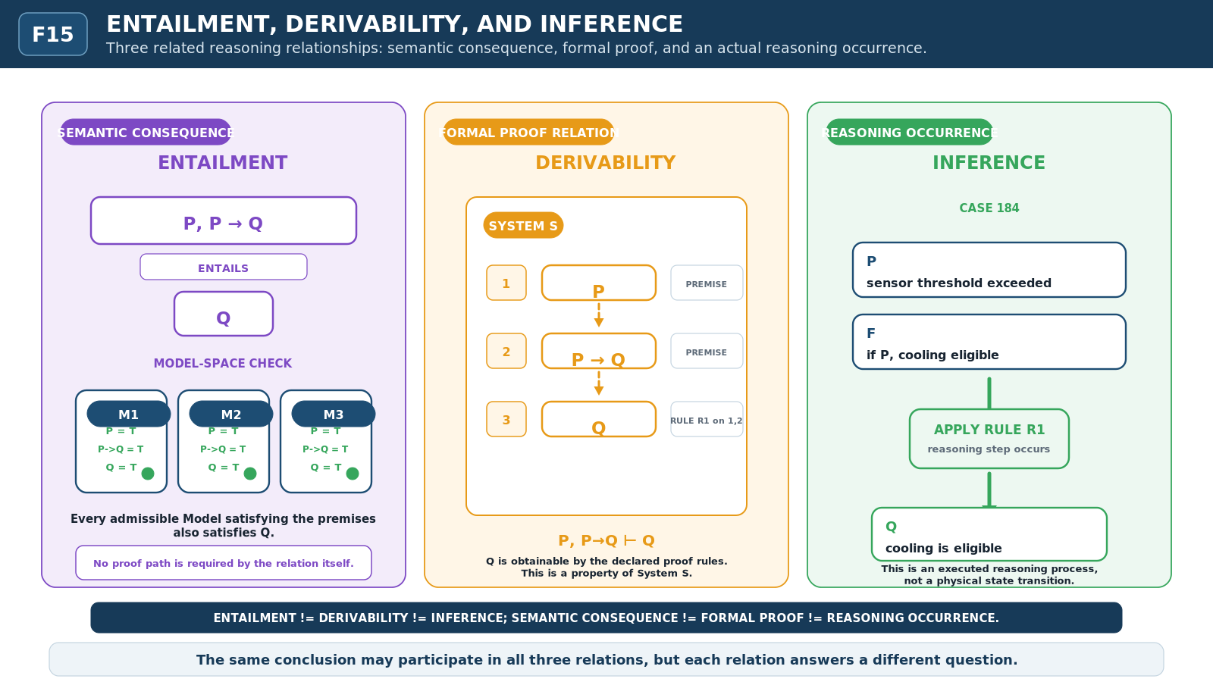
Figure F15 - Entailment, Derivability, and Inference. Semantic consequence, formal derivability, and an actual inference process occupy different reasoning relations and therefore use different visual channels.
CONSEQUENCE LAW
Entailment != derivability != inference. Semantic consequence, formal obtainability, and an actual reasoning process can support one another without collapsing into one relation.

RELATIONAL EQUIVALENCE

16. Equivalence Without Identity
Logical equivalence states that two expressions agree under a declared semantics or set of interpretations. That agreement does not make the expressions the same object. They can retain different syntax, structure, provenance, storage location, implementation, explanatory value, or computational cost while sharing the relevant truth behavior.
This continues a pattern visible throughout the series. Paper II showed that RESET and RESTORE can yield the same visible state while deriving authority from different sources. Paper III generalizes the discipline outward: same truth behavior does not prove same identity, and same conclusion does not prove same reasoning path. Equivalence is a relation that preserves the participants.
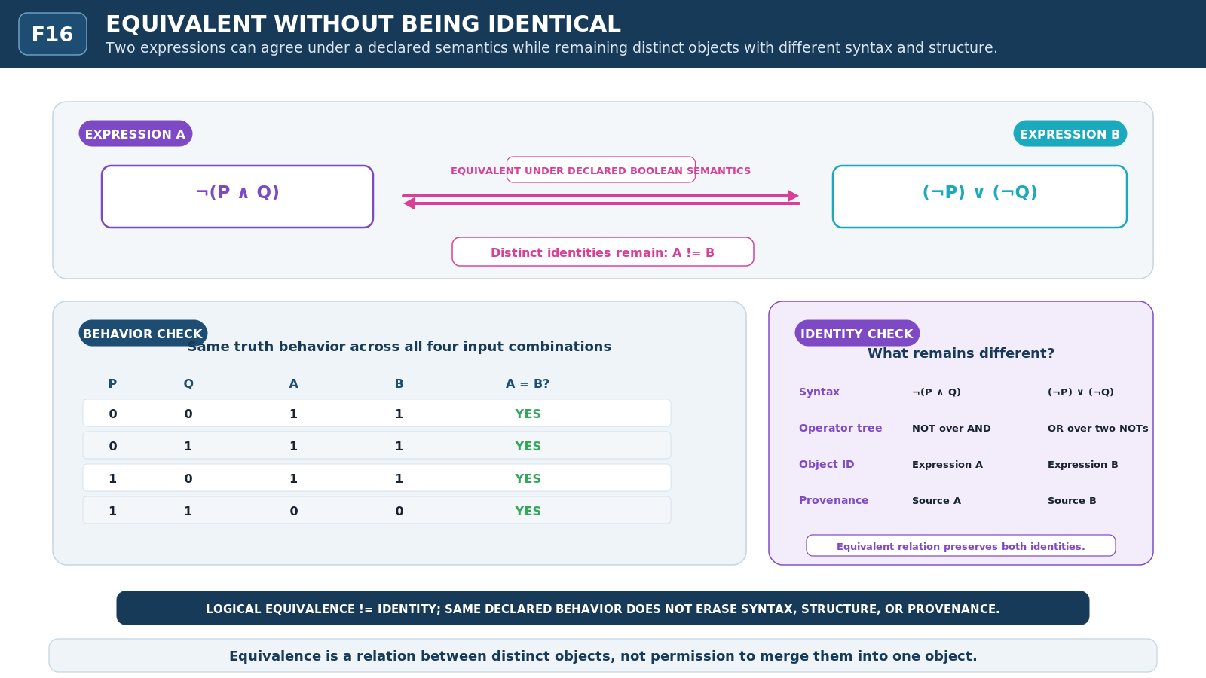
Figure F16 - Equivalent Without Being Identical. Two expressions can agree under a declared semantics while retaining distinct identity, syntax, structure, provenance, and implementation.
EQUIVALENCE LAW
Equivalent != identical. Agreement under one declared semantics does not merge syntax, provenance, implementation, or object identity.

LOGICAL PROPERTIES

17. Truth, Validity, Consistency, and Satisfiability
Logical vocabulary becomes clearer when each property is attached to the kind of object it evaluates. TRUTH is evaluated for a proposition or formula under an interpretation or Model. VALIDITY concerns whether a form, argument, or consequence relation preserves truth under the relevant semantics. CONSISTENCY concerns whether a set of commitments can coexist without the declared contradiction condition being forced. SATISFIABILITY asks whether at least one admissible Model realizes the requirements.
These properties answer different questions. A set can be consistent without every proposition in it being true in the current Model. A satisfiable formula need not currently hold. A true conclusion does not make an invalid argument valid, because the conclusion might have been reached for the wrong reason. Paper III therefore treats the property label as inseparable from its subject and semantic contract.
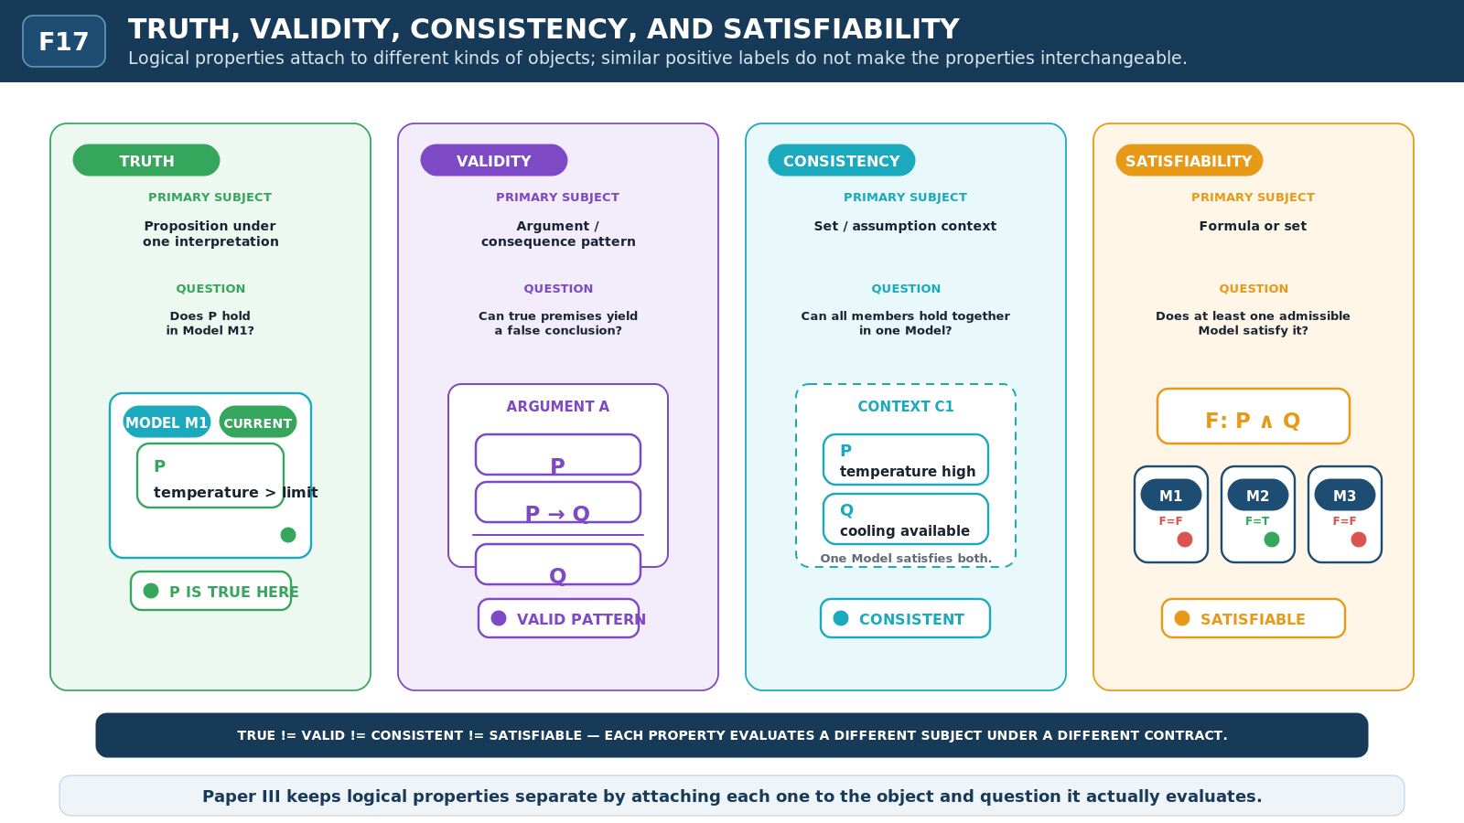
Figure F17 - Truth, Validity, Consistency, and Satisfiability. Logical properties attach to different subjects: propositions under interpretations, arguments or formulas, contexts, and candidate Model sets.
PROPERTY LAW
TRUE != VALID. CONSISTENT != TRUE. SATISFIABLE != ACTUAL. A logical property is meaningful only when the object and interpretation to which it applies are explicit.

MODAL REASONING

18. Necessity, Possibility, and Reachability
POSSIBILITY and NECESSITY reason over admissible alternatives. A proposition is possible when it holds in at least one relevant alternative under the declared modal context. It is necessary when it holds across every relevant alternative. CURRENT marks the instantiated state or Model being treated as authoritative now. REACHABILITY, by contrast, belongs to the transition structure: a target state is reachable when an allowed path from the current state can lead to it.
The distinction allows a system to represent a state that is possible in the broader Model space but unreachable from the present runtime configuration. Conversely, a currently true condition need not be necessary; another admissible Model may differ. Modal reasoning therefore describes the space of alternatives, while reachability describes the paths licensed by a particular transition system.
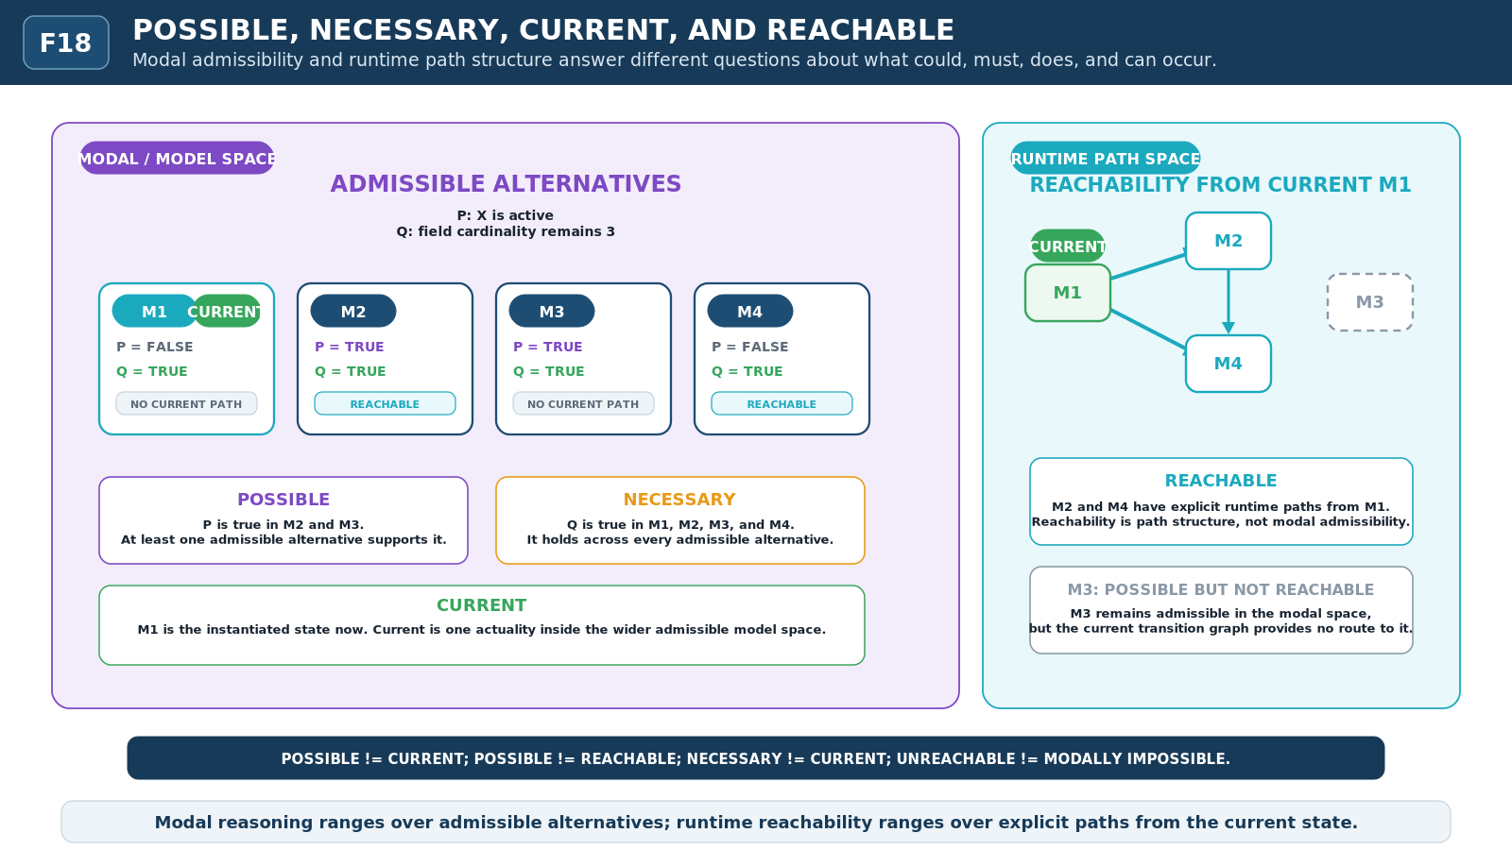
Figure F18 - Possible, Necessary, Current, and Reachable. Modal alternatives and runtime paths are separated so possible does not mean reachable, necessary does not mean merely current, and unreachable does not mean impossible.
MODAL LAW
Possible != reachable. Necessary != current. Unreachable from here != impossible under every admissible Model.

SEMANTIC RESOLUTION

19. Semantic Resolution and the Outer / Inner Contract
The six-layer language can now be read as one vertically composable system. L1 exposes exact state. L2 exposes direct transformation. L3 exposes structure and routing. L4 exposes behavior through time. L5 exposes evaluation and control. L6 exposes propositions, Models, consequence, and logical properties. No layer is automatically more true than another; each answers a different class of question at a different semantic resolution.
Upward abstraction compresses lower detail into more accessible meaning. Downward resolution restores causal specificity when a claim must be inspected, executed, debugged, or challenged. The highest-sufficient-resolution rule still applies: use the most abstract layer that can answer the present question without silently assuming unresolved lower facts. Descend only when additional causal or operational detail matters.
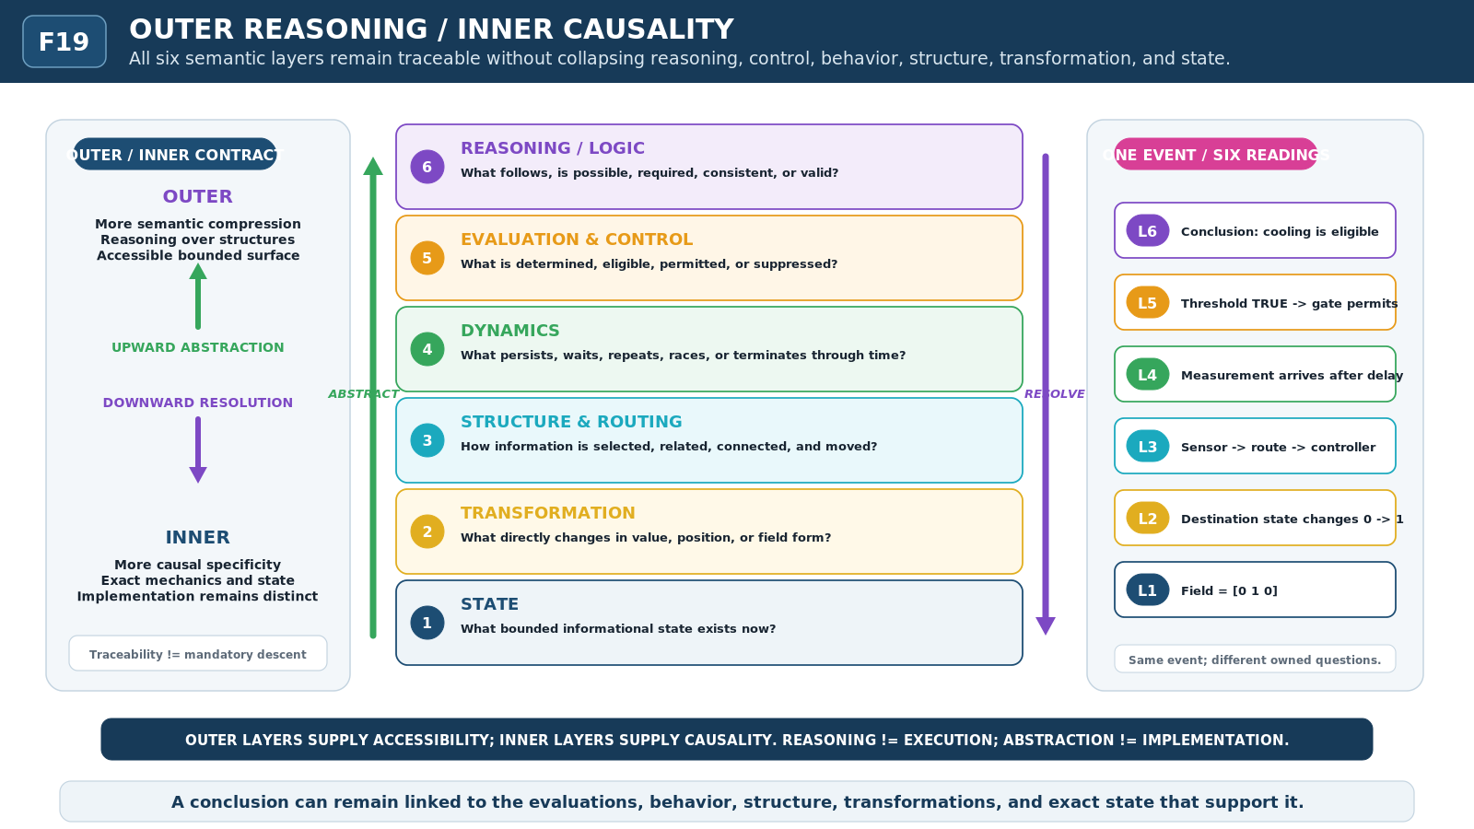
Figure F19 - Outer Reasoning / Inner Causality. All six semantic layers remain traceable in both directions: outward abstraction increases semantic compression while inward resolution increases causal specificity.
OUTER / INNER CONTRACT
Outer layers supply accessibility: an intelligence can reason safely at a bounded semantic surface. Inner layers supply causality: they expose how the relevant state, structure, or behavior actually exists and changes.

HERO SYNTHESIS

20. Cybernetic Judgment - Full-Series Synthesis
The final synthesis asks whether all six semantic layers can coexist in one bounded episode without collapsing into a single opaque notion of decision. The specimen begins with state and structure, acquires activity through time, exposes an observation, applies an evaluation, produces a Boolean result, resolves eligibility and control, and then allows an outer reasoning surface to state what follows under the active assumptions and Model.
The critical endpoint is deliberately split. A reasoning system may correctly conclude that operation Q is eligible. That conclusion is not evidence that Q executed. Actuality remains owned by the causal system: the gate must permit flow, the action must occur, and the lower layers must exhibit the resulting behavior or transformation. The separation prevents reasoning from rewriting reality merely by describing what should, may, or must be true under a contract.
Figure F20 - Cybernetic Judgment. One bounded episode is traced from state through behavior, evaluation, control, and reasoning while preserving the final distinction: Q ELIGIBLE is not Q EXECUTED.

What the synthesis demonstrates
All six semantic layers can describe one bounded episode without sharing the same owned question.
Observation, result, eligibility, permission, action, and resulting state remain distinct.
Reasoning can inspect lower mechanics without becoming their execution path or owner.
Upward abstraction and downward resolution preserve traceability across the full stack.
HERO THESIS
A conclusion remains inspectable when it can be traced outward to its reasoning context and inward through evidence, evaluation, control, behavior, structure, transformation, and exact state.

RESEARCH FRONTIER

21. Open Questions and Non-Collapse Laws

Questions preserved for later revision
Does DETECT deserve a distinct mechanic, or is it a constrained family of TEST operations over observations?
Where should MEASURE end and domain-specific interpretation begin when normalization, calibration, or derived quantities are required?
Is MATCH a distinct evaluative mechanic across patterns and structures, or a specialized comparison contract?
Should TEST name the act of applying a predicate, or should evaluation remain a broader family with several execution forms?
Can BOOLEAN RESULT remain visually distinct from generic state when diagrams become much denser or monochrome?
Is GUARD best represented as a proposition about eligibility, a control object, or two linked contracts?
Where exactly does ENABLE end and GATE begin when availability and permission are both conditional?
Does SUPPRESS require multiple contracts for temporary inhibition, masking, priority arbitration, and output muting?
When CHOOSE consumes scores, rankings, or race outcomes, which evaluation mechanics belong inside the choice contract and which remain upstream?
Can the same Boolean operators remain coherent at L5 over resolved conditions and at L6 over propositions without losing layer identity?
Where exactly does PREDICATE end and PROPOSITION begin?
Which assumptions must be explicit before a Model can be treated as admissible for satisfaction, entailment, or modal reasoning?
Can entailment, derivability, and inference remain visually distinct in large proofs without reverting entirely to conventional symbolic notation?
How should uncertainty, confidence, incomplete Models, and abstention interact with truth-valued evaluation without creating false precision?
Can possibility and reachability be composed cleanly when the transition system itself changes across Models?
Which L6 concepts are true cybernetic primitives, and which belong only to higher reasoning schemas or GROOVED mechanisms?

CORE NON-COLLAPSE LAWS

21.2 Non-Collapse Matrix
Concept A | != | Concept B | Concept A | != | Concept B
observe | != | evaluate | observe | != | mutate
detect | != | generic observe | measure | != | evaluate
compare | != | predicate result | predicate | != | result
bit state | != | truth value | Boolean result | != | trigger
evaluation | != | control | guard | != | gate
gate | != | action | eligibility | != | execution
enable | != | execute | disable | != | terminate
suppress | != | delete | select | != | choose
race | != | choose | proposition | != | state
formula | != | mechanism | assumption | != | actuality
model | != | world | quantification | != | aggregation
existence | != | activation | unique existence | != | exclusive occupancy
satisfaction | != | satisfiability | satisfiable | != | currently true
entailment | != | derivability | derivability | != | inference
transition | != | implication | logical equivalence | != | identity
truth | != | validity | consistency | != | truth
necessity | != | current truth | possibility | != | reachability
reasoning over structure | != | ownership | reasoning | != | execution
TRIAL BOUNDARY
The matrix records distinctions that survived the visual pressure test. It does not claim that every term is primitive or that the present names are final.

CLOSING MODEL

22. Conclusion
Cybernetic Mechanics III reduces the Evaluation-Reasoning dyad to one inspectable anatomy. EVALUATION begins with bounded information and produces explicit determinations under declared conditions. CONTROL consumes those determinations to govern availability, eligibility, permission, suppression, and choice. REASONING places determinations inside larger semantic structures so an intelligence can ask what is satisfied, what follows, what can be derived, what is consistent, what is possible, and what is necessary.
The figures show why these operations must remain distinct from the mechanics beneath them. Observation can occur without evaluation. A Boolean result can exist without becoming a trigger. A satisfied guard can leave an action merely eligible. A Model can describe a system without owning it. A valid consequence need not be a causal transition. A possible state need not be reachable from the current configuration. These distinctions allow high-level reasoning to remain compact without erasing the route back to causality.
The surviving contribution is therefore not a finished universal logic or a canonical CERBERUS operator inventory. It is a visual and conceptual discipline for cybernetic judgment: preserve the object being observed, preserve the criterion used to judge it, preserve the control relation that governs what may happen, preserve the reasoning context that supports a conclusion, and preserve the difference between that conclusion and the actuality of execution.
GOVERNING STATEMENT
Cybernetic evaluation derives explicit determinations from bounded observations. Cybernetic control governs what may proceed from those determinations. Cybernetic reasoning determines consequence and logical properties over bounded semantic structures. None of these operations alone proves that the underlying world changed.
SERIES CLOSURE
BE -> CHANGE -> ORGANIZE -> BEHAVE -> EVALUATE -> REASON is now represented as one vertically composable visual grammar across the three Cybernetic Mechanics papers. The series remains experimental and non-canonical pending later formal language work.

TRIAL-DERIVED L5 + L6

Appendix A. Working Vocabulary
The vocabulary below is the current planning vocabulary inherited from Cybernetic Language Trial 0 and pressure-tested through Paper III. Inclusion does not imply primitive status, canonical registration, final symbol assignment, or permanent naming.
L5 - EVALUATION & CONTROL  observe  detect  measure  compare  match  test  threshold  predicate  Boolean result  NOT  AND  OR  XOR  guard  eligibility  gate  enable  disable  suppress  choose  permission state | L6 - REASONING / LOGIC  proposition  formula  assumption context  model  universal quantification  existence  unique existence  satisfaction  satisfiability  entailment  derivability  inference  equivalence  truth  validity  consistency  necessity  possibility  reachability boundary

Compressed model
EVALUATE -> REASON
Observe evidence -> apply a declared evaluative contract -> record the resolved result -> govern eligibility and permission -> place relevant determinations into a bounded reasoning context -> determine consequence, compatibility, or modal status. The sequence is explanatory anatomy, not a mandatory execution pipeline.
FINAL NON-COLLAPSE
Conclusion != execution. A reasoning system may determine that an operation is valid, permitted, necessary, or eligible while the causal system still records that the operation did not occur.

