CERBERUS ARCHITECTURE SERIES / OCTOGROOVE
OCTOGROOVE
GRAPH ASSEMBLY FABRIC
Deterministic Document Compilation Through Reusable Planning, Asset Routing, Templates, Themes, and Human-Gated Media Generation
Core Thesis The AI should not have to remember the project. It should resolve the next bounded graph instruction.

Architecture Paper | Version 0.1 | August 2026
Companion architecture to the GROOVED PASS, OctoGroove AI Execution & Bootstrap Guide, and CERBERUS Template System.

Executive Overview
OctoGroove began as a human-gated method for building complex professional artifacts through eight bounded passes. This paper describes the next implementation layer: a graph assembly fabric that externalizes planning, document structure, figure dependencies, asset dependencies, generation rules, and verification state so that downstream execution can operate from addressable build objects rather than repeatedly reconstructing the project from conversation.
The architecture is deliberately cumulative. CERBERUS and SOLAR/MIRROR seed reusable semantic and visual material. A project-local OctoGroove workbook holds temporary build state. OneDrive persists physical files and build packages. Figures are constructed from addressable Assets. The Document Spine references completed Figures by identity. A verified artifact can then return new document relationships and reusable Assets to CERBERUS, enriching the next build rather than leaving its intelligence trapped in the finished file.
Think once. Preserve useful structure. Assemble deterministically. Promote what should be reused.

What this architecture changes
Before | Graph Assembly Fabric
Project state concentrated in conversation and working memory | Resolved state is persisted as bounded, addressable graph objects.
Figures may be reconstructed from descriptive prose | The Spine references a finished Figure ID; Figure construction lives elsewhere.
Image reuse depends on remembering folders and prior prompts | SOLAR/MIRROR routes reusable material into a bounded project Asset seed.
Generation style is repeatedly restated | Rulesets and Themes compile reusable generation guidance and exclusions.
Successful build knowledge dies with the document | Reusable Assets, Figures, Templates, Rules, and Themes can be promoted into a persistent library.

Reader destination
By the end of the paper, the reader should be able to explain the eight-pass graph surface, the Document Spine grammar, the recursive Asset dependency model, the distinction between temporary build state and persistent production capability, the role of SOLAR/MIRROR in project seeding, and the human-readable generation contract that lets recurring mistakes be repaired at their owning source.

Contents
Part | Title | Primary focus
Part I | From Method to Machine | System overview, pass fields, Template/Ruleset/Theme governance
Part II | External Build Memory and Document Compilation | Brainstorm compression, Spine grammar, Continuance, type lookup, Figure references
Part III | Asset Routing and Recursive Construction | SOLAR/MIRROR seeding, edge-list graph, build order, identity boundary, promotion
Part IV | Persistence, Ownership, and AI Working Memory | Build versus library graph, Airtable/OneDrive/CERBERUS ownership, external build memory
Part V | Governed Generation and Cumulative Production | Generation readback, persistent correction, maturity, accretion, creative unlocks
Appendix | Formal Principles and Boundaries | Non-collapse laws, implementation scope, related specifications

PART I
From Method to Machine
OctoGroove becomes an executable graph surface without losing its human gates or ownership boundaries.

1. From an Eight-Pass Method to a Graph Assembly Fabric
The Graph Assembly Fabric does not replace OctoGroove. It makes the existing pass discipline externally executable. The earlier OctoGroove architecture already established bounded pass ownership, explicit outputs, human approval gates, rollback, selective staleness, semantic QA, visual QA, and late composition. The Graph Assembly Fabric adds an implementation rule: every sufficiently resolved construction decision should be representable as an addressable object or relationship that downstream work can consume directly.
The result is a publication system in which intelligence is progressively compiled out of active memory and into durable project state. A brainstorm can remain expansive while meaning is still being resolved. Once a section, Figure, Rule, Theme, or Asset has been resolved, the system should persist the minimum structure needed to use it later. Downstream execution then references the persisted object rather than rebuilding the same reasoning from prose.
Externalized Build Memory | Resolved construction state that is persisted outside the AI working context and can be retrieved by stable identity and dependency.

Graph Assembly Fabric | The project-local and persistent structures that let OctoGroove seed, resolve, build, assemble, verify, reuse, and promote artifact components through explicit graph relationships.

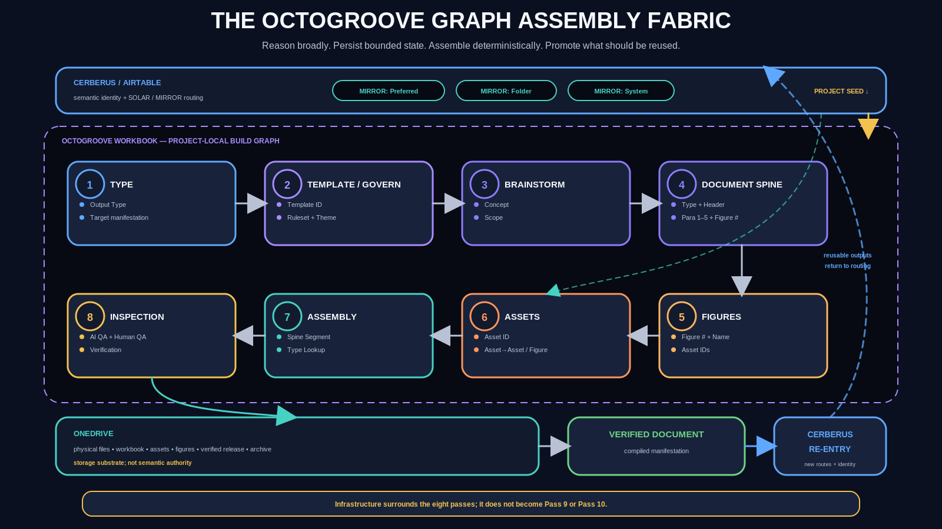
Figure 1. The OctoGroove Graph Assembly Fabric. The eight OctoGroove passes form the build surface. CERBERUS/SOLAR/MIRROR seed semantic and visual routes; OneDrive persists physical material; the verified document and reusable outputs return to the broader CERBERUS environment.

2. The Eight-Pass Graph Surface
Each pass remains bounded, but the approved output is now understood as a graph surface that can be read by later passes. Pass 1 declares the output type. Pass 2 binds the Template, Ruleset, and Theme. Pass 3 holds the brainstormed concept. Pass 4 compiles content into the ordered Document Spine. Pass 5 resolves Figures. Pass 6 resolves and builds Assets. Pass 7 walks the Spine and assembles the artifact. Pass 8 verifies semantic and rendered conformance.
The important shift is not that every field must be normalized into a huge database. The architecture uses bounded records where they are efficient and explicit edges where relationships matter. A five-paragraph Spine record can be sufficient when Continuance provides unbounded logical flow. An Asset edge list can be sufficient when three fields capture the graph relations that determine recursive construction.
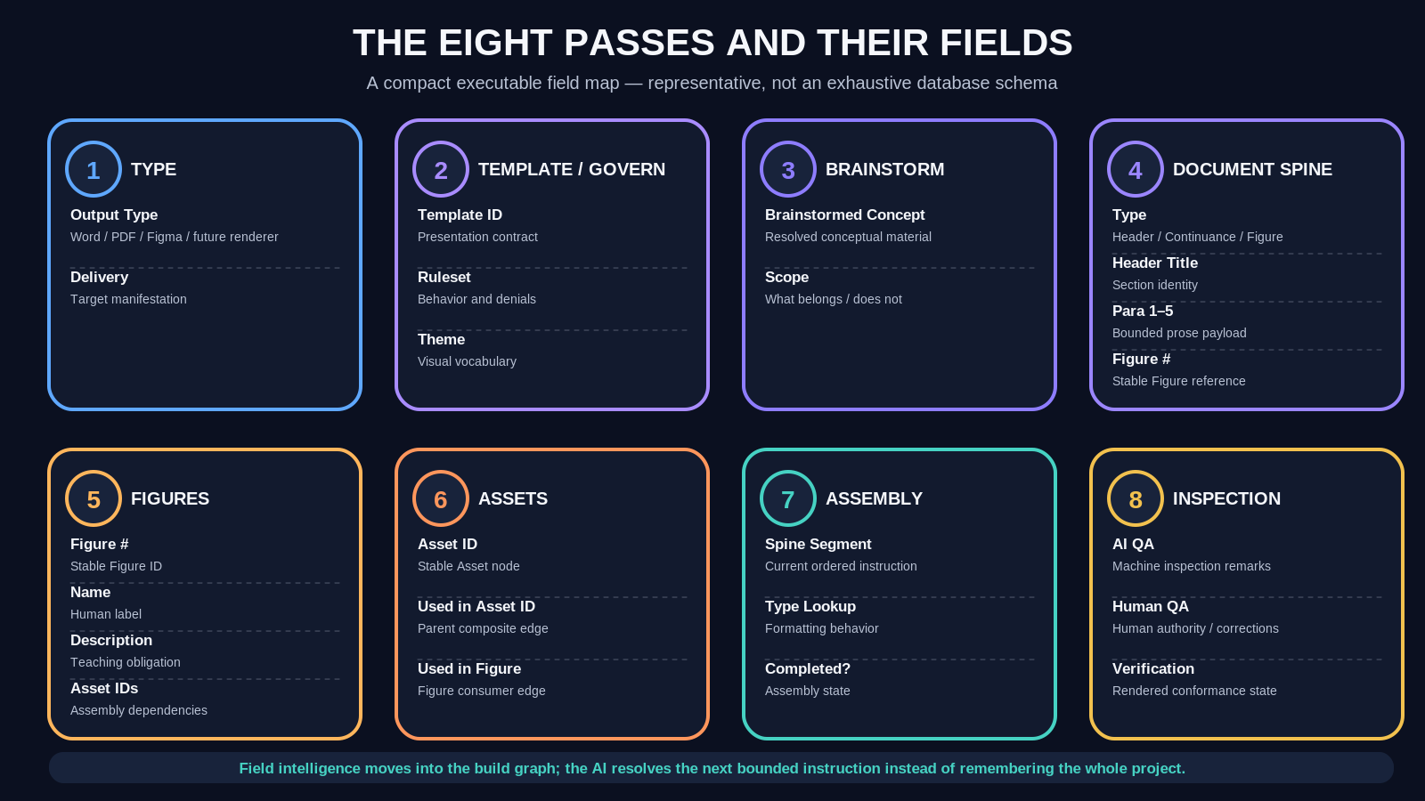
Figure 2. The Eight Passes and Their Fields. Representative fields externalize the decisions that each pass owns. The figure is a teaching map, not a claim that every eventual implementation field is already fixed.

3. Template Governance: Presentation, Ruleset, and Theme
The Template remains the placement and presentation contract defined by the CERBERUS Template System. It owns Regions, Slots, geometry, presence behavior, fit rules, and rendering expectations. The Graph Assembly Fabric extends this object by binding two additional reusable governance surfaces: a Ruleset and a Theme.
This separation prevents a monolithic Template from becoming a giant prompt. Presentation answers where and how information is placed. Rulesets answer how the build may behave. Themes answer what visual vocabulary is reachable and what curated generative character may be applied. These three surfaces can evolve independently while still being selected together through the Template.
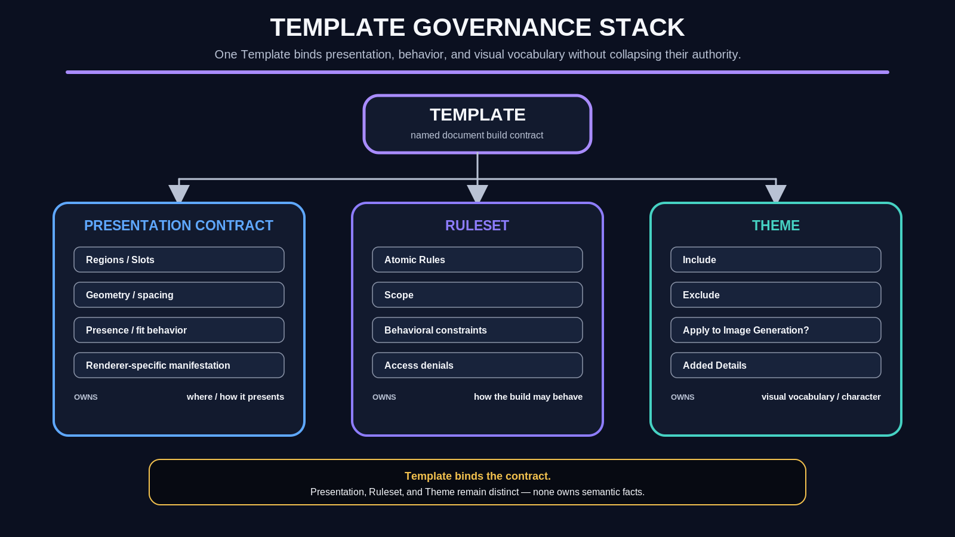
Figure 3. Template Governance Stack. The Template binds presentation, behavioral governance, and visual vocabulary without collapsing their ownership. Semantic facts remain outside all three.

4. Atomic Rules and Access Denials
Rules are intended to be small, composable modifiers rather than complete project instructions. A Rule can require canonical Assets, deny animals, restrict retrieval to a Shape folder, prohibit generated imagery, require exact labels, or constrain a specific renderer. Rulesets then bundle the Rules appropriate to a recurring document or Figure class.
Access Denials are especially valuable because they can reduce the reachable search surface before expensive reasoning begins. If a technical Figure is governed by Shapes Only and Canonical Assets Only, the AI should not inspect animal imagery, decorative photographs, or unrelated generated material and then reason about whether to reject it. The denial should prune the candidate surface upstream.
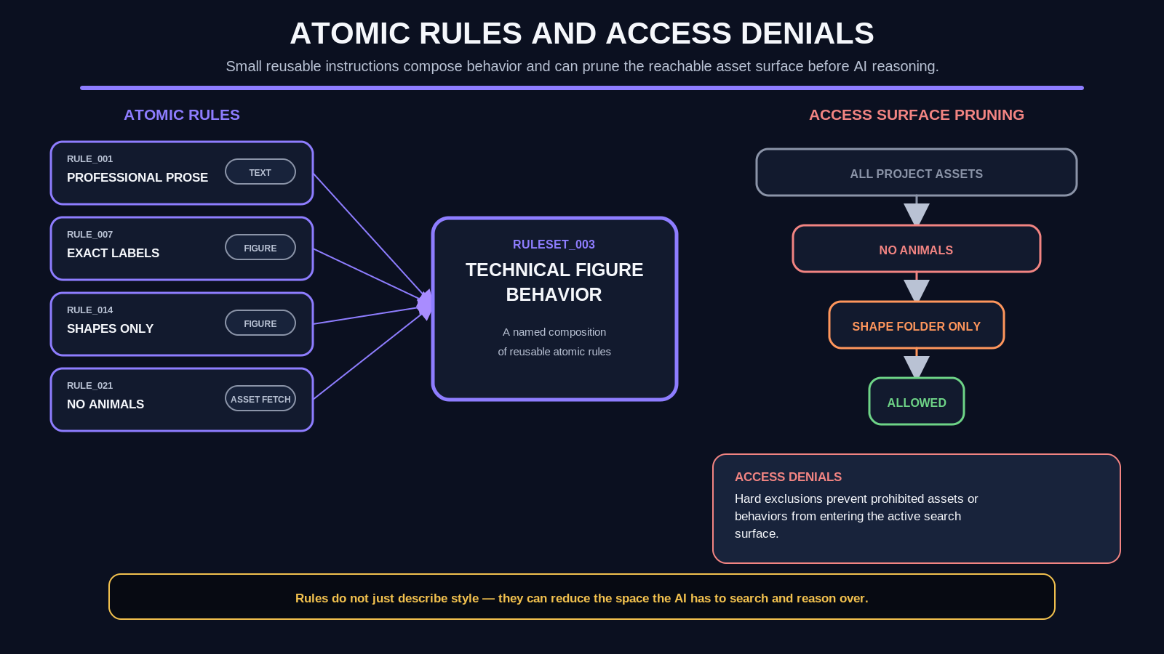
Figure 4. Atomic Rules and Access Denials. Atomic Rules compose into a Ruleset. Access Denials reduce the reachable execution surface rather than relying on repeated downstream rejection.

5. Theme Resolution and the Two-Channel Model
Themes govern visual territory. Their Include and Exclude fields determine what material is eligible for ordinary assembly. Separately, Apply to Image Generation? and Added Details govern whether curated Theme guidance participates in image generation. This split prevents Theme membership from being misread as prompt prose.
A Theme might include Worlds, Explorers, structural diagrams, environmental Assets, or a historical visual library because those objects belong to the presentation vocabulary. That does not mean every generated image should literally contain a World, an Explorer, and a diagram. Generation receives only the curated details that have been explicitly enabled for that purpose, together with the local requirement, applicable Rules, and exclusions.
Non-collapse Theme Include controls visual access. It does not automatically become image-generation prompt text.

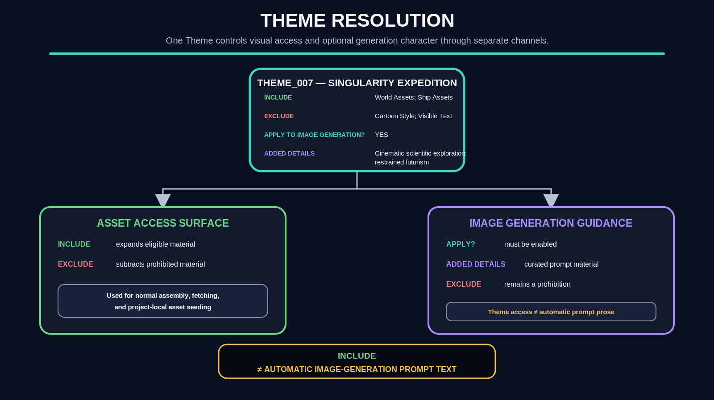
Figure 5. Theme Resolution. One Theme resolves into two distinct channels: asset access through Include/Exclude and optional image-generation guidance through Apply? plus Added Details.

PART II
External Build Memory and Document Compilation
Large acts of reasoning are progressively compiled into small ordered instructions.

6. The AI Should Not Have to Remember the Project
Large document projects are expensive to keep alive as conversational state. A model can repeatedly reread prior explanations, remember formatting decisions, track which Figures are finished, reconstruct where an Asset came from, and keep correction history active - or the system can persist those decisions once and retrieve only the subset needed for the current operation.
The Graph Assembly Fabric treats the AI context more like a working cache than a project database. Brainstorming can use broad context while meaning is unresolved. Once a portion is compiled into an addressable record, downstream execution should retrieve that record and its relevant dependencies rather than retaining the entire construction history. The architecture therefore scales by reducing reconstruction, not by pretending that reasoning is unnecessary.
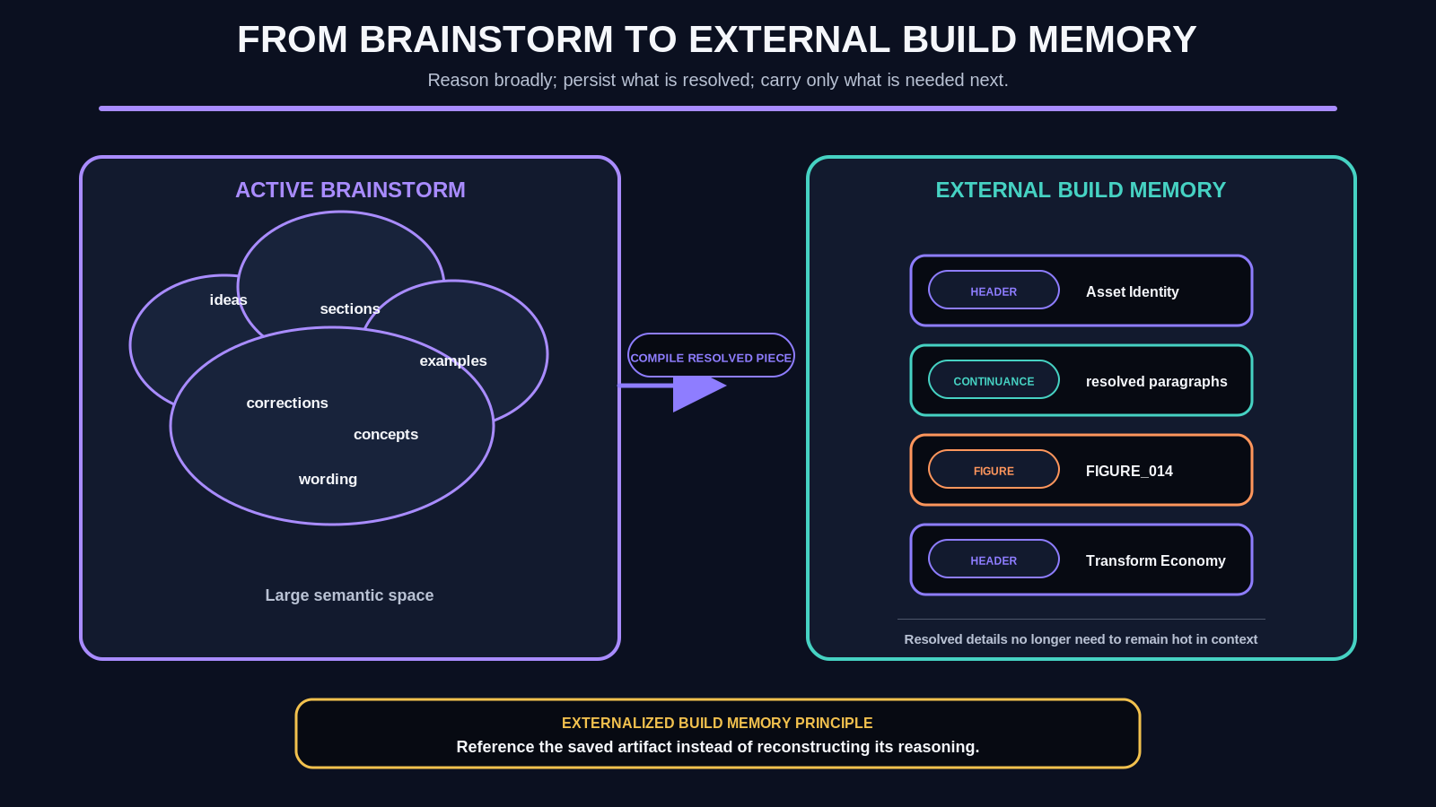
Figure 6. From Brainstorm to External Build Memory. Broad conceptual reasoning is progressively compiled into persistent, bounded records. Resolved construction state can leave active working memory without being lost.

7. The Document Spine Grammar
The Document Spine is the ordered mechanical representation of the paper. It does not attempt to normalize every sentence or paragraph into its own database record. Instead, each Spine row is a bounded instruction that carries the payload needed for deterministic assembly. The current grammar is intentionally small: Header, Continuance, Figure, and related Type-controlled records.
A Header opens a new logical section and emits its title and paragraphs. Continuance extends the same logical section using another bounded row. A Figure resolves a stable Figure ID and inserts the completed visual according to the active Template. The renderer simply walks the ordered Spine and applies the behavior associated with each Type.
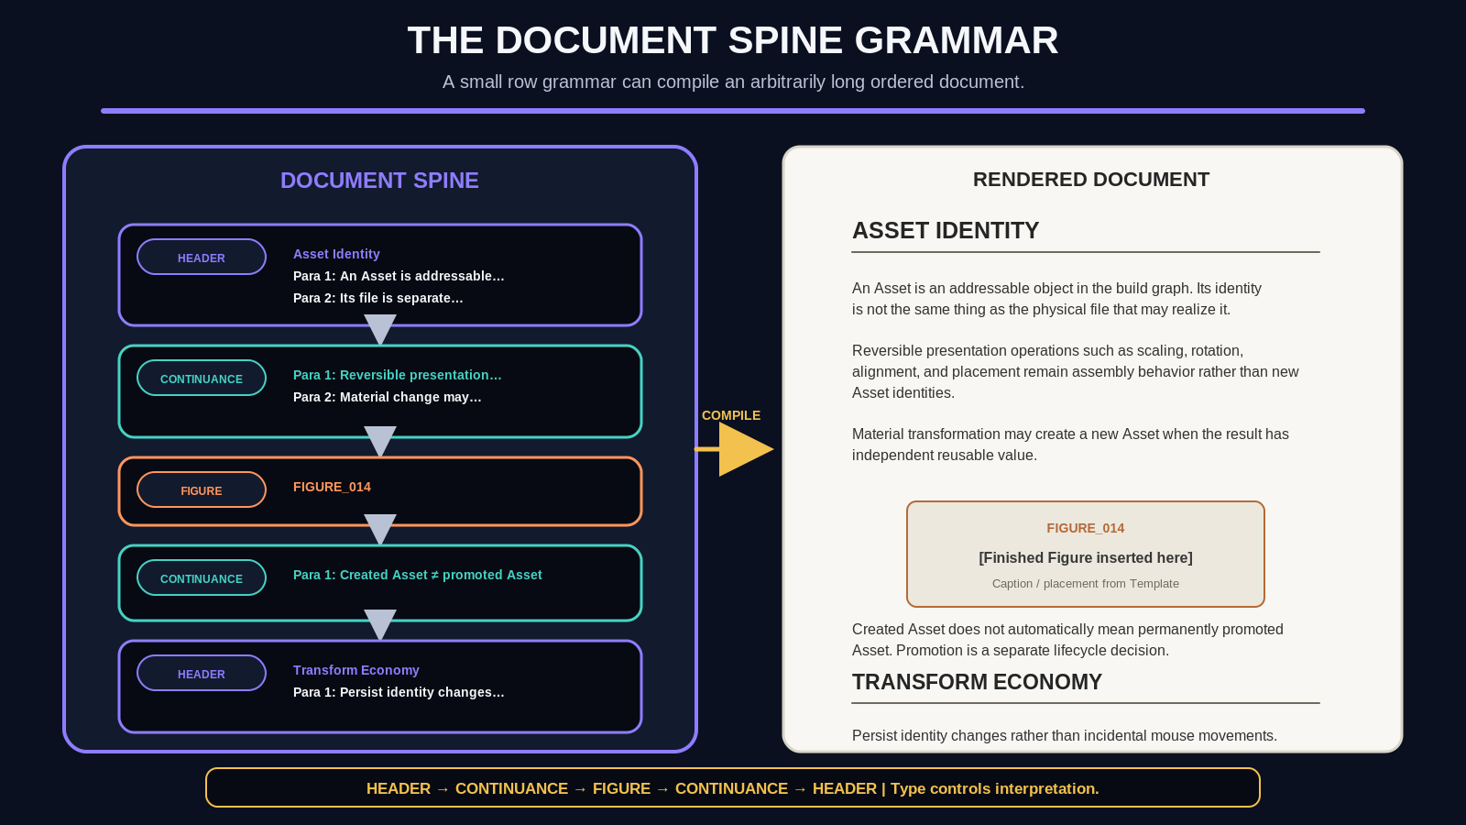
Figure 7. The Document Spine Grammar. Header, Continuance, and Figure records create an ordered document stream. Type controls interpretation; the resulting document is compiled from the sequence rather than re-authored at composition time.

8. Continuance: Bounded Storage, Unbounded Prose
The five paragraph fields in the current Spine design are a physical storage choice, not a semantic limit. When a section needs more prose, another Continuance row carries the next set of paragraphs. Multiple rows therefore compose one logical section without requiring an arbitrarily wide record or a fully normalized paragraph graph.
This pattern is important beyond prose. It demonstrates a general design preference: use bounded containers where they make execution legible, then use explicit continuation or dependency relationships to represent unbounded composition. The representation remains machine-readable without turning every small textual unit into a separate object.
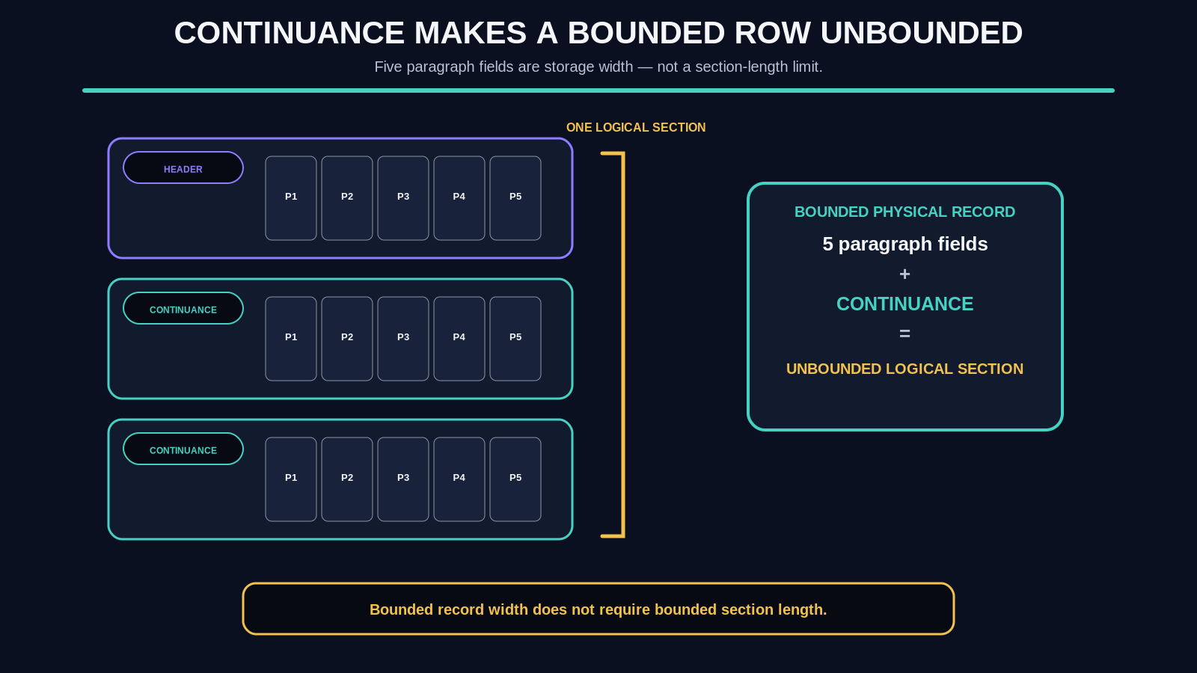
Figure 8. Continuance Makes a Bounded Row Unbounded. Multiple bounded records can represent one logical section. Five paragraph fields constrain record width, not section length.

9. Type Lookup Becomes Deterministic Formatting Behavior
Once the Spine has an explicit Type, the renderer no longer needs to infer formatting from prose. Header can map to header typography and section spacing. Continuance can explicitly suppress a new heading. Figure can resolve the Figure ID, insert the finished visual, and apply caption behavior. These mappings remain governed by the active Template rather than hard-coded forever into the Spine itself.
The goal is deterministic execution with replaceable presentation. The same semantic Spine could be rendered into different output environments or Themes as long as each renderer understands the Type contract and the selected Template provides the necessary presentation behavior.
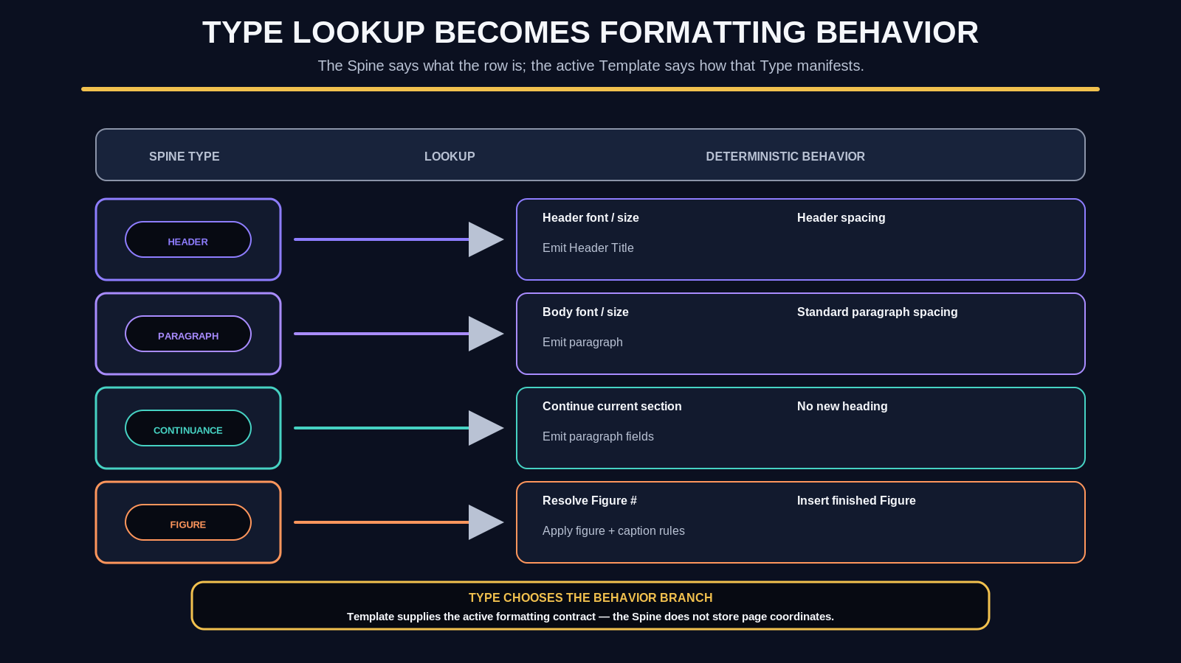
Figure 9. Type Lookup Becomes Formatting Behavior. Spine Type selects assembly behavior while the active Template supplies presentation parameters. Deterministic execution does not require presentation to be globally fixed.

10. A Figure Is Referenced, Not Reconstructed
The Spine should not contain a Figure's entire Asset history. Once a Figure has been built and assigned a stable identity, the document only needs the Figure reference. The Figure registry or build output owns its internal construction, while the Document Spine owns placement.
This distinction is a direct example of externalized build memory. A downstream assembler can retrieve FIGURE_017 without carrying the reasoning that selected its Assets, the geometry that composed them, or the intermediate steps that produced it. Those details remain available when debugging or rebuilding the Figure, but they are not required for routine document composition.
The document needs the Figure identity, not the Figure construction history.

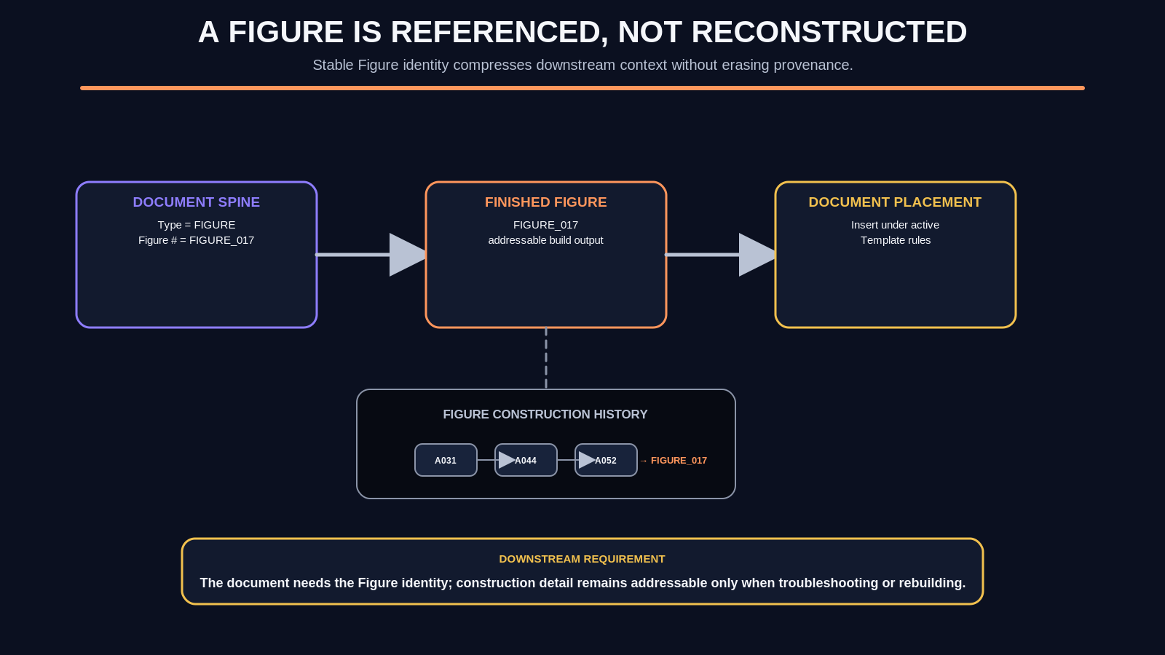
Figure 10. A Figure Is Referenced, Not Reconstructed. The Spine stores a stable Figure reference. Figure construction remains addressable elsewhere and is retrieved only when needed.

PART III
Asset Routing and Recursive Construction
Reusable visual material enters through governed routes, composes recursively, and promotes selectively.

11. SOLAR/MIRROR as the Project Asset Seed
A document build should not ingest the entire visual library. Relevant SOLAR records provide a bounded lexical entry point, and MIRROR exposes the Asset routes that matter to the current concept. For the initial implementation, the project only needs to read three MIRROR-facing fields from relevant records: Preferred, Folder, and System.
Those routes seed the project-local Asset Sheet with identifiers and retrieval locations. The workbook does not become a duplicate of MIRROR. It holds only the local dependency subset required for the current build. OneDrive remains the physical persistence substrate, while CERBERUS/Airtable remains the semantic and routing authority.
MIRROR field | Project function
Preferred | Provides the preferred display or representative Asset for the routed semantic term.
Folder | Provides the physical Asset folder or alias used for bounded retrieval.
System | Provides the routed system Asset IDs that may seed the project-local Asset surface.

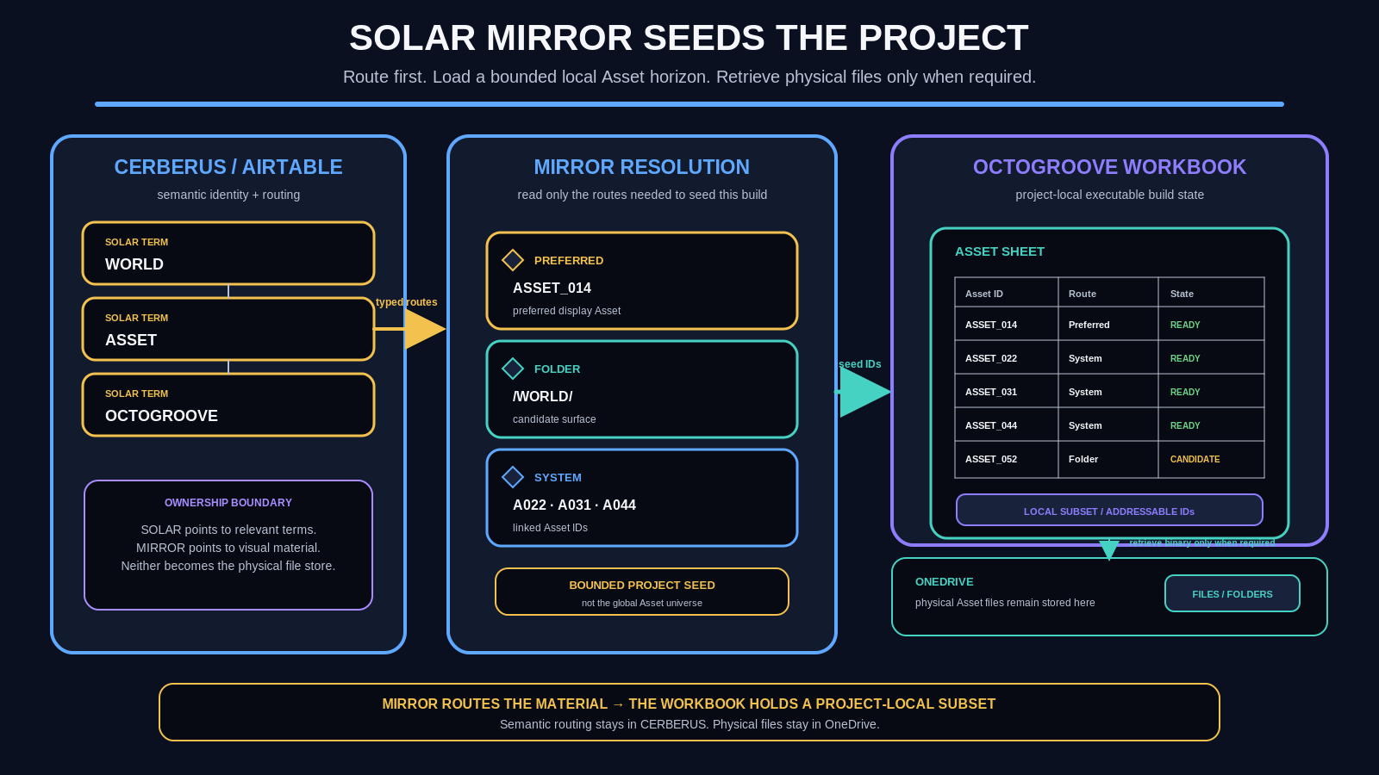
Figure 11. SOLAR/MIRROR Seeds the Project. Relevant SOLAR terms resolve MIRROR routes into a bounded local Asset seed. OneDrive stays external as physical storage rather than becoming part of the workbook.

12. The Asset Sheet Is an Edge List
The core Asset graph can be represented with three fields: Asset ID, Used in Asset ID, and Used in Figure. A row does not need to describe every transform or layout decision. It records the causal relationship required to reconstruct recursive composition.
If ASSET_001 and ASSET_002 are used to build ASSET_005, and ASSET_003, ASSET_004, and ASSET_005 are used in FIGURE_001, the spreadsheet rows are simply an edge-list representation of the graph. This makes recursive construction legible to both humans and automation without introducing a separate graph database for the project.
The table is an edge list. The asset system is a graph.

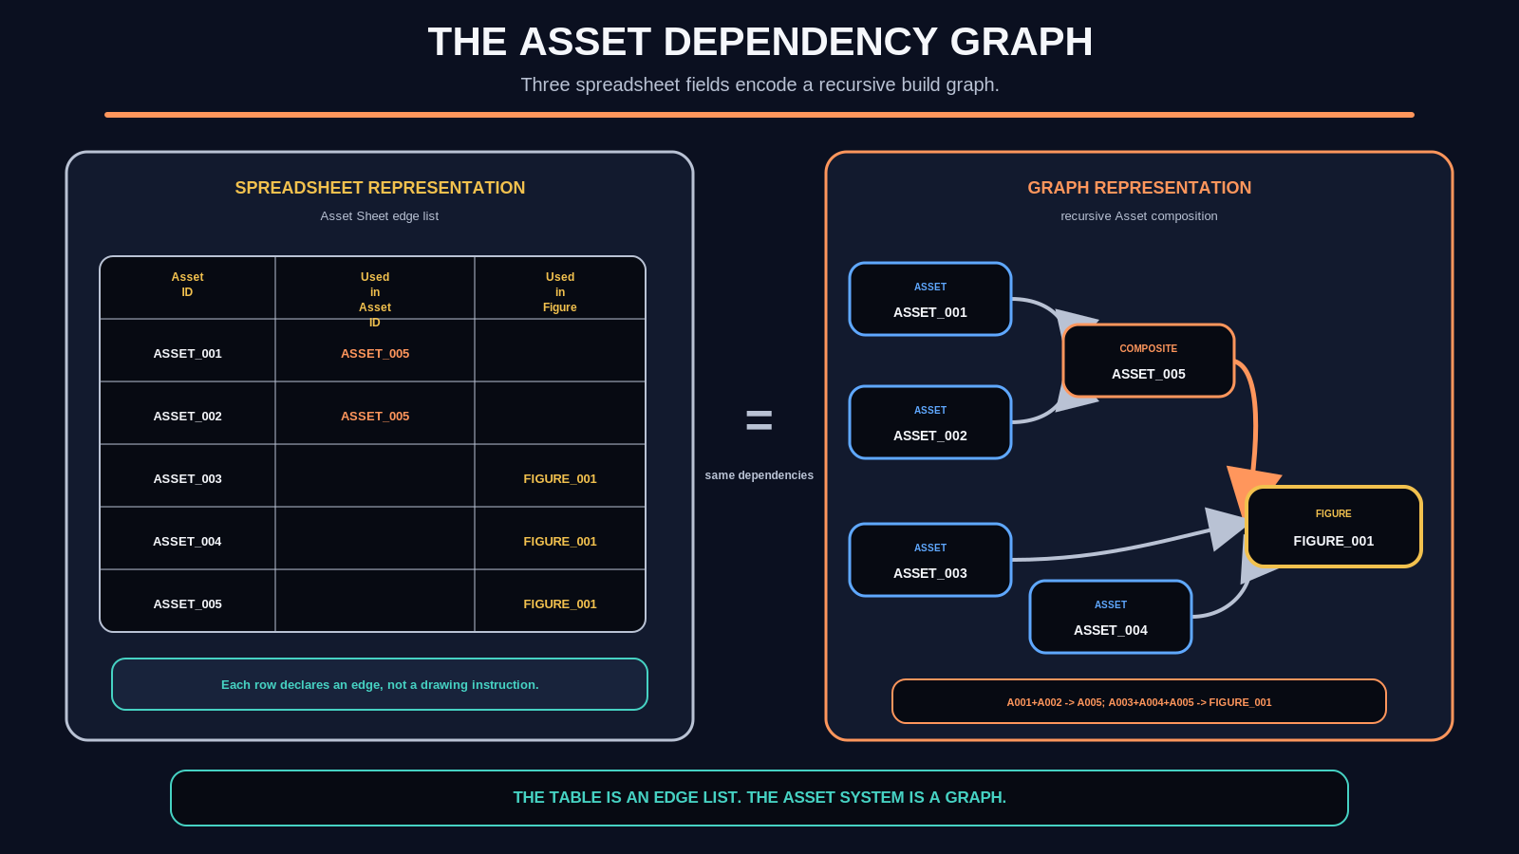
Figure 12. The Asset Dependency Graph. The spreadsheet edge list and the visual dependency graph encode the same relationships. Asset-to-Asset composition and Asset-to-Figure use remain distinct edges.

13. Dependency Depth Determines Build Order
Because the dependency relationships are explicit, the build sequence can be derived rather than remembered. Existing or fetched Assets form the deepest available layer. A composite becomes buildable when its required children are available. Larger composites follow. Figures are built only after their required Assets exist.
This does not mean every build must be strictly serial. Independent branches can be built in parallel. The important property is that dependency order is a consequence of the graph. A runtime can identify ready nodes, unresolved children, blocked Figures, and selective rebuild targets without asking an AI to reconstruct the entire plan from prose.
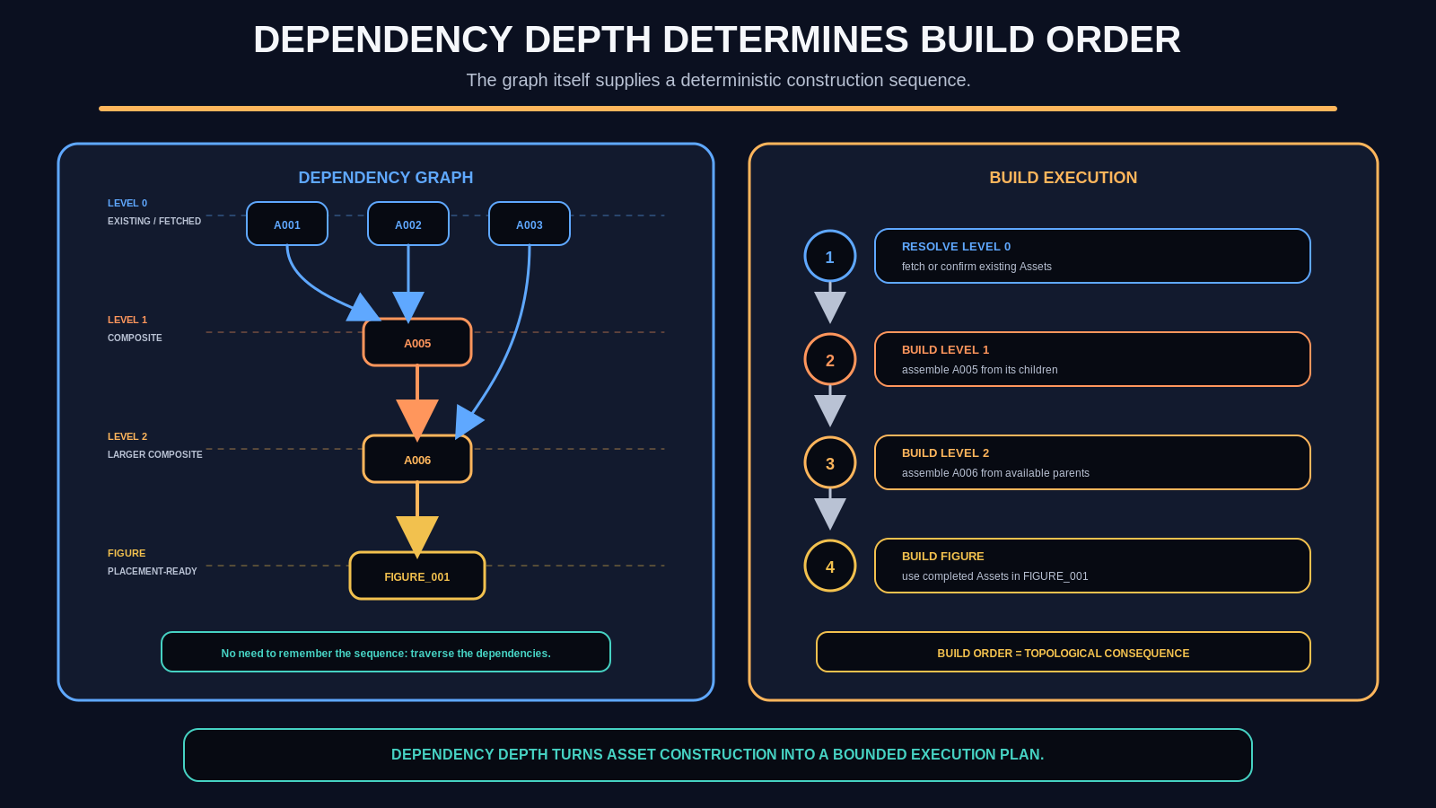
Figure 13. Dependency Depth Determines Build Order. Explicit dependencies reveal construction depth. Existing Assets feed composites; composites can feed larger composites; Figures resolve only when their required material is available.

14. The Asset Identity Boundary
Not every visual operation deserves persistent identity. Position, scale, rotation, ordinary opacity, alignment, layering, and other reversible presentation decisions should normally remain Figure-assembly parameters. Creating a new Asset ID for every five-degree rotation or ten-percent resize would preserve incidental execution detail rather than useful semantic or material structure.
A materially new, independently useful result may deserve a new Asset identity. Examples include a destructive edit that changes the reusable object, a permanently fused composite, a derived silhouette, or another state that must be addressed independently for reconstruction or reuse. The governing principle is to persist causal material change, not mouse movements.
Transform economy Save identity changes, not mouse movements.

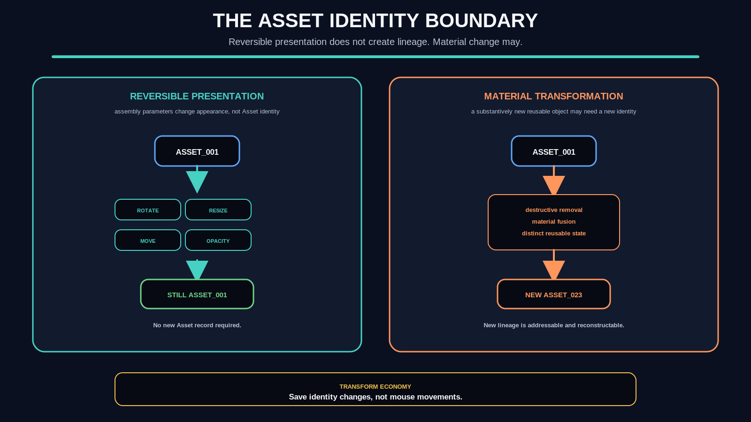
Figure 14. The Asset Identity Boundary. Reversible presentation changes remain variants of the same Asset. Materially new reusable results may receive new Asset identities.

15. Asset Creation Is Not Asset Promotion
Creating a derived Asset inside one project does not automatically justify permanent library promotion. The project may need a one-off crop, composite, or state that has no expected value outside the current Figure. That object can remain local and disappear when the build workspace is scrubbed, or be retained only inside an archived provenance package.
Promotion is a separate decision about reuse. A useful composite, Figure primitive, Template, Theme, or visual component can be saved to the persistent Asset Pool and routed through MIRROR. Separating identity creation from library promotion prevents the persistent library from becoming a dump of intermediate execution debris.
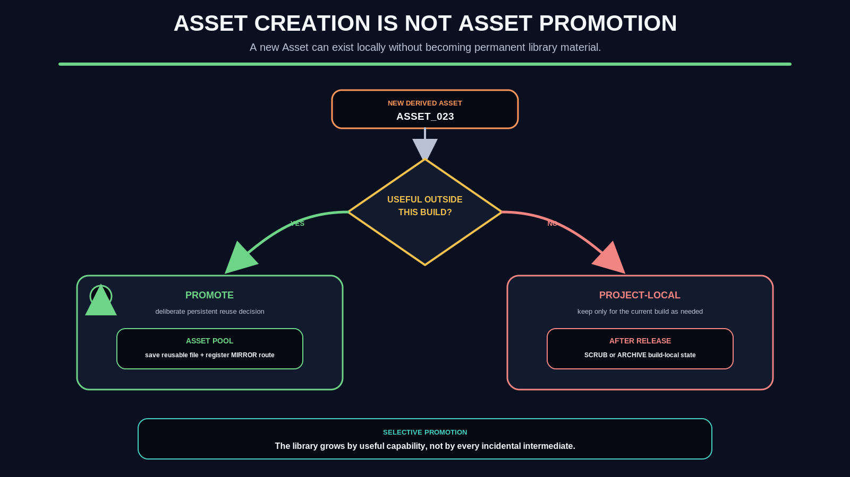
Figure 15. Asset Creation Is Not Asset Promotion. A newly derived Asset branches into two lifecycle paths: promotion when reusable, or project-local retention followed by scrub/archive when not.

PART IV
Persistence, Ownership, and AI Working Memory
The build workspace is disposable; the production vocabulary is cumulative.

16. Temporary Build Graph and Persistent Library Graph
The architecture deliberately contains two graphs. The Build Graph is temporary and project-specific: brainstorm, Spine, Figure planning, Asset requirements, assembly, inspection, and other execution state. The Library Graph is persistent: reusable Assets, Figures, Templates, Rules, Themes, MIRROR routes, and provenance that deserve to survive across builds.
The two graphs exchange material in both directions. Library objects are reused by a new project. Approved project outputs can be promoted back into the Library. At closure, temporary build state can be scrubbed or archived according to provenance needs. This preserves cumulative capability without forcing every project decision to become permanent canonical state.
The workspace is disposable. Reusable capability is not.

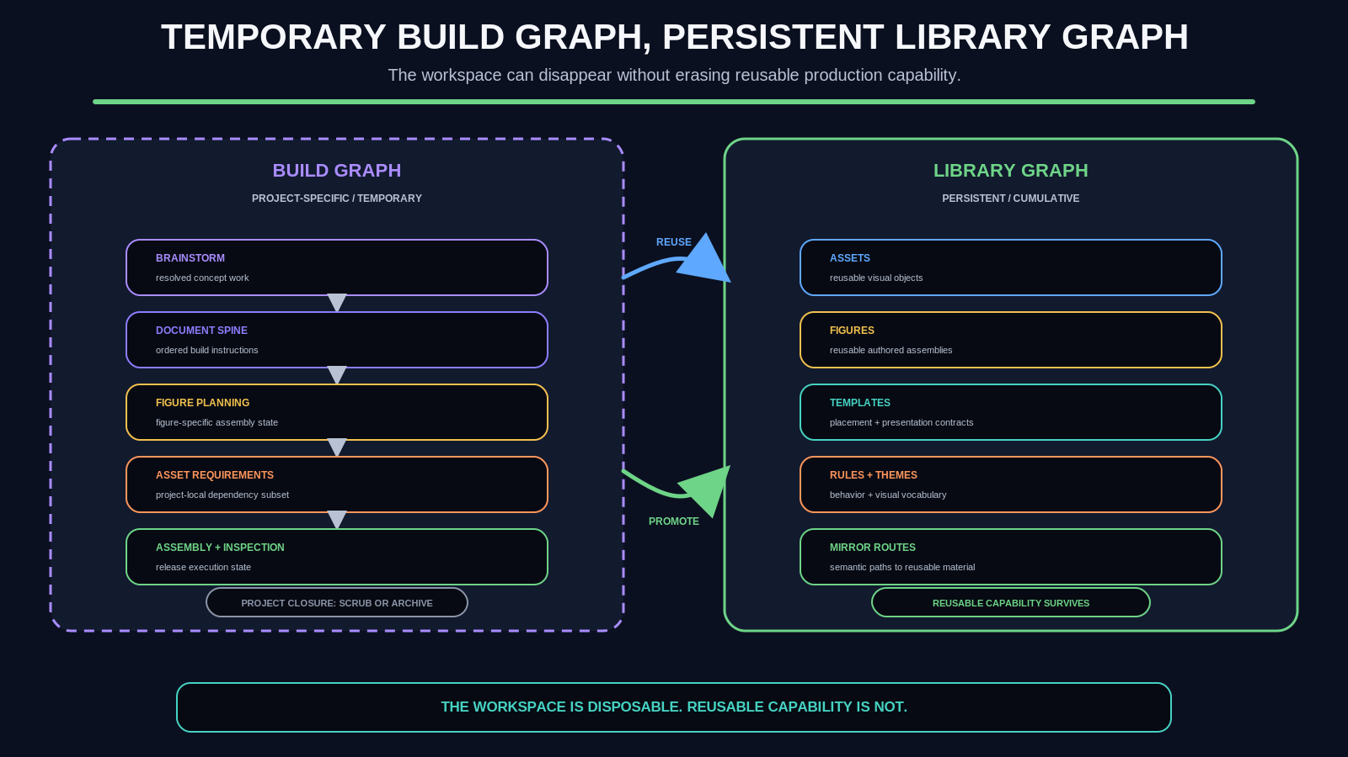
Figure 16. Temporary Build Graph, Persistent Library Graph. The Build Graph contains project execution state; the Library Graph contains persistent reusable capability. Reuse flows into projects, while promotion selectively flows back out.

17. System Ownership: Airtable, OneDrive, Workbook, and Artifact
The current implementation uses several technologies, but each is assigned a bounded responsibility. CERBERUS/Airtable owns semantic identity and routing. SOLAR and MIRROR make those routes usable. OneDrive owns physical persistence. The OctoGroove workbook owns temporary executable planning state. The final document is a compiled manifestation, not the canonical database of the systems that produced it.
Surface | Owns | Must not become
CERBERUS / Airtable | Semantic identity, SOLAR/MIRROR routing, document and Asset relationships | A shadow file store or temporary build workspace
OneDrive | Physical files, workbooks, build packages, Asset folders, finished artifacts | Semantic authority
OctoGroove workbook | Project-local build graph and deterministic planning state | The global Asset library or semantic source of truth
Verified document | Compiled manifestation for human use | The sole surviving record of build intelligence

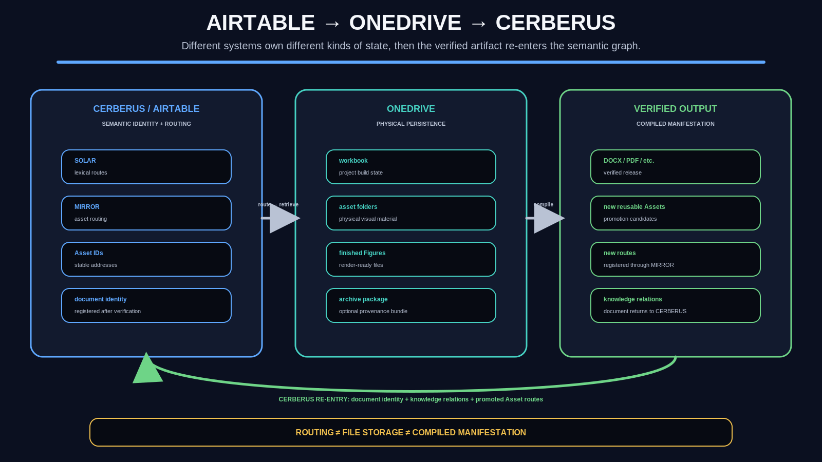
Figure 17. Airtable to OneDrive to CERBERUS. Semantic identity and routing, physical persistence, verified manifestation, and CERBERUS re-entry form a loop while retaining distinct ownership boundaries.

18. The Graph Becomes Long-Term Build Memory
The most important scaling effect is architectural rather than cosmetic. Without external build state, an AI must repeatedly keep or reconstruct project history, Figure plans, Asset provenance, formatting rules, correction history, and pending dependencies. With the graph, routine execution can focus on the current node and the subset of dependencies required to resolve it.
This paper does not claim a specific token-savings percentage or benchmarked performance gain. The claim is structural: explicit external state reduces the need to encode the same project relationships repeatedly inside active model context. When more context is needed, the system can retrieve it from the graph rather than relying on memory of how the object was originally constructed.
Externalized Build Memory Principle | Once a construction decision has been compiled into an addressable artifact, downstream execution should reference that artifact rather than repeatedly reconstructing its reasoning.

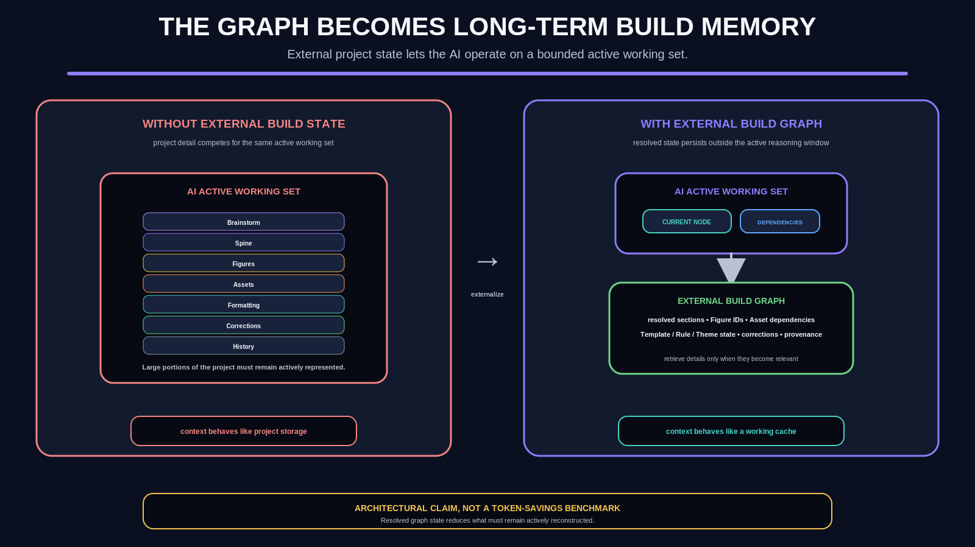
Figure 18. The Graph Becomes Long-Term Build Memory. The AI operates on the current node and relevant dependencies while the project graph persists resolved state externally. This is an architectural model, not a token benchmark.

PART V
Governed Generation and Cumulative Production
Generation becomes inspectable, correctable, reusable, and increasingly inexpensive to repeat.

19. Theme-Aware Image Generation
Image generation enters the fabric as another governed build operation rather than an opaque side activity. A local image requirement is combined with applicable Rules, explicitly enabled Theme Added Details, and relevant exclusions. The result is a compiled generation contract that can be displayed before generation.
The readback matters because it exposes where an unwanted behavior came from. A one-off problem can be corrected locally. A recurring Theme problem can be corrected at the Theme. The contract is then recompiled and reviewed again. Repeated mistakes therefore become opportunities to improve the reusable source rather than prompt patches that must be rediscovered in every future image.
Generation Readback Contract | A human-readable representation of the resolved local requirement, Rules, Theme generation guidance, exclusions, and final generation instruction used for a governed generation operation.

Persistent Correction Principle Recurrent generation errors should be repaired in the reusable source contract that caused them.

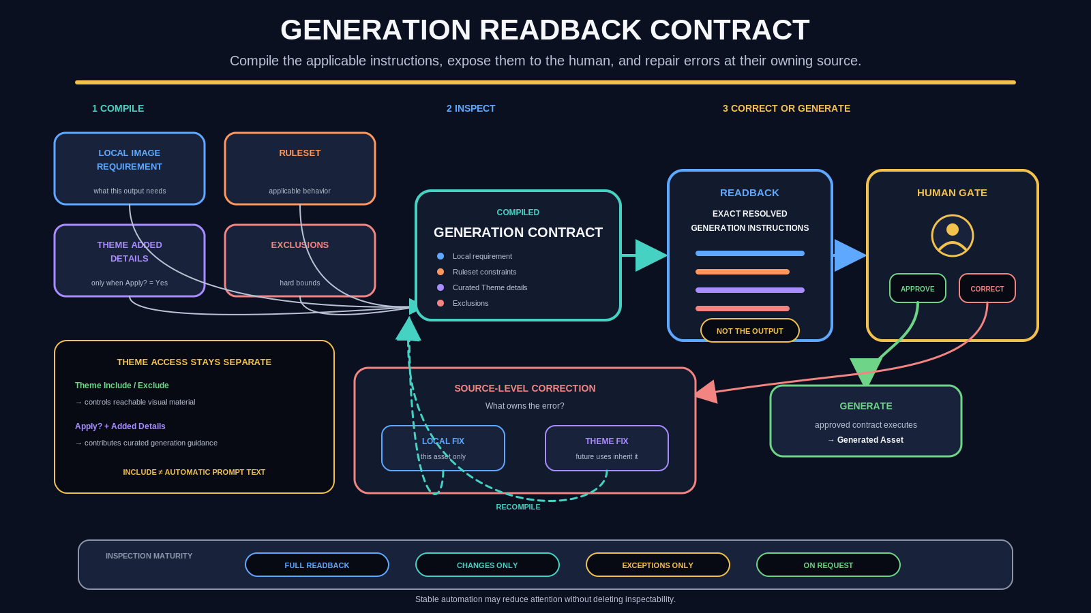
Figure 19. Generation Readback Contract. Local requirements, Rules, Theme guidance, and exclusions compile into a readback. Human approval proceeds to generation; corrections route to the local or persistent owning source and then recompile.

20. Mature Templates Can Hide Routine Complexity Without Deleting It
Early in the life of a Template, full readback is valuable. It lets the user observe exactly which Theme details are active, whether exclusions are being applied, and whether a recurring error belongs to the local requirement or the reusable Theme. After repeated successful use, the same Template may no longer need to interrupt the user for every routine contract.
The architecture therefore separates inspectability from attention. A mature workflow can show only changed guidance, exceptions, or on-request diagnostics while retaining the resolved contract and provenance underneath. Automation maturity should reduce ritual, not erase the ability to explain why the system behaved as it did.
Inspection mode | Intended use
Full readback | Development, new Themes, new Rules, or deliberate training of the reusable contract.
Changes only | Stable workflows where only newly introduced guidance or altered dependencies need attention.
Exceptions only | Mature Templates where ordinary behavior is trusted and only conflicts or uncertainty require interruption.
On request | Highly mature use where the contract remains available for troubleshooting but is not routinely surfaced.

21. Cumulative Production Intelligence
A completed document can leave behind more than a PDF or DOCX. It can add reusable Asset primitives, finished Figures, stronger Rules, corrected Themes, improved Templates, new MIRROR routes, verified backgrounds, and useful composites. The marginal cost of later work can therefore fall because later projects start from a larger production vocabulary.
This is GROOVE applied to publishing and media production: preserve the useful structure created by intelligence so future reasoning starts farther ahead. The goal is not to eliminate creative reasoning. It is to stop paying repeatedly for decisions that have already been made, tested, and expressed in reusable form.
Accretion Principle | Each completed build should be able to leave behind reusable structure that reduces the reasoning and production cost of later builds.

22. Immediate Application: The Triadic Machine Singularity Learning Series
The Triadic Machine Singularity Learning Series is an ideal first large-scale beneficiary. Paper 01 can create the initial machine, diagram, environment, and publication vocabulary. Paper 02 can reuse those Assets while extending the library. Later papers progressively work inside a mature visual language rather than rebuilding every system diagram, background, symbol, or environmental component from scratch.
The same mechanics preserve visual coherence without forcing every paper to look identical. A Theme can establish the acceptable visual territory, while local Figure contracts determine the specific composition. Reuse therefore increases continuity without collapsing variety.

23. Broader Creative Capability: From World Theme to Media Library
The architecture becomes especially interesting when applied to high-volume themed creation. A sufficiently explicit World can provide lore, visual grammar, environments, materials, recurring backgrounds, taxonomic symbols, and common presentation Assets. Hundreds of local creature descriptions can then generate coherent creature Assets without restating the entire World contract for every image.
Once those creatures are addressable Assets rather than isolated pictures, the same material can feed a Monster Glossary, field guide, game bestiary, documentary, atlas, trading-card interface, augmented-reality exhibit, or simulation. A generation run therefore becomes one stage in a reusable media pipeline rather than the end of the asset lifecycle.
The goal is not to generate 200 pictures. The goal is to build a coherent reusable visual world whose outputs remain addressable after generation.

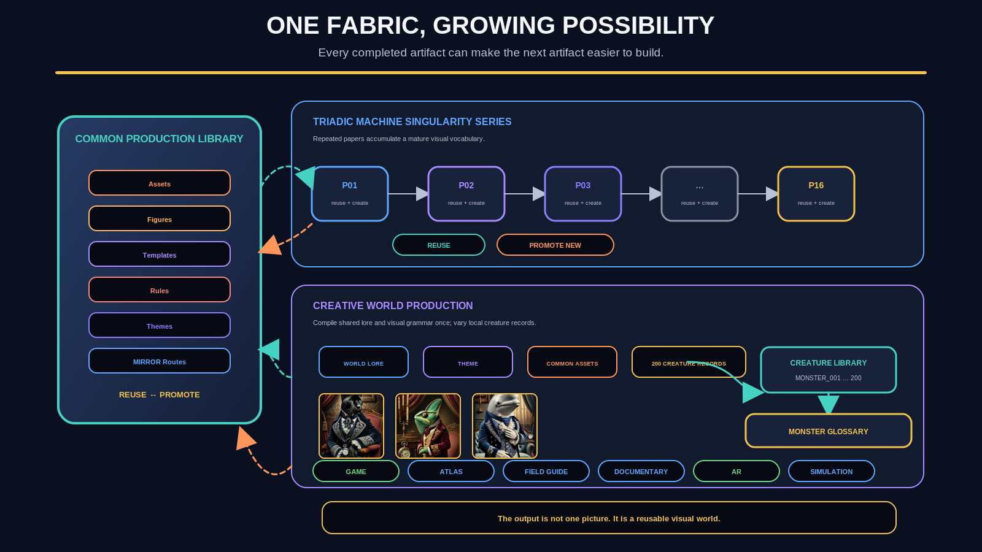
Figure 20. One Fabric, Growing Possibility. The same persistent production library can compound across a technical paper series and a themed World-generation pipeline. Both paths return useful outputs to the common Asset Pool.

APPENDIX
Formal Principles and Implementation Boundaries
The architecture remains simple only if its ownership distinctions remain explicit.

24. Formal Principles
ID | Principle | Normative statement
GAF-P01 | Externalized Build Memory | Resolved construction state should be persisted rather than repeatedly reconstructed in AI context.
GAF-P02 | Bounded Assembly | Execution should resolve the smallest sufficient current graph instruction and its dependencies.
GAF-P03 | Stable Reference | Completed Figures and Assets should be addressed by stable identities rather than rediscovered from prose.
GAF-P04 | Deterministic Spine | Document order and basic assembly behavior should derive from explicit Spine Types.
GAF-P05 | Recursive Asset Composition | Assets may be constructed from other Assets while retaining explicit lineage.
GAF-P06 | Transform Economy | Reversible presentation operations should not generate unnecessary persistent identities.
GAF-P07 | Selective Promotion | Only useful reusable outputs need promotion into the persistent Asset Pool.
GAF-P08 | Semantic Routing Before Retrieval | Use SOLAR/MIRROR routing to identify relevant material before retrieving physical files.
GAF-P09 | Behavioral / Visual Separation | Rulesets govern behavior; Themes govern visual vocabulary and optional generative character.
GAF-P10 | Generation Transparency | Material generative instructions should remain inspectable before or after execution.
GAF-P11 | Source-Level Correction | Repeated defects should be corrected in the reusable contract that owns them.
GAF-P12 | Cumulative Capability | Successful builds should be able to increase the capabilities of later builds.

25. Non-Collapse Laws
- CERBERUS semantic identity != OneDrive physical file.
- SOLAR route != Asset.
- MIRROR routing != file storage.
- Project Asset Sheet != canonical global Asset Pool.
- Asset != Figure.
- Figure != Document Placement.
- Reversible transform != new Asset identity.
- New Asset identity != permanent Asset promotion.
- Ruleset != Theme.
- Theme Include != image-generation prompt text.
- Theme generation detail != local Asset requirement.
- Template != Theme.
- Temporary Build Graph != persistent Library Graph.
- Archived provenance != live working state.
- Generation readback != generation result.
- Human approval != proof that an underlying semantic claim is externally true.
- Automation maturity != removal of inspectability.
- Document Spine != final rendered document.

26. Scope and Non-Scope
This paper owns | This paper does not fully specify
Graph mechanics of OctoGroove; project workbook architecture; Document Spine; Asset dependency model; persistent versus transient state; SOLAR/MIRROR seeding; system ownership; Rules, Rulesets, Themes; generation readback; promotion and cumulative capability. | Exact Airtable field implementation; final Excel formulas; VBA/Python/Office Script runtime; exact OneDrive folder hierarchy; universal Asset ID grammar; exhaustive Template/Rule/Theme catalogs; image model internals; full SOLAR/MIRROR architecture; renderer source code; final permissions/security implementation.

27. Implementation Implications
The conceptual architecture is sufficiently resolved that remaining questions are primarily engineering choices. The immediate implementation work can focus on the workbook schema, formulas or scripts for dependency traversal, Rule and Theme storage, asset fetch/promotion routines, generation readback UI, archive/scrub controls, and the renderer that walks the Spine. Those decisions can evolve without changing the paper as long as the ownership and non-collapse laws remain intact.
The strongest implementation test is recursive self-use. OctoGroove should be used to build its own future papers, Figures, Templates, and reusable Asset library. When the system discovers that a component is repeatedly useful, it should promote that component and route it through MIRROR. When a repeated generation or assembly error is traced to a reusable contract, it should repair the owning source. The infrastructure becomes more capable by doing real work.

Conclusion
The OctoGroove Graph Assembly Fabric turns document construction into a cumulative, inspectable graph process. It preserves the human gates and bounded pass responsibilities of OctoGroove while moving resolved build intelligence into external state that can be referenced, assembled, verified, and reused. The Document Spine compiles prose and Figure placement. The Asset graph compiles visual dependencies. SOLAR/MIRROR bounds retrieval. Rulesets and Themes govern behavior and visual vocabulary. Generation Readback makes AI imagery debuggable. Promotion returns useful outputs to a persistent production library.
The practical consequence is simple: future artifacts do not have to begin from zero. A successful build can leave behind the structures that made it successful. Over time, the system stops behaving like a sequence of isolated document projects and begins behaving like a semantic media factory with a cumulative parts bin - explicit underneath, increasingly effortless on top.
Every completed artifact can make the next artifact easier to build.

Related Specifications
Ref. | Specification | Relationship
[1] | GROOVED PASS v0.1 | Defines the eight-pass document construction method, bounded pass ownership, human gates, rollback, selective staleness, and conformance closure.
[2] | OCTOGROOVE AI EXECUTION & BOOTSTRAP GUIDE v1.0 | Operationalizes OctoGroove as an artifact spine in which downstream work consumes approved bounded outputs rather than conversational recollection.
[3] | CERBERUS Template System v0.1 | Defines Template, Region, Slot, Binding, Reader, MIRROR, and renderer boundaries used by the Graph Assembly Fabric.

