CERBERUS
STORYBOARD CONTINUITY
ENGINE
MEMORY MECHANICS
Compiled Autobiography, Semantic Development, and Reconstructable Cognitive History
WORLD | T-KEY | LIFE | SCHOOL | GROOVE | HISTORY | CONTEXT | EXTERNAL

Illustrative Architecture Paper
Version 0.1 | August 2026
Core proposition
The World stores causal history once. A person stores a compact, incrementally compiled route through that history. Life Trajectory reconstructs ordinary development; the Memory Groove records which Events are normally autobiographically addressable; current context decides what is worth reconstructing now.

World Events • T-Keys • Life Trajectories • Schools • Memory Groove • Recollection / Reflection • History Chunks • P-Key routing • U/I correspondence

EXECUTIVE SUMMARY

Abstract
Memory Mechanics extends the Storyboard Continuity Engine by treating autobiography as a reconstructable relationship to authoritative World history rather than as a permanently stored pile of narrative memories. World Events remain shared canonical objects. T-Keys remain compact. The system derives ordinary historical exposure from TIME, location, scope, class, role, Life Trajectory, institutional history, and permanent World positions; explicit links are reserved for Events that select a particular resolved person.
The central optimization is the Memory Groove. When a T-Key first becomes relevant, the engine walks the World Event sequence that can intersect that life, applies a deliberately configurable hard memory policy, and stores only a binary eligibility decision for each Event position. A Groove Cursor records the last compiled point. Later loads process only newer Events. Routine recall therefore begins with a bit lookup and semantic context routing instead of repeatedly recalculating fit against the person’s entire history.
Life Trajectory supplies the semantic self used by Memory. Sparse Culture and Region lifestamps query the historical World and accumulate language, cognitive skill, schooling, professional capability, and local opportunity. Schools act as semantic compilers: foundational tiers build reusable cognitive machinery and later tiers apply that machinery to domains. Historical attendance inherits the institution’s normal BitWord or Family outputs unless a causally meaningful exception is stored.
The architecture separates lived autobiography from learned history. An Event can have Groove value 0 while the person later learns a History Chunk about it. Recollection interprets an addressable Event through the historical self that existed then; Reflection interprets the same Event through the current self. P-Keys remain permanent World positions occupied by different T-Keys over TIME. U-Keys and I-Keys remain outside World-native identity: their own systems may retain exact personal correspondence while the World stores only sufficient causal descriptions such as “Cloaked Wanderer.”

What this paper formalizes
- Shared immutable World Events as the authoritative substrate for reconstructable autobiography.
- Deterministic historical exposure through Event scope, TIME, location, role, class, Life Trajectory, and explicit participant links.
- T-Key identity emerging from statistical population only when the World needs an individually addressable person.
- Sparse Culture and Region lifestamps, migration, hybrid biographies, and historically versioned schooling.
- Education tiers that build cognitive machinery first and domain application later through BitWord / Family outputs.
- The Memory Groove, hard 0/1 eligibility cutoff, Groove Cursor, incremental compilation, configurable Memory Policy, and deep-query override.
- Recollection through the historical self and Reflection through the current self.
- Learned History Chunks as writable semantic knowledge distinct from lived memory.
- P-Key + TIME occupancy routing, contextual semantic retrieval, reconstructable social topology, and U/I external identity boundaries.

NAVIGATION

Paper Map
Part | Title | Focus
1 | Memory Without Stored Biographies | Shared history and compact identity
2 | World History as the Memory Substrate | Event order, scope, participants and Sticky Bits
3 | T-Keys and Reconstructable People | Statistical personhood and Naming
4 | Life Trajectory as Developmental Reconstruction | Culture, Region, TIME and migration
5 | Schools as Semantic Compilers | Education tiers and BitWord/Family outputs
6 | The Memory Groove | Binary eligibility and incremental compilation
7 | Recollection and Reflection | Historical self versus current self
8 | Learned World History | History Chunks distinct from lived memory
9 | P-Key World Positions | Permanent World roles with temporal T-Key occupants
10 | Contextual Memory Retrieval | Objectives, surroundings and Language-bit overlap
11 | Social Memory as Graph Reconstruction | Shared historical topology
12 | External Individuals: U-Key and I-Key | World-native external actor projection
13 | Integrated Life Trace | Lena Venn from Naming to Reflection
14 | Formal Principles and Boundaries | Conformance laws and downstream interfaces
PART 1

Memory Without Stored Biographies
A person can possess a coherent life without carrying a duplicate of the World that produced it.

1. A Person Does Not Need to Store Their Life
A conventional character record tends to accumulate childhood history, schools, jobs, acquaintances, memories, knowledge, dialogue history, and ever more exceptions. In a long-running World this makes every person a miniature archive. Memory Mechanics starts from the opposite premise: if World history, TIME, geography, institutions, Culture, and developmental rules already explain an ordinary part of a life, the T-Key does not need to store that explanation again.
The individually unique payload should therefore remain small. Identity, Life Trajectory, explicit intersections, a compiled autobiographical index, and sparse exceptional state are enough to recover a much larger apparent biography when the current problem actually needs it.
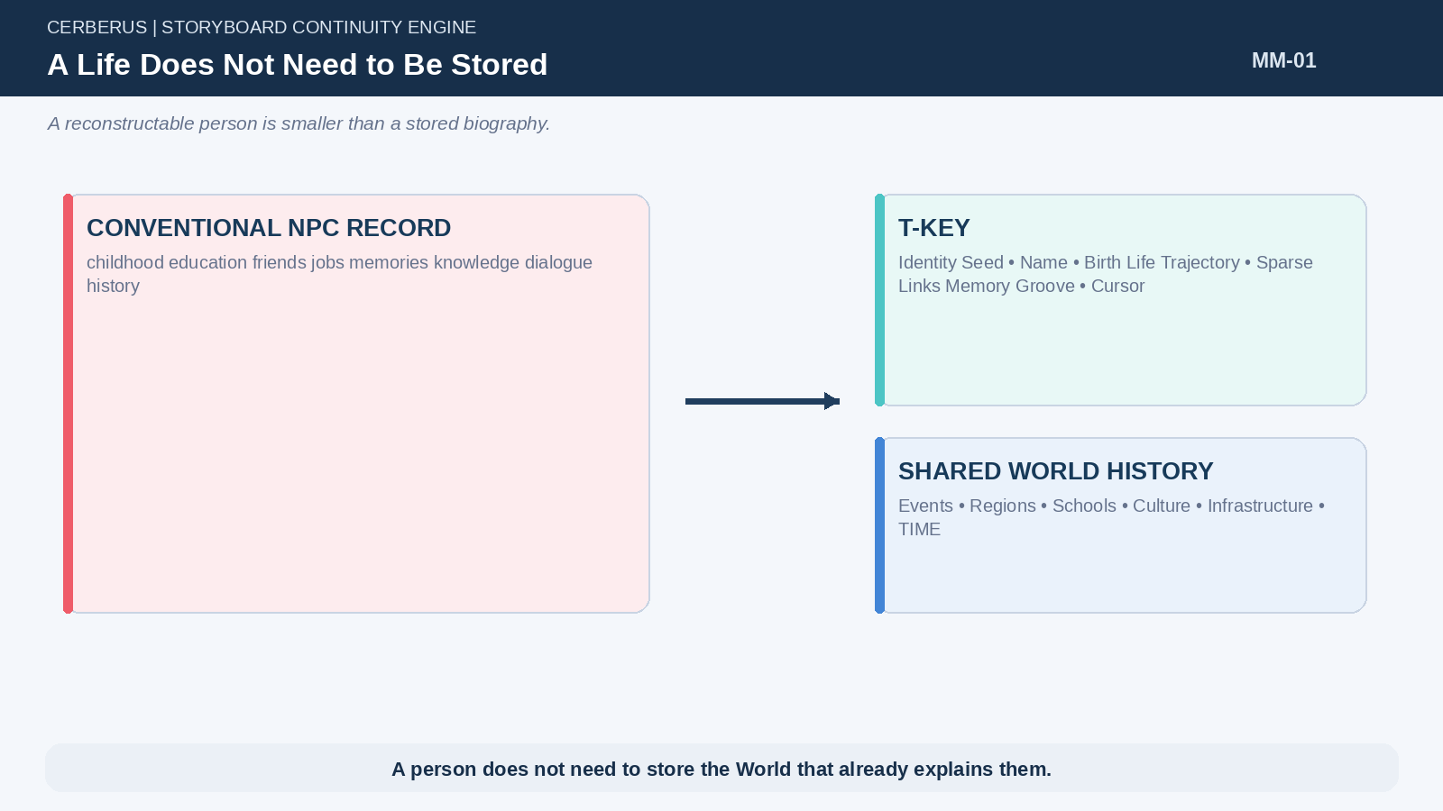
Figure 1. A Life Does Not Need to Be Stored.

2. World History Is Shared
A drought, raid, school, migration route, treaty, flood, or harvest festival is a World fact before it is anybody’s memory. Storing the Event once allows many people to reconstruct different autobiographical relationships to the same historical object. Their perspectives differ because role, age, location, language, skill, and prior experience differ—not because the Event has been copied into separate personal records.
This shared substrate is the major compression source. The World carries expensive causal context; people carry compact statements about how that context intersects them.
Architectural law
Store the Event once; reconstruct its witnesses many times.

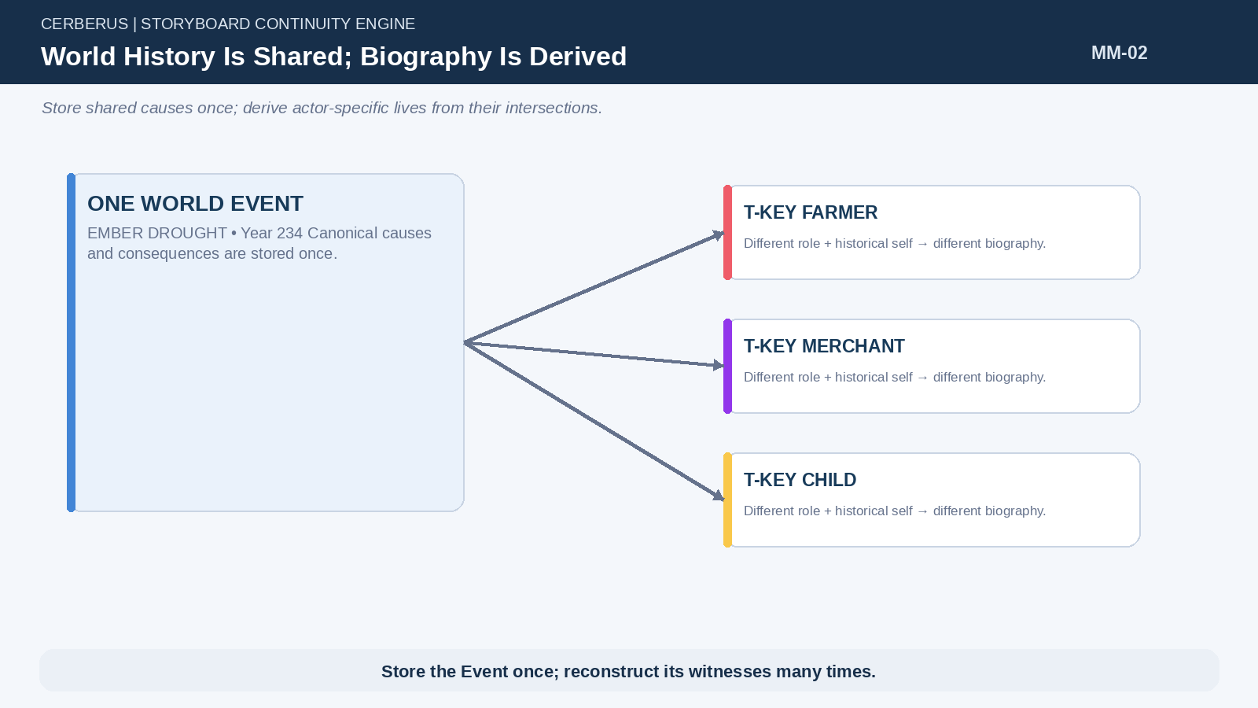
Figure 2. World History Is Shared; Biography Is Derived.

3. Identity Is Small; History Is Large
Long-lived Worlds may contain far more history than any one person can use. Memory therefore behaves as an index rather than as a private duplicate ledger. A compact identity can point into a large historical field, and the Memory Groove can mark only the addresses that normally deserve autobiographical reconstruction.
This asymmetry makes psychological richness compatible with bounded storage. The amount of history available to reconstruct may grow continuously while the person-side structure remains comparatively small.
Architectural law
History is large. Identity is small. Memory is an index.

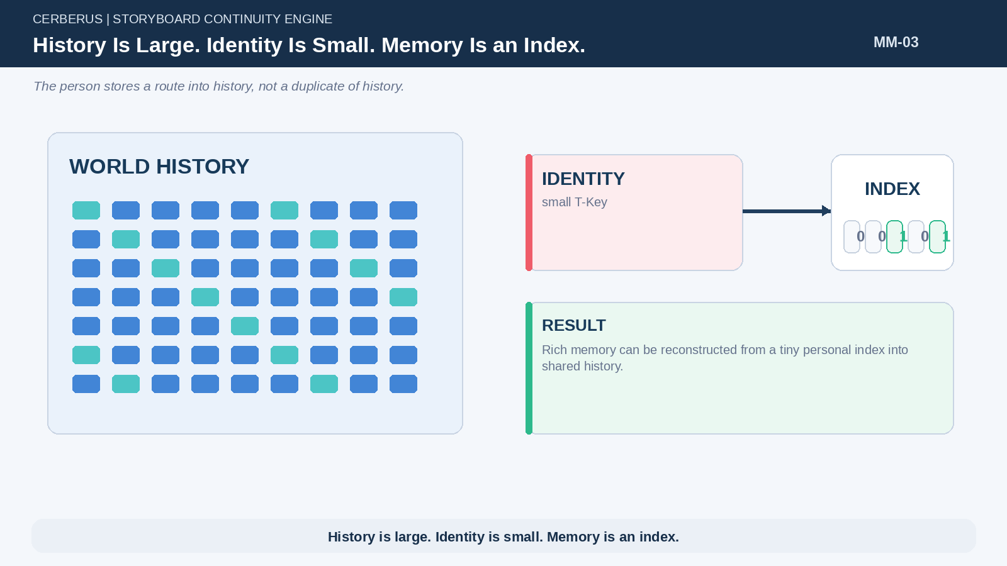
Figure 3. History Is Large. Identity Is Small. Memory Is an Index..

4. Reconstruct the Ordinary; Store the Exceptional
World context supplies the default life. If a historically defined school taught a known curriculum and the person attended normally, those outputs can be reconstructed. If the person lived in a Region during a known cultural period, the baseline semantic environment can be reconstructed. Personal storage is reserved for deviations that future consequence depends on: an unusual injury, expulsion, exceptional aptitude, independent learning, a specific selected Event, or another persistent difference.
The principle does not forbid detailed records. It states that detail should be earned by causal need rather than duplicated by default.
Architectural law
Reconstruct the ordinary; store the exceptional.

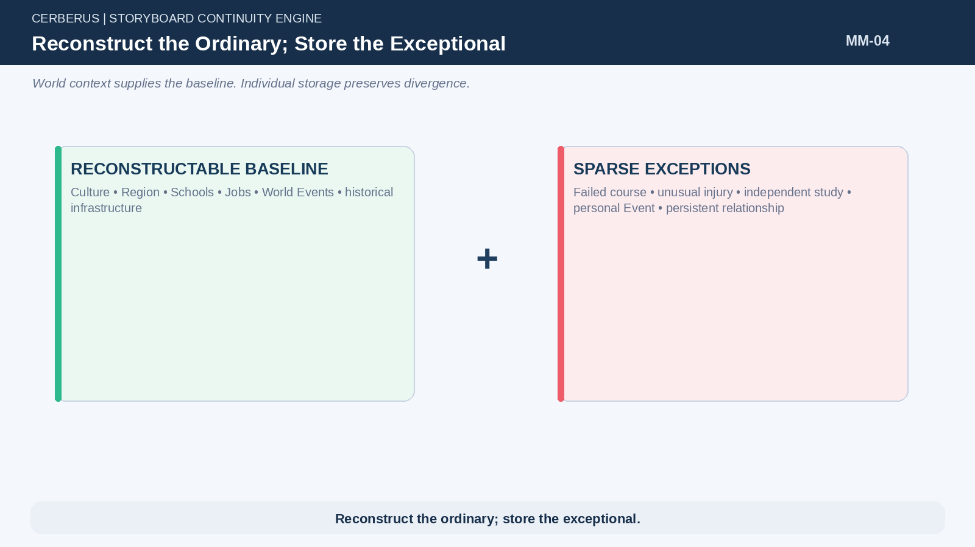
Figure 4. Reconstruct the Ordinary; Store the Exceptional.

5. Memory Richness Is Not Memory Storage
A T-Key may be able to reconstruct hundreds or thousands of historically specific experiences while carrying only a small number of explicit personal links and a compact Groove. Richness comes from the combination of shared Event detail and historically reconstructed actor state. Storage size and phenomenological detail are therefore independent dimensions.
This distinction is central to scale: the system may appear autobiographically deep without keeping every possible recollection hot or even explicitly represented.
PART 2

World History as the Memory Substrate
Memory reads an immutable causal ledger whose existing topology already answers most exposure questions.

6. The Ordered World Event Ledger
World Events exist in causal order. The ledger is not a mutable list of anecdotes; it is the authoritative sequence of consequential historical changes. Because Event order is stable, Memory can use that same order as a durable address space. No separate autobiographical numbering system is required.
If the World is rolled back, the causal timeline itself is rolled back. Ordinary operation does not rewrite earlier records merely to make later Memory easier. This preserves deterministic historical reconstruction.
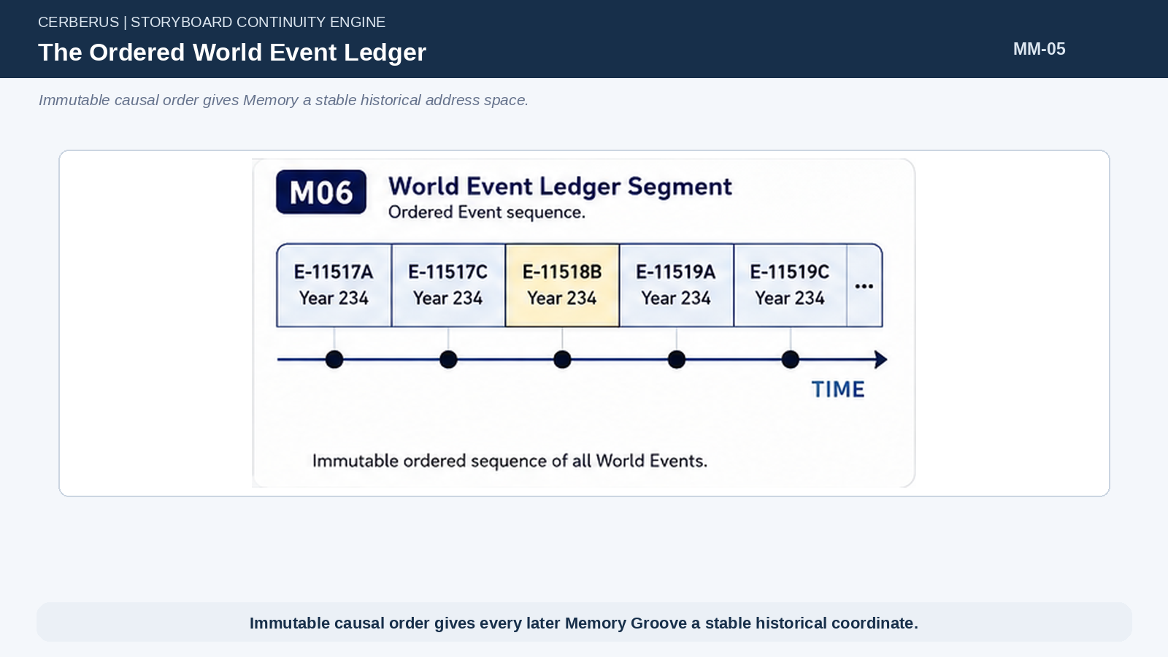
Figure 5. The Ordered World Event Ledger.

7. Event Scope
Events declare whether their relevant exposure is Global, Regional, Local, or Specific. Scope allows the system to infer broad historical intersection without creating person-to-Event links for everyone who might have known that something happened. A Global Event may be broadly accessible across the World; a Regional Event can be discovered from Region + TIME; a Local Event depends on finer spatial presence; a Specific Event identifies selected entities directly.
These classes are routing contracts. They control how candidate exposure is found before any autobiographical decision is made.
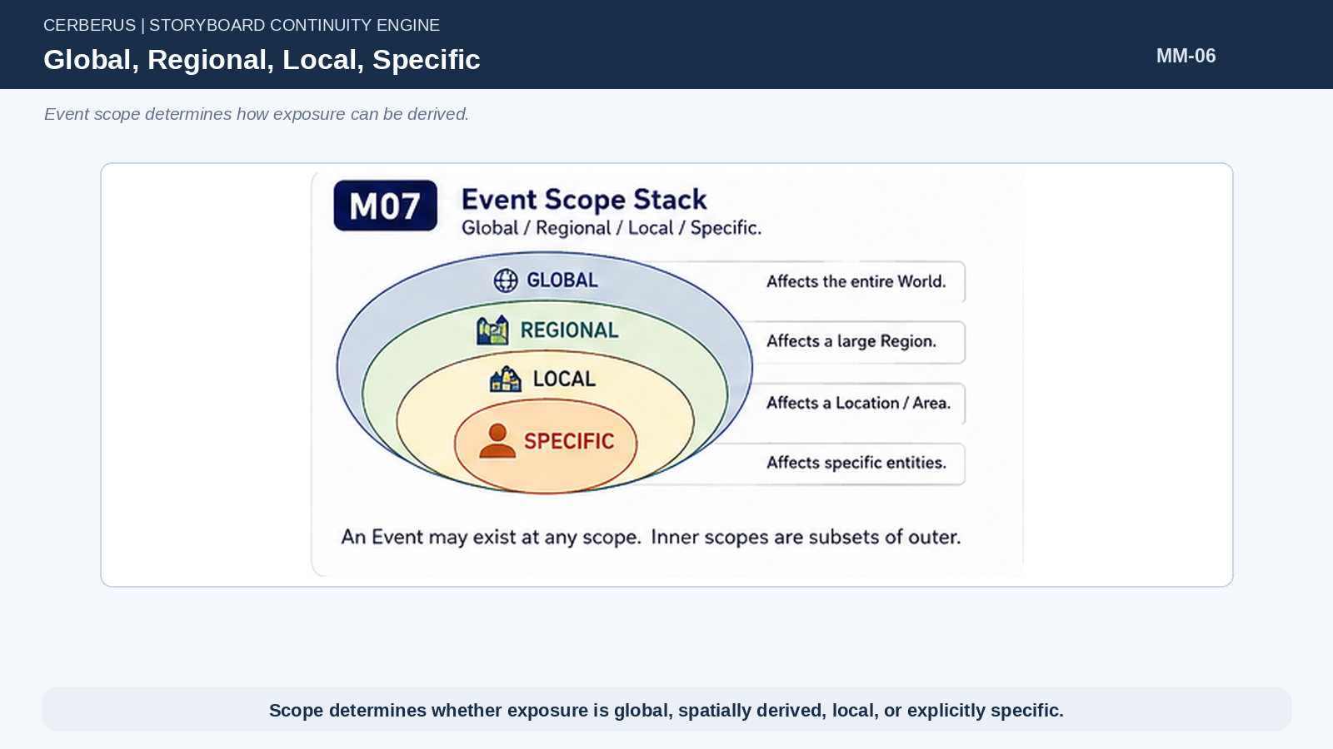
Figure 6. Global, Regional, Local, Specific.

8. Derived Historical Exposure
Most historical exposure is implicit in World topology. If a T-Key lived in Ember throughout a span containing 356 Ember Regional Events, those candidate intersections can be derived from the person’s Life Trajectory and Event metadata. The T-Key does not need 356 explicit links.
The same principle applies to Global and Local Events. The system first calculates the deterministic historical intersection; only later does Memory policy decide whether the Event becomes routinely reconstructable autobiography.
CandidateExposure(T) = WorldEvents ∩ LifeTopology(T) ∩ TIME

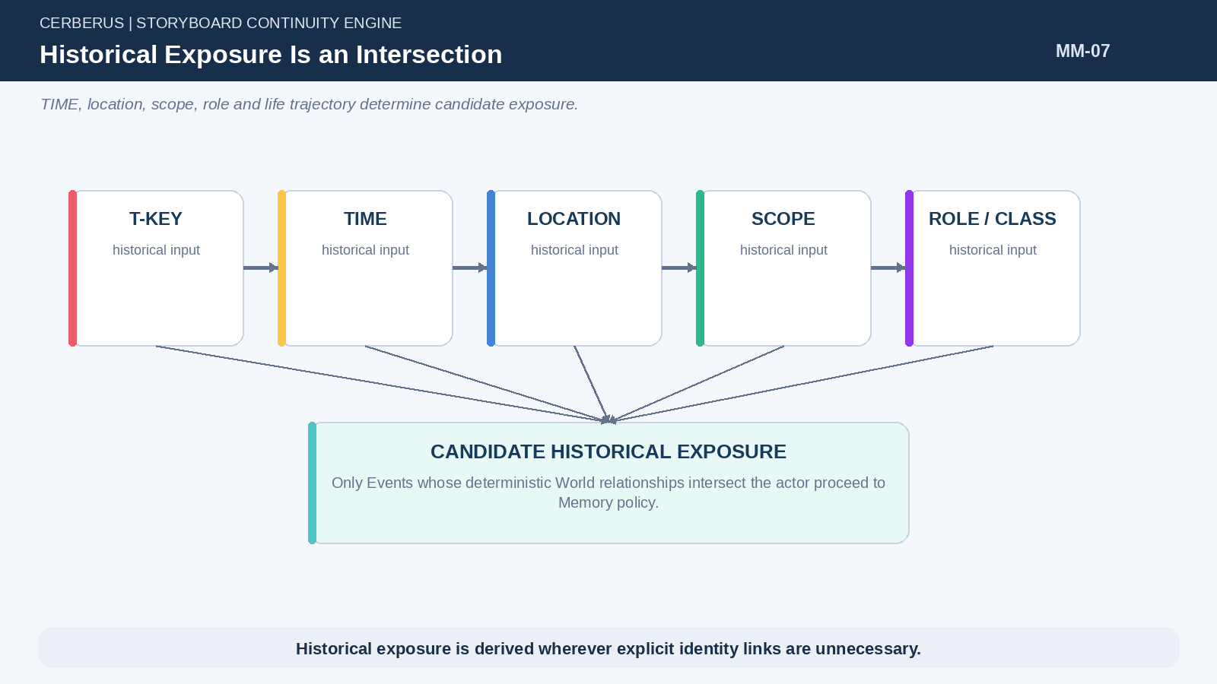
Figure 7. Historical Exposure Is an Intersection.
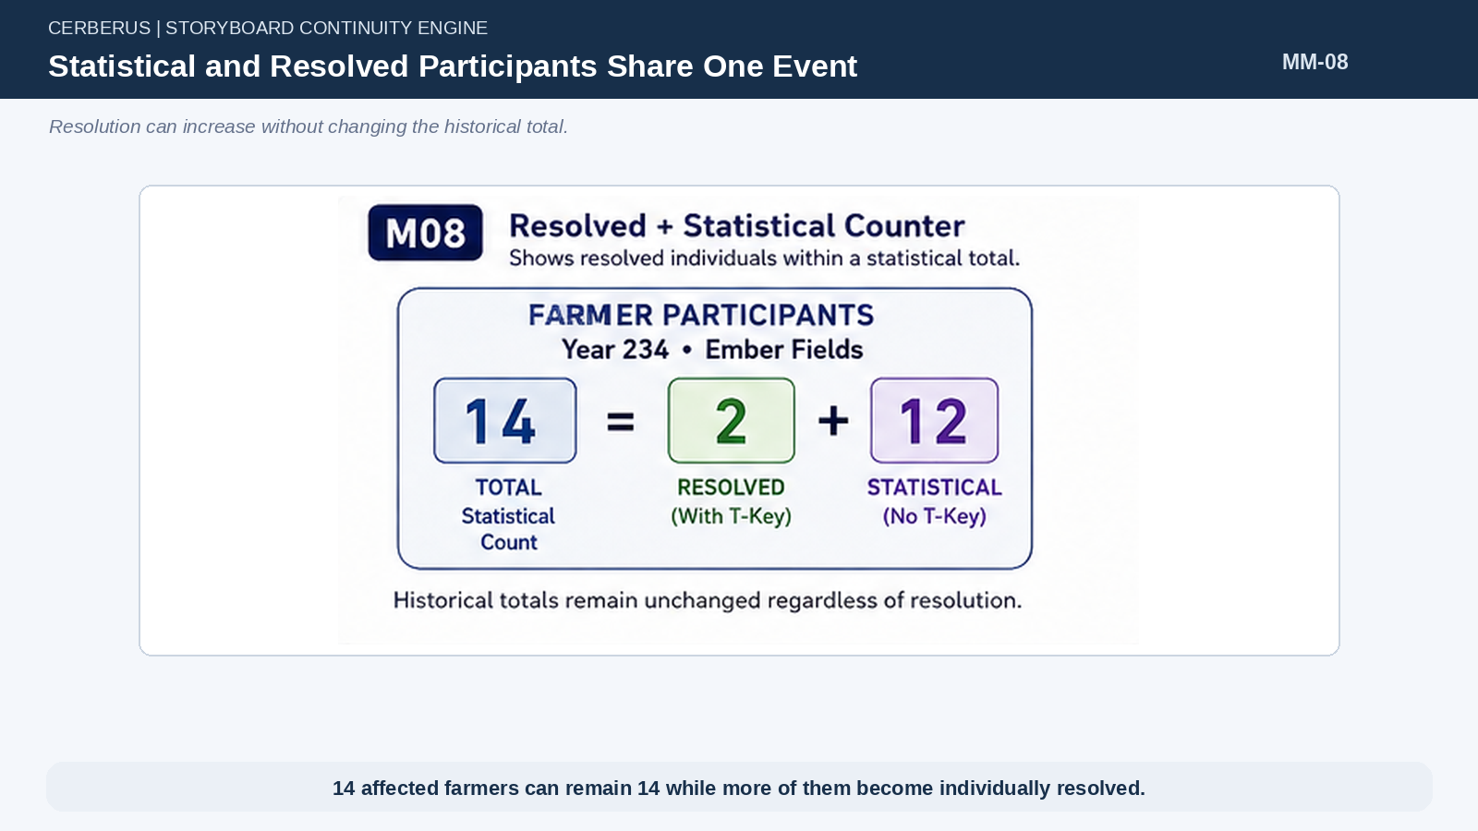
Figure 8. Statistical and Resolved Participants Share One Event.

9. Specific Participation
Some Events cannot be represented correctly by broad exposure alone. If bandits destroy the crops of two particular farmers, the Event can declare FARMER × 2 and list the two resolved T-Keys. That tiny link is enough to distinguish “I lived in Ember during the raid” from “my farm was one of the farms destroyed.”
The Event remains the authoritative object. The T-Key link identifies the actor’s specific role in that shared occurrence rather than copying the occurrence into a personal record.
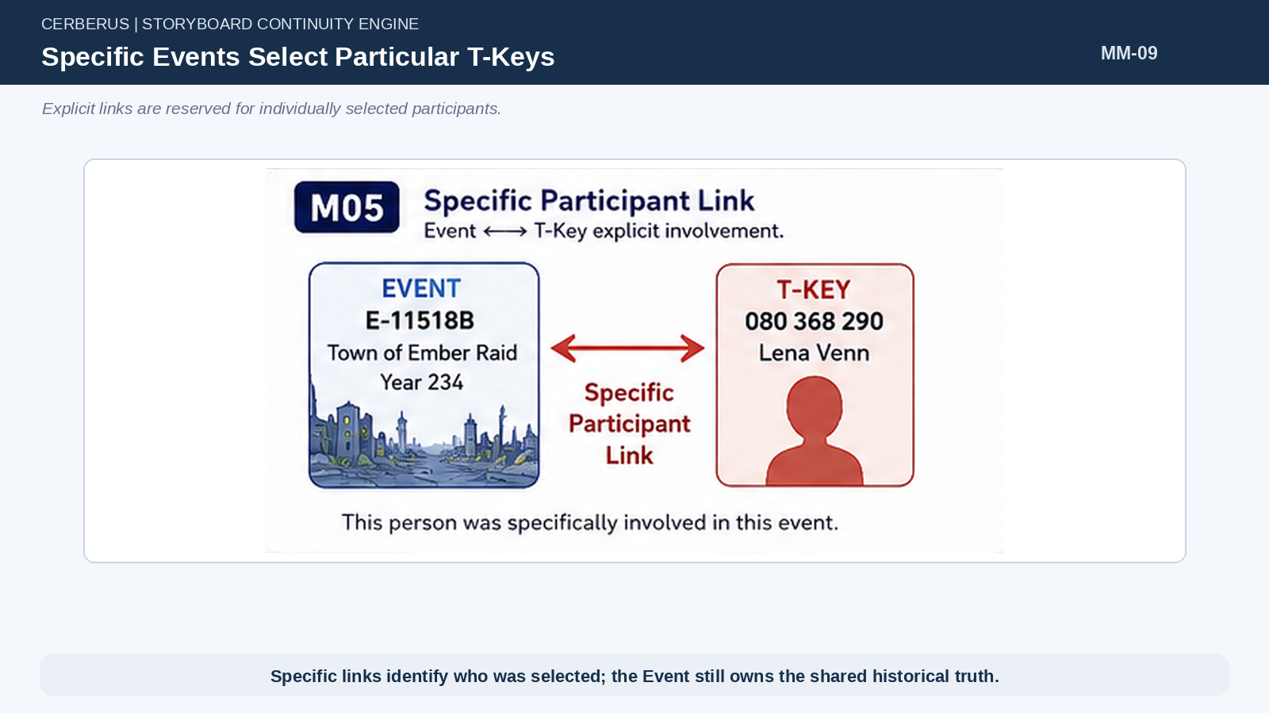
Figure 9. Specific Events Select Particular T-Keys.

10. Statistical and Resolved Participants Coexist
An Event may affect a population count that contains both individually resolved and statistical members. Fourteen affected farmers can be represented as two named T-Keys plus twelve statistical farmers. If another historical farmer later needs individual resolution, one statistical participant can be resolved without changing the total of fourteen.
This preserves historical truth while allowing identity resolution to increase on demand. The World knew that a person existed and was affected; it simply did not previously need that person’s name.
14 affected farmers = 2 resolved T-Keys + 12 statistical farmers

Architectural law
Resolving historical identity does not alter historical totals.

11. Events as Operators
World Events can also be compact Operators over Sticky Bit State. For fast loading, many consequences can be represented by Event TIME plus the relevant Bit change. A farm becomes destroyed, a curfew becomes active, a bridge becomes closed, or a title-holder becomes dead without requiring replay of an authored narrative.
The Event therefore functions both as historical meaning and as a causal state transition. Memory may read that Event later, but Memory does not own the state mutation.

12. State Effect Is Not Memory
A person may be changed by an Event that never becomes a routinely reconstructable memory. A school may close, a family may move, a profession may disappear, or a physical condition may change even if the person’s Groove records 0 for the Event itself. Causal state and autobiographical addressability therefore cannot be conflated.
This protects World authority. Forgetting, low comprehension, or aggressive Memory policy can never undo what objectively happened.
StateEffect(E,T) ≠ MemoryEligibility(T,E)

Architectural law
Memory eligibility is not state authority.

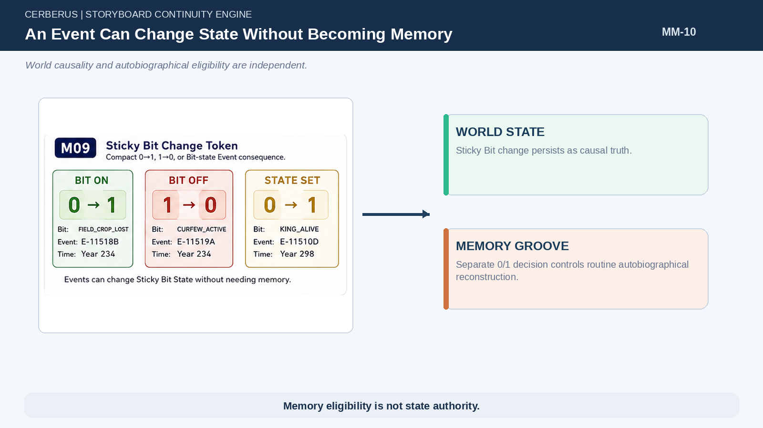
Figure 10. An Event Can Change State Without Becoming Memory.
PART 3

T-Keys and Reconstructable People
The World resolves individual people only when consequence requires individual addressability.

13. Statistical Person Before Individual Resolution
A population model can know that a Region contains farmers, children, smiths, scholars, or newborns without assigning names and detailed identities to every statistical member. These people are real enough for population accounting and causal totals but are not yet individually addressable actors.
This is the human analogue of resolution elsewhere in World Mechanics: existence does not force maximum representation.
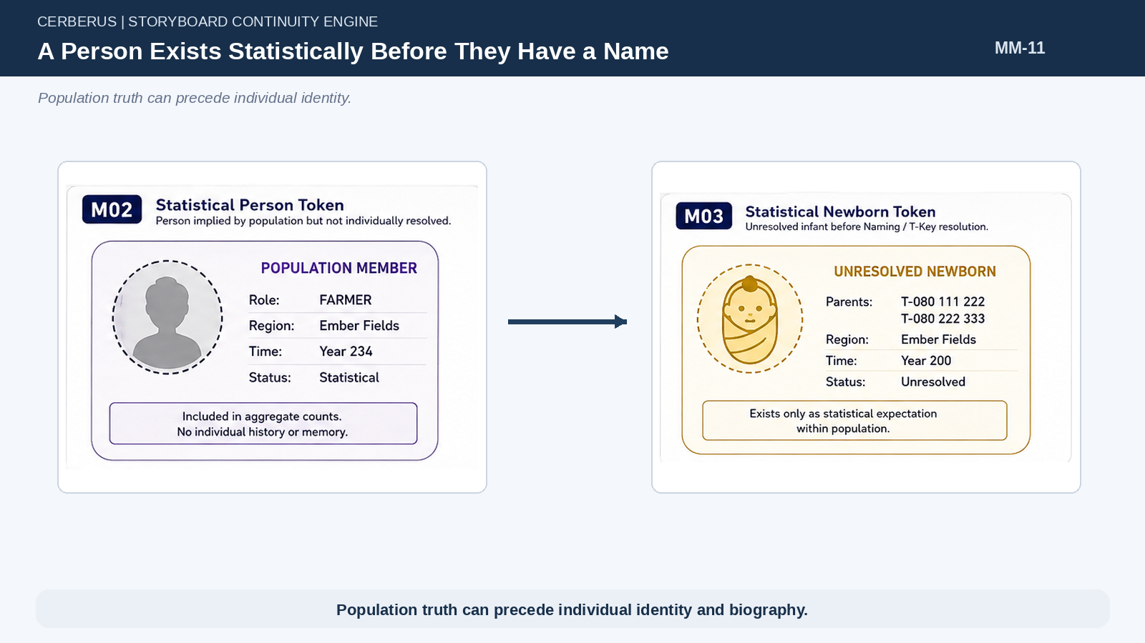
Figure 11. A Person Exists Statistically Before They Have a Name.

14. World Events Create Individually Resolved People
When a World Event requires a particular person, statistical possibility is resolved into a T-Key. Interaction, Naming, a specific injury, selection into a role, or another consequential Event can provide the trigger. From that point, the person can participate in individually addressable history while still reconstructing most ordinary biography from the World.
T-Key creation therefore marks an increase in identity resolution, not the creation of a fully simulated psyche.

15. Naming Event
The baby Naming Event is the canonical example. Two parent T-Keys already exist. Population state implies a newborn. The Naming Event records PARENT × 2 and CHILD × 1, resolves the child into a T-Key, attaches the chosen name, and anchors the child to historical Culture, Region, family, and TIME.
The Event is identity-relevant even though the child may receive Groove value 0 because a newborn cannot routinely reconstruct the ceremony as lived autobiographical memory.
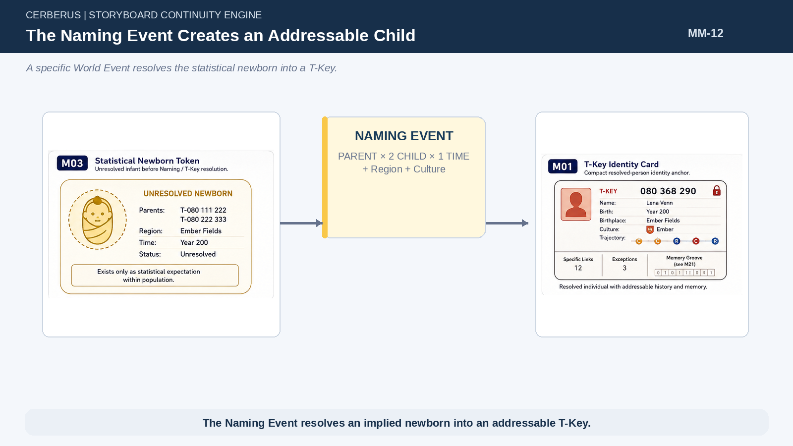
Figure 12. The Naming Event Creates an Addressable Child.

16. T-Key Minimal Payload
A practical T-Key can remain compact: Identity Seed, Name, Birth and Origin, sparse Life Trajectory, Specific Event Links, Memory Groove, Groove Cursor, and exceptional state that cannot safely be reconstructed. The precise storage form can evolve, but the ownership boundary should remain stable.
The payload does not need a prose childhood, full transcript, exhaustive friend list, or every Event that happened nearby. Those remain recoverable from shared history when relevant.
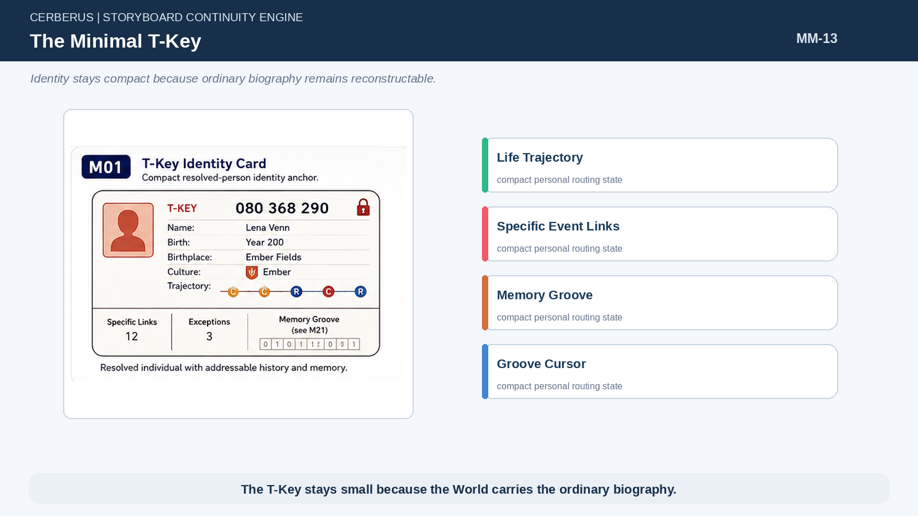
Figure 13. The Minimal T-Key.

17. T-Key Does Not Mean Fully Simulated Person
Individual addressability is not a promise that the person remains continuously instantiated. A T-Key can cool, disappear from active simulation, and later be reconstructed from its compact state plus the World. The person’s identity remains resolvable while detailed cognition is produced only when current consequence requires it.
This separation keeps large populations compatible with specific named characters.
PART 4

Life Trajectory as Developmental Reconstruction
Sparse developmental landmarks turn historical Culture, Region, and institutions into a coherent semantic self.

18. Sparse Developmental Landmarks
Life Trajectory defines a small set of ages or developmental moments at which the World is queried for meaningful developmental input. The working example alternates Culture and Region landmarks: 0C, 4C, 5R, 8C, 9R, 14C, and 15R. This schedule is illustrative rather than a universal final law.
The important mechanism is sparsity. Development is reconstructed at bounded landmarks instead of simulating every lesson, conversation, and day of childhood.
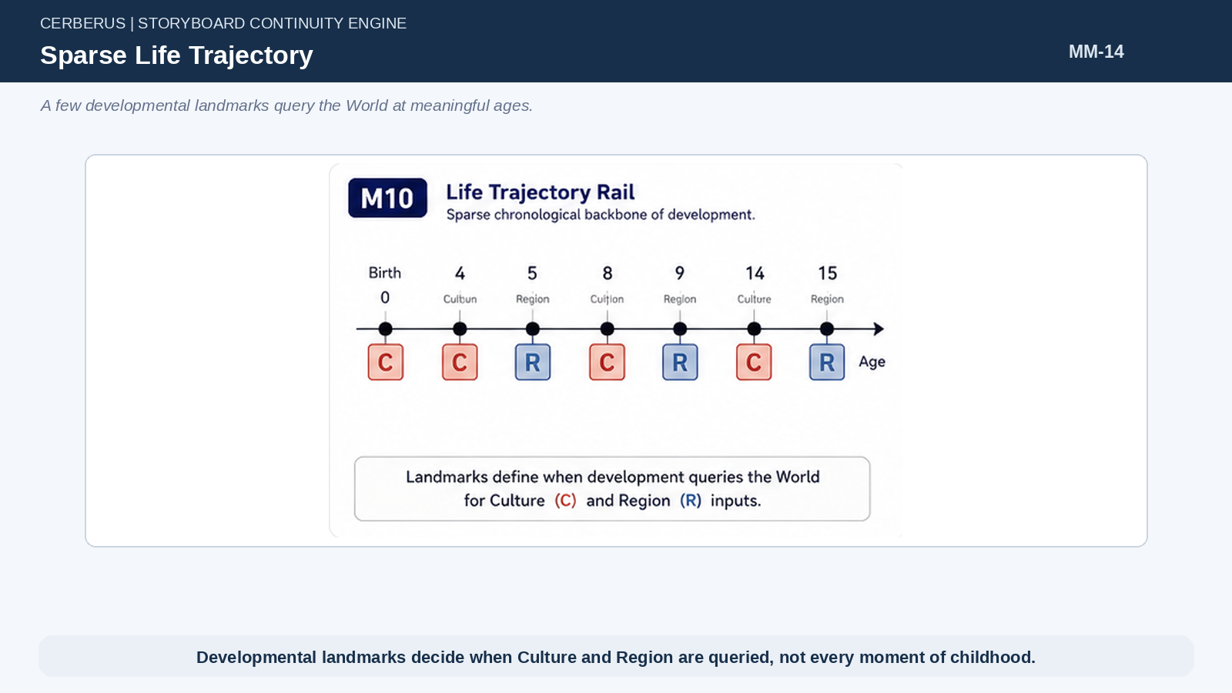
Figure 14. Sparse Life Trajectory.

19. Culture Lifestamps
A Culture stamp contributes language, customs, common knowledge, social expectations, identity terms, and culturally available reasoning. It is not merely a cosmetic ethnicity label; it is part of the semantic environment from which later interpretation and Memory become possible.
Because the stamp is historical, two people from the same named Culture may inherit different outputs when the Culture itself changes over generations.

20. Region Lifestamps
A Region stamp queries historically available schools, guilds, jobs, tools, technologies, infrastructure, and opportunities. Region therefore determines what structured developmental routes were actually available at that moment. A person cannot inherit a school curriculum from an institution that did not yet exist.
Region and Culture can overlap strongly, but they answer different questions and should remain separable inputs.
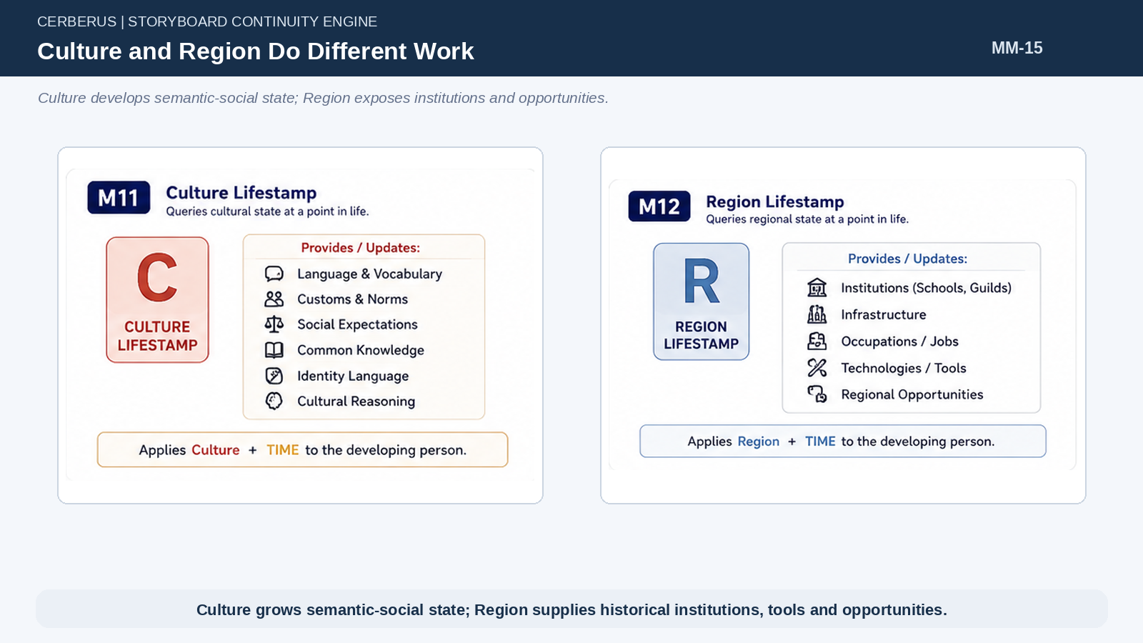
Figure 15. Culture and Region Do Different Work.

21. TIME Makes the Stamp Historical
Every lifestamp is a query into World history, not a lookup against the current World. Person + Location + TIME resolves the state of that place when the developmental landmark occurred. This prevents later curricula, infrastructure, social norms, or technologies from leaking backward into earlier lives.
Historical versioning is therefore a direct dependency of credible autobiographical reconstruction.
Lifestamp = Person × Location × TIME → Historical World State

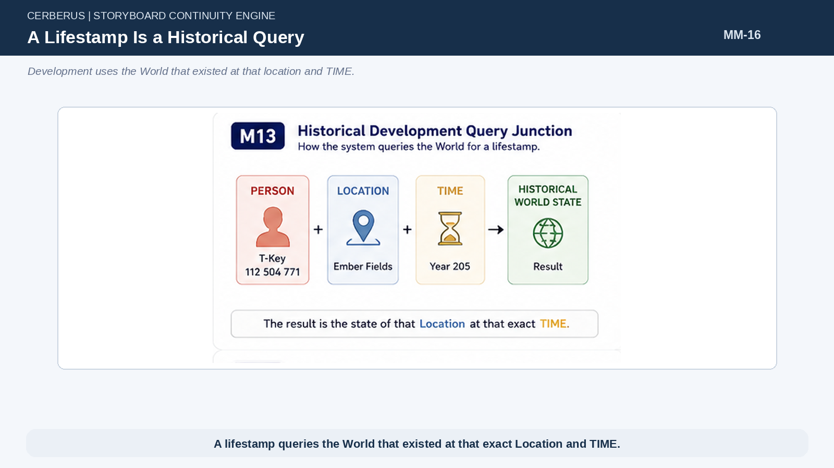
Figure 16. A Lifestamp Is a Historical Query.

22. Migration Changes Future Inputs
If a family moves from Ember to Rivergate when a child is seven, earlier Ember outputs remain part of the child while later Culture and Region landmarks query Rivergate. Migration changes the developmental route forward rather than rewriting the developmental past.
This allows biography to respond naturally to geography without requiring a new bespoke character archetype for every migration combination.
Architectural law
Migration changes future inputs; it does not rewrite earlier development.

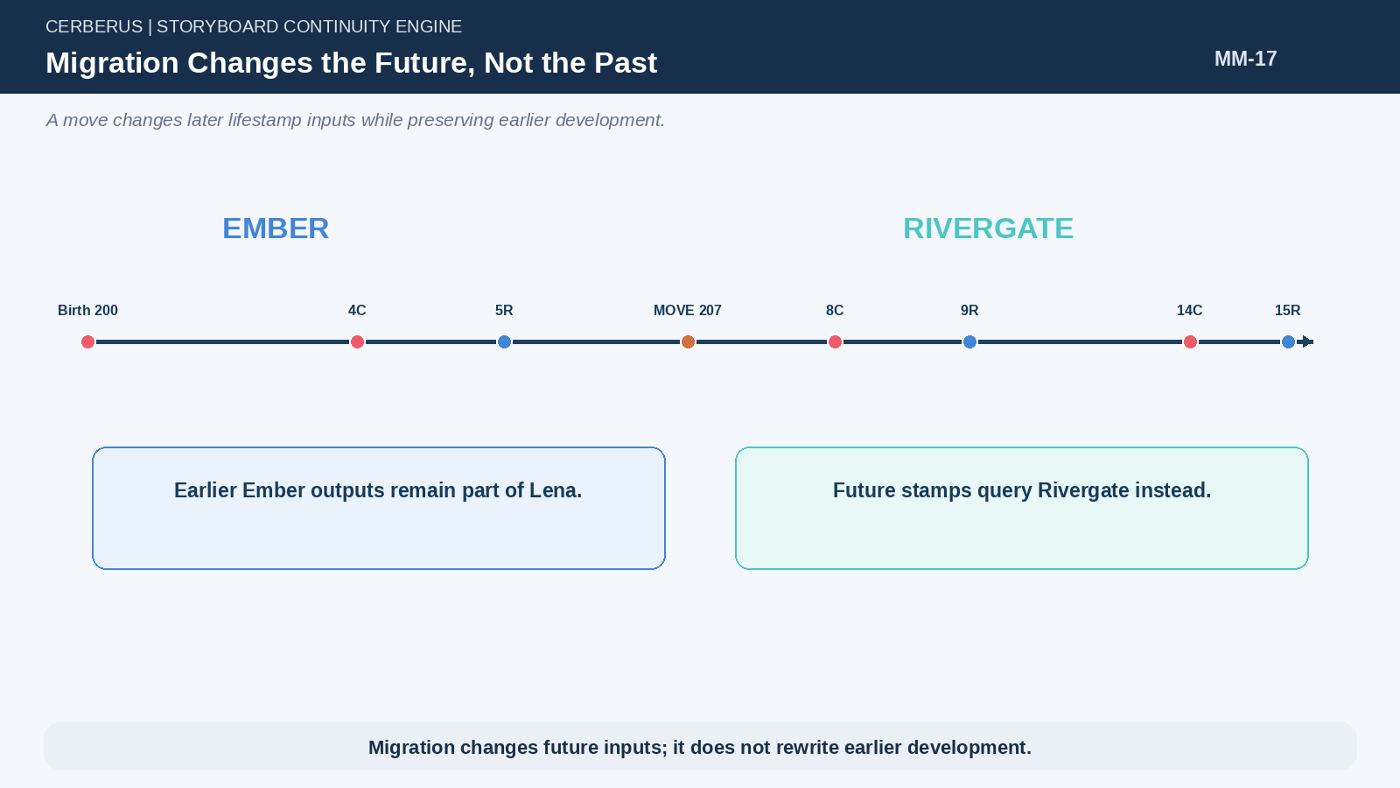
Figure 17. Migration Changes the Future, Not the Past.

23. Hybrid Biographies Emerge Naturally
A child who receives Ember family language and foundational schooling before acquiring Rivergate market, water, navigation, and trade semantics becomes a hybrid of both histories. Nothing needs to label the person as a special Ember–Rivergate class. The hybrid state is simply the accumulated result of the route actually taken through the World.
The same mechanism supports repeated migration, institutional transfers, and culturally mixed households.
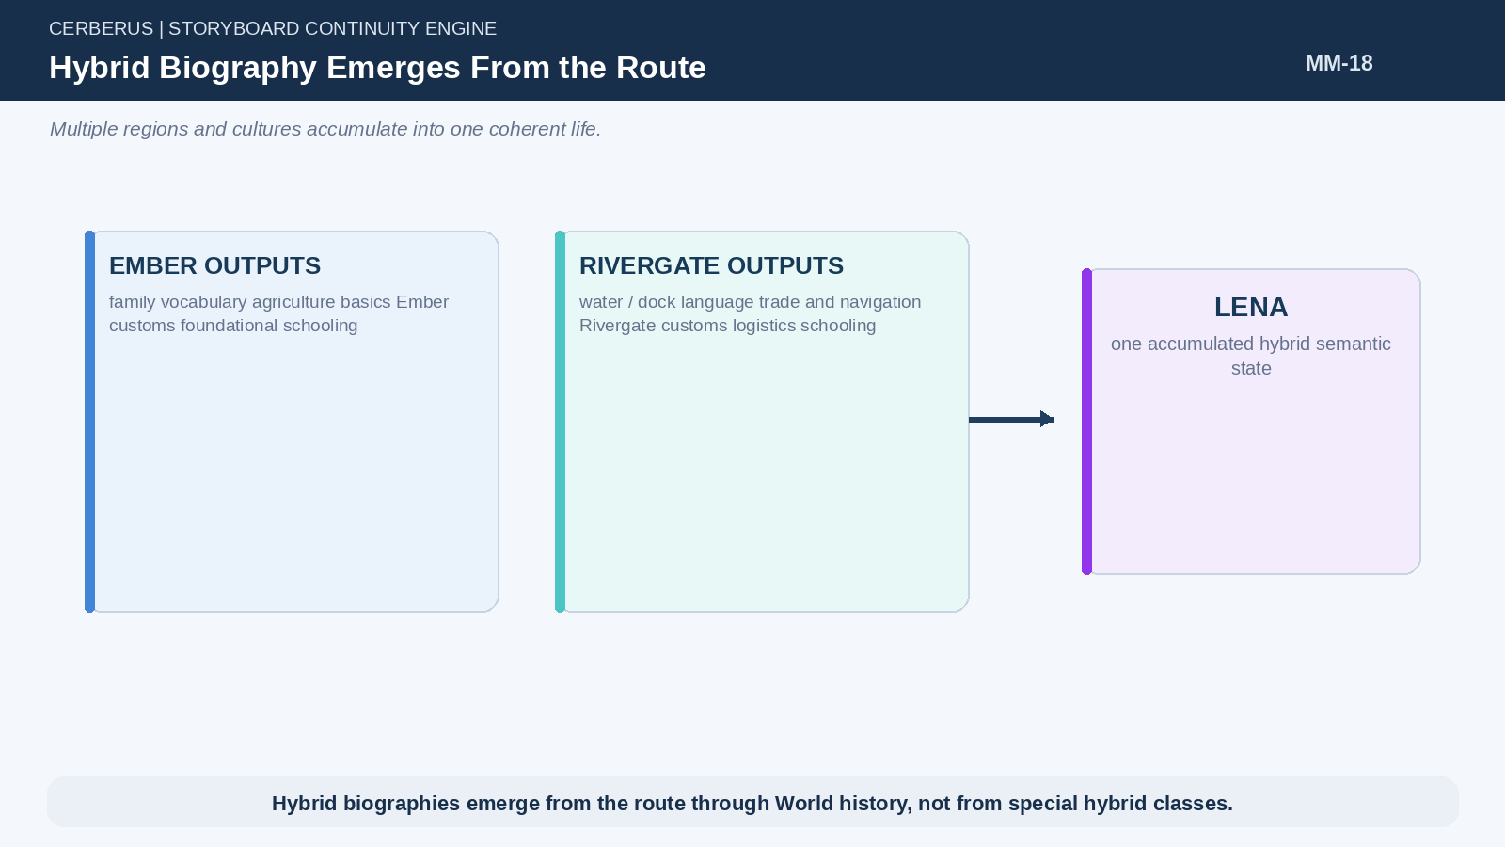
Figure 18. Hybrid Biography Emerges From the Route.

24. Development Is Accumulative
Normal lifestamps add outputs to existing semantic state. They do not erase prior learning merely because a new Region or Culture is encountered. Exceptions may remove, suppress, or alter particular capability where the World provides a causal reason, but ordinary development is cumulative.
This accumulation supplies the historical language, skill, and concept state later used by the Groove compiler and by recollection.
Stateₜ₊₁ = Stateₜ ⊕ Lifestamp(World, Location, TIME) ⊕ Exceptions

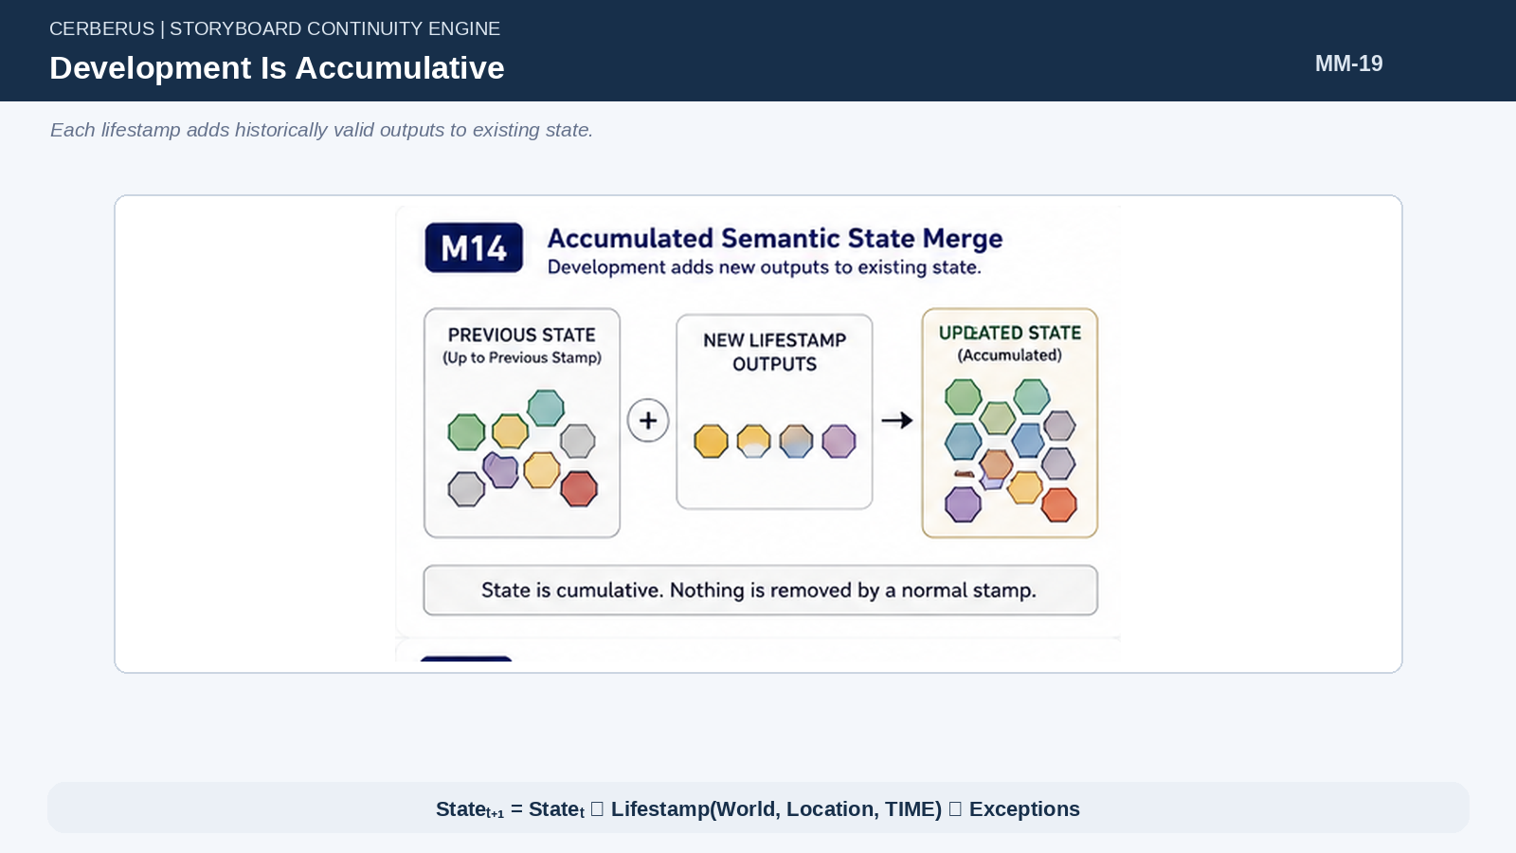
Figure 19. Development Is Accumulative.
PART 5

Schools as Semantic Compilers
Institutions turn historical attendance into legitimate semantic capability without storing every class and mark.

25. Educational History Is World Evidence
If the World knows that a school taught specific subjects during a historical interval and the Life Trajectory establishes that a person attended, the architecture has legitimate evidence that the normal institutional outputs were learned. This is more grounded than inventing skills directly on the character and far cheaper than simulating every course.
Individual grades, instructors, assignments, and attendance can exist at deeper resolution when consequence requires them, but they are not necessary for the baseline reconstruction.
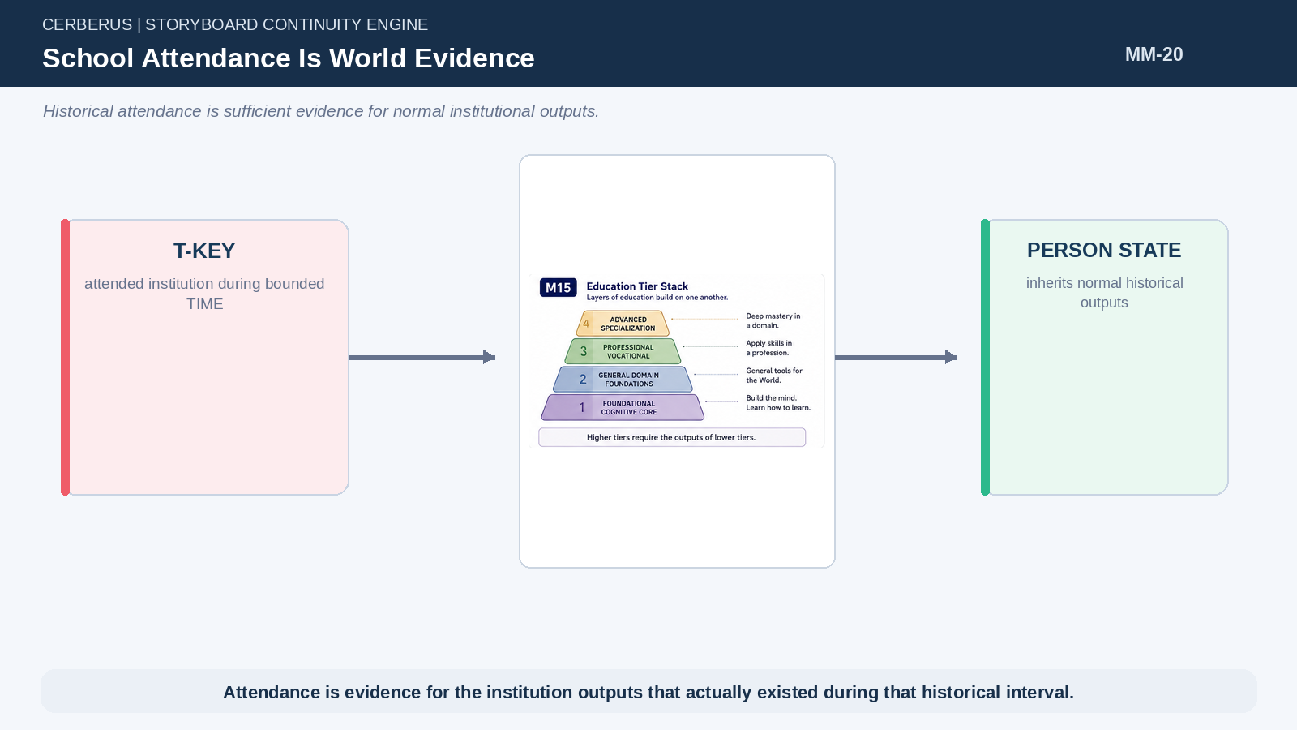
Figure 20. School Attendance Is World Evidence.

26. School Tiers
Education can be separated into tiers whose outputs build on one another. Foundational education develops the cognitive core. General-domain education exposes broad tools for interacting with the World. Professional or vocational education applies those tools to a domain. Advanced specialization deepens a narrower practice.
The exact tier names and counts can remain configurable; the important architecture is prerequisite-and-output composition.
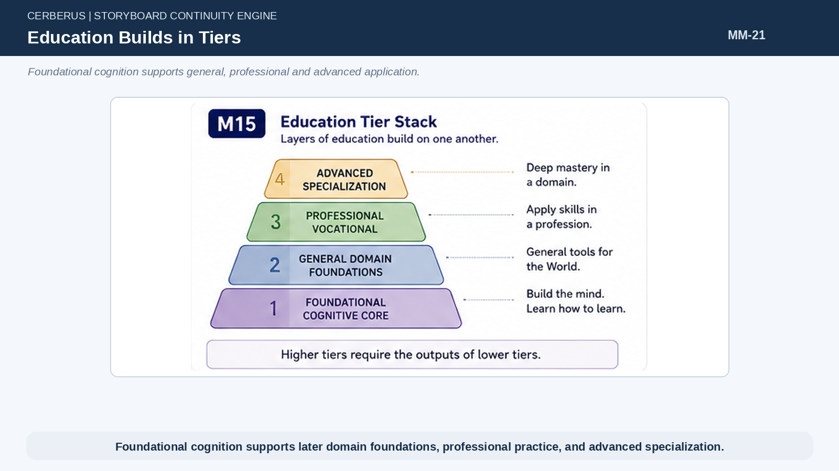
Figure 21. Education Builds in Tiers.

27. Foundational Schools Build Cognitive Machinery
Early schooling can output language, classification, comparison, sequencing, cause/effect reasoning, measurement, planning, prediction, feedback, correction, reflection, and communication. These are reusable capabilities rather than facts tied to one profession.
By giving characters these bounded cognitive competencies, later behavior can generalize across domains without creating a separate planning flag for every possible task.

28. The Cybernetic Learning Cycle
Foundational cognition can be organized as a reusable loop: observe, classify, model, choose, act, compare, and correct. Early education strengthens the ability to traverse increasingly complete portions of this cycle. Later professional schools do not need to reinvent the loop; they teach the person what semantic structures and actions apply within a particular domain.
This makes cognition compositional and explains why planning competence can transfer to unfamiliar but semantically comprehensible situations.
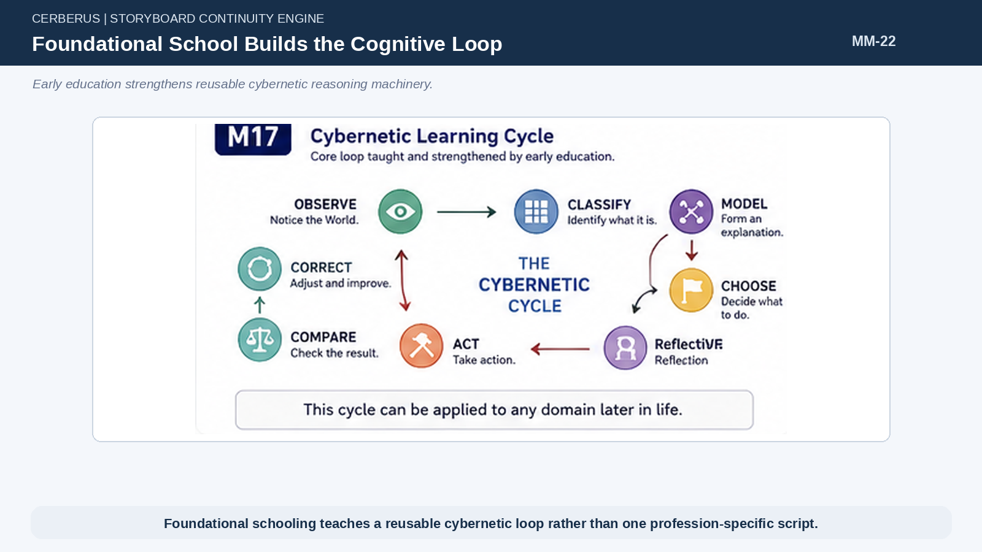
Figure 22. Foundational School Builds the Cognitive Loop.

29. Specialized Schools Apply Cognitive Machinery
Agriculture, medicine, logistics, engineering, governance, magic, cooking, or another profession attaches domain semantics to the previously acquired cognitive core. The same comparison and planning capabilities can now operate over crops, patients, inventory, structures, policies, spells, or recipes.
Domain competence therefore emerges from cognitive machinery + domain semantic state + experience rather than from a giant list of bespoke behaviors.
Domain Capability = Cognitive Core + Domain Semantics + Experience

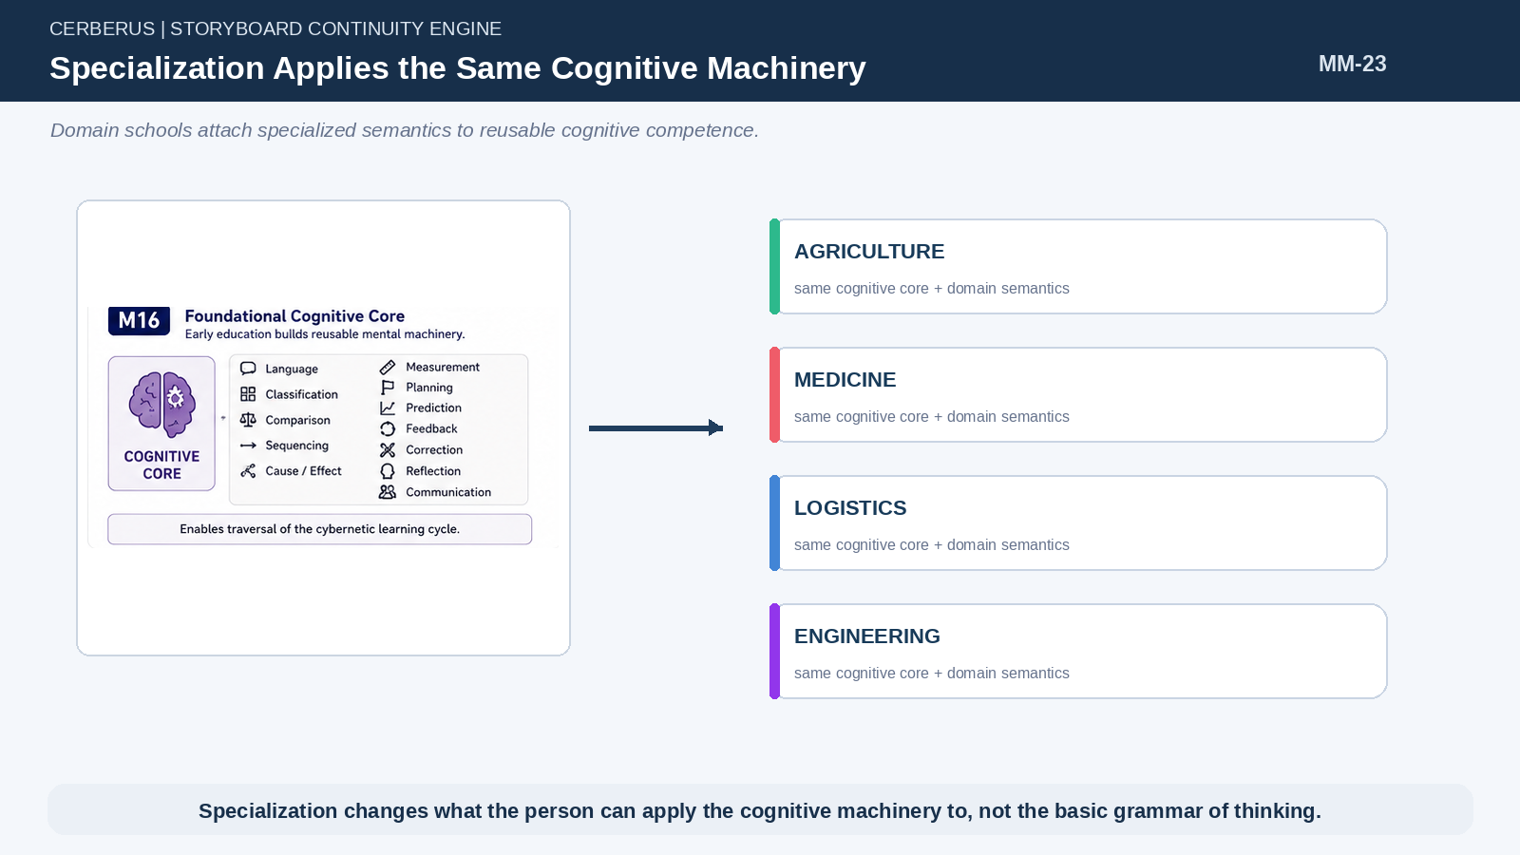
Figure 23. Specialization Applies the Same Cognitive Machinery.

30. Schools Output BitWords and Families
An institution can declare prerequisite and output BitWords or Families. A foundational school may output COGNITIVE_CORE, LANGUAGE_BASIC, NUMERACY_BASIC, or PLANNING_BASIC. A logistics school may require those and output ROUTING, INVENTORY, CAPACITY, SCHEDULING, and TRADE families.
The exact semantic identities remain governed by BIGFOOT/SK architecture. Memory Mechanics only requires that historical educational outputs be bounded and reconstructable.
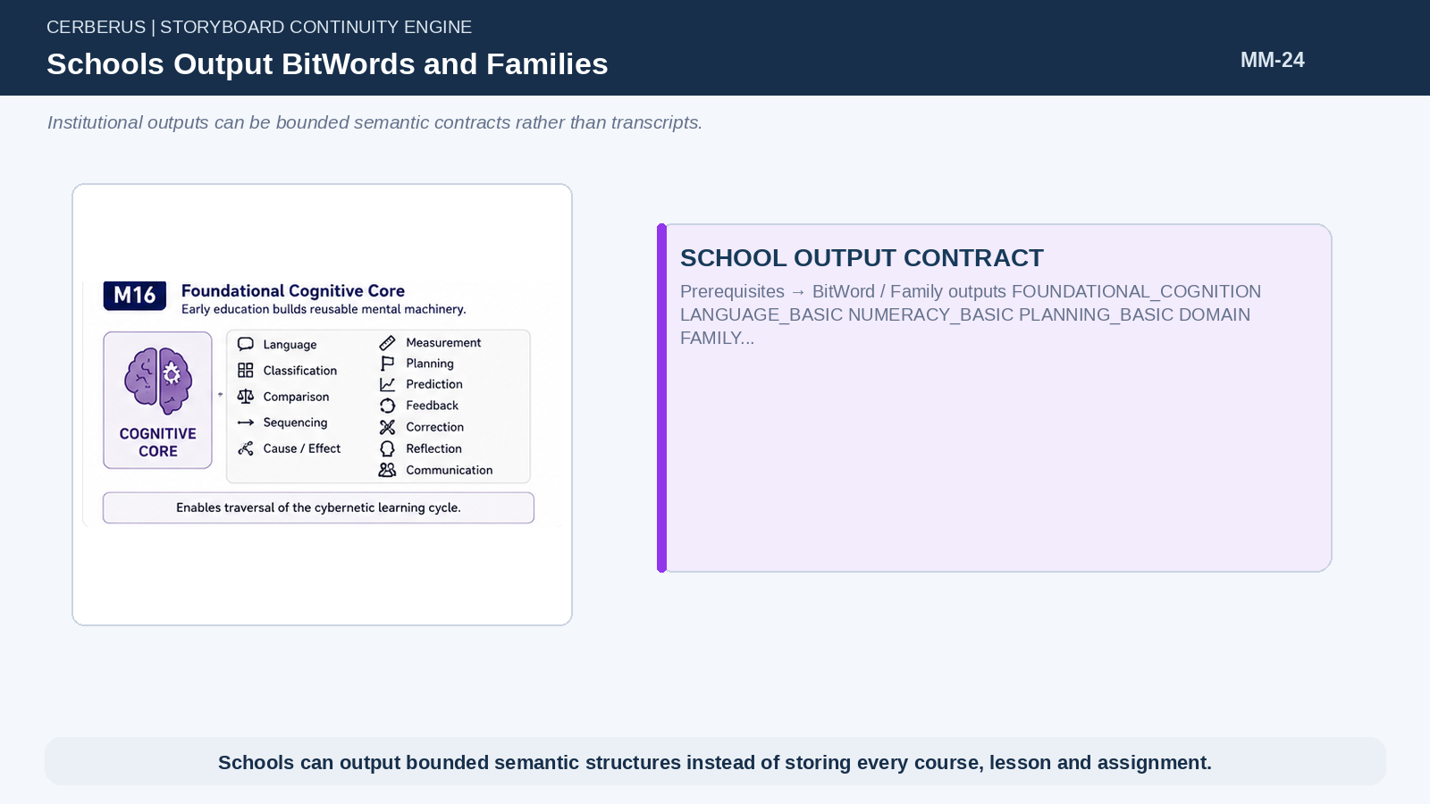
Figure 24. Schools Output BitWords and Families.

31. Historical School Versions Matter
A school in Year 180 may teach basic agriculture. The same institution in Year 220 may add irrigation and soil chemistry. By Year 260 it may teach automated machinery. Three graduates can all truthfully share the same school while possessing different skills because their historical attendance intersected different curriculum versions.
This avoids freezing institutions into timeless capability factories.
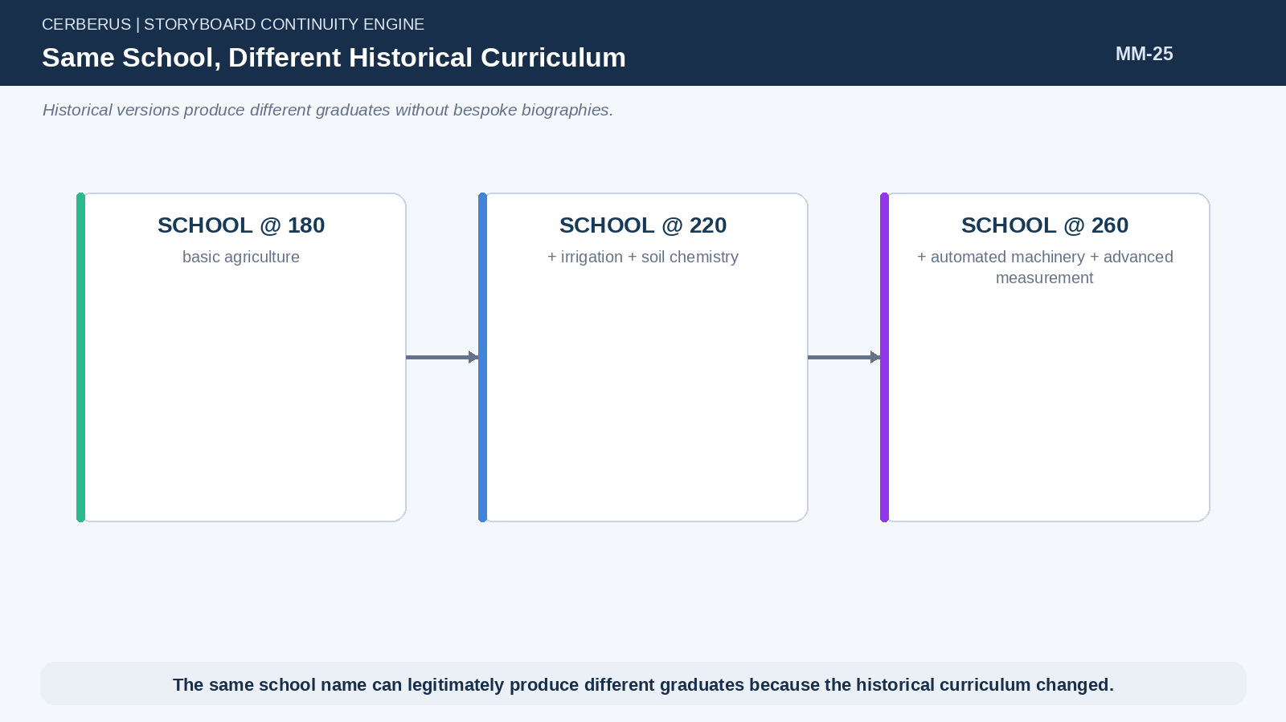
Figure 25. Same School, Different Historical Curriculum.

32. Do Not Simulate Transcripts Unless Needed
Course-by-course marks, assignments, teacher relationships, and attendance records can explode data without improving most behavior. The baseline system therefore resolves educational history only deeply enough to justify the capability currently required. A transcript becomes necessary only when later consequence depends on distinctions that the institutional output contract cannot explain.
This is an educational form of Lowest Sufficient Resolution.
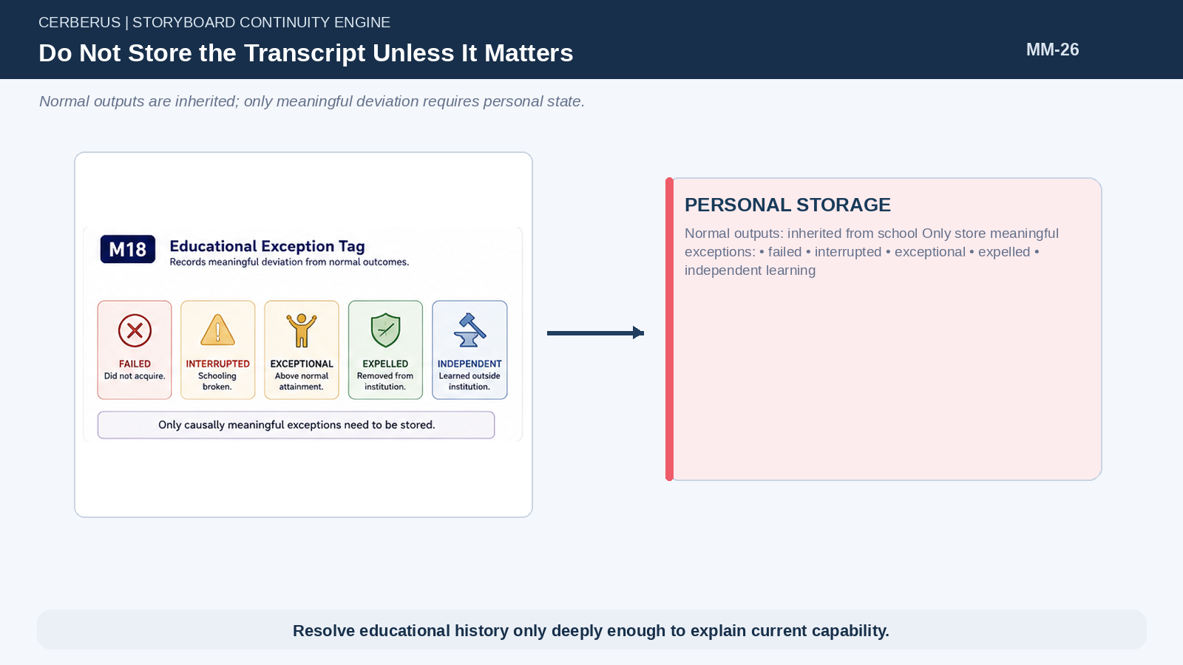
Figure 26. Do Not Store the Transcript Unless It Matters.

33. Educational Exceptions
Normal attendance inherits normal historical outputs. Exceptions record causally meaningful deviation: failed subject, interrupted schooling, expulsion, exceptional attainment, unusual specialization, or independent learning. These sparse exceptions are exactly the kind of personal state worth storing because they make the person diverge from the reconstructable baseline.
The World supplies the default; Events and exception tags preserve the difference.
PART 6

The Memory Groove
The system compiles expensive historical eligibility into a tiny binary tape and then resumes from the last completed Event.

34. Candidate Event Intersection
When a T-Key is first resolved or its Memory Groove must advance, the engine identifies the ordered World Events whose scope, TIME, location, class, role, P-Key occupancy, Life Trajectory, or explicit participant links intersect the person. These relationships are deterministic because the Events already happened in a fixed order and the person either occupied the relevant topology or did not.
This stage discovers candidates; it does not yet decide that the person forms a routine autobiographical memory.
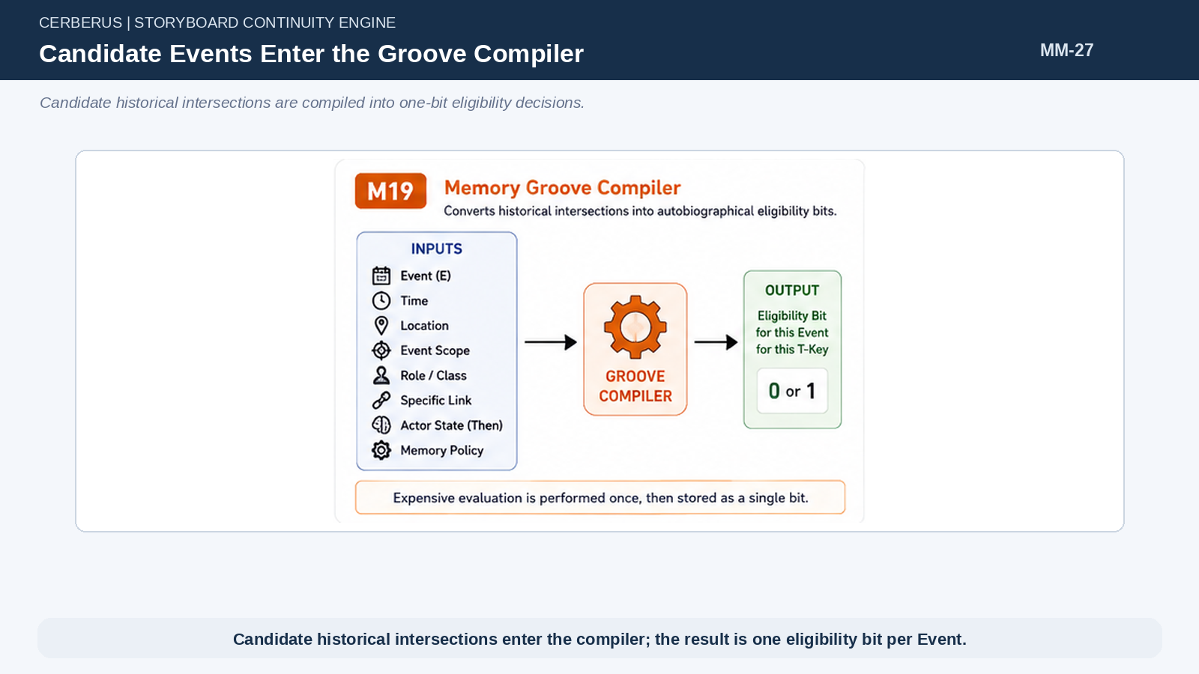
Figure 27. Candidate Events Enter the Groove Compiler.

35. Hard Eligibility Cutoff
Candidate Events pass through a bounded Memory Policy that produces a hard decision. The policy can consider historical semantic state, direct involvement, role relevance, and the simulation’s configured fidelity budget, but the output is intentionally simple: 0 or 1.
The important optimization is that the result is compiled. The engine does not repeatedly recalculate fuzzy fit every time the character loads.
G_T(E) ∈ {0,1}

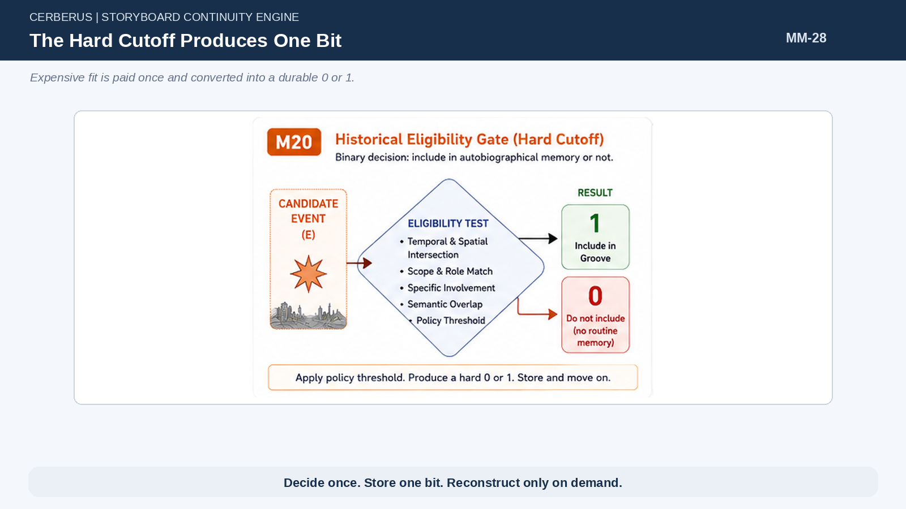
Figure 28. The Hard Cutoff Produces One Bit.

36. Binary Meaning
A Groove value of 1 means the Event may be routinely reconstructed as lived autobiographical history. A Groove value of 0 means ordinary retrieval should not spend the expensive work required to rebuild the experience. Neither value changes World Truth.
The binary decision is deliberately coarse because it exists to eliminate repeated computation. Richness is recovered later from the Event and actor state when a 1 is actually queried.

37. Memory Groove Is Not Memory Content
The Groove does not store a sentence such as “I remember the flood.” It stores permission to reconstruct the flood as part of this T-Key’s lived history. The canonical Event, historical World state, role, and historical semantic self remain elsewhere.
This distinction allows one bit to stand in front of a potentially very rich reconstruction path.
Architectural law
Store the decision, not the reconstruction.

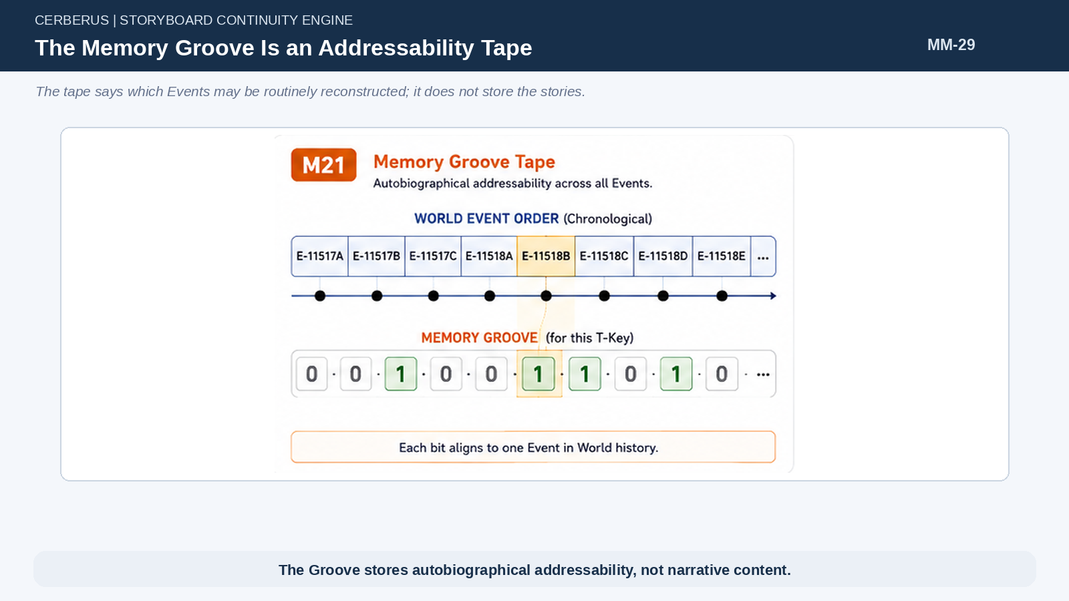
Figure 29. The Memory Groove Is an Addressability Tape.

38. Groove Addressing Follows World Event Order
Because World Events already exist in immutable causal order, Groove position can align directly to that order. Event N and Groove position N form a stable pair. This makes Event-to-bit and bit-to-Event routing simple and eliminates a second historical indexing scheme.
The World ledger therefore acts simultaneously as causal history and the coordinate frame for autobiographical eligibility.
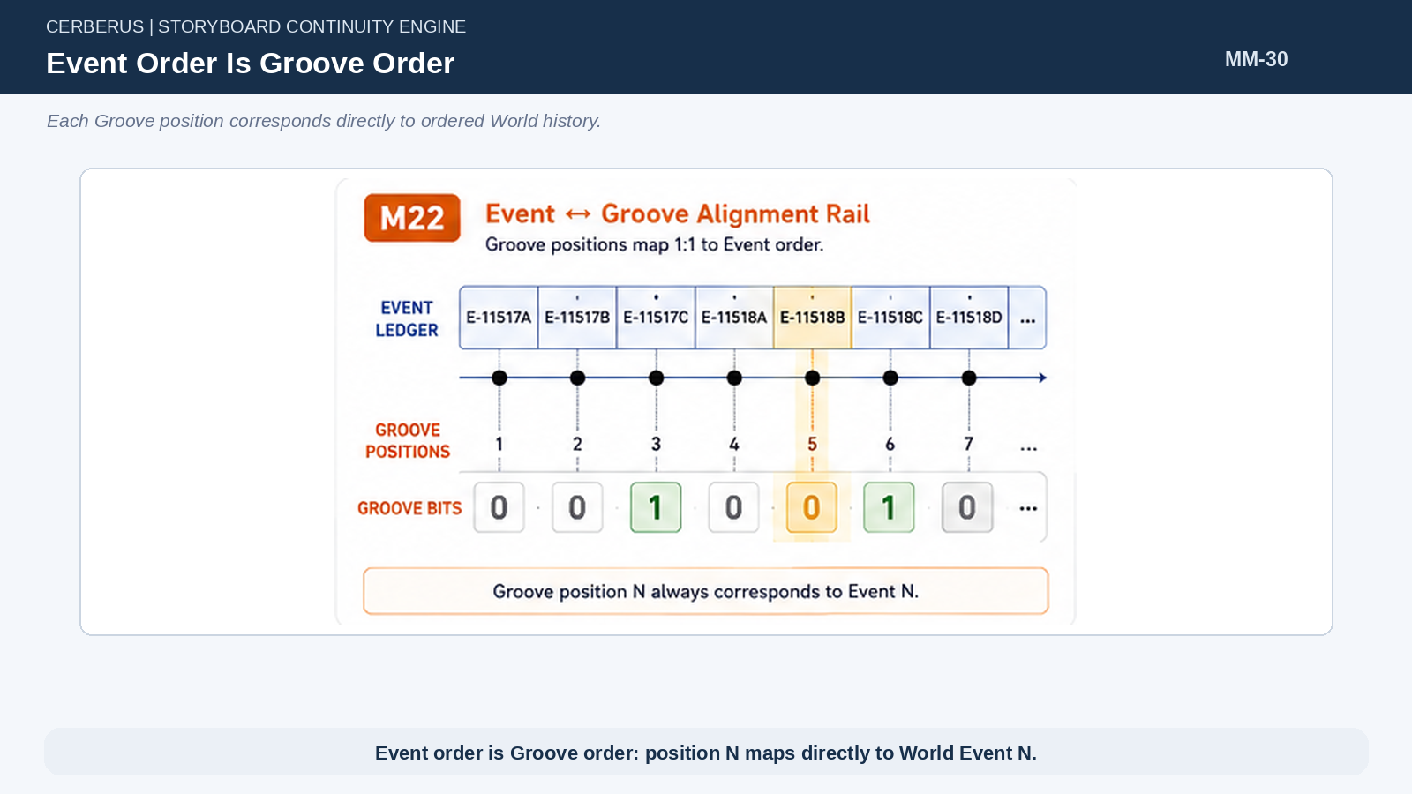
Figure 30. Event Order Is Groove Order.

39. Groove Cursor
The T-Key stores the last World Event position whose eligibility has been compiled. If the actor was last loaded at E-4821 and the World has advanced to E-5174, the next load begins at E-4822. Earlier history is not reconsidered.
The cursor is therefore a tiny progress marker that turns Memory formation into incremental compilation rather than repeated full-life analysis.
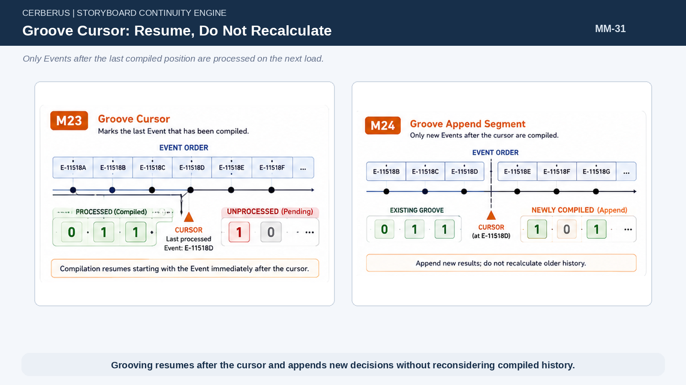
Figure 31. Groove Cursor: Resume, Do Not Recalculate.

40. Incremental Grooving
New Events are processed chronologically from Cursor + 1 to the current World Event. Their 0/1 results are appended to the existing Groove and the cursor advances. Historical actor state also progresses in order, so the compiler evaluates each Event against the person as they existed at that point rather than against their current knowledge.
This preserves developmental causality while bounding work to the uncompiled historical interval.
Groove_new = Groove_old + Compile(Cursor+1 … Current)

41. Memory Policy Is Deliberately Variable
A massive World with thousands or millions of T-Keys may use an aggressive cutoff so only strong autobiographical intersections become 1s. A focused simulation with twenty or thirty characters can lower the cutoff and permit denser autobiographical access. The policy changes computational fidelity, not the underlying Memory architecture.
This allows one system to serve both large-scale worlds and small high-detail experiments.
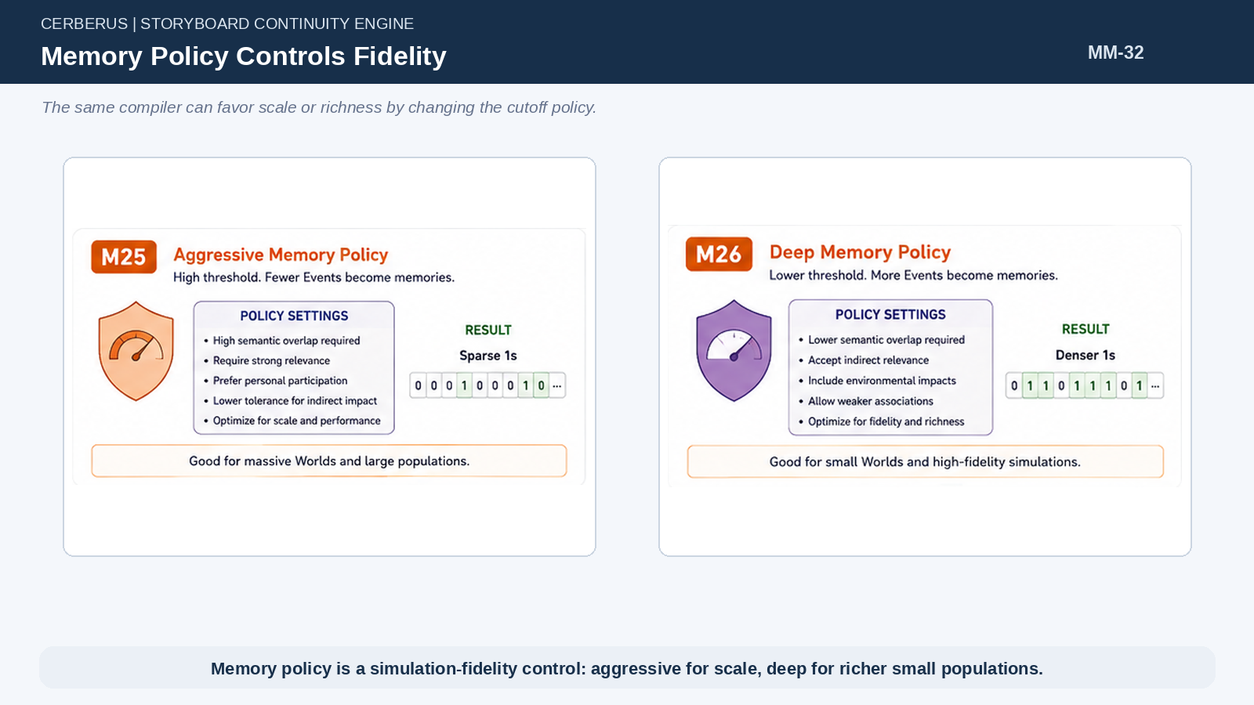
Figure 32. Memory Policy Controls Fidelity.

42. Decide Once; Store One Bit
The Groove exists to move expensive semantic fit out of routine loading. Once eligibility for a historical Event has been decided under the relevant policy, the normal path needs only the stored bit. Reconstruction is paid only when a later cognitive query actually reaches a 1.
The result is an enormous reduction in repeated work because most candidate Events can be dismissed before any detailed historical self or event-specific behavior is rebuilt.
Architectural law
Decide once. Store one bit. Reconstruct only on demand.

43. Zero Is Not Erasure
A 0 means “do not routinely reconstruct this Event as autobiography.” The Event remains canonical and may still be examined by an explicit deep query. A player can ask a character to think carefully about something outside ordinary memory routing, at which point the engine may spend additional calculations against historical context.
This keeps normal cognition brutally bounded without destroying access to exceptional investigation.
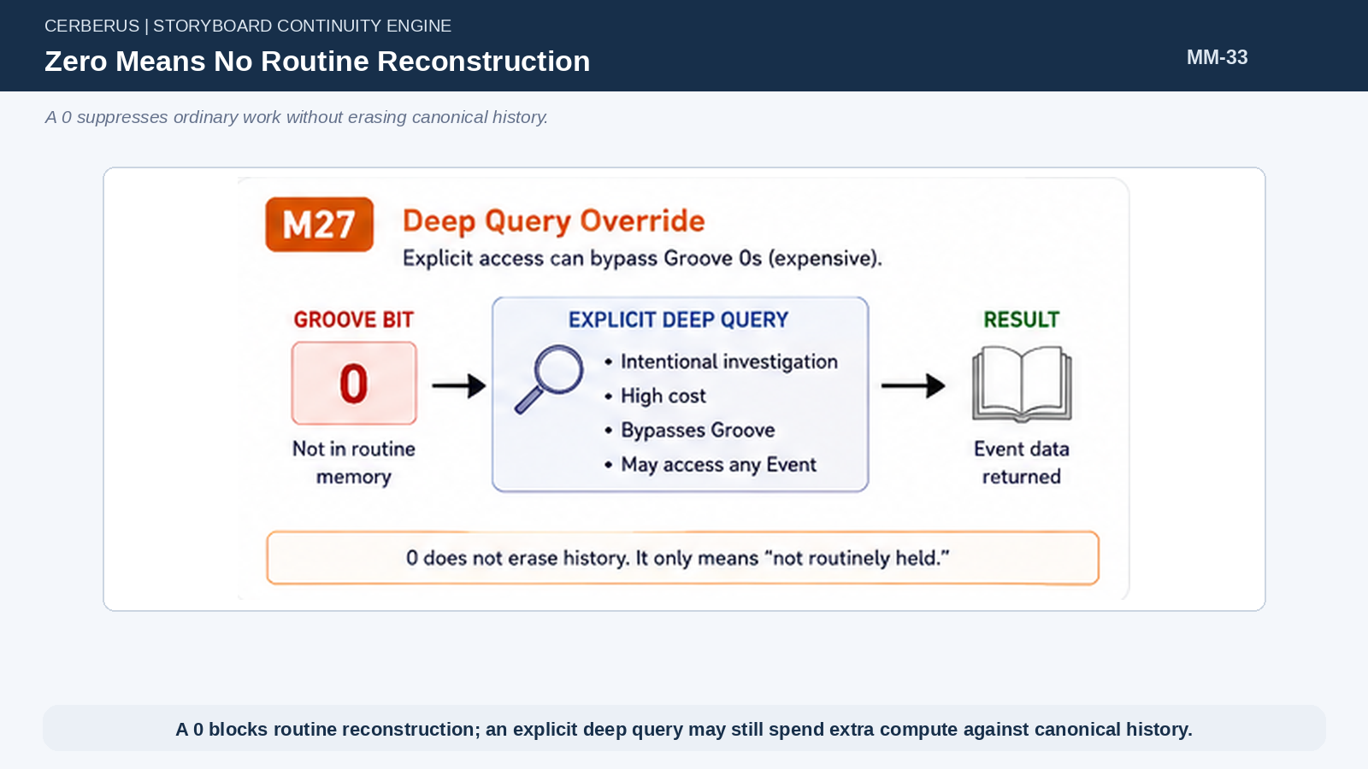
Figure 33. Zero Means No Routine Reconstruction.

44. Successive Compression of Cognitive Work
The architecture reduces work in stages: the World Event ledger is narrowed by historical topology; the Groove compiler reduces candidate history to sparse 1s; current context and Language-bit overlap narrow those 1s to a few relevant Events; only those few reach reconstruction. Expensive cognition sits at the bottom of several cheap filters.
This is how a character can exist inside a World containing millions of Events without scanning or interpreting millions of Events during every load.
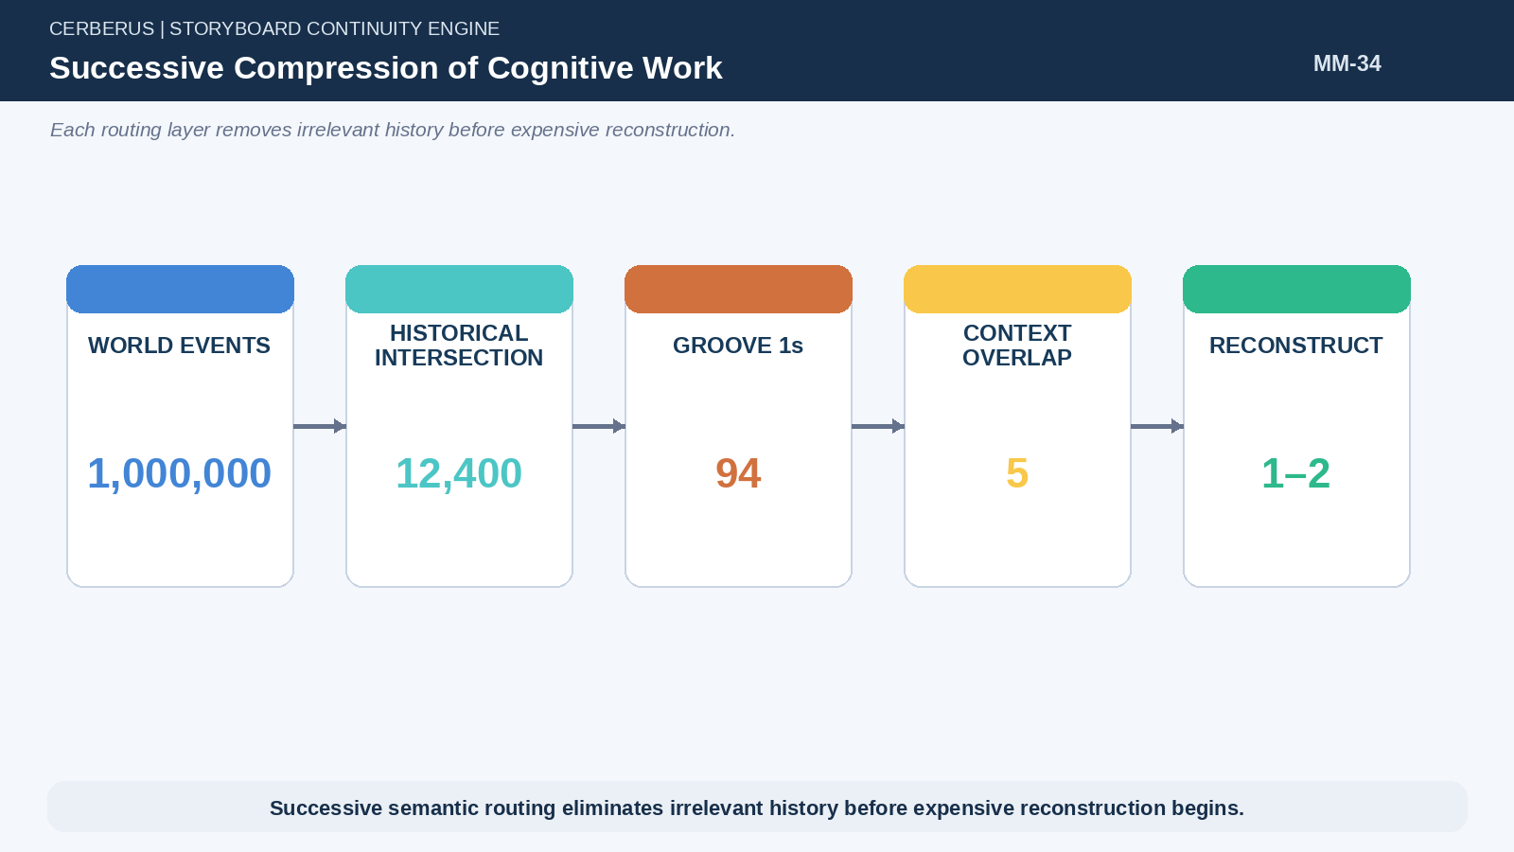
Figure 34. Successive Compression of Cognitive Work.
PART 7

Recollection and Reflection
The same Event can be reconstructed through the semantic self that existed then or interpreted again through the self that exists now.

45. Reconstruct the Historical Self
When a Groove-1 Event must be recalled, the system reconstructs the actor only through the Event TIME. Birth, Life Trajectory stamps, historical schools, prior applicable Events, and accumulated semantic state up to that point form the historical self. Future knowledge is excluded.
This makes recollection historically authentic without storing a prose snapshot of the person for every year of life.
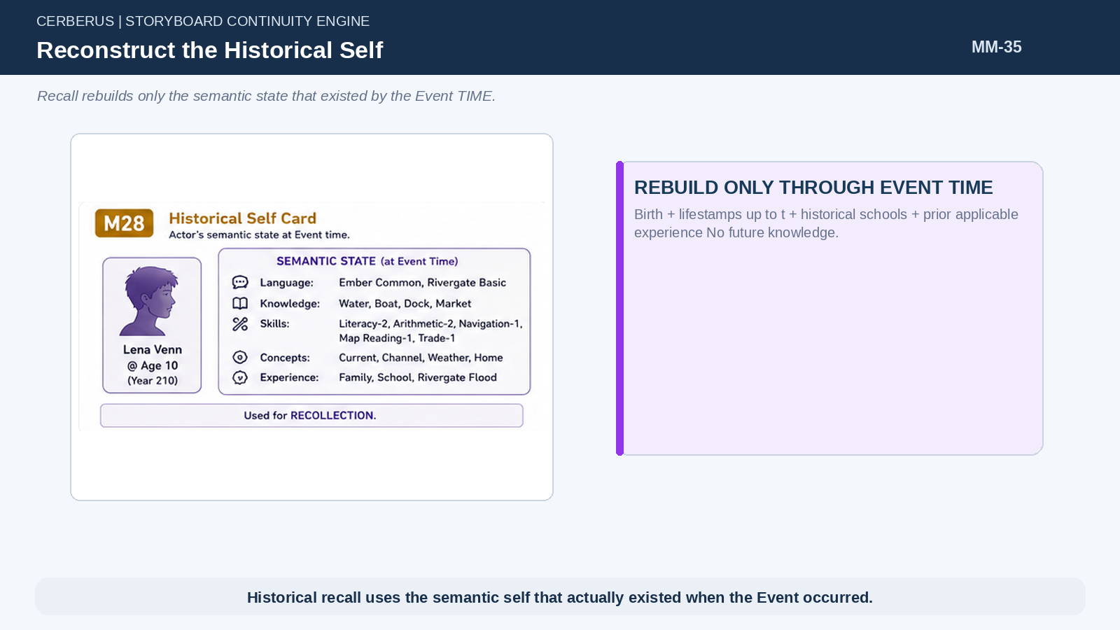
Figure 35. Reconstruct the Historical Self.

46. Recollection
Recollection interprets the Event through the semantic state available at the time. A ten-year-old may remember that the river covered the lower road and that adults kept children away from the docks without possessing later concepts such as cargo-route capacity or infrastructure redundancy.
The Event can therefore remain the same while the reconstructed experience reflects the actor’s historical age, role, vocabulary, skill, and prior experience.
Recollection(T,E) = Interpret(E, State_T(t_E))

47. Reflection
Reflection applies the current semantic state to the same historical Event. Years of logistics training may let the adult understand that the flood mattered because it severed a cargo route, not merely because water was high. This reinterpretation does not rewrite the Event or the earlier recollection.
The architecture can therefore model growth in understanding without storing multiple authored versions of the same memory.
Reflection(T,E,t_now) = Interpret(E, State_T(t_now))

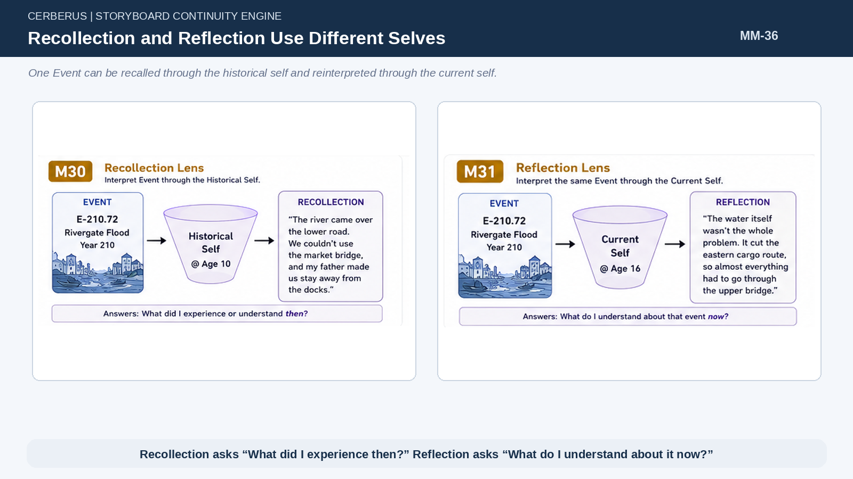
Figure 36. Recollection and Reflection Use Different Selves.

48. Historical Vocabulary Bounds Historical Experience
Ordinary recollection cannot silently borrow concepts the person did not possess at the time. Historical vocabulary and skill competence define the state space through which the Event can be reconstructed. A child, novice, and expert may all have Groove value 1 for the same Event while extracting different meaning.
This boundary is what turns schooling and Life Trajectory into genuine cognitive causes rather than decorative backstory.
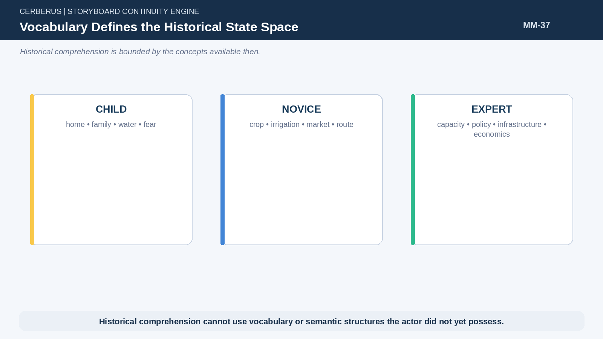
Figure 37. Vocabulary Defines the Historical State Space.

49. Current Knowledge Can Reinterpret the Past
Later learning can add causal structure, terminology, professional models, or social understanding that were absent during the original experience. Reflection is allowed to use those additions because it answers a different question: what does the person understand now?
The system can therefore support statements such as “at the time I blamed the weather; now I think the reservoir policy was the deeper problem” without storing two manually authored memories.
PART 8

Learned World History
A person may know about the past without claiming autobiographical access to it.

50. Lived History and Learned History Are Different
Autobiographical Memory and historical knowledge must remain separate. A person born after the Battle of Ember may know the battle in detail but cannot honestly reconstruct it as lived experience. Conversely, someone may remember a local event without possessing the later formal historical explanation.
This distinction prevents inherited, educational, or archival knowledge from becoming fake eyewitness memory.
LivedHistory ≠ LearnedHistory

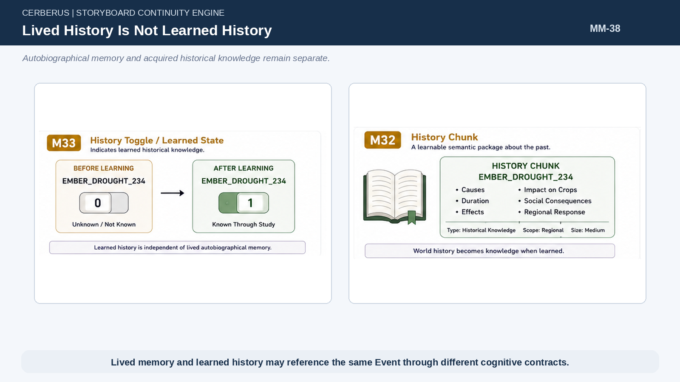
Figure 38. Lived History Is Not Learned History.

51. History Uses Semantic Chunks
World history can be packaged into learnable semantic chunks in the same spirit as vocabulary. A chunk such as EMBER_DROUGHT_234 may encode bounded facts, causes, consequences, Region, and TIME at the resolution appropriate for teaching or reasoning.
The chunk does not replace the canonical Event. It is a writable knowledge representation derived from World history.
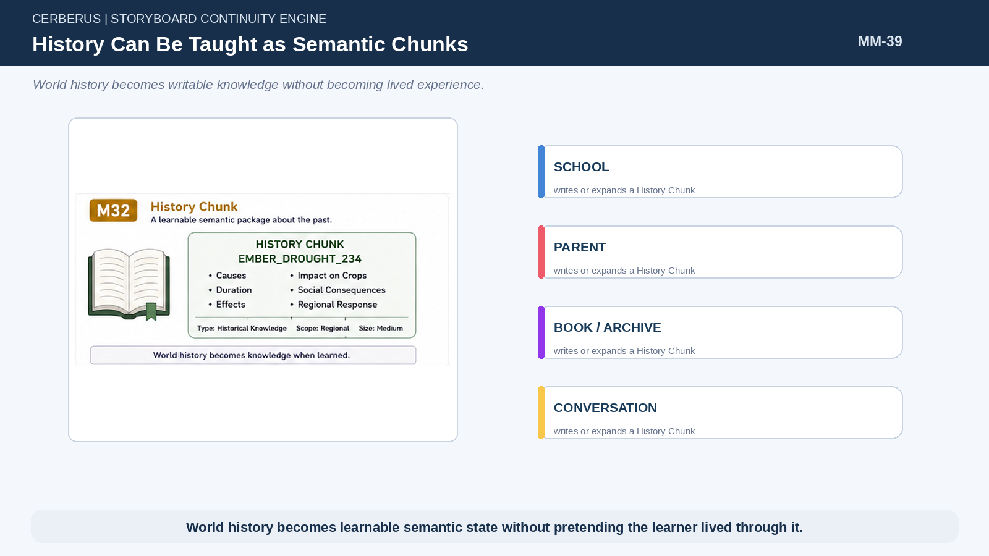
Figure 39. History Can Be Taught as Semantic Chunks.

52. History Chunks Are Writable
Schools, parents, books, guilds, archives, monuments, conversations, or other knowledge routes can write or expand History Chunks on a person. This gives historical knowledge a legitimate causal acquisition path rather than granting every character omniscient access to the past.
Because the knowledge is writable, later systems can support partial curricula, secrets, propaganda, discoveries, and revision without changing canonical history.

53. Binary or Higher-Resolution Historical Knowledge
Some historical knowledge can be represented by a simple known/unknown state. More complex subjects may require a larger BitWord or chunk with internal semantic resolution. The architecture intentionally does not force all history into one bit; it only requires that learned history remain distinct from autobiographical Groove state.
This keeps the simple case cheap while allowing richer knowledge where it matters.

54. Naming Event Demonstration
A child’s Naming Event illustrates the distinction cleanly. The Event creates identity and may be crucial to family history, but the newborn’s Memory Groove can hold 0 for ordinary recollection. Years later a parent can teach a MY_NAMING_HISTORY chunk. The person can then accurately say “I do not remember it; my parents told me.”
The World, lived Memory, and learned history all remain consistent.
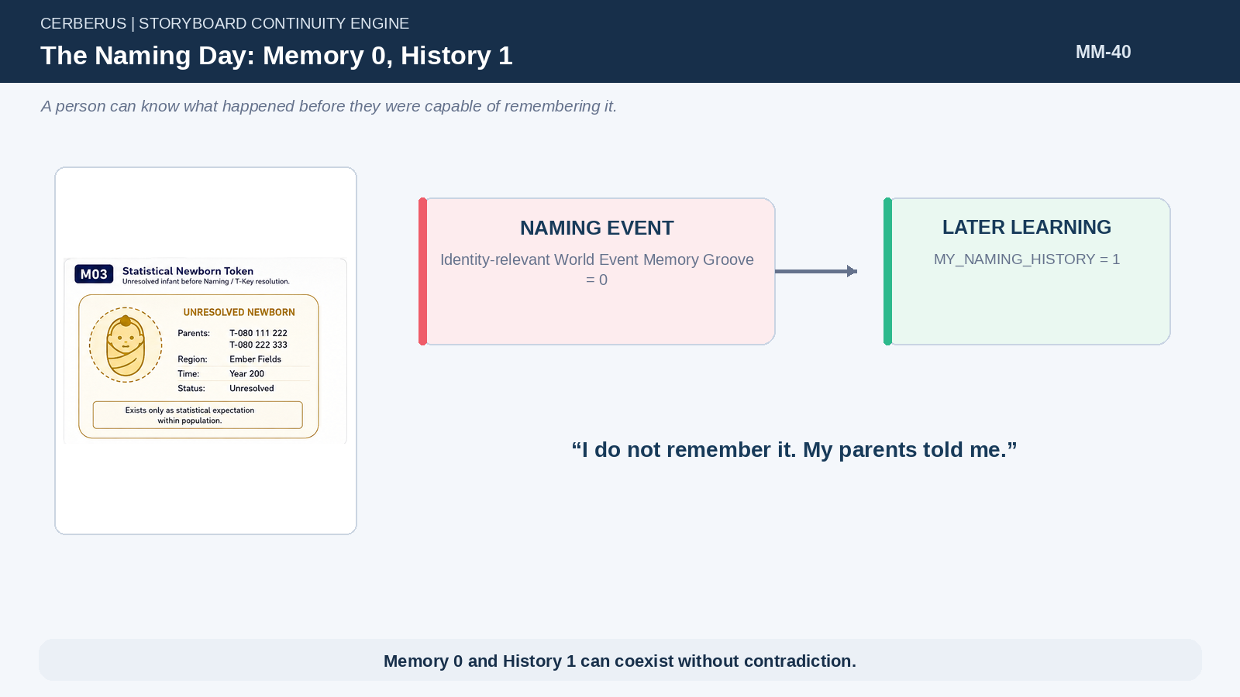
Figure 40. The Naming Day: Memory 0, History 1.

55. Canonical History Remains Separate
What a person knows about history does not become the World’s truth. A History Chunk can be incomplete, simplified, or—once later systems permit it—incorrect. Canonical Event history remains authoritative and can be compared against what individuals learned.
Memory Mechanics therefore preserves the same truth boundary established in World Mechanics: subjective or educational state may diverge without corrupting the World.
PART 9

P-Key World Positions
Permanent World roles provide stable historical routing while different T-Keys occupy them through TIME.

56. P-Key Is Permanent to the World
A P-Key identifies a permanent World position such as King, High Mage, or University Director. It is not a special kind of person and it is not a promoted T-Key. The World position persists even when the occupant changes.
This permanence makes P-Keys useful historical routing spines because Events can reference the role directly across generations.
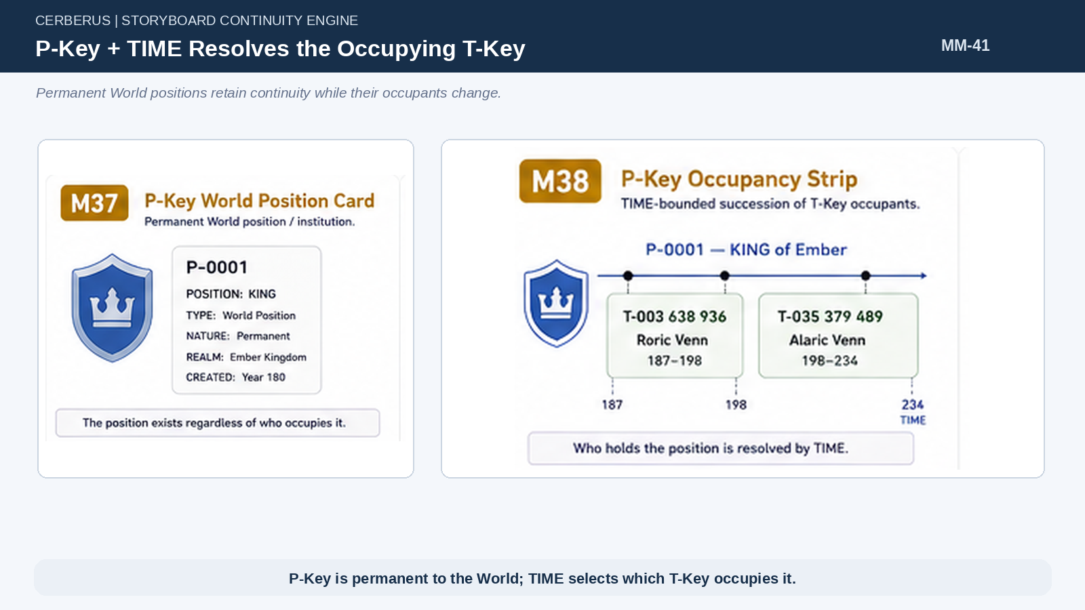
Figure 41. P-Key + TIME Resolves the Occupying T-Key.

57. P-Key Is Not the Person
P-0001 KING may be occupied by T-003 638 936 from Years 187–198 and by T-035 379 489 from Years 198–234. The P-Key retains continuity of the Kingship; each T-Key retains continuity of the actual human occupying it.
Role history and occupant history can therefore be queried independently and recombined by TIME.
P-Key ≠ T-Key

58. TIME Resolves Occupancy
Historical resolution is simple: P-Key + TIME returns the T-Key occupying that World position during the queried interval. An Event in Year 193 that references P-0001 resolves to one person; an Event in Year 220 resolves to the successor.
The permanent role can accumulate thousands of Event relationships without duplicating the occupant’s identity into every record.
Occupant(P,t) = T

59. Permanent Positions Create Dense Event Exposure
Kings, High Mages, Directors, commanders, and other persistent positions naturally intersect many Events because the World repeatedly selects those roles as causal participants. Their occupants therefore receive dense candidate autobiographical history during tenure without requiring a different Memory Engine.
Importance emerges from event topology: the role is mentioned often because the role matters often.

60. P-Key Events Feed the Occupying T-Key Groove
During grooving, Events routed through a P-Key become candidates for the T-Key whose occupancy interval overlaps the Event TIME. When the tenure ends, future P-Key Events belong to the next occupant. Already grooved experiences remain part of the former occupant’s biography.
This gives position-specific historical exposure a compact and deterministic routing rule.
CandidateEvents(T) ⊇ Events(P) ∩ Tenure(T,P)

PART 10

Contextual Memory Retrieval
Memory should be reconstructed because something in the present asks for it, not because the character continuously scans autobiography.

61. Memories Do Not Need to Compete Constantly
A person may possess many Groove-1 Events without keeping them all active. Routine simulation should not continuously rank every autobiographical possibility. Memory becomes useful when a current objective, conversation, location, visible object, person, task, or need creates a semantic query.
This moves memory retrieval from global scanning to context-driven routing.

62. Current Context Produces Semantic Query State
Current objectives and surroundings already carry semantic structure. Repairing an irrigation pump activates concepts around water, farming, machinery, flow, maintenance, location, helpers, and the task itself. A conversation about a flood activates another bounded semantic set.
This context bundle becomes the query surface used to select which already-addressable Events deserve consideration.
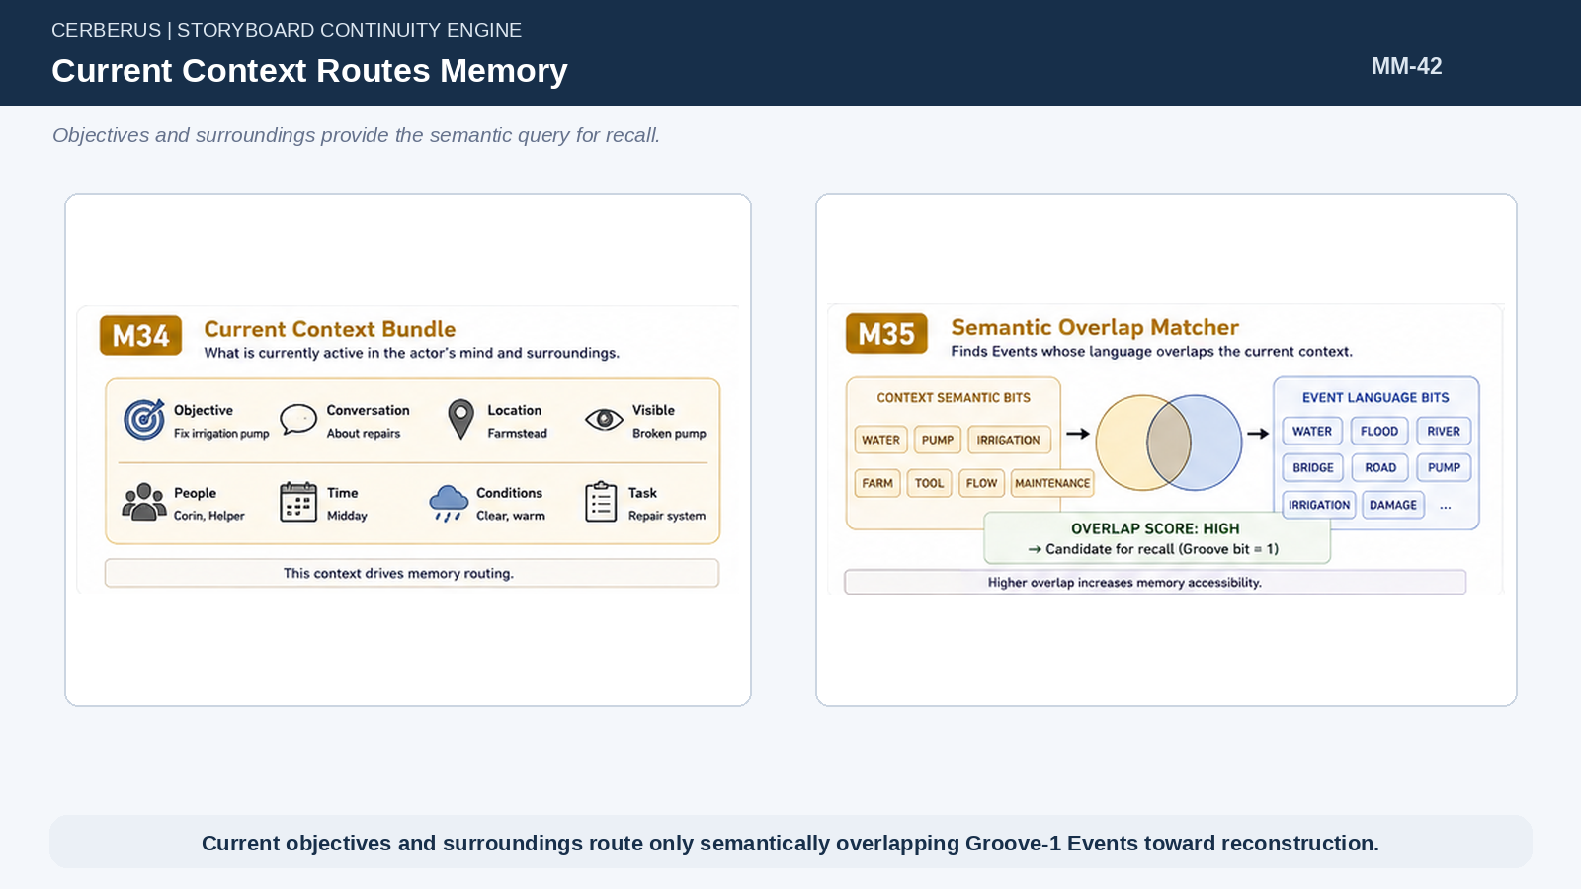
Figure 42. Current Context Routes Memory.

63. Events Carry Language Bits
World Events can carry tagged Language bits or semantic labels that summarize the concepts useful for retrieval. A flood might expose WATER, RIVER, BRIDGE, ROAD, DAMAGE, IRRIGATION, or related structures. These tags do not replace the Event; they make the Event cheaply discoverable from current context.
Because the tags belong to the shared Event, every person can route against the same semantic object without maintaining private search metadata.

64. Lexical Overlap Routes Recall
Routine recall intersects the person’s Groove-1 Event addresses with semantic overlap between current context and Event language. Only the small result set proceeds toward detailed reconstruction. This is a second major compression after grooving itself.
The system therefore avoids both scanning all World history and reconstructing every autobiographically addressable Event.
RecallCandidates = Groove₁ ∩ SemanticOverlap(CurrentContext, EventTags)

65. Only a Few Events Reach Reconstruction
In a large World, millions of Events may shrink to thousands of historical intersections, then to tens or hundreds of Groove 1s, then to only a few semantic matches with the present situation. The reconstruction engine operates at the end of that funnel.
The architecture spends rich cognition only where cheap semantic routing has already established relevance.

66. Objectives Influence What Comes to Mind
Because objectives are part of the current semantic context, different goals can surface different memories from the same person. A logistics task may recall floods, road closures, shortages, and prior repairs; a family conversation may retrieve naming, migration, or festival Events.
This gives memory practical behavioral relevance without requiring a separate authored trigger table for every possible recollection.
PART 11

Social Memory as Graph Reconstruction
Many relationships can be inferred from shared historical topology until the relationship itself becomes causally distinctive.

67. Avoid Giant Persistent Friend Graphs
If every T-Key permanently stored every classmate, coworker, neighbor, guild member, and passing acquaintance, social state would explode just as quickly as autobiographical memory. Much of that social history already exists in shared World topology and can be reconstructed when needed.
The system should therefore distinguish ordinary social exposure from relationships whose individual persistence changes future behavior.

68. Shared Graph Intersections
Two people may share school, cohort, workplace, household, Region, guild, migration route, Local Events, Specific Events, or repeated spatial-temporal overlap. These intersections provide evidence that the people plausibly knew one another without a permanent friend-list edge.
The evidence is reconstructable because the same historical structures already support each person’s Life Trajectory and Memory Groove.
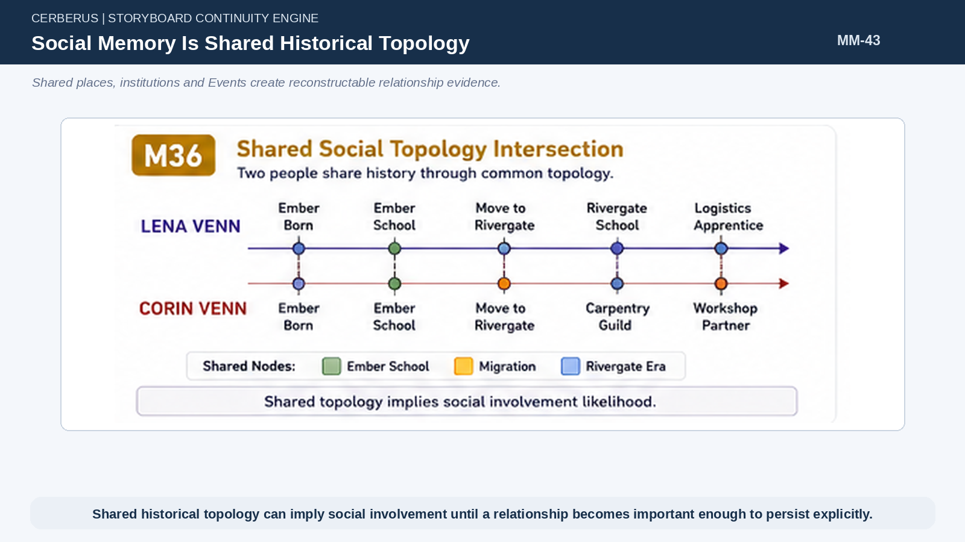
Figure 43. Social Memory Is Shared Historical Topology.

69. Shared Memories Strengthen Historical Relationship Evidence
If two T-Keys have multiple overlapping Groove-1 Events, the shared history becomes stronger evidence of meaningful social involvement. Repeated school, workplace, and Event intersections can make acquaintance or relationship more likely than one incidental co-location.
The architecture can use this evidence statistically without pretending that every shared Event guarantees friendship.

70. Statistical Involvement Likelihood
Social involvement can be estimated from shared topology, shared TIME, shared Events, roles, and memory overlap. The paper intentionally does not lock a universal percentage formula because different Worlds may need different social fidelity and different interpretations of proximity.
The important contract is that the probability comes from historical evidence rather than from arbitrary random relationship generation.
SocialLikelihood(A,B) = f(SharedTopology, SharedTIME, SharedEvents, SharedMemory, Roles) [conceptual]

71. Explicit Relationships Are Reserved for Causal Difference
When a relationship becomes independently important—marriage, rivalry, mentorship, family bond, oath, long-term friendship, or another continuing causal distinction—it can become persistent state. Before that point, reconstruction may be sufficient.
This mirrors the broader CERBERUS rule that individual persistence is earned by unresolved causal difference.

72. Dormant Social Relations Can Reappear
A name, institution, place, or Event can reopen old shared topology. Two former apprentices may have had no active relationship state for decades, yet a query about their old forge can reconstruct repeated overlap and make recognition or reminiscence plausible again.
This produces dormant social depth without keeping every old acquaintance active forever.
PART 12

External Individuals: U-Key and I-Key
External continuity may remember the World exactly while the World stores only the visitor’s causally sufficient local projection.

73. U-Keys and I-Keys Exist Outside World Event Identity
U-Keys represent players and I-Keys represent persistent individuals that can exist across games. Their full identity systems remain outside the native World Event identity graph. They can enter a World, cause Events, and maintain personal links to those Events without forcing the World to import their entire external data.
This boundary is essential for multiplayer scale and for privacy of personal semantic state.
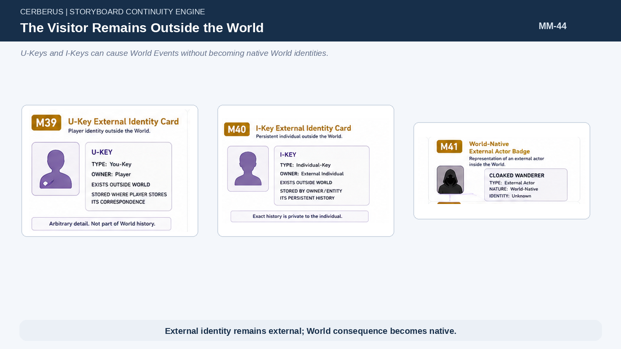
Figure 44. The Visitor Remains Outside the World.

74. World-Native External Actor Representation
When an external actor causes an Event, the World records a native description sufficient to explain the consequence: Cloaked Wanderer, visiting healer, foreign mage, organized raiding group, or another role/classification appropriate to the Event. The World does not need the visitor’s complete U-Key, I-Key, equipment history, social graph, SOLAR, or personal BitWords.
The World preserves causal semantics, not foreign ontology.

75. You-Shaped Stamp
The external person’s own Memory system may attach SELF to the World-native role recorded in the Event. If the World says “Cloaked Wanderer breached the gate,” the player’s private correspondence can state “I was the Cloaked Wanderer.” The Event remains World-native; the exact personal identity remains external.
This tiny correspondence is the you-shaped stamp.
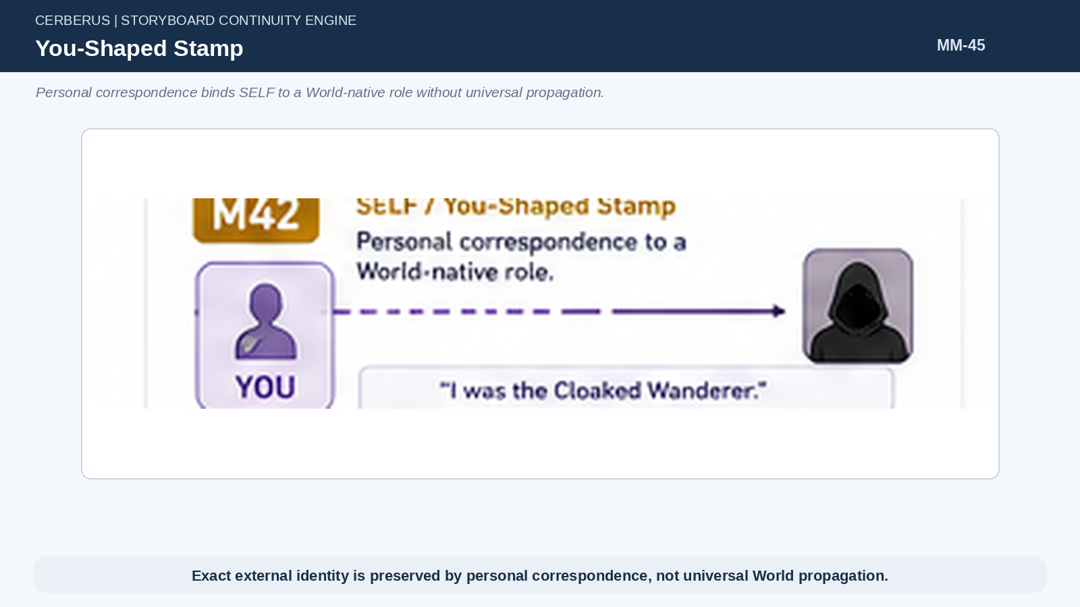
Figure 45. You-Shaped Stamp.

76. External Autobiography May Be Arbitrarily Detailed
A U-Key or I-Key can remember a shared raid with exact clan members, equipment, tactical sequence, personal injury, emotional significance, dialogue, screenshots, or any other detail its own continuity system chooses to preserve. That detail belongs to the external individual and does not need to become universal World history.
Personal memory can therefore be much richer than the World’s representation of the external actor.

77. World History Remains Compressed
The same raid may be stored by the World as a coordinated foreign group breaching a gate, destroying a supply depot, releasing prisoners, and causing measurable consequences. That is sufficient for native historical causality and for T-Key memory reconstruction inside the World.
Other players and NPCs can remember the World-native Event without inheriting exact foreign identity data.

78. Foreign Identity Does Not Propagate
The World should not become a cumulative archive of every player or persistent external individual who has ever visited. External identity stays outside; only the local causal projection becomes native. This prevents every player-made Event from forcing every World and every NPC to preserve everyone else’s exact character data.
The architecture scales because personal specificity expands outward into the owner’s memory instead of inward into shared World identity.
Architectural law
External identity remains external; World consequence becomes native.

79. Visitor / World Asymmetry
The visitor may retain exact correspondence to the World, while the World only needs sufficient information to remain historically correct. One side remembers “I and these clan members caused Event #11518B”; the other may remember “a coordinated group of cloaked raiders attacked Ember.” Both representations are correct within their responsibility boundaries.
This asymmetry is intentional and foundational.
Architectural law
The visitor remembers the World exactly. The World remembers the visitor sufficiently.

PART 13

Integrated Life Trace
The Lena Venn scenario demonstrates that a very small T-Key can yield a historically grounded, culturally hybrid, cognitively evolving autobiography.

80. Parents and Statistical Birth
Mara Venn and Corin Venn exist as T-Keys in Ember in Year 200. Population state supports the birth of a child before the World needs an individually addressable child record. At this stage the newborn can remain statistical while still contributing to household and population truth.
The individual identity appears only when a later Event requires it.

81. Naming Event Creates T-Key
The Naming Event records PARENT × 2 and CHILD × 1, resolves the newborn as T-112 504 771, and assigns the name Lena Venn. The Event anchors Lena to Year 200, Ember, her parents, and the applicable cultural naming context.
Identity resolution has increased, but the World has not created a giant biography.

82. Naming Is Identity-Relevant but Not Recalled
Lena’s Naming Event can receive Groove value 0 because the newborn lacks the historical semantic state required for ordinary autobiographical reconstruction. The Event still defines her identity and remains available as canonical family history.
Years later she can learn a MY_NAMING_HISTORY chunk without converting the Event into fake lived memory.

83. Ember Cultural Development
At the first Culture landmark, Lena queries Ember’s historical cultural state and accumulates family vocabulary, household expectations, local food and weather concepts, basic social norms, and other age-appropriate cultural semantics. The exact outputs depend on the Culture model rather than on an authored Lena-specific childhood.
This creates the first meaningful semantic state available to later Events.

84. Ember School Development
At the early Region landmark, Lena’s historical Ember environment exposes the school available in Year 205. Normal attendance can supply literacy, counting, basic farm-cycle concepts, tool safety, and foundational cognitive outputs without storing every lesson or mark.
Those outputs persist as part of Lena when she later leaves Ember.

85. Family Migration
At age seven the family relocates from Ember to Rivergate. The move is a specific Event and can become a strong Groove-1 autobiographical anchor because it directly selects Lena and changes her future developmental topology.
Nothing about the move rewrites the Ember lifestamps that already happened.

86. Rivergate Cultural Development
Later Culture stamps now query Rivergate. Lena accumulates water, boat, dock, market, trade, and local social vocabulary while retaining Ember family and agricultural concepts. The result is a hybrid semantic state that follows directly from migration.
No special mixed-culture template is necessary.

87. Rivergate School Development
At the next Region landmark, Rivergate’s historical infrastructure exposes a school that can add map reading, arithmetic, navigation, measurement, cargo, and trade semantics. These new outputs compose with Lena’s existing Ember foundation.
The person becomes different from both an Ember child who never moved and a Rivergate child who was born there.

88. World Events Cross the Developing Life
As Lena grows, World Events intersect her historical topology. An early frost may receive 0 because she was too young for routine reconstruction. A mill labor dispute may receive 0 under the configured policy because her historical semantic state does not justify enough autobiographical access. The family move receives 1. A later Rivergate flood receives 1. A tariff reform may remain 0 under an aggressive policy. A culturally important lantern festival may receive 1.
The Groove therefore becomes a compact compiled summary of which pieces of shared history deserve normal autobiographical reconstruction.

89. Recollection of the Flood
When Lena is later asked about the Rivergate flood, the system checks the Groove bit, rebuilds Lena at age ten, and interprets the Event through the concepts she possessed then: water, road, dock, current, bridge, family, home, and basic navigation. The resulting recollection can be specific without having been stored as prose.
Historical semantic development gives the memory its character-specific point of view.

90. Reflection on the Flood
By age sixteen Lena may possess logistics, inventory, routing, capacity, trade, and infrastructure concepts. Reflection can apply that current semantic state to the same flood and infer that disruption came from severed cargo routes or constrained bridge capacity. The Event remains unchanged; Lena’s interpretation has grown.
This is developmental cognition emerging from one World Event plus two different semantic selves.

91. Learned Naming History
If Mara later tells Lena about the Naming ceremony, a History Chunk can be written even though the original Groove bit remains 0. Lena can accurately distinguish what she was told from what she lived. The architecture therefore supports provenance at the coarse level required here without building a separate narrative memory system.
The Naming example simultaneously validates identity resolution, lived-versus-learned history, and historical reconstruction boundaries.

92. Resulting Person
From a compact T-Key, sparse Culture and Region lifestamps, a migration Event, historically versioned school outputs, a binary Groove, and a few explicit intersections, CERBERUS can recover an Ember-born, Rivergate-raised logistics apprentice with hybrid language, domain skills, specific lived memories, learned family history, and changing interpretations of the past.
The behavior is legitimate because it follows from existing World context rather than from fabricated biography fields.
Architectural law
One small record can reconstruct a culturally hybrid, historically grounded, cognitively evolving life.

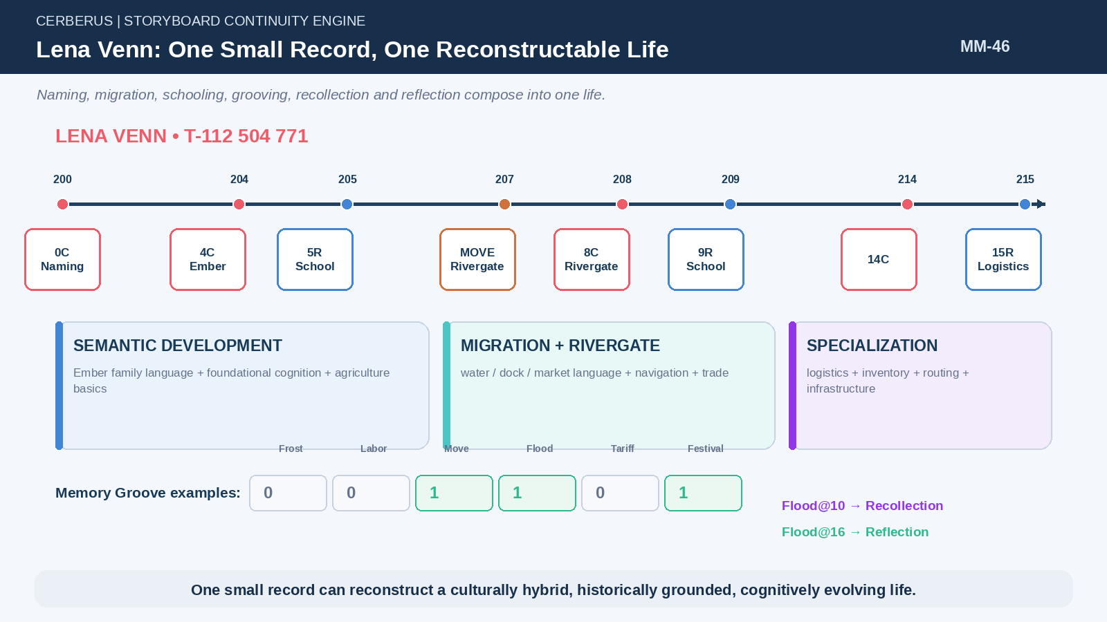
Figure 46. Lena Venn: One Small Record, One Reconstructable Life.
PART 14

Formal Principles and Boundaries
The final laws preserve ownership, scaling, and truth boundaries while leaving downstream Persona, emotion, and detailed I/U cognition open.

Formal Principles
# | Principle
1 | World history is authoritative; Memory is compiled access into that history.
2 | Store the Event once; reconstruct its witnesses many times.
3 | Historical exposure is derived wherever explicit identity is unnecessary.
4 | Resolving historical identity does not alter historical totals.
5 | Reconstruct the ordinary; store the exceptional.
6 | Memory richness does not require memory storage.
7 | Memory eligibility is not state authority.
8 | The Memory Groove stores autobiographical addressability, not experience content.
9 | Decide once; store one bit; reconstruct only on demand.
10 | Grooving resumes from the latest processed World Event rather than recalculating compiled history.
11 | Memory policy may vary with simulation fidelity without changing the architecture.
12 | Recollection uses the historical self; Reflection uses the current self.
13 | Historical vocabulary bounds historical comprehension.
14 | Lived history is not learned history.
15 | Institutional participation inherits historically valid institutional outputs unless a causal exception overrides them.
16 | Development is the accumulated result of Life Landmarks applied to historical World context.
17 | P-Key identifies permanent World continuity; T-Key identifies its temporal occupant.
18 | Current objectives and surroundings route memory through semantic overlap.
19 | Social history may be reconstructed from shared topology until individual relationship persistence becomes causally necessary.
20 | External identity remains external; World consequence becomes native.
21 | Exact external identity is preserved by personal correspondence, not universal World propagation.
22 | The visitor remembers the World exactly; the World remembers the visitor sufficiently.

Compression Identity
World History + Life Trajectory + Memory Groove + Sparse Personal Intersections = Reconstructable Autobiography

Explicit boundary
This paper does not attempt to solve full Persona mechanics, emotional architecture, psychopathology, dreams, detailed forgetting or decay, complete dialogue generation, fixed social-likelihood equations, detailed I-Key CERBERUS architecture, detailed U-Key persistence, individual transcripts, granular school marks, false-memory mechanics, or full cultural-memory transmission.
It owns a narrower and more reconstructive problem: how a World-resolved person develops semantic capability, compiles autobiographical access to causal history, retrieves relevant Events, and reconstructs lived experience efficiently. Downstream systems may read these outputs without changing the ownership boundaries established here.
Closing proposition
A simulated person does not become deep by carrying a larger pile of stored anecdotes. Depth emerges when a small identity can recover the right parts of a causally rich World through historically valid development, compiled autobiographical addressability, and present-time semantic context.

