CYBERNETIC MECHANICS
II
STRUCTURE & DYNAMICS
Visual Anatomy of Information Flow, Persistence, and Concurrency
Paper II of III | Cybernetic Mechanics Series | Version 0.1 | Verified Release | August 2026

0. Abstract and Reading Contract
Cybernetic Mechanics II examines the middle operational dyad of the Cybernetic Language Trial: Structure and Dynamics. Paper I established bounded informational state and direct transformation. This paper begins when those states acquire relationships: selection, grouping, source and destination roles, access, transfer, routes, boundaries, bindings, temporal persistence, recurrence, concurrent activity, coordination, competition, and termination. Its purpose is to make those relationships visible enough that a reader can distinguish what structure exists from what is presently happening through it.
The paper is deliberately visual and experimental. Paths, ports, junctions, selection overlays, temporal traces, process lanes, waiting frontiers, and history markers are reused across the figure program so that increasingly complex behavior can be inspected rather than inferred from decorative network imagery. The vocabulary remains provisional. Repetition in this paper is evidence that a distinction is useful; it is not promotion into CERBERUS canon.
RESEARCH POSTURE
Experimental, non-canonical visual mechanics paper. The working vocabulary, figure grammar, and operator distinctions are pressure-tested here; they remain revisable.

BOUNDED QUESTION
How is information organized into larger structures, where can it move, and how do those structures behave through time and simultaneous activity?

SERIES COMPRESSION
BE → CHANGE → ORGANIZE → BEHAVE → EVALUATE → REASON. Paper II owns ORGANIZE → BEHAVE: Structure & Routing plus Dynamics.

VISUAL LAW
Show the structure. Show the activity. Never confuse the path with what is presently moving through it.

Contents
1. The Structure-Dynamics Dyad
2. Selection and Masking
3. Boundaries and Neighborhoods
4. Group, Partition, and Concatenate
5. Divergence and Convergence
6. Source and Destination
7. Read, Write, Copy, and Move
8. Anatomy of a Route
9. Bind and Unbind
10. When Structure Acquires Time
11. Hold, Delay, History, and Temporal Windows
12. Advance, Repeat, Cycle, and Pulse
13. Reset and Restore
14. FAN-OUT vs FORK
15. Parallel, Synchronize, and Barrier
16. Race and Termination
17. The Mechanics That Make Propagation Possible
18. Semantic Resolution and Cross-Layer Interfaces
19. Cybernetic Circulation
20. Open Questions and Non-Collapse Laws
21. Conclusion
Appendix A. Working Vocabulary
SERIES POSITION

1. The Structure-Dynamics Dyad
The Cybernetic Mechanics series is organized as three complementary dyads. Paper I owns State and Transformation: what information is within a bounded field and what directly changes about it. Paper II owns Structure and Dynamics: how information participates in larger organizations and how those organizations behave through time. Paper III will own Evaluation and Reasoning. Adjacent layers may appear whenever an interface must be made legible, but ownership remains explicit.

Core thesis
Cybernetic structure defines the bounded relationships through which information can participate, be grouped, accessed, connected, and transferred. Cybernetic dynamics describes how those structures persist, recur, branch into concurrent activity, synchronize, compete, recover, and terminate through time. Structure gives information somewhere to go. Dynamics gives structured information a history.

Primary visual proposition
Paper I treated bounded information almost like cybernetic material. Paper II adds connective tissue and circulation. Cells remain recognizable, but paths, ports, boundaries, neighborhoods, branches, temporal intervals, histories, execution lanes, and waiting frontiers become co-equal visual actors. A route may exist while inactive. A selected cell may remain off. A history may remain after activity ends. Structure and activity must therefore be drawn as separate dimensions.
SERIES BOUNDARY
Domain systems own what the routed information means. Paper II owns the structural and temporal mechanics by which that information participates, moves, persists, and coordinates.

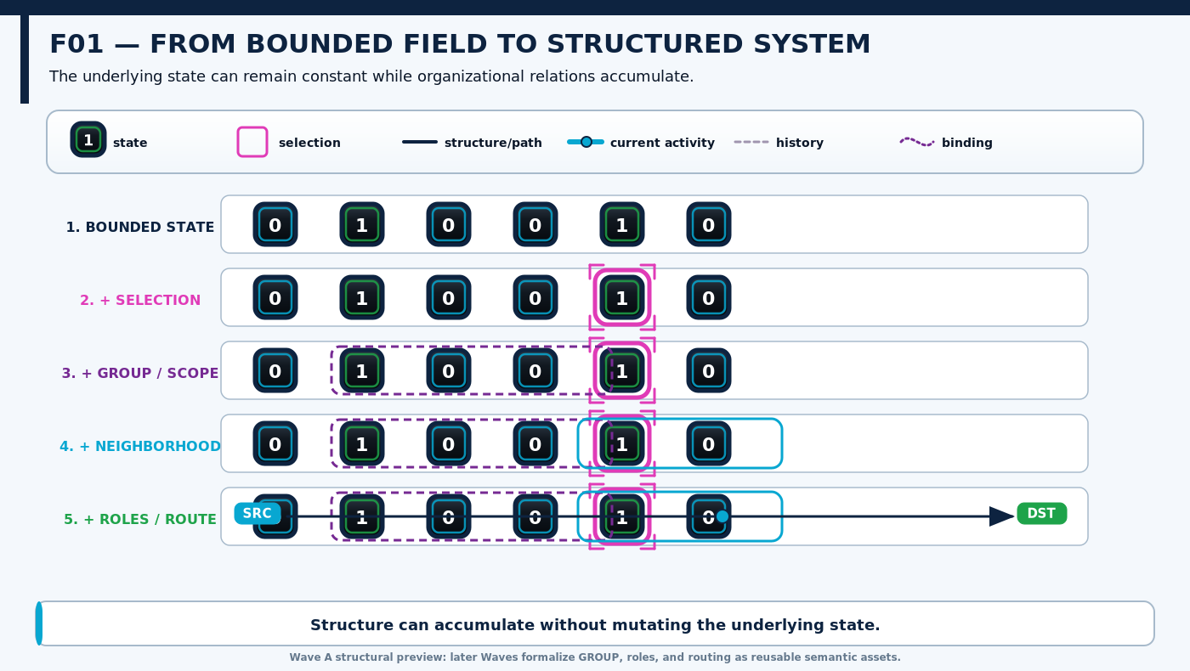
Figure F01 — From Bounded Field to Structured System. The same local values acquire selection, grouping, neighborhood, role, and route relationships without requiring local state mutation.
L3 — STRUCTURE & ROUTING

2. Selection and Masking
Selection identifies participation in a present operation or context without changing the selected member's underlying state. An inactive position can be selected, and an active position can remain unselected. Selection is therefore a relation layered over state rather than another word for activation.
MASK generalizes participation across a bounded domain. A mask can mark included and excluded members, and later variants may support weighted participation, but the mask does not determine what downstream operation is performed on participating members. This paper uses MASK as an experimental general mechanic and does not collapse it into any specialized Semantic Kernel that happens to use the same word.

Core non-collapse
selected ≠ active
mask ≠ mutation
included ≠ currently traversed
unselected ≠ absent
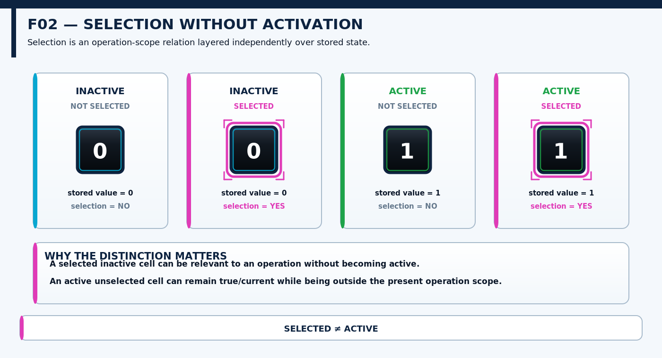
Figure F02 — Selection Without Activation. Four combinations demonstrate that selection and activation occupy independent visual and semantic channels.
SCOPE & LOCALITY

3. Boundaries and Neighborhoods
A boundary declares where a field, scope, route domain, process region, or other bounded structure begins and ends. Boundary is not automatically equivalent to blocking, security, containment, or termination. Those effects require additional contracts. The first responsibility of a boundary is simply to make the relevant extent explicit.
A neighborhood defines relational locality around a member or position. In a line it may mean adjacent positions; in a matrix it may mean orthogonal or diagonal neighbors; in an irregular graph it may be a declared set of linked nodes. Visual proximity on the page is not enough. The neighborhood must be part of the structure.
IMPORTANT BOUNDARY
Neighborhood defines local relational scope; it does not itself propagate, activate, or transform anything.

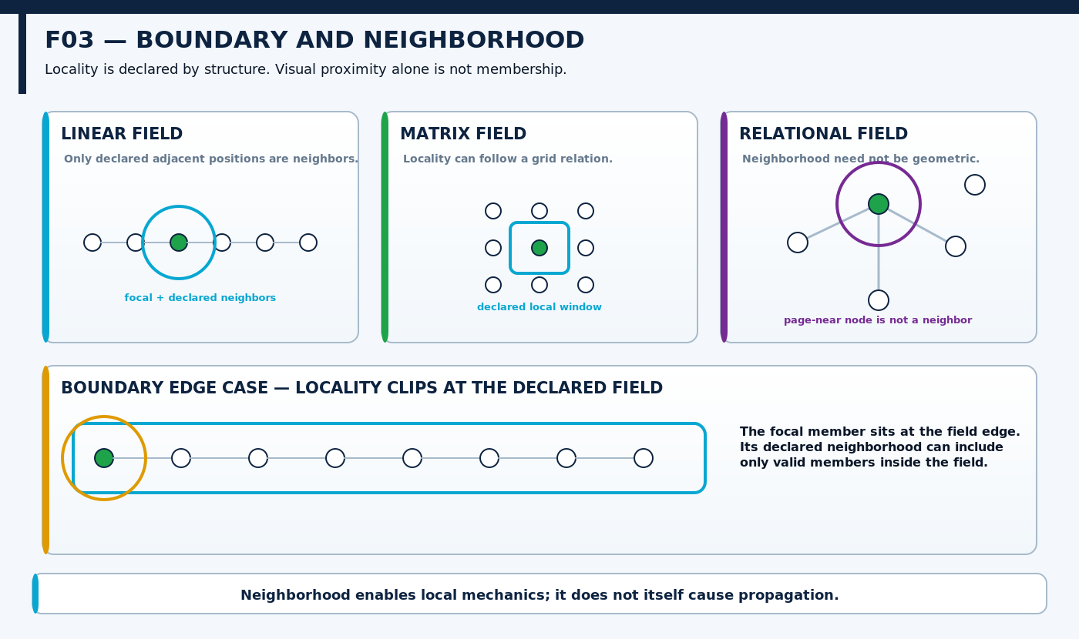
Figure F03 — Boundary and Neighborhood. Declared locality is shown across linear, matrix, and relational arrangements, including an edge case where the field boundary limits available neighbors.
STRUCTURAL ORGANIZATION

4. Group, Partition, and Concatenate
GROUP associates members under one bounded relation while preserving their individual identities. PARTITION divides a domain into explicit subdivisions. CONCATENATE assembles bounded structures into an ordered composite. These operations can appear visually similar because they organize the same underlying material, but the relation they add is different.
Grouping does not require a new sequence. Partition does not automatically delete, move, or transform members. Concatenation does require order: the first structure is followed by the second under an explicit composition relation. The vocabulary remains experimental, but preserving these distinctions makes later routing and decomposition mechanics easier to inspect.
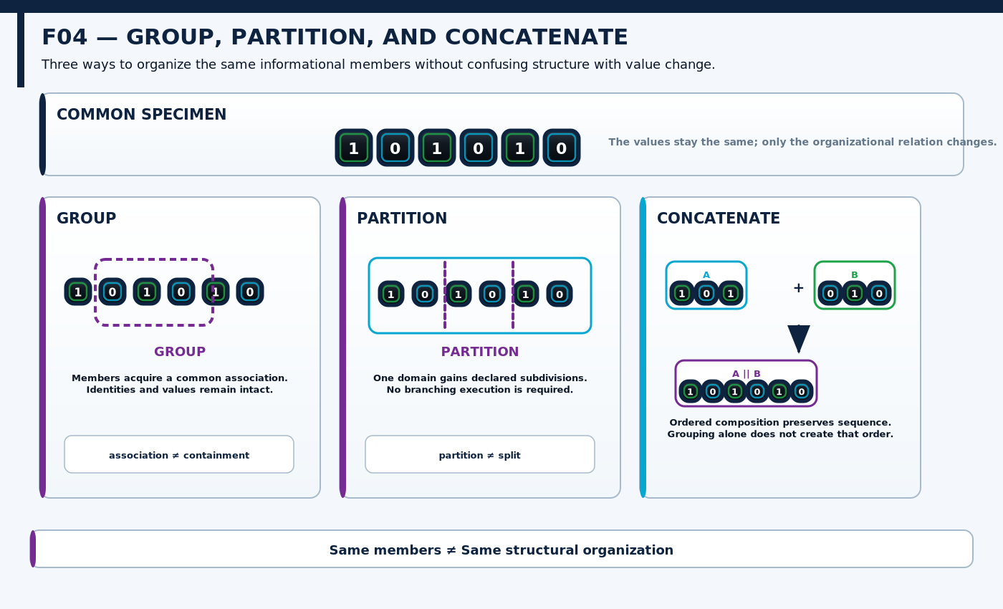
Figure F04 — Group, Partition, and Concatenate. One common specimen is reorganized three ways so the structural relation, rather than the data, becomes the changing variable.
BRANCHING & CONVERGENCE

5. Divergence and Convergence
Branching geometry does not identify one universal operation. SPLIT changes structural organization by resolving one input structure into multiple outputs. FAN-OUT leaves the source structure intact while exposing several outgoing routes. Later, FORK will reuse the same visual ancestry for an event in which active execution becomes concurrent. Similar shape is useful only if the modifiers preserve the semantic difference.
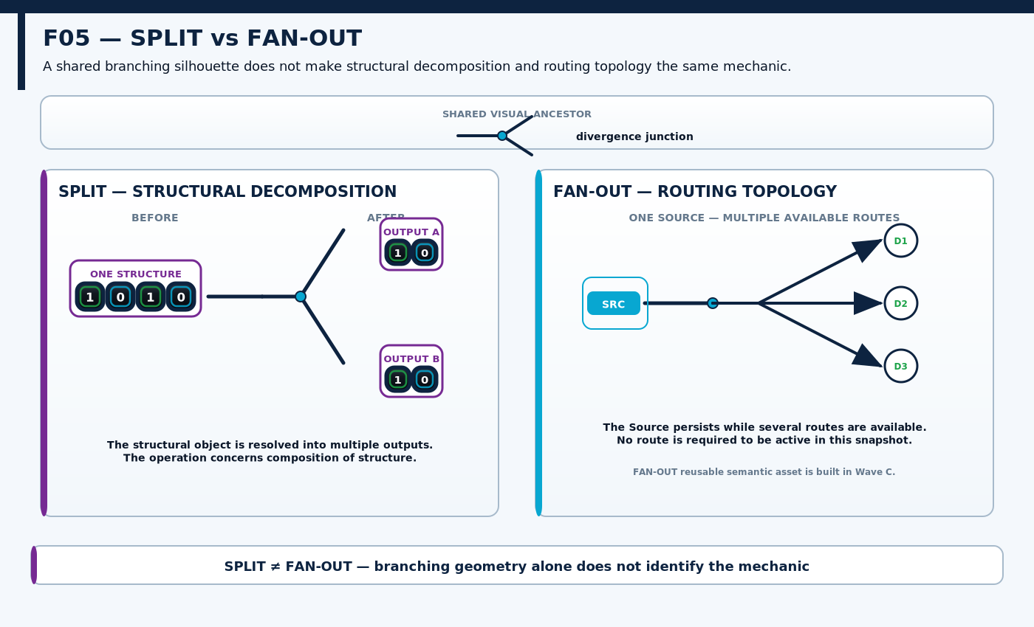
Figure F05 — SPLIT vs FAN-OUT. Shared divergence geometry is retained while structural decomposition is separated from routing plurality.

Convergence does not define reduction
The same discipline applies in the opposite direction. JOIN brings structures into a structural composition. FAN-IN brings routes toward a common destination or subsequent route. AGGREGATE would require an additional value-combination rule. Multiple arrows arriving at one point do not tell us whether values are added, averaged, selected, merely queued, or left distinct.
CONVERGENCE LAW
JOIN ≠ FAN-IN ≠ AGGREGATE. Geometry can converge while value semantics remain unresolved.

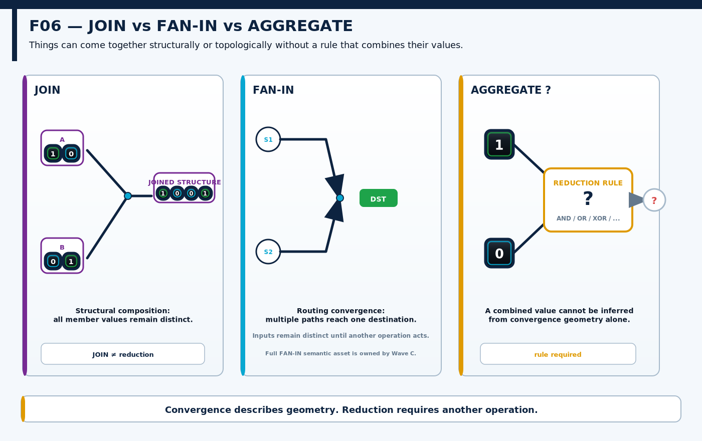
Figure F06 — JOIN vs FAN-IN vs AGGREGATE. Structural and routing convergence are shown without inventing a reduction rule for the arriving values.
RELATIONAL ROLES

6. Source and Destination
SOURCE and DESTINATION are contextual roles inside a relationship, not permanent object classes. The same bounded structure can receive information in one operation and provide information in the next. Treating the roles as intrinsic identities would make ordinary relay behavior impossible to describe cleanly.
The role therefore belongs to the active relation. Identity remains with the object. Directionality tells us which side is providing or receiving in the present operation, while later operations may reverse or reassign those roles without changing what the object is.
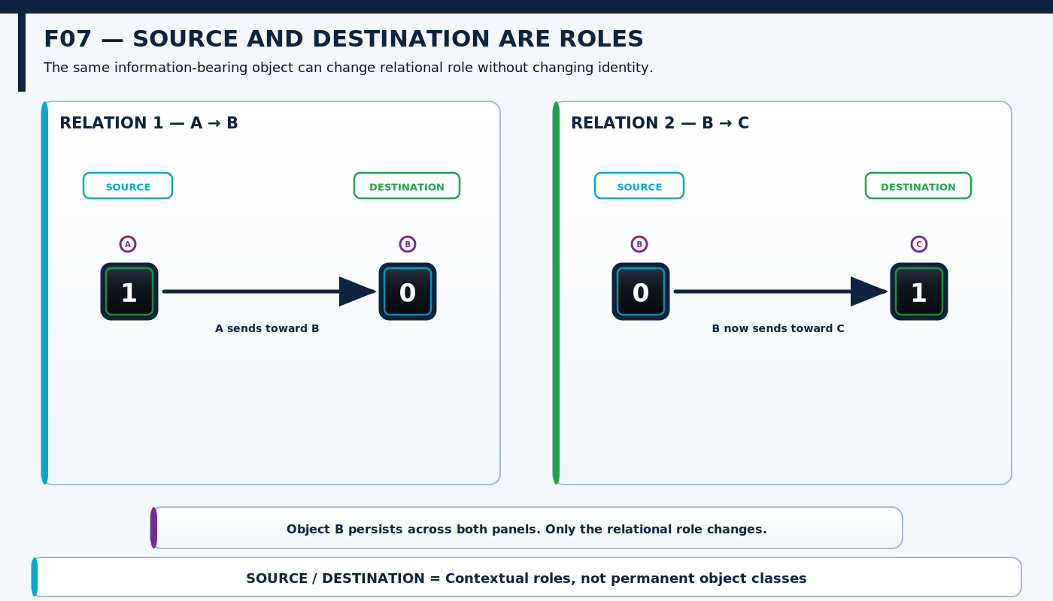
Figure F07 — Source and Destination Are Roles. The middle structure remains the same object while acting first as Destination and then as Source in a subsequent relation.
ACCESS & TRANSFER

7. Read, Write, Copy, and Move
READ obtains information from a source without implying source mutation. WRITE directs supplied information into a destination capable of accepting state. The resulting local change at that destination still belongs to the direct transformation mechanics established in Paper I. This makes WRITE an explicit cross-layer interface: L3 describes the access relation, while L2 owns the immediate state change that may follow.
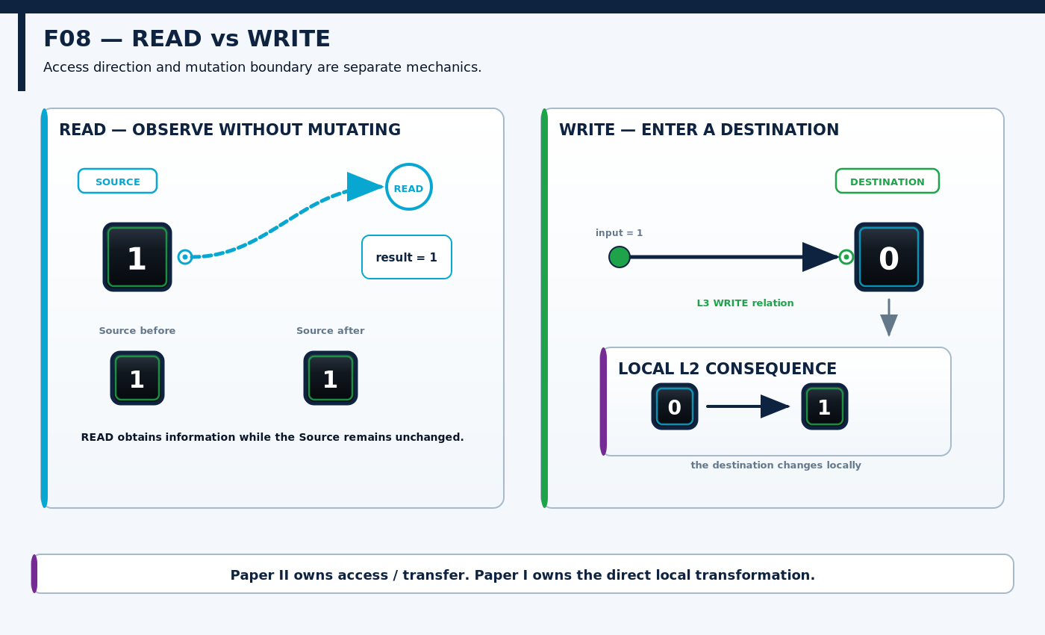
Figure F08 — READ vs WRITE. Non-destructive access is separated from destination ingress, while the local state change produced by writing remains a subordinate L2 consequence.
COPY and MOVE are transfer mechanics distinguished by source preservation. COPY produces corresponding information at a destination while the source remains present. MOVE transfers continuity to another structural location and relinquishes the corresponding source presence under the active contract. The vacated source is not automatically numeric zero, deleted structure, or destroyed identity; those claims require their own semantics.
CROSS-LAYER LAW
L2 positional movement changes state position inside a bounded field. L3 MOVE transfers information between structurally related source and destination locations.

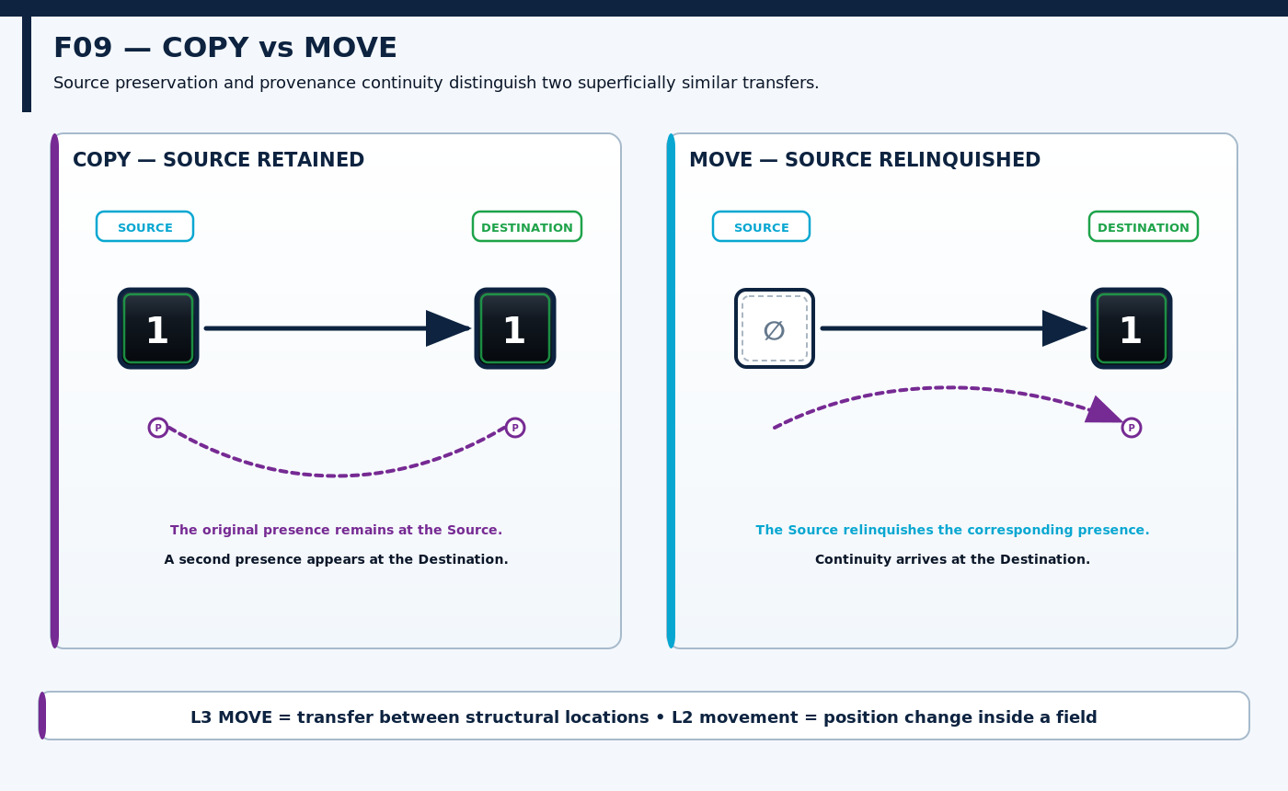
Figure F09 — COPY vs MOVE. Provenance separates source-preserving duplication from continuity transfer and source relinquishment.
ROUTING TOPOLOGY

8. Anatomy of a Route
A route is a bounded path relation between informational locations. Its existence does not imply that anything is presently traversing it. This distinction allows the paper to represent a stable network with some paths inactive, some carrying current activity, and some retaining only historical traces.
The route grammar therefore separates persistent path geometry, direction, source and destination ports, active traversal carriers, inactive segments, junctions, boundary crossings, and history. The path provides structural possibility. Activity through the path is another state layered on top of that possibility.
CORE DISTINCTION
Route existence ≠ active traversal. Route ≠ transformation. A path can remain while its current activity changes or ends.

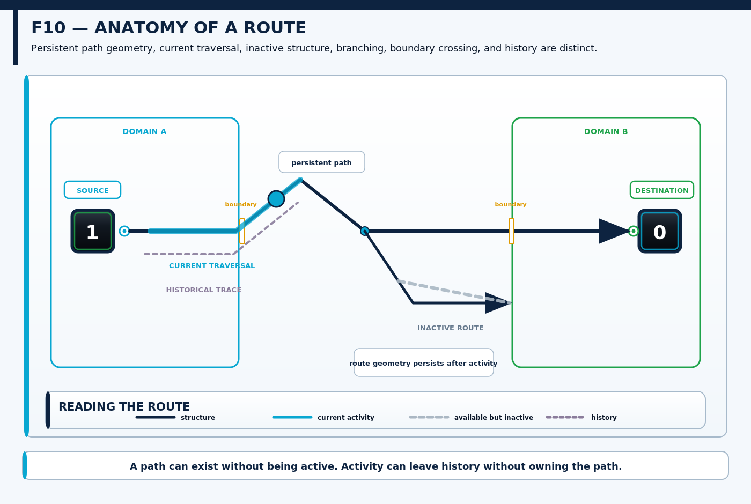
Figure F10 — Anatomy of a Route. Persistent route geometry, current traversal, inactive structure, direction, boundary crossing, junctions, and historical trace are separated in one reusable visual grammar.
RELATIONAL ATTACHMENT

9. Bind and Unbind
BIND establishes a declared relationship between structures without requiring either structure to contain, copy, move, route, or become the other. The exact meaning of the relationship belongs to the active contract: it may be contextual, referential, resource-oriented, interpretive, or another bounded relation.
UNBIND removes that relationship while the participating objects remain. The relation itself is therefore a first-class piece of state. This is useful precisely because it allows relationship state to change without silently rewriting object identity or structural location.
BINDING LAW
BIND ≠ CONTAIN ≠ ROUTE. Removing a binding does not delete either participant.

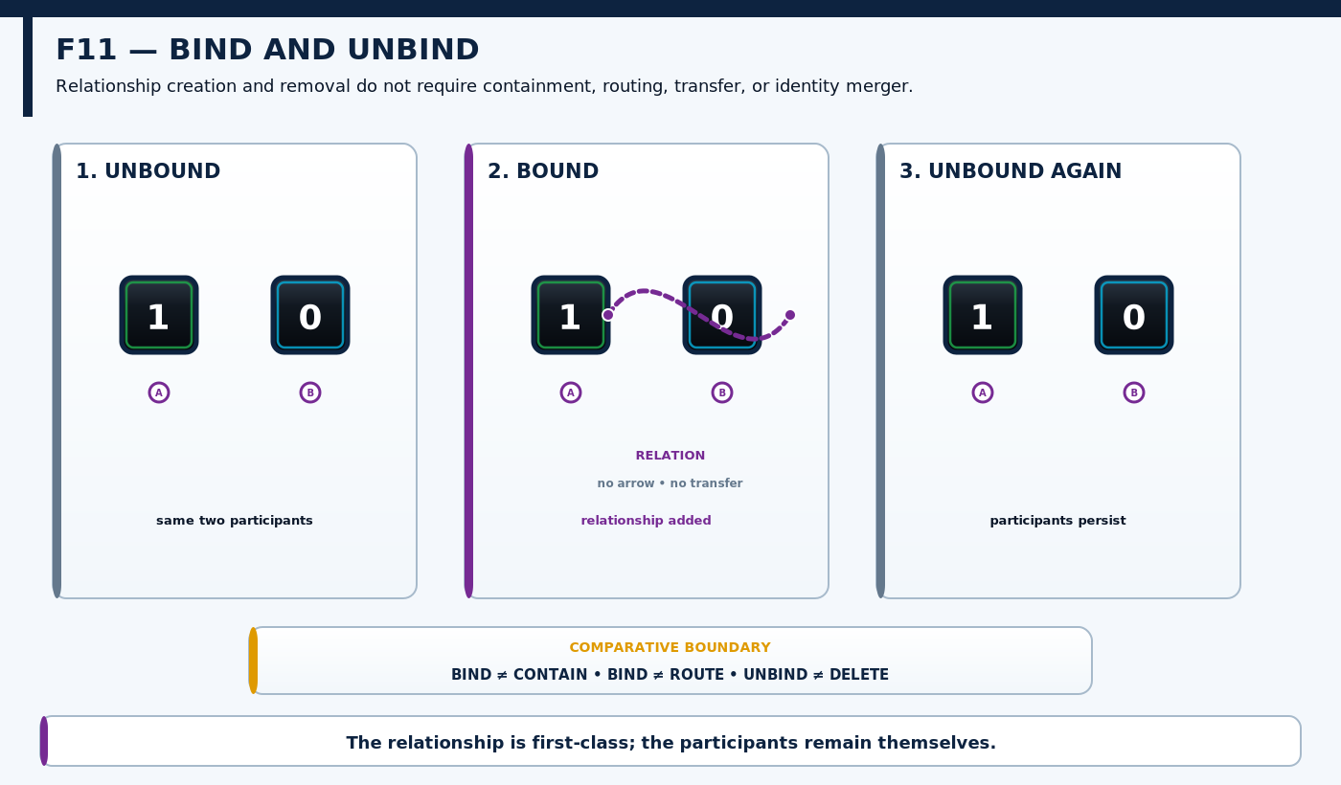
Figure F11 — BIND and UNBIND. Two stable structures gain and later lose an explicit relationship without containment, transfer, or identity merger.
L4 — DYNAMICS

10. When Structure Acquires Time
A structural snapshot can tell us which paths, ports, boundaries, and relationships exist. Dynamics begins when those structures are inspected across more than one moment. A fixed route can host different current activity at t0, t1, t2, and later moments while remaining the same underlying route.
This introduces a second visual dimension. Route direction describes where information may travel through structure. Temporal direction describes how the state of that structure changes across moments. The two can align in a particular figure, but they are not the same semantic axis.
MIDPOINT TRANSITION
A path is structure. A path across moments can become behavior.

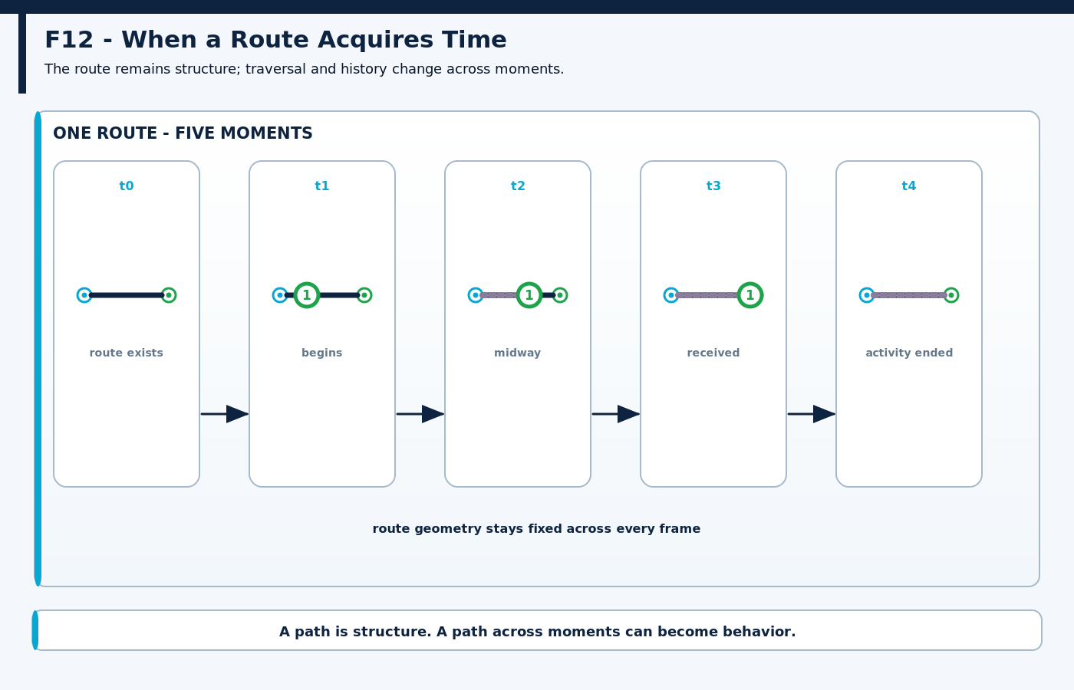
Figure F12 — When a Route Acquires Time. One invariant route hosts changing traversal, arrival, inactivity, and historical trace across successive moments.
PERSISTENCE & TEMPORAL SCOPE

11. Hold, Delay, History, and Temporal Windows
HOLD maintains a relevant state or process condition across an interval. DELAY shifts release, availability, delivery, or execution to a later interval. HOLD therefore adds duration to a present condition; DELAY adds temporal displacement to when something becomes available or proceeds. Neither requires the represented value itself to change.
TEMPORAL DISTINCTION
PRESERVE ≠ HOLD. PRESERVE is a direct mapping whose output equals its input. HOLD introduces an interval across which a condition remains in force.

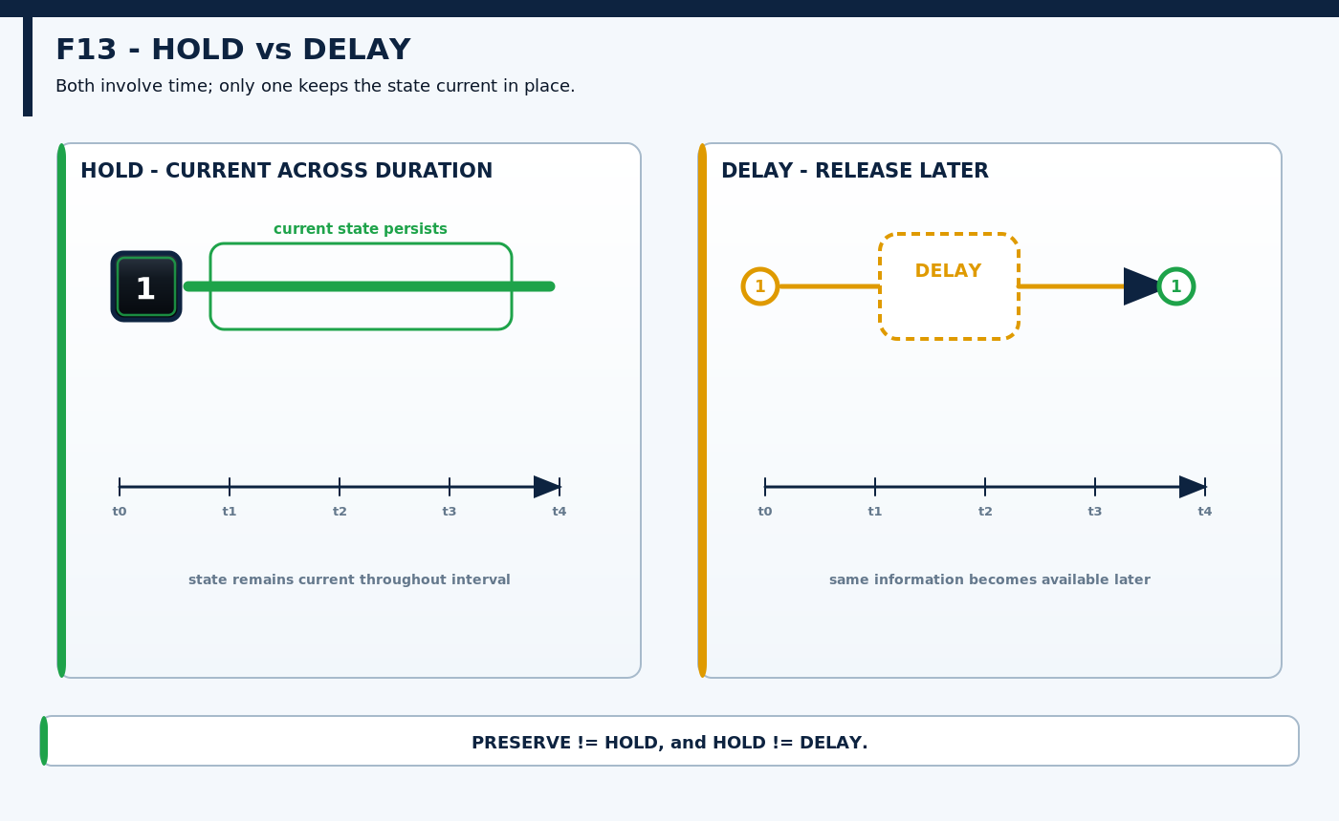
Figure F13 — HOLD vs DELAY. One state is maintained across an interval while another release is explicitly displaced to a later time.
History is larger than one retained state. A retained snapshot is one preserved prior condition. HISTORY is an ordered temporal relationship among prior states or events. A TEMPORAL WINDOW then selects a bounded interval of relevance without implying that material outside the window is deleted or false.
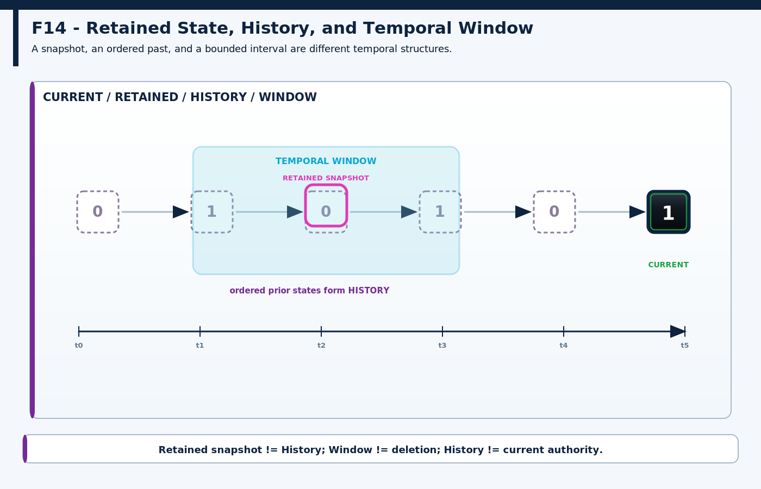
Figure F14 — Retained State, History, and Temporal Window. Current state, one retained snapshot, ordered history, and a bounded interval of temporal applicability remain visually distinct.
RECURRENCE

12. Advance, Repeat, Cycle, and Pulse
ADVANCE moves a cursor, phase, frame, or bounded process to its next declared condition. REPEAT causes a bounded activity to occur again. CYCLE adds a recurring ordered phase structure. PULSE describes a bounded transient: activity rises for a limited temporal extent and then resolves according to its contract.
The distinctions matter because recurrence is not one shape. A repeated event may have no meaningful phase ring. A cycle may be finite rather than endless. A pulse is not simply “active”; it has duration and temporal form. ADVANCE likewise refers to progression through a declared dynamic sequence rather than positional movement inside a Paper-I field.
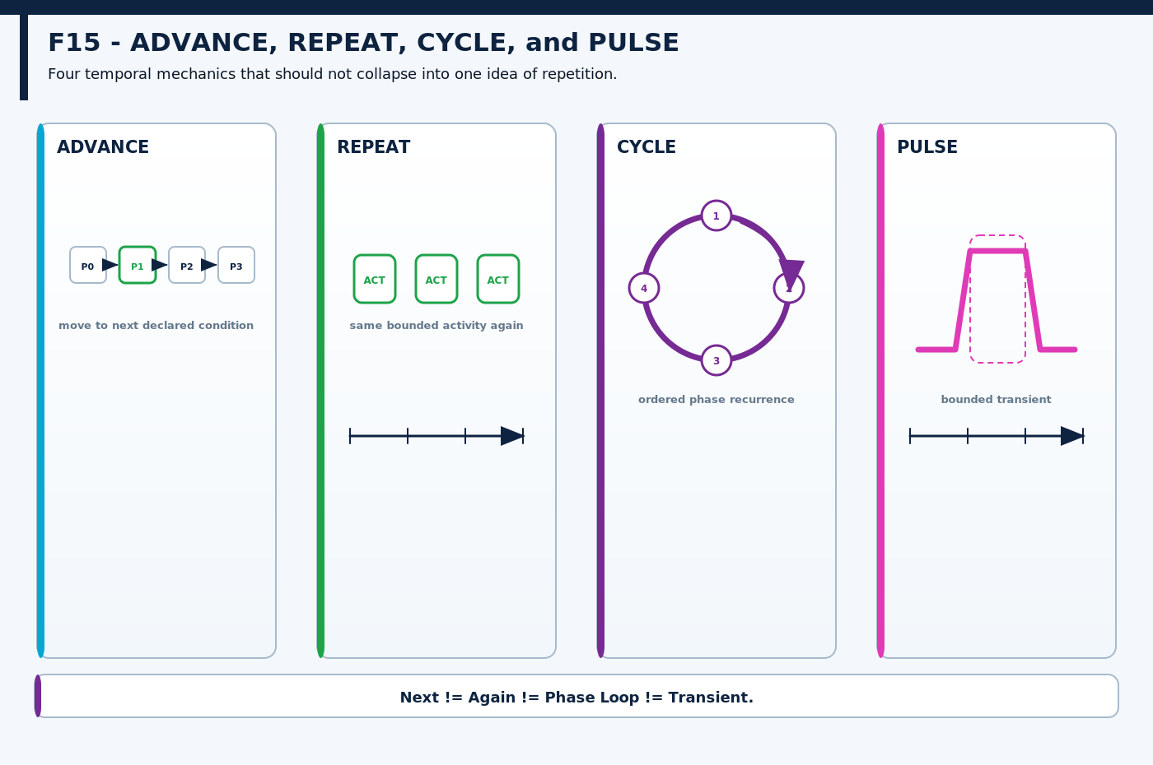
Figure F15 — ADVANCE, REPEAT, CYCLE, and PULSE. Four temporal topologies separate progression, recurrence, cyclic phase structure, and bounded transient activity.
RECOVERY & LIFECYCLE

13. Reset and Restore
RESET and RESTORE are especially useful because they may produce identical visible outputs while remaining different operations. RESET returns a process or system to a declared baseline or reset condition. RESTORE recovers a previously retained or historical state. Their authority therefore comes from different sources.
If the declared reset baseline happens to equal the retained historical state, the resulting bits or visible field may be identical. That equivalence does not collapse the operations. Provenance remains part of the mechanic: one path consults the reset contract, the other consults retained history.
SAME RESULT ≠ SAME OPERATION
Visible output equality is insufficient to establish semantic equivalence when the operations derive authority from different sources.

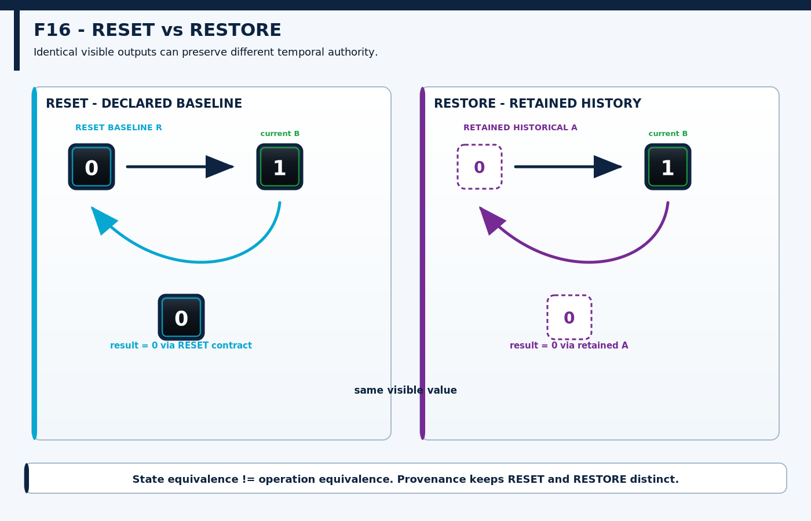
Figure F16 — RESET vs RESTORE. Identical-looking return states are traced to different sources of authority: declared baseline versus retained history.
TOPOLOGY BECOMES ACTIVITY

14. FAN-OUT vs FORK
FAN-OUT and FORK deliberately reuse the same branching ancestry. FAN-OUT is structural: one source or incoming route exposes multiple outgoing paths. FORK is dynamic: one active process reaches a point from which multiple concurrently active processes continue through time.
A network can contain fan-out while completely idle. A fork, by contrast, is an occurrence. The figure program therefore retains the common divergence junction while adding temporal occupancy and process lanes only when the branching itself becomes activity.
TOPOLOGY VERSUS OCCURRENCE
FAN-OUT = branching structure. FORK = branching activity through time.

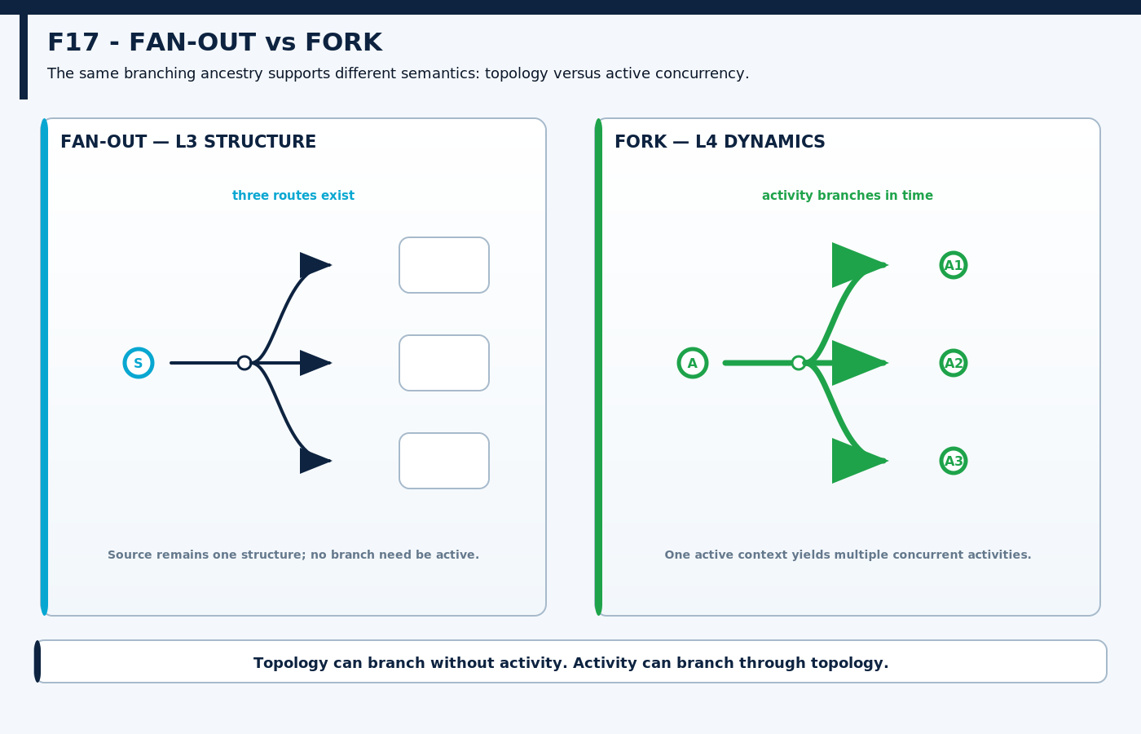
Figure F17 — FAN-OUT vs FORK. Shared divergence geometry is preserved while static route plurality is separated from the event that creates concurrent active branches.
CONCURRENCY & COORDINATION

15. Parallel, Synchronize, and Barrier
PARALLEL describes multiple active processes whose execution overlaps in time. It does not require identical start times, identical durations, identical work, or exact synchronization. SYNCHRONIZE establishes a declared temporal alignment. A BARRIER is different again: it is a waiting frontier that prevents participating processes from progressing beyond a point until release occurs.
The distinction makes waiting a positive dynamic condition rather than visual inactivity. A process can arrive early, remain active-but-blocked at the barrier, and later continue when other participating processes arrive. A barrier may produce synchronization, but it is the waiting and release mechanism rather than the abstract alignment itself.
PAPER III BOUNDARY
Paper II owns arrival, waiting, release, and continued motion. A complex predicate deciding whether release is permitted belongs outward in Evaluation & Control.

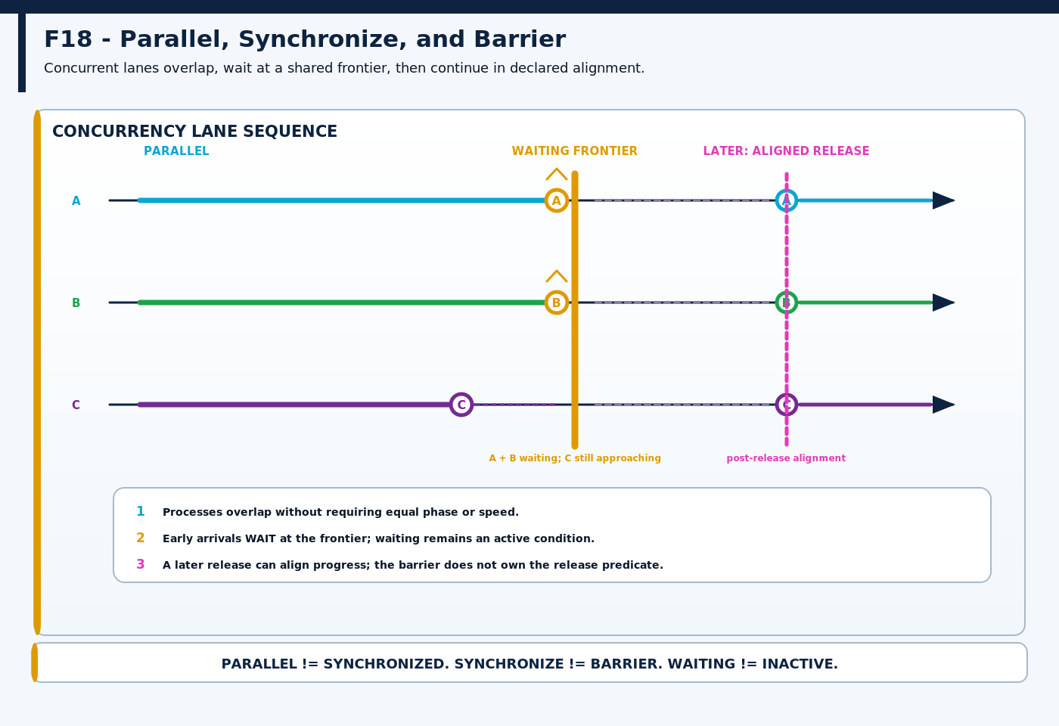
Figure F18 — Parallel, Synchronize, and Barrier. Unequal process arrivals, visible waiting, barrier release, and later alignment are shown on one reusable concurrency-lane grammar.
TEMPORAL COMPETITION

16. Race and Termination
RACE is a relation among concurrent processes in which relative arrival or completion matters. The race itself does not choose what the system should do with the result. It produces a temporal fact: one process reached its relevant endpoint before another. A later evaluator may consume that result.
TERMINATION ends the continuity of an active process. It does not automatically clear associated data, remove the underlying route, destroy the object, or assert logical falsehood. Process continuity and stored state are separate things. A route may remain after the process using it has ended.
OUTCOME VERSUS DECISION
RACE ≠ CHOOSE. TERMINATION ≠ DELETE. Dynamics can produce consequential timing without owning the evaluative response to that timing.

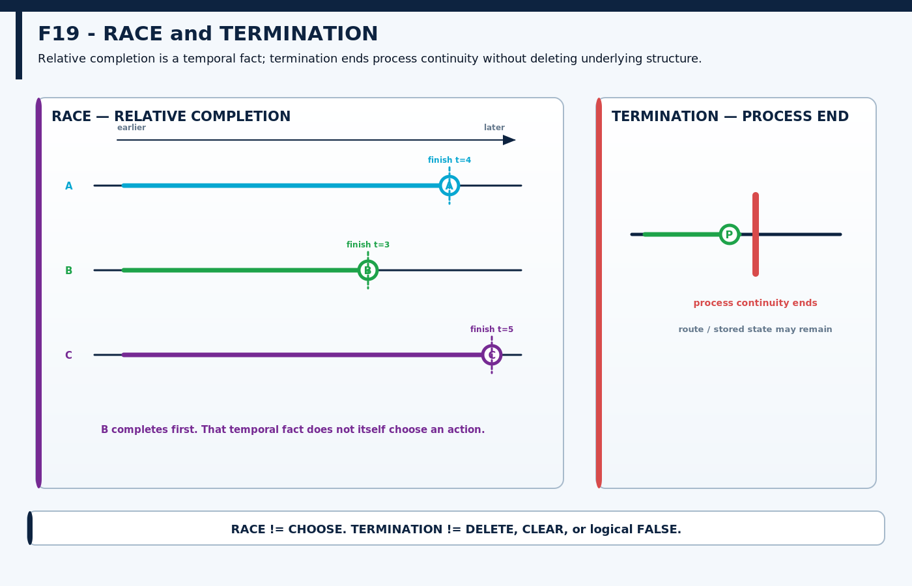
Figure F19 — RACE and TERMINATION. Relative completion is made explicit while process cessation remains distinct from deletion of the underlying information or structure.
COMPOSITION BOUNDARY

17. The Mechanics That Make Propagation Possible
Propagation is the deliberate boundary case for this paper. It looks like a named higher-order behavior, but much of its visible operation can be reconstructed from simpler mechanics already established: define a neighborhood, expose local routes, perform a local state transformation, advance time, and repeat the bounded rule.
The expanding pattern is therefore evidence of composition, not evidence that SPREAD must be promoted to a primitive. Paper II owns the ingredients that make propagation possible. A reusable named GROOVED SPREAD mechanism belongs at the higher compositional layer where its full contract can be declared and reused.
PRIMITIVE ≠ MECHANISM
A sophisticated visible behavior can emerge from smaller mechanics. This paper decomposes propagation without claiming ownership of every higher-order propagation mechanism.

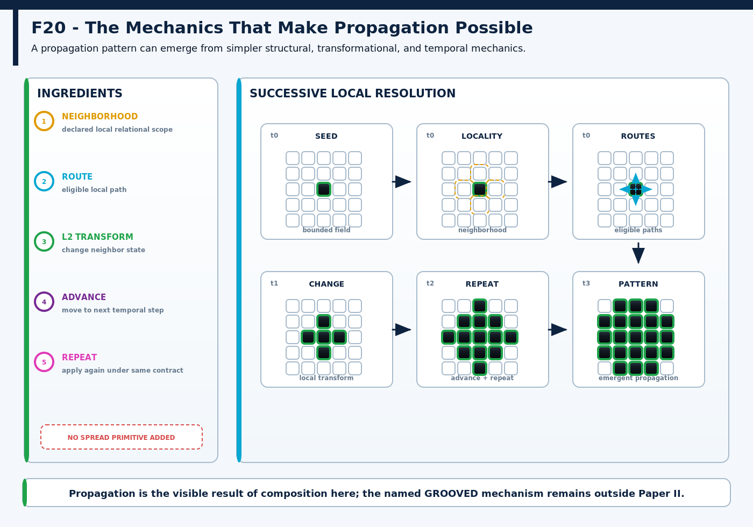
Figure F20 — The Mechanics That Make Propagation Possible. Neighborhood, routes, local L2 change, temporal advance, and repetition compose into an expanding pattern without making SPREAD a Paper-II primitive.
SEMANTIC RESOLUTION

18. Semantic Resolution and Cross-Layer Interfaces
The same causal event can be described at several semantic resolutions. A domain may say “distribute this measurement.” At L4 the system may fork or run downstream work in parallel. At L3 it may READ, COPY, FAN-OUT, and route the datum. At L2 destination fields change. At L1 exact state becomes inspectable.
These descriptions are not competing claims. Higher resolution can compress lower mechanics when those details are not needed, while lower resolution can be recovered when causal inspection matters. The operating principle remains highest sufficient resolution: use the least mechanical detail that preserves the meaning required by the present task.
Interface | Ownership rule
L2 → L3 | WRITE or MOVE may culminate in direct state transformation; Paper II owns the structural relation, Paper I owns the immediate mutation.
L3 → L4 | A route may exist statically; Dynamics determines persistence, recurrence, waiting, concurrency, and temporal outcome.
L4 → L5 | A barrier can wait and release; the predicate or guard that decides legal release belongs to Evaluation & Control.
Domain → L3/L4 | The domain owns what the information means; Cybernetic Mechanics owns how the information is structurally and temporally handled.

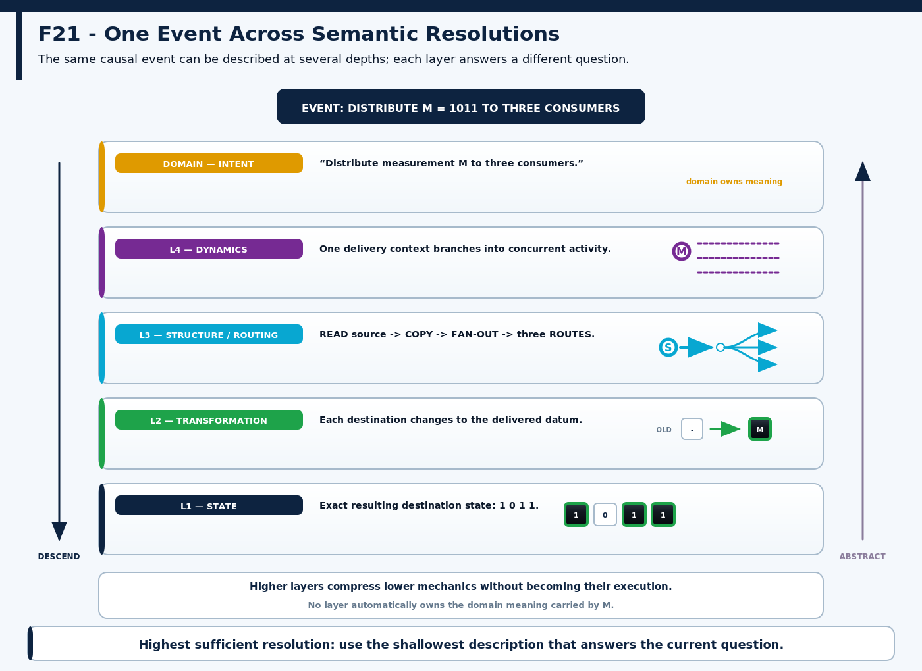
Figure F21 — One Event Across Semantic Resolutions. Domain intent, L4 dynamics, L3 routing, L2 transformation, and L1 state describe the same event at different depths without collapsing ownership.
HERO SYNTHESIS

19. Cybernetic Circulation
The final synthesis asks whether the complete Structure-Dynamics grammar can coexist inside one bounded system without degenerating into decorative complexity. The specimen is intentionally dense: some structures are selected, some information is read, copied, or moved, routes remain available while inactive, one branch is delayed, another forks into parallel activity, history trails remain, processes wait at a barrier, later synchronize, race toward different completion times, and selected processes terminate.
The system is not proposed as a universal architecture or workflow. Its purpose is reconstruction. A knowledgeable reader should be able to inspect the composition and identify what structure exists, what is active now, what happened earlier, which process is waiting, which relation is merely bound, and which process has ended without assuming that the underlying data or route vanished.
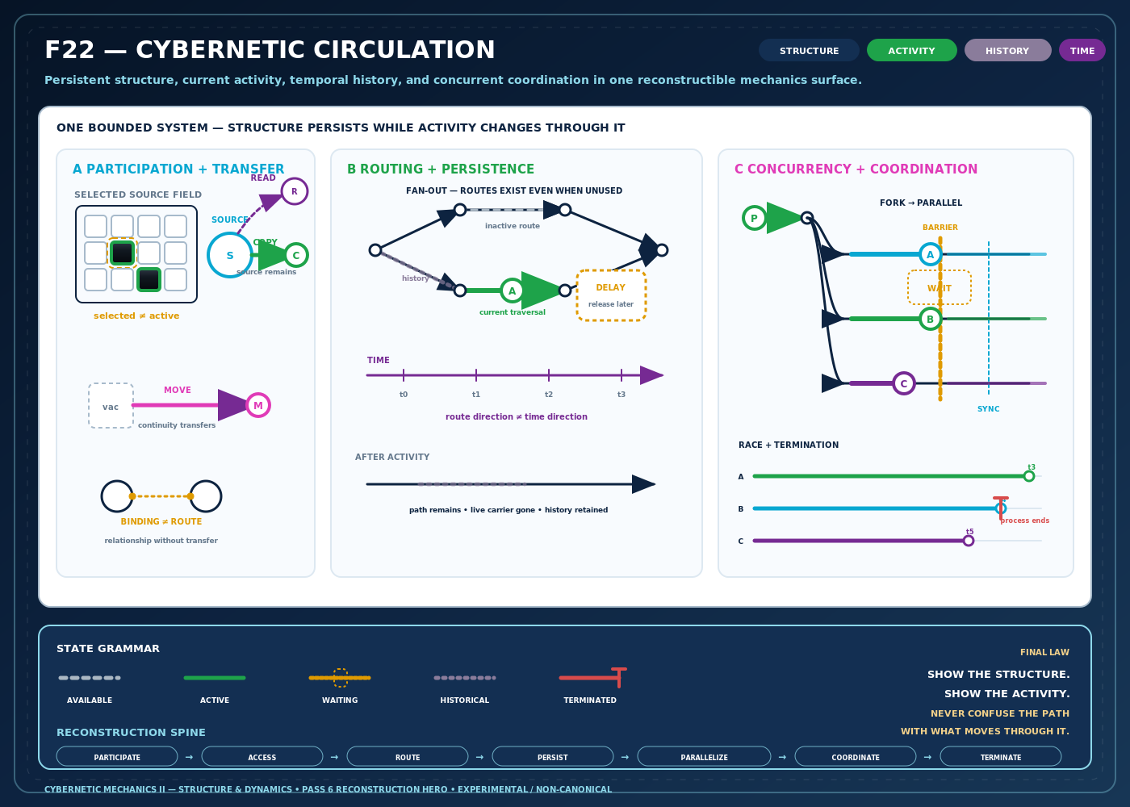
Figure F22 — Cybernetic Circulation. Persistent structure and current activity coexist in one inspectable system while selection, transfer, routing, persistence, history, concurrency, coordination, race, and termination remain distinct.

What the synthesis demonstrates
Persistent structure can remain visible while current activity changes or disappears.
Selection, traversal, waiting, history, and termination can coexist without sharing one visual channel.
Branching structure, branching activity, and structural decomposition remain separable.
Complex dynamic behavior can be composed from a small reusable visual grammar.
The system can be inspected at several semantic resolutions without making one resolution universally primary.
RECONSTRUCTION TEST
The hero succeeds only if the paper can be recovered from it: participation → structure → access → routing → persistence → recurrence → concurrency → coordination. This is an anatomy of the territory, not a universal runtime sequence.

RESEARCH FRONTIER

20. Open Questions and Non-Collapse Laws

Questions preserved for later revision
Is MASK a distinct general mechanic, or ultimately a structured family of SELECT relations?
How rigorous should PARTITION become about exhaustiveness and disjointness?
Does SPLIT hide several distinct structural mechanics behind one word?
Where exactly does L2 positional movement end and L3 MOVE begin in nested fields?
Does WRITE deserve an independent mechanic when its local consequence compiles into transformation?
Is FAN-IN sufficiently distinct from JOIN across more complex topologies?
What minimum contract distinguishes BIND from generic relation creation?
Does ADVANCE remain coherent across cursors, frames, phases, and sequences?
Is PULSE a primitive temporal form or a compact mechanism built from simpler dynamics?
Should synchronization name a process, a resulting relation, or two different contracts?
What constitutes a genuine RACE when the competing endpoints are not directly comparable?
Does TERMINATION need multiple classes for graceful completion, cancellation, and failure?
How much propagation can be explained mechanically before the paper begins teaching the higher-order SPREAD mechanism?
Can inactive route, waiting process, historical trace, and terminated process remain legible in increasingly dense figures without relying on color?

Core non-collapse laws
Concept A | ≠ | Concept B | Concept A | ≠ | Concept B
selected | ≠ | active | mask | ≠ | transformation
boundary | ≠ | automatic blocking | neighborhood | ≠ | propagation
group | ≠ | containment | group | ≠ | concatenate
partition | ≠ | split | split | ≠ | fan-out
join | ≠ | fan-in | join | ≠ | aggregate
source/destination | ≠ | permanent identity | read | ≠ | write
write | ≠ | local transformation | copy | ≠ | move
L3 MOVE | ≠ | L2 positional movement | route | ≠ | transformation
route existence | ≠ | active traversal | fan-out | ≠ | fork
fan-in | ≠ | aggregation | bind | ≠ | contain
retained state | ≠ | history | preserve | ≠ | hold
hold | ≠ | delay | repeat | ≠ | cycle
pulse | ≠ | active state | reset | ≠ | restore
parallel | ≠ | synchronized | parallel | ≠ | exact simultaneity
synchronize | ≠ | barrier | race | ≠ | choose
termination | ≠ | delete / clear | propagation mechanics | ≠ | GROOVED SPREAD

CLOSING MODEL

21. Conclusion
Cybernetic Mechanics II reduces the Structure-Dynamics dyad to one inspectable anatomy. STRUCTURE defines bounded relationships: what participates, how information is grouped, where it can be accessed, which paths connect locations, and which relations bind objects without merging them. DYNAMICS defines what happens when those structures persist through time: state can be held or delayed, activity can recur, processes can run concurrently, wait, synchronize, race, recover, and terminate.
The figures show why topology and activity must remain distinct. Branching geometry can mean structural split, routing fan-out, or dynamic fork depending on what additional relations are present. Convergence can exist without aggregation. A route can remain while current activity ends. A process can wait without becoming inactive, and it can terminate without deleting the state or structure it used.
The surviving contribution is therefore not a finished universal language. It is a visual and conceptual discipline for relational mechanics: show what exists, show what is active, preserve provenance through transfer, add time explicitly, expose concurrency rather than hiding it, and retain the route back to lower-resolution state whenever causal inspection is required.
GOVERNING STATEMENT
Cybernetic structure is the bounded organization of informational relationships. Cybernetic dynamics is the temporal behavior of those structures. Structure tells us what can connect; Dynamics tells us what happens when those connections persist across moments.

SERIES HANDOFF
Paper III — Evaluation & Reasoning begins where this paper deliberately stops: observation, predicates, Boolean results, guards, gates, control, propositions, models, inference, validity, satisfiability, consistency, necessity, and possibility.

TRIAL-DERIVED L3 + L4

Appendix A. Working Vocabulary
The vocabulary below is the current planning vocabulary inherited from Cybernetic Language Trial 0 for the second dyad. Inclusion does not imply primitive status, canonical registration, or final operator identity.
L3 — STRUCTURE & ROUTING  • select  • mask  • group  • partition  • split  • join  • concatenate  • source  • destination  • read  • write  • copy  • move  • route  • fan-out  • fan-in  • bind  • unbind  • neighborhood  • boundary | L4 — DYNAMICS  • hold  • delay  • advance  • repeat  • cycle  • reset  • restore  • history  • pulse  • temporal window  • fork  • parallel  • synchronize  • barrier  • race  • termination

Compressed model
STRUCTURE → DYNAMICS
Where information can participate and go → how that organization behaves through time. The sequence is explanatory anatomy, not a mandatory execution pipeline.

