CERBERUS
STORYBOARD CONTINUITY
ENGINE
WORLD MECHANICS
Persistent Semantic Reality, Causal Reconstruction, and Resolution-Based World Simulation
STATE | WORLD | TIME | LIFE | INFRA | POP | RESOLUTION | PERSIST

Illustrative Architecture Paper
Version 0.3 | August 2026
Core proposition
A persistent World does not need every implied entity and historical detail to remain instantiated. CERBERUS preserves sufficient causal state, reconstructs detail when consequence requires it, resolves at the lowest sufficient resolution, and retains individual distinction only while that distinction still changes the future.

World fabric • Life trajectories • Population resolution • Heating / cooling • Causal persistence • Historical reconstruction

EXECUTIVE SUMMARY

Abstract
The Storyboard Continuity Engine (SCE) is the CERBERUS architecture for advancing a persistent semantic World from one addressable state to the next. This version extends the original continuity model into a broader World Mechanics architecture. The World remains authoritative through semantic state rather than continuous rendering, but its state may now be represented at multiple resolutions: explicit individuals when interaction matters, groups and cohorts when collective structure matters, and regional aggregates when only population-scale truth is required.
The architecture treats World State as a causal fabric rather than a single frame or container tree. Tiles, Zones, Regions, Habitat, Society, Infrastructure, TIME, history, Assets, populations, and Life Trajectories intersect through explicit Models while retaining separate ownership. These structures do more than describe the World. They become reconstructive causes. A historical Region can determine which schools existed, which populations were viable, which developmental routes were available, and which Model versions must be used when the past is reconstructed.
The central economy comes from variable resolution and causal persistence. Heating raises a bounded context to the detail required for execution. Simulation resolves the interaction. Cooling reconciles the consequential result upward into the lowest representation that still preserves future causal validity. A transient deer can disappear back into herd statistics; a permanent injury may keep an individual distinct. Historical truth therefore does not require permanent microscopic representation.
This paper stops at the boundary where objective World history becomes a possible input to actor-specific cognition. Detailed autobiographical Memory, social inheritance, subjective reconstruction, forgetting, and dialogue belong to the separate Memory Mechanics paper. SCE owns what happened, where, when, which World structures caused it, and which authoritative consequences survived.
World Mechanics in one line
Preserve enough causal state to make the next valid World reconstructable—no more, and no less.

What this paper formalizes
- Persistent semantic reality and the distinction among existence, instantiation, simulation, animation, rendering, and representational resolution.
- A composable World fabric of Tile, Zone, Region, Habitat, Society, Infrastructure, TIME, history, Assets, and Map projection.
- Sparse human and animal Life Trajectories driven by Culture, Region, historical Infrastructure, Species Models, and developmental ticks.
- Herd and population aggregation, including normalized distributions and regional very-cold storage.
- Lowest Sufficient Resolution, Hot/Warm/Cold/Very Cold representation, Simulation Bubbles, heating, and cooling.
- Exact, constrained, statistical, and intentionally discarded reconstruction fidelity.
- Causal persistence, convergence, persistence thresholds, and identity promotion or reabsorption.
- Historical Model version integrity, shared World Events, natural baseline and civilization overlays, archives, forks, and replay.
- The authority boundary among Definition, Live State, Derived State, Proposal, Committed Delta, Projection, and Runtime Packet.
- The interface boundary between canonical World history and the downstream Memory Mechanics architecture.

NAVIGATION
Paper Map
Part | Theme | Purpose
1 | Persistent Semantic Reality | Why a World can remain true while representation changes.
2 | One Computational Grammar | How semantic state enters the same address–read–route–transform–write cycle at different scales.
3 | The World as Causal Fabric | Tile, Zone, Region, Map, Habitat, Society, Infrastructure, and place-time reconstruction.
4 | World Time and Causal Rhythms | Different clocks, historical versions, stable state, and shared World Events.
5 | Life Trajectories and Generative Populations | How Culture, Region, Infrastructure, migration, and institutions produce human development.
6 | Animal and Ecological Reconstruction | Species stages, Habitat, herd behavior, and statistical population state.
7 | Resolution, Heating, Cooling, and Reconstruction | How the World raises and lowers explicit detail while preserving causality.
8 | Causal Persistence and Representational Forgetting | When individual distinction persists, converges, or is deliberately discarded.
9 | World Change, History, and Reconstruction Across Time | Compression, reclamation, archives, forks, and historical replay.
10 | Integrated Runtime and Formal Principles | Human, animal, World-event, and infrastructure traces plus laws and boundaries.
Reading strategy. The figures form a parallel visual argument. Early figures establish continuity and semantic addressability; the middle figures show World structure, generative life, and ecological aggregation; the later figures formalize resolution, heating, cooling, persistence, and reconstructive history. A reader should be able to skim headings, figures, captions, equations, and laws before reading the full prose in depth.

PART 1

Persistent Semantic Reality
A World remains continuous because future-valid causal state survives even when its representation changes.

1. A World That Exists Between Frames
The authoritative World in SCE is semantic state, not a stream of rendered images. A forest, deer herd, road, city, school, river, or Region can remain part of the World while no high-fidelity representation is active. Rendering is one possible projection. Instantiation is one possible runtime state. Neither is the condition under which the World exists.
This allows the World to become computationally sparse without becoming causally discontinuous. When something becomes relevant, CERBERUS can raise only the bounded representation needed to determine what happens next. Once the consequence is resolved, the World can again return to a compact state.
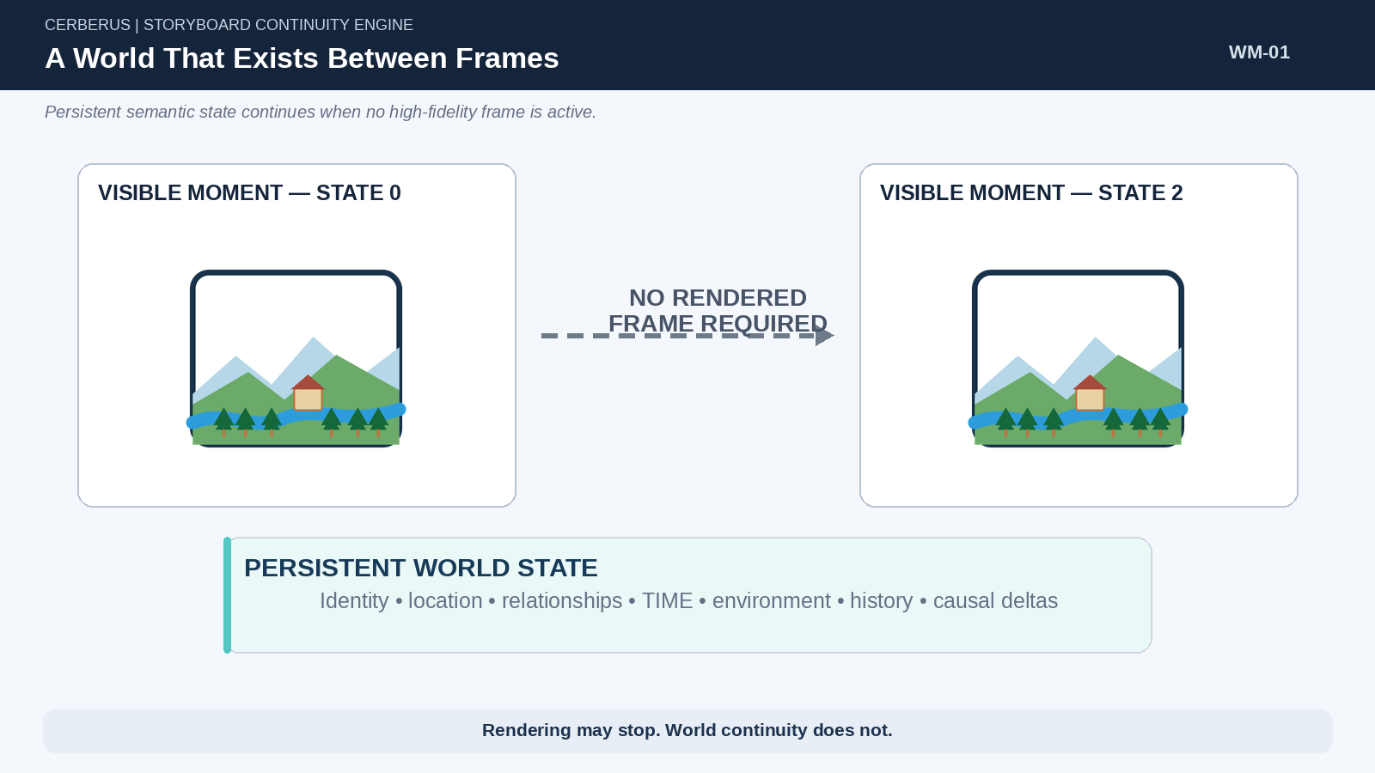
Figure 1. A World That Exists Between Frames. Persistent semantic World State continues through intervals in which no high-fidelity frame is rendered.

2. Existence Is Not Instantiation
SCE separates existence, instantiation, simulation, animation, and rendering because each answers a different question. Existence asks whether addressable state remains true. Instantiation asks whether an active representation has been materialized. Simulation asks whether an interaction is currently being resolved. Animation and rendering concern performance and perceptible output.
World Mechanics adds another independent dimension: representational resolution. A deer may exist at Hot resolution as an explicit individual, at Cold resolution only inside herd state, or at Very Cold resolution only through a regional population aggregate. The runtime stage and the persistence resolution must not be confused.
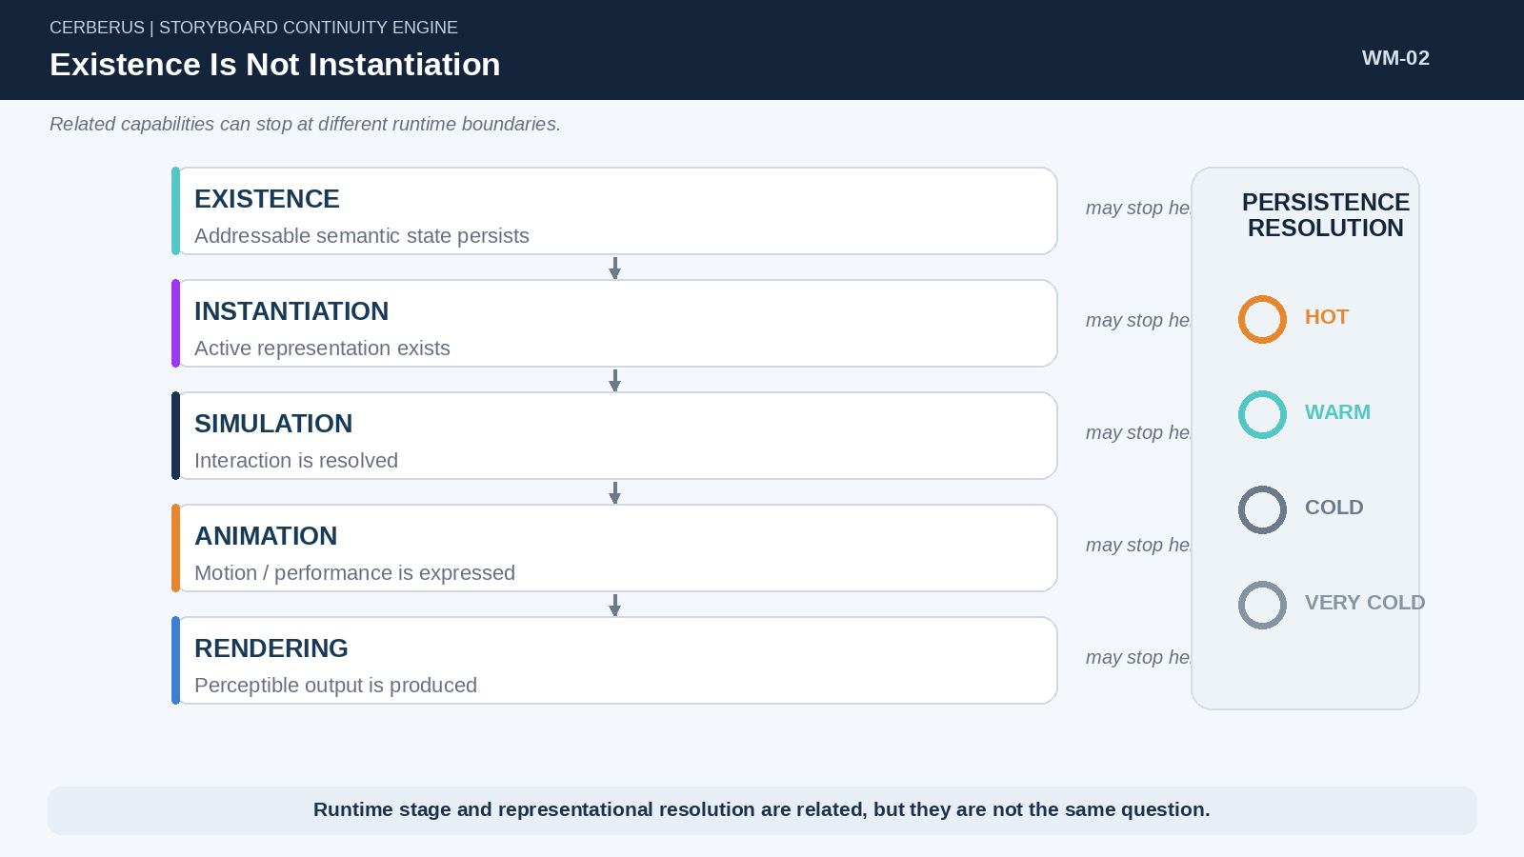
Figure 2. Existence Is Not Instantiation. Runtime capability and representational resolution are separate boundaries.

3. Historical Truth Is Not Current Representation
An occurrence can remain historically true after the representation that once expressed it has been deliberately collapsed. If Deer #481 was killed, the World does not need to preserve an active deer object forever. The later causal truth may be sufficiently represented by a herd population reduction, an adjusted adult cohort, and any other consequence that still matters.
Historical Truth ≠ Current Representation
The World may remain correct even when microscopic detail has cooled away.

This is not deletion of history. It is a change in the level at which the consequence is represented. The distinction matters because long-running Worlds become intractable if every historical detail is granted permanent explicit identity simply because it once existed.
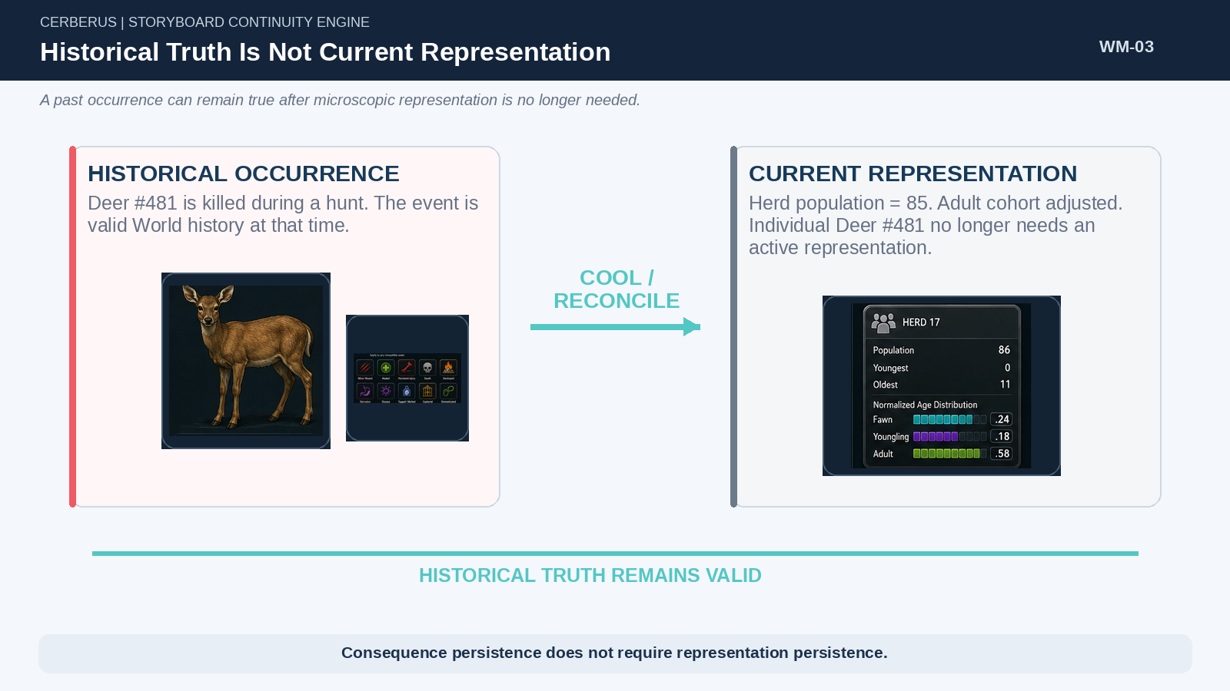
Figure 3. Historical Truth Is Not Current Representation. A deer death remains true after the individual has been reconciled into higher-level herd state.

4. Storyboard Continuity
The Storyboard remains an ordered sequence of causally valid states: State₀ → Event → State₁ → Event → State₂. The new mechanics extend that sequence by allowing representation to change between states. State₁ may cool into a compact aggregate and later heat into a different executable representation without breaking continuity.
Continuity criterion
A World transition is valid when the resulting state is an authorized consequence of the preceding addressable state and the representation retains every distinction required for valid future causality.

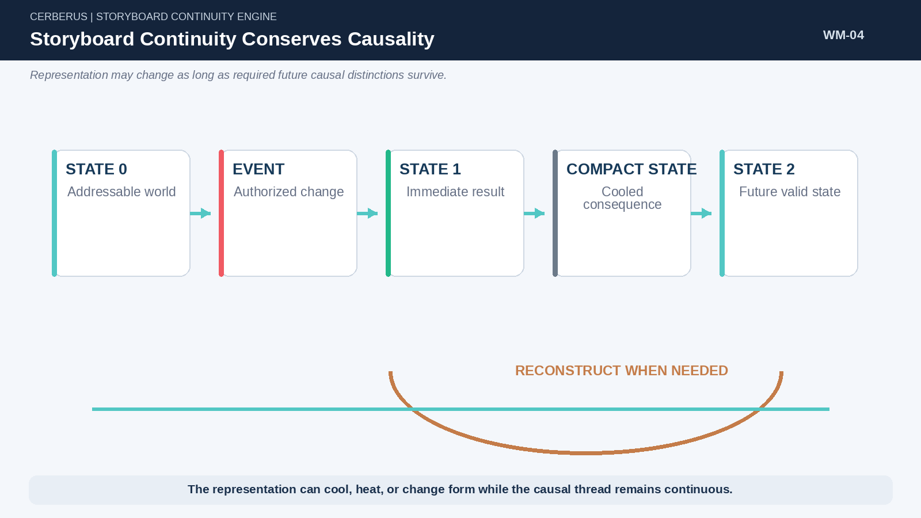
Figure 4. Storyboard Continuity Conserves Causality. Causal continuity can survive cooling and later reconstruction when future-relevant distinctions remain conserved.

PART 2

One Computational Grammar
Different Assets and scales preserve different semantics while participating in the same cybernetic process.

5. From Semantic State to World Operation
Simulation begins below the level of “character AI” or “world logic.” Bits encode primitive state; BitGroups provide reusable structures; BitWords bind those structures into bounded semantic contracts; Readers deterministically interpret them; NodeKeys identify exact referents. Models, Rules, Operators, and routes then declare what can happen to those referents in a particular operation.
A simulation-ready Asset is therefore not a special object class. It is a registered thing whose current state and applicable contracts are sufficiently defined for the operation being attempted. A human, deer, robot, river, vehicle, school, herd, or Region can enter the same computational grammar without sharing the same semantics.
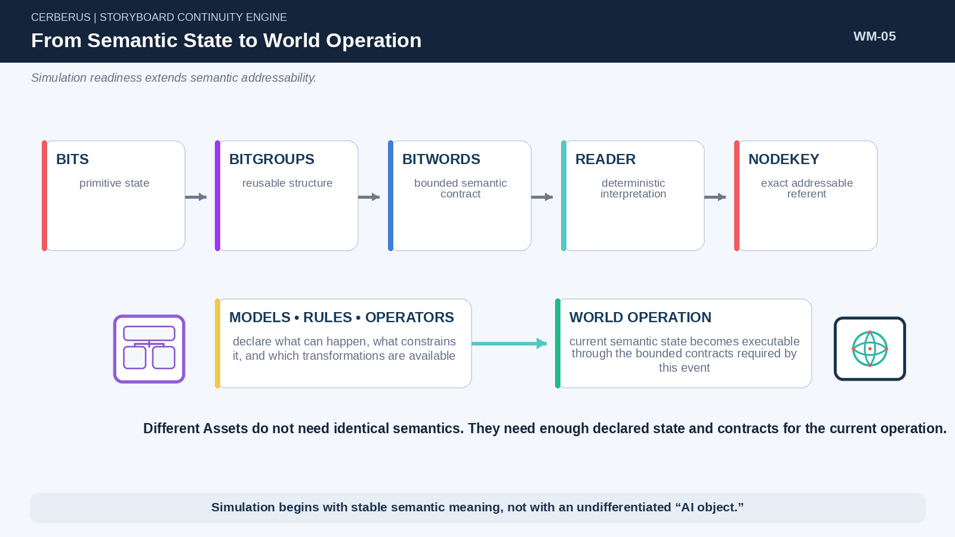
Figure 5. From Semantic State to World Operation. Bounded semantic construction extends into executable World operations through registered Models, Rules, Operators, and identity.

6. Different Assets, Same Runtime Grammar
Shared computation does not require shared meaning. A deer does not use the same Models as a river, and a Region does not expose the same state as a person. What they share is the process by which exact state is addressed, read, routed, transformed, written, and made addressable again.
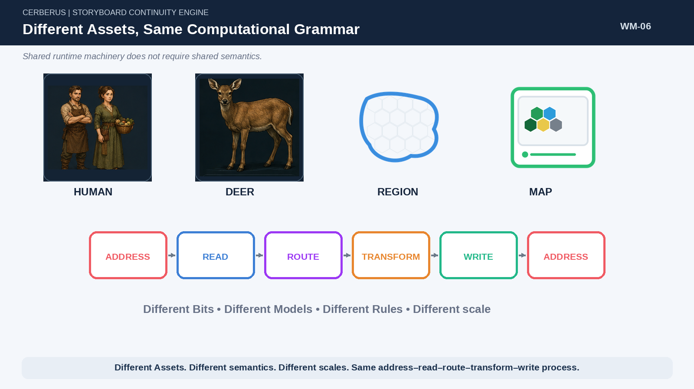
Figure 6. Different Assets, Same Computational Grammar. Different Assets can preserve distinct semantic contracts while using the same address–read–route–transform–write process.

7. NodeKey Closure
NodeKey Closure marks the completion of a consequential runtime cycle. A cycle begins from addressable state, performs bounded cybernetic work, produces a consequential result, authorizes an applicable delta, and ends when the updated result can again be addressed exactly. The return to addressability is not a numbering convenience; it is what makes the new World a valid starting point for the next cycle.

8. Bounded Operation → World Consequence
A local transformation can propagate outward through larger causal scales. An Operator changes a target. The target change may alter behavior. Behavior may alter nearby Assets, group configuration, environmental state, or infrastructure. The resulting consequence may then become persistent World context. World Mechanics is therefore the continuation of bounded semantic operations until the consequence has reached the level at which future World behavior depends upon it.
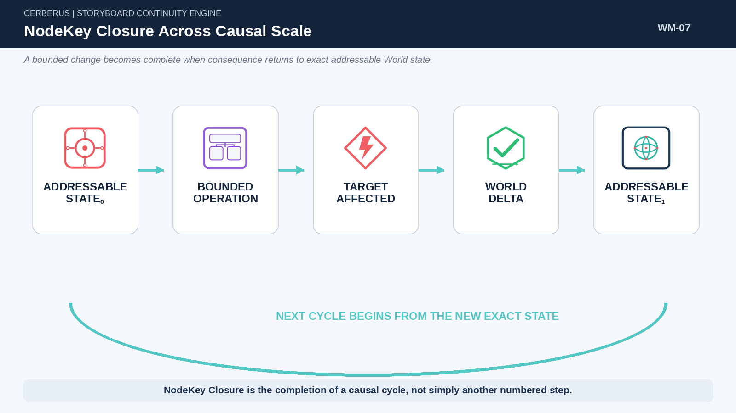
Figure 7. NodeKey Closure Across Causal Scale. A bounded operation becomes complete when the resulting World delta returns to exact addressability.

9. Selective Semantic Routing
The semantic families surrounding a runtime problem are available resources, not mandatory modules that must all execute. A Screech event may require Actor and Target identities, auditory Models, environmental attenuation, response Rules, Goal Logic, and a bounded amount of local simulation. Another event may require far less.
This semantic selectivity foreshadows the resolution architecture used later in the paper: the system not only chooses which semantic structures matter, it also chooses how much representational detail those structures require.
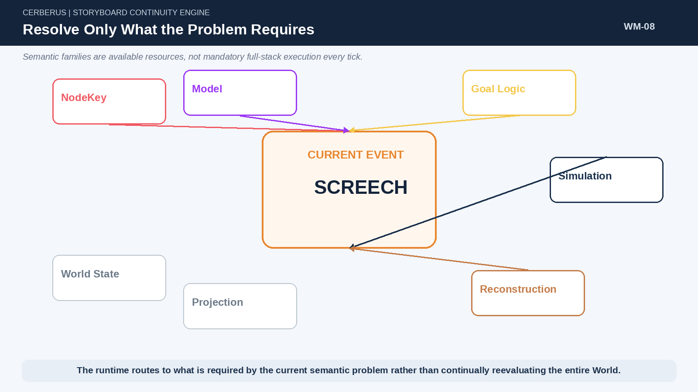
Figure 8. Resolve Only What the Problem Requires. Only the semantic families required by the current event need to resolve.

PART 3

The World as Causal Fabric
World State is a graph of spatial, ecological, social, developmental, temporal, and historical structures.

10. World State Is a Graph, Not a Frame
World State is not one giant rendered snapshot and it is not a single rigid containment tree. Spatial organization can include World, Region, Zone, and Tile, but Habitat, Society, Infrastructure, Assets, TIME, populations, history, and Life Trajectory can intersect those same referents without becoming children of the spatial hierarchy.
Different questions traverse different relationships. Movement may care about Tile adjacency. Breeding may care about Habitat, season, and carrying capacity. Human development may care about Region, Society, historical Infrastructure, and Life Trajectory. A Map may expose selected portions of the same structures without owning them.
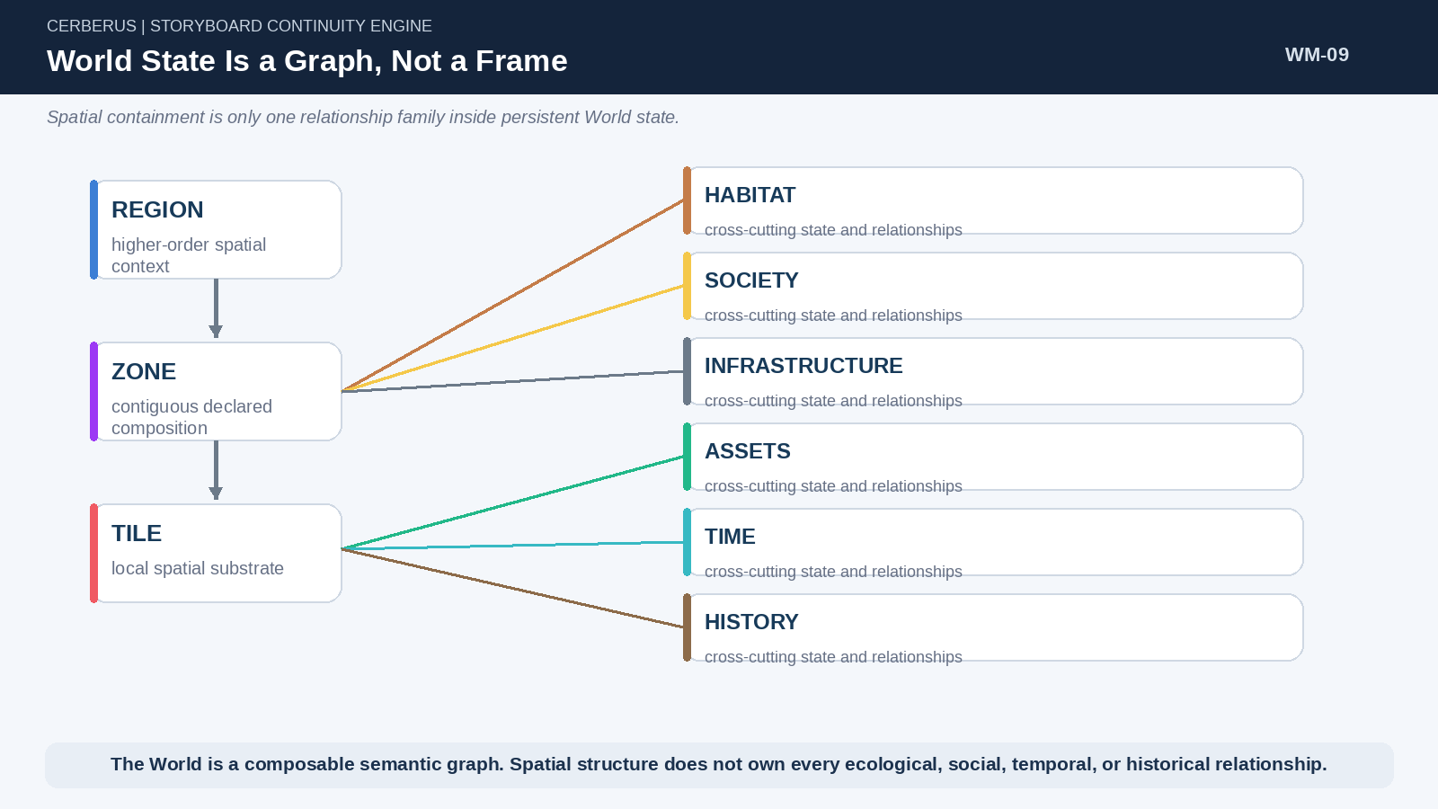
Figure 9. World State Is a Graph, Not a Frame. Spatial containment is only one relationship family inside the larger persistent World graph.
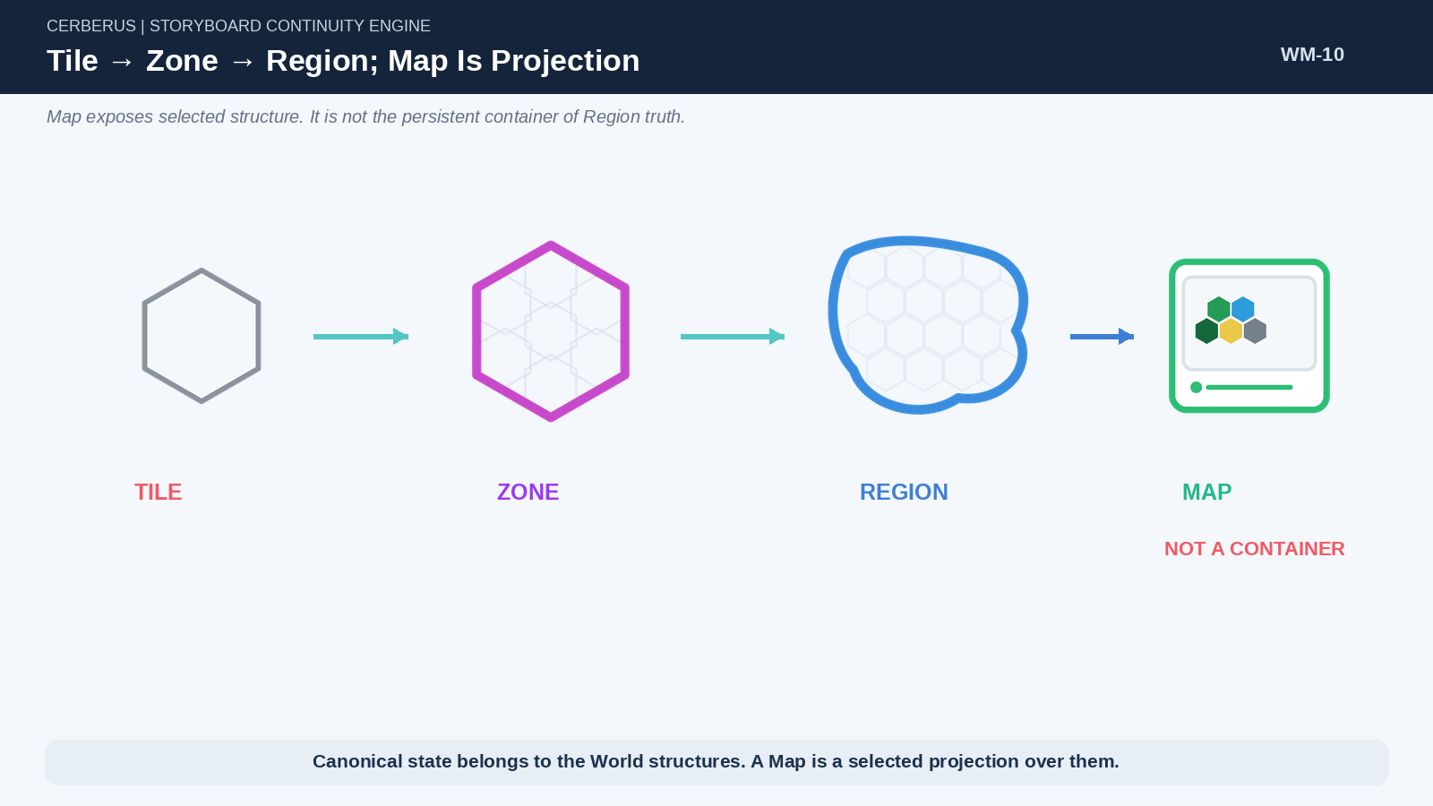
Figure 10. Tile → Zone → Region; Map Is Projection. Spatial composition and map projection remain separate responsibilities.

11. Tile — Local Physical Substrate
Tiles provide the smallest declared spatial substrate in the current World model. A Tile can carry a Tile Type and local state while receiving bounded contextual influence from surrounding Tiles. This allows adjacent Tiles of the same Type to differ because their neighboring water, terrain, vegetation, or other declared properties differ.
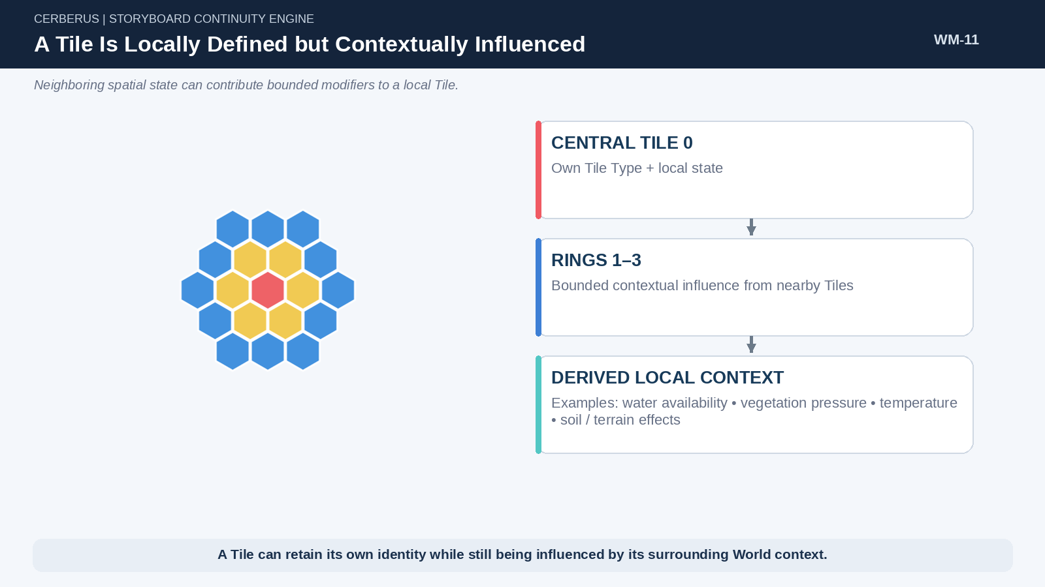
Figure 11. A Tile Is Locally Defined but Contextually Influenced. A central Tile can retain its own identity while receiving bounded modifiers from surrounding Tiles.

12. Zone — Emergent Spatial Composition
Zones group contiguous Tiles according to declared combinations or conditions. A Forest Zone can require a particular proportion of Forest Tiles and enough water; another Zone Type may use different thresholds. Zone therefore describes an emergent spatial composition rather than simply acting as a larger Tile.

13. Region — Higher-Order World Organization
Regions aggregate Zones into larger geographic, geological, administrative, political, or creator-defined structures. A Region is not required to be one biome. It may include forest, water, farms, roads, mountains, settlements, and infrastructure simultaneously. This is why Region becomes such a powerful reconstruction key: it can gather many different causal structures that share a larger spatial context.

14. Map — Projection, Not World Truth
Map is deliberately separate from Tile, Zone, and Region. It selects which fields of those structures are exposed and how they are represented for a particular viewing purpose. Game, strategic, debug, educational, and cinematic maps can all be valid projections over the same canonical World State.

15. Habitat Model — Ecological Possibility
Habitat describes the conditions under which biological populations can exist and change. Relevant dimensions may include temperature, food sources, water availability, migration pressure, carrying capacity, breeding conditions, and other declared ecological state. Habitat does not need to own every species behavior; it defines the environmental possibility surface those behaviors operate within.

16. Society Model — Collective Human Structure
Society describes customs, roles, collective practices, institutions, social organization, and other structures that shape how people interact with the World and with one another. Society can also influence developmental opportunities by determining which rituals, institutions, or expected pathways exist for a population.
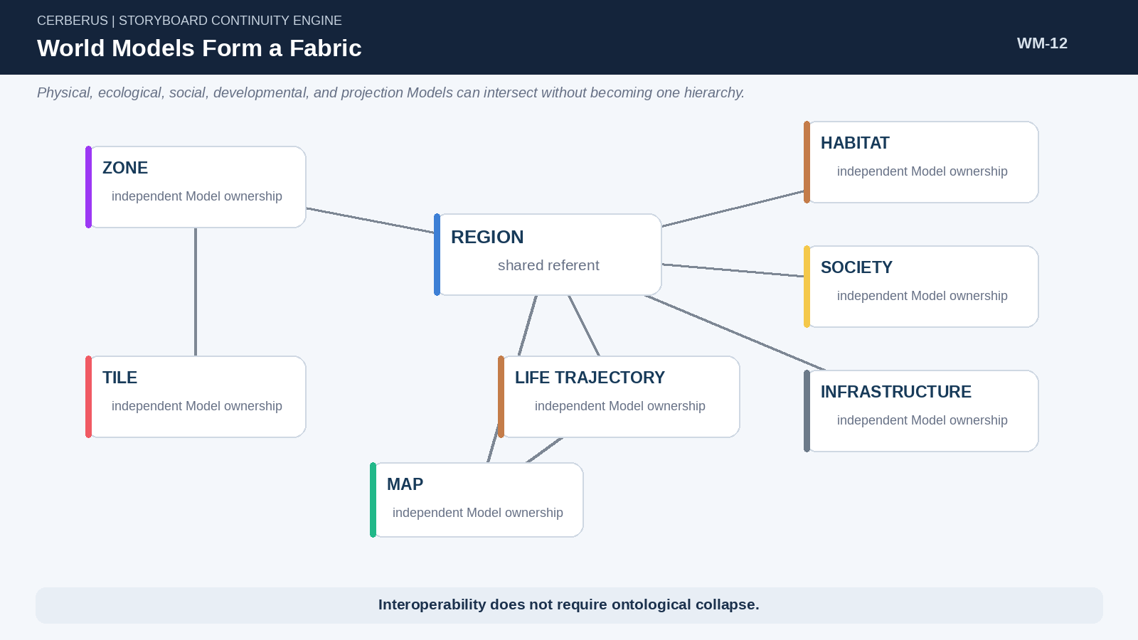
Figure 12. World Models Form a Fabric. Physical, ecological, social, developmental, and projection Models can intersect through shared referents without collapsing into one hierarchy.
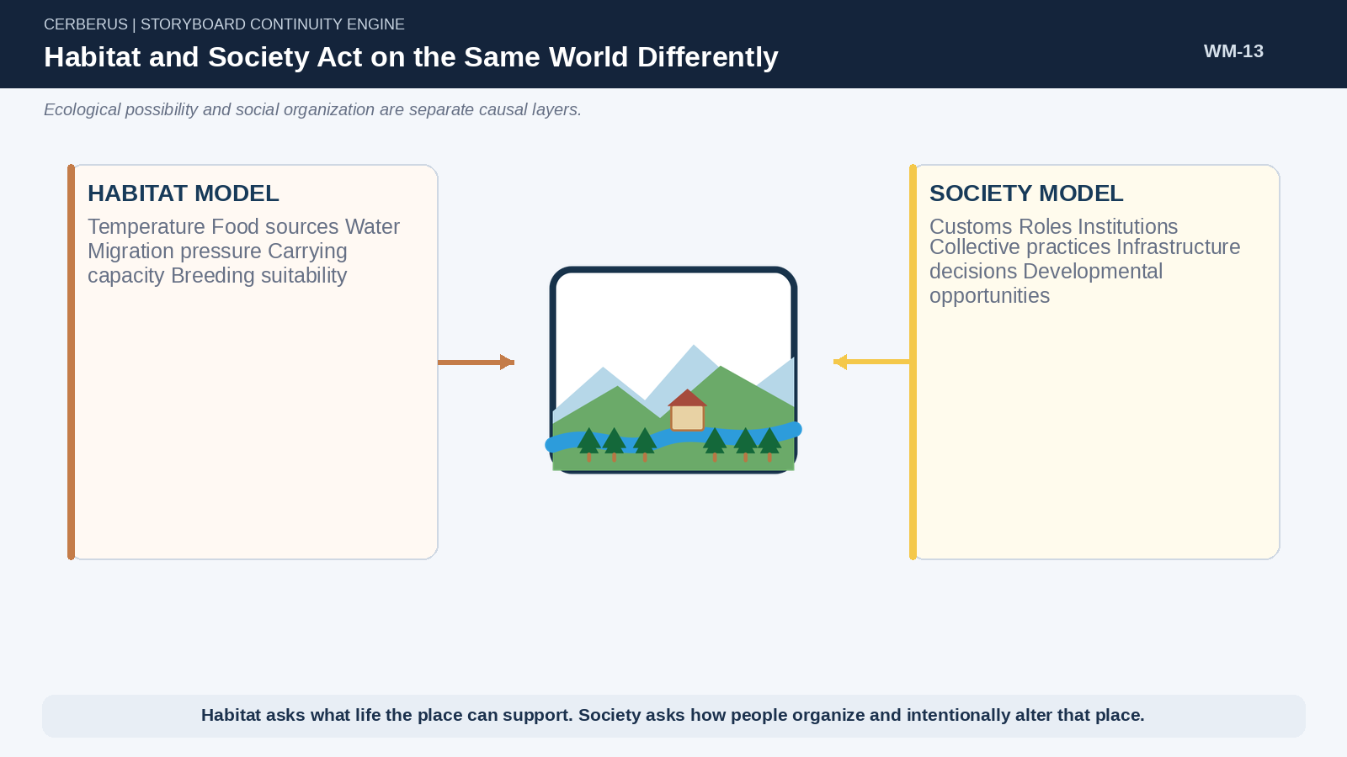
Figure 13. Habitat and Society Act on the Same World Differently. Ecological capacity and social organization influence the same Region through different Models.

17. Infrastructure Model — Persistent Capacity
Infrastructure is generative capacity. A school, forge, farm, hospital, road, fort, Guild hall, harbor, or other persistent structure changes what the World can do next. Infrastructure can expose Tasks, training routes, professional roles, resource flows, travel options, or developmental opportunities. It is therefore a cause of future population capability, not merely visual scenery.
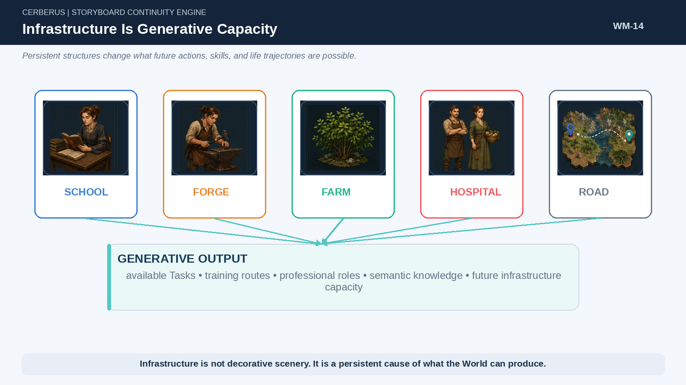
Figure 14. Infrastructure Is Generative Capacity. Persistent structures produce future actions, training routes, semantic capabilities, and additional infrastructure capacity.

18. Map as Reconstruction Index
Once spatial state is combined with TIME, a location becomes more than a coordinate. It becomes an index into causal history. “Ember, Year 181” can route to the Habitat, Society, Infrastructure, Events, and Model versions that were valid at that place and time. This place-time query is what allows later life and ecological reconstruction to remain grounded in the World that actually existed then.
(Location, TIME) → historical causal context
A place-time address identifies the World structures eligible for reconstruction.

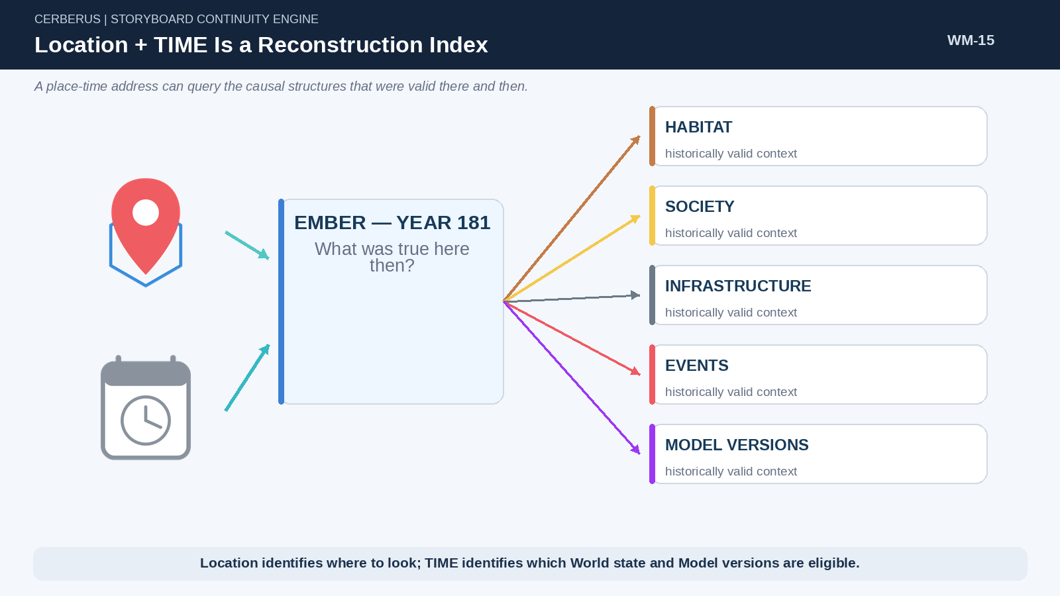
Figure 15. Location + TIME Is a Reconstruction Index. Historical place and time jointly resolve the Models and World structures that were valid then.

PART 4

World Time and Causal Rhythms
Different processes change on different clocks, while historical Model versions keep reconstruction temporally honest.

19. One World, Many Clocks
The World does not have one meaningful update frequency. Collision may require frame-scale resolution. Sound and damage may be event-driven. Goal selection and local needs may use minute-scale intervals. Weather, routines, ecology, migration, schooling, infrastructure, and generational change can operate on progressively longer rhythms.
TIME is therefore a routing context rather than a demand for universal ticking. A process should update at the frequency required by its causal role and remain stable between those causes of change.
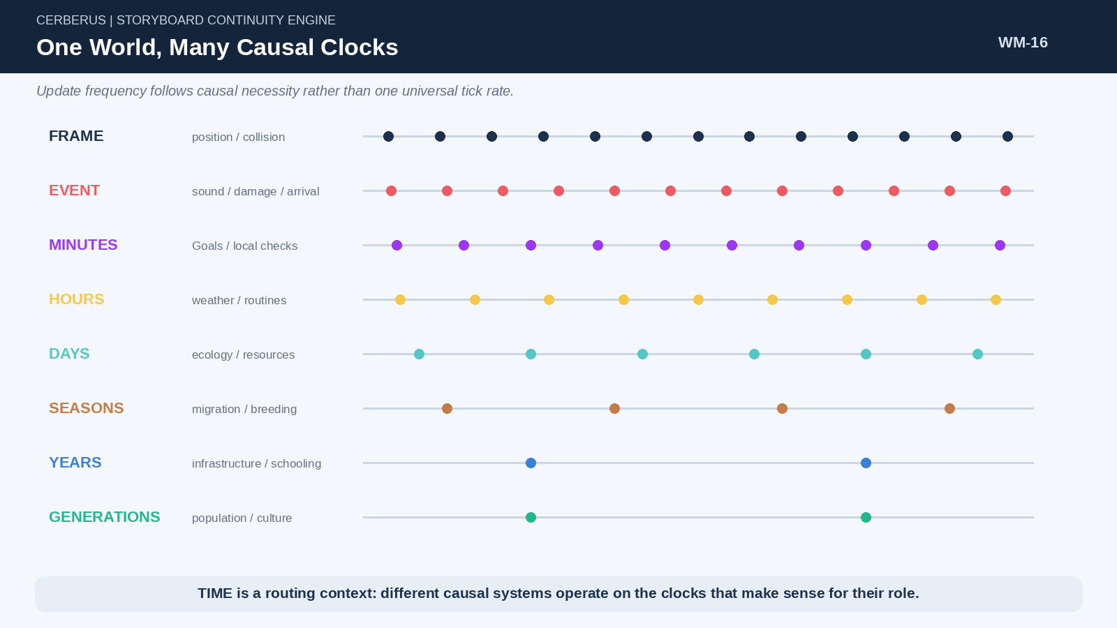
Figure 16. One World, Many Causal Clocks. Frame, event, interval, ecological, developmental, and generational processes can operate on different rhythms inside one World.

20. Stable State Before Recalculation
Continuity before reconsideration applies beyond individual Goals. Weather state, resource state, institutional availability, ecological relationships, infrastructure, and other World structures can remain stable until an Event or declared temporal boundary justifies recalculation. This avoids wasting computation on relationships that have not meaningfully changed.

21. Event-Driven and Interval-Driven Change
Immediate occurrences such as damage, death, construction, perception, or arrival are naturally event-driven. Gradual systems such as hunger decay, weather evolution, breeding, regrowth, or population change may use intervals. Long-duration processes such as education, institutional development, and demography can operate on yearly or generational ticks. The architecture is unified by causal state transition rather than one frequency.
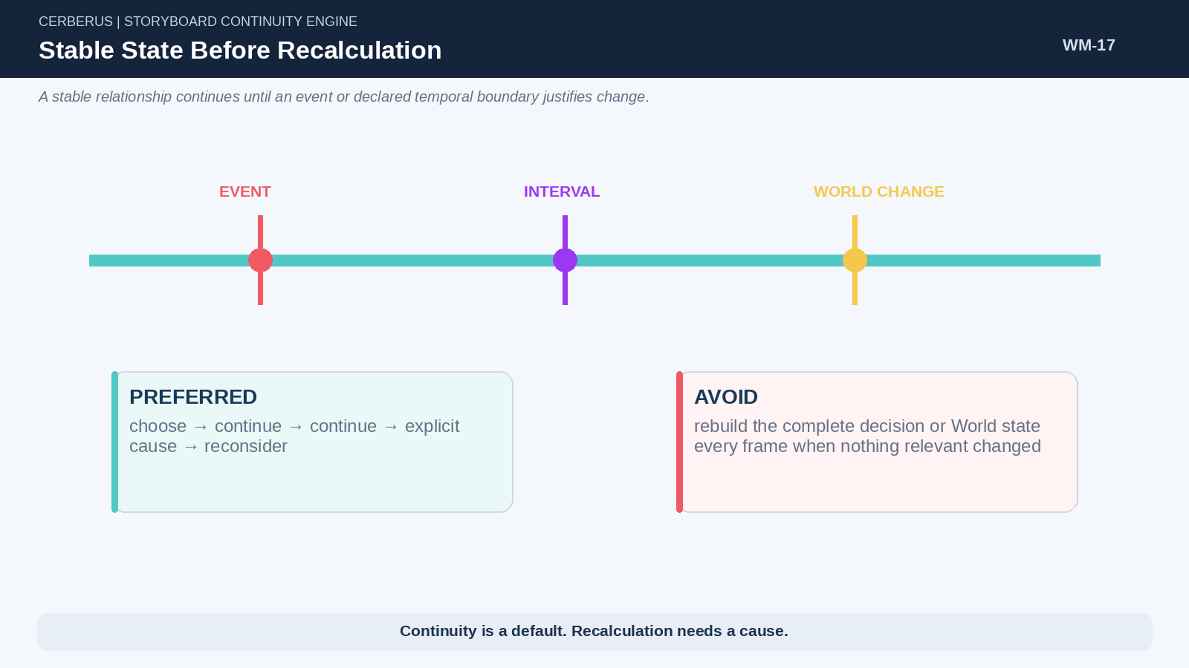
Figure 17. Stable State Before Recalculation. A stable state persists until an explicit Event or scheduled boundary provides a reason to change it.

22. Historical Model Versioning
Historical reconstruction must use the Models that were valid at the historical moment. If Ember Scholar Academy changed curriculum between Years 180 and 205, an elderly graduate should reconstruct against the older curriculum, while a younger graduate resolves against the newer one. Otherwise the World silently rewrites its own past whenever a definition evolves.
Historical Version Integrity
Reconstruction at time t must resolve against the World State and Model versions authorized for time t, not merely the current definitions.

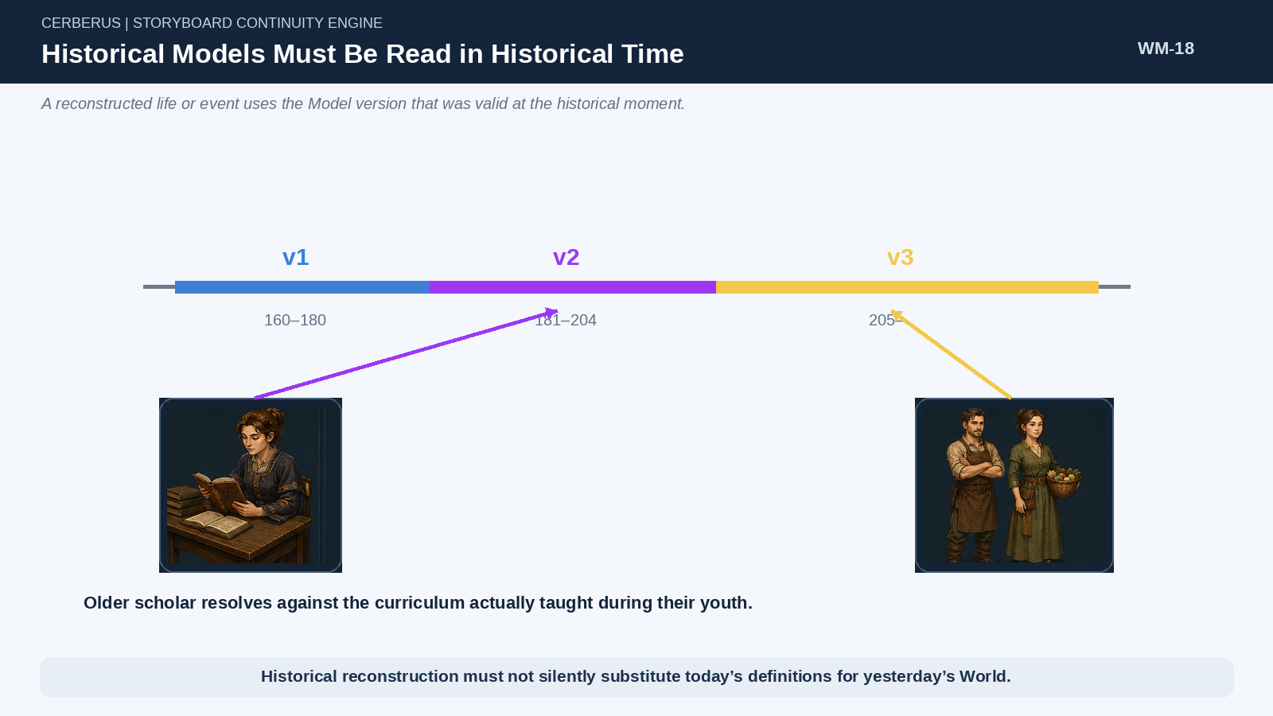
Figure 18. Historical Models Must Be Read in Historical Time. Different generations can resolve against different versions of the same persistent institution.

23. World Events as Shared Causes
A single World Event can explain thousands of later outcomes. If Ember Scholar Academy is destroyed in Year 173, later cohorts do not each need a personal record stating that the school was unavailable. Their Life Trajectory simply queries the historical Region and discovers that the institution did not exist at the relevant developmental tick.
Shared causes are therefore a major compression mechanism. Store the historical change once where it belongs in the World, then let later entities encounter its consequences through reconstruction.
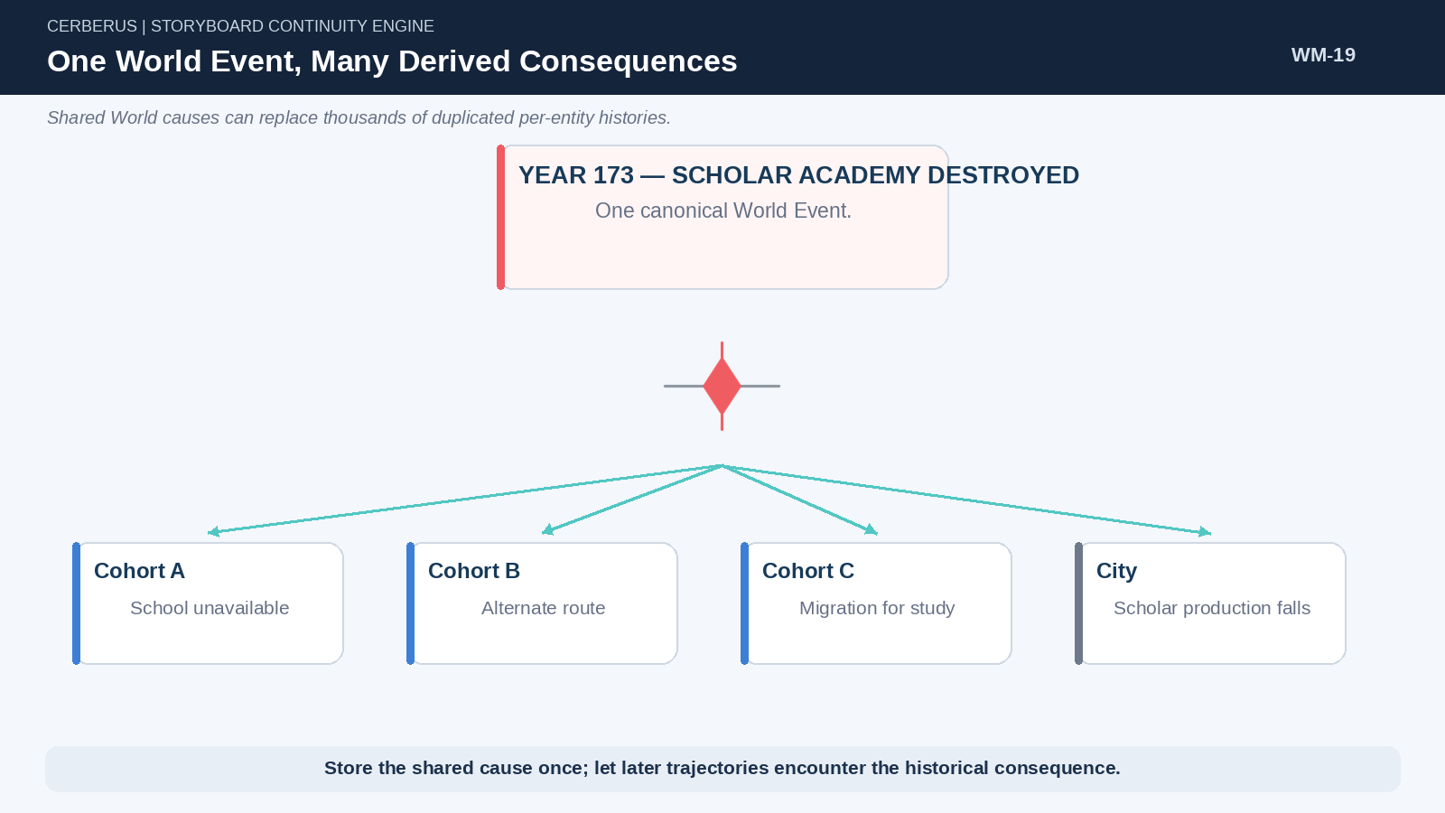
Figure 19. One World Event, Many Derived Consequences. A single canonical infrastructure Event can redirect many later trajectories without duplicate personal history.

PART 5

Life Trajectories and Generative Populations
Human complexity can emerge from sparse developmental ticks that query Culture, Region, Infrastructure, and historical World state.

24. Life Trajectory as Sparse Developmental State
A life does not need to be simulated or stored at full detail every year. The World can define sparse developmental checkpoints such as Naming, Cultural Experience, Regional School, Apprenticeship, or Advanced School. Each checkpoint can apply a large registered delta while the personal historical record remains small.
The exact ages and event names are Model-specific. The architectural principle is that ordinary development can be reconstructed from a small sequence of meaningful ticks rather than a giant handcrafted biography.
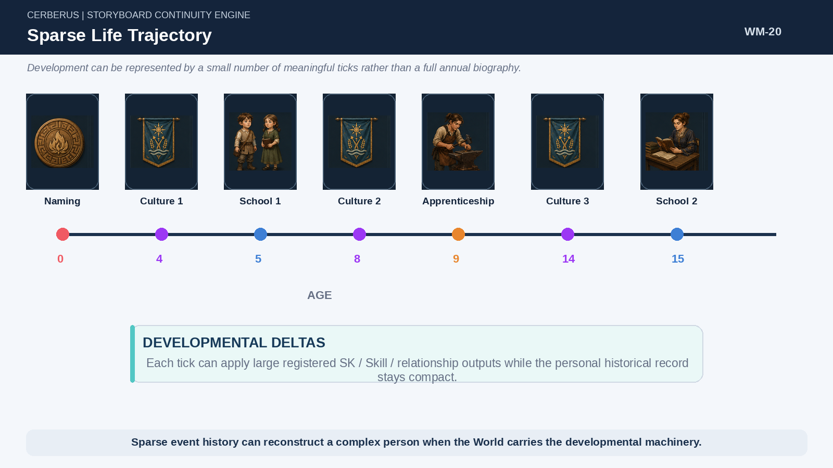
Figure 20. Sparse Life Trajectory. A compact sequence of developmental events can produce a rich adult state when the World carries the reusable outputs.

25. Culture and Region Interlock
Culture and Region can supply different developmental rails. In one World, Cultural experiences may occupy one set of developmental slots while Regional opportunities occupy another. Birth can participate in both. The example of alternating even and odd developmental ticks is a declared Model, not a universal requirement; its value is that independent causes can interlock without collapsing into one monolithic life table.
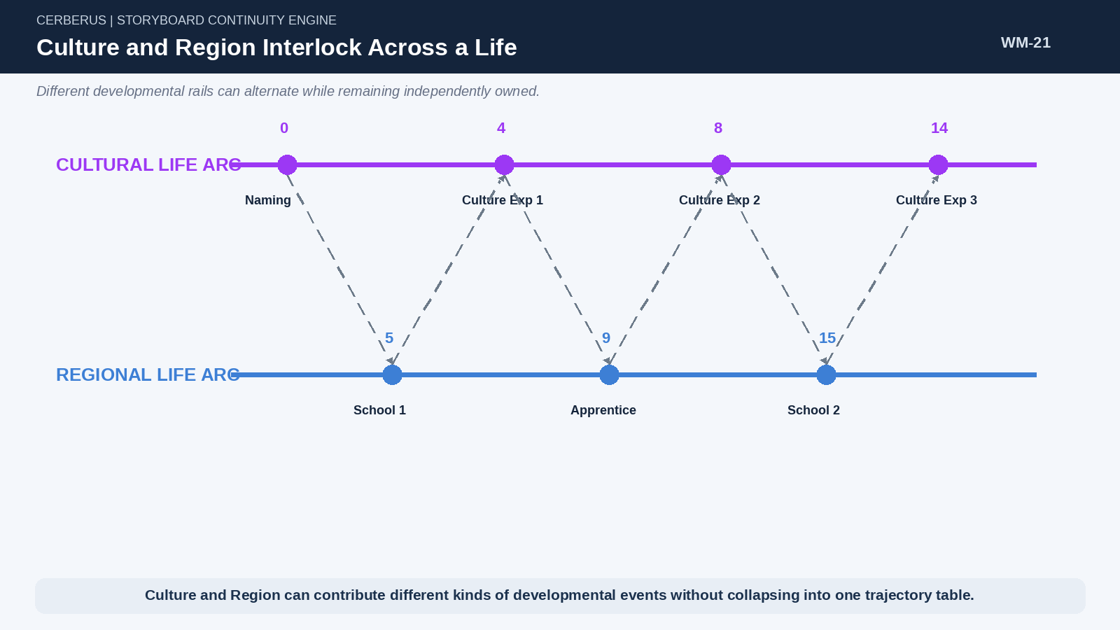
Figure 21. Culture and Region Interlock Across a Life. Separate developmental rails can weave into one biography while retaining independent ownership.

26. Naming as Fictional Provenance Projection
A fictional naming system may use Culture, birth Region, parental lines, sex where relevant to the declared culture, and deterministic seed to produce a name. The name can therefore become a human-readable projection of simulated provenance. Different cultures can use different inheritance ceremonies and pool structures. This is a game-world mechanic: the system reads declared fictional rules rather than inferring real-world culture from appearance.
Naming boundary
Culture is a declared World Model. CERBERUS does not guess cultural identity from visual appearance.

27. Regional Infrastructure Selects Development
When a regional developmental tick occurs, the system asks what Infrastructure actually exists in the character’s current Region at that historical time. Ember may expose City Defense, Agriculture, Blacksmithing, and Scholar routes; another settlement may expose entirely different options. Selection can then be weighted by eligibility, family, skills, social structure, demand, availability, or bounded randomness.
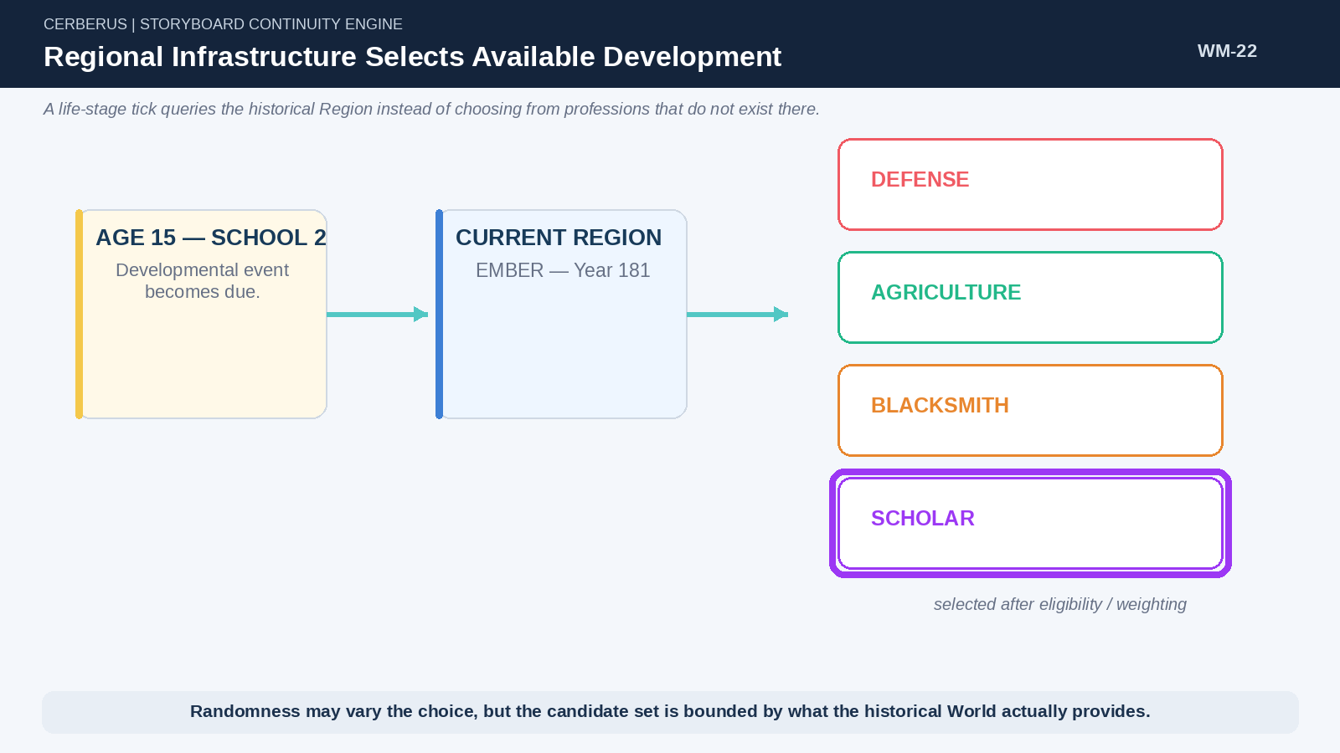
Figure 22. Regional Infrastructure Selects Available Development. A School-2 tick queries historical Ember and chooses only among institutions that actually exist there.

28. Schools as Semantic Compilers
An institution can be modeled as a developmental compiler. A five-year Scholar Academy may apply language and general skills in Year 1, math and logic in Year 2, research and history in Year 3, specialization in Year 4, and advanced specialization in Year 5. The World stores the curriculum once; many graduates can reference that shared trajectory rather than duplicating every semantic output.
This pushes complexity into the reusable institutional Model. The individual history can remain a small statement such as “Ember Scholar Academy, five-year Mathematics track,” while the Reader expands that reference into the relevant SK, Skill, Operator, relationship, and access consequences.
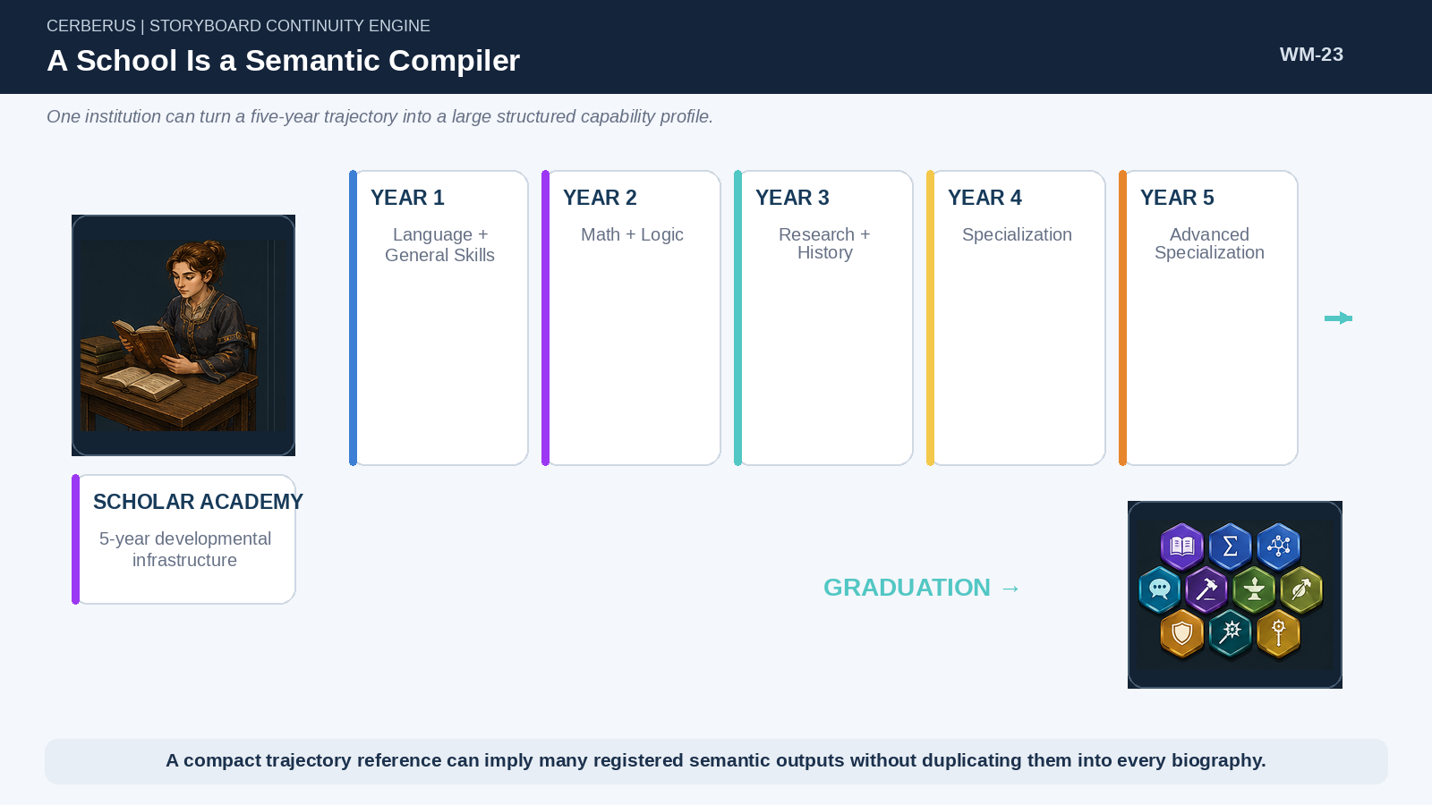
Figure 23. A School Is a Semantic Compiler. A five-year institutional route can produce a large structured capability profile from a compact trajectory reference.

29. Migration Produces Hybrid Lives
Movement between Regions naturally produces hybrid biographies. A character may be born in a northern Region, receive foundational education in Ember, and complete advanced study in a harbor city. Culture can continue to influence the person while the regional opportunity surface changes. No bespoke “northern–Ember–harbor hybrid” NPC template is required; the biography emerges from actual movement through the World.
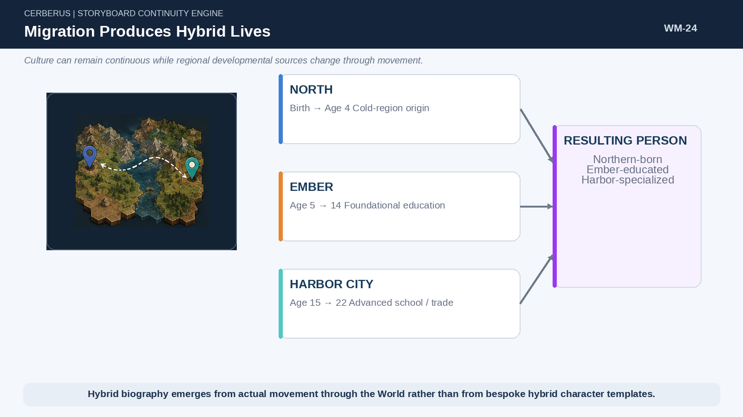
Figure 24. Migration Produces Hybrid Lives. A single life can accumulate developmental outputs from multiple Regions while retaining continuous identity and Culture.

30. Infrastructure Shapes Demography
A city gains scholars by building and sustaining institutions that produce scholars. The system does not need to declare “20% of Ember is scholarly” as an arbitrary population constant. A Scholar Academy accepts cohorts, applies its curriculum, produces graduates, and gradually changes the city’s capability distribution. Destroy the institution and later cohorts lose that route; the scholar population eventually ages and declines unless another cause replaces it.
This creates feedback. Graduates can become teachers, researchers, officials, builders, or founders of more advanced institutions. Population composition becomes a consequence of World history rather than a decorative demographic label.
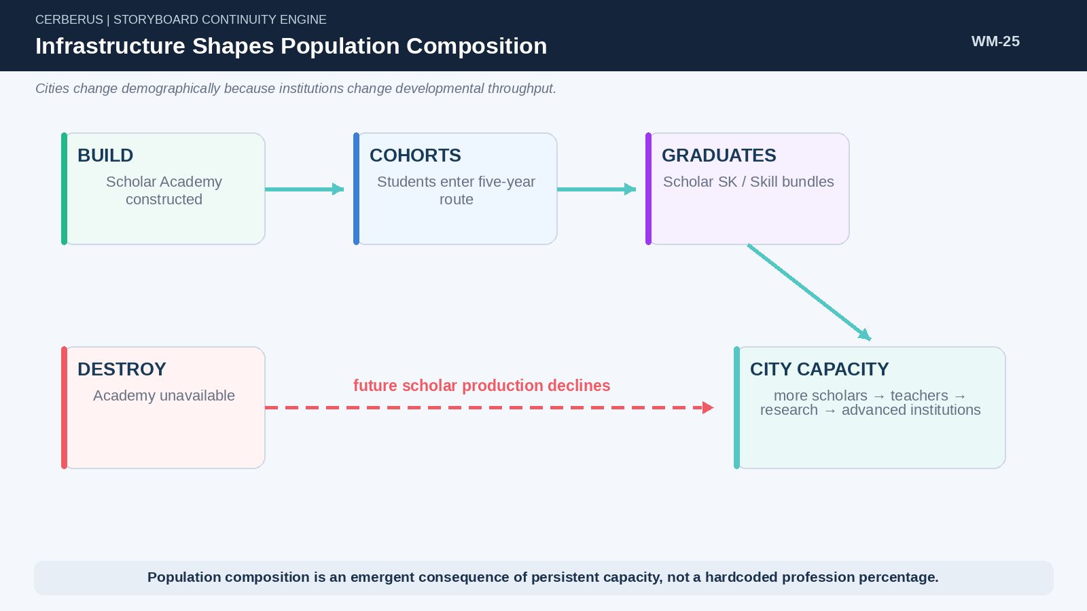
Figure 25. Infrastructure Shapes Population Composition. Institutional throughput changes the capabilities and future capacity of a city across generations.

PART 6

Animal and Ecological Reconstruction
Species Life Models, Habitat, herd behavior, and aggregate populations reuse the same World machinery at different complexity levels.

31. Species Life Models
Animals can often use highly regular developmental trajectories. A declared deer Model may map Ages 0–2 to Fawn Goal Logic, Ages 3–4 to Youngling Goal Logic, and Age 5+ to Adult Goal Logic. The exact thresholds belong to the simulation Model. The runtime only needs to resolve Age → Life Stage → applicable Goal Logic.
This keeps individual animal state compact. Life-stage logic can expose age-appropriate priorities while season, health, reproductive state, Habitat, and herd context independently modify current Goal selection.
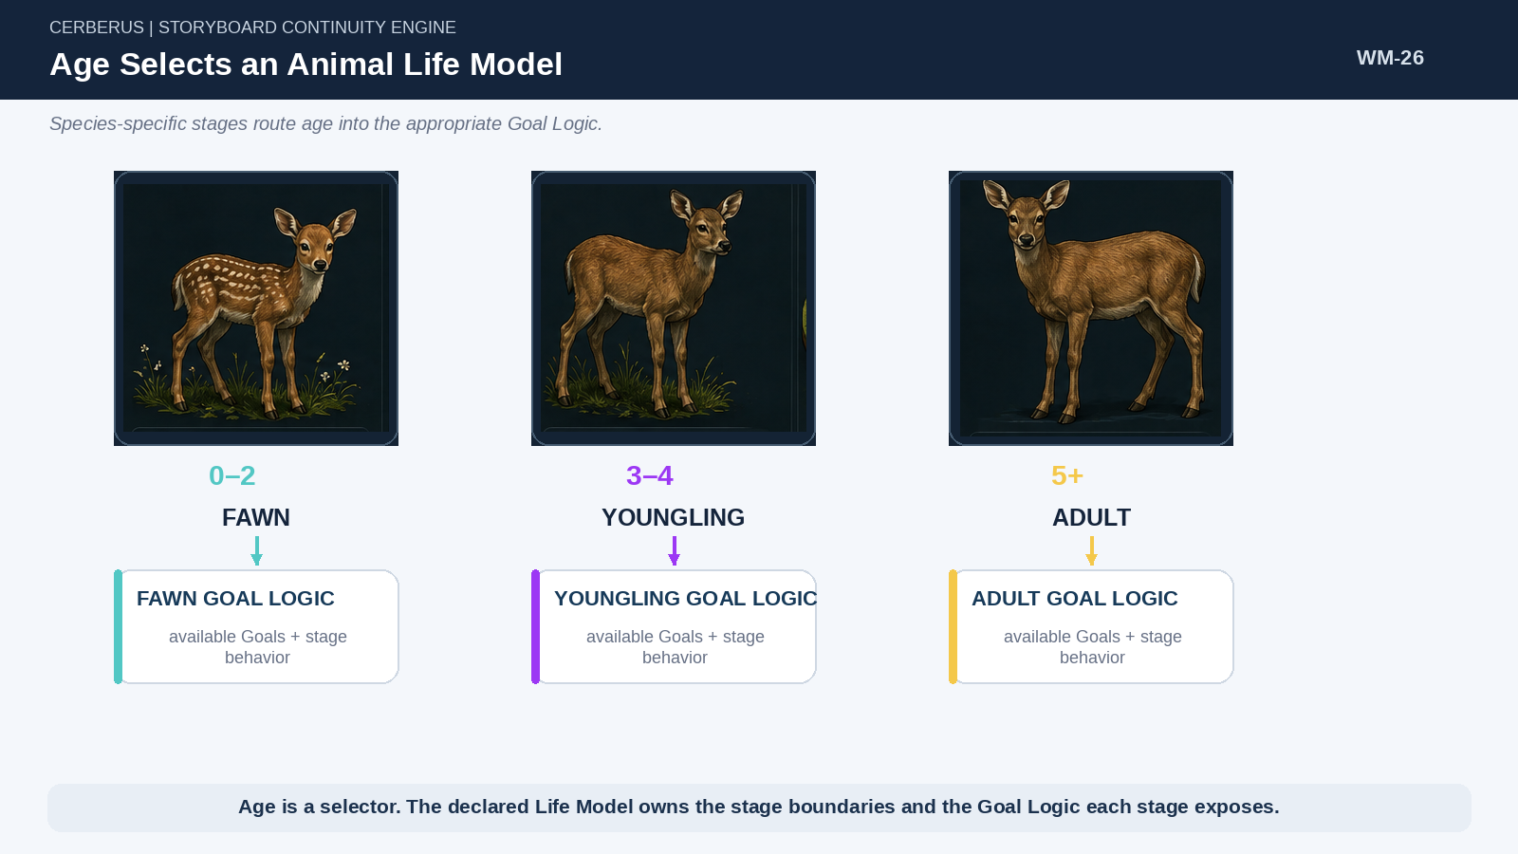
Figure 26. Age Selects an Animal Life Model. Age routes a deer into the developmental Goal Logic declared by the species Model.

32. Habitat Determines Population Possibility
Habitat constrains whether a species can exist in a place and how much population pressure the place can support. Food, water, temperature, carrying capacity, breeding suitability, migration conditions, and seasonal state can all affect the regional population Model. The World therefore does not need arbitrary encounter tables disconnected from environmental capacity.

33. Herd Model Is Not Habitat Model
Habitat and Herd answer different questions. Habitat asks whether a Region can support a population. Herd logic asks how members of that population organize, who leads, how group Goals are selected, how formation changes, and how collective response decomposes into local member behavior. Keeping the Models separate prevents ecological capacity from being confused with species-specific social behavior.
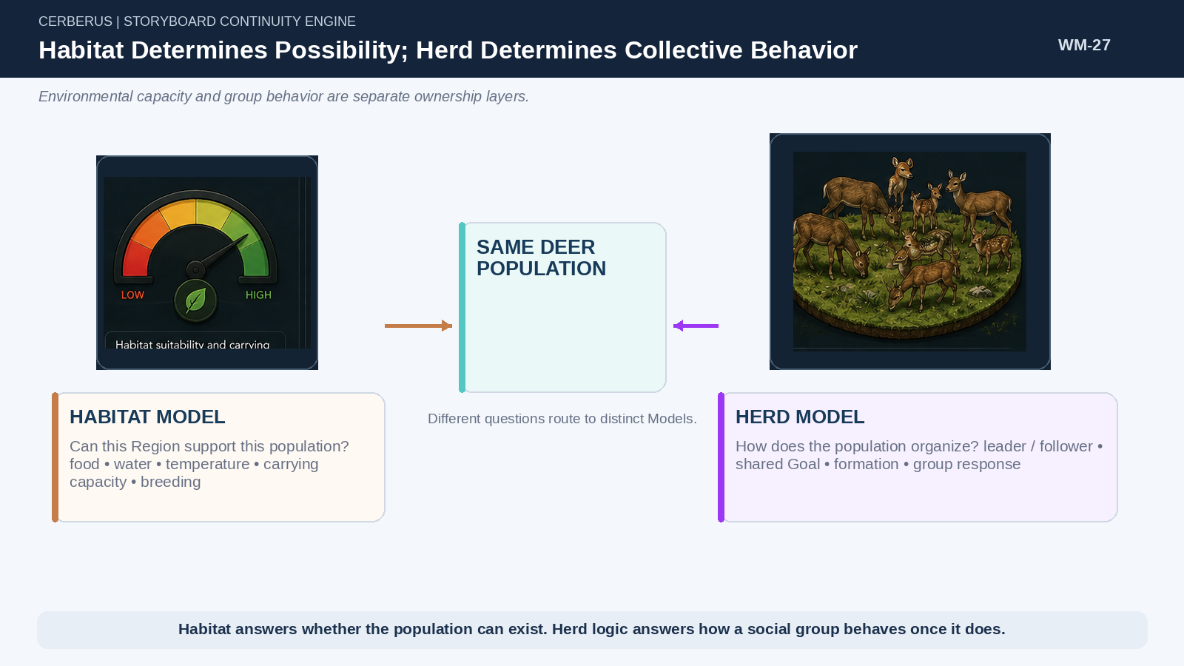
Figure 27. Habitat Determines Possibility; Herd Determines Collective Behavior. Environmental capacity and group behavior operate on the same population through distinct Models.

34. Herd-Level Behavior
A herd can resolve a shared macro Goal such as FLEE toward a Safe Region once at group level. Only where individual variation matters does the group decompose into member-level execution: fawn proximity, heading offsets, injuries, obstacles, leader/follower behavior, or other local constraints. The same recursive principle can later apply to crowds, convoys, robot swarms, military units, or production cells.
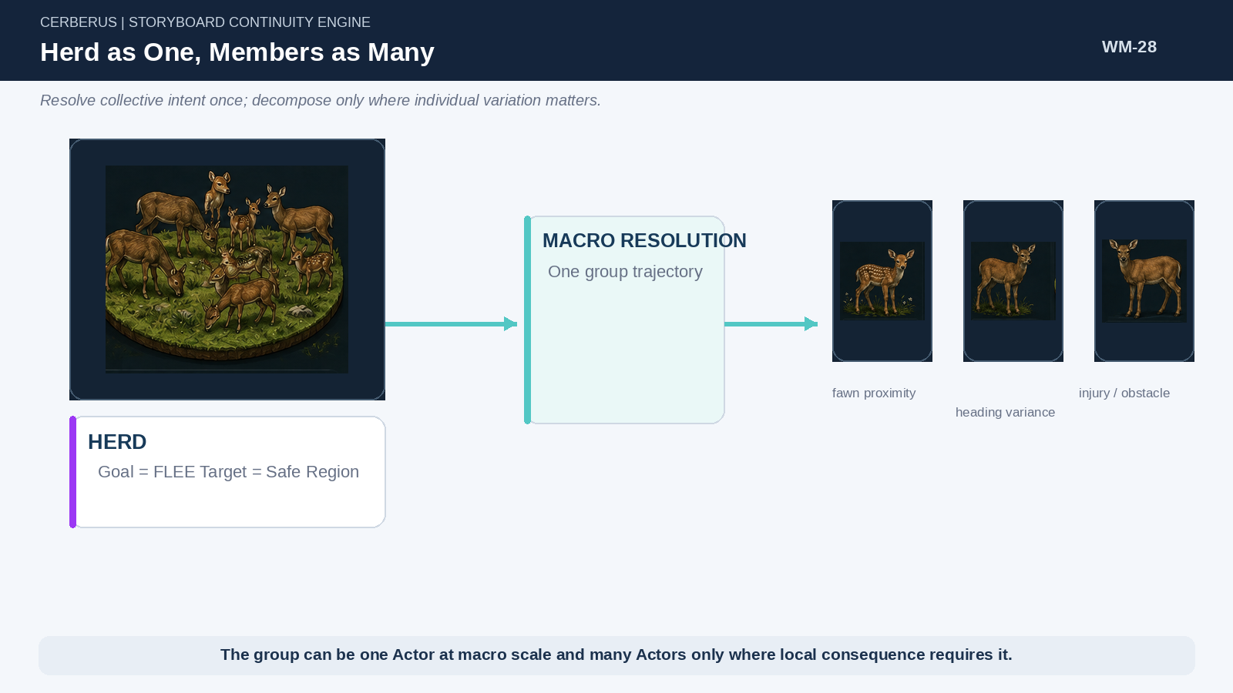
Figure 28. Herd as One, Members as Many. Collective intent is resolved once and decomposed only where local consequence requires individual detail.

35. Herd as Compressed Population State
A herd can remain semantically useful as a statistical object. Population, youngest and oldest ages, normalized age distribution, health or reproductive distributions, current Region, and other bounded fields can be sufficient while individual members remain implied. For a normalized distribution pᵢ over herd population N, expected cohort size is Nᵢ = N × pᵢ.
Nᵢ = Nₕₑᵣd × pᵢ
Normalized life-stage proportions can reconstruct approximate cohort counts without one age record per animal.

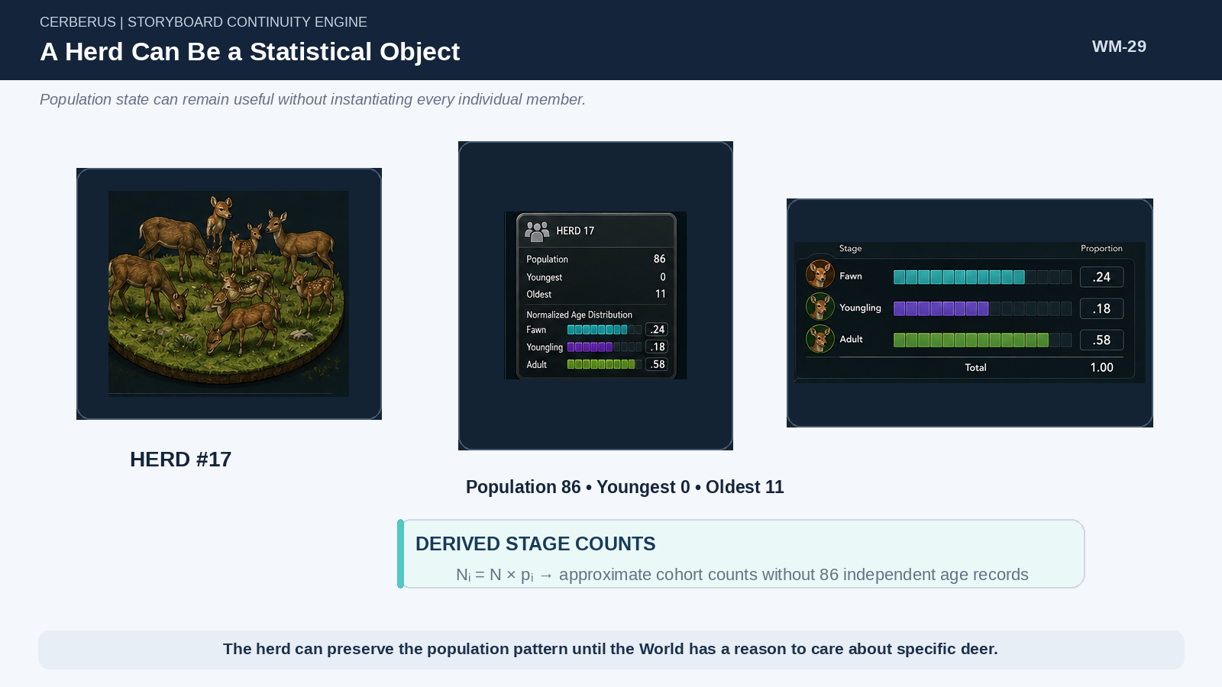
Figure 29. A Herd Can Be a Statistical Object. Herd population and normalized age structure can represent many animals without explicit individual records.

36. Regional Population Aggregation
Aggregation can continue upward. A very-cold Region may store deer herd count, herd size range, normalized age distribution, population trend, and other ecological summaries without retaining fifty explicit Herd records. When the Region heats, those herds can be reconstructed within the preserved constraints. When a herd becomes locally relevant, it can heat again into cohorts and individuals.
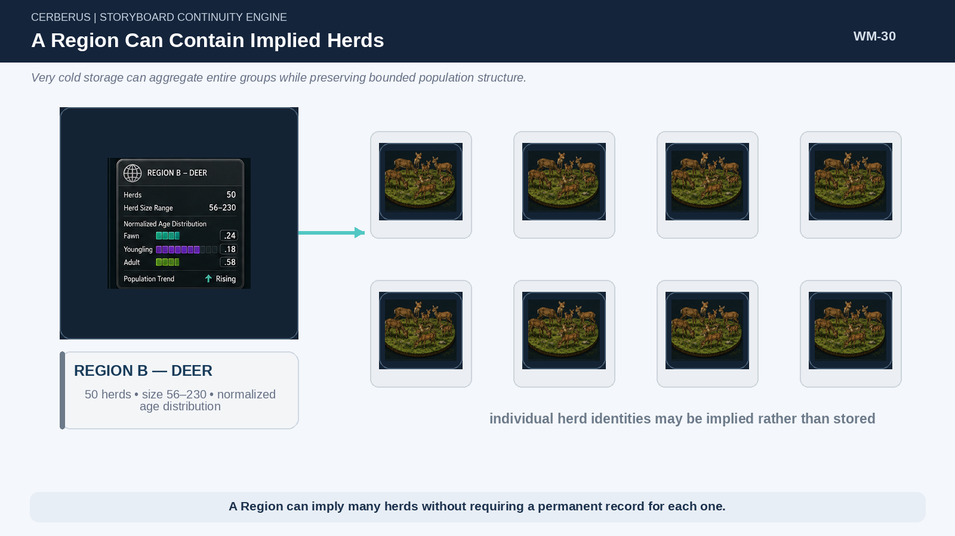
Figure 30. A Region Can Contain Implied Herds. Regional population state can imply many herds without storing each herd as a permanent identity.
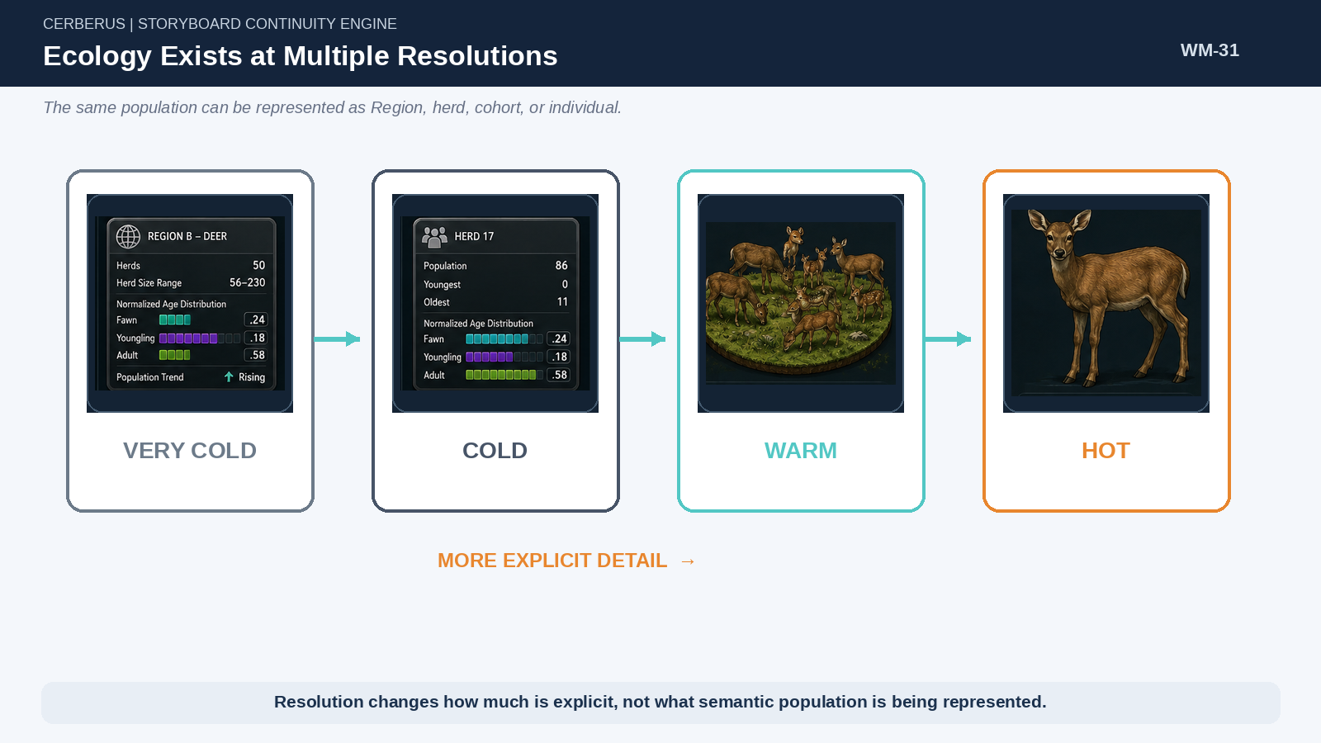
Figure 31. Ecology Exists at Multiple Resolutions. The same population can be represented as a regional aggregate, herd, local group, or explicit individual.

PART 7

Resolution, Heating, Cooling, and Reconstruction
The World changes representational detail according to consequence while retaining semantic continuity.

37. Lowest Sufficient Resolution
The governing question is not “How much detail can the engine calculate?” but “What is the lowest resolution sufficient to determine the consequential result?” Operational consequence, uncertainty, evidence requirements, dependency reach, observer proximity, presentation need, and compute budget can all influence the answer.
Some events are symbolic. Others require statistical, structural, geometric, or high-fidelity physical treatment. Defaulting to maximum fidelity wastes computation and can create false precision. SCE makes fidelity an explicit runtime decision.
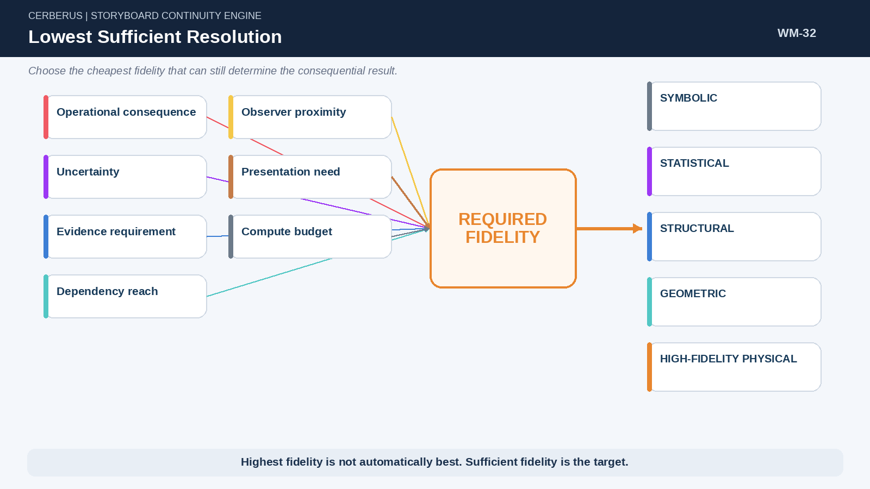
Figure 32. Lowest Sufficient Resolution. Required fidelity is selected from the causal needs of the current operation rather than from maximum available detail.

38. Resolution Ladder
World Mechanics uses Hot, Warm, Cold, and Very Cold as a conceptual resolution ladder. Hot state exposes explicit interactive individuals. Warm state keeps local or cohort detail available. Cold state retains group aggregates with members implied. Very Cold state retains regional or large-scale summary state. Different Models may define their own exact fields, but the direction of representational compression remains consistent.
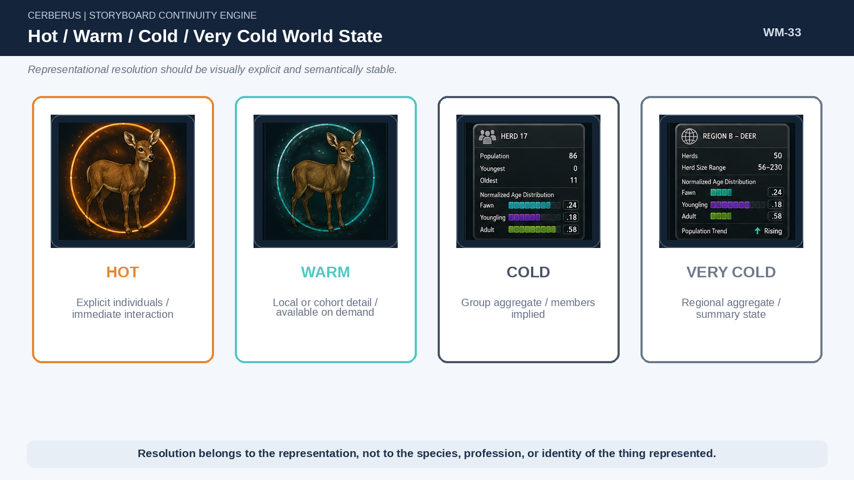
Figure 33. Hot / Warm / Cold / Very Cold World State. Representational resolution is explicit and independent of the semantic identity being represented.

39. Heating
Heating is the operation that raises bounded detail because consequence now requires it. A very-cold Region can reconstruct Herd records; one relevant Herd can expose a local group; a local interaction can instantiate explicit deer. Heating follows dependency reach and requested fidelity. It is not a command to instantiate everything nearby at the same resolution.
Aggregate State + Models + Historical Context + Fidelity Request → Active Representation
Heating raises only the state required by current causal work.

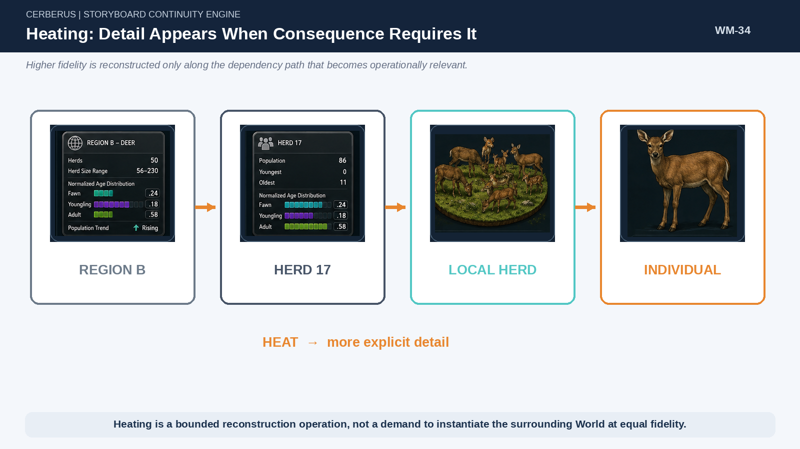
Figure 34. Heating: Detail Appears When Consequence Requires It. Regional state can progressively reconstruct herd, local group, and individual detail.

40. Cooling
Cooling is the inverse operation. Once explicit detail is no longer required, the system reconciles the meaningful results upward. Individual changes are absorbed into cohort or herd state; herd changes can be absorbed into regional state. Cooling is valid only after the higher-level representation preserves every distinction that still changes future outcomes.
Cooling law
Representation may collapse only after future-relevant causal differences have been conserved at the receiving level.

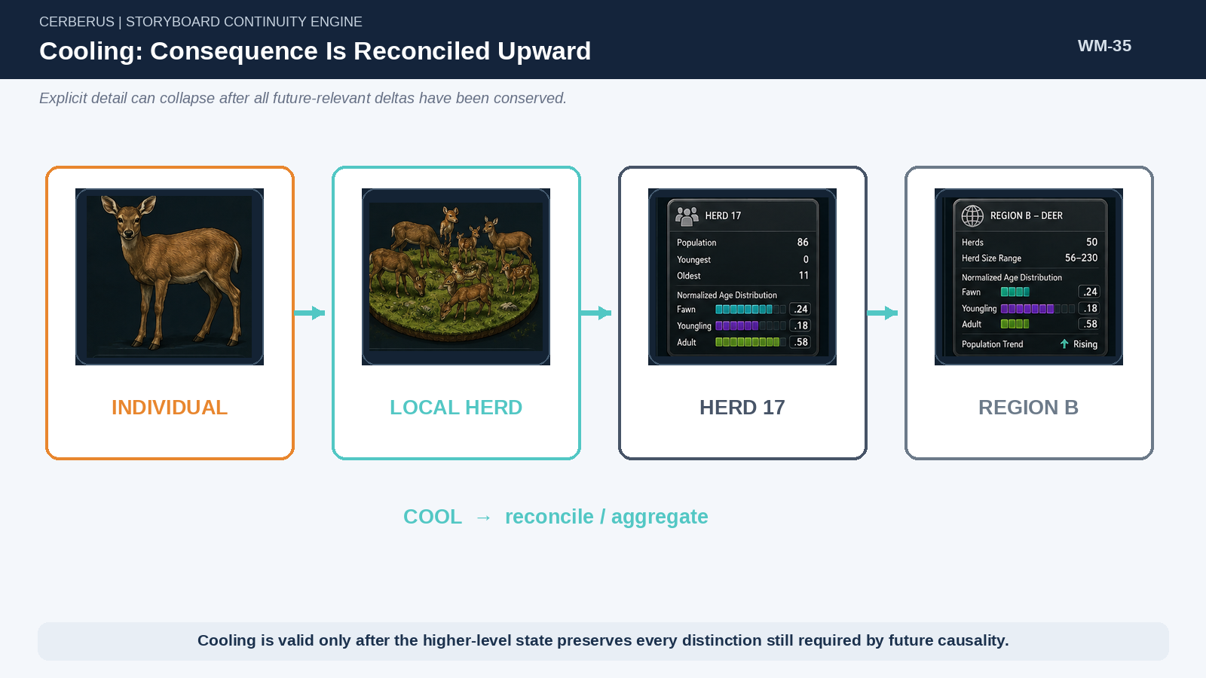
Figure 35. Cooling: Consequence Is Reconciled Upward. Explicit individual state can collapse into group and regional representations once required deltas are conserved.

41. Reconstruction Fidelity Classes
Reconstruction must state what kind of continuity it promises. Exact reconstruction preserves enough identity and state to recover the same required referent. Constrained reconstruction regenerates detail inside preserved bounds. Statistical reconstruction preserves aggregate properties but generates representative individual detail anew. Discarded detail is intentionally no longer recoverable because no authorized future process depends upon it.
Fidelity | Operational meaning
Exact | Required identity and state distinctions are preserved so the same referent can be recovered.
Constrained | Detail may be regenerated, but only inside explicitly preserved bounds and Models.
Statistical | Population or aggregate properties are conserved while individual details are newly instantiated representatives.
Discarded | The detail has been deliberately released because it no longer has a valid future causal dependency.

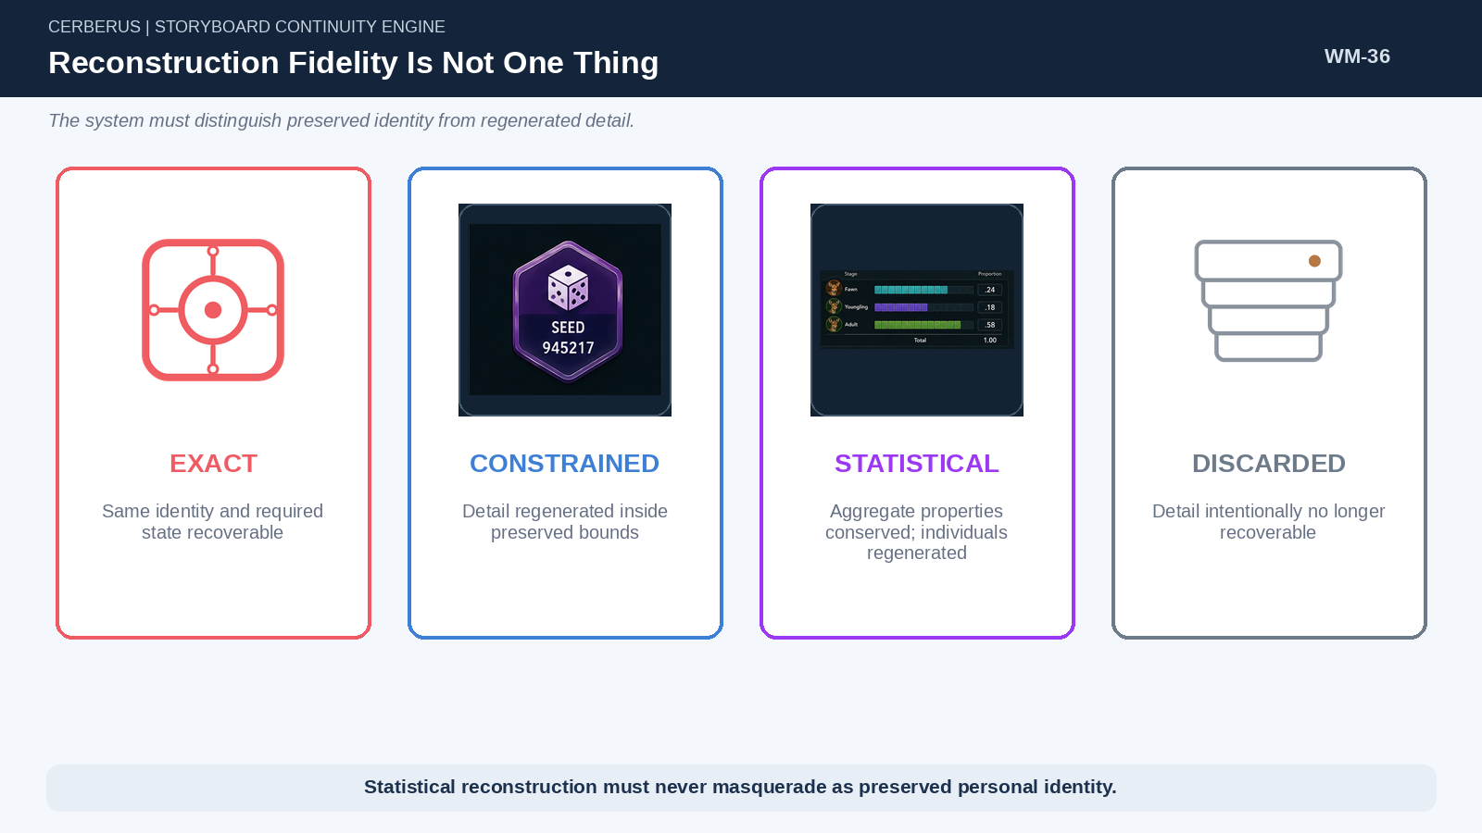
Figure 36. Reconstruction Fidelity Is Not One Thing. Exact, constrained, statistical, and discarded detail must never be conflated.

42. Deterministic Seeds
A deterministic seed can make arbitrary reconstruction repeatable. Region state plus the same Models and seed can regenerate the same bounded herd arrangement or local variation. This is useful for stable procedural detail, but repeatability is not historical identity. The system must not claim that a regenerated statistical deer is Deer #481 unless Deer #481 was actually preserved as an identity.
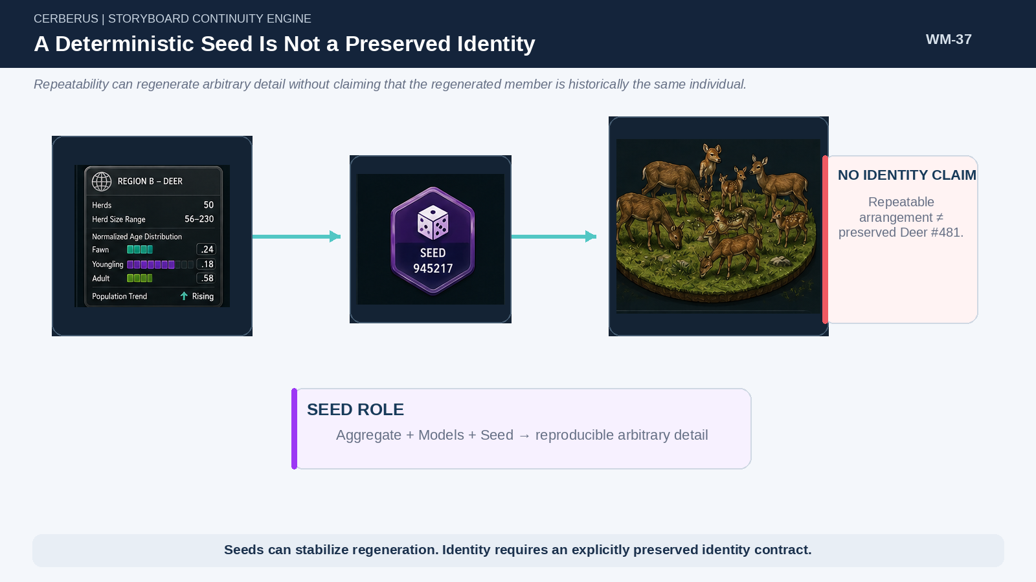
Figure 37. A Deterministic Seed Is Not a Preserved Identity. Repeatable reconstruction does not by itself create historical identity continuity.

43. Simulation Bubbles
A Simulation Bubble is a temporary high-fidelity dependency neighborhood around an interaction. The larger World can remain cold while the local bubble heats terrain, Actors, Targets, environmental constraints, group context, or other relationships required to resolve the event. This makes expensive computation local to consequence rather than local to arbitrary world size.
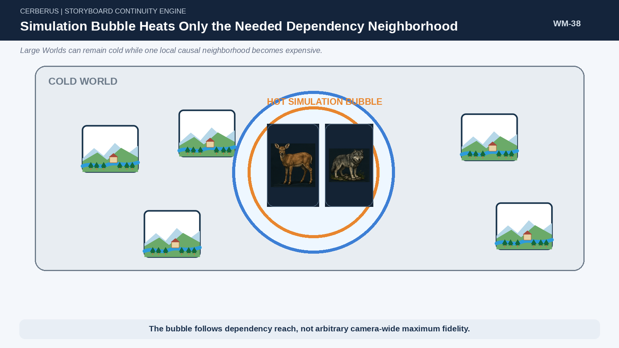
Figure 38. Simulation Bubble Heats Only the Needed Dependency Neighborhood. A local interaction can heat its connected context while the surrounding World remains compact.

44. Reconstruction Does Not Mean Omniscience
World reconstruction can recover objective state that an Actor does not know. Heating a Region, reconstructing a historical school, or regenerating a herd does not automatically grant nearby characters access to that information. World Truth and actor awareness remain separate. The downstream Memory Mechanics architecture will determine what a particular Actor experienced, retained, inherited, reconstructs, or currently believes.
Memory interface
World Mechanics supplies objective history and possible perception context. Memory Mechanics owns actor-specific retention, reconstruction, interpretation, inheritance, and forgetting.

PART 8

Causal Persistence and Representational Forgetting
Explicit identity remains only while the distinction continues to change future World outcomes.

45. Persistence Is Earned by Continuing Difference
Historical occurrence alone is not sufficient justification for permanent explicit representation. The governing persistence question is whether removing an individual distinction would change a future result. If the answer is no, the distinction may converge into a higher-level state. If the answer is yes, explicit persistence remains justified while that causal difference survives.
Persistence law
Individual persistence is earned by unresolved causal difference.

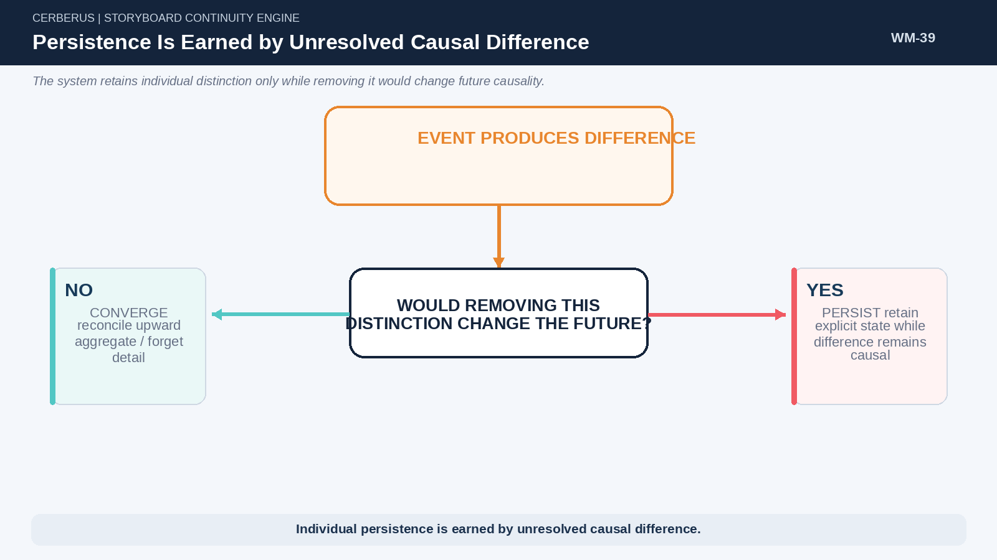
Figure 39. Persistence Is Earned by Unresolved Causal Difference. A persistence test routes convergent detail toward aggregation and divergent detail toward continued explicit state.

46. The Convergent Event
A fawn may be instantiated during a hunt, receive a minor arrow nick, heal, and return to ordinary herd behavior. If the wound leaves no continuing effect on mobility, survival, reproduction, relationships, tracking, or other future logic, the individual difference has converged. The system can reconcile the consequence and release the explicit individual representation.

47. The Divergent Event
A similar interaction may permanently damage a deer’s leg. Mobility changes can alter feeding, predation risk, movement, herd position, and reproduction. The consequence now remains causally different from the statistical norm. Preserving the individual may therefore be cheaper and more truthful than pretending the deer has converged into ordinary herd state.
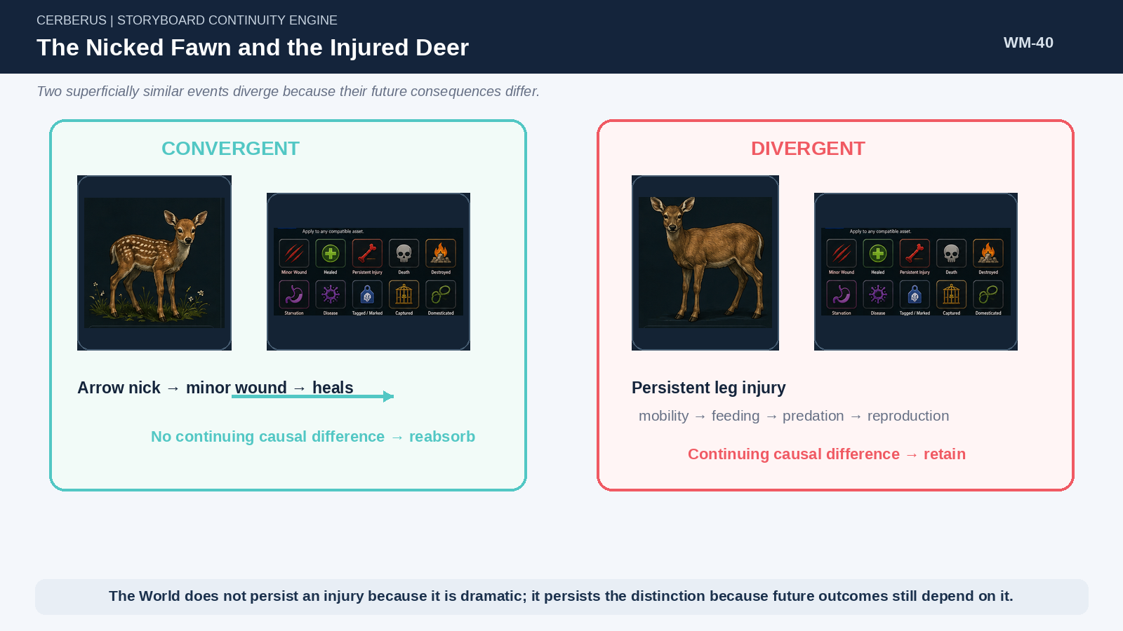
Figure 40. The Nicked Fawn and the Injured Deer. Minor injury can converge while permanent injury creates a continuing causal branch that justifies explicit persistence.

48. Preserve Consequence, Not Necessarily Identity
When an individual death no longer has identity-dependent consequences, the future World may only need “herd population −1” and the corresponding cohort change. The death was real; the World has absorbed its consequence. The explicit individual does not need to remain forever as a dead historical object merely to prove that the population reduction occurred.

49. Causal Conservation Without Representational Conservation
World correctness depends upon the conservation of meaningful consequence, not the conservation of every representation used along the way. This permits a causal delta to migrate upward through the hierarchy: individual → cohort → herd → Region. Each step may release detail if the receiving level can still generate valid future outcomes.
Consequence Persistence ≠ Representation Persistence
The causal result can survive even when the detailed representation does not.

50. Persistence Thresholds
Some effects become historically important only after accumulation. One deer death may be ordinary herd variation; sustained losses that reduce the regional population by a large amount may cross a declared threshold and become a persistent WILDLIFE_DECLINE Event. The World can therefore persist change at the level where significance emerges rather than promoting every contributing micro-event into permanent history.
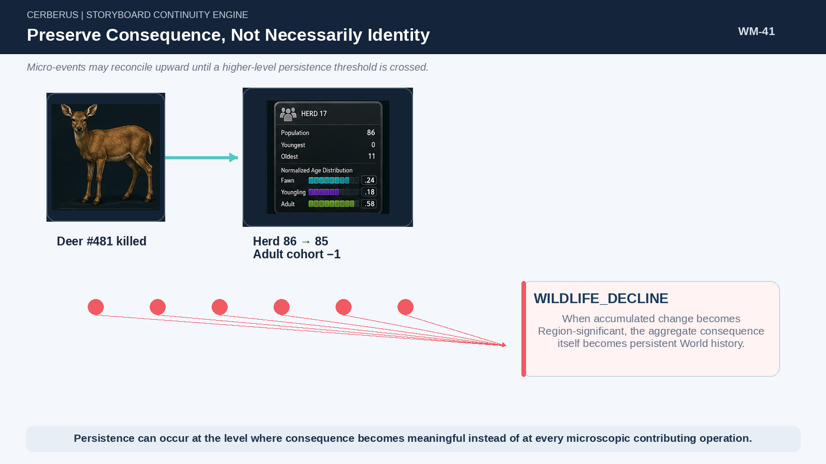
Figure 41. Preserve Consequence, Not Necessarily Identity. Micro-events can reconcile into herd state until an aggregate threshold becomes a persistent regional Event.

51. Identity Promotion
An implied statistical member can become a persistent individual when history gives it a continuing identity-dependent role. Tagging, domestication, repeated encounters, unique injury, reproduction tied to a tracked lineage, or narrative and operational importance can all justify promotion. Promotion reconstructs the current entity, establishes explicit identity, and begins preserving the additional state required by that identity.

52. Identity Demotion and Reabsorption
Explicit identity need not be eternal. After death, departure, or the expiry of every identity-dependent consequence, an entity may eventually be reducible to aggregate history. Demotion must be conservative: no reference, relationship, rule, memory anchor, lineage dependency, or other future causal route may still require the exact identity.

53. The Squirrel Problem
The deliberately absurd failure case is useful because it exposes a common persistence mistake. A player has a disastrous encounter with a Level 3 Sheep. Nearby squirrels perceive it. A naïve system writes permanent autobiographical memory into every squirrel, propagates the memory socially, and eventually allows descendants to inherit a culture organized around the player’s embarrassment.
Every arrow in that chain requires its own contract. Historical occurrence is not perception. Perception is not retention. Retention is not social transmission. Social transmission is not cultural persistence. Unless valid causal routes carry the event forward, the World is allowed to let the squirrels move on.
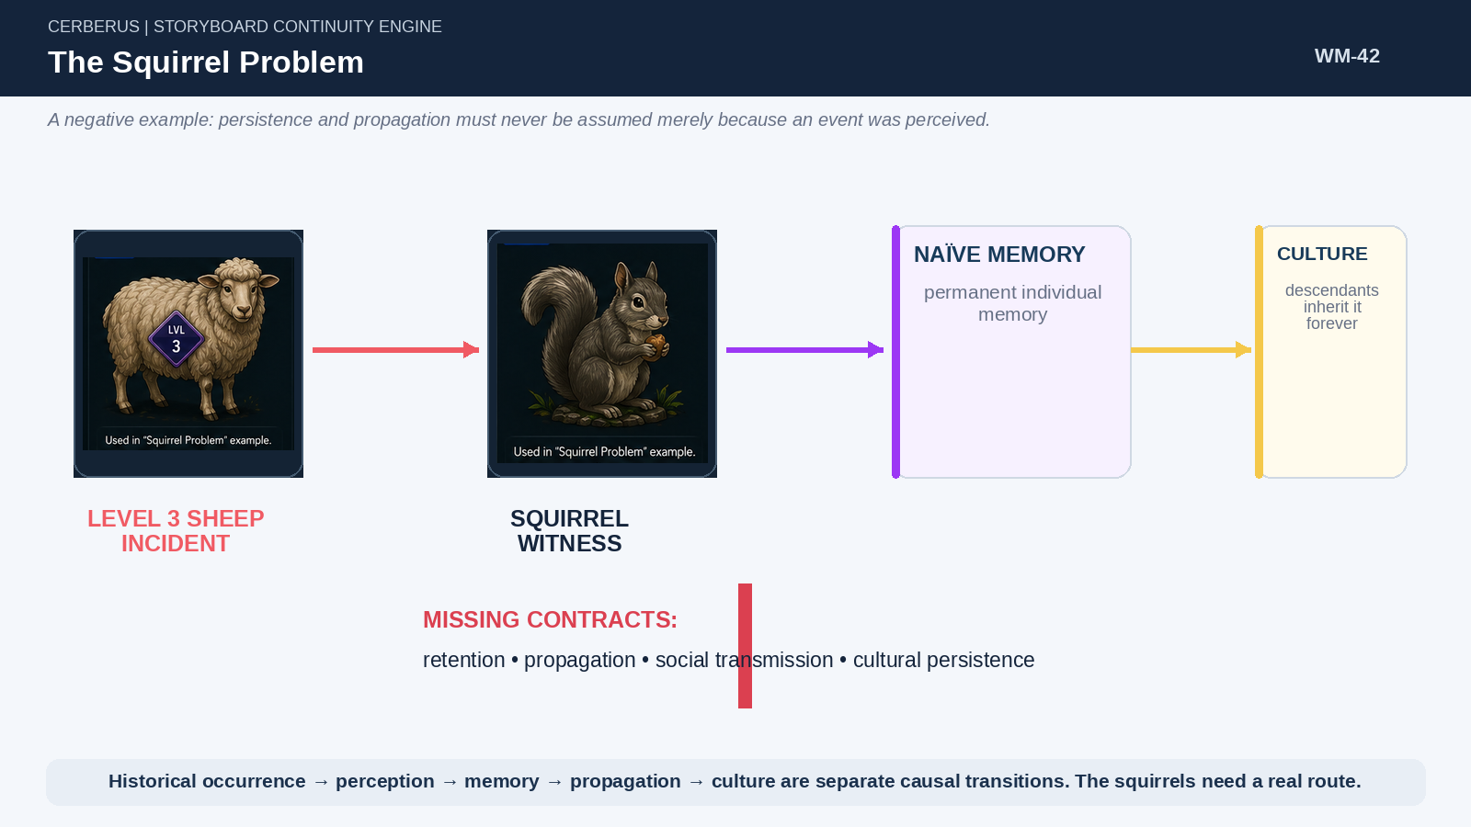
Figure 42. The Squirrel Problem. Persistence pathology occurs when perception, memory, propagation, and culture are treated as automatic consequences rather than separate governed transitions.

PART 9

World Change, History, and Reconstruction Across Time
Shared causes, layered environments, archives, and forks let the World remain historically rich without permanent microscopic state.

54. World Events as Compression
A World Event can compress many low-level operations into one historically useful cause. A Hard Winter may reduce fawn survival, alter herd age distributions, change migration pressure, and lower regional population. The World does not need thousands of permanent individual mortality objects if the population consequences can be represented accurately at the appropriate ecological level.
The same principle applies to infrastructure, harvests, roads, wars, institutional closures, and other large-scale processes. History becomes a set of causally useful anchors rather than a transcript of every runtime operation.

55. Natural Baseline, Civilization Overlay, and Reclamation
A natural substrate can remain semantically present while Society overlays roads, buildings, fields, and other infrastructure. The built state changes the World without necessarily erasing the underlying ecological identity. If maintenance ends, TIME, Habitat, and ecological processes can drive decay, regrowth, and succession back toward the underlying baseline.
Layered continuity
Natural baseline + civilization overlay + TIME can produce reclamation without replacing one giant “forest object” with a “village object” and later replacing it again.

56. Infrastructure Evolution
Infrastructure itself has history. Ember may begin with Defense, Agriculture, and Blacksmithing schools, later construct a Scholar Academy, and eventually add Medicine or Engineering. Different generations therefore encounter different developmental opportunity surfaces even when they share Culture, family, and birthplace. Institutional history becomes a direct cause of generational difference.

57. Regional Evolution
Regions can change through interactions among Habitat, Society, Infrastructure, population, Events, and TIME while preserving their identity. A Region can become more urban, more agricultural, less forested, more scholarly, or ecologically degraded without requiring the system to replace the Region with a new object. Identity, address, and state remain separate.

58. Cold Historical State
Older history does not need to remain active at the same computational temperature as recent state. Recent history may remain richly indexed; older periods can move into Cold or deep archival storage while staying addressable for historical reconstruction. The exact storage technology is an implementation choice; the architectural requirement is that the World preserve the anchors and version information promised by its declared reconstruction fidelity.

59. World Forks
A persistent World can fork at a historical time without duplicating its entire past. World A and World B may share history through Year 204 and store only divergent deltas afterward. Reconstruction of either branch reads the common history until the fork, then follows the branch-specific state. This is especially efficient when ordinary entities are themselves reconstructed from shared World causes rather than copied as giant per-entity files.

60. Historical Replay
Historical replay reconstructs canonical World state from preserved history, Model versions, identities, geometry where required, and declared fidelity. Replay is not subjective recollection. A later Memory system may use the reconstructed Event as an input and produce a bounded Actor-specific recollection, but World replay remains responsible for what the canonical history supports.

PART 10

Integrated Runtime and Formal Principles
The complete architecture closes causal loops while keeping World representation bounded, modular, and reconstructable.

61. Integrated Human Trace — Ember Scholar
Consider a character born in the north, moved to Ember before the first regional school tick, and later eligible for Ember Scholar Academy. Birth establishes identity, Culture, lineage, and provenance. Age 4 resolves a Cultural Experience. Age 5 queries historical Ember and selects among the institutions available then. Migration changes the Region used by later ticks. Age 15 queries the historical place-time context again and selects Scholar Academy. The five-year curriculum applies its registered semantic outputs.
The adult can therefore expose substantial knowledge, Skills, Operators, social access, and professional possibilities even though the stored developmental record contains only a small number of meaningful trajectory references and personal exceptions. The World carried most of the ordinary developmental machinery.
Human reconstruction trace
Birth + Culture + Region history + historical Infrastructure + sparse life events → reconstructable adult developmental state.

62. Integrated Animal Trace — Region B Deer
Region B stores a very-cold deer population profile. Player travel heats the Region and reconstructs Herd #17. Approaching the herd heats a local group; an individual fawn is instantiated because the interaction now requires member-level state. The player’s arrow produces a minor wound. The wound heals without continuing consequences, so the fawn’s distinction converges. Cooling reconciles the interaction back into herd and regional state without preserving a lifelong scar record.
Animal reconstruction trace
Regional population → herd → local group → individual interaction → persistence test → reconcile upward.

63. Integrated World Event Trace — Hard Winter
A Hard Winter operates at a different rhythm and resolution. Habitat conditions reduce fawn survival and change carrying capacity. The population Model updates age distribution and herd counts. If the aggregate change crosses a historical significance threshold, the World creates a persistent regional Event. Future population reconstruction, human hunting experience, and downstream Memory systems can reference that shared cause without recovering thousands of individual deaths.

64. Integrated Infrastructure Trace — Scholar Academy
Construction of a Scholar Academy creates persistent capacity. Future School-2 ticks now include a new developmental option. Cohorts enter the five-year route, graduate with registered semantic outputs, and alter the city’s skill distribution. Some graduates become teachers or researchers, increasing the World’s capacity to sustain more advanced institutions. If the Academy is later destroyed, future cohorts encounter the changed historical World automatically.

65. State Authority
World Mechanics retains the authority boundary established in SCE v0.2. Definitions declare what can exist. Live State is the current authoritative truth. Derived State is calculated for current use. Proposals are candidate changes. Committed Deltas are authorized consequential mutations. Projection consumes state without owning it. Runtime Packets carry transient working values through operations.
State class | Operational boundary
Definition | Canonical declaration of what can exist, how it is structured, and which contracts apply.
Live State | Authoritative current state read by runtime systems.
Derived State | Calculated value used for current reasoning or execution; transient unless explicitly written.
Proposal | Candidate Goal, Action, route, state change, or other unresolved possibility.
Committed Delta | Authorized consequential mutation that changes canonical Live State.
Projection | Human- or media-facing representation that consumes truth without owning it.
Runtime Packet | Transient working structure carrying resolved inputs, calculations, thresholds, and outputs.

Authority before mutation
Transient inference, generated projection, rejected Goals, statistical samples, and reconstruction candidates do not silently become World truth. Canonical state changes only through an authorized Committed Delta.

66. Formal Principles of World Mechanics
Principle | Meaning
Persistent Semantic Reality | World existence is maintained through authoritative semantic state rather than continuous rendering.
NodeKey Closure | A consequential cycle closes when its result returns to exact addressability.
World State Is a Graph | Spatial containment does not own every ecological, social, temporal, developmental, or historical relationship.
Map Is Projection | Visualization consumes World truth; it does not own the structures it exposes.
Continuity Before Reconsideration | Stable state persists until a declared cause justifies reevaluation.
Multiple Causal Rhythms | Update frequency follows causal necessity rather than a universal tick.
Lowest Sufficient Resolution | Use no more representational or simulation fidelity than consequence requires.
Historical Version Integrity | Reconstruction uses the World and Model versions valid at the historical time being reconstructed.
Infrastructure Is Generative | Persistent capacity changes future developmental and operational possibility.
Shared Causes Replace Redundant Histories | One World Event may explain many later trajectories and consequences.
Sparse-Reconstructable Life | Ordinary development may be reconstructed from declared trajectories and World history.
Group State May Replace Individual State | Individual distinction need not persist when a higher-level representation preserves every relevant consequence.
Cooling Conserves Causality | Representation may collapse only after future-relevant differences are preserved at the receiving level.
Reconstruction Fidelity Is Explicit | Exact, constrained, statistical, and discarded detail are not interchangeable.
Persistence Is Earned by Unresolved Difference | Explicit identity remains while removing it would change future outcomes.
Consequence Persistence ≠ Representation Persistence | A causal result can remain true after detailed representation is released.
Identity May Be Promoted | Statistical members can acquire persistent identity when history requires exact continuity.
Causally Dead Detail May Be Forgotten | Detail with no valid remaining dependency may be deliberately discarded.
World Truth ≠ Actor Awareness | Objective World reconstruction does not grant an Actor omniscient access.
Projection Does Not Own Runtime Truth | Maps, games, prose, animation, and interfaces present resolved state without redefining it.
Authority Precedes Canonical Mutation | Only authorized Committed Deltas change persistent World truth.
Store Causes Where Causes Are More Efficient Than Duplicated Effects | World history should retain shared causal anchors instead of repeating the same cause across every downstream entity.

67. Boundary with Memory Mechanics
This paper intentionally stops before detailed autobiographical cognition. World Mechanics owns what happened, when, where, which objective structures existed, which historical Models applied, which developmental causes were available, which perception opportunities physically existed, and which World consequences survived. These outputs become the substrate that Memory Mechanics can query.
Memory Mechanics will separately own what a particular Actor experienced, retained, forgot, inherited socially, reconstructs from history, interprets through knowledge and role, and currently recalls. Keeping the papers separate prevents actor-specific cognition from being used as a substitute for canonical World history.
World Mechanics supplies | Memory Mechanics later owns
What happened; when and where it happened. | What this Actor retained or can reconstruct from that history.
Historical Region, Habitat, Society, Infrastructure, and Model versions. | Actor-specific accessibility, interpretation, provenance, and forgetting.
World-side perception opportunity and objective participant topology. | Perceived experience, personal residuals, inherited narrative, and subjective recall.
Authoritative World Events and Committed Deltas. | How history changes Goals, Affinity, Relationships, planning, dialogue, and Persona.

68. Conclusion — A World That Can Become Detailed When Needed
The expanded Storyboard Continuity Engine does not preserve a World by permanently storing every thing the World has ever implied. It preserves the smallest authoritative causal state from which the detail required by future consequence can be validly recovered. Semantic identity keeps the World addressable. World Models supply the causal fabric. TIME and historical versions preserve temporal integrity. Life Trajectories make development reconstructable. Population aggregates allow enormous ecologies to exist compactly. Heating and cooling move detail to the level where it matters. Persistence tests decide which distinctions still deserve explicit identity.
The result is a World that can be rich without being uniformly expensive. A school can shape generations without storing thousands of bespoke biographies. A Region can contain thousands of implied animals without millions of permanent scar records. A historical Event can change later lives without being copied into every character. A local interaction can heat a small Simulation Bubble, resolve, reconcile its consequence, and return the World to compact semantic state.
Final proposition
CERBERUS preserves a World by conserving future-valid causal distinctions, not by refusing to forget representational detail.

Address → Resolve → Act → Simulate → Commit → Aggregate → Reconstruct when needed → Address again
Different Assets. Different semantics. Different scales. Same causal continuity.

PART A

Figure Reference
Controlled Pass 4 figure architecture composed from the approved Pass 6 visual asset vocabulary.

Figure ID | Working title
WM-01 | A World That Exists Between Frames
WM-02 | Existence Is Not Instantiation
WM-03 | Historical Truth Is Not Current Representation
WM-04 | Storyboard Continuity Conserves Causality
WM-05 | From Semantic State to World Operation
WM-06 | Different Assets, Same Computational Grammar
WM-07 | NodeKey Closure Across Causal Scale
WM-08 | Resolve Only What the Problem Requires
WM-09 | World State Is a Graph, Not a Frame
WM-10 | Tile → Zone → Region; Map Is Projection
WM-11 | A Tile Is Locally Defined but Contextually Influenced
WM-12 | World Models Form a Fabric
WM-13 | Habitat and Society Act on the Same World Differently
WM-14 | Infrastructure Is Generative Capacity
WM-15 | Location + TIME Is a Reconstruction Index
WM-16 | One World, Many Causal Clocks
WM-17 | Stable State Before Recalculation
WM-18 | Historical Models Must Be Read in Historical Time
WM-19 | One World Event, Many Derived Consequences
WM-20 | Sparse Life Trajectory
WM-21 | Culture and Region Interlock Across a Life
WM-22 | Regional Infrastructure Selects Available Development
WM-23 | A School Is a Semantic Compiler
WM-24 | Migration Produces Hybrid Lives
WM-25 | Infrastructure Shapes Population Composition
WM-26 | Age Selects an Animal Life Model
WM-27 | Habitat Determines Possibility; Herd Determines Collective Behavior
WM-28 | Herd as One, Members as Many
WM-29 | A Herd Can Be a Statistical Object
WM-30 | A Region Can Contain Implied Herds
WM-31 | Ecology Exists at Multiple Resolutions
WM-32 | Lowest Sufficient Resolution
WM-33 | Hot / Warm / Cold / Very Cold World State
WM-34 | Heating: Detail Appears When Consequence Requires It
WM-35 | Cooling: Consequence Is Reconciled Upward
WM-36 | Reconstruction Fidelity Is Not One Thing
WM-37 | A Deterministic Seed Is Not a Preserved Identity
WM-38 | Simulation Bubble Heats Only the Needed Dependency Neighborhood
WM-39 | Persistence Is Earned by Unresolved Causal Difference
WM-40 | The Nicked Fawn and the Injured Deer
WM-41 | Preserve Consequence, Not Necessarily Identity
WM-42 | The Squirrel Problem

PART B

Architecture Provenance
Source continuity and terminology boundary for the verified release.

This v0.3 World Mechanics release is a successor to CERBERUS | STORYBOARD CONTINUITY ENGINE v0.2. It retains the earlier paper’s core propositions—persistent semantic reality, NodeKey Closure, World State as a graph, Goal and Target continuity, selective simulation, Hot/Warm/Cold attention, Lowest Sufficient Resolution, authority before mutation, recursive group behavior, natural reclamation, and projection independence—while expanding the World-side reconstruction and persistence mechanics.
The composition also consolidates the author’s prototype Storyboard Continuity Engine workbook, unfinished Runtime Documentation, Figma/Map world diagrams, and the approved OctoGroove Pass 3–6 architecture developed for this revision. Where older prototype terminology differs from newer CERBERUS terminology, the newer responsibility boundaries govern this paper. Historical prototypes remain useful provenance rather than independent current authority.
The 42 numbered figures were composed in Pass 7 from the approved Pass 6 asset vocabulary plus native diagram geometry, labels, equations, tables, and causal relationships. The asset vocabulary supports the figure; the figure architecture defines the claim. No visual element is allowed to silently redefine the system’s semantic ownership boundaries.
Deliberate non-scope
Detailed autobiographical Memory mechanics are not completed here. They are the subject of the next paper and will load World history, topology, Life Trajectory, infrastructure, and perception opportunity from the canonical World Mechanics defined in this document.

