CERBERUS
Base Expansion Architecture
Bounded Externalization, Data Contracts, Home Anchoring, Base Crawling, and Local Semantic Specialization
ARCHITECTURE THESIS
CERBERUS scales by externalizing bounded Stacks rather than enlarging one physical Base indefinitely. A candidate Stack proves containment through deterministic diagnostics, exposes exactly one authorized outgoing relationship to the Base Data Contracts Table Z, preserves its outward contract through externalization, links directly to Home, and becomes discoverable through a compact Base Crawler while its own SOLAR and BOOTSTRAP provide local translation and competency.

Architecture Paper v0.1
Bootstrap Candidate | August 2026

Abstract
This paper defines CERBERUS BASE EXPANSION: a recursive federation architecture for allowing bounded Stacks to become independent Bases without fragmenting semantic identity or forcing the Home Base to reproduce their internal complexity. The architecture treats externalization as a governed change in implementation resolution. Tables may become Stacks, Records may unfold into richer structures, and internal topology may grow by orders of magnitude while a stable outward contract preserves continuity for existing consumers.
A Base Data Contracts Table, designated Z, acts as the controlled boundary for externalization. A Stack prepared to externalize maintains exactly one outgoing structural relationship to its Z contract. BASE SERVICE diagnostics are reused as an externalization preflight: every relationship originating inside the proposed boundary must terminate internally or resolve through Z. Any other boundary crossing is an uncontained link and must be repaired, contractualized, removed, or redesigned before the Stack is considered safely externalizable.
Once externalized, the new Base owns its implementation truth, maintains a direct relationship to the canonical Home Base, preserves structural ancestry separately from system membership, and can evolve autonomously inside its published contract. A compact Base Crawler resolves semantic jurisdiction at Home scale; the selected Base's SOLAR resolves exact local semantic location. Each Base also carries its own BOOTSTRAP, allowing an unfamiliar AI to inspect available Folds, load the Core, and specialize only after it understands the local semantic environment. The resulting model allows CERBERUS to grow into a federation of bounded semantic worlds while keeping global routing compact and local complexity local.
Keywords: Base expansion, externalization, Z contract, containment closure, Home Base, Base Crawler, SOLAR, BOOTSTRAP, semantic federation, bounded data contract, CERBERUS

Document Map
Sections | Focus
1–5 | Purpose, bounded growth, recursive granularity, Z contracts, and containment closure
6–10 | BASE SERVICE preflight, uncontained-link repair, contract continuity, implementation independence, and authority
11–15 | Home anchoring, federation topology, discovery surfaces, Base Crawler, and local SOLAR
16–20 | Local BOOTSTRAP, competency layering, multi-Base routing, local namespaces, permissions, and versioning
21–24 | Externalization lifecycle, failure modes, scalability properties, design laws, and non-goals

1. Purpose and Scope
BASE EXPANSION defines how CERBERUS grows from a single self-describing Base into a recursively federated system of bounded Bases. The paper addresses the moment when a Stack becomes large, specialized, permission-distinct, workflow-distinct, or implementation-heavy enough that independent deployment is useful. The architectural question is not merely how to move Tables. It is how to move implementation complexity without breaking semantic continuity.
The model therefore distinguishes semantic identity from physical granularity. A Stack may become a Base. A Table may become a Stack. A compact Record may unfold into multiple Tables. None of these changes automatically imply that the bounded semantic role presented to consumers has changed.
CENTRAL PRINCIPLE
Externalization changes implementation resolution. Contract evolution changes outward meaning. These are separate events and must not be conflated.
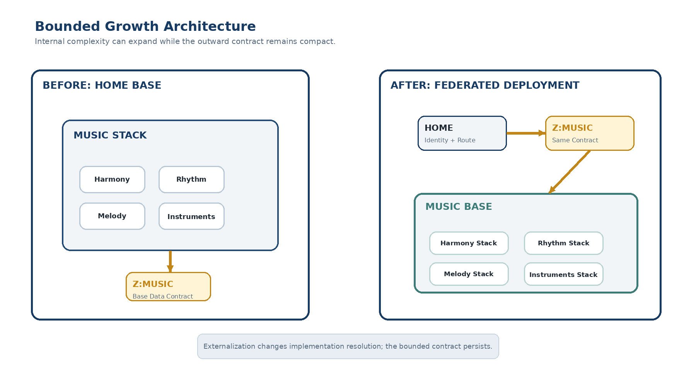
Figure 1. A bounded Stack can externalize into an independent Base while the Home-facing Z contract remains compact and continuous.

2. Growth Without Semantic Fragmentation
Externalization should not be treated as a fixed response to one platform limit. A Stack may become a Base because it acquires many Tables, because individual records require richer decomposition, because permissions or maintainers diverge, because domain vocabulary becomes highly specialized, or because independent runtime behavior becomes advantageous. Platform capacity may be one trigger, but it is not the semantic rule.
The governing objective is bounded growth: local complexity should be able to increase without forcing proportional growth in every system that depends on it. A parent should not need to learn the internal topology of a child merely because the child became more sophisticated.

2.1 Recursive Expansion
The pattern is recursive. A MUSIC Stack can become a MUSIC Base. Inside MUSIC, a Harmony Stack can later become a HARMONY Base. The same rules apply again. There is no architectural tier called “large Base”; there are only bounded structures that may externalize while preserving explicit contracts.
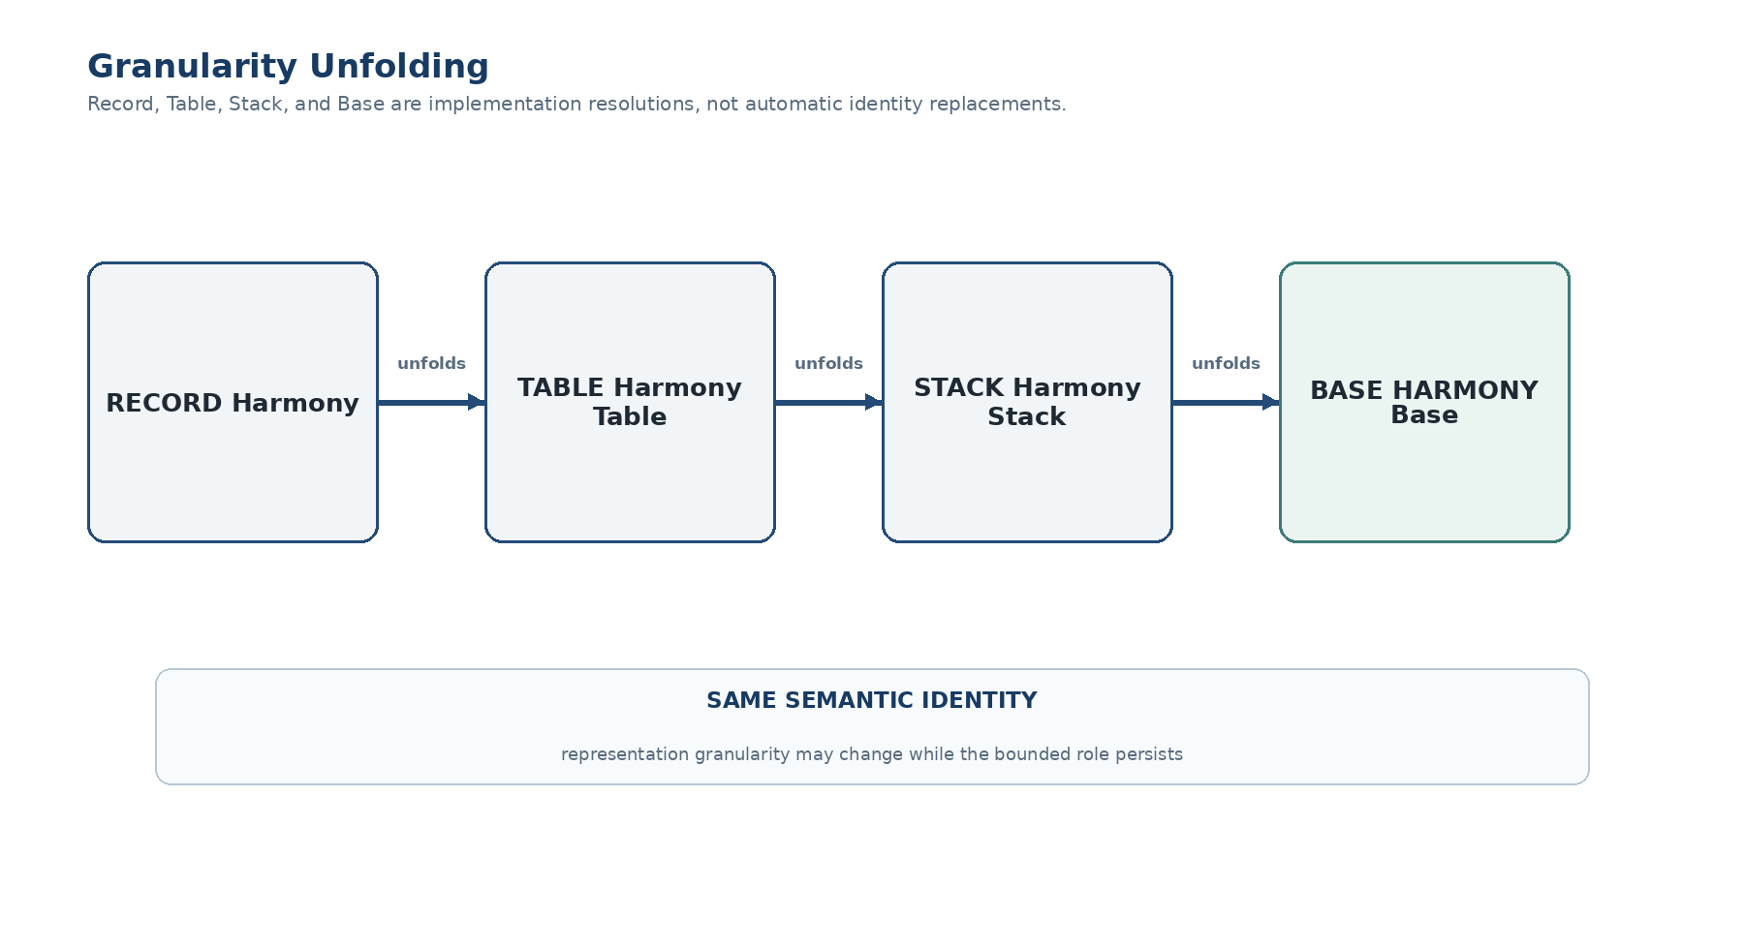
Figure 2. Implementation granularity can unfold from Record to Table to Stack to Base while the bounded semantic identity persists.

3. Representation Granularity and Identity Persistence
CERBERUS does not require an object to remain physically shaped the way it was when first authored. A former Table may become a Stack of several Tables; a former Record may later warrant a dedicated Table or Stack. The system preserves identity through explicit contracts and Registry relationships rather than through permanent dependence on one database layout.
Change | Semantic Interpretation
Record → richer Tables | The original concept gains implementation detail.
Table → Stack | One tabular representation becomes a bounded sub-system.
Stack → Base | A bounded sub-system receives independent deployment and local semantic services.
Internal reorganization | Implementation changes without automatically changing the outward contract.

IDENTITY PERSISTENCE
A Base identity is independent of the current arrangement of Stacks, Tables, Records, and Fields used to implement it.

4. Z — Base Data Contracts
The Base Data Contracts Table, designated Z, is the canonical boundary mechanism for Stack externalization. A candidate Stack maintains exactly one outgoing structural relationship to its Z contract. That relationship is not a list of every capability as separate graph edges. Instead, one bounded contract may declare many supported structures, inputs, outputs, routes, and externally visible behaviors.
This produces a narrow and testable boundary. Internally, a Stack may contain dense relationships among thousands or billions of semantic structures. Externally, its parent-facing structural dependence is concentrated through one registered contract gate.
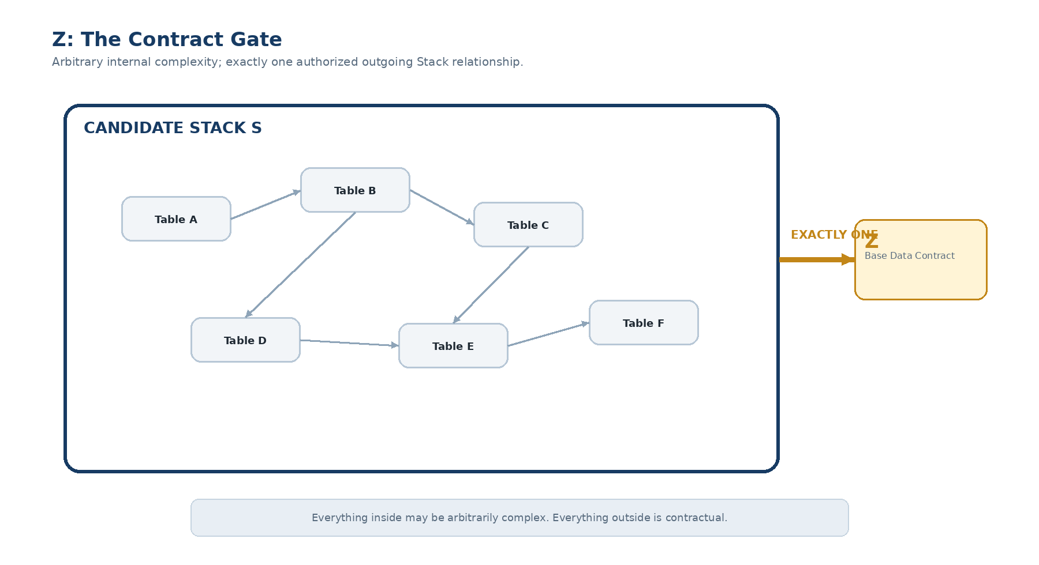
Figure 3. A candidate Stack may contain arbitrary internal complexity while exposing exactly one authorized outgoing structural relationship to Z.

4.1 One Boundary, Many Capabilities
“Exactly one outgoing link” does not mean “exactly one capability.” Z is a contract container. A single Z record can represent a rich outward surface while preserving one governed boundary relationship. This distinction prevents the parent graph from becoming entangled with every internal capability the Stack exposes.

5. Containment Closure
A Stack is safely externalizable only when its proposed boundary is containment-closed. Every structural relationship originating inside that boundary must either terminate inside the boundary or resolve through the authorized Z contract. Any other boundary crossing is an uncontained relationship.
Containment closure converts modularity from an architectural intention into a property that can be tested. Rather than declaring that MUSIC is independent and hoping no hidden field still links back to an unrelated Home Table, CERBERUS can inspect the graph and prove whether the claim is true.
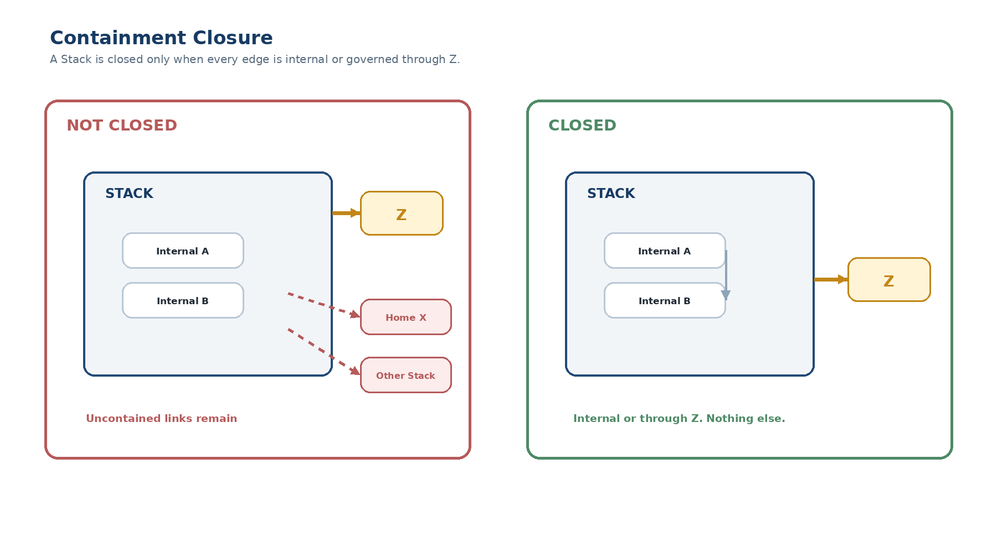
Figure 4. A closed Stack has only internal relationships plus its single authorized Z boundary. Any other outgoing relationship is uncontained.
CONTAINMENT CLOSURE RULE
For a proposed externalization boundary S, every edge originating in S must terminate in S or resolve through S’s registered Z contract.

6. BASE SERVICE as Externalization Preflight
BASE EXPANSION reuses the deterministic diagnostic machinery defined by the companion BASE SERVICE architecture. It does not invent a second validator. Canonical schema coordinates, exact relationship diagnostics, the five-state integrity language, and reinspection are applied to the proposed Stack boundary before migration.
A preflight crawl can therefore produce exact findings such as C17 → H4 or D22 → B9 and classify whether each relationship is a legal internal edge, the authorized Z relationship, or an uncontained crossing. Because the finding names the exact structural source, repair can be directed to the correct Field or relationship instead of relying on a broad “dependency problem” warning.
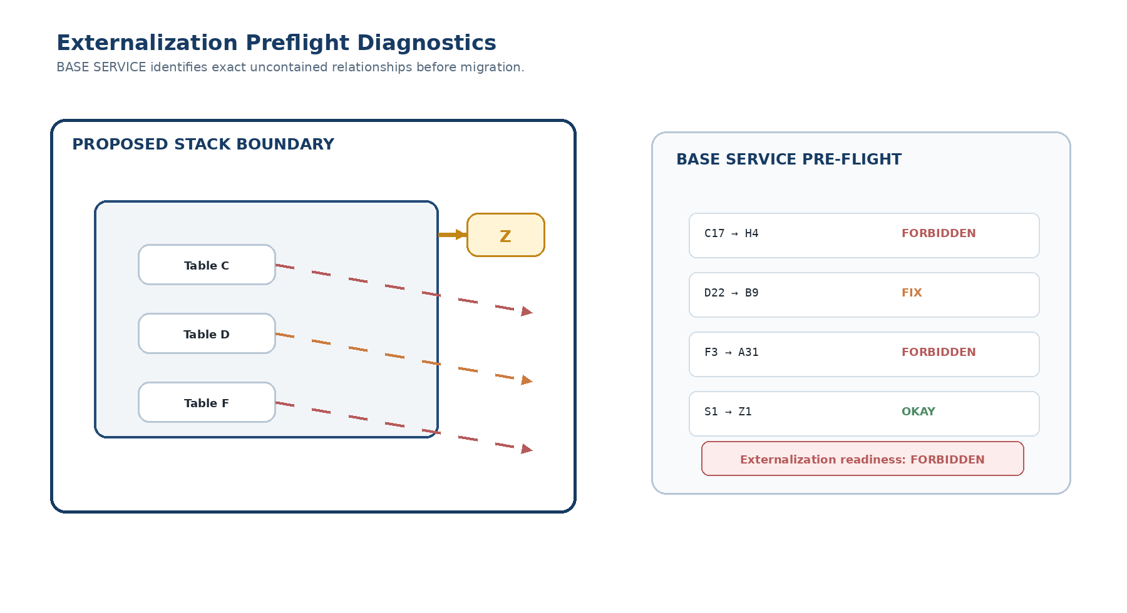
Figure 5. BASE SERVICE identifies exact uncontained links and can block externalization until the proposed boundary passes reinspection.

6.1 Externalization Readiness
Observed condition | Illustrative service state
Illegal link escapes the proposed boundary | Forbidden
Required Z relationship is missing | Fix
Known dependency is not yet represented through Z | Fix
Deprecated cross-boundary artifact remains but does not drive current operation | Warning
Closure is satisfied | Okay
Closure and all applicable preferred migration conditions are satisfied | Ideal

These mappings are architectural examples rather than an immutable diagnostic catalogue. The durable requirement is that externalization readiness reuses the same service language and deterministic conformance logic as the rest of the Base.

7. Resolving Uncontained Relationships
An uncontained relationship is not automatically deleted. It is evidence that the proposed boundary is incomplete. The owning designer must decide how that dependency should be represented after externalization. A valid resolution normally takes one of four forms: move the depended-upon structure inside the boundary; express the dependency deliberately through the Z contract; remove the relationship because it is obsolete; or redesign the boundary because the Stack is not actually independent in the proposed form.
Resolution | Use when
Internalize | The dependency semantically belongs inside the externalized Base.
Contractualize through Z | The dependency is genuinely external and must remain part of the public contract.
Remove | The edge is obsolete, accidental, or no longer authoritative.
Redesign boundary | The proposed Stack boundary does not match the true ownership graph.

After repair, the closure test is rerun. Externalization is considered conformant only when the observed graph passes the registered boundary contract again. The migration process therefore inherits BASE SERVICE’s reinspection principle: repair the graph, then prove the graph.

8. Contract Continuity Through Externalization
The Z contract is the continuity mechanism between the pre-externalization Stack and the post-externalization Base. Existing consumers should not need to learn a new semantic object merely because the implementation moved. Before externalization, the contract points into the local Stack implementation. After externalization, the same bounded contract routes to the new Base.
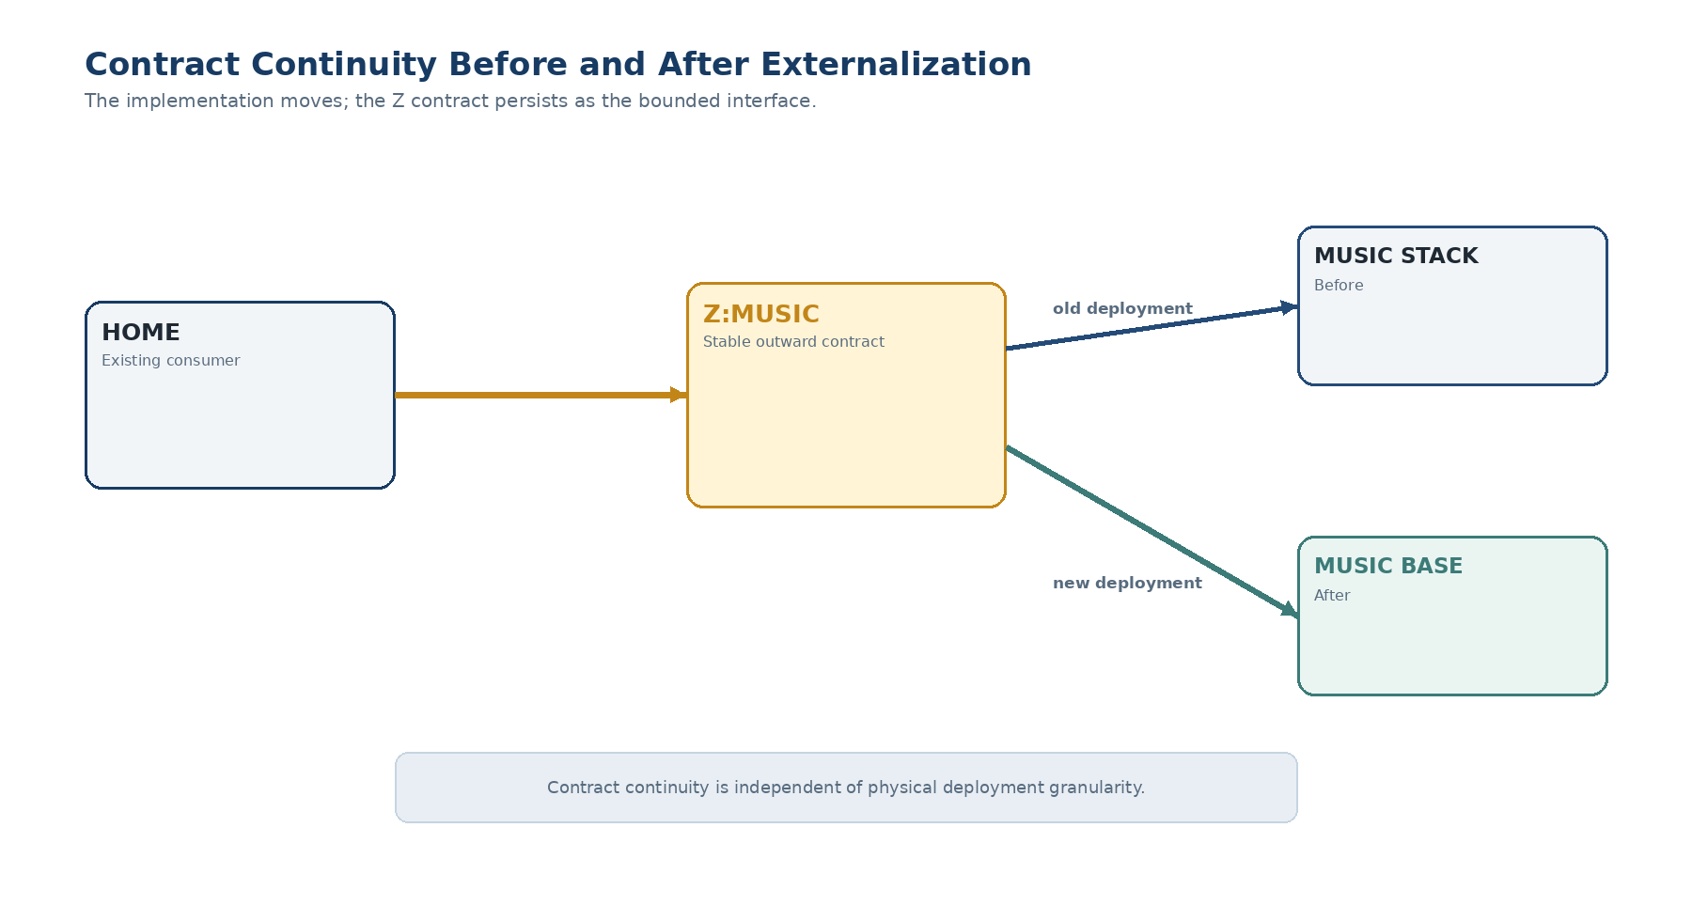
Figure 6. The Z contract remains the stable consumer-facing interface while the implementation changes from local Stack to externalized Base.

8.1 Contract Preservation
Externalization does not silently alter outward meaning. If MUSIC.Contract.v1 represented a given interface before migration, the act of moving MUSIC into an independent Base does not by itself create MUSIC.Contract.v2. A new public contract version is warranted only when the outward semantic promise changes.
DEPLOYMENT VS CONTRACT
Internal restructuring and deployment evolution may occur without changing the outward contract. Contract evolution is a separate governed event.

9. Contract vs Implementation
The contract and the implementation answer different questions. The contract states what the Base promises outward. The implementation states how the Base currently fulfills that promise. This separation is the primary mechanism by which Home can remain compact while local Bases become extremely sophisticated.
Contract may expose | Implementation may contain
Canonical identity | Stacks and Tables
Accepted inputs | Records and Fields
Produced outputs | Semantic Kernels and Readers
Registered routes or capabilities | BOSS, SOLAR, Rules, Operators
Compatibility / version expectations | Folds, documents, local workflows and runtime machinery

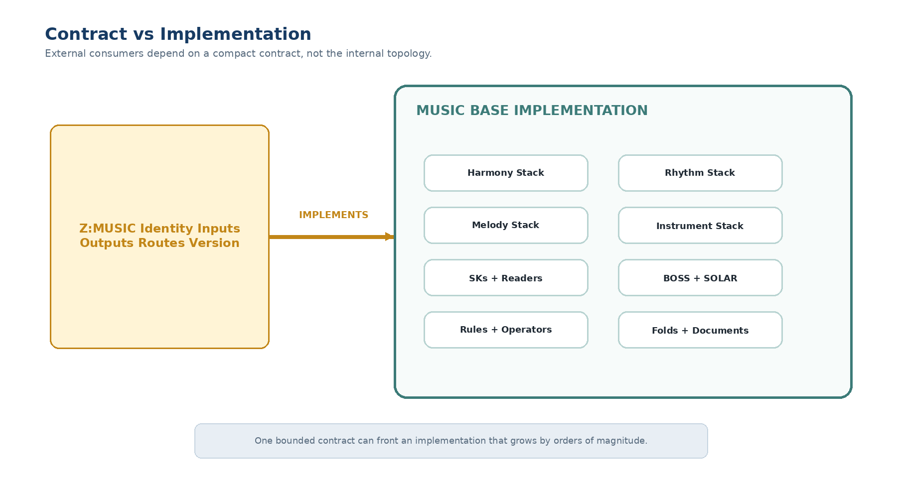
Figure 7. A compact Z contract can front a large local implementation without exposing that internal topology to every consumer.

10. No Shadow Authority
Externalization should not create an authoritative duplicate inside the parent Base. Retaining a full Home-side copy of the old Stack while simultaneously treating the new Base as authoritative creates synchronization ambiguity: two structures appear to own the same truth and downstream systems must decide which one wins.
The preferred pattern is smaller. Home retains the identity, Z contract, and route needed to reach the externalized implementation. The externalized Base owns the implementation truth. Historical snapshots may exist for provenance, but they are not competing live authorities.
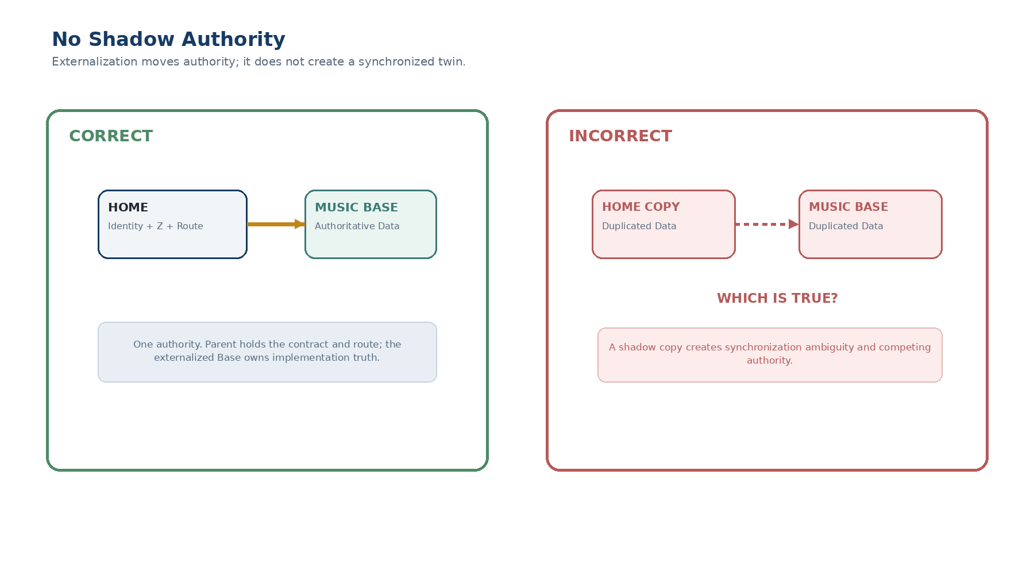
Figure 8. Correct externalization moves implementation authority to the new Base instead of creating synchronized twin state.

11. Direct Home Anchoring
Every Base participating in the CERBERUS system maintains an explicit direct relationship to the canonical Home Base. This remains true even when the Base was externalized from a Stack inside another externalized Base. The direct Home anchor preserves system membership independently of deployment depth.
This rule prevents a deeply nested federation from becoming a fragile traversal tree. If HARMONY originated inside MUSIC, HARMONY may preserve that origin relationship, but it does not need MUSIC to be reachable in order to know which CERBERUS system it belongs to.
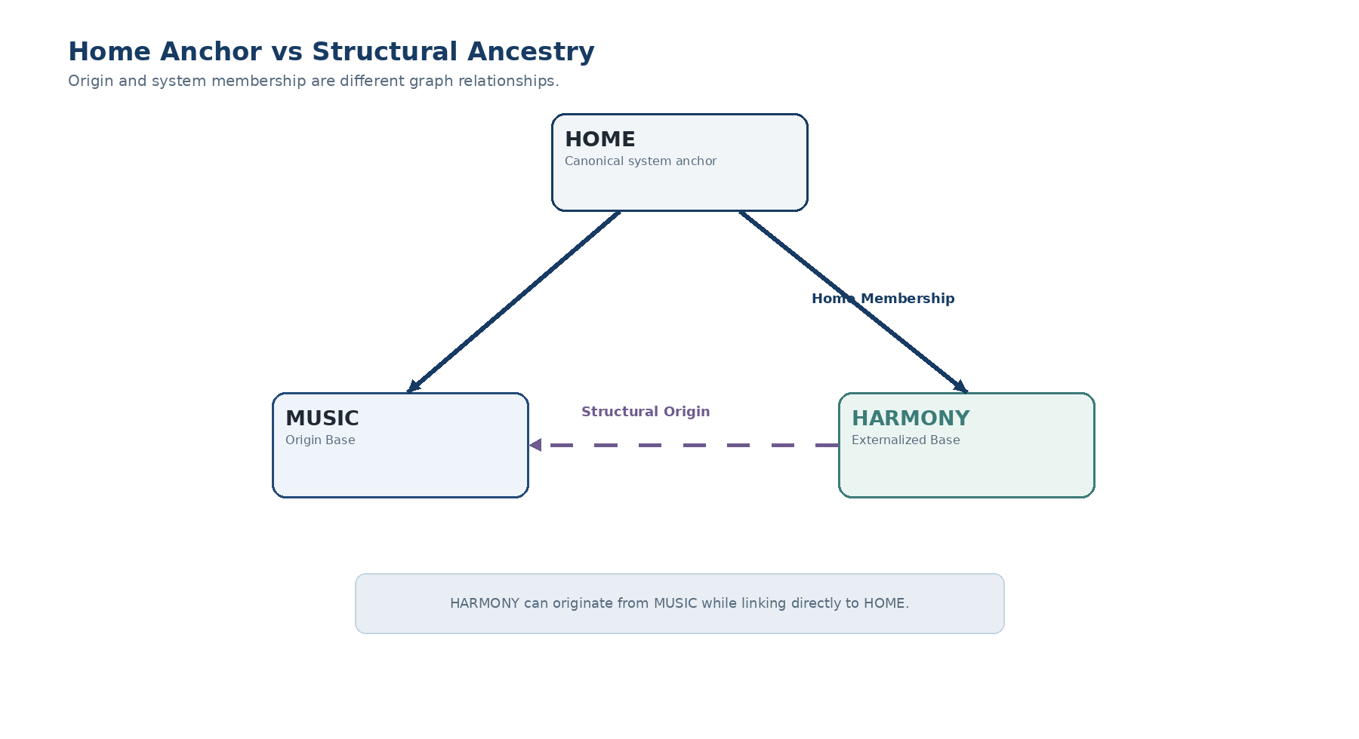
Figure 9. Structural ancestry and Home membership are separate relations: HARMONY can originate from MUSIC while anchoring directly to HOME.

12. Structural Ancestry vs System Membership
Structural ancestry answers “Where did this Base expand from?” System membership answers “Which canonical Home does this Base belong to?” These questions are related but not interchangeable. Preserving both allows CERBERUS to retain lineage without making lineage the mandatory routing path.
Relationship | Example | Purpose
Structural origin | HARMONY → MUSIC / Harmony Stack | Preserve where the Base was externalized from.
Home membership | HARMONY → HOME | Preserve direct membership in the canonical system.
Z implementation relation | MUSIC Z Contract → MUSIC Base | Preserve the outward data contract and implementation route.

HOME ANCHOR LAW
Every participating Base links directly to Home regardless of the depth or pathway through which that Base was externalized.

13. Home as a Federation Root
At small scale, Home may appear to be the Base that contains everything. At federation scale, that interpretation becomes misleading. Home is better understood as the canonical root registry of the system: it identifies bounded participating Bases, their contracts, discovery surfaces, and routes while leaving implementation complexity local.
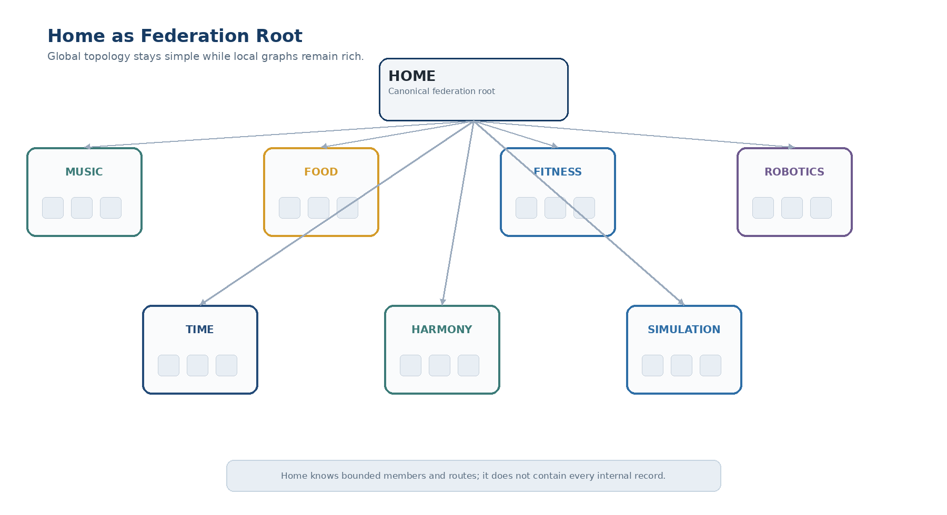
Figure 10. A simple Home-level graph can anchor many richly structured local Bases without absorbing their internal records.
This changes the scaling target. Home complexity should grow primarily with the number of bounded Bases and exposed contracts, not with the number of Fields, Records, BitWords, or semantic atoms contained inside those Bases.

14. Compact Base Discovery
Once knowledge is distributed across many Bases, Home requires a way to identify which semantic world should receive a request. The Base Crawler solves this by searching compact Base-facing discovery information rather than loading or indexing every internal semantic structure globally.
A discovery surface may include a Base identity, a bounded purpose description, broad aliases or semantic territory, exposed contract names, and a route to local SOLAR. The exact Registry schema can evolve. The architectural requirement is that discovery information remains coarse enough to scale with Bases rather than with internal records.
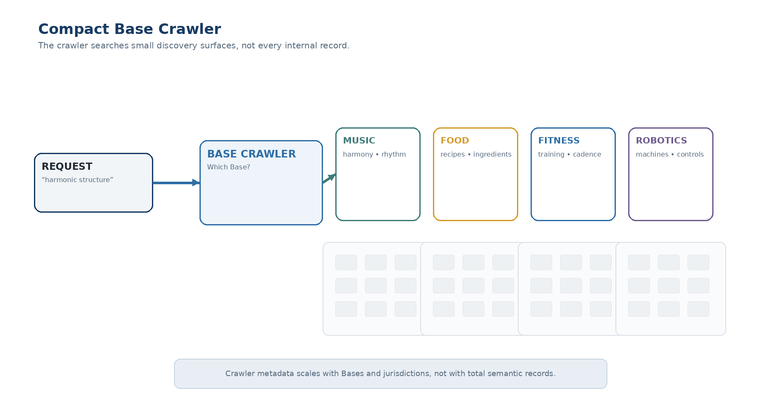
Figure 11. The Base Crawler selects MUSIC from compact discovery surfaces without traversing the large internal graphs behind every candidate Base.
CRAWLER SCOPE
The crawler answers “Which Base or Bases should receive this request?” It does not answer every domain-specific question itself.

15. Crawler and SOLAR
The Base Crawler and local SOLAR solve different resolution problems. The crawler identifies semantic jurisdiction: which bounded Base is likely to own the relevant knowledge or capability. The selected Base’s SOLAR then resolves semantic location: the exact local language, SK, BitWord, Registry object, or route implicated by the request.
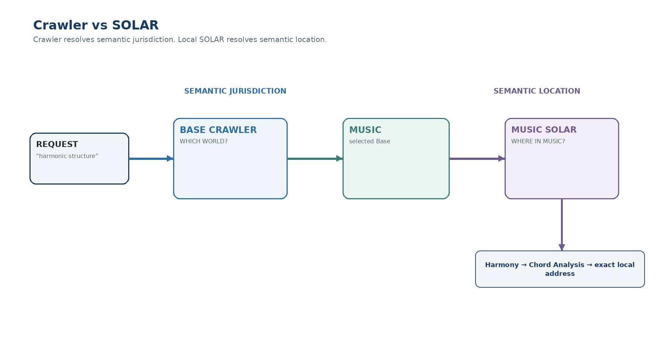
Figure 12. Crawler resolves semantic jurisdiction; the selected Base’s SOLAR resolves exact semantic location inside that jurisdiction.

15.1 Why SOLAR stays local
A globally monolithic SOLAR would eventually reproduce the vocabulary of every specialized Base and undermine federation. Local SOLAR allows MUSIC to grow thousands of music-specific terms without forcing Home, FOOD, FITNESS, or ROBOTICS to mirror that vocabulary. Home needs to know who understands the domain, not every word spoken inside it.

16. Local BOOTSTRAP and On-Demand Competency
Locating the correct Base does not guarantee that an unfamiliar AI already understands how to operate within it. Each Base therefore maintains its own BOOTSTRAP environment. BOOTSTRAP exposes the Core material and specialized Folds needed to acquire bounded competency without loading the entire Base.
An unfamiliar intelligence can search the available Folds, load the Core, establish the recurring primitives and local conventions, and only then specialize into Harmony, Rhythm, Composition, Performance, or another bounded area. This mirrors the architecture’s general preference for reusable cognitive primitives: understanding the Core makes later specialization substantially cheaper.
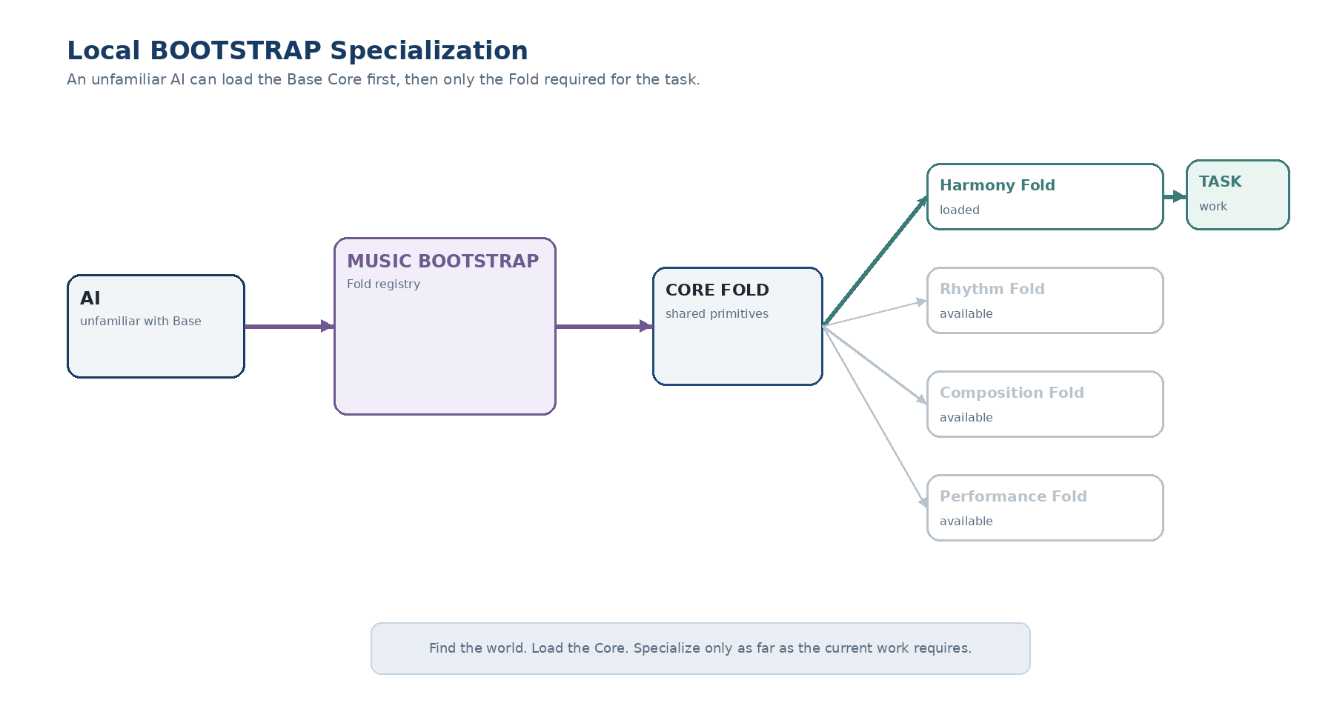
Figure 13. An unfamiliar AI can load the local Core first and then only the specialized Fold required for the current task.

17. Discovery and Competency Are Separate
The crawler should not load every candidate Base’s Core Fold simply to decide where a request belongs. Discovery is a low-cost routing problem; competency acquisition is a higher-cost learning problem. Combining them would cause Home to repeatedly load large amounts of irrelevant context.
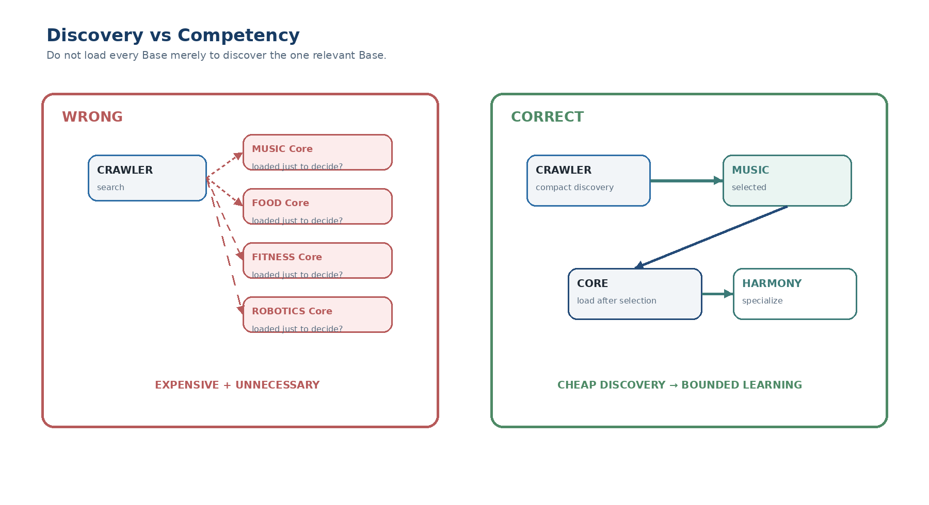
Figure 14. Cheap discovery occurs first. Core and specialized Folds are loaded only after a Base has been selected.
DISCOVERY–COMPETENCY SEPARATION
Do not load an entire world to decide whether that world is relevant. Find the world cheaply; learn it only when needed.

18. Multi-Base and Ambiguous Requests
Semantic jurisdiction is not always singular. A request such as “How does tempo affect running cadence?” legitimately concerns both MUSIC and FITNESS. The crawler may therefore return a bounded set of candidate Bases rather than forcing a false single winner.
Each selected Base can resolve its own part of the request through local SOLAR. The resulting exact structures can then be composed through registered cross-domain relationships or a higher-level bounded workflow. Home routes the jurisdictions; it does not need to perform the domain-specific translation itself.
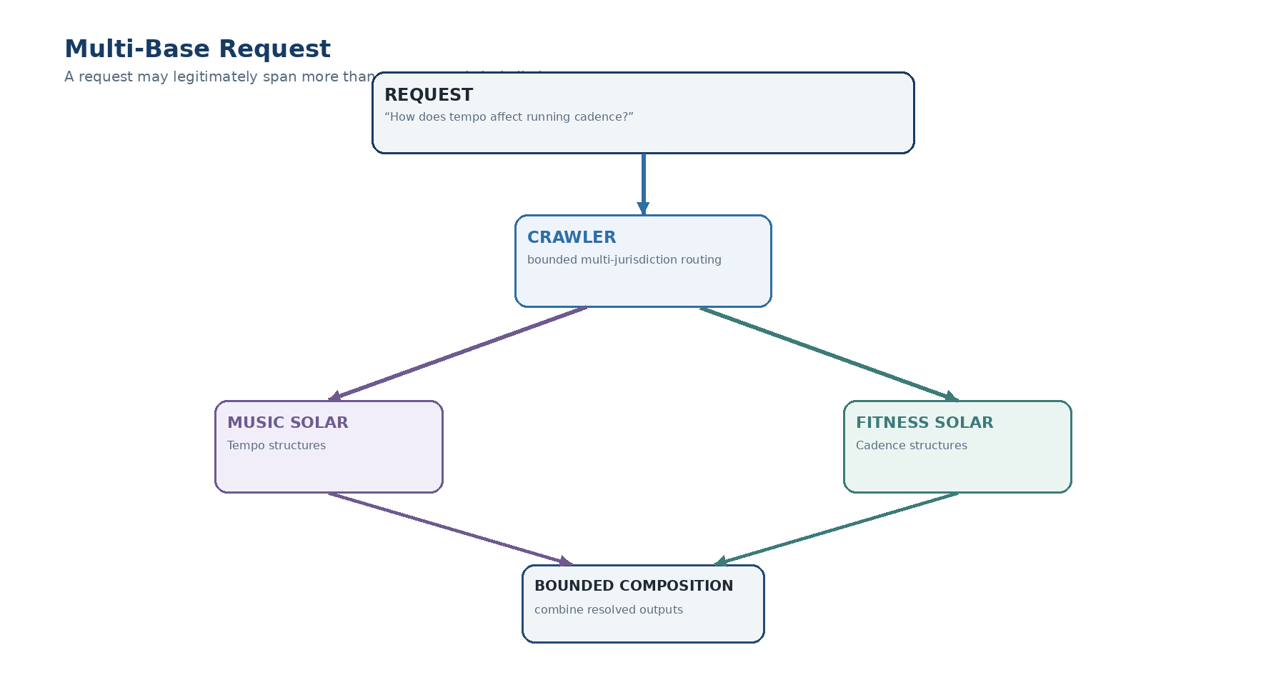
Figure 15. A cross-domain request can route to multiple local SOLAR environments and combine their resolved outputs without centralizing their vocabularies.

18.1 Candidate Negotiation
When several Bases appear plausible but the crawler cannot decide confidently, the architecture may support a lightweight candidate negotiation step. Candidate SOLAR environments can report whether the request is resolvable, potentially relevant, or outside their jurisdiction. The detailed protocol is intentionally left open in v0.1.

19. Local Namespaces and Compact Addresses
Federation should not require one enormous global Field numbering scheme. Each Base may retain compact local canonical coordinates and semantic addresses. Global resolution is achieved by qualifying the local address with the Base identity.
Thus MUSIC / A12 and FITNESS / A12 can both be valid without collision because A12 is interpreted inside different bounded Registries. The Base route establishes namespace; the local Registry establishes exact location.
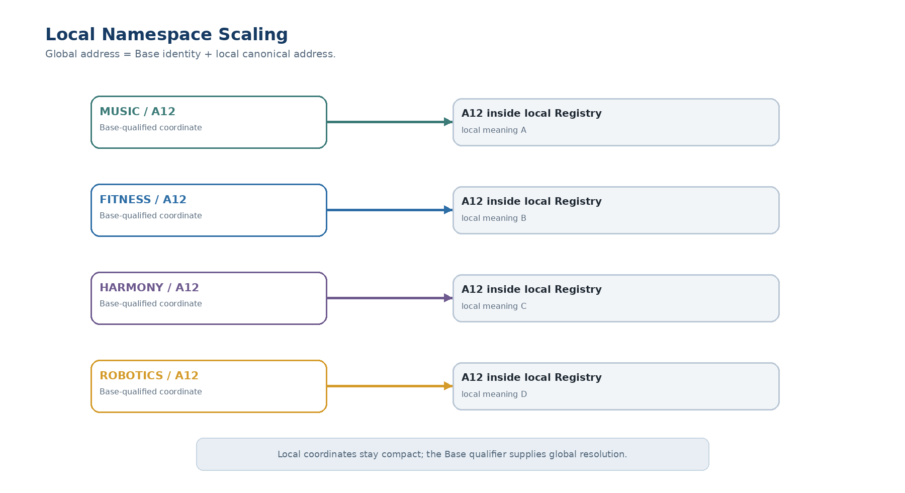
Figure 16. Base qualification allows local canonical coordinates to remain compact even as the federation grows.

20. Permission, Authority, and Contract Version Boundaries

20.1 Permission-aware discovery
Discovery must respect the same privacy and authorization principles as the rest of CERBERUS. A crawler should not reveal a private Base merely because its discovery surface happens to match a phrase. Permission filtering therefore occurs before unauthorized semantic disclosure or traversal.

20.2 Routing is not authority
Finding a Base or resolving an exact local address does not independently grant read, mutation, execution, or traversal authority. Routing identifies location; authorization remains governed by the target system’s permissions, Rules, and Operators.

20.3 Contract versioning
Public contract versions evolve independently from internal implementation versions. MUSIC may reorganize extensively while continuing to satisfy MUSIC.Contract.v1. If the outward semantic promise changes, the contract is versioned explicitly so existing consumers can detect compatibility requirements rather than silently receiving changed meaning.

21. Externalization Lifecycle
Externalization is a governed transformation rather than an informal copy operation. The lifecycle begins when a Stack is selected as a candidate and ends only when containment has been proved, the new Base is anchored Home, its contract remains available, and its discovery and local semantic services are published.
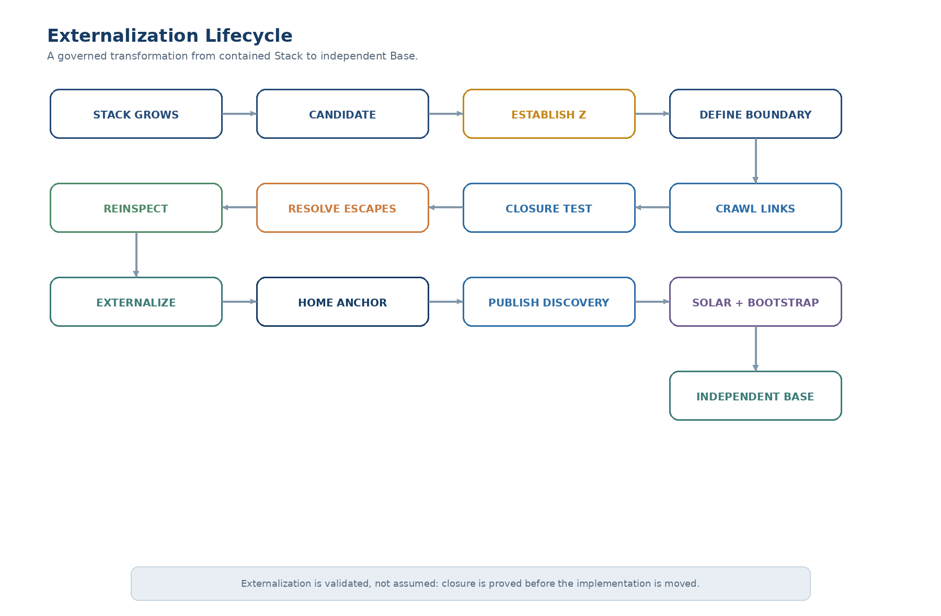
Figure 17. The externalization lifecycle validates Z, proves containment closure, repairs escaping dependencies, externalizes the implementation, anchors Home, and publishes local discovery and competency services.

21.1 Canonical sequence
Stage | Purpose
Select candidate | Identify the bounded Stack that should externalize.
Establish Z | Create or verify exactly one outgoing Stack relationship to the Base Data Contract.
Define boundary | Identify the structures owned by the future Base.
Crawl relationships | Enumerate outbound structural dependencies.
Test closure | Confirm every edge is internal or governed through Z.
Resolve escapes | Internalize, contractualize, remove, or redesign.
Reinspect | Prove closure after repair.
Externalize | Move implementation authority to the new Base.
Home anchor | Register direct canonical Home membership.
Publish discovery | Expose compact routing information.
Local services | Provide SOLAR and BOOTSTRAP for exact translation and competency.

22. Failure Modes
BASE EXPANSION separates failures by architectural layer so the system can fail explicitly rather than compensating through silent inference.
Failure | Meaning | Expected response
Boundary not closed | One or more links escape the proposed Stack boundary outside Z. | Do not externalize; return exact diagnostics.
Missing or ambiguous Z | No valid single contract gate exists. | Repair the contract relationship first.
Contract mismatch | New Base does not satisfy the outward contract expected by consumers. | Block incompatible use or migrate/version deliberately.
Home anchor absent | Base exists but is not directly registered to Home. | Register canonical system membership.
Discovery failure | Base exists but the crawler cannot reasonably route relevant requests to it. | Repair its discovery surface.
Local SOLAR failure | Correct Base was found but exact local semantic location cannot be resolved. | Return unresolved local translation.
BOOTSTRAP insufficiency | An unfamiliar intelligence lacks required local competency. | Load Core or appropriate specialized Fold.
Permission denial | Correct Base or target exists but current authority does not permit disclosure or action. | Fail without leaking unauthorized semantics.

23. Scalability Properties
The success criterion for federation is not simply that more records can exist. It is that internal complexity can grow without forcing equivalent growth in global routing, vocabulary, or parent-side implementation knowledge. BASE EXPANSION achieves this by keeping contracts bounded, discovery coarse, translation local, and competency loadable on demand.
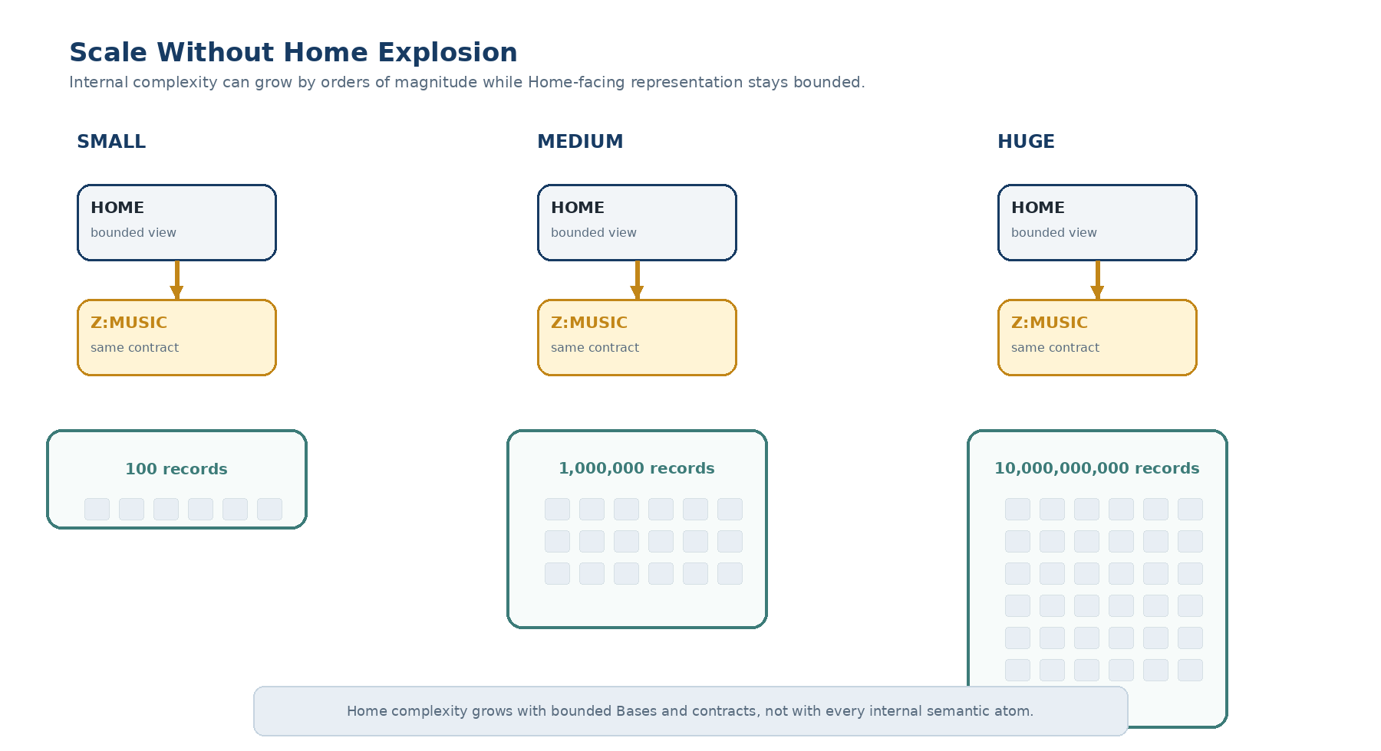
Figure 18. The Home-facing Z representation remains bounded even as the externalized Base grows from hundreds to billions of internal records.

23.1 Scaling invariants
Invariant | Effect
Home scales with bounded Bases and contracts | Global routing does not mirror every internal record.
Crawler scales with semantic jurisdictions | Discovery does not require full local vocabularies.
SOLAR scales locally | Specialized language stays with the Base that owns it.
BOOTSTRAP scales competency on demand | AI context grows only as far as the current task requires.
Z preserves bounded dependence | Internal complexity does not create uncontrolled parent entanglement.
Local namespaces remain compact | Global uniqueness comes from Base qualification rather than giant local numbering.

24. Formal Design Laws
Bounded Expansion Law — Internal complexity may expand without requiring proportional growth of the outward representation.
Externalization Granularity Law — Semantic identity may persist while Record, Table, Stack, and Base implementation granularity unfolds.
Z Boundary Law — A Stack prepared for externalization maintains exactly one registered outgoing structural relationship to its Base Data Contract in Z.
Containment Closure Law — Every relationship originating inside an externalized Stack boundary terminates inside that boundary or resolves through the registered Z contract.
Externalization Conformance Law — A Stack is not safely externalizable until deterministic diagnostics confirm closure of its proposed boundary.
Contract Preservation Law — Externalization does not silently alter the outward semantic contract.
Implementation Independence Law — Internal organization may evolve independently of the published contract unless the contract explicitly constrains it.
No Shadow Authority Law — The authoritative implementation resides in the externalized Base rather than in duplicated parent-side live records.
Home Anchor Law — Every participating Base maintains a direct relationship to the canonical Home Base.
Ancestry–Membership Separation Law — Structural origin and canonical Home membership are independent graph relationships.
Local Autonomy Law — Each Base owns and evolves its internal implementation while satisfying its outward contract.
Base Identity Persistence Law — Base identity persists through internal restructuring and deployment changes.
Crawler Jurisdiction Law — The Base Crawler resolves candidate semantic jurisdictions rather than exact local semantic addresses.
Local SOLAR Law — Exact domain translation is owned by the target Base’s SOLAR.
Discovery–Competency Separation Law — Locating a Base does not require loading its full competency context.
Competency Layering Law — An unfamiliar intelligence loads the Core before task-specific specialization when local interpretation requires it.
Local Namespace Law — A Base may maintain compact local addresses that become globally resolvable through explicit Base qualification.
Routing–Authority Separation Law — Discovery and translation do not independently grant access or mutation authority.
Contract Version Law — Outward contract meaning is versioned separately from internal implementation evolution.
Fail-Explicitly Law — Unresolved containment, jurisdiction, contract, translation, competency, or permission failures are surfaced rather than guessed around.

24.1 Non-goals of this paper
BASE EXPANSION intentionally stops before defining continuous cross-Base service federation. It uses BASE SERVICE to validate a candidate Stack during externalization, but it does not yet define child-Base health reporting to Home, federation-wide service dashboards, service-state-aware crawler routing, or cross-Base repair orchestration. Those behaviors belong to the later combination architecture that integrates Papers 1 and 2.

Conclusion
CERBERUS BASE EXPANSION establishes a disciplined route from one bounded Stack to a federation of independently scalable semantic Bases. The architecture first proves that the proposed Stack is genuinely bounded: exactly one outgoing structural relationship reaches the Z Base Data Contract, and every other relationship remains internal or is explicitly governed through that contract. BASE SERVICE provides the deterministic instrument for proving that closure before migration.
After externalization, continuity comes from the contract rather than from duplicated implementation. The new Base owns its internal truth, links directly to Home, preserves structural ancestry separately, and exposes enough discovery information for a compact Base Crawler to find it. Detailed language remains local through SOLAR; competency remains local through BOOTSTRAP and its Core and specialized Folds. Home therefore needs to know who owns a semantic world, how to reach it, and what bounded contract it exposes—not every record inside it.
CLOSING ARCHITECTURE
Prove the boundary. Preserve the contract. Anchor the Base Home. Let the crawler find the world. Let local SOLAR translate it. Let local BOOTSTRAP teach it.

