CERBERUS

SEMANTIC KNOWLEDGE
PACKING
  - Designing World Languages for Staged Learning, Compact Expertise, and Life-Changing Knowledge
ROUTE | BLOCK | BUNDLE | STAGE | LIFE | RESIDUAL | MASK | MATH | WORLD

Illustrative Architecture Paper
Version 0.1 | August 2026
Core proposition
A world semantic language can be deliberately organized so common learning stages, professions, cultures, and life histories form reusable and mathematically compatible knowledge structures. A character can then be reconstructed from shared chunks plus comparatively small individual differences while preserving exact semantic membership.

Semantic architecture series • BIGFOOT / Knowledge Systems

EXECUTIVE SUMMARY

Knowledge as Structured World Language
Semantic Knowledge Packing is a CERBERUS architecture for representing what an actor can understand, recognize, and recall without treating every item of knowledge as an independent database object. The starting point is an exact bounded semantic mask. Each route in a Language Pack has a stable physical position, and a character knowledge state marks which routes are active. With Pack identity, width, and Mapping Version fixed, the binary mask and its unsigned integer are two exact reversible views of the same state.
The paper then asks a different question: if human and agent knowledge is highly correlated, why should the semantic language be laid out as if knowledge states were random? People learn foundations, subjects, professions, regional practices, hobbies, and life experiences in coherent groups. CERBERUS can deliberately preserve those structures as Semantic Blocks, Knowledge Bundles, Learning Stages, and higher-order Life Chunks. Common expertise therefore becomes reusable structure instead of repeated individual membership lists.
This architecture separates two kinds of compression. Designed compression comes from semantic organization: coherent ranges, reusable Bundles, staged curricula, shared cultural cores, and Life Chunks. Opportunistic compression happens after an exact state already exists, when its integer representation happens to admit an unusually short mathematical expression. An exact loadout that equals 55^5 is interesting, but it is an encoding coincidence rather than the purpose of the language.
The result is a world language that can be learned in stages, shared across populations, mutated through bounded additions and omissions, and reconstructed exactly. Biography becomes computationally consequential because life history can contribute real knowledge structures. Individuality remains explicit through Personal Residuals and exceptions. Knowledge can change cheaply because the system records what changed rather than conceptually rebuilding the entire vocabulary state.
Architectural center
Do not encode each person knowledge independently. Design the world language so common ways of learning naturally produce reusable, mathematically compatible knowledge structures.

What this paper formalizes
- Exact knowledge membership as a bounded semantic mask and reversible integer representation.
- The distinction between physical Semantic Blocks, semantic Knowledge Bundles, Learning Stages, Life Chunks, and character-level Knowledge Profiles.
- Set-union composition for overlapping knowledge structures, including additions and omissions.
- Compression-aware Language Pack topology that preserves semantic integrity before mathematical convenience.
- Designed versus opportunistic compression, including the role of compression attractors and the 55^5 anomaly.
- Population-scale reuse, Mapping Version stability, and the handoff from knowledge state to World-Driven Agency.

ARCHITECTURE CONTRACT

Scope, Boundaries, and Required Distinctions
This paper owns the structure and representation of semantic knowledge loadouts. It describes how semantic identities can be arranged, grouped, learned, reused, changed, and represented exactly. It does not claim that knowing a concept confers the physical Skill to perform it, that a mathematically compact profile is more intelligent, or that every arbitrary knowledge mask has a short mathematical description.
IN SCOPE | OUT OF SCOPE
Language Pack route placement and stable mapping versions. | Globally optimal language permutation.
Knowledge Bundles, Learning Stages, Life Chunks, Personal Residuals. | A universal curriculum or single theory of expertise.
Exact binary/integer equivalence and bounded mathematical representations. | Unrestricted shortest-expression discovery or Kolmogorov complexity.
Designed and opportunistic compression as separate regimes. | Guaranteeing compression for random or irregular masks.
Population-scale reuse and bounded knowledge change. | Goal selection, Task assignment, or behavior-tree replacement.
Handoff from knowledge to World-Driven Agency. | Treating knowledge as Skill, permission, personality, or World Truth.

Four layers that must not collapse
SEMANTIC IDENTITY != PHYSICAL BIT POSITION
KNOWLEDGE MEMBERSHIP != MATHEMATICAL REPRESENTATION

The same semantic identity can move under a new Mapping Version without changing what it means. A physical route position can be active or inactive for different characters. A complete mask can be viewed as binary, an integer, or an exact mathematical expression without changing its membership semantics. Preserving these distinctions is the safety condition for every compression technique described later.

NAVIGATION

Paper Map
Part | Theme | Sections | Purpose
I | Exact Knowledge | 1-6 | Defines exact route membership, reversible scalar encoding, full masks, block mathematics, and natural compression regimes.
II | From Language to Learning | 7-12 | Shows why real knowledge is correlated and formalizes Blocks, Bundles, set union, staged learning, and reusable curricula.
III | Life Chunks and Individuality | 13-19 | Compiles experience into knowledge, separates shared Chunks from Personal Residual, and models additions, omissions, learning, and forgetting.
IV | Compression-Aware Topology | 20-26 | Treats Language Pack layout as an engineering problem while separating designed compression from mathematical coincidence.
V | Population and World Use | 27-30 | Scales shared knowledge across communities and hands bounded knowledge into World-Driven Agency.
VI | Formal Principles and Boundaries | 31-33 | Locks the architectural laws, implementation responsibilities, and unresolved mathematical research surface.
A | Appendix A | - | Compact formula and terminology reference.
B | Appendix B | - | Relationships to neighboring CERBERUS systems.
Reading order
The paper moves from exact representation to semantic structure, from semantic structure to lived knowledge, from lived knowledge to compression-aware layout, and finally from individual profiles to population-scale world use.

PART I

Exact Knowledge
Knowledge begins as exact route membership. Compression is a representation of that state, not a substitute for semantic identity.

1. Knowledge as an Exact Semantic Mask
A Language Pack is a bounded set of addressable semantic routes. A character Knowledge Profile does not need a separate record saying "knows" or "does not know" for every route. Instead, the profile can expose one exact mask whose positions correspond to the Pack mapping. An active position means that semantic route is present in the profile; an inactive position means it is absent from that profile.
The mask is therefore an identity pattern, not a score. It can represent spoken vocabulary, technical concepts, recognized equipment classes, procedural concepts, place names, symbols, or any other semantic routes registered by the language. World Truth remains separate: the world may contain a semantic fact that a character does not know, and a character may know a concept without possessing the Skill or authorization to act on it.
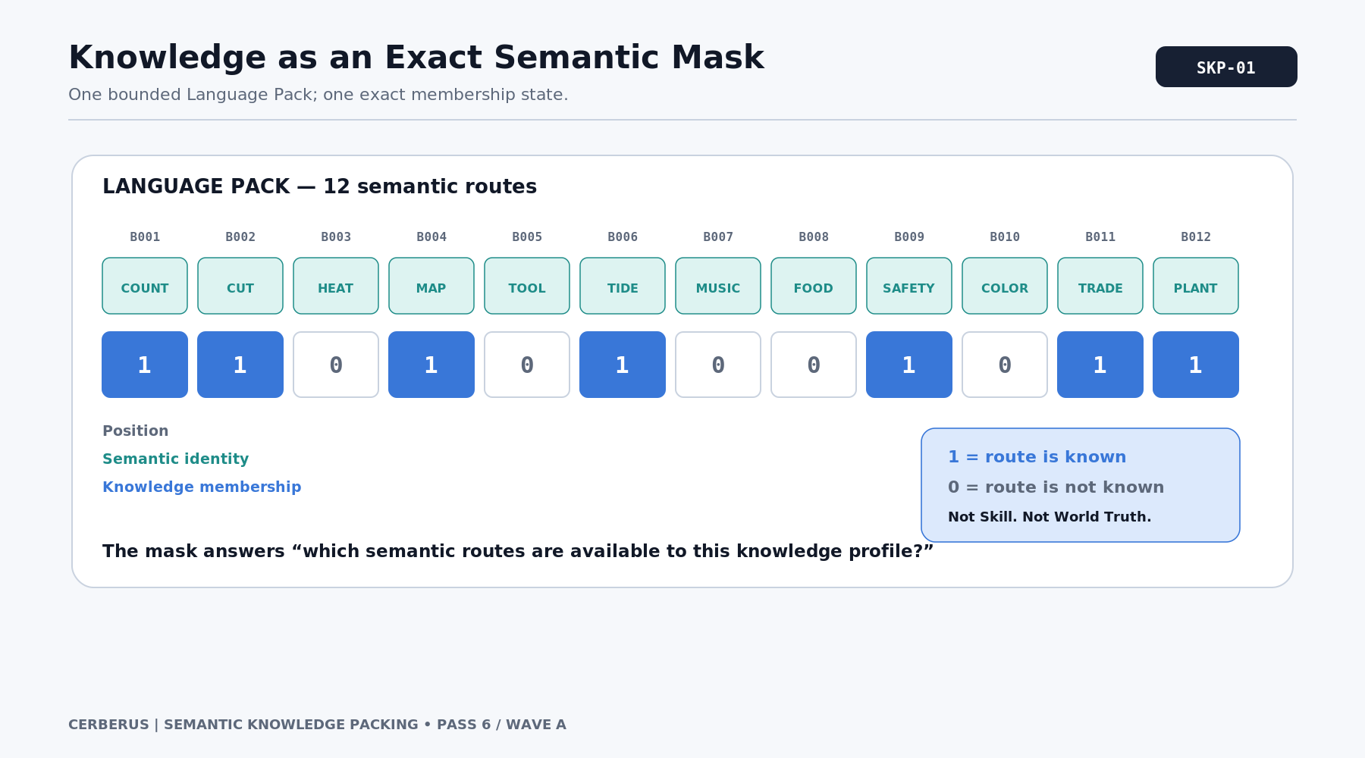
Figure 1. Knowledge as an Exact Semantic Mask.
Canonical statement
Knowledge is exact membership in a bounded semantic address space. The mask says which routes are available to this profile; it does not say how valuable, true, difficult, or behaviorally decisive those routes are.

2. Binary Mask and Exact Integer
Once the Pack width and bit convention are declared, the complete binary mask can be interpreted as an unsigned scalar. Under the CERBERUS convention used here, B1 carries weight 1, B2 carries weight 2, and route position i contributes 2^(i-1) when active. The scalar is therefore a lossless numerical view of the membership pattern.
For the 16-route example in the figure, the LSB-first state 0010110101000011 resolves to 49,844. Given the width 16 and the same mapping convention, 49,844 expands back into the exact original 16 positions, including leading inactive routes. This reversibility is what makes the numeric representation useful for transport, comparison, storage, and further exact mathematical compression.
V = SUM[b_i * 2^(i-1)] for i = 1..n

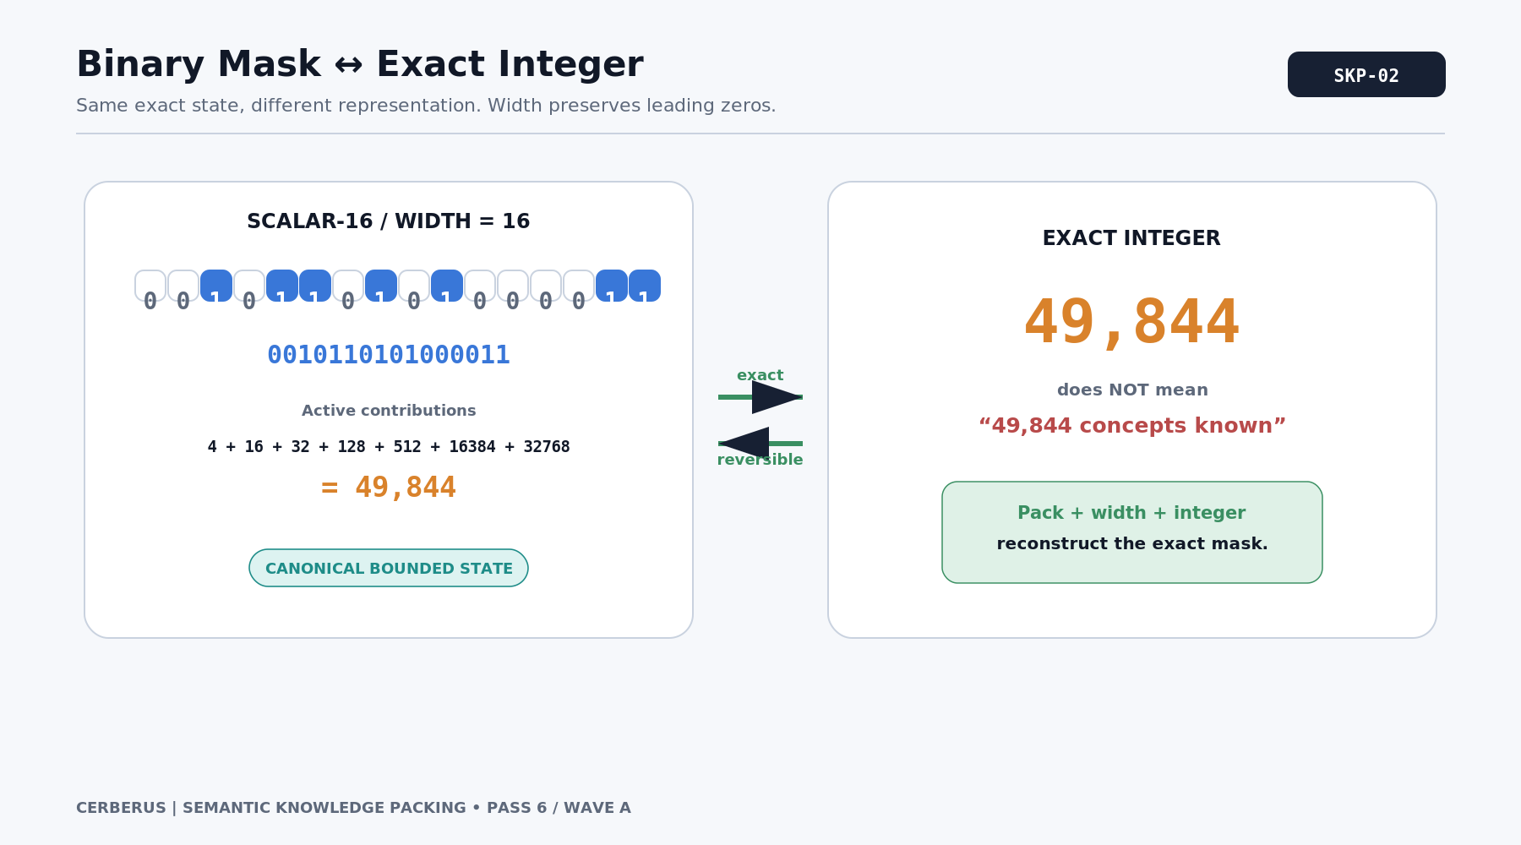
Figure 2. Binary Mask and Exact Integer.

3. Full Semantic Access: 2^n - 1
If all n routes in a bounded Pack are active, the mask is n consecutive ones. The corresponding integer is the geometric sum 1 + 2 + 4 + ... + 2^(n-1), which equals 2^n - 1. This is the natural full-mask boundary for any fixed-width Language Pack.
The informal nickname "God Mode" is useful during design discussions, but the formal distinction matters: a stored full mask is a static current state, while a dynamic full-access rule is a permission that resolves against the current Pack. If a new route is added under a new mapping version, an old static mask does not silently acquire it. Dynamic access and exact stored membership are related but different contracts.
FULL_MASK(n) = 2^n - 1

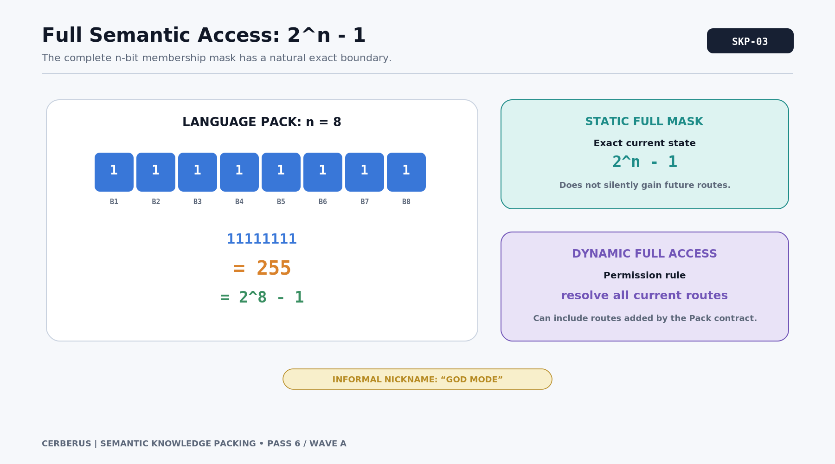
Figure 3. Full Semantic Access: 2^n - 1.
Static state vs dynamic permission
A value such as 2^10000 - 1 is an exact 10,000-route full mask. A rule that always grants the full current Language Pack is a different object and can expand when the Pack itself changes.

4. Same Amount, Different Knowledge
Counting active routes is useful for some diagnostics, but the count does not identify the knowledge. Two profiles can each contain four active routes and still encode completely different semantic states because the active positions differ. Likewise, one integer can be numerically larger than another while representing fewer active routes or less relevant expertise.
This prevents a tempting but incorrect interpretation: the packed integer is not a knowledge score. It is closer to an address-coded set identifier. Expertise, competence, confidence, recency, and quality belong to other semantic or Skill structures. Numeric magnitude is an artifact of which physical positions carry which powers of two.
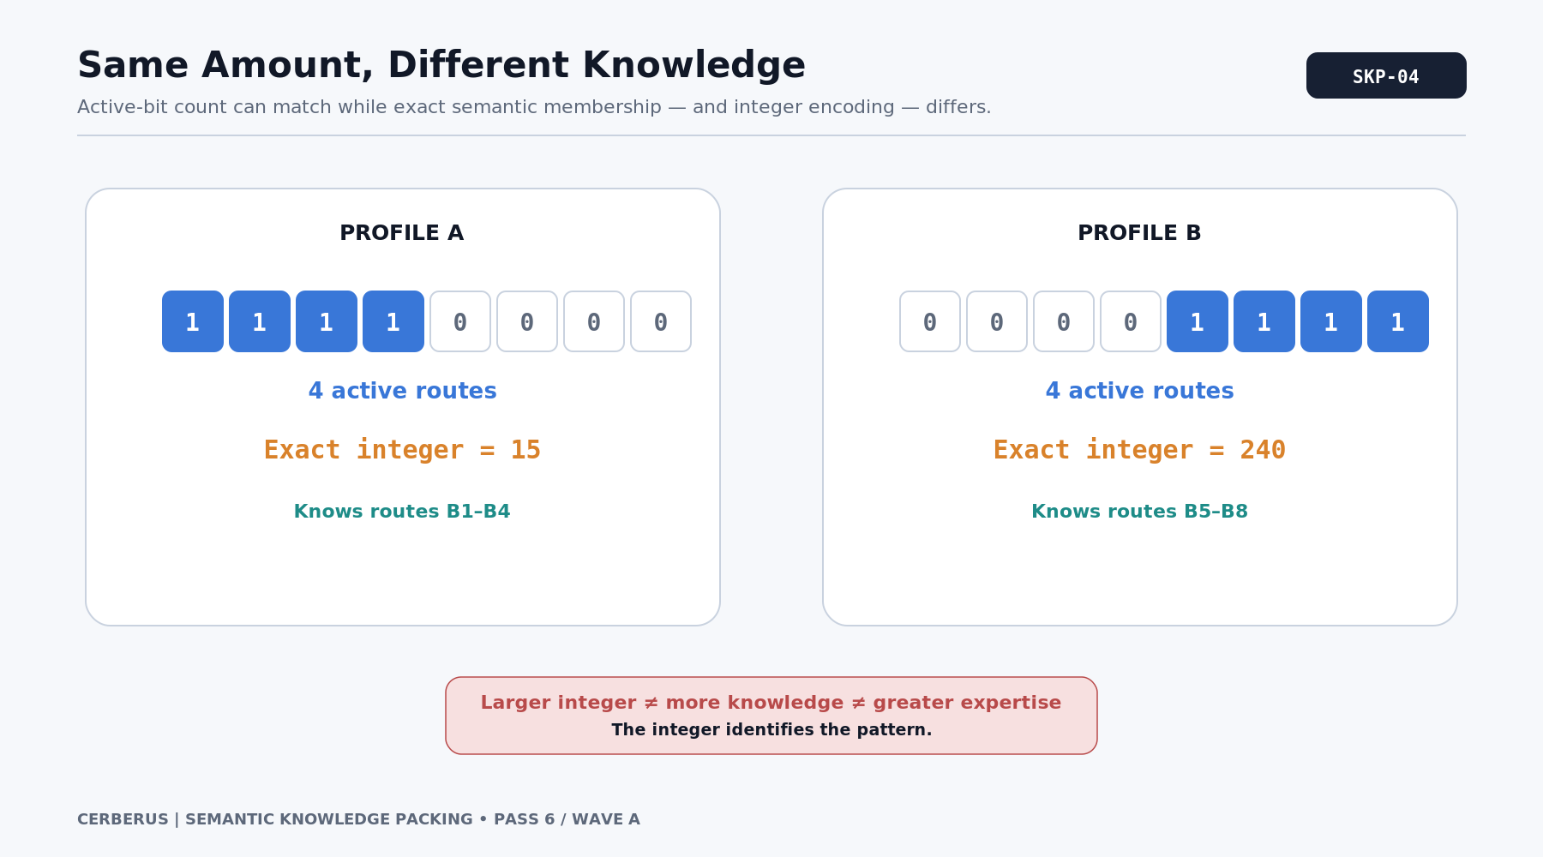
Figure 4. Same Amount, Different Knowledge.
Do not rank by scalar magnitude
The integer is exact encoding, not semantic quantity. Route count, Skill level, and expertise are separate measures.

5. A Contiguous Block Has a Cheap Exact Form
Contiguous active regions are especially inexpensive to describe mathematically. A run of m active routes beginning at zero-based offset k is a full m-bit mask shifted by k positions. The exact integer is therefore (2^m - 1) * 2^k. Hundreds or thousands of memberships can collapse to one compact expression when the semantic topology makes those memberships a regular block.
This is the first place where language layout begins to matter. A Semantic Block is a physical region of the address space; it does not define meaning by itself. The block becomes useful when a coherent semantic set is intentionally mapped into that region. The mathematics rewards regularity, but the semantics must justify the grouping first.
BLOCK(m, k) = (2^m - 1) * 2^k

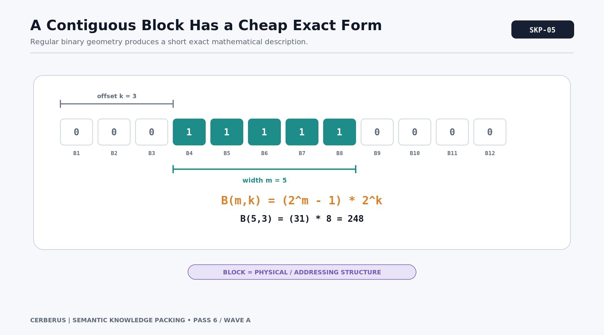
Figure 5. A Contiguous Block Has a Cheap Exact Form.

6. Sparse and Dense States Compress Differently
No single compression form dominates every mask. Sparse knowledge states naturally admit a sum of a few powers of two because only a few routes are active. Dense contiguous states admit shifted full-mask expressions. Repeated patterns may have other short forms. Medium-density irregular masks can remain expensive and may be best stored as raw binary, hexadecimal, a large integer literal, or a different exact representation.
The architecture therefore does not promise that every knowledge state will compress elegantly. It provides a family of exact representations and lets the system choose a useful one. The design target is narrower and more practical: common, meaningful, structured states should be inexpensive because the language was built around the ways knowledge is normally acquired.
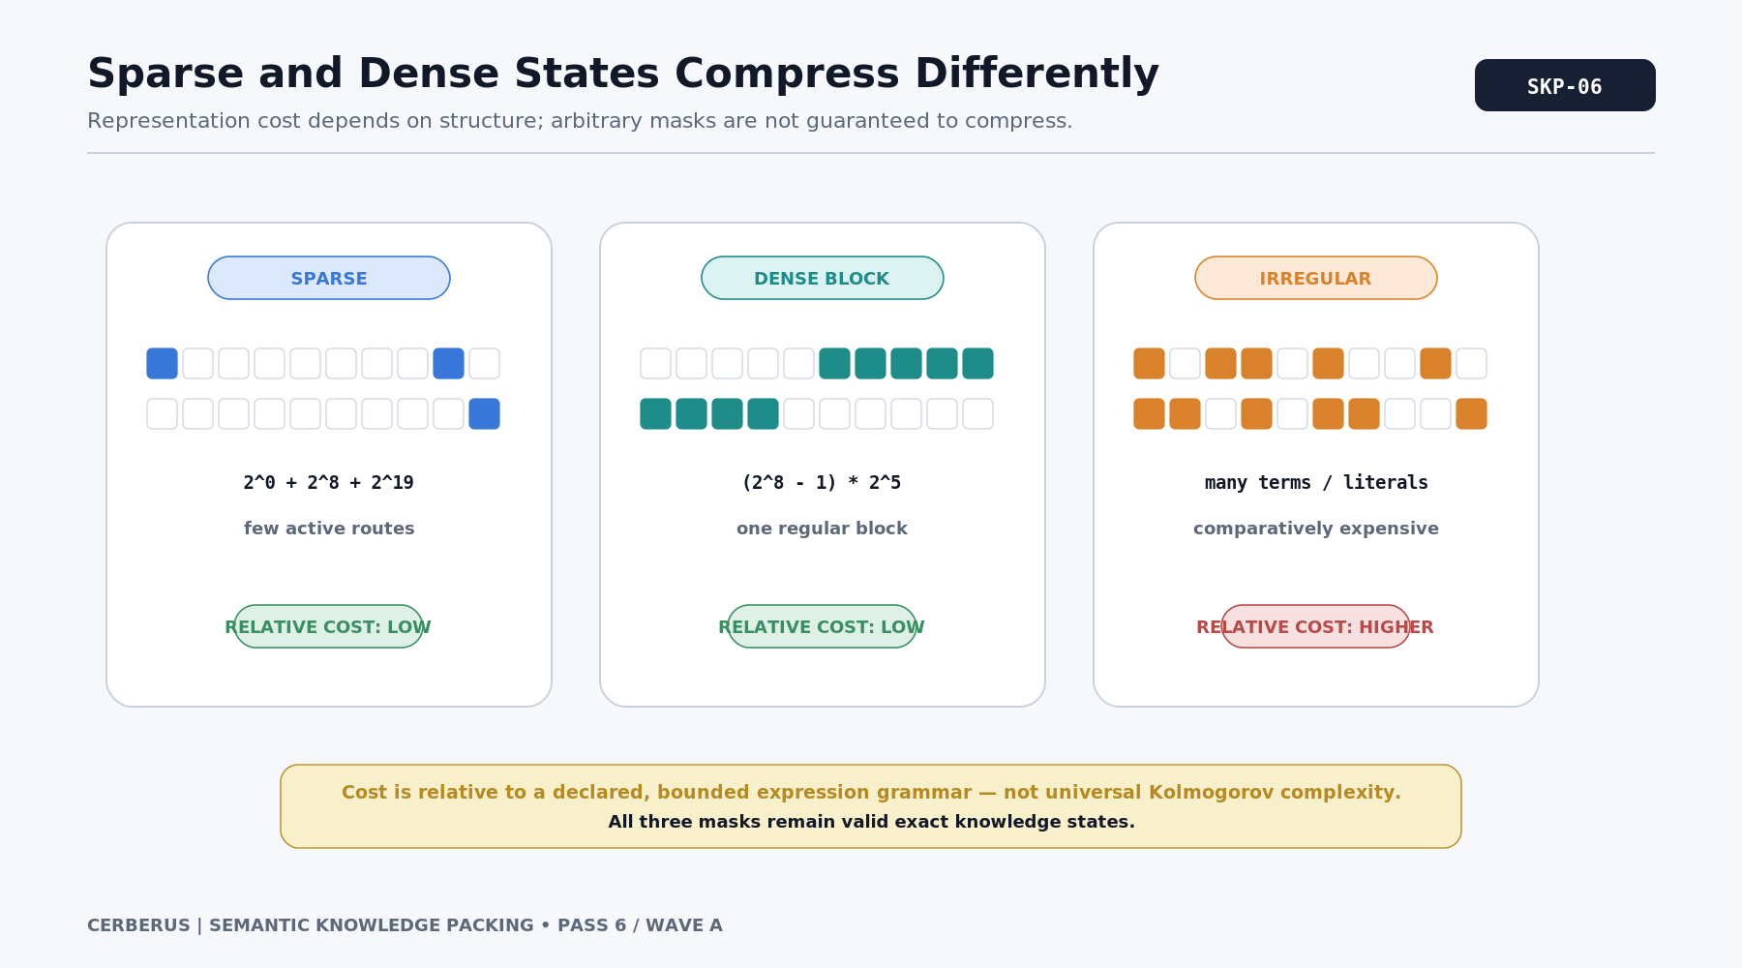
Figure 6. Sparse and Dense States Compress Differently.
Compression is conditional
Random masks can remain information-dense. Semantic Knowledge Packing improves the expected structure of real knowledge states; it does not repeal information theory.

PART II

From Language to Learning
The language is not a random bit field. Its topology can preserve how concepts are learned, grouped, and reused.

7. Human Knowledge Is Correlated
People rarely learn concepts as independent random samples from an entire world vocabulary. They learn semantic territories: arithmetic, cooking, crop care, engine maintenance, local geography, music, legal procedure, social customs, and thousands of other structured domains. Within each territory, particular concepts co-occur because curricula, practice, tools, and lived environments expose them together.
That correlation is an architectural opportunity. If the Language Pack ignores it, common expertise produces irregular masks that repeat similar membership information across many people. If the Pack preserves it, shared learning states can be represented as reusable structures. The language topology starts to mirror the knowledge ecology of the world.
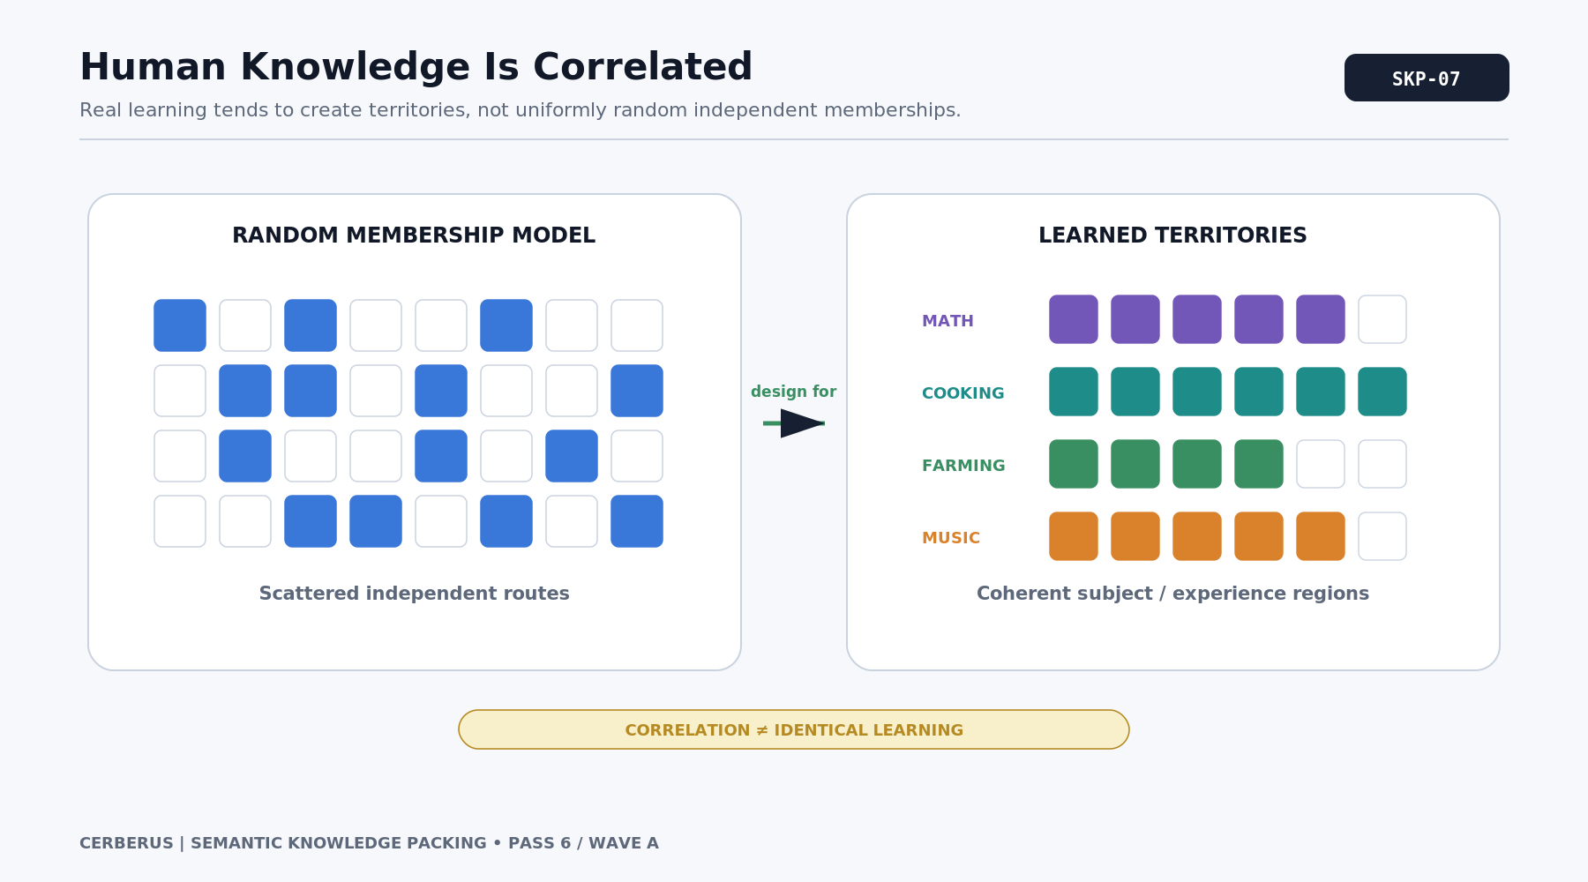
Figure 7. Human Knowledge Is Correlated.
Design implication
Optimize for the states the world is likely to produce, not for uniformly random masks that no population actually inhabits.

8. Semantic Route to Block to Bundle
Three levels must remain distinct. A Semantic Route is one addressable meaning. A Semantic Block is a physical neighborhood in the Pack. A Knowledge Bundle is a meaningful reusable set of routes. A Bundle may occupy one Block, several Blocks, or a mixture of contiguous and non-contiguous routes depending on the language design.
This separation prevents numerical convenience from silently becoming semantic authority. Physical adjacency can make a Bundle cheap to represent, but adjacency does not create the Bundle. The Bundle exists because the concepts belong together for learning, use, or interpretation. Physical topology is an implementation of that semantic decision.
ROUTE -> physical BLOCK != semantic BUNDLE

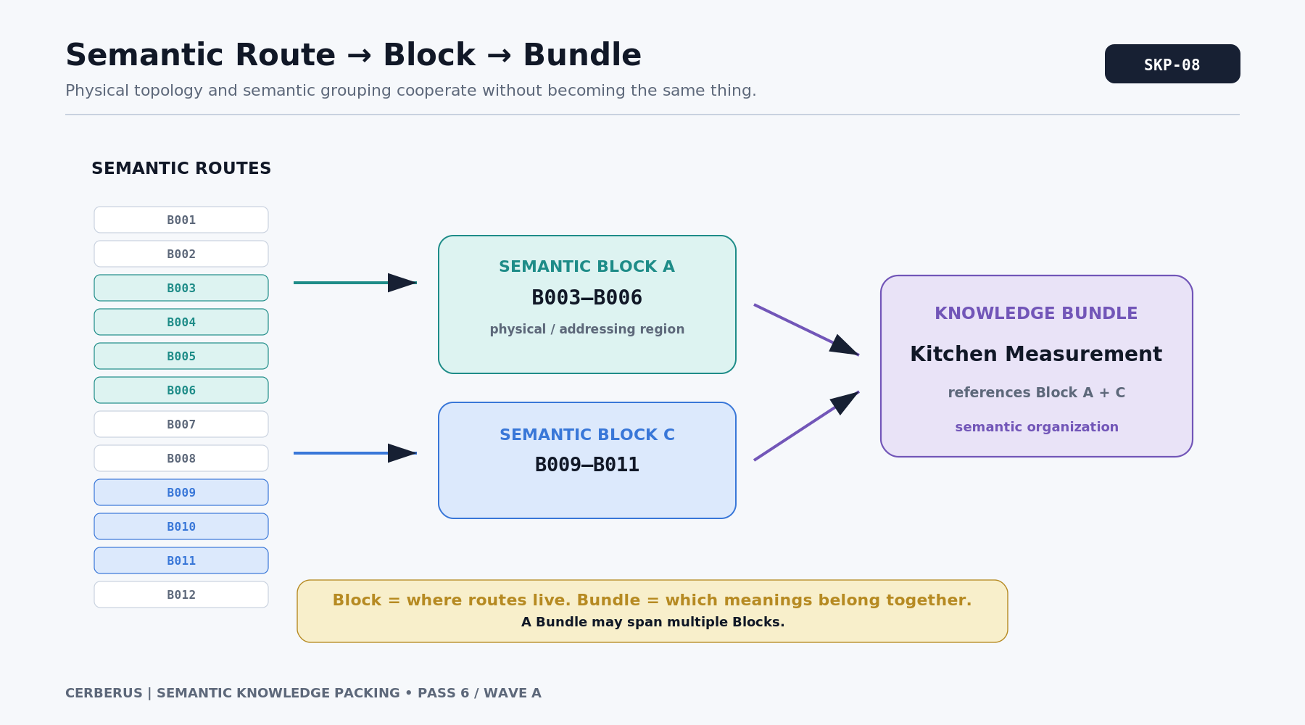
Figure 8. Semantic Route to Block to Bundle.

9. Knowledge Composition Is Set Union
Knowledge Bundles often overlap. A food-safety Bundle and a professional-cooking Bundle might both include temperature awareness, contamination concepts, or equipment recognition. When two masks overlap, ordinary integer addition is not the semantic composition law because shared active positions would be counted twice and carries could change unrelated bits.
The canonical operation is set union, implemented as bitwise OR on the masks. If two masks are provably disjoint, arithmetic addition happens to produce the same result, but that is a special case rather than the general rule. Bundle provenance may still be tracked separately even when the resolved Knowledge Profile contains only one active membership for a shared route.
K = B1 OR B2 OR ... OR Bn

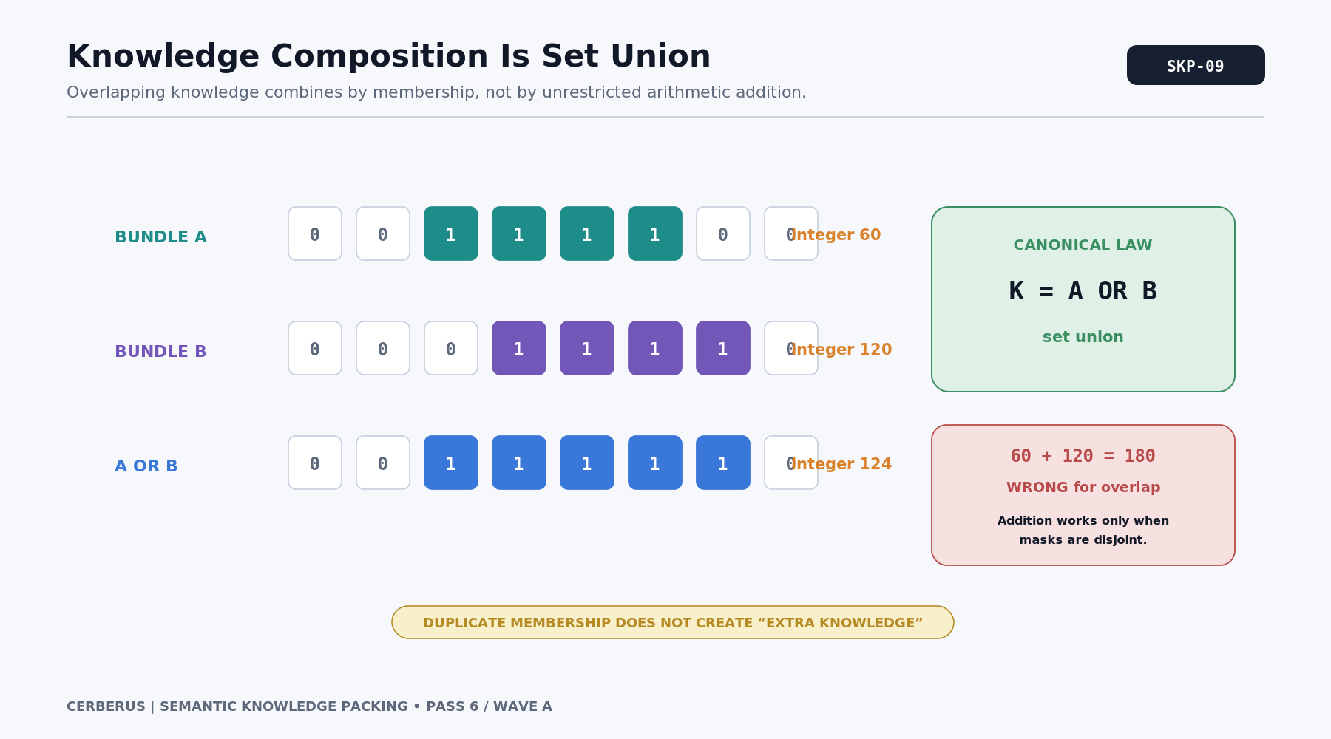
Figure 9. Knowledge Composition Is Set Union.

10. A Domain Becomes Learning Stages
A Knowledge Bundle becomes more useful when it can participate in an explicit learning progression. A domain such as Cooking can expose Foundation, Basic, Intermediate, Professional, and Specialist stages, with each stage contributing coherent semantic territory. The exact number and shape of stages is domain-specific; the important property is that progression is addressable.
This makes expertise developmental rather than binary. A learner can acquire the concepts needed for basic kitchen participation before professional methods, and a professional can later add a specialist Bundle without replacing the semantic foundation already learned. The language thus records where a learner currently sits inside the domain rather than only whether the whole domain is present.
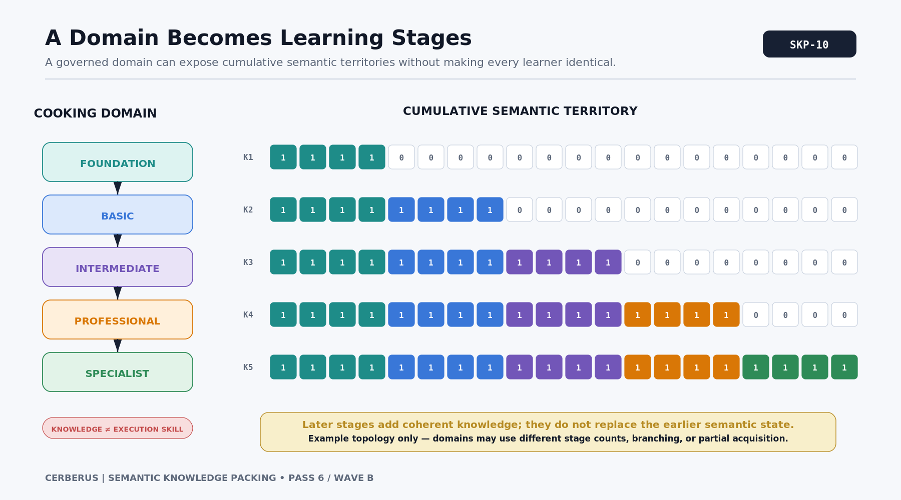
Figure 10. A Domain Becomes Learning Stages.

11. Learning Changes the Mask Incrementally
When a new stage is acquired, the profile can union the new stage mask with the existing knowledge state. Earlier active routes remain active unless an explicit forgetting or correction event changes them. This incremental law means a character can move through a curriculum without redefining the entire Language Pack or reconstructing unrelated knowledge.
The same pattern works below the stage level. A single concept can be added as a small delta; a sub-Bundle can be added when a practical experience teaches a cluster of concepts; or a whole stage can be granted after formal training. The architecture scales the size of the change to the semantic size of what was learned.
K_(t+1) = K_t OR B_new

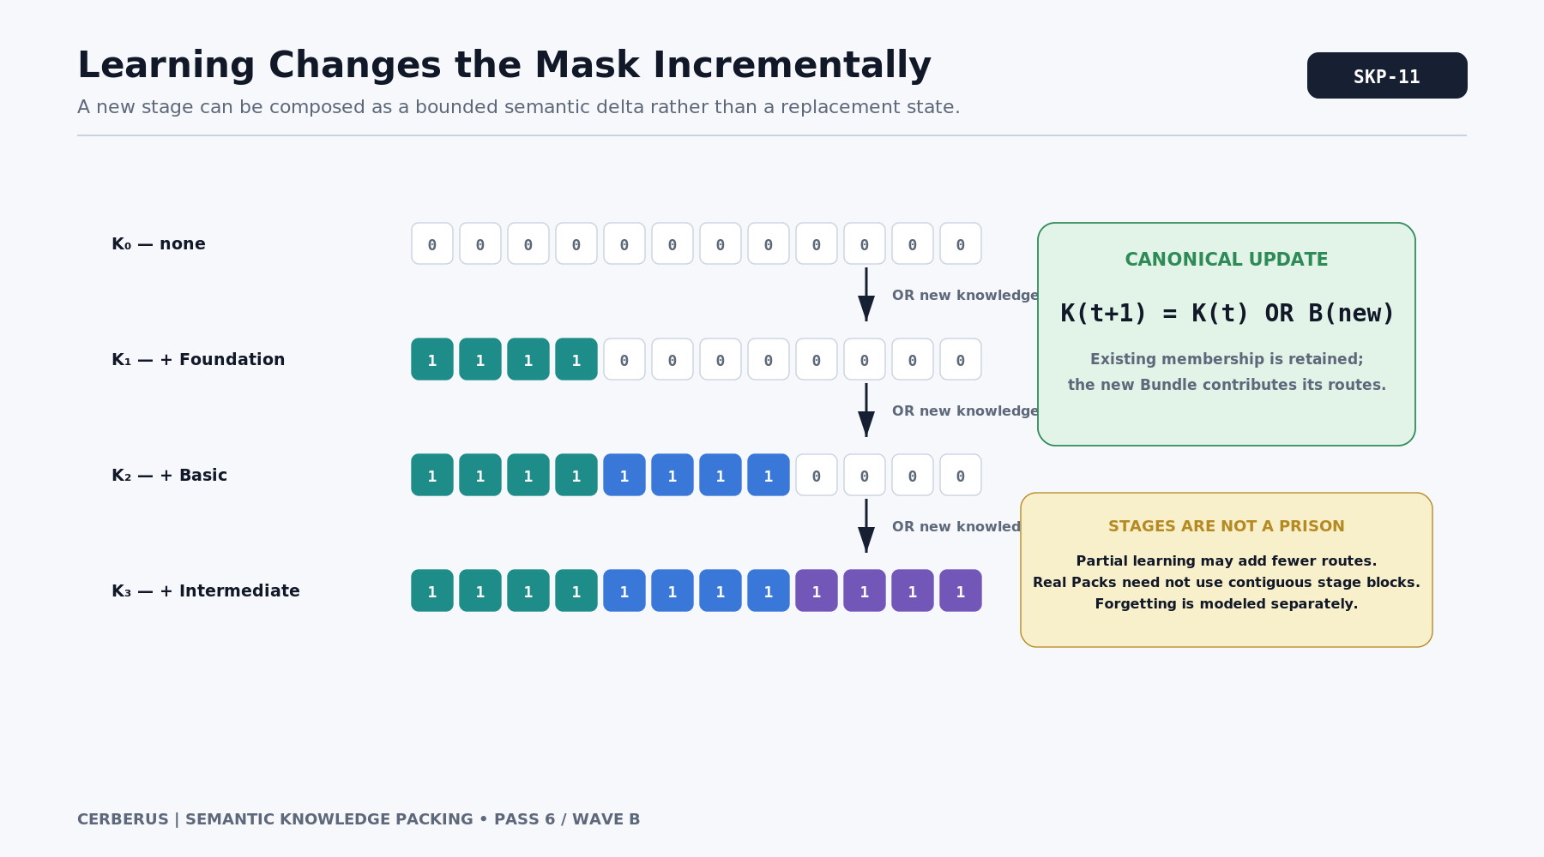
Figure 11. Learning Changes the Mask Incrementally.
Learning is a bounded delta
The canonical profile changes where learning occurred. Unrelated semantic territory does not need to be conceptually rewritten.

12. One Curriculum, Many Consumers
A governed semantic curriculum can serve several systems without becoming any one of them. NPC learning can use it to update knowledge. Player education can expose the same stages as lessons or discoveries. AI BOOTSTRAP can use the semantic sequence as a reconstruction path. Qualification systems can reference required stages. Dialogue and Task systems can test whether a concept is understood.
The consumers do not have to store or interpret the curriculum identically. The value lies in a shared semantic structure: Cooking Foundation means the same governed knowledge territory whether the consumer is a simulated worker, a player-facing learning interface, or an AI that must reconstruct the domain. One curriculum becomes infrastructure rather than duplicated documentation.
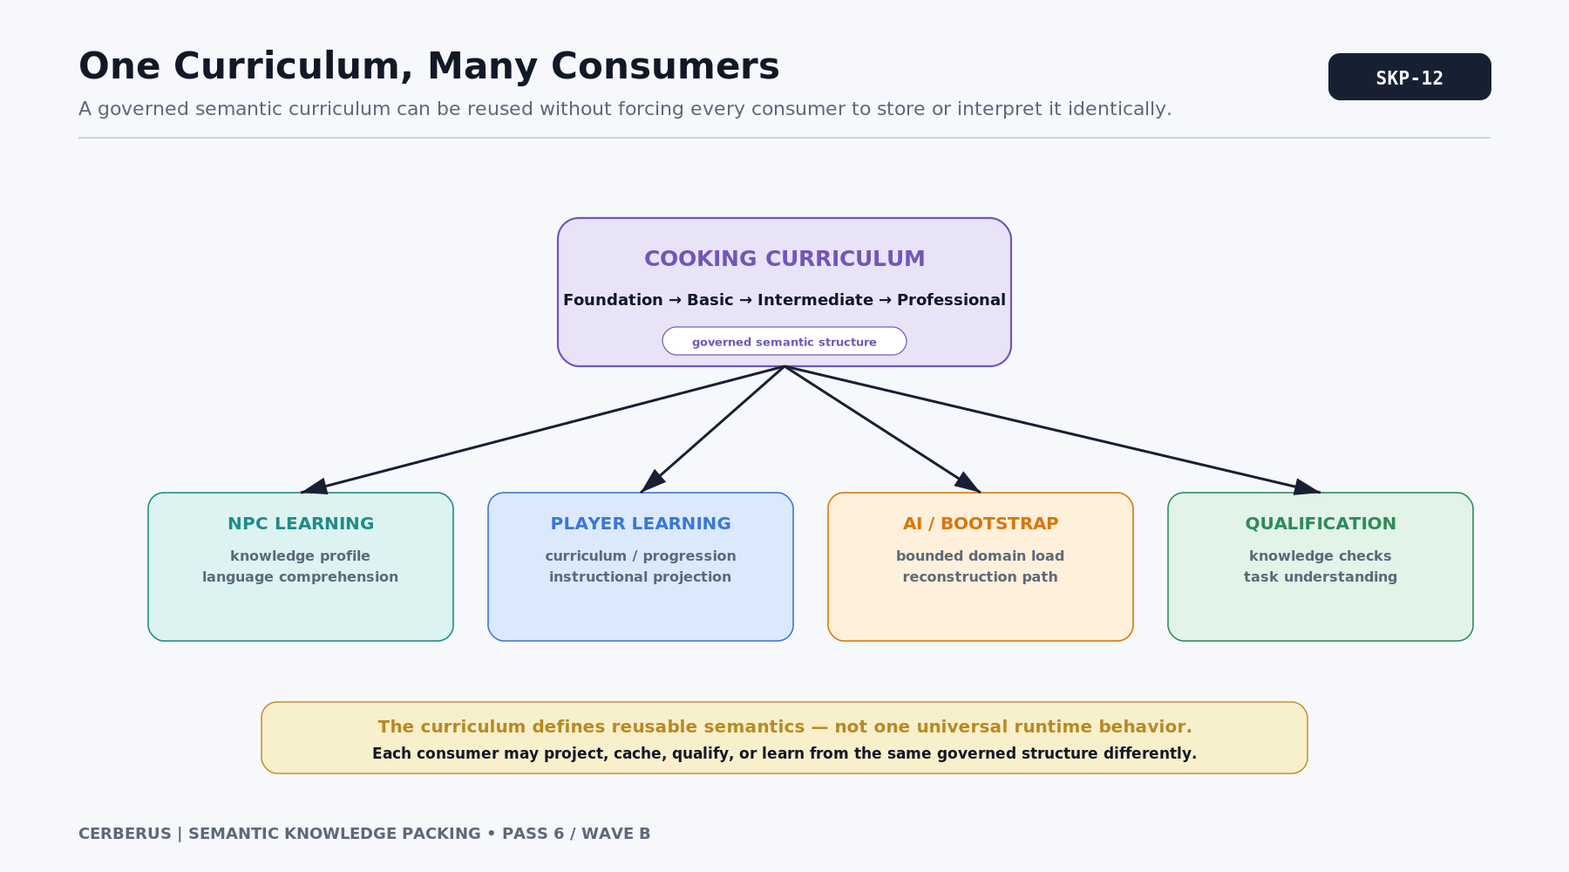
Figure 12. One Curriculum, Many Consumers.
Reuse without ownership transfer
The curriculum defines semantic learning structure. It does not own downstream Skill execution, behavior, interface presentation, or World Rules.

PART III

Life Chunks and Individuality
A character knowledge state can be assembled from reusable lived structures, then personalized through bounded residuals and exceptions.

13. Life Chunks Compile Experience Into Knowledge
Knowledge is acquired through life contexts as well as formal subject boundaries. A rural childhood, culinary school, restaurant employment, recreational fishing, parenthood, regional dialect, military service, or years inside a particular industry can expose a person to characteristic sets of semantic concepts. Semantic Knowledge Packing treats these contexts as reusable Life Chunks.
A Life Chunk is not a complete biography and is not required to predict exactly what every participant learned. It is a bounded semantic knowledge package associated with a developmental, cultural, educational, occupational, or experiential context. Characters can receive a standard Life Chunk and then accumulate additions, omissions, and personal residuals that reflect their individual history.
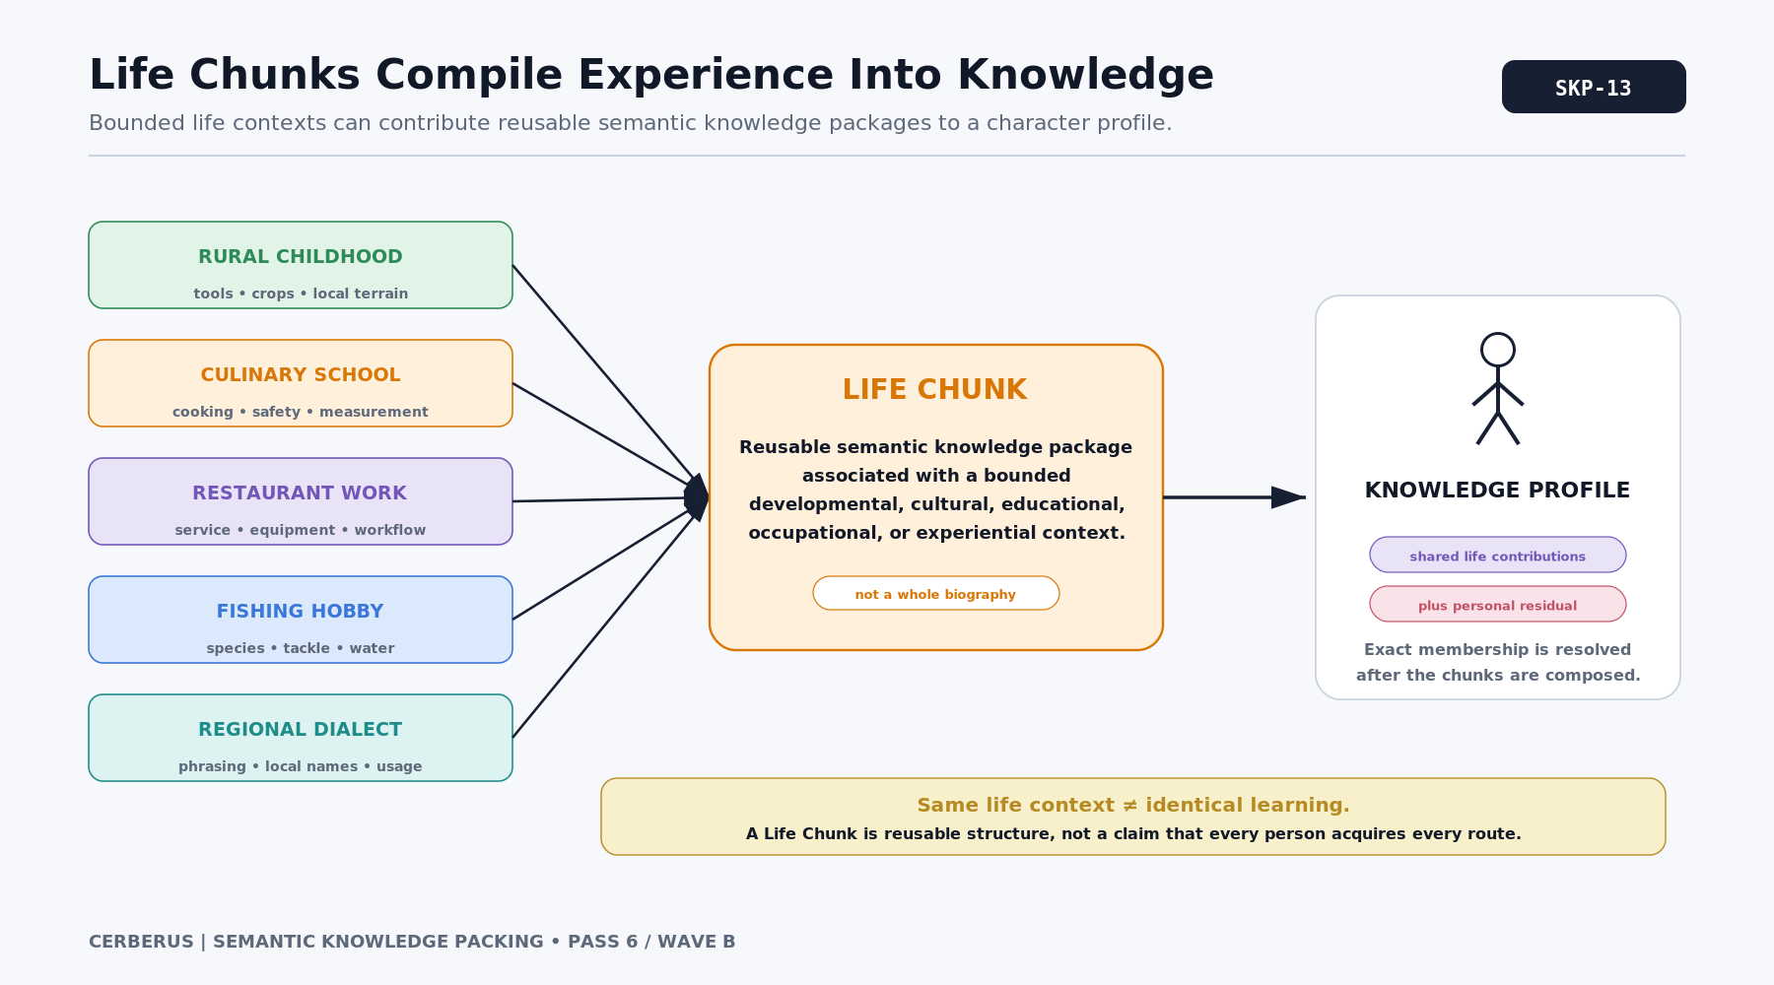
Figure 13. Life Chunks Compile Experience Into Knowledge.
Life Chunk
A reusable knowledge contribution associated with a bounded life context. It may reference multiple Bundles and does not need to occupy one contiguous bit region.

14. One Life Chunk Can Span Many Bundles
A Culinary School Life Chunk might contribute Cooking Foundation, Food Safety, equipment recognition, measurement, recipe grammar, kitchen communication, and institutional procedure. Those concepts belong to several semantic territories even though the lived experience that teaches them is unified. The Life Chunk therefore sits above individual Knowledge Bundles.
This is why Life Chunk cannot be treated as another name for Semantic Block. The physical representation can remain modular while the experiential structure composes across domains. That flexibility lets CERBERUS describe real learning histories without forcing every life event into one artificial contiguous region.
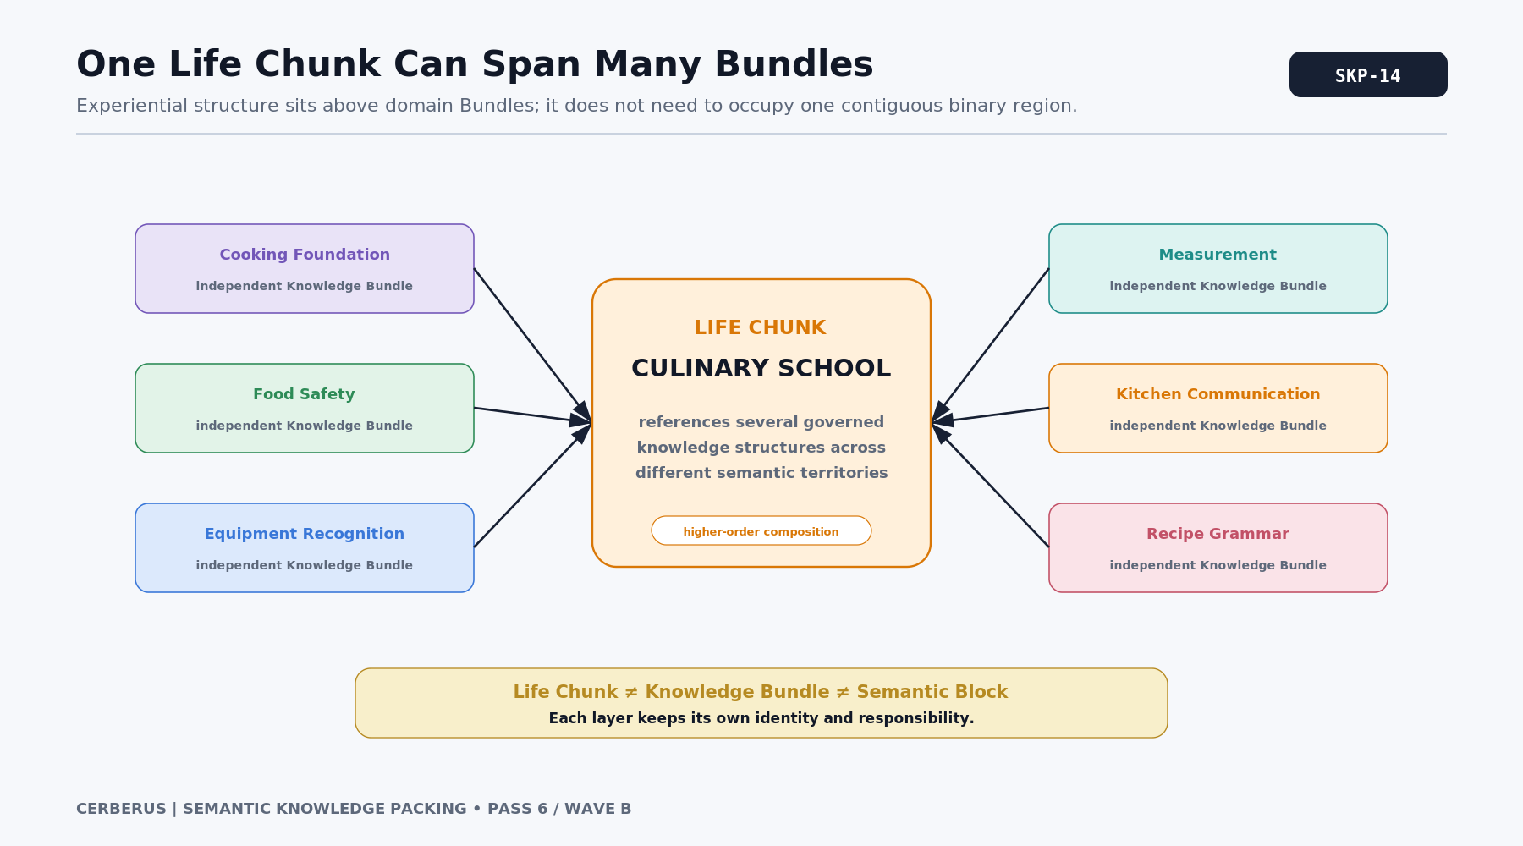
Figure 14. One Life Chunk Can Span Many Bundles.

15. Biography to Exact Knowledge Profile
Once Life Chunks are addressable, a biography can have computational consequences. A character raised on a farm, given general schooling, trained at culinary school, employed in a restaurant, and interested in fishing can accumulate the semantic contributions associated with each context. The resolved union produces one exact current Knowledge Profile.
This does not mean biography determines personality, moral choice, or competence. It means the backstory changes what semantic routes are plausibly available. A narrative fact such as "worked in a commercial kitchen for six years" can therefore stop being decorative metadata and become a source of structured world knowledge.
BIOGRAPHY -> Life Chunks -> Bundle union -> Exact Knowledge Profile

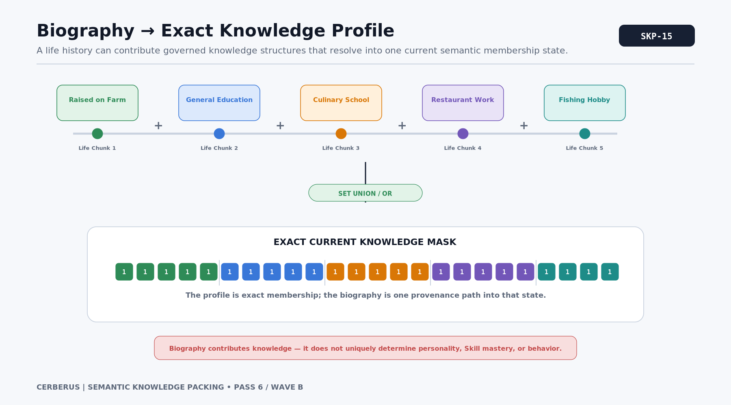
Figure 15. Biography to Exact Knowledge Profile.

16. Shared Chunks + Personal Residual
Large portions of a person knowledge are shared with other people. Language core, regional culture, general education, profession, and common hobbies may account for thousands of routes before any uniquely personal detail is considered. Those shared structures should be reusable rather than materialized as unrelated copies for every character.
The remaining individual knowledge can be represented as a Personal Residual: semantic memberships not already explained by the reusable Chunks used to reconstruct the profile. The residual is not noise. It is where unusual experiences, private interests, obscure facts, incomplete training, and one-off discoveries can remain exact without forcing every anomaly into the shared taxonomy.
K = C1 OR C2 OR ... OR Cn OR R

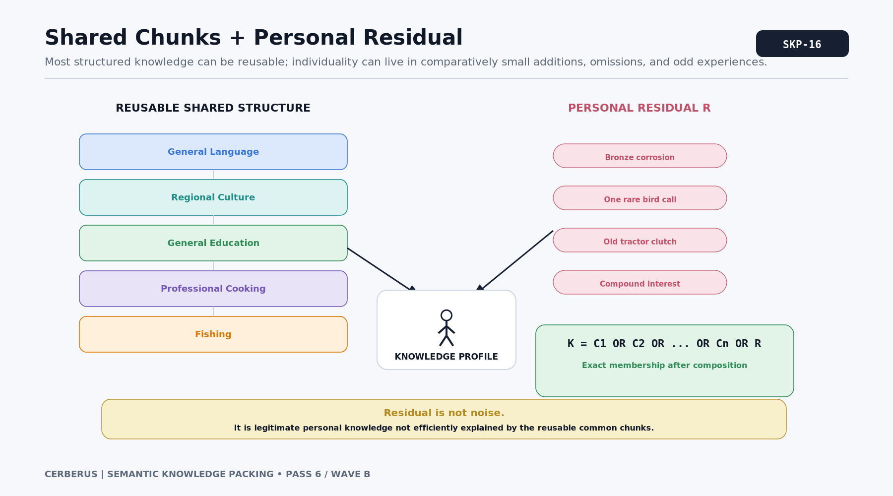
Figure 16. Shared Chunks + Personal Residual.
Population-scale implication
The expensive part of a character should often be the uncommon difference, not the enormous body of knowledge they share with everyone around them.

17. Exceptions Preserve Individuality
No professional or cultural Bundle should imply that every member learned every expected concept. A professional cook might lack pastry tempering and shellfish preparation yet know traditional smoke curing and wild mushroom identification. The architecture needs a way to preserve both the useful shared base and those departures.
Conceptually, a standard Bundle can be unioned with additions and then filtered by explicit missing knowledge. The exact implementation can use masks, residual lists, or other bounded structures, but the semantic rule is stable: common structure is a starting point, not a claim that individuals are identical.
K = (B OR A) AND NOT M

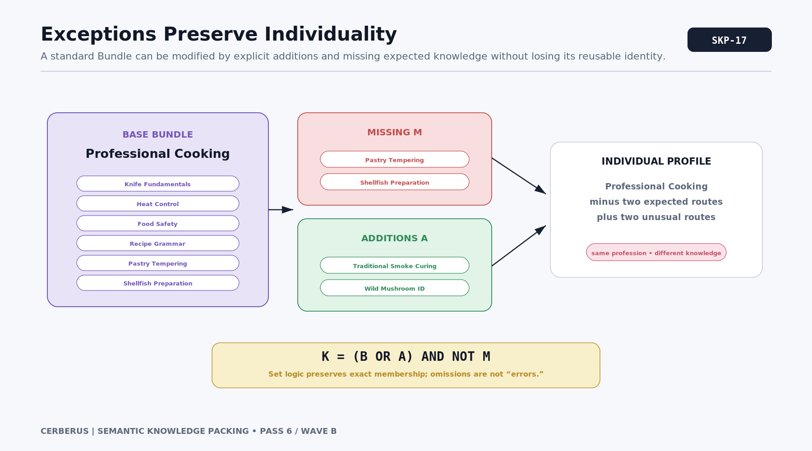
Figure 17. Exceptions Preserve Individuality.

18. Learning One Thing Should Change One Small Region
If a character learns one concept, the knowledge system should not require a conceptual rewrite of every other semantic membership. The new route can be activated directly, or a small Bundle can be added if the learning event genuinely supplies several concepts. This creates a natural delta model for changing knowledge over time.
An implementation may choose to cache a fully expanded mask for fast reads, store higher-order references and regenerate the mask, or keep both. The architectural point is independent of storage strategy: the semantic mutation is bounded by what was learned. The rest of the profile remains the same state.
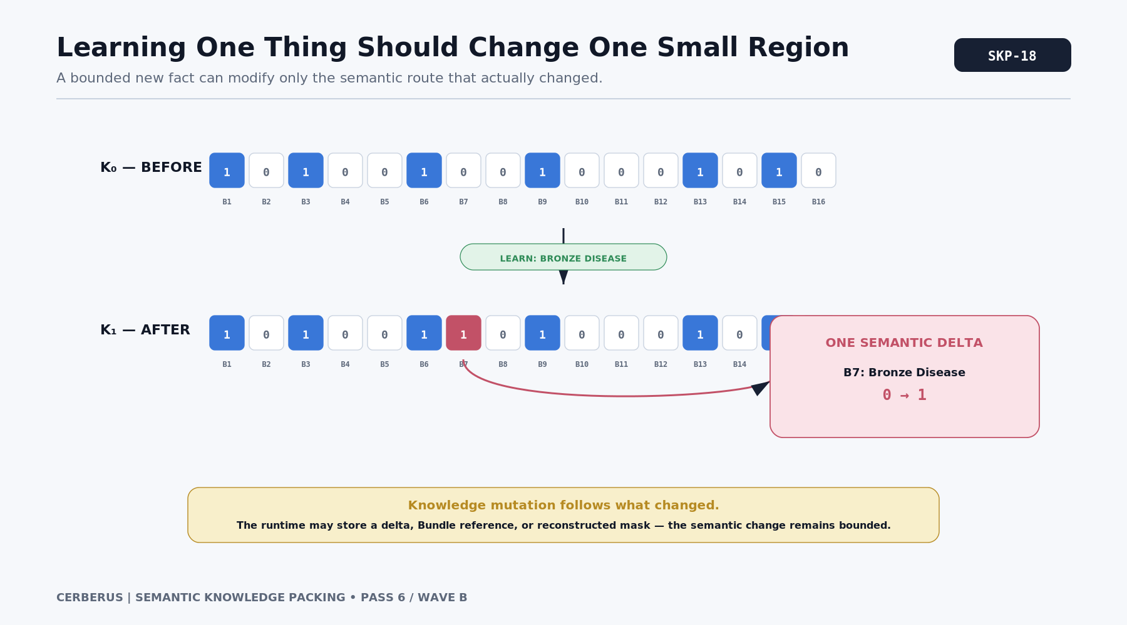
Figure 18. Learning One Thing Should Change One Small Region.
Cheap mutation
A large Language Pack can support frequent learning because a small knowledge event can be represented as a small semantic delta.

19. Forgetting Is Also a Bounded Delta
Knowledge loss is the inverse problem. A character may forget one concept, lose access to a specialized vocabulary through disuse, or retain a broad Life Chunk while missing particular expected details. Those changes should remove or suppress the relevant memberships without erasing the history that explains where the knowledge originally came from.
This distinction matters in persistent simulations. Current Knowledge Profile, historical experience, Skill state, and memory evidence do not have to collapse into one field. A forgotten route can be absent from current semantic comprehension while the biography still records that the character once studied the subject.
CURRENT KNOWLEDGE != BIOGRAPHICAL HISTORY != SKILL STATE

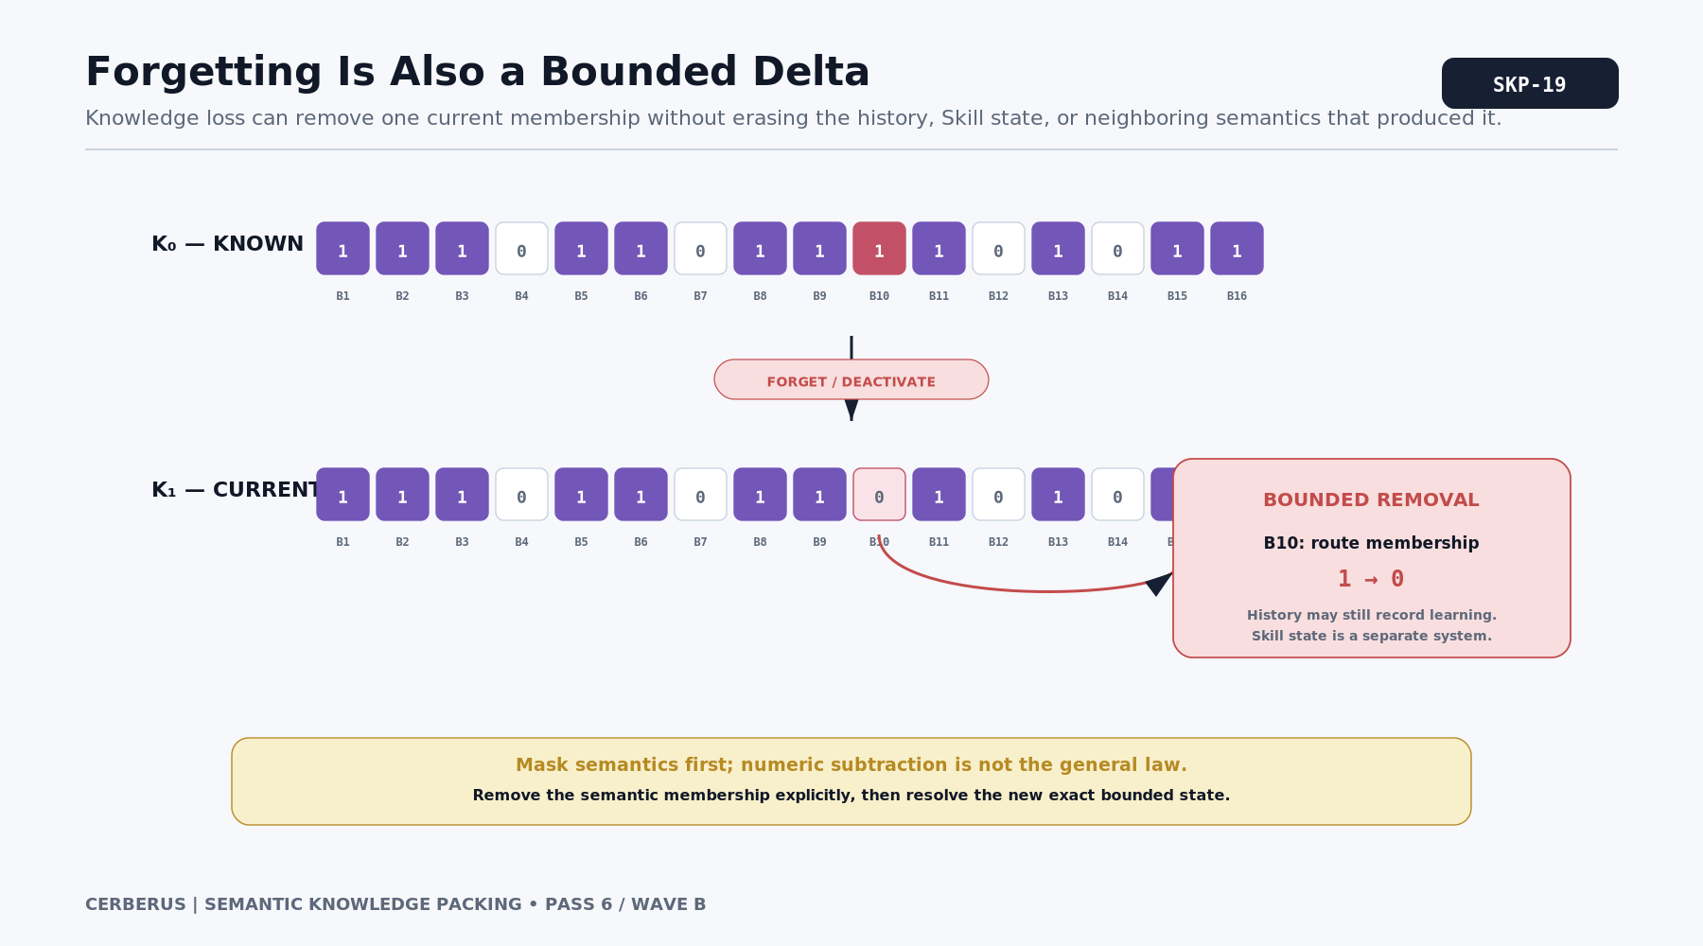
Figure 19. Forgetting Is Also a Bounded Delta.

PART IV

Compression-Aware Topology
The address space itself can be engineered so common semantic states tend to form regular, cheap, reusable patterns.

20. Language Topology Can Be Designed
A 1-n Language Pack is not forced to assign semantic routes arbitrarily. Placement can consider semantic coherence, learning sequence, Bundle overlap, expected population frequency, binary regularity, and room for future expansion. The result is a designed topology: an address space whose physical geometry supports the way the world actually teaches and uses its semantics.
The objective is not to make nearby integers mean nearby things. Binary positional weights make that impossible in the ordinary geometric sense: moving from one route position to the next changes the scalar contribution by a factor of two. The useful geometry is instead subset geometry. Which groups of active routes form cheap exact masks when the knowledge states the world actually produces are resolved?
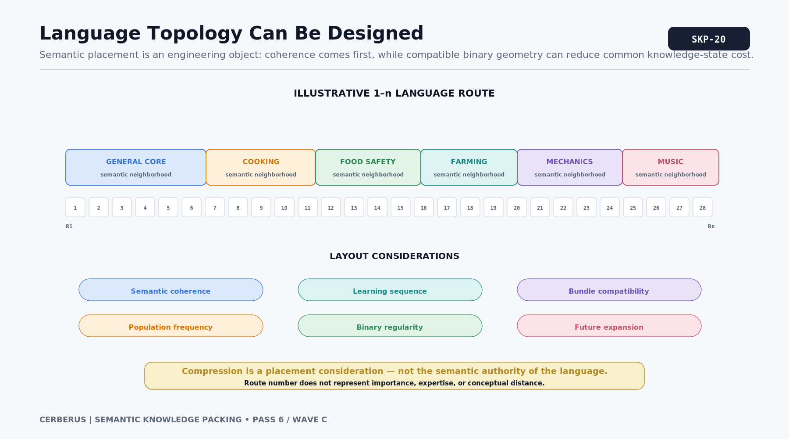
Figure 20. Language Topology Can Be Designed.
Semantic adjacency is not numeric adjacency
Compression-aware layout optimizes useful subsets and blocks, not smooth movement along the integer number line.

21. Rigid, Semi-Flexible, and General Semantics
Some semantic routes have strong local placement constraints because their meaning depends on a tight domain structure. Others have several plausible neighborhoods. General semantics such as measurement, sequencing, comparison, inspection, planning, communication, estimation, or basic safety can be useful across many domains and therefore offer greater placement flexibility.
That flexibility can be used strategically. If a common knowledge build is close to a favorable block structure, a congruent General Skill or General Semantic route may occupy a position that improves the resulting pattern. Its meaning remains genuine and stable; only its physical placement within an acceptable topology is chosen with compression in mind. This is strategic semantic packing, not meaningless filler.
MEANING STABLE; PLACEMENT OPTIMIZABLE WITHIN VALID SEMANTIC OPTIONS

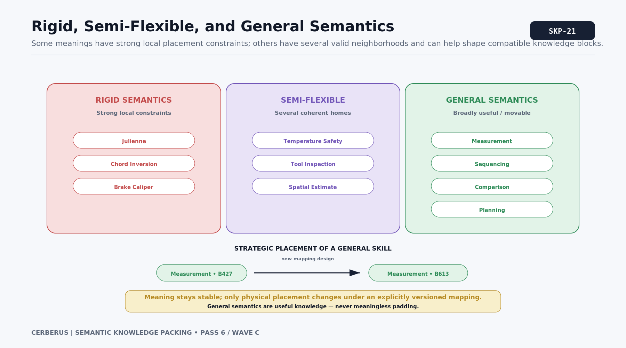
Figure 21. Rigid, Semi-Flexible, and General Semantics.

22. Semantic Integrity Before Compression
Compression is subordinate to semantic validity. A layout that produces a spectacular mathematical expression but scatters related concepts nonsensically, breaks a learning sequence, or destabilizes route identity is a bad language design. Mathematical convenience can choose among acceptable semantic layouts; it cannot manufacture acceptability.
A practical decision order is therefore semantic validity first, learning coherence second, stable identity and versioning third, and compression compatibility after those obligations are satisfied. These are architectural priorities rather than a claim that one global numeric optimizer can solve every tradeoff automatically.
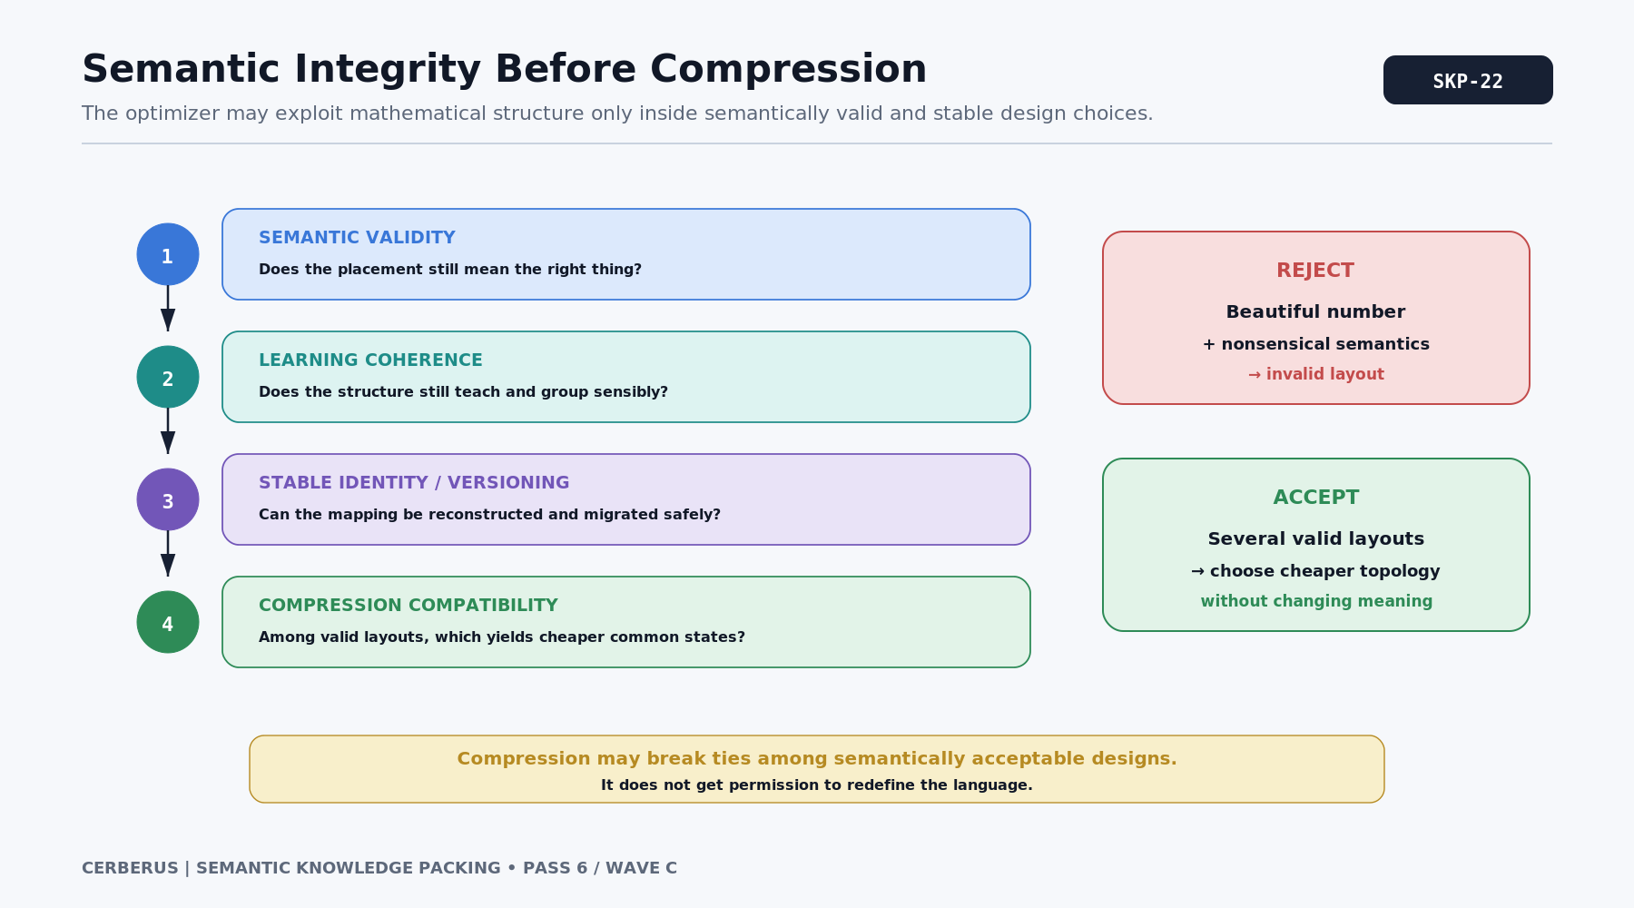
Figure 22. Semantic Integrity Before Compression.
Hard boundary
No meaningless padding. No arbitrary concept reassignment. No semantic distortion simply to reach a pretty number.

23. Designed Compression vs Opportunistic Compression
Designed compression is reliable because the language deliberately creates reusable structure: whole Semantic Blocks, Knowledge Bundles, Learning Stages, Life Chunks, and shared population cores. The architecture can depend on these structures because their semantics were intentionally governed.
Opportunistic compression begins only after the exact knowledge state already exists. The system may search its permitted mathematical grammar and discover that the resulting integer has an unexpectedly short exact expression. That shorter expression can be used for storage or transport, but the character knowledge was not chosen to produce it. If no useful expression is found, the architecture remains correct.
DESIGNED = semantic structure first | OPPORTUNISTIC = exact state first, math coincidence second

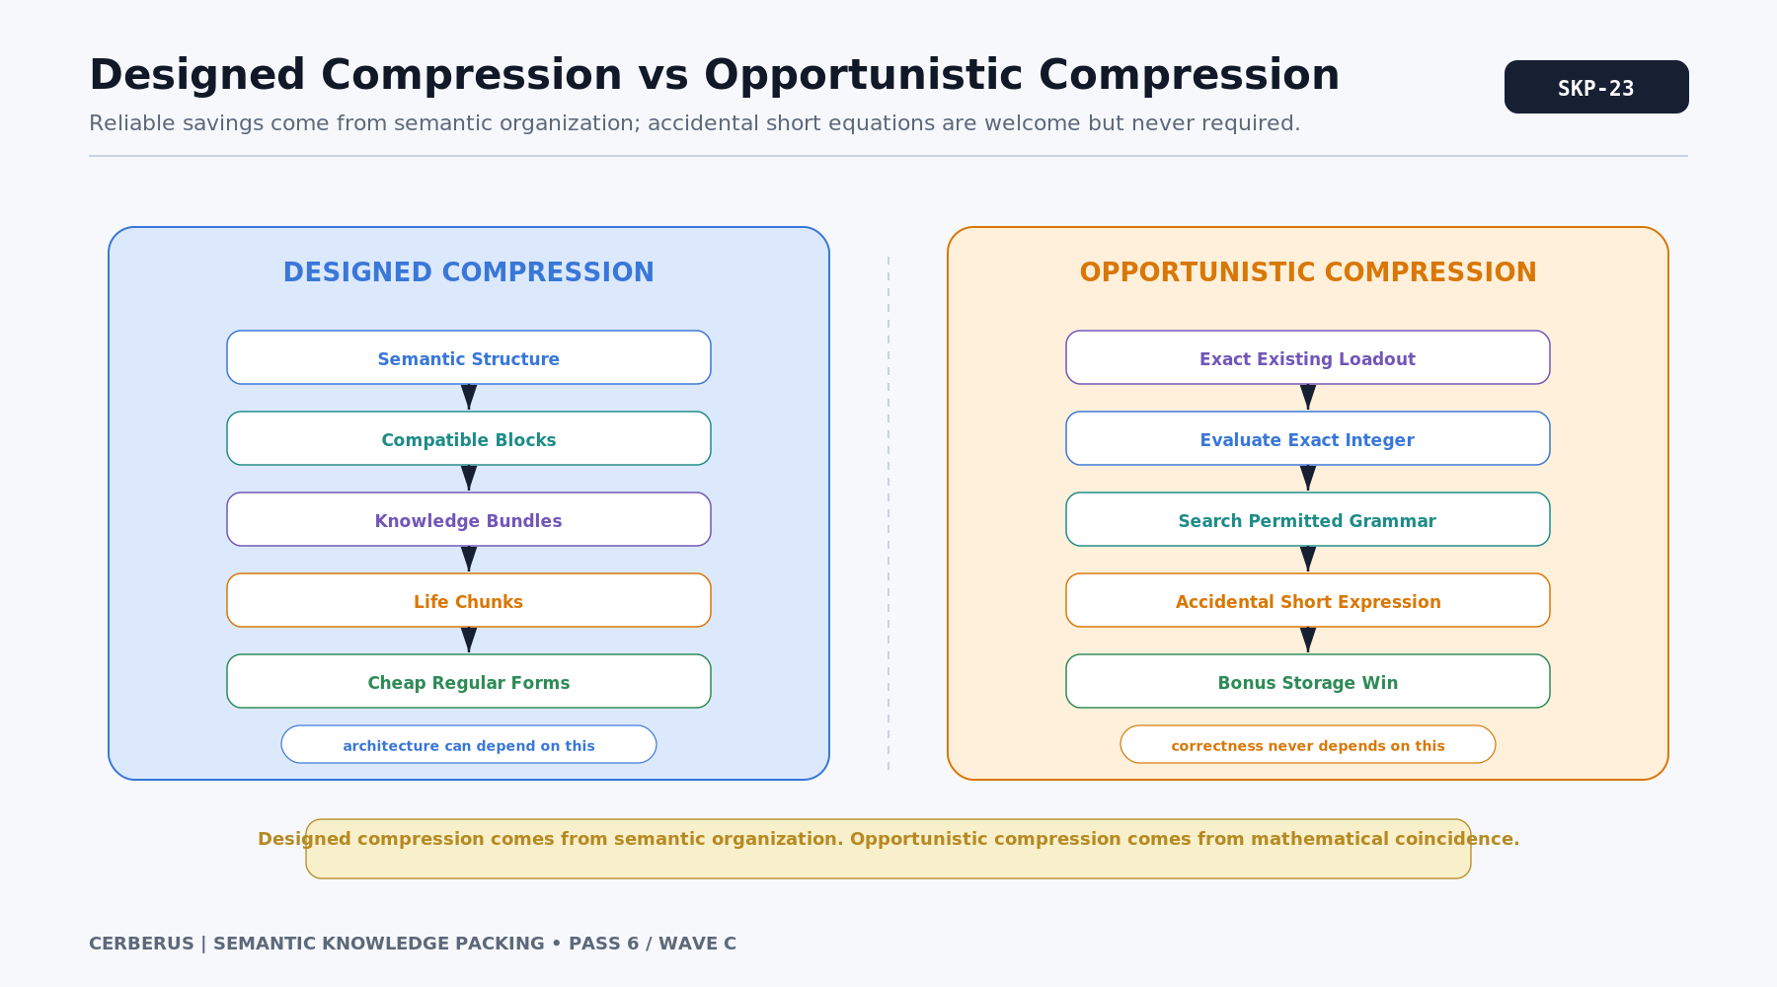
Figure 23. Designed Compression vs Opportunistic Compression.
Memorable distinction
Designed compression comes from semantic organization. Opportunistic compression comes from mathematical coincidence.

24. Compression Attractors
A compression attractor is an exact integer that is unusually cheap to describe under the bounded mathematical grammar permitted by the implementation. Full masks such as 2^n - 1, shifted blocks, powers, repeated masks, and small combinations of structured terms are obvious examples. Other useful forms can be registered later.
The word "attractor" describes representation cost, not a semantic force acting on characters. The system may rank exact states by the number of expression elements required to reproduce the integer, then study which common knowledge builds naturally lie near those low-description points. Because unrestricted shortest mathematical description is not generally computable, CERBERUS should use an explicit finite grammar and an operational cost metric rather than claim absolute mathematical optimality.
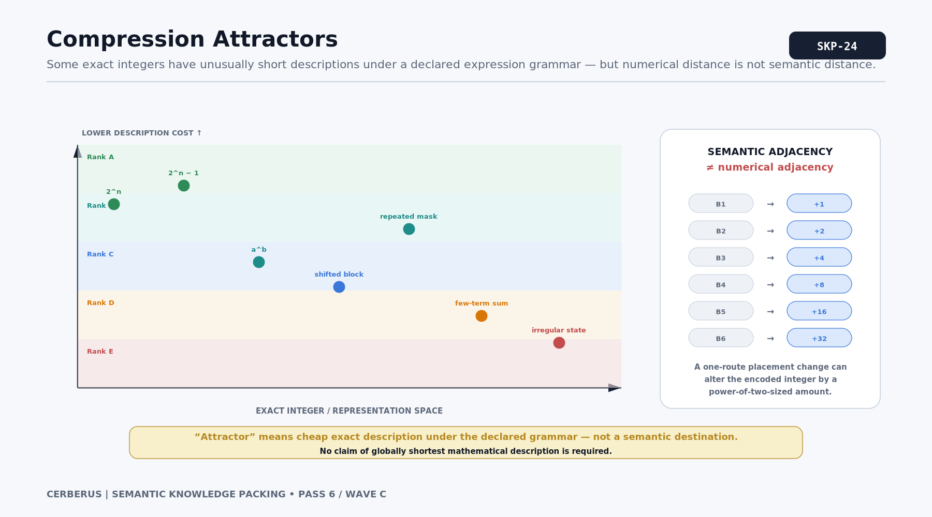
Figure 24. Compression Attractors.
Later mathematics
The compression landscape can be mapped and rank-coded, but the paper intentionally leaves the final expression grammar and optimization algorithm unresolved.

25. The 55^5 Anomaly
The flagship oddity illustrates opportunistic compression. One completely ordinary 29-route exact Knowledge Profile can resolve to the integer 503,284,375. That number happens to equal 55^5, so the entire exact mask can be referenced by a strikingly short mathematical expression when the Pack width and mapping contract are known.
The residual concepts in such a profile may be delightfully specific: bronze corrosion, a rare bird call, an old tractor clutch, compound interest, or any other facts acquired through a life. They may matter someday or never. The equation does not make them more meaningful. It merely stores the state cheaply. A one-route mapping change can destroy the coincidence even while the conceptual knowledge remains effectively the same.
55^5 = 503,284,375

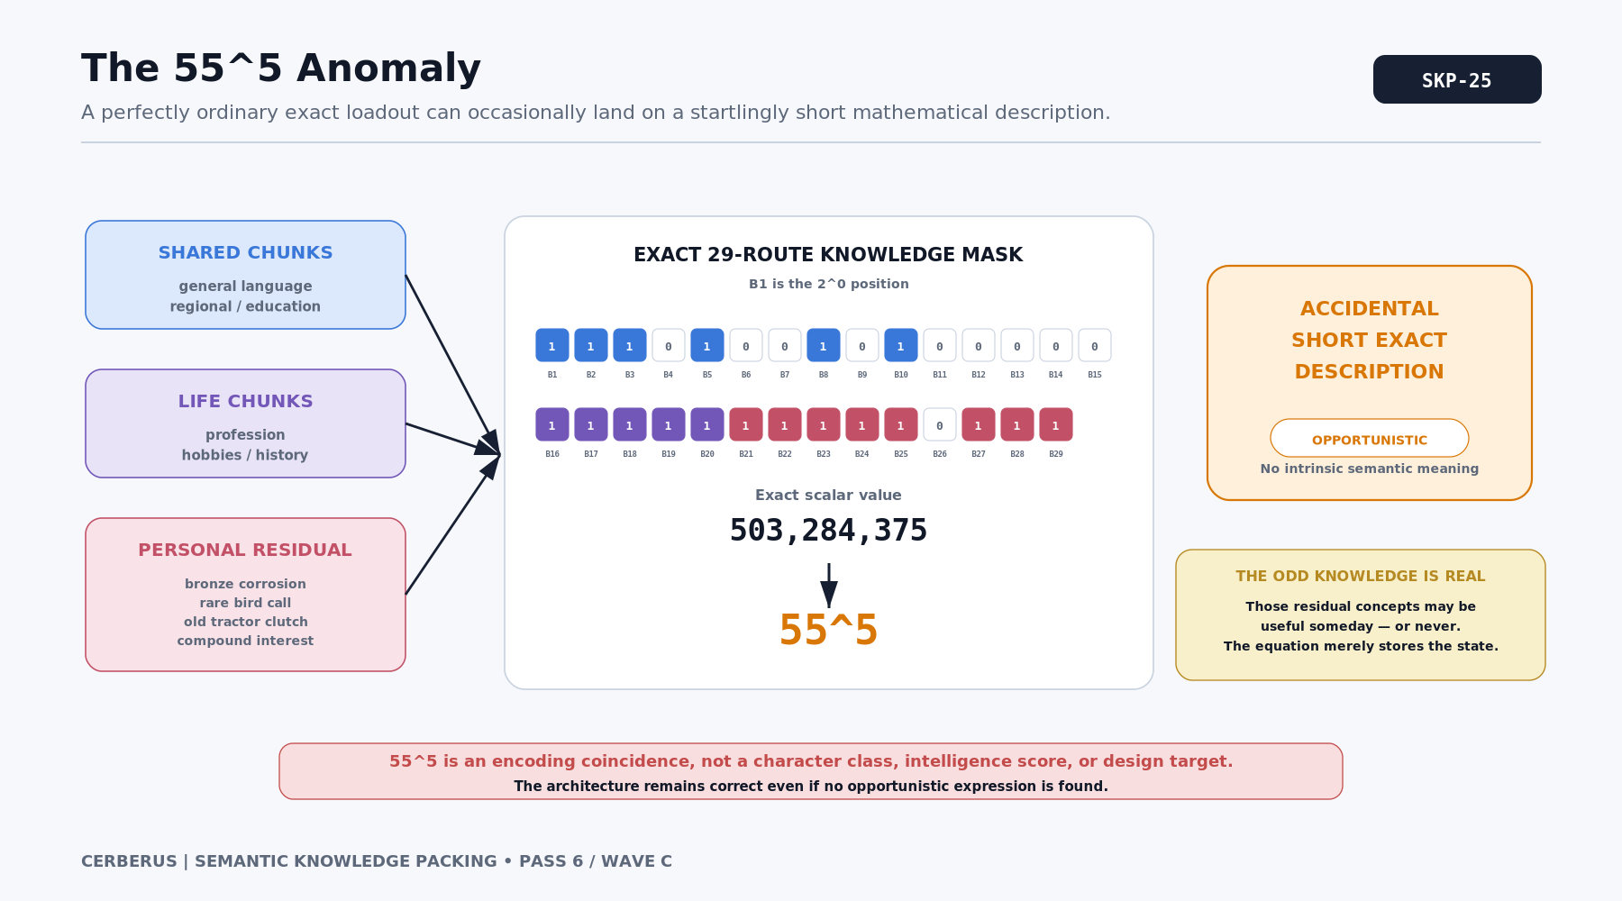
Figure 25. The 55^5 Anomaly.
Encoding coincidence
55^5 is not a character class, intelligence score, or design target. It is a bonus exact description discovered after the knowledge state exists.

26. Mapping Version Changes the Number, Not the Knowledge
Numeric interpretation depends on the route mapping. If Measurement moves from B427 to B613 under a redesigned Language Pack, every profile containing Measurement receives a different physical contribution to its integer. The same conceptual knowledge can therefore have one elegant representation under version 1 and an ugly representation under version 2.
This makes Mapping Version part of the encoding contract. Stored or transmitted numerical profiles must travel with enough context to identify the Language Pack and the exact route mapping against which they were encoded. Migrations can preserve conceptual knowledge while recomputing the mask and any derived compression expression.
INTERPRETATION CONTRACT = Language Pack ID + Mapping Version + Representation

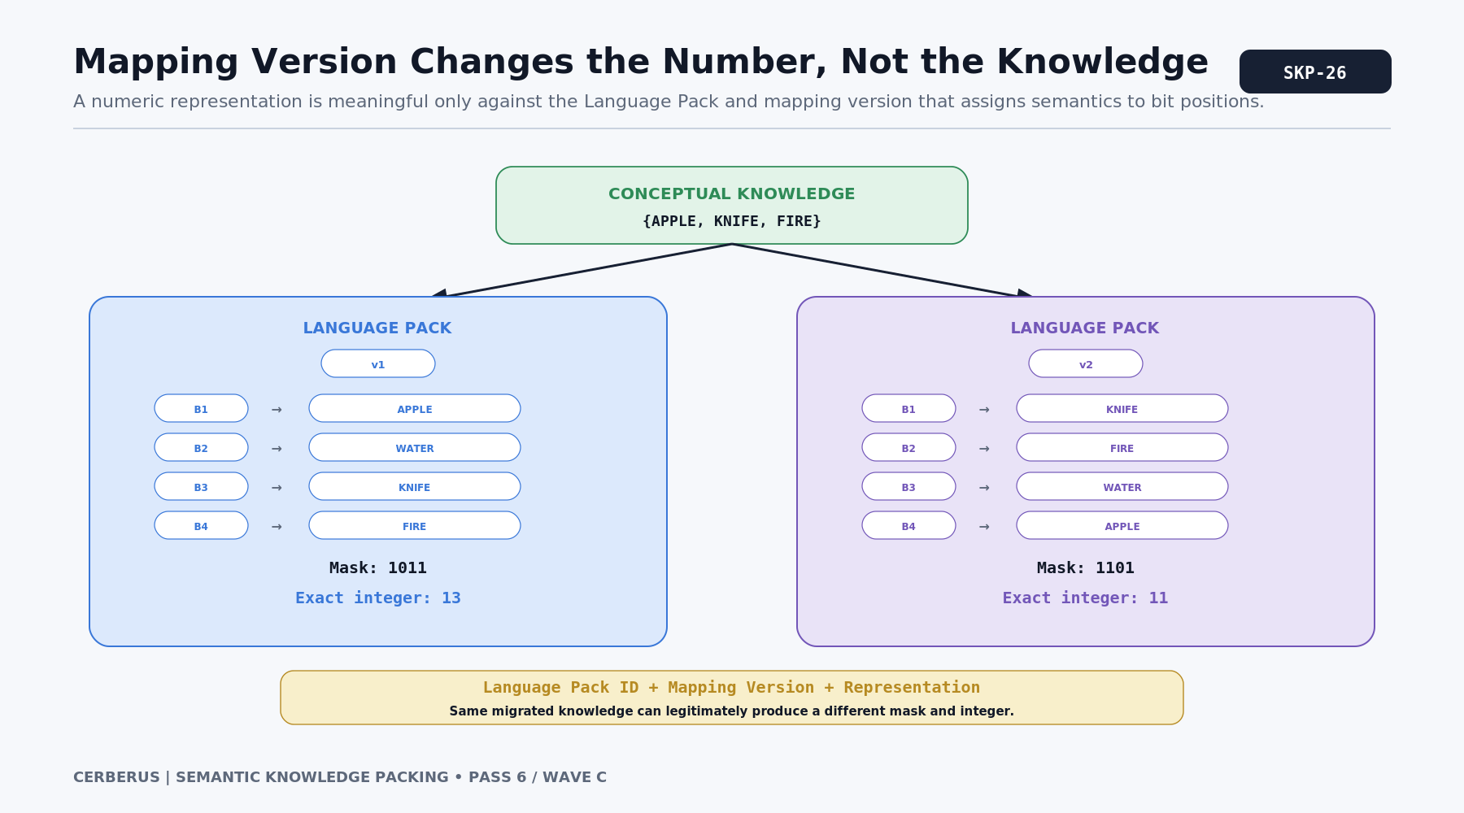
Figure 26. Mapping Version Changes the Number, Not the Knowledge.
Representation is versioned
Mathematical elegance belongs to a particular semantic topology. It is not an intrinsic property of the knowledge itself.

PART V

Population and World Use
Reusable knowledge structures become most valuable when entire communities share cores but diverge through profession, culture, history, and personal residuals.

27. A Village Shares Most of Its Knowledge
A village population may share a Language Core, regional culture, basic education, local geography, common tools, customs, and everyday safety knowledge. Those structures can be referenced as common semantic loadouts instead of independently rediscovering the same thousands of memberships for every resident.
Individuals then diverge through professions, organizations, hobbies, family histories, unusual experiences, and residual knowledge. A farmer, cook, mechanic, merchant, child, and elder can therefore share a large semantic foundation while remaining meaningfully distinct. The architecture exploits correlation without asserting homogeneity.
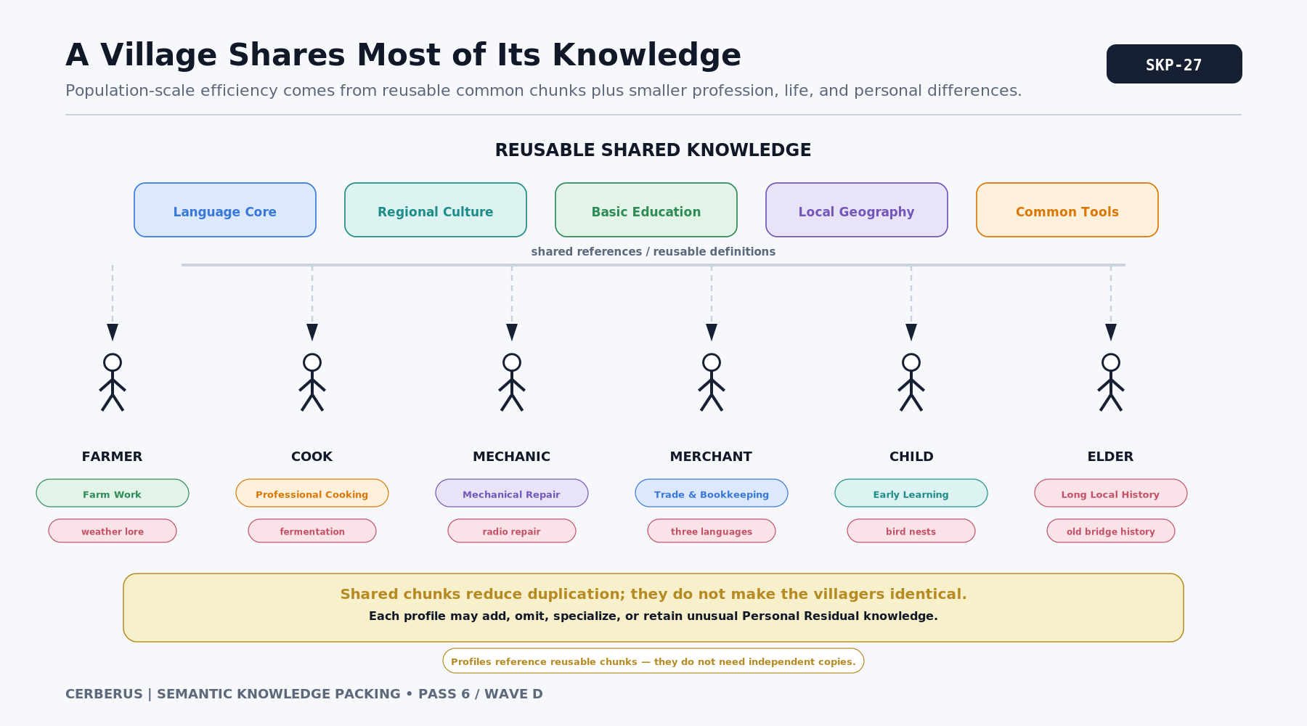
Figure 27. A Village Shares Most of Its Knowledge.
Population compression
Shared knowledge is reusable infrastructure; individuality is expressed through different Chunks, omissions, and Personal Residuals.

28. Life Chunks Produce Different Professions and Cultures
Profession and culture become structured contributors to semantic comprehension rather than immutable character classes. A coastal community may emphasize tides, fishing, navigation, marine weather, and boat equipment. A mountain community may emphasize terrain, livestock, snow, climbing, and weather interpretation. Both can exist under one shared World Truth while exposing different commonly learned semantic subsets.
Within either culture, profession Life Chunks further differentiate people. The same regional core can branch toward farming, cooking, mechanics, trade, medicine, governance, or craft. Personal Residuals keep the individual from collapsing into the statistical center of their group.
WORLD TRUTH != CULTURAL KNOWLEDGE != INDIVIDUAL KNOWLEDGE

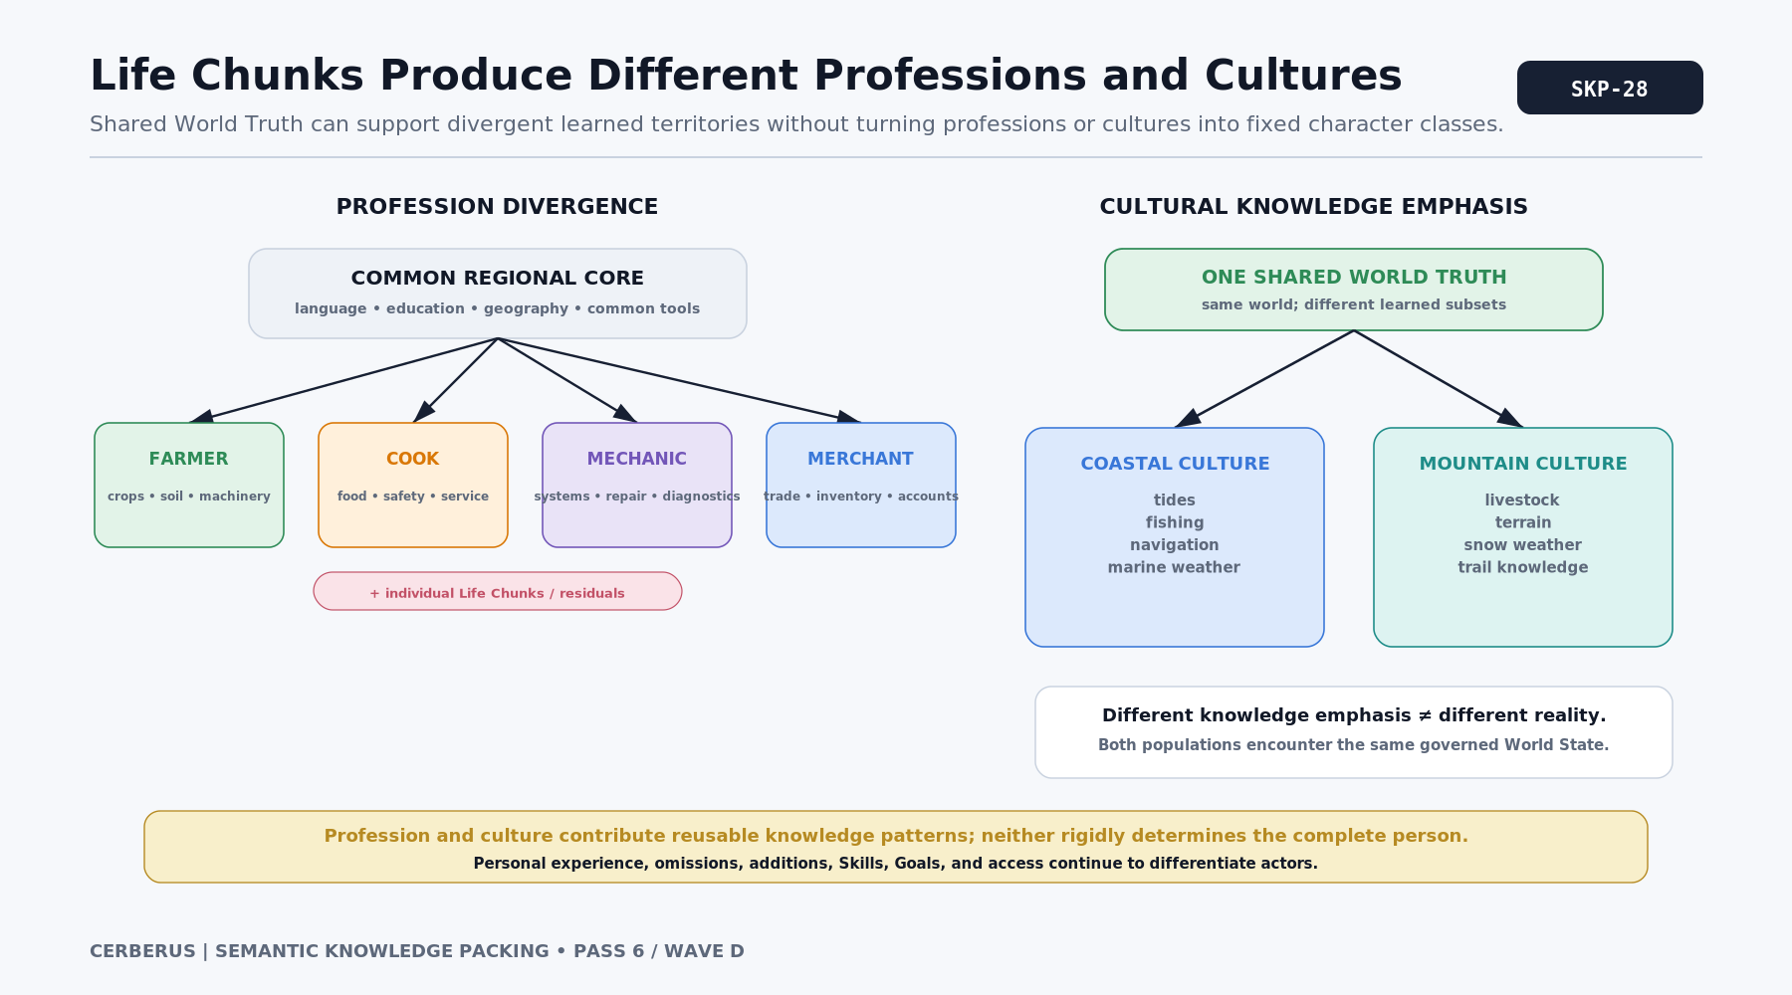
Figure 28. Life Chunks Produce Different Professions and Cultures.

29. Knowledge State Feeds World-Driven Agency
Packed knowledge determines what semantic identities an actor can resolve, recall, or recognize. It can answer questions such as: does this character understand JULIENNE, recognize a mandoline as cutting equipment, know that a particular plant is edible, understand the Task being requested, or know a route to the market?
Knowledge does not decide the action by itself. World-Driven Agency combines what the actor can understand with Skills, Goals, World Rules, Environment, resources, Task Access, and current World State. A character may understand a professional technique but lack the Skill to perform it, or possess the Skill but not know that the required equipment is nearby. The boundary preserves explainability.
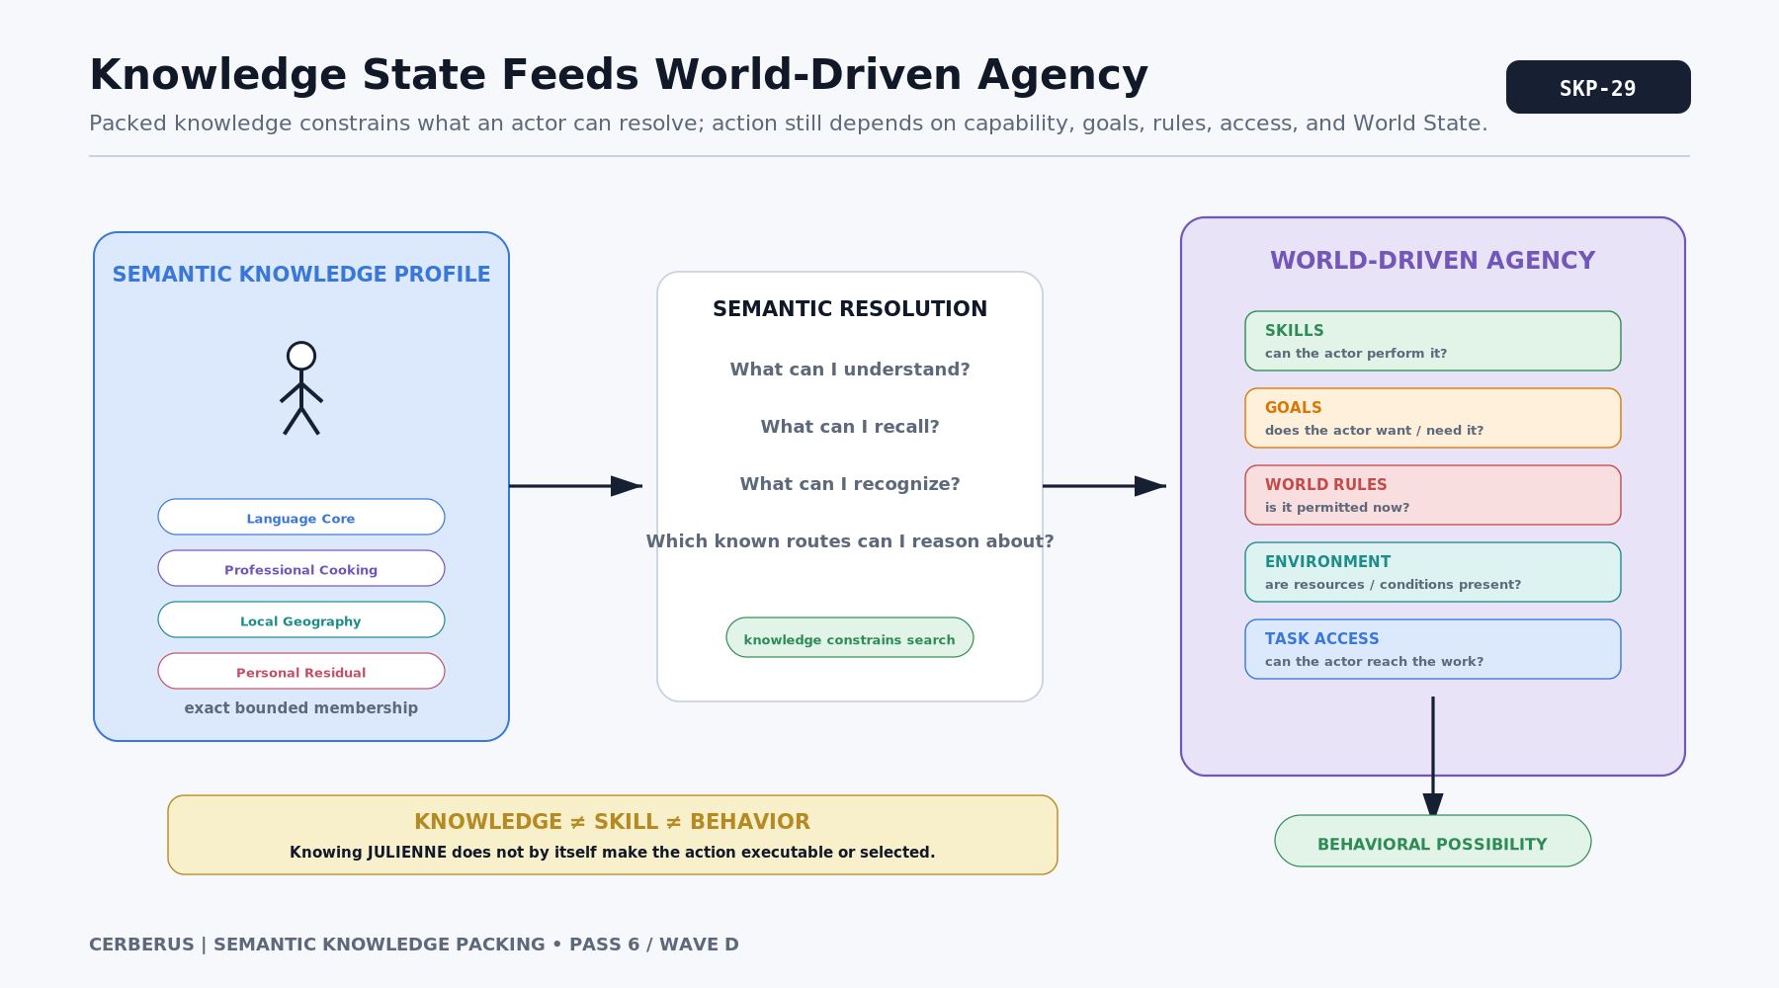
Figure 29. Knowledge State Feeds World-Driven Agency.
Knowledge is one bounded perspective
Semantic Knowledge Packing supplies comprehension and known facts. World-Driven Agency decides what possibilities survive the rest of the world constraints.

30. The Semantic Knowledge Packing Architecture
The full architecture begins with a governed World Semantic Language. Individual routes receive stable positions inside a versioned Language Pack. Physical Semantic Blocks support meaningful Knowledge Bundles; Bundles participate in Learning Stages; Stages and Bundles compose into Life Chunks; and a character Knowledge Profile resolves from shared structures plus Personal Residuals and explicit exceptions.
That profile expands into one exact bounded membership mask. The mask can be viewed as canonical binary or an equivalent exact integer. Designed mathematical forms exploit regular structures intentionally produced by the topology, while opportunistic forms exploit accidental short descriptions of the already-resolved integer. None of those representations owns the semantics. The semantics remain governed by the Language Pack and its Mapping Version.
The final Knowledge State then passes outward to the rest of CERBERUS. World-Driven Agency can ask what the actor understands and knows without needing a giant bespoke behavior script or duplicated knowledge table. The world remains semantically explicit; the actor remains bounded; and learning can change the actor by changing only the semantic structures that experience actually affected.
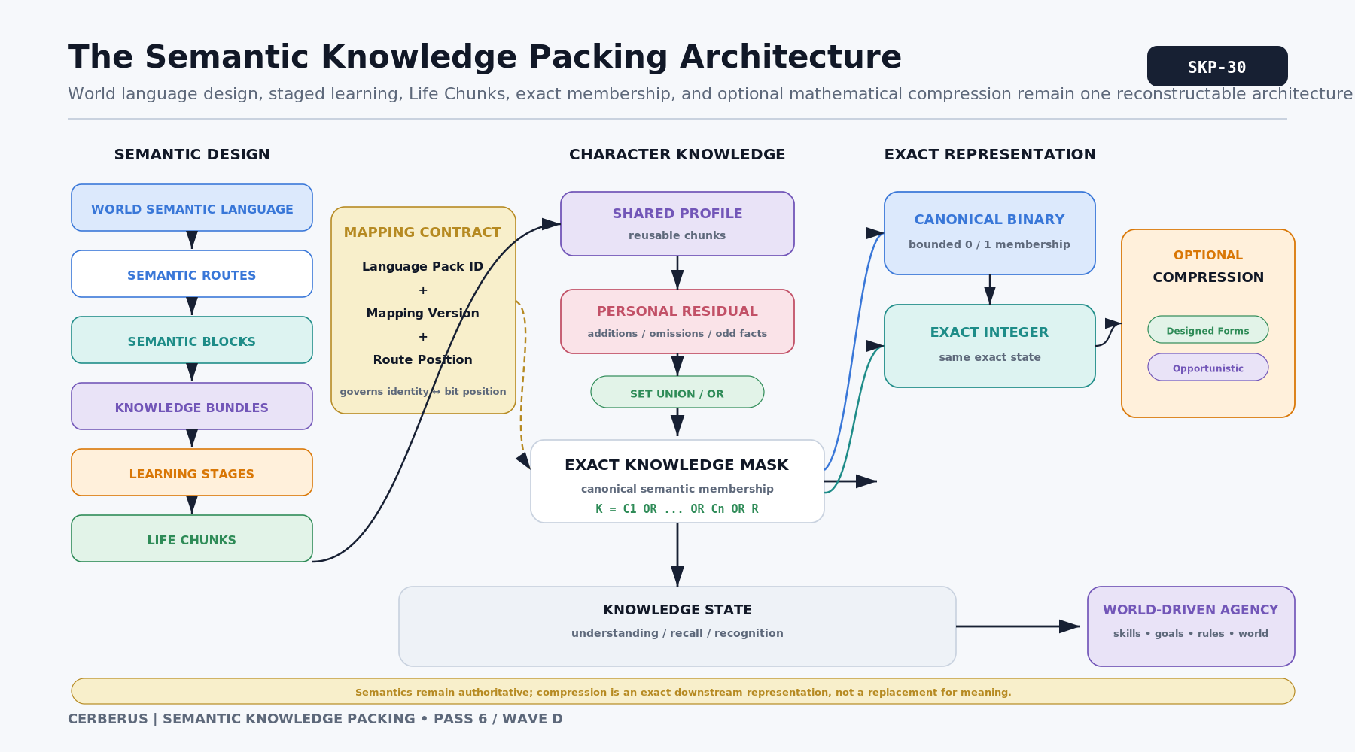
Figure 30. The Semantic Knowledge Packing Architecture.
Closing architecture law
Design the semantic language around how knowledge is learned and shared. Let exact binary state preserve membership. Let mathematics compress the representation when structure permits.

PART VI

Formal Principles and Engineering Boundaries
The architecture is compact only if semantic authority, representation, versioning, and downstream behavior remain separated.

31. Formal Principles of Semantic Knowledge Packing
Principle | Meaning
Canonical Knowledge Is Exact Membership | Knowledge resolves to an exact bounded set of semantic routes.
Binary and Integer Views Are Reversible | With Pack identity, width, convention, and Mapping Version fixed, binary and integer representations are equivalent.
Integer Magnitude Is Not Expertise | The scalar identifies a pattern; it does not rank knowledge quality, route count, or competence.
Knowledge Composition Is Set Union | Overlapping Bundles combine through semantic union / bitwise OR, not unrestricted arithmetic addition.
Human Knowledge Is Correlated | Language topology may exploit common learning, professional, cultural, and experiential structures.
Blocks Preserve Physical Topology | A Semantic Block is an addressing structure, not a source of meaning.
Bundles Preserve Semantic Meaning | A Knowledge Bundle exists because its routes belong together; compression benefits are secondary.
Learning Should Be Stageable | Domains may expose progressive semantic states without requiring one all-or-nothing expertise flag.
Life Can Compile Into Knowledge | Bounded life contexts may contribute reusable knowledge structures.
Shared Structure Precedes Personal Residual | Common knowledge should be reusable; individual variation remains explicit through residuals and exceptions.
Knowledge Mutation Follows the Change | Learning or forgetting a bounded concept should not conceptually rewrite unrelated semantic territory.
Topology Can Support Compression | Route placement may consider binary regularity when semantic integrity and stable identity are preserved.
No Meaningless Padding | A route may not be invented or semantically corrupted merely to improve a numeric pattern.
Designed and Opportunistic Compression Are Distinct | Reliable compression comes from governed semantic structure; mathematical coincidences are optional bonuses.
Mapping Version Is Part of Interpretation | A numeric state is not semantically interpretable without the mapping against which it was encoded.
Knowledge Is Not Behavior | Comprehension and known facts constrain agency but do not replace Skills, Goals, Rules, resources, or World State.

32. Responsibility and Implementation Boundaries
Semantic Knowledge Packing defines a representation architecture, not one mandatory database schema. A runtime may keep only chunk references and residual deltas, cache the fully expanded mask, store the integer, persist a compressed expression, or maintain several projections for different performance needs. What matters is that every projection reconstructs the same governed semantic state under the same Pack and Mapping Version.
The architecture also separates definition from occurrence. Language Pack definitions own semantic identity, route position, Bundle structure, and versioning. Character Knowledge Profiles own current membership, Life Chunk references, Personal Residuals, and explicit exceptions. Downstream systems own Skill levels, permissions, Goals, World Rules, Tasks, and behavior resolution. No compression representation is allowed to silently transfer authority across those boundaries.
Authoritative reconstruction path
Resolve Pack + Mapping Version -> expand reusable Chunks/Bundles -> apply additions/omissions/residual -> obtain exact mask -> derive integer -> optionally derive compressed expression.

Storage strategies may differ
- Chunk-first: store reusable Chunk references and a small residual, then expand when needed.
- Mask-first: maintain the exact current mask as authoritative state and use Chunks as provenance or reconstruction aids.
- Hybrid: keep reusable references plus a cached exact mask and invalidate/rebuild the cache when knowledge changes.
- Expression projection: store or transmit a short exact expression only when it is cheaper and the Pack/version contract is explicit.
These are implementation choices. The paper intentionally does not prescribe whether Airtable, a local database, a simulation engine, or a distributed service should materialize the same semantic state in exactly the same physical form.

33. Open Mathematical Work
The architecture deliberately stops before claiming a solved global optimization problem. The language can be compression-aware without possessing a mathematically perfect ordering. Several research questions remain useful precisely because the semantic contract is now clear enough to constrain them.
Research surface | Question
Bounded expression grammar | Which exact operators, constants, shifts, masks, powers, and registered forms are permitted when searching for a cheaper number representation?
Compression cost | How should expression length, token count, evaluation cost, storage bytes, or reconstruction latency be weighted?
Population weighting | Which knowledge states occur frequently enough that their compression cost should influence Language Pack placement?
Bundle layout | How should semantic locality, learning order, overlap, and future extensibility trade against block regularity?
General semantic placement | When several locations are semantically valid for a General Skill, which placement improves common loadouts without degrading language coherence?
Version migration | How should a Pack remap existing exact knowledge while preserving conceptual identity and invalidating obsolete compressed expressions?
Anomaly discovery | When is opportunistic compression worth searching for, and when is raw binary/hex/integer representation already cheaper operationally?
Research posture
Perfection is unnecessary. Hierarchical semantic Bundles already produce useful compression and cheap knowledge change. Compression attractors such as 55^5 can remain bonus oddities until the mathematical layer is mature.

APPENDIX A

Compact Mathematical Reference
Concept | Form | Meaning
Exact scalar | V = SUM[b_i * 2^(i-1)] | Unsigned exact encoding of the n-route membership mask under the declared B1 = 2^0 convention.
Full mask | FULL_MASK(n) = 2^n - 1 | All n semantic routes active.
Contiguous block | BLOCK(m,k) = (2^m - 1) * 2^k | m active routes beginning at zero-based offset k.
Bundle composition | K = B1 OR B2 OR ... OR Bn | Set-union composition; arithmetic addition is safe only for disjoint masks.
Learning delta | K_(t+1) = K_t OR B_new | Acquire a new route, Bundle, or stage without redefining unrelated knowledge.
Exceptions | K = (B OR A) AND NOT M | Start from a standard Bundle, add extra knowledge, then remove explicitly missing expected knowledge.
Shared + residual | K = C1 OR ... OR Cn OR R | Reconstruct a character from reusable common Chunks and a Personal Residual.
Interpretation contract | Pack ID + Mapping Version + width/convention + representation | Minimum context required to interpret a packed numeric knowledge state unambiguously.

Terminology
Semantic Route - One stable addressable meaning in a Language Pack.
Semantic Block - A physical region of route positions; may support efficient mathematical representation.
Knowledge Bundle - A meaningful reusable set of semantic routes.
Learning Stage - A governed incremental knowledge state inside a domain curriculum.
Life Chunk - A reusable knowledge contribution associated with a bounded life context.
Knowledge Profile - The actor current resolved semantic membership state.
Personal Residual - Knowledge not accounted for by selected reusable common structures.
Compression Attractor - An exact integer with unusually low description cost under a declared finite expression grammar.
Designed Compression - Compression produced intentionally through semantic structure and compatible topology.
Opportunistic Compression - A short exact mathematical description discovered after the semantic state already exists.
Mapping Version - The versioned contract assigning semantic identities to physical route positions.

APPENDIX B

Relationships to Neighboring CERBERUS Systems
Semantic Knowledge Packing is intentionally a bounded architecture. It depends on other CERBERUS systems for semantic identity, domain logic, reconstruction, runtime decision-making, and persistent continuity. The following relationships clarify ownership without requiring those neighboring systems to adopt the same storage representation.
System | Relationship
BIGFOOT / SKs | Provides governed semantic identities, BitWord structures, and domain meaning that Language Packs can route and bundle.
BOSS | Provides symbolic and semantic representation where stable symbols, Families, Communities, and Worlds are needed.
BOOTSTRAP | Can consume Learning Stages and Bundles as reconstruction or education paths without owning the canonical semantic identities.
SOLAR | Can route lexical definitions, terminology, and semantic recall associated with the routes represented in a knowledge profile.
SCE | Owns persistent storyboard continuity, bounded perception, memory/knowledge distinctions, and the broader model in which character state persists across events.
World-Driven Agency | Consumes bounded knowledge together with Skills, Goals, Rules, Environment, resources, and Task Access to derive explainable behavioral possibilities.
DARTBOARD | May project or operate on the resolved knowledge state at runtime without taking ownership of its semantic definitions.
EDIFICE | Can transport shared identity + version + binary/representation across compatible systems where reconstruction contracts are satisfied.
Boundary summary
Semantic Knowledge Packing answers "what semantic routes does this actor currently know?" It does not answer "what is true?", "what can the actor physically do?", or "what will the actor choose?" Those questions remain distributed across the wider CERBERUS architecture.

Source Architecture
This paper is a companion architecture within the CERBERUS semantic system. It assumes the existing distinction between exact semantic identities, stable mapping/version contracts, bounded actor knowledge, persistent World State, and World-Driven Agency. The 30 figures in this document are the approved Pass 6 Semantic Knowledge Packing figure set and are treated as part of the paper semantic contract.

