CERBERUS
SEMANTIC DISPLAY
Self-Describing Semantic Projection and Autonomous Visualization
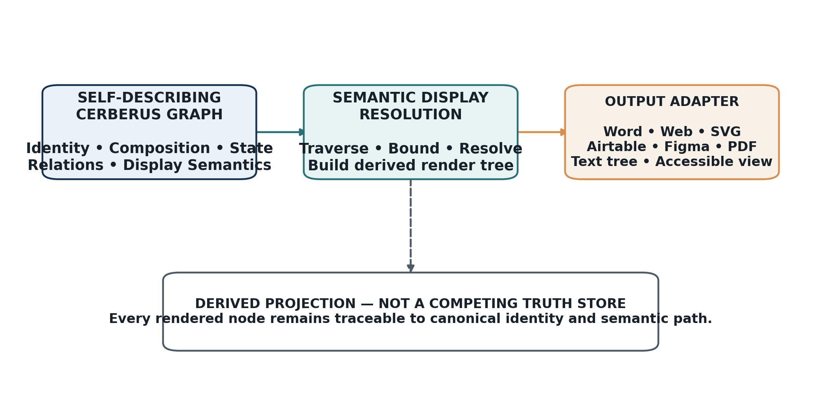
System statement: Semantic Display is a derived projection over self-describing CERBERUS structure.
Formal System Specification
Draft Version 0.1 | Review Baseline
14 August 2026
Core principle: if semantic structure describes itself sufficiently, visualization becomes traversal.

Document Control and Normative Status
Document control
Field | Value
Document | CERBERUS Semantic Display: Self-Describing Semantic Projection and Autonomous Visualization
Version | Draft v0.1
Status | Proposed formal review baseline; not a separate canonical registry
Architecture | CERBERUS / BIGFOOT / Semantic Kernel ecosystem
Primary function | Deterministic derivation of visual, spatial, textual, and multimodal projections from registered semantic structure
Canonical ownership | Existing CERBERUS identities, contracts, state, relations, permissions, and provenance remain authoritative
Date | 14 August 2026

NORMATIVE BOUNDARY
CERBERUS Semantic Display does not create a new source-of-truth registry. It resolves existing semantic identity, composition, state, relation, and display-relevant properties into derived renderings. Any implementation that requires the visualization layer to redefine canonical meaning is non-conforming.

Abstract
CERBERUS Semantic Display specifies a derived visualization capability for a semantic system whose components are self-describing from atomic identity upward. BIGFOOT already registers stable identities for Bits, BitGroups, Pure BitWords, and Compound BitWords; Semantic Kernel contracts already declare addresses, group structure, encodings, and valid state; Reader, SCREEN, CALL, and Personal Perceptual Language mechanisms already distinguish canonical state from projection. Semantic Display formalizes the consequence: once those semantic structures describe what they are, what they contain, how they relate, what state is currently instantiated, and which perceptual mappings are available, a conforming runtime can generate diagrams and other representations by traversal rather than by manually authoring a second semantic layer.
The specification defines display sufficiency, display-semantic relations, color and form mappings, layout and connector semantics, inheritance and viewer overrides, display modes, resolution behavior, entity-specific render contracts, route-portal rendering, state-aware displays, Reader/SCREEN/CALL/PPL integration, deterministic resolution algorithms, traceability, accessibility requirements, autonomous documentation generation, conformance laws, tests, and failure modes. FOOD-128 is used as the principal worked example because its nested BitGroup structure demonstrates how atomic self-description can branch and chain into a complete BitWord while remaining fully inspectable.

Architectural Dependencies and Related Specifications
Normative architectural context
Existing document | Role in this specification
BIGFOOT 4 Tables Details | Provides the four-table identity spine and the principle that semantic identity is registered once while structures reuse it by reference.
CERBERUS Semantic Bitword Notation & BIGFOOT Identity Registry v2.0 | Defines Bits, BitGroups, Pure/Compound BitWords, placement, composition, route bits, extensions, and identity/state separation.
CERBERUS SK Reader: Explanation & Export v1.0 | Defines deterministic explanation of canonical bitstate and the rule that presentation decodes declared meaning rather than inventing it.
CERBERUS Linked Semantics: SCREEN + CALL v1.0 | Defines projection, bounded semantic resolution, permission-first traversal, and display of registered correspondences.
Personal Perceptual Languages / MRMM v1.0 | Defines explicit, inspectable mappings from canonical data into color, sound, geometry, motion, space, text, haptics, and other modalities.
Bit-Level Architecture of the CERBERUS Cybernetic Loop v1.0 | Defines the separation of identity, classification, semantic possibility, transformation, constraint, instantiated state, and recursive feedback.

Where this specification defines new display semantics or projection behavior, those provisions are new to Semantic Display. Where it references existing identities, relationship classes, route notation, Reader behavior, SCREEN/CALL behavior, or Personal Perceptual Language boundaries, the existing source specification remains authoritative for the underlying CERBERUS concept.

Contents
Section | Topic
1 | Purpose and Scope
2 | Architectural Boundaries and Core Claims
3 | Self-Describing Semantic Substrate
4 | Formal Display Resolution Model
5 | Display-Semantic Properties
6 | Display Inheritance, Overrides, and Modes
7 | Structural Display Contracts by Entity Type
8 | Route, Relationship, and Extension Rendering
9 | Runtime State and Cybernetic Display
10 | Reader, SCREEN, CALL, and PPL Integration
11 | Deterministic Display Resolution Pipeline
12 | Traceability, Accessibility, and Safety
13 | Autonomous Documentation Generation
14 | Worked Example: FOOD-128
15 | Worked Examples: Compound and Extension Views
16 | Conformance Laws and Tests
17 | Failure Modes and Anti-Patterns
18 | Implementation Guidance, Versioning, and Formal Summary
Appendix A | Notation and Variable Registry
Appendix B | Example Semantic Display Relations
Appendix C | Conformance Checklist
Glossary | Defined Terms
Index | Subject Index by Section Reference

1. Purpose and Scope

1.1 Purpose
The purpose of CERBERUS Semantic Display is to specify how a conforming runtime may derive a human- or machine-facing representation from semantic structure that is already registered elsewhere in CERBERUS. The system is intended to support autonomous generation of BitWord decomposition diagrams, BitGroup layouts, instance views, relation maps, <R> portals, Compound trees, cybernetic traces, teaching diagrams, engineering views, accessible projections, and multimodal representations without copying semantic meaning into a dedicated visualization database.
The central architectural premise is that semantic display becomes a natural system property when components are self-describing from atomic identity upward. A Bit can declare its canonical identity, state domain, encoding, unit or scale, and relations. A BitGroup can declare its members, order, width, and group-level interpretation. A BitWord can declare ordered placements, version, width, route bits, and linked groups. A Compound BitWord can declare ordered constituents. A ModelKey can bind current state to an object. Bitlinks and extensions can declare relation topology. Once those facts are machine-resolvable, a renderer no longer needs a manually maintained diagram definition to know what to show.

1.2 Scope
- Derived visual, spatial, textual, symbolic, and multimodal representation of registered CERBERUS semantics.
- Generic rendering of Bits, BitGroups, Pure BitWords, Compound BitWords, Kernel instances, ModelKeys, Bitlinks, extension routes, Operators, Rules, and selected cybernetic traces.
- Display-relevant semantic relations such as default color, form, layout, label policy, value presentation, connector class, and portal behavior.
- Semantic inheritance and fallback rules that allow generic rendering when explicit display mappings are absent.
- Viewer- and context-specific projection through Personal Perceptual Languages without redefining canonical semantic identity.
- Resolution-aware rendering, including bounded structural decomposition and optional SCREEN-driven granularity.
- Autonomous generation of documentation figures and tables from the same canonical semantic substrate used by the runtime.
- Traceability from every rendered semantic object back to canonical identity, occurrence, state source, and relation path.

1.3 Explicit Non-Goals
- Semantic Display does not create or replace the Bits, BitGroups, BitWords, Compound BitWords, NodeKeys, Models, ModelKeys, Operators, Rules, Bitlinks, extension bindings, Reader definitions, SCREEN state, CALL results, or PPL mappings that already exist elsewhere.
- Semantic Display does not infer new domain meaning merely because two visual objects are adjacent, similarly colored, or spatially connected.
- Semantic Display does not make one visual mapping universally correct. A default mapping may exist while accessible, professional, educational, personal, or artistic projections differ.
- Semantic Display does not treat color as the sole carrier of identity, relation, state, validity, or epistemic status.
- Semantic Display does not require that every semantic object define custom display metadata. Generic typed fallback rendering is permitted and expected.

1.4 Conformance Language
The terms MUST, MUST NOT, SHALL, SHALL NOT, SHOULD, SHOULD NOT, and MAY are used in the engineering sense. MUST and SHALL identify requirements necessary for conformance. SHOULD identifies a strong default that may be departed from only with a documented rationale. MAY identifies an optional capability compatible with the specification.

2. Architectural Boundaries and Core Claims

2.1 No Separate Semantic Display Registry
CSD CORE LAW
CERBERUS Semantic Display SHALL NOT require a dedicated canonical registry that duplicates semantic meaning already represented by CERBERUS. Display-relevant semantics are ordinary registered properties or relationships of existing semantic objects, or are derived from those objects by deterministic rules.

This specification deliberately distinguishes a system capability from a new truth-owning subsystem. An implementation may use helper tables, caches, generated render trees, style catalogs, or adapter configuration for efficiency, but those artifacts are not allowed to become the authoritative definition of what a Bit, BitGroup, BitWord, relation, or state means. If the helper surface disagrees with the canonical semantic source, the canonical source wins.

2.2 Canonical Semantics Versus Projection
Canonical Semantic State ≠ Display Projection
The projection may be disposable, regenerated, personalized, or rendered through a different modality without changing the source semantics.
This separation follows the same architectural boundary already used elsewhere in CERBERUS: the Reader decodes canonical bitstate; SCREEN and CALL produce bounded projections of registered semantics; Personal Perceptual Languages map the same underlying state into sensory and symbolic channels. Semantic Display generalizes the rendering consequence while preserving the same ownership boundary.

2.3 Semantic Structure Determines Topology; Display Semantics Determine Projection
Topology = f(identity, membership, placement, composition, relation, extension)
Color, form, spacing, layout preference, modality, and visual emphasis select a projection of that topology; they do not create the topology.
For example, if the BitGroup manifest states that Calories, Fat, Protein, and Carbohydrates form Nutrition44, that membership is canonical semantic structure. A horizontal branch, vertical stack, four-column row, or audio sequence may all represent that same structure. The chosen presentation may be explicitly mapped, inherited from a display convention, overridden by a viewer PPL, or selected by a target adapter, but it must remain traceable to the same underlying group membership.

2.4 Emergent Capability
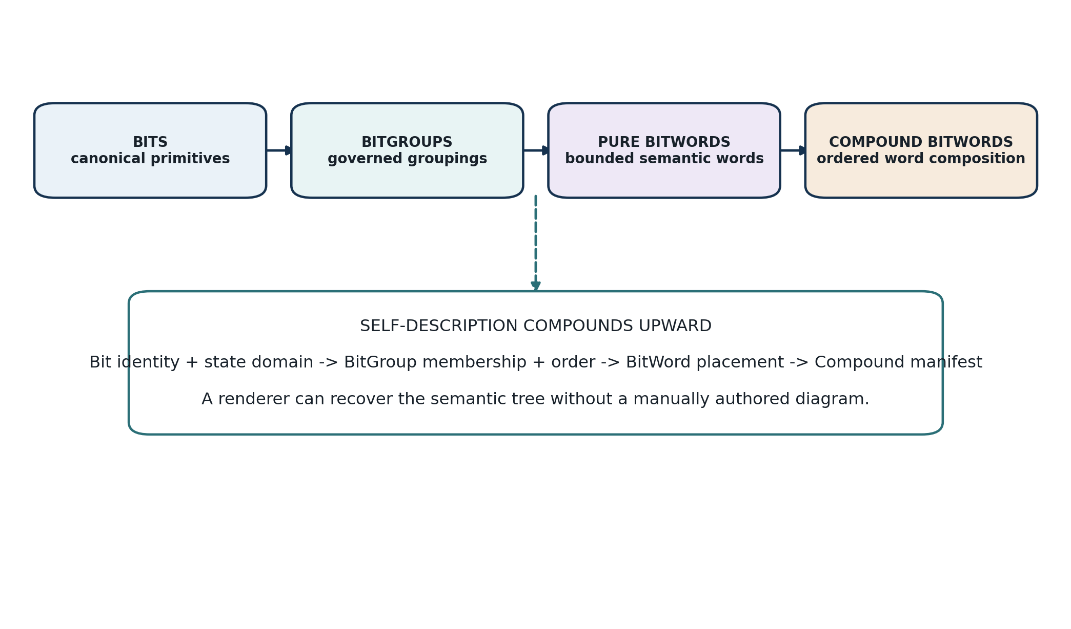
Figure 1. Self-description compounds upward from Bits to Compound BitWords.
A conforming system therefore treats autonomous visualization as a consequence of semantic normalization. The more completely the semantic objects describe their identity, type, containment, relationships, state, and optional display semantics, the less bespoke display logic is required. The ideal end state is not a library of manually drawn diagrams but a set of deterministic projections generated from the same semantic substrate the system executes.

3. Self-Describing Semantic Substrate

3.1 BIGFOOT Four-Layer Identity Spine
BIGFOOT provides the canonical identity backbone required by Semantic Display. Its four linked levels - Bits, BitGroups, Pure BitWords, and Compound BitWords - make semantic primitives, groupings, bounded words, and ordered compositions independently addressable. Human-readable names remain labels; stable IDs preserve identity across reuse, occurrence, documentation, rendering, and future system growth.
Table 1. Existing self-description usable by Semantic Display
Layer | Canonical identity | Display-relevant information already available
Bit | Bit ID | Name, definition, state domain, encoding, unit/scale, relations, route status, provenance.
BitGroup | BitGroup ID | Members, order, width, encoding/decode rule, parent/related groups, reuse status.
Pure BitWord | BitWord ID | Prefix, width, version, placements, linked groups/bits, route bits, prefix lineage.
Compound BitWord | BitWord ID / Compound identity | Ordered constituent manifest, occurrence order, total width, nested composition.

3.2 Identity Versus Occurrence
Semantic Display MUST preserve the difference between canonical identity and local occurrence. A Bit ID answers what a semantic primitive is. A B### address answers where an occurrence appears in a particular BitWord. A BitGroup ID identifies a governed grouping. A placement record identifies its local range and order. A Compound constituent occurrence identifies one placement of a complete BitWord inside a larger composition. Visual layouts that collapse these distinctions may be aesthetically convenient but are semantically unsafe.

3.3 Placement as Deterministic Display Input
A BitWord link to a Bit or BitGroup is insufficient for deterministic decomposition unless the occurrence and order are also known. The placement structure therefore becomes a critical display input. At minimum, Semantic Display SHOULD be able to resolve parent BitWord, child semantic identity, start address, end address, ordinal position, and any explicit occurrence-level metadata. From those facts it can construct engineering layouts, proportional widths, branch order, address labels, and exact trace-back paths.

3.4 Display Sufficiency
Display sufficiency is the condition in which enough semantic information exists to produce the requested display without inventing missing domain meaning. The required information varies by display mode. A label-only view may need only canonical identity and a human-readable name. A structural BitWord decomposition requires the ordered placement manifest. A state-aware Reader view requires an instantiated word and decode contract. An extension view requires the route identity and binding. A cybernetic view requires state, Operator, Rule, ModelKey, or event references.
S_D(O, M, rho, C) = sufficient registered information for object O under mode M, resolution rho, and context C
FAIL CLOSED
If the requested representation depends on semantic information that cannot be resolved canonically, the renderer SHOULD degrade to a lower-information view or mark the element unresolved. It MUST NOT fabricate a domain interpretation simply to complete a diagram.

4. Formal Display Resolution Model

4.1 Core Function
D = R_display(G, S, C, rho, P, M)
The formal expression above is conceptual rather than a mandated implementation API. It states that a display D is resolved from the canonical semantic graph G, optional instantiated state S, active context C, requested semantic resolution rho, viewer or perceptual mapping P, and display mode M. A runtime may add caches, adapters, device constraints, accessibility policy, or authorization context as internal parameters provided the resulting behavior remains conforming.
Table 2. Core display variables
Variable | Meaning
G | Registered CERBERUS semantic graph: identities, composition, Bitlinks, extensions, classifications, and declared display relations.
S | Optional instantiated state: ModelKey, Kernel instance, current Bitword, event, or snapshot.
C | Context: selected object, page, operation, task, SCREEN Context, or requested documentation scope.
rho | Requested semantic resolution or bounded decomposition depth.
P | Viewer/PPL/accessibility mapping applied after canonical display semantics are resolved.
M | Display mode: structure, layout, instance, Reader, relation, extension, cybernetic, teaching, engineering, or another registered mode.
D | Derived display projection, including semantic nodes, edges, labels, state, and traceability metadata.

4.2 Ephemeral Render Tree
A conforming implementation MAY construct an ephemeral render tree as an intermediate representation. The tree is a derived execution artifact, not a canonical semantic registry. It may contain display nodes with references to canonical identities, labels, semantic paths, display forms, colors, current values, child nodes, relation edges, and provenance. Caches MAY persist such trees for performance, but they MUST be invalidated or regenerated when their canonical dependencies change.

4.3 Traceability Function
τ(v) → {canonical identity, occurrence/path, state source, display-source relations, provenance}
Every semantic visual element v SHOULD support trace-back through τ. A user selecting a box labeled Umami should be able to determine which canonical semantic object it represents, where it occurs in FOOD-128, which display color or form relation produced the current appearance, whether the shown value comes from an instantiated ModelKey, and whether any PPL or accessibility override modified the presentation.

4.4 Projection Non-Mutation
render(O) ⇒ state(O) unchanged
Rendering is observational. A display operation MUST NOT mutate the canonical semantic object, Bitword state, ModelKey, extension binding, or relationship merely because it was exposed. Interactive controls that initiate changes are permitted, but the mutation must pass through the appropriate CERBERUS Operator/Rule/state-transition mechanism rather than being treated as a side effect of display.

5. Display-Semantic Properties

5.1 General Rule
Display semantics are ordinary semantic properties or relations attached to existing objects. This specification does not mandate one storage table or one relationship implementation. In Airtable they may be linked records or normalized relation records; in another runtime they may be graph edges, typed properties, or references to shared semantic objects. The requirement is that the relation type and target are explicit enough to inspect, version, and trace.
Table 3. Proposed display-semantic relations
Proposed relation | Purpose | Typical target
DISPLAY_COLOR | Recommended semantic color for a declared display purpose. | Color semantic object such as Pale Pink or Deep Red.
DISPLAY_FORM | Recommended spatial or symbolic form. | Square, Scalar Box, Portal, Container, Membership Grid.
DISPLAY_LAYOUT | Recommended arrangement for child semantics. | Chain, branch, grid, stack, nested tree.
DISPLAY_VALUE_MODE | How an instantiated value is normally exposed. | Boolean, decoded scalar, gauge, enum label, mask members.
DISPLAY_LABEL_MODE | How labels are selected or abbreviated. | Canonical name, plain-language label, engineering ID.
DISPLAY_CONNECTOR_HINT | Optional projection hint for a known semantic relation class. | Structural branch, Bitlink edge, extension portal, projection edge.
DISPLAY_ICON / SYMBOL | Optional linked symbol used in compatible projections. | BOSS symbol, icon NodeKey, glyph reference.

5.2 Color Is a Semantic Object
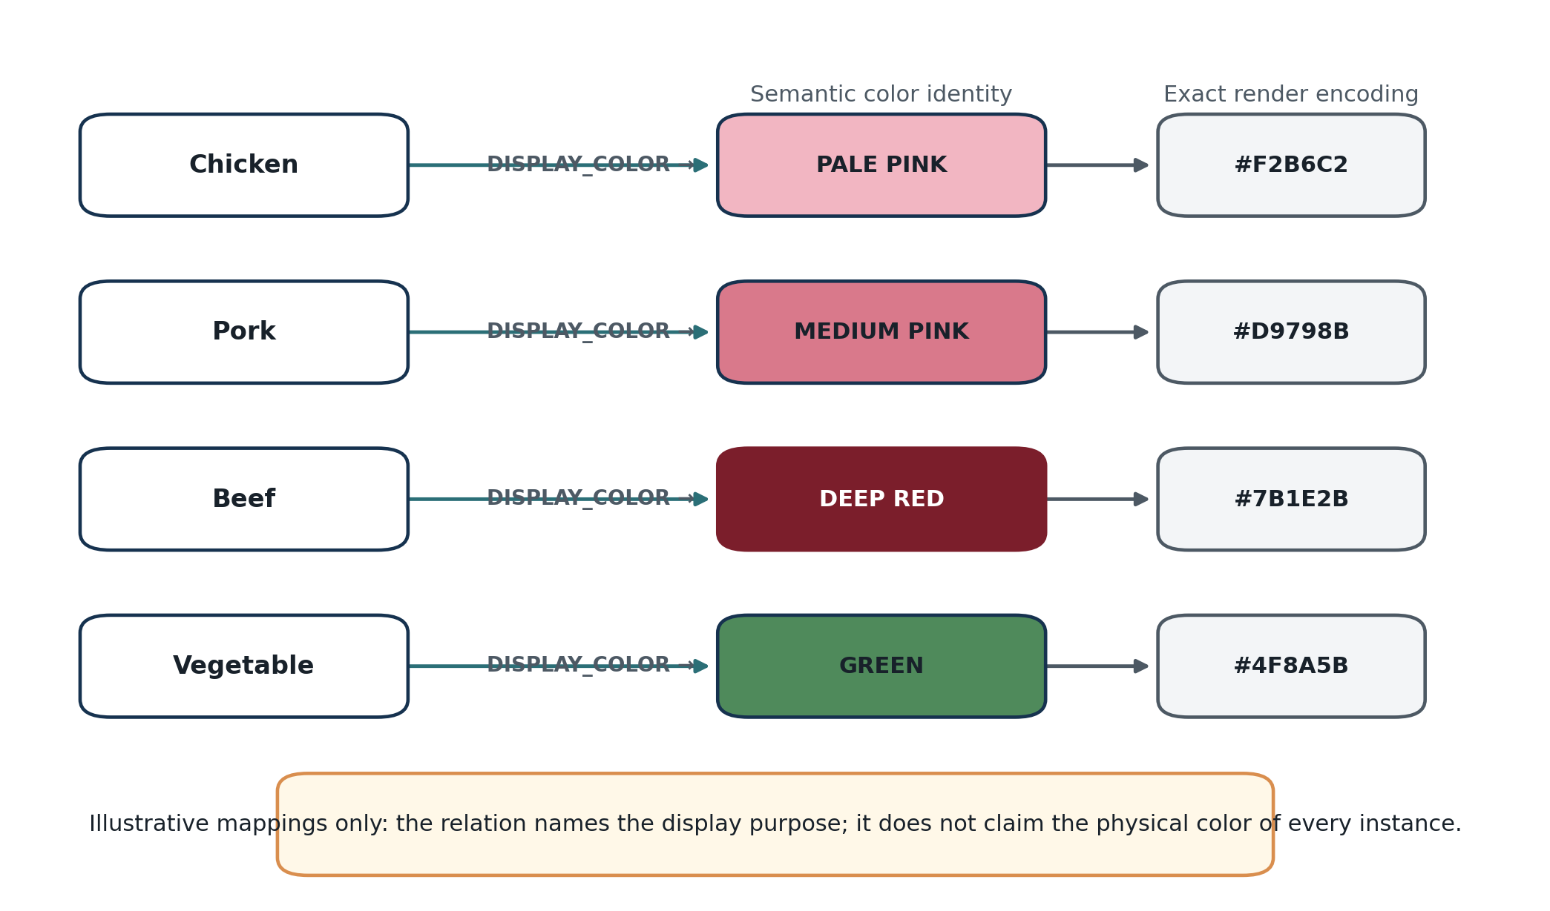
Figure 2. Example display-color relations resolve through semantic color identity to exact render encoding.
A display color name SHOULD be treated as a semantic identity distinct from any one encoding. For example, Deep Red may link to HEX, RGB, HSL, CIELAB, print-safe values, dark-mode variants, and accessibility metadata. A renderer selects the representation appropriate to its target device. Changing the exact HEX associated with a color semantic object therefore does not require editing every object that references that color.

5.2.1 Physical Color Versus Display Color
A conforming system MUST distinguish a property that means the physical or observed color of an object from a property that means how the object should be represented in a semantic display. Chicken DISPLAY_COLOR → Pale Pink does not assert that every chicken object is physically pale pink. The display relation states the purpose of the mapping. If a physical-color Kernel exists, that physical state remains a separate semantic source.

5.3 Form and Value Presentation
Form mappings allow the visual grammar to become self-describing as well. Boolean Bits may default to compact squares or state indicators; scalar groups may default to labeled rectangles containing raw and decoded values; membership masks may render as a grid; enums may render as one active labeled state; Pure BitWords may render as governed containers; Compound BitWords should preserve constituent boundaries; Route Bits may render as portals. These are projection defaults, not changes to the underlying semantic class.

5.4 Layout Semantics
Layout mappings specify how children should be spatialized when structural information alone does not uniquely determine the most useful arrangement. Useful layout concepts include CHAIN, HORIZONTAL_BRANCH, VERTICAL_BRANCH, STACK, GRID, INLINE, NESTED, COMPOSITION_TREE, and RELATION_GRAPH. An implementation MAY add other layouts, but the selected arrangement must preserve the underlying membership and ordering rules.

5.5 Connector Semantics
A line is not semantically neutral. Semantic Display MUST preserve the distinction among structural contribution, Compound composition, identity reuse, Bitlink relationship, canonical extension, namespaced extension, cybernetic state flow, and projection. A renderer MAY use color, stroke, glyphs, labels, directionality, or shape to differentiate the relation, but at least one non-color indicator SHOULD remain visible so the distinction survives monochrome or accessible rendering.
Table 4. Relation classes that MUST remain distinguishable
Relation class | Meaning | Recommended visual cue
Structural contribution | Child Bit/BitGroup contributes to a governed parent grouping. | Solid branch toward parent; no relation glyph required.
Compound composition || | Complete BitWords are composed in an ordered manifest. | Constituent containers feeding a parent Compound; preserve boundaries.
Identity ≡BIT | Occurrences resolve to the same canonical semantic primitive. | Identity label or paired endpoint annotation.
Bitlink ⇄ | Distinct semantic objects have an explicit registered relation. | Typed labeled edge; direction shown when applicable.
Canonical extension ↳ | Resolution continues through a governed target. | Portal form + ↳ glyph.
Namespaced extension ↳{NS} | Resolution continues through a namespace-bound target. | Portal form + namespace label.
Cybernetic flow | State/parameter/Rule/Operator dependency or transition. | Directional arrow with stage label.
Projection | Derived representation of canonical state. | Dotted or otherwise clearly secondary edge.

6. Display Inheritance, Overrides, and Modes

6.1 Inheritance
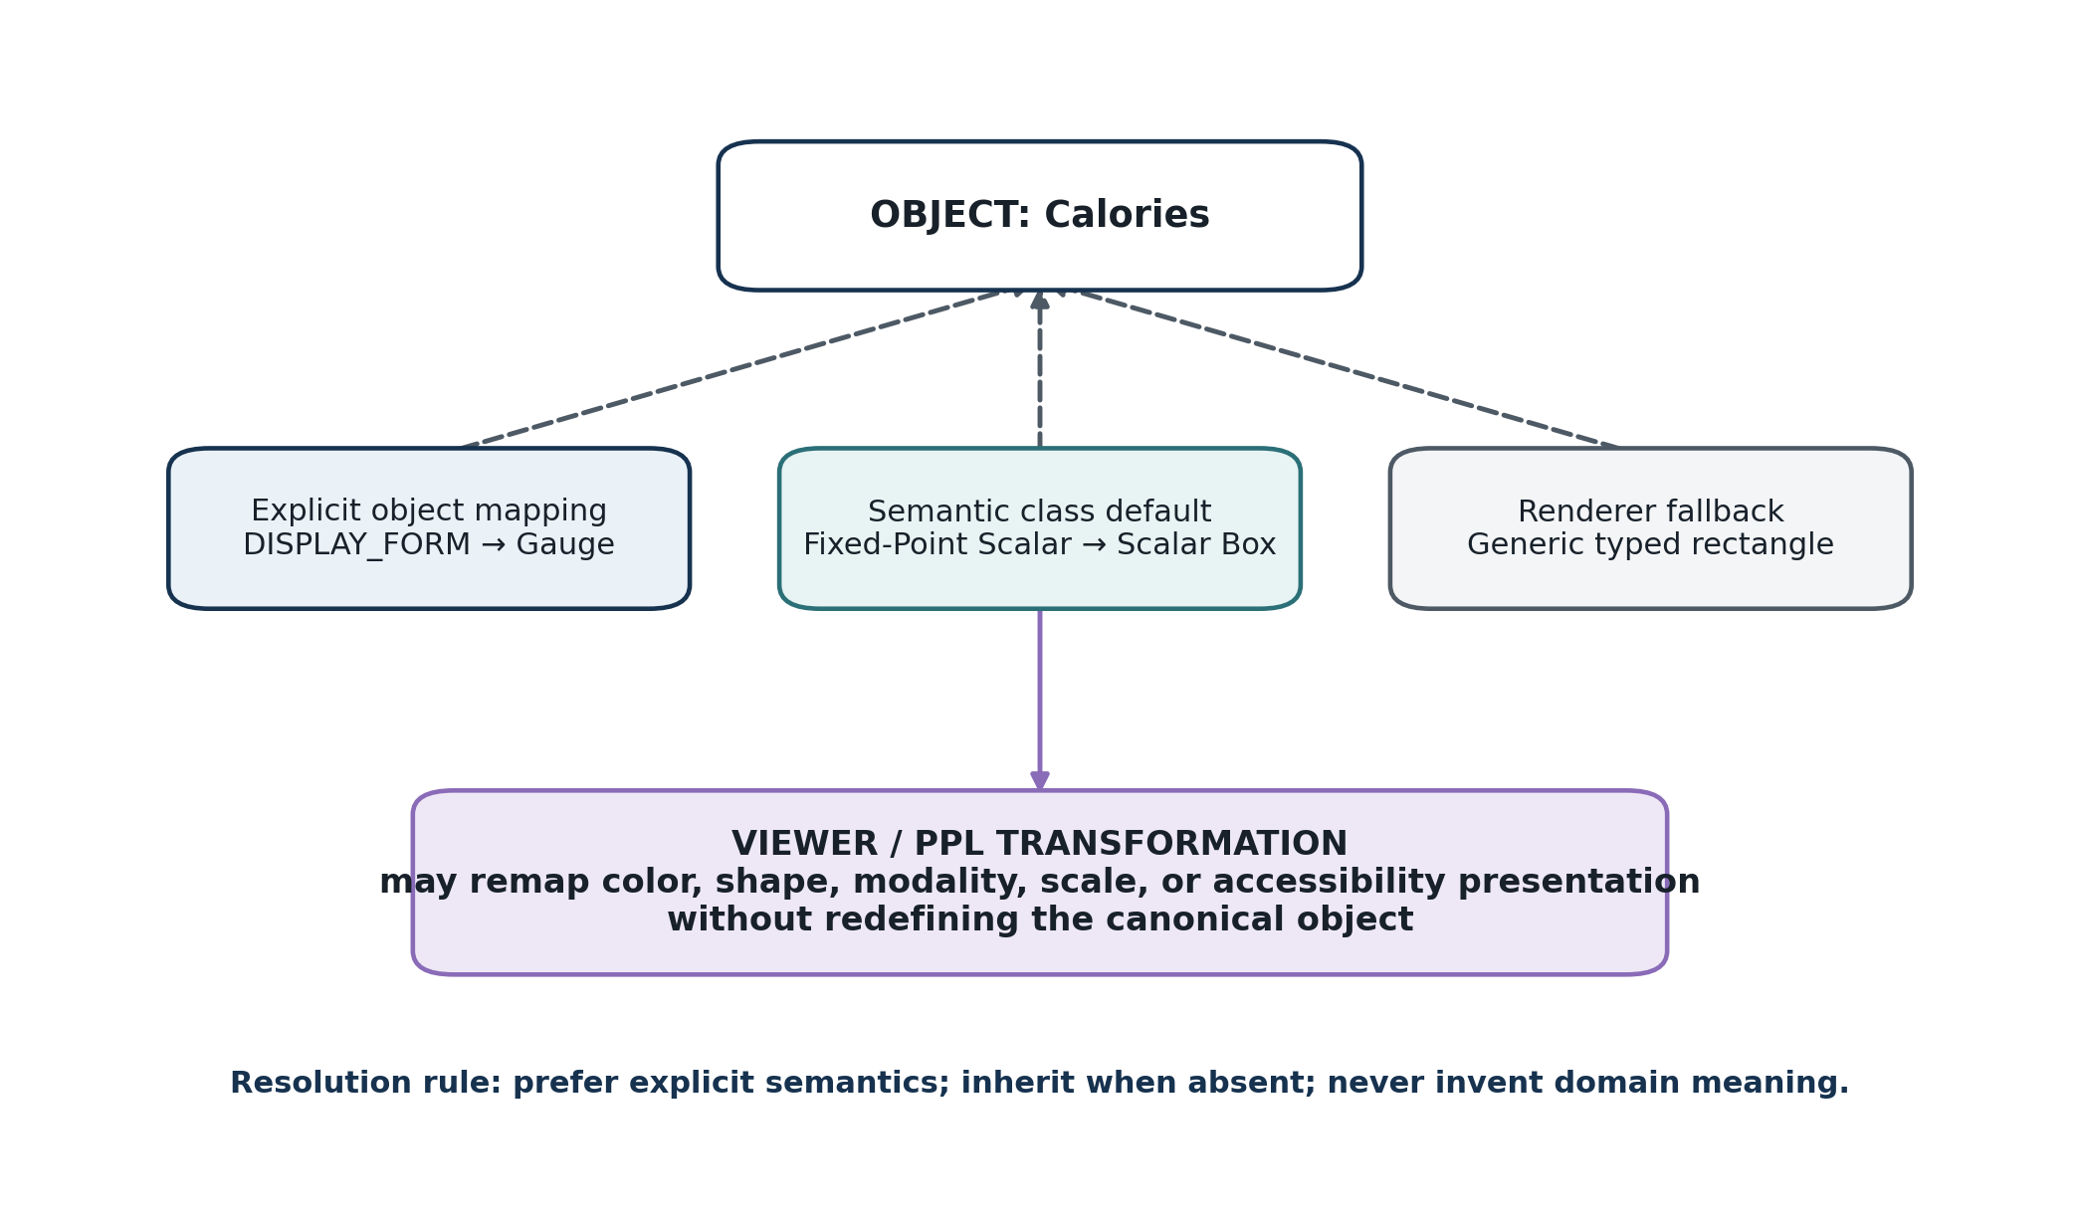
Figure 3. Display semantics may be explicit, inherited from semantic class, or supplied by a generic fallback before viewer/PPL transformation.
Self-description is most useful when every object does not need repetitive display configuration. An object may inherit display semantics from its semantic class or parent grouping. If Fixed-Point Scalar has a default form of Scalar Box, Calories can inherit that form simply by being classified as a Fixed-Point Scalar. Explicit object mappings may override the class default. If no explicit or inherited mapping exists, a renderer may fall back to a generic typed representation.

6.2 Canonical Display Resolution Precedence
1. Resolve any explicit display mapping attached to the semantic object for the requested display purpose.
2. Resolve occurrence- or context-specific mapping when the current placement legitimately requires a distinct presentation without changing semantic identity.
3. Resolve inherited defaults from semantic class, parent BitGroup, or declared display family.
4. Use a generic renderer fallback derived from semantic type, width, state domain, and structural role.
5. If the requested meaning remains unresolved, degrade the view or expose an unresolved state rather than inventing semantics.

6.3 Viewer and PPL Transformation
Viewer-specific projection is conceptually separate from canonical display resolution. After a canonical/default display representation has been resolved, a Personal Perceptual Language, accessibility profile, device constraint, or user preference MAY transform color, geometry, label density, size, modality, or other presentation parameters. Such transformations MUST preserve a traceable relationship to the same semantic source and MUST NOT rewrite canonical display relations or domain meaning.

6.4 Display Modes
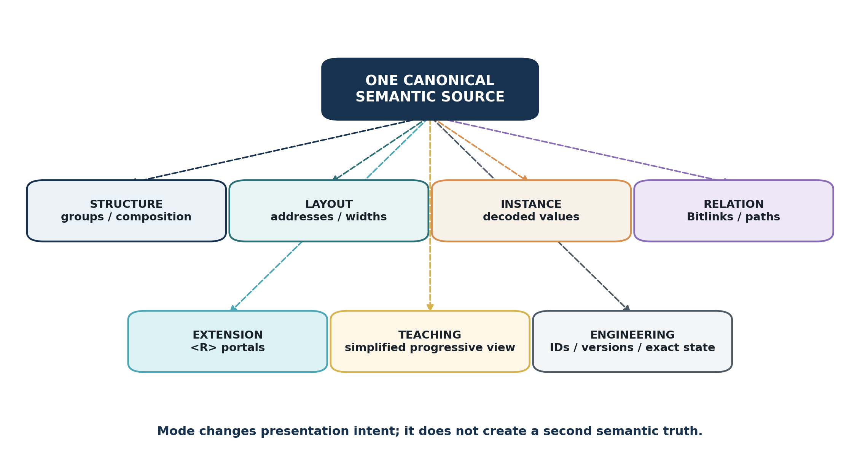
Figure 4. One canonical source can support multiple display modes without duplicating semantic truth.
Table 5. Standard Semantic Display modes
Mode | Primary question | Typical emphasis
STRUCTURE | What is this made from? | Groups, children, composition, ownership.
LAYOUT | Where does each component live? | B### ranges, widths, placement order, flattened offsets.
INSTANCE | What is currently true? | Decoded values, active states, validation status.
READER | How does the Kernel contract explain this word? | Sequential BitGroup decode, units, raw values, labels, version.
RELATION | What is explicitly connected? | Bitlinks, identity reuse, typed relations, bounded paths.
EXTENSION | Where can semantic resolution continue? | <R>, <R:C>, <R:X>, EXT, binding target, permission.
CYBERNETIC | How does state change or propagate? | Models, ModelKeys, parameters, Rules, Operators, deltas.
TEACHING | What representation best builds stable understanding? | Simplified labels, progressive decomposition, semantic color, examples.
ENGINEERING | What exact machine/registry details matter? | IDs, versions, addresses, widths, invariants, provenance.

7. Structural Display Contracts by Entity Type

7.1 Bit
A generic Bit display SHOULD be constructible from canonical identity, semantic name, state domain, encoding rule, optional unit/scale, and current value when an instance is supplied. Engineering views SHOULD expose the Bit ID and local occurrence address. Teaching views MAY hide the ID initially but must preserve traceability. Route Bits SHOULD expose their route class rather than appearing as ordinary Booleans.

7.2 BitGroup
A BitGroup display SHOULD preserve group identity, member identity, order when material, width, encoding class, and group-level interpretation. When the group is itself composed of meaningful subgroups, the display resolver MAY recurse until the requested resolution is reached. Different BitGroups SHOULD be visually distinguishable in teaching and structural views through labeled boundaries and, where available, semantic color mappings.

7.3 Pure BitWord
A Pure BitWord display requires BitWord identity, prefix, width, version, ordered placement manifest, linked BitGroups or direct Bits, route slots, and optional prefix lineage. Structural mode should branch or chain the declared components into the BitWord. Layout mode should expose exact bit ranges. Teaching mode should favor semantic grouping over a 128-cell binary strip unless the learner explicitly requests bit-level resolution.

7.4 Compound BitWord
A Compound BitWord display MUST preserve constituent semantic ownership. A Compound may be flattened for machine execution, but a semantic view should show the ordered constituent BitWords as explicit child containers. Repeated constituents should carry stable occurrence indices. Nested Compounds should remain recursively decomposable. An engineering overlay MAY show flattened offsets in addition to semantic paths.

7.5 ModelKey / Kernel Instance
When instantiated state is supplied, the renderer SHOULD clearly separate contract from actuality. The Semantic Kernel or BitWord definition explains the available state-space; the ModelKey or instance provides current word, parameters, thresholds, provenance, and validation status. A state-aware display SHOULD therefore identify both the governing contract/version and the source of the current value.

7.6 Bitlink, Operator, Rule, and Model
Relationship and cybernetic objects require different display forms because their semantic roles differ. Bitlinks are typed relation edges between explicit endpoints. Operators are transformations with declared read/write scope. Rules are constraints or conditions. Models interpret or derive state. A conforming display MUST not collapse these roles into generic unlabeled arrows merely because they all connect semantic objects.

8. Route, Relationship, and Extension Rendering

8.1 Route Bits and Portals
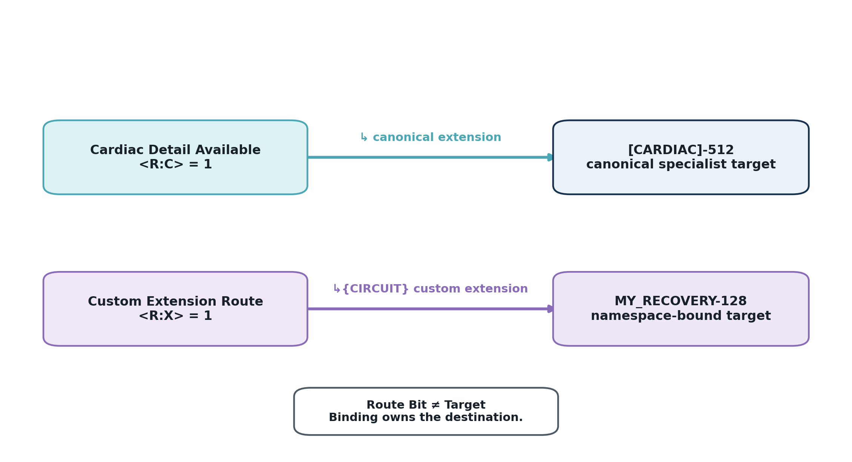
Figure 5. Canonical and custom Route Bits render as portals whose source state remains separate from the extension binding.
A Route Bit is still a Bit with stable semantic identity. The <R> notation indicates that the Bit participates in semantic routing. <R:C> indicates canonical routing; <R:X> indicates a custom destination resolved through a namespace. Semantic Display SHOULD therefore render the source route state as an addressable semantic object and the extension binding as a separate typed edge. The destination must not be visually embedded inside the source Bit in a way that implies containment.

8.2 Extension Routing State and EXT
A bounded enum that reserves EXT to mean that local vocabulary is insufficient SHOULD be shown as a routing instruction rather than a miscellaneous category. In an extension display, the active EXT state may expose the registered target or a portal indicator. In a compact instance display it may show only EXT plus a route-available marker. The display must not convert EXT into an inferred target when no registered extension binding exists.

8.3 Branching and Chaining
One source may expose multiple canonical or namespaced extension destinations. Semantic Display MAY show these as branches when the user requests extension topology. Recursive extension chains MAY be traversed for deeper views, but every actual render traversal MUST be finite, permission-bounded, and cycle-aware. The renderer SHOULD expose the current traversal depth and SHOULD allow a user to stop at the minimum sufficient semantic depth.

8.4 Permission and Epistemic Boundaries
Relation existence does not imply authorization to disclose target identity, read target state, execute a Model against it, or mutate it. Display resolution MUST apply viewer authorization before exposing protected information. Likewise, traversal into FRINGE, FASK, private, proprietary, or other epistemically scoped structures must preserve the original status; a visually connected target does not inherit the epistemic status of its source.

9. Runtime State and Cybernetic Display

9.1 State-Aware Rendering
A display may render a semantic contract without state, or an instantiated semantic object with state. When state is available, Semantic Display SHOULD be able to distinguish active, inactive, unknown, explicit-zero, not-applicable, invalid, historical, predicted, simulated, planned, or other governed state categories when the source contract defines them. It MUST NOT use fill color alone to communicate these distinctions.

9.2 Before, After, and Semantic Delta
For cybernetic or audit views, the renderer MAY show a before word, proposed word, committed word, and semantic delta. The delta should identify changed BitGroups or Bits rather than presenting an opaque hexadecimal difference when semantic decoding is available. The exact Operator, Rule, ModelKey parameters, and provenance may be expanded on demand.

9.3 Cybernetic Flow
A cybernetic display may spatialize the CERBERUS loop or a local state transition. It SHOULD visually preserve the distinction among source state, parameter binding, Model interpretation, Rule/comparator, Operator transformation, committed state, and downstream Bitlinks or projections. In particular, it must not draw a direct causal arrow from a source value to a target bit when the actual transition passes through a Model threshold and Rule decision.

9.4 Projection as Read-Only by Default
Interactive Semantic Display MAY provide controls that request Operators, open Readers, traverse extensions, change SCREEN resolution, or select CALL results. Those controls are user actions over the display; they are not permission to bypass the corresponding semantic contracts. A conforming UI therefore treats the display as read-only by default and routes any requested mutation through the appropriate CERBERUS execution mechanism.

10. Reader, SCREEN, CALL, and PPL Integration
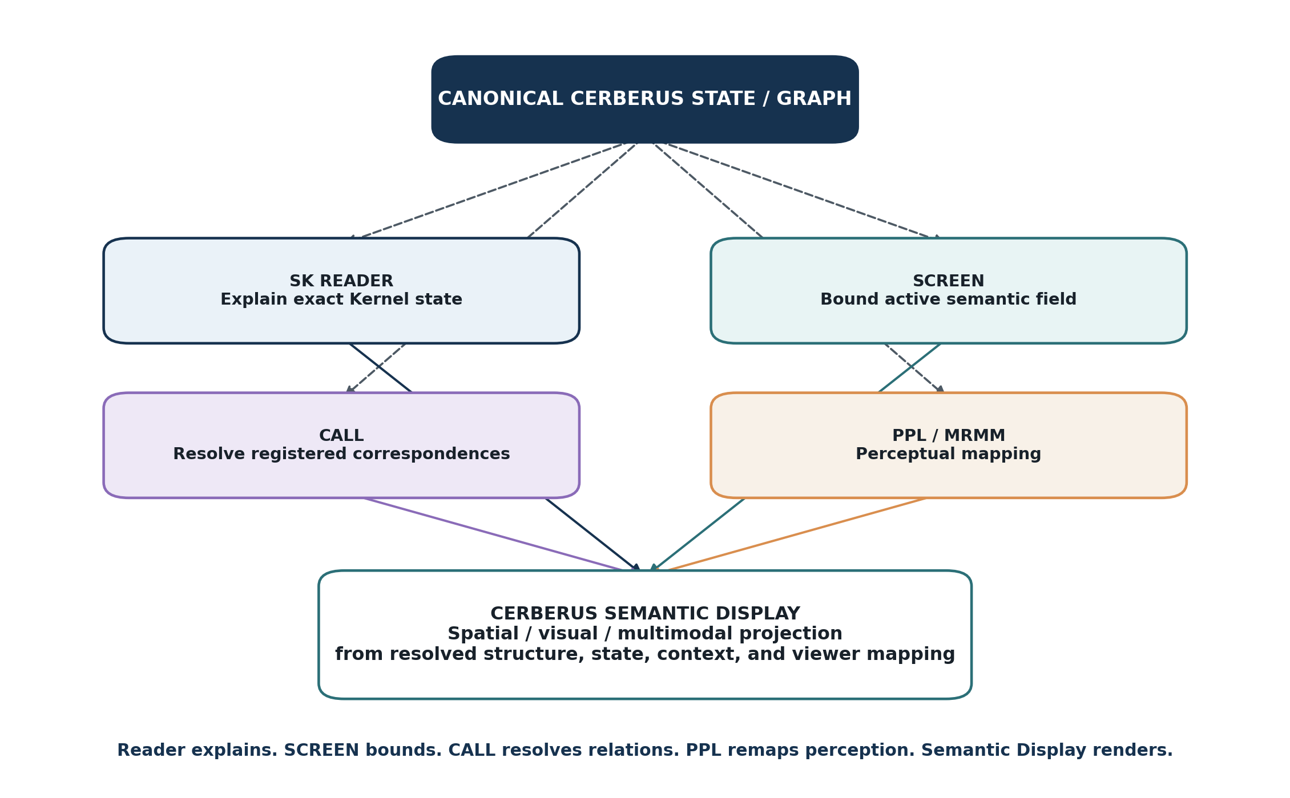
Figure 6. Semantic Display integrates with existing projection systems without replacing them.

10.1 SK Reader
The SK Reader is the deterministic explanation layer for a Semantic Kernel instance. It decodes declared BitGroups, labels, units, basis, presence flags, ModelKey parameters, and exact bit addresses. Semantic Display SHOULD reuse Reader output where a decoded state is requested rather than independently inventing a second interpretation path. A visual Reader view may spatialize the same ordered groups, but the Reader contract remains the authoritative decoding rule.

10.2 SCREEN
SCREEN supplies a bounded semantic context and resolution. When Semantic Display is invoked from an active SCREEN, the renderer SHOULD honor the authorized SCREEN Context and selected resolution rather than automatically expanding the whole graph. SCREEN can therefore act as the semantic field selector while Semantic Display acts as the projection mechanism.

10.3 CALL
CALL resolves registered correspondences inside the current SCREEN. Semantic Display may render CALL results as exact matches, BitGroup intersections, Bit matches, direct Bitlinks, or bounded paths. The display must not convert visual proximity or similarity into a new CALL correspondence. The relationship exists because CALL resolved it canonically, not because the renderer drew two objects near one another.

10.4 Personal Perceptual Languages / MRMM
Personal Perceptual Languages supply explicit mappings from canonical data and mathematical relationships into sensory or symbolic modalities such as color, sound, geometry, motion, space, text, and haptics. Semantic Display should treat those mappings as optional perceptual transforms over canonical/default presentation. The same semantic source may therefore appear through different coordinated projections while remaining traceable to the same underlying state.
INTEGRATION COMPRESSION
Reader explains the state. SCREEN bounds the active field. CALL resolves registered relations. PPL changes perceptual mapping. Semantic Display renders the resulting semantic structure.

11. Deterministic Display Resolution Pipeline
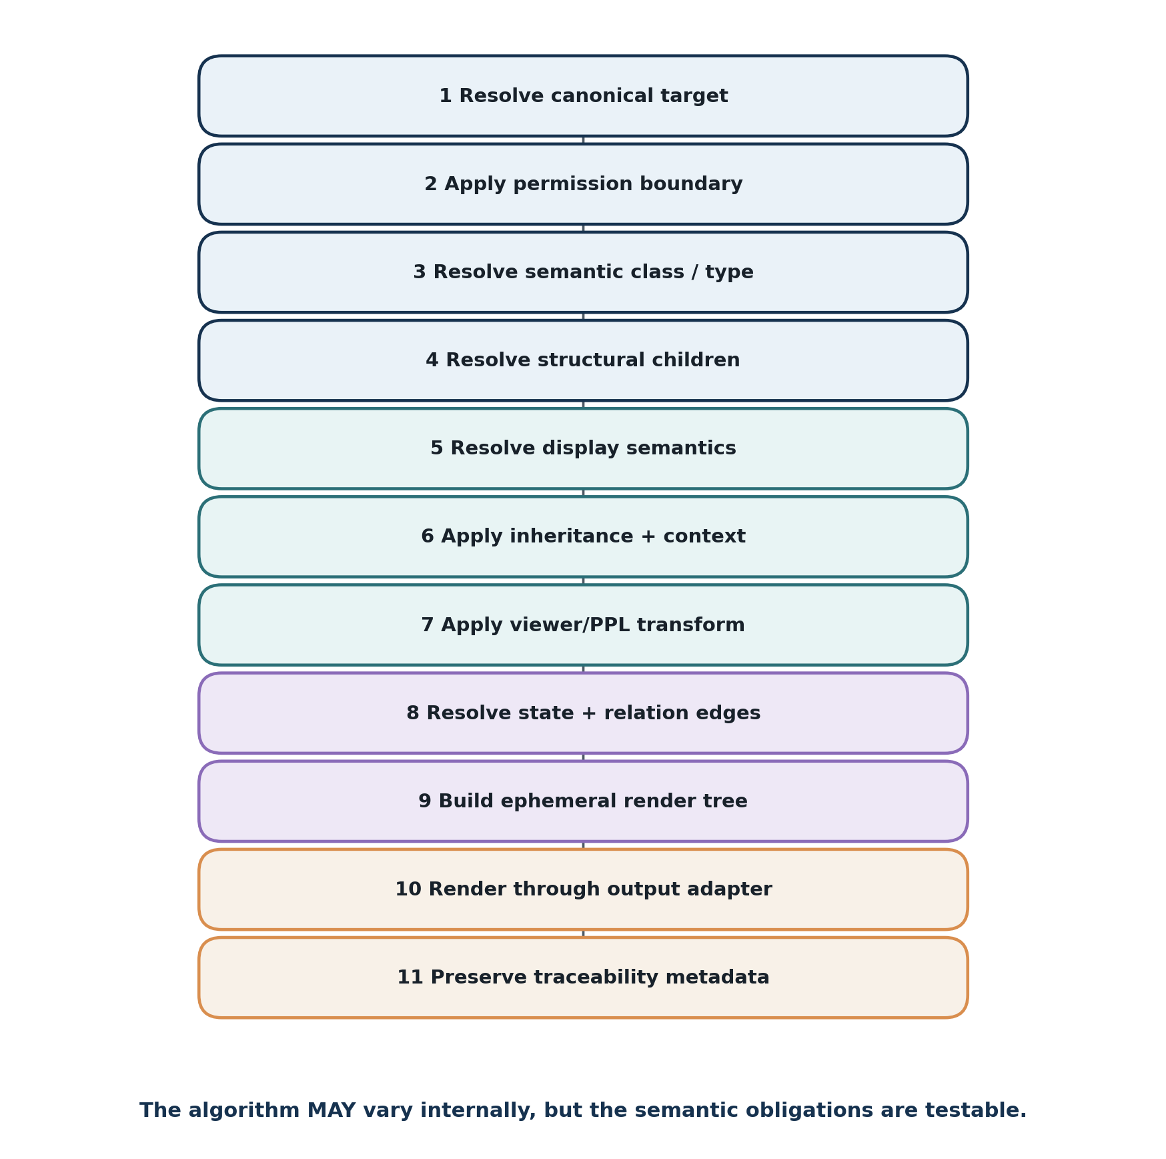
Figure 7. Generic Semantic Display resolution algorithm.

11.1 Required Behavioral Sequence
1. Resolve the canonical target identity and requested semantic path.
2. Apply authorization before relation discovery or protected target disclosure.
3. Resolve the target semantic class, object type, version, and relevant contract metadata.
4. Resolve structural children, placement, composition, or relation endpoints needed by the requested mode and resolution.
5. Resolve explicit display-semantic relations for color, form, layout, value presentation, label behavior, and connector hints.
6. Resolve inherited display semantics and context-specific overrides without redefining canonical meaning.
7. Apply permitted viewer/PPL/accessibility transformations after canonical/default display semantics are known.
8. Resolve instantiated state and typed relation edges when the requested mode requires them.
9. Construct an ephemeral render tree containing semantic identity, path, state, presentation parameters, children, and edges.
10. Render the tree through the requested output adapter.
11. Preserve traceability metadata sufficient to explain how every displayed semantic object was resolved.

11.2 Determinism and Generic Rendering
The exact geometry of a display need not be byte-for-byte identical across Word, SVG, web, terminal, or immersive adapters. Conformance concerns semantic determinism: the same canonical inputs, mode, resolution, viewer mapping, and adapter configuration should resolve the same semantic nodes, relationships, state, and declared presentation properties. Device-specific line breaking or spacing may vary without changing the semantic display contract.

11.3 Unresolved and Partially Resolved Objects
If the renderer can resolve identity but not a preferred color, it may use a generic color while preserving the identity. If it can resolve a BitGroup but not a custom child layout, it may use a generic ordered branch. If the relation target is permission-blocked, it may show an authorized portal indicator without disclosing the target. Partial rendering is therefore valid when it remains explicit about what is known, unknown, unavailable, or protected.

12. Traceability, Accessibility, and Safety

12.1 Traceability
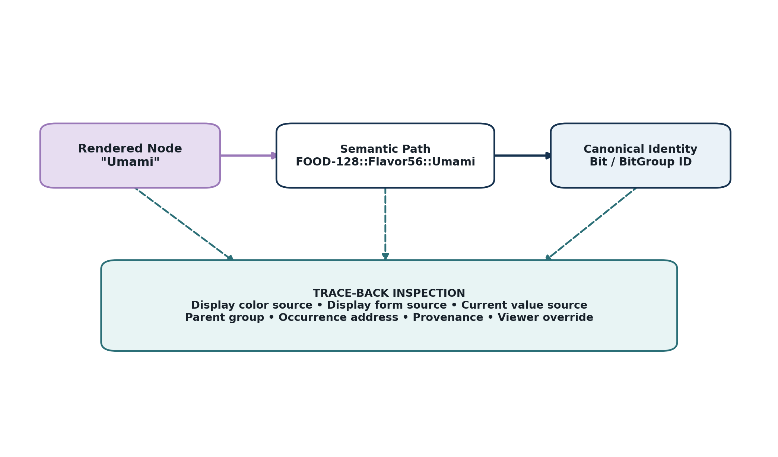
Figure 8. Every rendered semantic object should trace back through semantic path to canonical identity and display-source metadata.
Traceability is not optional decoration. It is the mechanism that prevents a generated diagram from becoming a detached secondary ontology. Every important display node SHOULD expose canonical identity or a resolver token. Every relation edge SHOULD expose relation class and, where applicable, the canonical Bitlink or extension binding identity. Every instantiated value SHOULD expose its source state. Every viewer override SHOULD be inspectable as a projection decision.

12.2 Accessibility
ACCESSIBILITY LAW
No critical semantic distinction SHALL depend solely upon color. Labels, shape, border, glyph, pattern, text, relation notation, or another independent cue must preserve the distinction when color is absent or remapped.

A conforming renderer SHOULD support monochrome output, high-contrast output, reduced-color palettes, larger text, text-only fallback, and alternative perceptual mappings where practical. Because display properties are semantic relations rather than hard-coded pixels, accessibility can be implemented as a different projection over the same canonical semantics instead of as a manually recreated second diagram.

12.3 No Silent Semantic Invention
A rendering engine may infer geometry from structure; it may not infer domain meaning from appearance. It may choose that a four-member ordered group is best rendered as a row; it may not decide that the group represents nutrition unless that meaning is registered. It may choose a generic portal shape for an <R:C> Bit; it may not invent a target when the binding is missing. It may abbreviate a label according to a display rule; it may not replace one semantic identity with a visually similar one.

12.4 Epistemic and Provenance Preservation
Projection must preserve provenance and epistemic scope where those distinctions matter. A FASK branch can be rendered vividly without being visually laundered into canonical real-world status. Imported, estimated, simulated, predicted, or experimentally derived state should remain distinguishable from observed or authoritative state when the source contract exposes those categories.

13. Autonomous Documentation Generation

13.1 Documentation as a Reader over Architecture
Semantic Display makes documentation generation a deterministic read operation over registered structure. Instead of drawing a FOOD-128 decomposition by hand, a documentation generator can resolve the BitWord placement manifest, recursively resolve BitGroups and members, apply semantic colors and forms, and emit the figure. The same source can then generate the exact layout table, a teaching decomposition, a Reader instance, a relation graph, an extension map, or an engineering appendix.
Canonical structure + display semantics + mode + resolution → generated documentation

13.2 Recommended Generated Artifacts
- BitWord semantic decomposition figure.
- Exact B### layout table with widths, group identities, state types, and encoding classes.
- BitGroup decomposition figure showing child order and semantic identity.
- Compound composition tree preserving constituent ownership and occurrence order.
- Instance Reader view with raw, decoded, unit/basis, and validation state.
- Extension portal diagram showing <R> source, binding, namespace, permission, and target.
- Cross-Kernel relation graph with typed Bitlinks and semantic paths.
- Cybernetic transition trace with source state, Model/ModelKey, Rule, Operator, delta, and propagation.
- Accessible or simplified teaching view using alternate PPL mappings without changing semantic identity.

13.3 Drift Prevention
The strongest practical benefit is not visual convenience but semantic drift prevention. When the diagram is regenerated from the same records that define the runtime, changes in BitGroup membership, placement, route class, version, or color mapping can be reflected automatically. A stale image can still exist as an exported artifact, but the authoritative generated view always points back to the current canonical contract.

14. Worked Example: FOOD-128

14.1 Why FOOD-128 Is a Strong Semantic Display Example
FOOD-128 is a compact fixed-width Semantic Kernel whose major regions have different semantic roles. Nutrition44 contains quantitative nutrition fields; Flavor56 contains eight perceptual/profile axes; CLASS16 is a membership mask; Version8 and Basis2 govern interpretation; Reserved2 preserves future compatibility. That heterogeneity makes FOOD-128 ideal for demonstrating how self-describing groups can be rendered differently while still branching and chaining into one governed 128-bit word.

14.2 Structural Decomposition
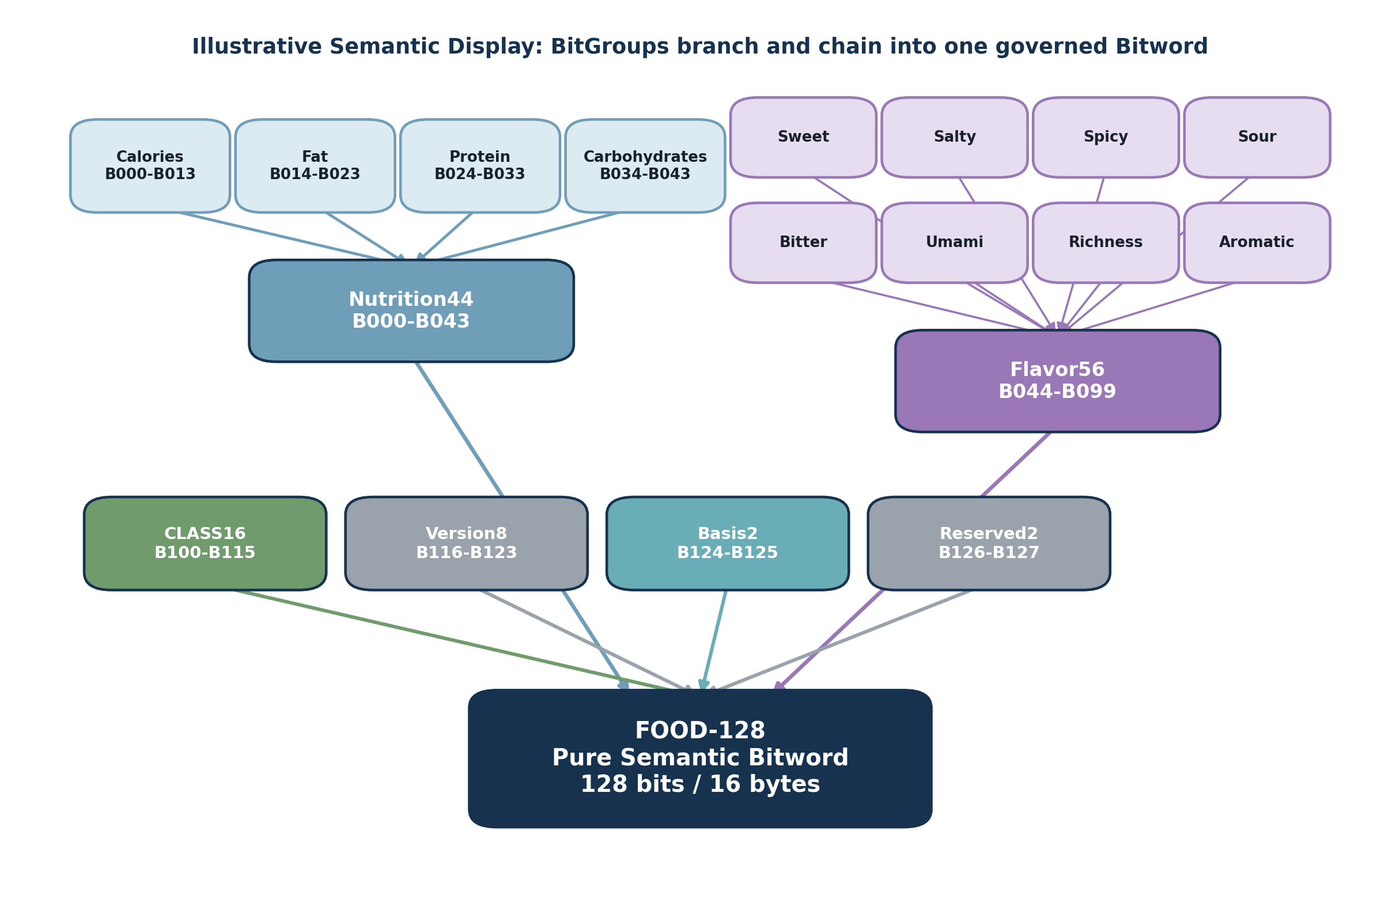
Figure 9. FOOD-128 autonomous semantic decomposition with distinct BitGroup colors and recursive child structure.
The figure can be produced from canonical structure rather than a bespoke drawing definition. The renderer resolves the ordered placement manifest for FOOD-128. It sees Nutrition44 and Flavor56 as semantically meaningful groups with child members, so it recursively opens them at the requested teaching resolution. CLASS16, Version8, Basis2, and Reserved2 are displayed as higher-level groups because deeper detail was not requested. Every box can retain the exact BitGroup/Bit identity and address range as traceability metadata even when the teaching surface shows only human-readable labels.

14.3 Example Structural Inputs
Table 6. FOOD-128 decomposition inputs used by Semantic Display
Semantic region | Bit range | Width | Display interpretation
Nutrition44 | B000-B043 | 44 | Branch to Calories, Fat, Protein, Carbohydrates; quantitative/scalar presentation.
Flavor56 | B044-B099 | 56 | Grid or branch to Sweet, Salty, Spicy, Sour, Bitter, Umami, Richness, Aromatic.
CLASS16 | B100-B115 | 16 | Membership grid or compact category mask.
Version8 | B116-B123 | 8 | Control/contract metadata.
Basis2 | B124-B125 | 2 | Interpretive basis enum.
Reserved2 | B126-B127 | 2 | Reserved/validation region.

14.4 Semantic Color within CLASS16
A CLASS16 teaching view may optionally expose category semantics through registered display colors. For example, Meat may link to a Deep Red display color and Vegetable to Green. A more specific food taxonomy could map Chicken to Pale Pink, Pork to Medium Pink, and Beef to Deep Red. These mappings remain display semantics: they help the reader form stable visual compression artifacts but do not replace the CLASS16 semantic identity, the food NodeKey, or any physical color state.

14.5 Display Modes from the Same FOOD-128 Contract
Table 7. Multiple projections over one FOOD-128 semantic contract
Mode | Generated view
STRUCTURE | Colored BitGroup tree showing how nested groups compose FOOD-128.
LAYOUT | Exact B000-B127 ranges, widths, and placement order.
INSTANCE | Current decoded values such as Calories, Protein, Flavor8 coordinates, active CLASS16 members, Basis, and validation state.
READER | Sequential group explanation with raw value, decoded value, unit/basis, and address range.
TEACHING | Progressive decomposition with color, plain-language labels, and hidden engineering detail until requested.
ENGINEERING | BitGroup IDs, Bit IDs, raw codes, version, reserved state, and exact traceability paths.

15. Worked Examples: Compound and Extension Views

15.1 [MEAL_PREP]-256 Compound Composition
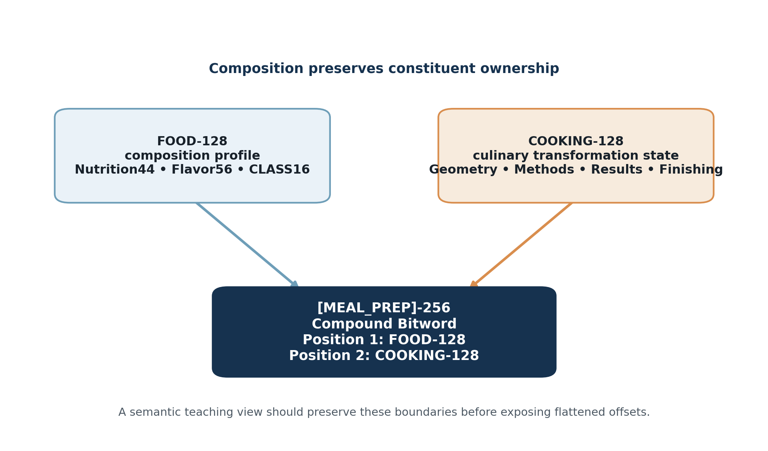
Figure 10. Semantic Display preserves FOOD-128 and COOKING-128 as independently meaningful constituents of [MEAL_PREP]-256.
The Compound view demonstrates why Semantic Display must not flatten semantic ownership prematurely. [MEAL_PREP]-256 is made from complete constituent words. A teaching view should therefore render FOOD-128 and COOKING-128 as separate child containers and allow the user to descend into either one. An engineering overlay may add flattened offsets, but the semantic path should remain constituent-qualified so the viewer can distinguish composition coordinates from local BitWord addresses.

15.2 Canonical and Custom <R> Portals
The route-portal figure in Section 8 demonstrates a second kind of visual topology: extension rather than containment. Cardiac Detail Available<R:C> remains a source Bit whose active state indicates canonical deeper resolution. The extension binding owns the destination [CARDIAC]-512. A Custom Extension Route<R:X> similarly remains a stable source Bit while a namespace such as {CIRCUIT} determines the target. Semantic Display must preserve this separation visually and in traceability metadata.

15.3 Relation Topology Versus Display Topology
The two worked examples intentionally contrast containment and extension. FOOD-128 children are structurally owned by the BitWord placement/group manifests. FOOD-128 and COOKING-128 are structurally composed into [MEAL_PREP]-256. By contrast, an <R> route points outward to semantic depth not contained in the source word. A generic drawing system may use arrows for all three, but a conforming Semantic Display must retain the semantic edge class so the user can tell “part of” from “composed with” from “resolve deeper through.”

16. Conformance Laws and Tests

16.1 Core Laws
Table 8. CERBERUS Semantic Display conformance laws
Law | Requirement
CSD-1 — No Competing Truth Store | Semantic Display SHALL derive from registered semantic state and relations and SHALL NOT become an independent semantic authority.
CSD-2 — Identity Preservation | Every rendered semantic node SHALL retain a resolvable canonical identity or semantic path.
CSD-3 — Projection Non-Mutation | Rendering SHALL NOT mutate canonical semantic state merely by displaying it.
CSD-4 — Structural Fidelity | Containment, composition, relation, extension, cybernetic flow, and projection SHALL remain distinguishable.
CSD-5 — Bounded Resolution | Every actual structural, relation, or extension traversal used for one render SHALL be finite and permission-bounded.
CSD-6 — Display Inheritance | Display semantics MAY be inherited from semantic classes or parents when explicit mappings are absent.
CSD-7 — Explicit Override | Specific display mappings MAY override inherited defaults without changing canonical meaning.
CSD-8 — Personal Projection Isolation | Viewer/PPL mappings SHALL NOT redefine canonical semantic identity or source state.
CSD-9 — Traceability | Every meaningful rendered node and edge SHOULD expose the semantic origin of its identity, state, and presentation.
CSD-10 — Accessibility | Critical semantics SHALL NOT depend solely on color.
CSD-11 — No Silent Semantic Invention | A renderer SHALL NOT invent missing domain meaning or inferred canonical relations.
CSD-12 — Relation-Class Preservation | Different CERBERUS edge classes SHALL remain distinguishable in generated displays.
CSD-13 — Contract/Instance Separation | A visual state SHALL identify the governing contract separately from the object-specific instantiated value when both are relevant.
CSD-14 — Adapter Neutrality | Output adapters MAY vary in geometry and device mechanics but SHALL preserve the resolved semantic nodes, state, relation classes, and traceability required by the chosen mode.

16.2 Minimum Conformance Tests
Table 9. Minimum conformance tests
Test | Pass condition
CSD-T01 Pure BitWord decomposition | Render FOOD-128 in STRUCTURE mode and verify all declared top-level BitGroups appear in placement order.
CSD-T02 Recursive BitGroup decomposition | Render Flavor56 at deeper resolution and verify the eight declared axes appear with preserved group ownership.
CSD-T03 Exact placement | Render LAYOUT mode and verify displayed ranges match the BitWord placement manifest.
CSD-T04 Semantic color resolution | Bind Meat to Deep Red and verify the renderer resolves the color identity to the target adapter encoding while preserving the Meat semantic identity.
CSD-T05 Inheritance | Remove an explicit scalar form mapping and verify the field inherits the declared scalar default or generic typed fallback.
CSD-T06 Viewer override | Apply a PPL color remap and verify the source semantic object and canonical display mapping are unchanged.
CSD-T07 Canonical route | Render an <R:C> Bit and verify source, extension edge, target, and traceability remain distinct.
CSD-T08 Custom route | Render an <R:X> binding and verify the namespace determines target resolution without redefining the source Bit.
CSD-T09 Compound boundaries | Render [MEAL_PREP]-256 and verify FOOD-128 and COOKING-128 retain separate constituent containers.
CSD-T10 Projection non-mutation | Generate all supported views of one instance and verify canonical state is byte-for-byte unchanged.
CSD-T11 Traceability | Select a rendered child and recover canonical identity, semantic path, display-semantic source, and current state source.
CSD-T12 Accessibility | Disable color and verify the representation remains semantically interpretable.
CSD-T13 Permission boundary | Expose a route whose target is not readable and verify the display does not leak unauthorized target state.
CSD-T14 Finite traversal | Introduce a candidate cycle or open extension graph and verify one render remains bounded by explicit depth/hop rules.

17. Failure Modes and Anti-Patterns
Table 10. Common Semantic Display failure modes
Anti-pattern | Why it fails
Manual semantic duplication | A diagram stores its own definitions or relationships and slowly diverges from the canonical architecture.
Display ontology capture | A display helper table begins to redefine what the semantic objects mean instead of merely describing or projecting them.
Color-as-identity | Removing or remapping color destroys the ability to distinguish semantic objects or states.
Unlabeled arrow collapse | Containment, Bitlinks, extensions, causal flow, and projection are drawn as the same generic edge.
Orphan visual node | A displayed box cannot resolve back to canonical identity or path.
Layout-as-semantics | Spatial proximity or screen position is interpreted as a semantic relation not registered in the system.
Infinite visual expansion | Recursive composition or <R> traversal is followed without an explicit bound.
PPL overwrite | A personal mapping is persisted as though it were canonical semantic truth.
Rendering hallucination | The renderer guesses missing domain meaning, missing labels, missing relation endpoints, or missing classification because the diagram would otherwise look incomplete.
Contract-instance conflation | A BitWord definition is visually confused with one object’s current ModelKey state.
Physical/display property conflation | A default display color is treated as the object’s measured physical color, or vice versa.
Flattened ownership loss | A Compound is shown only as one anonymous bit range, hiding its constituent semantic paths.

REFRACTORING RULE
If a display needs bespoke logic because the renderer cannot determine what an object is, first ask whether the semantic architecture is under-described. Improving atomic self-description is preferable to accumulating one-off diagram code.

18. Implementation Guidance, Versioning, and Formal Summary

18.1 Airtable and Data-Structure Platforms
Airtable is a practical prototype environment because linked records already behave like graph edges and reverse links expose dependency structure. Bits can link to BitGroups; BitGroups to BitWords; BitWords to Compounds; semantic objects can link to color, form, layout, symbols, and other display-relevant objects; extension bindings can link route sources to targets; rollups can expose reverse usage. A renderer can query the same relational data to produce documentation without introducing a separate semantic registry.
Other data-structure platforms can implement the same contract using relational tables, property graphs, document stores, RDF-like triples, or custom runtime objects. Conformance depends on semantic behavior, not storage technology.

18.2 Suggested Minimal Data Additions
Where the existing semantic objects are not yet sufficiently self-describing for autonomous display, the preferred intervention is to add explicit semantic relations rather than a new display subsystem. Typical additions include links such as DISPLAY_COLOR, DISPLAY_FORM, DISPLAY_LAYOUT, DISPLAY_VALUE_MODE, or an equivalent typed relation. Placement records may optionally expose diagram ordering or parent grouping when that information is not already unambiguous from the canonical manifest.

18.3 Versioning
Display semantics may evolve independently of the underlying BitWord contract. A semantic color mapping, layout recommendation, or teaching view can therefore be versioned or changed without redefining the Bit meaning or BitWord layout. If an application requires reproducible historical rendering, the export SHOULD preserve enough metadata to identify the display mapping or PPL version used at the time.

18.4 Formal Summary
FORMAL SUMMARY
CERBERUS Semantic Display is the emergent capability of a self-describing semantic architecture to generate context- and resolution-appropriate representations of its own structure. Identity describes what an object is. Composition describes what it contains. Relations describe how it connects. State describes what is currently true. Display semantics describe how it may be perceived. Semantic Display traverses those facts and renders a derived projection while preserving canonical ownership, permission, provenance, accessibility, and traceability.

Self-description + bounded traversal + projection semantics = autonomous semantic visualization
The design goal is therefore not a graphics package attached to CERBERUS. It is a semantic system complete enough that graphics, text explanations, engineering maps, teaching diagrams, extension portals, and multimodal projections can be regenerated from the same source. The strongest conformance test is simple: the visualization should contain no semantic information that cannot be traced back to the self-describing architecture from which it was generated.

Appendix A — Notation and Variable Registry
Table A1. Notation used by Semantic Display
Notation | Meaning
D | Derived Semantic Display projection.
G | Canonical CERBERUS semantic graph.
S | Optional instantiated semantic state.
C | Active semantic/display context.
rho | Requested semantic resolution or decomposition depth.
P | Viewer/PPL/accessibility perceptual mapping.
M | Display mode.
R_display | Conceptual Semantic Display resolution function.
S_D(O,M,rho,C) | Display sufficiency of semantic object O for the requested mode/resolution/context.
τ(v) | Traceability function from rendered visual node v to canonical semantic origin.
≡BIT | Canonical identity relation between Bit occurrences.
|| | Compound composition: made from complete BitWords.
:: | Semantic descent / path ownership notation.
⇄ | Explicit registered Bitlink relation.
<R> | Route Bit participates in semantic extension routing.
<R:C> | Canonical Route Bit.
<R:X> | Custom Route Bit resolved by namespace.
↳ | Canonical extension: resolve deeper through registered target.
↳{NS} | Namespaced custom extension.
EXT | Routing state indicating local vocabulary is intentionally insufficient.
1:=:1 | CALL glyph for one resolved semantic object connected by a registered correspondence to another.

Appendix B — Example Semantic Display Relations
The following records are illustrative examples of how display semantics could be expressed as ordinary relations in the existing CERBERUS graph. They are not a mandate for one storage table or canonical ID scheme.
Table B1. Illustrative display-semantic relations
Source semantic object | Relation | Target semantic object / value | Notes
Chicken | DISPLAY_COLOR | Pale Pink | Illustrative category projection.
Pale Pink | HEX | #F2B6C2 | One exact render encoding.
Beef | DISPLAY_COLOR | Deep Red | Illustrative category projection.
Vegetable | DISPLAY_COLOR | Green | Illustrative category projection.
Fixed-Point Scalar | DEFAULT_DISPLAY_FORM | Scalar Box | Inherited by scalar groups unless overridden.
Boolean Bit | DEFAULT_DISPLAY_FORM | State Square | Compact generic fallback.
Route Bit <R:C> | DEFAULT_DISPLAY_FORM | Canonical Portal | Should expose outgoing ↳ edge.
Route Bit <R:X> | DEFAULT_DISPLAY_FORM | Namespaced Portal | Should expose ↳{NS} edge and binding context.
Flavor56 | DISPLAY_LAYOUT | Grid 4×2 | Illustrative teaching layout for eight axes.
Nutrition44 | DISPLAY_LAYOUT | Horizontal Branch | Illustrative teaching layout for four quantitative children.

Appendix C — Conformance Checklist
☐ Canonical semantic meaning is resolved from existing CERBERUS identities/contracts, not duplicated into a display truth store.
☐ Every displayed node can resolve back to a canonical identity or semantic path.
☐ Bit ID and local B### occurrence are not conflated.
☐ BitGroup membership/order and BitWord placement are respected.
☐ Compound constituent ownership remains visible or recoverable.
☐ Relation classes remain distinguishable without relying on color alone.
☐ Route Bits and extension targets are represented as separate semantic objects/edges.
☐ Permissions are applied before protected relation/target disclosure.
☐ Recursive traversal is finite and bounded.
☐ Viewer/PPL mappings do not overwrite canonical semantic definitions.
☐ Display generation does not mutate canonical state.
☐ Unknown or unresolved meaning is shown honestly rather than inferred.
☐ Accessibility fallbacks preserve critical meaning without color.
☐ State-aware displays identify both contract/version and current state source.
☐ Generated documentation can be regenerated from canonical structure after a semantic change.

Glossary
Glossary of Semantic Display terms
Term | Definition
Accessibility Projection | A display mapping adapted for visual, auditory, motor, cognitive, or device constraints while preserving canonical semantic identity.
Adapter | The output-specific renderer that converts an ephemeral render tree into Word, SVG, HTML, Airtable UI, Figma, PDF, text, audio, haptics, or another target representation.
Bit | An exact bounded semantic primitive with stable canonical identity.
Bit Address | A local B### position or range inside a specific BitWord occurrence.
BitGroup | A governed conceptual grouping of Bits with declared membership, order, width, and group-level interpretation.
Bitlink | A first-class registered semantic relation connecting explicit semantic endpoints.
BitWord | A bounded binary semantic word governed by one semantic contract.
Canonical Display Semantics | Default or governed display-relevant relations resolved from canonical semantic objects before viewer-specific perceptual transformation.
Canonical Semantic State | Registered meaning, state, contract, relation, or identity that exists independently of the current interface projection.
Color Semantic Object | A semantic identity representing a color concept and optionally linked exact encodings such as HEX, RGB, HSL, or accessible variants.
Compound BitWord | An ordered composition of complete BitWords whose constituents retain their own semantic ownership.
Context | The selected object, page, task, SCREEN Context, documentation request, or other bounded situation used to resolve a display.
Display Form | A semantic mapping describing a preferred spatial or symbolic form such as Square, Scalar Box, Container, or Portal.
Display Inheritance | Resolution of presentation defaults from a semantic class, parent grouping, or display family when an object lacks an explicit mapping.
Display Layout | A semantic mapping that describes child arrangement such as chain, branch, grid, stack, nested tree, or composition tree.
Display Mode | The purpose-specific projection requested from one semantic source: structure, layout, instance, Reader, relation, extension, cybernetic, teaching, engineering, etc.
Display Projection | A derived representation of canonical semantics. It is not a source-of-truth registry.
Display Sufficiency | The condition in which enough canonical information exists to produce the requested display without inventing domain meaning.
Ephemeral Render Tree | A temporary derived structure containing render nodes, semantic identities, children, edges, state, and presentation parameters.
EXT | An extension routing state indicating that the local bounded vocabulary is intentionally insufficient and registered extension resolution is required.
Extension | A registered relation that allows semantic resolution to continue into another structure without making that structure part of the source payload.
Generic Fallback | A renderer-selected typed representation used when no explicit or inherited display mapping exists.
Identity Preservation | The requirement that a rendered semantic object remains traceable to the canonical identity it represents.
Instance | An object-specific or context-specific current state interpreted under a known semantic contract.
ModelKey | The instantiated CERBERUS state/parameter binding connecting a semantic Model/Kernel to a NodeKey.
Occurrence | One placement of a canonical Bit, BitGroup, or BitWord inside another structure or context.
Personal Perceptual Language (PPL) | An explicit learnable mapping from canonical data and relationships into perceptual or symbolic modalities.
Portal | A display form representing a semantic extension point such as <R:C> or <R:X>.
Projection Non-Mutation | The rule that merely rendering or inspecting semantic state does not alter it.
Pure BitWord | A BitWord whose complete payload belongs to one canonical semantic lineage.
Reader | The deterministic explanation layer that decodes a Semantic Kernel instance according to its declared contract.
Relation-Class Preservation | The requirement that containment, composition, Bitlinks, extensions, cybernetic flow, and projections remain visibly or inspectably distinguishable.
Render Tree Node | One ephemeral display element linked to a semantic target, path, state, display properties, child nodes, and/or relation edges.
Resolution | The semantic granularity or bounded decomposition depth exposed by a display.
Route Bit | A Bit whose canonical function is to signal or participate in semantic extension routing.
SCREEN | Semantic Context Resolution Engagement Evaluation Nexus: the bounded active semantic context and resolution mechanism through which CALL operates.
Semantic Display | The emergent CERBERUS capability to generate context- and resolution-appropriate projections from self-describing semantic structure.
Semantic Path | A path preserving ownership through BitWords, BitGroups, Bits, or Compound constituents, such as FOOD-128::Flavor56::Umami.
Self-Describing Semantic Object | An object that exposes enough registered identity, type, structure, relation, and optional display information for a runtime to reason about and render it generically.
Traceability | The ability to resolve a displayed element back to canonical identity, occurrence/path, state source, display-source relations, and provenance.
Viewer Override | A context- or user-specific permitted modification to presentation that does not redefine canonical semantics.

Subject Index
Section references are used instead of page references so the index remains stable across regenerated layouts, output adapters, and accessibility variants.
Subject index
Subject | Section reference(s)
Accessibility | 12.2, 16.1 CSD-10, Appendix C
Adapter | 4.2, 11.2, 18.1
Airtable | 18.1
Autonomous documentation | 13.1-13.3
Bit | 3.1-3.3, 7.1, Glossary
Bit address | 3.2, 7.1, 14.3
BitGroup | 3.1, 7.2, 14.2-14.3
Bitlink | 5.5, 7.6, 8, 10.3
BitWord | 3, 7.3, 14
CALL | 10.3
Canonical semantics | 2.2-2.3, 6.3, 12.1
Chicken color example | 5.2, 14.4, Appendix B
Color | 5.2, 12.2, 14.4
Compound BitWord | 7.4, 15.1
Conformance laws | 16.1
Conformance tests | 16.2, Appendix C
Connector semantics | 5.5
Cybernetic display | 9, 10, 11
Display color | 5.2, Appendix B
Display form | 5.3, 7, Appendix B
Display inheritance | 6.1-6.2
Display layout | 5.4, 7.2-7.4
Display modes | 6.4
Display projection | 2.2, 4, Glossary
Display registry, prohibition | 2.1
Display sufficiency | 3.4, 4.1
Engineering mode | 6.4, 14.5
EXT | 8.2, Appendix A
Extension | 8, 15.2
Failure modes | 17
FOOD-128 | 14, 15.1
Generic fallback | 6.1-6.2, Glossary
Identity versus occurrence | 3.2
Instance display | 6.4, 7.5, 9.1
MEAL_PREP-256 | 15.1
ModelKey | 7.5, 9, Glossary
Pale Pink | 5.2, 14.4, Appendix B
Permission | 8.4, 11.1, 12.4, 16.2
Personal Perceptual Language | 6.3, 10.4
Portal | 8.1, Appendix B, Glossary
Projection non-mutation | 4.4, 9.4, 16.1
Reader | 6.4, 10.1
Render tree | 4.2, 11.1
Resolution | 3.4, 6.4, 10.2, 11
Route Bit | 8.1-8.3, Appendix A
SCREEN | 10.2
Self-description | 2.4, 3, 13
Semantic color object | 5.2
Semantic path | 4.3, 12.1, Glossary
Teaching mode | 6.4, 14.5
Traceability | 4.3, 12.1, 16.1 CSD-9
Viewer override | 6.3, 16.1 CSD-8
<R:C> | 8.1, 15.2, Appendix A
<R:X> | 8.1, 15.2, Appendix A
↳ | 8.1-8.3, Appendix A
↳{NS} | 8.1-8.4, Appendix A

Related CERBERUS Specifications
Related documents
Document | Relevance
BIGFOOT 4 Tables Details | Identity spine, linked graph behavior, reuse, placements, Compound composition, extension relationships.
CERBERUS Semantic Bitword Notation & BIGFOOT Identity Registry — Formal System Specification v2.0 | Canonical notation and registry behavior for Bits, BitGroups, Pure BitWords, Compound BitWords, route bits, extension grammar, and state bindings.
CERBERUS SK Reader: Explanation & Export — Formal Specification v1.0 | Deterministic decoding, Reader Groups, CRT, lossless export, and traceable human-readable projection.
CERBERUS Linked Semantics: SCREEN and CALL — Formal System Specification v1.0 | Bounded semantic context, resolution levels, registered correspondences, permission precedence, and projection boundary.
Personal Perceptual Languages: Mathematical Relationship Modality Modeling — v1.0 | Canonical data to perceptual projection, multimodal mappings, accessibility, trace-back, and viewer-specific learned languages.
Bit-Level Architecture of the CERBERUS Cybernetic Loop — Formal Specification v1.0 | Identity, classification, Semantic Kernels, Operators, Rules, ModelKeys, semantic delta, and feedback.
CERBERUS FOOD-128 — Formal Specification v1.0 | Worked example semantic structure used in Section 14.
COOKING-128 — Formal Specification v0.1 | Companion culinary transformation Kernel used in the [MEAL_PREP]-256 composition example.

END OF SPECIFICATION

