ATLAS ASSOCIATION APPLICATIONS
AAA Architecture
Associative Traversal, Semantic Packets, Modality Transforms,
Transient Expression, and Non-Destructive DARTBOARD Projection
⬢ ▪︎-> x▪︎x ⬢▪︎⬢
CORE THESIS
AAA does not redefine canonical data. It associates existing system state and capabilities with optional, transient perceptual projections. Capability chooses what can be surfaced; Packet carries the selected semantic state; Transform maps that state across modalities; Expression is the resolved output.

Architecture Paper · Version 0.1 · August 2026

Abstract
Atlas Association Applications (AAA) define an optional application layer for turning existing CERBERUS state, relationships, BitGroup values, and capabilities into user-facing experiences without changing the canonical structures beneath them. AAA can be analytical, instructional, ambient, social, or deliberately playful. Its defining property is non-destructive projection: disabling an AAA removes its perceptual layer while leaving the underlying records, semantics, permissions, and operational state intact.
The architecture is centered on a compact runtime grammar: Capability → Packet → Transform → Expression. A Capability exposes something the system can surface. The Packet notation ▪︎-> denotes semantic state being sent for expression. The Transform notation x▪︎x denotes the mapping that converts the Packet into one or more target modality values. A single returned value is an Expression; multiple returned values form an Expression Bundle. For scalar BitGroups, transforms can map decoded values through explicit formulas into target dimensions such as color, particle spacing, particle speed, size, motion, sound, or other EFFECTS-supported modalities.
AAA therefore separates semantic rigor from experiential freedom. The Registry can remain exact while DARTBOARD and AVA become highly plastic. The same mechanism can support Semantic Zoom, Review, musical visualization, nutrition particles, profanity painting, AVA-to-AVA social interactions, or intentionally absurd graph projections. Because the projection is optional and bounded, playfulness need not contaminate system truth.
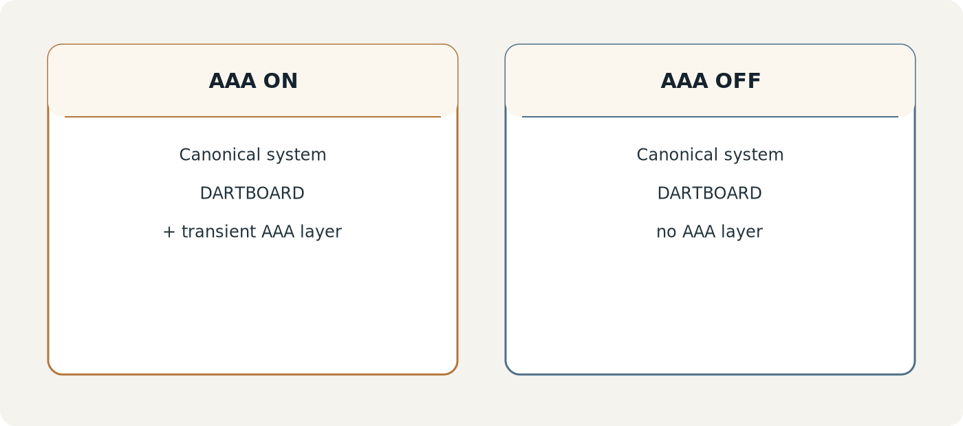
Figure 1. AAA as a removable projection layer.

Paper Map
Part | Focus
I | Architectural position and optionality
II | AAA symbolic language
III | Capability, Packet, Transform, Expression runtime grammar
IV | Scalar BitGroup transforms and modality mapping
V | Expression lifecycle and non-destructive boundaries
VI | Record-driven composition tables
VII | AVA embodiment and DARTBOARD projection
VIII | Interoperability with DRAGON, EFFECTS, and BOOTSTRAP
IX | Worked AAA applications
X | Shared workspaces, social scope, and permissions
XI | Reuse, scaling, and design laws
XII | Implementation reference and complete architecture

I. Architectural Position
AAA sits above the structures required for CERBERUS to function. It is intentionally inconsequential to canonical system operation: Registries, BitWords, routing, Models, Rules, Operators, BOOTSTRAP context, DARTBOARD resolution, and other core mechanisms remain valid whether every AAA is enabled or disabled. This is not a weakness of the layer; it is its central safety property.
AAA-L01 · NON-DESTRUCTIVE PROJECTION
A conforming AAA may change what the user perceives, but it does not silently redefine the canonical meaning of the source object being projected.

The consequence is unusual freedom. An AAA may paint over a word without rewriting it, annotate a record without editing it, turn a scalar into particles, or send an AVA across a shared workspace to bother a collaborator. The underlying system remains inspectable and reconstructable.
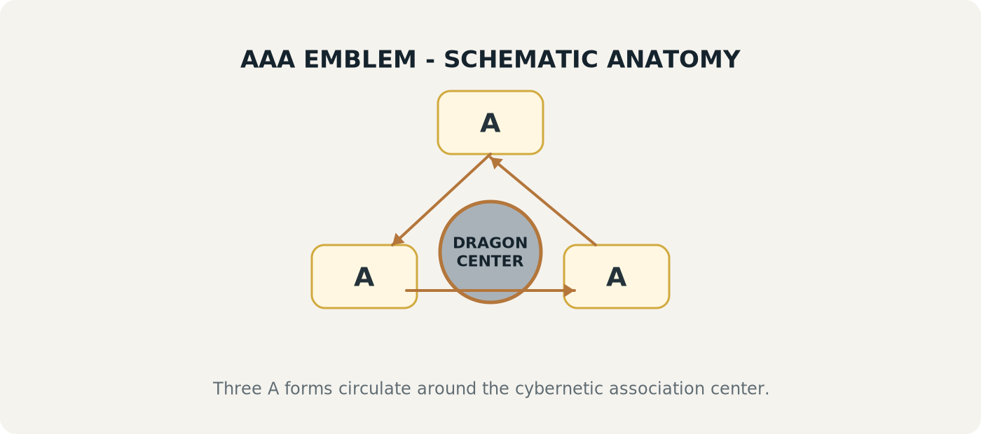
Figure 2. Schematic anatomy of the AAA emblem and its association center.
The emblem is treated as a visual language marker rather than a claim that AAA is itself the cybernetic core. AAA associates through the available system graph and can use DRAGON traversal, but the application layer remains optional.

II. AAA Symbolic Language
The notation provides a compact way to describe durable AAA components, runtime transfer, transform behavior, and transient outputs. The language intentionally distinguishes what is available from what actually occurred.
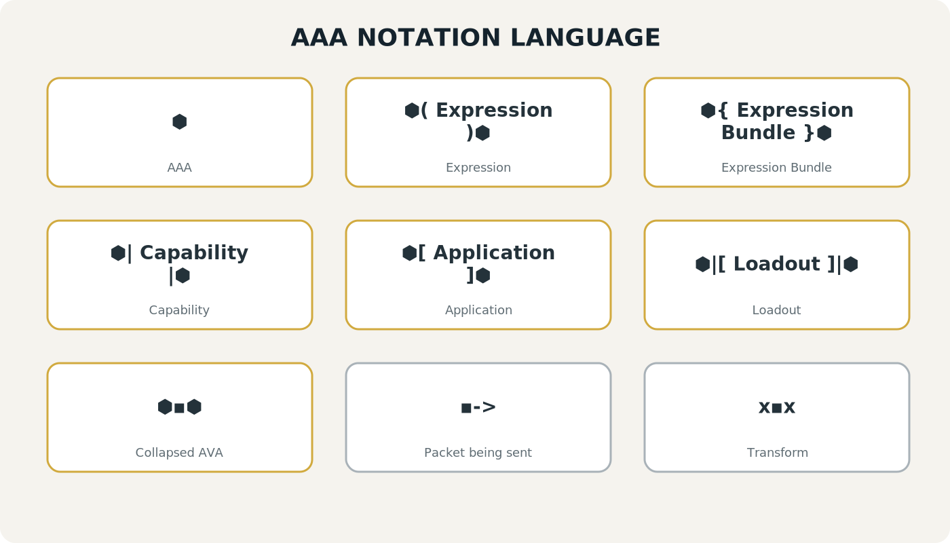
Figure 3. Complete AAA notation reference.
Notation | Name | Meaning
⬢ | AAA marker | Declares the Atlas Association Applications language/context.
⬢( Expression )⬢ | Expression | One actual resolved output after transform execution.
⬢{ Expression Bundle }⬢ | Expression Bundle | Multiple Expressions produced together.
⬢| Capability |⬢ | Capability | An available behavior or capability that AAA can expose.
⬢[ Application ]⬢ | Application | A complete selectable AAA composed from capabilities, association behavior, and configuration.
⬢|[ Loadout ]|⬢ | Loadout | A selected collection of AAA Applications.
⬢▪︎⬢ | Collapsed AVA | Persistent minimal AVA access state; conceptually a Bit hiding in the loop.
▪︎-> | Packet being sent | The semantic value/state being sent toward transform execution.
x▪︎x | Transform | The mapping that converts the Packet into one or more target modality values.

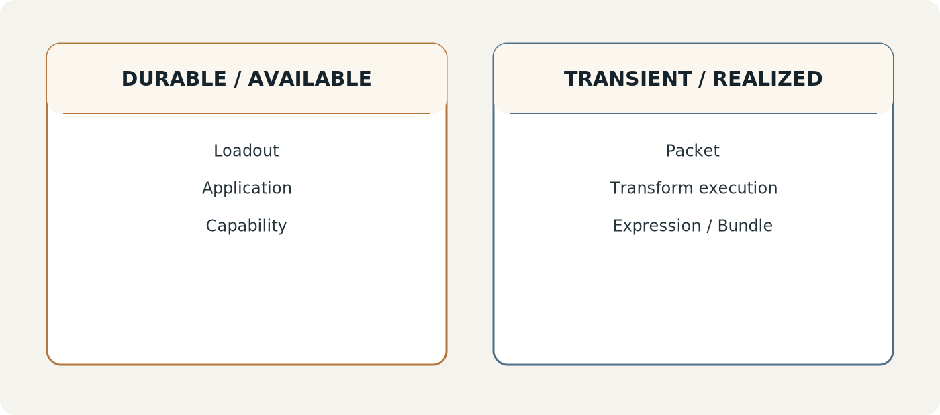
Figure 4. Durable application structure versus transient runtime realization.
Loadouts, Applications, Capabilities, associations, transform definitions, and permissions are durable authoring/configuration objects. Packets, transform executions, Expressions, and Expression Bundles are normally runtime objects. This separation prevents a transient shimmer or particle emission from becoming permanent ontology.

III. Core Runtime Grammar
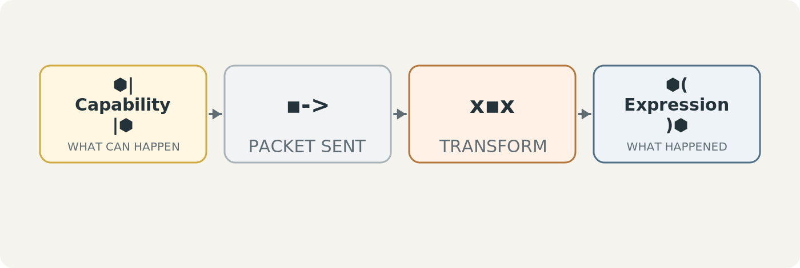
Figure 5. The core AAA runtime sentence: Capability → Packet → Transform → Expression.
The runtime nomenclature is exact. Capability is possibility. Packet is transfer. Transform is conversion. Expression is output. If a Transform returns several outputs, those outputs are not several Packets; they are several Expressions, collected as an Expression Bundle.
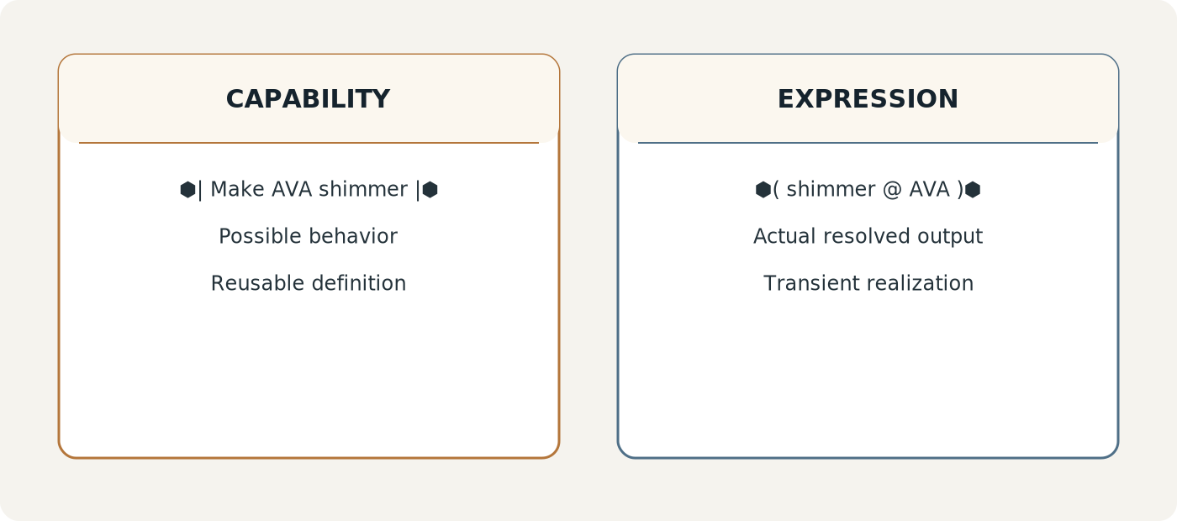
Figure 6. Capability and Expression are different semantic roles.
AAA-L02 · CAPABILITY / REALIZATION SEPARATION
A Capability describes what may be exposed. An Expression records what the runtime actually resolved and rendered.

Packet: semantic state in motion
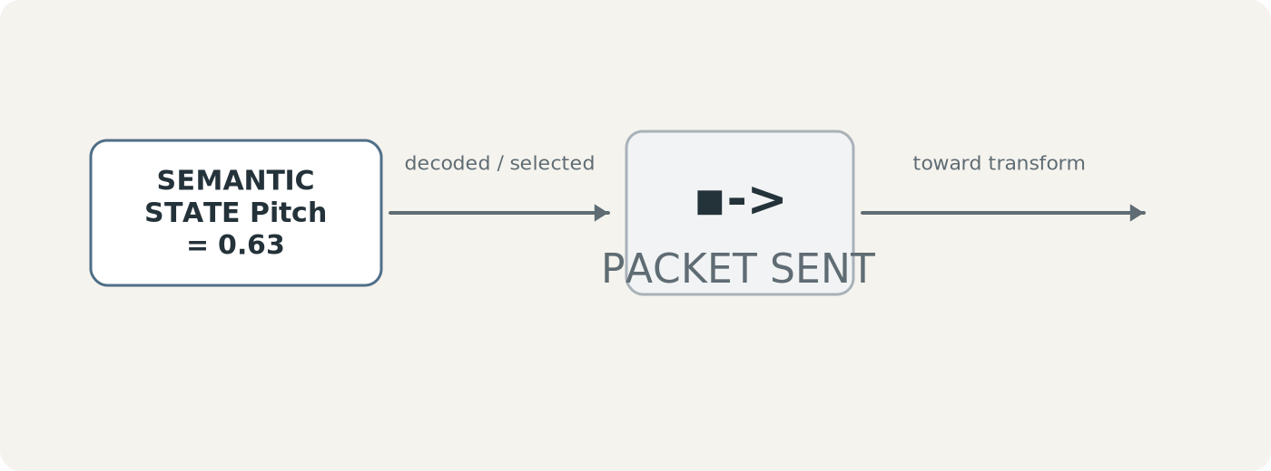
Figure 7. Packet notation ▪︎-> as semantic state being sent.
The Packet is not the Transform and is not an Expression. It carries the selected semantic value or values from the resolved source toward the transform layer. In modality transforms, those values are typically decoded scalar BitGroup values already governed by their own Semantic Kernel.
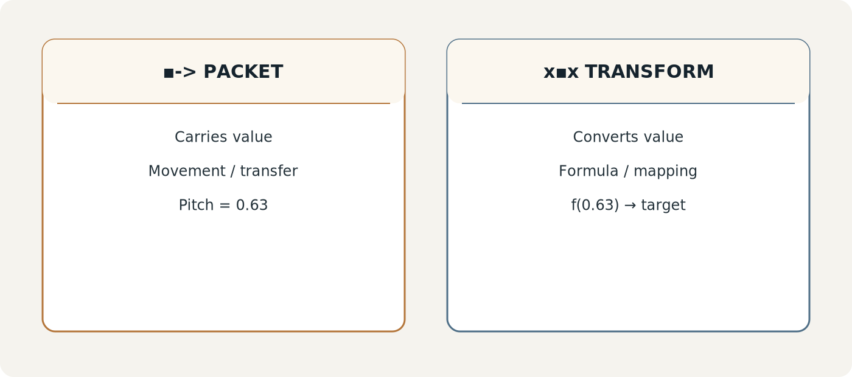
Figure 9. Packet and Transform are deliberately separate objects.
AAA-L03 · PACKET SEPARATION
The Packet carries semantic input toward expression. It does not itself define the mapping or the resulting perceptual output.

Transform: explicit cross-modality mapping
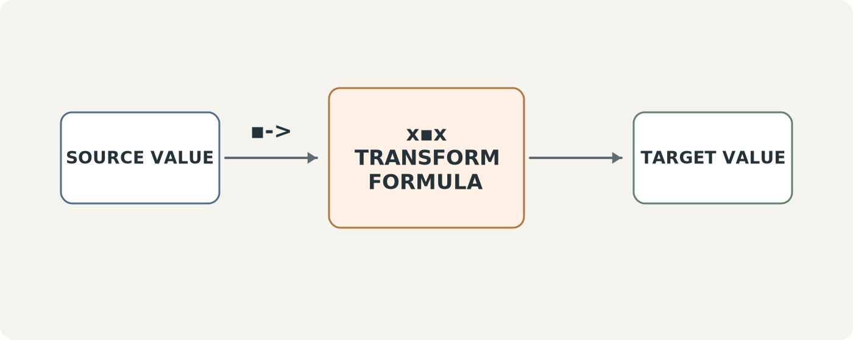
Figure 8. Transform notation x▪︎x as a conversion chamber between source and target values.
A Transform receives the Packet and applies a declared mapping. The transform may normalize an input range, apply a formula, bound the result, and return a value in a target modality. The transform does not assert that the source and target modalities are semantically identical. It only declares how one is projected into the other for the chosen application.
AAA-L04 · TRANSFORM SEPARATION
Transform defines the conversion contract between source values and target expression values. It is neither the source semantic state nor the resulting Expression.

IV. Scalar BitGroups and Modality Transforms
The transform mechanism becomes especially compact when the source is a scalar BitGroup. The Semantic Kernel already provides a bounded value. AAA does not need to reinterpret the meaning of that value; it can route the decoded scalar into a registered transform formula.
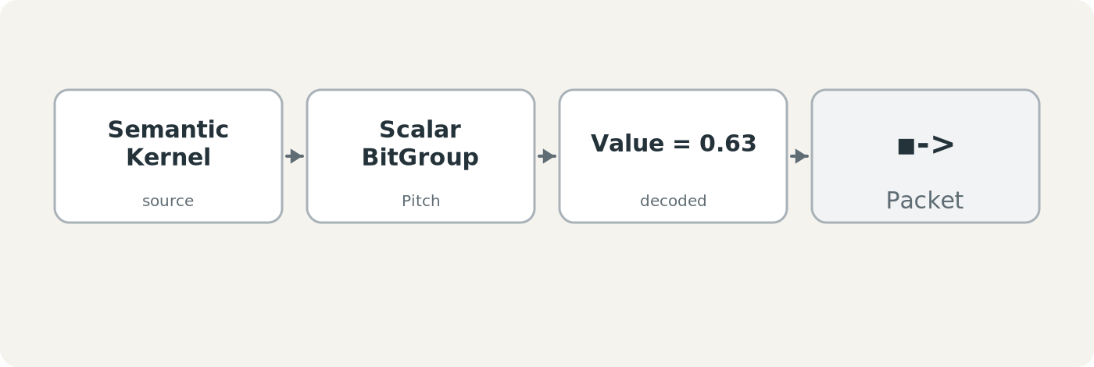
Figure 10. A scalar BitGroup value becomes the payload carried by a Packet.
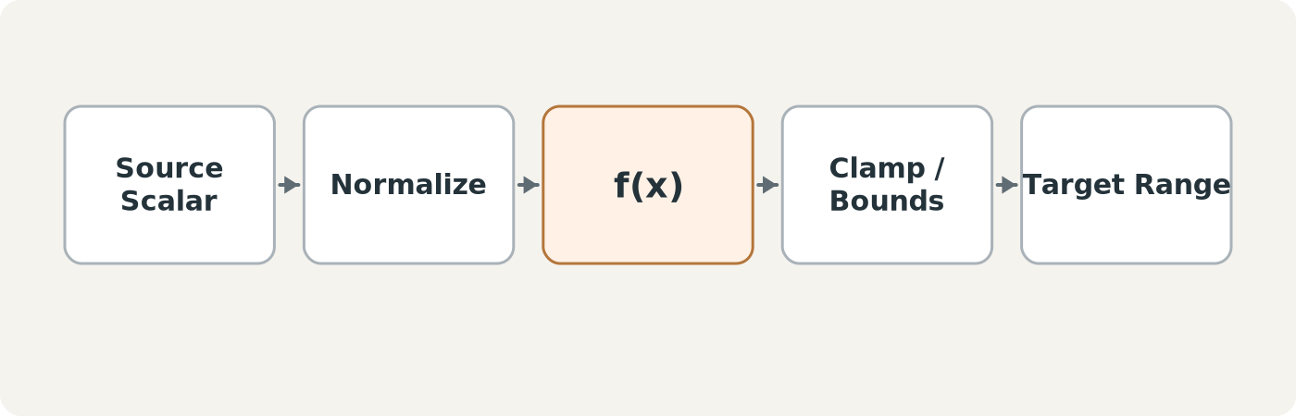
Figure 11. Generic scalar transform anatomy.
A simple transform can be modeled as source decoding → normalization → formula → bounds → target range. The exact function is transform-specific. Linear, curved, logarithmic, stepped, inverted, or other mappings can coexist so long as the transform record makes the mapping explicit.
GENERIC FORM · NON-CANONICAL EXAMPLE
For a bounded linear mapping, a runtime may normalize n = clamp((s - s_min)/(s_max - s_min), 0, 1), then resolve t = t_min + g(n)(t_max - t_min), where g is the transform curve. This is an implementation pattern, not a requirement that every AAA transform be linear.

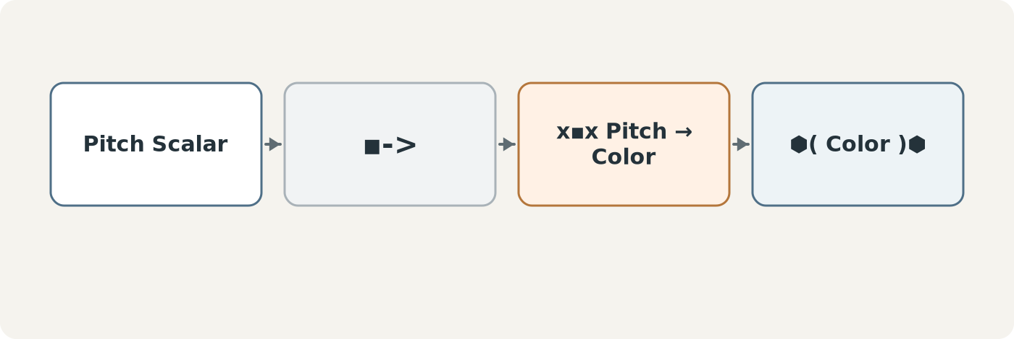
Figure 12. Example: Pitch scalar transformed into a Color expression.
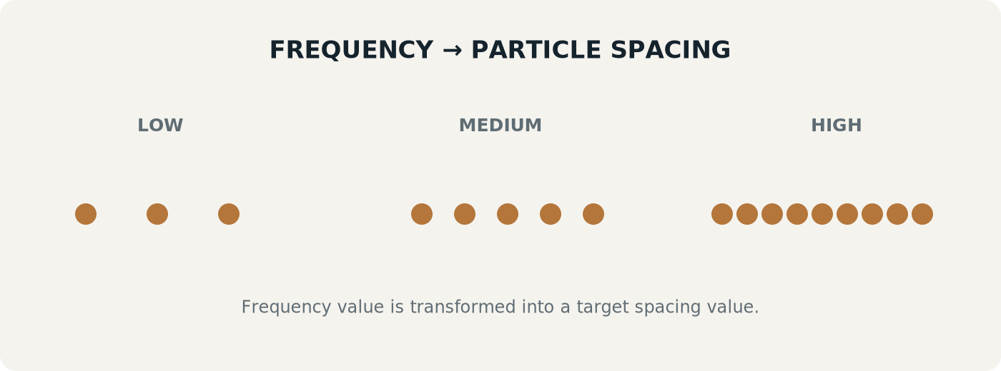
Figure 13. Example: Frequency transformed into particle spacing.
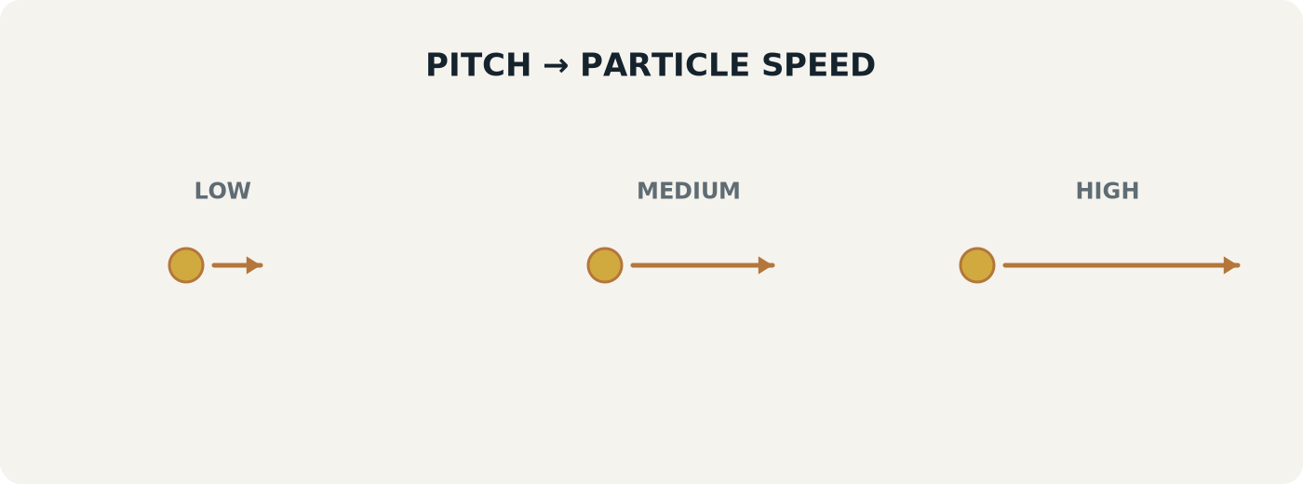
Figure 14. Example: Pitch transformed into particle speed.

One input, one or many outputs
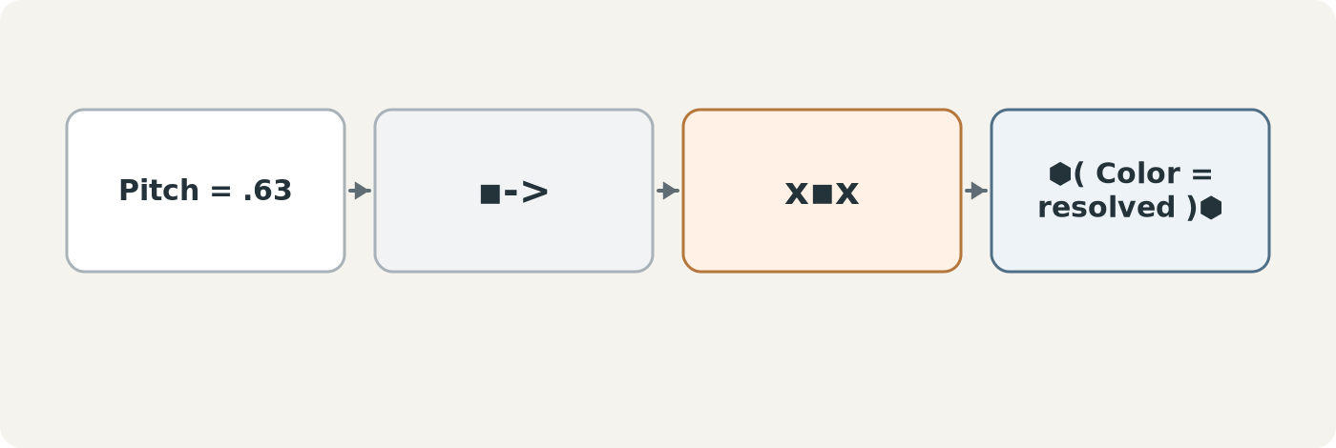
Figure 15. One Packet transformed into one Expression.
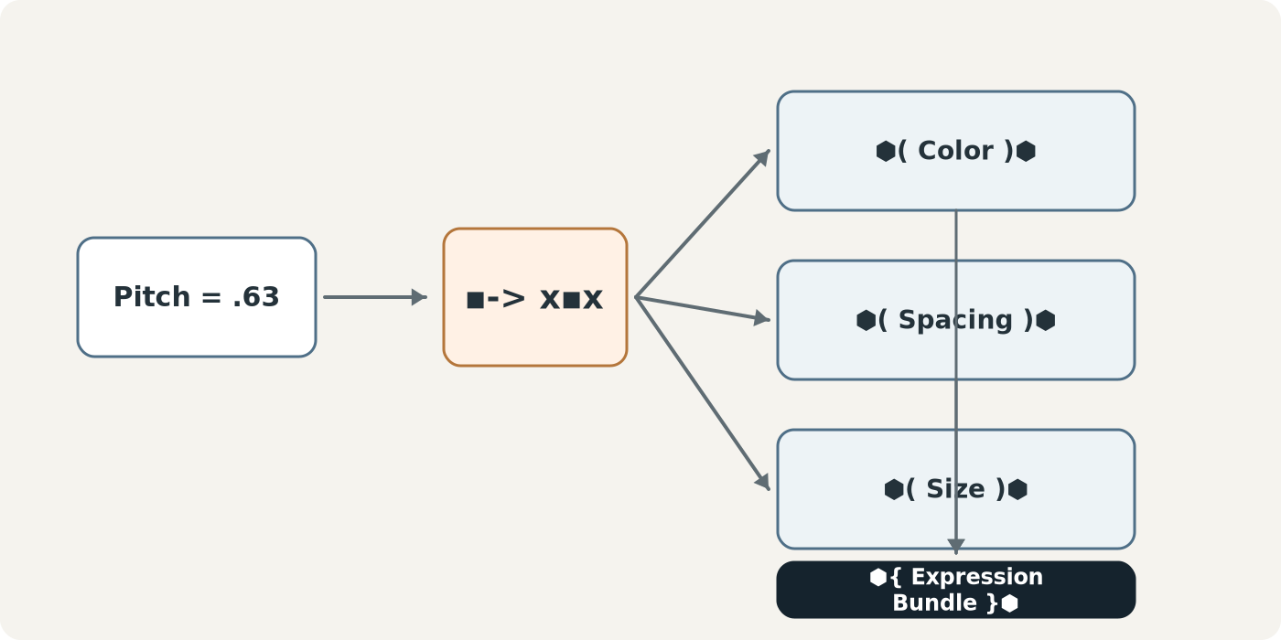
Figure 16. One Packet transformed into three Expressions and returned as an Expression Bundle.
The distinction between Packet and Expression Bundle is structural. A Packet may carry one semantic value. One Transform execution may fan that value out across several target properties. If Pitch produces Color, Spacing, and Size, the runtime returns three Expressions. Their grouping is the Expression Bundle.
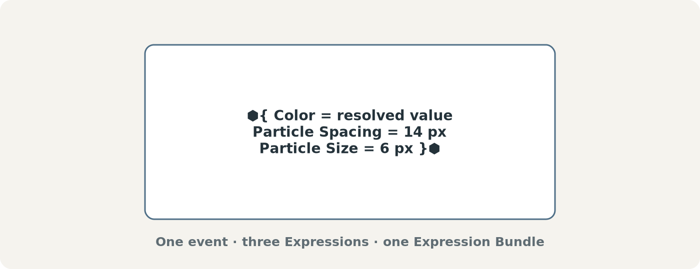
Figure 17. Expression Bundle anatomy.
AAA-L05 · EXPRESSION BUNDLE INTEGRITY
An Expression Bundle is a collection of actual Expressions. It is not another name for a Packet, Capability, transform definition, or source BitGroup.

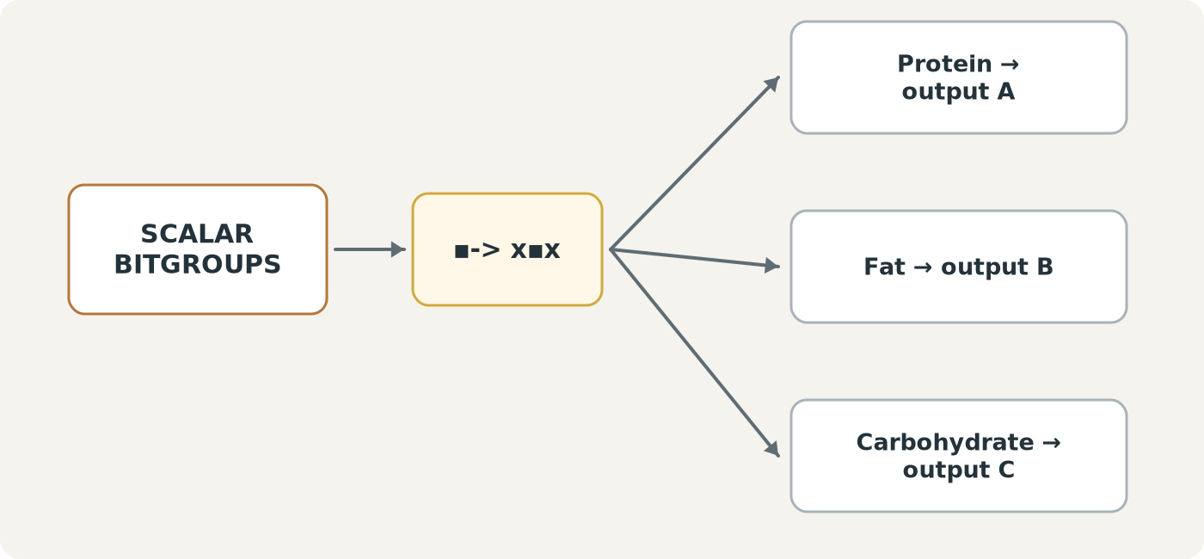
Figure 18. Multiple scalar inputs can execute parallel transform paths.

Transform registry
A transform table makes cross-modality mappings inspectable and reusable. Rather than embedding opaque conversion logic inside every Application, a transform record can expose the source modality, source semantic address, expected source range, formula or mapping, bounds, target modality, target range, EFFECTS binding, and version contract.
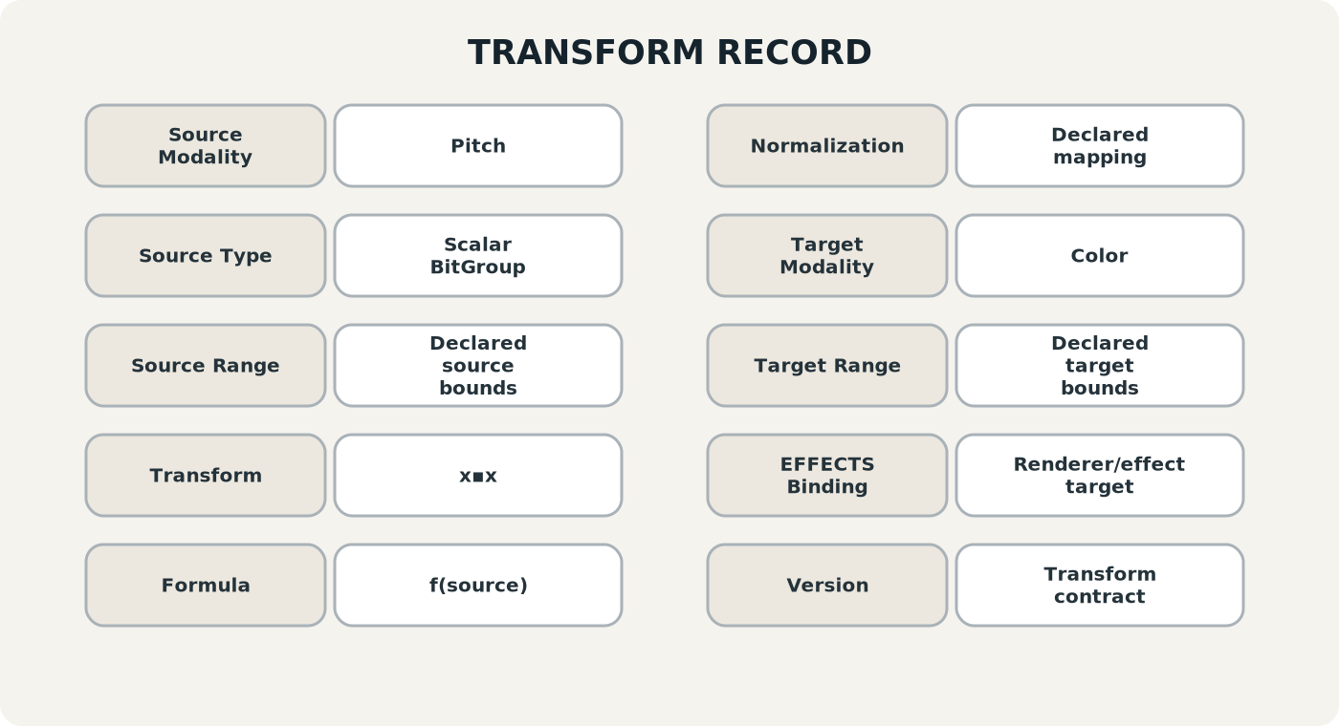
Figure 19. Reference anatomy for a Transform record.
Field | Purpose
Transform ID | Stable identity for the mapping contract.
Source Modality | The semantic or measured dimension entering the transform.
Source BitGroup / Address | Exact governed source of the scalar value.
Source Range | Declared domain of the source value.
Formula / Mapping | The conversion applied by x▪︎x.
Normalization / Bounds | How the value is normalized, clamped, inverted, stepped, or otherwise constrained.
Target Modality | Color, size, speed, spacing, sound, motion, shape, or another supported dimension.
Target Property / Range | Exact output property and legal target range.
EFFECTS Binding | The rendering/effect mechanism that can consume the transformed value.
Version | Transform contract version used for reproducibility.

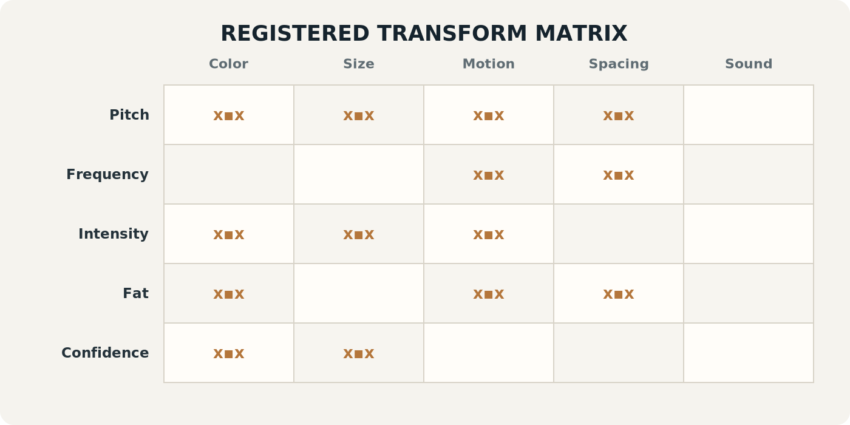
Figure 20. Transform matrix showing which source-to-target mappings are registered.
The transform matrix is a useful authoring and debugging view. A populated cell means a declared mapping exists. Blank cells mean no mapping has been registered; the runtime should not infer one merely because a target modality is technically available.
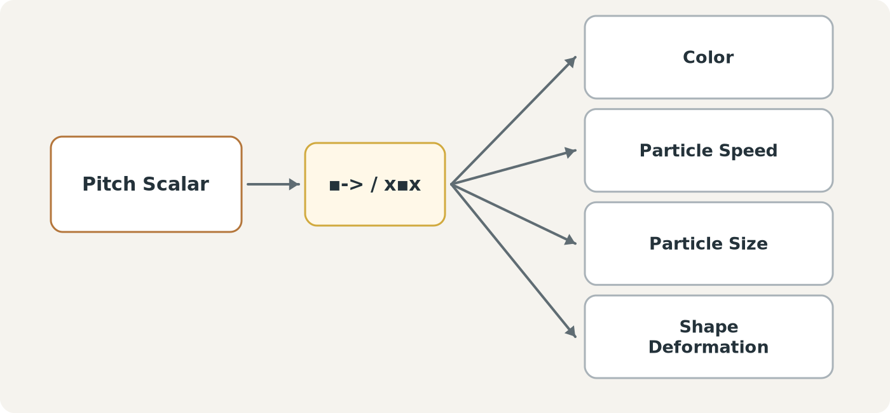
Figure 21. One source scalar may have several independent transforms.
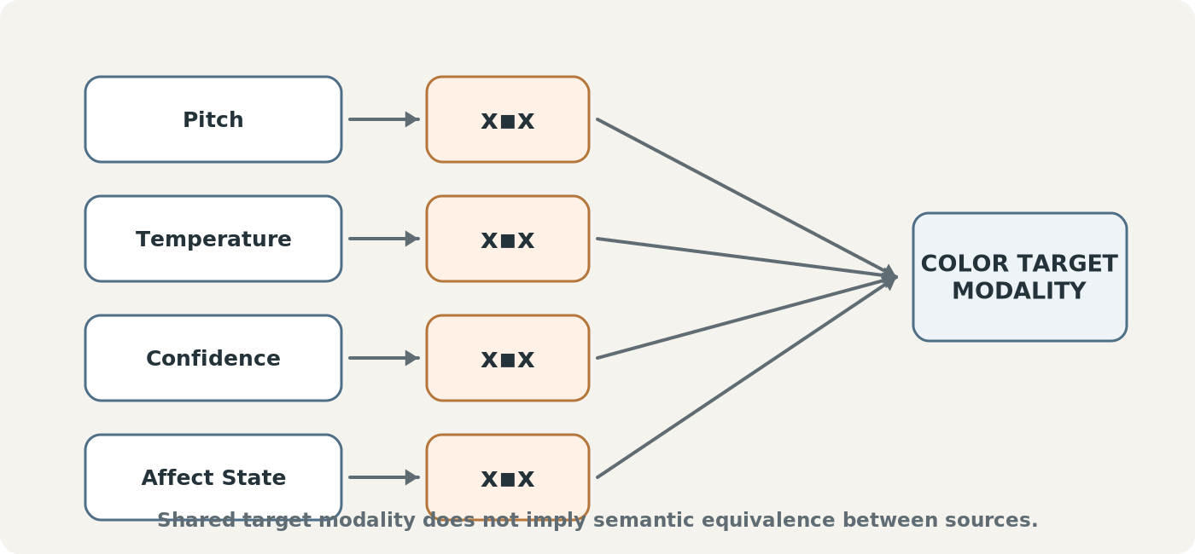
Figure 22. Different source semantics can project into the same target modality without becoming semantically equivalent.
AAA-L06 · TRANSFORM EXPLICITNESS
Cross-modality projection should use declared transforms rather than hidden equivalence assumptions. Pitch → Color and Temperature → Color are separate contracts even though both terminate in Color.

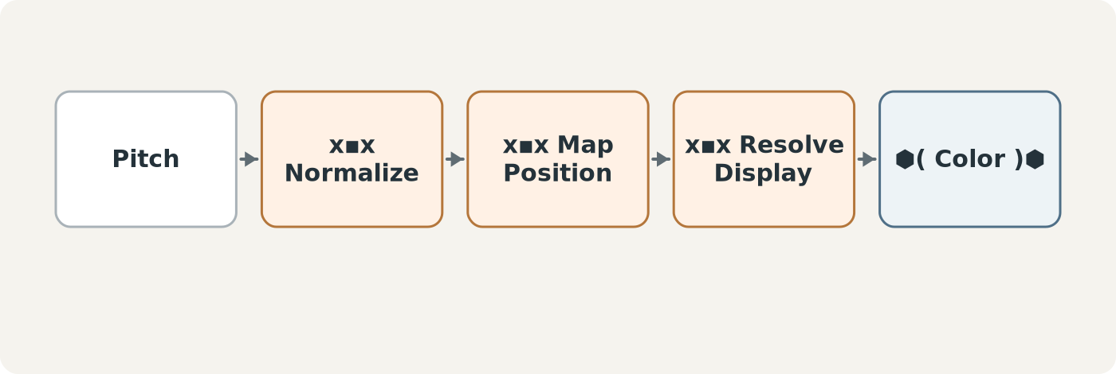
Figure 23. Transforms may be composed into explicit chains when a single mapping is insufficient.

V. Expressions, Lifetime, and Canonical Boundaries
Expressions are runtime realizations. They can be visible, audible, animated, spatial, tactile where supported, or otherwise perceptual. Their default lifecycle is short: generate, render, remain active for the required interval, then expire.
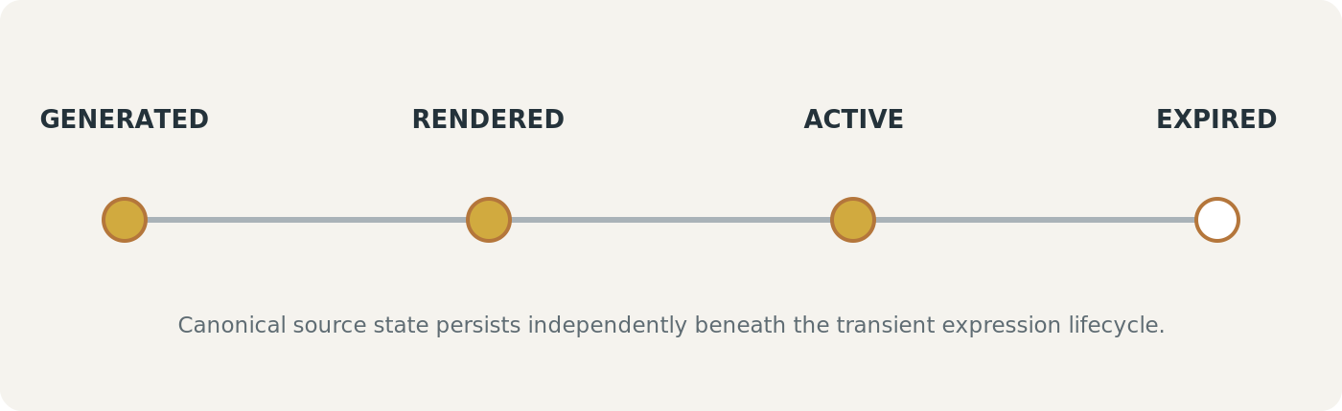
Figure 24. Expression lifetime compared with persistent canonical state.
The architecture therefore does not require an ever-growing permanent log of every shimmer, blink, particle, social joke, or AVA movement. Logging may be enabled for debugging, replay, QA, testing, audit-sensitive interaction, or deliberate archival use, but transient expression remains the default.
AAA-L08 · TRANSIENT EXPRESSION
Expressions should normally render and expire. Persistence is an explicit instrumentation or archival decision, not the default behavior of AAA.

AAA does not own canonical mutation
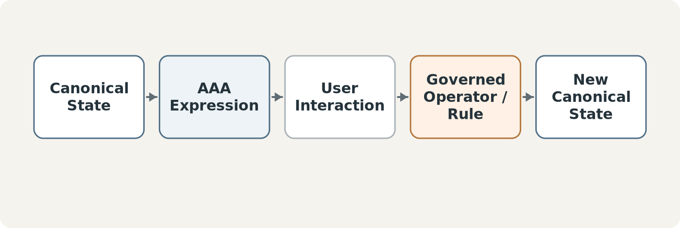
Figure 25. AAA may surface an interaction, while canonical mutation still follows governed system pathways.
An AAA can show an Approve button, point out a conflict, paint over profanity, or attach a note to a visible region. If the user requests an actual data change, that action routes through the existing authorized Operator, Rules, permissions, and Registry logic. The projection layer does not gain mutation authority merely because it displayed the control.
AAA-L09 · GOVERNED MUTATION
AAA may expose existing governed actions. It does not silently bypass the system pathways that own canonical change.

VI. Association and Record-Driven Composition
AAA is not merely an effects engine. Before something can be expressed, the Application must resolve what is being associated: a target, a relation, current context, relevant semantic state, and an available Capability. Once resolved, the Capability sends a Packet into the Transform layer.
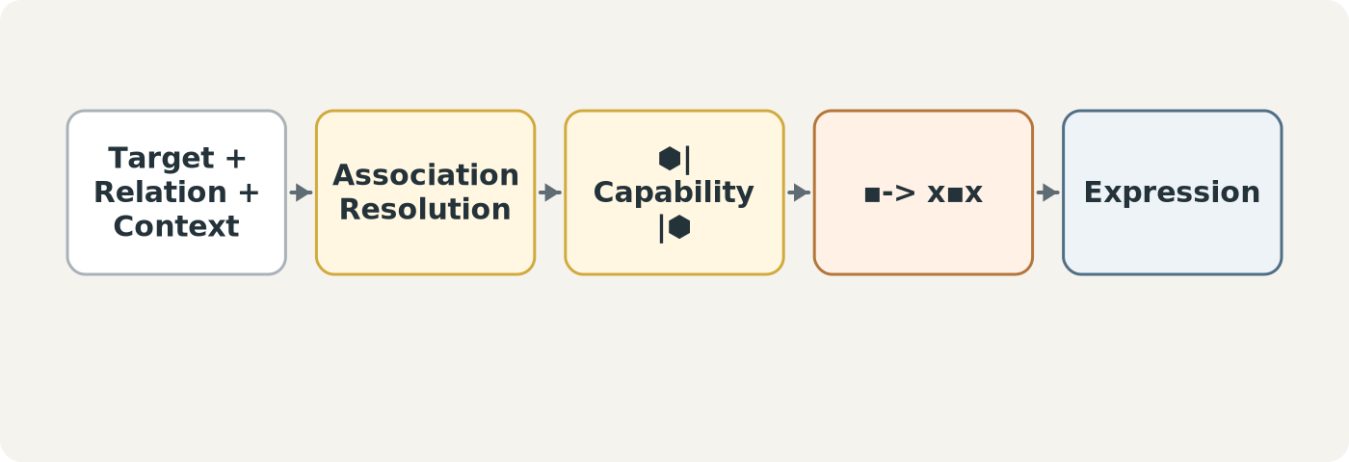
Figure 26. Association is the primitive that precedes expression.
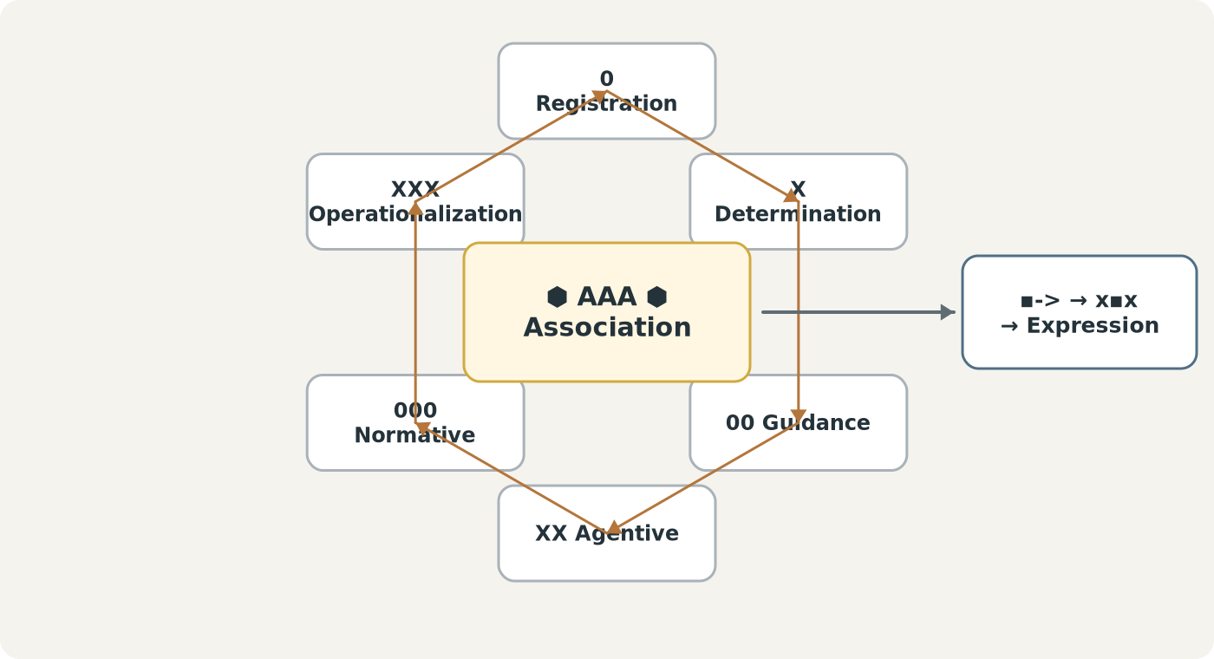
Figure 27. AAA can traverse the DRAGON cybernetic loop to resolve identity, applicability, guidance, agentive capability, normative constraints, and operational values.
The DRAGON diagram is a capability map rather than a claim that every AAA must traverse every position in a fixed linear order. An Application should use only the governed structures necessary to resolve its association.

Composition tables
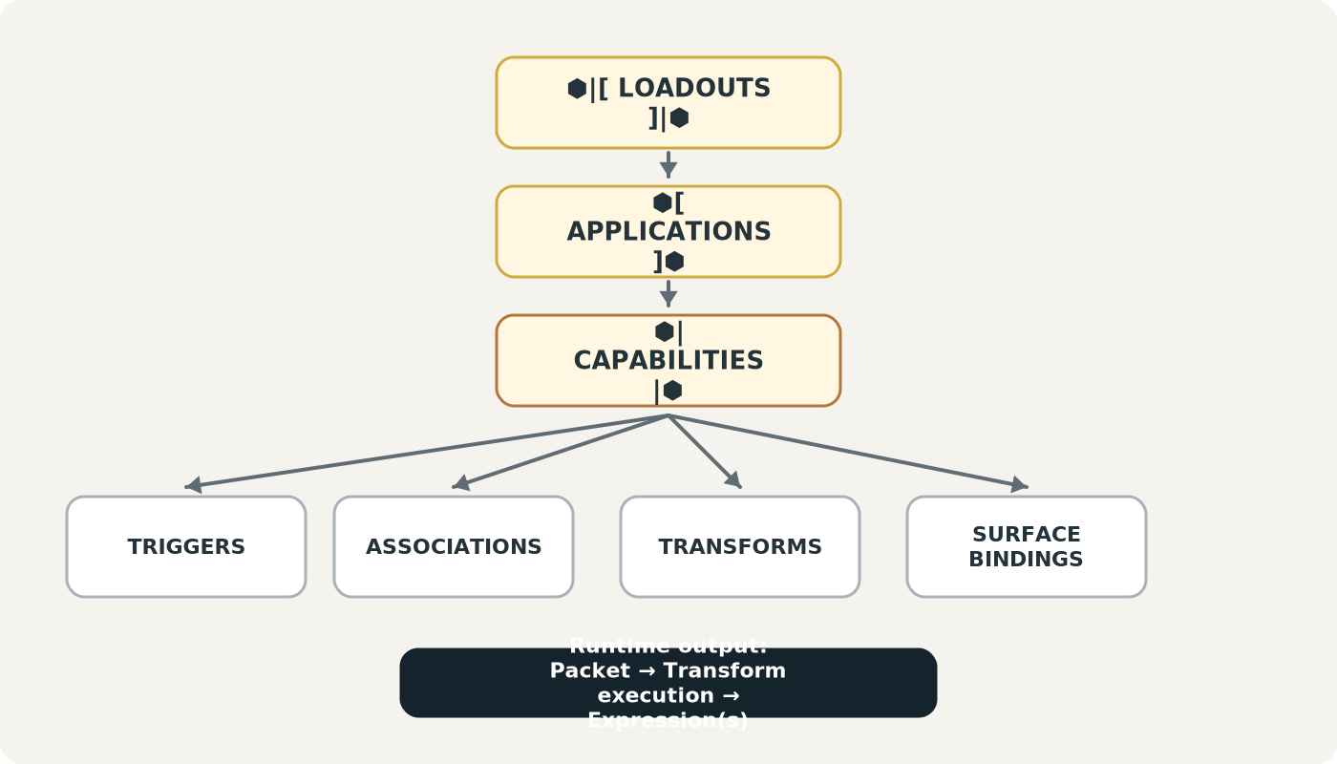
Figure 28. Recommended table architecture for composing AAA Applications.
Table | Primary Role
AAA Applications | Stores complete ⬢[ Application ]⬢ records.
AAA Capabilities | Stores reusable ⬢| Capability |⬢ definitions.
AAA Loadouts | Stores ⬢|[ Loadout ]|⬢ collections and ordering.
AAA Triggers | Defines events or conditions that initiate resolution.
AAA Associations | Defines target selection and graph traversal behavior.
AAA Transform Registry | Stores x▪︎x source-to-target mapping contracts.
AAA Transform Bindings | Connects source scalar values, transforms, and target properties.
AAA Surface Bindings | Declares where/how resolved Expressions may appear in DARTBOARD or AVA.
AAA Permissions / Scope | Controls local, targeted, group, shared, and presentation visibility.
Application–Capability Bindings | Supports reusable many-to-many composition between Applications and Capabilities.

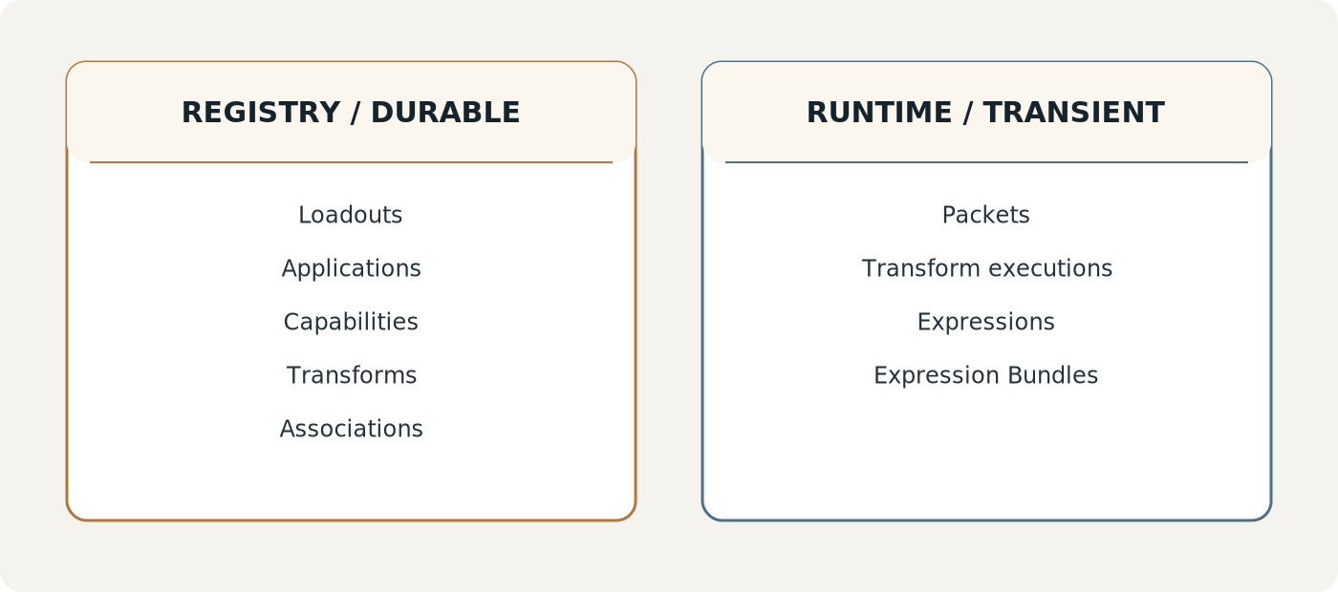
Figure 29. Durable registry objects versus transient runtime objects.
A permanent Expressions table is intentionally not required. The system can compose Applications and transforms from durable records while producing Packets and Expressions only when invoked. If later workflows require replayable authored expression patterns, those should be named separately from actual runtime Expressions so the language remains unambiguous.

VII. AVA and DARTBOARD
AVA - Awakened Virtual Animus - is not the same thing as AAA. AVA is the persistent embodied interaction point through which AAA can be surfaced. AAA is the application and association layer. AVA may remain docked as Home, float over DARTBOARD, host an active Application, become an expressive target, and return to its dock.
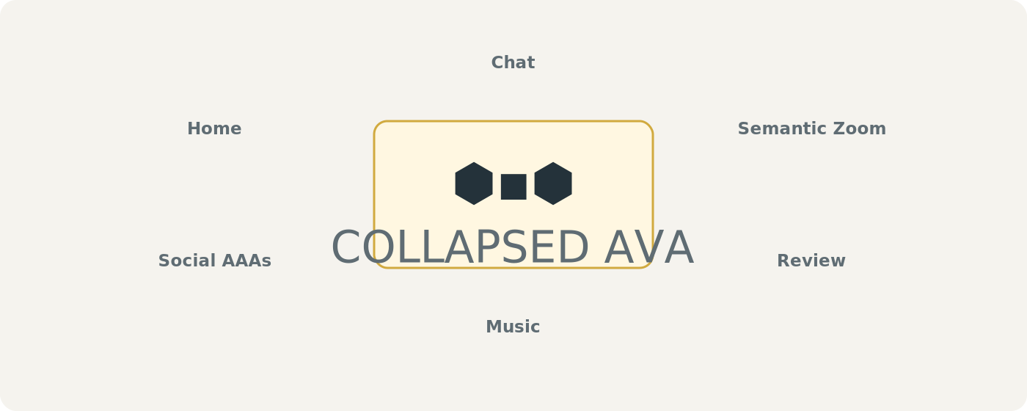
Figure 30. Collapsed AVA: ⬢▪︎⬢ as the persistent minimal access point.
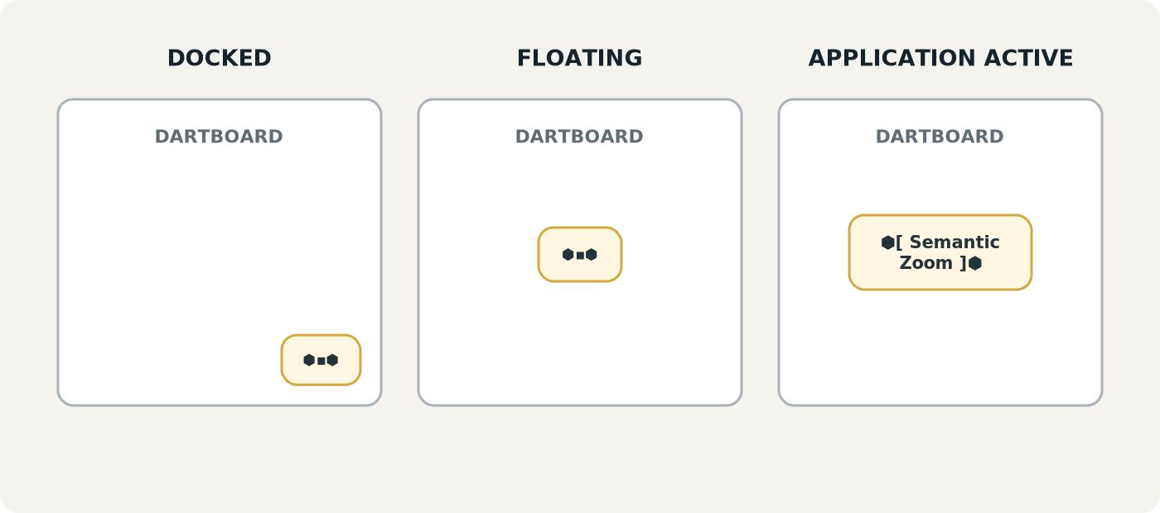
Figure 31. Docked, floating, and active AVA states.
The collapsed notation is intentionally compact: a semantic point inside the AAA loop. It does not require AVA to be literally implemented as a Semantic Kernel Bit; it communicates the idea of a large associative environment collapsed into a tiny persistent handle.

Projection layers
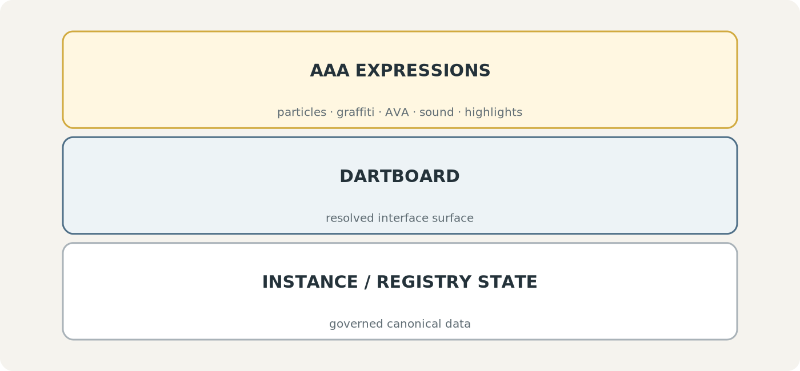
Figure 32. AAA Expressions sit above the DARTBOARD and canonical state layers.
The layer model makes destructive editing unnecessary. A censor AAA can visually cover a word while the original string remains present. A social AAA can graffiti the newest words in a shared document without writing into the document. Disabling the projection removes the expression immediately.
AAA-L10 · TOGGLEABILITY
Disabling an AAA removes its projection without requiring reconstruction of canonical source data.

VIII. Interoperability

AAA + EFFECTS
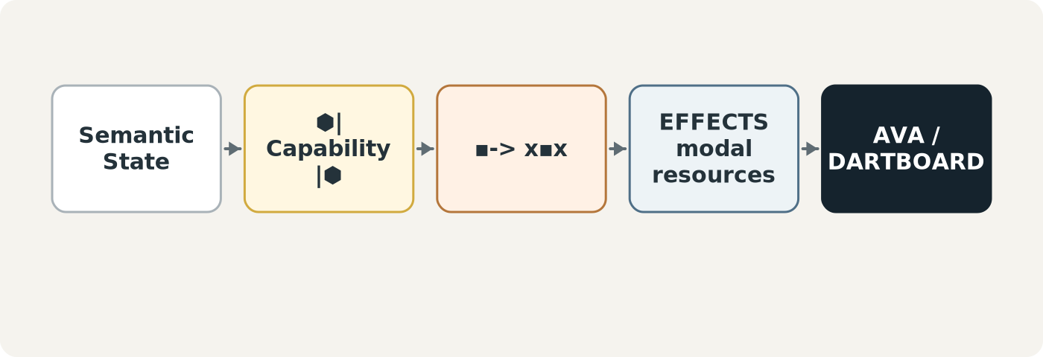
Figure 33. AAA resolves semantic state and transformed values; EFFECTS provides the expressive modalities that render them.
AAA answers what association should be surfaced and sends the relevant Packet. x▪︎x resolves the target values. EFFECTS supplies the expressive vocabulary - color, motion, sound, particles, shape, shimmer, fade, and other modalities - through which those values become perceptible.

AAA + BOOTSTRAP
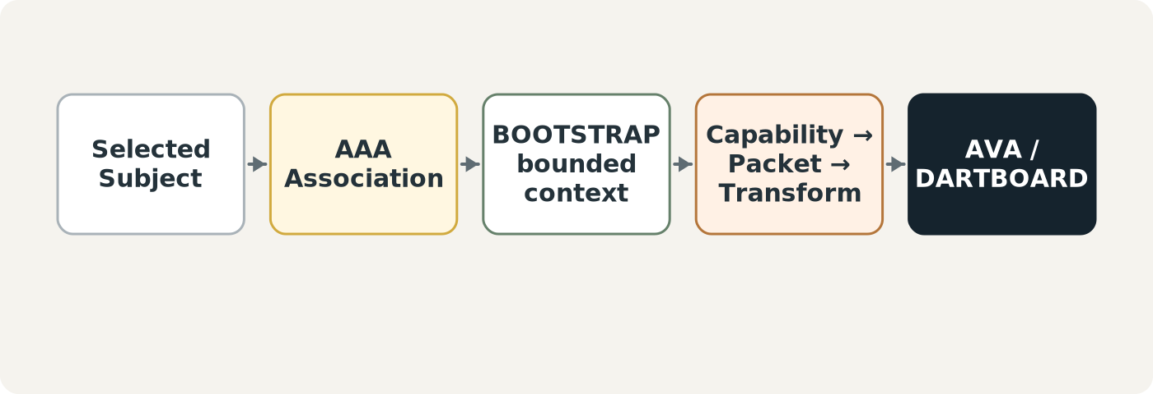
Figure 34. A knowledge-dependent AAA can use BOOTSTRAP to obtain bounded context before expression.
Semantic Zoom and Chat demonstrate this boundary. AAA does not own the definition or conversational knowledge. It resolves the selected subject, obtains the governed bounded context, then exposes an existing capability through AVA or DARTBOARD.

IX. Worked Atlas Association Applications
The examples below deliberately mix serious and absurd applications. This is architectural, not decorative: the same disciplined runtime grammar should support both. The difference is the selected association and transform, not the integrity of the underlying data.

Semantic Zoom
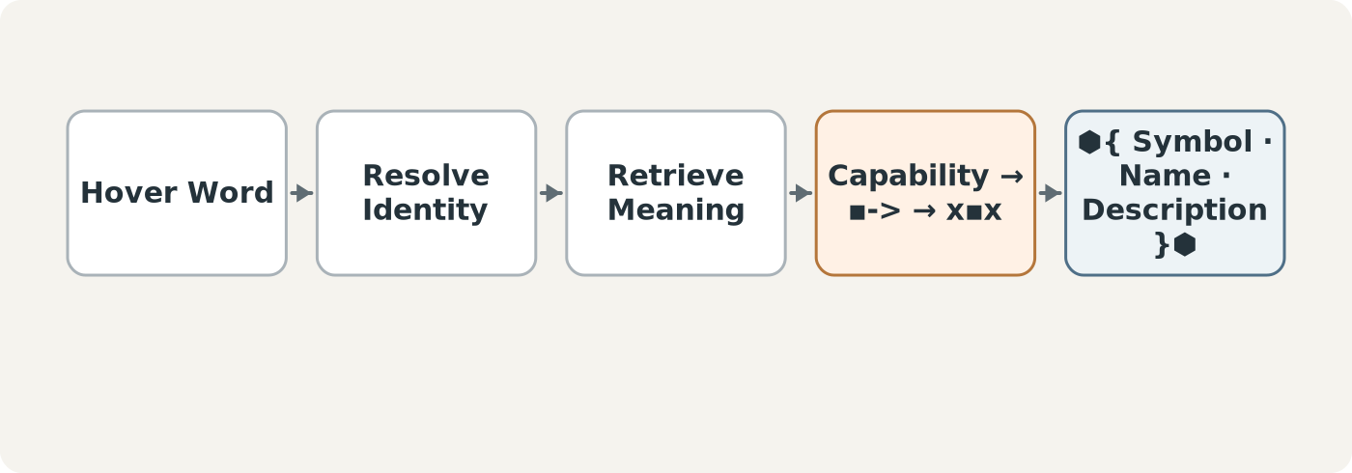
Figure 35. Semantic Zoom: hover → resolve identity → retrieve meaning → express context.
Semantic Zoom turns an unfamiliar symbol, word, or object into an immediate teaching surface. The selected item remains unchanged; AVA or DARTBOARD temporarily surfaces its existing semantic identity and description.

Chat
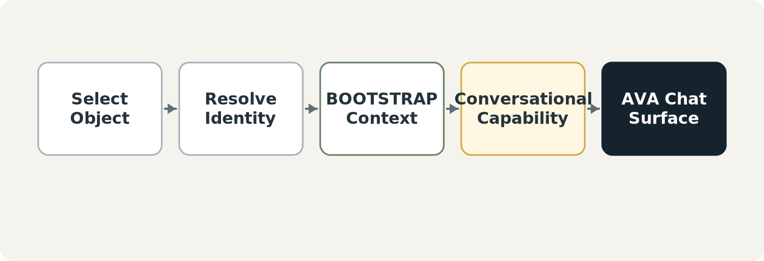
Figure 36. Chat: the selected object provides an exact conversational point with bounded context.
Chat is not a new intelligence system inside AAA. The system already supports reasoning and contextual retrieval. The Application supplies a convenient associative entry point so the user can converse about the currently selected semantic object.

Review
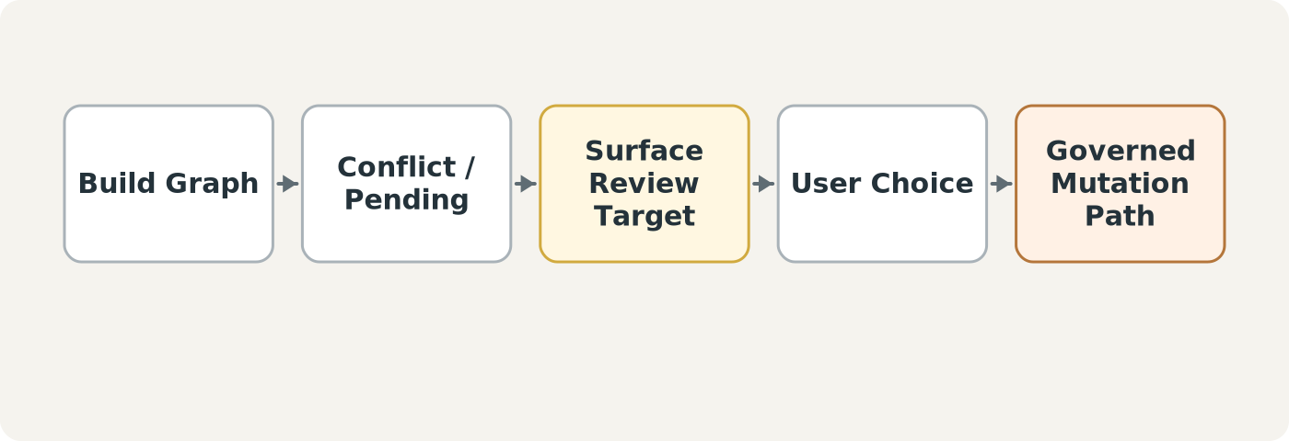
Figure 37. Review: surface unresolved work, then route actual decisions through governed mutation.
Review can highlight conflicts, missing definitions, or records requiring judgment. Its Expressions point, annotate, rank, or explain. Approved changes still pass through the appropriate system authority.

Music
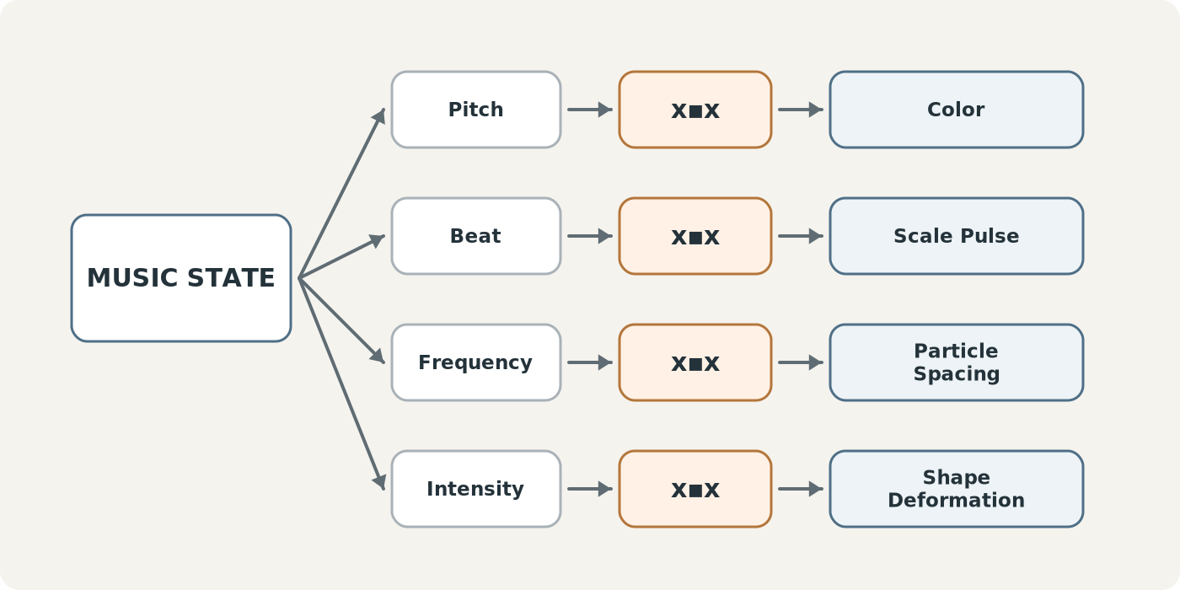
Figure 38. Music AAA: several musical scalar dimensions drive several perceptual transforms.
Music demonstrates fan-out across modalities. Pitch may control Color, Beat may control scale pulses, Frequency may control particle spacing, and Intensity may control deformation. Each mapping is separately registered. The resulting simultaneous outputs form an Expression Bundle.

Macro Particles
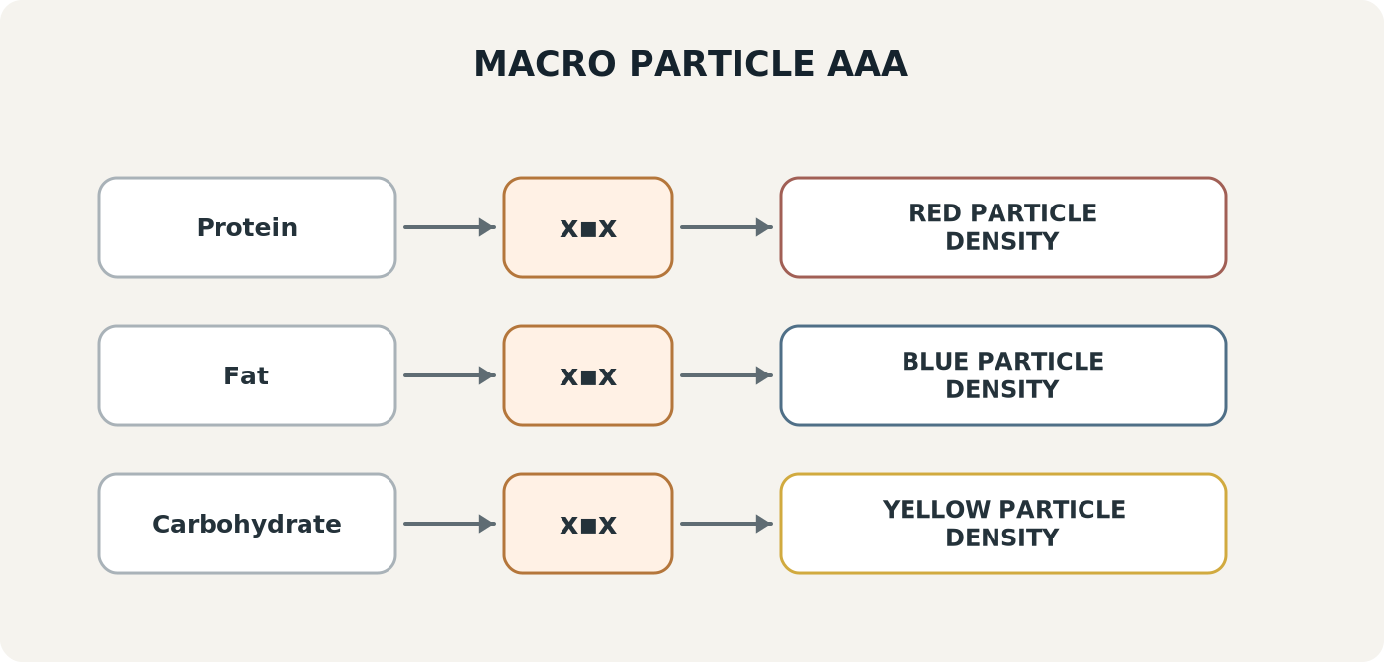
Figure 39. Macro Particles: nutrition scalars mapped into visible particle densities.
A food record can expose Protein, Fat, and Carbohydrate scalar BitGroups. The Application can transform those values into red, blue, and yellow particle densities respectively. The visualization does not change nutrition data and does not claim the nutrient literally is a color; it is an explicit perceptual mapping.

Happy Memory
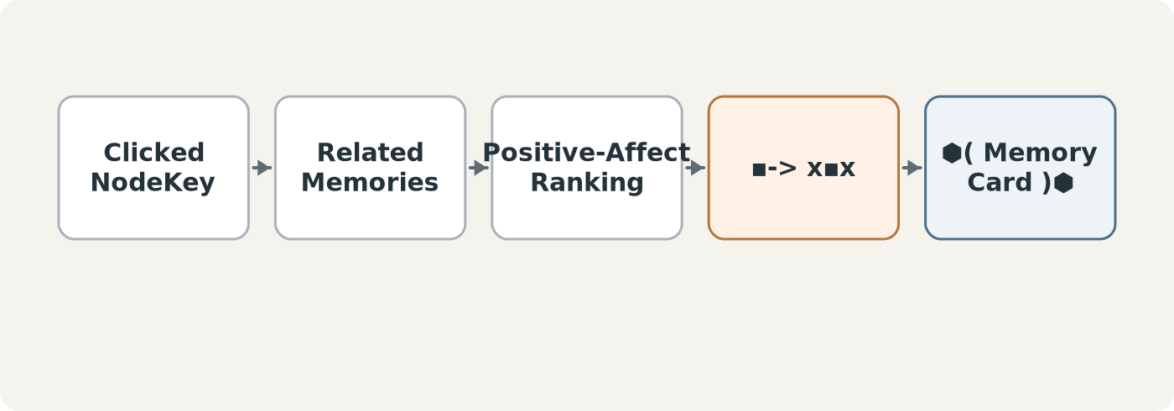
Figure 40. Happy Memory: relation traversal selects a positive linked memory and surfaces it transiently.
A selected NodeKey can route into related Memories, apply the system's chosen positive-affect criteria, and surface the best-fitting result beside AVA. Again, the Application is a projection over existing graph relations rather than a new memory store.

Sports Drop
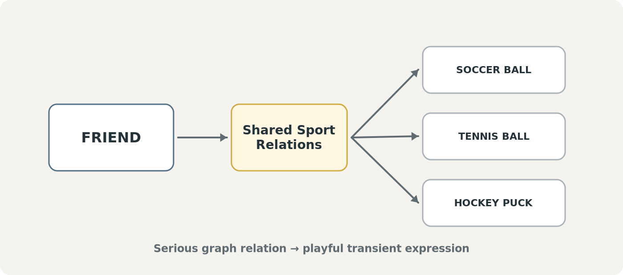
Figure 41. Sports Drop: serious relationship data projected as a deliberately playful visual.
A collaborator can be associated with sports previously played together. The corresponding sports assets can then fall onto or around that collaborator's interface representation. The underlying relation remains a normal graph fact; the falling ball is merely the chosen expression.

Shared Friend Drop
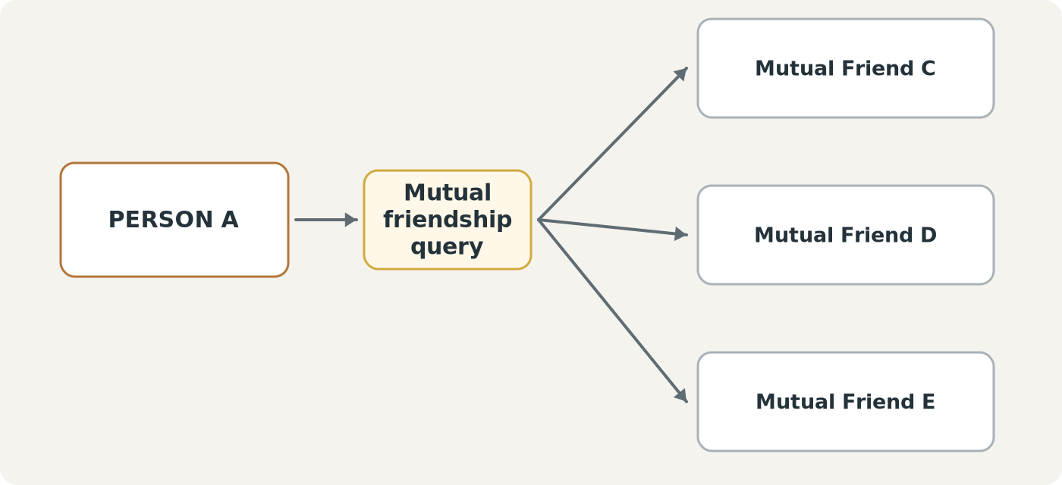
Figure 42. Shared Friend Drop: mutual-friend relations become transient visual objects.
The same composition pattern works when the projected object is another person or graph node. A mutual-friend query returns eligible identities, which the Application surfaces with its chosen visual behavior.

Censor Painter and Language Scold
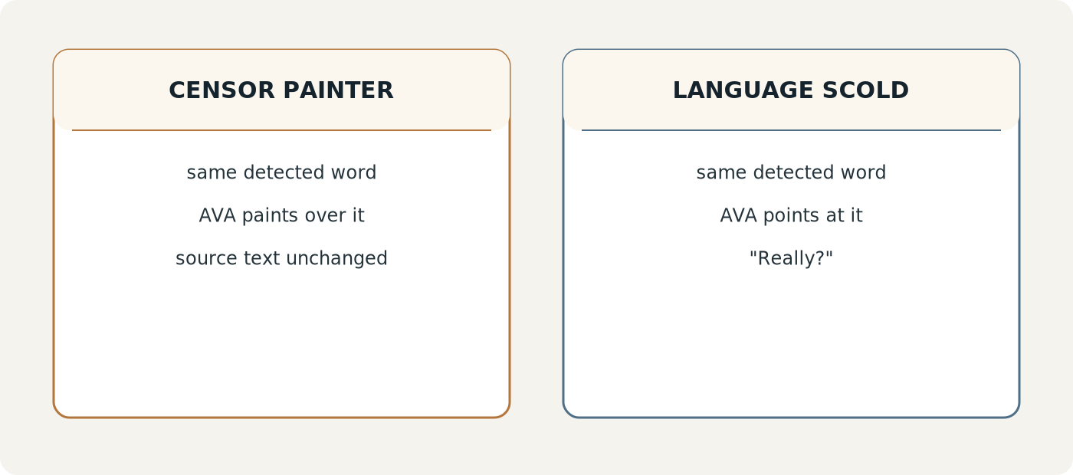
Figure 43. Two Applications can share the same language trigger while producing completely different projections.
One Application can have AVA fly down and paint over configured words. Another can point at the same word and scold the user. In both cases the source text remains canonical and untouched. Turning off the AAA reveals the original wording instantly.

X. Shared Workspaces and Social Projection
Non-destructive projection becomes especially powerful in collaborative environments. Several users can share the same canonical workspace while each sees a different local AAA layer. Targeted interactions can be sent to one collaborator, shared Applications can be visible to the whole workspace, and presentation layers can be scoped to an audience.
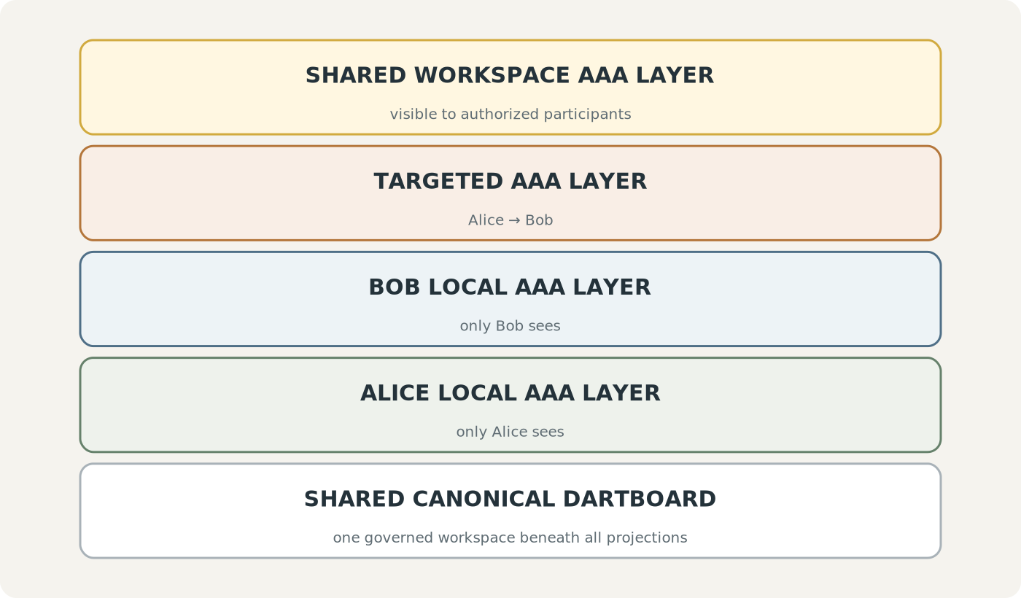
Figure 44. Multiple AAA perceptual layers over one shared canonical DARTBOARD.
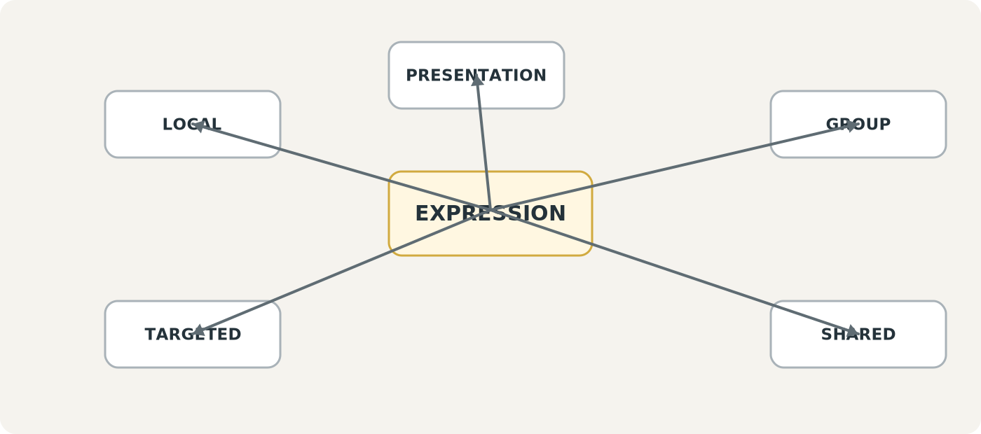
Figure 45. Expression scope: local, targeted, group, shared, or presentation.
Scope belongs to expression delivery, not semantic truth. A targeted graffiti expression does not become shared document content merely because it is anchored to a shared paragraph.

AVA-to-AVA interaction
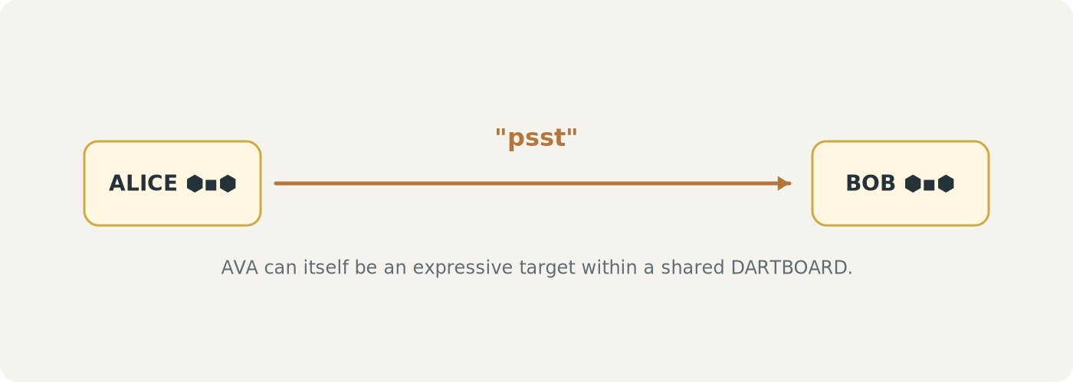
Figure 46. AVA itself can be an expressive target in a shared workspace.
An AVA can fly over to another participant's AVA, point, react, carry a tiny message, or trigger another permitted social expression. These interactions can remain transient and user-governed.

Permissions and focus
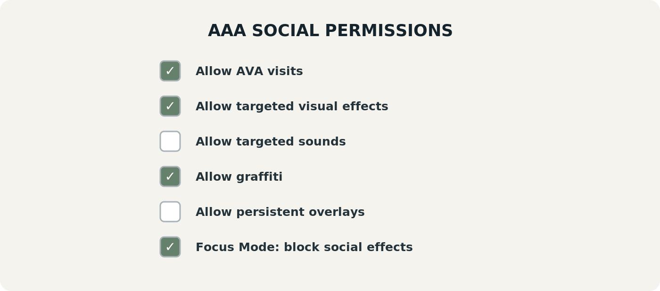
Figure 47. Example social projection permissions.
Permission controls are important because the same architecture that enables delightful collaboration could otherwise become distracting. Users should be able to allow or block AVA visits, targeted sound, graffiti, persistent overlays, or social effects during focus states without disabling the underlying shared workspace.
AAA-L12 · USER-CONTROLLED PROJECTION
Users control which AAA Applications, Loadouts, transforms, social scopes, and perceptual interactions are active for their experience.

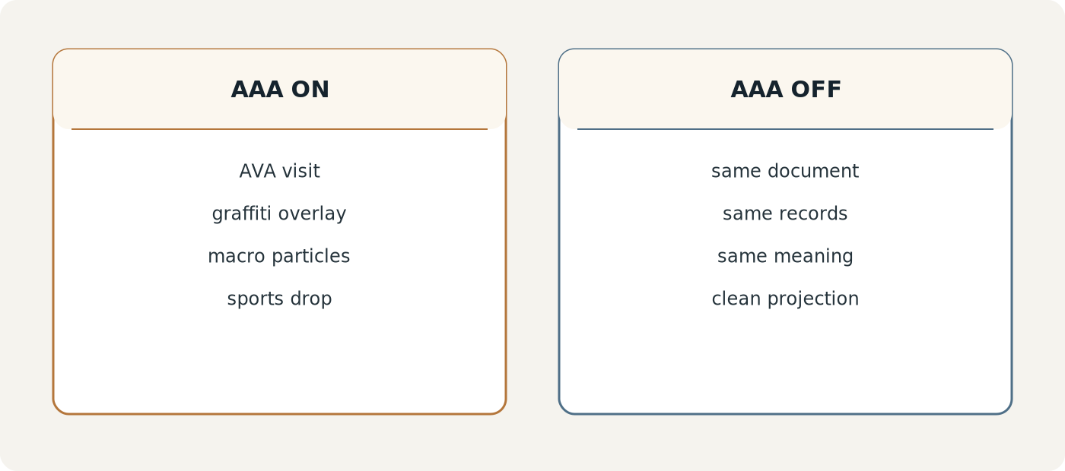
Figure 48. The entire expressive layer can be toggled away while the workspace remains intact.

XI. Reuse, Scaling, and Creative Multiplication
AAA becomes cheaper to extend as the reusable libraries grow. A Capability such as “Spawn Visual Asset” can support several Applications. A Transform such as Pitch → Color can be reused wherever its semantic and target contracts are compatible. Applications therefore become compositions of existing graph intelligence rather than isolated custom programs.
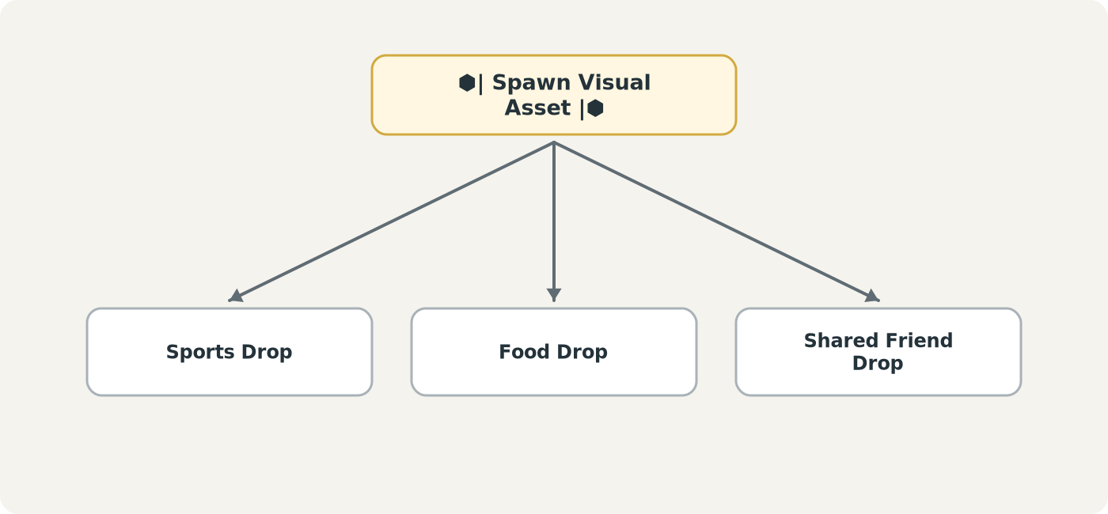
Figure 49. One reusable Capability can support several Applications.
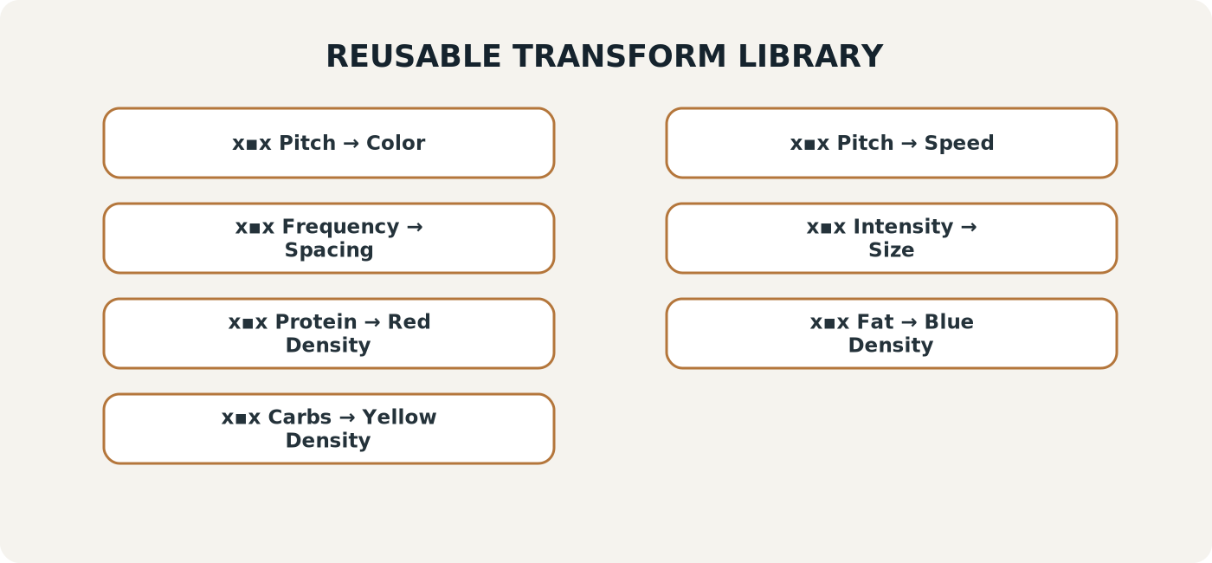
Figure 50. A reusable Transform library separates mapping contracts from individual Applications.
AAA-L11 · CAPABILITY AND TRANSFORM REUSE
Reusable Capabilities and Transforms may support multiple Applications where their declared contracts are compatible. Reuse does not permit silent semantic remapping.

Application composition
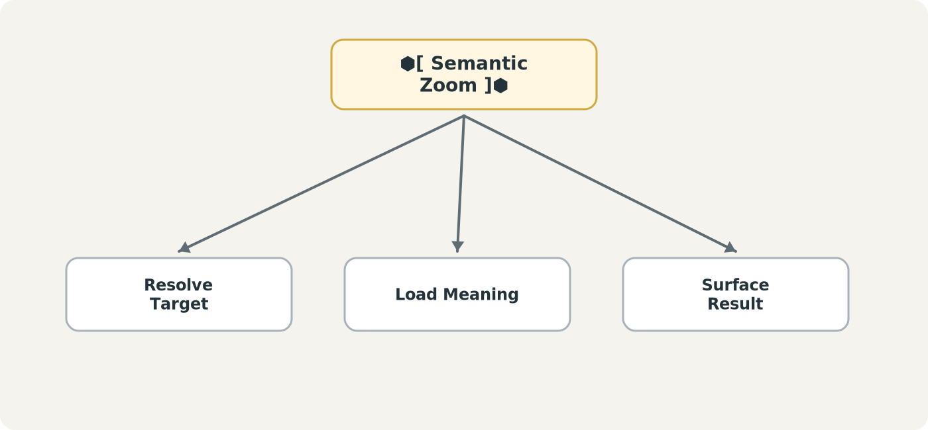
Figure 51. An Application is a composition of reusable capabilities rather than a monolithic behavior.
Semantic Zoom, for example, can reuse target resolution, context loading, and surface presentation capabilities. The record-driven model lets new Applications emerge by binding known pieces rather than rebuilding the same logic repeatedly.

Loadouts
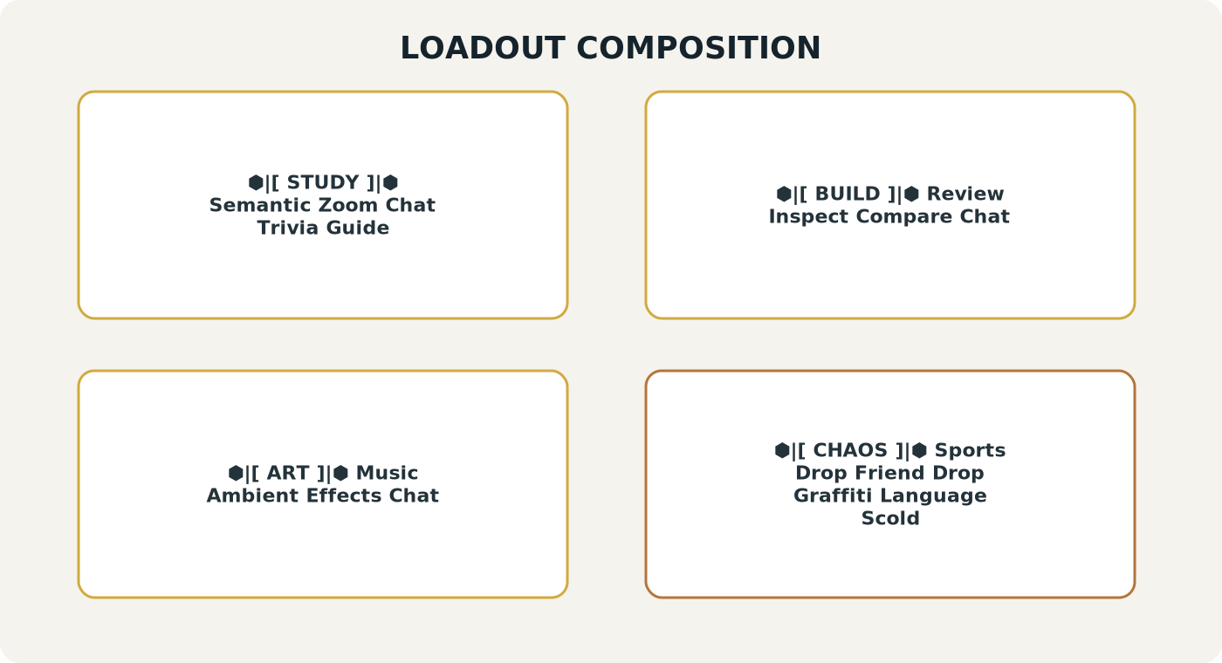
Figure 52. Loadouts group Applications for different working modes without changing system meaning.
A Study Loadout can emphasize Semantic Zoom, Chat, Trivia, and Guides. A Build Loadout can prioritize Review, Inspect, Compare, and Chat. An Art Loadout can emphasize Music and ambient effects. A deliberately chaotic social Loadout can contain Sports Drop, Friend Drop, Graffiti, and Language Scold. These are user-facing selections, not semantic partitions of the underlying graph.

One graph, many experiences
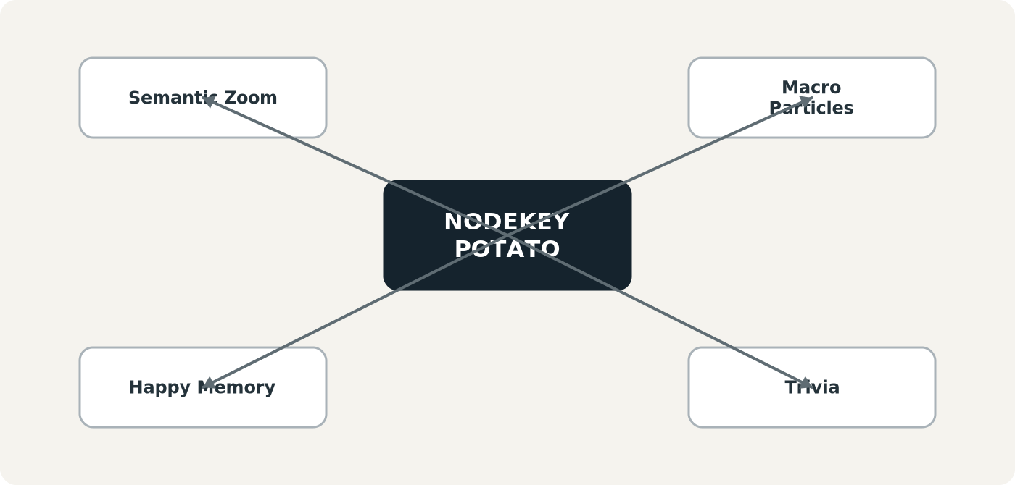
Figure 53. One NodeKey can support many unrelated AAA experiences because each Application selects a different association.
A single food NodeKey can support a definition, nutrition visualization, memory surfacing, trivia, comparison, or social joke without duplicating the source object. As the graph becomes richer, the number of meaningful associative projections grows combinatorially.
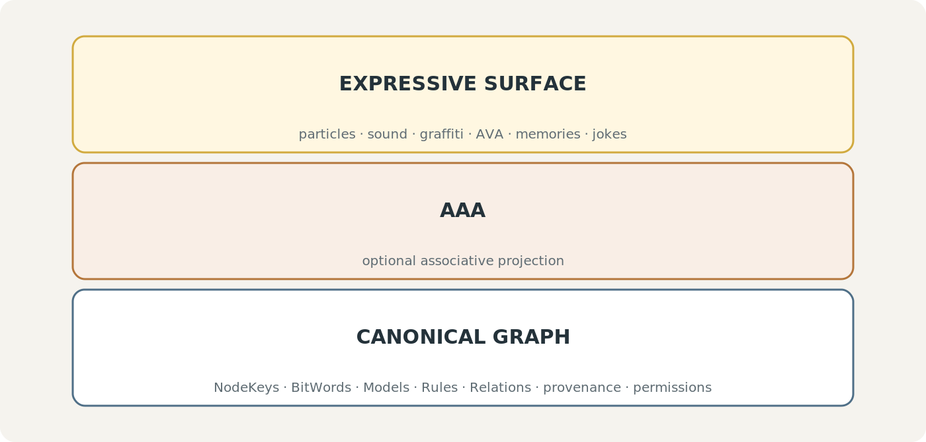
Figure 54. Canonical rigor and expressive freedom are intentionally decoupled.
This separation is the philosophical center of AAA. The Registry can be serious, governed, and exact while the visible experience can be educational, analytical, beautiful, strange, or completely unhinged. The more disciplined the source architecture is, the safer it becomes to be playful at the projection layer.
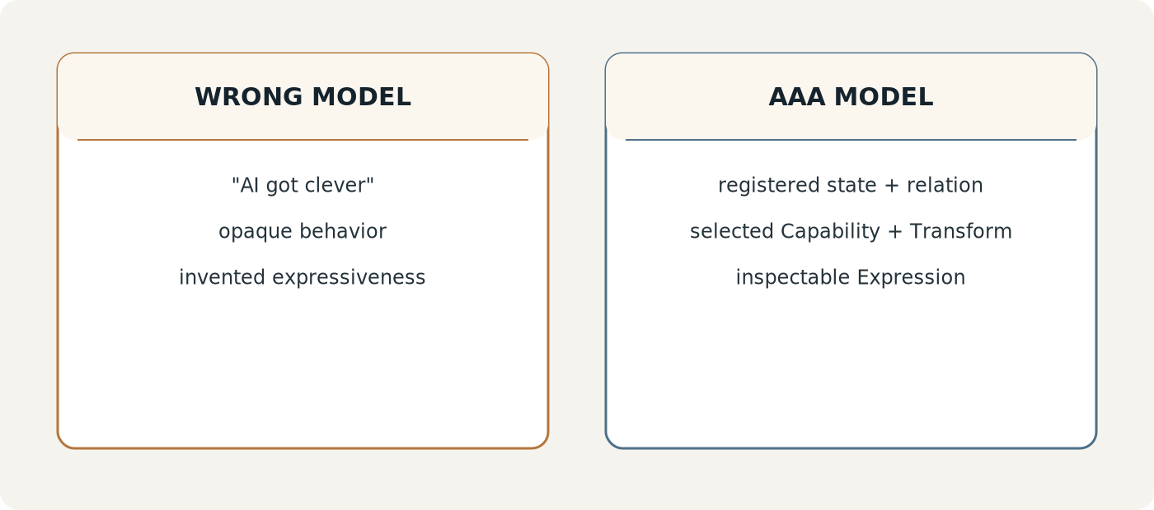
Figure 55. AAA is not explained as “the AI got clever”; it is registered state routed through inspectable associations and transforms.
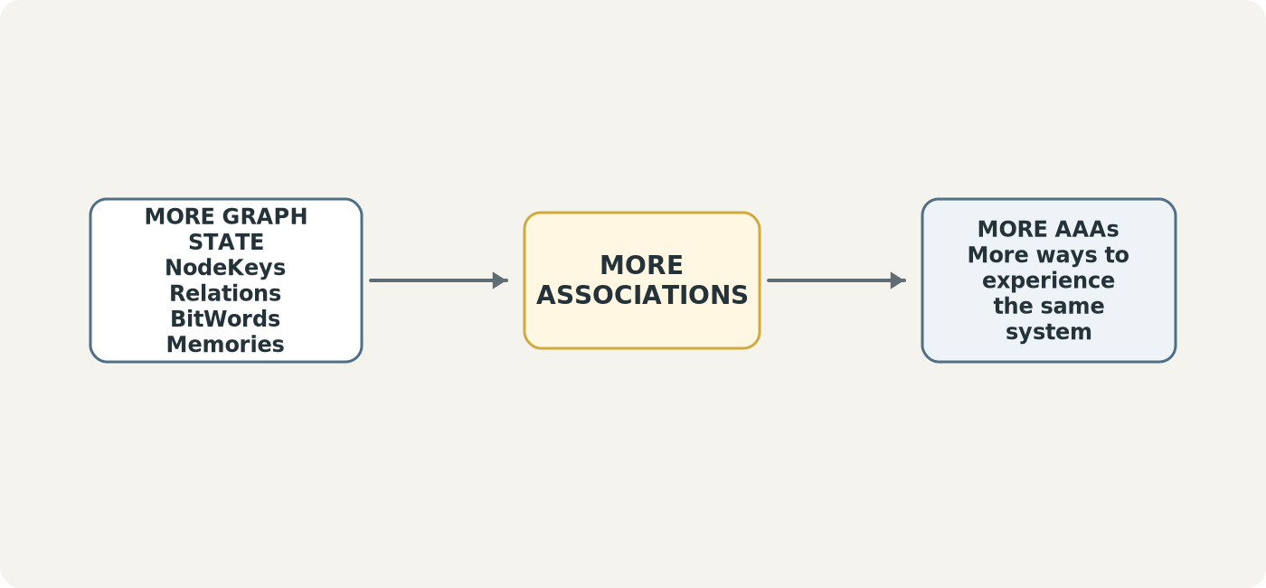
Figure 56. The AAA creative multiplier: richer graph state creates more potential associations and more possible experiences.

XII. Implementation Reference
A minimal implementation can begin with durable Tables for Applications, Capabilities, Loadouts, Triggers, Associations, Transform records, Transform Bindings, Surface Bindings, and Permissions. Runtime Packets and Expressions can remain in memory unless a workflow explicitly needs replay or audit persistence.
At invocation time, the runtime resolves the selected Application and Capability, obtains the relevant governed scalar BitGroup value or values, sends the Packet (▪︎->), applies the registered Transform (x▪︎x), resolves one or more output values, binds those values to EFFECTS-supported modalities, and renders the resulting Expression or Expression Bundle through AVA or DARTBOARD. If an interaction requests canonical change, the request leaves AAA and enters the existing governed mutation pathway.
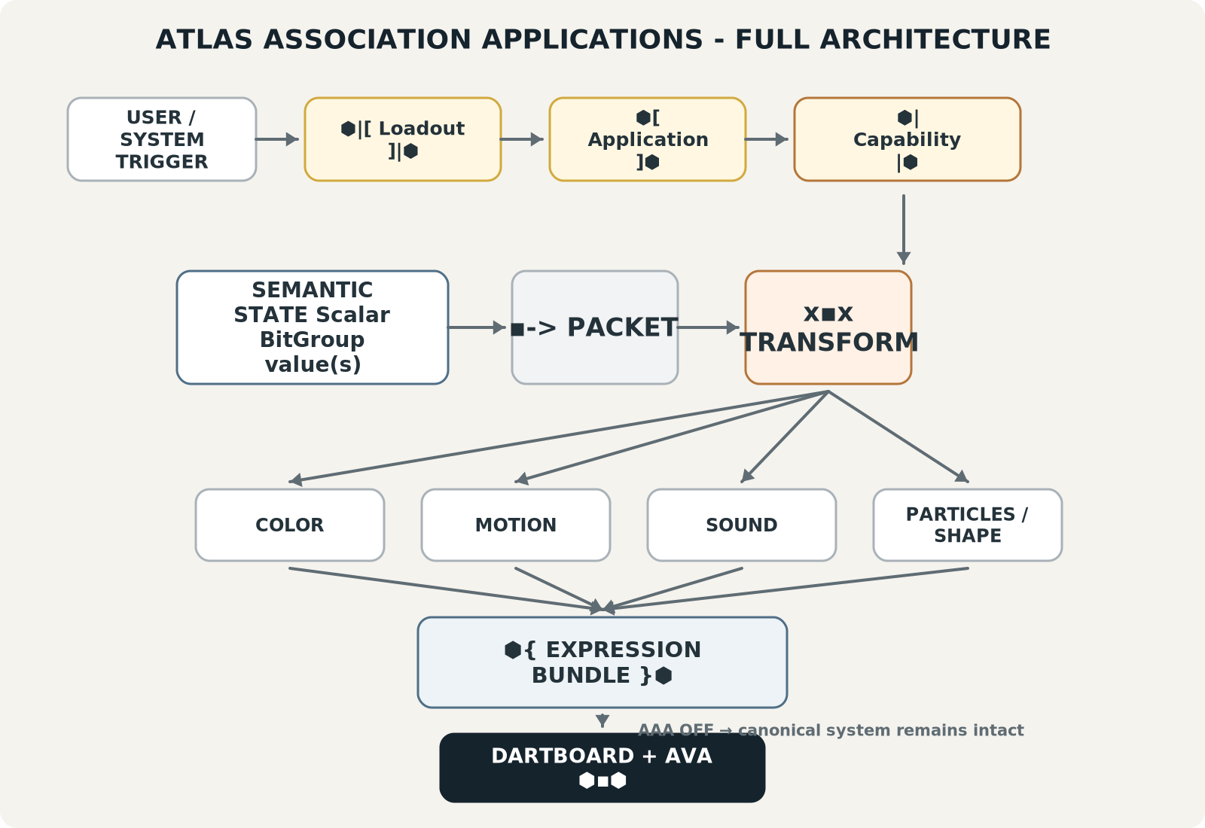
Figure 57. Full AAA architecture: from trigger and application selection through Packet, Transform, Expression Bundle, DARTBOARD, and AVA.

Design Laws
Law | Name | Statement
AAA-L01 | Non-Destructive Projection | AAA does not silently redefine canonical source semantics.
AAA-L02 | Capability / Realization Separation | Capability is possibility; Expression is actual output.
AAA-L03 | Packet Separation | Packet carries semantic input toward expression.
AAA-L04 | Transform Separation | Transform owns the declared conversion between source and target values.
AAA-L05 | Expression Bundle Integrity | A Bundle contains multiple actual Expressions.
AAA-L06 | Transform Explicitness | Cross-modality mappings are declared rather than inferred from visual similarity.
AAA-L07 | Semantic Preservation | Pitch → Color does not assert Pitch = Color.
AAA-L08 | Transient Expression | Expressions normally render and expire unless persistence is explicitly needed.
AAA-L09 | Governed Mutation | Canonical changes route through the system structures that own mutation.
AAA-L10 | Toggleability | Removing AAA projection leaves canonical source meaning intact.
AAA-L11 | Capability and Transform Reuse | Reusable components may serve multiple Applications when contracts permit.
AAA-L12 | User-Controlled Projection | Users govern active Applications, Loadouts, social scopes, and perceptual interactions.

Conclusion
Atlas Association Applications turn a dense semantic system into a plastic experiential environment without asking the semantic system to become less rigorous. AAA is deliberately optional. Its power comes from using what already exists: governed identities, relations, scalar BitGroups, contextual knowledge, effects, and interface surfaces.
The notation makes that boundary inspectable. ⬢| Capability |⬢ names what can be surfaced. ▪︎-> shows the Packet being sent. x▪︎x names the Transform that maps source values into target modalities. ⬢( Expression )⬢ names one actual output. ⬢{ Expression Bundle }⬢ names several outputs realized together. ⬢[ Application ]⬢ composes the experience, ⬢|[ Loadout ]|⬢ selects groups of experiences, and ⬢▪︎⬢ keeps AVA persistently available in its smallest form.
The result is a layer where deterministic scalar transformations and ridiculous social theater can coexist on the same architecture. A pitch value can become color or particle speed. Nutrition can become particles. A shared relation can become a falling sports ball. A word can be painted over or scolded without being rewritten. The canonical graph remains serious; the perceptual surface is free to become whatever the user finds useful, legible, delightful, or funny.

Appendix A. Quick Reference
Construction | Interpretation
⬢ | AAA language / application marker
⬢|[ Loadout ]|⬢ | Selected Application collection
⬢[ Application ]⬢ | One AAA Application
⬢| Capability |⬢ | Available capability
▪︎-> | Packet being sent
x▪︎x | Transform
⬢( Expression )⬢ | One actual transformed output
⬢{ Expression Bundle }⬢ | Multiple actual Expressions
⬢▪︎⬢ | Collapsed AVA

CANONICAL RUNTIME CHAIN
⬢| Capability |⬢ → ▪︎-> → x▪︎x → ⬢( Expression )⬢ OR ⬢{ Expression Bundle }⬢

