SEMANTIC GROOVING | Formal Specification v1.0
SEMANTIC GROOVING
Persistent Interpretive Structure, Semantic Accretion, and Cross-GROOVE Synthesis
A GROOVE Architecture for Reusable Model-Conditioned Semantic Projections over Shared Observable Corpora
CORE THESIS
Semantic interpretation need not remain ephemeral. When Model-conditioned interpretations are preserved against stable Observable Versioned Entry identities, prior semantic work becomes reusable computational material that can be filtered, intersected, cascaded, compared, re-swept, and synthesized to guide subsequent reasoning over the same corpus.

FORMAL SYSTEM SPECIFICATION
Version 1.0 • 15 August 2026
Interpret once. GROOVE it. Build from there.

Document Status and Relationship to the GROOVE Series
This document specifies Semantic Grooving as the persistence and composition layer of GROOVE. It assumes the basic GROOVE concepts of Observable Versioned Entries, typed relations, source locators, Bundle manifests, and hierarchical navigation, then extends them with saved Model-conditioned GROOVE Projections, configurable Sweep Profiles, Cross-GROOVE operations, Semantic Surfaces, projection lineage, and reusable Semantic Instruments.
Within the broader sequence, the first GROOVE specification establishes lightweight semantic routing over documents and folders. CERBERUS GROOVE extends those routes upward into Master artifacts, candidate system components, and multimodal simulation. This specification focuses on the emergent property that becomes visible once multiple GROOVE results are preserved over the same stable corpus: prior interpretation itself becomes reusable infrastructure.
NON-TRUTH BOUNDARY
A GROOVE Projection records an interpretation produced through declared Models and pass configurations. A Projection, intersection, persistent overlap, or repeated semantic path SHALL NOT by itself be treated as factual, causal, scientific, historical, or normative truth. Semantic synthesis routes inquiry; Observable sources ground claims.

Normative Language
The key words SHALL, SHALL NOT, SHOULD, SHOULD NOT, and MAY are used normatively. SHALL indicates a requirement for conformance to the relevant profile. SHOULD indicates a strong recommendation that may be departed from with an explicit reason. MAY indicates an optional implementation choice.

Scope
- Persistence of Model-conditioned semantic interpretation as versioned GROOVE Projections.
- Configurable Sweep Profiles composed of linear, branching, conditional, iterative, or Model-resolution passes.
- Cross-GROOVE operations over compatible Projections sharing stable Observable Entry identities or registered bridges.
- Progressive semantic zoom through BitWord resolution families such as SCIENCE-16 → SCIENCE-64 → SCIENCE-256.
- Interfaces for building passes, saving Projections, intersecting semantic surfaces, comparing routes, inspecting lineage, and returning to source artifacts.
- Handoff of recurring semantic structure into CERBERUS Models, SKs, Operators, Rules, Relations, Chains, and other formal components.

Contents
The paper is organized as an implementation-oriented progression from persistent interpretation to configurable passes, Cross-GROOVE synthesis, interfaces, worked examples, and formal system handoff.
Part | Title | Focus
I | Foundations | Entries, Models, Sweep Profiles, GROOVE Projections, semantic work persistence.
II | Semantic Accretion | Accretive corpora, saved interpretation, lineage, retroactive enrichment.
III | Configurable Pass Architecture | Custom pass definitions, BitWord zoom, branching and idea-comb profiles.
IV | Cross-GROOVE Synthesis | Semantic Surfaces, intersection, cascade, constrain, compare, bridge, re-sweep.
V | Interface Architecture | Projection Library, Pass Builder, Intersection Builder, Entry stacks, route compare, lineage.
VI | Worked Examples | SCIENCE × FOOD, Materials × Biology, MUSIC-128, cross-modal projections.
VII | Semantic Discovery and CERBERUS Handoff | Model Genesis, Operator discovery, provenance-preserving formalization.
VIII | Governance and Conformance | Review, uncertainty, permissions, staleness, failure modes, conformance.

QUICK REFERENCE
CORPUS → MODEL + SWEEP PROFILE → SAVED GROOVE PROJECTION → CROSS-GROOVE OPERATION → SEMANTIC SURFACE → TARGETED RE-SWEEP → NEW PROJECTION / MODEL / OPERATOR

Executive Summary
Most AI interpretation is transient. A model reads a corpus, reconstructs relevant context, produces an answer, and discards much of the relational work that made the answer possible. Future tasks may then pay again to recover the same domain boundaries, classifications, source relationships, or semantic neighborhoods. Semantic Grooving treats sufficiently grounded interpretive work as an artifact worth preserving.
A Semantic Groove is not merely a summary. It is a persistent, source-addressable projection created by applying a declared Model or Model set through a declared Sweep Profile to a bounded Observable Corpus. Because the Projection preserves the stable identities of the source Entries it interprets, independent Projections over the same corpus remain cross-synthesizable. A SCIENCE-16 GROOVE and a FOOD-128 GROOVE can therefore be intersected through shared Entry identities even though the Models encode different semantic vocabularies.
The resulting intersection is a Semantic Surface: a bounded region of Entries and relations made available for further reasoning. A new pass can then operate only on that surface. For example, a system may select SCIENCE-16:B09, representing Food Sciences for an illustrative registry, intersect it with a FOOD-128 Projection, and then run CHEMISTRY-256 over the resulting surface. Each result can be saved, versioned, traced, compared, reused, and re-swept.
This causes interpretation to accrete. The underlying documents, images, diagrams, songs, or datasets do not need to change. Instead, increasingly useful semantic infrastructure forms around stable sources. New Models can be applied selectively to regions already isolated by earlier Projections; alternate pass orders can be compared; recurring cross-GROOVE structure can be promoted into new Models or Operators; and future AI systems can start from compact semantic work already performed rather than repeatedly reconstructing the corpus from first principles.
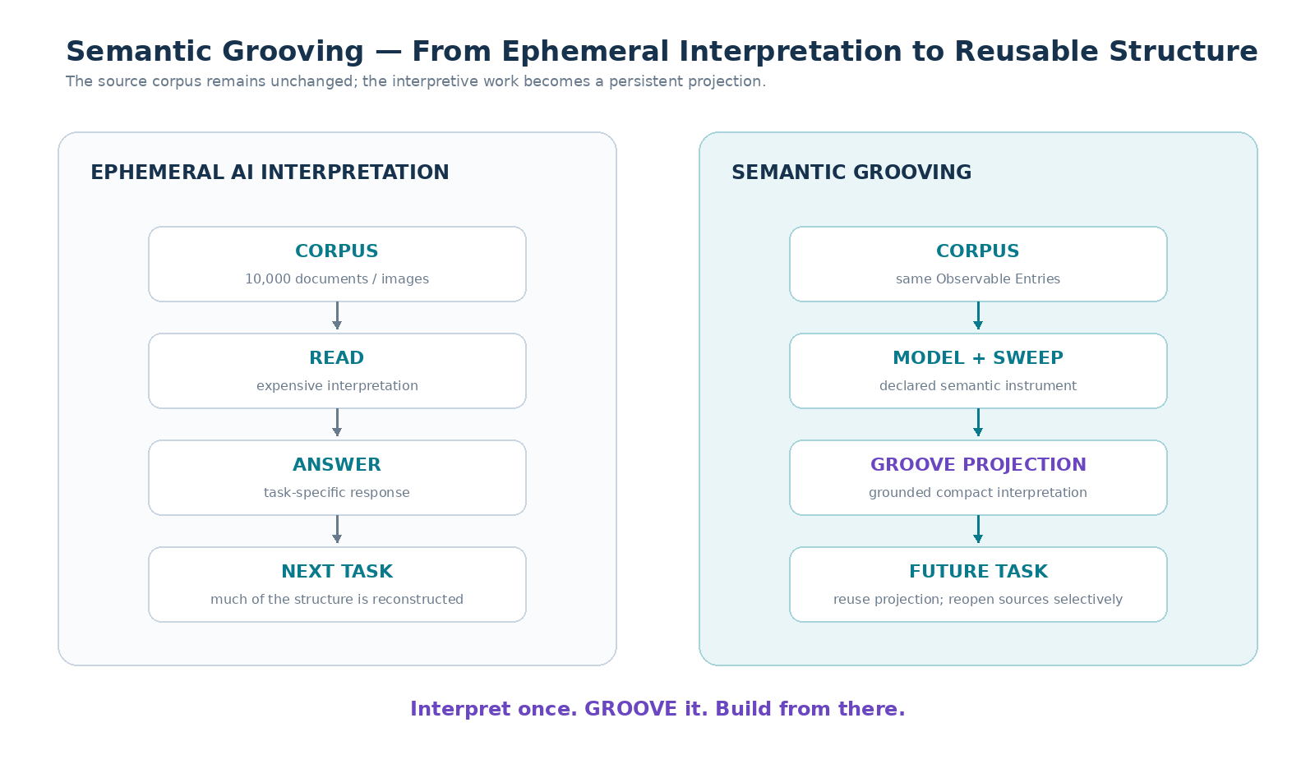
Figure 1. Semantic Grooving converts task-local interpretation into reusable semantic infrastructure while preserving the Observable source corpus.
PART I
FOUNDATIONS
From Observable source identity to persistent Model-conditioned interpretation

1. The Problem of Ephemeral Semantic Work
AI systems routinely perform valuable intermediate work that is rarely preserved as a reusable object. They infer which documents belong together, which terminology is foundational, which files are superseded, which images depict the same mechanism, which parts of a long document matter to the active question, and which source passages provide the strongest grounding. When this structure disappears after the task, the next task must often repeat the same semantic labor.
Semantic Grooving addresses this inefficiency by making reusable interpretation persistent. The objective is not to freeze one final reading of a corpus. The objective is to preserve declared, versioned, inspectable ways of seeing the corpus so that later reasoning can begin from known semantic handles and still descend to the original sources when required.
SEMANTIC WORK PERSISTENCE PRINCIPLE
Grounded semantic work that is likely to be reusable SHOULD be persisted rather than unnecessarily recomputed from source material for every subsequent reasoning task.

2. Observable Corpora and Stable Entry Identity
An Observable Corpus is a bounded set of source artifacts that can be inspected independently of any derived GROOVE interpretation. Entries may include documents, notes, images, diagrams, books, songs, score files, spreadsheets, datasets, prototypes, recordings, simulations, or other artifacts. Every Entry that participates in persistent Grooving SHOULD expose a stable identity within the scope of the corpus.
Stable Entry identity is the mechanism that makes independent interpretations composable. A Model may classify DOC-142 as Food Sciences, another may classify the same Entry as Fermentation, and a third may identify an organic-acid transformation. These statements remain separate semantic coordinates because each is attached to the same underlying source identity rather than being merged into a rewritten source artifact.
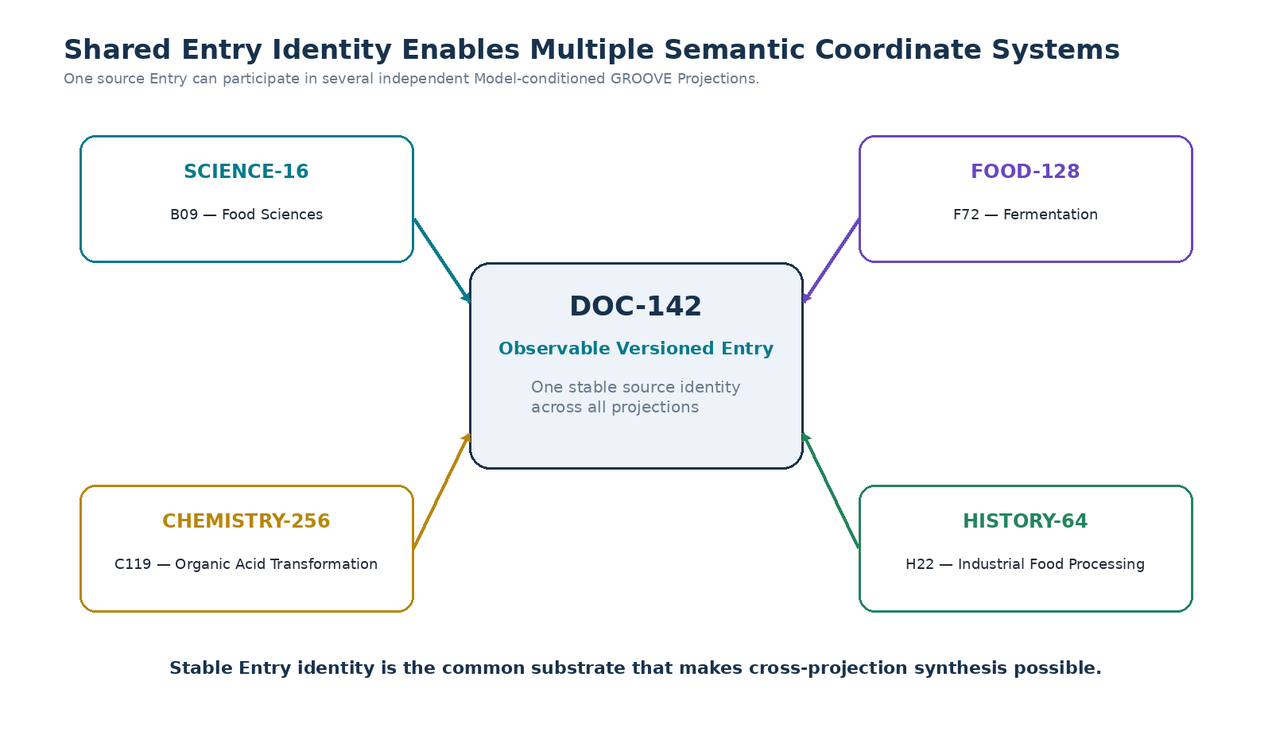
Figure 2. Multiple semantic coordinate systems can coexist over one stable Observable Entry identity.

3. Model, Sweep Profile, Projection, and Source
Semantic Grooving SHALL distinguish the semantic vocabulary used to perceive a corpus from the procedure used to apply that vocabulary and from the result produced by the procedure. This separation is essential for reproducibility, comparison, and later recomposition.
Object | Role | Example
Model | Defines the distinctions that can be expressed or resolved by a pass. | SCIENCE-16, FOOD-128, MUSIC-128
Sweep Profile | Defines the configured sequence or graph of semantic operations. | Science Domain Compilation v1.3
Observable Corpus | Defines the bounded source Entries. | Research Archive A snapshot v7
GROOVE Projection | Persists the semantic result produced by applying a Model/Sweep to a Corpus. | G-00412
Semantic Surface | Defines a bounded result of one or more Projection operations that can become input to a subsequent pass. | SCIENCE:B09 ∩ FOOD

CORE SEPARATION
MODEL ≠ SWEEP PROFILE ≠ GROOVE PROJECTION ≠ SOURCE CORPUS. A Model defines possible distinctions. A Sweep Profile defines an interpretive procedure. A Projection records the result of that procedure against a corpus. The source corpus remains independently observable.

4. Semantic Grooving
Semantic Grooving is the process of converting semantic interpretation into persistent, compact, source-grounded relational structure. A Grooving operation MAY include classification, summarization, relation discovery, semantic yield extraction, source-location orientation, candidate component identification, or any other configured operation whose result can be tied back to Observable Entries and to the Models and passes that produced it.
Semantic Grooving SHOULD favor compact reusable handles over duplication of source content. The Projection is a map into the corpus, not a replacement copy of the corpus. Where a future task requires deeper evidence, nuance, visual inspection, exact wording, or reinterpretation, the system SHOULD reopen the relevant Observable source.

5. The GROOVE Projection Object
A GROOVE Projection is the primary persistent object introduced by this specification. It records an interpretation of a bounded corpus under declared semantic conditions. The Projection MAY contain Entry mappings, relation edges, descriptions, confidence or review states, source locators, source-location descriptions, Model identities, Sweep Profile identities, and lineage to parent Projections.
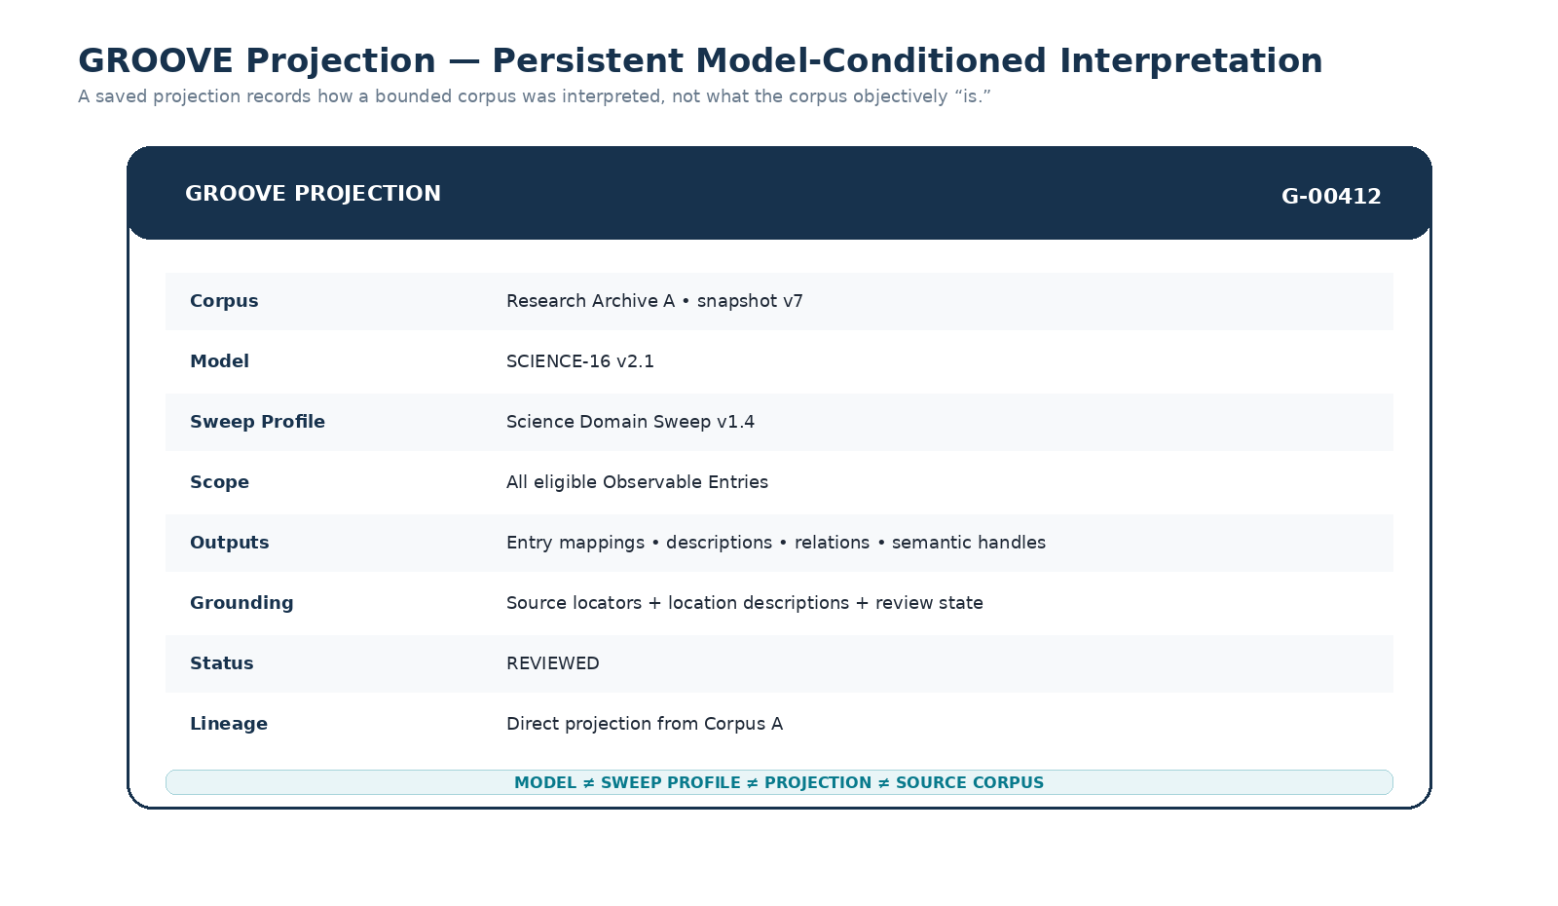
Figure 3. Reference GROOVE Projection object. A Projection declares the corpus, Model, Sweep Profile, outputs, grounding, status, and lineage used to produce it.

6. Projection Identity and Versioning
A persistent Projection SHOULD have its own stable identity and version. The identity allows later Projections, Interfaces, Master artifacts, or CERBERUS components to reference the Projection without collapsing it into the Model or Corpus that produced it. Versioning is necessary because any of the following may materially change the interpretation: source corpus membership, source Entry versions, Model version, Sweep Profile configuration, thresholds, review decisions, or human corrections.
A Projection MAY be immutable after publication, with later changes expressed as a new version. Alternatively, a workspace MAY expose mutable draft states followed by a committed version. In either implementation, downstream lineage SHOULD identify the exact parent Projection version on which a derived result depends.

7. Projection Non-Identity and Epistemic Boundary
A GROOVE Projection SHALL remain distinguishable from truth claims about the underlying world. If a Model maps an Entry into a particular domain, the Projection records that mapping under the declared procedure. The mapping may be reviewed, corrected, compared with another Model, or superseded by a later version. The source remains available for independent inspection.
Cross-GROOVE overlap is especially easy to overinterpret. The fact that a set of Entries survives two different semantic routes may indicate a useful region for further investigation. It does not establish causation, equivalence, scientific validity, historical consensus, or any other stronger proposition unless the relevant sources and validation processes support that proposition.
PART II
SEMANTIC ACCRETION
Persistent interpretation becomes substrate for later interpretation

8. The Semantic Accretion Principle
The Semantic Accretion Principle describes the emergent behavior that appears once multiple GROOVE Projections are preserved over stable Observable Entries: earlier semantic work can become a substrate for later semantic work. A later pass can use a saved Projection as a scope, compare it with another Projection, intersect the two, or use their combined structure to decide which original sources deserve renewed inspection.
SEMANTIC ACCRETION PRINCIPLE
When semantic interpretations remain attached to stable Observable Entry identities, preserved GROOVE Projections can become substrates for subsequent semantic operations, allowing interpretive structure to accumulate around a corpus without altering the underlying sources.

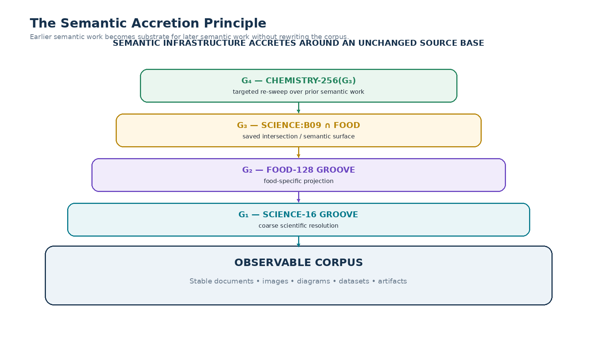
Figure 4. Semantic infrastructure can accrete in layers around an unchanged source corpus.

9. The Accretive Corpus
An Accretive Corpus is an Observable Corpus accompanied by persistent, versioned semantic Projections that increase the number and precision of reusable routes through the source material over time. The corpus itself does not need to absorb the derived interpretations. Instead, semantic infrastructure remains layered around it through stable Entry identity, Projection lineage, and source locators.
This architecture allows an archive to become easier to think with as it is used. The first pass may be expensive because the AI must inspect raw documents or images. After Grooving, later tasks can initially read compact descriptions and relation sets, isolate a small high-yield region, and reopen only the original sources necessary for the current question.

10. Semantic Compression Without Source Replacement
Semantic Grooving creates a form of operational compression. A corpus containing hundreds of images or thousands of pages can be represented initially by compact Entry identities, descriptions, Model handles, relation edges, and source locators. This compact representation reduces the cost of corpus-wide reasoning while preserving a path back to full-fidelity artifacts.
Compression SHALL NOT be interpreted as source elimination. The GROOVE description of an image is not the image; the GROOVE summary of a book is not the book; a note-event extraction from music is not the original recording. The compiled representation provides semantic routing, while the Observable source retains evidence, texture, ambiguity, and full detail.

11. Cold Reads and Warm Reads
A Cold Read occurs when an Entry lacks sufficient prior GROOVE metadata and therefore requires direct inspection at the fidelity necessary for the pass. A Warm Read occurs when the system can first consume a saved Projection and only reopen the source selectively. Warm reading is one of the primary practical benefits of Semantic Grooving because it converts repeated exhaustive interpretation into bounded targeted inspection.
Mode | Initial Input | Typical Cost | Source Reopen
Cold Read | Raw Observable Entry | Higher; full or substantial interpretation may be required. | Immediate or extensive.
Warm Read | Saved GROOVE handles + Projection context | Lower; compact semantics can be scanned quickly. | Selective when detail, evidence, conflict, or verification is needed.

12. Projection Lineage
Semantic Accretion requires explicit lineage. A derived Projection SHOULD identify the parent Projections, operations, Models, scopes, and Corpus versions from which it was produced. Lineage enables impact analysis: if a parent Projection is recompiled under a new Model version, downstream intersections and derived passes can be flagged for review rather than silently inheriting stale assumptions.
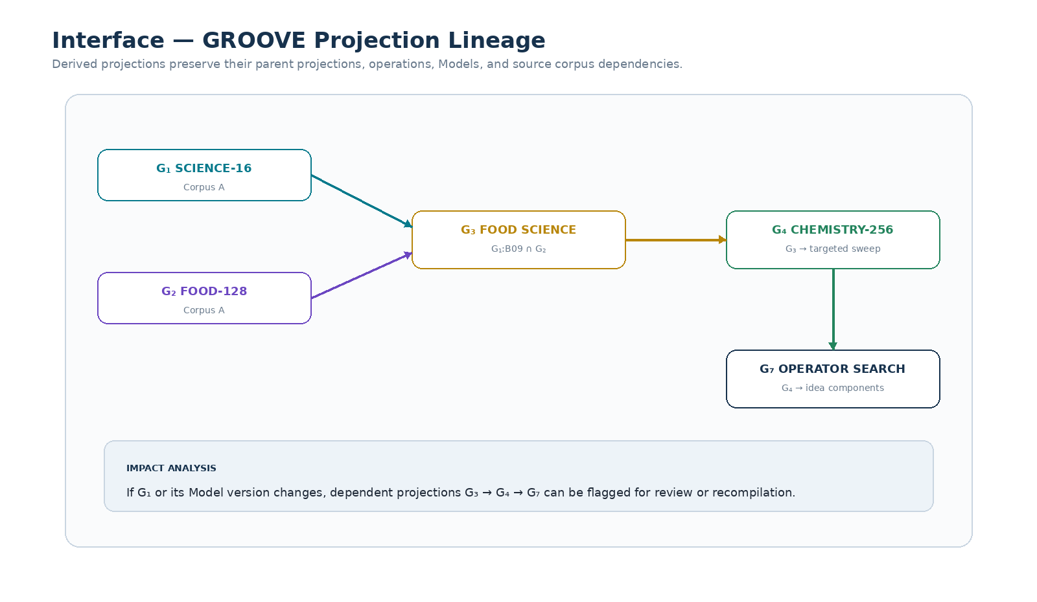
Figure 5. Projection lineage makes derived semantic work traceable and reviewable.

13. Retroactive Semantic Enrichment
New Models can increase the value of old GROOVE corpora. A newly published BIOLOGY-1024 Model, for example, does not require the entire archive to be reprocessed at maximum resolution. Existing Projections can first isolate likely high-yield regions, after which the new Model can be applied selectively. The resulting Projection is added to the Accretive Corpus without invalidating the earlier semantic layers.
Retroactive enrichment means that old source material can become more useful as the semantic ecosystem improves. This is a key distinction from static tagging systems: a corpus is not finished when it is first organized. Its accessible resolution can increase when new Models, Sweep Profiles, or Cross-GROOVE operations become available.
PART III
CONFIGURABLE PASS ARCHITECTURE
GROOVE defines a pass grammar, not one universal sequence

14. Sweep Profiles
A GROOVE Sweep Profile is a versioned configuration that declares how a corpus, Projection, or Semantic Surface will be interpreted. The profile MAY be linear, branching, conditional, iterative, or graph-structured. GROOVE SHALL NOT require every domain to use the same pass order because the useful decomposition of music, science, history, images, datasets, or personal notes differs substantially.
CONFIGURABLE PASS PRINCIPLE
GROOVE defines no universal semantic pass order. A Sweep Profile declares an ordered, branching, or iterative sequence of Model-conditioned operations appropriate to the corpus and intended output.

15. Pass Definition
A Pass is the atomic configurable operation of a Sweep Profile. A Pass SHOULD declare enough information that another system can understand what semantic operation was performed and what output is expected. A Pass MAY operate on raw Entries, previous pass outputs, saved Projections, a selected Model region, or a derived Semantic Surface.
Field | Purpose
Pass ID | Stable identity of the configured pass.
Pass Name | Human-readable description of intent.
Input | Corpus, Projection, prior pass output, or Semantic Surface.
Model | Model or Model set applied by the pass.
Resolution | BitWord or other semantic resolution, when applicable.
Operation | CLASSIFY, DESCRIBE, BUNDLE, RELATE, COMPARE, IDEA_COMB, EXTRACT, etc.
Scope | Subset or condition limiting eligible inputs.
Output | Expected semantic object or result type.
Grounding Requirement | When and how source evidence must be reopened or retained.
Review Gate | Conditions requiring human or authorized review.
Next Pass | Default continuation or branch target.
Failure Route | What happens when the pass cannot resolve confidently.

16. Custom Pass Builder Interface
A practical GROOVE runtime SHOULD expose Sweep Profiles as editable semantic workflows rather than hidden prompt logic. Users should be able to add a pass, choose the input Projection or Corpus, select a Model and resolution, select an operation, define the output, configure grounding and review gates, and route the result to another pass. This makes the interpretive procedure inspectable, repeatable, and shareable.
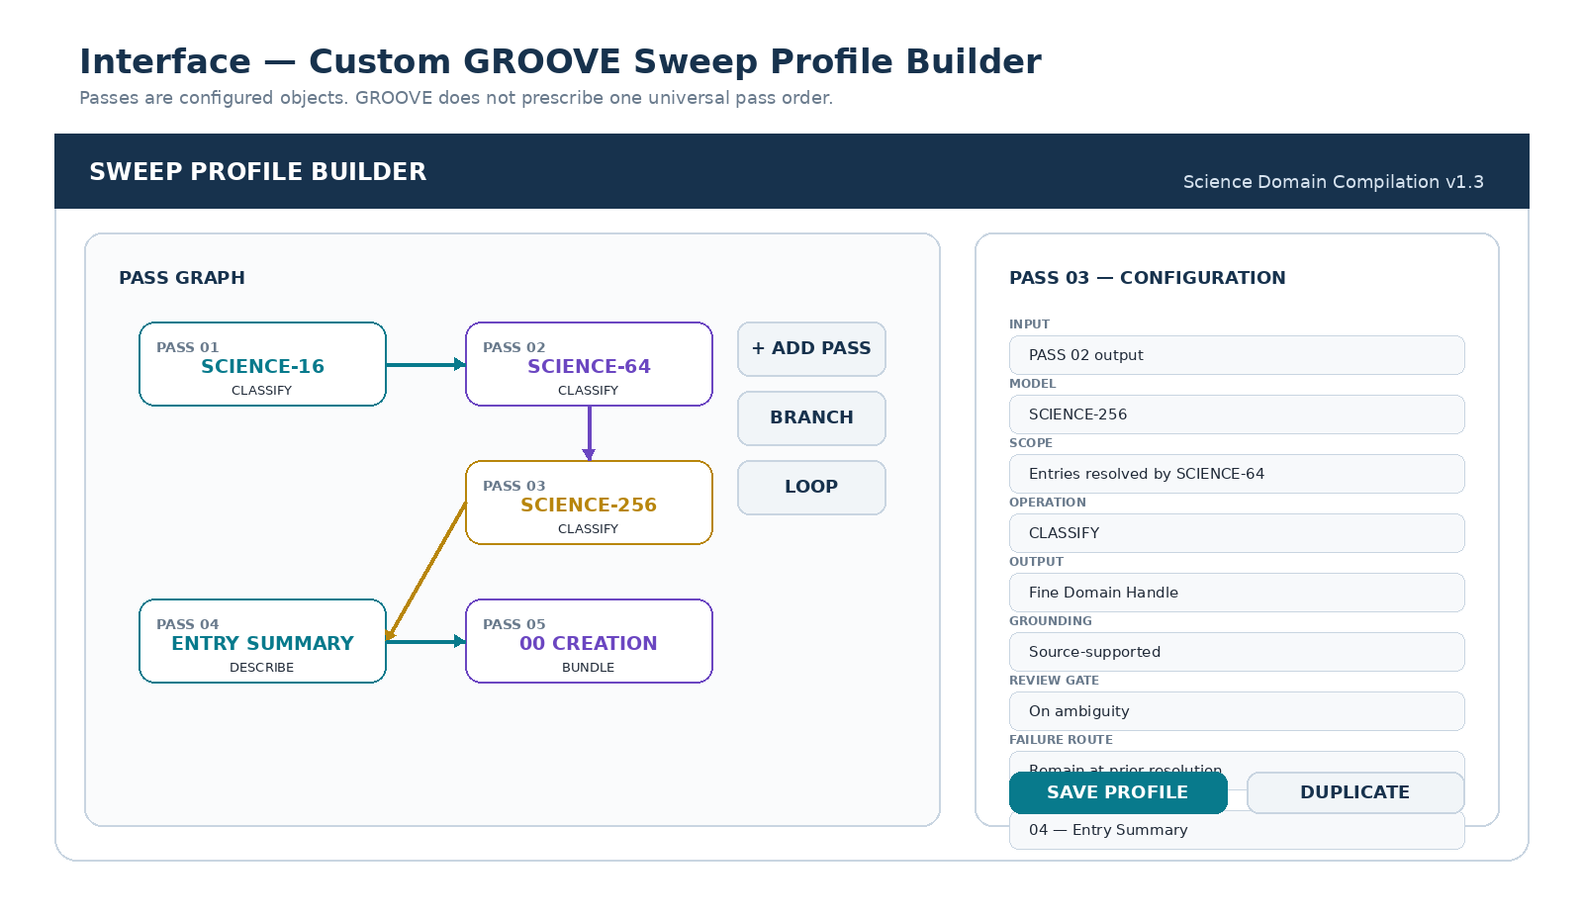
Figure 6. Custom GROOVE Sweep Profile Builder. Passes expose Model, input, operation, output, review, failure, and routing fields rather than hiding semantic traversal in one opaque prompt.

17. Branching and Conditional Passes
Different source modalities may require different initial observation procedures. A document may route through a section-aware text pass, an image through a visual semantic description pass, and a dataset through a schema pass. Their outputs can later merge into a common Entry synthesis and relation sweep. Conditional routing avoids forcing every artifact through an inappropriate interpretation path.
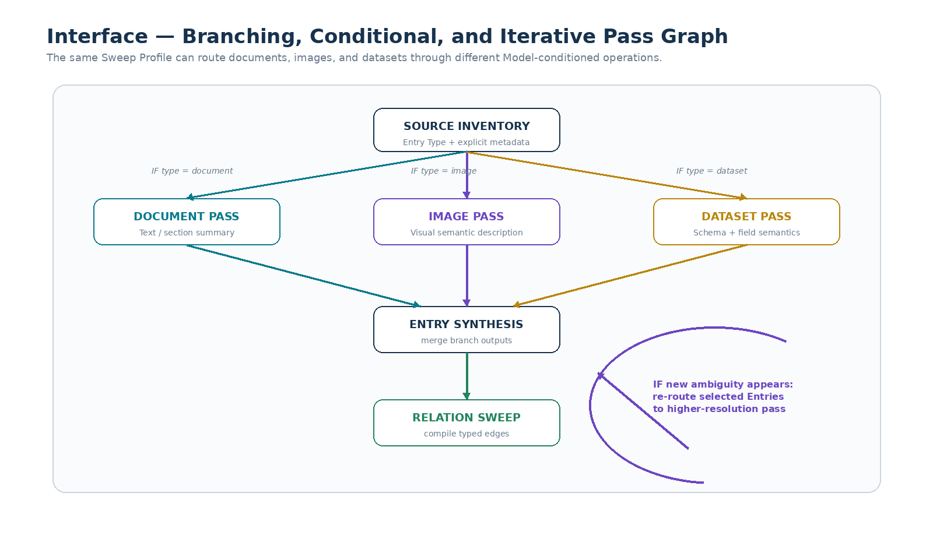
Figure 7. Branching, conditional, and iterative GROOVE passes can route different artifact types through different semantic operations before recombination.

18. Explicit Structure Before Inference
A pass SHOULD begin from the highest-confidence explicit structure already available. If a MIDI file already declares tracks, a GROOVE does not need to rediscover those tracks from raw audio. If a scientific database already contains reliable domain metadata, that metadata can seed the relevant Model handles. If a document has explicit section headings, the pass can reuse them as local orientation handles.
INFERENCE ECONOMY RULE
Use explicit source structure when it is available and grounded. Spend semantic inference on unresolved structure, not on reconstructing metadata the source already declares.

19. BitWord Resolution Ladders
BitWord resolution families provide a natural semantic zoom mechanism for GROOVE passes. A low-resolution Model can make broad distinctions cheaply; later passes can apply higher-resolution Models only where needed. The broader handles remain useful for routing even after narrower handles are added.
For illustration, SCIENCE-16 may provide broad domain distinctions, SCIENCE-64 intermediate distinctions, and SCIENCE-256 finer domain localization. These example assignments are not asserted as canonical registries by this document; they demonstrate how a resolution family can support progressive Grooving.
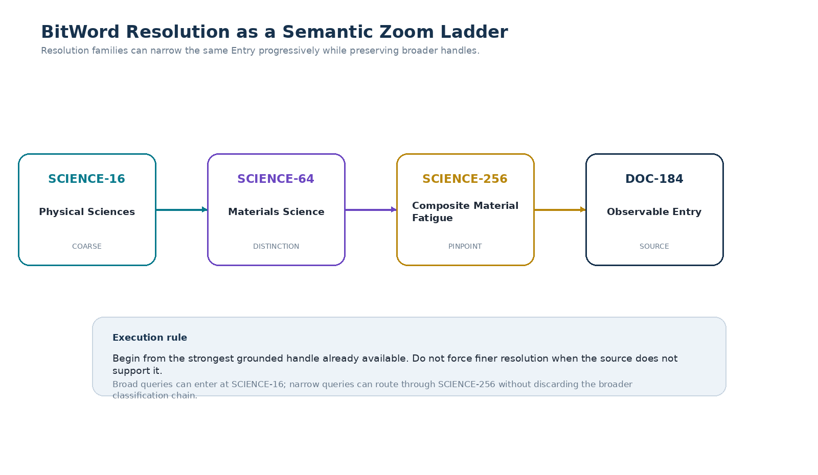
Figure 8. BitWord resolution can be used as a semantic zoom ladder while preserving the broader handles that remain useful for routing.

20. Example Science Sweep Profile
A Science-oriented Sweep Profile MAY begin with three resolution passes and then move into artifact interpretation, Bundle creation, and relation compilation. The important architectural point is that these passes are a configuration, not a requirement of GROOVE itself.
Pass | Configuration | Purpose
01 | SCIENCE-16 / CLASSIFY | Coarse domain resolution.
02 | SCIENCE-64 / CLASSIFY | Intermediate distinctions within resolved regions.
03 | SCIENCE-256 / CLASSIFY | Fine domain localization where supported.
04 | ENTRY SUMMARY / DESCRIBE_IN_CONTEXT | Describe each artifact from its resolved semantic position.
05 | 00 CREATION / BUNDLE | Compile candidate System Understanding Bundles or domain manifests.
06 | RELATIONS / RELATE | Create typed GROOVE edges among Entries and Bundles.
07 | RELATIONAL RE-SWEEP | Use established relations to ask more precise questions of the sources.
08 | MASTER / COMPILE | Produce a human-readable synthesized artifact, when desired.
09 | COMPONENT DISCOVERY / EXTRACT | Search for candidate Models, SKs, Operators, Rules, and other reusable structure.

21. Custom Idea-Comb Passes
A Pass can be configured to comb a specific semantic region for ideas from another domain. For example, a user may select a saved Materials Science region and ask a BIOLOGY-256 pass to look specifically for biological mechanisms, structures, strategies, or analogues inside that region. This is not a universal “biology of materials” claim; it is a configured way of inspecting a bounded corpus.
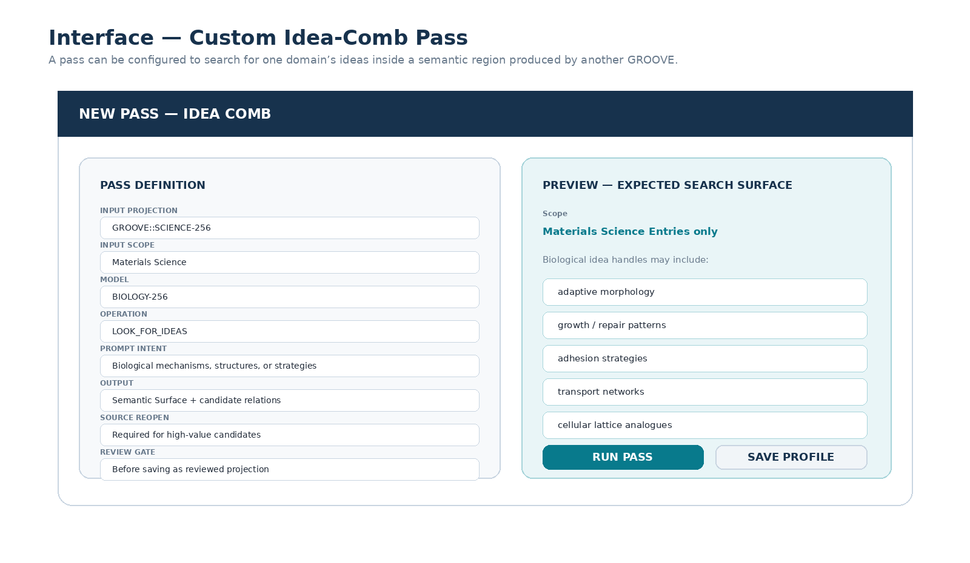
Figure 9. A custom Idea-Comb pass searches one semantic domain through another declared Model within a bounded source region.

22. Pass Profiles as Portable Semantic Procedures
A Sweep Profile MAY be saved independently of the corpus on which it was first used. If its required Models and operations are available, the profile can be applied to another compatible corpus. This makes the procedure itself portable. The published object does not contain a universal conclusion; it contains a reproducible method of looking.
Profiles MAY also be duplicated and branched. A user could compare Science Sweep A, which applies SCIENCE-16 → 64 → 256, with Science Sweep B, which inserts a Temporal pass between SCIENCE-64 and SCIENCE-256. Differences in resulting Bundles and relations become observable rather than hidden inside changing prompts.
PART IV
CROSS-GROOVE SYNTHESIS
Saved projections become operands for new semantic operations

23. Cross-Synthesizability
Two GROOVE Projections are cross-synthesizable when they preserve sufficient shared Entry identity, scope compatibility, provenance, and semantic structure to support meaningful combined operations without requiring either Projection to replace the other. Shared source identity is the most direct mechanism, but registered Liminal Bridges or other explicit correspondence systems may also support bounded cross-corpus synthesis.
Cross-synthesizability is a structural property, not a truth guarantee. It means the Projections can be meaningfully compared or composed under a declared operation. The result may still contain ambiguity, conflicting classifications, weak evidence, or unresolved semantic differences that require source inspection.

24. Semantic Surfaces
A Semantic Surface is a bounded set of Entries and relations exposed by one or more GROOVE operations and made available as the input scope for subsequent analysis. A Surface can be transient, used only for the current task, or saved as a derived GROOVE Projection when it is expected to have reusable value.
KEY DISTINCTION
An intersection is not a conclusion. It is a new bounded semantic surface from which better questions can be asked.

25. Reference Cross-GROOVE Operations
The following operation vocabulary is a reference set rather than a closed mathematical algebra. Implementations MAY support fuzzy membership, weighted assignments, multi-valued classifications, or other domain-specific semantics, provided operation behavior remains explicit and provenance is preserved.
Operation | Meaning
INTERSECT | Retain Entries or relations satisfying the declared scope of both Projections.
UNION | Expose compatible Projections together while preserving the origin of each semantic assignment.
DIFFERENCE | Inspect semantic assignments or Entries present in one Projection but not another.
CONSTRAIN | Use one Projection or semantic region as the input scope for another pass.
CASCADE | Feed a Projection or Surface sequentially into a subsequent Model-conditioned operation.
COMPARE | Preserve two or more interpretations and expose similarities, differences, uncertainty, or route-specific results.
BRIDGE | Search for or register explicit relations between bounded semantic regions.
RE-SWEEP | Return to original Observable Entries using prior semantic structure to guide new inspection.

26. Intersection Builder
A Cross-GROOVE interface SHOULD make the operation legible. The user should be able to select Projection A, optionally select a scope within it, choose an operation, select Projection B, preview the resulting Entry count or relation surface, and either save the result or add a follow-up pass. The interface should retain the Model identity of each operand rather than flattening them into unlabeled tags.
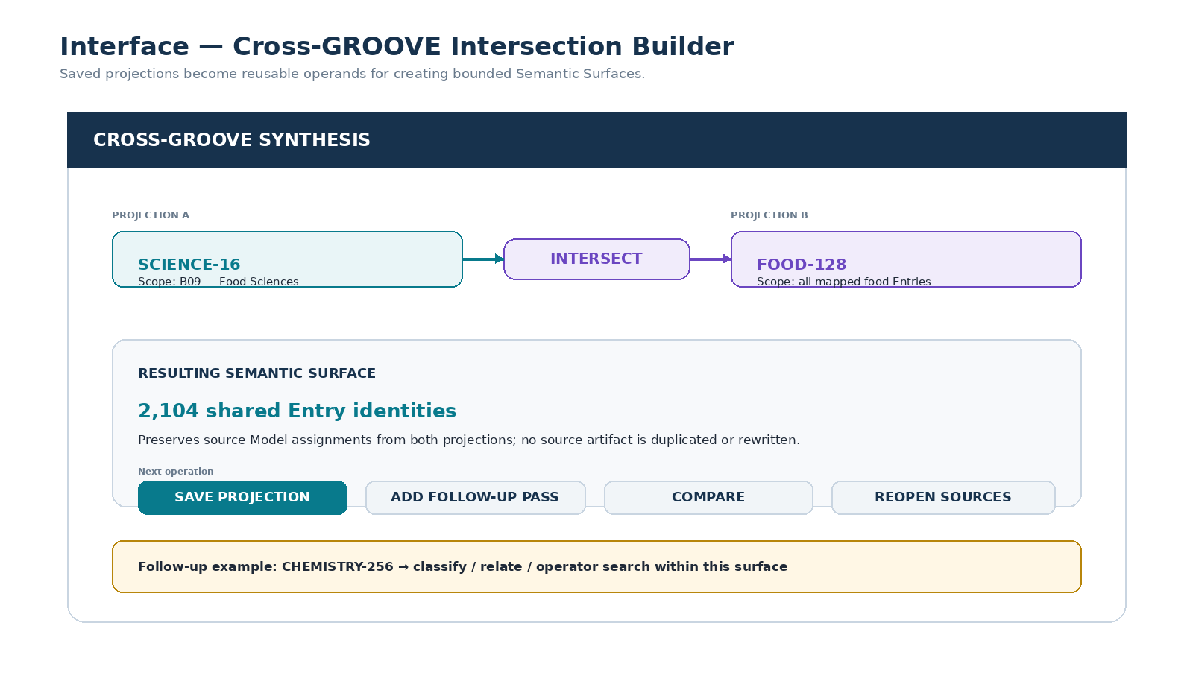
Figure 10. Cross-GROOVE Intersection Builder using SCIENCE-16:B09 and FOOD-128 as reusable semantic operands.

27. SCIENCE-16 × FOOD-128 Example
Assume, solely for illustration, that SCIENCE-16:B09 represents Food Sciences. A saved SCIENCE-16 Projection over Corpus A can be scoped to B09. A separate FOOD-128 Projection over the same Corpus A can then be intersected with that scope. The result retains the stable source Entries that participate in both semantic views while preserving which assignments came from SCIENCE-16 and which came from FOOD-128.
The derived Surface can be saved as a FOOD-SCIENCE Projection and then used as the input to another pass. For example, CHEMISTRY-256 may be applied only to that Surface. The system has therefore reduced the search space before invoking the more specialized Model, while retaining the parent Projection lineage necessary to explain how the scope was constructed.
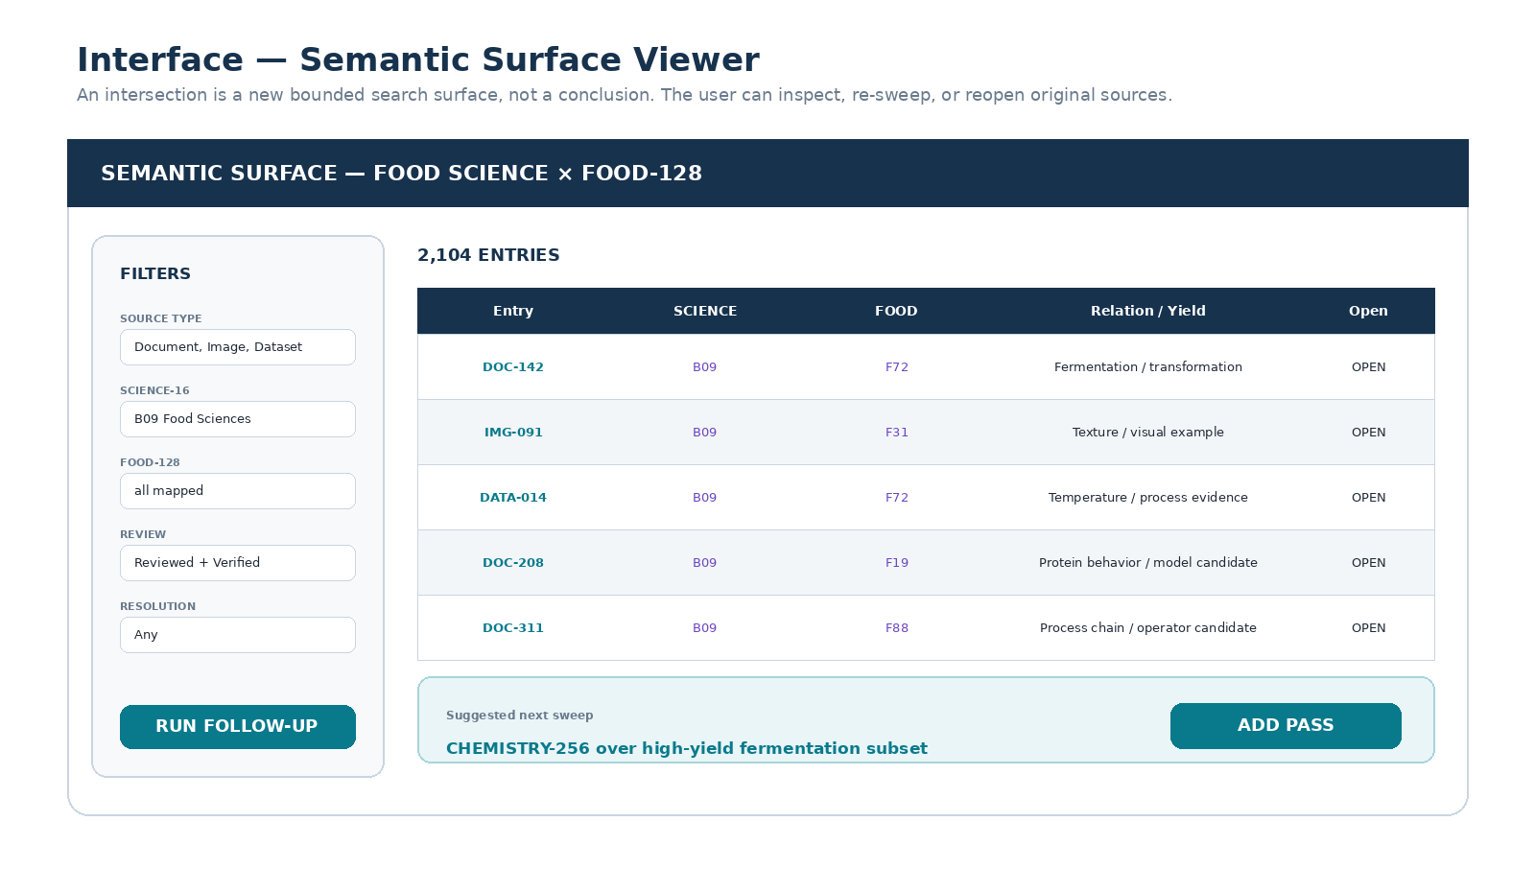
Figure 11. Semantic Surface Viewer. Cross-GROOVE results can be filtered, inspected, re-swept, or traced back to original sources before any stronger inference is accepted.

28. Constrain and Cascade
CONSTRAIN allows a saved Projection to become a semantic boundary for a new pass. Instead of running BIOLOGY-256 across an entire scientific archive, a system can constrain the input to Entries already mapped to Materials Science. CASCADE then expresses the ordered application of later Models or operations. This sequence is computationally useful because earlier broad Projections can act as inexpensive routing layers for later high-resolution interpretation.

29. Semantic Path Dependence
Cross-GROOVE results may depend on traversal order. Materials Science → Biology asks which biological structures or mechanisms appear within a region already bounded as Materials Science. Biology → Materials Science asks which material-science structures appear within a region first resolved biologically. These questions present different semantic boundaries to the later pass and therefore need not produce identical outputs.
SEMANTIC PATH DEPENDENCE
A → B MAY differ from B → A because earlier passes change the semantic boundary and evidence set presented to later passes. GROOVE SHALL preserve operation order where that order materially affects interpretation.

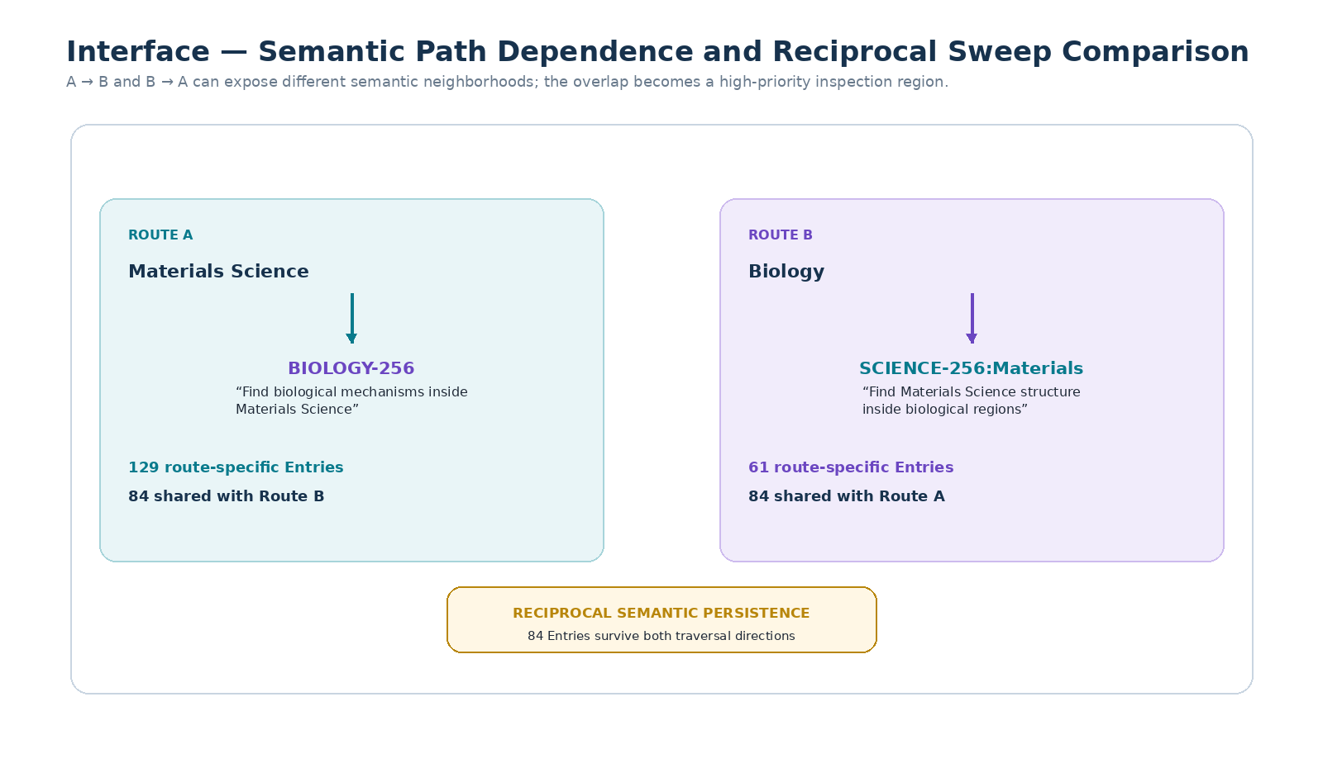
Figure 12. Reciprocal sweep comparison makes semantic path dependence visible and identifies Entries that persist across both traversal directions.

30. Reciprocal Semantic Persistence
When an Entry or relation remains salient under multiple independent, reversed, or otherwise reasonable sweep configurations, the persistence can be used as a prioritization signal for further inspection. It SHALL NOT be interpreted as proof. Reciprocal persistence is best treated as a high-value candidate region where deeper source reopening, expert review, or formal experimentation may be justified.

31. Stable Semantic Neighborhoods
Repeated GROOVE compilation may reveal neighborhoods of Entries that remain strongly related under several pass configurations. Such stability can inform Bundle boundaries, candidate Master documents, or published Semantic Instruments. The system SHOULD preserve the different routes that produced the neighborhood so users can distinguish robust overlap from one particular grouping heuristic.
PART V
INTERFACE ARCHITECTURE
Make semantic work visible, configurable, and navigable

32. Interface Design Goals
Semantic Grooving becomes substantially more useful when the interpretive machinery is exposed as an interface rather than buried in one large prompt. The user should be able to see which Projections exist, which Models created them, which passes are configured, where intersections came from, and how any derived semantic object traces back to source Entries.
- Make Projections first-class objects that can be opened, scoped, compared, and reused.
- Make Sweep Profiles visibly editable so users can construct domain-specific semantic procedures.
- Make Cross-GROOVE operations explicit rather than silently fusing Model outputs.
- Make source reopening one click away from any derived result.
- Make lineage and version dependencies inspectable before recompilation.
- Keep 000 navigation simple even if the underlying semantic graph is complex.

33. Projection Library
A Domain 000 or related navigation surface SHOULD expose saved GROOVE Projections alongside documents, relations, Master artifacts, and formal components. The Projection Library is the user’s semantic cache: it shows what interpretive work has already been performed and what can be reused as a scope for future passes.
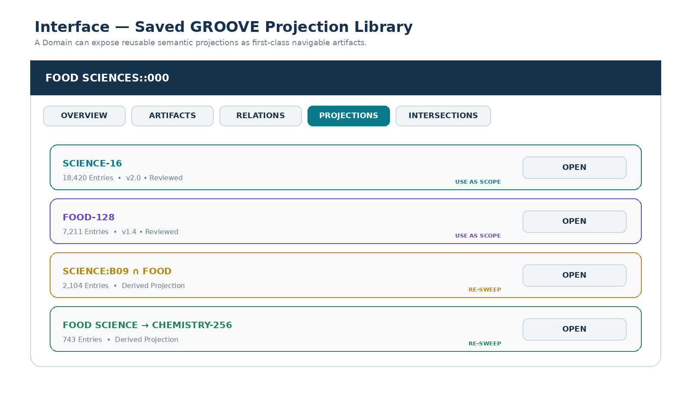
Figure 13. Projection Library. Saved GROOVE results become reusable navigational and computational artifacts inside a Domain 000 interface.

34. Entry Projection Stack
An Entry inspector SHOULD be able to show the semantic assignments that different Projections have made for the same Observable source. This is especially important when Models operate at different resolutions or in different domains. The interface should preserve plurality: the Projection stack shows how different semantic instruments see the Entry without pretending that those views are identical.
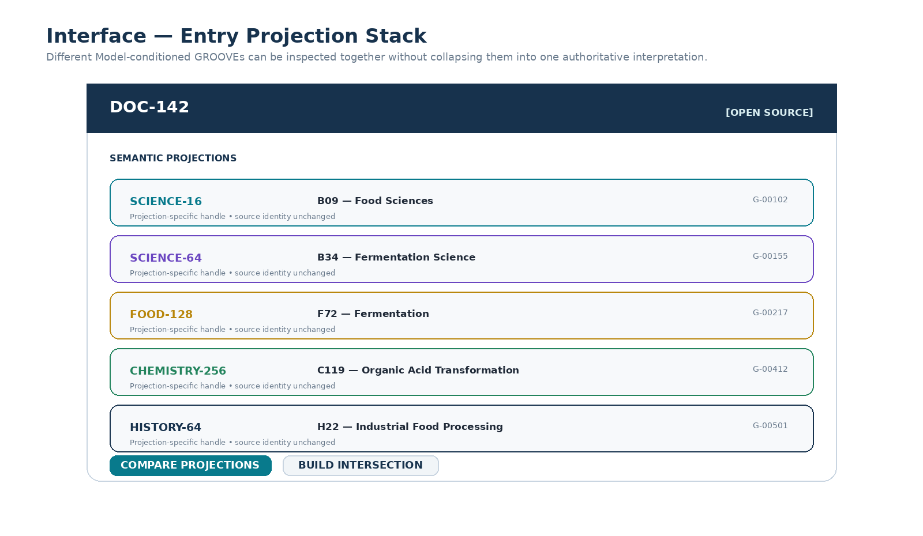
Figure 14. Entry Projection Stack. One source Entry can expose multiple independent Model-conditioned semantic handles without collapsing them into one interpretation.

35. Sweep Profile Builder
The Pass Builder shown earlier is a core interface of Semantic Grooving. It should support drag-and-drop or equivalent pass arrangement, Model and resolution selection, operation choice, scope definition, grounding requirements, review gates, conditional branches, loops, and version save. A Profile should be understandable as a semantic workflow at a glance.

36. Route Comparison Interface
When pass order or candidate Bundle structure is uncertain, a runtime SHOULD support comparison rather than forcing one configuration to become canonical prematurely. Route comparison can display shared Entries, route-specific Entries, stable relations, divergent classifications, and source subsets requiring review.

37. Projection Lineage Viewer
A Projection Lineage viewer SHOULD show which parent Projections, Model versions, operations, scopes, and source corpus snapshots contributed to the selected result. Impact analysis can then identify downstream Projections that may be stale after a parent changes.

38. Published Semantic Instrument Interface
A Semantic Instrument packages a Model or Model set, Sweep Profile, scope rules, output schema, and optional Cross-GROOVE operations into a portable interpretive procedure. The interface SHOULD make clear that the instrument is a method of observation rather than a universal conclusion. Applying the same Instrument to different corpora produces different corpus-specific Projections.
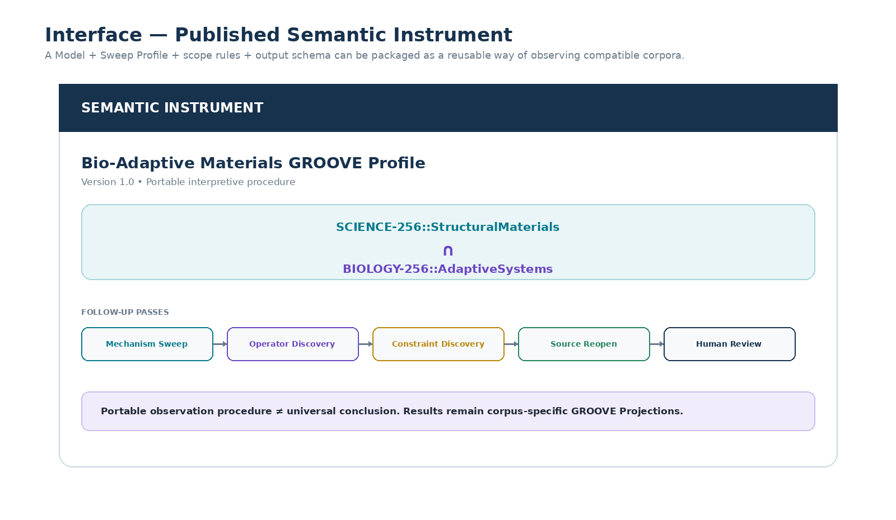
Figure 15. Published Semantic Instrument. Models and Sweep Profiles can be packaged as reusable interpretive procedures without universalizing the results they produce.

39. Global 000 and Domain 000 Integration
The simple 000 navigation convention remains valuable at this higher level. A Global 000 can route a user into the relevant Domain. The Domain 000 can then expose Artifacts, Relations, Projections, Intersections, Masters, Components, and Simulation links. Complexity remains beneath a straightforward front door.
A typical traversal may therefore be: Global 000 → Domain 000 → Projections → Cross-GROOVE Surface → source Entry. Another traversal may be Global 000 → Domain 000 → Components → selected Operator → source lineage. The same semantic infrastructure supports both archival reading and system construction.
PART VI
WORKED EXAMPLES
Cross-synthesis over science, materials, biology, and music

40. Worked Example A — Food Sciences Cross-GROOVE
Corpus A contains documents, figures, datasets, and notes spanning several scientific and food-related topics. A broad SCIENCE-16 Sweep is run once and saved. Separately, FOOD-128 is applied to eligible Entries and saved. Future tasks no longer need to reconstruct these two semantic coordinate systems from scratch.
- Select the saved SCIENCE-16 Projection and scope it to B09, Food Sciences, for this illustrative registry.
- Select the saved FOOD-128 Projection over the same corpus.
- INTERSECT the two Projections through shared Observable Entry identities.
- Preview the resulting Semantic Surface and reopen representative sources to validate the boundary.
- Save the reviewed Surface as a derived FOOD-SCIENCE Projection.
- Run CHEMISTRY-256 only on the derived surface rather than the entire corpus.
- Save the resulting chemistry projection and attach its parent lineage.
- Optionally run Operator Discovery or Model Genesis passes over recurring transformations.
The important result is not the specific classification vocabulary. It is that expensive semantic interpretation has become reusable infrastructure. The later CHEMISTRY pass inherits a carefully bounded input surface constructed from two prior semantic perspectives.

41. Worked Example B — Biological Ideas inside Materials Science
A user has a large research database already GROOVEd through a Science resolution family. They want to comb specifically for biological ideas within the Materials Science region. Rather than running a broad biological analysis over the entire database, they define an Idea-Comb pass whose input is the saved Materials Science scope and whose Model is BIOLOGY-256.
The pass is configured to look for candidate biological mechanisms, structures, or strategies; to preserve source locators; and to reopen the strongest candidates before the result can be marked reviewed. The resulting Surface may include recurring handles such as adaptive morphology, growth or repair patterns, adhesion strategies, transport-network analogues, or other concepts supported by the selected sources. These are search handles, not automatically validated scientific analogies.

42. Reverse the Route
The user then runs the reverse experiment: select biologically resolved regions first and apply a Materials Science pass. The system compares the two routes. Entries that survive both routes are surfaced as reciprocally persistent candidates. Route-specific Entries remain visible rather than being discarded, allowing the user to inspect why the semantic path altered the result.

43. Worked Example C — MUSIC-128 Semantic Grooving
Music demonstrates that Semantic Grooving is not restricted to prose documents. A source may be raw audio, MIDI, a score, a DAW project, or a CERBERUS-native musical object. GROOVE should reuse explicit source structure whenever available, then apply Model-conditioned passes only where interpretation remains unresolved.
A MUSIC-128 pass may resolve or register note events. Later passes can bundle notes into intervals, chords, motifs, phrases, tracks, sections, and finally a Song object. Each higher-level object preserves the identities of the lower-level components from which it is composed. The resulting semantic hierarchy becomes cheap to scan in future tasks compared with repeatedly resolving the raw waveform.
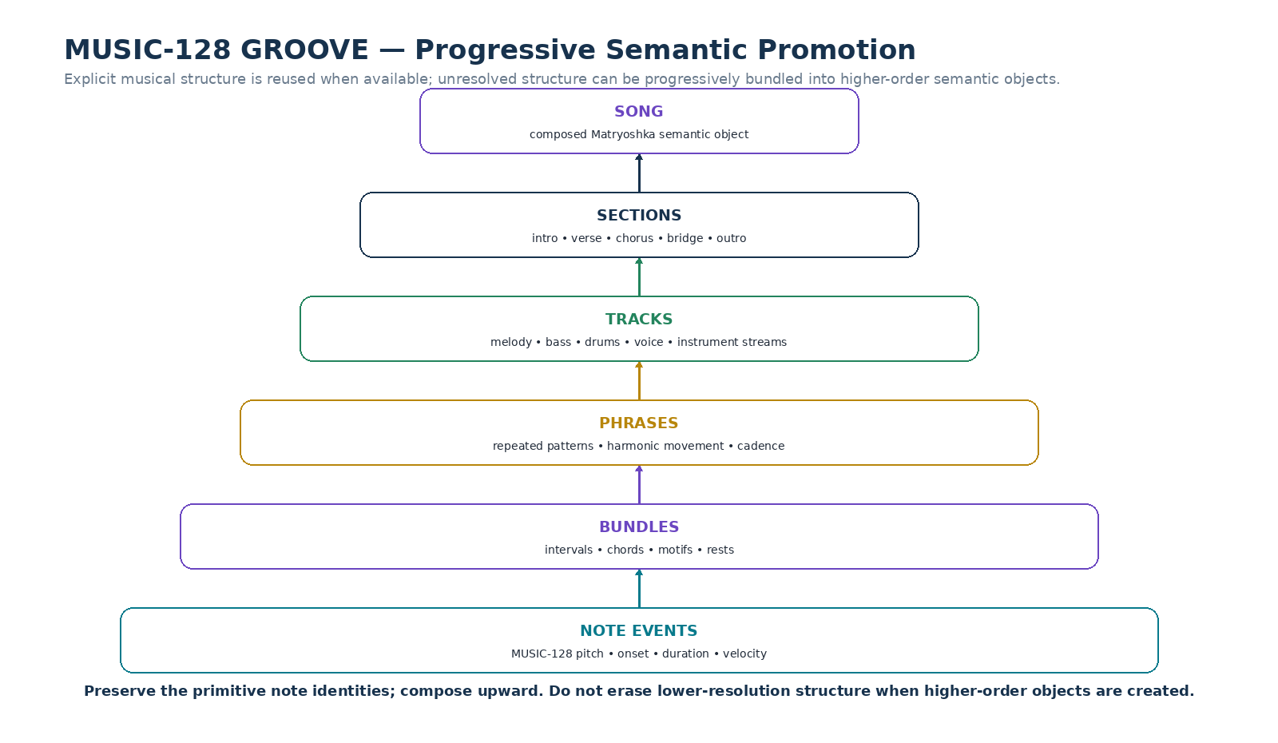
Figure 16. MUSIC-128 GROOVE can progressively promote note events into bundles, phrases, tracks, sections, and a Song while retaining lower-resolution identity.

44. Cross-Modal Music Projections
Once musical events have stable identities, other Models can project those identities into different modalities. A Color Model may bind notes or phrases to visual states; a Wave Model may expose geometric or interference behavior; a Spatial Model may place events in a room; a Movement Model may drive animation. The musical event stream remains the common semantic source, while each modality is a projection.
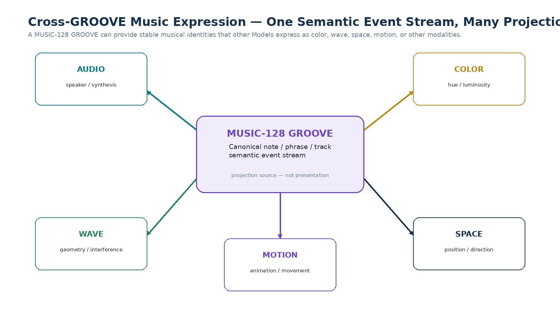
Figure 17. A saved MUSIC-128 GROOVE can act as the shared semantic source for audio, color, wave, spatial, and motion projections.

45. Resolution-Specific Musical Passes
A Sweep Profile MAY operate at different musical resolutions. Note-level Models can inspect pitch events, phrase-level Models can inspect tension or motif transformation, track-level Models can inspect persistent performance streams, and Song-level Models can inspect arrangement or historical context. Because the hierarchy is already GROOVEd, a later Model can enter at the semantic level relevant to its question rather than starting from raw audio.
PART VII
SEMANTIC DISCOVERY AND CERBERUS HANDOFF
When recurring semantic structure becomes a reusable formal component

46. The Result of Interpretation Becomes Computational Material
The most consequential property of Semantic Grooving is that a saved interpretive result can participate in later computation. A Projection can be scoped, intersected, routed, compared, fed to another Model, or used to generate a new Bundle. This turns semantic analysis from a disposable intermediate state into an addressable layer of the system.
CORE PRINCIPLE
The result of semantic interpretation can itself become computational material.

47. Semantic Model Genesis
Repeated Cross-GROOVE synthesis may reveal a stable set of dimensions that appears across many Entries or semantic surfaces. If those dimensions are useful, bounded, and sufficiently grounded, they may be promoted into a candidate Model. This process is called Semantic Model Genesis.
For example, an intersection between regeneration-oriented biological material and repair-oriented materials research may repeatedly surface dimensions such as damage detection, resource routing, target-state representation, repair propagation, and termination conditions. If these dimensions survive review and prove reusable, they can become the slots of a new Model such as an illustrative SELF-REPAIR-64.
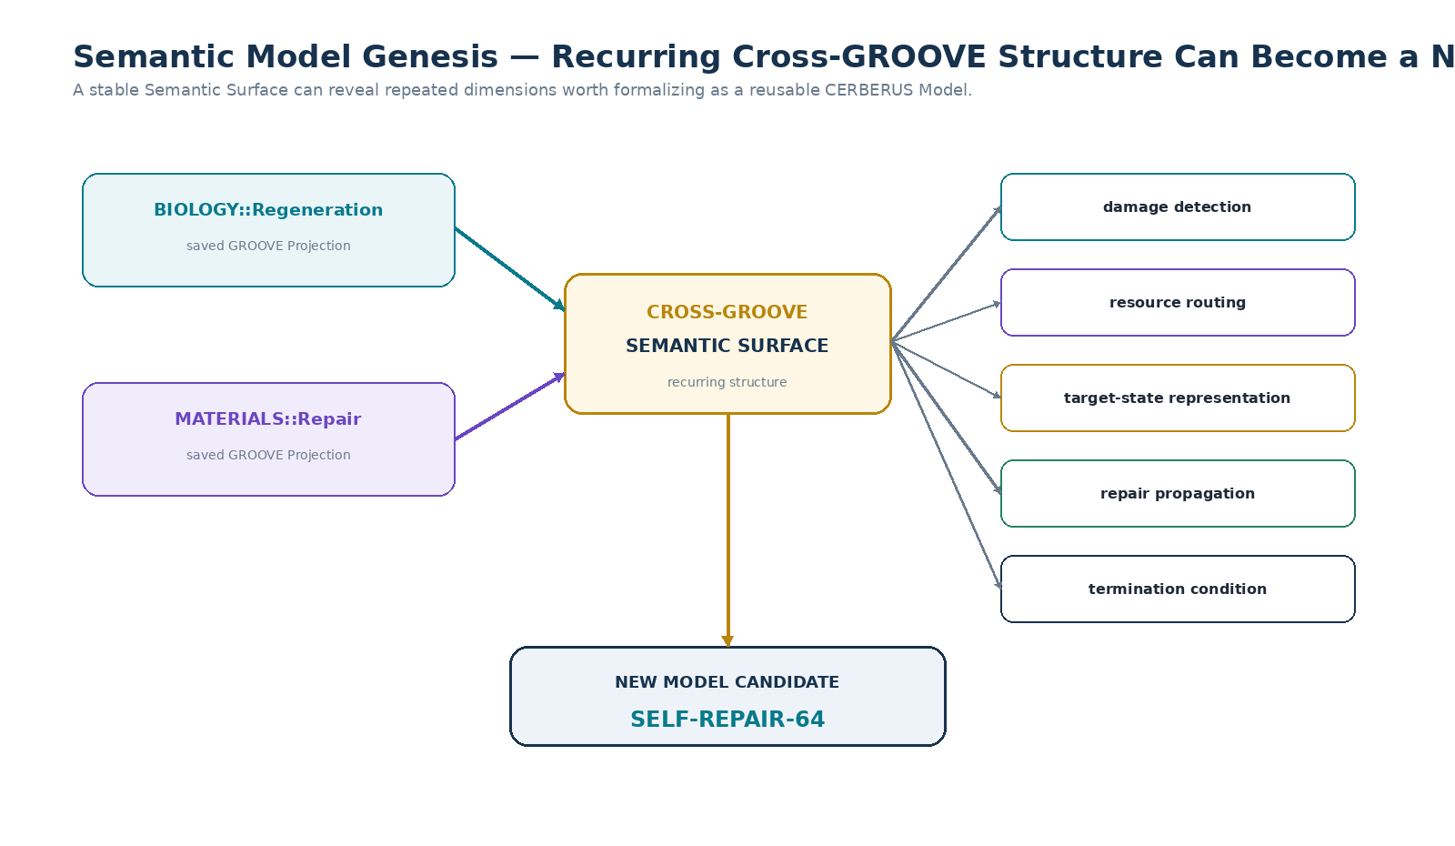
Figure 18. Semantic Model Genesis. Recurring cross-GROOVE structure can be promoted into a candidate Model while preserving the source Projections that exposed it.

48. Operator Discovery
Semantic surfaces can also be combed for repeated transformations. If many source artifacts describe a recurring change from one state to another under similar conditions, an Operator Discovery pass may propose a candidate transformation. The candidate SHOULD retain evidence links to the source Entries and the Projections or Master sections from which its semantics were derived.
A candidate Operator is not accepted merely because an AI can phrase it coherently. Formalization should distinguish transformation semantics from assumptions, constraints, values, and evidence. CERBERUS can then represent the Operator alongside the Models it transforms and the Rules that constrain it.

49. Rule and Boundary Discovery
Negative examples, exception notes, validation statements, failure descriptions, and explicit DO_NOT_INFER boundaries can produce candidate Rules. A GROOVE pass may detect that several documents repeatedly prohibit the same transition or constrain the same range. The resulting Rule candidate remains separate from the descriptive Projection that revealed it.

50. Master Artifact Compilation
A Domain MAY compile selected GROOVE Projections into a Master artifact that provides a coherent human-readable synthesis. The Master is a compiled projection, not the canonical replacement for source Entries. Each section SHOULD preserve provenance to the contributing GROOVE relations and Observable sources so that later formal components can trace downward through the Master and the Projection graph.

51. CERBERUS Component Handoff
Once semantic structure is reviewed, useful components can be registered in CERBERUS. The exact registry mapping depends on the broader architecture, but a typical handoff can distinguish identities, classifications, Models or SKs, Operators, Rules, values or Model Keys, relations, Chains, and Instances. Semantic Grooving supplies the discovery and provenance layer; CERBERUS supplies the formal operational representation.
GROOVE Discovery | Possible CERBERUS Handoff
Recurring semantic entity | NodeKey / registered identity
Stable possibility or state dimensions | Model or SK candidate
Repeated transformation | Operator candidate
Constraint / invariant / prohibition | Rule candidate
Actual configuration values | Model Key / value candidate
Repeated multi-step transformation | Operator Chain candidate
Cross-Domain relation | Liminal Bridge or registered relation
Coherent executable combination | Instance candidate

52. Provenance-Preserving Formalization
Formal components SHOULD retain backward routes through the semantic compilation chain. An Operator may point to the Master section that describes it, the GROOVE Projections that synthesized the relevant source region, and the exact documents, images, or datasets from which the interpretation originated. This preserves authorship, auditability, and the ability to revise an assumption when simulation exposes a problem.

53. Multimodal Simulation Feedback
Once GROOVE-derived components are instantiated in Praxis, Skene, or another runtime, simulation can generate new observations. A failed motion, contradictory state transition, unexpected resonance, or missing Rule can be captured as a Reflection and GROOVEd back into the relevant Domain. The semantic archive therefore participates in a cybernetic loop rather than ending at documentation.
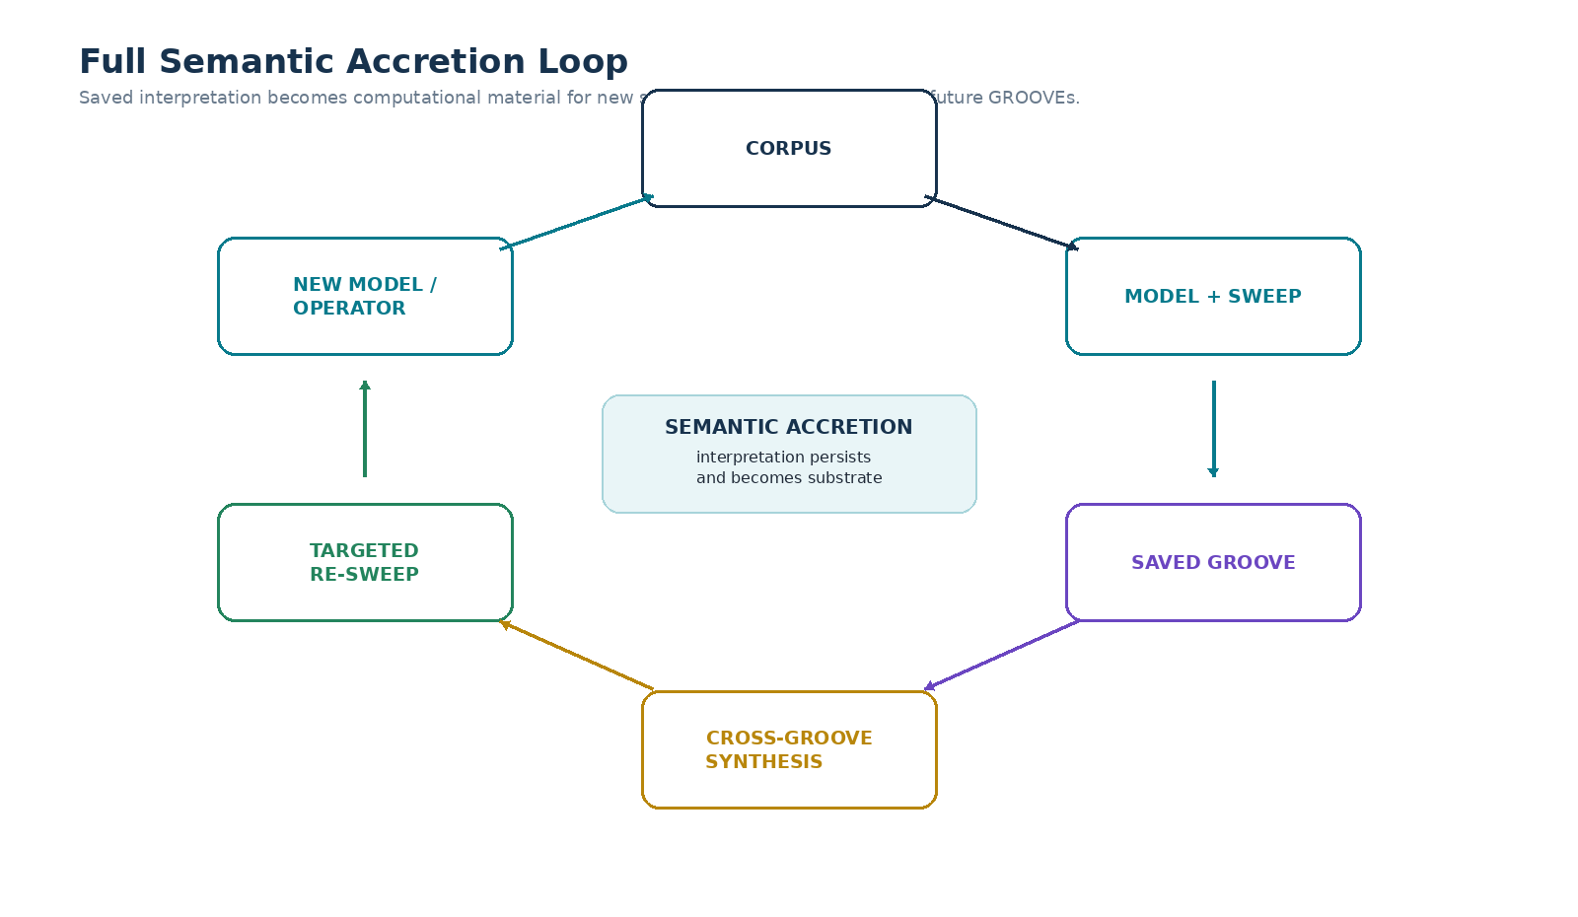
Figure 19. Full Semantic Accretion Loop. Saved Projections support Cross-GROOVE synthesis, targeted re-sweeps, new Models or Operators, and future GROOVE passes.
PART VIII
GOVERNANCE AND CONFORMANCE
Preserve provenance, permissions, uncertainty, and inspectability

54. Grounding Requirements
A saved Projection SHOULD preserve enough grounding to allow a reviewer or future AI system to understand why a semantic assignment exists. Grounding may include source locators, semantic location descriptions, exact data fields, explicit source metadata, derived notes, or links to visual artifacts. The appropriate resolution depends on the use case, but high-impact cross-GROOVE results SHOULD support selective reopening of original sources.

55. Review States
Implementations SHOULD distinguish machine-proposed semantic structure from reviewed or accepted structure. Suggested states include PROPOSED, REVIEWED, VERIFIED, STALE, RETIRED, and SUPERSEDED. The exact vocabulary may be configurable, but the interface SHALL NOT present unreviewed machine inference as if it were a ratified authorial or institutional relation.

56. Confidence and Uncertainty
Confidence MAY be recorded numerically or categorically, but a single score SHOULD NOT replace provenance or semantic explanation. A Projection can be structurally useful even when some Entry mappings remain uncertain. The system should preserve unresolved items and allow later higher-resolution Models, additional sources, or human decisions to refine them.

57. Permissions and Corpus Boundaries
Semantic Grooving may operate over personal notes, private organizational documentation, licensed archives, or public sources. A runtime SHALL respect the permission boundary of the corpus and of every Projection derived from it. Derived Projections do not automatically gain broader access rights than their sources. Cross-GROOVE synthesis MUST NOT be used to bypass source permissions.
A user may intentionally authorize only selected Domains or folders. This creates a semantic capability boundary: the assistant can build tools and Projections from the material the user has chosen to expose without requiring access to unrelated personal information.

58. Staleness and Recompilation
A Projection MAY become stale when source Entries change, source membership changes, a parent Projection is superseded, a Model version changes materially, or a Sweep Profile is edited. Lineage allows a runtime to identify affected descendants. Recompilation SHOULD create a new Projection version or explicit review state rather than silently overwriting the historical interpretation.

59. Failure Modes
Failure Mode | Risk | Mitigation
Projection collapse | Different Model views are merged into one false canonical interpretation. | Preserve Model and Projection identity on every semantic assignment.
False precision | A pass forces high-resolution classification unsupported by the source. | Retain the last grounded resolution and route ambiguity to review.
Circular self-confirmation | AI-generated relations are reused as if independently verified. | Preserve lineage; distinguish source evidence from derived Projection evidence.
Intersection overclaim | Semantic overlap is treated as causation or truth. | Apply the Non-Truth Principle and reopen sources.
Profile drift | A Sweep Profile changes without version trace. | Version profiles and bind every Projection to the exact version used.
Permission leakage | Derived Projections expose restricted source semantics. | Inherit and enforce source permission boundaries.
Stale descendants | Parent Projections change but downstream surfaces remain unreviewed. | Lineage-based impact analysis and recompilation flags.
Semantic monoculture | One Model becomes the only accepted view of a corpus. | Encourage plural Projections, compare routes, and preserve alternate interpretations.

60. Conformance Levels
An implementation MAY claim one of the following reference conformance levels. These levels are intended to separate minimal persistence from full cross-synthesis capabilities.
Level | Requirements
SG-1 — Persistent Projection | Stable Entry identity; declared Model; declared Sweep Profile; saved Projection; source locators; version/status.
SG-2 — Configurable Sweeps | SG-1 plus editable pass definitions, branching or conditional routing, and explicit review/grounding configuration.
SG-3 — Cross-GROOVE Synthesis | SG-2 plus Projection library, INTERSECT/COMPARE/CONSTRAIN or equivalent operations, Semantic Surfaces, and projection lineage.
SG-4 — Accretive Corpus | SG-3 plus retroactive enrichment, impact analysis, re-sweeps, saved derived Projections, and source-selective warm reading.
SG-5 — CERBERUS Handoff | SG-4 plus provenance-preserving promotion of recurring semantic structure into formal Models, Operators, Rules, or other executable system components.

61. Formal Principles
Principle | Normative Summary
Semantic Work Persistence | Grounded reusable interpretation SHOULD persist rather than be recomputed unnecessarily.
Stable Source Identity | Cross-projection synthesis depends on preservation of Observable Entry identity or explicit registered correspondence.
Projection Non-Identity | A Projection SHALL remain distinguishable from its source Corpus and from the Model used to produce it.
Model Declaration | A saved Projection SHOULD identify the Model and version through which it was produced.
Sweep Declaration | A saved Projection SHOULD identify the Sweep Profile and configuration used to produce it.
Semantic Accretion | New Projections MAY use prior Projections as semantic substrates without mutating the underlying Observable Entries.
Cross-Synthesizability | Compatible Projections MAY be intersected, constrained, compared, cascaded, bridged, or re-swept while preserving provenance.
Path Dependence | Sequential semantic operations SHOULD preserve order where order materially affects interpretation.
Progressive Resolution | Higher-resolution Models SHOULD be selectively applied where lower-resolution Projections indicate useful semantic yield.
Source Reopening | Derived Surfaces SHOULD support return to original Observable Entries for validation and deeper inspection.
Projection Lineage | Derived Projections SHOULD preserve dependencies on parent Projections and source versions.
Non-Truth Principle | Projection overlap, persistence, or synthesis SHALL NOT alone establish factual, causal, scientific, historical, or normative truth.

PART A
REFERENCE SCHEMAS
Implementation-oriented field sets for Projection, Pass, Surface, and lineage objects

Appendix A. GROOVE Projection Schema
Field | Required? | Description
Projection ID | SHALL | Stable identity for the saved semantic result.
Projection Version | SHALL | Version or immutable revision identity.
Corpus ID / Snapshot | SHALL | Bounded source corpus and relevant snapshot/version.
Model ID / Version | SHALL | Declared semantic vocabulary used by the pass.
Sweep Profile ID / Version | SHALL | Declared interpretive procedure.
Scope | SHALL | Eligible source region or parent Semantic Surface.
Operation Outputs | SHALL | Entry mappings, relations, descriptions, or other configured results.
Source Locators | SHOULD | Resolvable links or source references.
Semantic Locations | MAY | Section/region descriptions used for landing orientation.
Review State | SHOULD | PROPOSED, REVIEWED, VERIFIED, etc.
Parent Projection IDs | SHOULD | Lineage for derived Projections.
Permissions | SHALL | Access constraints inherited or declared for the projection.
Created / Updated | SHOULD | Temporal provenance for maintenance.
Notes | MAY | Human rationale, caveats, or review context.

Appendix B. GROOVE Pass Schema
Field | Description
Pass ID | Stable pass identity within a Sweep Profile.
Name | Human-readable operation name.
Input | Corpus, Projection, Surface, or prior pass output.
Model | Model or Model set used by the pass.
Resolution | BitWord or other semantic resolution.
Operation | Configured action such as CLASSIFY, RELATE, IDEA_COMB, EXTRACT, COMPARE.
Scope / Filter | Eligibility conditions.
Output Type | Expected semantic artifact.
Grounding Rule | When source evidence must be retained or reopened.
Review Gate | Conditions requiring human/authorized review.
Branch Condition | Optional routing predicate.
Next Pass | Default downstream pass.
Failure Route | Fallback on ambiguity or insufficient evidence.
Save Behavior | Transient Surface, draft Projection, or committed Projection.
Permissions | Access constraints applied to the pass and output.

Appendix C. Cross-GROOVE Operation Vocabulary
Operation | Reference Semantics | Typical Output
INTERSECT | Shared semantic membership or compatible relation surface under declared scope. | Semantic Surface / saved derived Projection
UNION | Joint exposure of compatible Projections while preserving origin. | Combined view
DIFFERENCE | Projection-specific semantic assignments or Entries. | Comparison Surface
CONSTRAIN | Use a saved Projection region as input boundary. | Filtered input scope
CASCADE | Ordered Model-conditioned operation over prior output. | Derived Projection
COMPARE | Expose similarities, differences, uncertainty, and route-specific results. | Comparison report / Surface
BRIDGE | Create or discover explicit relations between bounded semantic regions. | Bridge candidates / registered relations
RE-SWEEP | Reopen selected source Entries using prior semantic structure. | New or refined Projection

Appendix D. Reference Intersection Profile
The following example is deliberately schematic. It demonstrates how a reusable Cross-GROOVE procedure can be represented without encoding any universal conclusion about the source domains.
Field | Example Value
Instrument Name | Food Science Chemistry Exploration
Input Projection A | SCIENCE-16
Scope A | B09 — Food Sciences (illustrative)
Input Projection B | FOOD-128
Operation | INTERSECT
Save Surface | Yes — reviewed derived Projection
Follow-Up Model | CHEMISTRY-256
Follow-Up Operation | CLASSIFY + RELATE
Source Reopen | Required for high-yield candidate mechanisms
Review Gate | Human/authorized review before publication
Optional Handoff | Operator Discovery / Model Genesis

Appendix E. Interface Figure Index
Fig | Interface / Architecture | Fig | Interface / Architecture
1 | Ephemeral Interpretation vs Semantic Grooving | 11 | Semantic Surface Viewer
2 | Shared Entry Semantic Coordinate Systems | 12 | Semantic Path Dependence
3 | GROOVE Projection Object | 13 | Projection Library
4 | Semantic Accretion | 14 | Entry Projection Stack
5 | Projection Lineage | 15 | Published Semantic Instrument
6 | Custom Sweep Profile Builder | 16 | MUSIC-128 Hierarchical GROOVE
7 | Branching Pass Graph | 17 | Cross-Modal Music Projection
8 | BitWord Semantic Zoom | 18 | Semantic Model Genesis
9 | Custom Idea-Comb Pass | 19 | Full Semantic Accretion Loop
10 | Cross-GROOVE Intersection Builder

Closing Statement
Semantic Grooving treats AI interpretation as something that can be preserved, inspected, and recomposed rather than repeatedly discarded. A Model supplies distinctions. A Sweep Profile supplies a way of looking. A GROOVE Projection preserves what was found in a specific corpus. Stable Entry identities allow independent Projections to remain cross-synthesizable. Cross-GROOVE operations create new Semantic Surfaces. Targeted re-sweeps reopen the original evidence. Recurring structure can then become new Models, Operators, Rules, Bundles, and simulations.
The result is an Accretive Corpus: the source material remains observable and versioned while increasingly useful semantic infrastructure grows around it. New Models do not merely improve future documents; they can retroactively enrich old archives. New intersections do not merely produce another summary; they create bounded surfaces for new questions. New ideas can emerge from the relations among previously saved ways of seeing.
FOUNDATIONAL LINE
Interpretation can persist. Persistent interpretations can compose. Composed interpretations can become new ways of seeing — and, when grounded and formalized, new things to build.

