DRAGON
CYBERNETIC CYCLE ARCHITECTURE
A CERBERUS Architecture for Registered Identity, Model State, Operational State, and Experience Formation
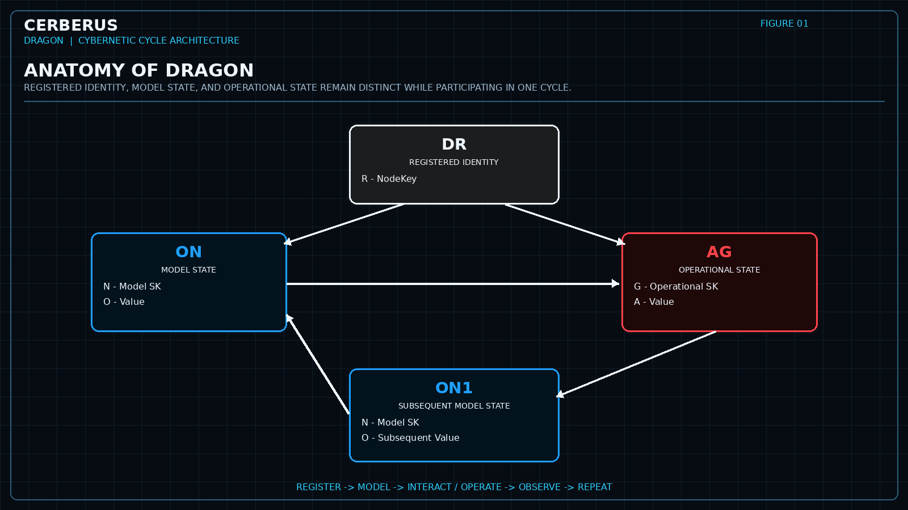
Figure 1 - Anatomy of DRAGON. Registered identity anchors independent Model and Operational state within one recurring cybernetic architecture.
CORE THESIS
DRAGON is CERBERUS's recurring cybernetic cycle for relating registered identity, modeled state, governed operations, and subsequent state so that interaction with a changing world can become structured experience.

Version 0.1 | Pass 8 Verified Release | September 2026

0. Abstract and Reading Contract
DRAGON is the cybernetic cycle through which CERBERUS keeps registered identity, modeled state, and governed operational state distinct while allowing them to participate in the same changing situation. DR establishes what registered subject is involved. ON represents state through Model Semantic Kernels. AG represents state associated with Operational Semantic Kernels whose own semantic contracts contain governed domain operations. Repeated cycles produce experience candidates that may later be retained and organized through ARMORY.
The architecture is deliberately epistemically conservative. A Model can change without CERBERUS knowing the mechanism that caused the change, and a record can describe an operational subject without owning the operator that acts on that subject. DRAGON therefore does not force every state transition through AG, does not convert editability into operationality, and does not invent causal machinery merely because before-and-after state is known.
READING CONTRACT
This paper defines the DRAGON cycle and the boundary through which it produces experience candidates. It does not define the internal memory mechanics of ARMORY, the internal encoding rules of Semantic Kernels, or the runtime authorization mechanisms that execute operations.

Contents
1. The DRAGON Proposition
2. The Problem: Identity, State, and Operation
3. DR - Determination and Registration
4. Semantic Kernel Types and DRAGON Routing
5. ON - Model State
6. AG - Operational State
7. State Transition and Causation
8. Operational Subject vs Operational Kernel
9. Recurrence and Experience Formation
10. DRAGON to ARMORY
11. Relationships to Adjacent CERBERUS Systems
12. Foundational Laws and Non-Collapses
13. Implementation and Reconstruction Considerations
14. Conclusion
Appendix A. Working Vocabulary

1. The DRAGON Proposition
A cybernetic system needs more than a registry and more than a collection of state fields. It needs a disciplined way to say which registered subject is participating, which semantic models currently describe that subject, which known operational systems apply, what changed, and what experience can be inferred from the transition without collapsing those questions into one record.
DRAGON supplies that discipline. Its three visible surfaces - DR, ON, and AG - are not a procedural script that must always execute in one order. They are complementary parts of a recurring cycle. DR anchors identity and determination. ON carries Model-SK state. AG carries Operational-SK state when an actual operator-bearing kernel participates. The cycle may then return to new Model state, new observation, or another interaction.
CENTRAL PROPOSITION
DRAGON preserves the distinction between what something is, what CERBERUS models about it, and what CERBERUS knows to act upon it.

2. The Problem: Identity, State, and Operation
Without an explicit cycle architecture, a Base can easily confuse the subject with one of its current states, mistake a changing value for an operator, or treat a verb-like record as execution machinery. Those collapses make later reasoning brittle because the system can no longer tell whether a claim concerns identity, observation, operational semantics, or causal explanation.
Question | DRAGON responsibility
What registered thing is involved? | DR anchors a stable NodeKey and determination.
What is represented about it? | ON binds the NodeKey to one or more Model SK states.
What governed operation applies? | AG binds the NodeKey to an Operational SK state when such a kernel actually participates.
What changed? | A subsequent Model state may be recorded.
Why did it change? | Known AG participation may explain part of the transition; otherwise the cause remains external, hidden, or unresolved.
What should persist? | DRAGON produces an experience candidate; ARMORY governs retention.

The result is a cycle that can be explicit where knowledge is explicit and agnostic where knowledge is incomplete. This is essential for simulation, observation, physical sensing, user editing, imported evidence, and any environment in which a state can be known more precisely than its cause.

3. DR - Determination and Registration
DR is the identity-facing surface of DRAGON. It establishes the registered NodeKey that later Model and Operational state refer to, and it preserves the governing determination or classification used to locate that identity within the wider CERBERUS system. State is attached to the registered subject; it does not manufacture the subject.
The practical consequence is simple: a NodeKey can survive changes in every Model value attached to it. A person may change emotional state, body state, training records, location, and temporal context without becoming a different registered identity merely because those states changed. Likewise, the appearance or disappearance of an Operational SK does not create or destroy the NodeKey.
IDENTITY LAW
ENTITY != MODEL != STATE != OPERATION. DR gives the cycle a stable referential anchor before state and operation are interpreted.

DR is not required to reproduce every detail of the DR registry inside this paper. The deeper determination/classification grammar remains independently governed. DRAGON only requires that the cycle can resolve a stable registered identity and the determination needed to interpret its participation.

4. Semantic Kernel Types and DRAGON Routing
Semantic Kernels participate in CERBERUS through three distinct roles: Descriptive, Model, and Operational. The classification is semantic metadata about how a kernel is used. It does not replace the BitWord identity of the kernel, and it may be revised later without rebuilding the kernel itself.
SK Type | Primary role | DRAGON state route
Descriptive | Learning, explanation, semantic navigation, display, or teaching. | No DRAGON state.
Model | Represents actual modeled state, records, coordinates, conditions, observations, logs, or other state-bearing semantic objects. | ON
Operational | Owns governed domain operations, transformations, applications, or equivalent operational machinery in its own semantic contract. | AG

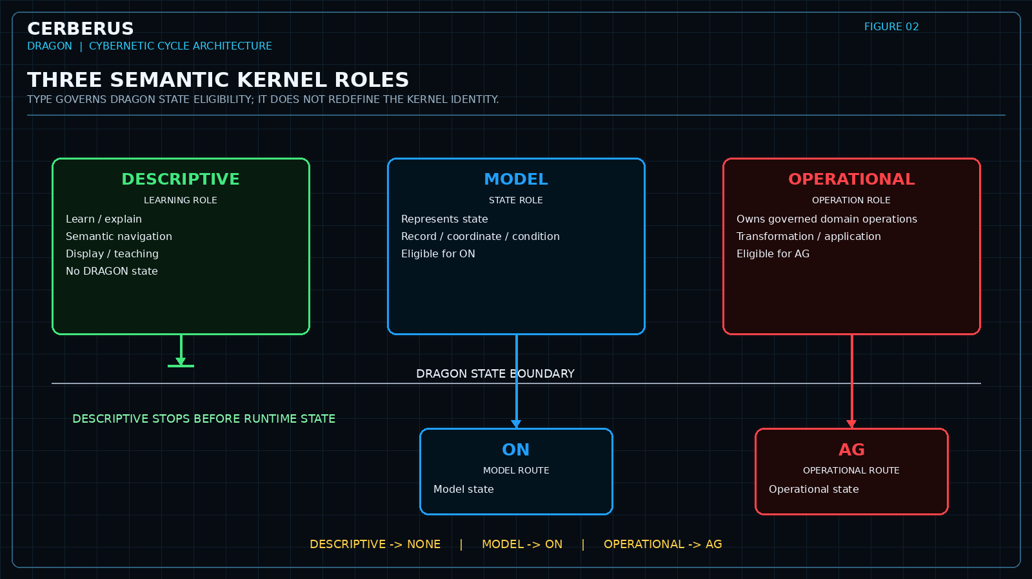
Figure 2 - Three Semantic Kernel roles. Descriptive kernels stop before DRAGON state; Model kernels are eligible for ON; Operational kernels are eligible for AG.
Routing eligibility must not be confused with state instantiation. A Model SK being eligible for ON does not mean every NodeKey receives an ON record for that Model. An Operational SK being eligible for AG does not mean it is currently active for every subject. Classification defines the permitted role; actual state records express concrete participation.
MODULARITY LAW
SK identity stays stable; routing can change. Reclassification changes the routing contract, not the kernel identity.

5. ON - Model State
ON is DRAGON's Model-state surface. Each normalized ON relation binds a registered NodeKey to one Model Semantic Kernel and the encoded value or state represented by that model.
Field | Meaning
R - NodeKey | The registered subject whose state is being represented.
N - Model SK | The Model Semantic Kernel defining the semantic shape of the state.
O - Value | The encoded or resolved value for that Model state instance.

ON is defined by representation, not permanence. A Model can represent a value that changes frequently, is edited by a person, is recalculated by software, or is revised after a new observation. None of those facts makes the Model Operational. Changeability describes the behavior of state over time; operationality describes semantic ownership of operators.
One NodeKey can participate in many independent Models at once. BODY can model anatomical state, EMOTION can model affective state, FIT can model a training or lift record, TIME can model temporal state, and FOOD can model food state. These Models may interact elsewhere, but they do not collapse into one giant record merely because they refer to the same subject.
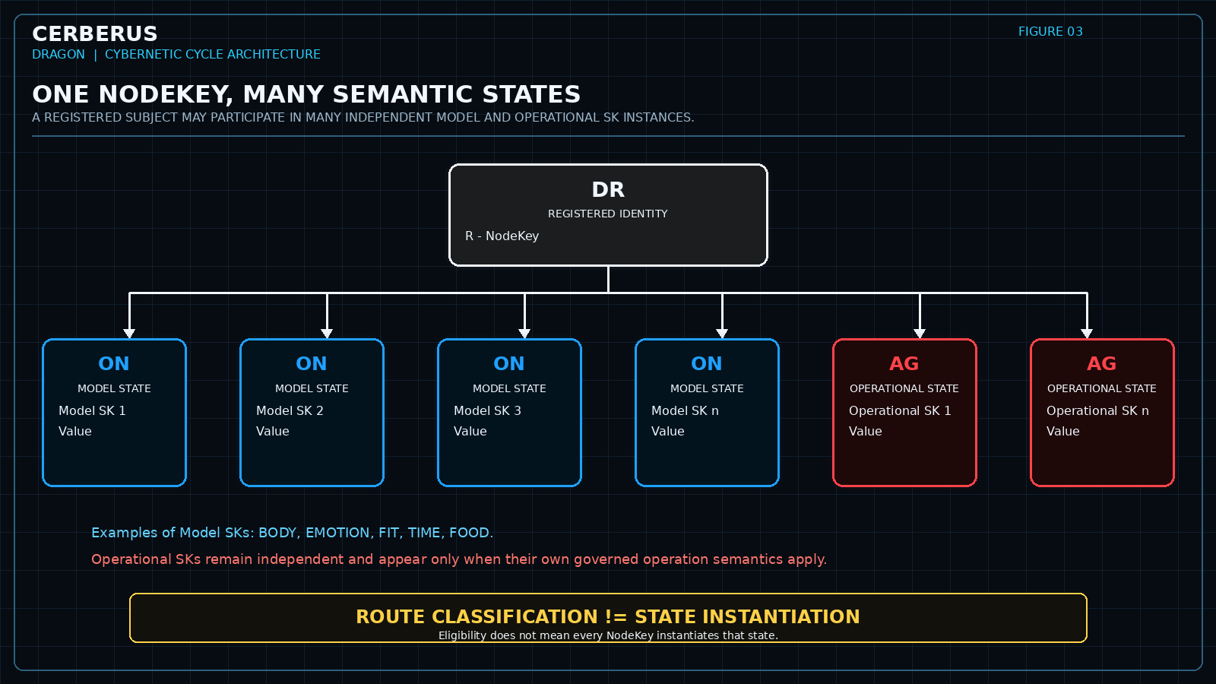
Figure 3 - One NodeKey, many semantic states. State instances remain independently typed even when they share the same registered identity.
ON LAW
ON represents modeled state, not permanence. CHANGEABILITY != OPERATIONALITY.

6. AG - Operational State
AG is DRAGON's Operational-state surface. Each normalized AG relation binds a registered NodeKey to an Operational Semantic Kernel and the operational value or state associated with that kernel's participation.
Field | Meaning
R - NodeKey | The registered subject participating in the operational relation.
G - Operational SK | The Operational Semantic Kernel that owns the governed domain-operation semantics.
A - Value | The current encoded operational state or value for that participation.

The criterion for AG is intentionally strict. A kernel belongs in AG because its own semantic contract contains governed domain operations, transformation/application semantics, or equivalent operator machinery. A record about exercise, placement, history, activity, or process is not Operational merely because the subject matter sounds operational.
AG also does not grant execution authority. It expresses operational semantics and operational state. Selection, validation, permission, invocation, interface action, and physical or simulated execution remain the responsibility of the runtime architectures that own those functions. This separation allows DRAGON to represent operational participation without turning every AG record into a command.
OPERATIONAL BOUNDARY
AG participation != execution authority. Representing a governed operation is not the same as authorizing or performing it.

7. State Transition and Causation
The simplest explicit DRAGON transition is a Model state followed by a known Operational-SK participation and then a subsequent Model state. In that case the architecture can preserve the known operational path without claiming more causation than the evidence supports.
But this path is not universal. A Model can change because of the physical world, a sensor, a user, another system, hidden simulation mechanics, imported evidence, or an unresolved cause that CERBERUS does not model. DRAGON must therefore permit a known before-state and a known after-state while leaving the mechanism unknown.
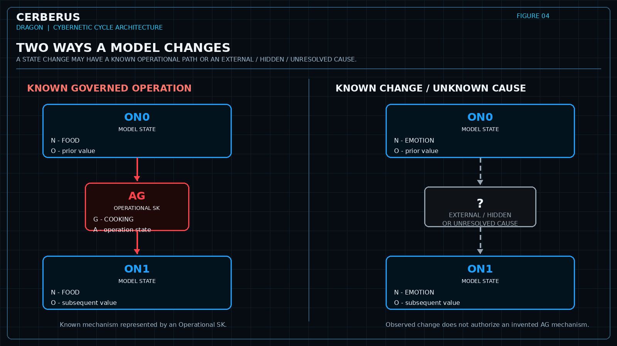
Figure 4 - Two ways a Model changes. Known Operational-SK participation and unresolved/external causation are both valid; only the first is represented as AG.
Case | What DRAGON may claim | What DRAGON must not claim
Known Operational path | An Operational SK participated between relevant Model states. | That the AG record explains every consequence unless the evidence supports that stronger claim.
External / hidden / unresolved cause | The Model state changed and the mechanism is not represented. | A fabricated AG record simply to fill the causal gap.

EPISTEMIC LAW
KNOWN STATE CHANGE != KNOWN TRANSFORMATION MECHANISM. DRAGON preserves uncertainty instead of converting missing causation into invented machinery.

8. Operational Subject vs Operational Kernel
A major classification error occurs when the subject of a record is mistaken for the semantic role of the kernel. FIT-128 is the canonical example. A FIT record can describe a lift, including an exercise, load, and repetition count, while remaining a Model because it does not contain the operator that performs the lift.
COOKING-128 illustrates the opposite role when its contract contains the governed culinary operations themselves. The fact that both kernels concern activity does not make them the same semantic type. The decisive question is not whether a record contains verbs or describes change; it is whether the governed operator machinery belongs to the kernel itself.
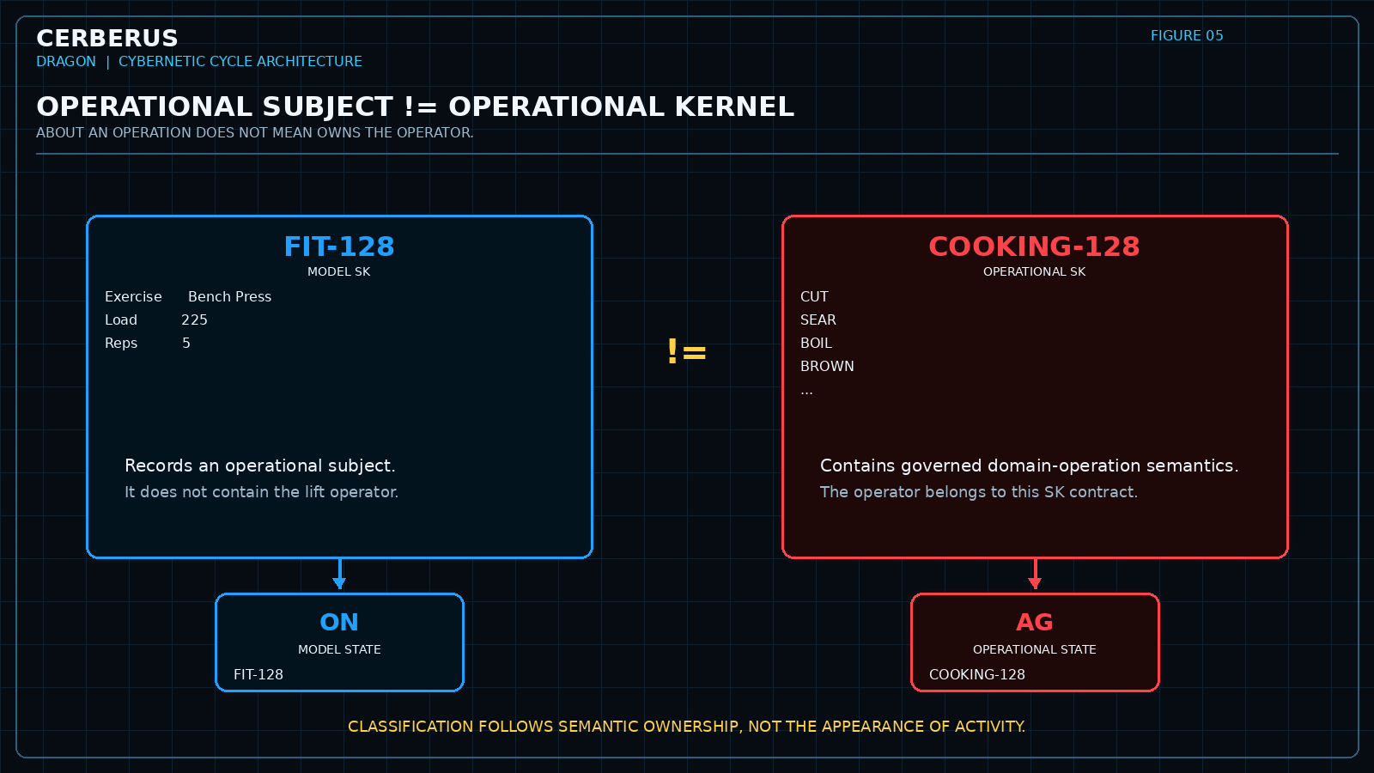
Figure 5 - Operational subject versus Operational kernel. FIT-128 records an activity and routes as Model state; COOKING-128 owns governed domain-operation semantics and routes as Operational state.
CLASSIFICATION TEST
TEACHES meaning -> Descriptive. MODELS state or records -> Model -> ON. OWNS governed domain operators -> Operational -> AG.

9. Recurrence and Experience Formation
DRAGON becomes cybernetic through recurrence. A registered subject is modeled, interacts with known operations or a changing environment, is observed again, and returns to updated state. The next cycle begins with more context than the previous one, but the cycle does not require every intermediate mechanism to be modeled.
The difference between successive states, together with relevant operations, interactions, observations, comparisons, and outcomes, can form an experience candidate. Candidate is the important word: DRAGON can identify that something potentially meaningful happened without deciding that the event deserves long-term retention.
Experience candidate may arise from | Examples
Known operation | A governed Operational SK participates and a relevant result is observed.
External change | A Model changes because of a sensor, person, environment, or another system.
Comparison | Expected state and observed state differ in a potentially meaningful way.
Repeated pattern | Similar transitions recur often enough to merit possible retention.
Unexpected result | A transition violates expectation or reveals a gap in the current Model.

DRAGON therefore produces structured candidates for experience rather than an indiscriminate event log. That keeps the cycle responsive without requiring every observed change to become durable memory.

10. DRAGON to ARMORY
ARMORY begins where DRAGON stops. DRAGON produces the experience candidate; ARMORY determines whether and how that candidate becomes accumulated structure. This paper deliberately treats ARMORY as a bounded companion architecture rather than reproducing its internal theory.
ARMORY position | Canonical name
A | Archives
R¹ | Retrospection
M | Meditation
O | Operational Core
R² | Response-Pattern
Y | Yous

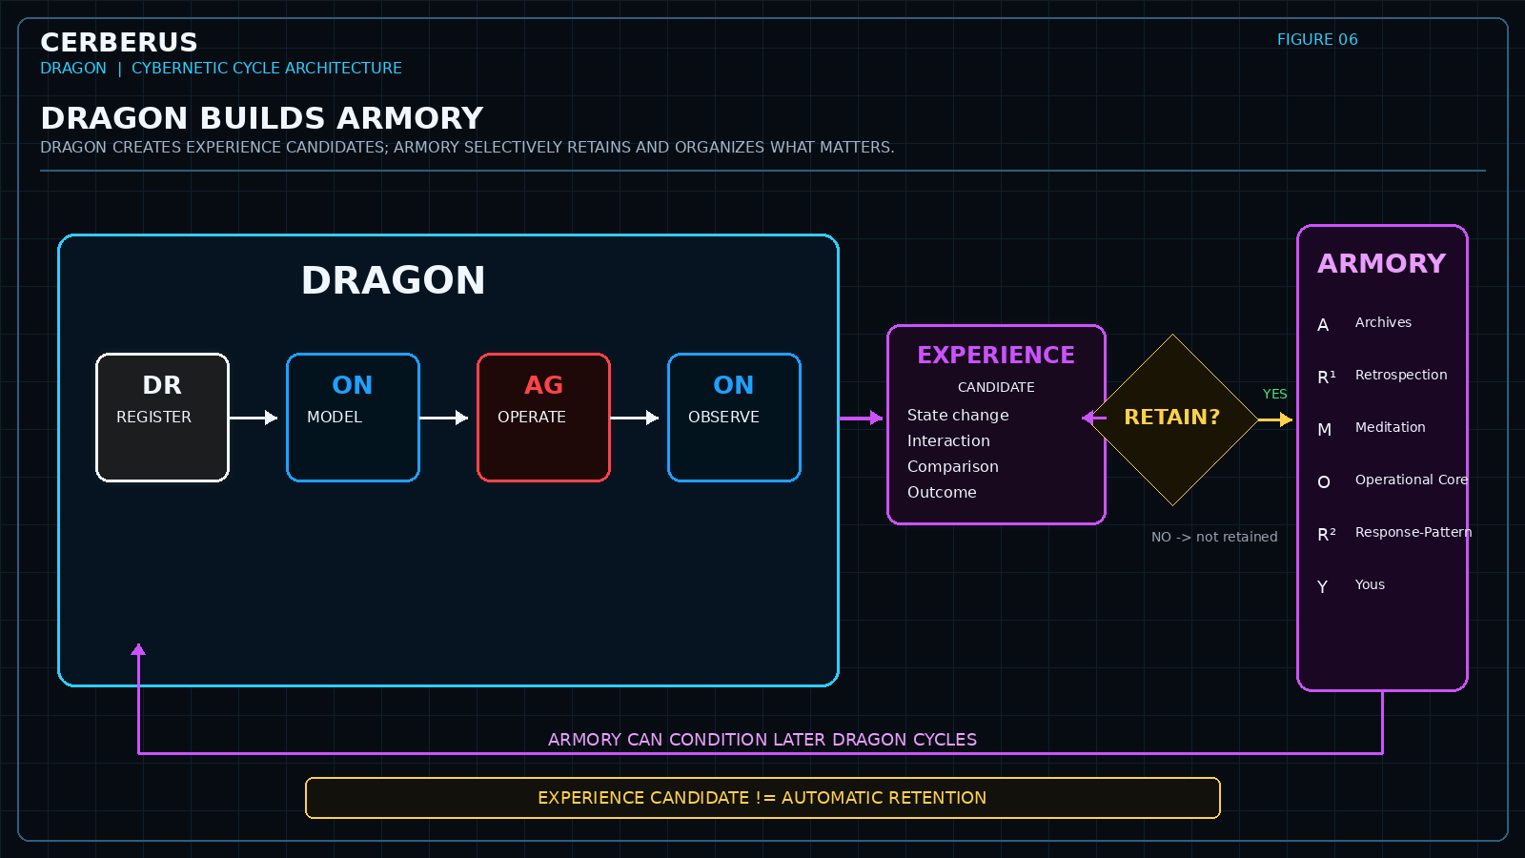
Figure 6 - DRAGON builds ARMORY. The cybernetic cycle produces experience candidates; ARMORY selectively retains and organizes experience, and accumulated ARMORY can condition later DRAGON cycles.
The feedback direction is equally important. Accumulated ARMORY can influence how later cycles are interpreted, which Models become relevant, what response patterns are available, and how a future situation is approached. The past therefore conditions future DRAGON without replacing current reality or converting memory into state truth.
BOUNDARY LAW
DRAGON creates experience candidates. ARMORY governs retention, interpretation, integration, stabilization, and reuse.

11. Relationships to Adjacent CERBERUS Systems
DRAGON is a connective cycle, not a replacement for the systems that define meaning, structure, interfaces, reading, execution, or memory. Its usefulness depends on maintaining those ownership boundaries.
System | Relationship to DRAGON
BIGFOOT / SK Reader | Provide the semantic identities, encodings, and reading machinery used to interpret Model and Operational SK values.
BOSS | Provides governed symbolic and operational vocabulary without becoming the DRAGON state store.
VISOR | Provides the structural map and reconstruction-oriented description of where DRAGON Tables and relationships live.
QUIVER | Can assemble relevant interface representations around DRAGON state without changing canonical state ownership.
DARTBOARD | Selects applicable runtime contributions and routes governed actions to their owners; AG itself does not grant execution authority.
MIRROR | Can represent relational structures and reusable reconstructions derived from governed source state without replacing DRAGON truth.
ARMORY | Receives selected experience candidates for retention and can condition future cycles.

These boundaries make DRAGON portable. The cycle can remain conceptually stable even when the interface, database, Reader implementation, or runtime engine changes.

12. Foundational Laws and Non-Collapses
IDENTITY != STATE.
MODEL != OPERATOR.
DESCRIPTIVE SK != MODEL SK != OPERATIONAL SK.
MODEL SK -> ON eligibility.
OPERATIONAL SK -> AG eligibility.
DESCRIPTIVE SK -> no DRAGON state.
ROUTE CLASSIFICATION != STATE INSTANTIATION.
CHANGEABILITY != OPERATIONALITY.
EDITABILITY != OPERATIONALITY.
OPERATIONAL SUBJECT != OPERATIONAL SK.
REPRESENTATION OPERATIONS != REPRESENTED OPERATIONS.
KNOWN STATE CHANGE != KNOWN CAUSE.
AG PARTICIPATION != EXECUTION AUTHORITY.
EXPERIENCE CANDIDATE != ARMORY RETENTION.
A conforming DRAGON implementation should make these distinctions inspectable rather than relying on convention. Violations should be detectable as classification, routing, structural, or runtime-boundary errors rather than silently tolerated ambiguities.

13. Implementation and Reconstruction Considerations
The current CERBERUS prototype expresses DRAGON through Airtable Tables and linked records, but DRAGON is not an Airtable ontology. The portable architecture is smaller than the current implementation surface and can be reconstructed in SQLite, another relational store, a graph database, or a custom runtime so long as the semantic identities and relationship contracts are preserved.
Portable relation | Minimum contract
DR | Stable registered NodeKey plus the determination/classification required to orient it.
ON | NodeKey x Model SK x Value.
AG | NodeKey x Operational SK x Value.
SK Type | One authoritative classification: Descriptive, Model, or Operational.
Derived route | Descriptive -> none; Model -> ON; Operational -> AG.
Experience handoff | A bounded candidate object or event relation sufficient for ARMORY to decide retention.

The implementation should prefer derived routing over duplicated editable route fields wherever practical. When a kernel changes type, the route changes with the classification rather than requiring manual synchronization across several independent fields. Existing state records may then be migrated deliberately rather than reinterpreted silently.
Reconstruction should also preserve uncertainty. An unknown causal gap in one implementation must not become a fabricated Operational SK in another simply because the target runtime prefers fully specified workflows. UNKNOWN is a legitimate state of knowledge and must remain distinguishable from zero, false, blank, and known no-op.
MIGRATION PRINCIPLE
Preserve semantic identity and governed relationships; recompile the material implementation.

14. Conclusion
DRAGON gives CERBERUS a recurring cybernetic structure in which identity, modeled state, and governed operational state can interact without losing their boundaries. DR anchors the registered subject. ON represents what is modeled about that subject. AG represents the participation of operator-bearing Semantic Kernels. Subsequent state can be known even when causation is incomplete, allowing the system to remain honest about what it knows.
The architecture becomes most useful through recurrence. Each cycle can produce a bounded experience candidate from state, interaction, and observed consequence. ARMORY may retain and organize selected candidates, and that accumulated structure can later condition another DRAGON cycle. In this way DRAGON creates the experience from which ARMORY grows without turning memory, state, identity, and operation into the same thing.
CLOSING THESIS
DRAGON is the cybernetic cycle that creates the experience from which ARMORY is built.

Appendix A. Working Vocabulary
Term | Working definition
AG | DRAGON operational-state relation binding a NodeKey to an Operational SK and operational value/state.
Descriptive SK | Semantic Kernel used for learning, explanation, semantic navigation, or display; not instantiated as DRAGON state.
DR | Determination / Registration surface that resolves the stable registered identity participating in the cycle.
Experience Candidate | A bounded result of a DRAGON cycle considered potentially meaningful for later retention.
Model SK | Semantic Kernel representing actual modeled state, records, coordinates, observations, conditions, or logs; eligible for ON.
NodeKey | Stable registered identity used as the referential anchor for DRAGON state.
ON | DRAGON Model-state relation binding a NodeKey to a Model SK and encoded value/state.
Operational SK | Semantic Kernel whose own contract contains governed domain operations, transformation/application semantics, or equivalent operator machinery; eligible for AG.
Routing eligibility | Permission implied by SK Type for where state may be instantiated; not a requirement that state exists.
State transition | A relationship between prior and subsequent modeled state, with causation represented only to the degree known.

OctoGroove Pass 8 Verification Record
Field | Status / Output
Pass | 8 - VERIFY
Status | Verified Release - ready for human approval
Authoritative Inputs | Approved Pass 3 Content Architecture; approved Pass 4 Figure Contracts; approved Pass 5 Asset Manifest; completed Pass 6 Waves A-H figure production; approved Pass 7 Composition Candidate.
Verification Scope | Rendered-release QA covering the complete document: dark CERBERUS theme, F01-F06 presence and legibility, figure-caption continuity, table integrity, terminology consistency, DR/ON/AG boundaries, three-way SK typing, causation rules, ARMORY handoff, and reconstruction language.
Figure Set | F01-F06 present exactly once, composed, captioned, and visually legible. Document-native prose and tables remain the semantic authority; illustrative figure microtext does not create new architecture.
ARMORY Boundary | Verified canonical sequence: A Archives; R1 Retrospection; M Meditation; O Operational Core; R2 Response-Pattern; Y Yous. DRAGON produces experience candidates; ARMORY governs retention and accumulated structure.
QA Result | PASS - no clipping, overlap, broken tables, missing figures, missing glyphs, or page-layout failures detected in the rendered release.
Release Gate | Human APPROVE / REVISE / ROLLBACK. Approval locks v0.1 as the verified release.

Pass 8 verification confirms the approved Pass 3-7 architecture as a coherent rendered release. Verification checked semantic boundaries, figure integrity, layout, terminology, and whole-document visual consistency without redesigning the approved architecture.

