CERBERUS
Semantic Skill Worlds
Portable Competence, Composable Game Mechanics, Cross-SK Mastery, and Emergent World Complexity
FORMAL SYSTEM ARCHITECTURE SPECIFICATION
Version 0.1
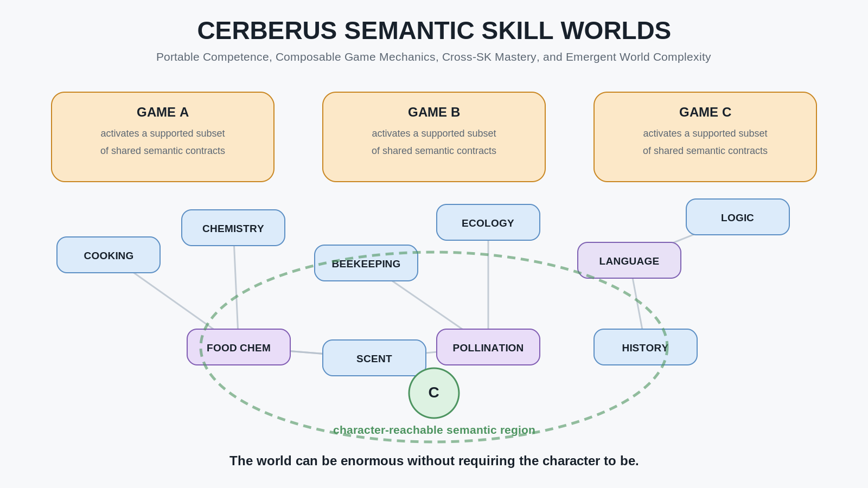
CORE PROPOSITION
Shared semantic contracts let characters preserve meaningful competence across worlds; specialist games can become reusable mechanics; intersecting Skills can form new domains; and enormous worlds can remain individually bounded.

Document Control
Field | Specification
Document | CERBERUS Semantic Skill Worlds
Subtitle | Portable Competence, Composable Game Mechanics, Cross-SK Mastery, and Emergent World Complexity
Version | 0.1
Status | Formal system architecture specification
Primary scope | Portable character competence; cross-game semantic Skill recognition; specialist games as reusable mechanics; experienced-entry games; semantic deepening; Cross-SK interaction; Intersection SKs; fictional ontology; compositional world scale.
Semantic dependencies | CERBERUS; BIGFOOT; Domain SKs; Skill SKs; BitWords; Operators; Rules; PULSE; SOLAR; MIRROR; Language SKs.
Explicit boundary | Does not define character transport/security, marketplace or licensing systems, exact Cross-SK runtime schema, a universal Skill taxonomy, professional certification, complete pedagogy, a complete game engine, or a canonical fantasy deep ontology.

Abstract
CERBERUS Semantic Skill Worlds examines what follows when bounded semantic access is applied not only to language, but to playable competence across many games and simulated worlds. The Language SK architecture established that a canonical linguistic system can remain shared while different characters reach different lexical and grammatical regions. CERBERUS Playable Semantic Skills separately established that character competence can be represented through stable Domain SK and Skill SK identities rather than through opaque game-specific classes. This paper begins from those results and explores their larger compositional consequences.
A character can carry developed competence across compatible games when the receiving game recognizes the same semantic Skill contracts. The receiving world does not need to reproduce every capability the character has ever learned. It activates only the semantic regions, BitWords, Operators, Readers, and other contracts it actually supports. Known but unsupported competence can remain dormant without being erased, while newly supported but unacquired capability becomes genuine novel territory for the player to learn.
This creates a different relationship between games and progression. A game may reward familiar mastery, introduce new semantic domains, or assume that the incoming character already possesses significant prerequisite competence. A character can therefore enter some worlds as an experienced practitioner rather than repeatedly restarting as a novice. Difficulty can arise from the gap between what a world demands and what the character can actually resolve or perform, rather than only from numerical enemy scaling or arbitrary difficulty modifiers.
Later parts of this paper extend the same architecture further. Specialist games can become reusable mechanics inside larger worlds. Legitimate real-world skills can receive fantasy extensions without falsifying the underlying real knowledge. Different histories of learning can refract through the same dungeon as different perceptions and affordances. Skills can deepen through new Operators and finer causal models rather than repetitive numerical grinding. Independently bounded SKs can then participate in registered cross-SK relations, producing derived domains that may themselves become learnable Skills. Fictional worlds can continue those structures beyond real-world ontology by declaring additional lawful state variables and causal layers. At sufficient scale, thousands of bounded semantic systems can compose into worlds whose total possibility space is enormous while each character experiences only a small, intelligible, personally developed region.
The central thesis is:
When games operate on shared Semantic Kernels, character competence can persist across worlds, specialized games can become reusable mechanics, novel domains can emerge from intersections between Skills, and massive worlds can grow compositionally from thousands of independently bounded semantic systems.

Contents
PART I PORTABLE COMPETENCE
1. Scope and Architectural Handoff
2. Canonical Domain and Character Reach
3. Semantic Skill Portability Across Games
4. Familiar Competence and Novel Semantic Territory
5. Experienced-Entry Games and Semantic Difficulty
PART II COMPOSABLE GAMEPLAY
6. Specialist Games as Reusable Semantic Mechanics
7. Legitimate Knowledge and Fantasy Extension
8. The Character as a Playable History
9. Semantic Deepening Instead of Numeric Grinding
10. From Operators to Underlying Material State
PART III SEMANTIC INTERSECTIONS
11. Cross-SK Interaction
12. Intersection Domains and Independent Mastery
13. Recursive Semantic Depth
14. Fictional Ontology and Lawful Magic
15. Multi-Resolution Mastery
PART IV WORLD SCALE
16. Contribution at Semantic Scale
17. The Bounded Character Inside the Massive World
18. Emergent Semantic Worlds
Conclusion - The World Can Be Enormous Without Requiring the Character to Be
Companion Architecture References

List of Figures
Figure 1. From Linguistic Possibility to Playable Possibility
Figure 2. Canonical Domain vs Character Reach
Figure 3. Portable Skill State Across Games
Figure 4. Familiar, Dormant, and Novel Territory
Figure 5. Experienced Entry: World Demand vs Character Capability
Figure 6. Specialist Game Becomes World Mechanic
Figure 7. The Mechanic Foundry
Figure 8. Legitimate Beekeeping to Spectral Pollen PULSE
Figure 9. Character as Playable History
Figure 10. Party Refraction Through a Dungeon
Figure 11. Semantic Deepening Instead of Grinding
Figure 12. From Operator to Underlying Material State
Figure 13. Sparse Cross-SK Interaction
Figure 14. Intersection SK With Its Own Mastery
Figure 15. Recursive Semantic Depth
Figure 16. Real-World Foundation to Fictional Deep Ontology
Figure 17. Same Object, Increasing Semantic Resolution
Figure 18. Compositional Semantic World
Closing synthesis. From semantic dimensions to play.
PART I PORTABLE COMPETENCE

1. Scope and Architectural Handoff
The Language SK paper concludes with a model of bounded minds inside shared language. Its canonical Language Dictionary and Language SK can remain larger than any one character's reachable vocabulary and grammar. Character Skill and MASK state determine which linguistic routes are presently available without rewriting the canonical language itself. One language can therefore support different levels of vocabulary, specialist terminology, translation ability, approximation, misunderstanding, and learning through differences in reachable state rather than through separately authored language systems for every character.
This paper begins by generalizing that relationship.
If a complete Language Dictionary can define linguistic possibility while a character reaches only a bounded portion, then a complete Domain SK can define playable semantic possibility while a character reaches only the capabilities made available through its Skill state, acquisition state, Reader capability, and the Rules of the current world.
The transition can be stated compactly:
bounded linguistic possibility -> bounded playable possibility
The architecture does not require every semantic possibility to be simultaneously available to every character. It requires the canonical domain to remain stable enough that a character's partial reach can be interpreted without confusing character state with domain truth.
This distinction already exists in CERBERUS Playable Semantic Skills. The Domain SK owns semantic and operational possibility. The attached Skill SK owns the character's progression through that possibility. Experience, Levels, progression tracks, and acquired MASK state may differ by character while the Domain SK remains shared. Stable Skill identities can then be recognized by receiving games through semantic intake.
Semantic Skill Worlds takes those mechanisms as established and asks a wider question:
What happens when many games, specialist systems, characters, and fictional worlds begin composing around the same addressable semantic capabilities?

This paper therefore does not redefine the internal mechanics of Language SKs, Domain SKs, Skill SKs, PULSE, SOLAR, MIRROR, or DARTBOARD. It uses their established responsibilities as architectural inputs. The concern here is composition at game and world scale.

Terminology Boundary
The word world in the title and throughout this paper refers to a simulated, game, educational, professional, or fictional environment unless the text explicitly refers to the BIGFOOT semantic hierarchy level named World. The two uses should not be conflated.
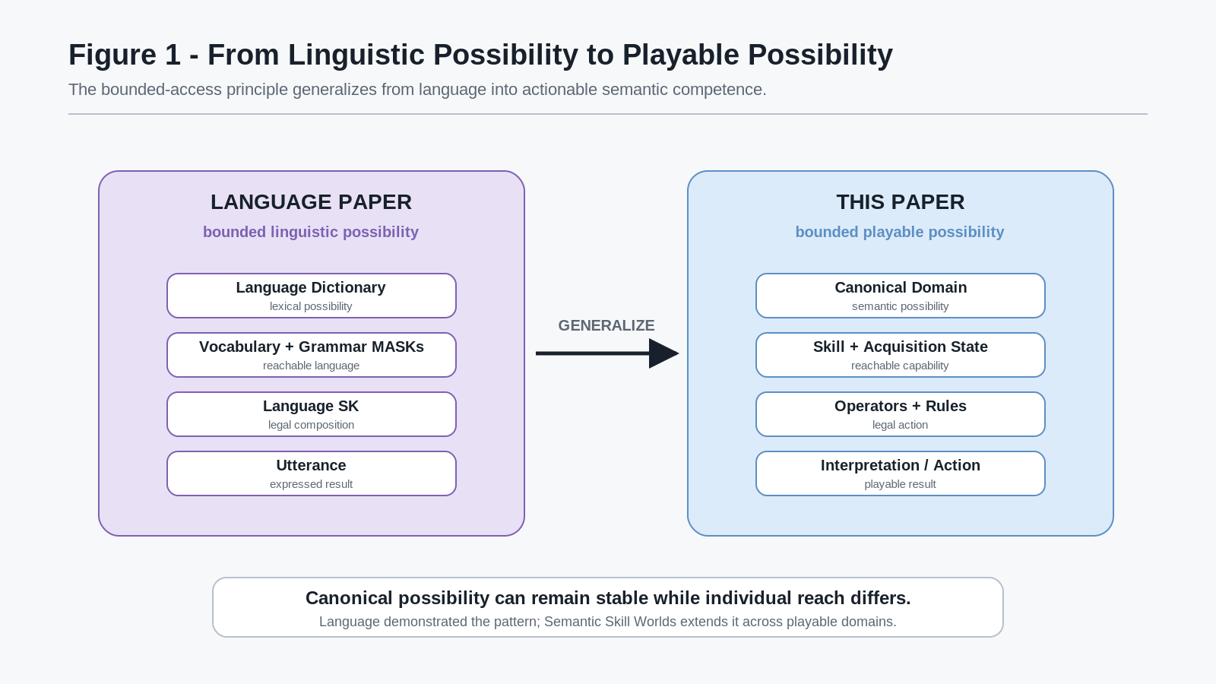
Figure 1. From Linguistic Possibility to Playable Possibility

Shared Possibility Principle
A world may contain vastly more semantic capability than any individual character can access.

This principle is not a limitation to be hidden. It is one of the primary sources of differentiation, specialization, learning, and replayability developed throughout this paper.

2. Canonical Domain and Character Reach
A character should not be treated as a miniature copy of the canonical domain. The Domain SK defines what the domain means and which semantic structures, Operators, Rules, Models, and relations exist. The character carries a bounded progression and acquisition state over that domain.
The distinction is important because it lets the same canonical domain support dramatically different characters without fragmenting semantic identity. A novice cook, professional chef, child learner, survivalist, fantasy innkeeper, and food-science specialist may all operate against the same underlying cooking semantics while reaching different portions of the available capability space.
The simplest representation is:
Canonical Domain -> Character Skill State -> Reachable Capability -> Action / Interpretation
The canonical domain can contain capabilities the character has never encountered. The character can also retain acquired capabilities that the current game does not expose. The current world then adds another boundary by deciding which contracts are supported, which Operators are permitted, which resources are present, and which local Rules apply.
This gives three distinct questions:
1. Does the semantic capability exist in the canonical domain?
2. Has this character acquired or developed the capability?
3. Does the current game or world support and permit the capability here?
Collapsing these questions produces brittle progression systems. Keeping them separate allows one shared semantic identity to survive changes in game, presentation, difficulty, and local context.
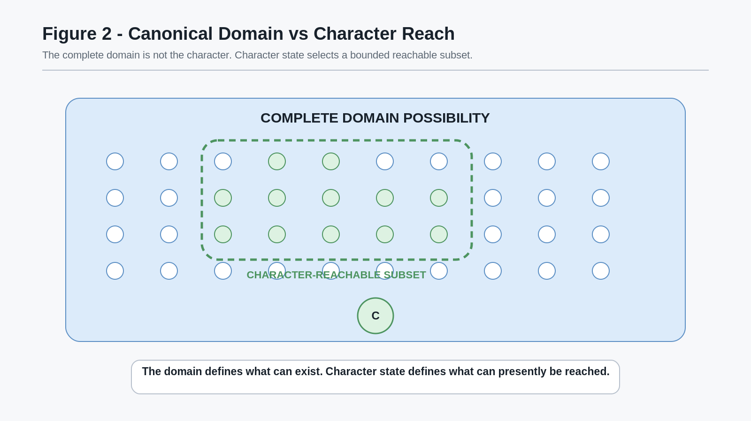
Figure 2. Canonical Domain vs Character Reach

Reach Separation Principle
The domain defines possible capability. Character state defines acquired capability. The current world defines which acquired capability can become active here.

This three-part separation becomes the basis of cross-game portability.

3. Semantic Skill Portability Across Games
CERBERUS Playable Semantic Skills already establishes that stable semantic Skill identities allow developed competence to move between compatible games. Semantic Skill Worlds extends that mechanism into a broader game-design consequence: a new game does not need to force an experienced character back to zero when it genuinely understands the same Skill.
The requirement is semantic compatibility, not visual similarity or coincidental naming.
A game that contains a system labelled Cooking is not automatically compatible with another game's Cooking state. The receiving game must recognize the relevant Skill SK and Domain SK identities or a declared compatible contract. Version, provenance, migration, and trust may matter to a production implementation, but those transport details remain outside the scope of this paper.
Where compatibility exists, the receiving game can activate only the subset it supports.
Consider one character whose developed cooking history includes Knife Skills, Heat Control, Mixing, Preservation, and Fermentation. Three games may expose different portions:
- Game A supports Knife Skills, Heat Control, and Mixing.
- Game B supports Heat Control, Preservation, and Fermentation.
- Game C supports Knife Skills, Baking, and Plating.
When the character enters Game A, existing Knife, Heat, and Mixing competence can become active. Preservation and Fermentation do not need to disappear merely because Game A has no use for them. They remain part of the character's history. If a later game supports those contracts, the same competence can become active again.
Likewise, Baking and Plating can exist in Game C as supported but novel semantic territory. The game recognizes them; the character has not yet acquired them. The receiving game therefore has something legitimate to teach without pretending that the character forgot everything learned elsewhere.
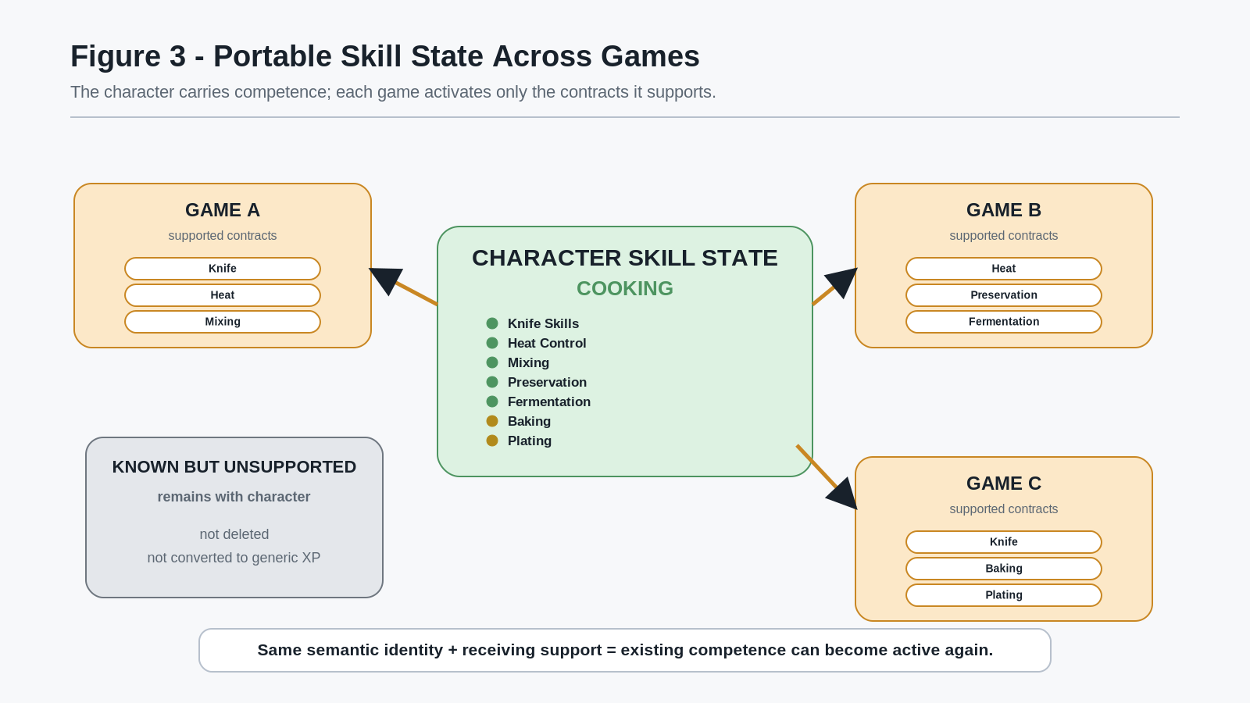
Figure 3. Portable Skill State Across Games

Supported-Subset Principle
A receiving game activates the semantic capability it supports; it does not need to erase the capability it does not.

This permits broad and narrow implementations to coexist. A restaurant game may expose a large portion of COOKING. A survival game may expose only camp cooking, preservation, sanitation, and resource-constrained preparation. A fantasy RPG may expose ordinary cooking plus dragon ingredients and magical heat sources. A space game may expose rationing, unfamiliar biology, pressure-safe preparation, or automated galley equipment. The shared semantics remain portable where the contracts actually overlap.

Dormant Competence Principle
Known but unsupported competence may remain persistent and dormant until a compatible environment makes it usable again.

Dormancy is not failure, deletion, or de-leveling. It is simply non-participation in the current world.

4. Familiar Competence and Novel Semantic Territory
Portability creates two distinct rewards when a character enters a new game.
The first is familiar competence. A player can encounter a known semantic system in a radically different context and immediately feel the consequences of previous learning. Heat Control learned in a restaurant can matter at a survival campfire, a dragonstone oven, or a starship induction surface. The world, materials, constraints, and MIRROR presentation can change while the underlying competence remains recognizable.
This creates a familiarity dividend: previous practice is not merely remembered by the player; it is acknowledged by the character model.
The second reward is novel semantic territory. A game can expose Skills, BitWords, Operators, or semantic regions that the character has never acquired. A player who normally prefers fantasy adventures may still be interested in a dedicated sailing game because it introduces Navigation, Sail Handling, Weather Reading, Maritime Terminology, or other capabilities that can later matter elsewhere. A player may enter an apiary game because BEEKEEPING itself is an attractive addition to the persistent character.
These motivations can coexist:
- Familiar: known and supported now.
- Dormant: known but unsupported now.
- Novel: supported now but not yet acquired.
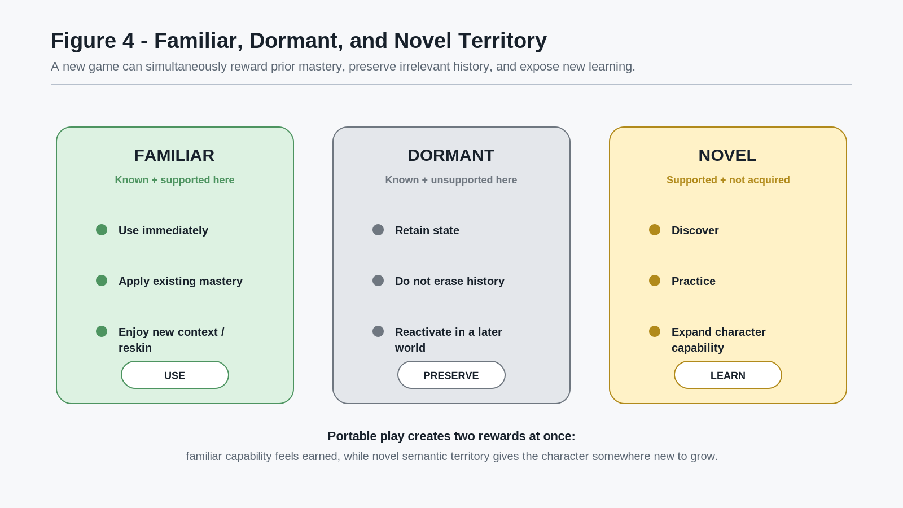
Figure 4. Familiar, Dormant, and Novel Territory
This changes the shape of progression. Growth does not have to mean only a larger value on one existing Skill. It may mean discovering a new semantic region, encountering a new Operator, learning a new tool, or entering a domain the character has never previously touched. Later sections examine this in greater depth, but the cross-game consequence appears immediately: games can become destinations for specific knowledge the player wants the character to acquire.
A dedicated niche game therefore has a different potential relationship to the wider ecosystem. It can remain enjoyable as a standalone experience while also becoming a particularly rich place to develop a certain Skill. The paper does not assume a particular marketplace, publisher model, or commercial outcome. The architectural point is narrower: shared Skill identities allow value created in one specialized experience to remain meaningful elsewhere.

Familiarity and Novelty Principle
Portable Skills can make prior knowledge immediately useful while allowing each game to contribute genuinely new semantic territory.

This is especially important for reskinning. A reskin is no longer only cosmetic when the world changes the local Rules, materials, constraints, affordances, and context around a familiar semantic capability. The player may understand the underlying discipline while still confronting a new problem.

5. Experienced-Entry Games and Semantic Difficulty
Persistent competence removes another assumption common to games: every new title does not need to begin with a fresh novice.
Some worlds can genuinely assume that the incoming character already knows what they are doing.
A game might contain early content that expects conversational High Elvish, intermediate Navigation, advanced Cooking, or substantial Monster Lore. This does not require an artificial difficulty setting. It can arise because the world presents problems whose solution space presupposes those capabilities.
An unreadable High Elvish inscription is not necessarily a harder version of a language puzzle. For a character with insufficient High Elvish, the inscription may simply be unreadable. A complicated preserved ingredient may not become solvable by adding more button prompts if the character lacks the necessary preservation knowledge. A dangerous crossing may remain dangerous when the character lacks Navigation. The same canonical obstacle can therefore produce different practical difficulty for different characters.
This creates an important distinction:
Player Difficulty != Character Capability
A skilled player can understand that an inscription matters while controlling a character who cannot read it. Conversely, a character may possess deep domain competence that the human player does not personally possess, allowing the game to project, explain, or assist according to the character's legitimate Skill state.
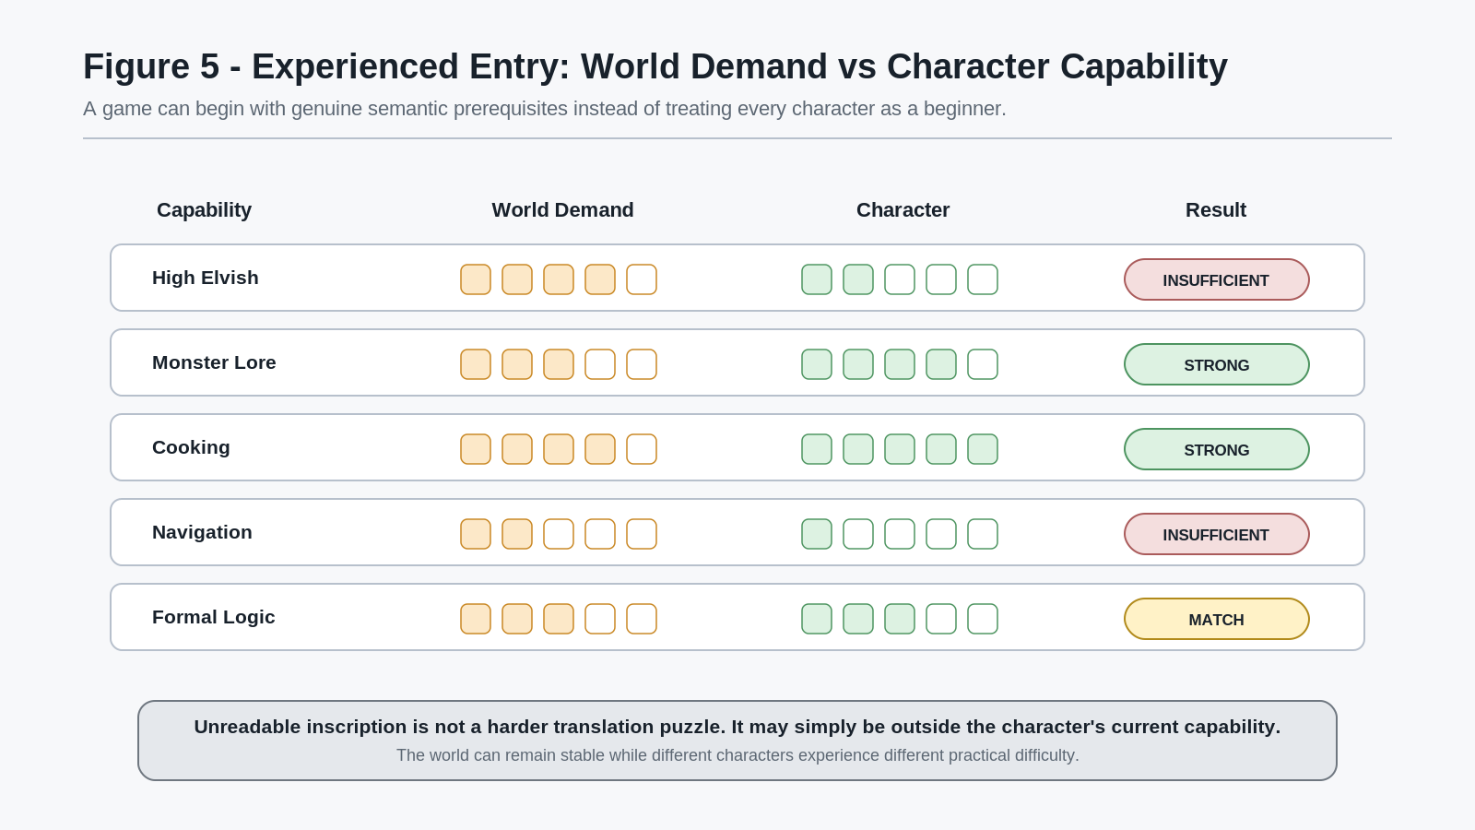
Figure 5. Experienced Entry: World Demand vs Character Capability

Semantic Difficulty Principle
Difficulty may emerge from the distance between a world's demands and a character's existing capability.

This permits games to start in the middle of expertise. A veteran chef does not need another tutorial explaining how to boil water. A skilled sailor does not need to forget navigation because the ocean belongs to another title. A legendary wizard does not need to relearn the semantic equivalent of Fireball Level 1 unless the new world actually uses a different magical contract.
The same architecture can also support beginner-friendly games. An open-entry title can expose introductory Skills, tutorial surfaces, or Learning Mode access. An advanced title can assume developed competence. A specialist title can target one narrow region deeply. A capstone experience can deliberately demand several developed domains at once. Those are design possibilities, not canonical CERBERUS game classes.
Missing competence also does not necessarily mean a player is excluded from multiplayer. Another character may supply the needed capability, turning party formation into a problem of accumulated expertise rather than a fixed Tank / Damage / Healer template. The deeper multiplayer consequences are developed in Part II.

PART II COMPOSABLE GAMEPLAY

6. Specialist Games as Reusable Semantic Mechanics
Portable competence changes more than the character. Once a semantic discipline has stable identity outside any one title, a game that explores that discipline deeply can become more than a self-contained experience. It can become a mature implementation of a mechanic that other games and worlds may expose through the same semantic contracts.
Consider a dedicated blacksmith game. Its play may be organized around Metallurgy, Forging, Heat Control, Materials, Tools, forming Operators, inspection, and persistent Skill development. In an ordinary isolated game architecture, most of that work terminates at the edge of the title. A later fantasy role-playing game that wants a smithy builds a second, usually unrelated, smithing system. The two experiences may use the same words while sharing no semantic identity.
CERBERUS permits a different relationship.
If the specialist game and the receiving world recognize the same Domain SKs, Skill SKs, BitWords, and registered Operators where appropriate, the fantasy smithy can expose those semantic capabilities in a new local context. The receiving world can then contribute what belongs to the receiving world: local ores, fuel, magical materials, economic conditions, available equipment, quests, cultural designs, local Rules, and MIRROR realization.
The specialist game contributes depth in the discipline. The larger world contributes the situation in which that discipline is being used.
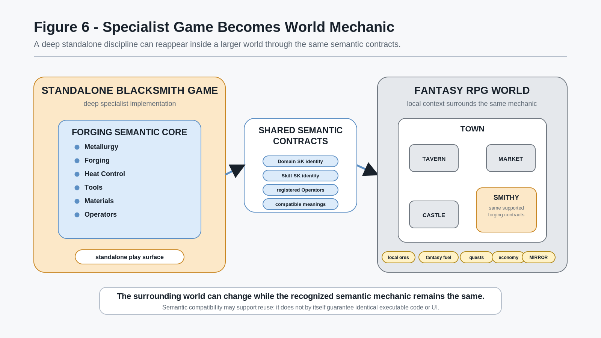
Figure 6. Specialist Game Becomes World Mechanic
This is not a claim that semantic compatibility automatically makes arbitrary code, interfaces, physics engines, or save files interoperable. A semantic contract identifies what a capability means and how it is addressed within the CERBERUS architecture. Executable reuse still depends on the technical environment that implements it. A studio may reuse code directly, rebuild an implementation against the same semantic contract, or expose only a compatible subset.
The architectural gain exists even when the implementation changes: the receiving world does not need to invent a second incompatible meaning for the same discipline.

Semantic Mechanic Reuse Principle
A specialist game can function as a reusable semantic mechanic when another game recognizes and implements the same relevant semantic contracts.

This allows depth to concentrate where it is useful. A standalone blacksmith title can devote substantial design effort to forging without requiring every fantasy game to independently become a blacksmith simulator. A larger role-playing game can support a narrower smithy surface while still recognizing the character's relevant competence. A historical simulation could expose a much broader portion. A survival game could support only improvised forging and repair. The shared contract does not force equal implementation depth.

Supported-Depth Principle
Semantic compatibility does not require every game to expose the same resolution or the same portion of a discipline.

A receiving game may therefore implement 15 percent, 40 percent, or nearly all of a semantic domain, provided it is explicit about which contracts it recognizes. Unsupported capability remains part of the character state according to the portability principles established in Part I.
This creates a practical studio pattern: the mechanic foundry.
A mechanic-foundry studio can deliberately build small, strange, unusually deep specialist games whose systems are useful on their own and potentially reusable elsewhere. One project may focus on cooking. Another on sailing. Another on beekeeping, tailoring, pottery, glassworking, music, construction, horse training, or watchmaking. Their value does not depend on every player wanting a giant standalone title in that discipline forever. The mature semantic mechanic can later become a tavern, port, apiary, tailor, kiln, concert hall, workshop, or construction site inside a larger world.
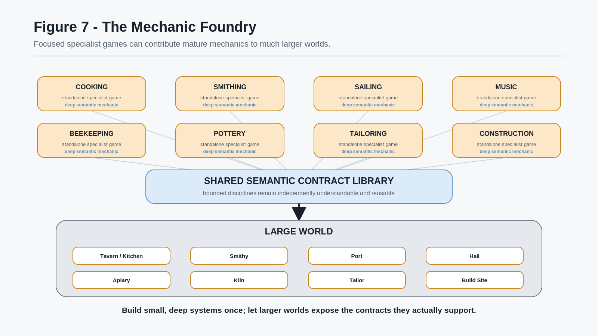
Figure 7. The Mechanic Foundry
Traditional large games often accumulate shallow approximations of many activities:
- a cooking minigame;
- a fishing minigame;
- a smithing minigame;
- a music minigame;
- a farming minigame;
- a sailing minigame.
A compositional semantic world can instead treat those activities as disciplines that may already have deep implementations elsewhere. The world designer is no longer forced to choose between making every subsystem internally from scratch or making every subsystem shallow. Mature pieces can be composed where technical and semantic contracts permit.

Discipline, Not Minigame Principle
A large world can invoke mature disciplines instead of representing every activity as a bespoke isolated minigame.

This distinction becomes increasingly important as the Skill library grows. A world containing hundreds or thousands of semantic disciplines would be impractical if every domain had to be authored as a monolithic subsystem inside one title. It becomes much more plausible when bounded systems can be developed, tested, improved, and reused independently.
The same principle also creates space for contributors whose expertise is narrower than an entire game. A specialist in fungi, metallurgy, language, cooking, or ecology can contribute a coherent semantic system without also authoring the surrounding continent, quest engine, economy, dialogue system, and combat model. Later sections return to this contributor-scale consequence at world scale.
For now, the key transition is simple:
Portable characters make competence reusable. Shared semantic mechanics make the environments that exercise that competence reusable as well.

7. Legitimate Knowledge and Fantasy Extension
Reusable semantic mechanics become especially interesting when the underlying discipline corresponds to legitimate real-world knowledge.
A beekeeping game is a useful example because it can remain grounded in actual apiary concepts while still becoming an imaginative fantasy mechanic. Its real-domain model might include colony roles, brood state, hive inspection, forage sources, pollen and nectar availability, seasonality, pollination relationships, honey handling, and recognition of pests or disease. The exact educational depth depends on the implementation and the authority of its source material, but the architectural distinction is stable: these concepts belong to the legitimate beekeeping domain rather than to a fantasy extension.
A simulation can also make relationships easier to perceive than they ordinarily are. It may represent where forage is located, how colony activity changes, which plant sources are being used, or how local environmental conditions affect the simulated hive. PULSE can then expose selected semantic layers from that canonical simulated state to an authorized Reader.
This is a powerful use of semantic perception. The player is not merely given a detached lesson about pollination or forage. The world can make those relationships actionable and visible in context.
The fantasy world can then go further.
Suppose advanced beekeeping competence, an acquired world-specific capability, or a particular magical tool unlocks a Spectral Pollen PULSE. That Reader might expose world-defined spectral trails, magical flowering sites, hidden pollinators, or a fictional ecological layer that does not exist in the real-world beekeeping model.
The distinction must remain explicit.
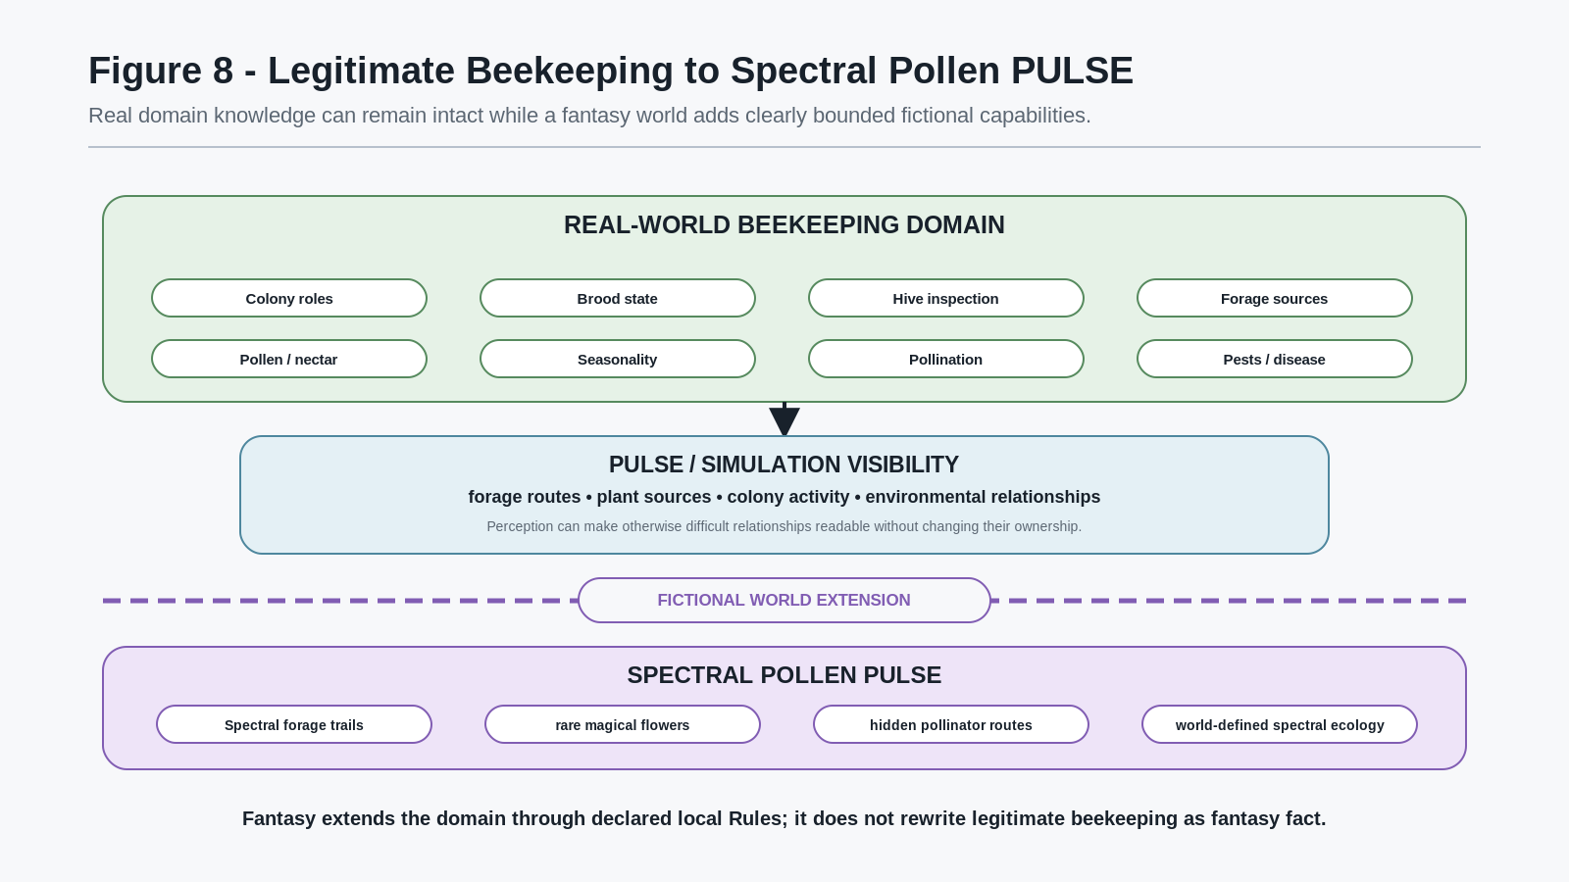
Figure 8. Legitimate Beekeeping to Spectral Pollen PULSE
The fantasy capability does not require the legitimate domain to become fictional. Instead, the world extends the domain through additional declared state, Operators, and Rules.

Real-Knowledge Preservation Principle
A fictional extension may build on legitimate knowledge without redefining the legitimate knowledge beneath it.

This means a player can learn something useful about an actual discipline and still receive a fantastic reward for developing it. The fantasy layer becomes a reason to care about the real substrate rather than a replacement for it.
A beginner might see bees moving around flowers. A more knowledgeable character may be able to interpret colony activity, forage value, or plant relevance. A fantasy specialist may eventually perceive a spectral relation that only exists according to that world's ontology. The sequence can therefore move from genuine observation, to semantic interpretation, to fictional extension.
The same pattern applies far beyond beekeeping:
- real metallurgy can support fictional arcane materials;
- real acoustics can support resonance magic;
- real botany can support spectral plant ecology;
- real cooking can support magical ingredients and world-specific reactions;
- real navigation can support fictional celestial or dimensional routing.
These examples do not require CERBERUS to claim that the fictional additions are real. The system preserves their provenance and ownership by keeping the real-domain model and the world-defined extension distinct.

Declared Fantasy Extension Principle
Fantasy becomes structurally compatible with legitimate knowledge when the fictional world adds declared semantic variables and Rules rather than silently replacing the real model.

PULSE is especially useful because it can turn deeper Skill development into richer perception. A character who has spent time learning a discipline can literally become capable of reading more of the world. The effect feels like a supernatural reward while remaining grounded in the character's accumulated semantic history.
This also creates a strong learning loop. A player can enter a niche game because the topic is genuinely interesting, build a legitimate Skill, and later discover that another game has an imaginative use for exactly that competence. Knowledge ceases to be something a game teaches and then discards. It becomes part of the character's persistent possibility space.
The paper does not attempt to define educational certification, professional competence, source validation, or assessment standards. A simulated Skill state is not automatically a professional credential. Those questions belong to dedicated learning and governance specifications. The point here is narrower:
Legitimate learning can remain mechanically valuable after the learning-focused experience ends.

8. The Character as a Playable History
Once portable Skills accumulate across many experiences, a character begins to represent something more interesting than a predefined class package.
The character can become an uneven record of what the player repeatedly found worth learning.
One player may continually choose cooking, botany, beekeeping, animal knowledge, and wilderness systems. Another may gravitate toward High Elvish, history, formal logic, music, and ancient texts. Another may develop metallurgy, mechanics, construction, navigation, and combat. None of these profiles needs to be authored in advance as a class.
The player creates them through history.
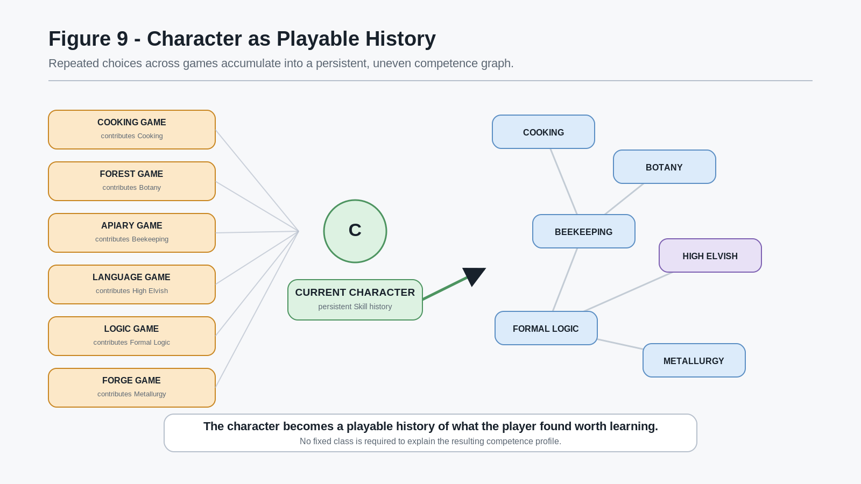
Figure 9. Character as Playable History
This produces a useful form of identity. The character is not a psychological model of the human player, and the system does not need to infer personality from gameplay. The character simply carries the mechanical consequences of previous learning choices.

Playable-History Principle
The character becomes a playable history of what the player found worth learning.

That history becomes especially visible in dungeons and other shared problem spaces.
Consider one canonical dungeon chamber containing an old inscription, a damaged metal hinge, toxic moss, a defeated monster, and an unusual pollen trace. The world state is singular. The chamber does not need five separate versions for five different roles.
A linguist may resolve the inscription. A blacksmith may understand the failure mode of the hinge. A botanist may identify the moss. A cook may recognize useful or dangerous properties of the carcass. A beekeeper with an appropriate PULSE Reader may notice that the pollen route is behaving abnormally.
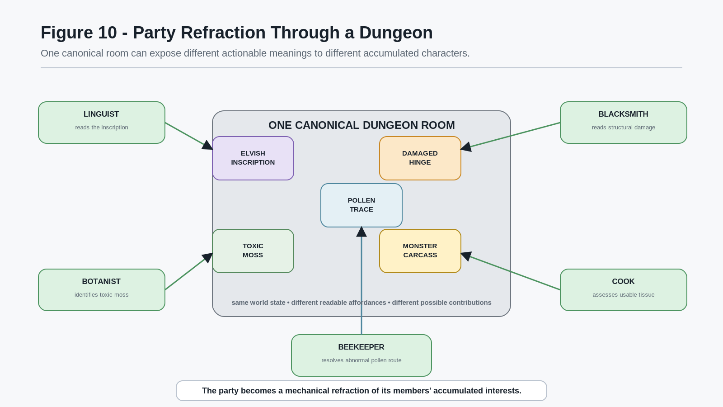
Figure 10. Party Refraction Through a Dungeon
The significance is deeper than giving different classes different colored interaction prompts. The semantic affordances already exist in the room. The characters bring different capability to them.
This means two parties may experience the same dungeon in materially different ways without the designer having to author unrelated copies of the dungeon. A combat-heavy group may treat a creature as an enemy and move on. An ecological group may investigate its habitat. A culinary group may harvest useful material. A historical group may connect the creature to a regional event. A linguistically capable group may interpret inscriptions that change the party's understanding of the entire location.
The game therefore does not merely branch on decisions. It can branch on what the characters are capable of noticing, interpreting, and doing.

Party Refraction Principle
A party can become a mechanical refraction of its members' accumulated interests.

The term refraction is deliberate. One canonical world is being encountered through multiple developed semantic lenses. The players see their own accumulated choices returned to them as world capability.
This also changes party composition. Fixed Tank / Damage / Healer roles may still exist where a game wants them, but the semantic party can be much stranger:
- chef + botanist;
- blacksmith + monster hunter;
- historian + logician;
- beekeeper + navigator;
- musician + linguist.
A dungeon can ask whatever its actual problem requires. Sometimes the bizarre mixture of competencies will matter more than combat archetypes.
PULSE adds another layer of asymmetry. A character may perceive information that the other characters cannot. As established by the PULSE architecture, private readable state should not automatically merge into a universal party HUD unless an explicit sharing mechanism allows it. The beekeeper may need to tell the group what the spectral pollen trace means. The linguist may need to translate the inscription. Multiplayer cooperation therefore includes the construction of shared understanding from individually bounded realities.

Shared-World / Bounded-View Principle
The world can remain canonical while characters differ in what they can read from it; cooperation emerges when those bounded readings are communicated and combined.

This is where the Skill system begins to reflect the group back at itself. A party is no longer only a set of avatars inhabiting the same geometry. It is a temporary composition of different semantic histories.

9. Semantic Deepening Instead of Numeric Grinding
Portable competence creates an obvious design question: if a character already has strong Cooking, Smithing, Navigation, or another Skill, what remains for a new specialist game to teach?
The answer does not need to be forced amnesia, a new incompatible Cooking Level, or endless repetition of familiar actions.
The new game can increase semantic depth.
A character may know broad cooking Operators such as chop, sear, braise, mix, bake, or ferment. A specialist title can introduce a more precise knife technique, a tool the character has never used, a different heat-control problem, a preservation method, a fermentation process, or a new BitWord representing a semantic region not previously exposed. A fantasy game can add registered world-specific Operators. A later scientific cooking game can expose Food Chemistry or materially deeper state.
The character arrives with genuine competence but still has something real to learn.
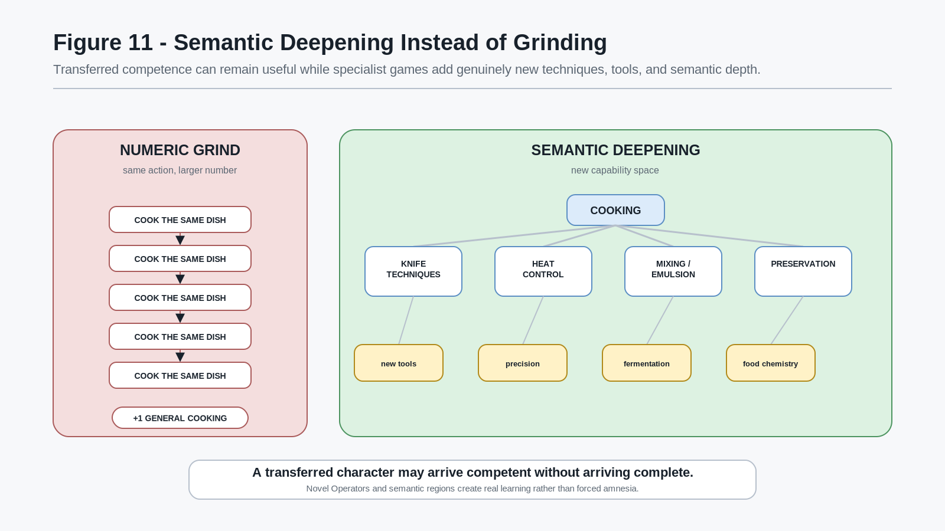
Figure 11. Semantic Deepening Instead of Grinding

Competent-Not-Complete Principle
A transferred character may arrive competent without arriving complete.

This principle is important for both portability and game design. If transfer automatically granted every technique that could ever belong to a broad Skill, specialist games would have nowhere to grow. If transfer granted nothing, portability would be meaningless. CERBERUS can preserve the developed competence actually acquired while allowing each compatible game to expose additional semantic territory.
This is also where game-specific Operators become valuable.
Suppose one fantasy title introduces a particular dragon-forge technique, ritual knife method, magical fermentation process, or world-specific cooking instrument. That Operator can have stable identity within the relevant semantic extension. The character can learn it there. Most other games may ignore it. A later game that recognizes the same extension can reactivate it.
The important distinction is between general competence and specific acquired capability.
A character who understands knives may adapt more quickly to an unfamiliar blade. That does not mean the character has already mastered every blade. A character who understands heat control may have a useful foundation for sous-vide, kiln firing, or dragonfire cooking. That does not mean those specific techniques were previously learned.

Transfer-Without-Closure Principle
Portable competence preserves what was learned without declaring the domain finished.

This makes progression multidimensional. Growth can move upward in proficiency, outward into new semantic regions, sideways into new tools and contexts, or later into intersections with neighboring disciplines.
That last direction becomes central to the next part of the paper.

10. From Operators to Underlying Material State
Semantic deepening eventually reaches a point where a familiar Operator can be resolved against a more detailed model of the thing being changed.
At a low simulation resolution, Cooking may legitimately treat an action as:
Ingredient -> SEAR -> Cooked Ingredient
That can be sufficient for a particular game. The semantic contract identifies the action and the result at the resolution the game needs.
A deeper cooking simulation may represent more of the input state: temperature, moisture, pH, composition, physical structure, time, pressure, or other registered properties. The same broad SEAR action can then resolve through a more detailed set of transformations and produce a more specific resulting state.
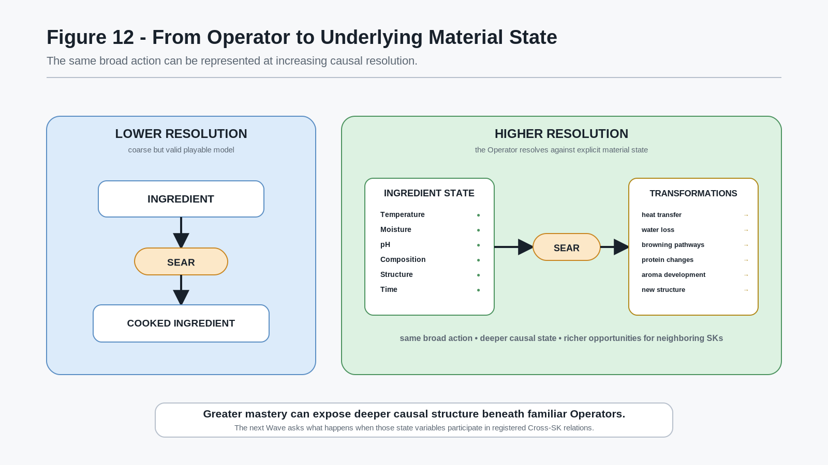
Figure 12. From Operator to Underlying Material State
This does not mean every game must simulate food chemistry or every Operator must descend to maximum possible resolution. Resolution is a design choice governed by the needs of the world and the semantic contracts it supports.
The key architectural consequence is that deeper state creates new neighboring relationships.
A cooking system that only stores cooked = true has little state for Chemistry, Scent, Biology, or Materials systems to inspect. A cooking system that exposes registered composition, temperature, moisture, structural, or volatile-compound state can support richer relations with those domains where appropriate.
The same pattern generalizes:
- Metallurgy can expose more material-state detail beneath Forging.
- Music can expose acoustical state beneath performance.
- Botany can expose chemical or ecological state beneath plant identification.
- Medicine can expose anatomical, physiological, or biochemical state beneath treatment.
- Fantasy domains can eventually expose world-defined state beneath familiar physical behavior.

Resolution-Deepening Principle
Greater mastery and higher-resolution simulation can expose deeper causal structure beneath familiar semantic Operators.

A coarse Operator and a detailed implementation are not necessarily competitors. The coarse Operator can remain a useful semantic handle while a deeper engine resolves the consequences internally. Where decomposition is explicitly registered, the higher-resolution model may also expose constituent Operators and intermediate states to advanced characters.
This creates another meaningful progression path. The novice may need a recipe. The competent cook may target a sensory result. The food scientist may reason about process variables. A still deeper specialist may reason about relationships between Cooking, Chemistry, Scent, or other domains. The semantic intent can stay recognizable while the resolution of reasoning increases.
That transition leads directly to Cross-SK interaction.

PART III SEMANTIC INTERSECTIONS

11. Cross-SK Interaction
The previous Part ended at a useful threshold. A semantic discipline can be represented at low resolution or at deeper causal resolution, and a character can develop enough competence to reason about increasingly detailed state beneath a familiar Operator. Once those deeper states are addressable, an additional possibility appears: state resolved through one Semantic Kernel can participate in an explicit relation with state resolved through another.
This is the beginning of Cross-SK interaction.
Suppose one SK contains a resolved semantic position addressed as B013 and another SK contains a resolved semantic position addressed as B045. A registered relation may state that a particular consequence becomes possible when both positions are active. The relation may also require additional conditions such as temperature, time, pressure, pH, geometry, location, a catalyst, or another registered state.
The important word is registered.
CERBERUS does not gain useful semantic behavior by assuming that every active bit in one BitWord should be compared with every active bit in every other BitWord and then asking an AI to invent a meaning for the coincidence. That would destroy the ownership boundaries already established by BIGFOOT and the SK Reader architecture.
Bits and BitGroups remain mathematical and logical structures. BitWord structure determines how state is segmented. BitGroup type determines the mathematics used to resolve that state. The SK Reader determines the semantic meaning of the positions within the relevant SK. A Cross-SK relation is a separate registered semantic relation that refers to those already resolved states.
A simplified pattern is therefore:
SK A reader-resolved state + SK B reader-resolved state + registered conditions -> registered result
The relationship is semantic because a system author explicitly defines what the relationship means. It is deterministic because the runtime can test the exact registered inputs and conditions.
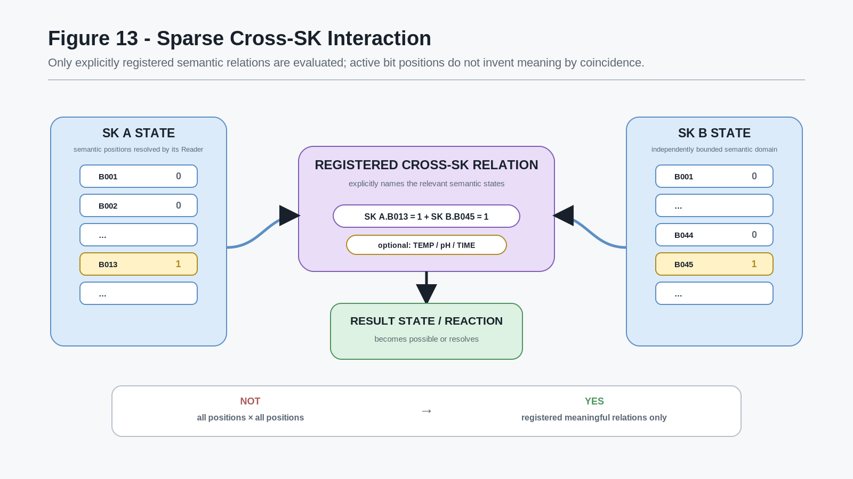
Figure 13. Sparse Cross-SK Interaction

Explicit Cross-SK Relation Principle
Semantic interaction between independent SKs should arise through explicit registered relations, not through arbitrary coincidence between their underlying bit positions.

This makes the relationship sparse by design.
If two 128-position semantic structures were naively treated as if every position might semantically interact with every position in the other, there would be 16,384 possible pairings before any additional conditions were considered. Most would have no useful meaning. As the number of SKs grew, blind pairwise comparison would become both computationally wasteful and semantically incoherent.
A registered-intersection model reverses the problem. The system stores the relations that actually matter. Runtime asks which registered relations are relevant to the currently active states, rather than attempting to manufacture meaning from the full Cartesian possibility space.

Sparse Intersection Principle
The mathematical possibility space may be enormous while the semantic interaction graph remains sparse, explicit, and purposeful.

This is particularly useful in domains such as Cooking, Chemistry, Scent, Materials, Biology, Ecology, Music, or fictional magic systems, where only certain combinations of state produce meaningful consequences.
Consider the scent example that motivated this branch. One semantic structure may represent the presence or absence of particular scent-relevant compounds or states. Another may represent another material, ingredient, organism, or environmental condition. If B013 in one resolved SK state and B045 in another are both active, a registered relation can test whether those states participate in a known reaction or effect. The rule may additionally require a temperature range, sufficient time, a particular pH, or another condition.
The consequence might be:
- a reaction becoming possible;
- an aroma state changing;
- a new material property appearing;
- an Operator becoming legal;
- a PULSE-readable state emerging;
- a later rule becoming eligible;
- a derived semantic record being activated.
The exact consequence belongs to the system that owns the relation. The important architecture is that the two contributing SKs do not have to collapse into one giant combined SK simply because a relation exists between them.

Independent-Domain Preservation Principle
Cross-SK interaction should allow independently owned semantic domains to interact without forcing those domains to surrender their own boundaries.

This is one of the features that makes compositional scaling plausible. Chemistry can remain Chemistry. Cooking can remain Cooking. Scent can remain Scent. A relation can bind specific states across them where the world requires it.
The result can be transient. A reaction may occur and terminate. A temporary state may become active only while conditions persist. But some intersections are rich enough that they begin to behave like recognizable disciplines in their own right.
That leads to Intersection SKs.

12. Intersection Domains and Independent Mastery
Some Cross-SK relations are narrow. Others form dense families of concepts, Operators, Rules, and recurring relationships. Once an intersection has enough coherent structure, it can become useful to represent that semantic territory as its own domain.
Cooking and Chemistry provide a simple illustrative example.
Cooking already contains a large semantic space concerning preparation, heat, cutting, mixing, preservation, finishing, and other culinary processes. Chemistry contains a different semantic space concerning composition, reaction, structure, concentration, and other chemical relationships. A character may become very competent in both domains while still lacking the specialized knowledge that belongs specifically to their intersection.
That intersection can be represented as a domain such as Food Chemistry.
The important consequence is that the new domain should not be treated as a free reward for maximizing both parents.
A master chef is not automatically a master chemist. A master chemist is not automatically a master chef. Even a character with substantial competence in both may still need to learn the conventions, experimental practices, relationships, vocabulary, Operators, and causal patterns that belong specifically to their overlap.
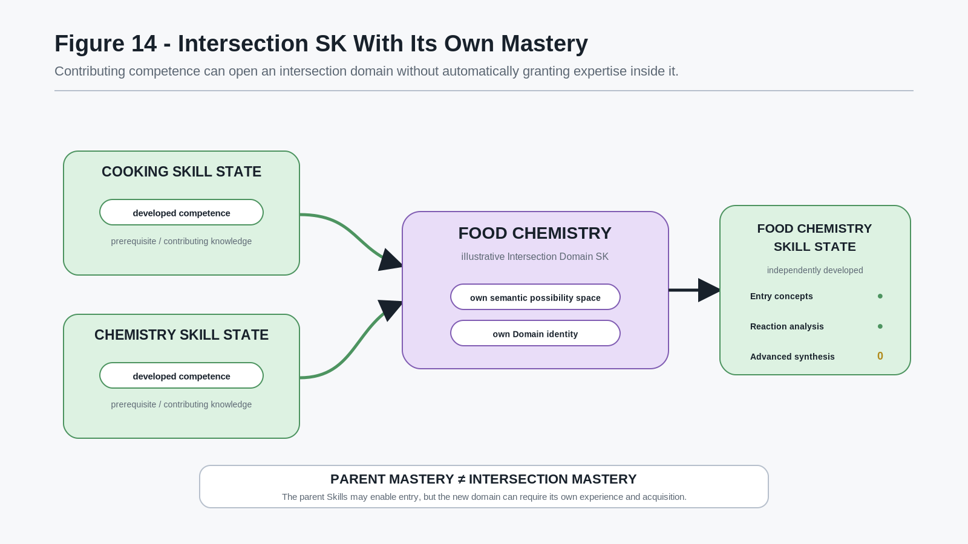
Figure 14. Intersection SK With Its Own Mastery
This preserves a clean separation between eligibility and mastery.
Parent Skills may contribute in several ways:
- satisfy prerequisites for entering the intersection domain;
- make advanced concepts immediately intelligible;
- reduce the amount of foundational instruction needed;
- expose additional relations or Operators;
- provide general competence bonuses where explicitly registered;
- allow the character to recognize why the intersection matters.
None of those mechanisms require the derived Skill state to be fabricated.

Intersection Mastery Principle
Mastery of contributing Skills may enable access to an intersection domain without automatically granting mastery of that domain.

This mirrors the broader Skill architecture already established by CERBERUS Playable Semantic Skills. Experience should still originate from meaningful use at the most specific Skill or track responsible for the successful activity. A character can therefore develop a genuine practice history inside the intersection rather than receiving a synthetic level calculated only from parent totals.
An Intersection SK may have its own:
- semantic positions;
- Reader meaning;
- registered Operators;
- Rules;
- progression tracks;
- acquisition MASKs;
- PULSE Readers;
- Language Dictionary relationships;
- local or cross-world extensions.
The exact contents depend on the domain. This paper does not define a universal schema for Intersection SKs. It establishes the architectural possibility and the ownership boundary.

Derived-Domain Ownership Principle
When a recurring Cross-SK territory becomes a coherent discipline, that discipline may receive its own semantic identity and govern its own internal meaning rather than remaining an unbounded pile of pairwise rules.

This distinction also prevents a common failure mode in combinatorial systems: naming every possible combination as a new domain whether or not it has coherent structure.
Not every A x B deserves an SK.
Some pairs may contain one useful relation. Some may contain hundreds. Some may be meaningless. The decision to create an Intersection SK should be driven by whether the intersection has enough stable internal semantics to justify independent identity and reuse.

Coherent-Intersection Principle
An intersection should become a domain because it contains coherent reusable semantic structure, not merely because two parent SKs can be named together.

Once this is allowed, Skill development stops looking like a collection of isolated vertical ladders. A mature domain can become the foundation for further semantic combinations.

13. Recursive Semantic Depth
An Intersection SK is still an SK.
Once it has stable semantic identity, bounded internal meaning, and registered relationships, it can participate in additional relations exactly as other domains do. This creates a recursive form of semantic depth.
A simple abstract pattern is:
A x B -> C
followed by:
C x D -> E
and later:
E x F -> G
The structure is no longer a traditional Skill tree in which every branch ultimately points toward a larger number on the same axis. It is an expanding graph in which developed knowledge can reveal entirely new semantic dimensions.
An illustrative path might be:
Cooking x Chemistry -> Food Chemistry
Food Chemistry x Scent Chemistry -> Aroma Engineering
Aroma Engineering x Perception -> Sensory Design
These names are illustrative, not a canonical CERBERUS taxonomy. Their purpose is to show how an already derived domain can become one parent of a still deeper specialization.
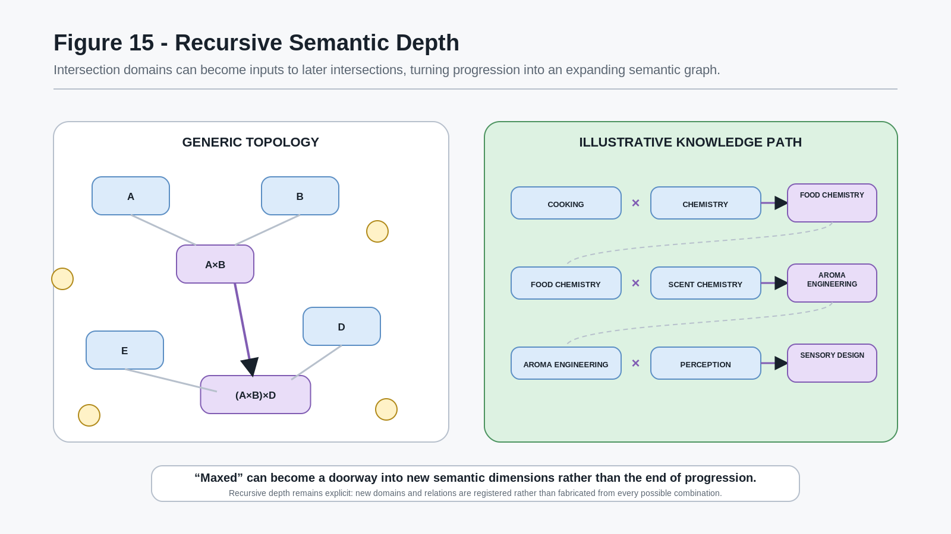
Figure 15. Recursive Semantic Depth
This gives a different meaning to the idea of "maxing" a Skill.
A character may become highly developed inside one domain and discover that the mastery does not end progression. Instead, it exposes relationships that were previously inaccessible or irrelevant. Strong Cooking may open serious Food Chemistry. Strong Food Chemistry may make a Scent-Chemistry intersection useful. That intersection may later connect to Perception, Medicine, Materials, Ecology, or a fictional domain.
The resulting character can become deeply specialized in a body of knowledge that did not exist as a single starting category.

Semantic-Dimension Principle
Mastery can expose new dimensions of competence rather than merely extending the numerical range of an existing Skill.

This is especially important for persistent characters that may move through many games. A game does not need to reset a highly developed Skill simply to create progression. It can introduce new Operators, new semantic regions, new resolutions, or new intersections that give the existing competence somewhere meaningful to go.
The same architecture also explains why two characters with similar top-level totals can remain profoundly different.
One character may develop Cooking into Food Chemistry and Scent relationships. Another may develop Cooking into Cultural Cuisine, Historical Foodways, Logistics, or Hospitality. A third may combine Cooking with fantasy biology and monster ecology. Their aggregate Cooking competence may be similar while their deeper semantic graphs diverge substantially.
This creates a form of specialization that is not centrally authored as a fixed class list. The character's path emerges from the sequence of domains, games, interests, and intersections that the player actually pursued.

Recursive Specialization Principle
A character's advanced specialization can emerge from the path of semantic intersections they develop rather than from a predetermined terminal class.

At sufficient depth, this architecture also becomes a natural foundation for fictional disciplines.
A fantasy world can introduce semantic variables and relationships that do not exist in reality. Those variables can interact with real-world-grounded domains through the same explicit contract logic. The result is not merely a fantasy label placed on top of real science. It can become a deeper fictional ontology with its own lawful internal behavior.

14. Fictional Ontology and Lawful Magic
The recursive-intersection model becomes especially powerful when a world is allowed to define semantic layers beyond the ontology represented by real-world knowledge.
The boundary must be explicit.
CERBERUS can represent legitimate real-world values such as temperature, pressure, mass, wavelength, concentration, composition, material state, biological state, or other measured and modeled properties. A simulation may use more or less scientific detail depending on its purpose and source authority.
A fantasy world may then declare additional variables that are not claims about reality.
For example, a fictional setting could define an aetheric state, spectral property, resonance layer, sympathetic coupling, identity field, or any other invented variable needed by the world. The exact vocabulary is not important here and should not be canonized by this paper. What matters is that the fictional variables can be given stable identities, bounded value spaces, registered Operators, and explicit Rules.
The world can therefore say, in effect:
The real-world model remains valid where the world uses it. The fictional universe additionally declares more state.
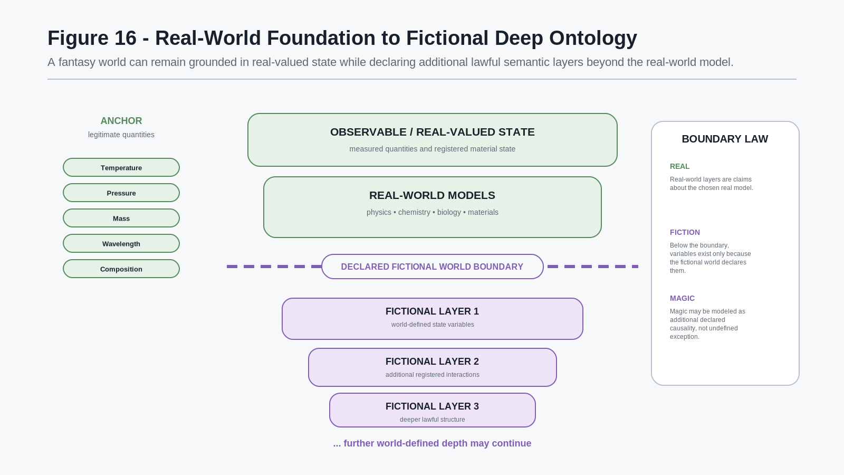
Figure 16. Real-World Foundation to Fictional Deep Ontology
This allows fantasy to become deeper without becoming semantically vague.
A simple magic system might define only a few additional state variables. A very deep world might define many layers of fictional structure beneath or alongside familiar physical models. The user may jokingly describe a domain as extending "twelve layers below quarks," but the architectural claim is precise: the world is free to define additional lawful depth after the point where it leaves the real-world ontology.

Explicit Fiction Boundary Principle
Real-world semantic models and fictional ontological extensions may coexist in one simulation, but the boundary between them must remain explicit.

This protects both sides.
The real-world model is not distorted into fantasy fact. The fictional model is not required to masquerade as established science. The simulation can use real quantities honestly and still continue into invented causal structure.
That yields a useful definition of magic for CERBERUS worlds:
Magic may be represented as additional declared causality within the fictional universe rather than as an undefined exception to causality.

A novice character may learn that a rune beside a flame produces a useful result. A deeper specialist may understand which fictional state the rune changes, why the material matters, what conditions constrain the effect, and which alternative Operators can produce the same target state. A still deeper researcher may reason about interactions several fictional layers beneath the mechanism that ordinary characters call magic.
This supports something much richer than Magic +25.
Characters can become experts in actual fictional disciplines.
They may perform experiments, learn technical vocabulary, compare models, discover relations, practice specialized Operators, develop intersection Skills, and perceive states that less developed characters cannot resolve. A fictional university, laboratory, guild, monastery, or wizard school can therefore teach a real body of simulated knowledge even though that knowledge is true only inside the fictional world.

Fictional Science Principle
A sufficiently explicit fantasy ontology can support knowledge that is fictional in reference but genuine in internal structure, practice, and consequence.

This is where the architecture can become deeper than reality without pretending to know more about reality than it does.
A world designer can anchor the upper layers in legitimate concepts, then extend downward or sideways through explicitly invented state. Because those additional layers are addressable, they can participate in Skills, Operators, Rules, Language, PULSE, and Cross-SK relationships like any other world-defined semantic system.
The resulting magic can also interact with ordinary domains.
Metallurgy can intersect with an arcane materials domain. Acoustics can intersect with resonance magic. Botany can intersect with spectral ecology. Cooking can intersect with aetheric ingredients. Language can contain the technical vocabulary required to reason about those systems. History can record earlier theories and obsolete practices. Culture can influence which interpretations become common.
The fantasy world grows by extension rather than by replacing every real-world relationship with arbitrary special cases.

15. Multi-Resolution Mastery
If the world contains both ordinary and deeper semantic structure, different characters do not need to experience an object at the same resolution.
The object can remain canonical while the readable description changes with Skill, Reader capability, context, and world Rules.
Consider one flower.
A traveler may resolve only a broad description: a red flower.
A botanically skilled character may resolve species, maturity, health, morphology, or other registered botanical state.
A beekeeper may resolve the flower's relevance as forage, pollen, or nectar according to the beekeeping model supported by the world.
A chemist may resolve relevant compounds where the simulation exposes them.
A scent specialist may resolve a more specific aroma profile.
A fantasy specialist may resolve a world-defined spectral state that does not exist above the fictional boundary.
A still deeper specialist may resolve additional fictional layers that even the ordinary wizard cannot interpret.
The flower itself has not become seven different objects.
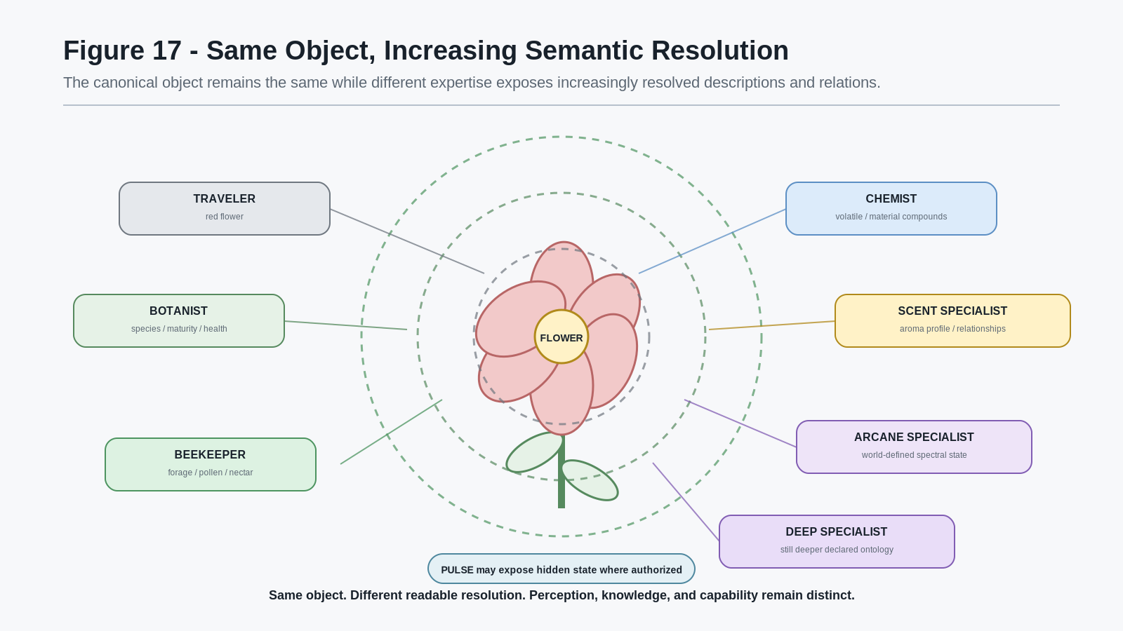
Figure 17. Same Object, Increasing Semantic Resolution
This distinction matters because semantic depth should not require multiplying world objects for every expertise level.

Canonical-Object / Variable-Resolution Principle
The same canonical object can support multiple levels of semantic resolution without becoming a different object for every observer.

PULSE can participate in this architecture where perception itself must be bounded. A Reader may expose semantic layers only to characters whose Profiles, Skills, equipment, authorization, or local Rules permit them to resolve that information. PULSE still does not author the truth. It exposes selected truth from the canonical world state.
This means a character can become powerful because they perceive and understand relationships that were always present in the world.
A novice sees a sword.
A blacksmith sees construction and wear.
A metallurgist sees deeper material state.
An arcane materials specialist sees additional world-defined properties.
A deep-field specialist sees relations beneath the resolution of ordinary magic.
The world does not need to spawn a new sword when the Skill increases. The character's access to the semantic structure of the sword changes.

Resolution-without-Replacement Principle
Progression may increase what a character can read, explain, and manipulate about existing world state without replacing that state with a new object or a new version of reality.

This creates powerful dungeon and exploration design.
A high-level secret can exist from the beginning. A structure may contain a stress pattern, historical trace, pollen route, magical field, scent relation, or material anomaly that only certain developed characters can resolve. Returning to an old location with deeper Skills can therefore reveal new affordances without retroactively rewriting the location.
It also reinforces the identity-refraction model from Part II. Two characters standing beside the same object may occupy different actionable semantic realities because their accumulated histories give them different access to the object's depth.
At this point the paper has moved from portable Skill state to something much larger:
- independent semantic domains can interact;
- meaningful intersections can become domains;
- derived domains can intersect recursively;
- fictional worlds can add lawful ontological depth;
- character mastery can expose increasingly resolved portions of that depth.
The remaining question is scale.
What happens when a world does not contain ten or twenty such systems, but hundreds or thousands?

PART IV WORLD SCALE

16. Contribution at Semantic Scale
Part III established that independently bounded Semantic Kernels can interact through explicit registered relations, that sufficiently coherent intersections can become domains in their own right, and that those derived domains can participate in further intersections. It also established that a fictional world may extend legitimate real-world models with clearly bounded world-defined ontology without confusing the invented layer with reality.
The next consequence is scale.
A world built from semantic composition does not require one author, one studio, or one monolithic specification to understand everything the world may eventually contain. Individual contributors can work on bounded portions of the semantic substrate while preserving the ownership boundaries that make later composition possible.
One contributor may develop a high-quality Beekeeping domain. Another may develop Metallurgy. Another may build a Language Dictionary and Language SK. Another may contribute a fungi domain, a music system, a historical corpus, an ecology extension, a specialist blacksmith game, or a set of world-local Operators. A different contributor may create MIRROR assets for several of those same semantic identities. Another may define PULSE Profiles that make selected world state readable to particular characters.
The contribution is valuable because it is bounded and addressable, not because it attempts to become the entire world.

Bounded Contribution Principle
A contributor may meaningfully expand a shared semantic world by authoring one well-bounded discipline, mechanic, relation set, or world extension without owning the entire world.

This principle is important because not every contribution should become a Semantic Kernel.
SKs own coherent semantic domains. Operators own registered actions. Rules own constraints and consequences. Language systems own linguistic composition and lexical possibility. PULSE owns bounded semantic readability. MIRROR owns material and presentational projection. SOLAR provides Base-local semantic routing and identity access according to its established architecture. Histories, cultures, assets, world records, quests, environments, and local content retain their own appropriate structures.
A large world therefore grows from SKs and other interoperable parts, not from forcing every useful contribution into SK form.

Appropriate-Ownership Principle
Compositional world building should preserve the native ownership of each contribution rather than converting every world component into a Semantic Kernel.

This makes the system extensible in several different directions.
A domain specialist can deepen a real or fictional discipline. A game designer can build a specialist title around mature SK contracts. A world designer can register local Rules and Operators. A writer can expand history, culture, lore, or language. An artist can create a new MIRROR realization. A simulation designer can create a PULSE projection that exposes state already present in the world. A later contributor can register meaningful Cross-SK relations without rewriting the parent domains.
The shared world can therefore accumulate semantic depth over time.
This resembles the mechanic-foundry model from Part II, but at a broader scale. The reusable unit is not only a complete game mechanic. It may be a domain, an intersection, a Reader, a relation family, a language, a visualization, a Rule system, or another bounded component whose contract is clear enough to compose safely.

Semantic Substrate Contribution Principle
A contribution can be valuable because it expands the shared semantic substrate even when it is not itself a complete game, world, or player experience.

That creates an unusually productive role for niche expertise.
A contributor who knows fungi does not need to design combat, economies, cities, dialogue, and multiplayer networking merely to make fungal knowledge useful in a fantasy world. The fungi system can remain bounded. A survival game may use toxicity and identification. A cooking game may use culinary state. An ecology simulation may use decomposition. A medicine system may register fungal pathology relations. A fantasy world may add explicitly fictional spectral fungi beneath the declared fantasy boundary. The original contribution remains intelligible because each downstream use binds to explicit semantic contracts rather than silently redefining the source domain.
The same pattern can operate with hundreds or thousands of contributors and systems.
The scaling advantage comes from composition rather than centralization.

Compositional Scaling Principle
World complexity can grow compositionally instead of monolithically.

A monolithic world engine must anticipate every discipline internally. A compositional semantic world can instead recognize bounded systems as they are added, then activate only the relationships that are explicitly supported.
That distinction becomes more important as the library grows. Ten SKs can be understood by inspection. A thousand SKs cannot be treated as one giant hand-authored mechanic. The architecture must allow each component to remain bounded while the world gains depth from their coexistence.
The resulting world is not merely a bag of independent modules. Cross-SK relations, shared objects, Language bindings, Rules, PULSE Readers, and character Skill histories allow those modules to become meaningfully entangled where the world actually requires it.
The next problem is therefore not whether the world can become large. It can.
The problem is how a character can inhabit such a world without being buried beneath the whole semantic library at once.

17. The Bounded Character Inside the Massive World
A semantic world may eventually support thousands of SKs, Intersection SKs, Operators, Rules, Language structures, PULSE Profiles, world records, histories, cultures, and MIRROR assets.
The character does not need to receive all of them.
This paper began with the distinction between canonical possibility and bounded reach. The same law that allowed a Language Dictionary to contain vastly more lexical possibility than one character knew now returns at world scale.
The world can contain an enormous semantic possibility space while the character resolves only the region relevant to that character's present state and context.
Relevant bounds can include:
- developed Skill states;
- acquired capability MASKs;
- supported SK contracts in the current game;
- PULSE Readers and Profiles;
- language competence;
- equipment and tools;
- location and proximity;
- culture and learned conventions;
- world authorization;
- current Rules;
- current task or interaction context;
- registered relationships reachable from the currently relevant state.
A character standing in an apiary does not need the runtime to foreground every Metallurgy, Sailing, Formal Logic, Deep Arcane Physics, and Ancient Language relation supported somewhere else in the world. Those systems can remain available in the world's larger semantic fabric without becoming part of the immediate experience.
Likewise, a player entering a smithy does not need a global encyclopedia of every possible Skill. The current environment, supported Operators, character history, nearby objects, local Rules, and relevant semantic relations already provide strong bounds on what should become actionable.

Bounded Experience Principle
The world may be semantically enormous while the individual experience remains bounded and intelligible.

This is not merely a user-interface convenience. It is an architectural consequence of preserving semantic boundaries.
A character's current possibility space can be understood as a reachable region inside the larger world graph. The region changes as the character learns, travels, acquires tools, joins cultures, unlocks PULSE Readers, enters new games, or develops new intersection Skills.
The world does not need to shrink when the character knows less. The character's reach is what changes.
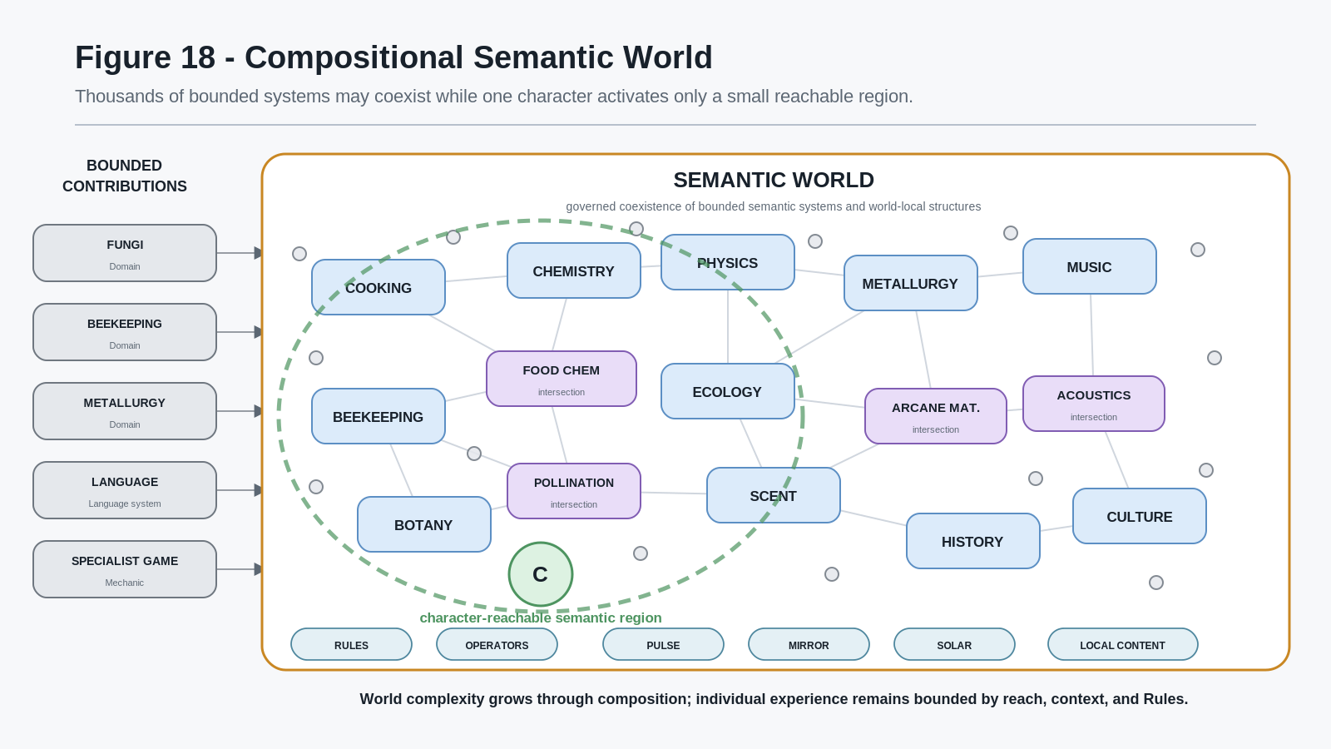
Figure 18. Compositional Semantic World
Figure 18 deliberately repeats the visual grammar introduced near the beginning of the paper. Figure 2 showed a character-reachable region inside one canonical domain. Figure 18 shows the same relationship at world scale.
The recursive symmetry is important:
one domain may exceed one character's reach; an entire world may exceed one character's reach by several orders of magnitude.
Neither case requires semantic collapse.

Relevance Routing Principle
A large semantic world should expose and execute the systems relevant to the current character, context, and registered relations rather than presenting the full world model as one undifferentiated surface.

This principle also protects gameplay from becoming a menu of Skills.
A player should not need to select from three thousand disciplines every time they examine a door. The door exists in the world with its registered state and relations. The character's capability determines which of those relations become readable or actionable. A linguist may notice an inscription. A blacksmith may notice the hinge. A structural specialist may notice load. A historian may recognize a construction period. A magical specialist may resolve a ward. A character with none of those Skills may simply see a door.
The semantic fabric is deep precisely because the surface experience does not need to display all of it simultaneously.

Latent-World Principle
World state and semantic relationships may remain latent to a character until that character has the capability, context, or Reader required to make them relevant.

This creates powerful return and discovery behavior.
A location can contain semantic relationships from the beginning. A later Skill does not need to spawn them retroactively. It can make an existing relation reachable. A game can therefore reward character history by allowing old places to reveal new meaning as competence develops.
The same bounded-access law also makes massive multiplayer and long-lived characters more plausible. Two characters may inhabit the same world but illuminate radically different regions of the semantic fabric. One party may be rich in language, history, and diplomacy. Another may be rich in engineering, ecology, and medicine. Their worlds overlap physically while differing in the relations they can productively resolve.
Because the underlying world remains canonical, those perspectives can still interact.
A beekeeper can explain the pollen route. A linguist can translate the inscription. A chemist can interpret the reaction. A navigator can plot the path. Shared understanding is built through characters whose reachable regions overlap only partially.
That is the same refraction effect from Part II, now applied to a world whose semantic depth may be effectively unbounded from the perspective of any one character.

18. Emergent Semantic Worlds
Once bounded contributions, portable character histories, specialist mechanics, Cross-SK relations, derived domains, fictional ontology, and bounded character reach are combined, the central architecture of this paper becomes visible.
A massive world does not have to be authored as one enormous game mechanic.
It can emerge from the lawful composition of many smaller semantic systems.
Consider the ingredients already established:
- Domain SKs define coherent semantic possibility spaces.
- Skill SKs govern how characters develop through those domains.
- BitWords and Readers make relevant semantic state addressable.
- Operators define registered actions.
- Rules constrain what can occur.
- Cross-SK relations connect independently owned domains where explicit semantic relationships exist.
- Intersection SKs give coherent derived disciplines stable identity where warranted.
- Language systems make those domains nameable, composable, and translatable.
- SOLAR provides established Base-local semantic routing and access.
- PULSE determines which selected semantic layers become readable to particular viewers.
- MIRROR determines how semantic identity is materially or visually projected.
- Games expose supported subsets of the larger semantic ecosystem.
- Characters carry persistent, uneven histories through those supported subsets.
- Worlds add local history, culture, assets, materials, Rules, fictional extensions, and context.
The resulting complexity comes from coexistence plus explicit relationship, not from asking one central AI to improvise the meaning of everything.

Lawful Emergence Principle
Emergent world complexity should arise from the composition of bounded semantic systems and explicit relationships rather than from unbounded semantic inference.

This distinction is crucial.
The system can produce combinations that no designer explicitly scripted as one bespoke scenario while still remaining grounded in authored semantics.
A dungeon designer may place a flower, a damaged structure, a monster, an inscription, a scent trace, and a magical field in one location. The designer does not have to pre-author every possible party solution as a branching dialogue tree. If those objects already participate in registered Botany, Beekeeping, Chemistry, Cooking, Language, Structural, History, Scent, and fantasy-domain relationships, different parties can discover different lawful possibilities according to the competence they bring.
The novelty emerges from recombination.
One party notices that the monster feeds on the flower. Another notices the flower's pollen route. Another connects the scent compound to a cooking ingredient. Another reads the old inscription and realizes the species was deliberately cultivated. Another detects a fictional spectral relationship layered beneath the ecology. A sufficiently strange party may combine all of those observations and solve the dungeon in a way no single class archetype could have described.
The world remains deterministic at the semantic-contract level even when the resulting play is surprising.

Semantic Recombination Principle
A world can produce novel playable situations when independently meaningful semantic systems are recombined under shared state and explicit Rules.

This creates the possibility of extremely large worlds built from thousands of contributing systems without requiring each system author to anticipate every downstream use.
The author of Beekeeping does not need to predict a future dragon-cuisine dungeon. The author of Scent Chemistry does not need to predict a spectral orchard. The author of High Elvish does not need to predict a blacksmithing puzzle. If the relevant semantic contracts later coexist in a world and a designer registers the necessary relationships, the systems can participate without being rewritten as a monolith.
That is where the combinatorial potential becomes enormous.
The number of possible pairings, intersections, party histories, world contexts, tool states, languages, PULSE Profiles, and fictional extensions can grow far faster than the number of original SKs. Yet the architecture does not require every mathematical combination to become meaningful. Sparse explicit relationships keep the semantic graph purposeful.
This yields the paper's world-scale formulation:
SKs provide semantic dimensions. Intersections create additional dimensions. Worlds determine which dimensions coexist. Characters determine which portions of that space become reachable and playable.

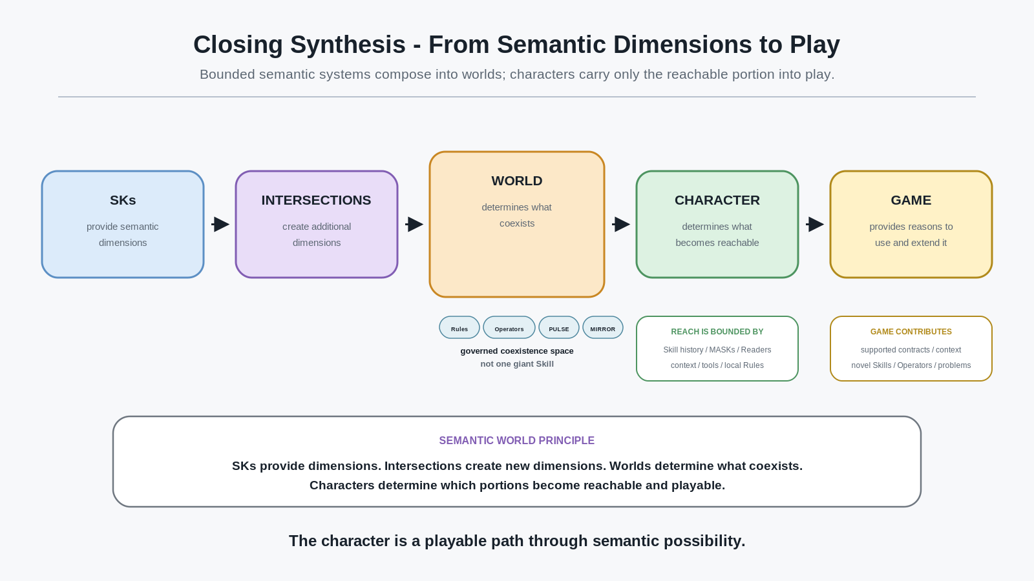
Closing synthesis. From semantic dimensions to play.
The role of the game is therefore important but no longer absolute.
A game can be a bounded environment that selects a useful portion of a much larger semantic ecosystem. It provides a reason to use familiar Skills, a context in which dormant Skills may reactivate, and opportunities to acquire novel Skills, Operators, BitWords, or intersection domains. It can be tiny and specialist or enormous and cross-domain. It can teach one discipline deeply or assume the player arrives with ten already developed.
Because the character persists semantically, individual games can become episodes in a much longer competence history.
Because the systems persist semantically, individual mechanics can become building blocks in many different worlds.
Because worlds can extend reality explicitly rather than replacing it vaguely, fantasy mastery can become as internally deep as the world designer is prepared to define.
Because characters remain bounded, the world can continue growing without requiring every player to understand everything it contains.

Semantic World Principle
A semantic world is not one giant Skill. It is a governed coexistence space in which many bounded semantic systems, character histories, world-local Rules, and presentation layers can interact through explicit contracts.

This is the architecture that allows a world to contain legitimate beekeeping, High Elvish grammar, formal logic, monster ecology, blacksmithing, food chemistry, spectral pollen, deep fictional physics, and thousands of other systems without requiring them to be flattened into one universal mechanic.
They remain themselves.
Their relationships make the world rich.

Conclusion - The World Can Be Enormous Without Requiring the Character to Be
This paper began immediately after CERBERUS Language SKs for Simulation.
The Language architecture showed that a complete linguistic possibility space can remain canonical while an individual entity reaches only a bounded subset determined by vocabulary, grammar, Skill, context, and learned relations.
CERBERUS Semantic Skill Worlds generalizes that idea across playable competence.
A character can carry meaningful Skill history between games when those games recognize the same semantic contracts. Familiar competence can remain useful while novel semantic territory gives new games something meaningful to teach. Some games can assume prior expertise rather than rebuilding every character from zero. Specialist games can function both as complete experiences and as reusable mechanics inside larger worlds.
Legitimate real-world disciplines can remain legitimate while fantasy worlds add clearly separated fictional extensions. A beekeeper can learn real apiary concepts and later gain access to a world-specific spectral pollen PULSE without confusing the fantasy capability with real beekeeping.
Characters can therefore become unusual compositions of what their players repeatedly chose to learn. In multiplayer, those histories refract through one canonical world as different readable and actionable possibilities.
Progression does not have to stop when a Skill becomes strong. New tools, Operators, resolutions, and neighboring disciplines can deepen it. Explicit Cross-SK relations can connect independently bounded domains. Coherent intersections can become Skills in their own right. Those domains can intersect again. A fictional world can continue the semantic ontology beyond real-world models through explicitly invented lawful state.
At world scale, thousands of such systems can coexist because no one character, game, contributor, or SK is required to own the whole structure.
The architecture remains bounded at every level:
- the SK owns its domain;
- the Operator owns its registered action;
- the Rule owns its constraint;
- the Cross-SK relation owns its explicit intersection;
- the Skill state owns character development through the domain;
- PULSE owns bounded readability;
- MIRROR owns projection;
- Language owns linguistic possibility and composition;
- SOLAR retains its established Base-local semantic routing role;
- the game owns the subset and context it supports;
- the world owns the coexistence of its local systems and Rules;
- the character owns an accumulated history of reachable competence.
The result is not a universal omniscient model.
It is a fabric of bounded systems capable of lawful composition.

Final Thesis
CERBERUS does not require a world to be authored as one enormous game system. A world may instead emerge from the composition of bounded semantic disciplines, each independently learnable, portable, extensible, and capable of interacting through explicit contracts. Characters carry their histories through this semantic space, while individual games and worlds determine which capabilities become active, useful, visible, and newly learnable.

The world can therefore become extraordinarily deep without demanding that every experience expose that depth at once.
A player may enter one game to learn beekeeping, another to master blacksmithing, another to study a language, and another to explore a bizarre fictional science several semantic layers beneath ordinary matter. Years later, those histories can meet inside one dungeon and become the exact combination of capabilities that makes a previously impossible solution obvious.
The character is no longer merely a Level.
The character is a playable path through semantic possibility.
And the world can keep getting bigger.

Companion Architecture References
This specification composes against established CERBERUS companion architectures and does not redefine their internal contracts.
- CERBERUS Language SKs for Simulation - Formal Specification v0.1
- CERBERUS Playable Semantic Skills - Formal Specification v0.1
- CERBERUS SK Reader Architecture v2.0
- CERBERUS PULSE for Fantasy and Simulation - Formal System Specification v1.0
- CERBERUS SOLAR MIRROR - Modular Imagery Routing for Reusable Object Reconstruction v0.1
- CERBERUS SOLAR - Persistent Lexical Routing and Semantic Recall v0.2
- CERBERUS COOKING Descriptive-128 - Educational SK Specification v0.1

