ARMORY
  - GOVERNED ACCUMULATION ARCHITECTURE
A CERBERUS Architecture for Retained Experience, Interpretation, Integration, Stable Operating Structure, Reusable Response-Patterns, and Bounded Yous
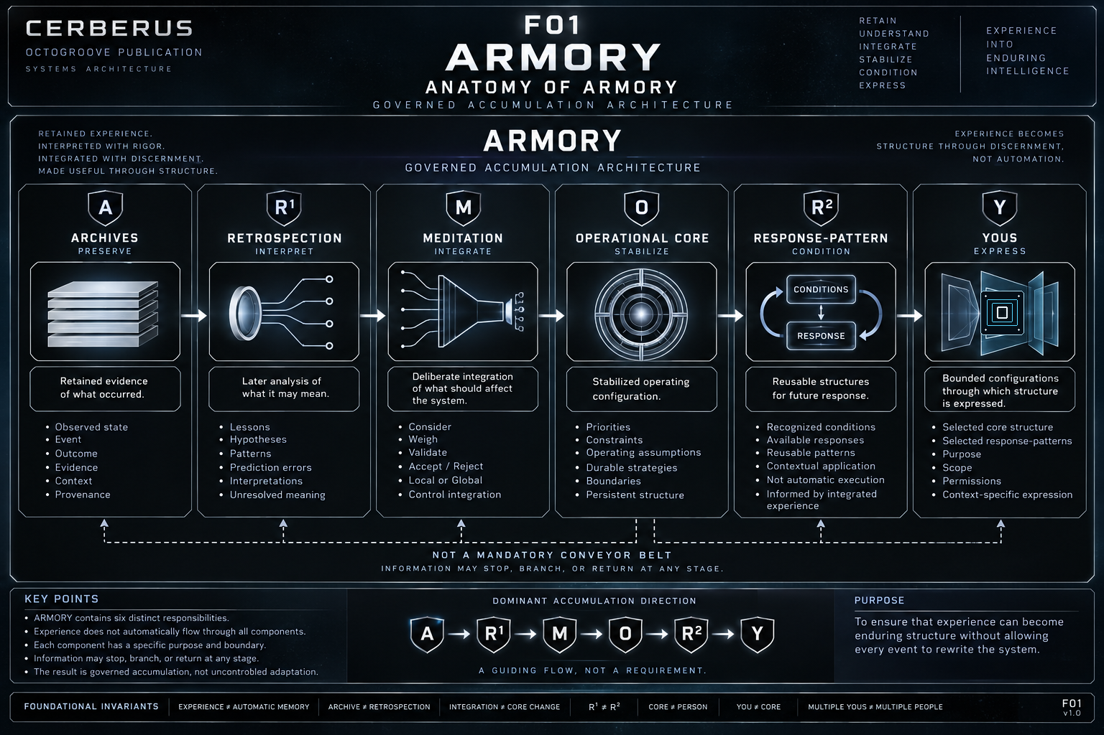
Figure 1 - Anatomy of ARMORY. Six distinct responsibilities form a governed accumulation architecture with a dominant direction but no mandatory conveyor belt.
CENTRAL THESIS
DRAGON creates experience candidates. ARMORY determines what survives, what it means, what deserves integration, what becomes stable, and what remains available for future expression.

Version 0.1 | Pass 8 Verified Release | September 2026

0. Abstract and Reading Contract
ARMORY is CERBERUS's governed accumulation architecture. It receives experience candidates produced through DRAGON and separates retention, interpretation, integration, stabilization, response conditioning, and bounded expression into distinct responsibilities. The purpose of this separation is not to slow adaptation for its own sake. It is to prevent one event, one interpretation, or one moment of uncertainty from silently rewriting persistent operating structure.
The six ARMORY responsibilities are Archives (A), Retrospection (R¹), Meditation (M), Operational Core (O), Response-Pattern (R²), and Yous (Y). They form a dominant accumulation direction, but they are not six compulsory processing steps. An Archive may remain only an Archive. A Retrospection may remain unresolved. Meditation may decline integration. A Core change may occur without creating a reusable Response-Pattern. A Response-Pattern may remain unavailable to a particular You.
This paper therefore treats accumulation as a governed network with explicit boundaries rather than an automatic memory pipeline. Evidence is preserved separately from later meaning; meaning is separated from integration; integration is separated from stabilization; and stabilized structure is separated from the bounded configurations through which it may later be expressed.
READING CONTRACT
Whenever the paper distinguishes two ARMORY responsibilities, the distinction is architectural. Similar subject matter, shared history, or proximity in the accumulation path does not collapse their ownership.

Contents
1. The ARMORY Proposition
2. From Experience Candidate to Accumulated Structure
3. A - Archives
4. R¹ - Retrospection
5. M - Meditation and Integration Control
6. O - Operational Core
7. R² - Response-Pattern
8. Y - Yous
9. ARMORY as an Anti-Overlearning Architecture
10. DRAGON and ARMORY Recurrence
11. Boundaries and Relationships
12. Foundational Laws and Non-Collapses
13. Implementation and Reconstruction Considerations
14. Conclusion
Appendix A. Working Vocabulary

1. The ARMORY Proposition
A cybernetic system that can encounter a changing world also needs a disciplined answer to a second problem: what, if anything, should persist after the encounter? Without that discipline, memory, learning, belief, strategy, and identity can collapse into one undifferentiated accumulation process. A new event can then acquire more authority than it deserves simply because it happened recently or produced a strong interpretation.
ARMORY provides the counterstructure. Its six responsibilities divide accumulation into different questions. Archives ask what was retained. Retrospection asks what retained experience might mean. Meditation asks what deserves integration. Operational Core asks what should remain stable enough to condition future operation. Response-Pattern asks what reusable response structure should be available when relevant conditions recur. Yous ask which bounded configuration of Core and selected patterns should be expressed for a particular purpose, scope, and permission set.
Responsibility | Canonical Question
A - Archives | What happened that is worth retaining?
R¹ - Retrospection | What can be learned or understood from what happened?
M - Meditation | What should actually be integrated?
O - Operational Core | What should remain reliably true about how the system operates?
R² - Response-Pattern | When relevant conditions recur, what response structure should be available?
Y - Yous | Which bounded configuration should express the accumulated structure for this purpose?

The dominant sequence A -> R¹ -> M -> O -> R² -> Y is useful for orientation, but it must not be mistaken for a mandatory conveyor belt. The architecture permits stopping, branching, uncertainty, local integration, rejection, and selective expression. Those alternatives are not failures of the architecture; they are part of the governance it provides.
ARMORY PROPOSITION
Experience can become enduring structure without allowing every experience to become enduring structure.

2. From Experience Candidate to Accumulated Structure
ARMORY begins at a boundary. DRAGON performs the recurring cybernetic encounter and may produce an experience candidate from registered identity, modeled state, known operational participation, observations, outcomes, and changes. Candidate status is intentionally weaker than memory status. It means that something potentially worth retaining has been formed; it does not mean that ARMORY must accept it.
The retention boundary is therefore the first non-collapse. EXPERIENCE CANDIDATE is not the same thing as AUTOMATIC MEMORY. The exact retention policy may vary by implementation and is not defined by this paper. What the architecture requires is that acceptance into ARMORY be explicit enough that later systems can distinguish a retained record from something that merely occurred or was briefly observed.
After retention, accumulation remains differentiated. Later interpretation can attach to an Archive without changing the Archive. Meditation can consider an interpretation without integrating it. A proposal can become a Core-candidate without yet being stabilized. Stabilized structure can support reusable Response-Patterns without automatically executing them. A You can select only the patterns relevant to its bounded context without duplicating the Core.
DOMINANT DIRECTION, NOT MANDATORY SEQUENCE
A -> R¹ -> M -> O -> R² -> Y describes the principal accumulation direction. It does not require every retained experience to traverse every responsibility.

3. A - Archives
Archives preserve retained evidence of experience. Their architectural job is deceptively simple: keep a stable account of what was observed, recorded, or otherwise accepted as historical material. That material may include an observed state, event, action, outcome, change, supporting evidence, provenance, and contextual state.
The Archive does not own later interpretation. If a later analysis concludes that an earlier event had a different cause, significance, or lesson than originally suspected, the proper response is not to rewrite the historical record until it agrees with the new interpretation. The later conclusion belongs in Retrospection and remains linked to the retained evidence from which it was derived.
This separation allows one Archive to support multiple Retrospections, including mutually competing explanations. It also allows a Retrospection to remain unresolved. Historical preservation and interpretive confidence therefore vary independently.
ARCHIVE INVARIANT
ARCHIVE != RETROSPECTION. Later meaning does not rewrite earlier evidence.

4. R¹ - Retrospection
Retrospection is the past-facing interpretive responsibility of ARMORY. It operates over retained experience and asks what can be learned or understood from what happened. A Retrospection may identify a lesson, causal hypothesis, recurring relationship, prediction error, successful strategy, failed strategy, contextual significance, discrepancy, or competing interpretation.
R¹ does not acquire truth merely by existing. Interpretations can differ in confidence, remain unresolved, or conflict with one another. The architecture therefore permits a stable Archive to have several retrospective branches without forcing one branch to overwrite the others or retroactively become the event itself.
The important distinction is temporal as well as semantic. Retrospection looks backward. Its job is to explain, interpret, compare, or extract meaning from what has already been retained. That work may later inform integration, but it does not itself define the response that must be available in the future.

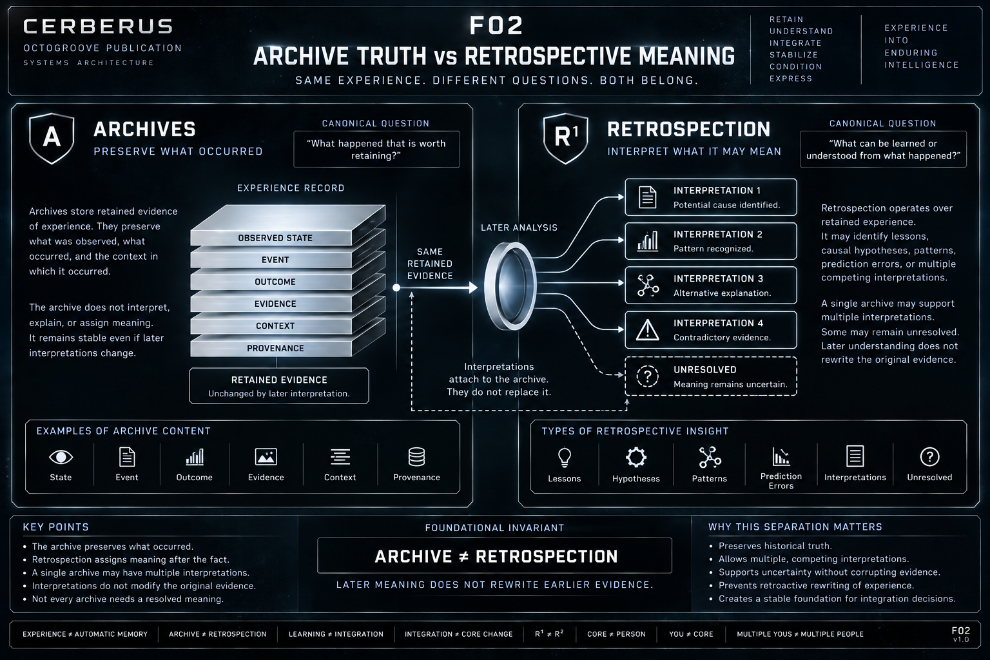
Figure 2 - Archive Truth vs Retrospective Meaning. Retained evidence remains stable while later interpretations branch around it and may remain multiple or unresolved.

5. M - Meditation and Integration Control
Meditation is ARMORY's deliberate integration responsibility. The term names the architectural function of considering what should affect persistent operating structure; it does not require a particular human contemplative practice. M exists because interpretation alone is too weak a basis for automatic adaptation.
Meditation may consider Archives, Retrospections, the existing Operational Core, current intent, confidence, contradictions, repeated evidence, consequences, and competing patterns. Its role is to weigh these materials against one another and determine what level of integration, if any, is justified.
Outcome | Meaning
RETAIN ONLY | Preserve the evidence and/or interpretation without further integration.
NOT YET | Keep the possibility open because the basis is currently insufficient.
UNCERTAIN | Preserve unresolved meaning or causal status explicitly.
LOCAL ONLY | Integrate within a bounded context without generalizing to the Core.
REJECT | Decline the proposed integration while retaining historical material when useful.
CORE-CANDIDATE | Permit a justified proposal to proceed toward persistent integration and stabilization.

These outcomes give ARMORY legitimate ways to avoid overgeneralization. A useful observation can remain useful without becoming a general rule. A promising interpretation can remain pending. An uncertain explanation can remain explicitly uncertain. A rejected integration does not require deleting the Archive that motivated the proposal.
EXPERIENCE != LEARNING.
LEARNING != INTEGRATION.
INTEGRATION != CORE CHANGE.

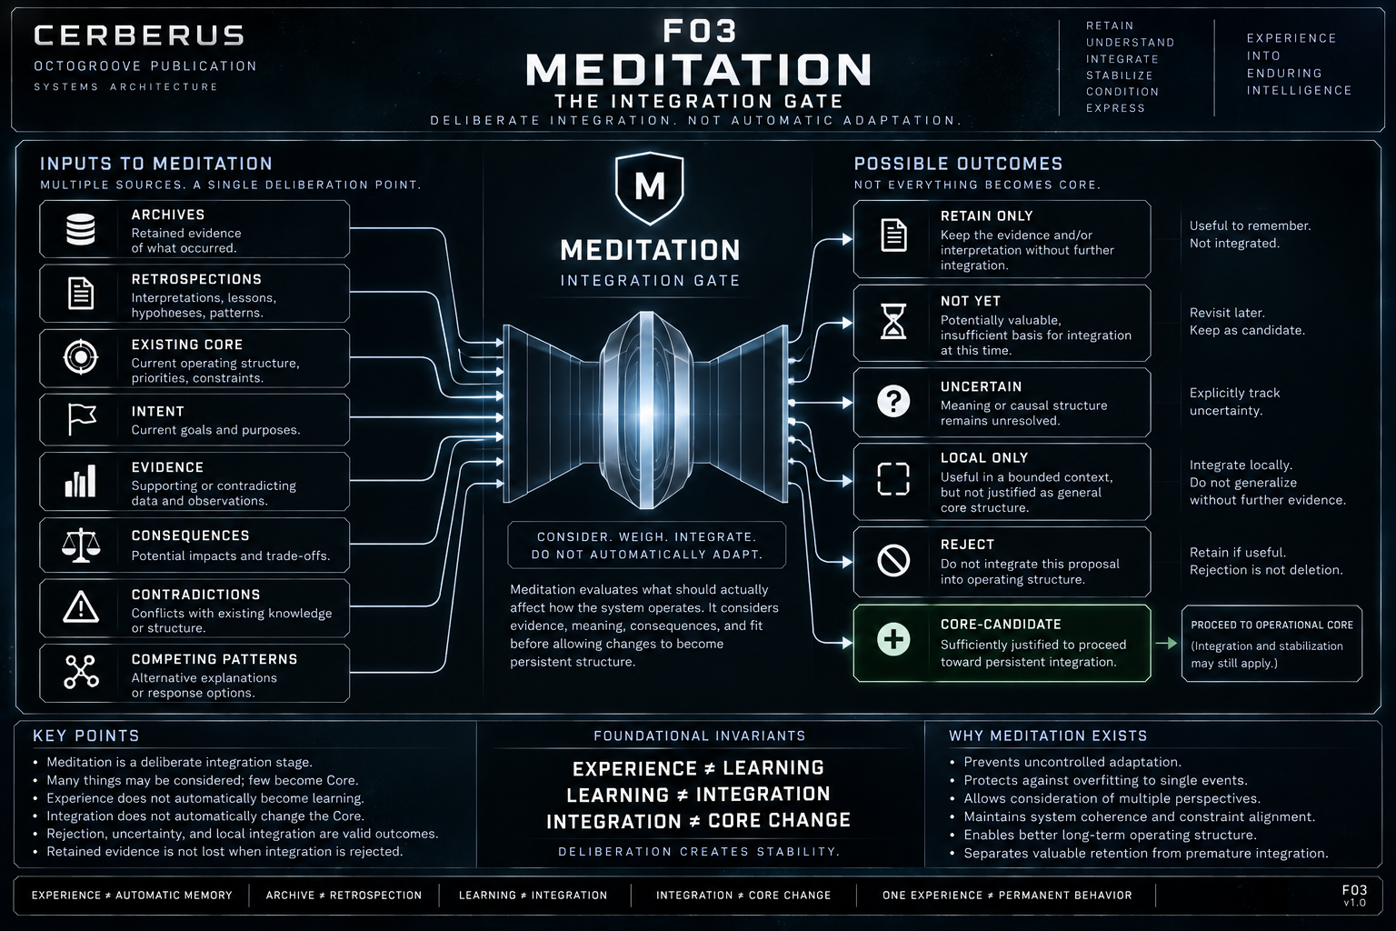
Figure 3 - Meditation: The Integration Gate. Many sources may enter deliberation, while several valid outcomes prevent automatic forwarding into persistent Core structure.

6. O - Operational Core
The Operational Core is ARMORY's stabilized operating configuration. It contains structure that has survived enough integration to become a durable condition of future operation. This may include stabilized priorities, constraints, learned operating assumptions, preferences, durable strategies, boundaries, or other persistent cybernetic configuration.
Stable does not mean immutable. The Core can change, but the architecture requires a meaningful distinction between a proposal for change and a stabilized change. A Core-candidate therefore remains different from accepted operating structure. This distinction allows the system to inspect pending adaptation without pretending that every considered proposal has already become part of the Core.
The Operational Core is also not the person, agent, or complete identity. It is an operating configuration. Collapsing Core into personhood would make ordinary adaptation look like replacement of the whole self and would make bounded specialization unnecessarily duplicative.
An Original Core exists as the default operating foundation. If multiple Core structures are ever used, that multiplicity must be explicit. A boundary such as an AIRGAP represents actual separation. Transfer across such a boundary must therefore be explicit rather than implied by proximity, shared naming, or shared history.
CORE INVARIANT
CORE != PERSON. Stable operating configuration is not total identity.

7. R² - Response-Pattern
Response-Pattern is ARMORY's future-facing reusable structure. It asks what should be readily available when relevant conditions recur. The distinction from Retrospection is fundamental: R¹ interprets the past; R² conditions possible future response.
A Response-Pattern links recognized conditions with an available response structure. Availability is not execution. The pattern may become relevant, selectable, or recommendable under matching conditions without forcing the system to enact it. Context, current state, authority, constraints, and the active You can still affect whether and how a response is expressed.
A Retrospection may help motivate a Response-Pattern, but the architecture deliberately places integration between them. An explanation of why something happened is not automatically a policy for what to do next time. That is why there is no architectural shortcut that simply turns R¹ into R².
R¹ RETROSPECTION != R² RESPONSE-PATTERN.
EXPLAINING THE PAST != CONDITIONING THE FUTURE.

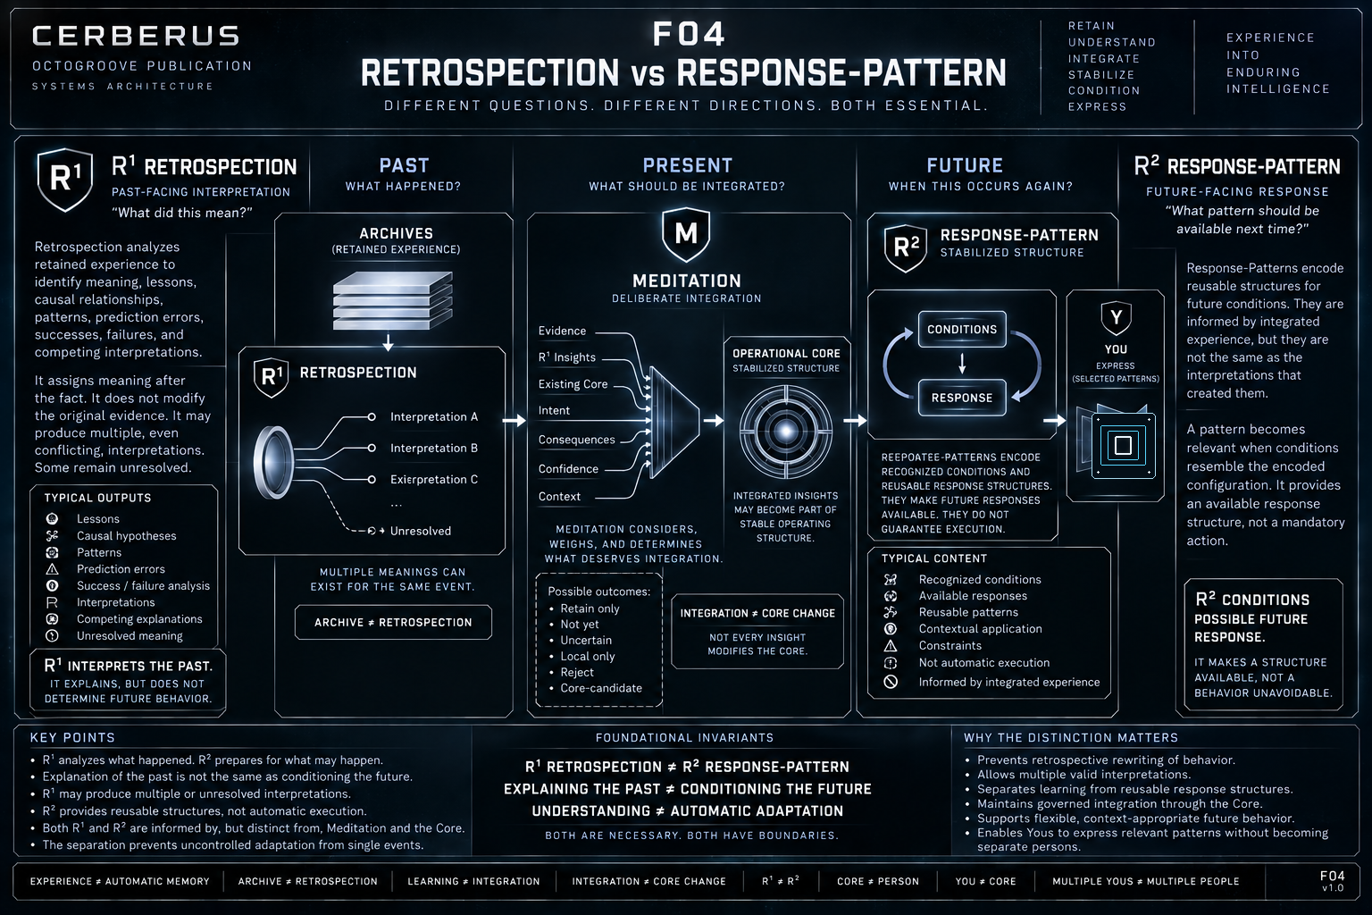
Figure 4 - Retrospection vs Response-Pattern. R¹ is past-facing interpretation; R² is future-available response structure, with deliberate integration separating the two responsibilities.

8. Y - Yous
Yous are bounded specialized operating configurations. A You provides a way to express accumulated structure for a particular purpose without duplicating the entire system or pretending that every available response pattern should be active in every context.
The canonical composition is one Operational Core plus selected Response-Patterns plus explicit purpose, scope, and permissions. Purpose answers why the configuration exists. Scope bounds where or when it applies. Permissions constrain what it is allowed to do. Selected Response-Patterns provide context-relevant reusable structures while remaining distinct from the Core they draw upon.
Element | Role inside a You
Operational Core | Shared stabilized operating foundation.
Selected Response-Patterns | Reusable structures made relevant to this bounded configuration.
Purpose | Why this You exists.
Scope | Where, when, or over what domain the You applies.
Permissions | What the You is allowed to do or expose.

Several Yous can share one Operational Core while selecting different Response-Patterns. That does not create several independent people, several copies of the Core, or several mutually isolated identities. It creates several bounded configurations through which the same accumulated foundation can be expressed differently.
YOU != CORE.
MULTIPLE YOUS != MULTIPLE PEOPLE.

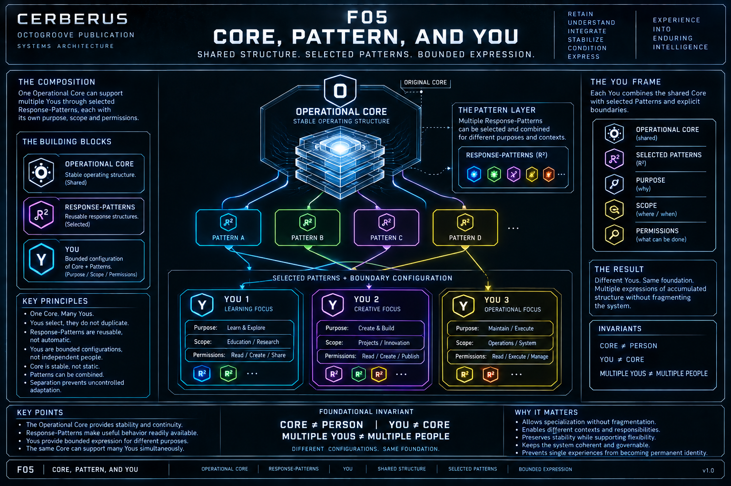
Figure 5 - Core, Pattern, and Yous. One Operational Core can support several reusable Response-Patterns and multiple bounded Y configurations without duplicating the Core.

9. ARMORY as an Anti-Overlearning Architecture
A naive adaptive architecture can collapse event, interpretation, belief, and persistent behavior into one rapid path. Something happens; the system assigns meaning; that meaning becomes belief; and belief changes behavior. The speed can look intelligent, but the architecture is vulnerable to noise, anomalies, manipulative inputs, one-off experiences, and premature certainty.
ARMORY inserts governed friction between those stages. An experience candidate may fail retention. A retained Archive may never receive a definitive Retrospection. A Retrospection may be considered without integration. Meditation may retain only, defer, preserve uncertainty, integrate locally, reject, or produce a Core-candidate. A Core-candidate may still fail to stabilize. Stabilized Core structure may or may not produce a Response-Pattern. A Response-Pattern may or may not be selected by a particular You.
This friction is not an argument against learning. It is an argument for learning that can preserve evidence, uncertainty, locality, reversibility, and context. The architecture creates places where the system can say NO, NOT YET, UNCERTAIN, RETAIN ONLY, or LOCAL ONLY without losing the historical material that may become useful later.
ANTI-OVERLEARNING PRINCIPLE
ONE EXPERIENCE != PERMANENT BEHAVIOR. Accumulation is governed so that adaptation can be responsive without becoming uncontrolled.

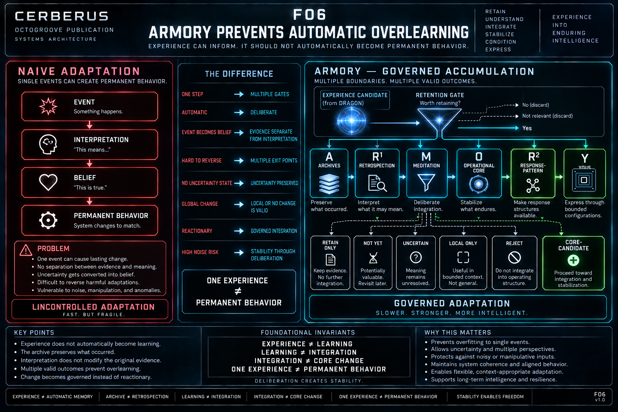
Figure 6 - ARMORY Prevents Automatic Overlearning. Typed responsibilities and multiple legitimate exits separate experience from automatic persistent adaptation.

10. DRAGON and ARMORY Recurrence
DRAGON and ARMORY form a larger recurrence without collapsing into one another. DRAGON is the live cybernetic cycle of encounter. It relates registered identity, Model state, Operational state or known operations, subsequent state, and the formation of experience candidates. ARMORY begins at the accumulation boundary and governs what is retained and what retained experience becomes.
The feedback direction matters just as much as the handoff. Accumulated ARMORY structure can condition a later DRAGON cycle by affecting available patterns, active constraints, expectations, stabilized operating configuration, selected You, and the context against which new experience is interpreted. Future encounters therefore do not begin from an empty system.
Conditioning is not determination. ARMORY does not predict or control the future world, and it does not replace the live encounter performed by DRAGON. New evidence can contradict prior structure. Unknown causes can remain unknown. Novel situations can exceed existing patterns. DRAGON continues to encounter; ARMORY supplies accumulated structure through which later encounters can be informed.
DRAGON CREATES EXPERIENCE CANDIDATES.
ARMORY GOVERNS ACCUMULATION.
ARMORY CONDITIONS DRAGON.
ARMORY DOES NOT REPLACE DRAGON.

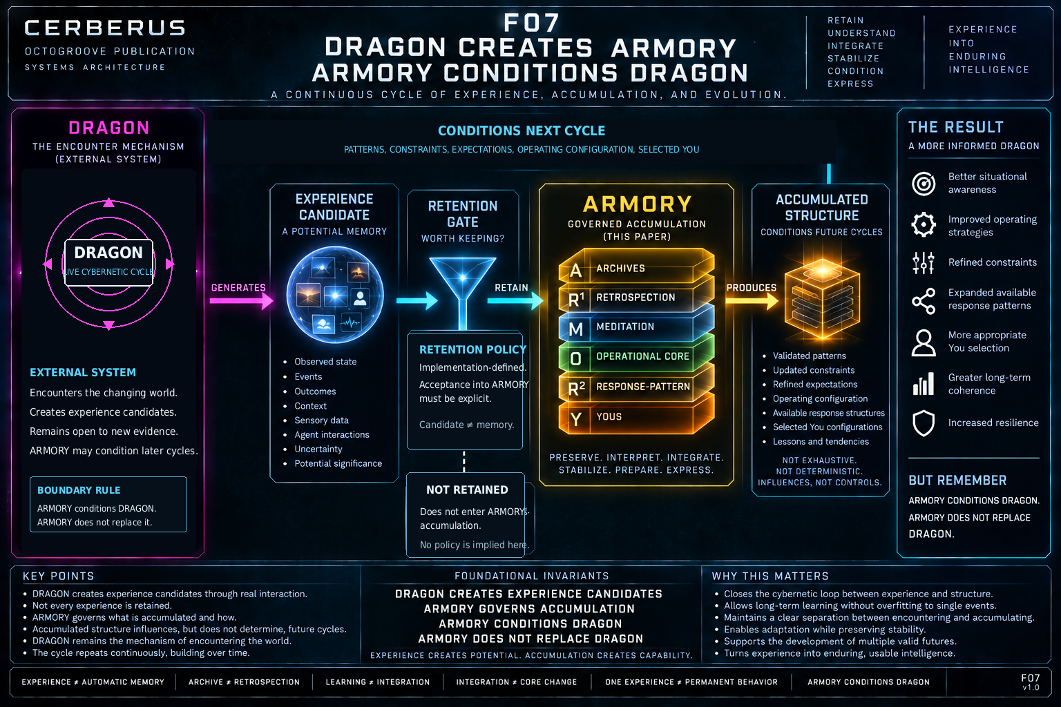
Figure 7 - DRAGON creates ARMORY; ARMORY conditions DRAGON. Experience candidates can become accumulated structure, which informs later encounters without replacing the live cybernetic cycle.

11. Boundaries and Relationships
ARMORY is useful because its internal responsibilities are bounded. The boundaries are not merely labels for stages in one algorithm. They preserve different kinds of authority over different kinds of accumulated structure.
Boundary | What the boundary protects
Archives / Retrospection | Evidence is preserved independently from later interpretation.
Retrospection / Meditation | Meaning can be considered without automatically becoming integration.
Meditation / Operational Core | Integration proposals remain distinct from stabilized operating structure.
Operational Core / Response-Pattern | Persistent structure and reusable conditioned responses are not the same object.
Response-Pattern / You | Available patterns can be selectively exposed rather than globally active.
Core / You | A bounded configuration references shared foundation rather than becoming a duplicate person.
DRAGON / ARMORY | Encounter and accumulation remain separate but recurrently coupled.

These distinctions make ARMORY composable. A future implementation can change how Archives are stored, how Retrospections are produced, how Meditation is presented, how Response-Patterns are selected, or how Yous are rendered without erasing the semantic ownership of the six responsibilities.
BOUNDARY PRINCIPLE
Different responsibilities may exchange information without becoming the same responsibility.

12. Foundational Laws and Non-Collapses
EXPERIENCE != RETENTION.
EXPERIENCE CANDIDATE != AUTOMATIC MEMORY.
RETENTION != INTERPRETATION.
ARCHIVE != RETROSPECTION.
LATER MEANING DOES NOT REWRITE EARLIER EVIDENCE.
RETROSPECTION != CORE CHANGE.
EXPERIENCE != LEARNING.
LEARNING != INTEGRATION.
INTEGRATION != CORE CHANGE.
CORE-CANDIDATE != STABILIZED CORE.
R¹ RETROSPECTION != R² RESPONSE-PATTERN.
EXPLAINING THE PAST != CONDITIONING THE FUTURE.
CORE != PERSON.
YOU != CORE.
MULTIPLE YOUS != MULTIPLE PEOPLE.
ONE EXPERIENCE != PERMANENT BEHAVIOR.
ACCUMULATION != UNCONTROLLED ADAPTATION.
ARMORY CONDITIONS DRAGON.
ARMORY DOES NOT REPLACE DRAGON.
A conforming ARMORY implementation should make these separations inspectable rather than relying on an operator to remember them. The purpose of the architecture is precisely to move the accumulation logic out of implicit human judgment and into explicit, reconstructable system structure.

13. Implementation and Reconstruction Considerations
ARMORY is an architecture, not a commitment to one database, interface, storage engine, or runtime. A native implementation may realize the responsibilities through Tables, records, graph relations, services, files, or other mechanisms. Portability depends on preserving the semantic contracts and boundaries rather than copying a particular prototype literally.
Archives should preserve stable historical identity and provenance. Later Retrospections should reference retained evidence rather than overwrite it. Multiple interpretations and unresolved status should remain representable. This allows reconstruction to preserve not only the latest conclusion but the path by which that conclusion became available.
Meditation requires explicit distinction among consideration, local integration, rejection, deferral, uncertainty, Core candidacy, and stabilization. An implementation that stores only a final yes/no result loses the governance structure that makes ARMORY useful. Similarly, Core-candidates should not become indistinguishable from stabilized Core simply because both are stored in the same environment.
Response-Patterns should remain reusable structures whose relevance can be evaluated without forcing execution. Yous should reference shared Core structure and selected patterns rather than silently cloning them. If Core multiplicity is introduced, the separation must be explicit, and any AIRGAP transfer must be represented as a governed transfer rather than implicit synchronization.
Reconstruction should preserve uncertainty and non-decisions. NOT YET, UNCERTAIN, RETAIN ONLY, LOCAL ONLY, and REJECT are meaningful outcomes. Dropping them during migration would bias the reconstructed system toward false certainty and excessive generalization.
PORTABLE ARMORY
Preserve responsibility, provenance, status, boundary, and relation. The material implementation may change.

14. Conclusion
ARMORY gives CERBERUS a governed way to accumulate experience without collapsing history, interpretation, learning, integration, stable operating structure, reusable response, and bounded expression into one undifferentiated memory system. Archives preserve what occurred. Retrospection interprets what it may mean. Meditation decides what deserves integration. Operational Core stabilizes what should endure. Response-Patterns make useful structures available for future conditions. Yous express selected accumulated structure within explicit purpose, scope, and permissions.
The architecture becomes most important at the places where nothing happens automatically. An Archive may stay unchanged while interpretation evolves. A Retrospection may remain unresolved. Meditation may refuse generalization. A Core-candidate may never stabilize. A Response-Pattern may remain merely available. A You may select only what its bounded context requires.
DRAGON and ARMORY therefore form a complementary recurrence. DRAGON encounters. ARMORY accumulates. Future DRAGON operates through what ARMORY has become, while remaining open to a world that can always produce new evidence, new uncertainty, and new experience.
CLOSING PROPOSITION
DRAGON explains how experience occurs. ARMORY explains how experience can become enduring structure without allowing every event to rewrite the system.

Appendix A. Working Vocabulary
Term | Working Definition
Experience Candidate | A structured candidate produced by DRAGON that may be offered to ARMORY for retention.
Archive | Retained evidence that preserves what occurred or was observed without owning later interpretation.
Retrospection (R¹) | Past-facing interpretation of retained experience.
Meditation | Deliberate integration responsibility that determines what level of persistence, if any, is justified.
Core-Candidate | A proposal sufficiently justified to proceed toward possible persistent integration but not yet equivalent to stabilized Core.
Operational Core | Stabilized operating configuration that conditions future operation without constituting the whole person or identity.
Response-Pattern (R²) | Reusable future-facing response structure made available under relevant conditions without guaranteeing execution.
You | Bounded specialized configuration using one Operational Core, selected Response-Patterns, purpose, scope, and permissions.
Original Core | The default operating foundation from which explicit Core multiplicity may later be distinguished.
AIRGAP | An explicit separation between Core structures; transfer across it must be explicit rather than assumed.
Accumulated Structure | The retained and integrated structure through which ARMORY can condition later DRAGON cycles.
Governed Friction | Architectural separation that permits retention, uncertainty, locality, rejection, and selective integration instead of automatic adaptation.

End of Pass 8 Verified Release.

