CERBERUS
DARTBOARD
Selective Runtime Resolution Through DARTS
Display • ARMORY • Routing • Temporal • Semiotic
CORE SYSTEM STATEMENT
DARTBOARD is the task-bounded runtime surface where the applicable DARTS projections are resolved, bound to governed Targets, and manifested for use without transferring ownership of the underlying state.
SHORT FORM
Pick the applicable DARTS. Resolve them. Land them on the Board. Route operations home.
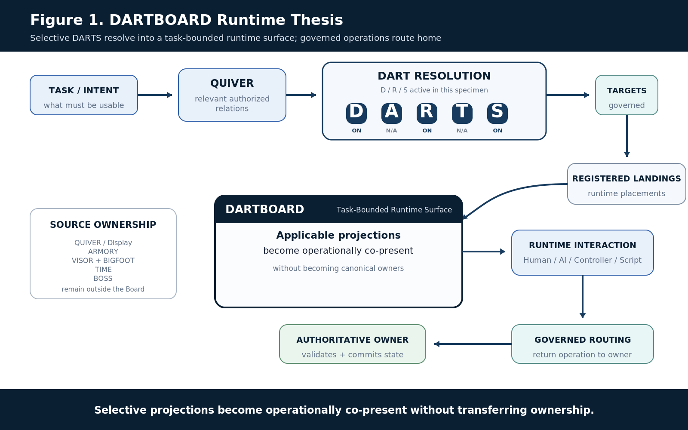
Figure 1. DARTBOARD runtime thesis.
Selective projections become operationally co-present without transferring ownership.
Version 0.1 • 24 August 2026 • Verified Release

Document Control
Control | Value
Document | CERBERUS DARTBOARD - Selective Runtime Resolution Through DARTS
Version | 0.1
Date | 24 August 2026
Status | Verified Release
Primary role | Task-bounded runtime resolution and manifestation surface
Projection architecture | DARTS - Display, ARMORY, Routing, Temporal, Semiotic
Primary runtime unit | One bounded DARTBOARD instance / operational surface
Figure program | 18 approved Figure Contracts; 18 Compound Constructs; 18 publication renders
Primary boundary | DARTBOARD composes governed projections; it does not become their canonical owner.

Executive Summary
CERBERUS separates runtime concerns that are often tangled together in ordinary applications. Display makes governed state usable. ARMORY contributes accumulated personal or cybernetic context when it matters. Routing reaches and operates exact registered targets. Temporal answers WHEN through TIME when a task has temporal semantics. Semiotic contributes governed meaning and symbolic context through BOSS. These five projection domains are DARTS.
DARTS is not a five-stage pipeline. A Board is complete when it resolves the subset required by the task. A BitWord inspector may require Display, Routing, and Semiotic while ARMORY and Temporal are intentionally N/A. A calendar editor may add Temporal. A memory-aware semantic object may add ARMORY without requiring time. N/A therefore means intentionally not applicable; it is not an unresolved error.
DARTBOARD is the meeting surface. It receives task-relevant projections, binds them around governed Targets or compound Anchors, and manifests them through registered Landings. Multiple DARTS may contribute to one visible object: a calendar cell can be a Display manifestation, route to exact TIME machinery, carry Temporal state, and show BOSS meaning at the same time. The surface remains derived. The authoritative systems survive its replacement or destruction.
PRIMARY ARCHITECTURAL LAW
Independent projections. Shared Targets. Registered Landings. Governed operation. DARTBOARD composes only what the current task requires.
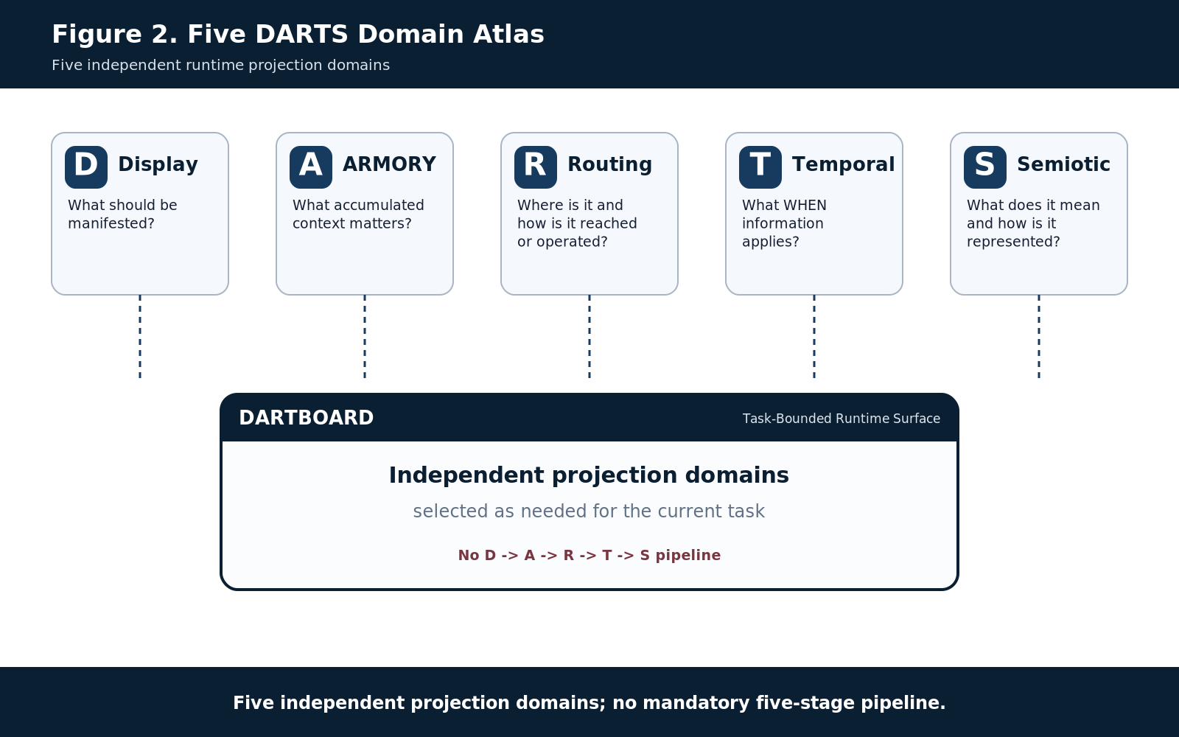
Figure 2. Five DARTS domain atlas.
Five independent projection domains; no mandatory five-stage pipeline.

Section Index
Part | Section
Part 1 | Foundation and Selective Resolution
Part 2 | Governed Targets, Anchors, and Landings
Part 3 | D - Display
Part 4 | R - Routing
Part 5 | A - ARMORY
Part 6 | T - Temporal
Part 7 | S - Semiotic and SOLAR Ingress
Part 8 | Selective Convergence and Runtime Profiles
Part 9 | SK Reader as a Specialized DARTBOARD Path
Part 10 | Governed Interaction, Mutation, and Reprojection
Part 11 | Ownership Boundaries
Part 12 | Worked Runtime Profiles
Part 13 | Normative DARTBOARD Laws
Part 14 | Reconstruction and Implementation Handoff
Appendix A | Implementation Source Map
Appendix B | Figure Index

Reading Order
Parts 1-2 establish DARTBOARD as selective runtime resolution over governed Targets. Parts 3-7 define the five DARTS contributions and their boundaries. Parts 8-10 show how those contributions converge, how the specialized Semantic Kernel runtime fits inside the broader architecture, and how governed interaction returns changes to authoritative owners. Parts 11-14 close the reconstruction contract with ownership boundaries, worked profiles, normative laws, and exact implementation handoff.

PART 1 - Foundation and Selective Resolution
DARTBOARD is a bounded runtime resolver and manifestation surface, not a sixth truth domain.

1. Purpose and Scope
DARTBOARD exists to turn registered CERBERUS structure into a usable runtime surface without duplicating the structures that supplied it. It operates above canonical data and semantic systems and below human-, AI-, controller-, or script-level interaction. The surface may be an editor, inspector, calendar, figure, control array, operational dashboard, learning tool, or other bounded manifestation.
The architecture generalizes earlier DARTBOARD work. The existing game/animation Formal Specification remains a specialized operational application, and the SK Runtime Interpretation & Interface Architecture remains the generic Semantic Kernel control substrate. This reconstruction artifact places both inside the wider DARTS convergence model rather than replacing them.

1.1 In Scope
- DARTS applicability and task-scoped resolution.
- Governed Targets, simple and compound Anchors, and registered Landings.
- QUIVER-selected Display through the D/E/F/G coverage grammar.
- VISOR and BIGFOOT Routing to exact operational structure.
- Optional ARMORY, Temporal, and Semiotic contributions.
- Specialized SK Reader routing into generated Display surfaces.
- Governed mutation, authority checks, commit, refresh, and reprojection.
- Reconstruction and implementation handoff for the next CERBERUS assistant.

1.2 Out of Scope
- DARTBOARD does not redefine the internal semantics of BIGFOOT, BOSS, SOLAR, TIME, ARMORY, VISOR, QUIVER, Effects, Skene, Praxis, or specialist Semantic Kernels.
- DARTBOARD does not infer semantic composition merely from screen adjacency, labels, geometry, or mathematical BitGroup type.
- DARTBOARD does not grant mutation authority merely because a control is visible or interactive.
- DARTBOARD does not require all five DARTS to participate in every task.
- DARTBOARD does not become a canonical copy of the records, meanings, histories, temporal state, or routes it manifests.
SCOPE BOUNDARY
DARTBOARD is a runtime resolution surface and orchestration boundary. It is not a monolithic Semantic Kernel, truth database, ontology, memory store, calendar, or universal interface schema.

2. The Five DARTS Domains
DART | Domain | Runtime question | Contribution | Primary architecture
D | Display | What should be manifested? | Usable manifestation, interface coverage, effects, controls | QUIVER; Display root; D/E/F/G
A | ARMORY | What accumulated context matters? | Personal relevance, memory, classification, learned context | 0000 / XXXX and wider ARMORY stack
R | Routing | Where is it and how is it reached or operated? | Addressing, traversal, Reader descent, mutation path | VISOR; BIGFOOT; Readers; Instances
T | Temporal | What WHEN information applies? | Coordinates, recurrence, precision, temporal interpretation | TIME
S | Semiotic | What does it mean and how is it represented? | Symbolic and conceptual context | BOSS; SOLAR as lexical ingress

The five domains have equal architectural status. They are available dimensions of runtime resolution, not five mandatory stages. A task can legitimately use D/R/S while A and T remain N/A. DARTBOARD must not manufacture a temporal, personal, or semantic contribution simply because that domain exists.

3. DART Applicability and Runtime Profiles
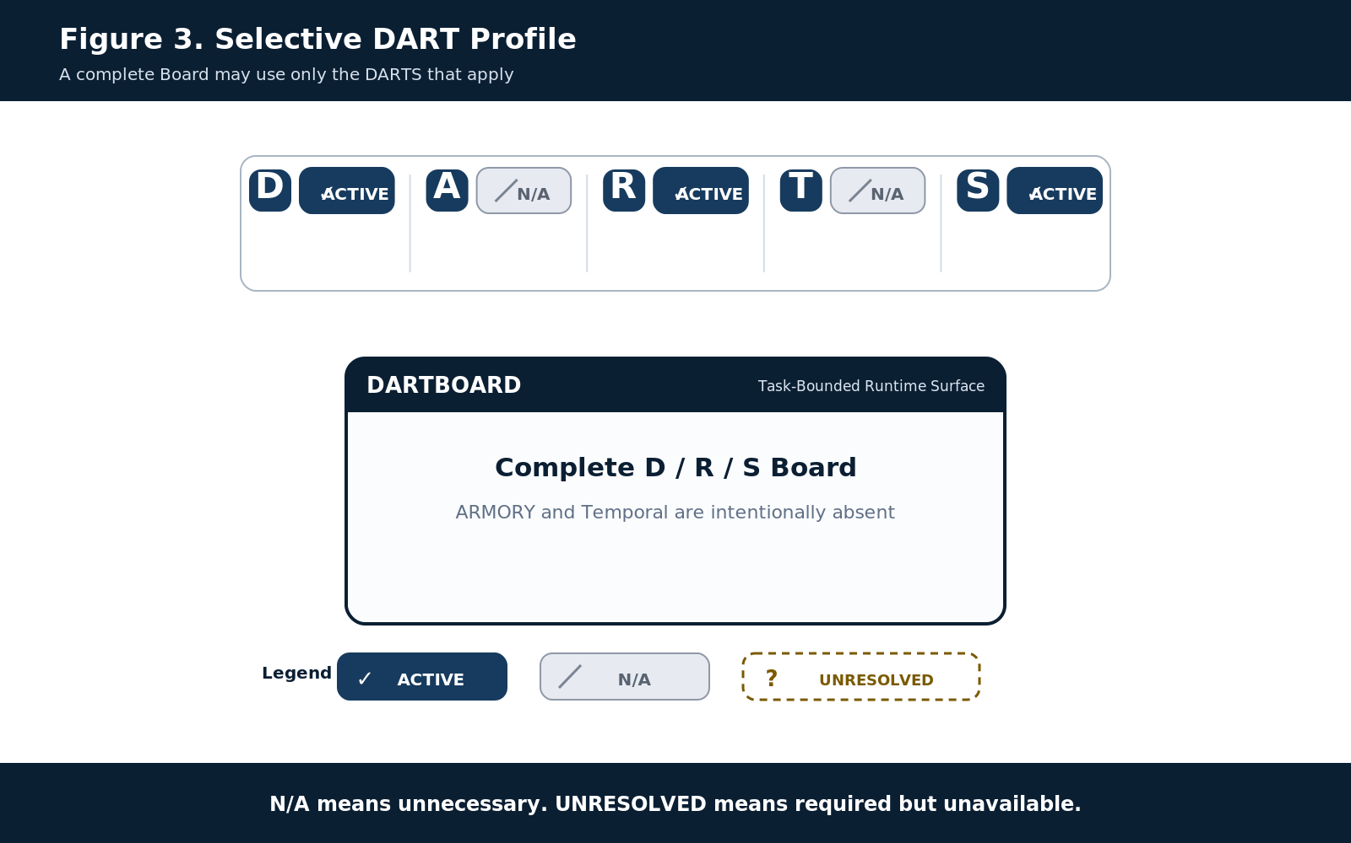
Figure 3. Selective DART profile.
N/A means unnecessary. UNRESOLVED means required but unavailable.
A DARTBOARD instance carries an applicability profile. ACTIVE means a domain applies and its required contribution has resolved. N/A means the domain is intentionally irrelevant to the current task. UNRESOLVED means the domain applies but the required contribution cannot currently be resolved. These states are semantically different and must remain visibly distinguishable.
State | Meaning | Conformance consequence
ACTIVE | Required and resolved | May participate in runtime composition.
N/A | Intentionally not applicable | Board can still be complete.
UNRESOLVED | Applicable but unavailable or failed | Board is incomplete for that required domain; surface should report or constrain the failure.

SELECTIVE PARTICIPATION LAW
Completeness is determined by task sufficiency, not by the number of active DARTS.

4. Singular DART
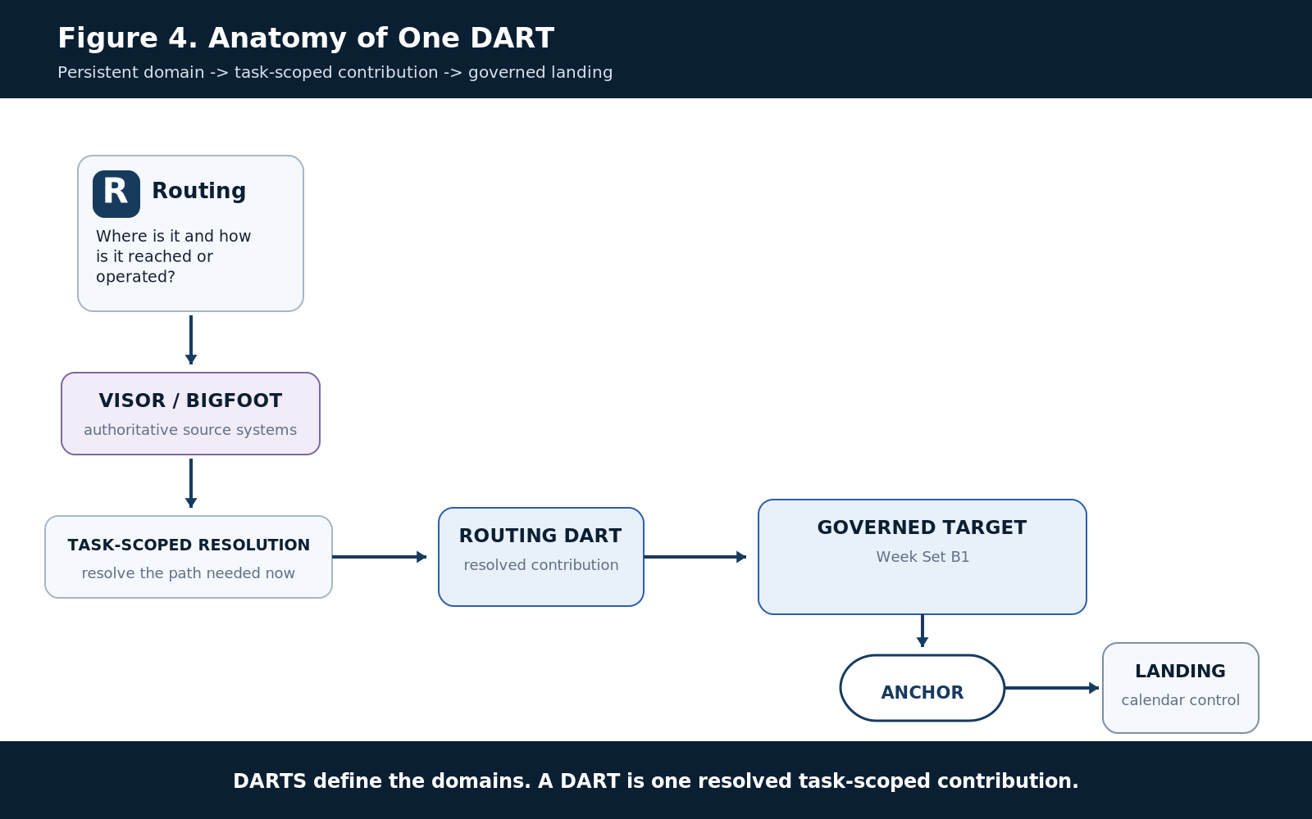
Figure 4. Anatomy of one DART.
DARTS define the domains. A DART is one resolved task-scoped contribution.
DARTS names the persistent five-domain architecture. A singular DART is one task-scoped resolved contribution from one of those domains to the current Board. A Routing DART may contain an exact VISOR-to-BIGFOOT path. A Semiotic DART may contain the BOSS Symbol, Family, and explanatory context needed beside a Display. A Temporal DART may contain the minimum TIME member required for the current operation.

PART 2 - Governed Targets, Anchors, and Landings
The Target is what the Board concerns; the Landing is how that Target is manifested here.

5. Governed Target
Every operative manifestation must concern a governed Target. A Target may be a record, NodeKey, registry object, Semantic Symbol, BitWord, Reader placement, BitGroup, Bit, TIME coordinate, or other registered structure. A Target may also be compound when the governed meaning itself is composed from several identities.
TIME provides the cleanest compound example. An ordinary temporal day-like position can be derived from Month × Week × Phase rather than stored as a separate independent date identity. DARTBOARD can manifest that compound temporal Target without claiming that the screen cell is the canonical date object.

6. Anchor and Landing
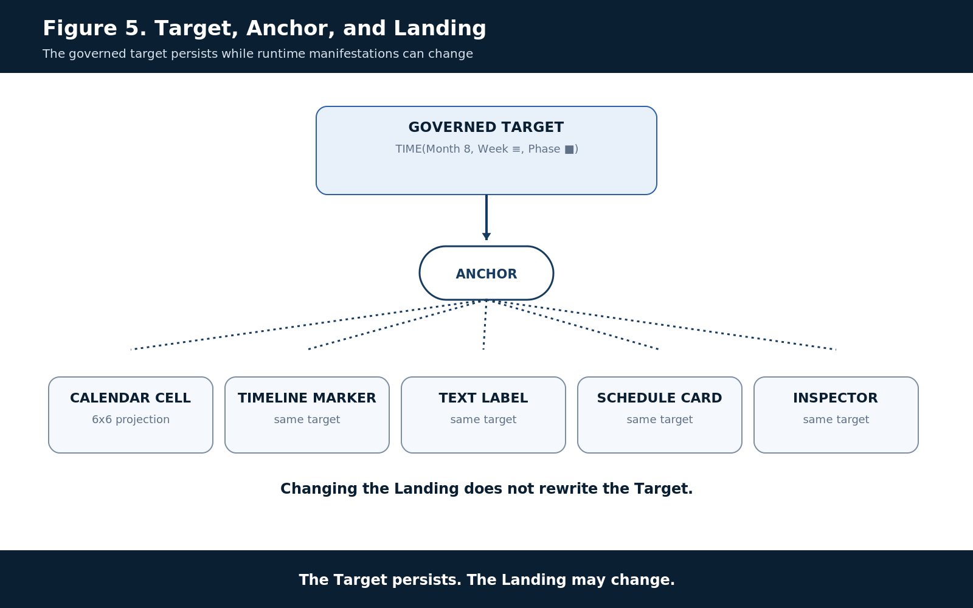
Figure 5. Target, Anchor, and Landing.
The Target persists. The Landing may change.
An Anchor is the governed reference through which several DARTs are known to concern the same Target. A Landing is the registered runtime placement through which a resolved DART contributes to the current manifestation. Target, Anchor, and Landing are therefore related but distinct responsibilities.
The distinction permits one Target to appear simultaneously as a calendar cell, timeline marker, text label, schedule card, inspector row, or other projection. Changing the Landing changes usability and geometry. It does not silently change the Target.
PROJECTION IDENTITY LAW
The Target persists. The Landing may change. Runtime geometry is downstream of governed identity.

7. Multiple DARTS, One Manifestation
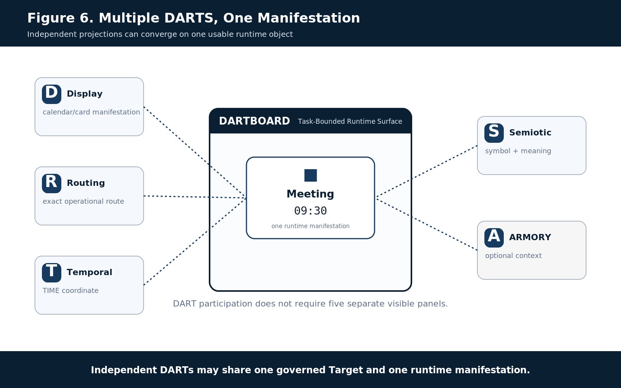
Figure 6. Multiple DARTS, one manifestation.
Independent DARTs may share one governed Target and one runtime manifestation.
Several DARTS may converge around one Target and one visible object. A meeting control can receive Display geometry, Routing to the exact target, Temporal coordinate and precision, and Semiotic labels or symbols. ARMORY may additionally contribute relevant history. The human still experiences one coherent object.
DART participation does not imply separate screen real estate. Routing can be invisible operational plumbing or a visible engineering trace. Semiotic content may be displayed inside the same control that Display provides. ARMORY may affect context or ranking without receiving a standalone panel.

PART 3 - D: Display
Display is the manifestation projection. D/E/F/G describes semantic coverage, not physical size.

8. Display Source and Ownership
Display begins with QUIVER and the registered Display structures. The Display root and its D/E/F/G tables identify viable manifestation contracts. DARTBOARD does not invent controls from labels or proximity; it resolves registered Display material and lands it on the Board.
The Display contribution can carry Interface Elements, declared composites, effects, presentation behavior, feedback, and control affordances. These are presentation contracts over governed state. They remain projections even when stable and reusable.

9. D/E/F/G Semantic Coverage
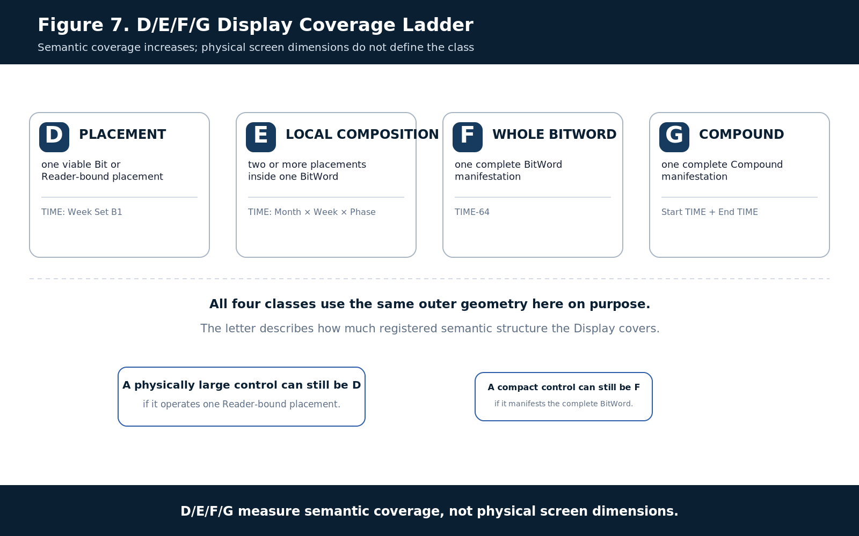
Figure 7. D/E/F/G Display coverage ladder.
D/E/F/G measure semantic coverage, not physical screen dimensions.
Class | Semantic coverage | TIME reference example
D | One viable Bit or Reader-bound placement | Week Set B1; Year F1; Fine Tick P1
E | Two or more placements composed within one BitWord | Month × Week × Phase; Hour + Minute; Offset Value + Offset Presence
F | One complete BitWord | TIME-32, TIME-64, TIME-96, TIME-128
G | One complete Compound | Start TIME + End TIME; recurring TIME + exception TIME when registered as a Compound

Coverage scope is independent of screen dimensions. A large explanatory figure may still be D-level if it addresses one placement; a compact technical control may be F-level if it faithfully exposes the complete BitWord. This prevents interface geometry from becoming a false proxy for semantic scope.

10. QUIVER-to-Display Resolution
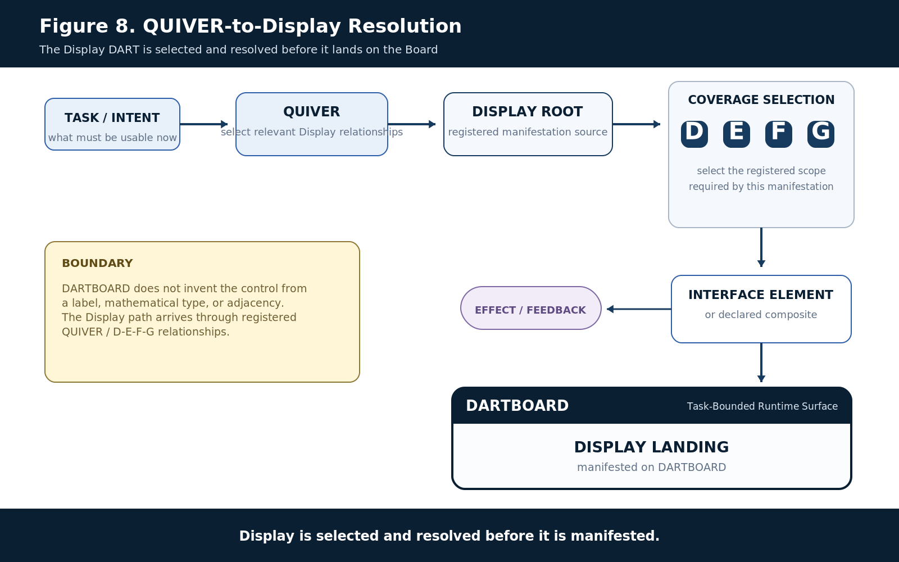
Figure 8. QUIVER-to-Display resolution.
Display is selected and resolved before it is manifested.
The Display path begins with task relevance rather than arbitrary widget choice. QUIVER selects the applicable relational material; the Display root resolves the appropriate D/E/F/G contract; registered Interface Elements or composites provide the control surface; effects and feedback may be added; and the resolved manifestation lands on DARTBOARD.
NO INTERFACE INFERENCE
Visual adjacency, shared labels, or compatible mathematics do not establish an interface contract. Composition and interaction behavior must be registered.

11. Projection, Geometry, and Composite Interaction
DARTBOARD geometry is derived from governed semantics. A slider position is not inherently a semantic value; a button is not inherently an operator; a matrix cell is not inherently a date. The binding makes the geometry meaningful.
Composite interaction must likewise be declared. Hour and Minute remain separate Reader semantics even when one human clock control operates both. Month, Week, and Phase remain separate temporal semantics even when their combination is projected into a calendar. Display can unify the interaction without collapsing the underlying identities.
PART 4 - R: Routing
Routing locates and operates exact governed structures and may descend only as far as the task requires.

12. Routing Begins with VISOR
Routing answers where the relevant structure is and how runtime operation reaches it. The canonical traversal begins with VISOR structural territory and can descend into BIGFOOT when exact semantic machinery is required.
The representative path is VISOR Stack → Registry Table → governed Target → BitWord → Reader → BitGroup → Bit → governed operation. This is a capability ladder, not a requirement that every request reach individual Bits.

13. Routing Descent and Minimum Structural Depth
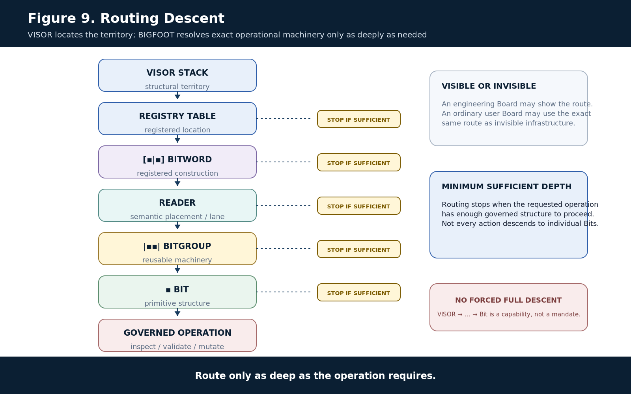
Figure 9. Routing descent.
Route only as deep as the operation requires.
A lookup that only needs a Registry record can stop at the table or target level. An SK inspector can stop at the BitWord or Reader. A mutation of one encoded field may descend to the BitGroup or exact Bits. Routing should therefore terminate at the minimum structural depth that preserves exact operation and governance.
Routing may itself be displayed. Engineering, debugging, and learning surfaces can expose the path from Target through VISOR, BIGFOOT, Reader, BitGroup, and Bits. Ordinary user surfaces may use the same route invisibly.

PART 5 - A: ARMORY
ARMORY contributes accumulated personal or cybernetic context when that context matters to the task.

14. ARMORY Is Optional Runtime Context
ARMORY is not a required component of every Board. It participates when personal history, relevance, learning, reflection, or related accumulated context should influence the runtime surface. When none of that matters, A = N/A is the correct state.
For the current reference demonstration, 0000 Memory and XXXX Memory Classification are the strongest implementation examples. The wider 00000 / XXXXX / 000000 / XXXXXX stack remains architecturally applicable, but later tables are still evolving and should not be treated as equally mature merely to fill the Board.

15. Stable Identity with Accumulated Context
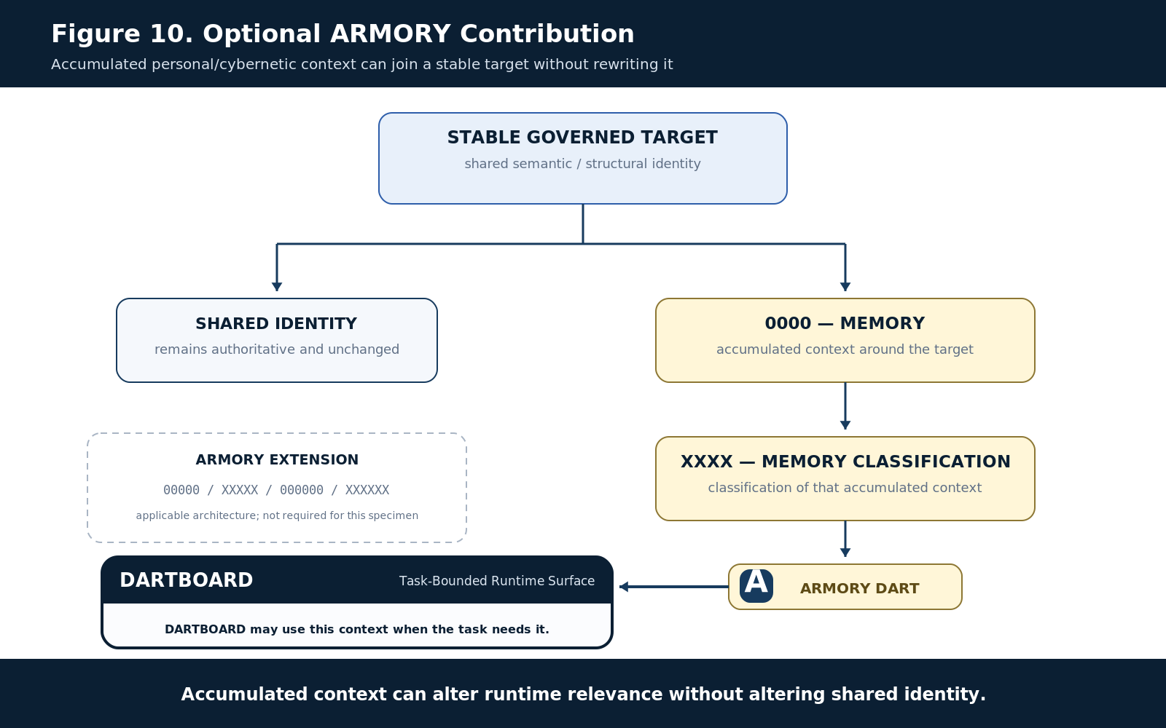
Figure 10. Optional ARMORY contribution.
Accumulated context can alter runtime relevance without altering shared identity.
ARMORY grows density around a stable governed Target. A memory or classification may change what is relevant, familiar, urgent, or useful to the current operator without redefining the shared target itself. That separation protects shared ontology from personal evidence while still letting personal context participate in runtime resolution.

PART 6 - T: Temporal
Temporal participates only when WHEN matters. TIME supplies temporal semantics; DARTBOARD supplies usable projection.

16. Temporal Is Selective
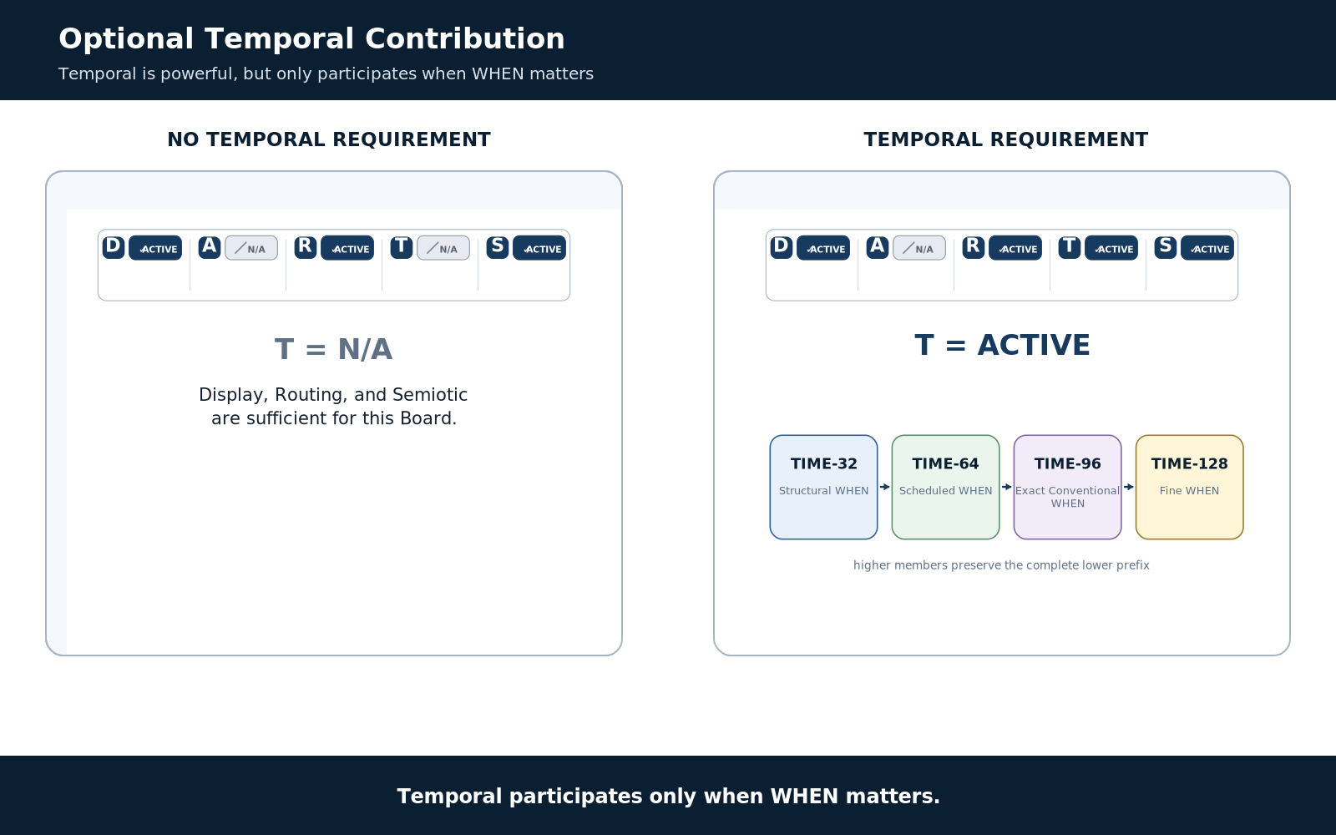
Figure 11. Optional Temporal contribution.
Temporal participates only when WHEN matters.
DARTBOARD is not a temporal architecture. Many complete Boards legitimately have T = N/A. When a task needs temporal coordinate, recurrence, precision, reference basis, or temporal context, the Temporal DART resolves the appropriate TIME semantics and contributes them to the current Board.
TIME uses a prefix-preserving resolution ladder: TIME-32 for structural WHEN, TIME-64 for scheduled WHEN, TIME-96 for exact conventional WHEN, and TIME-128 for fine WHEN. DARTBOARD should use the smallest member sufficient for the asserted temporal semantics.

17. TIME 6×6 Calendar as a Projection Specimen
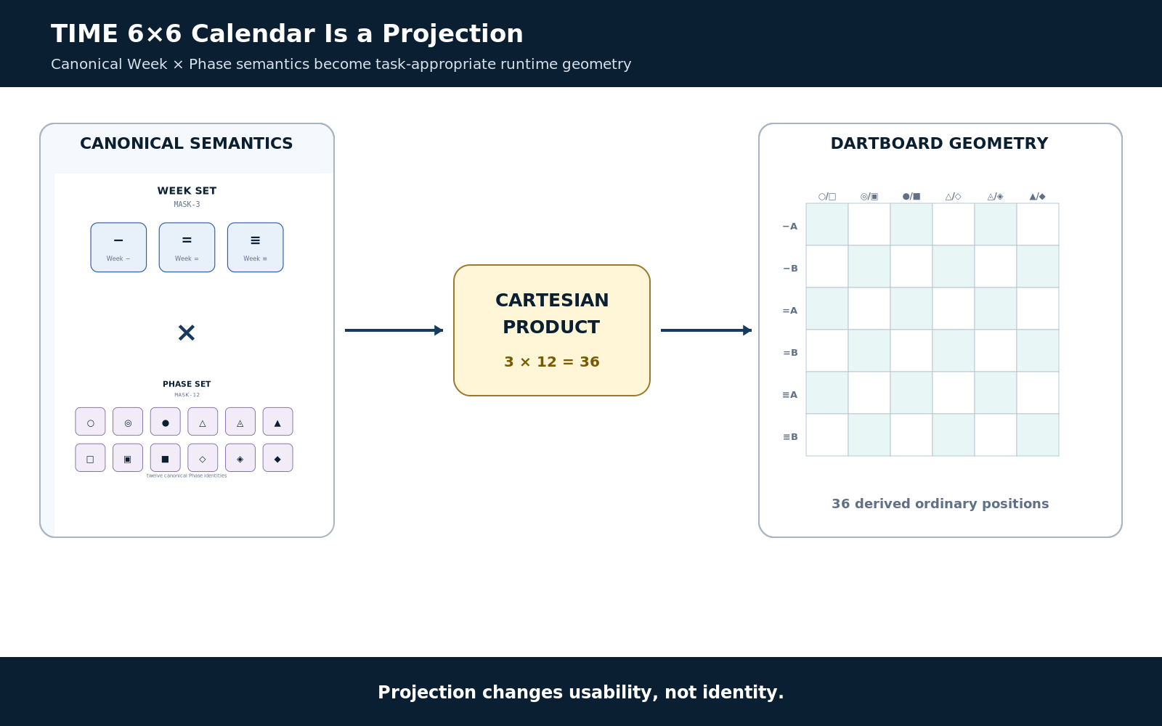
Figure 12. TIME 6×6 calendar is a projection.
Projection changes usability, not identity.
The 6×6 calendar demonstrates DARTBOARD in miniature. Week membership and Phase membership are canonical semantics. Their Cartesian product produces thirty-six ordinary positions. The 6×6 matrix changes geometry for interaction; it does not create thirty-six new stored date identities.
This is the general DARTBOARD rule: canonical structure determines meaning; DARTBOARD determines usable manifestation. The same TIME state can therefore appear as a calendar cell, text coordinate, clock, schedule card, timeline marker, or technical Reader view without changing the temporal Target.

18. Intercalary Stress Test
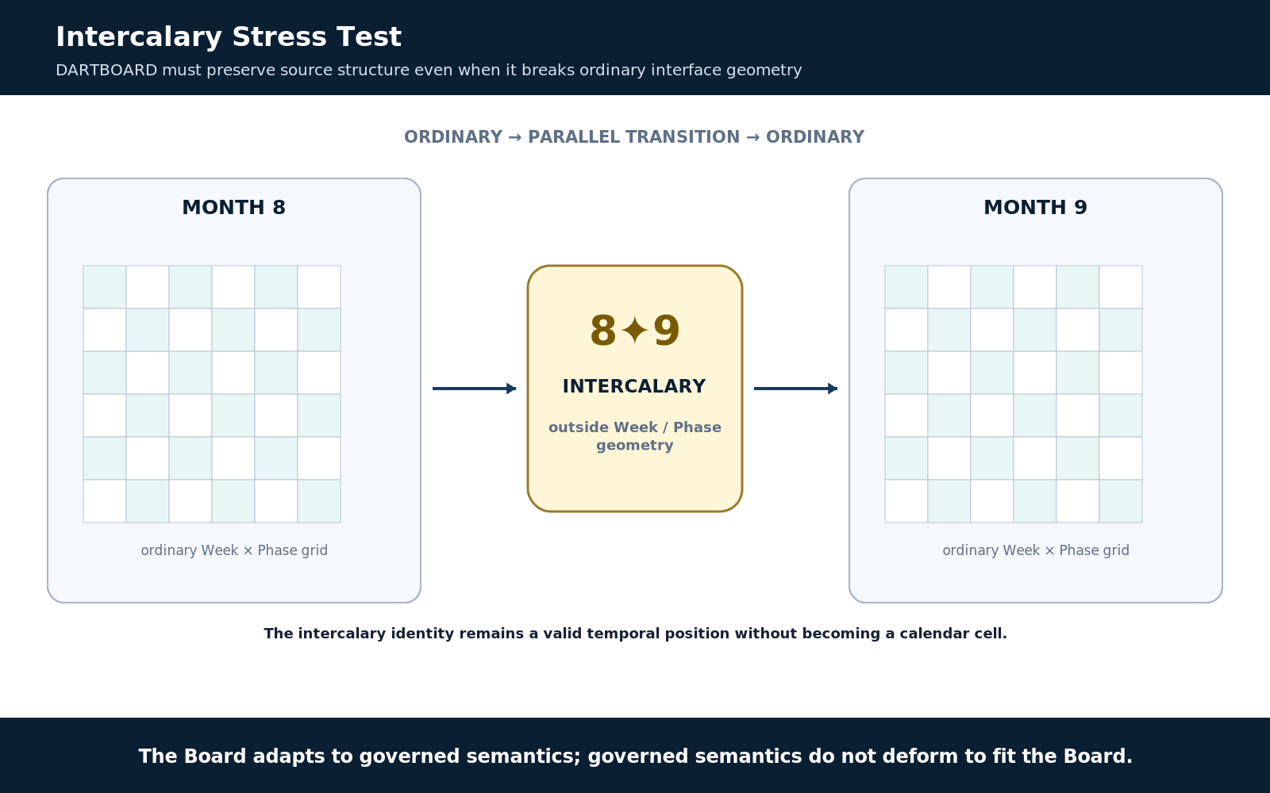
Figure 13. Intercalary stress test.
The Board adapts to governed semantics; governed semantics do not deform to fit the Board.
Intercalary time is the stress test that proves the Board must adapt to semantics rather than forcing semantics into a convenient interface. Intercalary transition positions remain outside ordinary Week/Phase geometry. A compliant Board must preserve that parallel branch instead of pretending every temporal position belongs in the 6×6 grid.
PROJECTION LAW
The Board adapts to governed semantics; governed semantics do not deform to fit the Board.

19. Temporal Context and External Interpretation
TIME may identify reference classes while mutable civil rules or Fine Tick interpretation remain in linked Time Context records. DARTBOARD may manifest an interpreted result, such as a civil-time label, without absorbing ownership of the rules that produced it. This is a general pattern: interpreted state may be displayed while interpretation authority remains external.

PART 7 - S: Semiotic and SOLAR Ingress
BOSS supplies governed meaning and symbolic context; SOLAR gives language a route into that registered territory.

20. Semiotic Origin: BOSS
Semiotic contributes the symbolic and conceptual material needed for a Target to be intelligible in context. BOSS can supply Semantic Symbol, Unique Form, Family, Community, World, description, and related contextual relationships. Meaning, glyph, screen placement, and runtime state remain separable even when DARTBOARD renders them together.

21. SOLAR Is Lexical Ingress, Not a Sixth DART
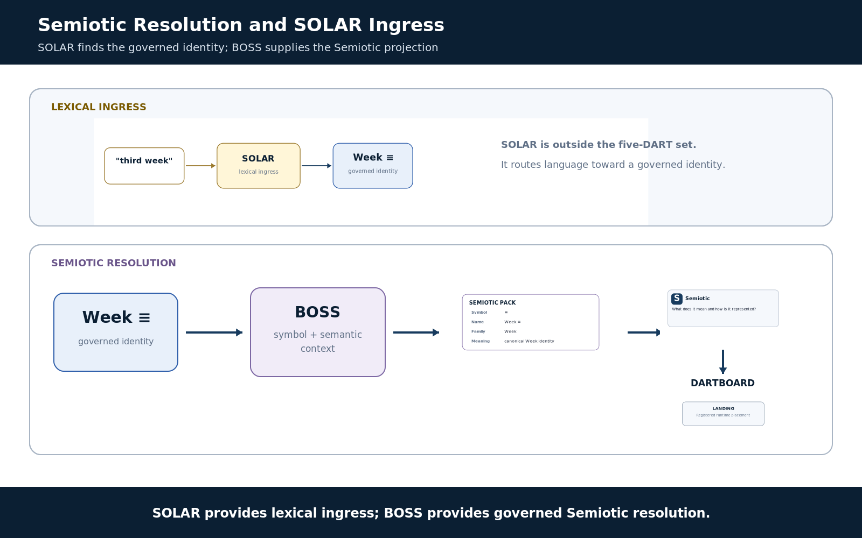
Figure 14. Semiotic resolution and SOLAR ingress.
SOLAR provides lexical ingress; BOSS provides governed Semiotic resolution.
Natural language can enter through SOLAR. A phrase such as “third week” may resolve to the governed Week ≡ identity when context supports that depth. BOSS then supplies the governed Semiotic material for that Target. SOLAR therefore helps find the target; it does not become an additional DARTS projection domain or replace the target’s semantic identity.
Semiotic frequently appears alongside Display. A control can show the registered symbol, name, and semantic explanation without requiring a separate “Semiotic panel.” This is another example of DART participation being independent from screen real estate.

PART 8 - Selective Convergence and Runtime Profiles
DARTBOARD composes an applicable subset, not a mandatory five-way intersection.

22. Selective Convergence
The runtime relationship is best expressed as a selected set rather than D ∩ A ∩ R ∩ T ∩ S. Each Board resolves the domains required by the current task, binds their contributions around governed Targets, and lands them into one coherent runtime surface.
The five-domain architecture therefore acts as a runtime capability profile. The profile helps explain which concerns are present, which are intentionally absent, and which failed to resolve. It also gives implementation and debugging surfaces a compact way to state what a Board is actually using.

23. Four Valid Profiles
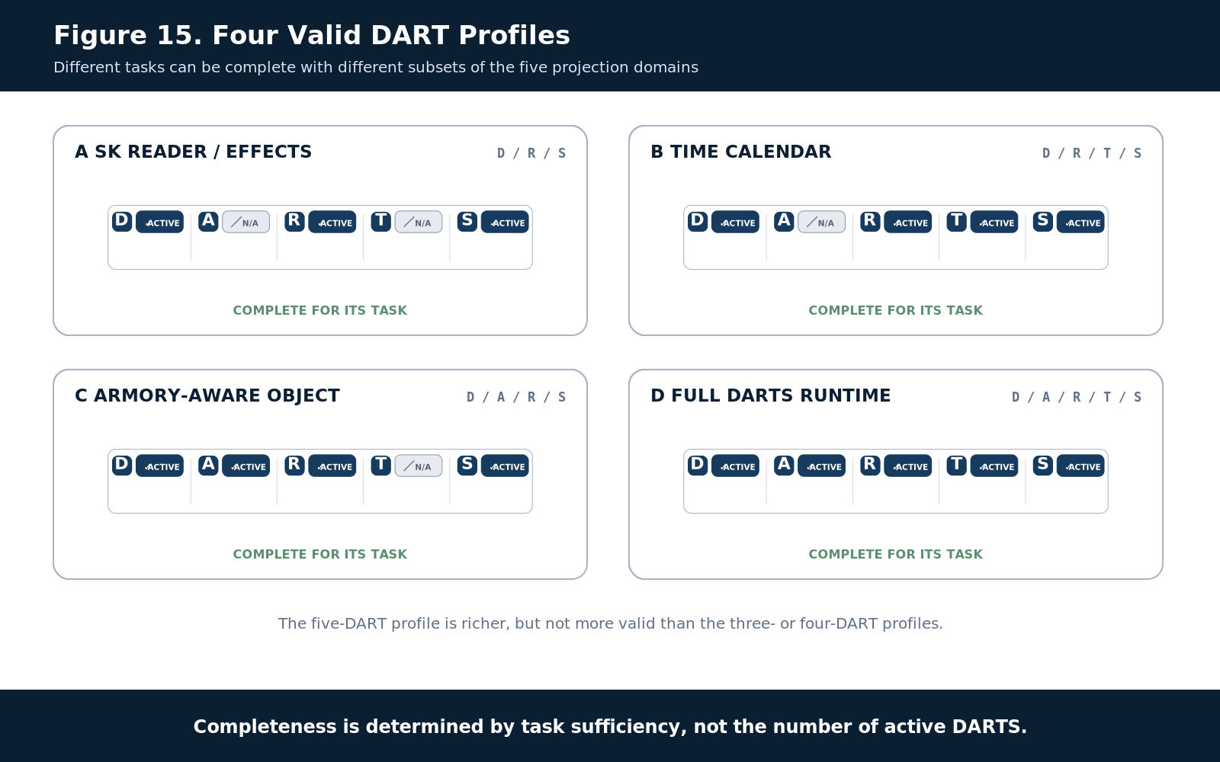
Figure 15. Four valid DART profiles.
Completeness is determined by task sufficiency, not the number of active DARTS.
Profile | D | A | R | T | S | Purpose
SK Reader / Effects | ACTIVE | N/A | ACTIVE | N/A | ACTIVE | Interface + exact routing + meaning; no personal or temporal requirement.
TIME Calendar | ACTIVE | N/A | ACTIVE | ACTIVE | ACTIVE | Calendar manifestation over temporal structure with exact routing and symbolic context.
ARMORY-Aware Object | ACTIVE | ACTIVE | ACTIVE | N/A | ACTIVE | Shared semantic object enriched by personal context without requiring WHEN.
Full DARTS Runtime | ACTIVE | ACTIVE | ACTIVE | ACTIVE | ACTIVE | All five dimensions are relevant; this is valid but not the default.

COMPLETENESS RULE
A full five-DART profile is not “more correct” than a three-DART profile. The correct profile is the smallest complete set for the task.

PART 9 - SK Reader as a Specialized DARTBOARD Path
The existing Semantic Kernel runtime is a specialized Routing-to-Display mechanism inside the broader Board.

24. Specialized R → D Path
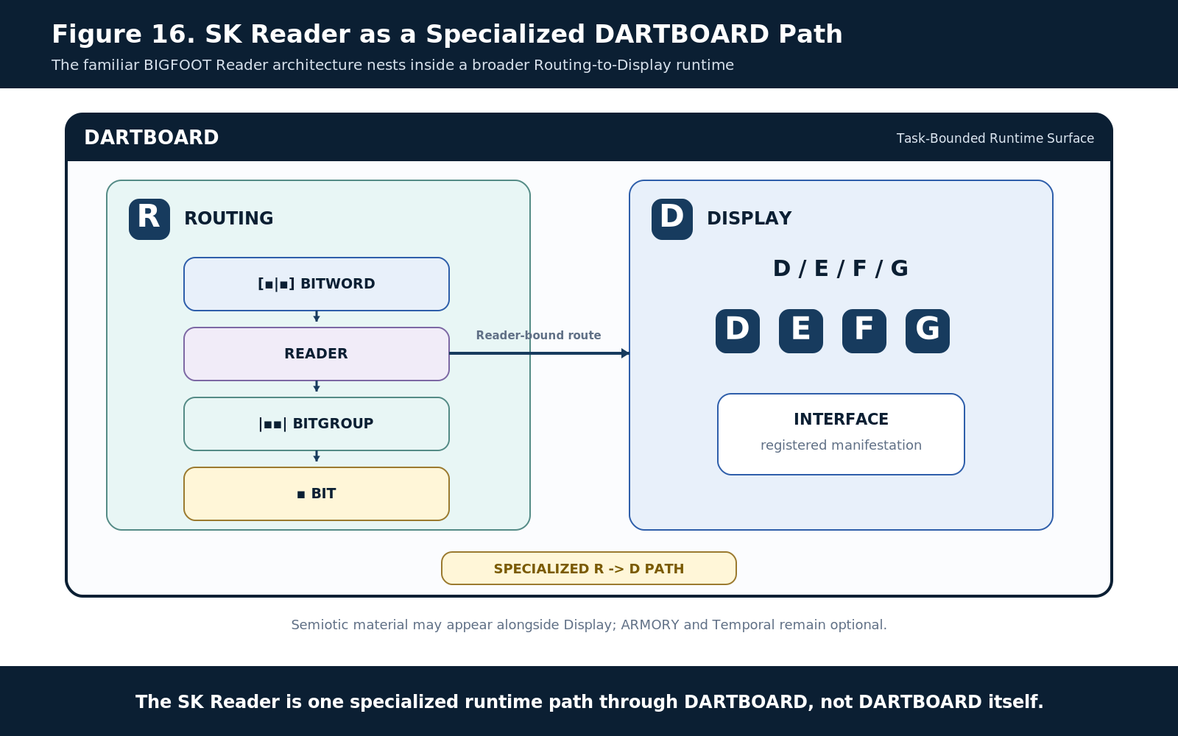
Figure 16. SK Reader as a specialized DARTBOARD path.
The SK Reader is one specialized runtime path through DARTBOARD, not DARTBOARD itself.
The earlier DARTBOARD SK Runtime Interpretation & Interface Architecture remains valid. A registered BitWord exposes ordered placements; the Reader resolves BitGroups and formulas; DARTBOARD renders the appropriate D/E/F/G controls; and interaction changes governed encoded state through authorized paths. The important reconstruction correction is scope: this is one specialized Routing → Display path, not the whole DARTBOARD architecture.
The same Board may add Semiotic material from BOSS, Temporal information from TIME, or ARMORY context around the Reader surface. Conversely, a Board may contain no Semantic Kernel editor at all. The specialized runtime substrate is therefore reusable without becoming universal ownership.

25. Generated Controls and Semantic Preservation
A generated control is a projection over registered semantics. Its geometry, color, label, symbol, or interaction style may evolve while the same BitGroup identity and Reader semantics remain stable. Visibility does not grant authority; interface-only state must not become a hidden second truth store.
SURFACE INHERITANCE
Read the Word. Render the Groups. Operate through the Board. The generated interface remains a projection over registered state.
PART 10 - Governed Interaction, Mutation, and Reprojection
DARTBOARD directs interaction; authoritative owners validate and commit state.

26. Visibility Is Not Authority
A visible or manipulable control does not automatically have permission to mutate the Target it represents. DARTBOARD must respect source ownership, action contracts, permissions, Rules, Operators, and scoped Instances. Mutation authority is resolved separately from presentation.

27. Governed Mutation Loop
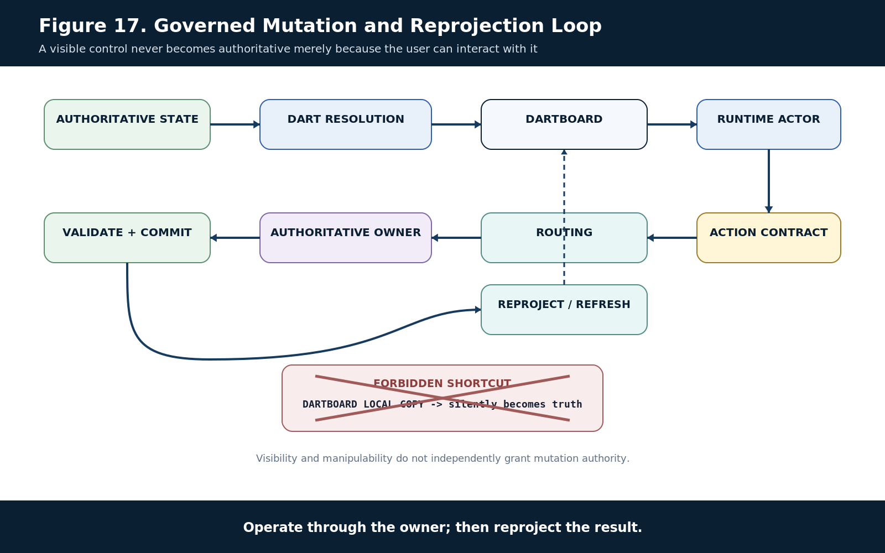
Figure 17. Governed mutation and reprojection loop.
Operate through the owner; then reproject the result.
Runtime interaction follows a closed governance loop. Authoritative state is resolved through QUIVER and the applicable DARTS. DARTBOARD manifests the result. Human, AI, controller, or script input invokes an explicit action contract. Routing reaches the authoritative owner, which validates and commits the change. DARTBOARD then refreshes or reprojects from the updated state.
The prohibited shortcut is for a local interface copy to silently become truth. Derived surface state can exist for interaction, but a committed semantic change must be written through the proper owner with provenance and validation.

28. Refresh, Reprojection, and Staleness
Because a Board is derived, it must respond when relevant authoritative state changes. A stale manifestation should be refreshed, invalidated, or visibly marked stale rather than continuing to look canonical. Reprojection is therefore part of the lifecycle, not merely a cosmetic redraw.
MUTATION LAW
Operate through the owner; then reproject the result.

PART 11 - Ownership Boundaries
DARTBOARD owns runtime composition; source systems retain canonical authority.

29. What DARTBOARD Owns
- The task-bounded runtime composition and current Board manifestation.
- The resolved applicability profile for the current Board.
- Runtime Landing relationships and the co-presence of applicable projections.
- The interaction surface and projection lifecycle needed to keep that manifestation usable.
- The exposure of registered action/routing contracts to the runtime surface.
- Derived Board-local state necessary for presentation, provided it remains distinguishable from canonical truth.

30. What DARTBOARD Does Not Own
- BIGFOOT Bit, BitGroup, BitWord, Reader, or structural semantic identity.
- BOSS semantic or symbolic identity.
- SOLAR lexical identity or alias truth.
- TIME canonical temporal state or Time Context authority.
- ARMORY source memories, classifications, reflections, or persona evidence.
- VISOR registry/table structural truth.
- QUIVER relationship authority.
- Effects, Skene, Praxis, or specialist system internals.
- Mutation authority merely because a control is visible.
- Copies of canonical records masquerading as independent runtime truth.

31. Complete Ownership Map
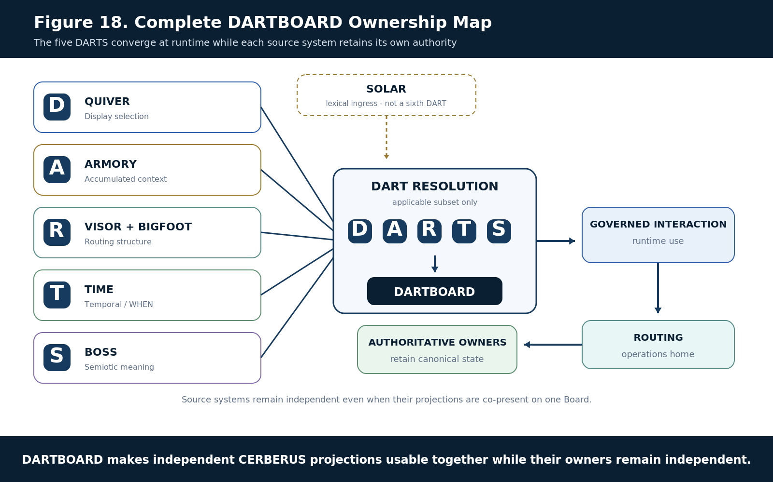
Figure 18. Complete DARTBOARD ownership map.
DARTBOARD makes independent CERBERUS projections usable together while their owners remain independent.
The ownership map is the final reconstruction view. QUIVER supplies task-relevant relational selection, ARMORY supplies optional accumulated context, VISOR and BIGFOOT supply Routing, TIME supplies Temporal semantics, BOSS supplies Semiotic meaning, and SOLAR provides lexical ingress outside the DARTS set. DARTBOARD composes only their applicable runtime projections and routes mutating operations back to the systems that own state.
SOURCE PERSISTENCE
Destroy or replace the DARTBOARD surface and the underlying registered systems remain. Rebuild the surface from those sources.

PART 12 - Worked Runtime Profiles
The same five-domain grammar describes very different surfaces without making them use identical content.

32. Example A - SK Reader / Effects Surface
Profile: D ACTIVE / A N/A / R ACTIVE / T N/A / S ACTIVE. QUIVER selects the appropriate D/E/F/G Interface Elements and effects. Routing exposes the path into the relevant BitWord, Reader, BitGroup, or Bits. Semiotic meaning from BOSS can be displayed alongside the control. No personal history or WHEN semantics are required, so ARMORY and Temporal remain explicitly N/A.

33. Example B - TIME 6×6 Calendar
Profile: D ACTIVE / A N/A / R ACTIVE / T ACTIVE / S ACTIVE. Display provides the 6×6 calendar manifestation. Routing reaches the relevant TIME BitWord and Reader roles. Temporal contributes Month, Week, Phase, Year, clock, precision, and context as required. Semiotic contributes the governed Week and Phase symbols and explanatory meaning. ARMORY remains N/A unless personal history or relevance is intentionally added.

34. Example C - ARMORY-Aware Semantic Object
Profile: D ACTIVE / A ACTIVE / R ACTIVE / T N/A / S ACTIVE. The Board manifests a shared governed target, routes to its exact structure, and displays BOSS meaning. ARMORY adds Memory or Classification context that changes personal relevance without redefining the shared object. No temporal assertion is manufactured merely because historical records could exist.

35. Example D - Full DARTS Runtime
Profile: D ACTIVE / A ACTIVE / R ACTIVE / T ACTIVE / S ACTIVE. All five domains may legitimately participate when the task needs interface manifestation, personal context, exact routing, temporal semantics, and symbolic meaning at once. This is the maximal profile, not the canonical default.

PART 13 - Normative DARTBOARD Laws
The laws below are the reconstruction contract for a conforming implementation or assistant mental model.

36. Inherited DARTS Laws
DARTBOARD inherits five global DARTS principles: projection independence, selective participation, authority preservation, surface convergence, and source persistence. These establish that projections may evolve independently, only relevant domains participate, convergence does not transfer authority, relevant projections may share one usable surface, and the surface can be replaced without destroying its sources.

37. DARTBOARD Laws
ID | Law | Normative statement
DB-R01 | Selective DARTS Law | A DARTBOARD runtime SHALL resolve only the DARTS domains applicable to the current task.
DB-R02 | N/A Distinction Law | A non-applicable DART SHALL NOT be treated as unresolved or missing.
DB-R03 | Ownership Preservation Law | Projection onto DARTBOARD SHALL NOT transfer canonical ownership from the source system.
DB-R04 | Governed Target Law | Every operative manifestation SHALL resolve to a governed Target or compound Target.
DB-R05 | Landing Distinction Law | Runtime placement SHALL remain distinct from the Target it manifests.
DB-R06 | Explicit Composition Law | Visual adjacency, shared geometry, or label proximity SHALL NOT establish semantic composition.
DB-R07 | Display Coverage Law | D/E/F/G SHALL describe semantic coverage rather than physical screen dimensions.
DB-R08 | Projection Identity Law | Interface geometry SHALL NOT be treated as canonical semantic identity.
DB-R09 | DART Co-Presence Law | Multiple DARTS MAY contribute to one runtime manifestation when they resolve to the same governed Target.
DB-R10 | Visibility Authority Law | Visibility or manipulability of a runtime control SHALL NOT independently grant mutation authority.
DB-R11 | Routed Mutation Law | State-changing operations SHALL return through governed Routing to the authoritative owner.
DB-R12 | Semantic Preservation Law | DARTBOARD SHALL preserve distinctions established by authoritative source semantics.
DB-R13 | External Interpretation Law | Interpreted results MAY be manifested without transferring ownership of the external interpretation authority.
DB-R14 | Minimum Resolution Law | Runtime resolution SHOULD stop at the minimum sufficient structural and semantic depth required by the task.
DB-R15 | Refresh Law | Derived runtime projections SHALL be refreshed, invalidated, or identified as stale when relevant authoritative state changes.
DB-R16 | Participation / Visibility Separation | A DART MAY participate operationally without receiving a distinct visible manifestation.
DB-R17 | Lexical Ingress Separation | SOLAR lexical routing MAY resolve a Target but SHALL NOT become a substitute for that Target’s semantic identity.

38. Conformance Failure Patterns
Failure | Why it is non-conforming
All five DARTS required on every Board | Violates selective participation and treats N/A as an error.
Calendar cell treated as the canonical TIME identity | Collapses runtime geometry into temporal truth.
BOSS symbol or SOLAR alias used as routing identity by string match alone | Collapses Semiotic or lexical projection into canonical identity.
Visible control writes directly to an ungoverned local copy | Breaks ownership and routed mutation.
ARMORY memory changes the shared semantic definition | Collapses personal context into shared ontology.
UI adjacency creates an undeclared composite | Violates explicit composition.
Intercalary time forced into the ordinary 6×6 grid | Deforms source semantics to fit Display geometry.

PART 14 - Reconstruction and Implementation Handoff
A fresh assistant should be able to reconstruct DARTBOARD from the five DARTS, their source boundaries, and the governed runtime loop.

39. Reconstruction Sequence
1. Learn the five DARTS and their independent ownership boundaries.
2. Learn that DARTS is not a five-stage pipeline.
3. Learn ACTIVE / N/A / UNRESOLVED and treat N/A as a valid complete state.
4. Learn singular DART as a task-scoped resolved contribution.
5. Learn governed Target, Anchor, and Landing; Target ≠ Landing.
6. Learn D/E/F/G as Display semantic coverage.
7. Learn Routing from VISOR into BIGFOOT/Readers only as deep as required.
8. Learn ARMORY as optional accumulated context.
9. Learn TIME as optional WHEN resolution and the 6×6 calendar as a projection.
10. Learn BOSS as Semiotic resolution and SOLAR as lexical ingress outside DARTS.
11. Learn multi-DART convergence around one Target.
12. Learn visibility ≠ authority and route mutations back to the owning system.
13. Learn refresh/reprojection after canonical change.
14. Learn that the Board is derived and replaceable while its sources persist.

40. Reconstruction Tests
Prompt / situation | Expected reconstruction
BitWord editor with semantic labels; no personal or temporal context | D ACTIVE / A N/A / R ACTIVE / T N/A / S ACTIVE.
User changes a governed value on the Board | Action contract → Routing → authoritative owner validates and commits → Board reprojects.
Same TIME coordinate shown as calendar, text, and timeline | One Target; several Landings. Manifestation changes; identity does not.
A required TIME reference cannot resolve | T = UNRESOLVED, not N/A.
Phrase “third week” enters from language | SOLAR may route to Week ≡; BOSS supplies Semiotic context; SOLAR is not a sixth DART.
Board is deleted or replaced | Canonical source systems remain and can rebuild the surface.

41. Implementation Handoff
The current Airtable implementation already separates the DARTS source surfaces. Display is represented through the Display root and D/E/F/G tables. ARMORY demonstrations should use 0000 and XXXX while the later ARMORY tables continue to evolve. Routing begins with VISOR Stack/Table structures and descends through BIGFOOT BitWord, BitGroup, and Bit records as required. Temporal uses the CERBERUS TIME architecture. Semiotic uses BOSS, while SOLAR supplies lexical routes into the registered network.
IMPLEMENTATION RULE
The live registry tables are implementation surfaces. The reconstruction artifact defines responsibility and traversal; implementation may evolve without collapsing those boundaries.

APPENDIX A - Implementation Source Map
Current registry surfaces provided for DARTBOARD reconstruction and implementation navigation.

A.1 Display - QUIVER / D/E/F/G
Display root 🖥️: Open Airtable
Display D 🖥️ D: Open Airtable
Display E 🖥️ E: Open Airtable
Display F 🖥️ F: Open Airtable
Display G 🖥️ G: Open Airtable

A.2 ARMORY
0000: Open Airtable
XXXX: Open Airtable
The wider ARMORY table sequence 00000, XXXXX, 000000, and XXXXXX remains architecturally applicable. For this reconstruction artifact, 0000 and XXXX are the primary demonstration surfaces because later tables are still being updated.

A.3 Routing - VISOR and BIGFOOT
VISOR Stack 🗃: Open Airtable
VISOR Registry Table 🗄️: Open Airtable
BIGFOOT Bit ▪︎: Open Airtable
BIGFOOT BitGroup |▪︎▪︎|: Open Airtable
BIGFOOT BitWord [▪︎|▪︎]: Open Airtable
BIGFOOT BitWord Folder [▪︎|▪︎] 📁: Open Airtable

A.4 Temporal
Temporal resolution is supplied by the CERBERUS TIME architecture, including the 6×6 operational calendar projection, TIME-32/64/96/128 resolution ladder, Week and Phase identities, intercalary branch, clock/precision semantics, and Time Context boundary. DARTBOARD uses TIME when T is applicable; it does not reproduce TIME as a local calendar schema.

A.5 Semiotic
BOSS ⭐: Open Airtable
BOSS supplies the governed Semiotic layer. SOLAR supplies lexical Names/Aliases and ingress routes into registered semantic territory; it remains outside the five-DART acronym.

A.6 Document and Figure Source Basis
Source | Role in this artifact
CERBERUS DARTS Architecture v0.1 | Defines the five global projection domains, selective participation, authority preservation, surface convergence, and DARTBOARD as the bounded meeting surface.
CERBERUS DARTBOARD - Semantic Kernel Runtime Interpretation & Interface Architecture v0.1 | Defines the generic BitWord/BitGroup/Reader runtime, generated controls, governed mutation, and interface-as-projection boundary.
CERBERUS DARTBOARD Formal Specification v0.1 | Defines the broader operational surface, authority law, runtime direction, and the principle that DARTBOARD is not a truth store.
CERBERUS TIME_DESCRIPTIVE-101 v0.1 | Provides the canonical temporal specimen: TIME ownership of WHEN, 6×6 projection, intercalary isolation, BOSS/SOLAR separation, and D/E/F/G publication examples.
DARTBOARD Pass 6 Figure Registry | 18 approved Figure Contracts implemented as 18 Compound Constructs and 18 rendered publication artifacts.

APPENDIX B - Figure Index
The 18 approved Pass 6 Compound Constructs used by this Verified Release.

Fig. | Title | Figure ID | Compound ID | Build
1 | DARTBOARD runtime thesis | DB-FG-001 | DB-CC-001 | Wave D
2 | Five DARTS domain atlas | DB-FG-002 | DB-CC-002 | Wave A
3 | Selective DART profile | DB-FG-003 | DB-CC-003 | Wave A
4 | Anatomy of one DART | DB-FG-004 | DB-CC-004 | Wave A
5 | Target, Anchor, and Landing | DB-FG-005 | DB-CC-005 | Wave A
6 | Multiple DARTS, one manifestation | DB-FG-006 | DB-CC-006 | Wave A
7 | D/E/F/G Display coverage ladder | DB-FG-007 | DB-CC-007 | Wave B
8 | QUIVER-to-Display resolution | DB-FG-008 | DB-CC-008 | Wave B
9 | Routing descent | DB-FG-009 | DB-CC-009 | Wave B
10 | Optional ARMORY contribution | DB-FG-010 | DB-CC-010 | Wave B
11 | Optional Temporal contribution | DB-FG-011 | DB-CC-011 | Wave C
12 | TIME 6×6 calendar is a projection | DB-FG-012 | DB-CC-012 | Wave C
13 | Intercalary stress test | DB-FG-013 | DB-CC-013 | Wave C
14 | Semiotic resolution and SOLAR ingress | DB-FG-014 | DB-CC-014 | Wave C
15 | Four valid DART profiles | DB-FG-015 | DB-CC-015 | Wave D
16 | SK Reader as a specialized DARTBOARD path | DB-FG-016 | DB-CC-016 | Wave D
17 | Governed mutation and reprojection loop | DB-FG-017 | DB-CC-017 | Wave D
18 | Complete DARTBOARD ownership map | DB-FG-018 | DB-CC-018 | Wave D

Closing System Statement
DARTBOARD
DARTS describe the available projection domains. DARTBOARD selects the applicable contributions, resolves them around governed Targets, manifests them through registered Landings, and routes operations back to their owners. The Board may disappear; the canonical systems remain.

Operational Compression
DART | Ask only when applicable
D - Display | What should be manifested, and at what D/E/F/G semantic coverage?
A - ARMORY | What accumulated personal or cybernetic context matters?
R - Routing | Where is the governed Target and how deeply must the route descend?
T - Temporal | Does WHEN matter, and what TIME resolution is sufficient?
S - Semiotic | What governed meaning, symbol, or conceptual context should accompany the Target?

A conforming Board is the smallest complete composition for the task. It may use three DARTS, four DARTS, all five, or any other applicable subset. Its runtime geometry can change. Its source systems remain authoritative and rebuildable.

