CERBERUS | WORLD CONTINUITY ARCHITECTURE
CAUSAL RESIDUE &
PROCEDURAL RECONSTRUCTION
The Liminal Architecture Between BitState, World History, and Memory
Paper intent
Define how a persistent World can conserve causal continuity without retaining an exhaustive recording of ordinary activity. The architecture separates completed causal residue, unfinished obligations, durable Event identity, autobiographical access, and procedural reconstructability so that each persists only when the future still needs it.
CORE THESIS
The World does not preserve every event. It preserves the causal differences, unresolved obligations, significant histories, and reconstructive conditions required for the future.
Version 0.1 | August 2026 | Verified Release
Professional Architecture Paper

Executive Summary
A persistent simulated World does not need to remember everything that ever happened. It needs to preserve enough causal structure for present state to remain authoritative, unfinished consequences to remain resolvable, historically significant occurrences to remain queryable, autobiographically relevant experience to remain reconstructable, and ordinary missing detail to remain bounded by the mechanisms that were actually possible at the time.
This paper defines the liminal architecture between BitState and Memory Mechanics. It explains where causal information can live when it is not retained as autobiographical memory and why an Event representation may disappear even though its consequences remain. A cooked steak can remain cooked through Sticky State without a permanent record that Paul cooked it. A High Five outcome can remain causally active as DRAW_CARD × 1 before a card reaches the player hand. A rebuilt farmhouse can be explained probabilistically from historical scripts, capabilities, institutions, resources, TIME, and Location without inventing an exact builder when none is known.
The design therefore favors causal conservation without representational conservation. The World keeps the forms of the past that still have work to do. Everything else may be reconstructed from surviving constraints or allowed to remain unknown.
LAW | The past persists only in the forms required by the future.

Field Specification
Document role | Liminal architecture / world continuity and reconstructive memory bridge
Primary boundary | BitState Architecture → Causal Persistence → Memory Mechanics
Occurrence-specific channels | State, Contract, World Event Log, T-Key Memory Groove
Reconstructive substrate | Procedural World Memory: Scripts, Rules, capabilities, institutions, resources, historical state, TIME, and Location
Epistemic statuses | KNOWN, CONSTRAINED, LIKELY, UNKNOWN
Worked examples | Steak causal residue; High Five DRAW_CARD × 1; farmhouse reconstruction and exception evidence
Status | Pass 8 Verified Release

Visual Roadmap
The eight figures form a parallel argument: boundary -> persistence vocabulary -> completed causality -> unfinished causality -> durable Event identity -> procedural reconstruction -> evidence precedence -> integrated causal lifecycle. The visual grammar remains fixed throughout: State is blue, Contract orange, Event lavender, Memory green, Procedure yellow, and UNKNOWN gray. Color is redundant with explicit labels rather than being the sole carrier of meaning.

1. Purpose - The Gap Between State and Memory
An occurrence happens in the World. Some consequences matter after the moment ends; others do not. The architectural problem is therefore not simply whether the World should "remember" the Event. It is to determine what causal information remains necessary, what form should carry it, and when the original Event representation may safely disappear.
At one side of this paper sits BitState Architecture, which answers what is authoritatively true now. At the other sits Memory Mechanics, which governs what a T-Key can later reconstruct or recollect autobiographically. Neither system alone explains where ordinary causal information lives between those two questions. This paper owns that bridge.
The bridge is intentionally narrow. It does not redefine BitWords, Sticky State, T-Key Grooves, the World Event schema, or the deeper mechanics of memory reconstruction. Instead, it explains how causal information reaches those structures and when information need not reach them at all.
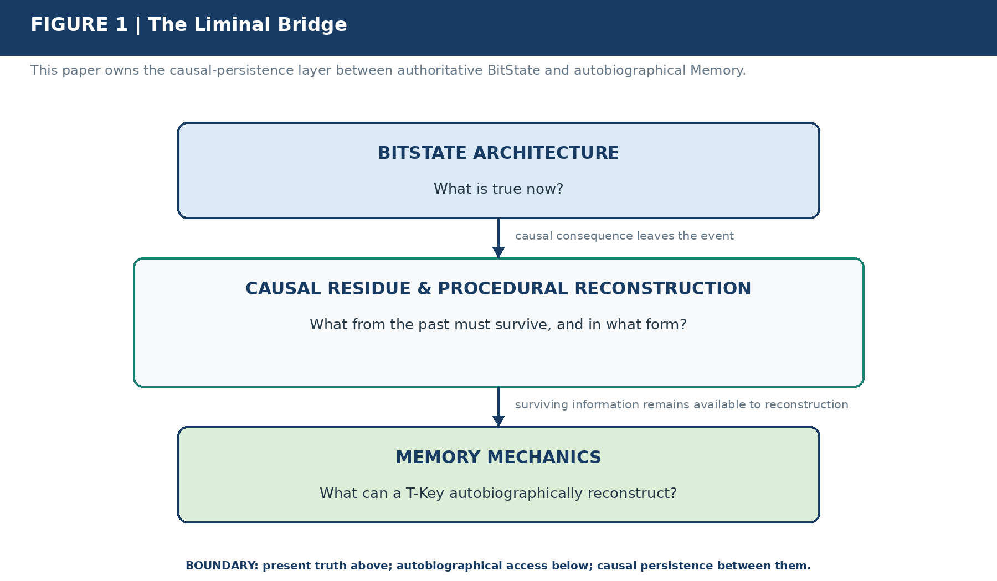
Figure 1. The Liminal Bridge. This paper owns the transition between persistent semantic state and reconstructable personal memory. It does not redefine either neighboring architecture.
DISTINCTION | BitState records authoritative present truth. Memory Mechanics governs autobiographical access. This bridge governs which causal differences must remain available between them.

2. The Causal Persistence Vocabulary
For direct occurrence routing, four questions matter immediately: What became true? What remains owed? Does the occurrence itself retain independent historical value? Does the occurrence remain autobiographically addressable to a particular person? Those questions route information toward State, Contract, World Event Log, and T-Key Memory Groove respectively.
A fifth visual identity, Procedure, names a different but equally important form of persistence: the historically valid mechanisms that make ordinary missing detail reconstructable. Procedure is usually not an Event output. A farmhouse reconstruction does not emit the Builder's Guild, construction rules, or skill requirements; those structures already exist in the World and constrain what histories remain possible.
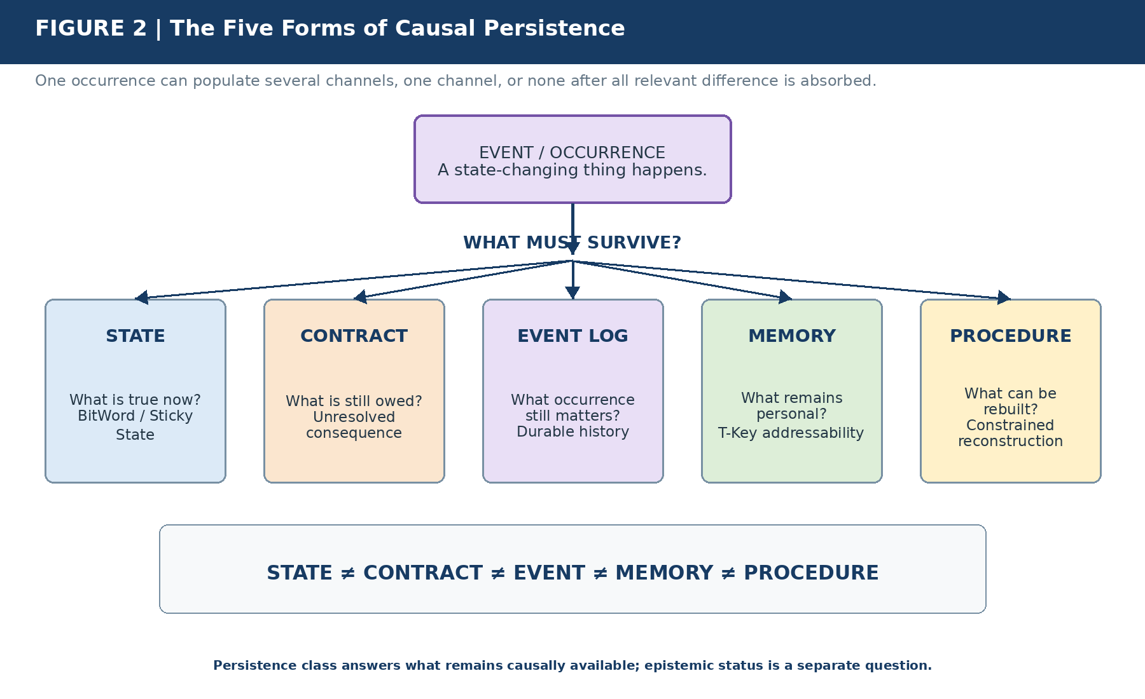
Figure 2. The Five Forms of Causal Persistence. An occurrence can survive as authoritative state, unresolved obligation, durable history, autobiographical addressability, or reconstructive possibility. Persistence in one channel does not imply persistence in the others.
DISTINCTION | STATE ≠ CONTRACT ≠ EVENT ≠ MEMORY ≠ PROCEDURE. The categories answer different causal questions and none is a substitute for another.

A single occurrence may populate several channels at once. A major fire can alter state, emit unresolved insurance or reconstruction obligations, remain in the World Event Log, and become a durable memory for witnesses. An ordinary meal may leave only changed food, inventory, and hunger state. Once all relevant causal difference has been absorbed, no additional Event or memory representation is required.

3. BitState as Causal Residue
The most economical persistence mechanism is often the state of the thing that changed. Before Paul cooks a steak, the steak can be represented by a bounded set of semantic states such as Cooked = 0, Doneness = RAW, and Surface = UNSEARED. The COOK Operator executes and terminates. Afterward, the steak can carry Cooked = 1, Doneness = MEDIUM, and Surface = SEARED. The action is over; the resulting state is not.
This is causal residue. The past has been compiled into the present configuration of an authoritative NodeKey. The World does not need to replay every historical action to determine what exists now, and it does not need to retain an exhaustive Event ledger merely because current objects bear consequences of earlier transitions.
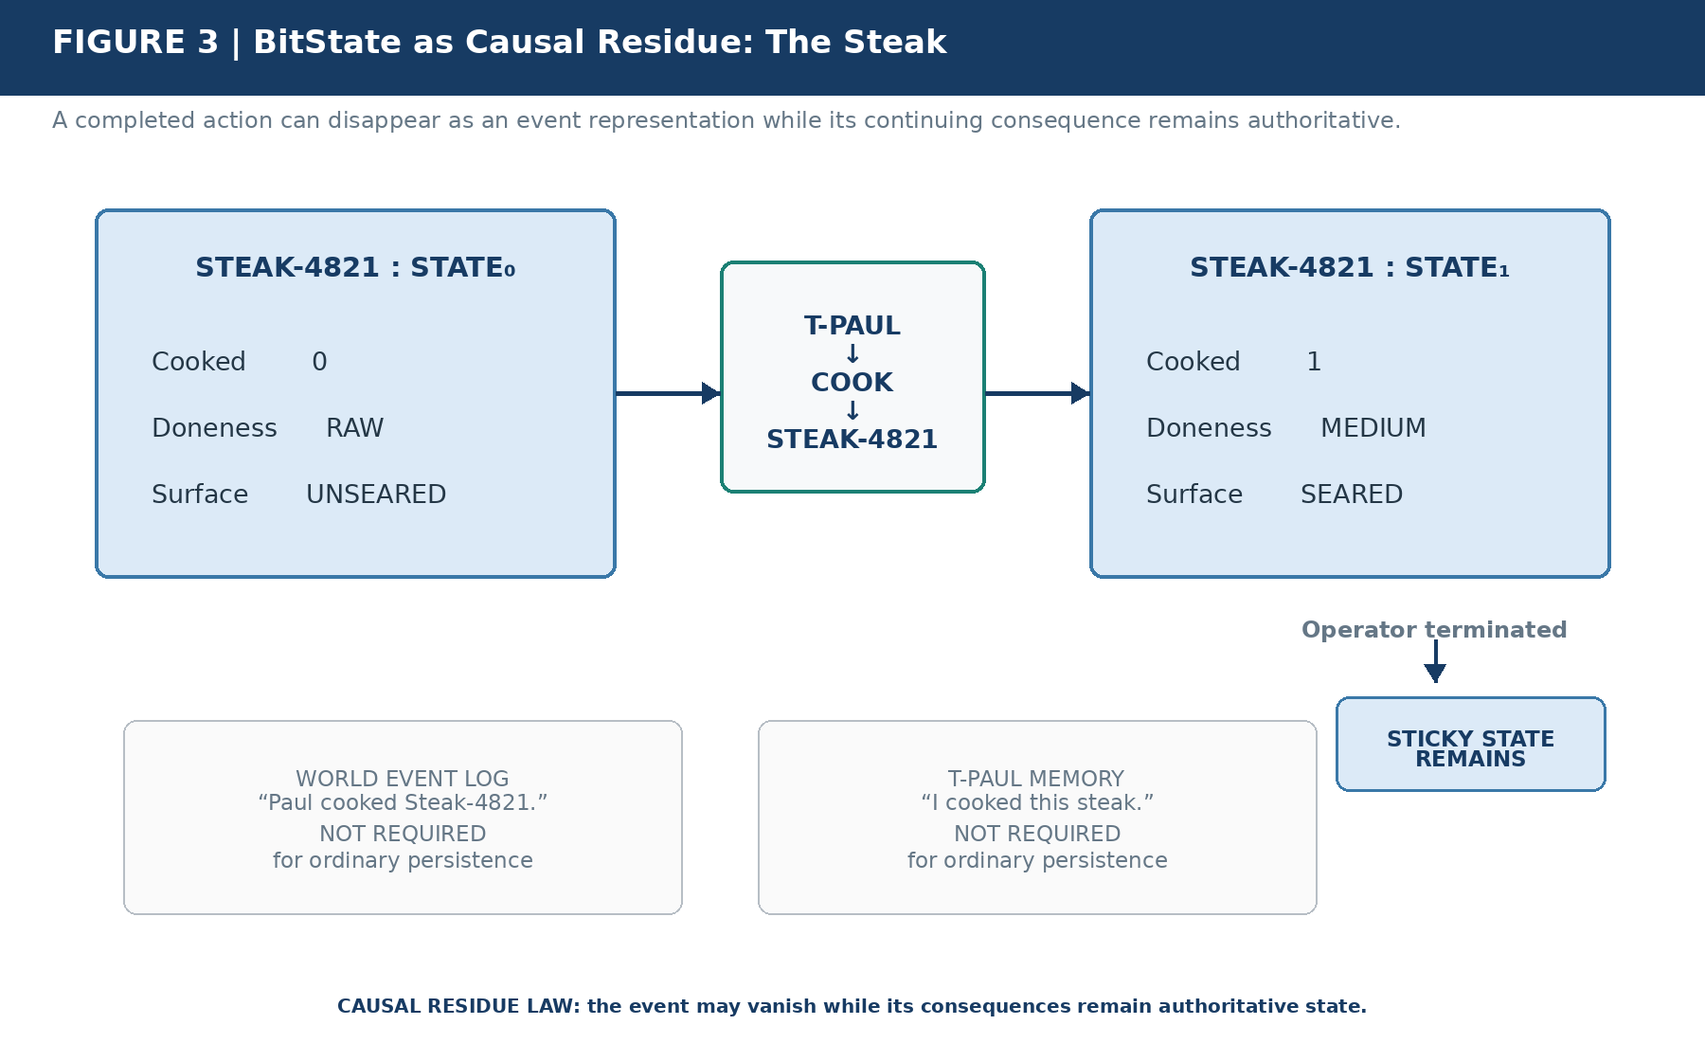
Figure 3. BitState as Causal Residue. The COOK Operator can terminate while the steak's Sticky State remains authoritative. A permanent Event record or autobiographical memory is optional unless independent historical or personal significance warrants it.
LAW | An event may cease to exist as a representation while its consequences continue to exist as authoritative state.

Sticky State makes this especially clear. A state such as COOKED remains after the Operator that produced it has terminated and persists until another legitimate transition changes it. Later, EAT may move that object into a consumed state. Continuity therefore advances as State₀ → Operator → State₁ → Operator → State₂, rather than by replaying a complete recording of the past.
"Not required" does not mean "forbidden." If the meal becomes evidentially important, historically significant, or personally distinctive, the occurrence may also persist through other channels. The routine case simply does not need them.

4. Contract Persistence - Causality Not Yet Absorbed
State residue handles completed causal consequences. Contracts handle the complementary case: the consequence has been earned or caused, but the authoritative result does not yet exist. High Five provides a clean example. A Scene outcome may award DRAW_CARD × 1 without directly knowing how a valid card draw must be implemented.
The outcome therefore becomes an unresolved obligation. An authorized resolver later evaluates the currently valid deck, Rules, player modifiers, Chance Set, replacement effects, and target state. Only after that resolver commits a valid card to the player hand has the causal difference been absorbed into state.
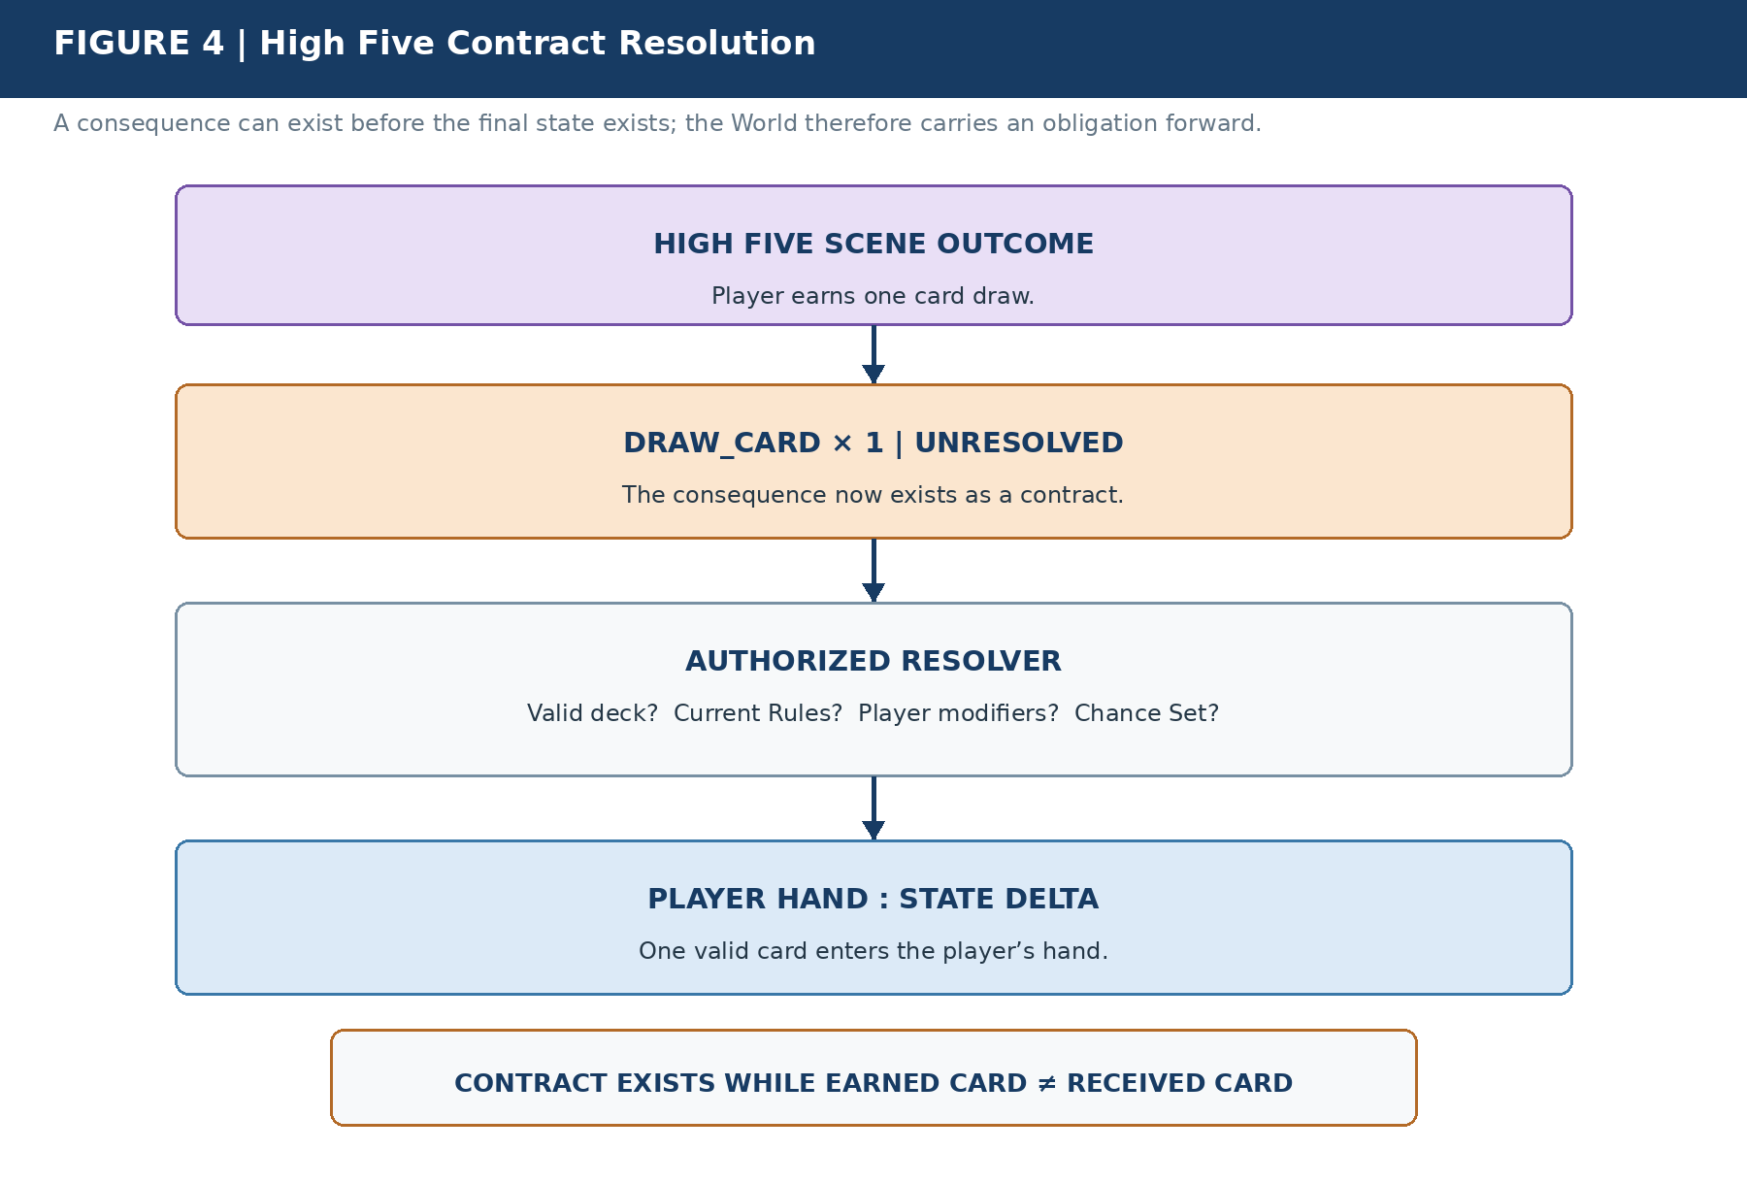
Figure 4. High Five Contract Resolution. The Scene does not need hard-coded knowledge of how card drawing is implemented. It emits the consequence contract; an authorized resolver interprets current Rules and valid sources before committing the state delta.
LAW | An outcome need not perform its consequence; it may create an obligation that persists until an authorized resolver absorbs the consequence into state.

The important inequality is EARNED CARD ≠ RECEIVED CARD. The unresolved Contract exists precisely because those states differ. Once the hand contains the legitimate result, the Contract can disappear or be marked satisfied. If resolution itself emits further bounded obligations, the World can carry those forward in turn.
This creates a broader World Between Frames principle: the World is not merely scripted forward. It can be obligated forward. Unresolved causal differences remain active work until a legitimate resolver can satisfy or transform them.

5. Event Persistence - When the Occurrence Itself Matters
Not every Event deserves durable historical identity. If Paul cooks dinner and all continuing consequences are sufficiently represented by food state, inventory, hunger, and other authoritative NodeKeys, the Event "Paul cooked dinner" may be expendable. Retaining it forever would add storage and query burden without preserving new causal information.
A town mill fire is different. The fact that the mill was destroyed does not capture everything that the occurrence itself can later explain: why food supply changed, why employment shifted, why people migrated, why reconstruction was commissioned, why insurance or ownership changed, or why particular T-Keys were exposed to a major local Event.
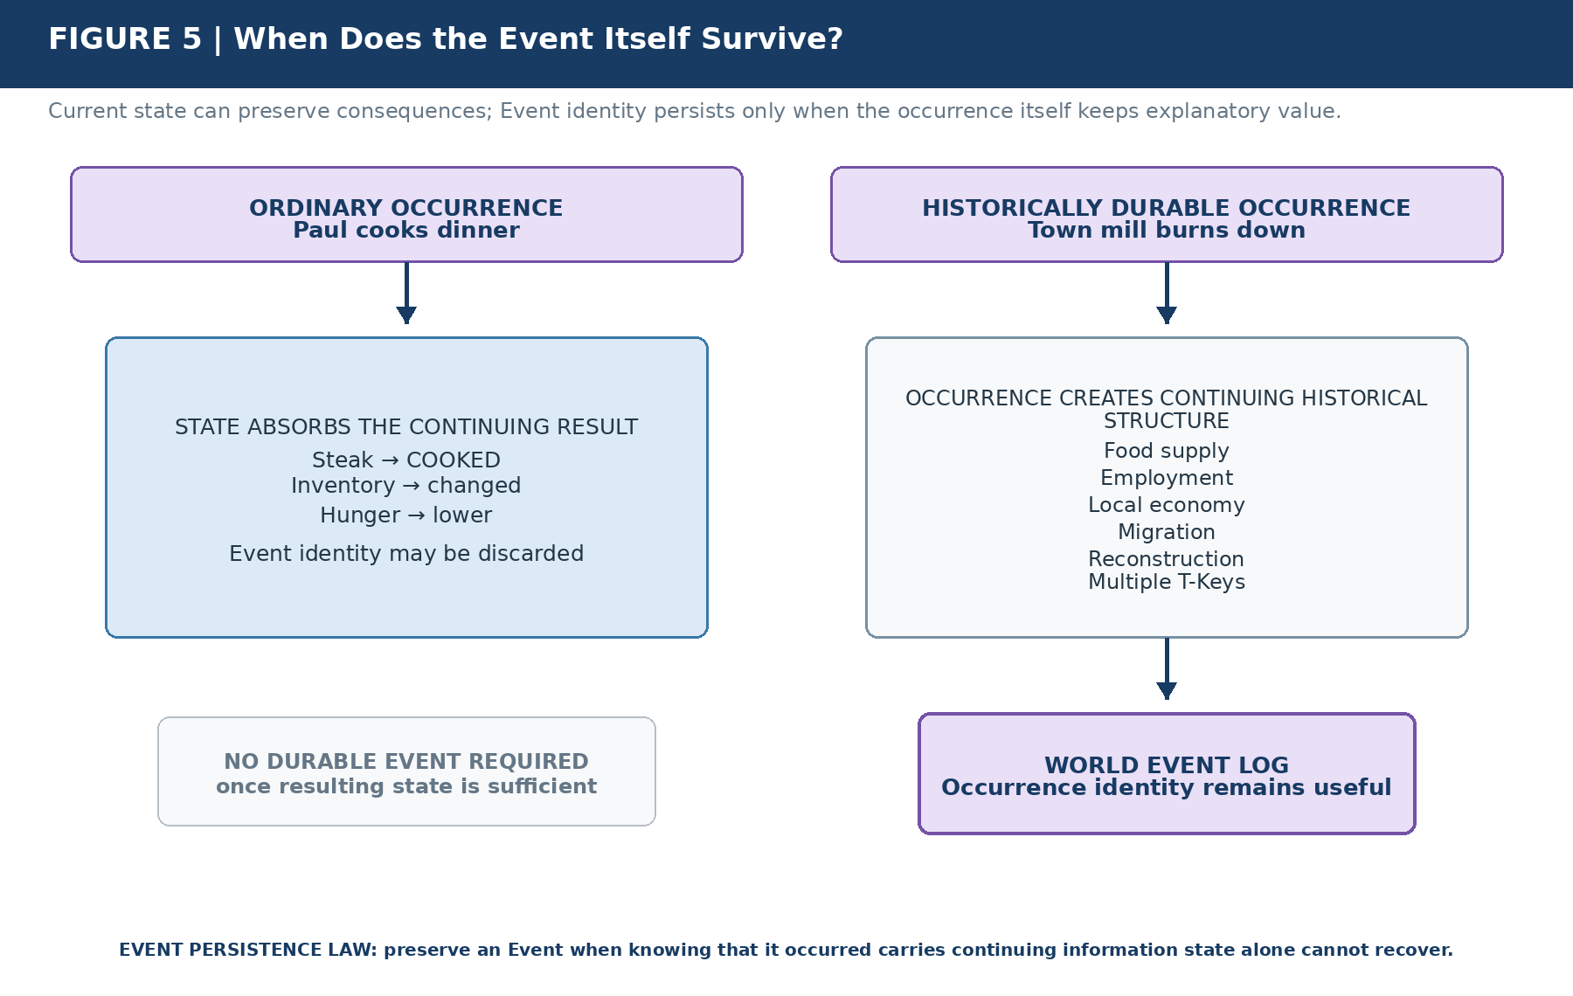
Figure 5. When Does the Event Itself Survive? Ordinary state-changing activity can vanish as an Event representation once its causal residue is adequately carried elsewhere. A historically durable occurrence persists because the identity of the occurrence continues to explain relationships, provenance, exposure, or downstream history.
LAW | Preserve an Event when knowing that the occurrence happened provides continuing causal or historical information not sufficiently represented by resulting state alone.

This rule prevents the World Event Log from becoming an exhaustive surveillance ledger of existence. Event identity is retained because it still answers useful historical or causal questions, not because every action is inherently worthy of permanent recording.

6. Procedural World Memory
The World remembers more than occurrences. It also preserves structures describing how ordinary transitions can happen: Scripts, Rules, capability requirements, institutions, resources, locations, historical populations, semantic affordances, and other historically valid conditions. Together these structures form Procedural World Memory.
Procedural World Memory does not assert that a particular Event happened according to the normal pathway. It preserves the mechanism space from which an ordinary history can be reconstructed. A construction Script can say that Farmhouse Type A requires CONSTRUCTION > 3, appropriate materials, a valid construction site, and a valid build sequence. Historical World state can say that a Builder's Guild existed locally, qualified builders were present, and materials were available.
DISTINCTION | The World can preserve how something normally happens without preserving a record that it happened exactly that way.

This distinction is the key to sparse history. The system need not store every board carried, nail hammered, ingredient moved, door opened, or ordinary conversation turn. It can preserve the enduring state those activities produced while retaining the domain structures that make ordinary missing detail reconstructable when later questions require it.

7. Constrained Historical Reconstruction
Reconstruction begins from surviving constraints rather than from a free-form narrative prompt. In the farmhouse example, the observed result is known: the farmhouse is rebuilt. The type is known. The valid build Script is known. Historical World state indicates which institutions, actors, resources, and Rules were available at the relevant TIME and Location. Together those facts define a bounded solution space.
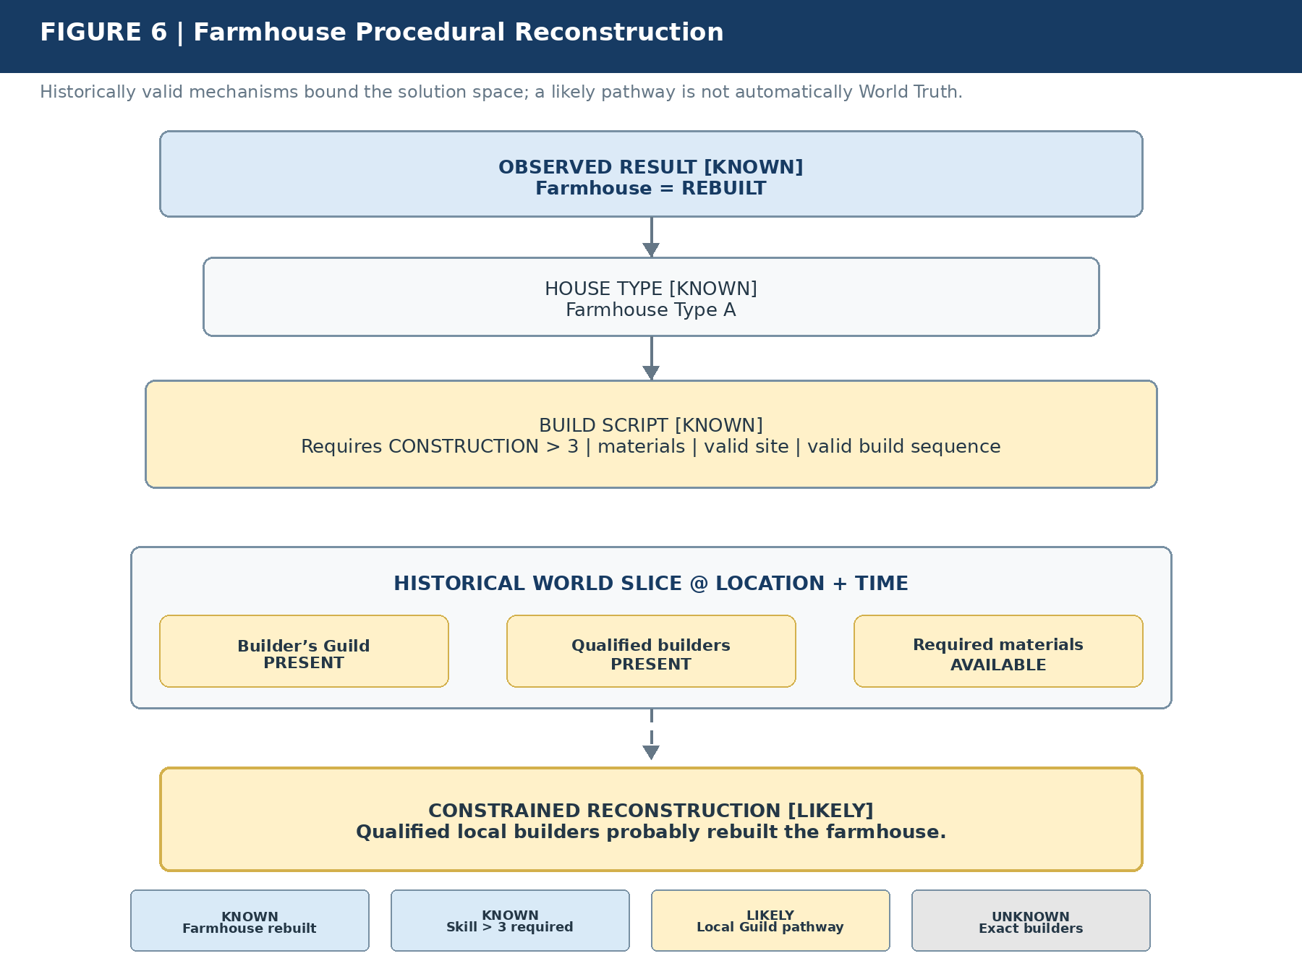
Figure 6. Farmhouse Procedural Reconstruction. The resulting state, valid build Script, historical institutions, available actors, resources, Rules, and Location constrain the solution space. The reconstruction may be highly likely without becoming an asserted fact about named participants.
A useful conceptual derivation is:
Likely History = Resulting State + Historical World State + Valid Scripts + Capabilities + Institutions + Resources + Rules + Evidence
This is not yet a finalized executable formula. It is the semantic derivation model: any reconstruction must satisfy surviving constraints. CERBERUS therefore should not infer that an untrained farmer rebuilt a structure alone if the registered construction system makes that pathway invalid.
LAW | Absence of stored detail permits constrained reconstruction, not unconstrained invention. A reconstruction must remain inside the solution space permitted by surviving World state.

The result can remain epistemically precise even when no unique answer survives: Farmhouse rebuilt - KNOWN. Skill greater than 3 required - KNOWN. Local Guild pathway - LIKELY. Exact builders - UNKNOWN. The ability to stop at UNKNOWN is a feature, not a reconstruction failure.

8. Evidence Precedence
Procedural likelihood is subordinate to evidence. The World may know the ordinary pathway and still preserve direct evidence that this particular occurrence happened another way. If a disaster destroyed the farmhouse and a travelling engineering unit rebuilt it as emergency assistance, a preserved Event, provenance record, or explicit participant link must suppress the generic Builder's Guild inference.
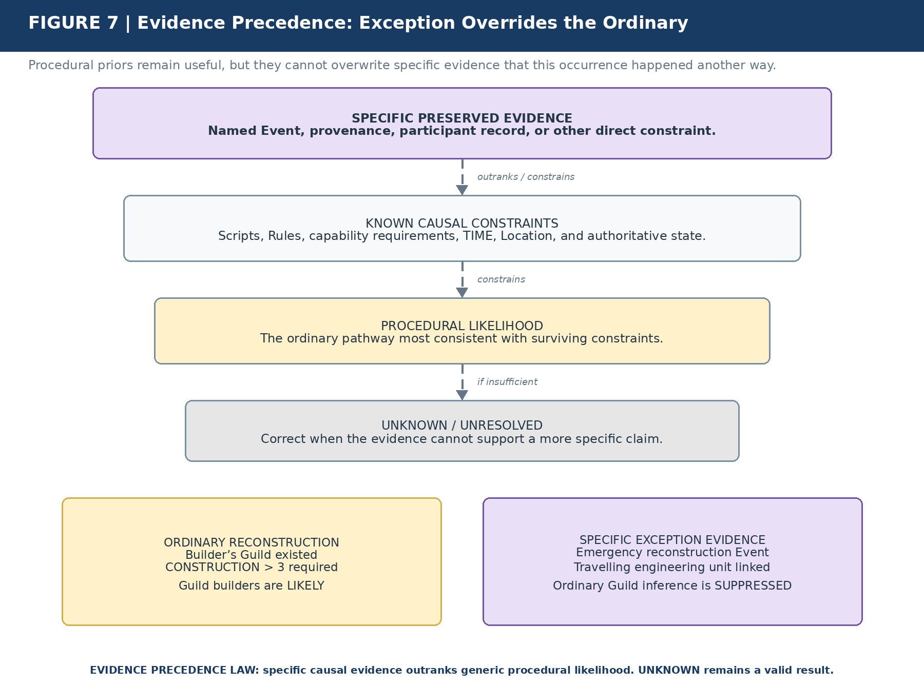
Figure 7. Evidence Precedence: Exception Overrides the Ordinary. The normal Builder's Guild pathway remains useful as a procedural prior, but it cannot overwrite specific evidence that an engineering unit performed this reconstruction. Epistemic status is preserved instead of converting likelihood into fact.
LAW | Specific causal evidence outranks generic procedural likelihood. A likely reconstruction must never overwrite a known exception.

The precedence hierarchy is therefore specific preserved evidence → known causal constraints → procedural likelihood → unknown or unresolved. The hierarchy prevents two opposite failures: ignoring strong evidence because a common pathway is convenient, and inventing false precision when the World no longer supports a more specific answer.

9. World Truth, Reconstructed History, and Recollection
Three layers must remain explicit. World Truth is what the World actually preserves as fact. Reconstructed History is what surviving causal evidence and procedural constraints support. Character Recollection is what a T-Key can reconstruct from its own historical position, developmental state, language, knowledge, and memory routing.
WORLD TRUTH  What is preserved as fact.  Exact builders may be unknown. | RECONSTRUCTED HISTORY  What surviving constraints support.  Guild builders may be the best-supported ordinary pathway. | CHARACTER RECOLLECTION  What a T-Key can reconstruct from its own historical position.  Paul remembers builders working around the farmhouse.

DISTINCTION | Reconstruction does not create World Truth. Recollection does not overwrite World Truth. A plausible personal memory may remain valid as recollection without becoming a historical fact.

This separation also allows later interpretation to change without rewriting the past. An adult can reflect on a childhood Event using knowledge acquired later while the historical self at Event TIME retains a different bounded understanding. The World, the reconstructed historical pathway, and the person's recollection can all remain mutually legible without collapsing into one record.

10. Memory Groove Integration
A T-Key Memory Groove is not responsible for reproducing every state transition a person witnessed. It provides autobiographical addressability. Exposure to an occurrence can be evaluated once; the Groove stores the resulting 0 or 1 decision; detailed recollection is reconstructed only on demand from the World, the T-Key's historical position, and any exceptional evidence that actually survives.
Paul can therefore have steak cooking → 0, farmhouse rebuild → 1, major fire → 1, and ordinary breakfast → 0. A zero does not mean the World forgot breakfast or that the event never occurred. It means routine autobiographical reconstruction does not require a preserved address for that occurrence.
LAW | Decide once. Store one bit. Reconstruct only on demand.

When queried years later about an ordinary farmhouse rebuild, Paul's recollection can be reconstructed from his age at the time, his Location, the farmhouse history, the normal build Script, the people plausibly present, and the vocabulary he possessed then. If an exceptional episode was specifically preserved - for example, a toy lost inside the unfinished wall and recovered by a particular engineer - that evidence can be composed with the reconstructed ordinary scaffolding rather than forcing the World to store an exhaustive recording of the entire construction period.

11. The Causal Persistence Lifecycle
The complete lifecycle starts with addressable State0. An Event, Operator, or governed transition produces causal differences. CERBERUS asks which of those differences still have work to do. Completed consequences can be absorbed into BitState. Unfinished consequences persist as Contracts. Independently meaningful occurrences can persist in the World Event Log. Autobiographically relevant exposure can be routed into T-Key Memory. Procedural World Memory remains available to reconstruct expendable detail.
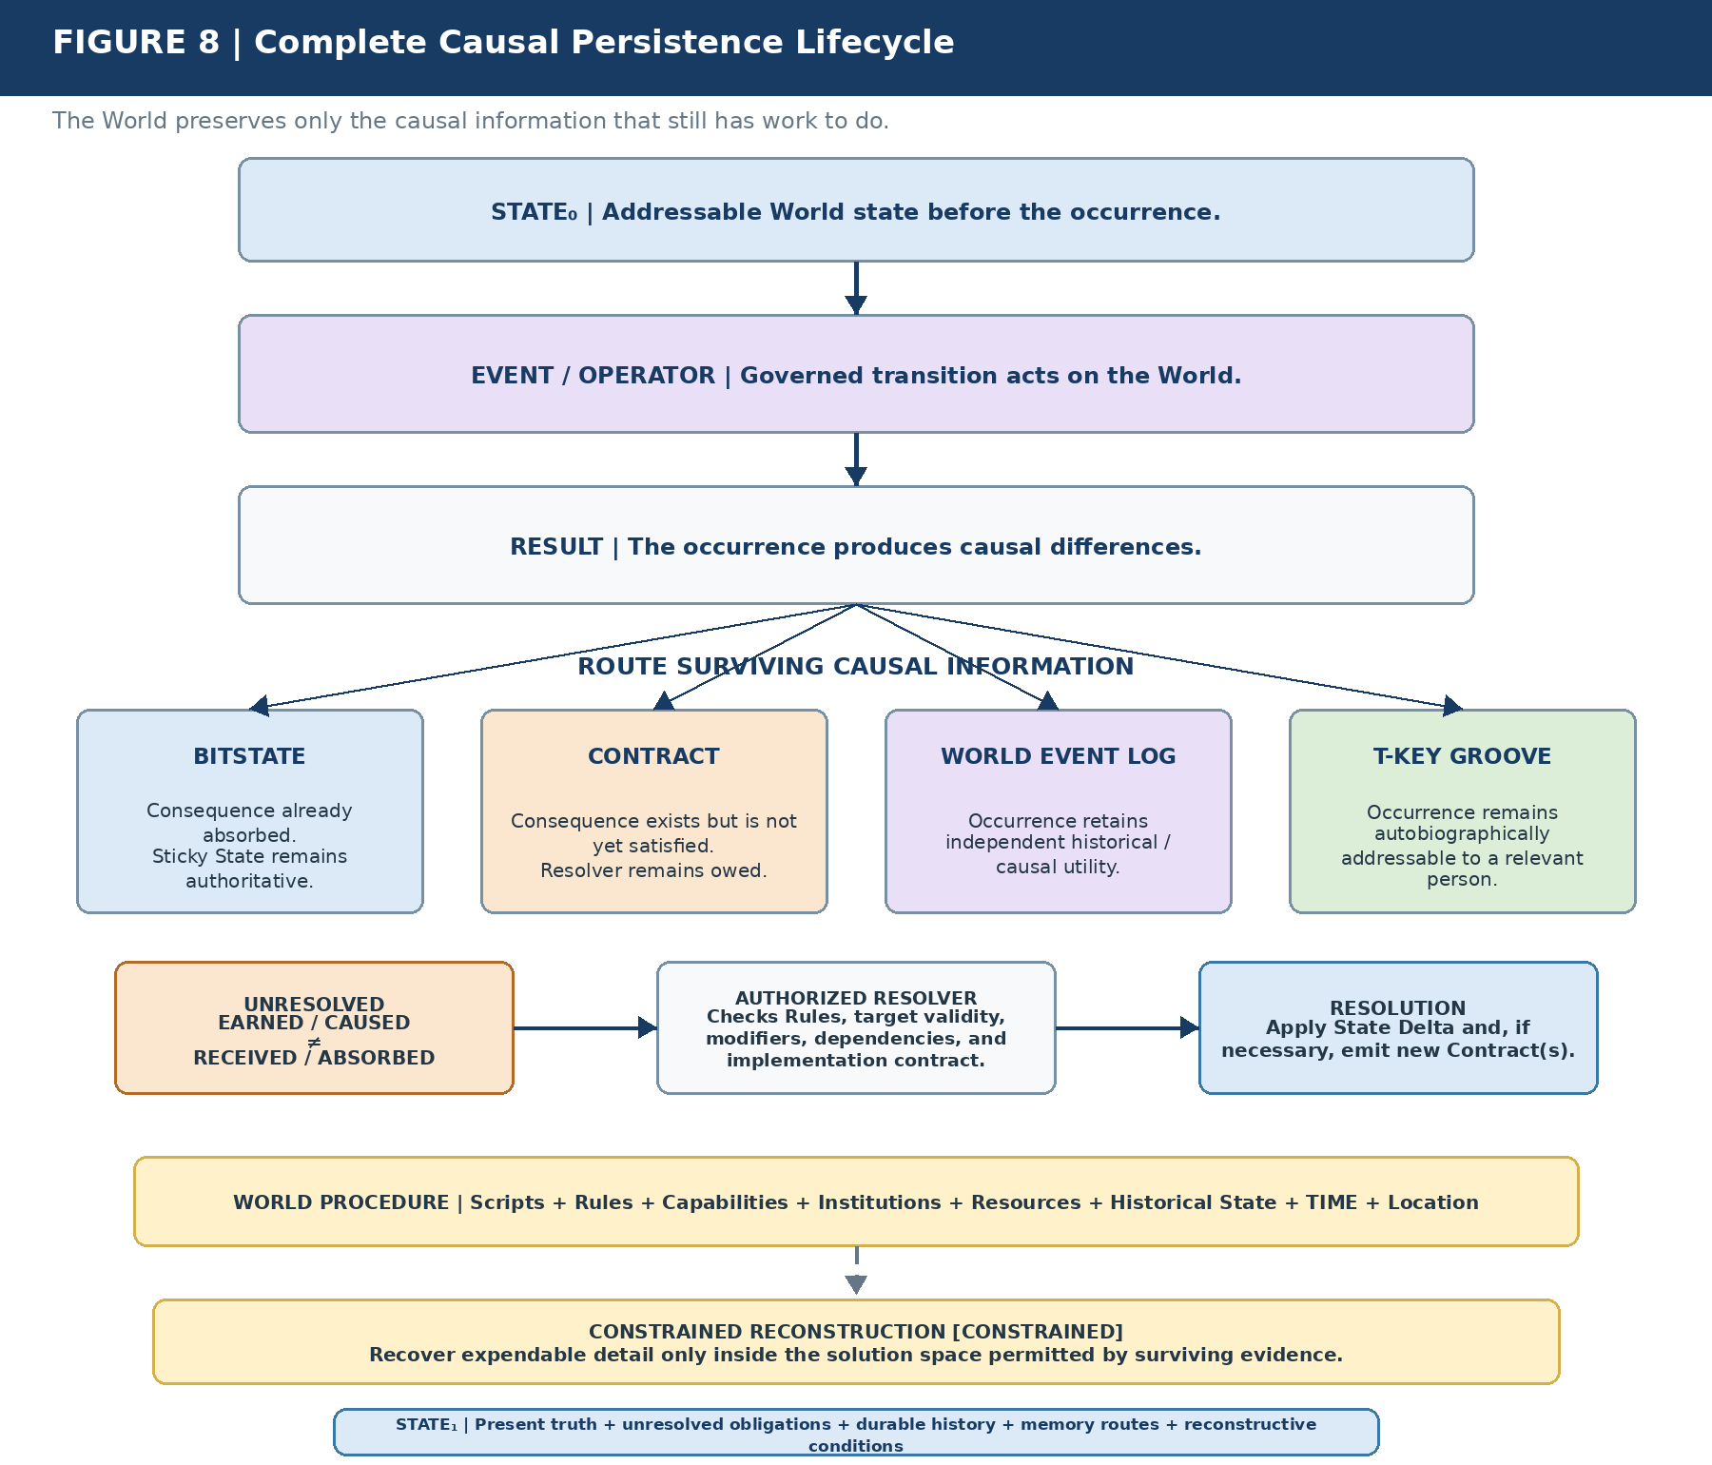
Figure 8. Complete Causal Persistence Lifecycle. The World does not require a complete recording of the transition. It preserves completed residue as state, unfinished consequence as contract, significant occurrence as Event, autobiographical access as T-Key memory, and ordinary recoverability through valid procedure.
Contracts can form a subcycle inside that larger flow. An unresolved obligation is checked by an authorized resolver, converted into a valid State Delta, or transformed into additional bounded Contracts. The World therefore advances with both authoritative present truth and any still-unresolved causal differences that remain legitimate work.
LAW | The past survives as state, obligation, history, memory, or reconstructive possibility. These channels can coexist, but none is a substitute for the others.

12. Worked Comparative Examples
The three recurring examples expose different persistence profiles without requiring different underlying principles. The table below summarizes the direct occurrence-specific channels. Procedural reconstruction is discussed separately because it is normally a World-side substrate rather than an Event output.
Example | State | Contract | World Event Log | Memory
Paul cooks steak | Strong: cooked state persists | Usually none after completion | Usually unnecessary | Usually unnecessary
High Five: DRAW_CARD × 1 | Hand changes after resolution | Essential until resolved | Usually unnecessary | Context-dependent
Farmhouse rebuild | Rebuilt state persists | Possible during work | Only if occurrence retains significance | Can often be reconstructed unless exceptional

The exceptional farmhouse variant demonstrates why evidence precedence matters. If a preserved disaster-recovery Event links a travelling engineering unit to the rebuild, the ordinary Guild reconstruction is suppressed even though the Guild pathway remains a valid procedural prior for other similar cases.
Together, the examples show that persistence is selective rather than hierarchical. State is not a cheaper Event; a Contract is not a temporary Event; Memory is not a copy of World Truth; and Procedure is not evidence that a particular pathway occurred. Each object answers a different question.

13. Final Synthesis
The architecture can now state a precise answer to the question "What survives this action?" The answer is not "the Event." It is whatever causal information the future still needs.
STATE | what remains true
CONTRACT | what remains owed
EVENT | what remains historically significant
MEMORY | what remains autobiographically addressable
PROCEDURE | what remains reconstructable

LAW | The past persists only in the forms required by the future.

Storage economy follows directly from this separation. Ordinary causal residue can live where it is cheapest and most useful: on the NodeKeys whose state actually changed. Unfinished work can remain compactly addressable as a Contract. Only occurrences with continuing explanatory value need durable Event identity, and only autobiographically relevant exposure needs a T-Key route. The architecture therefore avoids paying the cost of full historical representation for consequences that are already adequately carried elsewhere.
Reconstruction quality also improves because missing detail is not treated as a blank space for narration. The surviving World narrows the solution space through scripts, capability requirements, institutions, resources, historical state, TIME, Location, and preserved evidence. That gives CERBERUS a disciplined way to recover ordinary texture while preserving the difference between KNOWN, CONSTRAINED, LIKELY, and UNKNOWN.
Most importantly, the system remains causally conservative without becoming representationally exhaustive. A later query can still explain why a state is plausible, what obligations remain unresolved, which Events retain durable identity, and what a particular person can reconstruct, even though most mundane intermediate actions were never preserved as permanent records.
When an Event's causal consequence has been fully absorbed into authoritative state, the Event itself need not persist unless its occurrence retains independent historical, contractual, evidential, or autobiographical significance. When a consequence has not yet been absorbed, a Contract can carry that causality forward. When ordinary detail is missing, historically valid World mechanisms can constrain reconstruction without pretending to recover certainty that no longer exists.
The result is a sparse but causally deep World. CERBERUS does not store the movie. It stores enough authoritative state, unresolved obligation, significant history, autobiographical routing, and reconstructive structure that the movie remains recoverable where the future still needs it.
DISTINCTION | BitWords preserve consequence. Contracts preserve unfinished causality. The World Event Log preserves significant history. Memory Grooves preserve autobiographical access. Procedural World Memory preserves enough structure to reconstruct the ordinary.

