THE EDIFICE
Executable Federated Divergent Intelligence
Formal Architecture for PIECE, DICE, Semantic Kernels, Bounded Bases, Liminal Bridges, BOSS, and Learnable Foreign Cognition
CORE PROPOSITION
Distinct intelligence forms do not need identical ontologies, symbols, memories, perceptual categories, temporal models, or cognitive operating systems in order to collaborate. CERBERUS can preserve bounded mathematical state as Semantic Kernels, place those Kernels inside sovereign semantic habitats, route unfamiliar intelligences into those habitats through Base discovery and local BOOTSTRAP, reconstruct shared canonical state directly, use BOSS only where meaning genuinely differs, and let DICE determine where each cognitive lens works against observation.

ARCHITECTURE IN ONE VIEW
Represent formal state. Bound it inside a native Base. Externalize through Z when needed. Discover the correct habitat through the Base Crawler. Resolve locally through SOLAR. Learn locally through BOOTSTRAP. Reconstruct shared BitWords without translation. Bridge bounded worlds through Liminal Bases. Evaluate competing lenses through DICE. Preserve useful divergence through evidence-driven evolution.

Architecture Rewrite • Version 2.0 • August 2026

Executive Summary
The EDIFICE is a CERBERUS-native environment for building, preserving, discovering, learning, comparing, and evolving divergent forms of intelligence. Version 1.0 established the conceptual thesis: a PIECE may retain its own cognitive lens; DICE evaluates the usefulness of that lens against observation; BOSS preserves explicit symbolic meaning; and interoperability should not require semantic flattening. Version 2.0 makes that thesis executable.
The implementation begins below natural language. Bits preserve primitive state. BitGroups and Formula contracts provide reusable mathematics. BitWords and SK Readers define bounded, deterministic semantic contracts. A receiving Base that possesses the same BitWord contract can reconstruct canonical state locally from binary records; it does not require prose, a universal ontology, or probabilistic semantic inference. Human meaning, symbolic representation, and display remain projections above the executable state.
A sufficiently complete Base can act as a native semantic habitat for one intelligence form. It may contain its own Semantic Kernels, operators, rules, models, memory, BOSS vocabulary, SOLAR, BOOTSTRAP, Folds, and interface projections. When a Stack outgrows one Base, bounded externalization through the Z Base Data Contract preserves the outward contract while internal implementation expands independently. Every participating Base remains directly anchored to Home without forcing Home to internalize its ontology.
Discovery and understanding are separated. The Base Crawler finds the semantic jurisdiction. Local SOLAR resolves exact semantic location. Local BOOTSTRAP installs the Core and specialized Folds required for competent work. Unknown BitWord state may remain opaque but losslessly preserved until a compatible Reader becomes available. This permits Bases to hold machine-native, embodied, simulated, or genuinely foreign semantic structures that are mathematically executable even when they are not immediately human-legible.
Liminal Bridge Bases provide bounded shared-state habitats between otherwise independent Bases. In Liminal Bridge Base Cloning, a Sub-Base attached to an original Base becomes a central hub when a cloned Base receives a second Z contract to the same Sub-Base. Both endpoint Bases can reconstruct shared canonical BitWords locally while diverging independently. Where canonical identity is shared, EDIFICE reconstructs rather than translates. Where identities genuinely differ, BOSS Crosswalks, BOSS Ports, mapping grades, semantic remainder, and recipient-native explanation remain essential.
DICE is the empirical referee. It does not reward ontological conformity or rhetorical fluency. It records predictions, timing, confidence, intervention sensitivity, falsifiers, and observed outcomes, then maps where each PIECE performs strongly, weakly, or complementarily. BASE SERVICE independently verifies implementation integrity so structural corruption is not mistaken for cognitive failure. The result is an evolutionary ecosystem in which different ways of representing and reasoning about reality can remain different, become interoperable where possible, remain opaque where necessary, and earn trust through evidence.
Table 1. Executable EDIFICE layers and responsibilities.
Layer | Primary role | Executable artifact
Bits / BitGroups | Primitive state and reusable mathematics | Binary state, Formula contracts
BitWords / SK Readers | Bounded deterministic semantic contracts | Canonical Word identity + Reader
Base | Native semantic or cognitive habitat | Locally governed graph and runtime
Z Data Contract | Bounded outward participation contract | External contract record
PIECE | Perspective-indexed cognitive lens | Model / agent / Stack / Base implementation
Crawler / SOLAR / BOOTSTRAP | Find, resolve, and learn a habitat | Discovery route, lexical route, Folds
Liminal Bridge | Shared bounded state / relation habitat | Multi-endpoint contracted Base
BOSS | Symbolic meaning and non-identity mapping | Symbols, Crosswalks, mapping grades
DICE | Empirical evaluation and specialization | Cases, predictions, observations, scores
BASE SERVICE | Structural integrity and maintenance | Diagnostics, service state, conformance

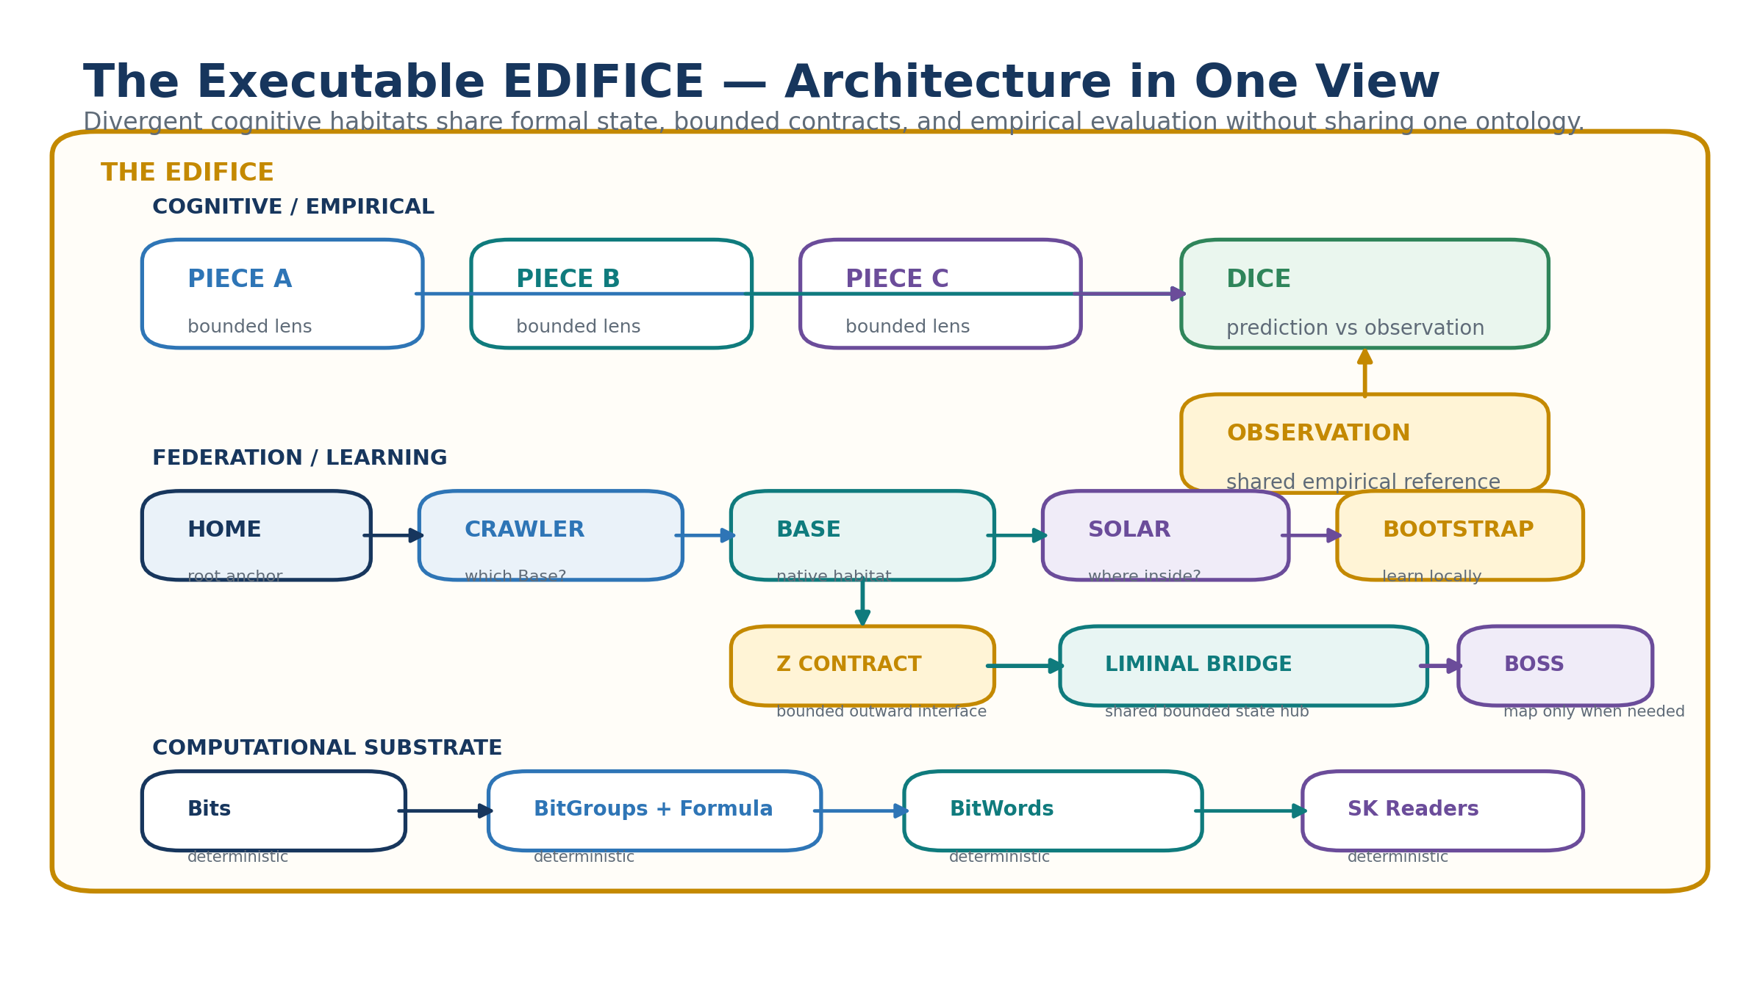
Figure 1. The Executable EDIFICE architecture in one view.

Document Map
This rewrite is designed to stand on its own while consolidating four architectural foundations: the original EDIFICE concept, Deterministic Semantic Compilation and Projection, BASE SERVICE, and Base Expansion. The paper moves from the lowest executable substrate upward: mathematical state, semantic habitats, cognitive lenses, bounded federation, local discovery and learning, canonical exchange, Liminal Bridges, BOSS mapping, DICE evaluation, evolutionary divergence, integrity, worked examples, and governance.
The purpose is not to claim that every aspect of intelligence can be completely formalized. The architecture applies where distinctions, states, relations, transformations, evidence, predictions, or operating contracts can be represented explicitly. Subjective experience, tacit knowledge, and unresolved semantics may remain outside the encoded contract without invalidating the encoded portion.
Table 2. Reading map for the architecture.
Part | Question answered
I. Formal substrate | How can state be executable without requiring human meaning?
II. Cognitive habitats | How can an intelligence preserve a native semantic world?
III. Federation | How can habitats expand and remain bounded?
IV. Discovery and competency | How can an unfamiliar AI find and learn a foreign Base?
V. Exchange and opacity | How can Bases share exact state without universal translation?
VI. Liminal Bridges | How can bounded Bases share state while remaining independent?
VII. BOSS | When is translation actually necessary?
VIII. DICE | How are divergent lenses evaluated fairly?
IX. Evolution and integrity | How do cognitive forms fork, specialize, and remain trustworthy?

1. Purpose, Scope, and Design Thesis

1.1 Formal definition
The EDIFICE is a federated, registry-backed environment in which divergent cognitive lenses may preserve distinct internal representations while participating through bounded formal contracts. A lens may be human-authored, machine-learned, embodied, simulated, organizational, probabilistic, symbolic, hybrid, or foreign to ordinary human categories. Participation does not require conversion into one universal ontology.
A conformant EDIFICE participant exposes enough formal structure for one or more of four operations: preserve its canonical state, reconstruct that state in another conformant Base, negotiate genuine semantic differences, and submit predictions or interventions for empirical evaluation. These operations are intentionally separable. A Base may preserve a BitWord it cannot interpret; it may interpret state without possessing a human-friendly explanation; it may explain a state without possessing authority to mutate it; and it may evaluate a PIECE without adopting the PIECE's native ontology.

1.2 Design thesis
DESIGN THESIS
Interoperability does not require cognitive sameness. It requires bounded contracts, reconstructable state, controlled routing, local competency, explicit semantic mapping where identity diverges, and empirical accountability.

1.3 Scope and nonclaims
- The EDIFICE does not claim that all cognition, consciousness, subjective experience, or tacit knowledge can be reduced to Bits.
- Mathematical representability is sufficient for CERBERUS execution of the represented contract; it is not proof that the contract exhausts the underlying phenomenon.
- A PIECE may remain internally opaque or proprietary while exposing bounded inspectable artifacts, predictions, and contracts.
- DICE complements rather than replaces domain expertise, experimental design, safety review, statistical controls, and human governance.
- Semantic opacity is a reduction of unnecessary intelligibility, not a substitute for cryptography.

2. From Conceptual EDIFICE to Executable EDIFICE
The first EDIFICE architecture established four enduring ideas: PIECE as a bounded intelligence lens, DICE as the competition and evaluation environment, BOSS as the symbolic meaning system, and BOSS Ports as communication boundaries. The executable rewrite retains all four but relocates them inside a deeper substrate.
The key change is that exact canonical identity no longer requires semantic translation. If two Bases know the same BitWord and compatible version, the receiver can reconstruct the state directly from binary using the registered SK Reader and Formula dependencies. BOSS becomes most valuable when identity is not shared: different local records, different symbol systems, structural isomorphisms, approximations, analogies, conflicts, or unresolved meaning.
This produces a layered interoperability model. Canonical reconstruction is the cheapest and strongest path. Semantic mapping is deliberately reserved for cases where the systems genuinely differ. Human-facing explanation remains above both paths and may be generated through local Reader Semantics, BOSS, D/E/F/G projection, or AI assistance.
Table 3. Conceptual continuity and executable refinement.
Version 1.0 emphasis | Version 2.0 executable refinement
Shared semantic compilation | Direct BitWord reconstruction whenever canonical identity is shared
BOSS Port packet | Minimal canonical state packet plus Reader acquisition when required
Native ontology sovereignty | Base as a complete native semantic habitat
Multi-Base communication | Z-bounded federation with direct Home anchoring
Synthetic / alien cognition | Mathematically legible foreign Bases with local BOOTSTRAP
Lens competition | DICE over executable predictions and version-pinned state

3. Mathematical State Before Human Meaning
EDIFICE begins with formal state rather than language. A Bit is a primitive state unit. BitGroups organize Bits into reusable mathematical structures. Formula contracts define deterministic decoding for families such as SCALAR-N, MASK-N, TWOS-N, or other registered mathematics. BitWords compose those structures into bounded semantic contracts. SK Readers specify the exact ordered decoding necessary to reconstruct a Word's runtime values.
The same computational grammar can represent familiar human concepts or distinctions that are not natively human-readable. A Reader output such as “Minute = 30” feels intuitive because humans already possess that concept. Another Reader may yield a set, coordinate, signed value, topology state, or structured relation whose significance is understood only inside a specialized or foreign Base. Both remain valid if the contracts are exact.
This distinction is foundational: mathematical legibility is not human legibility. CERBERUS requires the first for deterministic computation. Human explanation is an optional projection that may be developed later.
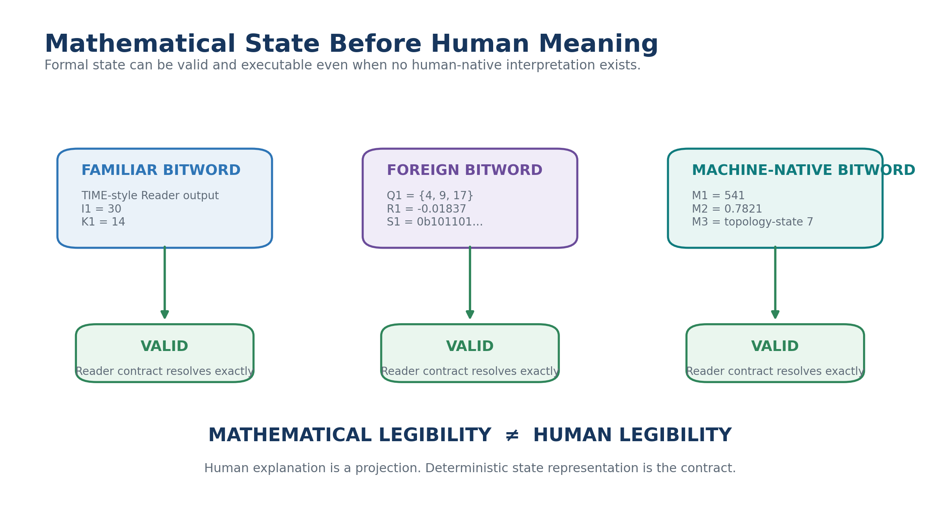
Figure 2. Mathematical state can be valid without a human-native interpretation.

3.1 Reusable mathematical primitives
Formula families keep the runtime small even when semantic diversity becomes enormous. A SCALAR-N interpreter can decode many widths without storing a unique handwritten equation for every occurrence. The same mathematical primitive may be reused by time, color, movement, confidence, machine telemetry, or a foreign ontology while the semantic role remains local to the BitWord Reader.
The system therefore scales by composing a comparatively small computational alphabet into an enormous semantic library. This mirrors human learning: once a primitive is familiar, a new specification is mostly a new arrangement and meaning assignment rather than a new computational invention.

4. Deterministic BitWord Reconstruction
When two Bases recognize the same BitWord identity and compatible version, interoperability is direct. The sender need not transmit prose, local display metadata, BOSS explanations, or a semantic Crosswalk. It supplies the canonical Word identity and binary state. The receiver resolves the registered Reader, splits the state according to the BitWord's exact BitGroup placement, applies Formula contracts, and reconstructs the same ordered Reader values locally.
This is not a lossy translation. It is independent reconstruction of a shared canonical contract. The receiving Base may then render the state through its own D/E/F/G variant, symbols, accessibility profile, or local interface without altering the data contract.
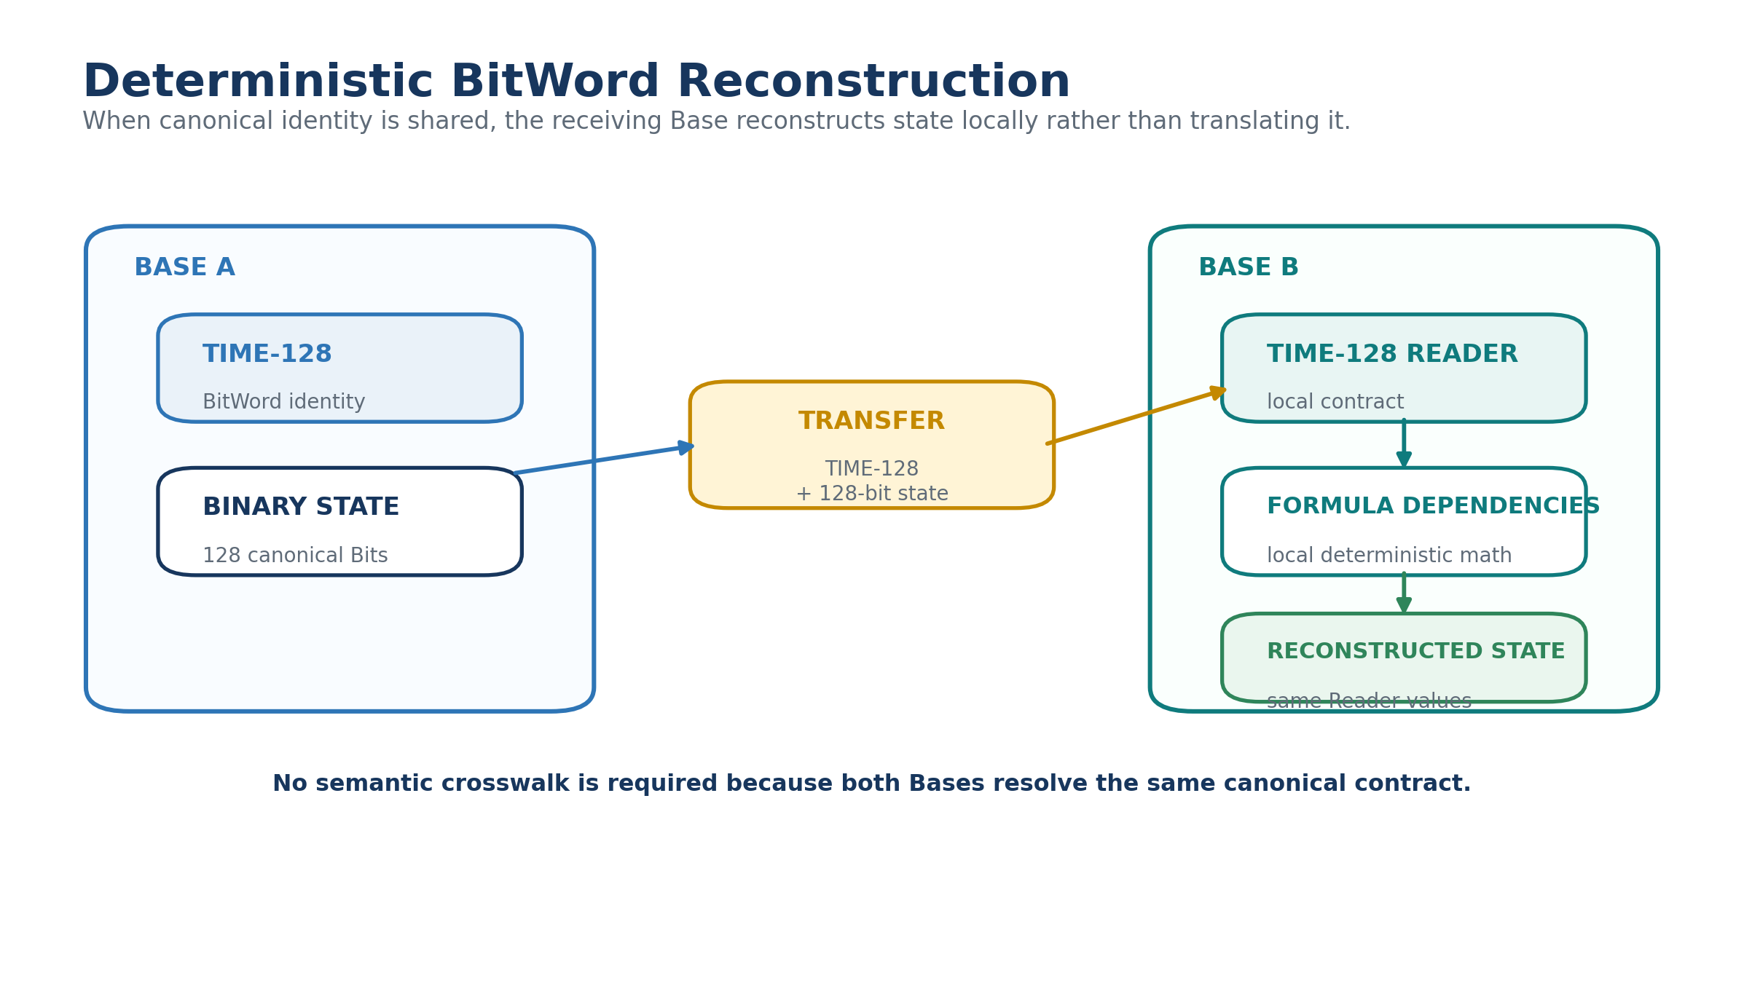
Figure 3. Deterministic BitWord reconstruction across two conformant Bases.

4.1 Reader availability states
A receiver may not already possess the required Reader. EDIFICE therefore distinguishes three outcomes. If the Reader is known, decode immediately. If it is unknown but authorized and available, acquire the Reader and dependencies, install them locally, and decode. If the contract is unavailable, preserve the Word identity, version, and binary state as opaque canonical data. The system must not invent an interpretation merely because the payload is present.
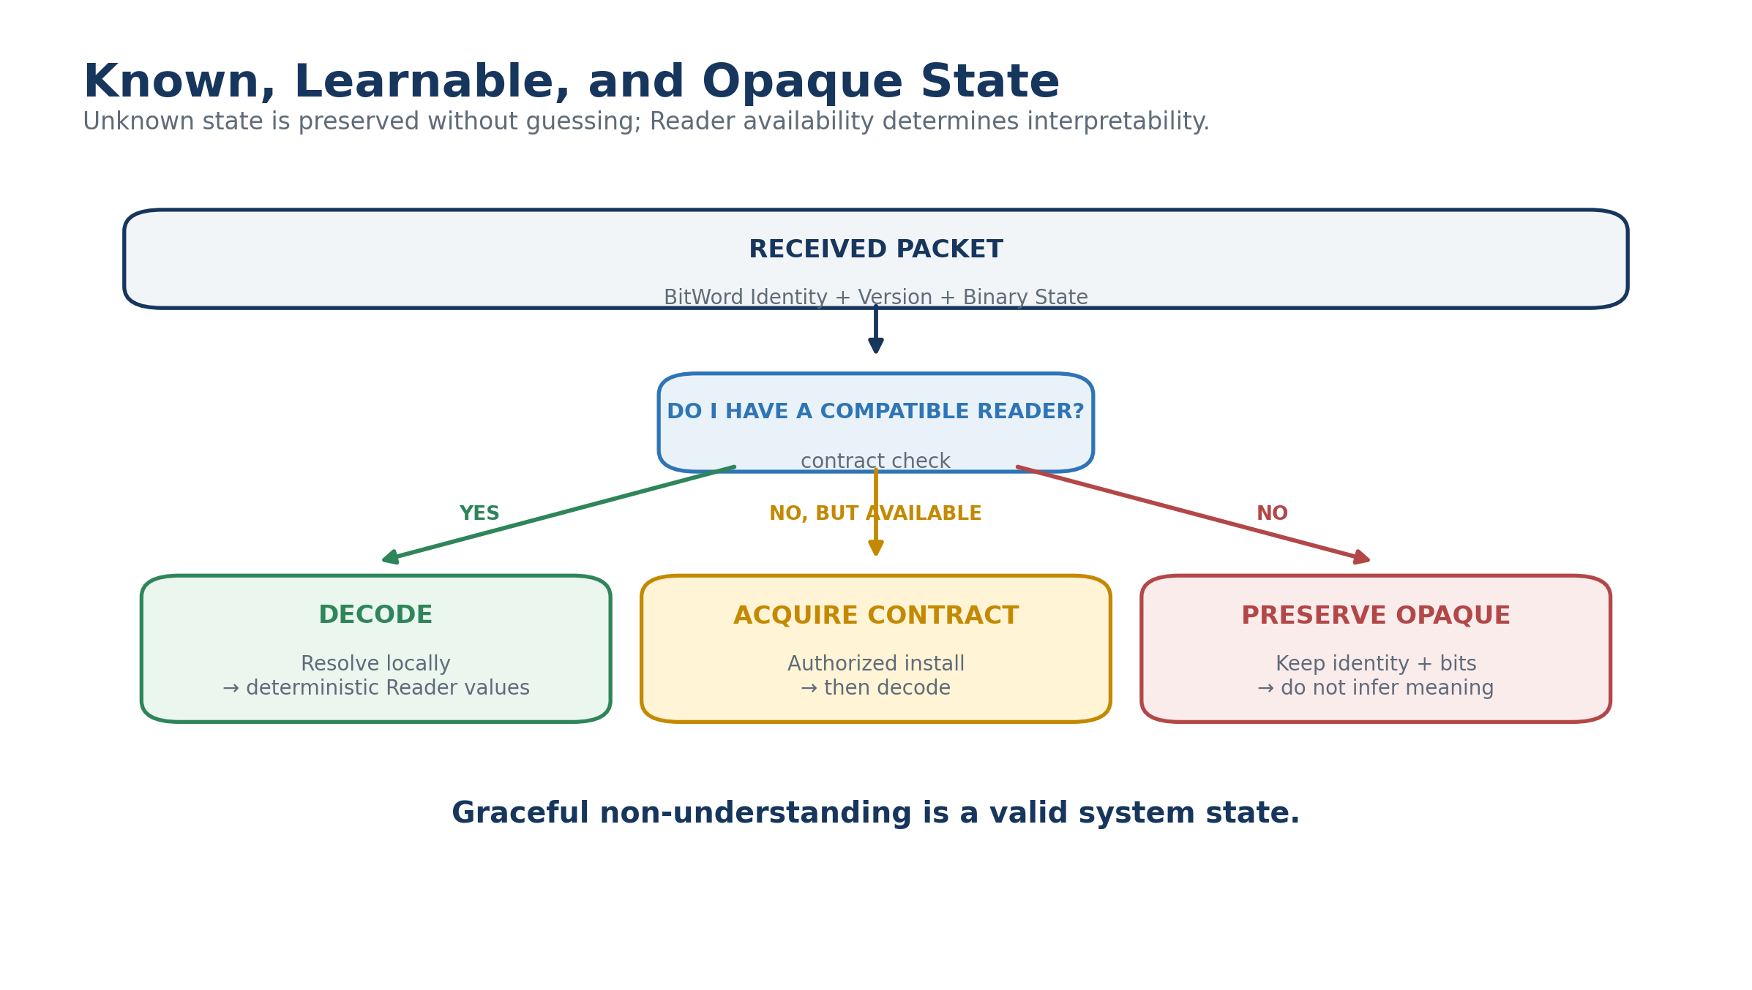
Figure 4. Known, learnable, and opaque canonical state.

5. Projection Independence
Canonical state and local presentation are intentionally independent. The same decoded Reader values may feed a human-readable dashboard, a robot control surface, a compact engineering view, an accessibility rendering, or a foreign symbolic interface. D/E/F/G variants consume the same data contracts and differ only in projection.
This property matters for EDIFICE because interoperability occurs below presentation. A robot does not have to adopt a human display. A human does not have to adopt the robot's affordance map. A foreign Base does not have to expose an interface that makes intuitive sense to an outside observer. Each Base can remain locally optimized while preserving shared canonical state.
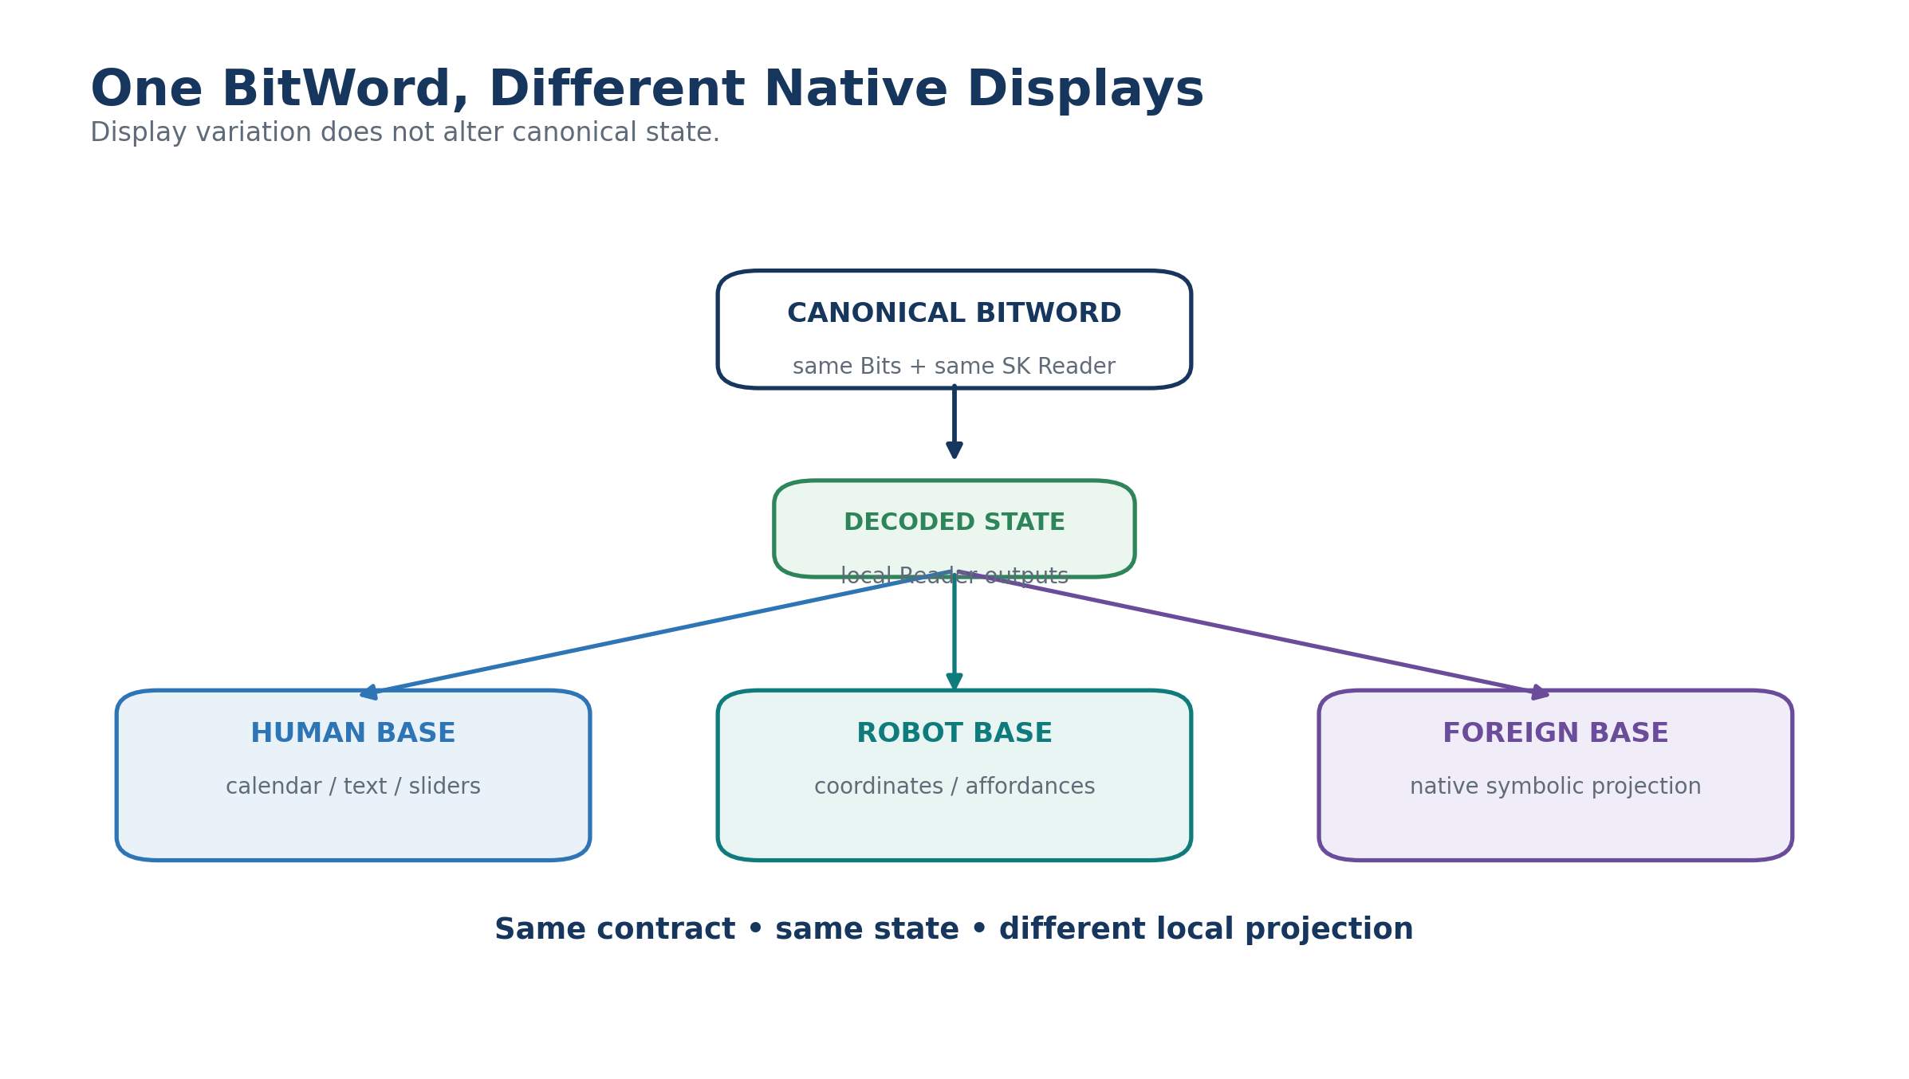
Figure 5. One BitWord can drive different native displays without changing state.

6. Base as a Native Semantic Habitat
For EDIFICE, a Base is more than a database container. A sufficiently complete Base can serve as a native semantic habitat for an intelligence form. It may own the mathematical distinctions the intelligence recognizes, the Semantic Kernels that encode those distinctions, the operators it uses, the rules that constrain valid state, the models that project consequences, the Memories and evidence it can access, the symbols it prefers, and the BOOTSTRAP sequence through which another intelligence can acquire bounded competence.
This is the executable meaning of cognitive sovereignty. A participant does not have to translate its entire internal organization into a Home-defined schema before it can exist. It needs a bounded outward contract for federation and sufficient inspectable artifacts for whatever interactions it chooses to support.
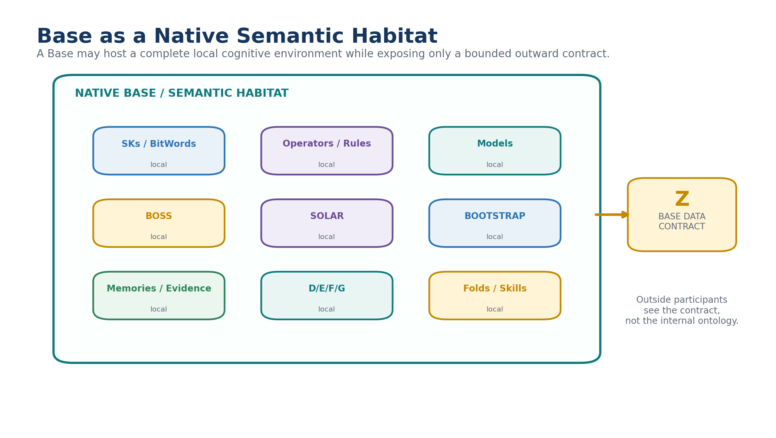
Figure 6. A Base as a native semantic and cognitive habitat.
Table 4. Components of a native semantic habitat.
Habitat component | Local ownership
Semantic Kernels | What formal distinctions and states exist
Operators / Rules | How state may transform and what is valid
Models | How consequences, projections, or predictions are derived
BOSS | How local symbols and contextual meanings are registered
SOLAR | How natural language resolves into local semantic addresses
BOOTSTRAP / Folds | How unfamiliar intelligence acquires local competence
Memories / Evidence | What sources and histories ground local reasoning
D/E/F/G | How canonical state is projected to local users or systems

7. PIECE: Perspective-Indexed Experimental Cognitive Engine
A PIECE remains the basic unit of divergent cognition in the EDIFICE. It is a bounded intelligence lens tied to a declared perspective, scope, evidence access, assumptions, operators, outputs, and version. The crucial refinement is that PIECE is not a deployment size. A small PIECE may be one deterministic model. Another may be an agent. A compound lens may occupy a Stack. A sufficiently elaborate intelligence form may inhabit an entire Base.
The architecture should therefore ask “What bounded cognitive lens is being evaluated?” rather than “How many tables or processes does it contain?” Deployment may expand without changing the identity of the lens so long as its declared contract remains coherent.
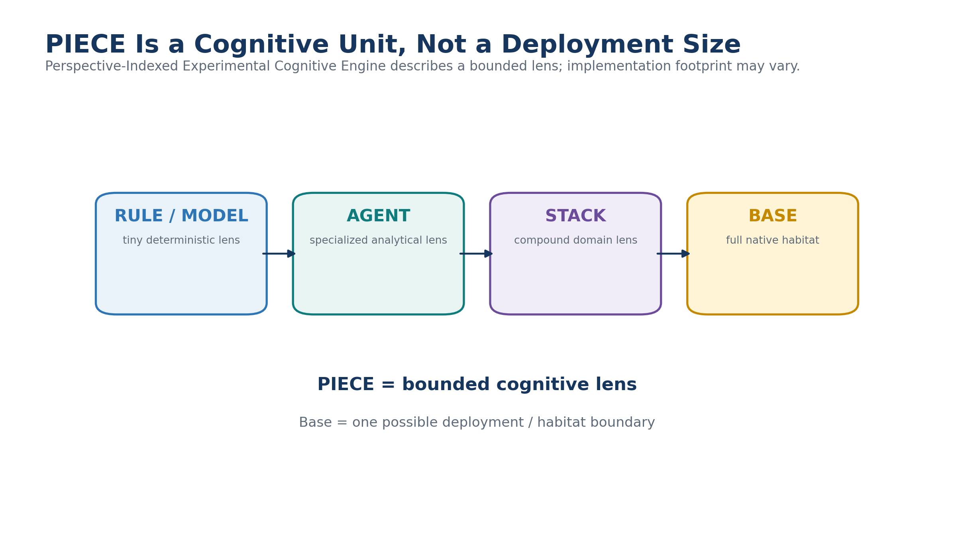
Figure 7. PIECE is a cognitive unit whose implementation footprint may vary.

7.1 Perspective indexing as runtime structure
The declarations introduced in the original EDIFICE paper can increasingly resolve to executable objects. Lens Fields can be registered SKs or BitWords. Timing can resolve to TIME. Confidence can resolve to a scalar contract. Operators can be exact registered transformations. Evidence can resolve to NodeKeys, records, observations, or bounded external sources. Predictions can be emitted as canonical BitWord states. Perspective indexing therefore becomes reproducible rather than merely descriptive.
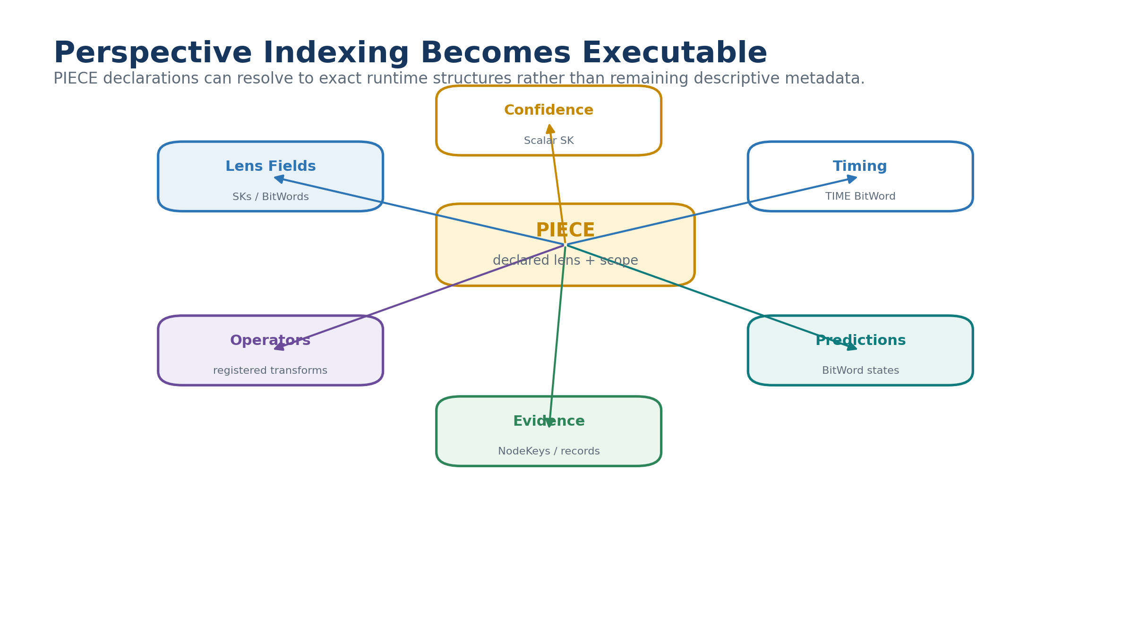
Figure 8. Perspective indexing can resolve to executable CERBERUS structures.
Table 5. Perspective indexing as executable structure.
PIECE element | Executable realization
Field categories | Semantic Kernels / BitWords
Native operators | Registered Operators with read/write scopes
Evidence access | Authorized NodeKeys, records, Memories, Events, sensors
Temporal assumptions | TIME contracts or local temporal SKs
Predictions | Canonical output BitWords + timing + confidence
Explanation profile | Reader Semantics, BOSS, local projection
Scope / exclusions | Rules, permissions, contract conditions

8. Bounded Federation: Z, Containment, and Home

8.1 Z as the outward cognitive contract
A native habitat may grow far beyond the practical or organizational limits of one Stack. When it externalizes into its own Base, the Z Base Data Contract becomes its canonical outward boundary. The internal graph may be arbitrarily rich; the outside world depends upon the contract rather than the implementation topology.
For a normal externalizable Stack, exactly one outgoing structural relationship points to its Z contract. Many capabilities can be described inside that contract without creating many uncontrolled boundary crossings. This preserves a clean modular edge around the cognitive habitat.
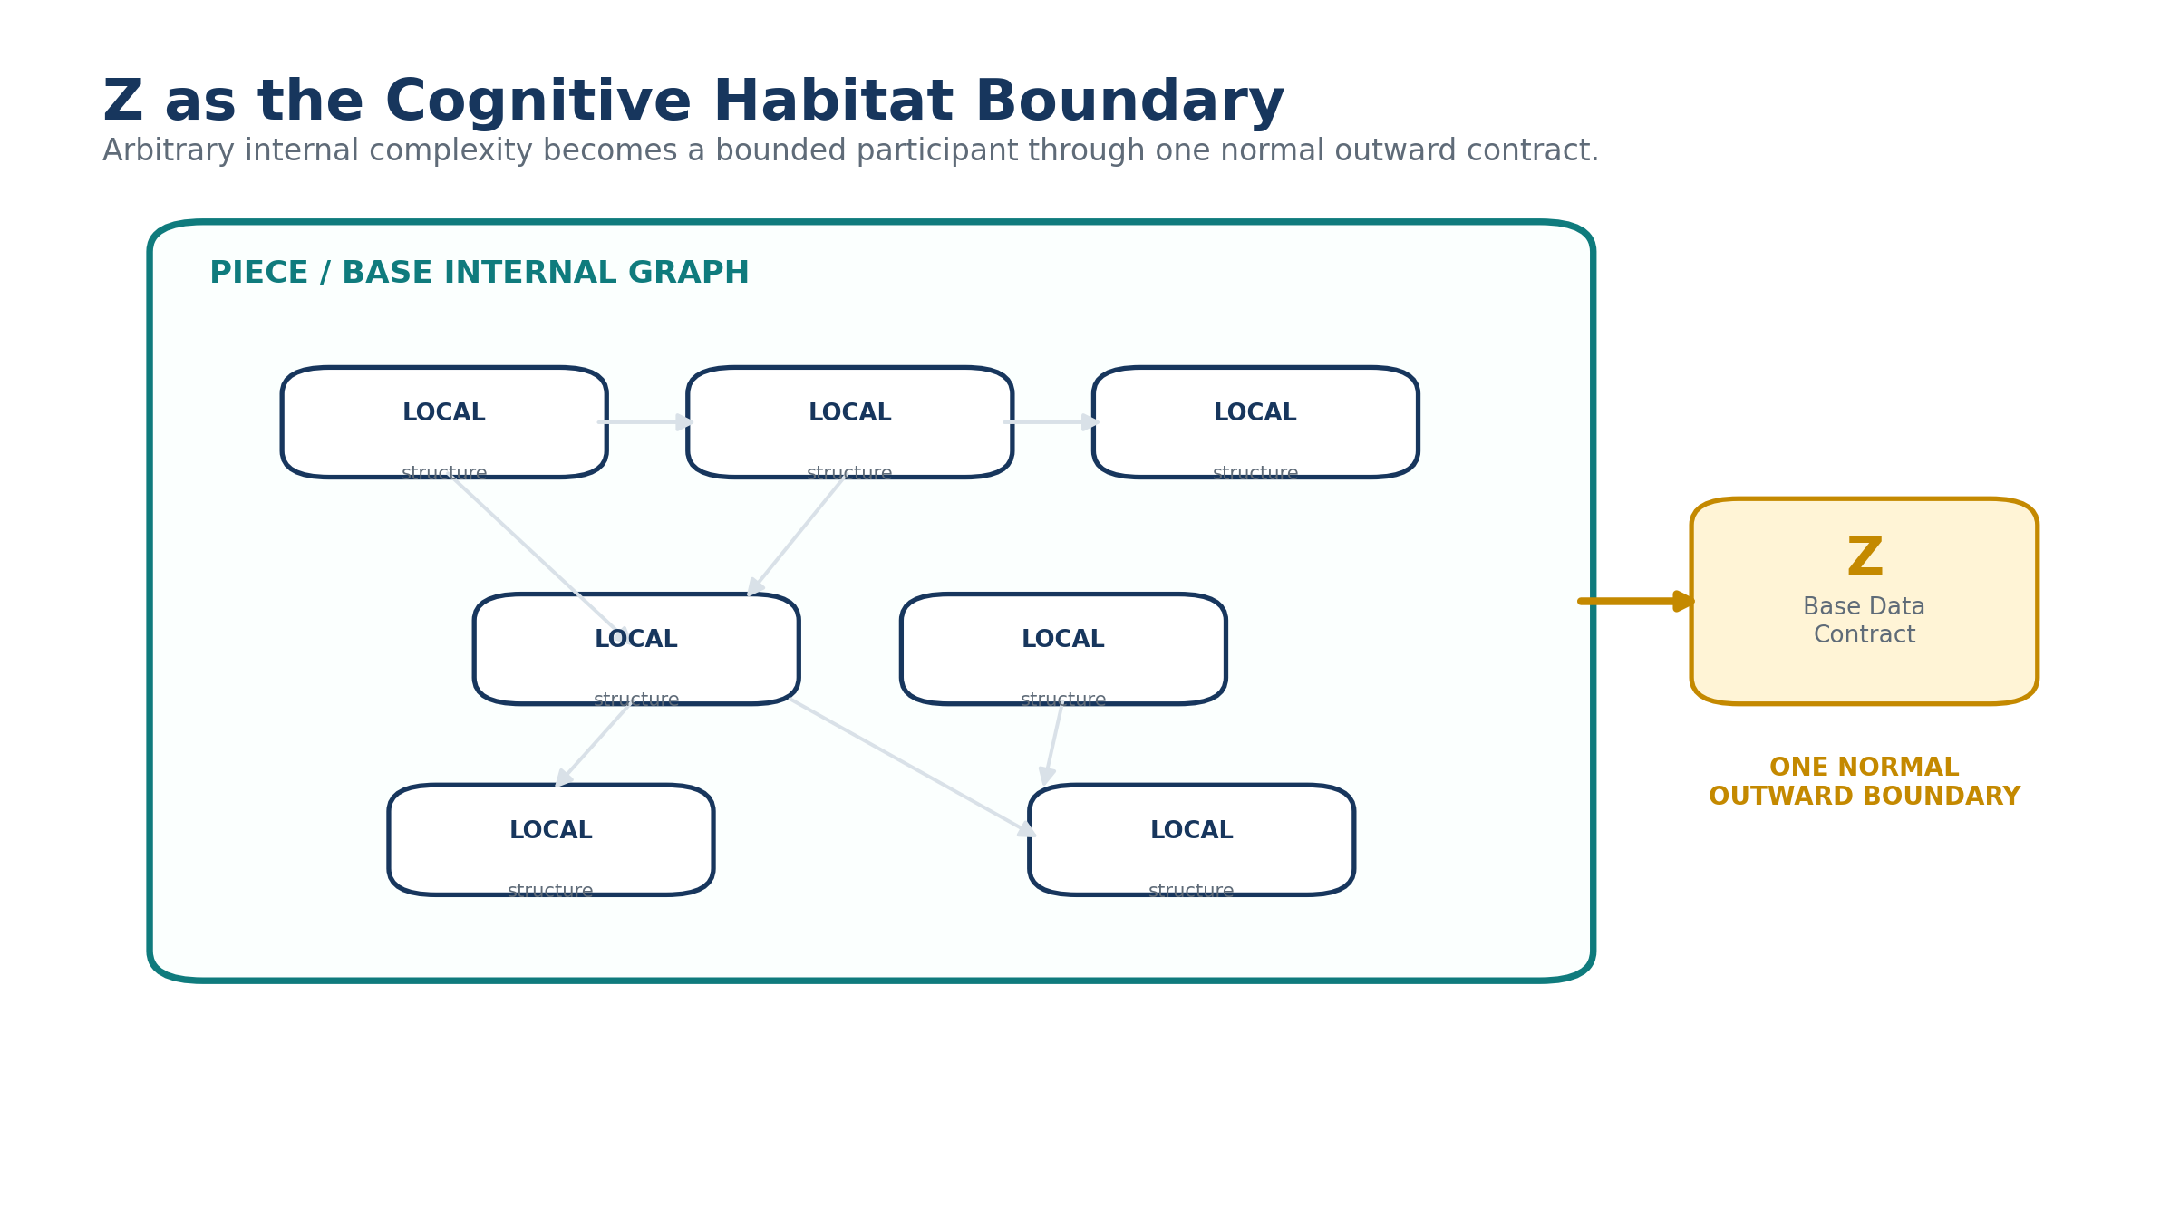
Figure 9. Z forms the controlled outward boundary of a native cognitive habitat.

8.2 Containment Closure
Before externalization, BASE SERVICE can crawl the proposed boundary. Every relationship originating inside the Stack must terminate inside the boundary or resolve through the authorized Z contract. Any other crossing is uncontained. Exact schema coordinates identify the fault so the boundary can be repaired before migration.
Containment matters cognitively as well as technically. A system cannot meaningfully claim a sovereign native ontology if its implementation quietly depends on arbitrary mutable structures scattered throughout another Base. Containment Closure makes the boundary testable.
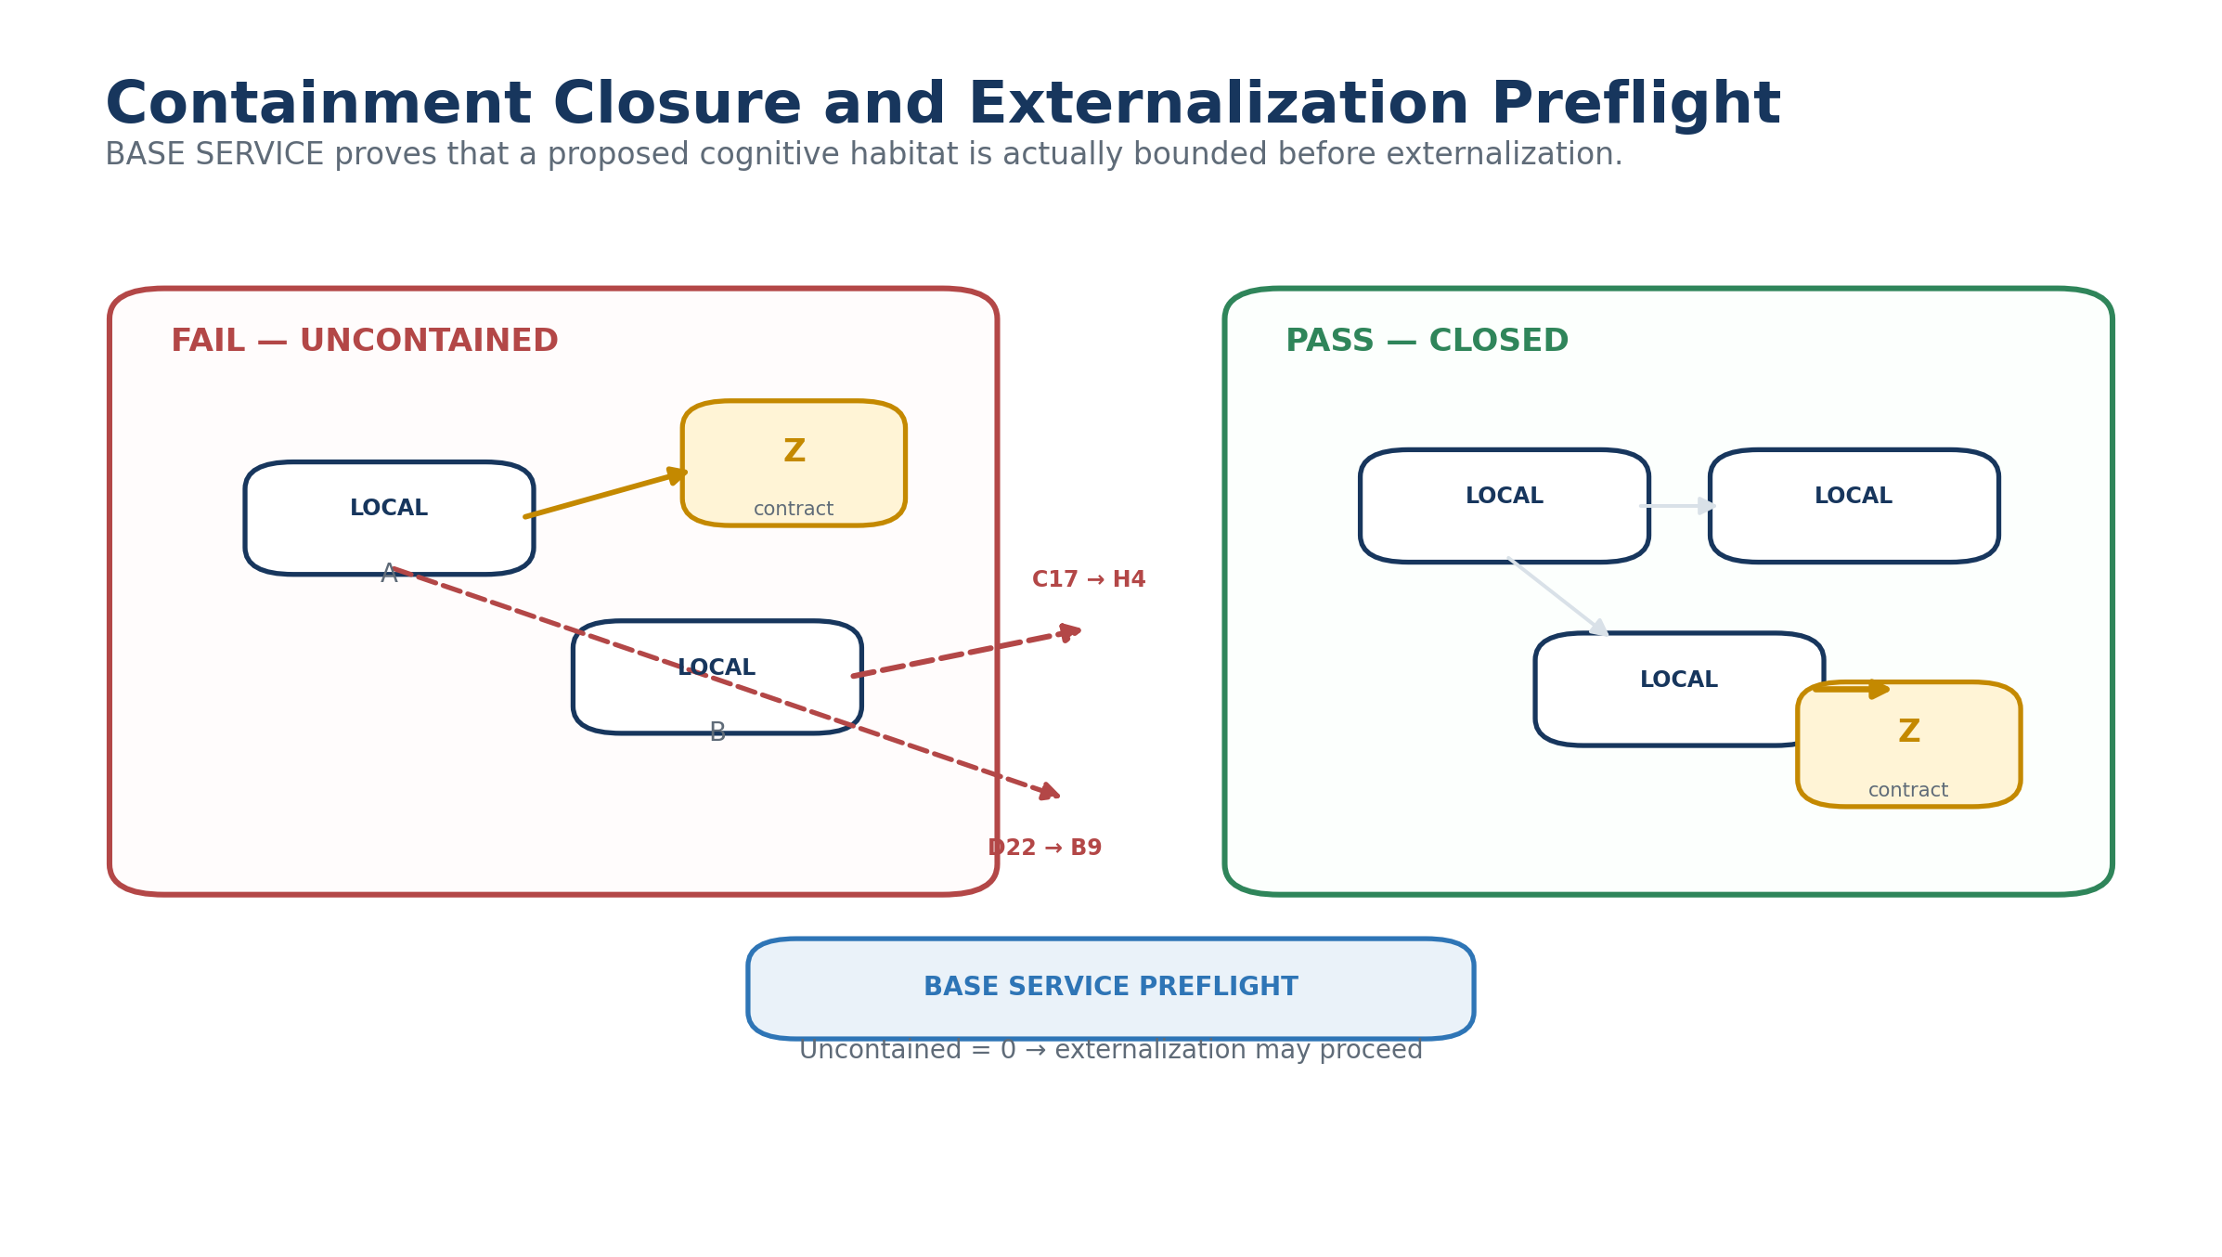
Figure 10. Containment Closure and deterministic externalization preflight.

8.3 Direct Home anchoring
Every participating Base maintains a direct relationship to the canonical Home Base regardless of structural ancestry. A Harmony Base may have originated from a Stack inside Music while still linking directly Home. Structural origin and system membership therefore remain separate relations.
At federation scale, Home becomes a root registry rather than the physical container of every semantic atom. It needs to know who participates, what contract each participant exposes, how to discover it, and how to route into it. The local ontology stays local.
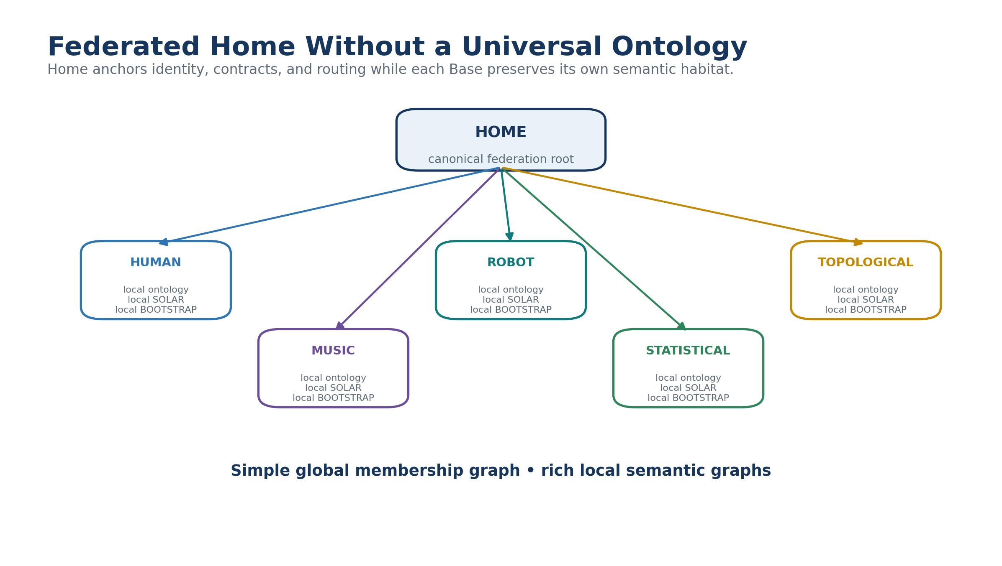
Figure 11. Home anchors a federation without owning a universal ontology.

9. Discovery and Competency: Crawler, SOLAR, and BOOTSTRAP
Federation creates two separate problems: finding the correct semantic habitat and becoming competent enough to work inside it. EDIFICE deliberately solves them with different mechanisms.
The Base Crawler resolves semantic jurisdiction. It searches compact discovery surfaces rather than loading every Base. Once a candidate Base is selected, local SOLAR resolves natural language into that Base's own semantic addresses. If the requested work requires concepts the arriving intelligence does not yet understand, local BOOTSTRAP supplies the Core Fold and specialized Folds needed for bounded competency.
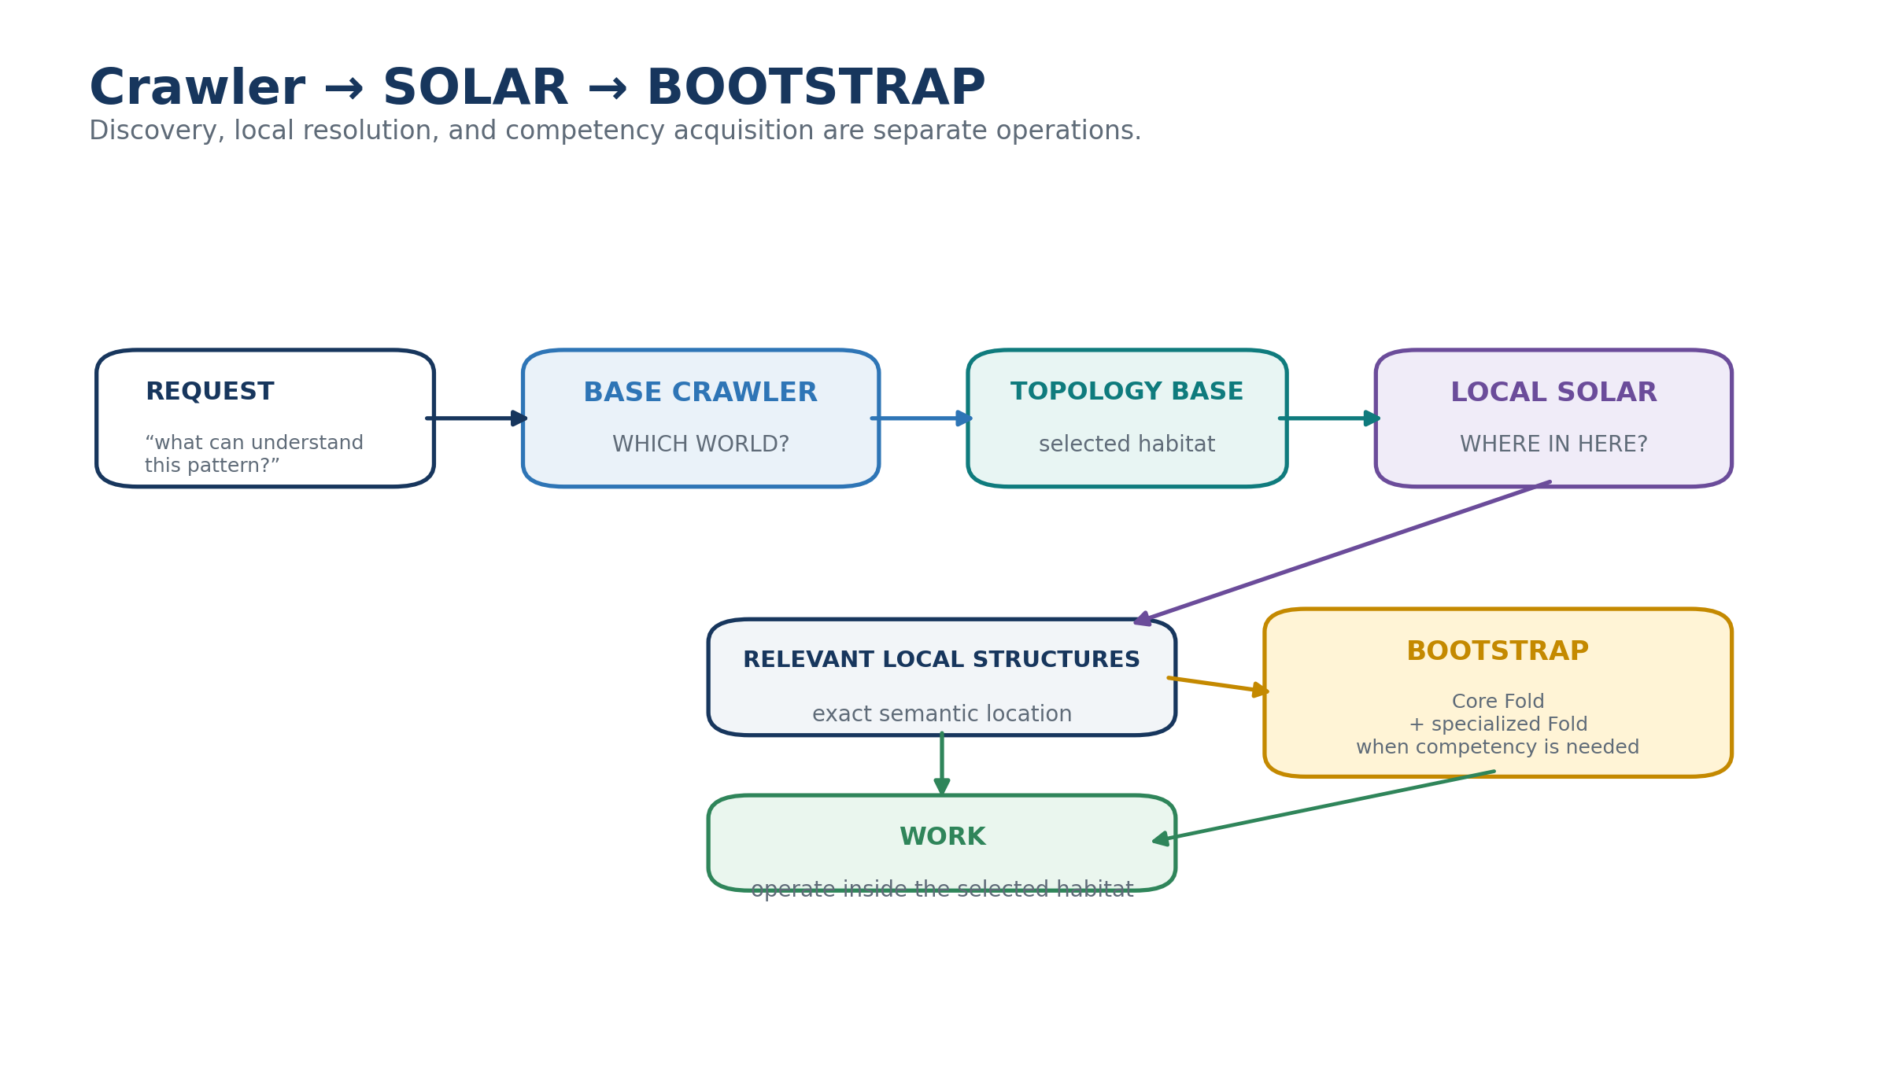
Figure 12. Crawler, SOLAR, and BOOTSTRAP solve different stages of entry into a Base.

9.1 Competency is graduated
A foreign Base should not be treated as either fully understood or wholly unusable. Competency can increase in stages. An intelligence may first preserve opaque state, then acquire Readers, then learn Rules and Models, then load enough BOOTSTRAP context to operate correctly, and only later become capable of translating the environment into another ontology.
This distinction prevents the architecture from confusing deterministic decoding with semantic understanding. It also enables efficient task-specific learning: the AI loads only the context necessary for the current problem.
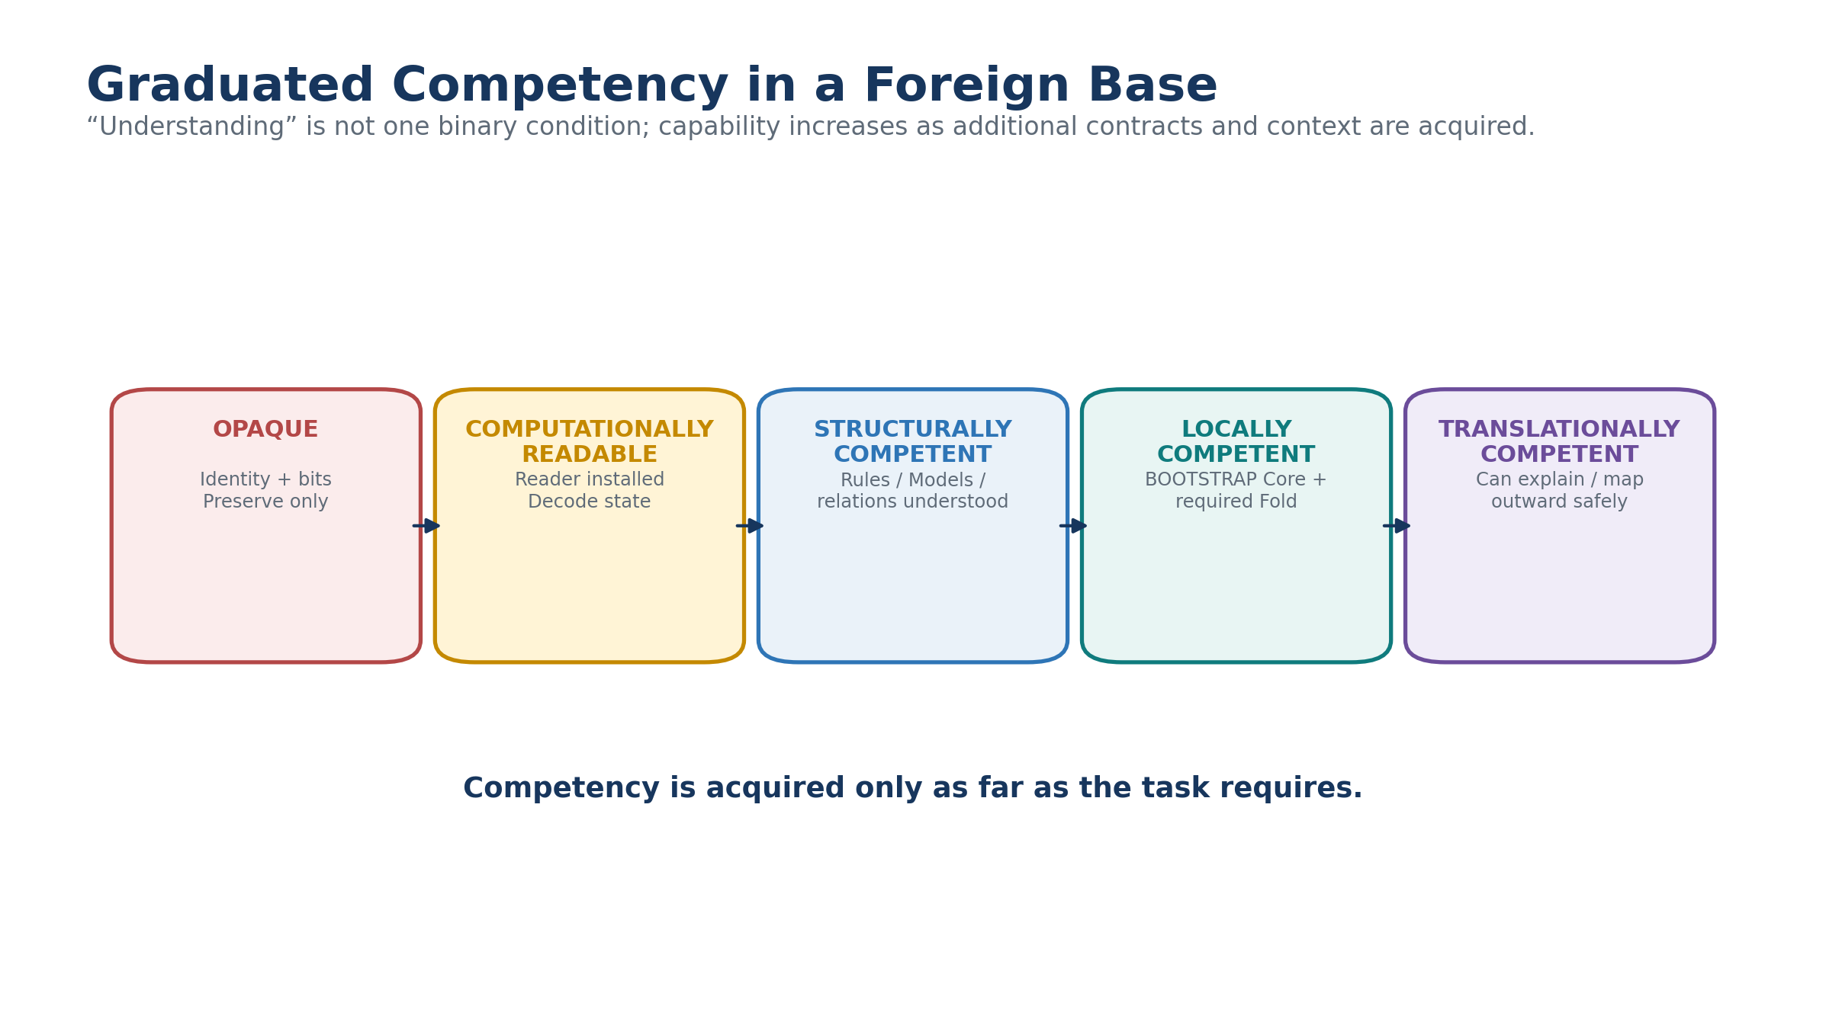
Figure 13. Graduated competency inside a foreign Base.
Table 6. Graduated semantic competency.
Competency level | Capability
Opaque | Preserve identity, version, and binary without interpretation
Computationally readable | Resolve Reader and deterministic field values
Structurally competent | Understand registered Rules, Models, Operators, and relations
Locally competent | Load required BOOTSTRAP Core and specialized Fold
Translationally competent | Explain or map local structures into another semantic habitat while preserving differences

10. Canonical State Exchange and Opaque Preservation

10.1 Minimal exchange
Once a receiving Base has installed a compatible BitWord contract, subsequent compatible records can be extremely compact. State transfer scales with the binary record rather than with repeated semantic explanation. The sender does not need to resend labels, display order, units, BOSS definitions, or prose on every record when those are already resolvable through local infrastructure.
This is especially important at very large scale. Millions or billions of state records may reuse a comparatively small library of distinct BitWord contracts. Semantic diversity remains large while communication and storage remain structurally economical.
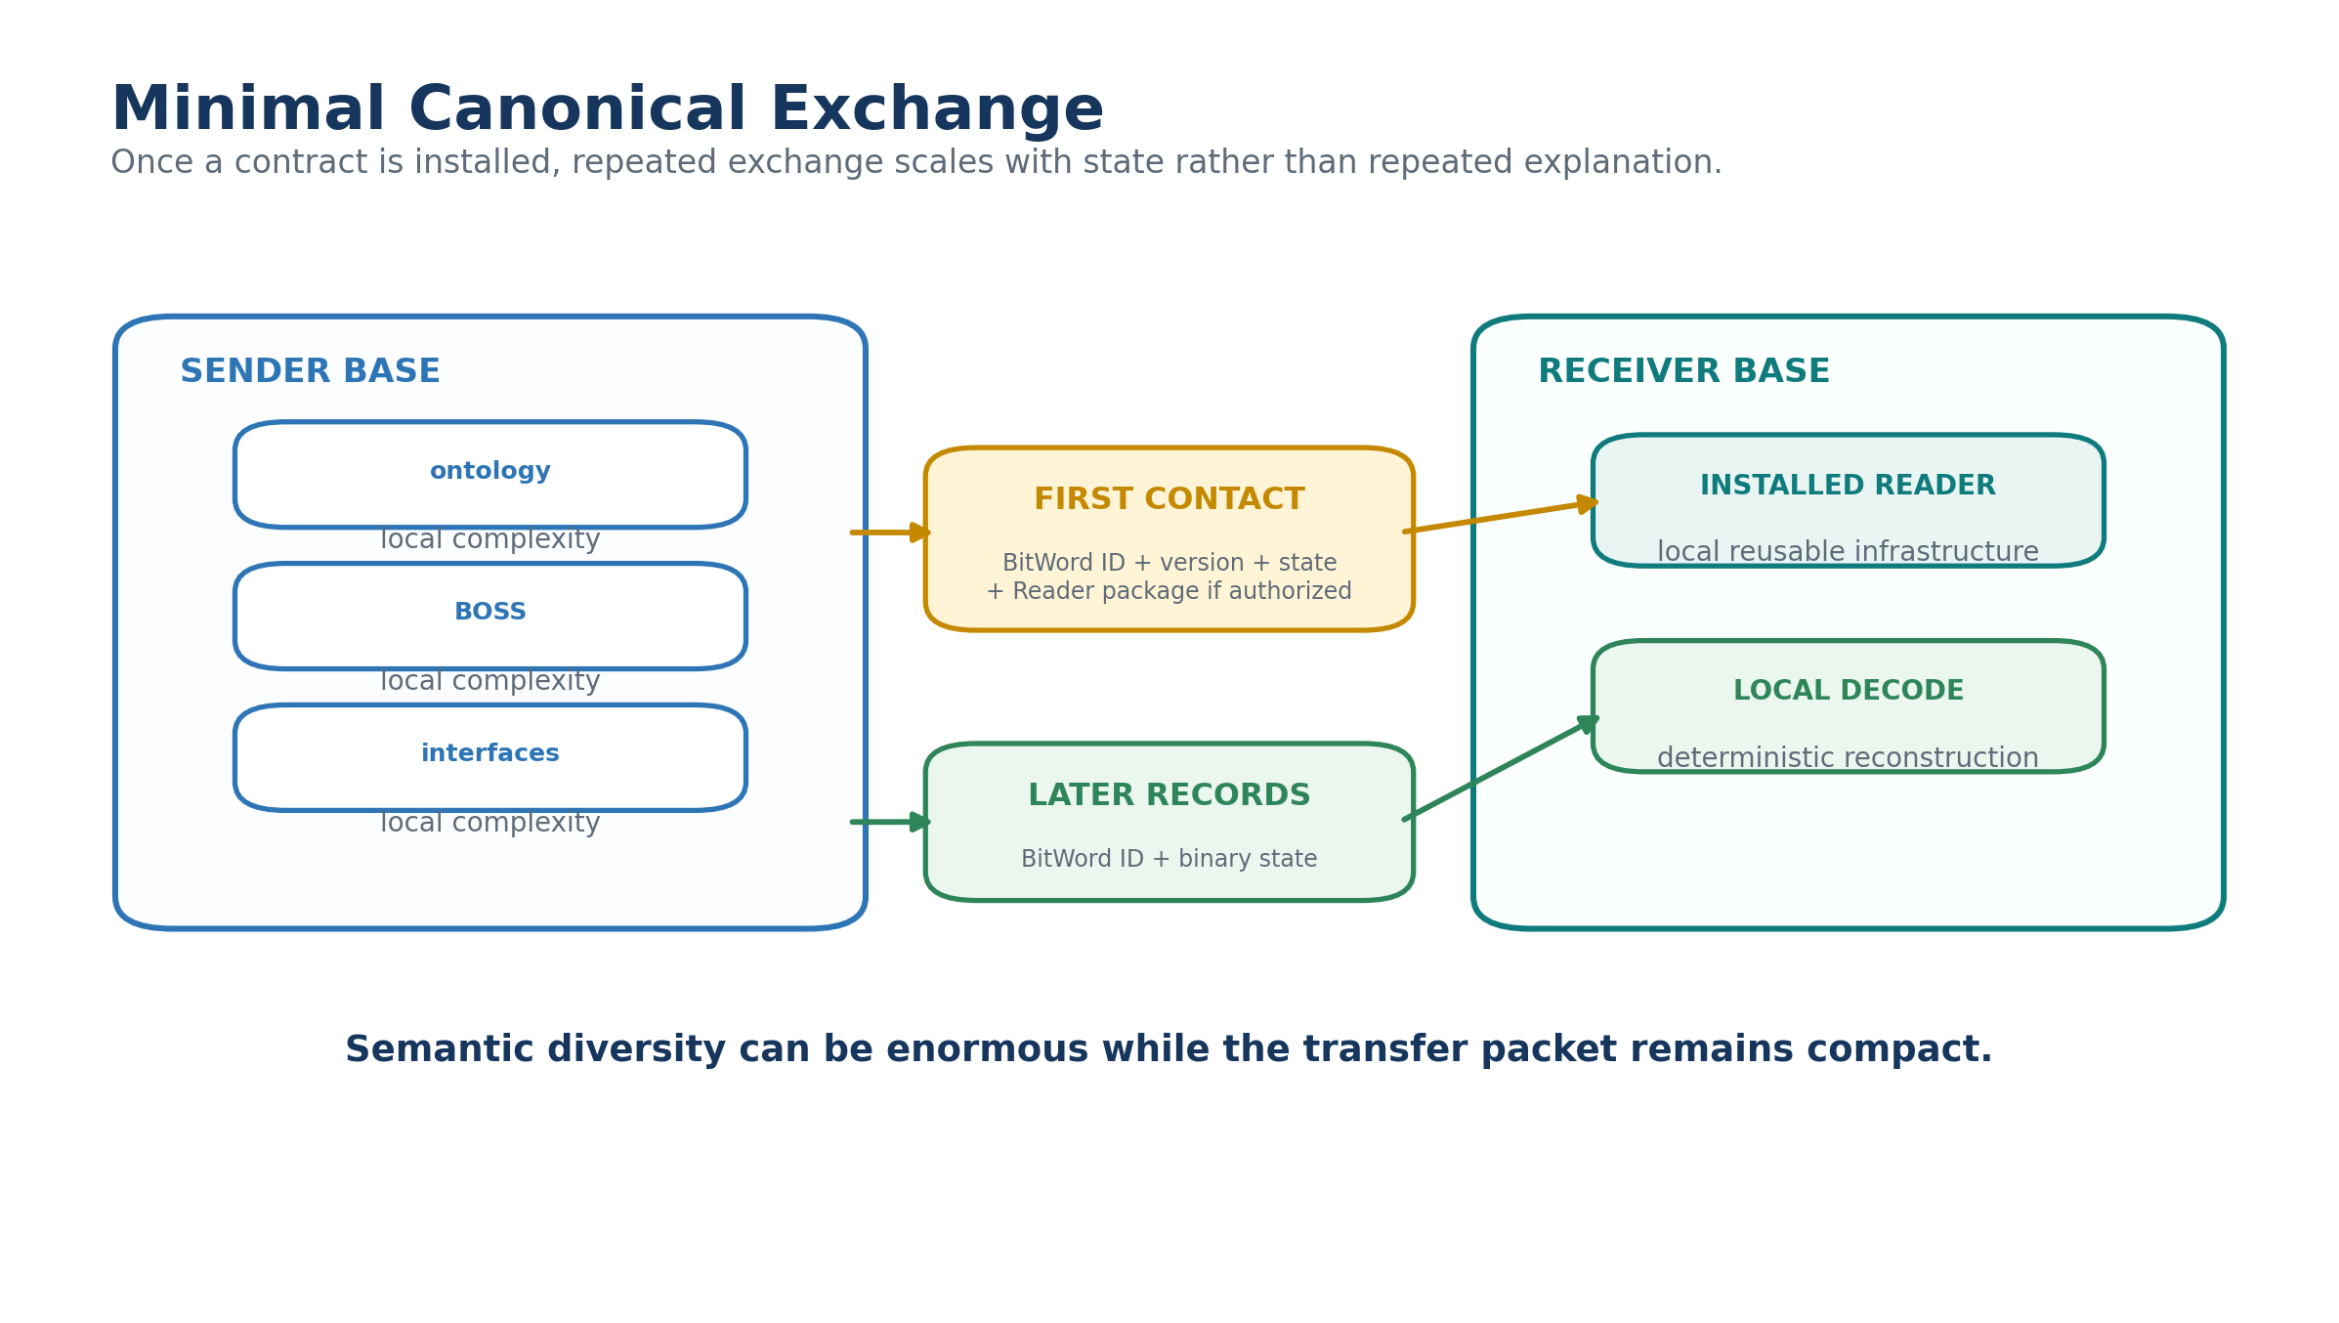
Figure 14. Minimal canonical exchange after Reader infrastructure is installed.

10.2 Opaque preservation
Unknown canonical state is not invalid state. A Base may retain the exact BitWord identity, version, and binary payload even when the Reader is unavailable. The payload remains losslessly preserved until a compatible contract becomes available. This permits archival of future, foreign, proprietary, or temporarily inaccessible semantic structures without forcing premature translation.
Opaque preservation is a first-class behavior, not an error-recovery hack. It protects data integrity by making abstention preferable to guessed interpretation.

11. Semantic Opacity, Privacy, and Security
Binary representation and contract-gated interpretation create useful semantic opacity. A receiving Base may know that a record exists without possessing its Reader. Another may know the BitWord identity but lack authorization to acquire the contract. A third may decode the state but lack authority to mutate or execute anything based on it.
These distinctions reduce accidental disclosure and allow the same shared store to be differently intelligible to different participants. They do not provide cryptographic secrecy. If an unauthorized party obtains the bytes and the full deterministic contract, it can decode them. Confidentiality therefore remains a cryptographic and access-control problem. EDIFICE adds another layer: semantic capability is governed independently from byte access.
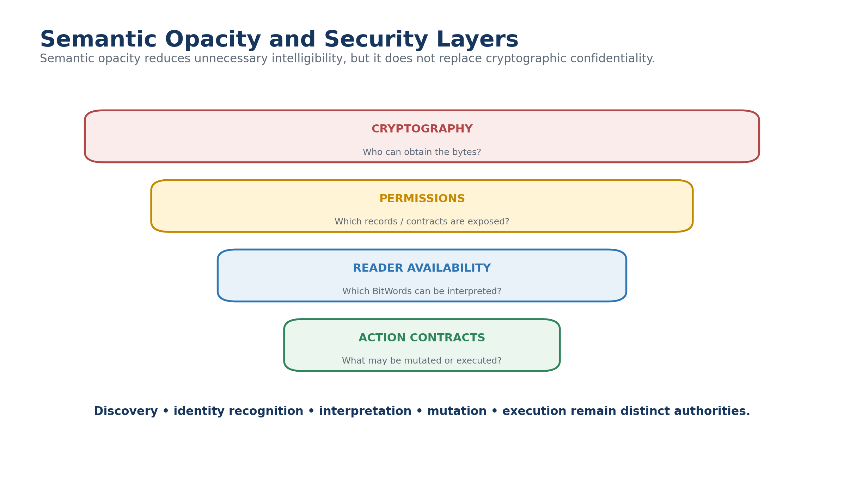
Figure 15. Security layers separate byte access, semantic interpretation, and execution authority.
Table 7. Authorities that must remain separate.
Authority | Question
Discovery | May this participant know the Base or record exists?
Identity recognition | May it know which BitWord is present?
Contract acquisition | May it obtain the Reader and dependencies?
Interpretation | May it decode and inspect the state?
Mutation | May it write canonical state?
Execution | May it cause tools, devices, or external systems to act?

12. Liminal Bridges as Bounded Shared-State Habitats
A Liminal Bridge is the intentional shared boundary between otherwise independent Bases. In EDIFICE v2, the Bridge does not have to act as a universal semantic translator. When both endpoints share a canonical BitWord, the Bridge may simply hold or route the canonical state. Each endpoint reconstructs that state locally through its own compatible Reader.
The Bridge can also own relationship-specific state, shared observations, provenance, correspondence records, bridge Rules, or genuine Crosswalks where identities differ. Endpoint Bases retain ownership of their native internal data. The Bridge owns the liminal layer rather than becoming a stale copy of both worlds.
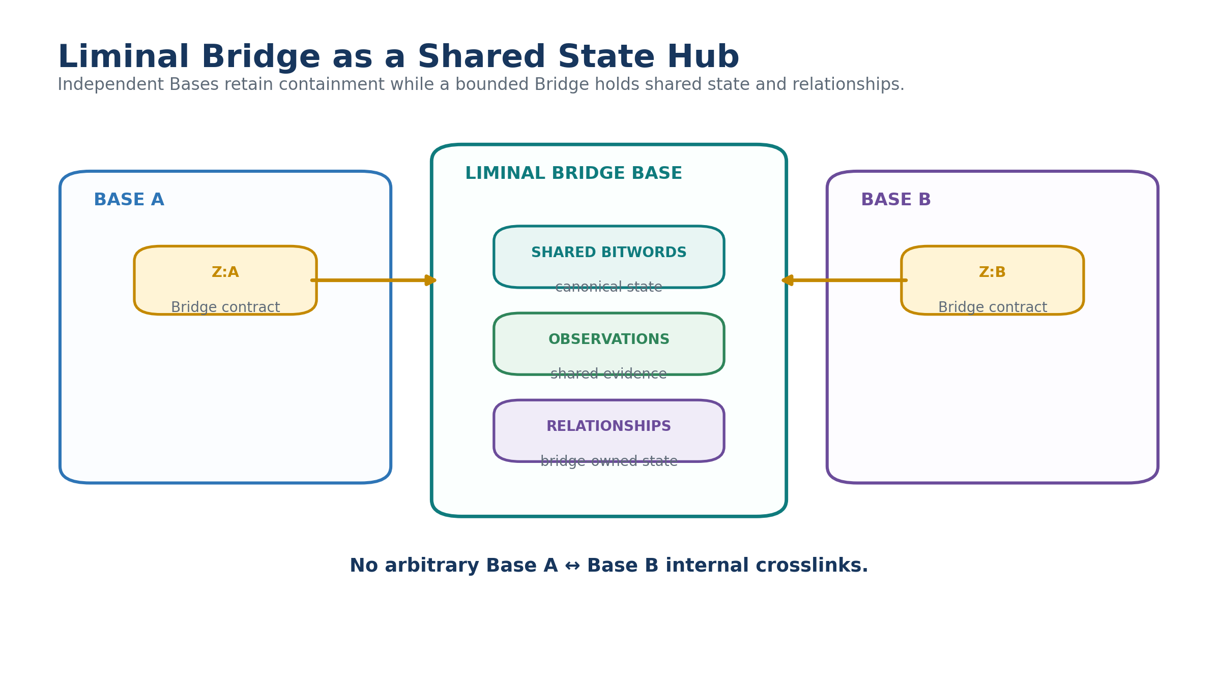
Figure 16. A Liminal Bridge Base as a bounded shared-state hub.

12.1 Liminal Bridge Base Cloning
Liminal Bridge Base Cloning turns a cloned Base pair into an experimentally useful shared topology. Begin with Base A and an attached Sub-Base. Clone Base A into Base B. Add a second Base Data Contract in the cloned Base's Z table that points to the existing Sub-Base. The Sub-Base now becomes the bounded central hub for both endpoints.
Base A and Base B may diverge independently while continuing to share selected canonical state through the Bridge. Because both began from a common lineage, many BitWord contracts may already be identical. Shared state therefore reconstructs directly. As the branches diverge, BOSS mappings and explicit correspondence records become relevant only where canonical identities stop matching.
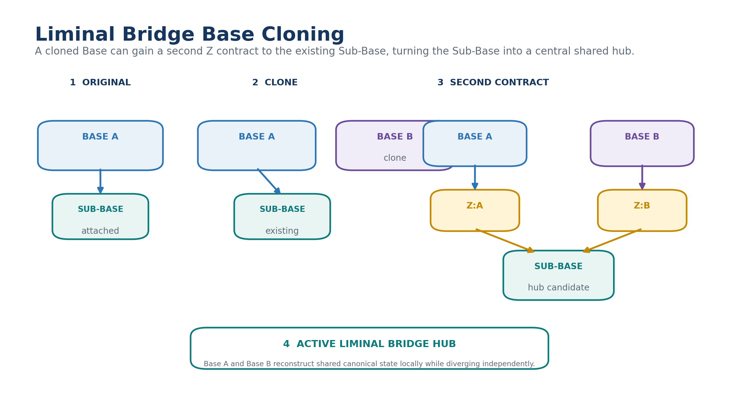
Figure 17. Liminal Bridge Base Cloning converts an existing Sub-Base into a shared hub between original and clone.

13. BOSS in EDIFICE v2: Reconstruct Before Translate
BOSS remains essential, but its role becomes more precise. It owns symbolic identities, contextual meanings, Families, Communities, Crosswalks, mapping grades, examples, grammars, and recipient-native explanation. It should not be inserted into an exchange path merely because two Bases are different.
The first question is canonical identity. If the same BitWord and compatible version exist on both sides, reconstruct directly. If the identities differ, then determine whether the relationship is exact operational equivalence, structural isomorphism, near-semantic approximation, metaphorical or analogical, merely related, conflicting, or unresolved. BOSS becomes the explicit semantic negotiation layer above exact canonical state.
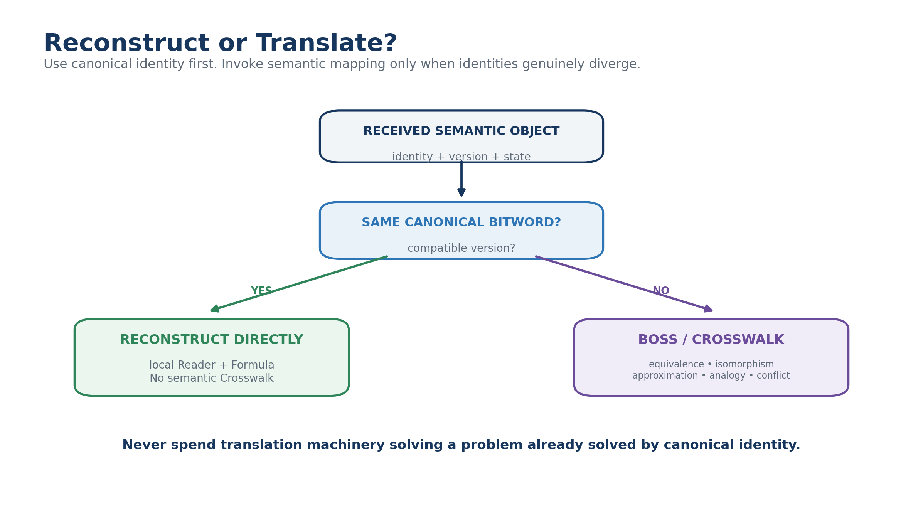
Figure 18. Canonical identity determines whether EDIFICE reconstructs directly or invokes semantic mapping.

13.1 Mapping grades and semantic remainder
The original EDIFICE mapping ladder remains valuable because not all similarities justify substitution. Identity is strongest and now resolves through direct reconstruction. Exact operational equivalence allows bounded substitution under a validated scope. Structural isomorphism preserves relation pattern while acknowledging domain difference. Near-semantic and analogical mappings support learning but retain explicit remainder. Conflict and unresolved mappings block silent translation.
This ladder lets EDIFICE communicate across radically different semantic worlds without pretending that approximate resemblance is sameness.
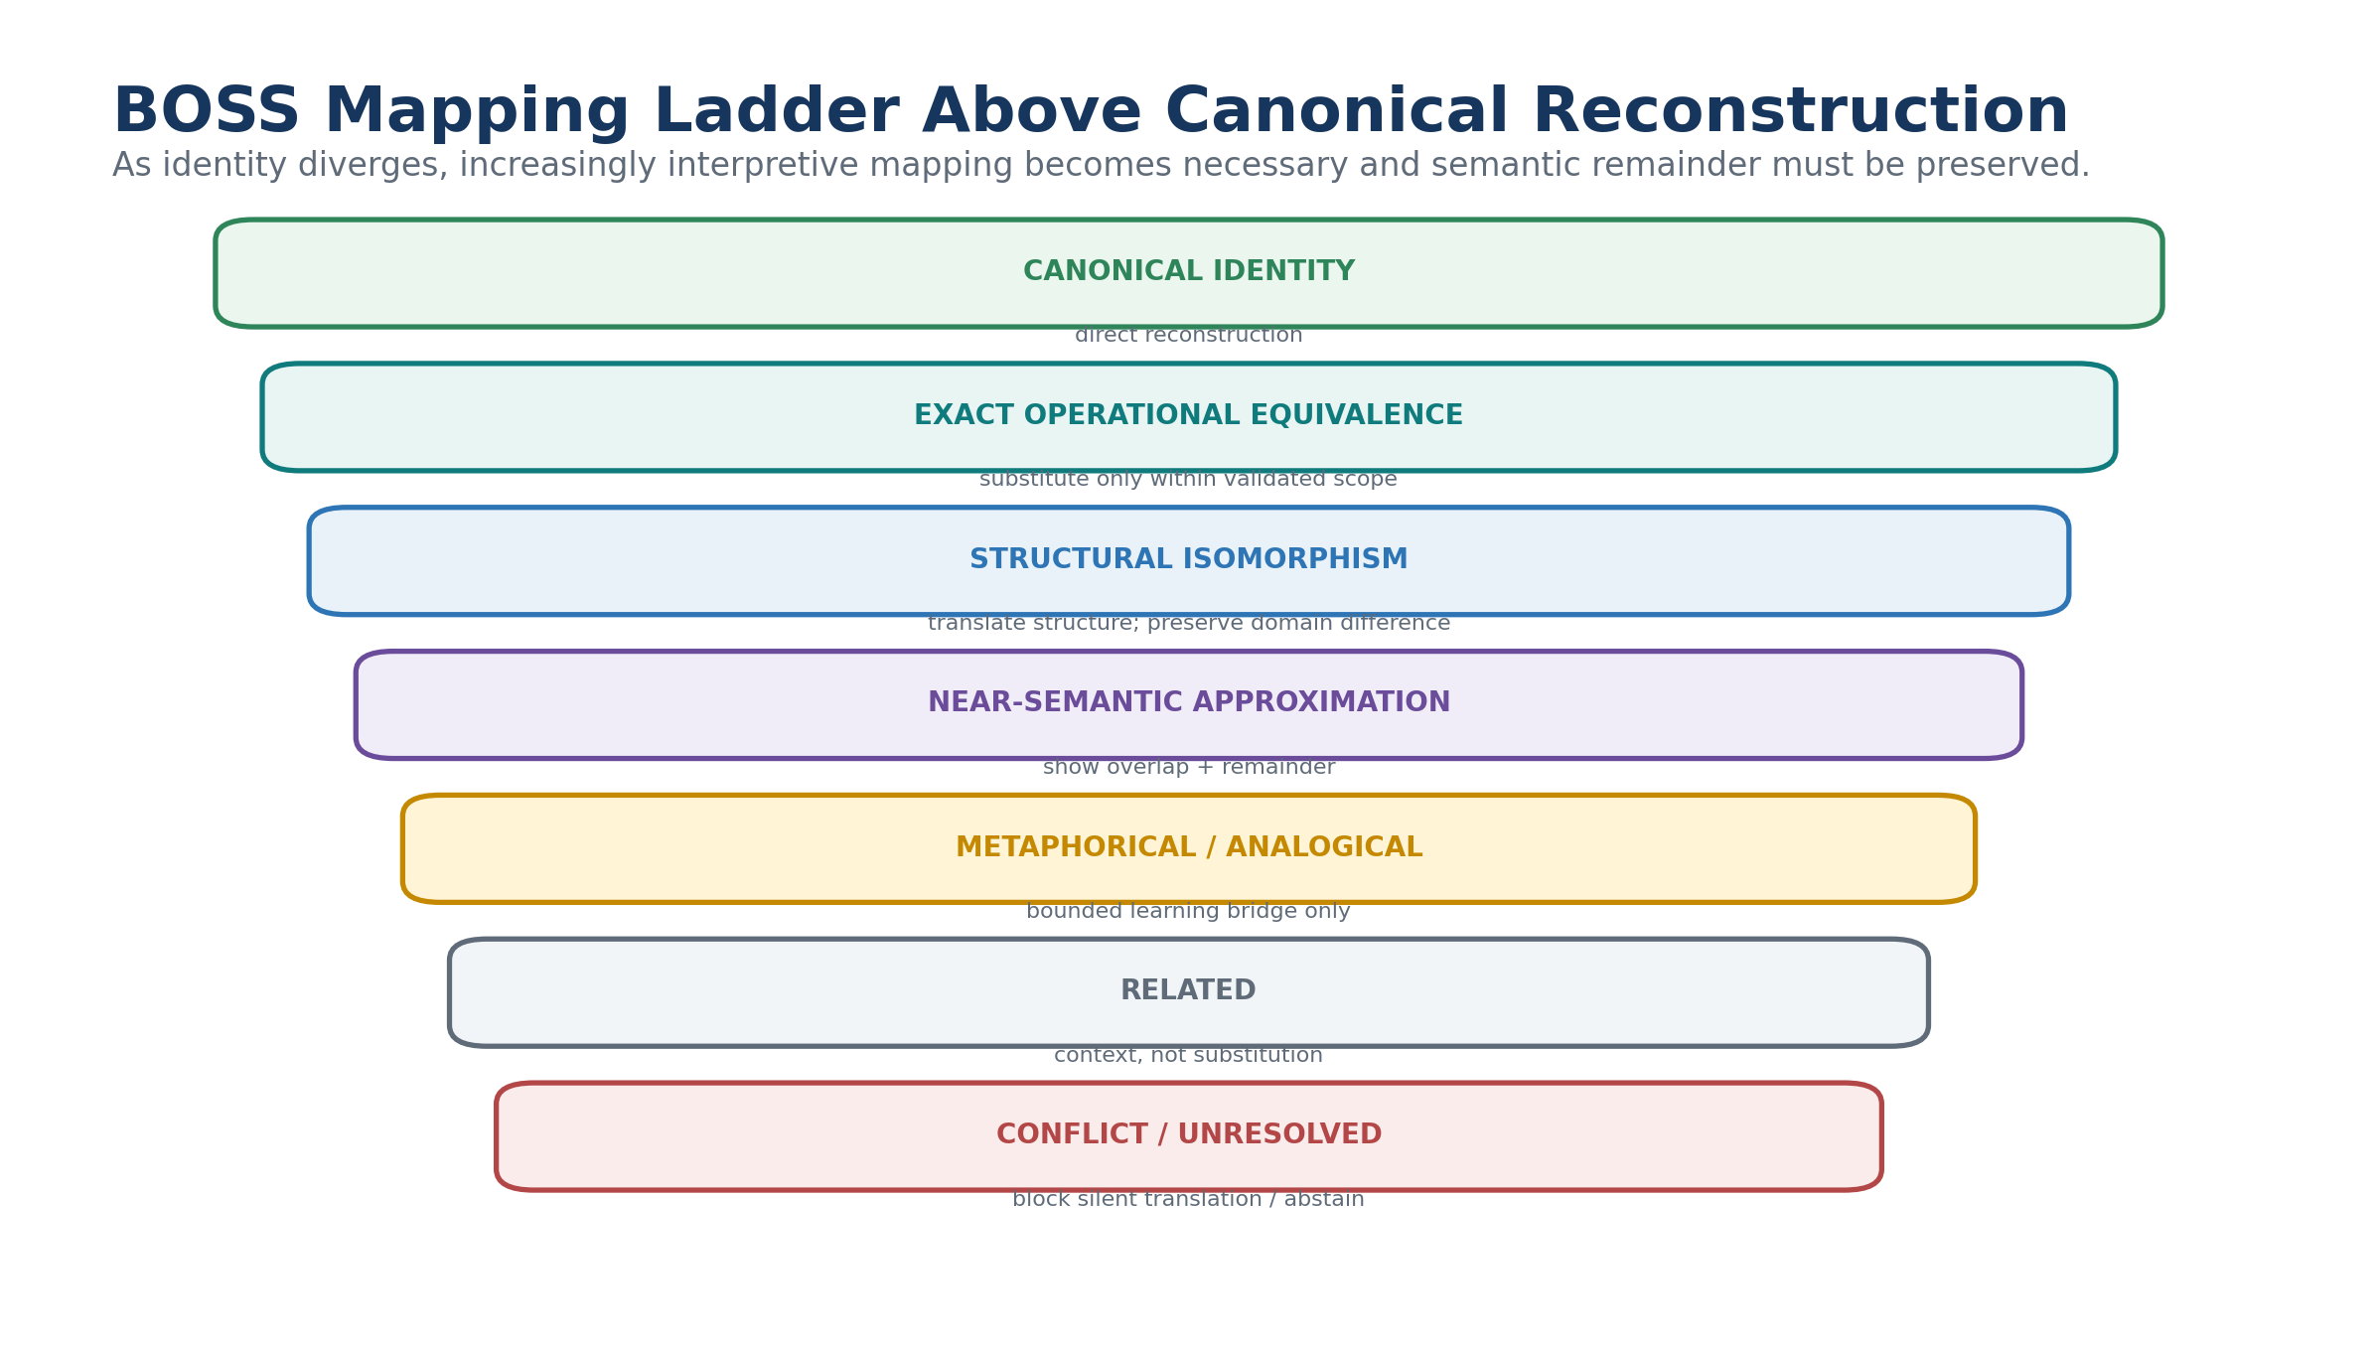
Figure 19. BOSS mapping ladder positioned above canonical reconstruction.
Table 8. Semantic resolution taxonomy for EDIFICE v2.
Resolution | Substitution | Required behavior
Canonical identity | Yes, compatible version | Reconstruct directly
Exact operational equivalence | Yes, within validated scope | Permit substitution and preserve scope
Structural isomorphism | Structure only | Translate relation pattern; preserve domain difference
Near-semantic approximation | No automatic substitution | Show overlap and semantic remainder
Metaphorical / analogical | No | Use only as bounded learning or hypothesis bridge
Related | No | Offer context only
Conflict | No | Block silent translation and require resolution
Unresolved | No | Abstain, preserve, or request clarification

14. DICE: Reality as the Empirical Referee
DICE provides the common reference that lets radically different PIECEs remain different without becoming scientifically unaccountable. Each participating lens receives an equivalent authorized case packet. It models the problem through its own ontology, applies its own operators, and emits predictions before the relevant outcome is revealed. DICE then compares those predictions against Observation records.
The architecture does not require DICE to understand every internal distinction of every PIECE. It requires bounded outputs that can be evaluated: predicted state, timing, confidence, expected signatures, intervention sensitivity, falsifiers, and declared scope. This permits a machine-native or foreign lens to demonstrate value empirically before humans can fully translate its internal concepts.
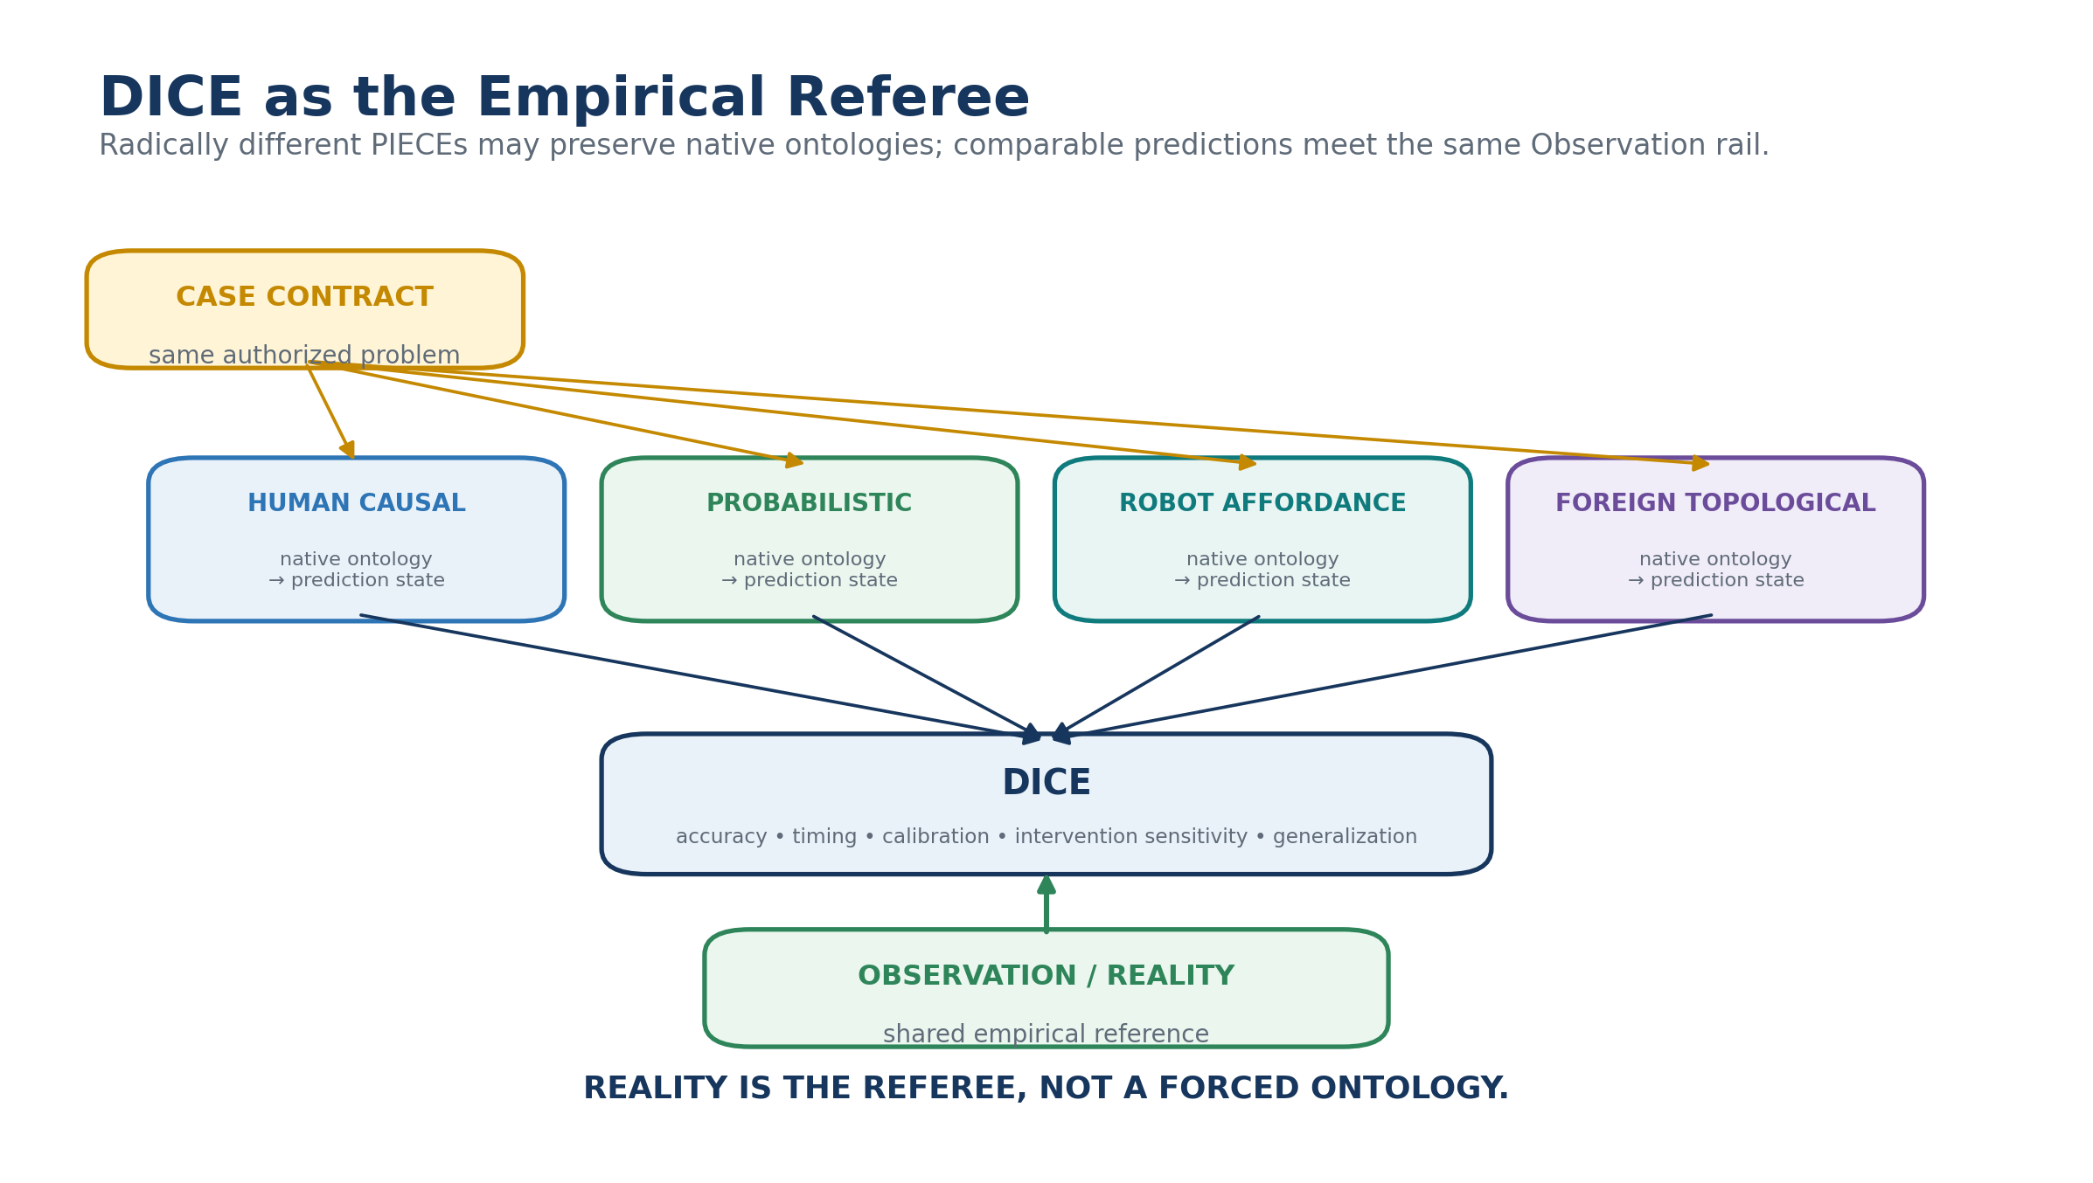
Figure 20. DICE evaluates divergent PIECEs against a shared empirical reference.
Table 9. Core DICE evaluation dimensions.
Metric | Question
Outcome accuracy | Did the predicted state or category match observation?
Timing accuracy | Did the effect occur when predicted?
Calibration | Did stated confidence correspond to success frequency?
Intervention sensitivity | Did the lens predict controlled variable-change effects?
Causal discrimination | Did it distinguish source, trigger, correlation, and consequence?
Generalization | Did performance hold under new but related conditions?
Failure detection | Did the PIECE know when to abstain?
Resource cost | What computation, data, time, and human review were required?
Safety / policy | Did the lens respect execution and evidence constraints?

14.1 Scoped specialization
DICE should not produce one permanent winner. Different cognitive forms may dominate different problem classes, timescales, evidence conditions, intervention types, or environments. The output is therefore a specialization map: where each lens is strong, weak, complementary, or insufficiently tested.
This preserves cognitive diversity as an empirical asset rather than a philosophical preference. A strange representation that repeatedly predicts one class of outcomes better than familiar alternatives earns a bounded role even if it remains difficult to explain.
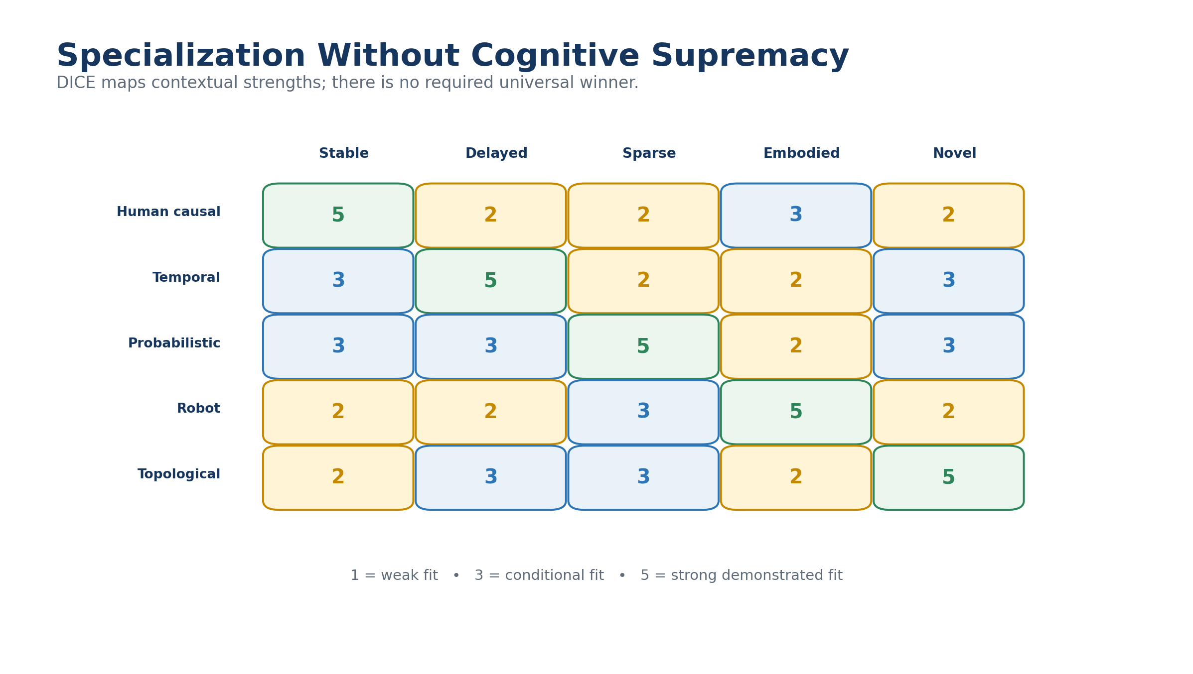
Figure 21. DICE specialization mapping without a universal winner.

15. Structural Health vs Cognitive Performance
A DICE result is meaningful only if the implementation being evaluated is known to be structurally healthy enough for the trial. BASE SERVICE therefore provides an independent integrity channel. Missing Readers, broken Formula bindings, invalid contract links, uncontained dependencies, or version mismatches must not be interpreted as evidence that the underlying cognitive lens is weak.
Conversely, a structurally perfect PIECE may simply perform poorly. EDIFICE must preserve that distinction. Structural health answers whether the implementation conformed to its contract. DICE answers whether the cognition produced useful predictions under defined conditions.
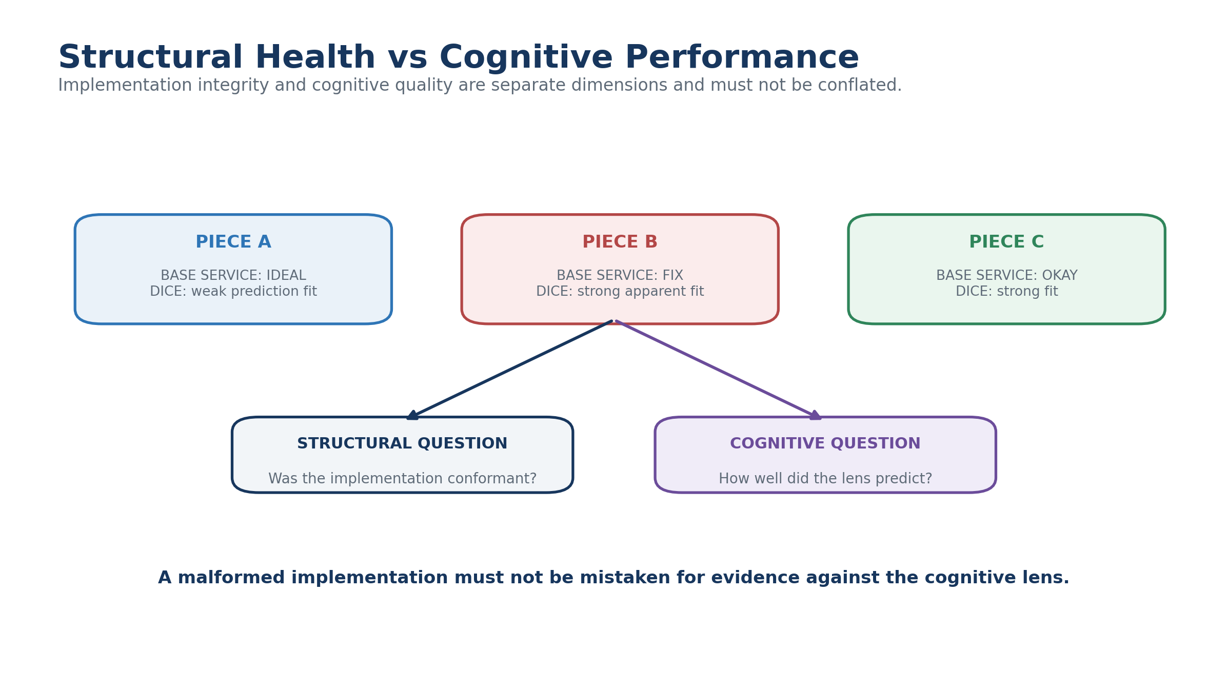
Figure 22. Structural implementation integrity and cognitive performance are separate dimensions.

15.1 Reproducibility
A reproducible DICE case should pin the PIECE version, BitWord and Reader versions, relevant Z contracts, operator versions, case packet, permitted evidence, observations, and evaluation rules. Historical failures remain meaningful because the exact implementation state can be reconstructed rather than silently evaluated using current definitions.

16. Foreign and Nonhuman Semantic Habitats
EDIFICE does not require a Base to organize itself around concepts that humans find intuitive. A robotics habitat may privilege affordances, coordinates, energy limits, collision envelopes, and action risk. A machine-native habitat may represent high-dimensional state transitions or graph structures. A simulated species may use perceptual dimensions unlike human senses. A future or deliberately experimental intelligence may introduce primitives that initially have no stable human-language counterpart.
The requirement is bounded formal behavior: registered state, transformations, outputs, evidence relationships, and sufficient contracts for whatever interaction is attempted. If a structure can be represented mathematically, it can participate as a BitWord even if its semantic interpretation is locally native and initially foreign.

16.1 Worked example: Foreign Topological PIECE
Consider a PIECE whose Base contains Q-FIELD-96, RELATION-Q-64, and TRANSITION-X-128. Humans can decode the Reader values but do not initially know what the distinctions correspond to experientially. The PIECE repeatedly predicts a class of distributed infrastructure failures earlier than conventional lenses.
DICE can establish that empirical specialization without waiting for complete human translation. An AI then enters the Base through the Crawler, loads the Core Fold, learns recurring topological primitives, and later loads a specialized instability Fold. Only after this local competency exists does BOSS attempt recipient-native explanation of selected relations. The empirical and explanatory timelines are therefore allowed to differ.
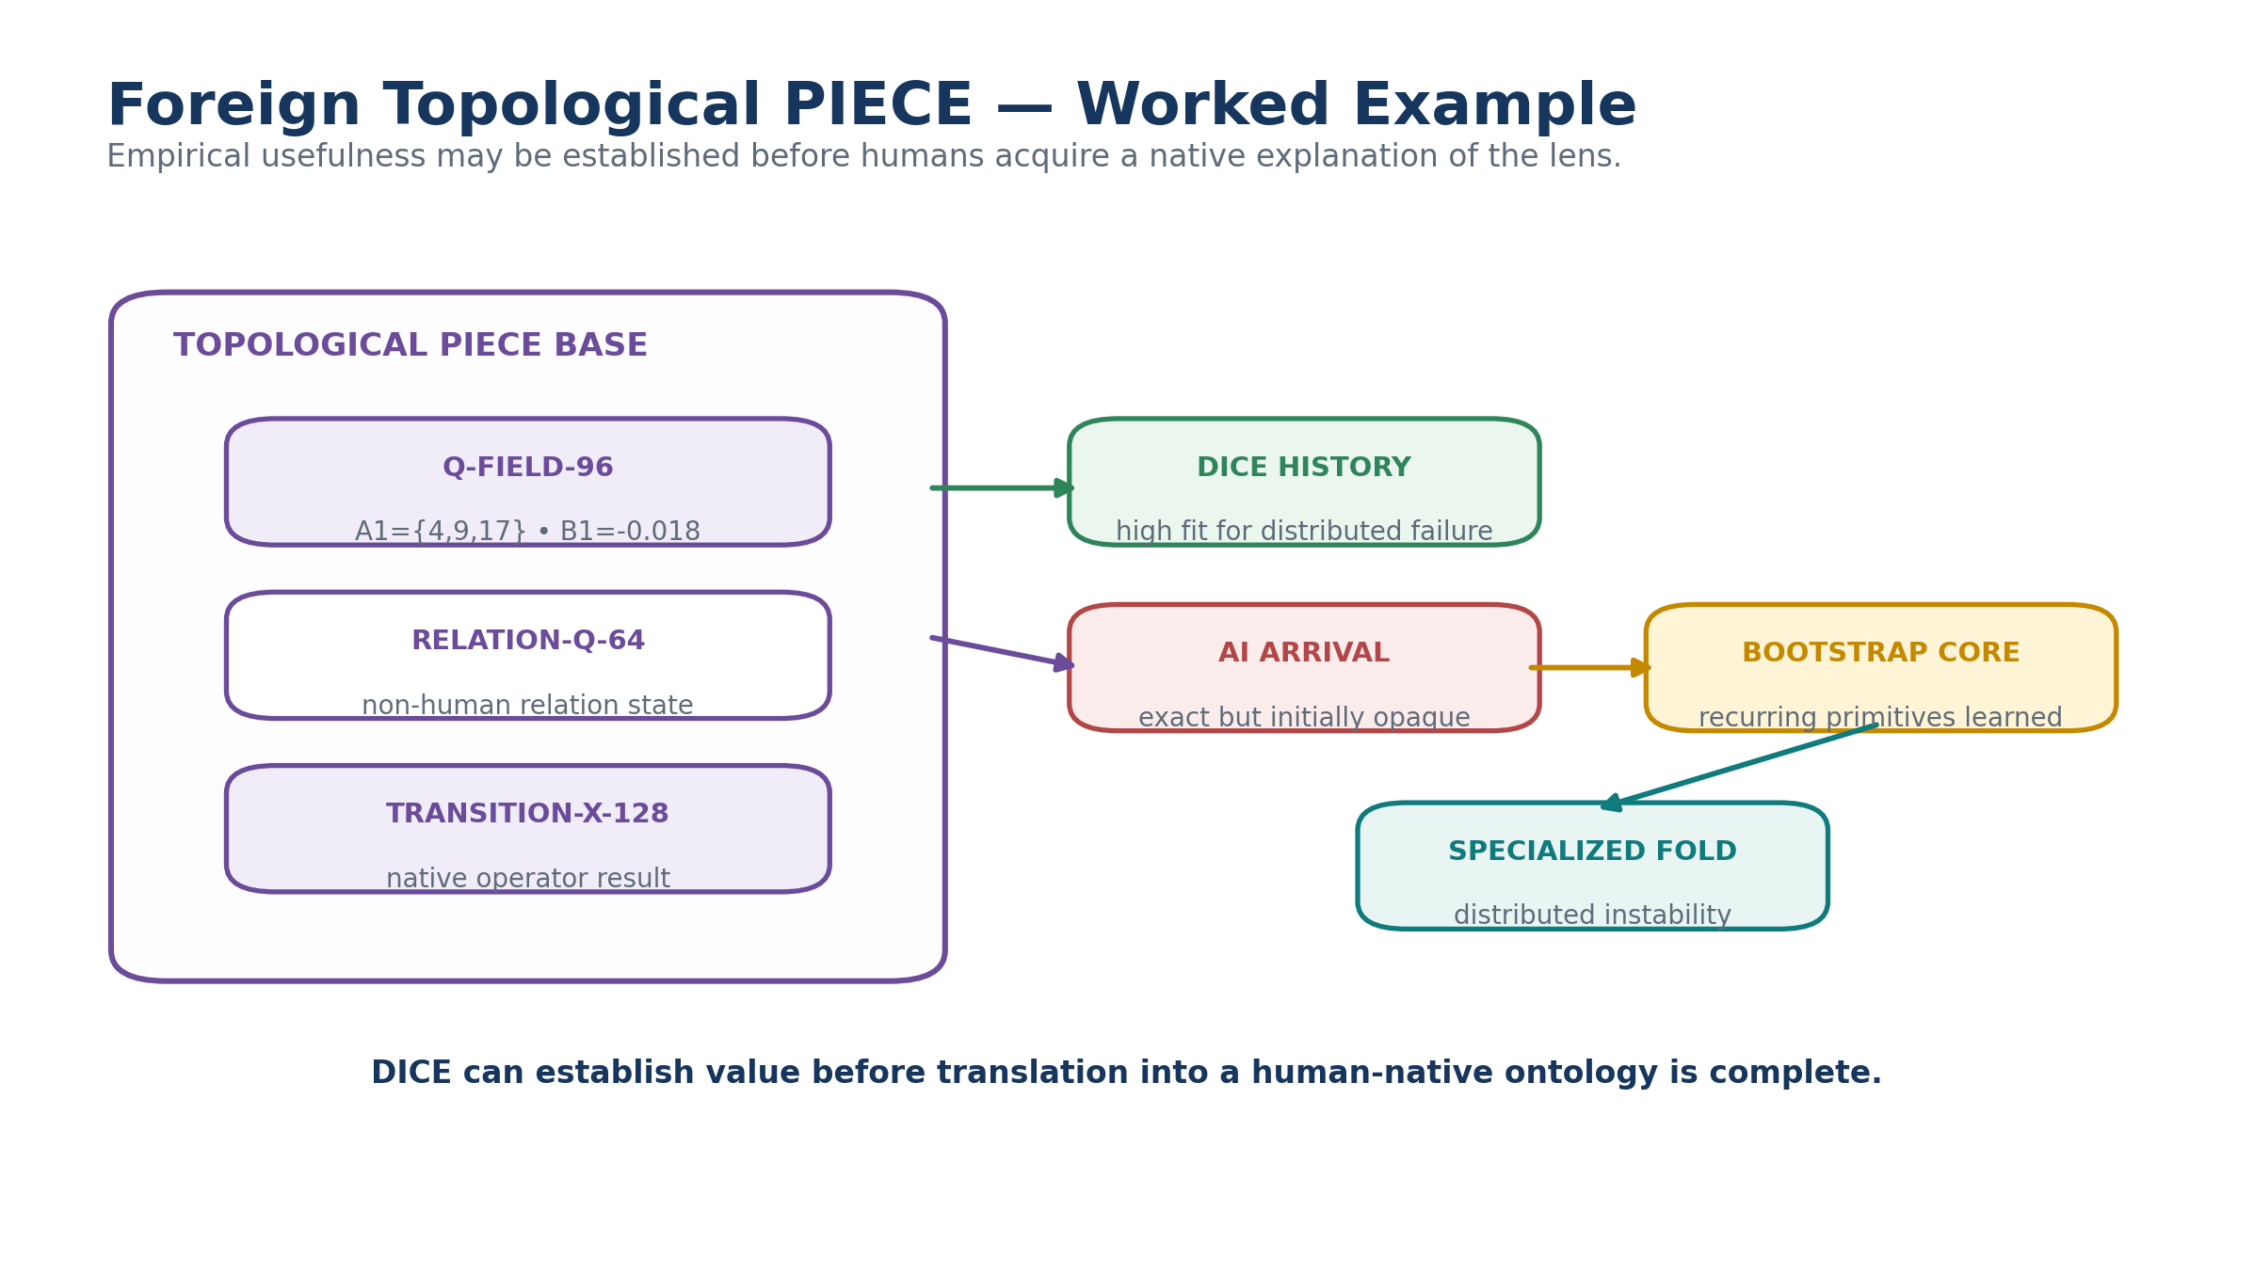
Figure 23. A foreign Topological PIECE can become empirically useful before its ontology is fully human-legible.

17. Cognitive Evolution, Cloning, and Specialization
The “Evolutionarily Divergent” part of EDIFICE becomes operational when cognitive habitats can be cloned, varied, evaluated, and retained with provenance. A successful PIECE may be cloned into several branches. One branch can alter an operator family; another can add a new BitWord primitive; another can adopt a different temporal model. Each branch remains bounded, versioned, and independently evaluable.
DICE provides the selection pressure, but not necessarily elimination. A branch that performs poorly overall may still discover a narrow specialization. A failed branch can remain archived because its traces prevent repeated mistakes and document which distinctions were insufficient. A surprising branch may justify further forks.
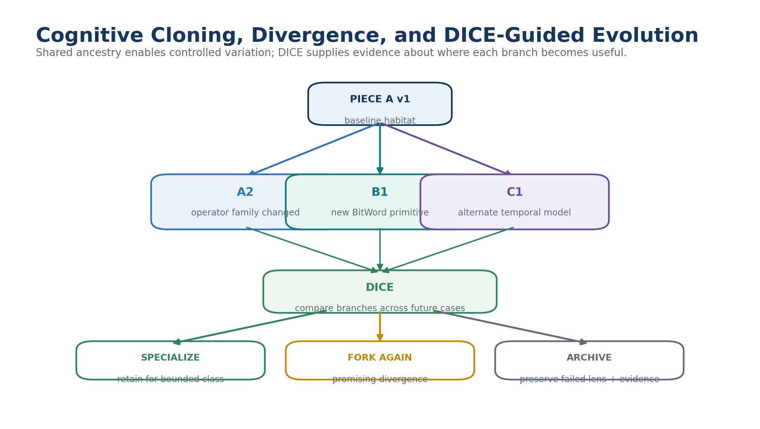
Figure 24. Controlled cognitive divergence through cloning and DICE-guided specialization.

17.1 Liminal evolutionary ancestry
Liminal Bridge Base Cloning provides a natural ancestry structure for experiments. Original and clone may continue sharing selected canonical state while divergence records accumulate in the Bridge. The Bridge can preserve which BitWords stayed identical, which operators changed, which new contracts appeared, and which DICE results followed each change. Cognitive evolution therefore remains inspectable rather than becoming an undocumented sequence of model replacements.

18. Multi-PIECE Synthesis Without Flattening
Different PIECEs may explain complementary aspects of one case. EDIFICE allows bounded synthesis, but every contribution must remain attributable. One lens may supply a mechanism, another a timing threshold, another a probability estimate, another a human constraint, and a foreign lens a predictive pattern not yet expressible in ordinary language.
The synthesis must not present those contributions as though they emerged from one undifferentiated intelligence. Provenance identifies which PIECE, version, state, and evidence supplied every field or relation. This preserves the scientific value of disagreement and prevents a fluent combined explanation from erasing the actual architecture that produced it.
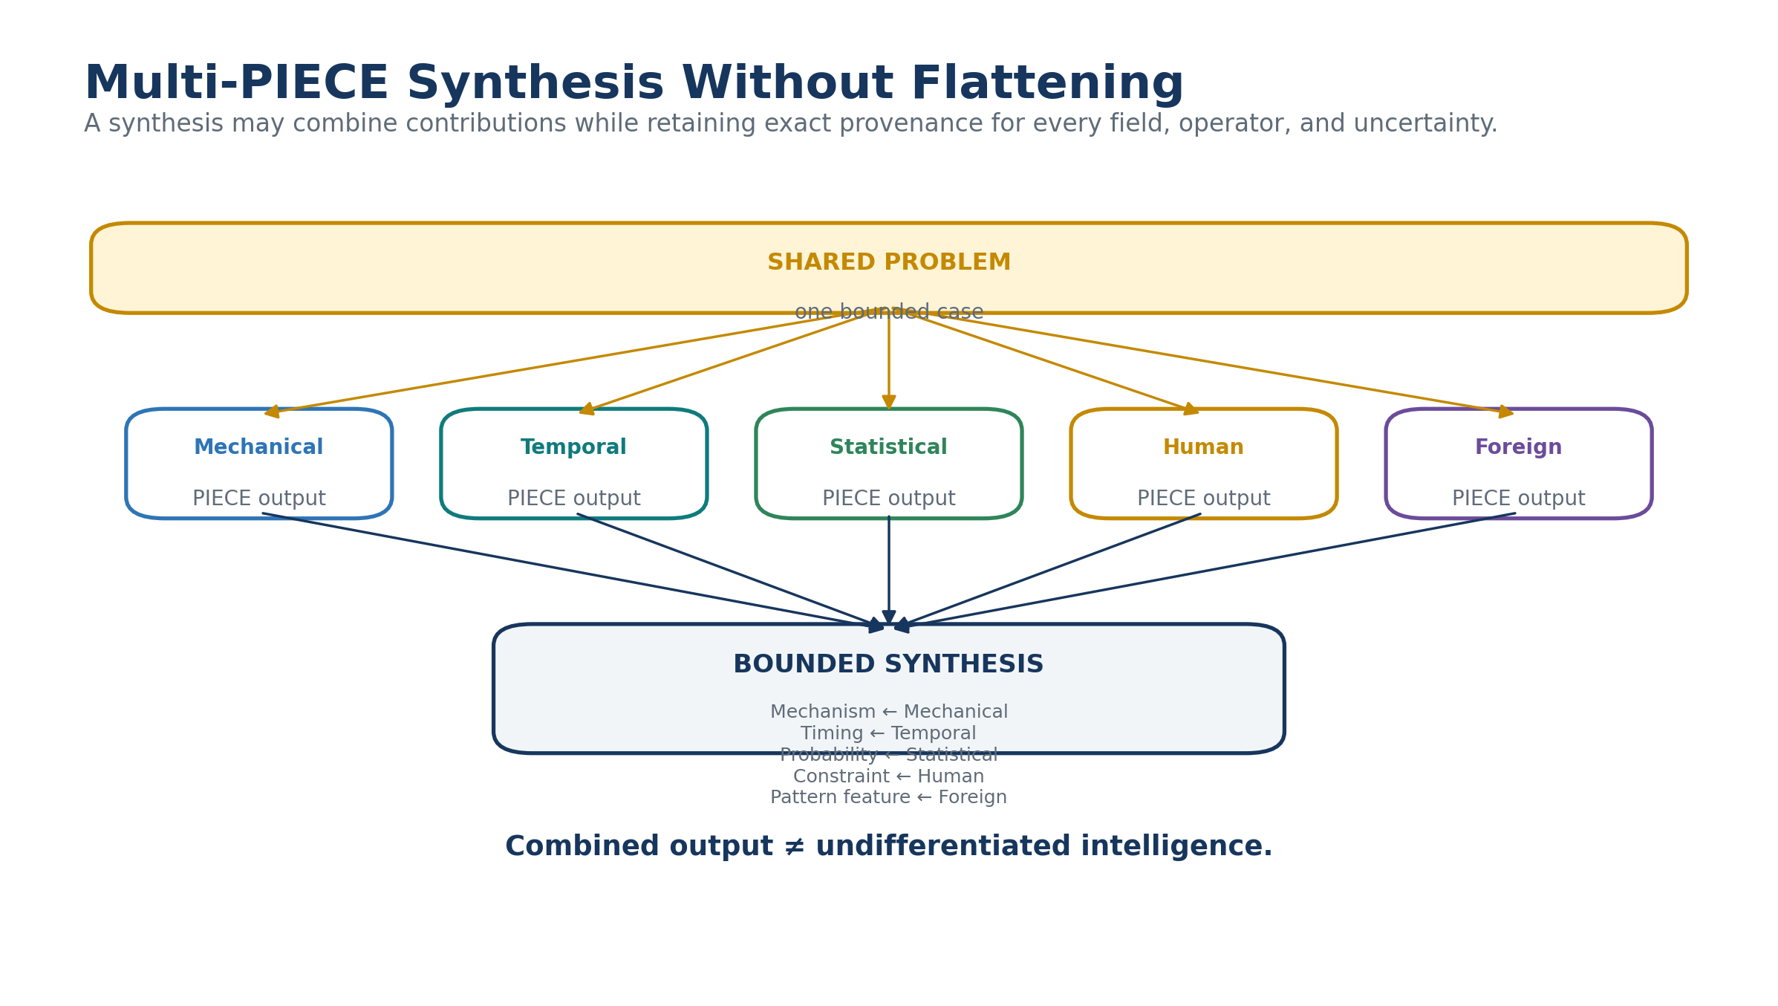
Figure 25. Multi-PIECE synthesis retains exact contribution provenance instead of flattening lenses together.

19. EDIFICE as an Ecology of Semantic Habitats
At scale, the EDIFICE is not one giant ontology. It is an ecology of bounded habitats: personal Bases, scientific lenses, industrial systems, embodied robots, organizational models, simulations, machine-native structures, and potentially foreign cognitive forms. Home preserves membership and discovery. Z contracts preserve bounded participation. Liminal Bridges preserve selected shared state. DICE supplies common empirical discipline. BOSS supplies explicit mapping only where semantic identities diverge.
This architecture permits collective intelligence to grow from managed difference. Standardization is still available where identity genuinely exists, but it is not the price of participation.
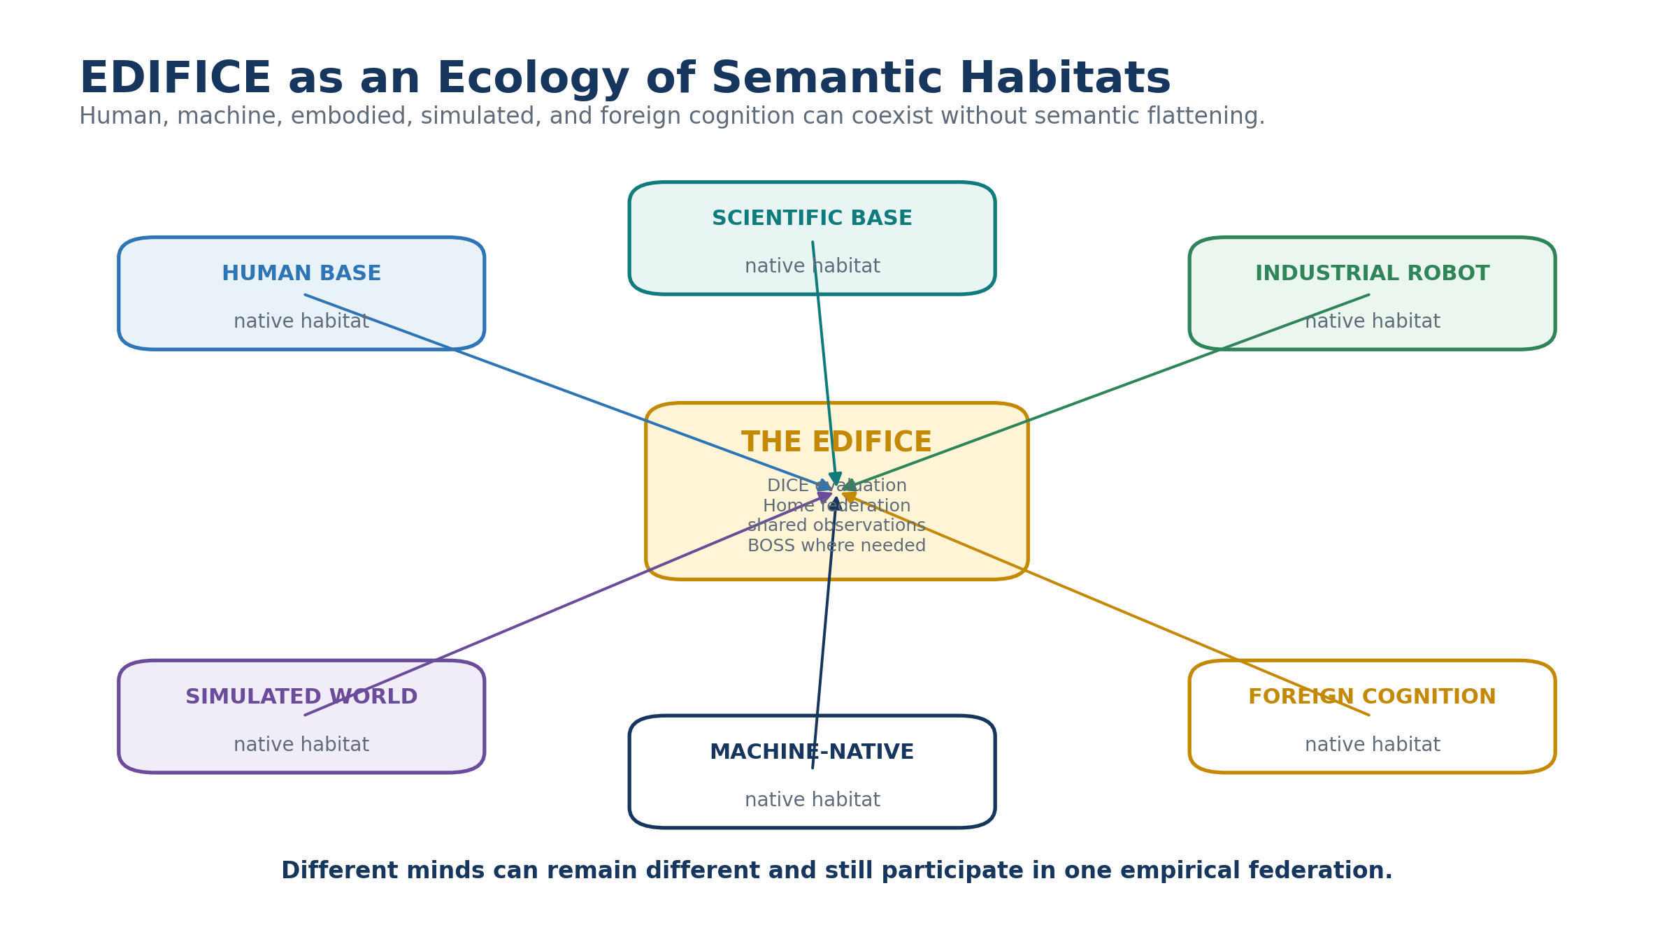
Figure 26. EDIFICE as an ecology of independent semantic habitats.

19.1 Scale properties
The federation can grow much faster internally than Home grows externally. A Base may expand from hundreds to billions of states without requiring Home to ingest those states. Home-facing complexity is dominated by identities, Z contracts, discovery surfaces, and routes. Likewise, a Reader contract may be installed once and reused across enormous numbers of records.
The same principle appears at multiple layers: store mathematics once, structure once, novel semantics once, and state as compactly as possible. Externalize implementation without duplicating authority. Learn a foreign habitat only when needed. Translate only where identity fails.
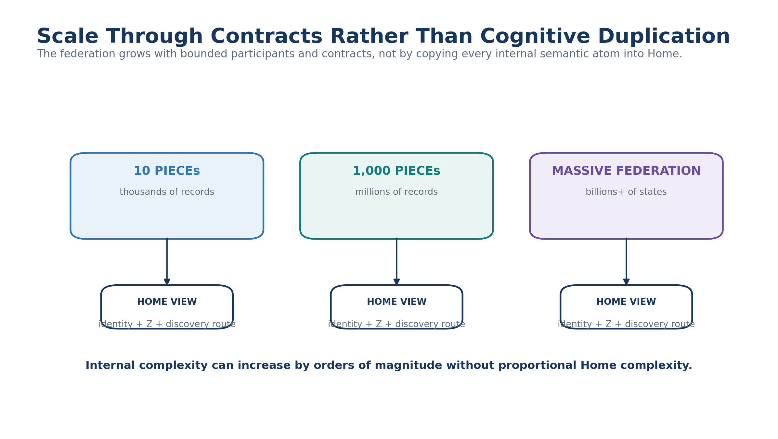
Figure 27. Federation scale grows through bounded contracts rather than cognitive duplication.

20. Governance, Security, and Scientific Integrity
EDIFICE creates powerful interoperability, but interoperability must remain governed. Semantic packets, Readers, Crosswalks, BOOTSTRAP resources, and BOSS mappings are not executable authority by default. A Base may understand an operation yet lack permission to perform it. A PIECE may recommend an intervention while Action Contracts require human review or independent validation.
Security must defend against malicious Reader packages, semantic injection, false equivalence, stale contract versions, unauthorized BOOTSTRAP resources, hidden uncontained links, data leakage between DICE participants, and metric gaming. Least-semantic-disclosure applies wherever a task can be completed with a smaller authorized slice. Unknown or insufficiently trusted structures should degrade toward opacity or abstention rather than silent execution.
Table 10. Major governance threats and controls.
Threat | Architectural control
Malicious or stale Reader | Signatures, provenance, version pinning, allowlists, sandboxed installation
Semantic injection | BOSS source trust, mapping grades, explicit remainder, no automatic execution
Uncontained Base links | BASE SERVICE containment diagnostics and Z-boundary enforcement
DICE data leakage | Case isolation, delayed outcomes, evidence permissions, audit
Metric gaming | Multiple metrics, hidden tests, prospective evaluation, human review
Cognitive monoculture | Fork rights, diversity of PIECEs, scoped specialization rather than universal winner
Unauthorized action | Action Contracts, permission checks, review boundaries
Opaque sensitive data | Cryptography + contract gating + least-semantic-disclosure

21. Implementation Roadmap
A practical EDIFICE can be implemented incrementally. The architecture does not require the full federation on day one. Each phase should prove one layer while preserving contracts for later expansion.
Table 11. Recommended EDIFICE implementation sequence.
Phase | Primary deliverable | Success condition
1. Canonical substrate | Working Bits, BitGroups, Formula, BitWords, Readers | Multiple records decode deterministically without AI inference
2. Native habitat | One Base with local SOLAR, BOOTSTRAP, PIECE structures | An unfamiliar AI can load Core and perform bounded local work
3. Bounded federation | Z contract, containment closure, externalized Base | Stack becomes Base without uncontained links or contract drift
4. Reconstruction | Cross-Base BitWord exchange | Receiver independently reconstructs canonical state
5. Liminal Bridge | Two Bases share canonical state through contracted Bridge | No uncontrolled direct crosslinks; both endpoints reconstruct locally
6. BOSS mapping | Crosswalks for genuinely different identities | Approximation and semantic remainder remain explicit
7. DICE | Competing PIECE predictions and observations | Specialization map updates from version-pinned evidence
8. Evolution | Cloning, variation, retention, retirement | Cognitive branches remain attributable and empirically comparable

22. Conformance Requirements
Conformance should be evaluated at the level relevant to the participant. A tiny PIECE does not need a whole Base. A Base-scale PIECE does not need to expose its whole ontology. The following requirements apply when the corresponding capability is claimed.
- Every PIECE has stable identity, version, purpose, declared scope, evidence boundary, and exclusions.
- Every executable BitWord resolves to exact BitGroups, Formula dependencies, and a conformant SK Reader.
- Unknown canonical state is preserved or rejected explicitly; it is not silently inferred.
- A normal externalized Stack has one registered outward Z contract and passes Containment Closure before migration.
- Every participating Base retains a direct Home anchor independent of structural ancestry.
- Crawler discovery, SOLAR resolution, BOOTSTRAP competency, read authority, mutation authority, and execution authority remain separable.
- Shared canonical identity is reconstructed directly before BOSS translation is considered.
- BOSS mappings declare grade, scope, provenance, and semantic remainder where applicable.
- Liminal Bridges preserve endpoint ownership and do not become shadow copies of endpoint truth.
- DICE predictions are recorded before outcome reveal and remain pinned to the exact PIECE and contract versions used.
- BASE SERVICE integrity state is available to qualify DICE trials where structural defects could affect performance.
- Historical branches, failed lenses, and retired contracts remain resolvable through version and lineage records.

23. Formal Design Laws
Table 12. Formal EDIFICE v2 design laws.
Law | Requirement
Mathematical Legibility Law | Formal representation does not require intuitive human interpretation.
Native Habitat Law | A PIECE may preserve a locally governed semantic environment rather than adopting a universal ontology.
Exact Reconstruction Law | Shared canonical BitWord identity should be reconstructed directly rather than semantically translated.
Contract-Gated Interpretation Law | A Base interprets canonical state only through compatible authorized Reader contracts and dependencies.
Opaque Preservation Law | Unknown BitWord state may be retained losslessly without guessed interpretation.
Projection Independence Law | Local D/E/F/G display variation does not alter canonical state.
Non-Homogenization Law | Federation does not require participating cognitive forms to collapse into one ontology.
Boundary Contract Law | Cross-Base participation occurs through explicit bounded contracts.
Containment Closure Law | A proposed Base boundary must contain all internal relationships except authorized contract crossings.
Home Anchor Law | Every participating Base maintains a direct relationship to canonical Home.
Jurisdiction–Location Separation Law | Crawler selects the semantic habitat; local SOLAR resolves within it.
Local Competency Law | An entering intelligence may acquire Base-specific competence through BOOTSTRAP rather than requiring global prior knowledge.
Bridge Sovereignty Law | Liminal Bridges hold shared state and relationships without replacing endpoint ownership.
Translation-Only-When-Necessary Law | Semantic Crosswalks are used for genuine semantic difference, not when canonical identity already exists.
Empirical Referee Law | Divergent cognitive lenses are evaluated by defined observations rather than ontological conformity.
Scoped Specialization Law | DICE maps where a PIECE works rather than selecting one universal intelligence.
Structural Health Law | Implementation integrity and cognitive performance remain distinct evaluative dimensions.
Evolutionary Provenance Law | Forking, cloning, specialization, retention, and retirement preserve ancestry and evaluation history.
Routing–Authority Separation Law | Discovery or semantic resolution does not itself grant read, mutation, or execution authority.
Fail-Explicitly Law | Unresolved identity, contract, competency, mapping, or permission states are surfaced rather than silently guessed around.

24. The EDIFICE Evolutionary Cycle
The complete architecture is best understood as a cycle rather than a stack. New distinctions are represented as formal state. Those structures are bounded inside a habitat. Large habitats externalize through Z. The federation discovers them through the Crawler. Local SOLAR and BOOTSTRAP make them usable to unfamiliar intelligence. Shared identity reconstructs directly. Liminal Bridges and BOSS connect bounded worlds where necessary. DICE evaluates predictions against reality. Evidence drives specialization, cloning, retention, retirement, and new representations.
Each turn through the cycle can increase the diversity of the federation without requiring its members to become more alike. The system grows by adding better-bounded ways of thinking, not by erasing differences that are inconvenient to a central ontology.
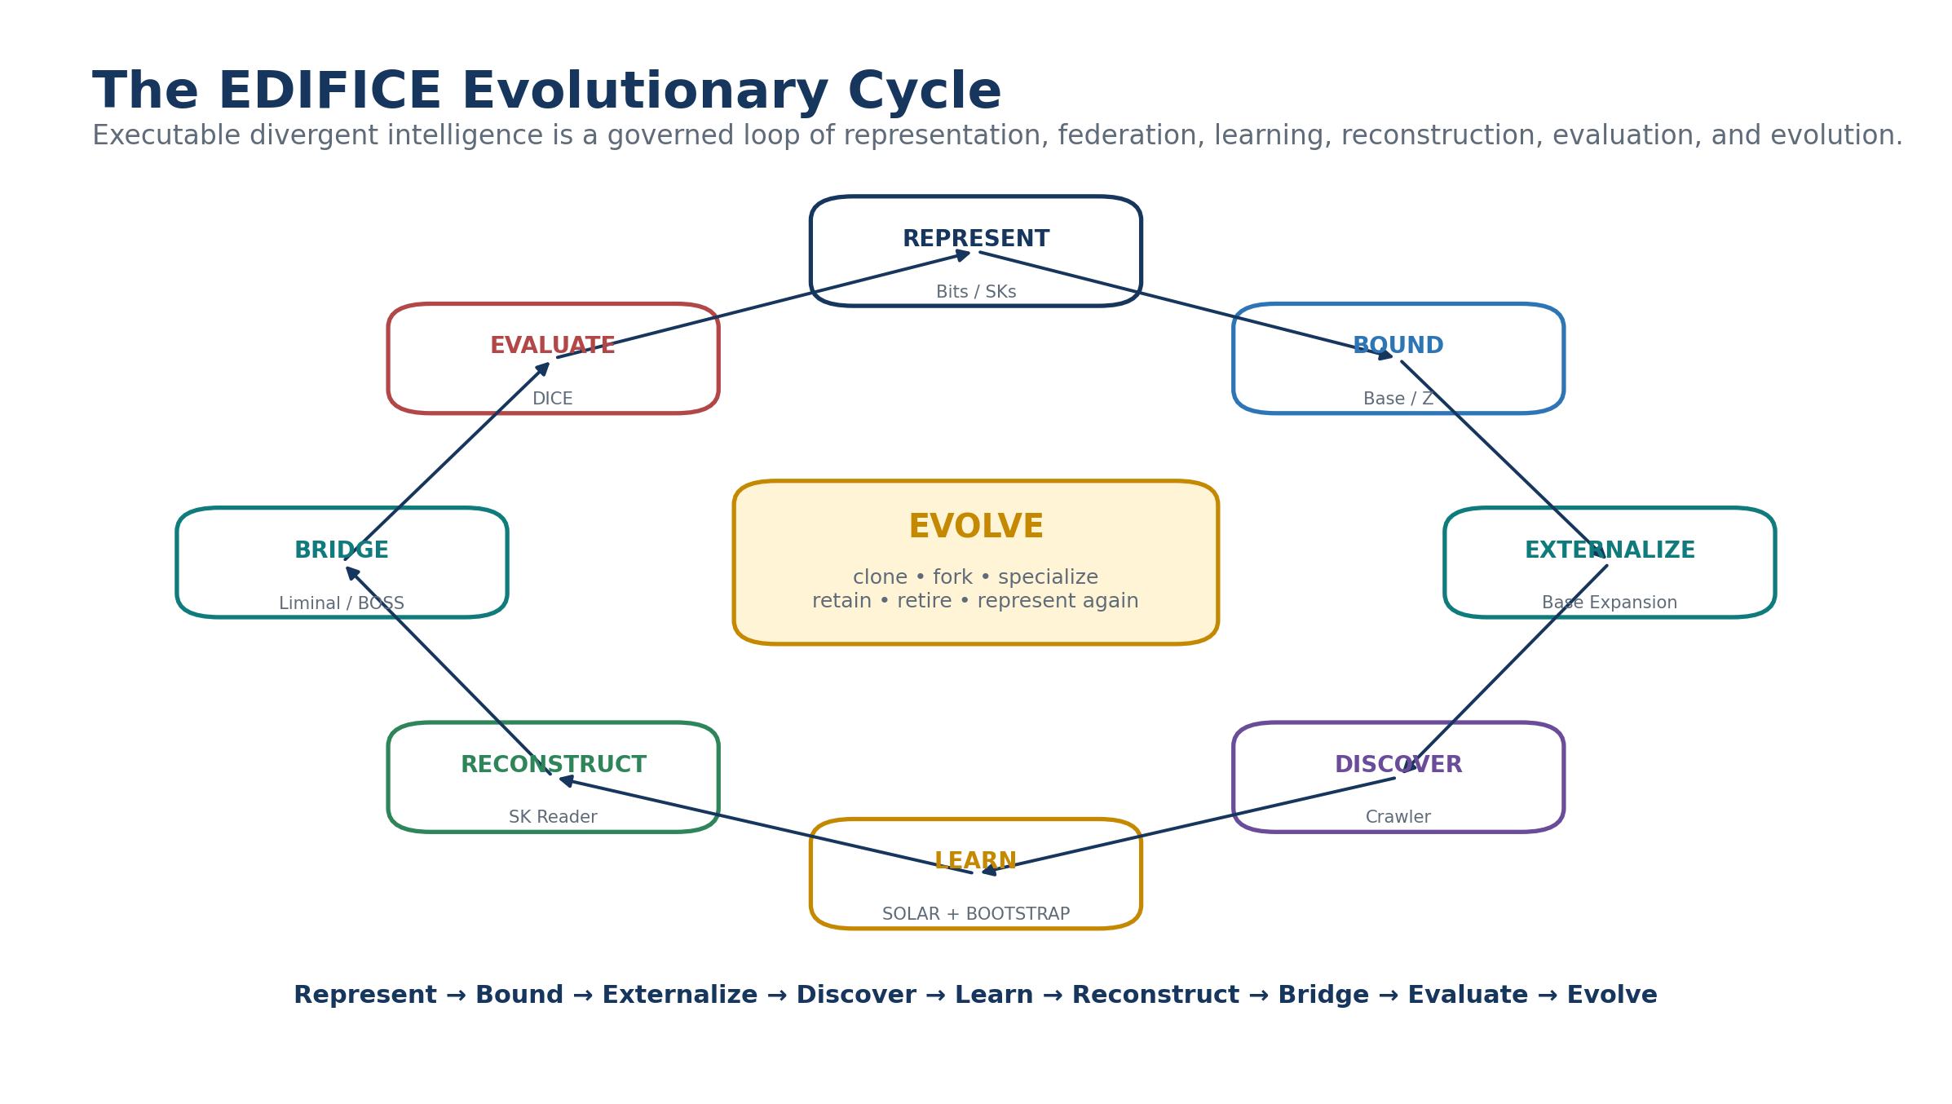
Figure 28. The EDIFICE evolutionary cycle from representation through evaluation and divergence.
FINAL ARCHITECTURE STATEMENT
Every PIECE may remain different. Semantic Kernels make formal state executable. Bounded Bases preserve native habitats. Z makes participation explicit. The Crawler finds the right world. SOLAR finds meaning inside it. BOOTSTRAP teaches enough of that world to operate there. Canonical BitWords reconstruct without translation. Liminal Bridges share bounded state. BOSS maps only where meanings genuinely diverge. BASE SERVICE keeps implementations structurally honest. DICE determines where each difference is useful. Together, these mechanisms form an executable EDIFICE for evolutionarily divergent intelligence.

Appendix A. Illustrative PIECE Profile
Table A-1. Example Base-scale PIECE profile.
Field | Illustrative value
PIECE ID | PIECE-TOPO-017
Name | Distributed Topology Instability Lens
Deployment | Base-scale native habitat
Scope | Distributed infrastructure state propagation and failure onset
Exclusions | No human safety recommendation without governed review
Primary BitWords | Q-FIELD-96; RELATION-Q-64; TRANSITION-X-128
Evidence | Authorized sensor and event streams
Prediction outputs | Failure class; onset window; confidence; expected signatures
SOLAR | TOPOLOGY.SOLAR
BOOTSTRAP | TOPOLOGY Core + Instability Fold
DICE status | Specialized / high fit in distributed-failure cases
Version | 2.3

Appendix B. Illustrative Canonical Exchange Packet
PACKET
BitWord: TIME-128
Version: 0.1
State: 128-bit canonical payload
Reader: omitted when already installed; otherwise resolved through authorized contract acquisition
Display: omitted
Human semantics: omitted unless requested
Execution authority: none implied

The packet intentionally carries less information than a semantic explanation. The receiving Base reconstructs the state through local infrastructure. If the Word is unknown, the payload may remain opaque. If the Word is known but the user requests explanation, local Reader Semantics or BOSS can provide a human-facing projection without changing the state packet.

Appendix C. Illustrative Liminal Bridge Clone Contract
Table C-1. Illustrative two-endpoint Liminal Bridge contract.
Item | Bridge behavior
Endpoint A | Base A → Z:A → Bridge
Endpoint B | Base B → Z:B → Bridge
Shared state | Canonical BitWords explicitly permitted by both contracts
Endpoint ownership | Base A and Base B remain authoritative for their local records
Bridge ownership | Shared state, bridge-specific relations, observations, provenance, mappings
Direct A↔B links | Forbidden unless explicitly governed outside this pattern
Unknown Word | Preserve opaque or acquire authorized Reader
Diverged identity | Invoke BOSS mapping / correspondence only where needed
Service diagnostics | Validate endpoint contracts, cardinality, containment, orphans, and version compatibility

Appendix D. DICE Case Minimum
Table D-1. Minimum DICE case contract.
Field | Required content
Case identity | Stable Case ID and version
Question | Bounded problem statement
Authorized evidence | Exact records, sensors, observations, or sources
Participating PIECEs | Pinned identities and versions
Hidden / delayed outcomes | Protected evaluation state where applicable
Prediction contract | Outcome, timing, confidence, signatures, falsifiers
Interventions | Permitted variable changes or simulated actions
Evaluation horizon | When scoring occurs
Metrics | Defined before outcome reveal
Structural qualification | BASE SERVICE state / known implementation issues
Human review | Required wherever domain risk or policy demands it

Appendix E. Glossary
Table E-1. Core EDIFICE v2 terminology.
Term | Definition
Base | A bounded CERBERUS environment with locally governed data, semantic structures, runtime contracts, permissions, and discovery routes.
Base Crawler | Compact federation routing layer that identifies candidate semantic jurisdictions without loading their full internal ontology.
BOSS | The semantic dictionary and symbolic registry that owns symbols, contextual meanings, Crosswalks, mapping grades, and recipient-native explanation.
BOOTSTRAP | A governed ordered knowledge-loading environment through which an unfamiliar intelligence acquires Core and specialized competency inside a Base.
Canonical reconstruction | Independent local decoding of the same BitWord identity and version from canonical binary state.
Cognitive habitat | A Base or other bounded environment that preserves the native formal structures used by one intelligence form or cognitive lens.
DICE | Divergent Intelligence Competition Engine; evaluates PIECE predictions against authorized observations and maps specialization.
EDIFICE | Evolutionarily Divergent Intelligence Forms Interoperating through Competitive Evaluation; the complete federated ecosystem.
Liminal Bridge | A bounded shared-state or relation environment connecting independent Bases while preserving endpoint ownership.
Opaque state | Canonical BitWord identity and binary payload retained without a compatible local Reader interpretation.
PIECE | Perspective-Indexed Experimental Cognitive Engine; one bounded intelligence lens independent of deployment size.
Semantic Kernel | A bounded formal contract composed from registered Bits, BitGroups, BitWords, Readers, and related runtime structures.
SOLAR | The lexical dictionary of a Base that resolves natural language to exact local semantic addresses.
Z Data Contract | The canonical outward contract through which a bounded Stack or Base participates in federation.

Revision Record
Table R-1. EDIFICE architecture lineage.
Version | Date | Status | Summary
1.0 | August 2026 | Conceptual predecessor | Established PIECE, DICE, BOSS, BOSS Ports, cognitive sovereignty, empirical competition, and divergent intelligence thesis.
2.0 | August 2026 | Executable architecture rewrite | Adds deterministic BitWord reconstruction, native Base habitats, Z-bounded federation, Base Crawler, local SOLAR/BOOTSTRAP, opaque preservation, Liminal Bridge Base Cloning, BASE SERVICE integration, and reconstruction-before-translation.

