EXPERIMENTAL RESEARCH TRIAL
CYBERNETIC LANGUAGE
TRIAL 0
  - A Primitive Core and Semantic Resolution Language for Information State, Transformation, Control, and Reasoning
First Coherent Experimental Attempt | Version 0.1 | August 2026 | Pass 8 Verified Release
REASONING / LOGIC
EVALUATION / CONTROL
DYNAMICS
STRUCTURE / ROUTING
TRANSFORMATION
STATE
TRIAL FIREWALL
Non-canonical. Nothing in this document becomes a CERBERUS primitive, symbol, BOSS identity, runtime instruction, or permanent visual standard merely by appearing here. Repeated use is experimental evidence, not adoption.

0. Abstract and Trial Contract
Cybernetic systems are usually described through several overlapping human vocabularies: Boolean logic, mathematics, graph theory, state machines, control systems, programming constructs, and domain-specific verbs. Each vocabulary is useful, but each tends to expose only part of what information is doing. This Trial asks whether a more normalized symbolic language can begin with primitive state mechanics and expand outward through transformation, structure, routing, dynamics, evaluation, control, and reasoning over structures.
The central design target is not merely an icon set and not merely an instruction set. The Trial seeks a vertically composable language in which the same cybernetic event can be read at multiple semantic resolutions. At the inner core, an observer may inspect exact state changes. At the outer surface, a person or AI may reason over propositions, constraints, possibility, consequence, or validity without first reconstructing every internal bit transition.
TRIAL PRINCIPLE | Build enough language to see the computation before trying to perfect the language used to describe it. The first successful artifact is a visualization in which information behavior becomes inspectable; the symbol inventory remains provisional.

0.1 Document control
Control | Pass 8 Verified Release
Specification | CYBERNETIC LANGUAGE - TRIAL 0
Version | v0.1
Class | Experimental research trial
Canonical status | Non-canonical / external exploratory work
Primary question | Can a normalized language span primitive state mechanics through reasoning over complete structures?
Figure set | 21 approved experimental figures
Asset posture | Paper-local, disposable, non-MIRROR
Next bounded paper | GROOVED Cybernetic Functions

0.2 Comparative inputs
The Trial does not treat prior descriptive SKs as the new language. They are comparative corpora that expose distinctions the Trial must either preserve or explain more clearly.
Comparative source | What it contributes to the Trial
MATHEMATICAL_OPERATORS-77 | Operator families, symbol ambiguity, earned vocabulary width, and the distinction between descriptive identity and later functional contracts.
FORMAL_LOGIC-45 | Logical objects, connectives, quantification, semantic versus syntactic consequence, inference schemas, validity/model properties, and modal reasoning.
GRAPH_NETWORK-64 | Topology, structure, traversal, connectivity, graph transformation, and the discipline that a descriptive projection does not own its underlying objects.
STATE_MACHINE-101 | State, event, guard, action, transition, history, concurrency, traces, reachability, temporal logic, and failure/equivalence distinctions.

0.3 Reading map
Part | Purpose | Primary figures
1 | Research boundary and experimental firewall | -
2 | Semantic resolution architecture | F01-F03
3 | Primitive state and Boolean foundations | F04-F07
4 | Structure, routing, dynamics, and motion | F08-F09, F15
5 | Evaluation, control, and logical surface | F10-F11, F19
6 | Normalized glyph grammar | F12-F14, F20
7 | Primitive classification and operator contracts | F16-F17
8 | Cross-resolution reading | F18
9 | Full-picture stress test and reconciliation | F21
10 | Laws, falsification, unresolved questions, and handoff | -

1. Research Boundary and Experimental Firewall

1.1 Central research question
RESEARCH QUESTION | Can information behavior be described through a normalized symbolic language that begins with primitive state mechanics and expands outward through structure, routing, dynamics, evaluation, control, and reasoning, allowing an intelligence to operate at the minimum semantic depth required for its task?

The question deliberately joins two problems that are often separated. The first is operational: what kinds of change can occur to information? The second is epistemic: at what resolution can that behavior be usefully understood, controlled, or reasoned about? Trial 0 treats those problems as related because a useful language must support both execution-facing detail and reasoning-facing abstraction.

1.2 What counts as a primitive
A primitive in this Trial is not defined as the smallest possible physical operation. Transistor behavior and CPU opcodes are implementation substrates, not the target abstraction. A candidate primitive is a sufficiently fundamental, reusable cybernetic distinction whose independent representation materially improves reasoning, composition, execution, or visualization.
Minimum | Question
Computational minimum | What is the smallest basis sufficient to construct the behavior?
Semantic minimum | What distinctions are independently useful enough to deserve stable meaning?
Visual minimum | What graphical construction rules are sufficient to express those distinctions coherently?

These minima are expected to diverge. NAND may be computationally sufficient for Boolean logic while remaining a poor human or AI reasoning vocabulary. Conversely, a semantically useful operation may compile into several lower-level changes without losing its value as an independently addressable cybernetic verb.

1.3 Experimental convenience shall not create canon
- Repetition does not establish correctness. A symbol used many times may still be replaced.
- Visual attractiveness is not semantic evidence. Elegant forms may encode bad distinctions.
- Computational irreducibility does not automatically justify an independent semantic primitive.
- Domain examples illustrate behavior but do not define the primitive.
- Paper-local assets remain disposable. No permanent asset identity, MIRROR route, or BOSS symbol is created here.
- Later Waves and later papers may merge, prune, branch, rename, or completely replace Trial 0 forms.

1.4 Scope and exclusions
Paper One owns the language substrate: candidate semantic layers, primitive classes, normalized glyph construction, cross-resolution reading, and first-generation stress tests. It does not own the higher-order strategy of compiling complex functions into reusable GROOVED patterns. That work is intentionally reserved for Paper Two.
BOUNDARY | Primitive language is not mechanism language. SPREAD, CASCADE, WAVE, OSCILLATE, feedback loops, reverse bit engineering, and compact trigger patterns may be expressible with this language without being primitives of it.

2. Semantic Resolution Architecture
Trial 0 organizes its first coherent attempt as six nested semantic resolutions. The layer count is experimental, but the topology is intentional: state sits at the core, while increasingly abstract forms of coordination and reasoning occupy outer layers. Outward movement increases semantic compression and reasoning leverage. Inward movement increases causal and mechanical specificity.
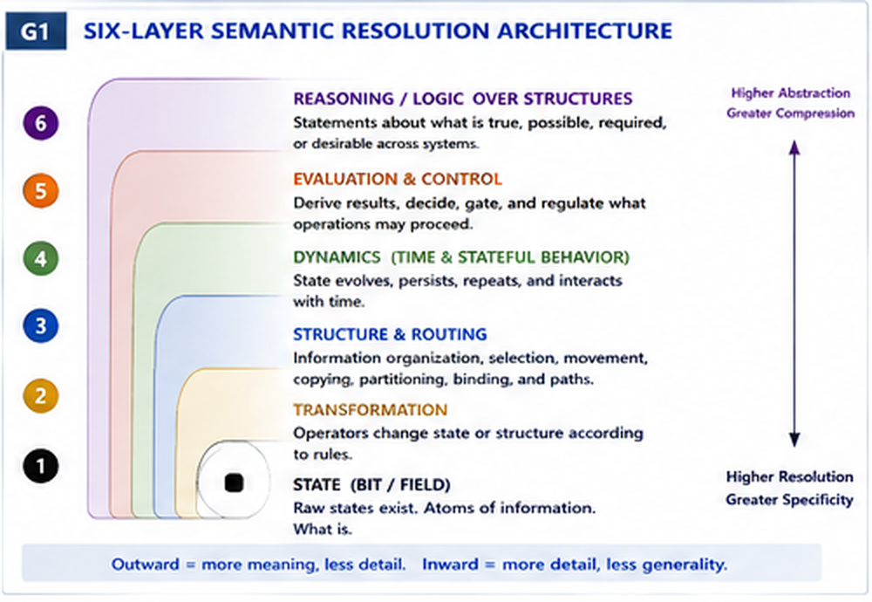
Figure 1. Six-layer semantic-resolution architecture: state at the core, reasoning over structures at the outer surface.

2.1 Six provisional layers
Layer | Role | Candidate concerns
L1 State | What exists | inactive/active, value, position, occupancy, current/initial/retained state, bounded fields
L2 Transformation | What directly changes | preserve, set, clear, invert, toggle, replace, push, shift, rotate, swap, permute
L3 Structure & Routing | How information is arranged and where it goes | select, mask, partition, group, split, join, concatenate, source, destination, read, write, copy, transfer, route, bind
L4 Dynamics | How behavior unfolds through time or simultaneous activity | hold, delay, advance, repeat, cycle, reset, restore, history, fork, parallel, synchronize, race, terminate
L5 Evaluation & Control | What is determined and what may proceed | observe, compare, predicate, threshold, Boolean result, guard, gate, enable, disable, choose, suppress
L6 Reasoning / Logic | How an intelligence reasons over complete structures | proposition, quantification, satisfaction, entailment, derivation, equivalence, inference, validity, satisfiability, consistency, necessity, possibility

2.2 Highest sufficient resolution
A language that always descends to atomic state is not necessarily more rigorous; it may simply be inefficient. Trial 0 therefore adopts a highest-sufficient-resolution rule: use the most abstract layer that can answer the current question without silently assuming unresolved lower-level facts. Descend only when the task requires more causal detail.
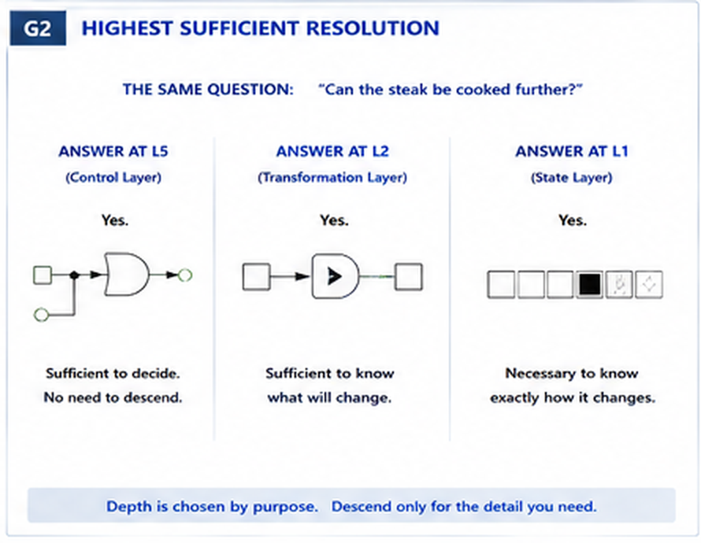
Figure 2. The same question can be answered at different semantic depths; deeper resolution is used only when the question requires it.

2.3 Compilation downward and abstraction upward
The language must remain useful in both directions. Downward compilation increases mechanical specificity: an outer requirement is resolved into transformations, field states, and eventually atomic changes. Upward abstraction compresses detail into a more meaningful description. Upward movement may be intentionally lossy; it preserves what matters at the higher layer rather than reproducing every internal event.
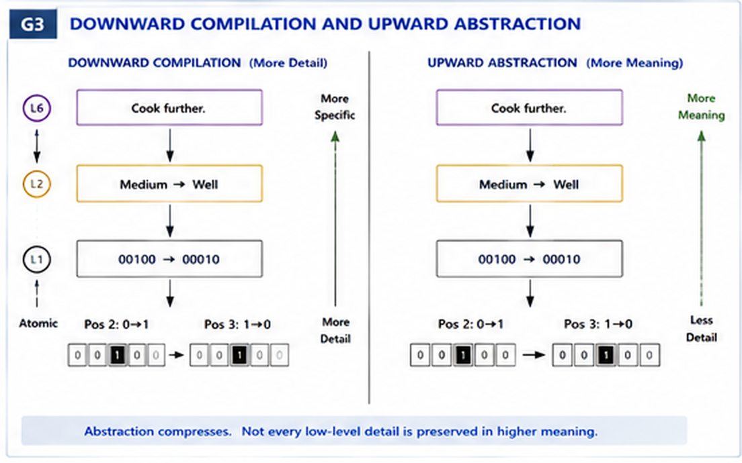
Figure 3. Downward compilation adds causal detail; upward abstraction preserves meaning while compressing low-level detail.
NON-COLLAPSE | Higher abstraction is not implementation. Lower implementation is not automatically better explanation. The language should preserve a trace between them without collapsing one into the other.

3. Primitive State and Boolean Foundations

3.1 State is the deepest common substrate
Trial 0 begins with bounded state rather than with programming-language verbs. A state cell is a location capable of carrying an interpreted value. A field is an ordered or structured collection of such locations. The same physical binary value can participate in many semantic contracts; therefore the language must distinguish the substrate value from its interpretation.

3.2 Complete unary transformation space
For one binary input mapped to one binary output, exactly four functions exist: force zero, preserve, invert, and force one. This is the first place where the Trial can claim functional completeness without judgment. The semantic question remains open: which of these deserve independent primitive identities, and how should related functions share visual ancestry?
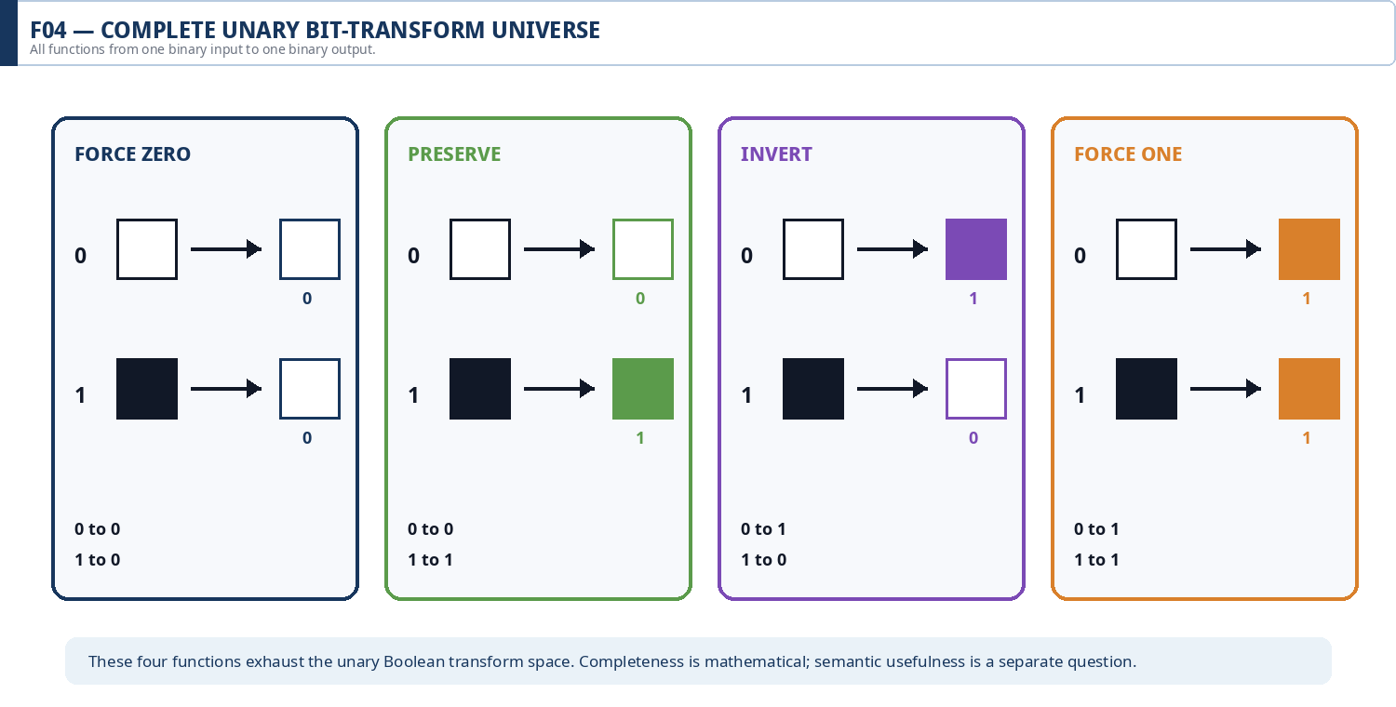
Figure 4. Complete unary bit-transform universe: force zero, preserve, invert, and force one.

3.3 Complete two-input Boolean space
Two Boolean inputs produce four input states, and each can independently map to zero or one. The resulting sixteen-function space is finite and exhaustible. Trial 0 enumerates the whole space before deciding which operations should remain independently named, which can be derived, and which are useful only in particular semantic layers.
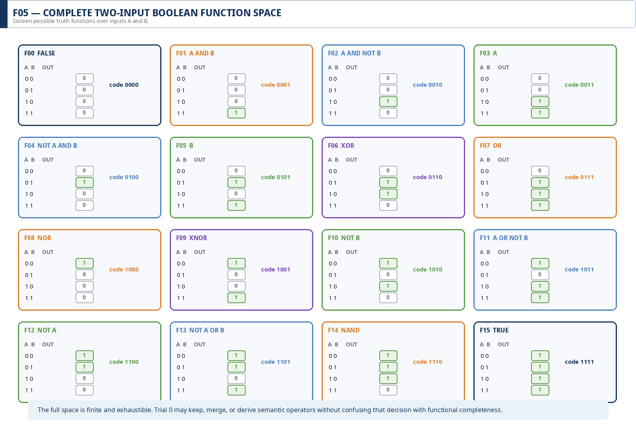
Figure 5. Complete two-input Boolean function space. Functional completeness does not dictate the final semantic vocabulary.

3.4 Bit state is not truth value
A visible one may mean active, occupied, selected, retained, present, triggered, or true under a predicate. FORMAL_LOGIC-45 already protects an analogous distinction: an active descriptive Bit selects a concept; it does not assert that the represented proposition is true. Trial 0 generalizes this protection to the language itself.
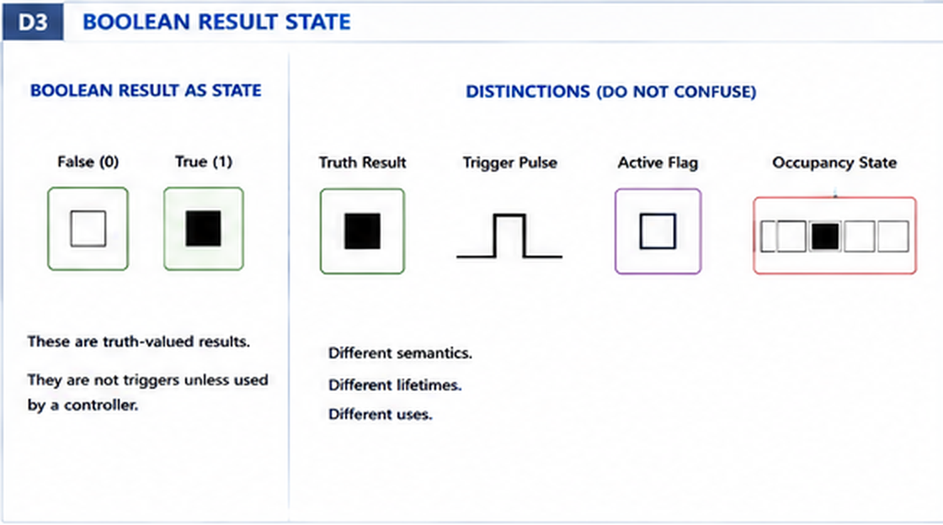
Figure 6. A Boolean truth result is one semantic use of binary state; it must not collapse into trigger, active flag, occupancy, or generic activation.
FOUNDATIONAL LAW | Bit state != truth value. Activation != assertion. Encoding does not determine semantic interpretation.

3.5 Mutation versus occupancy movement
The transition 00100 to 00010 can be described atomically as two coordinated flips: one position changes from one to zero while another changes from zero to one. Yet the higher-order description contains additional structure: one bounded ordered field, exclusive occupancy, a source, a destination, and a direction of movement. The Trial uses PUSH as a sacrificial primitive-discovery case.
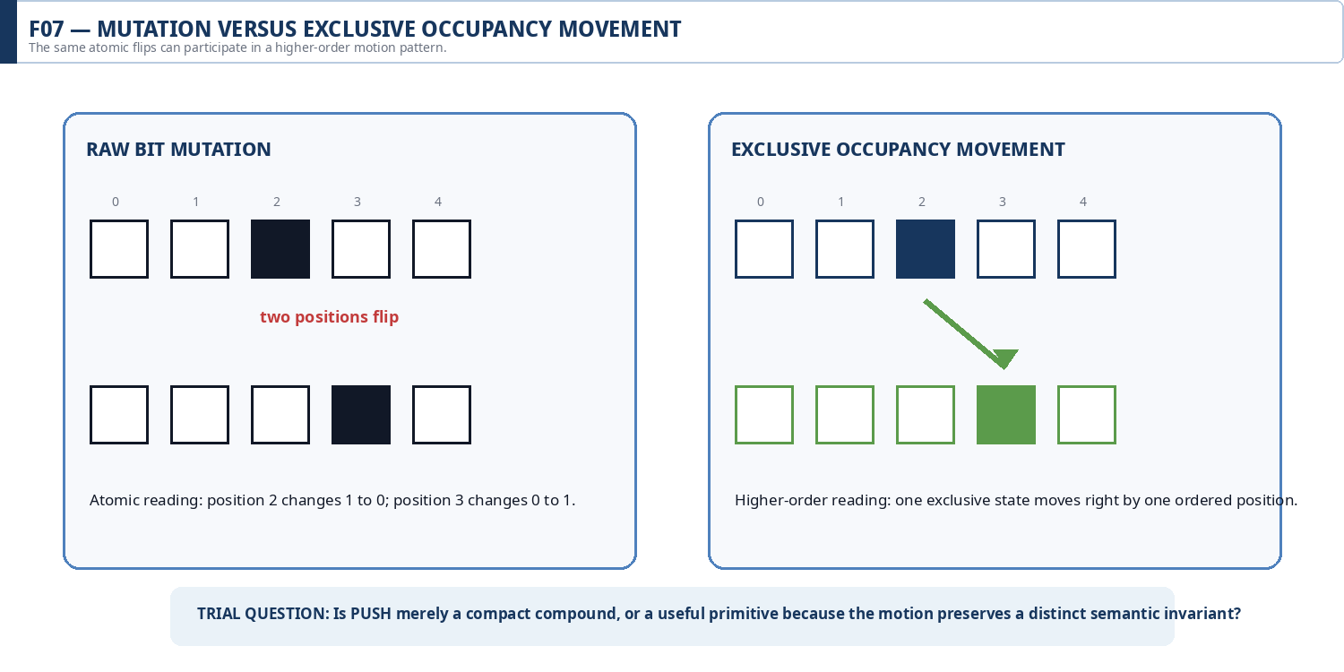
Figure 7. Raw mutation and exclusive occupancy movement can share atomic changes while preserving different higher-order semantics.
Trial 0 does not decide that PUSH is permanently atomic. It asks whether the higher-order invariant is useful enough that repeatedly decomposing it would reduce legibility more than it improves rigor. This is the general pattern used throughout the paper: decomposition is evidence, not an automatic demotion.

4. Structure, Routing, Dynamics, and Motion

4.1 Changing values is not the only way information changes
Information can be selected, grouped, partitioned, copied, moved, routed, observed, retained, or re-indexed without necessarily changing its local value. A language focused only on Boolean mutation would therefore miss much of the actual behavior of cybernetic systems.
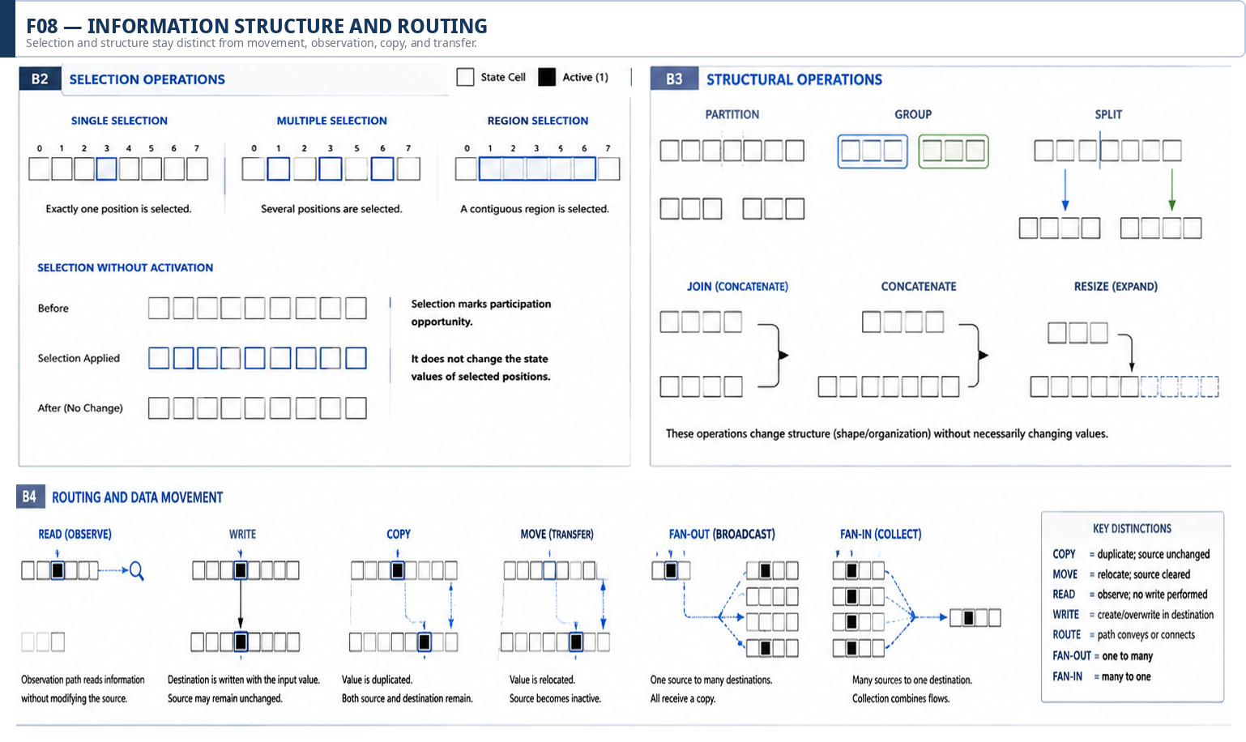
Figure 8. Selection, structural operations, and routing are distinct from activation and direct value transformation.

Key structural non-collapses
Distinction | Why it matters
Selected != active | Selection identifies participation; it need not change the selected state.
Read != write | Observation retrieves information without implying mutation.
Copy != move | Copy preserves the source; move relocates or clears it.
Route != transform | A path can convey information without changing its value.
Join != aggregate | Convergence of paths does not by itself specify a reduction rule.
Bind != contain | A relationship can attach context without moving one structure inside another.

4.2 Time creates new semantics
Once state can persist across moments, new distinctions appear: hold, delay, restore, history, repetition, synchronization, race, and termination. A purely combinational transform cannot represent these semantics by value mapping alone. Trial 0 therefore treats dynamics as a separate provisional layer rather than a modifier sprinkled over every operation.
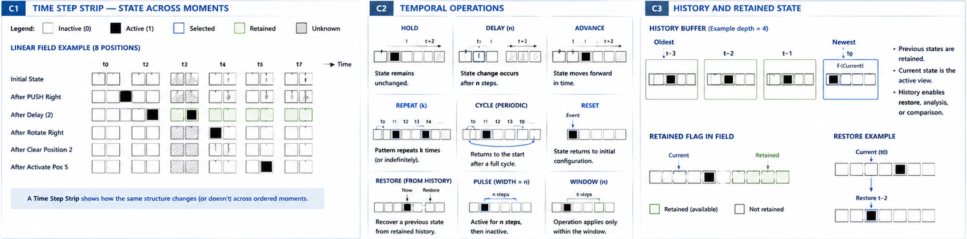
Figure 9. Cybernetic dynamics across time: state can hold, delay, advance, cycle, reset, restore, and retain history.

4.3 Cybernetic motion as a discovery vocabulary
Several information behaviors become easier to compare when described as motion: appear, disappear, push, jump, rotate, swap, branch, converge, rise, sink, spread, contract, hold, and pulse. These names are provisional and their status varies. Some may become primitives; others may prove to be mechanisms or convenient macros. Their purpose in Trial 0 is to expose recurring information geometry that existing implementation-specific vocabularies often describe awkwardly.
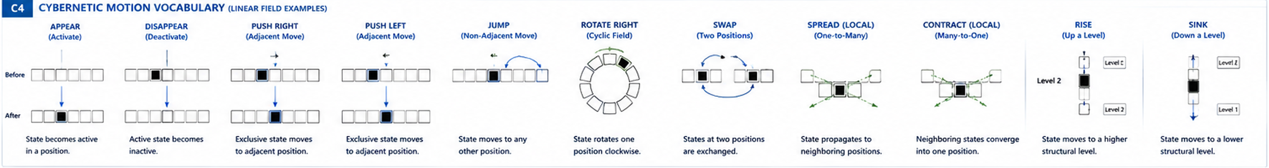
Figure 15. Experimental cybernetic motion vocabulary. The verbs expose recurring geometry; their primitive status remains unresolved.
LANGUAGE DISCIPLINE | A useful cybernetic word does not have to be an atomic operation. The Trial is allowed to discover compact names for recurring mechanisms without promoting them into the primitive core.

5. Evaluation, Control, and the Logical Surface

5.1 Observation and evaluation do not imply mutation
Many systems must determine facts about state without changing that state. Trial 0 therefore separates observation from evaluation, and evaluation from control. A sensor or Reader may inspect a field; a predicate may evaluate the observed value; the result may be Boolean; a gate may use that result to permit another operation; only then may a transformation change state.
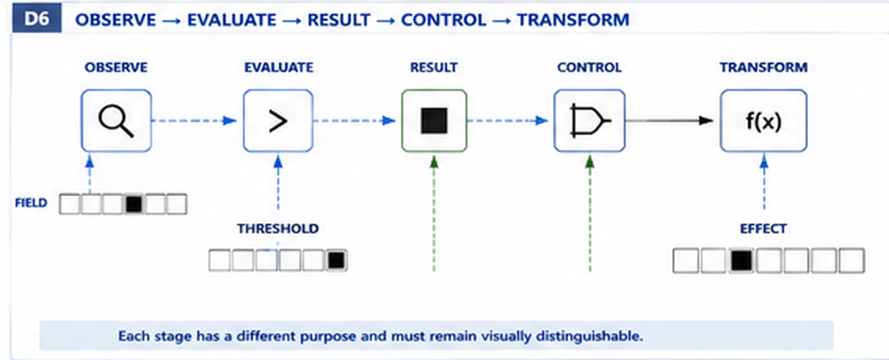
Figure 10. Observe -> evaluate -> result -> control -> transform. Each stage has a different cybernetic role.

5.2 Guard, gate, action, and transition
STATE_MACHINE-101 distinguishes events, guards, actions, and transitions. Trial 0 preserves that separation while adding a more explicit control distinction. A guard describes eligibility; a gate consumes a resolved control state to permit or suppress flow; an action performs behavior; a transition changes state. A formal guard does not imply a literal hardware gate, but the two concepts should not collapse merely because both participate in conditional execution.
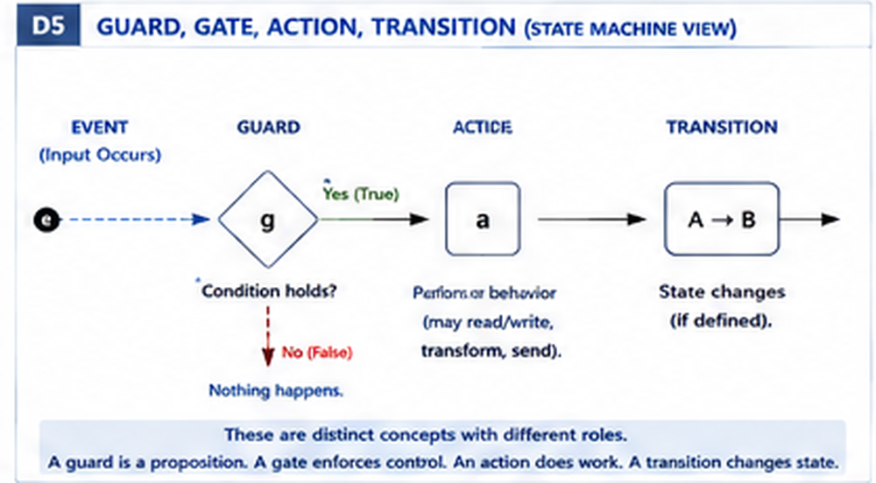
Figure 11. Guard, gate, action, and transition are related but non-identical concepts.

5.3 Logic belongs on the outside, not outside the language
Logic is not excluded merely because it operates at a higher abstraction. Humans and AI systems routinely interact with complex structures across surfaces whose internal semantics they do not fully reconstruct. An outer logical layer can expose propositions, predicates, quantified requirements, possibility, entailment, satisfiability, consistency, and equivalence while leaving the underlying mechanism in its own layer.
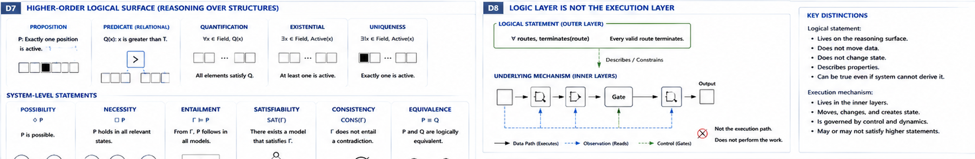
Figure 19. Logic acts as an outer reasoning surface over deeper mechanics; describing or constraining a mechanism is not the same as executing it.

Reasoning-layer distinctions inherited from comparative logic work
Distinction | Trial interpretation
Transition != implication | A transition changes or permits state change; material implication relates truth conditions.
Entailment != derivation | What follows under every admissible model may differ from what a current proof mechanism can mechanically derive.
Possible != reachable | Modal possibility and path reachability can overlap but answer different questions.
Satisfiable != currently true | A configuration can be realizable without being the current state.
Logical equivalence != identity | Two expressions can agree under a semantics without being the same object, structure, or implementation.
Reasoning over structure != ownership | The logical surface may describe a graph, field, or mechanism without becoming the authority for that structure.

OUTER / INNER CONTRACT | The outer layer supplies accessibility: an intelligence can reason safely at a bounded surface. The inner layers supply causality: they explain how the state actually changes.

6. Normalized Glyph Grammar

6.1 Semantic similarity should produce graphical similarity
Trial 0 does not attempt to memorize hundreds of unrelated icons. Its visual hypothesis is compositional: related semantic properties should generate related graphical features, while meaningful differences should appear as systematic graphical differences. A glyph becomes a structured projection of an operator contract rather than an arbitrary picture attached after the fact.
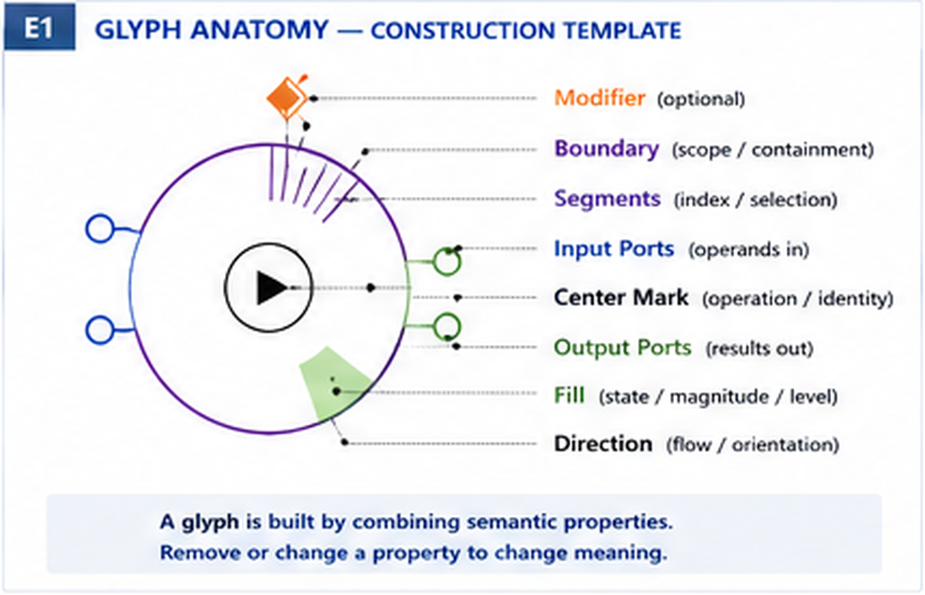
Figure 12. Experimental anatomy of a normalized cybernetic glyph.

6.2 Candidate visual grammar
Visual property | Candidate semantic load
Core geometry | Broad semantic family
Center mark | Exact operation or identity within a family
Input / output ports | Arity and direction of information entry/exit
Orientation | Directional behavior or movement
Boundary | Scope, containment, statefulness, persistence, or isolation
Segments | Indexed members, selection positions, cyclic order
Fill | State, magnitude, capacity, or progression
Modifier position | Condition, negation, temporal behavior, reversibility, priority, or other qualifiers

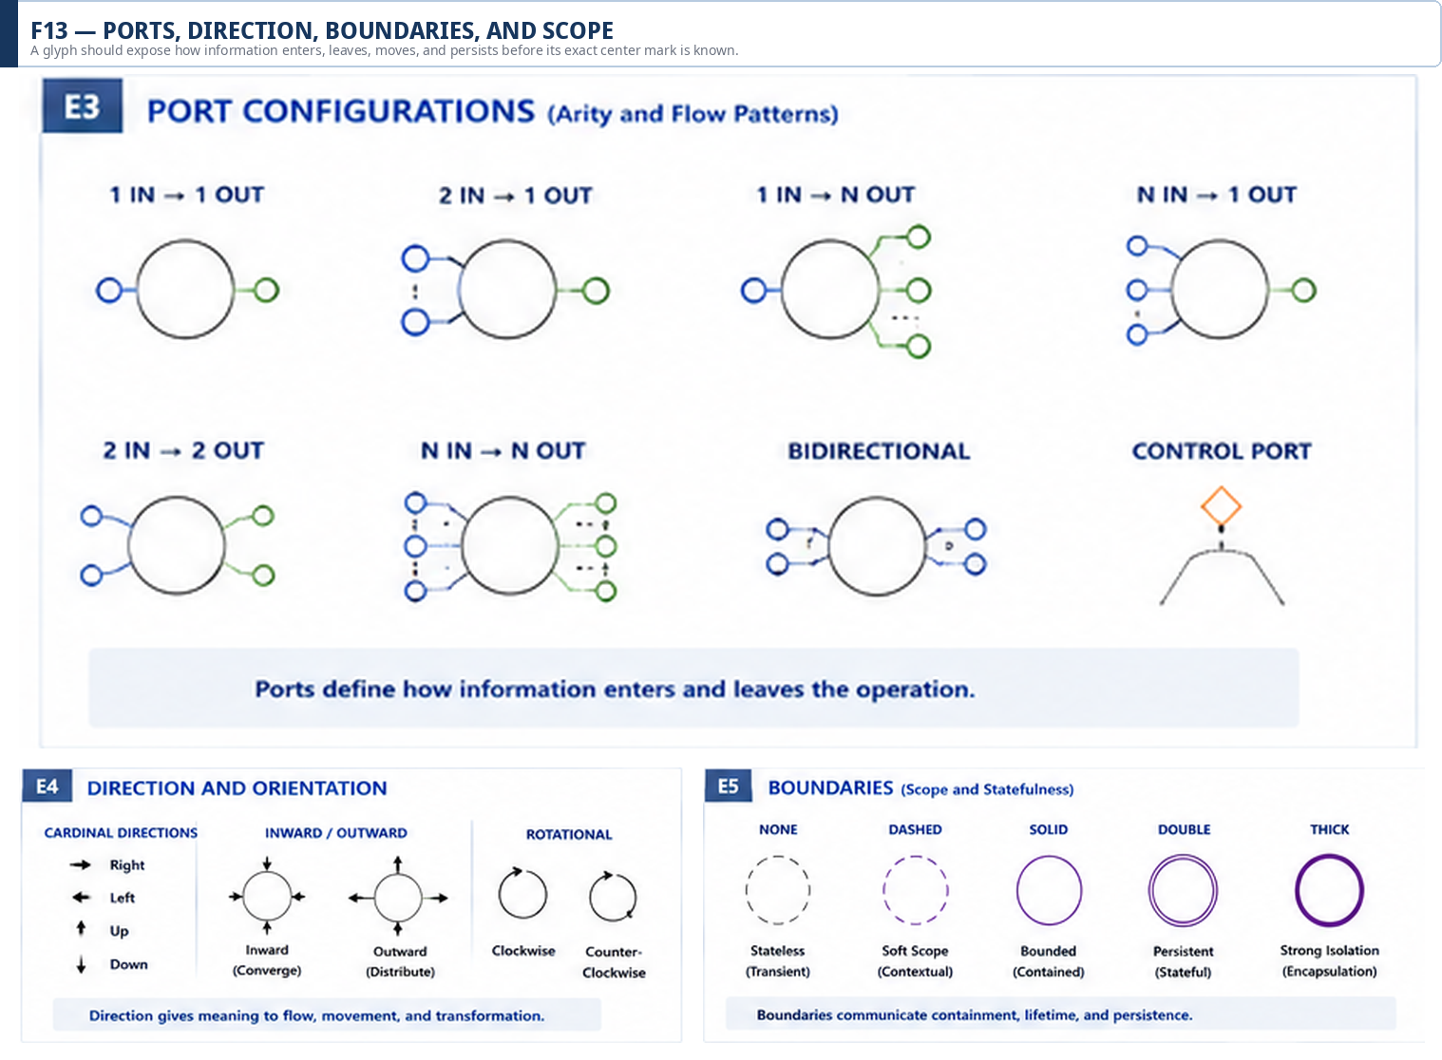
Figure 13. Ports, direction, boundaries, and scope carry structural meaning before an exact operator is known.

6.3 Cyclic and modular carriers
The segmented-ring experiment tests whether one normalized carrier can express bounded cyclic or indexed domains without collapsing their meanings. Angular position can indicate which member is involved; segment activation can indicate participation; radial fill can indicate degree or progression; orientation can indicate direction; the center can identify the operation. The same carrier may therefore support masks, phase, rotation, and modular state while keeping those semantics separable through context and modifiers.
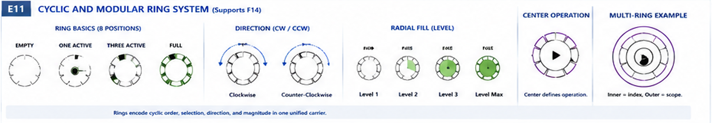
Figure 14. Experimental cyclic and modular ring grammar: indexed position, direction, fill, and center operation coexist in one carrier.

6.4 Color is redundant semantics
Color may accelerate recognition, but no unique semantic distinction should depend on color alone. The language must remain interpretable in monochrome, under low-resolution capture, across color-vision differences, and through machine perception. Shape, position, orientation, boundary, and port structure carry the canonical visual distinctions; color remains an optional perceptual accelerator.

6.5 Graceful semantic degradation
A normalized language should fail gradually. Removing color, fill, one modifier, or fine detail should reduce certainty rather than destroy all meaning at once. If the exact primitive becomes unreadable but the family, direction, arity, or statefulness remains recoverable, the visual grammar has preserved useful priors.
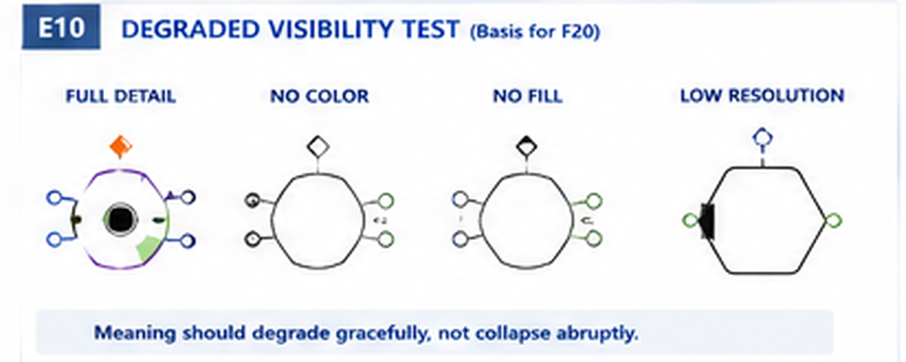
Figure 20. Graceful semantic degradation test: increasingly reduced forms should retain progressively broader meaning.

7. Primitive Classification and Operator Contracts

7.1 Status is a statement about independence, not importance
After several Waves of use, candidate concepts can be classified more rigorously. The classification does not rank concepts by value; it records how independently they appear to function in the emerging language.
Status | Meaning
Foundational | Present in every relevant cybernetic system or required to express the substrate itself.
Candidate Primitive | Independent operation with strong expressive leverage and no clearly superior decomposition yet.
Higher-Order Primitive | Widely useful unit whose internal composition may exist but whose independent identity improves reasoning.
Probable Compound | Decomposes cleanly into simpler operations without substantial semantic loss.
Mechanism | Reusable multi-operation pattern with internal structure.
Convenient Macro | Easy shorthand that adds little semantic clarity beyond its components.
Unresolved | Evidence is currently insufficient or conflicting.

7.2 SPREAD and PUSH as sacrificial cases
SPREAD and PUSH deliberately receive different kinds of pressure. SPREAD appears decomposable into neighborhood selection, local activation, temporal advance, repetition, and termination. PUSH appears decomposable too, yet the ordered exclusive-occupancy invariant may be semantically valuable enough to justify a higher status. Trial 0 does not force one answer; it demonstrates the method for obtaining one.
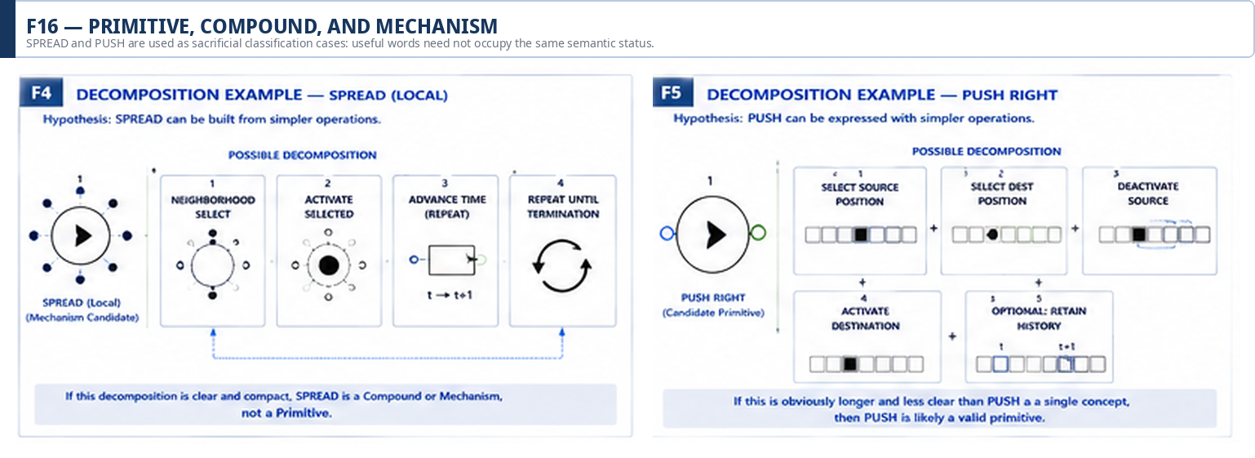
Figure 16. Primitive, compound, and mechanism classification tested through SPREAD and PUSH decompositions.

7.3 The glyph compresses recognition; the contract defines behavior
A mature operator cannot be specified by visual form alone. The Trial therefore proposes an operator contract containing the semantic information required to evaluate or later execute the operation. The glyph is a compressed perceptual handle over that contract.
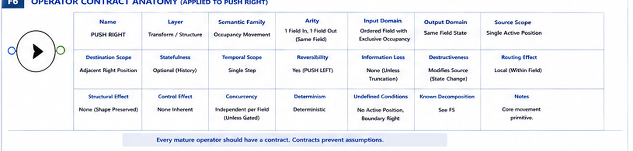
Figure 17. Experimental operator contract anatomy applied to PUSH RIGHT.
Contract field | Question
Semantic layer / family | Where in the language does this operation primarily belong?
Arity | How many inputs and outputs participate?
Input / output domains | What kinds of states or structures are accepted and emitted?
Source / destination scope | What bounded locations may be read or changed?
Statefulness / temporal scope | Does prior state or time affect the operation?
Reversibility / information loss | Can the original state be reconstructed?
Structural / routing / control effects | Does the operation reshape, move, or merely govern information?
Concurrency / determinism | How does the operation behave under simultaneous activity?
Undefined conditions | When is the operation invalid or unresolved?
Known decomposition | What lower-level composition, if any, reproduces the behavior?

CONTRACT LAW | The Trial should never let a clever pictogram substitute for an operator contract. Visual inference is useful; operational ambiguity is not.

8. Cross-Resolution Reading

8.1 One event, multiple legitimate descriptions
The same causal event can remain addressable at several semantic resolutions. The steak example makes the ladder intuitive: a domain goal can describe further cooking; the semantic transform can describe a doneness transition; the field layer can show exclusive occupancy moving; the atomic layer can show coordinated bit mutations. None of these descriptions is automatically more true than the others. Each answers a different question.
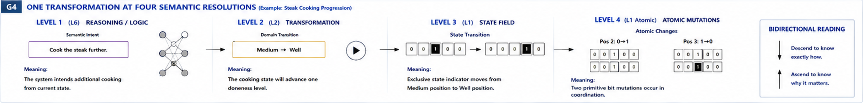
Figure 18. One transformation at four semantic resolutions: intent, domain transition, field state, and atomic mutations.

8.2 Structure-preserving abstraction
Upward abstraction is intentionally selective. It should preserve direction of change, domain meaning, causal intent, eligibility context, and outcome class when those features are relevant to the higher layer. It may omit exact positions, intermediate routes, auxiliary timing, or implementation-specific mechanics. The omitted information remains reachable by descending through the trace.

8.3 Why semantic zoom matters for a custom runtime
A future runtime may execute close to the inner layers while humans and AI systems interact mostly through the outer ones. A domain operator such as cook the steak can compile into field transitions and primitive changes; a debugger can descend further; a planning system can remain at a logical or control surface. The language becomes a shared intermediate vocabulary across those perspectives rather than forcing every participant to speak the lowest-level representation.
HIGHEST SUFFICIENT RESOLUTION | Use the highest semantic layer sufficient to answer the question; descend only when additional causal or operational resolution is required.

9. Full-Picture Trial and Reconciliation

9.1 Purpose of the stress test
The final Pass 6 Wave deliberately stops protecting the language. A complete cooking-system flow combines state, selection, transformation, spatial routing, delay, observation, predicate evaluation, Boolean result, gating, action, and outer reasoning. The example is intentionally generic enough to test the language rather than merely illustrate CERBERUS.
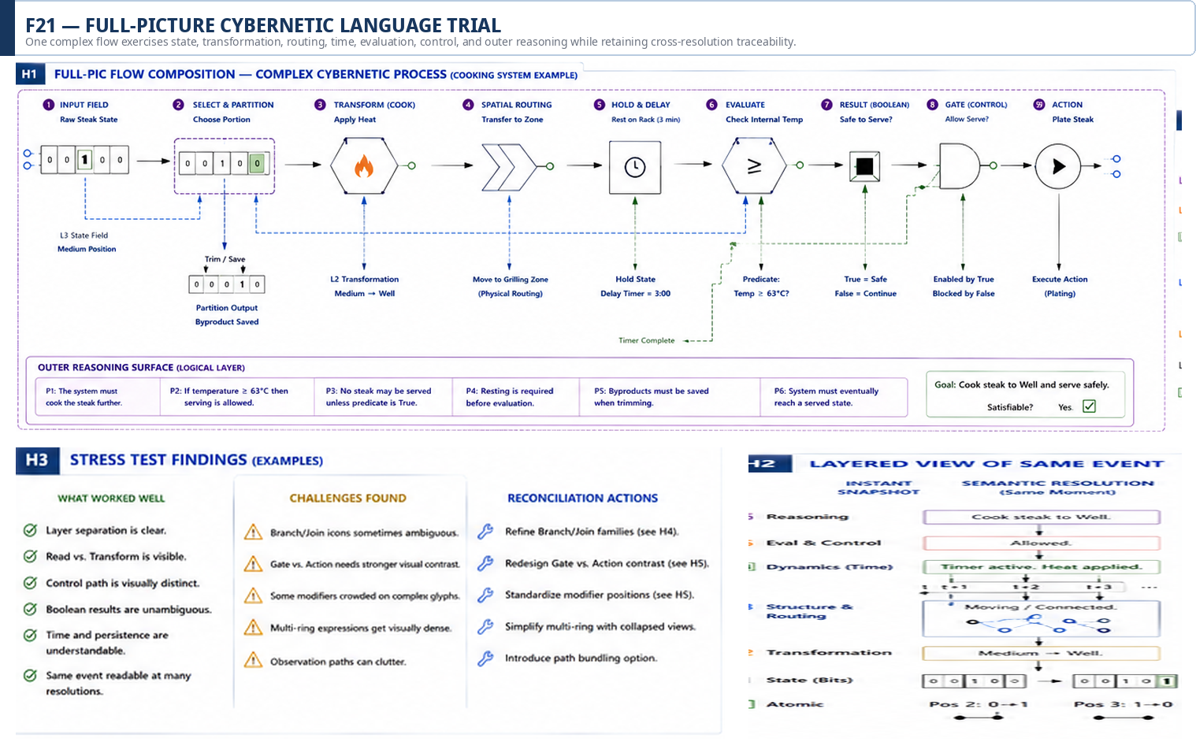
Figure 21. Full-picture Trial: a complex cybernetic process exercised across state, transformation, routing, time, evaluation, control, and reasoning layers.

9.2 What the Trial demonstrated
- Layer separation remained legible across a non-trivial composition.
- Read-only observation paths could be distinguished from transforming data paths.
- Control paths could govern whether operations proceed without masquerading as data carriers.
- Boolean evaluation results remained distinguishable from generic activation and occupancy states.
- Temporal retention and delay could be represented without collapsing into ordinary routing.
- The same event could be read at multiple semantic resolutions while preserving a causal trace.
- Outer logical statements could describe or constrain the mechanism without becoming the mechanism.

9.3 What the Trial exposed as weak
- Branch and join forms remain visually ambiguous in some compositions and need a stronger family distinction.
- Gate and action forms need more visual contrast so permission cannot be mistaken for execution.
- Modifiers can crowd compact glyphs when several qualifiers are active simultaneously.
- Multi-ring expressions become visually dense quickly and need stronger rules for when nesting is justified.
- Observation paths can clutter complex figures and may require bundling or selective visibility at higher resolutions.

9.4 Reconciliation actions carried forward
Issue | Pass 8 disposition
Branch / join ambiguity | Keep concepts; mark graphical forms provisional and require counter-example testing.
Gate versus action | Preserve semantic distinction; increase visual contrast in later iterations.
Modifier crowding | Reserve standardized modifier positions and permit omitted positions rather than filling every slot.
Dense multi-ring forms | Treat rings as earned carriers; do not use nesting merely because it is available.
Observation clutter | Investigate path bundling and resolution-dependent visibility in later visual-mechanics papers.

TRIAL RESULT | Trial 0 result: VIABLE, not canonical. The language is expressive enough to continue experimenting, and imperfect enough to justify continued experimentation.

10. Laws, Falsification, Unresolved Questions, and Handoff

10.1 Non-collapse laws
The following laws protect the distinctions that repeatedly proved important during brainstorming and the Pass 6 Waves. They are constraints on the Trial, not claims that the six-layer model is final.
Law | Protected distinction
L1 | Bit state != truth value; activation != assertion.
L2 | State != state valuation; a carrier and its interpretation remain distinct.
L3 | Mutation != state movement; coordinated occupancy motion may preserve higher-order structure.
L4 | Transformation != routing; routing does not imply mutation.
L5 | Observation != mutation; read-only paths must remain non-destructive.
L6 | Evaluation != control; a predicate result does not itself perform the controlled action.
L7 | Guard != gate execution; eligibility and permission mechanisms remain distinct.
L8 | Transition != implication; state change and truth-functional relation are different semantics.
L9 | Selection != activation; selected positions need not change value.
L10 | Copy != move; source preservation matters.
L11 | Sequential execution != concurrency; time order and simultaneous activity are different dimensions.
L12 | Possible != reachable; modal and path semantics remain distinct.
L13 | Entailment != derivation; semantic consequence and proof production remain distinct.
L14 | Primitive != mechanism; useful words may denote reusable compositions.
L15 | Semantic primitive != hardware primitive or CPU instruction.
L16 | Glyph != semantic identity; visual form is a projection of a contract.
L17 | Color != semantic identity; color may accelerate recognition but not own the distinction.
L18 | Reasoning over a structure != ownership of that structure.
L19 | Higher abstraction != implementation; lower implementation != automatically better explanation.
L20 | Trial reuse != canon.

10.2 Falsification program
A serious Trial must define ways to fail. The language should be considered weak where any of the following patterns persist after reasonable refinement:
- Every symbol must be memorized independently and unfamiliar forms cannot be partially inferred.
- Related mechanics look unrelated, or unrelated mechanics repeatedly collapse into the same visual form.
- Compound expressions become less readable than ordinary technical notation.
- The language only works for CERBERUS examples or only for binary fields.
- A supposed primitive repeatedly decomposes into a simpler and clearer composition.
- Atomic detail overwhelms higher-order reasoning, or outer reasoning hides necessary causality.
- An observer cannot tell whether a path reads, writes, moves, copies, gates, or transforms information.
- Color or high-resolution detail is necessary to recover basic meaning.
- Existing notation consistently communicates the same cybernetic distinction more clearly.

10.3 Unresolved questions after Trial 0
- Where should the boundary fall between Candidate Primitive and Higher-Order Primitive?
- Does quantification belong inside the normalized cybernetic language or remain an outer reasoning schema?
- Which cybernetic motion verbs survive repeated cross-domain use?
- Can ring carriers remain readable under compound scope, time, selection, and magnitude simultaneously?
- How much of an operator contract can be reliably inferred from form without making glyphs visually overloaded?
- When should a complex operation receive a named mechanism rather than remain a visible composition?
- How should a future compiler preserve reversible links between outer meaning and inner execution traces?
- Can humans and AI systems infer unseen but well-formed glyphs from the grammar at useful accuracy?

10.4 Handoff to Paper Two: GROOVED Cybernetic Functions
Paper Two begins only after a sufficiently expressive Trial language exists. Its bounded question is different: how can higher-order cybernetic functions be factored into reusable primitive compositions, GROOVED into persistent causal mechanisms, and reduced toward compact trigger states? This is where reverse bit engineering, SPREAD mechanisms, cascades, waves, recursive activation, oscillation, feedback patterns, and compact triggers belong.
HANDOFF | Paper One invents enough language to describe cybernetic behavior. Paper Two gets clever with it.

10.5 Handoff to the Cybernetic Mechanics Visual Series
Subsequent specialist papers can slow down and expose the mechanics category by category: state and temporal behavior; structural transformation; routing and concurrency; evaluation and control; logic and structural reasoning; propagation and fields; feedback; compound mechanisms; and eventually complete cybernetic system anatomy. Those papers can harden only the visual conventions that survive repeated use.

10.6 Closing statement
Trial 0 began as a question about a more efficient symbolic vocabulary for bitwise change. The experiment expanded the target without abandoning the core: a useful cybernetic language must make information behavior structurally legible from the inside out. State provides the substrate. Transformations change it. Structure and routing arrange and move it. Dynamics let it persist and interact through time. Evaluation and control determine what may happen. Logic and reasoning let an intelligence interact with the whole system without needing to reconstruct every deeper semantic layer.
PASS 8 VERIFIED END-STATE | The language does not seek merely to name operations. It seeks to make the behavior of information structurally legible.

Appendix A. Candidate Vocabulary by Semantic Layer
This appendix records the working vocabulary used to pressure-test the six-layer architecture. Inclusion does not imply primitive status.
Layer | Candidate vocabulary
State | inactive, active, specified, unspecified, value, position, occupancy, exclusive occupancy, distributed occupancy, initial, current, retained, bounded field
Transformation | preserve, force zero, force one, invert, toggle, replace, push, jump, shift, rotate, swap, permute, expand, contract, insert, remove
Structure & Routing | select, mask, group, partition, split, join, concatenate, source, destination, read, write, copy, move, route, fan-out, fan-in, bind, unbind, neighborhood, boundary
Dynamics | hold, delay, advance, repeat, cycle, reset, restore, history, pulse, temporal window, fork, parallel, synchronize, barrier, race, termination
Evaluation & Control | observe, compare, predicate, test, threshold, match, detect, measure, NOT, AND, OR, XOR, Boolean result, guard, gate, enable, disable, choose, suppress
Reasoning / Logic | proposition, formula, assumption context, model, quantification, existence, unique existence, satisfaction, entailment, derivability, equivalence, inference, validity, satisfiability, consistency, necessity, possibility

Appendix B. Pass 8 Verification Status
Area | Status at verification
Semantic resolution architecture | Coherent enough for continued Trial use; layer boundaries remain revisable.
Boolean foundation | Function spaces are complete; semantic naming and grouping remain experimental.
State movement / PUSH | Useful higher-order distinction; primitive status unresolved.
Structure and routing | Core non-collapses are strong; branch/join visual families need refinement.
Temporal and concurrency semantics | Expressive enough for the Trial; more stress testing required in specialist papers.
Evaluation and control | Separation is strong; gate versus action needs stronger visual contrast.
Logical surface | Required part of the language; outer reasoning must remain separate from execution.
Glyph grammar | Promising compositional system; modifier density and multi-ring complexity remain concerns.
Full-picture composition | Viable. Causality and multiple semantic resolutions remain inspectable.
CERBERUS adoption | None. Explicit future governance required for any adoption.

END OF PASS 8 VERIFIED RELEASE

