CYBERNETIC MECHANICS
I
STATE & TRANSFORMATION
Visual Anatomy of Bounded Information and Direct Change
Paper I of III | Cybernetic Mechanics Series | Version 0.1 | Verified Release | August 2026
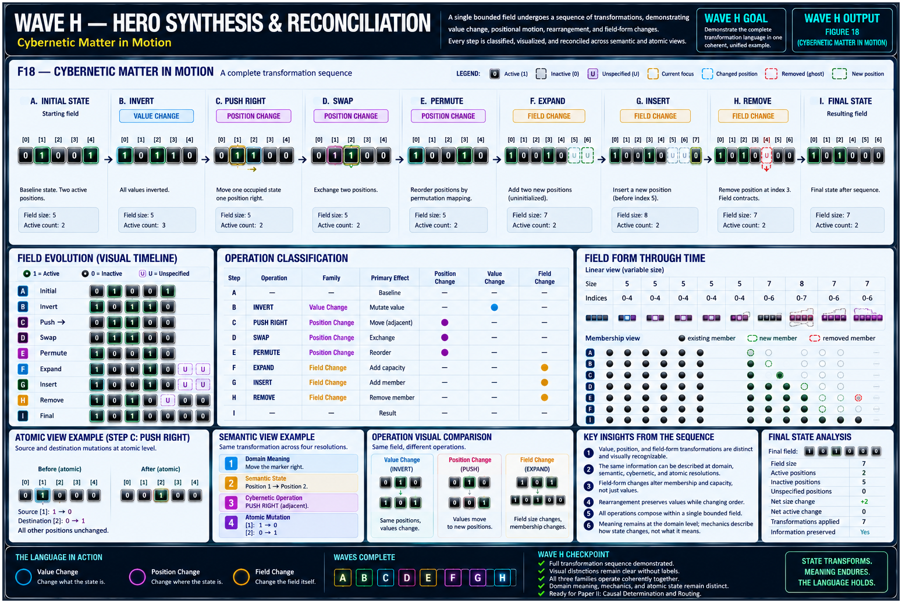
RESEARCH POSTURE
Experimental, non-canonical visual mechanics paper. The paper pressure-tests a working cybernetic vocabulary; it does not promote the Trial language, glyphs, or operator classifications into CERBERUS canon.

0. Abstract and Reading Contract
Cybernetic Mechanics I examines the deepest operational dyad of the Cybernetic Language Trial: State and Transformation. It asks what a bounded informational state is, what properties make that state legible, and which direct operations change value, position, occupancy, or the form of the field itself. The paper treats information as a visually manipulable substrate so that change can be inspected rather than mentally reconstructed from notation alone.
The visual program is deliberately stronger than the Trial 0 paper. State Cells, field boundaries, occupancy markers, before/during/after states, motion traces, atomic insets, and transformation-family carriers are reused across the figures to create visual fluency. Exact glyph geometry remains provisional.
READING LAW
State vocabulary and transformation vocabulary are experimental working semantics. A figure may make a candidate operator easier to see without proving that the operator is primitive, canonical, or permanently named.

Contents
1. The State-Transformation Dyad
2. State Is More Than Binary Value
3. Bounded Fields and Position
4. Occupancy Topologies
5. Initial, Current, Retained, and Unspecified
6. Direct Transformation
7. The Complete Unary Boolean Foundation
8. Working Transformation Vocabulary
9. Three Families of Direct Transformation
10. Mutation Versus Movement
11. PUSH as Adjacent Occupancy Movement
12. PUSH, JUMP, SHIFT, and ROTATE
13. Rearrangement: SWAP and PERMUTE
14. Field-Form Transformation
15. Transformation Properties
16. Semantic Resolution and Domain Independence
17. Cybernetic Matter in Motion
18. Open Questions and Non-Collapse Laws
19. Conclusion
Appendix A. Working Vocabulary

SERIES POSITION

1. The State-Transformation Dyad
The Cybernetic Mechanics series is organized as three dyads. Paper I owns State and Transformation: what information presently is inside a bounded field, and what directly happens to that state. Paper II owns Structure and Dynamics. Paper III owns Evaluation and Reasoning. Adjacent layers may appear as context, but ownership remains explicit.
BOUNDED QUESTION
What states can information occupy, and what are the fundamental ways those states can directly change?

Core thesis
Information is not adequately described by value alone. A state may also possess position, occupancy, specification, temporal role, membership, and a declared relation to a field. Transformation is therefore not merely “zero becomes one.” It may preserve, force, invert, replace, displace, exchange, reorder, expand, contract, insert, or remove.

Primary visual proposition
A reader should be able to see what changed. The paper therefore treats bounded information almost like cybernetic material: not literal matter, but a substrate whose value, position, and field form can be manipulated with stable visual cues.
SERIES COMPRESSION
BE → CHANGE → ORGANIZE → BEHAVE → EVALUATE → REASON. This paper owns the first two terms.

FIGURE PLATE

1. The Anatomy of Bounded State
The opening figure establishes the substrate used by every later transformation. A position continues to exist whether it is active, occupied, selected, current, retained, or explicitly specified.
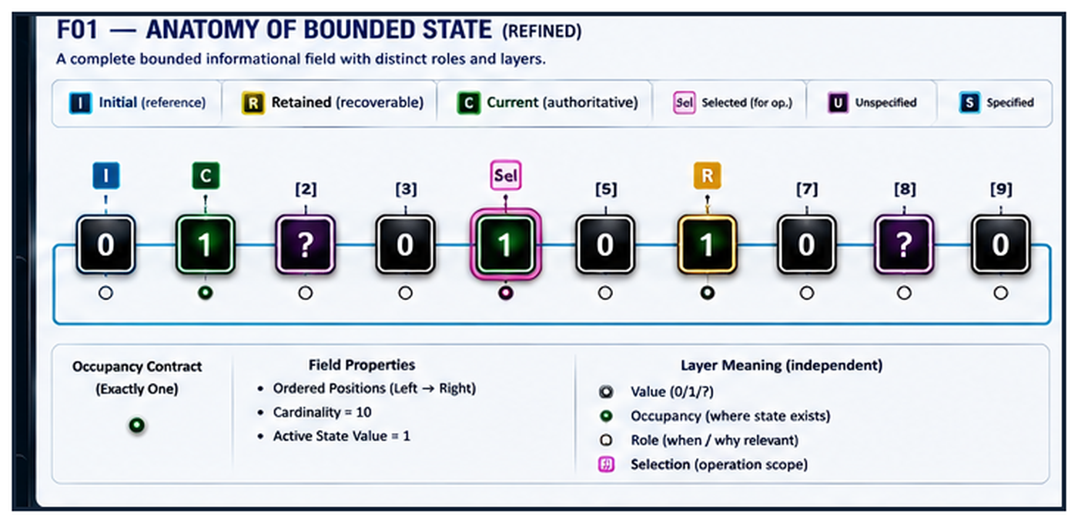
Figure F01 — The Anatomy of Bounded State. A single bounded informational field separates value, occupancy, specification, temporal role, selection, and membership. The cell is the position; the overlays describe independent properties.

L1 — STATE

2. State Is More Than Binary Value
Binary value is one property of state, not a complete semantic description. An active bit may be current, retained, selected, occupied, or merely one known value inside a larger field. An inactive value may be explicitly specified zero; it is not automatically absent, unknown, unoccupied, or irrelevant.

Core non-collapse
inactive ≠ unspecified
active ≠ selected
value ≠ position
position ≠ occupancy
specified ≠ active/inactive
current ≠ initial ≠ retained
field ≠ its contents
INTERPRETIVE RULE
The encoded value participates in meaning; it does not determine the meaning alone.
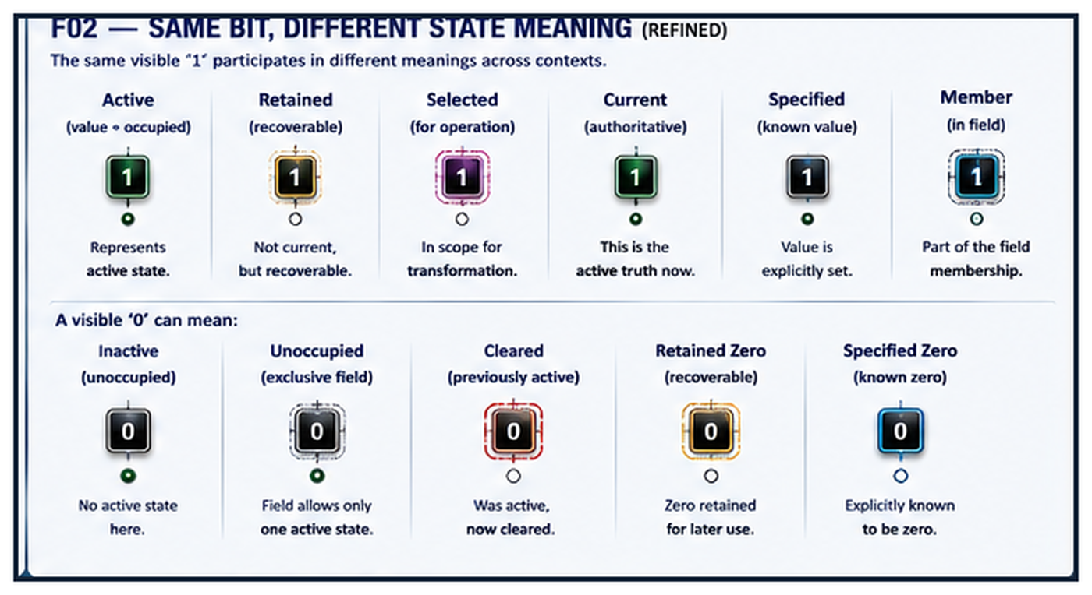
Figure F02 — Same Bit, Different State Meaning. Identical visible values can occupy different semantic roles because context and field contracts supply additional state properties.

STATE ENVIRONMENT

3. Bounded Fields and Position
A bounded field is the declared set of positions within which state is interpreted and transformed. The field supplies cardinality, ordering, indexing, occupancy rules, and a boundary. These properties determine which local operations are well-formed.
The sequence 00100 is therefore not necessarily five isolated bits. Under one contract it is a five-position ordered field with exclusive occupancy and the active state at a declared index. Under another contract, the same raw pattern may participate in a different semantic system.
INDEXING IS CONTRACTUAL
PUSH, ROTATE, INSERT, REMOVE, JUMP, and permutation require positions to be addressable. An indexing convention must be declared rather than guessed from display order.
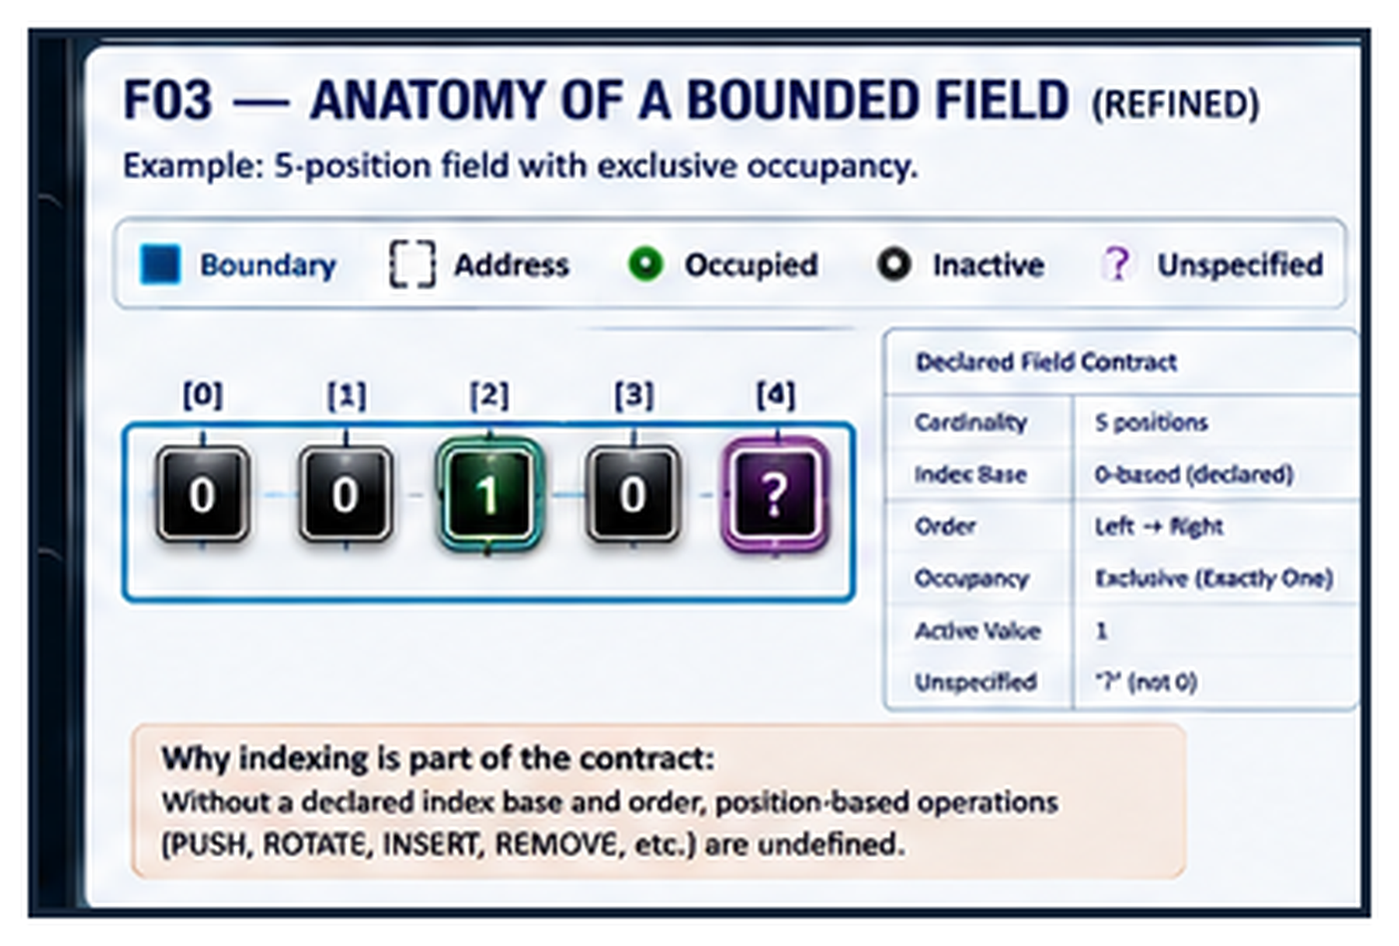
Figure F03 — Anatomy of a Bounded Field. Field boundary, addresses, occupancy rules, and cardinality turn raw values into an inspectable state space.

STATE ARRANGEMENT

4. Occupancy Topologies
Occupancy describes where relevant state presently resides. Exclusive occupancy permits exactly one occupied position; distributed occupancy permits several. Linear, matrix, and cyclic fields can use either rule. The topology changes what adjacent movement, rotation, and boundary behavior mean.
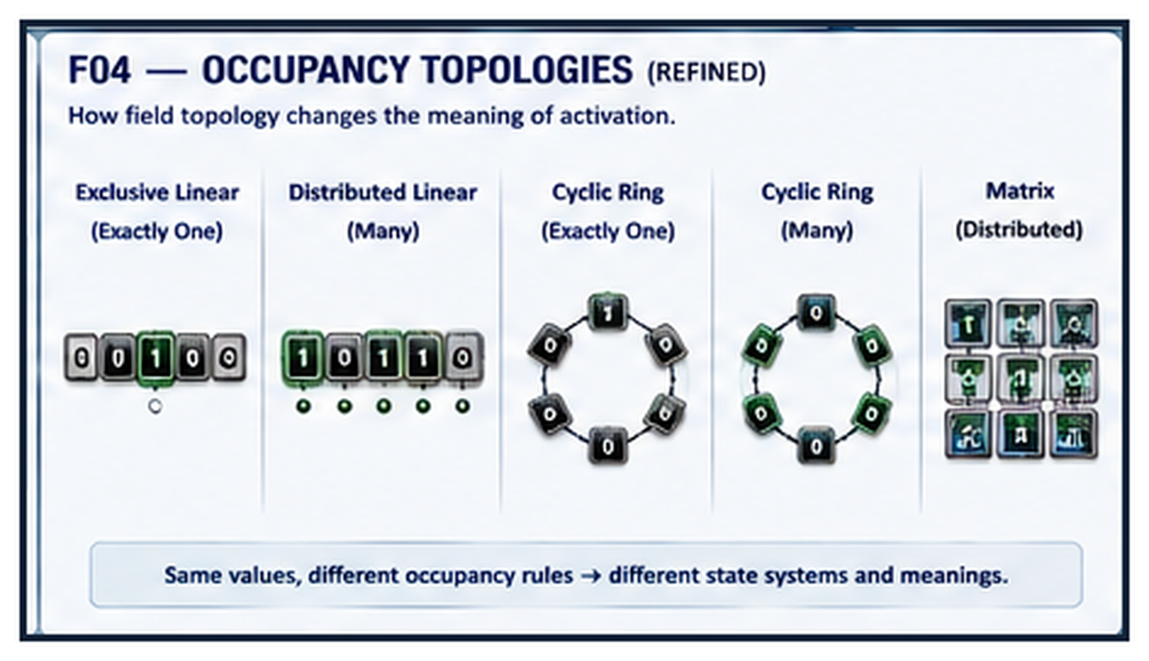
Figure F04 — Occupancy Topologies. The same values can participate in different state systems because field shape and occupancy contracts change the legal interpretation of activation.
IMPORTANT BOUNDARY
Occupancy is not value. A position can be present in the field, hold a known value, and still be unoccupied under the active occupancy contract.

STATE ROLE

5. Initial, Current, Retained, and Unspecified
State roles must remain distinct even when they refer to the same position. Initial is a reference condition. Current is authoritative now. Retained is preserved for later recovery or comparison. Unspecified means a value has not yet been resolved; it does not mean zero.
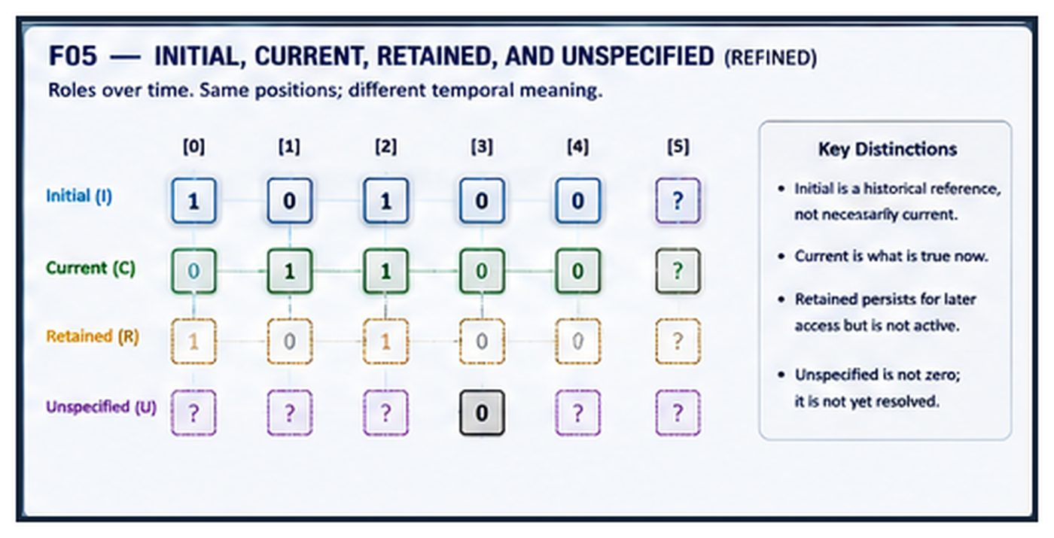
Figure F05 — Initial, Current, Retained, and Unspecified. Temporal role and specification are independent layers that may coexist over the same positions.
PAPER BOUNDARY
Paper I names these roles because transformations act on states that may carry them. History, delay, persistence mechanics, and dynamic restoration belong to Cybernetic Mechanics II.

L2 — TRANSFORMATION

6. Direct Transformation
Transformation is the direct alteration of bounded state. The working language distinguishes changes to represented value, changes to where state resides, and changes to the field that can hold the state. This distinction is more informative than treating every event as an undifferentiated set of bit flips.

Three candidate scales
Value transformation — the value at a position changes while the positions remain stable.
Positional transformation — state relocates or reorders among existing positions.
Field-form transformation — the membership, cardinality, or extent of the field itself changes.
PRIMITIVE ≠ MECHANISM
This paper studies direct transformation vocabulary. Higher-order behavior such as SPREAD may be composed from selection, neighborhood, repetition, timing, and local changes; those mechanism questions are deliberately reserved for later work.

FORMAL ANCHOR

7. The Complete Unary Boolean Foundation
For one Boolean input and one Boolean output, exactly four possible unary functions exist. This is one portion of the paper where completeness is mathematically known rather than hypothesized. The functions are Force Zero, Preserve, Invert, and Force One.
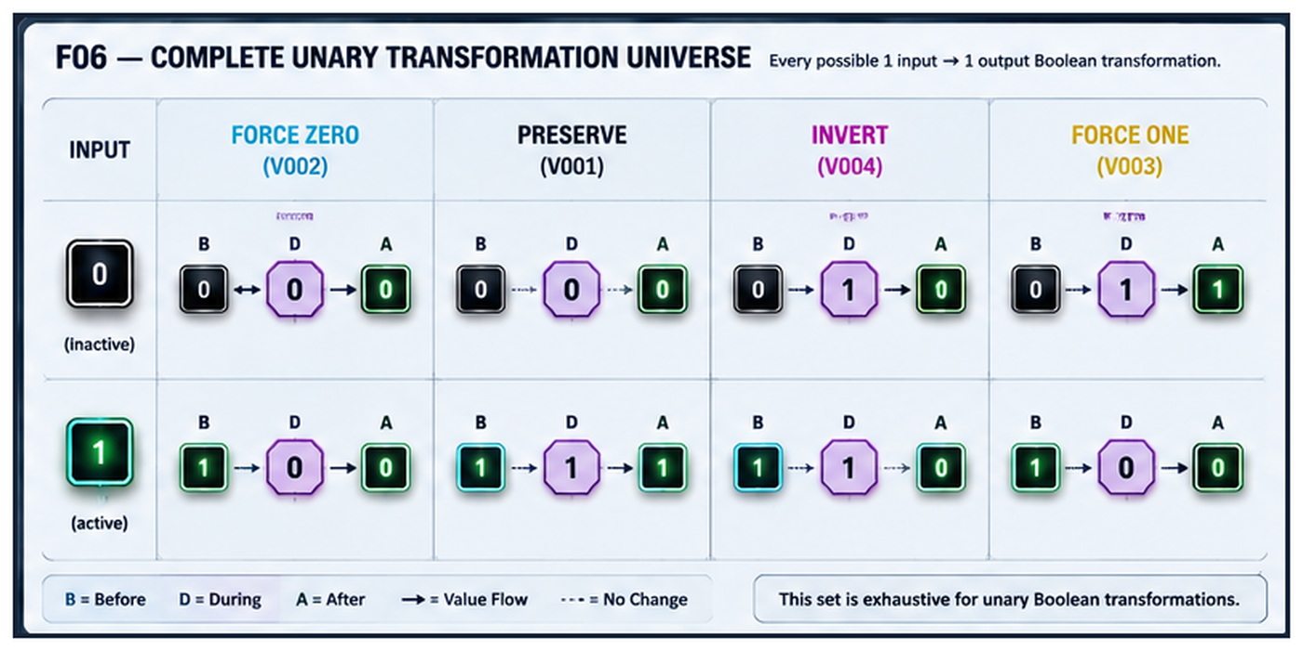
Figure F06 — Complete Unary Transformation Universe. Every possible one-bit to one-bit Boolean transformation is represented: force 0, preserve, invert, and force 1.
WHY PRESERVE MATTERS
No visible difference between input and output does not mean no operation occurred. PRESERVE can be an explicit transformation rule whose result happens to equal its input.

VOCABULARY ATLAS

8. Working Transformation Vocabulary
The current Trial-derived L2 vocabulary contains sixteen working terms. Inclusion in the atlas does not imply that all sixteen are equally fundamental or that their present names will survive later revisions.
Working family | Vocabulary
VALUE CHANGE | Preserve; Force Zero; Force One; Invert; Toggle; Replace
POSITION CHANGE | Push; Jump; Shift; Rotate; Swap; Permute
FIELD CHANGE | Expand; Contract; Insert; Remove
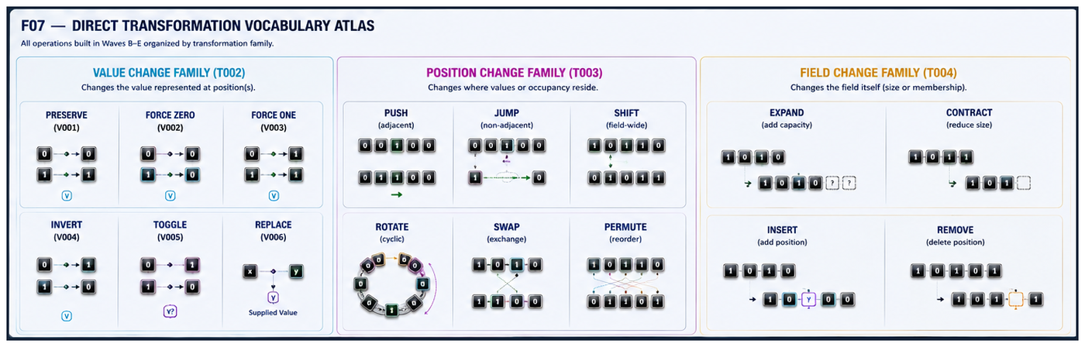
Figure F07 — Direct Transformation Vocabulary Atlas. The working operators are grouped by their primary transformation focus so differences can be compared rather than memorized as an unstructured list.

WORKING TAXONOMY

9. Three Families of Direct Transformation
The strongest classification emerging from the build is not organized by visual shape or conventional computer terminology. It asks what the operation primarily changes: the represented value, the position of state, or the field in which state can exist.
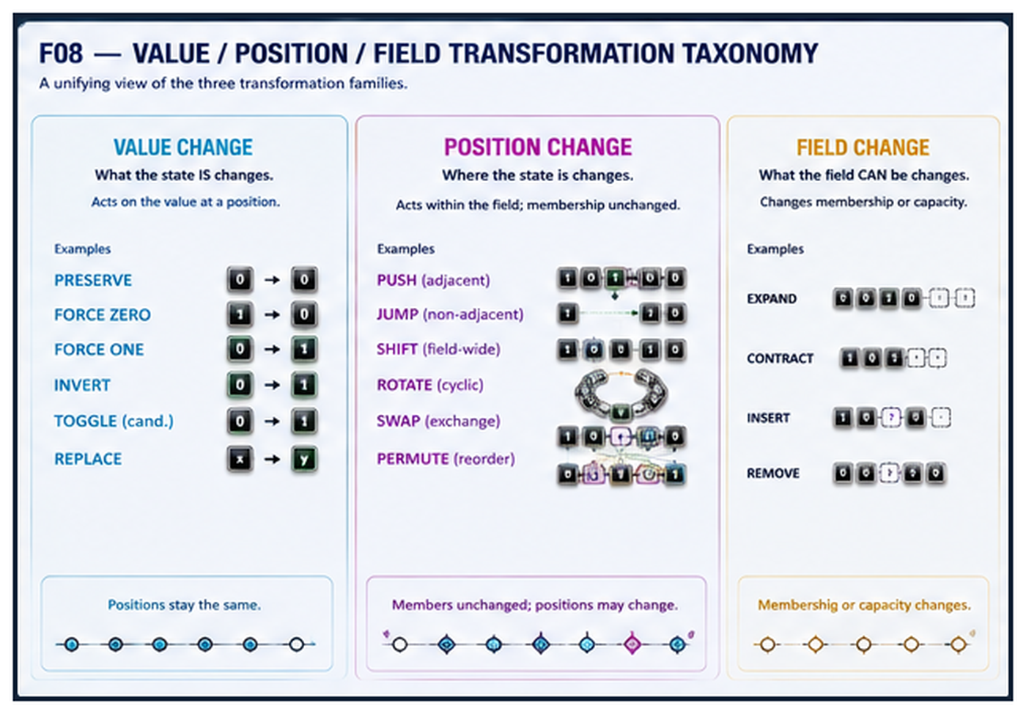
Figure F08 — Value Change, Position Change, Field Change. A unifying taxonomy separates changes to what the state is, where the state is, and what field can contain it.
RESEARCH TEST
If a transformation consistently refuses to fit the three-family model, the taxonomy should change. The language is being tested by the examples, not protected from them.

RESOLUTION

10. Mutation Versus Movement
The transformation 00100 → 00010 can be described atomically as two value mutations: the source becomes inactive and the destination becomes active. At field resolution, however, the same event preserves an additional relation: one occupied state moved one ordered position.
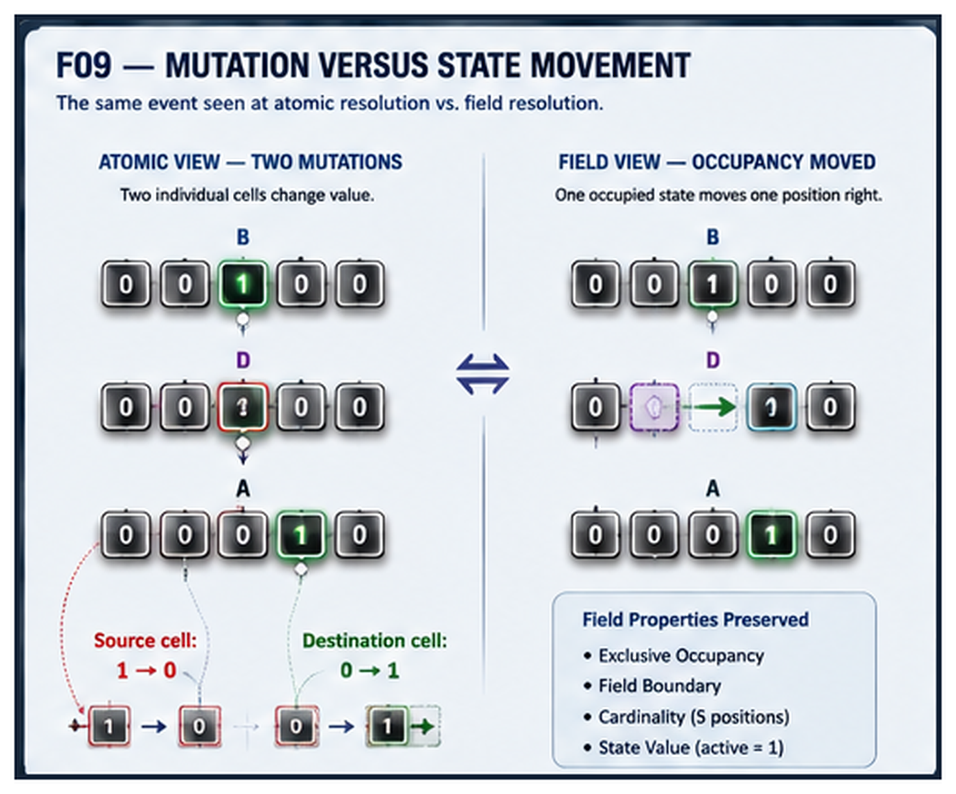
Figure F09 — Mutation Versus State Movement. Atomic truth and field-level meaning coexist: two local mutations implement one higher-order occupancy movement.
CORE DISTINCTION
Atomic mutations ≠ field-level transformation. A higher resolution may preserve direction, adjacency, exclusivity, source, and destination that are not evident from isolated bit changes alone.

PRIMITIVE-DISCOVERY CASE

11. PUSH as Adjacent Occupancy Movement
PUSH emerged because “flip two bits” did not preserve the operational meaning of adjacent occupancy movement. The current candidate definition is deliberately narrow: move one occupied state to an adjacent ordered position while preserving the field occupancy rule.
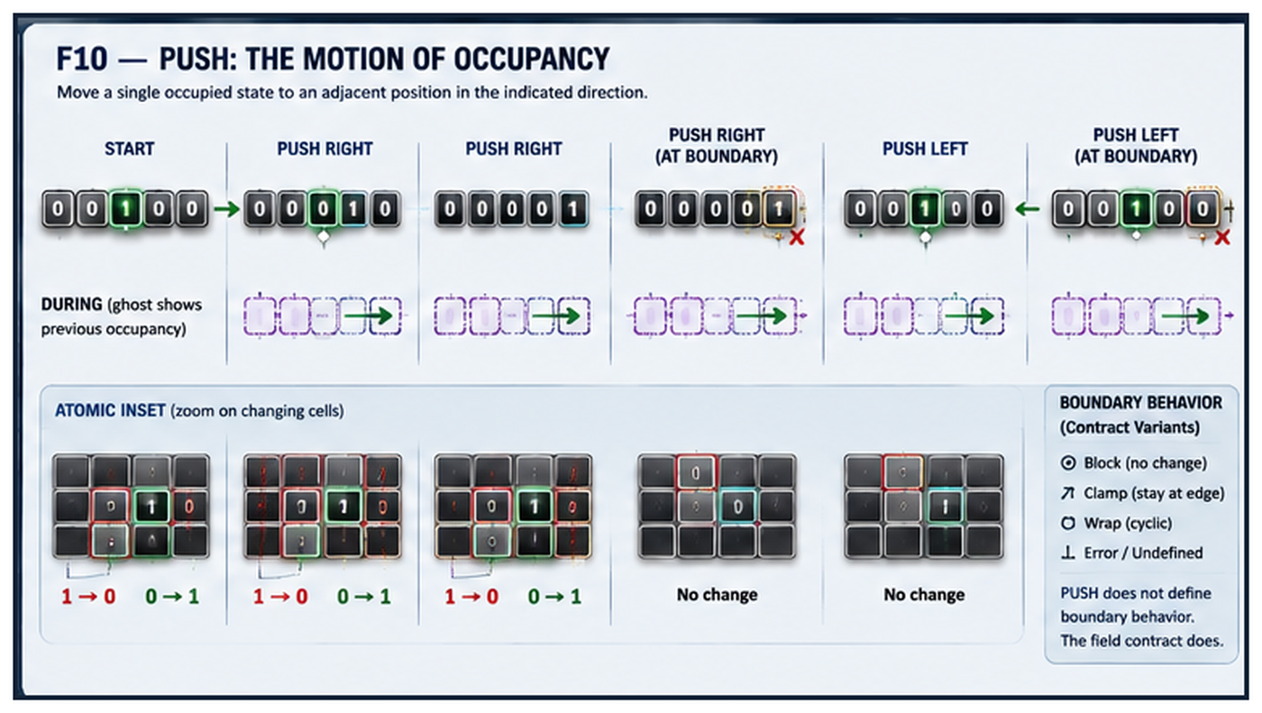
Figure F10 — PUSH: The Motion of Occupancy. Field-level motion is shown together with the atomic source and destination mutations that implement it.

Boundary behavior is not intrinsic yet
A push that reaches the edge may block, clamp, wrap, error, or become undefined depending on the field contract. The operation name should not silently determine that policy.
OPEN STATUS
PUSH is a strong candidate primitive because its decomposition is longer than the concept it preserves. The paper does not yet claim that this is sufficient proof of primitive status.

POSITIONAL MOTION

12. PUSH, JUMP, SHIFT, and ROTATE
Directional appearance is not enough to identify an operation. PUSH moves one occupancy adjacently. JUMP relocates one occupancy non-adjacently. SHIFT relocates the field contents according to a direction and boundary rule. ROTATE preserves membership cyclically by wrapping state through the boundary.
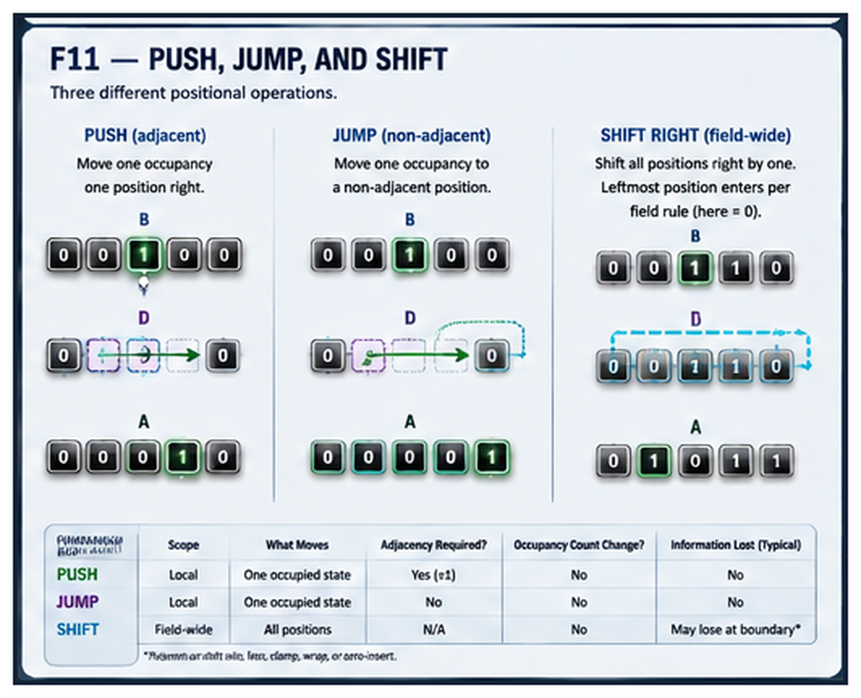
Figure F11 — PUSH, JUMP, and SHIFT. Similar direction can conceal different transformation scopes, adjacency assumptions, and boundary effects.

POSITIONAL MOTION — CONTINUED

12.2 ROTATE: Linear and Cyclic Views
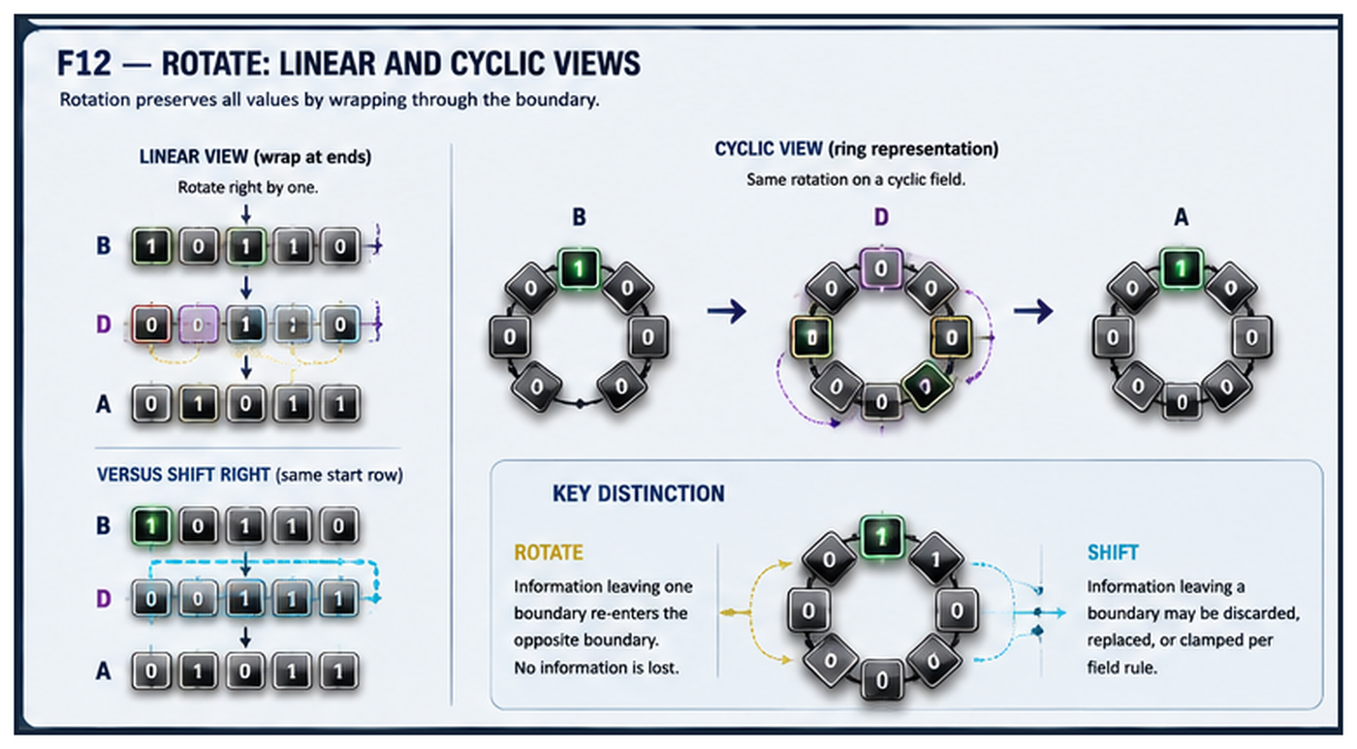
Figure F12 — ROTATE: Linear and Cyclic Views. The same cyclic transformation can be projected as boundary wrap in a linear field or as direct movement around a ring.

POSITION WITHOUT VALUE MUTATION

13. Rearrangement: SWAP and PERMUTE
Rearrangement exposes a particularly useful form of transformation: values can remain unchanged while their positional assignment changes. SWAP exchanges two positions symmetrically. PERMUTE generalizes positional rearrangement through an explicit mapping.
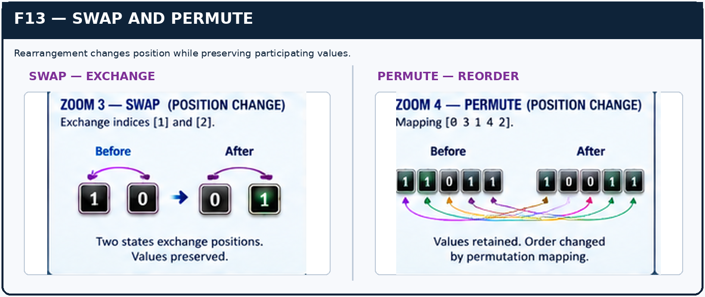
Figure F13 — SWAP and PERMUTE. Rearrangement preserves participating values while changing positional correspondence; provenance markers can be used when repeated values make identity visually ambiguous.
INFORMATION CONSERVATION
Rearrangement can be lossless and reversible even though the field state is visibly different. Change does not require value mutation.

THE FIELD ITSELF CHANGES

14. Field-Form Transformation
EXPAND, CONTRACT, INSERT, and REMOVE act on the representational field rather than only on the values inside it. These operators test the boundary between L2 Transformation and the structural concerns of Paper II. For this paper they are retained provisionally as direct field-form transformations.
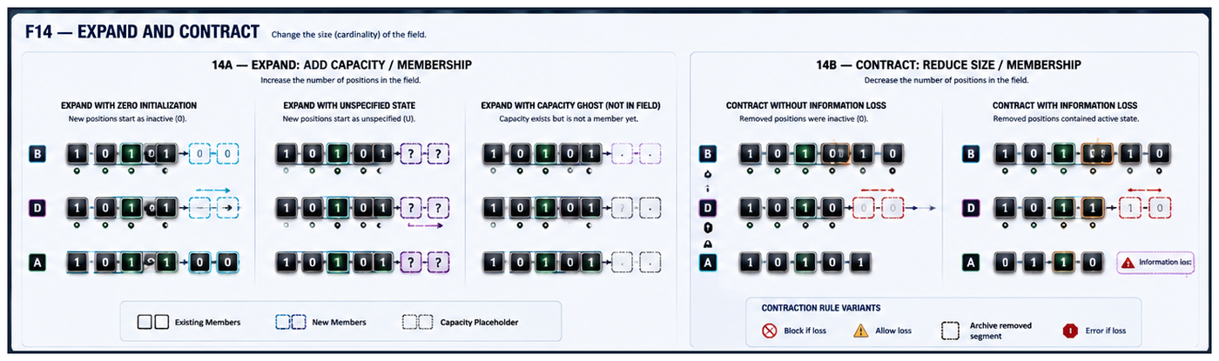
Figure F14 — EXPAND and CONTRACT. Cardinality may increase or decrease under explicit initialization, preservation, archival, or information-loss policies.
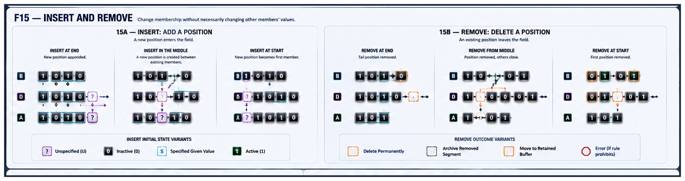
Figure F15 — INSERT and REMOVE. Changing field membership is not equivalent to activating, clearing, or forcing a value at an already-existing position.
NON-COLLAPSE LAW
deactivate ≠ remove; activate ≠ insert; clear position ≠ delete position; inactive capacity ≠ nonexistent capacity.

DESCRIPTIVE DIMENSIONS

15. Transformation Properties
Transformation families describe primary semantic focus. Properties describe behavior across additional dimensions. The paper uses properties to compare operations without automatically promoting every property into a new primitive.
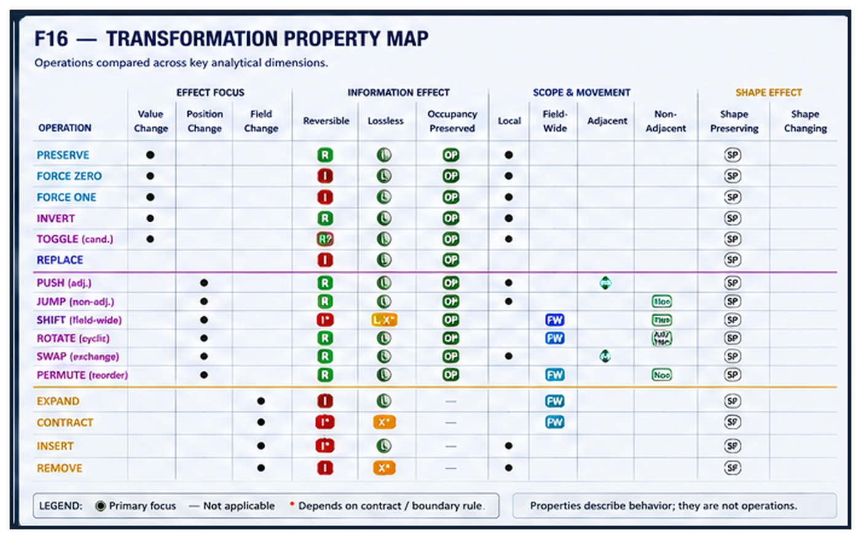
Figure F16 — Transformation Property Map. Candidate operations are compared across reversibility, information loss, scope, adjacency, occupancy, and shape effects.

Useful analytical dimensions
reversible / irreversible
lossless / information-losing
local / field-wide
adjacent / non-adjacent
occupancy-preserving / occupancy-changing
shape-preserving / shape-changing
OPERATOR CONTRACTS LATER
These properties are candidates for operator-contract metadata. They are not yet declared to be part of the primitive language itself.

MEANING TO MECHANICS

16. Semantic Resolution and Domain Independence
The transformation language is intended to operate below domain meaning without owning that meaning. A cooking system may define an ordered doneness field. Once that field exists, a domain instruction such as “cook further” can resolve to a state transition and then to a cybernetic operation such as adjacent occupancy movement.
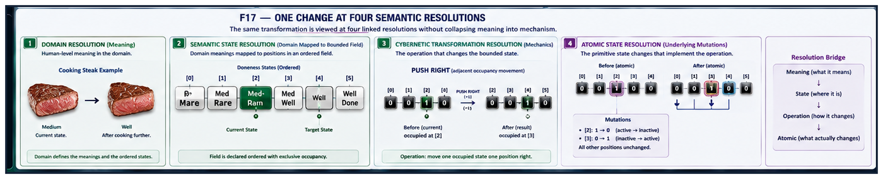
Figure F17 — One Change at Four Semantic Resolutions. Domain meaning, semantic state, cybernetic transformation, and atomic mutation describe one event at different depths without collapsing into one another.
OWNERSHIP LAW
The domain owns what the positions mean. The cybernetic language describes how the state changes.
The downward description can become increasingly causal: Cook further → Medium to Well → PUSH occupancy one ordered position → source 1 to 0 and destination 0 to 1. Upward abstraction can compress these details again, provided the route back to the deeper mechanics remains available when needed.

HERO SYNTHESIS

17. Cybernetic Matter in Motion
The final synthesis asks whether one bounded field can survive a sequence of different transformation classes while remaining visually and semantically traceable. The specimen is deliberately not a routed system or a temporal mechanism. It is one informational substrate undergoing direct operations.
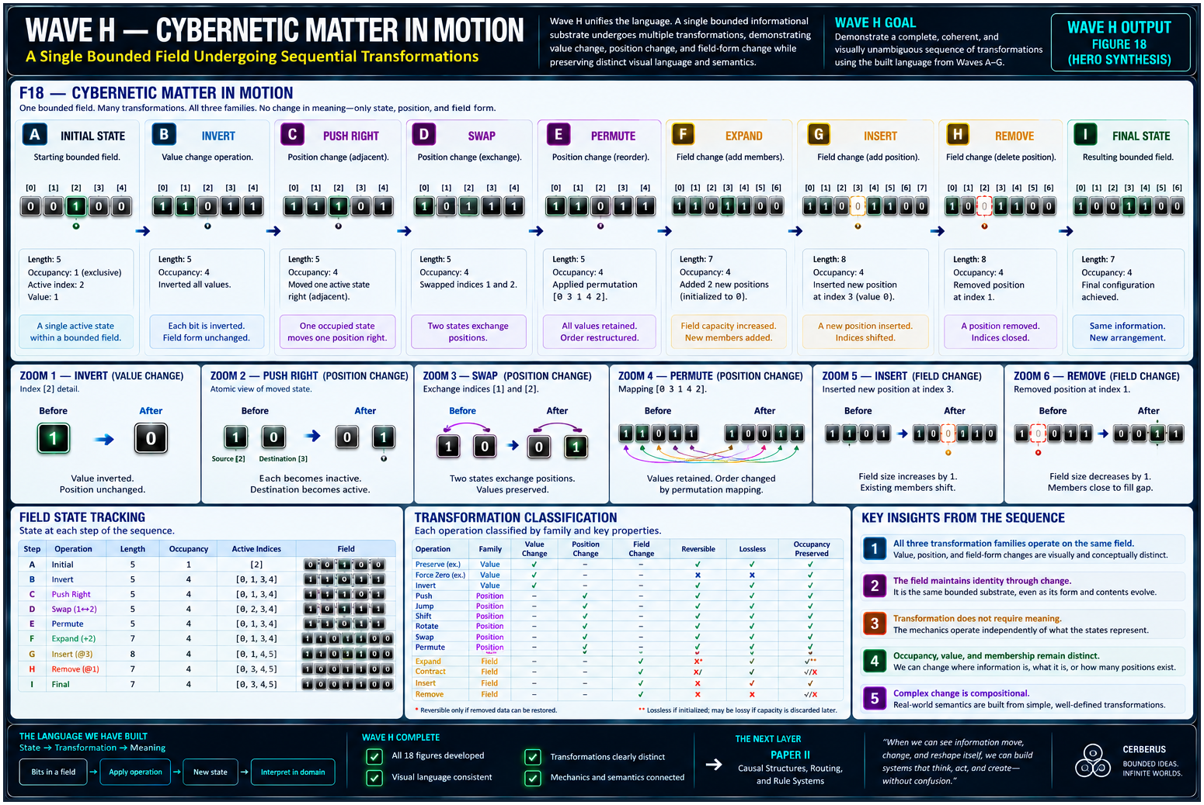
Figure F18 — Cybernetic Matter in Motion. One field undergoes value change, adjacent movement, rearrangement, expansion, insertion, and removal while the visual grammar continues to distinguish what changed at each step.

What the synthesis demonstrates
Value change, positional change, and field change can operate over one bounded substrate.
The same event can be inspected at domain, cybernetic, and atomic resolutions.
Field identity can persist while form and contents evolve.
Complex change is compositional: larger transformations can be built from smaller, inspectable changes.
VISUAL THESIS
If a knowledgeable reader can distinguish value change, position change, and field change before reading the labels, the central visual language is doing useful work.

RESEARCH FRONTIER

18. Open Questions and Non-Collapse Laws

Questions preserved for later revision
Is TOGGLE semantically distinct from INVERT, or should the two collapse at the Boolean layer?
Is PUSH a true semantic primitive or an especially useful compound?
Where should SHIFT end and PUSH begin across occupancy and field-wide motion?
Should EXPAND and CONTRACT remain L2 transformations or migrate toward the structural responsibilities of Paper II?
What is the cleanest representation of unspecified state?
Which transformation properties deserve independent visual grammar?
Can the same symbols remain legible across linear, matrix, and cyclic fields?
How much atomic detail can be hidden while preserving causal inspectability?

Core non-collapse laws
Concept A | ≠ | Concept B | Concept A | ≠ | Concept B
bit value | ≠ | semantic meaning | inactive | ≠ | unspecified
active | ≠ | selected | current | ≠ | initial / retained
value | ≠ | position | position | ≠ | occupancy
field | ≠ | contents | mutation | ≠ | movement
activation | ≠ | movement | deactivation | ≠ | removal
replace | ≠ | force | push | ≠ | shift / jump
shift | ≠ | rotate | swap | ≠ | copy
permutation | ≠ | value mutation | expand | ≠ | activate
contract | ≠ | deactivate | remove position | ≠ | clear position
transformation | ≠ | routing / temporal behavior | Trial vocabulary | ≠ | canonical language

CLOSING MODEL

19. Conclusion
Cybernetic Mechanics I reduces the State-Transformation dyad to one compact anatomy. STATE defines what information presently is within a bounded field. TRANSFORMATION defines what directly changes about that state. The strongest working taxonomy distinguishes change to value, change to position, and change to field form.
GOVERNING STATEMENT
Cybernetic state is not merely value; it is value situated within a declared informational field. Cybernetic transformation is the direct alteration of that state’s value, position, occupancy, or field form.
The figures demonstrate why this distinction is useful. A bit flip, occupancy movement, permutation, and field insertion can all produce different informational events even when they ultimately compile to small local mutations. Higher semantic resolution preserves the relations that make those events intelligible.
The paper therefore does not finish the language. It establishes a more inspectable substrate for revising it. The surviving contribution is a visual and conceptual discipline: show what is bounded, show what property changed, preserve the route to the underlying state, and refuse to collapse value, position, occupancy, field, and meaning into one undifferentiated notion of “data change.”
SERIES HANDOFF
Paper II — Structure & Dynamics begins where this paper deliberately stops: how bounded state is selected, grouped, routed, retained, repeated, synchronized, and made to behave through time.

TRIAL-DERIVED L1 + L2

Appendix A. Working Vocabulary
The vocabulary below is the current planning vocabulary inherited from Cybernetic Language Trial 0 for the first dyad. Inclusion does not imply primitive status.
L1 — STATE  • inactive  • active  • specified  • unspecified  • value  • position  • occupancy  • exclusive occupancy  • distributed occupancy  • initial  • current  • retained  • bounded field | L2 — TRANSFORMATION  • preserve  • force zero  • force one  • invert  • toggle  • replace  • push  • jump  • shift  • rotate  • swap  • permute  • expand  • contract  • insert  • remove

Compressed model
STATE → TRANSFORMATION
What exists → what directly happens to it. Within Transformation: VALUE CHANGE → POSITION CHANGE → FIELD CHANGE.

