CERBERUS
Semantic Kernel Specification
Authoring Standard
Canonical Bit Visual Grammar, Deterministic BitWord Assembly, Reader Topology, Interface Contracts, and Comparative Learning
REFERENCE PRINCIPLE
A formal Semantic Kernel Specification is simultaneously a bounded semantic contract, mathematical construction specification, Reader definition, exact interface declaration, interoperability statement, visual construction contract, comparative-learning surface, and deterministic implementation handoff. Actual Bit figures are derived from registered construction rather than independently decorated.
Field | Specification
Document | CERBERUS Semantic Kernel Specification Authoring Standard
Version | 2.0
Date | August 2026
Status | Verified Release
Supersedes | Version 1.0
Primary Subject | How CERBERUS SK Specs are bounded, composed, visually projected, interpreted, interfaced, compared, validated, and handed off
Numbering | Arabic section numbering; no Roman numeral section schemes
Reference Posture | Spec-first semantics; exact BIGFOOT normalization and reuse during implementation handoff

Document Control and Normative Posture
This standard defines the required structure of a CERBERUS Semantic Kernel Specification. It applies across domain families, including language, time, body, color, music, business, finance, simulation, effects, and future specialist Kernels. It preserves the semantic and interface rigor of v1.0 while adding a canonical visual grammar for registered Bits and a deterministic method for assembling, comparing, learning, and authoring BitWords.
The normative terms MUST, MUST NOT, SHOULD, SHOULD NOT, and MAY are used as requirements language. A Formal Spec is implementation-authoritative; a Candidate Spec may expose explicit unresolved requirements; a Concept Draft may explore alternatives without pretending that registry identities or D contracts are already frozen.
Class | Purpose | Contract posture
Concept Draft | Explore the bounded question, candidate mathematics, likely dependencies, and likely interface needs. | May use provisional requirements clearly marked as such.
Candidate Spec | Freeze the intended semantic boundary, Reader topology, resolution architecture, and construction requirements. | Exact contracts should be selected where available; missing contracts remain explicit requirements.
Formal Spec | Implementation-authoritative semantic, construction, Reader, interface, and interoperability contract. | Canonical interactive targets must bind exact registered D#.# contracts and exact registered construction.

Section Index
Ref. | Content
Part 1 | Purpose, laws, and the complete SK contract
Part 2 | Semantic boundary, dependencies, and resolution
Part 3 | Canonical Bit visual grammar
Part 4 | Deterministic BitGroup and BitWord assembly
Part 5 | Reader topology and semantic binding
Part 6 | DARTBOARD interface specification
Part 7 | Binary encoding, formulas, interoperability, and ownership
Part 8 | Structural comparison and comparative learning
Part 9 | Examples, conformance, and traceability
Part 10 | Implementation handoff and deterministic AI assembly
Appendices | Required content, templates, visual grammar, assembly/signature grammar, learning protocol, checklist, Effects additions, glossary

Part 1 - Purpose and Core Authoring Laws

1. Purpose and Scope
The purpose of an SK Spec is not merely to explain a datatype. The Spec is the durable bridge between semantic design and deterministic construction. A conforming document must let a human understand the bounded question, let an AI or builder reconstruct the required registered structures, let DARTBOARD reconstruct the intended interaction surface, and let future versions interpret historical states without hidden assumptions.
- Define one bounded semantic question and explicit exclusions.
- Declare the Series and every supported resolution member.
- Describe primitive Bits and mathematical BitGroups independently from contextual domain meaning.
- Declare the exact ordered BitWord construction and its Structural Signature.
- Declare physical placement order and Reader topology.
- Bind semantic Reader roles to exact interface metadata and D contracts.
- Declare accepted and emitted types, routes, Compound membership, runtime graph expectations, and external owners where applicable.
- Provide worked, invalid, comparative, and conformance examples appropriate to the SK.
- End with a registry-level implementation handoff sufficient for deterministic reconstruction.
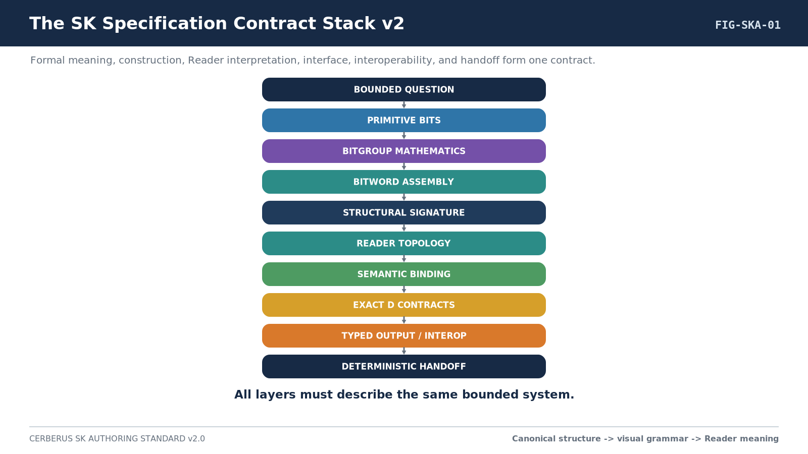
Figure 1. SK Specification Contract Stack v2.

2. Responsibility and Authority Separation
Version 2.0 makes a stronger separation between identity, visual projection, semantic interpretation, and interface presentation. BIGFOOT owns the registered primitive and compositional identities. The Bit Color relationship supplies canonical structural appearance. The visual toolkit reproduces that appearance. The SK Reader assigns bounded contextual meaning. DARTBOARD projects the resolved semantic targets through explicit interface contracts.
CRITICAL SEPARATION
Bit Color != Reader Meaning != Interface Color. A SCALAR Bit remains a SCALAR Bit regardless of whether an SK uses it for pitch, time, opacity, distance, temperature, money, or another bounded quantity.
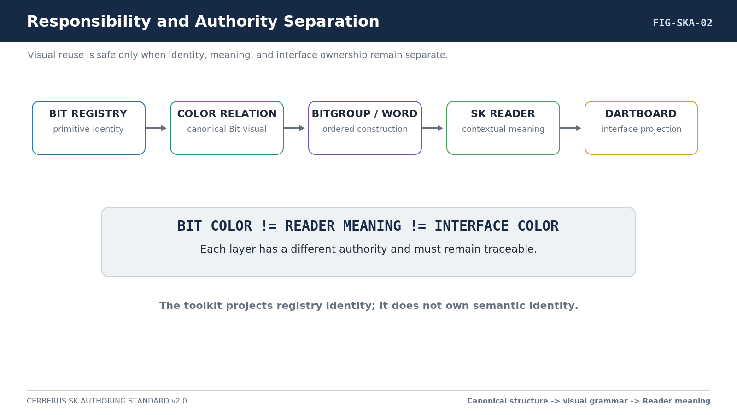
Figure 2. Responsibility and Authority Separation.

3. Core Authoring Laws
Law | Name | Normative statement
SK-A01 | Bounded Question Law | Each SK SHALL answer one bounded semantic question and SHALL NOT absorb unrelated semantic ownership merely because spare Bits exist.
SK-A02 | Spec-First Law | The ideal bounded semantic contract SHALL be authored before implementation-time BIGFOOT normalization or identity reuse.
SK-A03 | Math/Meaning Separation | Bits and BitGroups SHALL define primitive state and reusable mathematical structure; the SK Reader SHALL supply bounded contextual interpretation.
SK-A04 | Reader Address Law | Reader addresses such as A1 and A2 SHALL remain distinct from physical Bit addresses such as B032:B039.
SK-A05 | Explicit Composition Law | Any Reader lane spanning multiple placements SHALL identify a registered Composition Type and validate compatible continuation.
SK-A06 | Minimum Sufficient Resolution | A new resolution member SHALL be added only when it introduces justified semantic capability or precision.
SK-A07 | No Interface Inference | DARTBOARD SHALL NOT infer a D contract from BitGroup Type, Reader role, or target class.
SK-A08 | Exact D Contract Law | A Formal Spec SHALL bind every canonical/default interactive target to an exact registered D#.# contract.
SK-A09 | Figure Completeness Law | Each semantic Reader role SHALL be visually demonstrated as an interface figure or explicitly declared non-interactive.
SK-A10 | Formula Locality | A BitGroup Formula belongs to the canonical BitGroup record it interprets; the SK Reader composes and names resolved results.
SK-A11 | Projection Separation | Symbols, Bit colors, interface colors, shapes, and specialist viewports are projections and SHALL NOT become semantic identity.
SK-A12 | Rebuildability Law | Rendered UI and publication figures may be discarded; the Spec plus referenced records SHALL remain sufficient to reconstruct the logical system.
SK-A13 | Version Reversibility | Superseded Specs SHALL preserve interpretability of historical Bits, placements, Reader mappings, D contracts, and Compound dependencies.
SK-A14 | Deterministic Handoff | The end of the Spec SHALL expose the exact records, formulas, Reader contracts, D contracts, BOSS symbols, colors, visual toolkit references, and tests required for implementation.
SK-A15 | Canonical Bit Visual Identity | Every registered standard Bit SHALL resolve to its canonical structural visual identity through its registered Color relationship.
SK-A16 | Derived Appearance | A BitGroup or BitWord SHALL derive its structural appearance from its exact constituent Bits and SHALL NOT be independently recolored for aesthetics.
SK-A17 | Structural Color Separation | Canonical Bit Color identifies primitive representational grammar; it SHALL NOT silently encode Reader semantics, semantic domain, or interface role.
SK-A18 | State Separation | Canonical Bit Color SHALL NOT be interpreted as current binary state unless a separate explicit state-projection contract says otherwise.
SK-A19 | Visual Similarity | Visual similarity indicates structural kinship, not semantic equivalence.
SK-A20 | Toolkit Reuse | Equivalent registered Bit identities SHOULD reuse the same canonical visual assets rather than being manually redrawn.
SK-A21 | Visual Traceability | A formal visual construction SHALL remain traceable from displayed Bit to registered Bit to BitGroup to BitWord placement to Reader binding.
SK-A22 | Comparative Learning | An unfamiliar BitWord MAY be taught through comparison with a structurally similar familiar BitWord, provided structural similarity is not represented as semantic equivalence.
SK-A23 | Redundant Identity | Color MAY accelerate recognition but SHALL NOT become the sole recoverable carrier of structural identity; machine-readable identity and textual traceability must remain available.

4. The One-Line Declaration Grammar
Each semantic placement SHOULD be expressible in a compact declaration. The declaration is a cross-reference, not a substitute for the surrounding contract.
Semantic Placement | Reader Address | BitGroup or Word | Exact D Contract
Example: Primary Boundary-1 | C1 | SCALAR-8 | D1.2
The placement name says what the role means in this SK. The Reader address says where the Reader finds it. The mathematical structure says what registered machinery carries it. The D reference says exactly how the canonical/default interface operates that target. Range, zero/unset behavior, composition, output consequence, symbols, colors, validation, and versions remain explicit elsewhere in the role contract.

Part 2 - Semantic Boundary, Dependencies, and Resolution

5. Bounded Question and Ownership
Every SK begins with one explicit bounded question. The next block states what the SK owns and what it does not own. This is a semantic firewall against later scope creep and against the temptation to fill unused capacity with adjacent meaning merely because Bits are available.
Required block | Contents
Bounded Question | One sentence describing the semantic question the complete Word answers.
Owns | Semantic responsibilities that belong inside the SK.
Does Not Own | Adjacent responsibilities remaining with other SKs, Rules, Operators, Models, registries, Frames, renderers, or runtime systems.
Canonical Output | The resolved semantic object or state exposed by the Reader.
Authority Boundary | What the resolved state may describe versus what it may not authorize or establish.

6. Dependency Declaration
A dependency is another registered semantic contract whose exact structure should exist before the current Formal Spec can be completed. Merely accepting a generic Scalar, Mask, Event, Field, Path, or other typed input does not automatically create a hard dependency on whichever SK might produce it.
Dependency class | Required treatment
Hard SK Dependency | Name the exact SK/Series and explain why the current SK cannot own that meaning locally.
External Semantic Dependency | Name external Frames, domain adapters, registries, COLOR, TIME, BODY, or other semantic owners used by reference.
Optional <R> Route | Declare semantic continuation without making the destination a constituent of the current Word.
Compound Dependency | Declare only when the complete SK is a constituent of a Compound BitWord.
Runtime Graph Relation | Declare separately from both <R> and Compound membership.

7. Series and Resolution Architecture
Multi-resolution SKs use the Series name to list supported Bit steps while each member carries its resolution level. The level marker is a resolution index, not a document version. A later member must justify its additional capacity by new semantic capability, additional precision, or another explicitly useful representational extension.
RESOLUTION PRINCIPLE
A larger Word is not automatically a better Word. Additional capacity must be justified, and the lower member remains the preferred representation whenever it is sufficient.
Resolution requirement | Spec obligation
Level purpose | State what the level can express on its own.
Added capacity | State exactly what new capability or precision the next level adds.
Prefix relationship | Show whether the prior complete member is structurally preserved.
Reader continuation | Identify lanes extended through A2, B2, C2, and so on.
Promotion behavior | Declare conversion or promotion separately when higher resolution changes normalized interpretation.
Minimum sufficient resolution | Explain when a consumer should stop at the lower member.
Structural growth | Describe whether the later member extends a group, adds a group, introduces a primitive class, or changes ordered composition.

Part 3 - Canonical Bit Visual Grammar

8. Primitive Structural Identity
Version 2.0 adds a canonical visual literacy layer at the primitive Bit level. The objective is not decoration. A stable primitive appearance lets repeated structures become visually recognizable and allows BitGroup and BitWord silhouettes to emerge directly from registered composition.
Layer | Meaning
Bit Class | Structural role supplied by the primitive, such as Scalar Coordinate, Mask Member, Sign, or Route-capable.
Value Type | Kind of primitive value/state the Bit participates in.
Bit Color | Canonical perceptual identity used for structural recognition.
Reader Meaning | Contextual meaning assigned to the structure inside one bounded SK.

9. Canonical Bit Visual Alphabet
The registry remains authoritative for the Bit-to-Color relationship. The table below is a human-readable declaration of the current standard visual grammar, while deterministic figures should resolve the linked canonical Color records and toolkit assets rather than treat this table as an independent source of truth.
Bit Class | Color | Hex | Structural idea
Scalar Coordinate | Light Coral | #F08080 | Magnitude, quantity, or scalar coordinate machinery.
Mask Member | White / Black | #FFFFFF / #000000 | Ordinal Boolean-mask texture; odd positions White, even positions Black.
Presence | Green | #008000 | Presence or asserted existence.
Sign | Purple | #800080 | Numeric polarity/sign machinery.
Enum Member | Blue | #0000FF | Discrete bounded categorical member.
Route-capable | Cyan | #00FFFF | Route or branch-selection machinery.
Control Flag | Yellow | #FFFF00 | Operational Boolean modifier or control flag.
Validity / Null | Orange | #FFA500 | Qualification of whether an associated encoded value is defined/valid.
Continuation / Extension | Magenta | #FF00FF | Structural continuation or extension marker.
Integrity / Check | Teal | #008080 | Parity, checksum, verification, or integrity machinery.
Reserved | Gray | #808080 | Allocated structural capacity without active semantic assignment.
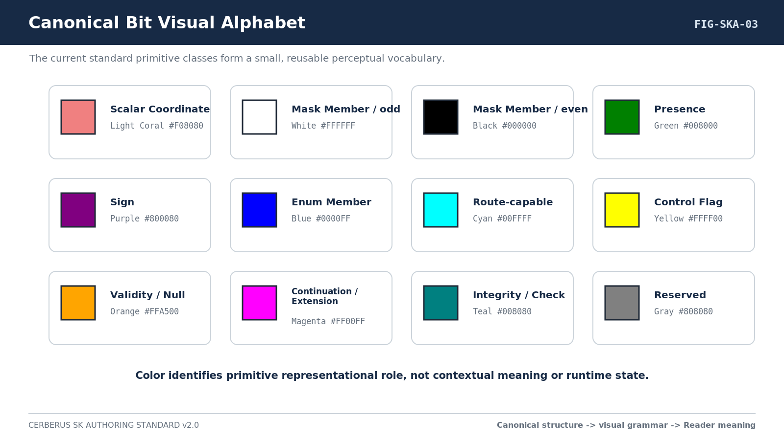
Figure 3. Canonical Bit Visual Alphabet.

10. MASK Texture Rule
MASK is intentionally different from the single-hue classes because a repeated alternating pattern is more recognizable than a flat run. MASK 1 is White, MASK 2 is Black, MASK 3 is White, and the ordinal pattern continues. The alternating visual texture describes primitive mask identity; it does not describe current selected/unselected state.
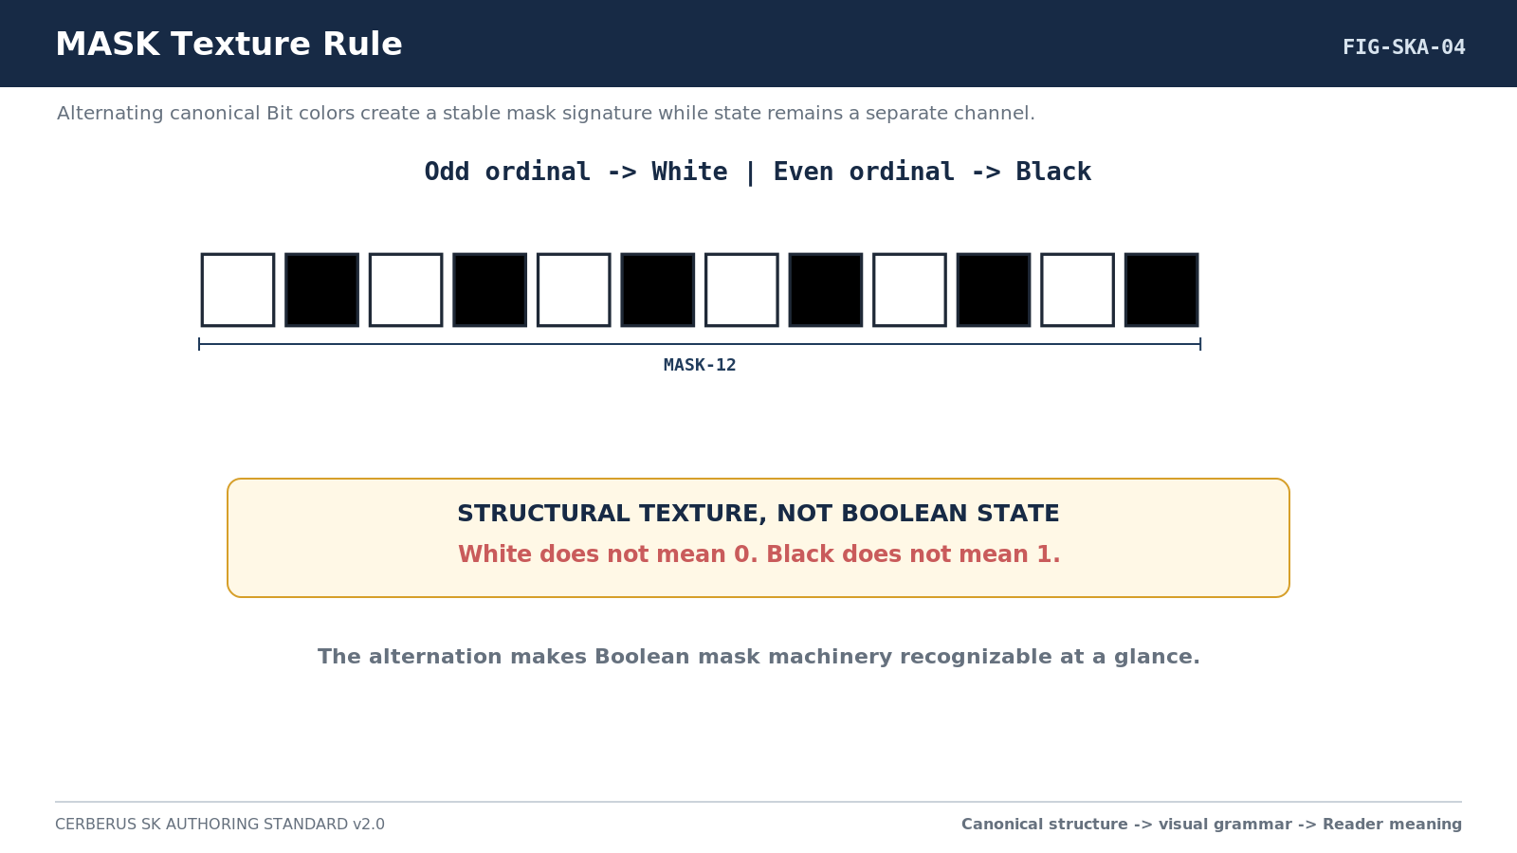
Figure 4. MASK Texture Rule.
MASK INVARIANT
White does not mean 0 and Black does not mean 1. The alternation identifies MASK ordinal structure. Runtime Boolean state must use a separate visual channel.

11. Structural Identity vs Runtime State
Canonical structural identity must survive runtime state changes. A SCALAR Bit remains visually a SCALAR Bit whether its current encoded state is 0 or 1. A MASK Bit remains its ordinal White or Black primitive. A future runtime may add borders, markers, opacity, illumination, checks, or other state projections, but those treatments are distinct from the canonical structural grammar.
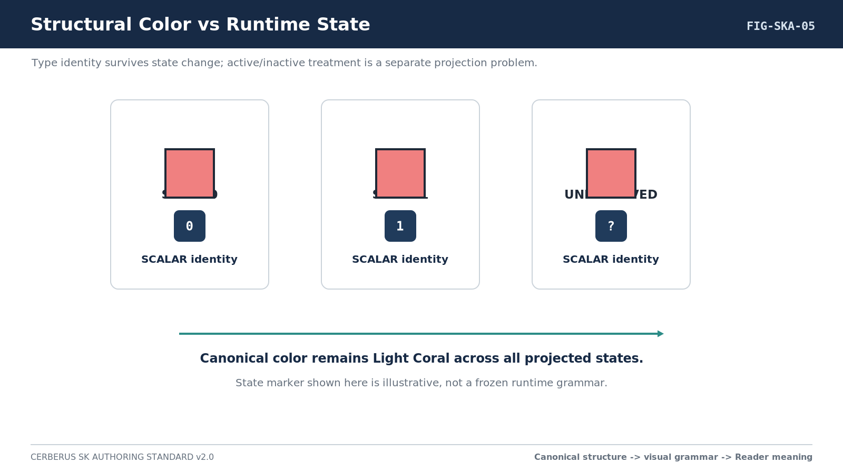
Figure 5. Structural Color vs Runtime State.

12. Toolkit Authority and Accessibility
The BIGFOOT Bit Visual Toolkit is an implementation surface for reproducible figures. It is not an independent semantic authority. Deterministic construction follows the chain Bit record -> linked Color -> canonical toolkit asset -> ordered composition. Publication figures may add labels, Reader addresses, brackets, or accessibility overlays without modifying the underlying Bit asset.
Color accelerates recognition but must never be the only recoverable identity carrier. Formal figures must remain interpretable through exact names, Structural Signatures, record references, order, or other machine-readable metadata so that a color-vision limitation or monochrome reproduction does not erase structural identity.

Part 4 - Deterministic BitGroup and BitWord Assembly

13. Construction Hierarchy
Visual construction follows the same semantic hierarchy as BIGFOOT construction. Canonical Bit assets are ordered into BitGroup constructs. Registered BitGroups are ordered into BitWords. Complete Words may participate in Compound BitWords. The publication figure is therefore downstream of the registered composition, not a parallel artistic interpretation.
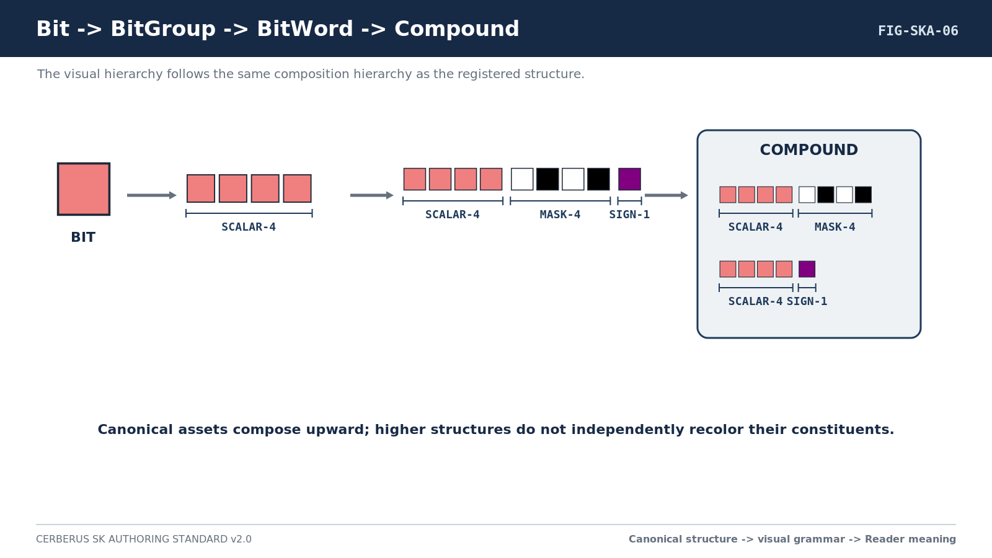
Figure 6. Bit -> BitGroup -> BitWord -> Compound.
CONSTRUCTION LAW
If the visual figure and the registered composition disagree, the figure is wrong. Visual clarity may add labels and spacing, but it may not reorder, recolor, or substitute the actual constituent machinery.

14. Canonical BitGroup Contract
A reusable BitGroup is a mathematical/structural object whose identity remains independent from the contextual Reader meaning assigned by any particular SK. Its Formula resolves the mathematical state of its constituent Bits; the SK Reader later assigns the bounded semantic role.
BitGroup field | Required meaning
BitGroup Identity | Stable canonical identity of the reusable mathematical group.
Width | Number of Bits in the local block.
Constituent Bits | Exact ordered primitive Bits.
Formula | Mathematical interpretation of the constituent state.
Composition Family | SCALAR, MASK, or another registered family.
Composition Type | Registered rule describing whether/how compatible blocks continue or compose.
Continuation Index | First block, second block, third block, and so on when applicable.
Visual Projection | Deterministic sequence of canonical constituent Bit assets; never an independently chosen group color.
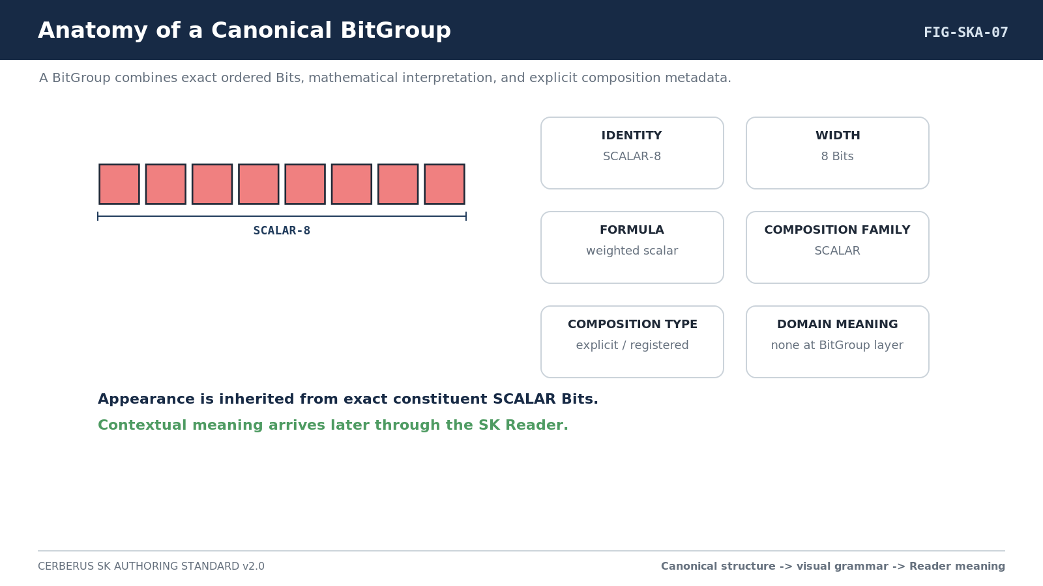
Figure 7. Anatomy of a Canonical BitGroup.

15. Canonical BitWord Assembly
A BitWord is physically assembled in canonical ordered placement. When shown visually, each BitGroup retains its constituent Bit colors and relative width. Group boundaries are exposed with spacing, brackets, names, or other non-destructive overlays rather than recoloring the group.
SCALAR-8 | MASK-6 | SCALAR-4 | SIGN-1
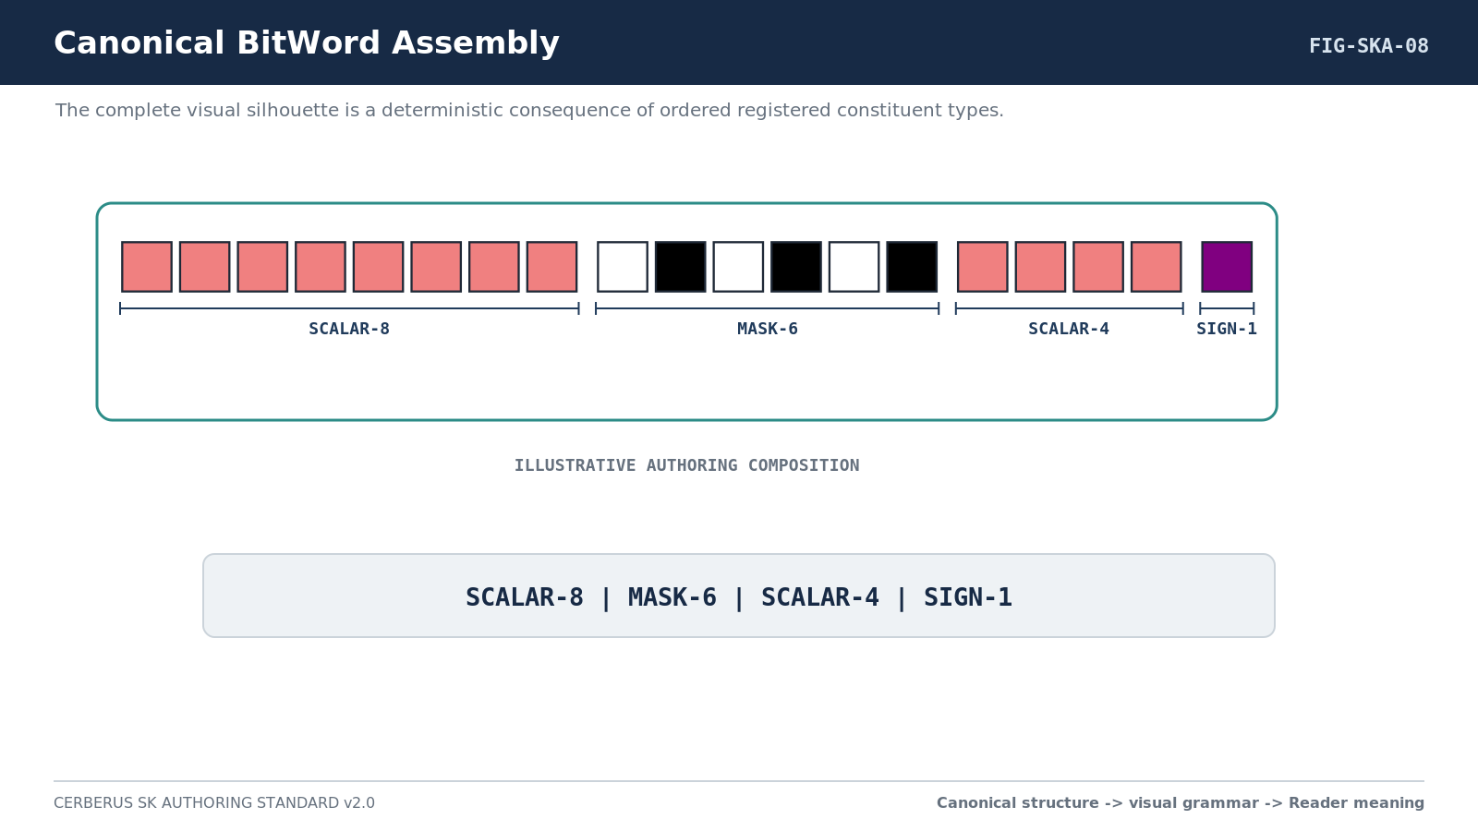
Figure 8. Canonical BitWord Assembly.

16. Structural Signature and Structural Silhouette
Every Formal SK containing a BitWord SHALL expose a Structural Signature: a compact machine-readable description of its ordered structural composition. The visual silhouette is the perceptual rendering of that same construction. The signature is not replaced by the figure, and the figure is not treated as a substitute for registered identity.
Width, sequence, transitions, repetitions, special primitive positions, and continuation are all information. At a shared scale, a twelve-Bit scalar run must remain visibly longer than a four-Bit run. Long Words may be globally scaled or shown with overview/detail treatment, but their relative internal width relationships must survive.
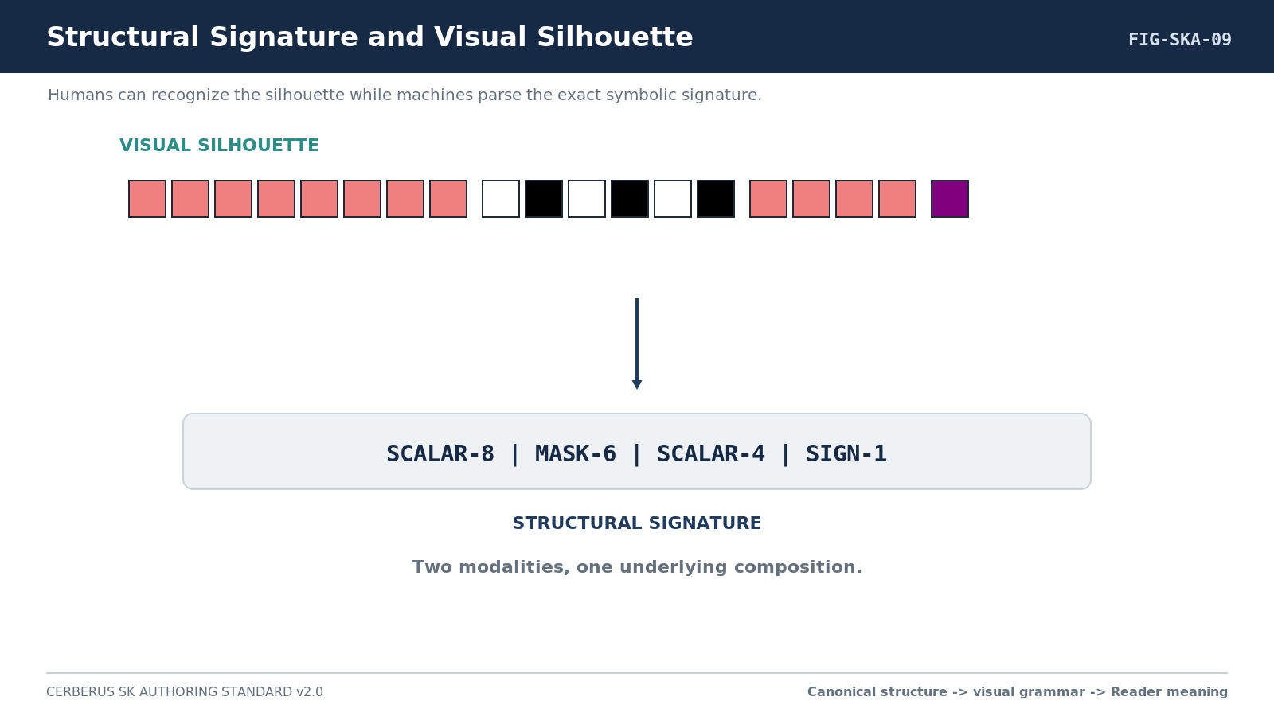
Figure 9. Structural Signature and Visual Silhouette.

Part 5 - Reader Topology and Semantic Binding

17. Resolution Growth as Structural Growth
A multi-resolution Series must show how the registered construction changes as capability grows. The visual comparison should make the extension legible: added BitGroups, extended groups, continuation blocks, new primitive classes, or other structural changes should be visible rather than hidden behind a generic larger box.
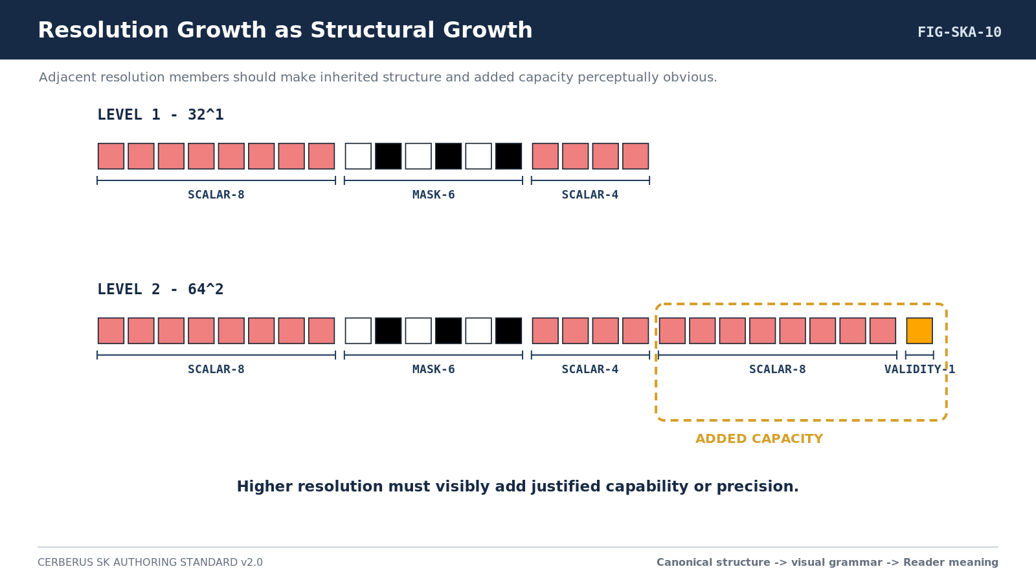
Figure 10. Resolution Growth as Structural Growth.

18. Reader Address Grammar
Reader addresses use a letter for semantic lane and a number for continuation depth. A1 and A2 may contribute to the same semantic lane when the Spec declares them compatible. Physical Bit addresses remain independent. Reader topology is therefore a second coordinate system over the physically ordered Word, not a rearrangement of it.

19. Physical Order and Reader Order
The BitWord preserves canonical physical placement order. The Reader may regroup placements by letter and traverse compatible lane members by number. This lets a prefix-stable Word retain its original construction while higher-resolution continuations extend semantic value.
Reader topology rule | Requirement
Lane grouping | Collect placements sharing the same Reader letter.
Continuation order | Sort compatible placements by Reader number.
Compatibility | Confirm Composition Family, Composition Type, continuation index, and declared lane contract.
Semantic result | Assign contextual meaning only after the mathematical composition resolves.
Interface target | State whether the D contract binds one placement, a composed lane, a nested Word, or another supported target.
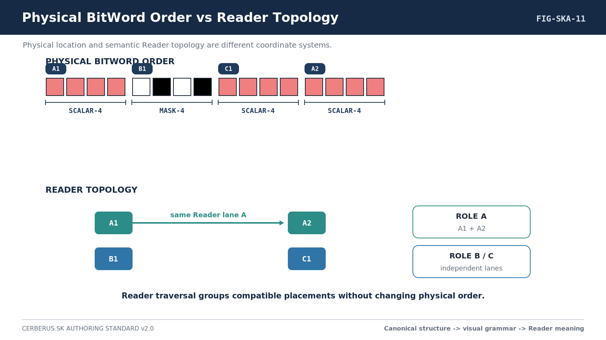
Figure 11. Physical BitWord Order vs Reader Topology.

20. Multi-Placement Lane Composition
When a Reader lane spans multiple placements, continuation is explicit behavior rather than a typographic convention. The Spec must name the Composition Type, prove compatibility, and state the resolved semantic target. The ordinary semantic interface may expose the composed lane while a Construction or Composition Inspector reveals the underlying placements.
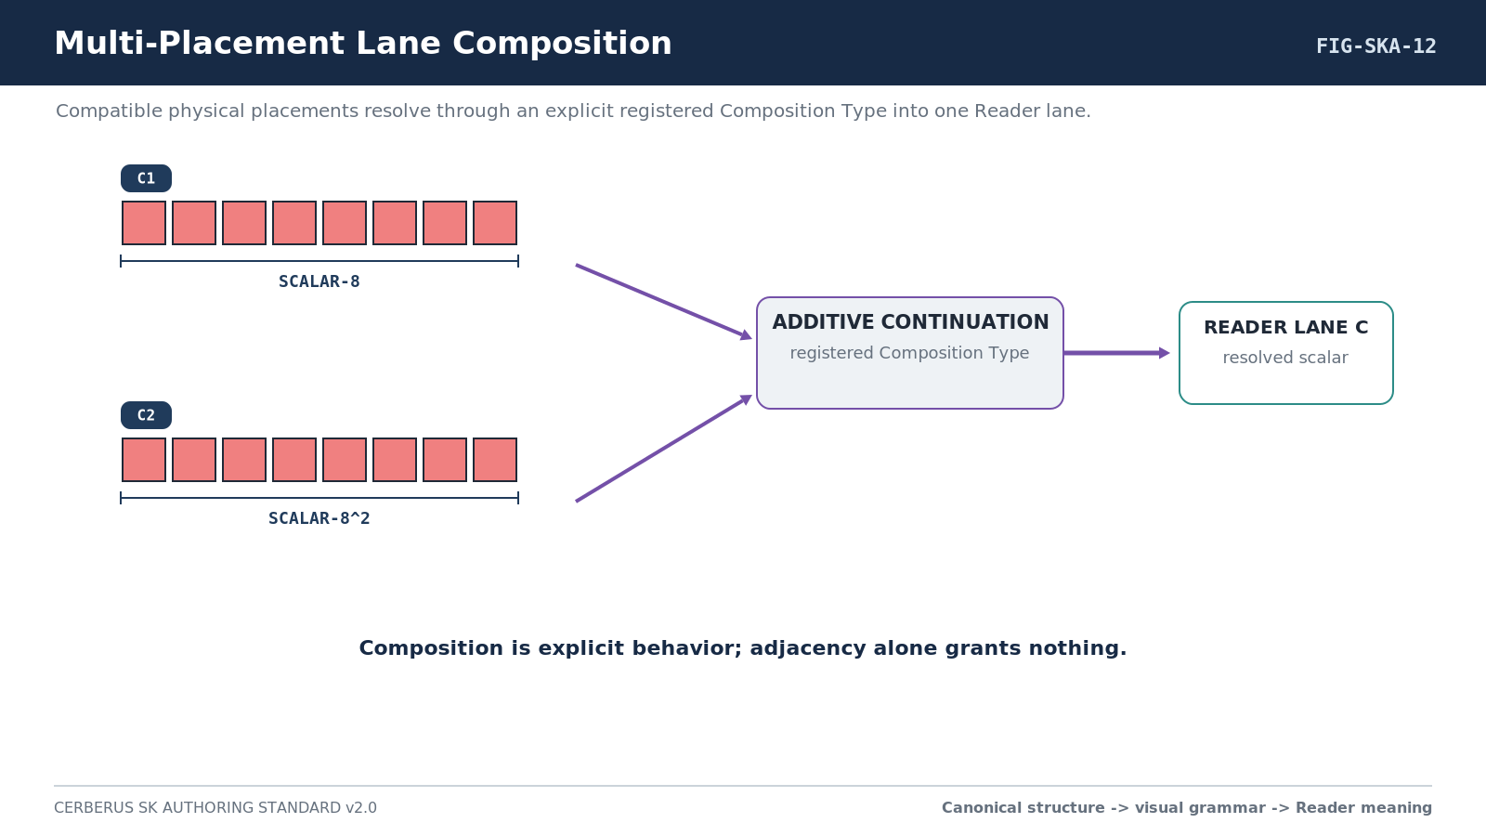
Figure 12. Multi-Placement Lane Composition.

21. Structural Reuse Without Semantic Collapse
Two BitWords may share the same structural machinery while operating in unrelated semantic domains. A SCALAR-8 remains a SCALAR-8 whether one Reader interprets it as a music parameter and another interprets it as a body measurement. Shared structure is therefore legitimate reusable representational grammar, not evidence that the domain meanings are the same.
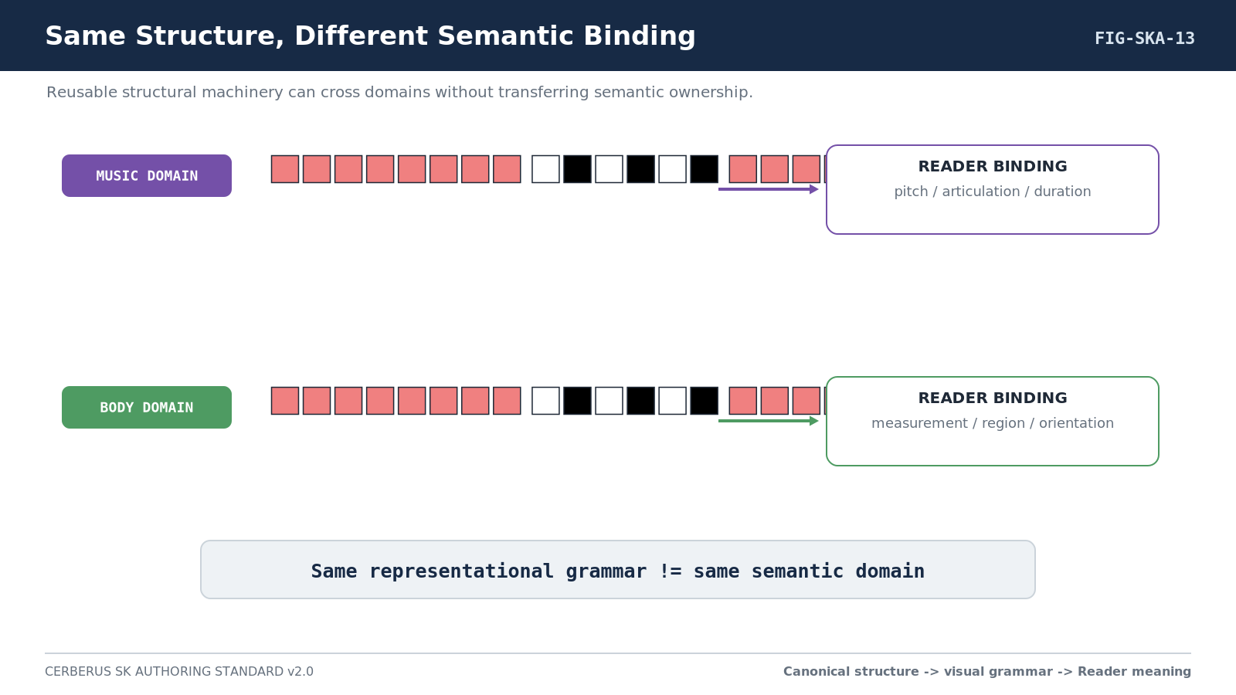
Figure 13. Same Structure, Different Semantic Binding.

Part 6 - DARTBOARD Interface Specification

22. Structure -> Reader -> Interface
DARTBOARD consumes Reader-resolved semantic targets. It does not independently reinterpret raw Bits, and it does not select interface behavior from mathematical type by inference. The same structural BitGroup may intentionally use different exact controls in different Reader roles.
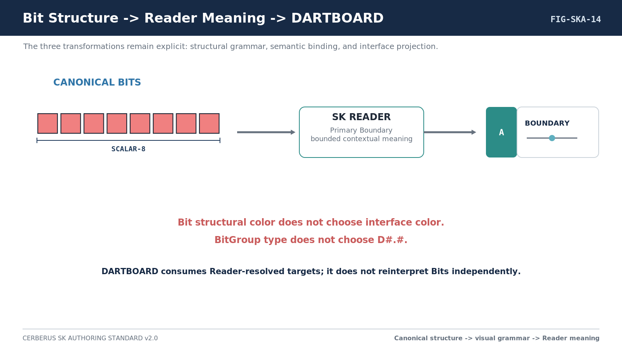
Figure 14. Bit Structure -> Reader Meaning -> DARTBOARD.

23. Interface-0 and ABCD Composition
The canonical/default interface projection is record-driven. Interface-0 supplies the stable shell grammar. A supplies the registered symbol, B the Reader/interface name, C the interface color/treatment, and D the exact D Table contract body. The runtime assembles these declared components; it does not choose them from visual similarity or BitGroup type.
0 [ A | B | D ] { C }
A = registered symbol
B = semantic Reader/interface name
C = interface color/treatment
D = exact D Table contract
NO INTERFACE INFERENCE
Mathematical type may validate compatibility with a declared D contract, but it MUST NOT select or silently replace the D contract. Bit Color likewise does not determine interface color.

24. D Table Contract Notation
Inside the D Table, records use #.# keys such as 1.2. Outside the D Table, references are qualified as D1.2. The first number identifies the interface family and the second identifies an exact reusable contract inside that family. #.# is structural identity, not version.

25. Mandatory Reader-Role Interface Figure
Every semantic Reader role SHALL have a dedicated figure showing its compact declaration, canonical structural construction inset, canonical/default interface, representative value/state, consequence or resolved-state panel where useful, and compact contract summary. A role intentionally non-interactive must say why rather than silently omitting the interface contract.
Figure element | Required content
Declaration strip | Semantic Placement | Reader Address | BitGroup or Word | exact D#.#.
Structural inset | Canonical Bit/BitGroup construction for the target or resolved lane.
Interface control | Symbol, semantic name, interface color, exact D body, and representative state.
Consequence / state | Effect, state, output, or concise resolved-state visualization where useful.
Contract card | Reader role, math, range, zero/unset, composition, exact target, validation, and output consequence.
Behavior prose | What changing the target means and what it must not silently change.
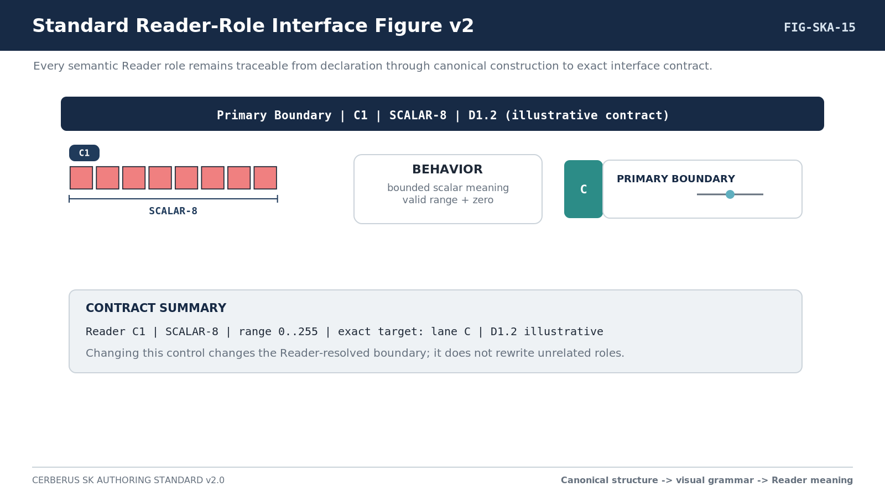
Figure 15. Standard Reader-Role Interface Figure v2.

26. Full Canonical Interface Assembly
After the per-role gallery, an interactive Formal Spec SHALL show the complete canonical/default interface assembled in Reader order. This is both documentation and design validation: a mathematically valid SK that produces a confusing or contradictory control surface has exposed a real design problem before runtime implementation.
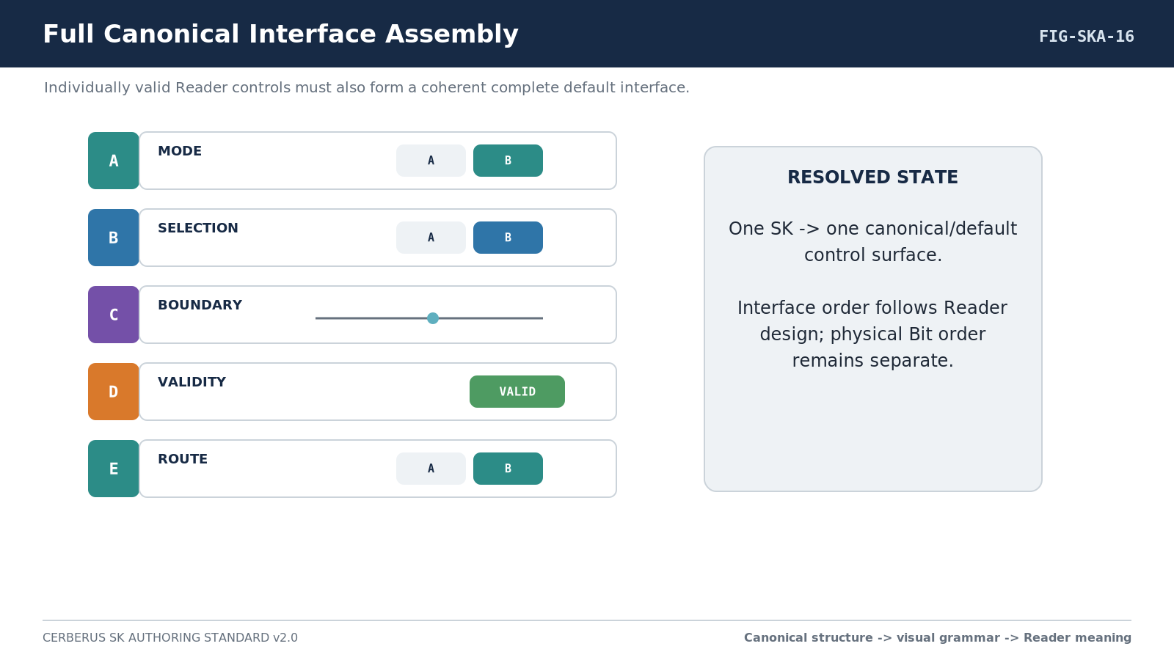
Figure 16. Full Canonical Interface Assembly.

Part 7 - Binary Encoding, Formula, Interoperability, and Ownership

27. Physical Bit Layout
Visual-first teaching does not replace rigorous encoding. A Formal Spec SHALL provide the complete physical Bit layout and every Bit address. Version 2.0 adds traceability to the canonical Bit identity and visual toolkit projection so the same registered primitive sequence is visible in both the formal map and the publication figures.
Required bit-table column | Meaning
Global Bit | B000, B001, and so on.
Reader Address | A1, C2, and so on, identifying placement/lane.
BitGroup | Exact reusable mathematical group.
Local Bit | Local position inside the BitGroup.
Canonical Bit Identity | Exact registered primitive used at the physical position.
Mathematical Contribution | Primitive contribution or independent-position semantics.
Reader Interpretation | What that contribution participates in semantically inside this SK.
Validity / Reserved State | Any MUST-zero, invalid, undefined, or reserved condition.

28. Formula and Reader Contract
The BitGroup Formula interprets the mathematical state of its constituent Bits. The SK Reader then composes placement outputs, assigns semantic roles, validates cross-role conditions, and exposes typed results. A Formula MUST NOT silently absorb semantic responsibilities owned by another SK.
Reader requirement | Formal Spec content
Formula sources | Exact BitGroup Formula identities/versions or canonical references.
Lane composition | How A1/A2/etc. resolve; required Composition Type and compatibility.
Semantic roles | Meaning, units/basis, zero/unset behavior, valid range, invalid combinations.
Output | Typed output class and basis/range.
Null/failure | Explicit behavior for missing, invalid, stale, or unresolved source state.
Determinism | Deterministic, seeded deterministic, stochastic, or externally driven where relevant.
Human explanation | Concise explanation sufficient for DARTBOARD inspection and debugging.

29. Relationship Grammar Separation
CERBERUS uses distinct relationship grammars for distinct jobs. They may appear near one another in an interoperability section, but they must never be collapsed into one generic link concept.
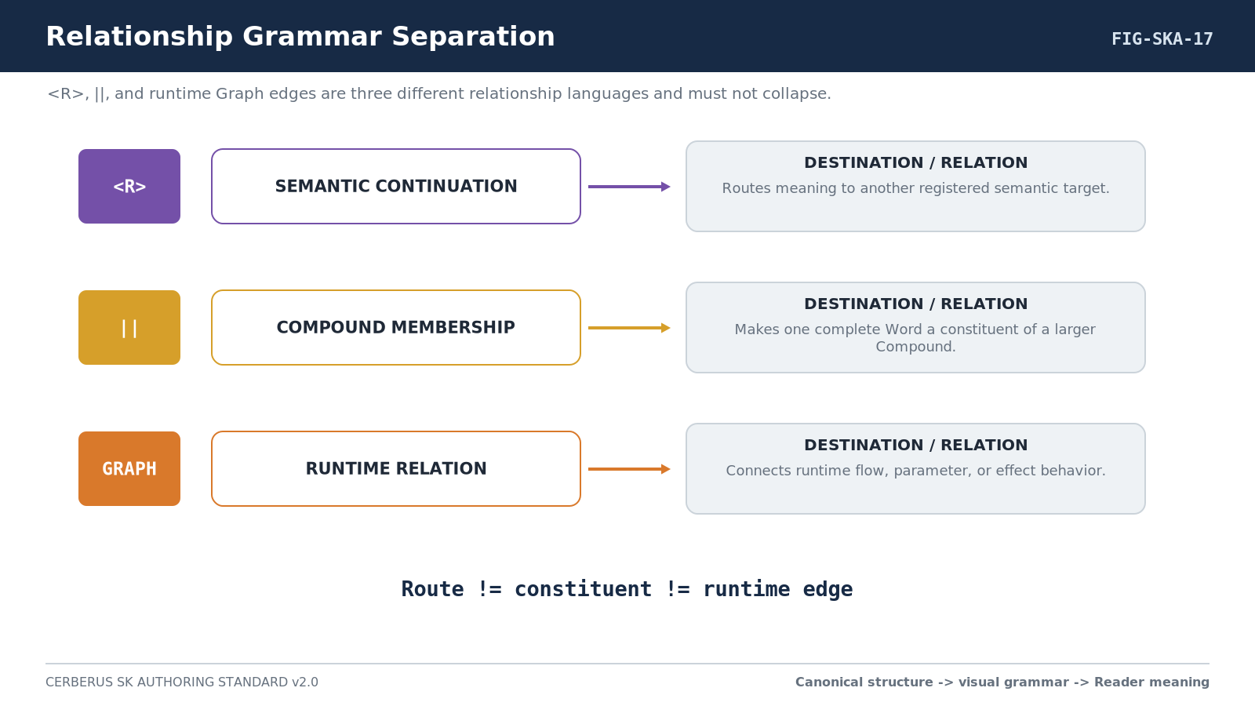
Figure 17. Relationship Grammar Separation.
Grammar | Meaning
<R> | Registered semantic continuation. The destination is related semantic territory but is not thereby made a constituent of the current Word.
|| | Complete-word Compound membership. Constituent relationship, not a semantic route and not a runtime edge.
Graph | Runtime relationship, parameter edge, or execution flow. It may exist without Compound membership.

30. Interoperability Card
Composable SKs SHALL include a compact interoperability card. The card lets another Spec depend on the SK without rereading the entire document and makes external ownership explicit enough to prevent semantic collapse.
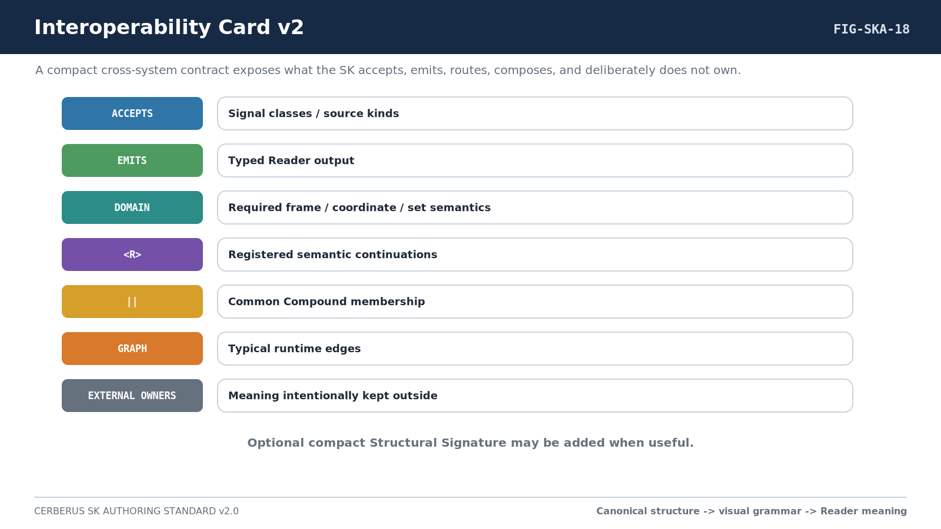
Figure 18. Interoperability Card v2.
Card field | Required content
Accepts | Directly accepted Signal Classes, data classes, or source states.
Emits | Typed Reader output.
Domain | Required domain, Frame, coordinate, set, or basis semantics.
<R> | Registered semantic continuations.
|| | Common complete-word Compound patterns.
Graph | Typical runtime flow and parameter edges.
External Owners | Timing, world identity, target geometry, calibration, authority, or other semantics intentionally kept outside.

Part 8 - Structural Comparison and Comparative Learning

31. Comparative BitWord Learning
An unfamiliar BitWord should not automatically be taught from zero. Version 2.0 permits a learner or AI to derive the Structural Signature, search known Words for a useful structural analogue, place the two constructions side by side, and identify exactly what is shared and what changes. Semantic interpretation is learned after that structural comparison, not replaced by it.
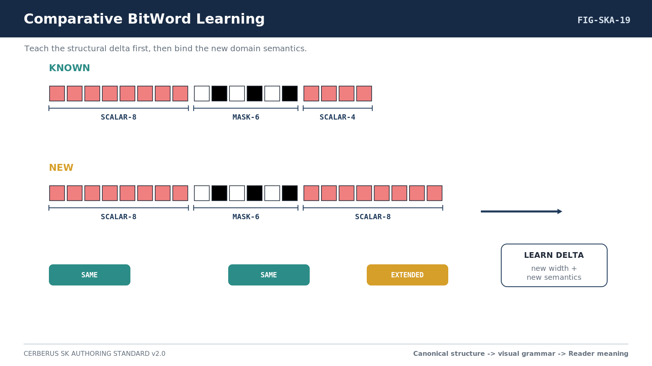
Figure 19. Comparative BitWord Learning.

32. Difference Vocabulary
Difference | Meaning
SAME | Equivalent structural unit in the compared position.
EXTENDED | Same structural family with increased width or continuation.
REDUCED | Same structural family with reduced width or capacity.
INSERTED | A structural unit appears in the new Word without a corresponding unit in the analogue.
REMOVED | A structural unit present in the analogue is absent from the new Word.
SUBSTITUTED | A different primitive or BitGroup family occupies a corresponding structural role.
REORDERED | The same or related units occur in a different physical sequence.

33. Cross-Domain Structural Kinship
The closest structural analogue may come from a domain that is semantically unrelated. This is permitted because the transfer is representational literacy, not semantic equivalence. A learner may recognize a familiar scalar-mask-scalar pattern and therefore understand the construction before learning what any of those positions mean in the new domain.
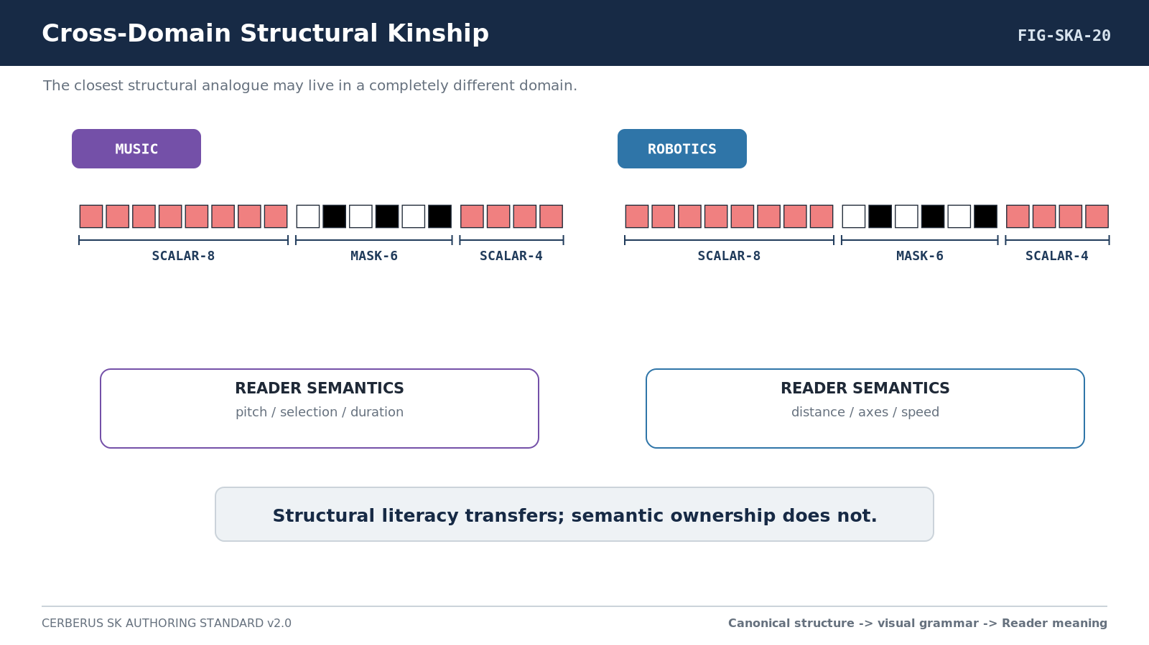
Figure 20. Cross-Domain Structural Kinship.
COMPARATIVE SAFETY
The closest structural analogue is not necessarily the closest semantic analogue. Structural matching narrows the construction-learning problem; Reader semantics still require independent interpretation.

34. AI Bootstrap Protocol
A bootstrap-capable AI can use the visual grammar and Structural Signature as complementary representations. The symbolic signature supports deterministic comparison while the visual silhouette provides fast perceptual segmentation and human-readable explanation.
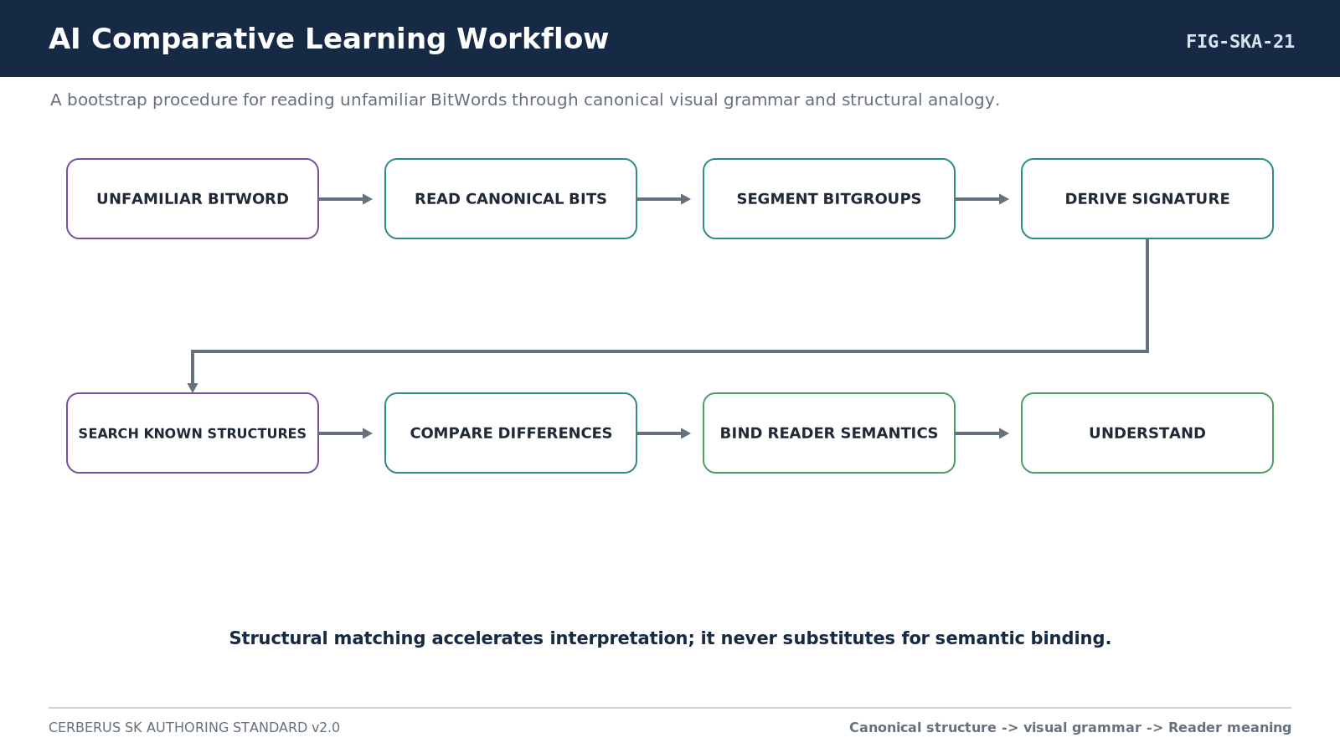
Figure 21. AI Comparative Learning Workflow.

35. AI Authoring Protocol
The same mechanism operates in reverse during authoring. The AI begins with the bounded requirement, identifies required representational machinery, searches registered Bits and BitGroups for exact reusable structures, inspects structurally related Words, composes only what is genuinely missing, derives the visual assembly from the canonical toolkit, binds Reader semantics, and validates before registration.
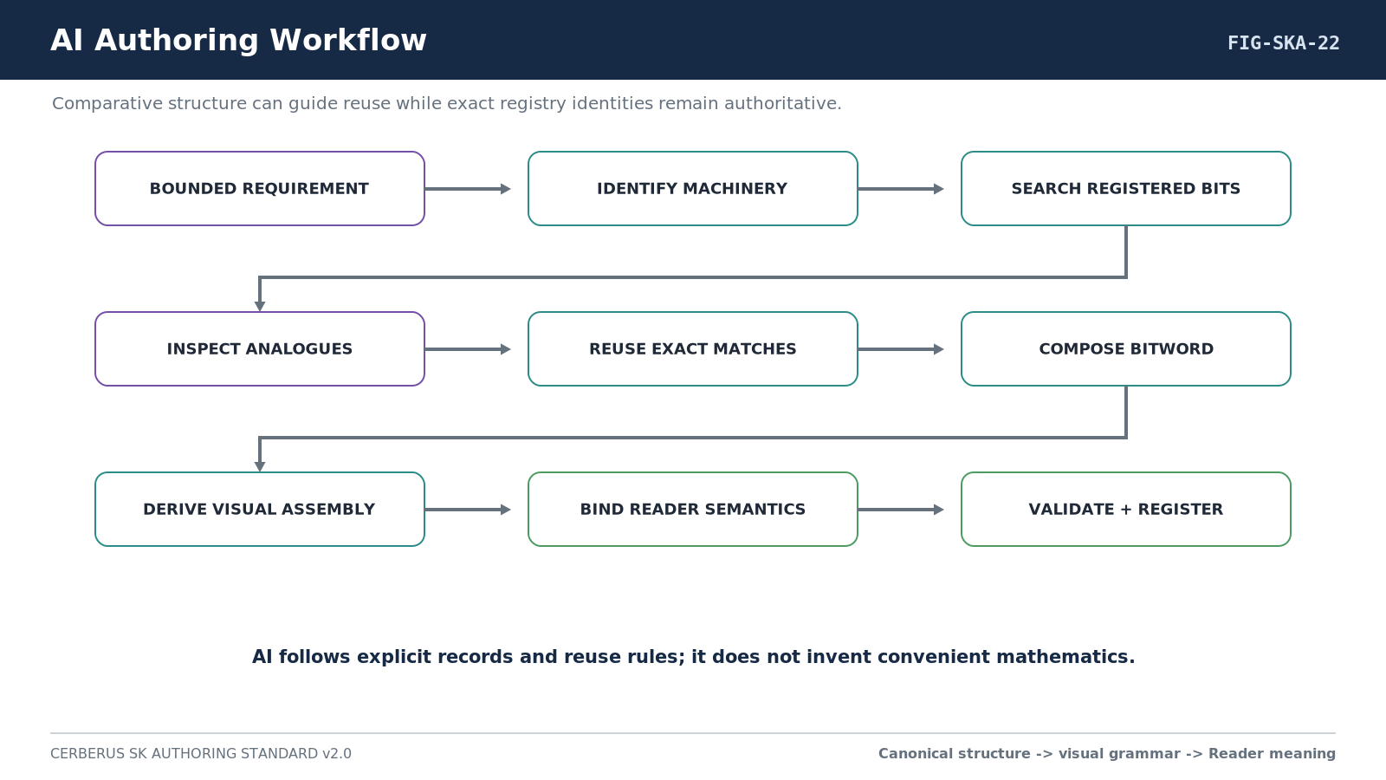
Figure 22. AI Authoring Workflow.

Part 9 - Examples, Conformance, and Traceability

36. Worked Example Set
Every Formal Spec SHALL contain a worked example set sufficient to prove useful operation and ownership boundaries. At minimum, include a minimal example using the lowest sufficient resolution, a rich example exercising major features, and a cross-SK example demonstrating interoperability without semantic collapse. Where comparison is useful, add a structural analogue example.
Example | Required demonstration
Minimal | Smallest valid state that makes the bounded question useful.
Rich | Representative state using the main semantic features of the SK.
Cross-SK | One declared route, Compound, or runtime graph relation with another SK while preserving ownership.
Structural comparison | A useful familiar analogue and explicit SAME/EXTENDED/etc. differences when such an analogue genuinely exists.
Optional personal/branch | Alternate profiles, branches, personal geometry, or model-specific projection without rewriting canonical semantics.

37. Invalid, Failure, and Unresolved States
A Formal Spec MUST show at least one invalid or unresolved case whenever cross-role constraints exist. The Reader and interface should expose failure rather than silently correcting input, fabricating semantic results, or substituting an inferred contract. Missing D contracts, incompatible continuations, invalid ranges, stale sources, unresolved dependencies, and illegal reserved states must remain observable.

38. Reverse Traceability
Every canonical/default interface target must be traceable backward through the Reader to its exact physical construction. This is essential for debugging, testing, AI inspection, and replay. The trace is not one-way: the same registered state must be readable forward from Bits through Formula and Reader into the declared output.
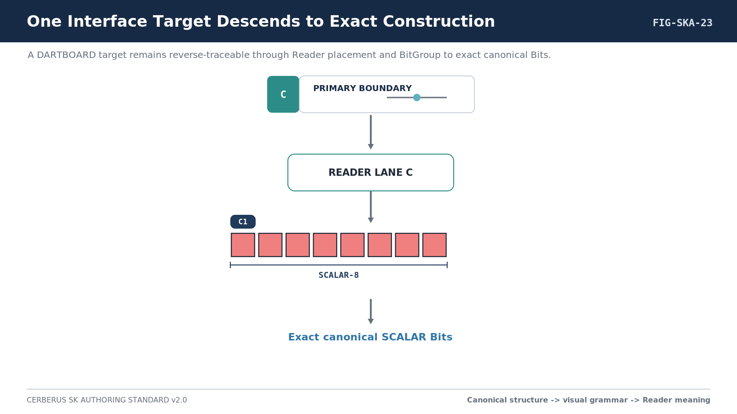
Figure 23. One Interface Target Descends to Exact Construction.

39. Visual Construction Conformance
Because structural figures are now deterministic projections of registered construction, the visual layer itself becomes testable. Conformance does not mean pixel-perfect sameness across renderers; it means identity, order, width relationships, group boundaries, canonical color assignments, and Structural Signatures agree with the registered source.
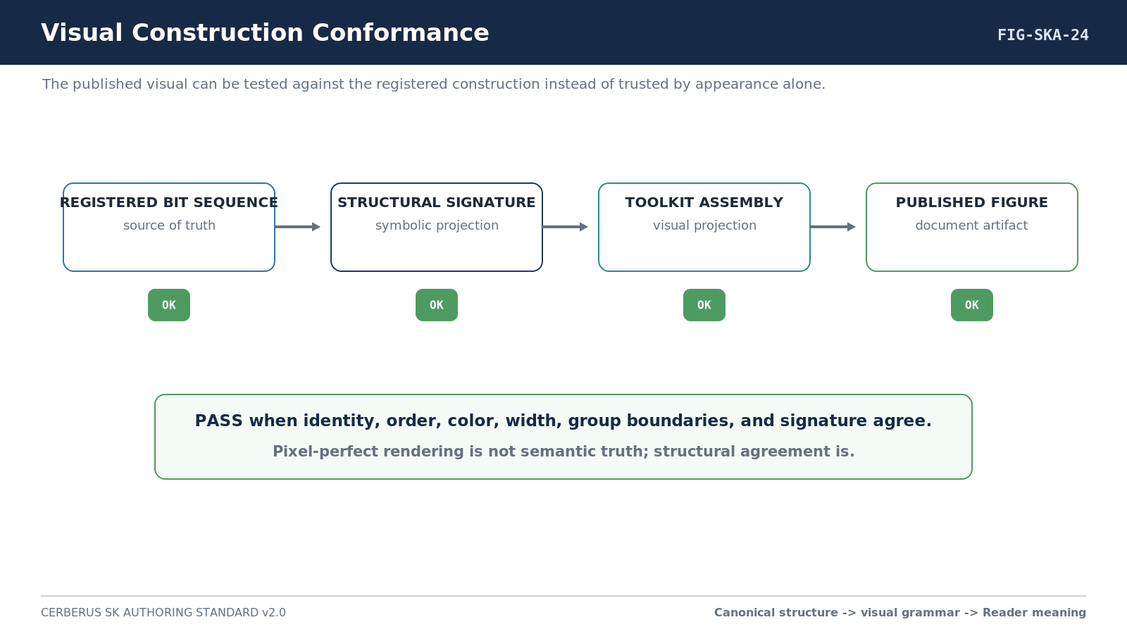
Figure 24. Visual Construction Conformance.
Test class | PASS condition
Reader reconstruction | Same registered Bit state resolves to the same semantic Reader output under the declared Spec version.
Interface reconstruction | Same Reader metadata plus exact D contracts reconstruct the same logical control structure.
No inference | Invalid or missing D contract is reported; runtime does not silently substitute another contract.
Target binding | Each control writes only to its exact declared Bit, placement, Reader lane, nested Word, or supported target.
Composition | A composed lane updates required underlying placements and rereads to the intended resolved value.
Bit visual identity | Every displayed Bit resolves to the correct canonical structural visual identity.
Derived appearance | BitGroups and BitWords are assembled from registered constituents rather than independently recolored.
Structural Signature | The symbolic signature matches the registered ordered composition.
Toolkit traceability | The visual assembly identifies the toolkit/manifest version used.
State separation | Runtime 0/1 state does not silently rewrite canonical structural identity.
Similarity safety | Structural similarity is never automatically treated as semantic equivalence.
Accessibility | Structural identity remains recoverable without relying solely on hue perception.
Version replay | Historical D/Reader/BitGroup/BitWord versions remain interpretable according to the saved contract.

Part 10 - Implementation Handoff and Deterministic Assembly

40. Required Implementation Handoff
The final substantive section of every Formal SK Spec is a build handoff. It converts the formal document into a deterministic registry and toolkit worklist without changing the bounded contract. Exact reuse occurs recursively: search for an exact registered identity, reuse an exact match, and build only what is genuinely absent from the canonical lower-level constituents.
Handoff block | Required contents
Bits | Exact primitive identities, classes, mathematical contributions, reuse semantics, and canonical Color relationships.
BitGroups | Exact groups, constituent Bits, Formula, Composition Family/Type, width, continuation index, and status.
BitWord | Series/member identity, width, placement order, physical ranges, and version.
Structural Signature | Exact ordered structural representation of the Word.
Visual Toolkit | Toolkit version/manifest and exact canonical assets/constructs used to produce structural figures.
Reader placements | Semantic placement name, Reader address, role, composition, output semantics, and validation.
D requirements | Exact D#.# for each canonical/default interactive target; missing contracts must be resolved before Formal status.
BOSS | Exact symbol records for interface roles or nested controls.
Interface COLOR | Exact presentation-color records/profiles where used; kept distinct from Bit structural color.
Formula / Reader | Formula identities/versions and Reader implementation contract.
Routes / Compounds / Graph | All declared interoperability relationships kept distinct.
Tests | Encoding, Reader, interface, visual construction, composition, interoperability, null/failure, comparison-safety, and replay tests.
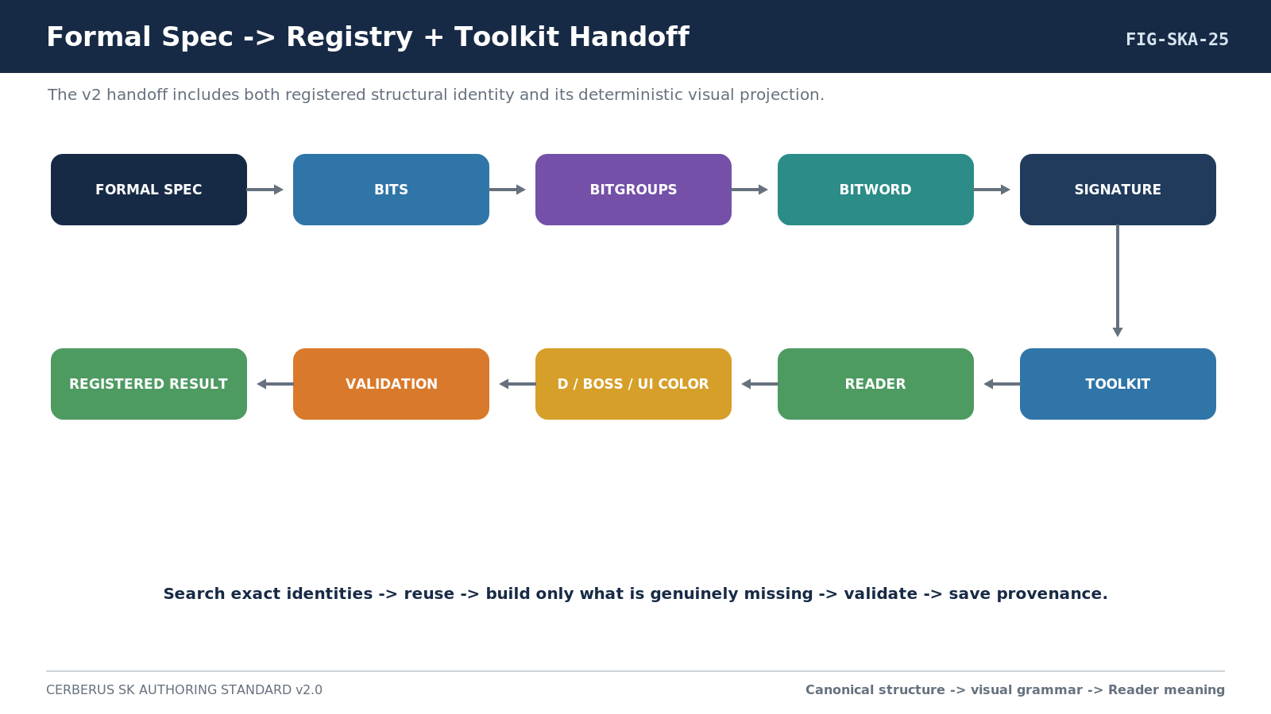
Figure 25. Formal Spec -> Registry + Toolkit Handoff.

41. Exact Reuse During BIGFOOT Implementation
IMPLEMENTATION RECURSION
Bit -> BitGroup -> Pure BitWord -> Compound BitWord. At each level: exact semantic/structural match? Reuse it. No exact match? Build the missing canonical structure from exact lower-level constituents, validate, then register it once.
Visual reuse follows the same principle. The canonical Bit asset is reused directly. Repeated BitGroups should reuse saved constructs when their registered construction is exact. A new BitWord visual is assembled from those exact lower-level assets. The figure designer never becomes a parallel source of structural truth.

42. Deterministic AI Assembly
1. Parse the Formal Spec for required Bits, BitGroups, BitWords, Reader placements, exact D contracts, BOSS/interface COLOR records, relationships, toolkit requirements, and tests.
2. Resolve exact identities in the appropriate registry or table.
3. Reuse exact canonical Bits and visual assets; build only genuinely missing canonical structures.
4. Assign physical placement topology and Reader addresses exactly as specified.
5. Derive the Structural Signature and visual assembly from registered composition.
6. Bind exact D/BOSS/interface metadata without inferring interface behavior from structural similarity.
7. Run construction, Reader, interface, composition, interoperability, null/failure, comparison-safety, and version-replay validation.
8. Save version, source Spec, provenance, toolkit manifest, and newly created canonical identities.

43. The Formal Spec as a Multi-Use Contract
A successful SK Spec is not merely a report. It is the common stable artifact linking human understanding, AI bootstrap, BIGFOOT construction, Reader reconstruction, DARTBOARD interface generation, comparative learning, interoperability, debugging, version replay, and later authoring. The document should remain useful even when the runtime, renderer, or database implementation is replaced.
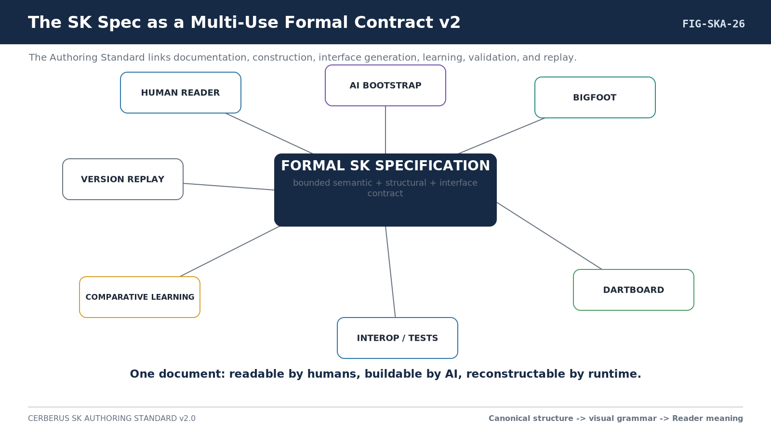
Figure 26. SK Spec as a Multi-Use Formal Contract v2.
CLOSING SYSTEM STATEMENT
One formal SK Specification should be readable as documentation, executable as an implementation contract, inspectable as structural and interface design, useful as a comparative-learning surface, and deterministic enough to reconstruct from registered records.

Appendix A - Formal SK Required Content Set
Figure pattern | Requirement | Purpose
1. Kernel Position / Boundary | Mandatory | Where the SK sits relative to its family, dependencies, routes, and external owners.
2. Canonical BitWord Assembly | Mandatory | Complete Word built from canonical Bit assets with visible BitGroup boundaries.
3. Structural Signature | Mandatory | Machine-readable ordered structural representation; may share a figure with assembly.
4. Reader Topology | Mandatory | Physical placement order versus Reader lanes and continuation.
5. Reader-Role Interface | Mandatory per interactive role | Declaration + structural inset + control + consequence + contract card.
6. Physical Bit Layout | Mandatory | Complete global Bit map and canonical identities.
7. Reader Pipeline / Traceability | Mandatory | Bits -> math -> placement -> Reader -> semantics -> output, or reverse traceability equivalent.
8. Full Interface Assembly | Mandatory when interactive | All canonical/default controls assembled.
9. Interoperability Card | Mandatory when composable | Accepts, emits, domain, <R>, ||, Graph, external owners.
10. Implementation Handoff | Mandatory | Spec -> registry/toolkit build path.
11. Resolution Comparison | Conditional mandatory | Required for multi-resolution Series.
12. Multi-Placement Composition | Conditional mandatory | Required when a Reader lane spans placements.
13. Invalid / Unresolved State | Conditional mandatory | Required when invalid or unresolved states can occur.
14. Structural Comparison | Conditional | Use when a meaningful analogue genuinely exists.
15. Specialist Consequence Figure | Conditional | Use when domain behavior benefits from visual explanation.
16. Worked Example Set | Mandatory | Minimal, rich, cross-SK, and appropriate invalid/comparison examples.

Appendix B - Standard Reader-Role Section Template
Element | Required content
Heading | Semantic role name.
Declaration | Placement Name | Reader Address | BitGroup/Word | exact D#.#.
Structural inset | Canonical Bit/BitGroup construction for the target or resolved lane.
Figure | Canonical/default interface plus consequence/state viewport where useful.
Purpose | Concise paragraph describing what the role means.
Mathematics | BitGroup, Formula, output domain, and composition.
Reader semantics | Allowed states/range, zero/unset, units/basis, invalid cases.
Interface | A/B/C metadata source, exact D contract, exact target.
Effect/output consequence | What changing the control changes and what it MUST NOT silently change.
Routes/dependencies | Any local <R>, model, domain, or external owner needed for interpretation.
Examples | At least one representative valid state; invalid example where appropriate.

Appendix C - Canonical Bit Visual Grammar Quick Reference
This appendix is a quick human reference. Registry links and canonical toolkit assets remain authoritative for implementation.
 | Bit Class | Canonical Color | Hex | Invariant
 | Scalar Coordinate | Light Coral | #F08080 | Same structural red family wherever reused.
 | Mask Member | White / Black | #FFFFFF / #000000 | Odd White, even Black; not runtime 0/1.
 | Presence | Green | #008000 | Presence/assertion machinery.
 | Sign | Purple | #800080 | Numeric sign/polarity machinery.
 | Enum Member | Blue | #0000FF | Bounded categorical member.
 | Route-capable | Cyan | #00FFFF | Routing/branch machinery.
 | Control Flag | Yellow | #FFFF00 | Operational Boolean modifier.
 | Validity / Null | Orange | #FFA500 | Defined/valid qualification.
 | Continuation / Extension | Magenta | #FF00FF | Structural continuation.
 | Integrity / Check | Teal | #008080 | Verification/check machinery.
 | Reserved | Gray | #808080 | Allocated but inactive capacity.
VISUAL GRAMMAR INVARIANT
Primitive visual identity survives domain transfer. Contextual meaning belongs to the SK Reader; presentation styling belongs to DARTBOARD.

Appendix D - BitGroup and BitWord Assembly Grammar
A publication figure for actual construction is generated from registered order. Authors may add non-destructive overlays but may not create an alternative structural composition for visual convenience.
Bit Asset -> ordered BitGroup Construct
BitGroup Constructs -> ordered BitWord Construct
BitWord Constructs -> Compound BitWord Construct (when applicable)
Registered construction -> Structural Signature
Registered construction + toolkit assets -> publication figure
- Bit cell geometry is stable within a toolkit version.
- Within-BitGroup spacing and between-BitGroup spacing are deterministic toolkit rules.
- BitGroup boundaries are shown by spacing, brackets, or labels rather than recoloring constituent Bits.
- At a shared scale, relative width is information and must survive rendering.
- Long Words may be globally scaled or shown as overview plus detail, but internal proportions and order must remain true.
- Accessibility labels or overlays may be added outside the canonical Bit asset.

Appendix E - Structural Signature Grammar
The Structural Signature names the ordered structural machinery of a BitWord independently from contextual domain semantics. It SHOULD use exact registered group identities where they exist and explicit illustrative labels where a teaching example is not claiming a current registry identity.
SCALAR-8 | MASK-6 | SCALAR-4 | SIGN-1
SCALAR-8¹ | SCALAR-8² | MASK-6 | VALIDITY-1
A Structural Signature supports deterministic comparison by type, width, sequence, repetition, insertion, deletion, continuation, and reordering. It is the machine-readable companion to the human-perceptual Structural Silhouette.

Appendix F - Comparative Learning Protocol
1. Read the unfamiliar Word from registered composition or canonical visual projection.
2. Segment the construction into BitGroups and derive its Structural Signature.
3. Search familiar registered Words for useful structural analogues.
4. Place the selected known and new structures side by side.
5. Label differences using SAME, EXTENDED, REDUCED, INSERTED, REMOVED, SUBSTITUTED, or REORDERED.
6. Separate structural knowledge already transferred from semantic bindings that remain new.
7. Learn the Reader meaning, units/basis, constraints, ownership boundaries, and interoperability of the new SK.
8. Never infer semantic equivalence solely from structural resemblance.

Appendix G - Formal SK Completion Checklist
1. Bounded semantic question is one sentence and exclusions are explicit.
2. Series and every resolution member are named using the current resolution notation.
3. Each added resolution has a stated semantic/precision justification and visible structural growth description.
4. All primitive Bits required by the ideal contract are listed.
5. All mathematical BitGroups identify Formula, Composition Family, Composition Type, width, constituents, and continuation behavior.
6. Canonical Bit Color relationships are resolved and visual construction uses registered toolkit assets.
7. Complete canonical BitWord assembly is shown.
8. Structural Signature exactly matches registered ordered composition.
9. Physical placement order is explicit.
10. Every placement has a Reader address.
11. Every composed lane documents letter-to-number traversal and compatibility.
12. Every semantic Reader role has a visual interface figure or explicit non-interactive justification.
13. Every Formal interactive target binds an exact D#.# contract; no inferred interface selection remains.
14. Bit structural color and interface color are explicitly separated.
15. BOSS symbol and interface COLOR references are explicit where used.
16. Full assembled canonical/default interface is shown when interactive.
17. Complete physical Bit map is shown.
18. Reader Formula/output/null/determinism behavior is defined.
19. Accepts/emits/domain/<R>/||/Graph/external-owner contract is complete where applicable.
20. Minimal, rich, cross-SK, invalid, and useful structural comparison examples are present as applicable.
21. Encoding, Reader, interface, composition, visual construction, interoperability, failure, comparison-safety, accessibility, and replay tests are defined.
22. Implementation handoff lists BIGFOOT, Structural Signature, visual toolkit, D, BOSS, interface COLOR, Reader, relationships, and tests.
23. Document uses Arabic numbering and consistent professional figure/table captions.
24. No rendered UI or publication figure is treated as canonical semantic truth.
25. No visual similarity claim is allowed to become semantic equivalence without independent semantic evidence.

Appendix H - Effects Specialist Additions
Effects SKs conform to the general standard and add a visual consequence viewport plus Effects Studio interoperability fields. Typed Signal Classes, declared Domains, visible Formula/Reader behavior, no silent coercion, parameter addressing, source preservation, explicit timing/spatial ownership, renderer separation, branching/replay posture, and specialist routing/composition remain the baseline.
Effects-specific block | Requirement
Effect Viewport | Abstract shapes, layers, fields, paths, masks, particles, or motion sufficient to show the semantic consequence.
Signal Contract | Accepted and emitted Signal Classes, basis/range, validity, provenance, determinism.
Domain Contract | Required target/domain fields such as coordinates, path position, normal/tangent, index, membership, or Frame.
Application posture | Generator, selector, transformer, combiner, application, or emitter/lifecycle role.
Parameter addressing | Any modulatable parameter must have a semantic target address.
Graph example | At least one valid runtime flow independent from Compound membership.
Source preservation | Where applicable, show that selection/eligibility/application does not rewrite upstream semantic state.
Preview status | Transient preview remains derived until explicitly saved/promoted through the appropriate authority.

Glossary
 | Term | Definition
 | Bit | Lowest registered primitive binary state/contribution used by a mathematical or semantic construction.
 | Bit Class | Structural primitive role such as Scalar Coordinate, Mask Member, Sign, or Route-capable.
 | Canonical Bit Visual Identity | Stable structural visual projection resolved from the registered Bit Color relationship.
 | Bit Visual Toolkit | Reusable implementation asset library that reproduces canonical Bit visual identity; not an independent semantic authority.
 | BitGroup | Reusable mathematical/structural grouping of Bits interpreted by a same-record Formula.
 | Composition Type | Registered rule describing whether/how compatible BitGroups continue or compose.
 | BitWord | Ordered registered composition of BitGroups/placements forming one bounded word-level structure.
 | Structural Signature | Machine-readable ordered description of a BitWord's representational machinery.
 | Structural Silhouette | Human-perceptual visual pattern produced by canonical primitive colors, widths, sequence, and transitions.
 | Structural Analogue | A familiar BitWord selected because its construction is useful for comparison with an unfamiliar Word.
 | Comparative Learning | Method that transfers structural familiarity through side-by-side comparison before learning new Reader semantics.
 | Reader Address | Semantic topology address such as A1 or A2; distinct from physical Bit address.
 | Reader Lane | All compatible placements sharing one Reader letter and resolving to one semantic result.
 | Semantic Binding | Contextual meaning assigned by the SK Reader to reusable structural machinery.
 | D Contract | Exact reusable interface contract stored as #.# inside the D Table and referenced externally as D#.#.
 | Interface Color | DARTBOARD presentation color/treatment; distinct from canonical Bit structural color.
 | Interface-0 | Stable record-driven interface shell using A symbol, B name, C interface treatment, and D exact interface body.
 | Formal Spec | Implementation-authoritative SK document satisfying the completion checklist in this standard.
 | Spec-first construction | Authoring posture in which ideal bounded semantics are defined before implementation-time identity normalization.
 | Series | Named family of multi-resolution SK members whose supported Bit steps are shown in the Series name.
 | Resolution level | Index attached to an individual Series member; distinct from document version.
FINAL ARCHITECTURAL LAW
A CERBERUS Semantic Kernel Specification is complete only when bounded meaning, reusable mathematics, canonical visual construction, physical placement, Reader topology, exact interface contracts, interoperability, validation, comparative-learning posture, and implementation handoff all describe the same system without relying on hidden inference.

