ROAR
REVERBERATING ORCHESTRATED ANALYSIS REPORTING
An Introductory Architecture for Multi-Resolution Reporting, Hierarchical Analysis, and Recursive Intelligence Roll-Up

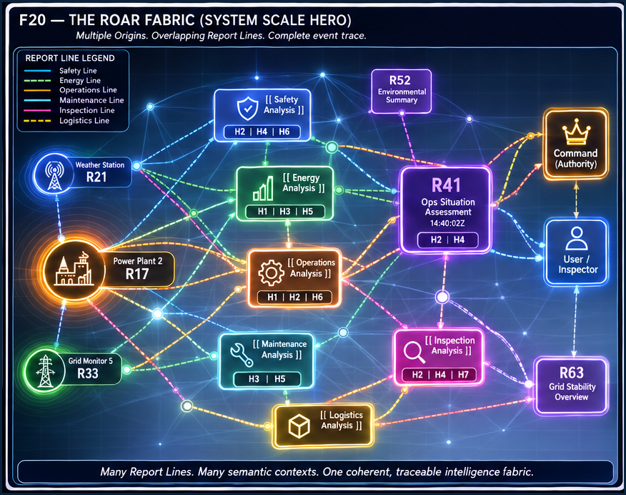
F20 — The ROAR Fabric. System-scale visual of overlapping Report Lines, analytical contexts, derived intelligence, Command/User endpoints, and preserved traceability.
GOVERNING PROPOSITION
They hear the ROAR, but it means different things. One event may be projected differently to many recipients; each recipient receives the representation appropriate to its own semantic question and analytical need.

Version 0.1 | Pass 8 Verified Release | August 2026

0. Abstract and Reading Contract
ROAR is a recursive semantic reporting architecture for systems in which one bounded reporting event may matter differently to several recipients. Rather than forcing one universal report representation up a hierarchy, ROAR lets the same Report project independently governed representations to multiple positions along one or more Report Lines. Each projection is read in the receiving context, analyzed where relevant knowledge lives, and compiled without destroying the source evidence from which later intelligence is derived.
This introductory paper establishes the mechanics and language required to reason about ROAR correctly: Report identity, line-relative H positions, destination-specific Projections, Reader-bound interpretation, GROOVED reporting, direct awareness, analytical compilation, derived Reports, provenance, recursive roll-up, confirmation, mismatch, escalation, and closure. Advanced capabilities such as adaptive sensing, learned reporting grooves, dynamic projection contracts, trust weighting, hypothesis competition, and self-reorganizing report fabrics are deliberately deferred.
READING CONTRACT
ROAR is not a communications protocol and does not prescribe a fixed packet width, hierarchy, transport, or organization chart. It defines semantic reporting behavior across whatever governed system structure already exists.

Contents
1. The ROAR Proposition
2. Native Report Grammar
3. Relative Hierarchy and Report Lines
4. One Report, Many Projections
5. Reader-Bound Meaning and GROOVED Reporting
6. Direct Awareness and Analytical Compilation
7. Provenance and Derived Reports
8. Recursive Analytical Roll-Up
9. Confirmation, Mismatch, Escalation, and Closure
10. Multi-Line Reporting Fabric
11. System-Scale ROAR Walkthrough
12. Foundational Laws and Non-Collapses
13. Applicability and Deliberate Boundaries
14. Conclusion
Appendix A. Working ROAR Vocabulary

1. The ROAR Proposition
One event can be heard differently throughout the system.
ROAR begins with a simple observation: different analytical contexts rarely need the same representation of the same event. A local specialist may need the complete available report. A supervisor may need one binary state. A domain analyst may need a six-bit GROOVED classification. Command may need a compact strategic projection—or, during direct inspection, the richest available representation.
ROAR therefore treats a Report as a stable bounded identity and its destination-specific representations as Projections. The Report remains one reporting event even when its projections differ in width, semantic question, Reader, purpose, and recipient. A receiving Stack may analyze its projection, compile it with other Reports, and produce a new Derived Report. That new Report begins its own bounded lifecycle.
CORE THESIS
One event. Many projections. Different meanings. Recursive analysis. Report what each recipient needs; analyze where the knowledge lives; roll up what the analysis earns; push unresolved state to an appropriate owner.

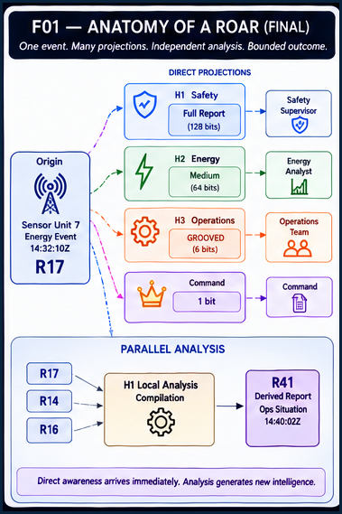
F01 — Anatomy of a ROAR. A single Report projects to several recipients, local analysis compiles source evidence, and a new Derived Report is created without replacing the original.

2. Native Report Grammar
ROAR extends existing CERBERUS expression; it does not invent a competing structural ontology.
The foundational notation remains the native Stack–Table–Field–Record grammar. ROAR uses that grammar to express a bounded Report and the reporting contexts through which it becomes relevant.
( Report )
| Field |
[ Table ]
|[ H1 ]|
|[ H2 ]|
…
|[ Hn ]|

The Record position identifies the bounded Report instance. The Field identifies local semantic meaning. The Table identifies the governed structural location in which that report class lives. H positions name relative Stack positions along the relevant Report Line. None of these roles collapses into another.
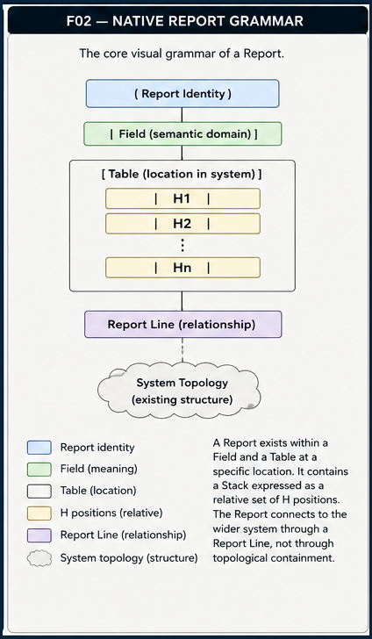
F02 — Native Report Grammar. The core ROAR expression preserves the existing alternating semantic/routing grammar while attaching relative H positions to the Report Line.

3. Relative Hierarchy and Report Lines
H is local to a reporting relationship, not intrinsic to a Stack.
An H coordinate answers one narrow question: where does this Stack sit within this particular Report Line? It does not assign permanent organizational rank, authority, importance, semantic depth, or report width. The same stable Stack may be H1 in one line, H3 in another, and H5 in a third because the reporting origins and contextual routes differ.
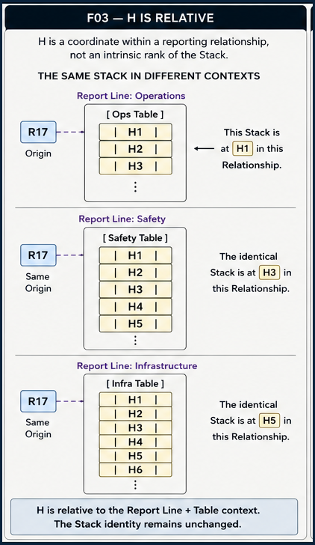
F03 — H Is Relative. The same Stack can occupy different H coordinates in different Report Lines while retaining one stable identity.
NON-COLLAPSE
Stack identity ≠ H position. H position is a line-local coordinate.

A Report Line is likewise not the system topology. It overlays existing structure and expresses a governed reporting relationship across it. A line can cross branches, skip intermediate structural neighbors, or directly address a distant analytical context without redefining containment or ownership.
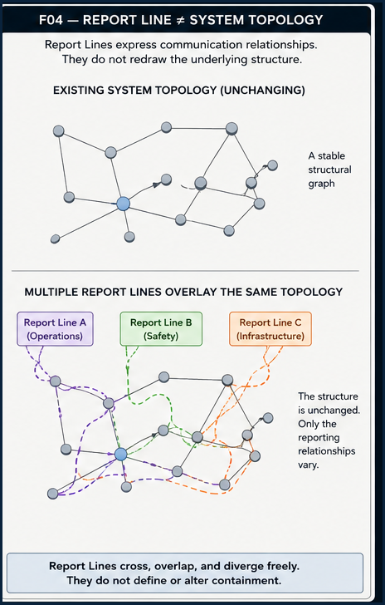
F04 — Report Line ≠ System Topology. Multiple reporting relationships may overlay one stable structural graph without changing the graph itself.

4. One Report, Many Projections
Projection is the central ROAR mechanic.
A Projection is the destination-specific representation of one Report. Different recipients may receive different semantic questions, Readers, representations, widths, and purposes from the same originating event. Initial projection is therefore fan-out by semantic need, not progressive compression through a forwarding chain.
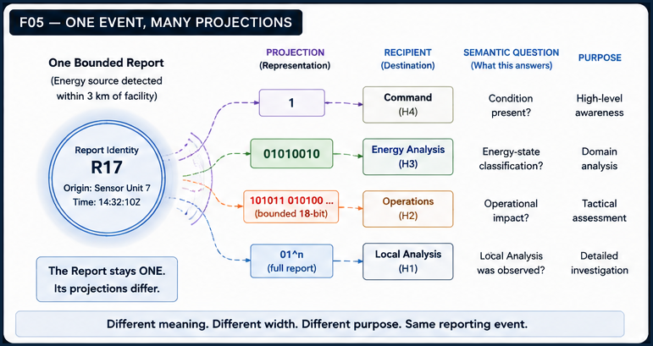
F05 — One Event, Many Projections. An energy-detection Report remains one identity while Command, domain analysis, operations, and local analysis receive different representations of that event.
Width itself carries no universal semantics. A one-bit projection can answer “condition present?”, “in contact?”, “route clear?”, or “support required?” depending on the receiving context and Reader. Identical bit patterns can therefore be validly interpreted as different meanings without contradiction.
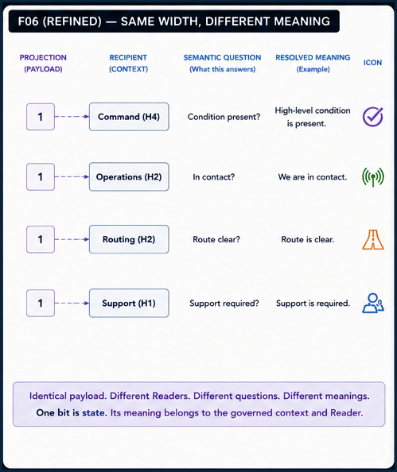
F06 — Same Width, Different Meaning. Identical single-bit payloads resolve into different meanings because they answer different semantic questions in different contexts.
Hierarchy also does not determine resolution. A User inspecting a phenomenon may legitimately receive the full report while an intermediate supervisor receives only one awareness bit. Another event may reverse that allocation. The correct rule is minimum sufficient reporting resolution for the recipient’s role in that specific reporting context.
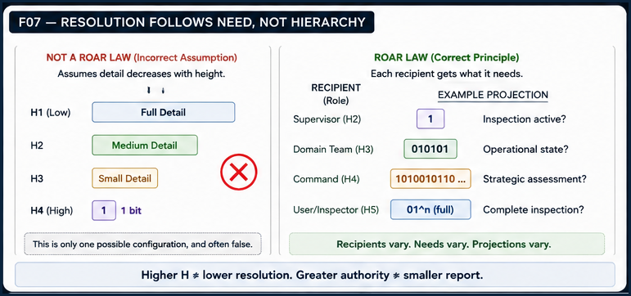
F07 — Resolution Follows Need, Not Hierarchy. ROAR rejects the assumption that detail must monotonically decrease with H. Different recipients receive different representations according to need.
Each Projection can be understood as a contract-bound representation. Conceptually it has a destination, semantic question, Reader, representation, width or resolution, purpose, salience role, and required sufficiency. These are semantic properties of the Projection; this paper does not prescribe a final database schema or wire-format header.
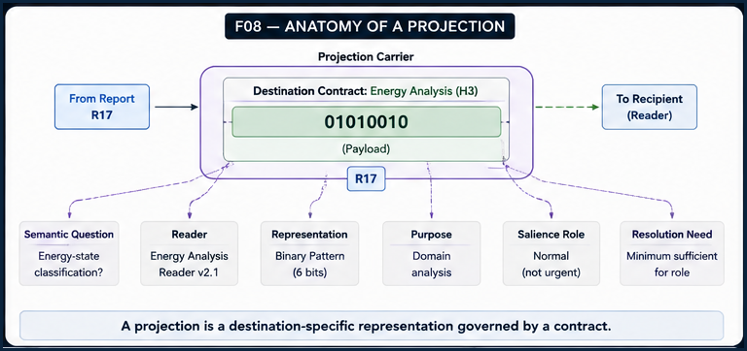
F08 — Anatomy of a Projection. A Projection carrier binds one Report identity to a destination-specific semantic question, Reader, representation, purpose, and resolution need.

5. Reader-Bound Meaning and GROOVED Reporting
Compact reports work because interpretation is governed, not because meaning is somehow hidden inside the raw bits.
A payload such as 101011 is not self-interpreting. ROAR depends on the receiving context having the correct Reader relationship. The same payload can therefore resolve differently under different Readers because the semantic question and mapping differ.
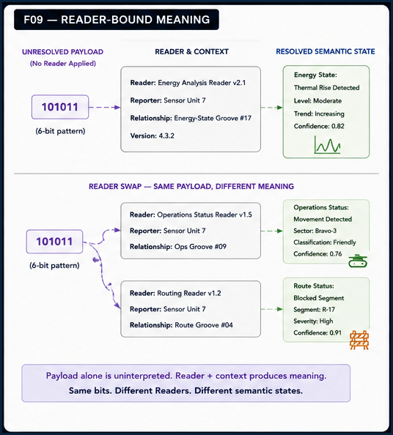
F09 — Reader-Bound Meaning. The same six-bit payload resolves into different semantic states under different governed Readers and relationships.
GROOVE makes established reporting relationships compact. A rich first encounter may be explicit and expensive. Once a stable semantic relationship has been validated and registered, later reports can use a small bounded pattern to activate that known relationship. Compression is earned by previously resolved semantic work; it is not evidence that meaning disappeared.
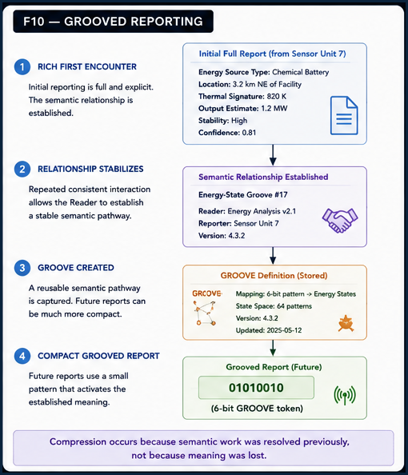
F10 — GROOVED Reporting. A rich reporting relationship stabilizes into a reusable GROOVE, allowing later compact patterns to recover known semantic meaning.
GROOVE LAW
The bits are not the full explanation. They are sufficient because the receiving system already knows how to interpret the established semantic relationship.

6. Direct Awareness and Analytical Compilation
ROAR separates immediate projection from deeper analytical roll-up.
Initial projections may reach several recipients immediately, while a local analytical Stack spends more time reading, comparing, and compiling richer source Reports. Higher-level awareness therefore need not wait for the organizational analysis chain to complete.
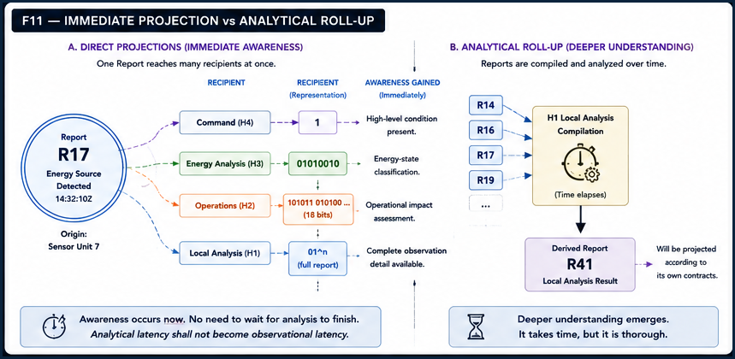
F11 — Immediate Projection vs Analytical Roll-Up. Direct projections provide immediate awareness while independent analytical compilation produces a later Derived Report.
OPERATIONAL PROPERTY
Analytical latency shall not become observational latency.

Within an analytical Stack, incoming Reports remain distinguishable. The Stack receives, reads with appropriate Readers, compares resolved states, compiles bounded findings, and determines an explicit outcome. That outcome may be local resolution, a Derived Report, a mismatch, or a need for escalation. Compilation is a bounded analytical process, not silent replacement of its inputs.
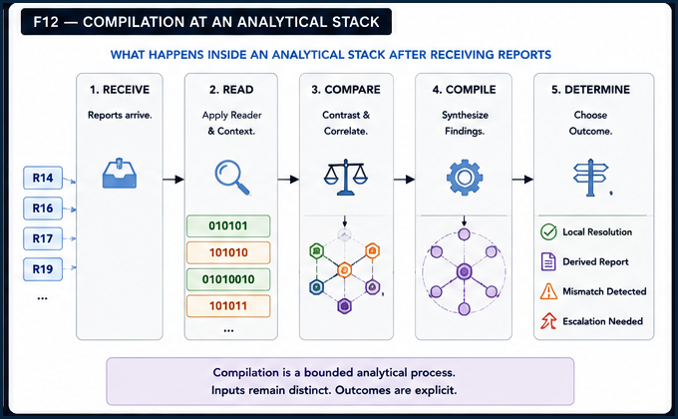
F12 — Compilation at an Analytical Stack. Incoming Reports pass through receive, read, compare, compile, and determine stages, yielding explicit analytical outcomes.

7. Provenance and Derived Reports
Analysis can create new intelligence without erasing the observations from which it was earned.
A Derived Report is a new bounded reporting object produced by analysis. It is not a revision of its source Reports. The source Reports remain preserved evidence with their own identities, while provenance links record which evidence contributed to the analytical result.
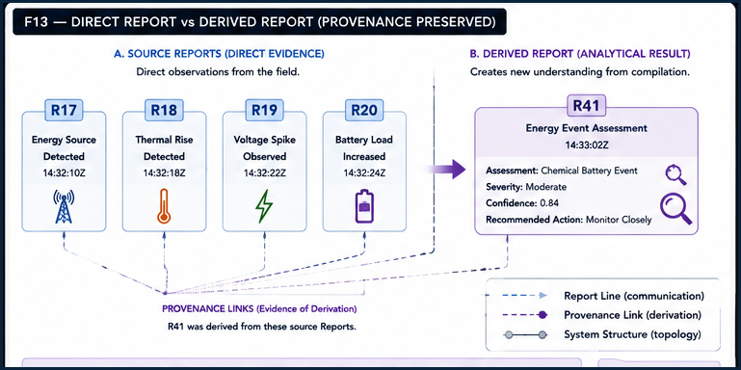
F13 — Direct Report vs Derived Report. Direct source Reports remain intact while analytical compilation produces a distinct Derived Report connected by provenance.
PROVENANCE PRINCIPLE
Compression without epistemic amnesia: increasingly compact intelligence can remain traceable to the evidence and analytical stages that produced it.

8. Recursive Analytical Roll-Up
Every eligible analytical Stack can become a new ROAR origin.
Recursive roll-up occurs when an analytical context turns received Reports into a new Derived Report, then projects that new Report according to its own contracts. Higher analysis can do the same again. Each level therefore compounds understanding without overwriting lower-level Reports or forcing all lower data upward unchanged.
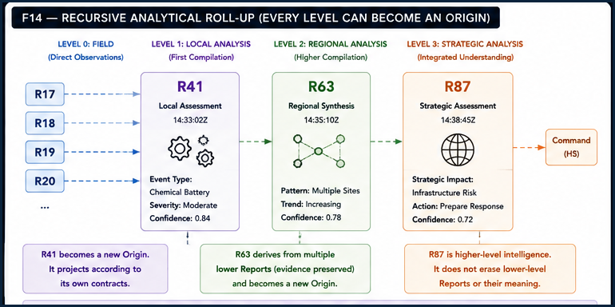
F14 — Recursive Analytical Roll-Up. Direct observations become local assessment, regional synthesis, and higher integrated understanding through successive new Reports, each with preserved evidence lineage.
This recursion is different from forwarding. A recipient does not simply pass the same Report upward. It analyzes what it received, closes what can be closed locally, and emits a new Report only when the earned analytical result must travel.

9. Confirmation, Mismatch, Escalation, and Closure
Reverberation is bounded. Agreement and disagreement both create reportable analytical state, but no Report echoes forever.
Independent analyses that reach the same conclusion can produce confirmation. Confirmation may raise confidence, permit closure, inform planning, or reduce the need for further investigation. It is not merely duplicated traffic. Conversely, differing conclusions produce a mismatch: valuable unresolved analytical state rather than system failure.
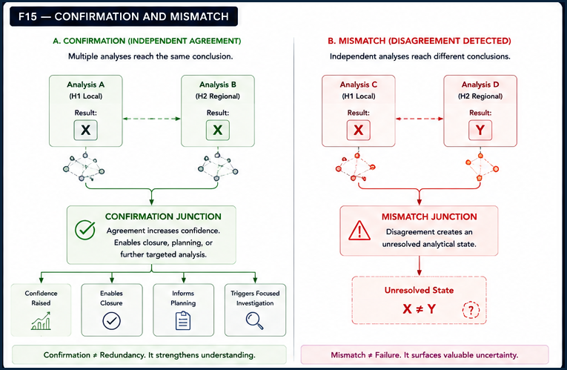
F15 — Confirmation and Mismatch. Agreement strengthens understanding; disagreement surfaces unresolved analytical state requiring ownership.
A mismatch has two foundational resolution paths. The system may perform more bounded analysis when additional evidence, Readers, comparisons, or assumptions can reasonably resolve the difference. Otherwise the unresolved state is escalated to an appropriate Command or User. Both branches terminate in either sufficient resolution, a new Derived Report, or an authoritative decision.
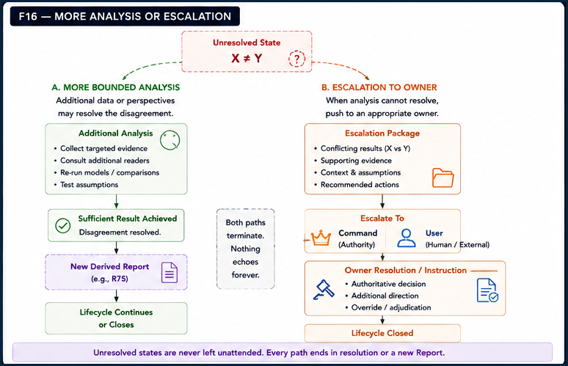
F16 — More Analysis or Escalation. Unresolved analytical state is either assigned more bounded analysis or escalated to an appropriate owner; both pathways terminate.
The complete ROAR lifecycle is therefore finite. A Report originates, projects, is delivered and read, may be analyzed and compiled, is resolved or assigned further ownership, and eventually terminates. If new analysis must travel, it creates a new Report and a new lifecycle. Closure preserves provenance; it does not delete history.
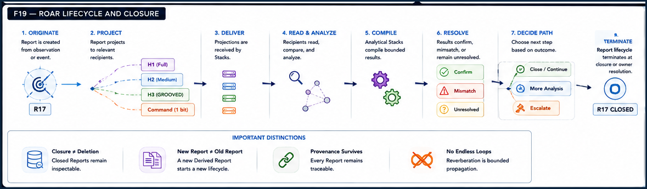
F19 — ROAR Lifecycle and Closure. The bounded Report lifecycle runs from origin through projection, delivery, analysis, compilation, resolution, path decision, and termination.

10. Multi-Line Reporting Fabric
ROAR scales by overlaying many line-local hierarchies on the same stable system structure.
One Origin may participate in several semantic Report Lines at once. Safety, energy, operations, maintenance, and inspection can all care about one event for different reasons. Each line may define a different H path, Projection, Reader, recipient, and purpose while preserving one originating Report identity.
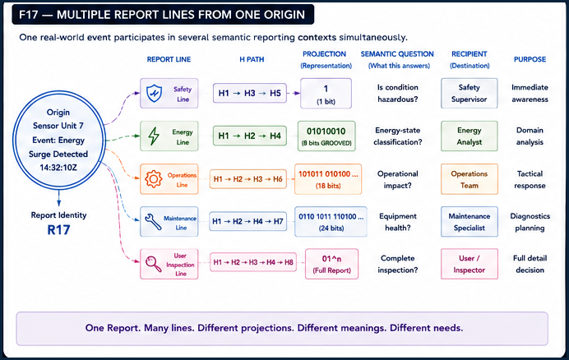
F17 — Multiple Report Lines from One Origin. One event participates in several semantic reporting contexts simultaneously, each with its own H path, representation, recipient, and purpose.
The inverse is equally important: one stable analytical Stack may occupy many H positions across different lines. H therefore describes the relationship, not the Stack. This is what allows ROAR to form a cross-cutting fabric rather than collapse the system into one giant hierarchy.
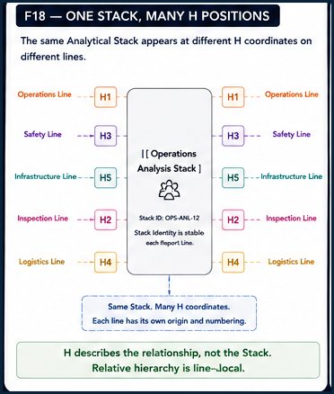
F18 — One Stack, Many H Positions. A single stable analytical Stack occupies different H coordinates on Operations, Safety, Infrastructure, Inspection, and Logistics lines.

11. System-Scale ROAR Walkthrough
A complete event trace demonstrates how the fabric behaves without losing identity, evidence, or closure.
At system scale, multiple Origins can ROAR concurrently while one event remains traceable from start to finish. A highlighted Report may directly project to several recipients, enter local analysis with other Reports, produce a Derived Report, encounter confirmation or mismatch in cross-analysis, and terminate after resolution. Other Report Lines continue independently in the background.
F20 — The ROAR Fabric. Multiple Origins and Report Lines coexist across a stable system graph. Analytical Stacks compile Reports, Derived Reports become new origins, and Command/User endpoints receive context-appropriate information.
SYSTEM-SCALE GUARANTEE
The right understanding, at the right place, in the right form, at the right time—while preserving provenance and bounded resolution.

12. Foundational Laws and Non-Collapses
ROAR is easiest to misunderstand when familiar concepts are silently treated as equivalent.

Identity, hierarchy, and projection
Law | Meaning
Report ≠ observation | An observation may originate a Report, but the Report is the governed bounded object shared through the system.
Report ≠ Projection | One Report may have many destination-specific Projections.
Projection ≠ payload alone | Meaning depends on the governed semantic question, Reader, and receiving context.
Stack identity ≠ H position | H is a relative coordinate within one Report Line.
H position ≠ report resolution | Hierarchy does not determine width, detail, or semantic depth.
Report width ≠ importance | A one-bit state may be strategically critical; a full report may simply be required for inspection.
Report Line ≠ containment hierarchy | Reporting topology overlays but does not redefine system topology.
Direct projection ≠ analytical roll-up | Initial awareness can be immediate while deeper derived intelligence is earned later.

Analysis, resolution, and lifecycle
Law | Meaning
Direct Report ≠ Derived Report | Analytical products are new Reports, not rewritten source evidence.
Compilation ≠ source evidence | Compilation synthesizes while preserving the input Reports and their provenance.
Confirmation ≠ redundancy | Agreement can modify confidence, closure, planning, or analytical demand.
Mismatch ≠ failure | Disagreement identifies unresolved analytical state requiring ownership.
Reverberation ≠ endless feedback | Every Report lifecycle terminates; additional analysis creates new bounded work.
Command/User ≠ mandatory recipient | Recipients are defined by the Report Line and context, not a universal endpoint.
Transport ≠ semantics | ROAR governs semantic reporting; physical or digital carriers are separate implementation concerns.
Closure ≠ deletion | Closed Reports remain inspectable and provenance remains available.

13. Applicability and Deliberate Boundaries
ROAR is intended to be portable across domains, but Paper I stops before advanced adaptive intelligence behavior.
ROAR can apply wherever distributed observers and analytical contexts require different views of the same event: industrial systems, robot fleets, disaster response, environmental sensing, scientific instrumentation, infrastructure operations, cybersecurity, autonomous systems, and human–machine decision environments. The architecture does not depend on military ranks or any specific game-world command model.
The semantic architecture is transport-independent. A Projection could be carried by radio, wire, optical signaling, local networks, stored files, manual relay, Morse-like pulse systems, or future transports as long as the carrier preserves the representation needed by the receiving Reader. ROAR does not specify the physical communications protocol.
DEFERRED ARCHITECTURE
Adaptive sensing, manifolded BRAID networks, GROOVED analytical loops, learned reporting relationships, dynamic projection widths, confidence mathematics, adversarial trust, semantic reconstruction, disconnected synchronization, prediction error, automatic prioritization, and self-modifying reporting topology belong to later work.

14. Conclusion
ROAR replaces the assumption of one report moving progressively upward with a more expressive model: one bounded Report can be heard differently throughout a governed reporting fabric. Each destination receives the semantic representation appropriate to its own need. Each analytical Stack can compile what it receives without erasing evidence. Each earned analytical result can become a new Report. Each mismatch is assigned to more analysis or an appropriate owner. Each lifecycle ends.
The result is a reporting architecture that supports immediate awareness and deep analysis simultaneously, preserves the distinction between evidence and interpretation, and scales across overlapping semantic contexts without requiring a single global hierarchy or a fixed relationship between authority and information width.
COMPRESSED MENTAL MODEL
ORIGINATE → PROJECT DIFFERENTLY → READ LOCALLY → ANALYZE → COMPILE → REPORT AGAIN IF NEEDED → CLOSE OR ESCALATE.

They hear the ROAR, but it means different things.

Appendix A. Working ROAR Vocabulary

Reporting objects and interpretation
Term | Working meaning
Report | A bounded reporting object with stable identity.
Origin | The component or analytical context that produces a Report.
Report Line | A governed contextual reporting relationship across relevant recipient Stacks.
H Position | The relative Stack coordinate within one Report Line.
Projection | A destination-specific representation of one Report.
Reader | The governed interpretive machinery that resolves a Projection into meaning.
Recipient | The Stack, Command role, User, or other governed context receiving a Projection.
GROOVED Report | A compact Projection whose semantic relationship was established previously.
Compilation | Bounded analysis of relevant Reports within one analytical context.
Direct Report | A Report produced directly from source observation or system state.

Analysis, ownership, and lifecycle
Term | Working meaning
Derived Report | A new Report created from analysis or compilation.
Provenance | The traceable evidence and derivation relationships supporting a Report.
Confirmation | Analytically meaningful agreement among independently resolved states.
Mismatch | Analytically meaningful disagreement requiring ownership or additional resolution.
Unresolved | A bounded analytical state not yet sufficient for closure.
Escalation | Movement of unresolved responsibility to an appropriate Command, User, or other authority.
Command | A governed authority role capable of authoritative resolution or instruction.
User | A human or external participant who may inspect, receive, or resolve information according to context.
Closure | Termination of a bounded Report lifecycle while retaining history and provenance.
Reverberation | Bounded propagation of one reporting event through destination-specific Projections across its Report Line or Lines.

PASS 8 VERIFIED RELEASE
Verified through Pass 8.

