CERBERUS BOOTSTRAP 0
System Orientation & Cybernetic Map
Atlas Navigation • BRAIN Root Stacks • CERBERUS Matryoshka • DRAGON / ARMORY • Bit Notation
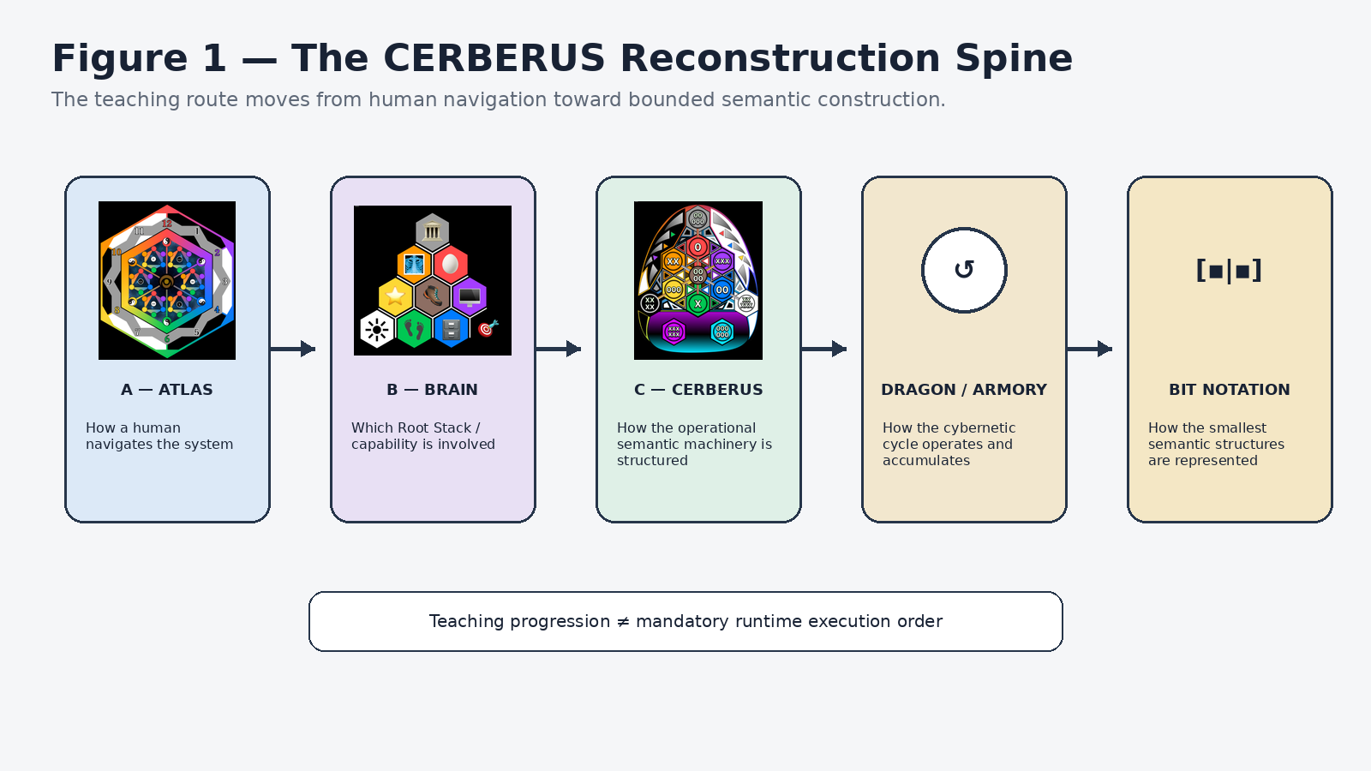
Figure 1. The CERBERUS Reconstruction Spine.
Version 0.1 | BOOTSTRAP Compression Library
Purpose: reconstruction interface for the overarching CERBERUS architecture and the BRAIN 1–10 document family.

Executive Orientation
This document is the top-level reconstruction interface for the CERBERUS architecture. It does not attempt to reproduce every subsystem specification. Instead, it establishes the shared scaffold that lets a fresh human or AI understand what the system looks like, how to read its notation, where detailed Root Stack documents attach, and how state moves through the cybernetic loop.
Governing reconstruction objective
After reading this paper, a fresh reader should be able to identify where a concept is encountered in Atlas, which BRAIN Root Stack owns deeper capability detail, which CERBERUS responsibility is active, how DRAGON and ARMORY participate in state change and learning, and what minimum Bit notation is required to continue into specialist documents.

The teaching spine
The document deliberately teaches from the most human-facing view toward the smallest semantic machinery: Atlas → BRAIN → CERBERUS → DRAGON / ARMORY → Bit notation. This sequence is pedagogical. It is not a claim that runtime execution always follows those steps in that order.
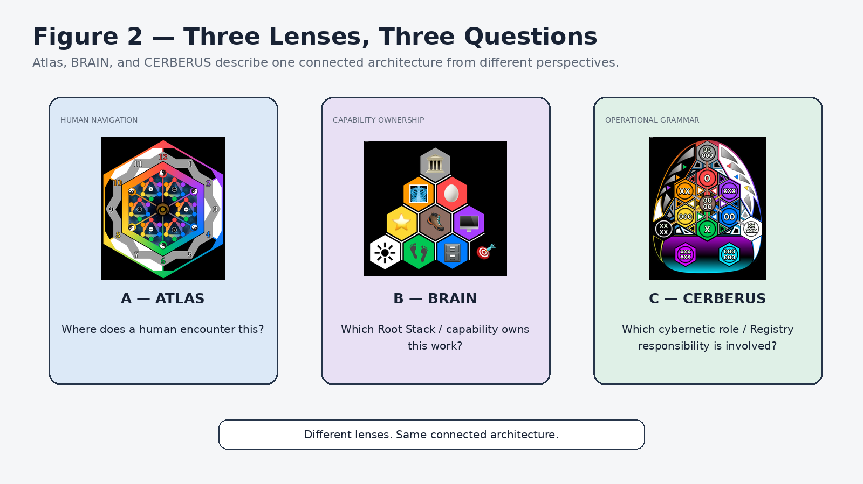
Figure 2. Atlas, BRAIN, and CERBERUS ask different questions about the same connected architecture.

One architecture, several orthogonal languages
Atlas, BRAIN, CERBERUS, and BitWord notation are coordinated descriptive languages. They can all apply to the same work without collapsing into one another. Atlas answers where a human encounters the work. BRAIN identifies the Root Stack or capability domain. CERBERUS identifies the cybernetic responsibility. Bit notation describes bounded semantic construction. A coordinate in one language does not automatically inherit the meaning of the same numeric position in another language.

Contents & Reading Route
Part | Focus | What the reader gains
Part I | The System at a Glance | Multiple lenses, shared Core, and the difference between teaching order and execution topology.
Part II | A — Atlas | Human navigation over CERBERUS-governed structures; Bands 1–9 and Quest Center/Core.
Part III | B — BRAIN | Root Stack capability map and the scaffold to which BRAIN 1–10 documents attach.
Part IV | C — CERBERUS Matryoshka | The 0/X cybernetic grammar, technical object boundaries, and recursive bounded contexts.
Part V | DRAGON & ARMORY | Active cybernetic responsibilities, accumulated operational product, feedback, and NodeKey Closure.
Part VI | D — Bit Notation | Minimum decoder for Bit, BitGroup, BitWord, Semantic Kernel/Model, and Model Key.
Part VII | Reading the Whole Architecture | Integrated A/B/C/D interpretation and signposts to E/F/G.
Part VIII | How to Continue | Progressive disclosure into BRAIN papers, specialist specifications, Semantic Kernels, and the deep corpus.

Orientation law
Same coordinate position does not imply same meaning. Shared identity is explicit, not inferred from visual alignment or numerical rhyme.

Compression rule
0 is not a summary of the folder. 0 is the reconstruction interface to the folder. The compression artifact must make deeper source material easier to reach, not less necessary.

PART I
The System at a Glance
One connected architecture can be navigated, located, operated, learned from, and constructed through different coordinated lenses.
Orientation
One connected architecture can be navigated, located, operated, learned from, and constructed through different coordinated lenses.

1. Multiple lenses over one governed architecture
CERBERUS is not organized as one giant undifferentiated map. The architecture separates human navigation, system capability, cybernetic responsibility, semantic construction, routing, knowledge acquisition, and manifestation into distinct languages. This separation makes the system legible without forcing every question into one coordinate system.
For this orientation paper, the central four languages are A — Atlas, B — BRAIN, C — CERBERUS, and D — BitWord. E — Routing, F — BOOTSTRAP, and G — DARTBOARD are introduced later as signposts. The separation is deliberate: a human-facing path through the system is not the same thing as the underlying topology, and a display surface is not the same thing as canonical truth.
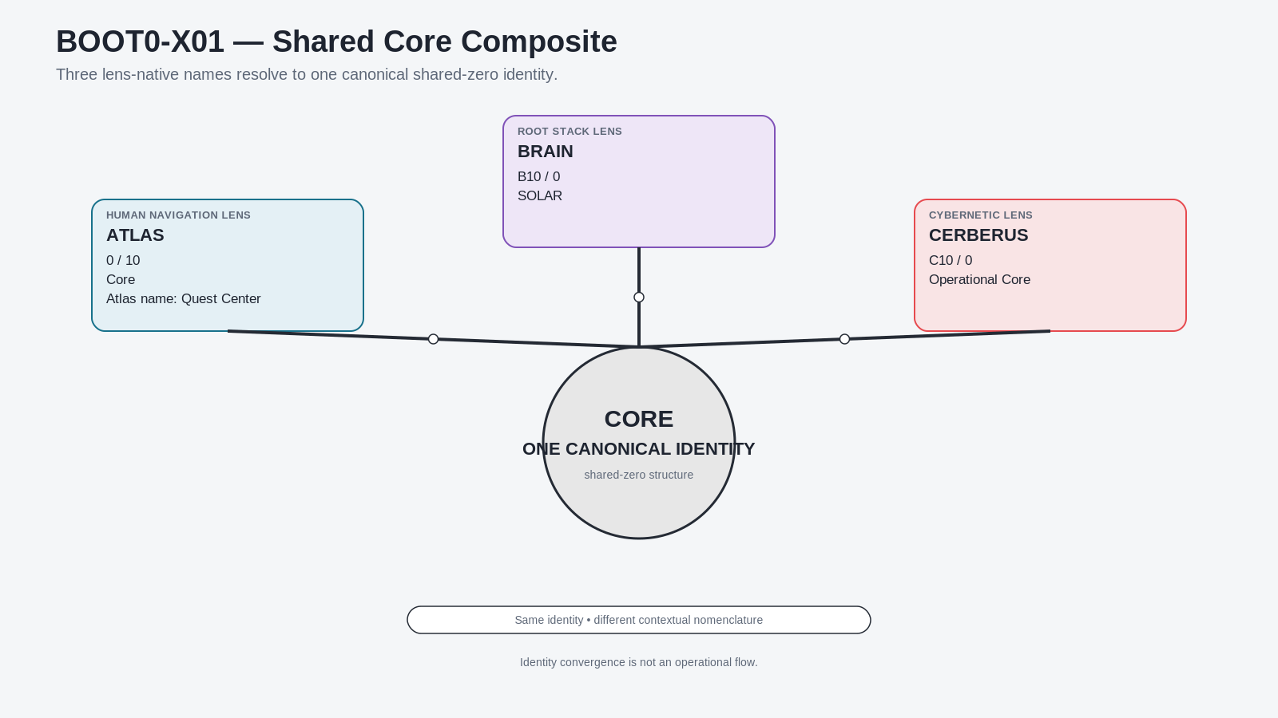
Figure 3. One Shared Core. Atlas, BRAIN, and CERBERUS use different lens-native names for one shared-zero identity.

2. The shared-zero identity
The most important convergence point is the shared Core. In the Atlas lens, the shared Core is encountered as Core and described by the Atlas-native name Quest Center. In the BRAIN lens, the corresponding shared-zero position is SOLAR. In the CERBERUS lens, the corresponding position is the Operational Core. These are not three synchronized copies. They are contextual names for one canonical structure.
The reader-facing position is commonly encountered as position 10 while the architecture treats it semantically as the zero/Core coordinate. This distinction is navigational rather than ontological: the number used to orient a reader does not create another Core.
Shared-zero invariant
Containment, correspondence, and shared identity are different relations. Shared Core identity must be explicit; it is never inferred merely because structures are drawn near one another.

PART II
A — ATLAS
Atlas is the human navigation lens built over CERBERUS-governed structure. It organizes encounter, not ownership of the underlying records.
Orientation
Atlas is the human navigation lens built over CERBERUS-governed structure. It organizes encounter, not ownership of the underlying records.

3. What Atlas is
Atlas bundles a person’s life into recognizable areas so that the system can be navigated according to lived experience rather than according to database storage. It is the human-facing map over the deeper CERBERUS structures. Records, relationships, permissions, Models, Rules, TIME state, Semantic Kernels, and other governed data remain owned by their canonical structures underneath.
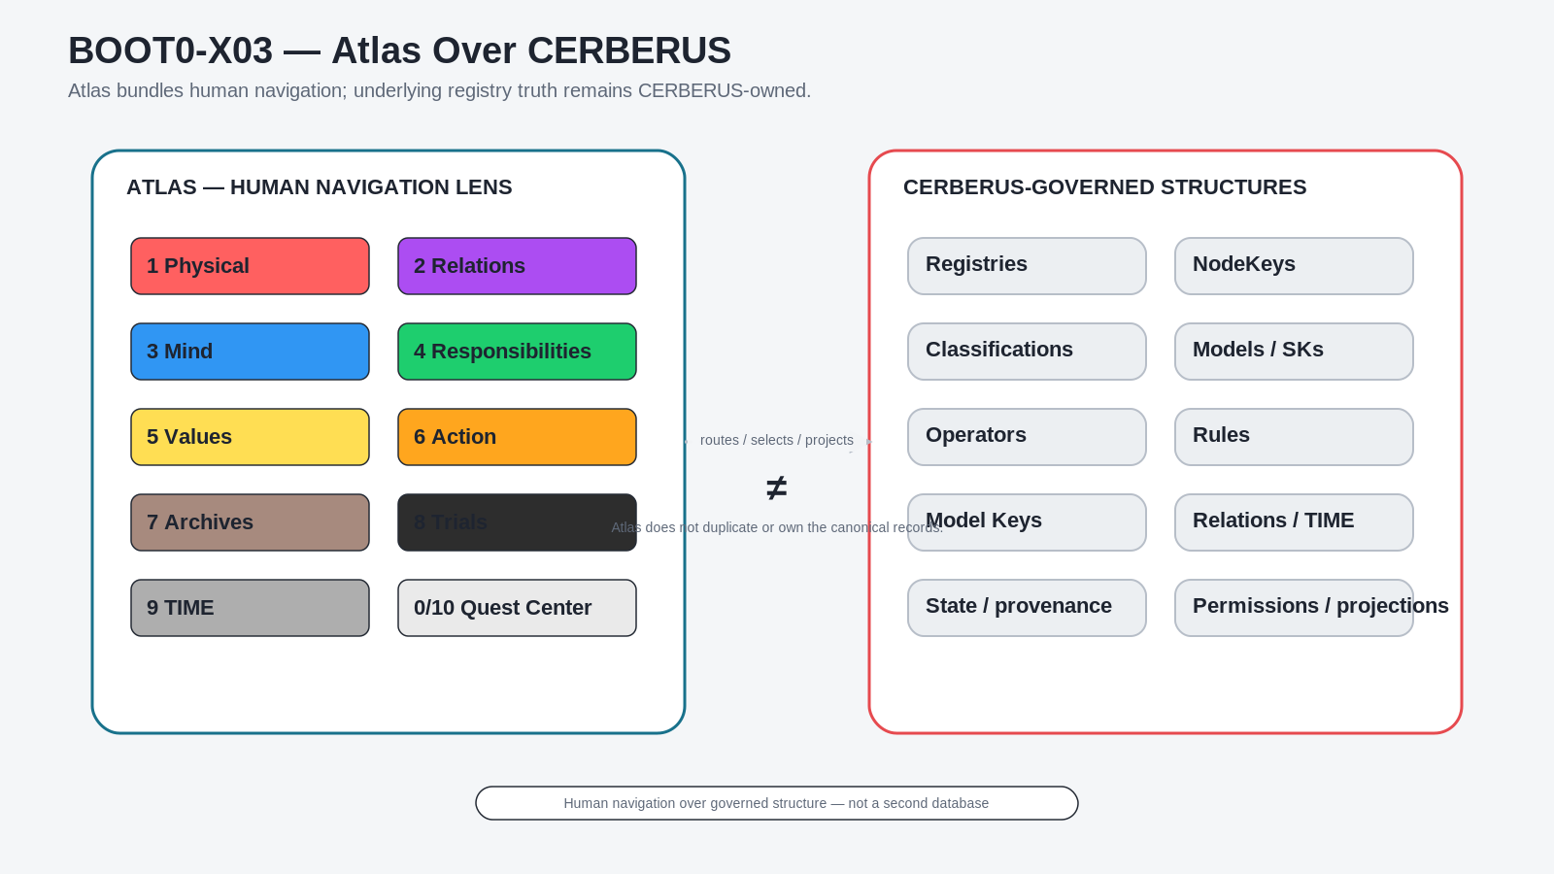
Figure 4. Atlas is a navigation lens over CERBERUS-governed structures, not a second database.
Boundary
Atlas answers “Where should a human encounter this?” CERBERUS and the relevant BRAIN Root Stack answer “What is it, who owns it, and how does it operate?”

4. Current Atlas map
The current Atlas orientation uses nine life-facing Bands around the shared Core. The present mapping is: 1 Physical, 2 Relations, 3 Mind, 4 Responsibilities, 5 Values, 6 Action, 7 Archives, 8 Trials, 9 TIME, with 0/10 Core described in Atlas as Quest Center. Earlier drafts that placed Management at A9 are historical and should not override the current map.
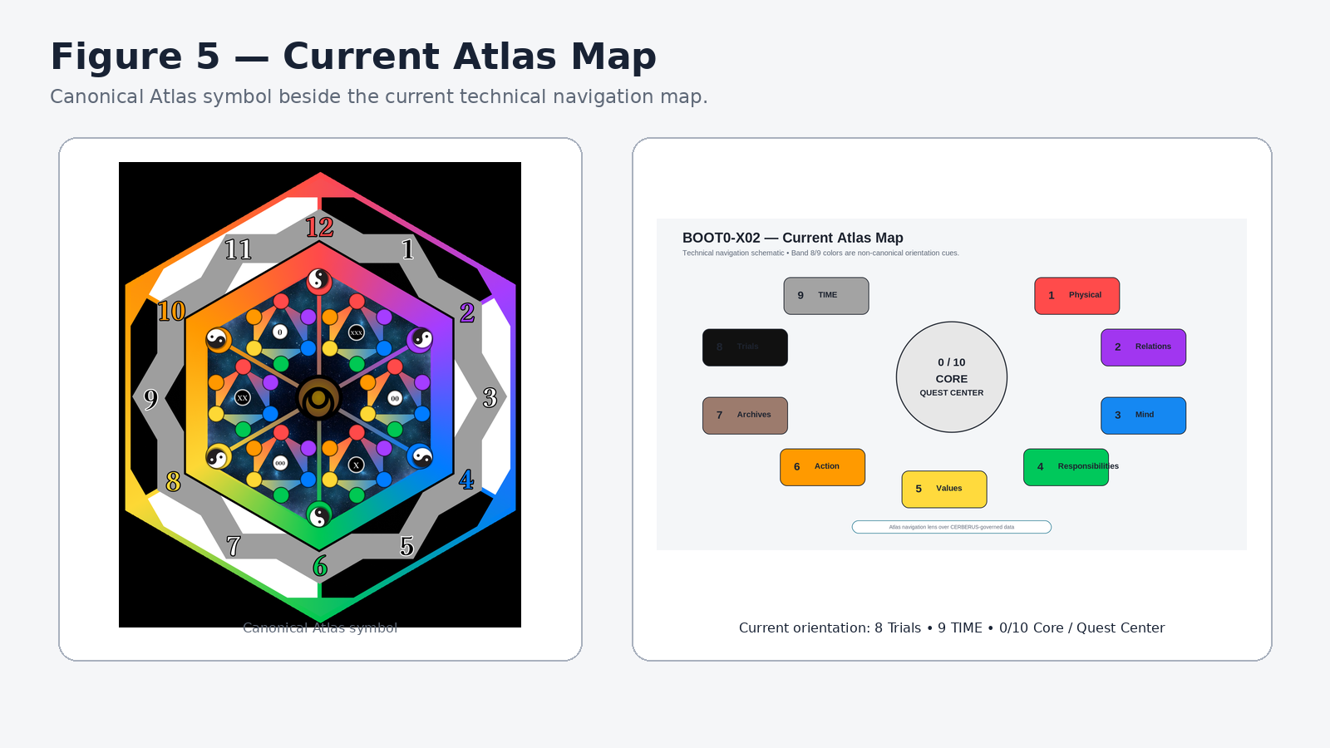
Figure 5. Current Atlas map with the canonical Atlas symbol and current orientation.

5. Bands 1–7: the human-facing life map
The first seven Bands are established by supplied Atlas plates. The plates are human-interface artifacts: they show how a person can encounter the system, not how the canonical records are physically stored. Each Band can surface records from multiple deeper structures without duplicating those records.
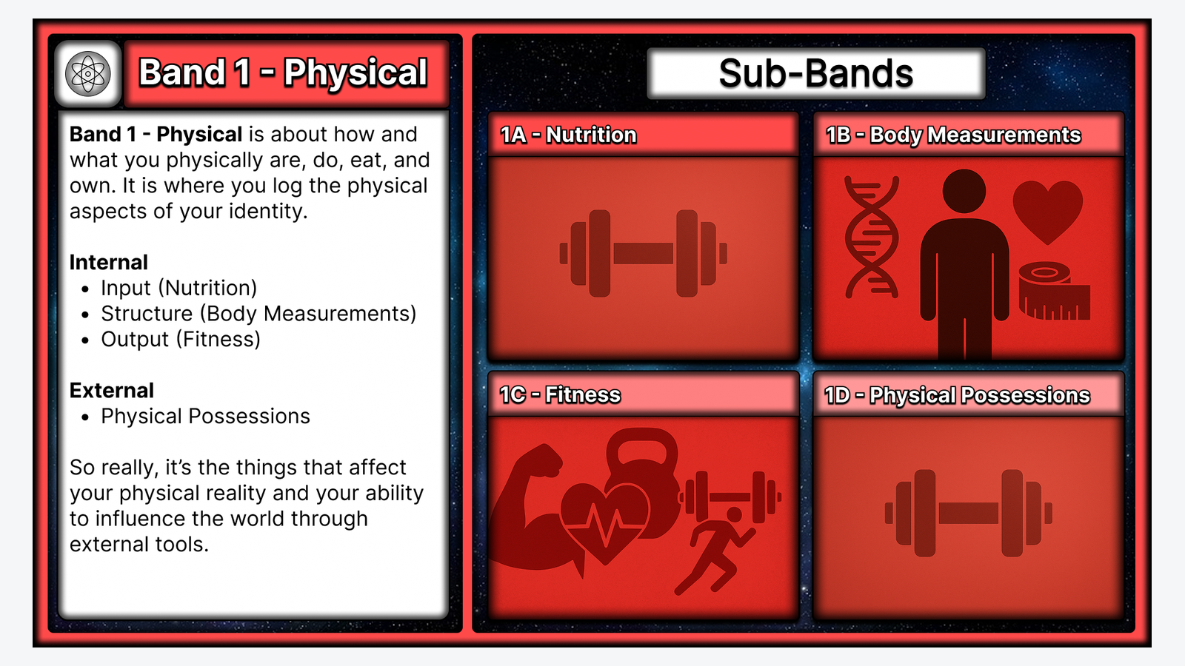
Figure 6A. Atlas Band 1 — Physical.
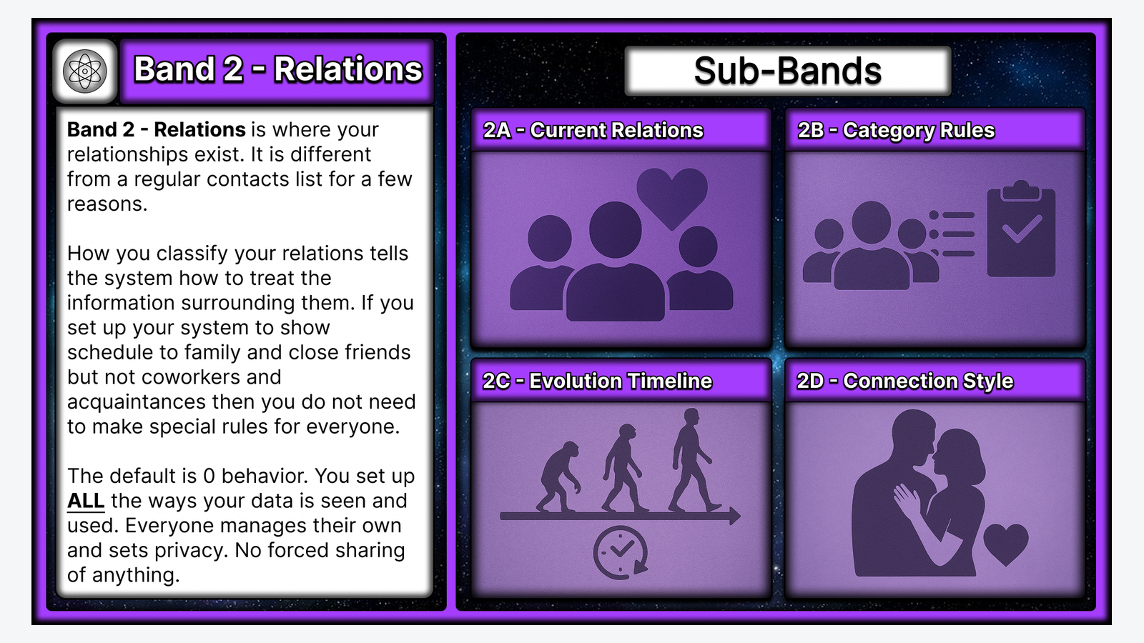
Figure 6B. Atlas Band 2 — Relations.

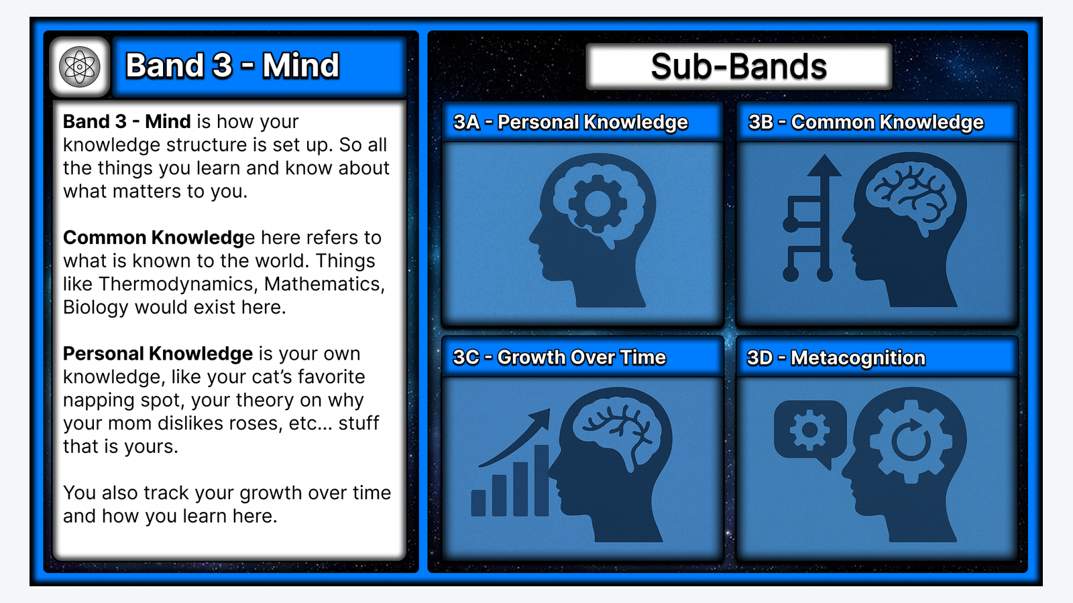
Figure 6C. Atlas Band 3 — Mind.
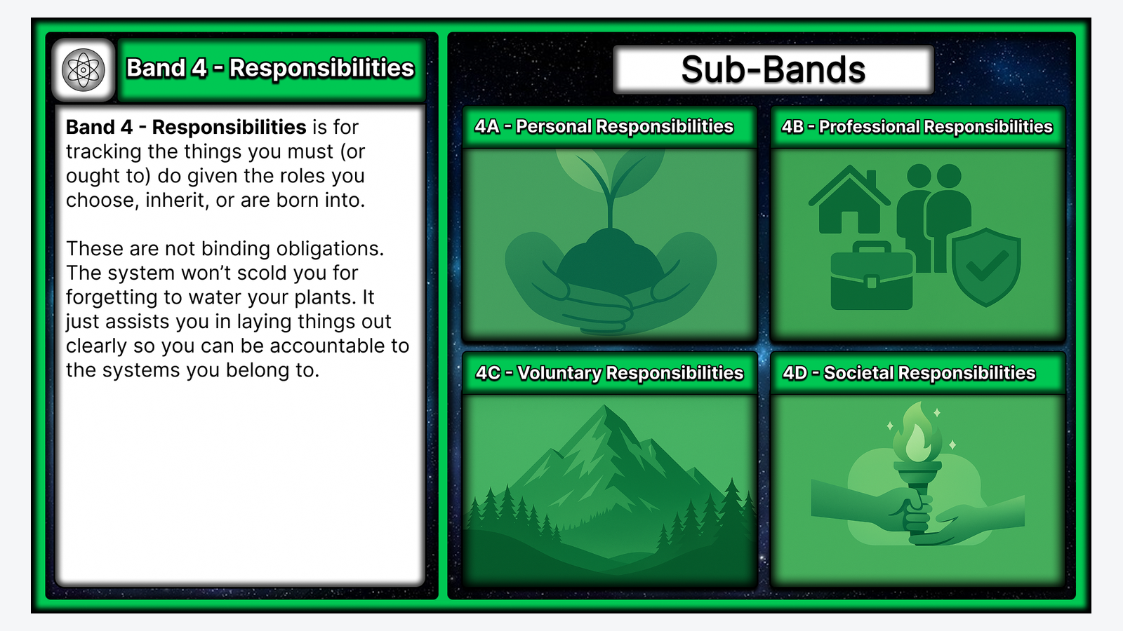
Figure 6D. Atlas Band 4 — Responsibilities.

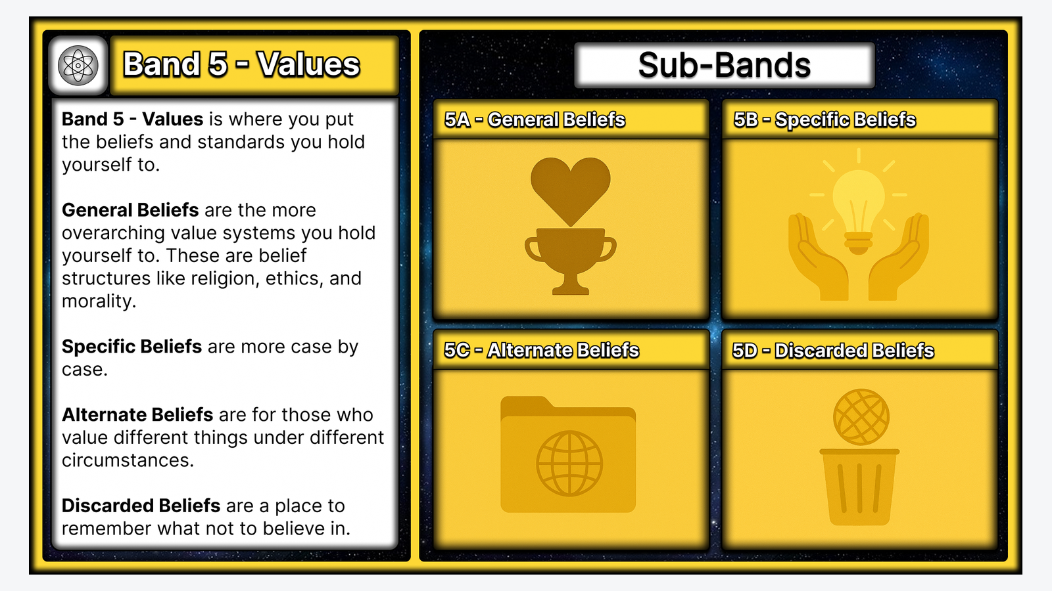
Figure 6E. Atlas Band 5 — Values.
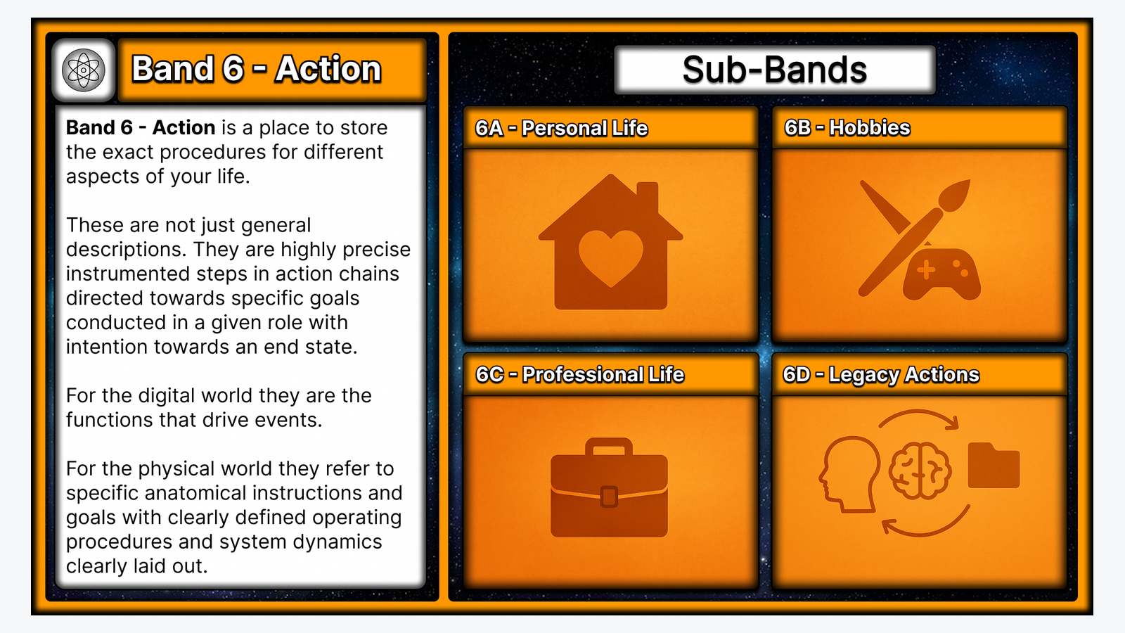
Figure 6F. Atlas Band 6 — Action.

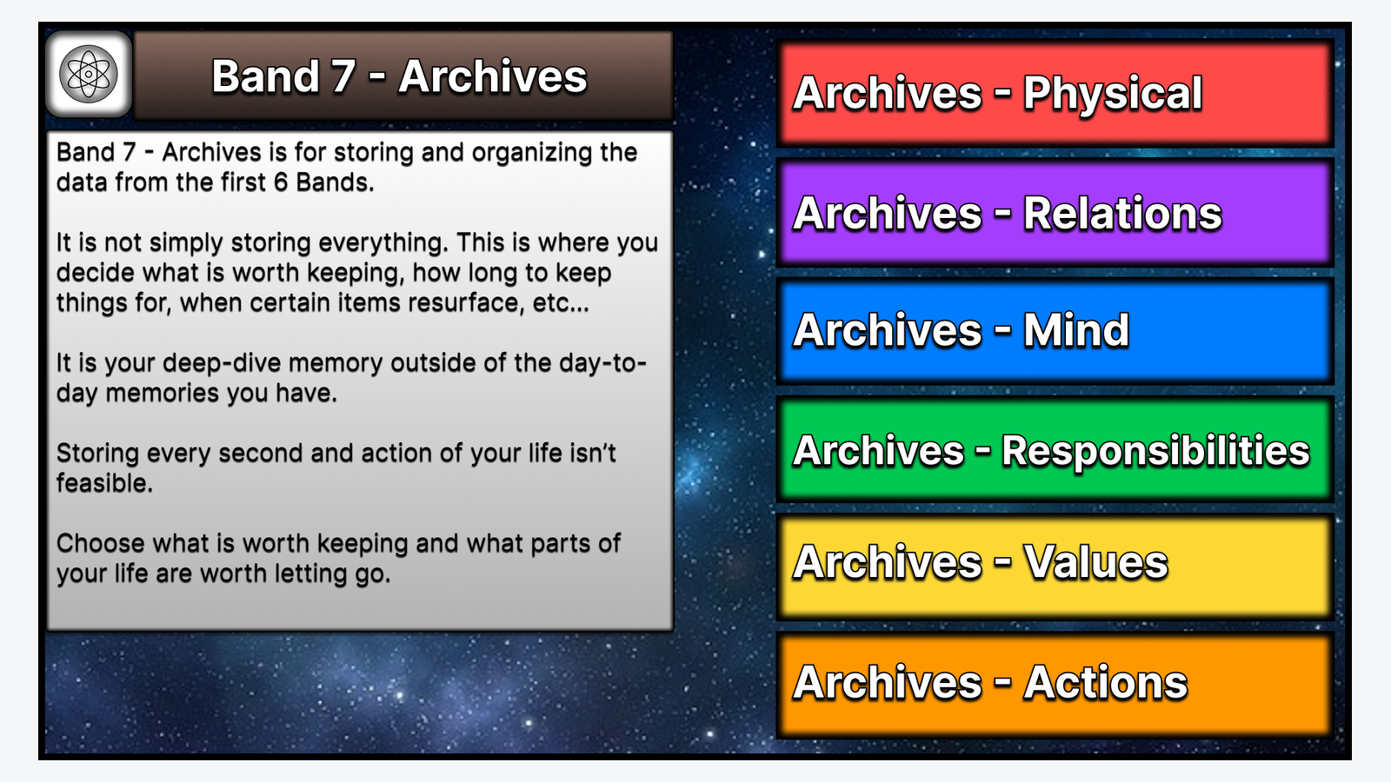
Figure 6G. Atlas Band 7 — Archives.
Band | Human navigation question
1 — Physical | What physically constitutes, affects, or extends my embodied life?
2 — Relations | Who and what relationships structure my social world?
3 — Mind | What do I know, learn, understand, and reflect upon?
4 — Responsibilities | What roles, commitments, and responsibilities shape what I ought or intend to manage?
5 — Values | What beliefs, standards, and evaluative structures matter to me?
6 — Action | What procedures, activities, and intentional action chains do I perform?
7 — Archives | What accumulated information should be retained, resurfaced, or allowed to recede?

6. Trials and TIME
Band 8 and Band 9 answer different questions. Trials is the Atlas area for provisional, experimental, tentative, or currently tested commitments and possibilities. TIME is the temporal/calendar-facing Band. A Trial may be scheduled, dated, recurrent, or otherwise temporally located without becoming TIME itself.
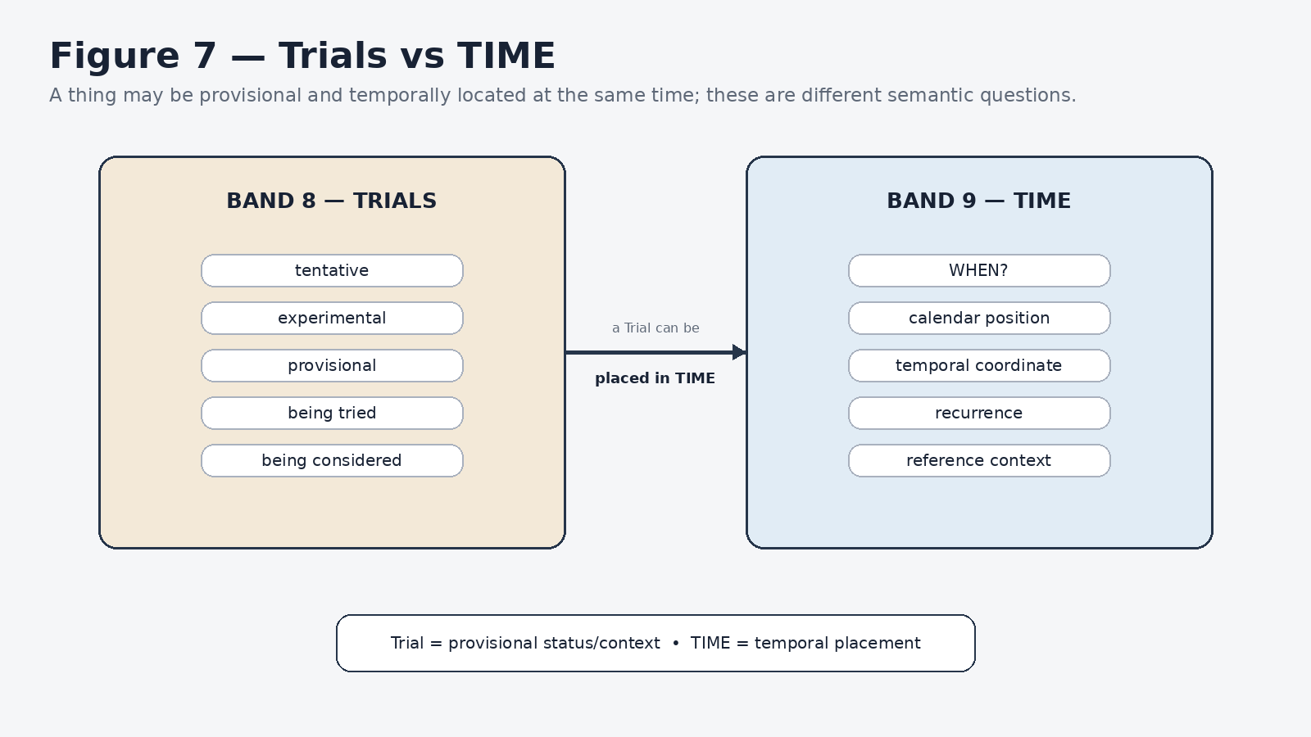
Figure 7. Trials and TIME are independent semantic dimensions.
Atlas Band 9 does not own formal temporal semantics. It is the human navigation route into the TIME architecture. The formal TIME system owns temporal coordinates and related semantics; Atlas merely gives those structures a life-facing place to be encountered.

7. Quest Center is Atlas nomenclature for Core
Quest Center is not a second node beside Core. It is the Atlas-native semantic name for the shared Core when viewed as the place from which a person can inspect, maintain, navigate, and govern the life-facing system. This is a useful example of a broader CERBERUS pattern: the same canonical identity can be named differently when a lens needs to describe its purpose in local terms.
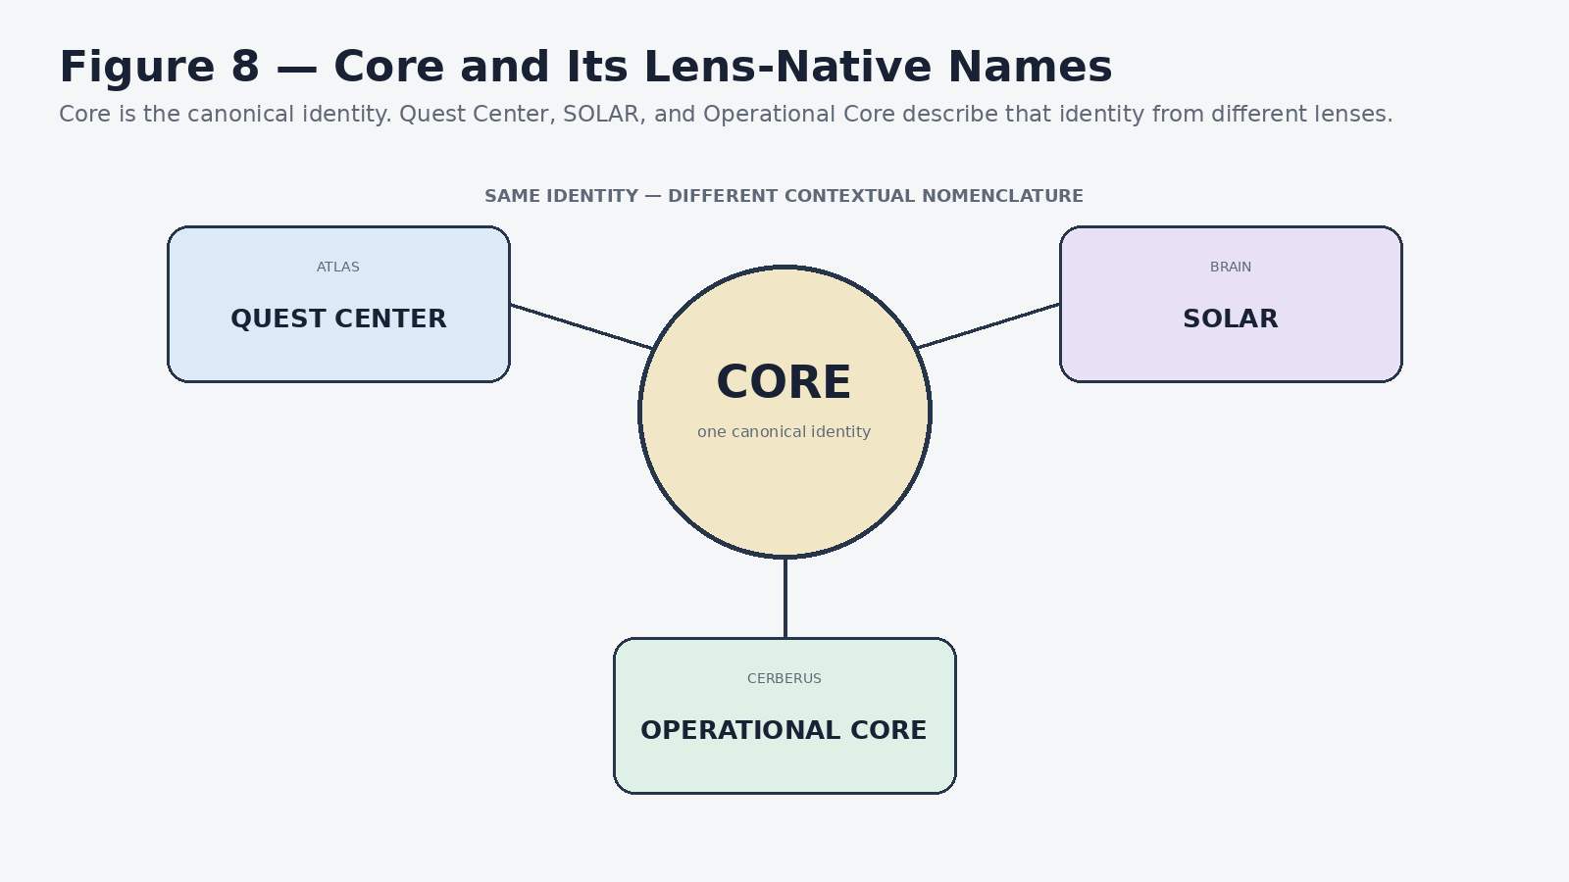
Figure 8. Core remains one identity while each lens uses its own contextual name.

PART III
B — BRAIN
BRAIN tells the system which major Root Stack or capability domain is involved. It is the scaffold to which the detailed BRAIN documents attach.
Orientation
BRAIN tells the system which major Root Stack or capability domain is involved. It is the scaffold to which the detailed BRAIN documents attach.

8. BRAIN as the Root Stack capability map
BRAIN is the Base Registry Adaptive Intelligence Network: the Root Stack map through which Base-level capabilities are located. The BRAIN Master Root Stack does not flatten the system into one table. It gives each Root Stack a canonical home, while cross-system relationships use references, outputs, or explicit bridges rather than competing ownership.
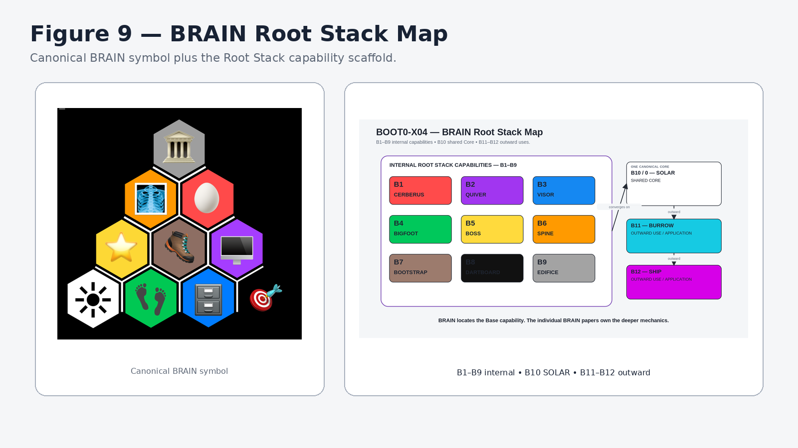
Figure 9. BRAIN Root Stack map.
Position | Root Stack | Orientation-level role
B1 | CERBERUS | Registry-backed cybernetic operating structure
B2 | QUIVER | Relational/loadout context and authorized selection
B3 | VISOR | Visual/interface projection of authorized structure
B4 | BIGFOOT | Operational semantic identities and terminology bridge
B5 | BOSS | Symbolic/semantic registry and conceptual organization
B6 | SPINE | Typed planning and recursive orchestration
B7 | BOOTSTRAP | Knowledge acquisition and system familiarization
B8 | DARTBOARD | Manifested operational/interface control surface
B9 | EDIFICE | Divergent cognitive/model interpretation and evaluation
B10 / 0 | SOLAR | Shared Core and lexical-semantic ingress/common center
B11 | BURROW | Outward Core application
B12 | SHIP | Outward Core application

These descriptions are deliberately orientation-level. The individual BRAIN papers own precise subsystem definitions, boundaries, internal registries, contracts, and implementation detail.

9. Internal capabilities, shared Core, outward uses
The BRAIN structure is easiest to read as three zones. B1–B9 are internal capability Root Stacks. B10 is SOLAR at the shared Core/zero coordinate. B11 and B12 sit outside the shared Core as outward uses or applications. The outer positions should not be drawn as though they were additional components inside the Core itself.
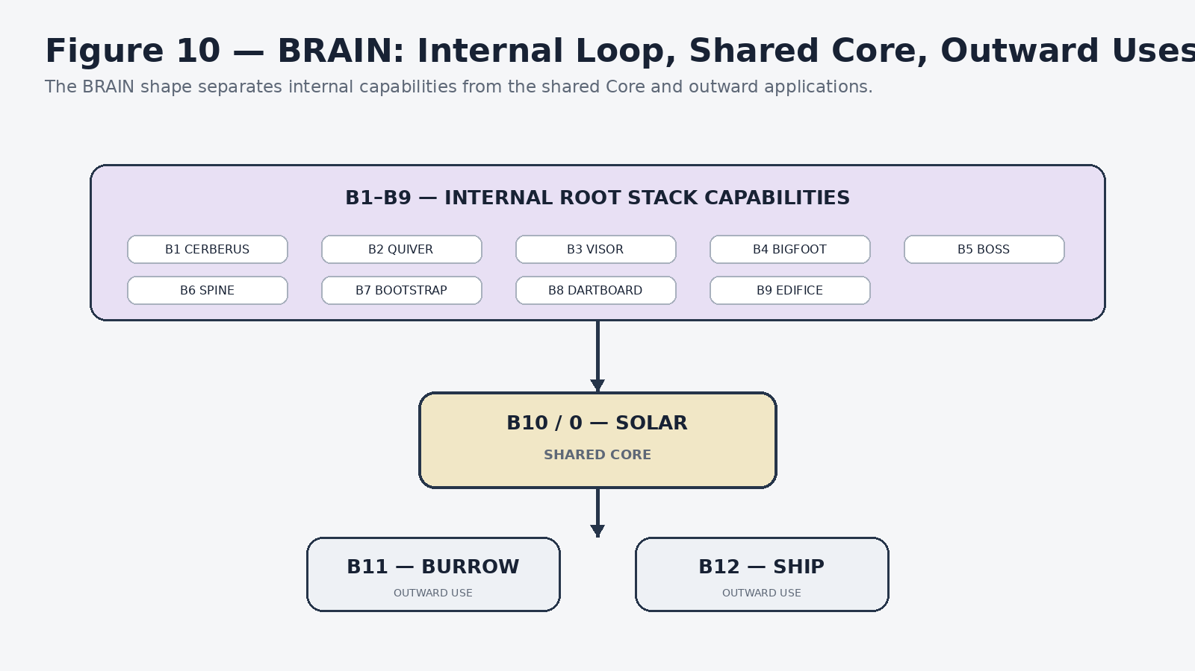
Figure 10. BRAIN separates internal capabilities, shared Core, and outward uses.

10. BRAIN as the BOOTSTRAP attachment scaffold
The new BOOTSTRAP Compression Library uses the BRAIN map as its attachment scaffold. This orientation paper establishes the whole-system coordinate system. Each detailed BRAIN compression paper can then attach to one Root Stack and provide the precision required to reconstruct that subsystem without forcing every other subsystem into the same document.
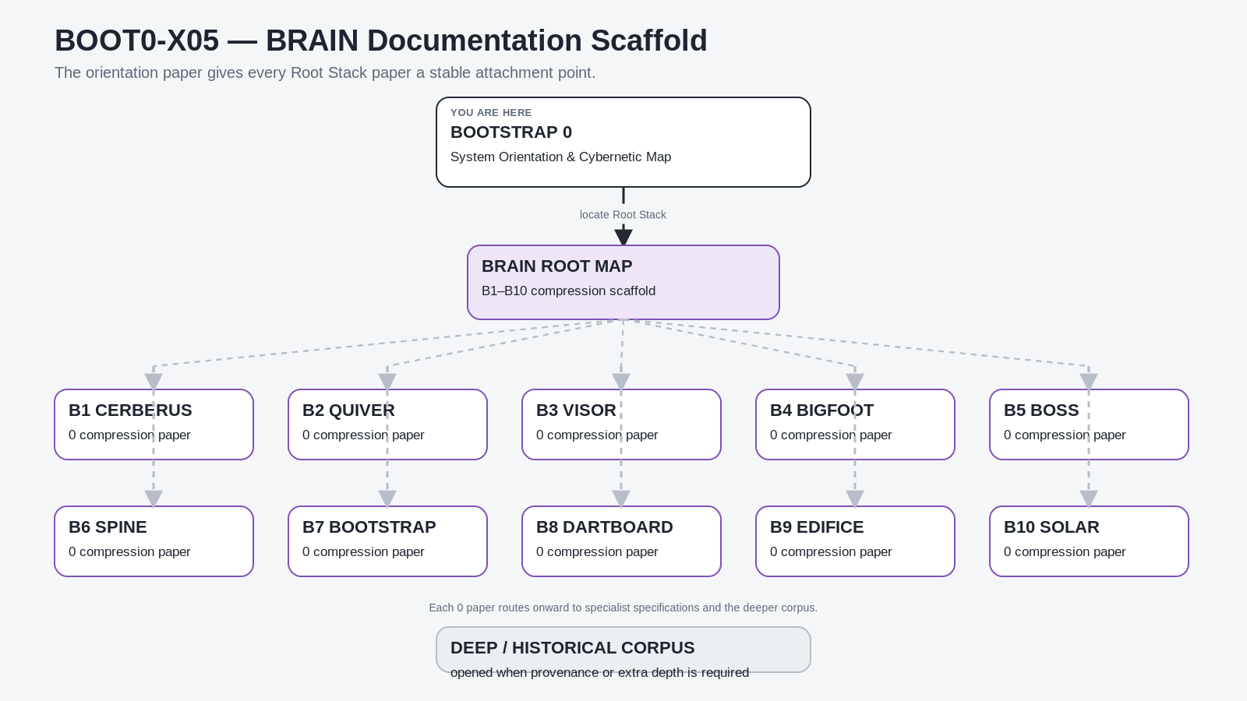
Figure 11. BRAIN document attachment scaffold.
Progressive disclosure
System Orientation → BRAIN Root Stack compression paper → specialist specifications → exact Semantic Kernels / notation → historical corpus when provenance or deeper reconstruction is required.

PART IV
C — CERBERUS Matryoshka
CERBERUS provides the recursive cybernetic operating grammar beneath the human navigation and Root Stack capability maps.
Orientation
CERBERUS provides the recursive cybernetic operating grammar beneath the human navigation and Root Stack capability maps.

11. The 0/X cybernetic grammar
CERBERUS uses a repeating 0/X-derived token language to identify cybernetic responsibilities. The tokens are semantic coordinates rather than arbitrary IDs. The first six positions form the active DRAGON responsibility set; later positions form the ARMORY-oriented accumulated and reflective responsibilities. The reader-facing tenth position corresponds to the shared Core; in the CERBERUS token grammar that position is represented by XXXXX, the Operational Core.
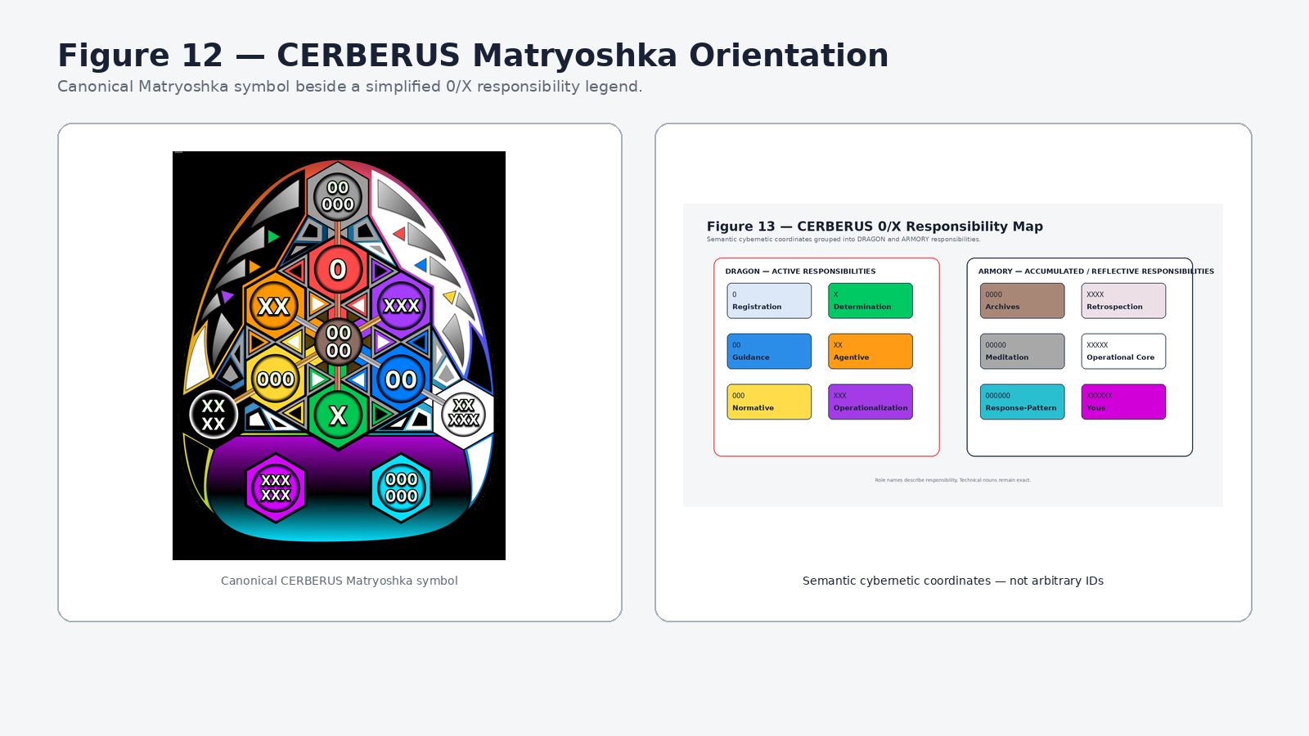
Figure 12. Canonical CERBERUS Matryoshka symbol with a simplified responsibility legend.
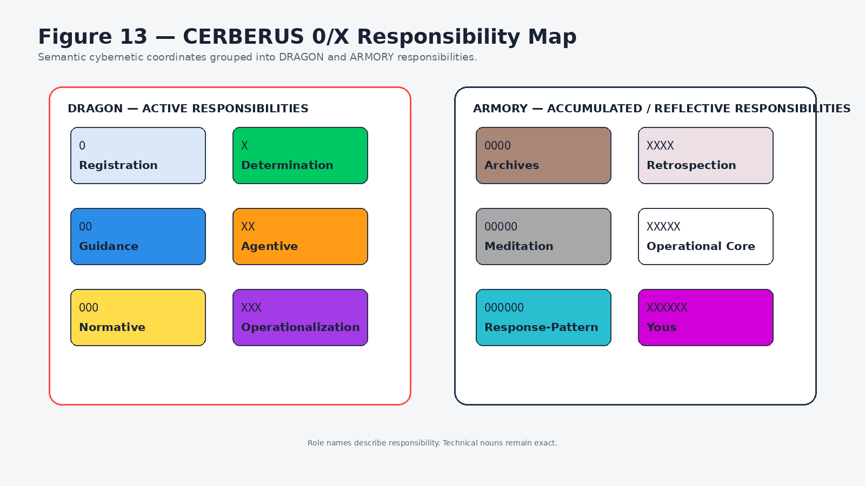
Figure 13. CERBERUS 0/X responsibility map.
Position | Token | Responsibility | Typical technical expression
C1 | 0 | Registration | NodeKey / stable identity
C2 | X | Determination | Classification / applicability
C3 | 00 | Guidance | Model / Semantic Kernel
C4 | XX | Agentive | Operator / Agent / Action Chain
C5 | 000 | Normative | Rule / Ruleset / constraint
C6 | XXX | Operationalization | Model Key / instantiated configuration
C7 | 0000 | Archives | Retained operational history
C8 | XXXX | Retrospection | Interpretation of accumulated experience
C9 | 00000 | Meditation | Structured reflective context
C10 / 0 | XXXXX | Operational Core | Shared Core viewed through CERBERUS
C11 | 000000 | Response-Pattern | Reusable response structure
C12 | XXXXXX | Yous | Bounded personified operating profiles

12. Responsibility is not the same thing as technical object type
The responsibility vocabulary explains what a Registry position is doing in the cybernetic architecture. The technical nouns identify the records, contracts, or structures that carry that responsibility. Registration does not replace the word NodeKey. Agentive does not replace Operator. Guidance does not replace Model or Semantic Kernel. Normative does not replace Rule.
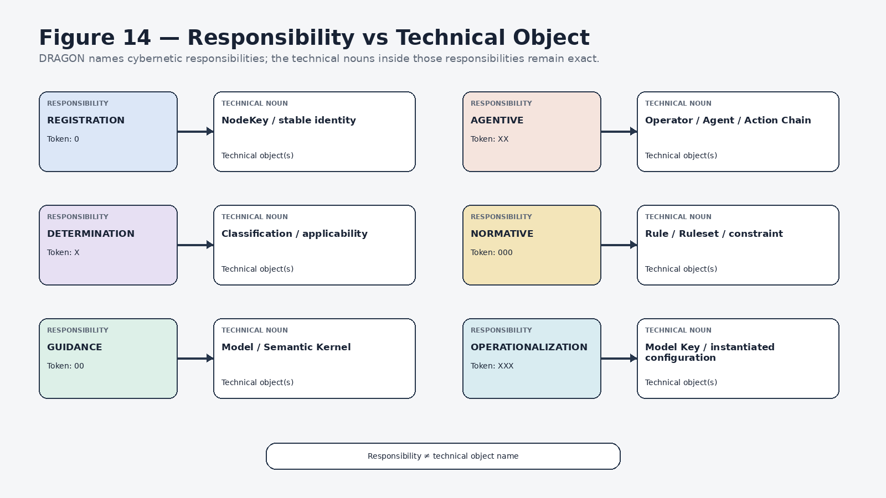
Figure 14. Registry responsibility and technical object remain distinct.
Language discipline
Use the responsibility name to describe the cybernetic role. Use the technical noun to describe the concrete object or contract. Keeping both preserves precision while still making the larger cycle legible.

PART V
DRAGON & ARMORY
DRAGON organizes active governed work. ARMORY is the accumulated operational product that can preserve experience, reflection, stabilized structures, and reusable response patterns.
Orientation
DRAGON organizes active governed work. ARMORY is the accumulated operational product that can preserve experience, reflection, stabilized structures, and reusable response patterns.

13. DRAGON: the six active responsibilities
DRAGON is the responsibility overlay for the six active CERBERUS positions: Registration, Determination, Guidance, Agentive, Normative, and Operationalization. It is most useful as a cyclic ownership grammar. The system may enter, revisit, or combine responsibilities according to the current task rather than executing them as a universal six-step script.
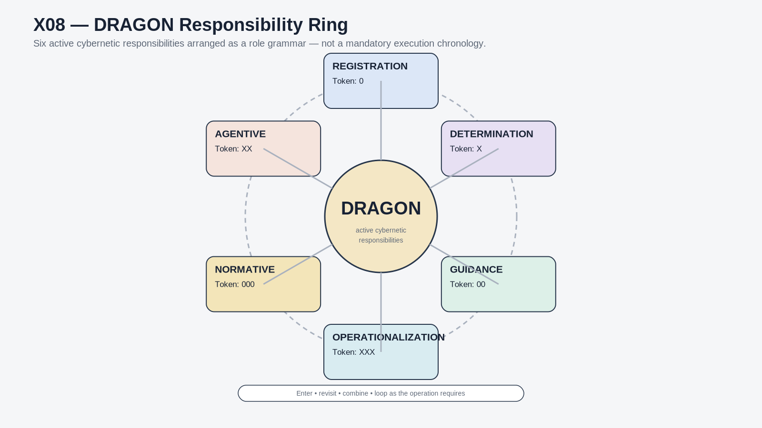
Figure 15. DRAGON responsibility ring.

14. One illustrative traversal
A simple teaching traversal can still be useful: identify the object, determine what applies, resolve the available guidance, propose or perform an action, evaluate applicable rules, and instantiate the resulting configuration. The important qualifier is that this is one explanatory route through the responsibility set, not a universal runtime order.
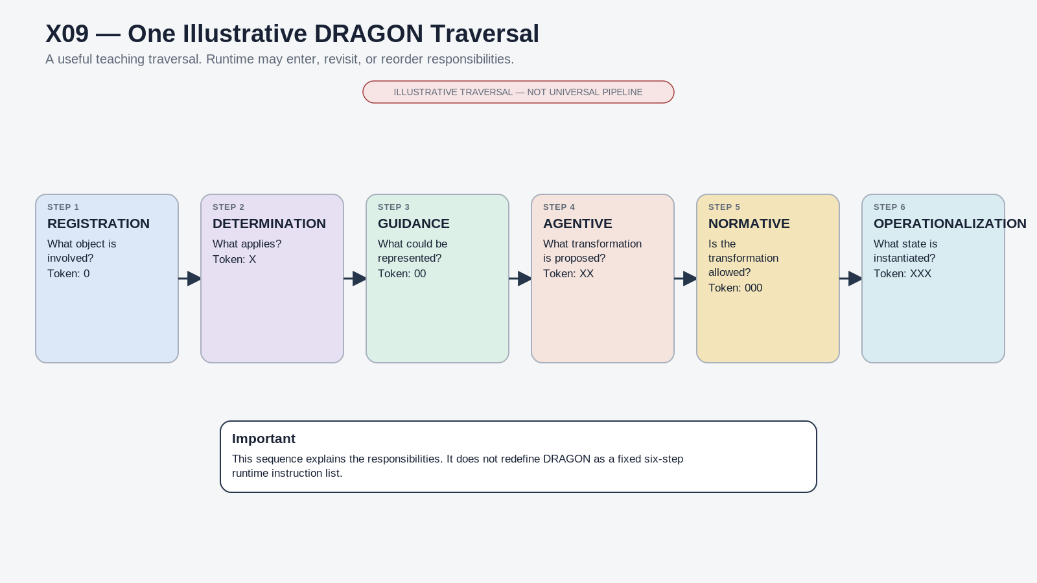
Figure 16. One illustrative DRAGON traversal; runtime may enter, revisit, or reorder responsibilities.

15. Possibility is not actuality
The distinction between Guidance and Operationalization is foundational. A Model or Semantic Kernel describes the bounded possibility space: what states are valid, representable, or available under the contract. A Model Key or equivalent instantiated configuration identifies what is actually true in a particular operational context. The richer possibility space must not be confused with the current selected state.
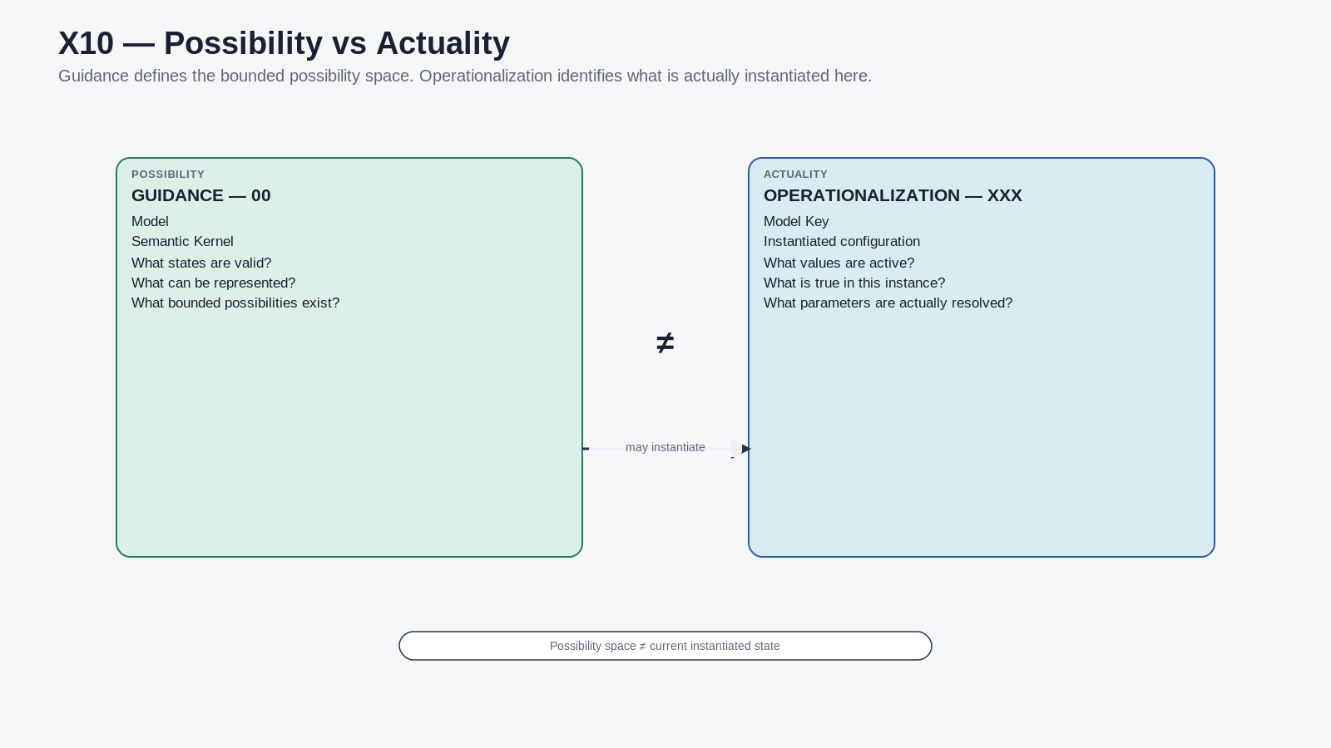
Figure 17. Guidance / possibility and Operationalization / actuality are different semantic responsibilities.

16. ARMORY: accumulated cybernetic product
ARMORY extends the cybernetic story beyond the immediate operation. Archives preserve what happened. Retrospection provides a place to interpret experience. Meditation provides structured reflective context. Operational Core represents stabilized learned structure at the shared Core. Response-Patterns capture reusable operational tendencies, and Yous provide bounded personified profiles where such profiles are appropriate. These are accumulated responsibilities, not merely a passive file archive.
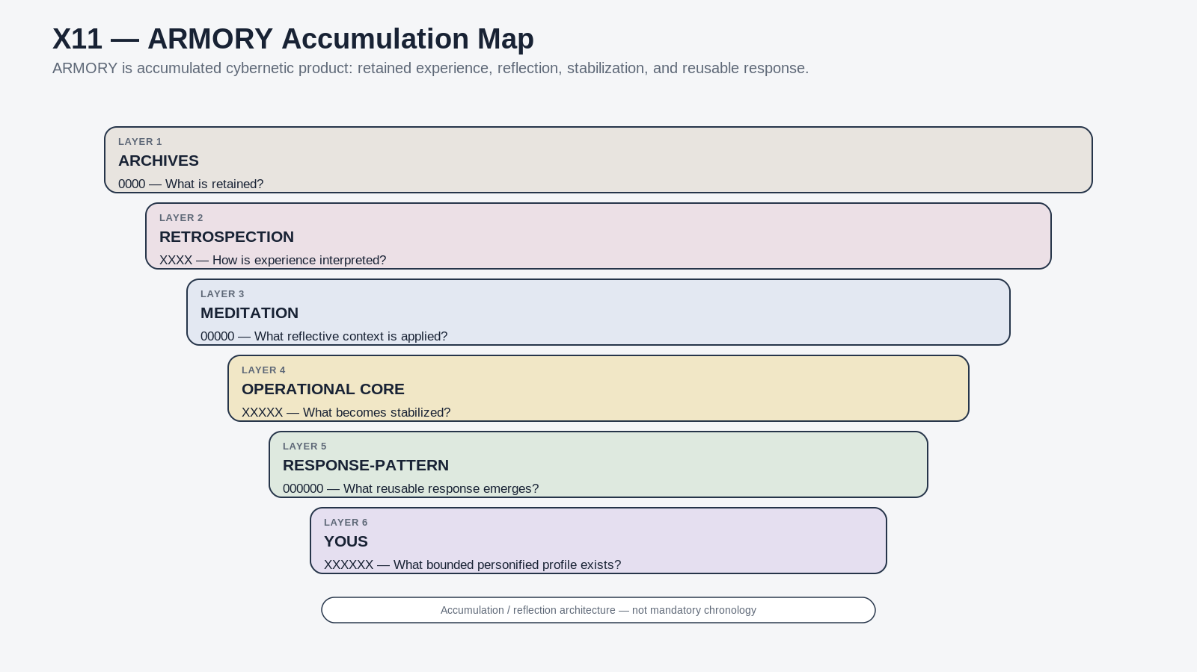
Figure 18. ARMORY accumulation map.
ARMORY boundary
ARMORY can preserve personal or system-specific experience without becoming the authority for the shared ontology. “What X means” and “what happened with X” remain different questions.

17. The larger cybernetic learning loop
A useful whole-loop view begins with exact addressable state. DRAGON performs governed cybernetic work. A consequential result is observed. Only an authorized delta can become canonical change. The resulting state becomes addressable again, which closes the current cycle. ARMORY can retain and interpret relevant consequences so that later DRAGON cycles have better bounded context available to them.
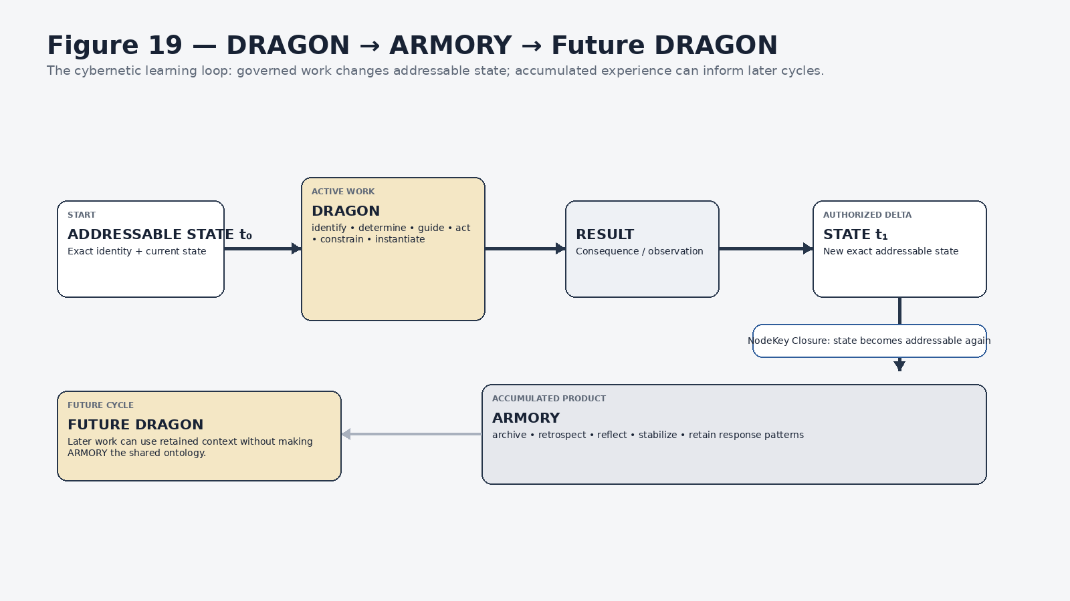
Figure 19. DRAGON → ARMORY → Future DRAGON.

18. Shared definition and lived experience remain separate
The system needs both stable shared meaning and personal accumulated experience. The shared semantic layer answers what a concept means under the governing ontology. ARMORY can record how that concept appeared in a person’s life or in previous operations. The second can inform interpretation, but it does not silently redefine the first.
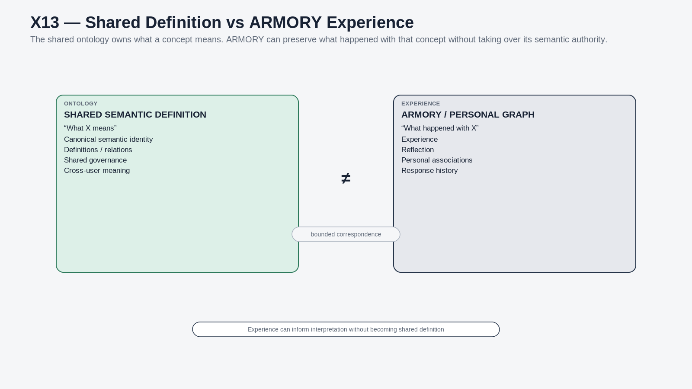
Figure 20. Shared semantic definition and ARMORY experience correspond without becoming identical.

19. NodeKey Closure
The cybernetic cycle is complete only when consequential change returns to exact addressable state. That closure is what allows the next operation to begin from a valid semantic starting point rather than from an untracked side effect. The pattern can be summarized as addressable state₀ → governed work → result → authorized delta → addressable state₁.
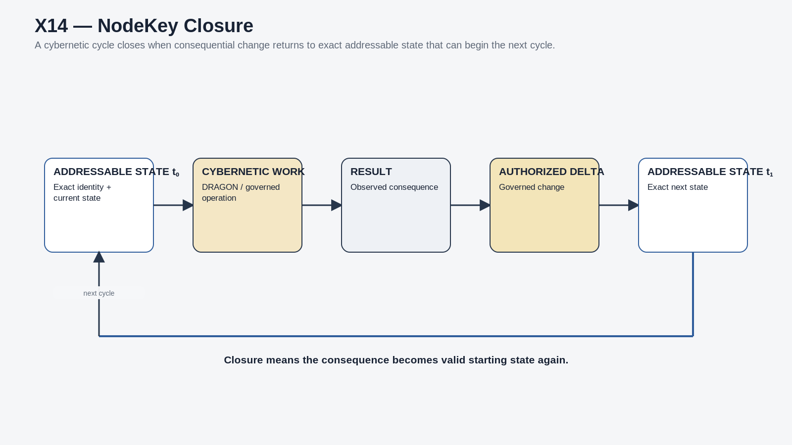
Figure 21. NodeKey Closure returns consequential change to exact addressable state.
Closure law
The world can continue because the consequence of one valid operation becomes the valid starting state of what happens next.

20. Matryoshka recursion
Matryoshka describes the recurrence of the bounded cybernetic contract at multiple scopes. A bounded context can contain another bounded context, which can contain another, without requiring a new architectural grammar at each level. Recursion is functional rather than numerical: the same responsibilities can reappear wherever a bounded system must observe state, operate through declared mechanisms, respect constraints, produce outputs, and receive feedback.
Recursive extensibility does not imply infinite runtime traversal. Deployed operations remain finite and scoped. Containment also does not imply shared identity. A child bounded context is inside a parent context; it does not become the parent, and it does not automatically share the parent’s canonical identity.
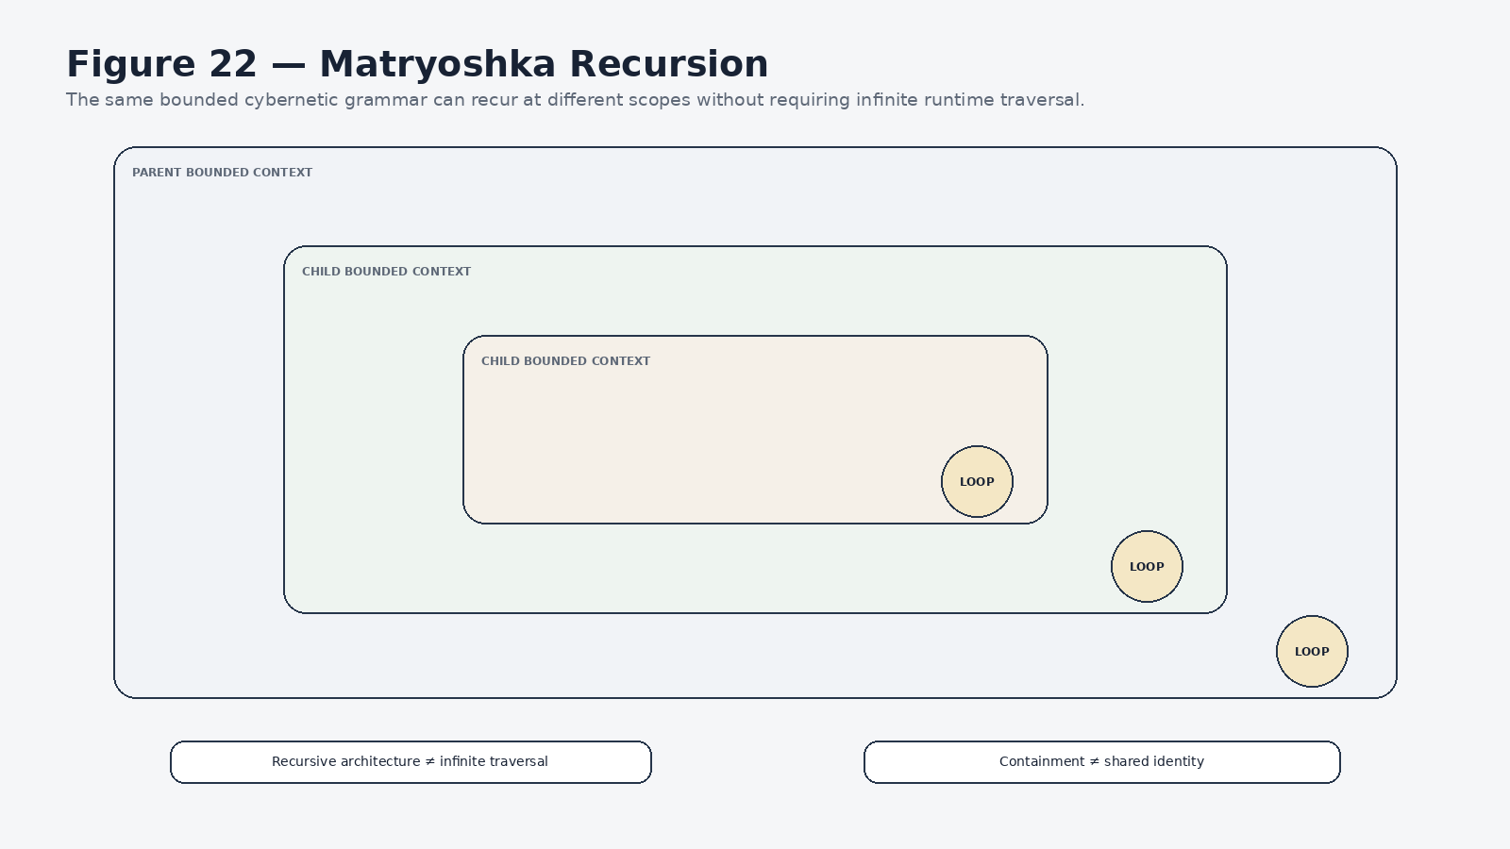
Figure 22. Matryoshka recursion repeats bounded grammar while preserving scope and identity boundaries.

PART VI
D — Bit Notation
Bit notation provides the minimum semantic-construction decoder required to read deeper Semantic Kernel and BitWord specifications.
Orientation
Bit notation provides the minimum semantic-construction decoder required to read deeper Semantic Kernel and BitWord specifications.

21. From semantic primitive to instantiated state
The BitWord language begins below the Registry and cybernetic layers. A Bit is a registered semantic primitive: the smallest stable semantic position. A BitGroup coordinates bounded Bits. A BitWord is a bounded semantic contract constructed from those groups. A Semantic Kernel or Model defines a valid possibility space over that structure, while a Model Key or equivalent configuration identifies an instantiated state.
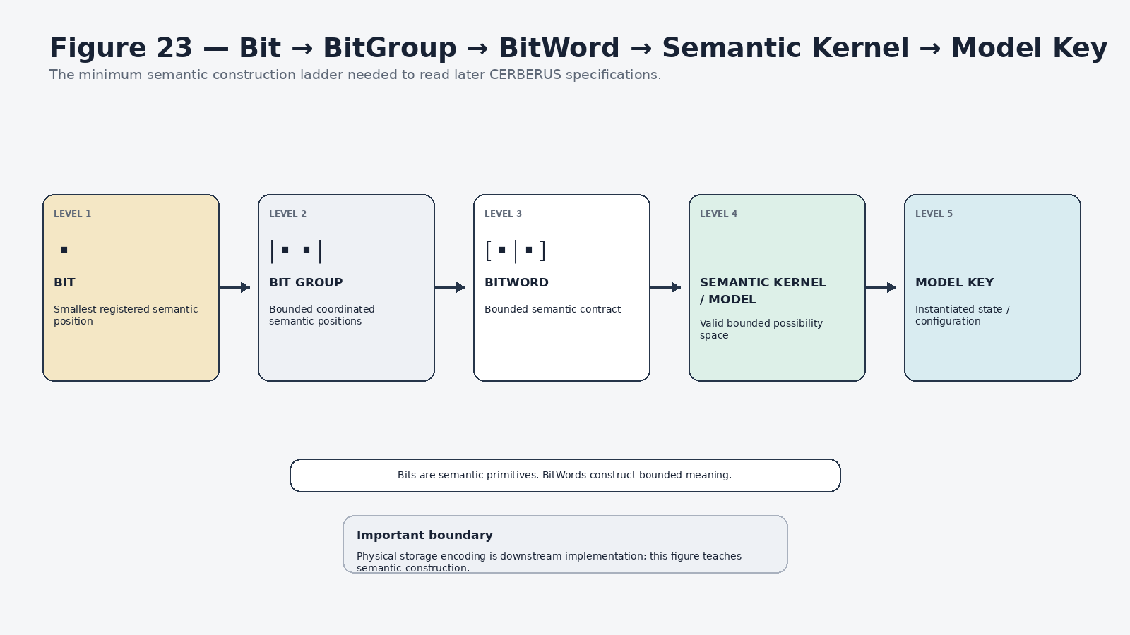
Figure 23. Bit construction ladder.
Meaning before representation
A Bit is not merely a raw binary storage cell. The architectural role is semantic: identity, allowed state, and interpretation are registered before downstream storage encoding is considered.

22. Minimum D-language decoder
This paper teaches only enough notation to let later specialist documents become readable. The exact construction rules, extension grammar, Compound BitWords, namespace behavior, Reader contracts, and full Semantic Kernel authoring requirements remain in their specialist specifications.
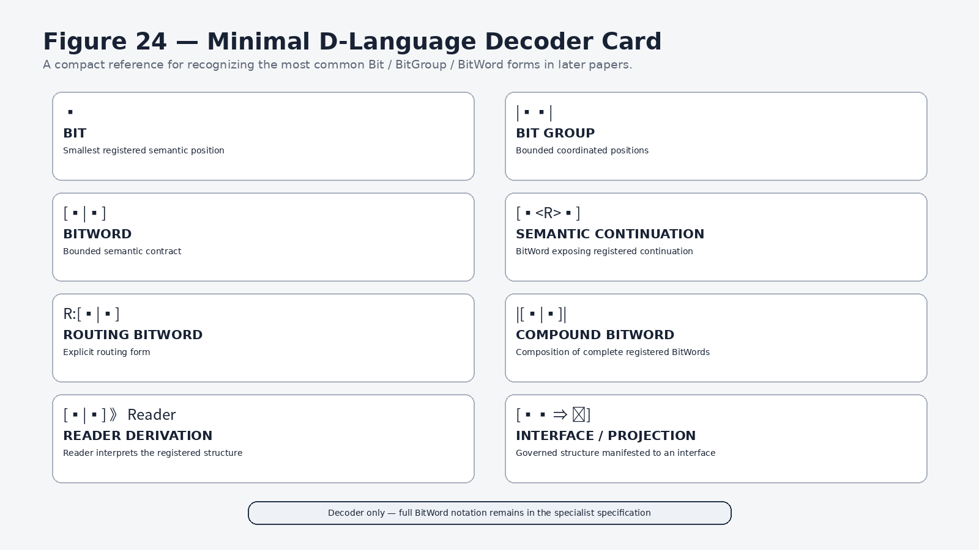
Figure 24. Minimal D-language decoder card.

23. Three construction relationships worth recognizing
Notation | Relationship | Meaning
PREFIX-n → PREFIX-m | Pure extension | More resolution in the same registered lineage.
A || B → [AB] | Compound composition | Complete registered BitWords are composed without erasing their source identity.
A ⇄ B | Registered relationship / Bitlink | Two structures are related explicitly without pretending they are one structure.

24. Identity, address, and state
One of the most reusable CERBERUS invariants is the separation of identity, address, and state. A NodeKey answers what the thing is. A route, Registry location, Stack, Base, or classification coordinate answers where it is encountered. A BitWord, Model Key, or Instance state answers what is currently true. Reclassification, movement, or state change does not automatically change identity.
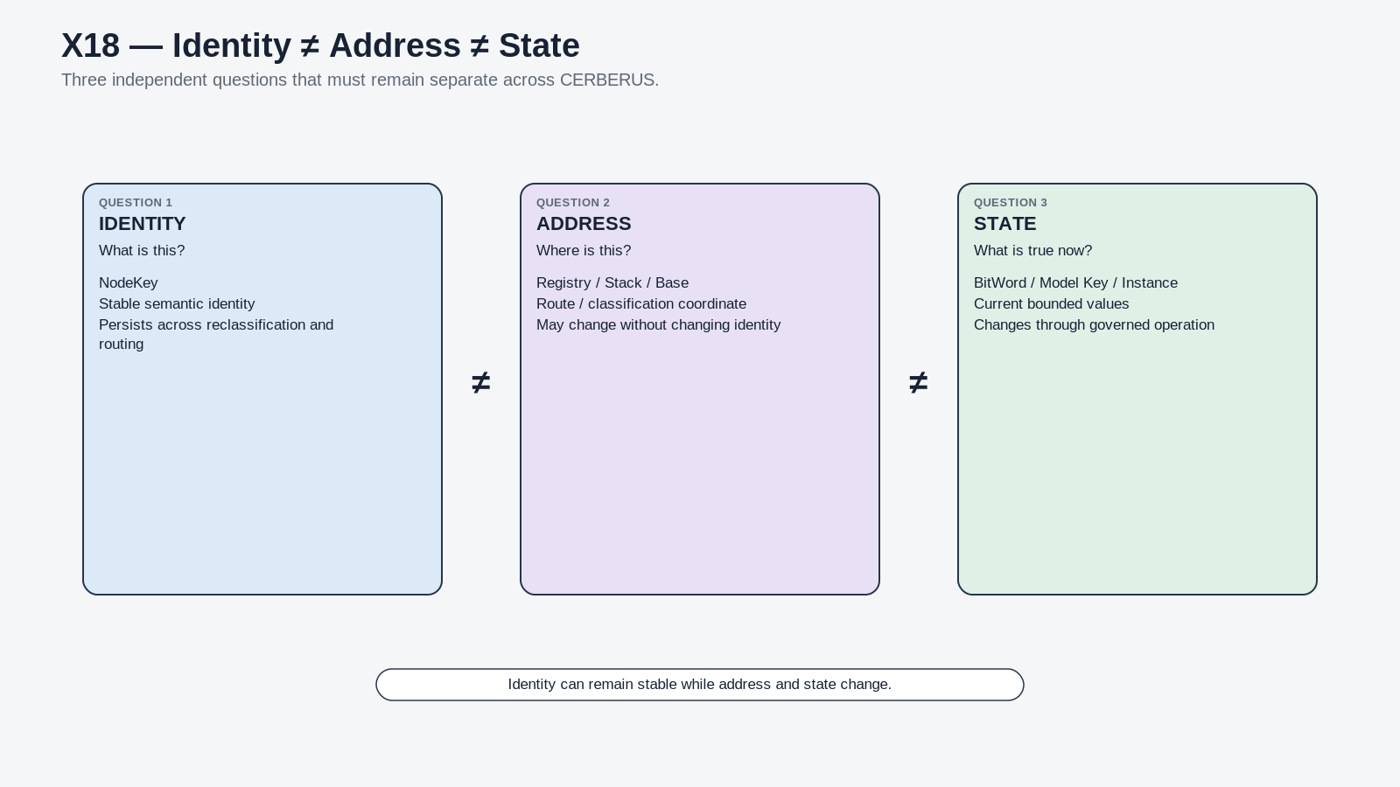
Figure 25. Identity ≠ Address ≠ State.

PART VII
Reading the Whole Architecture
The coordinate languages can now be combined without collapsing them into one pipeline.
Orientation
The coordinate languages can now be combined without collapsing them into one pipeline.

25. One work item through A, B, C, and D
Suppose a piece of work is encountered through A3 — Mind. The same work may belong to B5 — BOSS because its deeper capability is symbolic/semantic organization. Its current cybernetic responsibility may be C3 — 00 Guidance because the system is resolving bounded semantic possibility. The semantic structure participating in that work may be represented through a BitWord. These statements can all be true at once because each coordinate answers a different question.
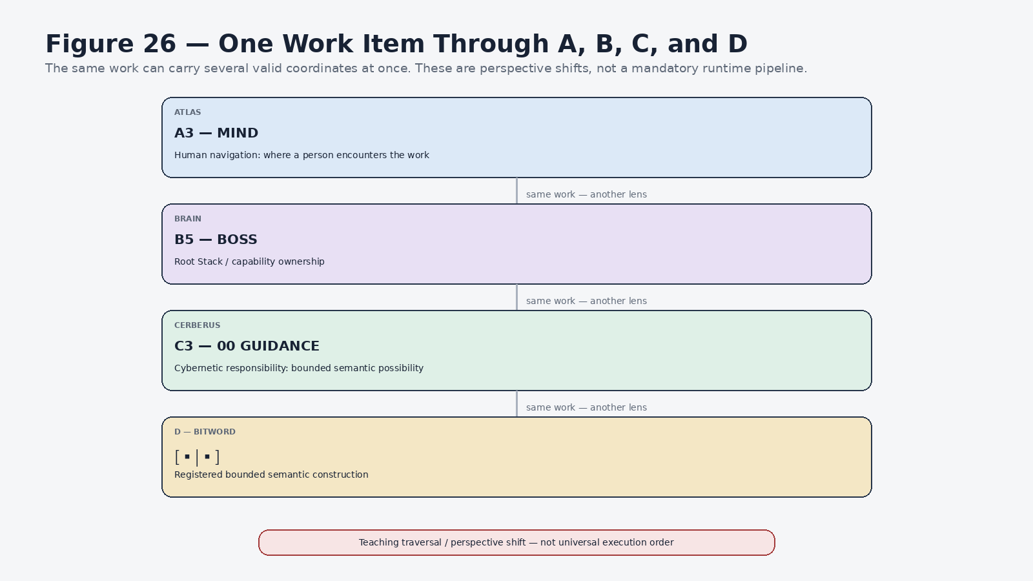
Figure 26. One work item through A, B, C, and D.
Do not convert this into a pipeline
A3 → B5 → C3 → D is a teaching perspective shift. Runtime can resolve the relevant structures through routing, permissions, Models, Rules, Operators, Readers, and other governed mechanisms appropriate to the task.

26. The complete A–G notation board
The wider notation architecture includes three additional languages. E — Routing describes where governed structure is and how traversal proceeds. F — BOOTSTRAP describes how the knowledge required to understand or operate a system is acquired and assembled. G — DARTBOARD describes how governed structure is manifested through operational or interface surfaces. This paper signposts them rather than teaching their full internal grammar.
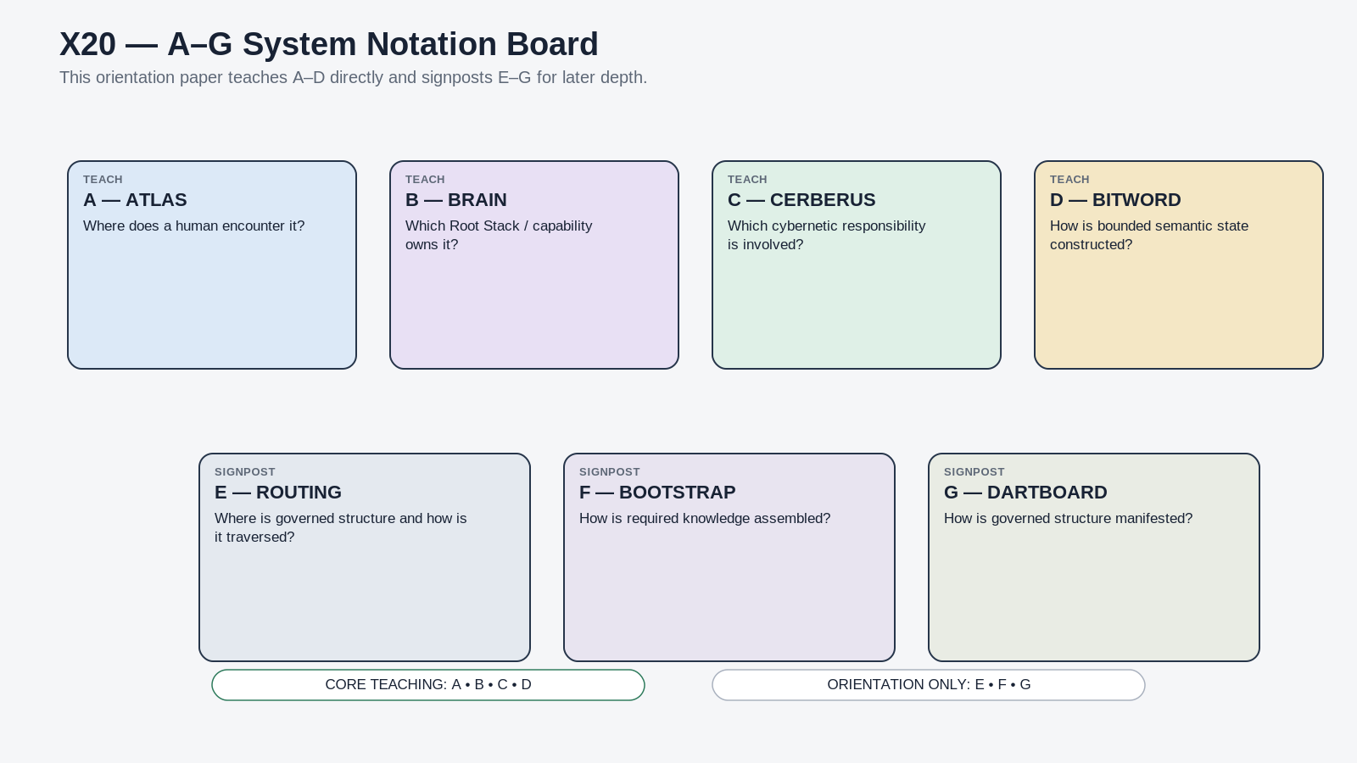
Figure 27. A–G system notation board.

27. Worked human example: planning an exercise routine
A human request such as “I want to plan a new exercise routine” illustrates why several lenses are useful. Atlas can surface the work through Physical and Action because those are intuitive human navigation areas. BRAIN routes deeper capability questions to the relevant Root Stacks. CERBERUS provides the responsibility grammar for identity, determination, guidance, action, rules, and operationalization. Appropriate Semantic Kernels can represent the required bounded state, while TIME can contribute temporal placement without becoming the owner of the exercise content itself.
The example should not be read as one fixed execution trace. Different tasks may enter the architecture through different routes, resolve permissions in different places, revisit Guidance after a Rule conflict, or operate across multiple Root Stacks. The value of the notation is that each piece of that work remains locatable and nameable even when the path changes.
Generalization test
The orientation is successful when a fresh reader can apply the same scaffold to a structurally different case — a book, relationship, legal obligation, creative project, robot task, simulation event, or journal entry — without needing a new architecture.

PART VIII
How to Continue
The compression paper should make deeper architecture easier to reach. It should never become the only place where the system can be understood.
Orientation
The compression paper should make deeper architecture easier to reach. It should never become the only place where the system can be understood.

28. Progressive disclosure into the BOOTSTRAP library
This document is the whole-system orientation layer. When the reader needs subsystem precision, the next route is the relevant BRAIN 1–10 compression paper. When that paper requires implementation depth, it should route into specialist specifications, exact Semantic Kernels, notation references, and the preserved historical corpus. The source graph remains available; the compression layer simply makes the route tractable.
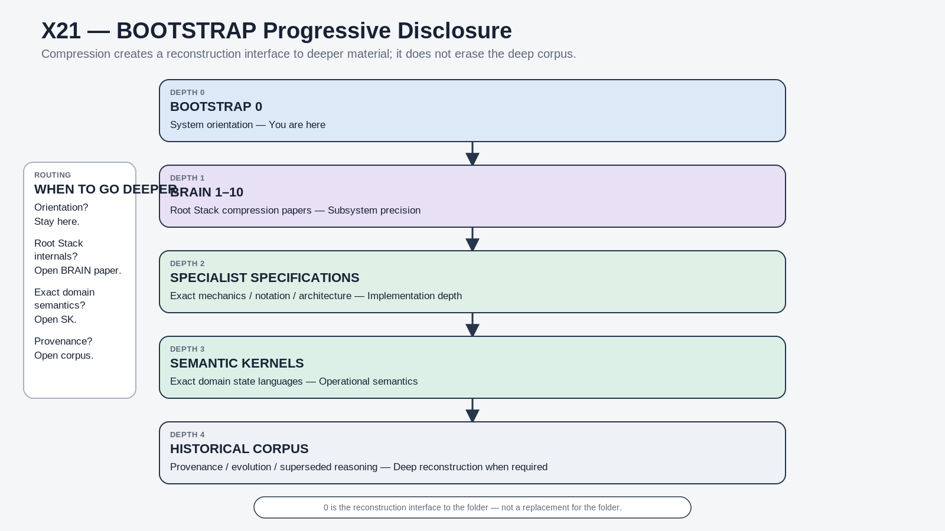
Figure 28. BOOTSTRAP progressive disclosure.

29. Reconstruction test
A fresh human or AI should be considered successfully oriented when it can answer the following questions without confusing navigation, capability ownership, cybernetic responsibility, or semantic construction:
- What is Atlas, and why is it a navigation lens rather than another data architecture?
- What are the current Atlas Bands, and why are Trials and TIME different?
- Why is Quest Center the Atlas-native name for Core rather than a separate system?
- What is BRAIN, and how do B1–B10 attach to the deeper Root Stack papers?
- Why are B11 and B12 outward uses rather than parts of the shared Core?
- What does the CERBERUS 0/X token grammar represent?
- Why is a Registry responsibility different from a NodeKey, Operator, Rule, Model, or Model Key?
- What is DRAGON, and why is it not a mandatory six-step pipeline?
- What is ARMORY, and why does accumulated experience not become the shared ontology?
- What does NodeKey Closure mean?
- What does Matryoshka recursion preserve?
- What is a Bit, BitGroup, and BitWord?
- Why must identity, address, and state remain distinct?
- Which deeper document should be opened when this orientation is insufficient?

Source Architecture & Provenance
This compression artifact reconstructs the current overarching system from the designated foundational architecture bundle, while preserving the distinction between current architecture, later corrections, specialist dependencies, and historical material.
Class | Source / correction | Use in this paper
Current foundational source | Matryoshka Nested Cybernetic Loops v0.2 | Whole-system nesting, shared zero, lenses, bounded cybernetics.
Current foundational source | System Notation Architecture v0.2 | A–G language separation, BRAIN mapping, CERBERUS position language, D-language orientation.
Current foundational source | Micro Architecture — From Bits Up v0.1 | Meaning before representation; identity/address/state; Bit and BitWord foundations.
Current foundational source | BRAIN — Base Registry Adaptive Intelligence Network v1.0 | Root Stack entry structure and Base-level capability organization.
Current foundational source | Meso Architecture — Beyond the Kernel v0.1 | Registry responsibility grammar; DRAGON/ARMORY; possibility vs actuality; larger loop.
Orientation context | SSS AAA — Global Epistemic Flywheel v0.1 | Shared SOLAR context and progressive epistemic orientation.
Cohesion / reading guide | Cohesion Guide v0.1 | Address vs identity; structural rhyme vs canonical identity; core vs specialist authority.
Cross-system dependency | TIME_DESCRIPTIVE-101 Community Descriptive Semantic Kernel Specification v0.1 | Supports the current Atlas Band 9 TIME boundary without expanding this paper into the full TIME specification.
Current correction | Atlas current mapping | 1 Physical, 2 Relations, 3 Mind, 4 Responsibilities, 5 Values, 6 Action, 7 Archives, 8 Trials, 9 TIME, 0/10 Core / Quest Center.
Historical / superseded | Earlier Atlas A9 Management snapshot | Preserved as history; not used as the current Atlas map.

Canonical reconstruction principle
Where later source material or explicit architecture corrections supersede earlier snapshots, the current reconstruction teaches the later architecture while preserving the earlier state as provenance rather than silently blending both.

Closing Orientation
The overarching system can now be read from the outside in. Atlas makes the architecture humanly navigable. BRAIN locates the major capability domain. CERBERUS names the cybernetic responsibility. DRAGON organizes active governed work. ARMORY preserves accumulated operational product and reflective context. Bit notation explains how bounded semantic state is constructed beneath those higher layers. The shared Core holds the lenses together without collapsing them into one language.
That scaffold is intentionally compact. Its success is not measured by how many historical pages it replaces, but by whether a fresh reader can enter any BRAIN 1–10 document and immediately understand where that document belongs, what kind of questions it answers, which distinctions must remain intact, and where to go next when more depth is required.
Final reconstruction sentence
Navigate with Atlas. Locate capability with BRAIN. Operate through CERBERUS. Learn through DRAGON and ARMORY. Construct bounded meaning with Bits and BitWords. Then follow the BRAIN paper that owns the depth you need.

