CERBERUS
FIELD_EFFECT-64
Candidate Semantic Kernel Specification
Procedural Pattern Generation Over Declared Effect Domains
CORE SPECIFICATION STATEMENT
FIELD_EFFECT-64 defines a bounded procedural Generator Semantic Kernel that evaluates a registered Formula Profile over a supplied Effect Domain to produce a typed procedural Field Signal. It declares the pattern family, exact Formula Profile selection, domain basis, spatial scale, temporal rate, phase, waveform or shape semantics, propagation direction and speed, falloff/envelope, controlled variation, seed/stability behavior, output shaping, and interpretation version.

Field | Specification
Document | CERBERUS FIELD_EFFECT-64 Candidate Semantic Kernel Specification
Version | 0.1
Date | August 2026
Series | FIELD_EFFECT-64
Member | FIELD_EFFECT-64¹
Effects Studio Role | FIELD_EFFECT / Generator
Bounded Question | What mathematical pattern is generated over the supplied domain?
Hard Effect-SK Dependencies | None; requires a supplied Effect Domain / adapter and registered Formula Profile semantics
Output | Typed Effect Field Signal
Authoring Basis | CERBERUS Semantic Kernel Specification Authoring Standard v1.0; Effects Studio SK Interoperability Reference v0.1; MASK-32-64 visual precedent; AUDIO_EFFECT-64 v0.2 visual-first precedent
Spec Role | Human-facing instruction manual, planning artifact, and compressed map of the live record architecture
Spec Class | Candidate Spec: Reader topology, physical allocation, candidate D requirements, and semantic contracts are planned; exact registered D#.# / BOSS / COLOR / Formula records remain an implementation promotion gate.

Section Index
Ref. | Section
Part 1 | Purpose, scope, ownership, interoperability, and normative laws
Part 2 | Member architecture, mathematical inventory, and Reader topology
Part 3 | FIELD_EFFECT-64¹ Reader-role interface specifications
Part 4 | Interface-0, D requirements, and complete DARTBOARD
Part 5 | Binary encoding, Reader algorithm, output, and interoperability
Part 6 | Worked examples, invalid states, and conformance
Part 7 | Planning handoff and promotion gate
Appendix A | Complete Reader state enumerations
Appendix B | Complete B000:B063 physical Bit map
Appendix C | Candidate D requirement index
Appendix D | Conformance / build checklist

SPEC ROLE
The records are the working machine. This document is the compressed human map: an illustrated instruction manual for learning, refreshing, reviewing, planning, and teaching how FIELD_EFFECT-64¹ is built and used. Runtime operation should resolve the live records directly rather than parse this document.

INTERPRETATION RULE
Reusable SCALAR BitGroups remain mathematical. Pattern Family, Phase, Propagation Speed, Variation, and every other Field-specific meaning arise only through FIELD Reader placement. Figures are explanatory projections for humans and do not become canonical semantic identity.

Part 1 — Purpose, Scope, Ownership, Interoperability, and Normative Laws

1. Purpose and Bounded Question
FIELD_EFFECT-64¹ is the bounded Effects Studio Generator for procedural patterns over supplied mathematical domains. It answers one question: what mathematical pattern is generated over this domain? The same generated Field may drive movement, light, color, geometry, particles, audio, haptics, camera behavior, masking, or another compatible consumer without becoming any of those downstream application semantics.
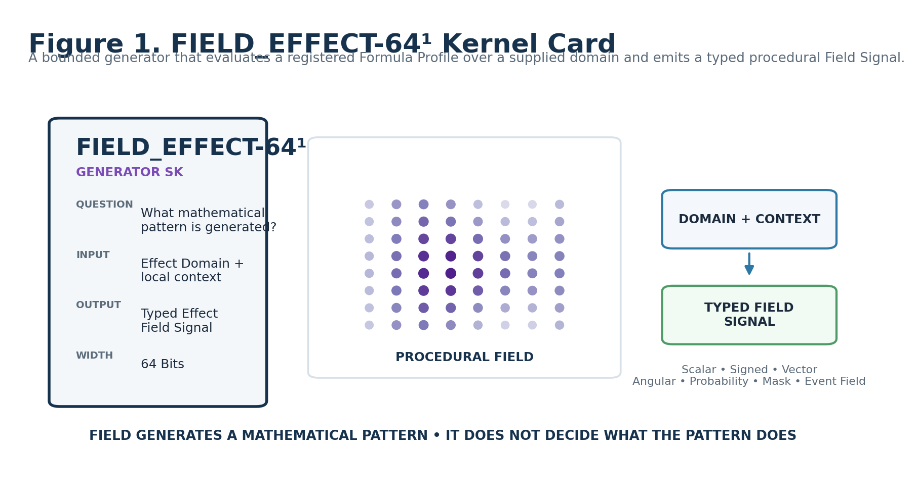
Figure 1. FIELD_EFFECT-64¹ Kernel Card.

2. Ownership and Non-Ownership
FIELD owns | FIELD does not own
Pattern family and selected registered Formula Profile | Canonical target identity, target ontology, or source geometry
Domain-basis interpretation required by the Formula | Canonical world coordinates or Frame identity
Spatial scale, temporal rate, phase, waveform, propagation, envelope, and controlled variation | Global start, duration, repetition, synchronization, or scene placement
Seed/stability and output-shaping semantics | Movement, Light, Color, Geometry, Material, Particle, Audio, Haptic, Camera, or other application meaning
Typed Field Signal emission and validity | Renderer implementation, world consequence, or downstream action
Explicit domain requirements and unresolved behavior | Silent fabrication of missing normals, tangents, paths, distances, Frames, or other domain data

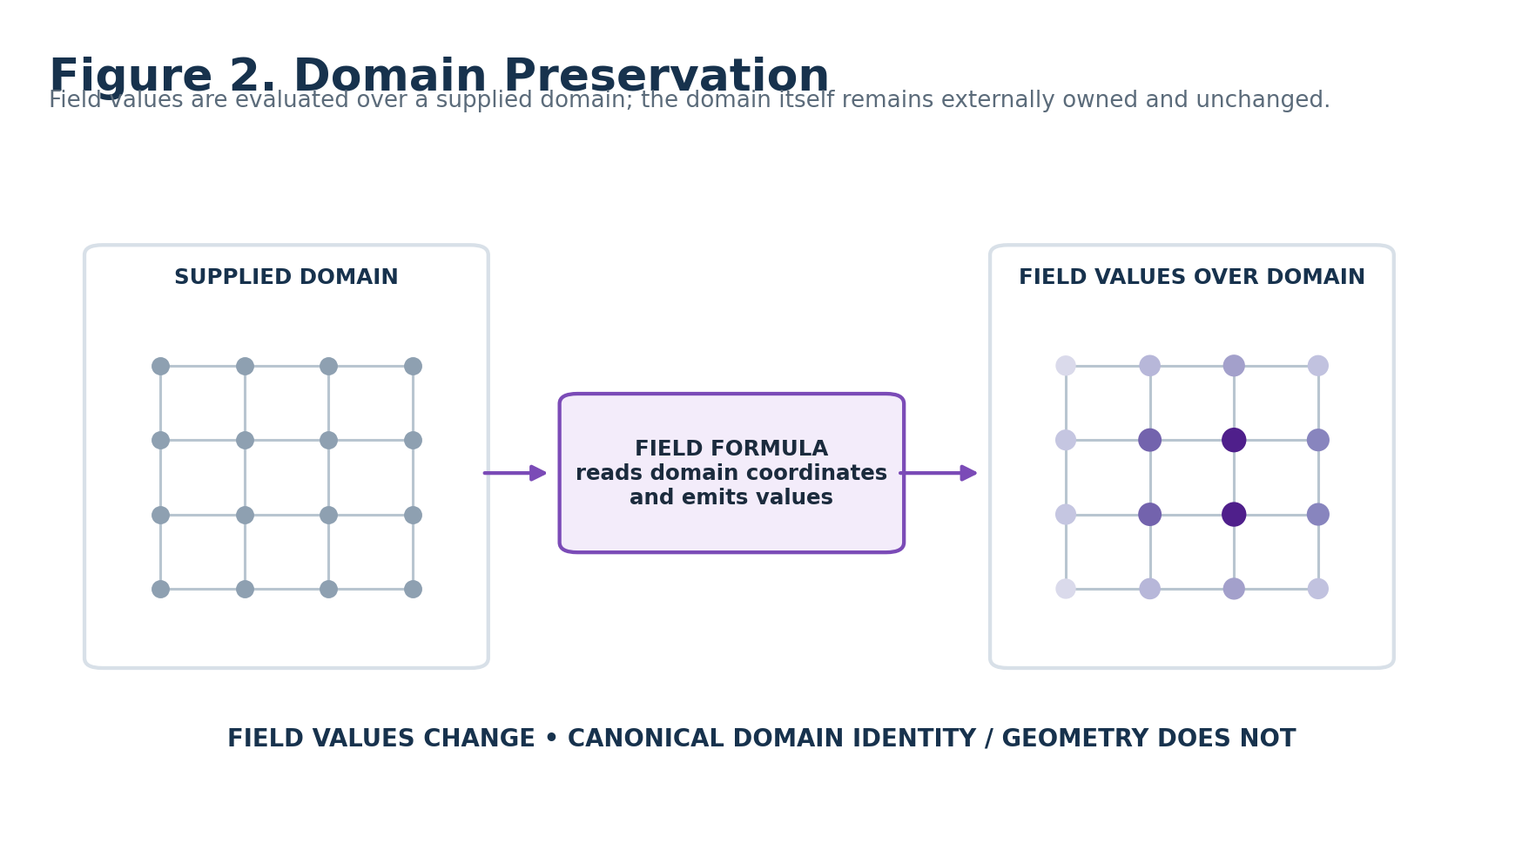
Figure 2. Domain Preservation: values are generated over the domain without rewriting it.

3. Shared-Cause Interoperability
FIELD is intentionally useful because its output is a typed procedural cause rather than an application effect. A single Shimmer Field may feed several Application SKs. Each consumer preserves its own ownership boundary, while provenance remains traceable to one upstream field generator.
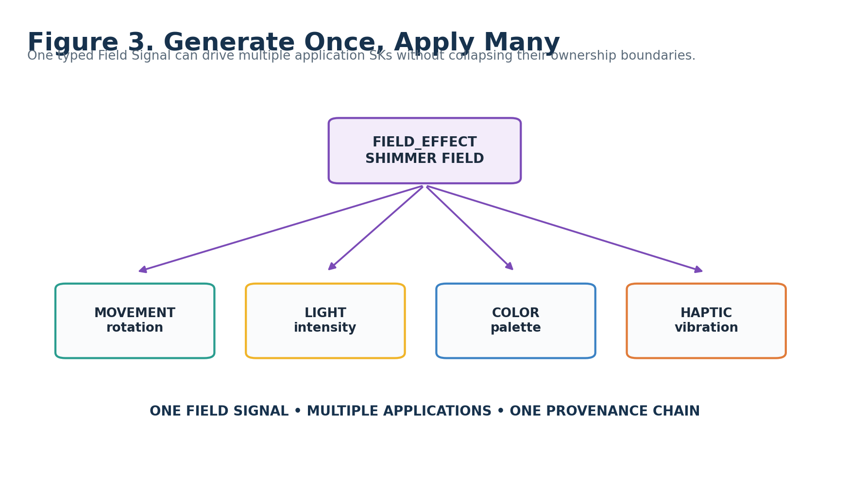
Figure 3. One Field Signal can drive multiple independent application semantics.

4. Effect Domain Adapter
FIELD consumes a declared mathematical view of the target domain. Different target kinds may expose points, axes, paths, surfaces, regions, volumes, or other normalized domain structures through an adapter. The Formula Profile declares which fields are required. FIELD does not need target-specific ontology merely to evaluate the pattern.
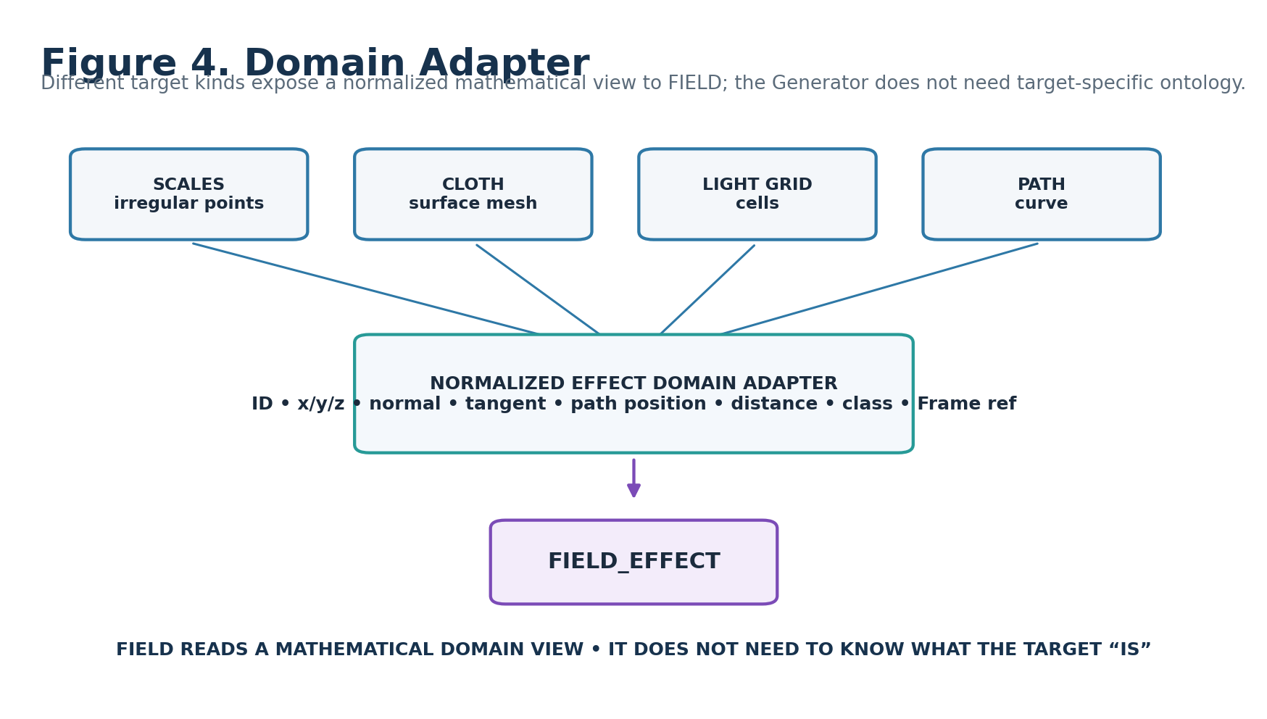
Figure 4. Domain Adapter: diverse target kinds expose a normalized mathematical view to FIELD.

5. Normative FIELD Laws
Law | Normative statement
FIELD-R01 Bounded Generation | FIELD SHALL generate procedural Field semantics only; downstream application meaning remains externally owned.
FIELD-R02 Domain Preservation | FIELD SHALL sample the supplied domain without silently mutating its canonical geometry, identity, or retained source.
FIELD-R03 Typed Output | Every resolved output SHALL expose its declared Effect Signal Class and semantic basis.
FIELD-R04 Pattern/Profile Separation | Pattern Family SHALL identify the conceptual procedural family; Formula Profile SHALL own the exact registered equation and interpretation contract.
FIELD-R05 Basis Declaration | Any Formula Profile requiring domain coordinates or relations SHALL validate that the declared Domain Basis is available.
FIELD-R06 Local Timing | Temporal Rate and Phase are intrinsic FIELD semantics; global start, duration, repetition, and synchronization remain externally owned.
FIELD-R07 Rate/Speed Separation | Temporal Rate and Propagation Speed SHALL remain distinct when the active Formula Profile uses both.
FIELD-R08 Formula Locality | Primitive Bits and generic SCALAR BitGroups SHALL NOT embed Field-specific equations or domain meaning.
FIELD-R09 Explicit Output Shaping | Raw, normalized, bipolar, rectified, remapped, or profile-shaped output behavior SHALL remain inspectable.
FIELD-R10 Stochastic Declaration | Controlled irregularity SHALL expose Variation and Seed/Stability behavior sufficient to determine replay posture.
FIELD-R11 Safe Zero | A1=0 SHALL resolve to NO FIELD / OFF and SHALL NOT fabricate a procedural pattern.
FIELD-R12 No Silent Coercion | Unavailable domain fields or incompatible Formula requirements SHALL remain unresolved unless a declared transform/profile explicitly handles them.
FIELD-R13 Application Non-Ownership | FIELD SHALL NOT become Movement, Light, Color, Geometry, Material, Particle, Audio, Haptic, Camera, or other application semantics.
FIELD-R14 Human Reconstructibility | The instruction manual SHALL preserve enough structure for a knowledgeable human to understand how the BitWord was built without treating the document as runtime truth.

Part 2 — Member Architecture, Mathematical Inventory, and Reader Topology

6. Minimum Sufficient Resolution
FIELD begins at 64¹. A 32-bit member would be misleading because four continuous controls—Spatial Scale, Temporal Rate, Phase, and Propagation Speed—already consume 32 Bits at eight-bit resolution before the Generator can declare Pattern Family, Formula Profile, basis, waveform, direction, falloff, variation, seed policy, output shaping, or version.
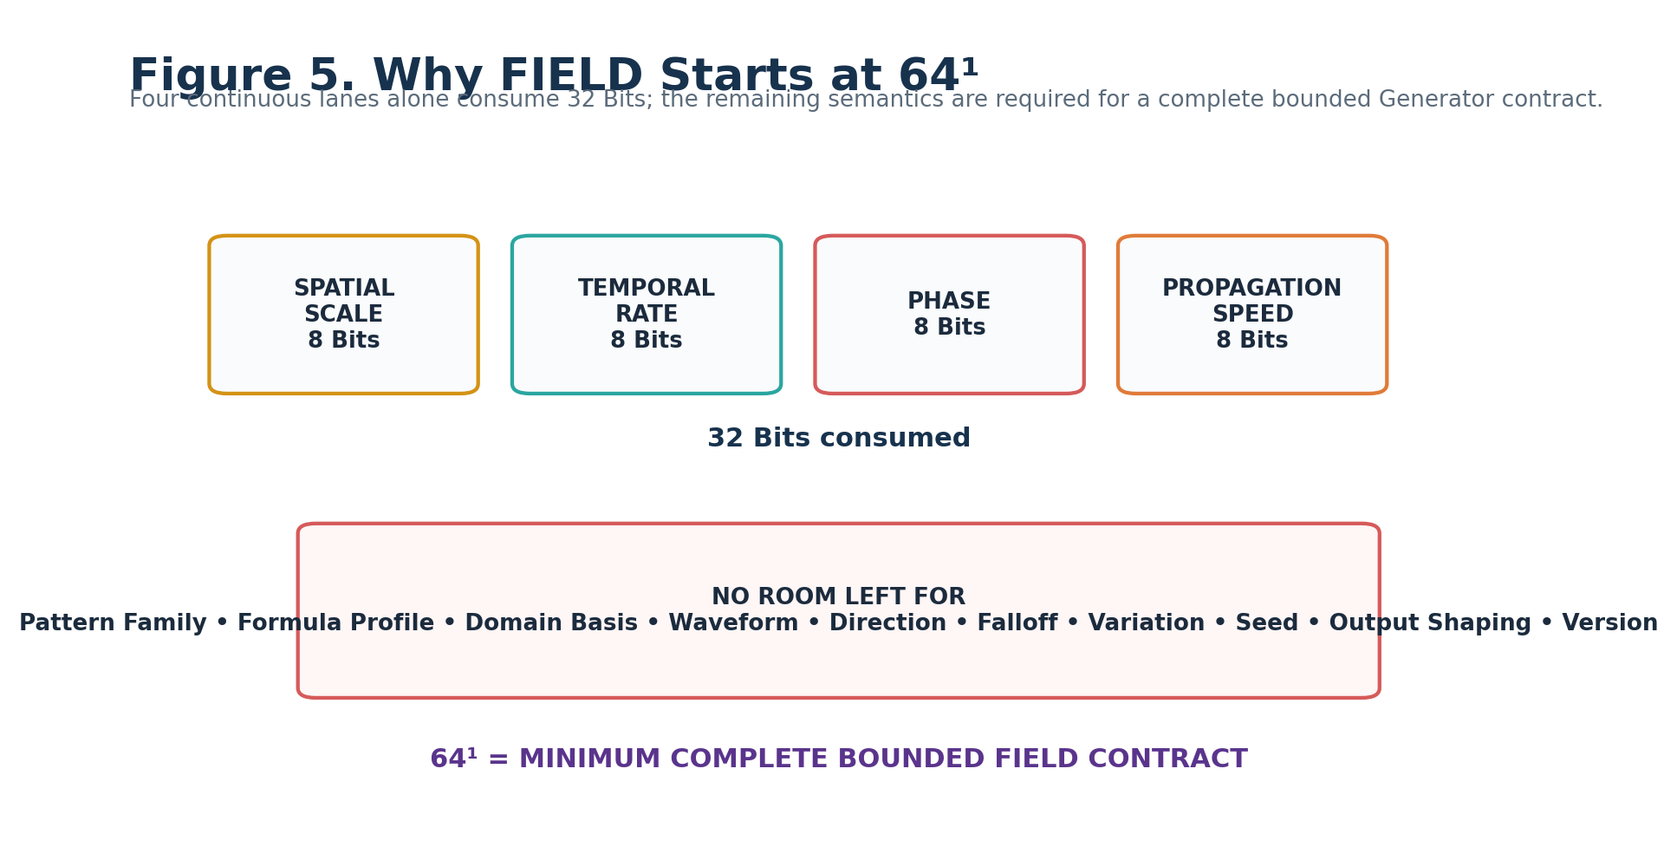
Figure 5. Why there is no FIELD_EFFECT-32¹ member.

7. Mathematical BitGroup Inventory
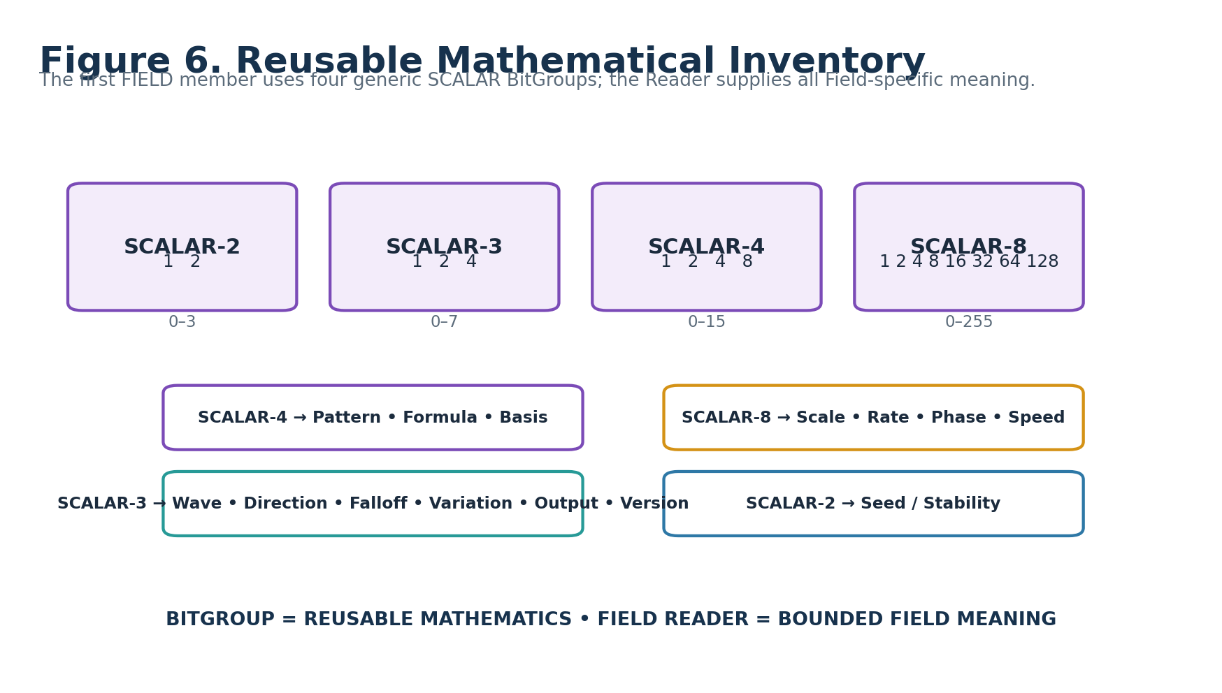
Figure 6. Reusable SCALAR inventory used by FIELD_EFFECT-64¹.
BitGroup | Width | Formula | Range | FIELD uses
SCALAR-2 | 2 | Σ bᵢ·2ⁱ | 0–3 | Seed / Stability
SCALAR-3 | 3 | Σ bᵢ·2ⁱ | 0–7 | Waveform, Direction, Falloff, Variation, Output Shaping, Version
SCALAR-4 | 4 | Σ bᵢ·2ⁱ | 0–15 | Pattern Family, Formula Profile / Variant, Domain Basis
SCALAR-8 | 8 | Σ bᵢ·2ⁱ | 0–255 | Spatial Scale, Temporal Rate, Phase, Propagation Speed

No FIELD Reader lane in v0.1 uses additive numeric continuation across multiple placements. Every SCALAR placement is a distinct semantic role. A future higher-resolution member must preserve B000:B063 literally and earn any added Reader lanes or numeric depth through a new bounded capability.

8. Physical Allocation
Reader | Bits | BitGroup | FIELD Reader meaning
A1 | B000:B003 | SCALAR-4 | Pattern Family
B1 | B004:B007 | SCALAR-4 | Pattern Variant / Formula Profile
C1 | B008:B011 | SCALAR-4 | Domain Basis
D1 | B012:B019 | SCALAR-8 | Spatial Scale / Frequency
E1 | B020:B027 | SCALAR-8 | Temporal Rate / Frequency
F1 | B028:B035 | SCALAR-8 | Phase
G1 | B036:B038 | SCALAR-3 | Waveform / Shape
H1 | B039:B041 | SCALAR-3 | Propagation Direction
I1 | B042:B049 | SCALAR-8 | Propagation Speed
J1 | B050:B052 | SCALAR-3 | Falloff / Envelope
K1 | B053:B055 | SCALAR-3 | Noise / Variation
L1 | B056:B057 | SCALAR-2 | Random Seed / Stability
M1 | B058:B060 | SCALAR-3 | Output Shaping
N1 | B061:B063 | SCALAR-3 | Version / Reserved

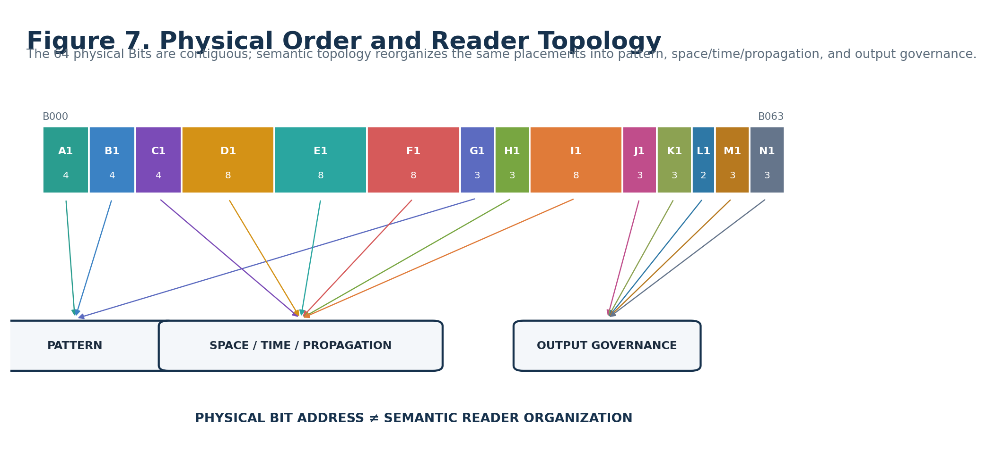
Figure 7. Physical order and semantic Reader topology.

9. Scale, Rate, and Propagation Are Different Questions
Spatial Scale, Temporal Rate, and Propagation Speed can all make a pattern appear “faster” or “denser” in casual language, but they are not interchangeable. Spatial Scale changes pattern density over the domain. Temporal Rate changes local evolution through time. Propagation Speed changes how quickly the pattern travels through the domain.
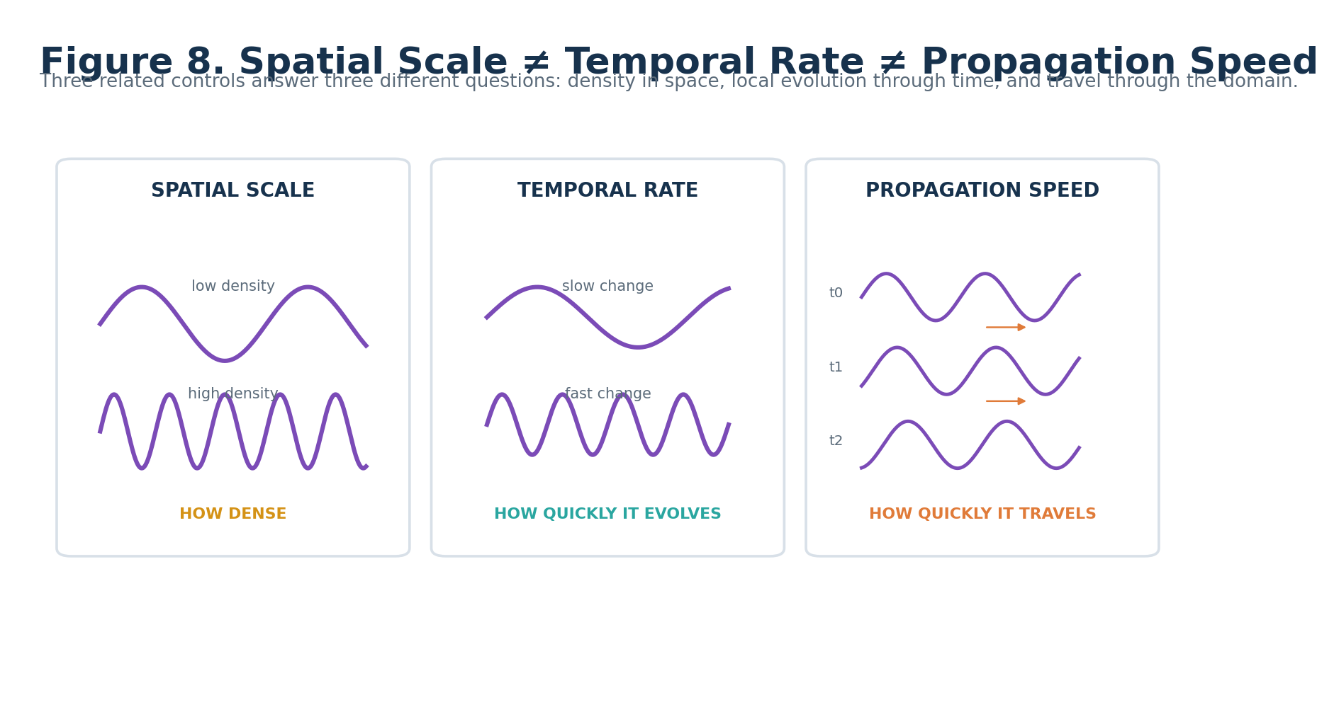
Figure 8. Spatial Scale, Temporal Rate, and Propagation Speed remain semantically distinct.

10. Pattern Family and Formula Profile
A1 describes the conceptual procedural family. B1 selects the registered mathematical interpretation within that family. The same Pattern Family can therefore remain stable while its precise equation, required domain data, invalid conditions, or output class change through a versioned Formula Profile.
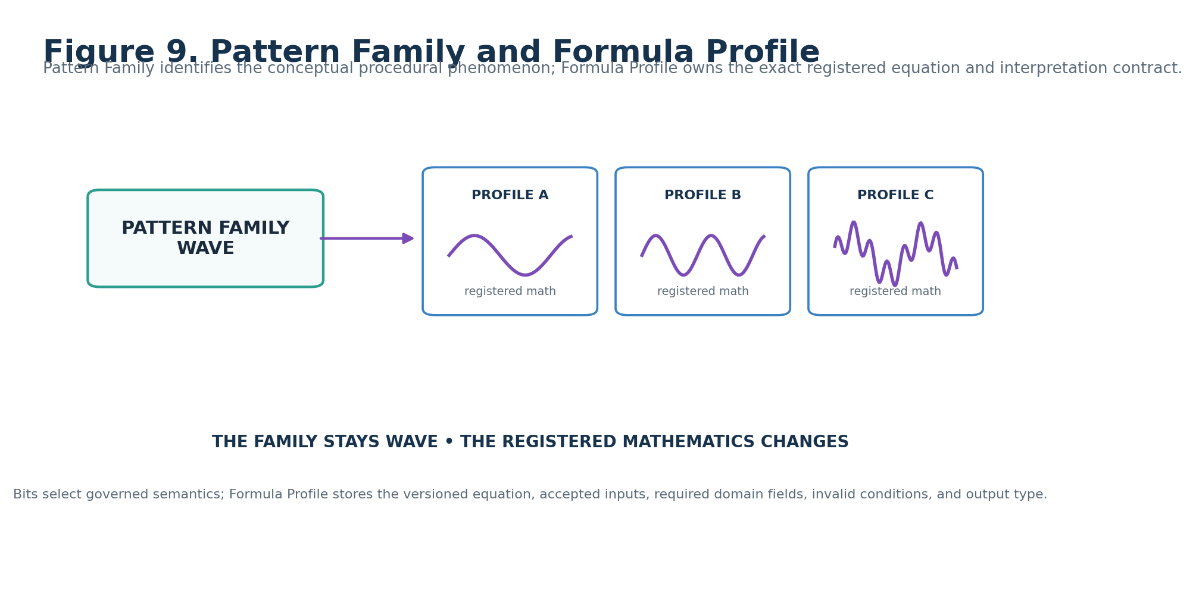
Figure 9. Pattern Family is conceptual; Formula Profile owns the exact equation.

Part 3 — FIELD_EFFECT-64¹ Reader-Role Interface Specifications
FIGURE CONTRACT
Each semantic Reader role below uses the same document grammar: declaration strip, real interface control, role-specific consequence viewport, Candidate D Class/requirement, mathematical carrier, zero/unset behavior, validation boundary, and non-ownership. The shell repeats; the semantic diagram does not.

11. Pattern Family — A1
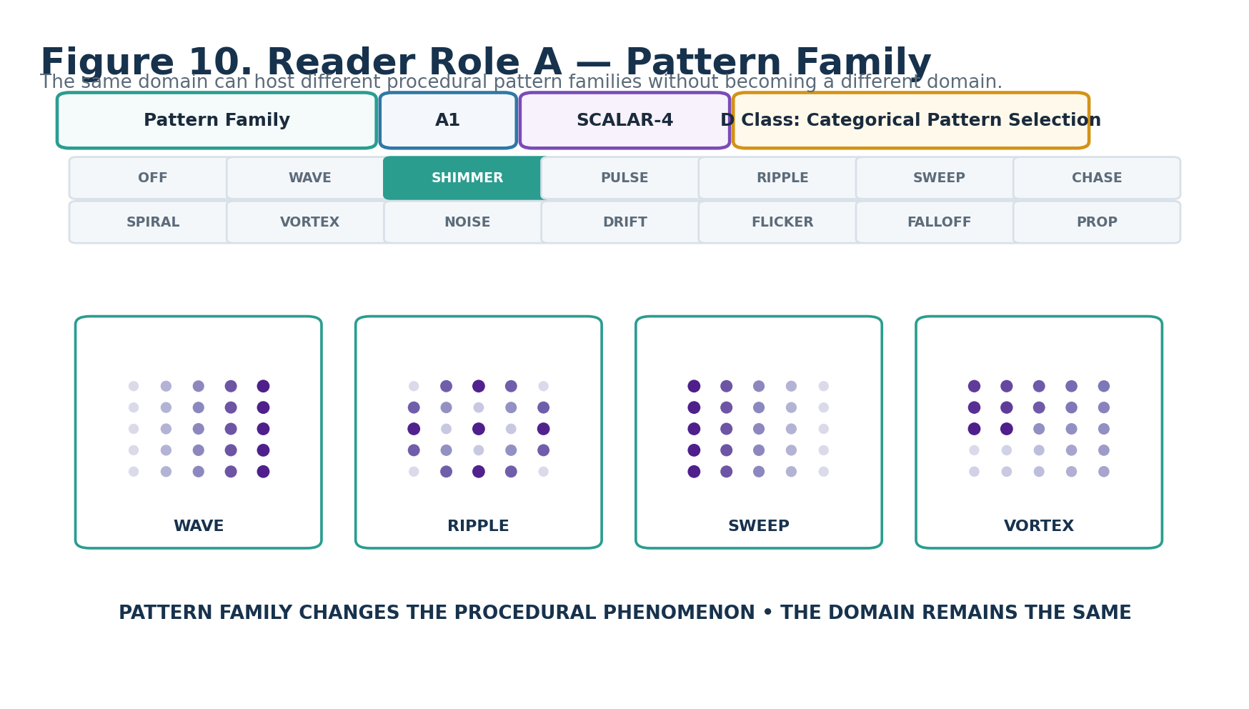
Figure 10. Pattern Family — A1.
DECLARATION
Pattern Family | A1 | SCALAR-4 | DREQ-CAT.FIELD_PATTERN
Property | Contract
D Class | Categorical Pattern Selection
D Requirement Key | DREQ-CAT.FIELD_PATTERN
Purpose | Defines the conceptual procedural pattern family. A1=0 is OFF / NO FIELD and suppresses generated Field output.
Representative states | 0 OFF; 1 WAVE; 2 SHIMMER; 3 PULSE; 4 RIPPLE; 5 SWEEP; 6 CHASE; 7 SPIRAL; 8 VORTEX; 9 NOISE; 10 DRIFT; 11 FLICKER; 12 FALLOFF; 13 PROPAGATION; 14–15 RESERVED
Validation / boundary | A1=0 is safe zero. Family selection does not contain the exact formula; B1 resolves the registered Formula Profile / variant.

12. Pattern Variant / Formula Profile — B1
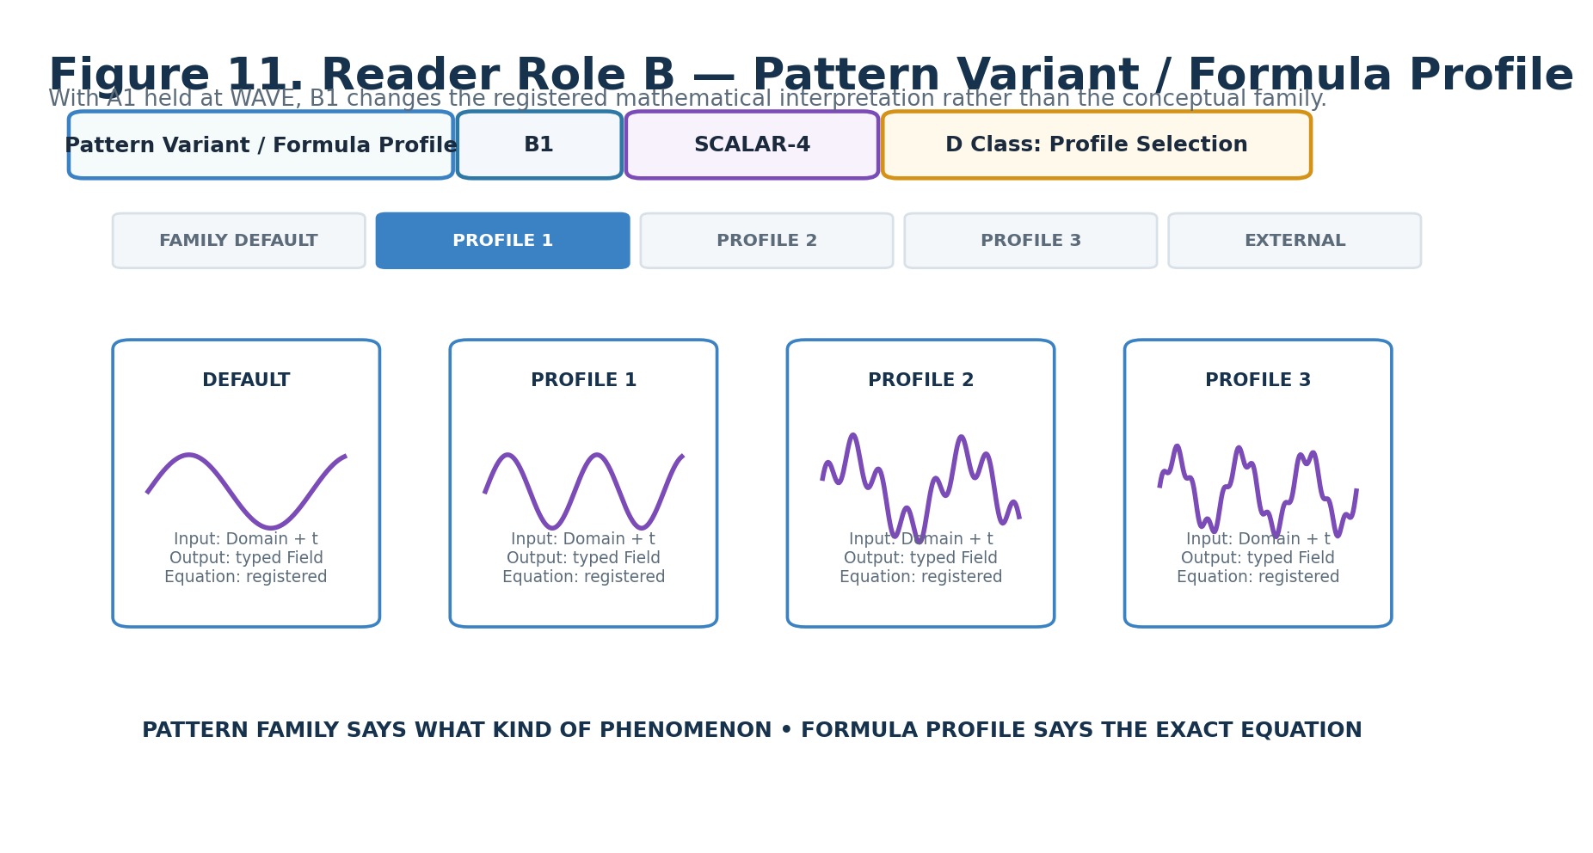
Figure 11. Pattern Variant / Formula Profile — B1.
DECLARATION
Pattern Variant / Formula Profile | B1 | SCALAR-4 | DREQ-PROFILE.FIELD_FORMULA
Property | Contract
D Class | Profile Selection
D Requirement Key | DREQ-PROFILE.FIELD_FORMULA
Purpose | Selects the registered Formula Profile or bounded variant used within the active Pattern Family.
Representative states | 0 FAMILY_DEFAULT; 1–14 REGISTERED_PROFILE / VARIANT slots governed by the active family; 15 EXTERNAL / RESERVED
Validation / boundary | The selected profile MUST declare accepted domain/context, required fields, exact equation, output Signal Class, undefined conditions, determinism posture, and human explanation.

13. Domain Basis — C1
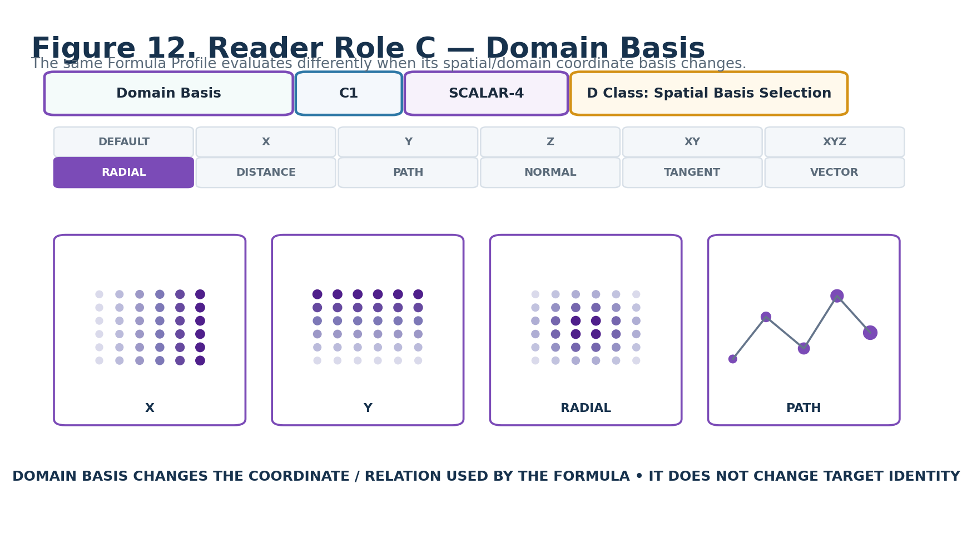
Figure 12. Domain Basis — C1.
DECLARATION
Domain Basis | C1 | SCALAR-4 | DREQ-SPATIAL.DOMAIN_BASIS
Property | Contract
D Class | Spatial Basis Selection
D Requirement Key | DREQ-SPATIAL.DOMAIN_BASIS
Purpose | Declares the coordinate, relation, or supplied basis through which the active Formula Profile evaluates the domain.
Representative states | 0 PROFILE_DEFAULT; 1 X; 2 Y; 3 Z; 4 XY; 5 XZ; 6 YZ; 7 XYZ; 8 RADIAL; 9 DISTANCE; 10 PATH_DISTANCE; 11 NORMAL; 12 TANGENT; 13 SUPPLIED_VECTOR; 14–15 RESERVED
Validation / boundary | The Domain Adapter MUST expose the required basis. Missing normals, tangents, paths, distances, or vectors remain unresolved unless the Formula Profile declares a valid fallback.

14. Spatial Scale / Frequency — D1
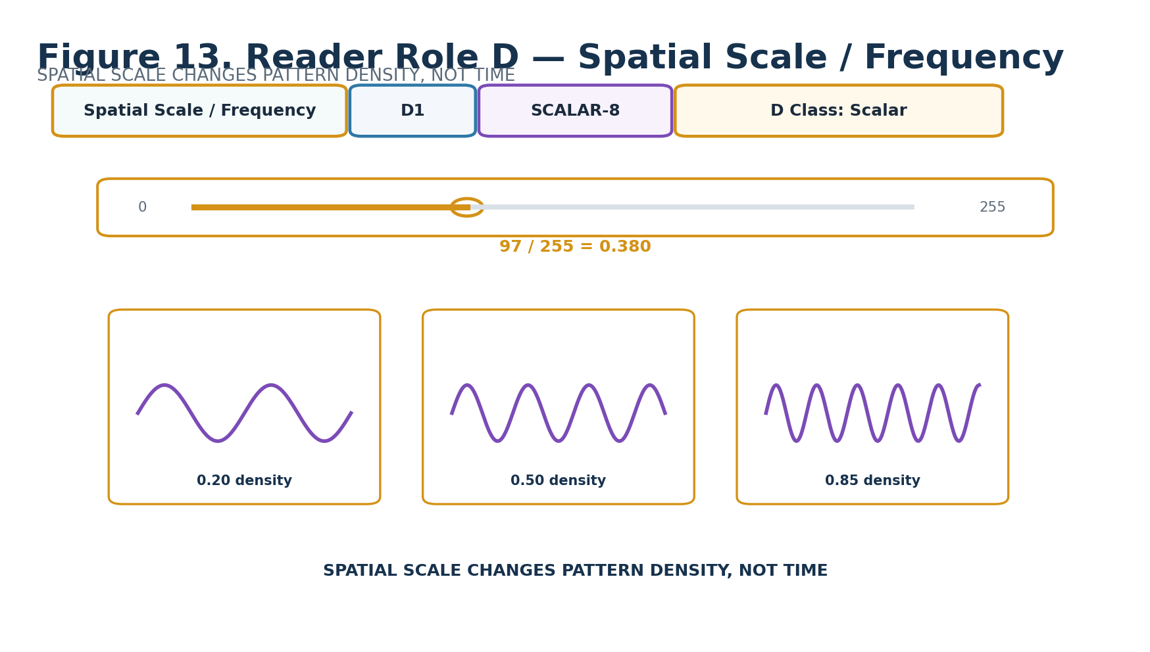
Figure 13. Spatial Scale / Frequency — D1.
DECLARATION
Spatial Scale / Frequency | D1 | SCALAR-8 | DREQ-SCALAR.SPATIAL_SCALE
Property | Contract
D Class | Scalar
D Requirement Key | DREQ-SCALAR.SPATIAL_SCALE
Purpose | Carries a normalized spatial-scale coordinate σ = D1 / 255 for the active Formula Profile.
Representative states | 0 → 0.000; 64 → 0.251; 97 → 0.380; 128 → 0.502; 255 → 1.000
Validation / boundary | Normalization is FIELD Reader semantics, not SCALAR-8 identity. Physical wavelength or domain-unit scale belongs to the Formula Profile / domain mapping.

15. Temporal Rate / Frequency — E1
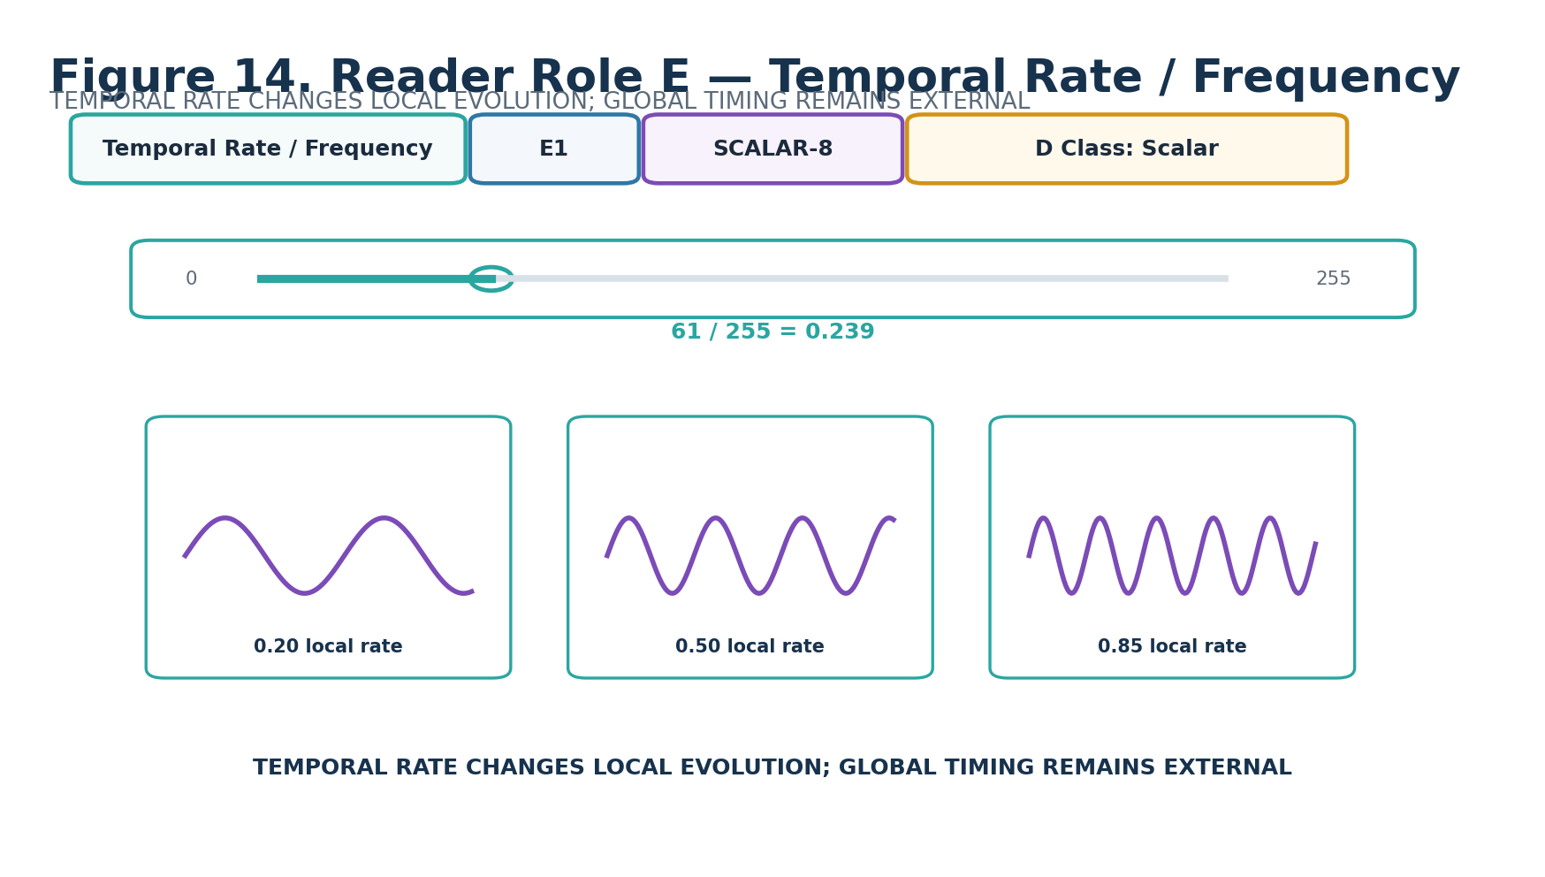
Figure 14. Temporal Rate / Frequency — E1.
DECLARATION
Temporal Rate / Frequency | E1 | SCALAR-8 | DREQ-SCALAR.TEMPORAL_RATE
Property | Contract
D Class | Scalar
D Requirement Key | DREQ-SCALAR.TEMPORAL_RATE
Purpose | Carries a normalized intrinsic temporal-rate coordinate r = E1 / 255.
Representative states | 0 frozen / minimum profile rate; 61 → 0.239; 128 → 0.502; 255 → 1.000 profile maximum
Validation / boundary | E1 governs local pattern evolution. Global start, duration, repeat, synchronization, and scene timing remain externally owned.

16. Phase — F1
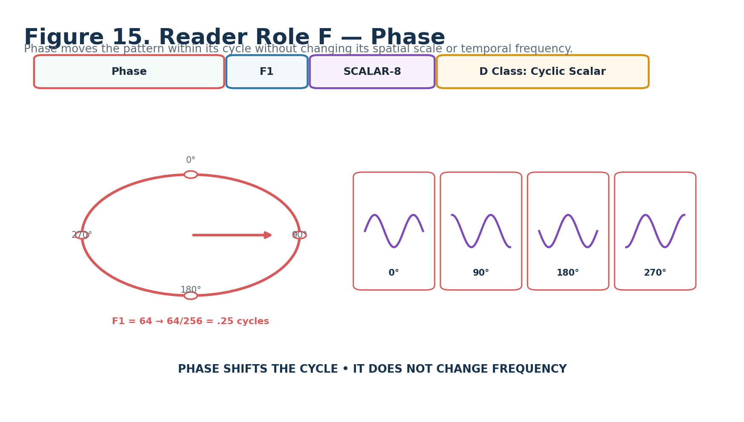
Figure 15. Phase — F1.
DECLARATION
Phase | F1 | SCALAR-8 | DREQ-CYCLE.PHASE
Property | Contract
D Class | Cyclic Scalar
D Requirement Key | DREQ-CYCLE.PHASE
Purpose | Carries the pattern phase as φ = F1 / 256 cycles, equivalent to θ = 2πF1/256.
Representative states | 0 → 0°; 64 → 90°; 128 → 180°; 192 → 270°; 255 → 358.59375°
Validation / boundary | The /256 mapping provides 256 unique phase states on [0,1) without duplicating the zero position at both ends. Phase does not change frequency.

17. Waveform / Shape — G1
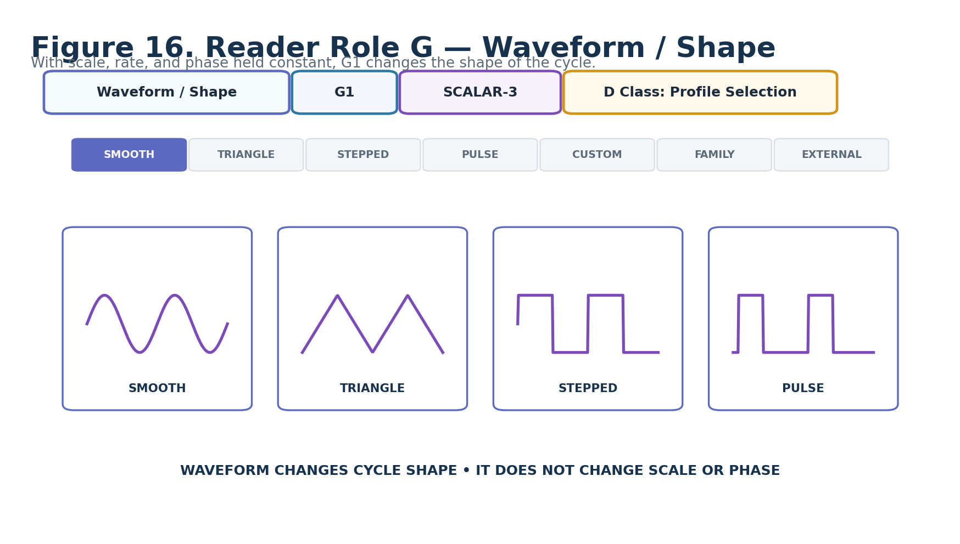
Figure 16. Waveform / Shape — G1.
DECLARATION
Waveform / Shape | G1 | SCALAR-3 | DREQ-PROFILE.WAVEFORM
Property | Contract
D Class | Profile Selection
D Requirement Key | DREQ-PROFILE.WAVEFORM
Purpose | Selects the semantic shape of the active cycle or family-specific local profile.
Representative states | 0 SMOOTH; 1 TRIANGULAR; 2 STEPPED; 3 PULSE_WIDTH; 4 CUSTOM_PROFILE; 5 FAMILY_SPECIFIC; 6 EXTERNAL; 7 RESERVED
Validation / boundary | Exact curve equations remain Formula/Profile-owned. Changing G1 does not silently change Spatial Scale, Temporal Rate, or Phase.

18. Propagation Direction — H1
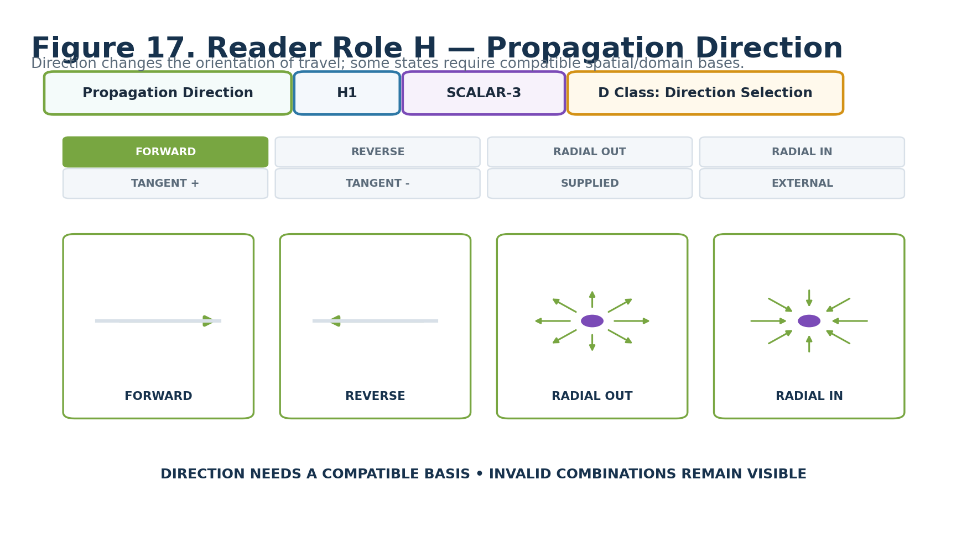
Figure 17. Propagation Direction — H1.
DECLARATION
Propagation Direction | H1 | SCALAR-3 | DREQ-DIR.PROPAGATION
Property | Contract
D Class | Direction Selection
D Requirement Key | DREQ-DIR.PROPAGATION
Purpose | Declares the semantic direction through which a propagating pattern travels.
Representative states | 0 FORWARD/POSITIVE; 1 REVERSE/NEGATIVE; 2 RADIAL_OUT; 3 RADIAL_IN; 4 TANGENT_FORWARD; 5 TANGENT_REVERSE; 6 SUPPLIED_ORIENTATION; 7 PROFILE/EXTERNAL
Validation / boundary | Direction states requiring radial/tangent/supplied orientation are valid only when compatible domain basis/context exists. Invalid combinations are not silently remapped.

19. Propagation Speed — I1
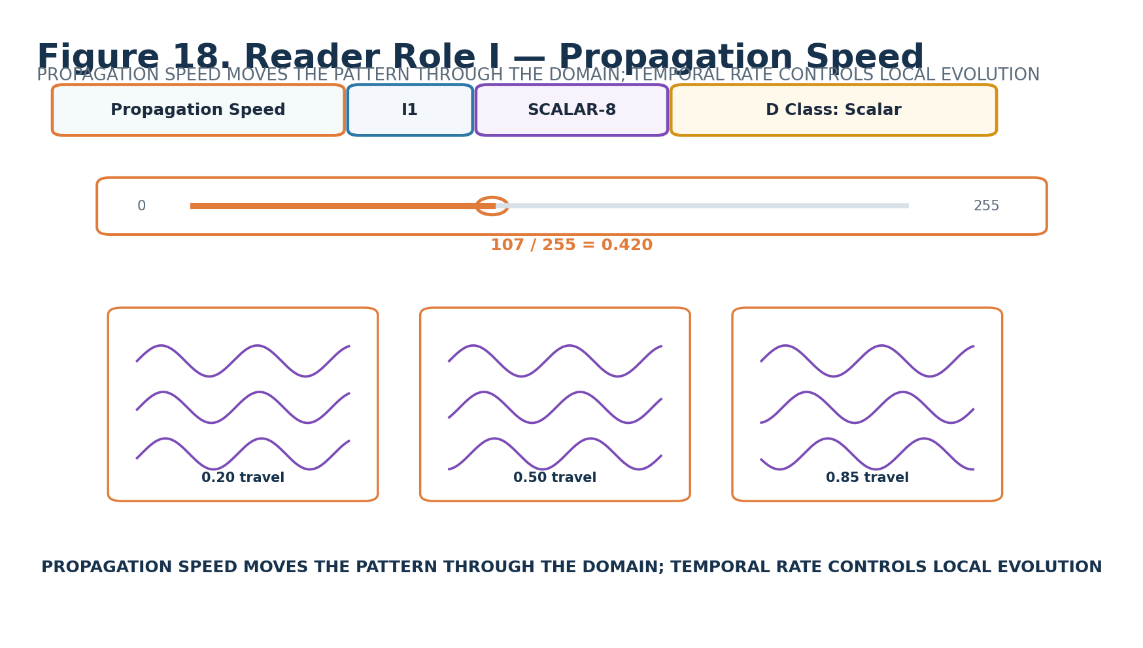
Figure 18. Propagation Speed — I1.
DECLARATION
Propagation Speed | I1 | SCALAR-8 | DREQ-SCALAR.PROPAGATION_SPEED
Property | Contract
D Class | Scalar
D Requirement Key | DREQ-SCALAR.PROPAGATION_SPEED
Purpose | Carries normalized travel speed v = I1 / 255 for propagating Formula Profiles.
Representative states | 0 stationary; 107 → 0.420; 128 → 0.502; 255 → 1.000 profile maximum
Validation / boundary | Propagation Speed describes travel through the domain. It is distinct from Temporal Rate, which describes local pattern evolution.

20. Falloff / Envelope — J1
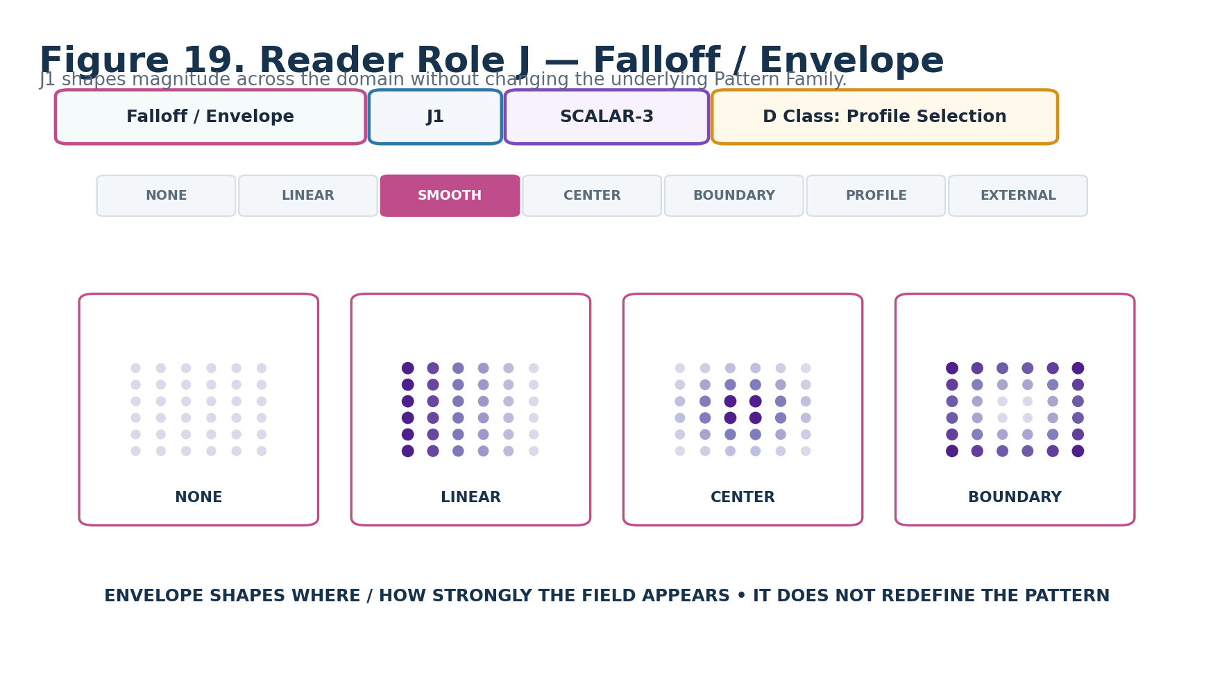
Figure 19. Falloff / Envelope — J1.
DECLARATION
Falloff / Envelope | J1 | SCALAR-3 | DREQ-PROFILE.FIELD_FALLOFF
Property | Contract
D Class | Profile Selection
D Requirement Key | DREQ-PROFILE.FIELD_FALLOFF
Purpose | Selects how generated magnitude is shaped across the active domain or boundary context.
Representative states | 0 NONE/UNIFORM; 1 LINEAR; 2 SMOOTH; 3 CENTER_EMPHASIS; 4 BOUNDARY_FADE; 5 PROFILE/MODEL; 6 EXTERNAL; 7 RESERVED
Validation / boundary | The exact profile equation remains externally registered. Envelope changes spatial magnitude shaping without redefining Pattern Family.

21. Noise / Variation — K1
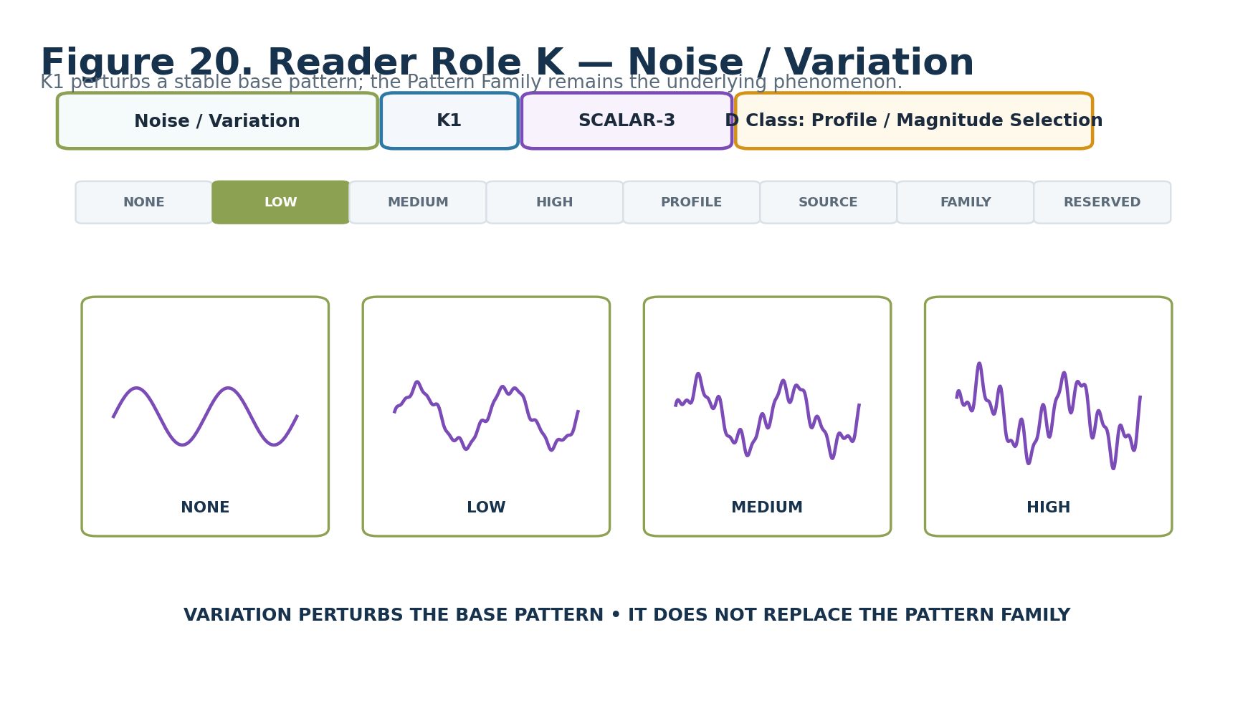
Figure 20. Noise / Variation — K1.
DECLARATION
Noise / Variation | K1 | SCALAR-3 | DREQ-PROFILE.FIELD_VARIATION
Property | Contract
D Class | Profile / Magnitude Selection
D Requirement Key | DREQ-PROFILE.FIELD_VARIATION
Purpose | Declares the requested degree/source class of controlled irregularity added to the base pattern.
Representative states | 0 NONE; 1 LOW; 2 MEDIUM; 3 HIGH; 4 PROFILE/MODEL; 5 SOURCE_DERIVED; 6 FAMILY_SPECIFIC; 7 RESERVED
Validation / boundary | K1 describes irregularity magnitude/type. Replay and seed stability are separately governed by L1.

22. Random Seed / Stability — L1
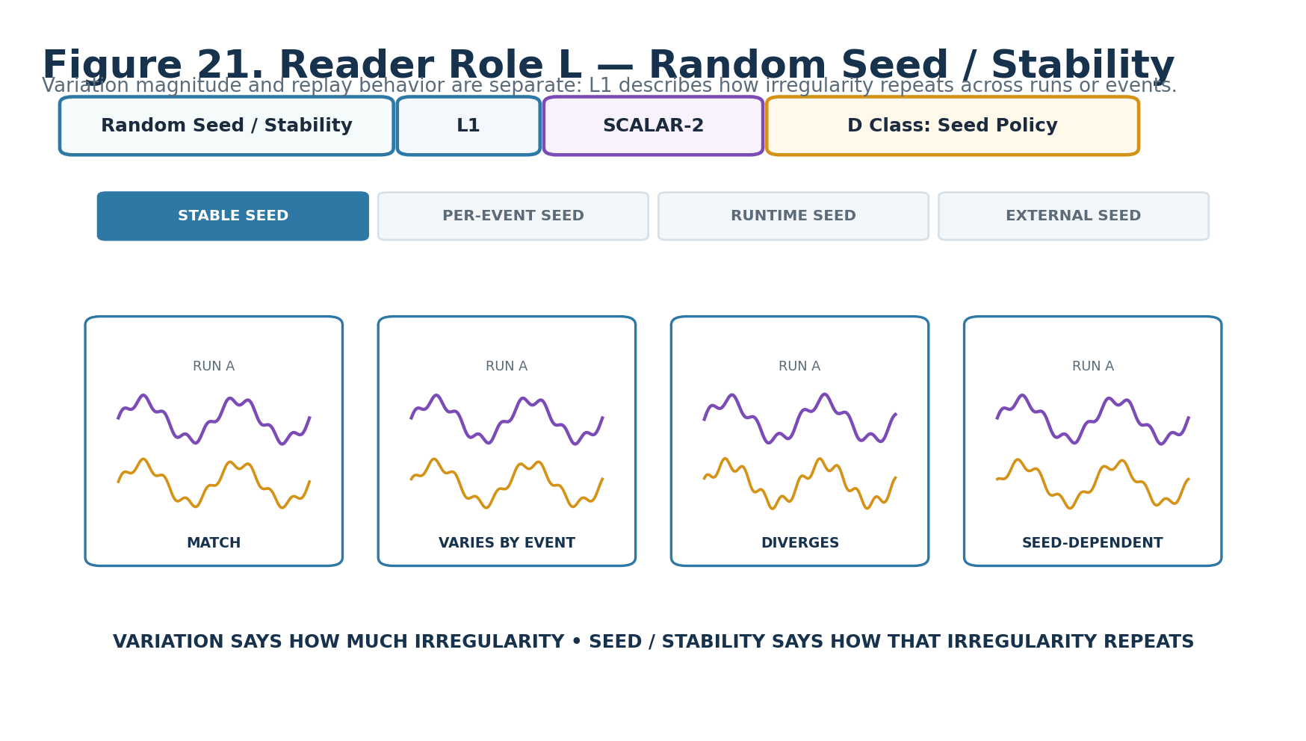
Figure 21. Random Seed / Stability — L1.
DECLARATION
Random Seed / Stability | L1 | SCALAR-2 | DREQ-POLICY.SEED
Property | Contract
D Class | Seed Policy
D Requirement Key | DREQ-POLICY.SEED
Purpose | Declares how stochastic or varied FIELD behavior obtains and retains its seed.
Representative states | 0 STABLE_SEED; 1 PER_EVENT_SEED; 2 RUNTIME_SEED; 3 EXTERNAL_SEED
Validation / boundary | Stable seed supports repeatable output for the same inputs. Per-event seed remains stable within an event but may change across events. Runtime seed does not promise replay. External seed requires supplied context.

23. Output Shaping — M1
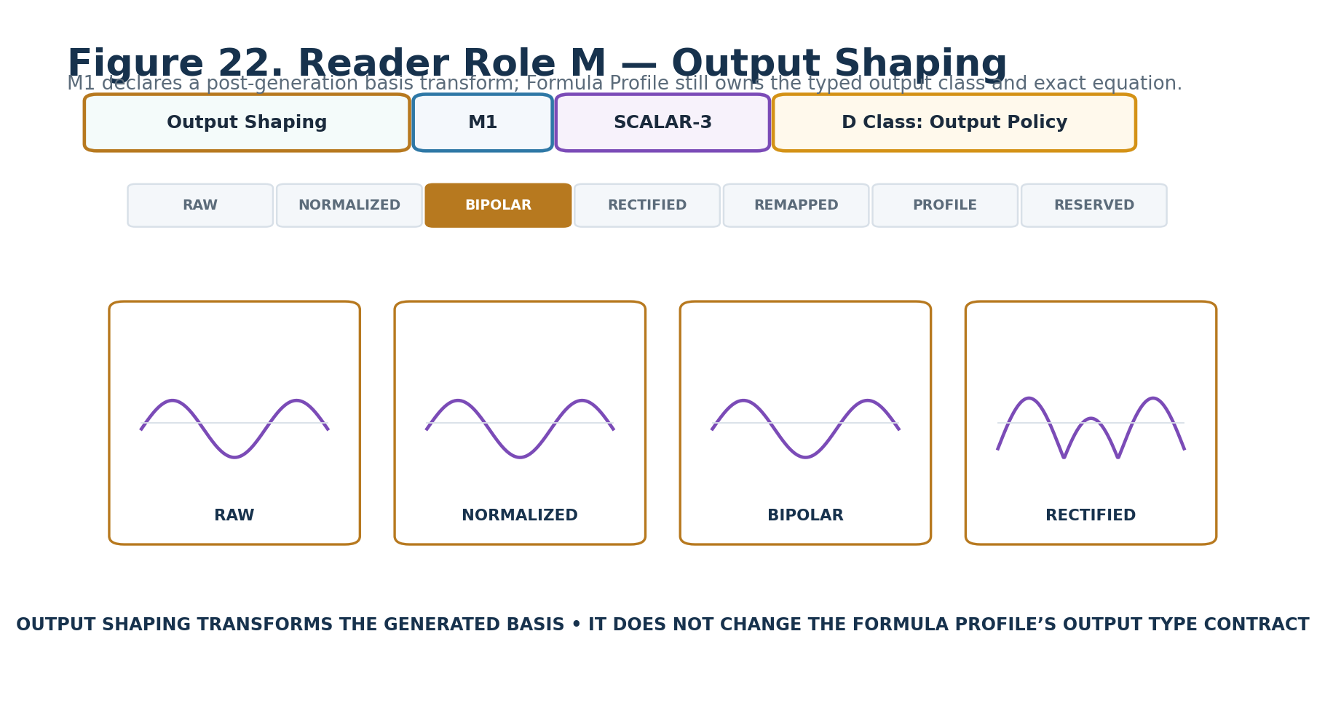
Figure 22. Output Shaping — M1.
DECLARATION
Output Shaping | M1 | SCALAR-3 | DREQ-POLICY.OUTPUT_SHAPING
Property | Contract
D Class | Output Policy
D Requirement Key | DREQ-POLICY.OUTPUT_SHAPING
Purpose | Declares a post-generation numerical-basis transform applied before the typed Field Signal is emitted.
Representative states | 0 RAW; 1 NORMALIZED; 2 BIPOLAR; 3 RECTIFIED; 4 REMAPPED; 5 PROFILE_SHAPED; 6–7 RESERVED
Validation / boundary | Output shaping does not change the semantic Signal Class declared by the Formula Profile. Any remap/profile requirements must remain explicit and inspectable.

24. Interpretation Version — N1
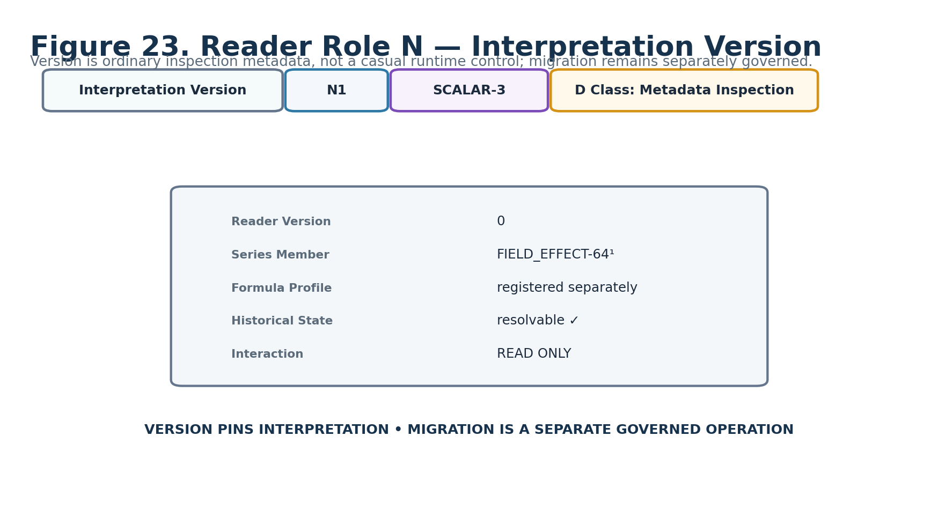
Figure 23. Interpretation Version — N1.
DECLARATION
Interpretation Version | N1 | SCALAR-3 | DREQ-META.VERSION_INSPECT
Property | Contract
D Class | Metadata Inspection
D Requirement Key | DREQ-META.VERSION_INSPECT
Purpose | Pins the bounded Reader interpretation for replay, inspection, and historical resolution.
Representative states | 0 current base interpretation; 1–6 registered future interpretations; 7 RESERVED
Validation / boundary | Ordinary DARTBOARD treatment is read-only. Migration is a separate governed operation rather than an incidental interface edit.

Part 4 — Interface-0, D Requirements, and Complete DARTBOARD

25. Interface-0 Composition
Interface-0 composes the declared symbol, Reader/interface name, color treatment, and D contract into a human-facing control. The BitGroup never infers the interaction geometry. F1 Phase is the clearest example: it uses SCALAR-8 mathematics but requires a cyclic dial rather than a generic linear slider.
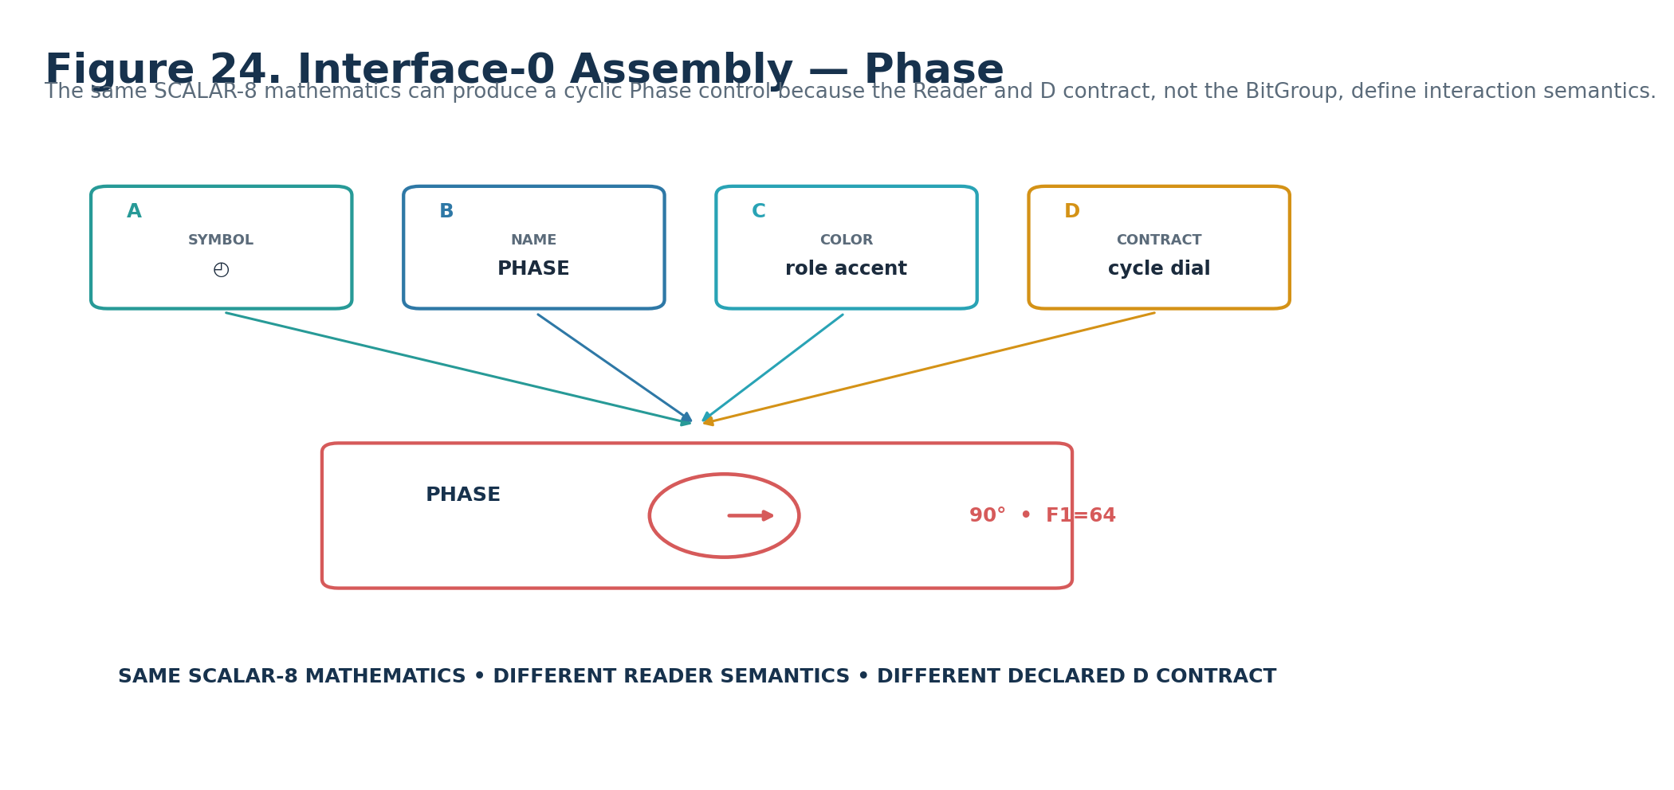
Figure 24. Interface-0 assembly for the Phase Reader role.

26. Candidate D Requirement Plan
Reader | Candidate D Class | Requirement
A1 | Categorical Pattern Selection | DREQ-CAT.FIELD_PATTERN
B1 | Profile Selection | DREQ-PROFILE.FIELD_FORMULA
C1 | Spatial Basis Selection | DREQ-SPATIAL.DOMAIN_BASIS
D1 | Scalar | DREQ-SCALAR.SPATIAL_SCALE
E1 | Scalar | DREQ-SCALAR.TEMPORAL_RATE
F1 | Cyclic Scalar | DREQ-CYCLE.PHASE
G1 | Profile Selection | DREQ-PROFILE.WAVEFORM
H1 | Direction Selection | DREQ-DIR.PROPAGATION
I1 | Scalar | DREQ-SCALAR.PROPAGATION_SPEED
J1 | Profile Selection | DREQ-PROFILE.FIELD_FALLOFF
K1 | Profile / Magnitude Selection | DREQ-PROFILE.FIELD_VARIATION
L1 | Seed Policy | DREQ-POLICY.SEED
M1 | Output Policy | DREQ-POLICY.OUTPUT_SHAPING
N1 | Metadata Inspection | DREQ-META.VERSION_INSPECT

CANDIDATE STATUS
These DREQ keys are planning requirements, not exact registered D#.# contracts. Promotion requires resolving exact registered contracts and the associated BOSS/COLOR/interface metadata.

27. Complete FIELD_EFFECT-64¹ Interface
The complete generated surface is a human-learning projection of the live Reader architecture. It assembles the same controls established in the individual Reader figures, presents synchronized inspection views, and exposes deterministic Reader output. The preview is disposable; the records are canonical.
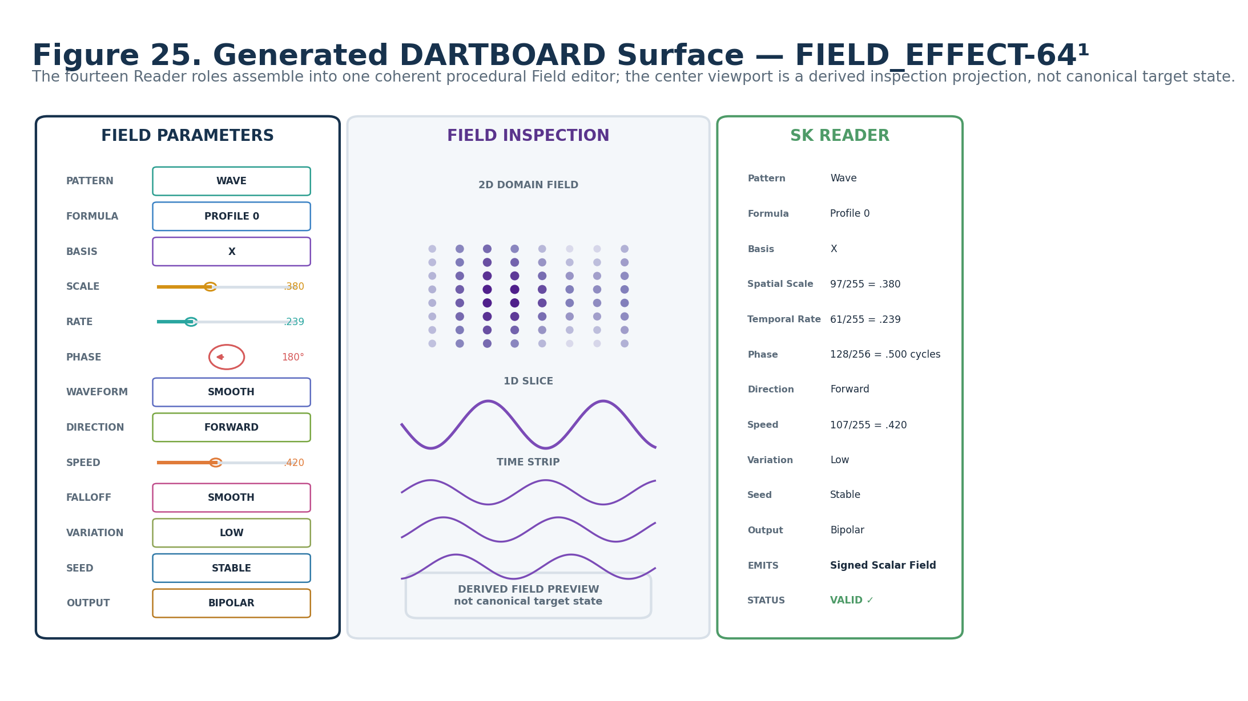
Figure 25. Generated DARTBOARD surface for FIELD_EFFECT-64¹.

28. One Control to Exact Bits
The Phase control demonstrates reversibility from interface back to the physical word. A human can understand the cycle through the dial, while the system resolves the exact Reader placement and constituent Bits directly from records.
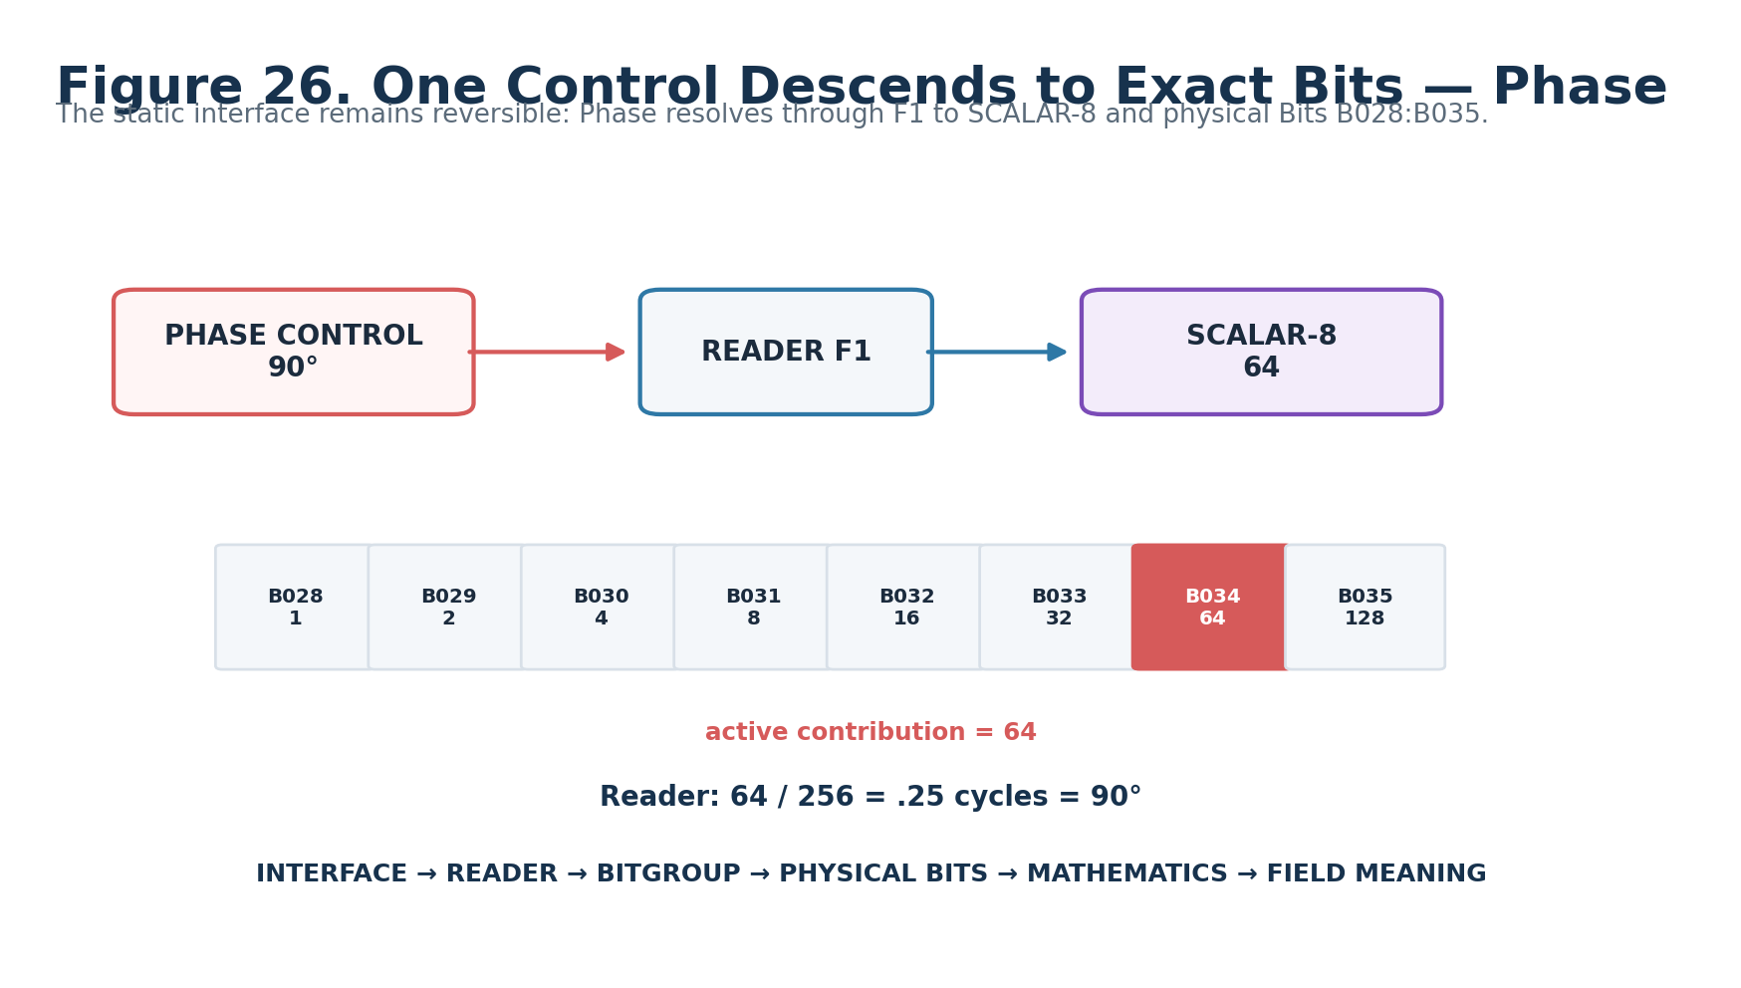
Figure 26. Phase control → F1 → SCALAR-8 → B028:B035 → 90° Reader meaning.

Part 5 — Binary Encoding, Reader Algorithm, Output, and Interoperability

29. Complete Physical Word
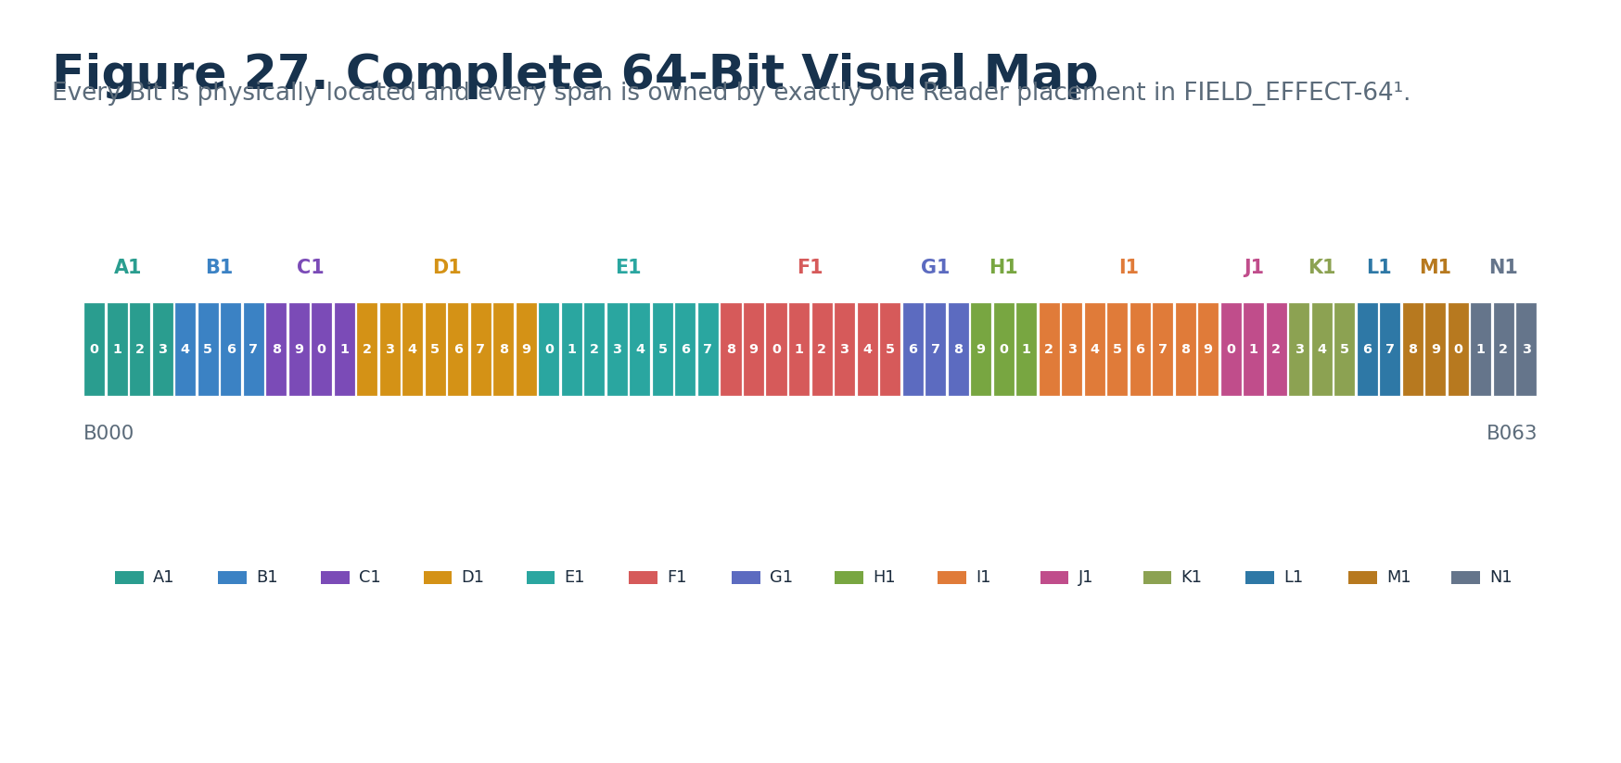
Figure 27. Complete 64-Bit visual map.
FIELD_EFFECT-64¹ uses all 64 physical Bits. There is no reserved padding. Reserved code combinations live inside selected Reader vocabularies rather than in unowned physical gaps.

30. Reader Algorithm
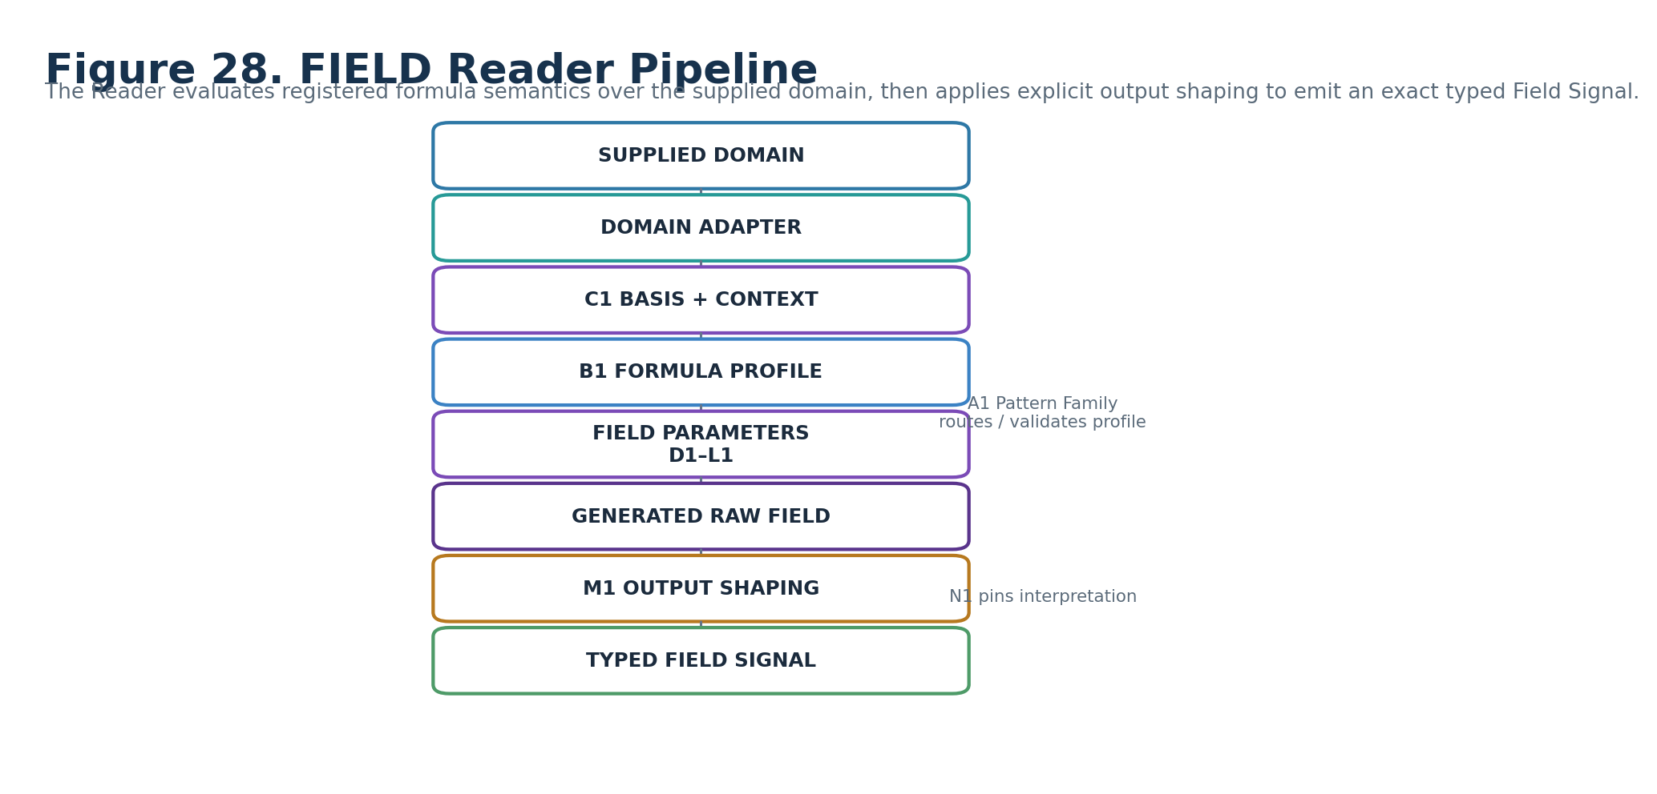
Figure 28. FIELD Reader pipeline from supplied domain to typed Field Signal.
Conceptually, the Reader resolves the domain and required basis, selects the registered Formula Profile, evaluates the procedural field using the configured scale/rate/phase/waveform/propagation/envelope/variation/seed semantics, applies explicit output shaping, validates the resulting Signal Class and domain requirements, and emits the typed Field Signal with validity and provenance. A1 routes or validates the conceptual family; N1 pins interpretation.

31. Output Signal Typing
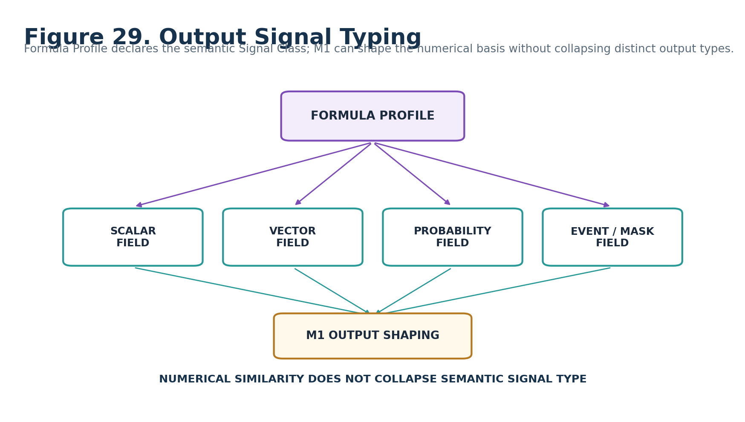
Figure 29. Formula Profile declares Signal Class; M1 shapes numerical basis without collapsing semantic type.
Output class | Meaning / example posture
Scalar Field | One scalar value per evaluated domain element / coordinate
Signed Scalar Field | Bipolar scalar value per domain location
Vector Field | Vector-valued procedural output where the Formula Profile declares vector semantics
Angular Field | Angular procedural output under a declared angular basis
Probability Field | Probability semantics remain typed as Probability rather than generic scalar
Mask Field | Participation semantics remain typed as Mask / Mask Field
Event Field | Event-like activation semantics over the domain
Declared extension | Additional types require an explicit registered Formula Profile and consumer compatibility

32. Interoperability Card
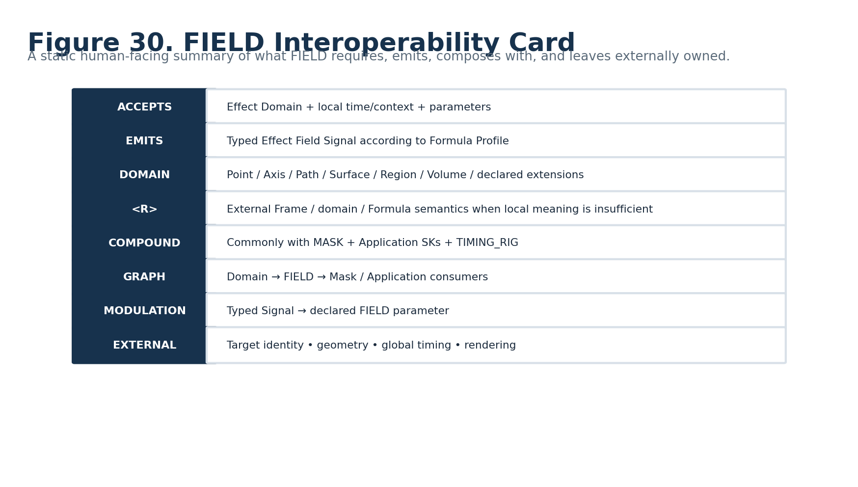
Figure 30. FIELD interoperability card.

33. Continuation, Compound, and Runtime Graph
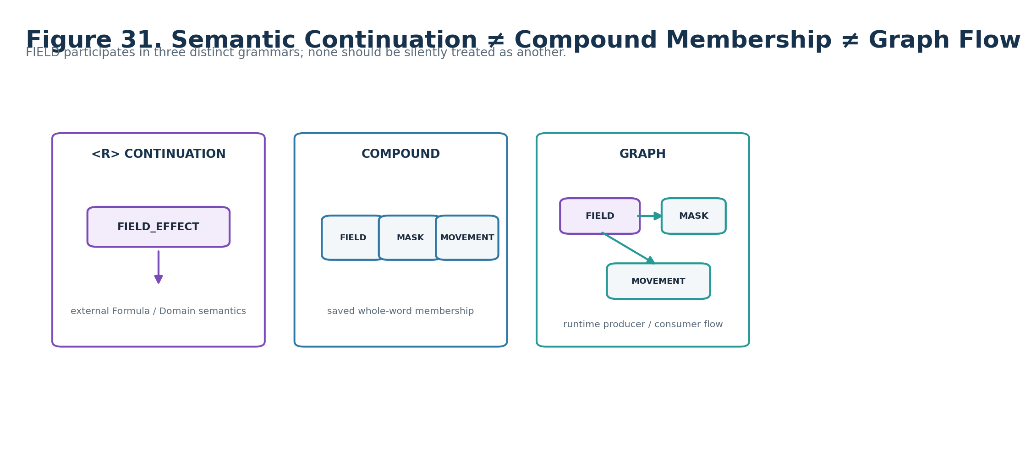
Figure 31. Semantic continuation, Compound membership, and runtime graph flow are distinct grammars.
`<R>` means the local FIELD meaning continues into explicitly external semantic context, such as a registered Formula or domain interpretation. Compound membership means FIELD_EFFECT-64¹ is one complete constituent of a saved assembly. Runtime graph edges connect producer and consumer nodes during execution. None of these relationships should be inferred from the others.

Part 6 — Worked Examples, Invalid States, and Conformance

34. Worked Example Set
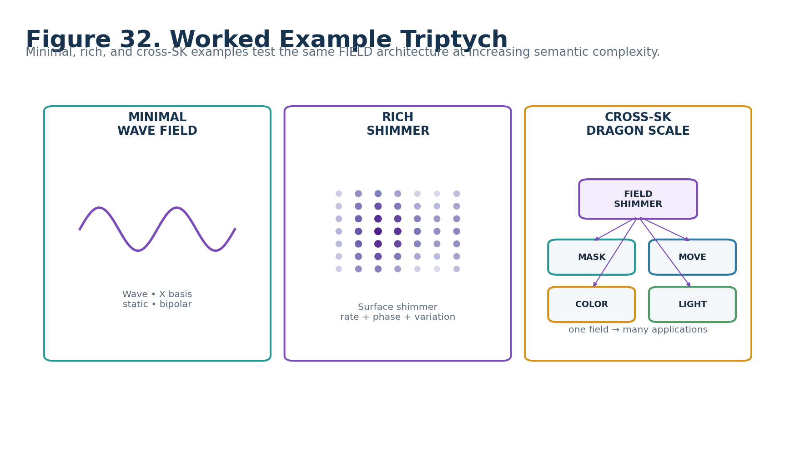
Figure 32. Minimal, rich, and cross-SK FIELD examples.

35. Minimal Valid Example — Static Wave Field
Reader | State
A1 Pattern Family | WAVE
B1 Formula Profile | Family/default registered Wave profile
C1 Domain Basis | X
D1 Spatial Scale | 0.25 normalized
E1 Temporal Rate | 0 / frozen
F1 Phase | 0
G1 Waveform | SMOOTH
H1 Direction | FORWARD
I1 Propagation Speed | 0 / stationary
J1 Falloff | NONE / UNIFORM
K1 Variation | NONE
L1 Seed / Stability | STABLE_SEED
M1 Output Shaping | BIPOLAR
N1 Version | 0

Expected result: a deterministic, static signed scalar Wave Field over the supplied X basis. The domain remains unchanged. No downstream application is implied.

36. Rich Example — Shimmer Field
A richer Shimmer configuration can combine a surface-appropriate basis, moderate spatial scale, live temporal rate, moving phase, smooth waveform, forward/radial propagation where valid, smooth falloff, low variation, stable seed, and normalized or bipolar output. The Formula Profile determines the exact shimmer equation and typed output.

37. Cross-SK Example — Dragon Scale Shimmer
A normalized dragon-scale domain may feed FIELD_EFFECT to generate one Shimmer Field. That output can then feed MASK to scope a subset, MOVEMENT for small rotation, COLOR for palette position, LIGHT for brightness, and GATE/PARTICLE behavior for event-triggered sparks. Each consumer remains a separate complete semantic responsibility.

38. Invalid / Unresolved Domain Basis
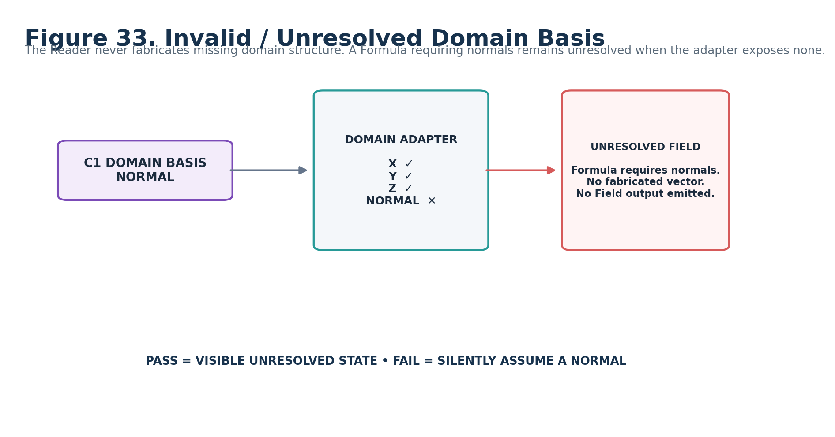
Figure 33. Missing required domain data resolves visibly as unresolved rather than fabricating a basis.

39. Intrinsic Pattern Timing and Global Timing
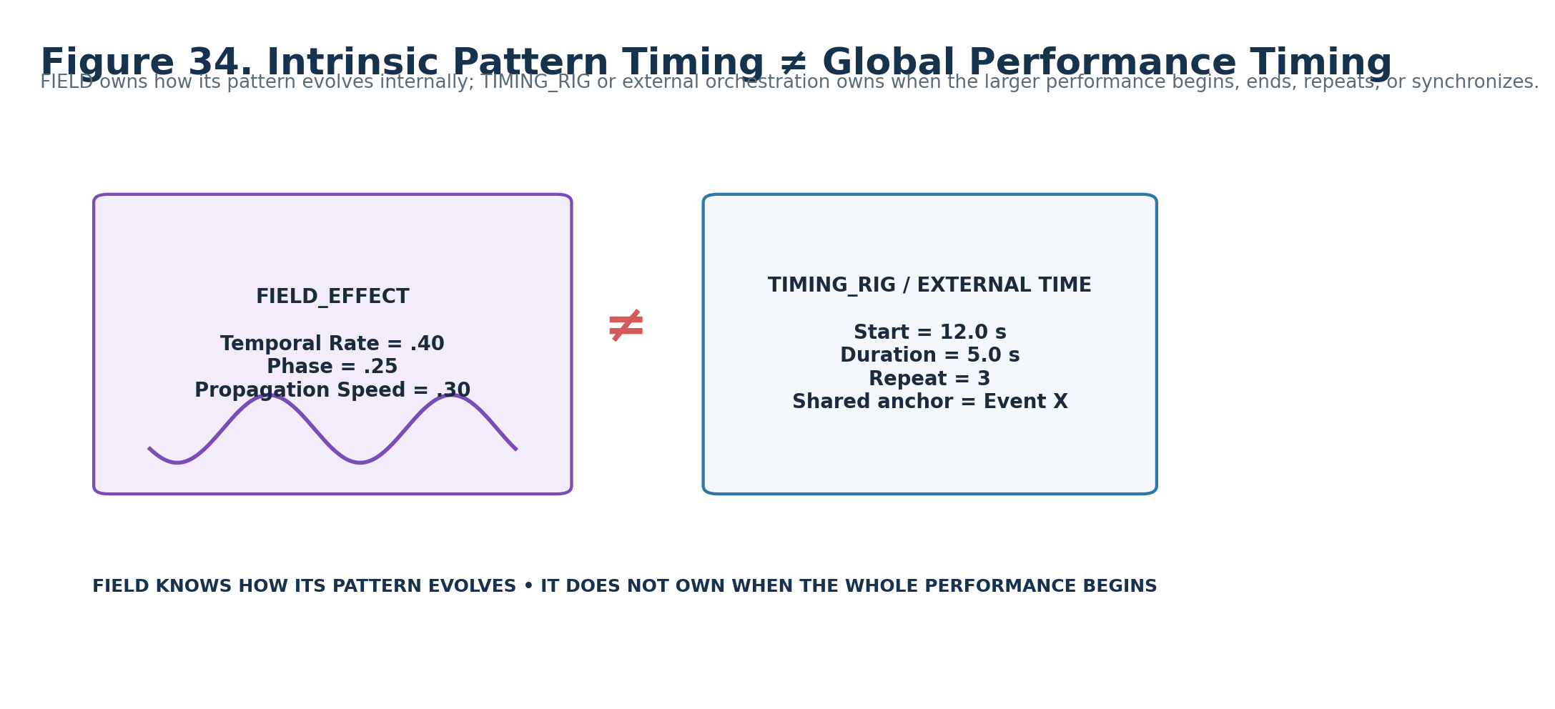
Figure 34. Temporal Rate / Phase / Propagation belong to FIELD; start/duration/repeat/synchronization remain external.

40. Conformance Tests
Test | Requirement | Expected
C-FIELD-01 | A1=0 emits no Field regardless of other stored roles | PASS required
C-FIELD-02 | SCALAR BitGroups remain generic and do not acquire Field-specific identity | PASS required
C-FIELD-03 | Missing required basis/domain field remains unresolved; no fabricated data | PASS required
C-FIELD-04 | Temporal Rate and Propagation Speed remain independently inspectable | PASS required
C-FIELD-05 | Phase uses cyclic F1/256 semantics and does not duplicate 0 at the upper endpoint | PASS required
C-FIELD-06 | Formula Profile owns exact equation, accepted inputs, required domain fields, undefined conditions, output class, and determinism posture | PASS required
C-FIELD-07 | K1 Variation and L1 Seed/Stability remain distinct | PASS required
C-FIELD-08 | M1 output shaping cannot silently change the Formula Profile Signal Class | PASS required
C-FIELD-09 | Domain and world geometry remain unchanged by Field generation unless another authorized operation mutates them | PASS required
C-FIELD-10 | Global timing is not inferred from E1/F1/I1 | PASS required
C-FIELD-11 | DARTBOARD is reconstructible from Reader/D contract/metadata and is not treated as canonical state | PASS required
C-FIELD-12 | Cross-SK consumers preserve independent application semantics and provenance | PASS required

41. Minimum Sufficient Resolution Gate
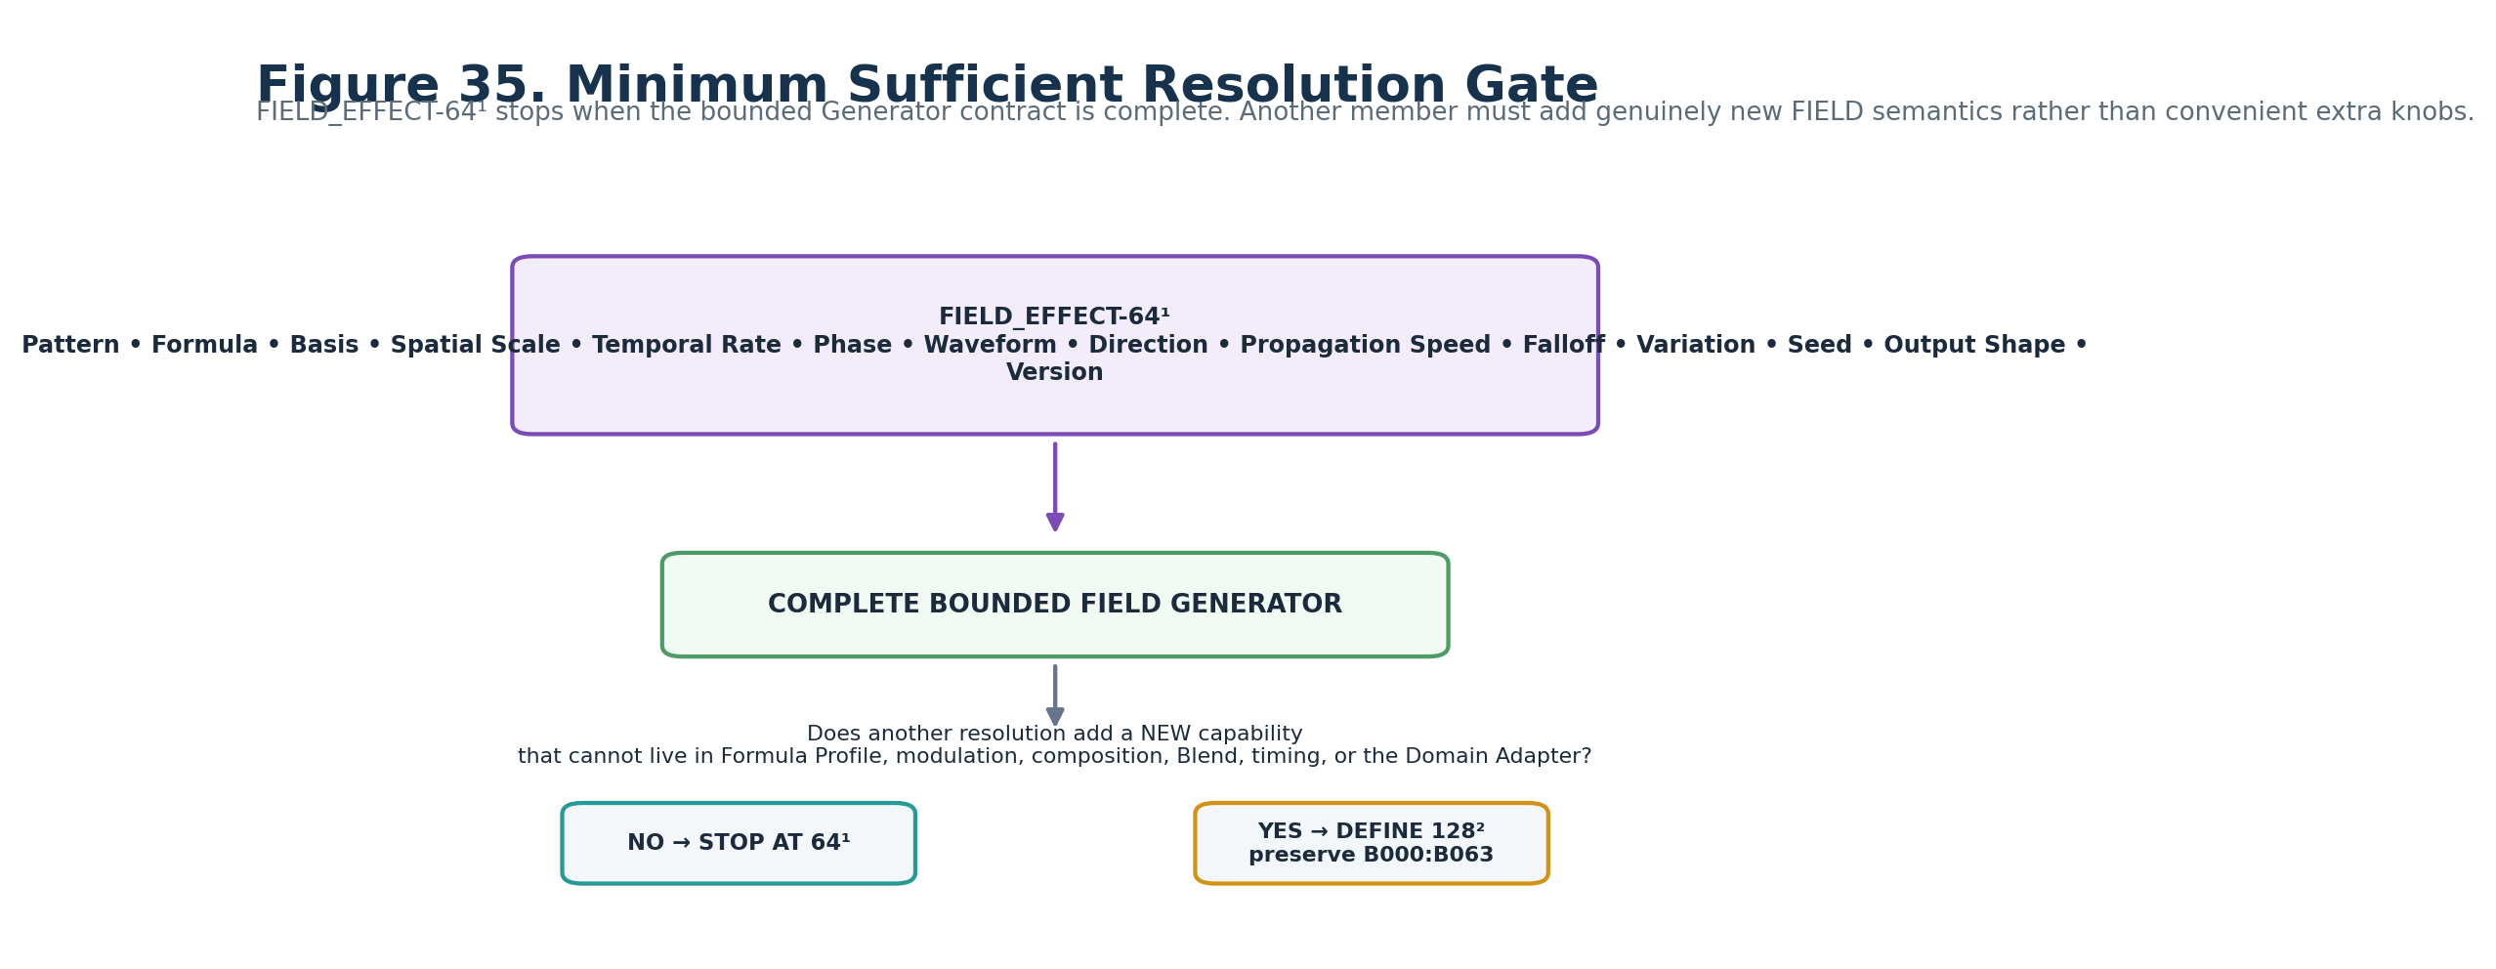
Figure 35. A future 128² member must add a genuinely new FIELD capability and preserve B000:B063 literally.

Part 7 — Planning Handoff and Promotion Gate

42. Deterministic Planning Manifest
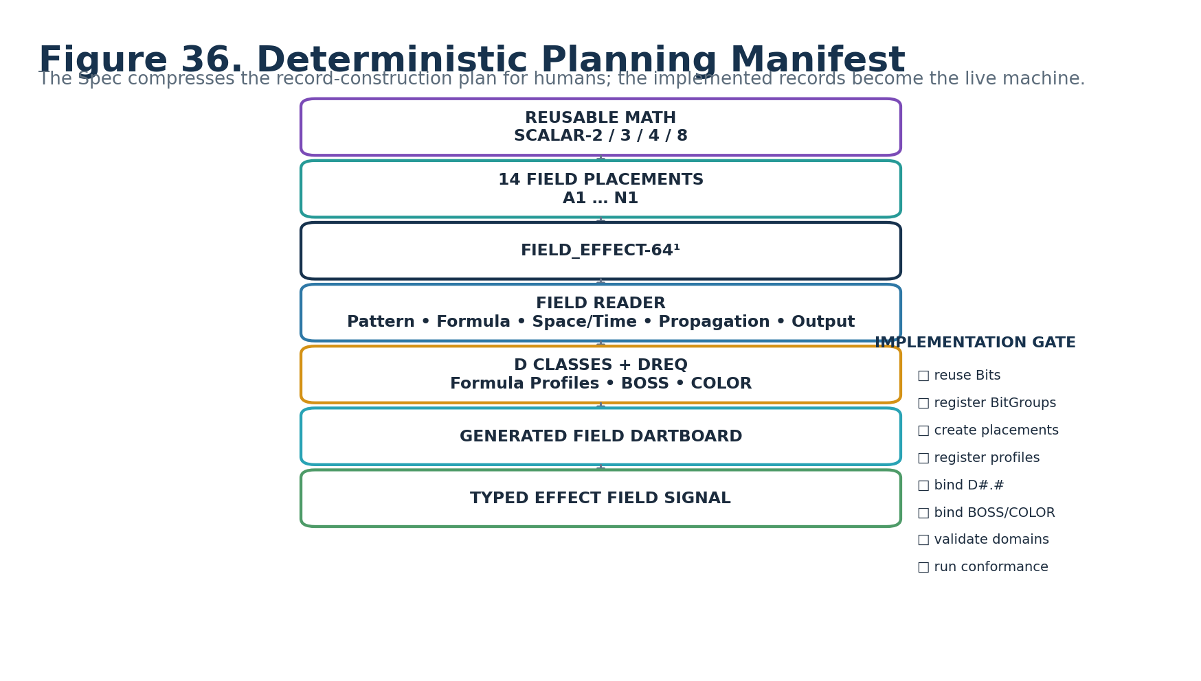
Figure 36. Human-facing planning manifest from reusable mathematics to a typed Field Signal.

43. Record Construction Plan
Record family | Planning requirement
Primitive Bits | Reuse/register scalar contribution Bits needed by SCALAR-2 / SCALAR-3 / SCALAR-4 / SCALAR-8.
BitGroups | Reuse exact generic SCALAR-2, SCALAR-3, SCALAR-4, and SCALAR-8 mathematics.
BitWord | Create FIELD_EFFECT-64¹ with exact B000:B063 physical allocation.
Reader Placements | Create A1–N1 placements with the exact semantic roles defined by this Candidate Spec.
Reader Enumerations | Register the approved Pattern, Basis, Waveform, Direction, Falloff, Variation, Seed, Output, and Version vocabularies.
Formula Profiles | Register exact pattern-family equations, required domain fields, accepted context, output Signal Classes, undefined conditions, determinism, and human explanation.
D Contracts | Resolve Candidate DREQs to exact registered D#.# contracts during promotion.
BOSS / COLOR | Bind human-facing symbols, labels, and interface treatment without making projection metadata semantic identity.
Validation | Implement domain-requirement checks, safe zero, invalid combination handling, Signal typing, and explicit unresolved states.
Tests | Run the conformance matrix plus deterministic replay/seed tests and DARTBOARD reconstruction checks.

44. Candidate → Formal Promotion Gate
PROMOTION GATE
Formal promotion requires exact registered D#.# bindings; exact BOSS/COLOR interface records; approved Formula Profile identities and versions; finalized Reader enumeration registrations; domain-adapter validation; output Signal typing; conformance tests; and verification that a human-facing DARTBOARD can be regenerated from the live records without treating this document as canonical runtime state.

45. Human-Learning Completion Test
A knowledgeable human should be able to return to this manual months later, skim the figures, and recover the correct mental model: FIELD evaluates registered mathematics over a supplied domain; its four SCALAR families remain generic; A1–N1 provide bounded Field meaning; Formula Profiles own exact equations; the Generator emits typed procedural causes; and downstream Application SKs decide what those causes do.
If the BitWord has not yet been built, this Spec should provide enough precision to guide record construction and identify unresolved registrations. Once built, the live CERBERUS records are the machine; this document remains the compressed human map.

Appendix A — Complete Reader State Enumerations
Reader role | Enumeration / formula
A1 Pattern Family | 0 OFF; 1 WAVE; 2 SHIMMER; 3 PULSE; 4 RIPPLE; 5 SWEEP; 6 CHASE; 7 SPIRAL; 8 VORTEX; 9 NOISE; 10 DRIFT; 11 FLICKER; 12 FALLOFF; 13 PROPAGATION; 14–15 RESERVED
B1 Formula Profile | 0 FAMILY_DEFAULT; 1–14 registered profile/variant slots governed by Pattern Family; 15 EXTERNAL/RESERVED
C1 Domain Basis | 0 PROFILE_DEFAULT; 1 X; 2 Y; 3 Z; 4 XY; 5 XZ; 6 YZ; 7 XYZ; 8 RADIAL; 9 DISTANCE; 10 PATH_DISTANCE; 11 NORMAL; 12 TANGENT; 13 SUPPLIED_VECTOR; 14–15 RESERVED
D1 Spatial Scale | 0–255; Reader coordinate σ=D1/255
E1 Temporal Rate | 0–255; Reader coordinate r=E1/255
F1 Phase | 0–255; Reader phase φ=F1/256 cycles
G1 Waveform | 0 SMOOTH; 1 TRIANGULAR; 2 STEPPED; 3 PULSE_WIDTH; 4 CUSTOM_PROFILE; 5 FAMILY_SPECIFIC; 6 EXTERNAL; 7 RESERVED
H1 Direction | 0 FORWARD; 1 REVERSE; 2 RADIAL_OUT; 3 RADIAL_IN; 4 TANGENT_FORWARD; 5 TANGENT_REVERSE; 6 SUPPLIED_ORIENTATION; 7 PROFILE/EXTERNAL
I1 Propagation Speed | 0–255; Reader coordinate v=I1/255
J1 Falloff | 0 NONE/UNIFORM; 1 LINEAR; 2 SMOOTH; 3 CENTER_EMPHASIS; 4 BOUNDARY_FADE; 5 PROFILE/MODEL; 6 EXTERNAL; 7 RESERVED
K1 Variation | 0 NONE; 1 LOW; 2 MEDIUM; 3 HIGH; 4 PROFILE/MODEL; 5 SOURCE_DERIVED; 6 FAMILY_SPECIFIC; 7 RESERVED
L1 Seed / Stability | 0 STABLE_SEED; 1 PER_EVENT_SEED; 2 RUNTIME_SEED; 3 EXTERNAL_SEED
M1 Output Shaping | 0 RAW; 1 NORMALIZED; 2 BIPOLAR; 3 RECTIFIED; 4 REMAPPED; 5 PROFILE_SHAPED; 6–7 RESERVED
N1 Version | 0 base interpretation; 1–6 registered future interpretations; 7 RESERVED

Appendix B — Complete B000:B063 Physical Bit Map
Global Bit | Reader | BitGroup | Local Bit | Contribution | Reader interpretation
B000 | A1 | SCALAR-4 | 0 | 1 | Pattern Family
B001 | A1 | SCALAR-4 | 1 | 2 | Pattern Family
B002 | A1 | SCALAR-4 | 2 | 4 | Pattern Family
B003 | A1 | SCALAR-4 | 3 | 8 | Pattern Family
B004 | B1 | SCALAR-4 | 0 | 1 | Formula Profile
B005 | B1 | SCALAR-4 | 1 | 2 | Formula Profile
B006 | B1 | SCALAR-4 | 2 | 4 | Formula Profile
B007 | B1 | SCALAR-4 | 3 | 8 | Formula Profile
B008 | C1 | SCALAR-4 | 0 | 1 | Domain Basis
B009 | C1 | SCALAR-4 | 1 | 2 | Domain Basis
B010 | C1 | SCALAR-4 | 2 | 4 | Domain Basis
B011 | C1 | SCALAR-4 | 3 | 8 | Domain Basis
B012 | D1 | SCALAR-8 | 0 | 1 | Spatial Scale
B013 | D1 | SCALAR-8 | 1 | 2 | Spatial Scale
B014 | D1 | SCALAR-8 | 2 | 4 | Spatial Scale
B015 | D1 | SCALAR-8 | 3 | 8 | Spatial Scale
B016 | D1 | SCALAR-8 | 4 | 16 | Spatial Scale
B017 | D1 | SCALAR-8 | 5 | 32 | Spatial Scale
B018 | D1 | SCALAR-8 | 6 | 64 | Spatial Scale
B019 | D1 | SCALAR-8 | 7 | 128 | Spatial Scale
B020 | E1 | SCALAR-8 | 0 | 1 | Temporal Rate
B021 | E1 | SCALAR-8 | 1 | 2 | Temporal Rate

Appendix B — Complete B000:B063 Physical Bit Map (continued)
Global Bit | Reader | BitGroup | Local Bit | Contribution | Reader interpretation
B022 | E1 | SCALAR-8 | 2 | 4 | Temporal Rate
B023 | E1 | SCALAR-8 | 3 | 8 | Temporal Rate
B024 | E1 | SCALAR-8 | 4 | 16 | Temporal Rate
B025 | E1 | SCALAR-8 | 5 | 32 | Temporal Rate
B026 | E1 | SCALAR-8 | 6 | 64 | Temporal Rate
B027 | E1 | SCALAR-8 | 7 | 128 | Temporal Rate
B028 | F1 | SCALAR-8 | 0 | 1 | Phase
B029 | F1 | SCALAR-8 | 1 | 2 | Phase
B030 | F1 | SCALAR-8 | 2 | 4 | Phase
B031 | F1 | SCALAR-8 | 3 | 8 | Phase
B032 | F1 | SCALAR-8 | 4 | 16 | Phase
B033 | F1 | SCALAR-8 | 5 | 32 | Phase
B034 | F1 | SCALAR-8 | 6 | 64 | Phase
B035 | F1 | SCALAR-8 | 7 | 128 | Phase
B036 | G1 | SCALAR-3 | 0 | 1 | Waveform
B037 | G1 | SCALAR-3 | 1 | 2 | Waveform
B038 | G1 | SCALAR-3 | 2 | 4 | Waveform
B039 | H1 | SCALAR-3 | 0 | 1 | Direction
B040 | H1 | SCALAR-3 | 1 | 2 | Direction
B041 | H1 | SCALAR-3 | 2 | 4 | Direction
B042 | I1 | SCALAR-8 | 0 | 1 | Propagation Speed
B043 | I1 | SCALAR-8 | 1 | 2 | Propagation Speed

Appendix B — Complete B000:B063 Physical Bit Map (continued)
Global Bit | Reader | BitGroup | Local Bit | Contribution | Reader interpretation
B044 | I1 | SCALAR-8 | 2 | 4 | Propagation Speed
B045 | I1 | SCALAR-8 | 3 | 8 | Propagation Speed
B046 | I1 | SCALAR-8 | 4 | 16 | Propagation Speed
B047 | I1 | SCALAR-8 | 5 | 32 | Propagation Speed
B048 | I1 | SCALAR-8 | 6 | 64 | Propagation Speed
B049 | I1 | SCALAR-8 | 7 | 128 | Propagation Speed
B050 | J1 | SCALAR-3 | 0 | 1 | Falloff
B051 | J1 | SCALAR-3 | 1 | 2 | Falloff
B052 | J1 | SCALAR-3 | 2 | 4 | Falloff
B053 | K1 | SCALAR-3 | 0 | 1 | Variation
B054 | K1 | SCALAR-3 | 1 | 2 | Variation
B055 | K1 | SCALAR-3 | 2 | 4 | Variation
B056 | L1 | SCALAR-2 | 0 | 1 | Seed / Stability
B057 | L1 | SCALAR-2 | 1 | 2 | Seed / Stability
B058 | M1 | SCALAR-3 | 0 | 1 | Output Shaping
B059 | M1 | SCALAR-3 | 1 | 2 | Output Shaping
B060 | M1 | SCALAR-3 | 2 | 4 | Output Shaping
B061 | N1 | SCALAR-3 | 0 | 1 | Version
B062 | N1 | SCALAR-3 | 1 | 2 | Version
B063 | N1 | SCALAR-3 | 2 | 4 | Version

Appendix C — Candidate D Requirement Index
Reader | Semantic role | D Class | Candidate requirement
A1 | Pattern Family | Categorical Pattern Selection | DREQ-CAT.FIELD_PATTERN
B1 | Pattern Variant / Formula Profile | Profile Selection | DREQ-PROFILE.FIELD_FORMULA
C1 | Domain Basis | Spatial Basis Selection | DREQ-SPATIAL.DOMAIN_BASIS
D1 | Spatial Scale / Frequency | Scalar | DREQ-SCALAR.SPATIAL_SCALE
E1 | Temporal Rate / Frequency | Scalar | DREQ-SCALAR.TEMPORAL_RATE
F1 | Phase | Cyclic Scalar | DREQ-CYCLE.PHASE
G1 | Waveform / Shape | Profile Selection | DREQ-PROFILE.WAVEFORM
H1 | Propagation Direction | Direction Selection | DREQ-DIR.PROPAGATION
I1 | Propagation Speed | Scalar | DREQ-SCALAR.PROPAGATION_SPEED
J1 | Falloff / Envelope | Profile Selection | DREQ-PROFILE.FIELD_FALLOFF
K1 | Noise / Variation | Profile / Magnitude Selection | DREQ-PROFILE.FIELD_VARIATION
L1 | Random Seed / Stability | Seed Policy | DREQ-POLICY.SEED
M1 | Output Shaping | Output Policy | DREQ-POLICY.OUTPUT_SHAPING
N1 | Version / Reserved | Metadata Inspection | DREQ-META.VERSION_INSPECT

PROMOTION NOTE
Candidate requirement keys are human-facing planning handles. Exact registered D#.# records remain authoritative once implementation is complete.

Appendix D — Conformance / Build Checklist
□ B000:B063 allocation matches the approved FIELD_EFFECT-64¹ map.
□ SCALAR-2 / SCALAR-3 / SCALAR-4 / SCALAR-8 are reused as generic mathematics rather than Field-specific duplicates.
□ A1=0 yields safe OFF / no Field output.
□ Every Reader role has a registered definition, state enumeration or formula, validation rule, and explicit ownership boundary.
□ B1 Formula Profiles declare accepted context/domain, required fields, exact equation, output Signal Class, undefined conditions, determinism, version, and human explanation.
□ C1 basis requirements are validated against the Domain Adapter; missing requirements remain unresolved.
□ D1/E1/I1 are normalized Reader coordinates rather than silently assumed physical units.
□ F1 phase uses 256 unique cyclic states and does not duplicate zero at the upper endpoint.
□ K1 Variation and L1 Seed/Stability remain distinct and replay behavior is testable.
□ M1 output shaping cannot silently alter the semantic Signal Class.
□ Global timing remains external to FIELD intrinsic rate/phase/propagation.
□ Cross-SK consumers preserve independent semantics and provenance.
□ Candidate DREQs are resolved to exact D#.# before Formal promotion.
□ BOSS symbols and COLOR/interface profiles are bound without becoming semantic identity.
□ DARTBOARD can be regenerated from records and is treated as a disposable human-facing projection.
□ Rendered instruction manual has been visually inspected for figure legibility, clipping, and semantic clarity.
PRODUCTION PRINCIPLE
The records are the machine. The Spec is the human compression artifact. The figures should let a knowledgeable person reconstruct the mental model quickly; the live system should resolve the records directly.

