CERBERUS GROOVE
Cybernetic Idea Bootstrapping from Multimodal Knowledge Bundles into Formal Systems and Simulation
CORE THESIS
CERBERUS GROOVE organizes heterogeneous idea artifacts into domain-bounded semantic maps, progressively compiles those maps into reusable system components, and preserves traceable pathways from formal models and simulation behavior back to the documents, images, diagrams, and observations from which they emerged.

FORMAL SYSTEM SPECIFICATION
Version 1.0 • 15 August 2026
Bundle the ideas. GROOVE the relations. Compile the components. Simulate what survives.

Document Control
Field | Value
Document | CERBERUS GROOVE — Cybernetic Idea Bootstrapping from Multimodal Knowledge Bundles into Formal Systems and Simulation
Specification Version | 1.0
Status | Formal design specification
Date | 15 August 2026
Companion Method | GROOVE — Grounded Relations Over Observable Versioned Entries
Primary Scope | Domain bundling, multimodal semantic compilation, Master artifact generation, CERBERUS component formalization, simulation feedback
Reference Implementation | CERBERUS Domain 000 interfaces with GROOVE relations, source locators, progressive sweeps, and Praxis/Skene launch

NORMATIVE LANGUAGE
The keywords SHALL, SHOULD, MAY, MUST NOT, and SHOULD NOT are used normatively. “Candidate” denotes machine- or human-proposed structure that has not yet been promoted into accepted canonical system state.

Executive Summary
GROOVE begins as a lightweight method for making document relationships explicit. CERBERUS GROOVE extends that method into a cybernetic idea-bootstrap architecture. A heterogeneous archive—notes, Word documents, PDFs, images, diagrams, spreadsheets, slides, prototypes, and prior simulations—is treated as a set of Observable Versioned Entries. These Entries are grouped into Domain Bundles, described in relation to those Domains, connected through typed GROOVE relations, and progressively re-read through the structure discovered in prior sweeps.
The resulting semantic map is not merely an index. It becomes a compilation manifest. GROOVE can guide the construction of a Master artifact, identify semantic yield, expose candidate identities, SKs or Models, Operators, Rules, values, chains, and unresolved questions, and preserve provenance from every formalized component back to the source material that motivated it. Once accepted components are registered in CERBERUS, they may be instantiated in Praxis and expressed through Skene or other modalities. Simulation observations and reflections return to GROOVE as new evidence, completing a cybernetic loop.
FOUNDATIONAL RULE
Source Artifact ≠ GROOVE Description ≠ GROOVE Relation ≠ Master Synthesis ≠ CERBERUS Component ≠ Simulation State ≠ Observation. Every upward compilation step SHALL preserve provenance downward.

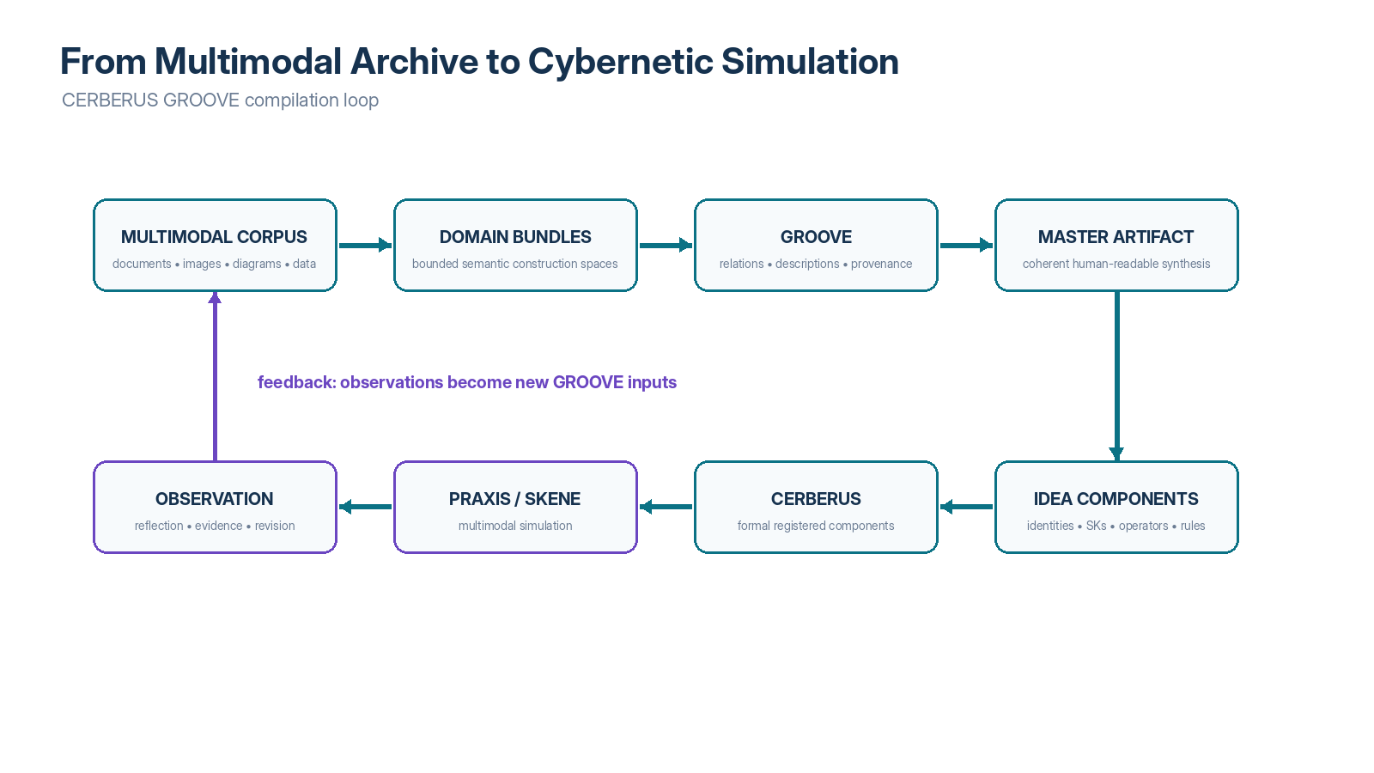
Figure 1. From multimodal archive to cybernetic simulation. GROOVE functions as a semantic compilation layer between human idea artifacts and formal CERBERUS components, while observation closes the feedback loop.

Contents
Part | Subject
Part I | Domain-Bounded Knowledge
Part II | Progressive Semantic Compilation
Part III | Master Artifact Compilation
Part IV | Idea Component Discovery
Part V | CERBERUS Formalization
Part VI | Multimodal Bootstrapping
Part VII | The Cybernetic Loop
Part VIII | Interface Specification
Part IX | Worked Domain Example
Part X | Governance, Limits, and Conformance
Appendices | Reference Schemas and Vocabularies

PART I — Domain-Bounded Knowledge

1. Purpose and Scope
This specification defines how GROOVE may be used inside CERBERUS as a domain-bounded semantic compilation and idea-bootstrap system. It specifies Domain Bundles, Domain 000 navigation, multimodal artifact registration, progressive semantic sweeps, Master compilation, semantic yield, candidate component extraction, provenance, interface behavior, simulation launch, and cybernetic feedback.
The specification does not require any one file provider, visual runtime, embedding model, language model, image model, or database. It defines the semantic contracts that allow those implementations to cooperate without confusing source artifacts, machine descriptions, inferred relations, accepted relations, compiled syntheses, formal system objects, and simulation outcomes.

2. Relationship to GROOVE Paper 1
The companion GROOVE specification establishes the general 000 / 00 / 01+ routing convention, the single-sheet Excel reference implementation, controlled relation vocabularies, semantic landing descriptions, provider-neutral Entry Locators, and the principle that GROOVE points while the Entry proves. CERBERUS GROOVE adopts those primitives and lifts them into a registered, recursive architecture in which Bundles, Entries, relations, candidate components, and simulation feedback can themselves become addressable system objects.
PAPER BOUNDARY
Paper 1 asks how a document corpus can become legible. This specification asks how that legibility can become operational—capable of compiling Master artifacts, formal components, and multimodal simulations.

3. Domain
A Domain is a bounded semantic construction space representing a coherent area of thought, design, research, or system development. A Domain is not identical to a folder. A folder is one storage projection of the Domain; the Domain may span multiple folders, providers, versions, and media types while remaining one semantic object.
SHALL A Domain expose a stable identity, human-readable name, purpose, scope, current status, and a Domain GROOVE::000 surface or equivalent navigation projection.
MAY An Observable Entry participate in multiple Domains without creating multiple canonical copies of the source artifact.
Domain Field | Meaning
Domain ID | Stable semantic identity independent of physical folder path.
Name | Human-readable domain title.
Purpose | What system, question, or capability the Domain is trying to construct.
Scope | Explicit inclusions and exclusions.
Foundation | Canonical Master or foundational Entry when one exists.
Artifacts | Observable Versioned Entries associated with the Domain.
Components | Candidate and formalized CERBERUS objects derived from Domain work.
Bridges | Explicit relations to other Domains.
Compilation State | Current sweep, Master version, source coverage, unresolved issues.

4. Domain Bundle
A Domain Bundle is the operational collection of observable artifacts, GROOVE descriptions, relations, paths, candidate components, and provenance records used to understand and develop a Domain. It is deliberately broader than a document folder. The Bundle may contain documents, images, diagrams, tables, prototypes, historical versions, Master artifacts, simulation observations, and cross-Domain bridge references.
Domain Bundling occurs before aggressive component formalization. This ordering reduces the risk of prematurely forcing a partially understood idea into an SK, Operator, or Rule merely because the formal vocabulary is available.

5. Global GROOVE::000 and Domain GROOVE::000
CERBERUS GROOVE retains the intentionally simple 000 navigation pattern. A Global GROOVE::000 routes among Domains. Each Domain exposes its own Domain GROOVE::000 that reveals the relational architecture, artifacts, component candidates, progressive passes, Master artifact, bridges, and simulation status for that Domain.
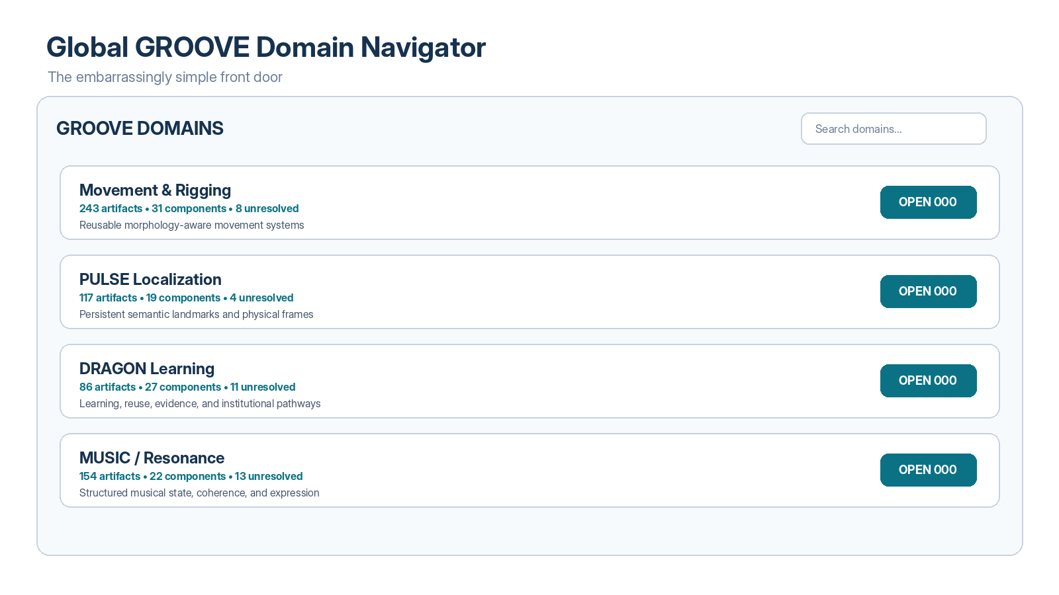
Figure 2. Global GROOVE Domain Navigator. The global 000 is intentionally simple: find the Domain, read its purpose and health indicators, then open its local 000.
Because CERBERUS uses 000 in other Registry Stack contexts, implementations SHOULD namespace documentation navigation semantically—for example GROOVE::000 or DOC::000—even when the visible interface shows only “000.” Namespace separation prevents the documentation router from being confused with a Rules registry or other independent stack position.
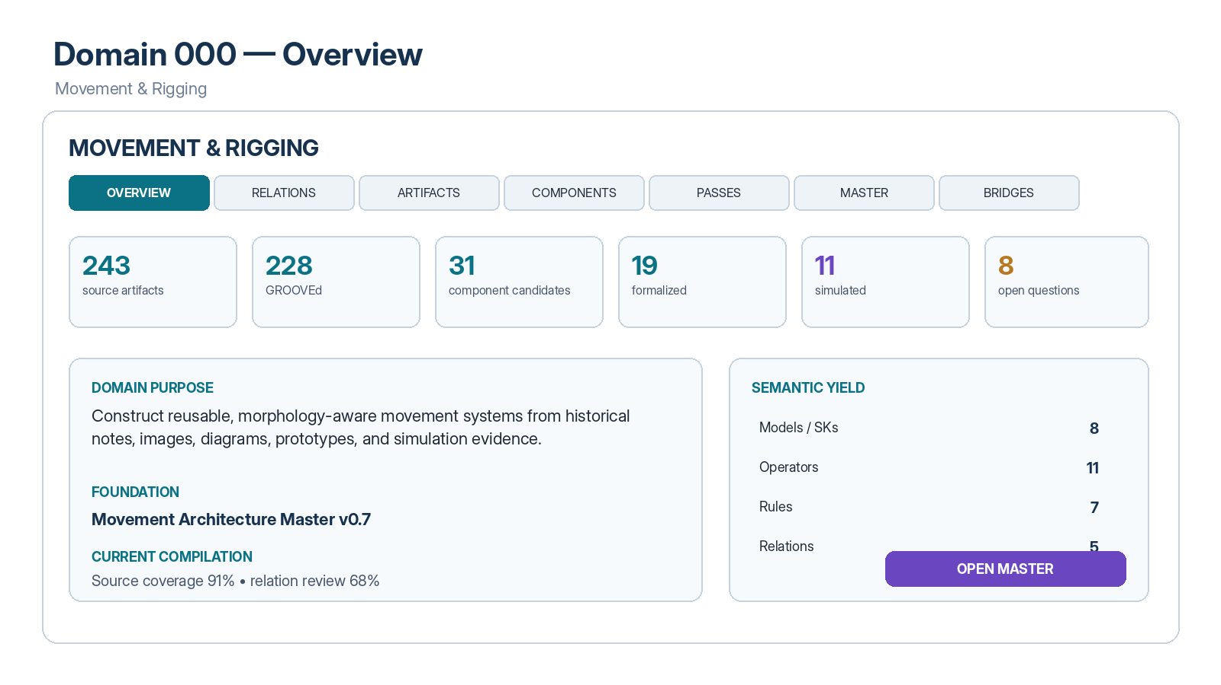
Figure 3. Domain 000 Overview. One Domain 000 can expose source volume, GROOVE coverage, component yield, simulation progress, Master status, and unresolved questions without requiring users to inspect the underlying graph first.

6. Multimodal Observable Versioned Entries
An Observable Versioned Entry is any inspectable source artifact that can be individually identified, located, versioned or timestamped sufficiently for provenance, and reopened for verification. Examples include DOCX, PDF, slide decks, spreadsheets, images, diagrams, audio transcripts, prototype screenshots, code snapshots, simulation captures, experiment notes, and external reference records.
Entry Property | Requirement
Identity | Stable enough to distinguish the artifact from copies and later versions.
Type | Document, image, diagram, table, slide, prototype, observation, etc.
Locator | Resolvable link, path, connector identifier, or other mechanism to reopen the artifact.
Version / Time | Version number, modified timestamp, revision identifier, or equivalent context.
Description | A GROOVE description may summarize what is observed and why it matters to the Domain.
Relations | Typed GROOVE edges may connect the Entry to other artifacts, Masters, concepts, or components.
Grounding | The original artifact remains the observable source and may be reopened whenever higher-fidelity inspection is required.

OBSERVABLE GROUNDING
A generated description of an image is not the image. A Master section derived from a diagram is not the diagram. A component formalized from a note is not the note. CERBERUS GROOVE SHALL preserve those layer distinctions.

7. Cross-Domain Bridges
Domains SHOULD remain bounded even when they reuse structure from one another. Cross-Domain relationships are therefore represented explicitly rather than resolved by merging the Domains into one undifferentiated corpus. Liminal Bridges are the preferred CERBERUS pattern for relationships that preserve endpoint independence while carrying relation identity, provenance, interpretation, and status.
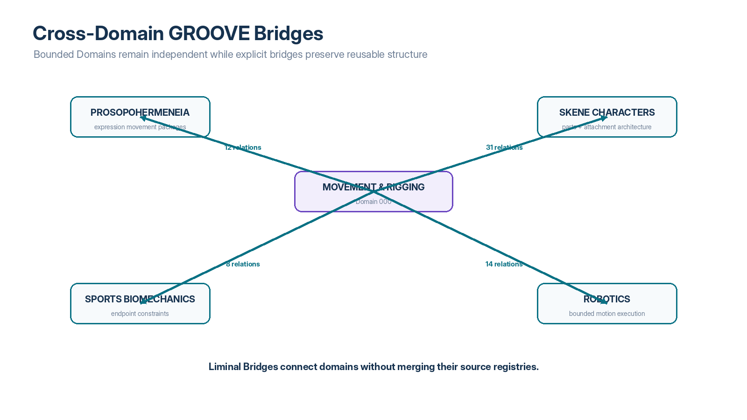
Figure 17. Cross-Domain GROOVE Bridges. Movement & Rigging can connect to Prosopohermeneia, Skene Characters, Sports Biomechanics, and Robotics without collapsing their independent domain semantics.

PART II — Progressive Semantic Compilation

8. Semantic Compilation Model
CERBERUS GROOVE treats historical idea artifacts as semantic source material. The compilation process does not rewrite those sources into a new canonical truth. Instead, it builds increasingly compact and operational representations above them: GROOVE descriptions and relations, Master syntheses, Idea Component Maps, formal CERBERUS components, and simulation states.
COMPILER ANALOGY
Human idea artifacts function as source material; GROOVE is an intermediate relational representation; the Master is a compiled human-readable representation; the Idea Component Map is a formalization staging layer; CERBERUS components are the registered target representation; Praxis and Skene provide execution and multimodal expression.

9. Progressive Sweep Protocol
The system SHOULD process large or poorly structured corpora through progressive sweeps rather than attempting perfect interpretation in a single pass. Each sweep has a bounded purpose and produces semantic handles that make later passes more selective and more informative.
Pass | Name | Primary Question | Typical Output
0 | Inventory | What exists? | Entry identity, type, locator, version, basic metadata.
1 | Description | What appears to be represented? | Grounded artifact descriptions and preliminary Domain relevance.
2 | Bundling | Which artifacts form useful semantic neighborhoods? | Candidate Domains, subdomains, membership relations.
3 | Relations | How do Entries depend on or interpret one another? | Typed GROOVE relations, source/target orientation.
4 | Component Discovery | What recurrent semantic primitives are present? | Identities, states, transformations, constraints, values, chains.
5 | CERBERUS Extraction | Which primitives map to formal CERBERUS objects? | Candidate SKs/Models, Operators, Rules, Model Keys, relations.
6 | Gap / Conflict | What is missing, contradictory, redundant, or unresolved? | Conflict records, missing yield, unresolved questions.
7 | Formalization | Which candidates are accepted? | Registered CERBERUS components and provenance links.
8 | Simulation | What happens when components are instantiated? | Praxis/Skene simulations, state transitions, observations.
9 | Reflection | What should change after observation? | Reflections, revised relations, Rule/Operator/Model updates, re-GROOVE triggers.

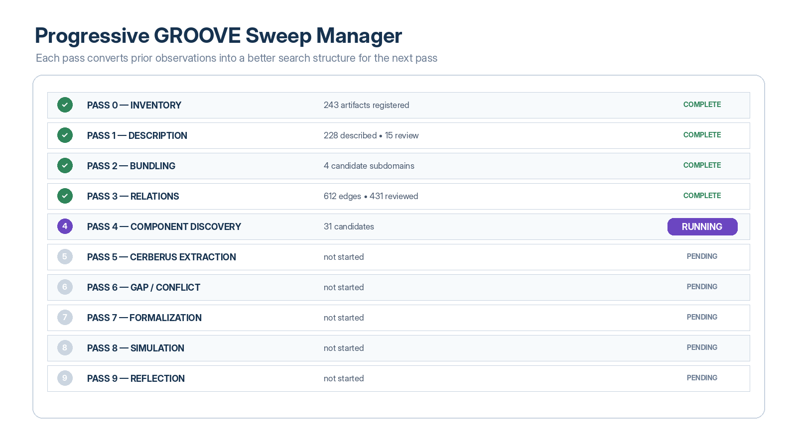
Figure 8. Progressive GROOVE Sweep Manager. The interface exposes the compilation pipeline as an inspectable set of passes rather than a hidden autonomous process.

10. Cold Read and Warm Read
A Cold Read occurs when an artifact lacks sufficient GROOVE metadata for the current task and must be inspected at source fidelity. A Warm Read occurs when a prior observation has already produced identity, description, Domain relevance, relations, semantic yield, and a source locator. Warm reading allows the AI to scan compact semantic representations first and reopen original artifacts selectively.
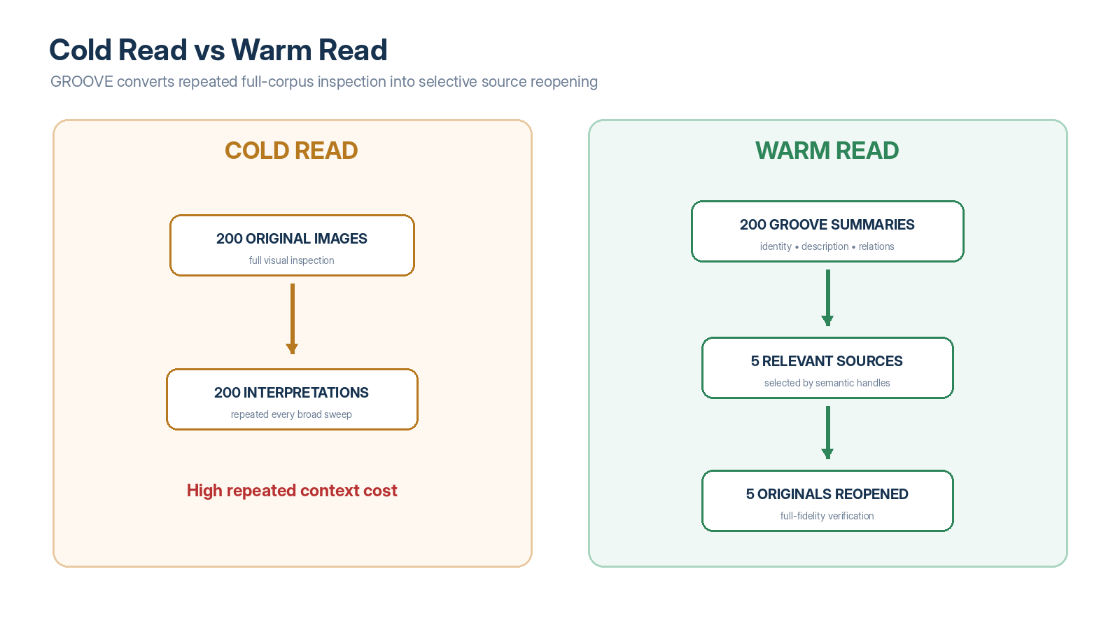
Figure 7. Cold Read versus Warm Read. The first multimodal pass may be expensive, but persistent GROOVE descriptions let later sweeps inspect a small subset of original artifacts at full fidelity.
SHALL Warm-read metadata preserve a locator to the observable source so that the original artifact can be reopened when uncertainty, conflict, precision, or provenance requires it.
SHOULD Machine summaries explicitly state what is observed, what is inferred, and why the artifact is relevant to the current Domain.

11. Bundle-Relative Description
A GROOVE description is contextual. The same image may be relevant to different Domains for different reasons. A robot workcell image may be significant to a Robotics Domain because it exposes bounded approach vectors, to a PULSE Domain because it shows landmark placement, and to a Safety Domain because it reveals physical separation between operational and human zones. The artifact remains one source; the GROOVE relations are Domain-relative projections around it.

12. Alternative Bundle Compilation
When the correct Bundle boundaries are unknown, AI MAY propose multiple reasonable structures and compare their stability. Candidate organizations can vary by technical system, lifecycle, operation type, process stage, user intent, or another declared grouping rule. The objective is not to identify a mathematically unique “correct” folder tree; it is to discover semantic neighborhoods and relations that remain useful across plausible organizations.
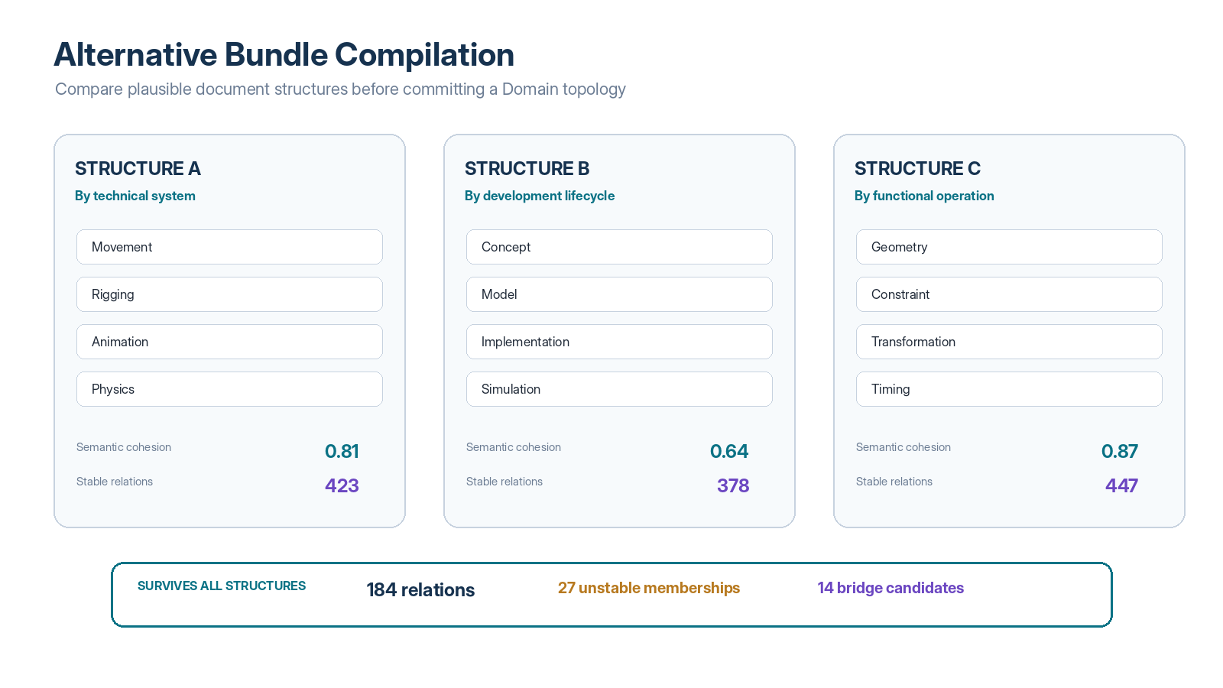
Figure 9. Alternative Bundle Compilation. Candidate document structures can be compared for diagnostic cohesion, persistent relations, unstable memberships, and potential cross-Bundle bridges.
A relation that survives several reasonable document-structure passes has stronger evidence of representing a persistent semantic neighborhood than a relation that appears only under one arbitrary grouping. Such persistence is diagnostic evidence, not proof of truth or equivalence.

13. GROOVE-Guided Re-Sweeps
The output of one sweep SHOULD become part of the interrogation structure of the next. A first pass may discover that Entry C requires A, D extends A, and E uses C. A second pass can then ask relational questions that were not available when all five artifacts were treated independently: whether E indirectly depends on A, whether C and D are specializations or conflicts, whether A lacks constraints discovered downstream, or whether an apparently adjacent Entry belongs in the Domain at all.
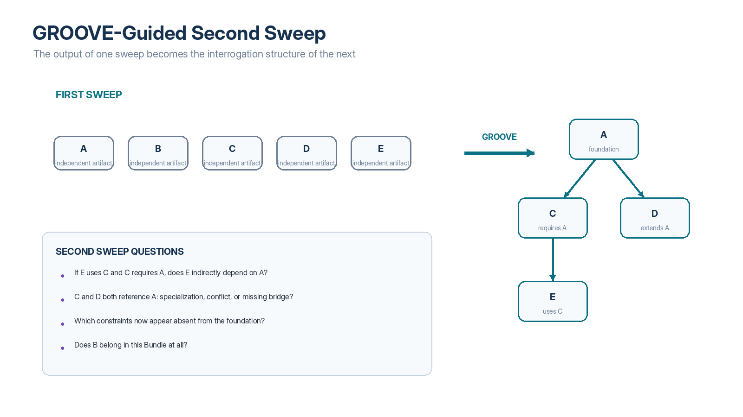
Figure 10. GROOVE-Guided Second Sweep. Newly registered relations do not terminate reading; they generate better questions for the next reading pass.
CYBERNETIC COMPILATION
READ → RELATE → USE RELATIONS TO READ AGAIN → DISCOVER HIGHER-ORDER STRUCTURE → RECOMPILE. The map is repeatedly improved by using the map.

14. Semantic Compression Without Source Loss
Progressive GROOVE sweeps create semantic compression. Hundreds of large source artifacts can be represented initially by compact descriptions, relation edges, concept inventories, candidate components, and unresolved questions. This compressed representation makes corpus-level reasoning tractable while preserving downward links to the source. Compression SHALL NOT be treated as deletion of provenance.

15. Multimodal Artifact Browser
The Artifact Browser is the primary interface for inspecting GROOVEd multimodal Entries. It SHOULD provide type filters, source thumbnails where appropriate, concise GROOVE descriptions, relation summaries, semantic yield, review status, and direct source access. Artifact cards should foreground why an Entry matters to the Domain rather than merely restating generic file metadata.
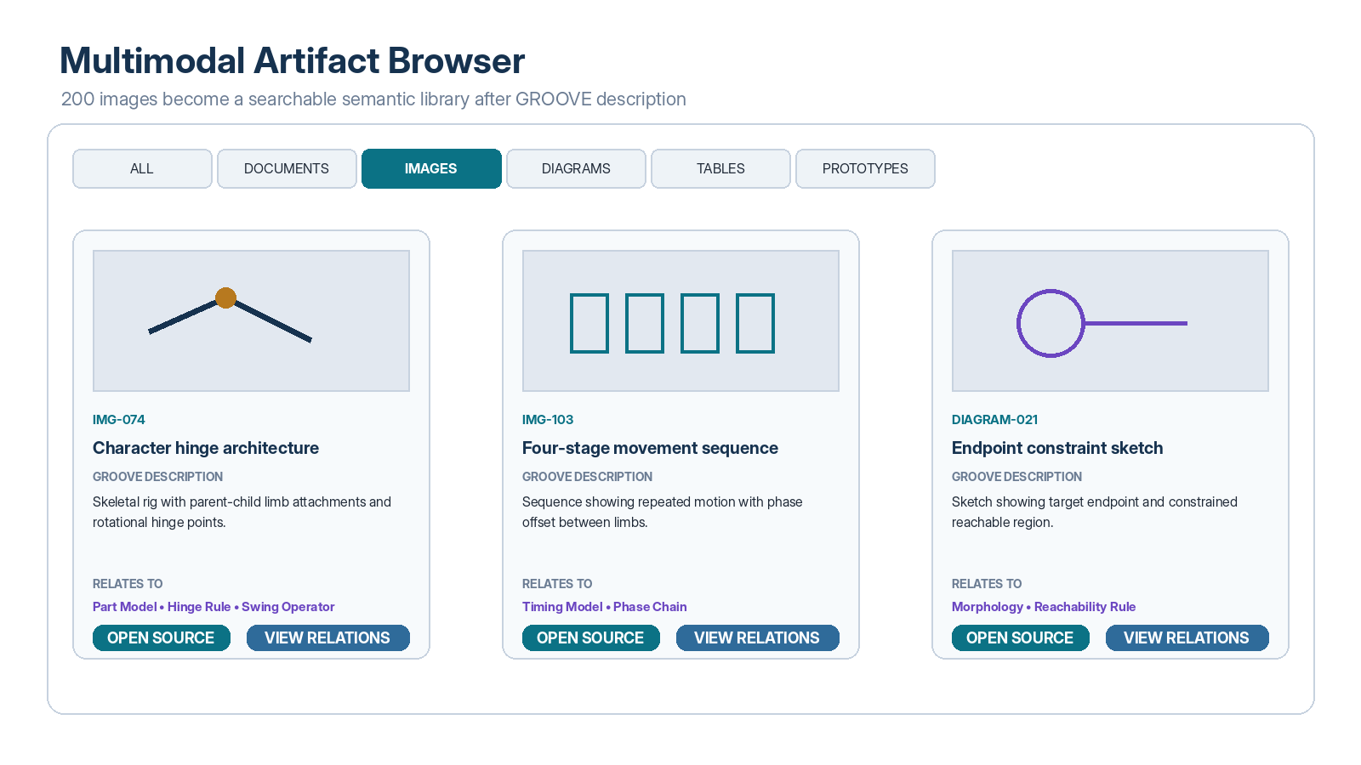
Figure 6. Multimodal Artifact Browser. A previously opaque collection of images and diagrams becomes a semantically addressable library while the original artifacts remain one click away.

PART III — Master Artifact Compilation

16. Master Artifact
A Master Artifact is a coherent, human-readable synthesis compiled from one or more GROOVE Bundles. It may be a professional Word document, specification, technical report, handbook, system map, or another stable explanatory form. It is a compilation target, not a replacement for the source corpus.
The Master SHOULD organize material according to the relational topology discovered by GROOVE rather than according to source file order. Foundation material may appear before extensions; superseded material may move to history; examples may be placed beside the concepts they illustrate; unresolved contradictions may be surfaced explicitly instead of silently reconciled.

17. GROOVE as Compilation Manifest
The GROOVE graph acts as the compilation manifest for the Master. It indicates which Entries are foundational, which extend or constrain others, which are examples, which versions supersede earlier ones, which concepts appear to have canonical owners, which source locations are relevant, and which boundaries must remain explicit.
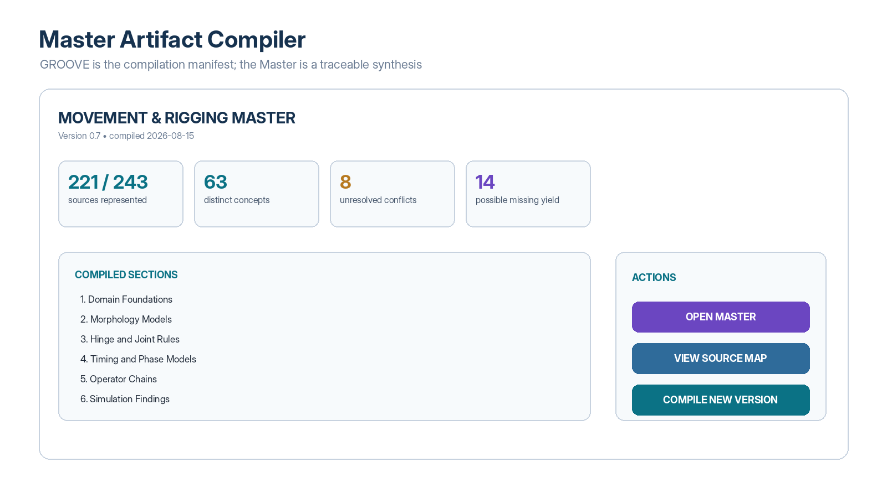
Figure 11. Master Artifact Compiler. The user can see source coverage, concept count, unresolved conflict count, missing semantic yield, compiled sections, and available actions before producing a new Master version.

18. Section Construction
Master sections SHOULD be assembled around semantic responsibilities rather than simple document summaries. A section may synthesize several Entries when their GROOVE relations indicate that they jointly define one concept, model, operator family, rule set, implementation, or worked example. Conversely, a single large source may contribute to several Master sections.

19. Provenance of Compiled Sections
Every materially synthesized Master section SHOULD expose a provenance view identifying the source Entries and meaningful locations from which it was compiled. A source map can include documents, image observations, prototype records, diagrams, and prior simulation results.
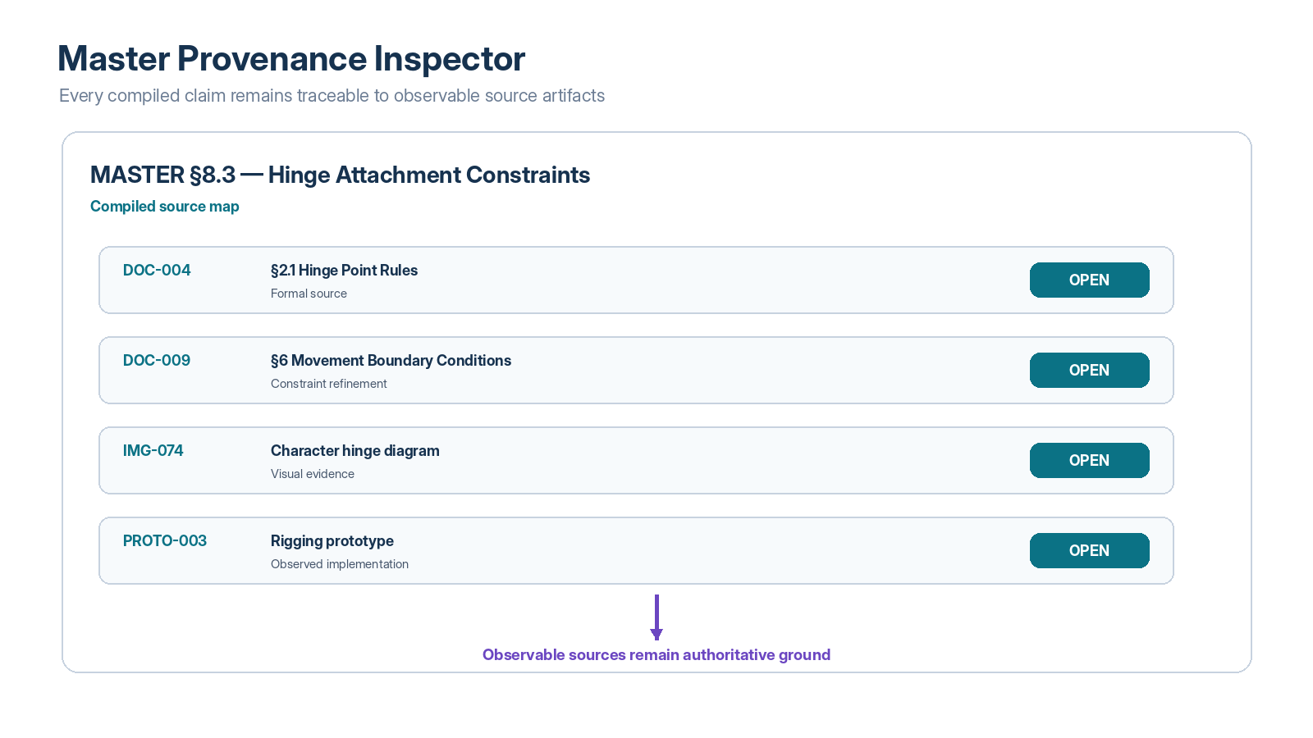
Figure 12. Master Provenance Inspector. Compiled sections remain inspectably linked to formal documents, visual evidence, and prototypes.
MUST NOT A Master section silently convert an inferred GROOVE description into source authority. The Master may synthesize; the source remains observable ground.

20. Missing Semantic Yield
After a candidate Master is compiled, the system SHOULD re-sweep all source Entries against the emerging Master structure. This completeness pass asks whether any artifact contains distinct ideas, constraints, exceptions, relations, evidence, examples, or open questions not represented in the current Master. The objective is to identify uncompiled semantic fragments before declaring the Bundle sufficiently represented.

21. Conflicts and Alternatives
When sources disagree, the compiler SHALL preserve the disagreement unless an explicit governance or authorial decision resolves it. Conflicting Entries may be tagged as alternative formulations, superseded branches, experimental variants, or unresolved conflicts. A Master SHOULD state the adopted interpretation and retain links to alternatives where they remain relevant.

22. Recompilation
A Master is versioned. When source Entries, GROOVE relations, component mappings, or simulation observations materially change, the Domain MAY be recompiled. Recompilation SHOULD produce an impact report identifying changed sections, newly included or excluded sources, altered semantic yield, unresolved conflicts, and component candidates whose provenance or meaning may have changed.

PART IV — Idea Component Discovery

23. Semantic Yield
Semantic Yield is the distinct reusable contribution that an Entry or Bundle makes to the active knowledge architecture. Yield is intentionally broader than novelty. An old document may contribute a canonical example, a failure case, a boundary, evidence, provenance, or an implementation detail even when its central idea has already been absorbed elsewhere.
Yield Class | Meaning
Identity | Introduces or clarifies a persistent semantic object.
Classification | Adds useful category structure.
SK / Model | Defines a possibility space, state model, or structured model.
Operator | Defines a transformation or action.
Rule | Constrains or validates a model, state, or transformation.
Value / Model Key | Provides actualized values or configurations.
Relation | Adds an important connection between existing objects.
Evidence | Supports, challenges, or measures a claim or component.
Boundary | Clarifies what must not be conflated or inferred.
Example | Provides a reusable instance that makes an abstraction legible.
Implementation | Shows how an abstract structure is realized.
Question | Identifies an unresolved design or research frontier.
Historical Provenance | Explains how a component or decision evolved.

24. Idea Component Map
The Idea Component Map is the staging representation between a compiled Master and formal CERBERUS registration. It groups discovered semantic yield by component class while preserving evidence counts, source links, relation status, and unresolved ambiguity. A candidate map SHALL NOT imply that every extracted idea has already become canonical system structure.
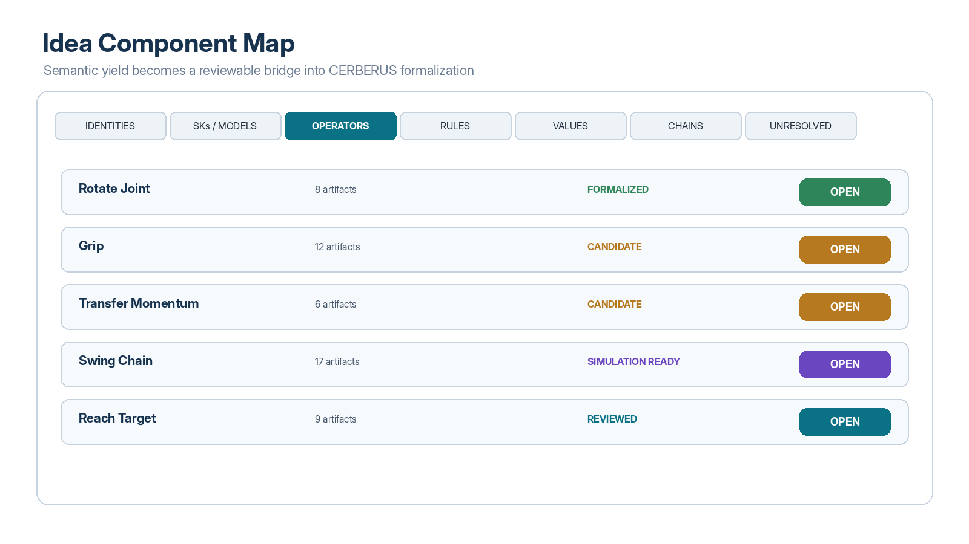
Figure 13. Idea Component Map. Candidate Operators are shown with source support and promotion status; equivalent tabs may expose identities, SKs/Models, Rules, values, chains, and unresolved fragments.

25. Component Candidate Classes
Candidate extraction SHOULD begin from observed semantic patterns rather than from a predetermined requirement to fill every CERBERUS slot. The compiler looks for stable identities, recurring possibility spaces, transformations, constraints, values, and chains. Only then are those patterns mapped to formal CERBERUS component classes.
Observed Pattern | Candidate CERBERUS Form
Persistent semantic object | NodeKey or equivalent identity.
Possibility / state structure | SK or Model candidate.
Transformation between valid states | Operator candidate.
Constraint, invariant, or validation condition | Rule candidate.
Actual configuration or quantitative value | Model Key / value candidate.
Ordered reusable sequence of transformations | Operator Chain or package candidate.
Cross-stack or cross-domain relation | Bitlink / typed relation / Liminal Bridge candidate.
Unresolved claim or possibility | FRINGE/FASK or unresolved candidate state, depending on the surrounding architecture.

26. Candidate Status
Status | Meaning
PROPOSED | Machine or human extraction has identified a possible component.
REVIEWED | A human or authorized process has inspected the candidate.
ACCEPTED | The semantic identity and intended role are approved.
FORMALIZED | The candidate has been registered as a CERBERUS component.
SIMULATION_READY | Dependencies and required parameters are sufficiently resolved for bounded simulation.
SIMULATED | At least one recorded simulation or execution exists.
REJECTED | The candidate was reviewed and not promoted.
ARCHIVAL | Preserved for history or reference without active component role.

27. Component Inspector
Every formal or candidate component SHOULD expose its Domain, type, status, dependencies, transformation target where relevant, supporting artifacts, Master sections, key GROOVE sources, unresolved issues, and available actions. A component should be understandable both upward—as a reusable system object—and downward—as the result of traceable source reasoning.
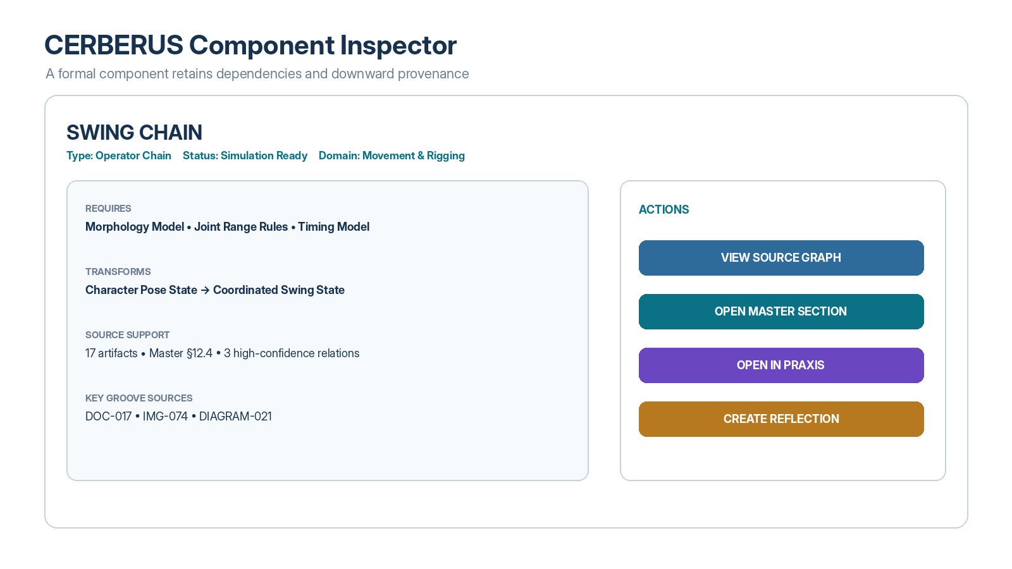
Figure 14. CERBERUS Component Inspector. The Swing Chain Operator remains connected to its Morphology Model, Rule dependencies, Master section, and original GROOVE sources, while also exposing an “Open in Praxis” action.

28. Archival Disposition
Not every Entry needs to remain active after compilation. The system SHOULD preserve historical source material while allowing active knowledge surfaces to become lighter. Recommended dispositions include ACTIVE, REFERENCE, ABSORBED, SUPERSEDED, HISTORICAL, and ARCHIVE.
Disposition | Interpretation
ACTIVE | Still contributes directly to current system understanding.
REFERENCE | Useful supporting evidence, example, or contextual material.
ABSORBED | Distinct useful semantics have been incorporated into a later Master or component.
SUPERSEDED | Replaced within a declared scope by a later formulation.
HISTORICAL | Important for lineage, chronology, or understanding architectural evolution.
ARCHIVE | Preserved but no distinct active semantic yield has been identified.

ARCHIVE PRINCIPLE
Archival disposition is not a judgment that an idea was worthless. It means the active system no longer needs to repeatedly carry that artifact as primary semantic load.

PART V — CERBERUS Formalization

29. Formal Registration
Accepted Idea Component candidates may be promoted into the appropriate CERBERUS Registry Stacks. Promotion is an explicit transition: a GROOVE-derived candidate does not become canonical merely because an AI extracted it. Registration assigns stable identity, classification, semantic contracts, dependencies, version state, and provenance.

30. SKs / Models
An SK or Model candidate represents structured possibility: the dimensions, allowable states, or semantic configuration space relevant to a concept. GROOVE may reveal Model candidates when multiple artifacts repeatedly describe the same state variables, dimensions, options, or bounded conditions. Model Keys or equivalent actualized value records remain distinct from the Model itself.

31. Operators
Operator candidates arise where artifacts describe transformations: rotate a joint, grip an object, translate a learner state, resolve a landmark, transfer momentum, compile a document, or move a product through a process stage. GROOVE relations can show which Models and Rules an Operator assumes, which Entries supply evidence, and which prior Operators it extends or composes.

32. Rules
Rule candidates arise from constraints, validation conditions, invariants, permission boundaries, safety restrictions, allowable ranges, or epistemic prohibitions. Rules SHALL remain distinguishable from the Operators they constrain and from the projections that visualize their effect.

33. Liminal Bridges
Cross-Domain or cross-Registry relationships SHOULD preserve endpoint independence. A Liminal Bridge records the relation, evidence, interpretation, scope, status, and optional summaries from each endpoint without taking ownership of the source data. This permits a Movement Operator to bridge into Prosopohermeneia, Robotics, or Sports Biomechanics without merging those Domains.

34. CERBERUS Rollup Traversal
CERBERUS Rollup Traversal may provide compact, always-ready summaries of registered stacks and components. In a GROOVE context, CRT complements source routing: GROOVE explains where and why; CRT summarizes what the selected semantic object currently contains; the observable source provides authoritative depth when required.
DIVISION OF LABOR
GROOVE: where / why. CRT: what is locally assembled. Observable Entry: source depth. CERBERUS component: formal system role.

35. SCREEN and CALL
A runtime MAY use SCREEN to establish the active semantic boundary for a question or task and CALL to resolve exact registered correspondences within that boundary. GROOVE supplies the documented and domain-level route; SCREEN/CALL can then select the bounded relations required to assemble a context package without loading the entire archive.

36. Instance Assembly
Once component candidates are formalized, Instances can provide scoped interaction surfaces over the registered data. An Instance may expose selected Models, Operators, Rules, values, and provenance controls for a specific task. GROOVE remains relevant because the user should be able to traverse from an Instance behavior back to the components, Master synthesis, and source artifacts that produced it.

PART VI — Multimodal Bootstrapping

37. Simulation as an Idea Test Surface
The endpoint of compilation is not necessarily a document. When the Domain represents behavior, interaction, spatial organization, learning, movement, music, robotics, or another dynamic system, formal CERBERUS components SHOULD be capable of entering a bounded simulation or execution environment. Praxis supplies the active field; Skene or another renderer may provide visual, spatial, auditory, or expressive projections.

38. Open in Praxis
A component marked SIMULATION_READY may expose an Open in Praxis action. The simulation interface SHOULD show the active component, Models, parameter values, Rules, current state, and observations separately. Animation or visualization MUST NOT silently author the underlying result; it should project or execute the resolved state according to the surrounding architecture.
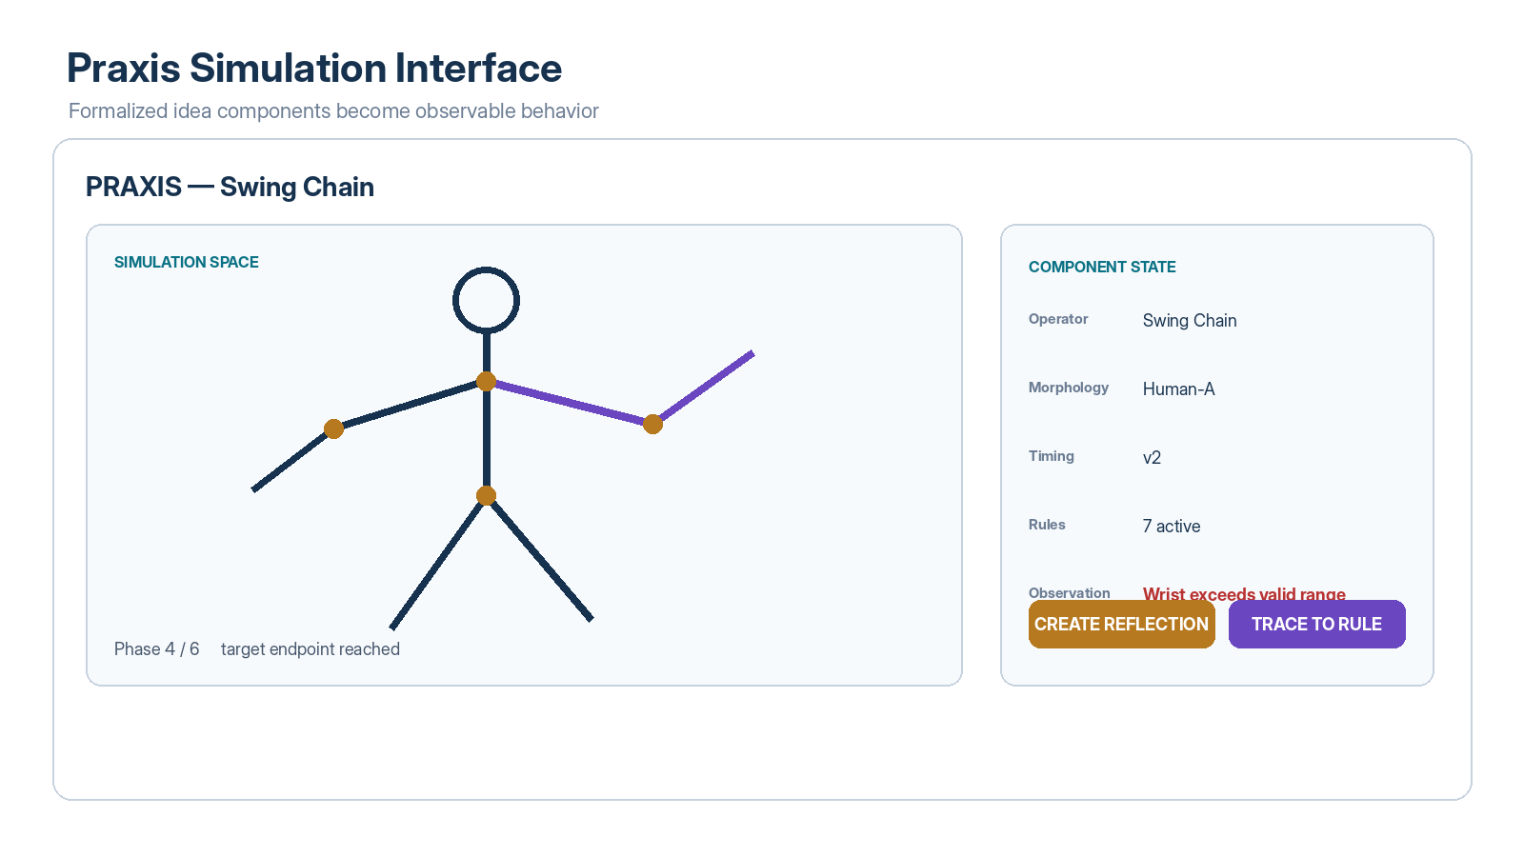
Figure 15. Praxis Simulation Interface. A formal Swing Chain is executed against a selected morphology and Rule set; the visible simulation exposes an invalid wrist state as an observation rather than silently correcting the source model.

39. Multimodal Expression
A Domain may compile into more than one modality. Movement may become visible animation and proprioceptive or spatial state. Music may become audio, visible resonance, and spatial force. Learning may become state transitions, guided scenes, and evidence dashboards. Industrial systems may become process simulations, spatial routes, and machine task contracts. GROOVE is modality-neutral because it routes semantic source and component relationships rather than prescribing one renderer.

40. Simulation Observation
Simulation output is an observable system event, not retrospective proof that the source idea was correct. Observations SHOULD record the exact component versions, parameters, Rules, Inputs, runtime, and relevant GROOVE provenance needed to reproduce or inspect the result.

41. Traceback
When a simulation behaves unexpectedly, the user SHOULD be able to traverse backward through the representation layers. An observed wrist failure may trace to a Rule, then an Operator, then a Master section, then the GROOVE relations and source artifacts from which that Rule was compiled. This makes simulation debugging simultaneously a model-debugging and source-interpretation process.
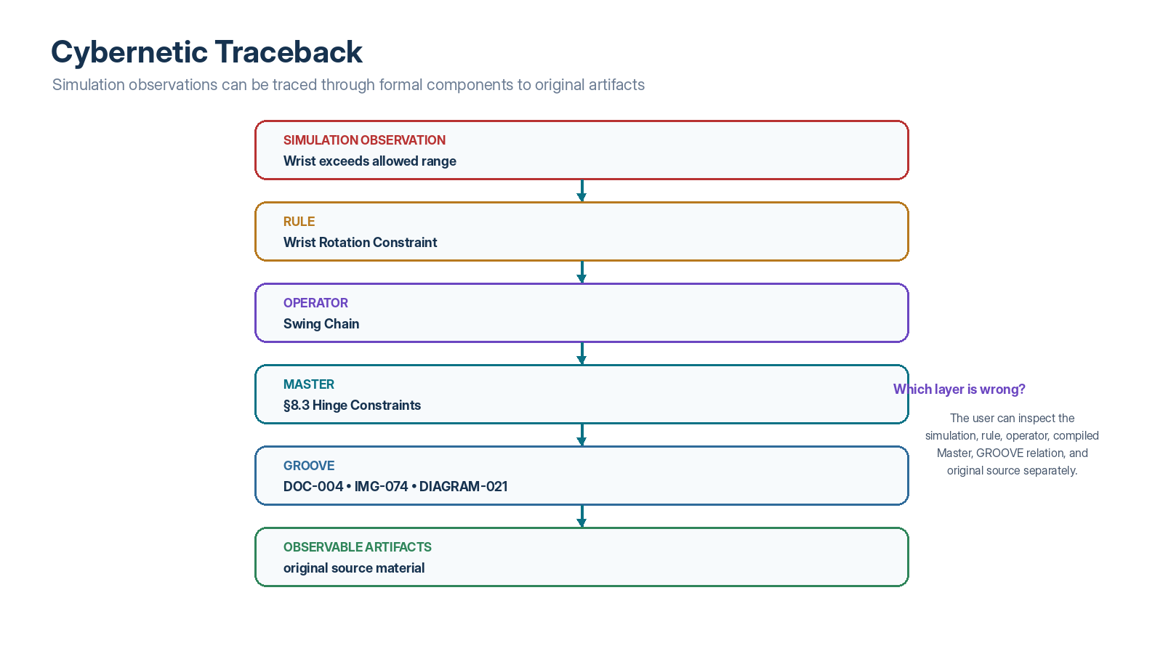
Figure 16. Cybernetic Traceback. An unexpected simulation state can be inspected without collapsing the simulation, Rule, Operator, Master synthesis, GROOVE relation, and original artifacts into one object.

PART VII — The Cybernetic Loop

42. Feedback Contract
CERBERUS GROOVE becomes cybernetic when simulation, execution, testing, and human reflection are routed back into the Domain as new Entries or evidence. The system can then re-GROOVE the affected relations, recompile the Master, revise candidate components, and run the updated system again.
CORE LOOP
OBSERVE → RELATE → FORMALIZE → SIMULATE → OBSERVE AGAIN. The output of system behavior becomes new grounded input for semantic development.

43. Reflection
A Reflection records an interpretation of observed behavior without overwriting the original observation. It may propose that a Rule is too permissive, an Operator lacks a phase dependency, a Model is missing a dimension, an image was previously misread, or a Master synthesis merged incompatible branches. Reflections SHOULD retain provenance to the state and artifacts that motivated them.

44. Re-GROOVE
Re-GROOVE is the targeted maintenance process for relations or descriptions whose meaning has changed. It may update an artifact description, redirect a canonical owner, revise a Source Location, change relation status, or add a new bridge discovered through simulation. Re-GROOVE does not necessarily require recompiling the whole Domain.

45. Recompile
Recompile is broader. It is appropriate when the Domain structure itself may have changed: major source additions, new stable relations, merged or split subdomains, Master restructuring, or formal component changes that alter the semantic architecture. A recompile SHOULD produce a diff-like review surface before accepted state is replaced.

46. Domain Evolution
Domains are versioned semantic organisms, not static folders. A mature Domain may gradually shift from a source-heavy state to a component-heavy state as useful ideas become formalized and old artifacts are absorbed or archived. The Domain 000 should continue to expose history, source provenance, current components, and unresolved questions even when the active reasoning surface becomes much smaller than the original archive.

PART VIII — Interface Specification

47. Interface Philosophy
The underlying semantic graph may be complex; the primary interfaces SHOULD remain simple. Users should not need to understand graph databases or Registry Stack implementation details to navigate a Domain. The front door should answer obvious questions: What Domain is this? What does it contain? How are the important Entries related? What has been compiled? What components exist? What remains unresolved? Can I open the source? Can I simulate the result?

48. Global Domain Navigator
The Global GROOVE::000 SHOULD provide one-row or one-card-per-Domain navigation with name, purpose, high-level counts, status, and an Open 000 action. It SHOULD NOT attempt to duplicate the full local relation architecture.

49. Domain 000 Tabs
Tab | Primary Function
OVERVIEW | Domain purpose, foundation, source coverage, component yield, Master and unresolved status.
RELATIONS | Graph and table views over GROOVE edges.
ARTIFACTS | Multimodal source browser with descriptions, yield, and source access.
COMPONENTS | Idea Component Map and formal component registry views.
PASSES | Progressive sweep manager and output review.
MASTER | Compiled Master status, source coverage, provenance, and recompilation.
BRIDGES | Cross-Domain relationships and Liminal Bridge status.
SIMULATION | Optional view of runnable components, recorded simulations, and reflections.

50. Relations Graph and Table
The Relations tab SHOULD expose both a graph view and a table view over the same underlying relation records. The graph provides cognitive topology; the table provides precise operational work. Selecting a node or edge SHOULD reveal identity, role, source and target, why the relation exists, provenance, status, and source-opening actions.
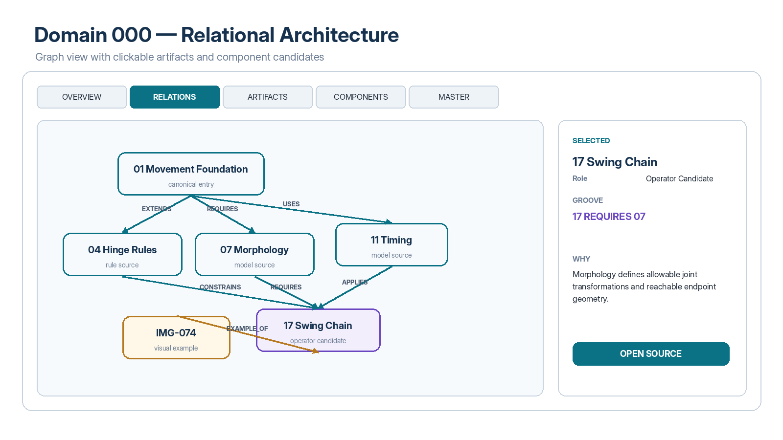
Figure 4. Domain 000 Relational Architecture. Clickable nodes and edges let a user move directly from the Domain graph to a source artifact, relation record, or component candidate.
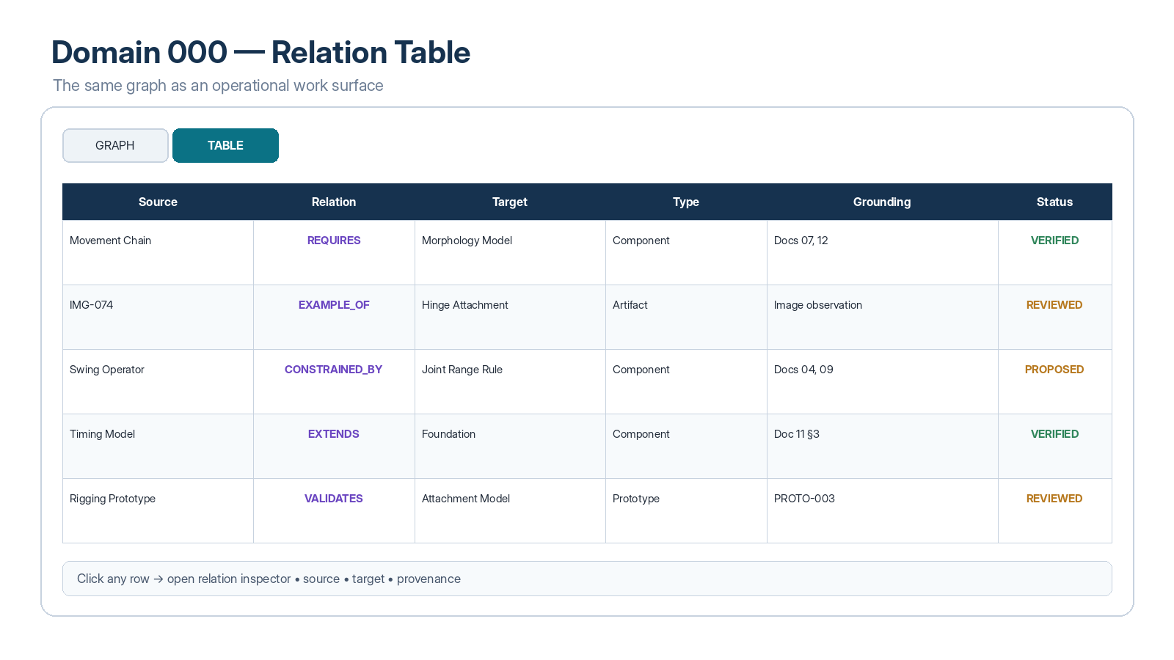
Figure 5. Relation Table. The same semantic graph is available as a dense operational surface suited to review, filtering, and editing.

51. Progressive Pass Manager
The Passes interface SHOULD show completion state, artifact counts, relation counts, unresolved review items, and outputs of each sweep. A pass SHOULD be rerunnable without implying that prior reviewed state is automatically overwritten. New proposals should be diffed against accepted state.

52. Master Compiler
The Master interface SHOULD expose current version, source coverage, unresolved conflict count, missing semantic yield, compiled sections, provenance, and actions to open, inspect, or compile a new version. The system SHOULD be able to explain why an Entry was included or excluded from a compiled Master.

53. Nested Navigation
The navigation stack SHOULD work in both directions. A user may move from Global 000 to Domain 000 to Master, Artifact, or Component and then into Praxis. The same user should also be able to move backward from a simulation observation to the Rule, Operator, Master section, GROOVE relation, and original source artifact.
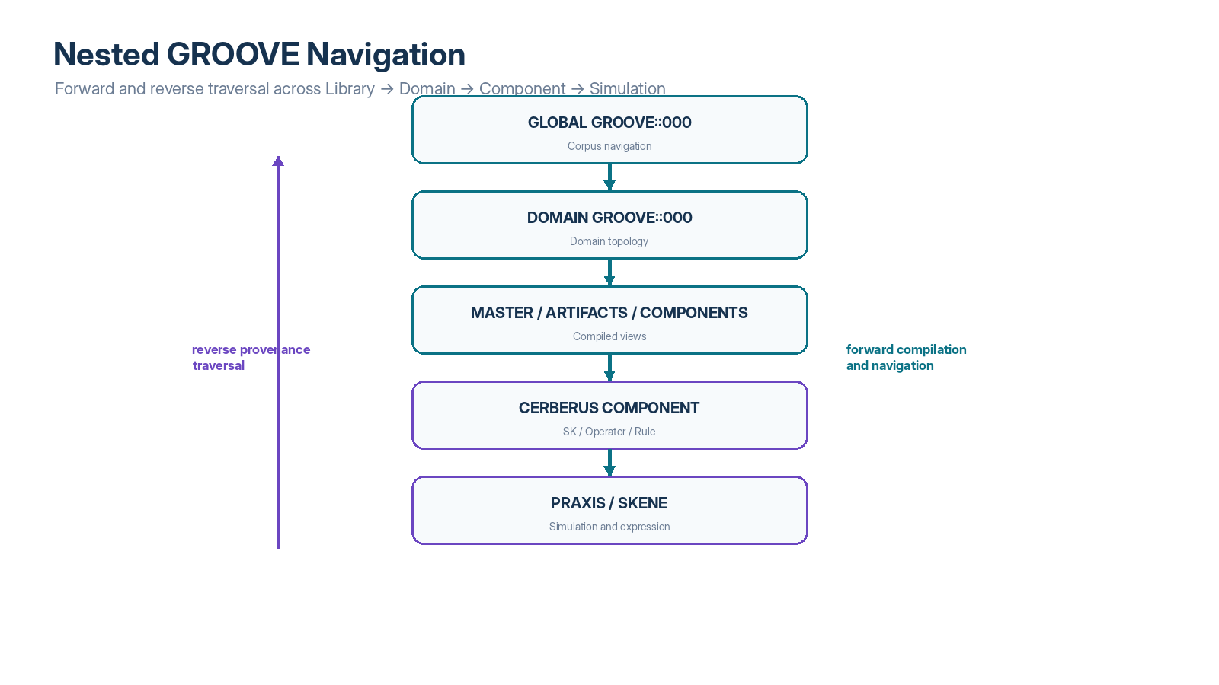
Figure 18. Nested GROOVE Navigation. Forward traversal supports compilation and use; reverse traversal supports provenance, debugging, and source verification.

PART IX — Worked Domain: Computational Morphodynamic Movement

54. Starting Corpus
The worked example assumes a historical Movement & Rigging corpus containing 21 notes, 7 formal documents, approximately 200 character and movement images, 14 diagrams, and 3 prototypes. The corpus contains ideas about character Parts, hinge attachment points, morphology, endpoint constraints, movement timing, inverse kinematics, reusable movement chains, and simulation behavior. The initial goal is not to force every artifact into a final formal schema. The first goal is to make the domain legible.

55. First Sweep
Pass 0 registers all artifacts. Pass 1 reads each document and image at sufficient fidelity to create a grounded description. A representative image receives an identity such as IMG-074, type Architecture Diagram, Domain Movement & Rigging, description “skeletal rig showing parent-child limb attachments and rotational hinge points,” candidate relations to the Part Model and Hinge Rule, and a direct source locator.
After this first expensive pass, the entire 200-image collection can be scanned through compact descriptions. Later tasks that concern hinge constraints can identify five or ten highly relevant images and reopen only those originals.

56. Relation Sweep
The relation sweep discovers that a Movement Foundation is extended by Hinge Rules, requires a Morphology model, and uses a Timing model. A Swing Chain candidate is constrained by the Hinge Rules, requires Morphology, applies Timing, and is illustrated by IMG-074. These relations are recorded independently of the visual graph used to display them.

57. Master Compilation
The first Master organizes the corpus around domain foundations, morphology, hinge and joint Rules, timing and phase, Operator Chains, and simulation findings. Source coverage is reported. Unrepresented semantic yield is surfaced as a review queue rather than silently dropped.

58. Component Extraction
The Idea Component Map identifies a Morphology Model, Joint Range Rules, a Timing Model, Rotate Joint and Grip Operators, a Transfer Momentum candidate, and a Swing Chain Operator Chain. The Swing Chain is promoted only after its dependencies and provenance are reviewed.

59. Simulation
The accepted Swing Chain is opened in Praxis with a selected morphology and seven active Rules. During phase four, the visible wrist exceeds its allowed range. The simulation records the observation without silently modifying the Operator or Rule set.

60. Traceback and Revision
The user selects Trace to Rule. The system reveals the Wrist Rotation Constraint, the Swing Chain Operator, Master §8.3, and the source map containing DOC-004, IMG-074, and DIAGRAM-021. The user can inspect whether the failure came from an incorrect Rule, an incorrect Operator interpretation, missing morphology data, or a misread source artifact. A Reflection is created, the Rule is revised, relevant relations are re-GROOVEd, the Domain is recompiled if necessary, and the simulation runs again.
WORKED EXAMPLE RESULT
A historical drawing has not merely been summarized. It has become one observable source in a traceable pathway that helped construct a formal Rule and Operator, produced simulation behavior, exposed a failure, and generated new knowledge.

PART X — Governance, Limits, and Conformance

61. Human Review and Machine Proposals
AI is useful for inventory, description, relation proposals, candidate bundling, concept extraction, component discovery, and completeness sweeps. However, machine-proposed relations and components SHALL remain distinguishable from reviewed or accepted state. A system that writes its own inferences into canonical GROOVE and then treats those inferences as authorial ground creates recursive epistemic drift.

62. Confidence and Review Priority
Large archives may generate thousands of relation proposals. Review effort SHOULD be prioritized toward high-impact structures: foundational relations, canonical concept ownership, supersession, cross-Domain bridges, DO_NOT_INFER boundaries, high-centrality components, unresolved conflicts, and any relation that would materially alter Master compilation or simulation behavior.

63. Non-Replacement Principle
GROOVE POINTS. THE ARTIFACT PROVES.
A GROOVE route, Master synthesis, or formal component may make a source easier to locate and use, but none of those layers erases the need to inspect the observable source when authority, precision, contradiction, or provenance matters.

64. Failure Modes
Failure Mode | Risk | Required Mitigation
Premature formalization | AI forces loosely understood ideas into SK/Operator/Rule slots. | Bundle and GROOVE the Domain before aggressive component extraction.
Summary drift | Repeated generated summaries gradually diverge from sources. | Preserve locators and reopen original artifacts selectively.
Graph overconfidence | Dense relation topology is mistaken for truth. | Track proposal/review status and separate structural evidence from semantic correctness.
Canonical collapse | Later documents silently overwrite original definitions. | Track concept ownership, versioning, supersession, and explicit governance.
Projection becomes truth | Simulation or visualization silently authors canonical state. | Keep formal state, projection, and observation layers distinct.
Archive overload | Every historical artifact remains active forever. | Use semantic yield and archival disposition while preserving provenance.
Bundle rigidity | One folder tree is treated as the only valid ontology. | Permit alternative Bundle compilation and cross-Domain participation.
Missing multimodal context | Images or diagrams are ignored after text compilation. | Register multimodal Entries and preserve source reopening paths.

65. Conformance Levels
Level | Minimum Capability
GROOVE-Domain Basic | Global or Domain 000; stable Domain identity; source Entry registry; typed relations; source locators.
GROOVE-Domain Multimodal | Basic + GROOVE descriptions for non-text artifacts + selective source reopening.
GROOVE-Compile | Multimodal + progressive sweeps + Master compilation + provenance map + semantic yield review.
GROOVE-CERBERUS | Compile + Idea Component Map + reviewed promotion into CERBERUS components + component provenance.
GROOVE-Cybernetic | CERBERUS + bounded simulation/execution + observation/reflection + traceback + re-GROOVE/recompile loop.

66. Core Conformance Requirements
1. A conforming implementation SHALL preserve stable identity between source Entries and higher-level derived representations.
2. A conforming implementation SHALL preserve source locators sufficient to reopen Observable Entries.
3. A conforming implementation SHALL distinguish machine-proposed from accepted relations and components.
4. A conforming implementation SHALL preserve version or temporal context where changes can affect interpretation.
5. A conforming implementation SHALL keep source artifact, GROOVE metadata, Master synthesis, formal component, simulation state, and observation distinct.
6. A conforming implementation SHOULD support reverse provenance traversal from formal components and simulation observations to source artifacts.
7. A conforming cybernetic implementation SHALL preserve simulation observations separately from the Rules or Operators those observations may later cause humans or authorized processes to revise.

67. Design Principles
BOUND THE PRIMITIVE LAYER, PRESERVE IDENTITY, COMPOSE UPWARD, NEVER LET PROJECTION BECOME TRUTH.
The same architectural discipline governing CERBERUS applies to documentation compilation and simulation.

DO NOT FORCE FUTURE SYSTEMS TO INFER A RELATIONSHIP YOU ALREADY KNOW.
Registered GROOVE relations reduce repeated context reconstruction.

ROUTE PRECISELY ENOUGH TO ELIMINATE UNNECESSARY INFERENCE; PRESERVE ENOUGH LOCAL FREEDOM TO INSPECT CONTEXT.
Semantic landing descriptions orient without brittle over-anchoring.

CLUSTERING PROPOSES PROXIMITY; GROOVE COMPILATION PROPOSES STRUCTURE.
Similarity alone does not establish dependency, authority, or conceptual ownership.

THE MAP SHOULD MAKE THE NEXT READ BETTER.
Every progressive sweep should increase the quality of the questions asked in the following sweep.

ARCHIVE SOURCES; COMPILE SURVIVING SEMANTICS.
Historical artifacts may leave the active surface without being destroyed or forgotten.

Appendix A — Domain 000 Reference Interface Schema
Surface | Minimum Fields / Controls
Domain Header | Domain ID, name, purpose, scope, version/status, foundation, Global 000 backlink.
Overview | Artifact count, GROOVE coverage, candidate/formalized/simulated components, open questions, Master version.
Relations | Graph/table switch, source, relation, target, scope, why, grounding, review state, source-open actions.
Artifacts | Type, identity, title, GROOVE description, Domain relevance, yield, review state, locator.
Components | Type tabs, component identity, evidence count, status, dependencies, Master/source links.
Passes | Pass number/name, completion state, input count, output count, unresolved review, rerun/review actions.
Master | Version, source coverage, sections, missing yield, conflicts, provenance, compile new version.
Bridges | Target Domain, relation type, endpoint summaries, evidence, status.
Simulation | Runnable component, current state, active Rules/Models, observation log, create reflection, trace to source.

Appendix B — Reference GROOVE Relation Vocabulary for Domain Compilation
Relation | Reference Meaning
FOUNDATION_FOR | Source establishes semantics on which Target is built.
REQUIRES | Source assumes concepts, structures, or dependencies supplied by Target.
EXTENDS | Source adds to Target without replacing it.
USES | Source consumes a mechanism defined by Target.
APPLIES | Source applies Target in a bounded context.
INSTANTIATES | Source realizes an abstract structure from Target.
SPECIALIZES | Source narrows Target for a specific domain or scope.
CONSTRAINS | Source limits valid interpretation or operation of Target.
VALIDATES | Source supplies evidence or testing relevant to Target.
EXAMPLE_OF | Source is a worked or visual instance of Target.
SUPERSEDES | Source replaces Target within a declared scope.
BRIDGES_TO | Source establishes an explicit cross-Domain or cross-system relation.
PARALLELS | Source and Target share meaningful structure without dependency.
CONTRADICTS | Source and Target contain materially incompatible claims or constraints.
DERIVED_FROM | Source synthesis/component was derived from Target evidence or reasoning.
DO_NOT_INFER | Explicitly blocks a plausible but invalid semantic collapse.

Appendix C — Artifact GROOVE Record
Field | Example
Entry ID | IMG-074
Domain | Movement & Rigging
Type | Architecture diagram
Version / Date | 2026-07-04
Locator | Resolvable source link
Observed Content | Skeletal rig with parent-child limb attachments and rotational hinge points.
Domain Relevance | Illustrates attachment hierarchy described in Character Parts source material.
Relations | EXAMPLE_OF Hinge Attachment Model; SUPPORTS Joint Constraint interpretation.
Semantic Yield | Visual example; candidate attachment relation; Rule evidence.
Review State | REVIEWED
Disposition | ACTIVE

Appendix D — Component Provenance Chain
A recommended provenance path for a formalized component is:
REFERENCE CHAIN
CERBERUS Component → Idea Component Candidate → Master Section → GROOVE Relations → Observable Versioned Entries → Source Locations. Simulation observations and reflections attach to the formal component and may route backward through the same chain.

Appendix E — Reference Domain Compilation Prompt
The following prompt pattern is intentionally provider-neutral and should be adapted to available file and connector capabilities:
AI COMPILATION PROMPT
Inventory the supplied Domain corpus. Preserve every source identity and locator. Describe each Entry only from observable content. Propose Domain-relative GROOVE relations using the registered relation vocabulary. Separate observed facts from inference. Do not promote proposed relations or components into accepted state. After the first relation pass, use the resulting graph to perform a second sweep for missing dependencies, contradictions, canonical owners, semantic yield, unresolved questions, and candidate identities, SKs/Models, Operators, Rules, values, and chains. For every candidate component, retain the source Entries and locations that support the proposal.

Appendix F — Reference Navigation Protocol
1. If the Domain is unknown, open Global GROOVE::000 and select the relevant Domain.
2. Open the Domain GROOVE::000 Overview to inspect purpose, foundation, current Master, source coverage, component yield, and unresolved state.
3. Use Relations to understand the internal semantic topology; switch between Graph and Table as needed.
4. Use Artifacts to inspect GROOVE descriptions and reopen original source material selectively.
5. Use Master to inspect compiled synthesis and provenance.
6. Use Components to inspect candidate or formalized SKs, Models, Operators, Rules, values, chains, and their dependencies.
7. If a formal component is simulation-ready, open it in Praxis or the relevant execution environment.
8. If behavior is unexpected, trace backward through Rule/Operator → Master → GROOVE → source artifact before modifying canonical state.
9. Record observations and reflections, then re-GROOVE or recompile at the smallest scope that preserves correctness.

Appendix G — Interface Figure Index
Figure | Interface / Diagram | Purpose
Figure 1 | Multimodal Archive to Simulation | Full cybernetic compilation loop.
Figure 2 | Global Domain Navigator | Central corpus navigation.
Figure 3 | Domain 000 Overview | Domain health and compilation status.
Figure 4 | Domain Relation Graph | Clickable relational topology.
Figure 5 | Domain Relation Table | Operational relation review.
Figure 6 | Artifact Browser | Multimodal semantic library.
Figure 7 | Cold vs Warm Read | Selective reopening efficiency.
Figure 8 | Sweep Manager | Progressive pass orchestration.
Figure 9 | Bundle Comparison | Alternative document structures.
Figure 10 | Second Sweep | Relations guide new reading.
Figure 11 | Master Compiler | Traceable synthesis compilation.
Figure 12 | Provenance Inspector | Master-to-source traceability.
Figure 13 | Idea Component Map | Candidate formal components.
Figure 14 | Component Inspector | Dependencies and source support.
Figure 15 | Praxis Simulation | Observable component behavior.
Figure 16 | Cybernetic Traceback | Simulation-to-source debugging.
Figure 17 | Cross-Domain Bridges | Bounded interoperability.
Figure 18 | Nested Navigation | Forward and reverse traversal.

Closing Statement
CERBERUS GROOVE treats documentation not as passive exhaust from prior thinking but as a recoverable substrate for future system construction. By bundling Domains, recording grounded relations, compiling Master artifacts, extracting reviewable component candidates, preserving source provenance, and feeding simulation observations back into the same semantic architecture, accumulated ideas can progressively become more legible, more reusable, and more operational without erasing the documents and artifacts from which they emerged.
SPECIFICATION SUMMARY
Bundle the ideas. GROOVE the relations. Compile the Master. Extract the components. Simulate the system. Trace the result. Feed the observation back.

