CERBERUS

MATHEMATICAL_OPERATORS-77
Descriptive Semantic Kernel Specification v0.1
Symbol Vocabulary, SK Memory, Professional Examples, Personal Anchors, and Future Functional Reuse
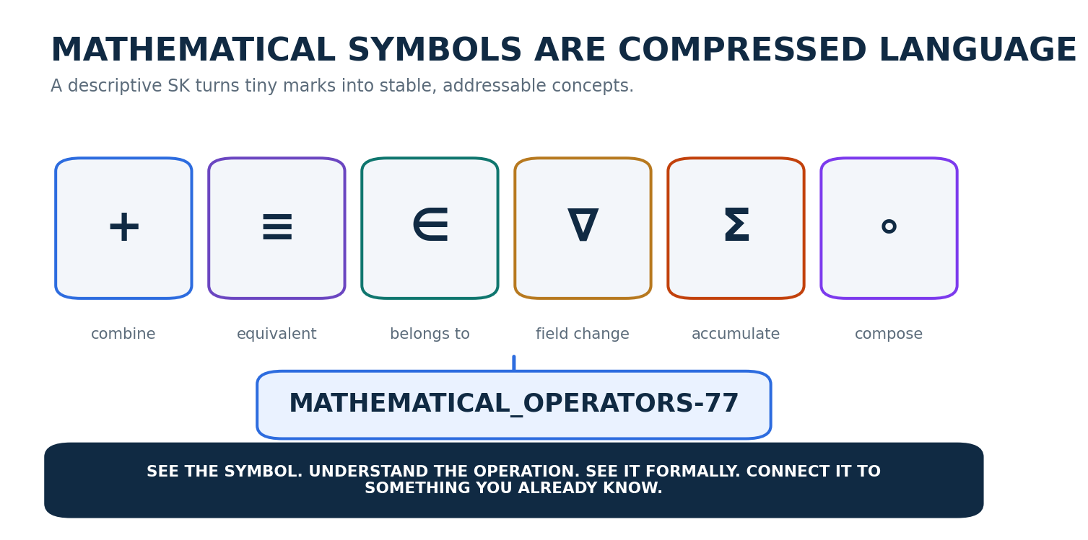
Figure 1. Mathematical symbols compress operations and relationships into compact reusable marks.
CORE PRINCIPLE | See the symbol. Understand the operation. See it formally. Connect it to something you already know. MATHEMATICAL_OPERATORS-77 is descriptive: it teaches a bounded operator vocabulary but does not execute those operators.

Candidate Descriptive Semantic Kernel Specification
18 August 2026

Document Control
Control | Value
Specification | CERBERUS MATHEMATICAL_OPERATORS-77
Version | v0.1
SK class | Descriptive Semantic Kernel
Semantic width | 77 Bits; B000-B076
Reader topology | A1-G1; seven DESCRIPTION-n BitGroups
Primary purpose | Bounded mathematical operator vocabulary with deterministic SK Memory retrieval
Memory layers | Symbol/Name, Description, Professional Example, Personal Example; References reserved and blank
Execution boundary | This SK does not execute, evaluate, parse, or validate mathematical expressions
Interface posture | Bit-level Operator Card, BitGroup palettes, complete-Word F variants; no E interface is required in v0.1
Resolution rule | Bit = 1 selects the descriptive operator address for the current projection; Bit = 0 leaves it unselected
Reference status | Reference fields intentionally unpopulated in v0.1

Abstract
MATHEMATICAL_OPERATORS-77 is a 77-Bit descriptive vocabulary kernel for common mathematical operators, relations, quantifiers, set operations, calculus operators, linear-algebra operators, transforms, and optimization functions. Its binary state is an activation mask over semantic operator addresses. When a Bit is active, the system follows that operator’s registered SK Memory links to retrieve its symbol, concise description, professional mathematical example, and a personal example grounded in already familiar CERBERUS structures. Reference fields are present as part of the memory contract but remain blank in this first version.
The kernel is intentionally non-executable. It does not claim that selecting Σ performs summation, that selecting ∇ computes a gradient, or that a sequence of active Bits forms an evaluable equation. Its role is to create a compact, inspectable, reusable mathematical phrasebook whose stable semantic identities can later be linked to functional Operator records, equation builders, expression trees, Model formulas, validation systems, or other mathematical tooling.
SHORT FORM | Symbols compress. Bits address. SK Memory explains. Personal examples anchor. Future systems may reuse the same vocabulary.

Reading Map
Part | Subject | Primary visuals
Part 1 | Semantic Boundary and 77-Bit Architecture | Figures 1-6
Part 2 | Arithmetic and Numeric Operators | Figures 7-9
Part 3 | Relations and Logic | Figures 10-14
Part 4 | Sets and Membership | Figures 15-17
Part 5 | Aggregate and Calculus | Figures 18-22
Part 6 | Vector and Linear Algebra | Figures 23-26
Part 7 | Functions, Transforms, and Optimization | Figures 27-29
Part 8 | Interface Architecture and SK Memory | Figures 30-34
Part 9 | Future Functional Reuse | Figures 35-38
Part 10 | Canonical Operator Registry | Tables 1-7
Part 11 | Validation, Laws, and Implementation Handoff | Reference contracts

Part 1 | Semantic Boundary and 77-Bit Architecture

1. Purpose and Bounded Question
MATHEMATICAL_OPERATORS-77 answers one bounded question: which mathematical operator concepts are selected in the current descriptive vocabulary, and what registered memory should a human receive for each selected concept? The kernel does not attempt to encode all mathematics, mathematical objects, constants, theorem systems, units, functions, or proofs. It is a compact operator-and-relation vocabulary.
The operator symbol is treated as part of the human-facing semantic identity, but symbol shape alone is not sufficient for decoding. The Reader category and operator name provide context. This matters because the same visible glyph can legitimately represent different mathematical operations: × may mean arithmetic multiplication, Cartesian product, or vector cross product. Context preserves the distinction.
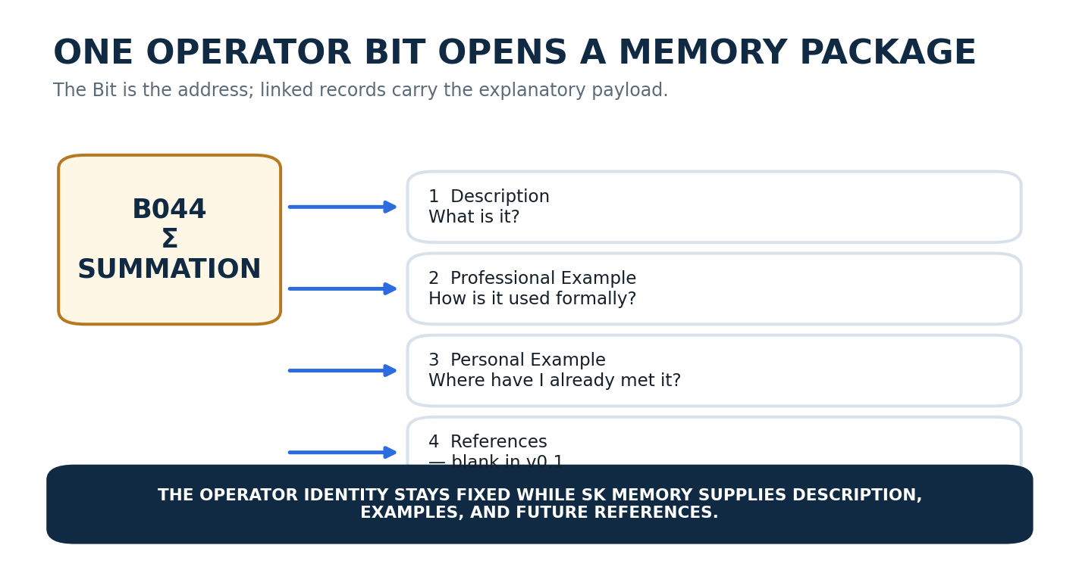
Figure 2. One operator Bit is a deterministic address into an ordered SK Memory package.

1.1 Word Anatomy
The Word uses seven descriptive BitGroups. Their widths are not padded to conventional binary boundaries. Each width is the current count of independently useful operator addresses in that category. The resulting 77-Bit width follows Minimum Sufficient Resolution: enough addresses to teach the selected vocabulary, no semantic padding.
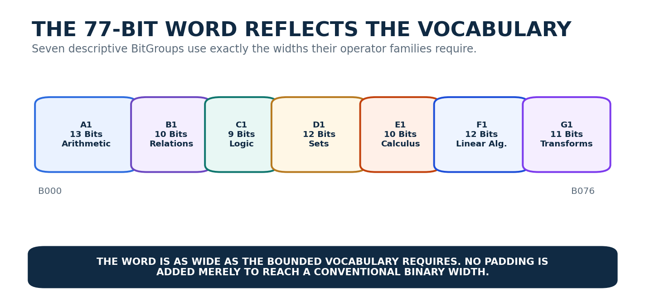
Figure 3. Seven uneven DESCRIPTION-n BitGroups produce the 77-Bit word without arbitrary padding.
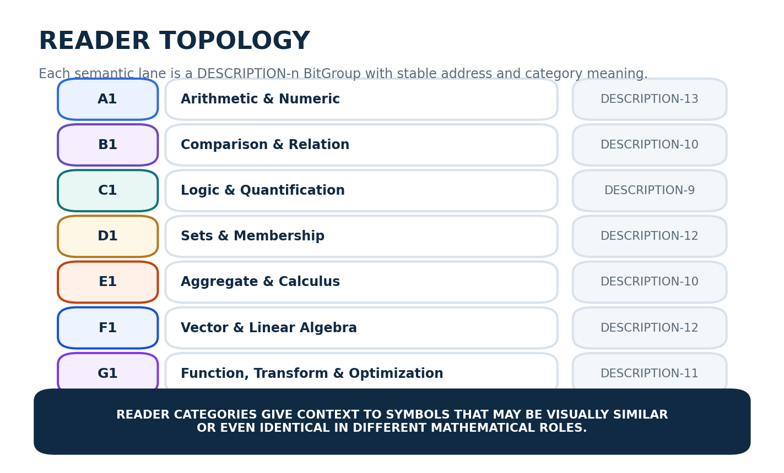
Figure 4. Reader topology A1-G1 supplies stable category context for every operator address.
Reader | Bits | BitGroup | Semantic category | Width
A1 | B000-B012 | DESCRIPTION-13 | Arithmetic & Numeric | 13
B1 | B013-B022 | DESCRIPTION-10 | Comparison & Relation | 10
C1 | B023-B031 | DESCRIPTION-9 | Logic & Quantification | 9
D1 | B032-B043 | DESCRIPTION-12 | Sets & Membership | 12
E1 | B044-B053 | DESCRIPTION-10 | Aggregate & Calculus | 10
F1 | B054-B065 | DESCRIPTION-12 | Vector & Linear Algebra | 12
G1 | B066-B076 | DESCRIPTION-11 | Function, Transform & Optimization | 11

1.2 Binary Selection Semantics
A Bit value of 1 means that the corresponding operator address participates in the current descriptive projection. A Bit value of 0 means that the operator is not selected for that projection. Neither state is a mathematical truth assertion. Selecting the ∧ Bit does not make an AND proposition true; selecting ∫ does not perform an integration; clearing ≠ does not assert equality. Binary state selects vocabulary.
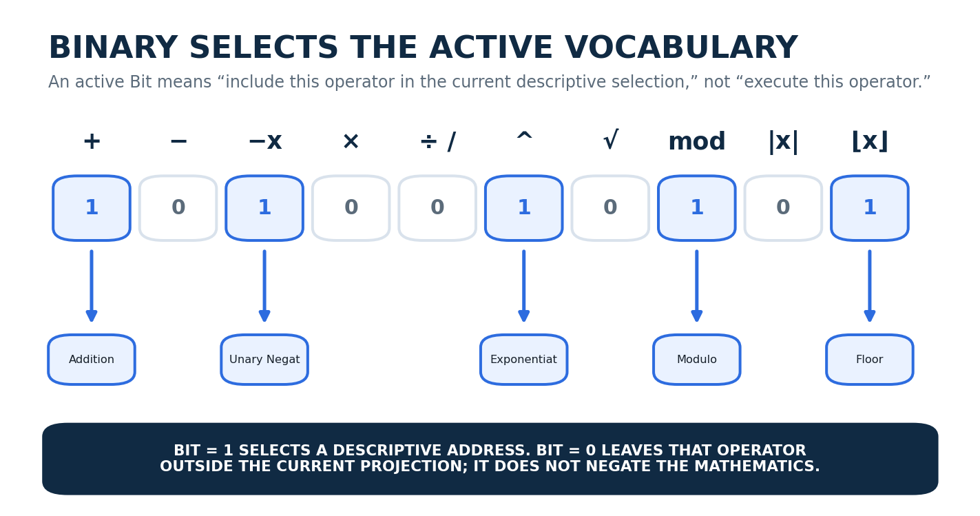
Figure 5. Binary state selects which operator concepts participate in the current descriptive vocabulary.
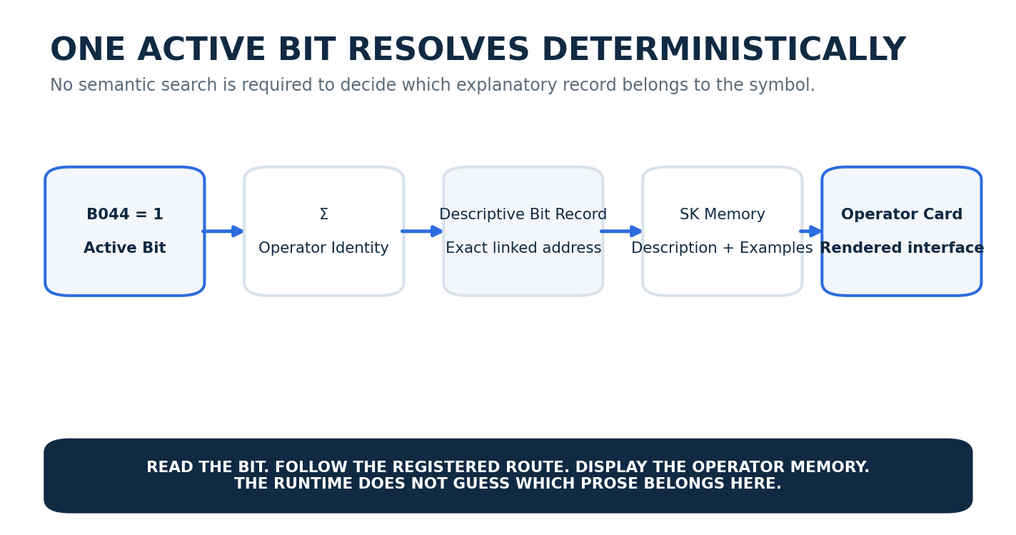
Figure 6. An active operator Bit resolves by exact linkage from Bit to semantic identity to SK Memory and interface.
NO EXECUTION INFERENCE | The descriptive kernel SHALL NOT infer an executable formula from a set of active Bits. Functional execution belongs to a separate mathematical Operator or expression architecture.

Part 2 | Arithmetic and Numeric Operators

2. A1 - Arithmetic & Numeric
A1 contains thirteen foundational operations used for combination, difference, sign reversal, scaling, quotient formation, powers, roots, cyclic wrapping, magnitude, integer rounding, combinatorial multiplication, and percentage display. Several symbols are visually familiar, but the Personal Example layer deliberately connects them to concrete CERBERUS mechanics rather than leaving them as schoolbook abstractions.
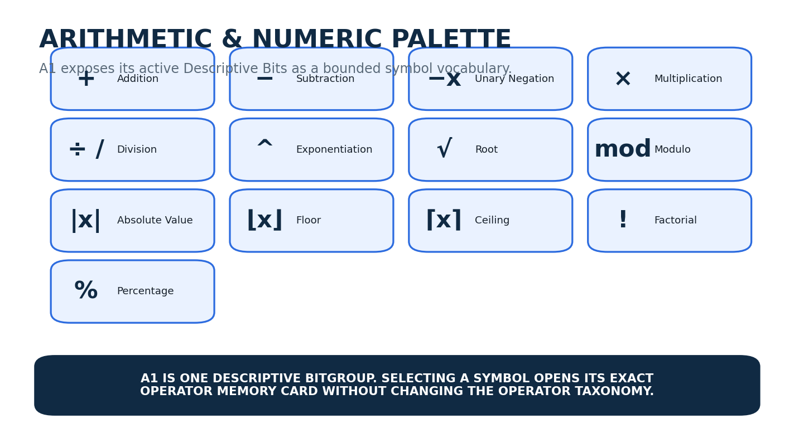
Figure 7. A1 operator palette: thirteen Arithmetic & Numeric descriptive addresses.
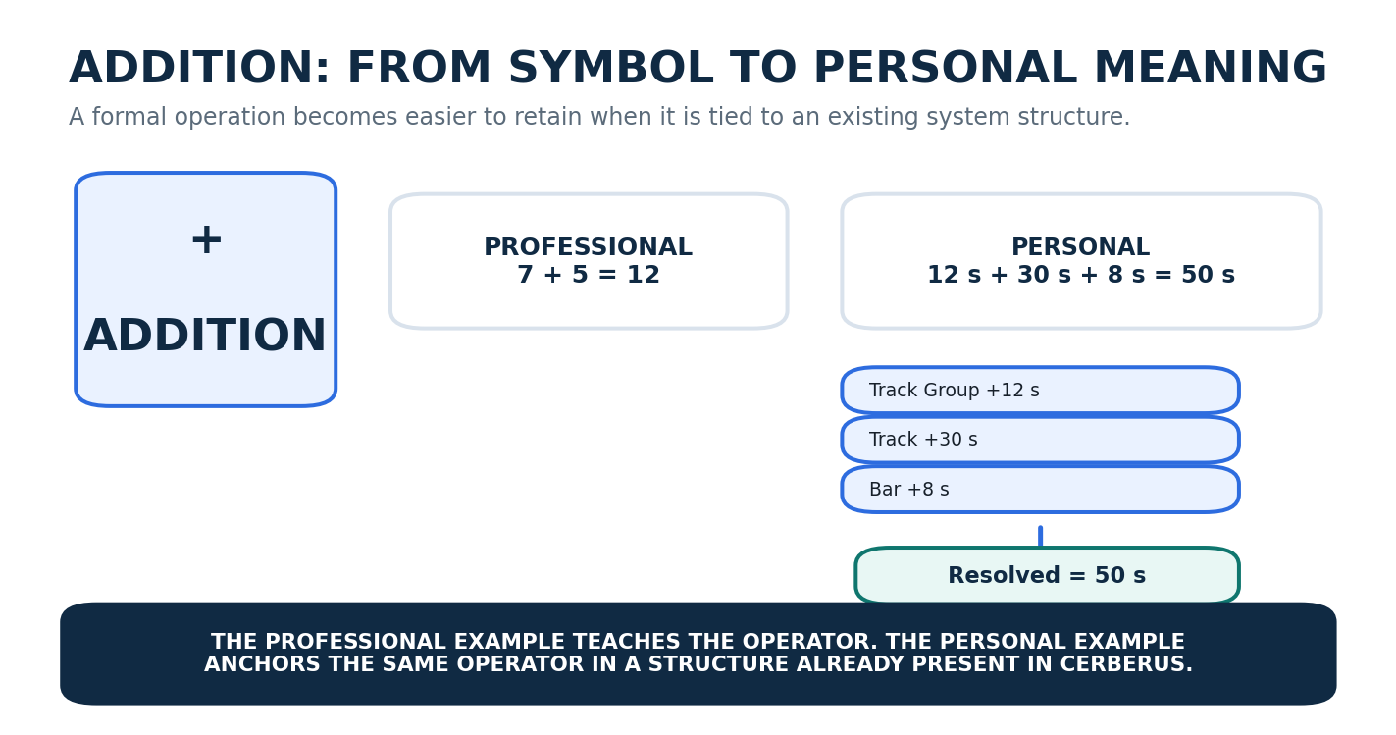
Figure 8. Addition connects the formal operation to recursive local-time accumulation in MUSICAL_PLACEMENT.
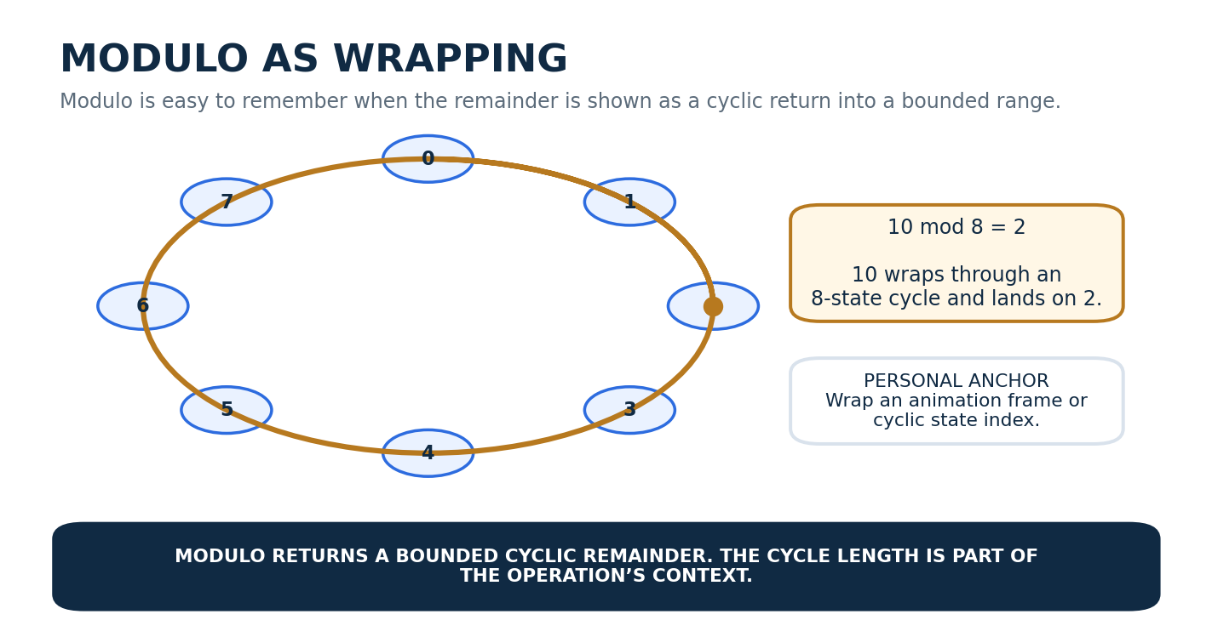
Figure 9. Modulo is taught as bounded cyclic wrapping rather than only as a remainder formula.

Part 3 | Comparison, Relation, Logic, and Quantification

3. B1 - Comparison & Relation
B1 distinguishes exact equality, inequality, order relations, approximation, equivalence, proportionality, and divisibility. The distinction between =, ≈, and ≡ is especially useful in CERBERUS because interfaces can be semantically equivalent without being visually identical, and approximate renderer behavior can be acceptable without changing exact canonical values.
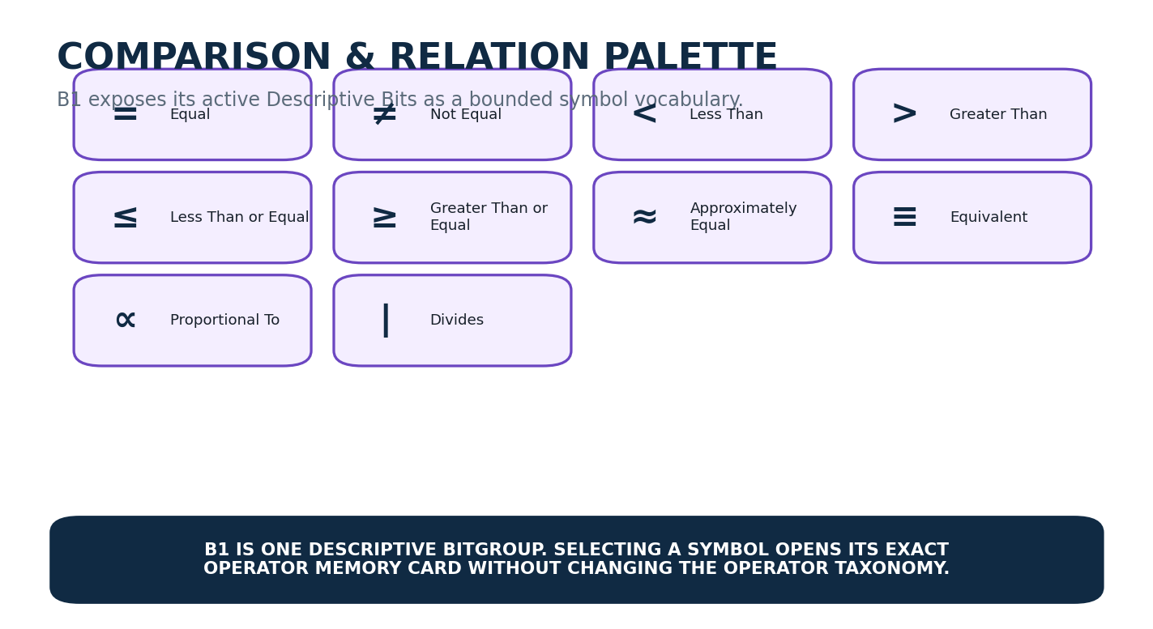
Figure 10. B1 relation palette.
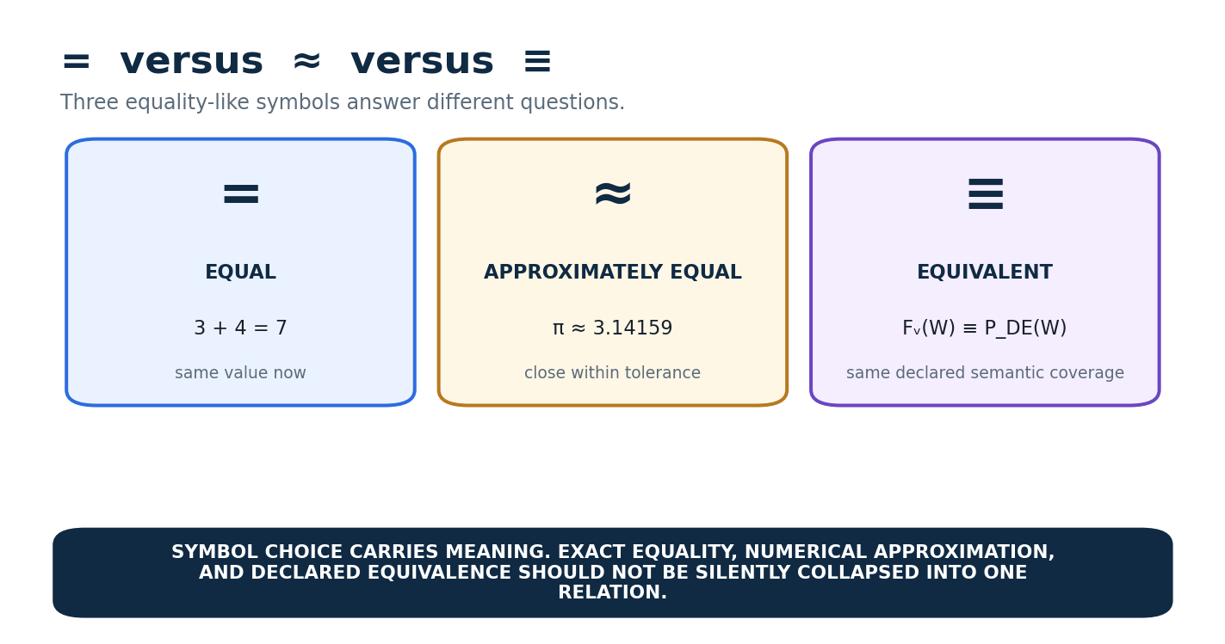
Figure 11. Exact equality, approximation, and equivalence are different relations and should remain visibly distinct.

3.1 C1 - Logic & Quantification
C1 provides the compact logical vocabulary required to describe validation laws, rule conditions, mutually exclusive states, implications, and quantified requirements. The Personal Examples intentionally use interface coverage and placement validation because these are places where symbolic logic already appears naturally in CERBERUS architecture.
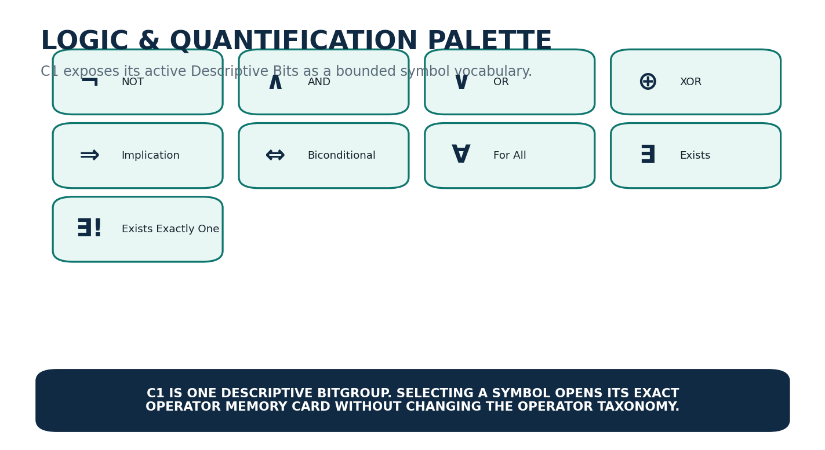
Figure 12. C1 logic and quantification palette.
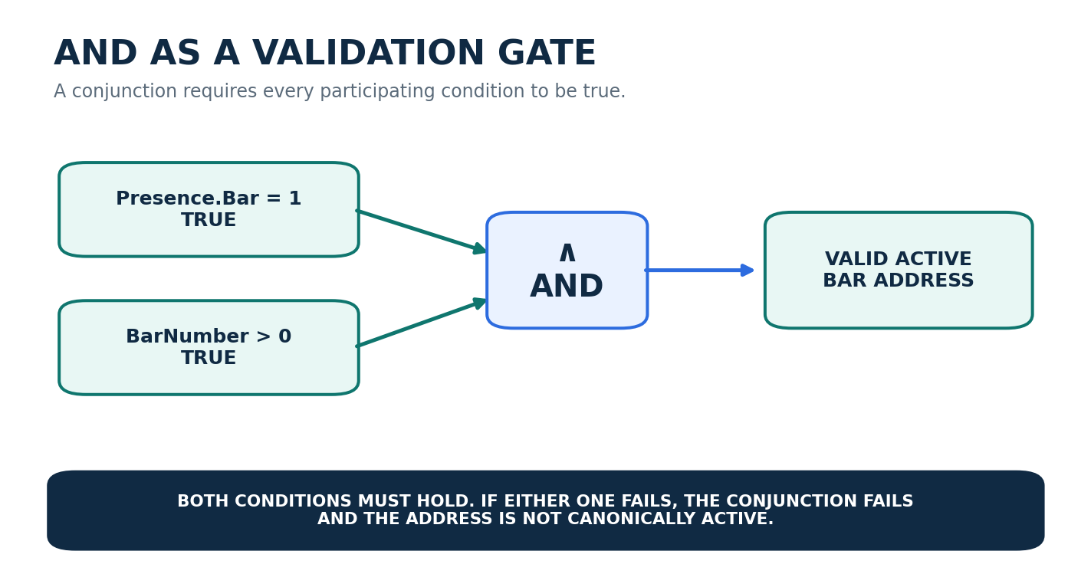
Figure 13. AND as a concrete validation gate for MUSICAL_PLACEMENT address state.
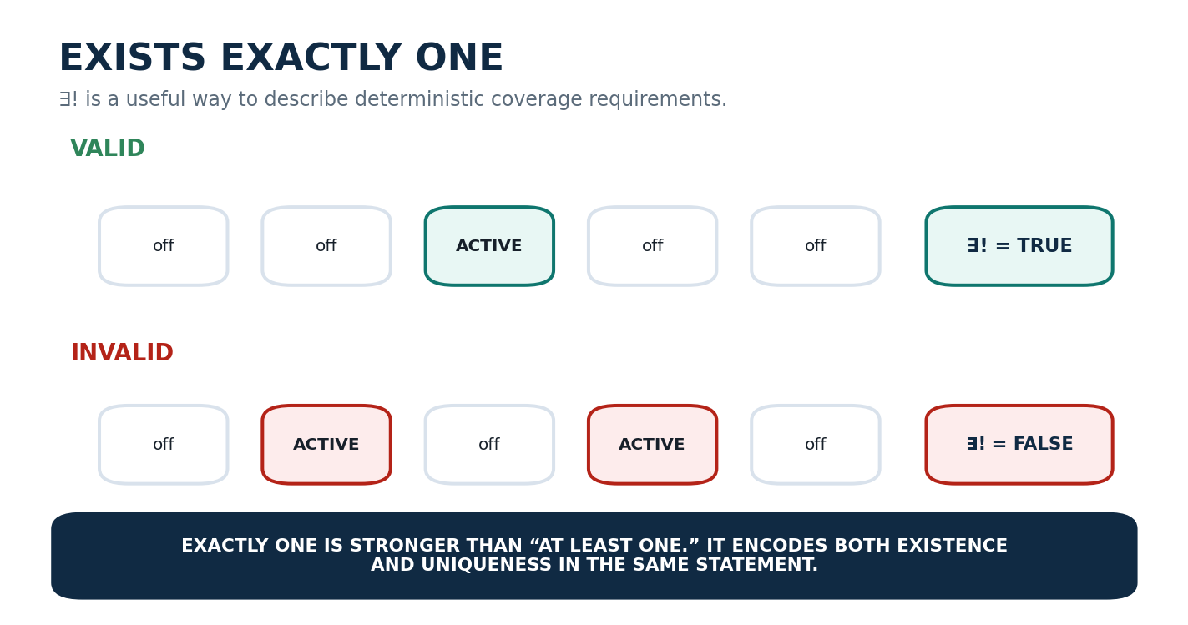
Figure 14. ∃! demonstrates the difference between at least one valid path and exactly one active path.

Part 4 | Sets and Membership

4. D1 - Sets & Membership
D1 captures the operators needed to speak precisely about membership, containment, combination, overlap, exclusion, complement, pairwise design spaces, and the collection of all subsets. These operators map naturally onto NodeKey filtering, Registry subsets, candidate sets, interface coverage, and bounded combinatorial exploration.
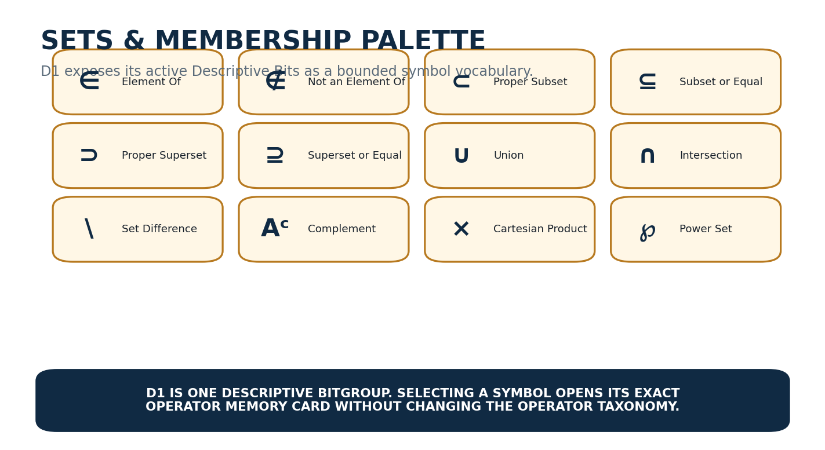
Figure 15. D1 sets and membership palette.
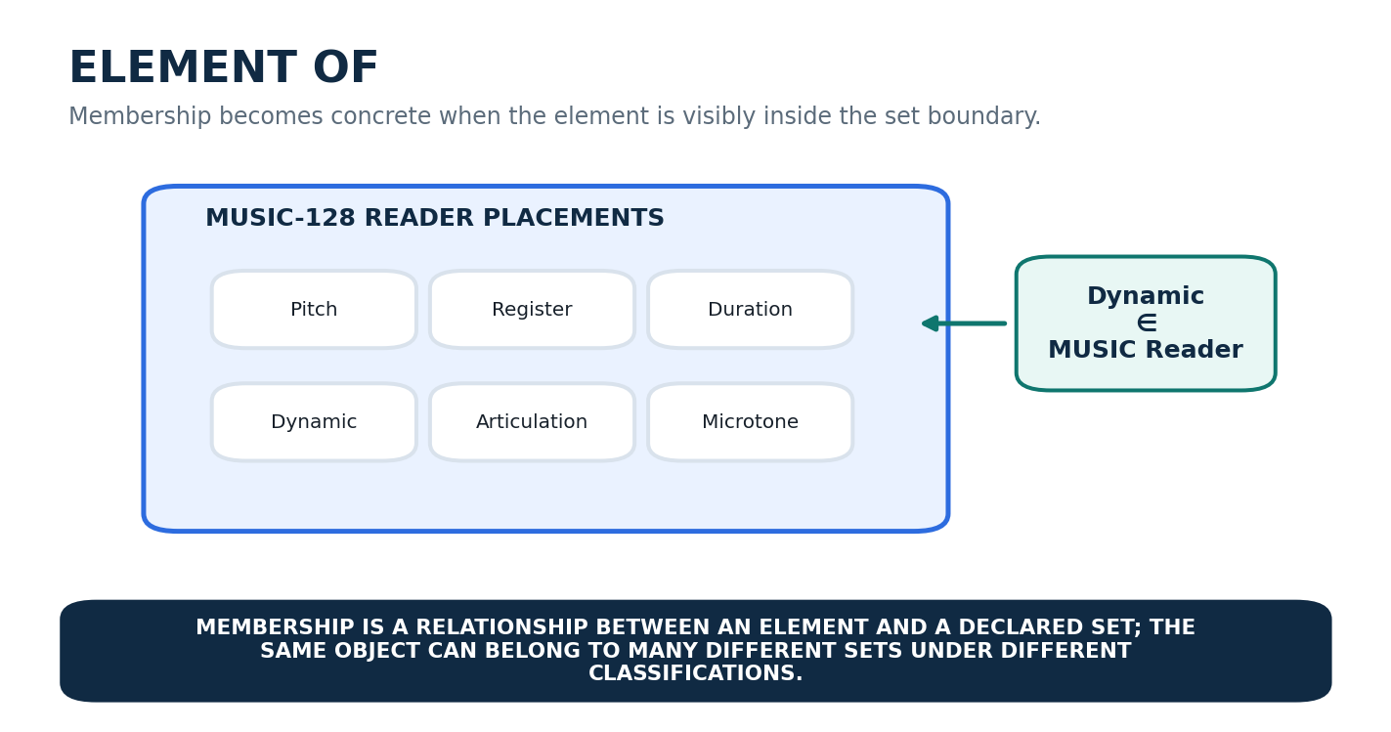
Figure 16. Element-of becomes intuitive when the semantic object is visibly contained by the declared set.
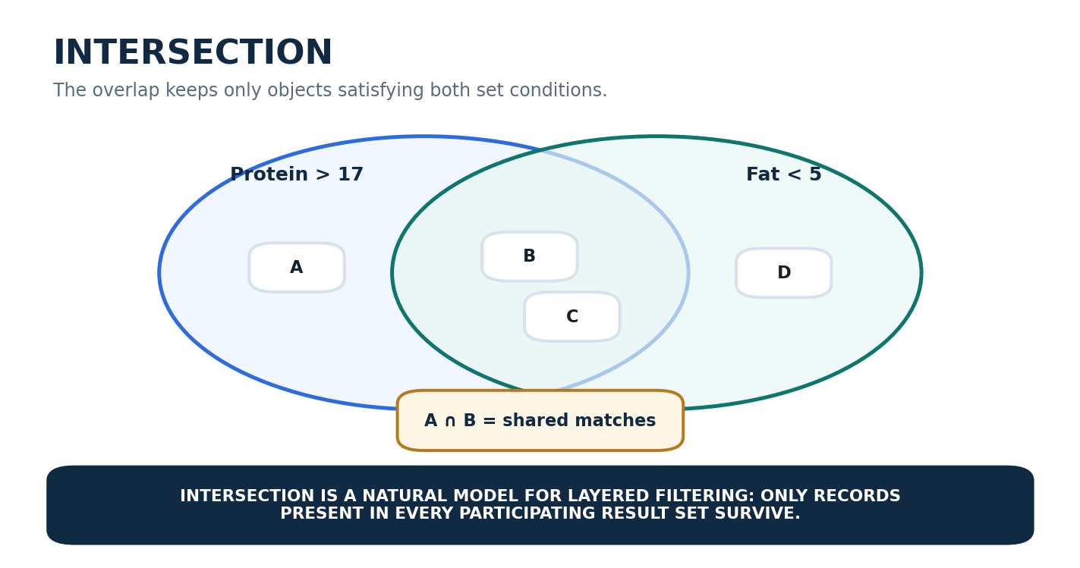
Figure 17. Intersection models layered filtering by retaining only records present in both result sets.

Part 5 | Aggregate and Calculus Operators

5. E1 - Aggregate & Calculus
E1 moves from discrete accumulation into continuous change and field structure. Summation and product compress repeated aggregation. Limits describe approach behavior. Derivatives and partial derivatives describe local rates of change. Integrals describe accumulation. Gradient, divergence, curl, and Laplacian describe local scalar and vector Field behavior. These are not executed here; the figures provide conceptual geometry and personal anchors.
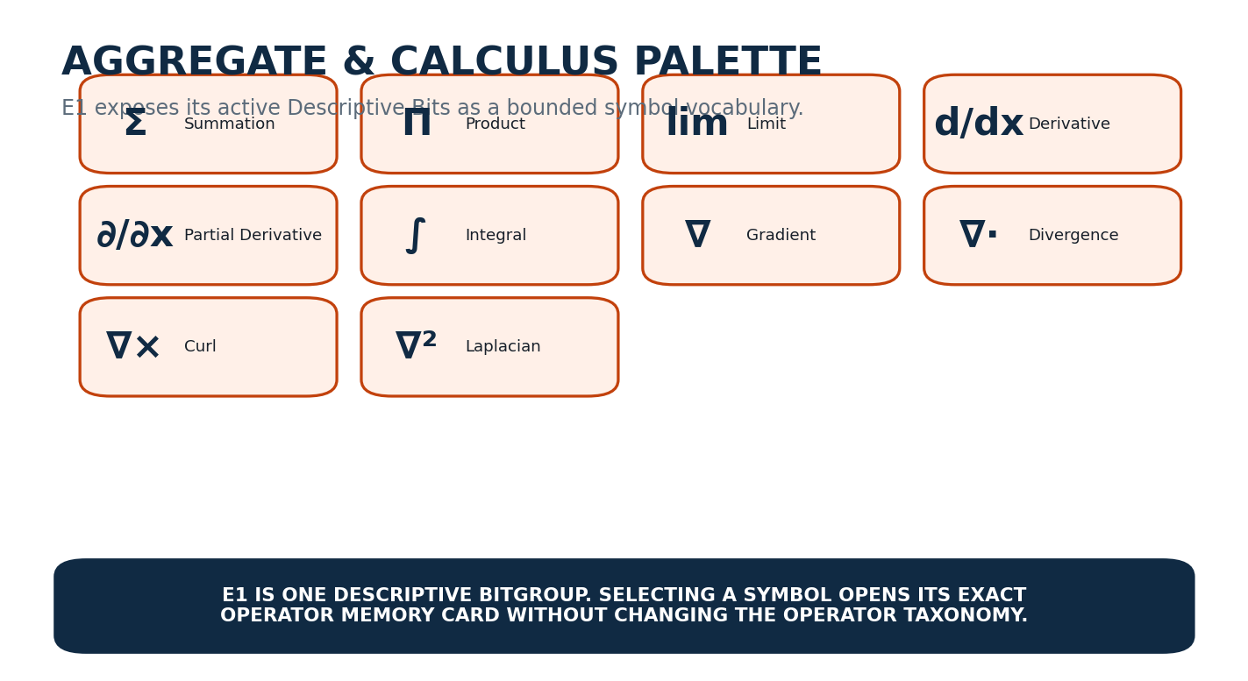
Figure 18. E1 aggregate and calculus palette.
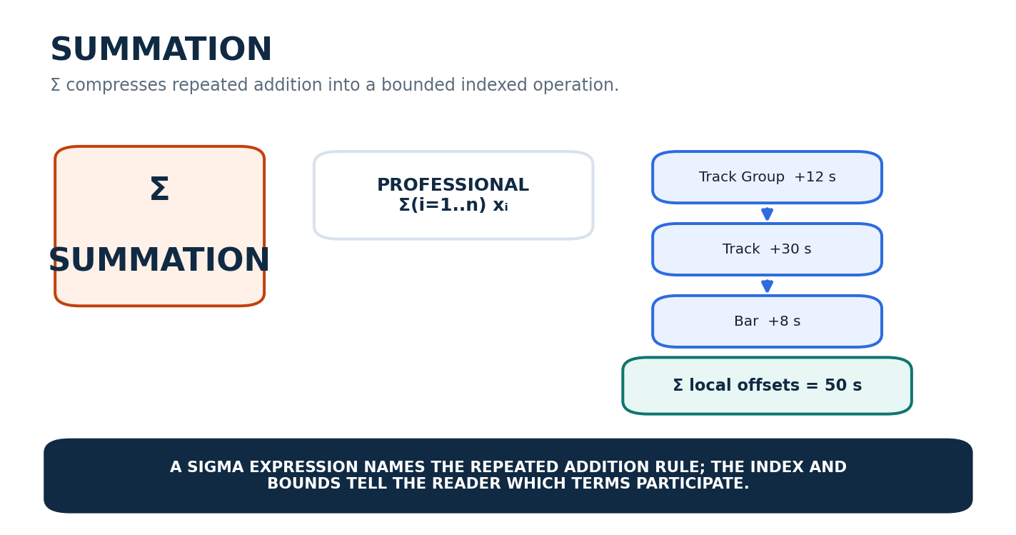
Figure 19. Summation bridges indexed notation and recursive accumulation of local placement offsets.
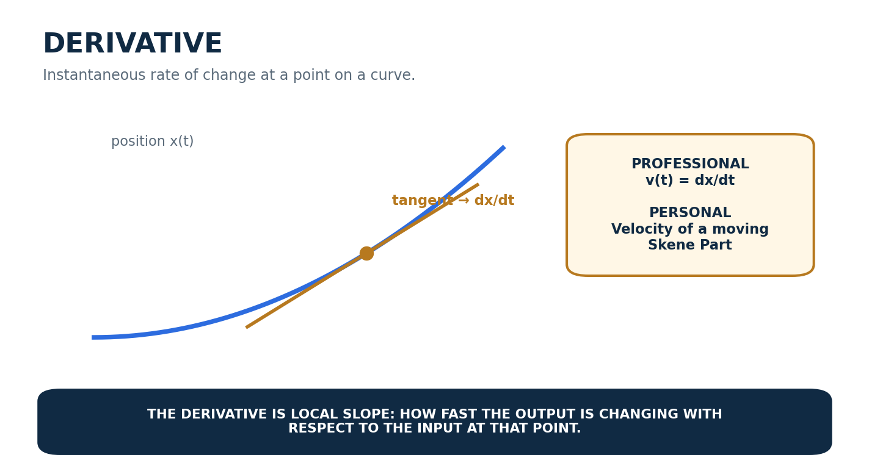
Figure 20. Derivative as instantaneous slope and a personal anchor for movement velocity.
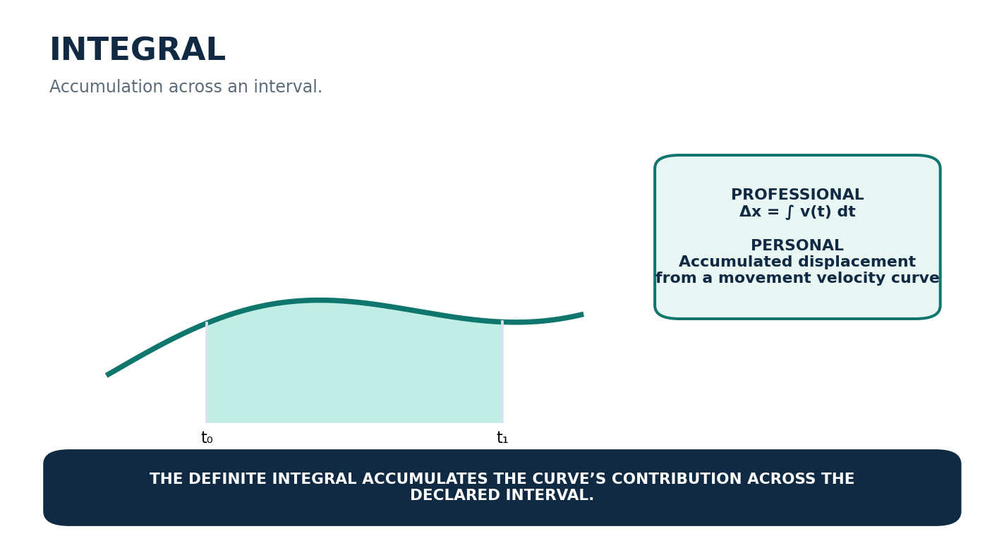
Figure 21. Integral as accumulation under a curve and a personal anchor for displacement.
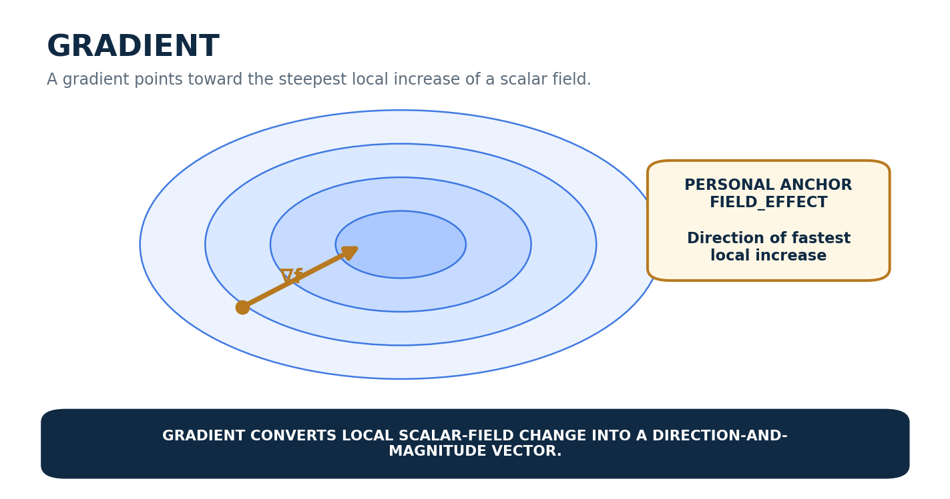
Figure 22. Gradient as the direction of steepest local increase in a scalar Field.

Part 6 | Vector and Linear Algebra

6. F1 - Vector & Linear Algebra
F1 provides a compact working vocabulary for alignment, perpendicular geometry, vector magnitude, generalized inner relationships, matrix construction, tensor composition, transform chaining, inversion, determinant structure, trace, and projection. Several symbols overlap visually with other categories; Reader context is therefore part of semantic disambiguation.
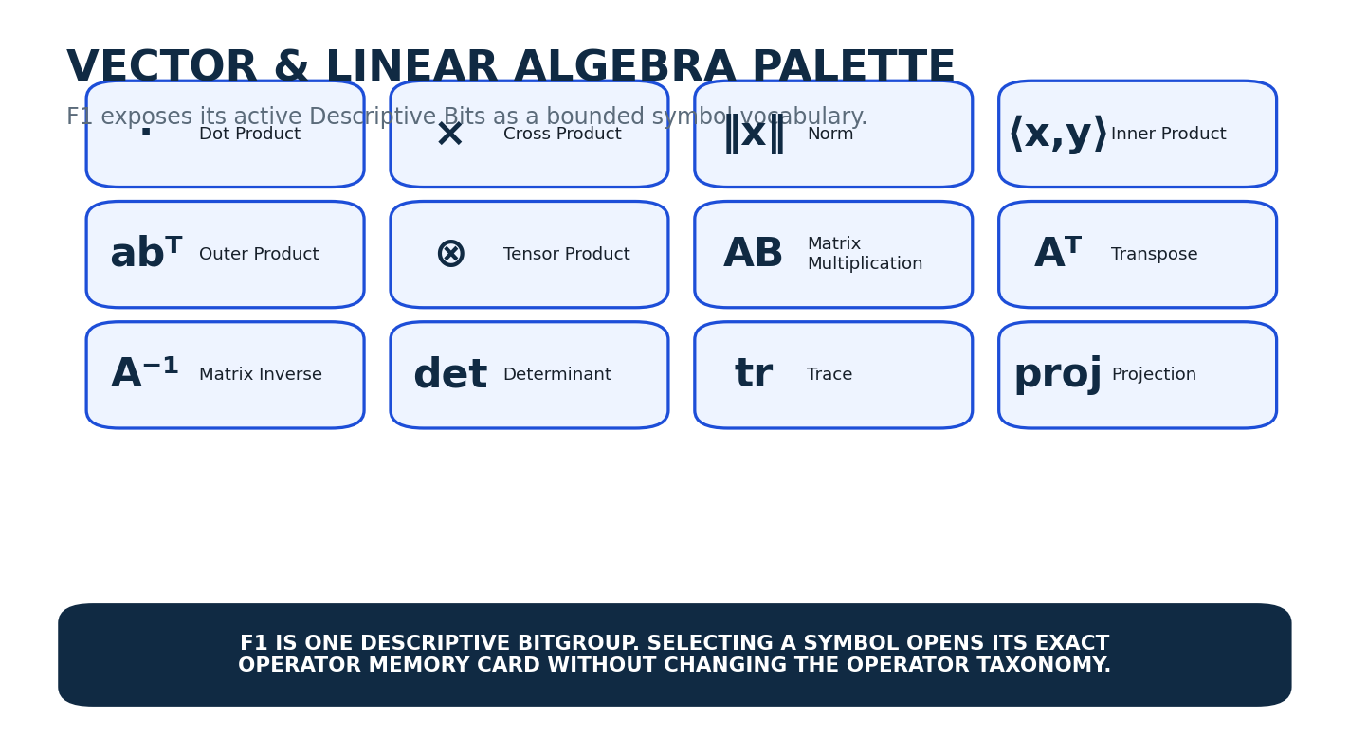
Figure 23. F1 vector and linear-algebra palette.
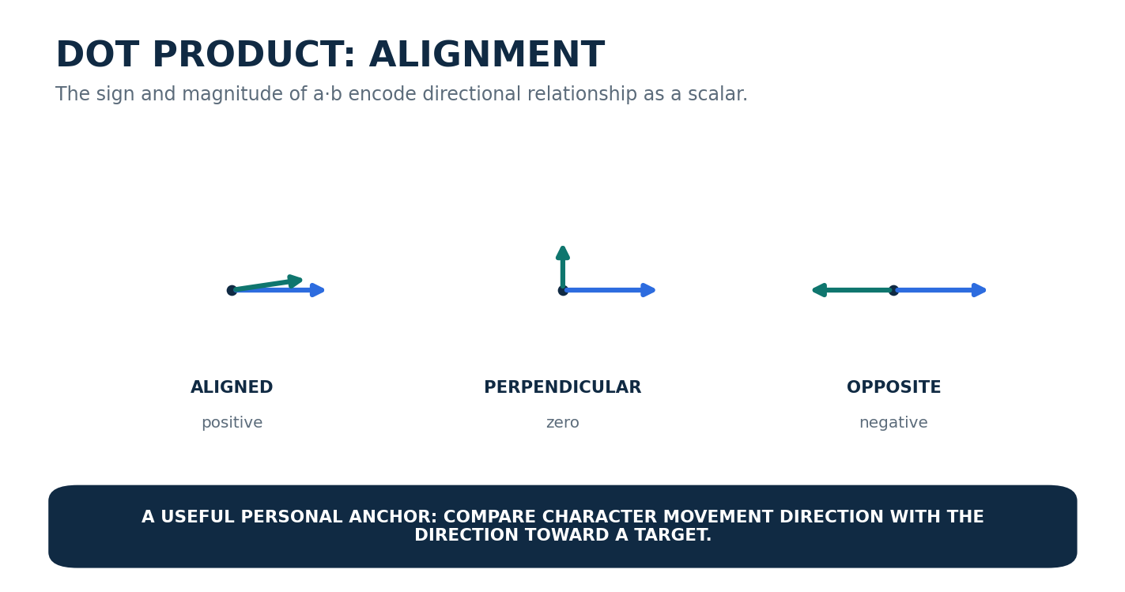
Figure 24. Dot product as alignment: positive, zero, or negative depending on direction.
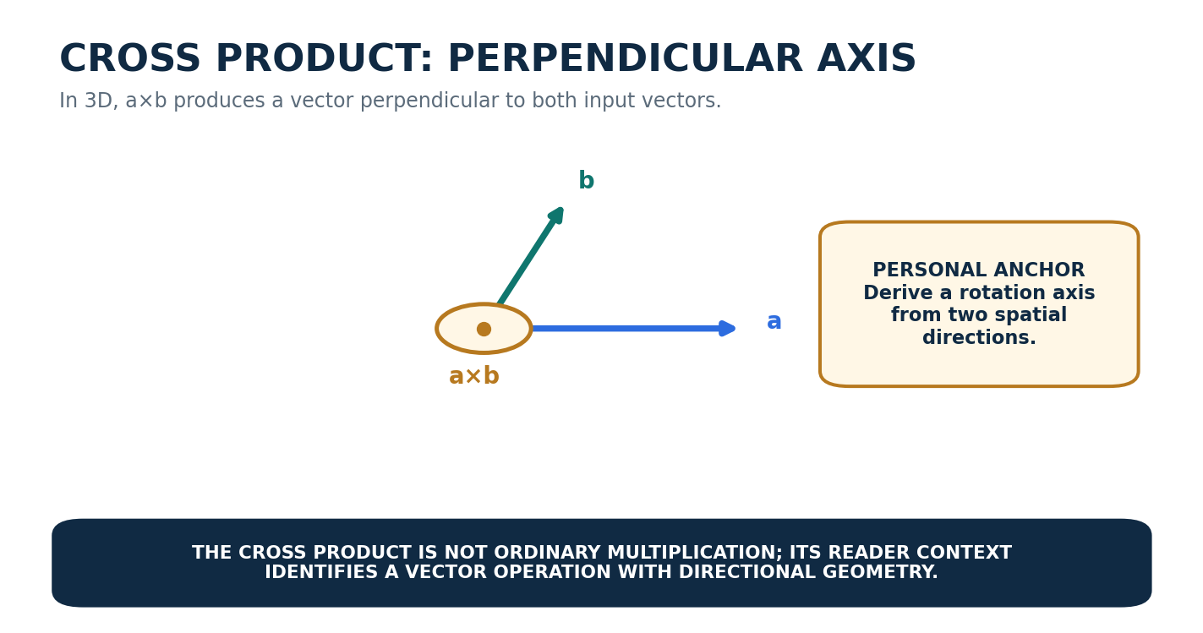
Figure 25. Cross product as a perpendicular-axis construction in three dimensions.
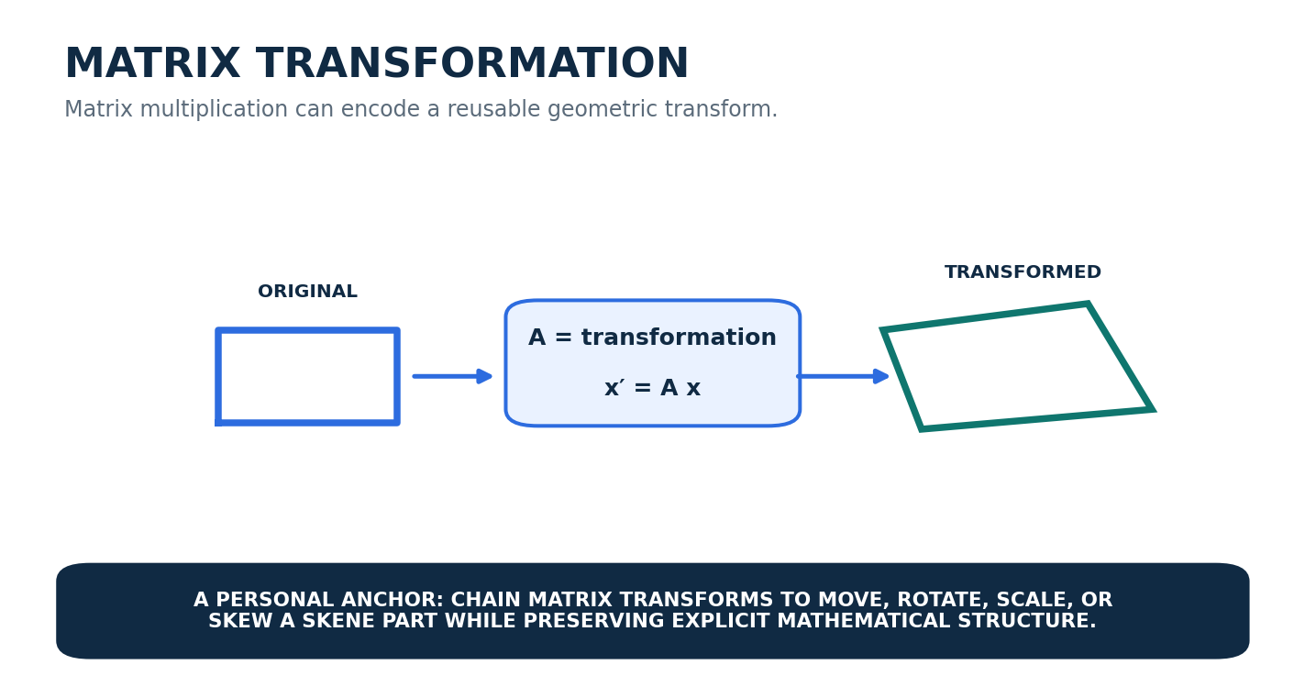
Figure 26. Matrix multiplication as a reusable geometric transformation pattern.

Part 7 | Functions, Transforms, and Optimization

7. G1 - Function, Transform & Optimization
G1 covers mappings, inverse mappings, chained functions, extrema, the arguments producing extrema, convolution, correlation, and two major integral transforms. This category is intentionally heterogeneous: its members are unified by the fact that they describe higher-order ways of mapping, selecting, or transforming information rather than simple scalar arithmetic.
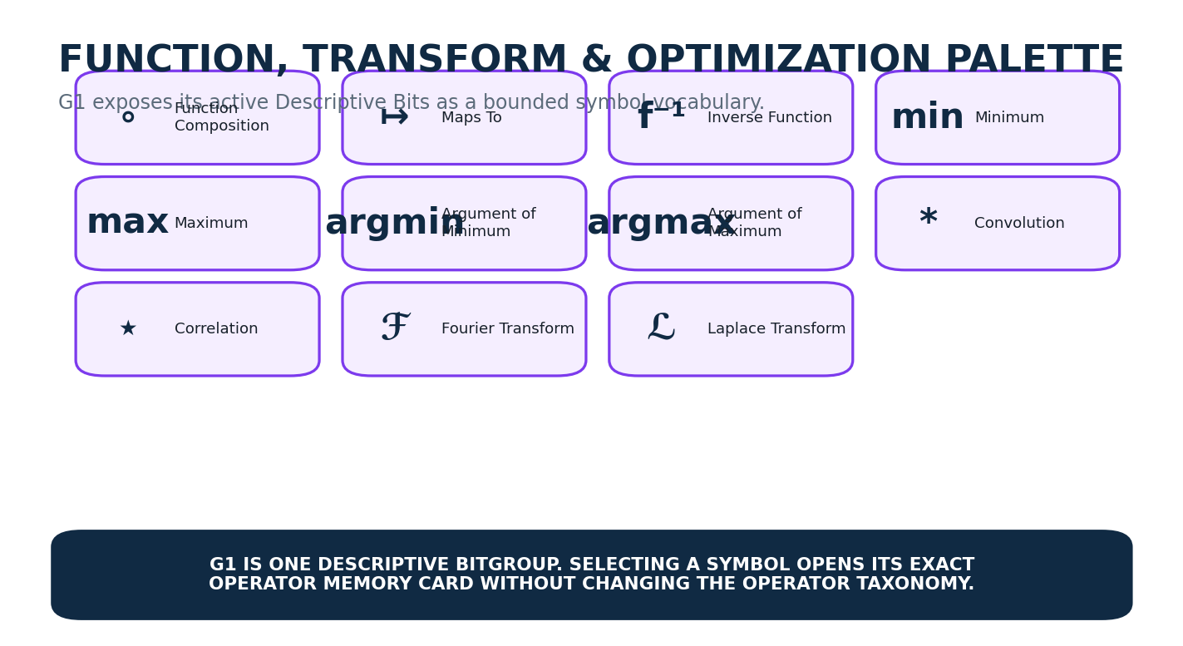
Figure 27. G1 function, transform, and optimization palette.
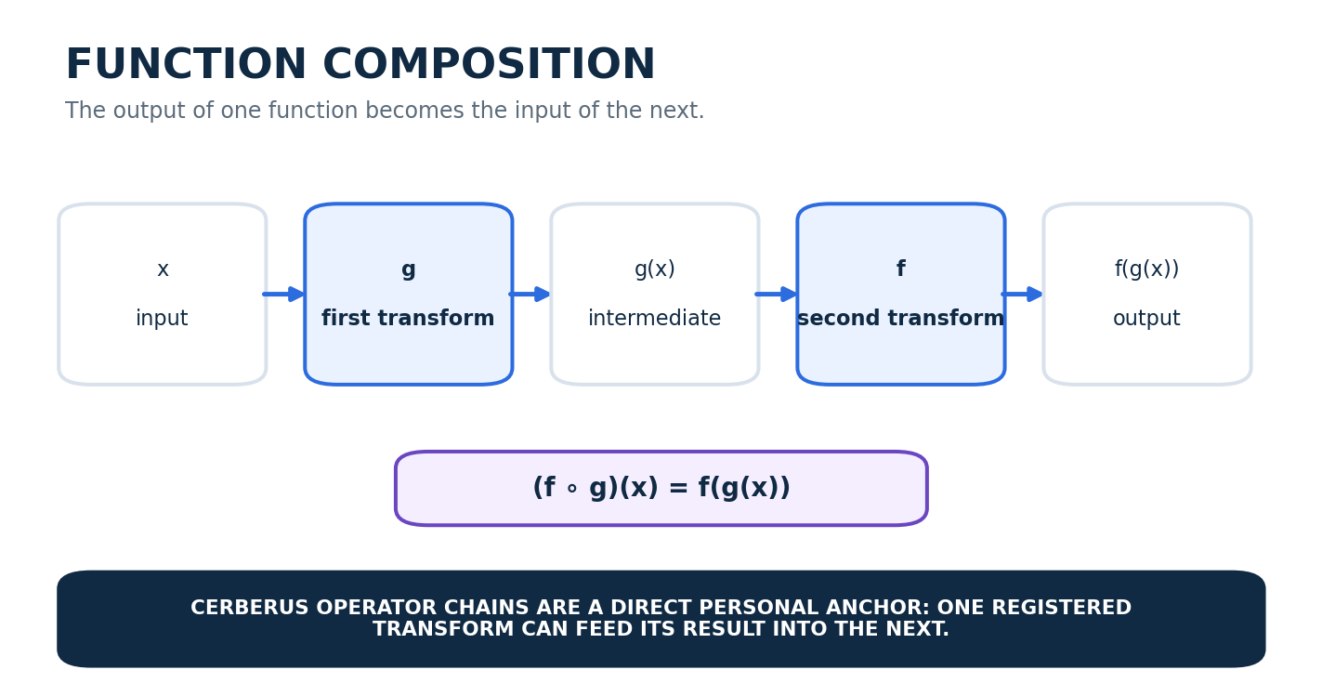
Figure 28. Function composition is a direct mathematical analogue for chained registered transforms.
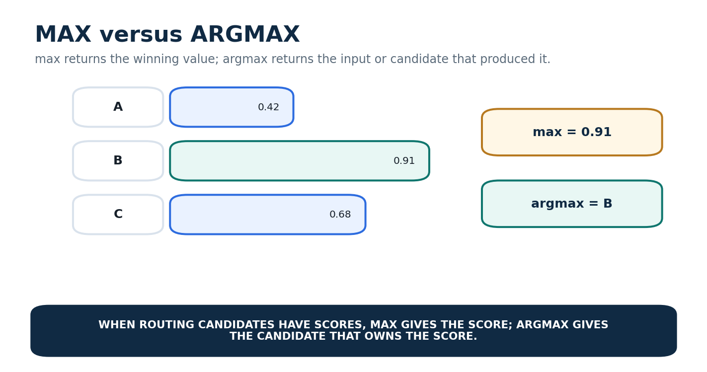
Figure 29. max and argmax return different things: the winning value versus the winning candidate.

Part 8 | Interface Architecture and SK Memory

8. Bit-Level Operator Card
A Descriptive Bit is independently viable as a human-facing information address, so the preferred Bit-level D interface is the Mathematical Operator Card. The symbol receives visual priority for recognition. Name, Description, Professional Example, Personal Example, and References are then presented as ordered memory layers. References remain visibly reserved but blank in v0.1.
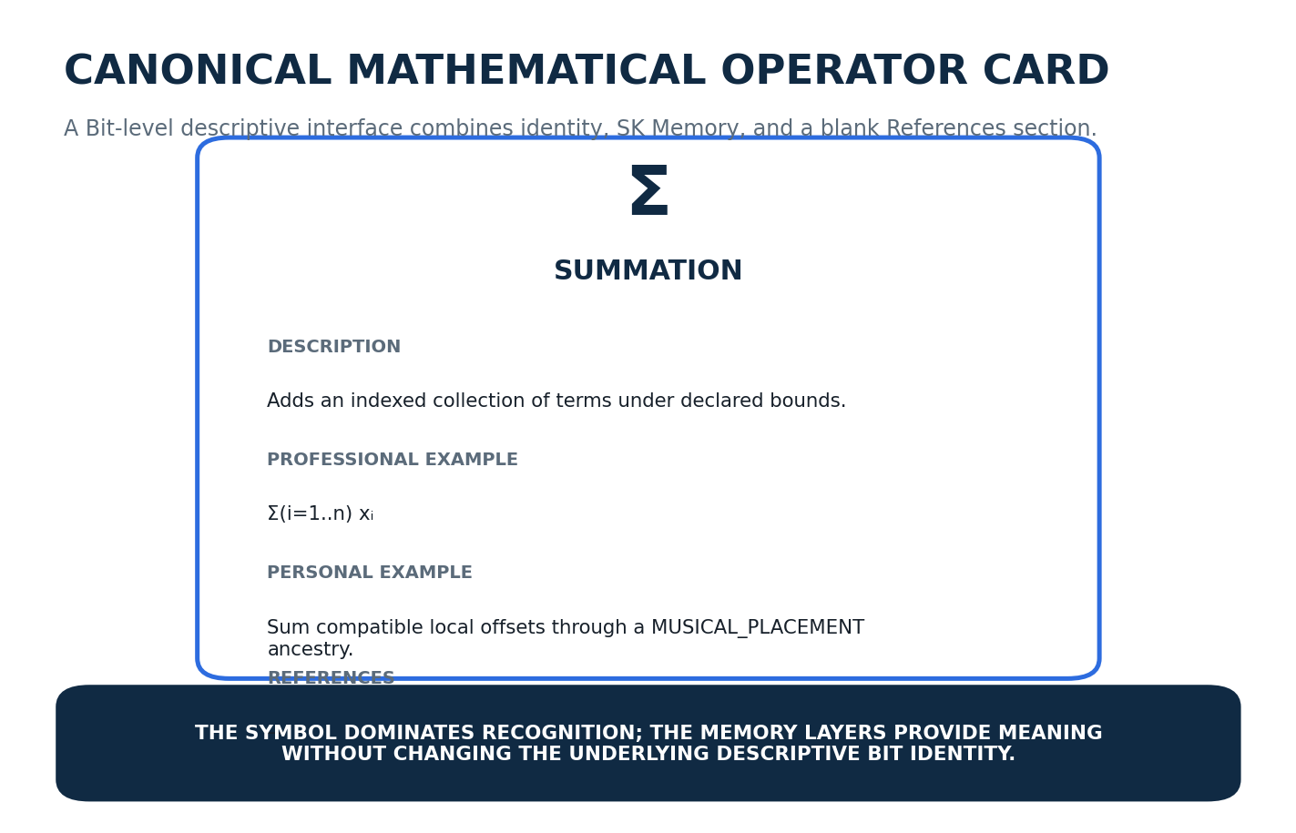
Figure 30. Canonical Bit-level Mathematical Operator Card.

8.1 BitGroup Palettes
Each DESCRIPTION-n Reader placement can also expose a category-level palette. The palette is not a separate semantic category; it is the BitGroup interface over the same active Bits. Selecting a tile follows the exact Bit address into the Operator Card. Inactive Bits may be hidden, muted, or shown as unselected depending on the chosen D variant.
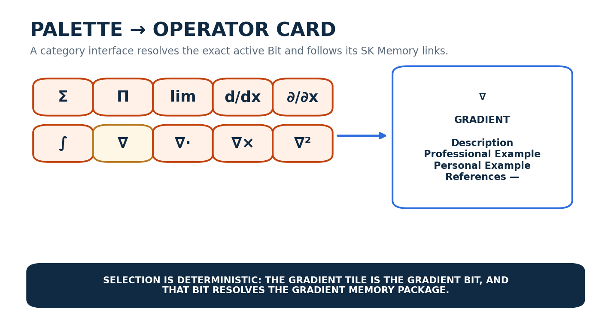
Figure 31. A category palette resolves one active Bit into its exact Operator Card and SK Memory package.

8.2 Complete-Word F Variants
MATHEMATICAL_OPERATORS-77 does not currently earn a dedicated E interface. Adjacent categories are not combined merely for symmetry. Instead, complete-Word F variants provide coherent whole-vocabulary views while preserving each Reader-bound BitGroup independently.
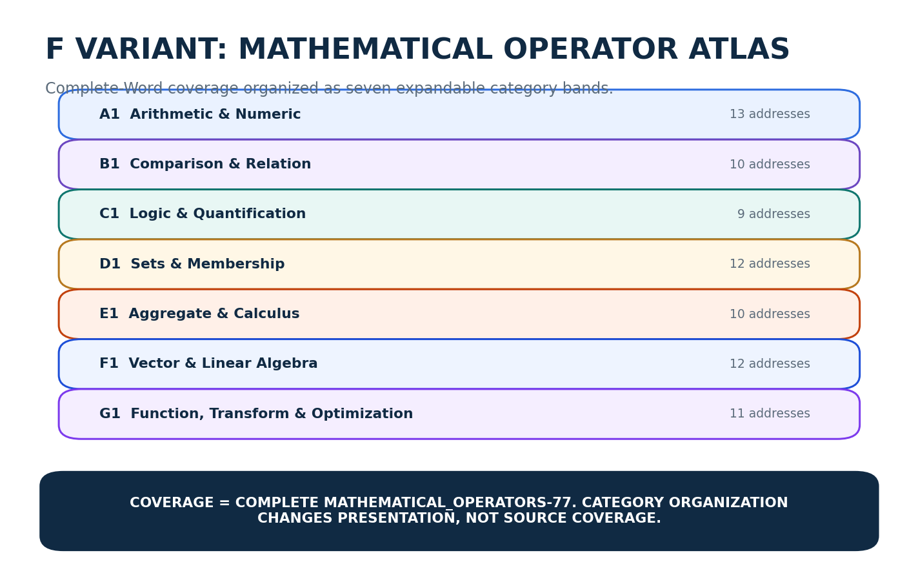
Figure 32. F Variant - Mathematical Operator Atlas with seven expandable category bands.
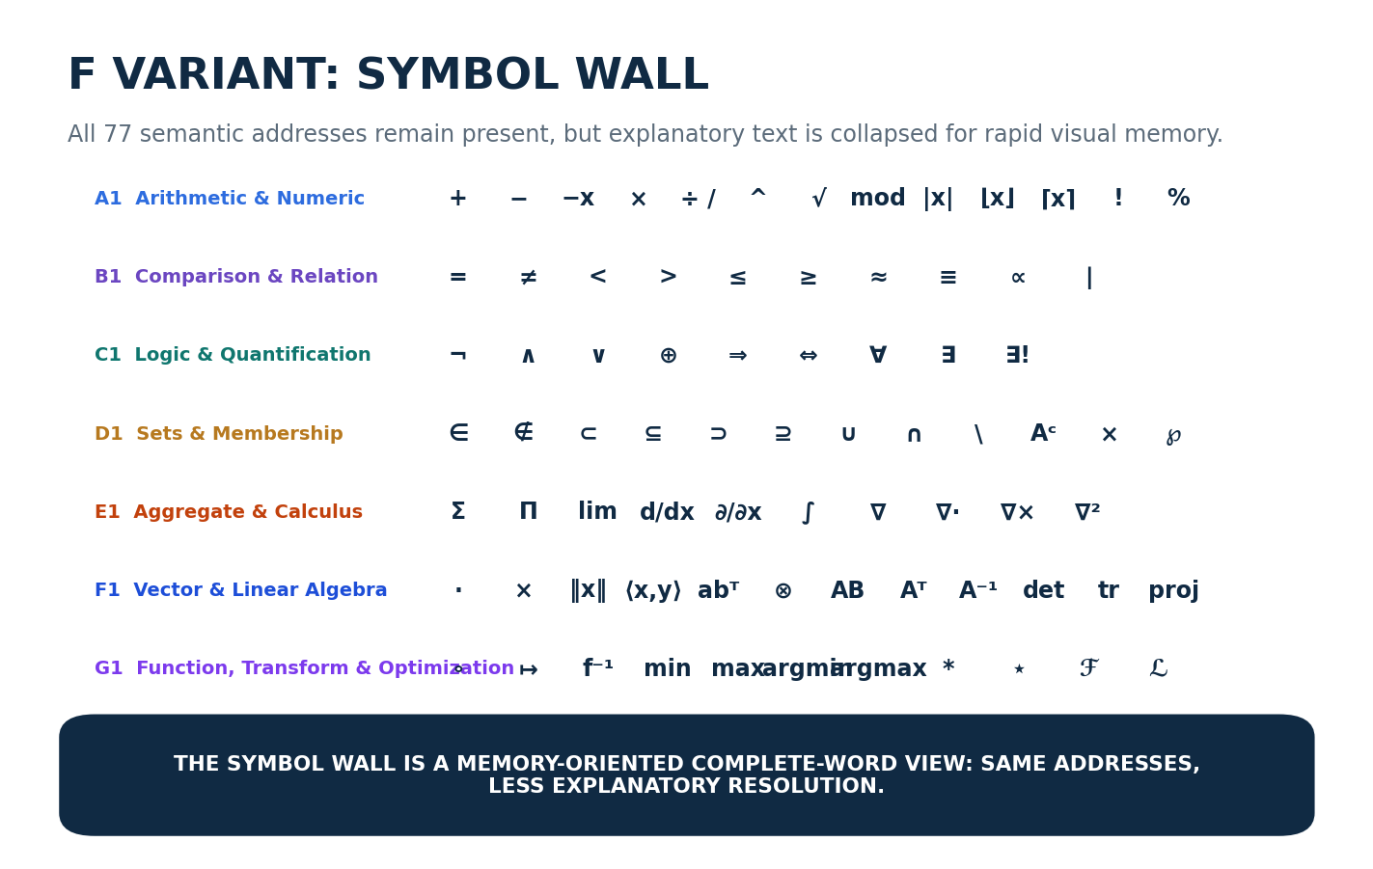
Figure 33. F Variant - Symbol Wall for rapid visual recognition across the full 77-address vocabulary.
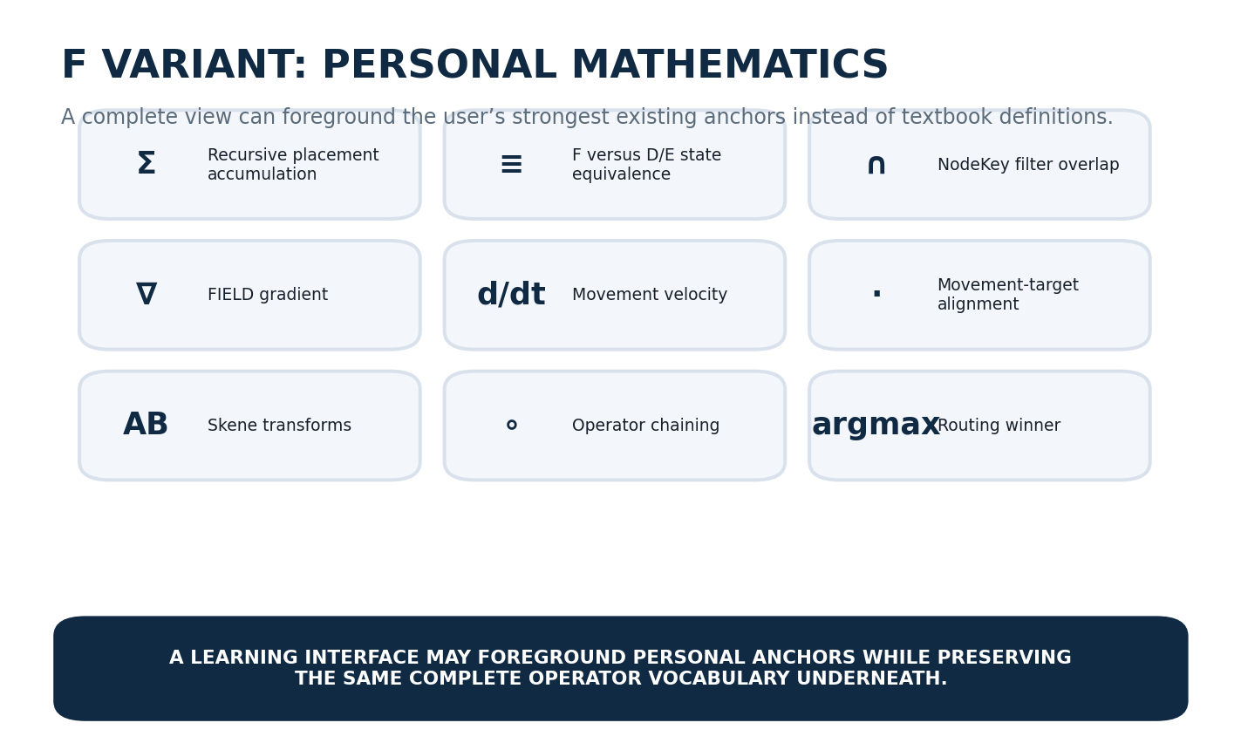
Figure 34. F Variant - Personal Mathematics, foregrounding remembered CERBERUS anchors while retaining complete source coverage.

Part 9 | Future Functional Reuse

9. Descriptive Vocabulary vs Functional Operator Contracts
This specification deliberately stops before execution. A later functional mathematical Operator system may define arity, accepted domains, emitted domains, precedence, associativity, formulas, undefined conditions, deterministic evaluation, symbolic simplification, and runtime behavior. Those functional records can link to the descriptive operator identity established here rather than inventing a parallel vocabulary.
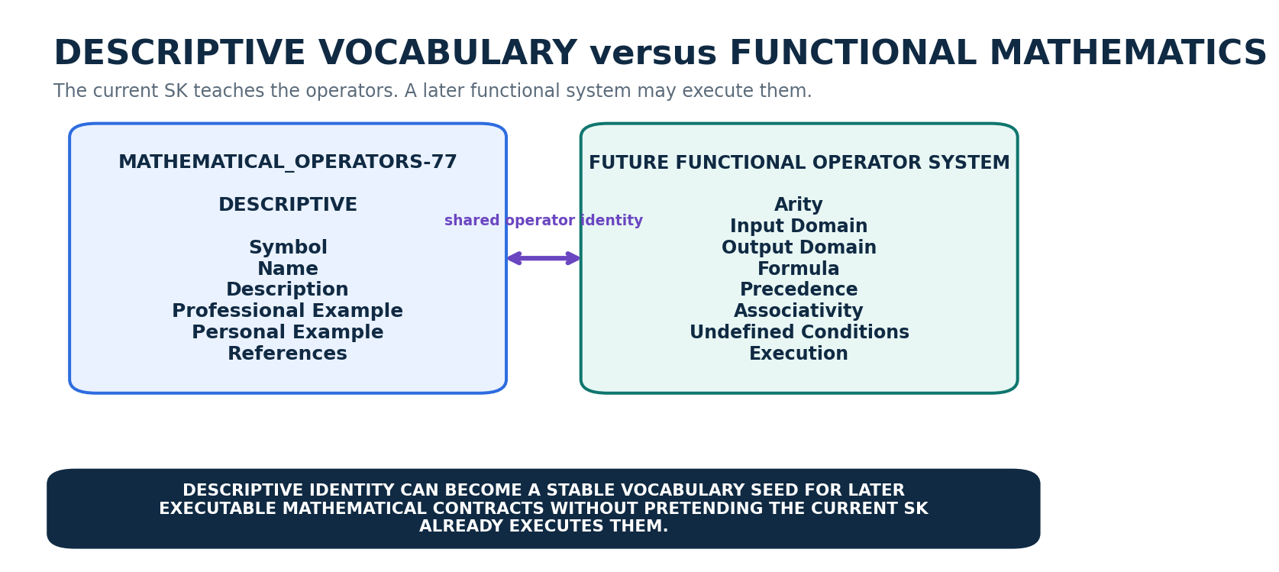
Figure 35. The current descriptive vocabulary can later link to a separate functional mathematical Operator system.
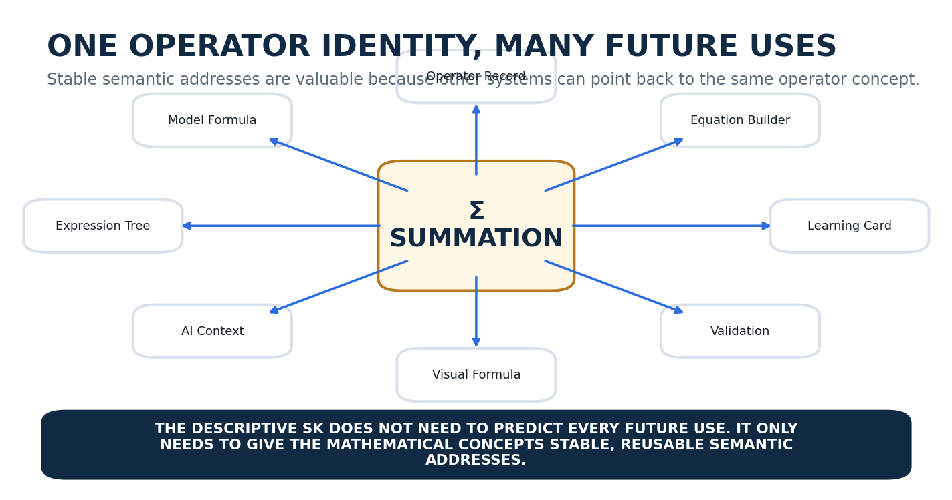
Figure 36. Stable operator identities can support many future mathematical interfaces and tools.

9.1 Personal Learning Connections
The Personal Example layer is not a runtime dependency graph. It is a cognitive bridge. Σ can remind the reader of MUSICAL_PLACEMENT accumulation, ≡ of DARTBOARD interface equivalence, ∩ of NodeKey filtering, ∇ of FIELD_EFFECT, d/dt of movement, AB of Skene geometry, ∘ of Operator chains, and argmax of routing selection. The same mathematical operator remains domain-independent even while the human learns it through domain-specific anchors.
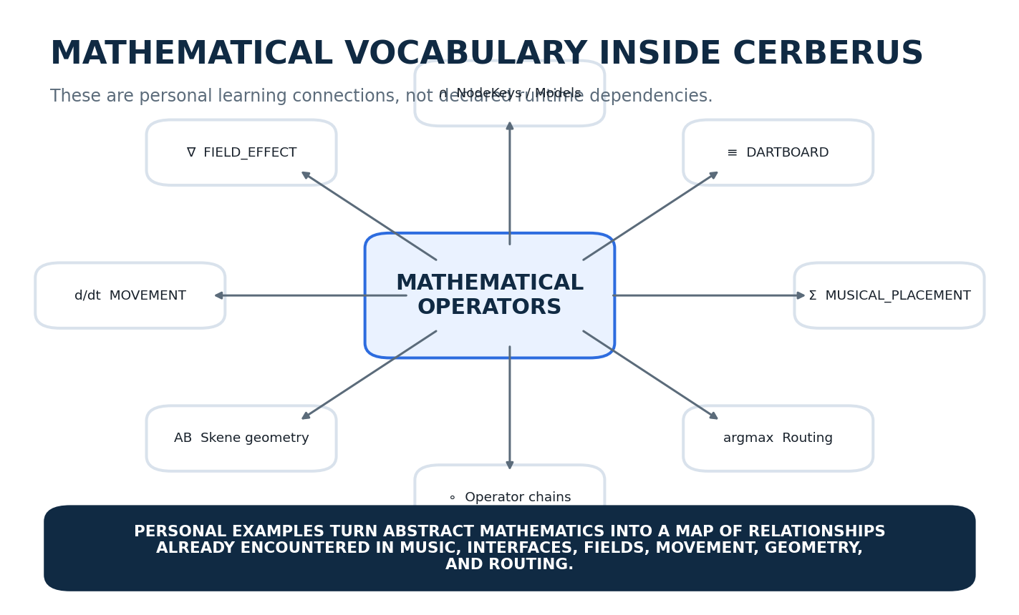
Figure 37. Personal examples connect mathematical vocabulary to existing CERBERUS structures without declaring those structures dependent on this SK.
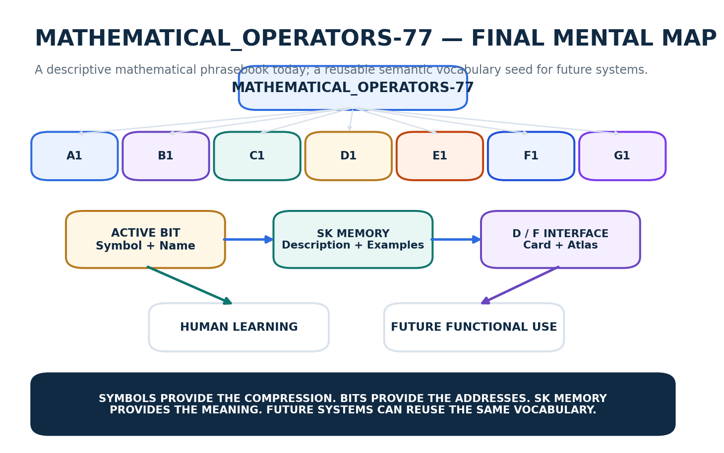
Figure 38. Final mental map of MATHEMATICAL_OPERATORS-77 as descriptive vocabulary and future semantic seed.

Part 10 | Canonical Operator Registry
The following tables are the candidate v0.1 descriptive payload registry. Each row corresponds to one semantic Bit address. Description, Professional Example, and Personal Example are intentionally concise enough to fit a first-pass SK Memory implementation. References are reserved but left blank as requested. The physical table implementation may store each memory layer in its own linked table while this specification presents the resolved human view.

10.1 A1 - Arithmetic & Numeric
Bit | Symbol / Operator | Description | Professional Example | Personal Example | References
B000 | +  Addition | Combines quantities by forming their sum. | 7 + 5 = 12 | Add compatible local offsets in a MUSICAL_PLACEMENT parent chain: 12 s + 30 s + 8 s = 50 s. | —
B001 | −  Subtraction | Finds the difference between one quantity and another. | 15 − 7 = 8 | Compare a resolved position with its parent origin: 50 s − 42 s = 8 s local offset. | —
B002 | −x  Unary Negation | Returns the additive inverse of a value, reversing its sign. | −(−3) = 3 | Reverse the sign of a signed movement or rotation offset while preserving magnitude. | —
B003 | ×  Multiplication | Forms a product; commonly used for scaling, repeated combination, and area-like relationships. | 6 × 4 = 24 | Map a normalized scalar into a bounded range by multiplying it by the range extent. | —
B004 | ÷ /  Division | Forms a quotient by comparing or partitioning one quantity by another nonzero quantity. | 12 ÷ 3 = 4 | Normalize a current value by dividing it by a declared maximum or extent. | —
B005 | ^  Exponentiation | Raises a base to a power, representing repeated multiplicative structure. | 2^8 = 256 | Binary Bit weights are powers of two: 1, 2, 4, 8, 16, and so on. | —
B006 | √  Root | Finds a value that produces the target when raised to a declared power; √ denotes the square root. | √81 = 9 | Euclidean distance uses a square root after summing squared coordinate differences. | —
B007 | mod  Modulo | Returns the remainder after integer division and is often used to wrap cyclic indices. | 10 mod 8 = 2 | Wrap an animation frame, palette index, or cyclic state back into a bounded range. | —
B008 | |x|  Absolute Value | Returns the nonnegative magnitude of a scalar without preserving its sign. | |−7| = 7 | Measure the size of a signed microtonal, rotational, or positional deviation regardless of direction. | —
B009 | ⌊x⌋  Floor | Returns the greatest integer less than or equal to the input. | ⌊3.8⌋ = 3 | Map a continuous coordinate to the preceding discrete grid cell or index. | —
B010 | ⌈x⌉  Ceiling | Returns the least integer greater than or equal to the input. | ⌈3.2⌉ = 4 | Compute the minimum number of fixed-size chunks required to contain a payload. | —
B011 | !  Factorial | Multiplies the positive integers from 1 through n; for n ≥ 1, n! = n(n−1)…1. | 5! = 120 | Five independently orderable Scene elements have 5! = 120 possible linear orderings. | —
B012 | %  Percentage | Expresses a quantity per hundred and commonly scales a proportion by 100. | 25% of 80 = 20 | Display a normalized 0–1 progress or intensity value as a 0–100% human-facing percentage. | —

10.2 B1 - Comparison & Relation
Bit | Symbol / Operator | Description | Professional Example | Personal Example | References
B013 | =  Equal | States that two expressions or quantities have the same value under the current interpretation. | 3 + 4 = 7 | Validate an exact field condition such as Version = 1. | —
B014 | ≠  Not Equal | States that two expressions or quantities do not have the same value. | 5 ≠ 8 | Flag a state when a decoded value differs from its required canonical value. | —
B015 | <  Less Than | States that the left quantity is strictly smaller than the right quantity. | 3 < 5 | Select NodeKeys whose Protein value is below a declared threshold. | —
B016 | >  Greater Than | States that the left quantity is strictly larger than the right quantity. | 9 > 4 | Select Model values that exceed a required threshold or score. | —
B017 | ≤  Less Than or Equal | Allows the left quantity to be smaller than or exactly equal to the right quantity. | x ≤ 10 | Validate that an interface value remains at or below its maximum bound. | —
B018 | ≥  Greater Than or Equal | Allows the left quantity to be larger than or exactly equal to the right quantity. | x ≥ 0 | Validate a nonnegative quantity such as MUSICAL_PLACEMENT Relative Start. | —
B019 | ≈  Approximately Equal | States that two quantities are sufficiently close under a declared tolerance rather than exactly identical. | π ≈ 3.14159 | Treat two rendered positions as visually equivalent within a small display tolerance while preserving distinct exact values. | —
B020 | ≡  Equivalent | States an equivalence or identity relation defined by the surrounding mathematical or system context. | 2/4 ≡ 1/2 under rational-value equivalence | F_v(W) ≡ P_DE(W): whole-Word and complete partitioned interfaces can have equivalent semantic-state coverage. | —
B021 | ∝  Proportional To | States that one quantity varies as a constant multiple of another. | F ∝ x | In a fixed timeline viewport, rendered note width can be proportional to musical duration. | —
B022 | ∣  Divides | For integers a and b, a ∣ b means b = ak for some integer k. | 3 ∣ 12 | A 4-bit nibble divides a 128-bit Word length exactly: 4 ∣ 128. | —

10.3 C1 - Logic & Quantification
Bit | Symbol / Operator | Description | Professional Example | Personal Example | References
B023 | ¬  NOT | Negates a proposition, reversing its Boolean truth value. | ¬True = False | If a Presence flag is not active, the associated address quantity must not participate. | —
B024 | ∧  AND | Is true only when all joined propositions are true. | True ∧ True = True | Presence.Bar = 1 ∧ BarNumber > 0 is required for an active Bar address. | —
B025 | ∨  OR | Is true when at least one joined proposition is true. | True ∨ False = True | A renderer may support a Visual ∨ Numeric ∨ Audio interface variant while sharing the same semantic target. | —
B026 | ⊕  XOR | Is true when exactly one of two Boolean propositions is true. | True ⊕ False = True | A binary toggle pair can enforce exactly one of two mutually exclusive modes without allowing both at once. | —
B027 | ⇒  Implication | States that whenever the antecedent is true, the consequent must also be true. | x > 2 ⇒ x^2 > 4 | Presence.Bar = 0 ⇒ BarNumber = 0 under the canonical placement gating rule. | —
B028 | ⇔  Biconditional | States that two propositions imply each other and therefore share the same truth condition. | n is even ⇔ n mod 2 = 0 | A quantity participates ⇔ its governing Presence gate is active under a strict paired contract. | —
B029 | ∀  For All | Declares that a proposition applies to every member of a specified domain. | ∀x ∈ R, x^2 ≥ 0 | For every exposed semantic placement, interface coverage must be validated within its current resolved scope. | —
B030 | ∃  Exists | Declares that at least one member of a domain satisfies a proposition. | ∃x ∈ Z such that x^2 = 9 | There exists a valid interface variant for a target when at least one registered compatible contract resolves. | —
B031 | ∃!  Exists Exactly One | Declares that one and only one member of a domain satisfies a proposition. | ∃!x ∈ R such that x + 2 = 5 | For each exposed semantic placement in an exact resolved partition, there exists exactly one active interface path. | —

10.4 D1 - Sets & Membership
Bit | Symbol / Operator | Description | Professional Example | Personal Example | References
B032 | ∈  Element Of | States that an object belongs to a set. | 3 ∈ {1,2,3} | Dynamic Intensity ∈ the set of MUSIC-128 Reader placements. | —
B033 | ∉  Not an Element Of | States that an object does not belong to a set. | 4 ∉ {1,2,3} | A non-musical rendering control ∉ the canonical MUSIC-128 semantic placements. | —
B034 | ⊂  Proper Subset | States that every element of A belongs to B and A is not equal to B. | {1,2} ⊂ {1,2,3} | A selected study vocabulary can be a proper subset of the full MATHEMATICAL_OPERATORS-77 address set. | —
B035 | ⊆  Subset or Equal | States that every element of A belongs to B, allowing A = B. | {1,2} ⊆ {1,2,3} | A valid D/E partition covers a subset of the complete Word placements, and the union of its members equals the full exposed set. | —
B036 | ⊃  Proper Superset | States that A contains every element of B and includes at least one additional element. | {1,2,3} ⊃ {1,2} | A broad Effects family can be a proper superset of a smaller effect-category selection. | —
B037 | ⊇  Superset or Equal | States that A contains every element of B, allowing the two sets to be equal. | {1,2,3} ⊇ {1,2} | A full candidate registry is a superset of any resolved subset selected from it. | —
B038 | ∪  Union | Combines the elements of two or more sets, keeping each distinct element once. | {1,2} ∪ {2,3} = {1,2,3} | Combine candidate interface sets from two compatible sources before applying a deterministic selection rule. | —
B039 | ∩  Intersection | Returns only the elements common to all participating sets. | {1,2} ∩ {2,3} = {2} | Find Food NodeKeys satisfying both Protein > 17 and Fat < 5 by intersecting the filtered sets. | —
B040 | \  Set Difference | Returns elements in the first set that are not in the second. | {1,2,3} \ {2} = {1,3} | Remove already-claimed semantic placements from a remaining interface-coverage candidate set. | —
B041 | Aᶜ  Complement | Returns the elements of the declared universe that are not in set A. | If U={1,2,3}, A={1}, then Aᶜ={2,3} | Within a bounded registry view, identify all records not currently selected by a filter. | —
B042 | ×  Cartesian Product | Forms ordered pairs from every element of one set with every element of another. | {a,b} × {1,2} = {(a,1),(a,2),(b,1),(b,2)} | Enumerate combinations such as Color Variant × Effect Variant when exploring a bounded design space. | —
B043 | ℘  Power Set | Returns the set of all subsets of a set. | ℘({a,b}) = {∅,{a},{b},{a,b}} | Three optional descriptive layers have 2^3 = 8 possible inclusion subsets in a presentation experiment. | —

10.5 E1 - Aggregate & Calculus
Bit | Symbol / Operator | Description | Professional Example | Personal Example | References
B044 | Σ  Summation | Adds an indexed collection of terms according to declared bounds or membership. | Σ(i=1..n) x_i | Resolve composition-relative placement by summing compatible local offsets along an active parent path. | —
B045 | Π  Product | Multiplies an indexed collection of terms according to declared bounds or membership. | Π(i=1..n) x_i | Combine independent scale factors applied through a chained geometric transformation. | —
B046 | lim  Limit | Describes the value an expression approaches as its input approaches a specified point or infinity. | lim(x→0) sin(x)/x = 1 | Inspect how an effect curve approaches a boundary value without requiring the boundary sample itself to define the trend. | —
B047 | d/dx  Derivative | Measures the instantaneous rate of change of a one-variable function with respect to its input. | v(t) = dx/dt | Differentiate a Skene Part position curve with respect to time to obtain instantaneous velocity. | —
B048 | ∂/∂x  Partial Derivative | Measures how a multivariable function changes with one variable while the others are held fixed. | ∂f(x,y)/∂x | Measure how one Effect output changes with Intensity while holding its other parameters fixed. | —
B049 | ∫  Integral | Accumulates continuously varying quantity across an interval; definite integrals measure total accumulation. | Δx = ∫(t0..t1) v(t) dt | Integrate a movement velocity curve over time to obtain accumulated displacement. | —
B050 | ∇  Gradient | Produces the vector of partial derivatives of a scalar field, pointing toward steepest local increase. | ∇f = (∂f/∂x, ∂f/∂y, ∂f/∂z) | Use a FIELD_EFFECT gradient to identify the local direction in which a field value increases fastest. | —
B051 | ∇·  Divergence | Measures the net local outward flow of a vector field from a point. | ∇·F | Detect source-like or sink-like behavior in a procedural vector Field. | —
B052 | ∇×  Curl | Measures the local rotational tendency of a vector field. | ∇×F | Characterize swirl or rotational flow in a movement, fluid, or procedural vector Field. | —
B053 | ∇²  Laplacian | Applies divergence to the gradient of a scalar field and captures local curvature or diffusion behavior. | ∇²f = ∇·(∇f) | Model local smoothing, diffusion, or curvature-driven change in a scalar Field. | —

10.6 F1 - Vector & Linear Algebra
Bit | Symbol / Operator | Description | Professional Example | Personal Example | References
B054 | ·  Dot Product | Combines two equal-length vectors into a scalar measuring directional alignment weighted by magnitude. | a·b = ||a|| ||b|| cos θ | Compare a Character movement direction with the direction toward a target. | —
B055 | ×  Cross Product | In three dimensions, combines two vectors into a vector perpendicular to both, with magnitude tied to their spanned area. | a×b | Derive a rotation axis perpendicular to two spatial direction vectors. | —
B056 | ‖x‖  Norm | Assigns a nonnegative magnitude or size to a vector or other mathematical object. | ||(3,4)||₂ = 5 | Compute movement-vector magnitude without preserving its direction. | —
B057 | ⟨x,y⟩  Inner Product | Generalizes the dot product to a space with a defined product that measures alignment or geometric relationship. | ⟨x,y⟩ = Σ x_i y_i in Euclidean space | Use an inner-product-like similarity measure when comparing normalized feature or state vectors. | —
B058 | abᵀ  Outer Product | Combines two vectors into a matrix containing all pairwise component products. | a bᵀ | Construct a matrix of pairwise interactions between two compact feature vectors. | —
B059 | ⊗  Tensor Product | Combines vector spaces or tensors into a larger joint structure that preserves independent dimensions. | u ⊗ v | Represent a joint state space built from independent coordinate or feature dimensions without collapsing them. | —
B060 | AB  Matrix Multiplication | Composes compatible linear transformations or combines matrix rows with matrix columns. | C = AB | Chain geometric transformations applied to a Skene Part or coordinate rig. | —
B061 | Aᵀ  Transpose | Swaps the rows and columns of a matrix. | [[1,2],[3,4]]ᵀ = [[1,3],[2,4]] | Reorient row-oriented and column-oriented representations when passing data between transformation conventions. | —
B062 | A⁻¹  Matrix Inverse | Returns a matrix that undoes an invertible linear transformation. | A⁻¹A = I | Undo a reversible geometric transform to recover a prior coordinate representation. | —
B063 | det  Determinant | Returns a scalar summarizing signed volume scaling and invertibility of a square matrix. | det([[a,b],[c,d]]) = ad − bc | Check whether a geometric transform collapses space; determinant 0 indicates it is not invertible. | —
B064 | tr  Trace | Returns the sum of the diagonal entries of a square matrix. | tr(A) = Σ a_ii | Use a compact scalar summary of a linear transform when a calculation depends on its diagonal contribution. | —
B065 | proj  Projection | Returns the component of a vector lying along a specified vector or subspace. | proj_b(a) = (a·b / b·b)b | Project a movement vector onto a floor direction, axis, or target-aligned lane. | —

10.7 G1 - Function, Transform & Optimization
Bit | Symbol / Operator | Description | Professional Example | Personal Example | References
B066 | ∘  Function Composition | Applies one function and then feeds its output into another function. | (f∘g)(x) = f(g(x)) | A CERBERUS Operator chain can feed the transformed output of one Operator into the next. | —
B067 | ↦  Maps To | Expresses the rule sending an input element to its output under a mapping. | x ↦ x² | Describe a declared value mapping such as normalized scalar ↦ interface position. | —
B068 | f⁻¹  Inverse Function | Reverses a bijective function so that outputs map back to their original inputs. | f⁻¹(f(x)) = x | Invert a reversible normalization or coordinate mapping to recover the source semantic value. | —
B069 | min  Minimum | Returns the smallest value in a set or domain. | min{4,1,7} = 1 | Return the smallest valid bound, score, or candidate value in a bounded registry result. | —
B070 | max  Maximum | Returns the largest value in a set or domain. | max{4,1,7} = 7 | Return the largest score among a bounded set of interface or routing candidates. | —
B071 | argmin  Argument of Minimum | Returns the input or candidate at which a function attains its minimum, not the minimum value itself. | argmin_x (x−3)² = 3 | Return the candidate configuration producing the lowest cost or error rather than returning only that score. | —
B072 | argmax  Argument of Maximum | Returns the input or candidate at which a function attains its maximum, not the maximum value itself. | argmax_{x∈{A,B,C}} score(x) = B | If B has the highest routing-fit score, argmax returns B while max returns B’s score. | —
B073 | *  Convolution | Combines two functions or signals by integrating or summing one as it shifts across the other. | (f*g)(t) = ∫ f(τ)g(t−τ)dτ | Apply a response kernel across an audio, image, or procedural signal to produce a filtered output. | —
B074 | ⋆  Correlation | Measures similarity between signals or patterns as one is shifted relative to the other. | (f⋆g)(τ) measures similarity at lag τ | Compare two movement or audio patterns across temporal offsets to find their best alignment. | —
B075 | ℱ  Fourier Transform | Transforms a signal between its original domain and a frequency-domain representation. | X(f) = ℱ{x(t)} | Decompose an audio or periodic effect signal into frequency components for inspection or processing. | —
B076 | ℒ  Laplace Transform | Transforms a time-domain function into the complex-frequency s-domain, often simplifying differential systems. | F(s) = ℒ{f(t)} | Analyze the response of a linear movement or control system using a transformed representation of its time dynamics. | —

Part 11 | Validation, Laws, and Implementation Handoff

11.1 Canonical Validation
Validation area | Candidate v0.1 rule
Bit range | Only B000-B076 are semantic addresses in MATHEMATICAL_OPERATORS-77 v0.1.
Reader width | A1-G1 MUST resolve to widths 13, 10, 9, 12, 10, 12, and 11 respectively.
Selection semantics | Bit = 1 means selected descriptive address; Bit = 0 means unselected. Neither state executes or negates the operator.
Operator identity | Each Bit MUST resolve one stable operator name and symbol under its Reader category.
Memory separation | Description, Professional Example, Personal Example, and References remain distinct SK Memory layers.
References | Reference fields MAY be blank. v0.1 intentionally leaves all References blank.
Symbol ambiguity | A glyph reused in another category MUST be disambiguated by Reader context and operator identity.
No execution inference | The runtime MUST NOT treat an active operator selection as an evaluable expression unless a separate functional contract explicitly supplies that behavior.
No fabricated memory | Missing descriptive payload remains missing; interfaces MUST NOT invent canonical operator documentation to fill a gap.
Complete F coverage | A valid F variant represents the complete MATHEMATICAL_OPERATORS-77 Word, even if explanatory detail is collapsed.

11.2 Formal Laws
Law | Requirement
Law 1 - Bounded Vocabulary | MATHEMATICAL_OPERATORS-77 defines the operator vocabulary declared in this specification and does not imply completeness over all mathematics.
Law 2 - Arbitrary Width | The 77-Bit width is semantically justified by the current address inventory and need not be padded to a power of two.
Law 3 - Selection, Not Assertion | Active Bits select descriptive operator addresses; they do not assert propositions or execute mathematics.
Law 4 - Reader Context | Reader category is part of interpretation and may disambiguate identical or similar glyphs used by different operators.
Law 5 - Memory Determinism | An active Bit resolves its operator memory through explicit registered linkage rather than semantic prose search.
Law 6 - Memory Layer Separation | Description, Professional Example, Personal Example, and References retain distinct roles and ownership.
Law 7 - Personal Example Non-Canonicity | A Personal Example is a learning anchor and SHALL NOT redefine the mathematical operator.
Law 8 - References Optional | A missing References payload is valid and SHALL remain absent rather than being fabricated.
Law 9 - Descriptive / Functional Separation | This descriptive SK SHALL NOT be treated as an executable mathematical Operator registry without a separate functional contract.
Law 10 - Stable Reuse | Future functional systems MAY link to these stable operator identities while adding their own executable semantics.
Law 11 - Interface Projection | Operator Card, category palette, Symbol Wall, Atlas, and Personal Mathematics are projections over the same descriptive addresses.
Law 12 - Complete F Coverage | Every F variant SHALL preserve complete Word coverage even when it collapses or reorganizes explanatory presentation.

11.3 Prototype Record Architecture
A minimal prototype can use the existing SK Memory pattern. Each operator Bit links to a Descriptive Bit record. That record carries or resolves the operator Symbol and Name plus links to the Description, Professional Example, Personal Example, and References tables. The References Link may be null or may point to an empty References record in v0.1, depending on the surrounding registry convention.
Record / Interface | Role
Operator Bit | Bit address; Reader category; operator identity link
Descriptive Bit record | Stable semantic memory address for the operator
Description record | Concise operator meaning
Professional Example record | Formal mathematical example
Personal Example record | CERBERUS-grounded learning anchor
References record | Reserved for ordered Reference Description / Link pairs; unpopulated in v0.1
Candidate D interface | Operator Card for one Bit; Palette for one Reader-bound DESCRIPTION-n BitGroup
Candidate F interfaces | Operator Atlas, Symbol Wall, Personal Mathematics

11.4 Implementation Sequence
Step | Prototype action
1 | Create the MATHEMATICAL_OPERATORS-77 Word and A1-G1 Reader placements.
2 | Create the 77 Descriptive Bit records with stable Bit address, symbol, operator name, and category.
3 | Populate Description records from Tables 1-7.
4 | Populate Professional Example records from Tables 1-7.
5 | Populate Personal Example records from Tables 1-7.
6 | Leave References unpopulated while preserving the References link field or empty References record contract.
7 | Build the Bit-level Mathematical Operator Card D interface.
8 | Build one category palette D interface reusable across A1-G1.
9 | Build the complete-Word Operator Atlas F variant.
10 | Add Symbol Wall and Personal Mathematics F variants if useful.
11 | Test binary-selected study sets and confirm only active operator Bits resolve into the interface.
12 | Only later, if useful, link descriptive identities to a functional mathematical Operator architecture.

END STATE | A bounded mathematical phrasebook exists as 77 stable semantic addresses. The user can select a vocabulary subset, open any active operator, recover its meaning and examples deterministically, and later reuse those same identities in richer mathematical systems without changing the descriptive kernel.

Operator Index
Bit | Reader | Symbol | Operator
B000 | A1 | + | Addition
B001 | A1 | − | Subtraction
B002 | A1 | −x | Unary Negation
B003 | A1 | × | Multiplication
B004 | A1 | ÷ / | Division
B005 | A1 | ^ | Exponentiation
B006 | A1 | √ | Root
B007 | A1 | mod | Modulo
B008 | A1 | |x| | Absolute Value
B009 | A1 | ⌊x⌋ | Floor
B010 | A1 | ⌈x⌉ | Ceiling
B011 | A1 | ! | Factorial
B012 | A1 | % | Percentage
B013 | B1 | = | Equal
B014 | B1 | ≠ | Not Equal
B015 | B1 | < | Less Than
B016 | B1 | > | Greater Than
B017 | B1 | ≤ | Less Than or Equal
B018 | B1 | ≥ | Greater Than or Equal
B019 | B1 | ≈ | Approximately Equal
B020 | B1 | ≡ | Equivalent
B021 | B1 | ∝ | Proportional To
B022 | B1 | ∣ | Divides
B023 | C1 | ¬ | NOT
B024 | C1 | ∧ | AND
B025 | C1 | ∨ | OR
B026 | C1 | ⊕ | XOR
B027 | C1 | ⇒ | Implication
B028 | C1 | ⇔ | Biconditional
B029 | C1 | ∀ | For All
B030 | C1 | ∃ | Exists
B031 | C1 | ∃! | Exists Exactly One
B032 | D1 | ∈ | Element Of
B033 | D1 | ∉ | Not an Element Of
B034 | D1 | ⊂ | Proper Subset
B035 | D1 | ⊆ | Subset or Equal
B036 | D1 | ⊃ | Proper Superset
B037 | D1 | ⊇ | Superset or Equal
B038 | D1 | ∪ | Union
B039 | D1 | ∩ | Intersection
B040 | D1 | \ | Set Difference
B041 | D1 | Aᶜ | Complement
B042 | D1 | × | Cartesian Product
B043 | D1 | ℘ | Power Set
B044 | E1 | Σ | Summation
B045 | E1 | Π | Product
B046 | E1 | lim | Limit
B047 | E1 | d/dx | Derivative
B048 | E1 | ∂/∂x | Partial Derivative
B049 | E1 | ∫ | Integral
B050 | E1 | ∇ | Gradient
B051 | E1 | ∇· | Divergence
B052 | E1 | ∇× | Curl
B053 | E1 | ∇² | Laplacian
B054 | F1 | · | Dot Product
B055 | F1 | × | Cross Product
B056 | F1 | ‖x‖ | Norm
B057 | F1 | ⟨x,y⟩ | Inner Product
B058 | F1 | abᵀ | Outer Product
B059 | F1 | ⊗ | Tensor Product
B060 | F1 | AB | Matrix Multiplication
B061 | F1 | Aᵀ | Transpose
B062 | F1 | A⁻¹ | Matrix Inverse
B063 | F1 | det | Determinant
B064 | F1 | tr | Trace
B065 | F1 | proj | Projection
B066 | G1 | ∘ | Function Composition
B067 | G1 | ↦ | Maps To
B068 | G1 | f⁻¹ | Inverse Function
B069 | G1 | min | Minimum
B070 | G1 | max | Maximum
B071 | G1 | argmin | Argument of Minimum
B072 | G1 | argmax | Argument of Maximum
B073 | G1 | * | Convolution
B074 | G1 | ⋆ | Correlation
B075 | G1 | ℱ | Fourier Transform
B076 | G1 | ℒ | Laplace Transform
SYMBOLS → ADDRESSES → MEMORY → UNDERSTANDING → FUTURE REUSE

